

**POR Number: 071-16**

**Contract Number: 60074-161196 001 CY**

**Contract Award Date: 2016-11-21**

**Date of Submission: February 2017**

**FINAL REPORT**

Qualitative and Quantitative Research

on Canada’s Economy – Winter 2016

*Prepared for:* Finance Canada

For more information, please contact: [finpub@fin.gc.ca](mailto:finpub@fin.gc.ca)

February 2017

Ce rapport est aussi disponible en français.

Phoenix SPI is a ‘Gold Seal Certified’ Corporate Member of the MRIA



**Table of Contents**

Executive Summary 1

Background and Objectives 1

Methodology 1

Key Findings 4

Note to Readers 7

Detailed Findings 8

Qualitative Findings 9

Quantitative Findings 22

Appendix 41

Annex 1: Qualitative Research Instruments 42

Annex 2: Quantitative Research Instruments 53

# Executive Summary

Phoenix Strategic Perspectives (Phoenix) was commissioned by the Department of Finance to conduct qualitative and quantitative research with Canadians on issues related to the economy.

## Background and Objectives

It is a challenging time for the global economy and external developments continue to impact the outlook for Canada. In July, the International Monetary Fund (IMF) once again downgraded its projection for global growth in 2017 to 3.4 percent. The Canadian economy continues to adjust to low commodity prices. Global oil prices fell throughout 2015 and the first part of 2016, though they have risen since. Household debt is high—particularly in Toronto and Vancouver—and there are increasing calls to address vulnerabilities. The Northern Alberta fires represented a sharp, but temporary, hit to the economy.

What is clear is that Canada cannot rely on the global economy to drive growth going forward. On that basis, Budget 2016 leveraged available fiscal capacity to help provide needed support to the economy both in the short and longer terms. This approach has been lauded internationally by both the IMF and the Organisation for Economic Co-operation and Development (OECD). Through the creation of a new Growth Council to advise on a long-term growth strategy, as well as ongoing work to bring into force key aspects announced in Budget 2016, the stage has now been set for Canada to begin tapping into new areas of economic growth. Given this, it is important for the Department of Finance to continue to obtain information on the public environment into which government actions will be communicated.

The Department of Finance, therefore, commissioned public opinion research. The primary objective of the research was to explore current attitudes among Canadians towards:

* the overall state of the Canadian economy,
* strengths and weaknesses of the economy,
* the state of the local economy,
* specific issues, such as the value of the dollar and interest rates, and
* the role of the federal government in the economy.

The research objectives are to explore Canadians’ overall concerns and perceptions about the current state of the Canadian economy, emerging economic issues, and their expectations about the role of the Government of Canada in the economy prior to Budget 2017.

## Methodology

To meet the research objectives, quantitative and qualitative research was conducted with Canadian residents. Specifically: a series of 10 in-person focus groups in five locations across Canada; and a 14-minute random digit dial (RDD) telephone survey of 2,000 Canadian residents, 18 years of age or older.

### Qualitative Research

Phoenix conducted a series of 10 focus groups with members of the general public between December 5th and 10th, 2016. Two sessions were conducted in each of Brampton, Moncton, Montreal, Calgary, and Coquitlam: one group with participants from low/middle-income households and the other with participants from high-income households. Groups lasted two hours and turnout was excellent, with at least eight participants taking part in each group. Recruitment was undertaken by Research House, under sub-contract to Phoenix, and participants received an honorarium of $100 in appreciation of their time.

The ten sessions were distributed as follows:

|  |  |  |
| --- | --- | --- |
| Date and time | Location | Group Composition |
| December 5, 5:30 p.m. Eastern | Brampton, Ontario | Low/Middle income |
| December 5, 7:30 p.m. Eastern | Brampton, Ontario | Higher income |
| December 6, 5:30 p.m. Atlantic | Moncton, New Brunswick | Low/Middle income |
| December 6, 7:30 p.m. Atlantic | Moncton, New Brunswick | Higher income |
| December 7, 5:30 p.m. Eastern | Montreal, Quebec | Low/Middle income |
| December 7, 7:30 p.m. Eastern | Montreal, Quebec | Higher income |
| December 8, 5:30 p.m. Mountain | Calgary, Alberta | Low/Middle income |
| December 8, 7:30 p.m. Mountain | Calgary, Alberta | Higher income |
| December 10, 10:00 a.m. Pacific | Coquitlam, British Columbia | Low/Middle income |
| December 10, 12:00 p.m. Pacific | Coquitlam, British Columbia | Higher income |

**This phase of the research was qualitative in nature, not quantitative. As such, the results provide an indication of participants’ views about the issues explored, but they cannot be generalized to the full population of members of the general public.**

The investigators for this study were Alethea Woods and Philippe Azzie. Alethea moderated the groups in Brampton, Calgary and Coquitlam. Philippe moderated the focus groups in Moncton and Montreal. Both moderators contributed to the final report.

### Quantitative Research

A 14-minute random digit dial (RDD) telephone survey was conducted with 2,000 Canadians 18 years of age and older from December 1-22, 2016. Interviewing was conducted by Elemental Data Collection (EDCI) using Computer Aided Telephone Interviewing (CATI) technology. An overlapping dual-frame (landline and cell phone) sample was used to minimize coverage error. A total of 500 interviews were completed with cell phone only (CPO) households from the cell phone sample and 1,500 interviews with households from the landline sample. The margin of error for this sample is ±2.2%, at a 95% confidence level.

The sample was stratified by region. The following table presents the regional distribution of the sample and associated margins of error for each region:

|  |  |  |
| --- | --- | --- |
|  | No. of Interviews | Margin of Error  (95% confidence level) |
| Canada | **2,000** | ±**2.2%** |
| Atlantic Canada | 200 | ±6.9% |
| Quebec | 450 | ±4.6% |
| Ontario | 600 | ±4.0% |
| Manitoba/Saskatchewan/Nunavut | 199 | ±6.9% |
| Alberta/Northwest Territories | 251 | ±6.2% |
| British Columbia/Yukon | 300 | ±5.7% |

The survey data has been weighted by region, age and gender to ensure results that are representative of the Canadian population. Population figures from Statistics Canada were used to construct the weights.

The table below presents information about the final call dispositions for this survey, as well as the associated response rates (using the Marketing Research and Intelligence Association [MRIA] formula[1]). The overall response rate was 7.3% (10.3% for the landline sample and 5.7% for the cell phone sample).

|  |  |  |  |
| --- | --- | --- | --- |
|  | **Total** | **Landline** | **Cell** |
| **Total Numbers Attempted** | **71,873** | **15,581** | **56,339** |
| **Out-of-scope - Invalid** | **43,321** | **4,428** | **38,893** |
| **Unresolved (U)** | **14,227** | **4,403** | **9,824** |
| *No answer/Answering machine* | 14,227 | 4,403 | 9,824 |
| **In-scope - Non-responding (IS)** | **12,232** | **5,604** | **6,628** |
| *Language barrier* | 396 | 182 | 214 |
| *Incapable of completing (ill/deceased)* | 137 | 109 | 28 |
| *Callback (Respondent not available)* | 2,951 | 975 | 1,976 |
| *Refusal* | 8,529 | 4,238 | 4,291 |
| *Termination* | 219 | 100 | 119 |
| **In-scope - Responding units (R)** | **2,093** | **1,146** | **994** |
| *Completed Interview* | 2,000 | 1,078 | 922 |
| *NQ - Quota Full* | 0 | 30 | 17 |
| *NQ - Age* | 93 | 38 | 55 |
| **Response Rate** | **7.3%** | **10.3%** | **5.7%** |

The potential for non-response bias was assessed by comparing the characteristics of respondents through unweighted and weighted data. The characteristics evaluated were gender and age. The table below presents a profile of the survey sample, unweighted and then weighted to match the population.

|  |  |  |
| --- | --- | --- |
|  | **Unweighted** | **Weighted** |
| **Gender and Age**   |  | | --- | | Male: 18-34 | | Female: 18-34 | | Male: 35-54 | | Female: 35-54 | | Male: 55+ | | Female: 55+ | | |  | | --- | | 12% | | 10% | | 18% | | 16% | | 24% | | 21% | | |  | | --- | | 14% | | 14% | | 18% | | 19% | | 16% | | 19% | |

As is generally the case for general population telephone surveys, older individuals (in this case, males aged 55+) are overrepresented in this sample (this was corrected with age weighting).

## Key Findings

### Qualitative Research

Economic issues were most likely to be identified as the most important issue needing to be addressed by the Government of Canada. This routinely included references to the economy and economic growth in general, trade/foreign trade, NAFTA/FTA, employment, and job creation.

Asked to choose an expression best describing their impression of the current state of the Canadian economy, participants were most likely to select terms expressing ‘middling’ as opposed to clearly positive or negative assessments. Expressions chosen most often included ‘uneven’, ‘unreliable’, ‘fragile’, and ‘recovering’.

Most participants believe that the Canadian economy is doing relatively well compared to others because of factors like Canada’s strong banking system, social safety net, and dependable trading relationships. While there is a widespread sense that things have bottomed out economically, many expressed uncertainty when asked about their confidence in the Canadian economy over the next few years, explaining that there are still too many unknowns in play.

Canada’s biggest economic strength, by far, was seen to be its natural resources, while the biggest perceived threat or challenge to the economy at this time was seen to be the protectionist attitude in the United States, including the possible effects of renegotiating NAFTA.

Local economic concerns tended to vary by location. In Brampton, key issues included youth unemployment, the cost of living, infrastructure, and lack of industry/companies. In Moncton, the main concern was that available jobs are not as good as they used to be (i.e., good paying jobs offering job security and good benefits). In Montreal, participants were most likely to focus on infrastructure renewal. In Calgary, the economic effects of the decline in the oil industry were front and centre (e.g., job loss, business closures, decline in the standard of living for many). In Coquitlam, key issues included the cost of housing and the cost of living in general.

The state of the economy clearly affects participants personally. Asked to write down one word to describe their feelings about their own current financial situation, participants were most likely to choose terms expressing a sense of uncertainty, insecurity, precariousness, and the need to adapt or adjust to this situation.

At least some participants in each group felt that the Government of Canada could be doing more to assist the middle class. Some suggestions focused specifically on tax-related issues, including having others pay more or pay their ‘fair share’ of taxes (i.e., taxing banks, increasing corporate taxes, taxing ‘big polluters’, increasing the tax rate on wealthy Canadians, and cracking down on tax havens/shelters), implementing a flat tax rate, reducing the tax rate for the middle class, lowering the GST, increasing tax breaks/deductions in general.

Leading the way in terms of preferences for possible infrastructure projects were affordable housing, bus, train, and subway systems, and roads. Substantial numbers also identified clean energy and seniors homes. In principle, most participants were receptive to a model of funding infrastructure projects that would involve privatizing major public assets. However, support was routinely qualified by the proviso that there should be oversight by government (i.e., guidelines, rules, and regulations). That said, many were opposed to this model, based primarily on the view that the private sector is driven by the profit motive, which should not be the motivating factor behind public infrastructure projects.

While there was a widespread perception that the Government of Canada should focus both on measures that address the overall economy and on measures targeting individual Canadians and families, most participants were of the impression that emphasis should be placed on a macro approach. The main reasons informing this perception were beliefs that the effects of focusing on the economy as a whole would be more widespread, more long-lasting, and more effective (e.g., more likely to generate additional economic activity/spin-offs).

Participants did not tend to take a doctrinaire approach to the question of balancing the federal budget. There was widespread agreement that a balanced budget is an important goal. At the same time, there was recognition that deficit spending is appropriate at times, as long as it is targeted and controlled.

There was a virtual consensus that managing our trade relationship with the United States is a top priority. Reasons routinely offered to explain why include perceptions that the U.S. is our main trading partner, that our economies are intertwined, our geographical proximity, and our generally good relations with them. At the same time, there was also a widespread sense that there would be benefits to Canada signing new trade agreements. Benefits would include the opening of new markets, job creation at home, sharing of expertise, and reducing our reliance on the U.S. market. Key concerns about new trade deals include possible threats to domestic industries in the same sector and quality control issues with incoming products. Some observed more generally that potential benefits and costs would depend specifically on the terms of the agreement in question.

### Quantitative Research

The economy and unemployment remain the top preferred focus for the Government of Canada (38%, no change from February 2016). Turning to economic perceptions, nearly four in 10 (38%) Canadians hold a positive perception of the Canadian economy, which is a significant increase from February 2016 (23%). In contrast, just 19% had a positive perception of the current state of the global economy. Views of the U.S. economy were similar to those of the Canadian economy. Just over one-third (35%) of Canadians said the U.S. economy is doing well, compared to 38% who felt this way about the Canadian economy. Residents of B.C. and Manitoba view their provincial economies more positively than other provinces, while Albertans and Atlantic Canadians were more likely to view their provincial economies negatively.

Nearly half of Canadians expect no change to the national economy over the next six months, while similar proportions think the economy will get stronger (25%) or weaker (23%). Provincially, Albertans and residents of Saskatchewan are optimistic about their economies, while Canadians in all other provinces were more likely to think that there will be no change in their provincial economy.

Canadians were divided in their expectations of the U.S. economy: 31% think it will improve, 38% think it will worsen and 25% feel it will stay the same. The plurality (46%) expect no change in the global economy in the next six months. Canadians who anticipate change were more likely to say the global economy will get worse (30%) rather than improve (18%). When asked about the outlook for the stock market, 36% of Canadians expect it to stay the same in the next six months, while those who anticipate a change were divided over whether it will improve (25%) or get worse (25%).

Half of Canadians (52%) rate their personal financial situation as good (just 17% think that their financial situation is bad). Six in 10 Canadians expect no change in their financial situation, while 28% think it will improve and 10% said it will get worse in the next six months. The majority of Canadians said they are not concerned that they or someone in their household will lose their job in the next six months, with half (49%) saying they are not at all concerned about job loss.

When asked about sources of stress for their households, Canadians listed the rising cost of living (49%), the quality of the environment when kids are older (43%), the middle class falling behind the top 1% (38%), quality of healthcare (35%) and being financially secure in retirement (32%) as major sources of stress. More than two-fifths of Canadians who do not have a home mortgage (45%) expect that it would be easy for them to attain one. A similar proportion of mortgage holders (43%) said it would be easy for them to continue making payments if interest rates increase.

Most Canadians think that supporting small businesses (77%), investing in skills training (76%), and helping workers re-train and acquire new skills (75%) would be effective policies to grow the national economy. Following this, two-thirds rated improving trade and business relationships with countries around the world (67%) and attracting investment in Canada (66%) as effective economic policies. Canadians were least likely to think that immigration-related policies would grow Canada’s economy. When asked how the Government of Canada should target financial support to small businesses, the majority of Canadians (58%) thought that the government should support small businesses regardless of sector.

When asked how easy or difficulty it is to identify the various tax benefits and credits they are eligible to receive, roughly four in 10 (39%) Canadians said it is easy for them to do this. Conversely, almost one-third (31%) find it difficult to understand which benefits and credits apply to them.

## Note to Readers

* The report presents the findings from the qualitative research, following by the findings from the quantitative research.
* All quantitative results in the report are expressed as percentages, unless otherwise noted. Throughout the report, percentages may not always add to 100% due to rounding.
* Demographic and other subgroup differences are identified in the report. When reporting subgroup variations, only differences that are significant at the 95% confidence level, indicative of a pattern, and/or pertaining to a subgroup sample size of more than n=30 are discussed in the report.
* The full set of tabulated data for the survey are available under separate cover.
* The research instruments for both phases of the research are appended to this report.

The costs associated with this project are$156,585.65 (HST included).

# 

# *Detailed Findings*

## 

## Qualitative Findings

Participants Recall Range of Things Associated with Government of Canada

By way of warm-up, participants were asked what if anything they have recently heard about the Government in Canada. At least a few participants in every group were able to identify something, though what they recalled varied from the very specific and definite to the very general and uncertain (e.g., *I think I recall something about* …). While a range of things was identified, the item identified most frequently was the government’s approval of the Trans Mountain pipeline. Perhaps not surprisingly, this was mentioned most often in Calgary.

Other things identified relatively frequently included the Prime Minister’s recent trips abroad (i.e., China, Africa, Cuba), his congratulating President-elect Trump following his victory in the US elections, negotiation of a free trade deal with Europe, and exploring trade deals with China. In the wake of the U.S. election results, a number of participants also recalled hearing about the possible need to renegotiate NAFTA. Other things participants identified included the following:

* Electoral reform
* Review of potential pipelines
* Concern over the Opioid epidemic
* Free passes to National parks in 2017
* Attempts to slow-down the housing market/housing bubble
* Legalization of marijuana
* Problems with the Phoenix pay system
* Syrian refugees
* Softwood lumber
* Job creation
* Interest rates
* Limiting/stopping foreign investment
* Plans to increase the number of immigrants Canada will accept
* Federal funding for Fundy national Park
* F-35 procurement
* Review of foreign investment
* Tax cuts for the middle class
* Trying to improve relations with Indigenous Peoples
* Imposing of a carbon tax

Economy – Top Issue in Need of Government Attention

In every group, participants were most likely to identify economic issues as the most important issue that needs to be addressed by the Government of Canada. Beyond general references to the economy and economic growth, routinely-identified economic issues included trade/foreign trade, NAFTA/FTA, employment (including youth employment), and job creation (including the need for good, well-paying full-time jobs). Other economic issues identified included economic diversification (especially in Calgary), building infrastructure, the need to reduce Canada’s economic dependence on the U.S., assisting the oil and gas industry, the need to build pipelines, and sustainable development.

Other issues identified with considerable frequency include more funding for health care (including home care and mental illness), Canada’s aging population, poverty and homelessness, managing our relationship with the U.S. following the U.S. election, and the environment. It should be noted that there was sometimes an economic dimension associated with these issues. For example, the resources required to adequately fund health care and social services, as well as an aging population, were seen to depend on a sound economy. As well, the need to manage Canada’s relationship with the U.S. in the wake of the election result was linked to President-elect Trump’s protectionist position and advocacy of renegotiating NAFTA. In short, even issues not identified as economic per se were sometimes linked to the economy.

A range of other issues identified infrequently included the following:

* Immigration (including integrating immigrants and recognizing their professional credentials)
* The wealth gap and perceived erosion of the middle-class
* Defence procurement/properly equipping Canada’s armed forces
* Increased funding for the provinces
* Long-term planning as opposed to short-term thinking
* Legislation that will allow employers to reduce pension benefits (Bill C-27)
* Helping the oil and gas industry
* The national debt and deficit
* Pipelines
* Helping Canadians first instead of refugees
* Student debt
* The environment and climate change
* Trade/foreign trade
* Child poverty
* Veterans’ care
* Border security
* Excessive surveillance

Assessments of Canadian Economy Tend to be Middling

Participants were given a hand-out with a list of expressions that might describe the Canadian economy and asked to choose the one that best describes their impression of its current state. In response, participants were most likely to provide ‘middling’ as opposed to clearly positive or negative assessments. Expressions chosen most often included ‘fragile’, ‘unreliable’, ‘uneven’, and ‘recovering’. By contrast, no one chose clearly positive expressions such as ‘strong’, ‘exceptional’, and ‘excellent’, and very few chose clearly negative expressions such as ‘weak’, ‘dangerous’, ‘decline’ or ‘crisis’.

Despite the variety of expressions chosen, there tended to be a relatively widespread common perception underlying and informing participants’ choices. This was a sense that Canada’s economy is very sensitive to forces beyond its borders. This was reflected in perceptions that Canada’s economy is intertwined with the global economy (particularly that of the U.S.), and the impression that there remains quite a bit of uncertainty in the global economy (e.g., price of oil, protectionist sentiment in U.S, slow recovery from recession of 2008).

Widespread Impression that Canada’s Economy Compares Well to Others

Despite differences of opinion about the term that best describes the economy’s current condition, there is a widespread perception that the Canadian economy is doing well comparatively speaking. Indeed, the large majority of participants believe the Canadian economy is doing better than other economies. Many factors were given to explain why including the following:

* A high standard of living
* A strong banking system
* The country’s social programs/social safety net (e.g., EI, CPP)
* Strong and dependable trading partners
* The demand for Canada’s natural resources
* Job growth/job opportunities
* Political stability (seen as an encouragement to investments)
* High levels of education
* A strong, well-trained workforce
* A high GDP
* Relatively low unemployment
* Infrastructure spending

Nearly all of those who did not think Canada was doing better than other countries felt it was doing at least as well as other countries. Taking as their frame of reference what they referred to as northern European countries, a few participants felt that Canada was not doing as well as these countries. This was based on the perception that people in these countries have a better quality of life in general and routinely rank higher than Canada in international comparative studies. While some participants acknowledged that there is job growth in Canada (typically a sign of a good economy), they added that the quality of available jobs is not as good as it once was, with many of the new jobs tending to be lower paying and part-time.

Participants Express Caution and Uncertainty About Canada’s Economic Future

Generally-speaking, participants’ impressions when thinking about Canada’s economy over the next few years tend to express a sense of caution and uncertainty. To the extent that there is optimism it tends to be guarded or lukewarm, with many expressing hope rather than conviction that things are improving.

Asked specifically about their confidence in the Canadian economy over the next few years, many said they could not say, while many others explained that while they think things are recovering and that the economy has ‘turned the corner’, there are still too many ‘unknowns’ in play (e.g., possibility of protectionist policies in the U.S that will adversely affect our trade). Indeed, when it came to the future, many participants opted to be non-committal, adopting a ‘wait and see’ or ‘steady as she goes’ attitude. Those who expressed confidence looking ahead focused on the new government’s investment in infrastructure and search for new international trade opportunities to explain why.

Some participants are of the opinion that things have not bottomed out yet and will get worse before they improve. These impressions were mainly informed by the belief that the general trend in the Canadian economy is that the cost of living is rising (e.g., cost of food, housing, education) while the quality of available jobs is on the decline (e.g., lower salaries, fewer benefits, less job security in the sense of full-time, permanent jobs). A few others expressed concern over the growing national debt and increased deficit spending to explain their pessimism.

Canada’s Resources Identified as its Main Economic Strength

Canada’s biggest economic strength, by far, is seen to be its natural resources (e.g., water, oil, gas, lumber, agriculture). A majority in all groups identified this as Canada’s main competitive advantage compared to other countries. Other routinely identified strengths tended to be trade-related and included the following: Canada having strong trading partners (i.e., strong economies/big markets), good trade agreements, proximity to our largest trading partner (i.e., the U.S), and good long-standing relations with its key trading partners.

Also identified frequently were Canada’s political and financial stability, its ready, able, well-qualified work force, and its good reputation world-wide. Other advantages included the size of the country (i.e., extending as it does from the Atlantic to the pacific allows it to trade with Europe and Asia), tourism, its multiculturalism, and its innovative industries (e.g., bio-technology, alternative energy).

Protectionist Sentiment in U.S. Perceived as Main Economic Threat

The biggest perceived threat or challenge to the Canadian economy at this time was seen to be the protectionist attitude in the United States, including the possible effects of renegotiating NAFTA. Other routinely identified potential threats included Canada’s dependence on the U.S. market, lack of economic diversification, and the uneven economic development in the country. Many other potential treats were identified by at least a few participants in most groups. They included:

* Loss of jobs in the manufacturing sector/jobs going overseas.
* The lower quality jobs being produced (e.g., low-paying, part-time, no benefits).
* Canada’s aging population and the corresponding increase in health care costs.
* High taxes/tax rates.
* The growing gap between rich and poor.
* The higher cost of living coupled with lower quality jobs.
* Canada’s trade deficit (i.e., importing more than it exports).
* Uneven economic development across the country/disparities between provinces.
* Tax havens for the rich.
* Brain drain/people leaving the country for better opportunities elsewhere.
* Sustainable development (i.e., need to balance economic growth with protection of environment.
* Exploiting natural resources too quickly.
* Making corporations pay their fair share (i.e., increasing corporate tax rate).
* Canada’s small population.
* The exchange rate/level of Canadian dollar.
* Growing national debt.

Various Economic Concerns at Local Level

Perhaps not surprisingly, local economic concerns tended to vary by location. Specifically:

* In Brampton, key issues included youth unemployment, the cost of living in general, infrastructure, and lack of industry/companies. Additional concerns included businesses closing as well as traffic and commuting problems (related to the lack of local jobs).
* In Moncton, the main concern was the perception that the types of jobs available are not as good as they used to be (i.e., good paying jobs offering job security and good benefits). This, coupled with the increased cost of living, makes it harder for people to ‘make ends meet’. Related to this was a widespread perception that most good, well-paying jobs in Moncton are in government and require one to be bilingual. Other local economic concerns included the unemployment rate, lobster fishers not getting the price they deserve for their catches, and the downsizing/departure of companies. Regarding the latter it was observed that companies are attracted to the Moncton area by tax breaks and incentives but tend to pull up stakes and leave once these breaks and incentives end.
* In Montreal, participants were most likely to focus on the need for infrastructure renewal, but many also drew attention to the high cost of housing/rent, the level of provincial taxation, and the perception that companies are leaving the province. Additional local concerns included increased poverty (evident in more and more ‘street people’), lack of recognition of foreign credentials/training, the importance of integrating immigrants, fraud in the construction industry and the high cost of construction materials
* In Calgary, the economic effects of the decline in the oil industry were front and centre. This includes a slow economy in general, job loss, shops/business closures, and a general decline in the standard of living for many. Additional issues included homelessness, the cost of healthy foods, and credit card scams.
* In Coquitlam, key issues included the cost of housing and the cost of living in general (e.g., it is hard for younger Canadians to build wealth and/or enter the housing market, etc.). Additional issues included homelessness, the need for a higher minimum wage, and small and medium-sized businesses closing down.

State of Economy Resonates at Personal Level

The state of the economy clearly affects participants personally, with some adding that the effect is much more evident when things are not going well than when they are going well. Asked to write down one word to describe their feelings about their current financial situation, participants were most likely to choose terms expressing a sense of living in a situation characterized by uncertainty, insecurity, precariousness, and the need to adapt or adjust to this situation.

Cost of Living has Palpable Impact on Personal Situation

There was a virtual consensus among participants that the cost of living is increasing, particularly with respect to food/groceries (especially healthy food), utilities, and housing (e.g., rent, property taxes, purchasing a house). Some also identified increases in transportation costs (e.g., transit costs, cost of fuel/gas) and prescription medications. Asked about the impact of the cost of living on their personal situation, participants routinely pointed to the following:

* The need to budget, plan.
* The need to cut back on expenses (e.g., sports for children, travel, going out to restaurants and movies).
* Reduced ability to purchase healthy foods because they are more expensive.
* The need to access/dip into savings (e.g., RRSPs).
* Putting off/delaying large expenses as long as possible.

The following measures taken in response to the increased cost of living were identified less frequently:

* Relying on family.
* Borrowing/increased debt.
* Buying things second-hand, on the Internet, or only if on sale.
* Getting a second job.
* Spouse/partner having to return to work.

Job Security an Issue for Many

At least a few participants in every group felt that they have job security. That being said, job security is an issue for many participants and/or varies with the economy. For example,

* Some participants explained that the economic situation in their region or their sector of the economy is precarious which means that their job security is never guaranteed. For example, some explained that they work in the service sector, the result being that they are always sensitive to economic fluctuations and downsizing.
* Some pointed to the nature of their work, explaining that they work on contract, and as a result have to search for new work on a regular basis. In other words, whatever work they get is by nature temporary.
* Some explained that they have taken on a second job and/or they or their spouse/partner has had to enter or re-enter the workforce in order to ensure greater security in terms of employment.

Other participants noted that while they have some job security, their jobs are seasonal and/or low paying and include few, if any, benefits. This, coupled with increases in the cost of living, renders the situation of many participants precarious/uncertain. A few participants are retired and therefore job security is not an issue for them. At the same time, it was noted that being on a fixed income as the cost of living increases can be stressful.

Regardless of their own security or lack of security in terms of employment, participants routinely observed that they know people (i.e., friends, acquaintances, family members) who lack job security. A few observed that job security is no longer something that can be taken for granted.

Perceptions of Federal Government Actions to Help Canadians

Recollection of measures taken by the Federal government to help Canadians was relatively limited, with no more than a few participants in any group able to bring anything to mind. That being said, participants who were able to recall measures tended to focus on specific initiatives. These included the following:

* Infrastructure spending
* Child Tax Credit
* Approval of the Trans Mountain pipeline
* Tax cuts for the middle class
* Negotiation of new trade agreements
* Providing breaks to students on the federal portion of their student loan.
* Extending maternity leave
* Legalizing marijuana
* Summer job programs for students
* Tax free savings accounts
* Disability tax credits
* Apprenticeship grants

A few participants who identified the Child Tax Benefit added that it is nevertheless subject to being ‘clawed back’. Measures or initiatives of a more general or unspecified nature, or about which participants were less certain included action on affordable housing and extending Employment Insurance benefits, and federal investment in cooperatives.

Widespread Perception that Federal Government Could do More for Middle Class

At least some participants in each group felt that the Government of Canada could be doing more to assist the middle class[2]. Some suggestions focused specifically on tax-related issues, including the following:

* Having others pay more or pay their ‘fair share’ of taxes: This included taxing banks, increasing corporate taxes, taxing ‘big polluters’, increasing the tax rate on wealthy Canadians, and cracking down on tax havens/shelters.
* Implementing a flat tax rate.
* Reducing the tax rate for the middle class.
* Lowering the tax rate for seniors.
* Lowering the GST.
* Increasing tax breaks/deductions in general.

Additional suggestions included the following:

* Implementing a national daycare program/subsidizing daycare.
* Extending paid parental leave.
* Increasing the availability of subsidized/affordable housing.
* Helping create better jobs (i.e., permanent, full-time, well-paying jobs).
* Providing/funding job training or education programs.
* Reinstating the sports credit/benefit for kids in sports.
* Additional infrastructure spending.
* Implementing a guaranteed minimum income.
* Increasing the minimum wage.
* Increased training for bilingualism (identified only in Moncton).

Some participants felt that the Government of Canada should focus as much (or more) on the ‘lower’ class and try to pull more members of this class up into the ‘middle class’. Specific measures that were identified to help achieve this include establishing a minimum guaranteed income and improving job-training programs (in partnership with the provinces). A few made the general suggestion that the federal government should focus on making sure that the middle class continues to grow rather than shrink. Finally, some participants noted that the federal government needs to focus more on the condition of young people, many of whom begin their professional life loaded down with student debt burdens.

Top Priorities for Infrastructure Spending

Participants were given a list of possible infrastructure projects and asked to identify their top three preferences. The list included the following possibilities:

* Recreation centres
* Seniors’ homes
* Bus, train and subway systems
* Water and sewage systems
* Roads
* Flood prevention projects
* Clean energy projects
* Infrastructure investments in First Nations communities
* Affordable housing

Leading the way was affordable housing, identified by a clear majority of participants. Just over half identified bus, train, and subway systems, followed by slightly fewer than half who identified roads. Substantial numbers also identified clean energy projects and seniors homes. Following this, in descending order of frequency, came water and sewage systems, infrastructure investments in First Nations communities, recreation centres, and flood prevention projects.

Support for affordable housing and seniors homes was relatively similar across locations. Support for bus, train, and subway systems was highest in Coquitlam, Brampton, and Calgary. Support for roads was highest in Brampton, while support for clean energy projects was highest in Calgary.

The following table identifies the key reasons provided by participants to justify their preferences for the types of infrastructure projects identified most frequently.

|  |  |
| --- | --- |
| Infrastructure Project | Key justifications |
| Affordable housing | * *Provides more disposable income for other necessities (e.g., food, clothing).* * *Helps single parents, especially single mothers.* * *The largest proportion of people’s salaries go to cover rent/housing.* * *Will reduce poverty/homelessness.* |
| Bus, train, subway systems | * *Will reduce pollution.* * *Allows for quicker/more efficient commutes.* * *Reduces highway traffic.* * *Enhances/improves tourism.* |
| Roads | * *Increases/improves transportation safety.* * *Allows for quicker commutes.* * *Enhances/improves tourism.* * *Allows for easier movement of goods.* * *Reduces need for frequent repairs/upgrades.* |
| Clean energy projects | * *Leads to job creation.* * *Reduces monopolies in energy sector.* * *Provides more cost-effective energy.* * *Promotes new industries and exports.* * *Health benefits.* |
| Seniors homes | * *Addresses issue of aging population.* * *Creates jobs.* * *Frees-up hospital resources.* * *Lightens responsibilities of family members.* |

Perceptions Related to Financing Infrastructure Projects

In principle, most participants were open to a model of funding infrastructure projects that would involve privatizing major public assets. However, it is important to note that this support was routinely qualified. For example, participants often qualified their support by saying that there should be oversight by government, as well as guidelines, rules, and regulations in place. Some specified that their support for such partnerships depended on the type of asset in question. In other words, the more significant the asset in terms of its importance to the public, the more there should be public oversight/regulation (e.g., a water filtration plant). Finally, a few said they could support this model as long as it did not adversely affect jobs or quality of service.

In addition, support was often subject to certain questions being answered, as many participants volunteered that they were unfamiliar with this model. Such questions typically included the following:

* *Is there evidence that this model works?*
* *What are the benefits and disadvantages or trade-offs of this approach?*
* *Is this approach cost-effective?*

Finally, some participants said they liked this model because it would result in lower taxes and/or freed up tax dollars for other uses/purposes.

On the other hand, many participants were opposed in principle to this model. Opposition was based primarily on the view that the private sector is driven by the profit motive, which should not be the dominant motivating factor behind infrastructure projects. Related to this, some said they did not want to start paying user fees for infrastructure like highways. In addition, it was suggested that this model has not worked well when and where it has been used. Specific examples of it not working included cost overruns, delays in construction, and reductions in quality of service. As a result, these participants tended to believe that the traditional approach to funding infrastructure projects is better because the focus is on the public good, not the bottom line or profit margin.

Finally, a number of participants said they simply do not know enough about this model to provide an opinion in support of or against it.

Need for Balanced Approach on Economy, But Focus Should be on Infrastructure

There was a widespread perception that the Government of Canada should focus both on measures that address the overall economy and on measures targeting individual Canadians and families. However, most participants were of the impression that more emphasis should be placed on a macro approach (i.e., one focused on infrastructure). The main reasons driving this perception were beliefs that the effects of focusing on the economy as a whole would be more widespread (e.g., more likely to affect everyone), more long-lasting (e.g., would have more long-term benefits), and would be more effective (e.g., more likely to generate additional economic activity/spin-offs). In relation to the latter point, it was suggested that focussing at the macro level would generate benefits that would allow government to finance measures targeting individual Canadian or families.

Support for measures targeting individuals or families was based mainly on the perception that the impact of such measures was more immediately palpable in the lives of those affected. In other words, such measures provide immediate benefit to specific individuals/families in need. It was also suggested that such measures also help stimulate the economy because the more money people have, the more likely they are to spend.

Balancing the Budget vs. Deficit Spending

Generally speaking, participants did not take a doctrinaire approach to the question of balancing the federal budget. There was widespread agreement that a balanced budget is an important goal. At the same time, there was recognition that deficit spending is appropriate at times, as long as it is targeted and controlled. It was often suggested that one needs to spend money in order to make money, and that just as a company may need to borrow in order to grow, so may a government need to engage in deficit financing at times. Some added that deficit spending serves to stimulate the economy which once stimulated can lead to the elimination of deficits and a return to balanced budgets.

That being said, some participants clearly feel apprehensive about increased deficits and adding to the national debt, and there was a sense among some that vigilance should be exercised in this regard so that spending does not spiral out of control adding to the debt burden of the next generation.

Perceptions of Private Sector Performance

Many participants did not feel qualified to comment in an informed way on the performance of the private sector. Moreover, there was a relatively widespread sense that the private sector is not a homogeneous entity about which it is possible to comment in general. For example, many participants expressed sympathy for the challenges faced by small and medium-sized businesses and consider the owners of such businesses as hard working and enterprising as well as job creators.

At the same time, there was an equally widespread perception that large companies should be doing more to create and keep good jobs in Canada. It was sometimes noted, for example, that companies benefit from government largesse (e.g., tax breaks, incentives) but provide relatively limited benefits in return in terms of the types of jobs they create and the types of benefits they offer. Indeed, many participants made it clear that they would like to see better quality jobs created through the private sector (e.g., better wages, job security, benefits). Some participants observed that the government needs to ensure that there are consequences for companies that benefit from government largess and then shut down and move elsewhere when conditions change or are not as attractive.

Near-Consensus that Government has Role to Play with Private Sector

Virtually all participants were of the opinion that the Government of Canada has a role to play in working with the private sector to help create jobs and grow the economy. Asked what this role should be, participants identified the following things:

* Providing resources/assistance to start-ups.
* Helping open access to markets/new markets.
* Helping foster businesses in new/emerging sectors (e.g., clean energy sector).
* Limiting/reducing the bureaucratic burden/red tape faced by businesses.
* Providing tax incentives to small and medium-sized companies.
* Maintaining good diplomatic relations with other countries to facilitate access to their markets.
* Providing incentives to companies/tax breaks that hire and train new employees, offer apprenticeship opportunities, and open new subsidiaries.
* Rewarding companies that engage in innovation/R&D.
* Investing in infrastructure and R&D.

Most Aware of Canada’s Efforts to Expand Trade Relationships

A majority of participants had some idea that Canada was trying to expand its trade relationships. As noted at the beginning of this report, when participants were asked if they had heard anything recently about the government of Canada one of the things identified most frequently was the Prime Minister’s attempts to negotiate a free trade deal with Europe and explorations of a possible trade deal with China. They tended to re-iterate these things in the context of the query regarding trade relationships, often mentioning the Trans-Pacific Partnership (TPP) by name. Beyond this however, they were unable to provide specific details.

Perceived Benefits and Concerns Related to New Trade Agreements

There was a widespread sense that there would be definite benefits to Canada signing new trade agreements. Benefits would include the opening of new markets/increasing Canada’s global footprint, job creation at home, sharing of expertise and technology, lower process for goods, and reduced reliance on the U.S. market.

The main concerns about new trade deals included possible threats to domestic industries in the same sector (e.g., fisheries, agriculture) and quality control issues with incoming products. Some observed more generally that potential benefits and costs would depend specifically on the terms of the agreements in question. Related to the latter, some specified that they would not be in favour of trading Canada’s fresh water resources.

Some were also of the opinion that negotiating new trade deals could have the adverse effect of annoying our traditional trade partners, resulting in some form of retaliation on their part. Finally, a few participants were concerned that opening up new trade deals might allow countries to impose lower standards in Canada at odds with our standards (e.g., safety, minimum wage, product quality, etc.) and even potentially sue the Canadian government for practices or standards seen to be discriminatory.

Virtual Consensus about Importance of Trade Relationship with U.S.

There was a virtual consensus among participants that managing our trade relationship with the United States is a top priority for the Government of Canada. Reasons routinely offered to explain why include perceptions that the U.S. is our main trading partner, the size of their market, the fact that our economies are intertwined, our geographical proximity (facilitating transportation in particular), their dependability as a trading partner, and our generally good relations with them. Some explained more generally that this is a top priority because our economic well-being as a country depends on our relationship with the U.S.

Perceived Benefits and Concerns Related to Trade Relationship with U.S.

Participants had no difficulty identifying benefits to Canada having a strong trading relationship with the United States. Indeed, they tended to re-iterate what they said when explaining the importance of the relationship with the U.S., namely the size of their market, the fact that our economies are intertwined, our geographical proximity, their dependability as a trading partner, and our longstanding relationship with them. Some added that we have similar cultures which facilitates interaction.

When it came to concerns, participants were most likely to point to President-elect Trump’s potentially protectionist policies. In this regard, it is worth recalling that one of the most frequently mentioned issues participants felt the Government of Canada needed to attend to related to the potential renegotiation of NAFTA/FTA in the wake of the presidential elections. In addition to this, participants identified the following concerns.

* Some felt that Canada is too dependent on the U.S. market/economy (i.e., it has tended to put all its economic eggs in one basket).
* Some worried that U.S. policies in the international arena could potentially adversely affect us given that we are their ally and are closely linked to them (i.e., guilt by association).
* A few felt that our proximity to the U.S. facilitates a ‘brain drain’ (i.e., Canadian companies/entrepreneurs leaving Canada for a more lucrative market).

Perceived Meaning of ‘Simplifying the Tax System

Opinions differed on the meaning of the expression ‘simplifying the tax system’. To some participants this meant making the tax code and/or the filing system less complicated so as to facilitate reporting. For example, reducing the amount of time and effort required to manage GST/HST returns or harmonizing federal and provincial taxes. To others, simplifying the tax system meant making it fairer or more equitable in some way. This included, for example, implementing a flat tax rate, closing tax loop holes, cracking down on tax havens, and replacing income tax with consumption taxes. Finally, by simplifying the tax system a few participants understood making it clear to Canadians how their tax dollars are spent. Regardless, of how they understood the expression, most participants felt that it is important to simplify the tax system.

Many Think Canada’s Tax System is Unfair

Many participants do not think Canada’s tax system is fair, particularly to the middle class and, according to some, to the lower class. The main reason given to support this impression was that the tax burden is not equitably distributed. Specifically, many have the impression that the middle class carries the bulk of the burden when it comes to paying taxes. Correspondingly, there is a perception that the wealthy and corporations do not pay their fair share of taxes and are also better placed to take advantage of loop holes or tax shelters.

Suggestions for making the system fairer in this regard included implementing a flat tax rate, lowering the tax rate on the middle class, granting more tax breaks/exemptions to the middle class, increasing corporate taxes, increasing the tax rate on wealthy Canadians, and lowering the tax rate for seniors. Similar suggestions were made earlier when participants were asked what the government could do to help the middle class.

Some said the tax system is unfair because of the sheer pervasiveness of taxation (i.e., virtually everything is taxed). Suggestions to deal with this included lowering the GST, replacing income tax with consumption taxes, and ensuring that a tax break from one level of government is not offset by a corresponding increase at another level.

## Quantitative Findings

### Priority Issues for the Government of Canada

Economy/unemployment remain top preferred priorities for Government

Nearly four in 10 Canadians (38%) said the Government of Canada should focus on issues relating to the economy. This is unchanged since February 2016 and significantly higher than February 2015. Of those who expressed a preference for the economy, 16% mentioned the economy (unspecified), and 9% pointed to unemployment and jobs as the top issue.

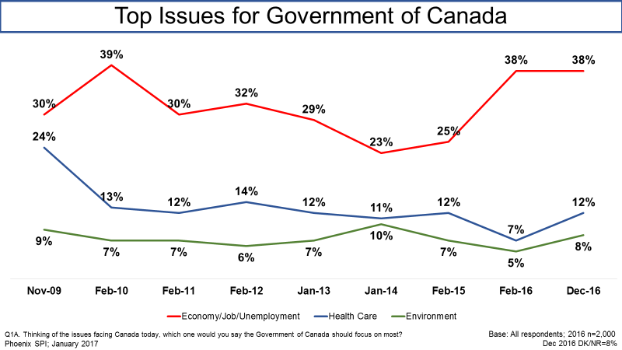

Following the economy, which was mentioned more than three times as often as any other issue, 12% of Canadians felt the Government of Canada should prioritize healthcare and 8% felt that environmental issues should be the top priority. All other issues were identified by fewer than 5% of respondents.

The likelihood of identifying the economy was higher in Alberta[3] (61%), as well as among men (45%), those with household incomes of $100,000 or more (44%), and Canadians aged 35-54 (42%). Canadians under 35, with a high school education or less, and with household incomes under $80,000 were less likely to mention the economy.

### Economic Perceptions

Nearly four in 10 Canadians view the economy positively

When asked to rate the current state of the Canadian economy, nearly four in 10 Canadians (38%) had a positive perception (scores of 7 to 10). This represents a significant increase in positive perceptions since February 2016, when 23% said the Canadian economy was performing well. Conversely, one in five (20%) had a negative perception (scores of 1 to 4) of the state of Canada’s economy, while the plurality (40%) were neutral (scores of 5 to 6), holding neither a negative nor a positive view of the Canadian economy.



Albertans (41%) were more likely to hold a negative view of the Canadian economy as were those who think the economy is getting weaker (37%). In addition, the likelihood of saying the economy is doing well increased with household income and was higher among Canadians under 35 (49%) and university graduates (44%).

Canadians view national economy more positively than global economy

Nearly one in five Canadians (19%) had a positive perception (scores of 7 to 10) of the current state of the global economy (compared with 38% who think the Canadian economy is doing well). Those who did not see the global economy as doing well were more likely to be neutral (52%; scores of 5 to 6) than to hold a negative view of the current state of the global economy (24%; scores of 1 to 4).

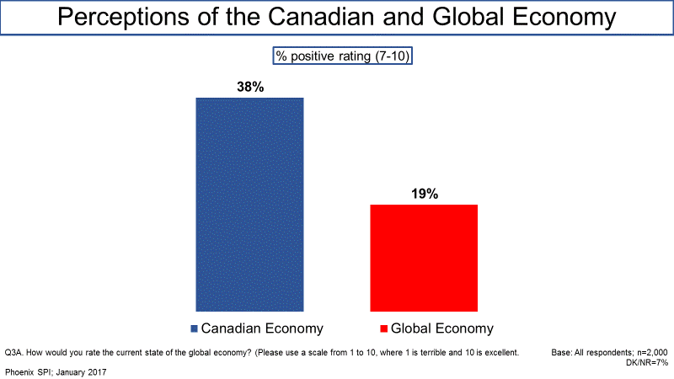

Across all subgroups, Canadians held similar views about the global economy, but Canadians under the age of 35 (26%) were more likely to hold positive views of the global economy than Canadians aged 55+.

Canadians hold similar views of the national and U.S. economies

Turning to the U.S. economy, just over one-third of Canadians (35%) said it is doing well (scores of 7 to 10), compared to 38% who said this about the Canadian economy. This is the first time since tracking began in 2009 that views of the Canadian and U.S. economies have been so similar.

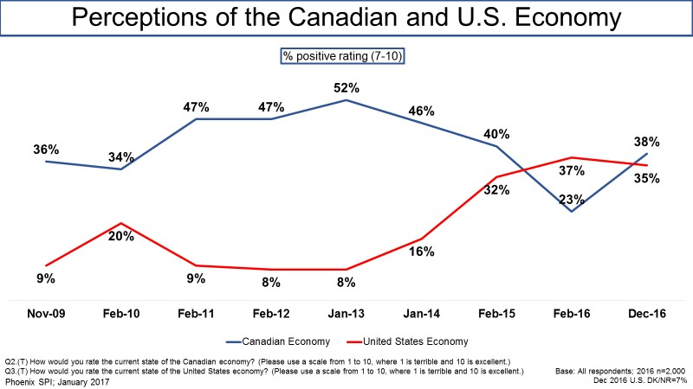

Allophones (53%), students (48%), those from households with an annual income of $150,000+ (44%), men (42%), and university graduates (40%) were more likely to rate the U.S. economy as good.

Residents of B.C. and Manitoba view their provincial economies more positively

When asked to rate the current state of their provincial economy, residents of British Columbia (51%) and Manitoba[4] (42%) were more likely to rate their province’s economy positively (scores of 7 to 10). In contrast, over half of Albertans and Atlantic Canadians, 58% and 56% respectively, said their provincial economy is doing poorly (scores of 1 to 4).

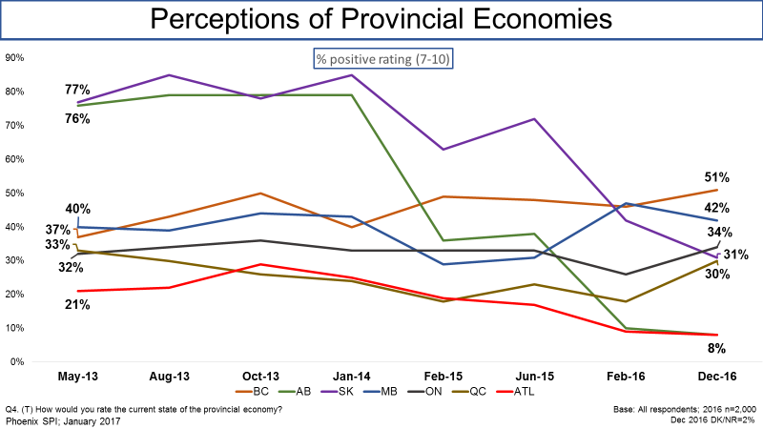

### Economic Outlook

Canadians expect no change to the national economy over the next six months

Approximately half (49%) of Canadians expect no change in the national economy over the next six months, while similar proportions think it will get either stronger (25%) or weaker (23%).

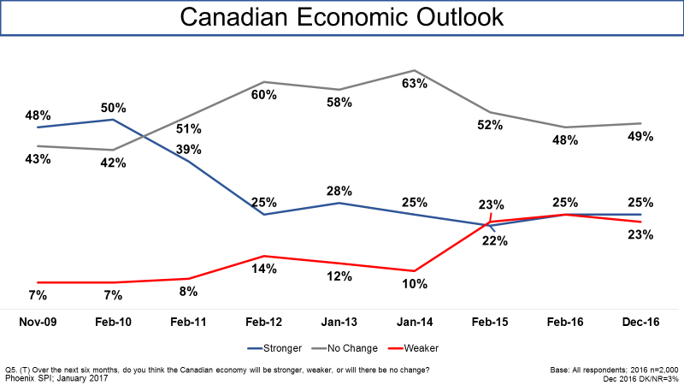

Residents of Alberta (41%), Manitoba (35%) and the Atlantic provinces (31%) were more likely to think that the Canadian economy will improve, while residents of Saskatchewan and Ontario, 31% and 27% respectively, were more apt to say the economy will get weaker over the next six months. Men, those with household incomes of $150,000+, and those under 35 were more likely to be optimistic and say the Canadian economy will get stronger.

Significant minority of Canadians expect no change in the global economy

Forty-six percent (46%) of Canadians expect the global economy to stay the same in the next six months. Those who anticipate a change were more likely to say the global economy will worsen (30%) rather than improve (18%) in the next half year.

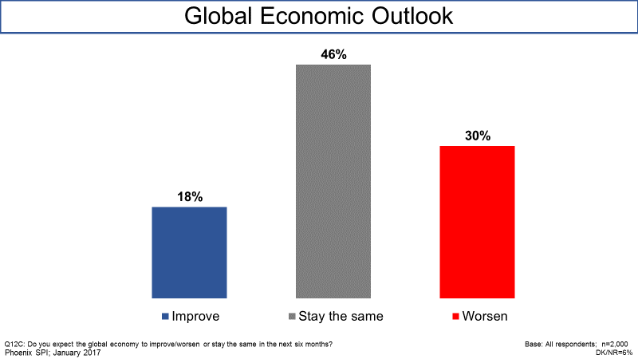

Albertans (25%) and residents of Saskatchewan (27%) were more likely to think the global economy will improve. In contrast, residents of British Columbia[5] (36%) were more likely to think that the global economy will worsen in the next six months. Canadians under 35 years of age (23%), those with a high school education (23%), and men (21%) were more likely to think the global economy will improve in the next six months.

Nearly four in 10 Canadians think the U.S. economy will worsen

Nearly four in 10 (38%) Canadians expect the U.S. economy to worsen in the next six months. Conversely, almost one-third (31%) are anticipating that the U.S. economy will improve by mid-2017. The rest (25%) expect there will be no change.[6]

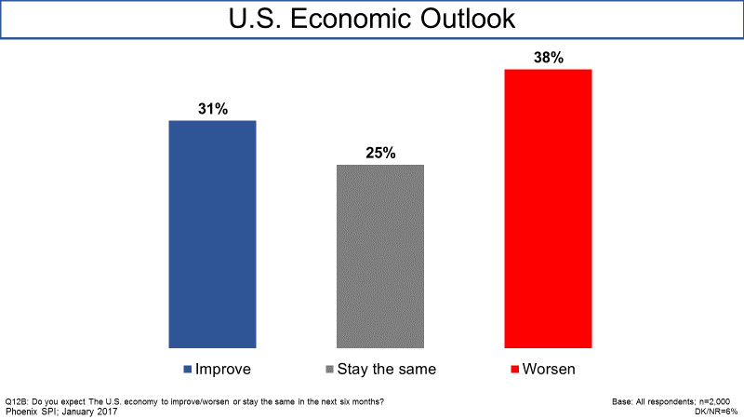

Albertans (41%), those with an annual household income of $80,000 to $100,000 (41%), and men (40%) were more likely to think the U.S. economy will improve. In contrast, Canadians under the age of 35 (45%) and women (46%) were more likely to think the U.S. economy will get worse in the next six months.

Canadians expect the stock market to stay the same

Turning to the stock market, the plurality of Canadians (36%) expect it to stay the same in the next six months. Those who anticipate a change were divided over whether it will improve (25%) or get worse (25%).

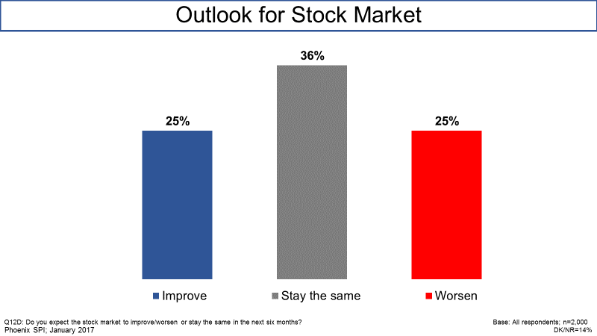

Albertans (37%), Canadians with an annual household income of $150,000+ (33%), and men (30%) were all more likely to think the stock market will improve in the next six months.

Residents of Alberta and Saskatchewan most likely to think economies will improve

Residents of Alberta (38%) and Saskatchewan (37%) were more likely to think their province’s economy will improve in the next six months. In contrast, Canadians in all other provinces were more likely to think that their provincial economy will stay the same (as opposed to improve or get worse).

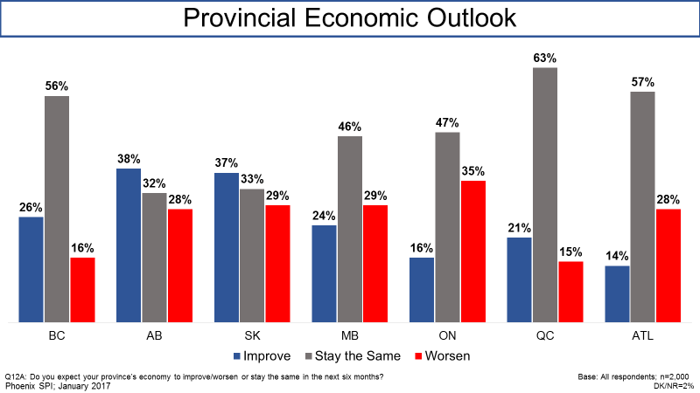

### Personal Financial Situation

Half of Canadians rate their personal financial situation as good

Half of Canadians (52%) rate their personal financial situation as good, with 10% saying it is *very* good (scores of 9 to 10). That said, three in 10 Canadians provided a neutral rating and 17% think that their personal financial situation is not good.

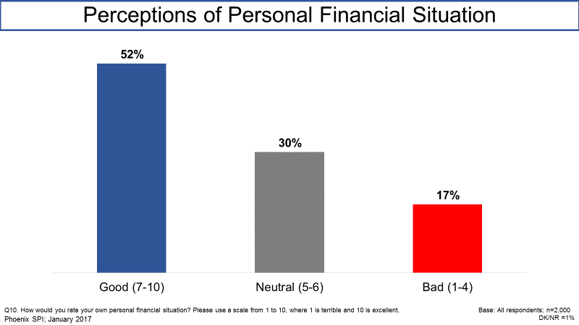

The likelihood of saying their personal situation is good increased with age, education, and household income. Compared to Canadians elsewhere in the country, Albertans (43%) were less likely to rate their personal financial situation as good.

Many Canadians expect personal financial situation to stay the same

Six in 10 Canadians (61%) expect their personal financial situation to stay the same in the next six months. Of those who expect a change, 28% think their personal financial will improve and 10% think it will get worse.

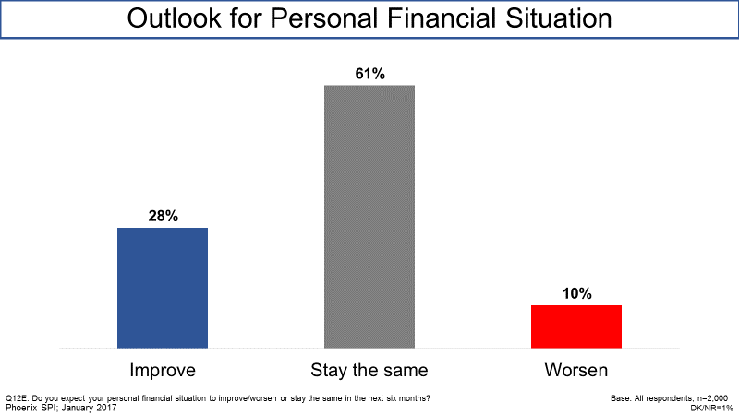

A little over two-fifths (44%) of Canadians under 35 expect their financial situation to improve, while three-quarters (74%) of Canadians age 55+ expect their personal financial situation to stay the same. Canadians with an annual household income of less than $40,000 were more likely to expect their personal situation to get worse in the next six months (14%). Men (33%) were more likely to expect their personal financial situation to improve than women (23%).

Majority of Canadians *not* concerned about job loss

The majority of Canadians (61%) are not concerned that they or someone in their household may lose their job in the next six months, with almost half (49%) saying they are not at all concerned (scores of 1 to 2). Conversely, a quarter of Canadians (25%) were concerned about job loss (12% were neutral).

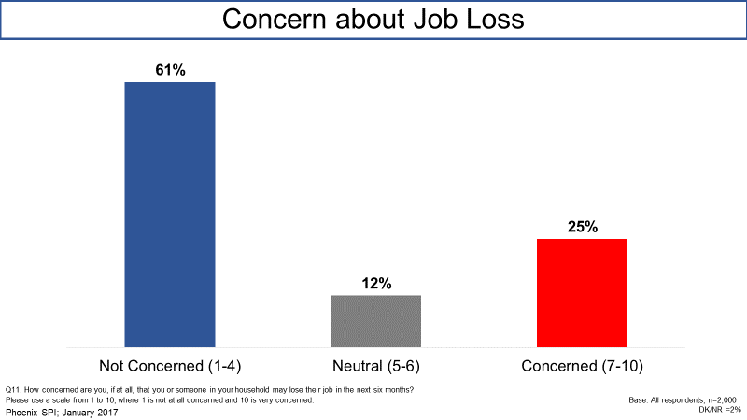

Concern about job loss was higher in Alberta, where 40% of residents said they are concerned they or someone in their household may lose their job. In addition, Canadians with an annual household income of under $40,000 (39%) show more concern about job loss than those with an annual household income of $150,000+ (15%).

### Sources of Stress

Rising cost of living major source of stress for Canadians

Approximately half (49%) of Canadians said the rising cost of living is a major source of stress for their household. Following the cost of living, 38% said that the middle class falling further behind the top 1% is a major source of stress (notably only 22% viewed income inequality in Canada as a major source of stress). In addition, 35% rated the quality of the healthcare system as a major source of stress (only 23% offered this assessment when the issue was presented as *the health of you and your family*). Roughly three in 10 said the following are a major source of stress: being financially secure for retirement (32%) and climate change/the quality of the environment (30%).

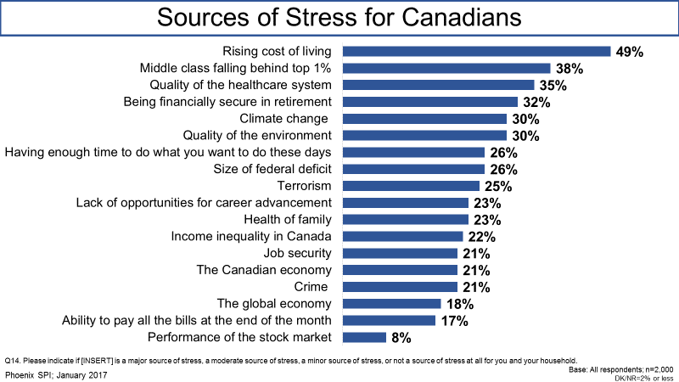

Canadians were less likely to view the following as major sources of stress: the global economy, the ability to pay all bills at the end of the month, and the performance of the stock market.

Top source of stress for parents is the quality of the environment

Among parents, the top of source of stress for them is the quality of the environment when their kids are older. Four in 10 (43%) parents said environmental quality is major source of stress for them and their household.

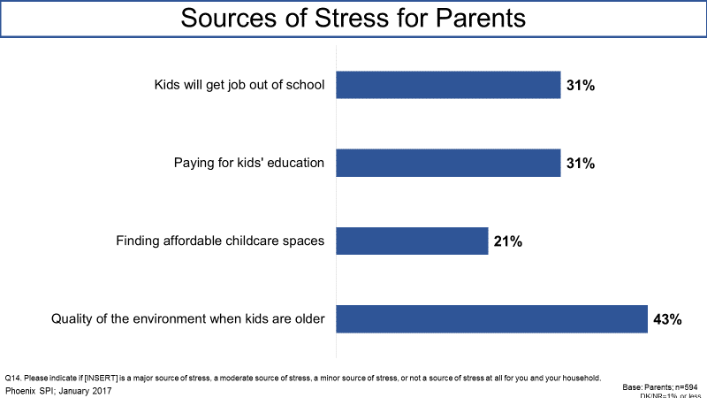

Significant minorities anticipate no difficulty in attaining a mortgage, making mortgage payments

More than two-fifths of Canadians who do not have a home mortgage (45%) expect that it would be easy for them to attain one. A similar proportion of mortgage holders (43%) said it would be easy for them to continue making payments if interest rates increase.

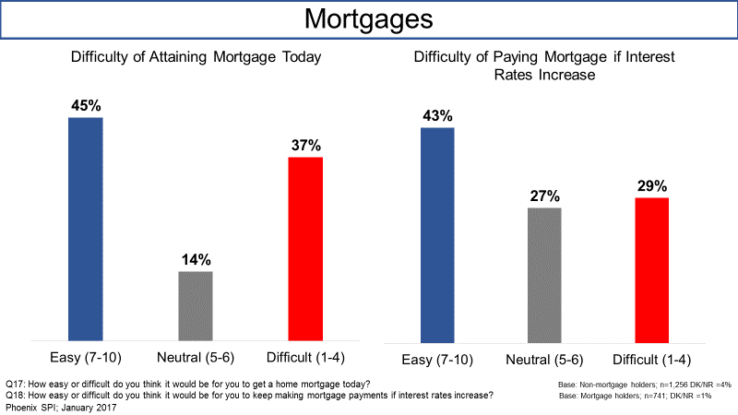

A little under half (48%) of Albertans who do not have a mortgage felt it would be difficult to get one, with 33% rating this as *very* difficulty. Following this, 40% of Ontarians think it would be difficult to obtain a mortgage today. Quebeckers were the least likely to think that it would be difficult to get a mortgage.

Among mortgage holders, Quebeckers (49%) and Ontarians (44%) were more the most, and Atlantic Canadians (30%) the least, likely to say it would be easy for them to continue making their mortgage payment if interest rates increase. The likelihood of Canadians thinking it would be easy to make their mortgage payment if rates increase increased with household income.

### Perceptions of Economic Policies

Support for small businesses and investing in workforce viewed as most effective economic policies

Of a list of potential policies that could help grow the economy, Canadians gave the highest effectiveness ratings (scores of 7-10) to policies focused on small businesses and the workforce. Specifically, strong majorities felt that supporting small businesses (77%), investing in skills training (76%), and helping workers re-train and acquire new skills (75%) would be effective policies when it comes to growing Canada’s economy.

Following this, two-thirds said that improving trade and business relationships with countries around the world, including in the Asia-Pacific region, the United States, and Europe[7] (67%) as well as attracting investment in Canada (66%) would help grow Canada’s economy[8]. In addition, just over six in 10 Canadians (62%) felt signing trade deals to open new markets for Canadian businesses would be an effective measure to grow the national economy.

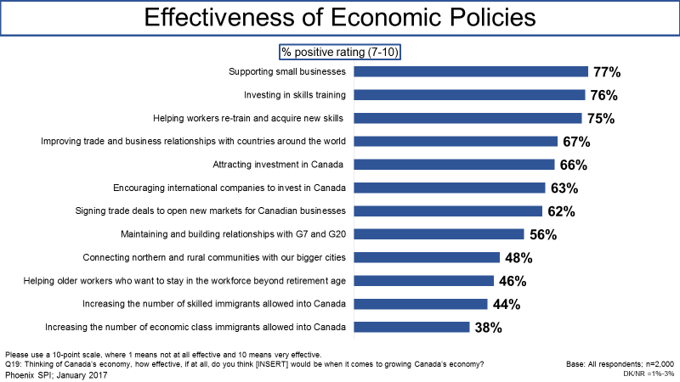

Canadians were least likely to think that immigration-related policies would grow Canada’s economy. Effectiveness ratings were higher, though, when immigration was linked to helping Canadian companies remain competitive and create jobs.

Canadians more likely to favour general not targeted support of small businesses

More than half of Canadians (58%) think that the Government of Canada should support small businesses in general, regardless of the sector in which they operation. Conversely, one-third (33%) would prefer that the government target financial support to small businesses in sectors that are expected to experience high rates of growth over the next few years. Among the rest, 5% declined to choose between the two options and volunteered that the Government of Canada should provide both types of support for small businesses and 4% said the government should do neither.

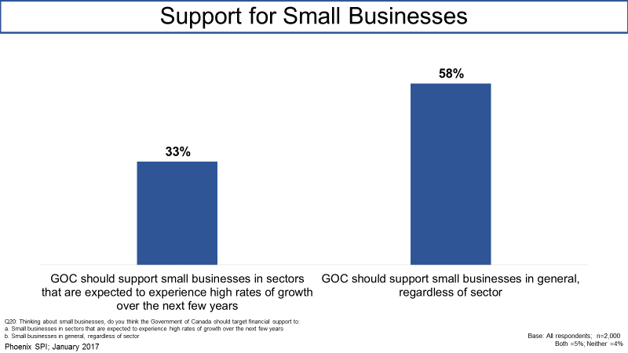

Compared to Ontarians (55%), residents of Quebec (63%) were more likely to favour support for small businesses in general. In contrast, Allophones (42%), Canadians with an annual household income of $150,000+ (40%), those under 35 (38%), university graduates (36%), and men (36%) were more likely to think that the government should only support small businesses in sectors that are expected to experience high rates of growth over the next few years.

### Tax Benefits and Credits

Divided views of ease of understanding benefits and credits

When asked how easy or difficulty it is to identify the various tax benefits and credits they are eligible to receive, roughly four in 10 (39%) Canadians said it is easy for them to do this. Conversely, almost one-third (31%) find it difficult to understand which benefits and credits apply to them. The rest (23%) were neutral.

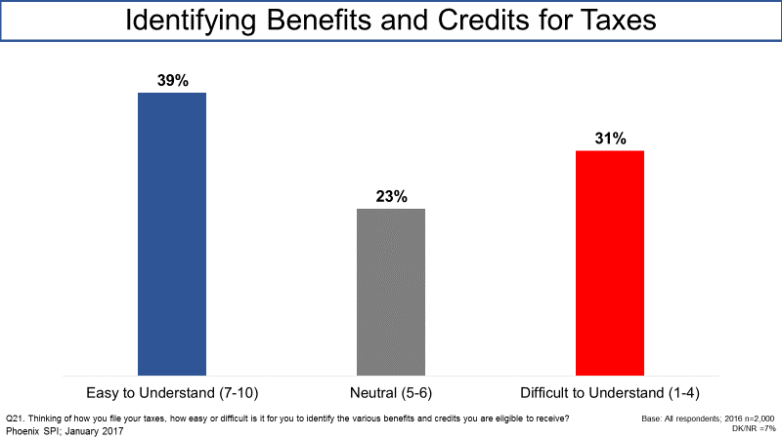

Atlantic Canadians (49%), Canadians with an annual household income of $150,000+ (49%), university graduates (44%), and Canadians aged 55+ (43%) were more likely to find identifying benefits and credits for taxes easy to do.

# *Appendix*

## Annex 1: Qualitative Research Instruments

1. **Recruitment Screener**

**Specifications**

* Recruit 12 participants.
* Participants to be paid $100.
* 1 group in each location will be held with participants from low/middle income households and the other with participants from high income households.
* “High income” is defined as anyone with a personal annual income of over $80,000 or anyone in a household with multiple incomes with an annual household income of over $100,000. **In Moncton and Montreal, a household income of over $80,000 also counts as “high income”.**
* “Low/middle” income is defined as anyone with a personal annual income of up to $80,000 or anyone in a household with multiple incomes with an annual household income of under $100,000.

|  |  |  |  |  |
| --- | --- | --- | --- | --- |
| **Group 1** | **Group 2** | **Group 3** | **Group 4** | **Group 5** |
| **Brampton** | **Brampton** | **Moncton** | **Moncton** | **Montreal** |
| December 5  5:30 pm  Low/middle income | December 5  7:30 pm  High income | December 6  5:30 pm  Low/middle income | December 6  7:30 pm  High income | December 7  5:30 pm  Low/middle income |
|  |  |  |  |  |
| **Group 6** | **Group 7** | **Group 8** | **Group 9** | **Group 10** |
| **Montreal** | **Calgary** | **Calgary** | **Coquitlam** | **Coquitlam** |
| December 7  7:30 pm  High income | December 8  5:30 pm  Low/middle income | December 8  7:30 pm  High income | December 10  10:00 am  Low/middle income | December 10  12:00 pm  High income |

**Questionnaire**

**A. Introduction**

Hello/Bonjour, my name is           . Would you prefer to continue in English or French? / Préférez-vous continuer en anglais ou en français?

**[INTERVIEWER NOTE: FOR ENGLISH GROUPS, IF PARTICIPANT WOULD PREFER TO CONTINUE IN FRENCH, PLEASE RESPOND WITH, "Malheureusement, nous recherchons des gens qui parlent anglais pour participer à ces groupes de discussion. Nous vous remercions de votre intérêt." FOR FRENCH GROUP, IF PARTICIPANT WOULD PREFER TO CONTINUE IN ENGLISH, PLEASE RESPOND WITH, “Unfortunately, we are looking for people who speak French to participate in this discussion group. We thank you for your interest.]**

I’m calling from Research House, a Canadian research firm. We’re organizing a series of discussion groups on behalf of the Government of Canada to explore issues around the current state of the Canadian economy. The groups will last up to two hours and people who take part will receive a cash gift to thank them for their time.

Participation is completely voluntary. We are interested in your opinions. No attempt will be made to sell you anything or change your point of view. The format is a "round table" discussion led by a research professional with up to eight participants. All opinions will remain anonymous and will be used for research purposes only in accordance with laws designed to protect your privacy.

**[INTERVIEWER NOTE: IF ASKED ABOUT PRIVACY LAWS, SAY: “The information collected through the research is subject to the provisions of the *Privacy Act*, legislation of the Government of Canada, and to the provisions of relevant provincial privacy legislation.”]**

Before we invite you to attend, we need to ask you a few questions to ensure that we get a good mix of people in each of the groups. This will take 5 minutes. May I continue?

Yes **CONTINUE**

No **THANK/DISCONTINUE**

**B. Qualification**

1. Do you, or any member of your household or immediate family, work in any of the following fields? **READ LIST**

Marketing research, public relations firm, or advertising agency,

The media (radio, television, newspapers, magazines, etc.),

A federal or provincial government department or agency

A political party

Yes **THANK/DISCONTINUE**

No **CONTINUE**

1. We have been asked to speak to participants from all different ages. May I have your age please? _________. **RECORD**

Under 18 **THANK/DISCONTINUE**

18 to 24 years

25 to 34 years

35 to 44 years

45 to 54 years

55 to 64 years

65 to 74 years

75 years or older **THANK/DISCONTINUE**

1. Record gender by observation. **50/50 SPLIT**

Female

Male

1. How many people, including yourself, live in your household?

One **ASK Q5**

Two **SKIP TO Q. 6**

Three **SKIP TO Q. 6**

Four or more **SKIP TO Q. 6**

**IF ONLY ONE PERSON IN HOUSEHOLD ASK:**

1. Which of the following categories best corresponds to your total personal annual income, before taxes, for 2015? **READ**

Under $30,000 **Low/middle income**

$30,000 to $60,000 **Low/middle income**

$60,000 to $80,000 **Low/middle income**

$80,000 to $100,000 **High income**

$100,000 to $150,000 **High income**

$150,000 and over **High income**

REFUSE/DK/NA **TERMINATE**

**ASK ALL FROM HOUSEHOLDS WITH MORE THAN ONE PERSON:**

1. Which of the following categories best corresponds to the total annual income, before taxes, of all members of your household, for 2015? **READ**

Under $30,000 **Low/middle income**

$30,000 to $60,000 **Low/middle income**

$60,000 to $80,000 **Low/middle income**

$80,000 to $100,000 **Low/middle income: EXCEPT IN MONTREAL + MONCTON\***

$100,000 to $150,000 **High income**

$150,000 and over **High income**

REFUSE/DK/NA **TERMINATE**

**\*NB: IN MONTREAL AND MONCTON HIGH INCOME HOUSEHOLDS ARE DEFINED AS $80K OR MORE.**

**ASK ALL**

1. Could you please tell me what is the last level of education that you completed? **READ LIST; GET MIX**

Some High School only

Completed High School

Trade School certificate

Some Post secondary

Completed Post secondary

Graduate degree

1. Are you working? **CHECK QUOTAS**

Full Time (35 hrs. +) **4 minimum**

Part Time (under 35 hrs.) **2 max.**

Homemaker **1 max.**

Student **1 max. GROUPS 1, 3, 5, 7, 9 ONLY**

Retired **2 max.**

Unemployed **1 max. GROUPS 1, 3, 5, 7, 9 ONLY**

1. What is your current occupation? **RECORD:**

Type of Job: ______________

Type of Company: _____________

1. Do you consider yourself to be a member of a visible ethno-cultural group?

Yes **CONTINUE**

No **GO TO Q12**

1. What is your ethnic background? **RECORD:**

Ethnicity: ______________

**IN MONTREAL, BRAMPTON, CALGARY, and COQUITLAM: Recruit at least two per group who are of non-European descent or who are other visible minorities (i.e., Chinese or South Asian, but could include aboriginal people or Afro-Canadians as well).**

1. Participants in group discussions are asked to voice their opinions and thoughts, how comfortable are you in voicing your opinions in front of others? Are you... **READ OPTIONS**

Very comfortable **MIN 5 PER GROUP**

Fairly comfortable

Not very comfortable **TERMINATE**

Very uncomfortable **TERMINATE**

1. Have you ever attended a discussion group or interview on any topic that was arranged in advance and for which you received money for your participation?

Yes **MAXIMUM 5 PER GROUP**

No **GO TO INVITATION**

1. When did you last attend one of these discussion groups or interviews?

Within the last 6 months **TERMINATE**

Over 6 months ago

1. How discussion groups or interviews have you attended in the past 5 years?

Fewer than 5

5 or more **TERMINATE**

1. Sometimes participants are also asked to write out their answers on a questionnaire. Is there any reason why you could not participate? If you need glasses to read, please remember to bring them. (Add hearing impairment.)

Yes **TERMINATE**

No

**TERMINATE IF RESPONDENT OFFERS ANY REASON SUCH AS SIGHT OR HEARING PROBLEM, A WRITTEN OR VERBAL LANGUAGE PROBLEM, A CONCERN WITH NOT BEING ABLE TO COMMUNICATE EFFECTIVELY.**

**C. INVITATION TO PARTICIPATE**

I would like to invite you to attend the focus group session where you will exchange your opinions in a moderated discussion with other Canadians from your community. The discussion will be lead by a researcher from the national public opinion research firm, Phoenix SPI. The session will be taped and observed but your participation will be confidential. The group will take place on **[DAY OF WEEK]**, **[DATE]**, at **[TIME]**. It will last two hours. People who attend will receive $100 to thank them for their time. Would you be willing to attend?

Yes

No **TERMINATE**

Do you have a pen handy so that I can give you the address where the group will be held? It will be held at **[INSERT FACILITY]**. I would like to remind you that the group is at **[TIME]** on **[DATE]**. We ask that you arrive 15 minutes early.

At the facility, you will be asked to produce photo identification, so please remember to bring something with you (for example, a driver's license). If you use glasses to read, please remember to bring them with you. Participants may be asked to review some materials in **[ENGLISH/FRENCH]** during the discussion.

The session will be video recorded for research purposes and representatives of the Government of Canada research team will be observing from an adjoining room. You will be asked to sign a waiver to acknowledge that you will be video recorded during the session. The recordings will be used only by the Phoenix SPI research team and will not be shared with others. As I mentioned, all information collected in the group discussion will remain anonymous and be used for research purposes only in accordance with laws designed to protect your privacy.

As we are only inviting a small number of people to attend, your participation is very important to us. If for some reason you are unable to attend, please call us so that we can get someone to replace you. You can reach us at **[INSERT NUMBER]** at our office. Please ask **for [INSERT NAME]**.

Someone will call you the day before to remind you about the session.

So that we can call you to remind you about the focus group or contact you should there be any changes, can you please confirm your name and contact information for me?

|  |  |
| --- | --- |
| First name: |  |
| Last Name: |  |
| Daytime phone number: |  |
| Evening phone number: |  |

1. **Moderator’s Guide**

**Introduction (5 minutes)**

* Introduce moderator/Phoenix
* Thanks for attending/value your being here
* Explain general purpose of focus group discussions:

- Gauge *opinions* about issues/ideas/products

- Not a knowledge test; no right or wrong answers (interested in opinions)

- Okay to disagree; want people to speak up if hold different view

- Do not need to direct all comments to me; can exchange ideas with each other

* + Tonight, we’re conducting research on behalf of the Government of Canada. The purpose of tonight’s discussion is to explore issues related to the economy.
  + Looking for candour and honesty; comments treated in confidence; reporting in aggregate form only; video-taping and note-taking for report writing purposes only; observers behind one-way glass.
  + If you have a cell phone, please turn it off.
  + Any questions? ACCEPT BRIEF QUESTIONS BUT DO NOT LINGER.
  + Roundtable introduction: Let’s go around the table so you can each introduce yourselves to the group. Please tell us your first name and a little bit about yourself, such as the kind of work you do and who lives with you in your home.

**Warm-up – General Context (15 minutes)**

Before we get into the main topic of our focus group tonight, I want to start with a broad question.

What have you heard recently, if anything, about the Government of Canada? Anything else?

Using the paper and pencil/pen in front of you, I’d now like each of you to write down your answer to the following question…

Thinking of all the issues facing Canada today, which **one** would you say the Government of Canada (that is, the federal government) should focus on most?

Keep in mind that there are issues that are municipal, provincial or federal government issues – please focus on FEDERAL issues.

PARTICIPANTS TO READ WHAT ISSUES THEY CAME UP WITH

What makes you say that?

Probe: - if no mentioned, ask ‘What about Canada’s economy?’

**Economy – Word Association Exercise (5 minutes)**

We’re going to be discussing Canada’s economy for the rest of the session. Before we do that, I’m going to hand you a sheet with some words (a “word cloud”) that might be used to describe Canada’s economy. I’d like you to take a look and circle the one word on the page that for you best captures or describes your feeling of the current state of the Canadian economy.

HAND OUT WORD CLOUD…AFTER PARTICIPANTS HAVE CIRCLED WORDS GO AROUND THE TABLE AND WRITE ON A FLIP CHART

Why did you choose that word? DISCUSS

**Economy – General Perceptions (35 minutes)**

What do you think are Canada’s biggest economic strengths? That is, what are our competitive advantages compared with other countries? Anything else?

Probe: - human capital/skills vs. resources

- traditional vs. innovation

What do you think are the biggest threats or challenges to Canada’s economy these days?

Probe: - short-term challenges

- long-term challenges

How do you think Canada’s economy is doing compared to other countries? Do you think we are doing better or worse than other countries? Or are we about the same?

Why do you think Canada’s economy is doing better/worse than other countries?

Probe: - government policies?

Thinking about the next few years, how much confidence would you say you have in Canada’s economy and how it will perform? Why do you say that?

ASK IF PARTICIPANTS THINK ECONOMY IS NOT DOING WELL: Do you think the economy is going to get worse before it gets better or have things bottomed out? Why?

What about the economy here in [NAME OF LOCATION]? How is the economy doing? What is the biggest local economic concern?

To what extent does the state of Canada’s economy affect you personally? Is it mostly just a story in the news or do you actually feel it personally when the economy is doing better or worse? How so?

I’d now like each of you to write down one word that you would use to describe your feelings about your own current financial situation. WHEN DONE, ASK: What did you each write and why? FLIPCHART

How do you feel about each of the following and how do they affect you? How about…? KEEP BRIEF IF ALREADY MENTIONED.

* Job security: Do you feel that your own job is more or less secure these days? What about the jobs of those around you, such as family, friends, or neighbours?
* What about the cost of living in general? What impact, if any, does it have on your personal situation? In what area or areas does it have the biggest impact? Anywhere else?

**Federal Action on Economy (30 minutes)**

Have you seen or heard anything that the federal government has done to help Canadians? IF NEEDED, FOLLOW UP WITH: Thinking about the economic well-being of Canadians, have you heard anything that the federal government has done to help Canadians?

Probe: - Infrastructure spending

- Child Tax Credit

- CPP expansion

Do you think the federal government is doing enough to help the middle class? If not, what more could the government do to help? Anything else?

Here is a list of types of infrastructure projects that could be built. Please read them over and pick which ones would be your top three.

ONCE PARTICIPANTS ARE DONE, HAVE A QUICK SHOW OF HANDS TO DETERMINE THE NUMBER WHO PICKED EACH OF THE PROJECT TYPES TO INFORM SUBSEQUENT DISCUSSION, THEN DISCUSS THE TOP PICKS AS TIME PERMITS (2-4 TYPES)

What are the types of projects that people chose? Let’s start with a show of hands in terms of who picked which projects as I go down the list to get a sense of your choices? After quickly doing that, we’ll continue our discussion.

Let’s start with… DISCUSS THE PARTICIPANTS’ TOP PICKS

Why did you choose that type of project? What types of benefits do you see flowing from it to you, your family, or other Canadians? Any others?

Probe: - tangible benefits (e.g., better public transit = quicker commute)

- attributes of popular infrastructure types

- focus on self/family vs. others?

As you know, infrastructure projects cost a lot of money and there is already a federal deficit. One way to pay for infrastructure projects would to privatize major public assets such as airports, ports and highways by leasing or selling stakes in these assets.  What do you think of this kind of approach?

Should the federal government focus more on measures that address the overall economy, such as infrastructure spending, or should it focus more on measures targeted at helping individual Canadians or families? Why do you say that?

In your view, how important is it for Canada to have a balanced budget? Why is it important/not important?

Do you think it is better for the government to spend money to invest in Canadians or to balance the Federal budget? Why?

**Private Sector (5** **minutes)**

What do you think about the performance of the private sector in Canada?

Probe: - perceptions of performance

- strengths, weaknesses

- how could it be strengthened?

Does the Government of Canada have a role to play in working with the private sector to help create jobs and grow the economy? If so, what role?

**International Trade (15** **minutes)**

Have you heard anything regarding Canada’s efforts to expand trading relationships, beyond our traditional partners like the United States? If so, what have you heard?

Probe: - trade missions, trade agreements, other

What benefits, if any, do you think there will be for Canada if we sign new trade agreements?

What concerns, if any, do you have if Canada signs new trade agreements?

Probe: - agriculture industry (e.g., beef, pork, canola, fisheries, food processing, others?

- auto industry?

- Other sectors?

What about trade with the United States? How important is it for the Government of Canada to focus on managing our trading relationship with the United States? What level of priority should be given to that? Why do you say that?

What benefits do you think there are in Canada having a strong trading relationship with the United States? Any other benefits?

Probe: - areas of impact (employment, incomes), tangible vs. abstract

- link to well-being of Canadians

- link to personal/family well being

- attentive to FTA/free trade perceptions

And what concerns do you have, if any, when you think about our trading relationship with the United States? Any others?

Probe: - areas of impact (employment, incomes), tangible vs. abstract

- link to well-being of Canadians

- link to personal/family well being

- attentive to FTA/free trade perceptions

**Taxation (5** **minutes)**

I’d now like to briefly turn to taxation issues…

What does ‘simplifying the tax system’ mean to you? Anything else?

Thinking about Canada’s tax system, how important is it that our tax system be simplified? Is it in need of simplification? If so, why do you say that?

Probe: - focus on federal, not provincial/municipal taxation

- evidence of need for simplification

Do you tend to think of Canada’s tax system as fair? If not, why is it unfair, who is it unfair to?

**Conclusion (5 minutes)**

Before we conclude…

Thinking about what we’ve talked about today, do you have any last thoughts that you’d like to share with the Government of Canada on any of the topics we’ve explored?

Thank you very much for your participation tonight and your thoughtful feedback. It is much appreciated.

**COLLECT HANDOUT MATERIAL**

## Annex 2: Quantitative Research Instruments

**INTRODUCTION**

Good afternoon/evening. My name is _______________ and I am calling from Phoenix, a public opinion research company.

CONFIRM WHETHER RESPONDENT PREFERS ENGLISH OR FRENCH

We are conducting a study on behalf of the Government of Canada to find out what people think about issues facing Canada today. Please be assured that we are not selling or soliciting anything. The survey is voluntary and your responses will be kept entirely confidential and anonymous. This survey is registered with the national survey registration system and it takes about 15 minutes.

[IF ASKED: The survey is being sponsored by Finance Canada]

[IF ASKED: This survey is registered with the national survey registration system. The registration system has been created by the Canadian survey research industry to allow the public to verify that a survey is legitimate, get information about the survey industry or register a complaint. The registration system's toll-free telephone number is 1-888-602-6742, extension 8728].

IF LANDLINE SAMPLE

We choose telephone numbers at random and then select one person from each household to be interviewed. To do this, we would like to speak to the person in your household, 18 years of age or older, who has had the most recent birthday. Would that be you?

IF CELL PHONE SAMPLE ASK A AND B

A Are you in a safe place to talk – for example not operating a motor vehicle?

Yes [RE-INTRODUCE YOURSELF, IF NECESSARY]

No [ARRANGE CALLBACK DATE/TIME]

B At home, do you have a traditional telephone line other than a cell phone?

Yes CHECK AGAINST QUOTA

No CHECK AGAINST QUOTA

**MAIN SURVEY**

1. **Assessments of Economy**

1A. (T) Thinking of the issues facing Canada today, which one would you say the Government of Canada should focus on most? **[CAPTURE FIRST MENTION]**

**[NO PRE-CODED LIST - INTERVIEWER NOTE: TOP ANSWER MUST BE RECORDED FIRST. ALL OTHER RESPONSES WILL BE RECORDED ON THE NEXT SCREEN]**

99 – [DO NOT READ] Don’t know/Refused

1B. (T) Are there any others? **[IF NECESSARY:** Thinking of the issues facing Canada today, which one would you say the Government of Canada should focus on most?]

**RECORD VERBATIM - [MULTIPLE MENTIONS]**

99 – [DO NOT READ] Don’t know/Refused

Q2. (T) How would you rate the current state of the Canadian economy? (Please use a scale from 1 to 10, where 1 is terrible and 10 is excellent.)

Terrible 1

2

3

4

5

6

7

8

9

Excellent 10  
VOLUNTEERED

Not sure 99

**[ROTATE ORDER OF QUESTIONS 3, 3A AND 4]**

Q3. (T) How would you rate the current state of the United States economy? (Please use a scale from 1 to 10, where 1 is terrible and 10 is excellent.)

Terrible 1

2

3

4

5

6

7

8

9

Excellent 10  
VOLUNTEERED

Not sure 99

Q3A. How would you rate the current state of the global economy? (Please use a scale from 1 to 10, where 1 is terrible and 10 is excellent.)

Terrible 1

2

3

4

5

6

7

8

9

Excellent 10  
VOLUNTEERED

Not sure 99

Q4. (T) How would you rate the current state of the **[PROVINCE]** economy? (Please use a scale from 1 to 10, where 1 is terrible and 10 is excellent.)

Terrible 1

2

3

4

5

6

7

8

9

Excellent 10  
VOLUNTEERED

Not sure 99

Q5. (T) Over the next six months, do you think the Canadian economy will be stronger, weaker, or will there be no change?

**[NOTE TO INTERVIEWER: IF RESPONDENT SAYS “HOPE” IT WILL BE STRONGER, CLARIFY WHAT S/HE ACTUALLY *THINKS* WILL HAPPEN]**

Stronger 1

Weaker 2

No change 3

Don’t know 99

1. **Personal Financial Situation**

Q10. How would you rate your own personal financial situation? Please use a scale from 1 to 10, where 1 is terrible and 10 is excellent.

Terrible 1

2

3

4

5

6

7

8

9

Excellent 10  
Don’t know 99

Q11. How concerned are you, if at all, that you or someone in your household may lose their job in the next six months? Please use a scale from 1 to 10, where 1 is not at all concerned and 10 is very concerned.

Not at all concerned 1

2

3

4

5

6

7

8

9

Very concerned 10  
Don’t know 99

Q12. Do you expect each of the following to improve/worsen or stay the same in the next six months?

**[RANDOMIZE ORDER]**

1. Yourprovince’s economy
2. The US economy
3. The Global economy
4. The stock market
5. Your personal financial situation

Q13. Are there any children under the age of 18 currently living in your household?

Yes 1

No 2

Q14. For each of the following, please indicate if it is a major source of stress, a moderate source of stress, a minor source of stress, or not a source of stress at all for you and your household.

**[RANDOMIZE ORDER]**

Major source of stress

Moderate source of stress

Minor source of stress

Not a source of stress

Not applicable                   [DO NOT READ]

Don’t Know                        [DO NOT READ]

(SPLIT) Job security / Lack of opportunities for career advancement

 (SPLIT) Being financially secure in retirement / having enough time to do what you want to do these days

 (SPLIT) Your ability to pay all the bills at the end of the month / The rising cost of living

 (SPLIT) The quality of the environment / Climate change

 (SPLIT) The health of you and your family   / The quality of the healthcare system

 (SPLIT) Crime / Terrorism

 (SPLIT) The global economy / The Canadian economy

(SPLIT) The performance of the stock market / The size of the federal deficit

(SPLIT) Income inequality in Canada / The middle class falling further behind the top 1%

(ASK AMONG PARENTS OF KIDS UNDER 18 ONLY) If your kids will get jobs out of school

(ASK AMONG PARENTS OF KIDS UNDER 18 ONLY)  Paying for your kids’ education

(ASK AMONG PARENTS OF KIDS UNDER 18 ONLY)  Finding affordable childcare spaces

(ASK AMONG PARENTS OF KIDS UNDER 18 ONLY)  The quality of the environment when your kids are older

Q15. Which of the following best describes your housing arrangement:

1. Own your home,
2. Rent your home,
3. Neither own nor rent your home

**[ASK IF Q15=1]**

Q16. Do you have a mortgage on your home?

Yes 1

No 2

**[ASK Q17 IF Q15=2 (rent) OR 3 (neither own or rent) OR Q16=2 (own but do not have a mortgage)]**

Q17. How easy or difficult do you think it would be for you to get a home mortgage today? Please use a scale from 1 to 10, where 1 is very difficult and 10 is very easy.

Very difficult 1

2

3

4

5

6

7

8

9

Very easy 10  
Don’t know 99

**[ASK Q18 IF Q16=1 (have a mortgage)]**

Q18. How easy or difficult do you think it would be for you to keep making mortgage payments if interest rates rise? Please use a scale from 1 to 10, where 1 is very difficult and 10 is very easy.

Very difficult 1

2

3

4

5

6

7

8

9

Very easy 10  
Don’t know 99

Q.19 Thinking of Canada’s economy, how effective, if at all, do you think each of the following policies would be when it comes to growing Canada’s economy? Please use a 10-point scale, where 1 means not at all effective and 10 means very effective. **READ AND ROTATE…**

1. Helping older workers who want to stay in the workforce beyond retirement age do so
2. (split) Improving trade and business relationships with countries around the world, including in the Asia-Pacific region, the United States and Europe/ [split] Maintaining and building new relationships with G7 and G20 countries
3. Connecting northern and rural communities with our bigger cities
4. Helping workers re-train and acquire new skills throughout their careers
5. Supporting small businesses
6. Investing in skills training
7. Signing trade deals to open new markets for Canadian businesses
8. (split) Attracting investment in Canada / [split] Encouraging international companies to invest in Canada
9. (split) Increasing the number of economic class immigrants allowed into Canada each year / [split] Increasing the number of skilled immigrants allowed into Canada each year, to respond to help Canadian companies remain competitive and create jobs

Not at all effective 1

2

3

4

5

6

7

8

9

Very effective 10  
 Don’t know 99

Q20. Thinking about small businesses, do you think the Government of Canada should target financial support to:

**[ROTATE OPTIONS]**

1. Small businesses in sectors that are expected to experience high rates of growth over the next few years
2. Small businesses in general, regardless of sector
3. (DO NOT READ) BOTH
4. (DO NOT READ) NEITHER

Q21. Thinking of how you file your taxes, how easy or difficult is it for you to identify the various benefits and credits you are eligible to receive?Please use a 10-point scale, where 1 means “very difficult” and 10 means “very easy”.

Very difficult to understand 1

2

3

4

5

6

7

8

9

Very easy to understand 10  
 Don’t know 99

**DEMOGRAPHICS**

READ: And now a few final questions for demographic purposes.

Q22. In what year were you born?

[RECORD YEAR – XXXX]

9999 – DO NOT READ: Don’t know/Refused

Q23. What is the highest level of formal education that you have completed? [READ LIST]

Grade 8 or less 1

Some high school 2

High School diploma or equivalent 3

Registered Apprenticeship or   
other trades certificate or diploma 4

College, CEGEP or other non-university   
 certificate or diploma 5

University certificate or diploma   
below Bachelor’s level 6

Bachelor’s degree 7

Post graduate degree above bachelor’s level 8

[DO NOT READ]   
Prefer not to answer 99

Q24. What language do you speak most often at home? [READ LIST — ACCEPT ALL THAT APPLY]

English 1

French 2

Another language DO NOT SPECIFY 3

VOLUNTEERED

Don’t know/Refused 99

Q25. Which of the following categories best describes your current employment status? Are you…? [READ LIST – ACCEPT ONE ANSWER ONLY]

Working full-time, that is, 35 or more   
hours per week 1

Working part-time, that is, less than 35   
hours per week 2

Self-employed 3

Unemployed, but looking for work 4

A student attending school full-time 5

Retired 6

Not in the workforce [FULL-TIME HOMEMAKER,  
UNEMPLOYED, NOT LOOKING FOR WORK]) 7

[DO NOT READ]

Other -- DO NOT SPECIFY] 98

[DO NOT READ]

Refused 99

Q26. Which of the following categories best describes your total household income? That is, the total income of all persons in your household combined, before taxes [READ LIST]?

Under $20,000 1

$20,000 to just under $40,000 2

$40,000 to just under $60,000 3

$60,000 to just under $80,000 4

$80,000 to just under $100,000 5

$100,000 to just under $150,000 6

$150,000 and above 7

(DO NOT READ) Refused 99

IF LANDLINE RECORD REGION FROM SAMPLE

IF CELL PHONE SAMPLE ASK Q27

Q27. In which province or territory do you live?

Newfoundland 1

Prince Edward Island 2

Nova Scotia 3

New Brunswick 4

Quebec 5

Ontario 6

Manitoba 7

Saskatchewan 8

Alberta 9

British Columbia 10

Yukon 11

Northwest Territories 12

Nunavut 13

Q28. And finally, to better understand how results vary by region, may I have your 6-digit postal code?

ACCEPT FIRST THREE DIGITS IF THAT IS ALL RESPONDENT IS WILLING TO GIVE

__ __ __ __ __ __

999999 – DK/NA

This completes the survey. In case my supervisor would like to verify that I conducted this interview, may I have your first name?

First Name: ______________________________

This survey was conducted on behalf of Finance Canada, and is registered under the Federal Access to Information Act. Thank you very much for your participation.

**RECORD:**

Language of interview

English 1

French 2

Gender [DO NOT ASK: record based on interviewer observation]

Female 1

Male 2

1. The MRIA response rate formula is as follows: [R=R/(U+IS+R)]. This means that the response rate is calculated as the number of responding units [R] divided by the number of unresolved [U] numbers plus in-scope [IS] non-responding households and individuals plus responding units [R].
2. Suggestions made by participants regardless of whether the measures in question fall under the competence of the federal government.
3. All mentions of Alberta include the Northwest Territories.
4. Including Nunavut.
5. Including the Yukon Territory.
6. Canadians were surveyed just over a month after the 2016 U.S. Presidential Election.
7. This drops to 56% when the statement does not identify regions by name: “maintaining and building new relationships with G7 and G20 countries as an effective economic policy”.
8. This drops to 63% when the statement is read as: “encouraging international companies to invest in Canada”.