Consumer Perceptions of Food Safety and Quality

Prepared for: Agriculture and Agri-Food Canada

Submitted by:
Ipsos-Reid Corporation
900-363 Broadway
Winnipeg, MB
R3C 3N9

Contact: Curtis Johnson
Senior Vice President
Agribusiness, Food and Animal Health
Ipsos-Reid Corporation
900-363 Broadway
Winnipeg, MB
R3C 3N9
Tel: (204) 949-3110

November 2004

Disclaimer: Information contained in this report consists of opinions expressed by the author(s); consequently, the views expressed herein are those of the originators and do not necessarily represent the opinions of the department or the government of Canada. The Government of Canada and it employees, servants or agents make no representations or warranties as to the accuracy or completeness of the information contained in this report. Parties who rely on the information do so at their own risk.

Executive Summary i
1.0. Introduction 1
2.0. Detailed Findings 2
2.1. Top-of-Mind Food Topics and Quality/Safety Trade-offs 5
2.2. Perceptions of Canadian Food Quality 22
2.3. Perceptions of Canadian Food Safety 30
2.4. Knowledge and Information Needs 41
2.5. Food Safety and Quality Initiatives 51
2.6. Purchase Behaviour and other Characteristics 58
3.0. Segmentation Analysis 67
3.1. Segmentation Methodology 67
3.2. Summary of Major Defining Variables 68
3.3. Summary of Segments 70
3.4. Supporting Charts and Graphs 79
3.5. Demographic Profile of Consumer Segments 90
3.6. Implications on Possible Communication Strategies 92
4.0. Study Methodology 94
4.1. Sample Design 94
4.2. Segmentation Methodology 95
4.3. Questionnaire Design and Pre-Test 96
4.4. Fieldwork Procedures 96
4.5. Call Disposition and Response Rates 97
4.6. Sample Profile 98

Executive Summary

Agriculture and Agri-Food Canada (AAFC) assigned a Food Safety and Quality Team with lead responsibility for food production-oriented policy development under the Agriculture Policy Framework (APF). In Spring 2004, the Food Safety and Quality Team commissioned Ipsos-Reid to conduct a market research study to obtain consumer perceptions, attitudes and behaviour related specifically to Canadian food quality and safety. The research findings will contribute to policy development, help set priorities and be instrumental in developing messaging and targeting in support of the APF.

The study addresses top-of-mind considerations when making food purchases in general and when buying food for the home or dining out. Perceptions of food quality and the level of confidence in the safety of food produced in Canada are both measured. Comparisons are made with food from other countries and responses to quality and safety initiatives are gathered. Consumers are asked about their knowledge of food production, quality and safety initiatives, current information sources, and their need for additional information.

A telephone interview approach was used to collect feedback from 1600 main/joint grocery shoppers for the home. The following analytic techniques were used to provide greater insight into the data:
- Correspondence Analysis – a qualitative approach used to group top-of-mind responses in terms of their association with food purchases in general, food bought for the home, and dining out
- Trade-off Analysis – a measure of the stated importance of food quality and safety attributes using consumer choices
- Penalty:Reward Analysis – a technique used to determine the drivers of positive and negative perceptions of food quality and safety concerns
- Convergent Cluster Analysis – used to create consumer segments and profile each one in order to develop targeted communication strategies

The following summarizes the findings and presents implications and recommendations for going forward.

Top-of- Mind Food Topics and Associations

When thinking of food purchases in general, “quality” is top-of-mind for most consumers. “Nutrition”, followed by “price” are other commonly mentioned aspects of the food purchase decision.

Top-of-mind considerations are similar when buying food for home consumption or when dining out, though “freshness” and “nutritional value” are more frequently mentioned for home purchases, while “taste” is mentioned more often for food purchased when dining out. Food “quality” is a major consideration whether buying food for the home or dining out and it is primarily defined by “freshness”, “nutrition” and “food safety”.

Correspondence analysis illustrates characteristics that consumers most closely associate with food quality as well as their considerations around food purchased for the home or when dining out. In addition to “freshness”, attributes closely associated with food quality include “farms where the food comes from”, “food handling”, “treatment of animals” and “environmentally responsible or sustainable production”. These attributes relate to the food system overall but are less immediate when making food purchase decisions for the home or when dining out.

“Nutritional value”, “ingredients in the food”, “brand or company name”, and “convenience” are found to be closely associated with food purchased for the home. “Quality”, “price” and “specific food items” appear to be equally associated with food for the home and dining out. Meanwhile, food that is “certified or labeled as meeting certain standards”, the “quantity of food or serving size”, the “company that processes or packages the food” and the “retailer or restaurant” are all associated with food purchased when dining out.

“Food safety” is not frequently mentioned top-of-mind though when asked directly in the trade-off analysis, “confidence in the safety of the food”, “knowing that the food has high nutritional value” and “knowing that the food is of high quality” are the top three attributes in terms of stated importance when buying food. These variables along with those identified as key drivers of quality perceptions and food safety confidence must be included future communications with consumers.

Food Quality

Consumers tend to concentrate on specific procedures and processes when thinking about food quality in general. They consider where the food comes from and how it was produced. Consumers associate quality with the way the food was handled, processed and packaged, how long it would last and remain fresh, the general safety of the food itself and whether it is organic.

Consumer perceptions of overall Canadian food quality are high, with about nine in ten people in each region giving Canadian food a quality rating of “good” or “excellent”. Food produced in Canada is rated highly with respect to important aspects of food quality, like “freshness” and “taste”.

Further analysis indicates that “healthiness” is the key driver of consumers’ perceptions of Canadian food quality. “Overall taste”, “consistent quality” and “nutritional value” are also important drivers of consumers’ overall impressions of Canadian food quality. Canadian food receives high ratings on each of these variables.

Less important drivers, but those for which performance should be monitored because they are mainly associated with perceptions of poor quality, include “the humane treatment of animals”, “fat content in food”, and “environmentally sustainable production practices”.

The quality of food that is produced in Canada is clearly seen as being better than food produced in other countries. Consumers feel that Canada has better production standards and practices than other countries and to a less extent more rules and the food is considered fresher than food from other countries because of its proximity to the market. Just under one in ten consumers simply prefer to buy Canadian.
Food Safety

Food safety is not a top-of-mind consideration when purchasing food for the home or when dining out, largely due to the confidence consumers have in the safety of food produced in Canada. They generally feel confident in the systems and regulations that are in place to manage activities in the food supply chain.

When addressed in more detail, consumers expressed uncertainty about some areas, in particular, the ability of the system to manage potential food safety problems arising from “genetically modified foods” and the “use of hormones, antibiotics and chemicals in plants and animals”. Additional analysis shows that managing “bacterial contamination during processing” and “animal diseases, such as mad cow and avian flu” are the main drivers in terms of maintaining consumer confidence in food safety.

If problems were to arise in food safety, processing is the area that is most often mentioned as being the likely source, followed by activities at the farm level or in restaurants. Consumers pay relatively little attention to the farms where the food comes from or the company that processes and packages the food. They admit to low levels of familiarity with food safety practices that are in place and this lack of knowledge may be the reason consumers point to these areas should a food safety problem arise.

Purchase Behaviour/Eating Habits

Compared with other activities in the supply chain, consumers pay the most attention to the grocery store where they purchase their food and when dining out, whether the food is certified or labeled as meeting certain standards. They feel that they are quite careful about what they purchase in terms of the safety of their food. A large majority also feels that they are careful about the way they store and prepare food and will throw food out once the expiry date has lapsed.

Most Canadians believe they eat a fairly well balanced diet, eating at least 3 servings a week of the main food groups. While meat, both red and white, are still regular components of most diets; about one in ten consumers consider themselves to be vegetarian. Meanwhile, organic foods are becoming a more common part of consumers’ diets, with at least one half saying they bought organic food in the past year.

Most food is still consumed in the home, with over three-quarters of Canadians eating three meals or less a week that are not produced in the home. Though various diets have been frequently in the media of late, less than one in ten Canadians would say they follow a weight losing diet.

Household spending on food varies considerably. Canadian consumers spend an average of about $150 per month, per household member, on food.

Knowledge and Information Needs

Consumers feel that they are knowledgeable about safe food practices within the home. This would indicate that they feel confident in the safety practices to which they have control. However, there is low familiarity with guidelines elsewhere in the food supply chain.

Most consumers say that they have read some information on food safety issues, but they would like more information on a variety of food safety topics. Though there are several food safety organizations and systems in existence that provide this type of information, the majority of consumers have not heard of most of these information forums.

The media, mostly newspapers and television, is the main source of food safety information for most Canadian consumers. The media is likely the biggest factor that impacts how consumers react to issues of food safety – current issues become top-of-mind and can affect consumer behavior. The impact can be positive or negative and this appears to be largely determined by industry response to a crisis, as evidenced by the handling of the BSE case in Canada in 2003.

Consumers feel that the government, in particular, the federal government, needs to play a leading role in ensuring food safety and informing the public about food safety and food quality issues.

Food Safety Initiatives

Food Safety and Quality Initiatives
Consumer familiarity with the concept of a food traceability system is low. Just over one third of consumers claim to be familiar with the concept of a food traceability system, while four in ten are not at all familiar with this concept.

Though Canadians have a low awareness of the concept of having a food traceability system, it appears to be something that they think would be beneficial with respect to helping them feel more confident in the level of food safety. A national traceability system would also contribute positively to consumer impressions of Canadian food quality.

A food traceability system could also lead to more transparency in the food production process, especially in the food processing sector, where consumers feel information is currently limited.

Canadians believe that the federal government would be best suited to provide a food traceability system.

Segmenting the Canadian Public on Food Related Issues

Based on their views and behaviors towards food-related issues, convergent cluster analysis produced five Canadian consumer segments -- Conscientious Consumers, Uninvolved Trusters, Busy Family Shoppers, Social Activists, and Informed Action Takers. The segmentation identifies those who are most knowledgeable and concerned with food issues as well as those who are most involved and take action.

Conscientious Consumers (32% of sample)

Accounting for about one third of consumers surveyed, this segment is the largest group overall. While it is made up of consumers of all ages, it has the highest incidence of seniors (65 or older). This segment also tends to have the lowest overall education of the segments and the lowest annual household income. Members of this segment typically have children living at home.

Conscientious Consumers appear to be very content with the quality of food produced in Canada. They consistently show the highest confidence in Canadian food and they have developed habits to ensure that their food is of good quality and safe. This group’s confidence in Canadian food extends to feeling that food in Canada is of better quality than food produced in other countries.

Conscientious Consumers do not appear to be as active as others are in dealing with food related issues. While they claim to have read articles or other information on food safety in the past year, few appear to take action on specific issues. It appears this group is well informed and is well-meaning Canadians. Perhaps being more conscientious about food safety and quality and better informed enables these consumers to be more confident in the food system.

Busy Family Shoppers (29% of sample)

Accounting for about three in ten consumers, this segment represents the second largest group. Busy Family Shoppers are the youngest respondents in the sample, with nearly four in ten being under the age of 35. This segment has the lowest incidence of singles and the highest incidence of larger households. They also are likely to be dual income earning households. Along with Uninvolved Trusters, members of this group tend to have higher levels of education than the other segments.

Food safety and quality issues are lower priorities for Busy Family Shoppers. Most follow proper food handling practices and they are less likely to spend time worrying about the safety of the food they eat. They also have an average level of knowledge concerning food safety practices. This group appears to take a very practical approach to food safety and quality. They consider nutritional value, price and quality to be the most important factors when buying food for the home or when dining out.

Busy Family Shoppers have very positive perceptions of Canadian food quality. This segment is not very active when it comes to food safety and quality issues, although slightly more active than Uninvolved Trusters.
Uninvolved Trusters (14% of sample)

This segment is one of the smaller ones including only 14% of consumers surveyed. Uninvolved Trusters tend to be in the middle age range. They also tend to have higher levels of education. This is likely a segment of singles or older couples as two thirds do not have children under the age of 18 in the home. This group also tends to have average household incomes.

Uninvolved Trusters share a concern with other segments about the nutritional value of the food they purchase for their home and when dining out. They also tend to place more importance on brand or company names and have a higher tendency to show an affinity for new and innovative foods.

Uninvolved Trusters appear to be very detached from food safety and food quality issues. Uninvolved Trusters have the greatest confidence of all the segments in the safety of food produced in Canada, while also admitting they have the lowest levels of familiarity with food safety practices and guidelines. Being disengaged, Uninvolved Trusters also have a low level of activism.

Social Activists (16% of sample)

This segment of consumers is one of the smaller groups (16%). They tend to be younger. Education levels are split with about a third having attained high school or less and just under half having at least attended university. Segment members are also likely to be singles, couples or smaller families.

Social Activists appear to be self-reliant for food safety and quality information, looking to ‘best before’ dates over retailer advice. This segment also claims to be knowledgeable about some aspects of food safety practices and guidelines while admitting a lack of knowledge in other areas. Social Activists are also the least confident of the segments concerning the safety of food produced in Canada.
While members of this segment are less likely to seek information and knowledge about food safety practices, there is a higher incidence of activism such as discontinuing purchases of certain food products or boycotting a particular food product due to food safety issues. Recognizing their age and low levels of knowledge of food related issues, much of this activism may be based on emotion.

Informed Action Takers (9% of sample)

This segment of consumers is the smallest of all the groups identified (9%). They are slightly older than some of the other segments, being somewhat more in the middle to higher age brackets. Education levels are split with this group. Family units are likely smaller with a lot of singles and couples. It is possible that many are empty nesters. Annual household incomes tend to be mostly in the middle brackets.

Informed Action Takers may be considered a group of aging ‘baby boomers’ who are sensitive to having high standards in Canada’s food safety system. They also appear to pick and choose among various issues around food safety and food quality.

Issues of importance to Informed Action Takers when buying food for either home or dining out focus mostly on nutrition and quality. They are knowledgeable about some aspects of food safety practices and guidelines while admitting a lack of knowledge in other areas.

Informed Action Takers are again in the middle when it comes to confidence in the safety of food produced in Canada. While informed, this group is skeptical of the ability of Canada’s food system to respond to specific concerns. This segment also takes action on their concerns. In the last year, they are the most likely segment to have discontinued purchasing certain foods, to have stopped eating at a specific restaurant or to have discontinued buying groceries from a particular retailer.

Research Implications and Recommendations

Quality, nutrition and price are consumers’ main considerations when buying food for the home or when dining out. Food quality is a top-of-mind issue and relates to freshness, nutrition, food safety and taste, with nutritional value and confidence in the safety of food driving overall perceptions of food quality. Consumer impressions of Canadian food quality are high and clearly superior to that of other countries. Production standards, practices and regulations contribute to this positive image of food quality.

Food safety is not immediately top-of-mind for consumers as they have high levels of confidence in the safety of food produced in Canada. In this respect, food safety appears to be assumed. Consumers typically get their information about food safety from the media, so this source appears to play a major role in consumer confidence in food safety. The systems that contribute to positive impressions of food quality also impact on the confidence that consumers have in food safety.

Consumers feel they know the appropriate food safety guidelines in the home and are generally confident that if a food safety problem were to occur, it would likely be elsewhere. They identify the activity that they know the least about, processing and packaging, as the weakest link in the supply chain in terms of food safety.

Consumers feel that they lack food safety information but it is evident that they do not actively seek it. The media is the primary and a typically passive source of information for the large majority. Those who look for information tend to rely on the Internet, brochures, and discussions with family, friends and people involved in health and the food industry, like doctors, dieticians and retailers. Most consumers are unaware of food safety forums that are now in place and there is limited familiarity with the concept of a food traceability system.

Confidence in the safety of food produced in Canada and overall impressions of food quality are high. However, given consumer reliance on media for information, risk of eroding this position is considerable. Consumers trust the food system yet have little knowledge of the food safety standards in the supply chain and are predisposed to attributing a food safety problem to processing and packaging rather than home preparation. Should media reports about food-borne illness arise, it is likely that confidence in the system will suffer and impressions of food safety and quality would be negatively affected.
To reinforce positive impressions of food quality, it is recommended that top-of-mind and driving attributes related to food quality be included in future communication efforts with Canadian consumers. As confidence in food safety appears to be largely driven by both implicit trust and the media, it is critical that the industry improves transparency and has in place systems to sustain consumer trust.

The research suggests that a traceability system would have a positive impact on consumer confidence in food safety. In fact, those with the lowest levels of confidence would be most responsive to the introduction of a traceability system.

The media can play a role in helping consumers become aware of control systems already in place throughout the supply chain, and particularly at the processing and packaging level. Consumers see the federal and provincial governments as the most reliable source of food safety information. However, as evidenced by consumer response when the industry introduced genetically modified foods compared with the successful management of the BSE case, it is clear that all industry stakeholders must participate and provide the same message.

Five consumer segments were identified in this study and can be used in developing targeted communications initiatives. Informed Action Takers represent the most receptive segment for direct communications about food quality and safety. They will seek information if available while a campaign targeted to this small segment is likely to resonate with Social Activists and Conscientious Consumers. In addition to the main drivers of quality and safety these groups will benefit most from information related to standards in the food chain of which they are least knowledgeable.

Busy Family Shoppers and Uninvolved Trusters do not actively seek food quality and safety information so require the media to reach them. Communications should be designed to reinforce currently held positive impressions of food quality and general confidence in food safety. It will be important to include attributes that are top-of-mind and of stated importance as well as the key drivers associated with positive impressions and confidence in the food system.

The chart below highlights some of the key differences with respect to food quality and safety for each segment.

Segment Characteristics Related to Food Issues
 | Conscientious  Consumers | Uninvolved  Trusters | Busy  Family  Shoppers | Social  Activists | Informed  Action  Takers
Segment Size  (% of Consumers) | 32% | 14% | 29% | 16% | 9%
Impressions of quality | High | High | Highest | Lowest | High
Confidence in safety | High | Highest | High | Lowest | High
Knowledge of standards | High | Minimal | Medium | Medium | Highest
Information gathering | Medium | Minimal | Minimal | Selective | Highest
Issues of concern | Diverse | Price | Nutrition | Nutrition Ingredients | Production Processing
Degree of activism | Low | None | None | High | Highest

Introduction

Agriculture and Agri-Food Canada (AAFC) is implementing a long-term strategy for the agriculture and agri-food sector in Canada. Part of this strategy was the assignment of a Food Safety and Quality Team with lead responsibility for food production-oriented policy development under the Agriculture Policy Framework (APF).

In the spring of 2004, Ipsos-Reid was commissioned to provide primary benchmark research on consumer perceptions, attitudes and behaviour related specifically to food safety and quality issues. The research findings will assist in policy development, setting on-going priorities, and in developing messaging in support of the APF.

Consumer opinion and behaviour with respect to Canadian food safety and quality issues will be anchored in the following areas.

- Top-of-Mind Topics and Quality/Safety Trade-Offs
- Top-of-mind considerations when making food purchase decisions
- Importance of specific food purchase decision considerations (e.g. price, overall quality, country of origin, etc.)
- Consumer knowledge of the food production and distribution process and the way it relates to their food buying behaviour

- Perceptions of Canadian Food quality
- Consumers’ overall impressions of the quality of Canadian food
- The determinants of food quality (i.e. characteristics associated with quality)
- Overall performance on specific quality characteristics
- Perceptions of Canadian food compared with imported food
- Differences in expectations and behaviour with respect to food consumed at home versus dining out

- Perceptions of Canadian Food Safety
- Consumer confidence in the safety of Canadian food
- Food safety in terms of top-of-mind concerns and awareness of current issues
- Impact of food safety concerns on consumer behaviour
- Food safety information needs and credible sources for food safety information (i.e. federal/provincial government, commodity organizations, manufacturers, processors, non-profit organizations, etc.)

- Food Safety and Quality Initiatives
- Consumer awareness of current food safety forums
- Consumer awareness of, interest in, and receptivity to traceability systems
- Who consumers feel is most credible and who should be responsible for putting traceability systems in place
- The impact a traceability system would have on consumers’ perceptions of Canadian food quality and confidence in food safety (e.g. reliability, accountability, etc.)

A telephone interview approach was used for gathering feedback from 1600 main/joint grocery shoppers for the home.

2.0. Detailed Findings

Notes on Reading and Interpreting the Results

The following report focuses on the detailed findings of this research. Findings are presented at the overall Canadian consumer level and significant differences at the regional level are highlighted. Statistically significant differences between demographic splits (for example: age, household income, gender, etc.) are also noted.

Margin of Error
When reviewing these results, the reader should keep in mind the margin of error (M.O.E.) associated with each question. With a sample size of 1600, the study’s findings can be interpreted with an accuracy level of +/-2.9%, at the 95% confidence interval. This means that if 50% of respondents answered “yes” to a given question, there is a 95% certainty that the correct value for the population is between 47.1% and 52.9%.

The research approach involved using a non-proportional sample design, whereby a specific number of interviews were conducted in each region to yield a minimum M.O.E. for that region. Quotas were imposed to ensure sufficient responses for regional reporting. Sampling within each region was proportional to the distribution of the population within that region.

The table below details the M.O.E. for each region and sample drawn for this study, as well as for the overall sample of Canadian Consumers.

Sample Allocation and Margin of Error
 | ATL | QC | ON | MB | SK | AB | BC | Canada
Full Sample | 200 | 275 | 300 | 200 | 200 | 200 | 225 | 1600
Effective Margin of Error | +/-6.9% | +/-5.9% | +/-5.7% | +/-6.9% | +/-6.9% | +/-6.9% | +/-6.5% | +/-2.9%
Split Sample | 100 | 137 | 150 | 100 | 100 | 100 | 113 | 800
Effective Margin of Error | +/-9.8% | +/-8.4% | +/-8.0% | +/-9.8% | +/-9.8% | +/-9.8% | +/-9.2% | +/-4.1%

Split Sample Technique
The reader will note that there is a M.O.E. listed for split samples, or samples half the size of the full sample. A split sample technique, where half the respondents are randomly assigned to respond to a specific series of questions while the remainder answer a different yet parallel set, was employed for certain questions. This was done in order to reduce overall interview length, decreasing respondent and interviewer fatigue. Questions that involved a split sample are noted below.

Split Sample Technique
Question | Q1a | Q1b | Q6 | Q12 | Q13
Unweighted Sample Size | 800 | 800 | 800 | 800 | 800

Open Ended versus Closed Ended Questions
Two main question types were used in this study. One was closed-ended questions, where a definite response is sought from the respondent. Examples of these are yes/no type questions, questions where a scaled response, number scales or word scales, is sought and questions where response categories are set at the start of the interviewing process, such as demographics (age, household income, etc.).

The graphic presentation of these closed-ended questions is relatively simple. The response categories used are listed in the graph and the percentage of respondents providing each possible answer noted. Typically, these questions will not elicit more than a single answer, so the categories are mutually exclusive with all responses having a cumulative total of 100%. If multiple responses are accepted, the categories will have a cumulative total greater than 100%.

The second type of questions is open-ended. These may have a pre-coded list of response categories where the response provided may fit what could be expected or they may be completely open, with responses being recorded verbatim. If a pre-coded list is provided, any response not fitting those codes/categories is recorded verbatim. All verbatim responses were then coded. That is, the research team reviewed the verbatim responses and assigned like responses to a single category. These categories are then reported, as with the closed-ended questions, with the percentage of respondents providing a specific category of response noted.

When reviewing data from open-ended questions, several response categories may be collapsed into one overall category, called a “NET”. For example, if a respondent is providing information regarding what they think is important about buying food for the home (Section 2.1 - Q1a), one respondent may say the nutritional value is most important while another says the fat content is the most important. While these are technically different responses, they are also part of the overall issue of nutrition, so both can be included in a “Nutrition (NET)” category.

When NET categories are reported graphically, points listed in all caps followed by the word NET are combined mentions. Specific items included in the NET are listed below that item and are preceded by a hyphen. Percentages of the items included in the NET are not cumulative, i.e., they may add to more than the percentage of the NET item due to a single respondent mentioning more than one item that was included in the overall NET and the NET would receive only one count. An example of this type of reporting can be found in Q1a/b, in the “2.1 Top-of-Mind Food Topics and Quality/Safety Trade-offs” Section of this report.

Reporting Statistically Significant Differences
Statistically significant differences are cited in many sections of this report. When a data table is included, such as in Q10 of Section 2.3 Perceptions of Canadian Food Safety (shown below) and the Detailed Tables Appendices, each column is appended with a letter. T-tests are conducted on results, with a letter in a cell indicating significant differences between samples. That letter directs the reader to note that the percentage reported in a specific cell is statistically different from the adjacent cell in the column indicated by the letter. To reduce confusion, letters are only included once, under the larger percentage of the cells being compared. For instance, if a significant difference exists between the responses from BC (column A) and Alberta (column B), and the percentage in Alberta is larger than BC, then an “A” appears under the percentage in the Alberta column.

For example, looking at the concept of “animal diseases such as mad cow disease and the avian flu” in the first column of the table below, it’s evident that 75% of consumers in BC are confident with the management of this concept, as are 84% of Alberta’s consumers. The letter “A” in the Alberta column indicates that this value is statistically different from the value in the BC column. A letter “A” also appears in the Saskatchewan/Manitoba column indicating a statistically significant difference here as well. In addition, Saskatchewan/Manitoba is also statistically different from the value in column “E” for Quebec.

Confidence in the Management of Food System Activities
Top2 Box: Completely / Somewhat Confident
- By Region -
 | BC | AB | SK/MB | ON | PQ | Atl
 | A | B | C | D | E | F
Base: All Respondents | n=225 | n=200 | n=400 | n=300 | n=275 | n=200
Additives and preservatives in food | 65% | 71% | 73% | 70% | 63% | 75%
Additives and preservatives in food |  |  | AE |  |  | AE
Animal diseases such as mad cow disease and the avian flu | 75% | 84% | 84% | 79% | 77% | 83%
Animal diseases such as mad cow disease and the avian flu |  | A | AE
Bacterial contamination from food processing such as E. coli and salmonella | 87% | 88% | 84% | 80% | 70% | 85%
 | DE | DE | E | E |  | E
Genetically modified or GMO food | 48% | 60% | 57% | 56% | 45% | 60%
Genetically modified or GMO food |  | AE | AE | E |  | AE
Hormones, antibiotics and chemicals in plants and animals | 52% | 61% | 63% | 55% | 43% | 60%
Hormones, antibiotics and chemicals in plants and animals |  | AE | ADE | E |  | E
Organically produced food | 89% | 82% | 83% | 81% | 74% | 89%
Organically produced food | BDE | E | E | E |  | BDE
NOTE: Letters in cells indicate the difference is statistically significicant at 5% level

2.1. Top-of-Mind Food Topics and Quality/Safety Trade-offs

It is important to get the top-of-mind thoughts, or what consumers think about a specific topic, in their own words. This gives a baseline measure of what consumers are thinking and provides some context for the remainder of the interview. This information is also important in developing communications that will resonate with the way consumers already think about a topic.

Consumers’ top-of-mind food issues are similar for both foods purchased for the home and for food chosen when dining out.

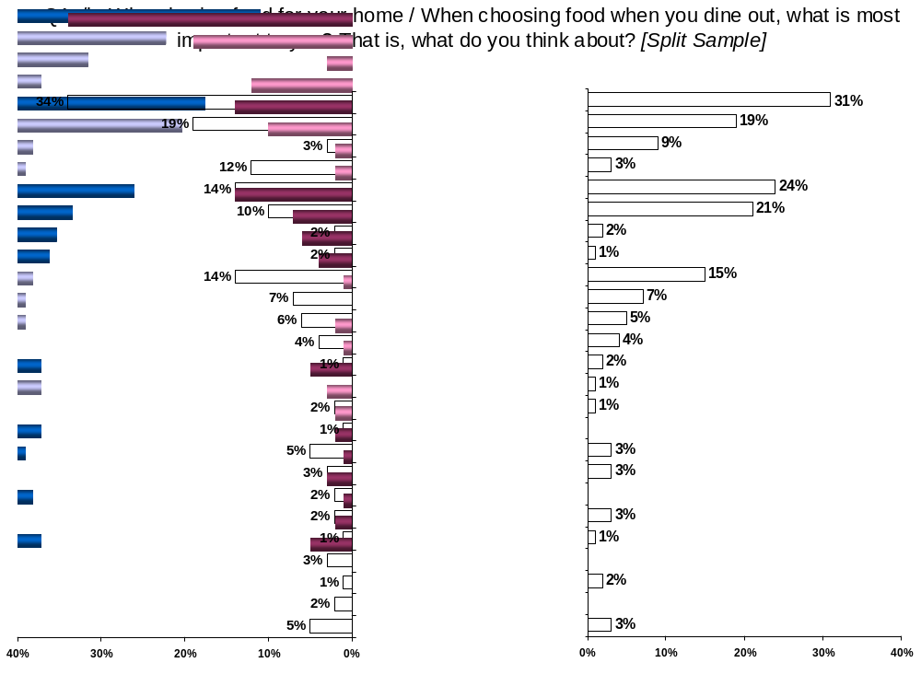

It appears that consumers make nutrition trade-offs for foods eaten in the home and those eaten in restaurants. Quality considerations, which include mentions of quality, freshness and taste/flavour, are similar for each activity. Nutrition (includes mentions of nutritional value, ingredients and fat content) is more frequently mentioned for foods purchased for the home (24%), than for foods eaten when dining out (14%). Price is the third most frequently mentioned top-of-mind considerations to consumers and is similar for home-based (15%) and restaurant-based (14%) food purchases.

Primary production considerations include mentions of organic food, GMOs, whether the food is certified or labeled as meeting certain standards and the treatment/health of animals. These considerations are top of mind for only 4% of consumers for both home-based and restaurant-based food purchases. Food safety considerations, which include mentions of food safety and food handling/cleanliness, are also low on consumers’ minds. Only 3% of consumers mentioned various food safety issues for foods purchased for the home, and 5% mentioned food safety considerations for foods purchased when dining out.

Consumers in Quebec are more likely to mention food quality considerations about food purchased for the home (36%) than are consumers in Saskatchewan/Manitoba (25%). On the other hand, consumers in Alberta are more likely to mention food quality issues about restaurant-based foods (45%) than are consumers in most provinces except Quebec and B.C.

Atlantic Canadians appear to focus more on nutrition for restaurant-based foods (23%) than do consumers in Alberta (11%), Saskatchewan/Manitoba (14%) and Quebec (10%). In addition, the nutritional value of home-based food products is more frequently mentioned among both Atlantic Canadians (34%) and British Columbians (35%) than Ontario consumers (21%) and consumers in Quebec (19%).

Consumers in Quebec are less likely to mention price as a top-of-mind food buying consideration for the home (10%) than are consumers in the Canadian Prairies (Alberta and Saskatchewan/Manitoba, 20% each). They are also less likely to mention price as a top-of-mind food consideration for restaurant-based foods (8%) compared with consumers in B.C. (17%), Alberta (16%) and Ontario (16%).

When it comes to food safety issues in restaurants, consumers in Saskatchewan /Manitoba appear to be more concerned (7%) than consumers in B.C. and Alberta (2% each).

Top-of-Mind Food Topics
For Home-Based Food Purchases
- By Region -
 | BC | AB | SK/MB | ON | PQ | Atl
 | A | B | C | D | E | F
Base: Block A respondents (Home) | n=113 | n=100 | n=200 | n=150 | n=137 | n=100
QUALITY (NET) | 29% | 29% | 25% | 29% | 36% | 33%
QUALITY (NET) |  |  |  |  | C
- Quality | 23% | 18% | 16% | 13% | 26% | 21%
- Quality | D |  |  |  | CD
- Freshness | 5% | 6% | 6% | 13% | 7% | 6%
- Freshness |  |  |  | A
- Taste/ flavour | 1% | 5% | 3% | 3% | 3% | 5%
- Taste/ flavour |  |  |  |  |  | A
NUTRITION (NET) | 35% | 24% | 26% | 21% | 19% | 34%
NUTRITION (NET) | DE |  |  |  |  | DE
- Nutritional value | 31% | 23% | 23% | 17% | 17% | 32%
- Nutritional value | DE |  |  |  |  | DE
- Ingredients in food | 3% | 1% | 3% | 3% | 1% | 2%
- Ingredients in food |  |  | E
- Fat content | 1% | - | - | 1% | 2% | -
Price | 15% | 20% | 20% | 17% | 10% | 17%
Price |  | E | E
Specific food items | 4% | 7% | 9% | 4% | 13% | 3%
Specific food items |  |  | DF |  | ADF
Variation in food choices | 5% | 4% | 5% | 7% | 3% | 6%
PRIMARY PRODUCTION (NET) | 3% | 4% | 2% | 6% | 4% | -
PRIMARY PRODUCTION (NET) |  |  |  | F
- Organic food | 2% | 2% | 0 | 3% | 1% | -
- GMOs | - | 1% | - | 1% | 1% | -
- If certified as meeting certain standards | 1% | - | 0 | 1% | 1% | -
- Treatment/health of animals | - | - | 1% | - | 1% | -
- Treatment/health of animals |  |  | D
FOOD SAFETY (NET) | 3% | 3% | 2% | 4% | 3% | 2%
- Food Safety | 3% | 3% | 2% | 4% | 1% | 1%
- Food handling/cleanliness | - | - | 0 | - | 1% | 1%
- Food handling/cleanliness |  |  |  |  |  | D
Convenience | - | 3% | 2% | 4% | 4% | 1%
Convenience |  |  |  |  | A
Unsure | 1% | 1% | 0 | 6% | 2% | 1%
Unsure |  |  |  | C
NOTE: Letters in cells indicate the difference is statistically significicant at 5% level

Top-of-Mind Food Topics
For Restaurant-Based Food Purchases
- By Region -
 | BC | AB | SK/MB | ON | PQ | Atl
 | A | B | C | D | E | F
Base: Block B respondents (Restaurants) | n=112 | n=100 | n=200 | n=150 | n=138 | n=100
QUALITY (NET) | 34% | 45% | 32% | 32% | 37% | 26%
QUALITY (NET) |  | CDF
- Quality | 19% | 21% | 11% | 20% | 20% | 14%
- Quality |  | C |  | C | C
- Taste/ flavour | 12% | 24% | 19% | 11% | 10% | 8%
- Taste/ flavour |  | ADEF | DEF
- Freshness | 3% | - | 1% | 1% | 6% | 4%
- Freshness |  |  |  |  | BCD | B
NUTRITION (NET) | 14% | 11% | 14% | 17% | 10% | 23%
NUTRITION (NET) |  |  |  |  |  | BCE
- Nutritional value | 9% | 10% | 7% | 13% | 7% | 16%
- Nutritional value |  |  |  |  |  | CE
- Fat content | 1% | 1% | 4% | 1% | 2% | 7%
- Fat content |  |  | D |  |  | ABDE
- Ingredients in food | 4% | - | 2% | 2% | 1% | -
Price | 17% | 16% | 10% | 16% | 8% | 15%
Price | E | E |  | E
Specific food item | 6% | 3% | 6% | 5% | 12% | 7%
Specific food item |  |  |  |  | BD
Variation in food choices | 6% | 3% | 9% | 4% | 8% | 7%
Variation in food choices |  |  | BD
FOOD SAFETY (NET) | 2% | 2% | 7% | 5% | 6% | 5%
FOOD SAFETY (NET) |  |  | AB
- Food Safety | 1% | 1% | 3% | 4% | 3% | 3%
- Food handling/cleanliness | 1% | 1% | 4% | 1% | 3% | 2%
- Food handling/cleanliness |  |  | D
PRIMARY PRODUCTION (NET) | 5% | 2% | 2% | 4% | 4% | -
PRIMARY PRODUCTION (NET) | F
- If certified as meeting standards | 3% | 1% | 2% | 2% | 3% | -
- Organic food | 1% | - | - | 1% | 1% | -
- Treatment/health of animals | - | - | - | 1% | - | -
The restaurant | 3% | 3% | 4% | 3% | 4% | 2%
Convenience | 2% | 3% | 1% | 2% | 2% | 3%
Brand or company name | 1% | - | - | 1% | - | -
Other | 1% | - | 2% | 2% | - | -
Other |  |  | E
None | - | 3% | 2% | 2% | 2% | 4%
None |  |  | A |  |  | A
Unsure | 1% | 6% | 6% | 6% | 6% | 3%
Unsure |  | A | A
NOTE: Letters in cells indicate the difference is statistically significicant at 5% level
Other demographic characteristics suggest that middle-aged consumers (35-54 years of age) are more focused on quality issues for foods purchased for the home (35%) than are consumers over the age of 55 (25%). Conversely, consumers over the age of 55 more frequently mention nutrition for home-based foods (31%) than do consumers under the age of 35 (20%).

Price is less significant a top-of-mind food issue for consumers over the age of 55 for either home-based or restaurant based foods (10% and 9%, respectively) than it is for middle aged consumers (both 17%).

Compared with consumers who have attended university (35%), those with lower levels of education (high school or less) are less focused on food quality for home-based foods (23%). They are also less concerned about food safety issues in restaurants (2%) than are consumers who have attended university (6%) or other post secondary institutions (7%).

Finally, lower income consumers (<$30,000/year) are the least concerned about food quality for home-based foods (17%) compared with middle and higher income consumers (33% and 40%, respectively). However, they are more concerned with nutrition for home-based foods (32%) than are higher income consumers (21%).

Food Quality means various things to Canadians.

Food quality encompasses the many attributes frequently associated with food. High quality food must be fresh, nutritious and safe. It must be produced in a fashion that preserves the environment, treats people and animals ethically and must be fairly priced. The ingredients and inputs used in the food production process should also be fresh and safe for humans, animals and the environment. Consumers expect producers and processors to take pride in the products they make available to consumers and only serve food products that they would serve to their own families.

Since the price of food is relatively unimportant to top-of-mind food quality impressions (price was mentioned by only 3% of respondents), one can infer that consumers expect their food to be priced in a way that supports all these attributes associated with quality. It can also be inferred that consumers might be willing to pay more for higher quality food.

There does not appear to be a consensus on the meaning of food quality; freshness, more than any other consideration, is first in the minds of consumers (mentioned by 29% of respondents) while considerations related to nutrition (17%) are next, followed by food safety (12%).

Considerations around agricultural production include mentions of organic food (3%), environmentally sustainable production (2%), where food comes from (2%) and treatment of animals (1%). Overall, agricultural production considerations are mentioned by only 7% of consumers and while closely associated with quality do not appear to be a significant contributor to Canadian top-of-mind food quality perceptions.

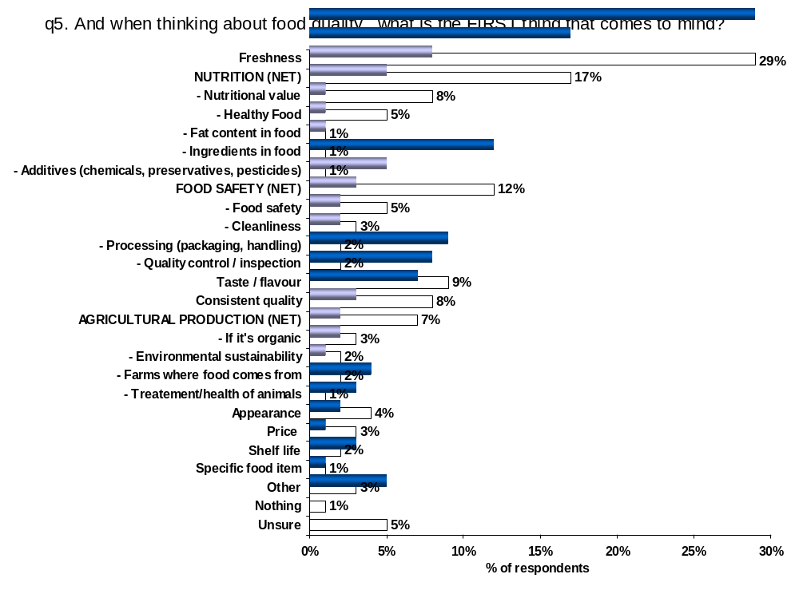

Consumers in B.C. mention freshness as a top-of-mind food quality consideration (35%) more than other regions in Canada. Conversely, consumers in Saskatchewan/Manitoba tend to mention freshness as a food quality matter less frequently (20%).

Consumers in Alberta tend to relate nutritional considerations to food quality (23%) significantly more than do consumers in Ontario (16%) and Atlantic Canada (13%). In addition, Alberta is the least likely province to relate agricultural production considerations to food quality (3%).

Food safety as it relates to top-of-mind food quality impressions are mentioned more frequently in Atlantic Canada (22%) and Saskatchewan/Manitoba (17%) than in other provinces.

Consumers over the age of 55 tend to relate freshness to food quality (33%) more than younger consumers, while those aged 18-34 tend to relate the overall taste or flavour of food (12%) to food quality more than do older consumers.

Less educated consumers relate consistency to food quality (12%) more than do consumers who have some post secondary education. Finally, female consumers (31%) are more inclined than male consumers (24%) to mention freshness as a top-of-mind food quality consideration. Male consumers are almost twice a likely as females to mention the overall taste or flavour of food as a quality consideration (13% versus 7%).

Meaning of Food Quality
- By Region -
 | BC | AB | SK/MB | ON | PQ | Atl
 | A | B | C | D | E | F
Base: All respondents | 225 | 200 | 400 | 300 | 275 | 200
Freshness | 35% | 29% | 20% | 29% | 27% | 25%
Freshness | CF | C |  | C | C
NUTRITION (NET) | 17% | 23% | 17% | 16% | 18% | 13%
NUTRITION (NET) |  | DF
- Nutritional value (nutrients: vitamins, minerals) | 7% | 12% | 10% | 6% | 9% | 8%
- Nutritional value (nutrients: vitamins, minerals) |  | D | D
- Healthy food | 3% | 7% | 3% | 6% | 6% | 2%
- Healthy food |  | CF |  | F | F
- Fat content in food | 1% | 1% | 1% | 1% | 3% | 1%
- Ingredients in food | 3% | 2% | 1% | 1% | 0 | 1%
- Ingredients in food | E
- Additives (chemicals, preservatives, pesticides) | 3% | 0 | 2% | 2% | - | 1%
- Additives (chemicals, preservatives, pesticides) | E |  | E |  |  | E
FOOD SAFETY (NET) | 11% | 10% | 17% | 12% | 10% | 22%
FOOD SAFETY (NET) |  |  | ABE |  |  | ABDE
- Food Safety | 4% | 5% | 9% | 8% | 1% | 11%
- Food Safety | E | E | AE | E |  | ABE
- cleanliness | 3% | 2% | 4% | 2% | 4% | 4%
- Processing (packaging, handling) | 3% | 2% | 3% | 1% | 3% | 6%
- Processing (packaging, handling) |  |  | D |  |  | BD
- Quality control / inspection | 1% | 1% | 1% | 1% | 3% | 1%
Taste / flavour | 7% | 7% | 8% | 10% | 8% | 7%
Consistent quality | 8% | 6% | 10% | 7% | 10% | 7%
AGRICULTURAL PRODUCTION (NET) | 7% | 3% | 6% | 8% | 7% | 8%
AGRICULTURAL PRODUCTION (NET) |  |  |  | B | B | B
- If it's organic | 3% | 1% | 1% | 2% | 4% | 1%
- Environmental sustainability | 1% | 2% | 1% | 4% | 1% | 5%
- Environmental sustainability |  |  |  |  |  | ACE
- Where it comes from | 1% | 0 | 3% | 1% | 2% | 2%
- Where it comes from |  |  | B
- The Humane Treatment of animals | 1% | - | 1% | 1% | - | 1%
- The Humane Treatment of animals |  |  | E
Appearance | 4% | 5% | 2% | 4% | 4% | 4%
Price | 3% | 6% | 4% | 3% | 3% | 3%
Shelf life | 0 | 2% | 2% | 1% | 3% | 2%
Specific food item | - | 2% | 2% | 2% | 1% | 1%
Specific food item |  | A | A
Other | 4% | 4% | 5% | 2% | 2% | 5%
Other |  |  | DE
Unsure | 4% | 3% | 6% | 5% | 6% | 4%
Unsure |  |  | B
NOTE: Letters in cells indicate the difference is statistically significant at 5% level

Top-of-Mind Associations With Food Quality

Consumers hold quite different associations for food quality versus food considerations in the home or when dining out.

The results examined previously showed that consumers think of similar things when they are making a food purchase in the home or when dining out. It also showed that many of the same thoughts are common when consumers consider food quality. Correspondence analysis (also know as image mapping) reveals distinct associations that consumers hold with each activity. These qualitative associations demonstrate the different things that consumers consider when dining out versus when buying food for the home. It also shows the factors that dominate their purchase decisions versus the things that come to mind when thinking about food quality.

Data collected regarding respondents’ top-of-mind considerations that they say are important when buying food (Q1a/b) and the things they associate with food quality overall (Q5) were transformed into a “correspondence plot” that demonstrates the general associations consumers hold for each. This approach sets the context for these activities and important considerations when developing communication materials.

How to interpret the plot:

- Each variable represents an attribute. From a consumer’s perspective, attributes are thoughts and ideas. These attributes help differentiate among the associations consumers hold or think about when considering food purchases for the home and when dining out as well as those they consider when thinking about food quality.

- The attributes include: quality control, consistent quality, quality of service, general food safety, food additives, the ingredients in food, GMOs, organic foods, healthy food, nutritional value, fat content, freshness, shelf life, overall taste or flavour, food processing activities, food handling, the farms where food comes from, environmentally responsible and sustainable production, the treatment of animals, price, convenience, presentation and appearance, atmosphere or ambiance, quantity, variation in food choices and specific food items.

- The correspondence plot depicts the following:

- Attributes (or thoughts and ideas) that are positioned close to each other are strongly associated with each other.

- Attributes (thoughts and ideas) strongly associated with a specific concept or activity (buying food in the home, buying food when dining out and food quality) appear near the concept/activity (enclosed in a circle). Those that are weakly or not associated with a concept/activity appear further away (outside of the circle).

- The vertical and horizontal grid lines, as well as the circles, are added for ease of visualizing the plot. They do not have any quantitative significance or value attached.

Attributes that were not considered as important to an activity in the previous analysis may nonetheless be associated with one of these activities more than the others. The reader is cautioned to remember that this is a qualitative technique aimed at identifying associations, not drivers, in the relationship.

The plot below illustrates the differences and similarities between the associations consumers make when considering these activities.

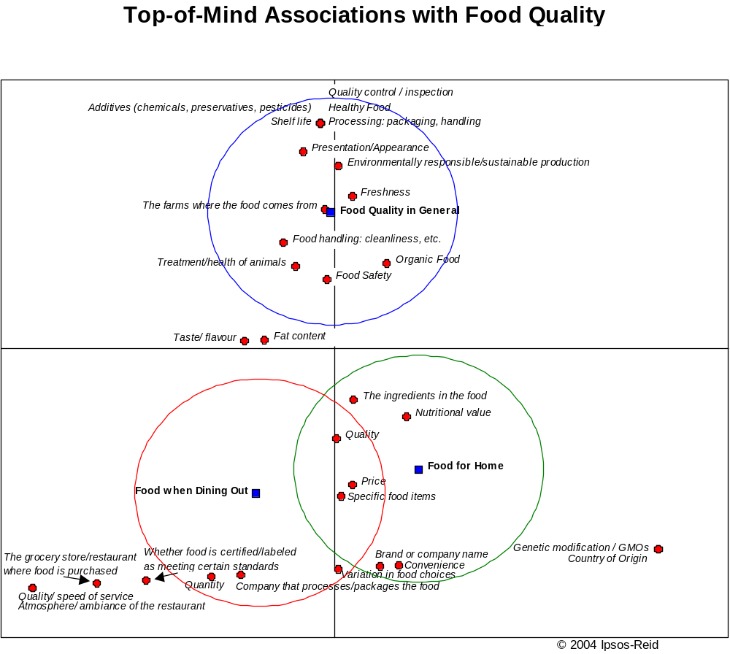
When thinking about food quality, consumers appear to concentrate on specific procedures and processes. They consider where the food comes from and how it was produced (including environmental practices and the treatment of animals), as well as the “additives” that went into the food. Consumers associate quality with the way the food was handled, how it was processed and packaged, how long it would last or remain fresh, the general safety of the food itself and whether it was organic. Though most of these associations are related to the supply chain, presentation and appearance are also important associations with food quality.

When buying food for consumption at home, consumers tend to focus more on specific contents of the food. Nutritional value is high in their consideration set, as are the actual ingredients in the food. Variation in food choice and convenience are also priorities. Consumers also associate buying food for the home with specific brands or companies and food items.

For food consumed outside the home, aspects of the restaurant itself have the greatest association. Respondents demonstrate high associations with whether the food is certified/labeled as meeting certain standards, the actual restaurant of purchase, the quantity of the serving, quality of service and ambiance as important when buying food for consumption outside the home. There also appears to be an association with the company that processes or packages the food.

Regardless of whether the food was purchased for consumption at home or when dining out, consumers make equal associations with the quality of the food, the price and specific food items. Similarly, the overall taste or flavour of the food and fat content appear to be roughly equally associated with both food for the home or when dining out and overall food quality.

Consumers do not acknowledge paying much attention to the farms where food comes from as a driver of their purchase decision.

While the farm where food comes from is associated with food quality, consumers give greater priority to other factors when making a food purchase decision.

The correspondence plot illustrates that the farm that produced the food is most associated with perceptions of food quality, yet when specifically asked, only half of consumers say they pay attention to the farms where food comes from. The grocery stores where food is purchased (90%), whether or not the food is certified or labeled as meeting certain standards (82%), and the restaurant where food is eaten (79%) are all significantly more on consumers minds than are farms. Processing companies are also more top-of-mind than are farms (63%).
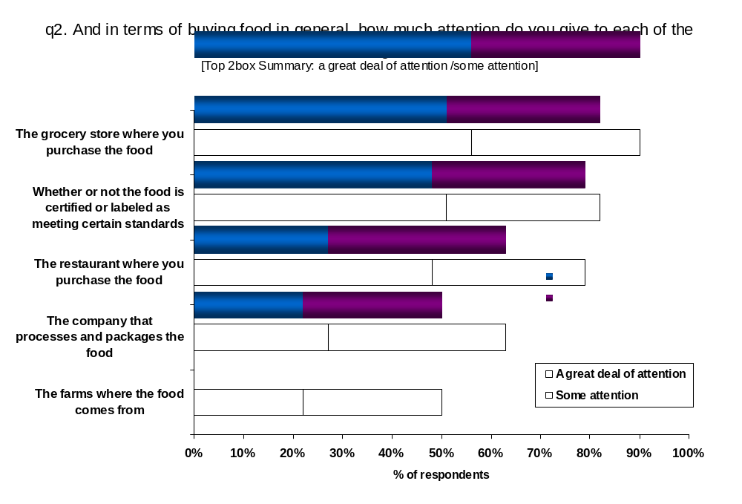

Lack of consideration regarding farms in the food purchase decision is likely because most consumers do not have a strong connection with the farm – as indicated later in this report (section 2.4, question 24), less than half of consumers acknowledge having been on a farm in the last two years (45%).

Food processing companies, while more strongly associated with the restaurant and home-based food purchase decision than with food quality, may be viewed more as the producers and marketers of various food products, with a fairly loose connection to the farm. Furthermore, local food safety stories regarding various food-processing companies have made national headlines. These isolated cases may or may not have deserved the attention received by the media; however, they appear to be sticking in the minds of many consumers.

It’s not surprising to see that consumers acknowledge paying attention to the grocery stores and restaurants in which they purchase food. More than two-thirds consume a meal that was not prepared at home at least once per week (section 2.6, question 33) and they are more closely connected to this part of the food value chain than anywhere else.

Finally, an increasing number of consumers regularly read labels on food products to obtain a variety of information including: ingredient lists, nutritional components, country of origin, and many other types of health or dieting claims as well as whether the food is certified or labeled as meeting certain standards. Regardless of whether the media and society’s concerns regarding obesity and other health issues are driving this behavior, consumers want to find out for themselves what they’re eating.

Atlantic Canadians pay more attention to the farms where the food comes from (58%) than do consumers in other regions of Canada. Consumers in Saskatchewan/Manitoba (81%) and Ontario (83%) pay more attention to restaurants than do consumers in Quebec (75%). Consumers in Saskatchewan/Manitoba (77%) and Quebec (75%) do not pay as much attention to whether the food is certified as meeting certain standards as do consumers in the rest of Canada. Compared to the rest of Canada, consumers in Quebec appear to pay the least attention to food processing companies (50%).

In general, females pay more attention than males to grocery stores (91% versus 87%, respectively), labeling/certification (84% versus 77%), food processing companies (65% versus 56%) and farms (53% versus 44%). This should not be surprising considering that more females are responsible for household food purchases.

In general, Canadians over the age of 55 pay more attention to farms (58%), food-processing companies (73%), grocery stores (95%) and food labeling/certification (86%) than do younger Canadians.

Canadians who have attended university are less likely than other Canadians to pay attention to food-processing companies (59%) and more likely than other Canadians to pay attention to the restaurants in which they dine (82%).

Canadians with lower incomes (<$30,000/year) pay more attention to food-processing companies than do other Canadians. Canadians with high incomes (>$75,000/year) pay more attention to restaurants.

Consumers consider food safety and nutrition as the most important aspects of the food buying process.

When communicating with consumers, it is important to feed back the factors that they say are important in their decisions. A few key messages must be identified and the trade-off approach enables us to narrow down those attributes of stated importance.

Paired tradeoff analysis is a technique for measuring the relative appeal of different aspects, or attributes, associated with a specific decision-making process. The output shows which aspects are more important and which are less, and by how much. Paired tradeoff analysis is especially useful in determining which aspects of a decision are more important to a consumer when deciding what purchases to make.

Paired tradeoff analysis offers important advantages in terms of accuracy over rating scale-based methods for assessing preferences. In paired tradeoff, respondents do not rate the attributes involved in the process but rather choose between them. Respondents are presented with several pairs of attributes and they choose the one in each pair that they feel is more important to the decision. People find choosing to be a much more natural task than rating, and as a result the data tend to be superior and the output more effective at discriminating among the importance of different attributes.

The paired tradeoff approach uses a standard design where a set of pre-determined blocks that are completely balanced are implemented. That is, the same number of respondents sees each possible pair. As such, one can create detailed tables on how often each item is selected (regardless of what it was paired with), and use that as the indicator of its importance. The main deliverable is a hierarchy of attribute importance.

The isotherm that follows graphically depicts the results of this paired trade-off analysis. The most important factors, or those chosen most often in their pairings, appear at the top of the graph. As the reader moves down the isotherm, factors of less importance appear next, finally getting to those that were chosen least often at the bottom. The distance between points on the graph represents the relative magnitude of the difference in importance between each factor compared to the others in the choice set. No actual values are reported in the isotherm to allow the reader to visualize which the important factors are and how much more important they are than others.

Confidence in food safety and knowing that the food has high nutritional value are the most important factors in a food purchase decision.

Among the factors tested, consumer confidence in food safety and the nutritional value of the food are the most important, followed by perceptions of quality, the ingredients in the food and perceptions of the environmental impact of production. New and innovative foods are the least important factor of those presented.



Females place significantly more importance than males on the humane treatment of animals (47% vs 39%) as well as food safety (70% vs 65%), food ingredients (61% vs 56%), and brand or company name (40% vs 36%). Conversely, males place more importance on quality (68% vs 61%), environmentally responsible production (58% vs 54%), and food produced in Canada (55% vs 46%).

Food safety is most important to consumers in Atlantic Canada (78%), followed by consumers in Alberta (71%) and least important to consumers in B.C. (65%). Nutrition is also more important in Atlantic Canada (75%) than other regions, followed by Quebec (71%) and Alberta (70%) and least important in Ontario (67%). The importance of food quality is similar across the provinces, ranging from a low of 61% in Alberta to a high of 65% in Saskatchewan/Manitoba.

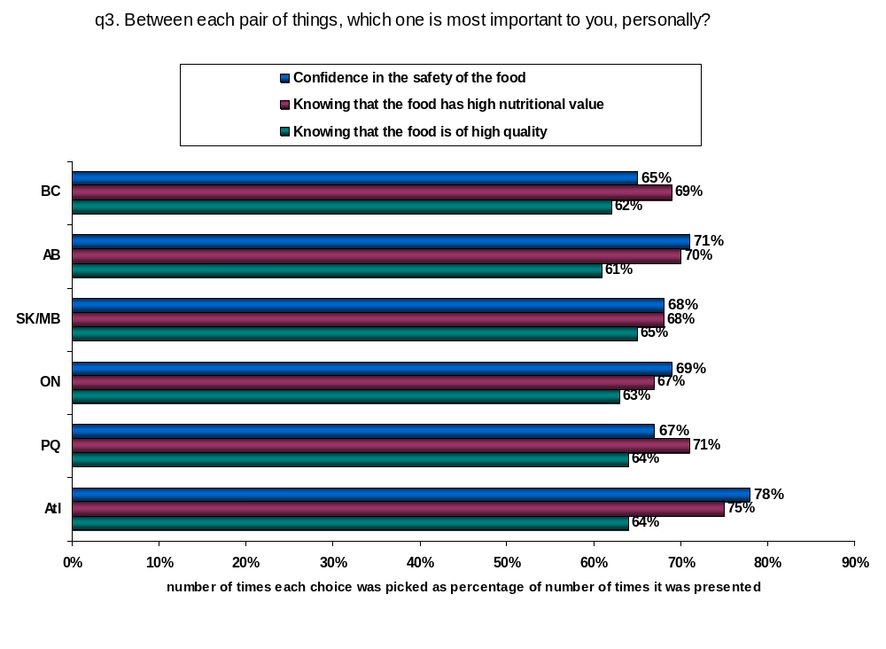

2.2. Perceptions of Canadian Food Quality

Consumer confidence in Canadian food quality is high.

Overall, consumers are confident in the quality of food that is produced in Canada. About 9 in 10 consumers in each region say Canadian food is either of excellent or good quality. Consumers in Alberta are the most confident with 45% saying that Canadian produced food is of excellent quality. Only a third of consumers in either B.C. or Atlantic Canada give Canadian food quality a rating this high.

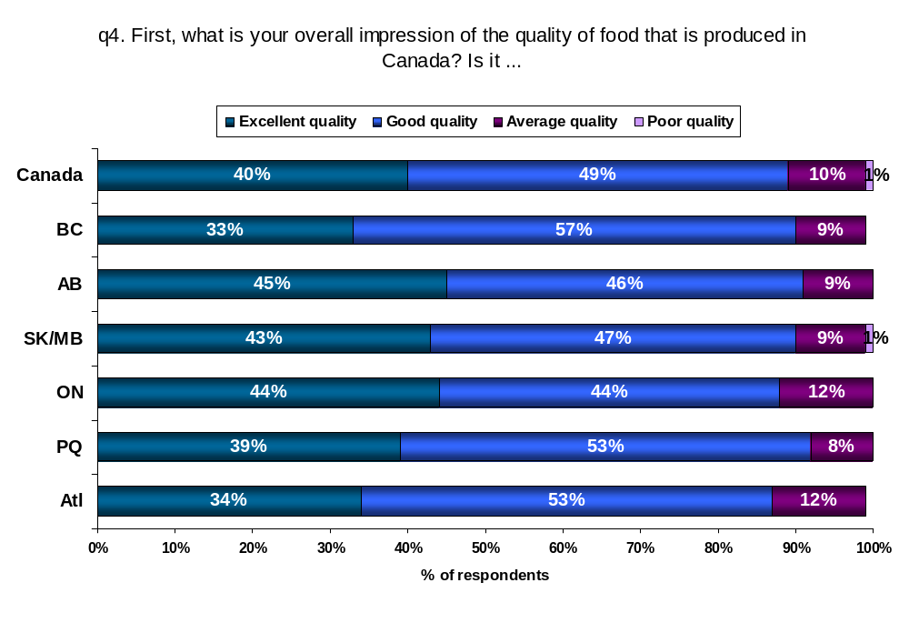

Males are more likely than females to say Canadian food is of excellent quality (48% vs 37%) while consumers with post secondary education are more likely than those with lower levels of education to say that the quality of Canadian food is excellent (44% vs 30%).

Consumers in the highest income category ($75,000 or more/year) are the most likely to say that food produced in Canada is of excellent quality (52%) particularly when compared with those in the lowest income category (less than $30,000 per year) who are least likely to give Canadian food an excellent rating (28%). The data suggests that lower income Canadians are making price / quality tradeoffs in the food purchase decision. High quality meat, cheese, produce and even cereal products are more expensive than foods like wieners and macaroni, which are cheap, but perceived as being of low quality. Lower income Canadians are frequently forced to choose cheaper, lower quality alternatives because of budgetary constraints.

Consumers give Canadian food top scores for freshness and taste.

Many consumers mention freshness as a top-of-mind contributor to food quality impressions and more than 8 in 10 rate Canadian food as either excellent (32%) or good (53%) in terms of freshness. While less of a top-of-mind contributor to food quality impressions, the overall taste or flavour of Canadian food also gets high scores, with 85% of respondents rating flavour either excellent (30%) or good (55%). Consumer ratings for consistent quality (82%), nutritional value (80%) and healthy food (79%) are not far behind.

Considering this, it’s not surprising that the overall quality of Canadian food scored highly. Consumers have told us that high quality food must be fresh and nutritious and consumers are very confident in the Canadian food supply to deliver on these attributes.
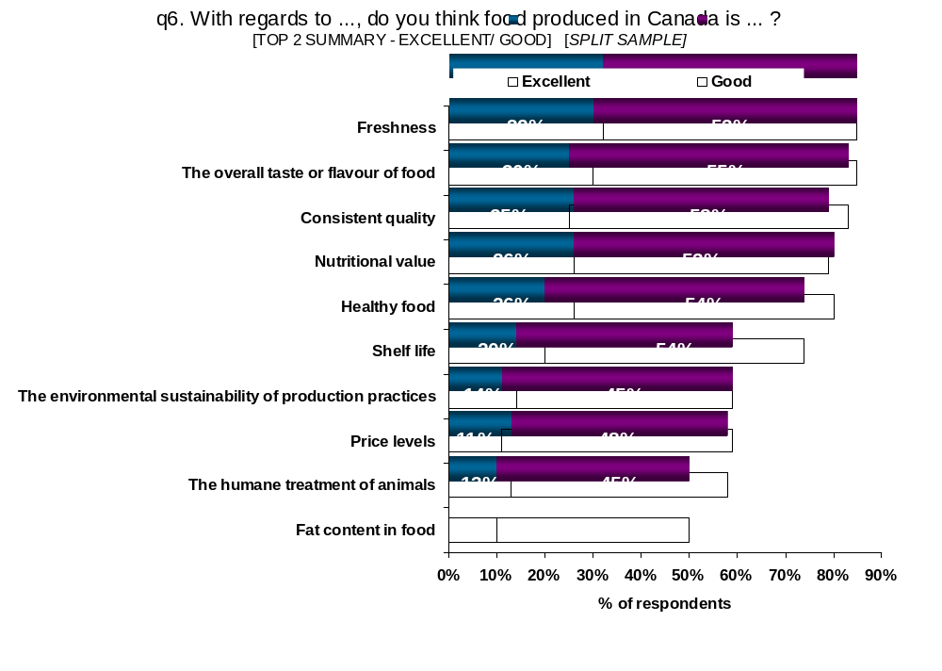

In view of the emergent obesity epidemic currently being reported in the media, it’s not surprising that scores for fat content in Canadian produced food are the lowest of the attributes assessed, with only half of respondents assigning an excellent (10%) or good (40%) rating. Nevertheless, slightly more people assigned the fat content in food a positive rating than did respondents assigning a negative rating, with slightly less than half saying the fat content in food was average (38%) or poor (10%).

In addition to fresh and nutritious food, consumers have said that quality food must also be safe, fairly priced and produced in a fashion that preserves the environment while treating animals humanely. Initiatives to address animal treatment and environmental sustainability need to be in place before promoting these attributes, as only about six in ten consumers feel Canada’s food supply system’s ability to deliver on these attributes is either excellent or good.

Regionally, there are some differences in opinion. Consumers in Quebec rate the freshness of Canadian produced food (92%) higher than consumers in any other region. They are also more likely to give high ratings for shelf life (81%). In addition, consumers in Quebec and Alberta give equal ratings for nutritional value (85% rating excellent or good) that are slightly higher than the ratings given by consumers in other regions. Finally, consumers in Quebec are more likely to give high ratings on the environmental sustainability of production practices (64%) than are consumers in both B.C. (51%) and Alberta (51%).

When examining other demographic characteristics, only a few minor differences are worth noting. Ratings for overall taste or flavour are highest among younger Canadians (18-34 years of age) and among more affluent Canadians (>$75,000/year). Those in the lowest income category (<$30,000) give the lowest ratings for consistent food quality (77% excellent or good).

The quality of food produced in Canada is definitely seen as being better than food produced in other countries.

An overwhelming majority of Canadians feel that food produced in Canada is better in terms of quality than food produced in other countries (92%). In fact, almost half of Canadians feel domestically produced food is “a lot better” in quality than imported food. The sentiment is similar in every region across Canada.

The ratings are fairly consistent across demographics though consumers with lower levels of education are slightly less likely than those who have attended university to believe that food produced in Canada is a lot better than food produced in other countries (52% vs 41%).
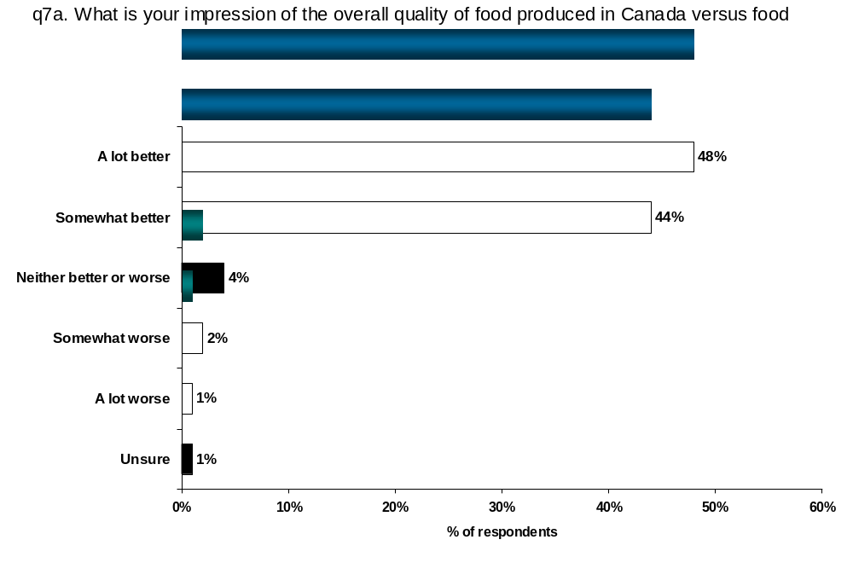

Respondents were asked to explain why they felt food produced in Canada is better than food produced in other countries. Many believe Canada has better standards and production practices than other countries (34%).

When it comes to food production, various government agencies are involved in food production and many consumers believe that Canada’s food quality is better because Canada has more rules and regulations than other countries (17%). The data suggests that overall, Canadian regulations with respect to the food supply are more stringent that those provided by other countries.

About 1 in 10 Canadians feel that the proximity of food producing areas and the markets in which food is consumed facilitates freshness, and this reflects positively on overall food quality.
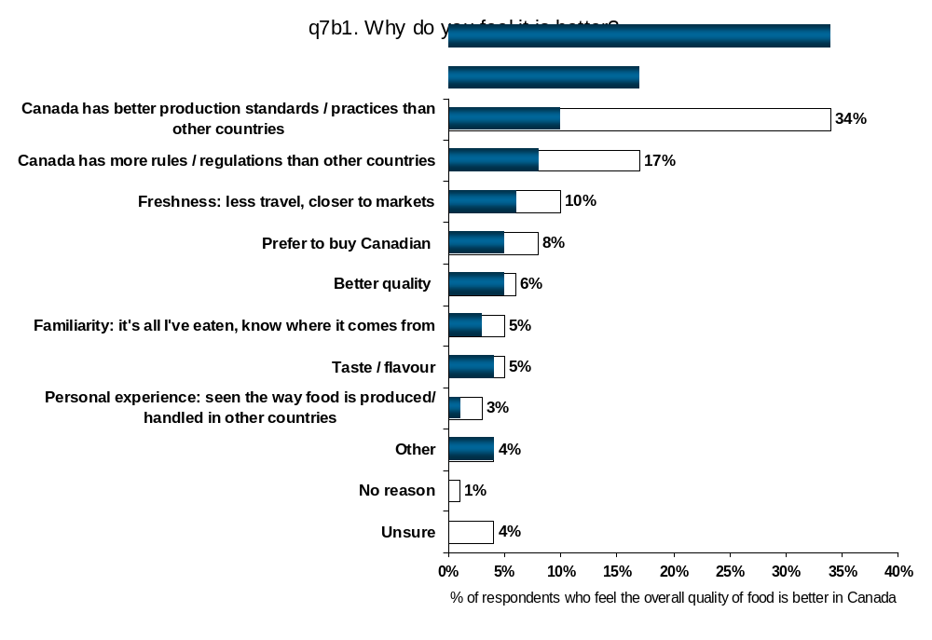

Consumers in Quebec are less inclined than others to say Canadian food quality is better than other countries because of production standards and practices in general (27%) but are slightly more likely to base their judgment on familiarity with production in Canada (8%) and personal experience in other counties (6%).

Consumers in eastern Canada are the most likely to identify proximity to markets as the reason for Canada having better quality food than other countries. Females are also more inclined than males to feel that proximity positively affects food quality (11% versus 7%, respectively).

Older Canadians (55+) are less likely than others to mention farm practices (26%) and are more likely to simply prefer buying Canadian and support the local economy (11%). Meanwhile, Canadians aged 35-54 are more inclined than their younger counterparts to feel that Canada’s superiority in food quality is due to its rules and regulations (20% vs 13%, respectively).

Very few consumers feel that the quality of domestically produced food is worse than food produced in other countries (3%). This small number said that other countries have better production standards and practices than Canada or simply have better quality in general.

Drivers of Food Quality Impressions in Canada

Simply relying on “stated” or “overt” importance ratings to identify the main criteria for overall perceptions of a product or service, in this case overall impression of food quality in Canada, tends to overstate the importance of the most “common” or “politically correct” responses.

Identifying implicit drivers of consumers’ impressions of food quality as well as explicit importance can uncover issues and factors of emerging importance that consumers may not acknowledge as drivers of their perceptions. If a factor is both explicitly stated as important as well as implicitly identified, that should become a key area of focus for AAFC. To determine the “covert” or “implicit” importance of specific attributes, we turn to Penalty/ Reward Analysis.

Penalty/Reward analysis looks at whether impressions of quality are correlated with specific attributes related to quality. This analysis does not require “independence” between attributes and looks at overall and individual attribute ratings at the low and high ends of the rating scale to identify the attributes that “drive” the overall ratings. A Penalty/reward analysis looks at the ends of the scale to determine if lower scale points are correlated with poor perceptions and if higher scale points are correlated with very good impressions of quality.

Running a penalty-reward analysis consists of running a series of independent variables against a dependent variable. There is no limit to the number of independent variables that can go into the analysis because only the variables that have a significant positive or negative impact on the dependent variable will show up in the results. For this analysis, Q4 “First, what is your overall impression of the quality of food that is produced in Canada?” acts as the dependent variable. Responses to Q6 (“With regards to…, do you think food produced in Canada is excellent, good, average or poor?”) and Q7 (“Thinking about all of the features of food quality we’ve discussed, what is your impression of the overall quality of food produced in Canada versus food produced in other countries?”) are examined as potential drivers of consumer perceptions of quality.

The underlying analytic technique for Penalty/ Reward Analysis is Shapley Value (SV). This technique uses cooperative game theory to develop a decision tool that provides reliable measures of the relative importance of a set of attributes. Conceptually, SV is very simple – examine the overall scores with all possible combinations of the attributes. To evaluate the strength of a particular attribute, compare the average strength of all combinations that include that attribute to all combinations that do not include it. In short, SV analysis assigns a value for each attribute, indicating the worth of that attribute toward the overall rating across all the possible combinations. The highly correlated nature of the data does not present a problem in SV analysis; hence SV analysis is stable and especially useful as a tracking tool.

Factors (from Q6 and Q7) that contribute to positive impressions of Canadian food quality (rating at Q4) show up as rewards. So, if Canada delivers on these attributes, overall perceptions of food quality are likely to improve. As well, these are the attributes that resonate with consumers and should be included when promoting Canadian food quality. On the contrary, poor performance on attributes that are primarily rewards are less likely to lead to lower perceptions of Canadian food quality.

Factors (from Q6 and Q7) that contribute to poor overall perceptions of quality (rating at Q4) show up as penalties. Failing to deliver on these attributes will result in lower overall perceptions of Canadian food quality. Typically, penalties represent “table stakes” or “cost of entry”; a certain level of performance on these attributes is expected and failure to meet those expectations usually drives the consumer away. However, exceeding expectations does not necessarily lead to higher overall perceptions of Canadian food quality.

The Penalty/Reward output is displayed as a bar chart indicating which areas are more likely to result in lower perceptions of quality and which are more likely to result in higher perceptions of quality. Attributes are sorted in descending order of ‘importance’ – i.e., magnitude, or the sum of the penalty and the reward. Items with both a large penalty and a large reward are considered more important than those with only a comparable sized penalty or reward. Factors that contribute the most to the overall impression of food quality appear at the top of the graph.

The results from Penalty/Reward analysis are presented on a standardized scale. If a factor has an overall reward associated with it (or positive impact on impressions of food quality), there will be a bar to the right of the centre line. Likewise, a bar to the left of the centre line indicates a penalty (or negative impact on impressions of food quality). Because it is presented on a standardized scale, the centre line represents zero, or no effect and the length of the bar for a specific factor represents its overall strength in the determining perceptions of food quality. In showing the output, it is typical not to present the numbers, as they are standardized and not actionable. Longer bars imply greater impact.

In this study, many attributes are penalties and rewards both, so positive performance results in higher overall ratings and poor performance results in lower overall ratings of food quality.

Healthiness, overall taste, consistent quality and nutritional value are the most important drivers of consumers’ overall impressions of Canadian food quality.

Healthiness is the key driver of consumers’ perceptions of Canadian food quality. It offers a strong reward if present and a represents a strong penalty if not. Penalties also exist for taste or flavour and consistency but these attributes are the dominant rewards that should be promoted along with healthiness.

Nutritional value and healthiness are the dominant penalties along with freshness and the humane treatment of animals and fat content in food. Failing to meet expectations on any of these variables will negatively impact perceptions of Canadian food quality.

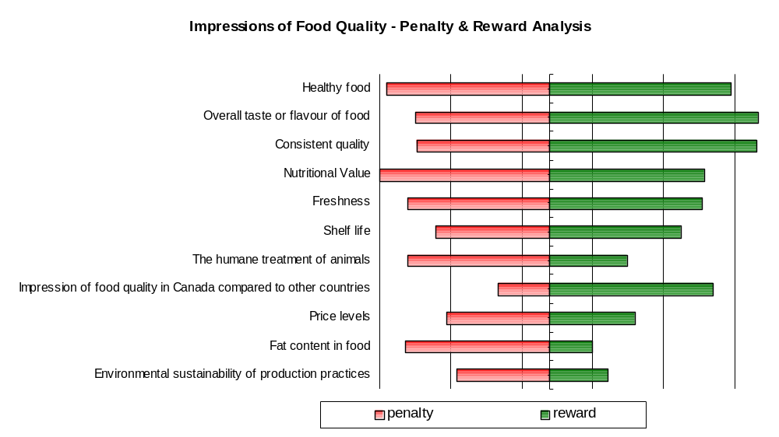
Nutritional value is more a penalty than it is a reward, as is consumers’ impression of the freshness of the food. Again, the positive gain in perception of overall food quality for delivering on these aspects is more than the loss would be if they were absent from a consumers’ overall impression of the food.

Quality comparisons with other countries, nutritional value and freshness are the second tier of rewards. Freshness is one of the attributes that should be included when promoting Canadian quality, as it is the top attribute in terms of stated importance.

2.3. Perceptions of Canadian Food Safety

Canadians are generally confident in the safety of our food supply.

About one in three consumers are completely confident that food produced in Canada is safe (35%). Meanwhile, just over half (55%) are somewhat confident while a very small number (2%) are not at all confident in the safety of Canadian food.

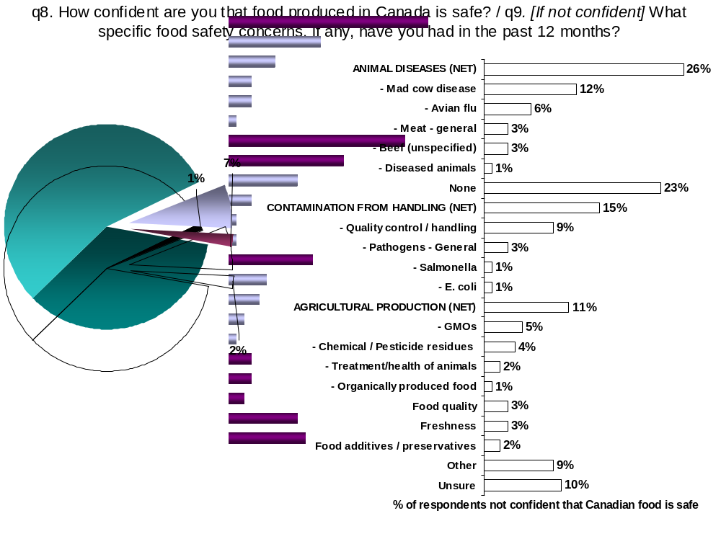

Consumers in the Prairies have the highest level of confidence in the safety of Canada’s food supply with almost one half of those in Alberta (49%) and Manitoba/Saskatchewan (45%) saying they are completely confident. Consumers in Quebec appear to have the least confidence in Canadian food safety with almost one quarter saying they are either not very (18%) or not at all confident (5%) in the safety of the country’s food supply.

Both males and females are confident in Canadian food though males are more likely to say that they are completely confident (44% vs 30%). Those with lower levels of education and income tend to be the least confident in the safety of Canadian food.

Of those Canadians who are not confident about the safety of Canadian food, agricultural-related issues largely drive their concerns.

Over one-quarter of Canadians who are not confident in the safety of Canadian food mention animal diseases as their primary food safety concern. This includes mentions of mad cow disease/BSE, avian flu and general comments regarding meat. It bears mentioning that interviews were conducted in mid-April, during which mad cow disease and avian flu outbreaks were making national headlines in the media.

Contamination from handling, mentioned by 15% of those not confident in Canadian food safety, includes reference to quality control/handling concerns and pathogens such as E. coli and salmonella. Agricultural production, mentioned by just over one in ten concerned Canadians, includes mentions of: genetically modified foods, chemical residues, livestock production practices and organic foods.

Nevertheless, slightly less than one-quarter state having no particular overriding concern that contributes to their skepticism of the safety of Canada’s food supply and 10% are unsure why they are skeptical.

Consumers are less confident in the Canadian system’s ability to manage substances used in the food production process and genetically modified foods versus managing safety risks associated with organically produced food.

Just over eight in ten consumers are confident in Canada’s ability to manage possible concerns like organically produced food, contamination from pathogens like E. coli and salmonella, and animal diseases like “mad cow” and the “avian flu”. Consumers have the highest level of confidence in the management of organically produced food and animal diseases with just over one-quarter of consumers saying they are completely confident (25% and 26%, respectively). While consumers may be concerned about these issues, they are however, confident that these issues are being managed appropriately by Canada’s food system.

Consumers are least confident in the food system’s management of genetically modified foods and the use of hormones, antibiotics and chemicals with less than one in ten saying they are completely confident in the management of those activities (9% and 8%, respectively). Consumers likely express concern over the management of these issues because of the mixed messages they receive from the media. GMOs and the use of hormones/antibiotics in animals are a hot news topic globally, with European countries leading dissent on these issues. While the Canadian government allows these practices domestically, the messages conveyed in the media are largely negative. As a result, these mixed messages may be confusing some consumers.
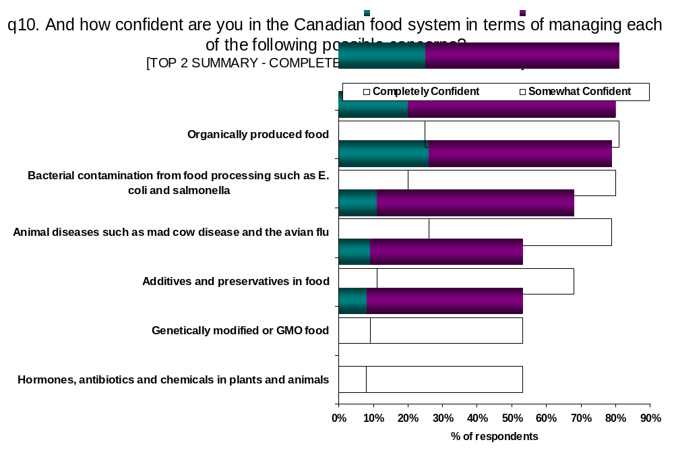

Consumers in the Prairies and Atlantic Canada tend to have the highest levels of confidence in the ability of Canada’s food system to manage each of the possible food safety concerns examined in this study. Consumers in Quebec generally have the lowest levels of confidence in the management of each possible safety concern.

Consumers in B.C are the most confident in the ability of Canada’s food system to manage organically produced food (31% very confident). Consumers in Alberta have the most confidence in the management of bacterial contamination (29%) while consumers in Quebec clearly have the least confidence in this aspect of food safety management (27% not very/not at all confident).

Not surprising, consumers on the Prairies have more confidence than others in the management of animal diseases (39%) and genetically modified food (13%). Consumers in B.C. and Quebec have the least confidence in Canada’s ability to manage this latter activity (47% and 50% not very/not at all confident, respectively).

Confidence in the Management of Food System Activities
Top2 Box: Completely / Somewhat Confident
- By Region -
 | BC | AB | SK/MB | ON | PQ | Atl
 | A | B | C | D | E | F
Base: All Respondents | n=225 | n=200 | n=400 | n=300 | n=275 | n=200
Additives and preservatives in food | 65% | 71% | 73% | 70% | 63% | 75%
Additives and preservatives in food |  |  | AE |  |  | AE
Animal diseases such as mad cow disease and the avian flu | 75% | 84% | 84% | 79% | 77% | 83%
Animal diseases such as mad cow disease and the avian flu |  | A | AE
Bacterial contamination from food processing such as E. coli and salmonella | 87% | 88% | 84% | 80% | 70% | 85%
 | DE | DE | E | E |  | E
Genetically modified or GMO food | 48% | 60% | 57% | 56% | 45% | 60%
Genetically modified or GMO food |  | AE | AE | E |  | AE
Hormones, antibiotics and chemicals in plants and animals | 52% | 61% | 63% | 55% | 43% | 60%
Hormones, antibiotics and chemicals in plants and animals |  | AE | ADE | E |  | E
Organically produced food | 89% | 82% | 83% | 81% | 74% | 89%
Organically produced food | BDE | E | E | E |  | BDE
NOTE: Letters in cells indicate the difference is statistically significant at 5% level

Looking at other demographic characteristics, females and males appear to be equally confident, except for managing animal diseases where males appear to be more confident in the system (31% vs 24%). Canadians in the youngest age category (18-34) appear to be the most confident in the management of GMO foods (13%) and hormones, antibiotics, and chemicals (12%). Older Canadians (55+) generally have the least confidence in each of the possible concerns assessed.

With the exception of managing GMO’s, consumers with lower levels of education are also the least confident in these possible food safety concerns. This is particularly true for the system’s ability to manage animal diseases and bacterial contamination (28% not very/not at all confident for each).

Drivers of Consumer Confidence in Food Safety in Canada

Penalty/ Reward Analysis was used to examine the relationship between consumers’ confidence in the ability of the Canadian food system to adequately address specific food safety concerns and consumer confidence in food safety overall. [NOTE: For a detailed discussion of the Penalty/Reward Analysis, please refer to the “Drivers of Food Quality Impressions in Canada” in Section 2.2, earlier in this report.]

For this analysis, Q8 (“How confident are you that food produced in Canada is safe?”) is used as a measure of overall confidence in the safety of food and acts as the dependent variable. Responses to Q10 (“And how confident are you in the Canadian food system in terms of managing each of the following possible concerns?”) are used as the potential drivers of overall confidence, acting as the independent variables.

Managing bacterial contamination is both a strong reward and a considerable penalty in terms of consumer confidence in food safety.

Ability to manage concerns about bacterial contamination during processing is the main driver affecting consumer confidence in food safety. This means that meeting consumer expectations is necessary to maintain confidence in the food system while positive performance in managing bacterial contamination will lead to greater consumer confidence.

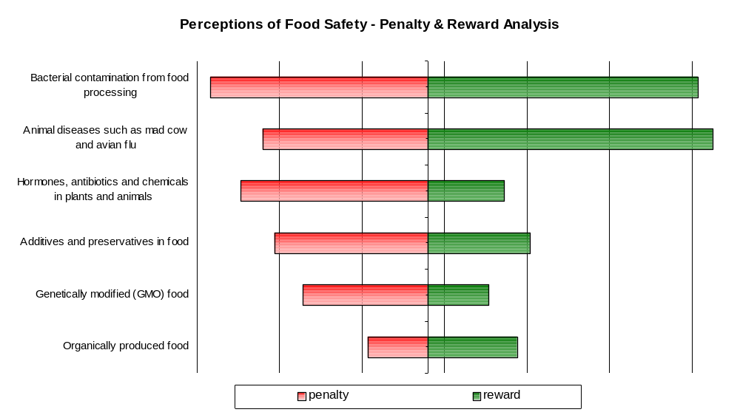
Though slightly less of a penalty and more of a reward, positive performance on managing animal diseases is also expected to have a considerable impact on consumers’ overall confidence in food safety. Managing hormones, antibiotics and chemicals in plants and animals as well as additives and preservatives in food and to a less extent, genetically modified food, are largely penalties that are more likely to negatively impact food safety confidence if expectations are not met than they are to positively impact it if expectations are exceeded. In fact, the reward for each is similar to that of managing organically produced food, which has the least impact on overall confidence in food safety.

The single case of mad cow disease/BSE reported in Alberta in 2003 is an excellent example of how a potential threat in the food supply chain has both a penalty and reward. Following the discovery of that single case of BSE, there was a great deal of speculation that consumer confidence in the beef industry would be devastated and sales of beef in Canada would suffer. This was not the case, in fact, domestic consumption increased.

The response from beef producers, processors and Government was unanimous in its support of the industry and the safety of beef in Canada. Retailers and independent groups responded with campaigns aimed to maintain beef sales and support beef producers who immediately felt the impact of closed borders and the loss of trade. Research conducted following this showed that consumer confidence in the ability of Canadian agencies to respond to this had increased since prior to the incident, as did sales of beef products. Support for the industry continued to grow, with a focus on the economic loss of the industry and sympathy for the producers, not distrust of the safety of beef.

Since that time, overall confidence in the safety of the food supply chain has increased across the country. While there are likely other factors at play, such support and sympathy for the economic hardships producers have suffered, the response to this situation was obviously one that has shown a reward in terms of consumer confidence in the system overall.
Most Canadians believe that food safety problems are likely to develop during processing.

If a food safety problem was to occur, Canadians are most likely to believe the problems would occur during food processing more than in any other segment of the food supply chain (38%). The processing sector, while not a common source of food contamination, is shrouded in mystery for many consumers.

Only 15% of Canadians believe problems would occur at the farm level, which reflects the positive perception consumers have of the farming sector. Contrary to the claims of the food industry, relatively few Canadians believe food safety problems would occur in restaurants (15%) or in the home (10%). This may be due to perceived knowledge of food safety practices and the impression of cleanliness that could be extended to food safety.
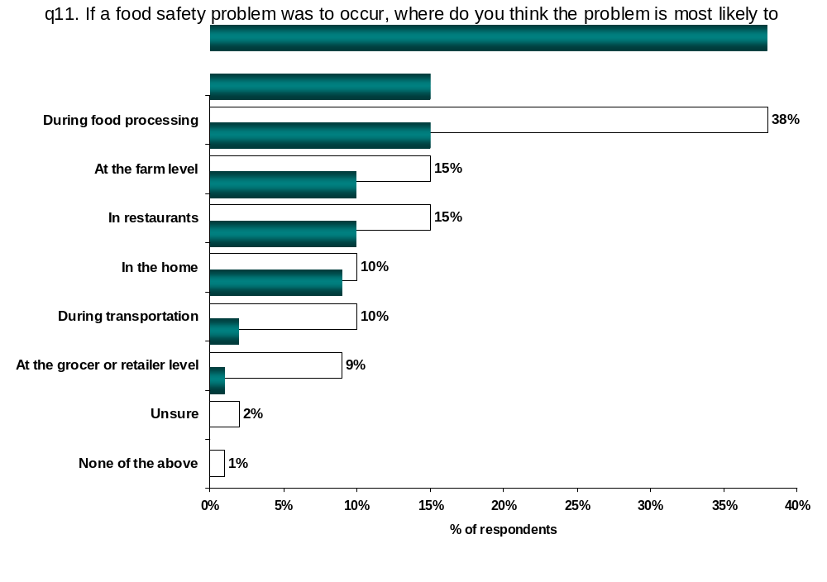

Consumers in all regions identify “during processing” as the most likely place for a food safety problem to occur. This view is held by consumers in the Prairies and Ontario (about 43% each) to a greater extent than consumers in other provinces. Consumers in B.C. and the Atlantic region are more likely than others to point to the “farm level” as the source of a potential food safety problem while consumers in Quebec are the most likely to believe a food safety problem would occur “during transportation” (17%) or “at the grocer or retail level” (16%). Consumers in Alberta (17%) and B.C. (15%), more than others, say that a food safety problem is most likely to occur “in the home”.

Consumers in Quebec are less inclined than most of the other regions to think that a food safety problem would likely occur either “at the farm level” (8%) or “in the home” (6%). Consumers in Ontario also do not believe that a food safety problem would occur “in the home” (8%).

Male and female perceptions of the potential source of a food safety problem are similar though males are slightly more likely to expect a problem to occur at the “farm level” (19% vs 13%). Meanwhile almost one-half of the older consumer population (55+) believe that a food safety problem is most likely to occur “during processing” (46%) rather than “at the farm level” (7%) or “in the home” (6%). While small differences are observed across education levels, a couple of significant differences are evident among those with the lowest income levels. This group is more likely than others to see potential problems at the “grocery or retailer level” (12%) or “during transportation” (15%) and less likely to expect a problem to occur in restaurants (11%).

When purchasing food for their home, almost all consumers say they read “best before” dates, but not always.

Reading “best before” dates can be viewed as the “frontline defender” against food-borne illness and most Canadians say they always read “best before” dates (79%); though they are less diligent with other “food safety practices”. Very few consumers say they always assess food handling practices where they purchase their food (18%) though four in ten say they do it most of the time (40%). The seemingly low incidence of consumers assessing food handling practices where food is purchased reflects the element of trust with this sector of the food value chain as consumers are more closely connected to it.

Almost one in three Canadians use the Internet as a source of food safety information (30%). Using the medium to disseminate food safety information could be valuable for some consumers, but not everyone.
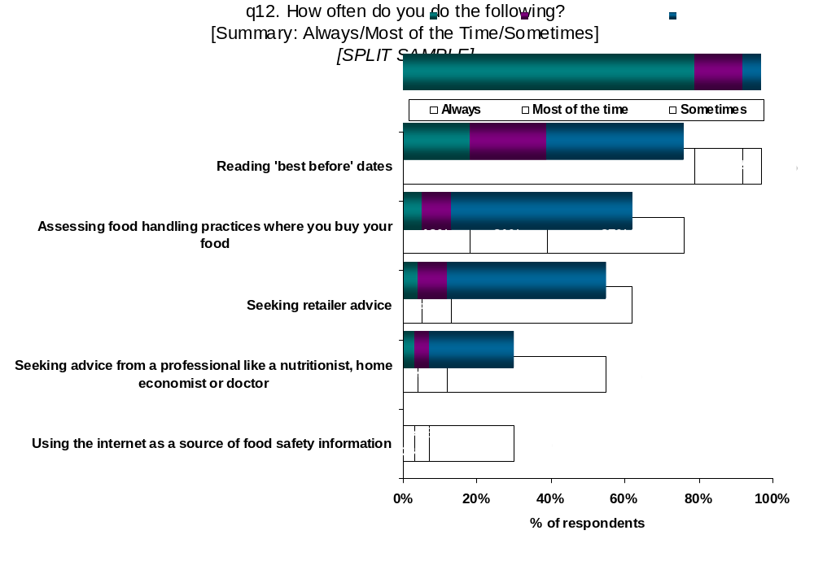

Consumers in Ontario are the most likely to say they “always read” best before dates (83%) and assess food handling practices where they buy their food (21%). Consumers in Manitoba/Saskatchewan are the least likely to make this claim (69%). Women and those with higher levels of education are also more likely to read best before dates.

Not surprising, those with higher levels of education are more likely to read best before dates though university graduates are the least likely to assess food handling practices with almost one in three saying that they never do (28%).

Most Canadians have read information on food safety issues.

Almost three quarters of Canadians have read an article or other information on food safety (71%) in the past year. Few Canadians have boycotted a particular food product (31%), a specific restaurant (28%) or a grocery retailer (16%) in the same time period.

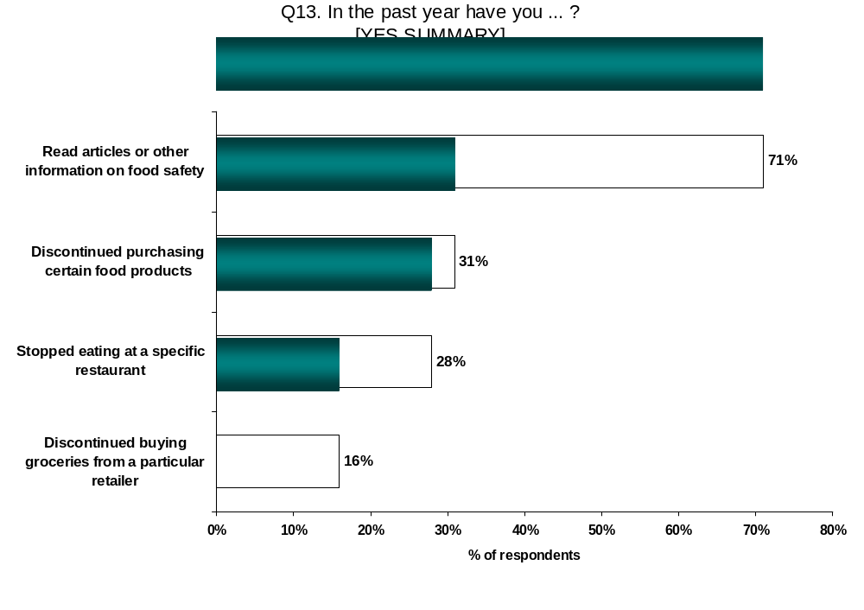

Consumers in Quebec are the least likely of all Canadians to have read articles or other information on food safety (60%), while consumers in B.C. are the most likely (85%). Atlantic Canadians are the least likely to have boycotted a grocery retailer (6%) in the past year.

Consumers under 35 are the least likely to have read about food safety (62%) and those with higher levels of education are the most likely to have done so (75%) as are those with the highest income levels (77%). While less likely to read about food safety, those with the lowest income levels are the most likely to say they have discontinued buying certain food products (39%) or groceries from certain retailers (27%).

Looking at the behaviour of consumers who lack confidence in Canadian food safety and quality, consumers who are not confident or only somewhat confident in the safety of Canadian food are more likely to have boycotted particular food products (43% and 35%, respectively). Consumers who are completely confident in the safety of Canadian food (22%) are the least likely to have done so.

Similarly, consumers who feel Canadian food is only of average or poor quality are more likely than consumers who feel Canadian food is of excellent quality to have boycotted a particular food product (47%, versus 25%). These consumers are also more likely to have boycotted a particular grocery retailer than consumers who feel Canadian food quality is excellent (27% and 13% respectively).

Food Safety Behaviours
Yes Summary
- By Impressions / Confidence in Food Quality / Safety
 | Impression of Food Quality |  |  | Confidence in Food Safety
 | Excellent | Good | Average/ Poor | Completely | Somewhat | Neutral/ Not very/ Not at all
 | A | B | C | D | E | F
Base: Block 2 Respondents (n=801) | n=330 | n=388 | n=79 | n=292 | n=425 | n=82
Read articles or other information on food safety | 72% | 71% | 67% | 72% | 71% | 68%
Discontinued purchasing certain food products | 25% | 33% | 47% | 22% | 35% | 43%
Discontinued purchasing certain food products |  |  | A |  | D | D
Discontinued buying groceries from a particular retailer | 13% | 18% | 27% | 15% | 17% | 20%
Discontinued buying groceries from a particular retailer |  |  | A
Stopped eating at a specific restaurant | 28% | 28% | 34% | 26% | 29% | 31%
NOTE: Letters in cells indicate the difference is statistically significant at 5% level

2.4. Knowledge and Information Needs

Most Canadians say they are familiar with food safety guidelines in the home but familiarity with guidelines elsewhere in the food supply chain is low.

More than 9 in 10 Canadians are familiar with guidelines for food safety practices in the home (92%) and over half say they know “a lot” (55%). Almost two thirds of Canadians are familiar with food safety practices in retail outlets (65%) and in restaurants (63%). However, because they are likely only “observers” at these locations, much fewer claim to know “a lot” (13% and 16%, respectively).

Less than half of consumers claim to be familiar with food safety practices in processing and packaging (47%) and on farms (46%). However, more Canadians say they know “a lot” about farm-based food safety practices (13%) than claim to know “a lot” about food processing safety practices (8%). This reflects the mystery surrounding the practices of food processing companies felt by some consumers and the inherent trust many of them have of the farm sector.
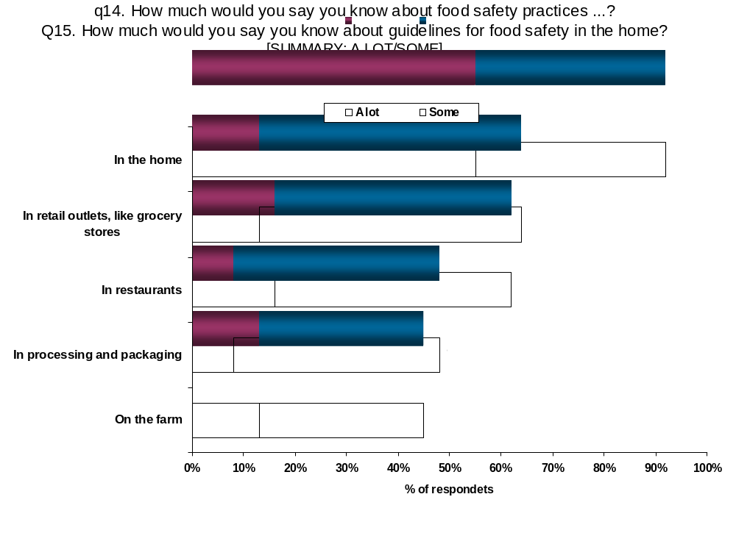

Consumers in Quebec (60%) are more likely than consumers in Ontario (51%) or Atlantic Canada (50%) to know “a lot’ about food safety practices in the home. Conversely, consumers in Quebec are less likely to know a lot/some about food safety practices in restaurants (57%) than are consumers in the western provinces (68%).

The three Prairie Provinces are the most likely to be familiar with food safety practices on farms (Alberta 54%, Saskatchewan / Manitoba 60%) than are consumers in the rest of Canada, particularly B.C. (39%), and Atlantic Canada (41%).

Finally, consumers in Quebec and Saskatchewan/Manitoba are more likely to know a lot/some about food safety in processing (53% and 51%, respectively) than are consumers in B.C., Ontario and Atlantic Canada (43% each). With the exception of restaurants, older consumers are more knowledgeable about food safety practices in the home and through the food chain while those with the highest incomes are most familiar with food safety practices in the home (94%) and at restaurants (68%).

Less than one half of Canadians have been on a farm in the last two years.

It is not surprising that Canadians are not very familiar with on-farm food safety practices as they are generally removed from production agriculture. Consumers in Alberta and Saskatchewan/Manitoba are the most likely to have been on a farm in the last two years (60% and 63%, respectively), while those in Quebec and Atlantic Canada are the least likely (37% and 35%, respectively).

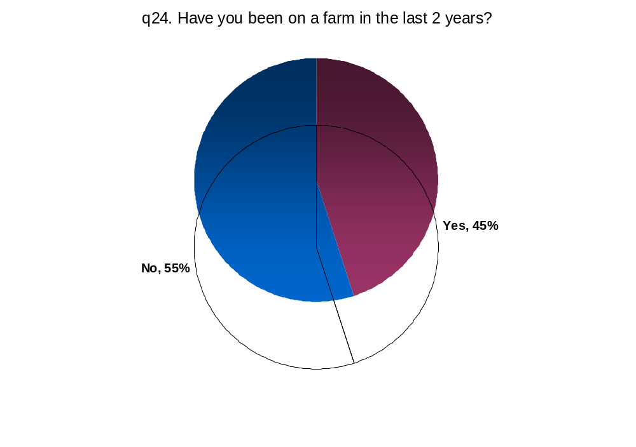

Consumers with some university or higher are the most likely to have been on a farm in the past two years.

The media is the source of food safety information for most Canadian consumers.

Almost 6 in 10 Canadians obtain food safety information from various media sources, which include mentions of newspapers, television and radio. It appears that consumers do not actively seek information, but instead absorb what information is put before them.

Considering that only a small number actively seek out federal government (4%) or provincial government sources (2%) for information, consumers could develop a perception that Canada lacks clear policy direction in this area.

Furthermore, as indicated later in this report, an overwhelming majority of consumers feel that food safety information should come from government sources (section 2.4, question 17b). Media hysteria and sensationalism may be a less trusted source of information for consumers, but it’s readily available in comparison to other more pragmatic and reliable sources.
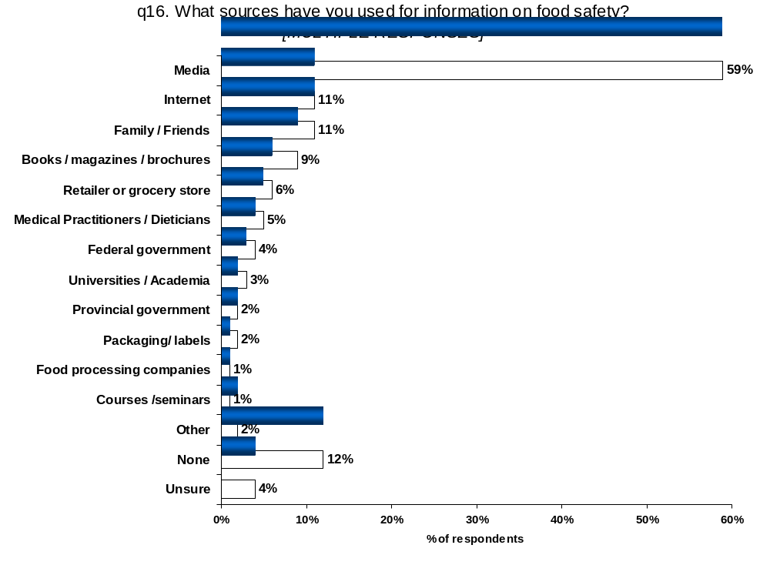

About 1 in 10 consumers have used the Internet for information on food safety in the past 12 months (11%) with some respondents specifying a internet site and others mentioning general internet searches. The same amount rely on family/friends (11%) for information, a source that could be risky for policy makers as word-of-mouth is likely heavily influenced by one’s personal opinion and may not reflect the reality of the food safety system.

Another source of food safety information is in literature such as books, magazines and brochures, however, few Canadians use this medium for information (9%). Whether this reflects a lack of effort on the part of the consumer or the lack of information available is unknown.

While packaging/labels are intended to provide information on nutrition and other related issues, food safety not being one of them, about 2% of consumers say they use labels for food safety information. Considering the increasing importance of label reading on consumer food choices, information from food traceability systems could be supplied on labels as another source of information for consumers.

Just over 1 in 10 do not report having used any sources for information on food safety (12%) in the past twelve months.

It’s not surprising that so many consumers rely on the media for information. More than nine in ten consumers are not likely to actively seek out the most reliable information on food safety issues (refer to section 3: segmentation). A variety of food safety issues, such as mad cow disease and avian flu outbreaks in western Canada, have recently made national headlines. Policy makers run the risk that consumers become confused with conflicting messages perpetuated in the media if a clear and consistent message is not actively given.

Consumers in Saskatchewan/Manitoba are the least likely of all Canadians to rely on the media for information on food safety (46%). Consumers in Quebec are about half as likely as those in other provinces to have used the Internet for food safety information in the past 12 months (7%). Also, consumers in Saskatchewan/Manitoba and Atlantic Canada are the most likely not to have recently used any sources for food safety information (15% and 17%, respectively).

Consumers would like to have more information on a variety of food safety topics.

Almost one quarter of consumers want more information on both agricultural production issues and food processing issues (both 23%). Agricultural production issues include mentions of various topics like general food safety on farms (7%), GMOs (5%), animal diseases (4%) and safety of meat/fish products (3%), outbreaks (2%), agricultural inputs like pesticides (2%) and antibiotics/hormones (1%) and organic production (2%). Food processing issues include mentions such as general processing food safety (14%), bacterial contamination like E.coli and Salmonella (4%), labeling of ingredients (3%), additives (2%) and packaging (1%). The high level of interest consumers exhibit on these topics confirm the sense of mystery surrounding these aspects of the food supply chain. Supplying consumers information on the processes and practices of companies and individuals involved in food production would likely have a positive impact on their perceptions of food safety and quality, provided, of course, that the information demonstrates the positive actions taken to manage quality and safety risks.

Topics on food safety in the home were mentioned by 13% of consumers. These include mentions of general home-based food safety (6%), food preparation information (6%), and expiry date information (2%). It appears that consumers could find value in information on such issues as: how to prepare and store food at home safely, how to read food labels, what do expiry dates mean and what are the repercussions from eating food that has expired. Again, home-based food safety is the “frontline defender” against food borne illness and is important and top-of-mind to many consumers in this study.

Some consumers would like to receive information on nutritional value (6%) and certification / labeling (5%). Health Canada’s food labeling initiatives may be useful in removing ambiguity around food labels.

About 1 in 4 consumers said there were no food safety topics that would be of benefit to them (14%) or were unsure what topics would be most beneficial (11%).

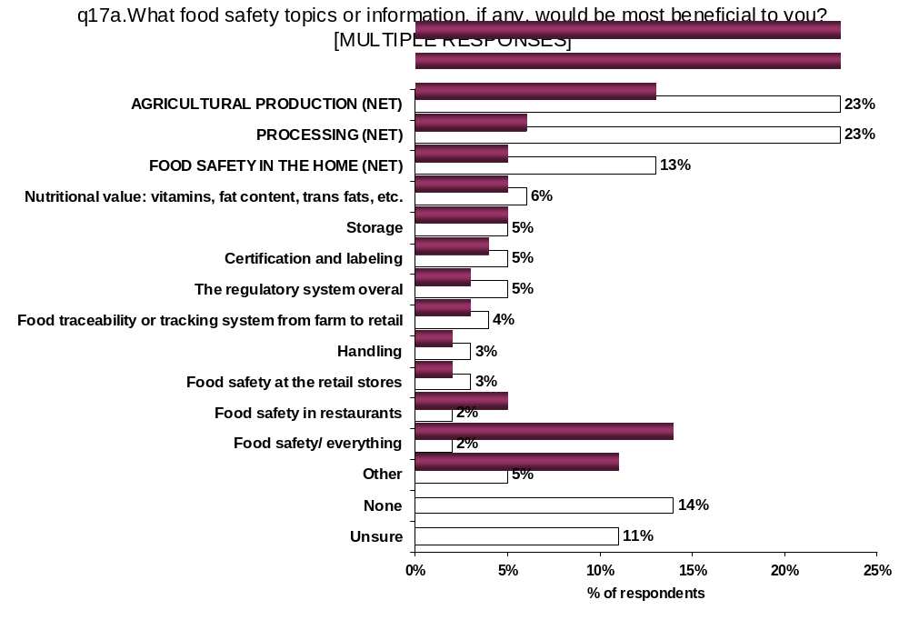

Consumers in Quebec (17%) are less likely than those in Alberta (24%) and Ontario (29%) to want information on food processing and less likely than all other provinces to want information on agricultural production issues (14%). In addition, consumers in Alberta, Saskatchewan / Manitoba (both 19%) and Atlantic Canada (21%) are more likely than consumers in Quebec and Ontario (12% each) to say there is no food safety information that would be of benefit to them.

Consumers with the lowest education levels and lowest income levels are the least likely to identify a food safety topic that would be of benefit to them.

More than three quarters of Canadians believe that governments should be involved in providing food safety information.

Just over one half of Canadians who mentioned a safety topic that would be of benefit to them, say the responsibility for disseminating food safety information belongs to the federal government (52%). Another 2 in 10 Canadians feel provincial governments should be responsible for providing food safety information. If governments provided food safety information, either through the media or another source, consumers are likely to respond to their messages. Finally, 15% believe information dissemination should be the responsibility of private industry.

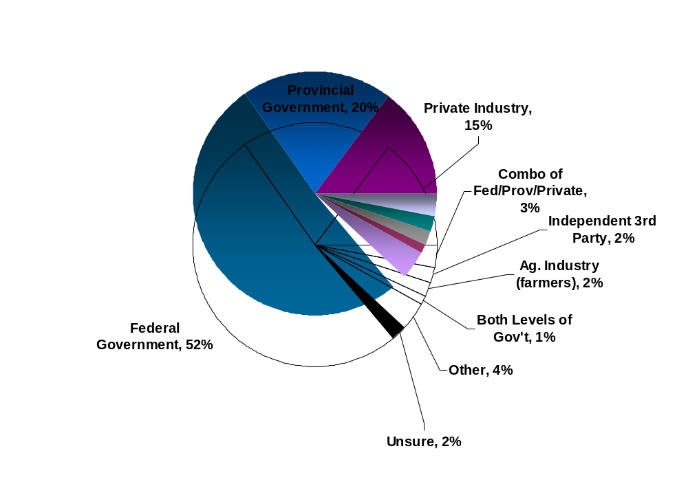

Consumers in Quebec are the least likely of all regions in Canada to feel the federal government should be responsible for providing food safety information (40%) and the most likely of all regions to feel the provincial government should be responsible (27%). Quebec is almost twice as likely as Saskatchewan / Manitoba or Ontario to feel that private industry should provide food safety information (20% versus 10% and 12%, respectively).

Provision of Food Safety Information
- By Region
 | BC | AB | SK/MB | ON | PQ | Atl
 | A | B | C | D | E | F
Base: Mentioned food safety topic | n=161 | n=143 | n=288 | n=240 | n=199 | n=142
Federal Government | 55% | 53% | 61% | 54% | 40% | 64%
Federal Government | E | E | E | E |  | E
Provincial Government | 17% | 17% | 14% | 20% | 27% | 14%
Provincial Government |  |  |  |  | ABCF
Private industry | 15% | 14% | 10% | 12% | 20% | 13%
Private industry |  |  |  |  | CD
Combo of federal/provincial/private | 6% | 7% | 5% | 4% | 1% | 1%
Combo of federal/provincial/private | EF | EF | EF | E
Independent third party organization | 1% | 3% | 1% | 3% | 2% | 1%
Agriculture industry (farmers) | 1% | 1% | 1% | 1% | 4% | 2%
Agriculture industry (farmers) |  |  |  |  | CD
Both levels of government | 2% | 1% | 2% | 2% | - | 1%
Both levels of government | E | E | E
Other | 4% | 4% | 3% | 3% | 4% | 3%
Unsure | - | 1% | 3% | 2% | 3% | 1%
Unsure |  |  |  | A
NOTE: Letters in cells indicate the difference is statistically significicant at 5% level

Consumers with higher levels of education and those in the higher income brackets are more likely to feel the federal government should be responsible for food safety information dissemination and those in the lower educations and in the lowest income bracket are more likely to say information is a provincial responsibility. Those in the highest income category are the least likely to assign responsibility to private industry (10%).

For most Canadian consumers, the Federal Government is obviously a trusted source of information regarding food safety and quality and the entire food delivery system overall.

Most Consumers would like to receive food safety information from various types of literature and the media.

The most mentioned top-of-mind food safety information source are brochures, with almost one-third of respondents mentioning this first (31%). Broadly, literature, which includes both brochures and direct mail campaigns, is the most preferred top-of-mind information delivery mechanism, with 4 in 10 respondents mentioning these information sources first (40%). Newspapers and magazines are top-of-mind for 17% of respondents and is the second most preferred information source. All media sources, including radio/t.v. (12%) in addition to newspapers/magazines, are the second most preferred top-of-mind food safety information delivery mechanism, mentioned by 3 in 10 respondents.

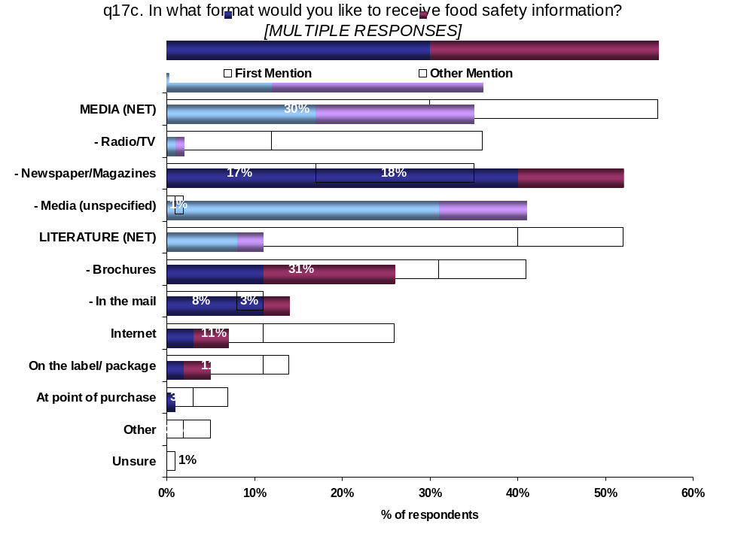

Looking at all the mentions of respondents, more consumers would like to receive food safety information via various media sources (56%) than through the various literature sources (52%), although both sources scored very high.

While most respondents would want the information delivered to them either through literature or the media, 1 in 10 first mention finding information on websites (11%) or the label or package (11%). This could be an effective medium for information exchange for some Canadians.

While very few regional differences exist, consumers in Saskatchewan/Manitoba (54%), Quebec (56%) and Atlantic Canada (60%) are more likely to prefer receiving information from various literature sources than are consumers in Alberta (42%). Quebec consumers are less likely to prefer information delivered through the Internet (19%) than are those in Alberta (29%) and Ontario (29%).

Younger consumers and those with higher levels of education are more likely to prefer getting information via the Internet, possibly because they are most apt to have convenient access to this medium. Consumers with lower income levels are the most likely to prefer to gather information from newspapers and magazines, which, if you don’t have Internet access, is more convenient.
The majority of Canadian consumers have not heard of the various food safety information forums.

The Food Safety Network, familiar to more consumers than any other forum, is familiar to less than 3 in 10 Canadians (28%). About 2 in 10 have heard of the organization FightBAC/Canadian Partnership for Consumer Food Safety Education (22%), On-farm Food Safety Systems (21%) and the Food Safety Information Society (19%). Only 15% of Canadians are familiar with the HACCP system. Increasing awareness of the existence of these programs could alleviate some of the mystery surrounding food production activities and increase confidence in the integrity of our food supply.

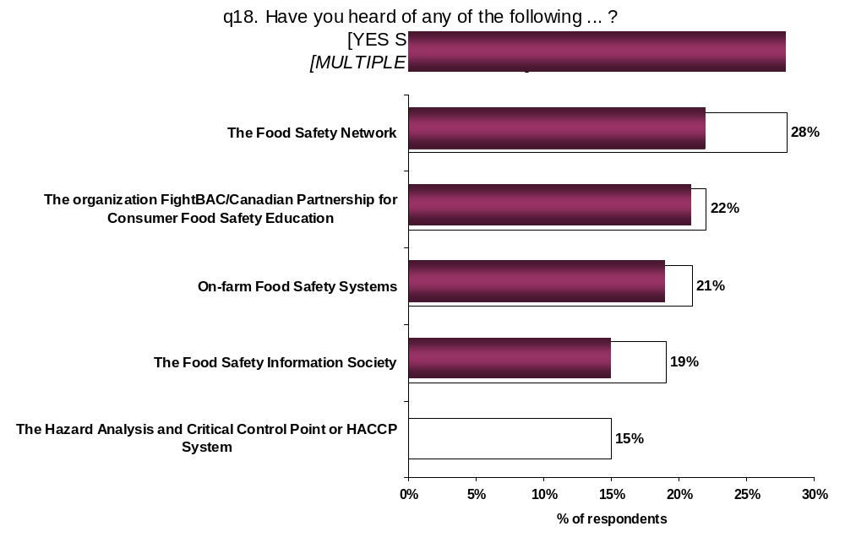

Consumers in Ontario are the most familiar with the organization FightBAC/Canadian Partnership for Consumer Food Safety Education (26%) while consumers in Saskatchewan/Manitoba (26%) and Alberta (29%) are most familiar with On-farm Food Safety Systems as are Quebec consumers (23%), though they are the least familiar with other forums queried.

Older consumers are least aware of HACCP (11%) but are more likely than others to have heard of on-farm food safety systems (25%).

2.5. Food Safety and Quality Initiatives

Consumer familiarity with the concept of a food traceability system is low.

Just over one third of consumers claim to be familiar with the concept of a food traceability system (36%). Even more consumers are not at all familiar with this concept (39%).

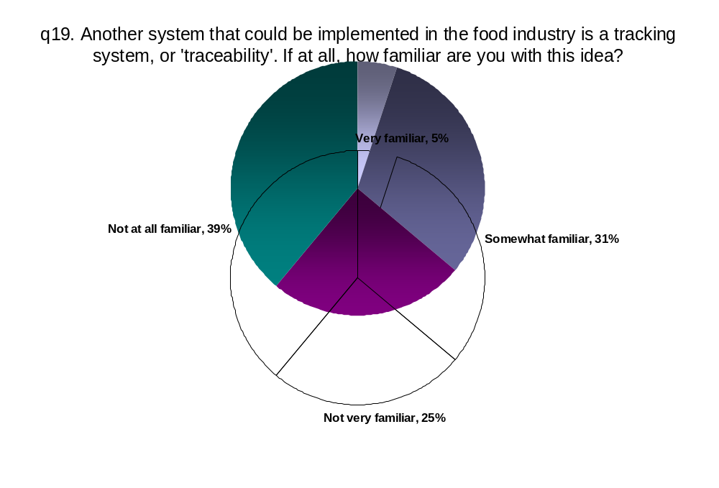

Consumers in Alberta and Saskatchewan/Manitoba are the most likely of all regions to be familiar with the concept of a food traceability system (51% and 46%, respectively) while consumers in Quebec are the least likely to be familiar with this concept (22%).

The following description of a traceability system for the Canadian food supply chain was then read to respondents:

“Traceability is a system that would enable Canada to trace or track food from the farm where it was produced, through processing and distribution to retail outlets where consumers like you buy it.”

Despite low familiarity with the concept, once presented to them, consumers say they would feel more confident about food safety if Canada had a national food tracing system in place.

More than one third of Canadians feel a food traceability system would greatly increase their confidence in food safety (34%) while one half say that a food tracing system would moderately increase their confidence in food safety. Some say a food tracing system would have no impact at all (14%).

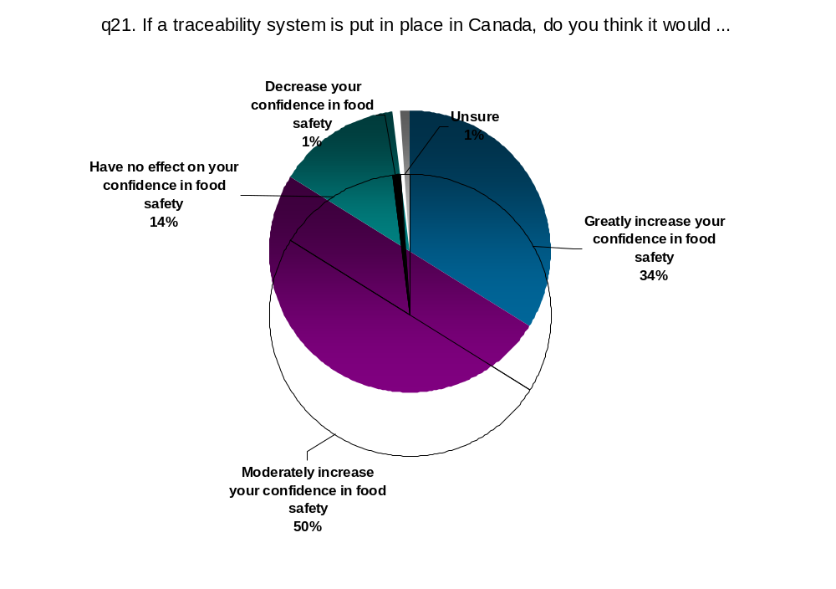

Consumers in Quebec and Ontario are most likely to feel that a traceability system would greatly increase their confidence in food safety (41% and 37%, respectively). Consumers in Manitoba/Saskatchewan are the most likely to say it would have no effect (21%).

A national traceability system would increase the confidence of females more than males (86% versus 79%, respectively).

Of the 10% of consumers who are either not very or not at all confident in the safety of our food supply, 40% say that a system of traceability would greatly increase their confidence in food safety and 46% say it would moderately increase their confidence in food safety. If the goal is to change the opinions of this small group of consumers, this is positive news. These findings suggest that a traceability system could be a very significant step in achieving that goal.

Impact of Traceability on Confidence in Food Safety
- By Level of Confidence in Canadian Food Safety -
 |  | Confidence in Food Safety
 | Total | Completely | Somewhat | Neutral/ Not very/ Not at all
 |  | D | E | F
Base: All respondents | 1600 | 595 | 864 | 140
Greatly increase your confidence in food safety | 34% | 38% | 31% | 40%
Greatly increase your confidence in food safety |  | E |  | E
Moderately increase your confidence in food safety | 50% | 43% | 54% | 46%
Moderately increase your confidence in food safety |  |  | D
Have no effect on your confidence in food safety | 14% | 16% | 13% | 10%
Decrease your confidence in food safety | 1% | 2% | 1% | 3%
Unsure | 1% | 0% | 1% | 1%
NOTE: Letters in cells indicate the difference is statistically significicant at 5% level

A national food traceability system in Canada would also have a largely positive impact on consumer impressions of Canadian food quality.

More than 9 in 10 Canadians say that a food traceability system would have either a strongly positive (19%) or positive (73%) impact on their impression of Canadian food quality – a more significant impact than on confidence in food safety.

Because many consumers recognize that food safety problems could occur in the home or in restaurants and grocery stores, which are likely not part of a food traceability system, consumers say the impact of traceability would not have as large an impact on food safety (84% say it will increase their confidence) as on food quality (92% say it will have a positive impact).

Food quality incorporates attributes like nutrition, freshness and ingredients in addition to safety. Consumers likely feel the delivery of these attributes, in addition to safety, could benefit from a traceability system.

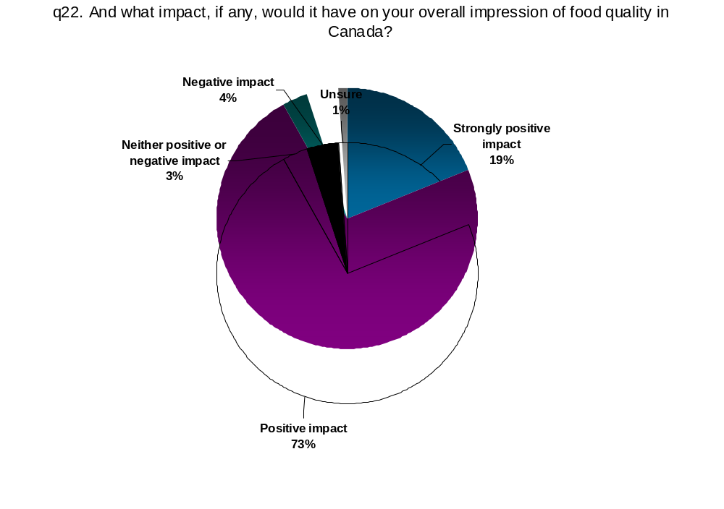

Consumers across regions feel a traceability system would have a positive impact on their impressions of Canadian food quality though Saskatchewan/Manitoba consumers are more likely than those in Ontario and Quebec to say that it would have no impact (12% versus 6% and 5%, respectively).

Consumers in the lowest income category are more likely than those in higher income categories to say that a traceability system would have a negative impact on their impression of food quality (6%, versus $30K to <$75K, 2% and $75K+, 3%).

Consumers with a low impression of the quality of Canadian food are much more likely than those who feel Canadian food is of excellent or good quality to feel that a traceability system would have a neutral impact (8%) or a negative impact (11%) on their impressions of food quality.

Impact of Traceability on Food Quality Impressions
- By Impressions / Confidence in Food Quality / Safety -
 |  | Impression of Quality |  |  | Confidence in Safety
 | Total | Excellent | Good | Average/ Poor | Completely | Somewhat | Neutral/ Not very/ Not at all
 |  | A | B | C | D | E | F
Base: All respondents | 1600 | 643 | 790 | 161 | 595 | 864 | 140
Strongly positive impact | 19% | 24% | 15% | 16% | 23% | 17% | 15%
Strongly positive impact |  | B |  |  | E
Positive impact | 73% | 69% | 79% | 64% | 70% | 76% | 69%
Positive impact |  |  | AC
Neither positive or negative impact | 3% | 4% | 2% | 8% | 3% | 3% | 5%
Neither positive or negative impact |  |  |  | AB
Negative impact | 4% | 3% | 3% | 11% | 3% | 3% | 9%
Negative impact |  |  |  | AB |  |  | DE
Unsure | 1% | 1% | 1% | 0% | 0% | 1% | 1%
Summary
Top2Box (Strongly positive/ Positive impact) | 92% | 93% | 94% | 80% | 93% | 93% | 84%
Top2Box (Strongly positive/ Positive impact) |  | C | C |  | F | F
Low2Box (Neither positive or negative/ Negative impact) | 7% | 6% | 5% | 19% | 6% | 6% | 15%
Low2Box (Neither positive or negative/ Negative impact) |  |  |  | AB |  |  | DE
NOTE: Letters in cells indicate the difference is statistically significant at 5% level

Governments would do the best job of putting a food traceability system in place.

More than 4 in 10 Canadians believe the federal government would do the best job of putting traceability systems in place (43%) and about one quarter believe the provincial governments would (24%). Nevertheless a little more than 2 in 10 Canadians feel that private industry would do the best job (21%).

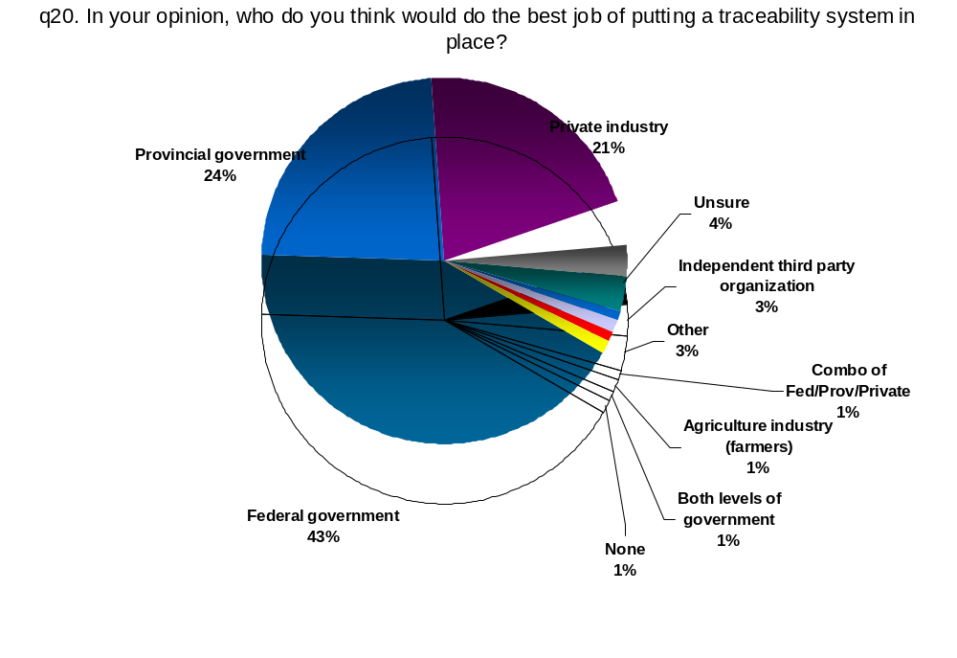

Alberta consumers are less likely to feel the federal government would do the best job of putting a food traceability system in place (34%) than are consumers in B.C. (46%), Ontario (46%) and Atlantic Canada (48%). Albertans are the most likely to feel their provincial government would do the best job (34%) while B.C. consumers are the least confident in their provincial government for this job (14%). Ontario consumers are the least likely to feel that private industry should do it (18%).

Respondents with lower educations are less confident than others in the federal government’s ability to do the job (32%) and are more confident than others in their own provincial governments (29%) or private industry (27%) for putting in a traceability system. Those with the highest income levels are the least confident in provincial governments (15%).

In the minds of consumers, a food traceability system could inject accountability and transparency in the food production process, particularly in the food processing sector where consumers have very little knowledge. As discussed earlier, the food processing sector appears to be shrouded in mystery and often only in the media when something goes wrong – and then become portrayed in a very negative manner. By providing consumers with the opportunity to receive information on practices, perceptions of this sector could improve.

Consumers have said that the price of food is not as important as other attributes, it’s possible that consumers would be willing to pay (through the price mechanism) for a system that guarantees the safety of our food supply.

2.6. Purchase Behaviour and other Characteristics

A large majority of Canadians are careful about the way they store and prepare food (85%) and will throw food out once the expiry date has lapsed (72%).

About four in ten Canadians feel in control over what’s in the food they buy (41%) while a similar number spend time worrying about the safety of their food (38%). One in ten respondents feel that as long as they reheat them thoroughly, it doesn’t matter how long leftovers are stored in the fridge.
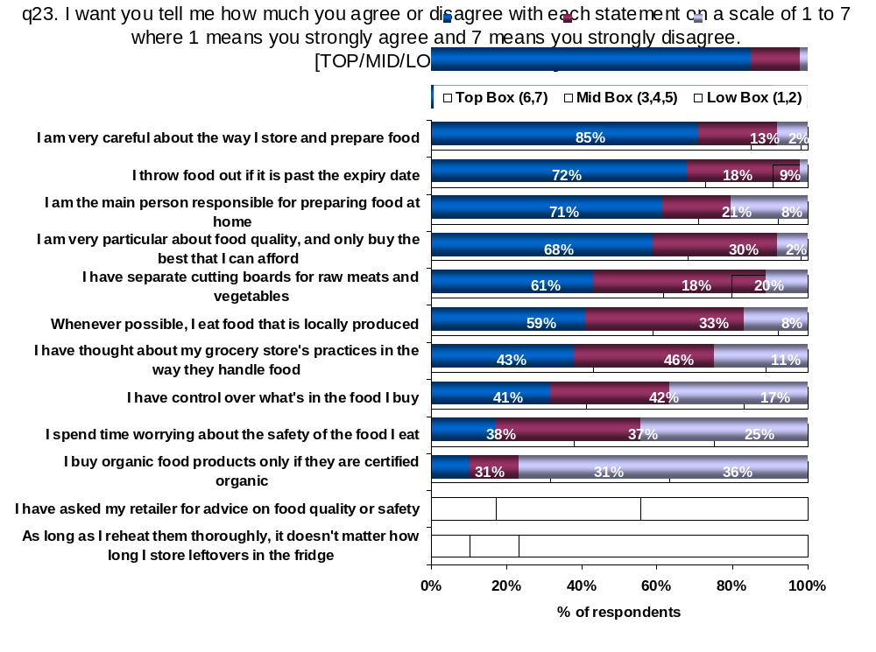

Consumers in Ontario and Atlantic Canada are the most likely to say they are very particular about food quality and only buy the best they can afford (72% and 75% top box, respectively). Saskatchewan/Manitoba consumers are the least likely to say they buy organic food products only if certified organic (20%) while consumers in Quebec are more likely than others to agree that they have control over what’s in the food they buy (50%) and that it does not matter how long they store leftovers in the fridge as long as they reheat them thoroughly (18%).

Quebec consumers are also more likely than others to agree that they have thought about their grocery store’s practices and the way they handle food (52%) and dramatically more likely than all other Canadians to agree that they spend time worrying about the food they eat (81%).

Females are more likely than males to be cautious about food safety and quality (82% versus 48% top box, respectively), possibly because they are almost twice as likely to say they are the main person responsible for preparing food at home.

Older consumers are more likely to feel that they have control over what’s in the food they buy (47%), have asked their retailer for advice on food safety and quality (24%) and will also be more likely to agree that leftovers are fine as long as they are reheated thoroughly (15%). Younger consumers are less likely to be very particular about food quality (57%), eat locally produced food when possible (44%) or be the main person responsible for preparing food at home (63%).

Consumers with lower levels of education are more likely to agree that they spend time worrying about food safety (43%) and feel it is alright to reheat leftovers regardless of how long they have been stored in the fridge (17%). Those with lower income levels are also likely to feel that leftovers can be kept for long periods as long as they are reheated thoroughly (16%). Consumers with some University or more are less likely than others to have thought about their grocery store’s practices (37%) or whenever possible, eat food that is locally produced (55%).

It is interesting to note that those with the lowest income levels are more likely than those with the highest income levels to feel that they have control over what’s in the food that they buy (48% versus 36%, respectively) and to have thought about their grocery store’s practices in the way they handle food (49% versus 39%). Lower income Canadians are the most likely to have asked their retailer for advice (25%) while those in the highest income bracket are the least likely to be the main person responsible for food preparation in the home (60%).

One in five Canadians have experienced a food borne illness in the last year.

Consumers in Ontario (24%) are more likely than consumers in Quebec (16%) to have experienced a food borne illness in the past year. Females (18%), older consumers (13%) and those with lower levels of education (14%) are less likely than others to say they have experience illness do to the food they ate.

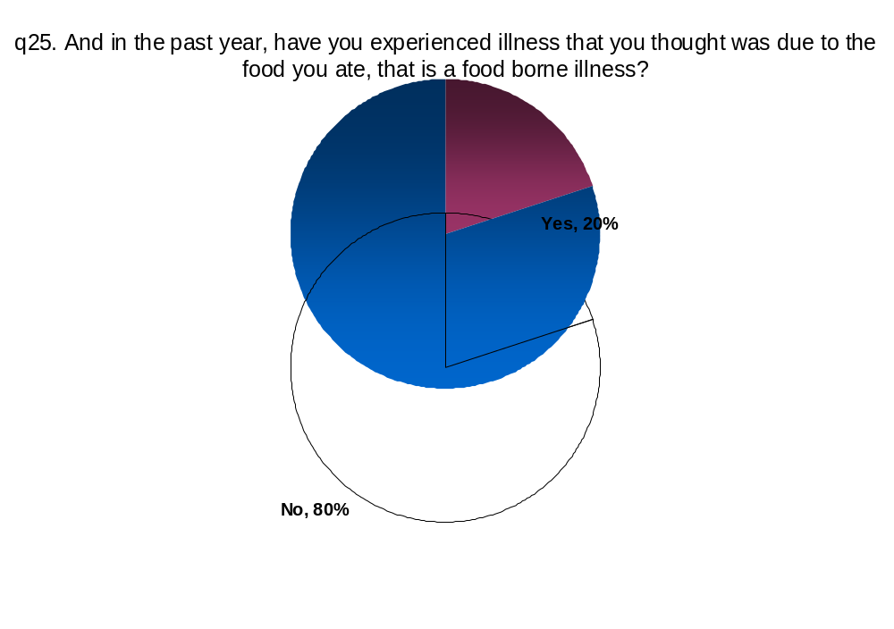

For a variety of reasons, many Canadians have boycotted specific food products.

More than one half of Canadians have boycotted a particular food because they were concerned about its safety (57%). Four in ten say they have boycotted food for environmental reasons (41%). And over one third have boycotted food products because of concerns of animal treatment (37%) or concerns about the country of origin (36%).

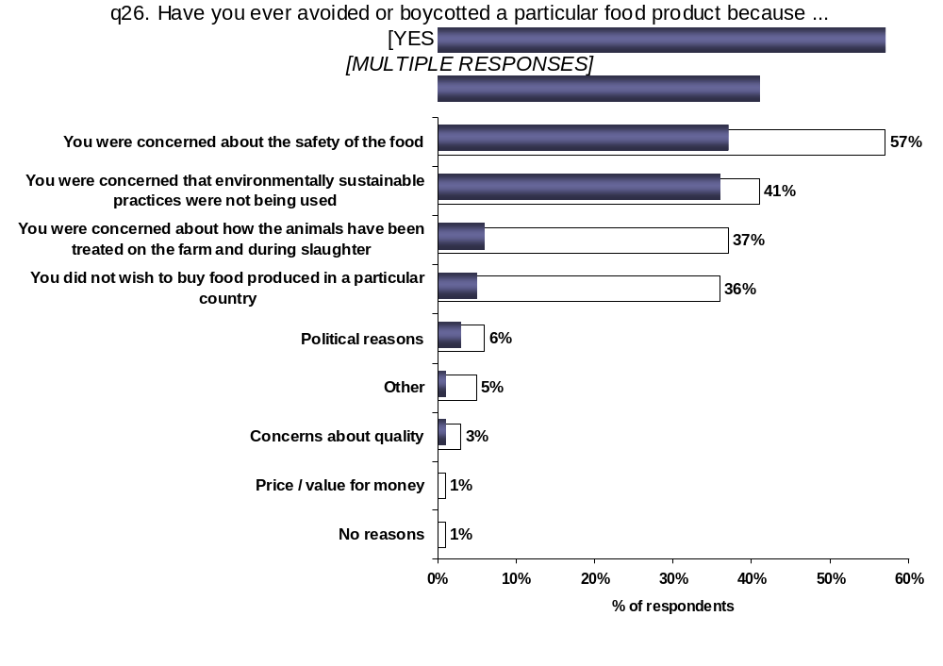

Consumers in B.C. and Ontario are the most likely to have boycotted food because of environmental concerns (48% and 47%, respectively). Consumers in Atlantic Canada and Saskatchewan/Manitoba (30% each) and in Alberta (29%) are the least likely to have boycotted food products because of concerns about animal treatment. Meanwhile, Quebec and Atlantic Canada consumers are the least likely of all regions to have boycotted food products because of concerns about country of origin (27% and 25%, respectively).

Females are more likely than males to boycott products because of concerns about food safety (59% versus 52%) and animal treatment (41% versus 31%). Older consumers are more likely than their younger counterparts are to avoid food products because of concerns about environmental sustainability (48% versus 38%) and those with higher levels of education tend to be generally more likely to boycott foods due to each of the concerns addressed than are consumers with lower levels of education.

Consumers in the lowest income category are more concerned than others about animal treatment (45% versus 35%) while consumers in the highest income group are more likely than others to boycott food produced in a particular country (43% versus 33%).
In an average week, Canadian consumption covers each of the main food groups.

Consumers in B.C. and Ontario are the most likely to say that they never eat read meat (both 14%), while consumers in Alberta and Saskatchewan/Manitoba are the most likely to eat red meat 5 or more times a week (19% and 20%, respectively).

Consumers in Ontario (23%) and Atlantic Canada (21%) are the most likely to say they eat white meat at least 5 times a week though consumers in Atlantic Canada are less likely than those in B.C. to eat fruits and vegetables this frequently (80% versus 87%, respectively). Consumers in Quebec (85%) are the most likely to say they eat cereal products, like bread, baked goods and breakfast cereals at least 5 times a week.
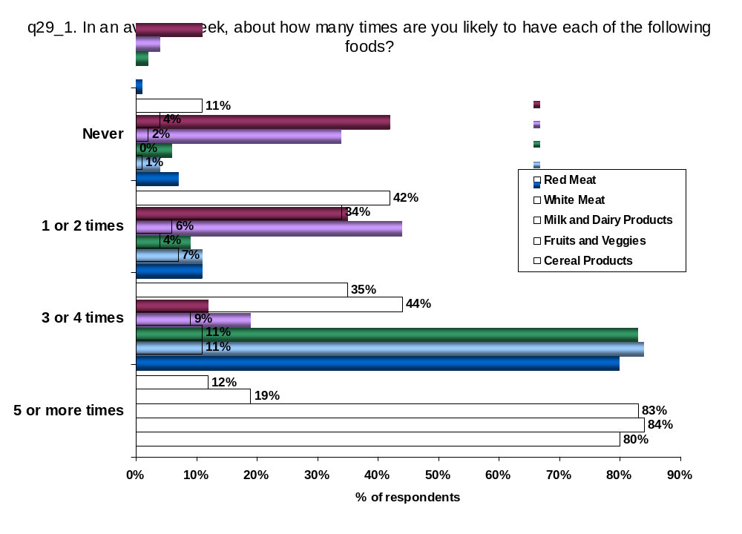

It is all or none for younger consumers as they are more likely than others to never consumer red meat (17%) or eat red meat at least 5 times a week (15%). They are also slightly more likely than others to eat white meat 5 or more times a week (23%). Those with some university or higher educations (15%) or with lower incomes (14%) are more likely than others to say they never eat red meat (15% and 14%, respectively) or white meat (6% and 8%, respectively).

Consumers with lower levels of education and the lowest incomes are less likely than others to consume milk and dairy products, fruits and vegetables, and cereal products at least 5 times a week (roughly 10 percentage points below for each category).
Most consumers have purchased organic food in the last year.

Consumers in B.C. are the most likely to have purchased organically grown cereal and vegetable products (62%), organic meats (45%) and free range eggs (66%).
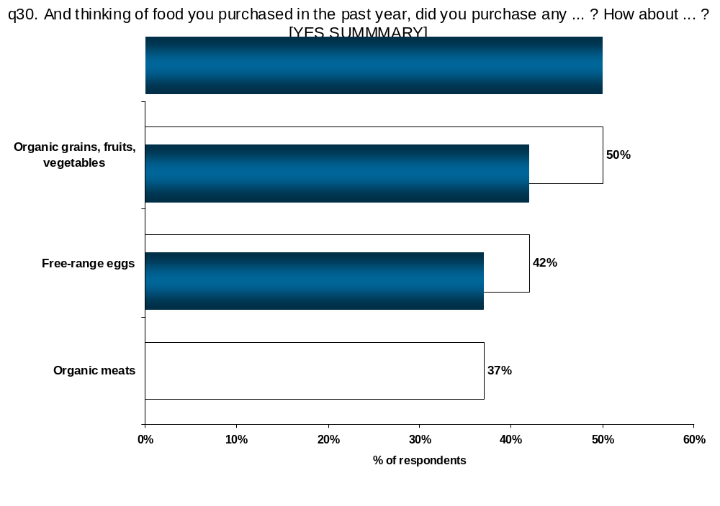

Almost 1 in 10 households have at least one vegetarian.

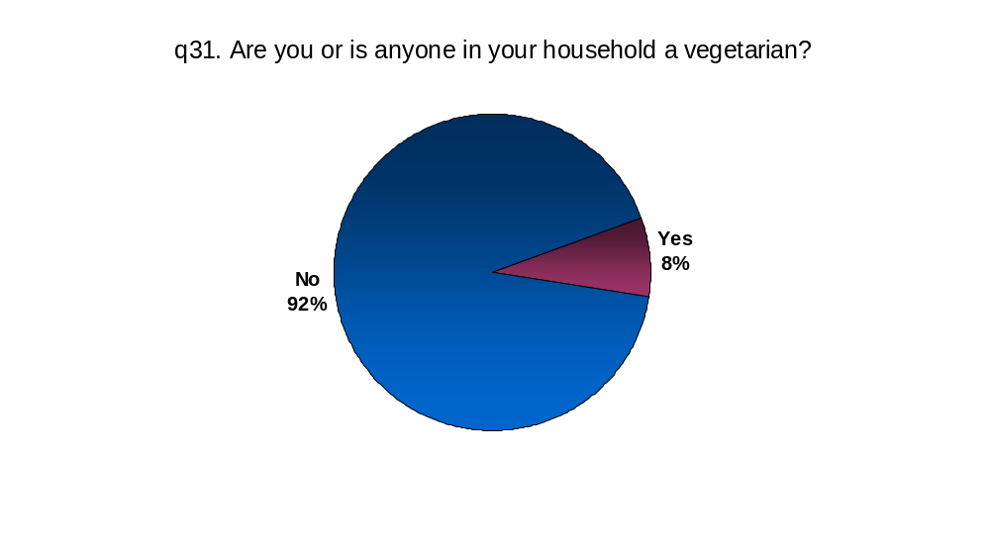
Households in B.C. and Ontario are more likely to have a vegetarian (10% and 9%, respectively) than are households in Saskatchewan / Manitoba (5%).

Most Canadians tend to follow an “evenly mixed” diet, consuming at least 3 servings a week of each of the main food groups.

More than 4 in 10 respondents eat a roughly equal mix of foods from all different groups, including meat, dairy, cereals and fruits and vegetables (44%). Nevertheless, about 3 in 10 either eat no red meat (8%) or a low amount of red meat (22%). Meanwhile, others eat low levels of white meat (14%) or no white meat at all (1%).

Very few respondents could easily be classified as following a specific “diet”. It is possible that the 7% of respondents consuming low or no cereals may be following the Atkins diet. The data also identified a small portion (3%) of consumers who appear to be vegetarian or vegan in their eating habits (another 5% have someone in their household, other than themselves who is a vegetarian).
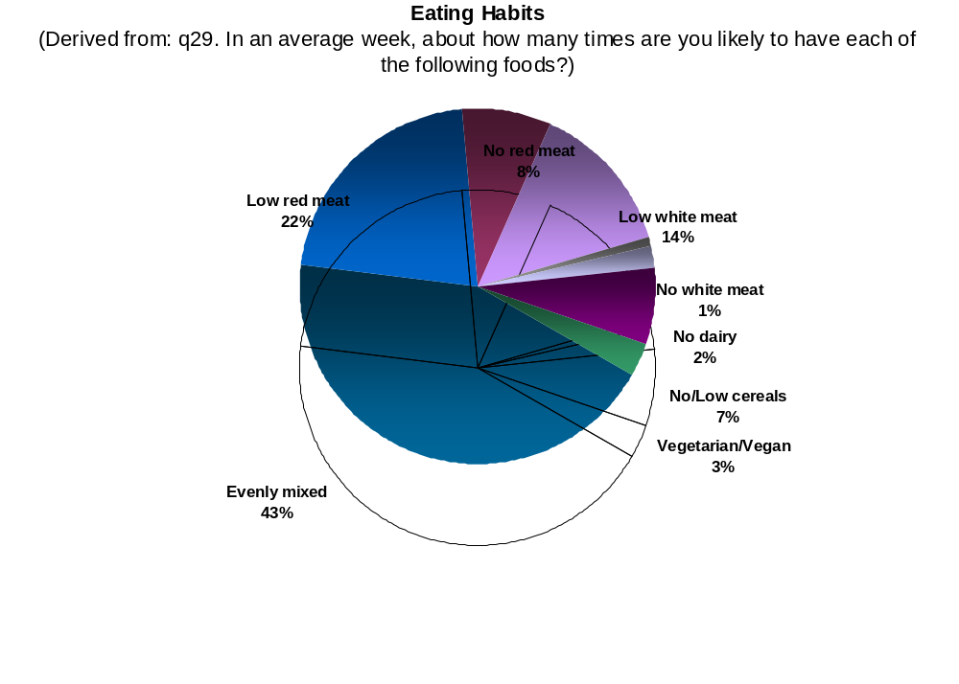

While consumers in Quebec (50%) are more likely than those Saskatchewan/Manitoba (42%) or Ontario (40%) to eat a roughly equal “mix” of food groups, those in Ontario are the most likely to eat no/low red meat (36%). Consumers on the prairies are the most likely to eat no/low white meat (25% each).

Consumers with lower levels of education are the least likely to be no/low red meat eaters (21% versus 33%) but more likely to be no/low white meat eaters (20% versus 13%). Those in the higher income categories are the most likely to have a “mix” (49%) but less likely to be no/low white meat eaters (10%). Those in the lowest income category are the least likely to be no/low red meat eaters (23%).
Household spending on food varies considerably.

Almost 2 in 10 Canadian households (19%) spend more than $500 per month on food, led by B.C. (23%), Alberta (26%) and Quebec (23%). About the same number (19%) spend less than $200 per month with households in Manitoba/Saskatchewan spending the least on average.

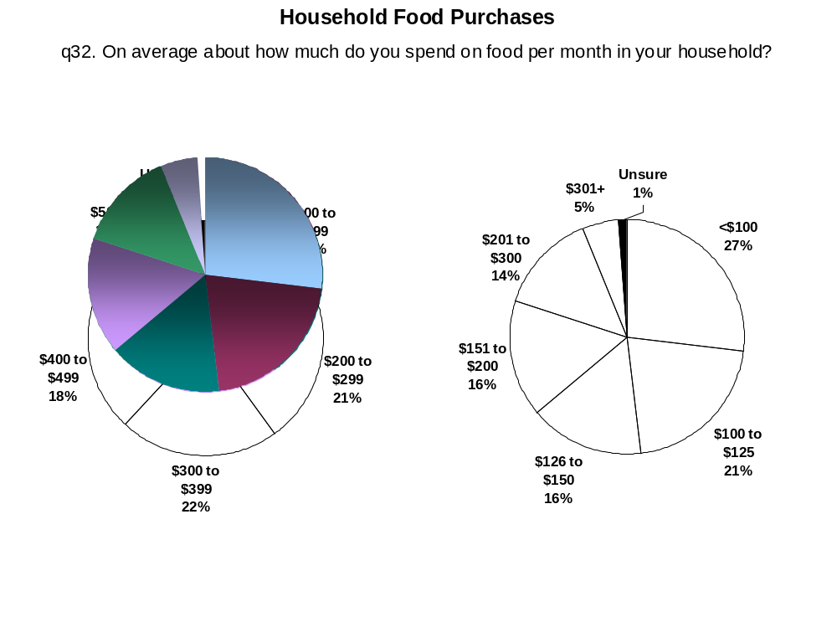

Not surprising, older consumers, those with lower levels of education and lower incomes spend the least per month on food.

The majority of consumers in Canada spend $100 to $200 per month for food on average per household member.

Using the midpoints of the household spending categories, the approximate spending per individual household member was determined. Depending on the number of individuals living in the home, overall monthly spending on food varies greatly from household to household. It is also dependent on other factors like income.

About a quarter of Canadian households (27%) spend $100 or less per member on food in an average month while nearly 1 in 5 spend $201 or more (19%).

Consumers in Canada spend an average of $150 per month per household member on food.

Average spending is highest in Quebec at $158 per household member and lowest in Saskatchewan/Manitoba at $143 per member. Residents of B.C. spend an average of $156 and Albertans spend an average of $155. Ontarians spend $146 per household member on average, slightly higher than Atlantic Canadians at $144.

Older Canadians report spending the most per household member ($172) while those with lower incomes report spending the least ($138).

In an average week, three quarters of the consumers in this study eat fewer than three meals that were not prepared at home.

Atlantic Canadians are the most likely across Canada to eat less than 1 meal not prepared at home (43%) while those in Alberta and Quebec are more likely than others to have at least 3 meals per week that were not prepared at home (29% and 30%, respectively).

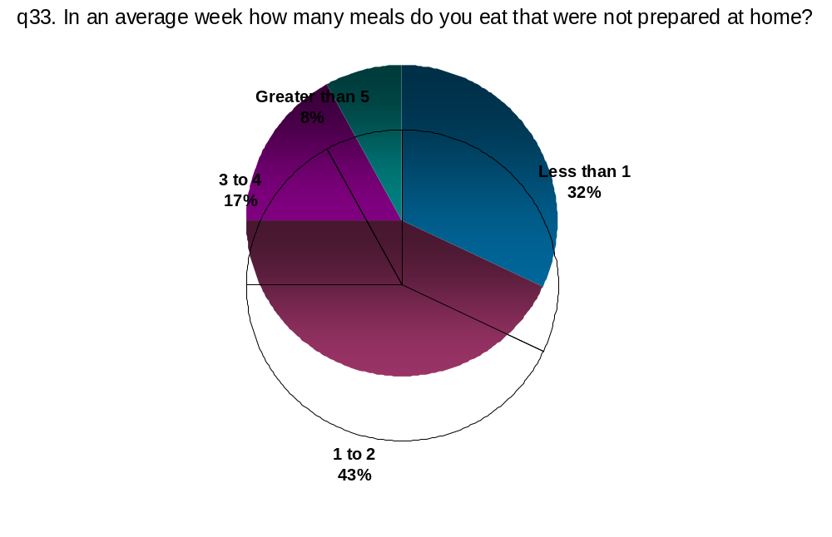

Males (34%) are more likely than females (21%) to eat three or more meals that were not prepared at home as are younger consumers (34%) and those with higher levels of education (31%). Somewhat surprising to note that those in the highest income bracket are only slightly more likely than others to eat three or more meals that were not prepared at home (30% versus 24%).

3.0. Segmentation Analysis

3.1. Segmentation Methodology

Traditional classification systems that rely mainly on demographic profiles of consumers assume all consumers of a certain age, gender or income will react in similar fashions. On the surface, this appears to be true, as the reader will note from the findings discussed so far in this report. For example, there appears to be a trend where households with lower incomes provide lower ratings of food safety and quality in Canada. This report has postulated that this potential trend could be due to the reliance of lower income households on cheaper food items that are inherently of lesser quality, becoming somewhat of a self-fulfilling prophecy.

Where these traditional classifications systems fail is when there is a desire to change the trend. Communication campaigns using demographic profiles to identify a target audience rely on the erroneous belief that because there appears to be consistency within a specific demographic profile, all members of that group will react the same way to attempts to influence the trend. The simple fact is, not all people with low incomes, for example, have the same motivations to change. It then becomes extremely important to understand the underlying motivations that different groups have with respect to food.

Segmentation analysis makes the assumption that one must go beyond traditional classifications and look at attitudes and behaviours to define groups of consumers that will respond to different stimuli in a similar fashion. The process of segmentation concentrates on identifying groups, or segments, of consumers that hold similar beliefs. These segments are created using a statistical process that identifies clusters of responses to attitudinal questions.

In an oversimplification of the general concept, if the reader thinks of plotting the raw responses to a series of questions, you might see a graph that looks something like this:
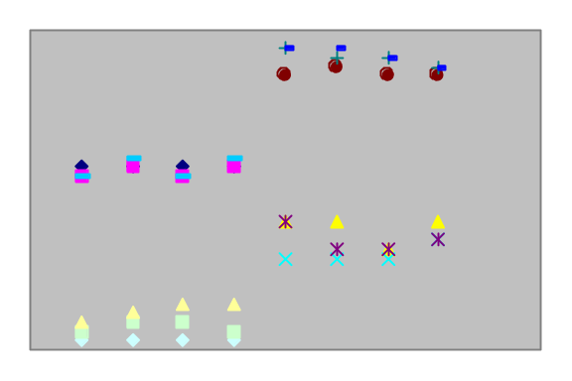
It is evident from this plot that there are four groups of responses to this series of questions. Each group appears to cluster around a central point. When this process is repeated several times, consistent and stable groups appear, which respond in similar fashions to one another and that become the segments within the population.

For a more detailed discussion of the segmentation methodology employed in this study, please refer to Section 4.2 Segmentation Methodology later in this report.

Identifying these segments is, among other things, an exercise in determining the correct audience for a specific communication campaign. It also helps to understand the specific messages that the group or segment will respond to. In essence, there are three main advantages that segmentation analysis provides: first, it identifies who can be reached (i.e., audiences that can be reached), second, it helps to identify how to reach the audience (i.e., what is the best medium and format of messaging), and finally, it helps clarify what messages the audience may respond to (i.e., what to tell them).

For AAFC, segmentation analysis will help understand the types of consumer segments that exist and how each may respond to implementing a comprehensive traceability system, nutritional labeling on food products, awareness campaigns promoting food safety standards and protocols and advertising campaigns providing information about different aspects of the food delivery system. It will further help to identify groups that can be moved from having lower impressions of food quality and safety to higher impressions of these aspects of the Canadian food delivery system.

3.2. Summary of Major Defining Variables

Recognizing that the research approach was not primarily designed as a segmentation study, several segments, or consumer groups, were identified and are based on dimensions related to Canadian food quality and safety. One specific dimension involves consumer attitudes and behaviour regarding food handling and preparation. Some focus is on practices within the home as well as practices consumers may observe at retail outlets and farms and specifically how much attention they pay to those practices. Another dimension focuses on consumer buying behaviour. This specifically addresses their views of organic products and whether they look for locally produced food items. Finally, there are distinct differences among the segments in terms of how they gather information and the sources they use. This includes their use of retailers for food quality and safety information and the degree of control consumers feel they have over what is in the food they buy.

The segmentation is driven by statements regarding consumers’ experience with food and is taken primarily from Q23, “First, I’ll read you a series if statements that might relate to your experience with food. I want you to tell me how much your agree or disagree with each statement on a 1 to 7 scale, where 1 means you strongly agree and 7 means your strongly disagree?” The statements in this question explored several aspects of buying food, food safety practices and information gathering. Responses to Q2 “In terms of buying food in general, how much attention do you give to each of the following?” were also used to add a dimension clarifying knowledge levels and areas of potential concern among consumers.

Once segments were determined, specific variables that contribute the most to the overall differences among segments were identified. The table below summarizes the combined responses rating a “6” and “7” for each variable with the greatest differentiating ability among consumer segments.

Top Defining Variables of the Segmentation
Q23. First, I'll read you a series of statements that might relate to your experience with food. I want you tell me how much you agree or disagree with each statement on a scale of 1 to 7, where 1 means you strongly disagree and 7 means you strongly agree.
Percentage Responding “6” or “7”  (on a 7-point scale) | Concerned Consumers | Uninvolved Trusters | Busy Family Shoppers | Social Activists | Informed Action Takers
 | A | B | C | D | E
 | (n=514) | (n=214) | (n=461) | (n=247) | (n=149)
Q23_5. I have separate cutting boards for raw meats and vegetables | 88%  BDE | 7%  D | 86%  BD | - | 78%  BD
Q23_7. I throw food out if it is past the expiry date | 87%  BDE | 50%  E | 88%  BDE | 78%  BE | -
Q23_9. I buy organic food products only if they are certified organic | 64%  BCDE | 7% | 7% | 31%  BC | 23%  BC
Q23_2. I spend time worrying about the safety of the food I eat | 60%  BC | 7% | 17%  B | 52%  BC | 54%  BC
Q23_8. I have asked my retailer for advice on food quality or safety | 35%  BCDE | 4% | 5% | 12%  BC | 19%  BC
Q23_11. I have thought about my grocery store's practices in the way they handle food | 64%  BCDE | 11% | 38%  B | 41%  B | 43%  B
Q23_12. Whenever possible, I eat food that is locally produced | 74%  BCD | 32% | 54%  B | 61%  B | 68%  BC
Q23_10. I am the main person responsible for preparing food at home | 82%  BCD | 53% | 74%  BD | 61% | 74%  BD
Q2_1. I pay attention to… The farms where the food comes from | 71%  BCD | 19% | 36%  B | 50%  BC | 65%  BCD
Q23_1. I have control over what's in the food I buy | 53%  BC | 22% | 32%  B | 46%  BC | 51%  BC
NOTE: Letters in the cells indicate where there is a significant difference. For example, if a cell in column B is flagged with a D, then the percentages recorded in columns B and D are different from one another at a statistically different level. Cells highlighted in yellow indicate the strongest agreement among the segments with a specific statement. Those highlighted in turquoise indicate the lowest agreement and those in tan indicate a difference in the level of agreement that is neither the strongest nor the weakest, but worthy of note nonetheless.

3.3. Summary of Segments

The discussion that follows presents general observations regarding each segment. Charts and graphs presenting responses to supporting survey questions by segment are included in Section 3.4.

Conscientious Consumers (32% of sample)

Conscientious Consumers appear to be very content with the quality of food produced in Canada. Nine in ten believe food produced in Canada is either excellent (38%) or good (52%) quality. They consistently show the highest confidence in Canadian food, scoring different aspects of food quality higher than the other segments. This is a group of consumers that appears to have great confidence in their food supply and does all the right things to ensure that their food is of good quality and safe.

This group’s confidence in Canadian food extends to feeling that food in Canada is of better quality than food produced in other countries. More than half feel Canadian food is a lot better (53%) and most of the remainder feels it is somewhat better (40%).

When asked what is most important to them when buying food for the home or when dining out, Conscientious Consumers focus on nutritional value and quality. This is something they share with Informed Action Takers and Social Activists that differentiates these segments from the others. These focal points also extend to their thoughts on food quality in general.

These consumers also have a high degree of confidence in the safety of food produced in Canada. Nearly nine out of ten rate their confidence level in the safety of food produced in Canada as either completely confident (27%) or somewhat confident (61%). They also show a high degree of confidence in the Canadian food supply system to respond to concerns from various sources, including organically produced food (87% completely or somewhat confident), bacterial contamination from food processing (77%), animal diseases (76%) and additives and preservatives (64%). While this level of confidence is not as high as the Uninvolved Trusters or Busy Family Shoppers, it is higher than in the other segments.

The Conscientious Consumers do not appear to be as active as the Social Activists or the Informed Action Takers. While they claim to have read articles or other information on food safety in the past year (80%), few appear to take action on specific issues. Only four in ten have discontinued purchasing certain food products (40%), a third have stopped eating at a specific restaurant (33%) and a fifth have stopped buying food from a particular retailer (21%). Even so, they claim to be well informed about food safety practices. More than half claim to know a lot or some about food safety on the farm (51%) and in processing and packaging (57%). An even higher percentage claim to know a lot or some about food safety practices in restaurants (65%) and in retail outlets (70%). Nine in ten of these consumers claim to know a lot (59%) or some (31%) about food safety practices in the home.

Forty percent of the Conscientious Consumers claim to be very or somewhat familiar with the idea of a food industry tracking system, or traceability. If this system were in place, it would greatly increase their confidence in food safety for a third (32%) while having a moderate increase for another half (46%) of these consumers. It would also have a positive impact on their impressions of food quality (27% strongly positive and 69% positive). Next to the Informed Action Takers, this represents the best impact of a traceability system among all the segments.

Accounting for 32% of the sample, this segment of consumers is the largest group overall. Members of the Conscientious Consumers segment are represented in all age brackets, but do have the highest membership within the older brackets, and the highest incidence of seniors aged 65 or older. While there appears to be fairly equal representation in this group among different education levels, they tend to have the lowest overall education of the segments. We would expect to find members of this group that have children (nearly four in ten of them, 38%) to have slightly larger, more established families than the other segments. In terms of income level, this segment earns the lowest annual household income, with a third (32%) earning less than $30,000 annually and three quarters (75%) earning less than $75,000.

It appears Conscientious Consumers are well-informed and well-meaning Canadians. They appear to know the right approach and have a lot of pride in Canadian food supply system.

Uninvolved Trusters (14% of sample)

Uninvolved Trusters appear to be detached from food safety and food quality issues. They are the least likely to give a positive response to many of the food safety and quality practices, with less than one in ten saying they keep separate cutting boards for meats and vegetables (7%), buying organic products only if they are certified organic (7%) or asking their retailer for advice on food quality or safety (4%). One in five say they pay attention to the farms where their food comes from and only one in ten have assessed the food handling procedures at the local retailer (11%). These consumers simply trust that their food is safe. Indeed, only 7% of these consumers spend time worrying about the safety of the food they eat. Less than a quarter of them state that they have control over what is in the food they buy (22%) while nearly a third claim that they do not have any control at all (31% disagree).

Most Uninvolved Trusters trust the quality of food produced in Canada (88% believe food produced in Canada is either of excellent or good quality). They consistently believe Canada produces food that is excellent or good in many of the aspects explored, including consistent quality (83% excellent/good), healthy food (78% excellent/good), price level (61% excellent/good) and humane animal treatment (60% excellent/good).

Uninvolved Trusters score Canadian food attributes very highly, yet only a third will go out of their way to eat locally produced food (32%). About the only area in terms of quality they appear to be concerned with is the fat content in food, where about four in ten rated foods produced in Canada as excellent or good (41%). Although most of these consumers believe that food produced in Canada is of higher quality than food produced in other countries (33% feel it is a lot better and 53% feel it is somewhat better), they lag behind all the other segments in their perceptions of the quality of Canadian food.

Uninvolved Trusters share a concern with other segments about the nutritional value of the food they purchase for their home. When dining out, they place a higher importance on price and taste, a distinction they share with the Busy Family Shoppers. They also tend to place more importance on brand or company names and have a higher tendency to show an affinity for new and innovative foods.

Uninvolved Trusters have the greatest confidence of all the segments in the safety of food produced in Canada. Ninety-four percent of the consumers in this group rate their confidence level as either completely confident (46%) or somewhat confident (48%). This high level of confidence is bolstered by their confidence in the Canadian food system to manage concerns rising from animal diseases such as mad cow disease and avian flu and concerns about bacterial contamination in food processing (both at 85% completely or somewhat confident). They are also highly confident that the system can handle concerns regarding food additives and preservatives (73%) and organically produced food (76%).

Highlighting how disengaged they are, Uninvolved Trusters admit the lowest levels of familiarity with food safety practices and guidelines. Less than a third claim a lot or some knowledge about food safety during processing and packing (30%) and only slightly more claim similar knowledge about food safety on the farm (36%). Nine in ten have a lot (51%) or some (39%) knowledge of food safety guidelines in the home.

Uninvolved Trusters are the least likely of all the segments to be familiar with the idea of a food industry tracking system, or traceability. Only 30% claim to be very or somewhat familiar with the traceability. Next to Social Activists, Uninvolved Trusters show the least potential to benefit from this type of system. If it were in place, it would greatly increase their confidence in food safety for just over a quarter of these consumers (28%) while having a moderate increase for a further 58%. It would have a less positive impact on their impressions of food quality (11% strongly positive and 76% positive) than for all other segments.

Being disengaged, Uninvolved Trusters demonstrate a distinct lack of activism. Less than one in five have discontinued purchasing certain food products (19%) or stopped eating at specific restaurants (15%) and only one in ten have discontinued buying groceries from a particular retailer in the past year. This segment is also the least likely to have ever boycotted a particular food for any reason. Only 39% have boycotted food because of a food safety concern while only one in five have done so because they were concerned about the environmental sustainability of production practices (20%), the treatment of animals on the farm or during slaughter (19%) or because the food was produced in a certain country (18%).

Accounting for 14% of the sample, this segment of consumers is one of the smaller ones in the sample. Uninvolved Trusters tend to be in the middle age range, with 41% aged 35 to 54. They tend to have higher levels of education than members of the other segments with nearly three quarters reporting some form of post-secondary education and 37% having completed a Bachelor degree or higher. This is likely a segment of singles or couples, as two thirds do not have children under the age of eighteen in the home (68%). This segment tends to have average household income levels, with half of them (50%) earning between $30,000 and just under $75,000 annually.

Uninvolved Trusters show a great deal of confidence in the Canadian food system. They simply trust that what they eat is of good quality and is safe. As long as they are not paying too much and it tastes good, load up the plate.

Busy Family Shoppers (29% of sample)

Busy Family Shoppers appear to focus their energies on priorities other than food safety and quality issues. The majority follow proper food handling practices like maintaining separate cutting boards for raw meat and vegetables (86%) and throwing out food if it is past the expiry date (88%) but far fewer members of this segment spend time worrying about the safety of the food they eat (17%). Only a third believe they have control over what’s in the food they eat (32%). Less than four in ten have assessed the food handling practices at their local retailer (38%) and even fewer pay attention to the farms where their food comes from (36%).

In terms of their level of knowledge concerning food safety practices, this segment sits in the middle compared to other segments. Just under one half of these consumers claim to have a lot or some knowledge concerning food safety on the farm or in processing and packaging (46% in each). About one in three Busy Family Shoppers claim similar knowledge levels about food safety in retail outlets (64%) and restaurants (63%). This segment appears to have the highest level of knowledge regarding food safety at home, with almost everyone saying they either know a lot (53%) or have some knowledge (43%) of food safety guidelines in the home.

The most important factors to consider for Busy Family Shoppers when buying food for the home or when dining out are nutritional value, price and quality. The most important aspects of food quality in general are freshness and taste. These consumers take what appears to be a very practical approach to food safety and quality. They are equally as likely to place importance on brand or company name as are the Uninvolved Trusters and place a higher degree of importance on price than other segments.

Busy Family Shoppers have very positive perceptions of Canadian food quality. Ninety-one percent rate it as either excellent (43%) or good (48%), the highest rating among all segments. This extends to their thoughts regarding Canadian produced food versus other countries, where 92% of these consumers believe it is either a lot better (50%) or somewhat better (42%). These positive perceptions of Canadian food quality may be driven by their confidence in the safety of the food system. Along with Uninvolved Trusters, this segment has the most confidence in food safety, with 94% being completely (38%) or somewhat confident (56%) that food produced in Canada is safe.

The confidence shown by Busy Family Shoppers is particularly evident in terms of the Canadian food system’s ability to respond to potential threats. Busy Family Shoppers have the second highest level of confidence in the system’s ability to respond to threats from bacterial contamination from food processing (84% completely or somewhat confident), animal diseases (83%), organically produced food (79%) and genetically modified foods (53%). They have the highest confidence of all segments when it comes to the ability of the system to manage concerns about additives and preservatives in food (74% completely or somewhat confident) and hormones, antibiotics and chemicals in plants and animals (60%).

Busy Family Shoppers are not very active when it comes to food safety and quality issues, although slightly more active than Uninvolved Trusters. Two-thirds have read articles or information on food safety in the past year (66%) but only a quarter say they have stopped eating at a particular restaurant (26%) in the same time period. One in five claim to have discontinued purchasing certain food products (20%) and one in eight have discontinued buying groceries from a particular retailer (12%) in the past year. Few of these consumers are likely to boycott or avoid particular foods; if they do, it is likely going to be because of a food safety concern (49% have done so in the past for this reason) rather than for some more political or conscience based reason (only a third have boycotted foods because of animal treat (31%), environmental concerns (33%) or due to the country of origin (32%)).

Over a third of Busy Family Shoppers (35%) claim to be familiar with the idea of traceability, with more than eight in ten (82%) claiming that it would either greatly increase (29%) or moderately increase (53%) their confidence in food safety if it were in place in Canada. This system would also show good returns in terms of their perception of overall food quality, with more than nine in ten claiming with would either have a strongly positive impact (16%) or a positive impact (75%).

Accounting for 29% of the sample, this segment represents the second largest group of consumers in Canada. Busy Family Shoppers are the youngest respondents in the sample, with nearly four in ten (36%) being under the age of 35 and just 23% who are 55 or over. Members of this group tend to have higher levels of education than other groups, but are not quite as highly educated as Uninvolved Trusters.

Busy Family Shoppers are the most likely of all the segments to have children and have the largest family units; more than half (53%) have three or more household members. Four in ten members of this segment (39%) report having children in the home, with an average of almost two children under the age of eighteen per household. This segment reports the highest income levels of all segments, with a third (32%) having annual household incomes of $75,000 or more. It is highly likely that the majority of these households are dual income families.

This segment has the lowest incidence of singles and the highest incidence of larger households, often that will include children under the age of eighteen. They are also likely to be dual income earning households suggesting that, even though they may have some specific concerns about food safety and quality, the Busy Family Shoppers may have other priorities and simply have confidence in Canada’s food system.

Social Activists (16% of sample)

Social Activists appear to pick and choose among various issues around food safety and food quality. Almost opposite to Informed Action Takers, they are unlikely to maintain separate cutting boards for raw meats and vegetables and eight in ten say they throw out food beyond its expiry date (78%). Social Activists are split on paying attention to the farms where food comes from, with half doing so (50%). A little less than half believe they have some control over what’s in the food they buy (46%). Four in ten have given some thought to food handling practices at their grocery store (41%) and half spend at least some time worrying about food safety (52%). These consumers tend to support local food products, with 61% eating locally produced food whenever possible.

Very few Social Activists have approached a retailer for advice on food quality or safety (12%). Indeed, they appear to be “self-reliant” for food safety and quality information, looking to ‘best before’ dates (80% always read them) over retailer advice (43% do this sometimes and 41% claim never to do this), professional advice (47% never do this) and the Internet (73% never do this). This segment has the lowest incidence of having read an article or information on food safety in the past year (63%).

Regardless, Social Activists claim to be knowledgeable about some aspects of food safety practices and guidelines while admitting a lack of knowledge in other areas. About six in ten say they know a lot or at least some about safety practices in retail outlets (59%) and restaurants (55%) compared to only four in ten that claim a similar level of knowledge about the food safety practices on the farm (38%) or in food processing and packaging (40%). This group appears to have the least knowledge regarding food safety guidelines in the home, with just over a third claiming to know a lot (36%) and just under half knowing some (47%). Nearly one in five claim to know not much or nothing at all (17%) about food safety in the home.

We can contrast this limited information gathering and knowledge about food safety practices with the higher incidence of activism within the Social Activists segment. Four in ten claim to have discontinued purchasing certain food products in the past year (40%) and a third have stopped eating at a specific restaurant (32%). This group appears to trust their retailer, with only 15% having stopped buying groceries at a particular retailer in the past year. A large number of these consumers claim to have boycotted a particular food product due to food safety issues (60%) or for environmental concerns (43%). More than a third of have done so due to the country of origin (37%) or over concerns for the treatment of animals (34%).

The top-of-mind factors Social Activists think about when buying food is quality, which they often equate with freshness and taste, and nutrition. This segment rates food produced in Canada the lowest of all segments in terms of quality, with just over eight in ten rating it as excellent (40%) or good (44%). Safety of the food is the most important factor in their purchase decisions, followed by knowing that the food has high nutritional value and is of high quality. The areas where they show the greatest concern for the quality of Canadian produced food are environmental sustainability of production, where just over half rate this as excellent or good (53%), price levels (also 53%), the humane treatment of animals (49% rate excellent or good) and fat content in food (only 45% rate Canadian food as excellent or good).

Social Activists are the least confident of the segments concerning the safety of food produced in Canada. A third claim to have complete confidence (34%) while half are only somewhat confident (50%) that food produced in Canada is safe. Their confidence is weakest around the ability of the food system to respond to hormones, antibiotics and chemicals in plants and animals (48% are completely or somewhat confident in the ability of the system to respond) and genetically modified foods (52% completely or somewhat confident). Confidence is also lower than other segments in terms of additives and preservatives in food (65% are completely or somewhat confident) which is not really surprising, considering that less than half of this segment believes they have control over what goes into the food they buy (46%).

A traceability system would show the least gain, in terms of countering these lower levels of confidence, among the Social Activists. To start with, this segment claims the second lowest level of familiarity with the idea; only a third said they were very or somewhat familiar (32%). More distressing is that only one in five Social Activists (22%) stated that having such a system in place in Canada would greatly increase their confidence in food safety while 51% said it would moderately increase their confidence. While three quarters (74%) of this segment stated traceability system would have a positive impact on their impressions of food quality and another one in six (16%) said it would be strongly positive, nearly one in ten (8%) said it would have a negative impact on their impression of food quality in Canada.

Accounting for 16% of the sample, this segment of consumers is one of the smaller groups in the sample. While Social Activists tend to be younger than other segments, they are slightly older than Busy Family Shoppers. Education levels among this group are split with about a third (31%) having attained high school or less and just under half (44%) having at least attended university, if not completing a degree. The family structure found in this segment is likely to be singles, couples or smaller families. If they have children under the age of eighteen in the home, which is only about a third of the respondents in this segment (35%), they are not likely to have more than one. This segment has the second highest income levels of all the segments.

Given the age and admitted low levels of knowledge, coupled with a lack of information seeking and a higher than normal degree of activism, Social Activists may be a group that chooses their issues based on emotion rather than rational, informed thought. They appear to follow issues important for a healthy diet and could be driven by what they see in the media. Rather than gaining information independently, this segment is likely to respond to issues of the moment based on how the information given to them makes them feel.

The reactionary nature of this segment puts them at risk. They are a group of Canadian consumers that should be included in efforts to increase confidence and impressions of food safety and quality.

Informed Action Takers (9% of sample)

Informed Action Takers also appear to pick and choose among various issues around food safety and food quality. The majority of these consumers are likely to maintain separate cutting boards for raw meats and vegetables (78%), though none are likely to throw out food beyond its expiry date. Two-thirds (64%) of this segment state that they strongly disagree with this latter statement, suggesting that they rely on their own judgment as to what is fresh and what is spoiled. Two-thirds of these consumers try to eat food that is locally produced (68%) and claim to pay attention to the farms where food comes from (65%). More than one half of these consumers agree that they spend time worrying about food safety (54%) and four in ten have assessed the food handling practices of their grocery store (43%). This segment is almost as likely as Conscientious Consumers to believe that they have control over what is in the food they buy; 51% agree with this statement.

Issues of importance to Informed Action Takers when buying food for either home or dining out focus mostly on nutrition and quality. They equate quality with freshness and consistency of the product. Their top level of concern when buying food: knowing that food has a high nutritional value, closely followed by having confidence in the safety of the food. Secondary to these concerns are: knowing that the food was produced in an environmentally sustainable way; that the food is of high quality; and the actual ingredients in the food. These consumers also place a good deal of importance on buying food produced in Canada.

Informed Action Takers hold the middle ground when rating the quality of food produced in Canada. Nearly nine in ten rate the quality of Canadian food as either excellent (42%) or good (47%), placing them somewhat ahead of the Social Activists and slightly behind the Busy Family Shoppers. This segment feels Canadian produced food performs very well in terms of freshness (91% rate this as excellent or good), overall taste or flavour (90% excellent or good) and nutritional value (84% excellent or good). Areas where these consumers give lower ratings than other segments include price levels (51% excellent or good) and the humane treatment of animals (59% excellent or good). While not rated highly, these consumers give the fat content of Canadian produced food the highest approval with 55% stating that it is excellent or good.

Informed Action Takers are again in the middle when it comes to confidence in the safety of food produced in Canada. A third say they are completely confident food produced in Canada is safe (34%) while just over half are somewhat confident (54%). While informed, this group is skeptical of the ability of Canada’s food system to respond to specific concerns. They consistently give the lowest confidence ratings for the potential issues examined in this study. In particular, they are not confident in the system’s ability to properly deal with genetically modified foods (48% completely or somewhat confident), hormones and antibiotics in plants and animals (51% completely or somewhat confident) and additives and preservatives in food (67% completely or somewhat confident). These consumers give the lowest rating of the segments to dealing with animal diseases and bacterial contamination for food processing (both at 72% completely or somewhat confident) and organically produced food (77% completely or somewhat confident).

The concerns held by this group may be well grounded; this appears to be the most well informed group of all the segments. Even though they are unlikely to throw out food beyond its expiry date, 90% of Informed Action Takers read ‘best before’ dates at least sometimes. Three-quarters of this group seek advice from a retailer at least sometimes (76%), with nearly a quarter saying they do this most times (12%) or always (10%). Eight in ten have assessed the food handling practices where they buy food (80% at least sometimes; 25% always). This group is also likely to look to professionals such as nutritionists, home economists and doctors for advice (61% at least sometimes). A quarter of these consumers will turn to the Internet for information (26% at least sometimes) and three-quarters have read an article or other information on food safety in the past year (76%).

This above average information gathering appears to have an impact on the level of knowledge this segment reports regarding food safety practices and guidelines and is the main difference between Informed Action Takers and Social Activists. Nearly three-quarters of Informed Action Takers report knowing a lot or some about food safety practices in retail outlets (72%) and in restaurants (70%) and half report similar levels of knowledge regarding these practices for farms (52%) and in processing and packaging (48%). Two-thirds claim to know a lot about food safety guidelines in the home (64%) and another 29% say they know some, making this the most informed segment overall.

Not only are Informed Action Takers well informed, this group takes action on their concerns. In the last year, they are the most likely segment of consumers to have discontinued purchasing certain foods (42%), to have stopped eating at a specific restaurant (36%) or to have discontinued buying groceries from a particular retailer (26%). This segment does lag behind the Conscientious Consumers in terms of boycotting particular foods, but tend to do this quite a bit for various reasons. Nearly six in ten have done so because they were concerned about the safety of a food (57%). Four in ten have boycotted foods because they were concerned the food was not produced using environmentally sustainable practices (43%), because they were concerned about the treatment of animals on the farm or during slaughter (43%) and because they did not wish to buy food produced in a particular country. Informed Action Takers are the only segment to have a significant response to boycotting or avoiding foods due to “political” reasons, with one in eight (12%) claiming to have done so.

Implementing a traceability system in Canada would have the greatest gains with this segment. Four in ten Informed Action Takers (40%) claim to be very or somewhat familiar with the idea already. Further, just under half say that such a system would greatly increase their confidence in food safety (46%) with an equal number (45%) stating it would have a moderate increase on that confidence. More than nine in ten consumers in this segment say it would have either a strongly positive (15%) or positive impact on their overall impression of food quality.

Accounting for 9% of the sample, this segment of consumers is the smallest of all the groups identified. In demographic terms, Informed Action Takers do not look very different from the Social Activists. They are slightly older than some of the other segments, with a tendency to come from the middle to higher age brackets. Half of these respondents (52%) are aged 45 or older. Education levels are split with this group; 31% have high school or less and 43% have at least attended if not completed university. The families here are quite likely smaller with a lot of singles and couples. It is possible that many are empty nesters. Less than half (48%) report more than two household members and only a third (34%) report having children under the age of 18 in the home. The annual household incomes reported by this group tend to concentrate in the middle brackets, with half of this group (49%) reporting earnings of between $30,000 and just under $75,000.

Informed Action Takers may be considered a group of aging ‘baby boomers’ that are sensitive to having high standards in Canada’s food safety system. Some of the consumers in this group could have a history of activism. As aging members of the population, members of this segment are likely concerned with their own health and the effects of the food they consume on that. Being used to making informed decisions, they are likely less reactionary; a group of consumers that put considerable thought into the actions they do take.

3.4. Supporting Charts and Graphs

The following is a distribution of responses by individual segment to certain key questions and areas explored in the study overall. The differences between segments have been discussed in Section 3.3.

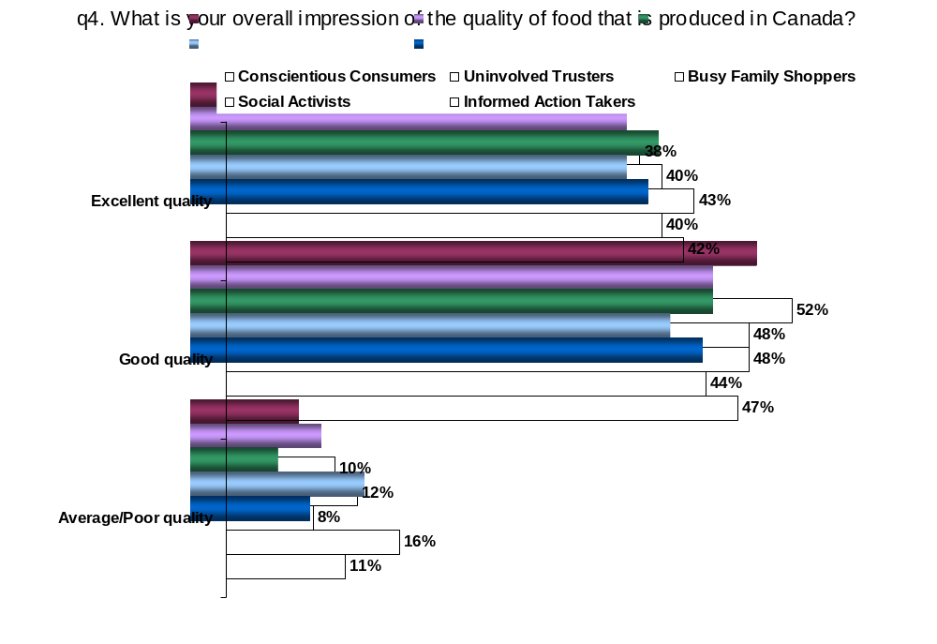

Most Important Aspects of Food Purchased for Home, When Dining Out & Food Quality in General by Consumer Segment

The table below presents the top-of-mind attributes each segment of consumers felt was important when choosing food for the home and when dining out.

Q1a/b. First, when buying food for your home/ When choosing food when you dine out, what is most important to you? That is, what do you think about?
Q5a. And when thinking about food quality, what is the FIRST thing that comes to mind?

 | Conscientious Consumers | Uninvolved Trusters | Busy Family Shoppers | Social Activists | Informed Action Takers
 | (n=514) | (n=214) | (n=461) | (n=247) | (n=149)
Food Purchased for Home | Nutritional value/  Quality | Nutritional value/  Price | Nutritional value/  Price | Quality/  Nutritional value | Nutritional value/  Quality
Food Purchased When Dining Out | Quality/  Nutrition | Price/  Taste | Price/  Quality | Quality/  Nutrition | Quality/  Nutrition
Food Quality in General | Freshness/  Consistent quality | Freshness/  Taste | Freshness/  Taste | Freshness/  Taste/Consistent quality | Freshness/  Consistent quality

Most Important Aspects of Buying Food in General by Consumer Segment
q3. Now I'll read you a number of things that you may or may not consider when buying food in general. This includes all the foods that you eat. Which one is most important to you, personally?

Percentage Choice Picked of Times Presented | Conscientious Consumers | Uninvolved Trusters | Busy Family Shoppers | Social Activists | Informed Action Takers
 | (n=514) | (n=214) | (n=461) | (n=247) | (n=149)
Confidence in the safety of the food | 66% | 63% | 72% | 75% | 65%
Knowing that the food has high nutritional value | 69% | 68% | 72% | 68% | 68%
Knowing that the food is of high quality | 62% | 65% | 66% | 61% | 58%
The ingredients in the food | 57% | 64% | 61% | 56% | 59%
Knowing that the food has been produced in an environmentally responsible way | 59% | 43% | 55% | 54% | 61%
Knowing that the food is produced in Canada | 46% | 47% | 47% | 53% | 57%
Knowing that animals were treated humanely | 51% | 36% | 44% | 44% | 39%
Price | 32% | 56% | 44% | 35% | 37%
Brand or company name | 38% | 41% | 41% | 36% | 36%
Knowing that the food was produced organically | 40% | 26% | 20% | 37% | 35%
New and innovative food that you have not tried yet | 23% | 26% | 19% | 22% | 23%
Impression of Different Components of Food Quality by Consumer Segment
Q6. With regards to ..., do you think food produced in Canada is ... ?

Percentage Responding:  “Excellent” or “Good” | Conscientious Consumers | Uninvolved Trusters | Busy Family Shoppers | Social Activists | Informed Action Takers
 | A | B | C | D | E
 | (n=514) | (n=214) | (n=461) | (n=247) | (n=149)
Consistent quality | 84%  E | 83% | 84%  E | 82% | 70%
Healthy food | 83% | 78% | 80% | 74% | 76%
Shelf life | 76% | 72% | 74% | 72% | 73%
Price levels | 63% | 61% | 57% | 53% | 51%
The humane treatment of animals | 61% | 60% | 58% | 49% | 59%
Nutritional value | 81% | 75% | 81% | 73% | 84%
Fat content in food | 52% | 41% | 51% | 45% | 55%
The overall taste or flavour of food | 83% | 80% | 89%  B | 81% | 90%
Freshness | 88% | 80% | 88% | 78% | 91%
The environmental sustainability of production practices | 62% | 50% | 60% | 53% | 70%  BD
NOTE: Letters in the cells indicate where there is a significant difference. For example, if a cell in column B is flagged with a D, then the percentages recorded in columns B and D are different from one another at a statistically different level.
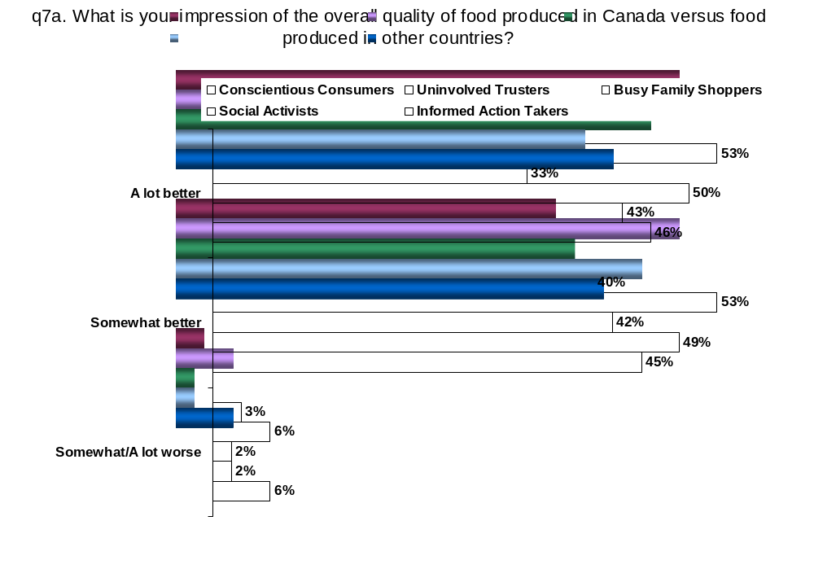

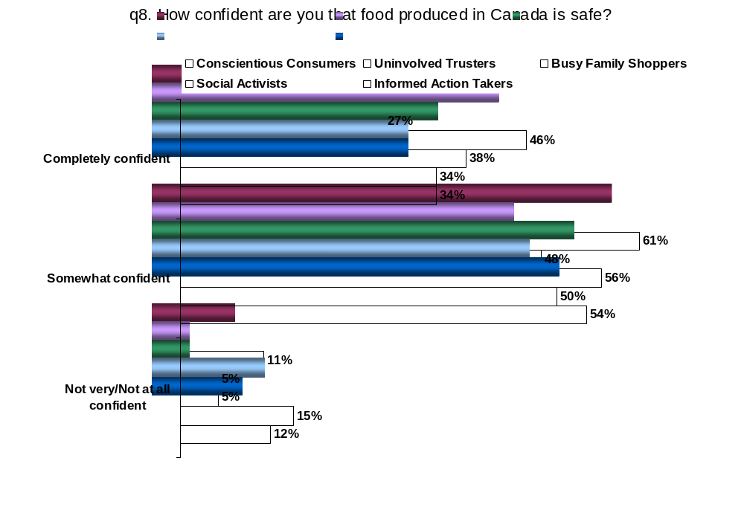

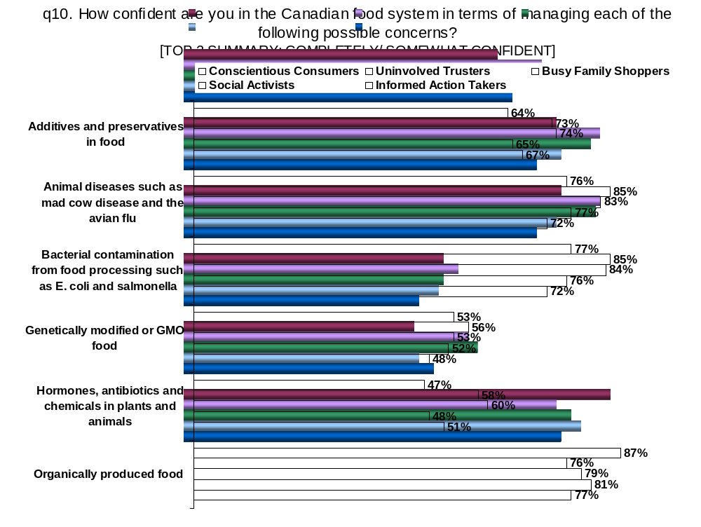

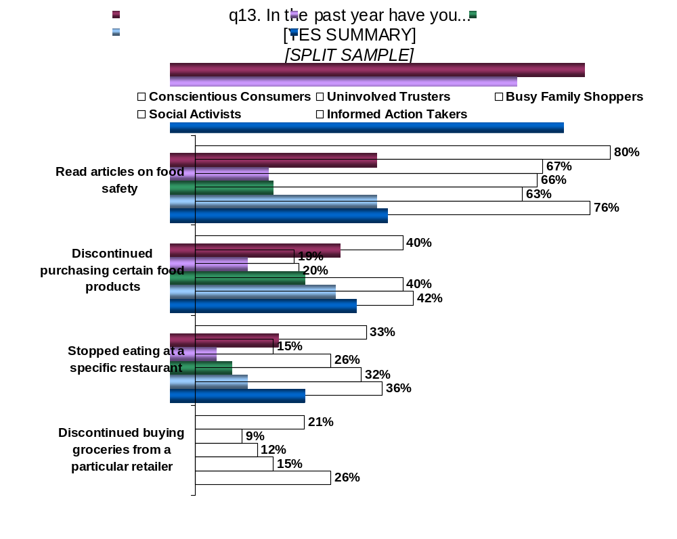

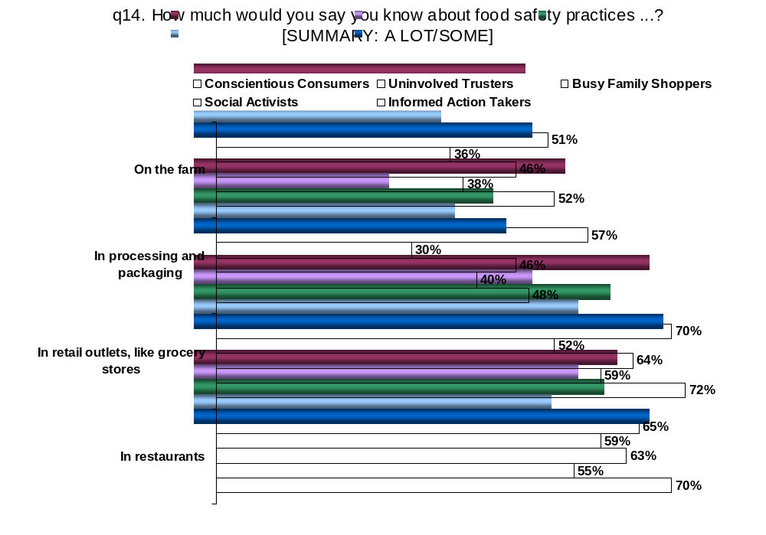

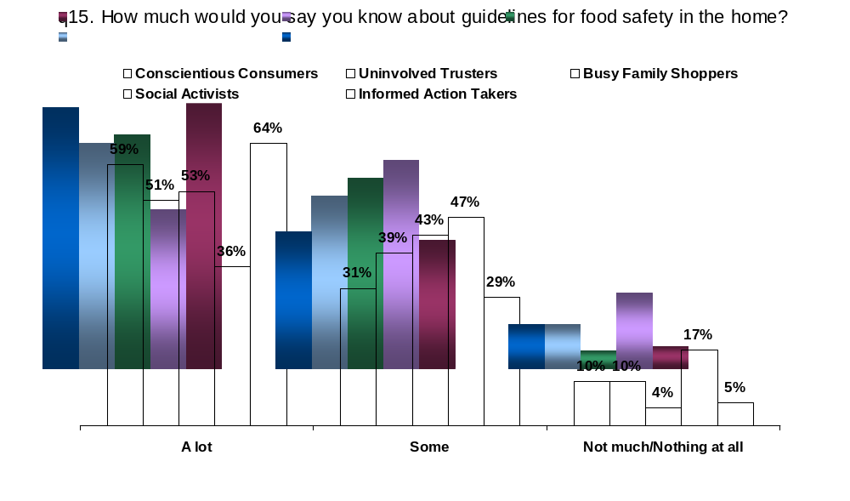

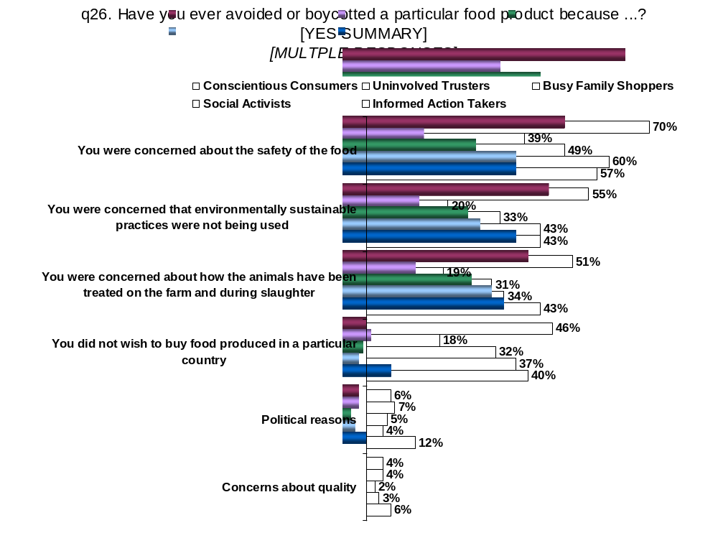

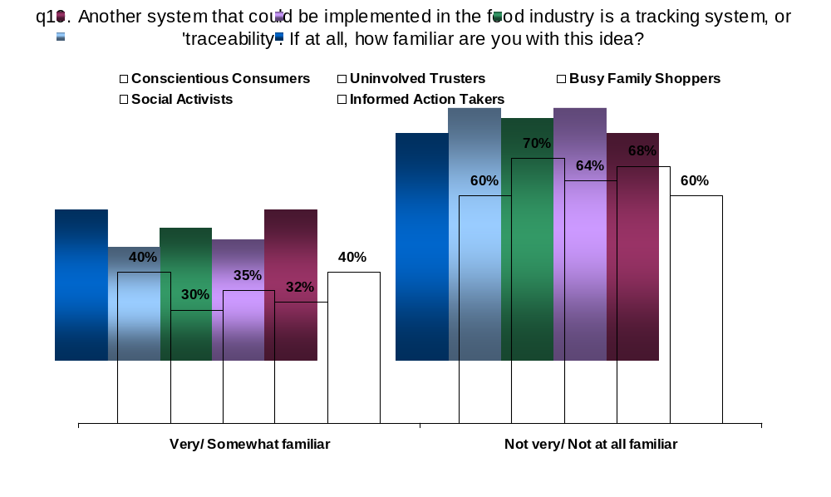
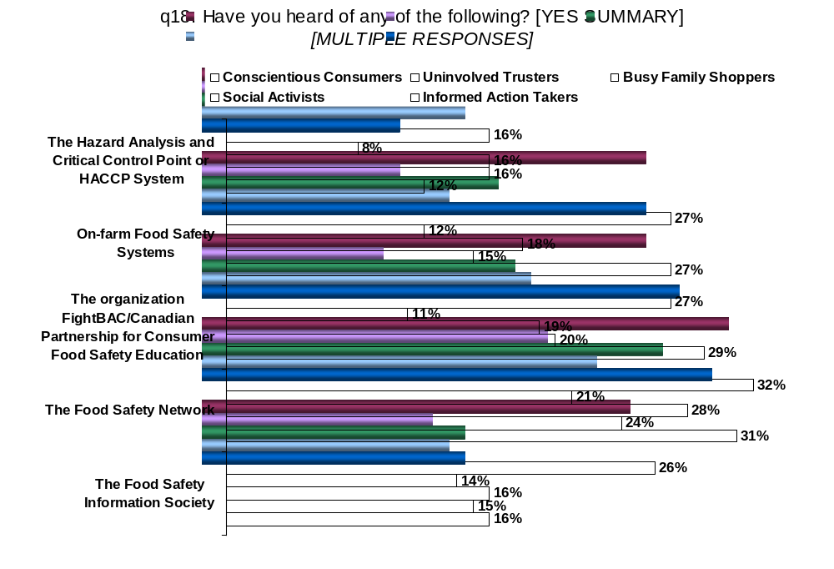

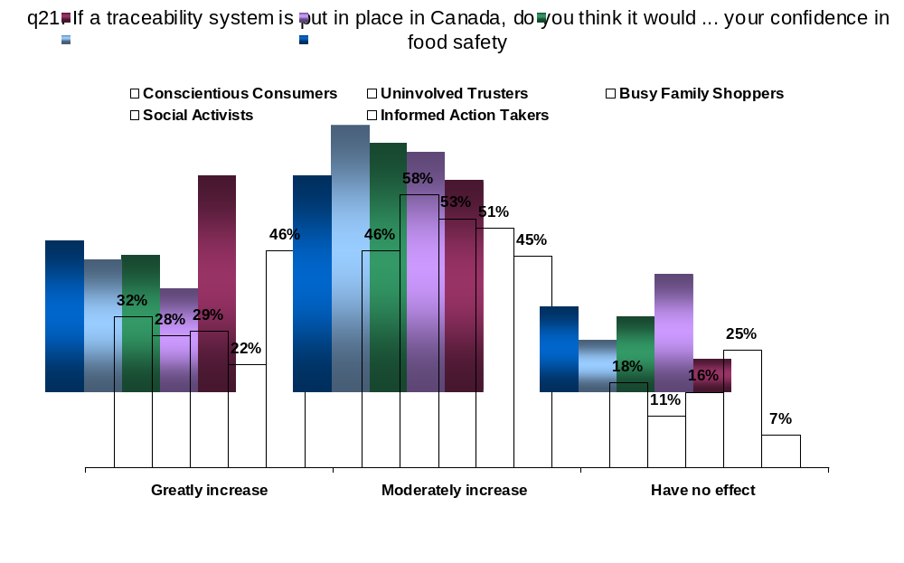

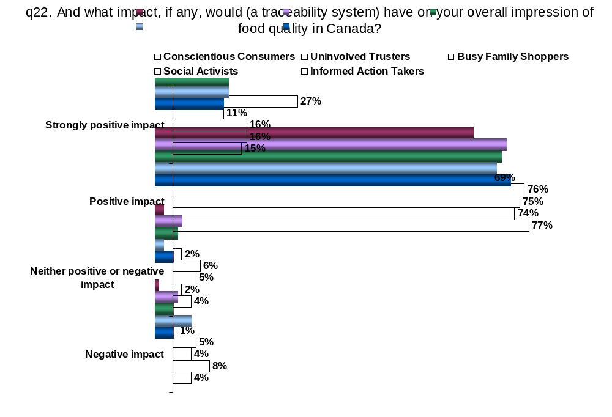

3.5. Demographic Profile of Consumer Segments

While demographic profiling is not the underlying methodology used to identify these segments, it is often useful to look to demographic profiling to further understand the segments.

The five segments identified range from a large group accounting for nearly a third of all respondents (Conscientious Consumers at 32%) to a fairly small group representing about one in ten consumers (Informed Action Takers at 9%).
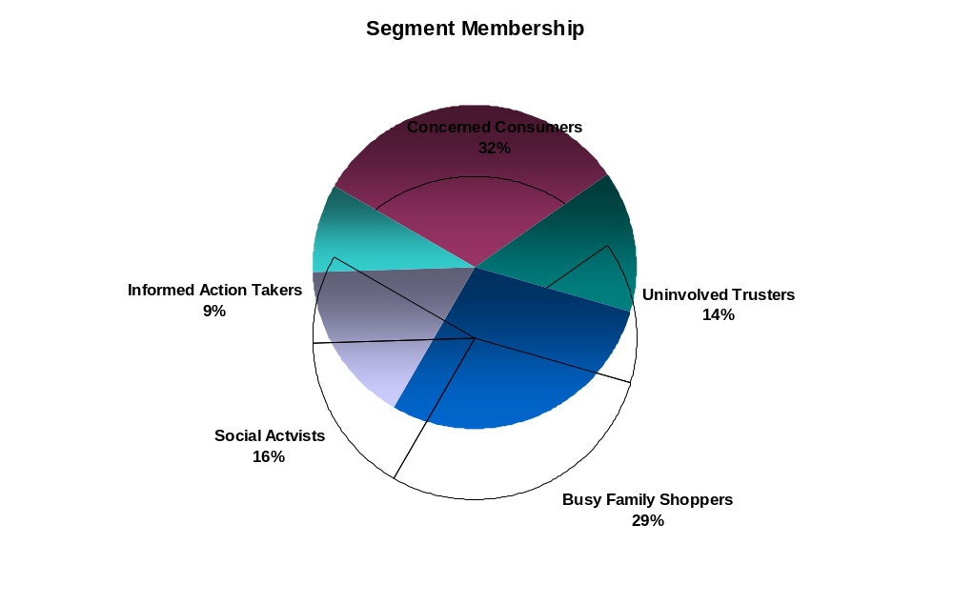

Some demographic differences exist and are presented in a profile of the segments noted in the table on the next page and discussed in more detail in Section 3.3.
General Demographic Profile Overview of Segments

 | Conscientious Consumers | Uninvolved Trusters | Busy Family Shoppers | Social Activists | Informed Action Takers
 | (n=514) | (n=214) | (n=461) | (n=247) | (n=149)
Age | Oldest with highest incidence of seniors | Middle age ranges | Youngest | 2nd Youngest | Middle to high age ranges
Education | Least educated overall | Most educated with highest levels | Most educated, but not highest | Polarized between high and low | Polarized between high and low
Household Size | Larger family | Smallest – Most likely to be single or couple | Largest – Most likely three or more in family | Single or couple and smaller families | Single or couple and smaller families
Family/Children in Home | Most children present in home | Least likely to have children | Very likely have children in home | Less likely to have children  (Small family) | Less likely to have children  (Small family)
Income | Lowest income in general | Middle income | Highest income  (Likely a two income family) | 2nd Highest income | Middle income

NOTE: These are general observations about demographic trends within each segment. They are meant to give the reader an image of who might be in the segment. They are not the drivers of the segmentation, i.e., these were not attributes included in defining the segments, but are instead used to profile the segments. Also note that these are general observations, not hard facts. For example, Conscientious Consumers tend to be the oldest segment, but do have members from all age brackets present.

3.6. Implications on Possible Communication Strategies

The segmentation analysis set out to answer three main questions: who can be reached, how can they be reached and what message will reach them. When five segments of the consumer population are defined, it is expected that not all of these segments can or will be targeted for change. It is also expected that there will be different messages and strategies implemented for different segments.

As was noted earlier in this report, nearly three-quarters of Canadian consumers do not actively seek information regarding food safety and quality. Sixty percent of consumers simply rely on what information is reported in various media while a further 12% do not turn to any source at all (see Section 2.4 Knowledge and Information Needs). This reliance on the media as the main source of information does not change across the segments identified. Where we do see some variation is a concentration of those claiming no source of information among the Uninvolved Trusters (20% claim no source) and the Busy Family Shoppers (14% no source), with Informed Action Takers the least likely to say they have no information source (6%), followed by the Conscientious Consumers (9%) and Social Activists (10%).

Informed Action Takers are the most likely of all segments to report multiple sources of information regarding food safety. They currently turn to media (58%), family and friends (14%), literature (12%), retail grocery stores (10%), professionals (8%), Universities (5%) and Government (5%), among others, for information on food safety. This is likely why they report strong levels of knowledge across categories. The information this segment is looking for revolves around numerous topics, including food processing (21%), food safety (14%), agricultural production (13%), storage (9%), certification and labeling (9%) and the regulatory system overall (7%).

Informed Action Takers are the ideal target for communication campaigns initiated by AAFC. What we see here is a segment of consumers, 9% of the population that actively seek out what they believe to be the most factual and salient information. They use the information to make informed decisions about what actions they take. While the topics they are interested in cover a lot of issues, they are the segment most likely to be interested in information about regulatory systems, certification and labeling and food traceability systems.

The remainder of the population, more than nine in ten consumers, are more likely to simply absorb food quality and safety information than they are to seek it. Conscientious Consumers and Social Activists (a combined 48% of the population) appear to react positively to the information put before them, mainly through the media. While consumers in these segments claim to have high levels of knowledge regarding food safety and quality in Canada, one in five claim they don’t need any further information or do not know what further information they do need. When they do want further information, these segments focus on food processing, agricultural production, food safety and nutrition. Any campaign designed to influence the opinion of the Informed Action Takers will have a trickle down effect on the Conscientious Consumers and Social Activists as long as major media outlets participate.

Busy Family Shoppers, nearly a third of consumers (29%), represent a segment that will be relatively hard to target specifically. These consumers don’t believe they have the time to do anything about food safety and food quality but the most basic and important things. Nearly a third (30%) of this segment do not know what further information they need or believe that they don’t need more information at all.

Uninvolved Trusters (14% of consumers) are also a segment that will be very hard to reach. As we have already seen, they don’t tend to go looking for information, they don’t appear to follow issues, they don’t seem to be concerned about food safety and quality and they don’t appear to care. They are simply looking for a good price on tasty food in a nice restaurant. While they tend to get their information from the media, they do not appear to act on the information they have. This is not likely to change, either. Like the Busy Family Shoppers, nearly a third (30%) of Uninvolved Trusters do not know what further information they need or believe that they don’t need more information.

Uninvolved Trusters are very similar in many aspects to the Busy Family Shoppers. It could be a simple matter of circumstance that differentiates between these two groups, children. Once the Uninvolved Trusters become mainstream family consumers, they are likely to react in a very similar fashion as Busy Family Shoppers to many issues in food safety and quality. Considering that these groups are the most likely to have reported suffering a food borne illness in the past year (21% of Uninvolved Trusters and 23% of Busy Family Shoppers), this may be the way to target these groups. It could be that because these are the least involved segments, they are the most at risk.

To sum up, there appears to be an order of priority among the segments identified when it comes to communication strategies that could be used to maintain the already high level of confidence among Canadian consumers regarding food safety and quality. The best opportunity involves reaching Informed Action Takers. Next come the Social Activists and Conscientious Consumers, who, although much more reactionary in general, are likely to respond to information if it is provided to them. Finally, Busy Family Shoppers and Uninvolved Trusters, are segments that are very difficult to evoke a reaction from and should likely not represent a target unto themselves at this time.

Regardless of which segment is targeted, the process will remain relatively unchanged: AAFC can best reach Canadian consumers through the media. A comprehensive media strategy will be required and any information shared with consumers should be branded as coming from the Government, a trusted source for information. Topics of greatest interest will revolve around points where the greatest unknowns lie for consumers, typically standards and regulations in food processing and agricultural production.

4.0. Study Methodology

The following presents the research framework used in gathering data for this report.

4.1. Sample Design

The study’s participants were screened to ensure that respondents were primarily or jointly responsible for deciding which foods were purchased for the home.

Given the significant variation in Canada’s population distribution, proportional sampling would result in small samples in the Prairie and Atlantic provinces. For that reason, non-proportional sampling was used to ensure sufficient sample was obtained in each region for acceptable analysis at regional levels. The sample distribution and associated margins of error are presented below.

Non-Proportional Sample Allocation
 | ATL | PQ | ON | MB | SK | AB | BC | Canada
Population Dist’n | 8% | 26% | 36% | 4% | 3% | 9% | 13%
Weighted sample | 124 | 395 | 606 | 55 | 54 | 155 | 212 | 1600
Non-Prop’l Dist’n | 13% | 17% | 19% | 13% | 13% | 13% | 14%
Full Sample | 200 | 275 | 300 | 200 | 200 | 200 | 225 | 1600
Margin of error | +/-6.9% | +/-5.9% | +/-5.7% | +/-6.9% | +/-6.9% | +/-6.9% | +/-6.5% | +/-2.9%
Split Sample | 100 | 137 | 150 | 100 | 100 | 100 | 113 | 800
Margin of error | +/-9.8% | +/-8.4% | +/-8.0% | +/-9.8% | +/-9.8% | +/-9.8% | +/-9.2% | +/-4.1%

While disproportional sampling ensures sufficient representation across Canada for regional analysis, the weights applied to overall survey data ensure that no province is over-represented at the national level. The overall Canadian sample is proportional to the national population distribution once weights are applied.

For example, Manitoba represents just 4% of Canada’s population. Proportional sampling would require completing only 55 surveys in that province, which yields a margin of error of 13.2% - an unacceptably high margin of error for national policy development. In response, the non-proportional sampling conducted here obtained 200 respondents with an associated margin of error of 6.9% - an acceptable error for Manitoba-level analysis. Nationally, however, these 200 responses are over-represented. By applying regional weights, the effects of any region’s responses are representative of the national population. As a result, the “effective” national sample is reduced by an equivalent amount.

After applying regional weights, with disproportional sampling, the final overall sample of 1600 results in an “effective” sample size of 1145 (and an associated margin of error of +/- 2.9%). For the split questions (1a/b, 6, and 12/13) the “effective” sample size is 573 with a margin of error of +/- 4.1%.

Within each province, quotas were imposed to ensure the sample reflected the region’s population distribution and that sufficient responses for reporting were achieved. Since sampling within each region was proportional to the distribution of the population, the actual sample size is equal to the “effective” sample size and regional margins of error were calculated accordingly.

4.2. Segmentation Methodology

The data collected in this study was segmented using a Convergent Cluster Analysis (CCA) technique. CCA solutions proceed with the following steps:

- A set of “starting points” is determined. There are as many starting points as clusters desired.
- Each respondent is classified into a group corresponding to the starting point to which the respondent is most similar.
- The averages for each variable are computed for the respondents in each group. These averages replace the starting points.
- Steps 2 and 3 are repeated until no respondents are reclassified from the previous iteration.

The quality of the solution can depend importantly on the quality of the starting points. For this reason, CCA dedicates a considerable portion of its resources generating high quality starting points and evaluating the reproducibility of solutions obtained from different sets of starting points.

Three methods of obtaining starting points are currently available in CCA:

- Distance-based points. This method searches for a set of starting points relatively distant from each other, but not on the outer fringes of the configuration of points. The intuitive basis for this procedure is recognition that points far apart are likely to belong to different clusters. If we can locate one starting point in or near each cluster, then we should have a good chance of identifying that cluster in the solution.
- Hierarchical-based starting points. This method selects a random sample of 50 objects and does a hierarchical cluster analysis of those objects. The centroids of the resulting clusters are taken as starting points.
- Density-based points. Rather than being uniformly distributed, most data sets are commonly thought to be mixtures of multivariate normal distributions. Such distributions are “lumpy,” having greater densities of points near the centers of regions that we would normally be interested in recovering as clusters. This suggests that one way to choose starting points would be to look for points that have many others relatively close to them, so long as no other starting points are chosen from the same region.

Since it is known that the starting points influence the solution, it is important to try different starting points to see if they all produce similar solutions. Reproducibility can be measured by determining to what extent the same objects are grouped together in each solution. With CCA, each clustering is repeated from at least 10 different starting points, measuring the reproducibility, and reporting the most reproducible of the solutions obtained. A “mixed” starting point strategy is used – that is, the first replication is distance-based, and after that the hierarchical and density methods are used alternatively.

As part of the segmentation process, several iterations of the clustering are performed to ensure the stability of the clusters and the reproducibility of the analysis. The segment solutions are developed under the assumption that there may be different numbers of clusters in a model. With that in mind, solutions are run using two, three, four, five and six segment models. These models are then compared to see how respondents moved from one model to another. In this study, the comparison showed that the models were consistent and stable with up to five segments and that adding a sixth segment did not provide positive gains. We have chosen to present the five segment models here and are confident that they are an accurate and useful representation of the data.

Once the five segment solutions were chosen, the variables most responsible for driving the segments were identified using F-ratios. The higher a variable’s F-ratio, the stronger that variable is in determining the cluster memberships. The top drivers were selected and the models were re-run with a reduced variable set. This eliminates the “noise” of unnecessary and unimportant variables and produces a more stable and reproducible solution.

4.3. Questionnaire Design and Pre-Test

The questionnaire was developed by Ipsos-Reid in consultation with AAFC over the course of several months. Monitored pre-tests were conducted in early April 2004 over the course of 3 days (2 in English Canada and one in French Canada) with about 10 interviews per test day. Initially, the length of the questionnaire in the pretests was about 30 minutes for the English version and 40 minutes for the French. Through an iterative process, the final questionnaire was reduced to about 20 minutes for the English survey and 25 minutes for the French survey.

4.4. Fieldwork Procedures

All calls were completed using Ipsos-Reid’s Computer Assisted Telephone Interviewing (CATI) system from April 16, 2004 to April 30, 2004. Ipsos-Reid’s CATI system incorporates random digit dialing which provides the most efficient random digit sample available. Whereby each exchange and working block has a probability of selection equal to its share of listed telephone households.

4.5. Call Disposition and Response Rates

The following table highlights the call dispositions and response rates from this study.

Call Disposition and Response Rates
 |  | English | French | Total
A | INVALID NUMBERS | 14,854 | 773 | 15,627
 | Out of service | 964 | 69 | 1,033
 | Non-residential | 13,890 | 704 | 14,594
B | NUMBERS NOT IN SAMPLE | 3,184 | 240 | 3,424
 | Language Problem | 498 | 39 | 537
 | Age, sickness | 158 | 28 | 186
 | Duplicate | 0 | 0 | 0
 | Not eligible | 2,528 | 173 | 2,701
C | NUMBERS IN SAMPLE FOR WHICH ELIGIBILITY COULD NOT BE ESTABLISHED | 5,804 | 1,596 | 7,400
 | No answer | 5,319 | 1,457 | 6,776
 | Refused prior to establishing eligibility | 485 | 139 | 624
D | ELIGIBLE NUMBERS IN SAMPLE FOR WHICH AN INTERVIEW COULD NOT BE COMPLETED | 8,273 | 2,089 | 10,362
 | Absent for a long period
 | Incomplete questionnaire | 564 | 129 | 693
 | Call back not completed | 2,057 | 575 | 2,632
 | Refused after establishing eligibility | 5,652 | 1,385 | 7,037
E | COMPLETED INTERVIEWS | 1,325 | 275 | 1,600
 | ELIGIBILITY RATE | 75.1% | 90.8% | 77.7%
 | RESPONSE RATE | 9.5% | 7.2% | 9.0%

The overall eligibility rate was 78% with an overall response rate of 9.0% for this study.

4.6. Sample Profile

As non-proportional sampling was used to ensure adequate regional reporting, the data were weighted to reflect the actual distribution of the Canadian population. The effective base and sample distribution for this study are shown below.
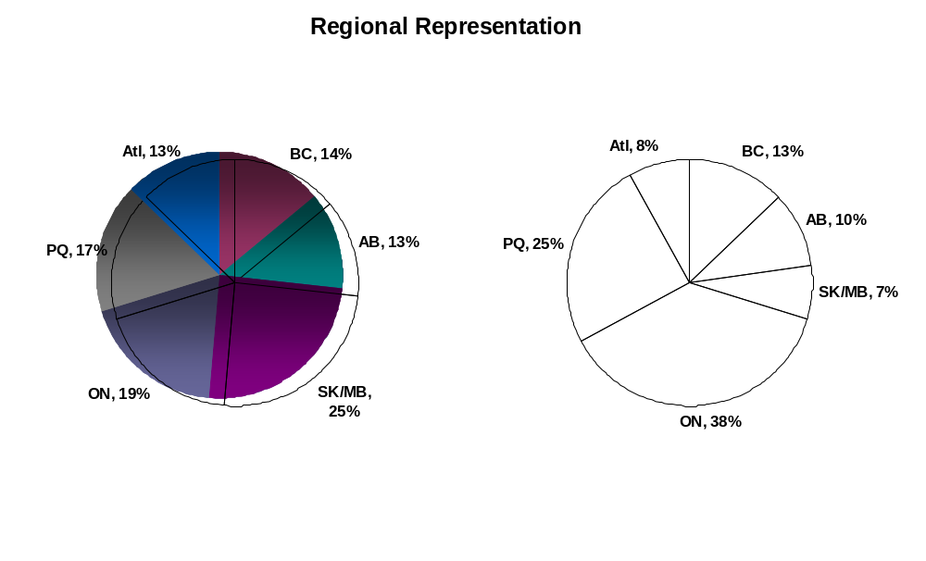

On average, Canadian households contain less than 3 people and those households with children have less than 2 living in their home.
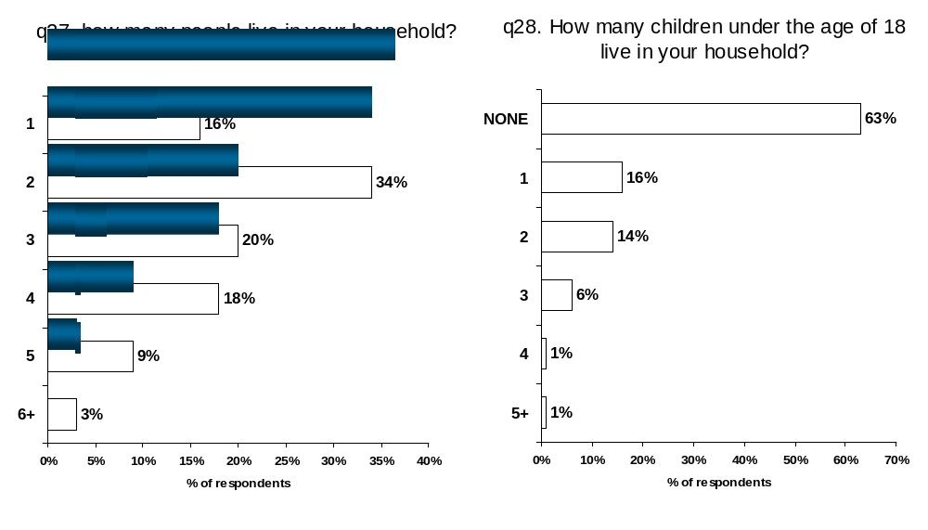

AGE, EDUCATION AND INCOME
 | Total | BC | AB | SK/MB | ON | PQ | Atl
 |  | A | B | C | D | E | F
Base: All respondents | 1600 | 225 | 200 | 400 | 300 | 275 | 200
AGE
18-24 | 7% | 9% | 8% | 7% | 6% | 6% | 8%
25-34 | 23% | 20% | 25% | 22% | 23% | 23% | 21%
35-44 | 20% | 18% | 18% | 14% | 23% | 19% | 18%
35-44 |  |  |  |  | C
45-54 | 20% | 22% | 24% | 25% | 16% | 21% | 21%
45-54 |  |  | D | D
55-64 | 16% | 17% | 14% | 12% | 16% | 19% | 13%
55-64 |  |  |  |  |  | C
65+ | 13% | 13% | 11% | 20% | 13% | 12% | 17%
65+ |  |  |  | ABDE
Not Stated | 1% | 1% | 1% | 0 | 2% | 1% | 2%
EDUCATION
High School or Less | 30% | 28% | 31% | 39% | 27% | 33% | 37%
High School or Less |  |  |  | AD |  |  | AD
Some/Completed College or Technical School | 28% | 27% | 27% | 26% | 30% | 26% | 32%
Some/Completed University | 41% | 44% | 42% | 35% | 44% | 41% | 29%
Some/Completed University |  | CF | F |  | CF | F
Not Stated | 0% | 1% | 0% | 0% | 0% | - | 2%
Not Stated |  | E |  |  |  |  | DE
INCOME
Under $15,000 | 7% | 7% | 5% | 7% | 5% | 9% | 12%
Under $15,000 |  |  |  |  |  |  | BD
$15,000 to less than $20,000 | 6% | 6% | 7% | 6% | 4% | 8% | 9%
$15,000 to less than $20,000 |  |  |  |  |  | D | D
$20,000 to less than $25,000 | 6% | 7% | 3% | 7% | 5% | 6% | 10%
$20,000 to less than $25,000 |  |  |  |  |  |  | BD
$25,000 to less than $30,000 | 6% | 7% | 7% | 7% | 6% | 5% | 5%
$30,000 to less than $40,000 | 9% | 8% | 7% | 12% | 9% | 9% | 15%
$30,000 to less than $40,000 |  |  |  | B |  |  | ABDE
$40,000 to less than $50,000 | 11% | 11% | 12% | 10% | 11% | 11% | 12%
$50,000 to less than $75,000 | 18% | 22% | 16% | 17% | 19% | 19% | 11%
$50,000 to less than $75,000 |  | F |  | F | F | F
$75,000 to less than $100,000 | 12% | 12% | 14% | 9% | 11% | 12% | 11%
$100,000 or more | 12% | 8% | 15% | 9% | 14% | 12% | 5%
$100,000 or more |  |  | ACF |  | F | F
Not Stated | 13% | 12% | 14% | 17% | 17% | 8% | 10%
Not Stated |  |  | E | EF | EF

T-Tests measure distances between the confidence intervals associated with sample data.

