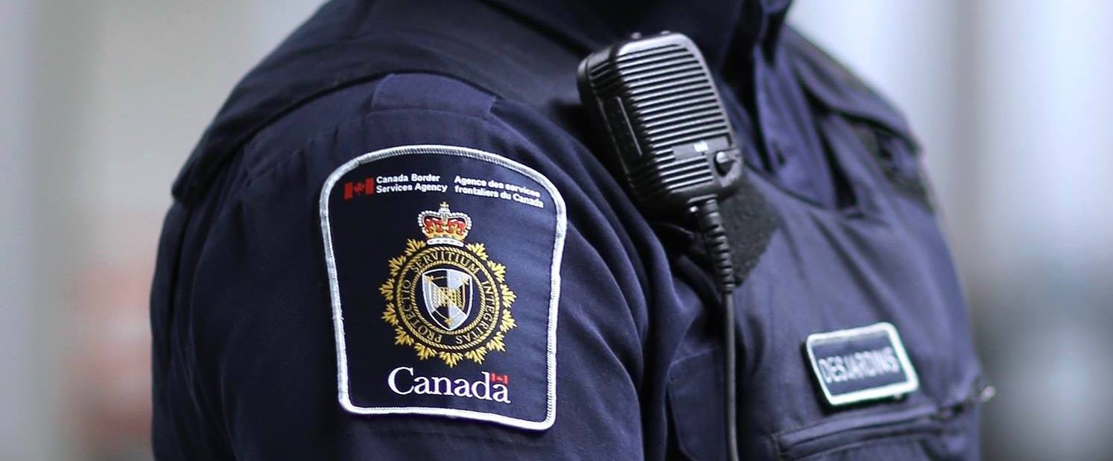

Canadian Views on CBSA and Border Management
Findings from 2020 General Population Survey and Focus Groups

Prepared for the Canada Border Services Agency (CBSA)
Supplier name: Ipsos Public Affairs
Contract number: 47419-200406/001/CY
Contract value: $174,443.41
Award delivery: 2020-01-28
Delivery date: January 6, 2021
Registration Number: POR-079-19

For more information on this report, please contact the Canada Border Services Agency at: por-rop@cbsa-asfc.gc.ca

Ce rapport est aussi disponible en français

Canadian Views on CBSA and Border Management
Findings from 2020 General Population Survey and Focus Groups
Final Report

Prepared for the Canada Border Services Agency (CBSA) Supplier name: Ipsos Public Affairs January 2021
This public opinion research report presents the results of a quantitative telephone survey conducted with 2,000 adult Canadians in March 2020; a quantitative survey which was conducted among 96 industry and business stakeholders via an open-link survey that was live between March and November 2020; and a series of 10 focus groups conducted by Ipsos Public Affairs on behalf of the Canada Border Services Agency. The focus groups were conducted with 85 adult Canadians in October and November 2020.
This publication may be reproduced for non-commercial purposes only. Prior written permission must be obtained from the Canada Border Services Agency. For more information on this report, please contact the Canada Border Services Agency at por-rop@cbsa-asfc.gc.ca.

Catalogue Number: PS38-108/2020E-PDF
International Standard Book Number (ISBN): 978-0-660-34966-4
Related publications (registration number: POR 079-19): Catalogue Number PS38-108/2020F-PDF ISBN 978-0-660-34967-1

© Her Majesty the Queen in Right of Canada, as represented by the Minister of Public Works and Government Services, 2020
POLITICAL NEUTRALITY STATEMENT
I hereby certify as Senior Officer of Ipsos that the deliverables fully comply with the Government of Canada political neutrality requirements outlined in the Communications Policy of the Government of Canada and Procedures for Planning and Contracting Public Opinion Research. Specifically, the deliverables do not include information on electoral voting intentions, political party preferences, standings with the electorate or ratings of the performance of a political party or its leaders.
Mike Colledge
President
Ipsos Public Affairs

Contents
1 Executive Summary 6
1.1 Introduction and Background 6
1.2 Research Objectives 6
1.3 Methodology 8
1.3.1 Table 1: Focus Groups Sample Profile 10
1.4 Notes to Readers 11
1.4.1 Interpretation of Qualitative Findings 11
1.5 Contract Value of the Public Opinion Research 11
2 Key Findings 12
2.1 Quantitative Research 12
2.2 Qualitative Research 14
3 Detailed Results: General Population Survey 16
3.1 Travel Habits of Canadians 16
3.2 Perceptions of Border Security 18
3.3 Awareness of CBSA 22
3.4 Impressions of CBSA 25
3.5 Interaction with CBSA Officers During Last Trip 27
3.6 Experience with Primary Inspection Kiosks During Last Trip 29
3.7 NEXUS 30
3.8 Border Crossing Information 32
4 Detailed Results: Stakeholder Survey 36
4.1 Moving Goods and Understanding Requirements 36
4.2 Interaction with the CBSA 37
4.3 E-Commerce 39
4.4 Customs Brokers 40
4.5 Awareness of and Participation in Trusted Trader Programs 42
4.6 Privacy 46
4.7 Awareness of Administrative Monetary Penalties (AMP) 47
4.8 COVID-19 48
4.9 Concluding Section 50
5 Detailed Results: Focus Groups 52
5.1 Perceptions of the CBSA 52
5.1.1 Effectiveness of the CBSA 52
5.1.2 Experiences with Border Services Officers 52
5.1.3 Types of Border Crossing Information and Sources 56
5.1.4 CBSA Careers 59
5.2 Awareness of Products and Services 61
5.2.1 Awareness, Perceptions and Use of NEXUS 61
5.2.2 Opinions on Collection of Additional Information 63
5.2.3 Electronic Inspection Kiosks 65
5.3 COVID-19 and Travel 67
5.3.1 Awareness and Impressions of the CBSA during COVID-19 67
5.3.2 Sources and Credibility of Information on COVID-19 and Travel 68
5.3.3 Expectations of Future Travel and Role of the CBSA 70
5.3.4 CBSA Land and Air Crossing Videos 71
6 Appendix 74
6.1 Sampling: General Population Survey 74
6.2 Non-Response: General Population Survey 75
6.3 Weighting: General Population Survey 75
6.4 Sampling: Stakeholder Survey 77
6.5 Weighting: Stakeholder Survey 77
6.6 Questionnaire: General Population Survey (English) 78
6.7 Questionnaire: General Population Survey (French) 90
6.8 Questionnaire: Stakeholder Survey (English) 102
6.9 Screening Questionnaire (English): Focus Groups 110
6.10 Screening Questionnaire (French): Focus Groups 115
6.11 Discussion Guide: Focus Groups 121
6.12 Discussion Guide (French): Focus Groups 126

Executive Summary

Introduction and Background
The Canada Border Services Agency (CBSA) has a mandate to provide integrated border services that support national security and public safety priorities, while facilitating the free flow of legitimate trade and travel. By doing so, the CBSA is an integral part of Canada’s Public Safety Portfolio by protecting Canadians and maintaining a peaceful and safe society.
Over the last few years, the CBSA has faced and addressed new challenges in implementing its mandate. This includes effectively managing a surge in asylum claimants at numerous points across the country over the course of the past few years and implementing new technologies for the important work that the organization conducts for Canadians. Further highlighting the CBSA’s role as a front-line agency that safeguards the safety and security of Canadians, the agency has also recently had to implement measures to protect against the global spread of COVID-19.
As part of the Federal Government’s Blueprint 2020, the CBSA has been proactive in implementing new programs and initiatives to transform the organization and prepare for the future. For example, as part of this endeavor, the CBSA improved services to air travellers by introducing Primary Inspection Kiosks (PIKs) at six major airports. The organization continues to strengthen its commitment to healthy workspaces through a wide variety of wellness initiatives, and the CBSA is transforming the border experience by implementing the CanBorder – eDeclaration program.
In order to continue to fulfil its mandate to Canadians and prepare the organization for future challenges, it is essential for the CBSA to understand Canadians’ knowledge, awareness, perceptions, and behaviours related to both the CBSA itself and the border crossing experience. Furthermore, information about Canadians’ attitudes towards the possibility of a friend or relative pursuing a career with the CBSA will shed light on how the agency is perceived and will help direct recruitment efforts.
Additionally, the CBSA would like to explore the attitudes, opinions, and experiences of business stakeholders during their regular interactions with the Agency and focus on topics associated with innovation and economy. As the timing of the survey also corresponded with the COVID-19 pandemic in Canada, questions related to how the pandemic has affected cross-border trade were also added.
The CBSA has previously carried out public opinion and client satisfaction surveys in 2007 and 2017. This report will detail new research conducted in 2020 that will update previous research conducted by measuring changes in client satisfaction and public opinion towards the CBSA and border-related topics, while investing a number of new topic areas that are included in the 2020 survey.

Research Objectives

Information gained through this survey will be used by the CBSA to assess progress in meeting organizational objectives and to better evaluate Canadians’ understanding of the CBSA and the border. Specifically, the objectives of the 2020 tracking survey are to:

- Obtain current information on the knowledge, awareness, perceptions and behaviours of Canadians related to the CBSA and the border; how Canadians recognize the CBSA and perceive the Agency and its services.
- Identify gaps in knowledge and awareness of the Agency’s programs and services within the traveller and commercial populations.
- Evaluate how Canadians who travel internationally perceive the effectiveness of communications and its impact on their behaviours (information sources, messaging of information intended for international travellers coming/returning to Canada).
- Evaluate how non-travellers perceive other issues such as detentions/removals, information sharing, privacy and other trending issues.
- Determine where threats to Canada are perceived to be coming from and the general confidence that Canadians have towards the CBSA in protecting Canada and Canadians.
- Determine how the Canadian public informs themselves of their obligations and responsibilities when crossing the border, their preferences on how they interact with the Agency and their level of satisfaction with services received.
- Identify where Canadians access information relevant to the border (travel and importing) and CBSA operations.
- Generate information that would help the CBSA better understand the actual concerns, barriers and opportunities perceived by Canadians on key issues (i.e. border wait times, security, access to services).
- Assess sentiment towards recruitment and level of support towards those who work or would work for the CBSA.
- Obtain sufficient demographic and psychographic information to develop key audience profiles of groups most likely to be engaged in CBSA issues.
In addition to the general population survey, the CBSA also carried out an online industry and business stakeholder survey. The stakeholder survey explored the attitudes, opinions, and experiences of CBSA’s business stakeholders, with particular emphasis on topics associated with innovation and economy, such as:
- Understanding of documentation requirements for the transport of restricted goods
- Interactions with the CBSA when asking a question related to their business
- Satisfaction with the CBSA in resolving questions or problems related to their business
- Use of customs brokers
- Adaptation to accommodate e-commerce values
- Participation in and satisfaction with Trusted Trader programs
- Awareness of the statistics on administrative monetary penalties posted to the CBSA website
- Ease of finding information related to import/export of goods during COVID-19
Qualitative focus groups were also carried out among Canadian travellers who use land and/or air crossings to provide a deeper dive into attitudes and opinion concerns the CBSA and the border.
The following areas were asked about in the March 2020 survey and viewed as opportunities to gain deeper insight via qualitative research:
  - Obtain current information on the knowledge, awareness, perceptions and behaviours of Canadians related to the CBSA and the border; how Canadians recognize the CBSA and perceive the Agency and its services.
  - Identify gaps in knowledge and awareness of the Agency’s programs and services within the traveller and commercial populations.
  - Identify where and how Canadians access information relevant to the border (travel and importing) and CBSA operations.
  - Assess sentiment towards recruitment and level of support towards those who work or would work for the CBSA.
  - Discuss information sharing and privacy (what are they comfortable with (say, in exchange for quicker passage/” trusted traveller” status?) and where do they draw the line? How can trust be gained/maintained?).
- Areas not included in the initial survey and that could be beneficial in informing current policy activity:
  - What do Canadians most recently recall hearing about the CBSA (be it in the news or via social media)?
  - What are Canadians impressions about the CBSA and border management from the onset of COVID- 19 to now?
  - Where do Canadians access information related to COVID-19 and travel?
    - Which sources do they trust and consider credible?
    - What do they need to know to be reassured and resume travelling?
  - Gauge intention to travel after the pandemic and expectations/concerns.
    - What do participants think that will look like?
    - What are their worries, thoughts etc. (delays, processes, what do they expect from us?)
    - Participants could view our videos explaining COVID-related changes to air and land entry and then be asked how they feel about the changes and their ability to facilitate safe travel and protect communities form further spread.

Methodology
To accomplish the research objectives mentioned above, the public opinion was carried out in three phases:
- Phase 1: Telephone survey among general population
- Phase 2: Online survey among business, industry, and stakeholders
- Phase 3: Focus groups among members of the general population
Phase 1 was carried-out among the general population of Canadian adults (18+) by telephone from March 5-29, 2020. A total of 2,000 interviews were completed. Respondents were recruited by telephone using dual-frame random digit dialing (RDD) methodology. In total, 1,300 interviews were carried-out on cell phones (65%), while the remaining 700 interviews were carried-out on landline phones. This dual-frame telephone approach is designed to produce a highly representative sample of respondents and considers the increasing number of Canadian households that either do not have a landline or have a landline, but use their cell phone as their primary telephone line. The average telephone interview duration was 14 minutes.
Quotas and weighting were employed to ensure that the sample reflects the adult population as determined by the latest census taken in 2016. The data has been weighted by age, gender, and region. Please see Section 4 for more details.
The overall findings of the research are considered to be accurate to within ±2.5 percentage points (19 times out of 20), of what the results would have been had all Canadian adults been surveyed. This interval will be wider among subsets of the population. Furthermore, all sample surveys may be subject to other sources of error, including, but not limited to coverage error, and measurement error.
Where appropriate, data in this 2020 wave has been tracked to a baseline study carried out in 2017. Data from a similar study in 2007 has also been included where possible. In some cases, changes to answer options will affect the direct comparability of findings and these instances are noted in the report. However, comparisons can still be made with regard to the overall trends observed in each wave.
Symbols have been used to indicate where the current wave’s results are statistically significant compared to the baseline study.
Phase 2 of the research was carried out by means of an online survey among commercial stakeholders involved in the import/export industry in some way. The link to the survey was distributed via email by the CBSA to members of the Border Commercial Consultative Committees (BCCCs) (21 members) and those receiving the survey link were encouraged to share the survey with their own membership lists. The Agency also promoted and sent reminders to encourage participation. The survey was live from March 13 to November 2, 2020. The COVID-19 pandemic emerged in Canada during this time, and could have impacted the survey participation rate. A total of 96 businesses completed the survey. For firmographic information on the sample and the contents of the survey, please see the Appendix.
As a result of the small sample size, weighting was not applied to this sample and should not be taken as being representative of the target population. Due to the small sample size, further made smaller by certain questions only being asked to specific types of businesses or business who have/have not undertaken a certain action, sub-group analysis was not carried out and all questions are reported in the aggregate.
Phase 3 was conducted by Ipsos on behalf of the CBSA, as follows:
- 1 Winnipeg online focus group and 1 Regina/Saskatchewan online focus group conducted on October 20, 2020
- 2 New Brunswick online focus groups conducted on October 21, 2020
- 1 Vancouver online focus group conducted on October 22, 2020
- 1 Calgary online focus group conducted on October 26, 2020
- 2 Montreal online focus groups conducted on October 28, 2020 in French
- 1 Toronto/GTA online focus group and 1 Windsor online focus group conducted on November 2, 2020
- Participants in all groups were a mix of frequent land and air crossing travellers prior to COVID-19 (before March 2020).

Table 1: Focus Groups Sample Profile
Variable | Number of participants
Location  Winnipeg, MB  Regina, SK  New Brunswick 1  New Brunswick 2  Vancouver, BC  Calgary, AB  Toronto, ON  Windsor, ON  Montreal, QC 1 (French)  Montreal, QC 2 (French) | 9  8  7  9  9  7  8  8  10  10
Area  Urban  Suburban  Rural | 57  22  6
Age  34 years and younger  35-44 years old  45-54 years old  55 years old or older | 33  20  19  13
Household income  Under $20,000  $20K to $40K  $40K to $60K  $60K to $80K  $80K to $100K  $100K to $150K  $150K or more  Refused | 2  8  8  15  24  19  7  2
Language  English-speakers  French-speakers | 65  20
Segment  Land Crosser  Air Crosser  Both | 38  45  2
Type of Travel  Business  Personal  Both | 7  59  19

Notes to Readers

Interpretation of Qualitative Findings
The findings presented for Phase 3 of this report are qualitative in nature. The value of qualitative research is that it allows for the in-depth exploration of factors that shape public attitudes and behaviours on certain issues. When interpreting the findings, it should be kept in mind that at no point is the intention to produce results that are statistically representative of the population at large. Separate quantitative surveys were conducted (Phases 1 and 2) and the report from those surveys should be consulted for a representative picture of attitudes and perceptions around border services.
The following chapters present the key themes – notably the findings were consistent across the different demographic groups and locations. The few notable sub-group differences have been called out where relevant. Quotes have been used throughout the report to illustrate key points in the voice of participants.

Contract Value of the Public Opinion Research
The contract value for this Public Opinion Research study is $174,443.41,

Key Findings

Quantitative Research

Awareness of and Experience with the CBSA
- Many Canadians are mobile and travelling abroad – two-thirds say they have travelled to another country in the past two years. On average, Canadians who have travelled abroad in the past two years have taken an average of 5 trips during this time period.
- As a result of these travelling behaviours, many Canadians have experience with the CBSA, usually at the nation’s airports upon their return to Canada. In fact, three-quarters say their last trip abroad was by air.
- Slightly more than half (57%) of Canadians are aware of the CBSA in some way, with about one quarter able to give the agency’s correct name on an unaided and open-ended basis when asked.
- Canadians typically come into contact with the CBSA in one of two ways, either through direct contact with a CBSA officer or through a primary information kiosk (PIK) at an international airport. Those who have had contact with a CBSA officer are also pleased with the service they received; over 9 in 10 say they had a positive experience with the CBSA officer and almost all said they were served in the official language of their choice.
- Of those who were searched and/or taken aside for further questioning, 9 in 10 say they believed that this was done in a respectful manner.
- Overall, Canadians have a very positive impression of the PIKs, rating them very highly on several attributes, such as communication, amount of time saved, and accessibility to individuals of all types.
- As such, perhaps it is not a surprise that Canadians view the CBSA in a favourable light. Almost 9 in 10 say that they have a positive impression of the CBSA.
- Further, 8 in 10 saying that they would be supportive of a family member of close friend who chose to pursue a career with the CBSA.
Managing the Canada-US Border
- Over three-quarters of Canadians believe that Canada is either doing a better job or doing a similar job as the US on border management. These opinions remain unchanged as compared to 2017.
- Compared to 2017, a larger proportion of Canadians believe that the border is more secure than 5 years ago (+6).
- This does not mean that Canadians are not concerned about border security. Four in ten are concerned that something or someone could enter Canada and threaten the security and safety of Canadians. Those worried about this issue cite terrorism, diseases, drugs, and weapons as their main concerns. However, one in five Canadians mentioned specifically COVID-19 or coronavirus as their main border management concern. This is not surprising, given the extraordinary circumstances that unfurled during fieldwork.
- Canadians also have confidence in the CBSA to successfully manage duties related to managing the border. They are largely confident in the CBSA’s ability to protect the personal information it collects from travel documents and keeping cargo moving across the border. Canadians are slightly less confident in the CBSA’s ability to identify and stop human trafficking and manage the entry of irregular asylum seekers into Canada. It is worth nothing that over half of Canadians continue to be confident in the agency’s ability to carry out these tasks.
Business/Industry Stakeholders
- Three-quarters (74%) of businesses surveyed say that the process of moving goods into Canada is efficient in some way. Among exporters, carriers, and service providers, 83% report being confident in knowing what documentation is required to export regulated goods from Canada. However, almost half (48%) of these same businesses say that the CBSA’s reporting requirements are difficult to understand.
- Almost all of businesses surveyed (94%) say that they have contacted the CBSA with a question or issue related to their business within the past two years. Of these, nine in ten (90%) say they were either ‘very satisfied’ or ‘somewhat satisfied’ with the courtesy of the CBSA representative they talked to. However, they were a little less satisfied with being the representative being able to answer their question (64%) or getting a prompt response (58%).
- Three-quarters (76%) of businesses surveyed said that they have adapted to accommodate e-commerce volumes. The remaining proportion may either have problems in meeting these volumes, or do not see it as particularly relevant to their business.
- Use of customs brokers is relatively widespread among those importing/exporting goods across the border. Three-quarters (76%) of businesses surveyed use a customs broker at least ‘sometimes’ to help facilitate shipping their goods across the border.
- The most common reason for hiring a customs broker is to assist in customs clearance (85%). However, customs brokers are also hired to carry out other functions such as tariff classification (46%), customs valuation (26%), international trade consulting (26%), freight management and consolidation (21%), regional/national warehousing (15%), and import/export purchase order management (10%).
- Awareness of CBSA’s Trusted Trader programs is very high among businesses surveyed. Nearly all (94%) report being at least nominally aware of the existence of such programs. Among those aware, two-thirds (66%) say they participate in these programs.
- Businesses that participate in the Trusted Trader programs are on the whole satisfied with various aspects of their membership. In particular, seven in ten (69%) of those surveyed who participate in these programs say they are satisfied to some degree with the benefits of these programs relative to their cost.
- When asked whether their organization (and their customers) would be willing to provide additional advance information to the Government of Canada in order to make the border clearance process smoother, 79% say they are willing to do so.
- Three-quarters (73%) of businesses surveyed say they were aware of the administrative monetary penalty statistics on the CBSA website, and six in ten (60%) of those aware say that they were useful in helping their business comply with customs requirements.
- In the case of communication system outages, email notifications are by far the preferred method of being notified (90%).
- Looking ahead, businesses surveyed mentioned issues with CBSA Assessment and Revenue Management (CARM) as one of the most pressing issues for the Agency to address (17%).

Qualitative Research

Focus Groups
- Overall focus group participants had positive to neutral perceptions of CBSA – the agency is seen as being effective in protecting Canada’s borders, particularly given the size of the border and the scope and scale of activities involved.
- Awareness and perceptions of the CBSA are mostly being driven by interactions with border service officers, and service experiences at land and air crossings. There was very little awareness of CBSA in the news, on social media, or in careers other than as border service officers.
  - The key factors that drive perceptions are the demeanour of border services officers, wait times, and past experiences having belongings or vehicles searched.
  - Key areas for improvement would be in reducing wait times, and providing greater consistency and more standardization across experiences with border services officers.
- Trusted sources of information are the CBSA and federal government website for information about border crossing, and this expands to established national and local news media outlets and journalists for information about COVID-19 travel – these are preferred both for their accuracy and credibility.
  - Social media and other sources are considered less reliable, and are used more as secondary sources. Use of supplementary research when using these sources is common.
- Modernization via digital and online tools, and the use of data, was generally viewed favourably if it tangibly results in a more efficient process and shorter wait times. As such, electronic inspection kiosks were mostly viewed favourably. However, comfort with providing more personal information was polarized between those who had no issues with this idea, and others who would need to find out more details in order to form an opinion, or were opposed to the idea in principle.
  - CBSA’s website, the CanBorder app, the ArriveCAN app for COVID-19, and social media were all viewed as useful tools that do or could facilitate easier and smoother travel, even if intent to use these was mixed.
- In order to feel comfortable traveling again post COVID-19, this would need to involve a combination of factors: a widely available and disseminated effective vaccine, and declarations by public health figures and government that it is safe to travel again.
- There is much uncertainty and mixed views about what travel will look like post-COVID-19. The CBSA’s role would be in providing credible information to the public, and planning to the degree possible for a surge in demand or general uncertainty and confusion in airports and at land crossings when travel resumes.
- The CBSA land and air crossing videos were effective in providing information and reassurance about measures taking place, but could go further in terms of pulling apart the roles of various agencies, and reassuring the public about enforcement.

Detailed Results: General Population Survey

Travel Habits of Canadians
Most Canadians have travelled abroad in the past two years, meaning that many Canadians have had the opportunity to interact with the CBSA and other foreign border agencies. In fact, two-thirds (66%) of Canadians say that they have travelled to another country within the past two years. Given the country’s vast size and location on the North American continent, it is not surprising that the most popular means of transport for Canadians going abroad is by plane (58%), followed by car/motorcycle (39%). The latter means is more popular among those residing in British Columbia (45%), Ontario (44%), and Saskatchewan and Manitoba (42%). This no doubt has to do with the proximity of Canadian urban centres in these provinces to popular destinations in the United States, such as Seattle, New York City, or various tourist destinations.
Of those who reported travelling abroad in the past two years, approximately 5 trips have been taken on average. There is some regional variation, as British Columbians who travelled abroad in the past two years report the highest average number of trips in the past two years (8.4), followed by Ontarians (7.8), and those living in Atlantic Canada (7.5).
Further speaking to the frequency with which Canadians travel abroad, almost 6 in 10 (59%) Canadians who said they travelled abroad at least once in the past two years said their most recent trip was sometime within the past six months. This proportion climbs to 64% among those in British Columbia who travelled in the past two years and 60% among Ontarians having done the same.
- Frequency of Travel Abroad
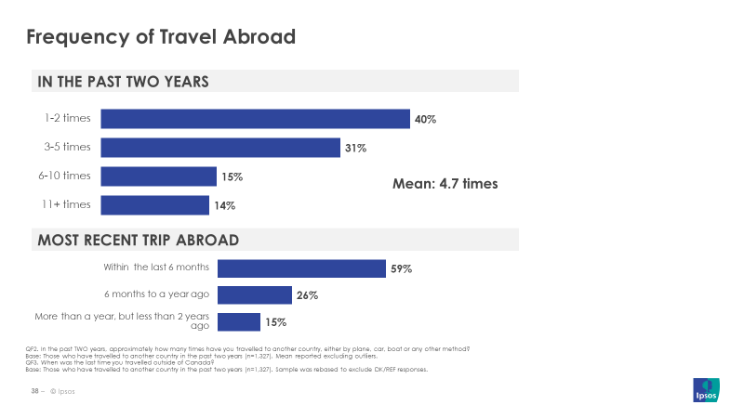
QF2. In the past TWO years, approximately how many times have you travelled to another country, either by plane, car, boat or any other method?
Base: Those who have travelled to another country in the past two years (n=1,327). Mean reported excluding outliers.
QF3. When was the last time you travelled outside of Canada?
Base: Those who have travelled to another country in the past two years (n=1,327). Sample was rebased to exclude DK/REF responses.

Delving deeper in the most recent trip taken by these Canadians who report going abroad within the past two years gives an interesting portrait of Canadians’ travel habits. Of these people, almost three-quarters (72%) returned to Canada by plane, with another quarter (25%) returning to the country by car. There is a definite regional dimension when it comes to the mode of transport used on Canadians’ most recent trip abroad. While air travel is undoubtedly popular across the entire country, those living in Alberta (82%), Atlantic Canada (81%), and Quebec (79%) are more likely to say their most recent trip abroad was by plane. Travel by car is more cited by those living in British Columbia (36%), Saskatchewan and Manitoba (33%), and Ontario (30%).
In addition, a large majority (90%) of Canadians who have been outside of the country in the past two years say their most recent trip abroad was for personal reasons, with the remaining 10% saying their trip was for business reasons. Those travellers aged 55+ are even more likely to say their most recent trip was for personal reasons (94%).
Canadians are also varied in the places where they go when they leave the country. While over half (54%) who travelled abroad in the past two years said their most recent trip was to the United States, other popular destinations include Mexico/Caribbean/Latin America (24%), and Europe (13%). Quebecers who travelled abroad in the past two years are significantly less likely to say their most recent trip was to the US (38%), but more likely to say that trip was to Mexico/Caribbean/Latin America (34%). Furthermore, three-quarters (73%) of those whose most recent trip was for business purposes say they went to/via the US.

- Profile of Travellers Returning to Canada Within Past Two Years
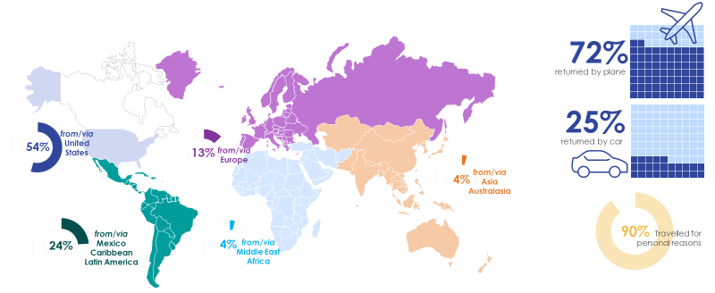QF4. From which country/region did you return on your LAST trip? If you connected through another country, please indicate the last country that you travelled through before entering Canada.
QF5. And how did you RETURN to Canada on your last trip? Was it ... ?
QF6. Was this trip for personal or business reasons?
Base (all questions): Those who have travelled to another country in the past two years (n=1,327).

Perceptions of Border Security
Nearly half of Canadians (45%) recall hearing something in the past year about actions by the Government of Canada to strengthen Canadian border security and safety, which is a statistically significant increase of 4 points since 2017. More significant is the increase in the proportion who say they clearly recall hearing about the government’s actions related to border security specifically (22%, +8).
Those who are aware of the CBSA, who have travelled more frequently abroad in the past two years, or have travelled recently are more likely to indicate they recall something about boarder security. Those aged 55+ (31% vs, 18-34 12%, 35-54 20%) are also more likely to recall than their younger counterparts. Notably, British Columbia (60%) and Quebec (60%) residents are more likely to display no recall compared to residents in Ontario (50%), Saskatchewan/Manitoba (47%), and Atlantic Canada (47%).
In addition to actions related to safety and security at the border, a similar proportion (41%) recall hearing about Government of Canada actions to support the flow of travellers and trade across the border.
Once again, frequent travellers (11 or more times vs. less than 6 times) are more likely to indicate clear recall of such actions, as are those who are aware of the CBSA (25% vs. 12% unaware). This trend also holds true for those aged 55+ (29% vs. 18-34 14%, 35-54 15%), compared to younger Canadians. Quebec residents are most likely to display no recall (68%), compared to all other regions. NEXUS members (30% vs. 22% non members), and those who have come back from the US on their most recent trip (24%), are significantly more likely to clearly recall government action to support cross border flow of travellers and trade, compared to those who returned from Mexico, Caribbean/Latin America (19%) or from countries outside Europe (12%).

- Awareness of Actions Taken by Government of Canada
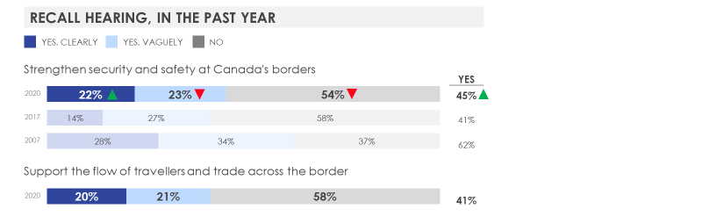
QA1. In the past year, do you recall hearing about any actions that the Government of Canada has taken to:
Base: All respondents 2020 (n=2,000); 2017 (n=2,310); 2007 (n=3,025)
Of those who said they have heard of actions the Government of Canada has taken in the past year to either strengthen security and safety at the border and/or support the flow of travellers and trade across the border, trade is the most often mentioned topic specifically (16%). This is understandable, given that the Canada-United States-Mexico Agreement (CUSMA) has received a large amount of attention in the last two years.
Other issues that were spontaneously mentioned by those who report hearing of actions include controlling illegal immigration and refugees (13%), followed by various coronavirus/COVID-19-related mentions (such as border closures and prevention protocols). The prominence of these mentions is also understandable, as the current wave was in-field and interviewing conducted during a turbulent time for the Canada-US border with regard to COVID-19. For example, both countries jointly announced on March 18 the temporary closure of the border.
These mentions are certainly a snapshot of the political and economic juncture of the time in field. The 2020 results mark a different pattern from the 2017 wave, when the most often cited actions had to do with refugees (22%). This was a time when the refugee crisis figured prominently in the news media. Furthermore, the results from both 2017 and 2020 are also different from the 2007 wave, when passport regulations (34%) were the most cited action. This was most likely the result of a change in US policy that required a passport to cross into Canada.
- Actions that the Government of Canada has taken
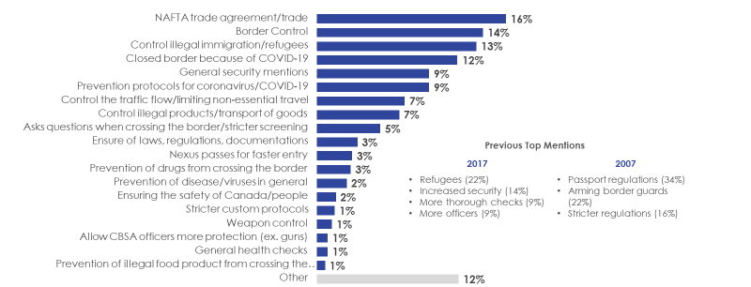 QA2. What actions do you recall hearing about?
Base: Those who say they recall hearing about actions taken to either strengthen security and safety at Canada’s borders and/or to facilitate the flow of travellers and trade across the border, excluding “Don’t know/refuse” responses 2020 (n=896); 2017 (n=934)

A larger proportion of Canadians believe that the Canada-US border is more secure now than five years ago. Almost half (47%) agree that the border is safer, a six-point increase from 2017. Residents of Atlantic Canada (58%) and Ontario (51%) are the most likely to agree, compared to other regions.
Expectedly, those who have a positive impression of the CBSA are more likely to agree that the Canada-US border is more secure (50%) compared to those who have a negative impression (28%) of the CBSA. This indicates that impressions of the agency can translate into confidence in the role that it plays.
While there is an increase in the proportion those who are neutral on this issue (33%, +4), what is more remarkable is the large drop in those who disagree with this statement (17%, -11) when compared to 2017.
- Perceptions of Security at Canada-US Border
QB1. Please rate the degree to which you agree or disagree with the following statement using a 7-point scale,
where 1 means you strongly disagree, 7 means you strongly agree, and the mid-point 4 means you neither agree nor disagree.
Base: All respondents (n=2,000); 2017 (n=2,310); 2007 (n=3,025)
The issue of border management can be seen in relative terms; international travel inevitably involves experiencing border control in at least one other country before coming back to Canada. Generally speaking, a majority of Canadians believe that their country does either a better or similar job as the US when it comes to border management.
Those aged 18 to 34 (42% vs. 32% 35-54, 34% 55+) are more likely to say Canada’s border management is better than the US. On the other hand, those who travelled to the US on their most recent trip are more likely to say Canada does a worse job than the US at border management (22% vs. 12% among those who went to Europe for last trip).
- Relative Perceptions of Border Management
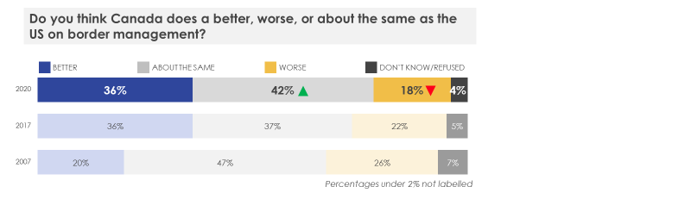 QB2. Compared to the United States, do you think Canada does better, worse, or about the same on border management?
Base: All respondents (n=2,000); 2017 (n=2,310); 2007 (n=3,025)
Generally speaking, Canadians’ level of concern about border security has not significantly increased since 2017. Four in ten (42%) report being concerned to some degree about people or goods entering Canada that could threaten the country’s safety and security. This year, fewer Canadians say they are concerned about border security (32%, -5), while more Canadians hold a neutral opinion about border security concerns (26%, +4).
Those who have not travelled at all in the past two years are more likely to be concerned with border security, compared to those who have travelled. However, while travel may alleviate concern, those with extremely frequent travel such as those who have travelled over 20 times in the past two years report the highest level of concern (53%) compared to less frequent travellers.
Those who are aware of CBSA (44% vs. 37% unaware), NEXUS members (50% vs. 40% non members), and those who have a negative impression of CBSA (64% vs. 40% positive impression) are more likely to be concerned about the entry of goods and people that may threaten Canadian security.
- Concern over Border Security
QB3. How concerned are you that some of the people or goods entering Canada could threaten the safety and security of Canadians?
Please use a 7-point scale where 1 is not at all concerned, 4 is somewhat concerned, and 7 is very concerned.
Base: All respondents (n=2,000); 2017 (n=2,310); 2007 (n=3,025)
While a portion of interviewing in 2020 was conducted during the extraordinary time of the COVID-19 pandemic, terrorism remains the main threat to border security in among those who report being concerned about border security (22%). Nonetheless, diseases/viruses join terrorism as the top threat as a quarter (21%) mention being most concerned about such illnesses, no doubt lifted to the top by specific mentions of coronavirus (9%). However, not all mentions of disease are related to COVID-19 but are more general (13%); for example, worries about disease from food or imported agricultural products also fall into this category. Residents of Quebec (31%) are most likely to mention being concerned diseases, viruses, or, COVID-19. Fewer Canadians mention concerns associated with drugs (10%) or weapons (8%).
With the exception of general mentions of diseases and specific mentions of coronavirus/COVID-19, Canadians’ perceived threats roughly follow a similar ranking as in 2017: terrorism, drugs, and weapons. Much had been made in recent years over illegal immigration into Canada, only 5% of those concerned about border security cite illegal immigration as their main worry.
- Specific Threats to Border Security
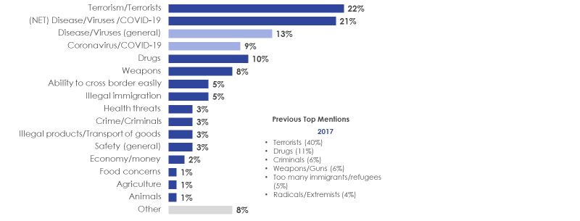 QB4. What type of threat are you most concerned about? (RECORD FIRST RESPONSE)
Base: Those who are concerned about threats crossing the border into Canada, excluding “Don’t know/refuse” responses 2020 (n=1,258); 2017 (n=1,407)

Awareness of CBSA
Roughly seven in ten Canadians (69%) believe that there is a single department or agency tasked with the primary responsibility of managing Canada’s borders, a decrease of 8 points from 2017. This decrease in the proportion who attribute primary responsibility to a single department could be based on confusion around multiple organizations being involved with border management, particularly related to immigration and customs.
Respondents who have travelled in the past two years (72% vs. 62% did not travel), those who are from Quebec (78% vs. all other regions), and those who are older (72% 35-54, 73% 55+vs. 58% 18-34) are more likely to be aware that a single department has primary responsibility.
- Awareness of Border Management Agency
QC1. To the best of your knowledge, is there a single department or agency of the Government of Canada that has primary responsibility for managing Canada's borders?
Base: All respondents (n=2,000); 2017 (n=2,310); 2007 (n=3,025)
Among those who say they are aware of a government agency primarily responsible for Canada’s borders, half (48%) are able to spontaneously name some variation of the CBSA’s name. Those who have travelled in the past two years or have travelled more frequently are more likely to name a variation of the CBSA. However, the most common incorrect answers revolve around the theme of immigration, and customs.
- Unaided Awareness of the CBSA
QC2. What is the name of that department or agency?
Base: Those reporting being aware of a department or agency responsible for managing Canada’s borders, excluding “Don’t know/refuse” responses (n=1,008).
However, awareness on an aided basis increases to 68% when those who say they are not aware of a government agency primarily responsible for the border or who attribute responsibility to the wrong organization are asked if they have ever heard of the Canada Border Services Agency or the CBSA. Those who have travelled in the past two years (71% vs 61% have not travelled), are NEXUS members (89% vs. 76% non-member) or travelled to the US on their most recent trip (77% vs, 65% Europe, 58% other) are more likely to be able to recall the CBSA on an aided basis.
- Aided Awareness of the CBSA
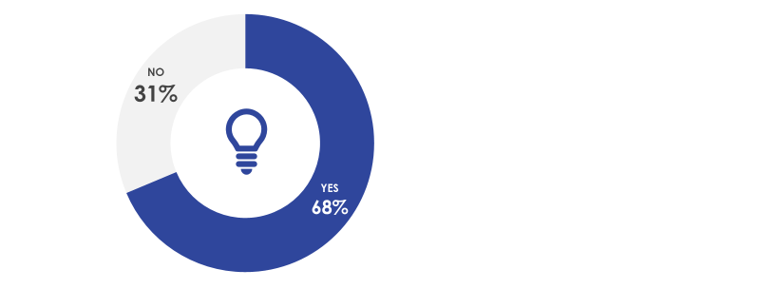 QC3. Have you heard of the Canada Border Services Agency or CBSA?
Base: Those who report not being aware of a department or agency responsible for managing Canada’s borders or attribute responsibility to the wrong organization, excluding “Don’t know/refuse” (n=976).
Taking into account those who can either spontaneously name the CBSA correctly and those who say they are aware of the agency when prompted on an aided basis, almost six in ten (57%) of Canadians are aware of the agency to some degree. Understandably, those who are members of NEXUS are more likely to be aware (83%), as are those who have travelled abroad in the past six months (67%) and likely to have their border crossing experience fresh in their minds. That being said, total awareness is lower in Quebec than in the rest of Canada (42%) and among younger Canadians aged 18-34 (48%).

- Total Awareness of the CBSA
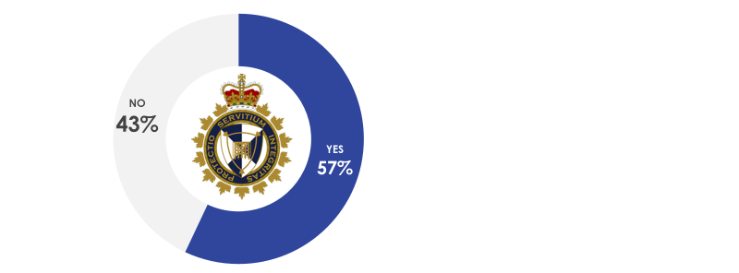
Unaided Awareness + Aided Awareness
Base: All Respondents (n=2000)

While the CBSA shoulders a variety of responsibilities related to managing Canada’s borders, Canadians mostly believe that its most important role is border control (32%) and older respondents (33% 35-54, 34% 55+ vs. 27% 18-34) are more likely to believe as much. Roughly a quarter believe that the agency’s most important role is controlling illegal products and the transport of goods (27%) and ensuring people’s safety (21%).
Fewer believe that the CBSA’s most important role is asking questions when crossing the border (15%), preventing drugs from crossing the border (12%), enforcing laws, regulations, and documentation (10%), preventing illegal weapons from crossing the border (8%), controlling illegal immigration (7%), preventing crime from crossing the border (5%), and preventing terrorism from crossing the border (3%).
- Canada Border Services Agency role in protecting the border
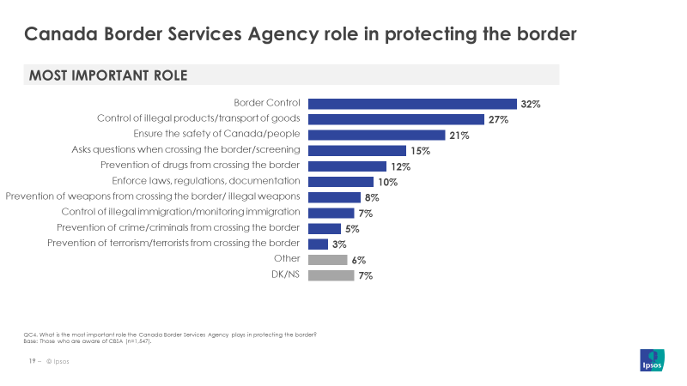 QC4. What is the most important role the Canada Border Services Agency plays in protecting the border?
Base: Those who are aware of CBSA (n=1,159).

Impressions of CBSA
Canadians have a positive view of the CBSA as almost 9 in 10 (87%) say that they have a ‘strongly positive’ or ‘somewhat positive’ impression of the agency. Quebec residents are the least likely to say that they have a ‘strongly positive’ view of the agency (14% vs. all other regions). On the other hand, those who returned from their last trip by car (32%) have a more ‘strongly positive’ impression of the CBSA than those who returned by plane (26%, indicating a positive difference in the land border crossing experience.
- Overall Impression of the CBSA
QC5. What is your OVERALL IMPRESSION of the Canada Border Services Agency? Would you say… (READ LIST)
Base: Those who are aware of CBSA (n=1,159). Previous Waves’ Base: All respondents 2017 (n=2,310); 2007 (n=3,025)
Note: Answer choices changed for 2020 to exclude a “neither positive nor negative” option. As a result, only “strongly” and “somewhat” positive responses from 2007 and 2017 are included for comparison purposes. Please note that changing the answer options affects the comparability of this wave to previous waves.
In addition to having a favourable opinion of the agency, Canadians say they are confident in the agency’s ability to keep people and goods moving across the border and protect the country from various threats in a responsible manner. Canadians’ level of confidence in the CBSA to adequately carry out various tasks fall under three tiers.
The first tier consists of the areas in which Canadians are most confident in the CBSA: protecting the personal information that it collects from passports and other travel documents (77%) and keeping traffic/cargo moving across the border (76%).
The next set of tasks Canadians are confident in relate to the CBSA’s ability to applying the right balance between securing the border and protecting privacy rights (69%), identifying and stopping dangerous people before they enter Canada (66%), and identifying and stopping illegal goods such as drugs and guns before they enter Canada (64%).
Finally, Canadians are slightly less confident in the CBSA’s ability to manage the entry of irregular asylum seekers into Canada (55%) and to identify and stop human trafficking (55%). Nonetheless, the fact that over half of Canadians have confidence in the agency’s ability carry out any range of responsibilities related to protecting the border while ensuring the smooth flow of goods and people across the border should be reassuring for the CBSA.
Those who have travelled in the past two years, younger Canadians, and residents of Atlantic Canada are more likely to have confidence in the CBSA’s ability to manage these issues.
- Confidence in the CBSA
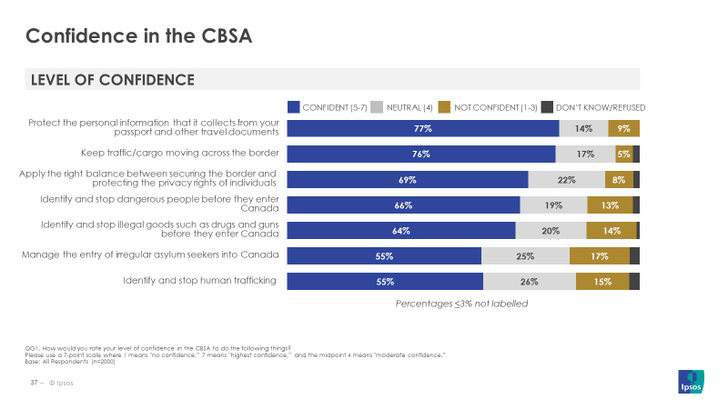
As you may know, the Canada Border Services Agency or CBSA is responsible for a number of activities including identifying and stopping inadmissible people and illegal goods from entering Canada, collecting duties and taxes on goods being brought into Canada, and detaining and removing people who are not allowed to be in Canada.
QG1. How would you rate your level of confidence in the CBSA to do the following things?
Please use a 7-point scale where 1 means "no confidence,” 7 means "highest confidence,” and the midpoint 4 means "moderate confidence.”
Base: All Respondents (n=2,000)
In addition to having a generally positive view of the CBSA and having confidence in the agency’s ability to protect the security and safety of Canadians, many Canadians also would have a favourable opinion of anyone close to them who would choose to work for the CBSA. Of those aware of the agency, 80% report that they would be supportive if a close friend or family member chose to pursue a career with the CBSA. Another 16% would be indifferent, meaning that the remaining 4% would either be not supportive of this friend/family member or refused to answer the question.
As would be expected, those who have a positive impression of the agency, would also be more supportive of their friends/family in pursuing a career with it (85% vs. 61% negative impression). Those aged 18 to 34 (74% vs. 83% 35-54, 84% 55+) and residents of Saskatchewan/Manitoba (67%) or Quebec (75%), are least likely to be supportive of pursuing a career with CBSA.
- Support for Family Member/Close Friend Pursuing Career with the CBSA
QC6. How supportive or unsupportive would you be if a close friend or family member chose to pursue a career with the Canada Border Services Agency?
Base: Those who are aware of CBSA (n=1,159).

Interaction with CBSA Officers During Last Trip
Those Canadians who have interacted with a CBSA officer while returning to Canada rate their experience very highly; a large majority (95%) say their experience was positive, with two-thirds (66%) saying that it was ‘very positive’.
Respondents from Quebec are the least likely to share this ‘very positive’ impression (43%), compared to respondents from other regions. Those who returned from their last trip via car (72%) are more likely than those who returned by plane (60%) to report a ‘very positive’ experience. Interestingly, those who travelled more recently in the past six months (72%) are more likely to have had a very positive experience than less recent travellers (59% 6 months to a year ago).
- Overall Impression of Experience with CBSA Officers
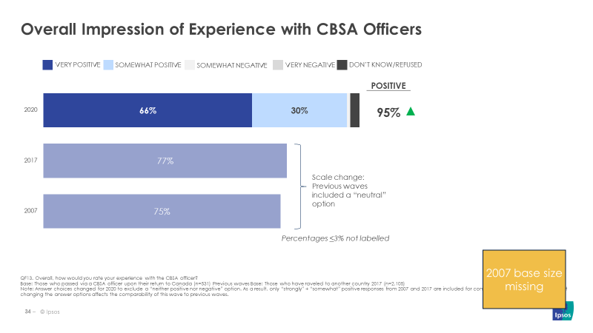

QF13. Overall, how would you rate your experience with the CBSA officer?
Base: Those who passed via a CBSA officer upon their return to Canada (n=531). Previous waves Base: Those who have traveled to another country 2017 (n=2,105)
Note: Answer choices changed for 2020 to exclude a “neither positive nor negative” option. As a result, only “very positive” + “positive” responses from 2007 and 2017 are included for comparison purposes. Please note that changing the answer options and base affects the comparability of this wave to previous waves.
Those who reported not using a kiosk upon their return to Canada (either because they did not return by plane or returned by plane and could not/choose not to use a PIK) had contact with a CBSA officer, who verified their identity and took their declaration. Of those who passed via a CBSA officer upon their return to Canada from abroad, 9 in 10 (91%) report having some kind of interaction with the officer. As would be expected, NEXUS members have had almost no interaction (52% vs. 30% non members) with a CBSA officer.
The CBSA is doing an excellent job of providing service in both English and French. Of those who said they had some degree of interaction with a CBSA officer, almost all (98%) say that their interaction took place in the official language of their choice, and this does not vary based on whether the respondents’ mother tongue is French or English. Remarkably, this is an increase over 2017’s already high levels (95%).
- Interaction with CBSA Officers
QF11. Still thinking about your last trip, how much interaction would you say you had with the Border Services Officers when coming BACK INTO Canada? Would you say that there was ...
Base: Those who passed via a CBSA officer upon their return to Canada (n=531).
QF12. Did this interaction take place in the official language of your choice (i.e. either English or French)?
Base: Those who interacted to some degree with a CBSA officer upon their return to Canada (n=486); 2017 (n=2105). Please note that changing the base affects the comparability of this wave to previous wave.
A similar proportion of Canadians report being searched and/or taken aside by CBSA officers for further questioning when entering Canada as compared to in previous years. Of those who have travelled to another country in the past two years, three in ten (30%) report either being searched (11%), taken aside for further questioning (10%), or both (9%). This is roughly in line with previous waves, (though different time range of past travel used as a base between years may affect comparability).
Those who have travelled more frequently out of the country in the past two years (6 times or more vs. 5 or less) are more likely to have been searched or taken aside by CBSA officers, which is expected given increased opportunity for interaction. Interestingly, those who came back from the US on their last trip (34% vs. Mexico/Caribbean/Latin America 27%, Europe 22%) are more likely to report having been searched/questioned, as are those who returned by car (38% vs. by plane 27%).
While there are differences based on generation such that those aged 35 to 54 (37% vs. 18-34 21%, 55+ 29%) are also more likely to have experienced search and questioning, there are no statistically significant differences based on gender.
Canadians’ experience with search and questioning by CBSA officers is largely positive; nine in ten (90%) say that the search and/or questioning was done in a respectful manner. This is an increase of 7 points from 2017 (though different base between years may affect comparability).
- Experience with Search and Questioning
QF14. Have you ever been searched or taken aside by CBSA staff for further questioning when returning to Canada?
Base: Those who have travelled to another country in the past two years 2020 (n=1,327); Previous Waves’ Base: Those who have travelled to another country in the past five years: 2017 (n=2,102); 2007 (n=2,667).
QF15. Do you feel that this was conducted in a respectful manner?
Base: Those who were searched and/or taken aside for further questioning 2020 (n=408); 2017 (n=667)

Experience with Primary Inspection Kiosks During Last Trip
As mentioned earlier, 72% of Canadians who have travelled abroad in the past two years returned to the country by plane. As such, many have had the opportunity to use primary inspection kiosks (PIKs) to verify their identity and make their customs declaration upon their arrival at the airport. Working in collaboration with airport authorities, the CBSA began implementing PIKs in early 2017 and has since expanded the number of international airports in Canada at which travellers can make a digital declaration.
A large majority (88%) of those who have travelled abroad in the past two years and returned to Canada by plane report having used a PIK. Canadians returning home most often come into contact with these kiosks at Terminal 3 of Toronto Pearson International Airport (40%), Montréal-Trudeau International Airport (26%), and Vancouver International Airport (12%).
- Primary Inspection Kiosk Use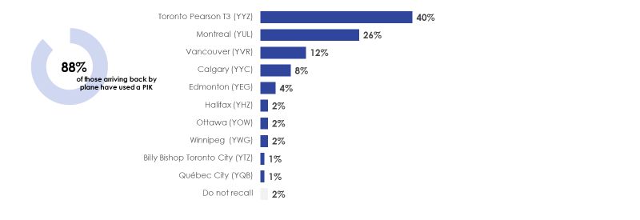QF8. When you arrived back in Canada from your last trip, did you use an electronic inspection kiosk at the airport? These are machines that automatically scan your passport details, take your customs declaration, and print out a slip that you give to a CBSA agent.
Base: Those who returned to Canada by plane on their most recent trip abroad (n=879).
QF9. At which airport did you use the electronic inspection kiosk?
Base: Those who reported using an electronic inspection kiosk (n=768).
Those who report having used a PIK upon their most recent return to Canada have a very favourable impression. A very large majority (94%) say they had a positive overall experience in using the kiosks, with almost 6 in 10 (59%) saying they had a ‘very positive’ experience.
Those who have travelled outside Canada in the past 6 months (vs. 1 to 2 years ago) are more likely to report a “very positive’ experience in terms of ease of using the machine, time saved, and use of plain language.
Travellers also have positive impressions when asked to evaluate the PIKs on a variety of factors. On use of plain language, 95% have a positive impression of the kiosks (64% ‘very positive’). With regard to the availability or wait times to use a machine, 93% say they have a positive impression (56% ‘very positive’). 9 in 10 (91%) say they have a positive impression of how much time they saved by using the machines (61% ‘very positive’) and a similar proportion say they have a positive view of how easy it was to use the machines (57% ‘very positive’). Finally, concerning the ability of all Canadians to use the machine, 90% have a favourable view (51% ‘very positive’) of accessibility.
- Overall Impression of Electronic Inspection Kiosks
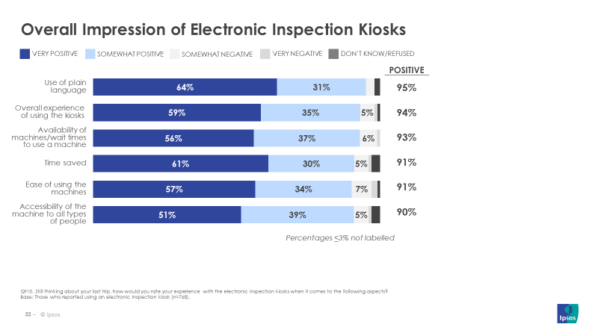 QF10. Still thinking about your last trip, how would you rate your experience with the electronic inspection kiosks when it comes to the following aspects?
Base: Those who reported using an electronic inspection kiosk (n=768).

NEXUS
There are a number of initiatives, activities, and programs that make it easier for people or goods to cross the Canada-US border, such as NEXUS, FAST, and CANPASS. The 2017 survey made it clear that NEXUS was the most easily recognized program, with 47% of those aware of such programs spontaneously mentioning NEXUS. In 2020, respondents were asked on an aided basis if they had ever heard of NEXUS. Two-thirds (67%) say they were aware of the program.
Awareness of NEXUS is higher among those who are aware of CBSA overall (76% vs. 44% unaware), those who have travelled out of the country in the past two years (77% vs. 45% have not), those who have travelled six or more times in the past two years (vs. less than 6 times), and those have travelled more recently in the past six months (85% vs, 6 months to less than 2 years). Considering NEXUS is a joint Canada-US program, it is expected that those who have come back from the US on their latest trip (85% vs. other regions) or returned by car (85% vs. plane 75%) are more likely to be aware of NEXUS. Older respondents (35-54 72%, 55+ 70% vs. 18-34 56%) and British Columbia residents (86% vs. all other regions) are also more likely to have heard of the program.
Of those aware of NEXUS, 10% say they are members of NEXUS. The same subgroups who report higher awareness of the program are also more likely to be members such as US travellers, frequent travellers, those who have travelled more recently, or British Columbia residents. One particular group who shows higher membership are those who travelled for business on their last trip (23% vs. 11% personal), this is likely due to higher priority given to expedited border crossing.
Those who are members are certainly taking advantage of the benefits of being part of such a program; three-quarters (72%) of those who report being members of NEXUS said they re-entered Canada using NEXUS on their most recent trip abroad.
- Awareness of and Use of NEXUS
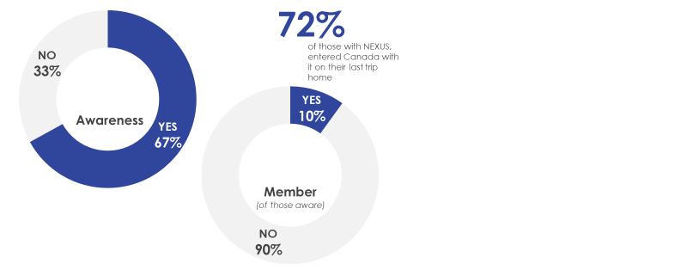 QE1. Have you ever heard of NEXUS?
Base: All respondents (n=2,000).
QE2. Are you currently a member of NEXUS?
Base: Those who have heard of NEXUS (n=1,359).
QF7. When you arrived back in Canada from your last trip, did you use NEXUS?
Base: Those who travelled to another country within the past 2 years and are members of NEXUS (n=129).
Of those who were unaware of NEXUS, one quarter (23%) said they were likely to sign up after learning a little about the program. Those who have travelled in the past two years displayed higher likelihood to sign up (29% vs. 19% have not travelled), as did more recent travellers who went out of Canada in the past six months (39% vs. one to two years ago 14%).
- Likelihood to Sign Up for NEXUS
QE3. NEXUS is a joint Canada-United States program that simplifies border crossings for preapproved
entering Canada and the U.S. by air, land or sea.
Base: Those who are not aware of NEXUS (n=641).

Two-thirds (67%) of Canadians are comfortable with more personal information being collected by the CBSA in order to facilitate a smoother border crossing. Of this, a quarter (26%) report being ‘very comfortable’, while one in ten (12%) say they are ‘not at all comfortable’ with more information being collected.
Canadians who are more likely to indicate they are ‘very comfortable’ with this prospect include those who are aware of the CBSA (30% vs. 19% unaware), NEXUS members (43% vs. 26% non members), those who have travelled in the past two years (28% vs. 22% not travelled), more frequent travellers i.e. 6 to 10 times in the past two years (34% vs. five or less times), those who last travelled six months ago (30% vs. 23% one to two years ago), as well as Quebec residents (32% vs. other regions).
- Comfort with More Personal Data Collected at Border Crossing
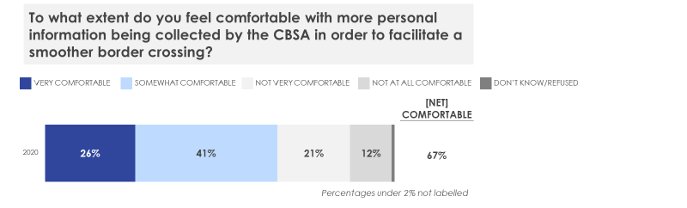 QE4. Many countries are exploring the use of new technologies to facilitate border crossings. While these new technologies can offer ease and convenience, they also collect more personal information for border authorities. To what extent do you feel comfortable with more personal information being collected by the CBSA in order to facilitate a smoother border crossing?
Base: All respondents (n=2,000).

Border Crossing Information
Four in ten Canadians (38%) have tried to look for information about crossing the border in the past. Seeking out information about border crossing is higher among those who have travelled more recently in the past year (vs. a year to two years) or those who have travelled more frequently i.e. six or more times in the past two years (vs. five or less times).
Respondents who are aware of the CBSA (45% vs. 21% unaware) are also more likely to indicate they have searched for this information. Past searches for information about border crossing are more common among those who have travelled to the US for their most recent trip (56% compared to other regions) and among those who returned from their last trip by car (62% vs. by plane 42%). This may indicate a need for more information specifically about cross-border travel.
Saskatchewan/Manitoba (50%) and British Columbia (48%) residents are more likely to seek out information (vs. Ontario 39%, Atlantic 37%, Quebec 23%) as do those between the ages of 35 and 54 (44% vs. 37% 18-34, 32% 55+).
- Sought Information about Crossing the Border
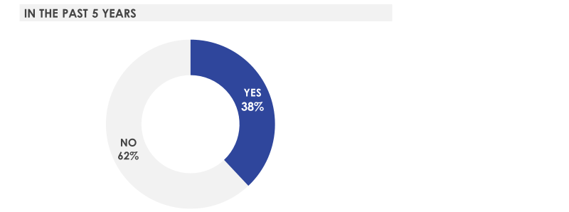 QD1. In the past five years, have you looked for information about crossing the Canadian border?
Base: All respondents (n=2,000).

The information most sought after by Canadians relates to duty-free allowances (59%) and document requirements (52%). Those who travelled in the past two years to Canada are more likely to have searched about duty free allowances (62% vs. 43% have not travelled) and conversely those who have not travelled in the past two years (61% vs. 50% have travelled) are more likely to look for document requirements. Other information that Canadians look for is waiting times to cross the border (35%) and which goods cannot be taken back to Canada (34%).
Searching for information about wait times to cross land borders is more common among NEXUS members (50% vs. 36% non-members), those who have travelled to Canada in the past two years (36% vs. 26% have not travelled), returned by car on their last trip (48% vs. 30% plane), those who have travelled more frequently (i.e. six or more times vs. less than six times), and those for whom their last travel was recent (i.e. 6 months ago 42% vs. 6 months to 2 years ago). Residents of British Columbia (48%) and Ontario (39%) are also more likely than other regions to seek information on land border wait times.
- Kinds of Information Sought After
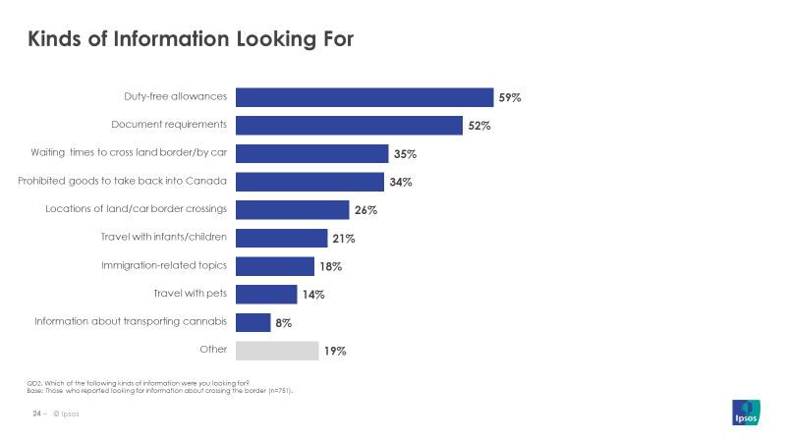 QD2. Which of the following kinds of information were you looking for?
Base: Those who reported looking for information about crossing the border (n=751).

Regarding which sources of information that Canadians turn to about crossing the border, using the Internet to search for information is the most popular source of information. Almost half of Canadians (46%) said they used an Internet search engine to find this information, with 4 in 10 (40%) mentioning this option as their first choice. Relatedly, the Government of Canada website is another popular choice, with 3 in 10 (29%) mentioning they use this source first when seeking information about crossing the border.
As for the CBSA’s own website, Canadians rank it third as a source of information about crossing the border (13% first mention). However, that is not to say that those looking for information won’t be directed to the CBSA website, especially if they use a search engine or follow links from another Government of Canada website.
While younger Canadians aged 18 to 34 are more likely to mention an internet search in their total mentions (56% vs. 43% 35-54, 40% 55+), it is actually older respondents who are more likely to mention visiting the CBSA website (20% 35-54, 19% 55+ vs. 8% 18-34).
Furthermore, 95% of those who looked for information on crossing the border in the past five years say they were able to find what they were looking for. Those who have a positive impression of the CBSA (97% vs 87% among those with a negative impression) are also more likely to report success in finding the information.

- Source of Information about Crossing the Border
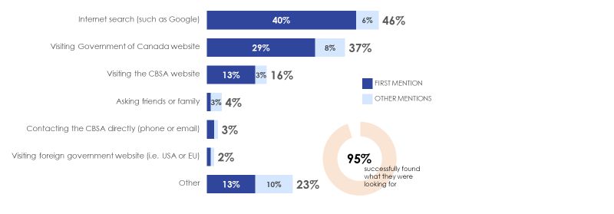
QD3. How or where did you go about finding information about crossing the border? (If mention visiting website, probe for more specific information about the type of website)
QD4. Were you successful in finding the information that you needed?
Base: Those who reported looking for information about crossing the border (n=751).

In addition to looking for information about crossing the border, some Canadians may have contacted the CBSA directly. One in ten (10%) Canadians say they have contacted the CBSA directly in the past 5 years. Those who have travelled outside the country in the past two years (13% vs. 5% have not travelled) or have returned by car in their most recent trip (18% vs. 11% plane) are more likely to have directly contacted the CBSA in the past five years. NEXUS members (41% vs. 10% non-members), frequent travellers who have left the country six or more times in the past two years (vs. five or less times), and more recent travellers who last left 6 months ago (16% vs. 7% one to two years ago) are also more likely to have directly contacted the CBSA.
By far, the primary means that individuals use to contact the CBSA directly is by calling the CBSA’s toll-free number (44%). Other ways in which individuals contact the CBSA include visiting the website (16%), visiting a CBSA office (13%), emailing the CBSA (9%), and sending a letter (2%).

Detailed Results: Stakeholder Survey
The following section details findings from the Stakeholder Survey.

Moving Goods and Understanding Requirements
Overall, businesses believe that the process of moving goods into Canada is efficient; three-quarters (74%) say that it is either ‘very efficient’ or ‘somewhat efficient’, leaving two in ten (22%) to say that it is inefficient in some way.
- Perceived Efficiency of Moving Goods into Canada
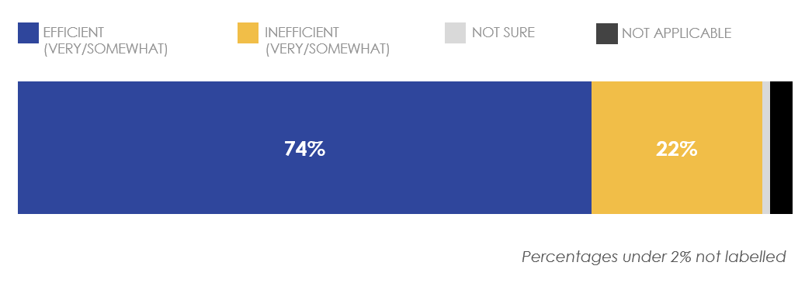
Q3. Generally speaking, how efficient or inefficient would you say is the process of moving goods into Canada?
Base: All respondents (n=96).
Among businesses in the ‘exporter’, ‘carrier’, or ‘service provider’ groups (n=40), a majority (83%) report being confident to some degree in knowing what documentation is required to export regulated goods from Canada.

- Confidence in Knowing What Documentation is Required to Export Regulated Goods from Canada
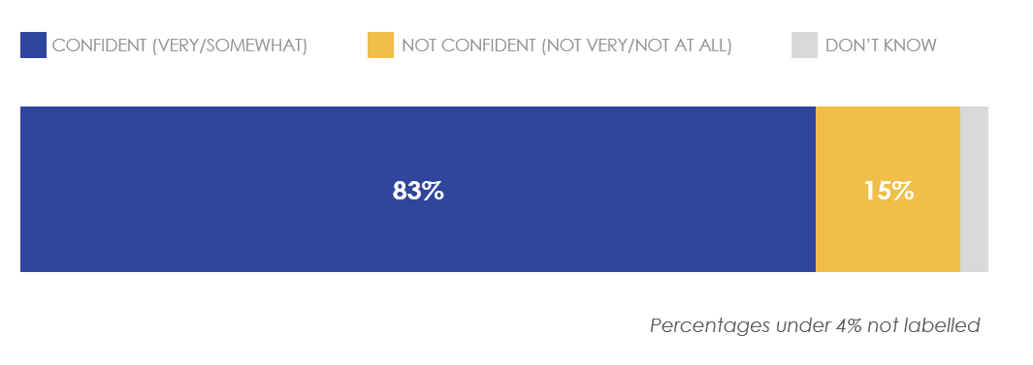
Q4. How confident are you in your knowledge of what documentation is required to export regulated goods from Canada? Base: Those in ‘exporter’, ‘carrier’ and ‘service provider’ groups (n=40).
When it comes to understanding the CBSA’s reporting requirements, these same businesses are split. Half (48%) say that the requirements are either ‘very easy’ or ‘somewhat easy’ to understand, while another half (48%) say that it is difficult to some degree.
- Ease in Understanding CBSA’s Reporting Requirements
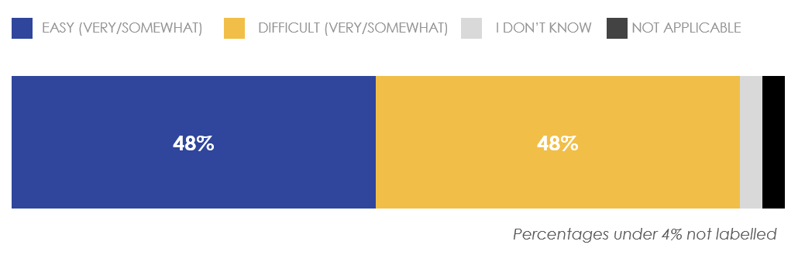
Q5. How easy or difficult is it to understand CBSA’s reporting requirements?
Base: Those in ‘exporter’, ‘carrier’ and ‘service provider’ groups (n=40).

Interaction with the CBSA
Almost all of businesses surveyed (94%) say that they have contacted the CBSA with a question or issue related to their business within the past two years. This is understandable, given the complexities and regulations surrounding the import and export of goods and services across the Canadian border.
- Contacted CBSA Within Past Two Years
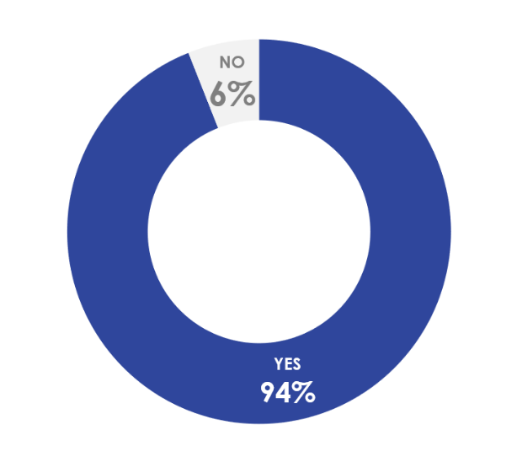
Q6. Have you had to contact CBSA with a question or issue related to your business in the past 2 years?
Base: All respondents (n=96)
Among those businesses surveyed that have directly contacted the CBSA with a question in the past two years, trade operations is the most common division department contacted (59%), followed by the CBSA Assessment and Revenue Management (CARM) Accounts Receivable Ledger (ARL) Unit (54%), and Technical Commercial Client Unit (54%).
Furthermore, four in ten (41%) say they’ve used the Border Information Services (BIS) automated telephone service. A smaller numbers of businesses say they’ve contacted the units related to the Trusted Trader programs (28%) and Special Import Measures Act (SIMA) registry (24%). Roughly two in ten (19%) say they reached out to the CBSA through the ‘Contact Us’ link on the CBSA website.
- Divisions Contacted at the CBSA
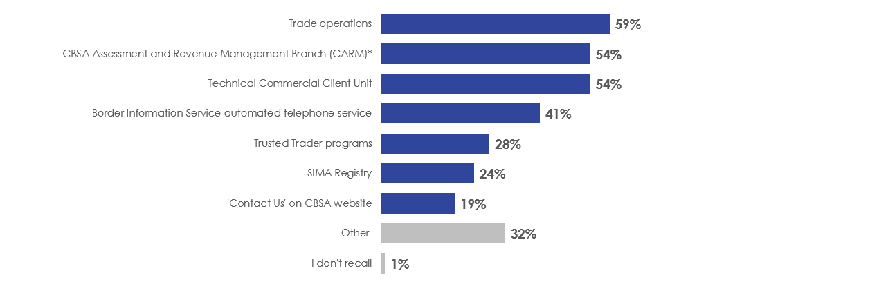 Q7. Whom did you contact within the CBSA? Select all that apply.
Base: Those who say they have contacted the CBSA with a question related to their business in the past 2 years (n=90).
“Trade operations” includes advance ruling requests, national customs rulings, drawback claims, duties relief applications, and adjustment or authorization requests.
* CARM Branch may also include Accounts Receivable Ledger (ARL) Support Team, as they use a CARM email address and are listed as Phase 1 of CARM on the CBSA website.

Overall, those who contacted the CBSA with a question related to their business were satisfied with how they were treated. Nine in ten (90%) of businesses surveyed who have contacted the CBSA say they were either ‘very satisfied’ or ‘somewhat satisfied’ with the level of courtesy of who they talked to.
However, it seems that there is still room for improvement when it comes to resolving the inquiry that led the business to contact the CBSA in the first place. Nearly two-thirds (64%) were satisfied in some way with the CBSA being able to answer their question or resolve their issue. Almost six in ten (58%) say they were satisfied with the promptness of the reply from the CBSA and a similar proportion (57%) say they were satisfied with the timeliness of resolving their problem.
- Satisfaction with Interaction with the CBSA
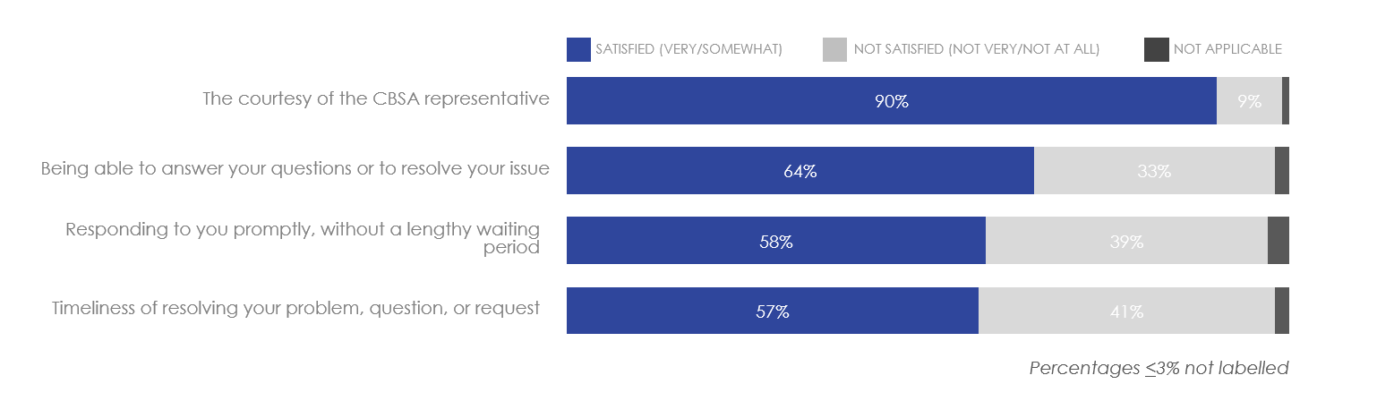 Q8. How satisfied were you with the following aspects of your interaction with the CBSA?
Base: Those who say they have contacted the CBSA with a question related to their business in the past 2 years (n=90).

E-Commerce
When asked how e-commerce has affected the way they do business, those surveyed generally had more positive mentions (33%) than negative mentions (24%). Businesses said that e-commerce has allowed them to do more business (18%), among with other positive mentions as to how e-commerce has allowed them to improve their business. However, businesses surveyed also mention a small number of downsides to the rise of e-commerce; notably, 11% say that they need better operational procedures. For other businesses surveyed, they said that e-commerce has had little impact on the way they do business (23%).
- E-Commerce Impact on Business
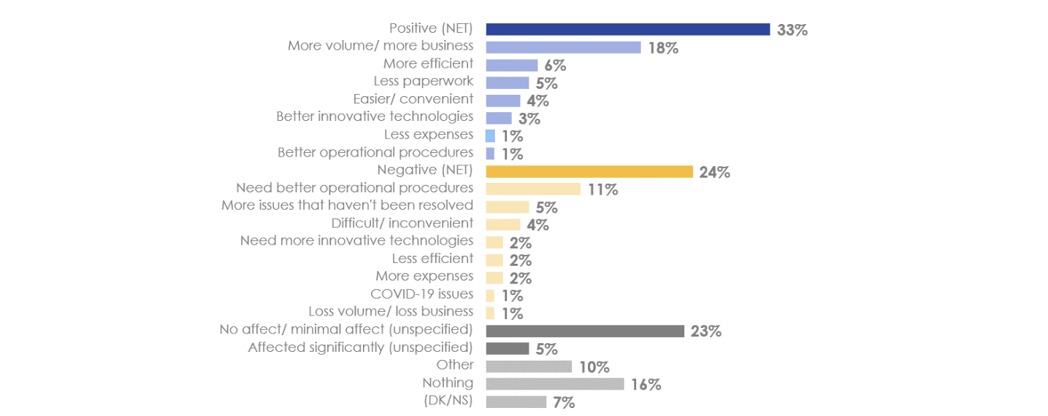
Q10. How has e-commerce affected the way you/your members do business?
Base: All respondents (n=96).
Given the current climate, three-quarters (76%) of businesses surveyed said that they have adapted to accommodate e-commerce volumes. The remaining 24% may either have problems in meeting these volumes, or do not see it as particularly relevant to their business.
- Adapting to E-Commerce Volumes
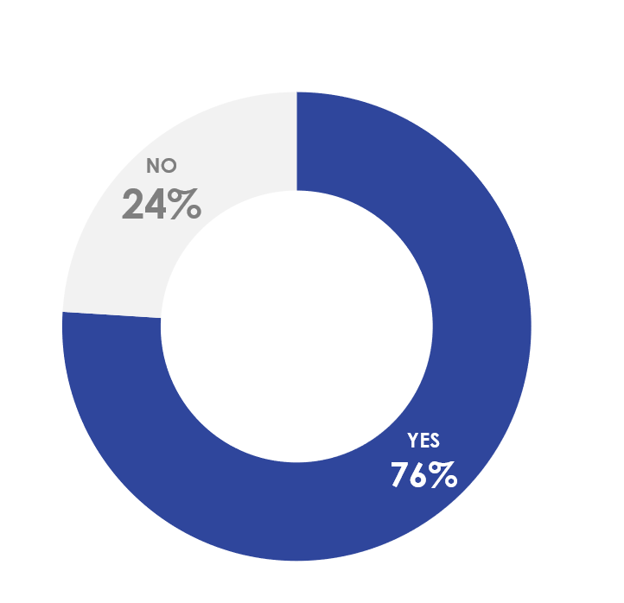
Q11. Have you adapted to accommodate e-commerce volumes?
Base: All respondents (n=96).

Customs Brokers
Three-quarters (76%) of the businesses surveyed (not already in ‘broker’ or ‘warehouse’ groups) use a customs broker at least ‘sometimes’ to help facilitate shipping their goods across the border. As a specialized professional whose expertise lies in arranging the customs clearance process by completing paperwork and advising on compliance with regulations, customs brokers can be a valuable asset to businesses. Within this proportion, half (50%) of those surveyed said their company uses a customs broker ‘all the time’, 12% say they use customs brokers ‘often’, and 14% say they use them ‘sometimes’.
- Frequency of Custom Broker Use
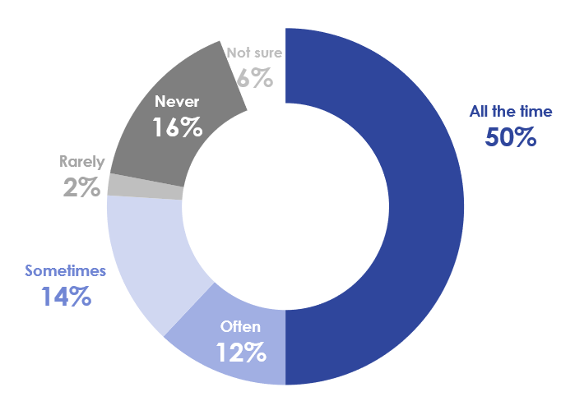
Q12. How often do you use a customs broker?
Base: Those not in ‘broker’ or ‘warehouse’ groups (n=50).
Among those businesses surveyed who have used a customs broker at least once in the past, recommendations from trusted people (33%) is favoured over other means such as an internet search (8%) or looking on the CBSA website (5%).
- Resources Used to Find Customs Broker
Q14. Which, if any, of the following sources did you use to find your customs broker? Please select all that apply.
Base: Those having used a customs broker (n=39).
As to what businesses hire customs brokers to do, the most common purpose is understandably to assist in customs clearance (85%). However, they are also hired to carry out other specific functions very much relevant to businesses shipping goods across the border: tariff classification (46%), customs valuation (26%), international trade consulting (26%), freight management and consolidation (21%), regional/national warehousing (15%), and import/export purchase order management (10%).
- Functions Performed by Customs Broker
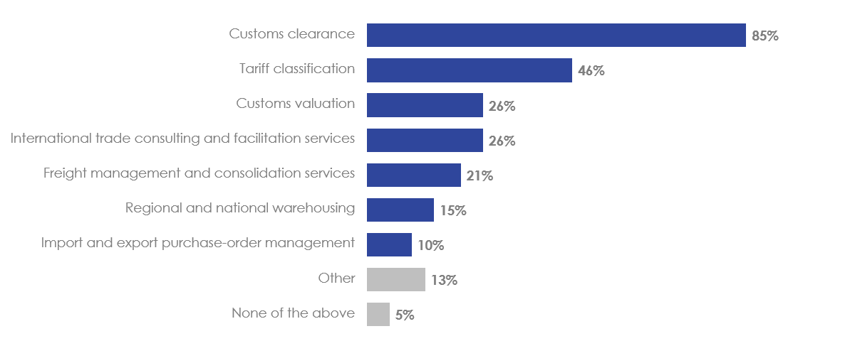
Q13. What functions does your customs broker perform on your behalf? Please select all that apply.
Base: Those having used a customs broker (n=39).

Awareness of and Participation in Trusted Trader Programs
Currently, the CBSA operates two Trusted Trader programs: Partners in Protection and Customs Self-Assessment. These programs make it easier for businesses to move commercial shipments across the Canadian border.
The Partners in Protection (PIP) program aims to improve border security while also streamlining border processes for businesses that are designated to be trusted traders. For more information, see: https://www.cbsa-asfc.gc.ca/security-securite/pip-pep/menu-eng.html.
The Customs Self-Assessment (CSA) program facilitates cross-border trade by simplifying import border requirements such that low-risk shipments can be processed more efficiently at the border. For more information, see: https://www.cbsa-asfc.gc.ca/prog/csa-pad/menu-eng.html.
Among businesses surveyed, awareness of these Trusted Trader programs is very high. Nearly all (94%) report being at least nominally aware of the existence of such programs.

- Awareness of the CBSA’s Trusted Trader Programs
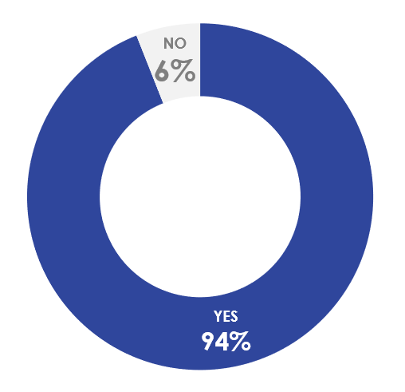
Q15. Is your business aware of the CBSA’s Trusted Trader programs?
Base: All Respondents (n=96).
Of those businesses aware of the programs, the most common way for businesses to have found out about them is through their trade association (46%). The CBSA website is also a common way for businesses to learn about the programs (32%), followed by a publication issued by a trade association (14%).
- Where First Learned of Trusted Trader Programs
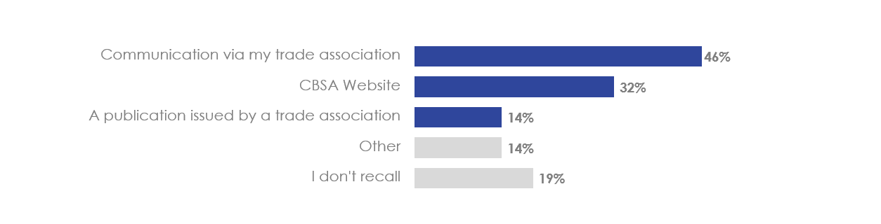 Q16. How did you first learn about the program?
Base: Those whose business participates in the Trusted Trader programs (n=59).
Among those aware, two-thirds (66%) say they participate in these programs.
- Participation in the CBSA Trusted Trader Programs
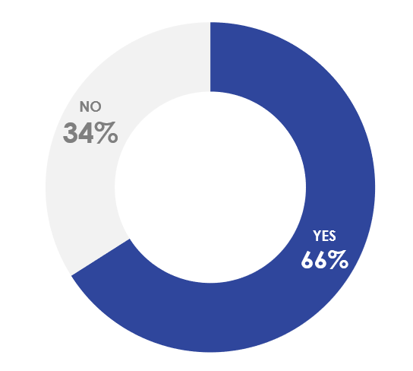
Q17. Does your organization participate in the CBSA’s Trusted Trader programs (e.g. The Partners in Protection (PIP) program or the Customs Self-Assessment program (CSA)?
Base: Those whose business participates in the Trusted Trader programs (n=59).
As for the 34% of businesses surveyed who say they did not participate in these programs, the most common answer as to why is that they were still in the process of applying to either program. Only a small number of companies said either that they were not interested in joining or that they believed the programs were not worth it.
- Reasons for Not Participating in Trusted Trader Program
Q18. Why does your organization not participate in the Trusted Trader programs?
Base: Those whose business does not participate in the Trusted Trader programs (n=20)
Businesses that participate in the Trusted Trader programs are on the whole satisfied with the time taken to approve their membership. A large majority (85%) say that they are either ‘very satisfied’ or ‘somewhat satisfied’ with the waiting time before their business was approved for participation. Only 15% said they were either ‘not very satisfied’ or ‘not at all satisfied’ with the time needed.
- Satisfaction with Time Taken to Approve Organization’s Membership
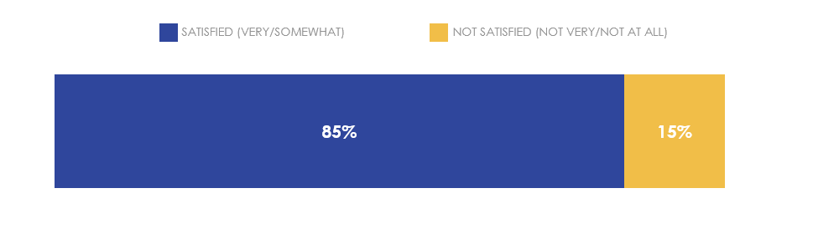
Q19. How satisfied or dissatisfied are you with the time it took to approve your organizations’ membership?
Base: Those whose business participates in the Trusted Trader programs (n=39).
Furthermore, many businesses see benefits in being part of either the PIP or CSA programs. Three-quarters of businesses surveyed that participate in these Trusted Trader programs say that the programs have been important (either ‘very’ or ‘somewhat’) in facilitating their organization’s goods in and/or out of Canada.
- Importance of Programs in Facilitating Goods In/Out of Canada
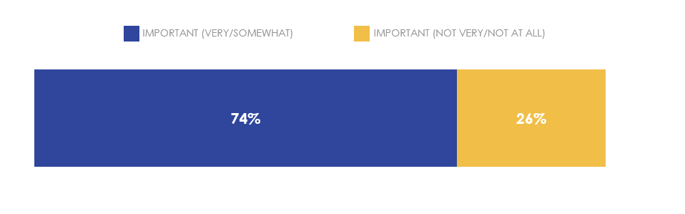
Q20. How important have these programs been in facilitating your organization’s goods into or out of Canada?
Base: Those whose business participates in the Trusted Trader programs (n=39).
As for businesses’ satisfaction with the benefits of the programs relative to the cost, seven in ten (69%) of those surveyed who participate in these programs say they are either ‘very satisfied’ or ‘somewhat satisfied’.
While programs such as PIP are voluntary and do not involve a fee, eligibility guidelines for the CSA stipulate that those importers wishing to be part of the program should be prepared to make an investment in business systems and also demonstrate that their recordkeeping processes adhere to all program requirements. For some businesses, the costs may simply outweigh any benefits they might be able to draw from the program.
- Satisfaction with Benefits of Programs Relative to Cost
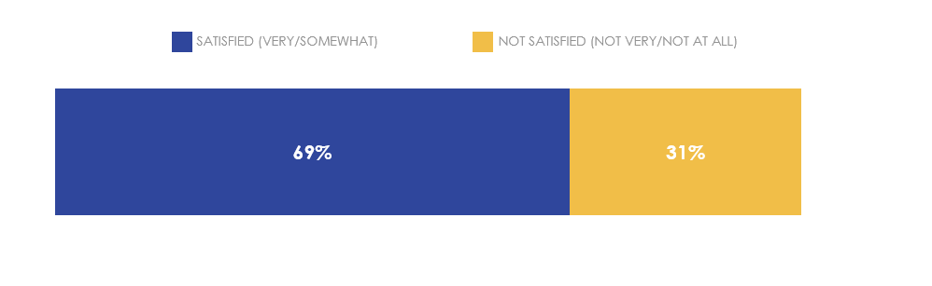
Q21. What is your level of satisfaction or dissatisfaction with the benefits your organization receives from being part of these programs relative to the cost?
Base: Those whose business participates in the Trusted Trader programs (n=39).

When asked what additional benefits they would be interested in receiving from being part of the Trusted Trader programs, over half (56%) of participating businesses say they don’t know of any specific additional benefits.

- Desired Benefits from Trusted Trader Programs
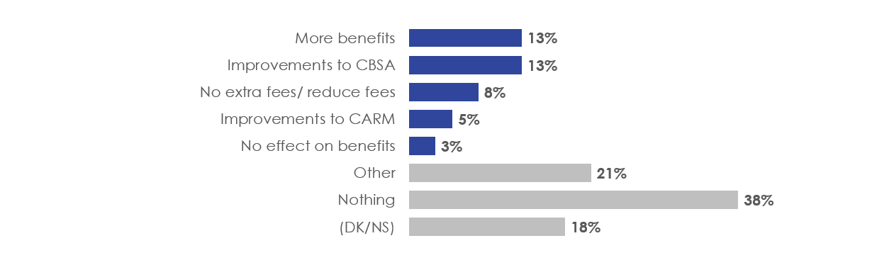
Q22. What other benefits would you appreciate, use, or participate in if they were added to Trusted Trader programs?
Base: Those whose business participates in the Trusted Trader programs (n=39).

Privacy
As with individuals, businesses are also concerned about protecting their privacy. When asked whether their organization (and their customers) would be willing to provide additional advance information to the Government of Canada in order to make the border clearance process smoother, the response was largely positive. Eight in ten (79%) say they were ‘somewhat willing’ or ‘very willing’ to provide this information, while 13% said they were ‘not very willing’ or ‘not at all willing’ to do so. Another 8% are unsure.
- Willingness to Provide Additional Information to Make Border Clearance Smoother
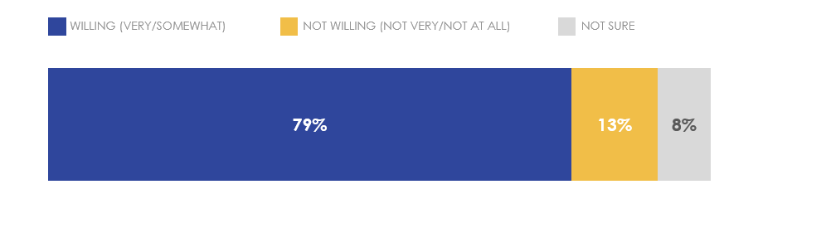
Q23. How willing would your organization (and your customers) be to provide additional advance information to the Government of Canada in order to make the border clearance process smoother?
Base: All respondents (n=96).

Awareness of Administrative Monetary Penalties (AMP)
The CBSA makes use of the Administrative Monetary Penalty System (AMPS) in order to fine those businesses who violate trade and border legislation. On the CBSA website, one can find not only details related to the AMPS, but also a master list of all contraventions that may be applied to commercial clients. Furthermore, the CBSA has made available on its website its archive of statistics on administrative monetary penalties issued since 2009 (for more information, see: https://www.cbsa-asfc.gc.ca/trade-commerce/amps/menu-eng.html#stat).
Of businesses surveyed, three-quarters (73%) say they were aware of the administrative monetary penalty statistics on the CBSA website.
- Awareness of AMP Statistics on the CBSA Website
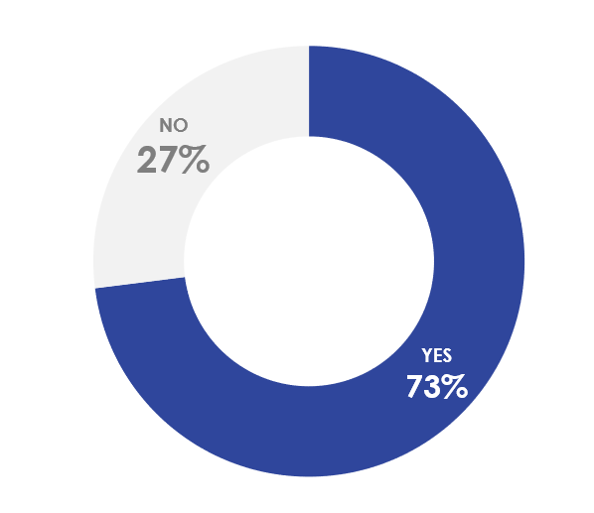
Q24. Are you aware that the CBSA posts statistics on the Administrative Monetary Penalties (AMP) that it has issued on its external website?
Base: All respondents (n=96).
As to whether these statistics were helpful, 60% of those aware of these statistics say that they were useful in helping their business comply with customs requirements.
- Usefulness of AMPs Posted to Website in Complying with Customs Requirements
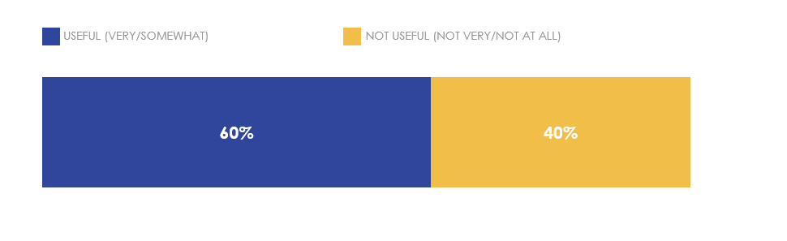
Q25. To what extent are the statistics posted by the CBSA on Administrative Monetary Penalties (AMP) useful in complying with customs requirements?
Base: Those aware of the AMP statistics on the CBSA website (n=70).

COVID-19
Without a doubt, the current COVID-19 pandemic has had a major influence on how businesses ship goods and services across the Canadian border. As the situation is subject to changing on-the-ground conditions, businesses who routinely transport goods and services across the border turn to the CBSA for reliable information on how the pandemic affects their business operations.
Businesses surveyed are most interested in hearing from the CBSA about new measures put in place to ease burdens on businesses (74%), followed by reduced hours of service at ports due to lower traffic flow (52%) and the closure of certain ports (51%). As these attributes have the most immediate impact on how companies go about their business, it is understandable that these topics are of the most interest.
- Most Useful Information on How CBSA Has Adjusted In Light of COVID-19
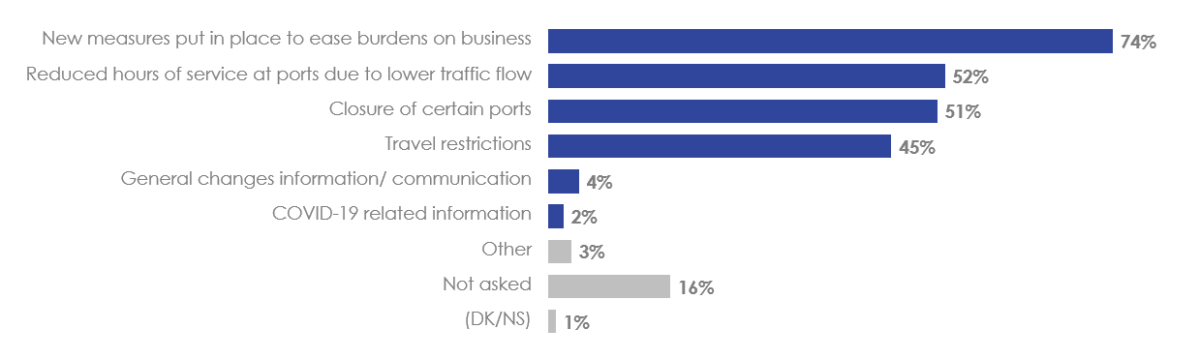
Q26. The current COVID-19 pandemic has led the CBSA to adjust business and operational processes. What sort of information about recent changes are you interested in? Select all that apply.
Base: All respondents (n=96).
Over half (56%) of businesses surveyed said that they sought information on moving goods and/or services across the border after March 2020, when the World Health Organization officially declared the COVID-19 outbreak to be a pandemic.
- Sought Information Since March 2020 on Moving Goods/Services Across Border
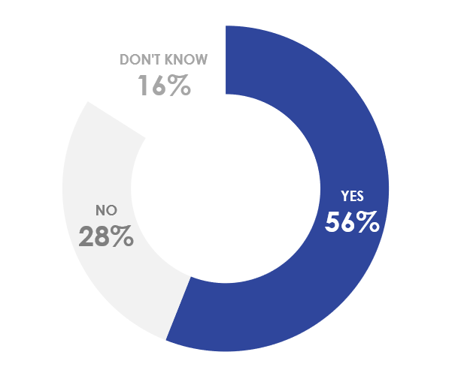
Q27. Have you recently (since March 2020) sought information about moving goods and services across the Canadian border?
Base: All respondents (n=96).
As for the different ways businesses looked for information since March 2020 on moving goods and/or services across the border, businesses believe that direct contact is the best approach. Of those surveyed who sought information during that time, eight in ten (80%) said they directly phoned or emailed the CBSA. Three-quarters (74%) chose to look for information on the CBSA website and a similar proportion (72%) turned to their industry associations.
Less popular ways of gathering information included another Government of Canada source (43%), third-party information online (35%), word-of-mouth (28%), and visiting a CBSA office in person (7%).
- Places Turned to for Information about Moving Goods Across Border
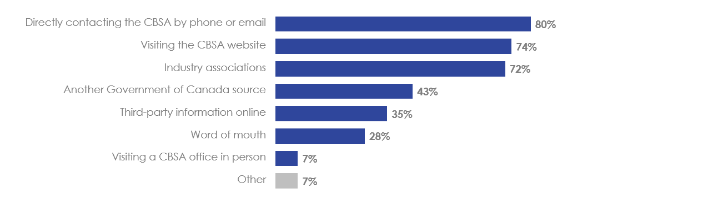
Q28. Where are you currently turning for information about moving goods across the Canadian border? Select all that apply.
Base: Those who have sought information since March 2020 on moving goods and services across the border (n=54).
As for those businesses that did not look for this information since March 2020, over half (56%) say that they would like to be contacted directly by e-mail in order to receive information from the CBSA about moving goods and/or services across the border.
- Preferred Method of Receiving Information from the CBSA about Moving Goods/Services Across Border
Q29. If you were interested in receiving information from the CBSA about moving goods and services across the Canadian border, how would you like to receive this information?
Base: Those who have not sought information since March 2020 on moving goods and services across the border (n=27).

Concluding Section
When asked what emerging issues the CBSA should be prepared for in the future, businesses surveyed mentioned issues with CBSA Assessment and Revenue Management (CARM) and financial issues in equal proportions (17%). Concerns over CARM is understandable, given that the project had been suspended with uncertainty surrounding the timeline for the various phases of the initiative.
Other concerns mentioned include improving operational processes (13%), greater efficiency (9%), better training for staff (8%), modernization of technology (6%), and more information being made available (6%).
- Emerging Issues the CBSA Should Be Prepared For
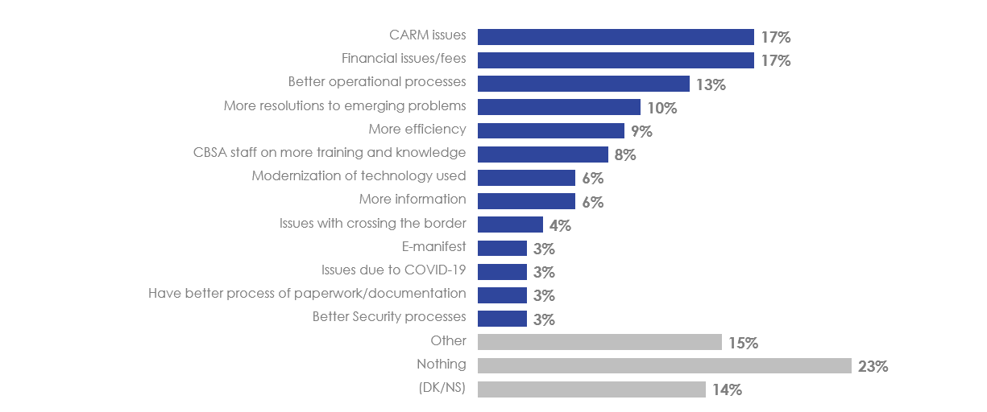 Q30. Looking forward, are there any emerging issues in your industry that CBSA should be prepared for?
Base: All respondents (n=96).
Email notifications are by far the preferred method of being notified of communication system outages (90%). Fewer businesses would like to be notified by a notice on the CBSA website (3%) or even via Twitter (1%). This is understandable, as it is a proactive form of communication that comes directly to the businesses, as opposed to the businesses reacting to an outage and going to seek out whether there is a communication system outage.
- Preferred Method of Being Notified of Communication System Outages
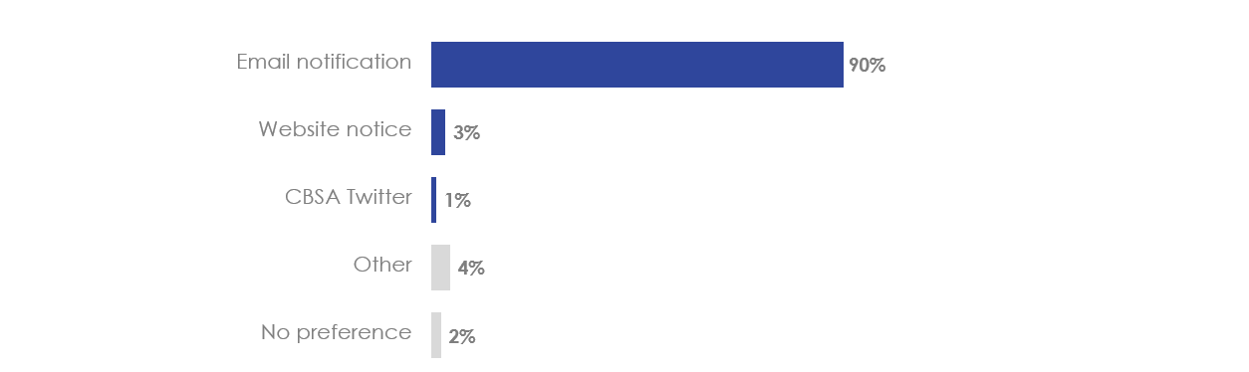 Q31. The Government operates information systems that communicate advance commercial information on shipments to help ensure their timely clearance at customs. From time to time, these systems suffer outages, which can lead to shipment delays. In such cases, what is your preferred method of being notified?
Base: All respondents (n=96).

Detailed Results: Focus Groups
The following section details findings from the Focus Groups.

Perceptions of the CBSA

Effectiveness of the CBSA
Most participants in the focus groups believed that the CBSA is somewhat or very effective in its core functions of keeping our borders safe and secure, and monitoring the flow of travel and goods in and out of the country. While many believed that there is an effective and efficient flow of travellers, there were some concerns expressed about long wait times, particularly at land crossings. Mentions were made that border services officers’ presence in airports and at land crossing locations is reassuring and adds a sense of safety and security, and an impression that the system is being smoothly run, when traveling. There was also positive sentiment towards the CBSA’s effectiveness in its role during the COVID-19 pandemic.
My impressions of CBSA is positive as I do believe that they are doing their best to keep us safe by keeping control of what and whom enters our country.
I’m just saying that we have such a huge landmass. I mean, we’re only talking about the controlled access border crossings, but look at all the coastal areas that we have that are uncontrolled. You just can’t be everywhere all the time, so that’s why I’m saying that they’re doing the best that they can with the tools and the equipment provided to them, but there’s a huge area of land that people can access without having any sort of control measures that are there.
[T]he visibility is really important to me about keeping that risk low of people trying to get through, and then they do enforce laws as far as gun control and different things coming through the border and so I think they really do a good job of that.
Yeah, I think the CBSA, they have a lot on their plate, especially right now like with COVID [-19] and everything, trying to keep up-to-date on all the changes that happened. And I think that, you know, that can be really stressful and they really need to definitely keep organized. And I think they are doing a good job and the best that they can given the circumstances right now.

Experiences with Border Services Officers
Many said that border service officers have a professional demeanour and used positive descriptors such as respectful, helpful, courteous, friendly, or smiling. Several mentions were made that Canadian border services officers have a preferable demeanour and are nicer than their US counterparts. The officers themselves were positively characterized as being more diverse and inclusive in terms of the demographics than US CBP officers.
Those with positive views found their experiences and interactions at land and border crossings went very smoothly and were straightforward. As with general demeanour, experiences with US CBP officers were perceived more poorly by some.
Entering Canada as a Canadian citizen is really welcoming, you feel really safe and depending where you are coming back from [and] it can also feel like a relief :P
Overall I am satisfied with my experiences interacting with CBSA. I feel compared to their American counterparts, they are more friendly as well as more diverse (more women, more ethnic backgrounds).
I’m not sure if it’s because I’m Canadian or not, but our side, when you’re returning from Detroit, seem to be so much more polite. Sometimes, when you go crossing at the border going into Detroit, [US CBP officers] can be extremely rude and I’ve been yelled at for no reason and asked weird questions, where I’d never get that on the Canadian side.
There were various reasons mentioned amongst those with less positive perceptions of the CBSA and border services officers. Some had a negative interaction in the past – mentions were made of feeling as though they might have been treated differently or had their vehicle / belongings searched because of their appearance, demographics or other personal characteristics, or based on the country they are traveling from.
At times, I have also seen people (acquaintances of mine) get controlled more often than I do (as a white person) on account of their appearance, their cultural background, or their ethnicity.
They can be more lenient in the sense that they are more likely to stop individuals that were born in third world countries who are returning home or their future home. I have been random[ly] stopped many times and so has my parent, and it made us wait a long time to reach home.
Others felt there is always level of uncertainty associated with whether or not they will be singled out for further inspection and whether or not they will be asked to pay duties. While this was perceived by some as random inspections which they understood was standard procedure, others felt that these decisions are left to individual service officers and made arbitrarily, or that they are being singled out. These interactions typically lack transparency or an explanation from border services officers.
I think they have the proper systems in place to protect our borders. I feel that when you cross into Canada, it depends on the mood of the agent if you will pay duties on good purchased.
I don’t know if it was a random search or something set them off. We had to pop the trunk, they went through suitcases, rummaged through our things.
They came specifically to me to talk to me. And they definitely didn’t say it was random. But they came to me through a crowd of people to pick me out.
For those who had their vehicles or belongings searched at land crossing locations or at airports, most characterized these as straightforward – typically they were asked questions, a search was conducted, and the border services officers while very thorough, were generally professional and courteous. Mentions were made both of belongings being put back neatly, or not treated with care or damaged. Concerns mentioned were for those who waited for a very long time for inspections or to be cleared to proceed with travel.
They stacked everything up nice. You know, it was scary because it was happening, but I knew that there was nothing for them to find so it was just an inconvenience, but it was fine—they put it all back nicely.
Mention was made that some border services officers lack empathy and are robotic in their approach to the job. As well, mention was made about not understanding the relevance or volume of questions border services officers ask when searching their vehicles / belongings.
I guess flying into an airport, the volume…cause you’re coming through Montreal or Toronto or a large international airport. I don’t know if professional is the right word, but there’s no chitchat, so to speak, with the guy at the booth, it’s very regimented. More serious in nature, I guess. The questions are sort of fired at you and you are expected to give certain answers in a certain way. Versus crossing the border—and I don’t cross enough that I’m recognized by anybody—it’s not like I’m going down to work every day and it’s like, ‘Hey, how are you today?’
There is some apprehension and feelings of stress or anxiety when crossing the border, particularly amongst those who might not do so on a regular basis and are not familiar with procedures and protocols. Mentions were made of feeling that they are being treated with suspicion by border services officers from the outset of an interaction for no apparent reason.
They could improve their process when asking questions. They can seem overly suspicious. They could change their tone of voice. Perhaps they could engage in amicable conversation to first get to know travelers and their destinations. When people are feeling fearful or have misconceptions about agents, they are more likely to be nervous and reply poorly.
I find that, I get the feeling that they expect you to understand the process. We don’t travel every day of the week, most of us, so we’re not used to it. And when we do travel, we’re pretty stressed, incoherent, trying to figure out what to do to make sure we get on that plane, and I just find that sometimes that’s, their expectations are a little higher than what they should be, but I guess they’re dealing with a whole bunch of passengers all the time during the day, it gets a little annoying for them, too.
Transparency […] about how when you’re being interrogated or you are being questioned, you don’t really know why. And it almost feels like if you ask, they’re going to be more suspicious of you. You never really know how to, you’re suspicious of them because they’re suspicious of you, and I really don’t think a really healthy way to start any interaction.
Some thought there were no major differences between land and air crossing border servicers officers. Others believed that there is a lack of consistency in demeanour, experiences and treatment of travellers across border service officers and locations. There were also differences by region – in Regina they felt that traveling through land borders is much easier than through airports, whereas in Winnipeg land crossing was considered more difficult than air crossing, while other regions had a mix of opinions or felt that both were equally smooth.
Amongst these participants, some considered land crossing service officers friendlier than air crossing service officers. It was acknowledged that this is partially due to familiarity and relationship-building amongst frequent land crossers, and the volume / number of service officers and travellers at large airports driving fewer personal interactions.
When you go through by car they are more friendly, personable. Maybe it’s because there is less volume there. At the airport they’re snarky, short with you. By car they are nicer, ‘have a great trip’, more friendly. The airport is just about getting you through. I enjoy crossing the border more in the car. I’m more intimidated and we’re always truthful and honest in what we’re declaring and we paid extra when we had to and I get all that. But it’s not friendly in the airport.
It’s still professional, but yeah, it is friendly, they ask ‘How are you doing today?’ type of thing. They see you cross over so much and stuff [via land crossing].
I feel as though there are a range of officers so I have experienced - when I think about those in airports, some don't ask me any single thing and smile curtly as they let me go, and other times I am ‘randomly’ chosen as a person of colour to be interrogated extensively.
Others believed the inconsistencies are between individual service officers regardless of location and whether traveling by land or air. Suggestions were made that they might benefit from more consistent training across all locations and types of crossings in order to provide a more uniform service experience. Regardless of opinions in terms of the inconsistencies, this was identified as a key area for potential improvement.
Having all of their employees be consistent (not having one that's too laid back, one that is polite and friendly, and then another that is clearly emotional about a personal matter, etc.)
I guess more maybe regular staff trainings. I know for me personally sometimes I feel as though some folks got different types of training than other employees there at the border, so it’s a bit like, did you guys study the same thing, I’m not sure about that. So just more consistency and I guess that would just be through regular staff trainings or something like that.
Awareness of if and how the CBSA has improved over time was mixed to low; amongst those who thought there have been improvements, these were mostly related to better customer service, such as border service officers who are friendlier or more consistent and professional than they have been in the past, or reduced line-ups and wait times facilitated by electronic inspection kiosks in airports.
The agents seem to be friendlier.
They improved the customs clearance process. We no longer have to wait in long queues.
Improved visibility and wait times at land crossings and in airports. Use of technology to enhance safety and wait times – [for example] scan in.
Improved with the ease and speed of entry with automated kiosks.
The most prevalent desired improvement by the CBSA was to reduce wait times and avoiding line-ups for travellers at border crossings, particularly land crossings. This was viewed as an issue that could be improved through better planning and anticipation of traffic based on events happening across the border that large numbers of people would be attending, or after long weekends.
Probably the time it takes to get through a checkpoint - to some degree that's limited by building space, for airports, but it'd be nice to increase the manpower and make things go faster.
Land crossings, however, can have lengthy line ups. Depending on when you cross back into Canada by land (long weekends for example), I find that the wait times lengthy and they don't have all lanes of traffic open.
It can be a long wait, it depends on the time coming back, especially long weekends when they know there's a lot of people coming back they don’t, they typically don’t have the all lanes of traffic open. Say on a Monday of a long weekend and you can be sitting in line for an hour easily.
Line ups, traffic on the bridges can be very heavy, so they could open up more lanes/agents. Same crowd management issues at airports too.
I think it’s a bit of staffing and planning. There [are] events like concerts and sporting events that they should be aware of, and it seems like those are the times where there’s the most lineups, and there’s three booths open when there could be eight or ten.
A couple of mentions were made that given there are sometimes long line-ups and wait times at airports for air crossers, providing seating or priority access for seniors or other populations who might not be able to physically stand for long periods would be a welcomed addition – and to assist them generally in getting from one end of the airport to another, if needed. However, these were general comments about the airport experience not specific to items under the CBSA’s purview.
The process of entering into Canada. Priority queue for families and the elderly. Wait times.
Have a seating arrangement, or a line for seniors.
Effectively for those who cannot be on their feet for extended periods and long lineups and delays, there could be an avenue of ease for those travellers, that was my recommendation. Not that they have initiated such a thing. I’m sure there is such a thing for the handicapped for the disabled and there are porters that I've seen and used which make travelling through airports a lot easier.
Mentions were made about frustrations related to process – the need for more signage and clear directions at land crossings, for more personnel, and more consistency and efficiency in approach to screening upon returning to the country via airport.
The CBSA could use more signage in the customs areas. It would be nice to have a consistent experience through CYYZ terminal 1 and terminal 2 with the electronic customs card via the app. Wouldn't mind seeing the same thing deployed at smaller airports like Saskatoon.
For a few, border crossing is viewed as a partnership between the CBSA and the traveller, in that an effective and efficient crossing involves the traveller being prepared – and so these individuals saw themselves as playing an active role when crossing.
I’ve done this several years, coming back into Canada, and you’ve got to know the rules. You’ve got to know what the limits are, what you can bring in, where your alcohol’s purchased, the amount, sizes, things like that. I always keep an itemized listing of what I buy, where I buy it, receipts at hand, and knock on wood, I’m probably jinxing myself, I’ve never had any problem doing this, and I’ve been doing this since the early 2000’s.
As long as you seem to know the rules and you have your passport handy and your paperwork filled out, there really is no issues getting across. […] As long as we’re doing our part, those guys are doing their best to get us in and out of the lines, as quickly as possible. And it’s commendable.

Types of Border Crossing Information and Sources
When looking for information, most look up the amount of goods they are able to bring across the border within various periods, and for information on the type of goods that are allowed or restricted – this was true even amongst frequent travellers who live near the border – as these rules can sometimes change. This was the most common reason for looking information up, followed by looking up wait times for land crossing.
There was a strong desire to avoid bringing in prohibited items or going over limits, because of the potential for being searched, or having to pay additional taxes or duties, and to facilitate as smooth of a crossing as possible.
If I'm going on a road trip through Niagara, I look up the wait times at the 3 different bridge options to find the fastest one. On most trips, I also usually review the guidelines related to purchasing alcohol and other goods.
I’d say, for my experience, looking up what we can bring back from the U.S., especially when the dollar was good, I was traveling from Seattle to Vancouver quite often. And you always saw on the way home, going through, on the Peace Arch crossing or whatever, that looked like cars that were taken to the side and searched and things like that, and I just got in my head, I never want to be that person. So looking up how much you can declare, how much you can bring back in terms of items, and alcohol, or whatever that looked like, that was kind of a big thing for me.
When asked about other information that they might want to look up (locations of land crossings, document requirements, traveling with pets or children, immigration related topics) these were much less relevant, frequent and top-of-mind. Most believed that transporting cannabis across border is prohibited, and so none said that they would seek information about transporting cannabis as a result.
I would look up any kind of new documentation I would need. Like let’s say if I needed my passport, but if they asked me for another piece of ID, or something like that, I would just make sure that I was up-to-date when I was going over, so I wasn’t going to be kind of ill prepared. Because I know that at the toll booth, they really, really don’t like when you’re having to search through your purse or anything. They want you to have your passport out and ready, hand it to them if they ask for it, and kind of be on your way. So, that’s something I really, really try to be up-to-date on.
I had been taking one of our grandchildren over to Detroit for a show, and had to sort out what was the best type of letter to have from the parent to allow us to bring him.
[…] I have in the past taken my animals across to see the vet across on the American side, because it’s usually cheaper for certain things, like vaccinations and stuff. So, I’ve tried to look to make sure there’d be no issue in bringing them back.
Most go directly to the CBSA or Canadian government website for information about crossing the border – these sites are regularly updated and considered the most accurate and reliable. Some find these sites to be difficult or time-consuming to navigate, but find in the end it is worthwhile to use these over other sources due to perceived accuracy; a few mentioned that information on the CBSA’s website could at times be outdated and better attention should be paid to ensuring the most up-to-date information is available at all times. Others characterized these sites as straightforward and clear to use, and easily find the information they are looking for.
I look directly on the CBSA website. When I'm in doubt on what I can bring back as part of my exemption, or items that have limits I can find the info there.
I would say the Government of Canada website. It’s really trustworthy, I've been using it for everything, for every research and its constantly being updated so definitely I’ve been able to find the information I need so I don’t plan on using a different website. I know the Government of Canada is trustworthy in their dates as necessary and, yeah, I really like it, no complaints and all the information is available.
Specifically when travelling taking a look at the CBSA page is a shortcut to finding details of the total package of what's required in terms of travel and crossing borders. And if there's a particular resource that I need the links are all there on the CBSA website.
[…] a lot of the information I’m trying to find on the Government of Canada website, because it should be the definitive source for these kinds of information. But whenever I go on the website, I just find it very daunting, lots of text and not real user-friendly interface that helps you with frequently asked questions, or chat with an agent, or anything like that. So usually, I end up either trying to call an embassy or somebody that I know that has gone through a similar experience, just talk to a person, because I feel like that information is just not really easily available.
I do find that I have mixed reviews on the website itself. Both the Government of Canada website and the CBSA? I think you just have to know where to look, so that’s just the issue, because it’s really, really hard. They give you all these…they say contact us, but then it doesn’t actually give you a number, you’re kind of going through a rabbit hole to get down to it. Sometimes you can find exactly what you’re looking for, but sometimes, it’s just, you’ll never get there, and you just have to contact them.
A few go to the government website of their destination to see if that particular country has any restrictions or requirements.
When travelling to a new destination, I look for health prerequisites (vaccinations, etc.). I always check the government sources first, starting with Canada and followed by the destination countries and municipalities.
A few might conduct a general internet search and look for experiences of other travellers to see if they have any relevant information or tips, but most thought that third party websites would be unreliable or inaccurate. Mentions were made that when looking for information a specific item or a more complicated issue, this could be difficult to find on the CBSA’s website as the information provided tends to be more generalized.
When it comes to others, I am interested in the experiences of other people who have taken trips similar to mine, so I can get a more “real’ overview of the situation.
Calling the CBSA directly is very rare and considered an inefficient and antiquated channel to use, although a few will call a land border crossing location directly to get information on wait times.
Mostly on their website or directly calling that particular border through which we plan to cross.
I generally rely on the online information because phones seem to be going in the way of the dodo.
There was low awareness of the CBSA’s social media sites and the CanBorder app; upon hearing about these during the sessions, there was mixed interest in trying these out on future trips – some thought there might be value in getting up-to-date information via these channels, or that a faster and smoother crossing could be facilitated by using them. However, others viewed social media accounts as a means for companies to market themselves or products, or follow accounts for purposes of general interest, so this wouldn’t seem relevant to the CBSA. While mention was made that questions can be asked directly be travellers on social media accounts, others felt that it would be difficult to look for and find specific information.
I’m not aware of them but I guess if they had real time updates that would be helpful to check out.
I’m not sure if I would rely on Facebook or Instagram […] like to do research of that, because there’s so many different profiles, it would be hard for me to distinguish like what’s a legitimate profile, as opposed to a fake profile. There’s so much information through Facebook, but a lot of it you just don’t know what’s real and what isn’t. So, I think I would just skip that.
I’m saying no, because I kind of look at social media as strictly that. It’s social, it’s fluff. If I want real information, I want to be able to go to a website.
I haven’t gone to the CBSA social media itself, but I do know when I’ve had questions about other Canadian government things, like Service Ontario, they’re a verified social media account and you can ask them questions directly and they’ll answer you. So, you don’t have to go and search on their website, and it’s very convenient.
I mean, I guess, it doesn’t seem like a good way to, it seems like social media accounts are more for marketing and advertising which borders services don’t really need advertising. It would be, it’s not an easy way to search a Twitter account or what not, to find a specific, like, oh, do you have information on this? Maybe for wait times it would be helpful […]
Amongst those who had used the CanBorder app, views were mixed – it was seen as helpful to a few while others did not find it user-friendly, thought that the information should be better updated, or found that it was incompatible with the electronic inspection kiosks.
For an app, it’s not as user-friendly as I think it could be.
They could improve on a lot of the stuff, some of the stuff, the interface. I find it, I mean, I can operate it quite well, but I know other people get frustrated with it, and then you got to show them how to use it. I don’t know what the word is, they need to revamp it, I guess, is what I’m trying to say.
I did download the app and it, you need to navigate to get the app onto your smart phone. But I found that maybe those new machines at the airport, maybe not all of those machines accept the new app. They would rather that you just go through the machines so not everybody was well aware of the app, again, it just wasn’t as frequent enough use, maybe that’s changed now.
Some ask family members or friends for information to find out about similar experiences – this is also related mostly to bringing goods back from other countries, limits, etc.

CBSA Careers
Most viewed a family member or close friend pursuing a career at CBSA positively. Many believed it would a stable, good government job that would pay well and have great benefits and pension.
I think it’s a great idea for the suitable candidate. It’s a great agency. If it was a member of my family or a friend, or somebody that I know, I would support them and encourage them to do so. Of course, considering all of the challenges that come with the position, I mean it has to be for the right person. And yeah, if the right person would apply, I would totally support them and encourage them.
I think the federal government takes really good care of their employees. I know some people that work in different federal agencies, and I know that they’ve been treated very well in terms of retirement plans, benefits for healthcare, and stuff like that. I think in terms of maternity leaves, and stuff like that, I really think they take the extra step more than a normal corporation would in terms of their employees. So that’s what I mean when I say great benefits.
I think working for the Canadian government is great. It’s a good job that pays well.
There was a perceived element of pride in working for the CBSA as the first welcoming face of the country when travellers are first arriving to Canada.
I would be very proud of them. I think it’s highly prestigious work.
I think it's a good job, a government position and a proud to be the front line at the entry.
There was some concern mentioned about safety working on the job as a border services officer, related both to dangerous situations involving criminal activity and the potential for confrontations, or use of weapons, and with COVID-19.
I think it would be a good career although I would perhaps be a little concerned for their safety.
I might worry about the mental strain or threat to safety, but I have family members in law enforcement who enjoy their jobs.
[…] a concern would be the safety component because there's always the chance of them being violently attacked or some such craziness.
Another concern was about having to move or travel frequently in order to take a job with the CBSA, and if moving would be required for those who do not live near a land crossing location or an airport.
I would only be opposed to it because I believe there is a good possibility that they would be relocated to another city.
It is a good choice for a career, it also depends if the person likes travelling for the job.
[…] they may have to go far away to go do that job, at a certain border crossing, certain airport. Cause I also did have a colleague that did this, and had to move from Vancouver to the Yukon. And even though they loved it, they had to leave everyone behind. So, in that particular case, it was a little bit difficult that way. But I know they were happy with it. So overall, I was still happy for them. But it could be a life-changing thing like that. Just having to move to where the need is across the longest border in the world!
A few had opinions on whether or not the work itself would be interesting – a position as a border services officer was viewed positively as being stimulating in that there would be a lot of varied interactions and travellers; however it was also viewed as not being a mentally stimulating position by a few.
[…] I think it would be an interesting job. I’ve worked behind a desk long enough in my life that I know it would certainly be a change of pace to deal with the volume of people that they do every day. So, I think it would be a pretty good position.
[…] some people may be very bored doing something like that I think. So it depends on the person, but you know you could be rather bored at that, I don’t, it wouldn’t suit me, it wouldn’t be what I would want but lots of people, you know, it depends on the personality right?
Careers at the CBSA were almost universally associated with being a border service officer. When probed, a few thought that would be corporate or non-border crossing roles that likely existed, but were hazy on specifics.
My son went to school for policing, so I know a little bit more about some of the opportunities, but like he was explaining to me that there’s a lot more to that particular job, as they also have to do research and investigations into products that are not allowed in Canada, like animals, certain types of animal trophies and things like that. And so, there’s a lot of more detective-type positions within the organization, as well.
I’m sure there are tons of administrative jobs that don’t require working at actual physical borders or airports.

Awareness of Products and Services

Awareness, Perceptions and Use of NEXUS
There was mixed awareness of NEXUS and there were a few participants in each session who were members across all focus groups.
Amongst those who were members, most characterized the program positively as facilitating faster and smoother travel while either land or air crossing, by avoiding long line ups. However, there was mention made of NEXUS lines at certain land crossings as being always or frequently closed (Manitoba and New Brunswick), or of line-ups for NEXUS being longer than the regular ones (Vancouver) and so these participants did not realize the benefits of their NEXUS membership.
I joined five years ago. No drawbacks, it is worth the effort to join as my crossings have been seamless.
I chose to become a member because it gets you through border crossings faster, you get to go to the head of the line. I've been a member for about 5 years. There are no drawbacks in my opinion other than it's only worth it if you are travelling to the US multiple times/year.
The NEXUS lines at the land border crossings in New Brunswick are generally closed, and if they are open, traffic is normally backed up so far you can't get through the border in a timely manner waiting for non-NEXUS members to go through the "normal" lines.
Amongst those who were not NEXUS members, barriers and reasons for not becoming a member varied.
Some were hesitant about the cost to become a member, although when probed most thought the amount was higher than the actual cost. Some felt that they do not travel enough each month or year to make becoming a member worthwhile. When probed, a few thought that traveling several times a year would be a sufficient critical mass to consider membership, while others felt that it was less about frequency, and more about a scenario such as working frequently in the US that would make it worthwhile.
I heard there's a fee for that and also need to submit a bunch of documents to get approval.
I’ve never really looked into the cost of the NEXUS. I think it would be probably around, I don’t know, maybe fifty dollars a month, maybe more than that. But again, because I don’t travel too often to Detroit, maybe three to five times a month, I don’t feel that it would be worth my while in my case. Maybe if I worked in the States, I would consider it because of the shorter wait times, but in my case, it’s not really a factor for me, it’s not something I would be interested in.
I wasn't aware of it before. I can see the appeal for those who have ties to the US and travel there often. I personally would not consider it, it isn't of any use to me as an individual who does not need to travel to the States frequently
I do not cross enough to see it useful currently. If I were to be employed in the USA, then I would probably pursue it.
A few mentioned feeling that although a NEXUS card could/would minimize wait times, this was only true if traveling alone. There was no perceived advantage to holding a NEXUS card if traveling with family members who are not NEXUS members.
Looked at it seriously before. Attractive to save time. Cost. If you use it by car every member of the car has to be a member.
I would really like to have it, especially for my line of work. Going into the States, and coming back. But when I go on vacation with my wife and family, I have to split up with them at the security section because I’ve been told if you are a NEXUS member and you don’t go through the NEXUS line, that’s a big no-no. If my family doesn’t have a NEXUS and I do, I’d have to split up with them, and I don’t want to do that, because we have a family and I want to be with my children when we go through that process. Especially with long lineups.
Others did not live in large centres with an airport that conducts NEXUS interviews, and so having to travel in person to take part in the interview was a barrier. These same participants also pointed to the fact that wait times are not overly burdensome in their airports, and therefore NEXUS does not solve a pain point for them.
Yes, but I believe you need to go to Calgary for the interview/approval and that is a deterrent for me - would like the card - but that holds me back.
Agreed, a huge barrier would be the lack of interview centre in Saskatchewan.
I might consider it, but haven't experienced anything at the airport that makes me feel it would make my travel much easier.
The only thing I heard is that you have to go in and talk to somebody before you get the card or whatever. I don’t know if you have to or not, I don’t know if it’s very long or not, but it just seems like an additional step into something that doesn’t just seem to be that worth it.
Mentions were made by some air travellers that they do not travel to the US and only other countries, or that it would be more worthwhile if it included other countries, so it would not be worthwhile to be a NEXUS member for this reason. Or, they might have other travel benefits that allow them to avoid long line ups.
This only applies when traveling to the united States, and I travel to Europe a lot, so it isn’t as useful to me.
NEXUS, to the best of my knowledge, is only between Canada and the U.S. And you’re required to go for an interview, and it’s a lot of, it just seems like a lot of hassle for not a big reward. We’re also members of Amex, so we get a lot of, we get shorter security lines through Amex and stuff like that, and I just feel like NEXUS is not worth the time that it requires to become a member, and the fee to deal with it.
When a description of the benefits of NEXUS was read, this mostly did not move the needle in terms of opinions on whether they would consider becoming a member, particularly amongst those who were more frequent land crossers, and traveled by air less frequently, or not at all. However, a few did feel that they would sign up as a result of hearing the detailed description.
I find that [description] appealing, I’m almost positively going to get NEXUS, a NEXUS card I would say.

Opinions on Collection of Additional Information
The issue of more information being collected by the CBSA to facilitate a smoother border crossing, and the concept of providing more information in exchange for shorter wait times, were polarizing.
Some were completely comfortable with these ideas and were happy to provide additional information if this resulted in time saved at the border. Mentions were made of having “nothing to hide” and so they didn’t see a need to feel uncomfortable.
If collecting it is for my benefit as well for a positive experience, I wouldn't mind. I agree it's pretty smooth with the kiosks and whatnot, if this new technologies would facilitate something more, I'm all for new ideas.
I have no issue with it, it’s the people with something to hide who will have a problem.
I don't mind giving more information if it will make for a faster/smoother crossing.
Others were apprehensive about this idea and objected to the notion of more information being collected – questions were raised about the relationship between more information and how this would facilitate a smoother border crossing as this concept was difficult to envision for these participants.
It depends on how much personal information is collected as if it gets hacked, my information would be accessible for others so just want to be cautious about the information I provide.
I feel that they have enough personal information from my passport and NEXUS card...what else could they need?
Like I said, with them knowing my passport, they pretty much know everything about me, they know where I’m traveling. Do they want to know how much money I make? Do they want to know my children’s names? Do they want to know my social insurance number, which I think they would already have anyways? I don’t really know what information would help speed that process up. What they would be looking for.
Questions arose about the type of information that would be collected and some felt that their opinion would depend on this or they failed to understand what else may be needed beyond what is collected at the moment. For some, financial information and health records were considered more sensitive and important.
I would need to know what kind of information that they're wanting before I would say that I’m okay with it, definitely.
I think it depends how much info are they looking for. If it is to do with my politics or religion then I don't think it should be allowed.
I guess my question would be, what more information would they want? I feel like, having my passport, they pretty much know everything about me, anyway! In order for me to add that question, do I feel comfortable giving more, I would need to understand what exactly what more information that they would require.
Well, a couple of people have mentioned fingerprints, and someone mentioned blood and urine tests. I think those kind of things might be crossing the line. I don’t think I would voluntarily submit any of that information. I don’t know, I’d have to think about it for a minute, in terms of what other type of information would I be concerned about.
Mentions were made about information gleaned via technology-enabled methods such as retinal and full body scans, and opinions on comfort with these were polarized. However, mention was also made that technology could enable faster processing – for example, by using an app to fill out customs information and being directed to a different customs line in their airport accordingly. Or, better tracking and clearance of individuals who have the same name as someone who has been identified as a person of interest in the system.
Currently, they have the 360 [degree] x-ray scanning, which is okay. Face identification would be the next step I guess, I'm okay with that if it can make the wait time shorter
No thank you. There’s just too much. It’s just the potential. We can’t just say blindly you can have fingerprints, and retinal scans because there is so much out there on the websites, with our shopping details and this and that. It’s just, what would they need that information for? When you give it to other parties, what are they going to do with it? You know?
Most of my border experiences, you fill out the custom forms, see an agent and out you go. Any time they want to do a further interview with you, if that’s something they can do on an app while I’m landing, in the airplane, pre-fill that out. Then they’d have the info ready, throw me into a different line. That could speed things up and I might be receptive to that. Again, all depends on the info they’re collecting.
A few were resigned to having more information collected not just by CBSA but many organizations, companies, and the government. They felt that this is simply part of the current reality for not just travellers but people in general. Mention was made about the potential for lost jobs, if information gathered were to somehow replace the need for employees.
I understand that this is the price of convenience, I'm not crazy about it, but it seems to be the direction things are going regardless, and if it makes things easier, I'm mostly on-board.
I'm a bit torn about the idea of more of my information being collected. But at the same time, I feel like it's something that we are heading towards anyways. Plus to top it off I feel that my data is already out there, with many government agencies.
I think everyone can agree here, that with the amount of data we already share with other agencies and other entities, like stores. CBSA would be the least of our worries, as far as data breach is concerned. I think that’s already a worry in most Canadians minds already anyways. It’s so tough, right? Our data’s already out there, so there’s sort of a feeling of resignation at this stage. What more can they really take from us, right?
I think it’s the same as other big organizations and the government agencies, so if you give the information to other government agencies, why is this one different, right?
My concern would be if adding additional technology in some way takes jobs away from folks that are at the border or behind the scenes. More and more we have, everything’s through technology. There’s less human interaction, which sometimes is great, and sometimes tends to be more frustrating. So I guess that would be my concern too. Over and above the sharing.
Mentions were made of the recent CRA breach, and there were concerns as a result about information gathered by the government being compromised.
I guess it depends on the type of information being collected. I am usually OK with information collected, but there have been a number of serious security breeches with government sites as of late, and many impact financial avenues.
Absolutely, unless it is tied directly to SIN or access to information that would permit identity theft (like the CRA breach). Health information or security information I am fine with.
It’s the same risk to a certain extent. It seems like the odds for the CBSA system for example, getting hacked, is pretty much the same as the risk of your information being hacked through the CRA system, or you name it. I guess that worry seems kind of silly at this stage.
Look what happened with CRA and here we’re good people and we file our taxes and there’s breaches for stuff, there could be breaches for this information that could be used for identity fraud. Things happen! Know what I mean? I just think our passport and things like that should be fine. I don’t mind the delay that it would take to go across to ensure my privacy.
Having the CBSA share their information with various levels of government received a mixed response – some were comfortable with this if the reasons behind sharing were legitimate; however there were concerns about which agency it might be shared with and why, that individuals should have the option to provide consent to have this information shared, or that there should be full transparency and disclosure on who the information is being shared with, and why. A few thought that their information is already being shared with government. Mentions were also made that there would be discomfort in sharing information with the US government.
I wouldn't mind the CBSA collecting more information, but I would want to know who would have access to this information.
For me […] the information does matter, of course it should. But it’s all about what it’s going to be used for, and who else would have access to it, and in this day and age, it doesn’t seem like anything is truly secure. So that’s definitely where my hesitation would come from.
Depends what info is provided. If any sort of info is provided which isn’t relevant and it causes an issue at the provincial level or at CRA which might cause scrutiny of my taxes, I wouldn’t approve of that because it has nothing to do with border security providing that information. So that all depends on what kind of information.
[…] I’d be more comfortable with the CBSA having it than the US border patrol [.]
I think this is already very commonplace already. If you look at the various arms of government and the various levels of government. For example, the elections acts. They already share information; they usually tell you about it and quite often they have it as an option for you to opt out.

Electronic Inspection Kiosks
For those who used an electronic inspection kiosk at the airport, this was mostly viewed positively as saving time for travellers compared to having to wait for and be interviewed by a border services officer in person.
Other positive feedback was that the kiosks are easy-to-use and understand, and that lines were typically minimal or moved quickly. Some of the features and functions of the kiosks were noticed and appreciated.
It was simple, easy and smooth as far as I was concerned. It certainly made it feel like the process was faster.
I have used this software. I loved it, it’s a real time saver and very efficient.
We never have to wait for the machines for longer than 5 minutes, we appreciate that you can input multiple people in at one kiosk.
I was just going to say that it’s been positive for me. I have found them way better than going through the whole process. They are overwhelming at first, but once, like everything else, it’s a learning curve. And once you learn the machine and how it works and what to do, it’s quite easy, actually. They look overwhelming at first, you look and think ‘What are these things?’ But it’s been great, now that you’ve used them, and you feel comfortable using.
I think it’s very clear and also unless I’m wrong I feel like there's also a visual indicator, like for instance when it shows you how to put your passport on the scanner it shows an image of which way to do it so that also helps.
[…] when I use the kiosk that the, when it’s time to take the picture of you it adjusts itself based on where you are, so I really like that feature.
However, some did experience long lines and wait times, and perceptions varied on the reasons for these – some thought that it seemed to depend on how many flights were coming in at the same time; a few questioned why not all kiosks would be made available at all times, and observed that some are shut down. Concern was expressed about machines which are not working correctly, and this made use of the kiosk difficult.
Time saved using a machine but the wait after kiosk is long.
Maybe airlines when they’re coming all together, and it’s midnight, it’s like five different, ten different airlines are coming and the lineups are crazy, but still they [are] monitoring very nicely. So if they can manage these planes, the airlines, coming maybe little less, put people in the same location, the same kiosks, would be nice.
Super easy to use, way faster than the normal line, the only (minor) annoyance was once when multiple machines were out of service.
I think the only problem with the availability of the machines it always depends on how many flights have come in at the same time so it’s a difficult question. If there's not many flights coming in, I know when I come back early in the morning there's no wait. When you come back at six, seven o’clock at night, you’ve got a longer wait for machines.
I’ve used it at several different airports […] There are always a couple of machines that don’t seem to be working, or the touch screen isn’t as responsive as it should be. So sometimes you think you’re hitting the right letters, and they’re not popping up, so it causes you to go back. Or you hit the next button, but you’re not ready to go. Because there are people that don’t travel frequently, those machines can be a bit difficult for them to navigate. Like I said, if it works, it’s good. If it doesn’t, it can be rather difficult.

COVID-19 and Travel

Awareness and Impressions of the CBSA during COVID-19
Many did not have any impressions of the CBSA from the outset of the pandemic to present – since most have not been travelling they do not currently have any interaction with the CBSA. For those few who have travelled during the pandemic, they remarked on how airports tended to be much emptier, and that other than being asked more questions at their airport when they return, travelling is not any worse or more difficult than pre-pandemic.
So it did take a bit longer [to travel during COVID-19], but I think just because they had to question everyone a bit more to make sure that everyone is quarantining once they get to Canada and they want to know where you're quarantining, who you’ll be with, they had many questions. I was going to stay with my parents, they needed to understand if they were elderly, or everything with that. So they were asking valid questions so obviously it just took a bit longer to get through everyone at that time.
Some were aware and keeping up-to-date on how long the land closure border was lasting and being extended. Awareness or knowledge of CBSA’s activities in the news or on social media was very low, although border services officers were commended for continuing on with their jobs during a difficult time. There was concern expressed about keeping air travel open during the pandemic while land crossing has been closed; however, there was also acknowledgment that this is a government policy decision.
The only news that I heard recently is probably the closure on the U.S. and the Canadian border, but other than that, not really.
[…] it’s an incredibly difficult time for everybody. I can’t imagine how many people have been going […] That [CBSA is] still doing their job. And that’s really commendable.
I believe they are diligent at land crossings only. Free to fly across though. It does not make sense at all.
I think this is coming from public health officials. So I think they're the ones, at a federal level, making the decisions on not opening our borders and the quarantine period.
Concerns were also expressed about a lack of quarantining by individuals entering the country and whether or not these were being enforced; when probed, it was acknowledged that the CBSA might not be the government agency to oversee this, and it was more likely local health authorities in charge of enforcing quarantine – although participants were not entirely sure if this was true. There were mentions of media and anecdotal stories of travellers from other countries who were using loopholes to visit Canada, such as coming through Alaska, and there was a desire expressed for authorities to change and enforce the rules such that these situations would not be allowed to happen any further – or, they had heard that the rules had been made stricter and this was viewed as a positive development.
They are stricter but should be even more strict. There are a lot of non-essential travellers still crossing through. I know personally of a couple that have come through from the States and are moving here. But they’re retired and were choosing to move here. They went back and forth a number of times just to get their stuff. And they have family members coming with them to help them move. And when they got here they were not quarantining at all. So then they were going out to stores and buying what they needed for their house. And a lot of people have said they’re going to Alaska but then are detouring along the way. So I don’t think there’s a lot of enforcement once they get past the border or they’re not strict enough about what’s acceptable in coming across.
The "Alaska Loophole" situation was the only issue I recall in recent months relevant to COVID-19.
Reopening the border to Americans with very strict travel rules. Certain Americans have also transited through Alaska.
I’ve heard some things about border crossing but I don’t know if that’s the CBSA or I heard about the Costco executives too. But is that really CBSA not enforcing something or is that someone in the government giving VIPs special treatment? Same with the people travelling to and from Alaska taking unnecessary stops. I don’t know if that’s the CBSA or other law enforcement that’s tracking that. I don’t know who issues the fines.
I have heard reports of American tourists being allowed into the country even though the border is meant to be closed.
I think it made me feel better that they were actually trying to limit the way that they could come into the country. So there would be more specific things to look into when they’re coming into the country. And then I know that they had to start putting hang tags on the car, so that even after they’ve left the border, people can identify that they are enroute to Alaska, and that they’re not supposed to be stopping in parks and things like that. So, yeah I liked how they did that. And it felt a little bit more secure. Because initially, when everybody kept talking about the Alaska loophole, I thought that was kind of crazy too, so I like how they changed that.

Sources and Credibility of Information on COVID-19 and Travel
Getting information about travel during COVID-19 is mainly through news media sources. The major national news outlets, local news, radio and newspaper – be it through traditional channels or online and social media – were all mentioned. Government websites, be they local, provincial or federal, were also mentioned as primary sources of information. These were all considered to be trustworthy and accurate. Media consumption has increased for many during the pandemic who are consuming more news and media than pre-COVID-19. Given how much information participants are being flooded with from various sources, combined with a heightened interest in the news and in some cases more time on their hands, getting information from credible sources during this time is particularly important.
No information updates on travel restrictions, information hard to find online, every outlet has a different story.
Government of Canada, Ministry of Health, local health units, municipal, provincial and federal government.
Credible source would be the government/CBSA and to a lesser extent, local news media.
I’m mostly keeping track of the closures and if it’s extended or not, and when it’s extended to. I usually just get that information second-hand from a local news site, but I would definitely trust the government and the CBSA more than the local news media. But I just find it easier to access, the local news.
While use of social media as a source of information has increased, this is not perceived on its own as a credible channel unless it is a trusted individual or account they are following. Instead, participants verify the information through other sources, or conduct additional research, in order to verify what they read.
[…] I’ll read something on Twitter, and then I’ll check it against Google search for news articles. It’s a good source, especially with so many people online where we can follow the actual journalists on Twitter, it’s a pretty solid source of information.
I don’t really trust what I hear on social media, word of mouth, or hearsay conversation. I prefer to go to online government resources, where I find that it’s online, it’s in line with what I’m hearing from the news.
Almost all were hesitant to travel until COVID-19 had been resolved in some way; most would wait until a vaccine or effective treatment is available to consider traveling again. Many would look to health authorities or experts, and/or various levels of government to officially state that travel is safe again as the signal. Given the amount and diversity of available information currently available on COVID-19, mention was made about not relying on one single source for information on when it is safe to travel again, but that their opinion would be composited based on a number of different persons, governments and sources of information. Mention was made in New Brunswick that given the perceived success of the Atlantic bubble in containing the number of COVID-19 cases, they would look to provincial and local authorities for direction and information, and follow protocols accordingly.
As a family we are planning on waiting until there's a vaccine out before we are planning to travel.
I would be very concerned and would not feel comfortable travelling until there is a vaccine and there is 0% of getting COVID-19.
To be honest with you I’m not too sure when it will be acceptable to travel in terms of what’s going to be the status of COVID-19, in terms of when the vaccine is out or when it’s very low cases, like they can almost not get COVID[-19], but for me, I think that for as long as possible I would not want to be travelling until I know 100 percent that there's no COVID-19 or that there's a vaccine. Because I don’t want to risk anything while travelling.
I would need to hear that, from the scientists and doctors, saying that it’s now safe to travel, and/or to have reassurances from the government saying that everyone is going to have a rapid test and still temperature checks, and all that sort of thing, as well, to be on a plane again.
Expectations of the CBSA would be that it would provide accurate and reliable information about current travel conditions and restrictions. In terms of its role onsite at airports and land border crossings, while forethought and planning are anticipated, there is potential for the reality of the situation to become overwhelming before being worked out. Working cooperatively with public health agencies would also be a key role for the CBSA.
To give me accurate and reliable information about travelling and any new policies or regulations to be aware of.
Work in collaboration with Public Health to make sure the information is correct, protecting the best interests of Canadians.
[…] depending on when exactly travelling will be allowed, I just want the CBSA to give me reliable information. Maybe something new will change, some new rules, regulations will come in place depending on whether, again, the status of COVID [-19].
Yeah of course they're going to have preparations and plans, and they’ll run through scenarios, but until the actual event occurs and they have people going through, they're never going to see what the real scenario is. And regardless of how much preparation you make, the reality is there are going to be many unforeseen occurrences. So I expect there would be delays for a while before they normalize the kind of things that could come up. So I don’t think that anybody can go in expecting, okay, they've made their adjustments, and everything is going to be as it used to be.
Consideration would need to be given to the destination country and how they were faring in terms of COVID-19, and whether or not health authorities either at home or within that country had stated that travel would be safe.
Increased transmission rates for COVID-19 in countries that do not have it under control, notably the United States.
The state of COVID-19 testing in the destination I am headed to--are they testing, what are the numbers, how easy is it to get tested, what are my options if I contract it while travelling?
I guess we will get that information from the news, like we have the vaccines or the people who got affected has dropped a lot all over the place, around the world. Otherwise I don’t think I feel comfortable to travel to other countries, especially now when there are more restrictions from different countries, have different rules. It’s not easy to travel.
Mention was made that right now is possibly the safest time to travel by plane because of low occupancy in airports and airplanes, distancing measures and more frequent cleaning of airplanes.

Expectations of Future Travel and Role of the CBSA
Expectations of travel once it is safe to do so again were mixed – some felt that there might be a surge in travel and possible general chaos and crowding due to pent up demand; some felt that air travel might become much more expensive; more safety requirements and restrictions such as masks and social distancing would be required; tracking of travellers might occur or more traveller information might be gathered by airlines or authorities for travellers; others felt that normal levels of travel might take a long time to resume due to ongoing concerns by travellers. Mention was made that allowing travel to open up in phases might be helpful in mitigating potential issues with crowding. While mention was made that post-COVID-19 travel will eventually go back to being the same as pre-COVID-19, others believed that there will be a “new normal” that will emerge post-pandemic.
I think air travel will be very limited and expensive. There will be a lot more safety protocols than before.
I think airports would be overcrowded as most people would want to travel as they would have avoided due to COVID [-19].
My concerns would be the long lineups. They’ll be the waiting times for screening and the people will clean in between. Especially for air because there has been so much transmission for air. And the wait times with at the border because I think everyone is going to travel at once.
I think that I would want them to keep up with the health checks, and making sure that they’re screening people for symptoms. Because I’m not sure how quickly people from all countries will be able to access the vaccine. So initially at least I would like to see that. And I’m not sure if that will ever go away, because after COVID [-19] is done, there will be something else. I think that this could just be our normal, so that would make me feel safer. As long as they checked, checking on people’s health and making sure that we try not to get into this exact situation again where it’s so bad.
I think the way they shut down provinces and they were expecting the provinces to reopen in phases. So maybe to make the travellers feel safe they can reopen travelling in phases, as in like essential workers can travel or maybe they can limit the number of airline bookings so it’s not overcrowded. And also, the people who are travelling are feeling safe to get back to absolute normal as it was before.

CBSA Land and Air Crossing Videos
The CBSA land and air crossing videos were well received, and thought to be clear and effective in providing information on what to expect while crossing the border, with step-by-step details laid out, although a handful of participants found the videos a bit lengthy. For some, the videos were reassuring that the government and the CBSA are ensuring the safety of Canadians – this was appreciated and consistent with their positive perceptions.
Generally positive, it's informative and detailed.
Video was very informative and the content that was in it makes sense as we are in a pandemic and the government is trying to keep everyone safe. I liked the idea of the app in case individuals lose the form some how.
Overall it certainly gives the impression that the CBSA is doing their due diligence to ensure the safety of Canadians. I think it's certainly informative lots to absorb.
Very informative but I do think this one was a little long. Will definitely lose people.
[I]t seems like there is a plan for enforcement and all the different levels, federal and provincial would all be involved as well as law enforcement so it does seem like there is a plan.
Some of the information provided in both videos were unexpected or not previously known, and provided reassurance that measures were being taken to ensure the safety of travellers. Others felt that the information was consistent with what they had heard from other sources. Some noticed the ArriveCAN app in the videos, and this information was relevant, interesting, and new – participants thought that there should be greater awareness of the app to the general public as a potentially useful tool. Mention was made of a preference for one app from the CBSA for both general border information and COVID-19-related information.
Very interesting information that I did not know. I like the idea of the app making it easier to cross borders. All ideas I approve of!
Looks great, I did not know about the app. Very enjoyable and understandable.
I think the video was quite informative over the actual procedures and stuff that they follow and the rules and stuff that are expected to be followed for anyone entering the country. It was a precise clear way for someone to understand it.
Yeah. If people are aware they might think of using it. Like myself, I wasn’t aware of the app but if I was, I might download it and have a look at it before my travel plans.
Details such as handing out information to travellers and the wearing of masks were noticed and appreciated.
It's very clear. Lots of info. The changes seem quite reasonable, with the exception of wearing the mask while driving. I feel CBSA is well-positioned to help stop the spread.
I didn’t realize they were handing out the actual handout at the border. That’s really good.
In both videos, there were concerns about the enforceability of quarantining rules in that these are based on the honesty of individual travellers, rather than having them being closely tracked and monitored. Better tracking and monitoring of all quarantined individuals, and negative consequences for those who broke the rules, were desired outcomes. When probed, there was acknowledgment that this would likely be the role of local health authorities or PHAC and not the CBSA – that said, this was not explicitly clear in the videos. Reliance on the self-declaration of symptoms by travellers was also a concern.
I think CBSA can only do what they can do in regard to screening and collecting the information on travellers when they enter but it will be up to proper authorities to make sure rules are followed once in Canada.
I am concerned that CBSA has limited ability to actually ensure travellers are following quarantine rules once inside the country.
I understand the point of the video and so I got the point, but I still don’t trust that we can control if you can control if people are going to leave their house or not if they happen to be quarantined. I think the app is a good idea, but it’s optional. Not everyone has phones or cell phones, or things like that, right? So I still don’t understand how they’re going to control people from leaving their house if they want to. I think someone mentioned earlier, people are quarantined, but we can’t really, you have to take their word for it really at this point. So that would be my biggest worry.
I think again that enforcement is part of it. I think it’s up to people’s honestly about how they answer the questions to begin with and their willingness to obey the rules afterwards […] it’s still up to as the individual in good faith to maintain that behaviour for the 14 days, and it’s not a jail sentence so if somebody decides to break those rules and go, I don’t think there's anything you can do about it. And a big part of it is trusting the travellers themselves.
I guess it’s my understanding that it’s enforcement officers within the province that are doing follow-ups, and I don’t know that CBSA agencies, I’m sure they’re working in conjunction with provincial officers, but I don’t think they’re the ones that are knocking on doors saying, ‘Hey Jane traveller, are you where you’re supposed to be?’
I like these changes better than the land travel. I find, I think that if they can get somebody to implement, people are traveling back into Canada, maybe have somebody monitor everyone’s temperatures or something like that. But again, I don’t know how truthful some people are going to be. I mean, on top of that like if some people do have the virus, and they have to go into quarantine, who is going to be monitoring the people that are put into self-isolation?
I am surprised they are not doing additional temperature checks for everyone arriving. I also think they should talk about what punitive measures you would face should you not self isolate.
I believe most people will follow the rules as outlined - these rules are pretty common knowledge now - but for those that break the rules, what then?
Directions on what needs to be done is clear. It states information will be shared and followed up on. Everything depends on travellers’ honesty when completing the forms.
I don't think some people will be honest to officers if they have COVID [-19]. The officers can't just trust everyone that they will quarantine and follow the rules. the only way to know if people have symptoms is to test them.
The only concern I have is about the questions. Everywhere you go they ask those questions. Hopefully people answer them honestly. But if they don’t and they’re asymptomatic I don’t see the questions help a lot. If people know they’re sick and they shouldn’t be travelling and choose to travel anyway…a lot of people just lie.
In the air crossing video, there was a question about what would happen in the event that someone who is taking a connecting flight, or supposed to be staying in the country, did not pass the screening questions – participants wanted to know if they would be sent back to their starting point or what would happen to them.
I wonder what would happen if someone came in and had symptoms but did not have a method of transport or a place to isolate. Would they be sent back?
I only had one question that I wasn’t 100% sure if it really covered clearly. So, what about a situation where somebody is flying into Canada but ends up with a connecting flight. If they’re identified as having COVID-19 symptoms, I noticed that it basically stated they would be provided with a fourteen-day quarantine order. But then would that require them to quarantine in the location that they have found themselves on this connecting flight? Or do they continue their journey and then quarantine?

Appendix

Sampling: General Population Survey
A total of 2,000 telephone surveys were completed between March 5-29, 2020. For telephone surveys in Canada, Ipsos makes use of dual-frame overlapping Random-Digital Dialing (RDD) to obtain its sample. This means that two different sampling frames are used, with potential respondents are randomly selected within each frame. A dual-frame sampling approach is often useful when single-frame sampling leaves a large amount of the target population under-covered. In the case of Canadian households, cell phone usage continues to rise and in some cases ￼, as a result using a traditional RDD approach that relies on landlines can undersample groups with only a cell phone in their household. These individuals tend to be to be younger and/or may live in more remote areas.
Within its dual-frame overlapping RDD approach, Ipsos stratifies both landline and cell phone samples at provincial and sub-provincial levels to ensure good geographic coverage. Ipsos periodically reevaluates the composition of its telephone sample to ensure that the cell/landline balance is in line with telecommunication trends as tracked by the CRTC. For this study, cell phones constitute 65% (n=1,300) of the total sample and landlines constitute the remaining 35% (n=700).
Given that cell phones are usually specific to an individual (and not a location/household as is the case for landlines), Ipsos interviews the person picking up the phone, given that they are over 18 years of age and are willing to participate in the interview. As landlines are specific to a household, which may have several adults living at that specific household, Ipsos must then select which adult in the household will participate in the survey. Best-practices dictate that if a single adult respondent is to be selected, then an adult must be randomly selected from within that household (Kish 1949). However, this involves knowing all adults living in that household – a practice that is not only time-consuming, but also intrusive. Ipsos uses an alternative method, which involves asking to interview the adult who will have their birthday next.
After excluding numbers dialed that were out of service, had no answer, or whose respondents could not communicate, refused to participate, or did not respond to follow-up calls, the number of in-scope responding units (R) is then used to calculate the incidence rate. The total number of completes and incompletes (defined as those who qualified for the study, but broke off partway) is divided by the number of in-scope responding units. The incidence rate for the cellphone sample is 63%, with the average interview lasting 14 minutes. Incidence rate for the landline sample is 88%, with the average interview lasting 14 minutes. Calculation of the incidence rate is shown below:
Incidence Rate Calculation: Cell Phone v. Landline Sample
Calculation for Data Collection | Cell phones | Landlines
Total Numbers Dialed | 60,261 | 24,004
Invalid (Not in service/no answer) | 49,333 | 19,060
Not responding (refusal/incomplete callback/language barrier) | 8,681 | 4,096
In-Scope Responding Units | 2,247 | 848
Over quota | 49 | 9
Disqualified | 781 | 91
Qualified respondent break-off (incomplete) | 117 | 48
Completed interviews | 1300 | 700
Response Rate = (Completes + Incompletes)/(Responding Units) | 63% | 88%

Non-Response: General Population Survey
As with any sample of the general population, there exists the possibility of non-response bias. In particular, this survey has limitations in that it does not include members of the population who do not have telephone access (landline or cellular). As alluded to above, even among those who are able to be reached via telephone, the study does not reach those who choose to not answer calls from unrecognized numbers or who cannot respond to a telephone survey in either official language. In addition, even among those who are able to be reached via telephone in either official language, many may choose to simply not participate in the study for any number of personal reasons. Thus, this sample can only reach those who could be contacted by telephone in either official language and were willing to be interviewed for zero monetary compensation. In addition, certain groups within the population are systemically less likely to answer surveys and we can correct for some of these gaps through weighting the sample to Statistics Canada census data.

Weighting: General Population Survey
The table below compares the unweighted sample to the 2016 census results by region, age, and gender. These are the variables against which the sample was weighted in order to be more representative of the adult Canadian population.
Unweighted Sample v. 2016 Census Data
 | Unweighted Sample | Census Data
Gender
Male | 51% | 49%
Female | 49% | 51%
Age
18-34 | 20% | 28%
35-54 | 35% | 35%
55+ | 45% | 37%
Region
British Columbia | 14% | 13%
Alberta | 11% | 11%
Manitoba/Saskatchewan | 7% | 6%
Ontario | 38% | 39%
Quebec | 23% | 24%
Atlantic | 8% | 7%

Overall, the sample is highly representative. The unweighted data skews slightly older, with the sample including a smaller proportion of young Canadians. However, this is traditionally a population that is difficult to encourage survey participation from. Furthermore, the unweighted data has slightly more men than women, something that is the inverse in the most recent Statistics Canada census.
To adjust for these differences, iterative proportional fitting (IPF), also known in other fields by names such as raking or random iterative method (RIM) weighting, has been used. The weighting efficiency was 94.9%, occurring after 3 iterations, with the minimum weight 0.70 and the maximum weight 1.55. At the 95% confidence level, the margin of error for the overall sample is +/-2.5 percentage points. Margins of error will be wider among sample sub-groups.

Sampling: Stakeholder Survey
A total of 96 online surveys were completed between March 13 - November 2, 2020. Ipsos had set up the survey as an open link that the CBSA distributed via email to members of the Border Commercial Consultative Committees (BCCCs) (21 members) and those receiving the survey link were encouraged to share the survey with their own membership lists. The CBSA also promoted the survey and sent reminders to members to encourage participation. However, the incidence rate of the survey cannot be calculated, given that the CBSA does not know to how many email addresses the original link was forwarded. Once the original message was sent to members, it was up to them to decide whether to comply with the request and to decide which email addresses to send the open link.

Weighting: Stakeholder Survey
As a result of the small sample size and the mode of recruitment, weighting was not applied to this sample and should not be taken as being representative of the target population. The composition of the unweighted sample by key firmographic variables is as follows:
 | Unweighted
Stakeholder group
Note: Multiple answers possible
Customs broker | 42%
Freight forwarder | 25%
Service provider | 23%
Commercial carrier | 19%
Importer | 18%
Warehouse operator | 14%
Canadian trade-focused business association | 14%
Exporter | 8%
Small- and/or medium-business owner | 6%
Other | 7%
Primary product
Services | 79%
Goods | 7%
A mix of both | 14%
Frequency of moving goods/services into Canada
Daily | 70%
Weekly | 3%
Monthly | 4%
A couple of times a year | 9%
Never | 14%

Questionnaire: General Population Survey (English)

[INTRO]
Hello, my name is... and I’m calling from Ipsos, a market research firm. We are conducting a 15-minute survey on behalf of the Government of Canada. It is totally voluntary and all responses will be kept strictly confidential. We are talking to people 18 years and over who are Canadian citizens or permanent residents of Canada. First, I would like to ask you some quick questions to see if you qualify for the study. May I begin?

[IF ASKED ABOUT CLIENT]
This study is being sponsored by the Government of Canada, and I will be happy to tell you which agency once we are a little further into the interview, if you are interested.

[DO NOT ASK]
S1. Record gender of respondent.
Male
Female

[ASK S1a IF LANDLINE SAMPLE]
S1a. May I please speak with the person in your household who is 18 years of age or older and who has had the most recent birthday? Would that be you?
(IF NOT, ASK TO SPEAK WITH MEMBER 18+ WITH THE LAST BIRTHDAY)

Yes (CONTINUE)
No (TERMINATE)
[IF S1a=NO/DK/REF THANK & TERMINATE (COUNT AS REFUSAL); OTHERWISE CONTINUE]

[ASK S1b IF CELL SAMPLE]
S1b. Are you 18 years of age or older?

Yes
No
[IF S1b=NO/DK/REF THANK & TERMINATE; OTHERWISE CONTINUE]

[ASK CEL1 IF SAMPLE=CELLPHONE]
CEL1. Have I reached you on your cellphone?

Yes
No
[IF CEL1=DK/REF, THANK AND TERMINATE]

[ASK FSAPROV IF CELLPHONE; OTHERWISE SKIP TO QFSA]
[LANDLINE REGION ALLOCAITON BASED ON AREA CODE/EXCHANGE]
[FSAPROV]
[Single Punch PREQUAL]
[QUOTA]
FSAPROV. In which province do you live?
British Columbia
Alberta
Saskatchewan
Manitoba
Ontario
Quebec
New Brunswick
Nova Scotia
PEI (Prince Edward Island)
Newfoundland and Labrador
Yukon
Northwest Territories
Nunavut
[IF FSAPROV = DK/REF, THANK & TERMINATE; OTHERWISE CONTINUE]

[ASK ALL]
QFSA. Can you please tell me the first three digits of your postal code?

[ASK QB IF SAMPLE=CELLPHONE]
QB. At home, do you have a traditional telephone line other than a cell phone?

Yes
No

[ASK QBB IF SAMPLE=LANDLINE]
QBB. At home, do you have a cell phone as well as a traditional telephone line?

Yes
No
[IF QB OR QBB = YES ASK Q4XX]

Q4xx -Which telephone do you consider your primary contact number?

Your cell phone
Your landline
Both equally

S2. Do you or any members of your immediate family work in any of the following areas?
[MULTIPLE PUNCH, RANDOMIZE]
Health care
Border services
Education
Federal government
Banking and finance
Policing
[IF ‘BORDER SERVICES’, ‘FEDERAL GOVERNMENT’, ‘POLICING’, OR DK/REFUSE, THANK AND TERMINATE]

S3. In what year were you born?
Quelle est votre année de naissance?

[IF DK/REFUSE, ASK S4]

S4. May I place your age into one of the following general age categories?
[SINGLE PUNCH]
18- 25 years
25-34 years
35-44 years
45-54 years
55-64 years
65-74 years
75 years or older
[IF DK/REFUSE, TERMINATE]

S5. In the past TWO years, have you ever travelled to another country by any of the following means?
[DOWN, RANDOMIZE]
Plane
Car or motorcycle
Bus or train
Boat
Another mode of transport [ANCHOR]

[ACROSS, SINGLE PUNCH]
Yes
No

[MAIN QUESTIONNAIRE BEGINS]

[SECTION A: AWARENESS OF GOC ACTIONS]
A1. In the past year, do you recall hearing about any actions that the Government of Canada has taken to:

[DOWN, RANDOMIZE]
Strengthen security and safety at Canada’s borders
Support the flow of travellers and trade across the border

[SINGLE PUNCH]
Yes, clearly
Yes, vaguely
No

[ASK IF A1 = “YES, CLEARLY” OR “YES, VAGUELY” ON ANY ATTRIBUTE. OTHERWISE, CONTINUE TO B1.]
A2. What actions do you recall hearing about?

[OPEN-END]

[SECTION B: VIEWS ON BORDER MANAGEMENT AND SECURITY]

B1. Please rate the degree to which you agree or disagree with the following statement using a 7-point scale, where 1 means you strongly disagree, 7 means you strongly agree, and the mid-point 4 means you neither agree nor disagree.

[STATEMENT]
I feel that the Canada-U.S. border is more secure now than FIVE years ago.
[SINGLE PUNCH, SCALE FROM 1-7]

B2. Compared to the United States, do you think Canada does better, worse, or about the same on border management?

[SINGLE PUNCH]
Better
Worse
About the same

[READ STATEMENT]
Every day, over 250,000 travellers enter Canada by air, land, or water. Billions of dollars’ worth of goods also enter the country on a daily basis.
B3. How concerned are you that some of the people or goods entering Canada could threaten the safety and security of Canadians? Please use a 7-point scale where 1 is not at all concerned, 4 is somewhat concerned, and 7 is very concerned.

[SINGLE PUNCH, SCALE FROM 1-7]

[ASK IF B3= 4-7]
B4. What type of threat are you most concerned about? (RECORD FIRST RESPONSE)
[OPEN END]

[AIDED AND UNAIDED AWARENESS OF CBSA]

C1. To the best of your knowledge, is there a single department or agency of the Government of Canada that has primary responsibility for managing Canada’s borders?

[SINGLE PUNCH]
Yes
No

[ASK IF C1 = “YES”]
C2. What is the name of that department or agency?

[IF C1 = NO OR IF C2 = ‘OTHER, SPECIFY’, ASK C3]
C3. Have you heard of the Canada Border Services Agency or CBSA?

[SINGLE PUNCH]
Yes
No
[IF NO OR DK/NR, SKIP to D1]

[ASK IF C2 IS NOT ‘OTHER, SPECIFY’ OR IF C3 = ‘YES’]
C4. What is the most important role the Canada Border Services Agency plays in protecting the border?

[OPEN-END]

[ASK IF C2 IS NOT ‘OTHER, SPECIFY’ OR IF C3 = ‘YES’]
C5. What is your OVERALL IMPRESSION of the Canada Border Services Agency? Would you say… (READ LIST)

[SINGLE PUNCH]
Strongly positive
Somewhat positive
Somewhat negative
Strongly negative

[ASK IF C2 IS NOT ‘OTHER, SPECIFY’ OR IF C3 = ‘YES’]
C6. How supportive or unsupportive would you be if a close friend or family member chose to pursue a career with the Canada Border Services Agency?

[SINGLE PUNCH]
Very supportive
Somewhat supportive
Indifferent
Not very supportive
Not at all supportive

[SECTION D: INFORMATION ABOUT CROSSING THE BORDER]

D1. In the past five years, have you looked for information about crossing the Canadian border?
[SINGLE PUNCH]
Yes
No

[IF ‘YES’ AT D1, CONTINUE TO D2. IF ‘NO’ OR ‘DK’, SKIP TO D5]
D2. Which of the following kinds of information were you looking for? (READ LIST, SELECT ALL THAT APPLY)

[MULTIPLE PUNCH, RANDOMIZE]
Waiting times to cross land border/by car
Locations of land/car border crossings
Information about transporting cannabis
Document requirements
Duty-free allowances
Travel with pets
Prohibited goods to take back into Canada
Travel with infants/children
Immigration related topics
Other, specify [ANCHOR]

D3. How or where did you go about finding information about crossing the border? (If mention visiting website, probe for more specific information about the type of website)

[DO NOT READ]
Visiting the CBSA website
Visiting Government of Canada website
Visiting foreign government website (i.e. USA or EU)
Internet search (such as Google)
Contacting the CBSA directly (through phone or email)
Checking CBSA’s social media accounts (such as Twitter, YouTube, or Instagram)
Using the CanBorder app
Asking friends or family
Other, specify [ANCHOR]

D4. Were you successful in finding the information that you needed?
[SINGLE PUNCH]
Yes
No

D5. In the past five years, have you directly contacted the Canada Border Service Agency or CBSA for any reason?

[SINGLE PUNCH]
Yes
No

[IF ‘NO’ or ‘DK/NR’ AT D5, SKIP TO E1. OTHERWISE, CONTINUE TO D6.]
D6. How did you contact the CBSA? Please list anything that comes to mind.

[DO NOT READ, MULTIPLE PUNCH]
Visiting the CBSA website
Emailing the CBSA
Calling the CBSA’s toll free number
Interacting with a CBSA social media account (such as Twitter or Facebook)
Visiting a CBSA office
Sending a letter to the CBSA
(DO NOT READ) Other (specify)

[SECTION E: AWARENESS OF NEXUS]

E1. Have you ever heard of NEXUS?
[SINGLE PUNCH]
Yes [IF YES, SKIP TO E2]
No [IF NO, SKIP TO E3]
[IF DK/NR, SKIP TO E3]

[ASK E2 IF ‘YES’ AT E1]
E2. Are you currently a member of NEXUS?
[SINGLE PUNCH]
Yes
No

[ASK IF ‘NO’ OR ‘DK’ AT E1]
E3.
NEXUS is a joint Canada-United States program that simplifies border crossings for preapproved travellers entering Canada and the U.S. by air, land or sea.
How likely are you to sign up for NEXUS in the near future?

[SINGLE PUNCH]
Strongly likely
Somewhat likely
Not very likely
Not at all likely

E4. Many countries are exploring the use of new technologies to facilitate border crossings. While these new technologies can offer ease and convenience, they also collect more personal information for border authorities. To what extent do you feel comfortable with more personal information being collected by the CBSA in order to facilitate a smoother border crossing?

[SINGLE PUNCH]
Very comfortable
Somewhat comfortable
Not very comfortable
Not at all comfortable

[SECTION F: EXPERIENCE TRAVELLING ABROAD]
[SKIP TO G1 IF ‘NO’ or ‘DK/NR’ TO ALL AT S5]

F2. In the past TWO years, approximately how many times have you travelled to another country, either by plane, car, boat or any other method?

F3. When was the last time you travelled outside of Canada?
[SINGLE PUNCH]
Within the last 6 months
6 months to a year ago
More than a year, but less than 2 years ago
(DO NOT READ) More than 2 years ago

F4. From which country/region did you return on your LAST trip? If you connected through another country, please indicate the last country that you travelled through before entering Canada.
[SINGLE PUNCH]
United States
Mexico/Caribbean/Latin America
Europe/EU
Asia
Middle East
Africa
Australia/New Zealand

F5. And how did you RETURN to Canada on your last trip? Was it...?
[SINGLE PUNCH]
by car [ONLY SHOW IF “UNITED STATES” AT F4]
by plane
Other (specify)

F6. Was this trip for personal or business reasons?
[SINGLE PUNCH]
Business reasons
Personal reasons
(DO NOT READ) Both

[ASK IF “YES” AT E2]
F7. When you arrived back in Canada from your last trip, did you use NEXUS?

[SINGLE PUNCH]
Yes [MARK AS GROUP ‘NEXUS’ AND SKIP TO F14]
No

[ASK IF “PLANE” AT F5]
F8. When you arrived back in Canada from your last trip, did you use an electronic inspection kiosk at the airport? These are machines that automatically scan your passport details, take your customs declaration, and print out a slip that you give to a CBSA agent.

[SINGLE PUNCH]
Yes [MARK AS GROUP ‘PIK’ AND CONTINUE TO SECTION MARKED ‘PIK EXPERIENCE’]
No [MARK AS GROUP ‘OFFICER’ AND CONTINUE TO SECTION MARKED ‘OFFICER EXPERIENCE’]
[IF DK/REFUSE, MARK AS GROUP ‘OFFICER’ AND CONTINUE TO SECTION MARKED ‘OFFICER EXPERIENCE’]

[TO RECAP:]
[NEXUS GROUP (NEXFLAG): IF ‘YES’ AT F7, THEN CODE AS 1. OTHERWISE, CODE AS 2.]
[PIK GROUP (PIKFLAG): IF ‘YES’ AT F8, THEN CODE AS 1. OTHERWISE, CODE AS 2.]
[OFFICER GROUP (OFFFLAG):
IF ‘CAR’ AT F5 AND NOT ‘YES’ AT F7, CODE AS 1.
IF ‘PLANE’ AT F5 AND NOT ‘YES’ AT F8, CODE AS 1.
IF ‘OTHER’ OR ‘DK/REF’ AT F5, AND NOT ‘YES’ AT F7, CODE AS 1.
IF ‘NO’ OR ‘DK/REF’ AT F8, CODE AS 1.
OTHERWISE, CODE AS 2.]

[PIK EXPERIENCE]
[QUESTIONS F9-F10 ONLY TO GROUP ‘PIK’]
F9. At which airport did you use the electronic inspection kiosk? (DO NOT READ LIST, RECORD FIRST RESPONSE)

Calgary International Airport – YYC
Edmonton International Airport – YEG
Halifax Stanfield International Airport – YHZ
Montreal-Trudeau International Airport – YUL
Ottawa International Airport – YOW
Billy Bishop Toronto City Airport – YTZ
Toronto Pearson International Airport (Terminal 3) – YYZ
Québec City Jean Lesage International Airport – YQB
Vancouver International Airport –YVR
Winnipeg Richardson International Airport – YWG
Do not recall

F10. Still thinking about your last trip, how would you rate your experience with the electronic inspection kiosks when it comes to the following aspects?
[ATTRIBUTES, RANDOMIZE]
Ease of using the machines
Time saved
Use of plain language
Accessibility of the machine to all types of people
Availability of machines/wait times to use a machine
Overall experience of using the kiosks [ANCHOR]

[SCALE, SINGLE PUNCH]
Very positive
Somewhat positive
Somewhat negative
Very negative

[CBSA OFFICER EXPERIENCE]
[F11-F13 ONLY TO GROUP ‘OFFICER’]
[READ STATEMENT]
Travellers sometimes interact with Canada Border Services Officers when entering Canada. These officials are different from the people who screen your luggage when entering an airport terminal and from the U.S. Customs Officials who operate in several Canadian airports to admit travellers heading to the United States.

F11. Still thinking about your last trip, how much interaction would you say you had with the Border Services Officers when coming BACK INTO Canada? Would you say that there was...

[SINGLE PUNCH]
No interaction
Almost no interaction
Some interaction
A lot of interaction

[DO NOT ASK IF ‘NO INTERACTION’ AT F11]
F12. Did this interaction take place in the official language of your choice (i.e. either English or French)?

[SINGLE PUNCH]
Yes
No

F13. Overall, how would you rate your experience with the CBSA officer?

[SINGLE PUNCH]
Very positive
Somewhat positive
Somewhat negative
Very negative

[ASK F14 TO ALL]
F14. Have you ever been searched or taken aside by CBSA staff for further questioning when returning to Canada?
(NOTE: if asked, pertains to search of person, luggage or vehicle.)

[SINGLE PUNCH]
Yes - searched
Yes - taken aside for further questioning
Yes - both searched and taken aside for further questioning
No

[DO NOT ASK IF ‘NO’, ‘DK’, or ‘REF’ AT F14]
F15. Do you think this was conducted in a respectful manner?

[SINGLE PUNCH]
Yes
No

[SECTION G: CONFIDENCE IN CBSA]
[READ STATEMENT]
As you may know, the Canada Border Services Agency or CBSA is responsible for a number of activities including identifying and stopping inadmissible people and illegal goods from entering Canada, collecting duties and taxes on goods being brought into Canada, and detaining and removing people who are not allowed to be in Canada.

G1. How would you rate your level of confidence in the CBSA to do the following things? Please use a 7-point scale where 1 means “no confidence,” 7 means “highest confidence,” and the midpoint 4 means “moderate confidence.”

[LIST OF ATTRIBUTES, RANDOMIZE]
The CBSA’s ability to protect the personal information that it collects from your passport and other travel documents
The CBSA’s ability to keep traffic/cargo moving across the border
The CBSA’s ability to identify and stop dangerous people before they enter Canada
The CBSA’s ability to identify and stop illegal goods such as drugs and guns before they enter Canada
The CBSA’s ability to manage the entry of irregular asylum seekers into Canada
The CBSA’s ability to identify and stop human trafficking?
(NOTE: if asked, human trafficking is people - mostly women and children - being transported against their will across international borders and forced to work in low-paying and unsafe jobs.)
The CBSA’s ability to apply the right balance between securing the border and protecting the privacy rights of individuals

[SINGLE PUNCH, SCALE 1-7]

[SECTION H: DEMOGRAPHICS]
[READ STATEMENT]
Thank you for your participation and time. To conclude, I have a few more questions that will only be used for statistical purposes. As a reminder, your responses are confidential, and you have the option to not respond to any of the following questions.

[IF YES TO ANY ATTRIBUTE AT S5, DO NOT ASK H1. DP TO AUTOCODE AS ‘YES’]
H1. Do you have an up-to-date Canadian passport?

[SINGLE PUNCH]
Yes
No

H2. What language did you first learn as a child and still understand?

[SINGLE PUNCH]
English
French
Other, specify

H3. What is the highest level of schooling or degree that you have completed? (DO NOT READ LIST)

[SINGLE PUNCH]
Some high school or less
High school graduate
Some college
Community/Technical college or CEGEP graduate
Private college graduate
Some university
Bachelor’s degree
Graduate degree
Other

H4. What is your annual HOUSEHOLD income from all sources, before taxes? (DO NOT READ LIST)

[SINGLE PUNCH]
Less than $30,000
$30,000 to less than $40,000
$40,000 to less than $50,000
$50,000 to less than $60,000
$60,000 to less than $80,000
$80,000 to less than $100,000
$100,000 to less than $120,000
$120,000 or more

H5. Were you born in Canada or another country?
[SINGLE PUNCH]
Canada
Another country

H6. Do you consider yourself to belong to any of the following groups?

[MULTIPLE PUNCH]
A member of a visible minority
An Indigenous person
A person with a disability
(DO NOT READ) None

Once again, thank you for your cooperation and time!

Questionnaire: General Population Survey (French)

[INTRO]
Bonjour, mon nom est... J’appelle de la part d’Ipsos, une société d’étude de marché. Nous faisons un sondage de 15 minutes pour le compte du gouvernement du Canada. La participation au sondage est tout à fait volontaire et toutes les réponses demeureront strictement confidentielles. Nous nous adressons à des gens de 18 ans et plus qui sont citoyens canadiens ou résidents permanents du Canada. J’aimerais d’abord vous poser quelques questions rapides pour savoir si vous êtes admissible à participer au sondage. Puis-je commencer?

[SI DEMANDÉ À PROPOS DU CLIENT]
Ce sondage est commandité par le gouvernement du Canada, et si vous êtes intéressé(e) à le savoir, je vous dirai de quel organisme il s’agit un peu plus tard.

[NE PAS POSER]
S1. Notez le sexe du répondant.
Homme
Femme

[DEMANDER S1a SI LIGNE TÉLÉPHONIQUE FIXE]
S1a. Puis-je parler au membre de votre foyer âgé de 18 ans ou plus et ayant le plus récemment célébré son anniversaire? Est-ce vous?
(SI N’EST PAS CETTE PERSONNE, DEMANDER À PARLER AU MEMBRE DU FOYER DE 18+ QUI A ÉTÉ LE DERNIER À CÉLÉBRER SON ANNIVERSAIRE)

Oui (CONTINUER)
Non (TERMINER)
[SI S1a=NON/DK/REF, REMERCIER ET TERMINER (CODE : REFUS). SINON, CONTINUER]

[DEMANDER S1b SI CELLULAIRE]
S1b. Avez-vous 18 ans ou plus?

Oui
Non
[SI S1b=NON/DK/REF, REMERCIER ET TERMINER. SINON, CONTINUER]

[DEMANDER CEL1 SI CELLULAIRE]
CEL1. Est-ce que je vous ai joint sur votre téléphone mobile?

Oui
Non
[SI CEL1=DK/REF, REMERCIER ET TERMINER]

[DEMANDER FSAPROV SI CELLULAIRE. SINON, ALLEZ À QFSA]
[FSAPROV]
[CHOIX UNIQUE PREQUAL]
[QUOTA]
FSAPROV. Dans quelle province habitez-vous?
Colombie-Britannique
Alberta
Saskatchewan
Manitoba
Ontario
Québec
Nouveau-Brunswick
Nouvelle-Écosse
l’île du Prince-Édouard
Terre-Neuve et Labrador
Yukon
(Territoires du) Nord-Ouest
Nunavut
[SI FSAPROV = DK/REF, REMERCIER ET TERMINER; SINON, CONTINUER]

[DEMANDER À TOUS]
QFSA. Veuillez me donner les trois premiers caractères de votre code postal.

[CODE POSTAL]

[DEMANDER QB SI CELLULAIRE]
QB. À la maison, avez-vous un téléphone terrestre traditionnel, différent d´un téléphone cellulaire?

Oui
Non

[DEMANDER QBB SI CELLULAIRE]
QBB. À la maison, avez-vous un téléphone cellulaire ainsi qu’une ligne téléphonique traditionnelle?

Oui
Non
[SI QB OU QBB = OUI, DEMANDER Q4XX]

Q4xx - Quel numéro de téléphone considérez-vous comme étant votre numéro principal?

Votre téléphone cellulaire
Votre ligne terrestre
Les deux également

S2. Est-ce que vous ou un membre de votre famille immédiate travaillez dans l’un des domaines suivants?

[CHOIX MULTIPLE, ALÉATOIRE]
Soins de santé
Services frontaliers
Éducation
Administration fédérale
Services bancaires et finances
Services de police
[SI ‘SERVICES FRONTALIERS’, ‘GOUVERNEMENT FÉDÉRALE’, ‘SERVICES DE POLICE’, OU DK/REF, REMERCIER ET TERMINER]

S3. Quelle est votre année de naissance?
[ANNÉE 1900-2002]
[SI DK/REF, DEMANDER S4]

S4. Puis-je vous classer dans l’une des catégories d’âge générales suivantes?
[CHOIX UNIQUE]
De 18 à 25 ans
De 25 à 34 ans
De 35 à 44 ans
De 45 à 54 ans
De 55 à 64 ans
De 65 à 74 ans
75 ans ou plus
[SI DK/REF, TERMINER]

S5. Au cours des DEUX dernières années, êtes-vous allé(e) dans un autre pays en utilisant un des moyens de transport suivants?
[RANGÉE, ALÉATOIRE]
Avion
Voiture ou moto
Autobus ou train
Bateau
Autre mode de transport [ANCRER]

[COLONNE, CHOIX UNIQUE]
Oui
Non

[QUESTIONNAIRE PRINCIPAL COMMENCE ICI]

A1. Au cours de la dernière année, vous rappelez-vous avoir entendu dire que le gouvernement du Canada avait fait quelque chose pour :

[RANGÉE, ALÉATOIRE]
Renforcer la sécurité aux frontières du Canada
Soutenir le flux de voyageurs et de marchandises qui passent la frontière

[CHOIX UNIQUE]
Oui, clairement
Oui, vaguement
Non

[DEMANDER SI A1 = “OUI, CLAIREMENT” OU “OUI, VAGUEMENT” À N’IMPORTE QUEL ATTRIBUT. SINON, CONTINUER À B1.]
A2. D’après vos souvenirs, quelles sont les actions dont vous avez entendu parler?

[QUESTION OUVERTE]

B1. Veuillez indiquer dans quelle mesure vous êtes d’accord ou en désaccord avec l’énoncé suivant en utilisant une échelle de 1 à 7, où 1 signifie que vous êtes fortement en désaccord, 7, que vous êtes fortement d’accord, et 4, la valeur médiane, que vous n’êtes ni d’accord ni en désaccord.

[ÉNONCÉ]
J’ai le sentiment que la frontière entre le Canada et les États-Unis est plus sécuritaire aujourd’hui qu’il y a CINQ ans.

[CHOIX UNIQUE, ÉCHELLE DE 1 À 7]

B2. Trouvez-vous que le Canada fait mieux, pire ou à peu près aussi bien que les États-Unis pour la gestion de la frontière?

[CHOIX UNIQUE]
Mieux
Pire
À peu près aussi bien

[LISEZ L’ÉNONCÉ]
Chaque jour, plus de 250 000 voyageurs entrent au Canada par voie aérienne, terrestre ou maritime. Des biens d’une valeur de plusieurs milliards de dollars entrent aussi chaque jour au pays.
B3. Dans quelle mesure êtes-vous préoccupé(e) par la possibilité que certaines des personnes ou certains des biens qui entrent au Canada menacent la sécurité des Canadiens? Veuillez utiliser une échelle de 1 à 7, où 1 signifie que vous n’êtes pas du tout préoccupé(e), 4, que vous êtes moyennement préoccupé(e), et 7, que vous êtes très préoccupé(e).

[CHOIX UNIQUE, ÉCHELLE DE 1 À 7]

[DEMANDER SI B3= 4-7]
B4. Quel type de menace vous préoccupe le plus? (INSCRIRE LA PREMIÈRE RÉPONSE)
[OPEN END]

[CONNAISSANCE SPONTANÉE ET ASSISTÉE DU ASFC]

C1. À votre connaissance, est-ce que la responsabilité de la gestion des frontières du Canada relève principalement d’un ministère ou d’un organisme précis du gouvernement canadien?

[CHOIX UNIQUE]
Oui
Non

[DEMANDER SI C1 = “OUI”]
C2. Comment s’appelle ce ministère ou cet organisme? (NE PAS LIRE LA LISTE)

[CHOIX UNIQUE]
L’Agence des services frontaliers du Canada
L’Agence canadienne des services frontaliers
L’ASFC
Autre (veuillez préciser)

[SI C1 = ‘NON’ OU SI C2 = ‘AUTRE’, DEMANDER C3]
C3. Avez-vous entendu parler de l’Agence des services frontaliers du Canada, ou ASFC?

[CHOIX UNIQUE]
Oui
Non
[SI ‘NON’ OU DK/REF, ALLEZ À D1]

[DEMANDER SI C2 N’EST PAS ‘AUTRE’ OU SI C3 = ‘OUI’]
C4. Quel est le rôle le plus important joué par l’Agence des services frontaliers du Canada pour protéger la frontière?
[OPEN-END]

[DEMANDER SI C2 N’EST PAS ‘AUTRE’ OU SI C3 = ‘OUI’]
C5. Quelle est votre IMPRESSION GÉNÉRALE de l’Agence des services frontaliers du Canada? Diriez-vous qu’elle est... (LIRE LA LISTE)

[CHOIX UNIQUE]
Très positive
Plutôt positive
Plutôt négative
Très négative

[DEMANDER SI C2 N’EST PAS ‘AUTRE’OU SI C3 = ‘OUI’]
C6. Dans quelle mesure seriez-vous favorable à ce qu’un ami proche ou un membre de votre famille choisisse de faire carrière à l’Agence des services frontaliers du Canada?

[CHOIX UNIQUE]
Très favorable
Plutôt favorable
Ni favorable ni défavorable
Pas très favorable
Pas du tout favorable

D1. Au cours des cinq dernières années, avez-vous cherché à obtenir de l’information sur le passage de la frontière canadienne?
[CHOIX UNIQUE]
Oui
Non

[SI ‘OUI’ À D1, CONTINUER À D2. SI ‘NON’ OU ‘DK’, ALLEZ À D5]
D2. Parmi les types d’information suivants, lesquels recherchiez-vous? (LIRE LA LISTE ET SÉLECTIONNER TOUTES LES RÉPONSES QUI S’APPLIQUENT)

[CHOIX MULTIPLE, ALÉATOIRE]
Les temps d’attente pour passer la frontière par voie terrestre/en voiture
Les lieux de passage de la frontière par voie terrestre/en voiture
Le passage de la frontière avec du cannabis
Les documents exigés
Les exemptions « hors-taxes »
Le passage de la frontière avec des animaux de compagnie
Les marchandises qu’il est interdit de rapporter au Canada
Le passage de la frontière avec des bébés ou des enfants
Des sujets liés à l’immigration
Autre (précisez) [ANCRER]

D3. Qu’avez-vous fait pour chercher à obtenir de l’information sur le passage de la frontière? (Si la personne dit avoir consulté un site Web, demandez plus de précisions sur le type de site Web)

[NE LISEZ PAS]
J’ai consulté le site Web de l’ASFC
J’ai consulté le site Web du gouvernement du Canada
J’ai consulté le site Web d’un gouvernement étranger (par exemple, des États-Unis ou de l’Union européenne)
J’ai fait une recherche sur Internet (par exemple, sur Google)
J’ai communiqué directement avec l’ASFC (par téléphone ou par courriel)
J’ai consulté les comptes de médias sociaux de l’ASFC (par exemple, les comptes Twitter, YouTube ou Instagram)
J’ai utilisé l’application FrontièreCan
J’ai demandé à des amis ou à des membres de la famille
Autre (précisez) [ANCRER]

D4. Avez-vous réussi à trouver l’information dont vous aviez besoin?
[CHOIX UNIQUE]
Oui
Non

D5. Au cours des cinq dernières années, avez-vous communiqué directement avec l’Agence des services frontaliers du Canada, ou ASFC, pour quelque raison que ce soit?

[CHOIX UNIQUE]
Oui
Non

[SI ‘NON’ OU ‘DK/REF’ À D5, ALLER À E1. SINON, CONTINUER À D6.]
D6. Comment avez-vous communiqué avec l’ASFC? Veuillez mentionner tout ce qui vous vient à l’esprit.

[NE LISEZ PAS, CHOIX MULTIPLE]
J’ai consulté le site Web de l’ASFC
J’ai envoyé un courriel à l’ASFC
J’ai appelé au numéro sans frais de l’ASFC
J’ai interagi avec un compte de médias sociaux de l’ASFC (tel que Twitter ou Facebook)
Je me suis rendu(e) dans un bureau de l’ASFC
J’ai envoyé une lettre à l’ASFC
(NE PAS LIRE) Autre (précisez)

E1. Avez-vous déjà entendu parler du programme NEXUS?
[CHOIX UNIQUE]
Oui [SI OUI, ALLEZ À E2]
Non [SI NON, ALLEZ À E3]
[SI DK/REF, ALLEZ À E3]

[DEMANDER E2 SI ‘OUI’ À E1]
E2. Êtes-vous actuellement membre du programme NEXUS?
[CHOIX UNIQUE]
Oui
Non

[DEMANDER SI ‘NON’ OU ‘DK’ À E1]
E3. [LISEZ L’ÉNONCÉ]
NEXUS est un programme conjoint entre le Canada et les États-Unis qui simplifie le passage de la frontière pour les voyageurs préautorisés qui entrent au Canada et aux États-Unis par voie aérienne, terrestre ou maritime.
How likely are you to sign up for NEXUS in the near future?
Quelle est la probabilité que vous adhériez au programme NEXUS dans un avenir rapproché?
[CHOIX UNIQUE]
C’est très probable
C’est assez probable
C’est peu probable
C’est très peu probable

E4. Plusieurs pays explorent la possibilité d’utiliser de nouvelles technologies pour faciliter le passage des frontières. Ces nouvelles technologies peuvent rendre le passage des frontières plus facile et plus commode, mais elles permettent aussi aux autorités frontalières de recueillir davantage de renseignements personnels. Dans quelle mesure vous sentez-vous à l’aise avec le fait que l’ASFC recueille davantage de renseignements personnels pour faciliter le passage de la frontière?
[CHOIX UNIQUE]
Très à l’aise
Plutôt à l’aise
Pas très à l’aise
Pas du tout à l’aise

[ALLEZ À G1 SI ‘NON’ OU ‘DK/REF’ À TOUS À S5]

F2. Au cours des DEUX dernières années, à peu près combien de fois vous êtes-vous rendu(e) dans un autre pays, que ce soit en avion, en voiture, en bateau ou par un autre moyen de transport?
[1-99]

F3. Quand êtes-vous allé(e) à l’extérieur du Canada pour la dernière fois?
[CHOIX UNIQUE]
Au cours des six derniers mois
Il y a environ 6 à 12 mois
Il y a plus de 12 mois, mais moins de 24
(NE PAS LIRE) Il y a plus de 24 mois (SI OUI, LES RAPPELLER QU’ILS ONT MENTIONNÉ PLUS TÔT QU’ILS ONT VOYAGÉ À L’EXTÉRIEUR DU CANADA DANS LES DEUX DERNIÈRES ANNÉES [REPETER UNE SEULE FOIS])

F4. De quel pays ou quelle région êtes-vous revenu(e) lors de votre DERNIER voyage? Si vous avez transité par un autre pays, veuillez indiquer le dernier pays dans lequel vous avez voyagé avant d’entrer au Canada.
[CHOIX UNIQUE]
Des États-Unis
Du Mexique/des Caraïbes/de l’Amérique latine
De l’Europe/de l’Union européenne
De l’Asie
Du Moyen-Orient
De l’Afrique
De l’Australie/de la Nouvelle-Zélande

F5. Et comment êtes-vous RENTRÉ au Canada lors de votre dernier voyage? Était-ce...?
[CHOIX UNIQUE]
En voiture [MONTRER SEULEMENT SI ‘ÉTATS-UNIS’ À F4]
En avion
Autrement (précisez)

F6. Was this trip for personal or business reasons?
Avez-vous fait ce voyage pour des raisons personnelles ou professionnelles?
[CHOIX UNIQUE]
Pour des raisons professionnelles
Pour des raisons personnelles
(NE PAS LIRE) Les deux

[DEMANDER SI “OUI” À E2]
F7. Lorsque vous êtes rentré au Canada après votre dernier voyage, avez-vous eu recours au programme NEXUS?

[CHOIX UNIQUE]
Oui [MARQUER COMME GROUPE ‘NEXUS’ ET ALLEZ À F14]
Non

[DEMANDER SI “AVION” À F5]
F8. Lorsque vous êtes rentré au Canada après votre dernier voyage, avez-vous utilisé une borne d’inspection électronique à l’aéroport? Ce sont des appareils qui numérisent automatiquement les détails de votre passeport, prennent votre déclaration de douane et impriment un bordereau que vous remettez à un agent de l’ASFC.

[CHOIX UNIQUE]
Oui [MARQUER COMME GROUPE ‘BIP’ ET CONTINUER À LA SECTION ‘EXPÉRIENCE BIP’]
Non [MARQUER COMME GROUPE ‘AGENT’ ET CONTINUER À LA SECTION ‘EXPÉRIENCE AGENT]
[SI DK/REF, MARQUER COMME GROUPE ‘AGENT’ ET CONTINUER À LA SECTION ‘EXPÉRIENCE AGENT]

[GROUPE NEXUS (NEXFLAG): SI ‘OUI’ À F7, CODER COMME 1. SINON, CODER COMME 2.]
[GROUPE BIP (PIKFLAG): SI ‘OUI’ À F8, CODER COMME 1. SINON, CODER COMME 2.]
[GROUPE AGENT (OFFFLAG):
SI ‘VOITURE’ À F5 ET NON ‘OUI’ À F7, CODER COMME 1.
SI ‘AVION’ À F5 ET NON ‘OUI’ À F8, CODER COMME 1.
SI ‘AUTRE’ OU ‘DK/REF’ À F5, ET NON ‘OUI’ À F7, CODER COMME 1.
SI ‘NO’ OU ‘DK/REF’ À F8, CODER COMME 1.
SINON, CODER COMME 2.]

[EXPÉRIENCE BIP]
[QUESTIONS F9-F10 SEULEMENT AU GROUPE ‘BIP’]
F9. À quel aéroport avez-vous utilisé la borne d’inspection électronique? (NE PAS LIRE LA LISTE, INSCRIRE LA PREMIÈRE RÉPONSE)

À l’aéroport international de Calgary – YYC
À l’aéroport international d’Edmonton – YEG
À l’aéroport international Stanfield d’Halifax – YHZ
À l’aéroport international Pierre-Elliott-Trudeau de Montréal – YUL
À l’aéroport international d’Ottawa – YOW
À l’aéroport Billy Bishop de Toronto – YTZ
À l’aéroport international Pearson de Toronto (aérogare 3) – YYZ
À l’aéroport international Jean-Lesage de Québec – YQB
À l’aéroport international de Vancouver – YVR
À l’aéroport international Richardson de Winnipeg – YWG
Je ne me souviens pas

F10. Toujours en repensant à votre dernier voyage, comment évalueriez-vous votre expérience avec les bornes d’inspection électronique par rapport aux aspects suivants?
[ATTRIBUTS, ALÉATOIRE]
La facilité d’utilisation des appareils
Le temps que vous gagnez
L’utilisation d’un langage simple
L’accessibilité des appareils pour tous les types de personnes
La disponibilité des appareils/le temps d’attente pour utiliser un appareil
L’expérience générale d’utilisation des bornes [ANCRER]

[ÉCHELLE, CHOIX UNIQUE]
Très positive
Plutôt positive
Plutôt négative
Très négative

[F11-F13 SEULEMENT AU GROUPE ‘AGENT’]
[LISEZ L’ÉNONCÉ]
Parfois, les voyageurs interagissent avec les agents des services frontaliers canadiens lorsqu’ils entrent au Canada. Ces agents ne sont pas les mêmes que ceux qui contrôlent vos bagages à l’entrée d’une aérogare d’aéroport et les douaniers américains qui travaillent dans plusieurs aéroports canadiens pour laisser entrer les voyageurs qui se rendent aux États-Unis.

F11. Toujours en repensant à votre dernier voyage, dans quelle mesure diriez-vous que vous avez eu des interactions avec les agents des services frontaliers lors de votre RETOUR au Canada?

[CHOIX UNIQUE]
Je n’ai eu aucune interaction avec eux
Je n’ai presque pas eu d’interactions avec eux
J’ai eu quelques interactions avec eux
J’ai eu beaucoup d’interactions avec eux

[NE PAS DEMANDER SI ‘AUCUNE INTERACTION’ À F11]
F12. Ces interactions ont-elles eu lieu dans la langue officielle de votre choix (c’est-à-dire en français ou en anglais)?

[CHOIX UNIQUE]
Yes
Oui
No
Non

F13. Dans l’ensemble, comment qualifieriez-vous votre expérience d’interaction avec les agents de l’ASFC?
[CHOIX UNIQUE]
Très positive
Plutôt positive
Plutôt négative
Très négative

[DEMANDER F14 À TOUS]
F14. Avez-vous déjà été fouillé(e) ou emmené(e) à l’écart par du personnel de l’ASFC en vue d’un interrogatoire plus poussé en rentrant au Canada?

[CHOIX UNIQUE]
Oui, on m’a déjà fouillé(e)
Oui, j’ai déjà été emmené(e) à l’écart en vue d’un interrogatoire plus poussé
Oui, on m’a déjà fouillé(e) et emmené(e) à l’écart en vue d’un interrogatoire plus poussé
Non

[NE PAS DEMANDER SI ‘NON’, ‘DK’, OU ‘REF’ À F14]
F15. Pensez-vous que cela a été fait de manière respectueuse?

[CHOIX UNIQUE]
Oui
Non

[SECTION G: CONFIANCE DANS L’ASFC]
[LISEZ L’ÉNONCÉ]
Comme vous le savez sans doute, l’Agence des services frontaliers du Canada, ou ASFC, a la responsabilité de mener un certain nombre d’activités, notamment d’identifier les personnes inadmissibles et les marchandises illégales et de les empêcher d’entrer au Canada, de percevoir des droits de douane et des taxes sur les marchandises apportées au Canada ainsi que de détenir et de renvoyer les personnes qui ne sont pas autorisées à se trouver au Canada.

G1. Dans quelle mesure faites-vous confiance à l’ASFC pour tout ce qui suit? Veuillez utiliser une échelle de 1 à 7, où 1 signifie que vous ne lui faites pas du tout confiance, 7, que vous lui faites totalement confiance, et 4, la valeur médiane, que vous lui faites modérément confiance.

[LISTE D’ATTRIBUTS, ALÉATOIRE]
La capacité de l’ASFC à protéger les renseignements personnels qu’elle amasse à partir de votre passeport et d’autres documents de voyage
La capacité de l’ASFC à assurer la circulation du trafic et du fret à la frontière
La capacité de l’ASFC à identifier et à arrêter les personnes dangereuses avant qu’elles entrent au Canada
La capacité de l’ASFC à identifier et à arrêter les marchandises illégales telles que les drogues et les armes à feu avant qu’elles entrent au Canada
La capacité de l’ASFC à contrôler l’entrée des demandeurs d’asile irréguliers au Canada
La capacité de l’ASFC à identifier et à empêcher la traite des personnes
La capacité de l’ASFC à trouver le juste équilibre entre sécuriser la frontière et protéger le droit à la protection des renseignements personnels des voyageurs

[CHOIX UNIQUE, ÉCHELLE DE 1 À 7]

[LISEZ L’ÉNONCÉ]
Merci de votre participation et de votre temps! Pour conclure, j’aimerais vous poser quelques questions supplémentaires qui serviront uniquement à des fins statistiques. Je vous rappelle que vos réponses sont confidentielles, et que vous avez la possibilité de ne pas répondre à n’importe laquelle des questions suivantes.

[SI ‘OUI’ À N’IMPORTE QUEL ATTRIBUT À S5, NE PAS DEMANDER H1. CODEZ COMME ‘OUI’.
H1. Avez-vous un passeport canadien à jour?

[CHOIX UNIQUE]
Oui
Non

H2. Quelle langue avez-vous apprise en premier à la maison lorsque vous étiez enfant, une langue que vous comprenez toujours?

[CHOIX UNIQUE]
Français
Anglais
Autre, veuillez préciser

H3. Quel est le plus haut niveau d’études que vous avez atteint ou le diplôme le plus élevé que vous avez obtenu? (NE PAS LIRE LA LISTE)

[CHOIX UNIQUE]
Études secondaires partielles
Diplôme d’études secondaires
Études collégiales partielles
Diplôme d’études collégiales (collège communautaire/technique ou cégep)
Diplôme d’études collégiales privées
Études universitaires partielles
Baccalauréat
Diplôme d’études supérieures
Autre

H4. Quel est le revenu annuel brut de votre FOYER provenant de toutes sources? (NE PAS LIRE LA LISTE)

[CHOIX UNIQUE]
Moins de 30 000 $
De 30 000 $ à moins de 40 000 $
De 40 000 $ à moins de 50 000 $
De 50 000 $ à moins de 60 000 $
De 60 000 $ à moins de 80 000 $
De 80 000 $ à moins de 100 000 $
De 100 000 $ à moins de 120 000 $
120 000 $ ou plus

H5. Êtes-vous né(e) au Canada ou dans un autre pays?
[CHOIX UNIQUE]
Au Canada
Dans un autre pays

H6. Do you consider yourself to belong to any of the following groups?
Considérez-vous que vous faites partie de l’un des groupes suivants?

[CHOIX MULTIPLE]
Minorité visible
Autochtone
Personne handicapée
(NE PAS LIRE) Aucune de ces réponses

Encore une fois, merci de votre coopération et de votre temps!

Questionnaire: Stakeholder Survey (English)

This survey is intended to gain more insight on your organization’s views about doing cross-border business and experiences with the CBSA. The information gathered will contribute to improving CBSA programs and services.

This survey will take approximately 10-15 to complete. It is completely voluntary and anonymous. You are not asked to identify yourself, and all information collected will remain confidential. All data will be examined in the aggregate, so no single respondent will be singled out.

Thank you in advance for your participation!

[ASK ALL]
- Are you a(n)…? Please select all that apply.

[RANDOMIZE, MULTIPLE PUNCH]
Importer [LABEL AS “IMPORTER”]
Exporter [LABEL AS “EXPORTER”]
Customs broker [LABEL AS “BROKER”]
Service provider [LABEL AS “SERVICE PROVIDER”]
Small and/or medium business owner [LABEL AS “OTHER”]
Freight forwarder [LABEL AS “OTHER”]
Commercial carrier [LABEL AS “CARRIER”]
Warehouse operator [LABEL AS “WAREHOUSE”]
Canadian trade-focused business association [LABEL AS “ASSOCIATION”]
Other, specify [ANCHOR, LABEL AS “OTHER”]

[ASK ALL]
- Does your organization primarily sell goods or services?

[ROTATE FIRST TWO, SINGLE PUNCH]
Goods
Services
A mix of both [ANCHOR]

[ASK ALL]
- Generally speaking, how efficient or inefficient would you say is the process of moving goods into Canada?

[SINGLE PUNCH]
Very efficient
Somewhat efficient
Somewhat inefficient
Very inefficient
Not sure
Not applicable

3a. How often does your organization import goods and services into Canada?

Daily
Weekly
Monthly
A couple times a year
Never

[ASK ONLY TO “EXPORTER”, “CARRIER”, AND “SERVICE PROVIDER” GROUPS]
- How confident are you in your knowledge of what documentation is required to export regulated goods from Canada?

[SINGLE PUNCH]
Strongly confident
Somewhat confident
Not very confident
Not at all confident
Don’t know

[ASK ONLY TO “EXPORTER”, “CARRIER”, AND “SERVICE PROVIDER” GROUPS]
- How easy or difficult is it to understand CBSA’s reporting requirements?

[SINGLE PUNCH]
Very easy
Somewhat easy
Somewhat difficult
Very difficult
I don’t know
Not applicable

[Q6-Q9: INTERACTION WITH THE CBSA]
[ASK ALL]
- Have you had to contact CBSA with a question or issue related to your business in the past 2 years?

[SINGLE PUNCH]
Yes [IF YES, CONTINUE]
No [IF NO, SKIP TO Q9]

[ASK ALL]
- Whom did you contact within the CBSA? Select all that apply.

[RANDOMIZE, MULTIPLE PUNCH]
CBSA Assessment and Revenue Management Branch (CARM)
Trusted Trader programs
Trade operations (i.e. advance ruling requests, national customs rulings, drawback claims, duties relief applications, adjustment or authorization requests)
Technical Commercial Client Unit (TCCU)
SIMA Registry
“Contact Us” on CBSA website
Border Information Service (BIS) automated telephone service
Other, specify [ANCHOR]
None of the above [ANCHOR, EXCLUSIVE]
I don’t recall [ANCHOR, EXCLUSIVE]

[ASK ALL]
- How satisfied were you with the following aspects of your interaction with the CBSA?

[ROW, RANDOMIZE]
Responding to you promptly, without a lengthy waiting period
The courtesy of the CBSA representative
Being able to answer your questions or to resolve your issue
Timeliness of resolving your problem, question, or request

[COLUMN, SINGLE PUNCH]
Very satisfied
Somewhat satisfied
Not very satisfied
Not at all satisfied
Not applicable

[ONLY ASK IF ‘NO’ AT Q6]
- If you needed to contact CBSA with a problem or issue related to your business, how would you do it?

[RANDOMIZE, MULTIPLE PUNCH]
Social media (Facebook, Twitter, Instagram)
Email
Telephone
Mail
CBSA website
Other, specify [ANCHOR]

[Q10-11: E-COMMERCE]
[ASK ALL]
- How has e-Commerce affected the way you/your members do business?

[RECORD OPEN-ENDED RESPONSE]

[ASK ALL]
- Have you adapted to accommodate e-commerce volumes?

[SINGLE PUNCH]
Yes
No

[Q12-14: CUSTOMS BROKERS]
[ASK Q12-14 ONLY IF NOT IN “BROKER” OR “WAREHOUSE” GROUPS]
- How often do you use a customs broker?

[SINGLE PUNCH]
All the time
Often
Sometimes
Rarely
Never
Not sure

[IF “NEVER” OR “NOT SURE”, SKIP TO NEXT SECTION AT Q15]
- What functions does your customs broker perform on your behalf? Please select all that apply.

[RANDOMIZE, MULTIPLE PUNCH]
Customs valuation
Tariff classification
Customs clearance
International trade consulting and facilitation services
Freight management and consolidation services
Import and export purchase-order management
Regional and national warehousing
Other, specify [ANCHOR]
None of the above [ANCHOR, EXCLUSIVE]

- Which, if any, of the following sources did you use to find your customs broker? Please select all that apply.

[RANDOMIZE, MULTIPLE PUNCH]
CBSA website
Internet search
Recommendation from someone else
Other, specify [ANCHOR]
I don’t recall [ANCHOR, EXCLUSIVE]

[Q15-22: AWARENESS OF AND PARTICIPATION IN TRUSTED TRADER PROGRAMS]
[ASK ALL GROUPS EXCEPT “BUSINESS ASSOCIATION” AND “SERVICE PROVIDER”]
- Is your business aware of the CBSA’s Trusted Trader programs?
[SINGLE PUNCH]
Yes [CONTINUE]
No [SKIP TO NEXT SECTION AT Q23]

- How did you first learn about the program?

[RANDOMIZE, MULTIPLE PUNCH]
Communication via my trade association
A publication issued by a trade association
CBSA Website
Other, specify [ANCHOR]
I don’t recall [ANCHOR, EXCLUSIVE]

- Does your organization participate in the CBSA’s Trusted Trader programs (e.g. The Partners in Protection (PIP) program or the Customs Self-Assessment program (CSA)?

[SINGLE PUNCH]
Yes [GO TO Q19]
No [GO TO Q18]

[ASK ONLY IF ‘NO’ AT Q17]
- Why does your organization not participate in the Trusted Trader programs?

[FREE RESPONSE]
[AFTER RESPONSE RECORDED, SKIP TO NEXT SECTION AT Q23]

[ASK ONLY IF ‘YES’ AT Q17]
- How satisfied or dissatisfied are you with the time it took to approve your organizations’ membership?

[SINGLE PUNCH]
Very satisfied
Somewhat satisfied
Somewhat dissatisfied
Very dissatisfied

[ASK ONLY IF ‘YES’ AT Q17]
- How important have these programs been in facilitating your organization’s goods into or out of Canada?

[SINGLE PUNCH]
Very important
Somewhat important
Not very important
Not at all important

[ASK ONLY IF ‘YES’ AT Q17]
- What is your level of satisfaction or dissatisfaction with the benefits your organization receives from being part of these programs relative to the cost?

[SINGLE PUNCH]
Very satisfied
Somewhat satisfied
Somewhat dissatisfied
Very dissatisfied

[ASK ONLY IF ‘YES’ AT Q17]
- What other benefits would you appreciate, use, or participate in if they were added to Trusted Trader programs?

[FREE RESPONSE]

[Q23: PRIVACY]
[ASK ALL]
- How willing would your organization (and your customers) be to provide additional advance information to the Government of Canada in order to make the border clearance process smoother?

[SINGLE PUNCH]
Very willing
Somewhat willing
Not very willing
Not at all willing
Not sure

[Q24-25: AWARENESS OF THE ADMINISTRATIVE MONETARY PENALTIES (AMP)]
[ASK ALL]
- Are you aware that the CBSA posts statistics on the Administrative Monetary Penalties (AMP) that it has issued on its external website?

[SINGLE PUNCH]
Yes [CONTINUE]
No [SKIP TO NEXT SECTION AT Q26]

[ASK ONLY IF ‘YES’ AT Q24]
- To what extent are the statistics posted by the CBSA on Administrative Monetary Penalties (AMP) useful in complying with customs requirements?

[SINGLE PUNCH]
Very useful
Somewhat useful
Not very useful
Not at all useful

[Q26-29: COVID SECTION (NEW)]
- The current COVID-19 pandemic has led the CBSA to adjust business and operational processes. What sort of information about recent changes are you interested in? Select all that apply.

[RANDOMIZE, MULTIPLE PUNCH]
Travel restrictions
Closure of certain ports
Reduced hours of service at ports due to lower traffic flow
New measures put in place to ease burdens on business
Other, specify [ANCHOR]

- Have you recently (Since March 2020) sought information about moving goods and services across the Canadian border?
[SINGLE PUNCH]
Yes [GO TO Q28]
No [GO TO Q29]

[IF YES AT Q27, ASK Q28]
- Where are you currently turning for information about moving goods across the Canadian border? Select all that apply.

[RANDOMIZE, MULTIPLE PUNCH]
Visiting the CBSA website
Visiting a CBSA office in person
Directly contacting the CBSA by phone or email
Another Government of Canada source
Third-party information online
Word of mouth
Industry associations
Customs broker [ONLY SHOW IF USING CUSTOMS BROKER (CODE 1, 2, 3) AT Q12]
Other, specify [ANCHOR]
None of the above [ANCHOR, EXCLUSIVE]

[IF NO AT Q27, ASK Q29]
- If you were interested in receiving information from the CBSA about moving goods and services across the Canadian border, how would you like to receive this information?

[RANDOMIZE, MULTIPLE PUNCH]
By visiting a website
Sent to me directly by email
Over a telephone call
Sent to me by traditional mail
Over social media
Other, specify [ANCHOR]
I am not interested in receiving this information [ANCHOR, EXCLUSIVE]

[Q30-31: CONCLUDING SECTION]
[ASK ALL]
- Looking forward, are there any emerging issues in your industry that CBSA should be prepared for?

[RECORD OPEN-ENDED RESPONSE]

- The Government operates information systems that communicate advance commercial information on shipments to help ensure their timely clearance at customs. From time to time, these systems suffer outages, which can lead to shipment delays. In such cases, what is your preferred method of being notified?

[RANDOMIZE, SINGLE PUNCH]
Website notice
CBSA Twitter
Email notification
Other (specify) [ANCHOR]
No preference [ANCHOR, EXCLUSIVE]

On behalf of the CBSA, thank you for taking the time to participate in this important survey.

Screening Questionnaire (English): Focus Groups

Recruitment Screener for CBSA
RECRUIT 10 FOR 8

Hello, my name is . I'm calling from Ipsos, a national public opinion research firm. We’re organizing a series of discussion groups with Canadians to explore current issues related to border services in Canada. The research is being conducted on behalf of the Canada Border Services Agency, or CBSA.

IF NEEDED: The CBSA is the federal agency that facilitates the flow of legitimate travellers and trade. The Agency also enforces more than 90 acts and regulations that keep our country and Canadians safe.

EXPLAIN ONLINE FOCUS GROUPS. In the [INSERT MARKET] session, the discussion group will involve about 10 people, all of them randomly recruited just like you. For their time, participants will receive an honorarium of $125.

This session will be led by a research professional and take place online and via telephone conference. It will last approximately 2 hours. To take part in a session, we need you to log into a secure website and dial-in via a telephone line. You therefore need access to a desktop or laptop computer, an internet connection and telephone line. Please note that you cannot log into this session using a smartphone or tablet, it must be accessed via a laptop or desktop.

Before we invite you to attend, we need to ask you a few questions to ensure that we get a good mix and variety of people. May I ask you a few questions?

Yes CONTINUE
No THANK AND TERMINATE

READ TO EVERYONE
Participation is voluntary. No attempt will be made to sell you anything or change your point of view. All opinions expressed will remain anonymous and views will be grouped together to ensure no particular individual can be identified.

S1) Do you or any member of your household work in or has retired from:

 | YES | NO
Market Research or Marketing | 1 | 2
Public Relations or Media (TV, Print) | 1 | 2
Advertising and communications | 1 | 2
A political party | 1 | 2
A government department or agency, whether federal or provincial | 1 | 2
A federal or provincial crown corporation | 1 | 2
Canada Border Services Agency (CBSA) | 1 | 2

IF “YES” TO ANY OF THE ABOVE, THANK AND TERMINATE

S2) Have you ever attended a consumer group discussion, an interview or survey which was arranged in advance and for which you received a sum of money?

Yes 1 MAX. ⅓ PER GROUP, ASK S3-5
No 2 SKIP TO Q1

S3) How long ago was it?

TERMINATE IF IN THE PAST 6 MONTHS

S4) How many consumer discussion groups have you attended in the past 5 years?

TERMINATE IF MORE THAN 4 DISCUSSION GROUPS

S5) What topics were discussed during the group(s) you attended?
________________________

IF ANY RELATED TO IMMIGRATION/REFUGEES, THANK AND TERMINATE

- ASK ALL

Q1) Could you please tell me your exact age? RECORD _______________
RECRUIT MIX IN EACH GROUP; TERMINATE IF UNDER 18 OR REFUSED

Q2) Please tell me the name of the village, town, or city and province where you live.
RECORD_________________________________________________________

RECRUIT PER RECRUITMENT TABLE
FOR NEW BRUNSWICK GROUPS, RECRUIT AT LEAST 2 PER GROUP FROM EDMUNSTON

Q3) Do you consider the area you live in to be…?

Urban 1
Suburban 2
Rural/Remote 3

AIM FOR MIX OF URBAN AND SUBURBAN IN EACH GROUP

Q4) Thinking about your travel prior to the COVID-19 pandemic and lockdown, please tell me on approximately how many occasions you returned to Canada from a trip abroad within the previous three years? That is, between February 2017 and February 2020. Was it…

More than 10 times 1
4-9 times 2
1-3 times 3 TERMINATE
Never 4 TERMINATE

Q5) And, on approximately how many times did you return to Canada by plane originating in another country between February 2017 and February 2020?

More than 10 times 1
4-9 times 2
1-3 times 3 MAY QUALIFY AS LAND CROSSER
Never 4 MAY QUALIFY AS LAND CROSSER

THOSE WHO RETURNED 4 TIMES OR MORE QUALIFY AS AIR CROSSERS

Q6) And, on approximately how many times did you return to Canada by car between February 2017 and February 2020?

More than 10 times 1
4-9 times 2
1-3 times 3 MAY QUALIFY AS AIR CROSSER
Never 4 MAY QUALIFY AS AIR CROSSER

THOSE WHO RETURNED 4 TIMES OR MORE QUALIFY AS LAND CROSSERS

FOR ALL GROUPS, RECRUIT HALF AIR CROSSERS AND HALF LAND CROSSERS PER Q 5 & 6

IF RESPONDENT HAS NOT RETURNED TO CANADA BY PLANE OR BY CAR 4 TIMES OR MORE BETWEEN FEBRUARY 2017 AND FEBRUARY 2020, THEY DO NOT QUALIFY

Q7) Would you say that most of your travel abroad has been for business or personal reasons?

Business 1
Personal 2
Both [DO NOT READ] 3

RECRUIT MIX

Q8) Could you please tell me what is the last level of education that you have completed?

Some high school 1
Completed high school 2
Some College/University 3
Completed College/University 4
DK/RF 99

RECRUIT MIX

Q9) Which of the following categories best describes your total household income? That is, the total income of all persons in your household combined, before taxes [READ LIST]?

Under $20,000 1
$20,000 to just under $ 40,000 2
$40,000 to just under $ 60,000 3
$60,000 to just under $ 80,000 4
$80,000 to just under $100,000 5
$100,000 to just under $150,000 6
$150,000 and above 7
DK/RF 99

RECRUIT MIX

- Q10) DO NOT ASK – NOTE GENDER
50/50 split in each group
Male 1
Female 2

Q11) What language do you speak at home [DO NOT READ]?

French 1 MUST MENTION FOR MONTREAL GROUPS
English 2
Other 3

Q12) Were you born in Canada or did you immigrate here from another country?

Born in Canada 1 SKIP TO Q14
Immigrated from another country 2 ASK Q13

RECRUIT MIX

Q13) In what year did you come to Canada? RECORD____________________

Q14) If you won a million dollars what would be the first two things you would do with the money? (MUST HAVE TWO RESPONSES TO ACCEPT. TERMINATE IF FLIPPANT, COMBATIVE OR EXHIBITS DIFFICULTY IN RESPONDING)

READ FOR ONLINE GROUPS
During the discussion, you will be audio taped. This taping is being done to assist us with our report writing. Also, there may be CBSA staff, including members of the staff from the department that sponsored this research, and by staff members from Ipsos, who will also be listening to the audio conference, and observing your responses in the online platform. This is standard online focus group procedure to get a first-hand look at the research process and to hear first-hand your impressions and views on the research topic.

Do you agree to be observed for research purposes only?

Yes 1 THANK & GO TO INVITATION
No 2 THANK & TERMINATE

****(IN EACH LOCATION, PLEASE ENSURE 10 PARTICIPANTS ARE RECRUITED FOR 8 TO SHOW)****

[Read to Stand-by Respondents]

Thank you for answering my questions. Unfortunately, at this time, the group you qualify for is full.

[Read to Screened in Respondents - ONLINE]
Wonderful, you qualify to participate in one of these group discussions which will take place on, (DATE) @ (TIME) for approximately 2 hours. All those who participate will receive a $125 honorarium as a thank you for their time.

Group # | Location | Time | Date
Group 1 | Winnipeg | 5:30pm CT / 6:30 ET | Tuesday, October 20
Group 2 | Regina | 6:45pm CT / 8:45 ET | Tuesday, October 20
Group 3 | New Brunswick | 5:30pm AT / 4:30pm ET | Wednesday, October 21
Group 4 | New Brunswick | 7:45pm AT / 6:45pm ET | Wednesday, October 21
Group 5 | Vancouver | 5:30pm PT / 8:30pm ET | Thursday, October 22
Group 6 | Calgary | 5:30pm CT / 7:30pm ET | Monday, October 26
Group 7 | Toronto / GTA | 5:30pm ET | Monday, November 2
Group 8 | Windsor | 7:45pm ET | Monday, November 2
Group 9 | Montreal (French) | 5:30pm ET | Wednesday, October 28
Group 10 | Montreal (French) | 7:45pm ET | Wednesday, October 28
Group 11 | New Brunswick (French) | 5:30pm AT / 4:30pm ET | Tuesday, November 3 (TBC)

Because there is a conference call component, and the discussion we will have is equally as important as your input via the website, we ask that you participate from a quiet room so there is less background noise on the call. We will provide you with a unique URL and toll-free 1-800 number for you to log in. As mentioned, this session can only be accessed via desktop or laptop computer.

As we are only inviting a small number of people, your participation is very important to us. We have invited you to participate based on the questions we went through a moment ago, so we ask that you do not send a representative on your behalf should you be unable to participate. IF FOR SOME REASON YOU ARE UNABLE TO ATTEND, PLEASE CALL SO THAT WE MAY GET SOMEONE TO REPLACE YOU. You can reach us at 1-xxx-xxx-xxxx at our office. Someone will contact you the day before to remind you about the discussion.

What would be a good time to reach you?
And at what telephone numbers?
And what is your email address?
May I please get your name? ON FRONT PAGE

Thank you very much for your help!

Screening Questionnaire (French): Focus Groups

Questionnaire de recrutement pour l’ASFC
RECRUTER 10 PARTICIPANTS POUR QUE 8 SE PRÉSENTENT

Bonjour, ici ________________. J’appelle de la part d’Ipsos, une firme nationale de recherche d’opinion publique. Nous organisons actuellement des rencontres afin de discuter avec les Canadiens de certains enjeux actuels liés aux services frontaliers au Canada. Il s’agit de groupes de discussion qui s’inscrivent dans le cadre d’une étude menée pour le compte de l’Agence des services frontaliers du Canada, ou ASFC.

AU BESOIN : L’ASFC est l’agence fédérale qui facilite la circulation des voyageurs et des marchandises commerciales légitimes. L’Agence applique également plus de 90 lois et règlements qui assurent la sécurité de notre pays et des Canadiens.

. Lors de la séance qui aura lieu à [INSÉRER LE MARCHÉ], le groupe de discussion réunira environ 10 personnes, toutes recrutées au hasard comme vous. Les participants recevront une somme de 125 $ en guise de remerciement pour le temps consacré à la rencontre.

Cette rencontre sera animée par un professionnel de la recherche et se déroulera en ligne et par conférence téléphonique. Elle durera environ deux heures. Pour y participer, vous devrez vous connecter à un site Web sécurisé et prendre part à la séance à l’aide d’une ligne téléphonique. Vous aurez donc besoin d’un ordinateur de bureau ou d’un portable, d’une connexion Internet et d’une ligne téléphonique. Veuillez noter qu’il est impossible de participer à la séance à l’aide d’un téléphone intelligent ou d’une tablette. Vous devez utiliser un ordinateur portable ou de bureau.

Avant de vous inviter à prendre part à une rencontre, nous devons vous poser quelques questions afin de faire en sorte de réunir des personnes de divers horizons. Puis-je vous poser quelques questions?

Oui
Non

La participation est volontaire. En aucun cas nous ne tenterons de vous vendre quoi que ce soit ni de vous faire changer d’opinion. Tous vos commentaires demeureront confidentiels et seront regroupés avec ceux des autres participants de façon à assurer l’anonymat des gens.

S1) Est-ce que vous-même ou un membre de votre foyer travaillez dans l’un ou l’autre des domaines suivants ou en êtes retraité?

 | OUI | NON
Études de marché ou marketing | 1 | 2
Relations publiques ou médias (télévision, presse écrite) | 1 | 2
Publicité et communications | 1 | 2
Un parti politique | 1 | 2
Un ministère ou un organisme gouvernemental, fédéral ou provincial | 1 | 2
Une société d’État fédérale ou provinciale | 1 | 2
L’Agence des services frontaliers du Canada (ASFC) | 1 | 2

S2) Avez-vous déjà participé à un groupe de discussion de consommateurs, à une entrevue ou à un sondage organisé à l’avance et pour lequel vous avez reçu une somme d’argent?

Oui 1
Non 2

S3) À quand remonte cette participation?

S4) À combien de groupes de discussion de consommateurs avez-vous pris part au cours des cinq dernières années?

S5) Quels sujets ont été abordés au cours du ou des groupes de discussion auxquels vous avez participé?
________________________

Q1) Pourriez-vous me dire votre âge exact? INSCRIRE _______________

Q2) Veuillez me donner le nom du village, de la ville ou de la province où vous habitez.
INSCRIRE ________________________________________________________

Q3) Selon vous, est-ce que la région où vous habitez est…?

Urbaine 1
Suburbaine 2
Rurale/éloignée 3

Q4) Si vous songez à vos voyages avant la pandémie de COVID-19 et le confinement, pouvez-vous me dire environ combien de fois vous êtes revenu au Canada après un voyage à l’étranger au cours des trois dernières années, c’est-à-dire entre février 2017 et février 2020. Est-ce…?

Plus de 10 fois 1
4 à 9 fois 2
1 à 3 fois 3
Jamais 4

Q5) Et environ combien de fois avez-vous pris l’avion dans un autre pays pour revenir au Canada entre février 2017 et février 2020?

Plus de 10 fois 1
4 à 9 fois 2
1 à 3 fois 3
Jamais 4

Q6) Et environ combien de fois êtes-vous revenu au Canada en voiture entre février 2017 et février 2020?

Plus de 10 fois 1
4 à 9 fois 2
1 à 3 fois 3
Jamais 4

Q7) Diriez-vous que la plupart de vos voyages à l’étranger ont été effectués pour des raisons professionnelles ou personnelles?

Professionnelles 1
Personnelles 2
Les deux [NE PAS LIRE] 3

Q8) Quel est le niveau de scolarité le plus élevé que vous avez terminé?

Études secondaires en partie 1
Diplôme d’études secondaires 2
Études collégiales/universitaires en partie 3
Diplôme d’études collégiales/universitaires 4
NSP/REFUS 99

Q9) Laquelle des catégories suivantes décrit le mieux votre revenu familial total, c’est-à-dire, le revenu total de tous les membres de votre foyer, avant impôts?

Moins de 20 000 $ 1
20 000 $ à un peu moins de 40 000 $ 2
40 000 $ à un peu moins de 60 000 $ 3
60 000 $ à un peu moins de 80 000 $ 4
80 000 $ à un peu moins de 100 000 $ 5
100 000 $ à un peu moins de 150 000 $ 6
150 000 $ et plus 7
NSP/REFUS 99

- Q10)
50/50 dans chaque groupe
Homme 1
Femme 2

Q11) Quelle langue parlez-vous à la maison?

Français 1
Anglais 2
Une autre langue 3

Q12) Êtes-vous né au Canada ou avez-vous immigré ici d’un autre pays?

Né au Canada 1
Immigré d’un autre pays 2

Q13) En quelle année êtes-vous arrivé au Canada? INSCRIRE ____________________

Q14) Si vous gagniez un million de dollars, quelles seraient les deux premières choses que vous feriez avec cet argent?

Lors de la rencontre, vos propos seront enregistrés. Ces enregistrements nous aideront à rédiger notre rapport. En outre, des membres du personnel de l’ASFC, y compris des membres du service qui a commandé l’étude, et des membres du personnel d’Ipsos seront à l’écoute de la conférence audio et observeront vos réponses sur la plateforme Web. Il s’agit d’une procédure normale dans le cadre d’un groupe de discussion en ligne. Elle permet d’obtenir un aperçu du déroulement de l’étude et d’entendre vos impressions et vos points de vue sur le sujet à l’étude.

Acceptez-vous d’être observé à des fins d’étude uniquement?

Oui 1 REMERCIER ET PASSER À L’INVITATION
Non 2 REMERCIER ET CONCLURE

Merci d’avoir répondu à mes questions. Malheureusement, à l’heure actuelle, le groupe auquel vous êtes admissible est complet.

Fantastique. Vous êtes admissible à participer à un de nos groupes de discussion qui se tiendra le (DATE), à (HEURE) et qui durera environ deux heures. Tous les participants recevront une somme de 125 $ en guise de remerciement.

Groupe | Lieu | Heure | Date
Groupe 1 | Winnipeg | 17 h 30 (HNC)/18 h 30 (HE) | Mardi 20 octobre
Groupe 2 | Regina | 19 h 45 (HNC)/20 h 45 (HE) | Mardi 20 octobre
Groupe 3 | Nouveau-Brunswick | 17 h 30 (heure de l’Atlantique)/16 h 30 (HE) | Mercredi 21 octobre
Groupe 4 | Nouveau-Brunswick | 19 h 45 (heure de l’Atlantique)/18 h 45 (HE) | Mercredi 21 octobre
Groupe 5 | Vancouver | 17 h 30 (HNP)/20 h 30 (HE) | Jeudi 22 octobre
Groupe 6 | Calgary | 17 h 30 (HNC)/19 h 30 (HE) | Lundi 26 octobre
Groupe 7 | Toronto (RGT) | 17 h 30 (HE) | Lundi 2 novembre
Groupe 8 | Windsor | 19 h 45 (HE) | Lundi 2 novembre
Groupe 9 | Montréal (français) | 17 h 30 (HE) | Mercredi 28 octobre
Groupe 10 | Montréal (français) | 19 h 45 (HE) | Mercredi 28 octobre

Au cours de la séance, vous serez appelé à participer à une conférence téléphonique et vos propos seront aussi importants que vos réponses en ligne. Veuillez donc choisir un endroit tranquille afin d’éviter que des bruits de fond nuisent au déroulement de la conférence téléphonique. Avant la séance, nous vous fournirons les renseignements de connexion nécessaires (adresse URL unique et numéro sans frais). Comme mentionné précédemment, il n’est possible de participer à la séance qu’au moyen d’un ordinateur de bureau ou d’un ordinateur portable.

Comme nous n’invitons qu’un nombre restreint de personnes, votre participation est très importante pour nous. Nous vous avons choisi à la lumière de vos réponses à nos questions. En conséquence, nous vous prions de ne pas demander à quelqu’un d’autre de participer à la rencontre à votre place si vous ne pouvez pas être présent. Vous pouvez nous appeler à nos bureaux au 1 xxx xxx-xxxx. Nous communiquerons avec vous la veille de la rencontre pour confirmer votre présence.

À quel moment est-il préférable de vous appeler?
Et à quel numéro de téléphone?
Et quelle est votre adresse courriel?
Puis-je avoir votre nom?

Merci beaucoup de votre aide!

Discussion Guide: Focus Groups

DISCUSSION GUIDE FOR CBSA
FOCUS GROUPS – ONLINE AND TELECONFERENCE
October 22, 2020

SESSION BREAKDOWN
Welcome and Introduction | 10 Minutes
Section 1: Perceptions of CBSA | 30 Minutes
Section 2: Awareness of programs and services | 30 Minutes
Section 3: COVID-19 | 45 Minutes
Wrap-up and Final Questions | 5 Minutes
SESSION TOTAL | 120 Minutes

DETAILED SESSION AGENDA
MODERATOR WELCOME  (10 MINUTES) | - Welcome & thanks for attending  - Overview of the session purpose  - Neutrality of Ipsos and importance of honest feedback  - Rules of engagement - informed and respectful dialogue  - Anonymity of your participation - remarks are not attributed and your privacy will be protected  - Audio recording for notetaking purposes; observers in the backroom/on the phone  - Technical considerations in using online study platform  - Quick round of intros - your first name, where you are located and what you do for fun (during first question) – Establish whether participant is Air Crosser, Land Crosser, or both
Unless otherwise noted, all questions are open-ended.
SECTION 1: PERCEPTIONS OF CBSA (30 MINUTES)
Written Question 1.
We are here today to have a discussion on border services in Canada. You have all been selected to participate in these sessions because you have travelled several times in the last few years prior to COVID-19, and returned to Canada by either land or plane.

For the first part of our discussion, I would like to ask you about this topic more generally and not in the context of COVID-19. The second half of our discussion will focus specifically on COVID-19.
I’d like to start by understanding what your current awareness is of the Canada Border Services Agency, or CBSA. From what you know, what does the CBSA do exactly?
Written Question 2.
- Overall, what are your impressions of Canada’s border system?
- What are your impressions of the CBSA?
Please note that setting border policy is not in the CBSA’s mandate, rather it is the federal agency that facilitates the flow of legitimate travellers and trade. The Agency also enforces more than 90 acts and regulations that keep our country and Canadians safe. Every day, over 250,000 travellers enter Canada by air, land or water. Billions of dollars’ worth of goods also enter the country on a daily basis.
Written Question 3.
- What does the CBSA do well?
- What can the CBSA improve upon?
- As far as you know, are there things the CBSA has improved in recent years?
Written Question 4.
I would like to ask you about information relevant to the border (travel and importing), and CBSA operations. What information, if any, have you looked for? Why was it important to you to look this information up?
Listen For / Telephone Probes (Topics)
- Waiting times to cross land border/by car
- Locations of land/car border crossings
- Information about transporting cannabis
- Document requirements
- Duty-free allowances
- Travel with pets
- Prohibited goods to take back into Canada
- Travel with infants/children
- Immigration related topics

Written Question 5.
Thinking about the information you were looking to find out about:
- What sources of information did you use?
- Why did you choose this source over others?
- Did you find the information you were looking for?
- Was the information correct / did it align with your experience at the border?

Listen For / Telephone Probes (Sources):
- Visiting the CBSA website [PROBE FOR USABILITY]
- Visiting Government of Canada website
- Visiting foreign government website (i.e. USA or EU)
- Internet search (such as Google)
- Contacting the CBSA directly (through phone or email)
- Checking CBSA’s social media accounts (such as Twitter, YouTube, or Instagram)
- Using the CanBorder app [PROBE FOR AWARENESS AND USABILITY]
- Asking friends or family

Written Question 6.
How would you feel if a close friend or family member chose to pursue a career with the Canada Border Services Agency? What would your reaction be? Please tell me the reason for your response.

Telephone Probes:
- What would be the benefits of working for CBSA?
- Would there be any drawbacks / concerns about working for CBSA?
SECTION 2: AWARENESS OF PRODUCTS AND SERVICES (30 MINUTES)

Written Question 7.
I would like to ask you now about a couple of specific services. The first one is NEXUS.
- Have you heard of NEXUS? [CLOSED END] Yes / No

- Are you currently a member of NEXUS? [CLOSED END] Yes / No

NEXUS is a joint Canada-United States program that simplifies border crossings for pre-approved travellers entering Canada and the U.S. by air, land or sea.
- For those of you who are not already members, how likely are you to sign up for NEXUS in the near future? What is appealing about becoming a member? Are there any barriers or reasons why you wouldn’t consider it?

- For those of you who are members, what made you choose to become a member? How long have you been a member? What have been the highlights and drawbacks of your experience?

NOTE TO MODERATOR: The NEXUS program is still accepting applications but is not currently conducting the interview portion of the application process due to COVID 19 and the enrolment centers being closed.
[IF AWARENESS IS LOW, READ FEATURES / BENEFITS]:
Avoid long line-ups and save time by:
- using automated self-serve NEXUS kiosks when entering Canada at nine major international airports and U.S. Global Entry kiosks for entry into the U.S.
- receiving expedited clearance through security screening lines at major and select mid-sized airports in Canada;
- receiving expedited clearance through the U.S. Transportation Security Administration Pre-Check lines at over 180 participating U.S. airports.
Enjoy a simplified entry process using dedicated vehicle lanes at 21 designated land border crossings.

Telephone Probes:
- What is your reaction to this description?
- Does hearing more specifics increase the appeal of this service?
Written Question 8.
Many countries are exploring the use of new technologies to facilitate border crossings. While these new technologies can offer ease and convenience, these new technologies collect more personal information for border authorities.
How comfortable do you feel with more personal information being collected by the CBSA in order to facilitate a smoother border crossing?

Telephone Probes:
- How much more information are you willing to give?
- Are there different types of information you’re more comfortable sharing than others? Is there any information you would refuse to share?
Written Question 9.
- Would you feel comfortable providing more information to CBSA in exchange for shorter wait times / quicker passage at the border?
- What if any concerns would you have with having more information provided to CBSA?
Telephone Probes:
- Internal security and privacy by CBSA, vs external forces (hacks, breaches)
- What needs to be true in order for you to trust the CBSA with more of your information?
- Would you be comfortable to have CBSA share this information with federal, provincial and municipal governments? How about US or international governments? Would you have any concerns about this?
Written Question 10.
For those of you who arrived back in Canada from your last trip by plane, did you use an electronic inspection kiosk at the airport? These are machines that automatically scan your passport details, take your customs declaration, and print out a slip that you give to a CBSA agent.

For those of you who did use an electronic inspection kiosk at the airport, what was the experience like?

Please tell me about…
- Ease of using the machines
- Time saved
- Use of plain language
- Accessibility of the machine to all types of people
- Availability of machines/wait times to use a machine
- Overall experience of using the kiosks
Written Question 11.
Travellers sometimes interact with Canada Border Services Officers when entering Canada by land and plane. These officials are different from the people who screen your luggage when entering an airport terminal and from the U.S. Customs Officials who operate in several Canadian airports to admit travellers heading to the United States.
Please tell me about past interactions you may have had with CBSA Service Officers in the past when coming BACK INTO Canada? What was the interaction, and how would you characterize these interactions?

Telephone Probes:
- For anyone who was searched or taken for further questioning – please tell me about this experience.
SECTION 3: COVID-19 AND TRAVEL (45 MINUTES)

Written Question 12.
Now I’d like to discuss travel in the context of the COVID-19. What are your impressions about CBSA and border management from the onset of COVID- 19 to now?

Telephone Probes:
- Is this the same, better or worse than before COVID-19?
- What is your understanding of how decisions are made about the border during COVID-19? Who is making the decisions?
Written Question 13.
What do you most recently recall hearing about CBSA, for example in the news or on social media?

Written Question 14.
- Where are you currently accessing information related to COVID-19 and travel?
- Which sources do you trust and consider credible?
Telephone Probes:
- Is anyone traveling outside the country right now for any reason? If so, please tell me about your current experiences.
Written Question 15.
I would like to ask you about your future travel intentions.
- What are your thoughts and concerns about resuming travelling when it becomes acceptable to travel again?
- What do you think travelling will look like once it has resumed?
- What do you need to know to be reassured and resume travelling – what needs to be true?
- What do you expect from the CBSA as it relates to YOUR travel experience?
Telephone Probes:
- Information expectations
- Communications expectations
- Logistical and practical expectations
- Safety expectations
- Service / experience expectations
Written Question 16A & B.
I’m going to show you a couple of videos now about the current changes to land border crossing and air entry into Canada.
Land Border Crossings
https://youtu.be/Olngf6T0NhY
Air Entry
https://youtu.be/TtRnFdk64eA
For this video, please tell me [REPEAT FOR BOTH]:
- Your overall reactions to it
- How you feel about the changes
- How you feel about the CBSA’s ability to facilitate safe travel
- How you feel about the CBSA’s ability to protect communities from further spread
FINAL QUESTIONS AND ADVICE (5 MINUTES)
Q17. What are your final thoughts and advice? Was there anything missing from our discussion of this topic today?
THANKS & WRAP

Discussion Guide (French): Focus Groups

GUIDE DE DISCUSSION – ASFC
GROUPES DE DISCUSSION – EN LIGNE ET PAR TÉLÉCONFÉRENCE
vf – 20 octobre 2020

DÉROULEMENT DE LA SÉANCE
Accueil et introduction | 10 minutes
Section 1 : Perceptions de l’ASFC | 30 minutes
Section 2 : Connaissance des programmes et services | 30 minutes
Section 3 : COVID-19 | 45 minutes
Conclusion et dernières questions | 5 minutes
DURÉE TOTALE DE LA SÉANCE | 120 minutes

PROGRAMME DÉTAILLÉ DE LA SÉANCE
ACCUEIL PAR LE MODÉRATEUR  (10 MINUTES) | - Souhaiter la bienvenue aux participants et les remercier pour leur présence  - Aperçu de l’objectif de la rencontre  - Neutralité d’Ipsos et importance de transmettre des commentaires honnêtes  - Règles de participation – dialogue éclairé et respectueux  - Anonymat de votre participation – vos remarques ne vous seront pas attribuées et votre confidentialité sera protégée  - Enregistrement audio pour la prise de notes; observateurs présents dans la salle attenante ou à l’écoute au téléphone  - Considérations techniques dans l’utilisation de la plateforme d’étude en ligne  - Tour de table des participants : votre prénom, l’endroit où vous habitez et vos loisirs (dans le cadre de la première question) – Établir si les participants traversent la frontière par voie aérienne ou par voie terrestre, ou les deux
À moins d’indication contraire, toutes les questions sont ouvertes.
SECTION 1 : PERCEPTIONS DE L’ASFC (30 MINUTES)
Question écrite 1.
Nous sommes ici aujourd’hui pour parler des services frontaliers au Canada. Vous avez tous été sélectionnés pour participer à ces séances parce que vous avez voyagé plusieurs fois au cours des dernières années, avant la pandémie de COVID-19, et êtes rentrés au Canada par voie terrestre ou aérienne.

Dans la première partie de notre discussion, je vous poserai des questions à ce sujet d’un point de vue général, et non dans le contexte de la pandémie de COVID-19. La deuxième moitié de notre discussion portera précisément sur la pandémie de COVID-19.
J’aimerais d’abord savoir dans quelle mesure vous connaissez l’Agence des services frontaliers du Canada, ou ASFC. D’après ce que vous savez, que fait exactement l’ASFC?
Question écrite 2.
- Dans l’ensemble, que pensez-vous du système frontalier canadien?
- Que pensez-vous de l’ASFC?
Veuillez noter que la politique frontalière ne relève pas de l’ASFC, dont le mandat est plutôt de faciliter la circulation des voyageurs et des marchandises commerciales légitimes. L’Agence applique également plus de 90 lois et règlements qui assurent la sécurité du pays et des Canadiens. Chaque jour, plus de 250 000 voyageurs entrent au Canada par voie aérienne, terrestre ou maritime. Des biens d’une valeur de plusieurs milliards de dollars entrent également au pays chaque jour.
Question écrite 3.
- Qu’est-ce que l’ASFC fait bien?
- Qu’est-ce que l’ASFC peut améliorer?
- À votre connaissance, y a-t-il des choses que l’ASFC a améliorées ces dernières années?
Question écrite 4.
J’aimerais savoir où et comment vous vous êtes renseigné au sujet de la frontière (voyages et importations) et des activités de l’ASFC. Quels renseignements cherchiez-vous? Pourquoi était-il important pour vous de trouver ces renseignements?
Écouter/Éléments pour sonder au téléphone (sujets)
- Temps d’attente pour traverser la frontière terrestre/en voiture
- Lieux de passage de la frontière terrestre/en voiture
- Renseignements sur le transport de cannabis
- Exigences en matière de documents
- Franchise de droits de douane
- Voyager avec des animaux de compagnie
- Marchandises qu’il est interdit de rapporter au Canada
- Voyager avec des bébés/enfants
- Sujets liés à l’immigration

Question écrite 5.
En ce qui concerne les renseignements que vous cherchiez à obtenir :
- Quelles sources de renseignements avez-vous consultées?
- Pourquoi avez-vous choisi cette ou ces sources de préférence à d’autres?
- Avez-vous trouvé les renseignements que vous cherchiez?
- Les renseignements étaient-ils exacts/correspondaient-ils à votre expérience à la frontière?

Écouter/Éléments pour sonder au téléphone (sources) :
- Visiter le site Web de l’ASFC [SONDER SUR LA FACILITÉ D’UTILISATION]
- Visiter le site Web du gouvernement du Canada
- Visiter le site Web d’un gouvernement étranger (p. ex. États-Unis ou Union européenne)
- Faire des recherches sur Internet (Google)
- Communiquer directement avec l’ASFC (par téléphone ou par courriel)
- Consulter les comptes de médias sociaux de l’ASFC (Twitter, YouTube ou Instagram)
- Utiliser l’application FrontièreCan [SONDER SUR LA CONNAISSANCE ET LA FACILITÉ D’UTILISATION]
- Demander à des amis ou des membres de la famille

Question écrite 6.
Si un ami proche ou un membre de votre famille vous disait qu’il a choisi de faire carrière à l’Agence des services frontaliers du Canada, qu’en penseriez-vous? Comment réagiriez-vous? Veuillez expliquer votre réponse.

Éléments pour sonder au téléphone :
- Quels seraient les avantages de travailler pour l’ASFC?
- Y aurait-il des inconvénients ou des désavantages à travailler pour l’ASFC?
SECTION 2 : CONNAISSANCE DES PRODUITS ET SERVICES (30 MINUTES)

Question écrite 7.
J’aimerais maintenant vous poser des questions sur certains services en particulier. Le premier est NEXUS.
- Avez-vous entendu parler de NEXUS? [QUESTION FERMÉE] Oui/Non

- Êtes-vous membre de NEXUS? [QUESTION FERMÉE] Oui/Non

NEXUS est un programme conjoint du Canada et des États-Unis qui simplifie le passage à la frontière pour les voyageurs préapprouvés entrant au Canada et aux États-Unis par voie aérienne, terrestre ou maritime.
- Pour ceux d’entre vous qui n’en sont pas membres, quelle est la probabilité que vous adhériez à NEXUS dans un avenir proche? Qu’est-ce qui est attrayant dans le fait de devenir membre? Y a-t-il des obstacles ou des raisons pour lesquelles vous ne l’envisageriez pas?

- Pour ceux d’entre vous qui sont membres, pourquoi avez-vous choisi de devenir membre? Depuis combien de temps êtes-vous membre? Quels ont été les points forts et les inconvénients de votre expérience?

NOTE AU MODÉRATEUR : Il est toujours possible de présenter une demande d’adhésion au programme NEXUS. Toutefois, en raison de la pandémie de COVID-19, les centres d’inscription sont fermés. Aucune entrevue n’est donc menée actuellement dans le cadre du processus d’adhésion.
[SI LA CONNAISSANCE EST FAIBLE, LIRE LES CARACTÉRISTIQUES/AVANTAGES] :
Les membres évitent les longues files d’attente et gagnent du temps :
- en utilisant les postes de déclaration automatisés NEXUS pour entrer au Canada dans les neuf aéroports internationaux canadiens, et les postes Global Entry pour entrer aux États-Unis;
- en profitant d’un dédouanement accéléré grâce à des lignes de contrôle de sécurité dans les principaux aéroports et dans certains aéroports de taille moyenne au Canada;
- en profitant d’un dédouanement accéléré grâce aux lignes de prévérification de la Transportation Security Administration dans plus de 180 aéroports participants des États-Unis.
Profitez d’un processus d’entrée rapide et simplifié en utilisant les voies réservées dans 21 postes frontaliers terrestres désignés.

Éléments pour sonder au téléphone :
- Quelle est votre réaction face à cette description?
- Est-ce que le fait d’en connaître les détails augmente l’attrait de ce service?
Question écrite 8.
De nombreux pays envisagent d’utiliser de nouvelles technologies pour faciliter le passage à la frontière. Si ces technologies peuvent faciliter le processus et le rendre plus pratique, elles permettent aux autorités frontalières de recueillir davantage de renseignements personnels.
Dans quelle mesure êtes-vous à l’aise à l’idée que l’ASFC recueille davantage de renseignements personnels pour faciliter le passage à la frontière?

Éléments pour sonder au téléphone :
- Quelle somme de renseignements supplémentaires êtes-vous prêt à donner?
- Y a-t-il des types de renseignements que vous êtes plus à l’aise que d’autres de communiquer? Y a-t-il des renseignements que vous refuseriez de communiquer?
Question écrite 9.
Seriez-vous à l’aise de fournir plus de renseignements à l’ASFC en échange de temps d’attente plus courts/d’un passage plus rapide à la frontière?
Auriez-vous des préoccupations à l’idée de fournir davantage de renseignements à l’ASFC?

Éléments pour sonder au téléphone :
- Sécurité interne et protection de la vie privée par l’ASFC, par rapport à des éléments extérieurs (piratage, failles)
- Qu’est-ce qui doit être vrai pour que vous fassiez confiance à l’ASFC en lui fournissant davantage de renseignements vous concernant?
- Seriez-vous à l’aise à l’idée que l’ASFC communique ces renseignements aux gouvernements fédéral et provinciaux et aux administrations municipales? Et aux gouvernements américain ou étrangers? Auriez-vous des préoccupations à cet égard?
Question écrite 10.
Pour ceux d’entre vous qui sont rentrés au Canada après leur dernier voyage en avion, avez-vous utilisé une borne d’inspection électronique à l’aéroport? Il s’agit d’un appareil qui numérise automatiquement votre passeport, reçoit votre déclaration douanière et imprime un reçu que vous remettez à un agent de l’ASFC.

Pour ceux d’entre vous qui ont utilisé une borne d’inspection électronique à l’aéroport, quelle a été votre expérience?
Écouter/Éléments pour sonder au téléphone :
- Facilité d’utilisation de l’appareil
- Temps gagné
- Utilisation d’un langage simple
- Accessibilité de l’appareil à tous les types de personnes
- Disponibilité des appareils/temps d’attente pour en utiliser un
- Expérience globale de l’utilisation de l’appareil
Question écrite 11.
Les voyageurs interagissent parfois avec les agents des services frontaliers canadiens lorsqu’ils entrent au Canada par voie terrestre ou aérienne.
Ces fonctionnaires sont différents des personnes qui contrôlent vos bagages à l’entrée d’un terminal d’aéroport et des fonctionnaires des douanes américaines qui travaillent dans plusieurs aéroports canadiens pour admettre les voyageurs se rendant aux États-Unis.
Veuillez me parler des interactions que vous avez peut-être eues dans le passé avec des agents de service de l’ASFC lors de votre RETOUR AU Canada. Quelle était l’interaction et comment décririez-vous ces interactions?

Éléments pour sonder au téléphone :
- Si vous avez fait l’objet d’une fouille ou été emmené pour un interrogatoire complémentaire, veuillez me parler de cette expérience.
SECTION 3 : COVID-19 ET VOYAGE (45 MINUTES)

Question écrite 12.
J’aimerais maintenant parler des voyages dans le contexte de la pandémie de COVID-19. Que pensez-vous de l’ASFC et de la gestion des frontières depuis le début de la pandémie de COVID-19 jusqu’à maintenant?

Éléments pour sonder au téléphone :
- L’opinion que vous en avez est-elle la même qu’avant la pandémie de COVID-19 ou est-elle meilleure ou moins bonne?
- Quelle est votre compréhension de la façon dont les décisions relatives à la frontière sont prises pendant la pandémie de COVID-19? Qui prend les décisions?
Question écrite 13.
Que vous rappelez-vous avoir entendu récemment au sujet de l’ASFC, par exemple aux nouvelles ou sur les médias sociaux?

Question écrite 14.
- À l’heure actuelle, où vous renseignez-vous au sujet de la pandémie de COVID-19 et des voyages?
- Quelles sont les sources auxquelles vous faites confiance et que vous jugez crédibles?
Éléments pour sonder au téléphone :
- Est-ce que quelqu’un voyage à l’extérieur du pays en ce moment pour une raison ou pour une autre? Si oui, parlez-moi de vos expériences.
Question écrite 15.
J’aimerais vous poser des questions sur vos intentions en ce qui concerne les voyages.
- Quelles sont vos réflexions et vos préoccupations concernant la reprise des voyages lorsqu’il sera de nouveau acceptable de voyager?
- À quoi ressembleront les voyages selon vous lorsqu’il sera de nouveau possible d’en faire?
- Qu’avez-vous besoin de savoir pour être rassuré et recommencer à voyager – qu’est-ce qui doit être vrai?
- Quelles sont vos attentes à l’égard de l’ASFC en ce qui concerne VOTRE expérience de voyage?
Éléments pour sonder au téléphone :
- En matière de renseignements
- En matière de communications
- Sur le plan logistique et des façons de faire
- En matière de sécurité
- En matière de service/d’expérience
Question écrite 16A & B.
Je vais maintenant vous montrer deux vidéos sur les changements actuels touchant le passage de la frontière par voie terrestre et l’entrée au Canada par voie aérienne.
Passage de la frontière par voie terrestre
https://www.cbsa-asfc.gc.ca/multimedia/ncov/land-terrestre-fra.html
Entrée par voie aérienne
https://www.cbsa-asfc.gc.ca/multimedia/ncov/air-avion-fra.html
Au sujet de cette vidéo, j’aimerais savoir [RÉPÉTER POUR LES DEUX] :
- Quelles sont vos impressions générales?
- Que pensez-vous des changements?
- Que pensez-vous de la capacité de l’ASFC à faciliter les voyages en toute sécurité?
- Que pensez-vous de la capacité de l’ASFC à protéger les communautés contre la propagation du virus?

DERNIÈRES QUESTIONS ET CONSEILS (5 MINUTES)
Q17. Quels sont vos derniers commentaires et conseils? Manquait-il quoi que ce soit à notre discussion sur ce sujet aujourd’hui?
REMERCIER ET CONCLURE

According to the CRTC, 1 in 3 Canadian households were cell phone-only in 2016. Source: Canadian Radio-Television and Telecommunications Comission (CRTC). “Communications Monitoring Report 2018”. https://crtc.gc.ca/eng/publications/reports/policymonitoring/2018/cmr1.htm.
See Kish, Leslie (1949). “A Procedure for Objective Respondent Selection within the Household.” Journal of the American Statistical Association 44(247) (September 1949), pp. 380-387.
See Lavrakas, Paul J. and Sandra L. Bauman (2008). “The Last-Birthday Selection Method & Within-Unit Coverage Problems” in Paul J. Lavrakas (ed.) Encyclopedia of Survey Research Methods (Thousand Oaks, CA: SAGE Publications). For a detailed discussion of within-household respondent selection techniques, see Gaziano, Cecile (2005), “Comparative Analysis of Within-Household Respondent Selection Techniques” Public Opinion Quarterly 69(1), pp. 125-157.
For more information on this technique, please see Cohen, Michael P. (2008). “Raking.” in Paul J. Lavrakas (ed.) Encyclopedia of Survey Research Methods (Thousand Oaks, CA: SAGE Publications), pp. 672-674. For a comparison against other weighting methods, please consult Kalton, Graham and Flores-Cervantes (2003). “Weighting Methods.” Journal of Official Statistics 19(2), pp. 81-97.

