CRA Client Satisfaction Survey:

Enquiries Telephone Line for Businesses

and Self-Employed Individuals

June 2005

Submitted to the Canada Revenue Agency



Phoenix Strategic Perspectives Inc.
1678 Bank Street, Ste. 2, Ottawa, Ontario K1V 7Y6
Tel: (613) 260-1700 Fax: (613) 260-1300 Email: info@phoenixspi.ca
www.phoenixspi.ca

Table of Contents

Executive Summary i

Introduction 1

CRA-Related Activities 3

Evaluation of Business Enquiries Telephone Service 7

Respondent Characteristics 16

Sub-Group Variations 22

Appendices:

- Note on Methodology
- Recruitment Guidelines
- Recruitment Telephone Script
- Recruitment Q&As
- Questionnaire – Mailout Version (French and English)
- Invitations/Reminders – Mailout Versions (French and English)
- Reminders – Online Versions (French and English)

Executive Summary
Phoenix SPI conducted a client satisfaction survey with individuals who called the Canada Revenue Agency business enquiries phone line. A random sample of people who called the 1-800 number were invited to participate in the survey and given the option of completing it on-line or by mail. In total, 812 individuals completed the survey (a response rate of 33%). Based on a sample of this size, the overall results can be considered to be accurate to within +/- 3.4%, 19 times out of 20 (for questions that applied to the full sample). Fieldwork was conducted April 15 to May 26, 2005.

Summary of Findings
Satisfaction with the service received when calling the 1-800 number was widespread. In total, 80% expressed satisfaction with the overall quality of service, with 43% saying they were very satisfied (only 6% expressed dissatisfaction). Moreover, the vast majority described the quality of service as meeting their expectations (69%) or exceeding them (23%).

Satisfaction was also widespread with respect to various aspects of service delivery. Three-quarters or more offered positive assessments for 8 of 10 service dimensions. Nearly everyone (94%) agreed they had been served in the official language of their choice. There was also widespread agreement that agents were courteous (87%), that the respondent was treated fairly (85%), that the information was clear (82%), that they were confident that their privacy was protected (81%), that the agent was knowledgeable and competent (80%), that their questions were fully answered (78%), and that their inquiry was resolved on first contact (76%). Positive evaluations in each of these areas were more likely to be strong than moderate (i.e. scores of 5, not 4 on 5-point scale). Satisfaction was also quite strong regarding the accuracy of information received (81%) and the hours of service (70%).

Assessments were less positive in terms of the CRA phone number being easy to find (67%) and respondents’ ability to get through to an agent without difficulty (55%). In addition, surveyed clients were less likely to be satisfied with the amount of time they had to wait to speak to a service agent (54%).

Not only was satisfaction relatively widespread on most issues, the large majority (80%) of surveyed clients experienced no problems with the service received through the phone line. Of those who reported encountering a problem, 22% said that CRA was hard to reach, and 17% that client service was poor. These issues were followed by problems retrieving information (11%), receiving inconsistent answers (10%), not having inquiries resolved on first contact (10%), and being left on hold for too long (10%).

While telephone was the main method of contact for survey respondents, significant numbers also used the CRA Web site (55%) and mail/fax (41%) to initiate contact with the CRA during the previous 12 months. They were least likely to have visited a tax office (16%).

Turning specifically to the CRA business phone line, the large majority (79%) called more than once during the previous 12 months: 36% called 2-3 times, 26% 4-10 times, and 17% more than ten times. In terms of the reasons for calling, these were quite varied. Heading the list, and cited by almost half, were obtaining information about the GST/HST or about payroll deductions/remittances. In addition, 34% called about registering for a business number and 26% called about T4s or other information slips. Smaller numbers (16%-18%) called to get contact information (i.e. addresses, phone numbers) or information about corporate or personal tax returns for business income. Significantly, most respondents (58%) said they visited the CRA Web site to try to obtain the needed information before calling the phone line.

Most respondents (57%) said they listened to some of the messages on the automated message system when calling the 1-800 number. Those who did were asked to rate their satisfaction with the usefulness of the information and the ease of use of the automated system. In response, 44% expressed satisfaction with the usefulness of the information, and 50% were satisfied with the ease of use of the system. The level of dissatisfaction in both areas was the same (17%).

Less than half (44%) of surveyed clients said they got through to an agent on their first call. Most others (35%) got through after 2-3 calls, although some had to call 4-5 times (9%) or more (8%). From the moment they wanted to speak to an agent (i.e. were finished with the automated message system), 78% of respondents said they had to wait five minutes or less to speak to the agent (38% spoke to an agent within two minutes). Among the rest, 13% said they waited 6-10 minutes, with 4% waiting more than 10 minutes. Three-quarters thought that the amount of time they had to wait to speak to an agent was reasonable.

There were a number of noteworthy sub-group differences. The clearest and most pervasive pattern related to respondent ‘type’, with service providers more likely to be heavy users of the business line and less likely to be satisfied with the quality of service. Turning to business size, use of the 1-800 line increased with the size of the organization, while satisfaction ratings were consistently higher among small firms. Regional differences were generally small and followed no distinct pattern except that callers from Quebec were the most likely to express satisfaction with the service received, both overall and with respect to the various service dimensions that were evaluated. Callers who completed the survey in French were less likely to have contacted CRA through each of the service channels, yet were more likely to express satisfaction with the service received.

Conclusions
Taken together, the findings suggest that the large majority of people who called the CRA’s main business enquiries line are satisfied with the service provided. Most expressed satisfaction with the overall quality of service received, with more than four-in-ten being very satisfied, and the vast majority said the service met or exceeded their expectations. In addition, large majorities said they received all the needed information and encountered no problems with the service. Since most respondents called the CRA business line on more than one occasion, much of the feedback received is clearly based on more than one encounter with service agents.

Specific aspects of service also tended to be evaluated positively, with over three-quarters providing positive feedback on issues related directly to interaction with service agents. Respondents were less positive about aspects of service preceding actual contact with a service agent – their ability to get through to an agent and the amount of time they had to wait to speak to an agent. That said, when asked directly if the amount of time they had to wait to speak to a service agent was reasonable, three-quarters said that it was. In addition, those who listened to automated phone messages prior to speaking to an agent expressed moderate satisfaction with the usefulness of the information and the ease of use of the automated system.

Finally, it is worth noting that a majority of respondents who called the business line said they first visited the CRA Web site to try to obtain the information they needed. This suggests that many of the respondents who called the phone line may have done so because they were unable to find some or all of the information they needed on the CRA Site.

Introduction
The Canada Revenue Agency (CRA) commissioned Phoenix Strategic Perspectives Inc. to conduct a client satisfaction survey with people who called the CRA’s main business enquiries phone line.

Background and Objectives
The Canada Revenue Agency offers a 1-800 number for people to call to obtain information and assistance related to taxation issues relevant to businesses. This number can be called by anyone, and thus has a mix of different ‘types’ of clients, including incorporated and unincorporated businesses, self-employed individuals, and third-party service providers (e.g. payroll, accounting and tax preparation firms). This 1-800 number receives, on average, about two and one-half million phone calls per year (not unique callers), with the calls more or less evenly spread out throughout the year (i.e. there is no peak season like that associated with the help line focused on individuals, that spikes during the February-April tax season). The formal name of the business 1-800 number is the Enquiries Telephone Line for Businesses and Self-Employed Individuals.

The CRA wanted to conduct client satisfaction research to better understand how the quality of service provided by the business enquiries phone line is perceived by callers (i.e. clients). Another objective of the study was to pilot test the recruitment methodology used for this research since this is the first time that this particular methodology is being used by the CRA to recruit research participants.

Research Design
To address the research objectives, people who called the business 1-800 number in March 2005 were invited to participate in the client satisfaction survey. Those who agreed to take part were given the option of completing the questionnaire on-line or receiving it and returning it by mail. In total, 2,519 callers were recruited for participation in this research. The survey was completed by 812 respondents, including both the online and mail versions (another 22 completed surveys were received by mail too late to include in the analysis). This represents a response rate of 33%. Based on a sample of this size, the overall results can be considered to be accurate to within +/- 3.4%, 19 times out of 20 (for questions that applied to the full sample). Fieldwork for this study was conducted April 15 to May 26, 2005.

The questionnaire used for this research incorporates key elements of the Treasury Board Secretariat’s Common Measurements Tool, which enables comparisons of service delivery across federal government departments and agencies.

Appended to this report is a detailed note on the methodology used for this research.

For editorial purposes, the terms ‘respondents’ and ‘surveyed clients’ are used interchangeably in the report to denote survey participants.

Appended to this report are the following:
- Note on Methodology
- Recruitment Guidelines
- Recruitment Telephone Script
- Recruitment Q&As
- Questionnaire – Mailout Version (French and English)
- Invitations/Reminders – Mailout Versions (French and English)
- Reminders – Online Versions (French and English)

CRA-Related Activities
This section of the report describes respondents’ dealings and activities with the Canada Revenue Agency (CRA) during the previous 12 months.

Web Site and Mail/Fax Used Frequently to Contact CRA, Along With Telephone
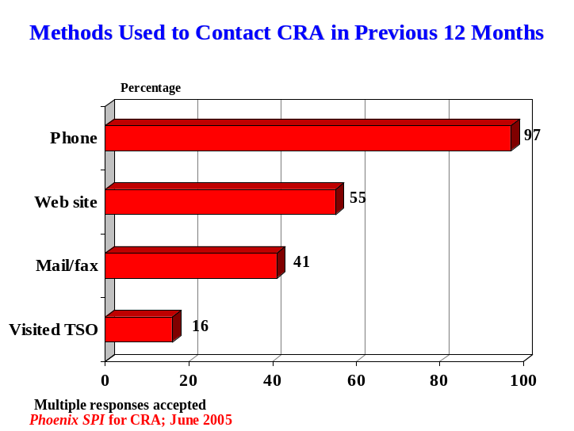Given the design of this study (i.e. focused on clients who recently called the CRA 1-800 business line), it is no surprise that the telephone was the main method used by respondents to contact the CRA in the previous 12 months. Virtually everyone (97%) said they used the telephone to initiate contact with the CRA during this time period. While the telephone was the main method of contact, 55% used the CRA Web site, and 41% used mail/fax to initiate contact with the CRA. Respondents were least likely to have visited a tax office during this period, with only 16% having done this.

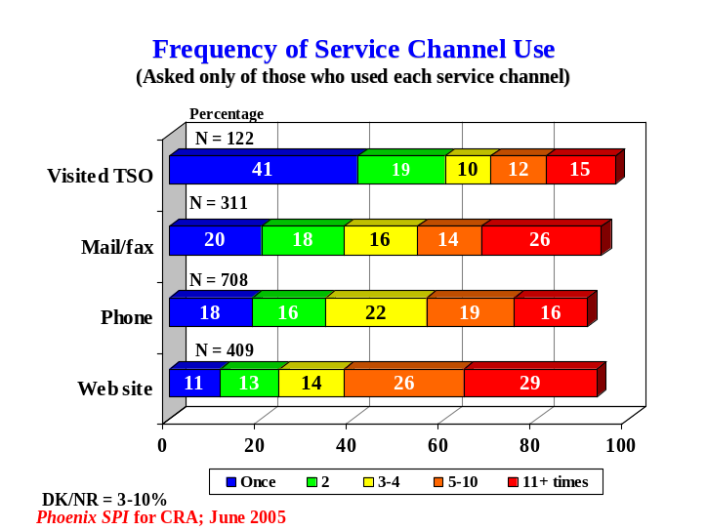Frequency of Use for Service Channels
The Web site was the most heavily used service channel in terms of frequency of use. In total, 55% of respondents who used this channel reported having visited the CRA site at least five times in the previous 12 months (29% visited it 11 or more times). Conversely, CRA tax offices received the lightest traffic flow, with a majority of people who used this channel (60%) having visited an office once or twice during the year.
In terms of mail/fax and phone, varied patterns of usage were evident, although the majority of respondents in each case (54-56%) indicated that they used the channel no more than four times in the previous 12 months. Telephone calls, in this instance, include all types of phone contact with the CRA, not just calls to the 1-800 business enquiries line.

Frequency of Calls to 1-800 Line Varies, Most Called More Than Once
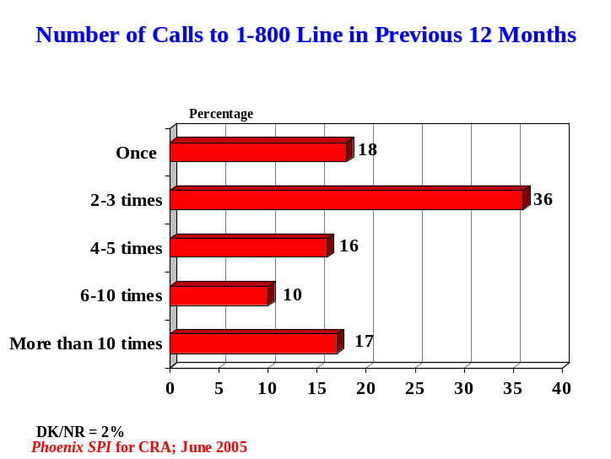While the frequency of calls to the CRA business enquiries line varied considerably, the large majority of respondents (79%) called the line more than once during the previous 12 months. The largest single proportion, over one-third (36%), said they called the line 2-3 times. Many called more often than this. Specifically, 16% called 4-5 times, 10% called 6-10 times, and 17% called more than ten times. At the other end of the spectrum, 18% called the phone line only once.

Of the different ‘types’ of respondents, service providers were far more likely to make multiple calls to the 1-800 number: 78% had called more than 10 times compared to 11% of business representatives and 7% of those who are self-employed.

GST/HST and Payroll Deductions – Most Common Reasons for Calling CRA
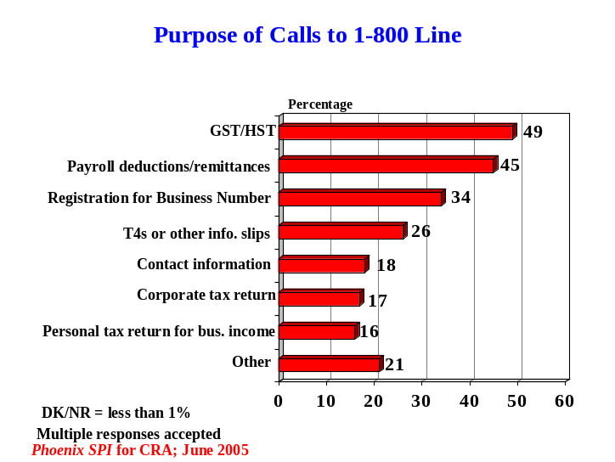Respondents called the business enquiries line for a variety of reasons during the previous 12 months. The two main reasons, however, were each identified by almost half of surveyed clients – to obtain information related to the GST/HST (49%) and related to payroll deductions/remittances (45%). As well, 34% called for information about registering for a business number, while one-quarter (26%) called about T4s or other information slips.

Smaller yet substantial numbers also called for CRA contact information, such as the address or phone number of a tax office (18%), or for information about corporate tax returns (17%) or personal tax returns for business income (16%). Included in the ‘other’ category, as presented in the preceding graph, are the following: to report account errors, to confirm receipt of items, to obtain general account information, to change/update the company profile, to request forms, to make instalment payments, and to check the balance owing.

Most Visited CRA Web Site for Information Before Calling Phone Line
A majority of respondents who called the CRA business enquiries line (58%) said they had visited the CRA Web site to try to obtain the information they needed before calling the phone line. Conversely, 40% said they called without first trying to obtain the information from the site.

The frequency of having visited the Web site before calling the 1-800 number varied somewhat. While the largest proportion visited the site 1-4 times, approximately one in five (21%) said they visited the CRA site at least five times to look for the information they needed before calling the phone line (12% visited the site more than 10 times).

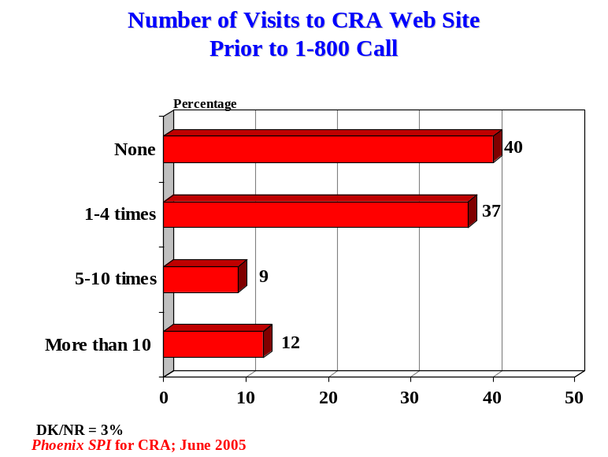

Note that many respondents who visited the CRA Web site more than once will have done so in advance of multiple phone calls to the 1-800 line (since we know that most respondents called the phone line more than once).

These results suggest that many respondents who called the business enquiries line may have done so because they were unable to find some or all of the information they needed on the CRA Web site.

It is worth noting that 21% of those who called the 1-800 number more than 10 times did not visit the Web site even once, while another 23% of these callers visited only 1-4 times. The situation is similar for those who called 6-10 times. Clearly, many of those who frequently call the business line do not visit the Web site often (or at all) before calling.

Half Learned About Business Enquiries Phone Line Through CRA
Half of the surveyed clients (51%) first learned about the CRA business enquiries phone line through the CRA itself. This was most likely to have occurred through a CRA publication (25%) or the CRA Web site (20%), although some learned about the phone line through a tax office (6%). Included in the ‘other’ category, and cited as sources by small numbers, are GST forms, a CRA agent, mail correspondence from CRA, and remittance statements or forms.

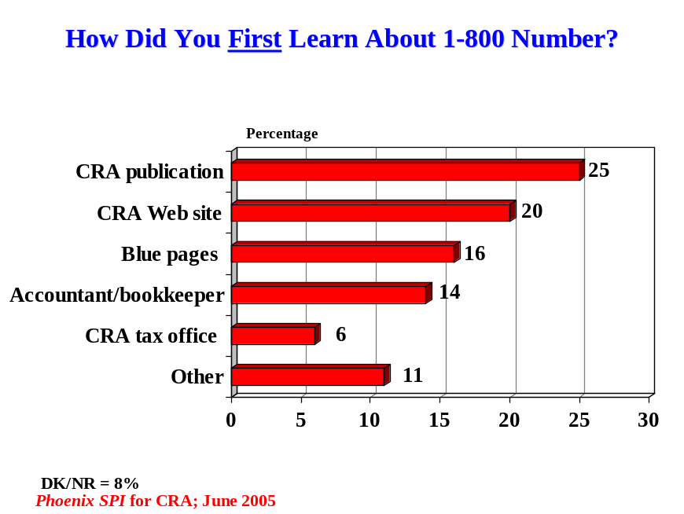

While a majority learned about the phone line through the CRA, some respondents learned about it through non-CRA sources, including the blue pages in phone books (16%) and accountants/bookkeepers (14%). Non-CRA sources included in the ‘other’ category are friends, colleagues, and employers.

In total, 8% could not recall how they first became aware of the business enquiries 1-800 number.

Evaluation of Business Enquiries Telephone Service
This section reports on respondents’ assessments of the service they received when calling the CRA business enquiries phone line. Respondents were asked to focus on service received during the previous six months. If they called the business enquiries line more than once during that time, they were asked to base their assessments on the service they received in general (i.e. thinking about all of their calls).

Widespread Satisfaction With Overall Quality of Service
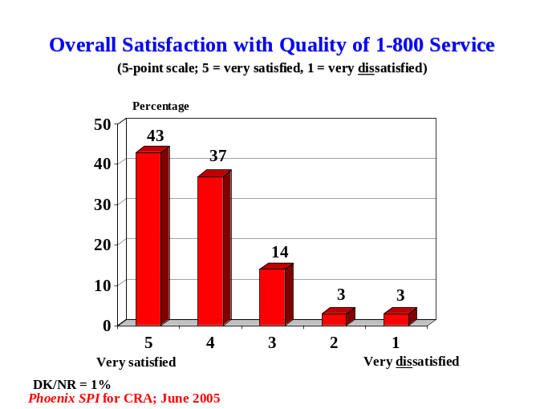Satisfaction with the service received when calling the CRA phone line was widespread. In total, 80% of respondents expressed satisfaction with the overall quality of service, with 43% saying they were very satisfied. Most of the rest (14%) were neutral in their assessment, with relatively few (6%) expressing dissatisfaction. Respondents used a 5-point scale to evaluate the service (1 = very dissatisfied; 5 = very satisfied). Compared to business representatives and self-employed respondents, service providers were noticeably less satisfied (68% vs. 79-86%).

Most Said Service Met or Exceeded Expectations
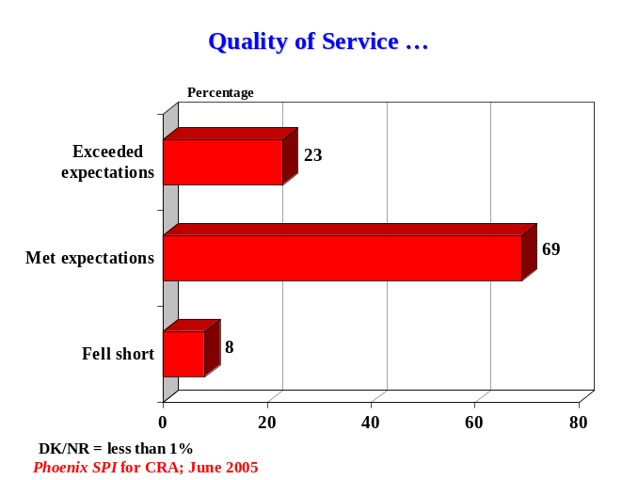Satisfaction with the service received was further reflected by the fact that the vast majority of respondents described the quality of service as meeting (69%) or exceeding (23%) their expectations. Relatively few (8%) felt that the quality of service fell short of their expectations. Note that almost three times as many respondents said that service exceeded expectations as those who thought it fell short of them.

The quality of service was slightly more likely to be viewed as falling short of expectations by service providers and representatives of businesses (9% each) versus self-employed respondents (4%).
Strongly Positive Assessments of Many Aspects of Service Delivery
Respondents were asked to assess various aspects of the service received by expressing their level of agreement or disagreement with 10 service-related statements. Using a 5-point scale (1 = strongly disagree; 5 = strongly agree), respondents were asked to rate their agreement with the following statements:
- The agent serving you was courteous.
- The agent serving you was knowledgeable and competent.
- You were able to get through to an agent without difficulty.
- You were treated fairly.
- You were served in the official language of your choice.
- You are confident that your privacy was fully protected.
- The agent serving you was able to respond to your inquiry on first contact.
- Your questions were answered to your full satisfaction.
- The information provided by the agent was clear and easy to understand.
- The CRA telephone number was easy to find.

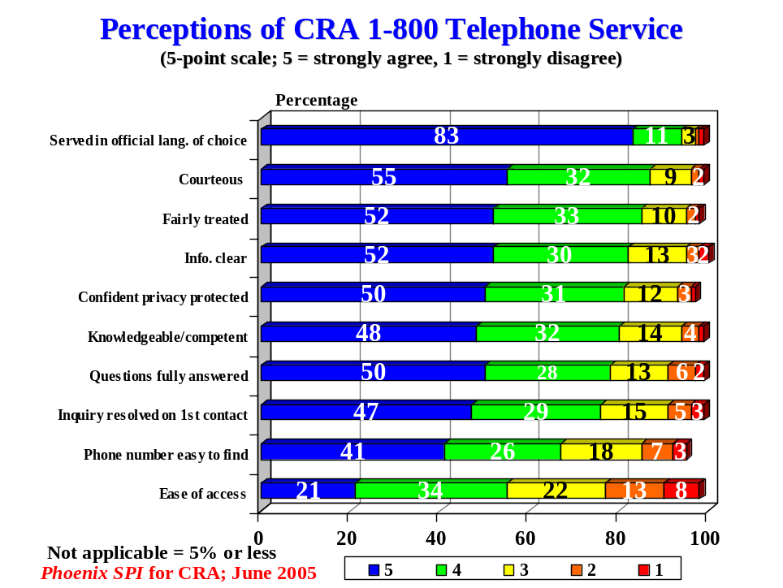

A majority of respondents expressed agreement with each of these statements. Moreover, levels of agreement exceeded 75% for all but two issues. Respondents were most likely to agree that they had been served in the official language of their choice. Nearly everyone agreed with this (94%), with more than three-quarters (83%) expressing strong agreement. There was also widespread agreement that agents were courteous (87%), that the respondent was treated fairly (85%), that the information was clear (82%), that they were confident that their privacy was protected (81%), and that the agent was knowledgeable and competent (80%). Over three-quarters agreed that their questions were fully answered (78%) and that their inquiry was resolved on first contact (76%). Agreement on all of these issues was much more likely to be strong than moderate (i.e. scores of 5, not 4 on 5-point scale).

Comparatively speaking, respondents were less likely to agree with the two statements about aspects of service that preceded contact with a service agent. Two-thirds agreed that the CRA phone number was easy to find, while slightly more than half (55%) agreed that they were able to get through to an agent without difficulty. Disagreement with these two statements ranged from 10-21%, and was highest in relation to ease of access.

Most Received All the Service/Information Needed
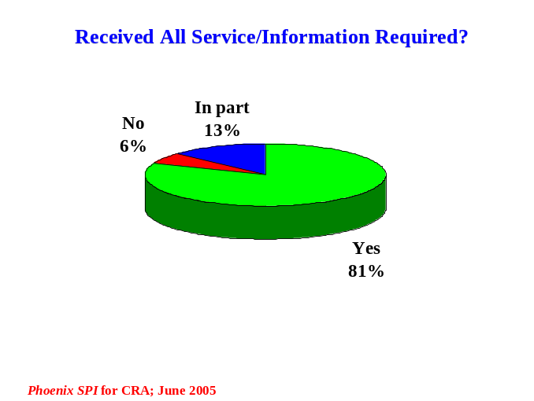Nearly all of the surveyed clients said they received all (81%) or part (13%) of the service or information they needed when calling the CRA business enquiries phone line. Six percent indicated that they did not receive what they needed.

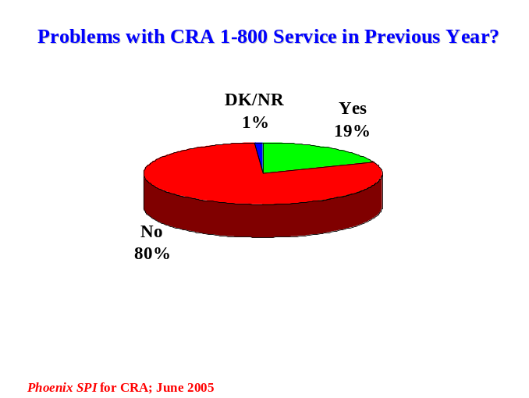Almost One in Five Experienced Problems With Phone Service
The large majority of respondents (80%) said they encountered no problems with the service they received through the CRA business phone line during the previous six months. However, almost one in five (19%) reported encountering a problem.

Asked to identify the type of problem(s) they encountered, 22% said that CRA was hard to reach, and 17% that client service was poor. These were followed by problems retrieving information (11%), receiving inconsistent answers (10%), not having inquiries resolved on first contact (10%), and being left on hold for too long (10%).

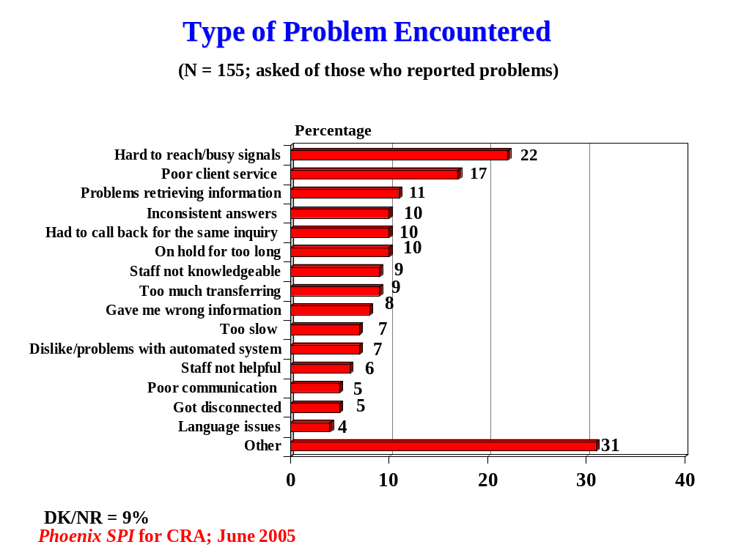
Other problems were identified less often, and included the staff not being knowledgeable (9%), being transferred too much during one call (9%), receiving inaccurate information (8%), the service generally being slow (7%), and problems with the automated system (7%).

The types of responses included in the ‘other’ category are being served by poorly trained staff, being unable to reach a specific agent, receiving generally confusing or frustrating service, and having agents make mistakes related to their enquiries, among others.

Satisfaction With Aspects of Service
Respondents were asked to rate their satisfaction with the following aspects of service delivery when they called the business enquiries phone line:
- The amount of time they had to wait to speak to a service agent.
- The accuracy of the information that was provided.
- The hours of service for the business phone line when they can speak with a service agent.

While a majority expressed satisfaction with all three aspects of service, the level and intensity of satisfaction varied. Respondents were most satisfied with the accuracy of the information – 81% expressed satisfaction with this, with 45% very satisfied. Satisfaction was also relatively widespread (70%) with the hours of service. In both cases, those who did not express satisfaction were much more likely to be neutral than dissatisfied.

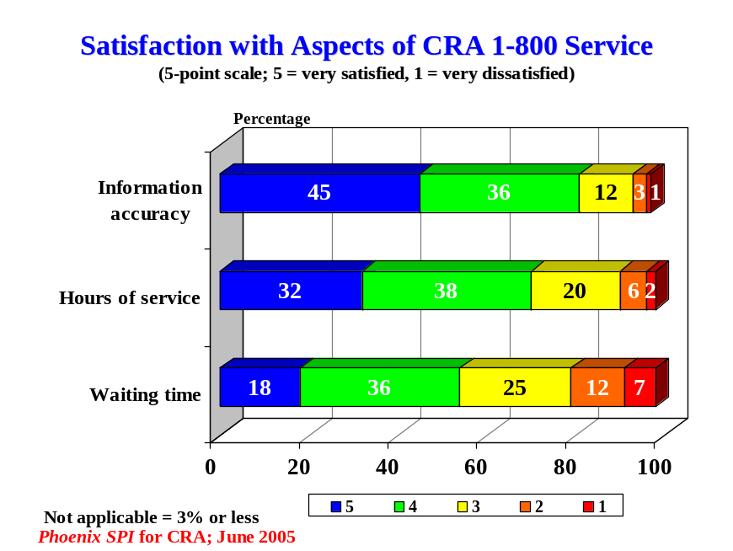

Surveyed clients were less likely to be satisfied with the amount of time they had to wait to speak to a service agent (54%). Conversely, almost one in five (19%) expressed some level of dissatisfaction with this aspect of service. Note that the number of respondents satisfied with the amount of time they had to wait to speak to a service agent is virtually identical to the number who agreed in an earlier question that they were able to get through to an agent without difficulty (55%).

Majority Who Called Business Line Listened to Automated Messages
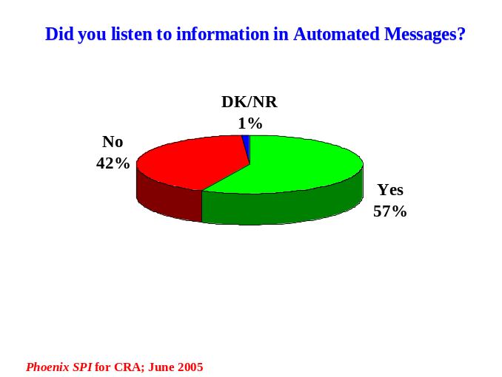A majority (57%) of those who called the CRA business enquiries line during the previous 12 months said they listened to at least some of the messages on the automated message system. Conversely, 42% said they did not listen to any of the information in these messages when they called the 1-800 number.

Moderate Satisfaction With Content and Ease of Use of Automated Message System
Respondents who listened to some of the automated messages were asked how satisfied they were with the usefulness of the information provided (using a 5-point scale: 1 = very dissatisfied; 5 = very satisfied). In response, nearly half (44%) expressed satisfaction with the usefulness of the information, although satisfaction was much more likely to be moderate than strong. At the other end of the spectrum, 17% expressed dissatisfaction with the usefulness of the information (37% were neither satisfied nor dissatisfied).
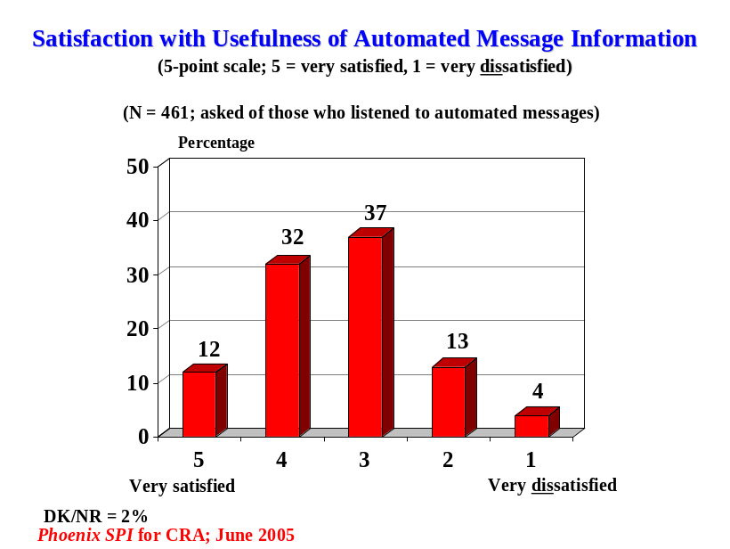

A similar pattern of responses emerged regarding the ease of use of the automated system. Using the same scale, exactly half of the respondents who listened to some of the messages expressed satisfaction with the ease of use of the automated system, including what the different options were and what they needed to do. Once again, almost one in five (17%) expressed dissatisfaction, while one-third were neither satisfied nor dissatisfied.

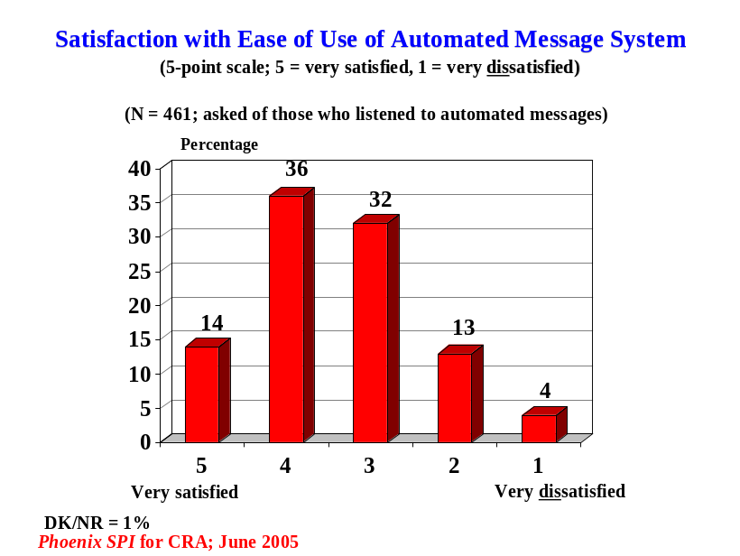

Over Four-in-Ten Got Through to Agent on First Attempt
More than four-in-ten of the surveyed clients (44%) said they got through to a service agent on their first call to the CRA business enquiries phone line. Most of the others (35%) indicated that they got through after 2-3 calls. Fewer than one in five (17%) said they had to call 4-5 times (9%) or more (8%) to get through to an agent.

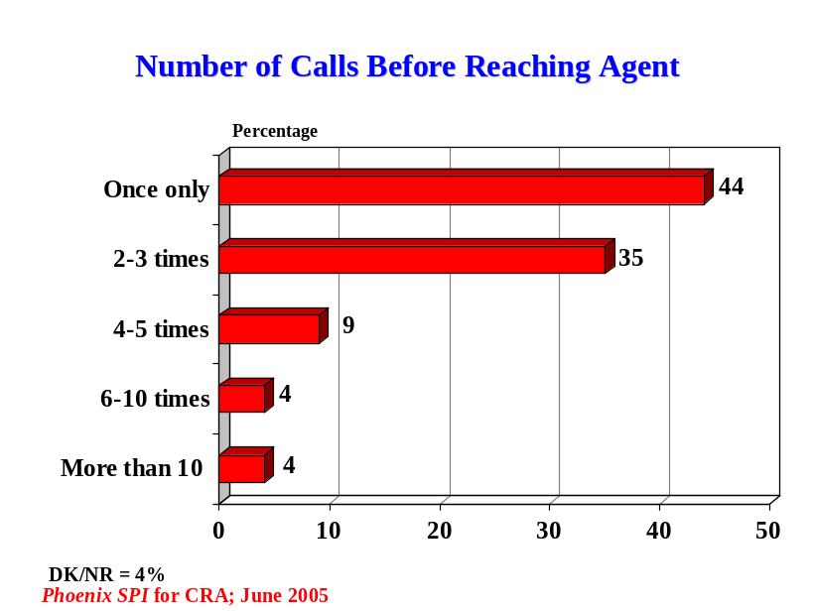

Most Able to Speak to Service Agent Within 5 Minutes
From the moment they wanted to speak to an agent (i.e. were finished with the automated message system) until a service agent came on the line, 78% of respondents said they waited five minutes or less to speak to the agent, with 38% saying they spoke to an agent within two minutes.

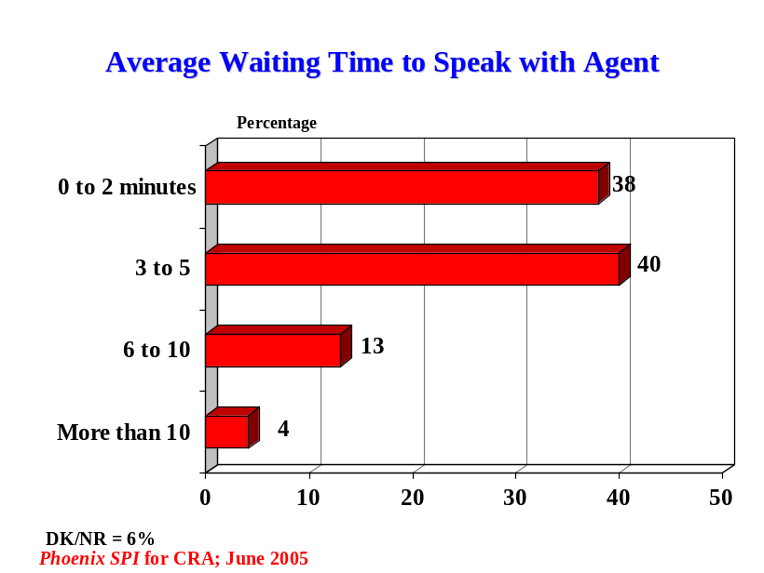

Some respondents had to wait longer than five minutes to speak to an agent: 13% said they waited 6-10 minutes, and 4% said they waited more than 10 minutes.

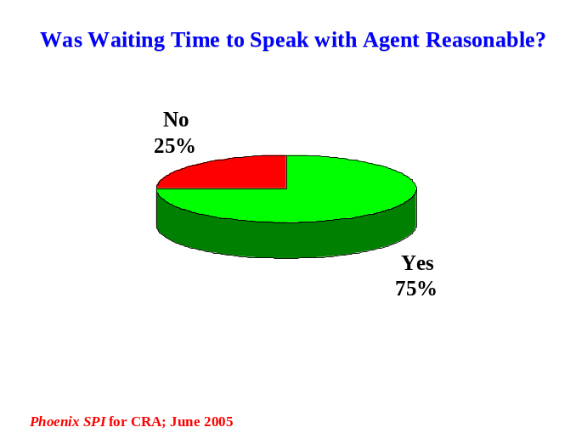Three-Quarters View Waiting Time as Reasonable
Three-quarters of surveyed clients described the length of time they had to wait to speak to a service agent as reasonable. Conversely, one-quarter did not.

The 25% of respondents who did not think the amount of time they had to wait to speak to an agent was reasonable were asked to identify what they consider to be an acceptable waiting time. In response, 74% felt that this should take no longer than two minutes. As well, one in five (21%) said an acceptable wait time was between 3-5 minutes. Only three respondents (1%) think it is acceptable to wait longer than five minutes.
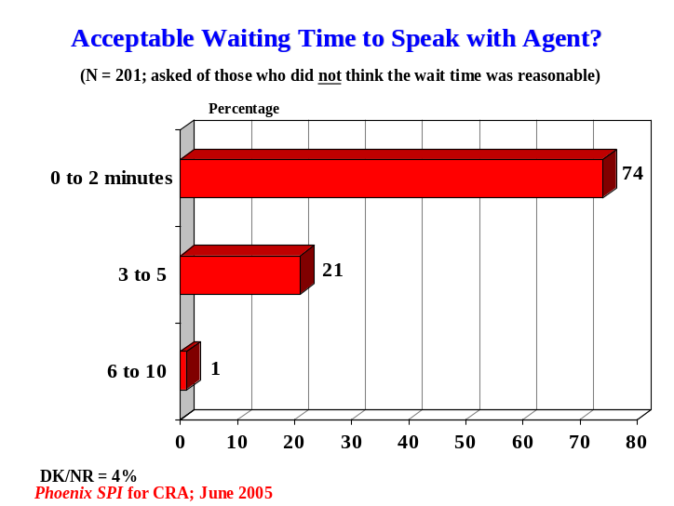

Suggestions to Improve Quality of Phone Service
Respondents were asked, in an open-ended fashion, to offer suggestions to help the CRA improve the service it provides to people who call the business enquiries phone line. Fully 66% did not offer any suggestions, while 5% said that the service is good and nothing needs improvement. In total, therefore, almost three-quarters of surveyed clients (71%) had no substantive feedback to provide in this area. Among those who did offer suggestions, respondents called most often for options to bypass the automated system, more staff to answer phones, faster service in general, and more knowledgeable/better trained staff.

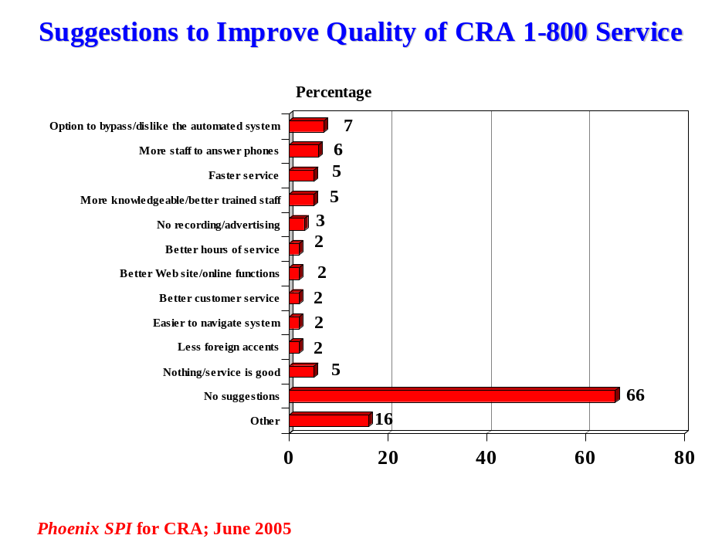

Respondent Characteristics
The following graphs present the characteristics of survey respondents and of the organizations that they work for, if relevant. This includes the ‘type’ of respondent, the nature and size of the business they work for (number of employees and annual revenues), their sector, their position in their company, region, and the language of participation in this research.

Type of Respondent
More than half of surveyed clients work for companies – incorporated (43%), unincorporated (7%), or service providers that provide accounting, payroll or taxation-related services to businesses (9%). Most of the rest are self-employed individuals (29%).

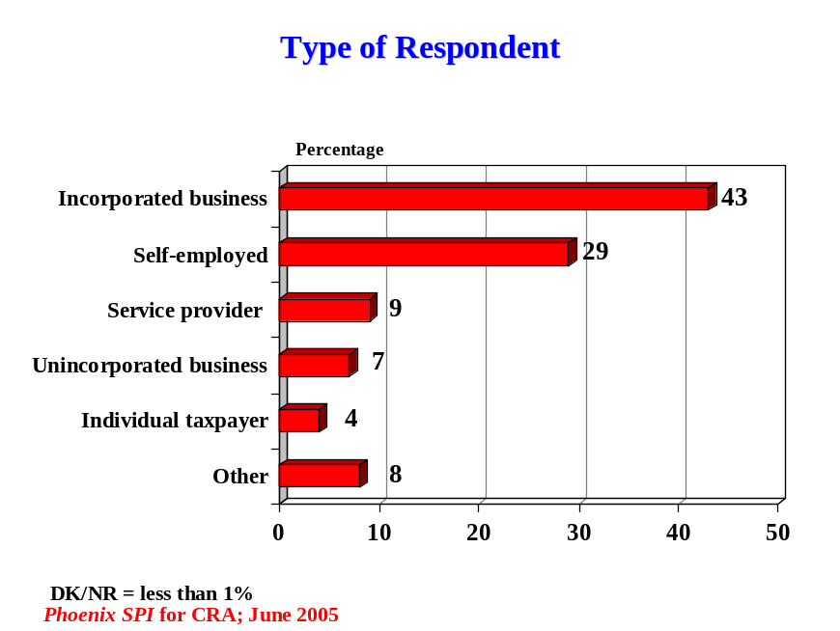

Included in the other category are charities, farms, churches, chartered accountants, and government or public agencies.

Type of Service Provider and Services Offered
Most of the service providers work for accounting firms (67%).
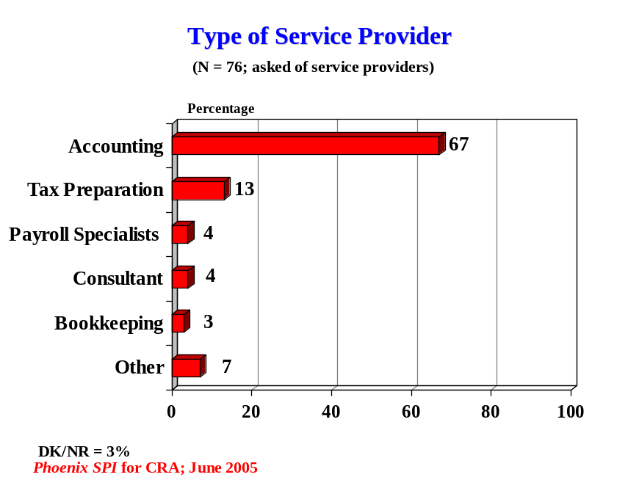

Service providers offer a variety of services to their business clients.
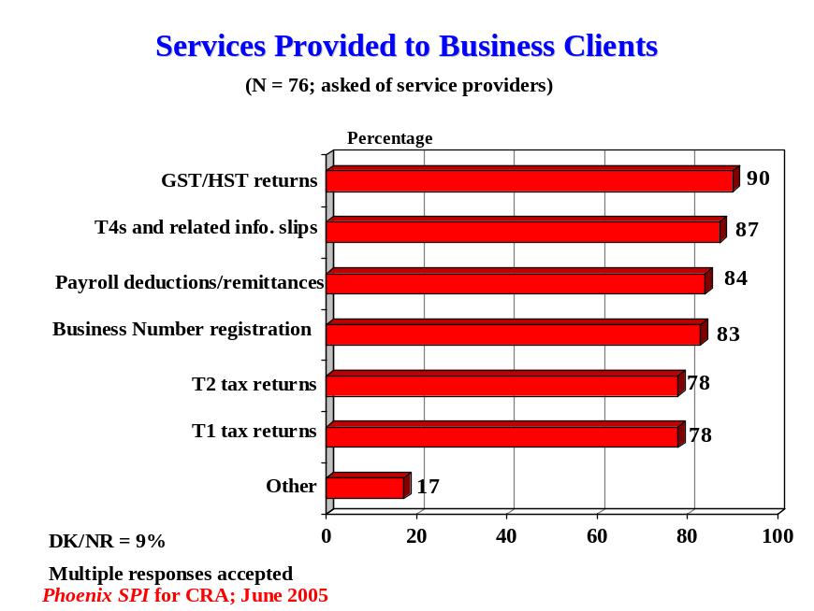
Position
Respondents who work for companies were asked to identify their position within their firm. Almost half (46%) are owners, presidents or CEOs. Smaller and similar numbers are accountants (11%), accounting managers (10%), or comptrollers/CFOs (8%). Also identified were payroll managers (4%), bookkeepers (3%), office managers (3%), secretaries (2%), payroll specialists (2%), and administrative clerks (2%).

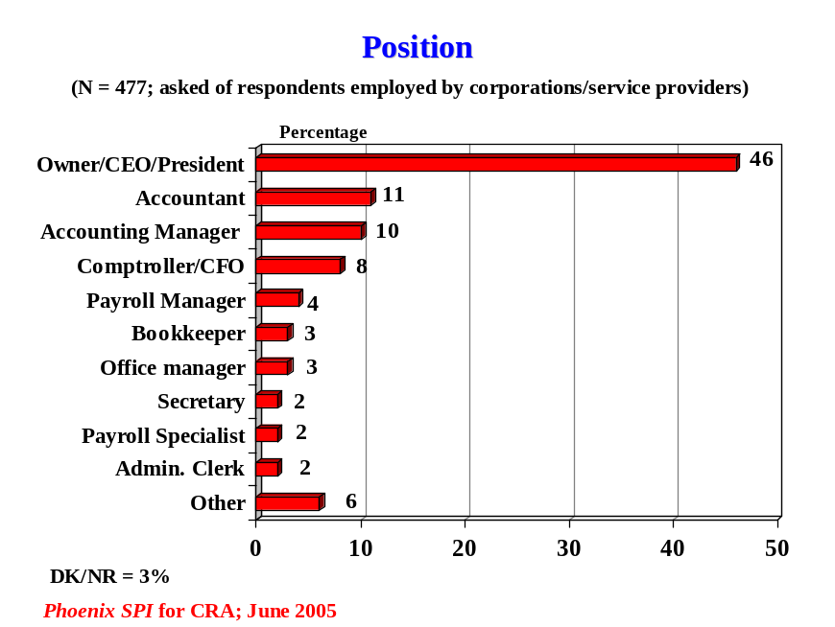

Included in the other category are directors and IT specialists, among others.

Number of Employees
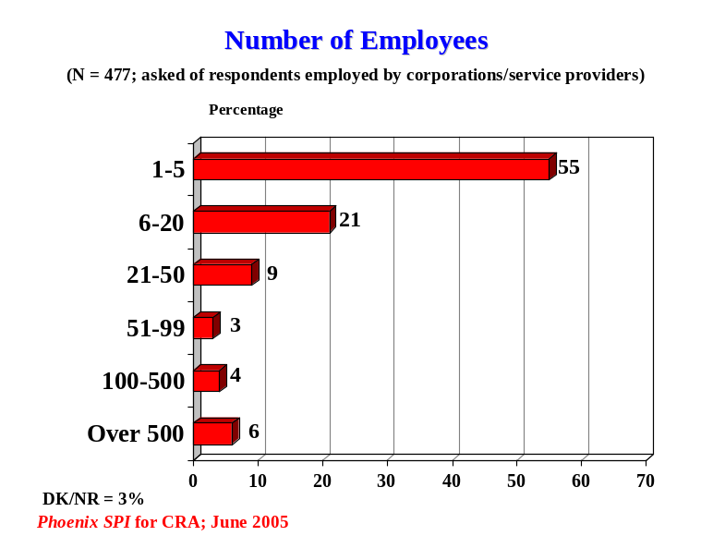Respondents who work for companies were asked to identify the number of full-time and part-time employees in their firm. The majority (55%) work in companies with five employees or less. In addition, 21% work in firms with 6-20 staff, 12% in firms of 21-99 employees, and 10% in companies with 100 employees or more.

Business Revenue
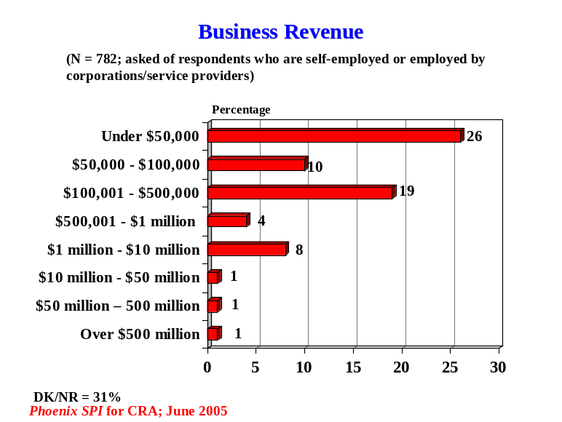Respondents who work for companies and self-employed individuals were asked to identify their total business revenue for their most recent fiscal year. This includes total revenue from all sources, before taxes and deductions, from the business’ Canadian operations. Over half (55%) had revenues of $500,000 or less (one-quarter earned under $50,000). Very few (3%) had revenues of over $10 million.

Sector
Respondents who work for companies and self-employed individuals were asked to identify the industry or sector in which their business operates. If they are active in more than one sector, they were asked to identify the main sector. The following graph presents the sectoral distribution of these businesses.

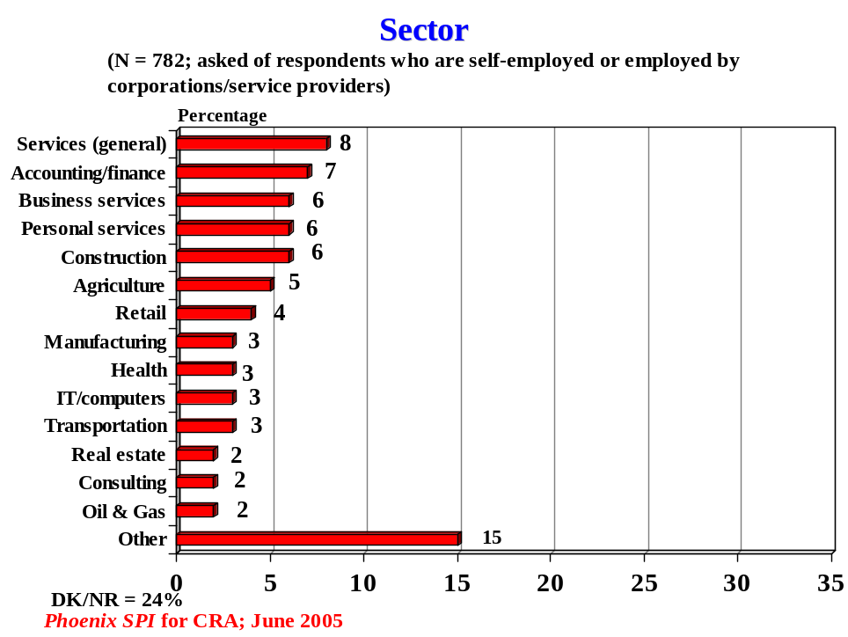
Location
All respondents were asked to identify the province in which they are personally located. The largest proportion (35%) are residents of Ontario, followed by those who live in British Columbia (20%) and Alberta (16%). Nearly identical numbers (9-10% each) live in Manitoba/Saskatchewan, Quebec, and Atlantic Canada.

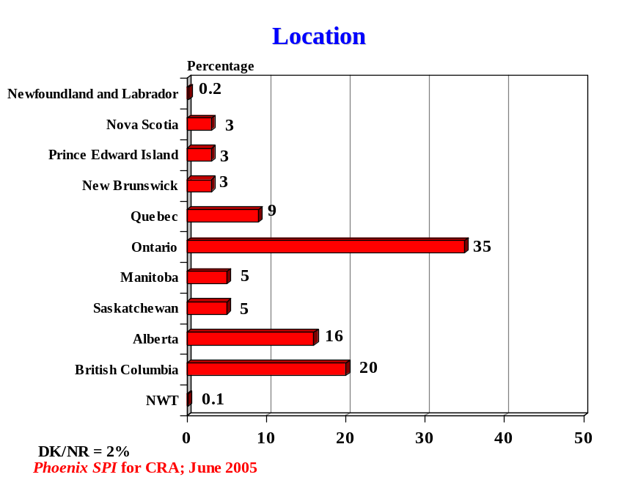

Language of Survey Completion

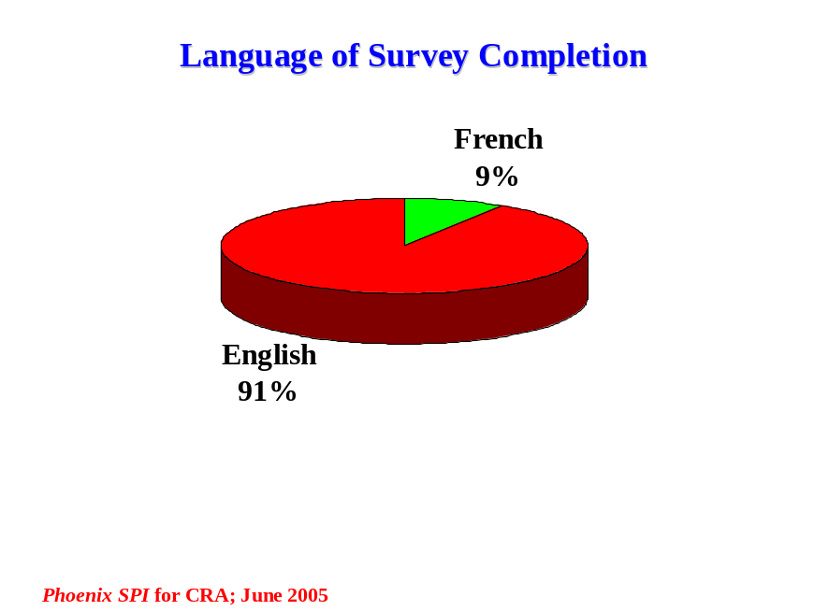

Sub-Group Variations
This section presents sub-group differences for key issues explored in this survey, including variations based on respondent type, business size, region, and language of survey completion. The information is presented in two ways. First, we provide summary descriptions of the main patterns in each area (presented in the same order and structure as information in the main report). These summaries are textual, with few numbers, for ease of access to the information. Second, we provide a detailed table that presents a breakdown of the findings for the various sub-groups. The table is also organized by theme.

Due to the relatively small sample sizes for the various sub-groups, caution should be exercised when reviewing and interpreting the results.

For this analysis, sub-group characteristics have been grouped as follows:

Respondent Type:
- Business (incorporated and unincorporated)
- Service provider
- Self-employed

Business Size:
- Small (1-5 employees)
- Medium (6-20)
- Large (21+)

Region:
- West
- Ontario
- Quebec
- Atlantic

Language of Survey Completion:
- French
- English

At the end of this section is a brief description of some of the behavioural and attitudinal differences between respondents who completed the survey online vs. those who completed it by mail.

Overview
There were a number of noteworthy sub-group differences. The clearest and most pervasive pattern related to respondent type, with service providers more likely to be heavy users of the business line and less likely to be satisfied with the quality of service. Turning to business size, use of the 1-800 line increased with the size of the organization, while satisfaction ratings were consistently higher among small firms. Regional differences were generally small and followed no distinct pattern except that callers from Quebec were the most likely to express satisfaction with the service received, both overall and with respect to the various service dimensions that were evaluated. Callers who completed the survey in French were less likely to have contacted CRA through each of the service channels, yet were more likely to express satisfaction with the service received.
CRA-Related Activities
A number of patterns were evident when analysing the CRA-related activities undertaken by respondents:
- Compared to representatives of businesses and self-employed individuals, service providers contacted the CRA with greater frequency with respect to all of the channels. In addition, despite being more likely to visit the Web site prior to calling, service providers were by far the heaviest users of the 1-800 line. Over three-quarters had called more than 10 times in the previous year (compared to 7-11% of the others).
- Use of the Web site and mail/fax increased with business size, as did the frequency of 1-800 calls. Conversely, the likelihood of not visiting the Web site prior to calling the business line was inversely related to business size, going from 40% of small businesses to 22% of large firms.
- Callers from Ontario were more likely to have used all three service channels, while those from Quebec were least likely to have visited a tax office. Atlantic Canadians were slightly more likely to have placed a higher volume of 1-800 calls and to have not visited the Web site prior to doing so. The pattern was reversed in Quebec. Quebec callers were the most likely to have called the business line only once and to have made a prior visit to the Web site.
- People who chose to participate in this research in French were less likely to have contacted the CRA through any of the service channels.

Evaluation of Business Enquires Telephone Service
In terms of assessments of service quality, the patterns that were most pronounced were once again related to respondent type and business size:
- Self-employed callers were the most and service providers the least likely to be satisfied with the quality of service (86% vs. 68%), and to say that service exceeded their expectations (28% vs. 8%). Service providers were more than twice as likely as others to have had a problem with the service they received (38% vs. 14-18%). As well, self-employed respondents were the most and service providers the least likely to offer positive assessments of the service, and to express satisfaction with various aspects of service delivery.
- Small firms were the most likely to be satisfied with the overall quality of service and to feel that it exceeded their expectations. With a few exceptions, they also tended to offer the most positive assessments of service and were the least likely to have experienced problems. In addition, these callers were the most likely to have listened to the automated message system and to have attributed usefulness to the information and to rate the system as easy to use.
- Regional differences tended to be relatively small. That said, callers from Quebec were the most likely to be satisfied with the overall quality of service and to offer positive assessments of the various aspects of service delivery. Those in the West were slightly more likely to have used the automated message system, and were the least apt to attribute usefulness to the information.
- Variations by language of survey completion were generally not large, but followed a consistent pattern. Respondents who completed the survey in French were more satisfied with the overall quality of service, experienced fewer problems, and offered more positive assessments of the service delivery.

Differences Based on Data Collection Method
An analysis was undertaken based on the data collection method used by respondents. This revealed the following:

Respondents who completed the survey online were more likely to have:
- Contacted the CRA by all services channels, especially by mail/fax (50% vs. 31% of those who completed a paper copy of the survey) and by visiting the Web site (70% vs. 37%)
- Contacted the CRA by phone six or more times (36% vs. 20%)
- Contacted the CRA by mail/fax three or more times (60% vs. 44%)
- Contacted the CRA by Web site three or more times (77% vs. 50%)
- Called the 1-800 line more than 10 times (21% vs. 13%)
- Heard about 1-800 line via the CRA Web site (26% vs. 12%)
- Said that service exceeded expectations (25% vs. 20%).

They were also more likely to have completed the survey in English and to reside in British Columbia.

Significantly, there were minimal differences in terms of satisfaction with the service received, both overall and with respect to the various aspects of service delivery.

Respondents who completed the survey by mail were more likely to have:
- Not visited the Web site before calling the 1-800 number (55% vs. 26% of people who completed the survey online)
- Agreed that their questions were answered to their full satisfaction (81% vs. 75%).

They were also more likely to have completed the survey in French, to reside in Quebec or Atlantic Canada, and to be self-employed (35% vs. 23%).
Demographic Table
 | Respondent Type |  |  | Business Size |  |  | Region |  |  |  | Language
 | Business | Service Provider | Self-employed | Small | Medium | Large | West | Ontario | Quebec | Atlantic | English | French
Method to Contact CRA
Web Site | 57 | 79 | 43 | 54 | 63 | 74 | 54 | 59 | 52 | 50 | 56 | 46
Mail/Fax | 43 | 83 | 27 | 46 | 48 | 62 | 40 | 45 | 37 | 43 | 42 | 33
TSO | 14 | 25 | 15 | 15 | 18 | 15 | 15 | 18 | 7 | 18 | 17 | 5
Frequency of 1-800 Calls
Once | 16 | 1 | 25 | 18 | 12 | 4 | 17 | 18 | 23 | 16 | 18 | 21
2-5 times | 56 | 12 | 60 | 55 | 39 | 43 | 53 | 52 | 45 | 53 | 52 | 47
More than 10 times | 11 | 78 | 7 | 14 | 32 | 34 | 16 | 18 | 17 | 23 | 17 | 18
Prior Visit to Web Site
None | 37 | 26 | 47 | 40 | 37 | 22 | 41 | 37 | 28 | 49 | 40 | 38
Overall Satisfaction
% satisfied (scores 4-5) | 79 | 68 | 86 | 81 | 70 | 74 | 77 | 81 | 86 | 81 | 80 | 86
Service Expectations
Exceeded | 22 | 8 | 28 | 24 | 16 | 14 | 22 | 25 | 17 | 18 | 23 | 15
Met | 69 | 83 | 67 | 68 | 74 | 74 | 70 | 65 | 78 | 72 | 68 | 79
Perceptions of Service
(% agree)
Official language | 93 | 93 | 96 | 93 | 92 | 93 | 93 | 94 | 96 | 96 | 94 | 95
Courteous agent | 85 | 76 | 95 | 86 | 77 | 82 | 86 | 88 | 92 | 91 | 87 | 91
Treated fairly | 84 | 68 | 91 | 82 | 81 | 80 | 81 | 86 | 92 | 89 | 84 | 91
Clear information | 80 | 67 | 88 | 82 | 68 | 77 | 80 | 80 | 86 | 84 | 81 | 84
Privacy protected | 79 | 88 | 79 | 78 | 80 | 87 | 79 | 82 | 79 | 87 | 81 | 79
(Percentage of Respondents)

Demographic Table
 | Respondent Type |  |  | Business Size |  |  | Region |  |  |  | Language
 | Business | Service Provider | Self-employed | Small | Medium | Large | West | Ontario | Quebec | Atlantic | English | French
Knowledgeable agent | 78 | 57 | 90 | 80 | 66 | 70 | 77 | 80 | 85 | 84 | 79 | 87
Questions fully answered | 75 | 67 | 88 | 76 | 67 | 72 | 77 | 77 | 85 | 80 | 77 | 86
First contact resolution | 75 | 62 | 86 | 77 | 70 | 64 | 77 | 78 | 79 | 70 | 76 | 79
Phone number easy to find | 65 | 65 | 67 | 67 | 60 | 66 | 66 | 65 | 70 | 69 | 66 | 68
Got through to agent | 54 | 28 | 66 | 56 | 42 | 42 | 53 | 55 | 66 | 57 | 54 | 67
Problem with Service
Yes | 18 | 38 | 14 | 17 | 24 | 27 | 19 | 20 | 14 | 20 | 20 | 15
Assessments of Service
(% satisfied)
Accuracy of information | 80 | 66 | 88 | 80 | 71 | 76 | 82 | 78 | 85 | 84 | 81 | 84
Hours of service | 65 | 63 | 76 | 65 | 61 | 65 | 68 | 67 | 79 | 81 | 69 | 76
Waiting time for agent | 52 | 36 | 65 | 53 | 45 | 43 | 49 | 55 | 72 | 62 | 53 | 66
Automated Msg. System
Listened to messages | 59 | 43 | 57 | 60 | 47 | 56 | 61 | 53 | 55 | 57 | 57 | 59
Usefulness of information | 37 | 42 | 55 | 41 | 33 | 36 | 42 | 47 | 46 | 45 | 45 | 40
Ease of use | 45 | 49 | 57 | 50 | 41 | 40 | 47 | 52 | 62 | 45 | 50 | 51
(Percentage of Respondents)

Appendix
Note on Methodology
Overview
Phoenix SPI was commissioned by the CRA to assess the level of client satisfaction among people who call the business enquiries phone line for assistance. The objective of the research was to better understand how the quality of service provided by the 1-800 number was perceived by callers (i.e. clients). This note presents a detailed description of the methodology used to undertake this study.

Given the nature of the service delivery, a key challenge associated with this research had to do with reaching the target audience – clients of the business enquiries line. Clients call the 1-800 number to obtain information or assistance for business-related taxation issues. The business enquiries line can be called by anyone, and contact information is generally not collected from callers. As such, there was no existing ‘client list’ to use to access this client group. In addition, the incidence level of these clients among the general population is very low. As a result, it would have been prohibitively expensive to reach this audience using a random digit dial survey or through the use of customized lists available from list brokers.

To access callers of the business enquiries line in a cost-effective, efficient manner, the CRA deployed a method of recruitment that had not previously been used by the Agency. This involved intercept recruitment done by call centre service agents. This was followed by a survey administered by Phoenix, where recruited callers had the option of completing the survey online or by mail. Since this was the first time that this methodology has been used by the CRA, one of the objectives of this study was to pilot test the methodology itself. This note, therefore, presents a short assessment of the functioning of the methodology, including a review of its strengths and weaknesses and the lessons learned.

Detailed Description of the Methodology
A number of methodological features were used to conduct this study, including an intercept method to recruit participants, and data collection conducted via online and mail surveys (determined by the client’s preference). This section presents a detailed description of the methodological approach used to conduct the research.

Participant Recruitment
The initial phase of this study involved the recruitment of research participants. As noted, this was necessary because the CRA does not maintain ‘client lists’ for this service channel (i.e. the names/phone numbers of people who had called the 1-800 business line). Recruitment took the form of intercept activity undertaken by service agents that staff the 1-800 line. This involved obtaining callers’: 1) agreement to participate in the research, and 2) contact information to enable their participation. During specified time periods, involving a certain number of service agents per call centre, people who called the 1-800 business enquiries line were informed about the research and invited to participate in it. This occurred once the caller’s initial enquiry (that prompted the phone call) had been dealt with by the service agent. Callers who agreed to take part in the research were asked to provide information that would support their participation (i.e. their preference regarding data collection method, language preference, contact information, etc.). This information was then forwarded to Phoenix by the CRA.

The following specifications applied to the recruitment activities:
- To ensure that a random sample of 1-800 callers was recruited, a ‘generic’ schedule was produced and shared with call centres to help govern the timing of the recruitment (see below). This generic recruitment schedule was modified by each call centre to take into consideration the specific circumstances and operational requirements of the call centre. The final timing of recruitment activity, including the identity and number of service agents used for this, was finalized by individual call centre managers, whose knowledge of their operations helped ensure that the approach used by each call centre was the most appropriate and best able to minimize the impact on service delivery. The main requirement asked of each call centre was to ensure that a random sample of callers was asked to participate. The generic recruitment schedule is presented below:

Monday | Tuesday | Wednesday | Thursday | Friday
Week 1
9:00-11:00 am | 1:00-3:00 pm | 5:00-7:00 pm | 9:00-11:00 am | 1:00-3:00 pm
Week 2
1:00-3:00 pm | 5:00-7:00 pm | 9:00-11:00 am | 1:00-3:00 pm | 9:00-11:00 am

Designed to coincide with the hours of operation of the 1-800 business enquiries line, recruitment periods were staggered across the week by time of day. As the table indicates, if recruitment was undertaken in the morning during Week 1, it was scheduled to take place in the afternoon of the same weekday during Week 2. While the implementation of this schedule was modified, the overall approach of varying the times of the day and days of the week was followed where possible.
- The target number of recruited participants was 4,000. This target was selected to provide for a 3:1 ratio (i.e. number of people recruited vs. projected number of completed surveys), with a buffer to allow for a lower completion rate, unusable contact information, and any unforeseen circumstances. To ensure that the regional distribution of recruited participants was generally reflective of the client base, target quotas were set based on the average number of weekly unique callers handled by each call centre. Each call centre was assigned a quota proportionate to the regional distribution of calls. The following table presents the quotas set for each call centre, as well as the actual number of recruited participants per call centre. Note that callers from Quebec received service from agents in Saint John, New Brunswick and Edmonton, Alberta. The quotas were based on information received from the CRA that indicated the regional distribution of unique callers (by call centre) for the similar time period for the previous year. It should be noted that these quotas were intended to serve as approximate guidelines only, as something for call centres to strive for, rather than as fixed numerical targets set in stone.
Call Centre | Target Number of Recruits | Actual Number of Recruits
Saint John | 360 (Non-Quebec))  200 (Quebec) | 343 (Non-Quebec)  122 (Quebec)
Sudbury | 400 | 407
Hamilton | 1,160 | 396
Edmonton | 960 (Prairies)  280 (Quebec) | 655 (Prairies)  112 (Quebec)
Vancouver | 640 | 484
Total | 4,000 | 2,519

- Three documents were developed and provided to call centre managers to govern the recruitment. The first document presented guidelines to cover the intercept activities. This included an overview of the recruitment process, detailed instructions for team leaders and agents to facilitate recruitment, and identification of the selection method to be used to recruit participants. The second document was a short telephone script for service agents to use with callers. It identified the purpose and nature of the research, introduced Phoenix as the research firm commissioned to conduct the study, and asked callers for their agreement to participate in the research. The phone script also asked callers who agreed to participate in the study to identify their preferred method of participation – online or mail survey – and to provide the contact information needed to enable participation (i.e. email address or full mailing address). The third document was a Q&A (questions and answers) piece for service agents to use with callers on an as-needed basis.
- The information obtained from callers who agreed to take part in this research was inputted by service agents directly into an Excel database designed specifically for this purpose. The Excel files were transmitted by each call centre to CRA’s Client Services Directorate (Assessment and Clients Service Branch) where they were merged and, in turn, transmitted electronically to Phoenix.
- The recruitment activity was monitored on a daily basis, and periodic adjustments were made based on the number of research participants recruited by each call centre. The purpose of the adjustments was to increase the number of recruited participants. The adjustments generally consisted of extending the hours of the recruitment activity, the number of service agents involved in the recruitment activity, or both.
- Initially, it was anticipated that all recruitment would be completed within a two-week period. However, recruitment took longer than expected due to various factors, including operational requirements (i.e. delivering service to callers in an effective manner). For some call centres, recruitment took place over a four-week period, at which time recruitment was deemed to have been completed even if the target guidelines had not been achieved.
- The list of callers who agreed to complete the survey was provided to Phoenix by the CRA. The list was in electronic format (Microsoft Excel), and contained the client’s name, area code, language preference (French/English), company name, if applicable, choice of data collection method (online or mail), and their email or mailing address (whichever was relevant for the client’s preferred data collection method). The area code was obtained to enable researchers to determine the geographic distribution of recruited participants and to compare the distribution of recruits with that of people who actually completed the questionnaire. The company name was included for use with mail surveys (i.e. to provide for a complete mailing address).
- Privacy requirements were reviewed and adhered to, ensuring compliance with the requirements of the Personal Information and Protection of Electronic Documents Act (PIPEDA).

Data Collection
Following the recruitment phase, the survey was administered using the two data collection methods – online and mail. The recruitment efforts yielded usable contact information for 2,519 callers (i.e. ‘usable’ refers to contact information that was complete enough to be used for the research). Invitations were sent to 1,143 recruited callers who expressed a preference to complete the survey by mail, and to 1,376 callers who expressed a preference to complete the survey online. Of these, 49 were returned as undeliverable – 13 (mail) and 36 (online). The survey was completed by 812 recruited callers (includes both mail and online). In addition, 22 mail surveys were received after the analysis had begun. When this is factored in, the study yielded a response rate of 33%. Based on a sample of this size, the overall results can be considered to be accurate to within +/- 3.4%, 19 times out of 20. The fieldwork was conducted between April 15 and May 26, 2005.

In addition, the following specifications applied to the data collection:
- A cover letter/email was sent to those who had agreed to participate in this research. It reiterated the purpose of the research, re-introduced Phoenix as the firm conducting the study, and encouraged participation.
- The questionnaire was designed to take approximately 10 minutes to complete, whether done online or via mail. The same questionnaire was used for both data collection methods (online vs. mail), although the formatting was different to facilitate ease-of-completion appropriate to each data collection method.
- In terms of the mail survey:
- The questionnaire was included with the cover letter sent to respondents in the mail. The envelope contained a business reply envelope (i.e. a self-addressed, postage pre-paid envelope) so that respondents could easily return the completed questionnaire to Phoenix.
- Two reminder post-cards were sent to all respondents who chose mail as their preferred method of completion. The reminders were sent approximately one week apart and included a 1-800 phone number for people to call if they had lost/ misplaced their questionnaire.
- Questionnaires returned by mail were data entered and subsequently merged with the data collected online.
- In terms of the online survey:
- The survey was accessed through a URL link contained in the email cover letter sent to respondents. The link took respondents to a page where they could select the official language of their choice. A personal identification number (PIN) was included in the email and was required to gain access to the survey. Respondents were able to bookmark the survey and return to it at a later time.
- The questionnaire was available online for approximately three weeks. It ‘resided’ on a secure non-government server, ensuring security of data and confidentiality of responses for respondents.
- Online support was available should respondents encounter any difficulties completing the questionnaire.
- Two emails were sent to respondents that had not yet completed the survey. The reminders were sent approximately one week apart.
  - A pre-test was conducted using the online version of the questionnaire. For the pre-test, 100 email cover letters were sent out (i.e. a subset of the full 1,376 to be sent out). After two days, 13 questionnaires had been completed by respondents. These questionnaires were reviewed with respect to data quality and survey performance. It was determined that no changes to the questionnaire were needed. Following this pre-test, the remaining email cover letters were sent out to all other recruited callers that had expressed a preference for completing the survey online.

Assessment of the Methodology
In this section, we evaluate the functioning of the methodology. This includes a review of the strengths and weaknesses of the methods used for the research, as well as the lessons learned.

Strengths – Methodological Aspects That Worked Well
The following aspects of the methodology worked well:
- The coordination and implementation of the recruitment worked quite well despite the fact that each call centre is independently operated and unique in terms of call volumes and other circumstances. An initial telephone conference was held with call centre managers to discuss the recruitment needs, answer any questions related to recruitment, and to finalize the operational aspects of the recruitment task. Recruitment updates were transmitted by the CRA’s project authority to Phoenix on a weekly basis.
- Most of the sample contained full and accurate contact information. In total, only 49 invitations to take part in the survey were returned as undeliverable (13 mail and 36 email).
- Assumptions were made when designing this research regarding the sample-to-completion ratio (i.e. the number of recruited participants vs. the projected number of completed surveys). It was assumed that the ratio would need to be 3:1 in order to generate the target number of survey responses. In the end, the usable sample (i.e. the sample for which there was complete contact information) obtained through the intercept recruitment was 2,470 (excluding emails that were undeliverable; i.e. bounced back). The number of completed surveys was 812. This represents a 33% response rate. As such, the response rate estimate was extremely accurate.
- Not only was the sample-to-completion ratio precise, the response rates were virtually identical for the two data collection methods – 33% for mail and 32% for online (when rounded).
- No respondents who chose to complete the survey by mail used the 1-800 number to request a new questionnaire. It would therefore appear that those recruited individuals who intended to complete the survey did so right away or simply did not misplace either their survey or business reply envelope. Or, alternatively, those who might have completed the questionnaire, but lost/misplaced the original copy, did not make the effort to call the 1-800 to obtain a replacement.
- Very few recruited individuals contacted Phoenix to inquire about the survey because they could not recall having agreed to take part in the study. In other words, there was little confusion or forgetting by participants regarding their prior agreement to take part (at least among those who contacted us in any manner – by phone or email).

Weakness – Methodological Aspects That Worked Less Well
Some aspects of the methodology worked less well. It should be noted, however, that the operational requirements of the call centres, by necessity, took precedence over the implementation of this research. That is, the requirement to deliver service to clients who called the 1-800 number was naturally of greater importance that undertaking tasks related to the measurement of client satisfaction. Accordingly, it may well be that some of these ‘deficiencies’ in terms of the implementation of the methodology may be unavoidable given the need to simultaneously deliver service to clients.

Areas where the methodology performed less well included:
- The initial phase of the research took significantly longer than planned and fell short of achieving the target number of recruits. Recruitment was scheduled to take place over a 2-week period and to yield 4,000 potential respondents. In total, however, the recruitment phase of the research ran into a fourth week in some call centres, and resulted in just over half of the target number of recruits – 2,519 callers.
- The regional distribution of the sample that resulted from the recruitment phase of the research, although quite good, was not as reflective of the actual distribution of unique callers as one would have liked. For instance, the proportion of respondents from Quebec and Ontario was noticeably lower than their proportion in the client population (while the proportion of respondents from the Prairies was higher). The following table presents the regional distribution of recruited participants, survey respondents, and the actual distribution of unique callers (i.e. the client ‘universe’):

Location | Recruited  Participants  % | Survey  Respondents  % | Universe of Callers  % | Difference Between Universe & Respondents
Atlantic | 10.88% | 9.10% | 8.49% | +0.61%
Quebec | 9.45% | 8.70% | 11.96% | -3.26%
Ontario | 37.12% | 34.50% | 39.59% | -5.09%
Prairies | 21.24% | 26.00% | 24.14% | +1.86%
Pacific | 19.53% | 19.80% | 15.83% | +3.97%
No response/Area code | 1.79% | 1.70% | - | -

- The deficiencies in terms of regional distribution were due, in part, to the unevenness with which the sample was generated by the individual call centres. As the table below indicates, the degree to which individual call centres met their targets or quotas was very uneven. For instance, only one call centre met its recruitment target, while some fell significantly short. In percentage terms, the extent to which individual call centres were able to achieve their target numbers varied from 35% to 107%.

Call Centre | Target | Actual
Saint John | 560 | 465
Sudbury | 400 | 407
Hamilton | 1,160 | 396
Edmonton | 1,240 | 767
Vancouver | 640 | 484
TOTAL | 4,000 | 2,519

- The contact information recorded for callers varied in terms of its completeness. Some critical information was missing for some recruits and therefore these recruited individuals could not be included in the research. Missing information was mainly an issue for those individuals who chose to complete the survey by mail. Naturally, more information was needed to send these callers the questionnaire – full name and address, instead of simply an email address. In total, approximately 80 recruits were excluded from the sample due to incomplete information. As noted, another 49 invitations to take part in the survey were returned as undeliverable (includes both mail and email).
- In terms of data quality, the data from the questionnaires that were completed and returned by mail required cleaning before they could be merged with the online data, as would be expected with mail-back self-administered questionnaires. This applied primarily to the observance of skip patterns, but also to the response format utilized by respondents. For example, question 1 in the CRA survey asks about the respondent’s method(s) of contacting the CRA during the previous 12 months and their frequency of doing so for each method used. Instead of providing numeric responses to the latter, some respondents completing the survey by mail provided text responses (i.e. ‘frequently’, ‘seldom’, etc.). There were other examples where data cleaning was required. However, this type of issue arises with all mail surveys or other self-administered surveys where it is not possible to control responses.
- The pre-test of the survey instrument was limited. While the responses for 13 completed online surveys were reviewed for completeness and to detect problems, follow-up interviews were not conducted with the respondents to gather additional feedback related to the questionnaire. The original design called for the recruitment of participants to participate in the pre-test, where their phone numbers would also be collected and used for the debrief interview following their completion of the questionnaire. For primarily logistical reasons related to the recruitment, this approach to the pre-test was abandoned. The main reason was a desire to simplify the research, where phone numbers would not be collected from callers, and where callers would not have to be given additional information about their possible participation in a pre-test.

Lessons Learned
Issues that needed to be addressed during the course of this research or that should be considered for any subsequent studies have been identified in the preceding sections. Some of the more important ‘lessons learned’ include:
- To complete the recruitment, a period of two weeks was insufficient. In any future deployment of this methodology, the planning and scheduling of the research should provide for a substantially longer recruitment period, such as a full month. Based on the recruitment figures, approximately 600 callers were recruited per week. With a longer recruitment period, the data collection phase should be staggered, where cover letters/emails are sent out in 2-3 waves to ensure that recruited participants can recall their agreement to participate in the research.
- As noted, the regional distribution of recruited participants (and therefore survey respondents) was not as reflective as one would have liked (compared to the regional distribution of actual callers). From a research perspective, the implications of this are most relevant with respect to Quebec since service to Quebecers is provided mainly in French (while the vast majority of all other callers receive service in English). To be able to better analyze the data to determine levels of satisfaction among callers who received service in French, it would be valuable to recruit larger numbers of French-language callers. To address this in future, the CRA might want to over-sample callers from Quebec to ensure that a minimum number of surveys are completed by callers who received service in French. This might be done by increasing the number of service agents who are engaged in recruiting callers from Quebec or staggering the recruitment activity (e.g. recruitment at call centres that service Quebec might start earlier or finish later). The final data, at the aggregate level, could then be weighted to reflect the regional distribution of actual callers.
- With respect to the regional distribution issue more generally, the CRA might want to consider how the achievement of targets/quotas by individual call centres could be made more consistent in future. While it should be understood that operational requirements had an impact in this area, and differed from call centre to call centre based on various circumstances, this issue would nevertheless appear to warrant further consideration; recall that the extent to which individual call centres were able to meet their target numbers varied considerably (from 35% to 107%).
- While the lists of recruited participants that were generated by the call centres were relatively good, greater quality control would be helpful to ensure that agents collect and record complete contact information for recruited individuals. As noted, almost 130 records were not usable (they were either excluded from the sample altogether due to incomplete information or resulted in ‘undeliverable’ mail/email).
- The research was designed to ensure that the recruitment activity did not compromise or diminish in any way the actual service provided by call centres to callers. The recruitment process provided for ‘local flexibility’ in terms of its implementation at individual call centres. Call centre managers are in the best position to judge how the research efforts and service delivery can be effectively balanced in their call centre.
- As would be expected, the mail portion of the fieldwork took longer to complete than the online. While the greatest proportion of respondents completed their questionnaires during the first half of the data collection period (i.e. they completed the survey quickly), substantial numbers of questionnaires continued to be returned by mail after completion of the online data collection. This was not an issue for this study, since the timeframe for completion was sufficiently flexible. However, it could represent a potential problem in future if tighter timeframes are needed.
- For methodologies that use mixed modes of data collection, it might be best to provide only pre-coded response categories wherever possible. While online surveys are self-administered, they differ from mail surveys in that the programming software enables the survey creator to determine the types of responses (e.g. numeric or text) that can be submitted by respondents. Conversely, it is harder to control the type of responses provided by respondents using a mail-back questionnaire. For example, question 1 in the CRA survey asks about the respondent’s method(s) of contacting the CRA during the previous 12 months and their frequency of doing so for each method used. Instead of providing numeric responses to the latter, some respondents completing the survey by mail provided text responses (i.e. ‘frequently’, ‘seldom’, etc.). A pre-coded list of response categories, in such situations, would provide for greater control regarding the type of responses that are provided for mail-back surveys.

Conclusions
Overall, the methodology used for this research appears to have been largely successful. Not only were a sufficient number of callers recruited by service agents to take part in the study, the response rate achieved during the data collection phase was consistent with industry standards and yielded a sufficient number of completed surveys to support data analysis. While the research design had a target of 1,000 completed surveys, the method used was able to yield 800 completed surveys. So, while the final sample is less than the target number, it nevertheless provides for a margin of error of +/-3.5%, 19 times out of 20. This is only slightly less than the +/-3.2% margin of error associated with a sample of 1,000 completed surveys.

Recruitment Guidelines

Process Overview
Summary
The Canada Revenue Agency is conducting a client satisfaction survey with callers of the Business Window. The purpose of the survey is to assess what clients think about the quality of this telephone service. In terms of the research process, callers would be recruited by Business Window service agents. Callers who agree to participate will be given the choice of completing an online survey or one sent by mail. The research is being conducted on behalf of the CRA by Phoenix SPI, a Canadian public opinion research company. Phoenix will be responsible for all aspects of the research process, including survey design, processing, data entry and analysis.
Detailed Overview
To recruit research participants, service agents are asked to inform callers about the research project and its objectives, ask them whether they are willing to participate, and record contact information for those who agree to participate. Service agents will not be administering the survey to callers. The recruitment exchange should take little call time and agents will be given a telephone script to use. Once recruited, callers will be sent the information needed to complete the survey, either online or by mail (their preference).

The recruitment is expected to take two weeks to complete. Agents will not be recruiting every caller, but only a random sample. A schedule for recruiting has been developed to ensure that a good cross-section of Business Window callers are included.

Recruited callers who take part in the survey will not be asked to comment on or name any specific CRA service agents. All questions will be of a general nature. All information will be treated in strict confidence, and findings from this research will be reported in aggregate form only.

The target is to recruit 4,000 callers from across the country to take part in the research. Quotas have been set for each call centre based on the proportion of calls that were fielded from unique callers for each region (based on last year’s data). These quotas are identified.

Instructions
The following sets out information for team leaders and agents to facilitate recruitment:
- A brief training session will be given to agents. This will involve advising agents of the study and recruitment process, as well as reading through the telephone script to make sure that it is clear. Since recruitment will be staggered (see below), this training might be delivered more than once over the two-week recruitment period depending on shift schedules. Any questions that agents have with the recruitment process or tools should be reported to their team leader.
- Team leaders will identify the agents that will conduct the recruitment (this should be determined randomly) and inform them when to begin recruiting. Specified agents will undertake recruitment during the designated time period.
- The recruiting should be done in two-hour blocks according to the schedule below to ensure a good cross-section of callers.
- Agents will attempt to recruit Business Window callers after their initial enquiry has been dealt with.
- Agents will use the telephone script provided to recruit callers (attached). They should follow the script and record the related contact information of people who agree to take part. Please read back the contact information collected for each caller to ensure that it has been accurately recorded.
- Contact information for callers who agree to participate in the research will be entered by service agents using an electronic form made available to them.

Method of Selection
In total, 4,000 callers from across the country need to be recruited by agents to take part in the survey. To ensure that a random and appropriate selection of callers is recruited, specified agents will undertake recruitment during the following time periods:

Monday | Tuesday | Wednesday | Thursday | Friday
Week 1
9:00-11:00 am | 1:00-3:00 pm | 5:00-7:00 pm | 9:00-11:00 am | 1:00-3:00 pm
Week 2
1:00-3:00 pm | 5:00-7:00 pm | 9:00-11:00 am | 1:00-3:00 pm | 9:00-11:00 am

The quotas set for each call centre are as follows:

Call Centre | Target Number of Recruits
Saint John | 360
Sudbury | 400
Hamilton | 1,160
Edmonton | 960 (Prairies)  480 (Quebec)
Vancouver | 640
Total | 4,000

Questions?
A Question & Answer sheet will be provided for use by service agents during recruitment (attached). This contains responses to questions that may be asked of agents by the callers.
Recruitment Telephone Script

read when callers’ enquiries have been completed:

- The Canada Revenue Agency is conducting a client satisfaction survey among people who call this 1-800 number. The purpose of the survey is to assess what our clients think of this telephone service.

- We are asking a number of callers if they would be willing to take part in this survey. People will be able to complete the survey at their convenience, either online or by mail, and it will take about 15 minutes of their time. The survey will be sent to people in about two weeks.

- The research is being conducted by Phoenix SPI, a Canadian public opinion research company.

- Your participation in this research is completely voluntary, but would be very helpful. Your dealings with the Canada Revenue Agency will not be affected whether or not you choose to participate. All information will be treated in confidence – no individuals will be identified in any way. Would you be willing to take part in this survey?

If No:

- Thank the caller for his/her time and discontinue.

If Yes:

- Thank you. It is very much appreciated.

- As I mentioned, you can complete the survey online or by mail. Which do you prefer?

If Online:

  - Could I please have your email address so Phoenix, the research company, can email you the link to the online survey? read back email address to confirm. The collection of this information is for use with this survey only. Once completed, the record with your email address will be deleted.
  - In two weeks or so, you will receive an email from Phoenix with a link to the questionnaire and with information on how to complete it.

If Mail:

  - Could I please have your name and mailing address so Phoenix, the research company, can send you the survey and a self-addressed, pre-paid return envelope? read back address to confirm. The collection of this information is for use with this survey only. Once completed, the record with your name and address will be deleted.
  - In two weeks or so, you will receive a cover letter and the survey from Phoenix, which will include information on how to complete it.

- Would you prefer to complete the survey in French or English? Record preference.

- To ensure we are getting participants from a variety of locations in Canada, could I please have the area code only from your phone number? Record area code.

- Which of the following categories best describes you or your company? Read list; check one only. (NOTE: DO NOT ASK IF AGENT CAN TELL PERSON’S STATUS FROM CONTENT OF PHONE CALL. AGENTS SHOULD FILL IN RESPONSE IF THIS IS THE CASE)

Corporation or Unincorporated Employer
Self-employed
Business that provides tax preparation and accounting services to other companies
Individual taxpayer not self-employed or representing a business
Other (specify): ________________

- Thank you very much for your time and cooperation, and for agreeing to take part in the survey.
Recruitment Q&As

Below is a list of questions that may be asked of service agents, with appropriate answers:

Q. Why is this survey being done?
A. The CRA is evaluating how callers perceive the quality of service provided by the Business Window.

Q. What will be done with the results of this survey?
A. The results will be used by the CRA improve the Business Window and tailor our services to your needs.

Q. Who else is involved in this study?
A. The research is being conducted on behalf of the CRA by Phoenix, a national public opinion research company.

Q. How do I complete the survey online?
A. You will receive an email with the link to the online survey. When you click on the link your Web browser will direct you to the survey.

Q. What do I do if I have technical problems completing the survey online?
A. There will be a ‘Contact Us’ button in the online survey that you will be able to click in order to send an email message to technical support. Any problems will be addressed as soon as possible.

Q. How do I return the survey if it is sent to me by mail?
A. A postage-paid return envelope will be included with the survey we send to you. You do not need to stamp or address the envelope; you simply drop it in the mail.

Q. Do I have to take part in the research?
A. No, your participation in the research is completely voluntary and your decision to participate or not will not affect any dealings you may have with the Government of Canada.

Q. How long will the survey take?
A. It will take approximately 15 minutes to complete the survey.

Q. Can you just have somebody call me instead?
A. We are only conducting this survey by mail and the Internet.

Q. Why are you asking me to participate?
A. Feedback from people like you who have called the 1-800 number will help the CRA ensure that it provides quality service through this telephone service

Q. Will my personal information be protected?
A. Yes, all information collected, used and/or disclosed will be used for research purposes only and administered as per the requirements of the Privacy Act. Your email address/mailing address will not be used for purposes other than this survey.

Q. Why do you need my area code?
A. We are collecting people’s area codes to ensure that we have an appropriate distribution of taxpayers from across the country included in the survey.

Q. Will the CRA contact me again after this survey?
A. No, your contact information will only be used to send you the survey (if by mail) or the online link/URL (if by online) and to issue reminders to complete the survey. After that time, your contact information will be deleted by the research company.

Q. Who can I contact to verify the legitimacy of this research?
A. Name.

Questionnaire – Mailout Version (English and French)

Canada Revenue Agency Survey:
Enquiries Telephone Line for Businesses & Self-Employed Individuals

Thank you for agreeing to take part in this survey on the quality of service provided by the Canada Revenue Agency’s (CRA) main telephone line for businesses and self-employed individuals (i.e. the 1 800 number).

While participation is voluntary, feedback from people like you who have used the business enquiries phone line is essential to the success of this research. The findings will be used to help the CRA improve the quality of service it provides to callers. Your responses will be kept entirely confidential. The CRA will only receive combined results – no individuals will be identified in any way.

The survey will only take about 10-15 minutes to complete. When you have completed the survey, please return it to Phoenix by fax (613-260-1300) or in the postage pre-paid, self-addressed envelope.

Once again, thank you for agreeing to take part in this study. Your participation is sincerely appreciated.

Instructions to complete the survey:
For some of the questions in this survey, please put an ‘X’ in the box that corresponds to your opinion or situation. Other questions include 5-point scales. For these questions, the lowest number on the scale (1) is always used for the most negative option, and the highest number (5) is always the most positive option. Finally, please note that some questions have ‘skip’ patterns, with instructions to proceed to or skip certain questions. In the survey, the acronym “CRA” is used to refer to the Canada Revenue Agency.

CRA-RELATED ACTIVITIES
The questions in this section ask about your dealings and activities with the Canada Revenue Agency during the past 12 months.

- During the past 12 months, in which of the following ways have you been in contact with the CRA? Please focus on contact initiated by you, not contact initiated by the CRA. In addition, for all methods that you have used, please identify the total number of times you contacted the CRA using that method during the past 12 months.

 | Used this method? | If yes, number of times method used?
Phone
Visited CRA tax office
Mail or fax
CRA website

- Thinking specifically of calls to the CRA business enquiries line, approximately how many times did you call this 1 800 phone line during the past 12 months?

Once [ ]

2-3 times [ ]
4-5 times [ ] CHECK ONE ONLY
6-10 times [ ]
More than 10 times [ ]
Don’t know [ ]

- What was the topic or subject of your call(s) when you called the CRA business enquiries phone line during the past 12 months? CHECK ALL THAT APPLY.

Filing corporate tax return [ ]
Contact information (e.g. address, phone number of tax office) [ ]
Filing personal tax return for business income [ ]
Payroll deductions/remittances [ ]
T4s or other information slips for employees [ ]
Registration for a Business Number [ ]
Filing of Goods and Services Tax/Harmonized Sales Tax [ ]
Other (specify):

- How many times, if any, did you visit the CRA website to try to obtain the information you needed before you called the CRA business enquiries phone line?

Not at all [ ]
1-4 times [ ]
5-10 times [ ] CHECK ONE ONLY
More than 10 times [ ]
Don’t know [ ]

- How did you first hear about/find the CRA business enquiries phone line 1 800 number?

CRA publication [ ]
CRA website [ ]
CRA tax office [ ] CHECK ONE ONLY
Blue pages in phone book [ ]
Accountant/bookkeeper [ ]
Don’t know [ ]
Other (specify):

EVALUATION OF CRA BUSINESS ENQUIRIES TELEPHONE SERVICE
The questions in this section ask about the service you received when using the CRA business enquiries phone line. Please focus on service received during the past six months. If you have called the business enquiries line more than once in the past six months, please base your assessments on the service you received in general (i.e. thinking about all of your calls).

- Thinking about the service you received when you called the phone line during the past six months, please indicate the extent to which you agree or disagree with each of the following statements. To do this, please use a 5-point scale, where ‘1’ means strongly disagree and ‘5’ means strongly agree. IF SOMETHING DOES NOT APPLY TO YOU, PUT AN ‘X’ IN THE ‘NA’ BOX.

The agent serving you was courteous
________________________________________________________
1 2 3 4 5
Strongly disagree Strongly agree NA

The agent serving you was knowledgeable and competent
________________________________________________________
1 2 3 4 5
Strongly disagree Strongly agree NA

You were able to get through to an agent without difficulty
________________________________________________________
1 2 3 4 5
Strongly disagree Strongly agree NA

You were treated fairly
________________________________________________________
1 2 3 4 5
Strongly disagree Strongly agree NA

You were served in the official language of your choice
________________________________________________________
1 2 3 4 5
Strongly disagree Strongly agree NA

You are confident that your privacy was fully protected
________________________________________________________
1 2 3 4 5
Strongly disagree Strongly agree NA

The agent serving you was able to respond to your inquiry on first contact
________________________________________________________
1 2 3 4 5
Strongly disagree Strongly agree NA

Your questions were answered to your full satisfaction
________________________________________________________
1 2 3 4 5
Strongly disagree Strongly agree NA

The information provided by the agent was clear and easy to understand
________________________________________________________
1 2 3 4 5
Strongly disagree Strongly agree NA

The CRA telephone number was easy to find
________________________________________________________
1 2 3 4 5
Strongly disagree Strongly agree NA

- Overall, how satisfied were you with the quality of service you received when you called the CRA business enquiries phone line during the last six months? Please use a 5-point scale, where ‘1’ is very dissatisfied, and ‘5’ is very satisfied. CHECK ONE BOX ON SCALE.

________________________________________________________
1 2 3 4 5
Very Dissatisfied Very Satisfied

- Would you say that the quality of the service you received exceeded your expectations, met your expectations, or fell short of your expectations?

Exceeded expectations [ ]
Met expectations [ ] CHECK ONE ONLY
Fell short of expectations [ ]

- Did you get all of the service or information you needed?

Yes [ ]
No [ ] CHECK ONE ONLY
Received part of what you needed [ ]

- During the past six months, did you have any problems with the service you received when calling the CRA business enquiries phone line?

Yes [ ]
No [ ] → GO TO QUESTION 12

IF YES:

- What problem(s) did you encounter?

- Thinking about the service you received when you called the business enquiries line during the past six months, please indicate the extent to which you were satisfied with the following aspects of service delivery. To do this, please use a 5-point scale, where ‘1’ means you were very dissatisfied and ‘5’ means you were very satisfied. IF SOMETHING DOES NOT APPLY TO YOU, PUT AN ‘X’ IN THE ‘NA’ BOX.

The amount of time you had to wait to speak to a service agent.
________________________________________________________
1 2 3 4 5
Very dissatisfied Very satisfied NA

The accuracy of the information that was provided
________________________________________________________
1 2 3 4 5
Very dissatisfied Very satisfied NA

The hours of service for the business phone line when you can speak with a service agent.
________________________________________________________
1 2 3 4 5
Very dissatisfied Very satisfied NA

- When people call the 1-800 number, there is a series of automated messages that callers can listen to that provide information on different subjects. When you called the business enquiries line during the last 12 months, did you listen to any of the information in these messages?

Yes [ ]
No [ ] → GO TO QUESTION 16

- Overall, how satisfied were you with the usefulness of the information provided by the automated message system when you called the CRA business enquiries phone line? Please use a 5-point scale, where ‘1’ is very dissatisfied, and ‘5’ is very satisfied. CHECK ONE BOX ON SCALE.

________________________________________________________
1 2 3 4 5
Very Dissatisfied Very Satisfied

- How satisfied were you with how easy it was to use the automated message system, including understanding what the different options were and what you needed to do. Please use a 5-point scale, where ‘1’ is very dissatisfied, and ‘5’ is very satisfied. CHECK ONE BOX ON SCALE.

________________________________________________________
1 2 3 4 5
Very Dissatisfied Very Satisfied

- On average, how many times did you have to call the CRA business enquiries phone line before getting through to a service agent?

Once only [ ]
2 – 3 times [ ]
4 – 5 times [ ] CHECK ONE ONLY
6 – 10 times [ ]
More than 10 times [ ]
Don’t know [ ]

- On average, how long did you have to wait on the phone before you were able to speak to a service agent? Please include the time from the moment you wanted to speak to an agent (i.e. were finished with the automated message system) until a service agent came on the line.

0 to 2 minutes [ ]
3 to 5 minutes [ ]
6 to 10 minutes [ ] CHECK ONE ONLY
More than 10 minutes [ ]
Don’t Know [ ]

- Do you consider the length of time you had to wait to speak to a service agent to be reasonable? CHECK ONE ONLY

Yes [ ] → GO TO QUESTION 20
No [ ]

IF NO:

- What would you consider an acceptable waiting time to speak to an agent?

0 to 2 minutes [ ]
3 to 5 minutes [ ]
6 to 10 minutes [ ] CHECK ONE ONLY
More than 10 minutes [ ]
Don’t Know [ ]

- Do you have any suggestions to help the CRA improve the service it provides to people who call the business enquiries phone line? PLEASE BE SPECIFIC.

RESPONDENT CHARACTERISTICS
These last questions are for analytical purposes only. Please remember that your responses to these and other questions will be kept confidential.

- Which of the following best describes you or your company?

Incorporated business [ ] GO TO Q.24
Unincorporated business [ ] GO TO Q.24
Self-employed [ ] GO TO Q.26
Service provider (i.e. provide payroll/
taxation-related services to businesses) [ ] GO TO Q.22
Individual taxpayer (not self-employed or
representing a business) [ ] GO TO Q.28
Other (specify): ________________

IF SERVICE PROVIDER:
- What type of firm do you work for?

Accounting [ ]
Payroll Specialists [ ] CHECK ONE ONLY
Tax Preparation [ ]
Other (specify): ___________________

- Please identify which of the following services you provide to your business clients. By business clients we mean clients who use your services for their business-related income and activities, not just for personal income. CHECK ALL THAT APPLY.

Filing corporate tax returns for business income (i.e. T2 tax returns) [ ]
Filing personal tax returns for business income (i.e. T1 tax returns) [ ]
Making Payroll deductions/remittances (e.g. Tax, CPP, EI deductions) [ ]
Preparing T4s and related information slips for employees [ ]
Registering clients for a Business Number [ ]
Filing Goods and Services Tax/Harmonized Sales Tax returns [ ]
Other. If you offer some other payroll or taxation-related service to business clients, please identify that service:

IF CORPORATION OR SERVICE PROVIDER:
- Please identify your position within your business/company.

Owner/CEO/President [ ]
Comptroller/CFO [ ]
Payroll Manager [ ]
Accounting Manager [ ] CHECK ONE ONLY
Accountant [ ]
Payroll Specialist [ ]
IT Specialist [ ]
Other (specify): _____________________

- In total, how many employees currently work for your business in Canada? By this, we mean both full-time and part-time staff.

1-5 [ ]
6-20 [ ]
21-50 [ ] CHECK ONE ONLY
51-99 [ ]
100-500 [ ]
Over 500 [ ]

- For your most recent fiscal year, what were your business’ total revenues? Please include total revenue from all sources, before taxes and deductions, from your business’ Canadian operations.

Under $50,000 [ ]
$50,000 - $100,000 [ ]
$100,001 - $500,000 [ ]
$500,001 - $1 million [ ] CHECK ONE ONLY
$1 million - $10 million [ ]
$10 million - $50 million [ ]
$50 million – 500 million [ ]
Over $500 million [ ]
No response [ ]

- In which industry or sector does your business operate? If you are active in more than one sector, please identify the main sector.

Industry or sector:

- In what province are you personally located?

Province:

Thank you. That completes the survey. Your participation is greatly appreciated. Please return the survey to Phoenix by fax (613) 260-1300 or in the self-addressed, postage-paid envelope.

Sondage de l’Agence du revenu du Canada :
Service téléphonique de renseignements aux entreprises et
travailleurs autonomes

Merci d’avoir accepté de prendre part à cette étude sur la qualité du principal service téléphonique de renseignements à l’intention des entreprises et des travailleurs autonomes offert par l’Agence du revenu du Canada ou « ARC » (c.-à-d. le numéro sans frais ou 1 800).

Bien que vous soyez libre de participer ou non, vos opinions et celles des autres personnes qui, comme vous, ont eu recours au service téléphonique de renseignements aux entreprises, sont essentielles à la réussite de cette étude. Les résultats serviront à améliorer la qualité du service qu’offre l’ARC à sa clientèle. Vos réponses seront traitées de manière strictement confidentielle. L’ARC ne recevra que des résultats combinés – aucune personne ne sera identifiée d’aucune façon.

Il ne vous faudra que de 10 à 15 minutes pour remplir le questionnaire. Une fois que vous aurez terminé, veuillez retourner le questionnaire à Phœnix, soit par télécopieur, au (613) 260-1300, soit par la poste, en utilisant l’enveloppe-réponse affranchie.

Encore une fois, merci d’avoir accepté de prendre part à cette étude. Nous vous sommes sincèrement reconnaissants de votre participation.

Instructions pour remplir le questionnaire :
Pour répondre à certaines questions, placez un « X » dans la case correspondant à votre opinion ou situation. D’autres questions offrent une échelle de réponses de 1 à 5 : le chiffre le plus bas (1) représente toujours l’option la plus négative et le plus élevé (5), l’option la plus positive. Enfin, certaines questions comportent des instructions « aller à » où vous devez passer à la question indiquée ou sauter certaines questions. Tout au long du questionnaire, l’acronyme « ARC » fait référence à l’Agence du revenu du Canada.

ACTIVITÉS EN LIEN AVEC L’ARC
Les questions de cette section portent sur vos rapports avec l’Agence du revenu du Canada, ou vos activités en lien avec l’Agence, au cours des derniers 12 mois.

- Au cours des derniers 12 mois, de quelle façon avez-vous communiqué avec l’ARC ? Il est question des communications que vous avez vous-même initiées et non celles initiées par l’ARC. Veuillez aussi indiquer le nombre de fois que vous avez utilisé chacun de ces moyens pour communiquer avec l’ARC au cours des derniers 12 mois.

 | Avez-vous utilisé ce moyen ? | Si oui, combien de fois avez-vous utilisé ce moyen ?
Par téléphone
En vous rendant au bureau d’impôt de l’ARC
Par la poste ou par télécopieur
Le site Web de l’ARC

- Pensez maintenant au service téléphonique de renseignements aux entreprises de l’ARC, accessible en composant un numéro sans frais (1 800). Environ combien de fois avez-vous fait appel à ce service au cours des derniers 12 mois ?

Une fois [ ]
2 ou 3 fois [ ]
4 ou 5 fois [ ] COCHER UNE SEULE CASE
6 à 10 fois [ ]
Plus de 10 fois [ ]
Ne sais pas [ ]

- À quel sujet avez-vous fait appel au service téléphonique de renseignements aux entreprises de l’ARC au cours des derniers 12 mois ? COCHER TOUTES LES CASES PERTINENTES.

Production d’une déclaration de revenus d’une société [ ]
Coordonnées (p. ex. l’adresse et le numéro de téléphone d’un bureau d’impôt) [ ]
Production d’une déclaration de revenus des particuliers tirés d’une entreprise [ ]
Retenues à la source ou remise des retenues à la source [ ]
Feuillets T4 ou autres feuillets de renseignements à l’intention des
employés et employées [ ]
Demande d’un numéro d’entreprise [ ]
Versement de la taxe sur les produits et services / taxe de vente harmonisée [ ]
Autre (veuillez préciser) :

- Combien de fois avez-vous consulté le site Web de l’ARC pour obtenir les renseignements dont vous aviez besoin avant de communiquer avec le service téléphonique de renseignements aux entreprises de l’ARC ?

Aucune [ ]
1 à 4 fois [ ]
5 à 10 fois [ ] COCHER UNE SEULE CASE
Plus de 10 fois [ ]
Ne sais pas [ ]

- Comment avez-vous appris l’existence du numéro sans frais du service téléphonique de renseignements aux entreprises de l’ARC pour la première fois ?

Publication de l’ARC [ ]
Site Web de l’ARC [ ]
Bureau d’impôt de l’ARC [ ] COCHER UNE SEULE CASE
Pages bleues de l’annuaire téléphonique [ ]
Comptable/commis-comptable [ ]
Ne sais pas [ ]
Autre (veuillez préciser) :

ÉVALUATION DU SERVICE TÉLÉPHONIQUE DE RENSEIGNEMENTS AUX ENTREPRISES
Cette partie traite du service que vous avez reçu quand vous avez communiqué avec le service téléphonique de renseignements aux entreprises de l’ARC. Il est question ici du service reçu au cours des derniers six mois. Si vous avez communiqué avec ce service plus d’une fois durant cette période, veuillez évaluer le service que vous avez reçu en général (c.-à-d. en tenant compte de toutes vos communications).

- Pensez au service que vous avez reçu quand vous avez communiqué avec le service téléphonique de renseignements aux entreprises au cours des derniers six mois. Veuillez indiquer dans quelle mesure vous êtes d’accord ou en désaccord avec chacun des énoncés ci-dessous. Pour ce faire, utilisez une échelle de 1 à 5, où « 1 » signifie que vous êtes tout à fait en désaccord et « 5 », que vous êtes entièrement d’accord. SI UN ÉNONCÉ NE VOUS CONCERNE PAS, COCHEZ LA CASE « S.O. ».

L’agent ou l’agente qui vous a servi(e) était courtois(e).
________________________________________________________
1 2 3 4 5
Tout à fait en désaccord Entièrement d’accord S.O.

L’agent ou l’agente qui vous a servi(e) était renseigné(e) et compétent(e).
________________________________________________________
1 2 3 4 5
Tout à fait en désaccord Entièrement d’accord S.O.

Vous avez facilement obtenu la communication avec un agent ou une agente.
________________________________________________________
1 2 3 4 5
Tout à fait en désaccord Entièrement d’accord S.O.

On vous a traité de manière équitable.
________________________________________________________
1 2 3 4 5
Tout à fait en désaccord Entièrement d’accord S.O.

On vous a répondu dans la langue officielle de votre choix.
________________________________________________________
1 2 3 4 5
Tout à fait en désaccord Entièrement d’accord S.O.

Vous êtes persuadé(e) qu’on a protégé vos renseignements personnels.
________________________________________________________
1 2 3 4 5
Tout à fait en désaccord Entièrement d’accord S.O.

On a pu résoudre la question dès le premier appel.
________________________________________________________
1 2 3 4 5
Tout à fait en désaccord Entièrement d’accord S.O.

On a répondu à vos questions à votre entière satisfaction.
________________________________________________________
1 2 3 4 5
Tout à fait en désaccord Entièrement d’accord S.O.

Les renseignements qu’on vous a donnés étaient clairs et faciles à comprendre.
________________________________________________________
1 2 3 4 5
Tout à fait en désaccord Entièrement d’accord S.O.

Le numéro de téléphone de l’ARC était facile à trouver.
________________________________________________________
1 2 3 4 5
Tout à fait en désaccord Entièrement d’accord S.O.
- Dans l’ensemble, jusqu’à quel point avez-vous été satisfait(e) du service que vous avez reçu quand vous avez communiqué avec le service téléphonique de renseignements aux entreprises de l’ARC au cours des derniers six mois ? Veuillez utiliser une échelle de 1 à 5, où « 1 » signifie que vous avez été très insatisfait(e) et « 5 », que vous avez été très satisfait(e). COCHER UNE SEULE CASE.

________________________________________________________
1 2 3 4 5
Très insatisfait(e) Très satisfait(e)

- Diriez-vous que le service que vous avez reçu a dépassé vos attentes, a satisfait vos attentes ou a déçu vos attentes ?

A dépassé vos attentes [ ]
A satisfait vos attentes [ ] COCHER UNE SEULE CASE
A déçu vos attentes [ ]

- Avez-vous obtenu tous les services ou les renseignements dont vous aviez besoin ?

Oui [ ]
Non [ ] COCHER UNE SEULE CASE
Reçu une partie de ce dont j’avais besoin [ ]

- Au cours des derniers six mois, avez-vous eu des difficultés avec le service reçu quand vous avez communiqué avec le service téléphonique de renseignements aux entreprises de l’ARC ?
Oui [ ]
Non [ ] → ALLER À LA QUESTION 12

SI OUI :

- Quelle(s) difficulté(s) avez-vous eue(s) ?

- Jusqu’à quel point avez-vous été satisfait(e) des aspects suivants du service que vous avez reçu quand vous avez communiqué avec le service téléphonique de renseignements aux entreprises, au cours des derniers six mois ? Veuillez utiliser une échelle de 1 à 5, où « 1 » signifie que vous avez été très insatisfait(e) et « 5 », que vous avez été très satisfait(e). SI UN ÉNONCÉ NE VOUS CONCERNE PAS, COCHEZ LA CASE « S.0. ».

Le montant de temps que vous avez dû attendre avant de parler à un agent ou une agente.
________________________________________________________
1 2 3 4 5
Très insatisfait(e) Très satisfait(e) S.O.

La précision des renseignements que vous avez obtenus.
________________________________________________________
1 2 3 4 5
Très insatisfait(e) Très satisfait(e) S.O.

Les heures de service du service téléphonique de renseignements aux entreprises pendant lesquelles vous pouvez parler à un agent ou une agente.
________________________________________________________
1 2 3 4 5
Très insatisfait(e) Très satisfait(e) S.O.

- Quand on compose le numéro sans frais, il y a une série de messages enregistrés qui offrent des renseignements sur différents sujets. Quand vous avez communiqué avec le service téléphonique de renseignements aux entreprises au cours des derniers 12 mois, avez-vous écouté certains des renseignements dans ces messages ?

Oui [ ]
Non [ ] → ALLER À LA QUESTION 16

- Dans l’ensemble, jusqu’à quel point avez-vous été satisfait(e) de l’utilité des renseignements offerts par le système de messages automatisé quand vous avez communiqué avec le service téléphonique de renseignements aux entreprises de l’ARC ? Veuillez utiliser une échelle de 1 à 5, où « 1 » signifie que vous avez été très insatisfait(e) et « 5 », que vous avez été très satisfait(e). COCHER UNE SEULE CASE.

________________________________________________________
1 2 3 4 5
Très insatisfait(e) Très satisfait(e)

- Jusqu’à quel point avez-vous été satisfait(e) de la facilité que vous avez eue à utiliser le système de messages automatisé incluant comprendre les différentes options et ce que vous deviez faire. Veuillez utiliser une échelle de 1 à 5, où « 1 » signifie que vous avez été très insatisfait(e) et « 5 », que vous avez été très satisfait(e). COCHER UNE SEULE CASE.

________________________________________________________
1 2 3 4 5
Très insatisfait(e) Très satisfait(e)

- En moyenne, combien de fois avez-vous dû composer le numéro du service téléphonique de renseignements aux entreprises de l’ARC avant de pouvoir parler à un agent ou une agente ?

Une seule fois [ ]
2 ou 3 fois [ ]
4 ou 5 fois [ ] COCHER UNE SEULE CASE
6 à 10 fois [ ]
Plus de 10 fois [ ]
Ne sais pas [ ]

- En moyenne, combien de temps avez-vous dû attendre en ligne avant de parler à un agent ou une agente ? Autrement dit, combien de temps s’est-il écoulé entre le moment où vous avez voulu parler à un agent ou une agente (c.-à-d. le moment où vous aviez fini d’écouter les messages du système automatisé) et celui où un agent ou une agente a pris la ligne?

0 à 2 minutes [ ]
3 à 5 minutes [ ]
6 à 10 minutes [ ] COCHER UNE SEULE CASE
Plus de 10 minutes [ ]
Ne sais pas [ ]

- Considérez-vous raisonnable le montant de temps que vous avez dû attendre avant de parler à un agent ou une agente ? COCHER UNE SEULE CASE
Oui [ ] → ALLER À LA QUESTION 20
Non [ ]

SI NON :

- Quel serait selon vous un délai d’attente raisonnable avant de parler à un agent ou une agente ?

0 à 2 minutes [ ]
3 à 5 minutes [ ]
6 à 10 minutes [ ] COCHER UNE SEULE CASE
Plus de 10 minutes [ ]
Ne sais pas [ ]

- Que proposeriez-vous à l’ARC pour l’aider à améliorer le service qu’elle offre aux personnes qui communiquent avec le service téléphonique de renseignements aux entreprises ? VEUILLEZ ÊTRE PRÉCIS(E).

CARACTÉRISTIQUES DES RÉPONDANTS ET RÉPONDANTES
Ces dernières questions ne sont posées qu’à des fins d’analyse. Rappelons que vos réponses à ces questions et aux autres questions seront traitées de manière confidentielle.

- Laquelle des descriptions suivantes correspond le mieux à votre situation ou à votre entreprise ?

Entreprise constituée en société [ ] ALLER À LA Q.24
Entreprise non constituée en société [ ] ALLER À LA Q.24
Travailleur ou travailleuse autonome [ ] ALLER À LA Q.26
Fournisseur de services (relatifs à la paie ou
à la fiscalité, destinés aux entreprises) [ ] ALLER À LA Q.22
Particulier (qui n’est pas travailleur autonome
ni représentant d’une entreprise) [ ] ALLER À LA Q.28
Autre (préciser) : ________________

SI VOUS ÊTES FOURNISSEUR DE SERVICES :
- Quel type de service offre l’entreprise pour laquelle vous travaillez ?

Comptabilité [ ]
Administration de la paie [ ] COCHER UNE SEULE CASE
Préparation de déclarations de revenus [ ]
Autre (préciser) : ___________________

- Parmi les services ci-dessous, veuillez indiquer ceux que vous offrez à vos entreprises clientes. On entend par « entreprise cliente » tout client qui a recours à vos services pour ses revenus ou ses activités d’affaires et non pas, uniquement, pour ses revenus personnels. COCHER TOUTES LES CASES PERTINENTES.

Production de déclarations de revenus des sociétés
(déclaration de revenus T2) [ ]
Production de déclarations de revenus des particuliers tirés d’une
entreprise (déclaration de revenus T1) [ ]
Retenues à la source ou remise des retenues à la source (p. ex. l’impôt,
les primes versées au RPC, les cotisations d’assurance-emploi) [ ]
Préparation des feuillets T4 et autres feuillets d’information à l’intention
des employés et employées [ ]
Demande d’un numéro d’entreprise [ ]
Production des déclarations de taxe sur les produits et services /
taxe de vente harmonisée [ ]
Autre. Si vous offrez, à vos entreprises clientes, d’autres services relatifs à la paie ou à la fiscalité, veuillez les décrire :

SI VOUS REPRÉSENTEZ UNE SOCIÉTÉ OU ÊTES FOURNISSEUR DE SERVICES :
- Veuillez indiquer le poste que vous occupez au sein de votre entreprise.
Propriétaire / PDG / président [ ]
Contrôleur / directeur financier [ ]
Gestionnaire du service de la paie [ ]
Gestionnaire du service de la comptabilité [ ] COCHER UNE SEULE CASE
Comptable [ ]
Spécialiste de l’administration de la paie [ ]
Spécialiste de la TI [ ]
Autre (préciser) : _____________________

- Au total, combien d’employés et d’employées votre entreprise compte-t-elle au Canada ? Il est question autant du personnel à plein temps que de celui à temps partiel.
1 à 5 [ ]
6 à 20 [ ]
21 à 50 [ ] COCHER UNE SEULE CASE
51 à 99 [ ]
100 à 500 [ ]
Plus de 500 [ ]

- Pour votre année fiscale la plus récente, quels ont été les revenus totaux de votre entreprise ? Veuillez inclure les revenus de toutes les sources, tirés des activités de votre entreprise au Canada, avant l’impôt et les déductions.

Moins de 50 000 $ [ ]
50 000 $ à 100 000 $ [ ]
100 001 $ à 500 000 $ [ ]
500 001 $ à 1 million $ [ ] COCHER UNE SEULE CASE
1 million $ à 10 millions $ [ ]
10 millions $ à 50 millions $ [ ]
50 millions $ à 500 millions $ [ ]
Plus de 500 millions $ [ ]
Pas de réponse [ ]

- À quel secteur ou à quelle industrie votre entreprise appartient-elle ? Si votre entreprise appartient à plus d’un secteur, veuillez nommer le secteur principal.

Secteur ou industrie :

- Dans quelle province êtes-vous personnellement situé(e) ?

Province :

Merci. Voilà qui termine le sondage. Nous vous sommes très reconnaissants de votre participation. Veuillez retourner le questionnaire à Phœnix par télécopieur, au (613) 260-1300, ou dans l’enveloppe-réponse affranchie.
Invitations/Reminders – Mailout Versions (English and French)

Re: Canada Revenue Agency Survey on the Enquiries Telephone Line for Businesses & Self-Employed Individuals

Thank you for agreeing to participate in a survey on the service provided by the Canada Revenue Agency (CRA) through its business enquiries phone line.

Phoenix SPI is a Canadian public opinion research company, and we are conducting this survey on behalf of the CRA. The survey focuses on the service provided by the CRA’s business enquiries 1-800 telephone line. You were recruited for this research at the end of a recent call you made to the business enquiries line.

We enclose a questionnaire and a postage-paid, pre-addressed envelope. We would appreciate receiving your completed questionnaire by May 11. You can send it to us using the envelope we have provided or by faxing it to us at (613) 260-1300.

Your participation in this research is voluntary. Your responses will be combined with those we receive from other respondents and you will not be identified in any way. The CRA will use the survey results as part of its on-going efforts to improve the quality of the service it provides.

If you have any questions about this study, please contact Phil Azzie of Phoenix by phone at (613) 260-1700, ext. 222, or by email at pazzie@phoenixspi.ca.

Thank you very much for your participation.


Stephen Kiar
President


Re: Canada Revenue Agency Survey on Business Enquiries Telephone Line
Phoenix SPI is a Canadian public opinion research company, and we are conducting a survey for the Canada Revenue Agency (CRA). We recently sent you a questionnaire dealing with the service you received during your call(s) to the CRA’s business enquiries 1-800 telephone line. If you have already completed and returned the questionnaire, please accept our thanks. If not, please take a few minutes to complete it. If you are unable to locate the questionnaire, contact us at 1-800-363-4229 and we will send you another copy. Please return the completed questionnaire by May 11 either by fax at (613) 260-1300 or by mail in the postage-paid, pre-addressed envelope we included with the questionnaire. Your participation in this research is voluntary, and all responses are confidential. If you have any questions, please contact Phil Azzie of Phoenix by phone at (613) 260-1700, ext. 222, or by email at pazzie@phoenixspi.ca. Thank you very much for your participation.
Sincerely,
Stephen Kiar
President

Objet : Sondage de l’Agence du revenu du Canada sur le
service de renseignements aux entreprises et travailleurs autonomes

Je vous remercie d’avoir accepté de prendre part au sondage sur le service téléphonique de renseignements aux entreprises offert par l’Agence du revenu du Canada (ARC).

Phœnix SPI est une maison canadienne de recherche sur l’opinion publique et a été chargée de réaliser ce sondage pour l’ARC. L’étude porte sur le service de renseignements aux entreprises de l’ARC, accessible en composant un numéro sans frais (1 800). On vous a invité(e) à participer à cette étude à la fin d’un appel que vous avez fait récemment au service de renseignements aux entreprises.

Vous trouverez ci-joint un questionnaire et une enveloppe-réponse affranchie. Prière de nous faire parvenir le questionnaire rempli au plus tard le 11 mai, soit dans l’enveloppe fournie, soit par télécopieur, au (613) 260-1300.

Vous êtes libre de participer ou non à cette étude. Vos réponses seront combinées à celles des autres répondants et vous ne serez identifié(e) d’aucune façon. L’ARC utilisera les résultats de cette étude dans ses efforts constants pour améliorer la qualité de son service.

Si vous avez des questions au sujet de cette étude, veuillez communiquer avec M. Philippe Azzie, de Phœnix, au (613) 260-1700, poste 222, ou par courriel à pazzie@phoenixspi.ca.

Je vous remercie beaucoup de votre participation.



Stephen Kiar
Président

Cartes postales de rappel (le texte des premier et dernier rappels sera le même)

Phœnix SPI est une maison canadienne de recherche sur l’opinion publique et a été chargée de réaliser un sondage pour l’Agence du revenu du Canada (ARC). Nous vous avons récemment envoyé un questionnaire portant sur le service que vous avez reçu quand vous avez téléphoné au service de renseignements aux entreprises de l’ARC, accessible en composant un numéro sans frais (1 800). Si vous avez déjà rempli et retourné le questionnaire, nous vous en remercions. Si vous ne l’avez pas encore fait, veuillez prendre quelques minutes pour le faire. Si vous avez égaré le questionnaire, communiquez avec nous au 1 800 363-4229 pour obtenir un autre exemplaire. Prière de retourner le questionnaire rempli au plus tard le 11 mai par télécopieur, au (613) 260-1300, ou par la poste, dans l’enveloppe-réponse affranchie accompagnant le questionnaire. Vous êtes libre de participer ou non à cette étude. Toutes les réponses seront traitées de façon strictement confidentielle. Si vous avez des questions, veuillez communiquer avec M. Philippe Azzie, de Phœnix, au (613) 260-1700, poste 222, ou par courriel à pazzie@phoenixspi.ca. Je vous remercie beaucoup de votre participation.
Reminders – Online Versions (English and French)

Subject Line: Canada Revenue Agency Survey on Business Enquiries Phone Line

Thank you for agreeing to participate in a survey on the service provided by the Canada Revenue Agency (CRA) through its business enquiries phone line.

Phoenix SPI is a Canadian public opinion research company, and we are conducting this survey on behalf of the CRA. The survey focuses on the service provided by the CRA’s business enquiries 1-800 telephone line. You were recruited for this research at the end of a recent call you made to the business enquiries line.

The survey can be accessed online through this URL: [put URL here]. When there, type in your password [your password is …]. We ask that you complete the survey by May 11. You can bookmark the survey and return to it at a later time if you are pulled away for any reason.

Your participation in this research is voluntary. Your responses will be combined with those we receive from other respondents and you will not be identified in any way. The CRA will use the survey results as part of its on-going efforts to improve the quality of the service it provides.

If you have any questions about this study, please contact Philippe Azzie of Phoenix by phone at (613) 260-1700, ext. 222, or by email at pazzie@phoenixspi.ca.

Thank you very much for your participation.

Stephen Kiar
President

Subject Line: Reminder: CRA Survey on Business Enquiries Phone Line

Phoenix SPI is a Canadian public opinion research company, and we are conducting a survey for the Canada Revenue Agency (CRA). We recently sent you a link to the online survey, which deals with the service you received during your call(s) to the CRA’s business enquiries 1-800 telephone line.

We notice that you have not yet completed the survey. Please take the 10 minutes or so needed to do so. The survey can be accessed through this URL: [put url here]. When there, type in your password [your password is …]. We ask that you complete the survey by May 11.

If you have any questions about the survey, please contact Philippe Azzie of Phoenix by phone at (613) 260-1700, ex 222) or by email, at pazzie@phoenixspi.ca.

Thank you in advance for your cooperation.

Stephen Kiar
President

Champ « sujet » :
Sondage de l’Agence du revenu du Canada sur le service téléphonique de renseignements aux entreprises

Je vous remercie d’avoir accepté de prendre part au sondage sur le service téléphonique de renseignements aux entreprises offert par l’Agence du revenu du Canada (ARC).

Phœnix SPI est une maison canadienne de recherche sur l’opinion publique et a été chargée de réaliser ce sondage pour l’ARC. L’étude porte sur le service de renseignements aux entreprises de l’ARC, accessible en composant un numéro sans frais (1 800). On vous a invité(e) à participer à cette étude à la fin d’un appel que vous avez fait récemment au service de renseignements aux entreprises.

Vous trouverez le questionnaire en ligne à l’adresse URL suivante : [insérer l’adresse URL]. Une fois que vous y serez, entrez votre mot de passe [votre mot de passe est…]. Prière de remplir le questionnaire au plus tard le 11 mai. Vous pouvez marquer le questionnaire d’un signet et y retourner plus tard si vous devez vous interrompre pour une raison ou une autre.

Vous êtes libre de participer ou non à cette étude. Vos réponses seront combinées à celles des autres répondants et vous ne serez identifié(e) d’aucune façon. L’ARC utilisera les résultats de cette étude dans ses efforts constants pour améliorer la qualité de son service.

Si vous avez des questions au sujet de cette étude, veuillez communiquer avec M. Philippe Azzie, de Phœnix, au (613) 260-1700, poste 222, ou par courriel à pazzie@phoenixspi.ca.

Je vous remercie beaucoup de votre participation.

Stephen Kiar
Président

Champ « sujet » :
Rappel : Sondage de l’ARC sur le service téléphonique de renseignements aux entreprises

Phœnix SPI est une maison canadienne de recherche sur l’opinion publique et a été chargée de réaliser un sondage pour l’Agence du revenu du Canada (ARC). Nous vous avons récemment envoyé un lien vers le questionnaire en ligne portant sur le service que vous avez reçu quand vous avez téléphoné au service de renseignements aux entreprises de l’ARC, accessible en composant un numéro sans frais (1 800).

Nous avons remarqué que vous n’avez pas encore rempli le questionnaire. Veuillez prendre une dizaine de minutes pour le faire. Vous trouverez le questionnaire en ligne à l’adresse URL suivante : [insérer l’adresse URL]. Une fois que vous y serez, entrez votre mot de passe [votre mot de passe est…]. Prière de remplir le questionnaire au plus tard le 11 mai.

Si vous avez des questions, veuillez communiquer avec M. Philippe Azzie, de Phœnix, au (613) 260-1700, poste 222, ou par courriel à pazzie@phoenixspi.ca.

Je vous remercie à l’avance de votre participation.

Stephen Kiar
Président

Theoretically, all respondents should have said they contacted the CRA by telephone during the previous 12 months because it was through a phone call to the CRA’s business phone line that participants were recruited for this study. Respondents who said they did not use the phone may have forgotten that they had contacted the CRA in this way.
These percentages are based on the total daily unique callers for Business Telephone Enquiries between February 2 and 27th, 2004. While the Quebec call centre no longer exists, with calls routed through Saint John and Edmonton, we have assumed that the regional distribution of callers has remained unchanged.
While online surveys are also self-administered, these surveys can be programmed in such a way that the type of responses provided can be controlled to a greater extent than for mail surveys. For instance, respondents cannot enter numbers where text-based responses are required or vice-versa due to the online programming. As well, respondents can be required to fill in responses before leaving a set of questions because the software will not allow them to proceed to the next page until data has been entered. In mail surveys, questions that require responses can be left blank by respondents because there is no ‘programming’ that can require them to put in a response.

