Corporate Connection:
CRA Electronic Services for Business

July 2005

Submitted to the Canada Revenue Agency



Phoenix Strategic Perspectives Inc.
1678 Bank Street, Ste. 2, Ottawa, Ontario K1V 7Y6
Tel: (613) 260-1700 Fax: (613) 260-1300 Email: info@phoenixspi.ca
www.phoenixspi.ca

Introduction
This report presents the results for a series of questions on electronic services for business, provided by the Canada Revenue Agency, that were included in the spring 2005 wave of Corporate Connection. Corporate Connection is a twice-yearly survey of CEOs and senior executives that focuses on current corporate and public affairs issues. For this wave of the study, 401 interviews were completed between May 16 and June 10, 2005. More than two-thirds of the sample (71%) consisted of CEOs, presidents and business owners. The results were weighted by size, sector and region to reflect the actual distribution of firms across Canada (according to Statistics Canada’s Business Register). Based on a sample of this size, the findings can be considered to be accurate within +/- 5%, 19 times out of 20.

This study was conducted by Phoenix Strategic Perspectives Inc., a public opinion research firm that specializes in public affairs and special audience research, in particular business audiences. Following the substantive questions reported on in this summary report is a set of graphs that present the characteristics of survey participants and their businesses. Where the analysis focuses on the size of business, surveyed companies have been grouped into the following categories: small (less than 50 employees), medium-sized (50-99), and large (100 employees and more, with over half of the large firms having 200+ employees). The set of questions addressed in this report is appended.

Findings
Most Aware of CRA Electronic Business Services
In total, 70% of corporate executives claimed to be aware that the Canada Revenue Agency (CRA) offers a number of electronic services through its Web site to help businesses with payroll, taxation and GST matters. Conversely, 30% said they were not aware of such services.

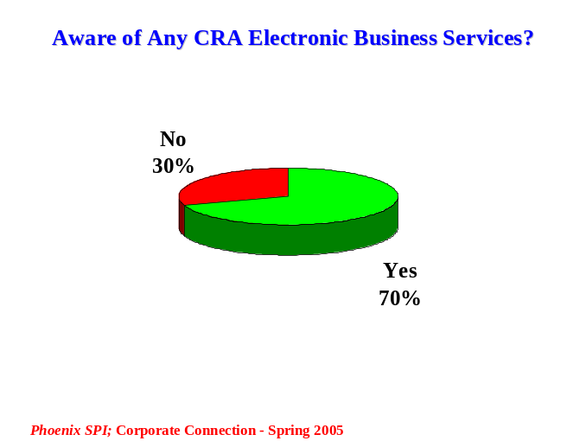
Executives of medium-sized firms were the most likely (88%), and those of large firms the least likely (63%), to be aware of these electronic services.

Regionally, executives from Atlantic Canada were the most likely (77%), and those from Quebec the least likely (60%), to say they were aware of these services compared to others (70% for Ontario and 73% for the West).

Almost Two-Thirds Have Used Electronic Services
Almost two-thirds of executives (64%) who were aware that CRA offers electronic services available to businesses on its Web site said that their company has used one or more of the services. Less than one-third (30%) had not any of these services (5% were uncertain).

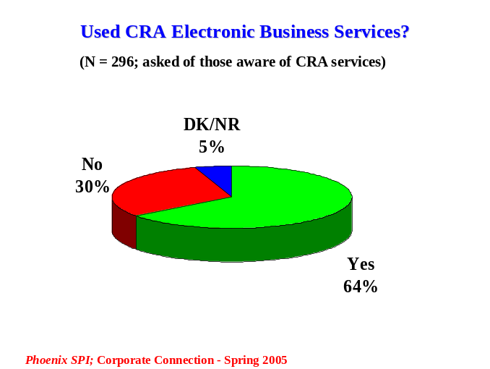
Medium-sized firms were slightly more likely to have used some of the services available (70% vs. 65-66% of the rest). That said, the likelihood of not using any of the services decreases as business size increases (from 31% of small firms to 20-21% of larger firms).

Executives from Atlantic Canada were the most likely to say that their company has used one or more of the services (74%), followed by those from Ontario (69%), and the West (64%). Quebec executives were the most likely to have not used any of the services (40% vs. 25-30% elsewhere).

Use of Service Provider – Top Reason for Not Using Electronic Services
Senior executives aware of the electronic services who work in companies that have not used any of them (N = 70) were asked to indicate why not. The main reason, cited by one-third (34%), was that a third-party looks after payroll, taxation and GST matters on behalf of the company.
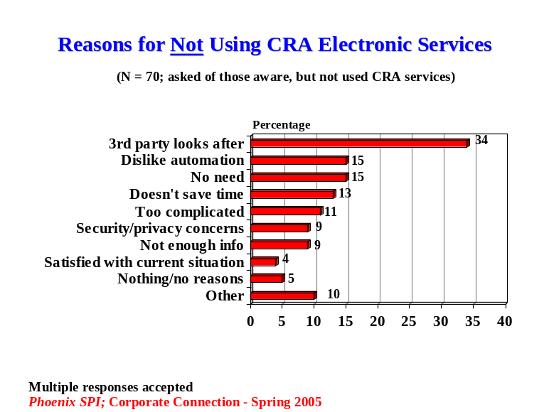

Also mentioned with some frequency was the lack of need to use the services (15%), a dislike of automation and preference for personal service (15%), the belief that these services do not save time or take longer (13%), the belief that electronic services are too complicated and paper is easier to use (11%), security and privacy concerns (9%), and the lack of information/awareness (9%).

The types of responses included in the ‘other’ category are banking issues, that this is done through head office, that it would not help, and accessibility issues. Five percent said there was no reason why their company has not used these electronic services.

Executives of small firms were the least likely to identify the use of a third-party service provider (34% vs. 44% of large firms and 62% of medium-sized firms). In addition, these executives were the only ones to mention a dislike of automation (17%) and the perception that these service are too complicated to use, with paper being easier (12%).

In terms of regional differences, executives from Quebec (58%) and Ontario (43%) were the most likely to say that a third party looks after these matters for the company, compared to those from the West (20%) and Atlantic Canada (11%). Other variations were minimal.

Characteristics of Survey Participants
The following graphs present the characteristics of survey participants by business size, position of respondent, location of business, and sector. Note that unweighted data is used to present the characteristics of the participants.
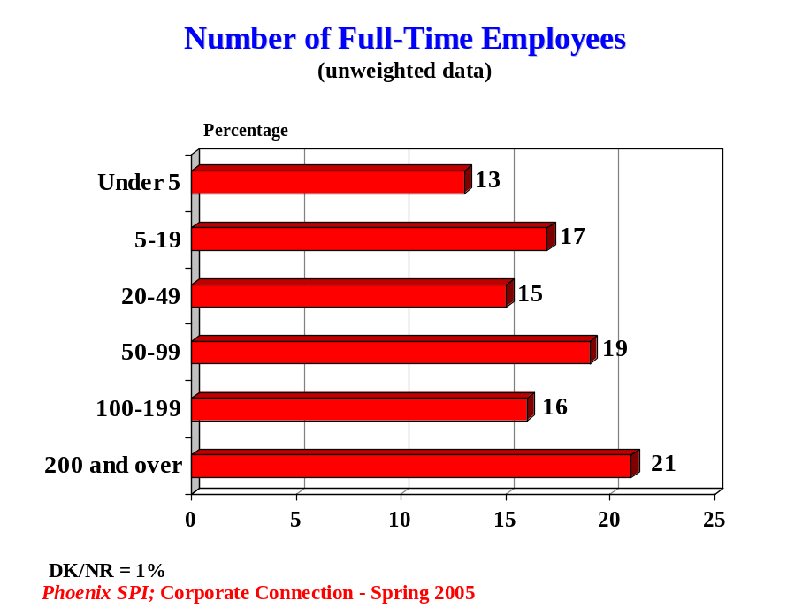

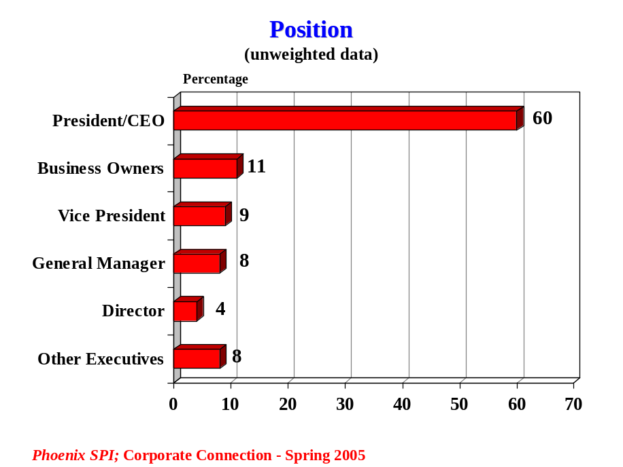

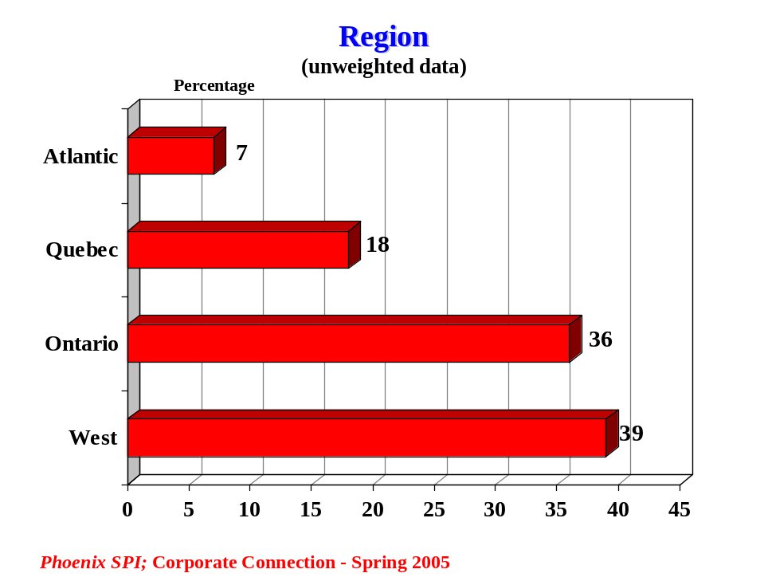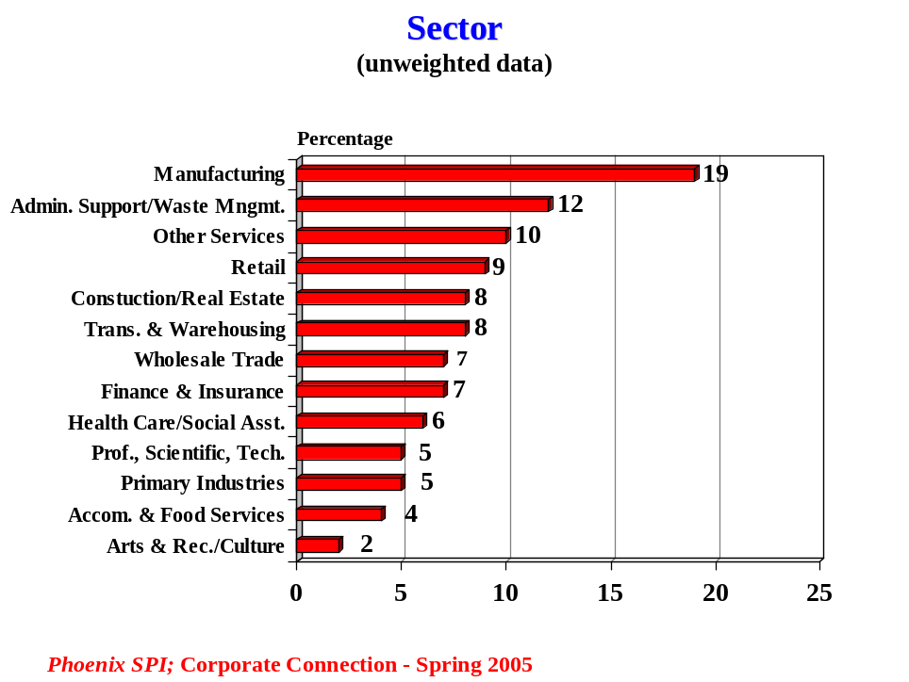
Appendix: Question Wording

- Were you aware that the Canada Revenue Agency, formerly known as Revenue Canada, offers a number of electronic services through its website to help businesses with payroll, taxation and GST matters (HST IN MARITIMES AND QUEBEC)?

Yes 1 CONTINUE
No 2 SKIP NEXT TWO QUESTIONS

ASK ALL THOSE AWARE OF CRA SERVICES:
- Has your company used any of the electronic services available to businesses on the Canada Revenue Agency website?

Yes 1 SKIP NEXT QUESTION
No 2 CONTINUE

ASK THOSE AWARE OF CRA SERVICES WHO HAVE NOT USED ANY:
- Why has your company not used any of the electronic services available to businesses on the Canada Revenue Agency website? (DO NOT READ LIST; ACCEPT MULTIPLE RESPONSES)

Security/privacy concerns
Cost issues (e.g. Internet access, need to upgrade computers, etc.)
Accessibility (e.g. access to Internet)
Banking issues (e.g. bank fees too high, not about to do with firm’s bank account)
Eligibility issues (i.e. not eligible to use services because they do not apply to firm)
Third-party looks after this for company (e.g. accountant, payroll company)
Nothing/no reason
Other (specify) _______________

