PWGSC Contract #39903-080474/001/CY
Contract Award Date: September 17, 2007
POR 182-07



Travellers’ Biosecurity Advertising Campaign

Focus Group Findings

Submitted to:

Alexandra Lozano
Analyst, Public Opinion Research
Internal Communications and Production
Canadian Food Inspection Agency
59 Camelot Drive
Ottawa, Ontario
K1A 0Y9

por-rop@inspection.gc.ca

EKOS RESEARCH ASSOCIATES INC.
November 2007

EKOS RESEARCH ASSOCIATES
Ottawa Office
99 Metcalfe Street, Suite 1100
Ottawa, Ontario
K1P 6L7
Tel: (613) 235 7215
Fax: (613) 235 8498
E-mail: pobox@ekos.com

Toronto Office
480 University Avenue, Suite 1006
Toronto, Ontario
M5G 1V2
Tel: (416) 598 8002
Fax: (416) 598 2543
E-mail: toronto@ekos.com

Edmonton Office
9925 109th St. NW, Suite 606
Edmonton, Alberta
T5K 2J8
Tel: (780) 408 5225
Fax: (780) 408 5233
E-mail: edmonton@ekos.com

Table of Contents

Executive Summary iii
Sommaire vii
1. Introduction 1
1.1 Background 1
1.2 Methodology 1
1.3 A Note on Qualitative Research 2
2. Findings 3
2.1 Wave I Focus Groups 3
2.2 Wave 2 Focus Groups 6

APPENDIX A: Materials Tested
APPENDIX B: Recruitment Screener
APPENDIX C: Moderators’ Guide

Executive Summary

Background

As part of their ongoing efforts to make travellers and importers aware of the instrumental role they play in protecting Canada from foreign diseases, pests and other threats, which they may unintentionally bring into the country, the Canadian Food Inspection Agency (CFIA) is planning a Travellers’ Biosecurity Campaign which will begin in the fall of 2007.

Prior to this campaign, two waves of focus groups were conducted to pre-test a number of CFIA Communications products with the public to gauge their effectiveness. The products included posters/print ads, television ads (in an “animatics” format and subsequently in a final cut), and web banners. A copy of the print materials tested in included as Appendix A to this report.

Methodology

Two separate waves of focus groups were conducted for this study:
- Wave I consisted of four focus groups on September 20 (2 English language groups in Toronto) and September 21 (2 French language groups in Montreal); and
- Wave II consisted of four focus groups on October 29 — two English language groups in Toronto and two French language groups in Montreal.

Wave I Findings

a) TV Ad

The television ad concept was received positively in the Toronto groups but left most in Montreal unmoved. Toronto participants in particular highlighted the ad’s brevity (“I thought it was good because it was brief… it kept my attention the whole time”) and its broad appeal (”I liked the ad… it seemed to be aimed at everyone”). Montreal participants were generally less engaged with the ad and while drawing out the key message, they seemed less clear on the creative concept. A small number also felt the ad took either an overly dramatic tone or communicated an excessive focus on a security ethic (“It makes me think of an ad you would see in the U.S.”).

There was a desire voiced by many for more detailed information to be included in the ad, although this was coupled with a general acknowledgement that this could quickly become unworkable for a 30-second spot. Most participants did note the contact information on the end title screen.

b) Print Ads

Participants were presented with either print ad A (featuring an image of a bird wearing an ice-pack and using a digital thermometer) or print ad B (featured the same bird without the ice pack and using a more traditional mercury thermometer). In each city, Print ad A was presented to the first group and print ad B to the second. Following a thorough review of the print ad presented, participants were asked to examine variations on different elements by looking at versions of the other treatments mounted on foam core boards. Each individual element tested is discussed separately below.

Image: With the exception of the second Toronto group (where roughly two-thirds dissented), there was a decisive preference for the bird image from ad A (with the ice pack and digital thermometer).

Headline: The headline “One Bird is All it Takes / Il ne suffit que d’un oiseau” was generally preferred over “Don’t Let Disease Take Flight / Empechez la maladie de prendre son envol”, although either headline is likely workable.

Main Message: While participants were generally clear on the message of the ad, it had a far greater degree of personal relevance for Toronto participants than was the case in Montreal.

Banner Ads: Two different iterations of banner ads were presented to participants. Version 1 was structured to rotate the screens in the following order: “One Bird is All it Takes / Be Aware and Declare, A single infected bird could introduce harmful animal diseases into Canada / Click to learn more (with Bird and Logo images)”. Version 2 rotated the screens in the following order: “Don’t Let Disease Take Flight / Be Aware and Declare, One bird is all it takes / Click to Learn More (with Bird and Logo images)”. While there was no strong consensus on which banner ad to use, version 2 is likely text heavy in the second panel. Regardless of which version was being discussed, the point was made that the image of the bird was the element that would catch most people’s attention and participants felt they would like to see it on all screen or earlier in the rotation.

Wave II Findings

The ads resoundingly passed the final check. Most participants clearly received some version of the key messages, taking away themes such as: “Be responsible and declare”, “Get informed about what you’re not allowed to bring into the country”, “It’s possible to unknowingly bring in products that are risky” and “There can be legal consequences to breaking import laws”.

Several participants noted that they were clearer on the ad’s information after several viewings, describing it as “an ad you would probably watch a few times to really get”.

Overall positive aspects of the ad were:
- The tone. While a small number of participants felt the tone was “over the top” or “too somber”, the dominant view was that it was “appropriate” and “attention grabbing” — “this is a serious issue and it deserves a serious tone”.
- The pacing. A number of participants felt the ad was brief and moved along quickly — “it moves along at a good clip…you wouldn’t get bored watching it”.
- The concept itself. Most participants allowed that they were initially unsure what the ad was about and felt that this would pique and hold their interest — “I thought it might be about health issues or even luggage…I like ads like that, ones where you need to watch all the way through to know what they’re about”.
- Ability to relate to the ad. The use of the father and his son towards the end of the ad was seen by a number of participants as effectively communicating the notion that “any of us could inadvertently bring in products that pose a risk”.

Conclusions

- All materials should be considered as having passed a final check, albeit with some possible modifications and with varying degrees of effectiveness.
- At the Animatics phase, the television ad was received notably better in Toronto than in Montreal. The final cut was well received across the board.
- The bird image with the digital thermometer and icepack is preferable to the image with the mercury thermometer
- There are few problems with the text used
- The print materials held a stronger personal resonance in Toronto than in Montreal
- There was no clear consensus on which banner ad was preferred.

Supplier Name: EKOS Research Associates
PWGSC Contract Number: #39903-080474/001/CY
Contract Award Date: September 17, 2007
To obtain more information on this study, please e-mail por-rop@inspection.gc.ca

Sommaire

Aperçu général

Dans le cadre de ses efforts constants pour sensibiliser les voyageurs et les importateurs au rôle instrumental qu’ils jouent afin de protéger le Canada contre les maladies, les insectes nuisibles et les autres menaces qu’ils pourraient, sans le vouloir, rapporter au Canada, l’Agence canadienne d’inspection des aliments (CFIA) a prévu une campagne sur la biosécurité des voyageurs, devant commencer à l’automne 2007.

Avant le déclenchement de la campagne, deux vagues de discussions de groupe ont eu lieu afin de présenter au préalable au public divers produits de communication de l’ACIA pour en mesurer l’efficacité. Il s’agissait, entre autres, d’affiches et de publicités imprimées, de publicités pour la télévision (d’abord en format animatique puis sous forme définitive) et de bandes-annonces sur Internet. On trouvera à l’annexe A ci-dessous un exemplaire de la publicité imprimée.

Méthodologie

La présente étude a donné lieu à deux vagues distinctes de discussions de groupe :
- La première vague s’est composée de quatre discussions de groupe tenues le 20 septembre (avec deux groupes de langue anglaise à Toronto) et le 21 septembre (avec deux groupes de langue française à Montréal);
- La seconde vague a comporté quatre discussions de groupe tenues le 29 octobre — soit deux en anglais à Toronto et deux en français à Montréal.

Résultats de la première vague

a) Publicité télévisée

Le concept de la publicité destinée à la télévision a été bien reçu à Toronto mais il a laissé froids la plupart des membres des groupes montréalais. Les participants de Toronto ont souligné en particulier la brièveté de l’annonce («Je l’ai trouvée bonne parce qu’elle est brève… elle a retenu mon attention tout au long») et sa portée élargie («J’ai aimé l’annonce… elle semblait s’adresser à tout le monde»). Cette publicité a suscité moins d’enthousiasme, en général, parmi les participants montréalais qui, invités à en définir le message principal, ont semblé moins bien saisir le concept créatif. Quelques-uns ont aussi estimé que l’annonce avait un ton trop dramatique ou insistait exagérément sur l’éthique de la sécurité («J’ai l’impression d’une publicité comme celles qu’on peut voir aux États-Unis»).

Beaucoup ont dit souhaiter que l’annonce renferme davantage de renseignements, tout en reconnaissant, de façon générale, que cela pourrait être irréalisable dans le cas d’un message publicitaire de 30 secondes. La plupart des participants ont remarqué les coordonnées figurant à l’écran du titre final.

b) Publicité imprimée

Comme publicité imprimée, les participants se sont fait présenter la version A (montrant un oiseau qui porte un sac de glace et se sert d’un thermomètre numérique) ou la version B (montrant le même oiseau mais sans le sac de glace et qui se sert du thermomètre à mercure traditionnel). Dans chaque ville, on a présenté la publicité imprimée A au premier groupe et la publicité imprimée B au second. Après un examen attentif de l’affiche qui leur était montrée, les participants devaient étudier des variations de divers éléments de l’autre version montés sur planches à noyau de mousse. Chaque élément mis à l’essai est exposé ci-dessous.

L’image : À l’exception du second groupe torontois (où près des deux tiers n’étaient pas d’accord), la préférence va nettement à l’oiseau de la version A (qui porte un sac de glace et un thermomètre numérique).

Le titre : En général, on a préféré le titre «One Bird is All it Takes / Il ne suffit que d’un oiseau» au titre «Don’t Let Disease Take Flight / Empêchez la maladie de prendre son envol», quoique l’un ou l’autre serait sans doute acceptable.

Le message principal : Bien que, de façon générale, les participants aient saisi le message de cette publicité, il est apparu beaucoup plus pertinent à ceux de Toronto qu’aux participants de Montréal.

Les bandes-annonces : Les participants ont pu étudier deux présentations différentes des bandes-annonces. La première version était structurée de telle sorte que les écrans apparaissent dans cet ordre : «Il ne suffit que d’un oiseau / Pensez-y et déclarez, Un seul oiseau infecté pourrait introduire des maladies animales dangereuses au Canada / Cliquez pour en savoir plus (avec l’image d’un oiseau et le titre)». Dans la seconde version, la rotation des écrans se faisait dans cet ordre : «Empêchez la maladie de prendre son envol / Pensez-y et déclarez, Il ne suffit que d’un oiseau / Cliquez pour en savoir plus (avec l’image d’un oiseau et le titre)». Sans consensus évident pour l’une ou l’autre des bandes-annonces, le texte de la seconde version a semblé trop lourd au second groupe. Cependant, peu importe la version, il est ressorti de la discussion que l’image de l’oiseau est l’élément susceptible de retenir l’attention de la plupart des gens, et les participants ont dit souhaiter qu’elle apparaisse sur tous les écrans ou au début de la rotation.

Résultats de la seconde vague

Les messages publicitaires passent haut la main le test de la catastrophe. La majorité des participants ont retenu l’une ou l’autre version des principaux messages et ont fait notamment ressortir les thèmes suivants : «Soyez responsable et déclarez», «Renseignez-vous sur ce qu’il est interdit de rapporter au Canada», «On peut ramener sans le vouloir des produits dangereux» et «Enfreindre les lois sur l’importation peut entraîner des conséquences judiciaires».

De nombreux participants ont mentionné qu’ils avaient mieux saisi le message publicitaire après plusieurs visionnements, certains disant que «c’est une publicité qu’il faudrait sans doute regarder à quelques reprises pour bien la comprendre».

Dans l’ensemble, les aspects positifs de cette publicité sont les suivants :
- Le ton. Bien qu’un petit nombre de participants l’aient jugé «exagéré» ou «trop sombre», l’impression dominante veut qu’il soit «approprié» et qu’il «attire l’attention» — «c’est une question importante qui mérite d’être traitée avec sérieux».
- Le rythme. Un certain nombre de participants ont trouvé que la publicité était brève et passait rapidement — «elle se déroule prestement… on ne s’ennuie pas en la regardant».
- Le concept lui-même. La majorité des participants ont avoué ne pas avoir été certains, au début, du sujet de l’annonce et pensent que cela peut piquer l’intérêt et le maintenir — «Je me suis dit qu’il était peut-être question de santé ou même de bagages… J’aime ces publicités qu’il faut suivre attentivement jusqu’à la fin pour savoir de quoi elles retournent.»
- Aptitude à se sentir concerné. Des participants ont trouvé efficace le fait de montrer un père et son fils à la fin de la publicité, comme moyen de faire passer l’idée que «n’importe qui d’entre nous pourrait sans le vouloir rapporter des produits à risque».

Conclusion

- On peut conclure de tout le matériel qu’il a passé le test de la catastrophe, quoique avec la possibilité de certaines modifications et des degrés d’efficacité variables.
- Dans sa phase animatique, la publicité destinée à la télévision a été beaucoup mieux reçue à Toronto qu’à Montréal. Le produit final a été bien accueilli partout.
- L’image de l’oiseau avec thermomètre numérique et sac de glace est jugée préférable à celle de l’oiseau avec thermomètre au mercure.
- Le texte a posé peu de difficulté.
- Le matériel imprimé a suscité une plus forte résonance personnelle à Toronto qu’à Montréal.
- Les bandes-annonces n’ont pas produit un net consensus.

Fournisseur : Les Associés de recherche EKOS
Nº du contrat avec TPSGC : 39903-080474/001/CY
Date d’attribution du contrat : 17 septembre 2007
Pour de plus amples renseignements, prière d’adresser un courriel à por-rop@inspection.gc.ca

Introduction

Background

Every traveller entering Canada plays a key role in protecting the country from foreign animal diseases, pests and plant viruses that could harm our agricultural resources. These could be unintentionally brought into Canada through plants, animals (and related products) or food. The Canadian Food Inspection Agency’s (CFIA) Traveller’s Biosecurity Campaign is aimed at creating awareness among the travelling public, particularly those people coming into Canada from high-risk countries.

CFIA’s goal is to make travellers and importers aware of the instrumental role they play in protecting Canada from foreign diseases, pests and other threats, which they may unintentionally bring into the country. Messaging will be placed in the context of securing Canada from the many threats posed by bringing banned goods into the country. Avian Influenza will be used as an example of a foreign animal disease that could be unintentionally brought into Canada.

Pre-testing communications products is a necessary step in conducting an effective communication campaign. Consequently, focus groups were used to pre-test a number of CFIA communications products with the public to gauge their effectiveness. These products will be used in the Travellers’ Biosecurity Campaign which will begin in the fall of 2007. The products tested through these focus groups included posters/print ads, television ads (in an “animatics” format and subsequently in a final cut), and web banners. A copy of the print materials tested in included as Appendix A to this report.

Methodology

Two separate waves of focus groups were conducted for this study:
- Four focus groups – two English language groups in Toronto on 20 September and two French language groups in Montreal on 21 September; and
- Four focus groups on October 29 — two English language groups in Toronto and two French language groups in Montreal.

Each group was composed of between eight and ten participants, with the following recruiting criteria used:
- All participants had to have travelled to Europe or Asia at least once within the past three years (a great number of those at the groups would in fact fall into the category of very frequent travelers);
- A minimum of three participants per group were born outside of Canada;
- Standard gender balance and age spread; and
- Standard exclusions (i.e., media, Government employees, etc.).

The Wave I focus groups tested the following materials:
- A 30-second television ad presented in animatics format;
- Four print advertisements (hereafter referred to as Ads A, B and C and “poster”); and
- Two web banner concepts (banner 1 and banner 2).

The Wave II groups were designed to “final check” a 30-second television ad presented in final cut format. Each group lasted approximately 50 minutes. In Toronto, two versions of the ad were tested, with one version featuring a somewhat “toned down” narration. The final cut was similar in nature to the animatics version tested in the Wave I groups.

A Note on Qualitative Research

The primary benefit of focus group discussions is that they allow for in-depth probing with participants on behavioural habits, perceptions and attitudes related to the subject matter. The group discussion also allows for flexibility in exploring other areas as they arise that may be pertinent to the investigation.

Focus groups allow for a textured understanding of the issues at hand in that the thoughts or feelings are expressed in the participants’ own language. The focus group technique is used as a means of developing insight and direction, rather than quantitatively precise or absolute measures. Due to the inherent biases in the technique, the data cannot be projected to any universe of individuals. While every effort was made – within the recruiting parameters – to balance various demographic characteristics when recruiting participants, these groups (and therefore the findings drawn from them) may not be said to be representative of the larger population as a whole. For the reader’s ease, these findings are depicted to some extent as definitive and representative — this is, however, true only for the universe represented by these participants.

Findings

Wave I Focus Groups

TV Ad

The television ad was received positively in the Toronto groups but left most in Montreal unmoved. Toronto participants in particular highlighted the ad’s brevity (“I thought it was good because it was brief… it kept my attention the whole time”) and its broad appeal (”I liked the ad… it seemed to be aimed at everyone”). Montreal participants were generally less engaged with the ad and while drawing out the key message, they seemed less clear on the creative concept. A small number also felt the ad took either an overly dramatic tone or communicated an excessive focus on a security ethic (“It makes me think of an ad you would see in the U.S.”).

In Toronto, two key elements of the ad were highlighted by participants in particular: the repetition (“this bag”) and the overall tone. Participants felt that the repetition was a good way to attract, and retain, their attention. The tone of the ad was felt to be appropriately serious without being too harsh. Toronto participants drew the message that “any one of us could represent a threat, even unwittingly”.

In Montreal, the repetition was more problematic and the tone, as noted above, was seen as excessively harsh by some — “It’s just another way that travel is becoming a hassle…all we see at airports is security measures, it’s disheartening”. Few if any grasped the notion that all travellers could pose a threat. It is quite likely that there are execution solutions to this reaction. The background airport noise on the French animatics seemed louder in comparison to the voice over than in the English version. The pace of speech of the French voice over also seemed faster than the English version. These aspects led to both some difficulty in comprehension (particularly for Canadians born outside the country) and likely a “rushed” feel to the ad which heightened the dramatic aspect. A small number of participants also noted that leading off the voice over with discussion of an “eclosion” placed them immediately in a dramatic frame of mind. While the corresponding word “outbreak”, was used in the English treatment, it did not garner a similar reaction.

There was a desire voiced by many for more detailed information to be included in the ad, although this was coupled with a general acknowledgement that this could quickly become unworkable for a 30-second spot. Most participants did note the contact information on the end title screen.

Print Ads

Participants were presented with either print ad A (featuring an image of a bird wearing an ice-pack and using a digital thermometer) or print ad B (featured the same bird without the ice pack and using a more traditional mercury thermometer). In each city, Print ad A was presented to the first group and print ad B to the second. Following a thorough review of the print ad presented, participants were asked to examine variations on different elements by looking at versions of the other treatments mounted on foam core boards. Each individual element tested is discussed separately below.

Image

With the exception of the second Toronto group (where roughly two-thirds dissented), there was a decisive preference for the bird image from ad A (with the ice pack and digital thermometer). It was described as “cute”, “interesting”, “the type of picture that makes me want to read the ad” and “appropriate…you can tell that the bird is sick”. While those dissenters in the second Toronto group felt that this image was either “over the top” or “trivializing an important message”, there were greater downsides to the mercury thermometer. Apart for the anachronistic element — “do the even still make those?” — some initially confused the thermometer for a cooking thermometer, cigarette or syringe.

Headline

The headline “One Bird is All it Takes / Il ne suffit que d’un oiseau” was generally preferred over “Don’t Let Disease Take Flight / Empechez la maladie de prendre son envol”, although either headline is likely workable.

The strong points of “One bird is all it takes” were it’s simplicity, relevance to the image and message, and its uniqueness “it made me wonder what it meant and I wanted to read on and find out. While some felt “’Don’t let disease take flight?’ sounded “too poetic” or distanced from the image and message, others immediately drew a public health message and were engaged to read on.

Problematic Text

Participants had no difficulty reading the text and drawing out a basic message. All participants volunteered that they understood the term “avian influenza”, although many acknowledged that they tend to use the more colloquial “bird flu”, and the term was clearly not a stumbling block for participants. The use of the term “Newcastle Disease”, on the other hand, is potentially problematic, as no participant in any group was familiar with it. One Montreal participant noted that web banner ad #2 deftly avoided any confusion by simply referring to “harmful animal diseases”.

Main Message

While participants were generally clear on the message of the ad, it had a far greater degree of personal relevance for Toronto participants than was the case in Montreal. A number of Toronto participants noted that the inclusion of the sentence “declare all poultry, eggs, feathers, meat and other bird products…” made the ad relevant to them: “Until I go to that part I thought it was just aimed at bird importers or smugglers and I don’t do that, I don’t even know anyone who does”. In Quebec, this point was curiously lost on most participants who felt the ad was strictly aimed at exotic bird fanciers. Consideration should be given to bolstering this aspect of the print ads, at least for the French version.

Some print treatments included the sentence “Find out what is required before bringing any live birds into Canada” and asked if it would be problematic to have this included in airport advertising, when it would perhaps be too late to do this research. This was a non-issue and participants were generally agnostic on whether to include this sentence or not.

Perhaps the toughest “sell” of the print campaign deals with reporting smuggling. Most participants volunteered that they would be loathe to report smuggling, with a host of reasons cited:
- “For me to know about, it would have to be an acquaintance…I’d talk to them, I wouldn’t turn them in”
- “I’m just not sure I’d want to get involved”
- “I wouldn’t chase after someone in an airport”

Banner Ads

Two different iterations of banner ads were presented to participants. Version 1 was structured to rotate the screens in the following order: “One Bird is All it Takes / Be Aware and Declare, A single infected bird could introduce harmful animal diseases into Canada / Click to learn more (with Bird and Logo images)”. Version 2 rotated the screens in the following order: “Don’t Let Disease Take Flight / Be Aware and Declare, One bird is all it takes / Click to Learn More (with Bird and Logo images)”.

While there was no strong consensus on which banner ad to use, version 2 is likely text heavy in the second panel. Regardless of which version was being discussed, the point was made that the image of the bird was the element that would catch most people’s attention and participants felt they would like to see it on all screen or earlier in the rotation.

The Government of Canada logo added legitimacy to the ad in many people’s eyes and would increase the likelihood for some of clicking through the ad.

Bottom Line

- All materials should be considered as having passed a final check, albeit with some possible modifications and with varying degrees of effectiveness
- The television ad was received notably better in Toronto than in Montreal, and some execution related solutions are offered below
- The bird image with the digital thermometer and icepack is preferable to the image with the mercury thermometer
- There are few problems with the text used
- The print materials held a stronger personal resonance in Toronto than in Montreal
- There was no clear consensus on preference between the proposed banner ads
- While some participants were unaware of the risks of importing animal products, most said they knew about this already but this campaign still serves as a worthwhile reminder

Wave 2 Focus Groups

The ads resoundingly passed the final check. Most participants clearly received some version of the key messages, taking away themes such as:
- “Be responsible and declare”
- “Get informed about what you’re not allowed to bring into the country”
- “It’s possible to unknowingly bring in products that are risky”
- “There can be legal consequences to breaking import laws”

Several participants noted that they were clearer on the ad’s information after several viewings, describing it as “an ad you would probably watch a few times to really get”.

Overall positive aspects of the ad were:
- The tone. While a small number of participants felt the tone was “over the top” or “too somber”, the dominant view was that it was “appropriate” and “attention grabbing” — “this is a serious issue and it deserves a serious tone”.
- The pacing. A number of participants felt the ad was brief and moved along quickly — “it moves along at a good clip…you wouldn’t get bored watching it”.
- The concept itself. Many participants noted that they were initially unsure as to what the subject of the ad was and felt that this would in fact pique and hold their interest — “I thought it might be about health issues or even luggage…I like ads like that, ones where you need to watch all the way through to know what they’re about”.
- Ability to relate to the ad. The use of the father and his son towards the end of the ad was seen by a number of participants as effectively communicating the notion that “any of us could inadvertently bring in products that pose a risk”.

Among the small number of participants in Toronto who were less favourable in their assessment of the ad, two main factors emerged as drivers. Some took objection to what they saw as an overly harsh tone, which they described as focussing more on laws and possible sanctions as opposed to articulating what risks the importation of banned products pose to Canada — “we’re responsible people…they shouldn’t use legal threats, just explain the problem to us”. A small number of participants remained confused by some of the basic imagery and language in the ad — “it’s not the suitcase that could be harmful, it’s what’s inside it”. Given the more dominant favourable reaction, we would not recommend seeking to address either of these points.

One area for consideration would be to make the web site URL and phone number somewhat more prominent in the ad, perhaps by having it on screen for a longer period of time. A number of participants only noted the website in subsequent viewings and only after being acknowledging that they had missed it during the first viewing. Several participants noted that they were focussing more on the images of the prohibited items than on the URL and phone number. Most participants, however, felt they were not likely to seek out additional information on the website or by phone.

Toronto participants leaned towards preferring version A of the ad (with the “harsher” tone), as opposed to version B (with the somewhat softer tone. Only one version of the ad was shown in Montreal.

There was near universal consensus that the campaign is worth doing and appropriate for the Government of Canada to undertake. Participants also suggested additional communications around these issues, particularly in airports.

Appendix A
Materials Tested

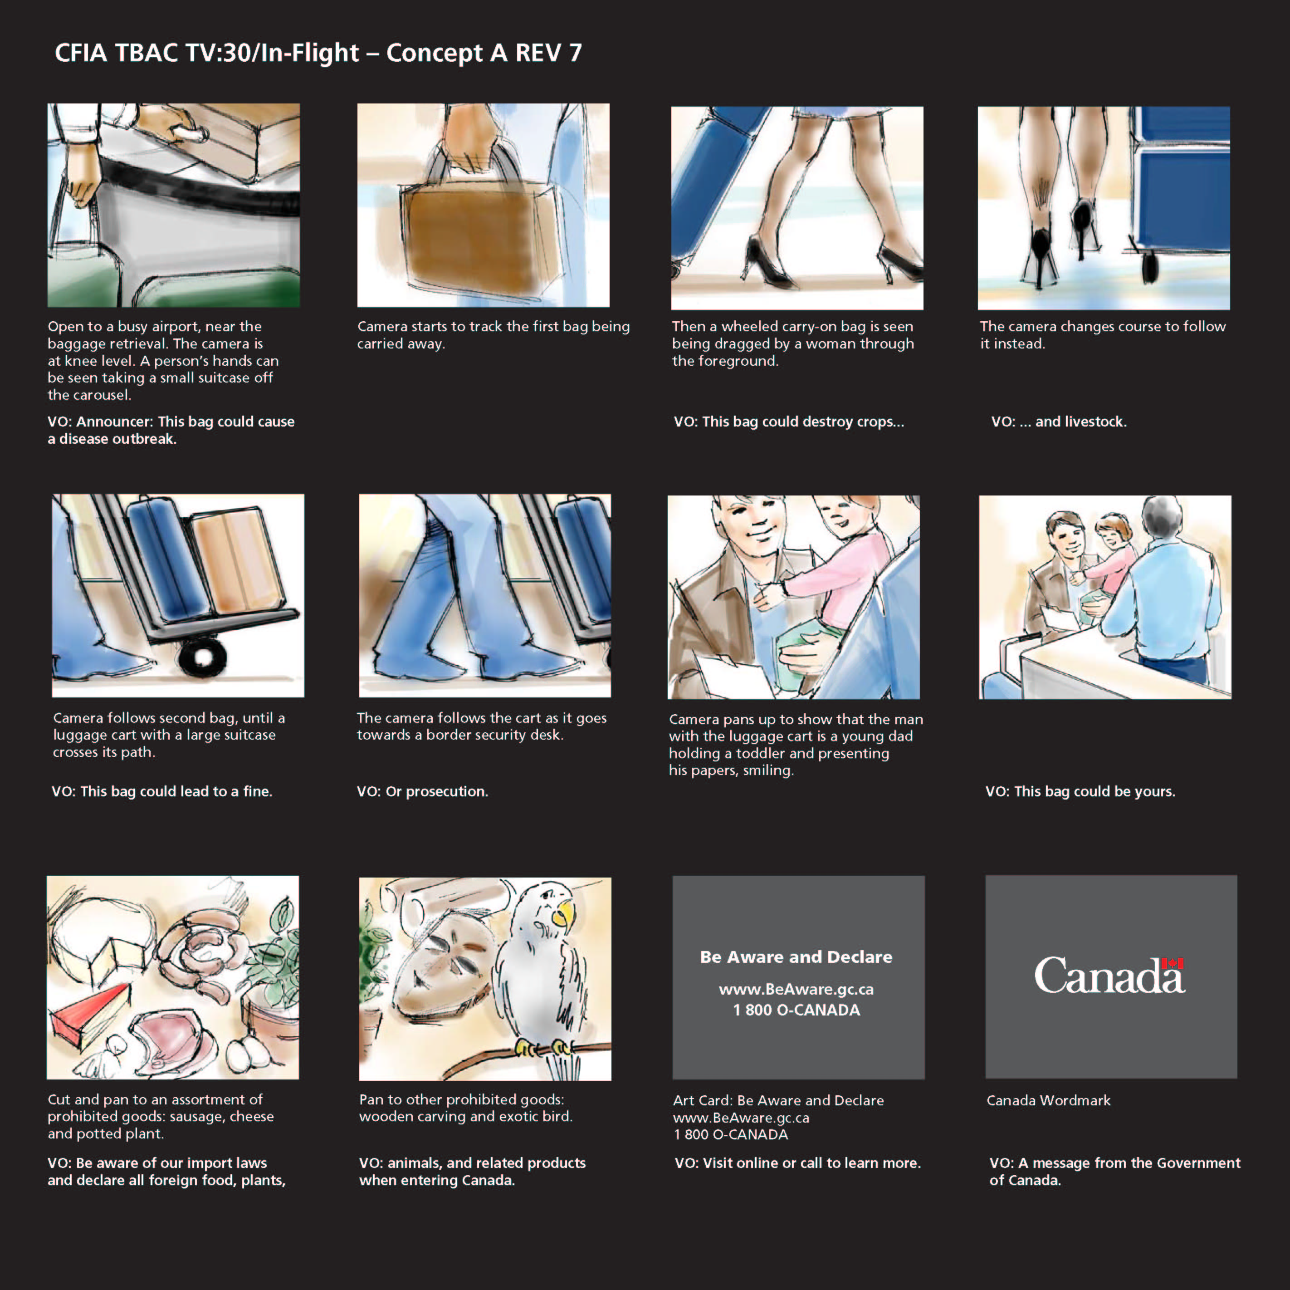


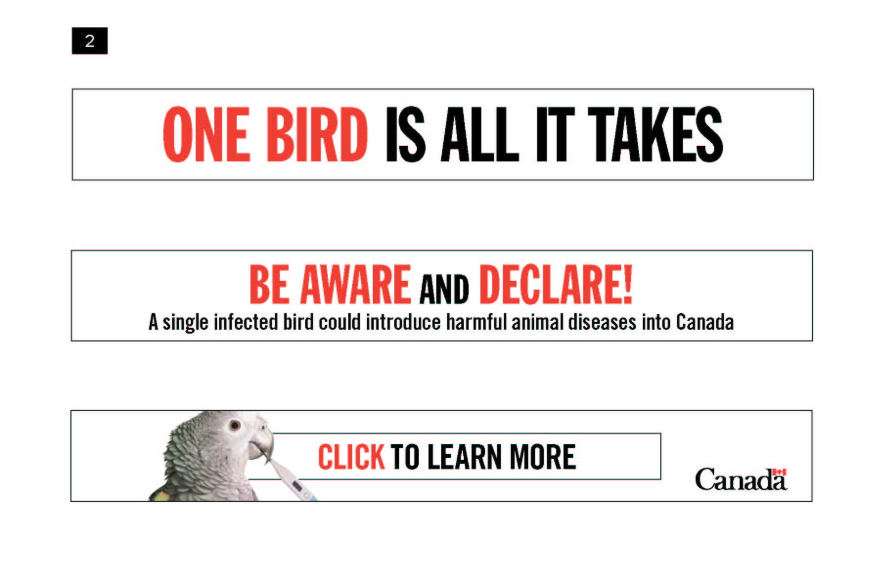

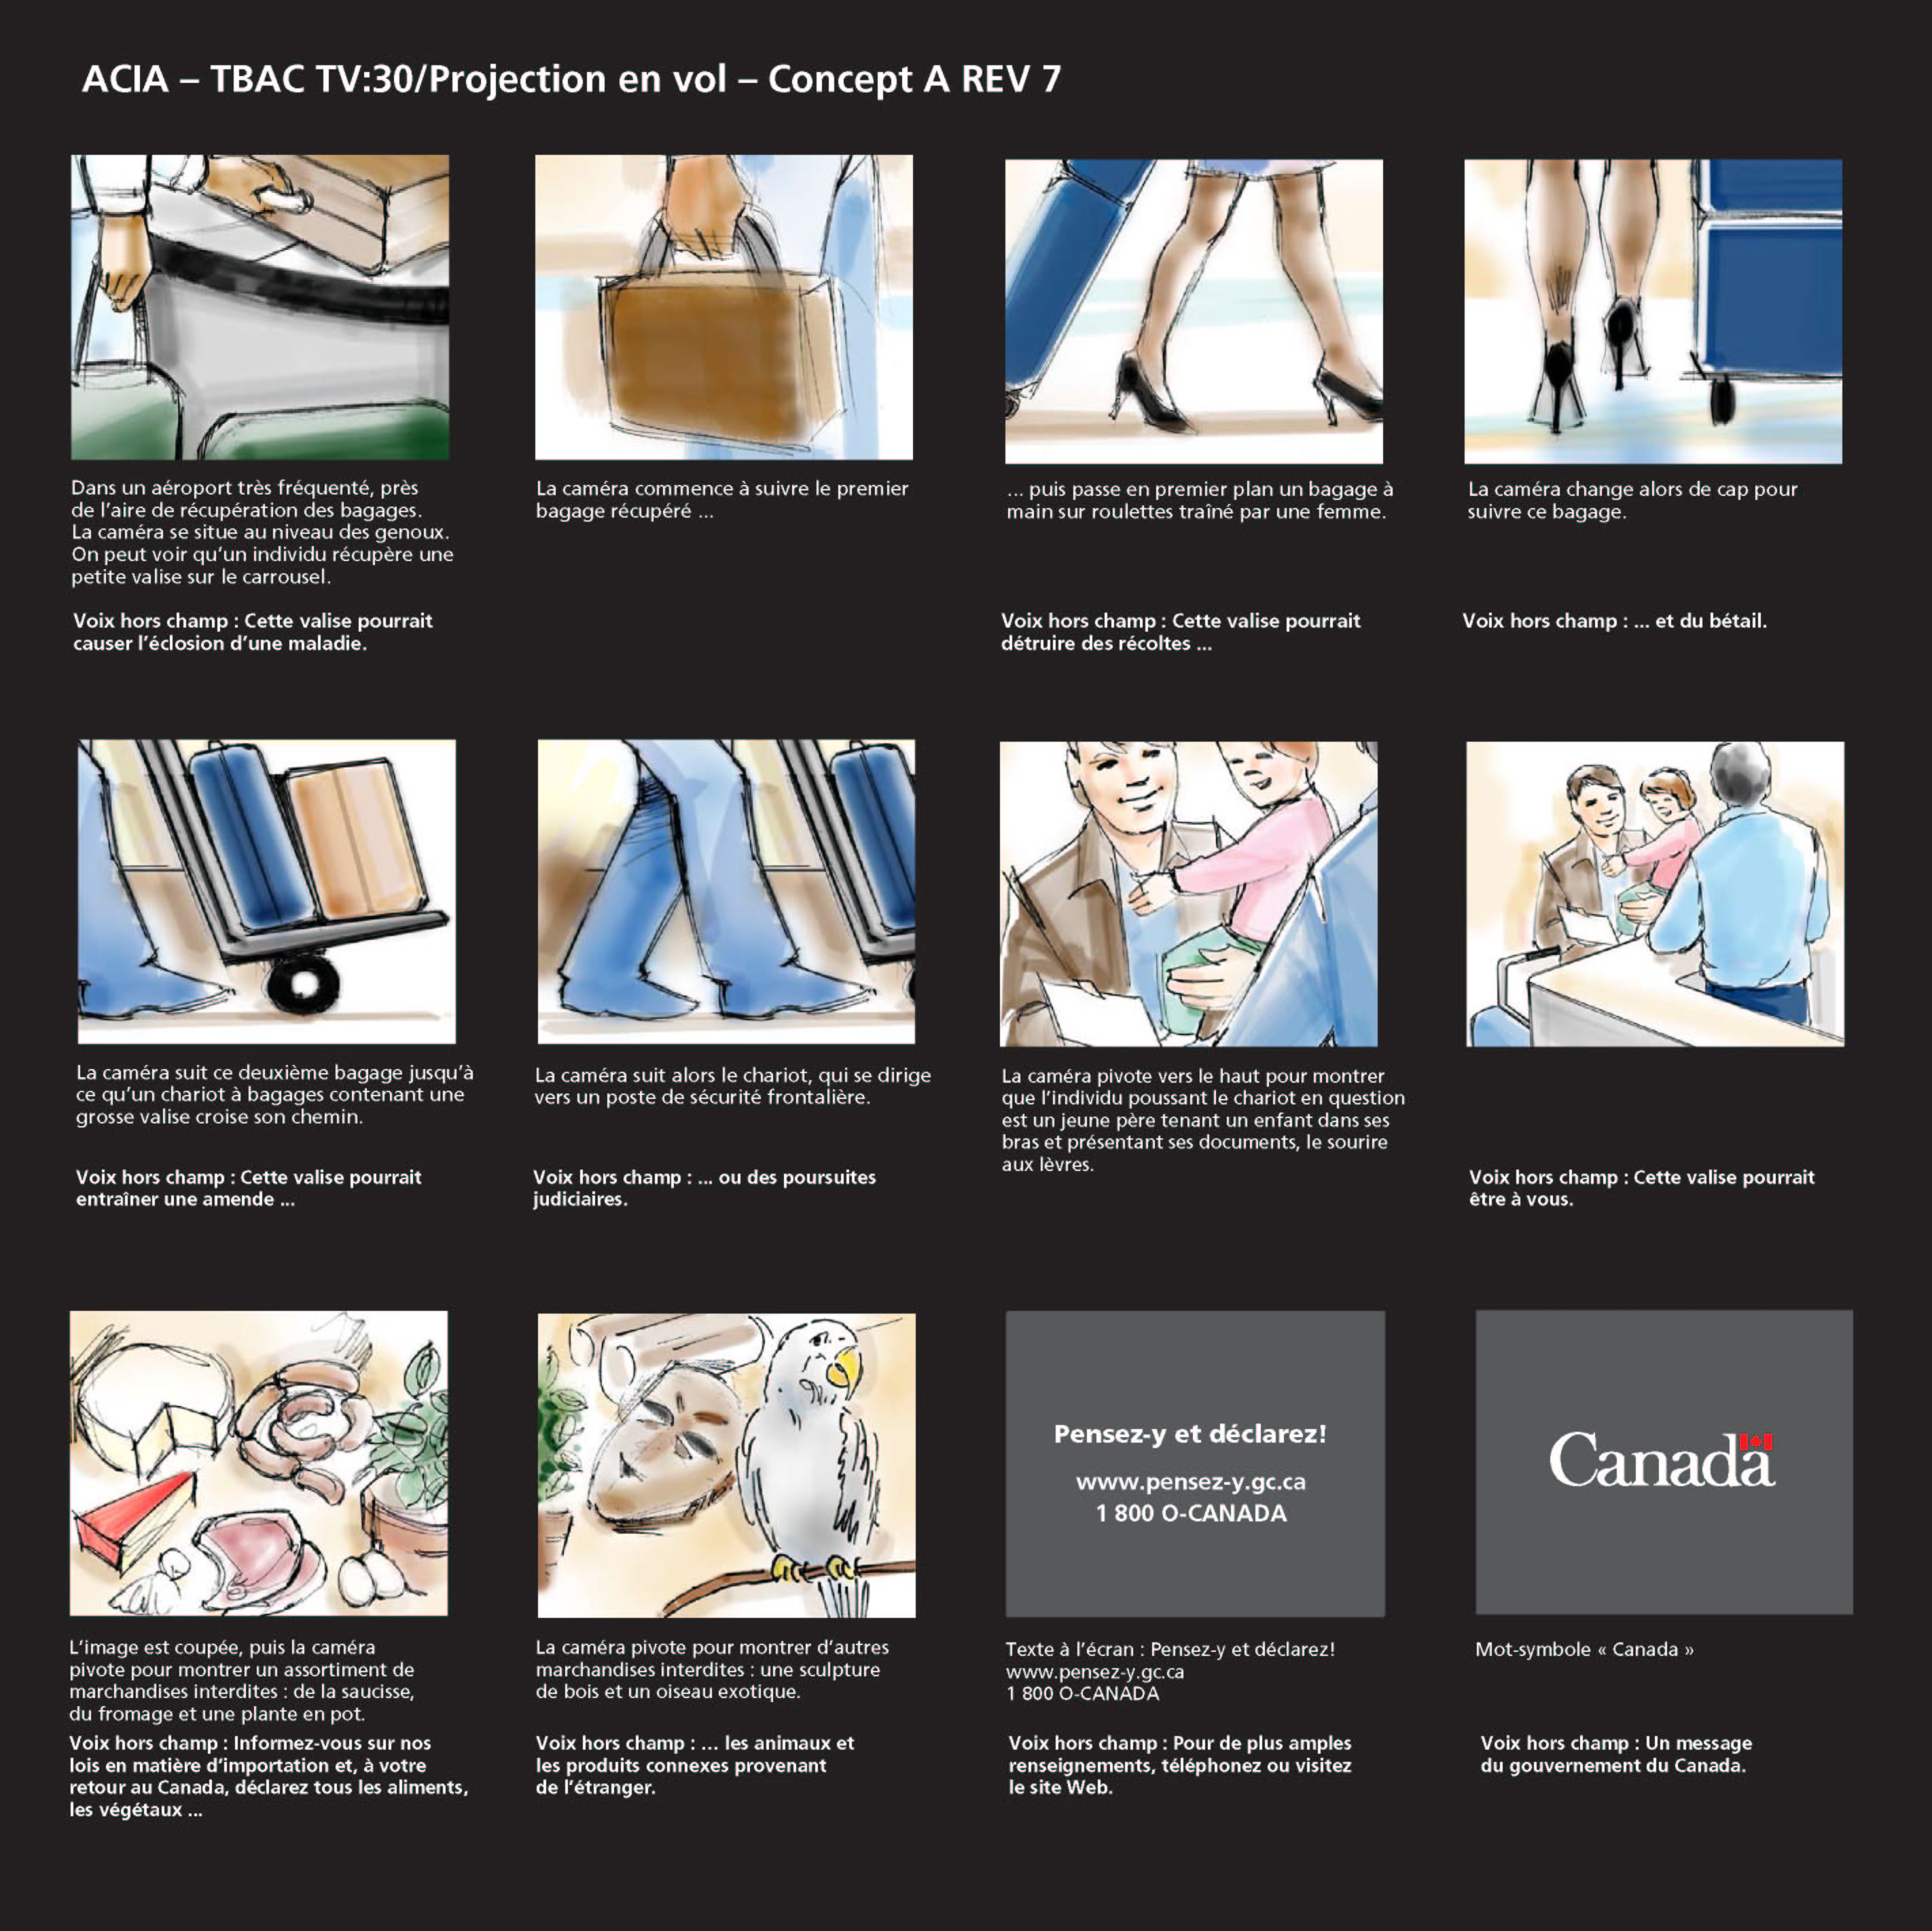
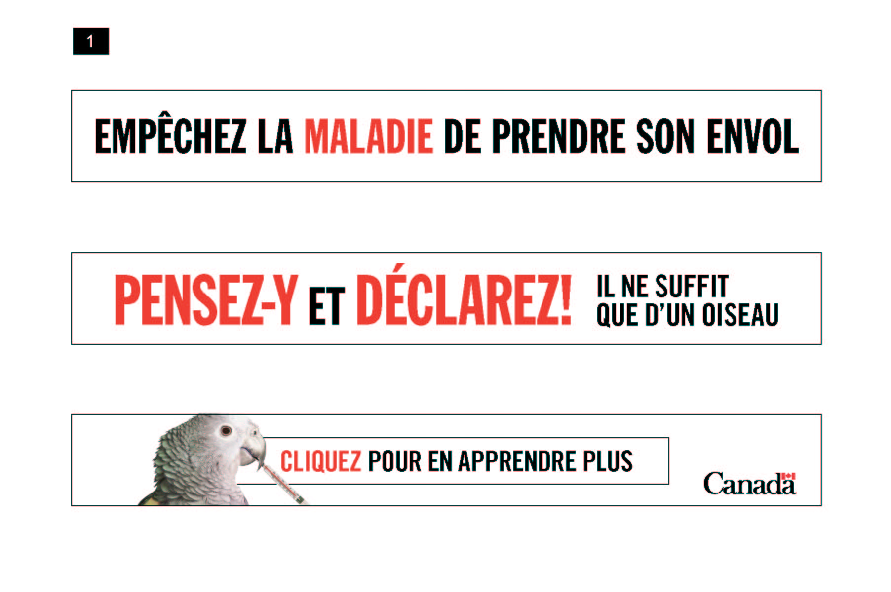

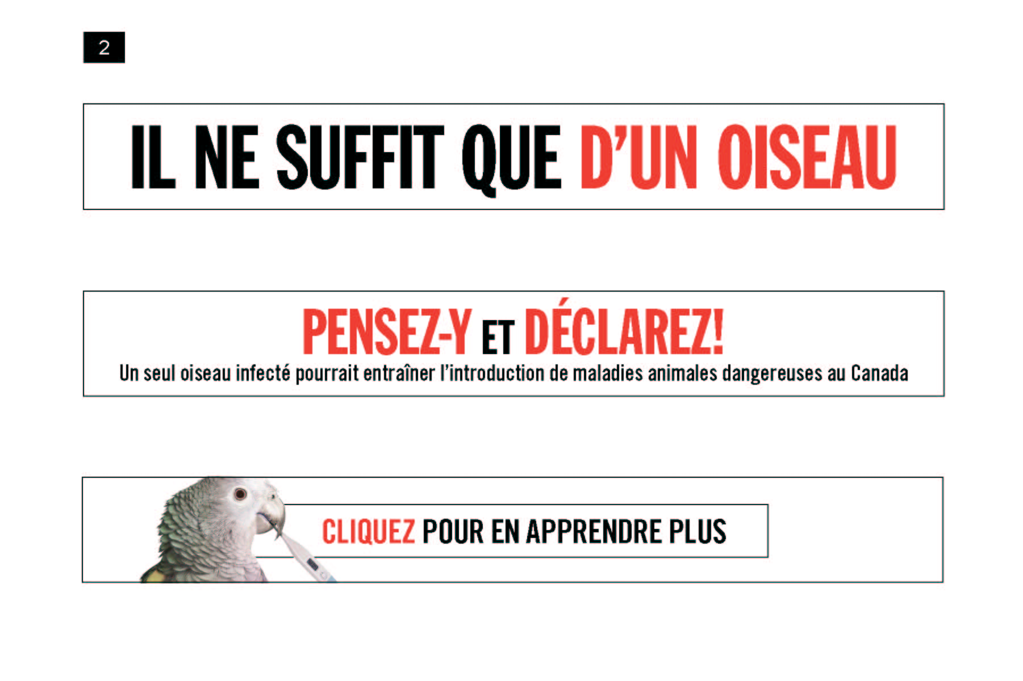

Appendix B
Recruitment Screener

15469 Travel Respondent Name: _________________________________________________________

Home Phone #: _________________________________________________________________

Business Phone #: ______________________________________________________________

E-Mail:_________________________________________________________________________

Group #:_______________________ Recruiter:_______________________________________

Recruit 12 per group

GROUP 1 GROUP 2 GROUP 3 GROUP 4
THURSDAY THURSDAY FRIDAY FRIDAY
SEPTEMBER 20TH SEPTEMBER 20TH SEPTEMBER 21ST SEPTEMBER 21ST
5:30 PM 7:30 PM 5:30 PM 7:30 PM
TORONTO TORONTO MONTREAL MONTREAL

Hello, my name is _________ from Research House Inc., we are calling today to invite you to a focus group discussion scheduled for (DATE). Your participation in the research is completely voluntary and your decision to participate or not will not affect any dealings you may have with Research House Inc. All information collected, used and/or disclosed will be used for research purposes only and administered as per the requirements of the Privacy Act. You will also be asked to sign a waiver to acknowledge that you may be audio and/or video taped during the session. The session will last a maximum of 2 hours and you will receive a cash honorarium as a thank you for attending the session. May we have your permission to ask you some further questions to see if you fit in our study?

Yes…………………………………..1
No……………………………………2 – THANK AND TERMINATE

INDICATE: Male………………………………..1 - (6) PER GROUP
Female…………………………….2 - (6) PER GROUP

1. Are you or is any member of your household or immediate family employed in, or ever been employed in:

1 Ever
No Yes No Yes
Market Research ( ) ( ) ( ) ( )
Marketing ( ) ( ) ( ) ( )
Public Relations ( ) ( ) ( ) ( )
Any media (Print, Radio, TV) ( ) ( ) ( ) ( )
A member of ACTRA ( ) ( ) ( ) ( )
Advertising ( ) ( ) ( ) ( )
Government of Canada ( ) ( ) ( ) ( )

IF YES TO ANY OF THE ABOVE – THANK AND TERMINATE

2a. May I have your age, please?

_________________________ SPECIFY

Under 25 years…………………………..1
25 – 34 years…………………………….2
35 – 44 years…………………………….3 - ENSURE A GOOD MIX IN EACH GROUP
45 – 54 years…………………………….4
Over 55 years…………………………….5

2b. What is your marital status?

Married / Common – Law………………1
Single / Div. / Wid. / Sep………………..2

3a. What is your current employment status?

Full Time Employed ( )
Part Time Employed ( )
Homemaker ( )
Student ( )
Retired ( )
Unemployed ( )

3b. What is your occupation? –IF RETIRED – ASK PRIOR OCCUPATION

____________________________________________ ________________________________________________
JOB TITLE TYPE / NAME OF COMPANY

IF MARRIED / COMMON – LAW ASK – WHAT IS YOUR SPOUSE’S OCCUPATION?

____________________________________________ ________________________________________________
JOB TITLE TYPE / NAME OF COMPANY

IF ANY CONNECTION TO STANDARD OR PROJECT RELATED OCCUPATION – THANK AND TERMINATE

4a. As we need to speak with people from all walks of life, could you please tell me into which category I may place your total annual household income? Would that be…

Under $40,000………………………………1
$40,000 - $60,000…………………………..2
$60,000 - $80,000…………………………..3
Over $80,000………………………………...4

4b. Could you please tell me, what is the last level of education that you have completed?

Some High School………………………….1
High School…………………………………2
Some College / University…………………3
Completed College / University…………...4

5. Have you travelled outside of Canada in the past 3 years?

Yes………………………… 1
No………………………….. 2 - THANK AND TERMINATE

6a. Where have you travelled in the past 3 years?

United States…………………………………... 1
South America…………………………………. 2
Caribbean ……………………………………… 3
Europe………………………………………….. 4 - MIN (6) PER GROUP MUST MENTION
Asia……………………………………………… 5 - MIN (6) PER GROUP MUST MENTION
Africa …………………………………………… 6
Other_______________________________ 7

IF EUROPE MENTIONED AT Q. 6 ASK:

6b. Where in Europe have you travelled, in the past 3 years?

Italy…………………………………….1
Spain…………………………………. 2
Greece ………………………………. 3
France……………………………….. 4
Germany ……………………………. 5 ENSURE A GOOD MIX OF DESTINATIONS IN EACH GROUP
UK……………………………………. 6
Holland …………………………….. 7
Other________________________ 8
Other________________________ 9
Other________________________10

IF ASIA MENTIONED AT Q. 6 ASK:

6c. Where in Asia have you travelled, in the past 3 years?

China…………………………………. 1
Japan………………………...………. 2
Indonesia………………….. ………... 3
Thailand …………………………….. 4
Vietnam……………………………… 5 ENSURE A GOOD MIX OF DESTINATIONS IN EACH GROUP
Korea………………………………… 6
Philippines…………………………… 7
Other_______________________ 8
Other________________________ 9
Other________________________10

7. What country were you born in?

Canada………………………………………… 1
Other_______________________________ 2 - MIN (3) / MAX (6) PER GROUP MUST MENTION

The next couple of questions deal with your imagination. Have a little fun with these questions and feel free to answer in any way, as there are no incorrect answers.

8a. What would be the first thing you would do, if you had just won one million dollars?

______________________________________________________________________________

______________________________________________________________________________

______________________________________________________________________________

8b. If you were a book in a library, what book would you be and WHY?

______________________________________________________________________________

______________________________________________________________________________

______________________________________________________________________________

____________ ANSWERS SPONTANEOUSLY ____________ VERY ENTHUSIASTIC

____________ VERY SURE OF HIMSLEF / HERSELF ____________ CARRIES ON A GOOD CONVERSATION
___________________________________________________________________________________________________________
NOTE: PAY EXTRA ATTENTION TO RESPONDENT ANSWERS – LOOK FOR COMPLEX, CREATIVE ANSWERS AND NOT JUST MEANINGLESS ANSWERS. LOOK FOR IMAGINATION AND A SENSE OF CREATIVITY / PARTICIPATION.

9. Participants in group discussions are asked to voice their opinions and thoughts, how comfortable are you, in voicing your opinions in front of others? Are you….

Very Comfortable……………………………1 – MIN 50% PER GROUP
Comfortable………………………………….2
Fairly Comfortable…………………………..3
Not Very Comfortable……………………….4 – THANK AND TERMINATE
Very Uncomfortable…………………………5 – THANK AND TERMINATE

10a. Have you ever attended a focus group or one to one discussion for which you have received a sum of money, here or elsewhere?

Yes…………………………………………….1 – MAX (50%) PER GROUP
No……………………………………………...2 – SKIP TO Q. 11

10b. When did you last attend one of these discussions?

___________________________________________________________
TERMINATE IF IN THE PAST 6 MONTHS

10c. How many focus group or one –to-one discussions have you attended in the past 5 years?
__________________________________
(SPECIFY) IF MORE THAN 5 – THANK AND TERMINATE

10d. Would you please tell me the topics discussed?

_______________________________________________________________________________
IF TRAVEL - THANK AND TERMINATE

11. What language do you speak most often at home?

English…………………………………..1 - GROUPS 1 & 2 MUST MENTION
French…………………………………..2 - GROUPS 3 & 4 MUST MENTION
Other…………………………………….3 – THANK AND TERMINATE

12. Have you yourself lived in Ontario / Quebec:

Less than 2 years ………………………….1 – THANK AND TERMINATE
Between 2 – 5 years……………………….2
More than 5 years…………………………..3

13. Have you been invited to another of these focus groups or interviews in the near future?

Yes……………………………………..1 – THANK AND TERMINATE
No……………………………………....2

14. Sometimes participants are asked to write out their answers on a questionnaire or watch a TV commercial during the discussion. Is there any reason why you could not participate?

Yes……………………………………..1 – THANK AND TERMINATE
No……………………………………....2

NOTE: IF RESPONDENT OFFERS ANY REASON SUCH AS SIGHT OR HEARING PROBLEM, A WRITTEN OR VERBAL LANGUAGE PROBLEM, A CONCERN WITH NOT BEING ABLE TO COMMUNICATE EFFECTIVELY – THANK AND TERMINATE

IMPORTANT:
The session is 2 hours in length, but we are asking that all participants arrive 10 minutes prior to the start time of the session. Are you able to be at the research facility 10 minutes prior to the session time?

Yes.......1
No........2 – TERMINATE

All participants in this study are asked to bring to the group PICTURE IDENTIFICATION. If you do not bring your personal identification then you will not be able to participate in the session and you will not receive the incentive fee. Are you going to bring along your ID?

Yes.......1
No........2 – TERMINATE

The group discussion will last approximately 2 hours and we offer each participant a $75.00 cash gift as a token of our appreciation. I should also tell you that the groups will be audio - taped for research purposes and members of the research team will be observing the discussion from an adjoining room. Everything you say will be kept confidential.
[ ] CHECK TO INDICATE YOU HAVE READ THE STATEMENT TO THE RESPONDENT.

DATE AND TIME:
GROUP 1 GROUP 2 GROUP 3 GROUP 4
THURSDAY THURSDAY FRIDAY FRIDAY
SEPTEMBER 20TH SEPTEMBER 20TH SEPTEMBER 21ST SEPTEMBER 21ST
5:30 PM 7:30 PM 5:30 PM 7:30 PM
TORONTO TORONTO MONTREAL MONTREAL

INCENTIVE: $75

LENGTH OF GROUP: 2 hours

LOCATION:

Toronto
EKOS Research
480 University Avenue
Suite 1006
416.598.8002

Montreal
Ad Hoc Research
1250 Guy Street
Suite 900
514.937.4040
Fax: 935.7700

15469 Travel Nom du répondant: _________________________________________________________

# à la maison: __________________________________________________________________

# au travail: ____________________________________________________________________

Courriel:_______________________________________________________________________

Groupe #:______________________ Recruteur:______________________________________
Recruter 12 par groupe

GROUPE 1 GROUPE 2 GROUPE 3 GROUPE 4
JEUDI JEUDI VENDREDI VENDREDI
20 SEPTEMBRE 20 SEPTEMBRE 21 SEPTEMBRE 21 SEPTEMBRE
17H30 19H30 17H30 19H30
TORONTO TORONTO MONTRÉAL MONTRÉAL

Bonjour/Bonsoir, mon nom est _________ de Research House Inc. Nous vous téléphonons aujourd'hui car nous souhaitons vous inviter à un groupe de discussion qui aura lieu le (DATE). Votre participation à cette recherche est entièrement volontaire et votre décision d’y participer ou non n’affectera en rien les interactions que vous pourriez avoir avec Research House Inc. Toute information recueillie, utilisée et/ou dévoilée ne sera utilisée qu’à des fins de recherche seulement et seront traitées conformément aux exigences de la Loi sur la protection des renseignements personnels. Nous allons aussi vous demander de signer un formulaire de consentement stipulant que vous pourriez être enregistré sur bande audio et/ou vidéo pendant la session. La session durera un maximum de 2 heures, et vous recevrez un montant en argent en guise de remerciement pour votre participation. Puis-je vous poser quelques questions afin de voir si vous vous qualifiez pour notre étude?

Oui…………………………………..1
Non.…………………………………2 – REMERCIER ET TERMINER

INDIQUER: Homme………………………………..1 – (6) PAR GROUPE
Femme….....………………………….2 – (6) PAR GROUPE

1. Est-ce que vous-même ou un membre de votre foyer ou famille immédiate travaillez ou avez déjà travaillé dans l’un des domaines suivants:

1 Déjà
Non Oui Non Oui
Recherche en marketing ( ) ( ) ( ) ( )
Marketing ( ) ( ) ( ) ( )
Relations publiques ( ) ( ) ( ) ( )
Un média (Presse écrite, radio, TV) ( ) ( ) ( ) ( )
Un membre de l'ACTRA / l'UDA ( ) ( ) ( ) ( )
Publicité ( ) ( ) ( ) ( )
Gouvernement du Canada ( ) ( ) ( ) ( )

SI “OUI” À UNE DES MENTIONS CI-DESSUS – REMERCIER ET TERMINER

2a. Puis-je avoir votre âge, svp?

_________________________ PRÉCISER

Moins de 25 ans…………………..... 1
25 – 34 ans………………………...…2
35 – 44 ans………………………..… 3 - ASSURER UN BON MIXTE DANS CHAQUE GROUPE
45 – 54 ans………………………….. 4
Plus de 55 ans………………………. 5

2b. Quel est votre statut civil?

Marié / Conjoint de fait.........................…....... 1
Célibataire / Div. / Veuf / Séparé.................... 2

3a. Quel est votre statut d’emploi actuel?

Employé à temps plein ( )
Employé à temps partiel ( )
Femme au foyer ( )
Étudiant ( )
Retraité ( )
Sans emploi ( )

3b. Quelle est votre occupation? SI À LA RETRAITE – DEMANDER OCCUPATION ANTÉRIEURE

____________________________________________ ________________________________________________
TITRE DE L’EMPLOI TYPE / NOM DE COMPAGNIE

SI MARIÉ(E) / CONJOINT(E) DE FAIT, DEMANDER – QUELLE EST L'OCCUPATION DE VOTRE CONJOINT(E)?

____________________________________________ ________________________________________________
TITRE DE L’EMPLOI TYPE / NOM DE COMPAGNIE

SI LIEN AVEC LES NORMES OU SI LES EMPLOIS ENTRENT EN CONFLIT AVEC LES OCCUPATIONS LISTÉES À LA Q.1 OU RELIÉES AU PROJET, REMERCIER ET TERMINER

4a. Comme nous devons parler à des personnes de toute provenance, laquelle des catégories suivantes correspond au revenu annuel total de votre foyer? Diriez-vous……

Moins de 40,000$………………………………1
40,000$ - 60,000$…………………………...... 2
60,000$ - 80,000$…………………………...... 3
Plus de 80,000$………………………………...4

4b. Quel est le dernier niveau de scolarité que vous avez complété ?

Secondaire en partie...................................... 1
Secondaire.................................................... 2
Cégep / Université en partie......................... 3
Cégep / Université complété......................... 4

5. Avez-vous voyagé à l'extérieur du Canada au cours des 3 dernières années?

Oui………………………… 1
Non……………………….. 2 – REMERCIER ET TERMINER

6a. Où avez-vous voyagé au cours des 3 dernières années?

États-Unis.....…………………………………... 1
Amérique du Sud………..……………………. 2
Caraïbes.. ……………………………………… 3
Europe………………………………………….. 4 - MIN (6) PAR GROUPE DOIVENT MENTIONNER
Asie……………………………………………… 5 - MIN (6) PAR GROUPE DOIVENT MENTIONNER
Afrique………………………………………...…6
Autre_______________________________ 7

SI EUROPE EST MENTIONNÉ À Q. 6 DEMANDER:

6b. Où en Europe avez-vous voyagé au cours des 3 dernières années?

Italie……..…………………………….1
Espagne.....…………………………. 2
Grèce …..……………………………. 3
France……………………………….. 4
Allemagne..…………………………. 5 ASSURER UN BON MIXTE DE DESTINATIONS DANS CHAQUE GROUPE
GB……………………………………. 6
Hollande …………………………….. 7
Autre________________________ 8
Autre________________________ 9
Autre________________________10

SI ASIE EST MENTIONNÉ À Q. 6 DEMANDER:

6c. Où en Asie avez-vous voyagé au cours des 3 dernières années?

Chine…………………………………. 1
Japon………………………...………. 2
Indonésie………………….. ………... 3
Thaïlande ………………………….. 4
Viêtnam……………………………… 5 ASSURER UN BON MIXTE DE DESTINATIONS DANS CHAQUE GROUPE
Corée………………………………… 6
Philippines…………………………… 7
Autre________________________ 8
Autre________________________ 9
Autre________________________10

7. Dans quel pays êtes-vous né?

Canada………………………………………… 1
Autre_______________________________ 2 - MIN (3) / MAX (6) PAR GROUPE DOIVENT MENTIONNER

Les prochaines questions font appel à votre imagination. Amusez-vous avec ces questions et sentez-vous à l’aise de répondre ce que
vous voulez car il n’y a pas de bonnes ou de mauvaises réponses.

8a. Quel serait la première chose que vous feriez, si vous gagniez un million de dollars?

_______________________________________________________________________________

_______________________________________________________________________________

_______________________________________________________________________________

8b. Si vous étiez un livre dans une bibliothèque, quel livre seriez-vous et POURQUOI?

_______________________________________________________________________________

_______________________________________________________________________________

_______________________________________________________________________________

____________ RÉPOND SPONTANÉMENT ____________ TRÈS ENTHOUSIASTE

____________ TRÈS SÛR DE LUI-MÊME/ELLE-MÊME ___________ TIENT UNE BONNE CONVERSATION ___________________________________________________________________________________________________________
NOTE: FAIRE EXTRÊMEMENT ATTENTION AUX RÉPONSES DES RÉPONDANTS – RECHERCHER DES RÉPONSES COMPLEXES ET CRÉATIVES ET NON PAS SEULEMENT DES RÉPONSES DÉNUÉS DE SENS. RECHERCHER DES PERSONNES QUI ONT DE L’IMAGINATION ET UN SENS DE LA CRÉATIVITÉ / PARTICIPATION.

9. On demande aux participants d’exprimer leur opinion et leurs pensées. Dans quelle mesure êtes-vous confortable d'exprimer votre opinion devant les autres? Êtes-vous….

Très confortable............................... 1 – MIN 50% PAR GROUPE
Confortable...................................... 2
Assez confortable............................ 3
Pas très confortable........................ 4 - REMERCIER ET TERMINER
Pas du tout confortable................... 5 - REMERCIER ET TERMINER

10a. Avez-vous déjà participé à un groupe de discussion ou à une entrevue face-à-face pour lequel vous avez reçu une somme d’argent, ici ou ailleurs?

Oui…………………………………………….1 – MAX (50%) PAR GROUPE
Non…………………………………………...2 – PASSER À LA Q. 11

10b. A quand remonte votre dernière participation à une de ces discussions?

___________________________________________________________
TERMINER SI AU COURS DES 6 DERNIERS MOIS

10c. À combien de groupes ou d’entrevues face-à-face avez vous participé au cours des 5 dernières années?
________________________________________________
(PRÉCISER) SI PLUS DE 5 – REMERCIER ET TERMINER

10d. De quels sujets avez-vous discuté?

_______________________________________________________________________________
SI VOYAGE – REMERCIER ET TERMINER

11. Quelle langue parlez-vous le plus souvent à la maison?

Anglais.......................................................... 1 – GROUPE 1 & 2 DOIVENT MENTIONNER
Français………………………………............. 2 – GROUPE 3 & 4 DOIVENT MENTIONNER
Autre……………………………………………. 3 – REMERCIER ET TERMINER

12. Vivez-vous au Québec:

Moins de 2 ans ………......................1 – REMERCIER ET TERMINER
Entre 2 à 5 ans ………………….......2
Plus de 5 ans ……………………......3

13. Avez-vous été invité à participer à un de ces groupes de discussion ou entrevues face-à-face prochainement?

Oui……………………………………..1 – REMERCIER ET TERMINER
Non…………………………………....2

14. On demande parfois aux participants d’écrire leurs réponses sur un questionnaire ou de regarder une publicité à la télévision. Y a t-il une raison quelconque pour laquelle vous ne pourriez pas participer?

Oui……………………………………..1 – REMERCIER ET TERMINER
Non…………………………………….2

NOTE: SI LE RÉPONDANT MENTIONNE UN PROBLÈME VISUEL OU AUDITIF, UN PROBLÈME À ÉCRIRE OU A S’EXPRIMER, UN PROBLÈME À COMMUNIQUER DE FAÇON EFFICACE, REMERCIER ET TERMINER
IMPORTANT:
La session durera 2 heures, cependant nous vous demandons d’arriver 10 minutes à l’avance. Seriez-vous en mesure de vous présenter à la salle de recherche 10 minutes avant la session?

Oui.........1
Non....... 2 – TERMINER

Tous les participants sont demandés d’apporter une piÈce d’identitÉ au groupe. Si vous n’apportez pas une pièce d’identité, vous ne pourrez pas participer au groupe et ne recevrez pas d’incitatif. Allez-vous pouvoir apporter une pièce d’identité?
Oui.........1
Non....... 2 – TERMINER

Le groupe de discussion durera environ 2 heures et nous remettrons à chaque répondant la somme de 75$ en argent comptant en guise de remerciement. Je dois aussi vous mentionner que les groupes seront enregistrés sur bande audio pour fins de recherche et que des membres de l’équipe de recherche observeront la discussion d’une salle voisine. Tout ce que vous direz restera confidentiel.

[ ] COCHEZ POUR INDIQUER QUE VOUS AVEZ LU L’ÉNONCÉ AU RÉPONDANT.

DATE ET HEURE:

GROUPE 1 GROUPE 2 GROUPE 3 GROUPE 4
JEUDI JEUDI VENDREDI VENDREDI
20 SEPTEMBRE 20 SEPTEMBRE 21 SEPTEMBRE 21 SEPTEMBRE
17H30 19H30 17H30 19H30
TORONTO TORONTO MONTRÉAL MONTRÉAL

INCITATIF: 75$

DURÉE DU GROUPE: 2 heures

LIEU:

Toronto
EKOS Research
480 University Avenue
Suite 1006
416.598.8002

Montréal
Ad Hoc Recherche
1250, rue Guy
Bureau 900
514.937.4040
Téléc: 935.7700

Appendix C
Moderators’ Guides

TRAVELLERS’ BIOSECURITY CAMPAIGN
MODERATOR’S guide

Introduction

- Groups are being audio-taped and observed by members of the research team. Your comments remain confidential. When we prepare our report, we will not attribute specific responses to any individual. All information that we collect will be administered in accordance with the Privacy Act.
- Please try to speak one at a time.
- There aren’t any right or wrong answers to the things we’ll be talking about — we’re just looking for your honest opinions.
- It’s ok to disagree. Please speak up even if you think you’re the only one who feels a certain way about an issue. It’s also ok, though, if you change your mind based on things you hear or new information.
- Moderator’s role: raise issues for discussion, watch for time, make sure everyone has a chance to speak.
- (Reminder) This session will last a bit less than two hours.

- Do you have any questions for me before we begin ?
- Please introduce yourselves, and tell me a bit about the international travel you do/have done.

TV Ads

- I am going to take you through a 30 second commercial that would be shown on television and on airplanes. It’s not in a finished format so I’ll need you to use your imaginations a bit when you see it — right now it is just drawings and a voice, but the final product would look like the type of ads you’re all used to seeing.
MODERATOR SHOWS VIDEO

- Moderator goes around the table and probes the following:
- What do you think of this commercial?
- What did you like about this ad? Are there any elements of the ad that stand out for you in a positive way?
- What did you dislike about this ad?/ Are there any elements of the ad that stand out for you in a negative way?
- How does it make you feel?
- Is messaging clear, understandable/what are key messages? Or If you had to summarize and choose one main message that this ad communicates, what would it be? How effectively is this communicated by the ad? What gives you that impression?
- Who do you think is the primary target audience for this ad?
- Any improvements you can think of?
- Was there anything about what the ad communicated that you felt was not credible or believable?
- Is there enough information provided?
- Would this ad grab your attention if you saw it at home while watching television? Would it stand out enough for you to get the message? Why or why not? Is the ad memorable?
- Does it motivate you to action (call or go to website to find out more information/declare even if it causes delays)? If yes, why? If no, why not?
- [If not already mentioned]: what about the people standing in line, the man with a child — is that an image that works in this commercial? Any type of people you think would work better?

- Let’s watch it one more time. Anything else jump out at you? Any different reactions?

Print Ads

- Now I’d like to look at some print materials. They could be posters or ads in magazines or newspapers, their goal is help make Canadians aware of the risks of bringing certain products back to Canada after travelling abroad.

- I will start with one possible poster. [Moderator goes around the table –probes the following]:
- What comes immediately to mind?
- What did you like about this ad? Are there any elements of the ad that stand out for you in a positive way?
- What did you dislike about this ad?/ Are there any elements of the ad that stand out for you in a negative way?
- What does this make you think of?
- Does it remind you of anything?
- How does it make you feel?
- Is messaging clear, understandable/what are key messages?
- Is there enough information?
- Does the poster catch your eye/make you want to read it?
- Does it motivate you to action (call or go to website to find out more information/declare even if it causes delays). If yes, why? If no, why not?

- Now let’s look at a version with a slightly different picture.

- Is one more appealing than the other?
- More likely to draw your attention?
- Which one?
- Why?

- Finally, I’d like to look at some banners that you might see on Internet pages. We’ll look at them one at a time. Before we begin, do you tend to click on banner ads?
- What comes immediately to mind?
- What does this make you think of?
- Does it remind you of anything?
- How does it make you feel?
- Is messaging clear, understandable/what are key messages?
- Is there enough information?
- Does it catch your eye/make you want to read it?
- Does it motivate you to action (click through on to the website)? If yes, why? If no, why not? (Those of you who said that you wouldn’t click on an ad, would you click on this one?)
- What types of sites would you expect to see this banner on?

- [Repeat with second banner]

- Now let’s look at them side by side.

- Is one more appealing than the other?
- More likely to draw your attention?
- Which one?
- Why?

Wrap Up

- Based on the ads that we reviewed today, what was the one piece of information / message that you think you’ll remember from the ads? Why does this stand out for you?

- How much of the issues we examined tonight was new to you? Had you heard about the risks of bringing certain materials back to Canada? Where had you heard about these risks?

- What questions, if any, do you have about these issues? Where would you go to get more information?

- Is there anything else the Government of Canada should be doing to inform Canadians about the risks of bringing banned products into the country? If yes, what else should the Government be doing?

- Questions From Observers

- Does anyone have anything they would like to add about the issues we’ve talked about today?

Thank you very much for your participation!

CAMPAGNe sur la biosécurité
des voyageurs
guide du modérateur

Introduction

- La discussion est enregistrée et observée par des membres de l’équipe de recherche. Vos commentaires vont demeurer confidentiels.
- Efforcez-vous d’intervenir à tour de rôle.
- Il n’y a pas de bonne ou de mauvaise réponse aux questions que nous allons soulever — nous voulons simplement connaître le fond de votre pensée.
- Il est permis d’être en désaccord. Exprimez-vous même si vous vous croyez la seule personne à être d’un certain avis sur une question. Il est aussi permis de changer d’opinion après avoir entendu celle des autres ou obtenu de nouveaux renseignements.
- Rôle du modérateur : soulever les questions à débattre, surveiller l’heure et voir à ce que tout le monde ait la chance d’intervenir.
- Veuillez maintenant vous présenter, me dire si vous avez des enfants et de quel âge.

Publicité télévisée

- Je vais vous faire voir un message publicitaire de 30 secondes qui doit être montré à la télévision et dans les avions. Le format n’est pas tout à fait au point et je vais donc vous demander de vous servir un peu de votre imagination — pour l’instant il n’y a que des dessins et une voix, mais le produit final va ressembler aux publicités auxquelles vous êtes habitués.

LE MODÉRATEUR MONTRE LA VIDÉO

- Le modérateur fait un tour de table et cherche à approfondir :
- Que pensez-vous de cette pub?
- Qu’est-ce que vous en ressentez?
- Le message est-il clair, compréhensible/que veut-on dire surtout?
- Auriez-vous des améliorations à y apporter?
- Y a-t-il suffisamment d’information?
- Vous incite-t-elle à agir (téléphoner ou consulter le site Web pour de plus amples renseignements/déclarer même si ça cause du retard)?
- [Si on ne l’a pas déjà mentionné] : que penser des personnes qui font la queue, de l’homme et de l’enfant — est-ce une image qui convient à cette pub? Y a-t-il d’autres genres de personnes qui conviendraient mieux, selon vous?

- Regardons-la une autre fois. Y a-t-il quoi que ce soit d’autre qui vous saute aux yeux? Réagissez-vous différemment?

Publicité imprimée

- Jetons maintenant un coup d’œil à des imprimés. Il pourrait s’agir d’affiches ou de publicités destinées à des magazines ou à des journaux et leur but est de mieux sensibiliser les Canadiens aux risques de rapporter certains produits au Canada après un voyage à l’étranger.

- Commençons avec une affiche potentielle. [Le modérateur fait un tour de table – et cherche à approfondir] :
- Qu’est-ce qui vous vient immédiatement à l’esprit?
- À quoi cela vous fait-il penser?
- Est-ce que ça vous rappelle quelque chose?
- Qu’est-ce que vous en ressentez?
- Le message est-il clair, compréhensible/que veut-on dire surtout?
- Y a-t-il suffisamment d’information?
- Est-ce que l’affiche attire votre attention/vous incite à lire son contenu?
- Vous incite-t-elle à agir (téléphoner ou consulter le site Web pour de plus amples renseignements/déclarer même si ça cause du retard)?

- Voyons-en une autre version avec une image légèrement différente.

- L’une est-elle plus attrayante que l’autre?
- Plus susceptible d’attirer votre attention?
- Laquelle?
- Pourquoi?

- Enfin, nous allons regarder quelques bandes-annonces que vous pourriez voir dans des pages Internet. Voyons-les l’une après l’autre.
- Qu’est-ce qui vous vient immédiatement à l’esprit?
- À quoi cela vous fait-il penser?
- Est-ce que ça vous rappelle quelque chose?
- Qu’est-ce que vous en ressentez?
- Le message est-il clair, compréhensible/que veut-on dire surtout?
- Y a-t-il suffisamment d’information?
- Est-ce que la bande-annonce attire votre attention/vous incite à lire son contenu?
- Vous incite-t-elle à agir (cliquer dans le site Web et le parcourir)?
- Dans quels genres de sites vous attendriez-vous à voir cette bande-annonce?

- [Répéter pour la seconde bande-annonce]

- Examinons-les maintenant côte-à-côte.

- L’une est-elle plus attrayante que l’autre?
- Plus susceptible d’attirer votre attention?
- Laquelle?
- Pourquoi?

Récapitulation

- Est-ce que les sujets que nous avons abordés ce soir avaient quoi que ce soit de nouveau pour vous? Étiez-vous au courant des risques qu’il y a à rapporter certains articles au Canada? Que saviez-vous à propos de ces risques?

- Quelles questions vous posez-vous, le cas échéant? Où iriez-vous chercher de plus amples renseignements?

- Y a-t-il quoi que ce soit que le gouvernement du Canada devrait faire pour renseigner les Canadiens au sujet des risques qu’il y a à rapporter des produits interdits au Canada? Si oui, qu’est-ce que le gouvernement devrait faire de plus?

- Questions des observateurs.

- Quelqu’un aurait-il quoi que ce soit à ajouter à ce dont nous venons de parler aujourd’hui?

Merci beaucoup de votre participation!

