

Culture.ca Online

Advertisement Evaluation

Focus Group Research Report

Prepared for: Sophie Chagnon
PCH

Date: October 3, 2003

Proprietary Warning

The information contained herein is proprietary to the Canadian Heritage Information Network (CHIN) and may not be used, reproduced or disclosed to others except as specifically permitted in writing by the originator of the information. The recipient of this information, by its retention and use, agrees to protect the same and the information contained therein from loss, theft or compromise. Any material or information provided by CHIN and all data collected by Decima will be treated as confidential by Decima and will be stored securely while on Decima’s premises (adhering to industry standards and applicable laws).



Table of Contents

Executive Summary 2
Background 4
Methodology 5
Participant Profile 6
Summary of Results 7
General Perceptions of Banner Advertising 7
Banner Concept Evaluation 9
Summary Concept Preferences 20
Perceptions on the Overall Messaging 21
Appendix A: Recruitment Screener 22
Appendix B: Moderation Guide and Participant Hand-outs 29

Executive Summary
Background: Culture.ca is a new website from the Department of Canadian Heritage that is now available for live testing at www.culture.ca. As part of their marketing campaign, the Culture.ca team is designing online advertisements that they would like to test with their specific target audience. More specifically, they would like to obtain feedback from adults between the ages of 25 and 49 who are members of the general population, with a particular emphasis on parents and guardians and/or teachers.

Research Objectives: The research team identified the following key research objectives:

- Gauge opinions regarding the banner concepts;
- Obtain general feedback on the understanding and clarity of the message and information presented in the banners;
- Gauge the “call to action” of the banners;
- Determine preferred banners;
- Gauge the appeal of the tag lines used in each banner concept;
- Obtain general recommendations for improvements.

Methodology: A total of two 90 minute sessions were conducted at Decima’s research facilities in Montreal in one evening (September 18, 2003). One session was conducted with English participants and the other with French participants. The sessions were conducted with members of the general population between 25 and 49 years of age, with a particular emphasis on parents of children between 5 and 17 years of age. All participants needed to be familiar with the Internet. To help gauge the level of familiarity, participants were specifically asked about their use of online search engines. A total of 19 individuals participated in the research.

For all sessions, participants were shown hardcopy creatives of the online ads via foam boards. As well, the material on the foamboards was presented on an overhead projector in the focus group room.

Attitudes towards banner ads in general

- Generally, participants rarely pay attention to banner ads and as a rule tend to avoid clicking on them.
- Participants did indicate they would be much more likely to click on the banner ad knowing it was presented by the Government of Canada.

Banner evaluations

- Generally, participants liked the banner concepts. There was a minimum of one banner ad that would succeed in getting each participant to click through – in other words, each participant liked at least one banner concept.
- The most appealing banners were Concept D (the disclaimer), Concept M (the beaver and the snow) and Concept S (Explore, Find and Share).
- The least appealing banners were Concept P (celebrities), Concept Q (opinion survey) and Concept F (biting into food).
- Humour, animation and imagery were particularly appealing features of the most preferred concepts. Another appealing feature across the concepts tested is the opportunity to learn something such as trivial information about Canada.
- Participants suggested avoiding banners that involve a lot of reading.
- Francophones were especially adamant about avoiding overly clichéd concepts and emphasized that Canadian topics or things that inspire pride should be prioritized.

Messaging

- Participants felt the banners communicated many messages although the most common ones mentioned refered to accessibility, diversity and an encouragement to explore Canadian culture.

Background
Culture.ca is a new website from the Department of Canadian Heritage that is now accessible at www.culture.ca. As part of their marketing campaign, the Culture.ca team is designing online advertisements that they wanted to test with their specific target audience. More specifically, they would like to obtain feedback from adults between the ages of 25 and 49 who are members of the general population, with a particular emphasis on parents and guardians and teachers.

Research Objectives

Generally, the objective of the research was to obtain participants’ feedback on the visual aspects of the advertisements and gauge their “call to action”.

More specifically, the research team identified the following key research objectives:

- Gauge opinions regarding the banner concepts;
- Obtain general feedback on the understanding and clarity of the message and information presented in the banners;
- Gauge the “call to action” of the banners;
- Determine preferred banners;
- Gauge the appeal of the tag lines used in each banner concept;
- Obtain general recommendations for improvements.

Methodology

Participant Selection

The sessions were conducted with members of the general population between 25 and 49 years of age, with a particular emphasis on parents of children between 5 and 17 years of age. All participants needed to be familiar with the Internet. To help gauge the level of familiarity, participants were specifically asked about their use of online search engines. A recruitment screener was developed in conjunction with the Department of Canadian Heritage to ensure that the participants reflected the target groups (see Appendix A).

Number and Location of Focus Groups

A total of two 90 minute sessions were conducted at Decima’s research facilities in Montreal in one evening (September 18, 2003). The first session was conducted in French and the second in English, both by the same Decima Research moderator, Rick Nadeau.

Group Composition

A total of 19 individuals participated in the research. The table below presents the breakdown of participants for each of the sessions.

Location and Number of Participants |  | Target Market Segment
Montreal, QC | 10 | - French adults
Montreal, QC | 9 | - English adults

Focus Group Visual Material

For all sessions, participants were shown hardcopy creatives of the online ads via foam boards. As well, the material on the foamboards was presented on an overhead projector in the focus group room.

Focus Group Result Interpretation

Qualitative research seeks to develop insight and direction rather than quantitatively projectable measures.

Due to the sample size, the special recruitment methods used, and the study objectives themselves, it is clearly understood that the work under discussion is exploratory in nature. The findings are not, nor were they intended to be, projectable to a larger population.

Specifically, it is inappropriate to suggest or to infer that few (or many) real-world users would behave in one way simply because few (or many) participants behaved in this way during the sessions. This kind of projection is strictly the prerogative of quantitative research.

Participant Profile
A series of profiling questions was asked upon recruiting the focus group participants. The table below provides insight regarding age, education, and gender across all participants.

Basic Demographic Profile
Age | # of participants
25-39 | 11
40 + | 8

Education
Completed High School or Less | 3
Some University or College | 1
Completed University/ College/ CEGEP | 14
Graduate Studies | 1

Gender
Male | 8
Female | 11

Summary of Results

General Perceptions of Banner Advertising
- As a general rule, participants do not click on banner ads and if they do, it is an extremely rare occurrence. This result was expected since various quantitative Internet studies have confirmed that click-through-rates are typically at around 2% across all commercial banner advertisements.

« Je n’ai pas le temps pour ça. Quand je vais sur Internet c’est pour un but précis – au diable le restant. »

- Participants expressed particular dislike for pop-ups and some have even gone as far as to obtain software that blanks out conventional banners.
- There is a negative predisposition that the banner ad is trying to sell a product or service – that it has nothing else other than a commercial motive.

« Bannière pour moi veut dire ‘consommation.’ »

- Banner ads that have incited some participants to click through, or at a minimum read them, include:
    - Banners related to the topic researched online;
    - Banners that have animation, i.e. things move inside the banner – “…si la banderole est animée.”
    - If per chance the banner happened to present a subject of personal interest;
    - If the banner is bright or colourful;
    - A reference to money or how to make money or if it involves winning a prize.
- Some participants have adopted an outright non-clicking policy because of a negative experience such as a virus, or an endless string of pop-ups: “I’m very, very wary.”
- Participants did admit that their likelihood of click-through does increase if the banner ad is presented by the Government of Canada. It should be noted however that there remained some level of scepticism among participants since there was a sense that if they were not looking for information on a Government service at the time, the Government banner ad is no more likely to arouse their interest than would a conventional commercial banner ad. Admittedly, the likelihood of clicking on a Government banner increases if the service advertised speaks to a need.
- There was also a sense that the nature of the Internet browsing would have an impact on their likelihood of click-through on a Government banner: Participants indicated they would be more likely to click on it if they are at home than if they are at the office. This seems to suggest that participants expect the visit to the Government site to be time consuming, and that by being at home, they are in a more appropriate setting for this type of browsing.
- There is an expectation that a Government of Canada banner would lead the user to credible and useful information, much more so compared to a commercial banner.
- There was a certain element of increased curiosity with respect to the Government banner – out of a desire to be an informed citizen, some participants felt they would want to be informed of the information to which the banner would lead.

Banner Concept Evaluation

Evaluation Process
The following steps were followed to obtain feedback from participants:

- Participants were each provided with an evaluation kit consisting of two pages (see Appendix B). On the first page, participants indicated their likelihood of clicking on the banner concept being presented. Using this same page, participants were also asked to rank the 10 concepts in order of preference. The second page provided participants the opportunity to provide feedback on proposed tag lines.
- The moderator presented each concept one at a time using both foam boards provided by CHIN and overhead projection of the same images found on the foam boards.
- Between each concept presentation, the moderator provided participants a few minutes to provide their answer to the designated question on the first page of their evaluation kit.
- The moderator emphasized that oral feedback was to be withheld until all concepts had been presented and each participant had had an opportunity to complete the first page of their evaluation kit.
- Once all concepts had been presented, the moderator displayed all foam boards at once and asked participants to complete the second part to the first page exercises, which consisted of the concept ranking.
- Once all participants had completed the ranking exercise, each concept was openly discussed one by one.

The following legend has been used for each concept to help communicate the results from the written exercise:

Popular banner – many would click on it

Somewhat popular banner – some would click on it

Unpopular banner – few or none would click on it

Concept M
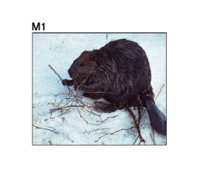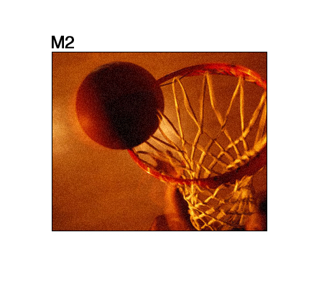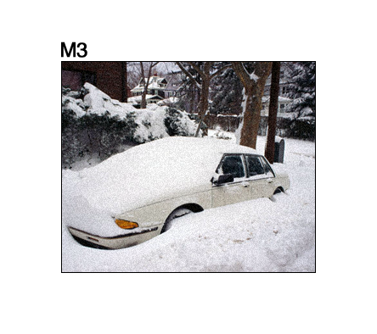
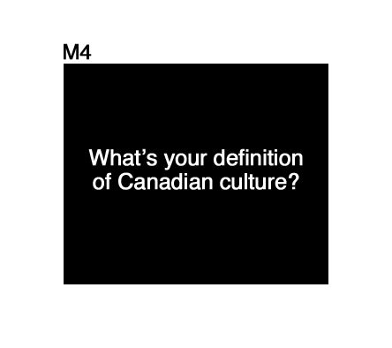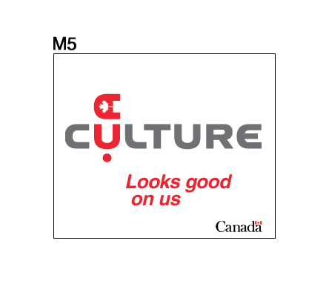
English | French | Overall

- The images and topics presented for this banner raised a lengthy discussion around what participants considered to be Canadian culture. Some did not entirely agree that snow was an appropriate symbol of Canadian culture.
- For the most part, participants, especially in the English group, indicated that they could relate to the images and the concepts presented in the banner: “It makes you think of your daily life.” “It makes us who we are.” “I can identify to it as a Canadian.”
- Participants emphasized that many of the concepts were cliché or stereotypical but that they were nonetheless representative. While English participants viewed the cliché aspect of the concepts appealing, Francophones were more likely to consider them demeaning. They did admit to the fact that they can relate to the concepts, however, they are not concepts that do Canadian culture justice: « Pour moi le Canada c’est autre chose. » « Il n’y a aucune images de fierté la dedans – ça ne me rend pas fier d’être Canadien. » « C’est comme si je faisais un site français avec la tour Eiffel et un béret. » Despite the negative sentiments towards the concepts (especially the poutine), many Francophones nonetheless indicated they would likely click out of curiosity.
- The proposed English tag line, “Looks good on us,” was not well received by participants. Alternate slogans for this banner included: “Culture.ca - Canadian life” (proposed by a participant and well received by many others), “Canadian living”, “Something different”, “That’s my life”, and “Play.”
- The proposed French tag line, “On s’y reconnait” was more or less well received although “Ca nous ressemble” also fared well. A suggested alternative was: “Ca nous rassemble.”

Concept F
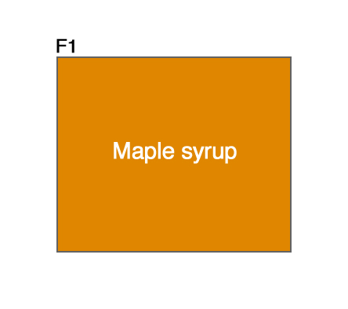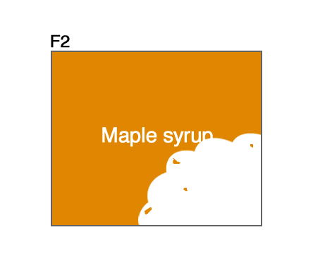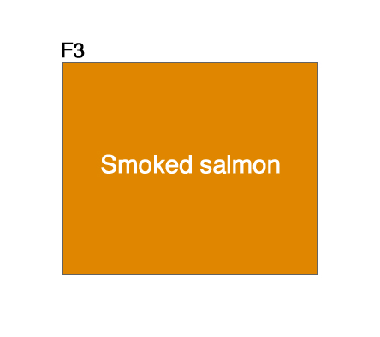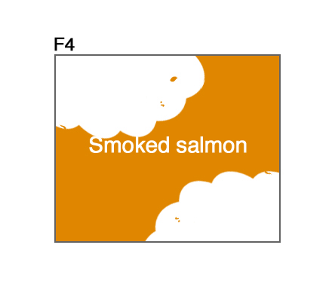
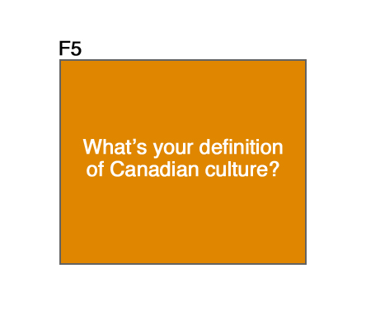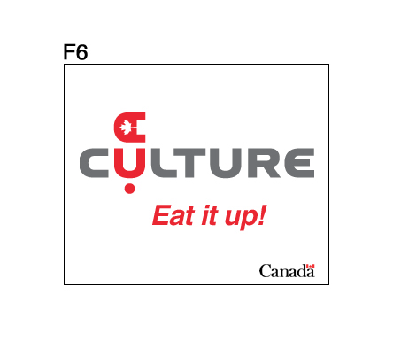
English | French | Overall

- For this concept, participants suggested that the use of images rather than words would be more effective at catching their attention.
- Many participants did not understand the “bite” in the picture – the confusion with a cloud likely led some to discredit the effectiveness of the banner. As well, Francophones felt the concept of the “bite” was overused and lacked originality.
- Francophones also believed that the concept was too exclusionary by not effectively capturing the multicultural aspect of cooking in Canada. There was a suggesting to add such items as “Canadian sushi,” “Marché Créole,” etc. since it is as much a part of our diet and that it also creates an interesting twist, since sushi is obviously not a dish of Canadian origin. « La culture canadienne moderne inclut la culture chinoise même si elle n’a pas été développée içi….et si je voyais une annonce où on défilait toute sortes de plats de toute sorte d’endroits et on disait ‘Canada’, je me dis ayoye, c’est riche le Canada. »
- Anglophones did not like the color used.
- The proposed English tag line, “Eat it up!” received mixed reviews. Those who liked it thought is was ideal given the culinary theme in the banner.
- The proposed French tag line was not popular either. “Goutez-y” and “Croquez dedans” were the most popular slogans among those proposed by the CHIN team. Alternatives proposed by participants included: “Ca nous aliment”, “Bouillon (de) culture(l)” and “Marmite (de) culture(l)”.

Concept P
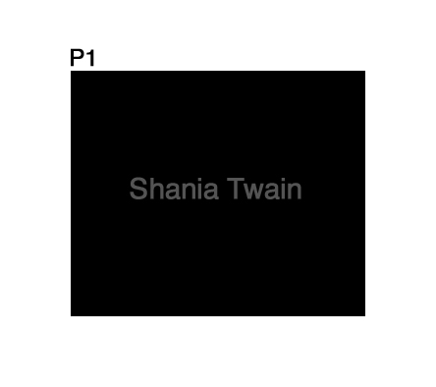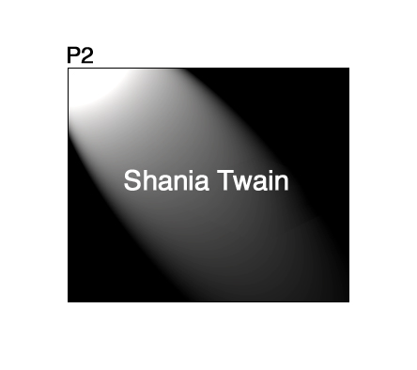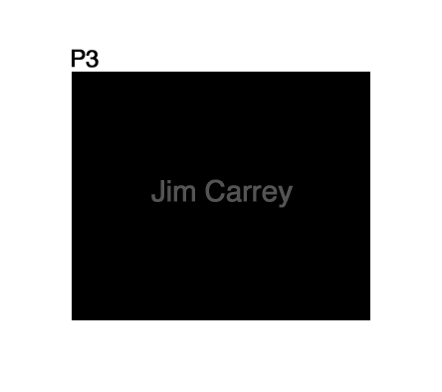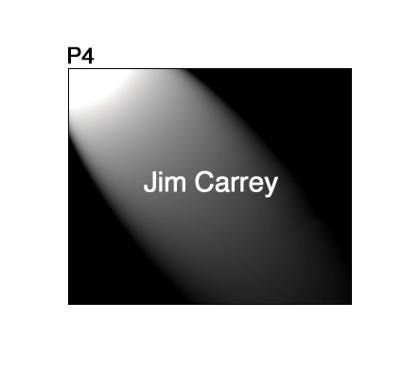
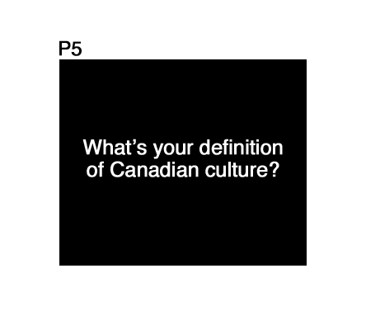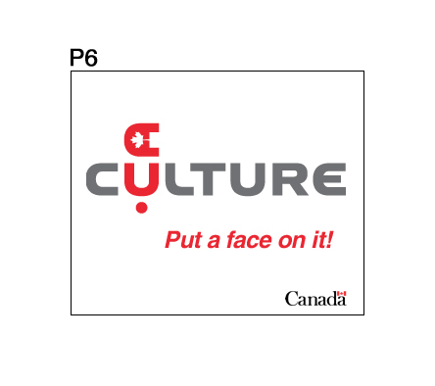
English | French | Overall
- This concept was controversial since participants were sceptical that the names selected would effectively represent Canadian culture. Although this did represent “Pop Culture,” participants were not convinced that this was the best way to portray Canadian culture. The fact that many felt “Famous exports” was an appropriate tag line for this concept is reflective of the sentiment that, despite the fact they were born in Canada, the individuals may have nothing else in common with Canada.
- For this concept to be liked, the individuals used will need to be carefully selected to ensure that Canadians still like them and that they still have a strong connection to the country. In both the English (Shania Twain and Jim Carrey) and French (Jacques Villeneuve and Céline Dion) concepts presented, participants felt that the individuals selected were too disconnected from Canada to be considered good cultural ambassadors.
- Some participants felt they could not relate or connect to celebrities in the same way as maple syrup or a car buried in snow: “Il y a un manque d’accessibilité.”
- The fact that individuals would be from such a wide array of fields was appealing (i.e. not just pop culture). Participants also responded more positively to names more closely tied to the arts such as Atom Egoyan and Margaret Atwood. Another appealing aspect of this concept was that it represented an opportunity to discover that a certain celebrity is in fact Canadian.
- There was a sense that this banner would be more appealing to a younger audience.
- “Put a face on it” was not well received as a tag line and nobody expressed interest in “In your face.” Alternatives included: “Do you know they are Canadian?”, “Stars North of the 49th”, “Look who we are” and “Famous exports.”
- “Entrez dans le portrait” was more or less well received – it was the most preferred among those suggested. Other suggestions included: “Image inné”, “Souriez!”, “Dévisagez-nous” and “Personnalité Actualité.”

Concept S





English | French | Overall

- Francophones did not see the link between the banner and culture. They also considered it juvenile, vague and politically correct. “Ca fait très Radio Canada.”
- The vagueness would discourage some from clicking since it does not speak enough to the content of the website – the words used in the banner are not sufficiently engaging. On the other hand, the general, passive nature of the concept was appealing to others who felt this approach was more inclusive, in other words everyone can connect with it, especially when compared to earlier concepts.
- The banner was considered completely different from typical commercial banners that are known for being more aggressive. It was deemed positive and “relaxed.” – “if you’re looking to take a break, you’ll take a break on it.”
- Other than a maple leaf, there is no obvious connection to Canadian culture.
- An improvement suggested in both sessions was the use of color and more specifically, the use of red in the maple leaf. It could turn red once the boy catches it.
- This concept was considered appropriate for younger audiences.
- The English tag line was very popular: “Draw your own conclusions.”
- Among the French tag lines proposed, “La culture en ligne” was most preferred followed by “La culture sur toute la ligne.”

Concept D
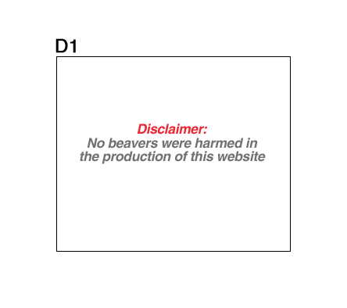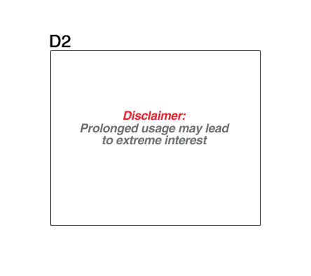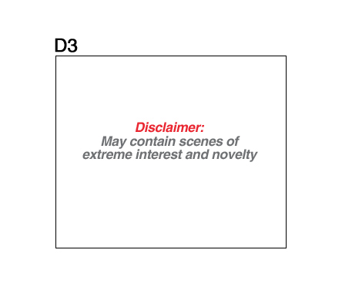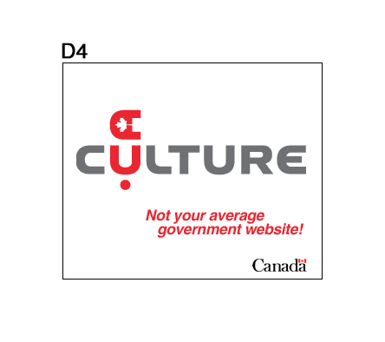
English | French | Overall

- This concept was popular because it was humorous. “If something is catchy enough to make me laugh, I’ll be much more interested in clicking on it.” In fact, the plain, serious look of the ad would require that it be funny in order to attract the attention of participants.
- Although the concept still referred to clichés such as the beaver and poutine, they are effective because they are laughed at.
- Use of words other than “Disclaimer” were proposed, such as “Warning” or “Caution.”
- English participants particularly liked the first disclaimer (see above) but less the second and third. “Enjoyment enhanced by consumption of poutine” was also very well received.
- Although the concept was popular, some participants still suggested the use of more color or fading images.
- Some participants indicated that the concept reminded them of the warnings on cigarette packs.
- Regarding the tag line, “Not your average government website” was best received and “Not another government website” was a close second. An alternative was “My government website.” These slogans were considered appealing insofar as the website lives up to expectations.
- Francophones clearly preferred “Un site gouvernemental pas ordinaire!” as the tag line.

Concept E
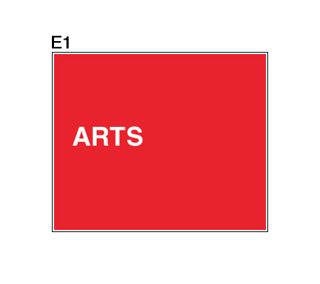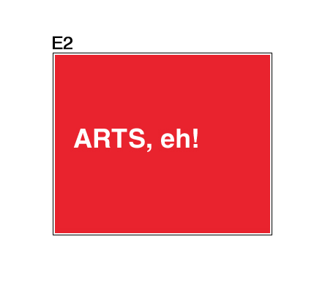
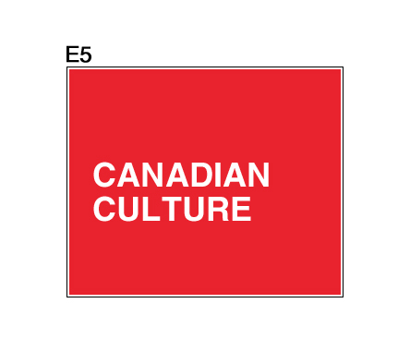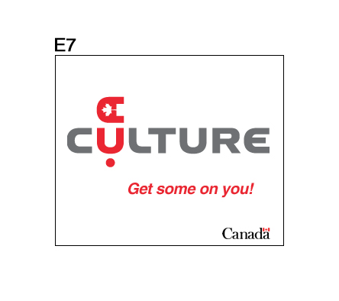
English | French | Overall

- The reactions to the English “Eh” and the French “Tsé” were completely opposite. While English participants saw their version as humorous and an interesting way to have fun with a truly Canadian feature, Francophones saw their version as demeaning and unrefined. Although Francophones did not deny the fact that “Tsé” is common in every day talk, it is not something appropriate for a Government of Canada banner ad. It is not an aspect of their culture that they particularly want to promote.
- The “Tsé” did however communicate that culture is accessible to all.
- The “Eh” was appealing because it is common to all Canadians.
- The color was appealing although some would have preferred less reading and more visual content such as images. The simplicity of the concept is also appealing, and if too much text is added to the banner, this simplicity could be lost quite easily. Without the use of images, it will be important to keep the use of text to a minimum to avoid having the user ignore it because it looks like a lot to read.
- “Get some on you” was not liked by any of the participants while “Come and get it” was somewhat better received. One participant proposed simply keeping with the concept theme and add “Eh!” after Culture.ca – this suggestion was popular.
- Neither one of the French tag lines proved interesting. The lack of interest in the concept itself likely discouraged creativity since no alternative tag lines were proposed by participants.

Concept L
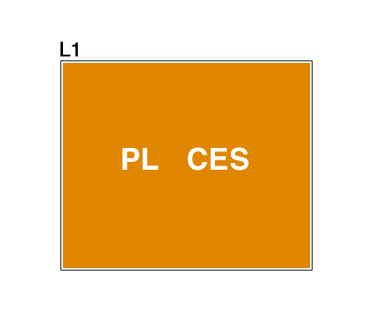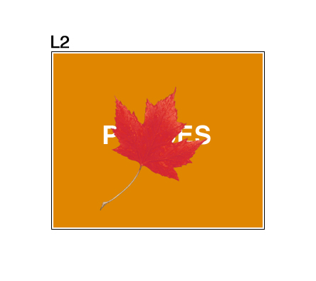
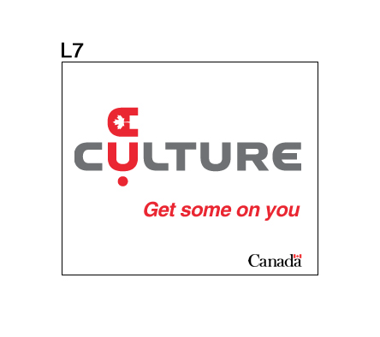
English | French | Overall

- Although the red maple leaf was appealing, most of the feedback on the color scheme was negative.
- The most positive element of this concept was the fact that it provides key insight into website content.
- A few participants were distraught by the fact that the leaf did not always represent the same letter.
- The concept overall was considered dull.
- Since the tag lines for concept L were the same as concept E, there is no additional feedback. Participants did not like either of the proposed tag lines any more than before despite the modified visual concept.
- Among Francophones, “Ca frappe fort” was much more appealing than “On s’y colle.” A suggestion was “Ca s’imprime en nous.”

Concept W
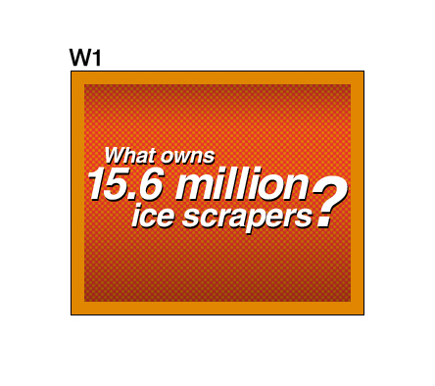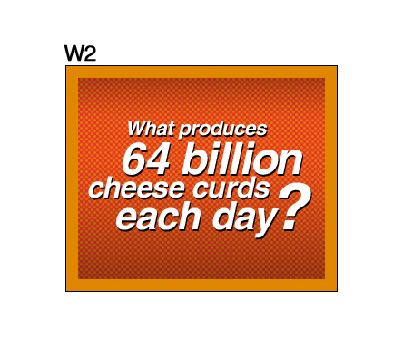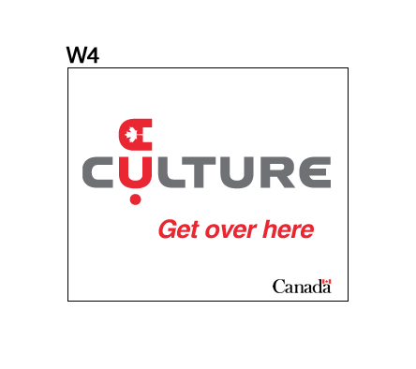
English | French | Overall

- The typeface and the font size reminded some of a lottery advertisement or of money in general – this received mixed reviews as some participants admitted to the fact that this would attract their attention while for others it was too common to attract their attention.
- The appeal in this concept was the general affinity for trivial statistics: “J’aime bien les statistiques sur toutes sorte d’affaires.”
- Although the statistics presented in the concepts were exaggerated and fictitious, participants did not seem to question them and furthermore, seemed quite convinced that they were true statistics. In fact, one participant indicated that he was even going to tell the cheese curd statistic to someone later in the evening. Even though no participant raised the point, CHIN will need to be sensitive to the impact fictitious statistics in their banner ads may have on the credibility of genuinely correct information and statistics presented on Culture.ca.
- The topics presented in the questions might lead some to believe that this is what is on the website. For some, this is an interesting proposition given their interest in trivial facts. However, for others who are more interested in aspects of Canadian culture other than ice scrapers and cheese curds, the banner is less appealing.
- The color scheme on this concept was considered better compared to other concepts that only had a simple orange background: “It’s the same color, it’s just toned differently.”
- The English tag lines were not popular – participants felt that they did not reflect the trivia theme at all. Proposed alternatives include: “Answers here”, “Feed your curiosity”, “Learn more”, “What do you know?”, “What do you say”, and “We’ve got trivia.”
- French participants favored “On vous attend” much more than “On en mange!”

Concept N





English | French | Overall

- Some participants liked the fact that the dog appeared to be travelling from coast to coast.
- Although the images were attractive, some felt there wasn’t’ enough of a “hook” to entice them to click through. A proposed suggestion would be to have images that speak more directly to a Canadian cultural event or landmark rather than a clichéd image of each province such as wheat fields and the CN Tower. An example would be an image of the Montreal Jazz Festival: “Something that relates to the culture of a place.”
- The colors in the banner and the landscape images used were considered appealing, especially if one can recognize that one of the landscapes is near where they live.
- This concept is attractive to those who enjoy travelling, an activity considered by a few as one of the ways one can experience Canadian culture.
- It was mentioned that Newfoundlanders are typically black.
- At one point during the dog’s walk, it was suggested that it should lift its head to look at a particular scene rather than stay in the same sniffing position across the entire banner.
- “Sniff us out!” and “Follow your trail” were not popular among English participants. Alternatives included: “Track us down”, “Catch your scent!”, “Explore with us”, “Discover your trail”, “Explore” and “Walk through it with us.”
- Francophones were critical of the proposed tag line “Dénichez-nous!” – they felt it was negative and that it undermined the potential for the website: “Ca représente pas une grosse richesse une niche.” Conversely, the second tag line that was proposed, “Suivez notre piste!” was much more appealing.

Concept Q
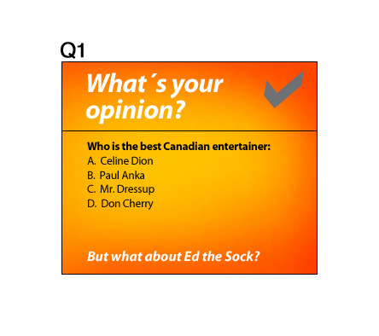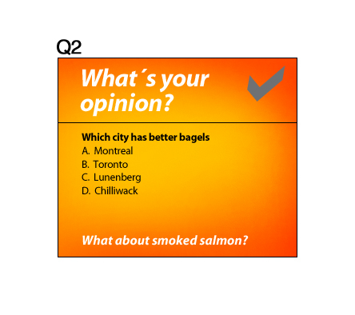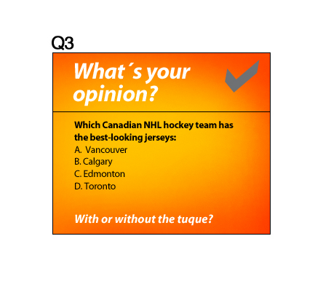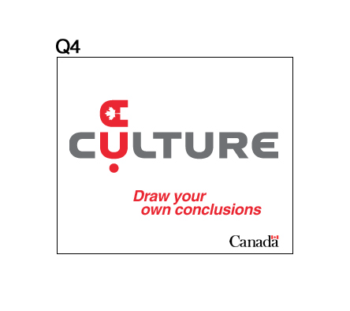
English | French | Overall
- This concept could be improved by adding statistics and by making the concept resemble a quiz rather than an opinion survey although the notion of a quiz or an exam was not universally appealing.
- Generally, the concept was considered mediocre for a few reasons:
    - The questions were not challenging or important: “What do you get out of it?”;
    - All the choices available were all potentially correct answers;
    - There is a lot to read, especially if many of these will appear in the same banner within 10 seconds;
    - There is a sense that clicking on the banner will lead to a survey.
- When prompted, participants felt the statements at the bottom of each page were a positive addition because they added an element of humour to the concept.
- Among English participants, the concept would be improved in they only kept the part that features “Culture.ca, Draw your own conclusions” – that would be enough to get them to click through.
- The English tag line “Draw your own conclusions” was well received in an earlier concept and the result is similar for this concept, although not as strongly. Nonetheless, most participants considered it appealing.
- The French tag line was deemed mediocre at best: “Tirez vos propres conclusions.” Participants did not offer altnernatives.

Summary Concept Preferences
The click-through ratings have been summarized in the table below and sorted in order of preference according to participant rankings.

Concept | English | French | Overall
D
Disclaimer
M
Beaver and the snow
S
Explore, Find and Share
W
Trivia and Statistics
N
Newfoundlander
E
Eh!
L
Maple Leaf stamp
P
Celebrities
Q
Opinion survey
F
Biting into food

Perceptions on the Overall Messaging
- When asked what they considered to be the main message behing the banner ad campaign, the following notions were mentioned:

  - Accessibility or information that is easily accessible : “Ca représente une image d’accessibilité.“
  - Oversimplification in a negative way – there was a sense that Canadian culture is more than what was presented in the banners. The fact that topics such as literature and theatre were not at all referenced but that concepts such as maple syrup and poutine are presented instead demeans Canadian culture. There was a concern that if the objective of the banners is to communicate the values in Canadian culture, that the objective was not met.
  - Sense of belonging
  - Tradition
  - “Venez nous voir!”
  - “They are trying to communicate culture.”
  - “We have a lot to offer in culture. Go out and see it.”
  - The website will present many facts and statistics on Canadian culture: “A big ball of information on Canada.”, “…how many books did Margaret Atwood write.”
  - “Learn about Canadian culture and be proud of it.”
  - Unity: “Learn more about Canadian culture so we can hold together better. There are so many differences on either end of the coasts and in the center – I think it is to bring more harmony and understanding of each other. To know a bit more of each other. To be proud.”
  - To explore.
  - “They want to make a point that there is actually a Canadian culture, very specific and different from other cultures.”
  - Diversity

Appendix A: Recruitment Screener

Client (Culture.ca Online Advertisement Evaluation)
Screener for Gen. Pop.

Questionnaire:
City 1: Thursday September 18th  French Adults: 6:00pm 1 $ 40  English Adults: 8:00pm 2 $ 40 | Study#: XXXX  CSRC Reg#: XXXX  Call: 1-800-554-9996  recruit 12 for 8-10 show
Respondent’s name:  Respondent’s phone #: (home)  Respondent’s phone #: (work)  Respondent’s fax #: sent? or  Respondent’s e-mail : sent?  Sample source (circle): client focus dbase random referral | Interviewer:  Date :  Validated:  Central Files:  On List:  On Quotas:

Hello, my name is . I'm calling from Decima Research on behalf of the Government of Canada. We’re organizing a discussion group in Montreal to obtain the public’s opinions on some advertising material currently under development. EXPLAIN FOCUS GROUPS. About 10 people like yourself will be taking part, all of them randomly recruited by telephone just like you. For their time, participants will receive a cash compensation for their time ($40). But before we invite you to attend, we need to ask you a few questions to ensure that we get a good mix/variety of people. May I ask you a few questions?

Participation is voluntary and all your answers will be kept confidential and will be used for research purposes only. We are simply interested in hearing your opinions, no attempt will be made to sell you anything. The format is a “round table” discussion lead by a research professional.

Yes 1 CONTINUE
No 2 THANK & DISCONTINUE

I have a few questions to ask to see if you qualify for the groups.

1) We realize it is short notice but would you be available to attend a discussion group on Thursday September 18th at INSERT TIME? (It will last one hour and you will receive $40.00 for your time)

Yes 1 CONTINUE
No 2 ASK FOR REFERRAL, THANK & TERMINATE
2a) Have you ever attended a consumer group discussion, an interview or survey which was arranged in advance and for which you received a sum of money?

Yes 1 MAX. ½ PER GROUP
No 2 GO TO Q3

2b) How long ago was it?

TERMINATE IF IN THE PAST 6 MONTHS

2c) And how many such groups have you ever attended?

5 or less 1 CONTINUE
6 or more 2 THANK & TERMINATE

3) Do you or does anyone in your household work in any of the following areas:
READ LIST...
 | YES | NO
Marketing Research/ Marketing Department/ Marketing | 1 | 2
Advertising | 1 | 2
Media Organization (TV, Radio, Newspaper, Magazine) | 1 | 2
Public Relations | 1 | 2
Government of Canada | 1 | 2
Been an ACTRA member | 1 | 2

IF YES TO ANY OF THE ABOVE OCCUPATIONS, THANK & TERMINATE

4) Do you currently have any children between the ages of 5 and 17 years old?

Yes | 1 | Aim for 50% of each group
No | 2

5) Are you a high school or grade or elementary school teacher?

Yes – grade school | 1
Yes – high school | 2
No | 3 | SKIP TO Q7

ASK IF Q5=1: 6a) Which grade(s) do you teach?

ACCEPT ALL THAT APPLY Grade(s): ____________________________

ASK IF Q5=2: 6b) What topics do you teach?

History 1
Language Arts (e.g. English or French literature) 2
Social Studies 3
Sociology 4
Political Science 5
Other 6

IF RESPONDENT TEACHES GRADE 6, 7 OR 8 OR Q5B<6, RESPONDENT IS CONSIDERED A “TARGET TEACHER”

7) Would you say that in an average week, you access the Internet from your home, work or elsewhere?

Yes 1
No 2 THANK AND TERMINATE

8) How often would you say you use either Internet search websites such as Yahoo, Google, MSNSearch, or Altavista, or search engines that are part of specific websites?

If necessary: An example would be to ask what are some of the websites they regularly visit and then ask if they use the search function on any of those specific sites.

Would you say…

Every time you use the Internet 1
Almost always 2
Once in a while 3
Rarely, or, 4 THANK AND
Never 5 TERMINATE

“TARGET TEACHERS” SKIP TO Q13

9) How old are you?

Under 24 1 - THANK AND TERMINATE
25-39 years 3

25 TO 49 – OBTAIN A MIX
40-49 years 4
50-59 years 5
60 years or over 6 THANK AND TERMINATE
Refuse 9

10) To which ethnic or cultural group do you belong? DO NOT READ LIST – ACCEPT ALL THAT APPLY

British (English, Irish, Scottish, Welsh) 1
French 2
German 3
Italian 4
AIM FOR 3 VISIBLE MINORITIES PER GROUP
Jewish 5
Polish 6
Spanish 7
Other European (ex. Russian, Scandinavian, Greek) 8
Chinese, Japanese, Vietnamese, Korean 9
Middle-Eastern 10
Aboriginal/ Native American 11
India/ Pakistani 12
African 13
South American/ Caribbean 14
Mexican 15
American/ USA 16
OTHER – SPECIFY_______________ 77
DK/RF 99

11) What is the highest level of education that you have completed?

Some high school or less 1
Completed high school 2
Some university/college 3
Some CGEP 4
Completed University (B.A.)/college degree 5
Complete CGEP 6
M.A./Ph.D. Degree or Higher 7
DK/RF 9

12) Are you physically handicapped?

Yes 1 AIM FOR AT LEAST 1 PHYSICALLY HANDICAPPED PER GROUP

No 2
DK/RF 9

13) Note respondent’s gender (By observation, do not ask):

Male 1 WE WOULD LIKE
Female 2 50/50 MIX (IF POSSIBLE)

14) You may be asked to write out answers to a questionnaire or read material. Would you feel comfortable doing that?

Yes 1 THANK & TERMINATE
No 2

TERMINATE IF RESPONDENT OFFERS ANY REASON SUCH AS SIGHT OR HEARING PROBLEM, A WRITTEN OR VERBAL LANGUAGE PROBLEM, A CONCERN WITH NOT BEING ABLE TO COMMUNICATE EFFECTIVELY OR IF YOU HAVE A CONCERN.

City 1: Thursday September 18th
French Adults: 6:00pm 1 $ 40
English Adults: 8:00pm 2 $ 40

As I mentioned earlier, the group discussion will take place the evening of Thursday September 18th at INSERT TIME. Would you be willing to attend?

Yes 1
No 2 THANK & DISCONTINUE

Do you have a pen handy so that I can give you the address where the group will be held. It will be held at:

630 Sherbrooke West
Suite 1101
Montreal, Quebec H3A 1E4
Tel:514-288-0199
Fax: 514-288-0131

We ask that you arrive fifteen minutes early to be sure you find parking, locate the facility and have time to check-in with the hosts. The hosts may be checking respondent’s identification prior to the group, so please be sure to bring some personal identification with you (i.e. driver’s license). Also, if your require glasses for reading, please bring them with you.

As we are only inviting a small number of people, your participation is very important to us. If for some reason you are unable to attend, please call so that we may get someone to replace you. You can reach us at 1-800-363-4229 at our office. Please ask for Eric Turcotte. Someone will call you the day before to remind you about the discussion.

May I please get your name: ON FRONT PAGE

Thank you very much for your help!

Appendix B: Moderation Guide and Participant Hand-outs

OUTLINE

1. Introduction 3 minutes
2. Participant Presentation/Warm-Up MAX 5 minutes
3. Online advertising – general discussion 8 minutes
4. Online ad presentation and evaluation 40 minutes
5. Online ad open discussion 30 minutes
6. Conclusion MAX 5 minutes
____________
Total 90 minutes

- INTRODUCTION 3 minutes

Welcome. You are about to be part of an important process in assisting our client evaluate online advertising material.

Before we begin, allow me to introduce myself. My name is Rick and I have been hired to lead you in the discussion tonight. To do that, I’ll ask a number of different questions and have you discuss your opinions with each other. It is important to remember that there are no right or wrong answers. It is your opinion that counts.

I may take some notes in order to report the results. However, I will be audio and video recording this session so that I don’t miss any details. These tapes will only be used to help me recall enough details to enable me to report people’s opinions accurately. Nothing you say or do will be identified to you as an individual and you will never be contacted in connection with this particular session. A few of my clients are here this evening to hear firsthand your ideas and thoughts. Again, there are no right or wrong answers. Thank you for joining me tonight. Are there any questions before we begin?

- PARTICIPANT PRESENTATION/ WARM-UP 5 minutes

- What I would like to do now is get to know you a little. Could you please tell me your name and a little something about yourself, be it a little word on your family, your job and how you use the Internet, especially at home.

- ONLINE ADVERTISING – GENERAL DISCUSSION 8 minutes

- When you are browsing the Internet, do you read or pay any attention to any of the banners that either stretch across the top of the website or along the side, usually the right hand side?
- How often would you say you click on these types of online ads?
- What usually catches your eye? What is it about the advertisement that gets you to click on them? PROBE IF NECESSARY: Is there a contest? Do they leave you guessing? Is it the subject matter? Is it the company or organization? Is it a product promotion?
- Is there a particular type of ad that you tend to select?
- Why don’t you click on online ads more often?
- Can you name and describe a publicity or a banner you clicked on?
- Would you be more likely to click on an ad that promoted a website sponsored by the Government of Canada or a specific Government department? Why or why not?

- ONLINE AD PRESENTATION AND EVALUATION 40 minutes

DISTRIBUTE HANDOUT
I will now present a series of potential online advertisements that are still under development. We are looking for your feedback to understand which ones you prefer and if any changes need to be made. I will walk you through them one at a time, for each one I would like you to use the evaluation grid in front of you to indicate your likelihood of ‘clicking’ on it.
MODERATOR PRESENTS EACH OF THE 10 CONCEPTS ONE AT A TIME WITH A PAUSE BETWEEN EACH TO ALLOW PARTICIPANTS TO INDICATE THEIR ‘CLICKING’ LIKELIHOOD
Using the column in the far right hand side of the sheet, I would now like you to rank order all the concepts I’ve just presented. In ranking each concept, please consider the visual appeal, the message and the content. Rank as number 1 the concept you prefer the most, number 2 your second most preferred all the way to number 10.

- ONLINE AD OPEN DISCUSSION 30 minutes

- Let’s discuss each of these online ad concepts individually. Let’s begin with the first one I showed you…(WALK THROUGH FOR EACH CONCEPT):
- What do you like or dislike?
- How many of you here would click on this to find out more? Why or why not?
- Is there something unique about this ad that drives its appeal/ lack of appeal?
- What about the color used?
- What about the selection of content or wording?
- What about the quality or selection of images or graphics used?

- Generally, what are your thoughts on these online ads?
- What are your thoughts on the approach they have used to get your attention?
- Do you consider them visually appealing?
- What do you think the ads are trying to communicate? What you do you think the message is behind these various ads?

- CONCLUSION 5 minutes

Those are all the questions I had for you this evening. Is there anything else that you would like to pass on to the development team as they refine these concepts?

Thank you and have a nice evening!

For each concept presented, please indicate your likelihood of ‘clicking’ on the ad:

 | Very likely | Somewhat likely | Not very likely | Not at all likely |  | Rank  1 to 10
Concept M | 1 | 2 | 3 | 4
Concept F | 1 | 2 | 3 | 4
Concept P | 1 | 2 | 3 | 4
Concept S | 1 | 2 | 3 | 4
Concept D | 1 | 2 | 3 | 4
Concept E | 1 | 2 | 3 | 4
Concept L | 1 | 2 | 3 | 4
Concept W | 1 | 2 | 3 | 4
Concept N | 1 | 2 | 3 | 4
Concept Q | 1 | 2 | 3 | 4

English taglines: For each concept presented, please indicate your opinion on the tagline. Do you like it or not:

Concept | Tagline | Yes | No | Suggestion
M | Looks good on us
F | Eat it up!
P | Put a face on it
P | In your face
S | Draw your own conclusion
D | Not your average government website
D | Not another government website
E | Get some on you
E | Come and get it
L | Get some on you
L | Come and get it
W | Get over here
W | Feast on it
N | Sniff us out
N | Follow your trail
Q | Draw your own conclusion

French taglines : Pour chaque concept présenté, veuillez indiquer votre opinion à l’égard du slogan. L’aimez-vous ou non :

Concept | Slogan | Oui | Non | Suggestion
M | Ça nous ressemble
 | C'est de chez nous
F | Plein la bouche!
F | Beurrez-en épais!
F | Goûtez-y!
F | Croquez dedans!
P | Entrez dans le portrait!
P | Un nouveau visage!
P | Envisagez-nous!
S | Pour lire entre les lignes
S | La culture sur toute la ligne
S | La culture en ligne
D | Un site gouvernemental pas ordinaire!
D | Pas juste un autre site du gouvernement!
E | Imprégnez-vous en!
E | Tombez dedans!
L | Ça frappe fort!
L | On s'y colle!
W | On vous attend.
W | On en mange!
N | Dénichez-nous!
N | Suivez notre piste!
Q | Tirez vos propres conclusions.

“…immediate "click-through" rates, or the number of times that the ads inspire people to click on them, has declined year over year to 2.14 percent from 2.44 percent. In comparison, the average overall click-through rate for Web ads was 0.7 percent in the first quarter of 2003.”, from Web ads proving flashier, by Stefanie Olsen, CNET News.com, April 28, 2003 (http://zdnet.com.com/2100-1104-998574.html)

