Canadian Heritage

Human Resources and Workplace Management Branch Client Survey

Final Report
January 2004

Executive Summary

Recognizing that internal service delivery efficiency and quality drives external service delivery efficiency and quality, Canadian Heritage (CH) engaged Phase 5 to conduct an internal survey for the Human Resources and Workplace Management (HRWM) Branch among CH employees who use their services. The end goal of this exercise is twofold: to provide HRWM with an assessment of current levels of satisfaction with the services they provide and, to use this information to direct their service improvement efforts.

At an overall level, the results show that providing services in the customer’s official language of preference, providing accessible services to persons with disabilities and fair treatment were viewed as strengths. These are primarily related to Access and to Equity and are fundamental requirements for service quality. On the other hand, areas for improvement were HRWM viewing themselves as service providers and HRWM staff understanding their customers’ business environment. These are related to client-centricity and are what distinguish good service from excellent service.

At the level of each of the four specific services (Staffing, Classification, Staff Relations and Human Resources Planning), the results indicate a moderate, overall level of satisfaction with each service. Within each, and in line with respondents’ general impressions, respondents appeared to be particularly satisfied with service attributes related to access and language. Indeed, most respondents indicated that regardless of the service requested, the hours of service were convenient (Access). The same is true for being able to access an HRWM service provider without difficulty(Access) for all of the services, except for Staff Relations, where this attribute received a relatively low rating compared to most other attributes assessed for that particular service. On the other hand, respondents appeared less satisfied with service attributes related to timeliness and being client-centric. Timeliness across all services was viewed as one attribute that could be improved. In fact it was also a key driver of overall satisfaction for all of the services, except for HR Planning. Similarly, attributes which reflect a client-centric attitude and approach like understanding the customer’s business environment and going the extra mile also received if not the lowest, among the lowest ratings among all attributes across all services.

The following are being offered as recommendations HRWM may want to consider as a way of improving future satisfaction ratings. These recommendations fall out of the findings from the survey.

Continue to provide accessible and fair service. These are basic requirements and while ratings indicated that they are strengths, it is important for HRWM to ensure they continue to be. These are not only ‘nice to haves’ but ‘need to haves’. As indicated above, they are the starting point for service provision.

Work towards improving performance on key drivers of overall satisfaction. Across the four services, some of the lowest ratings were for key drivers. These are important attributes because they are the ones most strongly associated with overall satisfaction. If HRWM wishes to increase its overall satisfaction scores, it is essential that they increase their scores on key drivers.

For Staffing, the key drivers which received the lowest ratings were:
- HRWM staff understood my business environment.
- I got the service in a reasonable amount of time.

For Classification, all of the key drivers received the lowest ratings:
- I got the service in reasonable amount of time.
- I received accurate information and advice.
- HRWM staff understood my business environment.
- The HRWM Team went the extra mile.

For Staff Relations, the key drivers which received the lowest ratings (of all attributes) were:
- I received accurate information and advice.
- The HRWM team went the extra mile.

For HR Planning, the key driver which received the lowest rating (of all attributes) was:
- The HRWM team went the extra mile.

Work towards improving performance on client-centric related attributes. If HRWM wishes to provide exemplary service which “delights” its customers, improving performance on “client-centric” attributes is important. In fact, the findings indicate that half of the client-centric attributes are also key drivers. Across all of the services, special attention should therefore be given to the following attributes.
- HRWM staff view themselves as internal experts. (Not measured for key driver status)
- HRWM view themselves as service providers. (Not measured for key driver status)
- HRWM staff understood my business environment. (Key driver)
- The HRWM Team went the extra mile. (Key drivers)

Table of Contents

Executive Summary 2
Table of Contents 4
1.0 Background & Objectives 5
1.1 Background 5
1.2 Objectives 5
1.3 Organization of Report 6
2.0 Research Methodology 7
2.1 Questionnaire Design 7
2.2 Sample and Sampling Procedure 7
2.3 Survey Administration and Response 8
2.4 Margin of Error 8
2.5 Data Processing 8
2.6 Analysis and Reporting 8
3.0 Respondent Profile 10
Chapter Highlights 10
3.1 Demographic Profile 10
3.2 Occupational Profile 12
4.0 General Impressions of HRWM 15
5.0 Staffing Services 17
Chapter Highlights 17
5.1 Planning and Processing a Staffing Action 18
5.2 Context and Outcomes of Most Recent Staffing Action 25
5.3 Awareness and Use of HRWM Staffing Services 28
5.4 Evaluation of HRWM Services for Most Recent Experience 31
6.0 Classification 37
Chapter Highlights 37
6.1 Classification Process 38
6.2 Context and Outcome of Most Recent Classification Action 45
6.3 Awareness and Use of HRWM Classification Services 48
6.4 Evaluation of HRWM Services for Most Recent Experience 50
7.0 Staff Relations 56
Chapter Highlights 56
7.1 Staff Relations Process 57
7.2 Context and Outcome of Most Recent Classification Action 63
7.3 Evaluation of HRWM Services for Most Recent Experience 64
8.0 HR Planning 69
Chapter Highlights 69
8.1 Human Resources Planning Activity 69
8.2 Awareness and Use of HRWM Human Resources Planning Services 70
8.3 Evaluation of HRWM Human Resources Planning Services for Most Recent Experience 72
9.0 Conclusions 78
10.0 Recommendations 78

1.0 Background & Objectives

1.1 Background

The Department of Canadian Heritage (CH) plays a pivotal role in maintaining, nurturing, and communicating Canada’s voice, and Canada’s values both inside and outside of the country. Indeed, the department is guided by the following four strategic objectives:

- To promote and disseminate Canadian content.
- To foster access and participation in Canadian culture.
- To foster and strengthen connection among Canadians.
- To promote understanding of Canadian citizenship and foster opportunities to participate civically.

The nature of the department’s objectives speaks to a high level of citizen-facing activities and interaction and as such, the degree to which the Department can communicate and deliver services efficiently and effectively to Canadians is tantamount to meeting these objectives.

Recognizing this, but also recognizing that internal service delivery efficiency and quality drives external service delivery efficiency and quality, CH, in congruence with the Service Improvement Initiative (SII) established by the Treasury Board Secretariat, engaged Phase 5 to conduct an internal survey for the Human Resources and Workplace Management (HRWM) Branch among CH employees who use their services. The end goal of this exercise is twofold: to provide HRWM with an assessment of current levels of satisfaction with the services they provide and, to use this information to direct their service improvement efforts.

1.2 Objectives

The focus of the survey was on four key strategic services provided by The Human Resources and Workplace Management Branch (HRWMB) within CH; they include:

- Human Resources Planning;
- Staffing;
- Classification; and
- Staff relations.

The survey explored issues such as the degree to which managers were aware of and used these services, how they assessed a recent service experience and their priority areas for learning and service improvement. (See appendix for a copy of the questionnaire.)

Specifically, the purpose of the survey was to:
- establish baseline measures of service satisfaction upon which to track service improvement;
- identify service gaps (divergence between client expectations and perceptions);
- identify the drivers that impact service satisfaction;
- identify priority areas for improvement; and
- assess awareness levels of the HRWMB service menu.

1.3 Organization of Report

This report is divided into 10 chapters. Chapter 1 provides the background and objectives for the current research study. Chapter 2 presents the methodology used to collect the data and chapter 3 provides a profile of respondents to the survey. Chapters 4 through 8 present the detailed results from the survey and an analysis of findings. Specifically, chapter 4 concerns overall impressions with HRWM services, chapter 5 concerns staffing services, chapter 6 concerns classification services, chapter 7 concerns staff relations issues, and chapter 8 concerns Human Resources planning services. Chapter 9 provides a concluding summary of the findings and chapter 10 provides recommendations for service improvement.

2.0 Research Methodology

2.1 Questionnaire Design

The core of the survey questionnaire uses the 10 mandatory questions of Treasury Board’s Common Measurement Tool (CMT) which, over time, will not only establish a baseline of client satisfaction that can be reviewed year over year but will also enable organizations to compare satisfaction levels for the same services across government departments.

For this first survey, additional questions were developed by Canadian Heritage staff to assess managers’ priorities for learning in the face of human resources modernization, their values, their awareness of branch services and how these services are most commonly accessed.

An Expert Review of the questionnaire conducted by Phase 5 determined that in general, the questionnaire was properly designed; however, some minor areas for improvement were noted. Changes to the questionnaire were made in consultation with staff at Canadian Heritage.

Prior to being finalized, the draft questionnaire was reviewed by staff at Canadian Heritage. The questionnaire was then translated by a professional third-party translator and as well reviewed by staff at Canadian Heritage to ensure accurate French nomenclature and appropriate level of language.

The resulting questionnaire was then programmed for use over the Internet using Computer Assisted Web Interviewing (CAWI) software. This software packages allows for skip logic and hard or soft edit programming, which allowed us to ensure that:
- only logically consistent answers could be given;
- not applicable questions would be skipped;
- “mark one” or “mark all that apply” questions would be selected appropriately; and
- “other specifies” could be collected and re-coded as required.

Upon completion of the questionnaire programming a series of 5 pre-tests (completed surveys) were conducted. The purpose of the pre-tests was to assess respondent cognition, survey length and flow, and to test the systems from a technical and programming point of view.

2.2 Sample and Sampling Procedure

The sample used for this study was provided by staff at Canadian Heritage and included employees with supervisory responsibilities and administrative employees with responsibilities for liaising with the HRWM Branch on behalf of their organizations (N=463). Invitations to the survey were sent to all individuals included on this list using the email address provided.

2.3 Survey Administration and Response

The online survey was conducted between December 11 and December 24, 2003.
This report is based on the completed surveys of 164 Canadian Heritage employees. This represents a 35% response rate. The sampling method used for the survey and the response rate across Canadian Heritage sectors provides a reasonable and fair representation of all clients who used HRWM services in the 12 months prior to the November 4th to November 21st , 2003 timeframe.

2.4 Margin of Error

With a total of 164 completed surveys out of 463 possible individuals, the resulting margin of error for overall results was approximately +/- 6.2%, 19 times of 20.

2.5 Data Processing

Survey data were cleaned to ensure that the skip logic programming worked properly and that no out of scope answers were given. Recoded variables were created as needed for the reporting process and all cleaning and recoding programming were saved to allow for review and use in the future.

In order to ensure that overall results were accurate, responses to the survey were weighted by sector (see figure 2.1 below for sector definition) to better represent the overall distribution of respondents in the database population. The unweighted sample distribution by sector is presented in Figure 3.6. When weighting is applied the sample distribution equals the population distribution.

Responses to the open-ended questions were analyzed and a series of summary categories and corresponding codes developed. Responses to open-ended questions were then coded into appropriate categories for analysis purposes.

2.6 Analysis and Reporting

Data analysis was conducted using SPSS. Results contained in this report are based on the 164 surveys completed. All survey questions were analyzed by the key analysis variables listed in Figure 2.1 and only statistically significant results are presented.

Figure 2.1: Key Analysis Variables

Key analysis variable | Categories
Sector or Region | - Planning & Corporate Affairs  - Public Affairs & Communications  (Includes regional responses)  - International & Intergovernmental  - Deputy Minister Reports  - Citizenship & Heritage  - Cultural Affairs
Gender | - Male  - Female
Level | - Executive  - Manager  - Supervisor
Liaison Role | - Responsibilities include liaising with HRWM  - Responsibilities do not include liaising with HRWM
Tenure | - Less than 2 years  - More than 2 years to less than 5 years  - More than 5 years to less than 10 years  - More than 10 years
First Official Language | - English  - French
Direct vs. Indirect Dealings with HRWM | - Deal directly with HRWM  - Deal with administrative officer who liaises with HRWM
Personally dealt with HRWM on most recent action | - Yes  - No
Age (Year of Birth) | - Born before 1964  - Born between 1964 and 1979

3.0 Respondent Profile

This chapter of the report provides a profile of those respondents that completed the survey. Overall, the profile of respondents to the survey reflects their profile within the department’s population.

Chapter Highlights
- More than half (62%) of the respondents to the survey are female.
- The large majority (82%) of respondents are older employees who were born before 1964.
- Some 12% of respondents are from an Employment Equity Community.
- Approximately three-fifths (59%) of respondents indicated that their first official language was French.
  - Some whose first official language is French completed the survey in English.
- The majority (54%) of respondents to the survey are Managers. Another 24% are Executives, 14% are Supervisors, and 8% indicated they were of some “other” level.
- Most respondents have been with Canadian Heritage for many years (some 42% for more than 10 years).
- A significant percentage (63%) of respondents indicated that their responsibilities include liaising with HRWM on HR matters.
  - Those more likely include Executives, those from Public Affairs and Communication or Deputy Minister Reports and those that indicated that French is their first official language.

3.1 Demographic Profile

3.1.1 Gender
As Figure 3.1 illustrates, some 62% of respondents to the survey are female.

Figure 3.1 Gender of Respondents (n=164)

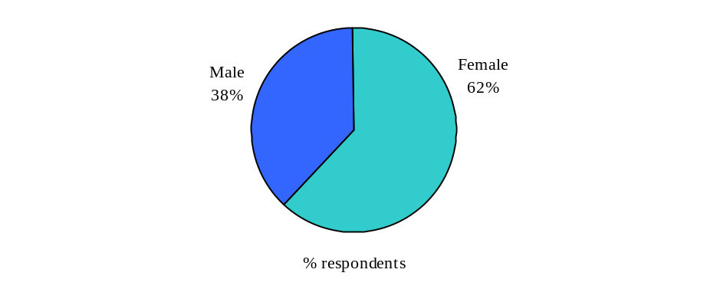

The gender of respondents was used as a key analysis variable during cross-tabulation analyses.

3.1.2 Year of Birth
The large majority of respondents are older employees and were born before 1964 (see Figure 3.2).
Figure 3.2 Year of Birth of Respondents (n=164) 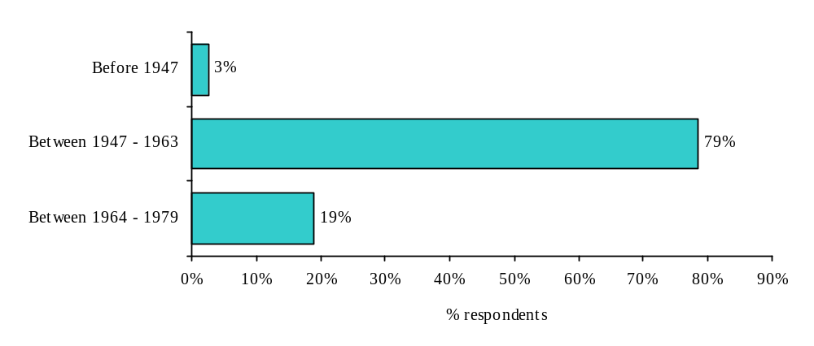
Year of birth was used as a key analysis variable during cross-tabulation analyses. For cross-tabulations two categories were used, 1) born before 1964 and 2) born between 1964 and 1979.

3.1.3 Employment Equity Community
As Figure 3.3 illustrates, approximately 12% of respondents are from an Employment Equity Community. Specifically, 5% are persons with a disability, 4% are visible minorities, and 2% are Aboriginal persons.

Figure 3.3 Employment Equity Community of Respondents (n=164)
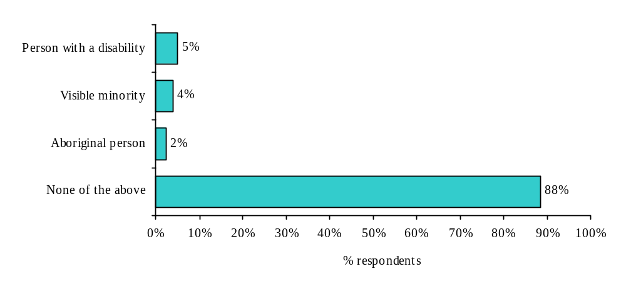 Employment Equity Community was not used as a key analysis for cross-tabulation purposes because of the low sample size for those from an Employment Equity Community.

3.1.4 First Official Language and Language of Survey Completed
Approximately three-fifths (59%) of respondents indicated that their first official language was French (see Figure 3.4). However, some 51% of respondents completed the survey in English, indicating that some respondents completed the survey in their second official language. Specifically, some of those whose first official language is French completed the survey in English.

Figure 3.4 Language of Respondents (n=164)

First Official Language Language of Survey Completed
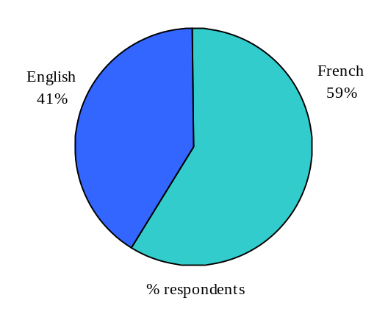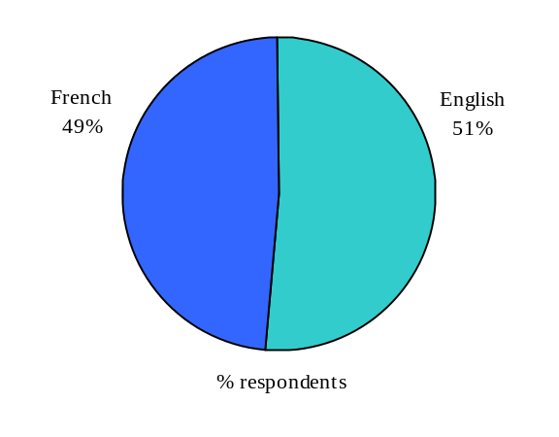
The first official language of respondents was used for cross-tabulation analyses.

3.2 Occupational Profile

3.2.1 Sector
As Figure 3.6 illustrates, the unweighted sample of the sector of respondents closely resembles the population. Nonetheless, weighting was conducted based on sector (see section 2.3) to ensure that any differences is response rates across sectors would not influence overall results.

Figure 3.6 Sector of Respondents (n=164)
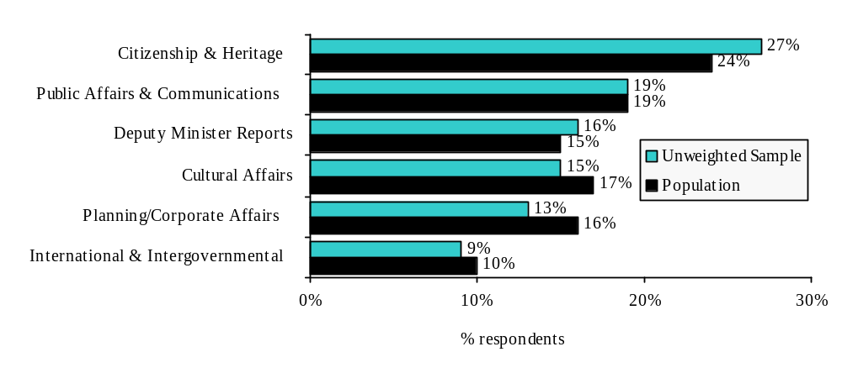

3.2.2 Level
The majority (54%) of respondents to the survey are Managers. Another 24% are Executives, 14% are Supervisors, and 8% indicated they were of some “other” level.

Figure 3.7 Level of Respondents (n=164)
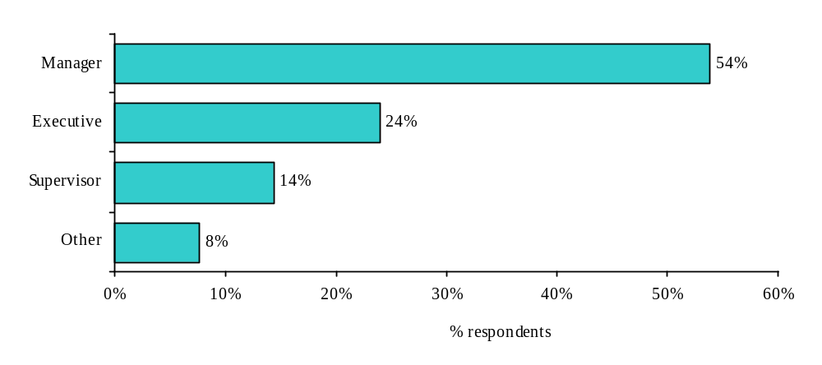

3.2.3 Tenure
Most respondents have been with Canadian Heritage for many years, with some 42% indicating they have been with Canadian Heritage for more than 10 years. Only 11% indicated they have been with Canadian Heritage for less than 2 years.

Figure 3.8 Tenure with Canadian Heritage (n=164)
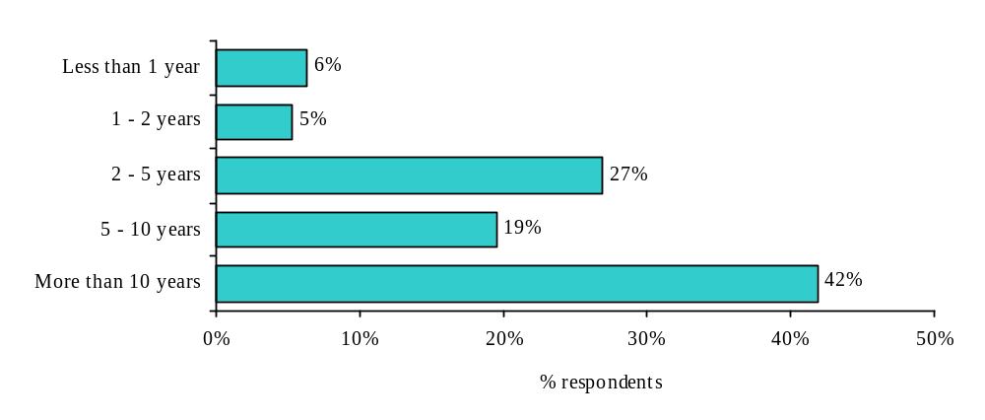

3.2.4 Liaising with HRWM
A significant percentage (63%) of respondents indicated that their responsibilities include liaising with HRWM on HR matters on behalf of their organization (see Figure 3.9).

Figure 3.9 Liaising with HRMW (n=164)
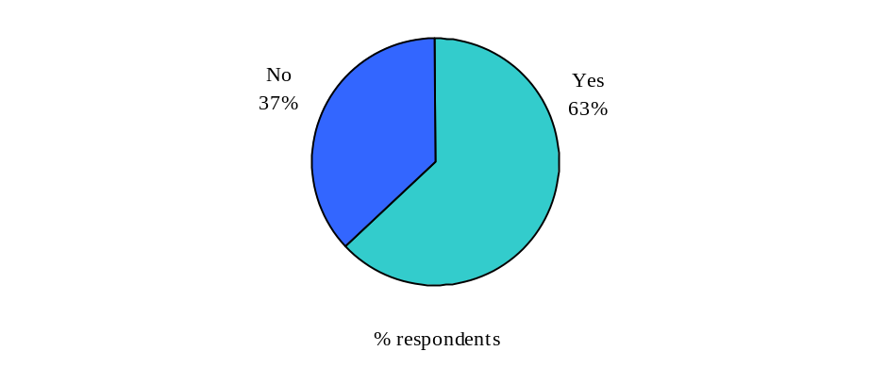

4.0 General Impressions of HRWM

This chapter of the report presents the findings from questions asked about the respondent’s overall experiences with HRWM. It is important to note that these questions were asked prior to the respondent being asked to evaluate specific services provided by HRWM (e.g. Staffing, Classification, Staff Relations, and HR Planning). They therefore represent ‘top-of-mind’ impressions and are a reflection of the attitudes and perceptions about HRWM they carry around with them.

Overall, agreement scores for general impression statements were moderately high (ranging from a mean score of 3.27 to 4.66 out of 5).

Areas of strength: These include providing services in the respondents’ official language of preference (76% strongly agreed, mean score 4.66), providing accessible HRWM services to persons with disabilities (46% strongly agreed, mean score 4.21), and staff that treat fairly those that use HRWM services (35% strongly agreed, mean score 3.97).

Areas for improvement: These include HRWM staff’s understanding of the respondents’ business environment (15% strongly agreed, mean score 3.27) and HRWM staff viewing their role as service provider (22% strongly agreed, mean score 3.54).

Figure 4.1 Overall Experiences with HRWM
(Please indicate your level of agreement or disagreement with the following statements. When answering, please consider your overall experiences with HRWM.)

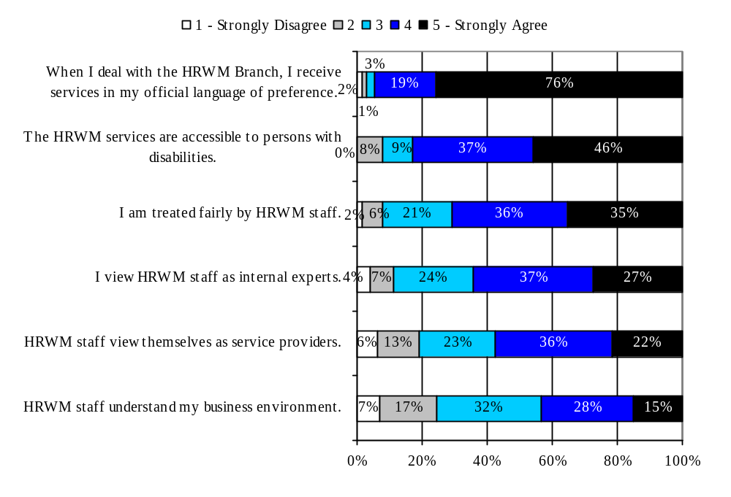
Mean Score (out of 5) | n=
4.66 | 161
4.21 | 66
3.97 | 160
3.76 | 163
3.54 | 149
3.27 | 158
Analysis of Significant Differences

An analysis of cross-tabulations revealed that significant differences across general impressions exist for a two statements: I view HRWM staff as internal experts and I am treated fairly by HRWM staff

Those most likely to view HRWM staff as internal experts are either relatively new to the department (less than two years) or very tenured (10 years or more). They also tend to be older employees (born before 1964). Those most likely to feel they are treated fairly by HRWM staff are more likely to be from Deputy Minister Reports and Citizenship & Heritage but least likely to be from Planning & Corporate Affairs.

I view HRWM staff as internal experts.
- Most likely to agree were those that have worked for Canadian Heritage more than 10 years (3.98) or less than 2 years (3.89) and least likely to agree were those that have worked for more than 5 years but less than 10 years (3.36) or more than 2 years but less than 5 years (3.65).
- More likely to agree were those born before 1964 (3.84) than those born between 1964 and 1979.

I am treated fairly by HRWM staff
- Most likely to agree were those from Deputy Minister Reports (mean score of 4.31) and Citizenship & Heritage (4.14) and least likely to agree were those from Planning & Corporate Affairs (3.45); mean scores for other sectors ranged from 3.87 to 4.07.

5.0 Staffing Services

This chapter of the report presents findings for staffing services.

Chapter Highlights
- Respondents were generally knowledgeable about planning and implementing a staffing action (mean score of 3.65 out of 5).
- They also indicated that they were generally knowledgeable about the roles, responsibilities, and accountabilities of Managers and the HRWM team in the staffing process.
- More than half (57%) of the respondents indicated that when it comes to staffing, they typically deal with their administration officer who liaises with the HRWM Team. The remaining 43% of respondents deal directly with the HRWM Team.
- Almost three-quarters (72%) of respondents indicated they have completed a staffing action in the past 12 months and of those who have completed a staffing action, the majority (54%) have completed only 1 or 2 actions.
- All staffing values appear to be equally and significantly important, except for Diversity, which although still important is not as important as Merit, Transparency, Timeliness, or Fairness.
- The large majority of respondents indicated that HRWM is either meeting their needs or exceeding them on these staffing values.
- During the most recent staffing action:
  - Just over two-thirds spoke directly with HRWM Team prior to beginning the staffing process.
  - Most of the time a position already existed and almost half of the time the respondent had the objective to appoint a particular person.
  - Very few respondents indicated they had used an External Consultant (17%).
  - Almost two-thirds chose an indeterminate staffing option; one-third chose temporary staffing (most under the Public Service Employment Act).
  - Almost all (96%) indicated they got the right person for the job and only 7% indicated they were involved in a staffing appeal.
- Generally speaking, those that conducted a staffing action in the past 12 months were aware of all the different staffing services offered by HRWM. However, there were significant differences in the usage of HRWM services.
- Regardless of the outcome, most respondents that completed a staffing action in the past 12 months were satisfied with the overall quality of the staffing services they received (average of 3.5 out of 5) and some (35%) indicated that HRWM either met their expectations or exceeded them (8%).
- Areas of strength for staffing services include convenient hours of service and being able to get through to the HRWM Team without difficulty.
- Areas for improvement for staffing services included delivering the service in a reasonable timeframe and going the extra mile.
- The top priorities for service improvement were quite varied, however, several centered on the process such as the specific steps, why it takes so long, and ways to simply the process.

5.1 Planning and Processing a Staffing Action

Questions on how respondents plan and process a staffing action were asked of all respondents.

5.1.1 Knowledge of the Staffing Process

Respondents indicated that they were generally knowledgeable about planning and implementing a staffing action (see Figure 5.1). On a 5-point scale, where 1 is “not at all knowledgeable” and 5 is “very knowledgeable”, the average knowledge score is 3.65. Specifically, some 20% indicated their knowledge level was a 5 out of 5 and a further 43% indicated it was 4 out of 5. Only 3% indicated that their knowledge level was a 1 out of 5 and 11% indicated it was 2 out of 5.

Figure 5.1 Knowledge of the Staffing Process

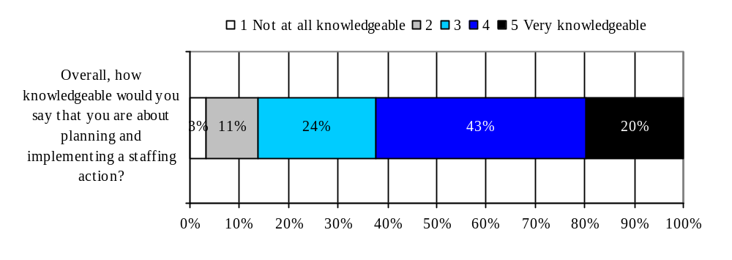
Mean Score (out of 5) | n=
3.65 | 159
Analysis of Significant Differences

An analysis of cross-tabulations revealed that some respondents were more likely to indicate they were knowledgeable about planning and implementing a staffing action than others namely, those at higher levels and those who personally interact with HRWM.

More knowledgeable about planning and implementing a staffing action
- More likely to be those who personally had dealings with the HRWM team on their most recent staffing action (4.00) than those who had not (3.57).
- More likely to be Executives (4.14) than Managers (3.65) or Supervisors (3.09).
- More likely to be those whose responsibilities include liaising with HRWM on HR matters (3.94) than those whose responsibilities do not (3.12).

5.1.2 Knowledge of Staffing Roles and Responsibilities

As Figure 5.2 illustrates, respondents also indicated that they were generally knowledgeable about the roles, responsibilities, and accountabilities of Managers and the HRWM team in the staffing process. On a similar 5-point scale, the average knowledge score of the role of Managers in the staffing process was 3.88 and of the role of the HRWM team was 3.62. The large majority of respondents indicated that their knowledge level was either a 4 or 5 out of 5 (72% for the role of Mangers and 60% for the role of the HRWM Team).

Figure 5.2 Knowledge of Roles in the Staffing Process
(How knowledgeable would you say that you are about the roles, responsibilities and accountabilities of the following people in the staffing process?)

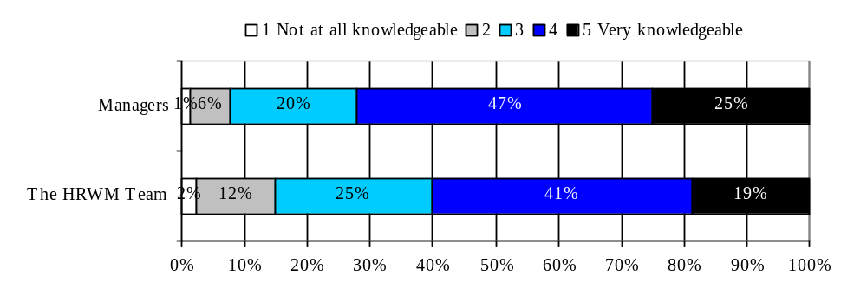 Analysis of Significant Differences
Mean Score (out of 5) | n=
3.88 | 158
3.62 | 159

An analysis of cross-tabulations revealed some significant differences. Executives (vs. Mangers or Supervisors) were more likely to say they were knowledgeable about the role of Managers in the staffing process. It is interesting to note that they rate their knowledge higher than the Managers themselves when it is the Managers’ role that is at the centre of the question.

Both for knowledgeable about the roles, responsibilities, and accountabilities of Managers and knowledgeable about the roles, responsibilities, and accountabilities of the HRWM Team there are significant differences depending on whether or not they liaise with or have had direct dealings with HRWM on their last staffing action. Respondents are more likely to say they are knowledgeable if they have had contact with HRWM.

More
- More likely to be Executives (4.15) than Managers (3.89) or Supervisors (3.48)
- More likely to be those whose responsibilities include liaising with HRWM on HR matters (4.09) than those whose responsibilities do not (3.50).

More knowledgeable about the roles, responsibilities, and accountabilities the HRWM Team
- More likely to indicate they were knowledgeable were those who personally had dealings with the HRWM team on their most recent staffing action (3.89) than those who had not (3.42).
- More likely to be those whose responsibilities include liaising with HRWM on HR matters (3.81) than those whose responsibilities do not (3.26).

5.1.3 Common way to access HRWM

Some 57% of respondents indicated that the deal with their administration officer who liaises with the HRWM Team, the remaining 43% of respondents deal directly with the HRWM Team (see Figure 5.3).
Figure 5.3 Person Dealings with HRMW (n=153)
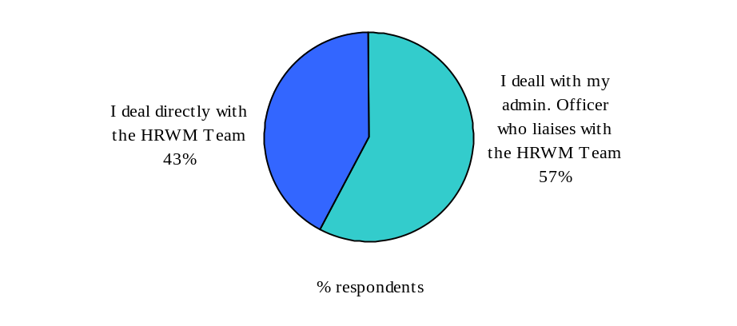
Analysis of Significant Differences:

An analysis of cross-tabulations revealed many significant differences in terms of the most common way that respondents access HRWM for staffing services. Those who deal directly with HRWM (vs. deal with an Administrative Officer who liaises with HRWM) are most likely to be from Deputy Minister Reports and to be females. Those who are less likely to deal directly with HRWM for staffing services are from Planning & Corporate Affairs or Citizenship & Heritage.

I deal directly with the HRWM Team
- Most likely to be those from Deputy Minister Reports (79%) and least likely to be those from Planning & Corporate Affairs (17%) or Citizenship & Heritage (25%); other sectors ranged from 38% to 58%.
- More likely to be those that personally had dealings with the HRWM staff on their most recent staffing action (56%) than those that did not (12%).
- More likely to be those whose responsibilities include liaising with HRWM (54%) than those whose responsibilities do not (21%).
- More likely to be Female (51%) than Male (31%).

5.1.4 Number of Staffing Actions in the Past 12 Months

Almost three-quarters (72%) of respondents indicated they have completed a staffing action in the past 12 months (see Figure 5.4). Of those that have completed a staffing action, the majority (54%) have completed only 1 or 2 actions, 29% have completed 3 or 4, and 17% have completed 5 or more.

Figure 5.4 Staffing Actions

Completed a Staffing Action Number of Staffing Actions
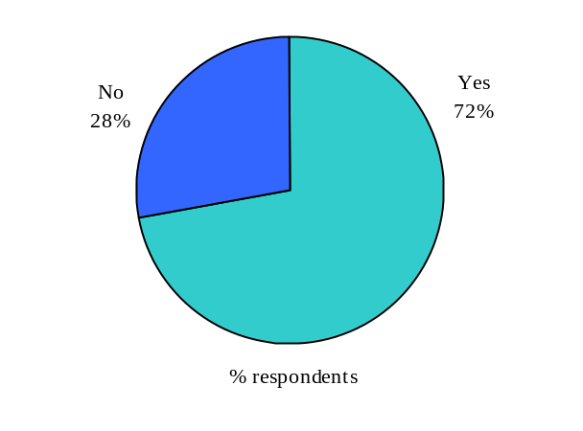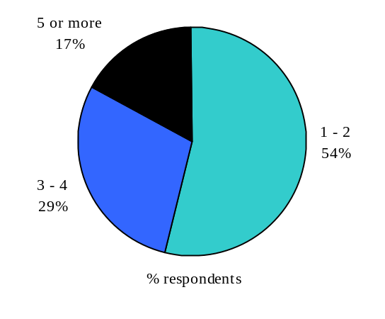

Analysis of Significant Differences

An analysis of cross-tabulations revealed several although not necessarily surprising differences for staffing actions (in the past 12 months) across level and across those whose responsibilities include liaising with HRWM. Executives and employees whose responsibilities include liaising with HRWM were most likely to have completed a staffing action.

Completed a Staffing Action
- More likely to be Executives (88%) than Managers (73%) or Supervisors (50%).
- More likely to be those whose responsibilities include liaising with HRWM (81%) than those whose responsibilities do not (56%).

Completed Many Staffing Actions (5 or more)
- More likely to be those whose responsibilities include liaising with HRWM (23%) than those whose responsibilities do not (3%)

Completed Fewer Staffing Actions (1 or 2)
- More likely to be those whose responsibilities do not include liaising with HRWM (71%) than those whose responsibilities do (47%).

5.1.5 Values Important to a Staffing Action

As Figure 5.5 illustrates, all staffing values appear to be equally and significantly important, except for Diversity. On a 5-point scale, where 1 is “not at all important” and 5 is “very important”, the mean scores for the four important staffing values were 4.70 for Merit, 4.67 for Transparency, 4.66 for Fairness, and 4.60 for Timeliness. In addition for all four of these staffing values almost all respondents indicated that the importance level was either a 4 or 5 out of 5 (93% to 97%). While still important, Diversity appears to be less important than these 4 staffing values. The mean score for Diversity was 4.03 out of 5 and only 74% indicated its importance level was either a 4 or 5 out of 5.

Figure 5.5 Importance of values when planning a staffing action
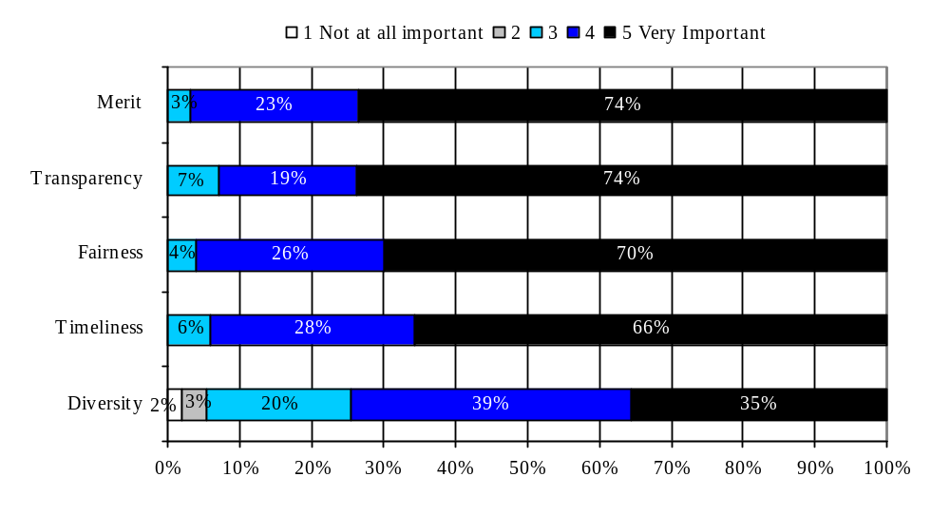 Analysis of Significant Differences
Mean Score (out of 5) | n=
4.70 | 161
4.67 | 161
4.66 | 161
4.60 | 161
4.03 | 161

An analysis of cross-tabulations revealed several important differences in terms of which staffing values are more important to certain types of individuals. Transparency is significantly more important to those whose first official language is French. Diversity, on the other hand, is significantly more important to Executives than it is to Managers or Supervisors. It is also significantly more important to employees from Deputy Minister Reports and Citizenship & Heritage than it is to those from Planning & Corporate Affairs and Cultural Affairs.

Transparency
- More important to those whose first official language is French (4.74) than those whose first official language is English (4.55).

Diversity
- Most important to those from Deputy Minister Reports (4.33) or Citizenship & Heritage (4.23) and least important to those from Planning & Corporate Affairs (3.62) or Cultural Affairs (3.79); other sectors ranged from 3.86 to 4.16.
- More important to Executives (4.30) than Supervisors (4.14) or Managers (3.87).
- Most important to those that have worked for Canadian Heritage for less than 2 years (4.35) and least important to those that have worked for more than 2 years but less than 5 years (3.68); those that have worked for more than 5 years had a mean score of 4.11.

5.1.6 Performance of HRWM in Respecting Values

When respondents were asked how well the HRWM Team is respecting these staffing values, the large majority of respondents indicated that HRWM is either meeting their needs or exceeding them. On a 5-point scale, where 1 is “HRWM is not meeting my needs” and 5 is “HRWM is exceeding my needs” the mean performance scores were 3.90 for Merit, 3.88 for Fairness, 3.78 for Transparency, 3.71 for Timeliness, and 2.94 for Diversity. Therefore, it appears that HRWM is performing well on the 4 staffing values that received the highest importance ratings and less so on the value (Diversity) that received a lower rating.

Figure 5.6 Performance of HRWM in respecting these values in the provision of Staffing Services
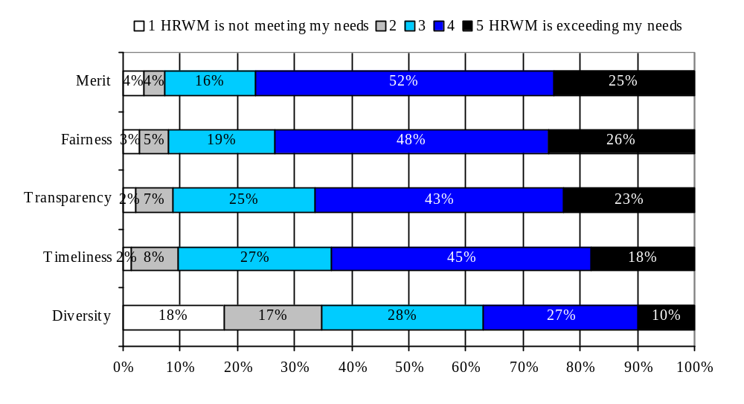
Mean Score (out of 5) | n=
3.90 | 144
3.88 | 144
3.78 | 141
3.71 | 132
2.94 | 147
Analysis of Significant Differences

Not surprisingly, an analysis of cross-tabulations revealed that performance in respecting the five staffing values was rated higher by those who personally had dealings with the HRWM Team than those who did not. However, the younger employees (born between 1964 and 1979) were less likely than the older ones to say that HRWM respects Timeliness.

Merit
- More likely to be those who personally had dealings with the HRWM Team (4.04) than those who did not (3.31).

Transparency
- More likely to be those who personally had dealings with the HRWM Team (4.09) than those who did not (3.63).

Fairness
- More likely to be those who personally had dealings with the HRWM Team (4.11) than those who did not (3.50).

Timeliness
- More likely to be those who personally had dealings with the HRWM Team (3.06) than those who did not (2.27).
- More likely to be those born before 1964 (3.08) than those born between 1964 and 1979 (2.36).

Diversity
- More likely to be those who personally had dealings with the HRWM Team (3.79) than those who did not (3.33).

5.1.7 Staffing Aspects to Understand Better

When respondents were asked the following open-ended question, “What specific aspects of staffing would you like to understand better?” the majority (61%) indicated “none”. Of those that did indicate an aspect they would like to better understand, the responses were quite varied. However, several aspects centered on the staffing process such as specific steps, why it takes so long and ways to simplify the process. Some respondents took this opportunity to provide recommendations for ways to improve understanding of staffing aspects, such as providing more communication or refresher courses. Please refer to Appendix A for all verbatim responses.

Figure 5.7 Aspects of Staffing to better understand (n=164)
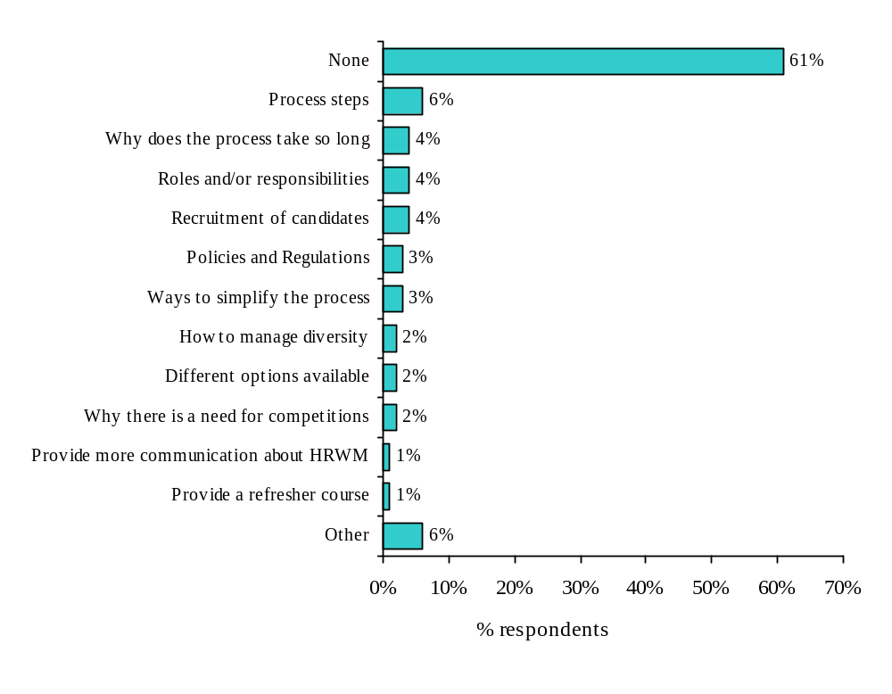
No significant differences were noted for the aspects individuals would like to understand better.

5.2 Context and Outcomes of Most Recent Staffing Action

5.2.1 Context of Most Recent Staffing Action

The context of the most recent staffing action was only asked of those that had completed a staffing action in the past 12 months (see Figure 5.4). Therefore, it is important to remember that those more likely to have completed a staffing action were Executives or Managers and those whose responsibilities include liaising with HRWM.

Just over two-thirds (69%) of those that completed a staffing action in the past 12 months spoke directly with the HRWM Team prior to beginning the staffing process. The main reason for not contacting the HRWM team was that their administrative officer liaises with the HRWM team on their behalf.

Although 69% of respondents indicated they spoke with the HRWM Team prior to the staffing process, over three-quarters (77%) indicated that they had personally dealt with the HRWM Team at some point during the most recent staffing action. This means that while administrative officers’ internal clients were not likely to have spoken to HRWM prior to beginning the staffing action, they did step in at one point during the process. Hence, it appears that most often, the administrative officer is not the only person in contact with HRWM on a particular staffing action.

Most of the time (71%) a position already existed and almost half of the time (45%) the respondent had the objective to appoint a particular person. Only 17% of those that completed a staffing action in the past 12 months indicated that they had used an External Consultant. Those that did use an External Consultant did so for several reasons including lack of time to do it themselves, lack of expertise in their group and lack of services provided by the HRWM Team.

Figure 5.8 Context of Recent Staffing Action
Context of Most Recent Staffing Action | % Yes | N=
Spoke directly with the HRWM Team prior to beginning the staffing process to discuss the best staffing option | 69% | 118
Reasons for not contacting the HRWM team prior to beginning the staffing process  - My admin. officer liaises with the HRWM team on my behalf  - I did not require the HRWM team's advice for this action  - I had discussed this action with the HRWM team earlier  - I was unable to reach the HRWM team in reasonable time  - I don't know who my HRWM team contact is | 76%  29%  14%  7%  5% | 37
Personally had dealing with the HRWM Team | 77% | 118
A position already existed | 71% | 118
Objective to appoint a particular person | 45% | 118
Used External Consultant | 17% | 118
Reasons for using External Consultants  - I didn’t have the time  - I didn’t have the required expertise in my group  - HRWM doesn’t provide the service  - HRWM couldn’t provide the service in the required timeframe | 60%  50%  41%  37% | 20

Analysis of Significant Differences

An analysis of cross-tabulations revealed the some significant differences in the context of the most recent staffing action. The most revealing difference centered on sector. Respondents from Cultural Affairs were the ones most likely to have spoken with HRWM prior to beginning the staffing process and those least likely to have done so were from either the International & Intergovernmental or Citizenship & Heritage sectors.

Spoke directly with the HRWM Team prior to beginning the staffing process to discuss the best staffing option
- Most likely to be those from Cultural Affairs (94%) and least likely to be those from International & Intergovernmental (46%) or Citizenship & Heritage (50%); other sectors ranged from 65% to 79%.
- More likely to be those who personally had dealings with the HRWM Team on the most recent staffing occasion (78%) than those that did not (37%).
- More likely to be those whose responsibilities include liaising with HRWM (75%) than those whose responsibilities do not (53%).

Personally had dealings with the HRWM team
- More likely to be those whose responsibilities include liaising with HRWM (83%) than those whose responsibilities do not (62%).

5.2.2 Outcome of Most Recent Staffing Action

Almost two-thirds (66%) of those that completed a staffing action in the past 12 months indicated that they chose an indeterminate staffing option. The remaining 34% of staffing options chosen were temporary, most under the Public Service Employment Act. A wide variety of reasons were give as to why a temporary staffing option was chosen. It is interesting to note however, that close to half (48%) of the respondents chose a temporary staffing option because they needed to staff the position as quickly as possible. This raises the question of whether some employees are choosing the temporary staffing option because it allows them to fill the position quickly regardless of whether or not the position should be indeterminate.

Almost all (96%) of those that completed a staffing action in the past 12 months indicated that in the end they got the right person for the job and only 7% indicated that they were involved in a staffing appeal for this staffing action.

Figure 5.9 Outcome of Recent Staffing Action

Outcome of Most Recent Staffing Action | % Yes | N=
Staffing Option Chosen  - Indeterminate  - Temporary, under Public Service Employment Act  - Temporary, not under Public Service Employment Act  - Temporary, developmental | 66%  23%  9%  3% | 118
Why Temporary Staffing Option was Chosen  - To staff the position as quickly as possible  - To respond to a temporary operational requirement  - To protect the position for its incumbent (acting elsewhere)  - To offer a developmental opportunity  - To respond to budgetary constraints  - To try the employee out  - To give employee the opportunity to meet position qualifications  - To begin work until a permanent position is created | 48%  46%  28%  27%  24%  18%  18%  18% | 40
In the end, got the right person for the job | 96% | 97
Involved in a staffing appeal for this staffing action | 7% | 118

Analysis of Significant Differences

An analysis of cross-tabulations revealed only one significant difference in the outcome of a staffing action. Those most likely to have chosen a Temporary - not under the Public Service Employment Act option were those that did not personally deal with HRWM on their most recent staffing action.

Temporary – Not under Public Service Employment Act
- More likely to be those that did not personally have dealings with the HRWM Team on the most recent staffing action (22%) than those that did (6%).

5.3 Awareness and Use of HRWM Staffing Services

Generally speaking, those that conducted a staffing action in the past 12 months were aware of the different staffing services offered by HRWM. Those that conducted a staffing action in the past 12 months were most likely to be aware that HRWM ensures that the competition results (including letter of offer) are issued (94% aware) but were least likely to be aware that HRWM provides advice in assessing the impact of the chosen option on the organization (77% aware).

However, there were significant differences in the usage of HRWM services. Most used services included, ensuring that the competition results (including letter of offer) are issued (81% used, 87% of aware used) and advice in the development of the statement of qualifications and competition poster (69% used, 75% of aware used). The least used services were HRWM participation as a board member in interviews (18% used, 20% of aware used).

Figure 5.10 Awareness and Use of HRWM Staffing Services

HRWM Staffing Services | % Aware | % Used | % of Aware that Used | n=
Ensuring that the competition results (including letter of offer) are issued. | 94% | 81% | 87% | 118
Advice in the development of the statement of qualifications and competition poster | 92% | 69% | 75% | 118
Advice on the best staffing or recruitment options | 91% | 62% | 68% | 118
Advice on planning the staffing process. (including issues of employment equity and official languages) | 90% | 49% | 55% | 118
Advice in preparing the rating guide, interview questions and suggestions on standardized tools | 90% | 39% | 43% | 118
Advice and follow-up on official languages issues (tests, validity, training plans, etc) | 90% | 49% | 54% | 118
Advice throughout the process to deal with developments and special challenges | 89% | 58% | 66% | 118
HRWM participation as a board member in interviews if needed | 87% | 18% | 20% | 118
Advice in assessing the impact of the chosen option on your organization | 77% | 46% | 60% | 118

Analysis of Significant Differences

An analysis of cross-tabulations revealed many significant differences in awareness and use of HRWM staffing services. Not surprisingly, those most likely to be aware and use staffing services were those whose responsibilities include liaising with HRWM and those who personally had dealings with HRWM.

However, there are a few interesting differences. Those least likely to be aware that HRWM provides advice in preparing the rating guide, interview questions and suggestions on standardized tools are from Corporate or Planning and male. Also, those least likely to go to HRWM for advice and follow-up on official languages issues (tests, validity, training plans, etc) and for ensuring that the competition results (including letter of offer) are issued are the younger respondents. This is true despite the younger respondents being equally aware as the older ones (born before 1964) that HRWM provides the services.
Advice on planning the staffing process. (Including issues of employment equity and official languages)

Aware of
- More likely were those whose responsibilities include liaising with HRWM (95%) than those whose responsibilities do not (79%)

Advice in assessing the impact of the chosen option on your organization

Aware of
- More likely were those that personally had dealings with the HRWM team for the most recent staffing action (81%) than those that did not (59%).
Used
- More likely were those that personally had dealings with the HRWM team for the most recent staffing action (50%) than those that did not (30%).

Advice in the development of the statement of qualifications and competition poster

Used
- More likely were those that personally had dealings with the HRWM team for the most recent staffing action (74%) than those that did not (48%).

Advice in preparing the rating guide, interview questions and suggestions on standardized tools

Aware of
- Most likely to be those from Public Affairs & Communications (100%) and least likely to be those from Planning & Corporate Affairs (71%); other sectors varied from 83% to 96%.
- More likely to be Female (96%) than Male (80%).
Used
- More likely to be Supervisors (67%) than Executives (51%) or Managers (33%).

Advice and follow-up on official languages issues (tests, validity, training plans, etc)

Used
- More likely to be those born before 1963 (54%) than those born between 1964 and 1979 (21%).

Ensuring that the competition results (including letter of offer) are issued.

Used
- More likely to be those born before 1963 (85%) than those born between 1964 and 1979 (58%).

5.4 Evaluation of HRWM Services for Most Recent Experience

5.4.1 Overall Assessment

Regardless of the outcome, most respondents that completed a staffing action in the past 12 months were relatively satisfied with the overall quality of the staffing services they received. On a 5-point scale, where 1 was “very dissatisfied” and 5 was “very satisfied” the mean score was 3.50 out of 5. Some 16% indicated that their overall satisfaction level was a 5 out of 5 and another 41% indicated it was a 4 out of 5.

When respondents were asked to compare their most recent staffing action with the service they expected to receive, most indicated that HRWM met their expectation, with some indicating it was better than expected. On a 5-point scale, where 1 was “much worse than expected” and 5 was “much better than expected” the mean score was 3.33 out of 5. Some 45% of respondents indicated that the comparison to what they expected was 3 out of 5. However, it is important to note that respondents were not asked what level of service they expected.

Figure 5.11 Satisfaction with Overall Quality of Staffing Service

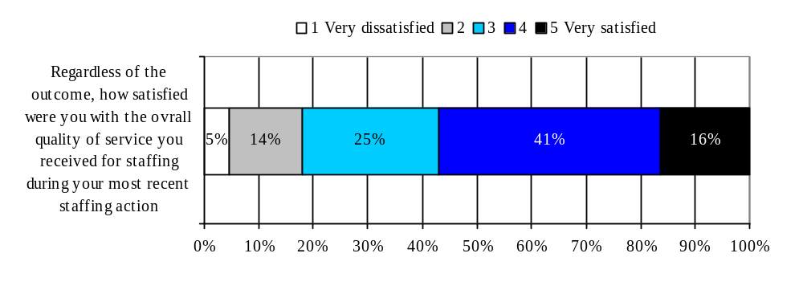Figure 5.12 Comparison to Expectations
Mean Score (out of 5) | n=
3.50 | 117

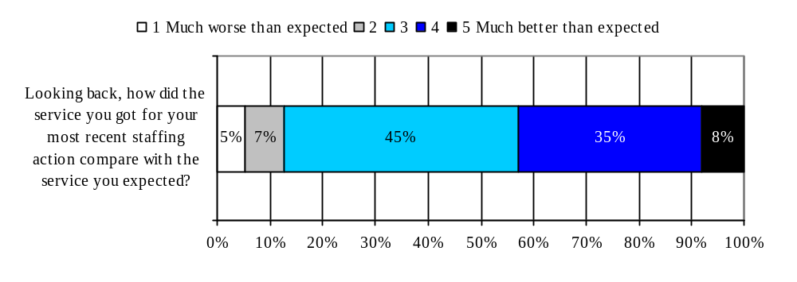
Mean Score (out of 5) | n=
3.33 | 116

Analysis of Significant Differences

An analysis of cross-tabulations revealed only one significant difference was revealed. Those most likely to indicate that the service exceeded their expectations are respondents who had personally dealt with HRWM on their most recent staffing action.

Compared to Expectations
- More likely to be those that had personal dealings with the HRWM team (3.43) than those that did not (3.00).

5.4.2 Performance of HRWM Staffing Services on Various Attributes

Respondents that completed a staffing action in the past 12 months were asked several agreement statements about specific aspects of the HRWM staffing services. These statements were positively worded and respondents were asked to indicate their level of agreement or disagreement on a 5-point scale, where 1 is “strongly disagree” and 5 is “strongly agree”.

Areas of strength: These include convenient hours of service (mean score 3.94, with 35% indicating they “strongly agreed”), and that they were able to get through to the HRWM Team without difficulty (mean score 3.75, with 28% indicating they “strongly agreed”).

Areas for improvement: These include delivering the service in a reasonable timeframe (mean score 3.34, with 12% indicating they “strongly disagreed”) and going the extra mile (mean score 3.39, with 6% indicating they “strongly disagreed”).

Key attributes driving overall satisfaction

By conducting a partial correlation between the various attributes and overall satisfaction it is possible to determine which attributes are most highly correlated with overall satisfaction. These attributes are called drivers of overall satisfaction because they are the most important ones in determining overall satisfaction.

The primary attributes driving overall satisfaction were being informed of everything in order to get the service and receiving the service in a reasonable amount of time. Hence, respondents who rate these two attributes high were most likely to rate their overall level of satisfaction with HRWM high. That being said, HRWM staffing services received a moderate agreement rating on informing individuals of everything they must do in order to get the service (mean score 3.67) and received the lowest rating of all attributes on delivering the service in a reasonable amount of time (mean score 3.34).

The secondary attributes driving overall satisfaction are providing consistent information and advice and understanding of the business environment. On both of these attributes HRWM staffing services received moderate ratings of 3.59 and 3.41 respectively.

Figure 5.13 Performance of HRWM in respecting these values in the provision of Staffing Services

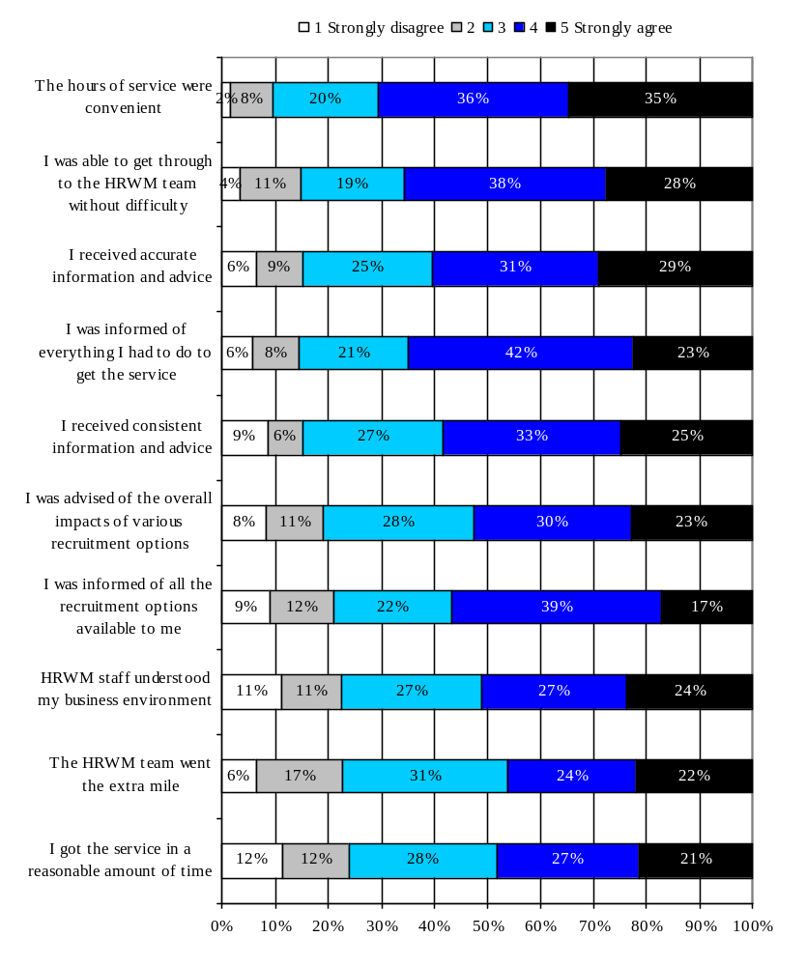Black shading represents primary drivers of overall satisfaction
Mean Score (out of 5) | n=
3.94 | 114
3.75 | 113
3.68 | 113
3.67 | 112
3.59 | 114
3.48 | 110
3.44 | 111
3.41 | 115
3.39 | 110
3.34 | 116
Grey shading represents secondary drivers of overall satisfaction
Analysis of Significant Differences

An analysis of cross-tabulations revealed some significant differences. Again, those most likely to have dealt with HRWM on their last staffing action were the ones most likely to have given the attributes higher ratings.

The hours of service were convenient
- More likely to agree were those that had personal dealings with the HRWM team (4.05) than those that did not (3.52).

I was able to get through to the HRWM team without difficulty
- Most likely to agree were those from Cultural Affairs (4.21) or Planning & Corporate Affairs (4.15) and least likely to agree were those from Public Affairs and Communications (3.17); other sectors ranged from 3.64 to 3.78.
- More likely to agree were those that had personal dealings with the HRWM team (3.85) than those that did not (3.32).

I received accurate information and advice
- More likely to agree were those that had personal dealings with the HRWM team (3.83) than those that did not (3.10).
- More likely to agree were those born before 1963 (3.79) than those born between 1964 and 1979.

I was informed of everything I had to do to get the service
- More likely to agree were those that had personal dealings with the HRWM team (3.81) than those that did not (3.11).

HRWM staff understood my business environment
- More likely to agree were those that had personal dealings with the HRWM team (3.56) than those that did not (2.84).

The HRWM staff went the extra mile
- More likely to agree were those that had personal dealings with the HRWM team (3.58) than those that did not (2.69).

I got the service in a reasonable amount of time
- More likely to agree were those that had personal dealings with the HRWM team (3.53) than those that did not (2.63).

5.4.3 Top Priorities for Service Improvement

When respondents were asked the following open-ended question, “What would be your top two priorities for service improvement with regard to the staffing services provided by HRWM?” some 39% could not provide a response. Of those that did provide a priority for service improvement, the most common priority was to make the process faster (18%) followed by better advice or more knowledgeable staff (11%), and more accessible services (7%). It is not surprising to see that making the process faster is the most common top priority since the timeliness attribute (I got the service in a reasonable amount of time.) was both a key driver of satisfaction and the one that received the lowest rating. A wide variety of other priorities for service improvement were noted, please refer to Appendix A for all verbatim responses.

Figure 5.14 Top two priorities for service improvement (n=118)
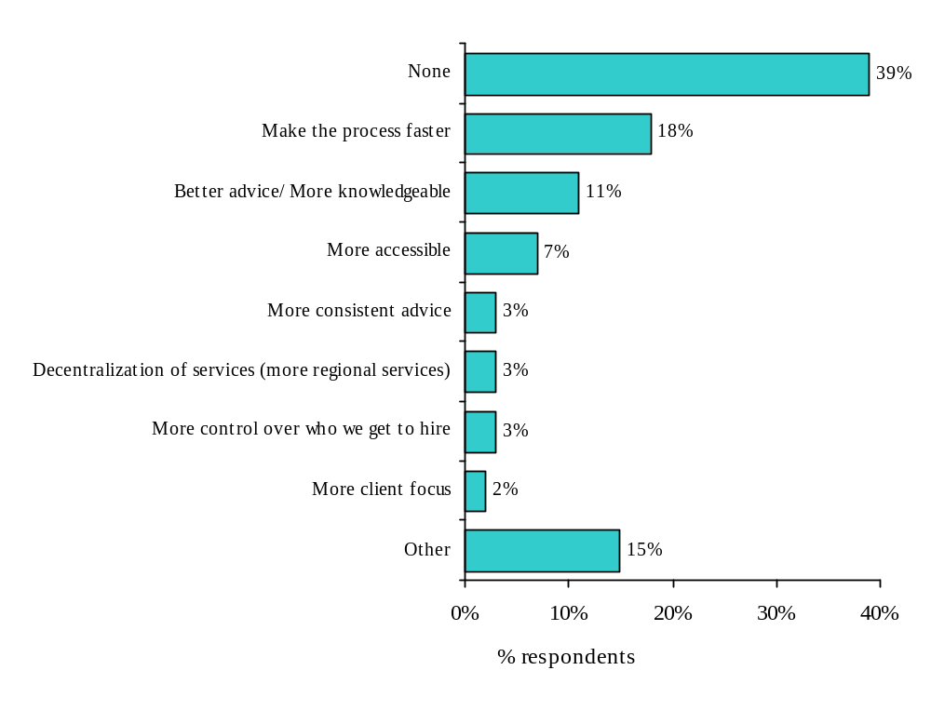
No significant differences were noted in the top priority areas for staffing services.

6.0 Classification

This chapter of the report presents findings for classification services.

Chapter Highlights
- Compared to staffing, respondents indicated they were somewhat less knowledgeable of the classification process (mean score 3.21).
- Respondents also indicated somewhat lower knowledge about the roles of Managers or the HRWM Team in the classification process compared to the staffing process.
- Similar to staffing services, the majority (56%) of respondents indicated that the most common way they interact with HRWM is through their administrative officer who liaises with the HRWM Team.
- Half of respondents indicated that they have completed a classification action in the past 12 months.
  - Most (64%) have completed only 1 or 2 classification actions.
- When respondents were asked how well the HRWM Team is achieving key outcomes in a classification decision, the large majority of respondents indicated that HRWM is usually meeting their needs and sometimes exceeding them.
- During the most recent classification action:
  - Two-thirds spoke directly with the HRWM Team prior to beginning the classification process.
  - Some 81% indicated that they had personally dealt with the HRWM Team.
  - Some 89% indicated they had a specific occupation group and level in mind.
  - Significantly more respondents indicated that they had used an External Consultant for a classification action (40%) than for a Staffing Action (17%).
  - Almost half (49%) indicated that they themselves obtained or drafted the Work Description.
  - Almost all (84%) indicated that in the end they got the group and level they wanted and none were involved in a classification grievance.
- Regardless of the outcome, most respondents that completed a classification action were relatively satisfied (mean 3.47 out of 5) , however, one area for improvement appears to be how standards are applied to the classification (mean 2.82 out of 5).
- Areas of strength for classification services include convenient hours of service and being able to get through to the HRWM Team without difficulty.
- Areas for improvement for classification services included going the extra mile and understanding of the business environment.
- The top priority for service improvement was to provide better advice or more knowledgeable staff

6.1 Classification Process

Questions on how respondents plan and process a classification action were asked of all respondents.

6.1.1 Knowledge of Classification Process

Compared to the Staffing Process, respondents indicated they were somewhat less knowledgeable of the Classification Process. On a 5-point scale, where 1 is “not at all knowledgeable” and 5 is “very knowledgeable”, the average knowledge score was 3.21 for the Classification Process (compared to 3.65 for the Staffing Process). Specifically, some 16% indicated their knowledge level was a 5 out of 5 and a further 19% indicated it was 4 out of 5. However, most respondents (42%) indicated that their knowledge level was 3 out of 5, indicating they were not quite sure about their level of knowledge.

Figure 6.1 Knowledge of the Classification Process

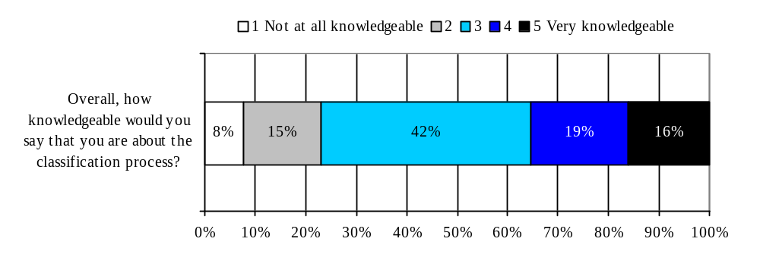Analysis of Significant Differences
Mean Score (out of 5) | n=
3.21 | 157
An analysis of cross-tabulations revealed a few significant differences in those more likely to be knowledgeable about planning and implementing a classification action. Not surprising, those who had dealt with HRWM were the ones most likely to say they were knowledgeable. This was also true of Executives.

More knowledgeable about planning and implementing a classification action
- More likely were those that personally had dealings with the HRWM team for the most recent classification action (mean 3.72 out of 5) than those that did not (mean 2.88 out of 5).
- Most likely to be Executives (3.55) followed by Managers (3.18) and Supervisors (2.78).
- More likely to be those whose responsibilities include liaising with HRWM (3.40) than those whose responsibilities do not (2.85).

6.1.2 Knowledge of Roles in the Classification Process

Respondents also indicated somewhat lower knowledge about the roles of Managers or the HRWM Team in the Classification Process compared to the Staffing Process. On a similar 5-point scale, the average knowledge score of Managers in the classification process was 3.42 (compared to 3.88 in the Staffing Process) and of the HRWM team was 3.42 (compared to 3.62 in the Staffing Process). The most common response for respondents was a knowledge level of 3 out of 5 (35% for the role of Mangers and 36% for the role of the HRWM Team).

Figure 6.2 Knowledge of Roles in the Classification Process
(How knowledgeable would you say that you are about the roles, responsibilities and accountabilities of the following people in the Classification process?)
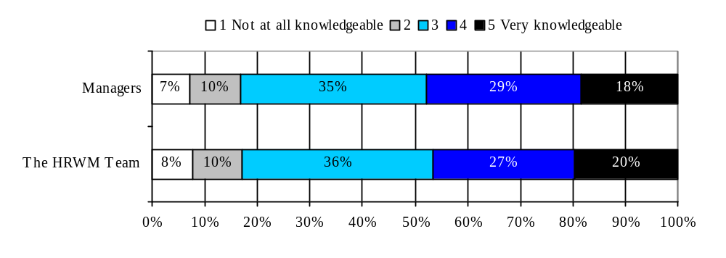 Analysis of Significant Differences
Mean Score (out of 5) | n=
3.42 | 158
3.42 | 158
As with overall knowledge of the classification process, an analysis of cross-tabulations revealed several significant differences in those more likely to be knowledgeable about the roles and responsibilities of Managers or the HRWM Team in the classification process. Again, those most likely to have dealt with HRWM and Executives were the ones most likely to say they were knowledgeable. Those who indicated that French was their first official language were most likely to say they were knowledgeable about the role of managers.

More knowledgeable about the roles, responsibilities, and accountabilities of Managers
- More likely were those that personally had dealings with the HRWM team for the most recent classification action (mean 3.97 out of 5) than those that did not (mean 3.23 out of 5).
- More likely to be those whose responsibilities include liaising with HRWM (3.58) than those whose responsibilities do not (3.15).
- More likely to be those who indicated that French was their first official language (3.57) than those who indicated that English was their first official language (3.20).

More knowledgeable about the roles, responsibilities, and accountabilities the HRWM Team
- More likely were those that personally had dealings with the HRWM team for the most recent classification action (mean 3.92 out of 5) than those that did not (mean 3.13 out of 5).
- Most likely to be Executives (3.81) followed by Managers (3.31) and Supervisors (3.23).
- More likely to be those whose responsibilities include liaising with HRWM (3.57) than those whose responsibilities do not (3.14).

6.1.3 Common way to access HRWM

Similar to staffing services (57%), the majority (56%) of respondents indicated that the most common way they interact with HRWM is through their administrative officer who liaises with the HRWM Team. The remaining 44% of respondents indicated that they deal directly with the HRWM Team.
Figure 6.3 Personal Dealings with HRMW (n=150)
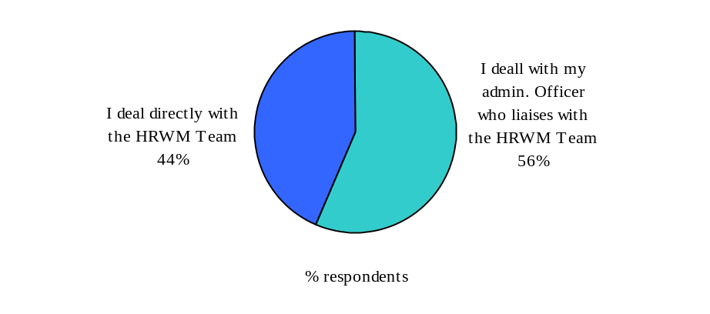
Analysis of Significant Differences:

An analysis of cross-tabulations revealed several important differences in how individuals commonly access HRWM classification services. Those most likely to deal directly with HRWM are from Deputy Minister Reports and those least likely are from Planning & Corporate Affairs. And not surprisingly, having liaison responsibilities or having dealt with HRWM on the most recent Classification action are also associated with a higher likelihood of dealing directly with HRWM for all Classification purposes.

I deal directly with the HRWM Team
- Most likely to be those from Deputy Minister Reports (83%) and least likely to be those from Citizenship & Heritage (26%) or Planning & Corporate Affairs (26%); other sectors ranged from 33% to 58%.
- More likely to be those that personally had dealings with the HRWM Team on their most recent classification action (69%) than those that did not (0%).
- More likely to be those whose responsibilities include liaising with HRWM (56%) than those whose responsibilities do not (20%).

6.1.4 Number of Classification Actions in the Past 12 Months

Half (50%) of respondents indicated that they have completed a classification action in the past 12 months. Of those that have completed a classification action, most (64%) have completed only 1 or 2. Some 19% have completed between 3 and 4 and some 17% have completed 5 or more classification actions.

Figure 6.4 Classification Actions (n=164)

Completed a Classification Action (n=164) Number of Classification Actions (n=82)
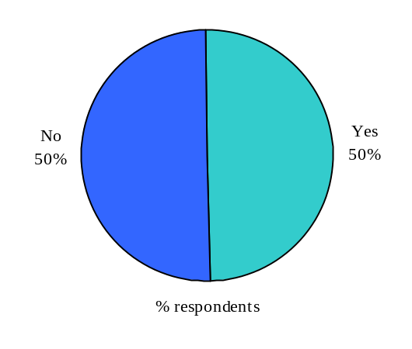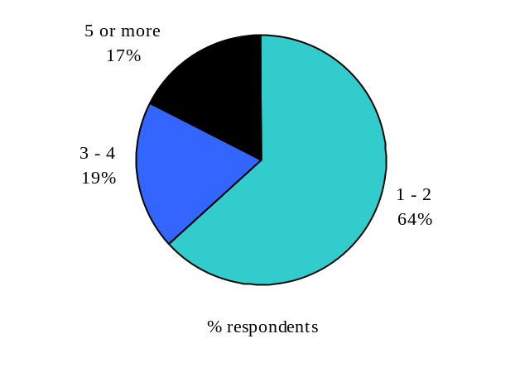
Analysis of Significant Differences
An analysis of cross-tabulations did not reveal any surprising differences in those more likely to have completed a classification action. They are most likely to be Executives and those who have liaison responsibilities.

Completed a Classification Action
- Most likely to be Executive (65%) followed by Managers (53%) and least likely to be Supervisors (25%).
- More likely to be those whose responsibilities include liaising with HRWM (66%) than those whose responsibilities do not (21%).

6.1.5 Outcomes Important in a Classification Decision

Not surprisingly, the three outcomes of a classification decision that were investigated had high importance ratings. On a 5-point scale, where 1 is “not at all important” and 5 is “very important” the highest agreement was for classifying positions within the unit fairly compared to all positions in the department (mean score 4.52), followed by competitiveness in attracting or keeping valued employees (4.37) and classifying positions within the unit fairly compared to all positions in government (4.30).

Figure 6.5 Importance of the following in a classification decision

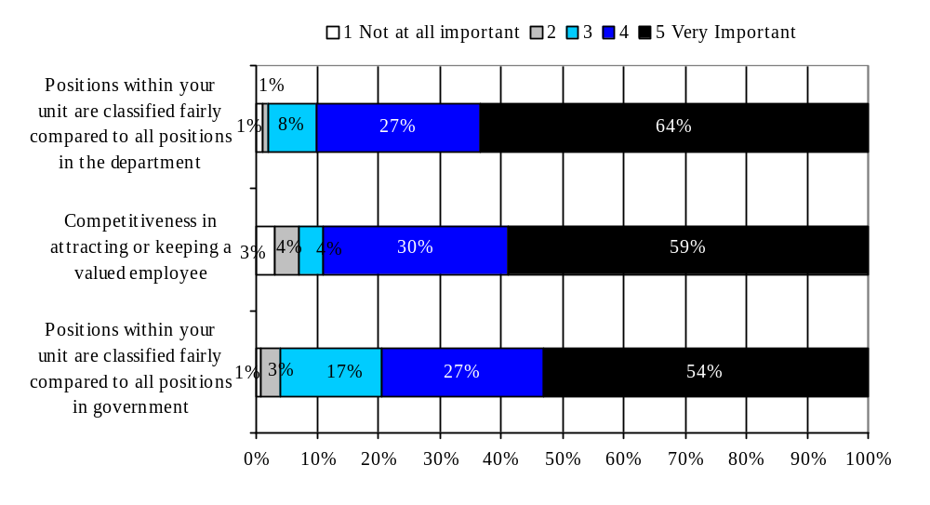
Mean Score (out of 5) | n=
4.52 | 157
4.37 | 155
4.30 | 156
Analysis of Significant Differences

An analysis of cross-tabulations revealed only one significant difference in outcomes that are important in a classification decision. Females were more likely than males to say that positions within their unit are classified fairly compared to all positions in the department.

Positions within your unit are classified fairly compared to all positions in the department
- Females were more likely (4.64) than Males (4.35).

6.1.6 Performance of HRWM in Respecting Outcomes in a Classification Decision

When respondents were asked how well the HRWM Team is respecting these outcomes in a classification decision, several respondents (about four in ten) indicated that HRWM is usually meeting their needs (a rating of 4 our of 5) and sometimes exceeding them (a rating of 5 out of 5). However, about the same proportion (one in three) gave a rating of 3 out of 5. On a 5-point scale, where 1 is “HRWM is not meeting my needs” and 5 is “HRWM is exceeding my needs” the mean performance scores were quite moderate; 3.28 for classifying positions fairly compared to all positions in the department, 3.15 for classifying positions fairly compared to all positions in government, and 3.09 for competitiveness in attracting or keeping a valued employee.

Figure 6.6 Performance of HRWM in respecting these values in the provision of classification

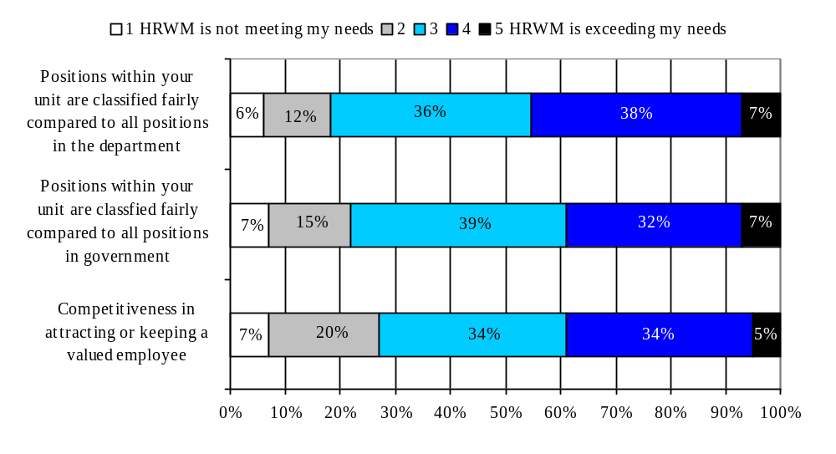Analysis of Significant Differences
Mean Score (out of 5) | n=
3.28 | 138
3.15 | 128
3.09 | 132

An analysis of cross-tabulations revealed some interesting differences in the performance of HRWM in achieving these classification decision outcomes. Respondents who do not have liaison responsibilities are most likely to provide higher ratings to two of the three statements: Positions within your unit are classified fairly compared to all positions in the department and Positions within your unit are classified fairly compared to all positions in government.

Positions within your unit are classified fairly compared to all positions in the department
- More likely to be those whose responsibilities do not include liaising with HRWM (3.58) than those whose responsibilities do (3.15).

Positions within your unit are classified fairly compared to all positions in government
- More likely were those that personally had dealings with the HRWM team for the most recent classification action (mean 3.17 out of 5) than those that did not (mean 2.55 out of 5).
- Most likely to be Executives (3.42) followed by Supervisors (3.30) and Managers (2.91).
- More likely to be those whose responsibilities do not include liaising with HRWM (3.52) than those whose responsibilities do (3.00).

6.1.7 Aspect to Understand Better

When respondents were asked the following open-ended question, “What specific aspects of classification would you like to understand better?” the large majority (68%) indicated “none”. Of those that did indicate an aspect they would like to better understand, the responses were quite varied. Some wanted to better understand why classification practices are not fairer or how the classification criteria are applied. Please refer to Appendix A for a complete list of verbatim responses.

Figure 6.7 Aspects of Classification to better understand (n=164)
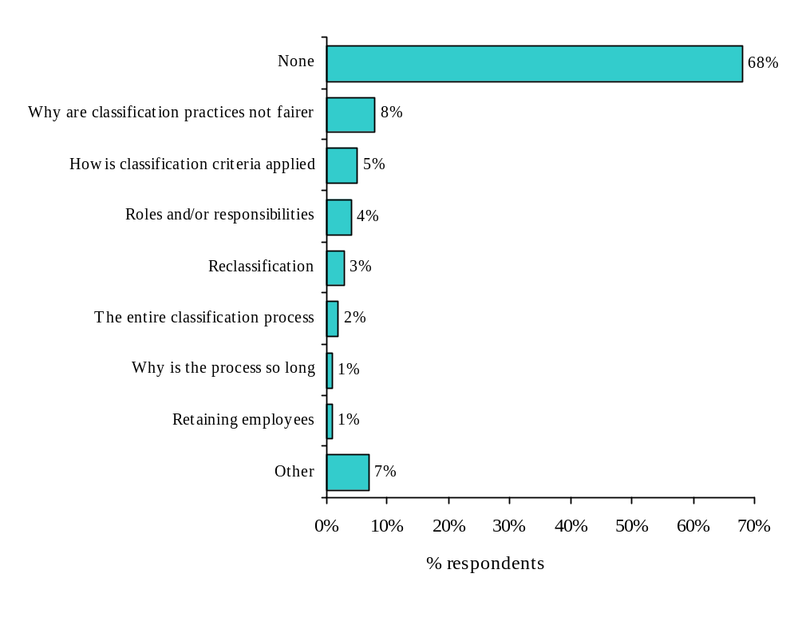
No significant differences were noted in the aspects that respondents would like to better understand about the classification process.

6.2 Context and Outcome of Most Recent Classification Action

6.2.1 Context of Most Recent Classification Action

The context of the most recent classification action was only asked of those that had completed a classification action in the past 12 months (see Figure 6.4). Therefore, it is important to remember that those more likely to have completed a classification action were Executives and those whose responsibilities include liaising with HRWM.

Two-thirds (67%) of those that completed a classification action in the past 12 months spoke directly with the HRWM Team prior to beginning the classification process. The main reason for not contacting the HRWM team was that their administrative officer liaises with the HRWM team on their behalf.

Although 67% of respondents indicated they did speak with the HRWM Team prior to the classification process, over three-quarters (81%) indicated that they had personally dealt with the HRWM Team at some point during the most recent classification action. Similarly to Staffing, an administrative officer’s internal client did, at some point during the classification process, personally contact HRWM.

Some 89% of those that completed a classification action indicated that on their most recent action they had a specific occupational group and level in mind. Significantly more respondents indicated that they had used an External Consultant for a classification action (40%) than for a staffing Action (17%). Those that did use an External Consultant for their most recent classification action had several reasons including lack of expertise in their group, lack of time to do it personally and HRWM either not providing the service or not being able to do so in the required timeframe.

Figure 6.8 Context of Recent Classification Action

Context of Most Recent Classification Action | % Yes | N=
Spoke directly with the HRWM Team prior to beginning the classification process to discuss the best classification option | 67% | 82
Reasons for not contacting the HRWM team prior to beginning the classification process  - My admin. officer liaises with the HRWM team on my behalf  - I did not require the HRWM team's advice for this action  - I had discussed this action with the HRWM team earlier  - I don't know who my HRWM team contact is  - I was unable to reach the HRWM team in reasonable time | 81%  19%  8%  8%  7% | 26
Personally had dealing with the HRWM Team | 79% | 82
Had a specific occupational group and level in mind | 89% | 82
Used External Consultant | 40% | 82
Reasons for using External Consultants  - I didn’t have the required expertise in my group  - I didn’t have the time  - HRWM couldn’t provide the service in the required timeframe  - HRWM doesn’t provide the service | 61%  55%  51%  35% | 33

Analysis of Significant Differences
An analysis of cross-tabulations revealed a few significant differences in terms of the context of the most recent classification action. The most revealing difference was that the sectors most likely to use external consultants for classification are Planning & Corporate and Citizenship & Heritage.

Spoke directly with the HRWM Team prior to beginning the classification process to discuss the best classification option
- More likely to be those who personally had dealings with the HRWM Team during their most recent classification action (82%) than those who had did not (12%).

Used External Consultants
- Most likely to be those from Planning & Corporate Affairs (67%) or Citizenship
& Heritage (65%) and least likely to be those from Intergovernmental & Intergovernmental (0%); other sectors ranged from 22% to 33%.

6.2.2 Outcome of Most Recent Classification Action

Almost half (49%) of those that completed a classification action in the past 12 months indicated that they obtained or drafted the Work Description (WD). Some 38% indicated that it was an external consultant obtained or drafted the WD and 14% indicated that it was their administrative officer.

Almost all (84%) of those that completed a classification action in the past 12 months indicated that in the end they got the group and level they wanted and none of the respondents were involved in a classification grievance during their most recent classification action.

Figure 6.9 Outcome of Recent Classification Action
Outcome of Most Recent Classification Action | % Yes | N=
How did you develop the Work Description  - I obtained or drafted a Work Description  - A Consultant obtained or drafted a Work Description  - My administrative officer obtained or drafted a Work Description | 49%  38%  14% | 38
How did you obtain or draft the Work Description  - I obtained a similar Work Description from a colleague and adapted it  - I obtained a similar Work Description from the HRWM Team and adapted  - I obtained a generic Work Description from the HRWM Team and adapted it  - I drafted the Work Description | 43%  36%  11%  10% | 19
In the end, got the group and level you wanted | 84% | 82
Involved in a classification grievance during this classification action | 0% | 82

Analysis of Significant Differences
An analysis of cross-tabulations revealed only one significant difference in terms of the outcome of a classification decision:

In the end, got the group and level you wanted
- Most likely to be those from Public Affairs and Communications (100%) or International & Intergovernmental (100%) and least likely to be those from Planning & Corporate Affairs (58%); other sectors varied from 71% to 92%.

6.3 Awareness and Use of HRWM Classification Services

Generally speaking, those that conducted a classification action in the past 12 months were aware of all the different classification services offered by HRWM. Those that conducted a classification action in the past 12 months were most likely to be aware that HRWM provides advice on linguistic profiles and security profiles (95% aware) and classifying positions (93% aware) and least likely to be aware that HRWM arranges classification committees (61% aware) or performs desk audits (57% aware)

As with staffing services, there were significant differences in the usage of HRWM classification services. The most used service was for classifying positions (68% used, 73% of aware used). The least used services were arranging classification committees (9% used, 15% of aware used) and performing desk audits (13% used, 23% of aware used).

Figure 6.10 Awareness and Use of HRWM Classification Services
HRWM Classification Services | % Aware | % Used | % of Aware that Used | n=
Advice on linguistic profiles and security profiles | 95% | 47% | 50% | 82
Classifying positions | 93% | 68% | 73% | 82
Advice in the development of work descriptions | 90% | 44% | 49% | 82
Advice on planning the classification action | 81% | 43% | 53% | 82
Advice on organizational design and structure | 68% | 23% | 34% | 82
Arrangement of classification committees | 61% | 9% | 15% | 82
Performance of desk audits | 57% | 13% | 23% | 82

Analysis of Significant Differences
An analysis of cross-tabulations revealed some interesting significant differences. As with Staffing, those most likely to be aware of and use classification services are those whose responsibilities include liaising with HRWM and those who had personally dealt with HRWM on their most recent classification action. However, one surprising finding is that there are differences by sector on use of HRWM for performance of desk audits. Those from International & Intergovernmental are most likely to use the service and those least likely are from Public Affairs & Communications where no one indicated they had used the service.

Advice on organizational design and structure
Aware
- More likely to be those that personally had dealings with HRWM (77%) than those that did not (35%).

Advice on planning the classification action
Aware
- More likely to be those that personally had dealings with HRWM (86%) than those that did not (59%).

Used
- More likely to be those that personally had dealings with HRWM (49%) than those that did not (18%).

Advice on linguistic profiles and security profiles
Aware
- More likely to be those that personally had dealings with HRWM (98%) than those that did not (82%).
- More likely to be those whose responsibilities include liaising with HRWM (99%) than those whose responsibilities do not (77%).

Advice in the development of work descriptions
Aware
- More likely to be those that personally had dealings with HRWM (95%) than those that did not (71%).

Performance of desk audits
Used
- Most likely to be from International & Intergovernmental (50%) and least likely to be from Public Affairs and Communication (0%); other regions varied from 6% to 33%.

6.4 Evaluation of HRWM Services for Most Recent Experience

6.4.1 Overall Assessment

Regardless of the outcome, most respondents that completed a classification action in the past 12 months were somewhat satisfied with the overall quality of the classification services they received. On a 5-point scale, where 1 was “very dissatisfied” and 5 was “very satisfied” the mean score was 3.47 out of 5. Some 23% indicated that their overall satisfaction level was a 5 out of 5 and another 34% indicated it was a 4 out of 5.

One area for improvement appears to be the standards applied to job classifications. On a similar satisfaction scale, the mean score was only 2.82 out of 5. Some 18% indicated that their satisfaction level was 1 out of 5 or “very dissatisfied” and another 16% indicated that their satisfaction level was 2 out of 5. The most common response was 3 out of 5 (35%).

When respondents were asked to compare their most recent classification action with the service they expected to receive, most indicated that HRWM met their expectation. On a 5-point scale, where 1 was “much worse than expected” and 5 was “much better than expected” the mean score was 3.12 out of 5, with the most common response being 3 out of 5 (39%). However, it is important to note that respondents were not asked what level of service they expected.

Figure 6.11 Satisfaction with Overall Quality of Classification Service
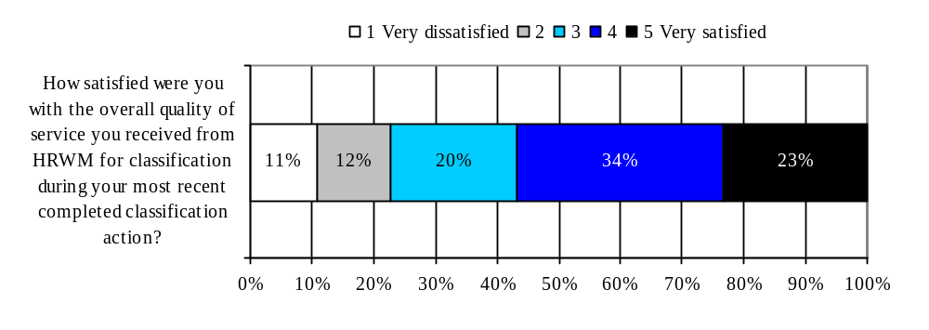
Mean Score (out of 5) | n=
3.47 | 80

Figure 6.12 Satisfaction with Standards Applied to Classification

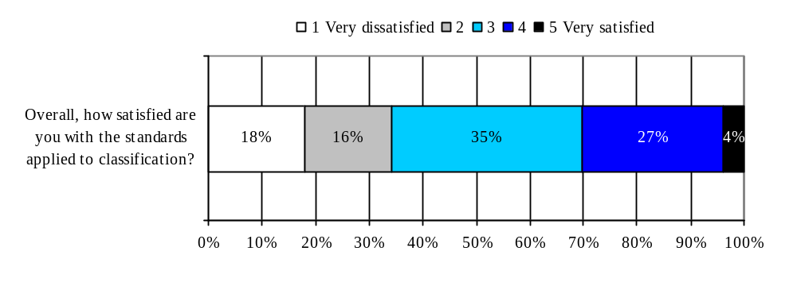
Mean Score (out of 5) | n=
2.82 | 78
Figure 6.13 Comparison to Expectations

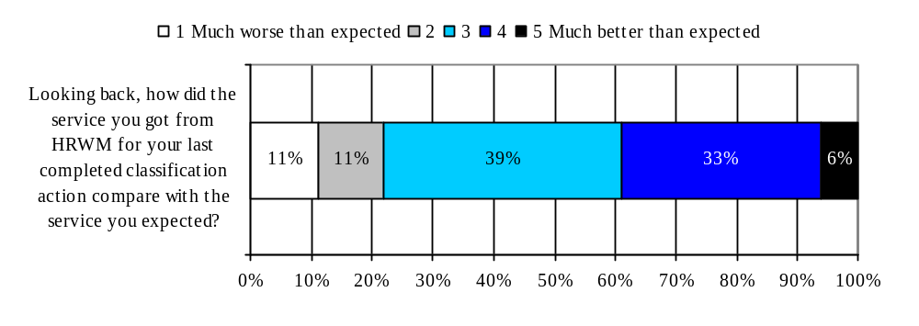
Mean Score (out of 5) | n=
3.12 | 77
Analysis of Significant Differences
An analysis of cross-tabulations revealed several significant differences in overall satisfaction, satisfaction with how the standards are applied to classification, and whether the service exceeded their expectations. Those most likely to be satisfied with classification services are from International & Intergovernmental and those least likely are from Planning & Corporate Affairs. Also, females vs. males are most likely to be satisfied. Finally, those most likely to be satisfied with the classification standards and most likely to say their service expectations were exceeded are those who personally dealt with HRWM on their most recent action.

Higher Satisfaction with Overall Quality of Classification Service
- Most likely to be those from International & Intergovernmental (mean 4.00) and least likely to be those from Planning & Corporate Affairs (mean 2.30); other sectors ranged from 3.47 to 3.73.
- More likely to be Female (3.78) than Male (2.98).

Higher Satisfaction with Standards Applied to Classification
- More likely to be those that personally had dealings with the HRWM Team (3.62) than those that did not (3.82).

Classification Service Exceeded Expectations
- More likely to be those that personally had dealings with the HRWM Team (3.24) than those that did not (2.54).

6.4.2 Performance of HRWM Classification Services on Various Attributes

Respondents that completed a classification action in the past 12 months were asked several agreement statements about specific aspects of the HRWM classification services. These statements were positively worded and respondents were asked to indicate their level of agreement or disagreement on a 5-point scale, where 1 is “strongly disagree” and 5 is “strongly agree”.

Areas of strength: These include convenient hours of service (mean score 3.98, with 35% indicating they “strongly agreed”), and that they were able to get through to the HRWM Team without difficulty (mean score 3.83, with 29% indicating they “strongly agreed”).

Areas for improvement: These include going the extra mile (mean score 3.19, with 14% indicating they “strongly disagreed”) and understanding of the business environment (mean score 3.32, with 9% indicating they “strongly disagreed”).

Key attributes driving overall satisfaction

By conducting a partial correlation between the various attributes and overall satisfaction it is possible to determine which attributes are most highly correlated with overall satisfaction. These attributes are called drivers of overall satisfaction because they are the most important ones in determining overall satisfaction.

The primary attributes driving overall satisfaction with classification services were delivering the service in a reasonable amount of time and understanding of the business environment. The secondary drivers were providing accurate information and advice and going the extra mile. As indicated in the figure 6.14 below, compared to all of the attributes used to assess service quality of classification services, these four key drivers of overall satisfaction received the lowest ratings.

2-53
Figure 6.14 Performance of HRWM in the provision of Classification services

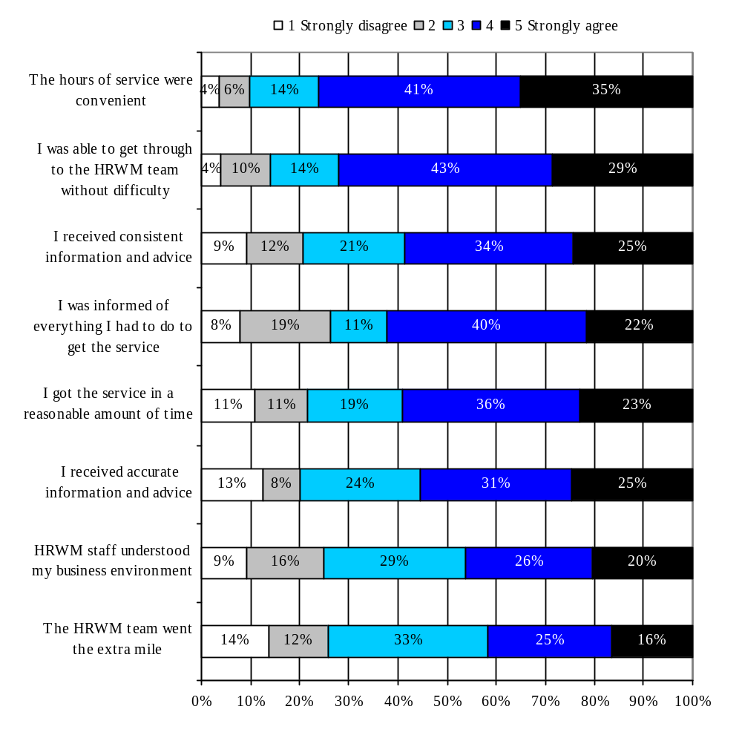
Mean Score (out of 5) | n=
3.98 | 77
3.83 | 76
3.53 | 78
3.49 | 78
3.49 | 78
3.48 | 77
3.32 | 78
3.19 | 77
Black shading represents primary drivers of overall satisfaction
Grey shading represents secondary drivers of overall satisfaction
Analysis of Significant Differences
An analysis of cross-tabulations revealed few surprising significant differences for Classification services. Respondents who had personally dealt with HRWM on their most recent classification action were the ones most likely to give all of the attributes higher ratings. However, it is interesting to note that for two key attributes (HRWM staff understood my business environment and The HRWM team went the extra mile), those most likely to give high ratings were from International & Intergovernmental and those least likely to give high ratings were from Planning & Corporate Affairs.

The hours of service were convenient
- More likely to be those that personally had dealing with the HRWM Team (4.11) than those that did not (3.27).

I was able to get through to the HRWM team without difficulty
- More likely to be those that personally had dealing with the HRWM Team (4.03) than those that did not (2.66).

I received consistent information and advice
- More likely to be those that personally had dealing with the HRWM Team (3.67) than those that did not (2.86).
- More likely to be those that did not use an external consultant (3.85) than those that did use an external consultant (3.05).

I was informed of everything I had to do to get the service
- More likely to be those that personally had dealing with the HRWM Team (3.67) than those that did not (2.63).
- More likely to be those that did not use an external consultant (3.85) than those that did use an external consultant (2.95).

I got the service in a reasonable amount of time
- More likely to be those that personally had dealing with the HRWM Team (3.75) than those that did not (2.21).
- More likely to be those that did not use an external consultant (3.82) than those that did use an external consultant (2.97).

I received accurate information and advice
- More likely to be those that personally had dealing with the HRWM Team (3.68) than those that did not (2.47).
- More likely to be those that did not use an external consultant (3.87) than those that did use an external consultant (2.85).

HRWM staff understood my business environment
- Most likely to be those from International & Intergovernmental (4.50) and least likely to be those from Planning & Corporate Affairs (2.60); other sectors ranged from 3.20 to 3.53.
- More likely to be those that did not use an external consultant (3.62) than those that did use an external consultant (2.86).

The HRWM team went the extra mile
- Most likely to be those from International & Intergovernmental (3.83) and least likely to be those from Planning & Corporate Affairs (2.00); other sectors ranged from 3.26 to 3.50.
- More likely to be those that did not use an external consultant (3.57) than those that did use an external consultant (2.61).

6.4.3 Top Priorities for Service Improvement

When respondents were asked the following open-ended question, “What would be your top two priorities for service improvement with regard to the classification services provided by HRWM?” some 50% could not provide a response. Of those that did provide a priority for service improvement, the most common priority was to provide better advice or more knowledgeable staff (14%). Other priorities for improvement centered on the classification process (more consistent, faster, better communication, more accessible staff) or the actual classifications (simplified, updated). Please refer to Appendix A for all verbatim responses.

Figure 6.15 Top two priorities for service improvement (n=82)

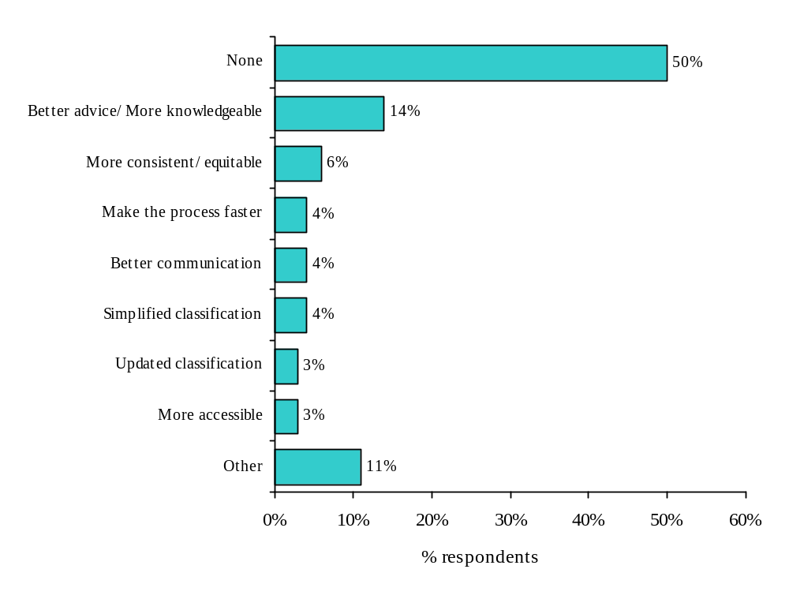
No significant differences were noted for the priority areas for improvement.

7.0 Staff Relations

This chapter of the report presents findings for staff relations services.

Chapter Highlights
- Respondents indicated that they were somewhat knowledgeable about the staff relations process (mean 3.34 out of 5).
- Respondents were also somewhat knowledgeable about the roles and responsibilities of Managers and the HRWM Team in a staff relations issue.
- As opposed to Staffing (43%) or Classification (44%) services, the most common way that respondents accessed HRWM Staff Relations services (76%) was by dealing directly with the HRWM Team.
- Slightly less than half (43%) of respondents indicated they have managed a staff relations issue at Canadian Heritage for a non-EX employee within the past 12 months.
  - A wide variety of needs for staff relations assistance from HRWM were mentioned.
- During the most recent staff relations issue:
  - Almost all (85%) personally had dealings with the HRWM Team.
  - Just over half (56%) indicated that it was resolved to their satisfaction with another 35% that indicated it was partly resolved, and only 9% indicated that it was not resolved to their satisfaction.
- Regardless of the outcome, most respondents that managed a staff relations issue were relatively satisfied with the overall quality of the services they received (mean 3.79 out of 5)
- Areas of strength for HRWM staff relations services include confidence in confidentiality and convenient hours of service.
- In general, agreement scores with service quality attributes concerning HRWM Staff Relations were higher than for Staffing services or Classification services. Therefore, while there remains room for improvement on going the extra mile, improvements in Staffing and Classification services appear to be required first.

7.1 Staff Relations Process

Questions on knowledge of staff relations issues asked of all respondents.

7.1.1 Knowledge of Staff Relations Process

Respondents indicated that they were somewhat knowledgeable about the staff relations process. On a 5-point scale, where 1 was “not at all knowledgeable” and 5 was “very knowledgeable” the mean score was 3.34. The most common response given by respondents was 3 out of 5 (37%).

Figure 7.1 Knowledge of the Staff Relations Process

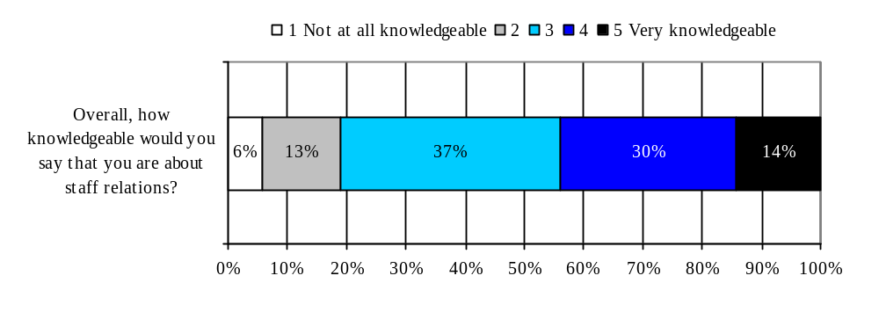 Analysis of Significant Differences
Mean Score (out of 5) | n=
3.34 | 160
An analysis of cross-tabulations revealed only one significant difference in terms of those more likely to indicate they were knowledgeable about the staff relations process: Executives were the ones most likely to say they were knowledgeable.

More knowledgeable about the Staff Relations Process
- Most likely to be Executives (3.83) than Managers (3.22) or Supervisors (2.97).

7.1.2 Knowledge of Roles During a Staff Relations Issue

Respondents were also somewhat knowledgeable about the roles and responsibilities of Managers and the HRWM Team in a staff relations issue. On a similar 5-point knowledge scale, some 55% indicated a 4 or 5 out of 5 for their knowledge of the roles and responsibilities for Managers and some 48% for the HRWM Team.

Figure 7.2 Knowledge of Roles during a Staff Relations Issue
(How knowledgeable would you say that you are about the roles, responsibilities and accountabilities of the following people during a staff relations issue?)

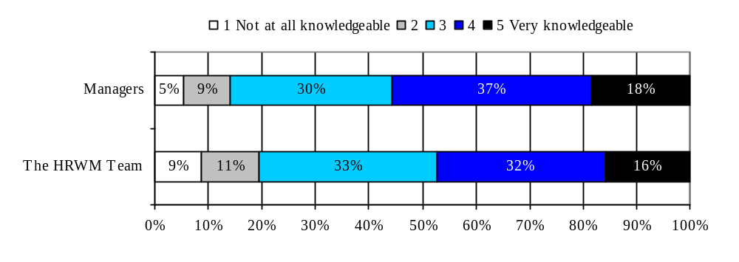
Mean Score (out of 5) | n=
3.55 | 160
3.35 | 160
Analysis of Significant Differences
As with other services, an analysis of cross-tabulations revealed several significant differences in terms of those who were more likely to indicate they were knowledgeable about the roles and responsibilities of Managers and the HRWM Team in the Staff Relations process. Those more likely to say they are knowledgeable about the roles of Managers and HRWM were Executives (vs. Mangers or Supervisors). And, those more likely to say they are knowledgeable about the role of Managers were from Deputy Minister Reports or Public Affairs & Communications. However, those more likely to say they are knowledgeable about the role of the HRWM Team were from Deputy Minister Reports also or Planning & Corporate Affairs (3.70).

More knowledgeable about the roles, responsibilities and accountabilities of Managers
- Most likely to be those from Deputy Minister Reports (3.89) or Public Affairs & Communications (3.81) and least likely to be those from Cultural Affairs (3.08); other sectors ranged from 3.39 to 3.70.
- Most likely to be Executives (3.90) than Managers (3.49) or Supervisors (3.18).
- More likely to be those whose responsibilities include liaising with HRWM (3.69) than those whose responsibilities do not (3.30).

More knowledgeable about the roles, responsibilities and accountabilities of the HRWM Team
- Most likely to be those from Planning & Corporate Affairs (3.70) or Deputy Minister Reports (3.62) and least likely to be those from Cultural Affairs (2.92) or International & Intergovernmental (2.93); other sectors ranged from 3.27 to 3.58.
- Most likely to be Executives (3.73) than Managers (3.24) or Supervisors (3.15).

7.1.3 Common way to access HRWM

As opposed to Staffing or classification services, the most common way that respondents accessed HRWM was by dealing directly with the HRWM Team (76%). Only approximately 24% of respondents indicated that for a staff relations issue they dealt with their administrative officer who liaises with the HRWM Team.

Figure 7.3 Most Common way to access HRWM (n=71)
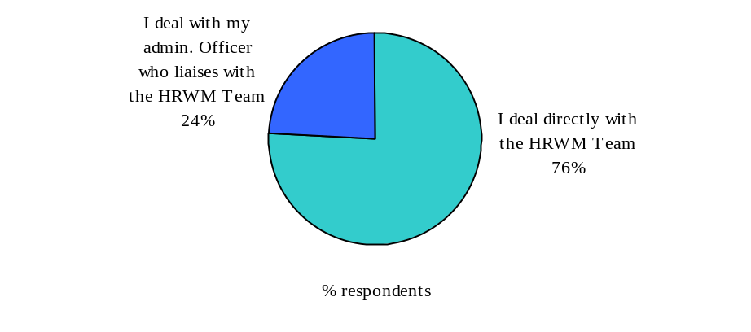
Analysis of Significant Differences:

An analysis of cross-tabulations revealed one significant difference: those who deal directly with HRWM on Staff Relations issues are also the ones who were more likely to have dealt with HRWM on their most recent Staff Relations issue.

I deal directly with the HRWM Team
- More likely to be those that personally had dealings with HRWM (85%) than those that did not (20%).

7.1.4 Number of Staff Relation Issues in the Past 12 Months

Slightly less than half (43%) of respondents indicated they have managed a staff relations issue at Canadian Heritage for a non-EX employee within the past 12 months. Of those that have managed a staff relations issue, over three-quarters (79%) indicated it was only on 1 or 2 occasions, 16% 3 or 4 occasions, and only 5% indicated it was for 5 or more occasions.

Figure 7.4 Managing Staff Relations Issues

Managed a Staff Relations issue at
Canadian Heritage for a non-EX employee within the past 12 months (n=164)
Number of Staff Relations issues managed in the past 12 months (n=72)

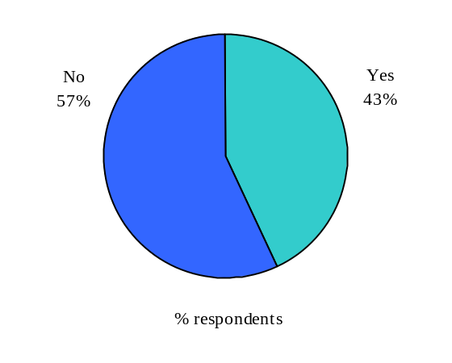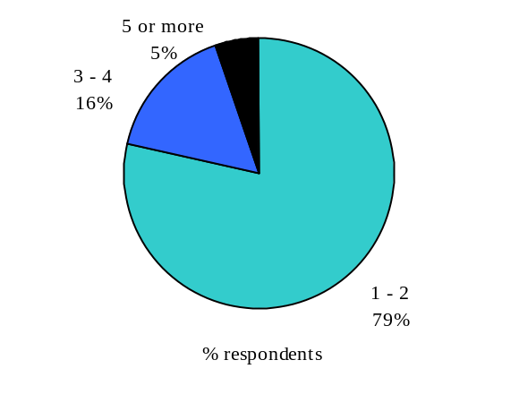

Analysis of Significant Differences
An analysis of cross-tabulations revealed few significant differences in terms of those more likely to have managed a staff relations issue. Those who had managed an issue in the past 12 months were most likely to have been Executives or Managers (vs. Supervisors) and most likely to have been those with liaison responsibilities.

Managed a Staff Relations Issue
- Most likely to be Executives (55%) or Managers (47%) and least likely to be Supervisors (17%).
- More likely to be those whose responsibilities include liaising with HRWM (50%) than those whose responsibilities do not (33%).

7.1.5 Aspect to Understand Better

When respondents were asked the following open-ended question, “What specific aspects of the staff relations process would you like to understand better?” the majority (62%) indicated “none”. Of those that did indicate an aspect they would like to better understand, the responses were quite varied. For example, how to better resolve conflicts or grievances or roles and responsibilities with regards to staff relations. Please refer to Appendix A for a complete list of verbatim responses.

Figure 7.5 Aspects of Staff Relations to better understand (n=164)
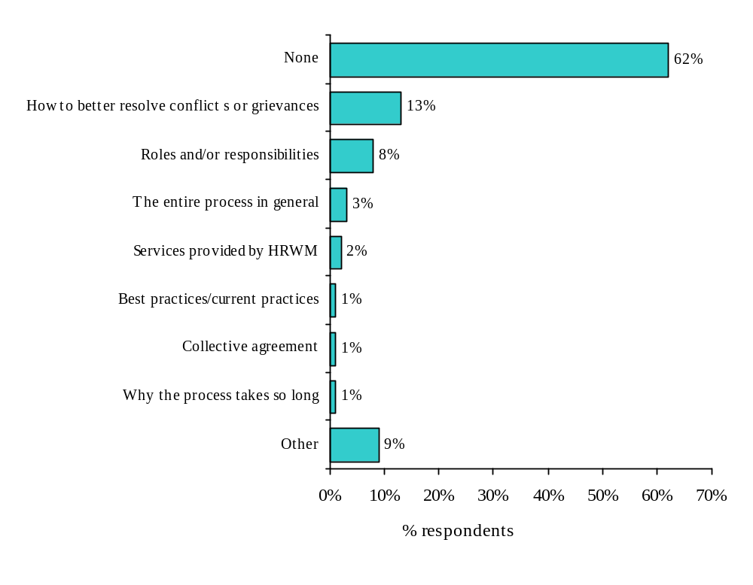
No significant differences were noted in the aspects of staff relations that respondents would like to better understand.

7.1.6 Assistance from HRWM

For those that managed a Staff Relations issue, the most common need was for assistance from the HRWM Team for Performance Management (45%). However, assistance was sought for a wide variety of other needs, including Leave Management (42%), Conflict Resolution (35%), Employee Assistance (29%), Complaints including harassment (28%), Collective agreement provisions (28%) and Discipline (24%).

Figure 7.6 With which staff relations issues did you need assistance from HRWM (n=69)
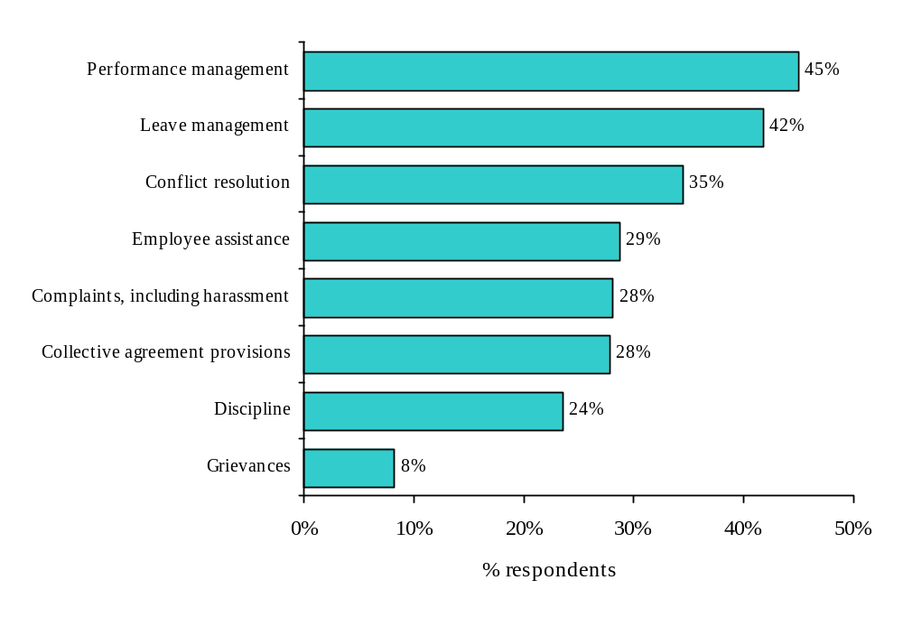
No significant differences were noted in the types of assistance that respondents sought for a Staff Relations issue.

7.2 Context and Outcome of Most Recent Staff Relations Issue

7.2.1 Context of Most Recent Staff Relations Issue

Almost all (85%) of those that managed a Staff Relations issue during the last 12 months personally had dealings with the HRWM Team.

Figure 7.6 Context of Recent Staff Relations Issue

Context of Most Recent Staff Relations Issue | % Yes | N=
Personally had dealing with the HRWM Team | 85% | 72

Analysis of Significant Differences
An analysis of cross-tabulations revealed only one significant difference: females were the ones most likely to have dealt with HRWM on their most recent Staff Relations issue.

Personally had dealings with the HRWM Team
- More likely to be Female (93%) than Male (72%).

7.2.2 Outcome of Most Recent Staff Relations Issue

Just over half (56%) of those that managed a Staff Relations issued indicated that the issue was completed resolved to their satisfaction with another 35% that indicated it was partly resolved. Only 9% indicated that the issue was not resolved to their satisfaction.

Figure 7.7 Was the staff relations issue resolved to your satisfaction (n=72)

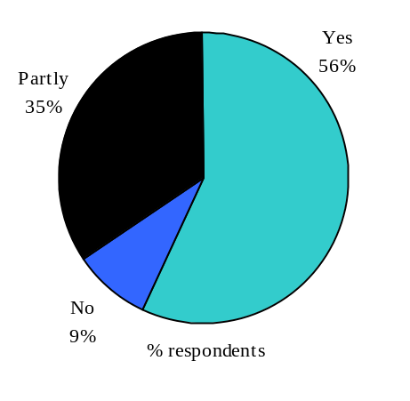
No significant differences were noted in the resolution of the staff relations issue.

7.3 Evaluation of HRWM Services for Most Recent Experience

7.3.1 Overall Assessment

Regardless of the outcome, most respondents that managed a relations issue in the past 12 months were relatively satisfied with the overall quality of the Staff Relations services they received. On a 5-point scale, where 1 was “very dissatisfied” and 5 was “very satisfied” the mean score was 3.79 out of 5. Some 25% indicated that their overall satisfaction level was a 5 out of 5 and another 45% indicated it was a 4 out of 5.

When respondents were asked to compare their most recent staff relations action with the service they expected to receive, most indicated that HRWM met their expectation, with some indicating it was better than expected. On a 5-point scale, where 1 was “much worse than expected” and 5 was “much better than expected” the mean score was 3.41 out of 5, slightly higher than for staffing (3.33) or classification (3.12). However, it is important to note that respondents were not asked what level of service they expected.

Figure 7.8 Satisfaction with Overall Quality of Staff Relations Service

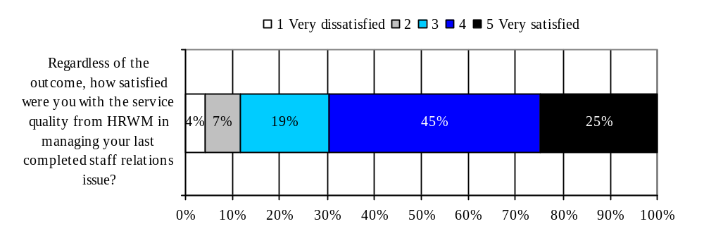
Mean Score (out of 5) | n=
3.79 | 69
Figure 7.9 Comparison to Expectations

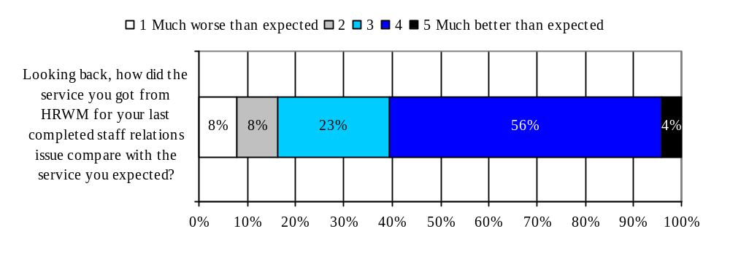
Mean Score (out of 5) | n=
3.41 | 68
Analysis of Significant Differences

An analysis of cross-tabulations revealed that those that personally had dealings with the HRWM Team on their last Staff Relations issue were more likely to be satisfied with the service and indicate that the service exceeded their expectations:

Higher satisfaction with the overall quality of the staff relations service
- More likely to be those that personally had dealings with the HRWM Team (3.88) than those that did not (3.05).

Service exceeded expectations
- More likely to be those that personally had dealings with the HRWM Team (3.50) than those that did not (2.69).

7.3.2 Performance of HRWM Staff Relations Services on Various Attributes

Respondents that managed a staff relations issue in the past 12 months were asked several agreement statements about specific aspects of the HRWM staff relations services. These statements were positively worded and respondents were asked to indicate their level of agreement or disagreement on a 5-point scale, where 1 is “strongly disagree” and 5 is “strongly agree”.

Areas of strength for HRWM Staff relations services include confidence in confidentiality (mean score 4.18, with 47% indicating they “strongly agreed”), and convenient hours of service (mean score 4.06, with 29% indicating they “strongly agreed”).

In general, agreement scores with attributes concerning HRWM Staff Relations were higher than for Staffing services or Classification services. Therefore, while there remains room for improvement on going the extra mile (mean score 3.62, with 7% indicating they “strongly disagreed”), improvements in Staffing and Classification services appear to be required first.

Key attributes driving overall satisfaction

By conducting a partial correlation between the various attributes and overall satisfaction it is possible to determine which attributes are most highly correlated with overall satisfaction. These attributes are called drivers of overall satisfaction because they are the most important ones in determining overall satisfaction.

The primary attributes driving overall satisfaction were informing the respondent of everything that was required in order to get the service and delivering the service in a reasonable amount of time. Moderately high agreement scores were noted for these two primary attributes (3.89 and 3.86 respectively.

The secondary attributes driving overall satisfaction were providing accurate information and advice and going the extra mile. These two attributes received the lowest agreement scores (3.80 and 3.60 respectively) among staff relation attributes, but were not as low as similar attributes in Staffing and Classification services.

Figure 7.10 Satisfaction with HRWM Staff Relations Services
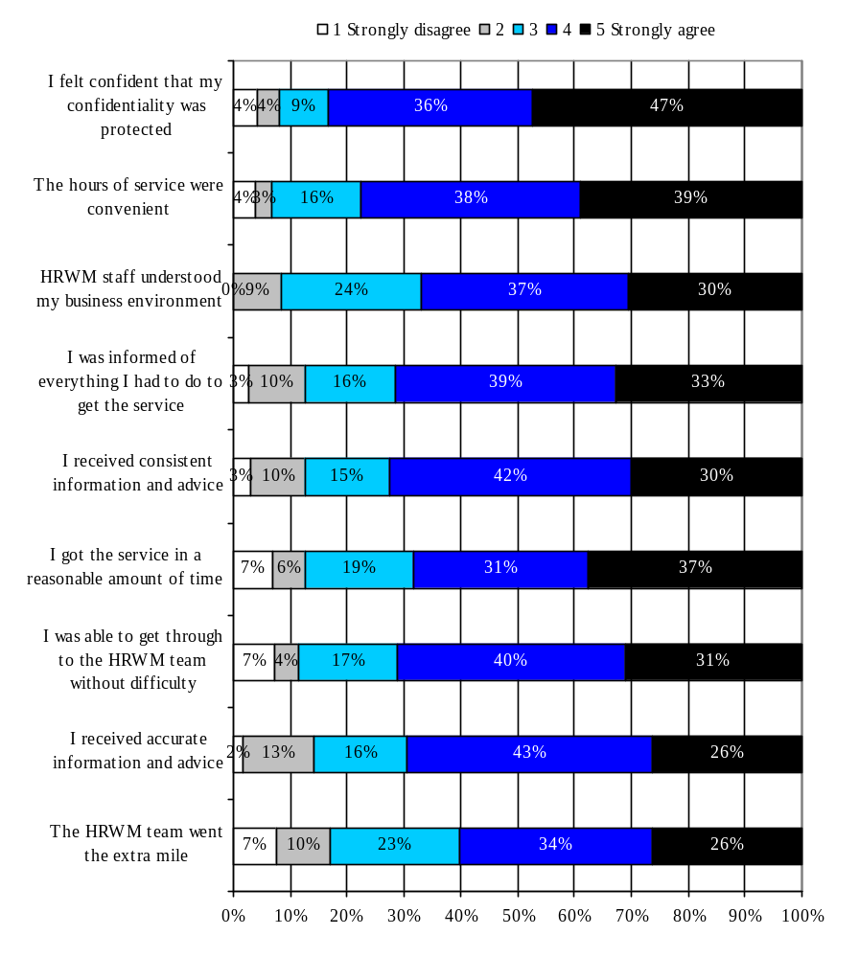 Black shading represents primary drivers of overall satisfaction
Mean Score (out of 5) | n=
4.18 | 70
4.06 | 68
3.89 | 68
3.89 | 70
3.87 | 69
3.86 | 69
3.83 | 67
3.80 | 69
3.62 | 65
Grey shading represents secondary drivers of overall satisfaction

Analysis of Significant Differences
An analysis of cross-tabulations revealed several significant differences for the Staff Relations attributes based on three variables: Having personally dealt with HRWM on the most recent Staff Relations issue, age and language.

For all of the attributes except for one (I was able to get through to the HRWM team without difficulty) having personally dealt with HRWM was more likely to be associated with higher ratings. For two attributes (I was informed of everything I had to do to get the service and I was able to get through to the HRWM team without difficulty) those more likely to give higher ratings were older employees (born before 1964). Finally, for the attribute The HRWM team went the extra mile, those who indicated their first official language was English were the ones more likely to give it a higher rating.

The hours of service were convenient
- More likely to be those that personally had dealings with the HRWM Team (4.21) than those that did not (2.91).

HRWM staff understood my business environment
- More likely to be those that personally had dealings with the HRWM Team (3.99) than those that did not (3.04).

I was informed of everything I had to do to get the service
- More likely to be those that personally had dealings with the HRWM Team (3.99) than those that did not (3.18).
- More likely to be those born before 1964 (4.04) than those born between 1964 and 1979 (3.18).

I received consistent information and advice
- More likely to be those that personally had dealings with the HRWM Team (4.00) than those that did not (2.78).

I got the service in a reasonable amount of time
- More likely to be those that personally had dealings with the HRWM Team (4.01) than those that did not (2.69).

I was able to get through to the HRWM team without difficulty
- More likely to be those born before 1964 (3.97) than those born between 1964 and 1979 (3.14).

I received accurate information and advice
- More likely to be those that personally had dealings with the HRWM Team (3.89) than those that did not (3.04).

The HRWM team went the extra mile
- More likely to be those that personally had dealings with the HRWM Team (3.73) than those that did not (2.52).
- More likely to be those that indicated that English was their first official language (4.00) than those that indicated that French was their first official language (3.37).

7.3.3 Top Priorities for Service Improvement

When respondents were asked the following open-ended question, “What would be your top two priorities for service improvement with regard to the staff relations services provided by HRWM?” some 53% could not provide a response. Responses varied for those that could provide a priority for service improvement. Some wanted better help resolving the issue, others wanted better accessibility or visibility of HRWM staff relations services or better communication from HRWM. Finally, some wanted a faster staff relations process.

Figure 7.11 Top two priorities for service improvement (n=72)
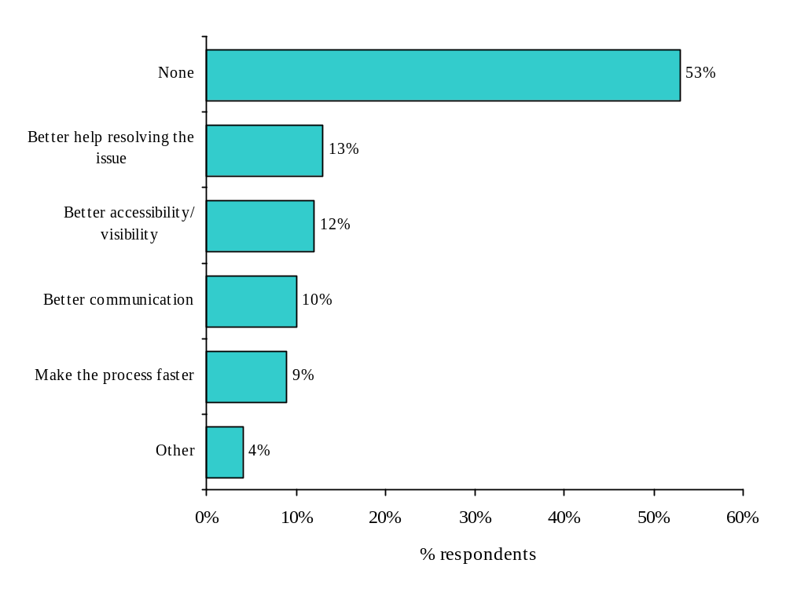
No significant differences were noted in the priority areas for improvement to staff relations services.

8.0 HR Planning

This section of the report presents findings for Human Resources planning services.

Chapter Highlights
- Very few (15%) respondents indicated that they have ever hired a Consultant to assist them with Human Resources (HR) planning activities. Those that have, hired one for HR planning advice (73%).
- There appear to be significant differences in the level of awareness of various Human Resources planning services that the HRWM Team provides. Less than half were aware that HRWM provides Human Resources planning models (48%), succession planning advice (46%), environmental scanning (44%), or information on best practices trends, or current research (40%).
- Generally, less than a quarter (23%) of respondents has used an HR planning service.
- Regardless of the outcome, most respondents that completed a Human Resources planning action in the past 12 months were relatively satisfied with the overall quality of the HR planning services they received (mean 3.55 out of 5).
- Significantly more respondents indicated that the service provided for their most recent HR planning action exceeded their expectations (3.49 out of 5) than for staff relations (3.41), staffing (3.33) or classification (3.12).

8.1 Human Resources Planning Activity

Very few (15%) of respondents indicated that they have ever hired a consultant to assist them with Human Resources planning activities. Of those that have hired a consultant, most (73%) have hired them for Human Resources planning advice and few have used them for other activities such as planning models, environmental scanning, or succession planning.

Figure 8.1 Human Resources Planning Activity

Context of Most Recent HR Planning Action | % Yes | N=
Have you ever hired a consultant to assist you with human resources planning | 15% | 164
Services Provided by Consultant  - Human Resources Planning Advice  - Human Resources Planning Models  - Environmental Scanning  - Succession Planning Advice  - Information on best practices or current research  - Employment Equity and Diversity Advice  - Other | 73%  30%  22%  21%  13%  4%  30% | 25

Analysis of Significant Differences
An analysis of cross-tabulations revealed no significant differences in the Human Resources planning activity of respondents.

8.2 Awareness and Use of HRWM Human Resources Planning Services

There appear to be differences in the level of awareness of various Human Resources planning services that the HRWM Team provides. Specifically, most respondents (85%) were aware that HRWM provides employment equity and diversity advice and over half were aware that HRWM provides Human Resources planning advice (68%) or demographic analysis and reports (60%). However, less than half were aware that HRWM provides Human Resources planning models, succession planning advise, environmental scanning, or information on best practices trends, or current research.

Generally, less than a quarter of respondents have used a HRWM Human Resources planning service. The most used HR planning service was demographic analysis and reports (27% used, 45% of aware used), employment equity and diversity advice (23% used, 27% of aware used), and HR planning advice (22% used, 33% of aware used). The least used HR planning services were succession planning advice (7% used, 15% of aware used) and information on best practices, trends, or current research (8% used, 20% of aware used).

Figure 8.2 Awareness and Use of HRWM HR Planning Services

HRWM HR Planning Services | % Aware | % Used | % of Aware that Used | n=
Employment equity and diversity advice | 85% | 23% | 27% | 164
Human resources planning advice | 68% | 22% | 33% | 164
Demographic analysis and reports | 60% | 27% | 45% | 164
Human resources planning models | 48% | 12% | 25% | 164
Succession planning advice | 46% | 7% | 15% | 164
Environmental scanning | 44% | 13% | 29% | 164
Information on best practices, trends or current research | 40% | 8% | 20% | 164

Analysis of Significant Differences
An analysis of cross-tabulations revealed several important significant differences in terms of those respondents more likely to be aware of and to use HR Planning services. Sector, appears to be the most determining variable. Across most services, Deputy Minister Reports is the sector most likely to be aware of and to use HRWM for HR Planning purposes. The sector which appears to use the services the least is Cultural Affairs.

Human resources planning advice
Aware
- Most likely to be those from Deputy Minister Reports (88%) or Public Affairs and Communications (84%) and least likely to be from International & Intergovernmental (44%), other sectors ranged from 52% to 63%.
- More likely to be those born between 1964 and 1979 (90%) than those born before 1964 (63%).
Used
- Most likely to be those from Public Affairs and Communications (39%) and least likely to be from International & Intergovernmental (6%), other sectors ranged from 11% to 32%.
- More likely to be those whose responsibilities include liaising with HRWM (31%) than those whose responsibilities do not (10%).

Human resources planning models
Aware
- Most likely to be those from Deputy Minister Reports (79%) and least likely to be from Cultural Affairs (32%), other sectors ranged from 37% to 50%.
Used
- Most likely to be those from Deputy Minister Reports (29%) and least likely to be from Cultural Affairs (0%), other sectors ranged from 6% to 19%.

Demographic analysis and reports
Aware
- Most likely to be those from Deputy Minister Reports (92%) and least likely to be from Cultural Affairs (39%), other sectors ranged from 44% to 73%.
- Most likely to be Executives (82%), or Managers (60%) and least likely to be Supervisors (37%).
- More likely to be those whose responsibilities include liaising with HRWM (68%) than those whose responsibilities do not (47%).
Used
- Most likely to be those from Planning & Corporate Affairs (46%) or Deputy Minister Reports (44%) and least likely to be from Cultural Affairs (4%), other sectors ranged from 13% to 26%.
- Most likely to be Executives (50%), or Managers (24%) and least likely to be Supervisors (8%).
- More likely to be those whose responsibilities include liaising with HRWM (34%) than those whose responsibilities do not (15%).

Succession planning advice
Aware
- Most likely to be those from Deputy Minister Reports (79%) and least likely to be from Cultural Affairs (32%), other sectors ranged from 37% to 50%.
Used
- Most likely to be those from Deputy Minister Reports (21%) and least likely to be from Cultural Affairs (0%) or International & Intergovernmental (0%) or Planning & Corporate Affairs (0%); other sectors ranged from 7% to 13%.

Information on best practices, trends or current research
Aware
- Most likely to be those from Deputy Minister Reports (67%) and least likely to be from International & Intergovernmental (27%), other sectors ranged from 32% to 41%.

Used
- Most likely to be those from Deputy Minister Reports (25%) and least likely to be from Cultural Affairs (0%); other sectors ranged from 5% to 10%.

8.3 Evaluation of HRWM Human Resources Planning Services for Most Recent Experience

8.3.1 Overall Assessment

Regardless of the outcome, most respondents that completed a Human Resources Planning action in the past 12 months were relatively satisfied with the overall quality of the HR Planning services they received. On a 5-point scale, where 1 was “very dissatisfied” and 5 was “very satisfied” the mean score was 3.55 out of 5. Some 16% indicated that their overall satisfaction level was a 5 out of 5 and another 37% indicated it was a 4 out of 5.

When respondents were asked to compare their most recent HR Planning action with the service they expected to receive, most indicated that HRWM met their expectation, with some indicated it was better than expected. On a 5-point scale, where 1 was “much worse than expected” and 5 was “much better than expected” the mean score was 3.49 out of 5, slightly higher than for staff relations (3.41), staffing (3.33) or classification (3.12). However, it is important to note that respondents were not asked what level of service they expected.

Figure 8.3 Satisfaction with Overall Quality of Human Resources Planning Service
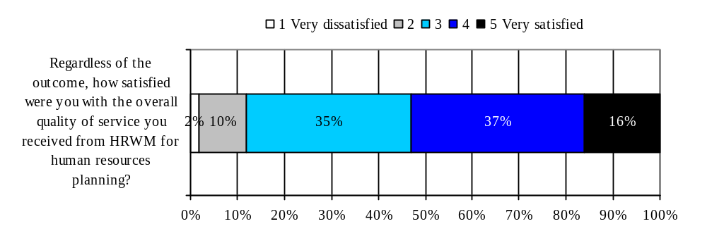
Mean Score (out of 5) | n=
3.55 | 69
Figure 8.4 Comparison to Expectations
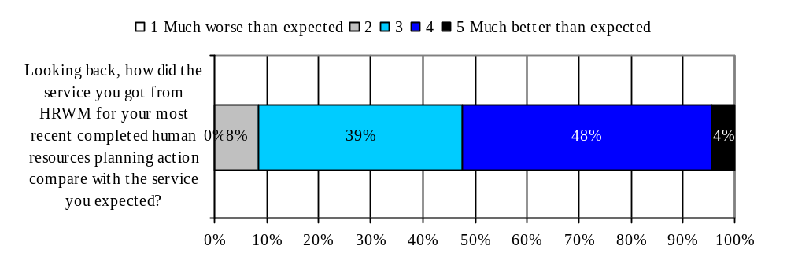
Mean Score (out of 5) | n=
3.49 | 68
Analysis of Significant Differences
An analysis of cross-tabulations revealed that the older respondents were the ones more likely to be satisfied overall with HR planning services:

Higher satisfaction with the overall quality of the Human Resources Planning service
- More likely to be those born before 1964 (3.67) than those born between 1964 and 1979 (3.09).

8.3.2 Performance of HRWM Human Resources Planning Services on Various Attributes

Respondents that completed a Human Resources planning action in the past 12 months were asked several agreement statements about specific aspects of the HRWM HR Planning services. These statements were positively worded and respondents were asked to indicate their level of agreement or disagreement on a 5-point scale, where 1 is “strongly disagree” and 5 is “strongly agree”.

Areas of strength: These include convenient hours of service (mean score 4.10, with 34% indicating they “strongly agreed”), and being able to get through to the HRWM team without difficulty (mean score 3.86, with 31% indicating they “strongly agree”).

Area of improvement: This includes only one attribute i.e. going the extra mile (mean score 3.50).

Key attributes driving overall satisfaction

By conducting a partial correlation between the various attributes and overall satisfaction it is possible to determine which attributes are most highly correlated with overall satisfaction. These attributes are called drivers of overall satisfaction because they are the most important ones in determining overall satisfaction.

The primary attribute driving overall satisfaction with HR Planning Services was going the extra mile. This attribute received the lowest rate and as noted above was an area for improvement.

The secondary attributes driving overall satisfaction were being able to get through to the HRWM Team without difficulty and providing consistent information and advice. For both of these important attributes agreement scores were relatively high (3.86 and 3.76 respectively) and in fact, were among the highest of all of the attributes rated.

Figure 8.5 Satisfaction with HRWM in Human Resources Planning services

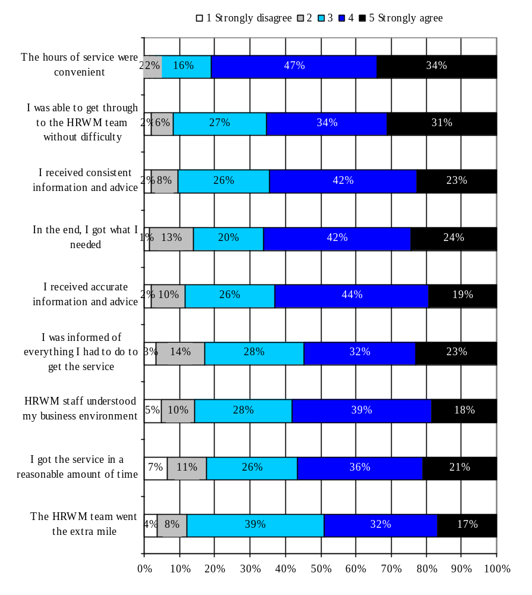
Mean Score (out of 5) | n=
4.10 | 66
3.86 | 65
3.76 | 66
3.75 | 66
3.69 | 64
3.57 | 66
3.57 | 65
3.53 | 65
3.50 | 60
Black shading represents primary drivers of overall satisfaction
Grey shading represents secondary drivers of overall satisfaction
Analysis of Significant Differences
An analysis of cross-tabulations revealed some significant differences relative to HR Planning attributes, with Sector being the most important variable.

The hours of service were convenient
- Most likely to be those from Planning & Corporate Affairs (4.60) and least likely to be those from Public Affairs & Communications (3.61); other sectors ranged from 4.00 to 4.25.

I was able to get through to the HRWM team without difficulty
- Most likely to be those from Cultural Affairs (4.50) and least likely to be those from Public Affairs & Communications (3.22) or International & Intergovernmental (3.33); other sectors ranged from 3.92 to 4.24.

I got the service in a reasonable amount of time
- Most likely to be those from Cultural Affairs (4.50) and least likely to be those from International & Intergovernmental (2.67) or Public Affairs & Communications (2.83); other sectors ranged from 3.62 to 4.00.

8.3.3 Top Priorities for Service Improvement

When respondents were asked the following open-ended question, “What would be your top two priorities for service improvement with regard to Human Resources Planning services provided by HRWM?” some 51% could not provide a response. Responses varied for those that could provide a priority for service improvement. Similar to Staff Relations services, priorities for improvement centered around providing better information, making services available more known or accessible, or making the process faster.

Figure 8.6 Top two priorities for service improvement (n=69)
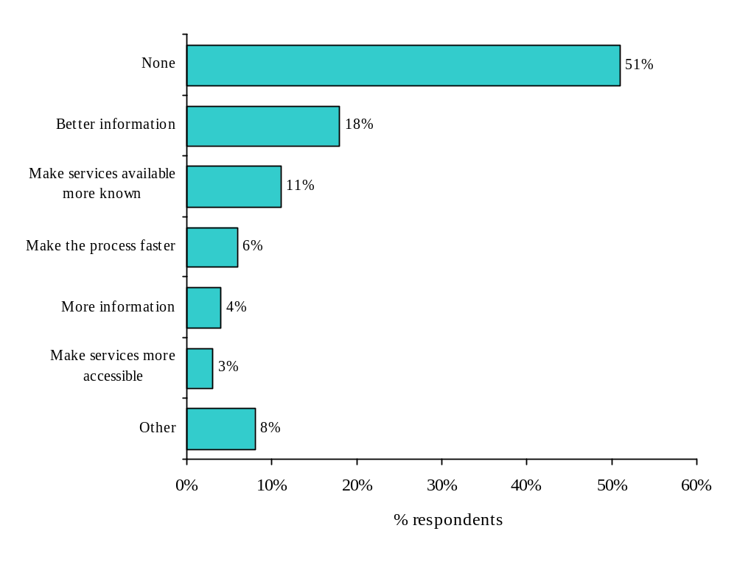
No significant differences were noted in the priorities for improvements to the HR planning services.

9.0 Conclusions

At the very beginning of the survey, respondents were asked to respond to a series of statements to gauge their general impressions of and attitudes towards HRWM. These impressions give us an indication of the image respondents’ hold of HRWM. The results show that providing services in the customer’s official language of preference, providing accessible services to persons with disabilities and fair treatment were viewed as strengths. These are primarily related to Access and to Equity and are fundamental requirements for service quality. On the other hand, areas for improvement were HRWM viewing themselves as service providers and HRWM staff understanding their customers’ business environment. These are related to client-centricity and are what distinguish good service from excellent service. Indeed, viewing oneself as a service provider first and foremost and taking the time to understand the customers’ business environment are fundamental to providing value-add service.

The survey also included an assessment of four specific services (Staffing, Classification, Staff Relations and Human Resources Planning). The results indicate a moderate, overall level of satisfaction with each service. Within each, and in line with respondents’ general impressions, respondents appeared to be particularly satisfied with service attributes related to access and language. Indeed, most respondents indicated that regardless of the service requested, the hours of service were convenient (Access). The same is true for being able to access an HRWM service provider without difficulty(Access) for all of the services, except for Staff Relations, where this attribute received a relatively low rating compared to most other attributes assessed for that particular service. On the other hand, respondents appeared less satisfied with service attributes related to timeliness and being client-centric. Timeliness across all services was viewed as one attribute that could be improved. In fact it was also a key driver of overall satisfaction for all of the services, except for HR Planning. Similarly, attributes which reflect a client-centric attitude and approach like understanding the customer’s business environment and going the extra mile also received if not the lowest, among the lowest ratings among all attributes across all services.

The majority of respondents to the survey indicated that their job responsibilities included liaising with HRWM on behalf of their organization. The rest of the respondents typically interacted with HRWM through their Administrative Officer. In addition to liaison responsibilities, the survey also asked respondents whether they had personally interacted with HRWM on their last action (be it for Staffing, Classification, Staff Relations or HR Planning) and this, whether or not they had liaison responsibilities. The results to the survey were therefore examined to determine whether these two variables (liaising with HRWM or personally interacting with HRWM) led to different ratings. Across all of the services, the results show that interaction with HRWM is typically associated with higher ratings.

From a knowledge perspective, respondents indicated they were most knowledgeable of Staffing and least knowledgeable of Classification. When asked what aspects of Classification they would like to better understand, the top answer centred on understanding why Classification practices were not fairer. Given how respondents rated three classification-related values, it appears that the perceived lack of fairness may be associated with jobs being classified fairly compared to all positions in government rather than within the department.

10.0 Recommendations

The following are being offered as recommendations HRWM may want to consider as a way of improving future satisfaction ratings. These recommendations fall out of the findings from the survey.

Continue to provide accessible and fair service. These are basic requirements and while ratings indicated that they are strengths, it is important for HRWM to ensure they continue to be. These are not only ‘nice to haves’ but ‘need to haves’. As indicated above, they are the starting point for service provision.

Work towards improving performance on key drivers of overall satisfaction. Across the four services, some of the lowest ratings were for key drivers. These are important attributes because they are the ones most strongly associated with overall satisfaction. If HRWM wishes to increase its overall satisfaction scores, it is essential that they increase their scores on key drivers.

For Staffing, the key drivers which received the lowest ratings were:
- HRWM staff understood my business environment.
- I got the service in a reasonable amount of time.

For Classification, all of the key drivers received the lowest ratings were:
- I got the service in reasonable amount of time.
- I received accurate information and advice.
- HRWM staff understood my business environment.
- The HRWM Team went the extra mile.

For Staff Relations, the key drivers which received the lowest ratings (of all attributes) were:
- I received accurate information and advice.
- The HRWM team went the extra mile.

For HR Planning, the key driver which received the lowest rating (of all attributes) was:
- The HRWM team went the extra mile.

Work towards improving performance on client-centric related attributes. If HRWM wishes to provide exemplary service which “delights” its customers, improving performance on “client-centric” attributes is important. In fact, the findings indicate that half of the client-centric attributes are also key drivers. Across all of the services, special attention should therefore be given to the following attributes.
- HRWM staff view themselves as internal experts. (Not measured for key driver status)
- HRWM view themselves as service providers. (Not measured for key driver status)
- HRWM staff understood my business environment. (Key driver)
- The HRWM Team went the extra mile. (Key drivers)

Appendix A: Complete Verbatim Responses

Staffing Aspects Respondents would like to Better Understand

PROCESS STEPS
- Tout le processus au complet pour mieux comprendre les impacts lors de la dotation
- The whole process/responsibilities
- The process between requesting a posting and actually having the poster go up
- The entire process, it is a very grey zone for me.
- Les processus en général. Comme ils changent souvent, une formation en dotation condensée.
- Le processus au complet et en particulier la dotation externe
- Le processus
- It would help to have a more complete understanding of all the processes which need to be undertaken
- How to access diversity 'pools'

WHY DOES THE PROCESS TAKE SO LONG
- Why staffing takes soooo long
- Why it takes so long to classify a position
- Why are there significant delays in the process. it sometimes takes 3 months to hire someone.
- Timely staffing - assignments, acting, competition, etc
- I simply would like faster, more responsive service
- How we can staff more easily and more quickly
- How to get it done faster.
- Ce qu'on entend par délai raisonnable quant on sait que les ressources humaines.

ROLES AND/OR RESPONSIBILITIES
- What functions are delegated to PCH and which are retained by the PSC
- What can you do for me?
- Get a better understanding of what the manager's responsibilities are towards staffing.
- Delegation of staffing
- Clarity on roles and responsibilities - what can HR do for managers to simplify and expedite the procedure
- Changes to my responsibilities and accountabilities further to HR modernization

RECRUITMENT OF CANDIDATES
- Recrutement et identification des candidats potentiels
- Recrutement a partir de pré-sélectionné, recrutement dans groupes désignés
- Lorsque je suis hésitante ou que ma connaissance est moindre dans une mesure de dotation
- Justice entre la dotation des postes PM vs postes administratifs
- Embauche de nouveaux employés
- Dotation
- Comment allez chercher un employé qui a son nom dans la banque de la fonction publique

POLICIES AND REGULATIONS
- Quand le concours est ouvert seulement a l'intérieur ou extérieur
- Priorités
- Les systèmes de promotion des employés a l'interne et de reclassification
- Les réglements obligtoires ou de quelles façons peut-on, autre que le processus normal
- Changements avec le c-25

WAYS TO SIMPLIFY THE PROCESS
- Short cuts to staffing, alternative approaches, not worrying all the time about every little detail
- Les réglements devraient être simplifiés
- It would be useful to know what the simplest ways of staffing are, providing you can maintain fairness
- Il me semble que le processus n'est pas suffisamment simple
- Certains cas de dotation sont plus complexes que d'autres. Encore la nous ne sommes pas les experts.

MANAGING DIVERSITY
- Les méthodes d'embauche qui touchent les enjeux de diversité
- Exigences et possiblités en matière de recrutement pour satisfaire aux besoins de diversité
- Diversité, équité
- Competencies versus knowledge ensuring diversity in staffing procedures

OPTIONS AVAILABLE
- I'm not really sure I understand completely all of the various options: casual, term, assignment
- Différentes options qui s'offrent aux gestionnaires et pourquoi le processus est si long.
- Ce qui est possible et ce qui ne l'est pas.

THE NEED FOR COMPETITIONS
- Why we bother to hold competitions for positions that are already filled.
- Nomination sans concours

MORE COMMUNICATION
- Logic behind some of the policy rules. Values are preached but far from practiced (trust, loyalty, respect)
- List of what I need to do and forms i need for it and who to see for it

REFRESHER COURSE
- Would be helpful to have a mandatory annual staffing for managers refresher course.
- Refreshers from time to time of staffing authorities -- advice versus direction

OTHER
- Statement of qualification writing
- Quand nous aurons la délégation d'autoritts rôle de la nouvelle commission de la fonction publique
- Participation des conseillers aux comités de sélection
- Nous suggérer des nouvelles méthodes d'évaluation des candidats, ex questionnaires types, etc
- Les gestionnaires connaissent mieux que les RH leurs besoins. Je trouve que les RH ne rélaisent pas
- Je suggérerais que les gestionnaires aient accès a un document qui décrirait les différentes étapes
- Il s'agit d'avoir accès aux différentes sources d'information qu'en un cas précis ce présente.
- I like being able to rely on the experts to provide the various options at any point in the process
- Façon d'arrivée aux buts en respectant les valeurs et ce dans un temps raisonnable
- Comparative results of competitions should be provided according to each section of the competition

Suggested Improvements to Staffing Services

MAKE THE PROCESS FASTER
- Vitesse de réaction
- Timeliness,
- Timeliness and efficiency need to be greatly improved. All processes in a staffing action take too much time
- Streamling and timeliness
- Simplification du processus livraison plus rapide amélioration des communications
- Retour d'appel rapide conseil et avis sans jugement
- Rappel plus rapide;
- Rapidité, plus de solutions
- Rapidité et efficacité
- Rapidité du service ; flexibilité
- Rapidité d'exécution
- Rapidité capacité a conseiller sur diversité
- Rapidité & concours externe
- Raccourcir le temps d'exécution et simplifier le processus.
- More timely
- Integrated approach faster service
- Faster turnaround better understanding of our business and staff
- Faster response time particularly when an effort was made to discuss the overall staffing plan with HRW
- Faster classification more availability of HRWM staff for selection boards
- Enough staff to be able to provide service, faster response/return calls promptly
- Additional trained and qualified staffing officers are urgently required.
- Accélération du processus
- Ability to speed up the processes such as PSC clearances; language testing; etc.

BETTER ADVICE/ MORE KNOWLEDGEABLE
- Understand better the local work environment and needs, and flexibility for the managers to hire
- Qu’ils essaient de comprendre d'abord et avant tout nos besoins et nous conseiller en conséquence
- Provide more information to managers if managers are expected to take on more responsibility.
- Obtenir toute l'information nécessaire obtenir de l'information juste et en temps opportune
- More discussion of the impacts of various staffing options, by a manager in hrwm, before proceeding
- Make sure that they provide accurate information (e.g. screening process at beginning could be improved)
- Learn your business so that you give accurate advice
- Knowledgeable and timely advice, not lose documents.
- Increase knowledge level of HR service providers increase involvement in staffing actions
- Équité et clarté, transparence et bons conseils
- Connaissance de tout l'éventail des mesures d'appui pour le recrutement des groupes cibles
- Be more helpful and less authoritative

MORE ACCESSIBLE
- More flexible hours. More officers to provide service/advice.
- Meilleure disponibilité de la part du conseiller pour le/la rencontrer (one-on-one).
- Meilleure accés aux servives temps approprit pour achever le prpocessus
- Contact direct
- Availability to fit my schedule, more support at the administrative end of the process
- Accessibiilté et compréhension
- Accés a une base d'information gtntrique rapiditt
- Accés a l'information formation sur la dotation

MORE CONSISTENT ADVICE
- Consistent, equitable advice clarity on services HR provide
- Consistent advice; learn to take some risks in staffing
- Consistency, time efficient

DECENTRALIZATION OF SERVICES (MORE REGIONAL SERVICES)
- Les questions de dotation en région, dans un environnement oû nous ne disposons pas de budgets
- Doter un poste de conseiller en ressources humaines en région afin de mieux comprendre les besoins.
- Decentralization of services with more HR staff in regions.

MORE CONTROL OVER WHO WE GET TO HIRE
- Time and our ability to hire someone we've invested resources, training and effort in. (casual or term)
- Plus de flexibilité dans l'écriture du questionnaire d'entrevue
- Please do not tell me to go to the PSR inventory when you know that I will get hundreds of applicants

MORE CLIENT FOCUS
- That there is more follow-up, ongoing guidance and pro-active involvement
- Mettre l'accent sur le besoin du client. Offrir les difftrentes options/choix disponibles.

OTHER
- We needed to know how the qualifications would be marked
- Verify that applicants fit the criteria - one person we interviewed was casual
- Une demarcation plus claire entre ce qui releve de la DG et ce qui releve de l'administration
- Un agent junior était le conseiller ainsi ne connaissait pas a fonds la dotation
- The service is good. I would recognize staffing team for being client and service focused
- Obtenir un meilleur appui pour la rédaction des descriptions de tâches, des énoncés de qualité
- La teneur et l'offre des services en matière de dotation de la dggrhmt sont pratiquement inexistantes.u
- Justice entre dotation des postes PM vs postes administratifs reconnaissance de l'expertise
- I would like to be offered the opportunity to be provided with a list of options available to me
- Focus on the goal and outcome of the process and work with managers to make the process more effective
- Déléguer les pouvoirs aux gestionnaires suite au cours sensibiliser certains gestionnaires des mécanis
- Déja énumérées dans les questions précédentes
- De la formation sur les nouvelles politiques de dotation
- Conseils et orientation - aide a la préparation des documents nécessaires
- Clear table of all staffing instruments (table- competition, deployment)
- Better idea of who to go to for what
- Avoir recours a leurs services pour la rédaction des énoncés de qualité et des grilles d'évaluation
- Assurer d'avoir tous les détails en début du processus pour éviter les surprises

Classification Aspects Respondents would like to Better Understand

FAIRER CLASSIFICATION PRACTICES
- Why is it that administrative staff are so poorly dealt with in this department?
- Selon mon expérience, une grande majorité des fonctionnaires occupent des postes qui sont classifiés
- Relation entre certains types de postes et niveaux
- Reasoning behind relativity and why it is crucial in some cases and non existant in others.
- Pourquoi les postes en région sont-ils toujours classés plus bas qu'a l'administration centrale ?
- Pourquoi il y a plus de flexibilité pour les groupes PM
- Pour la norme de classification n'est pas unifie au sein du gouvernement? (ocs/pointage/etc)
- Les écarts pour un même niveau, entre les régions et l'administration centrale
- Le processus d'évaluation des compétences et expertises
- La rétention et la promotion d'employés de valeur
- La relativité entre la classification de poste d'un ministère a l'autre
- Différence entre travail en région et au centre, pourquoi pour un mème emploi, un salaire différent.
- Classify regional employees equally with NCR employees!!
- Actuellement, la classification des postes ne reflète pas la réalité du travail accompli.

CLASSIFICATION CRITERIA
- What the benchmarks are for key positions, i.e. an AS--07 manager responsible for planning and resource
- Les normes de classifications sont dépassées dans bien des cas; il donc est trés difficiles
- Les différences parfois très nuancées entre les classifications (pm2 versus pm3 par exemple).
- How to classify a position
- Facteurs utilisés pour l'évaluation des postes
- Détails quant aux facteurs qui déterminent les classifications exactes.
- Critères de classification
- Comparability to other positions vs individual needs
- Comment le niveau est déterminé, quels outils sont utilisés

ROLES AND/OR RESPONSIBILITIES
- What help HR will provide with job descriptions and rationales, versus what I have to do myself
- The extent of HR's responsibilities.
- Rôles et responsabilités, liste et accès de tous les outils disponibles, délais raisonnables, etc.
- Rôles et responsabilités
- Rôle de l'agent vis a vis celui du gestionnaire dans l'identification des besoins d'une organisation
- Le rôle du gestionnaire et comment mieux travailler en collaboration avec les RH

RECLASSIFICATION
- The reclassification process
- Reclassification; relationship to succession planning
- Reclassification de poste - employé
- Quelles sont les procédures pour re-classifier un poste et l'impact sur les autres.
- How new position description can be rated using old system ratings

THE ENTIRE PROCESS
- Tout le processus
- Les règles en vigueur
- Les critères et revoir le processus au complet. Comprendre le sens des définitions que l'on utilise
- All of it.

WHY IS THE PROCESS SO LONG
- Why it takes so long, why we have to do our own research and not HR?
- Pourquoi le processus est toujours long et pénible ?

RETAINING EMPLOYEES
- Why there is so much resistance to meeting the objective of retaining the employees?

OTHER
- Why there is not a common approach in the department and in government to certain classifications.
- Why central agencies value young people with no experience more than experience people in line department
- What has happened to UCS? Are we using this standard? If so, why are we still relying on benchmarks?
- The jargon.
- Service au lieu de directives meilleure compréhension de l'environnement
- Les couvés élevés du processus (temps et argent)
- L'embauche d'étudiants
- La marge discrétionnaire dont dispose le gestionnaire
- Integration of the IS group into the new table; one broader classification covering PM, AS, CR etc
- Il semble y avoir des règles.
- I don't understand why classification takes a more adversarial, policing approach
- Accountability for staffing, options

Suggested Improvements to Classification Services

BETTER ADVICE/ MORE KNOWLEDGEABLE
- Understanding of our business and position requirements timely classification
- Un personale ayant une meilleur compréhension des normes et des besoins dans la fonction publique
- Stop throwing rules and process at us. We need advice that you stand behind not weasel words
- Reconnaître les subventions et contributions dans nos JD le groupe as a aussi sa place au ministère
- More consistent advice with regard to linguistic profiles; more clarity with regard to classification
- Messages clairs et surtout cohérents des agents administratifs et de la DGGRHMT et dans un délai raisonnable
- I'd like to attend a workshop on best practices/tips associated with reclassification.
- Here again a presentation on what services are offered to help us.
- Expertise et diligence
- Connaissance du milieu de travail en région simplification et rapidité du service
- Compréhension de l'environnement de travail et service dans un délai raisonnable
- Avoir des postes repères pour la création de nouvelle description de travail simplifier la description

MORE CONSISTENT/ EQUITABLE
- Justice et équité
- Justice entre la classification des postes PM vs postes administratifs reconnaissance de la gestion
- Consistency across the department resources in HRWM to do the job
- Consistency
- Assurer l'équité entre postes comparables

MAKE THE PROCESS FASTER
- Time frame communication with manager, re: status and issues and not wait until decision is completed
- Rapidité de la transaction flexibilité
- La rapidité du processus jusqu'a la fin.

BETTER COMMUNICATION
- Service level standards with "guaranteed" delivery dates.
- Reorientation to helping the manager get the classification required to do the job
- Meilleure communication afin que l'on puisse comprendre a fonds toutes les étapes a suivre.

SIMPLIFIED CLASSIFICATION
- Une simplification des normes de classification un guide pratique de mise en oeuvre
- Make it less onerous.
- Avoir plus d'aide et de conseils en matière de dotation - éviter la paperasse inutile

UPDATED CLASSIFICATION
- Updated classification evaluation standards. More trained and qualified classification officers.
- Redéfinir les critères d'évaluation -ils sont désuets
- Classification system is aniquated and does not meet current needs. Very limited in-house capacity

MORE ACCESSIBLE
- More availability and flexible hours.
- Availability and willingness to guide and support the process

OTHER
- That more help be provided internally instead of managers having to use consultants
- Rédaction de descriptions de fonctions discussion plus approfondie quant au calibre de la personne reche
- Quit picking on the AS group. I do find the service overall very good and know their hands are tied
- Nobody cared about what I as a manager needed. Objective was approached in a myopic method
- Les conseillers sont beaucoup trop "by the book". ils ont de la difficulté a comprendre les contextes
- Fournir un plus grand nombre de solutions lorsqu'il y a un problème au niveau de la classification
- Expect higher visibility and more opportunities for quick and direct action
- Accent sur le service au client; présenter des options pour aider le client.
- Ability to see the UCS standards that are being used by classification; we are writing to them

Staff Relations Aspects Respondents would like to Better Understand

CONFLICT RESOLUTION/ GRIEVANCES
- What support if any do managers have in case of conflict.
- The 'rules' concerning grievances, the rights of employees and managers regarding reclassifications
- More training on issues such as conflict resolution. more information about their functions
- Les systèmes de gestion du rendement.
- Les griefs logés par des employés
- Le gestionnaire peut réagir comment pour différentes situations. Employé non performant, négligence
- La culture organisationnelle de PCH m'échappe parfois. On fait preuve d'une grande tolérance
- Issues surrounding grievances, complaints, mediation, etc.
- If there is a serious matter that arises in the workplace with a member of staff working for me
- Habituellement lorsqu'un gestionnaire vient me voir pour conflit avec un employé
- Grievances
- Grief
- Gestion de congés
- Congé, gestion du rendement
- Conflits d'intérot
- Conflit entre superviseur et employé
- Conflict resolution. The rights and responsibilities of the employer vis disabled employees.
- Conflict resolution
- Comment "dealer" avec les employés a problèmes. règlement de conflits
- Cas de soumission de griefs et procédures

ROLES AND/OR RESPONSIBILITIES
- The role of the department vis a vis the PSC
- Rôles et responsabilités du gestionnaire; rôles et responsabilités de l'employé
- Roles and responsibilities, services provided
- Roles and responsibilities of managers. Roles and responsbilities of HR
- Rôle du siège social vis a vis celui des régions
- Rôle du gestionnaire
- Responsabilité des superviseurs et leurs droits
- Niveaux de responsabilité de la haute direction.
- My recent experiences have been positive, but I should learn more about services, roles, etc.
- Mes responsabilités en tant que gestionnaire dans la question de conflits.
- Les droits et responsabilités des gestionnaires en cas de conflits avec les employés
- Les droits des employées (ex. heures de rendez-vous par mois qu'ils ont le droit)
- Le rôle du gestionnaire et comment mieux collaborer avec les RH
- Difficile a répondre. Comprendre cas par cas. Le role du gestionnaire et ses droits.

THE ENTIRE PROCESS IN GENERAL
- Rafraîchir mes connaissances générales sur les relations de travail en général.
- R & R formal / informal process
- Not sure....would like more general information
- Get a better understanding of the process
- Certains aspects précis comme ce qu'un gestionnaire a le pouvoir de faire

SERVICES PROVIDED BY HRWM
- Types of issues/cases they deal with, what they can offer me who to go to for what
- Toute l'aide qu'ils peuvent nous apporter
- Their services to managers
- I don't think I know who my staff relations officer is! -- so I'd like to know that

BEST PRACTICES/CURRENT PRACTICES
- I would like to be more up to date with current rulings on issues/appeals from across the government
- Best practices

COLLECTIVE AGREEMENT
- La convention collective; la délégation d'autorité; les activités précises des res.hum. pour la RTT
- Interpretation of collective agreements

WHY THE PROCESS TAKES SO LONG
- Why things take so long

OTHER
- Who's responsible for our appalling working conditions? why do we have inadequate quiet space
- The continuation of an acting salary at a higher level when in fact, the acting period is complete.
- The advisory role of staff relations to management and what drives their recommendations/advice.
- Suggest mandatory training for all managers
- Reconciling the need to accommodate diversity or long-term illness with restrictions
- Programmes de transition
- Les subtilités des actions de dotation
- Les enjeux
- Je ne suis pas certaine si c'est possible de comprendre a fonds les aspects??
- Je comprends bien les relations de travail mais c'est un côté plus complexe des ressources humaines
- Information about leave and performance measurement
- Imputabilité de chaque niveau de gestion.
- Il faudrait d'abord que je m'informe avant d'éclaircir des points précis... je n'ai pas eu
- I would like to know how much initiative a manager can take, and how much is pre-determined
- How to refer staff to employee assistance

Suggested Improvements to Staff Relations Services

BETTER HELP RESOLVING THE ISSUE
- Supporter les actions du gestionnaire, plutôt que protéger premièrement l'intégrité des règles
- Provide real solutions to the resolve of problems, theories are not enough. Look at providing solutions
- Meilleure aide et appui en matière de griefs description claire du processus qui sera suivi
- Il devrait y avoir une personne (genre Lise Courcy) pour les non EX au ministère
- Gestion du rendement
- Gestion des griefs plans d'apprentissage
- Formation en région
- Aider le gestionnaire dans son action et mener l'objectif a terme avec le gestionnaire.
- Accueil plus personnaliste des nouveaux employés information et conseils sur avantages sociaux

BETTER ACCESSIBILITY/ VISIBILITY
- More outreach to management
- They need to be more accessible, people do not know what they have available to them
- More flexible hours of service.
- Disponibilité et appréciation du milieu de travail dans lequel j'opère
- Disponibilité des conseillers
- Crédibilité et visibilité
- Clearer higher-level of service and availability and quicker and confident dealings with client.
- Clarté d'approche dans un cas de conflit aide pour résolution dans un temps acceptable
- Accessibilité partage d'information

BETTER COMMUNICATION
- Would be helpful to have a checklist of actions to be taken in specific cases (such as performance)
- I was not sure who in staff relations I should contact for what type of issue
- HR could hold a general information session related to staffing issues for our management team
- Honesty and communication. Commitment and fairness.
- Communication ouverte - terminologie facile a comprendre.
- A regular meeting -- say quarterly -- between staff relations and managers above a certain level.
- A clear outline provided to all levels of management (from EX to supervisors)

MAKE THE PROCESS FASTER
- Retourner les appels sans délai - ta prend parfois des messages dans plusieurs boites vocales,
- Rapidité du service et qualité des conseils
- Rapidité du service clarification de procédures souvent complexes
- Not have to request the same information four or five times before I get it,
- More knowledgeable advice. Timely response.
- It was sometimes difficult to arrange a timely meeting, due to their busy schedule
- Greater promptness, better advice, more pro-activeness.

OTHER
- More complete information for managers to see. The ability to contact someone directly.
- Il devrait y avoir de la formation offerte aux gestionnaires, afin que nous comprenions mieux
- Appui au recrutement et a la classification

Suggested Improvements to HR Planning Services

BETTER UNDERSTANDING/ INFORMATION
- More informed and more involved HR specialists. Too much is left to managers to do
- More flexible hours. More information on the services they can provide.
- More complete information. More direct contact.
- Expertise et diligence
- Conseils pour faciliter la dotation aide pour trouver une solution simple
- Compréhension de l'environnement formation des gestionnaires
- Compréhension de la business du client compréhension de la situation actuel organisationnelle
- Better understanding of clients' business environment; better integration of people plans
- Better information on services available. I only became aware through business planning exercises
- Augmenter l'expertise et la qualité des conseils
- Accurate response and helping us, not you

MAKE THE PROCESS FASTER
- Speedier response times enhanced capacity to provide advice on labour relations issues
- Speed accurate advice based on legality not opinion
- Efficacité, rapidité et courtoisie
- Accélération du processus

OTHER
- Une ouverture a des réalités de travail qui ne sont pas traditionnelles
- Recevoir tout information statistique par intervalle régulière. Avoir plus d'information
- Quitté en matière d'emploi santé et sécurité
- Planification de la sucession
- More engagement in terms of data and appropriate model/format of a plan.
- Meeting with each manager in the department to provide information on the range of serious
- Make this service common knowledge and available. HR should be approaching managers
- Je ne savais pas que tous ces services sont offerts. La DGGRHMT devrait mieux faire
- J'aimerais de l'appui pour pouvoir créer une stratégie de relève pour ma petite équipe
- J'ai demandé des info pour le produire le plan des RH au d'AC
- Informer les gestionnaires sur les différentes possibilités en matière d'emploi.
- Inform clients of what you can do for them as opposed to telling them what they have to do
- In terms of statistics /demographics information available due to privacy etc.
- HRWM could assign a qualified HR person to work with the client on planning issues
- Des données fiables en tout temps, des analyses un peu plus poussées des questions de RH
- De l'aide dans un temps raisonnable meilleure compréhension des enjeux
- Communicating in the regions what services are available.
- Accessible staff in the region more administrative support to managers
- Accent sur le service au client versus suivre les procédures
- A planning mechanism that is communicated and works

A partial correlation analysis describes the linear relationship between two variables while controlling for the effects of one or more additional variables. In this case, the partial correlation analysis describes the relationship between one specific staffing attribute and overall satisfaction with staffing while controlling for all the other staffing attributes.
Primary attributes are those that have a statistically significant relationship with overall satisfaction while controlling for the effects of the other attributes.
Secondary attributes are those that have a very strong, but not statistically significant, relationship with overall satisfaction while controlling for the effects of the other attributes.
A partial correlation analysis describes the linear relationship between two variables while controlling for the effects of one or more additional variables. In this case, the partial correlation analysis describes the relationship between one specific classification attribute and overall satisfaction with classification while controlling for all the other classification attributes.
Primary attributes are those that have a statistically significant relationship with overall satisfaction while controlling for the effects of the other attributes.
Secondary attributes are those that have a very strong, but not statistically significant, relationship with overall satisfaction while controlling for the effects of the other attributes.
A partial correlation analysis describes the linear relationship between two variables while controlling for the effects of one or more additional variables. In this case, the partial correlation analysis describes the relationship between one specific staff relations attribute and overall satisfaction with staff relations while controlling for all the other staff relations attributes.
Primary attributes are those that have a statistically significant relationship with overall satisfaction while controlling for the effects of the other attributes.
Secondary attributes are those that have a very strong, but not statistically significant, relationship with overall satisfaction while controlling for the effects of the other attributes.
A partial correlation analysis describes the linear relationship between two variables while controlling for the effects of one or more additional variables. In this case, the partial correlation analysis describes the relationship between one specific staff relations attribute and overall satisfaction with staff relations while controlling for all the other staff relations attributes.
Primary attributes are those that have a statistically significant relationship with overall satisfaction while controlling for the effects of the other attributes.
Secondary attributes are those that have a very strong, but not statistically significant, relationship with overall satisfaction while controlling for the effects of the other attributes.

