
CHIN 2004 National Membership
Study

Final Report

Prepared for: Manon Larocque
Canadian Heritage Information
Network

Date: January 2004

 | 

 Toronto Ottawa Montreal
2345 Yonge Street 160 Elgin Street 630 Sherbrooke Street West
 Suite 405 Suite 1820 Suite 1101
Toronto, ON Ottawa, ON Montreal, QC
M4P 2E5 K2P 2P7 H3A 1E4
(416) 962-2013 (613) 230-2013 (514) 288-0037

info@decima.com www.decima.com

Table of Contents
Introduction 1
Executive Summary 2
Detailed Analysis
CHIN Mandate and Benefits 10
CHIN Products and Services 17
Artefacts Canada 17
VMC Image Gallery 28
Virtual Museum of Canada 31
CHIN Investment Programs 34
CHIN Executive Produced Virtual Exhibits 36
VMC Investment Program – Virtual Exhibits 38
Community Memories Program 40
Marketing Initiatives 43
Skills Development 44
Learning Resources Highly Familiar Among Members 46
Learning Resources Somewhat Familiar to Members 55
Learning Resources Relatively Less Familiar to Members 65
General Perception of Program Communication 71
CHIN Member Communication 81
Future Directions 94
Member Profile 95
Final Comments from Executive Interviews 98

Study Methodology 100
Appendices: A: Survey Questionnaire
B: Executive Interview Guide

Contact Information:
Rick Nadeau
Vice President
Decima Research Inc.
160 Elgin Street, Suite 1820
Ottawa, Ontario K2P 2C4
(613) 230-2013
rnadeau@decima.com

Introduction
As outlined on its website, “The Canadian Heritage Information Network (CHIN) and Canadian museums work together to strengthen our collective ability to create, present and manage Canadian online content.” In striving to achieve this goal, CHIN provides a variety of products and services to its membership. This membership consists of more than 1,000 cultural institutions across Canada. To gauge how well it is meeting its mandate, CHIN solicited Decima Research to conduct a membership consultation exercise.

The broad themes of the research include:

- General awareness/ knowledge of CHIN and its current mandate,
- Awareness, use and satisfaction with CHIN investment programs,
- Awareness, use and satisfaction with CHIN learning resources,
- Member communication,
- Future direction.

Executive Summary

Study Findings
CHIN Mandate and Benefits

Although survey respondents were not entirely clear on what CHIN’s mandate is, many were nonetheless able to provide meaningful insight. Respondents seem to primarily perceive that CHIN’s mandate involves communicating Canadian heritage information, providing access on Canadian cultural heritage by electronic means, representing and supporting heritage through a network of organizations, uniting museums, increasing professional performance and communication, and promoting new technologies such as the VMC.

Members also emphasized that CHIN allows them to fulfill their own mandate because of the access it provides to databases, publications, collections, tools, and catalogues. CHIN is also seen as a networking leader and motivator by providing the opportunities to bring museums closer together despite their geographical dispersion.

When asked if there are similarities between CHIN and their organization’s mandates, respondents feel the similarities are mostly with respect to the conservation, interpretation and dissemination of heritage, in either digital or non-digital format. Some organizations feel CHIN’s mandate is associated with their own organization’s mandate through the sharing of artefacts in the VMC, the introduction and promotion of local history, and the promotion at an international level – “CHIN is our international window”.

Upon being provided CHIN’s mandate, executive interview participants agreed that this mandate is being met successfully. When asked to explain why CHIN is successful in meeting certain aspects of its mandate, many attributed it to the financial support offered. Others felt their success is attributable to the participation from multiple museums, CHIN’s up-to-date knowledge of technology, the encouragement given to museums to share information, the promotion of CHIN as an organization across its membership, and the coherence of its website.

When specifically asked to rate CHIN membership advantages in terms of importance, at least three quarters of respondents found the advantages listed very or somewhat important. A vast majority (92%) considered the possibility to be part of a community of practice that allows sharing of thoughts and ideas on information technology and digital heritage very or somewhat important. Similarly, 91% considered it is an important advantage to have priority access to all CHIN services and activities. The exposure of their institution’s collections and activities online through the Virtual Museum of Canada was deemed important to 88% of respondents compared to 85% for the collaboration with museum professionals in the development of digital heritage, and 85% for CHIN publications.

In terms of being a primary source for digital content across its membership, it is worth noting that approximately a third of respondents use CHIN and its services more than any other source for digital content. Other sources include local and national museums and associations (such as: the Société des Musées Québecois, Horizon Zero, Verizon, Canadian Council of Archives, the web in general, the Getty Institute, city archives, National Archives, etc.).

Interestingly, some members felt CHIN was weak with respect to areas where CHIN has not traditionally been active. For instance, some members would like CHIN to be involved in non-digital related areas of museum management and administration, such as physical exhibit planning, display area planning, filing, etc.

CHIN Investment Programs

Respondents were asked a series of questions on the three CHIN investment programs. In general, familiarity with the programs does not breed usage, however usage does breed satisfaction. Awareness of the three investment programs was 51% for the CHIN Executive produced Virtual Exhibits, 72% for the VMC Investment Program and 81% for the Community Memories Program. Among those familiar with CHIN Executive produced Virtual Exhibits, 37% have accessed the program. This compares to 32% among those aware of the VMC Investment Program and 29% among those aware of the Community Memories Program. Satisfaction is high among those having accessed each of these programs – at least 80% among those having used each of the programs are either somewhat or very satisfied with the programs.

Analysis for each of the programs with respect to relevance reveals a strong relationship between usage and relevance. On average, 95% of respondents having used a program within the past 3 years feel the program is relevant to their organization. More interesting though is the fact that an important proportion of non-users still feel the program is relevant. More specifically, 59% of those familiar with CHIN Executive produced Virtual Exhibits and not having accessed the program within the past 3 years still feel the program is relevant for their organization. Equivalent results for the VMC Investment and Community Memories Programs are 77% and 76% respectively.

Participants feel the CHIN Executive produced Virtual Exhibits and the VMC Investment Programs are more appropriate for larger institutions – there is a sense the programs should be better adapted for smaller institutions that are faced with more limited resource and time constraints. Despite a high level of satisfaction with Community Memories specifically, a few program enhancements as proposed by members include more technical support and guidance throughout the “production” process since the process is both long and occasionally technically challenging.

Generally, usage of CHIN investment programs likely depends on members’ awareness of them and their ability to dedicate resources towards them.

CHIN Products and Services

Artefacts Canada
The most popular section on the Artefacts Canada website seems to be the Humanities section (87%), followed by Archaeological Sites (20%) and Natural Sciences (13%). It appears that users refer to Artefacts Canada mainly to conduct research for exhibitions, and would like to see more links to other sources as well as curatorial information. Again among users, the majority (61%) often find what they are looking for when they visit the site and another 28% “occasionally” find what they are looking for.
In terms of why certain members are not contributing to the site – results show that the main reasons are their lack of an automated collections management system, poor perceived quality of automated data, insufficient quantity of automated data, an impression that the process is complicated or they are simply not aware they could contribute.
In terms of potential improvements, those who are aware of Artefacts Canada recommended adding more information about the records, an easier way to conduct a search, easier navigation, better organization of the catalogues, more images, and better technical support.

Virtual Museum of Canada
This initiative is greatly appreciated by members. The online survey results show respondents are satisfied with the VMC’s content, its various services and the quality of its featuring.
The survey also probed for additional types of information that members would like to see added to the VMC Image Gallery specifically. Less than a fifth of respondents could think of something that could be added. Potential recommendations included adding more background information (e.g. on the artist, on the artefact).
However, the executive interviews reveal respondents are not overly familiar with the VMC, especially its marketing initiatives. Those who are familiar with the VMC suggest including more small museums, partnering with other institutions in order to increase the visibility of the site, simplifying the navigation of the site, focusing the marketing initiatives on marketing channels that are appropriate for smaller communities and adding the site to more search engines.

Marketing Initiatives

The new initiatives show great potential given the high level of interest demonstrated by members for each of the proposed concepts. First, the vast majority of respondents are interested in having their organization partner with CHIN (92%). Among the specific concepts tested, interest was highest for participating in a television series and development of a digital heritage repository whereas interest was lowest for an online shopping area. Results across specific initiatives are shown below:

 | % very or somewhat interested
Television series: built from content developed for Virtual Exhibits, games and other museums’ digital content | 71%
Develop and host a secure national repository of high resolution digital images for museums’ potential commercial activities | 68%
Repurposing VMC member museums’ virtual exhibit content for other media use such as wireless applications, print, radio, etc. | 66%
Online shopping area: a portal through which members could advertise and sell products they currently | 57%

Skills Development

Twelve learning resources that CHIN offers to strengthen the knowledge and abilities of heritage professionals were evaluated in terms of familiarity, frequency of use, satisfaction and relevance to members’ organizations.

Generally, self-assigned familiarity with the various learning resources offered by CHIN is high. Results show that eight in ten members are familiar with at least five learning resources and, on average, members are familiar with eight learning resources. The ones with which respondents are most familiar and therefore use more often are Artefacts Canada, CHIN publications, and resources from the Canadian Conservation Institute and the Conservation Information Network.

It is important to note that just because members are not using specific learning resources, it does not imply a lack of relevance. Clearly relevance of these learning resources is typically much higher among users. However, at least two thirds of non-users of CHIN publications, workshops, CCI and CIN resources, online and e-mail courses, and of opportunities to share information with other members still consider these learning resources relevant to their organization. Learning resource users were mostly satisfied, with the only exception being those who participated in a collaboration or partnership in research initiatives where the proportion of satisfied users was 39%.
Specific results for each of the learning resources considered in the research are as follows:

- 84% of members are familiar with Artefacts Canada and 77% find this resource relevant. About 75% of users are satisfied with this resource.
- 83% of members are familiar with CHIN’s publications and 87% find this resource relevant. About 73% of users are satisfied with this resource.
- 82% of members are familiar with CHIN’s workshops and 87% find these resources relevant. About 70% of users are satisfied with these resources.
- 75% of members are familiar with resources from the CCI and the CIN and 82% find this resource relevant. About 86% of users are satisfied with this resource.
- 71% of members are familiar with CHIN’s online courses and 79% find this resource relevant. About 69% of users are satisfied with this resource.
- 68% of members are familiar with the opportunity for members to post and share information with other CHIN members and 80% find this resource relevant. About 73% of users are satisfied with this resource.
- 60% of members are familiar with the reference databases and 71% find this resource relevant. About 72% of users are satisfied with this resource.
- 59% of members are familiar with CHIN’s email courses and 75% find this resource relevant. About 80% of users are satisfied with this resource.
- 57% of members are familiar with the collaborations or partnerships with other heritage institutions in the development of Executive produced Virtual Exhibits and 64% find this resource relevant. About 53% of users are satisfied with this resource.
- 48% of members are familiar with the Centre for Exhibition Exchange and 46% find this resource relevant. About 60% of users are satisfied with this resource.
- 42% of members are familiar with collaboration and partnership in research initiatives and 54% find this resource relevant. About 39% of users are satisfied with this resource.
- 38% of members are familiar with onsite visits by CHIN staff and 57% find this resource relevant. About 64% of users are satisfied with this resource.

Members seem to think that they need to be provided a more organized and comprehensive outline of training activities hosted by CHIN. They feel they need to do all the searching for these training activities themselves whereas CHIN should be keeping them informed via communication bulletins. As well, given the fact that not all members are necessarily technologically adept, course descriptions need to be simplified so that all members can judge their respective value for their institution.

For the most part, members agree that the learning resources that CHIN offers align well with their institution’s needs. Participants were apt to say that their research needs are especially well met given the information CHIN provides through its databases. As well, participants felt that programs such as the Virtual Museum and Community Memories serve their purposes perfectly, especially since they are a smaller organization. Generally, respondents feel that the availability of resources for small organizations is increasing, but remains insufficient. A common plea among these small organizations is that, although programs and services are relevant, they cannot fully take advantage of these programs and services because of a lack of resources (financial and/or human) and time.

Approximately 7 in 10 respondents report having a collections management system in place. CHIN has a strong presence as a collections management software information provider. Seven in ten respondents claim being aware of CHIN’s Software Review.

CHIN Member Communication

More than half of all respondents are interested in each of the topics CHIN communicates. In general, CHIN’s website is not only the most used medium members use to look for information on CHIN, but also the preferred medium for receiving communication from CHIN. Many of the types of information are expected to be communicated “as soon as they happen” as opposed to a schedule-based frequency.

Generally, members appear pleased with the manner in which CHIN communicates with them with respect to their learning resources. In fact, about one quarter feel communication is excellent and 57% feel it is “good.” Those familiar with at least nine learning resources were much more likely to consider CHIN’s communications “excellent” compared to those familiar with fewer learning resources. Interestingly though, despite admitting to being familiar with no more than four learning resources, two-thirds of these respondents rated CHIN’s communications as either “good” or “excellent.”

Members use a variety of channels to communicate with CHIN. CHIN’s website is the most common as mentioned by 85% of members, followed by CHIN’s toll-free number (39%) and by its email service (service@chin.gc.ca) (35%). Users of each of these channels are for the most part satisfied with the service they get (87%, 83% and 68% satisfaction respectively).

CHIN members have the opportunity to share and access information using an online contribution process. Respondents were asked to rate the importance of sharing and accessing certain information with other members.

- Members felt it is most important to access information on conference or training events (87% feel this type of information is important to access), followed by newsletters (85%), news releases (83%), documents (81%) and finally, job opportunities (66%).
- Members felt it was most important to share information on job opportunities (56%), followed by news releases (54%), conference or training events (53%), newsletters (49%), and finally, documents (49%).

Over half of all respondents (54%) are aware that as CHIN members they can participate in an e-mail distribution list (listserv). Among respondents aware of the distribution list, 50% say their organization has participated in such a list in the past year. Among participants having participated, 88% say they are satisfied with the experience.

One of the research objectives was to understand members’ format preferences with respect to receiving CHIN publications. Close to two thirds of respondents expressed interest in either one of the three proposed online formats, which increased to about 96% when the fee-based model was presented to those who were initially interested in a softcopy or hardcopy format.

In terms of the recommended direction of future communications and promotion, participants emphasized CHIN should continue to place efforts into enhancing communication with members. They also feel CHIN should continue to play a major role as a disseminator of heritage information.

Future Directions

Members were asked to suggest topics they would like CHIN to consider in future initiatives. Suggestions included writing for digital content, preservation and re-creation of electronic records, and how to invest in hardware and software to avoid outdated equipment.

Respondents were asked their perspective of the areas that CHIN is to explore or research over the next three years to meet members’ needs in the fields of digital heritage and information technology. In general, respondents expect CHIN to continue leading the digital side of the museum sector, as it provides support and engages organizations to participate in the transition to digital heritage. Over four in five respondents are interested in seeing CHIN focus their research on digital preservation, intellectual property rights, digitization, collections management, standards and trends in technology.

Conclusion

The majority of respondents expressed great satisfaction and appreciation for what CHIN is doing for museums.

Concluding suggestions proposed by members include adjusting activities and programs to better suit small to medium size museums, to consider that remote museums might have different needs than centralized museums, to encourage sharing information of what other museums are doing, and to provide a granting program that could help them get their databases up to speed.

It was also mentioned that there is a need of a larger discussion about digital culture, digital creation and digital content, the concepts and differences across the concepts.

Research Methodology
The research was conducted exclusively with CHIN members, based on contact information that CHIN provided to Decima. The research was conducted using two data collection methodologies: 1) a quantitative portion consisting of an online survey, and, 2) a qualitative portion consisting of executive interviews with members who completed the quantitative portion.

The research detailed in this report is based on a custom survey conducted by Decima Research. The on-line survey was conducted from the early December 2003 to late January 2004, and the research presented in this report was collected from a final sample of 168 organizations. The 20-minute executive interviews were conducted during December 2003 and January 2004, with 27 CHIN members. The maximum margin of error at the 95% confidence level for a sample of 168 is +/- 6.9%.

Both the surveys and the executive interviews were strategically conducted to ensure national representation and appropriate representation across the types and size of members. The distribution of completed online interviews is displayed in the following table:

Region | West* |  | MB/SK |  | ON |  | QC |  | Marit. |  | Total
Language | E | F | E | F | E | F | E | F | E | F
Basic | 37 | - | 12 | - | 31 | - | 2 | 3 | 21 | 3 | 109
Contributing | 11 | - | 4 | - | 6 | - | - | 27 | 11 | 0 | 59
TOTAL | 48 |  | 16 |  | 37 |  | 32 |  | 35 |  | 168

Decima approached the individual at each institution who is mostly familiar with or responsible for the relationship with CHIN. Respondents participating in the study were offered a summary report as an incentive.

CHIN members were contacted by telephone by Decima Research and provided a thorough introduction to and explanation of the consultation process. Upon recruitment, the recruiter obtained the member’s email address in order to email them a consultation information letter and the link to the online survey. Two Decima consultants served as executive interviewers to ensure the consistency and quality of the data collected. All study participants were provided the option to conduct the interview in the official language of their choice.

Detailed Analysis

CHIN Mandate and Benefits
The perception of CHIN members towards its mandate is generally related to communication, technology, and professional development within the heritage community.

A primary objective of the research aims at understanding the extent to which CHIN members actually understand the organization’s mandate. Respondents were asked to explain in their own words what they considered to be CHIN’s mandate, the coded results of which are presented below.

Respondents seem to primarily perceive that CHIN’s mandate involves communicating Canadian heritage information (32%), providing access on Canadian cultural heritage by electronic means (22%), representing and supporting heritage through a network of organizations (21%), uniting museums and increasing professional performance and communication (20%), and promoting new technologies such as the VMC (17%). (QA1)
Perceived CHIN’s Mandate

Total
(n=168)
Communicate Canadian Heritage Information | 32%
Access electronically Canadian cultural heritage | 22%
Represent/support/speak of heritage with network of organizations | 21%
Unite museums/increase professional performance and communication | 20%
Promotion of new technologies (I.e. Virtual Museums) | 17%
Education of professionals/heritage community | 15%
Develop inventory/collections management | 14%
Make information about heritage accessible | 11%
Educate/Inform citizens of Canadian heritage | 10%
Preservation of Canada's cultural heritage | 10%
Create/ensure standards of collections in Canada | 7%
Support for CHIN members | 7%
Give all provinces/regions a chance to participate | 2%
It is fine/wonderful (general) | 2%
Provide funding for the heritage community | 1%
Promotion of self learning | 1%
Provide a directory of Canadian museums | 1%
Other | 4%
Don't know/refused | 4%

Executive Interview Insights

Respondents who participated in an executive interview were asked to relate CHIN’s mandate to their organization’s mandate. Respondents felt that the similarities between CHIN and their organization’s mandates are mostly with respect to the conservation, interpretation and dissemination of heritage, in either digital or non-digital format. Some organizations feel CHIN’s mandate is associated with their own organization’s mandate through the sharing of artefacts in the VMC, the introduction and promotion of local history, and the promotion at an international level – “CHIN is our international window”. A few organizations indicated that CHIN’s mandate is the same as the one for their organization but at the national scale as opposed to the smaller (regional) scale.

Members also emphasized that CHIN allows them to fulfill their own mandate because of the access it provides to database, publications, collections, tools, and catalogues. CHIN is also seen as a networking leader and motivator by providing the opportunities to bring museums closer together despite their geographical dispersion.

Only a few respondents felt they could not relate their organization’s mandate to CHIN’s mandate. They felt this disconnect was attributable to either their own lack of technology or because they knew very little about CHIN.

For the most part, members agree that the programs and services that CHIN offers align well with their institution’s needs. Participants were apt to say that their research needs are especially well met given the information CHIN provides through its databases. As well, participants felt that programs such as the Virtual Museum and Community Memories serve their purposes perfectly, especially since they are a smaller organization. Generally, respondents feel that programs and services for small organizations are increasing, but remain insufficient. A common plea among these small organizations is that, although programs and services are relevant, they cannot fully take advantage of these programs and services because of a lack of resources (financial and/or human) and time.

The perceived benefits of membership are mostly related to CHIN’s services and the assistance offered to becoming an online organization.

Respondents were asked in an unprompted manner to prioritize the advantages of being a CHIN member. One quarter of members felt that a key benefit of membership is the access to information, cultural resources and research tools as provided by CHIN. Another quarter considered the networking, communication and links to other museums highly beneficial. Other common responses included the exposure, visibility, and promotion of their heritage collection (20%), and another 20% felt that the learning, education, training and workshops offered are a key benefit of membership. Detailed responses are provided below. (QA2)
Perceived Advantages for CHIN Members (unprompted)

Total
(n=168)
Information/cultural resources/research tools | 25%
Networking/communication/links to other museums | 23%
Exposure/visibility/promotes our heritage collection | 20%
Learning/education/training/workshops | 20%
Funding/grants | 16%
Updates on the community/current practices/guidelines/technology | 14%
Access to collections/artefact database records | 14%
Free internet access/e-mail/web hosting | 13%
On list/part of national heritage community | 11%
Educates the public about Canada's heritage | 10%
Expertise/professional advice | 9%
Technical support/knowledgeable staff | 7%
Participation in Virtual Museum | 7%
Job postings/bulletin board | 6%
Programs/services (general) | 5%
Access to CHIN database/on-line resources | 4%
Publications/literature | 3%
Preserving Canada's heritage/making a contribution (general) | 3%
Community Memories program | 3%
Having input into future changes | 3%
Artefacts Canada website (general) | <1%
Other | 16%
Prefer not to say | 11%

When specifically asked to rate CHIN membership advantages in terms of importance, at least three quarters of respondents found the advantages listed very or somewhat important. A vast majority (92%) considered the possibility to be part of a community of practice that allows sharing of thoughts and ideas on information technology and digital heritage very or somewhat important. Similarly, 91% considered it is an important advantage to have priority access to all CHIN services and activities. The exposure of their institution’s collections and activities online through the Virtual Museum of Canada was deemed important to 88% of respondents compared to 85% for the collaboration with museum professionals in the development of digital heritage, and 85% for CHIN publications.

Workshops and courses, the VMC Investment Program, Internet support, and discounts were considered important by 75% to 83% of respondents. (QA3)

CHIN Membership Advantages (Prompted)

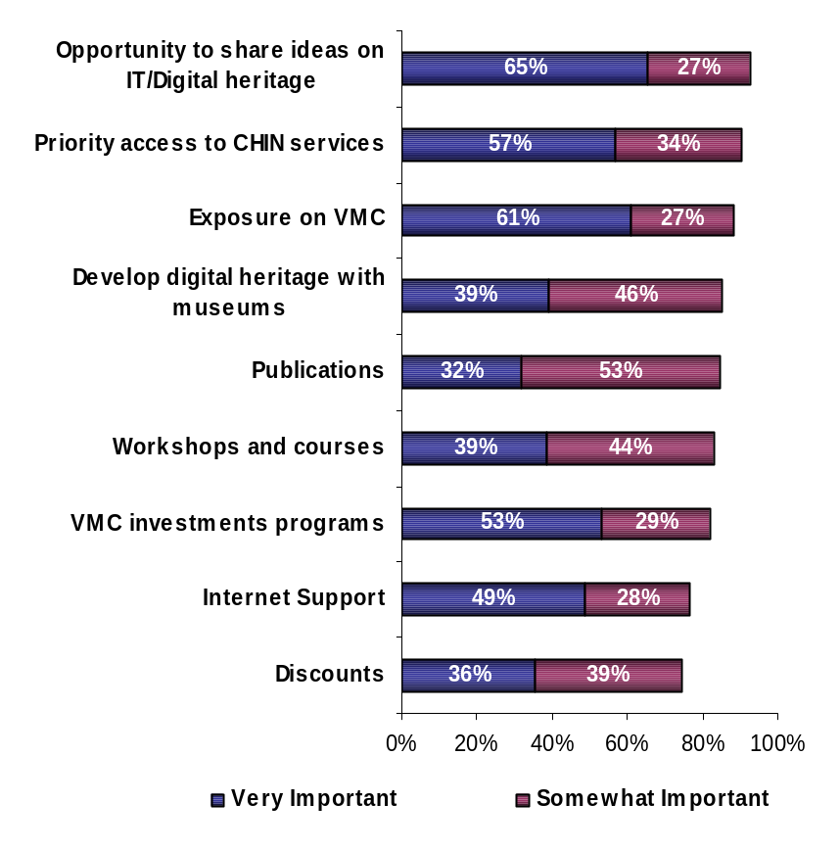

Base: All respondents, n=168

Contributing members were more likely to say it is very or somewhat important to have the exposure of their institution’s collections and activities online through the VMC, compared to basic members. (96% vs. 86%)
Similarly, respondents in Ontario are more likely (97%) to say it is very or somewhat important to have the exposure of their institution’s collections and activities online through the VMC compared to respondents from the West or the Maritimes (86% and 80% respectively).

Respondents in Western Canada were less likely to say it is very or somewhat important to have priority access to all CHIN services and activities (82%), compared to those in the Maritimes (96%), and in Ontario (97%).

Executive Interview Insights

Respondents were asked to explain what they considered CHIN strengths and weaknesses.

Areas in which CHIN is seen as particularly strong include Artefacts Canada, their distribution of information to keep their members updated, providing Internet access, providing guidance and standards to get museums online, online catalogues, the digitization of photographs, collections management software, and other funding programs such as the VMC Investment Program, Virtual Exhibits, and the Community Memories Program.

When asked to explain these successes, many felt they originated from the financial support offered by the federal government. Others felt they are attributable to the participation from multiple museums, CHIN’s up-to-date knowledge of technology, the encouragement given to museums to share information, the promotion of CHIN as an organization across its membership, and the coherence of its website.

Generally, CHIN’s perceived weaknesses are associated to technical issues and communication by electronic means. A number of respondents mentioned facing technical challenges, specifically with the navigation of CHIN’s website and changing data in it. Others also experienced trouble with some of the software provided to them by CHIN. And finally, some respondents felt that the communication from CHIN via e-mail and / or the Internet is not always effective – a number of respondents feel overloaded with information received via email and sense that some of the communication with or from CHIN would be more effective if it were mostly conducted over the phone or in person.

Another weakness related to the nature of the training programs offered. Although most of those having followed a CHIN-sponsored course were satisfied, there remain a few respondents who did not agree with the way education programs are marketed. They seemed to believe that the descriptions make the courses sound too complicated, or that they are either too basic or too advanced for their needs.

Interestingly, some members felt CHIN was weak with respect to areas where CHIN has not traditionally been active. For instance, some members would like CHIN to be involved in non-digital related areas of museum management and administration, such as physical exhibit planning, display area planning, filing, etc.

Finally, members seemed to believe that small organizations (those with about 1 or 2 employees) should deserve more attention. A few also complained about the fact that CHIN dropped the collections management component of their service.

Participants provided some suggestions to help rectify some of these perceived weaknesses:

- Suggestions related to the software issues included sending more step-by-step user bulletins, or updates or “check-ups” throughout the process to avoid frustration.
- As for communication, suggestions included distributing single-page information notes in PDF format that are easy to download and archive, and to have more one-on-one informal meetings with members.
- Members seem to think that they need to be provided a more organized and comprehensive outline of training activities hosted by CHIN. They seem to feel that they need to do all the searching for these training activities whereas CHIN should be keeping them informed via communication bulletins. As well, given the fact that not all members are necessarily technologically adept, course descriptions need to be simplified so that all members can judge their respective value for their institution.

Becoming a CHIN member is considered an easy process.

The majority of respondents indicated that the process to join CHIN is rather easy. While almost half of all respondents (48%) find the process ‘very easy’, over a third consider it ‘fairly easy’, and less than 5% find it ‘fairly’ or ‘very’ complicated. Over a tenth of respondents were probably not involved in the application process, as they opted not to give an opinion. (QA4)

Evaluation of Membership Application Process

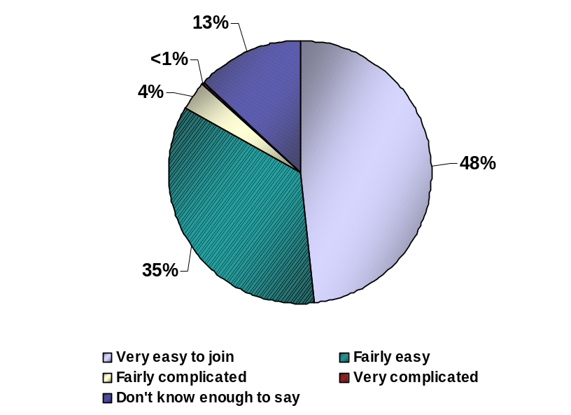

Base: All respondents, n=168

Respondents from the West are less likely (74%) to say that the process to join CHIN is either very easy or fairly easy, compared to those in Quebec (90%) and in the Maritimes (92%).

CHIN Products and Services

Artefacts Canada
The use of Artefacts Canada is predominantly focused towards the Humanities section for research purposes.

Respondents were asked what sections of Artefacts Canada they visit. The majority of survey participants say they visit the Humanities section of Artefacts Canada (87%) while about a fifth access the Archaeological section, and over a tenth visit the Natural Sciences section (13%). (QB10)

Artefacts Canada Sections Used
Canadian Newspapers Advertising Amount
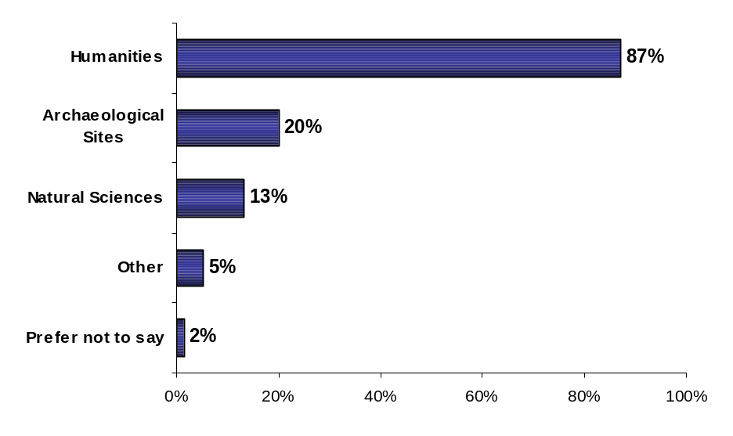

Base: Respondents who access Artefacts Canada, n=96

Over two thirds of respondents use Artefacts Canada to conduct research for exhibitions. More than four in ten respondents say discipline-specific research or to find images is the most common use of Artefacts Canada. Four in ten respondents also use this database to support their collection management. Around one third use it for personal purposes or to look for copyright information. Other uses include education (25%), conservation (20%), and specific provincial information (13%). (QB11)

Reasons for Accessing Artefacts Canada
Canadian Newspapers Advertising Amount
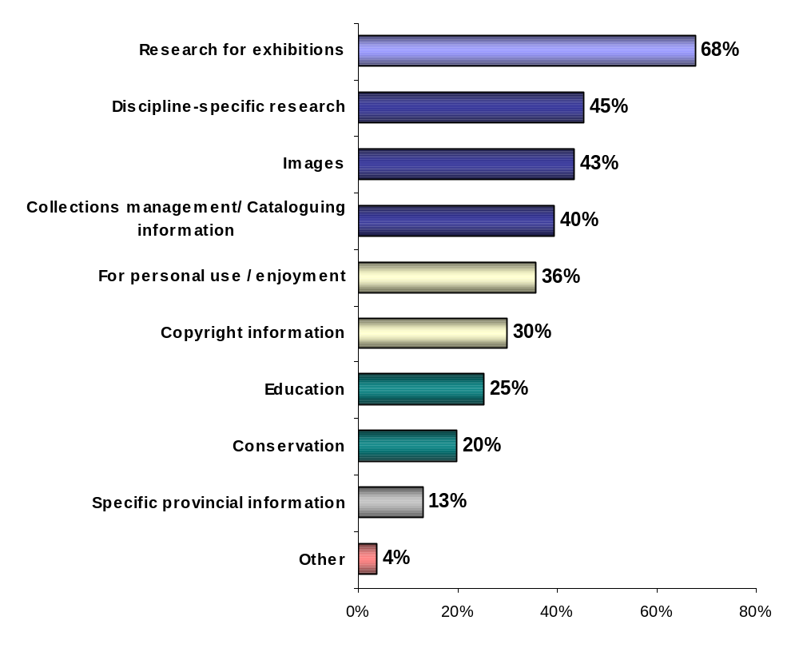

Base: Respondents who access Artefacts Canada, n=96

Respondents could not easily suggest additions to Artefacts Canada. Generally, suggestions related to providing more links and additional background on artefacts and artists.

When respondents were asked in an unprompted manner what kind of information they would like to see added to Artefacts Canada, three-quarters of respondents did not have anything to say. One tenth would like to see more background about the artists (i.e. biography) or the artefacts. From 1% to 5% of respondents suggested the inclusion of more images, links to descriptions, a keyword search, and international access to institutes and their artefacts. (QB12)

Information to Add to Artefacts Canada

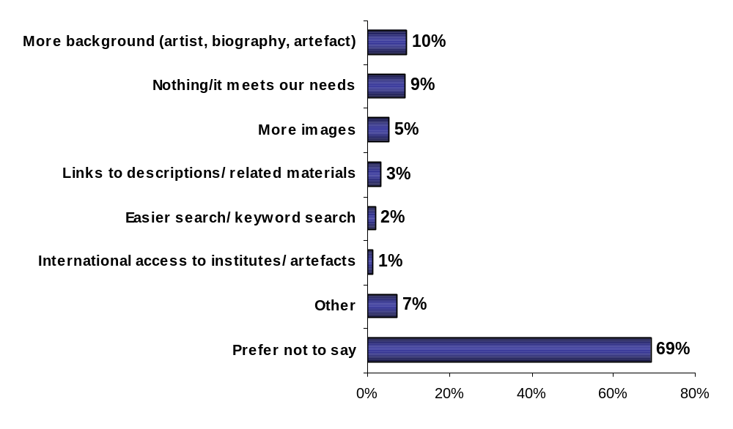

Base: Respondents who access Artefacts Canada, n=96

Having obtained suggestions in an unprompted manner, respondents were provided a list of possible additions to Artefacts Canada. At least three quarters of respondents were either ‘very’ or ‘somewhat’ interested in each of the suggestions. The most appealing suggestion was the addition of links to related information (97%), followed by curatorial information (95%), multimedia information (86%), oral histories (83%), and finally intangible heritage (74%). (QB13)

Information to Add to Artefacts Canada (Prompted)

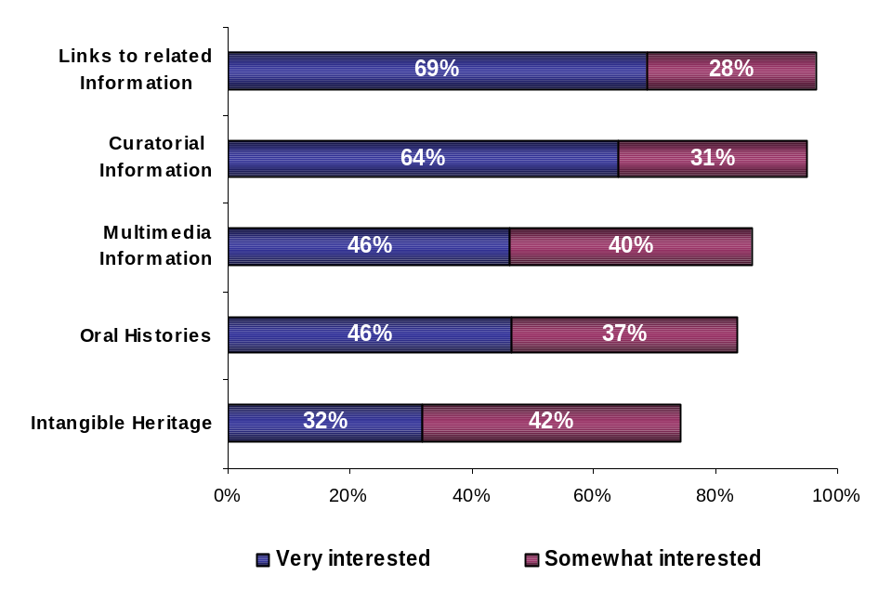

Base: Respondents who access Artefacts Canada, n=96

Basic members were more likely to say they would be very or somewhat interested in seeing multimedia information added to Artefacts Canada, compared to contributing members (91% vs. 74%).

Six in ten Artefacts Canada users “often” find what they search on the site.
In general, over half of respondents (55%) actually access Artefacts Canada while more than four in ten respondents claim not to be users of this database. Over two thirds of Artefacts Canada users find what they search for either always (5%) or often (61%), while the remaining third find what they are looking for occasionally (28%) or rarely (6%). (QB9)
Access and Success of Searches Using Artefacts Canada
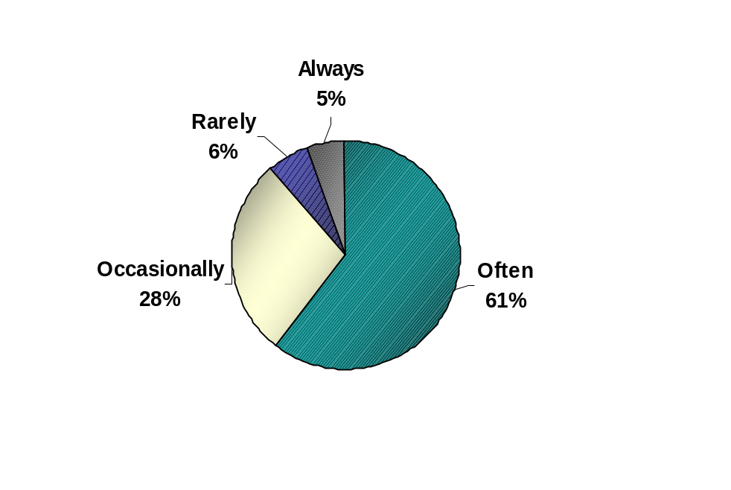
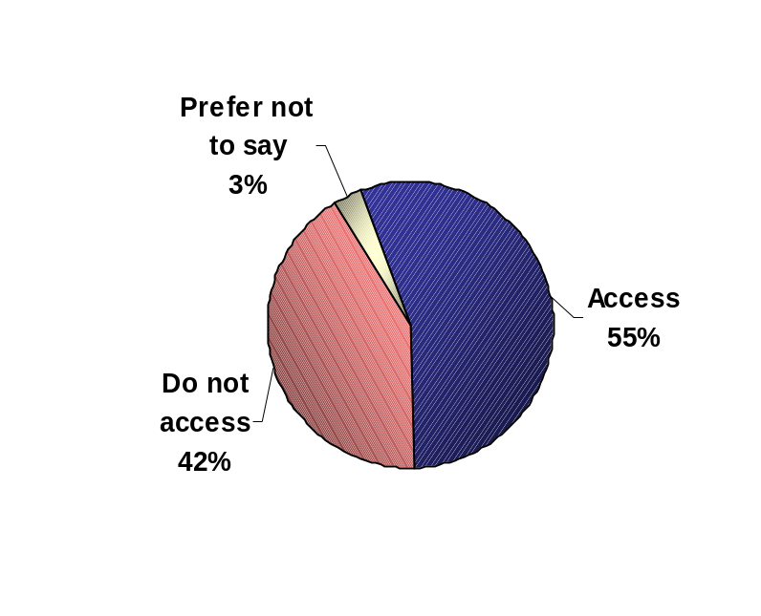
Base: All respondents, n=168
Base: Respondents who access Artefacts Canada, n=96

Executive Interviews Insights

Organisations in Quebec seem to be completely satisfied with Artefacts Canada in terms of content, support, navigation, promotion of collections, exposure, and research – “Ce service est plus que pertinent. Il nous permet de diffuser nos collections, de faire connaître d’autres musées à la population canadienne. Ce service nous permet aussi d’échanger et de découvrir ce que d’autres musées ont". In contrast, respondents from organizations outside Quebec are not very familiar with Artefacts Canada.

Those who are aware of Artefacts Canada do not use the database on a regular basis, and a few mention it needs more information about the records, an easier way to conduct a search, easier navigation, better organization of the catalogues, more images, and better technical support. Others say they like Artefacts Canada but do not access it because of the lack of time, or because it is overly oriented to Central and Eastern Canada.

The reasons for not contributing to Artefacts Canada are mainly related to collections management systems issues and process complications such as lack of staff or an impression that the process is complicated.

The reasons for not contributing to Artefacts Canada are mostly related to the lack of automated data or collections management systems. Over a third of non-contributors report that they do not have an automated collections system (39%), while 32% do not have a sufficient quantity or quality of automated data, and 10% are in the process of automating records.

Additional results show that 15% of non-contributors were not aware they could contribute, 8% find the contribution process too complicated, 7% say they might contribute in the future, and 5% do not have enough staff to get involved in this process. Finally, 8% of non-contributors are not interested and 6% already have their collections on their own website. (QB2)

Reasons for Not Contributing to Artefacts Canada

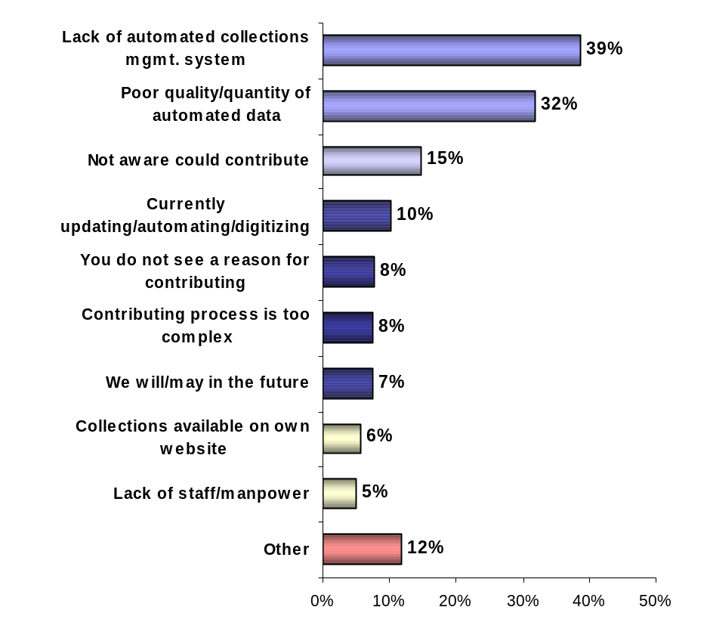

Base: Respondents whose organization has not contributed to Artefacts Canada, n=97
In terms of possible recommendations, current contributors are for the most part pleased and feel no changes need to be made to the process (32%) and another 36% did not provide any answer. As for non-contributors, most did not provide any insight. (QB3)

Recommendations for the Contribution Process

 | Contributors  (n=61) | Non-contributors  (n=97)
It is easy to use/none/no changes/suggestions/satisfied | 32% | 8%
Make process easier/less confusing/more intuitive | 9% | 8%
Technical support/on-line help was good | 7% | -
Grants/funding/extra resources | 6% | 6%
Long process/time consuming/make it quicker | 5% | -
Provide extra staff to complete task | 3% | 1%
Luc Pesant was a great guide/helpful | 3% | -
Experienced problems/difficulties (general) | 2% | -
Universal collections management database/more compatibility | 1% | 1%
Provide software/computer program | <1% | -
In the process currently (general) | - | 1%
Provide free/low cost software | - | 2%
Make institutions/CHIN members more aware of process | - | 2%
Other | 2% | 2%
Don't know enough to comment/unfamiliar with process/Not applicable | 4% | 21%
Prefer not to say | 36% | 52%

CHIN has a strong presence as a collections management software information provider. Seven in ten respondents claim being aware of CHIN’s Software Review.

In total, one fifth of respondents are currently looking for collections management software. As well, two thirds are aware of CHIN’s collections management software review, and 42% of all respondents have considered using their software review. (QB5, QB6, and QB7)

Collections Management Software Review – Use and Awareness

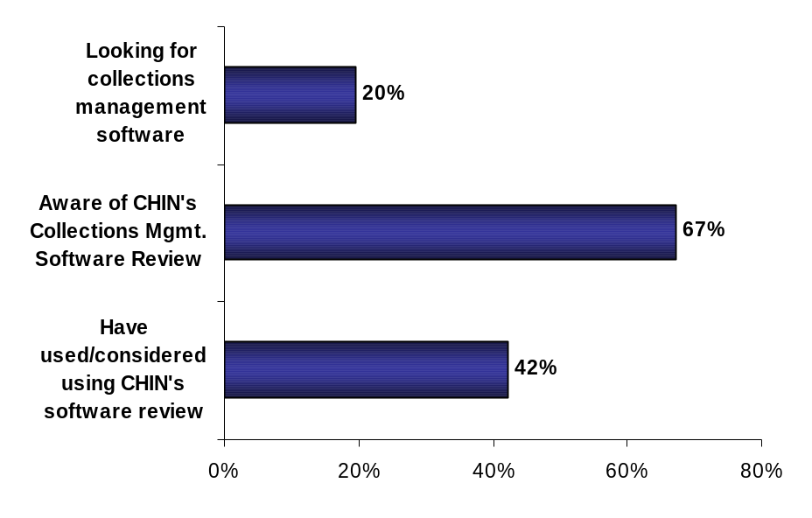
Base: All respondents, n=168
In total, 71% of respondents report having a collections management system in place. The most common software is GCI’s Vital Collections/File Maker Pro (27%), followed by Access or a customized version of it (15%). To a lesser extent, respondents mentioned Past Perfect (3%), Inmagic (2%), Heritage Sentinel (2%), Superbase (2%), Access to Collections (1%), Micro-Musee (1%), Gestions des Collections Innis (1%), Museum Information Management System (MIMS) (1%), or an unspecified database (1%). (QB4)

Collections Management Software Used

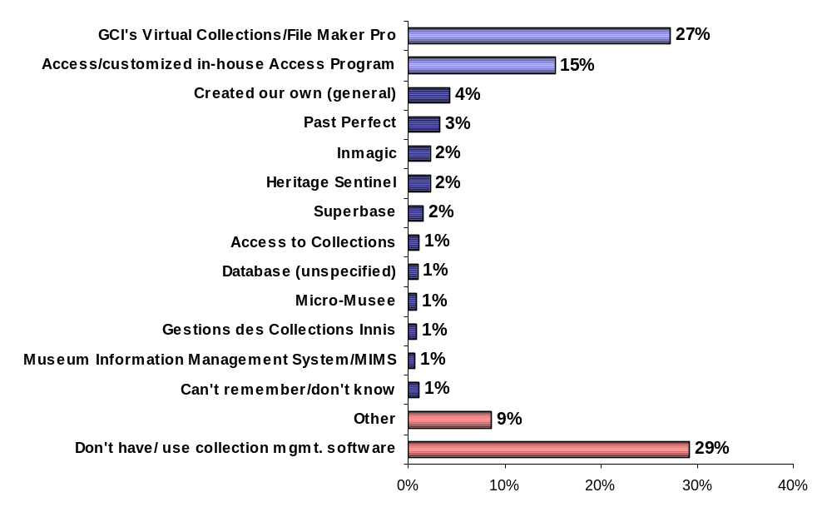

Base: All respondents, n=168
Over half (55%) of respondents who have used or considered using CHIN’s Collections Management Software Review (n=73) think its comparative analysis function is the most relevant (55%), while over a fifth (22%) consider the criteria checklist the most important feature, and 14% consider the product profile the most important feature. (QB8)

Most Relevant Collections Management Review

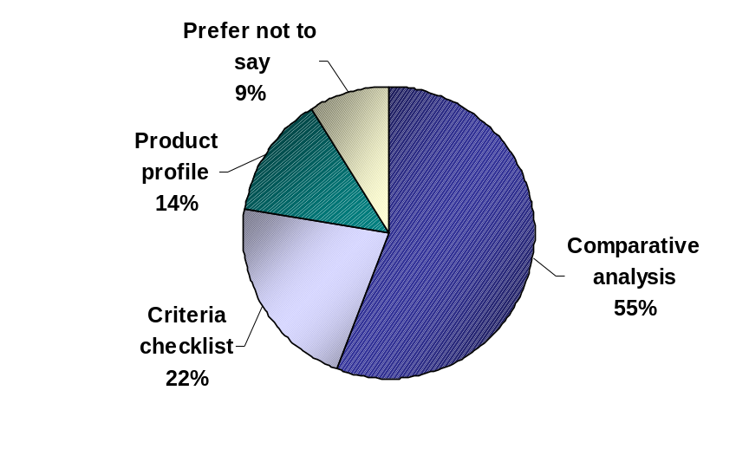

Base: Respondents who have used or considered using CHIN’s Collections Management Software Review, n=73

VMC Image Gallery
The Image Gallery is popular and visited mainly for research purposes and recreation.

Approximately three-quarters of respondents report consulting the Virtual Museum of Canada Image Gallery at least a few times a year. Almost a fifth of respondents claim to visit a few times a month (19%), or about once a month (17%). About four in ten respondents visit the VMC Image Gallery a few times a year (39%). Approximately one in ten members can be considered “lapsed” Image Gallery users since they have accessed the site within the past two years but not recently. Approximately 12% of respondents have not visited the VMC Image Gallery. (QB15)

Frequency with Which the VMC Image Gallery is Consulted

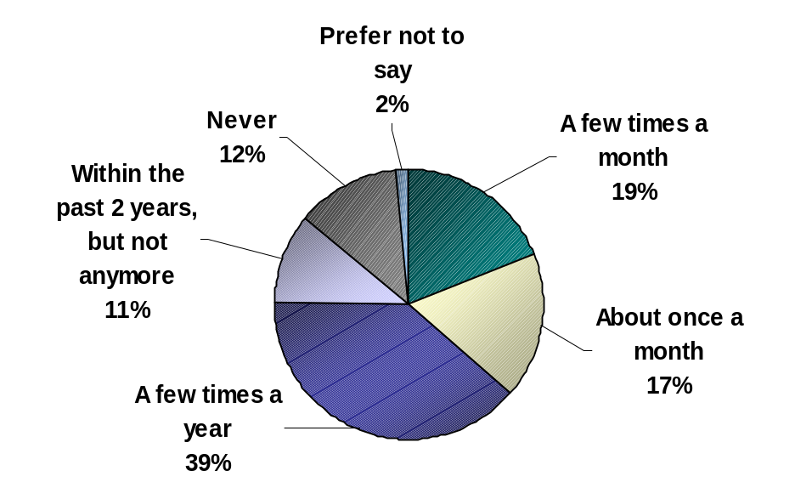

Base: All respondents, n=168
Similar to Artefacts Canada, two-thirds of Image Gallery users (i.e. having accessed at least once within the past year, n=127) say their main reason for accessing the Gallery is to conduct research for exhibitions (65%). The Image Gallery appears to be attractive to almost half of its visitors (47%) for personal enjoyment purposes. About 43% of users indicated they access the site for the images themselves, without specifying a purpose or reason for accessing them.

Other common reasons to accessing the VMC Image Gallery include for education purposes (34%), to research for a specific discipline (33%), for collections management related reasons (29%), for copyright information (21%), for conservation (13%), and for specific provincial information (13%). (QB16).

Reasons to Access the VMC Image Gallery

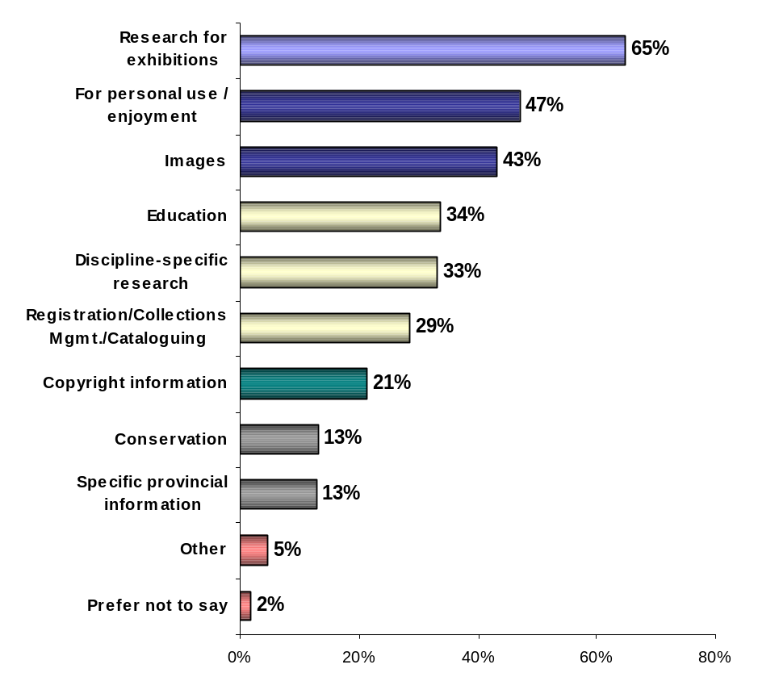

Base: Respondents who consult the Image Gallery on the VMC, n=127
Less than a fifth of respondents suggested changes or additional information they felt could be added to the VMC Image Gallery. The only additions participants could recommend were more background information on the artists or the images (7%), more images (3%) and links to descriptions or related materials (1%). (QB17)

Desired Information on VMC Image Gallery

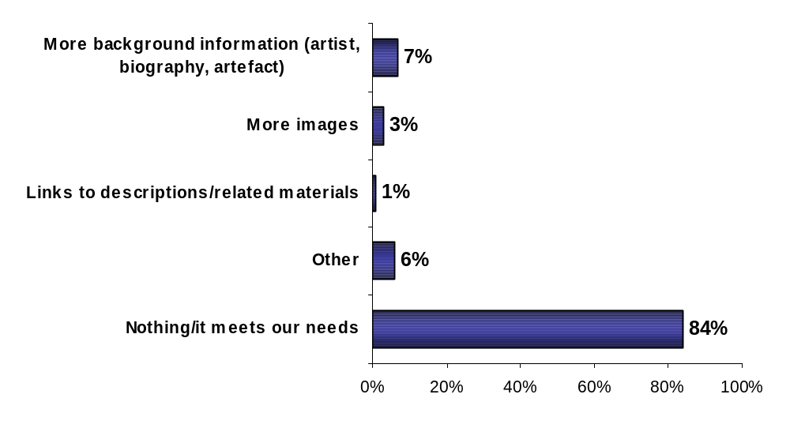

Base: All respondents, n=168

Virtual Museum of Canada
Overall, the VMC is well perceived by members, especially with respect to its content, its various services and the quality of its featuring.

The Virtual Museum of Canada is clearly a successful initiative. More than four in five respondents rated the Virtual Museum of Canada as either ‘excellent’ (32%) or good (53%), while 7% consider it ‘fair’ (6%) or ‘poor’ (1%). Only a few respondents have never visited the VMC (5%). (QB18)

This result was consistent across the various types of institutions and across the country.

General Evaluation of Virtual Museum of Canada

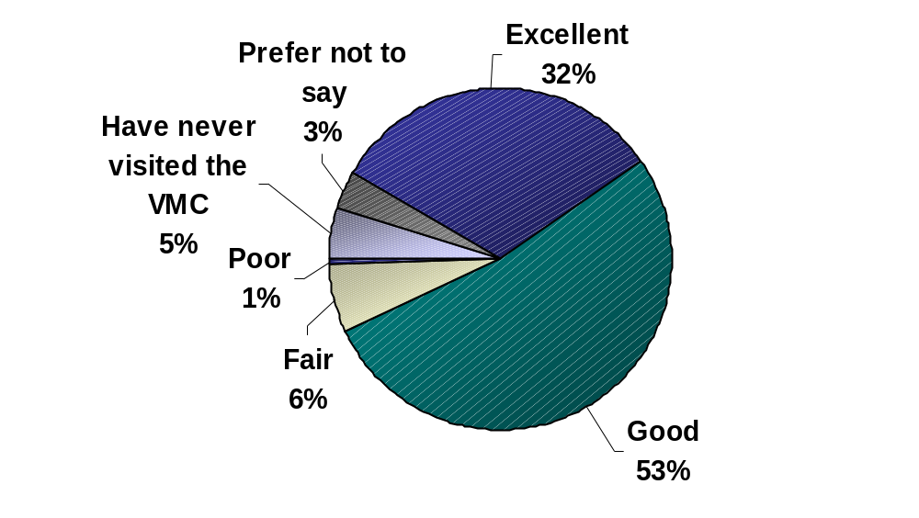

Base: All respondents, n=168
The positive image of the VMC is well supported by the evaluation of its specific features. The majority of respondents (88%) who have visited the VMC (n=153) rated the quality of content either ‘excellent’ (31%) or good (57%). The quality of services was also well perceived by 88% of respondents, where 29% rated it as ‘excellent’ and 59% as ‘good’. The VMC’s quality of featuring is also well perceived as 21% rated this feature ‘excellent’ and 66% rated it ‘good’.

Although not their strongest features, the site design and navigation and the search engines still received very positive ratings. The quality of the site design and navigation was evaluated positively by 78% of respondents, with 18% of them rating the feature as ‘excellent’ and 60% as ‘good’. Finally, the quality of search engines was well received by 74% of respondents, of whom 17% considered it ‘excellent’ and 57% considered it ‘good’. (QB19).

VMC Features Evaluation

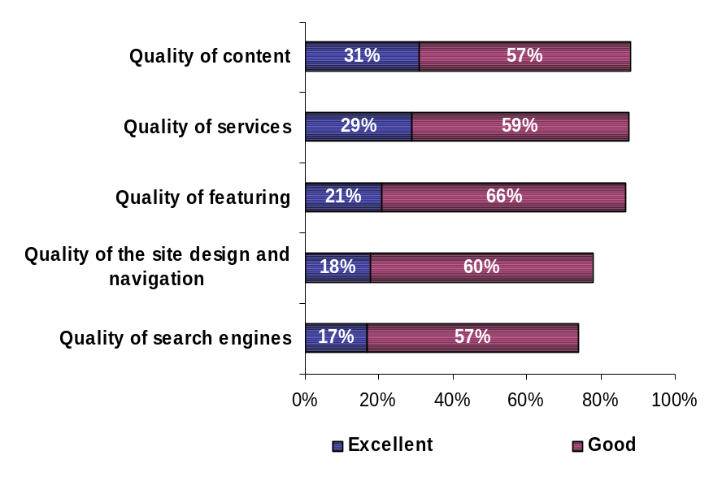

Base: Respondents who rated the Virtual Museum of Canada, n=153

Executive Interview Insights

Although the online survey results showed members quite pleased with the VMC, the executive interviews revealed that respondents are not very familiar with it. This made it difficult for many to make recommendations or suggestions for improvements.

Of the few who access it on a regular basis, they suggested hosting a one-page mini website for the different museums in Canada instead of just a list of members. Other suggestions included more small museums; having more institutions and partners involved that could direct people to the website, such as public libraries; further promoting the site as a research tool, especially with established teachers and entry-level teachers; and enhancing the visibility/ publicity to the general public, i.e. through a newsletter.

Respondents also suggested incorporating easier navigation into the site, with more images, and smaller but more exhibits. Other items include a “speakers corner” and a “traveling road show” to create a reference library.

Respondents could not easily explain how the VMC might be expected to evolve over the coming years. Generally, they felt the VMC would evolve along with technology – that as technology becomes more sophisticated and as new tools are developed, they would be integrated into the VMC.

Marketing Initiatives. The majority of respondents support the VMC’s advertising efforts even though some were not aware of them and/or have never seen them. They simply assumed that the initiatives are positive because they help promote their services and collections, and increase the awareness of heritage overall.

Suggestions for improving the marketing initiatives included adding the site in more search engines (i.e. Google), and to increase the focus on marketing channels appropriate for smaller communities, such as local or community based newspapers, tourism associations, economic development associations, and community council associations. Respondents felt this would improve the outreach to average Canadians and to those who do not regularly engage in the arts.

Although not specific to the VMC, a few respondents would like to have CHIN marketing collateral, such as brochures, rulers and pens that they can hand out at their museum events. They have often found themselves having to explain what CHIN is about and this kind of material would at least make sure they are providing appropriate information.

CHIN Investment Programs
Awareness of the three investment programs is mixed, ranging from about 50% for the CHIN Executive produced Virtual Exhibits to a high of 80% for the Community Memories program. Familiarity does not breed usage, however usage does breed satisfaction.

Survey participants were asked to indicate their familiarity, level of access, satisfaction and perceived relevance of three main CHIN programs: the CHIN Executive produced Virtual Exhibits, the VMC Investment Program, and the Community Memories Program.

In general, respondents are more likely to be familiar with the Community Memories Program (81%) and the VMC Investment Program (72%) than with the Executive produced Virtual Exhibits (51%). (QC1). Despite the high levels of familiarity, approximately one-third of those familiar with each program claim to have accessed at least one of these programs in the last 3 years, ranging from 29% for Community Memories to 37% for the Executive produced Virtual Exhibits. (QC2)

Despite low participation, satisfaction and perceived relevance are high. Over four in five respondents who have accessed a program are either ‘very satisfied’ or ‘somewhat satisfied’ with it (QC3). More than half of all respondents think the CHIN programs are either ‘very relevant’ or ‘somewhat relevant’ to their organization. (QC4)
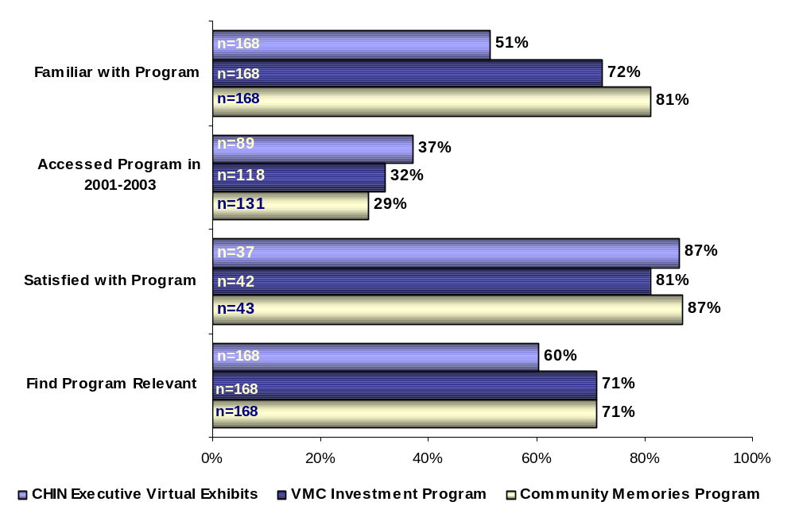

CHIN Programs

Analysis for each of the programs with respect to relevance reveals a strong relationship between usage and relevance. As is the case for each of the three programs, those having accessed the actual program since 2001 are much more likely to consider the program relevant for their institution compared to those who are familiar with the program but have not used it.

Relevance of CHIN Programs by Access of Programs
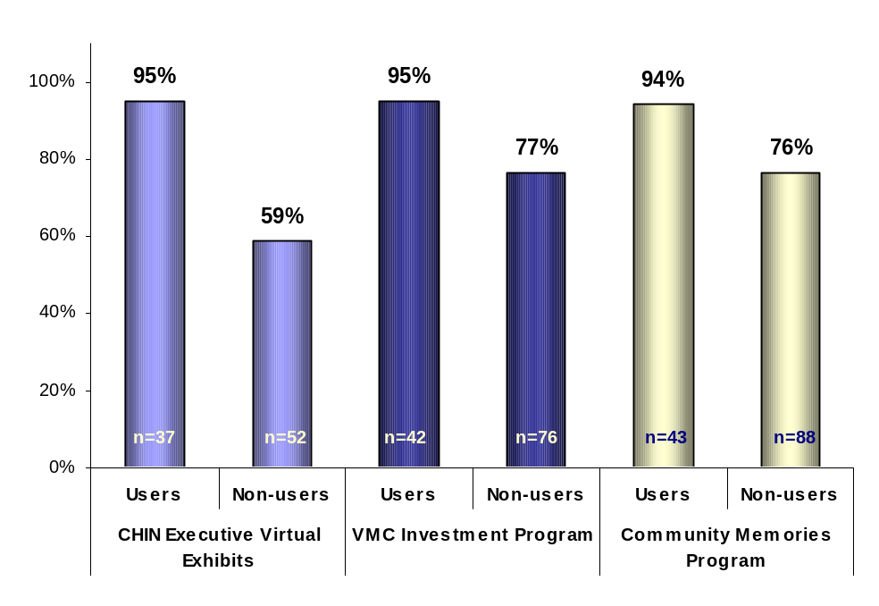

Base for “Users”: Respondents who accessed the program in the last 3 years
Base for “Non-users”: Respondents familiar with the program but have not accessed
it in the last 3 years

Executive Interview Insights

When respondents were asked if the current CHIN programs meet their organization’s needs regarding information technology and museum digital heritage, respondents said that CHIN programs meet their organization’s needs insofar as they have the time and resources to take advantage of them. The majority feels there is no need for changes as the programs are currently good. There is nonetheless a sense that despite the quality and variety of the programs, members do not have the time or staff to take advantage of them.

CHIN Executive Produced Virtual Exhibits
Approximately half of survey participants are familiar with the Executive produced Virtual Exhibits. Among these respondents, participation seems to be higher in the last year. In total, 37% of respondents have accessed this program during the last 3 years. (QC1a and QC2a)

Familiarity and Access to Executive Produced Virtual Exhibits

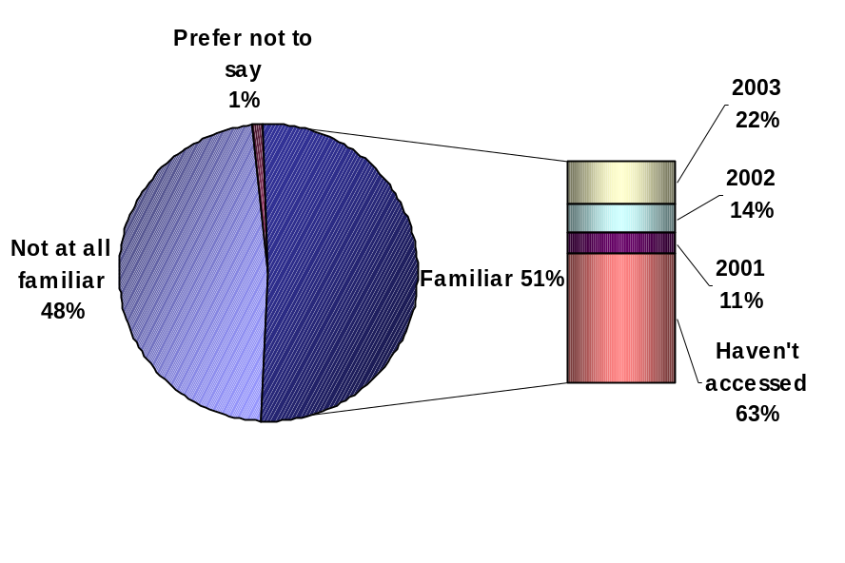
37%

Base: (QC1a) All respondents, n=168; (QC2a) Respondents familiar with Ex. Virtual Exhibits, n=89

Over four in five users (86%) are satisfied with the Executive produced Virtual Exhibits. Almost half (47%) say they are ‘very satisfied’, 39% say they are somewhat satisfied, and 7% say they are neither satisfied nor dissatisfied. (QC3a)
Satisfaction with Executive Produced Virtual Exhibits
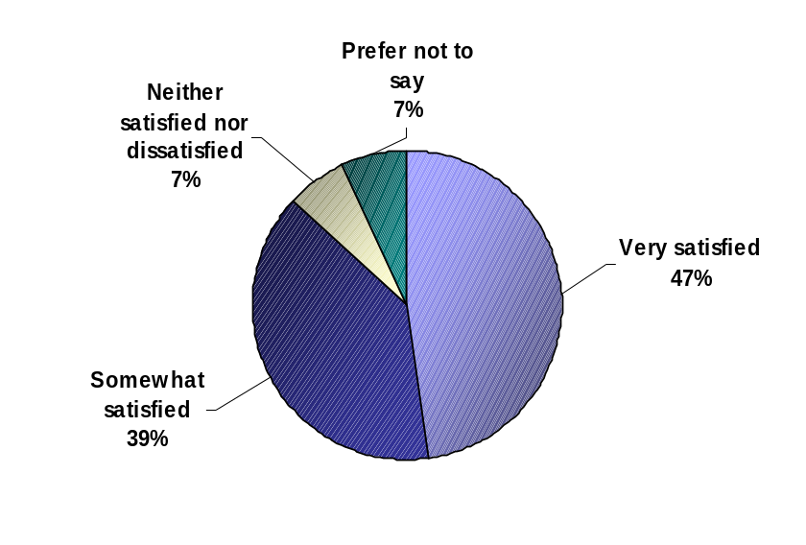

Base: Respondents whose organization has accessed Exec. Produced Virtual Exhibits in the past 3 years, n=37

Under two thirds of all respondents (60%) say the Executive produced Virtual Exhibits program is relevant for their organization. Almost a quarter (23%) say this program is ‘very relevant’, 37% say it is ‘somewhat relevant’, 20% say it is not very relevant, and 10% say it is not at all relevant. (QC4a)

Relevance of Executive Produced Virtual Exhibits

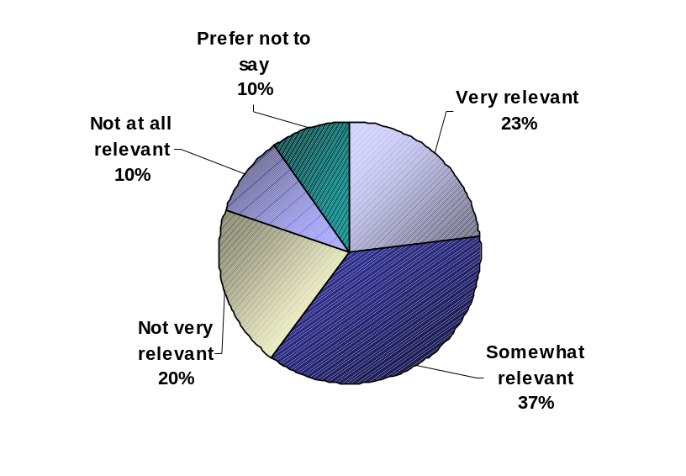

Base: All respondents, n=168

Executive Interview Insights

Members were asked their opinion about the CHIN Executive produced Virtual Exhibits. A few respondents feel this program is too big for the type of organization they are. Only one respondent was very familiar with the program and felt the collective project they participated in was very interesting. However, many respondents are not too familiar with this program. After being read a description of the program, they seemed to be interested and thought it was relevant for their organization. In general, respondents suggested revising this program for smaller institutions and adjusting the website to make it easy to visit for those who have dial-up Internet access.

VMC Investment Program – Virtual Exhibits
Close to three quarters of survey participants are familiar with the VMC Investment Program. Among these respondents, participation in this program has been increasing since 2001. In total, 32% of respondents have accessed this program during the last 3 years. (QC1b and QC2b)

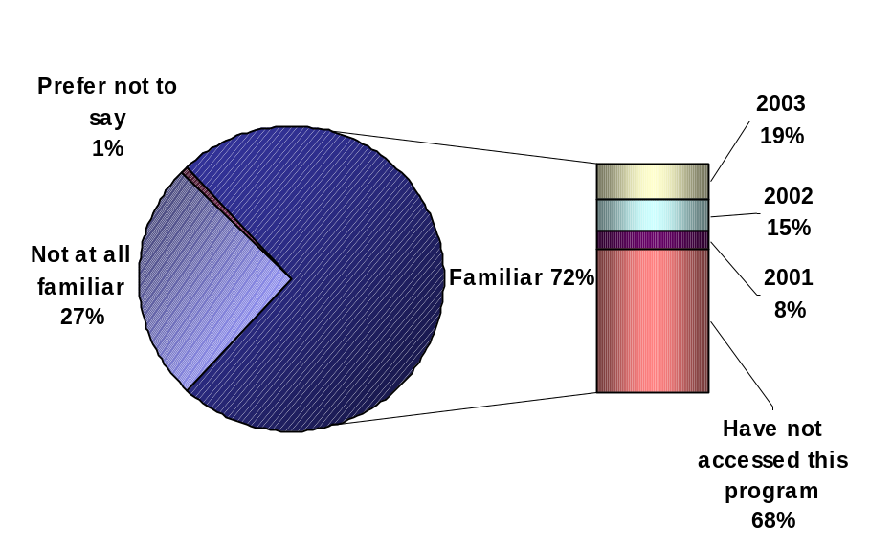
32%
Familiarity and Access to VMC Investment Program

Base: (QC1b) All respondents, n=168; (QC2b) Respondents familiar with VMC Inv. Program, n=118

Four in five program users (80%) are satisfied with the VMC Investment Program. Almost half (47%) say they are ‘very satisfied’, 33% say they are somewhat satisfied, 5% say they are neither satisfied nor dissatisfied, and 8% say they are somewhat dissatisfied. (QC3b)

Satisfaction with VMC Investment Program
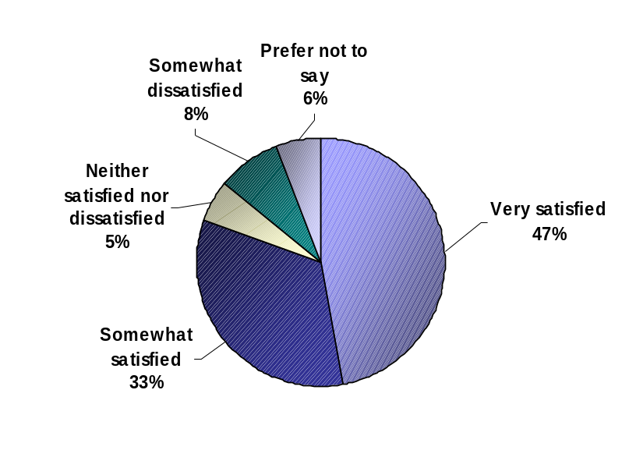

Base: Respondents whose organization has accessed VMC Inv. Program in the past 3 years, n=42

Over two thirds of all respondents (71%) say the VMC Investment Program is relevant for their organization. Almost a quarter (38%) say this program is ‘very relevant’, 33% say it is ‘somewhat relevant’, 13% say it is not very relevant, and 7% say it is not at all relevant. (QC4b)

Relevance of VMC Investment Program
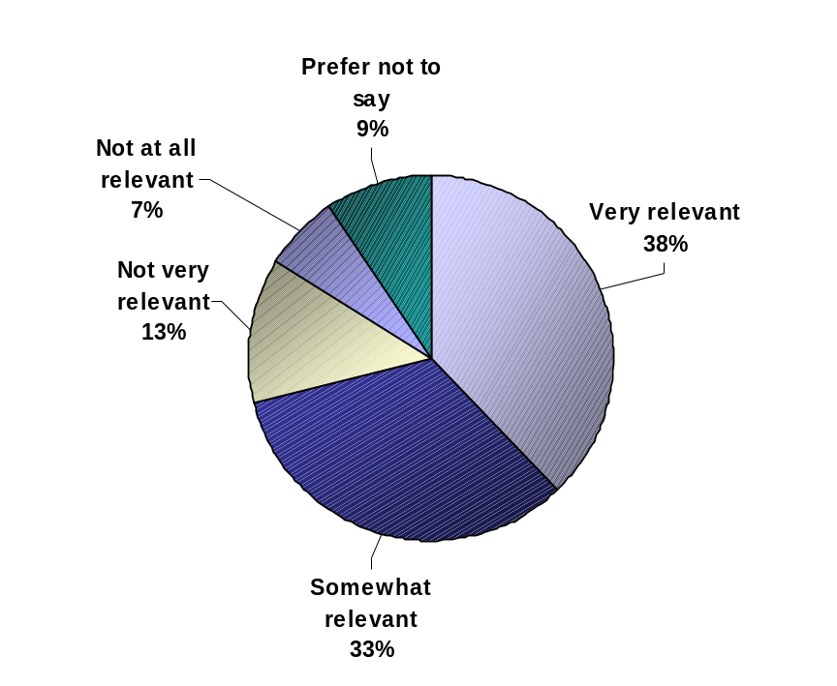

Base: All respondents, n=168

Executive Interview Insights

When respondents were asked their opinion about the Virtual Museum of Canada Investment Program, most respondents were not very familiar with this program. After a brief description most of them said it is a relevant program for their organization, but they feel it is too big for their capabilities, overwhelming, and too complex. Suggestions to improve the VMC Investment Program are to negotiate the copyrights in a collective way, and to make the program simpler and clearer, and to adjust it so small organizations can participate.

Community Memories Program
Approximately four in five survey participants are familiar with the Community Memories Program. Among these respondents, 29% say they participated in this program in 2003. (QC1c and QC2c)
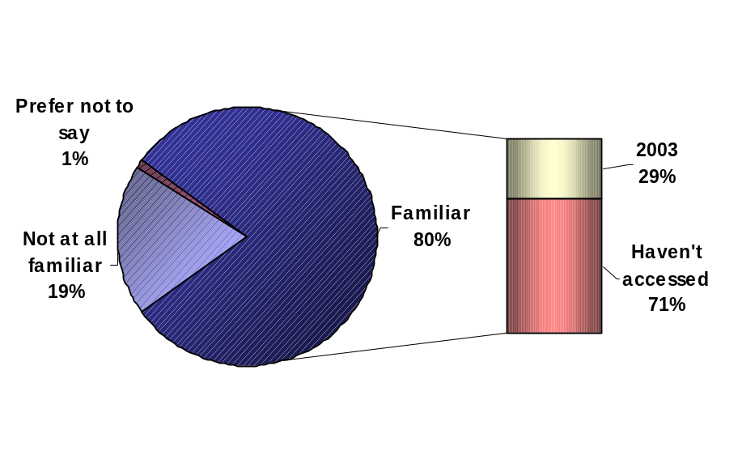
Familiarity with the Community Memories Program

Base: (QC1c) All respondents, n=168; (QC2c) Respondents familiar with Community Memories Program, n=131

Over four in five program users (83%) are satisfied with the Community Memories Program. Almost half of respondents (47%) are ‘very satisfied’, 36% are somewhat satisfied, 3% are neither satisfied nor dissatisfied, 5% are somewhat dissatisfied, and 2% are very dissatisfied. (QC3c)

Satisfaction with the Community Memories Program

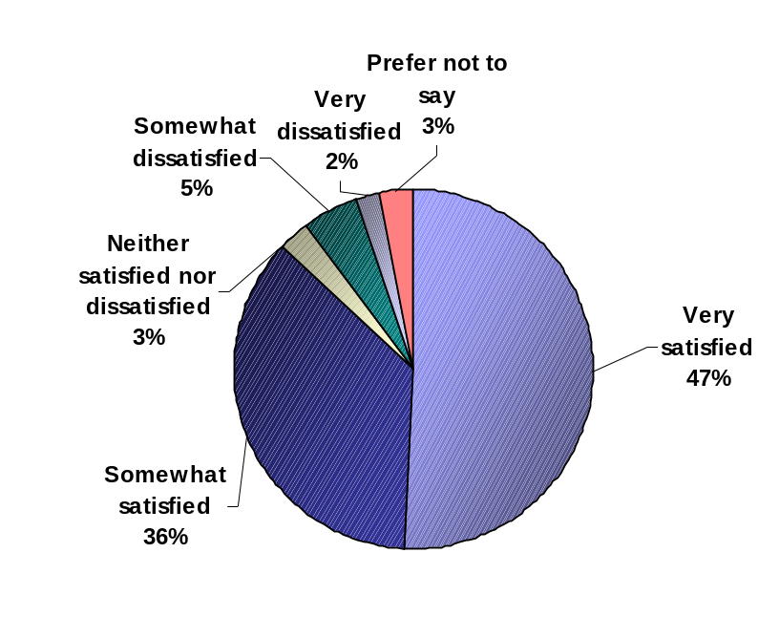

Base: Respondents whose organization has used the C. Memories Program in the past 3 years, n=43
Close to two thirds of all respondents (71%) say the Community Memories Program is relevant for their organization. Almost half of all respondents (45%) say this program is ‘very relevant’, 26% say it is ‘somewhat relevant’, 1% say it is not very relevant, and 11% say it is not at all relevant. (QC4c).

Respondents in Quebec are the least likely to say that the Community Memories Program is either very or somewhat relevant to their organization (42%), compared to respondents in Western Canada (73%), Ontario (72%), and the Maritimes (92%).

Relevance of the Community Memories Program
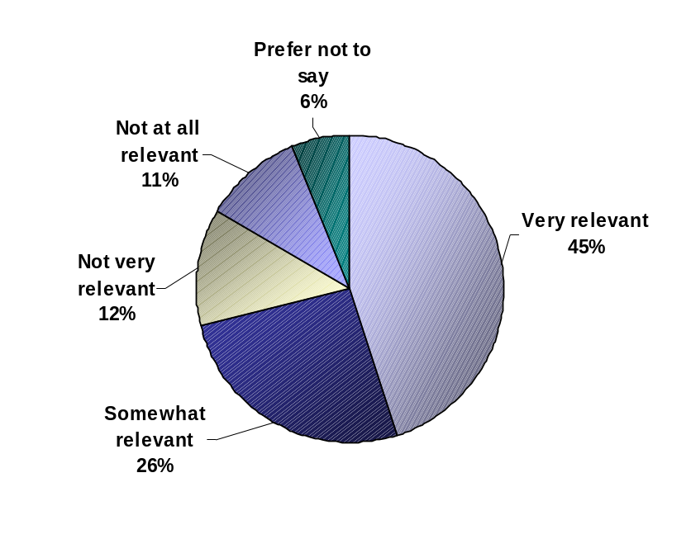

Base: All respondents, n=168

Executive Interview Insights

Respondents were asked their opinion about the Community Memories Investment Program. Most respondents are aware of this program and many are currently taking advantage of it. Some find the application process too long and that the effort to “get their story out” too overwhelming. As well, participants were somewhat frustrated by the fact that they did not know what all these efforts would generate – they did not know what to expect, however having seen the results, they are for the most part pleased with the outcome and with the fact that it is an opportunity for small organizations too – “It’s an ‘inter-generational’ wonderful tool”.

Apparently some respondents experienced software problems that caused frustration and discouragement, like the limitation on the size and number of pictures they could use. More freedom on what the museums want to do is expected, as opposed to having to meet the criteria of the program. Other respondents expressed interest participating in the future, an interest that is constrained solely by time and resources.

Some improvements for the program include reducing the paperwork, providing funding to hire a special person to work on the project, having flexible deadlines (to avoid situations where the person that is working on it leaves the organization), simplifying the software required, and increasing communication with members throughout the initiative to provide ongoing assistance and guidance (a number of participants felt they were on their own).

Marketing Initiatives
The new CHIN marketing initiatives show great potential, especially the television series and the development of a digital heritage repository.

The vast majority of respondents (92%) showed interest in having their organization participate in possible partnerships with CHIN. Respondents were presented four different initiatives and were asked to rate their interest in each of them. (QD1) Those from Ontario were more likely to say that their organization would be very or somewhat interested in participating in partnerships with CHIN (100%), compared to respondents in Western Canada (90%), and in Atlantic Canada (86%).

Seven in ten respondents (71%) said they are interested in participating in the television series initiative, which would be built from content developed for Virtual Exhibits, games and other museums’ digital content. Over a quarter (25%) are ‘very interested’ and 44% are ‘somewhat interested.’ (QD2a) Over two thirds of respondents (68%) say they are interested in developing and hosting a secure national repository of high resolution digital images for museums’ potential commercial activities. Over a quarter (26%) indicated they are ‘very interested’ and 42% indicated they are ‘somewhat interested’. (QD2b)

Two thirds of respondents (66%) say they are interested in repurposing VMC member museums’ virtual exhibit content for other media use such as wireless applications, print, radio, etc. A quarter is ‘very interested’ and 41% are ‘somewhat interested.’ (QD2c) Over half of all respondents (57%) say they are interested in participating in an online shopping area initiative, which would be a portal through which members could advertise and sell products they currently sell. About a fifth of respondents (21%) indicated they are ‘very interested’ and 36% indicated they are ‘somewhat interested’. (QD2d)
Interest in Partnership Possibilities
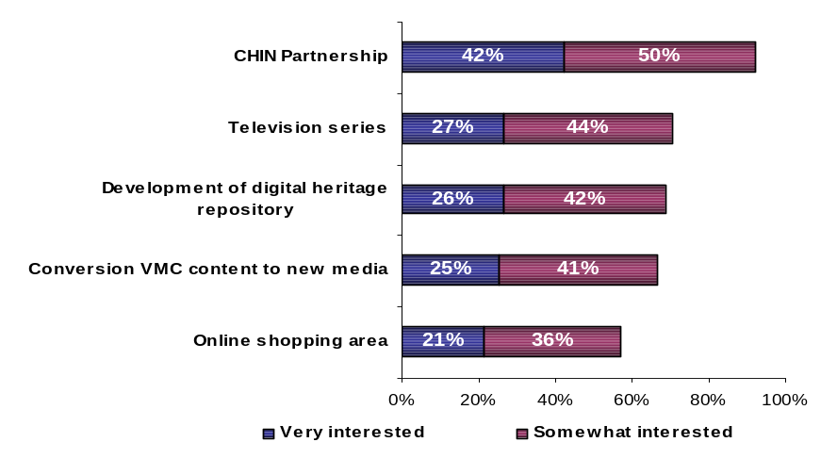

Base: All respondents, n=168

Skills Development

General Evaluation of CHIN’s Learning Resources for Heritage Professionals
Twelve learning resources that CHIN offers to strengthen the knowledge and abilities of heritage professionals were evaluated in terms of familiarity, frequency of use, satisfaction and relevance to members’ organizations.

Awareness was at least 66% for six of the learning resources. Four of the six top learning resources (Artefacts Canada, publications, workshops, and resources from the CCI and CIN) are used a few times a year by over a third of respondents, while online courses and information sharing with other CHIN members are never used by 35% and 27% of respondents respectively. Learning resources that show the highest proportion of satisfied respondents are the resources from the CCI and the CIN (86%), and the e-mail courses (80%). The learning resources that seem to be most relevant are the publications (87%), workshops (87%), and resources from CCI and CIN (82%).

CHIN’s Learning Resources: Familiarity, Frequency of Use, Satisfaction and Relevance

 | Familiar (Top-Two Box) | Frequency  (Highest %) | Satisfaction Among Users  (Top-Two Box) | Relevance (Top-Two Box)
Artefacts Canada | 84% | A few times a year (41%) | 75% | 77%
Publications | 83% | A few times a year (45%) | 73% | 87%
Workshops | 82% | A few times a year (33%) | 70% | 87%
Resources from the Canadian Conservation Institute and the Conservation Information Network | 75% | A few times a year (41%) | 86% | 82%
Online courses | 71% | Never used (35%) | 69% | 79%
Opportunity for members to post and share information with other CHIN members | 68% | Never used (27%) | 73% | 80%
Reference databases | 60% | A few times a year (27%) | 72% | 71%
E-mail courses | 59% | A few times a year (24%) | 80% | 75%
Collaborations/partnerships with other heritage institutions in the development of Executive produced Virtual Exhibits | 57% | Never used (37%) | 53% | 64%
Centre for Exhibition Exchange | 48% | A few times a year (21%) | 60% | 46%
Collaboration, partnership in research initiatives | 42% | Never used (41%) | 39% | 54%
Onsite visits by CHIN staff | 38% | Never used (15%) | 64% | 57%

In total, 81% of respondents are very or somewhat familiar with at least five of the learning resources. On average, respondents are familiar with 8 of the 12 learning resources.

Familiarity with Learning Resources
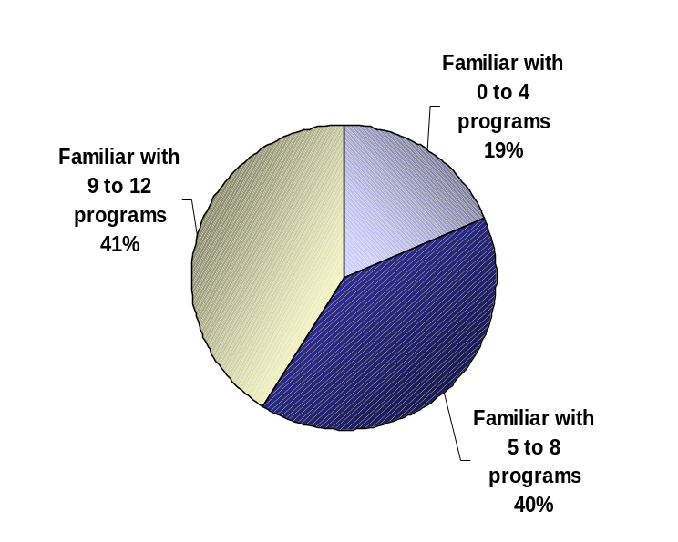

Base: All respondents, n=168

Learning Resources Highly Familiar Among Members
Respondents are most familiar with and are most likely to access Artefacts Canada, CHIN publications and resources from the CCI and CIN. Respondents are also very aware of the workshops, but the availability of and accessibility to this specific service may explain why usage is lower compared to other resources – if the member does not have the time or the staff to participate in workshops when they are presented, they may not be able to participate.

Artefacts Canada
Over four in five respondents are familiar with Artefacts Canada, 32% report being ‘very familiar’, 52% ‘somewhat familiar’, and 15% ‘not at all familiar’. Over a fifth of all respondents (23%) say they have used Artefacts Canada at least once a month, 41% say they have used it a few times a year, and 15% have never used it. (QE1a and QE2a)

Familiarity and Usage of Artefacts Canada

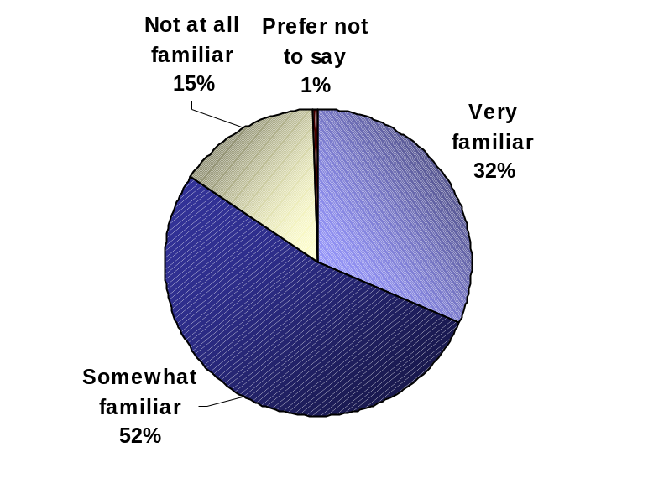

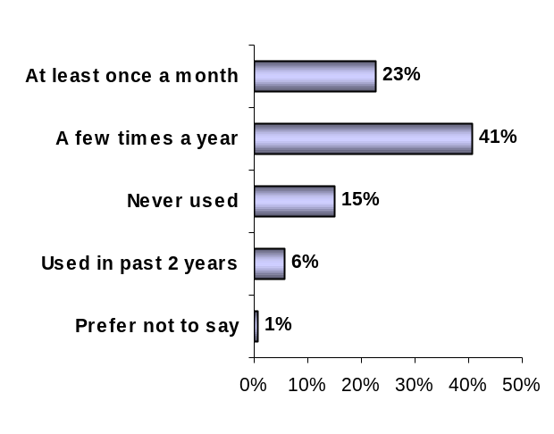

Familiar 84%

Base: All respondents, n=168

Three quarter of users (75%) are satisfied with Artefacts Canada. Almost a third of respondents (32%) say they are ‘very satisfied’, 43% say they are somewhat satisfied, 17% say they are neither satisfied nor dissatisfied, and 5% say they are somewhat dissatisfied.

Respondents in Ontario (91%) and Quebec (97%) are more likely to say they are very or somewhat satisfied with Artefacts Canada, compared to respondents in Western regions (62%). (QE3a)
Satisfaction with Artefacts Canada

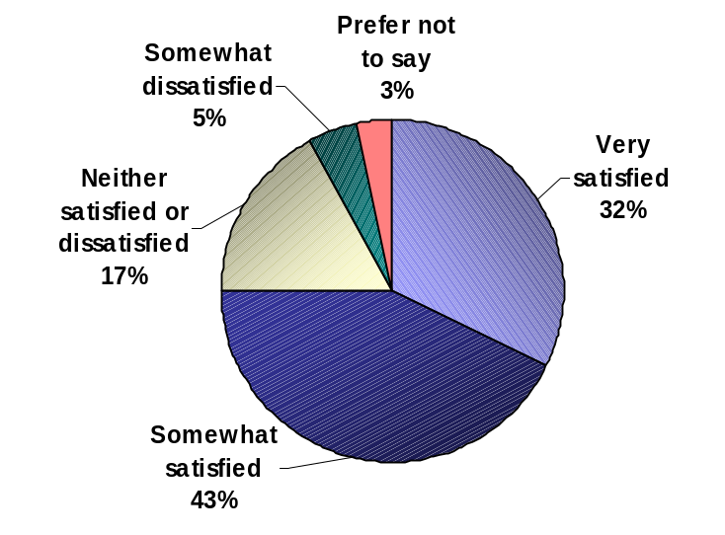

Base: Respondents who have used Artefacts Canada, n=118
Over three quarters of respondents (77%) say Artefacts Canada is relevant to their organization. Four in ten respondents (41%) say this service is ‘very relevant’, 36% say is ‘somewhat relevant’, 17% say is not very relevant, and 3% say it is not at all relevant. “Users” of Artefacts Canada are more likely to say it is relevant to their organization (95%), compared to non-users (45%). (QE4a)

Relevance of Artefacts Canada

 | Total | Users* | Non-Users
 | n=168 | n=107 | n=61
Very relevant | 41% | 55% | 17%
Somewhat relevant | 36% | 40% | 28%
Not very relevant | 17% | 5% | 37%
Not at all relevant | 3% | - | 7%
Prefer not to say | 4% | - | 11%
TOP-TWO BOX | 77% | 95% | 45%
*Accessed within the past 2 years

Contributing members are more likely to say that Artefacts Canada is very or somewhat relevant to their organization (93%), compared to Basic members (73%). Respondents located in the Maritimes are the least likely to say that this service is very or somewhat relevant (55%), compared to those in the West (79%), Ontario (84%), and Quebec (87%).

Publications
Over four in five respondents say they are familiar with CHIN publications, 33% report being ‘very familiar’, 50% ‘somewhat familiar’, and 17% ‘not at all familiar’. Over a tenth of all respondents (16%) say they have used these publications at least once a month, 45% have used them a few times a year, and 13% have never used them. (QE1f and QE2f)

Familiarity and Usage of Publications
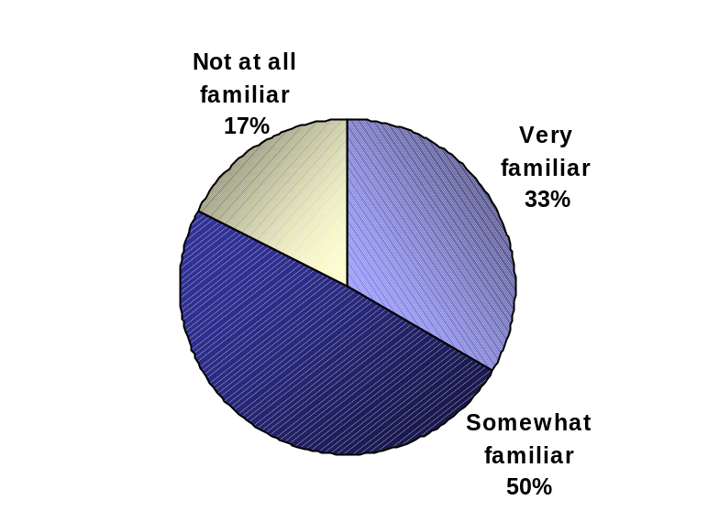

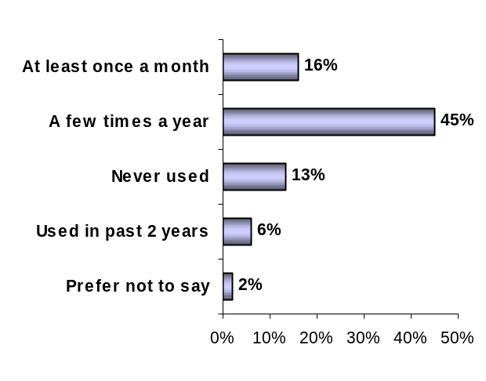

Familiar 83%
Base: All respondents, n=168
Almost three quarters of users (72%) are satisfied with CHIN’s publications. A third of respondents (34%) say they are ‘very satisfied’, 38% say they are somewhat satisfied, and 25% say they are neither satisfied nor dissatisfied. (QE3f)

Satisfaction with Publications

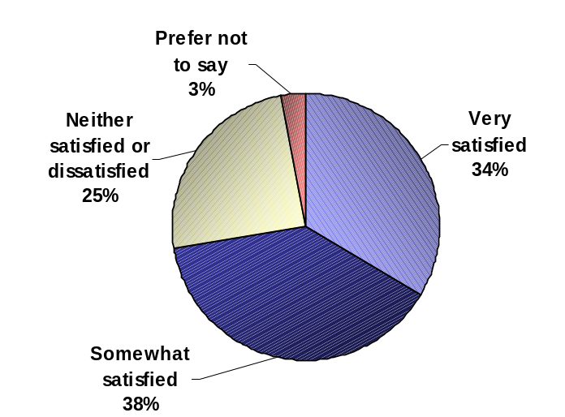

Base: Respondents who have used CHIN’s publications, n=118

Almost 9 in 10 respondents (87%) say CHIN’s publications are relevant for their organization. Almost a third of respondents (31%) say these publications are ‘very relevant’, 56% say they are ‘somewhat relevant’, 10% say they are not very relevant, and 2% say they are not at all relevant. Although publication users are much more likely to consider the publications relevant compared to non-users, it is important to note that fully 71% of non-users still consider this service either very or somewhat relevant to their organization. (QE4f)

Relevance of Publications

 | Total | Users* | Non-Users
 | n=168 | n=106 | n=62
Very relevant | 31% | 44% | 12%
Somewhat relevant | 56% | 54% | 59%
Not very relevant | 10% | 1% | 23%
Not at all relevant | 2% | 1% | 3%
Prefer not to say | 1% | - | 3%
TOP-TWO BOX | 87% | 98% | 71%
*Accessed within the past 2 years

Workshops
Over four in five respondents say they are familiar with CHIN workshops, 36% report being ‘very familiar’, 46% ‘somewhat familiar’, and 18% ‘not at all familiar’. A few respondents (3%) say they have used these workshops at least once a month, 33% have used them a few times a year, and 30% have never used them. (QE1g and QE2g)

Familiarity and Usage of Workshops
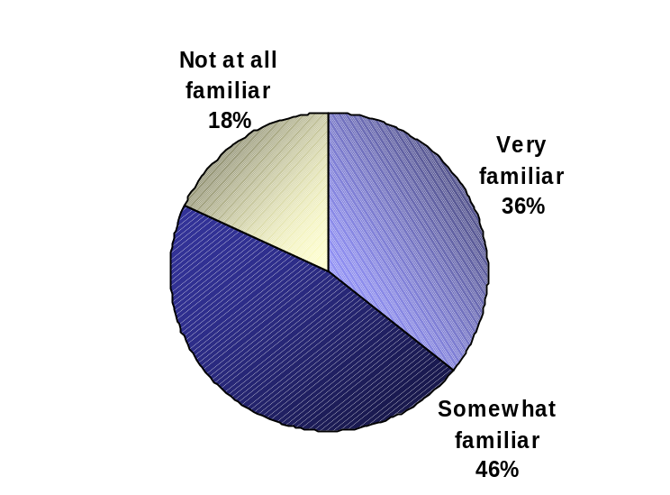
Familiar 82%
Base: All respondents, n=168

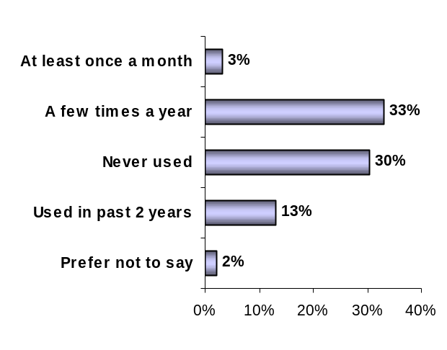

Approximately 7 in 10 users (70%) are satisfied with CHIN’s workshops. Over a third of respondents (36%) say they are ‘very satisfied’, 34% say they are somewhat satisfied, 22% say they are neither satisfied nor dissatisfied, and 3% are somewhat dissatisfied. (QE3g)

Satisfaction with Workshops

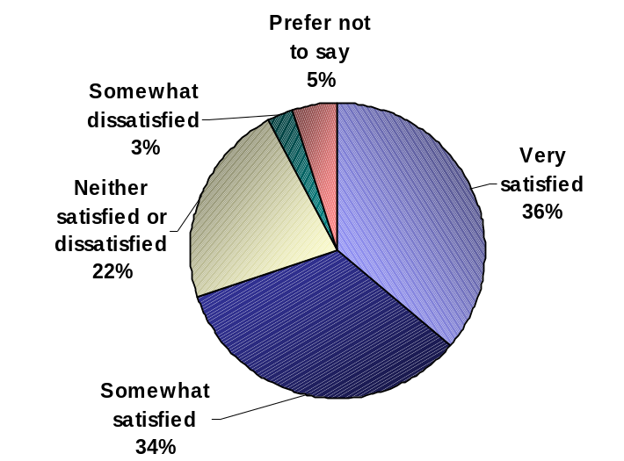

Base: Respondents who have used CHIN’s workshops, n=86

Almost 9 in 10 respondents (87%) say CHIN’s workshops are relevant for their organization. Over a third of respondents (36%) say this service is ‘very relevant’, 51% say it is ‘somewhat relevant’, 9% say it is not very relevant, and 2% say it is not at all relevant. Although users are much more likely to consider the workshops relevant compared to non-users, it is important to note that fully 80% of non-users feel this service is either very or somewhat relevant to their organization. (QE4g)
Relevance of Workshops

 | Total | Users* | Non-Users
 | n=168 | n=63 | n=105
Very relevant | 36% | 54% | 25%
Somewhat relevant | 51% | 46% | 54%
Not very relevant | 9% | 1% | 14%
Not at all relevant | 2% | - | 3%
Prefer not to say | 2% | - | 4%
TOP-TWO BOX | 87% | 99% | 80%
*Accessed within the past 2 years

Canadian Conservation Institute and Conservation Information Network Resources
Three quarters of respondents say they are familiar with the resources from the Canadian Conservation Institute and Conservation Information Network. About 32% report being ‘very familiar’, 43% ‘somewhat familiar’, and 25% ‘not at all familiar’. A tenth of all respondents (10%) say they have used these resources at least once a month, 41% have used them a few times a year, and 15% have never used them. (QE1e and QE2e)

Familiarity and Usage of CCI and CIN Resources

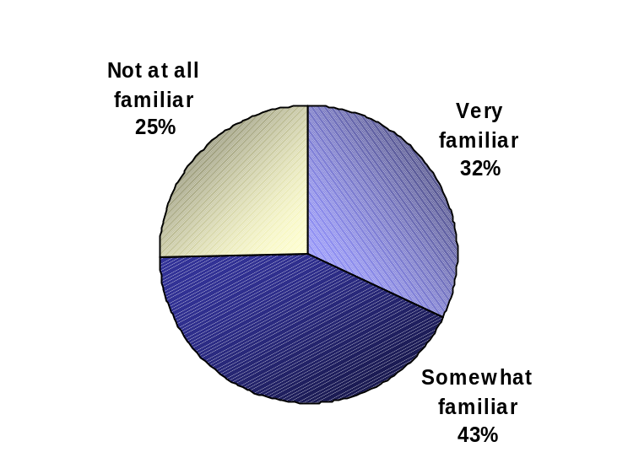
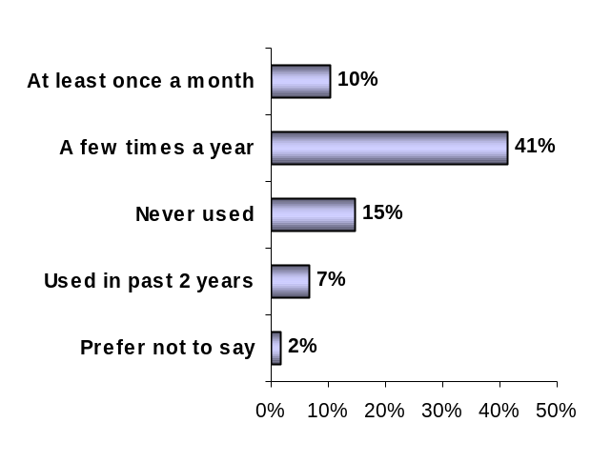

Familiar 75%
Base: All respondents, n=168
Almost 9 in 10 users (87%) are satisfied with the resources from the CCI and the CIN. Half of all respondents (51%) say they are ‘very satisfied’, 36% say they are somewhat satisfied, 12% say they are neither satisfied nor dissatisfied, and 1% say they are very dissatisfied. (QE3e)

Satisfaction with CCI and CIN Resources

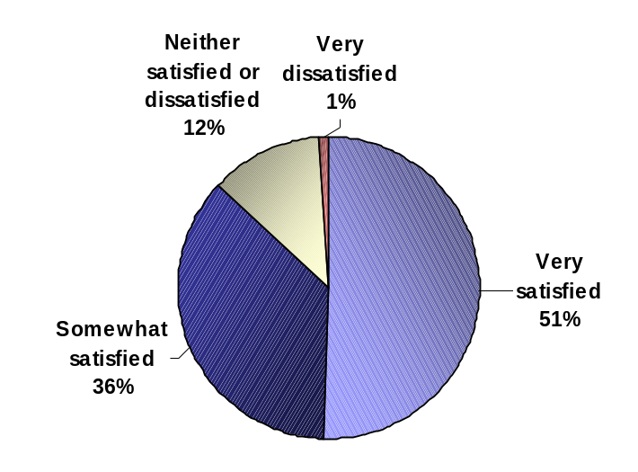

Base: Respondents who have used CCI and CIN resources, n=98

Over four in five respondents (82%) say the resources from the CCI and the CIN are relevant for their organization. Almost half of all respondents (47%) say these resources are ‘very relevant’, 35% say they are ‘somewhat relevant’, 12% say they are not very relevant, and 2% say they are not at all relevant. While 95% of users consider these resources either very or somewhat relevant to their organization, the equivalent proportion among non-users is 68%. (QE4e)

Relevance of CCI and CIN Resources

 | Total | Users* | Non-Users
 | n=168 | n=85 | n=83
Very relevant | 47% | 70% | 23%
Somewhat relevant | 35% | 25% | 45%
Not very relevant | 12% | 5% | 20%
Not at all relevant | 2% | - | 4%
Prefer not to say | 4% | - | 8%
TOP-TWO BOX | 82% | 95% | 68%
*Accessed within the past 2 years

Learning Resources Somewhat Familiar to Members
Members were somewhat familiar with learning resources such as reference databases, online and email courses and collaboration opportunities with other members and other institutions.

Online Courses
Close to three quarters of respondents say they are familiar with CHIN online courses, 27% report being ‘very familiar’, 44% ‘somewhat familiar’, and 28% ‘not at all familiar’. A few respondents (2%) say they have used these online courses at least once a month, 25% have used them a few times a year, and 35% have never used them. (QE1h and QE2h)

Familiarity and Usage of Online Courses

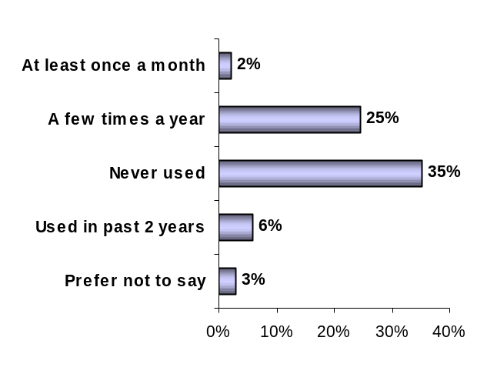
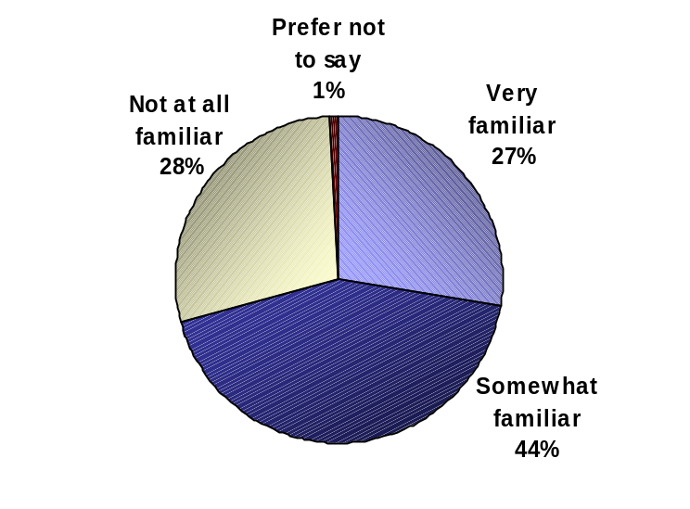
Familiar 71%

Base: All respondents, n=168
Approximately 7 in 10 users (69%) are satisfied with CHIN’s online courses. A quarter of respondents (25%) say they are ‘very satisfied’, 44% say they are somewhat satisfied, and 25% say they are neither satisfied nor dissatisfied. (QE3h)

Satisfaction with Online Courses
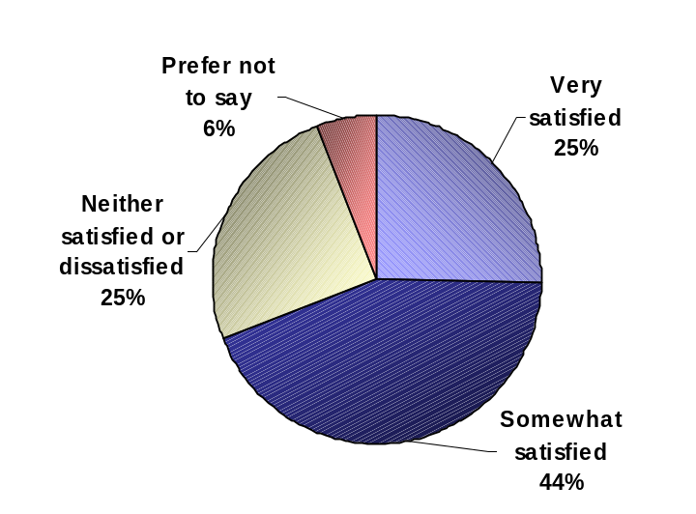

Base: Respondents who have used the online courses, n=60

Almost four in five respondents (79%) feel CHIN’s online courses are relevant to their organization. Over a third of respondents (32%) say this service is ‘very relevant’, 46% say it is ‘somewhat relevant’, 13% say it is not very relevant, and 2% say it is not at all relevant. While 96% of users consider these resources either very or somewhat relevant to their organization, the equivalent proportion among non-users is 72%. (QE4h)

Relevance of Online Courses

 | Total | Users* | Non-Users
 | n=168 | n=46 | n=122
Very relevant | 32% | 54% | 24%
Somewhat relevant | 46% | 41% | 48%
Not very relevant | 13% | 4% | 16%
Not at all relevant | 2% | - | 3%
Prefer not to say | 6% | - | 9%
TOP-TWO BOX | 79% | 96% | 72%
*Accessed within the past 2 years

Base: All respondents, n=168

Sharing Information with Other CHIN Members
Over two thirds of respondents say they are familiar with the opportunity to share information with other CHIN members, 24% report being ‘very familiar’, 44% ‘somewhat familiar’, and 32% ‘not at all familiar’. Over a tenth of all respondents (11%) say they have shared information with other CHIN members at least once a month, 23% say they have shared information a few times a year, and 27% have never shared information. (QE1d and QE2d)

Familiarity and Experience with Sharing of Information with Other CHIN Members

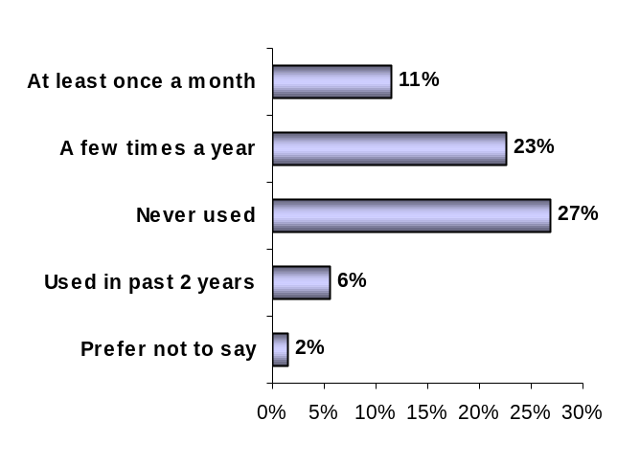
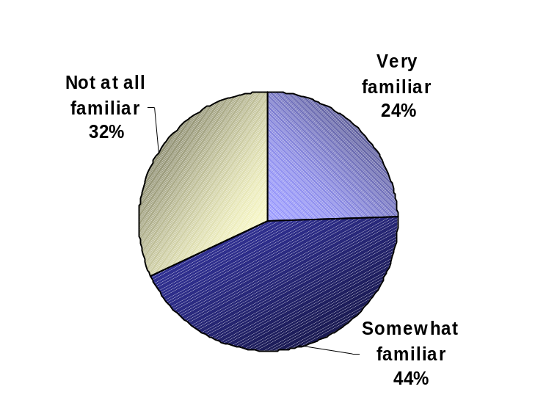
Familiar 68%

Base: All respondents, n=168
Base: All respondents, n=168
Close to three quarters of users (73%) are satisfied with the opportunity to share information with other CHIN members. Over a third of respondents (35%) say they are ‘very satisfied’, 38% say they are somewhat satisfied, and 26% say they are neither satisfied nor dissatisfied. (QE3d)

Satisfaction with the Sharing of Information with Other CHIN Members

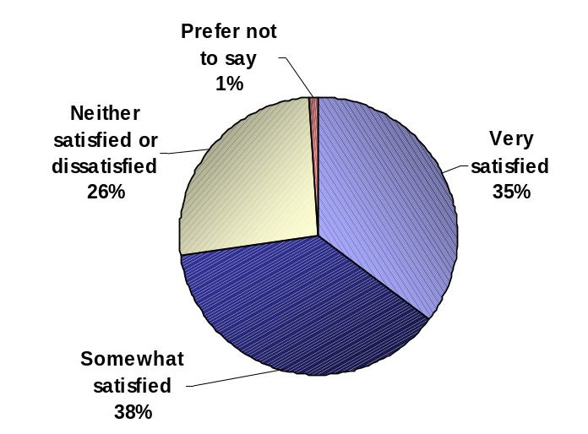

Base: Respondents who have shared information with other members, n=65

Four in five respondents (80%) say the opportunity to share information with other CHIN members is relevant for their organization. Over a third of respondents (34%) say this opportunity is ‘very relevant’, 46% say it is ‘somewhat relevant’, 15% say it is not very relevant, and 2% say it is not at all relevant. While 92% of users consider this resource either very or somewhat relevant to their organization, the equivalent proportion among non-users is 72%. (QE4d)

Relevance of Sharing Information with Other CHIN Members

 | Total | Users* | Non-Users
 | n=168 | n=53 | n=115
Very relevant | 34% | 55% | 24%
Somewhat relevant | 46% | 37% | 48%
Not very relevant | 15% | 8% | 19%
Not at all relevant | 2% | - | 3%
Prefer not to say | 3% | - | 5%
TOP-TWO BOX | 80% | 92% | 72%
*Accessed within the past 2 years

Reference Databases
Almost two thirds of respondents are familiar with the Reference Databases, 13% report being ‘very familiar’, 47% ‘somewhat familiar’, and 40% ‘not at all familiar’. Over a tenth of all respondents (12%) say they have used the Reference Databases at least once a month, 27% say they have used them a few times a year, and 15% have never used them. (QE1c and QE2c)

Familiarity and Usage of Reference Databases

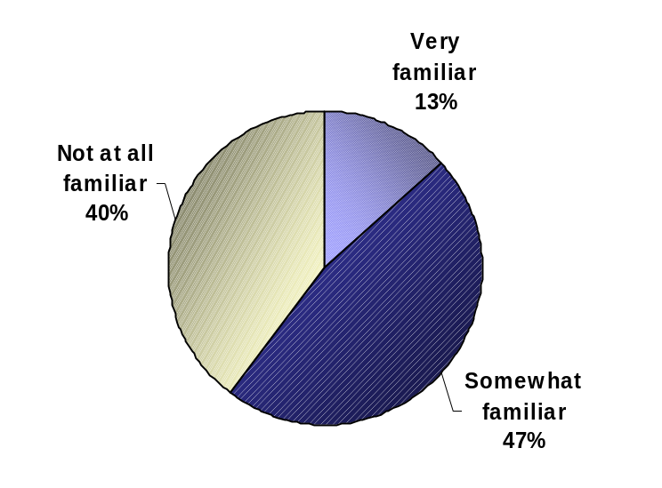

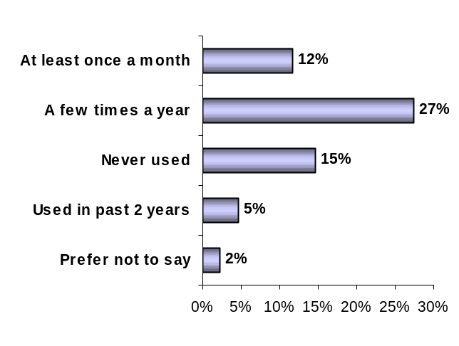

Familiar 60%
Base: All respondents, n=168
Close to three quarters of users (72%) are satisfied with the Reference Databases. Over a quarter of respondents (29%) say they are ‘very satisfied’, 43% say they are somewhat satisfied, 23% say they are neither satisfied nor dissatisfied, and 1% say they are somewhat dissatisfied. (QE3c)
Satisfaction with Reference Databases

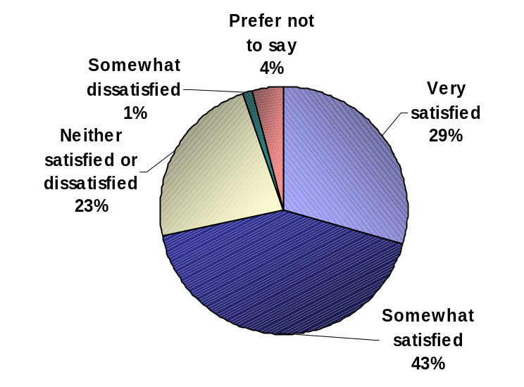

Base: Respondents who have used the reference databases, n=79

Close to three quarters of respondents (71%) consider reference databases relevant for their organization. Almost a third of respondents (31%) say this service is ‘very relevant’, 40% say it is ‘somewhat relevant’, 20% say it is not very relevant, and 2% say it is not at all relevant. Users are much more likely to consider this service relevant to their organization (97%), compared to non-users (54%). (QE4c)
Relevance of Reference Databases

 | Total | Users* | Non-Users
 | n=168 | n=67 | n=101
Very relevant | 31% | 54% | 16%
Somewhat relevant | 40% | 43% | 38%
Not very relevant | 20% | 1% | 32%
Not at all relevant | 2% | - | 4%
Prefer not to say | 6% | 1% | 10%
TOP-TWO BOX | 71% | 97% | 54%
*Accessed within the past 2 years

E-mail Courses
Over half of respondents say they are familiar with CHIN e-mail courses, 22% report being ‘very familiar’, 36% ‘somewhat familiar’, and 40% ‘not at all familiar’. A few respondents (3%) say they have used these e-mail courses at least once a month, 24% have used them a few times a year, and 22% have never used them. (QE1i and QE2i)

Familiarity and Usage of E-mail Courses

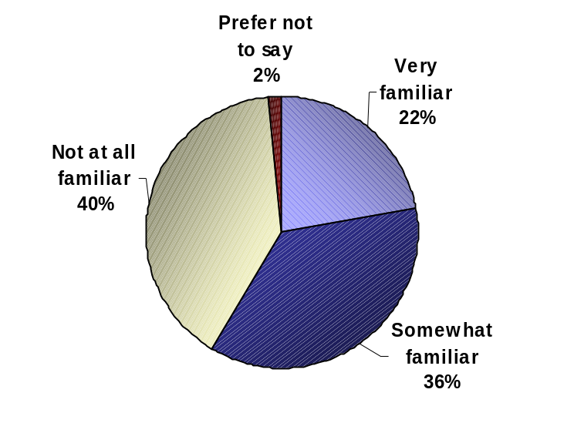

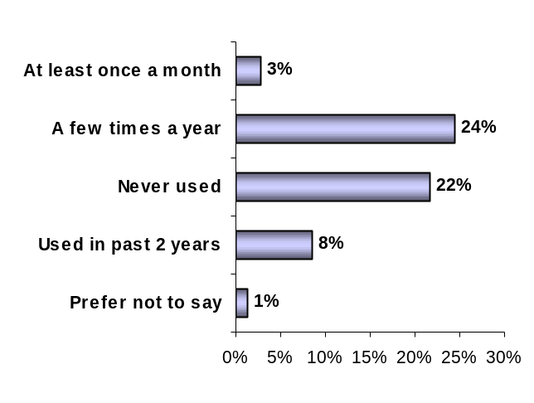

Familiar 58%
Base: All respondents, n=168
Four in five users (80%) are satisfied with CHIN’s e-mail courses. Over half of respondents (55%) say they are ‘very satisfied’, 25% say they are somewhat satisfied, and 18% say they are neither satisfied nor dissatisfied. (QE3i)

Satisfaction with E-mail Courses

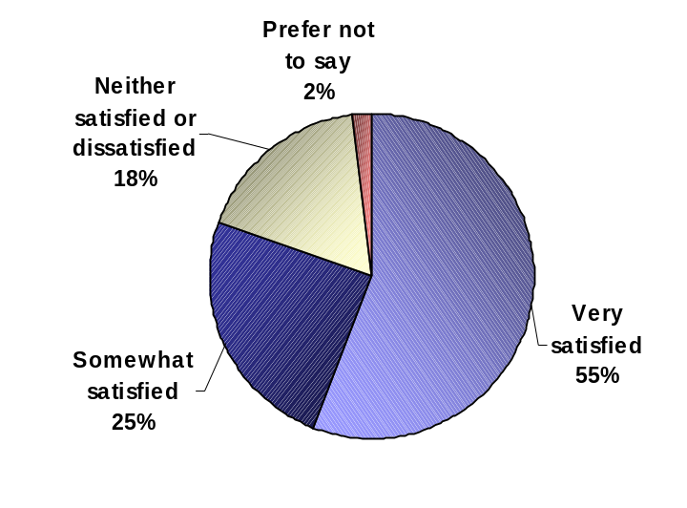

Base: Respondents who have used e-mail courses, n=60

Almost three quarters of respondents (75%) feel CHIN’s e-mail courses are relevant for their organization. Over a quarter of respondents (29%) say CHIN e-mail courses are ‘very relevant’, 46% say they are ‘somewhat relevant’, 15% say they are not very relevant, and 3% say they are not at all relevant. While 94% of users consider these resources either very or somewhat relevant to their organization, the equivalent proportion among non-users is 67%. (QE4i)

Relevance of E-mail Courses

 | Total | Users* | Non-Users
 | n=168 | n=44 | n=124
Very relevant | 29% | 47% | 22%
Somewhat relevant | 46% | 47% | 46%
Not very relevant | 15% | 6% | 18%
Not at all relevant | 3% | - | 4%
Prefer not to say | 8% | - | 11%
TOP-TWO BOX | 75% | 94% | 67%
*Accessed within the past 2 years

Collaborations and Partnerships with Other Institutions for Virtual Exhibits
Over half of all respondents say they are familiar with the collaborations and partnerships with other heritage institutions in the development of Executive produced Virtual Exhibits. About 9% report being ‘very familiar’, 48% ‘somewhat familiar’, and 41% ‘not at all familiar’. Less than a tenth (5%) of all respondents say they have taken advantage of these collaborations at least once a month, 8% have done so a few times a year, and 37% have never taken advantage of these collaborations. (QE1k and QE2k)

Familiarity and Collaboration with Other Institutions for Virtual Exhibits

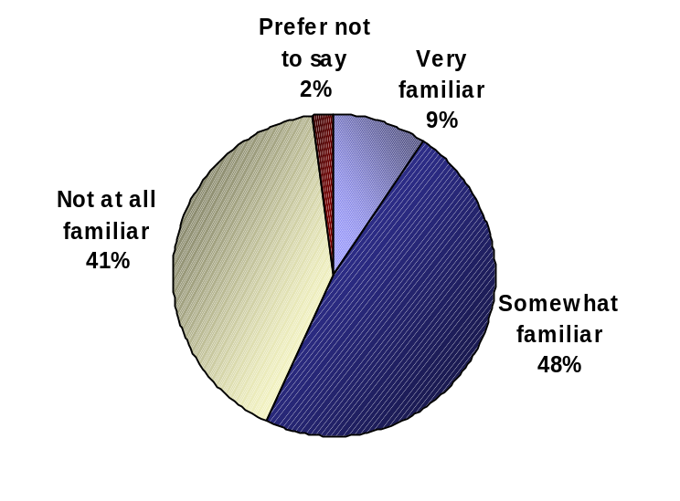
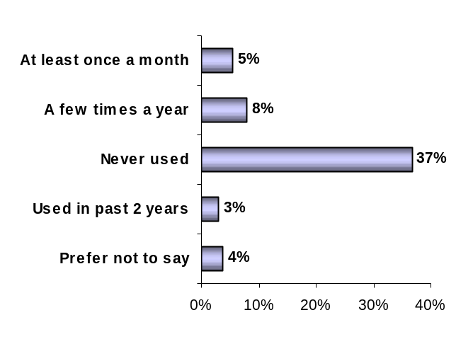

Familiar 57%
Base: All respondents, n=168
Over half of all users (53%) are satisfied with the collaborations and partnerships with other heritage institutions in the development of Executive produced Virtual Exhibits. Over a tenth of respondents (13%) say they are ‘very satisfied’, 40% say they are somewhat satisfied, and 35% say they are neither satisfied nor dissatisfied. (QE3k)
Satisfaction with Collaborations with Other Institutions for Virtual Exhibits

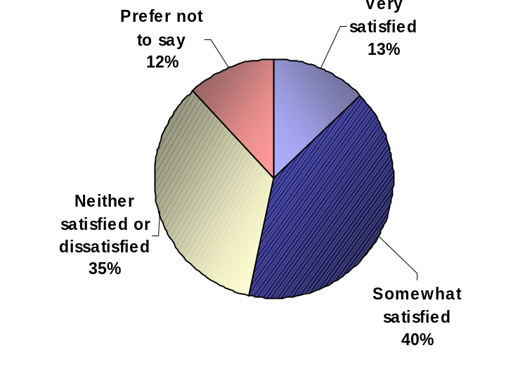

Base: Respondents who have collaborated with other institutions for Virtual Exhibits, n=37

Close to two thirds of respondents (64%) say these collaborations are relevant for their organization. Over a fifth of respondents (21%) say these partnerships are ‘very relevant’, 43% say they are ‘somewhat relevant’, 22% say they are not very relevant, and 5% say they are not at all relevant. Those who collaborate with other institutions in the development of Executive produced Virtual Exhibits are more likely to say these collaborations are relevant to their organization (83%), compared to those who do not collaborate (61%). (QE4k)
Relevance of Collaboration with Other Institutions for Virtual Exhibits

 | Total | Collaborate* | Do not collaborate
 | n=168 | n=25 | n=143
Very relevant | 21% | 41% | 18%
Somewhat relevant | 43% | 42% | 43%
Not very relevant | 22% | 11% | 24%
Not at all relevant | 5% | - | 5%
Prefer not to say | 9% | 6% | 10%
TOP-TWO BOX | 64% | 83% | 61%
*Collaborated within the past 2 years

Respondents in Ontario are more likely than those in the West to say that these partnerships are very or somewhat relevant to their organization (82% vs. 60%).
Base: All respondents, n=168

Learning Resources Relatively Less Familiar to Members
Although not completely foreign to members, learning resources in this section are nonetheless relatively less familiar to members compared to those in previous sections. These include the Centre for Exhibition Exchange, onsite visits by CHIN staff, and collaborations in research initiatives.

Centre for Exhibition Exchange
Almost half of all respondents are familiar with the Centre for Exhibition Exchange, 14% report being ‘very familiar’, 34% ‘somewhat familiar’, and 51% ‘not at all familiar’. A few respondents (3%) say they have used the Centre for Exhibition Exchange at least once a month, 21% say they have used it a few times a year, and 17% have never used it. (QE1b and QE2b)

Familiarity and Usage of the Centre for Exhibition Exchange

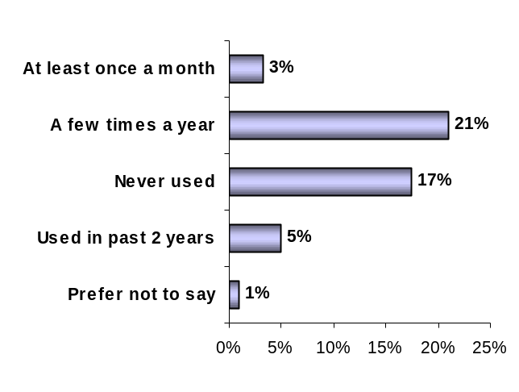

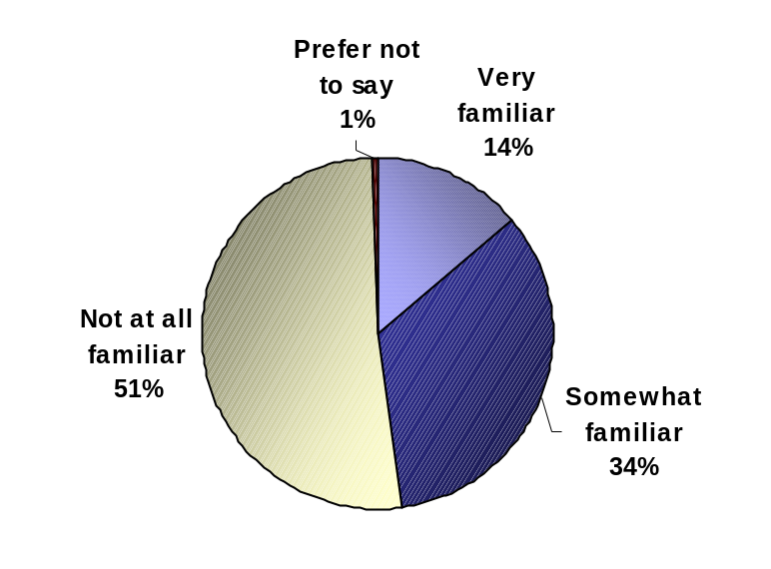
Familiar 48%
Base: All respondents, n=168
Over half of users (61%) are satisfied with the Centre for Exhibition Exchange. Over a fifth of respondents (22%) say they are ‘very satisfied’, 39% say they are somewhat satisfied, 34% say they are neither satisfied nor dissatisfied, and 4% say they are somewhat dissatisfied. (QE3b)

Satisfaction with the Centre for Exhibition Exchange

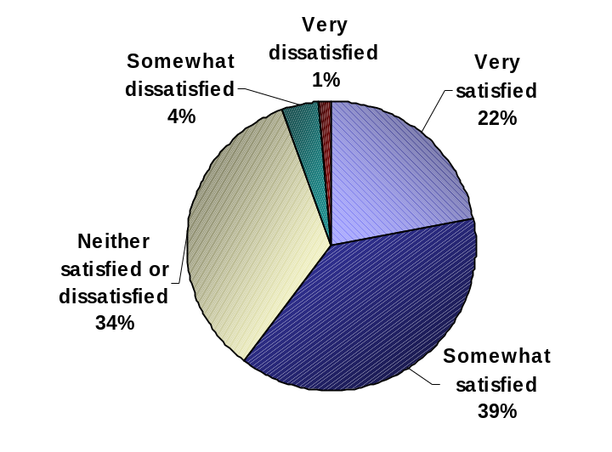

Base: Respondents who have used the Centre for Exhibition Exchange, n=53

Almost half of all respondents (46%) say the Centre for Exhibition Exchange is relevant for their organization. A fifth of respondents (20%) say this service is ‘very relevant’, 26% say it is ‘somewhat relevant’, 35% say it is not very relevant, and 10% say it is not at all relevant. Users of the Centre for Exhibition Exchange are more likely to say this service is relevant to their organization (87%), compared to non-users (33%). (QE4b)
Relevance of the Centre for Exhibition Exchange

 | Total | Users* | Non-Users
 | n=168 | n=43 | n=125
Very relevant | 20% | 61% | 7%
Somewhat relevant | 26% | 26% | 26%
Not very relevant | 34% | 8% | 43%
Not at all relevant | 10% | 3% | 13%
Prefer not to say | 9% | 3% | 11%
TOP-TWO BOX | 46% | 87% | 33%
*Accessed within the past 2 years

Onsite Visits by CHIN Staff
Over a third of respondents say they are familiar with CHIN’s onsite staff visits, 14% report being ‘very familiar’, 24% ‘somewhat familiar’, and 60% ‘not at all familiar’. A few respondents (1%) say they have taken advantage of these visits at least once a month, 9% have done so a few times a year, and 15% have never taken advantage of these visits. (QE1j and QE2j)

Familiarity and Usage of Onsite Visits by CHIN Staff

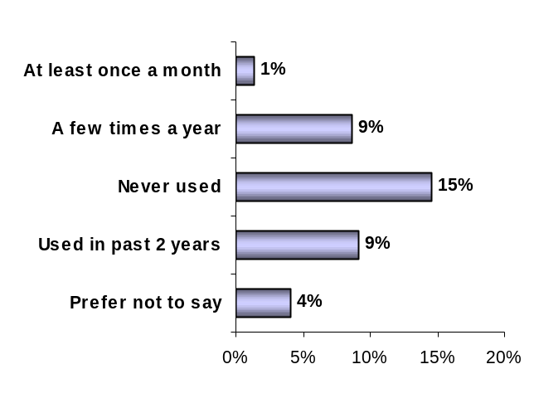
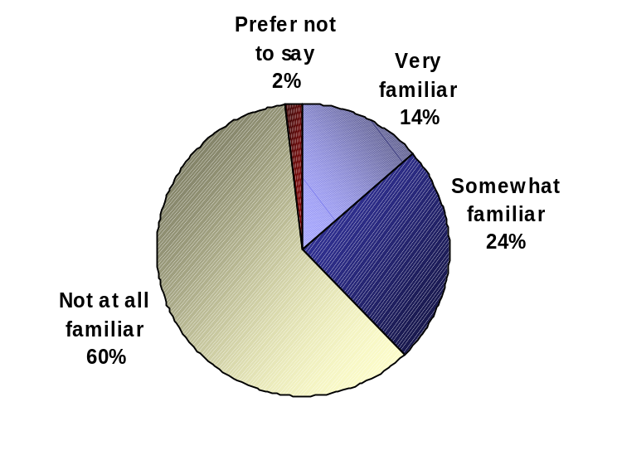
Familiar 38%
Base: All respondents, n=168
Almost two thirds of users (64%) are satisfied with CHIN’s staff visits. Over four in ten respondents (43%) say they are ‘very satisfied’, 21% say they are somewhat satisfied, and 23% say they are neither satisfied nor dissatisfied. (QE3j)

Satisfaction with Onsite Visits by CHIN Staff

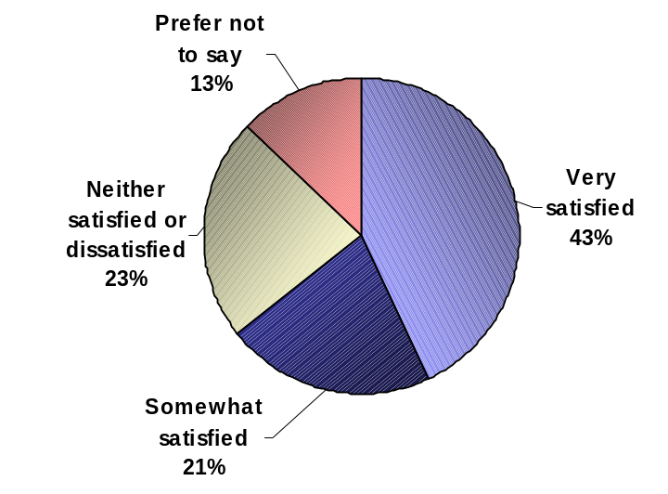

Base: Respondents who have used onsite visits by CHIN staff, n=38

Over half of respondents (57%) say CHIN’s staff visits are relevant for their organization. Over a fifth of respondents (23%) say the visits are ‘very relevant’, 34% say they are ‘somewhat relevant’, 26% say they are not very relevant, and 6% say they are not at all relevant. Respondents who have taken advantage of CHIN onsite staff visits are more likely to say the visits are relevant to their organization (100%), compared to those who have not been visited (53%). (QE4j)
Relevance of Onsite Visits by CHIN Staff

 | Total | Users* | Non-Users
 | n=168 | n=16 | n=152
Very relevant | 23% | 62% | 19%
Somewhat relevant | 34% | 38% | 33%
Not very relevant | 26% | - | 29%
Not at all relevant | 6% | - | 7%
Prefer not to say | 11% | - | 12%
TOP-TWO BOX | 57% | 100% | 53%
*Accessed within the past 2 years

Collaboration / Partnerships in Research Initiatives
Approximately four in ten respondents say they are familiar with the collaborations and partnerships in research initiatives, 3% report being ‘very familiar’, 39% ‘somewhat familiar’, and 56% ‘not at all familiar’. A few respondents (2%) say they have taken advantage of these collaborations at least once a month, 7% have done so a few times a year, and 30% have never taken advantage of these collaborations. (QE1l and QE2l)

Familiarity with and Collaboration in Research Initiatives

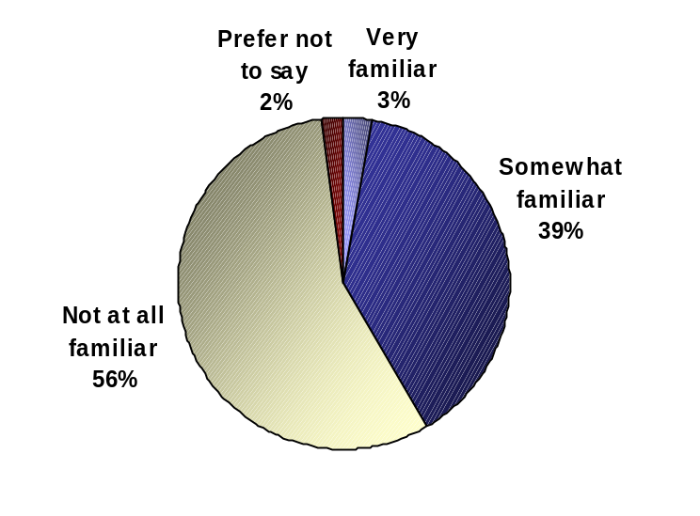

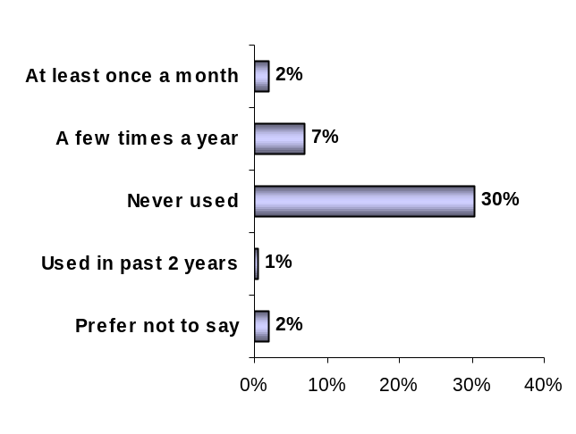

Familiar 42%
Base: All respondents, n=168
Four in ten respondents (40%) are satisfied with the collaborations and partnerships in research initiatives. Over a tenth of respondents (11%) say they are ‘very satisfied’, 29% say they are somewhat satisfied, and 43% say they are neither satisfied nor dissatisfied. (QE3l)

Satisfaction with Collaborations in Research Initiatives

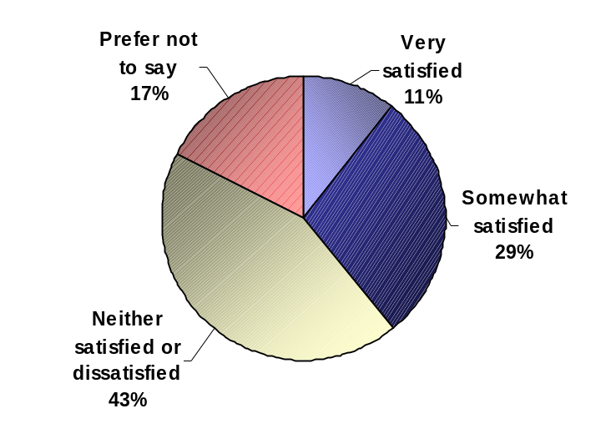

Base: Respondents who have used the collaboration/ partnership in research initiatives, n=22

Over half of all respondents (54%) say these collaborations are relevant for their organization. Close to a fifth of respondents (18%) say these partnerships are ‘very relevant’, 36% say they are ‘somewhat relevant’, 31% say they are not very relevant, and 4% say they are not at all relevant. Respondents who collaborate in research initiatives are more likely to say that these collaborations are relevant to their organization (96%), compared to non-users (50%). Respondents in Ontario are more likely to say these partnerships are very or somewhat relevant to their organization, compared to those from Western regions (47%). (QE4l)

Relevance of Collaboration in Research Initiatives

 | Total | Collaborate* | Do not collaborate
 | n=168 | n=17 | n=151
Very relevant | 18% | 24% | 18%
Somewhat relevant | 36% | 72% | 33%
Not very relevant | 31% | 4% | 33%
Not at all relevant | 4% | - | 5%
Prefer not to say | 10% | - | 11%
TOP-TWO BOX | 54% | 96% | 50%
*Collaborated within the past 2 years

General Perception of Program Communication

Roughly four in five respondents (80%) rates the manner in which CHIN communicates its key professional development services as either excellent (23%) or good (57%). Approximately 15% of respondents say it is fair, and 3% say it is poor. (QE5)

Evaluation of Program Communication

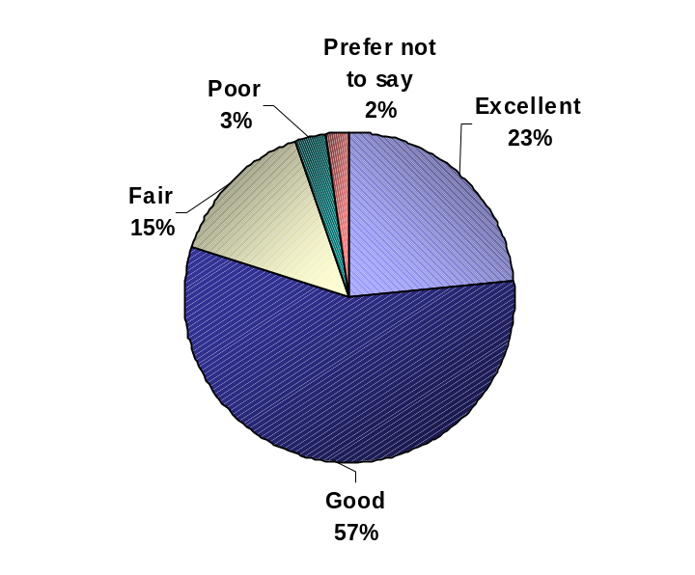
Base: All respondents, n=168

Awareness of CHIN’s publications and online courses appears to have a slight impact on the overall evaluation of program communication. Respondents who are very or somewhat familiar with CHIN’s publications are more likely to say that the communication of programs overall is excellent or good, compared to those who are not aware of these publications (84% vs. 61%). Similarly, respondents who are familiar with the online courses are more likely to say communications in general are either excellent or good, compared to those who are not familiar with the online courses (85% vs. 68%).

Those familiar with at least nine programs and services were much more likely to consider CHIN’s communications “excellent” compared to those familiar with fewer programs and services. Interestingly though, despite admitting to being familiar with no more than four programs and services, two-thirds of these respondents rated CHIN’s communications as either “good” or “excellent.”

Evaluation of Programs Communication by Number of Programs Respondents Are Familiar With

 | TOTAL | Familiar with 0 to 4 programs | Familiar with 5 to 8 programs | Familiar with 9 to 12 programs
 | n=168 | n=33 | n=68 | n=67
Excellent communication | 23% | 8% | 18% | 35%
Good | 57% | 58% | 61% | 52%
Fair | 15% | 22% | 14% | 12%
Poor communication | 3% | 4% | 4% | 2%
Prefer not to say | 2% | 8% | 2% | -
TOP 2 BOX | 80% | 66% | 80% | 87%
Approximately a third of respondents use CHIN and its services more than any other source for digital content. Other sources include local and national museums and associations.

Respondents were asked how much they use CHIN and its services for information on digitization, standards, collections management, information management and intellectual property. Approximately a third of respondents use CHIN exclusively or most of the time to look for information on each of these topics. (QE6)

Usage of CHIN as a Source of Information

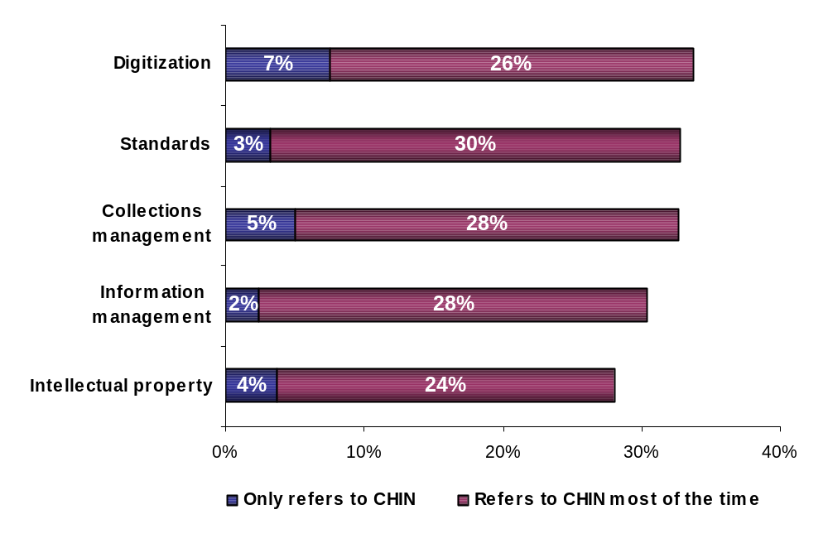

Base: All respondents, n=168

In general, other resources respondents use for digital content are local museums and related associations. The sources mentioned more frequently are the Ontario Museum Association, the Société des Musées Quebecois, the Nova Scotia Museum, and their own network or colleagues. It is important to note that 24% of respondents said “other” and 42% preferred not to specify or could not recall which other sources they use. (QE7)

Other Resources for Digital Content

 | Total (n=168)
OMA/Ontario Museum Association | 7%
SMQ/Societe des Musees Quebecois | 4%
Nova Scotia Museum | 4%
Our own network/colleagues (general) | 4%
Info muse | 3%
CHIN/RCIP | 3%
CMA/Canadian Museum Association | 3%
Glenbow Museum (general) | 3%
BCMA/British Columbia Museums Association | 3%
Museums Alberta | 2%
University (general) | 2%
AABC/Archives Association of British Columbia | 2%
CCI | 2%
Getty institute | 1%
Global Museum | 1%
Canadian Council of Archives | 1%
BCAA/British Columbia Archival Association | 1%
National Archives of Canada | 1%
AMA | 1%
Local experts | 1%
National Museum of Canada | 1%
Still new/not had time to look | 1%
Other | 24%
None/not applicable to us | 8%
Prefer not to say | 42%

Executive Interview Insights

When respondents were asked if they felt CHIN is succeeding in its current mandate, they were not entirely comfortable discussing CHIN’s mandate without being provided a description from the interviewer. Only then were they able to confidently assess that CHIN’s mandate is relevant and that they are successful within this context.

An important component of the mandate involves CHIN serving as a primary source of information on digital heritage and content. Results show that CHIN seems to be a primary resource for information about digital heritage and content, however, many organizations complement this information with other sources (such as: the Société des Musées Québecois, Horizon Zero, Verizon, Canadian Council of Archives, the web in general, the Getty Institute, city archives, National Archives, etc.).

CHIN is the first organization that respondents think of in terms of digital heritage and digital content. Among the actions that CHIN could consider to become the absolute resource for information on digital content, respondents suggested providing more references to other informative research sites, sending more representatives onsite to explain CHIN services and programs, be a portal to sites that are not primarily focused on digital culture, make their site user friendly for smaller organizations, and offer more workshops and on-line courses for smaller museums.

Over four in five respondents are interested in seeing CHIN focus their research on digital preservation, intellectual property rights, digitization, collections management, standards and trends in technology.

Close to 9 in 10 respondents (88%) say they are interested in seeing the areas of digital preservation, intellectual property rights, and digitization as future research topics for CHIN. Fully 54% say they are ‘very interested’ and 35% say they are ‘somewhat interested’ in seeing digital preservation researched in the future. Almost half (49%) say they are ‘very interested’ and 39% say they are ‘somewhat interested’ in seeing intellectual property rights and digitization researched in the future.

Collections management (84%), standards (84%), trends in technology (81%), and the understanding of web audiences (81%) are interesting for at least four in five respondents. Less than three quarters of respondents would like to see the information management and architecture (73%) and business models for emerging environment (58%) topics explored in the future by CHIN.

Respondents in Ontario are more likely than those in the West to say they are very or somewhat interested in seeing Intellectual property rights covered in the future (100% vs. 86%), as well as Information management and architecture (95% vs. 62%). (QE8)
Areas for Future Research (Prompted)

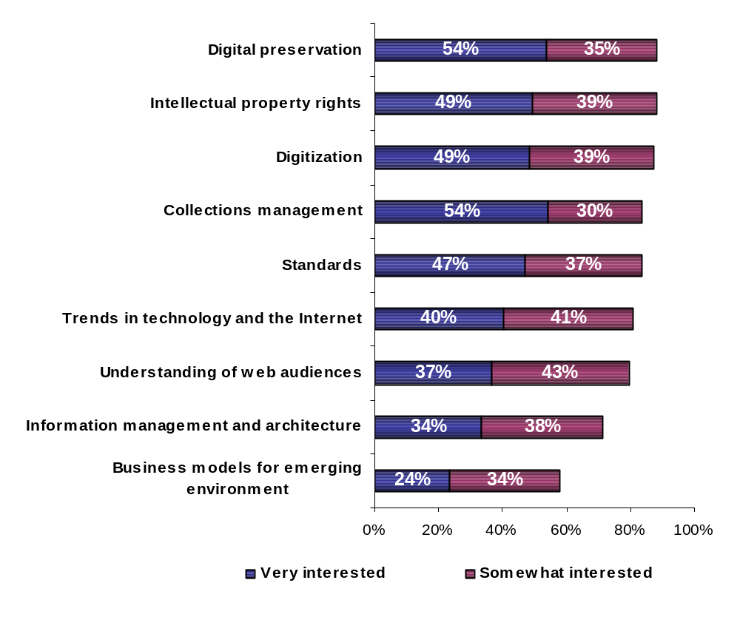

Base: All respondents, n=168

Other areas of research include monetary or financial aid (3%), new technologies (3%), marketing, promotion and increasing public awareness (2%), and revenue generation (1%). (QE9)

Other Areas for Research

 | Total (n=168)
Monetary/financial aid | 3%
New technologies/trends/display methods | 3%
Copyright (general) | 3%
Marketing/promotion/increasing public awareness | 2%
Make it less cost prohibitive/revenue generation | 1%
Other | 11%
No other area | 6%
Unsure/don't know | 10%
Prefer not to say | 62%

Executive Interview Insights

In order to explore respondents’ opinion on CHIN’s educational initiatives, respondents were asked if their organization had taken advantage of these initiatives in the past. Many respondents have taken advantage of the professional development that CHIN offers. The most common course mentioned is Copyright law. Those who mention not having used any publications, not having attended conferences or taken courses/workshops, expressed interest in these resources but face financial and/or time constraints.

Suggested content for potential initiatives include copyrights, collections management and gallery standards, classifying and describing photographs, writing for digital content, digitization, content management, conservation, preservation and re-creation of electronic records, exhibit design and programming, interpretation and education, how to invest in hardware and software to avoid outdated equipment, how to deal with Canada Customs when importing or exporting art, how to manage donations from private institutions, how to seek funding, administration, and how to familiarize staff with using CHIN and its resources. A suggestion for publications was to include more critical discourse on digital art or digital content as art.

One of the research objectives is to understand members’ format preferences with respect to receiving CHIN publications. Close to two thirds of respondents expressed interest in either one of the three proposed online formats (HTML, PDF or printer friendly formats), while 23% still prefer a paper copy. Close to a tenth (9%) would like to receive the publications on a CDROM, and 2% by e-mail. (QE10)

Likelihood to Receive Publications Online

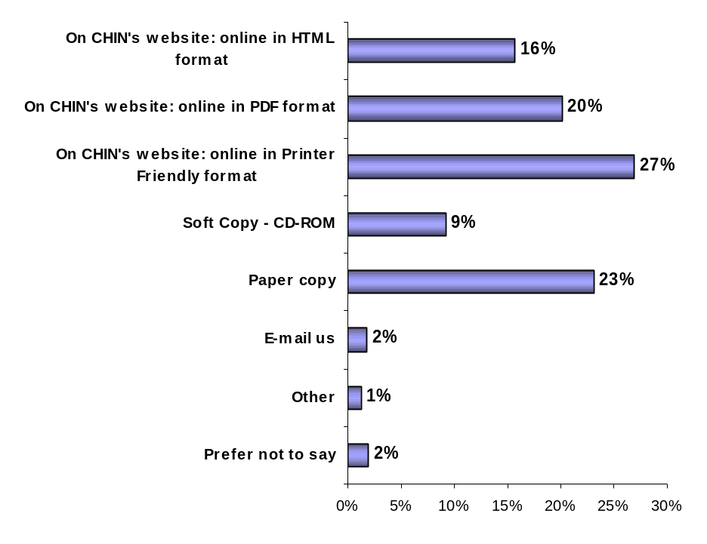

63% Online
37% Non-online
Base: All respondents, n=168
Among respondents who say they prefer a softcopy or hardcopy version of a publication, 88% say they would be likely to opt for an online version given the scenario that non-online versions would be offered for a fee. The appeal of a free online copy of a publication based on a fee-based softcopy or hardcopy version increases from 63% to 96% among all respondents. (QE11)

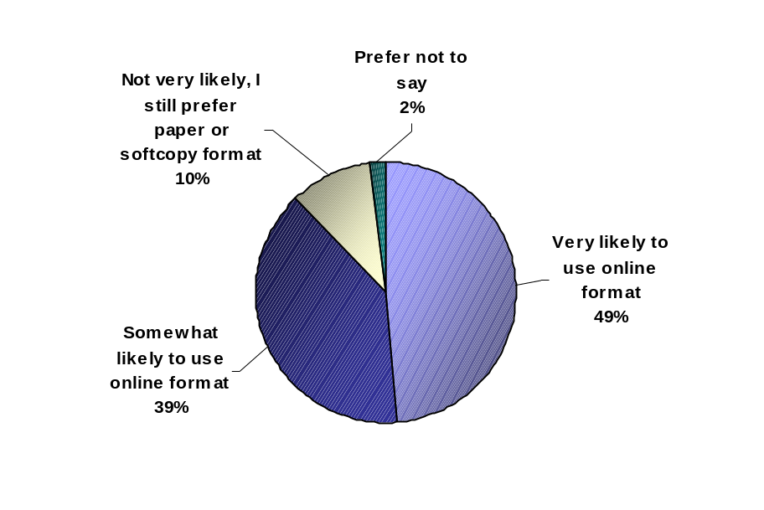

Likelihood to Receive Free-of-Charge Publications Online

Base: Respondents whose preferred format for future publications is not on CHIN’s website, n=58
The online printer friendly format is the most appealing to respondents who initially favored a softcopy or hardcopy format. About a third (33%) would prefer the PDF format, and 19% would prefer the HTML format. Results at the bottom of the page show the transition in preferences for online formats prior to the fee-based scenario and after. (QE12)
Preferred Online Format

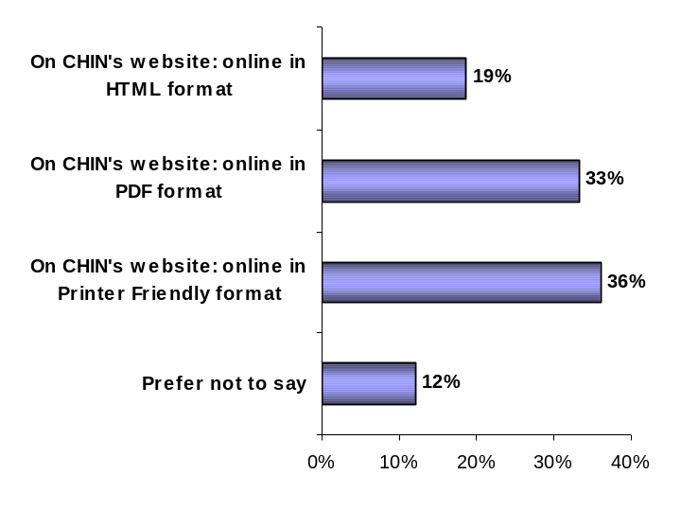

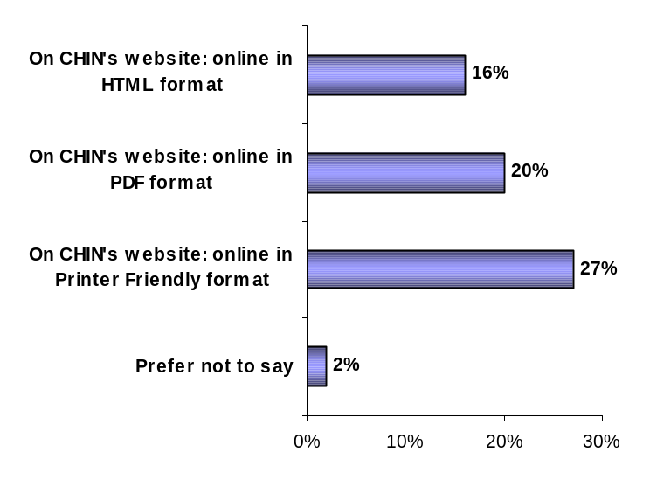
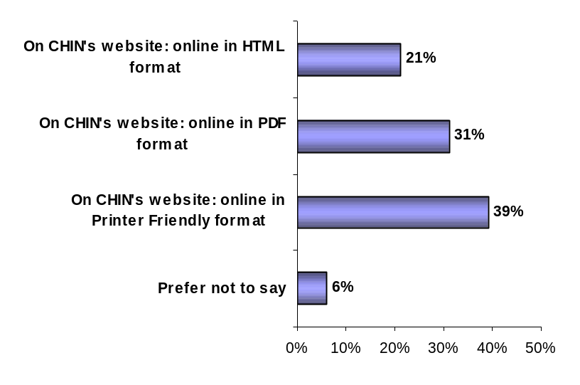
Before and After Fee-Based Scenario Online Publication Format Preferences
Base: Respondents likely to use online rather than paper or softcopy given the potential fee based system, n=51
Base: All respondents, n=168

CHIN Member Communication
More than half of respondents are interested in the topics CHIN tends to communicate. CHIN’s website is the preferred medium and members seem to prefer receiving the information “as it happens.”

In order to improve the level of communication between CHIN and its members, respondents were asked their level of interest in certain topics, the type of format and the frequency with which they would like to receive this information. At least half of all respondents are either ‘very’ or ‘somewhat’ interested in the topics listed, with CHIN programs, its services and products being the topic that generates the most interest (95%).

Most topics are expected to be communicated through CHIN’s website or the general membership e-mail, with the exception of the steps to follow when submitting an investment program proposal, the consultation results, and the statistics of traffic for museums in the VMC. For these specific types of information, members prefer a customized e-mail rather than the general membership e-mail. All events are expected to be communicated as soon as they happen as opposed to a schedule-based frequency.

Contributing members are more likely to say they are very or somewhat interested in being communicated digital content best practices, compared to Basic members (95% vs. 84%). Similarly, members in Ontario are more likely to say they are interested in this topic, compared to respondents in Western Canada (80%).

Members in Ontario are more likely to say they are very or somewhat interested in the steps to follow when submitting a VMC Investment Program proposal (97%), compared to members in Western Canada (75%). Similarly, those in Ontario are more likely to say they are very or somewhat interested in CHIN’s programs, services and products (100%), compared to members in Western Canada (91%). (QF1)

A summary table for each of the different types of information is presented on the following page.
Preferred Communications Format and Frequence

Type of information | Level of Interest  (Top-Two Box) | Two Most Popular Formats | Frequency  (Highest)
CHIN programs, services and products | 95% | Posted on CHIN's website (37%) General membership e-mail (27%) | As it happens (58%)
Digital content best practices | 87% | Posted on CHIN's website (36%) General membership e-mail (28%) | As it happens (53%)
Steps to follow when submitting a VMC Investment Program proposal | 86% | Posted on CHIN's website (33%) Customized e-mail to you (35%) | As it happens (70%)
Future research initiatives and research results in CHIN’s areas of expertise | 85% | Posted on CHIN's website (40%) General membership e-mail (26%) | As it happens 56%
Survey results | 80% | Posted on CHIN's website (38%) General membership e-mail (34%) | As it happens (66%)
Digital content initiatives undertaken by fellow CHIN members | 76% | Posted on CHIN's website (42%) General membership e-mail (28%) | As it happens (48%)
Consultation results | 75% | Posted on CHIN's website (41%) Customized e-mail to you (25%) | As it happens (64%)
Statistics such as the percent of VMC traffic sent to members’ sites or the percent of VMC traffic sent to members’ museum content | 72% | Customized e-mail to you (47%) Posted on CHIN's website (25%) | As it happens (33%)
CHIN’s Annual Report | 68% | Posted on CHIN's website (50%) General membership e-mail (16%) | Annually (81%)
CHIN’s presence at different events (CHIN on the Road) | 67% | Posted on CHIN's website (32%) General membership e-mail (31%) | As it happens (51%)
VMC marketing campaign initiatives and results (billboards, public service announcements, etc.) | 56% | Posted on CHIN's website (43%) General membership e-mail (27%) | As it happens (48%)

The use of CHIN’s website as a communication channel is the most popular among members. Over four in five respondents accessed it in the last 6 months to look for information on CHIN, its services and products. Almost four in ten respondents used the toll-free number, 35% sent e-mails to CHIN, and 23% consulted CHIN staff at a conference or through onsite visits. (QF2)

Communication Channels Used by Members

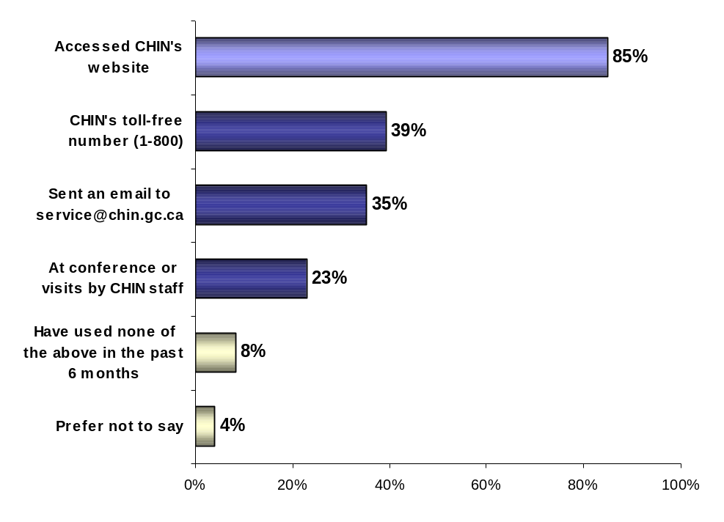

Base: All respondents, n=168
Among CHIN’s website users, almost four in five (78%) visit this website on a regular basis. In total, 39% of respondents say they visit this website a few times a year, and another 39% say they visit it a few times a month. (QF3)

A vast majority (87%) of users say they are either ‘very satisfied’ (34%) or ‘somewhat satisfied’ (53%) with CHIN’s website. (QF4)

CHIN Website Usage and Satisfaction

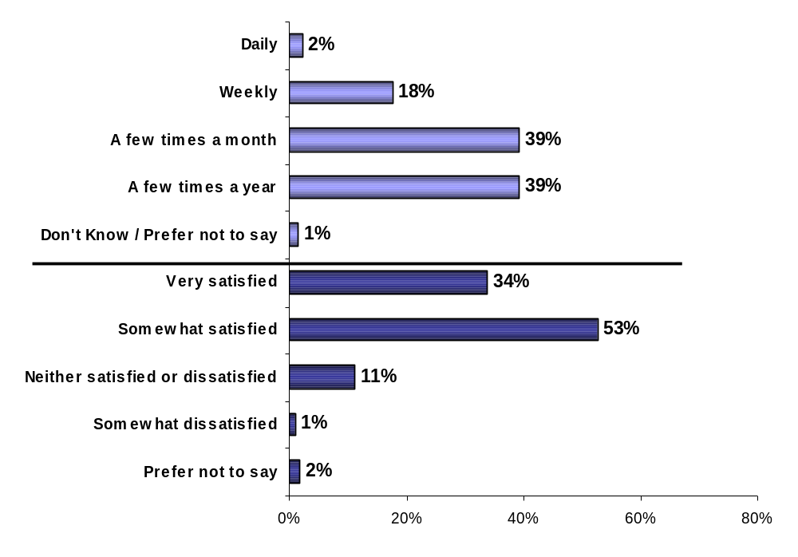

Base: Respondents who accessed CHIN’s website, n=140
Respondents were asked to indicate the information that they could not easily find or did not find at all when visiting CHIN’s website. Half of respondents (49%) say they always find what they look for. Under a tenth of website visitors say the site is not user-friendly (6%) or the cross-reference links to the Artefacts Canada database and searching was difficult (1%). (QF5)

Information Difficult to Find on CHIN’s Website

Base: Those who accessed CHIN’s website | Total (n=140)
Not user-friendly/problems with the system (general) | 6%
Searching/cross-reference links to Artefacts Canada database | 1%
It was my fault for not being able to find what I needed | 2%
Other | 6%
I rarely use it | 1%
Can always find what I'm looking for on CHIN's website | 49%
None/I can find what I need | 4%
Prefer not to say | 32%

Among respondents who used the 1-800 number to contact CHIN, over three quarters (77%) say they used it a few times a year, and 16% used it a few times a month. (QF6)

Over four in five (83%) respondents say they are either ‘very satisfied’ (57%) or ‘somewhat satisfied’ (26%) with the services they received through CHIN’s toll-free number (1-800-820-CHIN). (QF7)

Toll-Free Number Usage and Satisfaction
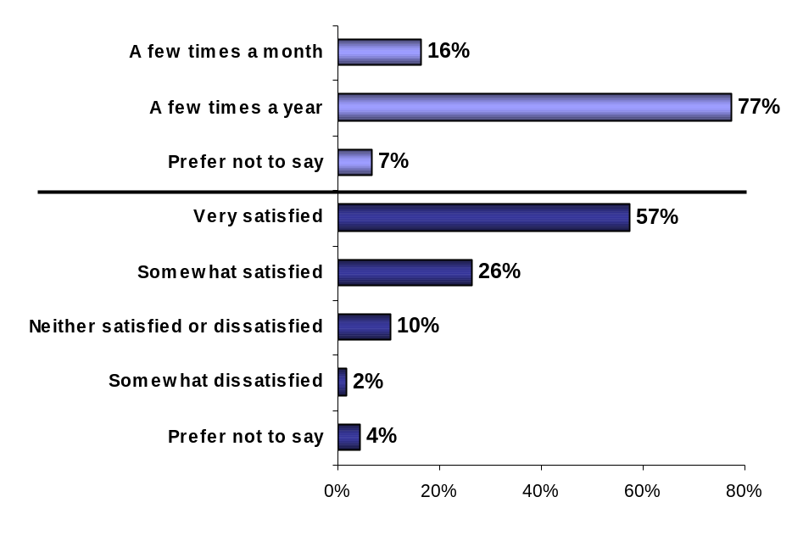

Base: Respondents who accessed CHIN’s 1-800 number, n=67
Among respondents who used the e-mail service in the past 6 months, 56% say they used it a few times a year, 13% used it a few times a month, 14% used it weekly, and 9% used it daily to contact CHIN. (QF8)

Over two thirds of respondents (68%) say they are either ‘very satisfied’ (48%) or ‘somewhat satisfied’ (20%) with CHIN’s e-mail information service. (QF9)

E-mail Usage and Satisfaction

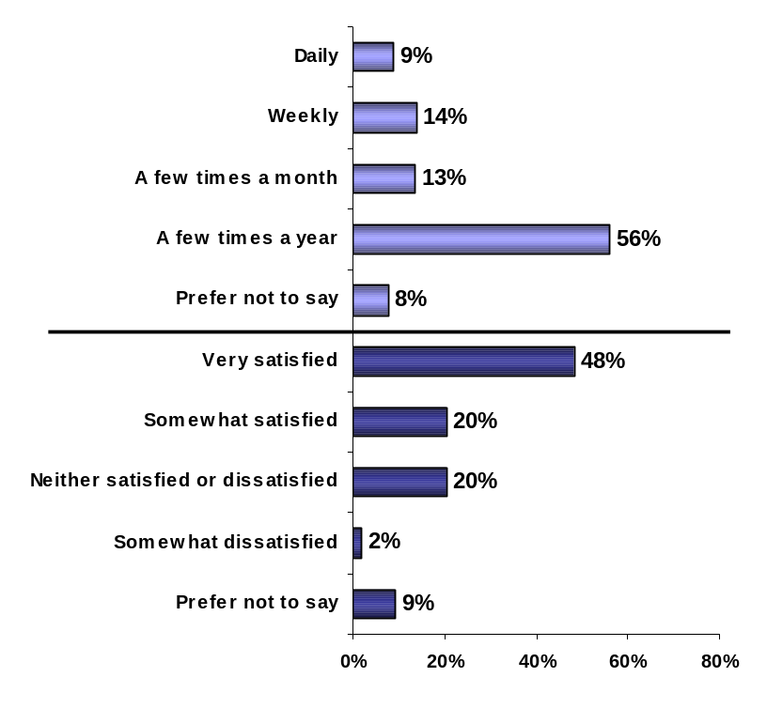

Base: Respondents who accessed CHIN’s e-mail information service, n=61
Among respondents who met with CHIN staff at a conference or an onsite visit in the past 6 months, over four in five respondents (86%) say they are either ‘very satisfied’ (51%) or ‘somewhat satisfied’ (35%) with the information they received about CHIN. (QF10)

Satisfaction with CHIN Delegates at Conferences or Onsite Visits

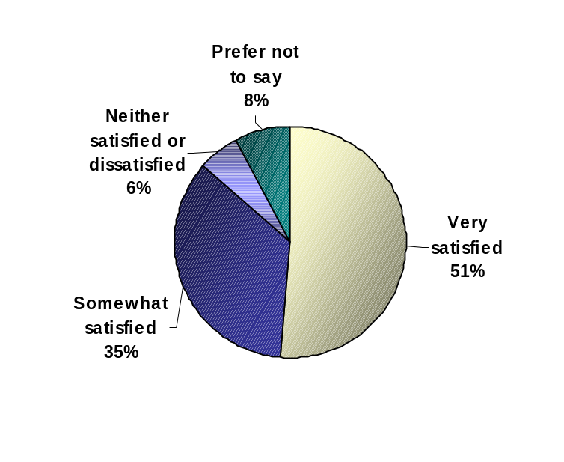

Base: Respondents who met with CHIN staff at a conference or onsite visit, n=42

The majority of respondents (93%) do not use other means of communication with CHIN. Among the 7% who prefer channels other than the existing channels, 2% indicated a preference for regular mail or e-mail and 1% indicated telephone. (QF11a)

Online Collaboration
CHIN members have the opportunity to share information using an online contribution process. Respondents were asked to rate the importance of sharing certain information with other members. Close to 9 in 10 respondents (87%) say it is either ‘very important’ (38%) or ‘somewhat important’ (49%) to access information on conference or training events. (QF12a)

Approximately 85% of respondents show interest in other members’ newsletters, 26% say it is ‘very important’ and 59% say it is ‘somewhat important’ to access this information. Respondents in Ontario are more likely to say it is very or somewhat important to access newsletters than those in Western Canada (95% vs. 81%). (QF12d)

News releases from other members are important to 83% of respondents, where 24% say it is ‘very important’ and 59% say it is ‘somewhat important’ to access this type of information. Respondents in Ontario are more likely to say it is very or somewhat important to access news releases than those in Western Canada (95% vs. 80%). (QF12e)

Four in five respondents (81%) say it is important to have access to other CHIN members’ documents. Approximately 30% say it is ‘very important’ and 51% say it is ‘somewhat important’ to access this information. (QF12b)

Finally, two thirds of respondents (66%) say it is important to have access to job opportunities from other CHIN members. Approximately 29% say it is ‘very important’ and 37% say it is ‘somewhat important’ to access this information. Respondents in Ontario are more likely to say it is very or somewhat important to access this information than those in Western Canada (76% vs. 63%). (QF12c)

Importance to Access Other CHIN Members’ Information

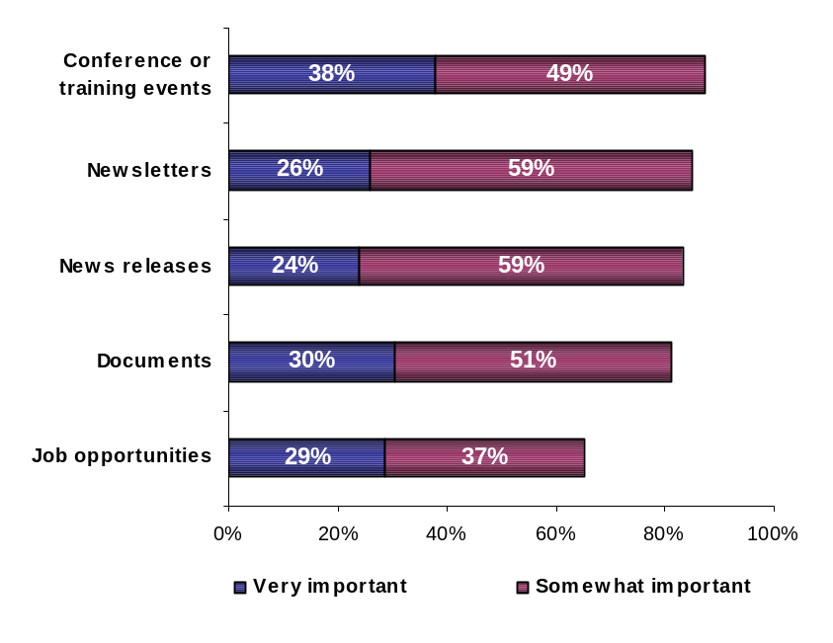

Base: All respondents, n=168

The percent of those who consider sharing information important is lower than the percent of those who consider accessing information important. Job opportunities is the most appealing type of information respondents consider important to share with other members (56%), where 24% say it is ‘very important’ and 32% say it is ‘somewhat important’. Respondents in Ontario are more likely to consider this type of information important compared to those in Western Canada (76% vs. 48%). (F13c)

Over half of all respondents (54%) consider it important to share their news releases with other members, 18% say they it is ‘very important’ and 36% say it is ‘somewhat important’ to share this type of information. Respondents in Ontario are more likely to say it is very or somewhat important to do a contribution of this type than those in Western Canada (72% vs. 45%) (QF13e) Sharing information on conference or training events is important for 53% of respondents, 17% saying it is ‘very important’ and 37% saying it is ‘somewhat important’. Respondents in Ontario are more likely to say it is very or somewhat important to do a contribution of this type than those in Western Canada (66% vs. 44%). (QF13a)

Close to half of respondents (49%) consider it important to share their newsletters with other members - 12% say it is ‘very important’ and 37% say it is ‘somewhat important’ to share this type of information. (QF13d) Finally, 49% of respondents say it is important to share their documents with other members. Approximately 11% say it is ‘very important’ and 38% say it is ‘somewhat important’ to share this information. (QF13b)

Importance of Contributing Information to Share with Other CHIN Members

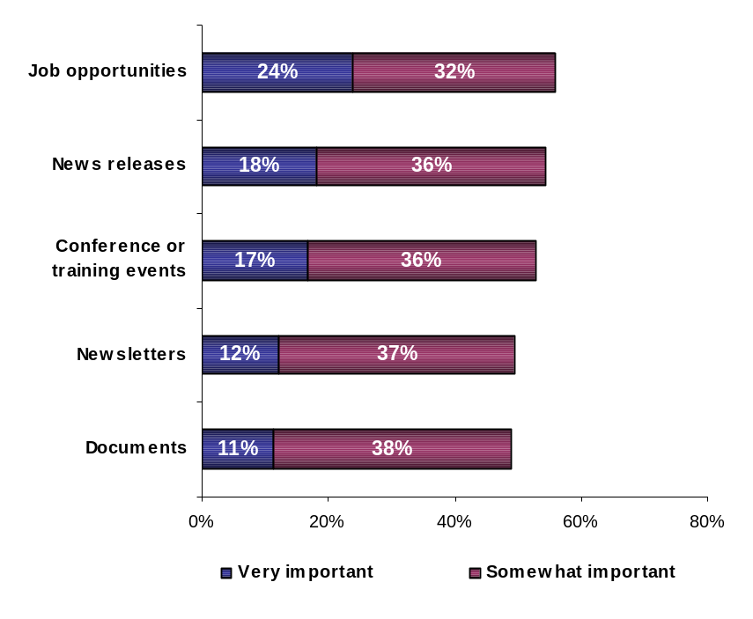

Base: All respondents, n=168
CHIN members were asked to rate the importance of receiving and accessing personalized selections of certain types of information from the heritage community. Over three quarters of respondents (78%) say it is either ‘very important’ (35%) or ‘somewhat important’ (43%) to receive information on conference or training events. Respondents in Ontario are more likely to say they are very or somewhat interested in receiving this type of information than those in Western Canada (93% vs. 68%). (QF14a)

Approximately 72% of respondents show interest in receiving other members’ newsletters, 22% say it is ‘very important’ and 50% say it is ‘somewhat important’. (QF14d)

Seven in ten respondents (70%) say it is important to receive other CHIN members’ documents. Approximately 25% say it is ‘very important’ and 45% say it is ‘somewhat important’ to receive this information. Respondents in Ontario are more likely to say they are very or somewhat interested in receiving other members’ documents, than those in Western Canada (84% vs. 58%). (QF14b)

News releases from other members are important to 68% of respondents, where 26% say it is ‘very important’ and 42% say it is ‘somewhat important’ to access this type of information. (QF14e)

Finally, over half of all respondents (56%) say it is important to receive information on job opportunities from the heritage community. Approximately 25% say it is ‘very important’ and 31% say it is ‘somewhat important’ to access this information. Respondents in Ontario are more likely to say they are very or somewhat interested in receiving other members’ documents than those in Western Canada (72% vs. 45%). (QF14c)
Interest in Receiving Personalized Information Via E-mail
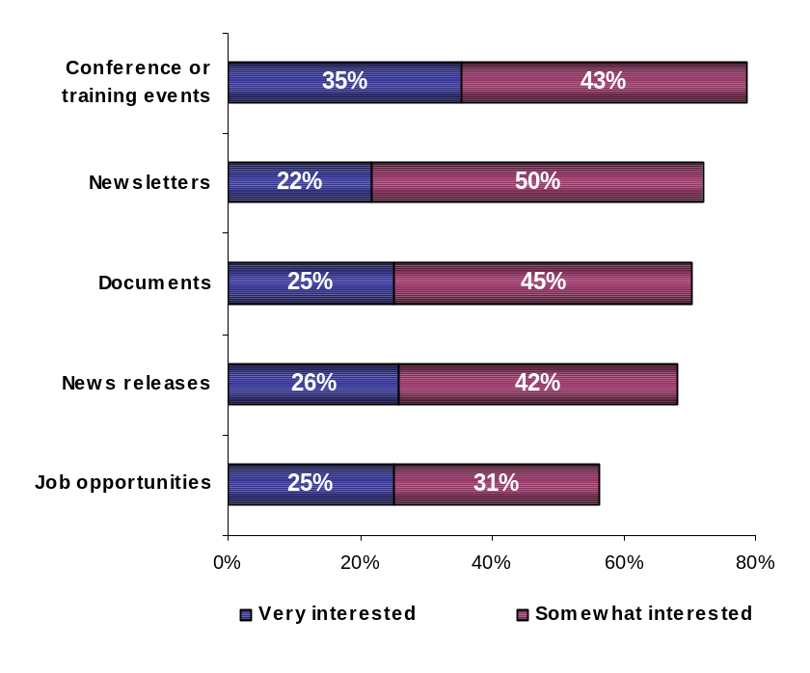

Base: All respondents, n=168
CHIN’s E-mail Distribution List

Over half of all respondents (54%) are aware that as CHIN members they can participate in an e-mail distribution list (QF15). Among respondents aware of the distribution list, 50% say their organization has participated in such a list in the past year. (QF16)

Among participants having participated in an e-mail distribution list (listserv) managed by CHIN in the past year, 88% say they are either ‘very satisfied’ (55%) or ‘somewhat satisfied’ (33%). (QF17a)

The rationale behind the lack of participation in the distribution list is related to lack of time (21%), no interest (14%), already feel overloaded with information (13%), lack of relevance (11%), or use other methods (4%). (Q17b)

Participation in CHIN’s E-mail Distribution List
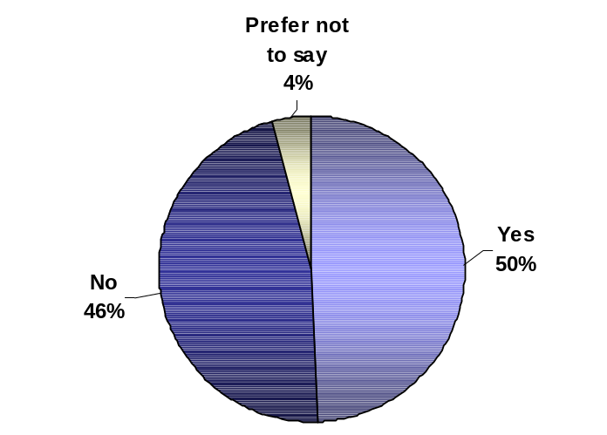

Why
not?
Base: Respondents aware of e-mail distribution list, n=90

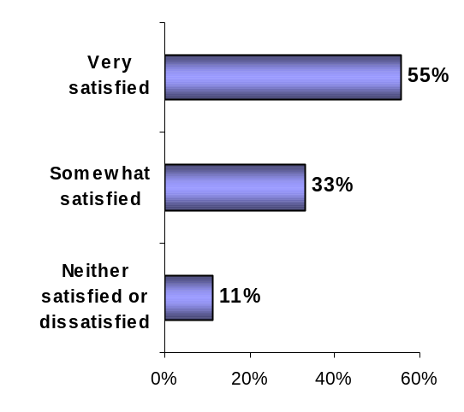

No time/too busy | 21%
No need/reason to participate | 14%
Information overload/receive too much e-mail | 13%
Not relevant to us | 11%
Use other methods/list serves | 4%
Other | 15%
Prefer not to say | 33%
Over half of all respondents (58%) say they are interested in using more interactive online discussion tools, 16% say they are ‘very interested’, 42% say they are ‘somewhat interested’, 33% say they are not very interested, and 4% say they are not interested at all. (QF18)

Interest in More Interactive Online Discussion Tools

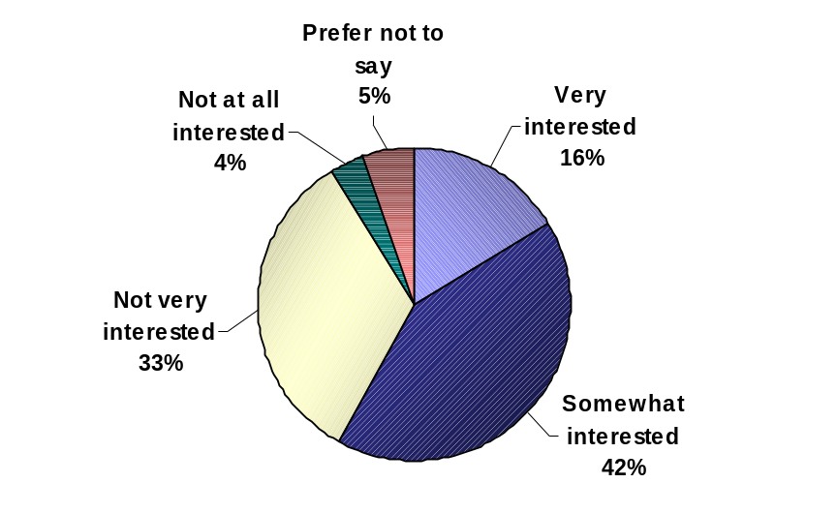

Base: All respondents, n=168

Future Directions

Executive Interviews Insights

Respondents were asked their perspective of the areas that CHIN is to explore or research over the next three years to meet members’ needs in the fields of digital heritage and information technology. In general, respondents expect CHIN to continue leading the digital side of the museum sector, as it provides support and engages organizations to participate in the transition to digital heritage. Areas that are seen to be the priorities for research are herein grouped in four main categories: technology, museum related, funding, and communication/promotion.

Technology

- Copyright, rights about dissemination, rights about dissemination on the Web
- Prepare a newsletter (i.e. quarterly) with online technology updates (mail-out or online distributed)
- Archiving digital material (CDs, DVDs)
- Continue to help cataloguing different museum pieces
- Funding to do the basic work to prepare for digitization
- Look for technology evaluators, set standards, encourage members to use it

Museum related

- Courses on conservation of objects
- Explore religious heritage
- Work along with the Societe des Musées de Québec to have the same categories and sub-categories in English and French
- Continue with programs like the Community Memories Program

Funding

- Research the training needs for members by region, because some regions are more expensive than others, and therefore funding does not have the same effect

Communication & Promotion

- Continue working on enhancing communication with members
- Continue being a major source of heritage dissemination
- Enhance marketing – advertising research to measure how to make marketing more effectively

Member Profile
Roughly 38% of respondents say their organization has either no or one full-time or part-time employee. About 42% of respondents say they have from 2 to 5 full time employees, while 36% say they have from 2 to 5 part-time employees. About 75% of members have 6 or more volunteers on staff. (QG1)

Number of Full-Time and Part-Time Employees
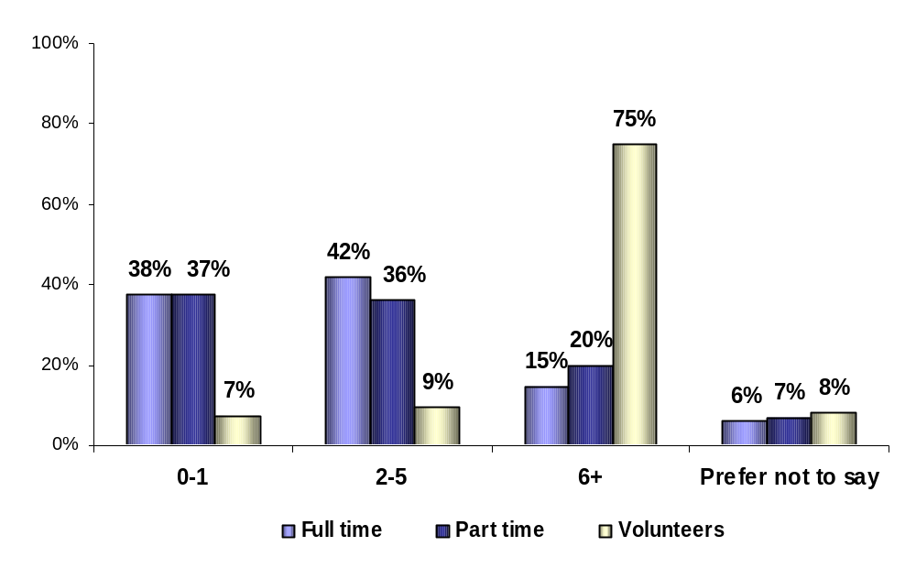

Base: All respondents, n=168
Over four in five respondents say their organization belongs to a provincial museum association. (QG2)

Belong to a Provincial Museum Association
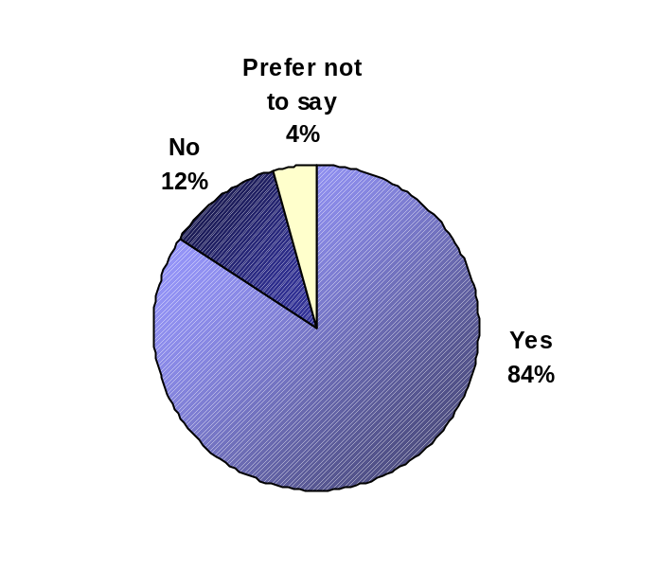

Base: All respondents, n=168
Half of respondents (49%) say the organization where they currently work has dial-up Internet access and close to another half (46%) say they have High-Speed Internet access. (QG3)

Type of Internet Access

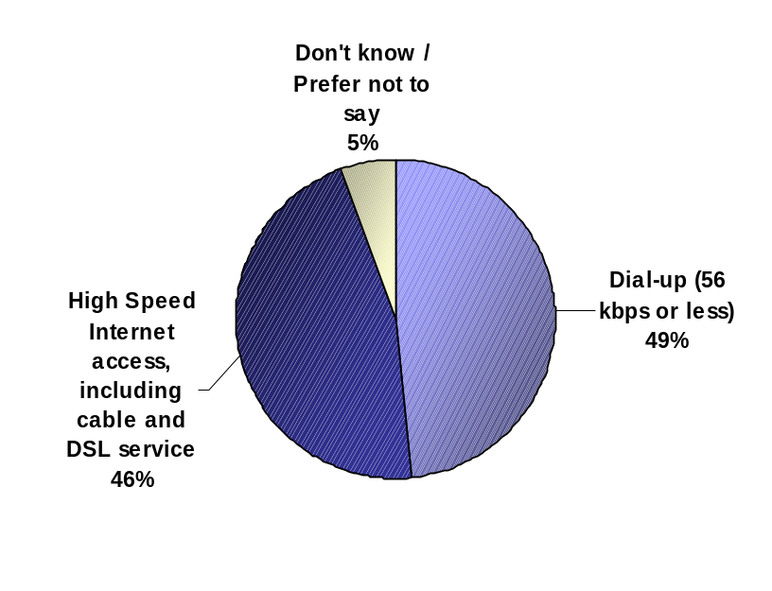

Base: All respondents, n=168

Final Comments from Executive Interviews
The majority of respondents expressed great satisfaction and appreciation for what CHIN is doing for museums – “A big thank you. We’re very grateful, it might not seem much for someone in Ottawa, but in a small museum we have a unique story to tell Canada, it’s creating an opportunity”.

The main request to better meet members needs was to ease the navigation of CHIN’s site, as it appears to be too difficult to find a topic even during a second search. Another option is to create a seminar or course to teach how to navigate the site. – “Many times, when I look for resources I found before, I can’t find them later”.

On the technology side, other suggestions include easier downloads (i.e. ready-to-use technical assistance), and focus in general on user-friendly technology.

Other suggestions include adjusting activities and programs to better suit small to medium size museums, to consider that remote museums might have different needs than centralized museums, to encourage sharing information of what other museums are doing, and to provide a granting program that could help them get their databases up to speed - “You can digitize a lot of things, but it is hard to find some way to hire staff to do that first important step”.

It was also mentioned that there is a need of a larger discussion about digital culture, creation and digital content, the concepts and differences.

Study Methodology

Questionnaire Design
Decima Research designed in conjunction with CHIN the questionnaire and research material, including:
- A telephone recruitment script for recruiting members to participate in the consultation,
- An email script that will be sent to members who agree to participate,
- The quantitative survey to be administered online,
- An executive interview invitation script that will be used to invite members to participate in a 30-minute executive interview,
- The executive interview script.

CHIN pre-tested the survey instrument internally to ensure that the questions were logical and that the material covered was appropriate for members. Once a final English questionnaire was formulated, Decima Research took care of translation.

Data Collection
The research was conducted exclusively with CHIN members, based on contact information that CHIN provided to Decima. The research was conducted using two data collection methodologies: 1) a quantitative portion consisting an online survey, and, 2) a qualitative portion consisting of executive interviews with members who completed the quantitative portion.

Detailed Methodology
The research detailed in this report is based on a custom survey conducted by Decima Research. The on-line survey was conducted from the early December 2003 to late January 2004, and the research presented in this report was collected from a final sample of 168 organizations. The 20-minute executive interviews were conducted during December 2003 and January 2004, with 27 CHIN members. The maximum margin of error at the 95% confidence level for a sample of 168 is +/- 6.9%.

Both the surveys and the executive interviews were strategically conducted to ensure national representation and appropriate representation across the types and size of members.

Region | West* |  | MB/SK |  | ON |  | QC |  | Atlantic |  | Total
Language | E | F | E | F | E | F | E | F | E | F
Basic | 37 | - | 12 | - | 31 | - | 2 | 3 | 21 | 3 | 109
Contributing | 11 | - | 4 | - | 6 | - | - | 27 | 11 | 0 | 59
TOTAL | 48 |  | 16 |  | 37 |  | 32 |  | 35 |  | 168

Decima approached the individual at each institution who is mostly familiar with or responsible for the relationship with CHIN. Respondents participating in the study were offered a summary report as an incentive.

CHIN members were contacted by telephone by Decima Research and provided a thorough introduction to and explanation of the consultation process. Upon recruitment, the recruiter obtained the member’s email address in order to email them a consultation information letter and the link to the online survey. Two Decima consultants served as executive interviewers to ensure the consistency and quality of the data collected. All study participants were provided the option to conduct the interview in the official language of their choice.

Sample Design and Selection
Completed interviews for each region are as follows:

Sample Distribution by Region

The data were weighted in tabulation to replicate actual population distribution by province, membership type and language.

Appendix A – Survey Questionnaire

Introduction

Thank you once again for your interest in participating in CHIN’s national membership consultation. The following survey will help provide CHIN valuable insight into its current performance and the needs of its members.

Please note that none of your answers will be linked to your specific organization – all results will be reported to CHIN in aggregate form. We therefore encourage you to provide honest and constructive feedback on the issues at stake.

As well, you are strongly encouraged to discuss with other members of your organization in completing this consultation questionnaire. Although CHIN is interested in obtaining your personal views on the issues, it is particularly interested in the manner in which the needs of your organization as a whole are being met.

Finally, as a token of appreciation, CHIN will be providing all participating members a summary report of the consultation findings. You will have an opportunity to express your interest in receiving this report at the end of the survey.

Thank you once again, and we look forward to your feedback!

CHIN Mandate and Benefits

A1. How would you summarize CHIN’s mandate in a few sentences?

A2. What do you consider the three most important advantages of being a CHIN member?

1.
2.
3.

A3. Through various conversations, some organizations have provided the following as advantages of being a CHIN member. Please indicate the extent to which each item is an important advantage for your organization.

RANDOMIZE | Very Important | Somewhat Important | Not very Important | Not at all Important
Discounts – all members benefit from discounts negotiated by CHIN (e.g. CHIN workshops, conference registration fees, CHIN sponsored events, etc.) |  |  |  | 
Internet Support – members looking to obtain financial support to pay for Internet access and Internet training |  |  |  | 
Exposure of your institution’s collections and activities online through the Virtual Museum of Canada |  |  |  | 
Possibility to be part of a community of practice that allows sharing of thoughts and ideas on information technology and digital heritage |  |  |  | 
Have priority access to all CHIN services and activities |  |  |  | 
Be eligible for Virtual Museum of Canada investment programs |  |  |  | 
Collaborate with museum professionals in the development of digital heritage |  |  |  | 
Publications |  |  |  | 
Workshops and courses |  |  |  | 

A4. How would you describe the process your organization followed to become a CHIN member?

Very easy to join | Fairly easy | Fairly complicated | Very complicated | Don’t know enough to say
 |  |  |  | 

CHIN Online Services

Focus on Artefacts Canada

B1. Has your organization contributed to Artefacts Canada?

Yes |  | => B3
No | 

B2. Please explain why your organization has not contributed to Artefacts Canada over the past few years? SELECT ALL THAT APPLY

You were not aware you could contribute | 
You do not have an automated collections management system | 
Your automated data is not of sufficient quality or quantity | 
Contributing process is too complex | 
Your collections information is available on your own website | 
You do not see a reason for contributing | 
Other reasons – please specify ___________________________________ | 

B3. What changes to the contribution process would you suggest?

B4. Which collection management software does your organization use?

Don’t have/ use collection management software | 
Specify software: ____________________________________ | 

B5. Is your organization currently looking for collections management software?

Yes | 
No | 

B6. Are you aware of CHIN’s Collections Management Software Review?

Yes | 
No |  | => GO TO B9

B7. Have you used or considered using CHIN’s Collections Management Software Review?

Yes | 
No |  | => GO TO B9

B8. Please indicate below the part of CHIN’s collection management software review that is the most relevant to your organization?

Comparative analysis | 
Criteria checklist | 
Product profile | 

B9. When you access Artefacts Canada, would you say you always find what you are looking for, often find what you are looking for, occasionally, rarely or never find what you are looking for?

Always | Often | Occasionally | Rarely | Never | Do not access Artefacts Canada
 |  |  |  |  | 

IF RESPONDENT DOES NOT ACCESS ARTEFACTS CANADA, SKIP TO B15
B10. Which sections of Artefacts Canada have you used?

Humanities | 
Natural Sciences | 
Archaeological Sites | 
Other sections – please specify (i.e. data dictionaries) _________________ | 

B11. CHIN members have told us that they access Artefacts Canada for a number of reasons. For which of the following reasons or purposes does your organization access Artefacts Canada? Please select as many as apply to your organization:

Discipline-specific research | 
Research for exhibitions | 
Registration / Collections management / Cataloguing information | 
Images | 
Copyright information | 
Conservation | 
Education | 
Specific provincial information | 
For personal use / enjoyment | 
Other reasons – please specify _______________________ | 

B12. Please outline below specific types of information you would like to see added to Artefacts Canada:

B13. To what extent would your organization be interested in seeing the following types of information added to Artefacts Canada: RANDOMIZE LIST

Click on the item to obtain more information | Very interested | Somewhat interested | Not very interested | Not at all interested
Curatorial information |  |  |  | 
Links to related information |  |  |  | 
Oral histories |  |  |  | 
Multimedia, which involves using several media on the Artefacts Canada website, such as audio and video content |  |  |  | 
Intangible heritage |  |  |  | 

ASK B14 ONLY IF RESPONDENT RARELY OR NEVER FINDS WHAT THEY ARE LOOKING FOR AT B9
B14. Please indicate below information you could not easily find or could not find at all when you used Artefacts Canada over the past year.

VMC Image Gallery

B15. How often do you typically consult the Image Gallery on the Virtual Museum of Canada?

Weekly | A few times a month | About once a month | A few times a year | Within the past 2 years, but not anymore | Never
 |  |  |  |  | 

ASK B16 IF USES VMC IMAGE GALLERY AT LEAST A FEW TIMES A YEAR AT B15

B16. Our members have told us that they access the VMC Image Gallery for a number of reasons. For which of the following reasons or purposes does your organization access the VMC Image Gallery? Please select as many as applies to your organization:

Discipline-specific research | 
Research for exhibitions | 
Registration / Collections management / Cataloguing information | 
Images | 
Copyright information | 
Conservation | 
Education | 
Specific provincial information | 
For personal use / enjoyment | 
Other reasons – please specify _______________________ | 

B17. Please outline below specific types of information you would like to see added to the VMC Image Gallery:

Virtual Museum of Canada

B18. Overall, how would you rate the Virtual Museum of Canada?

Excellent | Good | Fair | Poor | Have never visited the VMC
 |  |  |  | 

SKIP TO C1 IF RESPONDENT HAS NEVER VISITED THE VMC AT B18
B19. Overall, how would you rate the following sections or aspects of the Virtual Museum of Canada? RANDOMIZE LIST

 | Excellent | Good | Fair | Poor | Don’t know
Quality of the content |  |  |  |  | 
Quality of the site design and navigation |  |  |  |  | 
Quality of the search engines |  |  |  |  | 
Quality of Featuring (the coordinated presentation of heritage content and resources in an effective and dynamic fashion across the various landmarks of the VMC, which reflect events of cultural significance to the various audiences of the VMC in a manner which is engaging, educational, entertaining and informative.) |  |  |  |  | 
Quality of the services such as: VMC Exhibits, Image Gallery, Fun & Games, Teachers’ Centre, Museums & Events, Community Memories, @Boutiques, My Personal Museum, In the News, Send a Postcard, VMC Friends and About VMC. |  |  |  |  | 

CHIN Programs

C1. CHIN helps Canadian museums develop engaging, high quality digital heritage content and encourages collaborative alliances through the following programs. For each one, please indicate the extent to which you were familiar with the specific program prior to this consultation.

Click on the program to obtain more information | Very familiar | Somewhat familiar | Not at all familiar
CHIN Executive produced Virtual Exhibits |  |  | 
VMC Investment Program – Virtual Exhibits |  |  | 
Community Memories – Investment Program |  |  | 

C2. Listed below are the CHIN programs with which you are familiar. For each one, please indicate whether your organization has accessed the specific program within the past three years – you can select multiple years for each program.

Exclude programs ‘not at all familiar’ in C1 | 2003 | 2002 | 2001
CHIN Executive produced Virtual Exhibits |  |  | 
VMC Investment Program – Virtual Exhibits |  |  | 
Community Memories – Investment Program* |  | - | -
*Community Memories – Investment Program was not available until 2003

C3. Listed below are the CHIN programs your organization has accessed within the past 3 years. For each one, please indicate the extent to which you are satisfied.

Include programs accessed in C2 | Very satisfied | Somewhat satisfied | Neither satisfied nor dissatisfied | Somewhat dissatisfied | Very dissatisfied
CHIN Executive produced Virtual Exhibits |  |  |  |  | 
VMC Investment Program – Virtual Exhibits |  |  |  |  | 
Community Memories – Investment Program |  |  |  |  | 

C4. Given the descriptions provided by clicking on each program name below, to what extent do you consider each of these CHIN programs relevant to your own organization?

 | Very relevant | Somewhat relevant | Not very relevant | Not at all relevant
CHIN Executive produced Virtual Exhibits |  |  |  | 
VMC Investment Program – Virtual Exhibits |  |  |  | 
Community Memories – Investment Program |  |  |  | 

New CHIN Initiatives
D1. In its efforts to improve the visibility of museums and heighten the collective profile of member museums online through the VMC, CHIN is looking at different partnership possibilities.

How interested would your organization be in participating in such partnerships?

Very interested | Somewhat interested | Not very interested | Not at all interested
 |  |  | 

D2. How interested would your organization be in participating in each of the following initiatives?

Online shopping area: a portal through which members could advertise and sell products they currently sell
Television series: built from content developed for Virtual Exhibits, games and other museums’ digital content
Repurposing VMC member museums’ virtual exhibit content for other media use such as wireless applications, print, radio, etc.
Develop and host a secure national repository of high resolution digital images for museums’ potential commercial activities

Very interested | Somewhat interested | Not very interested | Not at all interested
 |  |  | 

E. Building Capacity

E1.CHIN creates awareness, provides advice and builds capacity in the areas of information management, standards, intellectual property rights, collections management, and digitization in order to strengthen the knowledge and abilities of heritage professionals with respect to digital heritage.

Below is a list of services that CHIN provides on an ongoing basis to build capacity among the heritage community. For each one, please indicate the extent to which you were familiar with each specific service prior to this consultation.

Click on the service to obtain more information | Very familiar | Somewhat familiar | Not at all familiar
Artefacts Canada (previously known as National Inventories) |  |  | 
Centre for Exhibition Exchange (CEE) |  |  | 
Reference databases |  |  | 
Opportunity for members to post and share certain types of information with other CHIN members |  |  | 
Resources from the Canadian Conservation Institute (CCI) and the Conservation Information Network (CIN) |  |  | 
Publications |  |  | 
Workshops |  |  | 
Online courses |  |  | 
E-mail courses |  |  | 
Onsite visits by CHIN staff |  |  | 
Collaborations/ partnerships with other heritage institutions in the development of Virtual Exhibits |  |  | 
Collaboration, partnership in research initiatives |  |  | 

E2. Listed below are CHIN services with which you are familiar. For each one, please indicate how often you access each of these services on average.

Exclude services “Not at all familiar” at E1 | Weekly | A few times a month | About once a month | A few times a year | Have never used this service | Have used this service within past 2 years but not anymore
Artefacts Canada (previously known as National Inventories) |  |  |  |  |  | 
Centre for Exhibition Exchange (CEE) |  |  |  |  |  | 
Reference databases |  |  |  |  |  | 
Opportunity for members to post and share certain types of information with other CHIN members |  |  |  |  |  | 
Resources from the Canadian Conservation Institute (CCI) and the Conservation Information Network (CIN) |  |  |  |  |  | 
Publications |  |  |  |  |  | 
Workshops |  |  |  |  |  | 
Online courses |  |  |  |  |  | 
E-mail courses |  |  |  |  |  | 
Onsite visits by CHIN staff |  |  |  |  |  | 
Collaborations/ partnerships with other heritage institutions in the development of Executive produced Virtual Exhibits |  |  |  |  |  | 
Collaboration, partnership in research initiatives |  |  |  |  |  | 

E3. Listed below are CHIN services you currently use or used to use. For each one, please indicate the extent to which you are satisfied.

Exclude services ‘never used’ in E2 | Very satisfied | Somewhat satisfied | Neither satisfied or dissatisfied | Somewhat dissatisfied | Very dissatisfied
Artefacts Canada (previously known as National Inventories) |  |  |  |  | 
Centre for Exhibition Exchange (CEE) |  |  |  |  | 
Reference databases |  |  |  |  | 
Opportunity for members to post and share certain types of information with other CHIN members |  |  |  |  | 
Resources from the Canadian Conservation Institute (CCI) and the Conservation Information Network (CIN) |  |  |  |  | 
Publications |  |  |  |  | 
Workshops |  |  |  |  | 
Online courses |  |  |  |  | 
E-mail courses |  |  |  |  | 
Onsite visits by CHIN staff |  |  |  |  | 
Collaborations/ partnerships with other heritage institutions in the development of Executive produced Virtual Exhibits |  |  |  |  | 
Collaboration, partnership in research initiatives |  |  |  |  | 

E4. To what extent do you consider each of the following CHIN services relevant to your own organization?

 | Very relevant | Somewhat relevant | Not very relevant | Not at all relevant
Artefacts Canada (previously known as National Inventories) |  |  |  | 
Centre for Exhibition Exchange (CEE) |  |  |  | 
Reference databases |  |  |  | 
Opportunity for members to post and share certain types of information with other CHIN members |  |  |  | 
Resources from the Canadian Conservation Institute (CCI) and the Conservation Information Network (CIN) |  |  |  | 
Publications |  |  |  | 
Workshops |  |  |  | 
Online courses |  |  |  | 
E-mail courses |  |  |  | 
Onsite visits by CHIN staff |  |  |  | 
Collaborations/ partnerships with other heritage institutions in the development of Executive produced Virtual Exhibits |  |  |  | 
Collaboration, partnership in research initiatives |  |  |  | 

E5. Generally, how would you rate the manner in which CHIN communicates the key professional development services it offers, such as the courses, workshops, publications, etc. presented in the previous questions?

Excellent communication | Good | Fair | Poor communication
 |  |  | 

E6. Considering the various sources you use for information and guidance on intellectual property, digitization, standards, information management and collections management, which of the following best describes your organization’s use of CHIN and its various services?

 | Only refers to CHIN | Most of the time | Sometimes | Rarely | Never
Intellectual property |  |  |  |  | 
Digitization |  |  |  |  | 
Standards |  |  |  |  | 
Information management |  |  |  |  | 
Collections management |  |  |  |  | 

E7. Please provide a list of some of the other resources your organization accesses for digital content related matters. Reference specific websites, organizations, publications, etc. as much as possible.

E8. CHIN has done research in the following areas in the past – please indicate the extent to which your organization would be interested in seeing them covered in the future:

RANDOMIZE | Very interested | Somewhat interested | Not very interested | Not at all interested
Business models for emerging environment |  |  |  | 
Understanding of web audiences |  |  |  | 
Trends in technology and the Internet |  |  |  | 
Digitization |  |  |  | 
Intellectual property rights |  |  |  | 
Digital preservation |  |  |  | 
Standards |  |  |  | 
Collections management |  |  |  | 
Information management and architecture |  |  |  | 

E9. What other areas would you like CHIN to research with respect to information technology and digital heritage?

E10. CHIN is looking to understand how its membership prefers to receive publications. Please select your preferred format for future publications:

On CHIN’s website: online in HTML format | 
On CHIN’s website: online in PDF format | 
On CHIN’s website: online in Printer Friendly format | 
Softcopy - CD-ROM | 
Softcopy - Diskette | 
Paper copy | 
Other (Specify_________________________) | 

ASK E11 IF PREFERRED FORMAT AT E10 IS OTHER THAN “On CHIN’s website…”
E11. In an effort to recover some of the costs it incurs by publishing and distributing paper and softcopy versions of its publications, CHIN is considering introducing a fee-based system whereby a member would pay every time they request a softcopy or hardcopy version of a publication. Given this potential fee-based system, how likely are you to now consider receiving future publications only online rather than in paper or softcopy format?

Very likely to use online format | Somewhat likely to use online format | Not very likely, i.e. I still prefer paper or softcopy format | Not at all likely, i.e. I still prefer paper or softcopy format
 |  |  | 

ASK E12 IF VERY OR SOMEWHAT LIKELY TO USE ONLINE FORMAT AT E11
E12. What would be your preferred online format for future publications?

On CHIN’s website: online in HTML format | 
On CHIN’s website: online in PDF format | 
On CHIN’s website: online in Printer Friendly format | 

F. CHIN Member Communication
F1. CHIN is responsible for disseminating a variety of content to its members. It currently undertakes this communication in a variety of ways throughout the year. For each type of communication content listed below, please use the first drop down menu to indicate your level of interest in the specific content. If you are either “very” or “somewhat” interested, please use the other two drop down menus to select your preferred format for that specific content and how often you would like to receive it.

Level of Interest |  | Format |  | Frequency | 
Very Interested |  | Posted on CHIN’s website |  | As it happens
Somewhat Interested |  | Onsite museum visit |  | Weekly
Not Very Interested |  | Customized e-mail to you |  | Bi-weekly
Not at all Interested |  | General membership e-mail |  | Monthly
 |  | Paper newsletter |  | Bi-annually
 |  | CD-ROM |  | Annually
 |  | Paper hardcopy
 |  | Presented at provincial museum association conferences

RANDOMIZE LIST | Level of Interest | Format | Frequency
Statistics such as the percent of VMC traffic sent to members’ sites or the percent of VMC traffic sent to members’ museum content
Future research initiatives and research results in CHIN’s areas of expertise
VMC marketing campaign initiatives and results (billboards, public service announcements, etc.)
CHIN’s presence at different events (CHIN on the Road)
Digital content best practices
Digital content initiatives undertaken by fellow CHIN members
Survey results
Consultation results
Steps to follow when submitting a VMC Investment Program proposal
CHIN’s Annual Report
CHIN programs, services and products

F2. Below are some of the ways that CHIN members can access information on CHIN and the services and products it offers – please indicate if you have obtained information on CHIN through them within the past 6 months. Select all that apply.

 | Used within past 6 months
Accessed CHIN’s website (www.chin.gc.ca) | 
CHIN’s toll-free number: 1-800-820-CHIN (2446) | 
Sent an email to service@chin.gc.ca | 
In person at a conference or through onsite visits by CHIN staff | 

ASK F3 TO F5 IF THE PARTICIPANT USED THE WEBSITE IN THE PAST 6 MONTHS

F3. On average, how often would you say you access CHIN’s website?

Daily | Weekly | A few times a month | A few times a year
 |  |  | 

F4. How satisfied are you with CHIN’s website overall?

Very satisfied | Somewhat satisfied | Neither satisfied or dissatisfied | Somewhat dissatisfied | Very dissatisfied
 |  |  |  | 

F5. Please indicate below information you could not easily find or could not find at all when you visited CHIN’s website.

 Can always find what I’m looking for on CHIN’s website

ASK F6 & F7 IF THE PARTICIPANT USED THE 1-800 # IN THE PAST 6 MONTHS

F6. On average, how often would you say you call CHIN’s 1-800 number?

Daily | Weekly | A few times a month | A few times a year
 |  |  | 

F7. Overall, how satisfied are you with the services you receive through CHIN’s 1-800 number?

Very satisfied | Somewhat satisfied | Neither satisfied or dissatisfied | Somewhat dissatisfied | Very dissatisfied
 |  |  |  | 

ASK F8 & F9 IF THE PARTICIPANT USED THE E-MAIL SERVICE IN THE PAST 6 MONTHS

F8. On average, how often would you say you access CHIN’s e-mail information service?

Daily | Weekly | A few times a month | A few times a year
 |  |  | 

F9. How satisfied are you with CHIN’s e-mail information service overall?

Very satisfied | Somewhat satisfied | Neither satisfied or dissatisfied | Somewhat dissatisfied | Very dissatisfied
 |  |  |  | 

ASK F10 IF THE PARTICIPANT MET WITH CHIN STAFF AT A CONFERENCE AT A SITE VISIT IN THE PAST 6 MONTHS

F10. How satisfied are you with the information you obtain about CHIN at conferences or during site visits?

Very satisfied | Somewhat satisfied | Neither satisfied or dissatisfied | Somewhat dissatisfied | Very dissatisfied
 |  |  |  | 

F11. Besides its website, 1-800 number, direct email service or meetings during conferences or site visits, are there other means your organization would prefer to communicate with CHIN? For each method, please use the drop-down menus to indicate how often your organization communicates with CHIN this way and the extent to which you are satisfied with this method. (ENTER UP TO 3 ANSWERS)

Answer 1:
Answer 2:
Answer 3:

F12. CHIN members can share information on a variety of topics through the CHIN website by using an online contribution process. How important is it for you to access the following types of information?

 | Very important | Somewhat important | Not very important | Not at all important
Conference or training events |  |  |  | 
Documents |  |  |  | 
Job opportunities |  |  |  | 
Newsletters |  |  |  | 
News releases |  |  |  | 

F13. How important is it for you to contribute or share the following types of information with other CHIN members?

 | Very important | Somewhat important | Not very important | Not at all important
Conference or training events |  |  |  | 
Documents |  |  |  | 
Job opportunities |  |  |  | 
Newsletters |  |  |  | 
News releases |  |  |  | 

F14. How interested are you in receiving and accessing personalized selections of the following types of information from the heritage community via an e-mail notice?

 | Very interested | Somewhat interested | Not very interested | Not at all interested
Conference or training events |  |  |  | 
Documents |  |  |  | 
Job opportunities |  |  |  | 
Newsletters |  |  |  | 
News releases |  |  |  | 

F15. Were you aware that as a CHIN member you can participate in an e-mail distribution list (listserv)?

Yes | 
No |  | => SKIP TO F18

F16. Has your organization participated in an e-mail distribution list (listserv) managed by CHIN in the past year?

Yes |  | => F17a. How satisfied were you with the experience?
No |  | => F17b. Why have you not recently participated?

F18. How interested would you be in using more interactive online discussion tools?

Very interested | Somewhat interested | Not very interested | Not at all interested
 |  |  | 
G. Member Profile
G1. Could you please indicate approximately how many full-time paid employees, part-time paid employees and volunteers work for your organization? (If none, enter “0”)

Full-time paid | ________
Part-time paid | ________
Volunteers | ________

G2. Is your organization currently a member of a Provincial Museum Association (PMA)?

Yes | 
No | 

G3. What type of Internet access does your organization currently have?

Dial-up (56 kbps or less) | 
High Speed Internet access, including cable Internet service and DSL service (i.e. you are always connected, it does not occupy your phone line when you are online, etc.) | 
Don’t know | 

Executive Interview Recruitment
As part of CHIN’s national member consultation, we are also conducting a series of telephone interviews with some of the members who completed this questionnaire. The telephone interviews will delve more deeply into the issues beyond “Yes/No” and scale questions and will touch on issues that are difficult to cover in a formal questionnaire. The interviews will be conducted throughout December and early January and we are hoping you will be able to participate.

The interviews will last approximately 30 to 40 minutes and will be conducted by a Decima Research consultant. To ensure consistency in the data collection approach, CHIN members are encouraged to participate in this structured interview format. As well, similar to the survey you just completed, you are encouraged to invite members of your organization to sit in on the executive interview since we will be interested in obtaining the “organization’s” perspective on the issues.

Are you interested in participating in a telephone interview?

Yes | 
No |  | => SKIP TO SECTION H

Please enter your name and the telephone number where we will be able to reach you. As well, specify a preferred date and time you would like to be contacted, as well as a backup date, and time and we will strive to accommodate these as best as possible. If we cannot schedule an interview on those particular days, someone from Decima will contact you to schedule another date and time.

Contact name:
Telephone number: | (ext. )

 | Date | Time of day  (enter local time)
Preferred interview date and time
Backup interview date and time

Executive Summary Report
Are you interested in obtaining an executive summary of the consultation results? If so, would you prefer we mail you a paper copy or will an emailed document suffice?

If mailed – obtain contact name and mailing address:

Contact name:
Organization (optional):
Street:
City, Province:
Postal Code:

If e-mail – obtain email address:

____________________________________________________________________

Thank you and have a nice day!

CHIN SERVICE AND PROGRAM DESCRIPTIONS

Artefacts Canada (previously known as National Inventories): Artefacts Canada contains more than 4 million collection records and over 300,000 images from hundreds of museums across the country. This resource is used by national and international heritage professionals to research and discover the fascinating world of Canadian cultural and natural collections. Artefacts Canada is also used for comparative cataloguing. Records with images are made more publicly accessible in the Virtual Museum of Canada’s Image Gallery.

Centre for Exhibition Exchange (CEE): The CEE includes information about exhibitions that are available, currently circulating, under development, for sale, or looking for partners.

Reference databases: Online resources in museology and heritage-related disciplines including museology bibliographies, artists in Canada, library catalogues, surveys, arts & humanities, archeology & other science information.

Opportunity to post and share certain types of information with other CHIN members: Through its website, CHIN offers members the opportunity to share certain types of information. In the website section called “Add information”, members can inform other members of conference or training events, discussion groups (listserv), share documents, post job opportunities, newsletters and news releases.

Canadian Conservation Institute: Learn about the proper care and preservation of museum collections through the CCI.

Conservation Information Network: An international collaboration, the Conservation information Network (CIN) provides information on the conservation and restoration of cultural property. The Bibliographic Database of the Conservation Information Network (BCIN) provides access to over 190,000 bibliographic citations for conservation literature.

Standards: Information and resources on appropriate standards for cataloguing, managing and sharing information about your collection.

Oral histories: These include tape-recorded historical information obtained in interviews concerning personal experiences and recollections; they could also be a written work based on oral history.

Intangible heritage: Also known as living cultural heritage, this includes a focus on the practices, representations, and expressions, as well as the associated knowledge and the necessary skills, that communities, groups and, in some cases, individuals recognize as part of their cultural heritage. This is typically manifested through, among other ways, oral traditions and expressions, the performing arts and social practices and festive events.

VMC Image Gallery: Available on the Virtual Museum of Canada website, the Image Gallery is a selection of images of artefacts and works of art in Canadian museums. Visitors can learn more about the objects and museums through links to object descriptions and to museum Web sites.

CHIN Executive produced Virtual Exhibits: Through the executive production of virtual exhibits for the VMC, CHIN uses its expertise to ensure that multimedia knowledge and skills are available to Canadian museums, providing them with the tools needed to effectively use technology within their own organizations. CHIN’s executively produced exhibitions encourage partnerships and opportunities for continued exchange and learning within the Canadian and international museum communities, by bringing together varied organizations to work collectively on the creation of virtual exhibits of mutual interest.

VMC Investment Program – Virtual Exhibits: The VMC is a collaboration between Canadian museums and CHIN. The VMC Investment Program is open to all public, not-for-profit museums that have demonstrated their commitment to work collaboratively with colleagues across the country by becoming members of CHIN; and to organizations that have an ongoing role in representing museums or managing several institutions and that are making proposals on behalf of multiple museums.

Community Memories – Investment Program: The Community Memories program strengthens the capacity of smaller museums to create content for the Web by supporting their development of online local history exhibits. Museums whose proposals are selected are supplied with user-friendly software and a standard investment of $5,000.

Appendix B – Executive Interview Guide
INTRODUCTION

Good afternoon / good morning, may I please speak with ______________________.

My name is ___________, and I am calling from Decima Research on behalf of the Canadian Heritage Information Network. We are following up on the personal interview you had scheduled with us upon completing our online survey. Is this still a good time to conduct the interview – it should take approximately 20 to 30 minutes? (IF NO, RESCHEDULE THE INTERVIEW)

I would like to remind you that you can invite other colleagues to participate in this interview. We are looking to obtain not only your personal views on these issues but those of your organization as a whole.

Before we begin, I just want to inform you that your comments will remain anonymous and that all research results will be presented to CHIN in aggregate report format. I would also emphasize that we are eager to obtain your honest opinions on the issues we will be discussing – CHIN is quite interested in hearing what its members have to say on these issues and it is only through honest feedback that they can genuinely enrich its relationship with its members and the services they provide to their membership.

To help me pull my report together, I will be audio-recording this interview. Do you have any objections to this? Again, these recordings will only be used by Decima to help write the report – nobody from CHIN will have access to these recordings.

Finally, as a sign of appreciation for your time and cooperation, CHIN will be sending you the results of the research.

Thank you once again for your time. Let us begin.
CHIN’S MANDATE

B1. Do you feel that CHIN is succeeding in its current mandate? Is CHIN your organization’s primary resource for information about digital heritage and content? What would CHIN need to do to become your organization’s uncontested resource for information about digital content – in other words, every time you think of digital heritage and content, you think of CHIN?

B2. In your opinion, where has CHIN been most successful? Where have they had the most positive impact? What do you feel is at the root of this success?

B3. In your opinion, where has CHIN been less successful? What do you think is at the root of this problem? How can CHIN improve their performance with respect to these issues? Is it even CHIN’s responsibility? Where should CHIN be more active?

B4. Based on what you know of CHIN, how would you relate CHIN’s mandate to your own organization’s mandate? Do you feel that CHIN is relevant to your organization?

If ‘relevant’: Why?
If ‘not relevant’: Why not? Were they relevant to your organization before? How can they become relevant? Do they need to change or does your organization need to change for there to be a better fit?
Do you feel that the programs and services that CHIN can offer to its members align well with your institution’s needs?

CHIN ONLINE SERVICES AND PROGRAMS

I would like to discuss some of the online services that CHIN provides.

C1. What are your impressions of the service called Artefacts Canada? (READ BRIEF SERVICE DESCRIPTION IF NEEDED) Is it a relevant service for your organization? Why? Why not?

C2. CHIN undertakes a number of marketing initiatives (such as online ad campaigns, televisions ads, ads in bus shelters, etc.) to heighten the collective profile of member museums on the Virtual Museum of Canada. What are your thoughts on these particular services? Are they relevant to your organization? Are they effective? How would you improve them?

C3. Another CHIN objective is to build capacity to ultimately empower heritage professionals in the area of digital heritage. This is achieved through research and disseminated through workshops, online courses, email courses, publications, and conference presentations.

Has your organization taken advantage of this knowledge in the past few years? (REFER TO ONLINE SURVEY)
How effective do you believe these are?
Do you believe these initiatives are well suited for CHIN?
What other types of content do you believe should be offered by through these initiatives? What types of content should CHIN prioritize?

C4. CHIN also runs three main programs. The first I would like to discuss is the CHIN Executive produced Virtual Exhibits.

What are your thoughts on this program? Is it relevant to your organization? If not, why not?
Is it effective? How could it be improved?

C5. CHIN runs another program called the Virtual Museum of Canada Investment Program.

What are your thoughts on this program? Is it relevant to your organization? If not, why not?
Is it effective? How could it be improved?

C6. CHIN runs another program called the Community Memories Investment Program.

What are your thoughts on this program? Is it relevant to your organization? ? If not, why not?
Is it effective? How could it be improved?

C7. Do the current CHIN programs meet your organization’s needs regarding information technology and museum digital heritage? How? Should there be any changes to the current programs to best meet your needs?

D. FUTURE DIRECTION

D1. From your perspective, what are the areas that should be explored or researched by CHIN over the next three years to meet your needs in the fields of digital heritage and information technology?

D2. Specifically with respect to the Virtual Museum of Canada:

What do you feel is missing on the VMC? What would you add or remove?
Where or how do you see this initiative evolving over the next few years? PROBE IF NEEDED: Do you see them needing to change over the next few years? Does the content need to evolve? Will the content delivery approach need to change? Will the way it is presented need to change?

D3. Do you have any final comments you would like to pass on to CHIN regarding their ability to help meet your organization’s digital content needs today and in the next few years to come?

Those are all the questions I have – were you interested in obtaining an executive summary of the consultation results? If so, would you prefer we mail you paper hardcopy or will an emailed document suffice?

If mailed – obtain contact name and mailing address:

Contact name:
Organization (optional):
Street:
City, Province:
Postal Code:

If email – obtain email address:

____________________________________________________________________

Thank you and have a nice day!

