

PCH On-Line Survey

final report

Submitted to:

Canadian Heritage

EKOS RESEARCH ASSOCIATES INC.
March 31, 2004

EKOS RESEARCH ASSOCIATES
Ottawa Office
99 Metcalfe Street, Suite 1100
Ottawa, Ontario
K1P 6L7
Tel: (613) 235 7215
Fax: (613) 235 8498
E-mail: pobox@ekos.com

Toronto Office
480 University Avenue, Suite 1006
Toronto, Ontario
M5G 1V2
Tel: (416) 598 8002
Fax: (416) 598 2543
E-mail: toronto@ekos.com

Edmonton Office
9925 109th St. NW, Suite 606
Edmonton, Alberta
T5K 2J8
Tel: (780) 408 5225
Fax: (780) 408 5233
E-mail: edmonton@ekos.com

Table of Contents

EXECUTIVE SUMMARY iii
1. Introduction 1
1.1 Background 1
1.2 Methodology 1
1.3 Organization of the Report 1
2. Learning and Career Development 3
2.1 Learning Culture Index: Overall Score 3
2.2 Learning Culture Index: Organizational Support 5
2.3 Learning Culture Index: Supervisor Support 9
2.4 Learning Plans 14
2.5 Training 22
3. Workplace Well-Being 31
3.1 Business Health Culture Index 31
3.2 Workplace Well-Being 38
4. Diversity 41
4.1 Diversity in the Workplace 41
4.2 Diversity and Career Progression 43
5. Profile 47
5.1 Occupational Group 47
5.2 Years at PCH and the Public Service 48
5.3 Age 49
5.4 Management Responsibilities 50

Appendix A: Survey Questionnaire
Appendix B: Composites and Residuals

EXECUTIVE SUMMARY

Objectives and Methodology

The purpose of this research was to obtain the views of Canadian Heritage (PCH) employees on the topics of learning and career development, workplace well-being and diversity. Several key measures from the Public Service Employee Survey (PSES) were replicated to examine changes in employee attitudes over time.

All indeterminate and term employees in the Department were invited to participate in the survey. The survey was conducted as a self-administered questionnaire that employees accessed online over the Internet. The data collection period occurred between March 15 and March 26. In total, 1,048 employees completed the questionnaire for a response rate of 54 per cent. This sample has an associated margin of error of up to +/- 2.1 per cent, at a 95 per cent confidence interval (i.e., 19 times out of 20).

Key Findings

Findings are organized by the three key survey themes: learning and career development, workplace well-being, and diversity. Employee subgroup differences are detailed in the body of the report.

Learning and Career Development

Employee perceptions of support for learning and development in the Department were analyzed using indices that were created by combining a number of related measures on the survey. Eight indicators were combined to form the Learning Culture Index (LCI) – an overall indicator of employee satisfaction with the Department in terms of the learning and development environment where they work. Across all PCH employees, the LCI score was 14.7 (on a 24 point scale), with four in 10 employees providing a score on the high end of the composite index. Active planning for or participation in training are related to higher scores on this attitudinal index. The mean score on the LCI in 2004 is virtually the same as in 2002.

The LCI can be separated into two indices representing organizational support for learning and development and supervisor support for learning and development. PCH employees tend to provide slightly more positive ratings of supervisor support for learning development compared to organizational support (40 per cent of employees have scores on the high end of the former index compared to 35 per cent for the latter index). For both indices, the mean scores have not changed significantly since 2002.
Looking at the individual measures that comprise the LCI (and the sub-indices of organizational and supervisor support), the areas where employees are most positive relate to access to training and their supervisor’s support in terms of keeping them informed, accepting input and providing feedback on performance. Weaker elements have to do with opportunities for promotion within the Department and supervisor’s support in developing their employee’s career and determining their employee’s learning needs.

For the 2003-04 fiscal year, nearly two-thirds of PCH employees had either a written (49 per cent) or verbal (13 per cent) learning plan. Of employees with a learning plan, nearly three-quarters indicated that they have made progress in completing the objectives identified in their learning plans. Workload and lack of funds are the most commonly cited barriers to completing learning plan objectives. Two-thirds said that their learning plan took Departmental, branch or regional objectives into account (up by eight percentage points from 2001). Four in 10 PCH employees report having written work objectives.

Conferences and seminars and the traditional classroom-training format are the most common methods of training among PCH employees, with about half of employees participating in these forms of training last fiscal year for between four to five days each. Employees with a learning plan are more likely to have participated in training. Estimated costs for conferences and classroom-training are in the range of $1,000 for each employee participating. One-third of employees reported attending Departmental Forum, such as the Administrative Forum training, in the last fiscal year.

Half of PCH employees participated in informal learning activities in their work unit or Department sometimes or frequently during the 2003-4 fiscal year.

Three-quarters of employees strongly or mostly agree that PCH is a great place to learn.

Workplace Well-Being

Four indicators on the survey were combined to form a Business Health Culture Index (BHCI) at Canadian Heritage – an overall indicator of where employees place themselves in terms of the environment in which they work and the extent to which stress and satisfaction are balanced in their work. The mean BHCI score for PCH falls on the positive end of the scale, indicating that employee satisfaction outweighs stress. Perceived support for learning and development is related to more positive scores on the BHCI. When compared to the same index score from the PSES survey two years ago, the mean is significantly higher, suggesting that satisfaction now outweighs stress to a greater degree.

Considering the individual measures that comprise the scale, employee satisfaction ratings related to recognition and input have remained stable since 2002 (with employees being more satisfied with recognition than input). However, employee stress related to demands from workload and effort has decreased since 2002, thus producing the improved overall score on the BHCI.

More than eight in 10 employees agree the Department is a “great place to work” (a slight decrease from 2002). Employees with a high score on the LCI are more likely to agree that PCH is a great place to work. Fewer employees believe that senior management does a good job of sharing information.

Diversity

Nine in 10 employees agree that every individual in their work unit is or would be accepted as an equal member of the team regardless of race, national or ethnic origin, gender, disability, sexual orientation, age or religion.

For the vast majority of PCH employees (nine in 10), religion, sexual orientation and disability have not had a negative impact on career progression. Barriers owing to race, gender and age are reported with somewhat greater frequency among employees overall. As well, when the results are considered for employment equity groups separately, there is a reportedly higher incidence of employees experiencing negative impacts on career progression based on characteristics such as disability or race.

Introduction

Background

The purpose of this research was to obtain the views of Canadian Heritage (PCH) employees on the topics of learning and career development, workplace well-being and diversity. This survey serves to update several key measures taken in 2002 from the Public Service Employee Survey and from the 2001 PCH Employee Survey. The information will, in turn, feed into measurements of performance, in particular for the Learning and Workplace Well-Being Directorate, and will be used to spark further discussions in the Department on these important issues.

Methodology

All indeterminate and term employees in the Department were invited to participate in the survey. The survey was conducted as a self-administered questionnaire that employees accessed online over the Internet. An alternate format version of the survey was also available for those with visual impairments and who rely on screen reading technology.

The bilingual survey instrument included 40 questions. Many replicated the 2002 Public Service Employee Survey to provide a trend analysis. Once designed, programmed and translated, the survey instrument was pretested with a small group of employees.

The data collection period occurred between March 15 and March 26. A total of 1,950 employees were e-mailed an invitation to participate in the survey. In total, 1,048 employees completed the questionnaire for a response rate of 54 per cent. This sample has an associated margin of error of up to
+/- 2.1 per cent, at a 95 per cent confidence interval (i.e., 19 times out of 20).

Organization of the Report

There are four additional chapters in this report. Chapter Two presents findings related to learning and career development. PCH employees’ perceptions of workplace well-being are discussed in Chapter Three. Chapter Four describes results pertaining to diversity. Chapter Five includes a profile of the survey sample.

Learning and Career Development

Learning Culture Index: Overall Score

Eight indicators from the PCH employee survey were combined to form the Learning Culture Index (LCI) – an overall indicator of employee satisfaction with the Department in terms of the learning and development environment where they work (this index is later divided into two separate indices measuring supervisor and organizational support for learning and development).

The points on the index (ranging from a possible 0 to 24) are separated into three approximately equal zones representing high, medium and low scores. Four in 10 respondents scored high on the index – reflecting their perception of a strong support for learning and development at PCH. About half of employees (47 per cent) have a medium score and 13 per cent a low score.

The mean score on this index is 14.7, which is essentially the same as in 2002 when the average score was 15.0.

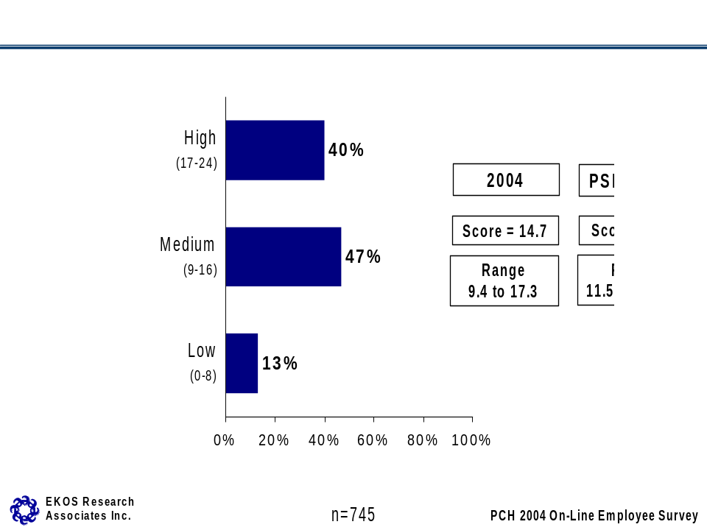
- Direct Report employees score higher on the index due to their expression of high levels of satisfaction with the overall learning environment. Public Affairs and Communications sector employees have a lower mean score compared to the overall Department (see Table 1 on page 13 for individual sector results).
- Employees in the Canadian Heritage Information Network, Human Resources and Workplace Management, Financial Management and Sport Canada branches tend to score higher on the LCI than employees in other branches while employees in the Major Events and Celebration branch and Quebec Region score lower on the index (see Table 1 on page 13 for individual branch and region results).
- Administrative Services Group employees score higher on the index while Computer Systems Group employees tend to score lower.
- Employees who have been working for Canadian Heritage for less than one year and the Public Service for less than two years have a higher mean score than the Department as a whole.
- Employees not directly responsible for a team of employees and financial resources have a lower mean score on the Learning Culture Index.
- Employees who agree that PCH is a great place to work/learn have a higher LCI score. Employees without a learning plan have a lower mean score, while those with a verbal learning plan have the highest mean score.
- Employees who agree they get adequate recognition from their immediate supervisor when they do a good job have a higher mean score on the index.
- Employees who agree that their supervisor would take their suggestions for improvements seriously have a more positive score on the LCI compared to those who disagreed with the statement.
- Employees who agree that in their work unit every individual is accepted as an equal member of the team have a more positive score on the LCI.

Learning Culture Index: Organizational Support

Learning Culture Index: Organizational Support

Three indicators (discussed separately below) were combined to form an index of organizational support for learning at PCH – an overall indicator of employee’s assessment of their organization’s support for learning and career development. When points on the index are divided into three equal ranges, the distribution is as follows: just over one-third of respondents scored high on the index, 44 per cent have a medium score and 21 per cent a low score on the index.

The mean score on this index is 5.37, virtually the same as in 2002 when the average score was 5.41.

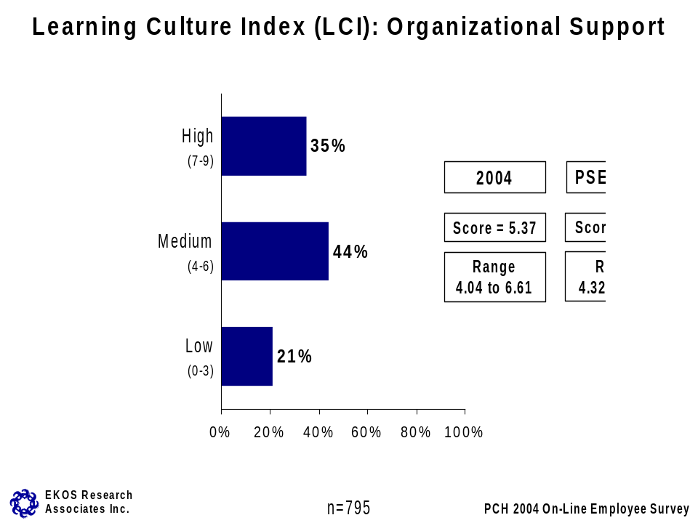

- Direct Report employees have a higher mean score on this index, indicating more positive perceptions of their organization’s support for learning and career development compared to other employees. The opposite is true for Public Affairs and Communications sector employees who tend to have a lower score on the index (see Table 1 on page 13 for individual sector results).
- Employees in the Human Resources and Workplace Management, Financial Management and Sport Canada branches have a higher mean score on the index compared to employees in other branches. Employees in the Major Events and Celebration branch score lower on the index (see Table 1 on page 13 for individual branch results).
- Executive and Administrative Services Group employees have higher mean scores, while Computer Systems and Program Administration Group employees and those 55 years or older score lower than average.
- Those employees who have worked in the Public Service for five to 10 years score lower on this index than other employees.
- Those employees directly responsible for a team of employees and financial resources have higher mean scores on the index compared to those who do not have responsibilities in this area.
- Employees who identify themselves as visible minorities have lower mean scores than other employees.
- Employees who agree that PCH is great place to work/learn have higher mean scores on the index.
- Employees who agree they get adequate recognition from their immediate supervisor when they do a good job have a higher mean score on the index.
- Employees who agree that their supervisor would take their suggestions for improvements seriously have a more positive score on the index compared to those who disagreed with the statement.
- Employees who agree that in their work unit every individual is accepted as an equal member of the team have a more positive score on the index.

Measures of Organizational Support

Results for each of the individual measures that comprise the organizational support for learning and development index are presented in this section. PCH employees are generally positive about getting the training they need in order to do their jobs. Nearly three-quarters feel they get the training they need to do their jobs. Substantially fewer (56 per cent) believe they have opportunities for promotion given their education, skills and experience. While the measure of opportunities for advancement is relatively unchanged since 2002, employees’ rating of access to training has declined over this period (by seven percentage points)

Employees are generally unlikely to feel that a lack of access to developmental assignments has had an effect on their careers. Six in 10 feel (59 per cent) think that a lack of access to developmental training has no little or no effect on their career progress, while one-third (35 per cent) feel that it has had a moderate to significant effect (a marginal decrease of four percentage points since 2002).

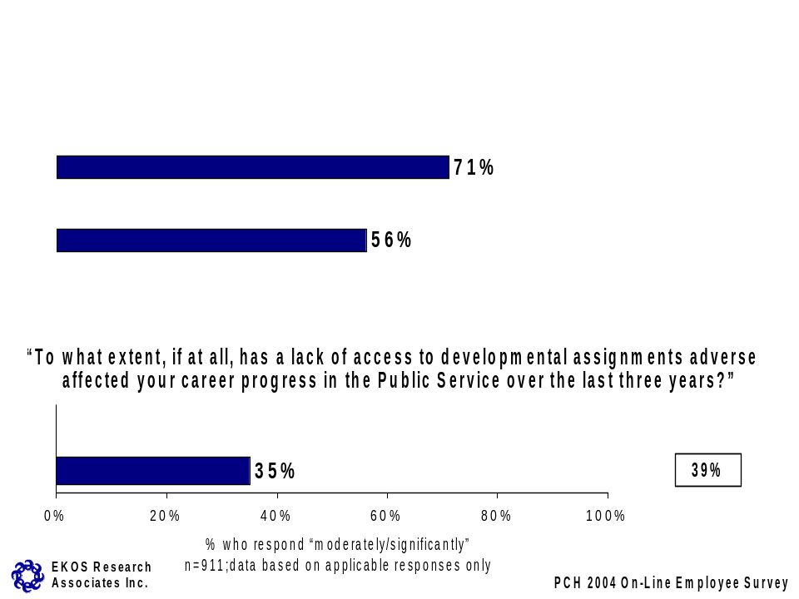

Employee sub-group differences on each of the questions are summarized below. Note that sub-group differences that have been noted with respect to the index are not repeated here. Only significant differences that are evident for the individual measure, but not for the index, are described.

Get the training needed to do the job
- Employees who agree that PCH is a great place to work/learn are more likely to agree that they get the necessary training to do their job.
- Employees who took classroom training last year (particularly those taking five or more days of training are more likely to agree with the statement.

Opportunity for promotion
- Employees in Aboriginal Affairs are more likely than those in other branches to say that they have opportunities for promotion within their Department. The opposite is true of employees in the Atlantic Region, who disagree they have opportunities for promotion given their education, skills and experience.
- Employees with less experience (less than two years) in Canadian Heritage or the Public Service are more likely to feel that they have the opportunity to advance given their education, skills and experience.
- Perceived opportunities for advancement is positively linked to overall attitudes toward the Department; those who believe PCH is a great place to work/learn and employees who have a high score on the LCI are more apt to agree they have opportunities for advancement at PCH.

Access to developmental assignments
- Employees in the Atlantic Region feel that a lack of access to developmental assignments has had a minimal effect on their careers.
- Commerce Group employees feel that a lack of access to developmental assignments has had a minimal effect on their career progress
- Employees aged 45-54, those with 10+ years of experience in the Public Service and those responsible for employees and financial resources are also more likely to feel it has had no effect on their career progress.
- Employees who disagree that PCH is a great place to work/learn are more apt to indicate their career progress has been impeded by lack of access to developmental assignments.

Learning Culture Index: Supervisor Support

Learning Culture Index: Supervisor Support

Five survey items (described below) were combined into an overall index representing supervisor support for learning and development. Like the indices discussed previously, respondent ratings on the each of the composite items are combined in an additive fashion and have been assigned a high, medium and low overall score. Four in 10 PCH employees provided an overall high rating of support for learning and development from their immediate supervisor/manager, while 44 per cent have a medium score rating. Sixteen per cent have a low score rating. The mean rating on the index in 2004 is 9.3, similar to the PSES 2002 score of 9.7.

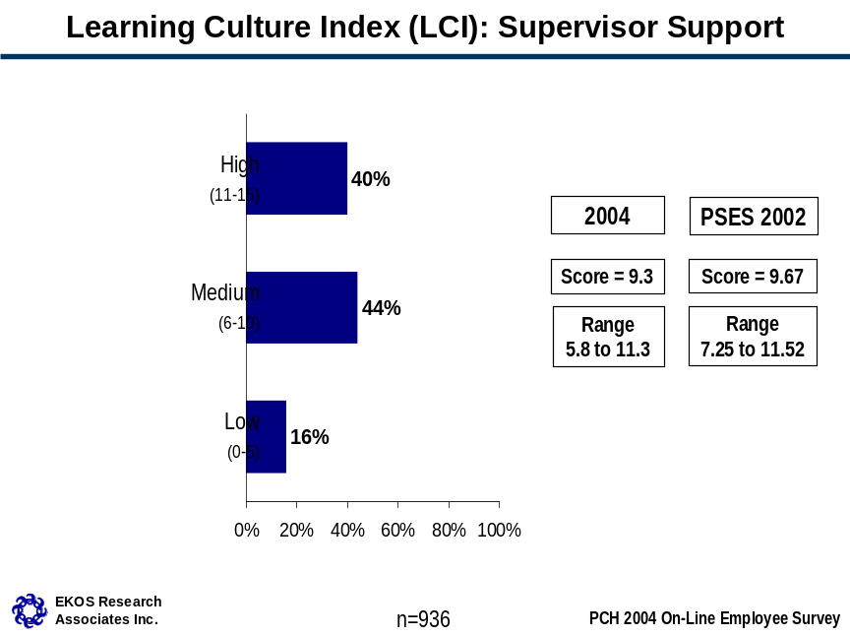

In terms of employee sub-group differences:
- Direct Report employees have a higher mean score on the supervisor support for learning and development index, while the mean rating is lowest for Public Affairs and Communications employees (see Table 1 on page 13 for individual sector results).
- Across PCH, Canadian Heritage Information Network employees, Human Resources and Workplace Management and Aboriginal Affairs branch staff and Ontario Region employees have significantly higher mean ratings on the sub-index, while Canadian Culture Online, Film, Video and Sound Recording, Major Events and Celebration and Quebec Region employees have lower scores compared to the average (see Table 1 on page 13 for individual branch and region results).
- Employees who have been working at Canadian Heritage for less than one year and those who have worked in the Public Service for less than two years have higher mean scores than other employees on this particular index.
- Rated supervisor support for learning and development is highly and positively related to scores on stress/satisfaction (Business Health Culture Index). As well, employees who agree that PCH is a great place to work/learn have higher scores on the index, as do employees with a verbal learning plan.
- Employees who agree they get adequate recognition from their immediate supervisor when they do a good job have a higher mean score on the index.
- Employees who agree that in their work unit every individual is accepted as an equal member of the team have a more positive score on the index.

Measures of Supervisor Support

This section discusses results for each of the individual measures that combined to form the supervisor support for learning and development index. The current PCH employee survey replicated a number of items from the 2002 PSES concerning supervisor support. Eight in 10 PCH employees mostly or strongly agree that their immediate supervisor keeps them informed about the issues affecting their work and takes them seriously if they were to suggest ways to improve the way things are done. The former rating represents a small increase from the 2002 PSES results (four percentage points), while the latter rating is virtually unchanged. About two-thirds of employees mostly or strongly agree that they receive useful feedback from their immediate supervisor/manager on this job performance (a similar result as in 2002).

Employees’ ratings are somewhat less positive with respect to supervisor support for learning and development specifically. Approximately six in 10 employees (56 per cent) mostly or strongly agree their immediate supervisor does a good job of helping them develop their career and a somewhat smaller proportion (54 per cent) agree that their supervisor helps them determine their learning needs. These results are the same as those found in the 2002 PSES.
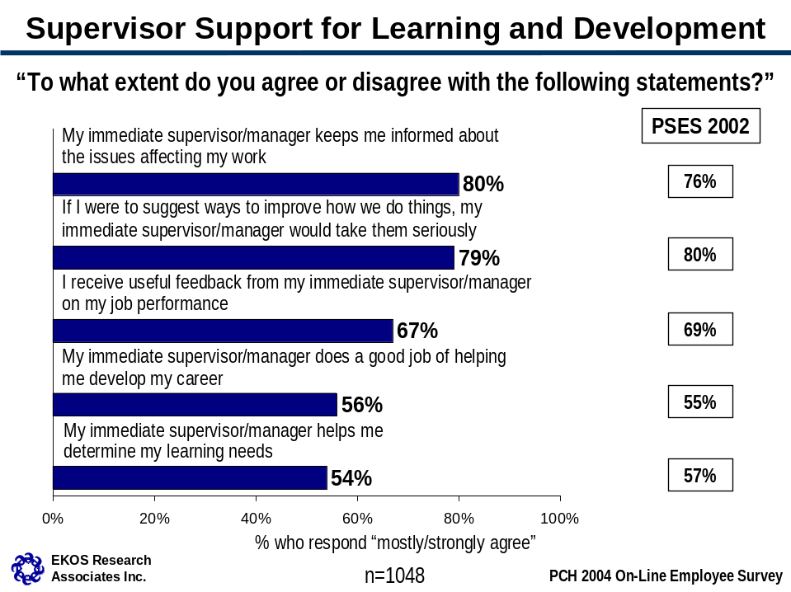

Sub-group differences among PCH employees are described below.

Supervisor keeps me informed
- Across PCH, Ontario Region employees are more likely to agree that their supervisor keeps them informed about issues affecting their work compared to the average. Employees in Knowledge, Information and Technology Services, Film, Video and Sound Recording and Citizenship and Heritage Residual branches, as well as Computer Systems Group employees more often disagree with the statement.
- Employees who agree that PCH is a great place to work/learn were more apt to agree with that their supervisor keeps them informed.

Supervisor takes suggestions seriously
- Human Resources and Workplace Management branch employees are more apt to agree that their supervisor would take their suggestions for improvement seriously compared to other PCH employees. Employees who directly manage a team of employees and financial resources are also more likely to agree with the statement. Employees with the least tenure (less than one year with PCH) are also more likely to agree that their supervisor would take their suggestions seriously compared to the average. Program Administration Group employees are less likely to agree with the statement.
- Employees who agree that PCH is a great place to work/learn and employees who have a verbal learning plan are more likely to agree with the statement.

Receive useful feedback on job performance
- Employees in Aboriginal Affairs and in the Ontario Region are more likely to agree that they receive useful feedback from their supervisor on their job performance compared to the average.
- Employees who agree that PCH is a great place to work/learn are also more apt to agree that their supervisor provides useful feedback.

Supervisor does a good job of helping develop career
- Direct Reports staff are more apt to agree that their supervisor does a good job helping them to develop their career. On the other hand, staff in the Public Affairs and Communications sector more often disagree with the statement. Human Resources and Workplace Management branch employees provide a more favourable rating of their supervisor on this aspect compared to the average. Citizenship and Heritage Residual branch staff are less likely to agree with the statement.
- Those in the 45-54 year age category are more likely to disagree their supervisor does a good job in this area, while the youngest employees (less than 35 years of age) are least likely to disagree with the statement. The age pattern is reflected in the results based on tenure - employees who have more tenure with PCH and with the Public Service are more likely to disagree their supervisor does a good job of helping them to develop their career.
- Employees who agree that PCH is a great place to work/learn more often agree with the statement. Employees who have a learning plan (particularly those with a verbal learning plan) agree with statement more often than those who do not.

Supervisor helps determine learning needs
- Direct Report staff (and Human Resources and Workplace Management branch staff specifically within that sector) are more apt to agree that their immediate supervisor helps them determine their learning needs. Public Affairs and Communications sector employees, Film, Video and Sound Recording branch employees and those with a CO-designation disagree with the statement more often than average.
- Employees who agree that PCH is a great place to work/learn and those who have a verbal learning plan were more likely to agree that their supervisor helps determine their learning needs.

Table 1: Learning Culture Index Mean Scores: By Sector, Branch and Region
Department Overall | Overall Score  (14.7) | Organizational Support (5.38) | Supervisor Support  (9.3)
Sector
- Direct Reports* | 16.2 | 6.20 | 10.1
- Cultural Affairs | 14.6 | 5.51 | 9.1
- Citizenship and Heritage | 15.2 | 5.51 | 9.6
- International and Intergovernmental Affairs | 15.5 | 5.75 | 9.8
- Planning and Corporate Affairs | 14.7 | 5.31 | 9.2
- Public Affairs and Communications | 13.4 | 4.74 | 8.7
Branch
Assistant Deputy Minister’s Office Composite* | 17.0 | 6.60 | 10.0
Citizenship and Heritage Residual* | 13.5 | 4.99 | 8.5
Deputy Minister’s Office Composite* | 14.9 | 5.87 | 9.3
Cultural Affairs Residual* | 14.6 | 5.53 | 9.2
International and Intergovernmental Affairs Residual* | 15.4 | 5.48 | 9.7
Public Affairs and Communications Residual* | 13.3 | 5.56 | 8.1
Human Resources and Workplace Management | 17.3 | 6.61 | 10.6
Strategic Policy and Research | 16.3 | 5.85 | 10.5
Arts Policy | 15.7 | 5.71 | 9.7
Canadian Culture Online | 11.8 | 4.59 | 6.7
Film, Video and Sound Recording | 13.0 | 4.98 | 7.9
Publishing Policy and Programs | 15.4 | 5.88 | 9.8
Official Languages Support Programs | 15.5 | 5.66 | 9.5
Multiculturalism and Human Rights | 15.5 | 5.65 | 9.3
Citizenship Participation and Promotion | 16.1 | 5.92 | 10.4
Aboriginal Affairs | 16.8 | 5.57 | 11.3
Canadian Heritage Information Network | 16.5 | 5.43 | 11.2
Canadian Conservation Institute | 13.6 | 5.22 | 8.2
International Affairs | 14.7 | 5.48 | 9.6
Sport Canada | 15.9 | 5.71 | 10.0
Financial Management | 16.2 | 6.24 | 9.9
Planning and Corporate Affairs Residual/  Corporate Review and Corporate Planning* | 14.7 | 5.52 | 9.4
Knowledge, Information and Technology Services | 13.7 | 4.58 | 9.0
Communications | 14.6 | 5.31 | 9.5
Major Events and Celebration | 11.9 | 4.06 | 7.5
Region
Atlantic Region | 13.5 | 4.68 | 9.2
Quebec Region | 9.4 | 4.04 | 5.8
Ontario Region | 15.5 | 4.70 | 10.6
Prairies and Northern Region | 14.0 | 4.50 | 9.2
Western Region | 14.4 | 4.71 | 9.4
* Shaded areas indicate unofficial sector/branch names created to ease analysis. See Appendix B for full list of branches included in these groups.

Learning Plans

For the 2003-04 fiscal year, nearly two-thirds of PCH employees had either a written or verbal learning plan. Half had a written plan (49 per cent), while an additional 13 per cent had verbal learning plans. Just over one-third of employees (35 per cent) had no learning plan last year.

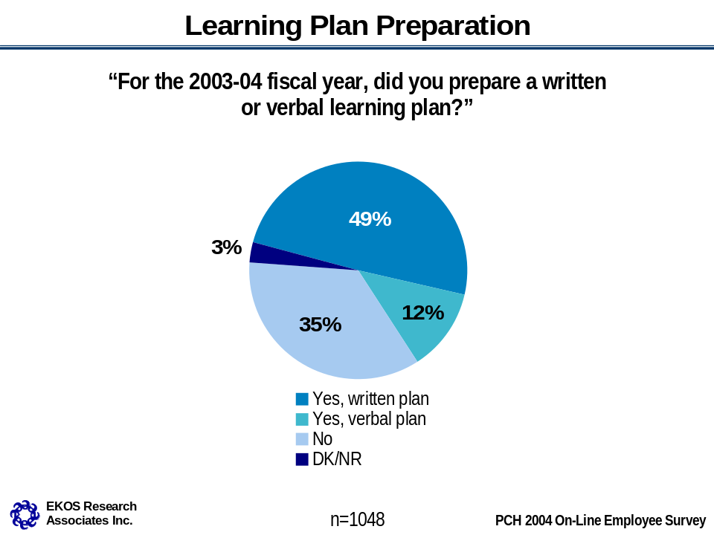

- International and Intergovernmental Affairs sector employees are more likely than employees in other sectors to have a written plan. Direct Report staff and Public Affairs and Communications sector employees are least likely to have had a learning plan for the 2003-04 fiscal year (see Table 2 below for individual sector results).
- Across branches, employees in the International and Intergovernmental Affairs Residual, Citizenship Participation and Promotion, International Affairs, Sport Canada, Knowledge, Information and Technology Services branches, along with Atlantic and Western Region staff are more likely than those in other branches to have a written learning plan. Employees in the Deputy Minister’s Office Composite, Aboriginal Affairs, Multiculturalism and Human Rights and Financial Management are least likely to have a learning plan of any kind (see Table 2 below for individual branch and region results).

Table 2: Learning Plan Preparation: By Sector, Branch and Region
Department Overall | Yes, written plan  (49%) | Yes, verbal plan  (12%) | No learning plan  (35%)
Sector
- Direct Reports* | 34% | 15% | 48%
- Cultural Affairs | 51% | 14% | 32%
- Citizenship and Heritage | 47% | 14% | 35%
- International and Intergovernmental Affairs | 80% | 7% | 11%
- Planning and Corporate Affairs | 54% | 9% | 34%
- Public Affairs and Communications | 44% | 13% | 41%
Branch
Assistant Deputy Minister’s Office Composite* | 53% | 9% | 38%
Citizenship and Heritage Residual* | 38% | 14% | 48%
Deputy Minister’s Office Composite* | 32% | 10% | 55%
Cultural Affairs Residual* | 64% | 17% | 16%
International and Intergovernmental Affairs Residual* | 92% | 0% | 8%
Public Affairs and Communications Residual* | 55% | 9% | 36%
Human Resources and Workplace Management | 42% | 15% | 39%
Strategic Policy and Research | 16% | 28% | 56%
Arts Policy | 41% | 11% | 40%
Canadian Culture Online | 59% | 14% | 24%
Film, Video and Sound Recording | 65% | 11% | 24%
Publishing Policy and Programs | 34% | 16% | 48%
Official Languages Support Programs | 23% | 26% | 45%
Multiculturalism and Human Rights | 30% | 12% | 51%
Citizenship Participation and Promotion | 70% | 19% | 11%
Aboriginal Affairs | 17% | 20% | 60%
Canadian Heritage Information Network | 74% | 6% | 11%
Canadian Conservation Institute | 63% | 9% | 24%
International Affairs | 78% | 13% | 2%
Sport Canada | 75% | 7% | 16%
Financial Management | 32% | 11% | 52%
Planning and Corporate Affairs Residual/  Corporate Review and Corporate Planning* | 54% | 5% | 41%
Knowledge, Information and Technology Services | 68% | 10% | 18%
Communications | 11% | 21% | 64%
Major Events and Celebration | 12% | 11% | 76%
Region
Atlantic Region | 67% | 13% | 18%
Quebec Region | 16% | 9% | 75%
Ontario Region | 28% | 17% | 46%
Prairies and Northern Region | 85% | 6% | 6%
Western Region | 68% | 13% | 17%
* Shaded areas indicate unofficial sector/branch names created to ease analysis. See Appendix B for full list of branches included in these groups.

- Commerce Group and Program Administration Group employees are more likely to have a written learning plan in place, while Executive Group employees are more apt to have verbal plans. Administrative Services Group and Clerical and Regulatory Group employees are less likely to have any learning plan. Information Services Group employees are the most unsure about whether they have a learning plan or not.
- Employees aged 35-44 are less likely than other employees to have any kind of learning plan, while those aged 55+ are more likely to report they have a verbal learning plan in place.
- Those employees with one to two years experience are more likely than other employees to have a written learning plan in place, while those with less than one year experience at Canadian Heritage are more likely not to have a learning plan. Those with more than 10 years of experience at both Canadian Heritage and in the Public Service are more likely to have a verbal learning plan in place.
- Employees with a high LCI score are also more likely to have developed a learning plan.

Of those employees with a learning plan in place, nearly three-quarters (72 per cent) mostly or strongly agree that they have made progress in completing the objectives identified in their learning plans. One in five disagree (mostly or strongly).
- In terms of subgroup differences, only Direct Report employees are more likely to agree with this statement.
- Employees who disagree that PCH is a great place to work/learn and who have a low LCI score more often disagree with this statement compared to the average.
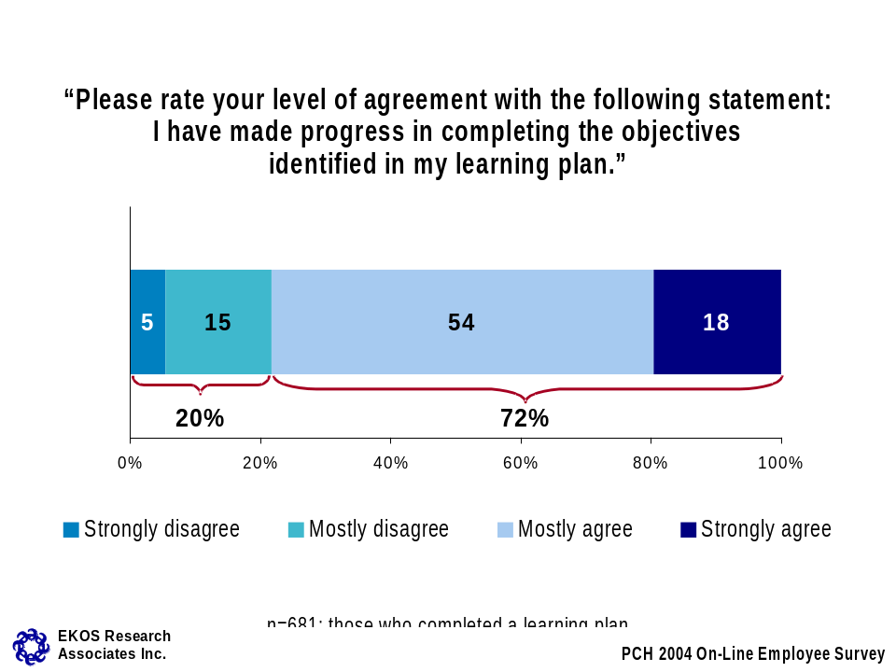

Two-thirds (67 per cent) of those employees with a learning plan in place take (to a moderate or great extent) Departmental, branch or regional objectives into account when preparing their learning plans. This is up slightly since the last time this question was asked in 2001 (by eight percentage points for those taking objective into account to a great extent). Sixteen per cent of employees who have learning plans took these objectives into account to a small extent, and another eight per cent reported Departmental, branch or regional objectives were not taken into account at all.
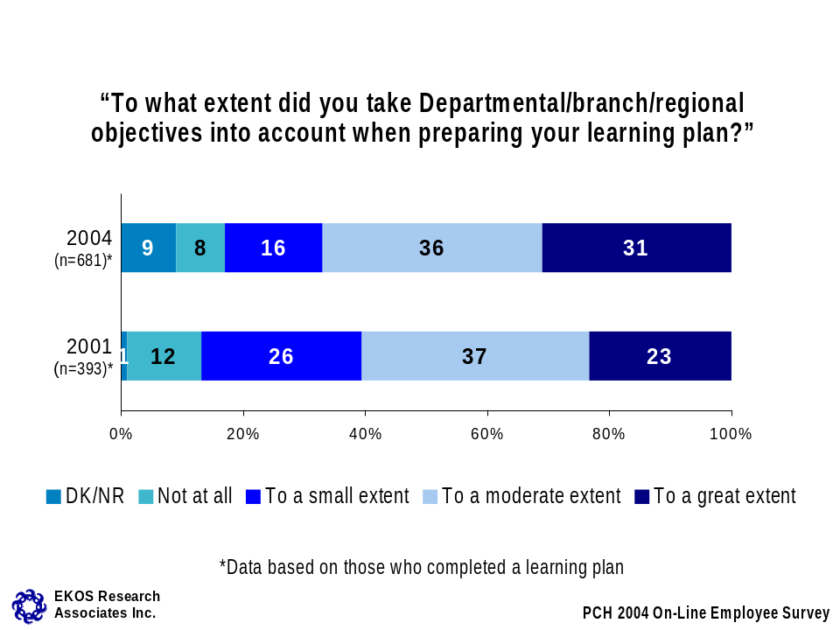

- International and Intergovernmental Affairs sector employees are more likely than average to report that they did not take Departmental, branch or regional objectives into account at all when preparing their learning plans compared to the average.
- There are no employees more likely to take Departmental, branch or regional objectives into account to a great extent when preparing their learning plans. In fact, Sport Canada staff more often indicated not taking objectives into account at all.
- Program Administration Group employees are more likely than others to take Departmental, branch or regional objectives into account, to a great extent, as are employees who are 45 years of age or over. Economics, Sociology and Statistics Group employees are more likely to report that they take these objectives into account to a moderate extent, as are those who have been with Canadian Heritage for five to 10 years. Younger employees (less than 35 years of age) are less apt to take these objectives into consideration when preparing their learning plans than average.
- Employees with a high LCI score report taking Departmental/branch/regional objectives into account to a great extent. Those with verbal learning plans have more often taken objectives into account to a moderate extent, compared to the average.
Of those employees who have a learning plan, nearly half (46 per cent) report that workload is the primary barrier to completion of the objectives identified in their learning plans. Three in 10 cite lack of funds, followed by 14 per cent who feel that lack of management support is the primary barrier and eight per cent citing lack of awareness of learning opportunities. Fourteen per cent have experienced no barriers in completing their learning plans.

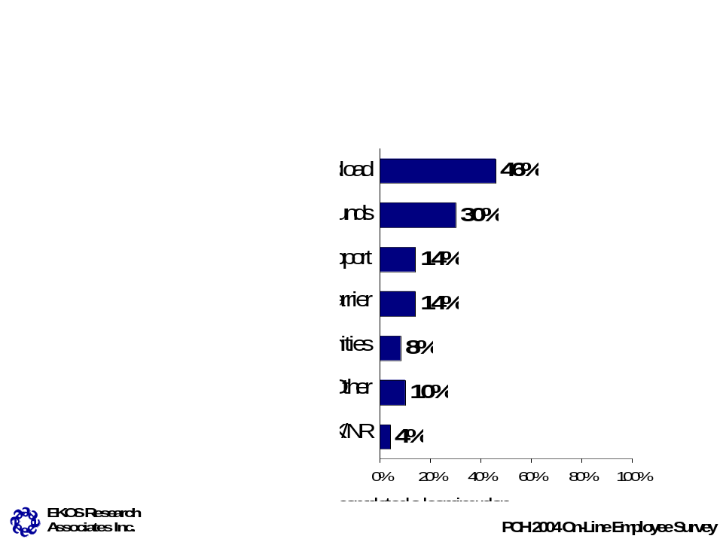

- Public Affairs and Communications and Planning and Corporate Affairs sector employees are more likely than employees in other sectors to feel that lack of funds was the primary barrier to completing their learning plan objectives. Planning and Corporate Affairs employees are also more likely to cite a lack of management support as a primary barrier. Citizenship and Heritage Residual sector employees are more likely to report that their workload is the primary barrier (see Table 3 below for individual sector results).
- Knowledge, Information and Technology Services, Western Region and International and Intergovernmental Affairs Residual branch employees are more apt to cite lack of funds as the primary barrier. Knowledge, Information and Technology Services employees are also more likely to cite a lack of management support as the primary barrier when compared to the average (see Table 3 below for individual branch and region results).

Table 3: Barriers to Completing Learning Plan: By Sector, Branch and Region
Department Overall | Workload  (46%) | Lack of funds  (30%) | Lack of  supervisory support  (14%) | No barrier  (14%) | Not aware of opportunities  (8%)
Sector
- Direct Reports* | 46% | 26% | 6% | 18% | 11%
- Cultural Affairs | 33% | 24% | 18% | 19% | 12%
- Citizenship and Heritage | 55% | 17% | 11% | 12% | 6%
- International and Intergovernmental Affairs | 43% | 24% | 14% | 19% | 9%
- Planning and Corporate Affairs | 37% | 41% | 21% | 16% | 5%
- Public Affairs and Communications | 50% | 43% | 12% | 8% | 8%
Branch
Assistant Deputy Minister’s Office Composite* | 31% | 27% | 23% | 12% | 7%
Citizenship and Heritage Residual* | 36% | 14% | 21% | 28% | 16%
Deputy Minister’s Office Composite* | 28% | 28% | 11% | 30% | 13%
Cultural Affairs Residual* | 38% | 26% | 15% | 19% | 5%
International and Intergovernmental Affairs Residual* | 42% | 49% | 21% | 15% | 10%
Public Affairs and Communications Residual* | 57% | 21% | 21% | 17% | 0%
Human Resources and Workplace Management | 50% | 29% | 2% | 15% | 12%
Strategic Policy and Research | 73% | 9% | 9% | 0% | 0%
Arts Policy | 56% | 5% | 14% | 14% | 11%
Canadian Culture Online | 31% | 16% | 31% | 13% | 4%
Film, Video and Sound Recording | 7% | 56% | 25% | 25% | 12%
Publishing Policy and Programs | 41% | 5% | 14% | 24% | 19%
Official Languages Support Programs | 65% | 11% | 14% | 11% | 12%
Multiculturalism and Human Rights | 50% | 12% | 22% | 9% | 3%
Citizenship Participation and Promotion | 45% | 25% | 3% | 20% | 3%
Aboriginal Affairs | 46% | 21% | 0% | 18% | 0%
Canadian Heritage Information Network | 63% | 14% | 12% | 4% | 0%
Canadian Conservation Institute | 62% | 20% | 7% | 7% | 9%
International Affairs | 37% | 22% | 14% | 21% | 4%
Sport Canada | 55% | 10% | 2% | 17% | 15%
Financial Management | 38% | 30% | 0% | 22% | 8%
Planning and Corporate Affairs Residual/  Corporate Review and Corporate Planning* | 51% | 14% | 14% | 14% | 0%
Knowledge, Information and Technology Services | 37% | 53% | 29% | 16% | 5%
Communications | 44% | 22% | 0% | 0% | 11%
Major Events and Celebration | 18% | 70% | 11% | 18% | 0%
Region
Atlantic Region | 55% | 37% | 6% | 3% | 0%
Quebec Region | 35% | 71% | 29% | 0% | 35%
Ontario Region | 55% | 52% | 14% | 0% | 14%
Prairies and Northern Region | 53% | 45% | 3% | 12% | 10%
Western Region | 49% | 50% | 19% | 9% | 10%
* Shaded areas indicate unofficial sector/branch names created to ease analysis. See Appendix B for full list of branches included in these groups.
- Computer Systems Group employees are more likely to cite lack of funds and lack of management support as the primary barriers. Administrative Services Group employees are more likely than employees in other branches to report that they have experiences no barriers in completing their learning plan objectives and Economics, Sociology and Statistics Group employees are more likely to cite workload.
- Employees with little experience with Canadian Heritage or the Public Service are more likely to report that lack of awareness of learning opportunities is a barrier, while those employees with 5+ years of experience are more likely to cite workload as the primary barrier.
- Employees who are directly responsible for a team of employees and financial resources are more likely to cite workload as the primary barrier, while those without such responsibilities cite a lack of funds and lack of awareness of opportunities as primary barriers to completing their learning plans.
- Employees who identify themselves as visible minorities are more likely to report that lack of awareness of learning opportunities, while employees who are not members of an employment equity group cite workload as the primary barrier to completing their learning plan objectives.
- Employees who disagree that PCH is a great place to work/learn and who have a low LCI score more often cite lack of supervisor/management support as the primary barrier.

Four in 10 PCH employees (43 per cent) report having written work objectives, while half (51 per cent) do not.

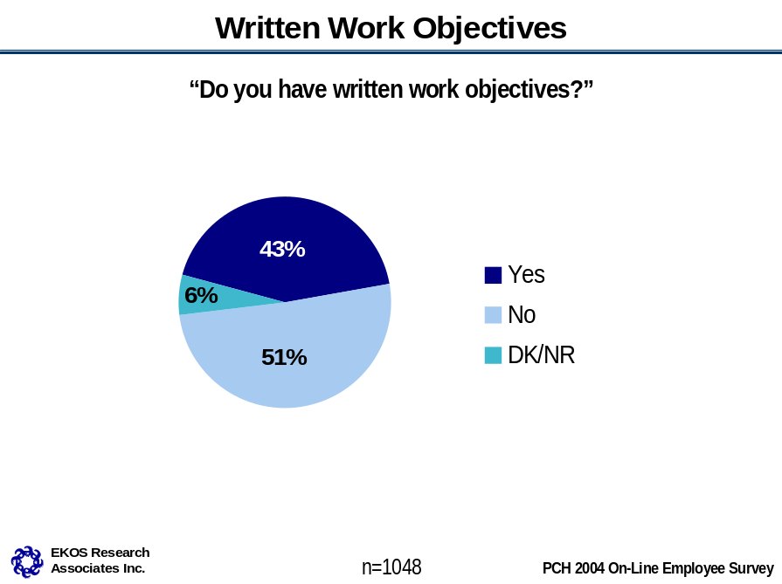

- Citizenship and Heritage Residual sector employees are more likely than others to have written work objectives, while Direct Report staff are less likely to.
- Canadian Conservation Institute and Atlantic Region employees are more likely than employees in other branches and regions to have written work objectives, while Financial Management employees are less apt to report having written work objectives.
- Executive Group employees are more likely to have written work objectives while Administrative Services Group employees are less likely to have written work objectives and Clerical and Regulatory Group employees are more likely to say they “don’t know”.
- Employees aged 45-54 are more likely than average to have written work objectives.
- PCH employees directly responsible for a team of employees and financial resources are more likely to have written work objectives compared to those who do not have these responsibilities.
- Employees that have a written learning plan also more often have written work objectives.

Training

Participation in Training

Conferences and seminars and the traditional classroom-training format are the most common methods of training among PCH employees. Fifty-three per cent of employees attended a conference or seminar in the last year. A similar proportion, 52 per cent, spent at least some time in classroom training during the 2003-04 fiscal year. One-third of employees reported attending Departmental Forum, such as the Administrative Forum, in the last fiscal year. Only a minority of PCH employees indicate having spent time in the last year on e-learning (11 per cent) or university or college course training (seven per cent).

Considering all employees (i.e., including those who did not attend a conference/seminar), the average number of days spent on conferences or seminars was 2.2. Among those employees who attended a conference or seminar, 3.6 days were spent last year on this training. The average number of days spent in classroom training across all employees was 2.6. Considering only those employees who reported taking some classroom training, the average number of days in training was 4.6.

The average number of days spent attending Departmental Forum across all employees was 1.1 day and 2.9 days considering only those who attended. The overall average time spent on university or college training and e-learning is low (1.4 and 0.6, respectively), though university or college courses are of a comparatively longer duration considering only those taking this training (16 days on average).

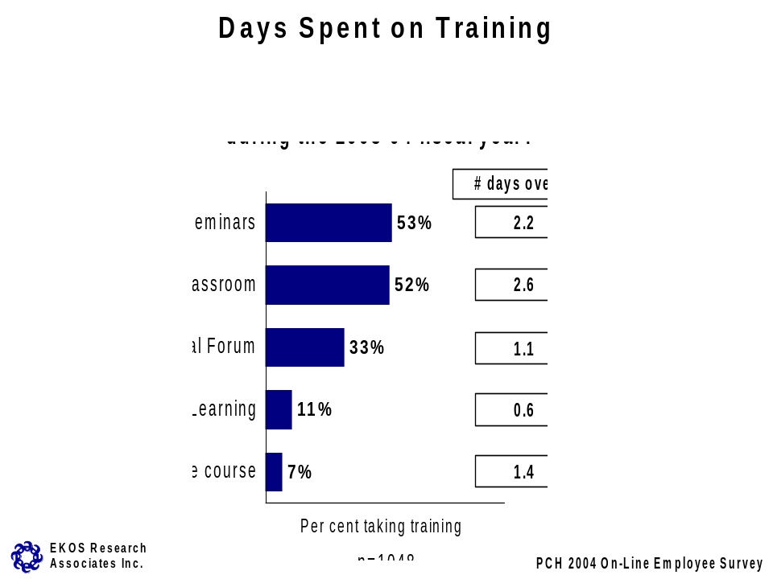
Differences among employee sub-groups for each of the training methods are summarized below (for individual sector, branch and region results see Table 4 on page 25).

Conferences or Seminars
- Across PCH sectors, Planning and Corporate Affairs employees are more apt to have attended conferences or seminars last year, while Public Affairs and Communications employees are less likely to have participated in this type of training.
- Employees in the Publishing Policy and Program, Human Resources and Workplace Management, Planning and Corporate Affairs Residual and those working in the Atlantic Region are most likely to have participated in a conference or seminar in the last year. Least likely to have attended a conference or seminar are employees in the Deputy Minister’s Office Composite.
- Executive Group employees and those in the “other” occupational categories are among the most likely participants in conferences/seminars. Administrative Services Group and Clerical and Regulatory Group staff are less likely to have attended a conference or seminar.
- Those with the least tenure with PCH (less than two years) are more apt to have attended a short-term conference or seminar (one day last year) compared to the average.
- Employees who directly manage employees or resources are marginally more likely to have attended a conference or seminar last year than those who do not.
- Employees without a learning plan are less likely to have attended a conference or seminar last year.

Classroom Training
- Across sectors, employees in Planning and Corporate Affairs and International and Intergovernmental Affairs are more likely to have taken classroom training (with the mean overall days being highest for Planning and Corporate Affairs sector employees). Employees in the Public Affairs and Communications sector are least likely to have taken classroom training last year.
- Staff in the Human Resources and Workplace Management, Citizenship Participation and Promotion, Knowledge, Information and Technology Services and International Affairs branches have higher rates of participation in classroom training than the average across Canadian Heritage. Participation in classroom training is lowest in the Multiculturalism and Human Rights branch and those working in the Western and Ontario Regions.
- Staff in the Computer Systems Group and Administrative Services Group have the highest likelihood of taking classroom training (with Computer Systems Group employees spending more days on average in training). Commerce Group and Program Administration Group employees are least likely to have taken classroom training last year.
- Employees with a written learning plan and those with a high score on the LCI are more likely to have taken classroom training last year.

Departmental Forum
- Direct Report staff and Public Affairs and Communications sector employees are marginally more likely than average to have attended Departmental Forum last year.
- Human Resources and Workplace Management branch staff are more likely than other employees to have attended Departmental Forum last year, as are Executive Group, Clerical and Regulatory Group and Administrative Services Group staff. Employees in the Ontario, Western and Atlantic Regions are more apt to have attended Departmental Forum for longer durations last year. Citizenship Participation and Promotion staff and Programme Administration Group staff are less likely to have attended Departmental Forum last year.

E-learning
- Staff in the Human Resources and Workplace Management branch are more apt than average to have participated in e-learning in the last year, while Film, Video and Sound Recording branch staff are less likely.
- Computer Systems Group employees and those with less than two years tenure with the Public Service also have a greater likelihood of having taken e-learning, as do employees with a disability and visible minority employees. Commerce Group, Economics, Sociology and Statistics Group, or Program Administration Group employees are less likely to have taken e-learning last fiscal year.
- Employees with a high LCI score are more apt to have taken e-learning last year.

University or College Courses
- International Affairs employees and those with less than two years tenure in the Public Service are more likely to have taken university/college courses last year. Public Affairs and Communications sector employees, those in the Ontario and Western Regions and Program Administration Group employees are somewhat less likely to have participated in this form of training.
Table 4: Days Spent on Training: By Sector, Branch and Region (based on those who participated in training)
 | Days spent on training
Department Overall | Conferences (3.6 days) | Classroom  (4.6 days) | Dept. Forum  (2.9 days) | E-learning  (4.3 days) | University  (16.2 days)
Sector
- Direct Reports* | 5.1 | 4.6 | 3.3 | 13.6 | 13.6
- Cultural Affairs | 3.4 | 4.0 | 2.3 | 2.4 | 21.5
- Citizenship and Heritage | 3.8 | 4.5 | 2.4 | 2.6 | 26.7
- International and Intergovernmental Affairs | 2.9 | 4.5 | 2.3 | 2.6 | 12.1
- Planning and Corporate Affairs | 3.3 | 6.4 | 2.5 | 3.0 | 25.3
- Public Affairs and Communications | 3.3 | 3.3 | 3.4 | 2.0 | 4.1
Branch
Assistant Deputy Minister’s Office Composite* | 1.0 | 3.2 | 2.1 | 0 | 90.0
Citizenship and Heritage Residual* | 3.4 | 4.5 | 2.3 | 2.0 | 0
Deputy Minister’s Office Composite* | 4.9 | 3.3 | 2.3 | 3.0 | 28
Cultural Affairs Residual* | 3.3 | 3.5 | 2.0 | 4.0 | 3.5
International and Intergovernmental Affairs Residual* | 2.5 | 3.5 | 2.4 | 4.0 | 9.6
Public Affairs and Communications Residual* | 2.7 | 3.1 | 2.4 | 2.0 | 3.3
Human Resources and Workplace Management | 3.8 | 5.8 | 3.9 | 3.0 | 9.2
Strategic Policy and Research | 10.1 | 4.0 | 2.8 | 160.0 | 6.3
Arts Policy | 3.6 | 3.0 | 3.7 | 1.0 | 6.5
Canadian Culture Online | 3.4 | 5.8 | 2.4 | 1.0 | 26.0
Film, Video and Sound Recording | 4.0 | 5.1 | 1.8 | 0 | 59.0
Publishing Policy and Programs | 3.3 | 3.5 | 2.2 | 4.0 | 12.9
Official Languages Support Programs | 3.0 | 4.1 | 2.1 | 1.0 | 0
Multiculturalism and Human Rights | 3.2 | 3.5 | 2.7 | 10.0 | 33.0
Citizenship Participation and Promotion | 2.3 | 6.0 | 2.7 | 1.0 | 19.8
Aboriginal Affairs | 7.6 | 3.6 | 3.1 | 1.0 | 13.2
Canadian Heritage Information Network | 4.8 | 5.1 | 1.6 | 2.7 | 12.8
Canadian Conservation Institute | 3.2 | 3.4 | 2.4 | 3.0 | 3.0
International Affairs | 3.8 | 5.3 | 3.1 | 2.0 | 16.1
Sport Canada | 2.5 | 4.8 | 1.8 | 2.3 | 4.8
Financial Management | 2.8 | 7.7 | 2.7 | 3.8 | 12.3
Planning and Corporate Affairs Residual/  Corporate Review and Corporate Planning* | 3.7 | 4.8 | 2.3 | 1.4 | 3.0
Knowledge, Information and Technology Services | 3.5 | 6.6 | 2.4 | 3.2 | 41.1
Communications | 4.2 | 2.6 | 4.0 | 5.0 | 2.7
Major Events and Celebration | 2.2 | 4.0 | 2.7 | 4.0 | 12.0
Region
Atlantic Region | 3.1 | 3.0 | 2.6 | 1.8 | 3.3
Quebec Region | 3.2 | 3.6 | 2.2 | 1.5 | 0
Ontario Region | 3.6 | 2.0 | 4.1 | 1.5 | 6.0
Prairies and Northern Region | 3.3 | 3.6 | 3.8 | 1.8 | 6.0
Western Region | 3.1 | 4.2 | 4.5 | 1.5 | 0
* Shaded areas indicate unofficial sector/branch names created to ease analysis. See Appendix B for full list of branches included in these groups.

Money Spent on Training

Employees who participated in each of the forms of training were asked to estimate the amount of money the Department spent on their training last year (excluding travel expenses and incidentals). Note that the reported means are based on valid responses, which exclude the large proportion of employees who did not know the cost of their training (almost seven in 10 employees who took e-learning or university or college courses, for example, did not know how much their training cost). The mean does, however, include the 10 to 20 per cent of employees who indicated on the various items that their training did not cost anything.

Among employees who were aware of the cost of training, classroom training represents the highest annual expenditure at about $1,215 (higher for Planning and Corporate Affairs sector and lower for Cultural Affairs and Public Affairs and Communications sectors). This is followed by expenditures on conferences and seminars ($935, lower for Public Affairs and Communications sector employees and those with less than one year tenure at PCH and higher for those who directly manage people and resources) and university or college courses ($895) each year. Departmental Forum and e-learning courses are estimated to be somewhat less expensive, at $665 and $650 each year.

Considering overall per capita training expenditures (i.e., assigning a zero value for those employees who did not take each type of training last year), again, expenditures are highest for classroom training at $538, followed by conferences or seminars at $389. Reflecting their lowest cost and lower rates of participation, per capita costs of university/college courses, Departmental Forum and e-learning are under $100 per employee.
- Employee sub-group differences in terms of amount of money spent on training generally reflect rates of participation. For example, the per capita expenditure on classroom training is higher for the Planning and Corporate Affairs sector and lower for the Public Affairs and Communications and Cultural Affairs sectors. Knowledge, Information and Technology Services branch per capita spending on classroom training is much higher than the average, while expenditures are lower, for example, in the regions. Expenditures are highest among Computer Systems Group employees and lowest for Commerce Group and Clerical and Regulatory Group staff. Those without a learning plan and those with a low score on the LCI also have lower per capita expenditures on classroom training compared to the average.
- Considering conferences and seminars, Direct Report staff and Planning and Corporate Affairs sector employees have the highest per capita expenditures. Per capita expenditures are also higher for Canadian Heritage Information Network employees and Planning and Corporate Affairs Residual, the Executive Group and “other” occupations categories, and among those who directly manage employees or resources.
- For individual sector, branch and region results see Table 5 below.

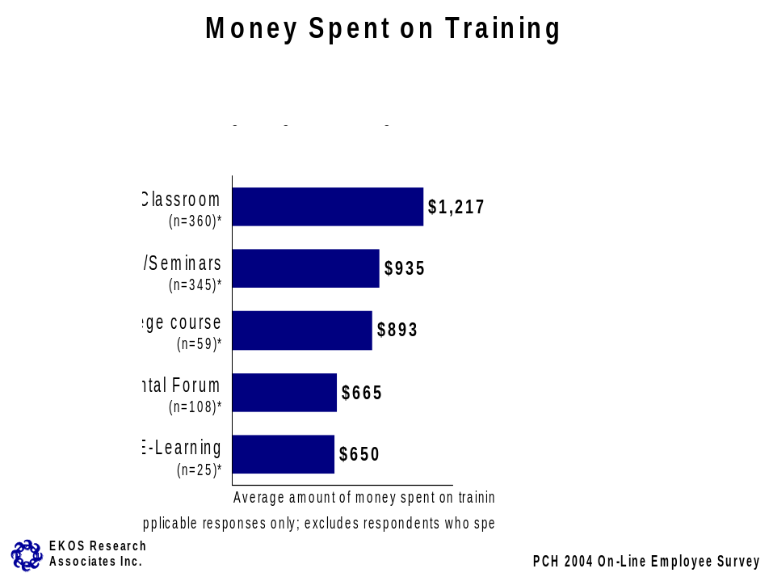

Table 5: Money Spent on Training: By Sector, Branch and Region
Column 1: assumes ‘zero’ for those with no training days (n=1048)
Column 2: ‘none’ filtered out (n=various)
 | Classroom |  | Conferences |  | University |  | Dept Forum |  | E-learning
 | 1 | 2 | 1 | 2 | 1 | 2 | 1 | 2 | 1 | 2
Department Overall | 529 | 1199 | 381 | 934 | 61 | 867 | 91 | 666 | 24 | 660
Sector
- Direct Reports* | 496 | 1062 | 541 | 1137 | 110 | 1328 | 136 | 722 | 11 | 364
- Cultural Affairs | 299 | 838 | 357 | 768 | 75 | 889 | 54 | 709 | 3 | 189
- Citizenship and Heritage | 406 | 1050 | 431 | 1081 | 45 | 666 | 50 | 411 | 33 | 772
- International and Intergovernmental Affairs | 488 | 845 | 325 | 809 | 94 | 733 | 16 | 305 | 5 | 300
- Planning and Corporate Affairs | 1438 | 2174 | 530 | 1216 | 58 | 1418 | 40 | 294 | 63 | 956
- Public Affairs and Communications | 293 | 832 | 235 | 676 | 36 | 660 | 167 | 924 | 22 | 570
Branch
Assistant Deputy Minister’s Office Composite* | 271 | 515 | 29 | 195 | 101 | 1000 | 0 | 0 | 0 | 0
Citizenship and Heritage Residual* | 514 | 1512 | 449 | 941 | 0 | 0 | 36 | 261 | 22 | 500
Deputy Minister’s Office Composite* | 480 | 1020 | 467 | 1240 | 147 | 2536 | 28 | 438 | 0 | 0
Cultural Affairs Residual* | 391 | 997 | 340 | 812 | 89 | 800 | 51 | 289 | 0 | 0
International and Intergovernmental Affairs Residual* | 438 | 910 | 234 | 754 | 70 | 669 | 5 | 200 | 0 | 0
Public Affairs and Communications Residual* | 784 | 1390 | 123 | 487 | 83 | 750 | 0 | 0 | 61 | 550
Human Resources and Workplace Management | 628 | 1033 | 563 | 940 | 53 | 611 | 156 | 521 | 17 | 400
Strategic Policy and Research | 159 | 3000 | 673 | 1488 | 163 | 1300 | 360 | 1587 | 23 | 315
Arts Policy | 323 | 1126 | 189 | 374 | 42 | 389 | 226 | 1278 | 0 | 0
Canadian Culture Online | 269 | 1054 | 391 | 748 | 11 | 300 | 24 | 306 | 18 | 189
Film, Video and Sound Recording | 247 | 801 | 405 | 1060 | 80 | 773 | 0 | 0 | 0 | 0
Publishing Policy and Programs | 239 | 679 | 482 | 864 | 122 | 1489 | 38 | 1500 | 0 | 0
Official Languages Support Programs | 270 | 843 | 322 | 739 | 0 | 0 | 41 | 317 | 0 | 0
Multiculturalism and Human Rights | 233 | 996 | 180 | 482 | 9 | 500 | 96 | 658 | 0 | 0
Citizenship Participation and Promotion | 691 | 1007 | 156 | 1017 | 48 | 500 | 63 | 650 | 10 | 300
Aboriginal Affairs | 104 | 464 | 466 | 1177 | 18 | 516 | 62 | 283 | 0 | 0
Canadian Heritage Information Network | 1145 | 1592 | 1081 | 2026 | 110 | 574 | 0 | 0 | 68 | 358
Canadian Conservation Institute | 117 | 361 | 527 | 1192 | 46 | 700 | 42 | 310 | 103 | 2000
International Affairs | 564 | 892 | 433 | 866 | 203 | 844 | 9 | 250 | 0 | 0
Sport Canada | 526 | 896 | 392 | 791 | 23 | 378 | 36 | 345 | 15 | 300
Financial Management | 729 | 1514 | 590 | 1079 | 36 | 600 | 83 | 326 | 30 | 1000
Planning and Corporate Affairs Residual/  Corporate Review and Corporate Planning* | 961 | 1787 | 936 | 1210 | 62 | 1000 | 47 | 400 | 50 | 425
Knowledge, Information and Technology Services | 2176 | 2643 | 392 | 1423 | 82 | 3600 | 6 | 100 | 102 | 1284
Communications | 253 | 535 | 153 | 560 | 113 | 684 | 28 | 500 | 0 | 0
Major Events and Celebration | 183 | 595 | 32 | 450 | 26 | 502 | 40 | 650 | 0 | 0
Region
Atlantic Region | 255 | 490 | 364 | 565 | 36 | 533 | 395 | 868 | 2 | 49
Quebec Region | 340 | 745 | 355 | 762 | 0 | 0 | 123 | 412 | 110 | 692
Ontario Region | 33 | 422 | 173 | 524 | 12 | 437 | 358 | 935 | 0 | 0
Prairies and Northern Region | 225 | 872 | 377 | 936 | 26 | 800 | 102 | 1533 | 0 | 0
Western Region | 240 | 986 | 242 | 778 | 0 | 0 | 256 | 2455 | 0 | 0
* Shaded areas indicate unofficial sector/branch names created to ease analysis. See Appendix B for full list of branches included in these groups.

Informal Learning

Half of PCH employees (51 per cent) sometimes or frequently participated in informal learning activities in their work unit or Department during the 2003-4 fiscal year. Informal learning activities were defined in terms of the following examples: team presentations followed by team discussions, on-the-job coaching, team building, mentoring and communities of practice. About one in four employees (26 per cent) participated in informal learning activities rarely and one in five (21 per cent) reported that they never participated in these activities last year.

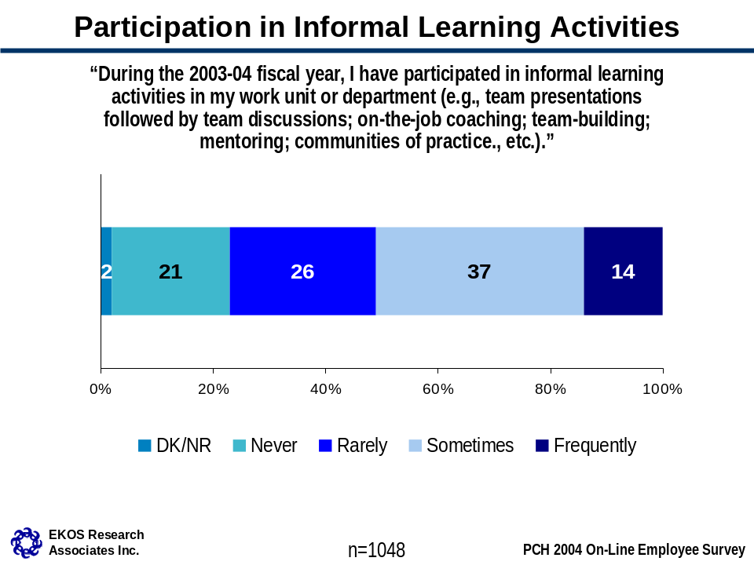

- Across the Department, Direct Report employees and Cultural Affairs sector employees are more likely than average to have participated in informal training activities frequently last year. Public Affairs and Communications sector employees more often reported rarely participating in informal learning compared to the average.
- Employees in the Publishing Policy and Program, Human Resources and Workplace Management, Planning and Corporate Affairs Residual and in the Western Region are most apt to have participated in informal learning activities last year. Film, Video and Sound Recording and Citizenship Participation and Promotion staff were more likely to indicate rarely participating than average and Canadian Conservation Institute, Citizenship and Heritage Residual and Deputy Minister’s Office Composite employees to never have participated in informal learning activities last year.
- Across occupational groups, the Executive Group and Economics, Sociology and Statistics Group indicate the greatest frequency of participation in informal learning activities. Employees who manage people and financial resources are similarly likely to report greater levels of informal training. Program Administration Group employees are more apt to indicate rarely participating in informal learning activities and Administrative Services Group and Computer Systems Group employees more often say they never did.
- Those with less tenure with PCH (1-5 years) and with the Public Service (2-5 years) are more apt to characterize their participation in informal learning activities as rare or not at all compared with other employees.
- Employees who disagree that PCH is a great place to work/learn, those without a learning plan and staff with a low score on the LCI more often say they never participate in informal learning activities.

Overall Support for Learning

Three-quarters of employees strongly or mostly agree that PCH is a great place to learn. Sixteen per cent of employees mostly disagree with this statement and seven per cent strongly disagree.
- Human Resources and Workplace Management employees and those with a high score on the LCI are more apt to agree that PCH is a great place to learn compared to the average across Canadian Heritage.

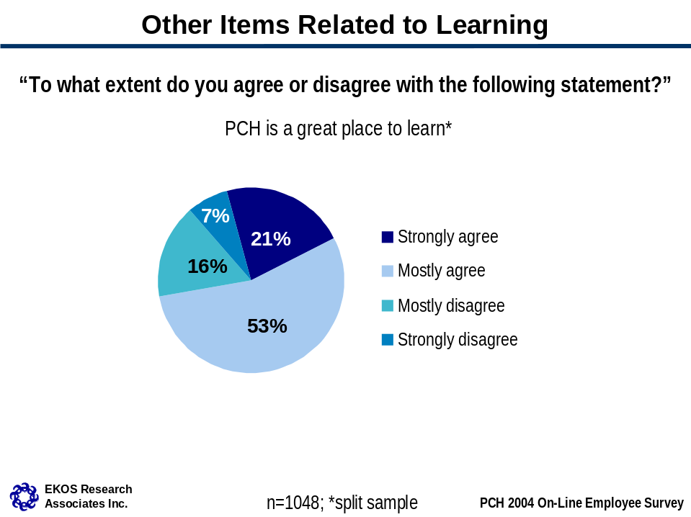

Workplace Well-Being

Business Health Culture Index

BHCI

Four indicators on the survey (discussed individually below) have been combined to form a Business Health Culture Index (BHCI) at Canadian Heritage – an overall indicator of where employees place themselves in terms of the environment in which they work and the extent to which stress and satisfaction are balanced in their work. Essentially, employee responses to each question count towards their overall score on the index, with responses representing employee stress (as indicated by demand and effort at work) being subtracted from ratings of satisfaction (as indicated by perceptions of influence and reward). The scores on the index range from -2 to +2, with 0 indicating that stress and satisfaction cancel each other out. In prior research leading to the development of the BHCI, the index is characterized as a measure of whether the health culture of the organization works for or against its business objectives.

The mean BHCI score for PCH is +0.73. This indicates that satisfaction outweighs stress. When compared to the same index score from the PSES two years ago, the mean is significantly higher, demonstrating that satisfaction now outweighs stress to a greater degree. In other words, the health culture may be said to be more conducive to meeting PCH’s business objectives. This is because stress (as reflected in workload issues) is significantly reduced from the 2002 situation.

Considering the distribution of scores on the index, the majority of employees at PCH (62 per cent) express higher levels of satisfaction than stress (i.e., satisfaction from control and reward outweighs stress owing to demand and effort), with 34 per cent at the far positive end. Twenty per cent are at the “offset” point where satisfaction and stress are evenly matched. Fewer than one in five PCH employees (18 per cent) are more stressed than they are satisfied.

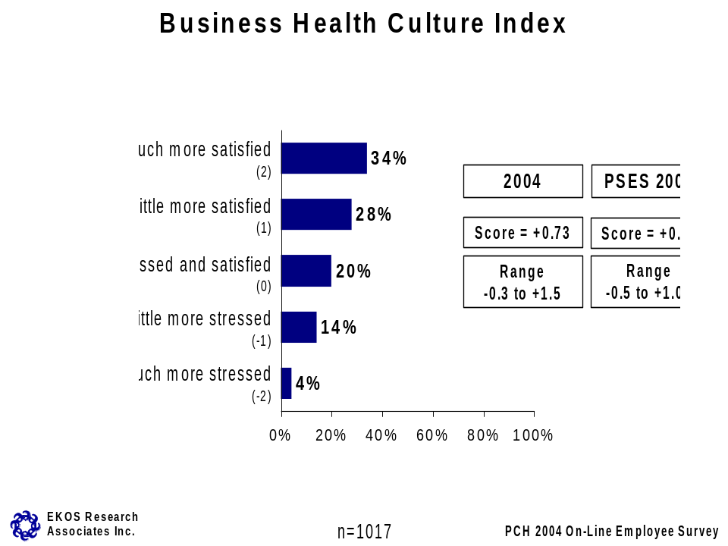

- Citizenship and Heritage Residual employees are more likely than other employees to report satisfaction from influence and reward than stress from demand and effort at work. International and Intergovernmental Affairs sector employees are more often “a little more stressed” than satisfied than other employees (see Table 6 below for individual sector results).
- Canadian Heritage Information Network, Communications and Canadian Conservation Institute employees have higher BHCI scores, while Major Events and Celebration, Canadian Culture Online and Sport Canada staff score lower on the index (see Table 6 below for individual branch results).

Table 6: Business Health Culture Index Scores: By Sector, Branch and Region
 | Low Score (-2.0) | Mean Score (0.75) | High Score (2.0)
Sector
- Direct Reports* | -2.0 | 0.84 | 2.0
- Cultural Affairs | -2.0 | 0.79 | 2.0
- Citizenship and Heritage | -2.0 | 0.94 | 2.0
- International and Intergovernmental Affairs | -2.0 | 0.52 | 2.0
- Planning and Corporate Affairs | -2.0 | 0.93 | 2.0
- Public Affairs and Communications | -2.0 | 0.55 | 2.0
Branch
Assistant Deputy Minister’s Office Composite* | -1.0 | 0.63 | 2.0
Citizenship and Heritage Residual* | -2.0 | 0.59 | 2.0
Deputy Minister’s Office Composite* | -2.0 | 0.69 | 2.0
Cultural Affairs Residual* | -2.0 | 0.58 | 2.0
International and Intergovernmental Affairs Residual* | -2.0 | 0.52 | 2.0
Public Affairs and Communications Residual* | -2.0 | 0.79 | 2.0
Human Resources and Workplace Management | -2.0 | 1.05 | 2.0
Strategic Policy and Research | -1.0 | 0.60 | 2.0
Arts Policy | -2.0 | 0.51 | 2.0
Canadian Culture Online | -2.0 | 0.40 | 2.0
Film, Video and Sound Recording | -1.0 | 0.80 | 2.0
Publishing Policy and Programs | -1.0 | 1.03 | 2.0
Official Languages Support Programs | -2.0 | 0.61 | 2.0
Multiculturalism and Human Rights | -2.0 | 0.83 | 2.0
Citizenship Participation and Promotion | -1.0 | 1.00 | 2.0
Aboriginal Affairs | -2.0 | 0.9 | 2.0
Canadian Heritage Information Network | -1.0 | 1.5 | 2.0
Canadian Conservation Institute | -2.0 | 1.1 | 2.0
International Affairs | -2.0 | 0.8 | 2.0
Sport Canada | -2.0 | 0.4 | 2.0
Financial Management | -1.0 | 1.0 | 2.0
Planning and Corporate Affairs Residual/  Corporate Review and Corporate Planning* | -2.0 | 0.7 | 2.0
Knowledge, Information and Technology Services | -1.0 | 1.0 | 2.0
Communications | 0 | 1.1 | 2.0
Major Events and Celebration | -2.0 | -0.3 | 2.0
Region
Atlantic Region | -2.0 | 0.4 | 2.0
Quebec Region | -2.0 | -0.1 | 2.0
Ontario Region | -1.0 | 1.0 | 2.0
Prairies and Northern Region | -2.0 | 0.4 | 2.0
Western Region | -2.0 | 0.8 | 2.0
* Shaded areas indicate unofficial sector/branch names created to ease analysis. See Appendix B for full list of branches included in these groups.
- Information Services Group employees and Clerical and Regulatory Group employees are more likely than others to experience more satisfaction than stress. On the other hand, Commerce Group and Executive Group employees are slightly less likely to report more satisfaction than stress.
- Employees aged 45-54 tend to be more stressed than satisfied compared with other age groups.
- When examining experience in the Public Service, those with less than two years of experience are more likely to feel more satisfied than stressed, while those with five or more years in the Public Service score lower on the index.
- Those with direct responsibility over employees and finances scored lower on the BHCI than those without these responsibilities.
- Employees who disagree that PCH is a great place to work/learn and those who score low on the LCI also have a lower than average score on the BHCI.
- Employees who agree that their supervisor would take their suggestions for improvements seriously have a more positive score on the BHCI compared to those who disagreed with the statement.
- Employees who agree that in their work unit every individual is accepted as an equal member of the team have a more positive score on the BHCI.

Measures of Business Health Culture

The results for the individual measures that comprise the BHCI are presented in this section. PCH employees are generally positive about the amount of supervisor recognition they receive; over three-quarters (77 per cent) mostly or strongly agree the recognition they receive for doing a good job is adequate. This rating is virtually unchanged since 2002.

Three-quarters (74 per cent) of employees are often/always able to balance their personal, family and work needs, two-thirds (65 per cent) say they are often/always able to complete their assigned workload during regular working hours and more than half (54 per cent) feel they often/always have a say in decisions that impact their work. All of these ratings have improved since the 2002 PSES.

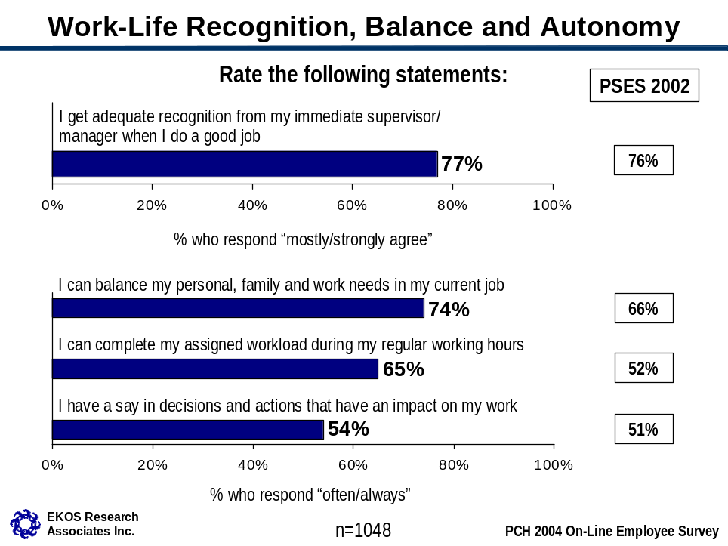

Employee sub-group differences on each of the indicators are summarized below.

Recognition from immediate supervisors
- Employees in the Publishing Policy and Program branch are more likely than those in other branches to say that they get adequate recognition from their supervisor when they do a good job.
- Employees aged 35 years or less are more likely to agree they get adequate recognition from their supervisor.
- Length of tenure with the Public Service also has an effect on the perception of adequate recognition for a job well done. Those with fewer than two years experience in the Public Service are more likely than average to feel they get adequate recognition, while those with 10 or more years experience are more apt to disagree with the statement.
- Employees who agree that PCH is a great place to work/learn and who have a high score on the LCI are more likely to agree with the statement.

Work-Life Balance
- Cultural Affairs and Planning and Corporate Affairs sector employees are more likely than other employees to feel they can always balance personal, family and work needs in their current job. Public Affairs and Communications employees are less likely to report they can always maintain this balance.
- Employees in the Knowledge, Information and Technology Services and Publishing Policy and Program branches are more likely than other employees to feel they can always balance their personal, family and work needs in their current job. This sentiment is echoed by employees in the Clerical and Regulatory Group, Computer Services Group and Administrative Services Group more often than among employees in other positions. On the other hand, Executive Group staff are less apt to feel they can balance their personal and professional responsibilities, while Program Administration Group staff are more likely to feel they can maintain this balance only sometimes.
- Younger employees (less than 35 years of age), those who have been working at PCH for less than one year and those with less than five years experience in the Public Service are more likely to feel they are always able to balance work and family responsibilities. This is also true of those who do not directly manage a team of employees and financial resources.
- Those who agree that PCH is a great place to work/learn and who have a high LCI score are more likely to indicate always balancing their personal and work needs.

Completing assigned work
- Planning and Corporate Affairs sector employees are more likely than others to feel they can always complete their assigned workload during regular hours, relative to other sectors. Public Affairs and Communications employees are more likely to report that they can complete their workload during regular hours only sometimes.
- Employees in the Knowledge, Information and Technology Services and International Affairs branches are more likely than average to feel they can complete their assigned workload during regular hours, relative to other employees, while those in the Sport Canada and Official Languages Support Programs branches and in the Atlantic Region are more likely to report than others that they rarely or never complete their work during regular hours.
- Computer Services Group and Clerical and Regulatory Group employees are more likely than others to feel they can always complete their assigned work during regular hours. On the other hand, employees at the Executive level are more likely than average to report that they rarely or never complete their work during regular hours.
- Younger employees (less than 35 years of age) are more likely to feel they can complete their assigned work during regular office hours, while older employees (45-54 years in particular) are more likely to feel they can only complete their work within regular work hours sometimes if at all.
- The same pattern can be seen when examining the number of years employees have worked for Canadian Heritage and the Public Service. Those with less experience are more likely to feel they can always complete their assigned work, while those with five or more years experience are more likely to feel they can rarely or never complete their work within regular hours.
- Employees who directly manage a team of employees and financial resources are less likely to feel they can complete their work during regular working hours compared to those without these responsibilities.
- Those who disagree that PCH is a great place to learn are more apt to report they can rarely or never complete their assigned within regular working hours.
- Employees who identify workload as the primary barrier in completing their learning plan objectives are more likely to indicate completing their work within regular work house only sometimes, rarely or never.

Say in decisions that impact their work
- Planning and Corporate Affairs sector employees are more likely to feel they always have a say in decisions that impact their work, while International and Intergovernmental Affairs sector employees are more likely to feel this is true only sometimes.
- Employees in the Human Resources and Workplace Management and Knowledge, Information and Technology Services branches are more likely than employees in other branches to feel they have a say in decisions that impact on their work. Computer Systems Group staff are more likely to share this view, while employees in the Sport Canada and Film, Video and Sound Recording branches and Program Administration Group employees are more likely to feel this is true only some of the time.
- Not surprisingly, those employees who have 10 or more years experience at PCH are more likely to feel they often have a say in decisions that impact their work. Employees directly responsible for a team of employees and financial resources are also more likely to feel this way.
- Employees with a verbal learning plan more often say they have input into decisions often compared to the average.

Workplace Well-Being

The overall ratings of the Department as a “great place to work” are very favourable – 84 per cent of employees mostly or strongly agree with this statement. Substantially fewer (57 per cent) mostly or strongly agree that senior management does a good job of sharing information. The former rating represents a modest decrease from 2002 (down six percentage points since 2002 and four percentage points since 2001). The rating of senior management sharing information is similar to 2002.

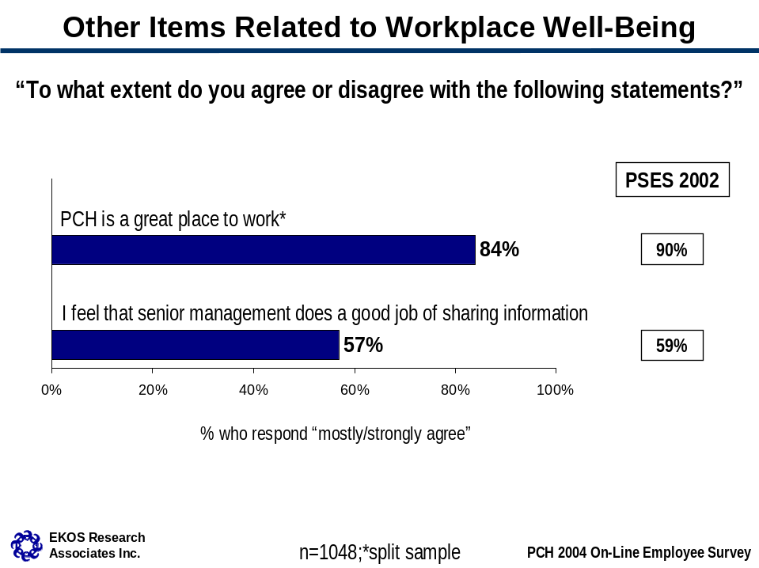

Employee sub-group differences are summarized, as follows.

PCH great place to work
- Those with a high score on the LCI are more likely to agree that PCH is a great place to work.

Senior management good job sharing information
- Human Resources and Workplace Management staff are more likely than other employees to agree that senior management at PCH does a good job of sharing information, as are those in the Ontario and Western Regions. Film, Video and Sound Recording employees more often disagree with this statement compared to the average. Across occupational groups, the Executive Group, the Clerical and Regulatory Group and the Administrative Services group, as well as those with management responsibilities are more apt to agree that senior management does a good job in this area. PM and Commerce Group employees more often disagree with the statement.
- Employees who agree that PCH is a great place to work/learn and those with a high LCI score are more apt to agree with the statement.

Diversity

Diversity in the Workplace

The vast majority of employees (89 per cent) mostly or strongly agree that every individual in their work unit is or would be accepted as an equal member of the team regardless of race, national or ethnic origin, gender, disability, sexual orientation, age or religion. Six per cent mostly disagree with the statement and three per cent strongly disagree. The proportion who strongly agrees with this statement (63 per cent) has declined since 2002 (by eight percentage points).

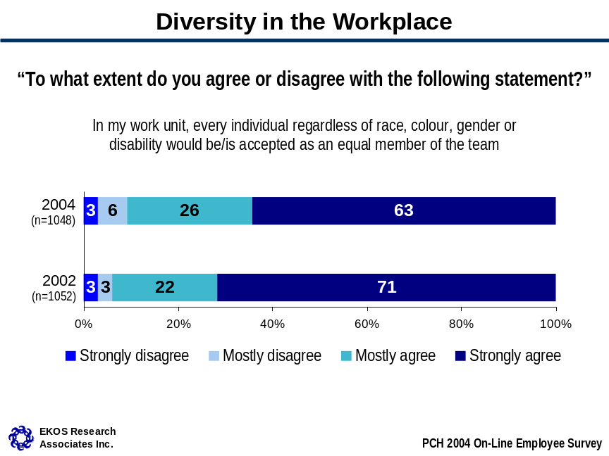

- Employees in the Canadian Conservation Institute, Film, Video and Sound Recording and Knowledge and Information and Technology Services branches are less likely than others to agree that every individual in their work unit is accepted as an equal member of the team. Computer Systems Group employees and also employees who are visible minorities more often disagree with the statement compared to the average (see Table 7 below for individual branch results).
- This measure is positively related to perceptions that PCH is a great place to work/learn and scores on the LCI index.

Table 7: Diversity in the Workplace: By Sector, Branch and Region (based on those who participated)
 | In my work unit, every individual would be/is accepted as an equal member of the team
Department Overall | Strongly agree (63%) | Mostly agree  (26%) | Mostly disagree  (6%) | Strongly disagree  (3%)
Sector
- Direct Reports* | 68% | 21% | 7% | 2%
- Cultural Affairs | 63% | 24% | 7% | 5%
- Citizenship and Heritage | 66% | 25% | 2% | 2%
- International and Intergovernmental Affairs | 70% | 22% | 5% | 3%
- Planning and Corporate Affairs | 63% | 25% | 9% | 1%
- Public Affairs and Communications | 57% | 32% | 5% | 5%
Branch
Assistant Deputy Minister’s Office Composite* | 69% | 19% | 7% | 0%
Citizenship and Heritage Residual* | 62% | 30% | 0% | 2%
Deputy Minister’s Office Composite* | 68% | 19% | 8% | 5%
Cultural Affairs Residual* | 64% | 33% | 0% | 3%
International and Intergovernmental Affairs Residual* | 69% | 20% | 6% | 6%
Public Affairs and Communications Residual* | 59% | 32% | 3% | 6%
Human Resources and Workplace Management | 76% | 20% | 3% | 0%
Strategic Policy and Research | 46% | 32% | 18% | 4%
Arts Policy | 64% | 28% | 5% | 3%
Canadian Culture Online | 50% | 22% | 15% | 13%
Film, Video and Sound Recording | 58% | 16% | 13% | 13%
Publishing Policy and Programs | 64% | 27% | 7% | 0%
Official Languages Support Programs | 63% | 34% | 0% | 0%
Multiculturalism and Human Rights | 66% | 26% | 2% | 3%
Citizenship Participation and Promotion | 71% | 21% | 4% | 0%
Aboriginal Affairs | 89% | 8% | 0% | 0%
Canadian Heritage Information Network | 69% | 23% | 7% | 0%
Canadian Conservation Institute | 54% | 26% | 3% | 8%
International Affairs | 80% | 17% | 0% | 4%
Sport Canada | 68% | 28% | 2% | 2%
Financial Management | 72% | 22% | 4% | 2%
Planning and Corporate Affairs Residual/  Corporate Review and Corporate Planning* | 63% | 31% | 7% | 0%
Knowledge, Information and Technology Services | 58% | 24% | 15% | 2%
Communications | 71% | 25% | 4% | 0%
Major Events and Celebration | 53% | 36% | 4% | 7%
Region
Atlantic Region | 57% | 37% | 5% | 0%
Quebec Region | 42% | 38% | 7% | 13%
Ontario Region | 64% | 26% | 3% | 5%
Prairies and Northern Region | 54% | 31% | 9% | 3%
Western Region | 60% | 33% | 5% | 2%
* Shaded areas indicate unofficial sector/branch names created to ease analysis. See Appendix B for full list of branches included in these groups.

Diversity and Career Progression

For the vast majority of PCH employees (90 per cent or more), religion and sexual orientation are not perceived to have adversely affected their career progress in the Public Service in the past three years at all.

Nine in 10 employees who provided a valid response indicated no adverse impact on the basis of disability. Considering only the responses of employees who self-identified as having a disability (n=42), however, 38 per cent reported no adverse effect on career advancement owing to their disability. Within this group, 13 per cent indicated their disability has adversely affected their career progress significantly, 26 per cent said moderately and 20 per cent minimally.

Among employees providing a valid response, 77 per cent reported that race, national or ethnic origin had not been a barrier to their career progress in the Public Service in the past three years (four per cent report a significant effect). This figure drops to 43 per cent among employees who self-identify as being a member of a visible minority group (n=101). Within this group, 17 per cent have experienced a significant adverse effect, 13 per cent a moderate effect and 21 per cent a minimal effect.

About seven in 10 employees (72 per cent) report no adverse effect on career advancement on the basis of gender (four per cent indicate a significant effect). Interestingly, there is no significant difference in the responses of men and women in the Department on this item.

Two-thirds of PCH employees (65 per cent) have experienced no adverse effect on their career progression owing to their age (five per cent significantly). Examining the results by age group, older employees (55+) (n=81) are more apt to indicate a significant (13 per cent) or moderate impact (19 per cent) on their career advancement based on age. The next most likely age group to indicate an adverse effect on their career due to age is the under 35 year age cohort.

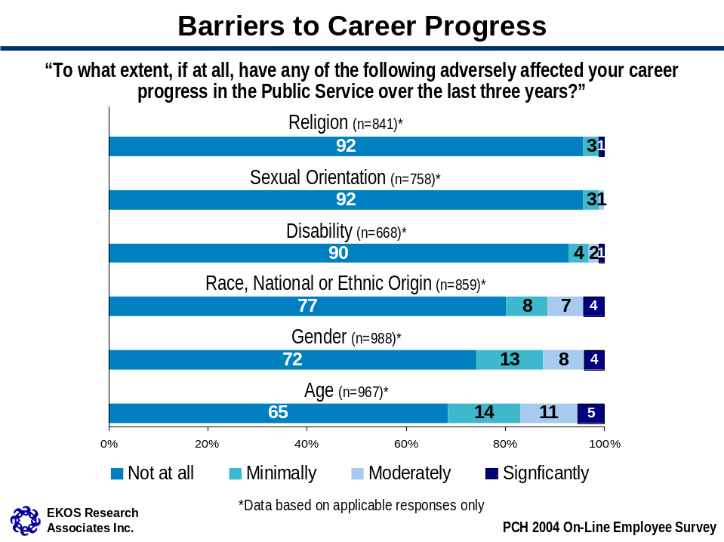

Employee scores on the LCI are related to perceptions of career barriers – across all the types of barriers, employees with a higher score on the LCI are less apt to report barriers to their advancement on the basis of religion, gender and so on. Employee who are more likely to agree that PCH is a great place to work/learn are also more likely to report experiencing no barriers to career progress on the basis of race, gender and age. Other employee sub-group differences include:

Religion
- Visible minority employees are more apt to indicate a negative impact on their career advancement on the basis of religion than other employees.

Sexual Orientation
- There are no notable differences among employee sub-groups.

Disability
- Knowledge, Information and Technology Services branch staff and Clerical and Regulatory Group employees are more apt to indicate a negative impact on career progress as a result of disability than average.

Race, National, Ethnic Origin
- AS and employees in the “Other” occupational category are less likely to have experienced any adverse effect on the basis of race, national or ethnic origin compared to the average. Employees in the Economics, Sociology and Statistics group indicate a minimal effect more often than others and Computer Systems Group employees more often say somewhat.

Gender
- Direct Report staff and Cultural Affairs sector employees, as well as employees in the Human Resources and Workplace Management branch, and Administrative Services Group employees more often report no significant career effect on the basis of gender. On the other hand, Canadian Conservation Institute employees and Knowledge, Information and Technology Services, Film, Video and Sound Recording and Financial Management branch staff and Computer Systems Group employees are more likely than others to say gender has had a significant or a moderate negative effect on their career progression. Atlantic Region and Citizenship and Heritage Residual branch employees more often rate the impact as minimal. Those in the 45 to 54 year age category and with five to 10 years experience with PCH are also more likely to cite a negative impact on their advancement as a result of gender. Employees with a disability or who are visible minorities also report a negative impact on the basis of gender.

Age
- Citizenship and Heritage Residual and International Affairs branch staff, those in the Western Region and Commerce and Information Services Group employees more often indicate a negative impact on the basis of age compared to the average. Human Resources and Workplace Management and Sport Canada staff are less likely to indicate a negative impact from age.

Profile

Occupational Group

Of the 1,950 employees that were e-mailed an invitation to participate in the online survey, 1,048 responded. Every branch of Canadian Heritage is represented in the sample to some extent, as is nearly every occupational group. In fact, the distribution of occupational groups is similar to the actual distribution of those groups within the population of PCH, with two exceptions: the data contain a slight over sampling of Programme Administration Group employees and a slight under sampling of Clerical and Regulatory Group employees.

The largest occupational groups represented in the survey are Programme Administration Group employees (35 per cent) and Administrative Services Group employees (21 per cent).

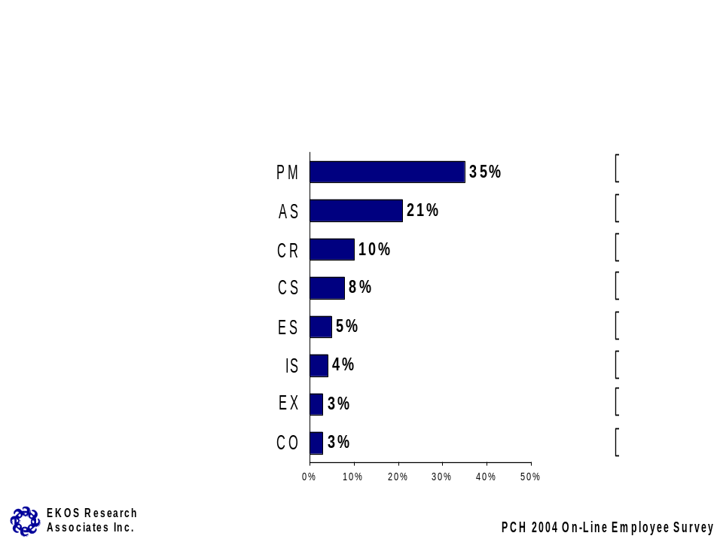

Years at PCH and the Public Service

Most employees (58 per cent) have been with Canadian Heritage for five years or less, although three in 10 report having worked at Canadian Heritage for more than 10 years. When it comes to experience in the Public Service, however, half of respondents have worked in the Public Service for more than 10 years.

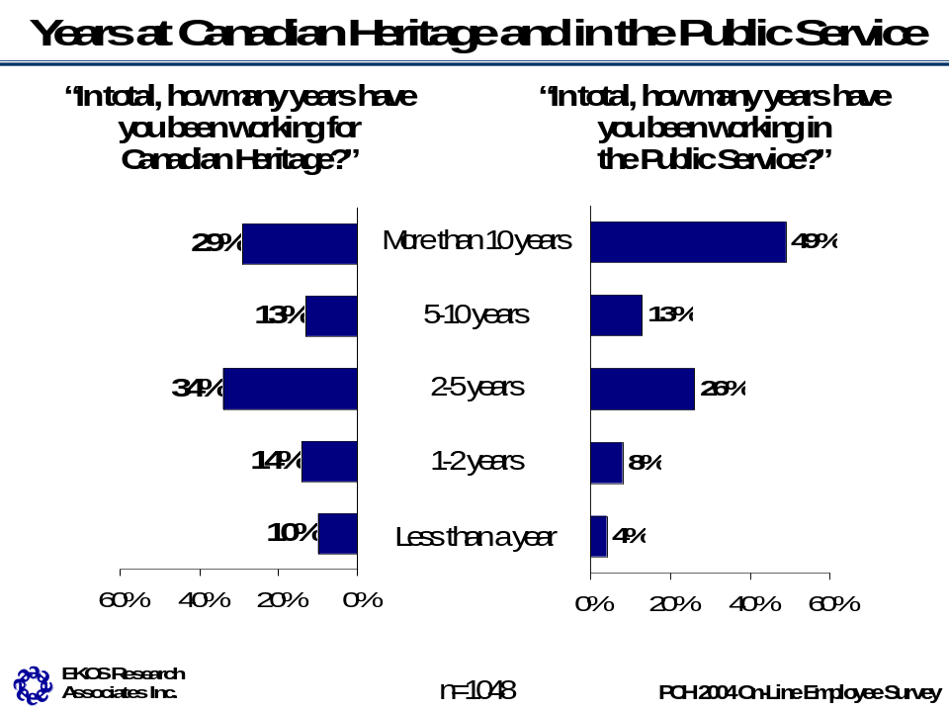

Age

The majority of employees (65 per cent) are between the ages of 35 and 54, with very few younger than 25 (three per cent) or older than 55 (seven per cent). One-quarter (26 per cent) are aged 25-34 years.

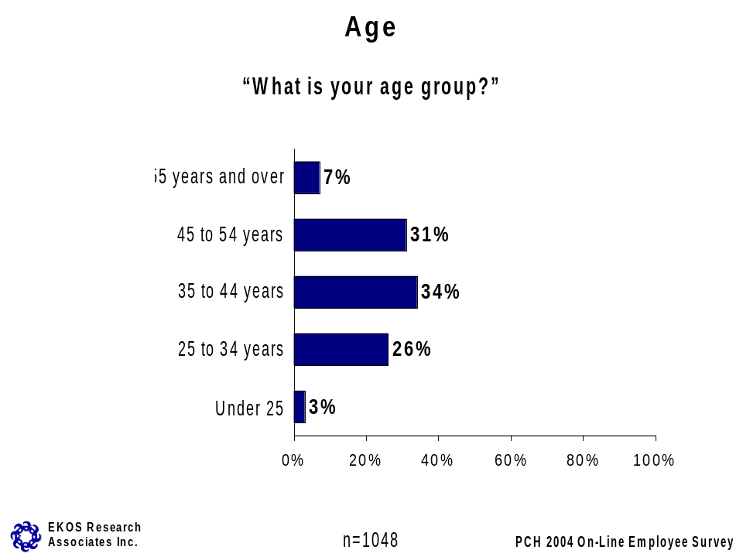

Management Responsibilities

About one-quarter of employees (24 per cent) indicate that they directly manage a team of employees and financial resources.

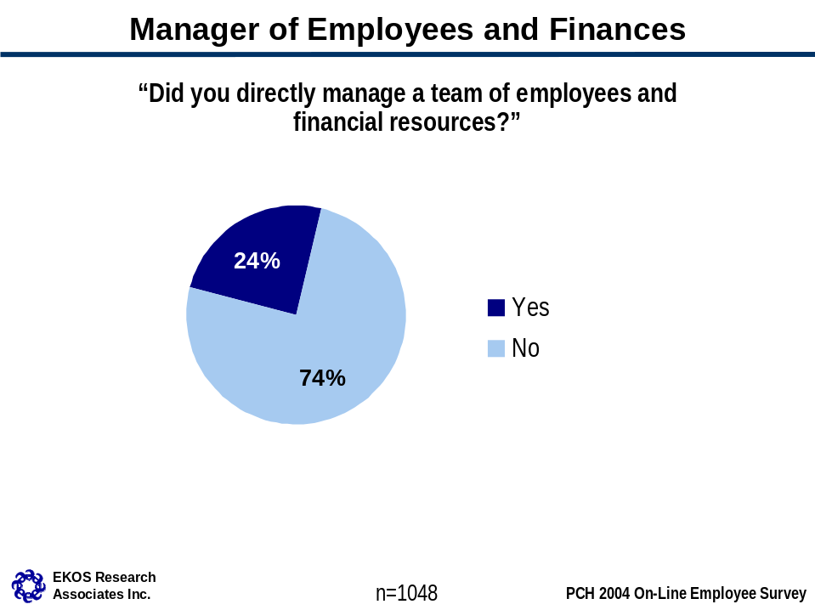

Appendix A
Survey Questionnaire

INTRO EKOS Research Associates has been commissioned by Canadian Heritage to conduct an employee survey examining employee perceptions of learning and career development, workplace well-being and diversity. The purpose of this research is :
- to identify progress in key areas since the 2002 Public Service Employee Survey and subsequent dialogue sessions;
- to identify issues pertaining to learning, career development, workplace well-being and diversity that require attention;
- to provide information for organizational health measures;
- to stimulate dialogue in the branches and regions. Please be assured that your responses will be kept strictly confidential.

INSTRUCTIONS

Consider the questions and your answers carefully. Unless otherwise indicated, you may provide only one answer per question. On each screen, after selecting your answer, click on the "Back" or "Continue" buttons at the bottom of the screen to move forward or backwards in the questionnaire. If you have any questions about how to complete the survey, please call EKOS Research Associates at 1-800-388-2873 or send an email to PCH@ekos.com

Q1
To what extent do you agree or disagree with the following statements ?
1 Strongly agree
2 Mostly agree
3 Mostly disagree
4 Strongly disagree
9 Don't know/No response
8 Not applicable

Q1A
I believe I have opportunities for promotion within my department, given my education, skills and experience.
1 Strongly agree
2 Mostly agree
3 Mostly disagree
4 Strongly disagree
9 Don't know/No response
8 Not applicable

Q1B
My immediate supervisor/manager does a good job of helping me develop my career.
1 Strongly agree
2 Mostly agree
3 Mostly disagree
4 Strongly disagree
9 Don't know/No response
8 Not applicable

Q1C
I receive useful feedback from my immediate supervisor/manager on my job performance.
1 Strongly agree
2 Mostly agree
3 Mostly disagree
4 Strongly disagree
9 Don't know/No response
8 Not applicable

Q1D
My immediate supervisor/manager keeps me informed about the issues affecting my work.
1 Strongly agree
2 Mostly agree
3 Mostly disagree
4 Strongly disagree
9 Don't know/No response
8 Not applicable

Q1E
I get the training I need to do my job.
1 Strongly agree
2 Mostly agree
3 Mostly disagree
4 Strongly disagree
9 Don't know/No response
8 Not applicable

Q1F
My immediate supervisor/manager helps me determine my learning needs.
1 Strongly agree
2 Mostly agree
3 Mostly disagree
4 Strongly disagree
9 Don't know/No response
8 Not applicable

Q1G
If I were to suggest ways to improve how we do things, my immediate supervisor/manager would take them seriously.
1 Strongly agree
2 Mostly agree
3 Mostly disagree
4 Strongly disagree
9 Don't know/No response
8 Not applicable

Q1H
I get adequate recognition from my immediate supervisor/manager when I do a good job.
1 Strongly agree
2 Mostly agree
3 Mostly disagree
4 Strongly disagree
9 Don't know/No response
8 Not applicable

Q1I
In my work unit, every individual, regardless of race, national or ethnic origin, gender, disability, sexual orientation, age or religion would be/is accepted as an equal member of the team.
1 Strongly agree
2 Mostly agree
3 Mostly disagree
4 Strongly disagree
9 Don't know/No response
8 Not applicable

Q1J
PCH is a great place to &QROT1
1 Strongly agree
2 Mostly agree
3 Mostly disagree
4 Strongly disagree
9 Don't know/No response
8 Not applicable

Q1K
I feel that senior management does a good job of sharing information.
1 Strongly agree
2 Mostly agree
3 Mostly disagree
4 Strongly disagree
9 Don't know/No response
8 Not applicable

Q2
To what extent, if at all, have any of the following adversely affected your career progress in the Public Service over the last three years ?
1 Not at all
2 Minimally
3 Moderately
4 Significantly
9 Don't know/No response
8 Not applicable

Q2A
Race, National or Ethnic Origin
1 Not at all
2 Minimally
3 Moderately
4 Significantly
9 Don't know/No response
8 Not applicable

Q2B
Gender
1 Not at all
2 Minimally
3 Moderately
4 Significantly
9 Don't know/No response
8 Not applicable

Q2C
Disability
1 Not at all
2 Minimally
3 Moderately
4 Significantly
9 Don't know/No response
8 Not applicable

Q2D
Sexual Orientation
1 Not at all
2 Minimally
3 Moderately
4 Significantly
9 Don't know/No response
8 Not applicable

Q2E
Age
1 Not at all
2 Minimally
3 Moderately
4 Significantly
9 Don't know/No response
8 Not applicable

Q2F
Religion
1 Not at all
2 Minimally
3 Moderately
4 Significantly
9 Don't know/No response
8 Not applicable

Q2G
To what extent, if at all, has a lack of access to developmental assignments adversely affected your career progress in the Public Service over the last three years ?
1 Not at all
2 Minimally
3 Moderately
4 Significantly
9 Don't know/No response
8 Not applicable

Q2H

1 Not at all
2 Minimally
3 Moderately
4 Significantly
9 Don't know/No response
8 Not applicable

Q3
Rate the following statements :
1 Always
2 Often
3 Sometimes
4 Rarely or never
9 Don't know/No response
8 Not applicable

Q3A
I can complete my assigned workload during my regular working hours.
1 Always
2 Often
3 Sometimes
4 Rarely or never
9 Don't know/No response
8 Not applicable

Q3B
I can balance my personal, family and work needs in my current job.
1 Always
2 Often
3 Sometimes
4 Rarely or never
9 Don't know/No response
8 Not applicable

Q3C
I have a say in decisions and actions that have an impact on my work.
1 Always
2 Often
3 Sometimes
4 Rarely or never
9 Don't know/No response
8 Not applicable

Q4
For the 2003-04 fiscal year, did you prepare a written or verbal learning plan ?
1 Yes, written plan
2 Yes, verbal plan
3 No
9 Don't know/No response

Q5
If... Q4.NE.3
Please rate your level of agreement with the following statement :I have made progress in completing the objectives identified in my learning plan.
1 Strongly agree
2 Mostly agree
3 Mostly disagree
4 Strongly disagree
9 Don't know/No response
8 Not applicable

Q6
If... Q4.NE.3
To what extent did you take Departmental/branch/regional objectives into account when preparing your learning plan ?
1 Not at all
2 To a small extent
3 To a moderate extent
4 To a great extent
9 Don't Know/No Response

Q7
If... Q4.NE.3
What is the primary barrier you have faced in completing the objectives identified in your learning plan ?
1 No barrier
2 Lack of funds
3 Workload
4 Lack of supervisory/management support
5 Not aware of available learning opportunities
6 Other -> AQ7; C250 L1 C80
9 X Don't know/No Response

Q8
Do you have written work objectives ?
1 Yes
2 No
9 Don't know/No response

Q18
Excluding language training, approximately how many days did you spend on the following types of training during the 2003-04 fiscal year ? (Please enter 0 if no training)
1 Response -> AQ18; N3.0 [0-365]
9 Don't know/No response

Q18A
Number of Days Spent on Classroom Training
1 Response -> AQ18A; N3.0 [0-365]
9 Don't know/No response

Q18B
Number of Days Spent on University/College Course Training
1 Response -> AQ18B; N3.0 [0-365]
9 Don't know/No response

Q18C
Number of Days Spent on E-learning Training
1 Response -> AQ18C; N3.0 [0-365]
9 Don't know/No response

Q18D
Number of Days Spent on Departmental Forum (e.g., Administrative Forum) Training
1 Response -> AQ18D; N3.0 [0-365]
9 Don't know/No response

Q18E
Number of Days Spent on Conference/Seminar Training
1 Response -> AQ18E; N3.0 [0-365]
9 Don't know/No response

Q19
Excluding official language training, travel expenses and incidentals, approximately how much money did the Department spend on the training you took in the following categories during the 2003-04 fiscal year ? (Please enter 0 if no training)
1 Response -> AQ19; N6.0 [0-999999]
9 Don't know/No response

Q19A
Amount of Money Spent on Classroom Training
1 Response -> AQ19A; N6.0 [0-999999]
9 Don't know/No response

Q19B
Amount of Money Spent on University/College Course Training
1 Response -> AQ19B; N6.0 [0-999999]
9 Don't know/No response

Q19C
Amount of Money Spent on E-learning (excluding CampusDirect) Training
1 Response -> AQ19C; N6.0 [0-999999]
9 Don't know/No response

Q19D
Amount of Money Spent on Departmental Forum (e.g., Administrative Forum) Training
1 Response -> AQ19D; N6.0 [0-999999]
9 Don't know/No response

Q19E
Amount of Money Spent on Conference/Seminar Training
1 Response -> AQ19E; N6.0 [0-999999]
9 Don't know/No response

Q9
During the 2003-04 fiscal year, I have participated in informal learning activities in my work unit or Department (e.g., team presentations followed by team discussions; on-the-job coaching; team-building; mentoring; communities of practice, etc.).
1 Frequently
2 Sometimes
3 Rarely
4 Never
5 Don't know/No response

Q14
In which branch do you work ?
1 DN
2 N DIRECT REPORTS
3 --Minister's Office
4 --Minister of State's Office - Sport
5 --Minister of State's Office - Multiculturalism and Status of Women
6 --Deputy Minister's Office
7 --Senior Advisor to the Deputy Minister
8 --Ombudsman's Office
9 --Human Resources and Workplace Management
10 --General Counsel
11 --Strategic Policy and Research
12 --Portfolio Affairs
13 --Corporate Secretary
14 N CULTURAL AFFAIRS
15 --Assistant Deputy Minister's Office
16 --Broadcasting and Innovation
17 --Arts Policy
18 --Canadian Culture Online
19 --Film, Video and Sound Recording Policy and Programs
20 --Copyright Policy
21 --Publishing Policy and Programs
22 --Cultural Investment Review
23 --Strategic Planning and Coordination
24 N CITIZENSHIP AND HERITAGE
25 --Assistant Deputy Minister's Office
26 --Policy Coordination and Strategic Planning
27 --Official Languages Support Programs
28 --Multiculturalism and Human Rights
29 --Heritage Branch
30 --Citizenship, Participation and Promotion
31 --Aboriginal Issues
32 --Canadian Heritage Information Network
33 --Canadian Conservation Institute
34 N INTERNATIONAL AND INTERGOVERNMENTAL AFFAIRS
35 --Assistant Deputy Minister's Office
36 --International Affairs
37 --Sport Canada
38 --Trade and Investment
39 --Vancouver/Whistler 2010 Bid Secretariat
40 --Planning and Intergovernmental Affairs
41 N PLANNING AND CORPORATE AFFAIRS
42 --Assistant Deputy Minister's Office
43 --Financial Management
44 --Corporate Review
45 --Knowledge, Information and Technology Services
46 --Corporate Planning
47 N PUBLIC AFFAIRS AND COMMUNICATIONS
48 --Assistant Deputy Minister's Office
49 --Associate Assistant Deputy Minister's Office
50 --Communications
51 --E-Services
52 --Major Events and Celebrations
53 --Management, Regional and Correspondence Services
54 --Atlantic Region
55 --Quebec Region
56 --Ontario Region
57 --Prairies and Northern Region
58 --Western Region

Q15
Please indicate your occupational group using its two letter acronym (e.g., ST, AS, CR).
1 DN
2 AS
3 CA
4 CO
5 CR
6 CS
7 DM
8 ED
9 EG
10 EL
11 EN
12 ES
13 EX
14 FI
15 GL
16 GS
17 GT
18 IS
19 LA
20 LS
21 MM
22 MS
23 OM
24 PA
25 PC
26 PE
27 PG
28 PM
29 SI
30 ST

Q16
In total, how many years have you been working for Canadian Heritage ?&QERROR
1 Less than 1 year
2 1 to 2 years
3 2 years and a day to 5 years
4 5 years and a day to 10 years
5 More than 10 years

Q17
In total, how many years have you been working in the Public Service ?
1 Less than 1 year
2 1 to 2 years
3 2 years and a day to 5 years
4 5 years and a day to 10 years
5 More than 10 years

Q10
What is your age group ?
1 Under 25
2 25 to 34 years
3 35 to 44 years
4 45 to 54 years
5 55 years and over

Q12
Do you directly manage a team of employees and financial resources ?
1 Yes
2 No
9 Don't know/No response

Q20
Are you :
1 Yes
2 No
3 No Response

Q20A
An Aboriginal person ?
1 Yes
2 No
3 No Response

Q20B
A person with a disability ?
1 Yes
2 No
3 No Response

Q20C
A member of a visible minority group ?
1 Yes
2 No
3 No Response

QERROR
If... Q17.LT.Q16

1 ->Q16 Your years working in the Public Service must be equal to or greater than your years working for Canadian Heritage. Please correct your response(s).

QEND

THNK
Thank you very much for taking the time to complete this survey.

Appendix B
Composites and Residuals

Appendix B: Composites and Residuals

Assistant Deputy Minister’s Office Composite
ADM’s Office (Cultural Affairs)
ADM’s Office (Citizenship and Heritage)
ADM’s Office (International and Intergovernmental Affairs)
ADM’s Office (Public Affairs and Communications)
ADM’s Office (Planning and Corporate Affairs)

Citizenship and Heritage Residual
DG – Heritage Branch
DG – Policy Coordination and Strategic Planning

Deputy Minister’s Office Composite
ADV – Senior advisor
Leg – General counsel
Omb – Ombudsman
PA – Portfolio Affairs
DMO – Deputy Minister’s office
MIN-DEPT’L STAFF – Sec. State Multi.
MIN-DEPT’L STAFF – Sport
MIN-DEPT’L STAFF

Cultural Affairs Residual
DG – Broadcasting
DG – Copyright Policy
DG – Cultural Investment Review
DG – Strategic Planning and Coordination

International and Intergovernmental Affairs Residual
DG – Planning and Intern. Affairs
DG – Trade and Investment
DG – Vancouver-Whistler 2010

Public Affairs and Communications Residual
DG – E-service
DG – Management Reg. and Corr. services

Much of the e-learning that occurs at PCH is through Campus Direct which is “free” to users and may explain why employees do not know the cost of their training.
Given the lower participation rates in some types of training and the high proportion of “don’t know” responses, sub-group differences are not reported with the exception of classroom training and conferences/seminars.
Shain, M. and H. Suurvali, Health and Learning Cultures at Canadian Heritage, based on the Results of the Public Service Employee Survey, 2002, Final Report, 2003.

