A Report to

Canadian Heritage

Canada Day Poster Challenge
Focus Group Evaluation
April 2005

Table of Contents
I. Executive Summary 1
A. Introduction and Methodology 2
B. Background and Objectives 2
C. Key Findings 3
II. Introduction 6
A. Background 7
B. Research Objectives 8
C. Methodology 9
III. Themes and Formats 11
A. Reaction to 2005 Theme 12
B. Preferred Themes 12
C. Formats 13
IV. Prize Structure 15
A. Prize Structure 16
B. Prizes 16
C. Judging 17
V. Distribution and Promotion 18
A. Methods for Distributing Information/Materials 19
B. Timing of the Canada Day Poster Challenge 19
VI. Appendix A – Participant Characteristics 21
VII. Appendix B – Participating and Non-Participating Screeners 25
VIII. Appendix C – Participating and Non-Participating Discussion Guides 34
IX. Appendix D – Preferred Canada Day Poster Challenge Themes and Prizes 41
X. Appendix E – 2005 Canada Day Poster Challenge Materials 44
XI. Appendix F – 1997, 1998 and 2003
Canada Day Poster Challenge Materials Tested 49

- Executive Summary

Executive Summary

Introduction and Methodology
The Strategic Counsel is pleased to present to Canadian Heritage this report of findings from qualitative research with primary and secondary school teachers.
The results discussed in this report are drawn from nine focus groups held with primary and secondary school teachers from three cities: Winnipeg, Toronto and Montreal. Three groups were held in each location, and included one group among primary teachers split equally among those who had previously participated in the Poster Challenge and those who had not. One group each was conducted among non-participating and participating secondary school teachers.
Participants were mailed a package prior to the groups to allow them time to review the materials. Focus groups were approximately 1 hour in length. The groups were held on March 15th, 16th and 23rd, 2005.

Background and Objectives
The Canada Poster Challenge has been run on a yearly basis since 1987. The objective of this initiative is to create an interesting, fun and creative way for young people, 18 years of age and under, to celebrate Canada and to gain a greater appreciation of Canada’s heritage and diversity.
Overall, participation in the Canada Day Poster Challenge has declined significantly since it’s inception in 1987. Participation particularly in the last few years has ranged from a high of 37,070 in 1997 to a low of 8,242 in 2004. Reasons for this declining participation however, are not exactly clear. It is within the context of seeking a greater understanding of the interest in and motivation to participate as well as the barriers to participation that Canadian Heritage wished to conduct an evaluation of the Canada Day Poster Challenge among primary and secondary school teachers.
The overall objective of this research was to evaluate among teachers the usefulness of materials and their effectiveness as a way of encouraging participation; assess the relevance of themes; and explore reactions to the layout and design of materials.

Executive Summary

Key Findings

Overall Reaction to the Canada Day Poster Challenge
Overall, teachers supported the purpose of the contest and indicated that the Canada Day Poster Challenge would be a fun and interesting project to do with their students. However, many felt that the program as it currently stands has a number of shortcomings.
Across the groups, teachers cited a number of barriers to their participation. These included:
- A concern that the theme for 2005 did not easily fit into the curriculum.
- Material for 2005 seemed suitable for a selected age cohort of students, but was deemed unsuitable for most others.
- By the same token, the broad age coverage of the contest was seen to unduly favour older students. They felt that younger students may feel intimidated by being judged at the same level as older students.
- The timing of the contest did not work for teachers since they planned their year by mid-September and had little flexibility to incorporate additional activities later in the year.

Themes
Overall, the current the 2005 “Canada from East to West – 100 years Alberta/Saskatchewan” theme was seen as too narrowly defined and not relevant. Many described that theme as too history focussed, old fashioned and specialized. Consequently, many teachers were not interested.
Teachers believed that themes for the Canada Day Poster Challenge needed to be broad to allow for interpretation and to let students choose an approach that interests them. Teachers stressed that themes needed to be broad enough to tie into their curriculum, otherwise they saw little connection to their course work and thus minimal value in participating as a class or individual student exercise.
Teachers also thought that themes needed to be less “traditional” and more reflective of current issues which students personally connect with more readily, in order to engage and motivate them to participate. Some suggestions for themes included, artists, musicians, personalities, multiculturalism, gay marriage, racism, fashion, community, Aboriginal culture, technologies and sports.

Executive Summary

Formats
Teachers expressed a need for short, simple, easy to read materials which could be easily reproduced for students. They largely rejected the 2005 activity guide as being too cluttered, confusing and containing too much information.
Most agreed that they did not need a lot of information sent to them. Details about the contest theme, prize, rules and deadline were seen as the most important pieces of information students needed to get started. While a “one page” document was preferred, teachers indicated a need to know where they could access additional information. Most felt that the website would be a good resource for accessing more detailed information about the contest and support materials.

Prize Structure
There was universal agreement among teachers that prizes should be separated by age/grade categories in order to provide an equal opportunity for all students to win. Teachers strongly agreed that there was unfair to compare younger students with older ones. Teachers suggested that it would be more appropriate for students to compete against their peers in K-3, 4-6, 7-8 or 7-9 and 9-12 or 10-12.
Teachers also commented that current prizes did not appeal to most students and that they should better reflect that age and interests of students. In terms of prizes, most indicated that cash and gift certificates would appeal to all students. Scholarships were also seen as appropriate for high school students, while smaller gifts such as tattoos, stickers and magnets were good for younger students.
Interestingly, teachers across the groups suggested that prizes should be awarded to schools. Many felt that this would get teachers and principals excited and encourage them to participate. Appropriate prizes for schools included library resources, computer software or art supplies.

Distribution
Teachers across the groups commented that how and when they receive materials, to some extent, influences their decision to participate. While most could not explain how they received the Poster Challenge materials, they were very clear in how they would prefer to receive information and materials in the future. All were clear in that information should not be sent to the principal because it often gets lost or tossed in the garbage. Instead, packages sent directly to department heads in Art, History, Geography, Social Science and English were seen as the best way of reaching teachers. Many also advised sending multiple packages to multiple departments to better promote the contest.

Executive Summary
Overall teachers indicated that the Poster Challenge materials came too late for their classes to participate. Most indicated that they planned their entire year at one time and had little leeway to build in activities that arrived later, after the start of the school year. This was even more problematic for those on a semester system.
Overall, teachers agreed that information and materials sent in August or September would give them enough time to incorporate that Poster Challenge in their curriculum and discuss joint projects with other teachers.

- Introduction

Introduction

Background
The Canada Poster Challenge has been run on a yearly basis since 1987. The objective of this initiative is to create an interesting, fun and creative way for young people, 18 years of age and under, to celebrate Canada and to gain a greater appreciation of Canada’s heritage and diversity.
All schools are provided with an activity guide outlining the rules of the contest and explaining each year’s themes. In addition to the schools, information is also distributed by youth groups, libraries, shopping malls, parks and historic sites, etc. Information is also available on the Canadian Heritage website. Promotional activities are also undertaken by Celebrate Canada Committees to encourage participation. The themes vary from year to year and may be as broad as “celebrating Canada’s natural beauty” or as specific as “celebrating the centenary of Alberta and Saskatchewan”.
Students design posters based on the theme. Posters are judged by a provincial and territorial Celebrate Canada Committee which chooses a finalist. Finalists from each province and territory win a trip to Ottawa to take part in Canada Day celebrations and are guests of the Minister of Canadian Heritage. They also take part in a three-day program that culminates with Canada Day festivities on Parliament Hill and an opportunity to meet the Governor General and the Prime Minister. The festivities surrounding their visit to the National Capital are captured in photos and a booklet produced showing all the finalists and their artwork. A grand prize winner is chosen from among these and their poster becomes the official poster for Canada Day. Each participating student receives a postcard from the Minister of Canadian Heritage.
Overall participation in the Canada Day Poster Challenge has declined significantly since it’s inception in 1987. Participation particularly in the last few years has ranged from a high of 37,070 in 1997 to a low of 8,242 in 2004. Reasons for this declining participation however, are not exactly clear. It is within the context of seeking a greater understanding of the interest in and motivation to participate and the barriers to participation that Canadian Heritage wished to conduct an evaluation of the Canada Day Poster Challenge among primary and secondary school teachers.

Introduction

Research Objectives
The overall objective of this research was to evaluate among teachers, the effectiveness of the content, format and design of the Poster Challenge Activity Guide. Specific objectives were to:
- Determine the effectiveness of the Activity Guide as a way of encouraging participation in the Poster Challenge
- Determine the extent to which users will be able to identify the content component of the Guide and that the educational component is seen as supporting students in designing their entries
- Determine the usefulness of the Activity Guide within a classroom setting, in terms of it being user-friendly, interest in the games and activities, and the list of resources for further research and study
- Determine the extent to which the Guide’s length is appropriate in terms of the amount of information
- Explore reactions to the layout and design of the Guide, in terms of graphics, colours, and ease of reproducing the design
- Assess the usefulness of the theme in terms of ease of interpretation and the extent to which a more general theme would be easier to interpret
- Identify any additional components that should be included in the Guide.

Introduction

Methodology
The results discussed in this report are drawn from nine focus groups held with primary and secondary school teachers from three cities: Winnipeg, Toronto and Montreal. Three groups were held in each location, and included one group among primary teachers split equally among those who had previously participated in the Poster Challenge and those who had not. One group each was conducted among non-participating and participating secondary school teachers.
Participating teachers were recruited from a list of participating schools provided by Canadian Heritage. The Strategic Counsel identified and recruited teachers who had not previously participated from schools in each city. Teachers were recruited from visual arts, history, social sciences or civics programs. Efforts were made to ensure a good mix of gender, age and ethnicity. Appendix A provides details of participant characteristics. Teachers 25 years of age or younger were not recruited.
Participants were mailed a package (including the activity guide, brochure, post-card and poster) prior to the groups to allow them time to review the materials and to provide a better position to make informed comments at the time of the groups, therefore, enhancing the overall value of the evaluation process.
Each group was approximately 1 hour in length. Ten teachers were recruited for each group, aiming for eight to participate. The groups were held on March 15th, 16th and 23rd, 2005.
It should be noted that the small sample of a qualitative research design precludes any kind of projection of views to the overall population of primary and secondary teachers. The findings are meant to be directional only.

Overall Reaction to the Canada Day Poster Challenge
Overall, teachers indicated that the Canada Day Poster Challenge would be a fun and interesting project to do with their students. Many supported the purpose of the contest in celebrating pride in Canada and its achievements. However, many felt that the program as it is, falls short of teacher and student expectations as a vehicle for motivating teachers and students to participate.
Initial barriers cited by teachers included a lack of relevance to both teachers and students and a concern that the theme for 2005 did not easily fit into the curriculum. A further barrier identified initially, was that the 2005 material seemed suitable only for a small age cohort of students around the middle years and were deemed unsuitable for others, being too junior or too advanced. The timing of the contest was also identified early on as a significant barrier, since most teachers indicated that they planned their year by mid September and had little flexibility to make changes once their year was planned.

- Themes and Formats

Themes and Formats

Reaction to 2005 Theme
In order to provide a realistic test, teachers were sent the 2005 “Canada from East to West – 100 years Alberta/Saskatchewan” materials (activity guide, brochure, post-card and poster) before the group and asked to review it.
Overall, reactions to the 2005 “Canada from East to West – 100 years Alberta/Saskatchewan” theme were fairly negative. Teachers in each location generally commented that the topic was too restrictive and lacked relevance for both teachers and students.
Most teachers felt the majority of students could not relate or would not be interested in the topic. The theme was generally seen as too history focussed, old fashioned and lacking a sense of discovery and excitement about Canada. This was conveyed strongly among Quebec teachers who indicated that their students generally do not feel any rapport with the West, but teachers in other groups also made much the same comments.
Teachers across the groups also indicated that the theme was too specific to incorporate easily into their curriculum. Most felt the 2005 theme was aimed at social studies or history students. Many also felt that theme was most appropriate for students in the middle years (grades 6-8). The topic was seen as too simple for high school students and inappropriate and of little interest for primary students.
Similarly, most art teachers commented that the theme was difficult as a stimulus for creative ideas on which to base a poster.

Preferred Themes
Across the groups, teachers indicated a preference for general themes which were more open to interpretation and wherein students could choose an approach that interested them. Many commented that themes needed to be broad and relatively basic in order to cover the interests and lives of young Canadians in each of the country’s diverse regions.
Many also felt that the themes needed to be broad enough to relate to curriculum, regardless of grades or disciplines taught. Teachers commented that they also required motivation to get involved in this type of project and that wanted to obtain both educational and creative/fun value from the exercise. All teachers agreed that both teachers and students needed to see the value in participating in this contest.

Themes and Formats
In addition to being broad, teachers indicated that themes need to be less “traditional” and more reflective of current issues which students are more personally connected with, in order to engage and motivate them to participate.
Teachers across the groups cited a broad range of themes that would be interesting to students and would fit all grade level curriculums. Overall, these themes centre on the people, times and beauty of Canada. Some specific examples included outstanding Canadian men or women, artists, musicians, athletes, personalities, animals, landscapes, family, multiculturalism/diversity, addressing racism, fashion, community, Aboriginal culture, inventions, technologies, sports, and equality rights.

Formats
In all groups, teachers indicated a desire for materials which are short and simple and can be easily posted or reproduced for students. Most indicated a preference for one or two pieces of material which provided enough background information for students to get started. Teachers generally wanted material that outlined the contest theme, prize, rules and deadline and provided a link to further resources.
Teachers also emphasized that materials should be more visual, stimulating and fun. Across the groups, teachers described the current materials as conservative, dull and uninspiring. Consequently, the materials were hard to read and created little interest. “I found myself tuning out, it was boring, the layout made me yawn, and I had to dig through it”.
Overall, teachers believed the activity guide was primarily a resource meant for teachers, but there was some confusion about the intended audience and how the guide was to be used. Some teachers, namely those teaching history or social studies, liked the amount of background information, however, most found the guide too cluttered, unstructured and laden with information that was difficult to get through. “I thought, wow, there is a lot of reading, a lot of information”. Some also commented that the scattering of exercises throughout the booklet rather than at the back end make it difficult to photocopy them so they could be used in class.
Teachers in each location accepted that information about the contest and support materials could be easily accessed from the website. Many teachers in Toronto and Montreal indicated that they actually preferred to use the website. Many indicated that students are more comfortable with the Internet and would prefer to access the website in order to obtain more background information regarding a selected theme. They felt that this would offer a more interactive and fun way for students to participate. Many commented that using the Canadian Heritage website for additional information would provide students with an opportunity to explore themes conduct their research and interpret the information on their own. While all teachers supported the idea of putting more background information on the website, this was

Themes and Formats
particularly the case in Montreal. However, all made the point that the website information needed to be simple and easy to understand and should be as visually appealing as possible.
While some teachers indicated that they liked the activities and games, most agreed that it would be difficult to create one booklet with activities that appealed to every age group. Others also noted that the activities could not be easily reproduced for students because they were interspersed throughout the publication with text and pictures. Many indicated that the guide could be restructured with an introductory section for teachers containing the details about the contest, followed by an activity and games section for students. Having said this, though, most indicated that a simple one page poster type format would be preferred for conveying basic information about the contest.
Teachers were also shown examples of earlier contest promotional material which were done in a one page poster style format. While most had trouble with the way the information was presented and the style of the poster, they thought a poster format was an excellent vehicle for promoting the contest.
In terms of the poster distributed in May displaying the winners’ work, teachers indicated that the poster was useful because it was simple and had a visual design which teachers felt students would be drawn to. Many teachers indicated that the poster would help guide and motivate their students because it showed examples of previous work. While the poster was seen as a useful piece of material, there were some suggestions for improving it. Some pointed out that the poster was double sided and they had to decide which side to show. As an alternative they suggested including information related to the contest on the side of the winning poster or publishing a calendar showing the grand prize winner and runner ups.
While most teachers across the groups indicated that they brochure was nicely produced and formatted, most felt that it was not an essential piece of material. Most found it very detailed and repetitive of the information in the activity guide.

- Prize Structure

Prize Structure

Prize Structure
Across the groups, there was strong agreement that the current prize structure is not equitable and does not motivate teachers or students to participate in the Canada Day Poster Challenge, as one participant noted “you can’t compare grade 3 with grade 12”. Many teachers commented that it was difficult to motivate students to get involved when the chances of winning were so low. The idea of one grand prize winner and one provincial winner was seen to offer a very limited chance of winning. Teachers also commented that younger students were particularly less motivated to participate when they saw the quality of entries from older students, on which they would be compared. These teachers generally felt that it was intimidating and discouraging, and that many students would give up before they even got started.
As such, there was universal agreement that prizes should be separated by age/grade categories in order to provide an equal opportunity for all students to win. Teachers recommended four grade categories: Kindergarten to grade 3, Grades 4 to 6, Grades 7 to 8 or Grades 7 to 9 and Grades 9 to 12 or Grades 10 to 12.
A few art teachers commented that they were opposed to the concept of a “contest” overall and would not encourage students to participate. The majority however, did not share this view and saw no problem with students competing with one another in the same grade category and that this would, in part, be a source of motivation.

Prizes
Overall, teachers commented that it was hard to motivate students to participate because current prizes do not appeal to most students. Teachers across the groups felt that participation would increase if prizes better reflected the age and interests of students.
While teachers felt that it was “a nice touch” to acknowledge student participation, most felt that the signed post-card meant little to students, as one participant in Toronto commented “they could care less; it would be in the blue box in seconds”. Many teachers suggested that students would prefer to receive something more permanent and useful. Items seen as appropriate and appealing to all age groups included Canadian themed items, such as pins, t-shirts, and ball caps.
Some teachers liked the trip to Japan as the grand prize however a number of teachers, particularly those in Montreal, considered the trip too expensive and not very relevant to learning about Canada. High school teachers in both Toronto and Montreal also stated that a trip to Ottawa with parents was not highly appealing to senior students. While many teachers thought that younger students would enjoy a

Prize Structure
trip to Ottawa, most were quick to note that many young people had probably already seen Ottawa on school trips and/or with parents.
While current prizes are liked by some, the majority of teachers felt that their students would be more likely to participate if they had the opportunity to win cash or gift certificates. A chance for high school students to win a scholarship was also seen as an appealing prize among a number of high school teachers in Winnipeg and Toronto. Many teachers at the primary level felt that younger kids would be happy receiving smaller gifts such as pins, tattoos, stickers, pencil cases and magnets.
Interestingly, in each location, teachers suggested that prizes should also be awarded to schools. Many felt that a prize for the winner’s school would “get them excited about it” and would encourage teachers and principals to participate. Teachers in Montreal similarly felt that prizes should be awarded to all schools or at least individual classes that showed strong participation. Prize suggestions for schools included resources for the library, computer software or components, and or art supplies. Teachers in Montreal also suggested a school visit by a popular Canadian performer or sports hero.
Several teachers in Toronto and Montreal suggested that instead of having one winning poster with runner ups on the back, there should be a calendar with each of the 12 winning posters in its own month. Most believed that a calendar would better capture the various works submitted.
A number of teachers suggested that students might be more motivated if their work were displayed in prominent and meaningful public places, such as in the subway, in institutions and museums. Teachers in Winnipeg and Toronto also suggested posting all or a significant number of submissions on the website.
A number of teachers also made the point that especially with younger students, the goal should be to encourage participation rather than winning and that to do this many smaller prizes would be more useful as a motivating tool.

Judging
Many teachers across the groups, especially those who taught visual arts, wanted to know who was judging the posters and what criteria was being used. Many indicated that understanding who and how the posters were being judged would influence their decision to participate. Given that the Poster Challenge is an art contest, many of these teachers wanted to know that their students would be judged on their artistic expression.

- Distribution and Promotion

Distribution and Promotion

Methods for Distributing Information/Materials
Teachers indicated that how and when they receive materials influences their decision to participate. Interestingly, across the groups many teachers commented that they had not seen the 2005 kits in their schools. Even those who were aware of the contest noted that they generally don’t keep an eye out for the materials and that if they came across it, it was often by chance. Teachers also had a vague recollection of how they received their information. Those who had received the materials indicated that they found it in the school mail, in their mail slot, in their department or in the staff room.
While many could not explain how they received the Poster Challenge materials, they were very clear in how they would prefer to receive information and materials in the future.
Primary and secondary teachers across the groups strongly emphasized that materials should not be sent to principals. All agreed that principals are inundated with mail and most information ends up getting lost or tossed in the garbage.
Packages sent directly to department heads were seen as the best way of reaching teachers. There was broad agreement that teachers in Art, History, Geography, Social Science and English departments would be interested in participating. Most advised sending more than one package to a multiple departments within each school to better promote the contest.
Associations for History or Art teachers were also mentioned in Toronto as a good way of reaching teachers because most teachers were members and attended yearly conferences. In Winnipeg, several teachers indicated that Manitoba Citizenship would be a good avenue since they regularly sent brochures to every school.

Timing of the Canada Day Poster Challenge
Teachers indicated that a key to their participation was receiving materials at the right time. Across the groups, teachers indicated that materials currently arrived too late for them to participate. Many felt that it was too difficult to incorporate the contest into the lessons and activities that they had already planned at the beginning of the school year.
Specifically, teachers at the primary level indicated that if they would not be able to deal with the contest materials until after the holiday season, and therefore would not have enough time to devote to it. They also commented that there was a potential for the materials to get lost in the holiday shuffle.

Distribution and Promotion
Secondary teachers similarly expressed difficulties in incorporating the contest in November because of the semester system. Teachers indicated that they were busy prepping first semester students in December for exams in January, and the February deadline is too early to give second semester students time to prepare their submissions.
There was widespread consensus among teachers at both the primary and secondary that they needed to receive materials earlier in the year in order to absorb the information, consider how the theme fits with the culture of their students and incorporate it into their into their plan. Many teachers also suggested that having the materials before the year began would give them enough time to discuss joint projects with their colleagues.
Teachers also commented that they are flooded with information for various other agency/organization poster contests at the beginning of the school year. They suggested that earlier mailings would ensure that they had a chance to review all poster contests and decide which they would participate in.
Overall, teachers accepted that packages sent in August/September would give them enough time to incorporate the Poster Challenge into their year. A few teachers in Montreal felt that they could incorporate materials in October once the kids had settled in.
A number of teachers commented that they would like to receive information in June when they were reviewing their materials and building their lesson plans for the following year. These teachers however, generally preferred to have everything prepared for the following year before leaving for the holiday season.
Many, though, pointed out that if they received the materials too early (before the summer holiday) they might forget or possibly lose the information when they were packing up their classrooms at the end of the year.
A number of participants spontaneously suggested that some information could be sent with the winning poster in June to promote the contest for the upcoming year. More detailed information could then be sent in late August or September when teachers were getting all of their material ready.

- Appendix A – Participant Characteristics

Participant Characteristics – Winnipeg

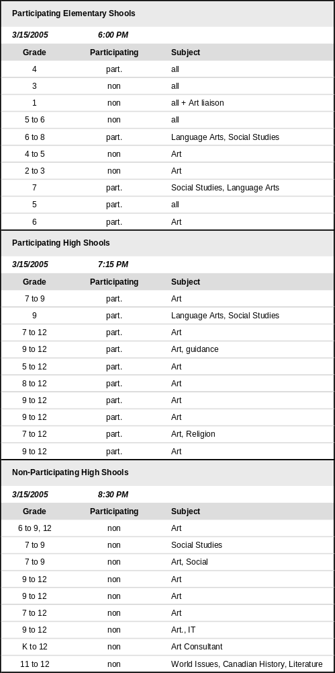

Participant Characteristics – Toronto

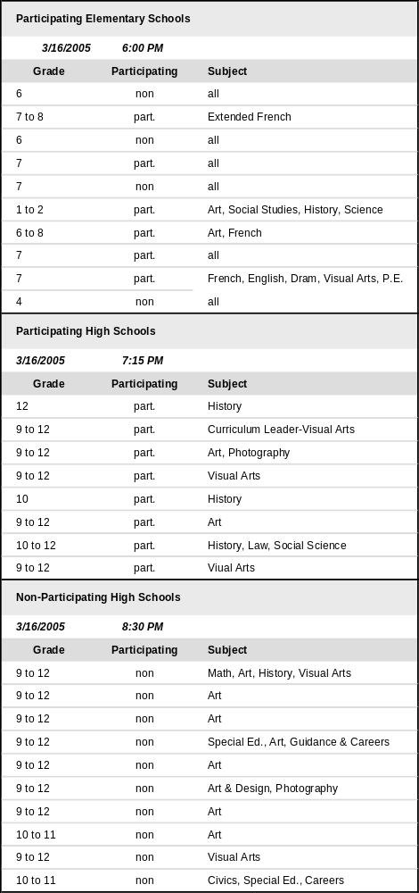

Participant Characteristics – Montreal

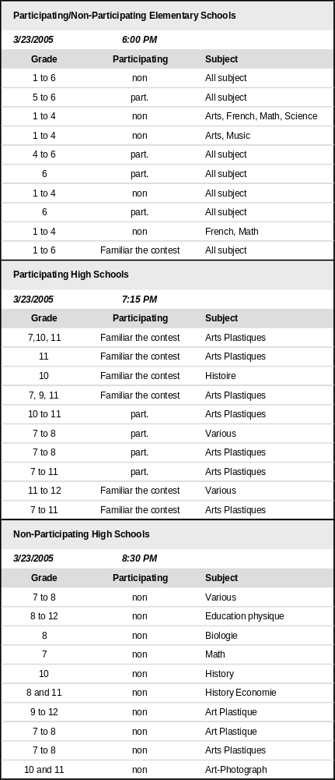

- Appendix B – Participating and Non-Participating Screeners

Appendix B – Participating and Non-Participating Screeners

Recruitment Screener: Participating Schools

INSTRUCTIONS FOR RECRUITERS:

PRIMARY SCHOOL SESSIONS (UP TO GRADE 8) – ENSURE HALF OF EACH GROUP ARE TEACHERS FROM SCHOOLS THAT PARTICIPATED AND HALF ARE FROM NON PARTICIPATING SCHOOLS.

FOR ALL SESSIONS, PLEASE ENSURE A GOOD MIX BY GENDER AND GRADE LEVEL TAUGHT

Good morning/afternoon. My name is ______________ and I am calling from The Strategic Counsel a national public opinion research firm. We are undertaking a project on behalf of Canadian Heritage, the federal government department responsible for fostering participation in cultural activities across Canada. Last year, your school participated in the Canada Day Poster Challenge that was organized by Canadian Heritage. Can I speak to the teacher who organized this for the school? If there was more than one teacher involved in this activity, may I speak to one of them?
WHEN APPROPRIATE TEACHER IS ON THE LINE REPEAT INTRO AND THEN SAY
Before going on, I’d just like to confirm that you were involved in the Canada Day Poster Challenge that your school participated in last year.
YES – CONTINUE
NO - ASK TO SPEAK TO A TEACHER WHO WAS
WHEN NEXT TEACHER IS ON THE LINE REPEAT INTRO AND QUESTION AND THEN GO ON
We have been asked by Canadian Heritage to bring a group of teachers together who have previously participated in this Challenge to evaluate the effectiveness of the Activity Guide and discuss ways to improve its usefulness to you as well as to encourage greater participation in the Challenge.

Appendix B – Participating and Non-Participating Screeners
We are doing this by inviting teachers to take part in a one hour discussion group. We are offering all participants an honorarium of $100 for their participation. Participation is voluntary and all your answers are confidential and will be used for research purposes only. The format is a “round table” discussion led by a research professional – no attempt will be made to sell you anything. Canadian Heritage is very interested in hearing from teachers and considers feedback from participants to be very important in order to ensure the continued success of the Canada Day Poster Challenge.
But before we invite you to attend, I need to ensure that you are over 24 years of age.
YES CONTINUE
NO - ASK IF THERE IS ANOTHER TEACHER WHO WAS INVOLVED IN THE CONTEST AND COULD COME TO THE PHONE
IF NO OTHER TEACHER PARTICIPATED, THANK AND TERMINATE
IF YES, BUT THE OTHER TEACHER IS NOT AVAILABLE ASK FOR THIS TEACHER’S NAME AND ARRANGE A TIME TO CALL BACK
WHEN OTHER TEACHER IS ON THE PHONE REPEAT FROM INTRO
Before going on can I first ask you a few questions?
- Are you familiar with the concept of a focus group?
❑ Yes
❑ No
IF YES, CONTINUE
IF NO, EXPLAIN FOLLOWING “a focus group consists of eight to ten participants and one moderator. During a one -hour session, participants are asked to discuss a wide range of questions regarding the Challenge and the activity Booklet”

2. What grade level or levels do you teach?
❑ 1 to 4
❑ 5 to 6
❑ 7 to 8
❑ 9 to 10
❑ 11 to 12

Appendix B – Participating and Non-Participating Screeners
3. Gender (by observation)
❑ Male
❑ Female

ENSURE BALANCE IN EACH GROUP BY Q.2/3 ABOVE

The group is to be held on:

Toronto – Tuesday, March 15 at (Primary – 6:00, Secondary – 7:15)
Montreal - Thursday, March 17 at (Primary – 6:00, Secondary 7:15)
Winnipeg - Thursday, March 17 at (Primary – 6:00, Secondary 7:15)

4. Are you able to attend?

YES CONTINUE

NO ASK IF THERE IS ANY OTHER TEACHER IN THE SCHOOL WHO WAS INVOLVED IN THE CHALLENGE - IF NO THANK AND TERMINATE

IF YES, THERE IS ANOTHER TEACHER WHO PARTICIPATED, ASK TO SPEAK WITH THIS TEACHER, IF THE OTHER TEACHER IS NOT AVAILABLE ASK FOR THIS TEACHER’S NAME AND ARRANGE A TIME TO CALL BACK

The location is __________________________________________________________________

For administrative purposes what is the spelling of your name

NAME ____________________________________

Just in case you have not yet seen the Activity Booklet for this year’s Challenge, we will be couriering you a copy prior to the group. We ask that you review the booklet prior to coming to the group so that we can use the one-hour duration of the discussion as effectively as possible. Shall we send it to the school or to your home address? Please bring the booklet to the group as well.

IF SCHOOL CONFIRM ADDRESS

Appendix B – Participating and Non-Participating Screeners

IF HOME ASK FOR ADDRESS AND HOME PHONE NUMBER

We will confirm your attendance by phone prior to the group, what is the best number to reach you at: Phone number ______________

Thank You

Appendix B – Participating and Non-Participating Screeners

Recruitment Screener: Non-Participating Schools

INSTRUCTIONS FOR RECRUITERS:

PRIMARY SCHOOL SESSIONS (UP TO GRADE 8) – ENSURE HALF OF EACH GROUP ARE TEACHERS FROM SCHOOLS THAT PARTICIPATED AND HALF ARE FROM NON-PARTICIPATING SCHOOLS.

FOR ALL SESSIONS, PLEASE ENSURE A GOOD MIX BY GENDER AND GRADE LEVEL TAUGHT

Good morning/afternoon. My name is ______________ and I am calling from The Strategic Counsel, a national public opinion research firm. We are undertaking a project on behalf of Canadian Heritage, the federal government department responsible for fostering participation in cultural activities across Canada. Every year Canadian Heritage organizes a Challenge to find the best student-designed posters which will be used to promote Canada Day. I’d like to speak with the teacher in your school who would be most likely to be responsible for coordinating this type of activity. It may be an arts teacher or a civics/history teacher.
WHEN APPROPRIATE TEACHER IS ON THE LINE SAY
Good morning/afternoon. My name is ______________ and I am calling from The Strategic Counsel, a national public opinion research firm. We are undertaking a project on behalf of Canadian Heritage, the federal government department responsible for fostering participation in cultural activities across Canada. Every year Canadian Heritage organizes a Challenge to find the best student-designed posters which will be used to promote Canada Day. Have you heard of the Canada Day Poster Challenge?
YES – CONTINUE
NO - CONTINUE
This Challenge is promoted through an Activity Guide that is sent to schools. The Guide also serves as a resource tool for teachers. We have been asked by Canadian Heritage to bring together a group of teachers who have not previously participated in the Challenge to discuss and evaluate the effectiveness of the Activity Guide that is sent to schools to explain the themes and rules.

Appendix B – Participating and Non-Participating Screeners
We are doing this by inviting teachers to take part in a one-hour discussion group. We are offering all participants an honorarium of $100 for their participation. Participation is voluntary and all your answers are confidential and will be used for research purposes only. The format for the session is a “round table” discussion led by a research professional – no attempt will be made to sell you anything. Canadian Heritage is very interested in hearing from teachers and considers this research to be very important for helping them continue the success of the Canada Day Poster Challenge. We are very interested in hearing your views on the Activity Guide. In order for you to familiarize yourself with the Guide, we will be sending it to all participants before the session for their review.
But before we invite you to attend, I need to ensure that you are over 24 years of age.
YES CONTINUE
NO - ASK IF THERE IS ANOTHER TEACHER WHO WOULD BE INVOLVED IN THIS TYPE OF ACTIVITY IN THE SCHOOL, IF NO OTHER TEACHER WOULD BE INVOLVED, THANK AND TERMINATE
IF THERE IS ANOTHER TEACHER, ASK TO SPEAK WITH THIS TEACHER, IF THIS TEACHER IS NOT AVAILABLE ASK FOR THEIR NAME AND ARRANGE A TIME TO CALL BACK

WHEN OTHER TEACHER IS ON THE PHONE REPEAT FROM SECOND INTRO
Before going on can I first ask you a few questions?
- Are you familiar with the concept of a focus group?
❑ Yes
❑ No
IF YES, CONTINUE
IF NO, EXPLAIN FOLLOWING “a focus group consists of eight to ten participants and one moderator. During a one -hour session, participants are asked to discuss a wide range of questions regarding the Challenge and the Activity Booklet”

2. What grade level or levels do you teach?
❑ 1 to 4
❑ 5 to 6
❑ 7 to 8
❑ 9 to 10
❑ 11 to 12

Appendix B – Participating and Non-Participating Screeners
3. Gender (by observation)
❑ Male
❑ Female

ENSURE BALANCE IN EACH GROUP BY Q.2/3 ABOVE

The group is to be held on:

Toronto – Tuesday, March 15 at (Primary – 6:00, Secondary – 8:30)
Montreal – Thursday, March 17 at (Primary – 6:00, Secondary 8:30)
Winnipeg - Thursday, March 17 at (Primary – 6:00, Secondary 8:30)

4. Are you able to attend?

YES CONTINUE

NO ASK IF THERE IS ANY OTHER TEACHER IN THE SCHOOL WHO WAS WOULD BE INVOLVED IN THIS TYPE OF ACTIVITY - IF NO THANK AND TERMINATE

IF THERE IS ANOTHER TEACHER, ASK TO SPEAK WITH THIS TEACHER, IF THIS TEACHER IS NOT AVAILABLE ASK FOR THEIR NAME AND ARRANGE A TIME TO CALL BACK

The location is __________________________________________________________________

For administrative purposes, what is the spelling of your name?

NAME ____________________________________

Just in case you have not yet seen the Activity Booklet for this year’s Challenge, we will be couriering you a copy prior to the group. Please review it prior to the group and bring it with you on the day of the discussion. Shall we send it to the school or to your home address?

IF SCHOOL, CONFIRM ADDRESS

IF HOME, ASK FOR ADDRESS AND PHONE NUMBER

We will confirm your attendance by phone prior to the group, what is the best number to reach you at: Phone number ______________

Thank You

- Appendix C – Participating and Non-Participating Discussion Guides

Appendix C – Participating and Non-Participating Discussion Guides

CANADA DAY POSTER CHALLENGE FOCUS GROUPS
WITH PARTICIPATING TEACHERS/SCHOOLS

INTRODUCTION (5 MINUTES)

- Explain purpose of groups
  - As we briefly explained at the time we called to invite you to attend this discussion, we’d like to get your opinions and views on various aspects of the Canada Day Poster Challenge a program that is coordinated by Canadian Heritage
  - Over the course of the next hour I’d like to ask you a few questions to explore your views on how Canadian Heritage could increase the level of participation in the Challenge in schools across Canada
- Explain features of focus group facility and role of moderator
  - Moderator is not an employee of Canadian Heritage and therefore may not be able to answer some questions about the Challenge
  - Some observers from Canadian Heritage are present to observe the discussion and to learn from your comments
  - All your comments are confidential. Our report will not attribute comments by name. We are looking mostly for patterns in the comments that we hear across a series of groups, any similarities between groups and/or differences between teachers who have/have not participated or between elementary and secondary levels
  - Groups are being audio-taped in order to be able to review tapes at the time of report writing
- Explain Canada Day Poster Challenge
  - The Canada Day Poster Challenge was launched in 1987 and is run on a yearly basis. The idea behind this initiative is to create an interesting, fun and creative way for young people, 18 years of age and under, to celebrate Canada and to gain a greater appreciation of Canada’s heritage and diversity. Schools are provided with an activity guide and a brochure outlining the rules of the contest (SHOW 2005 ACTIVITY GUIDE AND BROCHURE AND A PREVIOUS YEAR’S INFORMATION POSTER FOR SECONDARY/ELEMENTARY SCHOOLS AS APPLICABLE) and explaining each year’s themes. This information can also be found on the Canadian Heritage website. The themes vary from year to year and may be as broad as “celebrating Canada’s natural beauty” or as specific as “celebrating the centenary of Alberta and Saskatchewan.” Students design posters based on the theme. These are judged by a provincial or territorial Celebrate Canada Committee which chooses a finalist. Finalists from each province and territory win a trip to Ottawa to take part in Canada Day celebrations and are guests of the Minister of Canadian Heritage. They also take part in a three-day program that culminates with Canada Day festivities on Parliament Hill and an opportunity to meet the Governor General and the Prime Minister. The festivities surrounding their visit to the National Capital are captured in photos and a booklet produced showing all the finalists and their artwork. (SHOW NATIONAL CAPITAL VISIT BOOKLET.) A grand prize winner is chosen from among these and their poster becomes the official poster for Canada Day (SHOW POSTER). Each participating student receives a postcard from the Minister of Canadian Heritage (SHOW POSTCARD).

Appendix C – Participating and Non-Participating Discussion Guides
  - Before we begin, I’d like to know a bit more about each of you. HAVE PARTICIPANTS INTRODUCE THEMSELVES BY FIRST NAME ONLY, GRADE(S) AND COURSES TAUGHT

REASONS FOR PARTICIPATION (10 MINUTES)

- First, I’d like to know how you learned about the contest. Where and how did you first hear about it? Probe for:
  - Through school – administration or another teacher
  - Via the media, through newspaper articles, radio or cable tv
  - Canadian Heritage web site
  - Other (specify)
- And, what made you decide to participate? What was it about the Challenge that appealed to you?
- Generally, how did your students respond to it? Did they view it as a fun way to express their feelings about Canada? Why/why not?
- Is this something you will continue to participate in? Why/why not?
- Does this type of activity (e.g. celebrating Canada and drawing posters on this theme) integrate well into your course work? Why/why not?
  - Which courses is it most appropriate for, in your view?
  - Is this activity suitable for all grades or more suitable for some than others?
    - If suitable for some, which ones?
    - Why do you not see it as more inclusive or encompassing a broad range of grades/age groups?

THEMES & FORMAT (15 MINUTES)

- What was your reaction to this year’s theme “Canada from East to West – 100 years Alberta/Saskatchewan?” Probe for:
  - Does it lend itself well to a Poster Contest? Why/why not?
  - What difficulties, if any, might your students or you as teachers have relating to this theme?
- In general, do you prefer to have historical themes such as the 2005 theme or something broader? Why?
- What other kinds of themes would your students like to draw about that would fall under the general heading of celebrating their pride in Canada and its achievements?
- How much information would you need to get you/your students started with this activity? Is the information provided too much, too little, about right? Why?
  - Which is more effective - a brochure, a booklet or the web site? (SHOW EXAMPLES OF EACH) Why? Probe for:
    - To what extent do you use the Guide or the web site as resource tools versus simply providing students with the contest rules
  - Is this an activity that you do in the classroom, or do you encourage the students to do this on their own time?
    - How useful is the 8 ½ X 11 Guide versus the brochure? Do you need both pieces? If not, which one is more useful in getting students to participate?

Appendix C – Participating and Non-Participating Discussion Guides
  - How do you share this information with your students? Probe for:
    - Any issues related to photocopying of materials (impractical) and preference for greater number of copies. How many copies do you need?
    - If students doing on their own time, what kind of information tool would be more effective for them?

PRIZE STRUCTURE (15 MINUTES)

- I mentioned earlier that each province/territory selects a finalist and this individual attends Canada Day festivities with dignitaries. There are also celebrations within the province/territory for each of the 13 provincial/territorial finalists that give them quite a bit of press/profile. The national prize winner has their poster printed and distributed. All participants receive a signed postcard from the Minister of Canadian Heritage
- Do these kinds of prizes motivate your students?
  - If not, why not? What kinds of prizes would be more appealing, keeping in mind that the idea is to celebrate Canada on Canada Day?
  - Is there anything else that could be done to recognize the contributions of all students besides the postcard from the Minister?
- Would you recommend any changes to the prizes or to the entry rules of the contest? What changes would you recommend? Probe for:
  - Are there enough prizes?
  - Does the contest need to be separated according to age groups or by elementary/secondary levels? How would this improve participation? What prizes would be appropriate for each of these levels?

DISTRIBUTION AND PROMOTION (10 MINUTES)

- The timing of the Challenge is as follows:
  - The winning poster is usually distributed to schools in June of each year. By the third week in December, the brochure and guide are sent to schools so that they can get started on their entries. These are submitted February 28th.
- Does the timing of the contest work well from your point of view and given how the school year rolls out? Why/why not?
- Ideally, at what time of year would you like to receive these materials?
  - Would it be better for you if the timing was moved forward in order to get something out to you in September, at the beginning of the school year?
  - Does the fact that this is a Canada Day-focussed activity create any difficulties or challenges for you at that time of year? If so, how could this be resolved?
- How can we make more teachers/schools aware of this initiative? What is the best way of getting this out to teachers?

WRAP-UP (5 MINUTES)

- Do you have any final thoughts or advice on how to increase the level of participation in this activity?
- Any other comments on any of the aspects of the Challenge that we have discussed this evening?

THANK YOU

Appendix C – Participating and Non-Participating Discussion Guides

CANADA DAY POSTER CHALLENGE FOCUS GROUPS
WITH NON-PARTICIPATING TEACHERS/SCHOOLS

INTRODUCTION (5 MINUTES)

- Explain purpose of groups
  - As we briefly explained at the time we called to invite you to attend this discussion, we’d like to get your opinions and views on various aspects of the Canada Day Poster Challenge a program that is coordinated by Canadian Heritage
  - Over the course of the next hour I’d like to ask you a few questions to explore your views on how Canadian Heritage could increase the level of participation in the Challenge in schools across Canada
- Explain features of focus group facility and role of moderator
  - Moderator is not an employee of Canadian Heritage and therefore may not be able to answer some questions about the Challenge
  - Some observers from Canadian Heritage are present to observe the discussion and to learn from your comments
  - All your comments are confidential. Our report will not attribute comments by name. We are looking mostly for patterns in the comments that we hear across a series of groups, any similarities between groups and/or differences between teachers who have/have not participated or between elementary and secondary levels
  - Groups are being audio-taped in order to be able to review tapes at the time of report writing
- Explain Canada Day Poster Challenge
  - The Canada Day Poster Challenge was launched in 1987 and is run on a yearly basis. The idea behind this initiative is to create an interesting, fun and creative way for young people, 18 years of age and under, to celebrate Canada and to gain a greater appreciation of Canada’s heritage and diversity. Schools are provided with an activity guide and a brochure outlining the rules of the contest (SHOW 2005 ACTIVITY GUIDE AND BROCHURE AND A PREVIOUS YEAR’S INFORMATION POSTER FOR SECONDARY/ELEMENTARY SCHOOLS AS APPLICABLE) and explaining each year’s themes. This information can also be found on the Canadian Heritage website. The themes vary from year to year and may be as broad as “celebrating Canada’s natural beauty” or as specific as “celebrating the centenary of Alberta and Saskatchewan.” Students design posters based on the theme. These are judged by a provincial or territorial Celebrate Canada Committee which chooses a finalist. Finalists from each province and territory win a trip to Ottawa to take part in Canada Day celebrations and are guests of the Minister of Canadian Heritage. They also take part in a three-day program that culminates with Canada Day festivities on Parliament Hill and an opportunity to meet the Governor General and the Prime Minister. The festivities surrounding their visit to the National Capital are captured in photos and a booklet produced showing all the finalists and their artwork. (SHOW NATIONAL CAPITAL VISIT BOOKLET.) A grand prize winner is chosen from among these and their poster becomes the official poster for Canada Day (SHOW POSTER). Each participating student receives a postcard from the Minister of Canadian Heritage (SHOW POSTCARD).

Appendix C – Participating and Non-Participating Discussion Guides
  - Before we begin, I’d like to know a bit more about each of you. HAVE PARTICIPANTS INTRODUCE THEMESELVES BY FIRST NAME ONLY, GRADE(S) AND COURSES TAUGHT

OVERALL REACTION (10 MINUTES)

- Having read through some of the materials, I’d like to get your initial reaction as to whether this is something you would consider participating in. Why/why not?
- Is this the kind of activity that would interest your students? If so, why? If not, why not?
- Does this type of activity (e.g. celebrating Canada and drawing posters on this theme) integrate well into your course work? Why/why not?
  - Which courses is it most appropriate for, in your view?
  - Is this activity suitable for all grades or more suitable for some than others?
    - If suitable for some, which ones?
    - Why do you not see it as more inclusive or encompassing a broad range of grades/age groups?

THEMES & FORMAT (15 MINUTES)

- What is your reaction to this year’s theme “Canada from East to West – 100 years Alberta/Saskatchewan?” Probe for:
  - Does it lend itself well to a Poster Contest? Why/why not?
  - What difficulties, if any, might your students or you as teachers have relating to this theme?
- In general, would you prefer historical themes like this over something broader? Why?
- What other kinds of themes would your students like to draw about that would fall under the general heading of celebrating their pride in Canada and its achievements?
- How much information would you need to get you/your students started with this activity? Is the information provided too much, too little, about right? Why?
  - Which is more effective - a brochure, booklet or the web site? (SHOW EXAMPLES OF EACH) Why? Probe for:
    - To what extent would you use the Guide or the web site as resource tools versus simply providing students with the contest rules
  - Is this an activity that you would do in the classroom, or would you encourage the students to do this on their own time?
    - How useful is the 8 ½ X 11 Guide versus the brochure? Do you need both pieces? If not, which one would be more useful in getting students to participate?
  - How would you share this information with your students? Probe for:
    - Any issues related to photocopying of materials (impractical) and preference for greater number of copies. How many copies do you need?
    - If students would be participating on their own time, what kind of information tool would be more effective for them?

Appendix C – Participating and Non-Participating Discussion Guides
PRIZE STRUCTURE (15 MINUTES)

- I mentioned earlier that each province/territory selects a finalist and this individual attends Canada Day festivities with dignitaries. There are also celebrations within the province/territory for each of the 13 provincial/territorial finalists that give them quite a bit of press/profile. The national prize winner has their poster printed and distributed. All participants receive a signed postcard from the Minister of Canadian Heritage
- Would these kinds of prizes motivate your students?
  - If not, why not? What kinds of prizes would be more appealing, keeping in mind that the idea is to celebrate Canada on Canada Day?
  - Is there anything else that could be done to recognize the contributions of all students besides the postcard from the Minister?
- Would you recommend any changes to the prizes or to the entry rules of the contest? What changes would you recommend? Probe for:
  - Are there enough prizes?
  - Does the contest need to be separated according to age groups or by elementary/secondary levels? How would this improve participation? What prizes would be appropriate for each of these levels?

DISTRIBUTION AND PROMOTION (10 MINUTES)

- The timing of the Challenge is as follows:
  - The winning poster is usually distributed to schools in June of each year. By the third week in December, the brochure and guide are sent to schools so that they can get started on their entries. These are submitted February 28th.
- Does the timing of the contest work well from your point of view and given how the school year rolls out? Why/why not?
- Ideally, at what time of year would you like to receive these materials?
  - Would it be better for you if the timing was moved forward in order to get something out to you in September, at the beginning of the school year?
  - Does the fact that this is a Canada Day-focussed activity create any difficulties or challenges for you at that time of year? If so, how could this be resolved?
- How can we make more teachers/schools aware of this initiative? What is the best way of getting this out to teachers?

WRAP-UP (5 MINUTES)

- Do you have any final thoughts or advice on how to increase the level of participation in this activity?
- Any other comments on any of the aspects of the Challenge that we have discussed this evening?

THANK YOU

- Appendix D – Preferred Canada Day Poster Challenge Themes and Prizes

Preferred Canada Day Poster Challenge Themes

Winnipeg | Toronto | Montreal *
Images of Canada | Artists/Musicians/Writers | Images of Canada
Canadian flag (personal connection) | Native culture/approach to the environment | My Canada
Canadian people | Racism/Prejudice/Multiculturalism | Images of other provinces (choose a province)
“I am Canadian” | Fashion | Event/Period in Canada’s History (i.e. arrival of Jacques Cartier)
About my province | Personalities | Fauna
Innovations: Past, Present and Future | Outstanding Canadian men or women | Cities
People and Inventions | Family | Geography
Symbols of Canadian diversity | Community | History
Symbols of our country | Inventions | Native Peoples
Ordinary Canadians: past and present | Technologies | Immigration
Physical environment | Gay marriage (in their own lives)
Animals, birds, creatures | Canadian places
Portraits | Transportation (railroad)
Genealogy | Peace
Transportation | Canadian Events
Technology
Building Canada
Folk art
Canadian Art History
* In Montreal there was far more interest in discussing why’ and how’s of the program than the thematic content.

Preferred Canada Day Poster Challenge Prizes

Winnipeg | Toronto | Montreal
Cash | Cash (incremental by age) | Pins
Scholarships | Scholarships for seniors | Magnets
Gift certificates | Gift certificates ($100) | Tattoos
Maple Leaf pins | Young students – trip to Ottawa is good | Tickets to a museum
Tattoos/stickers | Computer software | Art kit and supplies
Pencils/pens | Buttons | Prize for schools - Visit by a “celebrity” – hockey player, musician, actor/actress. Multimedia computer/computer programs
Pencil case | Pencils | Winning posters – public recognition (announce winners on the internet, produce super-sized calendar - with all 12 winners reflecting the calendar and distributed to schools, institutions, libraries, etc.
t-shirts | Flag with poster on it | Train travel and visit to another region of Canada
Ball caps | Prize for schools – library resources (historical text, atlas), art supplies, videos, computer software (some flexibility, depends on what school needs)
Canadian books | Poster – display in prominent public place
$1000 in art supplies | Winning posters should be distributed in calendar form
Flags
Rulers
Buttons
Water bottles
Gift bags

- Appendix E – 2005 Canada Day Poster Challenge Materials

2005 Canada Day Poster Challenge Activity Guide
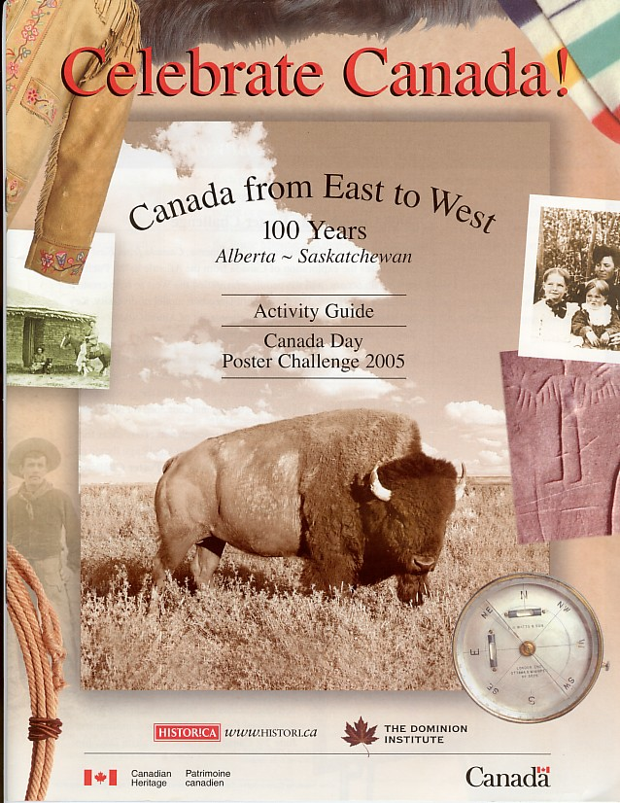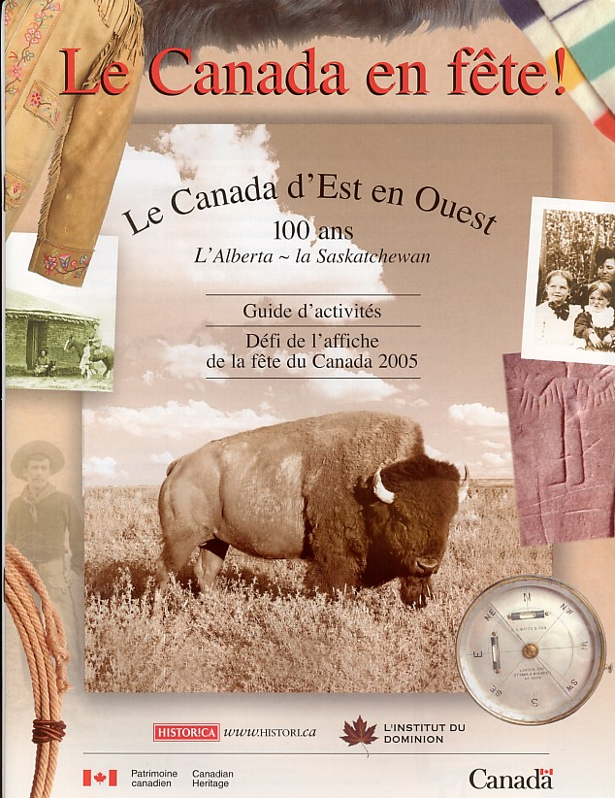

2005 Canada Day Poster Challenge Brochure
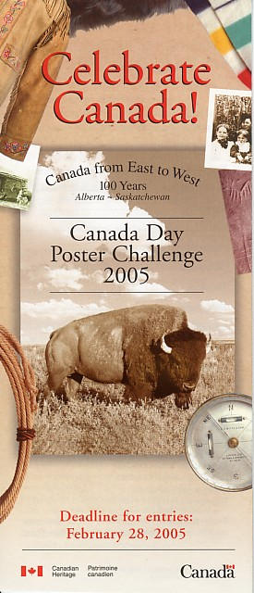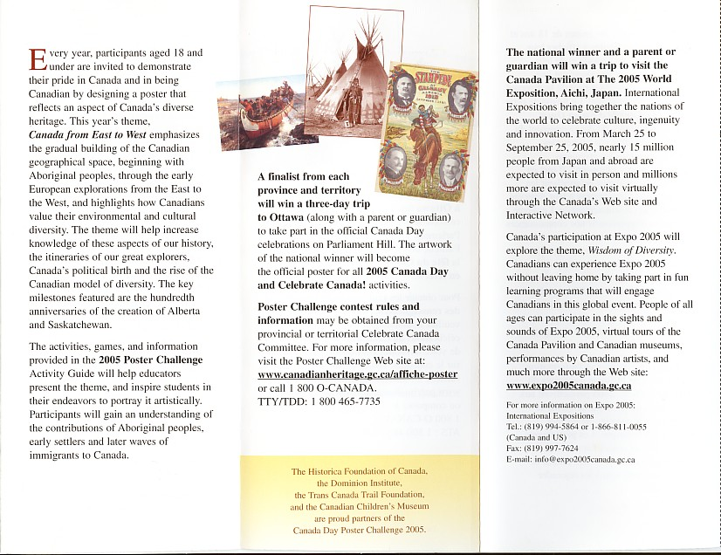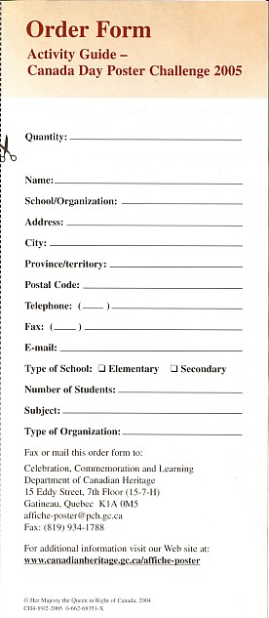

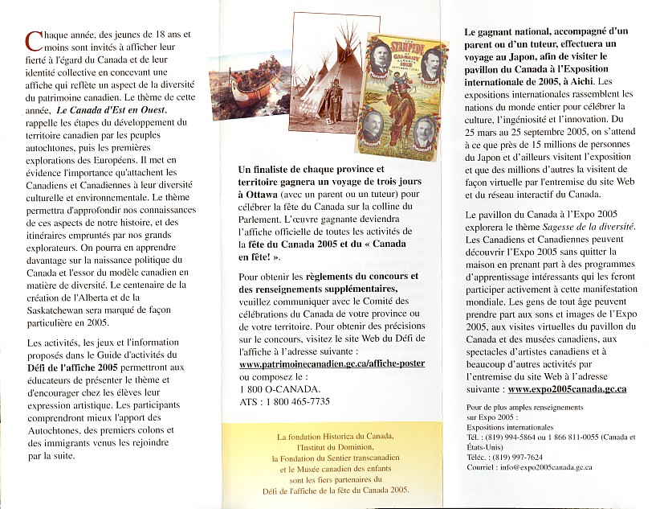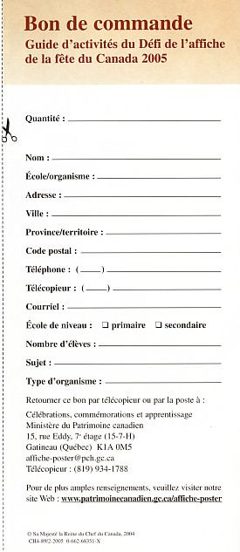

2005 Canada Day Poster Challenge Post-Card
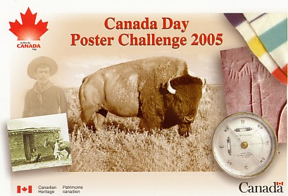

2004 Canada Day Poster Challenge – National Winning Poster
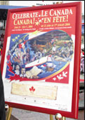

- Appendix F – 1997, 1998 and 2003 Canada Day Poster Challenge Materials Tested

1997 Canada Day Poster Challenge Material Tested

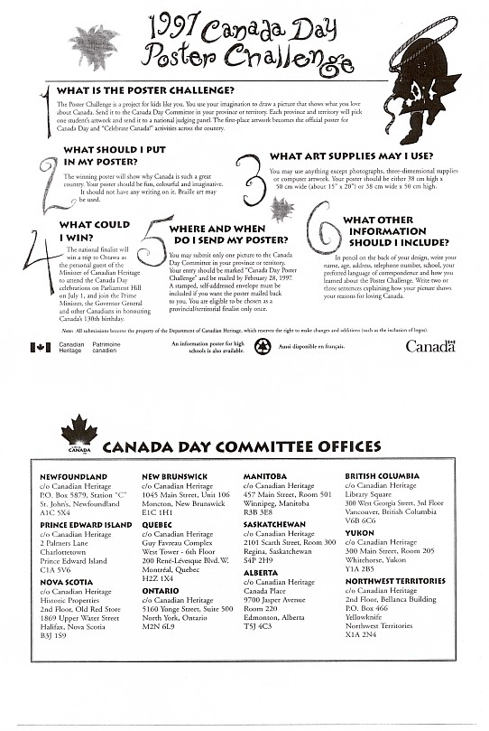
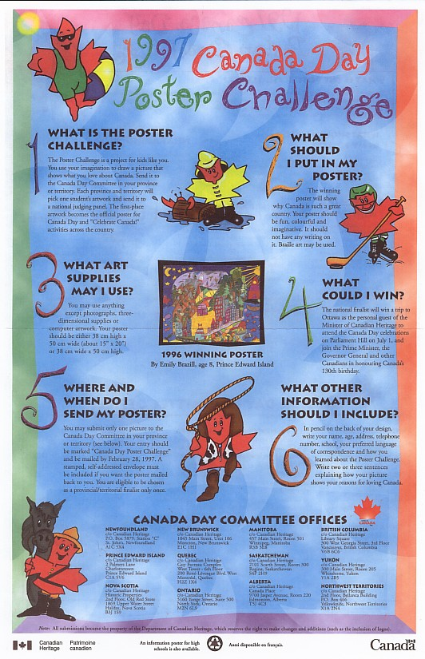

1998 Canada Day Poster Challenge Material Tested

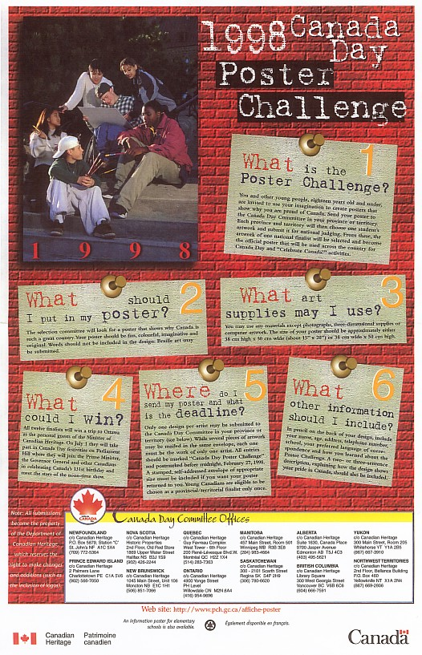
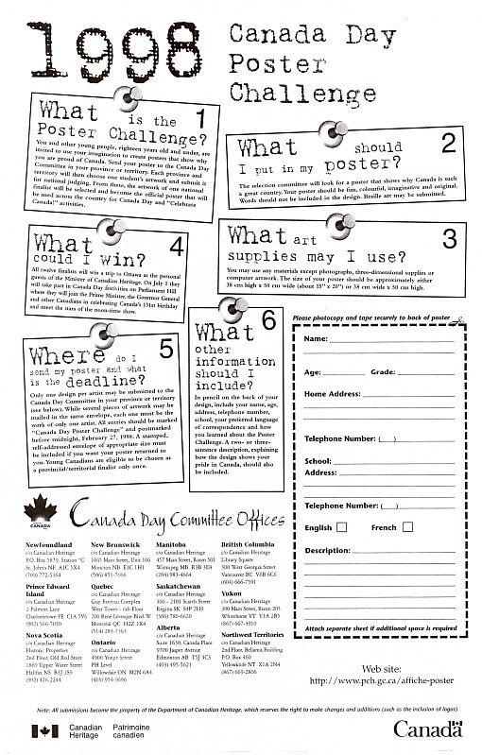

1998 Canada Day Poster Challenge Material Tested

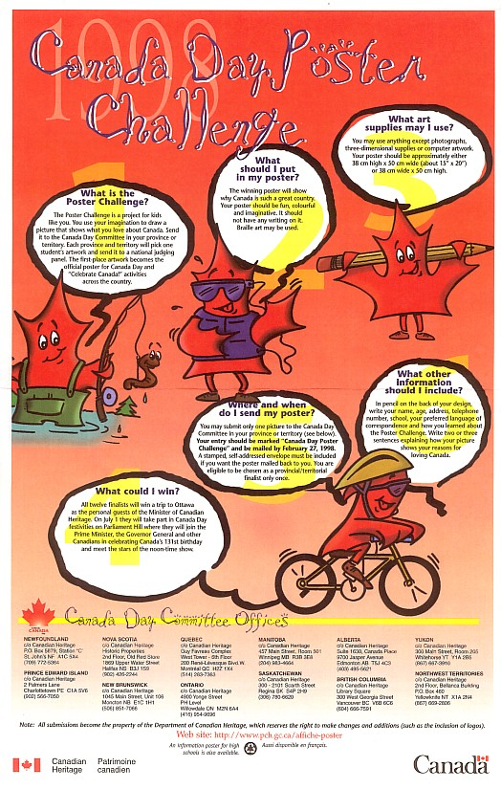
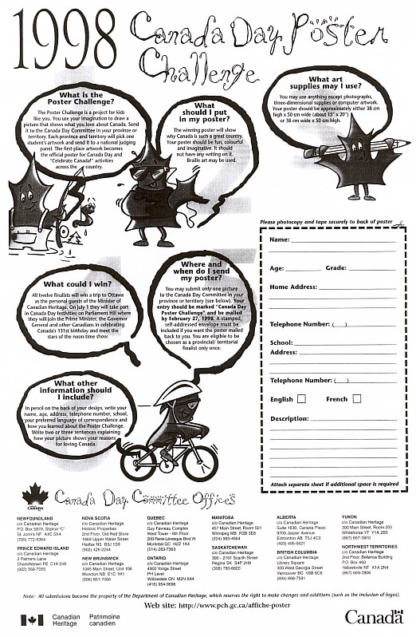

2003 Canada Day Poster Challenge Activity Guide Tested



