POR Registration Number: POR 105-16
PWGSC Contract Number: 5K002-161802/001/CY
Contract Award Date: February 8, 2017
Delivery Date: May 12, 2017
2017 Client Satisfaction Survey
Report

Prepared by
Ipsos Public Affairs
Prepared for:
Canadian Grain Commission

Ce rapport est aussi disponible en français
For more information on this report, please email:
(Generic email address for the department)

Political Neutrality Statement
I hereby certify as Senior Officer of Ipsos that the deliverables fully comply with the Government of Canada political neutrality requirements outlined in the Communications Policy of the Government of Canada and Procedures for Planning and Contracting Public Opinion Research. Specifically, the deliverables do not include information on electoral voting intentions, political party preferences, standings with the electorate or ratings of the performance of a political party or its leaders.

Mike Colledge
President
Ipsos Public Affairs

Table of Contents
1.0 Executive Summary 3
1.1 Discussion of Findings 3
1.2 Overall Conclusions/Recommendations 5
1.3 Résumé 5
2.0 Introduction 9
2.1 Background 9
2.2 Research Objectives 9
3.0 Methodological Report 10
3.1 Qualitative Interviews 10
3.2 Quantitative Survey 10
3.3 Challenges Encountered 13
4.0 Detailed Analysis of Qualitative Findings 14
4.1 Overall Impressions of Services 14
4.2 Specific Service Areas 17
4.3 User Fees and Cost Recovery 26
4.4 Other Issues Discussed 29
5.0 Detailed Analysis of Quantitative Findings 30
5.1 Awareness, Impression and Usefulness of the CGC 30
5.2 Grading Services 32
5.3 Sampling, Inspection, Weighing and Quality 37
5.4 Licensing and Security 38
5.5 Producer Cars 39
5.6 Service Centres 40
5.7 Importance of Scientific Research 42
5.8 User Fees and Surplus 42
6.0 Appendix 45
6.1 Table of Figures 45
6.2 Questionnaire 46
6.3 Qualitative Self-Directed Interview Guide 60
6.4 Qualitative Interviewer Lead Interview Guide 69
6.5 Invitation to Self-Directed Interview 73

Executive Summary
The Canadian Grain Commission is the regulator of Canada’s grain handling industry. It is the official certifier of Canadian grain. The CGC is Canada’s scientific research organization on grain quality.
The CGC commissioned Ipsos to gather feedback from industry representatives and Canadian grain producers to improve their programs and services and to review their proposed changes to their user fees.

Discussion of Findings

Overall Awareness and Impressions of Services
Both in the qualitative discussions with industry stakeholders and quantitative survey of producers, the activities and services provided by the CGC were generally positively viewed.
There is almost universal awareness (99%) of the CGC, and among those aware, three-quarters (75%) have a positive overall impression (5 or more on a 7-point scale), which represents an increase compared to 2010 (62%). Three-quarters (74%) of respondents view the CGC as useful, which is also higher than views reported in 2010 (62%).
Most interviewed industry representatives were satisfied with the services provided by CGC and felt that communication, timing and completeness of information were all important service aspects.

The Canadian Grain Commission and the Industry Reputation
Among producers surveyed, grain grading services was identified as an important service (83%) There is near unanimous agreement (96% strongly/ somewhat) that having the CGC’s sampling, inspection and weighing services is beneficial to Canada’s reputation for consistent and reliable grain quality. Producers also understand the importance of Canada’s grain quality system being based on scientific research, with eight in ten (81%) saying this is very important.
Among industry representative interviewed, many agreed that the role of the CGC is important in maintaining the Canadian industry’s reputation, however there were suggestions that perhaps third party inspections/grading may benefit the industry. These participants were concerned that the CGC does not take buyers’ needs into account nor the business needs of the industry. The need for quality scientific research was referenced by a few participants.

CGC Services
Overall producers were positive about the CGC’s services. Six in ten (62%) indicate that a service centre in their province would be very valuable to them (6 or 7 on the scale). This was mirrored in the qualitative interviews, where many participants suggested more local service centres would reduce turnaround times and potentially improve access to training and other resources.
Among industry representatives interviewed, most were fairly positive about their experiences with the CGC service delivery. Most felt that improvements could be made in terms of reducing the cost and implementing faster turnaround times for services. Many also noted the lack of flexibility or conformity to the international industry standards for reporting and the impact this has had on their business.
The reported use of the CGC’s grain grading services among producers in the past three crop years has increased (45% from 34%). Among these users, there is almost universal agreement (96%) that having the CGC set grain grades and standards is beneficial to Canada’s reputation for consistent and reliable grain quality. Three-quarters (73%) think that the CGC making binding decisions on grade and dockage is very important. But fewer than one in ten (7%) have used this service in the last three crop years, mostly because they didn’t need to.
While industry representatives interviewed were divided on the role of the CGC in providing these services, many suggested changes to the grading system modernization of the process (such as improved online presence, e-certification). Others were concerned with consistency in application, suggesting expanding across the industry or increasing inspection related training. Flexibility was also frequently mentioned in relation to CGC services, with some suggesting flexibility in choice of tests, the format of the documentation/certification, timing of inspections (hours of operation as well as frequency). When it came to providing services for container shipping, while most participant opposed this proposal, some felt that similar requirements should apply as with bulk shippers to ensure fairness.
Nine in ten agree (92% strongly/ somewhat) that the CGC’s quality assurance system serves producers well. Similarly, industry representatives interviewed were satisfied with the quality sampling system, but many suggested improvements could be made to ensure consistency, including increased training and resources for sample comparison (physical examples, photos).
Nine in ten (88%) respondents think it is very important that the CGC provide producers with payment protection and a similar proportion (90%) strongly agree that this program reduces the risk of producers of not getting paid by a grain company. Among interviewees, when discussing options for the use of the surplus, the proposal to create a fund to compensate eligible producers in the event they are not paid by a grain company was less popular.
Most producers (91%) say they haven’t used producer cars to ship their grain in the past three crop years. Among those who have (9%) most are very satisfied (58%) with the assistance provided by the CGC when ordering producer cars.

User Fees and Surplus
The proposal by the CGC to reduce its fees from its current cost of $1.80 per tonne of grain that is exported to $1.50 was very positively received, there is almost unanimous agreement (94%) among responding producers and most industry representative participants also agreed with this proposal. Some however worried that lowering fees might result in a reduced quality of service delivery.
When told that the CGC has accumulated a surplus of $107 million, and read a list of five options on what the CGC should do with this surplus, the most preferred choice is temporarily reducing CGC’s user fees even lower than the current proposed reduction (40%), followed by opting for creating a fund to compensate eligible producers in the event they are not paid for their grain deliveries (23%). Industry representatives interviewed also preferred lowering user fees further temporarily, however modernizing the grading system and other infrastructure and research investments were also important suggestions. Some felt these options would be a longer-term investment in the industry that would in turn reduce turnaround times and costs.

Overall Conclusions/Recommendations
The results of the 2017 survey indicate that Alberta, Manitoba and Saskatchewan grain producers hold positive impressions of the CGC and that views have become more positive over the past seven years. Similarly, these producers feel that CGC has become more useful to grain producers than in the past. Now, three-quarters of producers indicate that CGC is useful to producers.
Industry representatives interviewed, however are divided on the importance and purpose of the Canadian Grain Commission. The cost-recovery model that increased the burden on the industry due to lower federal contributions has resulted in some concerns that CGC’s services are not competitive with the industry and would benefit from a review.
Most producers recognize the importance of CGC’s grain grading services and producers are using these services in increasing numbers. In fact, grain grading is perceived to be one of the most useful services the CGC provides producers. Satisfaction with these services is high. High percentages of users indicate that CGC’s grain grading services, such as setting grain grades and standards and sampling, inspection and weighing, are beneficial to Canada’s reputation for consistent and reliable grain quality.
Similarly, industry representatives interviewed appreciated the CGC’s grain grading services and suggested improvements to inspection-training for industry to improve effectiveness, provide consistency, meet expectations and improve business practices.
The survey also finds that most producers agree with the proposed reduction in fees and would prefer that CGC’s surplus be used to temporarily reduce CGC’s fees even lower than the current proposed reduction.
Industry representatives interviewed also agree with the proposed decreases, and would prefer the surplus be used to reduce fees, however it is important to note support for alternate proposals of investment in modernization and infrastructure that may lead to similar cost reductions long-term.

Résumé
La Commission canadienne des grains (CCG) est chargée de la réglementation de l’industrie de la manutention des grains au Canada. C’est la certificatrice officielle des grains canadiens. Elle est l’organisation de recherche scientifique du Canada pour ce qui est de la qualité des grains.
La CCG a chargé Ipsos de recueillir de la rétroaction auprès de représentants de l’industrie et de producteurs de grain canadiens en vue d’améliorer ses programmes et services et d’examiner les modifications proposées à ses frais d’utilisation.

Discussion des constatations

Sensibilisation globale et impressions à l’égard des services
Dans le cadre des discussions qualitatives avec les intervenants de l’industrie et de l’enquête quantitative auprès des producteurs, les activités et les services offerts par la CCG étaient généralement perçus de façon positive.
Les groupes cibles affichent un taux de sensibilisation à la CCG presque parfait (99 %). De plus, parmi ces répondants très sensibilisés, les trois quarts (75 %) ont une impression globale positive (5 ou plus sur une échelle de 7 points), ce qui représente une augmentation par rapport à 2010 (62 %). Les trois quarts (74 %) des répondants considèrent la CCG comme utile, ce qui est aussi un taux plus élevé que celui des points de vue mentionnés en 2010 (62 %).
La plupart des représentants de l’industrie interviewés étaient satisfaits des services offerts par la CCG et croyaient que la communication, les délais de fourniture et l’intégralité des renseignements étaient d’importants aspects des services.

Commission canadienne des grains et réputation de l’industrie
Parmi les producteurs sondés, les services de classement des grains ont été indiqués comme étant un service important (83 %). Il y a quasi-unanimité (96 % fortement ou assez d’accord) à l’effet que l’offre de services d’échantillonnage, d’inspection et de pesée par la CCG aide à maintenir la réputation dont jouit le Canada pour ce qui est de la constance et de la fiabilité de la qualité du grain qu’il produit. Les producteurs comprennent aussi l’importance du fait que le système d’assurance de la qualité des grains du Canada est fondé sur la recherche scientifique, huit sur dix (81 %) affirmant que cela est très important.
Parmi les représentants de l’industrie interviewés, bon nombre ont convenu que le rôle de la CCG est important pour le maintien de la réputation de l’industrie canadienne; toutefois, il a été donné à penser que des services d’inspection et de classement offerts par des tiers pourraient bénéficier à l’industrie. Ces participants étaient préoccupés à l’égard du fait que la CCG ne tient compte ni des besoins des acheteurs, ni des besoins opérationnels de l’industrie. Quelques participants ont mentionné le besoin de recherche scientifique de qualité.

Services de la CCG
Dans l’ensemble, les producteurs étaient positifs en ce qui concerne les services offerts par la CCG. Six sur dix (62 %) ont indiqué qu’un centre de services dans leur province leur serait très utile (6 ou 7 sur l’échelle). Cela a été reflété dans les entrevues qualitatives, dans le cadre desquelles de nombreux participants ont donné à penser qu’un plus grand nombre de centres de services locaux réduirait les délais d’exécution et pourrait améliorer l’accès à la formation et à d’autres ressources.
Parmi les représentants de l’industrie interviewés, la plupart étaient assez positifs quant à leurs expériences relatives à la prestation de services par la CCG. La plupart croyaient que des améliorations pourraient être apportées pour ce qui est de la réduction du coût et de la mise en œuvre de délais d’exécution des services plus rapides. Bon nombre ont aussi mentionné le manque de souplesse ou de conformité quant aux normes industrielles internationales relatives à la production de rapports, ainsi que les incidences que cela a eues sur leurs entreprises.
L’utilisation déclarée des services de classement des grains offerts par la CCG parmi les producteurs au cours des trois dernières années de récolte a augmenté (de 34 % à 45 %). Parmi ces utilisateurs, il y a quasi-unanimité (96 %) quant à l’énoncé « le fait que la CCG établisse des grades et des normes applicables aux grains est avantageux pour la réputation du Canada pour ce qui est de la constance et de la fiabilité de la qualité du grain qu’il produit. » Les trois quarts (73 %) croient que le fait que la CCG prenne des décisions exécutoires relatives aux grades et aux impuretés est très important. Toutefois, moins d’un sur dix (7 %) a utilisé ce service au cours des trois dernières années de récolte, en grande partie parce que les producteurs n’ont pas besoin de le faire.
Bien que les représentants de l’industrie interviewés aient été divisés en ce qui concerne le rôle de la CCG dans la fourniture de ces services, bon nombre ont proposé des modifications à la modernisation du système de classement du processus (p. ex. présence en ligne améliorée, certification électronique). D’autres étaient préoccupés quant à la cohérence dans l’application, et ont proposé une expansion à l’échelle de l’industrie ou une augmentation de la formation relative aux inspections. La souplesse a aussi été mentionnée de façon fréquente en ce qui concerne les services offerts par la CCG. Certains ont proposé une souplesse dans le choix des tests, le format de la documentation ou de la certification, ainsi que le délai d’exécution des inspections (heures de fonctionnement ainsi que fréquence). En ce qui concerne l’offre de services d’expédition par conteneurs, bien que la plupart des participants se soient opposés à cette proposition, certains croyaient que pour assurer l’équité, des exigences comparables à celles imposées aux expéditeurs de vrac devraient s’appliquer.
Neuf répondants sur dix sont d’accord (92 % fortement ou assez d’accord) que le système d’assurance de la qualité de la CCG sert bien les producteurs. De même, les représentants de l’industrie interviewés étaient satisfaits du système d’échantillonnage de la qualité, mais bon nombre ont donné à penser que des améliorations pourraient être apportées afin d’assurer la cohérence, y compris une formation et des ressources accrues pour la comparaison des échantillons (exemples physiques, photos).
Neuf répondants sur dix (88 %) croient qu’il est très important que la CCG fournisse aux producteurs une protection des paiements et une proportion semblable (90 %) est fortement d’accord que ce programme réduit le risque que les producteurs ne soient pas payés par une compagnie céréalière. Parmi les personnes interviewées, lorsqu’il s’agit de discuter des options relatives à l’utilisation de l’excédent, la proposition de créer un fonds à partir duquel indemniser les producteurs admissibles s’ils ne sont pas payés par une entreprise céréalière a été moins populaire.
La plupart des producteurs (91 %) disent ne pas avoir utilisé les wagons de producteurs pour expédier leur grain au cours des trois dernières années de récolte. Parmi ceux qui ont eu recours à ce service (9 %), la plupart sont très satisfaits (58 %) de l’aide offerte par la CCG au moment de commander des wagons de producteurs.

Frais d’utilisation et excédent
La proposition de la CCG de réduire ses frais actuels de 1,80 $ la tonne de grain qui est exportée à 1,50 $ a été reçue de façon très positive. Il y a quasi-unanimité (94 %) parmi les producteurs répondants, et la plupart des représentants de l’industrie participants sont aussi d’accord avec cette proposition. Toutefois, certains craignaient que la réduction des frais entraîne une diminution de la qualité de la prestation des services.
Lorsqu’ils ont été informés que la CCG avait accumulé un excédent de 107 millions de dollars, et qu’on leur a lu les cinq options quant à ce que la CCG devrait faire avec cet excédent, le premier choix a été de réduire temporairement les frais d’utilisation de la CCG encore plus bas que la réduction actuellement proposée (40 %), suivi de l’option de créer un fonds à partir duquel indemniser les producteurs admissibles s’ils ne sont pas payés pour leurs livraisons de grain (23 %). Les représentants de l’industrie interviewés préféraient également une réduction encore plus marquée des frais d’utilisation; toutefois, la modernisation du système de classement et d’autres investissements dans l’infrastructure et la recherche constituaient aussi des propositions importantes. Certains estimaient que ces options constitueraient un investissement à plus long terme dans l’industrie qui, par ricochet, réduirait les délais d’exécution et les coûts.

Conclusions générales et recommandations
Les résultats du sondage 2017 indiquent que les producteurs de grain de l’Alberta, du Manitoba et de la Saskatchewan ont des impressions très positives de la CCG et que les opinions sont devenues plus positives au cours des sept dernières années. De même, ces producteurs croient que la CCG est devenue plus utile aux producteurs de grain que dans le passé. Maintenant, les trois quarts des producteurs indiquent que la CCG est utile aux producteurs.
Les représentants de l’industrie interviewés sont toutefois divisés en ce qui concerne l’importance et l’objectif de la Commission canadienne des grains. Le modèle de recouvrement des coûts qui a augmenté le fardeau qui pèse sur l’industrie en raison de l’abaissement des contributions fédérales a donné lieu à certaines préoccupations à l’égard du fait que les services offerts par la CCG ne sont pas concurrentiels par rapport à l’industrie et bénéficieraient d’un examen.
La plupart des producteurs reconnaissent l’importance des services de classement des grains de la CCG, et de plus en plus de producteurs ont recours à ces services. En fait, le classement des grains est perçu comme étant l’un des services les plus utiles offerts aux producteurs par la CCG. La satisfaction à l’égard de ces services est élevée. Des pourcentages élevés d’utilisateurs indiquent que les services de classement des grains offerts par la CCG, tels que l’établissement de grades et de normes ainsi que les services d’échantillonnage, d’inspection et de pesée, sont avantageux pour la réputation du Canada pour ce qui est de la constance et de la fiabilité de la qualité du grain qu’il produit.
De même, les représentants de l’industrie interviewés ont apprécié les services de classement des grains offerts par la CCG et ont proposé que des améliorations soient apportées à la formation relative à l’inspection à l’intention de l’industrie afin d’accroître l’efficacité, d’assurer la cohérence, de répondre aux attentes et d’améliorer les pratiques opérationnelles.
Le sondage a aussi permis de conclure que la plupart des producteurs sont d’accord avec la réduction des frais proposée et qu’ils préféreraient que l’excédent de la CCG soit utilisé pour réduire temporairement les frais de la CCG à un niveau encore plus base que la réduction proposée à l’heure actuelle.
Les représentants de l’industrie interviewés sont aussi d’accord avec les réductions proposées, et préféreraient que l’excédent soit utilisé pour réduire les frais; toutefois, il est important de souligner l’appui envers d’autres propositions d’investissement dans la modernisation et l’infrastructure qui pourraient mener à des réductions de coût comparables à long terme.

Introduction

Background
The CGC is proposing changes to user fees and wishes to gather views from grain producers and various industry stakeholders regarding these proposed changes to user fees and CGC services.
As part of their last round of consultations and proposal to change their fees in 2012-2013, the CGC committed to stakeholders that it would review all of their user fees on a 5-year cycle to help ensure that user fees remain aligned with the costs of providing services and licenses. The current review cycle is scheduled to end on March 31, 2018.
Most CGC fees collected are for services that are delivered to and paid for by licensed grain companies, and are ultimately passed on to grain farmers. The CGC has not conducted a survey of industry representatives since 2001. The results of the last producer survey conducted by the CGC in 2010, in support of their previous consultations on user fees, demonstrated that there was almost universal agreement among producers that having the CGC set grain grades and standards helps to uphold Canada’s reputation for consistent and reliable grain quality, and a strong majority of producers felt that the CGC served them well.
In 2012, the Government amended the Canada Grain Act as part of the Jobs and Growth Act, 2012 which significantly altered CGC services. Since the last survey was conducted prior to the changes, CGC has commissioned Ipsos to collect new survey data on producer perceptions of CGC services as well as those of industry representatives to gauge if satisfaction levels have changed and if support for those services remains.

Research Objectives
The specific research objectives for this undertaking were as follows:
- To provide insight on the awareness, perceptions and sentiments of Canadian grain producers and grain industry representatives regarding the CGC, its programs, activities and services.
- To determine satisfaction levels of Canadian grain producers and grain industry representatives with the CGC, its programs, activities and services.
- To establish the level of support for cost-recovery and user fee adjustments.
- To determine services relevant to Canadian grain producers and grain industry representatives, and hence areas where CGC should remain relevant.
Research findings are intended to inform decision making as it relates to proposed CGC user fees as well as to gauge the performance of current CGC programs. Research findings may lead to enhancements to CGC programs and services.
This report details the results of this research, conducted in two parts (quantitative and qualitative), between February 2017 and March 2017. The total contract value of this research was $161,245.88 including HST.
The key audience for this study include Canadian grain producers and industry representatives.

Methodological Report

Qualitative Interviews
Ipsos conducted a series of 47 interviews through a combination of self-directed interviews through a Workbook format, follow-up conversations and in-depth interviews. A common research instrument was used across these different approaches to maintain consistency while allowing a larger group of industry representatives. Participants had access to the questions to complete at their own pace, review responses with colleagues or look for information to provide a detailed and thoughtful response to the discussion.
 | Number of Participants
Self-Directed Completes | 29
Telephone Interviews | 18 + 2 (follow-ups from self-directed)
Total | 47

Participants were recruited from CGC industry lists and included a range of participants, from company executives, elevator operators and quality assurance managers to key contacts in industry associations and other industry representatives.
Each interview lasted between 30 and 45 minutes.

Quantitative Survey
Ipsos conducted an 11-minute telephone survey among Canadian grain producers in Manitoba, Saskatchewan, Alberta and a small number in the Peace River Region of British Columbia. The survey was conducted between March 13th and March 24th, 2017. The survey involved a non-probability sample of grain producers in these provinces/regions based on businesses that were drawn from two SIC codes – wheat farming (111) and cash grains (119). As a comprehensive database of all grain producers is not available, Ipsos sourced the sample through two profession sample firms -- Survey Sampling International (SSI) and The Marketing Systems Group (MSG). Survey respondents were screened for age and their role within the farm. To qualify, respondents had to be 18 years of age or older, and the primary decision-maker for their farm operation. For confirmation as a grain producer, each respondent self-identified themselves as a grain producer prior to commencing the survey.
A total of n=100 surveys were conducted in each of Alberta (n=100), Saskatchewan (n=100) and Manitoba (n=100). Due to limited sample, available for grain producers in the Peace River region of British Columbia, a ‘best effort’ scenario was used and ultimately two producers in the Peace River region were surveyed.
The final data were weighted to reflect the actual distribution of producers in each province based on Statistics Canada’s 2011 Census of Agriculture. Data from the 2016 Census of Agriculture is not yet publicly available. The distribution is as follows: 31% in Alberta/BC Peace River Region, 53% in Saskatchewan, 16% in Manitoba. A similar weighting scheme was also used in the previous CGC surveys conducted in 1997, 2001 and 2010.
The unweighted and weighted distribution of the sample and the associated margins of error (calculated at a 95% confidence interval) is shown in the table below.
 | Unweighted  Sample Size | Weighted Sample Size | Margin of Error
Total Western Canada | 302 | 302 | ± 5.6
Region
Alberta/ British Columbia | 102 | 94 | ± 9.7
Saskatchewan | 100 | 160 | ± 9.8
Manitoba | 100 | 48 | ± 9.8

The table below shows the distribution of interviews between grain only and grain and livestock producers.
 | Grain Only | Grain and Livestock
Region
British Columbia | 100% | -
Alberta | 66% | 34%
Saskatchewan | 67% | 33%
Manitoba | 67% | 33%
Age
18 to 34 | 78% | 22%
35 to 54 | 66% | 34%
55+ | 67% | 33%
Education
High school or less | 56% | 44%
Some post-secondary | 73% | 27%
University + | 78% | 22%
Acres of Cropland
Less than 300 acres | 52% | 48%
300 to 649 acres | 61% | 39%
650 to 999 acres | 79% | 21%
1000 acres or more | 68% | 32%
Total Farm Sales
Less than $100K | 64% | 36%
$100K to less than $200K | 65% | 35%
$200K to less than $400K | 67% | 33%
$400K or more | 68% | 32%

The following table provides the call dispositions and response rate calculation, as per the MRIA’s empirical method of calculating response rates for telephone surveys.
Empirical Calculation for Data Collection | Total
Total Numbers Attempted | 3555
Invalid (NIS, fax/modem, business/non-res.) | 334
Unresolved (U) (Busy, no answer, answering machine) | 1458
In-scope - non-responding (IS) | 922
Language problem | 4
Illness, incapable, deaf | 8
Household refusal | 862
Respondent refusal | 30
Qualified respondent break-off | 10
In-scope - Responding units (R) | 441
Over quota | -
No one 18+ | -
Occupation Disqualified | 302
Completed interviews | 302
Response Rate = R/(U+IS+R) | 20%

A note on tracking data
Where appropriate and available, data from the most recent producer survey conducted in 2010, has been used for comparison purposes. Since the 2010 producer survey included a sample of producers in Ontario and Quebec, the data from that survey has been filtered to exclude those respondents so that the comparisons between 2010 and 2017 data are based on Western producers only.

Challenges Encountered

Qualitative Research
For the qualitative research, challenges encountered including seasonal barriers to reaching the target industry representatives. The fieldwork window was lengthened to improve opportunities to speak with various audiences of interest, including executive level, quality assurance managers, elevator representatives and other industry representatives across Canada. A self-directed portion of the interview to be completed at their leisure to facilitate ease of responding, response preparation and scheduling. These were reviewed to identify areas for follow-up interviews.

Quantitative Research
We encountered a few challenges with this research study. The first challenge was the limited sample available for the target population – grain producers aged 18 and above across Alberta, Saskatchewan, and Manitoba, as well as the Peace River region of British Columbia. The lack of a comprehensive database of all grain producers resulted in Ipsos having to use a panel of grain producers. The panel sample was limited, particularly in Manitoba. In the end, the available sample performed well (we achieved a much higher response rate than expected) allowing us to reach our target quotas of n=100 in each of Manitoba, Saskatchewan and Alberta. However, because of the extremely limited sample in Peace River, we were only able to obtain two completes in this region.
The second challenge was our effort to complete surveys with Francophone producers. Given that the overall sample of producers was limited and the fact that we were interviewing producers in Western Canada, we were not able to achieve any Francophone completes.
The third challenge was obtaining current estimates for grain producers in Canada. We had to use the 2011 Census of Agriculture, as figures from the 2016 Census were not available at the time that we were analyzing the data. Hence, our weighting estimates are not based on the most current figures.

Detailed Analysis of Qualitative Findings
The qualitative findings of the interviews with industry stakeholders are directional in nature and cannot be extrapolated to a larger audience.
Throughout the interviews, participants expressed concerns regarding the cost and timeliness of services, consistency between inspectors and differing opinions on the mandate of the Canadian Grain Commission, either as a regulator or as a service provider.

Overall Impressions of Services
Participants both in the self-directed and interviewer lead interviews were asked to rate several aspects of Canadian Grain Commission services in relation to their satisfaction and the importance of each of these aspects. Overall, many participants found general interactions with the Canadian Grain Commission to be satisfactory.

Availability of Service
Most participants were very satisfied or somewhat satisfied with the availability of CGC staff to complete the inspection.
The vast majority of frontline CGC staff I deal with are well trained, courteous and helpful when I ask questions of them.

Generally satisfied. Quality people at CGC. For the most part we have a good relationship with the CGC.

“They are great - we are very experienced so we usually know what to expect. they are very fair, concise and clear. they are prompt. they are great to deal with. some other companies are not so great to deal with.”

Figure 1 – Satisfaction with Availability of Service
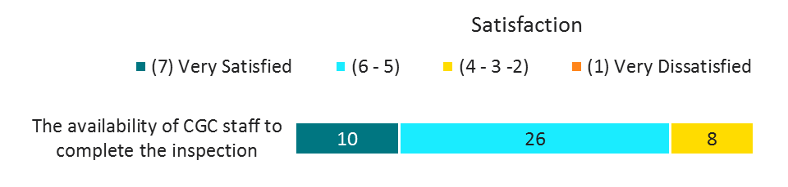
Q.1. There are several aspects of official inspection services and weighing certification oversight services. On a scale of 1 to 7, with 1 being very dissatisfied and 7 being very satisfied, please rate your satisfaction with …
While satisfied, a number still noted that at times it can be difficult to reschedule an inspection. This was particularly heard among participating bulk vessel clients, who face challenges with coordinating in-coming vessels with inspections. Other concerns were the limited availability of CGC inspectors outside of business hours, which might cause business delays.
“Usually good with timing but sometimes if a boat is delayed due to weather etc. [CGC] isn't as good with rescheduling etc. We can experience some delays but I suppose that is to be expected a bit.”

“We export grain - the CGC is required to be there where we load vessels - I give it a 6 because there have been times when labour hasn't been available and we can't load without them.”

Inspector Review of Shipping Documentation
Overall, participants were satisfied with the inspector reviews of shipping documentation.
Figure 2 – Satisfaction with Inspector Review of Shipping Documentation
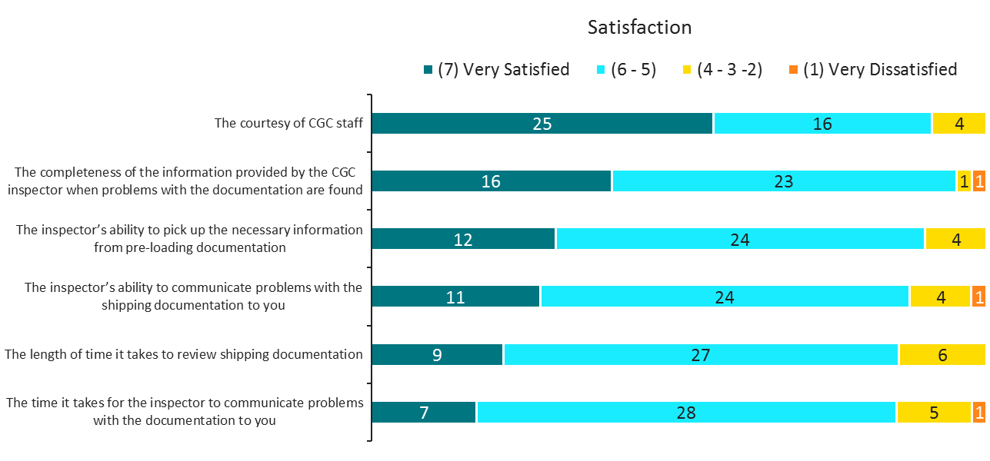
Q.1. There are several aspects of official inspection services and weighing certification oversight services. On a scale of 1 to 7, with 1 being very dissatisfied and 7 being very satisfied, please rate your satisfaction with …
What we like is that they know they our service for the industry. They respond to our needs.

Where it is enforced we have to use it but in other times we'll choose another supplier. The services they provide are good quality but if we had options, we may choose other options.

The courtesy of CGC staff and the information they provide when problems are found were both highly viewed by participants. Timing to review the shipping documentation and timing to communicate problems were both less satisfactory, again because of the high time pressures of businesses.
“Speed is the only element that could use some improvement. Some tests aren't done here. They are sent to Montreal. This can contribute to delays. Sometimes we're loading a vessel and don't know if we've made the spec.”

“Mainly just the turnaround times aren't as quick as private sector counterparts - not always initiation on their part when there are problems. - we have to seek it out ourselves. Could be quicker and more proactive.”

The timeliness of service is not aligned with commercial practices/expectations - nor is the ability of CGC staff to communicate the existence of problems and engaging in meaningful/pragmatic discussions to address the problems. The approach is very much one of "regulator" and not "service provider" - which does not lend itself well to any initiatives to increase the CGC's involvement in export business.

Another suggestion by one participant was that the current inspection system is outdated and inflexible. Others’ comments mirrored this complaint that perhaps a modernization is required, such as providing live access to reports to follow the inspection results.
The system that they work in hasn't been modernized is very inflexible. They're working from a documentation system that requires a review to be consistent with how Grain trades today. The current grading system that's in place today is cause for a number difficulties in executing sales and documentation because it's not modernized to keep up with trade. Within our system we have a particular way of assessing "dockage" and the rest of the world has another way.

If there were things we could change about the current system it would be to have more regular and updated communication about the status of grain being loaded onto the vessel, if it wasn't meeting spec. We would appreciate to have "live" access to the OSCAR reports to know ourselves where each of the specs were coming in and where we need to improve.

Quality Sampling
Quality sampling was again positively viewed by participants, with issues of speed and consistency being brought up by select participants. Even among the satisfied participants, some felt that the sampling process could be faster, while others are concerned with the human impacts on consistency between inspectors.
Figure 3 – Satisfaction with Quality Sampling
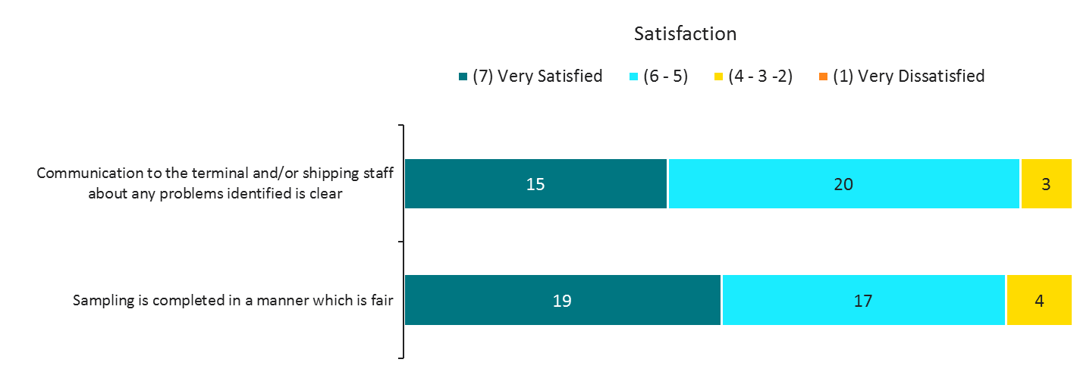
Q.1. There are several aspects of official inspection services and weighing certification oversight services. On a scale of 1 to 7, with 1 being very dissatisfied and 7 being very satisfied, please rate your satisfaction with …
“They are great - we are very experienced so we usually know what to expect. they are very fair, concise and clear. they are prompt. they are great to deal with. some other companies are not so great to deal with.”

Please make sure everyone has same standards. Human factors are a consideration. Some people are better at explaining the information to us than others.

We often feel that CGC could work more closely with us in respect to quality of our product in relation to customer expectations, and feel they take too much of a "by the book" approach, which doesn't add value to the company or the customer.

Importance of Services
Participants were also asked to rate the same aspects on their level of importance. Many felt all of the aspects were very important, with the availability of Canadian Grain Commission staff, fairness of sampling and communication to the terminal having the highest number of “very important” responses.
“Good - very important. to settle conflicts - grade conflicts. availability - timing could be improved - speed of the results. importance - important for turnaround - we need a quick turnaround time - staff availability is important. any time I phone - I'm usually able to talk to someone.”

Figure 4 – Importance of Service Aspects
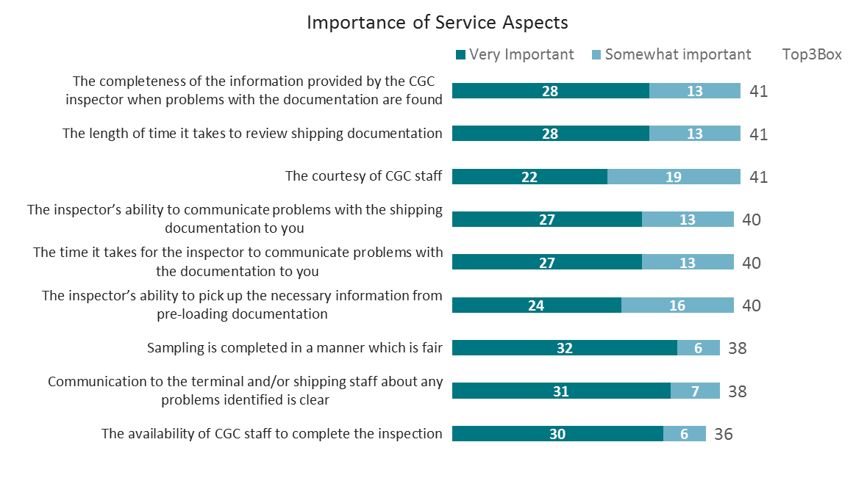
Q.1. There are several aspects of official inspection services and weighing certification oversight services. On a scale of 1 to 7 with 1 being not at all important and 7 being very important, please rate the importance of …

Specific Service Areas

Analytical testing
A portion of the self-directed interview focused on analytical tests and their applicability. Participants were split in their use of the Canadian Grain Commission’s analytical tests. Among those who use them, most participants felt that the tests met their needs, such as contract terms and completed test, but they felt the tests were no more than adequate.
Figure 5 – Use of Analytical Testing
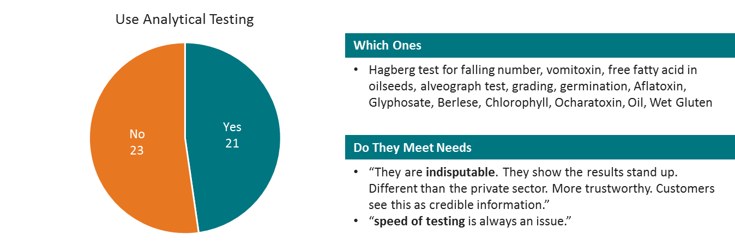
Q2. Do you use any of the Canadian Grain Commission’s analytical tests? Which ones do you use? How do they meet your needs?
When asked about potential improvements to the services, there many participants indicated faster turnaround times or lower prices. Participants felt that improving these two factors could make them more competitive.
“Lower prices to be in line with other providers in the industry; improve turnaround times for results”
Suggested improvements from several participants regarding additional testing included on site Vomitoxin testing as well as deoxynivalenol. A few other participants provided more specific suggestions including wet gluten, microbiological testing, and e. coli testing of split peas.
“Wheat gluten on different moisture basis as requested by Colombia buyers. These we usually need to go to a 3rd party.”

“Microbiological testing - a lot of our exports we use SGS for microbiological testing - the other testing we do is PCR for GMOs and we use an external lab. If they offered these then they would do it all - one-stop.”

“Not really. e. coli testing of split peas - but very specific and not everyone needs it. always nice to have a choice. “

Letter of Analysis/Statements of Assurance
The Letters of Analysis/Statements of Assurance are services that are widely used by participants. Most participants used the letter of analysis or the statement of assurance services provided by the Canadian Grain Commission. Breaking down those that use these services, most use both of the services, some participants used solely the letter and a few used solely the statement of assurance.
Figure 6 – Use of Letters of Analysis and Statements of Assurance
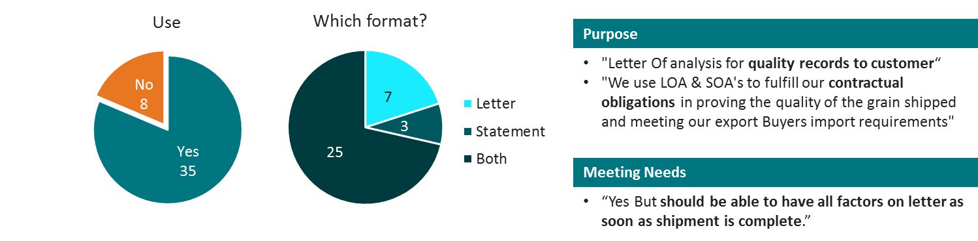
Q4. Do you use either letters of analysis or statements of assurance?
Often, these tests were used as they were requested by the customer/buyer, or an aspect of their contractual obligation to the customer/buyer. One participant said they use these documents as, “export assurance to customers - usually because customers request it.” Similarly, another participant stated, “the LOA to validate quality of the cargo to meet contract terms with customers. SOA - used for the same purpose.”
"Importer needs are ever-changing, documentation has to be flexible to meet the demands of global customers."

What they're recording on is a little out of date…Statement of Assurance deals with a previous crop year. E.g. we're still using the 2015-2016 crop year right now. They don't turnover to the new year quickly. This is ok in Canada but someone in another country may not understand our crop year. It can add questions and time to the overall process.”

Participants were also asked about potential improvements to these services, as well as any additional feedback. Many felt that the documents were meeting their needs but would like to see services adapt to the industry and their changing needs. This was often discussed as needing to be “more flexible” in providing what the customer is looking for, as the “demands of the global customers” shift. One participant suggested e-Certificates to improve both the adaptability and timeliness of these documents.
“More Information on letter as it pertains to quality ordered by customer Not Just Standard Grades from CGC"

Another suggestion is to standardize service measures across Canada.
"Standardize services across Canada, spec. time for test results"

Certificate Final
Many participants use the certificate final service offered by the Canadian Grain Commission. However, many participants either also or exclusively use a private sector certificate as well.
Figure 7 – Use of Certification Final and Private Sector Certificates
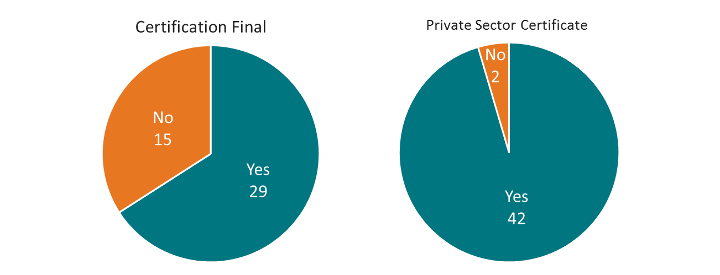
Q5. Do you use the Certificate Final after it has been issued? Q6. Do you use private sector certification such as SGS?
It was often mentioned that the timeliness of the certificate is an issue, as well as the inconsistencies between the Certificate Final provided by the Canadian Grain Commission and “international standards.”
“Timeliness is a problem and certain assessments are not in keeping with international standards."

When asked when the certificate final is used, several participants noted it was used only if requested by customers. The lack of timeliness and misalignment with international standards perhaps contribute to the reasons why participants favoured a private sector certificate.
"In many cases customers prefer and in fact require the use of a different third party service provider for inspecting and reporting on the quality of the shipment. In these cases, the grain industry incurs the costs of for both the third party inspection company, and the Canadian Grain Commission, for double inspection on the same shipment.”

On the other hand, almost all participants indicated that they use a Private Sector Certificate. This certificate was favoured as it more adequately met the needs of those using these services. Participants who used the Private Sector Certificate used the service as they felt it was more business focused, offered lower costs compared to the Certificate Final of the Canadian Grain Commission, and there was less bureaucracy and levels of management. Some participants suggested that the private sector offerings are more flexible that the services offered by the Canadian Grain Commission, and more able to adapt to their business needs. This is similar to the comments around the need for modernization and integration of technologies within CGC services heard during the discussion of service aspects.
Pricing is much, much more competitive and reasonable from the private sector for documentation and testing.

Weighing
The weighing services offered by the Canadian Grain Commission meets the needs of most participants, however a number had feedback to improve the current services and others felt that perhaps weighing services from CGC should not be a requirement.
Figure 8 –Weighting Services Meeting Needs of Participants
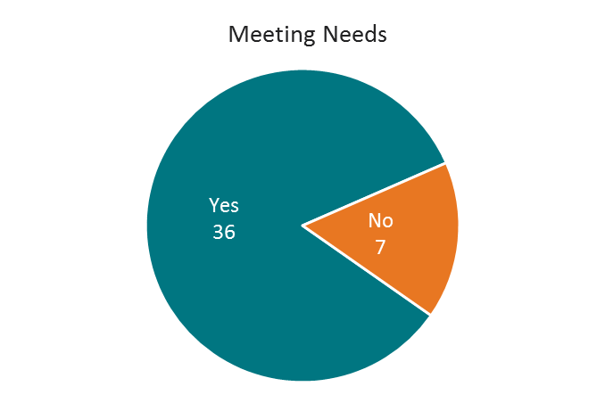
- Q7. Are the Canadian Grain Commission’s weighing services meeting your needs?
A few felt very strongly about the need to maintain the service but provided some feedback on improvements. Again, the speed of service was an area noted for improvements and timeliness of the agent. One participant noted that the service is complex and should be easier to comply with. One participant suggested perhaps more flexibility in the format and titling of documents to comply with customer requirements would be helpful. Others cited issues with consistency, where a confirmed weight changes over time causing major delays.
“I wish it was faster - the final weights and cert of weights would come quicker.”

Reasons provided for removing CGC weighing services included that the terminal provides these services already, that in some cases automated equipment is performing this task and inspections/audits of this equipment might be more time effective. Others see it as creating additional workload and it is not currently providing value.

“no - I guess sometimes we are so close to being finished and they end at 4pm no matter what. Hasn't happened recently but has in the past. We're nearly done the weighing and 4 hits and they leave. We have trucks to load…”

“The Weighing service seems very complicated and should be easier to comply with. Always seems we need to do something else and changes.”

“The terminal provides all information and completes all tasks in regards to weighting. The CGC should not be charging for a service that we are providing to ourselves.”

Container Shipments
Participants were also asked about the potential for Canadian Grain Commission to provide services to companies that provide container shipment services for Canadian grain. Most participants who felt it appropriate to provide feedback on this issue, did not think there was an opportunity for CGC to provide any additional services to these companies.
Figure 9 – Potential for CGC to provide services for container shipping
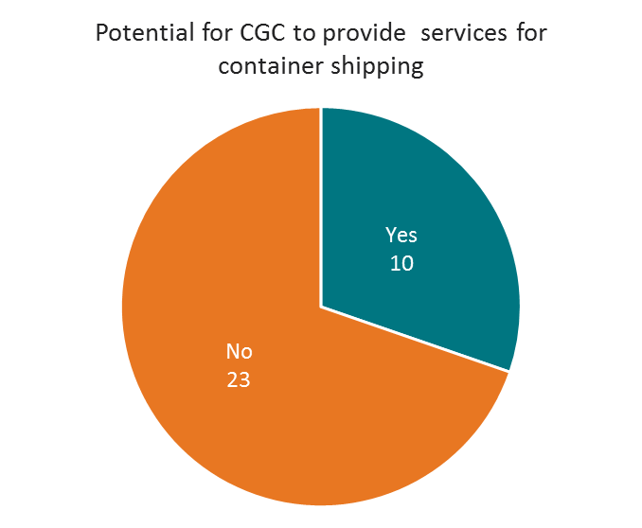
Q8. Container shipments are used to export Canadian grain, but they are not regulated by the Canadian Grain Commission. Are there services that the Canadian Grain Commission could provide to companies that are shipping grain in containers?
For those that said yes, suggestions included on-site sampling and grading, as well as a full weight inspection standard. One participant felt that the structure for container systems had potential gaps, as their focus is on bulk shipments, they felt that whatever services are mandatory for bulk shippers should be mandatory for container shippers as well to ensure quality and fairness in payment.

Grain Grading and Inspection
In discussing grain grading and inspection, participants were divided on the role of the Canadian Grain Commission. Some indicated that the CGC provides a valuable service essential to the grain industry in this area, while others felt that allowing third party inspections/grading would benefit the industry. The key drivers for most participants who suggested making CGC services in this area optional was the cost in time and money. A few also suggested customers request independent grading companies as well which is inefficient doubling of efforts when combined with CGC mandated grading.
Participants were also asked to talk more specifically about what services were meeting their needs and which ones were not. Many noted the Canadian Grain Commission had “well defined grade requirements”, and spoke positively about the grain grading guide. They felt the guide suited their needs in terms of specifications and requirements. Some other specific mentions on aspects that they were particularly important included buyer familiarity, variables or specifications used within grading, and the grading tables.
"We have one of the best grading systems in the world. It addresses the needs it was designed to. “

“Well defined grade requirements, commercial cleanliness and moisture specifications.”

Good to have the brand of CGC - well respected across the world - respected by buyers.

While most participants had some suggested improvements to the current system, a few worried that any changes may make a complicated system more cumbersome or complicated. Key concerns or areas for change at a high level included the pricing, speed for analysis and modernization. Some suggested having more local analysis would be beneficial, allowing for less time for turnaround and potentially the ability to review draft documentation ahead of final certification. An increase in online or e-certification services was also seen as a potential improvement to increase the speed and reduce costs involved in grading and inspection. A few participants noted that CGC is already moving in this direction.
Some participants discussed tightening the regulations or increase the standardization of grain grading practices to get more consistent results. Consistency in application of the grades was also an issue raised, with a few participants suggesting that simplifying the grading system while other suggested broad training programs be made available to industry. Others suggested a that physical samples and/or high quality photos would assist in training and knowledge, having a point of comparison of what different issues with the grain might look like to use from working with producers through to distribution.
Flexibility was also a concern for some participants, some felt that rather than hard-coded grades the system needs more flexibility, others felt flexibility was needed in terms of document wording, increment amounts, and scheduling.
Wish it was a tighter standard. I come back to everyone does things a bit differently. more standardization of practices so we get more consistent results.

“It can be more flex in terms of documentation and wording - analysis being done more locally would make things faster.”

More flexibility e.g. sometimes we use the third party for 500 tonnes increments ... CGC will only do 2000 tonnes. The more info we have as we work, the better it is for us. CGC has to be more flexible to be competitive.

Some also indicated that the current system is not in line with buyer’s wants or needs. That it should be updated to allow for the flexibility to comply with the buyer and facilitate business. For instance, one participant noted that some tolerances do not provide value for buyers. Others noted that there are a lot of commercial transactions that happen outside of the determinants and perhaps the parameters need to be adjusted to keep up with minor changes in the industry.
“…Clients don't use classifications, they use specs ... this creates issues and inefficiencies (papers, emails etc). The system needs to be aware of account for that.”

“Statutory grading system is not current with buyers wants/needs. Need to amend the act so that terminals can utilize mineral oil to suppress fugitive dust emissions.”

The parameters of grain grades need to be updated, there have been minor changes here and there as we find problems with it, but it needs to be fully reviewed from the ground the up.

Some other concerns included creating a fair playing field with US based imports, onsite testing for non-grading factors (i.e. Falling numbers and Vomitoxin), and a need to allow terminals to use mineral oil to suppress fugitive dust emissions. One participant also commented on the perceived lack of recourse available if there is some discrepancy with the grading received from CGC.

Determination of Commercially Clean
Participants were asked to provide comments on the aspects of commercial cleanliness that are working for them, that are not working for them and suggested changes. Among those who use this process, many participants noted that the current system is adequate for them and that they do not have any major concerns with the current approach. Common concerns again were regarding timing, cost and whether this step is necessary if not in line with the buyer’s requirements. Others indicated that it is not in line with the standards in the rest of the world or is less of a concern as contracts move towards “not commercially clean” requirements. Some feel that this process puts Canada at a competitive disadvantage on the world stage.
One participant noted that they sent an uncleaned sample to CGC which was determined to have been cleaned and resulted in a requirement that they pay more. A few noted that the cost to clean upon arrival is cheaper.
Another noted that they disagree with the impact of each commercially clean component not standing on its own but rather using totals. Other mentions of what might need to change included attrition, adopting an overall dockage minimum, and the impact of the lost weight.
Figure 10 – Feedback on the Determination of Commerically Clean process
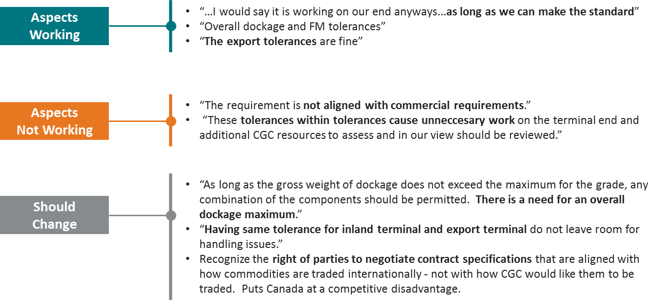
Q10. Canadian grain must be commercially clean when it is shipped to export markets. The Canadian Grain Commission uses a process called the Determination of Commercially Clean.

Grain Grading and Inspection Training
As mentioned above, some participants suggested improved grain grading and inspection training for the industry. Most participants indicated that training would be valuable, however had different ideas of what this might include.
Some felt that the industry would benefit from different levels of training from beginner to expert on different aspects of grain grading and inspection. The value of this for some participants was in building on the CGC reputation from a personal development perspective, in assisting the industry to meet their standards and understanding what they mean, as well as promoting consistency in application of the regulations. Others viewed this as an opportunity for cost-savings for their business, they could rely on local CGC trainers/inspectors rather than flying across the country.
“It might be regular scheduled training courses or sessions, audit process for consistency with third party providers. Needs to be in-person.”

“Could be training just at the local CGC offices in their labs - always good.”

“It would be better for the whole industry ... the market needs standardization in grading training ... talk same language”

“It would likely help exporters understand the process behind the training and appreciate that side of the industry.”

The format suggested by participants varied greatly, including:
- materials or resources for self-directed learning;
- in-person training courses, local conferences or small group training;
- open houses at CGC labs;
- certification of traders in country and at terminals;
- hands-on training to see/show differences;
- invitations or materials for foreign buyers; and
- Ability to request trainer to visit office for lunch & learn with team.
Figure 11 – Value of Inspection-Related Training
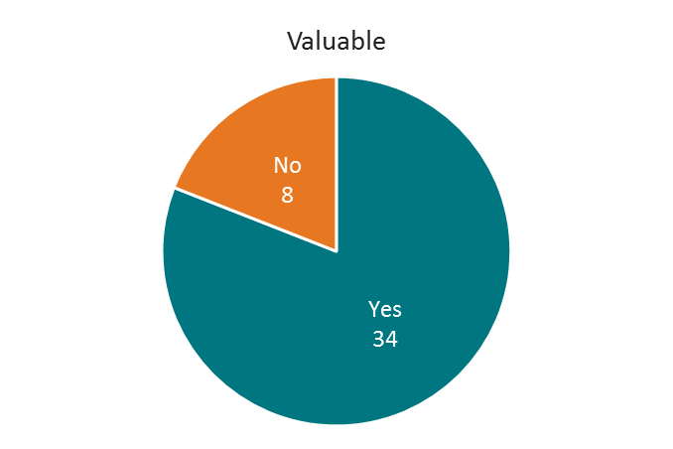
Q11. Would it be valuable for the Canadian Grain Commission to provide inspection-related training to the industry?
Topics for training range from general overviews of what the Canadian Grain Commission does and why it exists, to more topic specific and time sensitive training, including:
- Overview of Standards & Process, including:
  - Western Canada standards introductory training for Eastern Canada
- Tests and certifications – what they are, their use, process, implications, how they affect the grain;
- Sampling - What does into reviewing a sample, how the sample is collected
- Inspection – how does it work, what are the options or additional test available, what next steps are if the results are not favourable;
- Purpose - Why we measure certain attributes and what decisions they help end use clients make;
- Business Focused
  - Overview of the Grading Process for Business Focused (non-Ag) colleagues;
  - Characteristics/aspects that foreign buyers focus on;
  - Complete value chain training from producers to food manufacturers (from growing wheat to producing flour to final food product)
- Updates - New crop challenges or variability updates, changes to inspection process & services
Among those who did not think CGC offered training would be useful, they indicated either than their company has taken the initiative to develop their own comprehensive internal training or that a third-party supplier is currently already offering this service. Another comment was that the training for CGC inspectors varies greatly between them and it might not be the best way to guide inspection.

User Fees and Cost Recovery
The discussion of user fees permeated the overall discussion of the Canadian Grain Commission and their services. At the core of this issue was participants concern about their competitiveness within the international industry and potential duplication of work.

User Fee Proposal
Participants were presented with the Canadian Grain Commission’s proposal to temporarily reduce the fees per tonne in order to deal with the surplus. Most participants were in agreement with this proposal, however some had conditions for their agreement while others felt that the Canadian Grain Commission would still be overcharging for their service.
Figure 12 – Opinion of User Fee Change Proposal
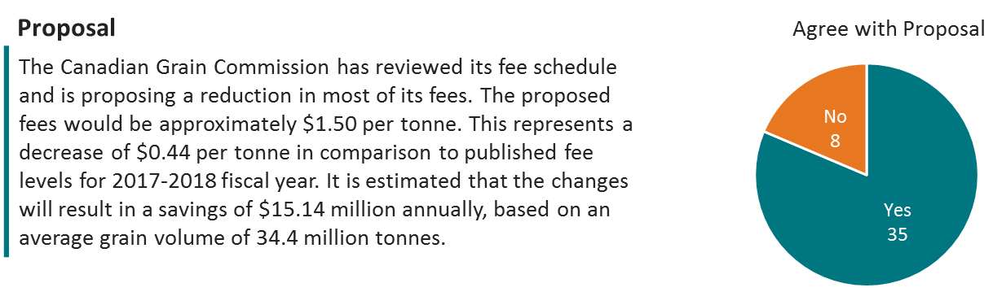
Q12. Do you agree with this proposal?
Those who disagree felt that either the role of the Canadian Grain Commission overall needs to be reviewed or that the proposal does not go far enough in providing a cost savings. Some suggested comparing these costs with other third party providers or competing organisations (FGIS), as they felt that they provide cheaper rates for inspection and weighing services.
“The customer requirements have changed greatly in recent years. Few customers need the validation from the CGC. As a result, the CGC is not providing as much value.”

Some participants were concerned that lowering fees might result in lower quality, and wanted to be certain that it doesn’t affect the level of services that their customers value, again speaking to the strength of the CGC brand internationally.
“I would add as long as it doesn't negatively impact the quality of grain leaving our country then I am in favour it.”

“I just know that it's costly for us and so would support a reduction in fees and anything that would help our business.”

An increase in business for the Canadian Grain Commission with reduced fees as well as Canadian exporters with reduced costs were another potential outcome highlighted by participants, however many participants noted that their choice of provider came down to customer request, when not regulated to use CGC.
Decreasing will still end up just increasing their revenues. Even the biggest cynic in our area recognizes there is nothing stronger than the reputation of the CGC - legitimacy and fear... good thing. Increasing their market through fee reductions will be good for everyone.

Others wondered if this would be a temporary or permanent reduction, and whether if temporary using the money for training or other programs might be a better investment.

Improvements to Funding Model
Participants were split on whether they felt the funding model for the Canadian Grain Commission needed to be improved.
Figure 13 – Need for Funding Model Improvement
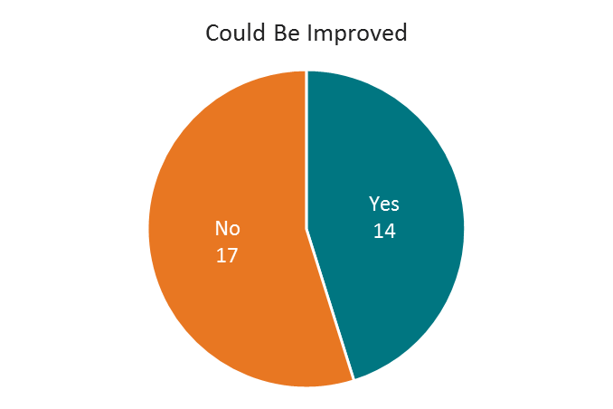
Q13. Are there ways that you feel the Canadian Grain Commission’s funding model could be improved?
Among those who indicated that they feel it should be improved, suggestions including changing the mandate to being soley a regulator and not a provider, allowing for private competition, getting more funding from federal funds rather than service fees, making services optional rather than mandatory.
“Become a regulator not a provider would lower the cost to producers - paying 1.83 private industry is charging probably 60 cents a ton.”

“The CGC should become a regulatory body only regulating the Grain Act with no physical presents.”

“Functions for the Good of Canada should be paid for from federal appropriations. Only direct costs associated with services should be included in CGC fees. Mandatory services should not have fees associated with them.”

Some felt that having a cost-recovery system for a regulator develops a conflict of interest as some feel that to generate more revenue, the regulatory body may be overzealous inspection.

How Should the Surplus be Used?
Many participants felt that reducing user fees below the proposed amount would be a good application of the surplus, however, many were also in favour of investing it to modernize the grading system. Many participants noted that investing in the infrastructure for the Canadian Grain Commission, including the modernizing the grading system and equipment would be beneficial. They felt that this might improve response rates for test which would overall have a positive impact on their business.
Figure 14 – Potential Uses for the Canadian Grain Commission surplus
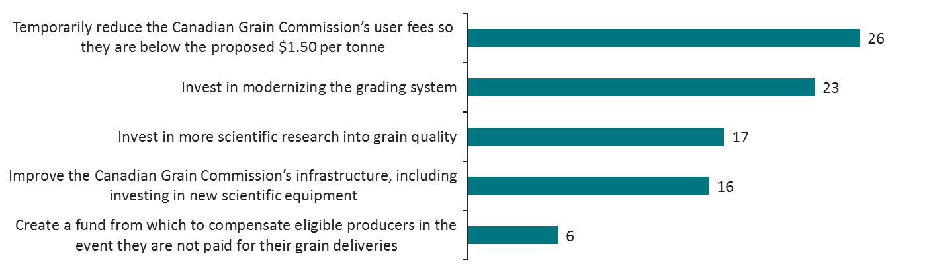
Q14. The Canadian Grain Commission has accumulated a surplus of $107 million as of September 30, 2016. In your opinion, how should the Canadian Grain Commission use the surplus?
The surplus should go into improving the system with some reduction in fees.

Some other suggestions made included improving research and development (specifically as it relates to funding for the Canadian International Grains Institute), modernizing the CGC process, providing more crop surveys on a wider range of grains, more training for the industry, more labs in smaller markets (save time and courier fees). One participant suggested a rebate dependent on the amount of grain shipped was also suggested, while others felt strongly that investing in improved grain quality would be a more long-term investment of this surplus. Overall participants felt it needed to be used within the grain industry and not added to a general federal government surplus.

“The CGC most definitely needs to upgrade the website to the portal or web-based program so that we (the industry) can submit our request on-line in a standard manner and receive e-certs upon completion.”

Dust mitigation and fusarium research were each mentioned by one participant as additional areas for consideration.

Other Issues Discussed
The role and mandate of the Canadian Grain Commission was often brought up by participants in throughout the discussion. While some applaud the role, and stress the importance of the CGC in protecting the brand and reputation of Canadian grain, others worry about the competitiveness of the international market and the impact the mandatory services have on the cost of doing business with the Canadian industry. Others felt there is likely a balance to be struck between allowing for private competition in inspections and grading, and maintaining the regulatory framework that protects the Canadian industry.
They are often there providing their service but its all for not because we can't get things going. Ideally they shouldn't be regulated / mandated service in the first place. If CGC became the regulator and not the service provider (instead regulate other SPs so they could be requested instead of required.)

In general terms, we need the CGC. Less government isn't always better -- it's a valuable service for the industry. CGC can grow by providing more user-specific info and investing in new technologies that can also help private sector ... consumers want to know how to ID quality products e.g. "when it says wheat, is it really wheat or a GMO?

The issue of user fees was also a contentious issue. While all participants would like to pay less for the services and programs offered by the Canadian Grain Commission, some felt a mandatory service that is in the benefit of all Canadians should not be charging user fees. Some felt certain services should be covered by federal funds and user fees should only apply to those that have a direct benefit to users.
CGC has an opportunity under their new leadership to modernize processes and work with the grain companies to tailor their services so as to add value in this post WCB era. By listening to what the industry has to say, they can become an entity the grain companies would happily opt to use, rather than being forced to use at our expense.”

Another suggestion to address the discussion around regulation versus service delivery is the notion of conducting audits on third party providers to continue to regulate the industry while allowing for cost-savings from the perspective of some stakeholders.
Others had specific recommendations for other areas, such as abolishing the Producer Car program, improving personalized services from local staff, decreasing management levels and improved training for inspectors.
Others offered positive commentary on activities overall, staff and one mentioned an appreciation of the workload distribution across geographies when one region is experiencing higher volumes.

Detailed Analysis of Quantitative Findings

Awareness, Impression and Usefulness of the CGC

Awareness and Overall Impression
Consistent with previous surveys, there is almost universal awareness (99%) of the CGC among Western Canada grain producers.
Three-quarters (75%) of those respondents who acknowledge having heard of the CGC, give a score of 5 or more when asked to rate their overall impression of the CGC on a 7-point scale. This is significantly higher than the scores reported among Western Canada grain producers in 2010 (75% vs. 63% in 2010).
When comparing the most positive scores (6 or 7 on the scale) to the most negative scores (1 or 2 on the scale), producers are eight times as likely to hold a very positive impression (39%) than a very negative impression (5%), up from 2010 when producers were 5 times more likely to hold a positive impression.
Figure 15 - Awareness and Impression of CGC
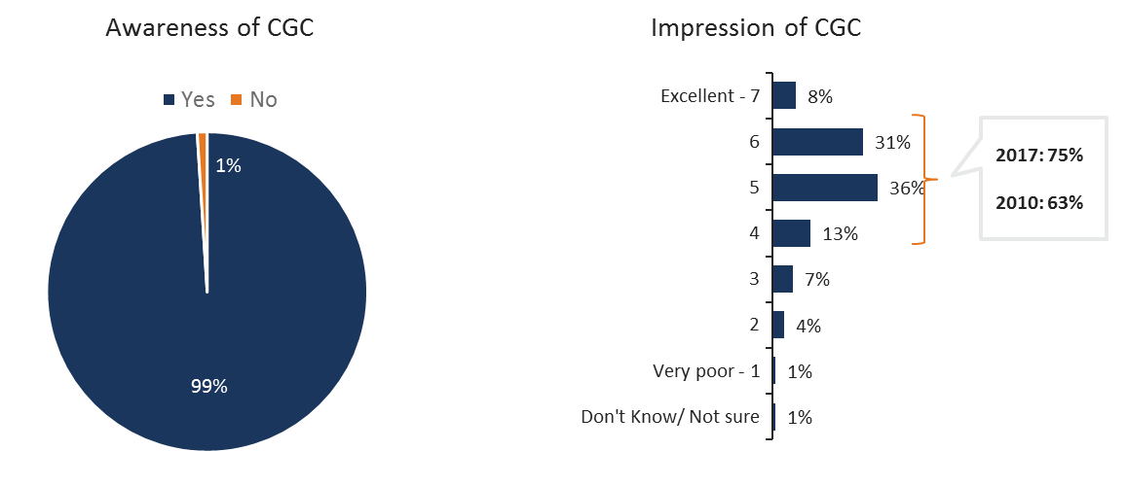
3T. To begin, have you heard of the Canadian Grain Commission? Base: All respondents (n=302)
4T. Based on your own experience or what you have read, seen or heard, what is your overall impression of the Canadian Grain Commission? Please use a scale of 1 to 7, where 1 means a very poor impression and 7 means an excellent impression. Base: Those who have heard of CGC (n=300)
While a large majority of producers in each province/region have a positive impression of CGC, there is some difference in the intensity of their impression. On average, Manitoba producers are directionally more positive than those in Alberta (5.2 out of 7 vs. 4.8 out of 7 respectively). Consistent with previous surveys, on average, grain only producers hold directionally more positive views of CGC than mixed operators (5.1 out of 7 vs. 4.8 out of 7). While there is little difference in views of producers based on the size of their farm, there is some difference based on 2016 farm sales. Producers with farms that earned greater than $200,000 are on average directionally more positive than those with farms that earned between $100,000 and $200,000.

Overall Usefulness
Three-quarters (74%) of respondents view the CGC as useful (5 or greater on the 1-7 scale). This is significantly higher than the scores reported among producers in 2010 (74% vs. 62% in 2010).
Figure 16 - Usefulness of CGC
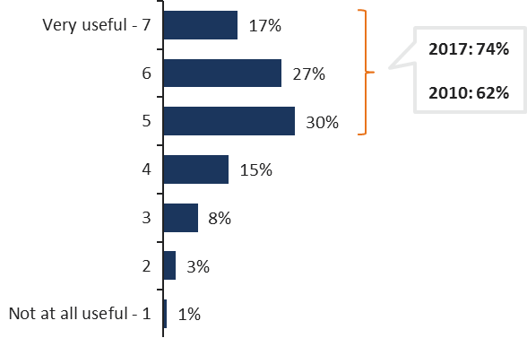
5T. Using a scale from 1 to 7, where 1 means not at all useful and 7 means very useful, in your opinion, how useful is the Canadian Grain Commission to producers? Base: All respondents (n=302)
A closer examination of the most positive scores (6 or 7 on the scale) versus the least negative scores (1 or 2 on the scale) reveal that producers are more than 11 times as likely to view the CGC as very useful (44%) rather than not at all useful (4%).
On average, Manitoba producers rate the CGC more useful than those from Alberta (5.4 out of 7 vs. 5 out of 7 respectively). There is some variation in opinions by age of producers as well with older producers (age 55+) rating CGC higher on average than those under age 55 (5.3 out of 7 vs. 4.8 out of 7 respectively). Notably, whereas there ARE some directional differences in impressions of CGC by type of operations, opinions on the usefulness of CGC are more consistent across farm type.

Usefulness of specific activities
Respondents were then asked about the usefulness of specific activities of CGC. Majorities of respondents view all CGC activities as useful (score the activity at least 5 out of 7 on the scale).
Looking at the proportions who perceive the activities as very useful (6 or 7 on the scale), the most useful activities are (in order from highest to lowest): grain grading in general (69%), providing grain grades to farmers who send in samples (68%), settling grading disputes between farmers and grain companies/ elevator managers (67%), establishing Canada’s grain grades (66%), grain quality in general (65%), making sure farmers get paid when they sell grain to licensed grain companies (65%), and grading grain for export/ at terminal elevators (64%), with about two-thirds who deem these as very useful.
Among the least useful activities are helping grain marketers sell Canadian grain (37%) and allocating producer cars (33%).
Notably, Manitoba producers are more likely than those in Alberta to rate allocating producer cars as useful. Producers in Saskatchewan are more likely than those in Alberta to rate providing grain grades to farmers who send in samples as useful.
Figure 17 - Usefulness of Specific Activities of CGC
ACTIVITY | % Very Useful  (Rating of 6 or 7)
Grain grading (general) | 69%
Providing grain grades to farmers who send in samples | 68%
Settling grading disputes between farmers and grain companies/elevator managers | 67%
Establishing Canada’s grain grades | 66%
Grain quality (general) | 65%
Making sure farmers get paid when they sell grain to licensed grain companies | 65%
Grading grain for export / at terminal elevators | 64%
Monitoring grain shipments to ensure they are safe | 61%
Coordinating Canada’s grain quality assurance system | 58%
Conducting grain quality research | 53%
Licensing grain companies | 51%
Gathering statistics & keeping records of grain movement and grain export sales | 48%
Operating service centres across the prairies that provide grain grading/inspection services | 45%
Upholding the rights of grain producers | 45%
Conducting the harvest survey to determine crop quality | 43%
Crop variety approvals | 43%
Helping grain marketers sell Canadian grain | 37%
Allocating producer cars | 33%

6. I am going to read out a list of some of the activities of the Canadian Grain Commission, using a scale of 1 to 7, where 1 means not at all useful and 7 means very useful, please indicate how useful you think each one is. Base: Sample sizes vary by activity

Grading Services

Importance of CGC Grain Grading Services
Western producers see the grading services provided by the CGC (that is when producers can directly send in samples to the CGC and receive a grade for a fee) as important to them. Eighty-three percent indicate grading services is important to them, scoring it 5 or higher on a 7-point scale. This is on par with the percentage rating grading services important in 2010.
In fact, two-thirds (67%) score grading services 6 or 7 on the scale. Comparatively, fewer than one in ten producers (6%) rate grading services as not at all important (1 or 2 on the scale).
Figure 18 - Importance of CGC Providing Grading Services to Producers
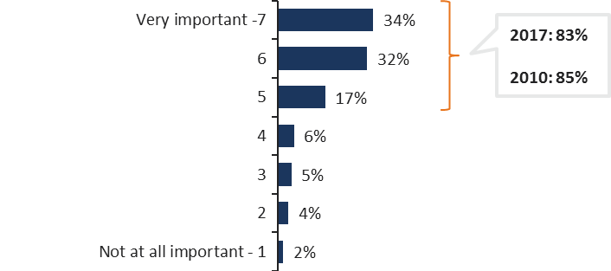
7T. On a scale of 1 to 7, where 1 means not at all important and 7 means very important, how important is it to you that the Canadian Grain Commission provide grading services to producers – that is when producers can directly send in samples to the CGC and receive a grade for a fee? Base: All respondents (n=302)
There is some variation in opinions by age of producers with older producers (age 55+) rating grading services offered by CGC of higher importance than those under the age of 55 (5.8 out of 7 vs. 5.2 out of 7 respectively).

Use of and Satisfaction with CGC Grain Grading Services
More than four in ten (45%) Western producers say they have used the CGC’s grain grading services in the past three crop years. This is up from 34% in 2010. Notably, the incidence of using the CGC for grain grading services in the past 3 crop years is higher among Saskatchewan producers than it is among Alberta producers.
Ninety percent of Western producers that report using CGC for grain grading services in the past 3 crop years are satisfied with the services they received (score of 5 or higher out of 7). This is on par with the results found in 2010 (91%).
Eight in ten (80%) rate their satisfaction 6 or 7 on the scale compared to only two percent who assign them the lowest satisfaction ratings (1 or 2 on the scale).
Figure 19 - Use of and Satisfaction with CGC Grain Grading Services
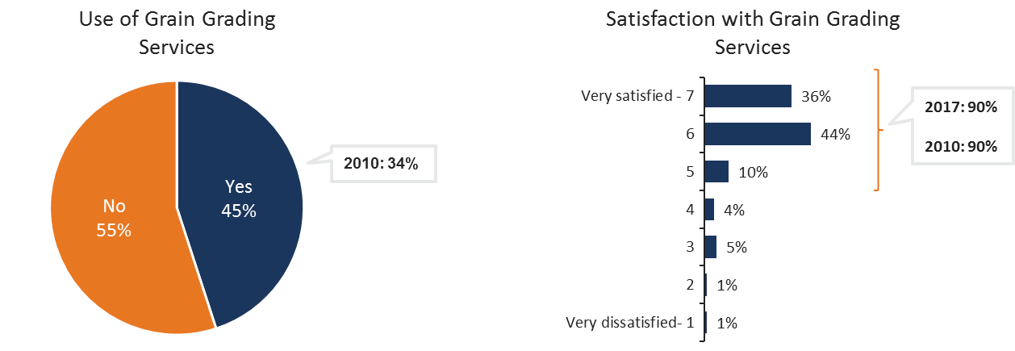
8T. Have you used the Canadian Grain Commission grain grading service for producers any time in the past three crop years? Base: All respondents (n=302)
9T. On a scale of 1 to 7, where 1 means that you were very dissatisfied and 7 means you were very satisfied, how satisfied were you with the CGC grading services for producers—not the grade you received—but the services you were provided? Base: Those who used CGC in the past 3 crop years (n=127)

CGC Setting of Grain Grades and Canada’s Reputation
Among those who have used CGC grain grading services in the past 3 crop years, there is almost universal agreement (96%) that having the CGC set grain grades and standards help uphold Canada’s reputation for consistent and reliable grain quality.
Figure 20 - CGC Setting Grain Grades/ Standards Beneficial to Canada’s Reputation for Consistent and Reliable Grain Quality
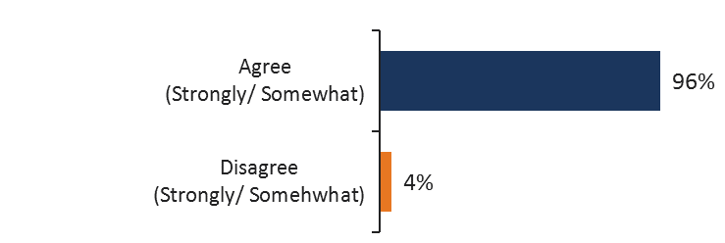
10T. Do you strongly agree, somewhat agree, somewhat disagree or strongly disagree that having the CGC set grain grades and standards help uphold Canada’s reputation for consistent and reliable grain quality? Base: Those who used CGC in the past 3 crop years (n=127)

Importance of CGC Making Binding Decisions on Grade and Dockage
A large majority (86%) of producers think that the CGC making binding decisions in cases where a producer does not agree with the grade and dockage assessed by a primary elevator is important (scoring their importance 5 or higher on a 7-point scale). This is on par with 2010 data (88%). Seven in ten producers score their importance 6 or 7 on the 7-point scale (73%), and this too is on par with 2010 data (74%). This compares to only four percent who think this is not at all important (1 or 2 on the scale).
Figure 21 - Importance of CGC Making Binding Decisions on Grade and Dockage
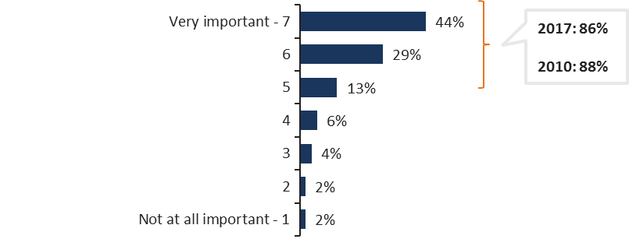
11T. As part of the CGC’s producer protections, if a producer does not agree with the grade and dockage assessed by a primary elevator, the producer can ask the CGC to determine grade and dockage and make a binding decision. On a scale of 1 to 7, where 1 means not at all important and 7 means very important, how important do you find this service? Base: All respondents (n=302)
The proportion who say asking the CGC to make a binding decision on grade and dockage is very important (6,7 on the scale) is significantly higher among:
- those with a high school education or less (79%) compared to those with a university education (65%);
- those aged 55 and older (76%) compared to those aged 35 to 54 (58%).

Use of and Usefulness of CGC Binding Decision
Although producers believe that the CGC making a binding decision on grade and dockage is very important, fewer than one in ten (7%) acknowledge having asked the CGC to make a binding decision on grade and dockage of a grain delivery in the last three crop years. This is consistent with 2010 (9%).
Figure 22 - Asked for Binding Decision
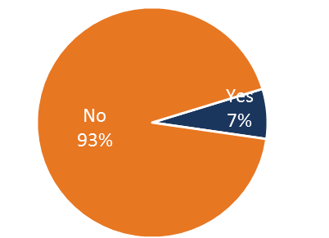
12T. And, over the course of the last three crop years, have you asked the Canadian Grain Commission to make a binding decision and determine the grade and dockage of a grain delivery? Base: All respondents (n=302)
Asking CGC to make a binding decision on grade and dockage of a grain delivery in the last three crop years is significantly higher among those with a high school education or less than among those with some post-secondary education and those with a university education (13% vs. 3% and 2%, respectively).
Those who have not made use of this service were asked why they have not. The most common reason is that they didn’t need to. Other reasons cited are that they were satisfied with the grain grade or there was no dispute.
Figure 23 - Reasons for Not Asking CGC for a Binding Decision
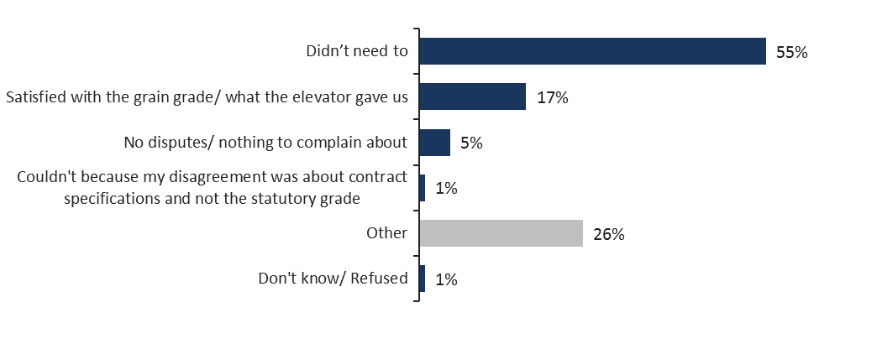
14. Why haven’t you used this service? Base: Those who have not asked the CGC to make binding decisions (n=281)
Among the very small number who have made use of this service, almost all think this service is useful (chart not shown due to small sample size).

Quality Parameters Assessed Via Instrumentation
Survey respondents were told that industry representatives and farm groups have asked the CGC to explore using instrumentation to assess quality parameters.
When read a list of quality parameters and asked what parameters they would like to see assessed via instrumentation rather than by a visual inspection, eight in ten (80%) say fusarium damage should be assessed this way. Majorities also want mildew (63%), frost (63%) and sprouted (62%) to be assessed via instrumentation.
Figure 24 - Quality Parameters Preferred to Be Assessed Via Instrumentation Rather than Visual Inspection
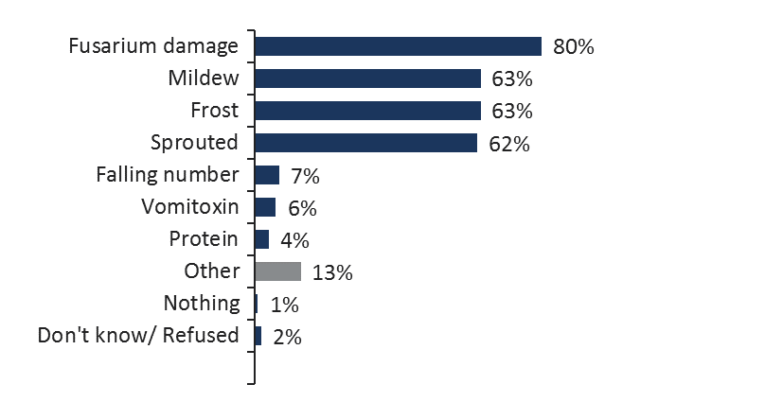
15. Industry representatives and farm groups have asked the CGC to explore using instrumentation to assess quality parameters. What are the quality parameters you’d like to see assessed via instrumentation rather than by a visual inspection? Base: All respondents (n=302)
Notably, Manitoba producers are more likely than those in Alberta to say fusarium damage should be assessed via instrumentation (89% vs. 75%, respectively).

Sampling, Inspection, Weighing and Quality

CGC Sampling, Inspection and Weighing Services and Canada’s Reputation
There is near unanimous agreement (96% strongly/ somewhat) that having the CGC’s sampling, inspection and weighing services help in terms of upholding Canada’s reputation for consistent and reliable grain quality.
Figure 25 - CGC’s Sampling, Inspection and Weighing Services Beneficial for Canada’s Reputation for Consistent and Reliable Grain Quality
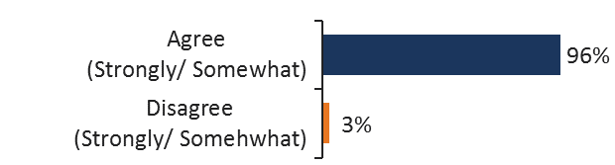
16T. Do you strongly agree, somewhat agree, somewhat disagree or strongly disagree that having the CGC’s sampling, inspection and weighing services help uphold Canada’s reputation for consistent and reliable grain quality? Base: All respondents (n=302)
The proportion who strongly agree that CGC’s sampling, inspection and weighing services help uphold Canada’s reputation for consistent and reliable grain quality is significantly higher among those aged 55 and older (70%) compared to those aged 35 to 54 (48%).
Among those who agree with this view the most common reason is that they set standards of quality (36%).
Figure 26 - Reasons CGC’s Sampling, Inspection and Weighing Services Are Beneficial for Canada’s Reputation
Reasons | %
They set standards of quality | 36%
Upholds the global reputation of Canadian grain farmers | 12%
They're independent/ impartial | 11%
It's a needed organization | 11%
Standards are consistent (across the country) | 9%
They are honest/ trustworthy/ have integrity | 7%
Watchdog/ provides oversight/ controls | 6%
Helps sell/ market grain (in Canada/ overseas | 5%
Helps farmers/ ensures producers are treated fairly | 4%
Acts as a regulatory body | 4%
Customers/ consumers need to know what they're getting | 3%
Able to make (binding) decisions | 2%
Acts as an intermediary (between producers and grain companies) | 2%
Can resolve disputes/ disagreements | 1%
Controls grain company actions | 1%
They are doing a good job/ it is their job | 1%
Other | 20%
Don’t know/ Refused | 4%

17T. Why is it that you strongly/ somewhat agree? Base: Those who strongly/ somewhat agree that the CGC’s sampling, inspection and weighing services help uphold Canada’s reputation for consistent and reliable grain quality (n=288)

CGC Quality Assurance System and Producers
An overwhelming majority agree (92% strongly/ somewhat) that the CGC’s quality assurance system serves producers well.
Figure 27 - CGC’s Quality Assurance System Serves Producers Well
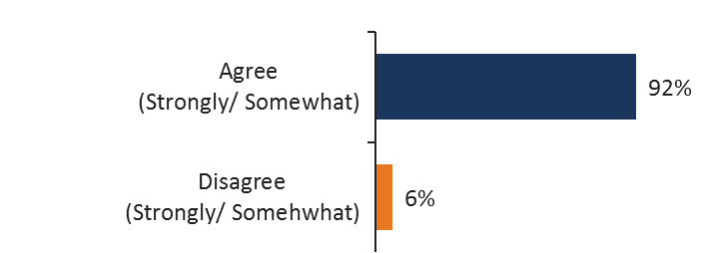
18T. Please tell me whether you strongly agree, somewhat agree, somewhat disagree or strongly disagree with the following statement: The Canadian Grain Commission’s quality assurance system serves producers well. Base: All respondents (n=302)
There are no significant differences across regional or other sub-groups in perceptions that the CGC’s quality assurance system serves producers well.

Licensing and Security

Importance of CGC Payment Protection
Respondents were informed that as part of the CGC’s producer protections, the CGC has a licensing and security program, where grain elevators and dealers must post security that covers the amount they owe farmers. If a company or dealer can’t or won’t pay, eligible producers could be paid from this security.
Producers recognize that the CGC’s payment protection is important and an overwhelming majority agree that it minimizes the risk of producers not getting paid for their grain. An overwhelming majority (88%) think it is very important (6 or 7 on the scale) that the CGC provide producers with payment protection and a similar proportion (90%) strongly agree that this program reduces the risk of producers of not getting paid by a grain company.
Figure 28 - Importance of CGC Providing Producers with Payment Protection
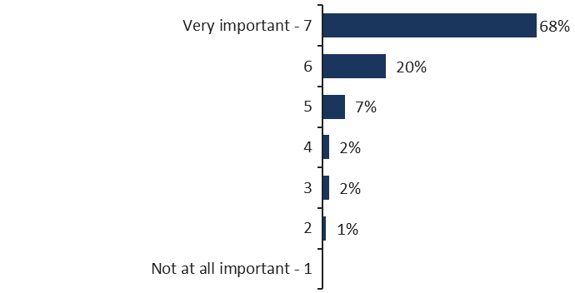
19T.As part of the Canadian Grain Commission’s producer protections, the CGC has a licensing and security program, where grain elevators and grain dealers must post security that covers the amount they owe farmers. If a company or dealer can’t or won’t pay, eligible producers could be paid from this security.
On a scale of 1 to 7, where 1 means not at all important and 7 means very important, how important is it to you that the Canadian Grain Commission provides producers with payment protection?
Figure 29 - CGC’s Licensing and Security Program Protects Producers from Risk of Not Getting Paid
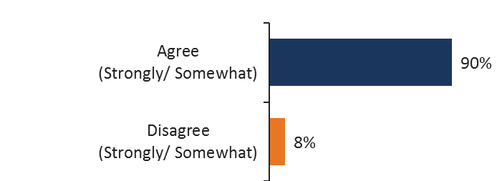
20T. Do you strongly agree, somewhat agree, somewhat disagree or strongly disagree that the CGC’s licensing and security program protects producers from the risk of not getting paid by a grain company? Base: All respondents (n=302)
There are no significant differences across regional or other sub groups in perceptions that the CGC’s licensing and security program is important and reduces the risk of non-payment.

Producer Cars
Most producers (91%) say they haven’t used producer cars to ship their grain in the past three crop years. Those who have (9%) tend to be very satisfied (58%), scoring 6 or 7 on a 7-point scale with the assistance provided by the CGC when ordering producer cars.

Figure 30 - Use of and Satisfaction with Producer Cars
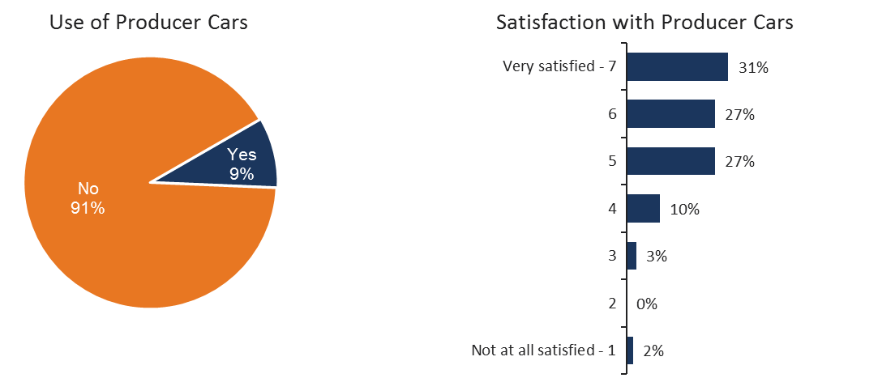
21T. Under the Canada Grain Act, grain producers are entitled to order producer cars from the Canadian Grain Commission directly or through an administrator who forwards the application to the Canadian Grain Commission. Did you use producer cars to ship your grain in the past 3 crop years? Base: All respondents (n=302)
22T. On a scale of 1 to 7, where 1 means not at all satisfied and 7 means very satisfied, how satisfied were you with how the CGC helps farmers order producer cars? Base: Those who used producer cars (n=27** Very small sample size)
There are no significant regional or other sub-group differences in use of producer cars and in satisfaction with the way in which CGC helps farmers order producer cars.

Service Centres

Use of CGC Service Centre Services
Respondents were asked their usage of specific services at a CGC service centre. The most used service is submitting a sample for grade, dockage, protein, moisture content, test weight (44%), mentioned by more than four in ten Western producers. About three in ten have sought information about grain grades (30%) and submitted sample for analytical tests (27%). More than one in ten (14%) have sought a binding decision on grade and dockage through a submitted sample inspection. The least used services are seeking information about getting paid for a grain delivery (7%) and getting help with a complaint about a grain company or grain dealer (7%).
Figure 31 - Use of Specific Services Provided at CGC Service Centres
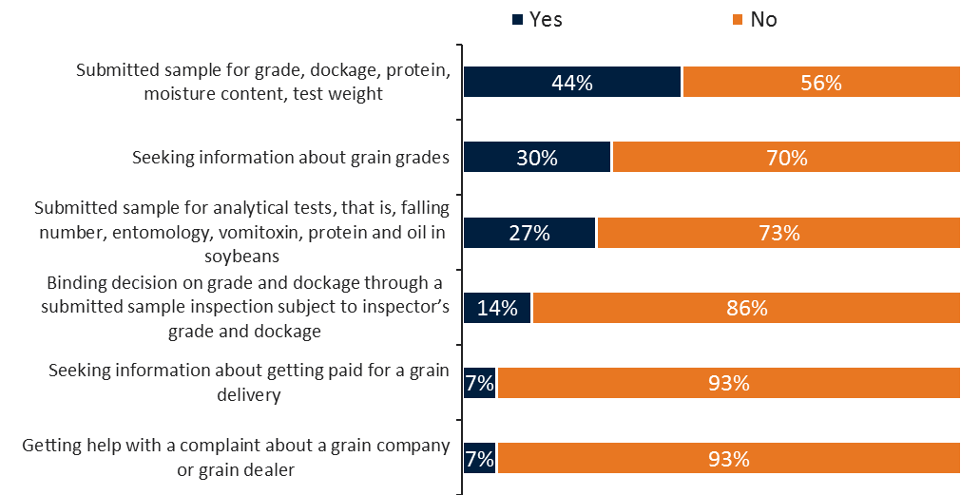
23. In the past three crop years, have you used any of the following services at a Canadian Grain Commission service centre?
Producers in Saskatchewan and Manitoba are significantly more likely than those in Alberta to have submitted a sample for analytical tests (35% and 31% vs. 12%).
Those who produce both grains and livestock are significantly more likely than those who produce grains only to have sought a binding decision on grade and dockage through a submitted sample (21% vs. 11%) and information about getting paid for a grain delivery (12% vs. 5%).

Value of a Service Centre in Your Province
Producers were asked about the value of having a service centre in their province. Six in ten (62%) indicate that this would be very valuable to them (6 or 7 on the scale).
Figure 32 - Value of Having a Service Centre in Your Province
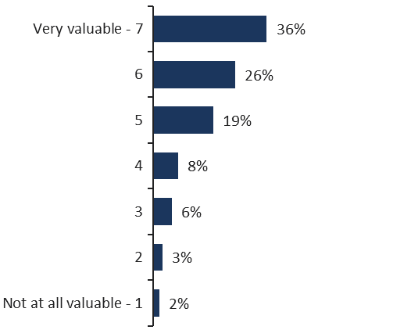
24a. On a scale of 1 to 7, where 1 means not at all valuable and 7 means very valuable, how valuable do you think a service centre in your province is to producers such as yourself?
There are no significant regional or other sub-group differences in the perceived value of having a service centre in their province.

Importance of Scientific Research
Producers understand the importance of Canada’s grain quality system being based on scientific research. Eight in ten (81%) acknowledge that this is very important (6 or 7 on the scale), including over half (54%) who rate the importance at the highest level (rating of 7).
Figure 33 - Importance of Canada’s Grain Grading System Based on Scientific Research
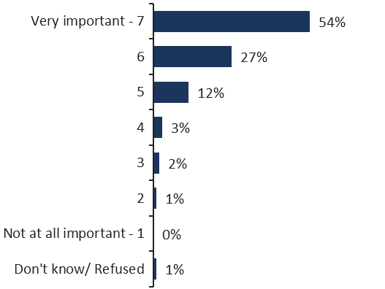
25T. Canada’s grain quality system is based on scientific research carried out by the Canadian Grain Commission. Using a scale of 1 to 7 where 1 means not at all important and 7 means very important, in your opinion, how important is it that Canada’s grain grading system be based on scientific research? Base: All respondents (n=302)
There are no significant regional or other sub-group differences in views on how important it is that Canada’s grain quality system be founded on scientific research.

User Fees and Surplus

Agreement with Proposed Reduction in Fees
Producers were informed that the CGC recovers most of its costs through fees, and that it is proposing to reduce the cost of the grain quality assurance system from its current cost of $1.80 per tonne of grain that is exported to $1.50. When asked if they agree with this reduction in fees, there is almost unanimous agreement (94%) with this proposal.
Figure 34 - Agreement with Proposed Reduction in Fees Charged to Grain Producers Whose Grain is Exported
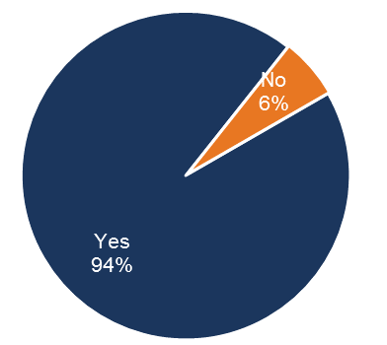
26. The CGC recovers most of its costs through fees. Currently, for every tonne of grain that is exported, the CGC’s grain quality assurance system costs about $1.80 per tonne. The CGC is proposing to reduce this cost to $1.50 per tonne. Most of these costs are ultimately paid by grain producers whose grain is exported. Do you agree with this proposed reduction in fees? Base: All respondents (n=302)
There are no significant regional or other sub-group differences in agreement with the CGC reducing the fees it charges producers per tonne of exported grain.
Notably, Manitoba producers are significantly more likely than those in Saskatchewan to agree with the reduction in fees (99% vs. 92%, respectively).

Preferred Way to Use Surplus
Producers were informed that because of higher than expected grain volumes and lower than expected spending the CGC has accumulated a surplus of $107 million as of September 30, 2016. When read a list of options and asked their top three preferred choices on what the CGC should do with this surplus, the most favoured choice is temporarily reducing CGC’s user fees even lower than the current proposed reduction (40%). One-quarter (23%) opt for creating a fund from which to compensate eligible producers in the event they are not paid for their grain deliveries. About one in ten choose modernizing the CGC’s infrastructure, including investing in new scientific equipment (14%), investing in more scientific research into grain quality (13%) and investing in improving the grading system (10%).
Figure 35 - Preferred Way to Use Surplus
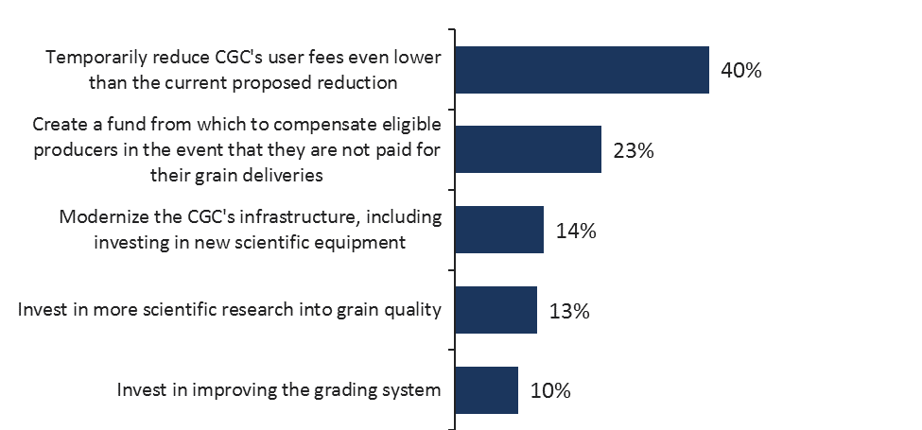
26. As a result of higher than expected grain volumes and lower than expected spending, the CGC has accumulated a surplus of $107 million as of September 30, 2016. In your opinion, what are your top three choices for what CGC should do with this surplus? Base: All respondents (n=302)
There are no significant regional or other sub-group differences on preferred ways for CGC to use the surplus.

Appendix

Table of Figures
Figure 1 – Satisfaction with Availability of Service 14
Figure 2 – Satisfaction with Inspector Review of Shipping Documentation 15
Figure 3 – Satisfaction with Quality Sampling 16
Figure 4 – Importance of Service Aspects 17
Figure 5 – Use of Analytical Testing 17
Figure 6 – Use of Letters of Analysis and Statements of Assurance 18
Figure 7 – Use of Certification Final and Private Sector Certificates 19
Figure 8 –Weighting Services Meeting Needs of Participants 20
Figure 9 – Potential for CGC to provide services for container shipping 21
Figure 10 – Feedback on the Determination of Commerically Clean process 24
Figure 11 – Value of Inspection-Related Training 25
Figure 12 – Opinion of User Fee Change Proposal 26
Figure 13 – Need for Funding Model Improvement 27
Figure 14 – Potential Uses for the Canadian Grain Commission surplus 28
Figure 15 - Awareness and Impression of CGC 30
Figure 16 - Usefulness of CGC 31
Figure 17 - Usefulness of Specific Activities of CGC 32
Figure 18 - Importance of CGC Providing Grading Services to Producers 33
Figure 19 - Use of and Satisfaction with CGC Grain Grading Services 33
Figure 20 - CGC Setting Grain Grades/ Standards Beneficial to Canada’s Reputation for Consistent and Reliable Grain Quality 34
Figure 21 - Importance of CGC Making Binding Decisions on Grade and Dockage 34
Figure 22 - Asked for Binding Decision 35
Figure 23 - Reasons for Not Asking CGC for a Binding Decision 36
Figure 24 - Quality Parameters Preferred to Be Assessed Via Instrumentation Rather than Visual Inspection 36
Figure 25 - CGC’s Sampling, Inspection and Weighing Services Beneficial for Canada’s Reputation for Consistent and Reliable Grain Quality 37
Figure 26 - Reasons CGC’s Sampling, Inspection and Weighing Services Are Beneficial for Canada’s Reputation 37
Figure 27 - CGC’s Quality Assurance System Serves Producers Well 38
Figure 28 - Importance of CGC Providing Producers with Payment Protection 39
Figure 29 - CGC’s Licensing and Security Program Protects Producers from Risk of Not Getting Paid 39
Figure 30 - Use of and Satisfaction with Producer Cars 40
Figure 31 - Use of Specific Services Provided at CGC Service Centres 40
Figure 32 - Value of Having a Service Centre in Your Province 41
Figure 33 - Importance of Canada’s Grain Grading System Based on Scientific Research 42
Figure 34 - Agreement with Proposed Reduction in Fees Charged to Grain Producers Whose Grain is Exported 42
Figure 35 - Preferred Way to Use Surplus 43

Questionnaire

English
CGC Producer Satisfaction Survey: Questionnaire February 23, 2017
Province:
Alberta
Saskatchewan
Manitoba
CD#
INTRODUCTION
[LANGUAGE OF CALLER RECORDED AT GREETING]
[INTERVIEWER TO PROCEED WITH INTRODUCTION IN LANGUAGE OF RESPONDENT AT GREETING]
[INTRODUCTION]
Good morning/afternoon/evening. My name is _______________ and I am calling from Ipsos, a national public opinion research company. Please let me assure you that we are not trying to sell anything.
Today, we are conducting a survey on behalf of the Canadian Grain Commission, a Government of Canada agency. The survey is being conducted among farmers to ask for their views about some grain industry issues.
All responses will be kept strictly confidential and will remain anonymous. Responses are recorded in statistical form only. This survey is registered with the national survey registration system maintained by the Market Research and Intelligence Association (MRIA).
(IF NECESSARY: This survey will take approximately 15 minutes to complete.) Participation in this survey is completely voluntary.
1T. Are you 18 years old or more, and the primary decision-maker for your farm operation?

Yes [CONTINUE]
No [ASK TO SPEAK TO THAT PERSON, READ INTRO AGAIN]
[If not available arrange for callback. if respondent indicates this is not a good time to complete the interview, arrange callback]
2T. On your farm operation, do you produce: [READ LIST]
Grains only, including cereals, oilseeds, pulses or any other crops such as buckwheat or corn?
Both grains and livestock?
Livestock only?
[if livestock only or dk/ns thank and terminate]
iF LIVESTOCK ONLY tERMINATE: thank you but we are looking to speak with grain farmers this evening. I hope that we will be able to complete a survey with you on a different topic in the near future. Thanks again.
3T. To begin, have you heard of the Canadian Grain Commission?
Yes
No
4T. Based on your own experience or what you have read, seen or heard, what is your overall impression of the Canadian Grain Commission? Please use a scale of 1 to 7, where 1 means a very poor impression and 7 means an excellent impression.
[1-7]
5T. Using a scale from 1 to 7, where 1 means not at all useful and 7 means very useful, in your opinion, how useful is the Canadian Grain Commission to producers?

[1-7]

6. I am going to read out a list of some of the activities of the Canadian Grain Commission, using a scale of 1 to 7, where 1 means not at all useful and 7 means very useful, please indicate how useful you think each one is.
[ASK RESPONDENT A RANDOMIZED SET OF 6 ACTIVITIES]
Grain grading (general)
Establishing Canada’s grain grades
Providing grain grades to farmers who send in samples
Settling grading disputes between farmers and grain companies/elevator managers
Operating service centres across the prairies that provide grain grading and inspection services
Grading grain for export / at terminal elevators
Grain quality (general)
Conducting the harvest survey to determine crop quality
Conducting grain quality research
Coordinating Canada’s grain quality assurance system
Monitoring grain shipments to ensure they are safe
Licensing grain companies
Making sure farmers get paid when they sell grain to licensed grain companies
Upholding the rights of grain producers
Gathering statistics & keeping records of grain movement and grain export sales
Helping grain marketers sell Canadian grain
Allocating producer cars
Crop variety approvals
[1-7]
Grading services
7T. On a scale of 1 to 7, where 1 means not at all important and 7 means very important, how important is it to you that the Canadian Grain Commission provide grading services to producers – that is when producers can directly send in samples to the CGC and receive a grade for a fee?
(NOTE TO INTERVIEWER: IF FARMERS ASK WHAT GRADING SERVICES ARE SAY:
This is also called the submitted sample program, not the harvest sample program)
[1-7]
8T. Have you used the Canadian Grain Commission grain grading service for producers any time in the past three crop years? [IF YES CONTINUE OTHERWISE SKIP TO Q 11]
Yes
No
9T. On a scale of 1 to 7, where 1 means that you were very dissatisfied and 7 means you were very satisfied, how satisfied were you with the CGC grading services for producers—not the grade you received—but the services you were provided?
[1-7]
10T. Do you strongly agree, somewhat agree, somewhat disagree or strongly disagree that having the CGC set grain grades and standards help uphold Canada’s reputation for consistent and reliable grain quality?
Strongly agree
Somewhat agree
Somewhat disagree
Strongly disagree
11T. As part of the CGC’s producer protections, if a producer does not agree with the grade and dockage assessed by a primary elevator, the producer can ask the CGC to determine grade and dockage and make a binding decision.
On a scale of 1 to 7, where 1 means not at all important and 7 means very important, how important do you find this service?
[1-7]
12T. And, over the course of the last three crop years, have you asked the Canadian Grain Commission to make a binding decision and determine the grade and dockage of a grain delivery?
Yes
No
[IF YES AT Q12 CONTINUE. IF NO SKIP TO Q 14 IF DK/NS SKIP TO Q15]
13T. And on a scale of 1 to 7, where 1 means it is not at all useful and 7 means it is very useful, how useful do you think this service is to producers such as yourself?
[1-7]
[SKIP TO Q.15]
14. Why haven’t you used this service? (DO NOT READ) (ACCEPT ALL RESPONSES)
Didn’t need to
Couldn’t because my disagreement was about contract specifications and not the statutory grade.
Other (specify)
15. Industry representatives and farm groups have asked the CGC to explore using instrumentation to assess quality parameters. What are the quality parameters you’d like to see assessed via instrumentation rather than by a visual inspection? (READ FULL LIST OF PARAMETERS) (ACCEPT ALL MENTIONS)
[RANDOMIZE]
Mildew
Frost
Sprouted
Fusarium damage
Other (specify)
Sampling, Inspection, Weighing and Quality
16T. Do you strongly agree, somewhat agree, somewhat disagree or strongly disagree that having the CGC’s sampling, inspection and weighing services help uphold Canada’s reputation for consistent and reliable grain quality?

Strongly agree
Somewhat agree
Somewhat disagree
Strongly disagree

17T. Why is it that you [INSERT RESPONSE FROM Q16]?

[OPEN-ENDED]

- Please tell me whether you strongly agree, somewhat agree, somewhat disagree or strongly disagree with the following statement: The Canadian Grain Commission’s quality assurance system serves producers well.

Strongly agree
Somewhat agree
Somewhat disagree
Strongly disagree

Licensing and security

19T.As part of the Canadian Grain Commission’s producer protections, the CGC has a licensing and security program, where grain elevators and grain dealers must post security that covers the amount they owe farmers. If a company or dealer can’t or won’t pay, eligible producers could be paid from this security.

On a scale of 1 to 7, where 1 means not at all important and 7 means very important, how important is it to you that the Canadian Grain Commission provides producers with payment protection?

[1-7]

20T. Do you strongly agree, somewhat agree, somewhat disagree or strongly disagree that the CGC’s licensing and security program protects producers from the risk of not getting paid by a grain company?

Strongly agree
Somewhat agree
Somewhat disagree
Strongly disagree
[DK/NS]

Producer Cars

21T. Under the Canada Grain Act, grain producers are entitled to order producer cars from the Canadian Grain Commission directly or through an administrator who forwards the application to the Canadian Grain Commission. Did you use producer cars to ship your grain in the past 3 crop years?

Yes
No

22T. On a scale of 1 to 7, where 1 means not at all satisfied and 7 means very satisfied, how satisfied were you with how the CGC helps farmers order producer cars?

[1-7]

Service centres

- In the past three crop years, have you used any of the following services at a Canadian Grain Commission service centre? (RECORD YES/NO FOR EACH)
[RANDOMIZE]
Binding decision on grade and dockage through a submitted sample inspection Subject to inspector’s grade and dockage
Submitted sample for grade, dockage, protein, moisture content, test weight
Submitted sample for analytical tests, that is, falling number, entomology, vomitoxin, protein and oil in soybeans
Seeking information about grain grades
Seeking information about getting paid for a grain delivery
Getting help with a complaint about a grain company or grain dealer
Yes
No
24a. On a scale of 1 to 7, where 1 means not at all valuable and 7 means very valuable, how valuable do you think a service centre in your province is to producers such as yourself?
[1-7]
Research
25T. Canada’s grain quality system is based on scientific research carried out by the Canadian Grain Commission. Using a scale of 1 to 7 where 1 means not at all important and 7 means very important, in your opinion, how important is it that Canada’s grain grading system be based on scientific research?

[1-7]
User fees and cost recovery
26. The CGC recovers most of its costs through fees, Currently, for every tonne of grain that is exported, the CGC’s grain quality assurance system costs about $1.80 per tonne. The CGC is proposing to reduce this cost to $1.50 per tonne. Most of these costs are ultimately paid by grain producers whose grain is exported. Do you agree or with this proposed reduction in fees?
(NOTE TO INTERVIEWERS: IF FARMERS ASK HOW THEY ARE PAYING FOR THE GRAIN COMMISSION’S QUALITY SYSTEM, SAY: “When grain is shipped out of a port terminal, there are grading costs incurred. These costs end up being reflected in the price you receive for your product.”)

(NOTE TO INTERVIEWERS: IF FARMERS ASK HOW the figure of $1.80 per TONNE was determined, SAY: “The actual cost per tonne of the CGC’s grain quality system varies for each crop but it is estimated that the highest cost per crop, wheat for example, is about $1.80 per tonne.” )

Yes
No
Surplus
- As a result of higher than expected grain volumes and lower than expected spending, the CGC has accumulated a surplus of $107 million as of September 30, 2016. In your opinion, what are your top three choices for what CGC should do with this surplus? (READ – RECORD FIRST, SECOND AND THIRD CHOICE)

[RANDOMIZE]
Temporarily reduce CGC’s user fees even lower than the current proposed reduction
Invest in improving the grading system.
Invest in more scientific research into grain quality.
Modernize the CGC’s infrastructure, including investing in new scientific equipment.
Create a fund from which to compensate eligible producers in the event they are not paid for their grain deliveries.
Demographics
I have a few questions for statistical purposes now.

28T. In what year were you born? [RANGE 1900-1998]
29T. What was the highest level of formal education you attained? [READ LIST]
No high school
Some or Completed high school
Some or Completed technical school
Some or Completed university
30T. How many acres did you have under crop this year? ____ acres [RANGE ACRES 1-20,000] [RANGE HECTARES 1-10,000 – RECORD NUMERICAL VALUE]
31T. Which of the following categories best describes what you expect your total farm sales to be in 2016?
Less than $50,000
$50,000 – just under $100,000
$100,000 – just under $200,000
$200,000 – just under $400,000
$More than $400,000

French
Enquête de la Commission canadienne des grains (CCG) sur la satisfaction des producteurs : Questionnaire ‒ 23 février 2017
Province :
Alberta
Saskatchewan
Manitoba
Nº du district agricole :
PRÉSENTATION
[LANGUE DE L’APPELANT ENREGISTRÉE À L’ACCUEIL]
[L’INTERVIEWEUR DOIT PROCÉDER À L’INTRODUCTION DANS LA LANGUE DU RÉPONDANT À L’ACCUEIL.]
[INTRODUCTION]
Bonjour OU bonsoir, Je m’appelle _______________ et je travaille pour Ipsos, une entreprise nationale de recherche sur l’opinion publique. En premier lieu, laissez-moi vous rassurer, je n’essaye pas de vous vendre quoi que ce soit.
Aujourd’hui, nous menons une enquête au nom de la Commission canadienne des grains, un organisme du gouvernement du Canada. L’enquête est réalisée auprès des producteurs dans le but d’obtenir leur point de vue concernant certaines questions liées à l’industrie des grains.
Soyez assuré que vos réponses seront traitées de manière strictement confidentielle et anonyme. Ces dernières sont enregistrées sous forme de statistiques seulement. Ce sondage est enregistré auprès du système national d’enregistrement des sondages de l’Association de la recherche et de l’intelligence marketing (ARIM).
(AU BESOIN : Il faut environ 15 minutes pour répondre au questionnaire.) La participation au sondage est entièrement volontaire.
1T. Êtes-vous âgé de 18 ans ou plus et êtes-vous le principal décideur de votre exploitation agricole?

Oui [POURSUIVEZ.]
Non [DEMANDEZ À PARLER À CETTE PERSONNE ET REPRENEZ DEPUIS LE DÉBUT.]
[Si la personne n’est pas disponible, prenez des dispositions pour un rappel. Si le répondant indique que ce n’est pas un moment propice pour réaliser l’entrevue, prenez des dispositions pour un rappel.]
2T. La production de votre exploitation agricole comprend-elle : [LISEZ LA LISTE]
Des grains seulement, y compris des céréales, des oléagineux, des légumineuses ou toute autre culture, telle que le sarrasin ou le maïs?
Des grains et du bétail?
Du bétail seulement?
[Si l’exploitation agricole ne comprend que du bétail, ou si la personne ne sait pas ou qu’elle est incertaine, remerciez-la et terminez l’appel.]
SI L’EXPLOITATION AGRICOLE COMPREND DU BÉTAIL SEULEMENT, METTEZ FIN À LA CONVERSATION : Merci, mais nous cherchons à parler avec des producteurs de céréales aujourd’hui. J’espère que nous pourrons réaliser une enquête auprès de vous sur un autre sujet dans un avenir rapproché. Merci encore.
3T. Pour commencer, avez-vous entendu parler de la Commission canadienne des grains?
Oui
Non
4T. Selon votre propre expérience ou ce que vous avez lu, vu ou entendu, quelle est votre impression générale concernant la Commission canadienne des grains? Veuillez utiliser une échelle de 1 à 7, où 1 signifie « très mauvaise impression » et 7 signifie « excellente impression ».
[1-7]
5T. Sur une échelle de 1 à 7, où 1 signifie « complètement inutile » et 7 signifie « très utile », à votre avis, dans quelle mesure la Commission canadienne des grains est-elle utile pour les producteurs?

[1-7]

6. Je vais lire une liste de certaines des activités de la Commission canadienne des grains. Sur une échelle de 1 à 7, où 1 signifie « complètement inutile » et 7 signifie « très utile », veuillez indiquer dans quelle mesure, selon vous, chaque activité est utile.
[DEMANDEZ AU RÉPONDANT D’ÉVALUER UN ENSEMBLE ALÉATOIRE DE SIX ACTIVITÉS.]
Classement des grains (général)
Établissement des grades de grain du Canada
Fourniture de grades de grain aux producteurs qui envoient des échantillons
Résolution de différends relatifs au grade entre les producteurs et les compagnies céréalières ou les directeurs de silo
Exploitation de centres de services qui fournissent des services de classement et d’inspection des grains, dans l’ensemble des Prairies
Détermination du grade du grain destiné à l’exportation ou aux silos terminaux
Qualité des grains (général)
Enquête sur les récoltes afin de déterminer la qualité des cultures
Recherches sur la qualité des grains
Coordination du système d’assurance de la qualité des grains du Canada.
Surveillance des expéditions de grain pour en assurer la salubrité
Délivrance de licences aux compagnies céréalières
Contrôle en vue d’assurer que les producteurs sont payés lorsqu’ils vendent du grain à des compagnies céréalières agréées
Défense des droits des producteurs de grain
Collecte de statistiques et tenue de dossiers sur le transport et les ventes à l’exportation de grains
Aide aux marchands de grain pour la vente du grain canadien
Attribution des wagons de producteurs
Approbation des variétés de cultures
[1-7]
Services de classement des grains
7T. Sur une échelle de 1 à 7, où 1 signifie « pas du tout important » et 7 signifie « très important », quelle importance accordez-vous au fait que la Commission canadienne des grains offre aux producteurs des services de classement des grains – c’est-à-dire que les producteurs peuvent envoyer directement à la Commission des échantillons et, moyennant des frais, recevoir un grade?
(NOTE À L’INTENTION DE L’INTERVIEWEUR : SI LES PRODUCTEURS DEMANDENT CE QUE SONT LES SERVICES DE CLASSEMENT, RÉPONDEZ :
Cela est aussi appelé « Programme d’échantillons soumis », et non « Programme d’échantillons de récolte ».)
[1-7]
8T. Au cours des trois dernières campagnes agricoles, avez-vous eu recours aux services de classement des grains de la Commission canadienne des grains à l’intention des producteurs? [SI OUI, POURSUIVEZ. AUTREMENT, PASSEZ À LA QUESTION 11.]
Oui
Non
9T. Sur une échelle de 1 à 7, où 1 signifie « très insatisfait » et 7 signifie « très satisfait », quel est votre degré de satisfaction à l’égard des services de classement offerts aux producteurs par la Commission (il ne s’agit pas du grade que vous avez reçu, mais plutôt des services qui vous ont été fournis)?
[1-7]
10T. Êtes-vous fortement en accord, plutôt d’accord, plutôt en désaccord ou fortement en désaccord avec l’énoncé suivant : « le fait que la Commission établisse des grades et des normes applicables aux grains aide à maintenir la réputation dont jouit le Canada pour ce qui est de la constance et de la fiabilité de la qualité du grain qu’il produit »?
Fortement en accord
Plutôt d’accord
Plutôt en désaccord
Fortement en désaccord
11T. Dans le cadre des protections offertes aux producteurs par la Commission, si un producteur n’est pas d’accord avec le grade de grain et le taux d’impuretés déterminés par un directeur de silo primaire, le producteur peut demander à la Commission de déterminer le grade et le taux d’impuretés du grain, puis de prendre une décision exécutoire.
Sur une échelle de 1 à 7, où 1 signifie « pas du tout important » et 7 signifie « très important », quel est le degré d’importance que vous accordez à ce service?
[1-7]
12T. Au cours des trois dernières campagnes agricoles, avez-vous demandé à la Commission canadienne des grains de prendre une décision exécutoire et déterminer le grade de grain et le taux d’impuretés d’une livraison de grain?
Oui
Non
[SI LA RÉPONSE À LA QUESTION 12 EST OUI, POURSUIVEZ. SI LA RÉPONSE EST NON, PASSEZ À LA QUESTION 14. SI LA RÉPONSE EST « JE NE SAIS PAS » OU « JE NE SUIS PAS CERTAIN », PASSEZ À LA QUESTION 15.]
13T. Sur une échelle de 1 à 7, où 1 signifie « pas du tout utile » et 7 signifie « très utile », dans quelle mesure croyez-vous que ce service est utile pour les producteurs comme vous?
[1-7]
[PASSEZ À LA QUESTION 15.]
14. Pourquoi n’avez-vous pas utilisé ce service? (NE LISEZ PAS.) (ACCEPTEZ TOUTES LES RÉPONSES.)
Je n’ai pas eu besoin de l’utiliser.
Je n’ai pas pu l’utiliser parce que mon désaccord concernait des modalités contractuelles et non le grade réglementaire.
Autre (préciser)
15. Des représentants de l’industrie et des groupes agricoles ont demandé à la Commission d’étudier la possibilité d’utiliser des instruments pour évaluer les paramètres de qualité. Quels sont les paramètres de qualité que vous aimeriez voir évalués à l’aide d’instruments plutôt que par une inspection visuelle? (LISEZ LA LISTE COMPLÈTE DES PARAMÈTRES.) (ACCEPTEZ TOUTES LES MENTIONS.)
[ROTATION ALÉATOIRE]
Mildiou
Gel
Grains germés
Grains fusariés
Autre (préciser)
Échantillonnage, inspection, pesée et qualité
16T. Êtes-vous fortement en accord, plutôt d’accord, plutôt en désaccord ou fortement en désaccord avec l’énoncé suivant : « le fait que la Commission canadienne des grains offre des services d’échantillonnage, d’inspection et de pesée aide à maintenir la réputation dont jouit le Canada pour ce qui est de la constance et de la fiabilité de la qualité du grain qu’il produit »?

Fortement en accord
Plutôt d’accord
Plutôt en désaccord
Fortement en désaccord
17T. Pourquoi avez-vous répondu [INSÉREZ LA RÉPONSE À LA QUESTION 16]?
[QUESTION OUVERTE]
- Veuillez dire si vous êtes fortement en accord, plutôt d’accord, plutôt en désaccord ou fortement en désaccord avec l’énoncé suivant : « le système d’assurance de la qualité de la Commission canadienne des grains sert bien les producteurs ».

Fortement en accord
Plutôt d’accord
Plutôt en désaccord
Fortement en désaccord
Agrément et garantie
19T. Parmi les protections offertes aux producteurs par la Commission canadienne des grains figure un programme d’agrément et de garantie dans le cadre duquel les exploitants de silos à grain et les négociants en grains doivent verser une garantie qui couvre le montant qu’ils doivent aux producteurs. Dans le cas où une compagnie ou un négociant refuserait de payer ou ne serait pas en mesure de le faire, les producteurs admissibles pourraient être payés à partir de cette garantie.

Sur une échelle de 1 à 7, où 1 signifie « pas du tout important » et 7 signifie « très important », quel est le degré d’importance que vous accordez au fait que la Commission canadienne des grains offre aux producteurs une protection des paiements?

[1-7]

20T. Êtes-vous fortement en accord, plutôt d’accord, plutôt en désaccord ou fortement en désaccord avec l’énoncé suivant : le programme d’agrément et de garantie de la Commission protège les producteurs contre le risque de ne pas être payés par une compagnie céréalière?

Fortement en accord
Plutôt d’accord
Plutôt en désaccord
Fortement en désaccord
[Ne sais pas/incertain]
Wagons de producteurs
21T. En vertu de la Loi sur les grains du Canada, les producteurs de grain ont le droit de demander à ce que la Commission canadienne des grains leur alloue des wagons de producteurs. Ils peuvent faire cette demande directement auprès de la Commission ou par l’entremise d’un administrateur, qui fera parvenir la demande à la Commission en leur nom. Au cours des trois dernières campagnes agricoles, avez-vous utilisé des wagons de producteurs pour expédier votre grain?

Oui
No

22T. Sur une échelle de 1 à 7, où 1 signifie « pas du tout satisfait » et 7 signifie « très satisfait », quel est votre degré de satisfaction quant à la façon dont la Commission aide les producteurs à obtenir des wagons de producteurs?

[1-7]

Centres de services
- Au cours des trois dernières campagnes agricoles, avez-vous utilisé l’un ou l’autre des services suivants à un centre de services de la Commission canadienne des grains? (INDIQUEZ OUI OU NON À CÔTÉ DE CHAQUE SERVICE.)
[ROTATION ALÉATOIRE]
Décision exécutoire sur le grade de grain et le taux d’impuretés dans le cadre de l’inspection d’un échantillon soumis (sous réserve du classement et de la détermination des impuretés par l’inspecteur)
Échantillon soumis pour détermination du grade, du taux d’impuretés, de la teneur en protéines, de la teneur en eau ou du poids spécifique
Échantillon soumis aux fins d’analyse, c’est-à-dire indice de chute, entomologie, dosage de la vomitoxine, détermination de la teneur en protéines et en huile du soja
Demande de renseignements sur les grades de grain
Demande de renseignements sur la façon d’être payé pour une livraison de grain
Demande d’aide à l’égard d’une plainte concernant une compagnie céréalière ou un négociant en grains
Oui
Non
24a. Sur une échelle de 1 à 7, où 1 signifie « complètement inutile » et 7 signifie « très utile », veuillez indiquer dans quelle mesure la présence d’un centre de services dans leur province est utile pour les producteurs comme vous?
[1-7]
Recherche
25T. Le système d’assurance de la qualité des grains du Canada est fondé sur la recherche scientifique réalisée par la Commission canadienne des grains. Sur une échelle de 1 à 7, où 1 signifie « pas du tout important » et 7 signifie « très important », à quel point est-il important que le système d’assurance de la qualité des grains du Canada soit fondé sur la recherche scientifique?
[1-7]
Frais d’utilisation et recouvrement des coûts
- La Commission recouvre la majeure partie de ses coûts grâce aux frais. À l’heure actuelle, pour chaque tonne de grain exportée, le système d’assurance de la qualité de la Commission coûte environ 1,80 $ la tonne. La Commission propose de réduire ce coût à 1,50 $ la tonne. La majeure partie de ces coûts sont payés en fin de compte par les producteurs de grain dont le grain est exporté. Êtes-vous d’accord ou en désaccord avec cette réduction des frais proposée?
(NOTE À L’INTENTION DES INTERVIEWEURS : SI LES PRODUCTEURS DEMANDENT DE QUELLE FAÇON ILS PAYENT POUR LE SYSTÈME D’ASSURANCE DE LA QUALITÉ DE LA COMMISSION CANADIENNE DES GRAINS, DITES : « Lorsque du grain est expédié à partir d’un terminal portuaire, des coûts de classement sont engagés. Ces coûts finissent par être reflétés dans le prix que vous recevez pour votre produit. »)

(NOTE À L’INTENTION DES INTERVIEWEURS : SI LES PRODUCTEURS DEMANDENT COMMENT LE MONTANT DE 1,80 $ LA TONNE A ÉTÉ DÉTERMINÉ, DITES : « Le coût réel à la tonne du système d’assurance de la qualité des grains de la Commission varie selon la culture, mais il est estimé que le coût le plus élevé par culture, le blé par exemple, est d’environ 1,80 $ la tonne. »)

Oui
Non
Excédent
- En raison de volumes de grains plus élevés que prévu et de dépenses inférieures à celles prévues, en date du 30 septembre 2016, la Commission avait accumulé un excédent de plus de 107 millions de dollars. Quels sont vos trois premiers choix quant à ce que la Commission devrait faire avec cet excédent? (LISEZ – INDIQUEZ LE PREMIER, LE DEUXIÈME ET LE TROISIÈME CHOIX.)
[ROTATION ALÉATOIRE]
Réduire temporairement les frais d’utilisation de la Commission à un niveau encore plus bas que la réduction proposée à l’heure actuelle.
Investir dans l’amélioration du système de classement.
Investir davantage dans la recherche scientifique sur la qualité des grains.
Moderniser l’infrastructure de la Commission, notamment investir dans de nouveaux équipements scientifiques.
Créer un fonds à partir duquel il sera possible d’indemniser les producteurs admissibles s’ils ne sont pas payés pour leurs livraisons de grains.
Démographie
J’ai maintenant quelques questions pour des fins statistiques.

28T. En quelle année êtes-vous né? [FOURCHETTE : 1900-1998]
29T. Quel est votre plus haut niveau de scolarité? [LISEZ LA LISTE.]
Aucunes études secondaires
Études secondaires partielles ou complètes
Études techniques partielles ou complètes
Études universitaires partielles ou complètes
30T. Combien d’acres en culture avez-vous cette année? ____ acres
[FOURCHETTE DES ACRES : 1-20 000] [FOURCHETTE DES HECTARES : 1-10 000 – INDIQUEZ LA VALEUR NUMÉRIQUE.]
31T. Parmi les catégories suivantes, laquelle correspond le mieux à la valeur prévue de vos ventes à la ferme totales en 2016?
Moins de 50 000 $
De 50 000 $ à moins de 100 000 $
De 100 000 $ à moins de 200 000 $
De 200 000 $ à moins de 400 000 $
Plus de 400 000 $

Qualitative Self-Directed Interview Guide

English
Questions for 2017 industry interviews
Introduction
The CGC is the regulator of Canada’s grain handling industry. It is the official certifier of Canadian grain. The CGC is Canada’s scientific research organization on grain quality.
Guided by the Canada Grain Act, the CGC certifies the quality, safety and weight of Canadian grain that is delivered to domestic and export markets. To do this, it:
  - Regulates all aspects of grain handling in Canada through grain quality and quantity assurance programs
  - Carries out scientific research to understand all aspects of grain quality and grain safety and to support the grain grading system
The Canadian Grain Commission has commissioned Ipsos to gather feedback from industry representatives, such as yourself, in order to improve their programs and services. Your participation is voluntary and the identity of the participants we interview is kept confidential. This is an initial self-directed qualitative interview. At our discretion, Ipsos may follow-up with individual participants to further explore the information provided in this initial workbook.
This initial review should take about 30 minutes of your time.
Services
- Although you may not be directly involved with some aspects of official inspection and weighing certification oversight, as we discuss each of the service aspects we would like your opinion, either based on your personal experience or what you know from discussions with others in your organization.
There are several aspects of official inspection services and weighing certification oversight services. On a scale of 1 to 7, with 1 being very dissatisfied and 7 being very satisfied, please rate your satisfaction with (INTERVIEWER READS STATEMENTS AND REPEATS THE SCALE FOR EACH STATEMENT).
Now, on a scale of 1 to 7 with 1 being not at all important and 7 being very important, please rate the importance of (INTERVIEWER READS STATEMENTS AND REPEATS THE SCALE FOR EACH STATEMENT).
Service aspect | - Satisfaction | - Importance
Availability of service

The availability of CGC staff to complete the inspection | - 1 to 7 | - 1 to 7
Inspector review of shipping documentation

- The inspector’s ability to pick up the necessary information from pre-loading documentation | - 1 to 7 | - 1 to 7
- The courtesy of CGC staff | - 1 to 7 | - 1 to 7
- The length of time it takes to review shipping documentation | - 1 to 7 | - 1 to 7
- The inspector’s ability to communicate problems with the shipping documentation to you | - 1 to 7 | - 1 to 7
- The time it takes for the inspector to communicate problems with the documentation to you | - 1 to 7 | - 1 to 7
- The completeness of the information provided by the CGC inspector when problems with the documentation are found | - 1 to 7 | - 1 to 7
- Quality sampling
- Communication to the terminal and/or shipping staff about any problems identified is clear | - 1 to 7 | - 1 to 7
- Sampling is completed in a manner which is fair | - 1 to 7 | - 1 to 7

- Any other feedback/comments related to the ratings provided above. [OPEN]

- Currently, the Canadian Grain Commission offers analytical testing services at port locations. Examples of tests include an alveograph test, the Hagberg test for falling number, a test for free fatty acids in oilseeds, and nitrogen or protein using the combustion nitrogen analysis method.
  - Do you use any of the Canadian Grain Commission’s analytical tests?
    - Yes [IF YES SHOW FOLLOW-UP OPEN ENDS]
    - No
  - Which ones do you use? [OPEN]
  - How do they meet your needs? [OPEN]
  - How could the Canadian Grain Commission improve its analytical testing services? [OPEN]

- What other analytical tests could the Canadian Grain Commission provide? [OPEN]
  - Do you have any other feedback concerning analytical tests? [OPEN]

- When requested by the exporter, the Canadian Grain Commission issues letters of analysis and statements of assurance on export shipments. Letters of analysis provide additional information on a specific grading factor, or analytical test on a specific parcel/cargo sample. Statements of assurance provide additional grain quality or safety information based on historical monitoring of Canadian grain, not on the specific cargo sample.

  - Do you use either letters of analysis or statements of assurance?
    - Yes, letters of analysis
    - Yes, statements of assurance
    - Both
    - Neither
[IF YES OR BOTH SHOW FOLLOW-UP OPEN ENDS]
  - For what purpose do you use them? [OPEN]
  - Are they meeting your needs? [OPEN]
  - How could they be improved? [OPEN]
  - Do you have any other feedback concerning letters of analysis or statements of assurance? [OPEN]
Certification
- The Canadian Grain Commission issues a Certificate Final to exporters for every export shipment of grain loaded to ships from licensed terminal elevators, except shipments going to the United States. The Certificate Final shows that Canada has certified the grade and weight of an export shipment of grain in relation to grain standards set by the Canadian Grain Commission.
  - Do you use the Certificate Final after it has been issued?
    - Yes
    - No [IF NO SHOW FOLLOW-UP OPEN END]
  - If not, how could it be improved? [OPEN]
  - If yes, what do you currently use it for? How can it be improved? [OPEN]
  - Do you have any other feedback concerning Certificate Final?

- Do you use private sector certification such as SGS?
    - Yes [IF YES SHOW FOLLOW-UP OPEN END]
    - No
  - Why do you use private sector certification? [OPEN]
  - Do you have any other feedback concerning private sector certification? [OPEN]
Weighing
- Are the Canadian Grain Commission’s weighing services meeting your needs?
    - Yes
    - No [IF NO SHOW FOLLOW-UP OPEN END]
  - If no, how could they be improved? [OPEN]
  - Do you have any other feedback concerning weighing services? [OPEN]
Container shipments
- Container shipments are used to export Canadian grain, but they are not regulated by the Canadian Grain Commission.
  - Are there services that the Canadian Grain Commission could provide to companies that are shipping grain in containers?
    - Yes [IF YES SHOW FOLLOW-UP OPEN END]
    - No
  - If yes, please describe what they would be. [OPEN]
  - Do you have any other feedback concerning shipping grain in containers? [OPEN]
Grain grading and inspection
- What aspects of Canada’s grain grading system currently meet your needs? [OPEN]
  - What should be changed to make it more useful, modern or relevant for you? [OPEN]

- Canadian grain must be commercially clean when it is shipped to export markets. The Canadian Grain Commission uses a process called the Determination of Commercially Clean.
  - What aspects of the commercial cleanliness component of the grain grading system are working for you? [OPEN]
  - What aspects aren’t working for you? [OPEN]
  - What should be changed? [OPEN]

- Would it be valuable for the Canadian Grain Commission to provide inspection-related training to the industry?
- Yes [IF YES SHOW FOLLOW-UP OPEN END]
- No
  - If yes, what would it look like? [OPEN]
  - Do you have any other feedback concerning inspection-related training for the industry? [OPEN]
User fees and cost recovery
- The Canadian Grain Commission has reviewed its fee schedule and is proposing a reduction in most of its fees. The proposed fees would be approximately $1.50 per tonne. This represents a decrease of $0.44 per tonne in comparison to published fee levels for 2017-2018 fiscal year. It is estimated that the changes will result in a savings of $15.14 million annually, based on an average grain volume of 34.4 million tonnes.
  - Do you agree with this proposal?
    - Yes
    - No
  - Please tell me more about your position on this. [OPEN]

- Are there ways that you feel the Canadian Grain Commission’s funding model could be improved?
- Yes [IF YES SHOW FOLLOW-UP OPEN END]
- No
  - If yes, please describe how it could be improved. [OPEN]
  - Do you have any further feedback concerning the Canadian Grain Commission's funding model? [OPEN]
Surplus
- The Canadian Grain Commission has accumulated a surplus of $107 million as of September 30, 2016. In your opinion, how should the Canadian Grain Commission use the surplus?
- Temporarily reduce the Canadian Grain Commission’s user fees so they are below the proposed $1.50 per tonne
- Invest in modernizing the grading system
- Invest in more scientific research into grain quality
- Improve the Canadian Grain Commission’s infrastructure, including investing in new scientific equipment
- Create a fund from which to compensate eligible producers in the event they are not paid for their grain deliveries
- Any other suggestions for how the surplus should be used? [OPEN]
- Do you have any further feedback concerning the Canadian Grain Commission's surplus? [OPEN]
Final
- Do you have any other suggestions, feedback or concerns that you would like to share with the Canadian Grain Commission? [OPEN]

- Thank you for taking the time to take part in this initial workbook. We would like the opportunity to follow-up with you should we require any further clarifications based on your submissions. Please confirm the best way to reach you below:
- Name:
- Phone Number:
- E-mail Address:

[MESSAGES – THANK YOU]
Thank you for your time in participating in this important research. As mentioned previously a representative from IPSOS may be in touch in the coming days to schedule a time to further discuss your responses and feedback. Please be aware that you may or may not be contacted for this next step depending on the nature of the feedback provided.

French
Questions pour les entrevues auprès de l’industrie en 2017
Introduction
La Commission canadienne des grains (CCG) est l’organisme chargé de réglementer l’industrie de la manutention des grains au Canada et d’assurer la certification officielle des grains canadiens. Elle est l’organisation de recherche scientifique du Canada pour ce qui est de la qualité des grains.
Guidée par la Loi sur les grains du Canada, la Commission certifie la qualité, la salubrité et le poids du grain canadien livré sur les marchés nationaux et étrangers. À cette fin, elle :
  - réglemente tous les aspects de la manutention des grains au Canada grâce à ses programmes d’assurance de la qualité et de la quantité;
  - mène de la recherche scientifique pour comprendre tous les aspects de la qualité et de la salubrité des grains et pour appuyer le système de classement des grains.

La Commission canadienne des grains a retenu les services d’Ipsos pour recueillir les commentaires de représentants de l’industrie, comme vous, en vue d’améliorer ses programmes et ses services. La participation est volontaire, et l’identité des participants aux entrevues demeure confidentielle. Il s’agit d’une première entrevue qualitative autogérée. À notre discrétion, Ipsos pourrait effectuer un suivi auprès de participants individuels afin d’explorer les renseignements fournis dans ce premier cahier de travail.
L’examen initial ne devrait prendre que 30 minutes de votre temps.
Services
- Même s’il est possible que vous ne participiez pas directement à certains aspects de l’inspection officielle ou de la surveillance de la certification de la pesée, au cours de notre discussion de chacun des aspects des services, nous aimerions connaître votre opinion, selon votre expérience personnelle ou ce que vous savez au vu des discussions avec d’autres personnes au sein de votre organisation.

Les services d’inspection officielle et les services de surveillance de la certification de la pesée comportent plusieurs aspects. Sur une échelle de 1 à 7, où 1 signifie « très insatisfait » et 7 signifie « très satisfait », veuillez indiquer votre degré de satisfaction à l’égard de (L’INTERVIEWEUR LIT LES ÉNONCÉS ET RÉPÈTE L’ÉCHELLE POUR CHAQUE ÉNONCÉ) :
Maintenant, sur une échelle de 1 à 7, où 1 signifie « pas du tout important » et 7 signifie « très important », veuillez indiquer le degré d’importance que vous accordez à (L’INTERVIEWEUR LIT LES ÉNONCÉS ET RÉPÈTE L’ÉCHELLE POUR CHAQUE ÉNONCÉ) :
Aspects du service | - Satisfaction | - Importance
Disponibilité du service

La disponibilité du personnel de la Commission pour effectuer l’inspection. | - De 1 à 7 | - De 1 à 7
Examen par l’inspecteur de la documentation d’expédition

- La capacité de l’inspecteur d’obtenir les renseignements nécessaires à partir des documents préalables au chargement. | - De 1 à 7 | - De 1 à 7
- La courtoisie du personnel de la Commission. | - De 1 à 7 | - De 1 à 7
- Le temps nécessaire pour examiner les documents d’expédition. | - De 1 à 7 | - De 1 à 7
- La capacité de l’inspecteur de vous communiquer les problèmes liés aux documents d’expédition. | - De 1 à 7 | - De 1 à 7
- Le temps que l’inspecteur prend pour vous communiquer les problèmes liés aux documents. | - De 1 à 7 | - De 1 à 7
- Le caractère complet des renseignements fournis par l’inspecteur de la Commission lorsque des problèmes liés aux documents sont relevés. | - De 1 à 7 | - De 1 à 7
- Échantillonnage de qualité
- Les problèmes relevés sont communiqués de façon claire au personnel du silo terminal ou de l’expédition. | - De 1 à 7 | - De 1 à 7
- L’échantillonnage est effectué de manière équitable. | - De 1 à 7 | - De 1 à 7

- Avez-vous d’autres commentaire ou observations concernant les cotes attribuées ci-dessus. [QUESTION OUVERTE]

- À l’heure actuelle, la Commission canadienne des grains offre des services d’analyse dans les ports. Parmi les analyses figurent, entre autres, l’analyse alvéographique, la détermination de l’indice de chute (Hagberg), la détermination de la teneur en acides gras libres des oléagineux, et la détermination de la teneur en azote et en protéines à l’aide de la méthode de dosage par combustion.
  - Avez-vous recours à l’un ou l’autre des services d’analyse offerts par la Commission canadienne des grains?
    - Oui [SI LA RÉPONSE EST OUI, POSEZ LES QUESTIONS OUVERTES DE SUIVI.]
    - Non
  - Lesquels utilisez-vous? [QUESTION OUVERTE]
  - En quoi répondent-ils à vos besoins? [QUESTION OUVERTE]
  - Quelles améliorations la Commission canadienne des grains pourrait-elle apporter à ses services d’analyse? [QUESTION OUVERTE]

- Quels autres services d’analyse la Commission canadienne des grains pourrait-elle offrir? [QUESTION OUVERTE]
  - Avez-vous d’autres observations concernant les services d’analyse? [QUESTION OUVERTE]

- À la demande de l’exportateur, la Commission canadienne des grains émet des lettres d’analyse et des énoncés d’assurance visant les expéditions destinées à l’exportation. Les lettres d’analyse fournissent des renseignements supplémentaires sur un facteur de classement particulier ou sur une analyse visant un lot ou un échantillon de cargaison particulier. Les énoncés d’assurance fournissent des renseignements supplémentaires sur la qualité ou la salubrité des grains en se fondant sur les données antérieures de surveillance du grain canadien, non pas sur l’échantillon de cargaison particulier.
  - Utilisez-vous les lettres d’analyse ou les énoncés d’assurance?
    - Oui, les lettres d’analyse
    - Oui, les énoncés d’assurance
    - Oui, les deux
    - Ni l’un ni l’autre

[SI LA RÉPONSE EST OUI, POSEZ LES QUESTIONS OUVERTES DE SUIVI.]
  - À quelle fin les utilisez-vous? [QUESTION OUVERTE]
  - Répondent-ils à vos besoins? [QUESTION OUVERTE]
  - Comment pourrait-on les améliorer? [QUESTION OUVERTE]
  - Avez-vous d’autres observations concernant les lettres d’analyse ou les énoncés d’assurance? [QUESTION OUVERTE]
Certification
- La Commission canadienne des grains délivre un certificat final aux exportateurs pour toutes les exportations de grain chargé sur des navires à partir de silos terminaux agréés, à l’exception des expéditions à destination des États-Unis. Le certificat final indique que le Canada a certifié le grade et le poids d’une expédition de grain destinée à l’exportation en fonction des normes visant les grains établies par la Commission canadienne des grains.
  - Utilisez-vous le certificat final après sa délivrance?
    - Oui
    - Non [SI LA RÉPONSE EST NON, POSEZ LES QUESTIONS OUVERTES DE SUIVI.]
  - Dans la négative, comment pourrait-on l’améliorer? [QUESTION OUVERTE]
  - Dans l’affirmative, à quelles fins l’utilisez-vous actuellement? Comment peut-on l’améliorer? [QUESTION OUVERTE]
  - Avez-vous d’autres observations concernant le certificat final?

- Avez-vous recours à la certification offerte par le secteur privé, par SGS par exemple?
    - Oui [SI LA RÉPONSE EST OUI, POSEZ LES QUESTIONS OUVERTES DE SUIVI.]
    - Non
  - Pourquoi avez-vous recours à la certification offerte par le secteur privé? [QUESTION OUVERTE]
  - Avez-vous d’autres observations concernant la certification offerte par le secteur privé? [QUESTION OUVERTE]
Pesée
- Les services de pesée de la Commission canadienne des grains répondent-ils à vos besoins?
    - Oui
    - Non [SI LA RÉPONSE EST NON, POSEZ LES QUESTIONS OUVERTES DE SUIVI.]
  - Dans la négative, comment pourrait-on les améliorer? [QUESTION OUVERTE]
  - Avez-vous d’autres observations concernant les services de pesée? [QUESTION OUVERTE]

Expédition par conteneurs
- Les expéditions par conteneurs sont utilisées pour exporter le grain canadien, mais elles ne sont pas réglementées par la Commission canadienne des grains.
  - Y a-t-il des services que la Commission canadienne des grains pourrait offrir aux entreprises qui expédient du grain par conteneurs?
    - Oui [SI LA RÉPONSE EST OUI, POSEZ LES QUESTIONS OUVERTES DE SUIVI.]
    - Non
  - Dans l’affirmative, veuillez décrire ces services. [QUESTION OUVERTE]
  - Avez-vous d’autres observations concernant l’expédition de grain par conteneurs? [QUESTION OUVERTE]

Classement et inspection des grains
- Quels aspects du système de classement des grains du Canada répondent à vos besoins? [QUESTION OUVERTE]
  - Comment pourrait-il être modifié afin de le rendre plus utile, plus actuel ou plus pertinent pour vous? [QUESTION OUVERTE]

- Les exportations de grain canadien doivent être commercialement propres. La Commission canadienne des grains a recours à un processus appelé « Détermination de la propreté commerciale ».
  - Quels aspects de l’élément de propreté commerciale du système de classement des grains fonctionnent pour vous? [QUESTION OUVERTE]
  - Quels aspects ne fonctionnent pas pour vous? [QUESTION OUVERTE]
  - Que devrait-on modifier? [QUESTION OUVERTE]

- Serait-il utile que la Commission canadienne des grains offre à l’industrie une formation relative à l’inspection?
- Oui [SI LA RÉPONSE EST OUI, POSEZ LES QUESTIONS OUVERTES DE SUIVI.]
- Non
  - Dans l’affirmative, quel en serait le contenu? [QUESTION OUVERTE]
  - Avez-vous d’autres observations concernant la formation relative à l’inspection pour l’industrie? [QUESTION OUVERTE]

Frais d’utilisation et recouvrement des coûts
- La Commission canadienne des grains a examiné son barème des droits et propose une réduction de la plupart de ses frais. Les frais proposés s’élèveraient à environ 1,50 $ la tonne, soit une baisse de 0,44 $ la tonne en comparaison avec les niveaux de frais publiés pour l’exercice 2017-2018. Il est estimé que les changements donneront lieu à des économies de 15,14 millions de dollars par année, en se fondant sur un volume moyen de grain de 34,4 millions de tonnes.
  - Êtes-vous d’accord avec cette proposition?
    - Oui
    - Non
  - Veuillez m’expliquer plus en détails votre position à cet égard. [QUESTION OUVERTE]

- Selon vous, y a-t-il des façons d’améliorer le modèle de financement de la Commission canadienne des grains?
- Oui [SI LA RÉPONSE EST OUI, POSEZ LES QUESTIONS OUVERTES DE SUIVI.]
- Non
  - Dans l’affirmative, veuillez décrire comment il pourrait être amélioré. [QUESTION OUVERTE]
  - Avez-vous d’autres observations concernant le modèle de financement de la Commission canadienne des grains? [QUESTION OUVERTE]
Excédent
- En date du 30 septembre 2016, la Commission canadienne des grains avait accumulé un excédent de 107 millions de dollars. À votre avis, comment la Commission canadienne des grains devrait-elle utiliser cet excédent?
- Réduire temporairement les frais d’utilisation de la Commission à un niveau inférieur au 1,50 $ la tonne proposé.
- Investir dans la modernisation du système de classement.
- Investir davantage dans la recherche scientifique sur la qualité des grains.
- Améliorer l’infrastructure de la Commission, notamment investir dans de nouveaux équipements scientifiques.
- Créer un fonds à partir duquel indemniser les producteurs admissibles s’ils ne sont pas payés pour leurs livraisons de grains.
- Avez-vous d’autres propositions concernant la façon dont l’excédent devrait être utilisé? [QUESTION OUVERTE]
- Avez-vous d’autres observations concernant l’excédent de la Commission canadienne des grains? [QUESTION OUVERTE]

Dernières questions
- Avez-vous d’autres propositions, observations ou préoccupations que vous aimeriez communiquer à la Commission canadienne des grains? [QUESTION OUVERTE]

- Merci d’avoir pris le temps de contribuer à ce premier cahier de travail. Nous aimerions avoir l’occasion d’effectuer un suivi auprès de vous pour d’éventuelles précisions concernant vos réponses. Veuillez confirmer ci-après le meilleur moyen de vous joindre.
- Nom :
- Numéro de téléphone :
- Courriel :

[MESSAGES – REMERCIEMENT]
Merci d’avoir pris le temps de participer à cette importante recherche. Comme il a été mentionné précédemment, un représentant d’IPSOS pourrait vous contacter au cours des prochains jours pour fixer une heure pour discuter de vos réponses et de vos observations. Veuillez noter que, selon la nature des observations formulées, vous pourriez être contacté ou non pour cette prochaine étape.

Qualitative Interviewer Lead Interview Guide
Questions for 2017 Industry Interviews
Introduction (5 Minutes)
Explain to participants:
- Ipsos
- The length of interview (45-60 minutes)
- Taping of the discussion (audio)
- Results are confidential and reported in aggregate/individuals are not identified/participation is voluntary/
- The role of moderator is to ask questions, timekeeper, objective/no vested interest
- The Canadian Grain Commission has commissioned Ipsos to gather feedback from industry representatives, such as yourself, in order to improve their programs and services.
- Role of participants: not expected to be experts, speak openly and frankly about opinions, no right/wrong answers
Warm-up
Could you tell me a bit about your business?
Services (15 minutes)
Although you may not be directly involved with some aspects of official inspection and weighing certification oversight, as we discuss each of the service aspects we would like your opinion, either based on your personal experience or what you know from discussions with others in your organization.
There are several aspects of official inspection services and weighing certification oversight services. Let’s talk about the three main aspects of service, availability, inspector review and quality sampling.
Availability of service
This includes:
- The availability of CGC staff to complete the inspection
What is your experience with the availability of CGC staff and services? Positive? Negative?
PROBE: Are you satisfied with this aspect of the CGC’s service?
PROBE: How important is this to your overall satisfaction with CGC’s services?
PROBE: Any other feedback/comments related to this service?
Inspector review of shipping documentation
This includes:
- The inspector’s ability to pick up the necessary information from pre-loading documentation
- The courtesy of CGC staff
- The length of time it takes to review shipping documentation
- The inspector’s ability to communicate problems with the shipping documentation to you
- The time it takes for the inspector to communicate problems with the documentation to you
- The completeness of the information provided by the CGC inspector when problems with the documentation are found
What is your experience with CGC review of shipping documentation? Positive? Negative?
PROBE: Are you satisfied with this aspect of the CGC’s service?
PROBE: How important is this to your overall satisfaction with CGC’s services?
PROBE: What aspects of this do they need to improve upon? Do you have any suggestions for improvements?
PROBE: Any other feedback/comments related to this service?
Quality sampling
This includes:
- Communication to the terminal and/or shipping staff about any problems identified is clear
- Sampling is completed in a manner which is fair
What is your experience with CGC quality sampling? Positive? Negative?
PROBE: Are you satisfied with this aspect of the CGC’s service?
PROBE: How important is this to your overall satisfaction with CGC’s services?
PROBE: What aspects of this do they need to improve upon? Do you have any suggestions for improvements?
PROBE: Any other feedback/comments related to this service?
Analytical Testing
Currently, the Canadian Grain Commission offers analytical testing services at port locations. Examples of tests include an alveograph test, the Hagberg test for falling number, a test for free fatty acids in oilseeds, and nitrogen or protein using the combustion nitrogen analysis method.
  - Do you use any of the Canadian Grain Commission’s analytical tests?
    - Yes
    - No
  - PROBE: Which ones do you use?
  - PROBE: How do they meet your needs?
  - PROBE: How could the Canadian Grain Commission improve its analytical testing services?
What other analytical tests could the Canadian Grain Commission provide?
  - PROBE: Do you have any other feedback concerning analytical tests?

Letters of analysis and statements of assurance
When requested by the exporter, the Canadian Grain Commission issues letters of analysis and statements of assurance on export shipments. Letters of analysis provide additional information on a specific grading factor, or analytical test on a specific parcel/cargo sample. Statements of assurance provide additional grain quality or safety information based on historical monitoring of Canadian grain, not on the specific cargo sample.
  - Do you use either letters of analysis or statements of assurance?
    - Yes, letters of analysis
    - Yes, statements of assurance
    - Both
    - Neither
[IF YES OR BOTH SHOW FOLLOW-UP OPEN ENDS]
  - PROBE: For what purpose do you use them?
  - PROBE: Are they meeting your needs?
  - PROBE: How could they be improved?
  - PROBE: Do you have any other feedback concerning letters of analysis or statements of assurance?
Specific Service Areas (15 minutes)
Certification
The Canadian Grain Commission issues a Certificate Final to exporters for every export shipment of grain loaded to ships from licensed terminal elevators, except shipments going to the United States. The Certificate Final shows that Canada has certified the grade and weight of an export shipment of grain in relation to grain standards set by the Canadian Grain Commission.
  - Do you use the Certificate Final after it has been issued?
    - Yes
    - No [IF NO SHOW FOLLOW-UP OPEN END]
  - PROBE: If not, how could it be improved?
  - PROBE: If yes, what do you currently use it for? How can it be improved?
  - PROBE: Do you have any other feedback concerning Certificate Final?

Do you use private sector certification such as SGS?
    - Yes [IF YES SHOW FOLLOW-UP OPEN END]
    - No
  - PROBE: Why do you use private sector certification?
  - PROBE: Do you have any other feedback concerning private sector certification?
Weighing
Are the Canadian Grain Commission’s weighing services meeting your needs?
    - Yes
    - No [IF NO SHOW FOLLOW-UP OPEN END]
  - PROBE: If no, how could they be improved?
  - PROBE: Do you have any other feedback concerning weighing services?
Container shipments
Container shipments are used to export Canadian grain, but they are not regulated by the Canadian Grain Commission.
  - Are there services that the Canadian Grain Commission could provide to companies that are shipping grain in containers?
    - Yes [IF YES SHOW FOLLOW-UP OPEN END]
    - No
  - PROBE: If yes, please describe what they would be.
  - PROBE: Do you have any other feedback concerning shipping grain in containers?
Grain grading and inspection
What aspects of Canada’s grain grading system currently meet your needs?
  - PROBE: What should be changed to make it more useful, modern or relevant for you?

Canadian grain must be commercially clean when it is shipped to export markets. The Canadian Grain Commission uses a process called the Determination of Commercially Clean.
  - PROBE: What aspects of the commercial cleanliness component of the grain grading system are working for you?
  - PROBE: What aspects aren’t working for you?
  - PROBE: What should be changed?

Would it be valuable for the Canadian Grain Commission to provide inspection-related training to the industry?
- Yes [IF YES SHOW FOLLOW-UP OPEN END]
- No
  - PROBE: If yes, what would it look like?
  - PROBE: Do you have any other feedback concerning inspection-related training for the industry?
User fees and cost recovery (10 minutes)
The Canadian Grain Commission has reviewed its fee schedule and is proposing a reduction in most of its fees. The proposed fees would be approximately $1.50 per tonne. This represents a decrease of $0.44 per tonne in comparison to published fee levels for 2017-2018 fiscal year. It is estimated that the changes will result in a savings of $15.14 million annually, based on an average grain volume of 34.4 million tonnes.
  - Do you agree with this proposal?
    - Yes
    - No
  - PROBE: Please tell me more about your position on this.

Are there ways that you feel the Canadian Grain Commission’s funding model could be improved?
- Yes [IF YES SHOW FOLLOW-UP OPEN END]
- No
  - PROBE: If yes, please describe how it could be improved.
  - PROBE: Do you have any further feedback concerning the Canadian Grain Commission's funding model?

Surplus (10 minutes)
The Canadian Grain Commission has accumulated a surplus of $107 million as of September 30, 2016. In your opinion, how should the Canadian Grain Commission use the surplus?
- Temporarily reduce the Canadian Grain Commission’s user fees so they are below the proposed $1.50 per tonne
- Invest in modernizing the grading system
- Invest in more scientific research into grain quality
- Improve the Canadian Grain Commission’s infrastructure, including investing in new scientific equipment
- Create a fund from which to compensate eligible producers in the event they are not paid for their grain deliveries
- PROBE: Any other suggestions for how the surplus should be used?
- PROBE: Do you have any further feedback concerning the Canadian Grain Commission's surplus?
Final (5 minutes)
Do you have any other suggestions, feedback or concerns that you would like to share with the Canadian Grain Commission?
[MESSAGES – THANK YOU]
Thank you for your time in participating in this important research.

Invitation to Self-Directed Interview

SUBJECT: Canadian Grain Commission Client Satisfaction Research
Dear [NAME],
We would like to invite you to participate in our review of the Canadian Grain Commission’s programs and services. We are interested in finding out about grain industry representatives’ views on a variety of aspects of the quality assurance system, and so we need your help.
We would appreciate you participating in an initial review by answering some core questions to assist us gathering feedback on key areas. This is an initial self-directed qualitative interview that will take about 30 minutes of your time. You are welcome to complete at your earliest convenience prior to March 15th, 2017.
Link: http://ipsospasurveys.com/s/cgc-client-satisfaction/?code=[UNIQUECODE]
As a token of our appreciation for your participation in the initial self-directed interview and your participation in follow-up conversations about your responses, you will be offered an incentive of $100 for your time.

If you have any questions about this invitation or are no longer able to participate, please respond to Pam Dias Martyn at pam.dias.martyn@ipsos.com , or call 1-877-588-0515.
Your responses will be confidential. Your name will not be connected with the information that you provide and it will not be possible to connect your answers to you personally and it will have no effect on any dealings you may have with the Canadian Grain Commission.
Your participation in this research is completely voluntary and you are free to choose not to participate if you wish. We hope these results will improve the client experience for you and for all Canadian gain producers. If you have any questions or comments about the research, please feel free to contact:
Ruth Davy | Rémi Gosselin
Senior Research Manager  Ipsos Public Affairs Canada | Manager, Corporate Information Services  Canadian Grain Commission
Tel.: 613.688.8981 | Tel.: 204.983.2749 / TTY: 1-866-317-4289
ruth.davy@ipsos.com | remi.gosselin@grainscanada.gc.ca

Thank you very much for your participation.
OBJET : Recherche de la Commission canadienne des grains sur la satisfaction de la clientèle
Madame, Monsieur,
Nous vous invitons à participer à notre examen des programmes et des services offerts par la Commission canadienne des grains. Nous sommes désireux d’en savoir plus sur les points de vue des représentants de l’industrie sur une diversité d’aspects du système d’assurance de la qualité; nous avons donc besoin de votre aide.
Nous vous serions reconnaissants de participer à un examen initial en répondant à certaines questions de base visant à nous aider à obtenir des commentaires sur certains domaines clés. Il s’agit d’une première entrevue qualitative autogérée qui prendra environ 30 minutes de votre temps. Nous vous invitons à remplir le questionnaire dès que vous le pourrez avant le 15 mars 2017.
Lien : http://ipsospasurveys.com/s/cgc-client-satisfaction/?code=[UNIQUECODE]
En témoignage de notre reconnaissance pour votre participation à l’entrevue autogérée initiale et aux conversations de suivi concernant vos réponses, nous vous offrons 100 $ pour votre temps.

Si vous avez des questions concernant cette invitation ou si vous ne pouvez plus participer, veuillez répondre à Pam Dias Martyn, à pam.dias.martyn@ipsos.com, ou composer le 1-877-588-0515.
Nous traiterons vos réponses en toute confidentialité. Votre nom ne sera pas lié aux renseignements que vous fournissez, et il ne sera pas possible de faire le lien entre vos réponses et vous. Ces renseignements n’auront aucune incidence sur les interactions que vous pourriez avoir avec la Commission canadienne des grains.
Votre participation à la recherche est entièrement volontaire, et vous êtes libre de ne pas y participer. Nous espérons que les résultats permettront d’améliorer votre expérience client et celle de tous les producteurs de grain canadiens. Si vous avez des questions ou des observations au sujet de la recherche, n’hésitez pas à communiquer avec :
Ruth Davy | Rémi Gosselin
Gestionnaire principale de la recherche  Ipsos − Affaires publiques Canada | Gestionnaire, Services intégrés d’information  Commission canadienne des grains
Téléphone : 613-688-8981 | Téléphone : 204-983-2749  Téléimprimeur : 1-866-317-4289
ruth.davy@ipsos.com | remi.gosselin@grainscanada.gc.ca

Merci beaucoup de votre participation.

