Lake Superior Community Awareness Survey

January 2005

Aggregate Report Submitted to Environment Canada

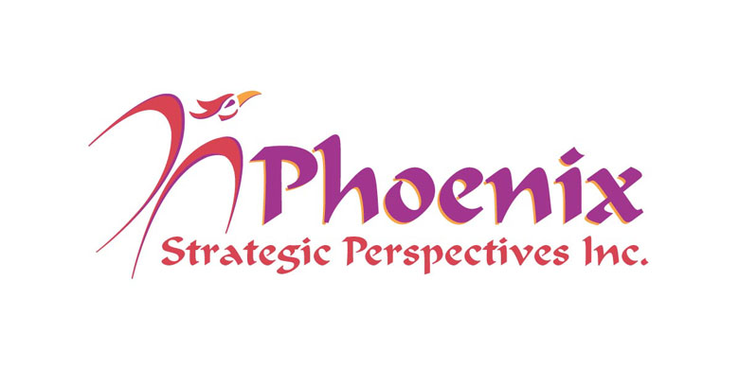

Phoenix Strategic Perspectives Inc.
1678 Bank Street, Ste. 2, Ottawa, Ontario K1V 7Y6
Tel: (613) 260-1700 Fax: (613) 260-1300 Email: info@phoenixspi.ca
www.phoenixspi.ca

Table of Contents

Executive Summary i

Introduction 1

Findings 2

Participant Characteristics 28

Demographic Differences 32

Appendices:
Questionnaire (English and French)

Executive Summary
- The Lake Superior Binational Working Group (WG) conducted a survey among residents of four north-western Ontario communities – Thunder Bay, Wawa, Marathon and Sault Ste. Marie – to better understand the attitudes and awareness of residents regarding sustainability and environmental issues both in general and with respect to the Lake Superior area. The survey was sent to residents by mail and 857 completed surveys were returned. This represents a response rate of 25%. The results can be considered to be accurate to within +/- 3.4%, 19 times out of 20.

- Residents identified a broad range of economic, environmental and social issues as the most pressing issues facing their community. Leading the way was the employment situation, identified by one-third of residents (33%). However, from a cumulative perspective, environmental issues were cited most often, with the prime focus on water (43%) and garbage-related issues (41%). Air pollution (18%) and health care (17%) were also identified by substantial numbers. As well, similar numbers identified a host of social (23%), economic (22%), and environmental issues (22%), with each specific issue within these broader categories identified by relatively small numbers.

- Residents were asked to identify the most important environmental issue affecting: 1) them and their household, 2) their community, 3) the Lake Superior basin, and 4) the province. Overall, the set of issues seen to be most relevant to each level or area tend to be relatively distinct. For instance, air and energy issues are top concerns when the focus is on the province as a whole, water issues when the focus is on the Lake Superior Basin, and water and garbage issues when the focus is on the community and the household. The greatest overlap in the priority mix is between the household and community.

- Three-quarters (74%) said they obtain their household drinking water from a municipal system – either one that draws water from Lake Superior or one using a well. However, a substantial number (13%) draw water directly from a lake or stream. Smaller numbers (5%) get their household water from a personal or shared well.

- 51% said that the quality of their household water has been tested in the past five years. Among the rest, 29% said it has not been tested, while 19% were uncertain.

- 81% said that they often (45%) or always (36%) conserve oil, gas, or electricity. Nearly all the rest said they sometimes do this (18%). However, when the focus is on water conservation, significantly fewer (60%) said they often (38%) or always (22%) conserve water (21% less than those who do this for oil, gas or electricity).

- 89% leave their household garbage by the road to be collected by garbage trucks. Substantial numbers also take some of it to a recycling centre (43%), use roadside collection for recycling materials (39%), or take garbage to a local landfill or transfer station (30%) (multiple responses accepted). Small numbers (5%) said they burn some of their garbage.

- Approximately half of surveyed residents (51%) think that at least a few households in their community burn some or all of their garbage, while an additional 6% think many households do this (43% think that no households in their community burn garbage).

- 73% said their community has a hazardous waste disposal program for things like batteries, solvents and pesticides, while 14% said their community does not and 13% were uncertain. Among residents who said their community has a hazardous waste disposal program, similar numbers said they always or often use it (39%) or rarely/never use it (34%). Just over one-quarter were in between, saying they sometimes use it.

- 62% of residents do not know if their community has implemented any watershed management plans for rivers or streams in their area. Just over one-quarter (27%) said their community has implemented such a plan, and 11% said that it has not. As well, 50% do not know if there are any land trusts or conservancies in their area. Among the remainder, most (43%) said that there were land trusts/conservancies, while 7% said there were not. It is important to note that many residents may not have understood what is meant by the term “watershed management plans”, and may have interpreted “land trusts or conservancies” to mean “parks”.

- Two-thirds were unaware (41%) or unsure (24%) about any government advisories in their area in the past year to limit consumption of fish due to contamination. Conversely, 35% indicated that they were aware of such government advisories. Among residents who were aware of government advisories to limit fish consumption, 54% said it had no effect on their consumption. However, 32% said they eat less fish as a result, while 4% stopped eating fish entirely (10% never ate fish and still do not).

- The reason cited most often to explain why people in their community might continue with behaviours that are bad for the environment is that it is inconvenient to change (60%). This was followed, at a distance, by similar numbers who focused on the belief that one person won’t make a difference (33%), people being too busy to change (31%), the belief that others aren’t changing so why should they (31%), and the perception that it’s someone else’s responsibility (29%) (multiple responses accepted).

- Below are results to a series of questions in which residents were asked to rate both their level of knowledge and level of concern on issues in four areas – water pollution, air pollution, land use, and health issues ( using a 7-point scale where 1 = not at all; 7 = extremely). In all these areas with the exception of health issues, residents tended to express the highest levels of concern on issues they felt they were most knowledgeable about, and the lowest levels of concern on issues that they acknowledged knowing relatively little about.
Water-Related Issues:
- A majority claimed at least moderate knowledge with respect to water conservation (53%), quantity (52%), and quality (52%). Smaller numbers (28-36%) claimed to be knowledgeable about each of the remaining issues: sewage treatment, storm-water run-off, septic systems, stream bank erosion, and agricultural and parking lot pollution.
- Personal concern about individual issues ranged from 42% to 81%, and was more likely to be strong than moderate. Leading the way was concern about water quality (81%), followed by conservation (70%), quantity (67%), sewage treatment (65%), and storm water run-off (51%). Fewer than half (42-46%) expressed concern on each of remaining issues.
Air-Related Issues:
- Only on one issue, energy consumption, did a majority of residents rate themselves as at least moderately knowledgeable (55%). Significantly less claimed to be knowledgeable about energy production (43%) and garbage burning (40%) as they relate to air quality. Those who did not claim to be knowledgeable were more likely to claim to have little-to-no knowledge (i.e. scores of 3 or less on the scale).
- A majority expressed concern with each of these air-related issues, and were much more likely to express strong than moderate concern. Concern was highest regarding energy consumption (78%), followed by energy production (71%), with majorities expressing strong concern on both of these issues (53-59%). Comparatively fewer expressed concern with garbage burning (58%).
Land Use Issues:
- Knowledge of individual land use issues ranged from 31-50%. On only two issues did half claim to be at least moderately knowledgeable: logging practices and wildlife habitat loss. For all other issues – shoreline development, mining activities, invasive exotic species, forest fragmentation, and urban sprawl – residents were more likely to admit lack of knowledge than to claim knowledge (particularly for the latter three issues).
- Residents were most likely to express concern about wildlife habitat loss (72%), with over half expressing strong concern. Following this were concern about logging practices (64%), invasive exotic species (61%), shoreline development (56%), and forest fragmentation (54%). Less than half expressed concern regarding mining activities (47%) and urban sprawl (43%).
Health Issues:
- Half the residents claimed to be at least moderately knowledgeable about hazardous waste, with just under half claiming moderate knowledge (or more) regarding pesticides (49%) and toxins (45%).
- The level of personal concern over individual health issues tended to be widespread and quite similar (78-81%), with approximately two-thirds expressing strong concern for each issue.

- Two issues topped the list as environmental issues residents would like to know more about: air pollution (22%) and water quality/pollution (21%). That said, cumulative interest in water-related issues is increased by interest in learning more about water supply/quantity (10%) and sewage/water treatment (4%). In total, just over one-third of residents would like to know more about water-related issues. Substantial numbers would like to know more about energy production (13%), logging practices (13%), food toxins (12%), and waste issues (12%).

- Residents prefer to learn about environmental issues through newspapers (68%) and television (64%). Significant numbers would also like to learn about them through the radio (40%) and websites (35%). Approximately one-in five indicated a preference for group presentations (20%) and workshops (19%).

Conclusions and Implications
Environmental issues tend to resonate with residents of these four Lake Superior Basin communities. Survey respondents raised such issues in the context of the top issues facing their community and did so with considerable frequency. Second only to key economic concerns – the general economic situation and unemployment problems – environmental issues were very much top-of-mind for surveyed residents. Cumulatively, the focus on issues related to the environment equalled all others combined. Some of this might be attributed to the fact that this was a self-administered survey on environmental issues. Nevertheless, the findings provide clear indication that environmental issues are important to residents of these communities.

Three sets of environmental issues tend to stand out among others – water, air and garbage issues. This is particularly true when the focus is on the resident’s household and community. Clearly, these environmental issues are close to home from the perspective of residents, and, as such, appear to have the biggest impact on their daily lives. Beyond this, a focus on water, air and garbage issues recurs time and again throughout the survey.

That said, the mix of environmental issues seen to be most relevant to each level or area (i.e. household, community, Lake Superior basin, province) tend to be relatively distinct. That is, a different mix of environmental concerns emerges as the focus or framework shifts. For instance, air and energy issues are top concerns when the focus is on the province as a whole, water issues when the focus is on the Lake Superior Basin, and air, water and garbage issues when the focus is on the community and the household. The greatest overlap in the priority mix is between the latter two levels – the household and community – where there is a greater degree of overlap relative to the other levels.

In addition to being something that residents give some thought to, the environment appears to be an issue that many try to do something about, at least to a certain extent. For example, most say they frequently or always engage in energy and water conservation (although fewer do the latter). Substantial numbers take their garbage to a recycling centre or use roadside recycling. Moreover, two-thirds of those who say their community has a hazardous waste disposal program say they use it at least sometimes. In short, community residents appear to embrace environmentally-friendly behaviours, at least with respect to some of the ‘basics’ (i.e. energy conservation, recycling).

On the other hand, knowledge levels appear to be relatively low. There is widespread uncertainty among residents regarding the existence of watershed management plans, land trusts or conservancies in their area, and whether there have been any government advisories in the past year about fish contamination and consumption. As well, surveyed residents acknowledged relatively low levels of knowledge for most of the environmental issues that were explored in this way. This included a majority of issues in all areas (i.e. water pollution, air pollution, land use, and health issues). Issues that residents claimed to be more knowledgeable about tended to be ‘macro’ issues (e.g. water conservation, water quality, energy consumption) or issues that have received considerable media coverage in recent years (e.g. logging practices, wildlife habitat loss). Issues of a very specific nature were invariably at the bottom of the list in terms of the knowledge levels of community residents.

Not surprisingly, the research suggests that knowledge of environmental issues is of relevance. As noted, there tends to be a relationship between knowledge of and concern about environmental issues. When asked to rate both their level of knowledge and concern on issues in four areas – water pollution, air pollution, land use, and health issues – residents tended to express the highest levels of concern on issues they felt they were most knowledgeable about, and the lowest levels of concern on issues that they acknowledged knowing relatively little about. The only exception was health issues. While this exception is noteworthy, it is not surprising. The health issues residents were asked about – hazardous waste, pesticides, toxins in food – convey by their very designation a negative connotation that can translate into significant concern about these issues regardless of knowledge about them. In summary, higher levels of knowledge and concern go hand in hand. What is less certain is whether greater knowledge leads to greater concern or vice versa, or indeed whether the relationship works in both directions.

In general, the fact that environmental issues tend to resonate with residents suggests that outreach programs and attempts to address gaps in awareness and knowledge of environmental issues can count on a certain degree of receptivity among residents. Moreover, the identification of a range of environmental, economic and social issues as pressing community issues provides a foundation for integrating or linking such considerations (i.e. showing the connection between them). The following should be kept in mind in any attempt to develop effective outreach programs:

- Use frames of reference people understand/relate to. Recall that when asked in an open-ended way what environmental issue they would like to know more about, the two issues mentioned most often were air pollution and water quality/ pollution. These frames of reference could be used as a basis for addressing gaps in awareness and knowledge. For example, garbage burning could be discussed within the framework of air quality/pollution, while sewage treatment could be placed within the framework of water quality. In addition, the top-of-mind focus of surveyed residents on water and garbage-related issues suggests that outreach activities targeting these two areas would resonate with residents, and that they would be receptive to proposed solutions designed to improve the situation or mitigate negative impacts from human behaviours.

- Different environmental issues resonate at different levels. As noted, the mix of environmental concerns tends to shift as the focus or framework shifts (i.e. household, community, basin, province). This suggests that outreach activities might be better received if they are linked to the areas or levels that residents most closely associate with each set of issues. For instance, education and other activities focused on dump/landfill sites would be linked to the community, garbage and recycling to the household (secondarily to the community), energy to the province as a whole, and so on. This is the way that residents tend to view the priority mix, so communicating with them from this perspective could be expected to resonate more effectively.

- Importance of inconvenience for explaining behaviour that is bad for environment: To the extent that outreach activities are intended to influence behaviour, it should be kept in mind that residents overwhelmingly cited inconvenience as the reason people continue activities that are bad for the environment (not lack of knowledge). In other words, raising awareness and disseminating knowledge are necessary but not sufficient for altering environmentally-unfriendly activities. With this in mind, outreach activities should highlight whenever possible the ease or facility of undertaking certain environmentally-friendly activities. They should also strive to make the changed behaviours as convenient as possible to undertake.

- Consider resident preferences for receiving information: Serious attention should be given to residents’ preferred methods for receiving information about environmental issues. The strong preference for newspapers and television suggests that residents prefer methods that bring the information to them as opposed to methods that require them to go to the information. Methods such as workshops, group presentations, and even websites to a certain extent, require that people “go to” the information and are therefore more apt to be perceived as involving effort and inconvenience.

- Draw links between the environment and health. In light of the importance of health issues among community priorities and the high degree of concern expressed over health-related environmental issues, connections between environmental issues and health could form an effective basis for outreach activities.

We offer the following additional observations relevant to outreach initiatives:
- While convenience does matter, the relationship between levels of knowledge and concern suggest that outreach efforts should strive to increase levels of knowledge of key environmental issues, which could be expected to contribute to higher levels of concern. This, in turn, would provide a motivational base to encourage appropriate action on the part of residents.
- The findings of this and other research indicate that many Canadians tend to think of environmental issues in global or general terms. In this survey, for instance, residents tend to express greater knowledge about, and concern for, environmental issues of a general nature, such as air and water quality/pollution; they express less knowledge/concern regarding more specific issues (e.g. storm water run-off, stream bank erosion, forest fragmentation). This suggests that efforts to communicate with and inform residents about very specific environmental issues may be more problematic and less certain of success. This suggests the need to limit the number of complex issues to the highest priorities (i.e. set priorities for outreach efforts as they relate to highly specific issues, and limit the number of these).
- The significant difference in the proportions of residents that engage in energy vs. water conservation suggests that linking the two may be of some value. That is, build on the attentiveness that residents exhibit to energy conservation in efforts to encourage more water conservation (e.g. some form of ‘People in our community are doing a good job conserving energy. It is time to make the same efforts to conserve our water supply’). It is likely that residents are less sensitized to the need for water conservation, since efforts to encourage energy conservation have a considerably longer history in Canada. However, it is important to understand that there are greater cost implications in energy than water conservation for specific households, and that financial savings is a key motivator.
- There is a considerable gap in the proportion of residents that say they burn at least some of their garbage and respondents’ perceptions that this is being done with some regularity by community residents. Moreover, knowledge about garbage burning ranked lowest of all air pollution issues, with large numbers acknowledging low levels of knowledge. This would appear to be an area where outreach activities could focus to raise awareness of the impact that burning garbage has on the quality of the air, and of available alternatives to burning waste.
- The finding that half of surveyed residents that were aware of a government advisory to limit fish consumption due to toxic contamination did not change their consumption habits speaks to the limitations of government advisories. It would appear that these people were aware of the notice but chose to disregard it. This underscores the importance in outreach activities of educating residents about health and environmental issues, not just informing or warning them.
- Beyond inconvenience, the potential barrier to action that resonated most widely involved environmental action being a personal vs. collective responsibility – one person not making a difference, other aren’t doing it, so why should they, or it being someone else’s responsibility. This highlights the need to address this issue in communications messages.

Introduction
The Lake Superior Binational Working Group (WG) wanted to better understand the attitudes and awareness of residents of Lake Superior. To this end, it conducted a survey among residents of four north-western Ontario communities. The results of the survey are intended to be used by the Working Group’s committees (chemical, terrestrial, aquatic, habitat, developing sustainability, and communications) to develop outreach programs. These would address gaps in knowledge and awareness revealed by the survey, and would foster improved decision-making that integrates social, economic, and environmental considerations.

Accordingly, the main objectives of the survey were to:
- Determine the state of knowledge and awareness of the residents of Thunder Bay, Wawa, Marathon and Sault Ste. Marie regarding sustainability and environmental issues in general, and with respect to the Lake Superior area; and
- Determine how to best address any gaps in awareness and knowledge.

The data collection, data entry and coding for this survey were undertaken directly by members of the Lake Superior Working Group. Data collection was undertaken using a mail survey, which was sent out between March 24 and April 2, 2004. Completed surveys were accepted until the beginning of June. Phoenix Strategic Perspectives Inc. was commissioned to analyze the data and prepare five reports – an overall, aggregate report and four community-specific reports. This report (aggregate report) presents the overall, combined results for all four communities. The community-specific reports are available under separate cover.

In total, 857 completed surveys were returned. This represents a response rate of 25% (4,048 surveys were distributed, but 624 of these were returned as ‘undelivered’). The results can be considered to be accurate to within +/- 3.4%, 19 times out of 20. The characteristics of survey respondents are described in this report, and are compared with available Statistics Canada 2001 census data (see section titled Participant Characteristics).

For editorial purposes, the terms ‘respondents’ and ‘residents’ will be used interchangeably to denote survey respondents. Appended to this report is a copy of the questionnaire (English and French).

Note on Presentation of Findings:

At times throughout this report, results have been ‘grouped’ so as to present a range of responses. This can take two forms:
- The first groups similar proportions of respondents identifying different issues (e.g. “similar numbers, X-Y%, identified issues A, B, and C”).
- The second provides the range of respondents answering in a certain way (e.g. “the proportion of respondents claiming knowledge of A [e.g. different water-related issues] ranged from X-Y%).

Findings

Top Issues Facing Community
Residents identified a broad range of economic, environmental and social issues, both general and specific, when asked to identify the three most pressing issues facing their community. Leading the way was the employment situation, identified by one-third of all respondents. Other pressing economic issues were seen to include the cost-of-living, including the cost of energy, electricity and taxes (16%) and the availability/production of energy (7%).

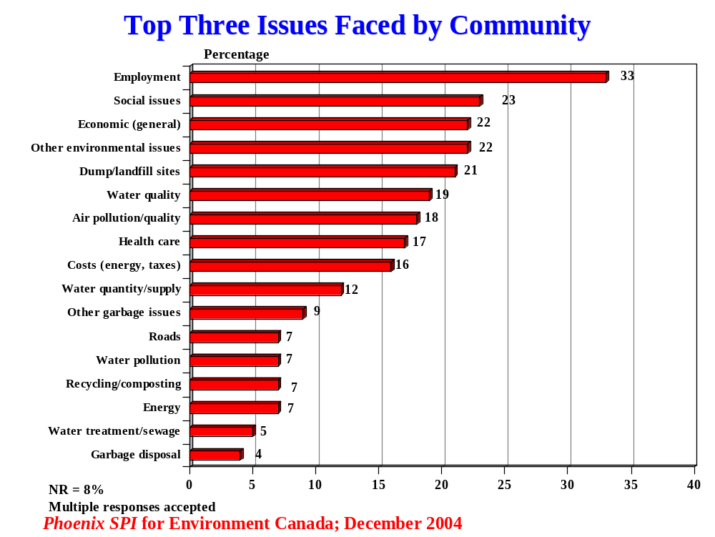
Environmental issues were cumulatively (i.e. as a group) cited most often. The focus tended to be primarily and almost equally on water (43%) and garbage-related issues (41%). The only specific environmental issue identified by substantial numbers that was not related to water or garbage was air pollution (18%). Disposal in dump/landfill sites was the main garbage-related issue (21%), followed by recycling/composting (7%), and disposal in general (4%). Other garbage-related issues (9%) included garbage in general, burning, and hazardous waste. Water quality led the way among water-related issues (19%). This was followed by water supply/quantity issues, which included things like water shortages, levels, conservation and water management (12%). Other water issues included water pollution (7%) and issues related to treatment and sewage (5%).

The only specific social issue identified by substantial numbers was health care (17%), followed at a distance by road-related issues (7%).

Similar numbers identified a host of social (23%), economic (22%), and environmental issues (22%). These issues, identified broadly as ‘social issues’, ‘economic (general)’, and ‘other environmental issues’, include issues of a general nature or specific issues grouped together because they were identified by small numbers. For instance,
- Included in the ‘other environment’ category are toxins, noise, destruction of ecosystems, pollution in general, mills, habitat, population/numbers, mining, pesticides, and logging;
- Included in the ‘social’ category are education, land use, and smoking by-law, and social issues in general; and
- Included in the ‘economic’ category are economic development, the decreasing tax base, mine closure, the declining population, and attracting new business.

Note that residents focussed on environmental issues prior to being asked about them specifically (i.e. in the context of the top issues faced by their community). Even though this was a self-administered survey, which respondents knew was focussed on environmental issues, this nevertheless suggests that environmental issues are important relative to other perceived priorities in these communities.

Most Important Environmental Issues
Residents were asked to focus specifically on the environment and to identify the most important environmental issue that affects them and their household, their community, the province, and the Lake Superior basin respectively.

When focussing on themselves and their household, respondents most often identified air quality/pollution and water quality/pollution as the top environmental issue that affects them (16% each). Issues related to water (27%) and garbage (22%) were cumulatively most important and similarly likely to be identified. The most important water-related issue was water quality/pollution (16%), followed by water supply/quantity issues (7%), and issues related to treatment and sewage (4%). Recycling/composting was the single most important garbage-related issue (10%), followed by a host of other garbage-related issues, including garbage in general, disposal, burning, hazardous waste (8%), and dumps/landfill sites (4%). A host of other environmental issues were also identified (16%), including toxins, noise, mills, logging, mining, food, pesticides, and global warming.

Just over one-quarter (27%) of surveyed residents did not provide a response to this question.
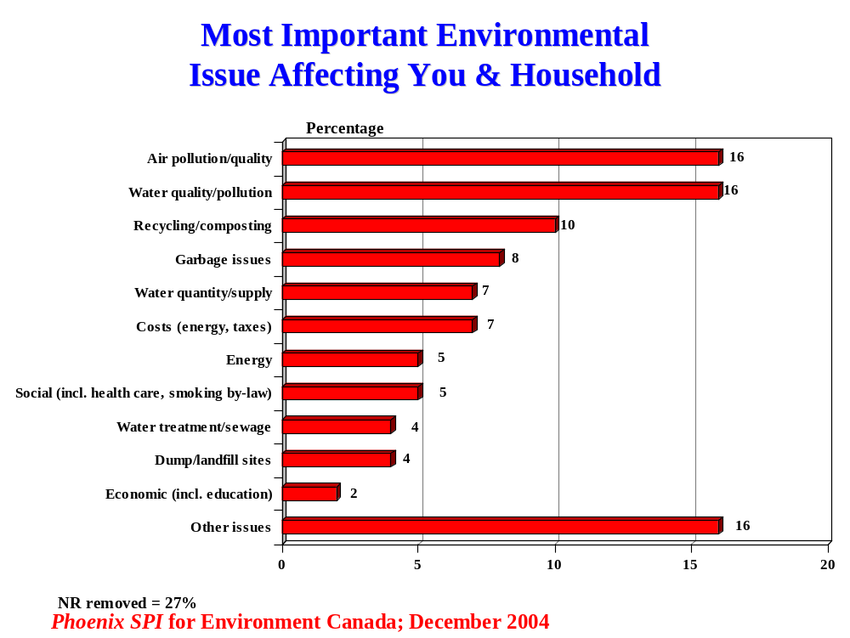

At the community level, garbage-related issues increase in relevance and importance as environmental issues. In addition to dumps/landfill sites, the issue identified most often (18%), this includes a host of issues such as garbage in general, disposal, hazardous waste, and recycling/composting (8%). Water-related issues are second in importance and only slightly less important than at the household level. Nearly one-quarter identified water-related issues, including water quality/pollution (13%), water supply/quantity (6%), and treatment/sewage issues (4%). Air pollution/quality remains an important issue at the community level (15%). A host of other environmental issues were identified, each by relatively small numbers, including toxins, noise, mills, logging, road salt, pesticides, and pollution from roads and transportation.

One-in-five (21%) provided no response to this question.

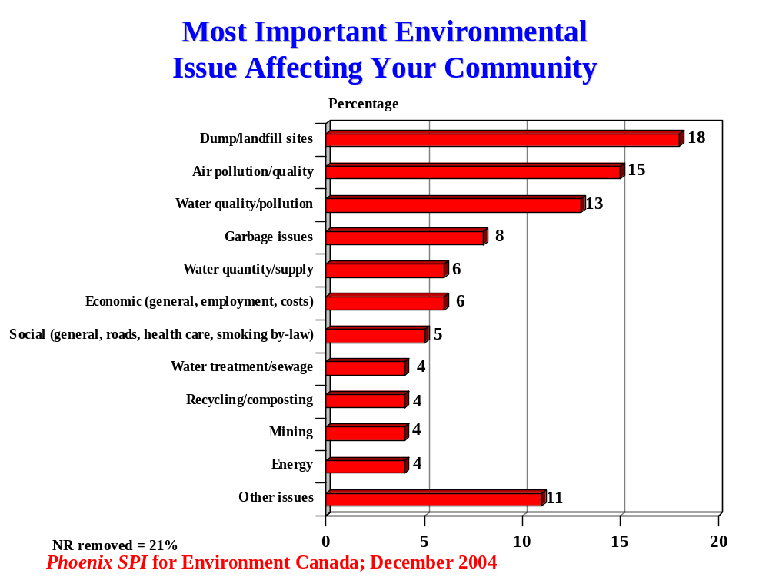
When the focus is on the Lake Superior basin, water-related issues emerge undisputedly as the most important environmental issues. Nearly half identified water-related issues, including water quality/pollution (27%) and water supply/quantity (18%). All other issues were identified by relatively small numbers, although garbage-related issues again do have some prominence (cited by 9% in total). Air pollution is viewed as considerably less important in relation to the Lake Superior basin (3%).

Included in the ‘other’ category are a host of issues, including toxins, noise, destruction of ecosystems, pollution in general, mills, population, mining, and global warming.

Thirty percent of respondents did not provide a response to this question.

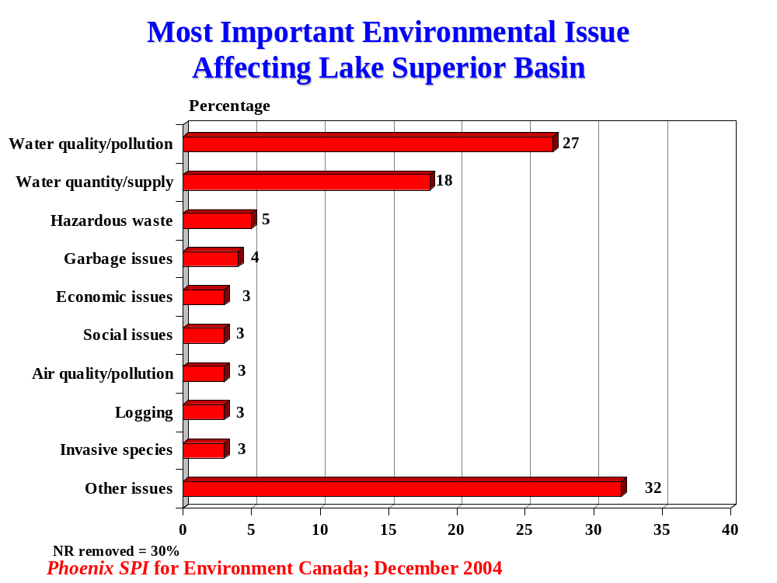

Residents think air pollution is the most important environmental issue at the provincial level, with nearly one-quarter (23%) identifying it as such. When the focus is province-wide, air pollution is considered a more important environmental issue than water-related issues (17%) and garbage-related issues (11%), which was not the case at the household, community and Lake Superior Basin levels. A substantial number (16%) identified energy as the most important environmental issue at the provincial level.

A host of other environmental issues was identified by small numbers, and are included in the ‘other’ category, including toxins, noise, the destruction of ecosystems, pollution in general, pesticides, mills and global warming.

Close to three in ten (28%) did not provide a response to this question.

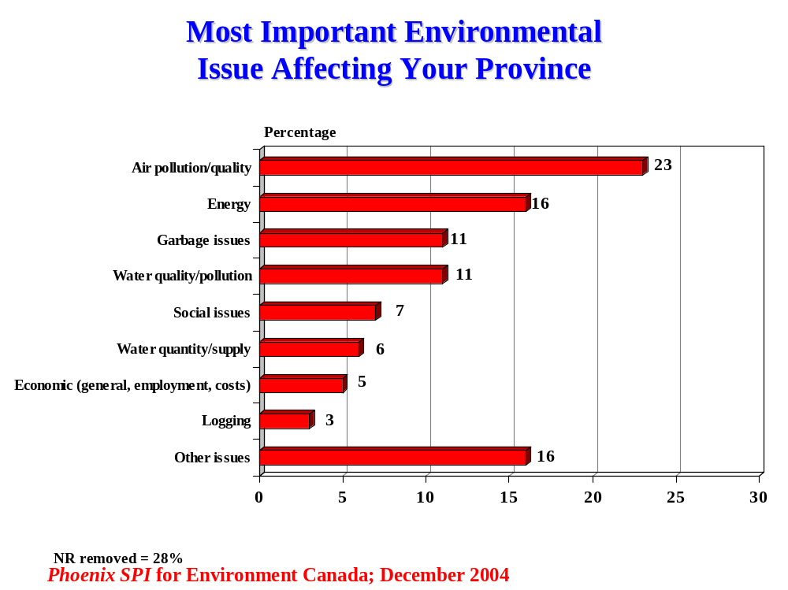

Comparison of Top Environmental Issues
The following table compares the importance attributed to various environmental issues at the household, community, Lake Superior basin, and provincial levels. Note the increased importance of water-related issues when the focus is on the Lake Superior basin (45% vs. 17-23% elsewhere). Note in particular the increased importance of the issues of water supply/quantity (18% vs. 6-7% elsewhere) and water quality/pollution (27% vs. 11-16% elsewhere).

Overall, it is worth noting that the set of issues seen to be most relevant to each level or area (i.e. household vs. community, etc.) tend to be relatively distinct. That is, a different mix of environmental concerns emerges as the focus shifts. For instance, air and energy issues are top concerns when the focus is on the province as a whole, water issues when the focus is on the Lake Superior Basin, and water and garbage issues when the focus is on the community and the household. The greatest overlap in the priority mix is between the latter two levels – the household and community, where there is a greater degree of overlap relative to the other levels.

Issue | You & Household | Community | Lake Superior Basin | Province
Air Quality/ Pollution | 16% | 15% | 3% | 23%
Water Quality/Pollution | 16% | 13% | 27% | 11%
Garbage issues | 8% | 8% | 4% | 11%
Recycling/Composting | 10% | 4% | - | 2%
Water Quantity/Supply | 7% | 6% | 18% | 6%
Costs (energy, taxes) | 7% | 2% | - | 2%
Energy | 5% | 4% | - | 16%
Dump/Landfill sites | 4% | 18% | 1% | 2%

Three-Quarters Draw Household Drinking Water From Municipal Systems
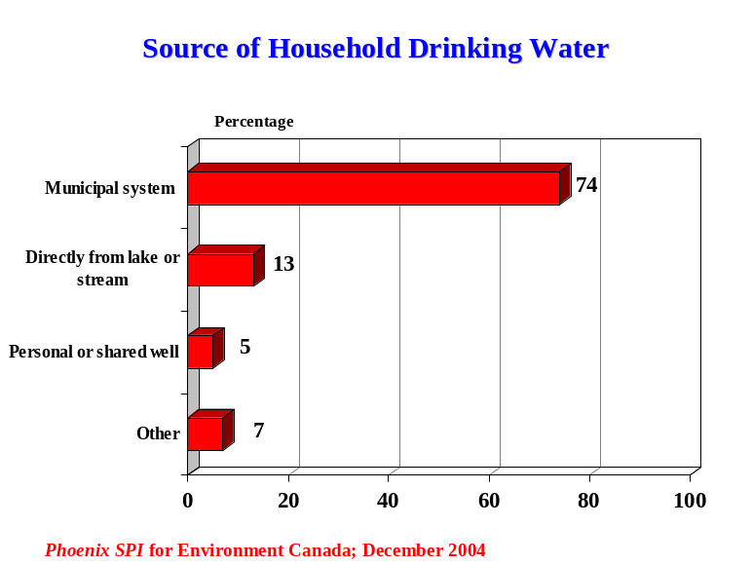Three-quarters of surveyed residents obtain their household drinking water from a municipal system – either a system that draws water from Lake Superior or one using a well. However, a substantial number (13%) draw water directly from a lake or stream. Smaller numbers (5%) get their household water from a personal or shared well.

The questionnaire had two choices for households on municipal systems – drawing Lake Superior water or using wells. Responses from households on municipal systems in towns or cities drawing from reservoirs or other lakes were obliged to select the “Other” category, hence the “Other” category is higher than may be expected. Included in the ‘other’ category are purchased or store-bought water, delivered bottled water, underground aquifiers, ground water, filtration plant, spring water, Loch Lomond, Lake Superior and a well, and Wawa Lake.
Half Say Household Water Has Been Tested in Past 5 Years
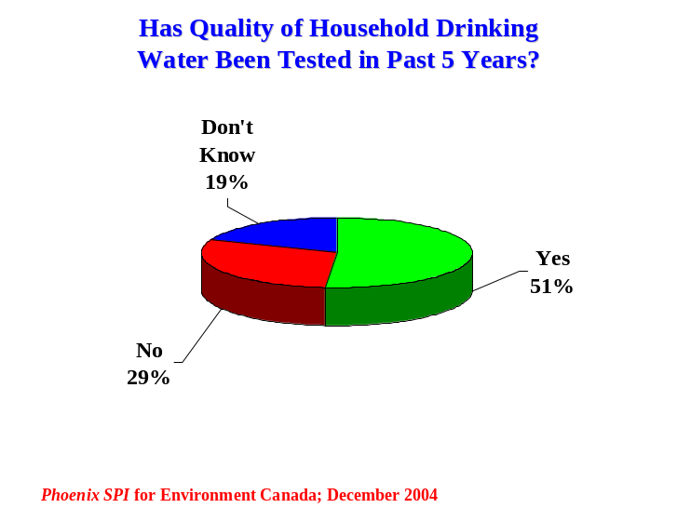Just over half the residents of the area (51%) said that the quality of their household water has been tested in the past five years. Among the rest, 29% said it has not been tested, while 19% were uncertain.

Widespread Conservation of Oil, Gas & Electricity, Less so for Water
The large majority (81%) of residents said that they often (45%) or always (36%) conserve oil, gas, or electricity. Nearly all the rest said they sometimes do this (18%).
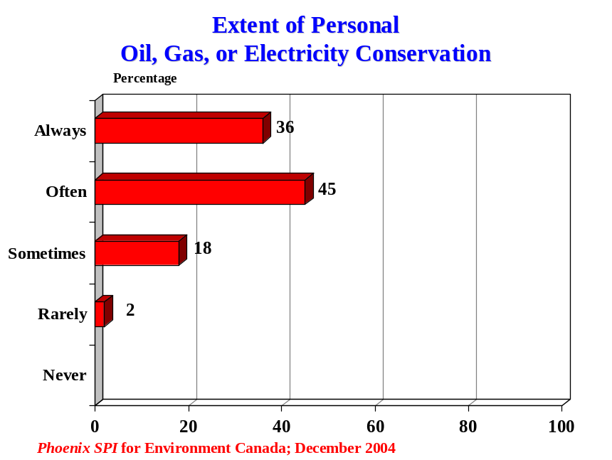

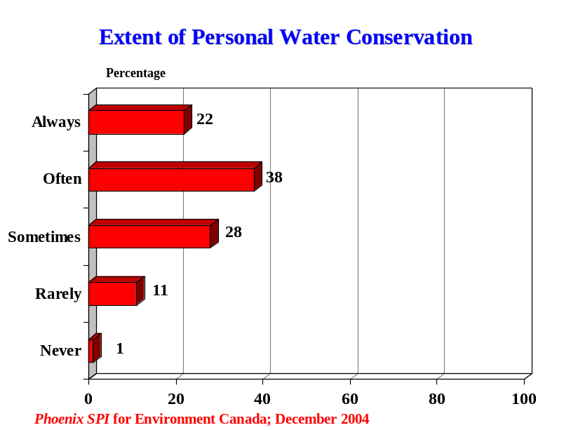When asked the same question about water, 60% indicated that they often (38%) or always (22%) conserve water. Note that this is 21% less than those who do this for oil, gas or electricity.

Among those remaining, over one-quarter of surveyed residents said they sometimes conserve water (28%), while 12% said they rarely or never do this.

Vast Majority Use Roadside Collection for Garbage, Other Methods Also Common
The vast majority of surveyed residents leave their household garbage by the road to be collected by garbage trucks (89%). That said, a substantial number also use other methods, such as taking some of it to a recycling centre (43%), using roadside collection for recycling materials (39%), or taking garbage to a local landfill or transfer station (30%) (multiple responses accepted).
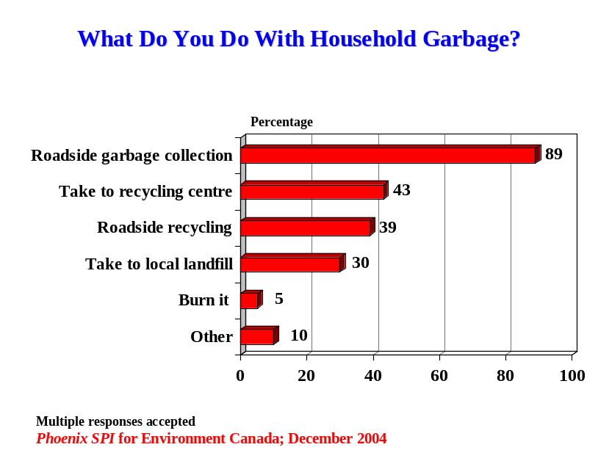

Small numbers (5%) said they burn garbage. Composting is the activity identified most often in the ‘other’ category. Also included in the ‘other’ category is taking garbage to Thunder Bay, taking it to Sault Ste. Marie, putting it in a dumpster, and recycling some and putting the rest by the road.

Burning Garbage Perceived to be Relatively Widespread
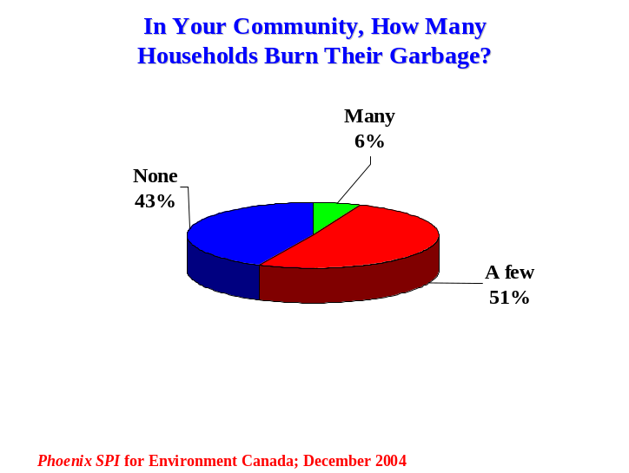When asked about how many households in their community burn some or all of their garbage, in their view, approximately half of surveyed residents (51%) think that at least a few households in their community burn their garbage, while an additional 6% think many households do this. Conversely, 43% think that none of the households in their community burn garbage.

Clearly, there is a significant gap between surveyed residents that acknowledge burning some of their garbage (5%) compared to the proportion perceived to do this (57%).

Almost Three-Quarters Say Community Has Hazardous Waste Disposal Program
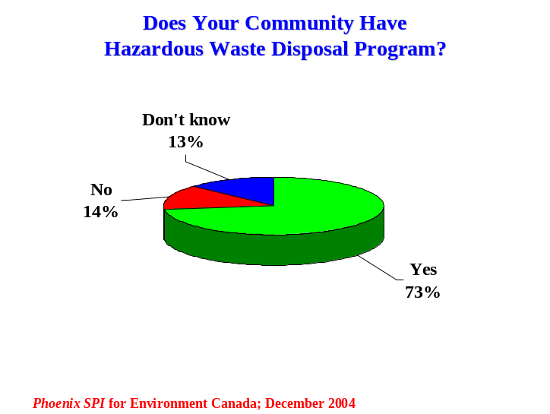Nearly three-quarters (73%) said their community has a hazardous waste disposal program for things like batteries, solvents and pesticides. Among the rest, 14% indicated that their community does not have such a program, while 13% were uncertain.

Use of Hazardous Waste Programs Varies Considerably
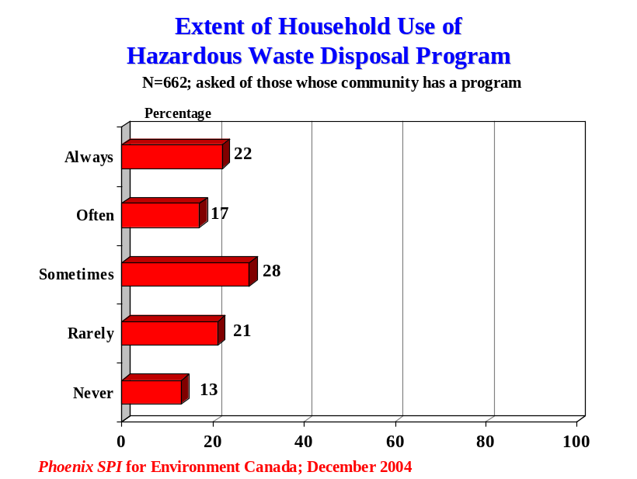Residents who said their community has a hazardous waste disposal program (n= 662) were asked to what extent their household uses it. Residents were divided in terms of their usage, with similar numbers saying they always or often use it (39%) or rarely/never use it (34%). Just over one-quarter were in between, saying they sometimes use it.

Widespread Uncertainty About Community Watershed Management Plans
There is widespread uncertainty about implementation of watershed management plans in the area. When asked if their community has implemented any watershed management plans for rivers or streams in their area, 62% of residents said they did not know. Just over one-quarter (27%) said their community has implemented such a plan, and 11% said that it has not.
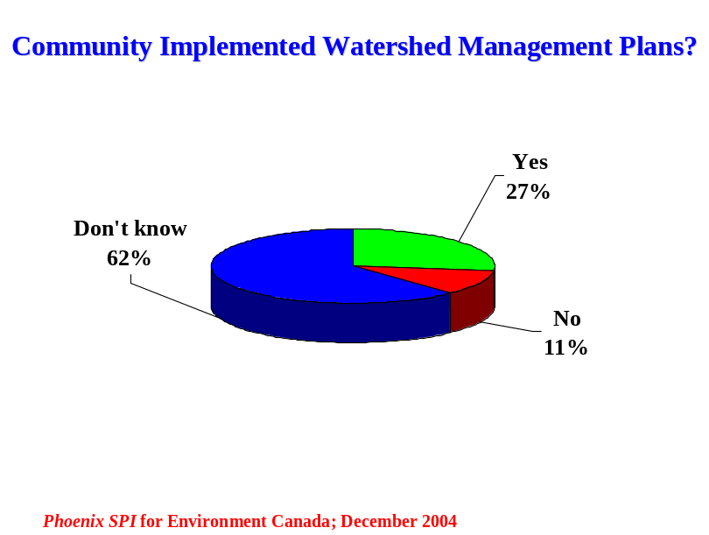

It is important to note that many residents may not have understood what is meant by the term “watershed management plans”.

Many Unsure About Existence of Land Trusts or Conservancies
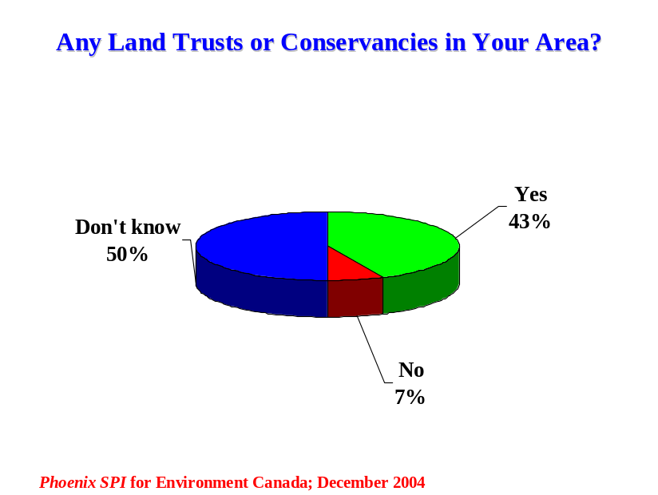Exactly half of the surveyed residents said they do not know if there are any land trusts or conservancies in their area. Among the remaining half, most (43%) said that there were land trusts or conservancies, while 7% said there were not. As with the previous question, there may have been some misunderstanding as to what was meant by this question.

Numerous residents may not have understood what is meant by the terms “land trusts or conservancies” and may have interpreted this to mean “parks”.

Two-Thirds Unaware or Unsure About Government Advisories Regarding Fish
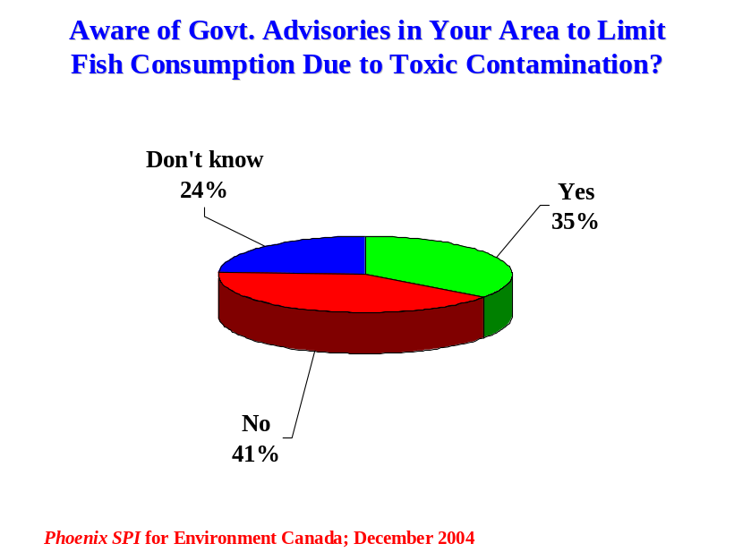When asked if in the past year they were aware of any government advisories in their area to limit consumption of fish due to contamination, 41% of residents said that they were not aware of this, with a further 24% saying they did not know. In total, therefore, two-thirds (65%) were unaware or unsure about any government advisories on fish consumption. Conversely, 35% indicated that they were aware of such government advisories.

Fish Advisories Have Limited Impact
Residents who were aware of government advisories in their area to limit consumption of fish (n= 291) were asked to what extent it affected the amount of fish they eat. Just over half (54%) said it had no effect on their consumption of fish. However, 32% said they eat less fish as a result, while a few (4%) said they stopped eating fish entirely. A total of 10% said they never ate fish and still do not.

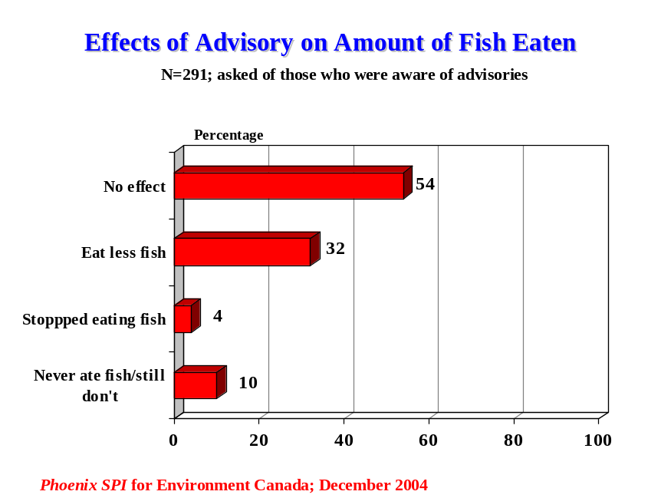

Inconvenience – Main Reason for Behaviours That Hurts Environment
The reason cited most often to explain why people in their community might continue with behaviours that are bad for the environment is that it is inconvenient to change. This was identified by 60% of respondents. It was followed, at a distance, by similar numbers who focused on the belief that one person won’t make a difference (33%), people being too busy to change (31%), the belief that others aren’t changing so why should they (31%), and the perception that it’s someone else’s responsibility (29%) (multiple responses accepted).
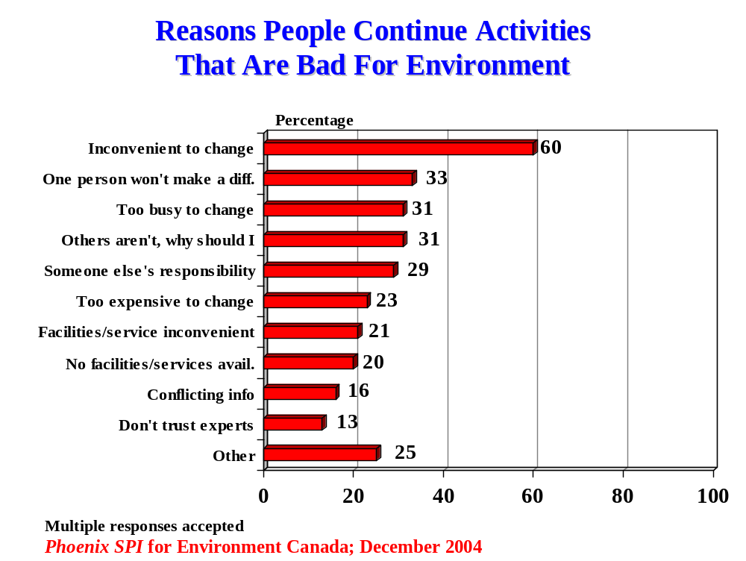

Between one-fifth and one-quarter identified a number of other reasons: cost (i.e. it is too expensive to change), the fact that facilities/services are inconvenient to use, and perceptions that such facilities are not available. A smaller number of surveyed residents identified information-related reasons, including the existence of conflicting information (16%) and a lack of trust in the “experts” (13%).

Included in the ‘other’ category are a lack of care/concern, thoughtlessness, lack of education, habit, inability to see the big picture, unwillingness to pay costs associated with not doing these activities, lack of pressure/consequences, laziness, a perception that big industry is the main culprit, and the cold weather (i.e. as an explanation for why people let their car idle).
Knowledge and Concern

For the next series of questions, residents were asked to rate both their level of knowledge and level of concern on issues in four areas – water pollution, air pollution, land use, and health issues. To do this, they were asked to use a 7-point scale (1 = not at all; 7 = extremely). The results follow.

Water-Related Issues
Residents were asked to rate their level of knowledge and personal concern with the following water-related issues:
- Water quality.
- Water quantity.
- Septic systems.
- Sewage treatment.
- Storm water runoff.
- Stream bank erosion.
- Water conservation.
- Pollution form agriculture.
- Pollution form parking lots.

In terms of knowledge, the proportion of surveyed residents claiming to be at least moderately knowledgeable on individual issues (scores of 5 or more) ranged from 28% to 53%. A majority claimed at least moderate knowledge with respect to three issues: water conservation (53%), water quantity (52%), and water quality (52%).
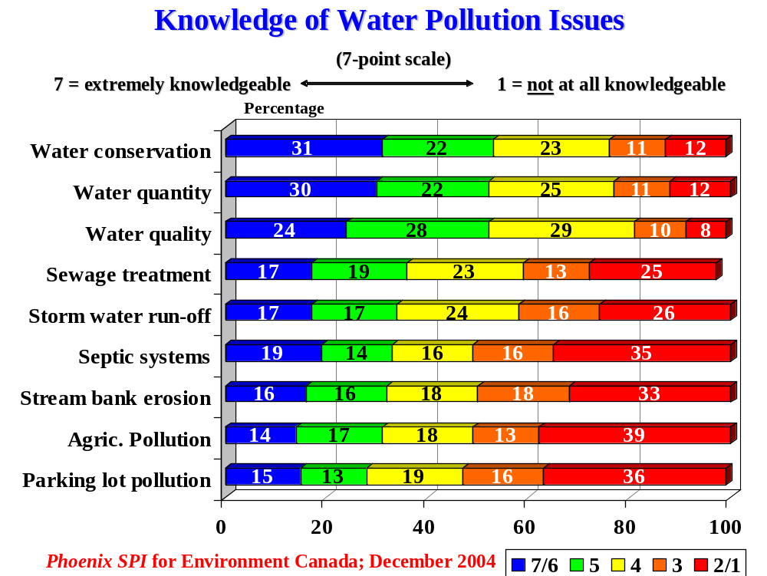
Smaller and roughly similar numbers (28-36%) claimed to be knowledgeable about each of the remaining issues, with almost equal numbers claiming strong and moderate knowledge. For all these other issues, residents were more likely to admit lack of knowledge than to claim knowledge. This was especially the case for septic systems, stream bank erosion, and agricultural and parking lot pollution, where a majority of residents (51-52%) indicated that they had little to no knowledge.

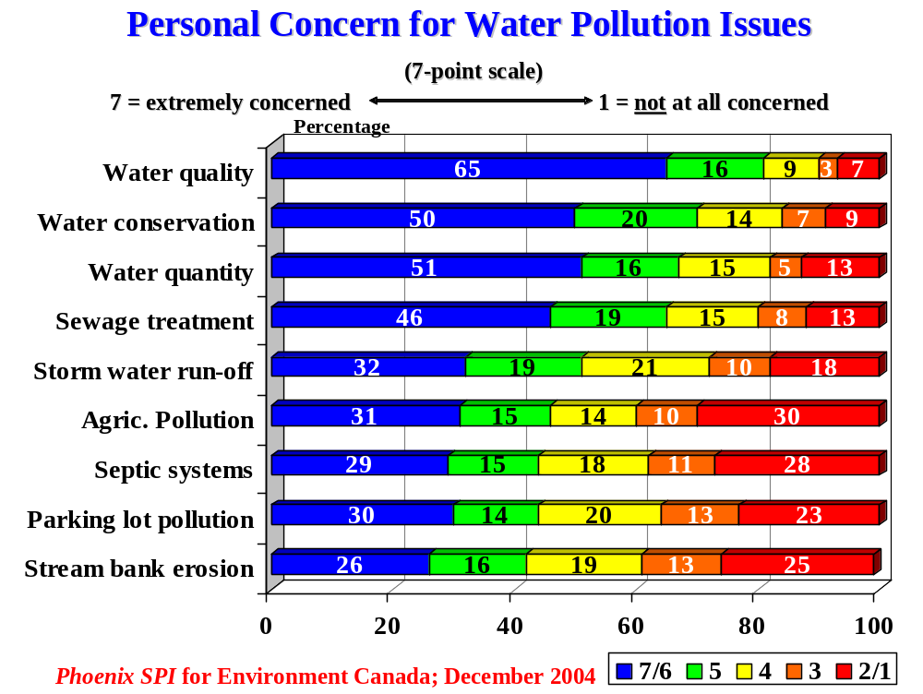Personal concern about individual issues ranged from 42% to 81%. Moreover, those who expressed concern were more likely to express strong than moderate concern. Leading the way was concern about water quality (81%), with two-thirds expressing strong concern. This was followed by concern with water conservation (70%), quantity (67%), sewage treatment (65%), and storm water runoff (51%).

Fewer than half (between 42-46%) expressed concern on all remaining issues, although residents were more likely to be concerned than not on all these issues.

Lack of concern ranged from 10-40%. It was highest with respect to the same four issues that people claimed to know the least about: septic systems, stream bank erosion, and agricultural and parking lot pollution.

The accompanying table compares the perceived level of knowledge in each area (scores of 5-7) with the level of concern (scores of 5-7), and shows the gap between the two.

Water-Related Issues
Issue | Knowledge  % | Concern  %
Water conservation | 53% | 70%
Water quality | 52% | 81%
Water quantity | 52% | 67%
Sewage treatment | 36% | 65%
Storm water run-off | 34% | 51%
Septic systems | 33% | 44%
Stream bank erosion | 32% | 42%
Agricultural pollution | 31% | 46%
Parking lot pollution | 28% | 44%

Interestingly, respondents tend to express the highest levels of concern on issues they feel they are most knowledgeable about, and the lowest levels of concern on issues that they acknowledge knowing relatively little about.

Air-Related Issues
Residents were asked to rate their level of knowledge and personal concern regarding the following air pollution issues:
- Energy production.
- Energy consumption.
- Garbage burning.

Only on the issue of energy consumption did a majority of residents rate themselves as at least moderately knowledgeable (55%). Significantly less claimed to be knowledgeable about energy production (43%) and garbage burning (40%) as they relate to air quality. Those who did not claim to be knowledgeable were more likely to claim to have little to no knowledge (i.e. scores of 3 or less on the scale).

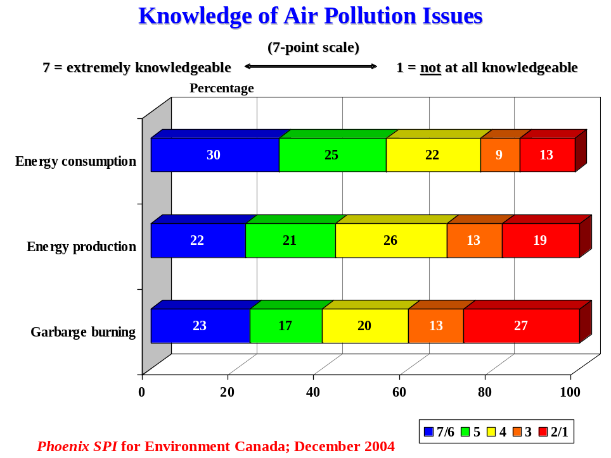

In terms of personal concern, a majority of residents expressed concern with each of these issues, and they were much more likely to express strong than moderate concern with all of them.

Concern was highest regarding energy consumption (78%), followed by energy production (71%), with majorities expressing strong concern for these issues (53-59%). Comparatively fewer expressed concern with garbage burning (58%).

Lack of concern ranged from 10-27%, and was highest with respect to garbage burning.

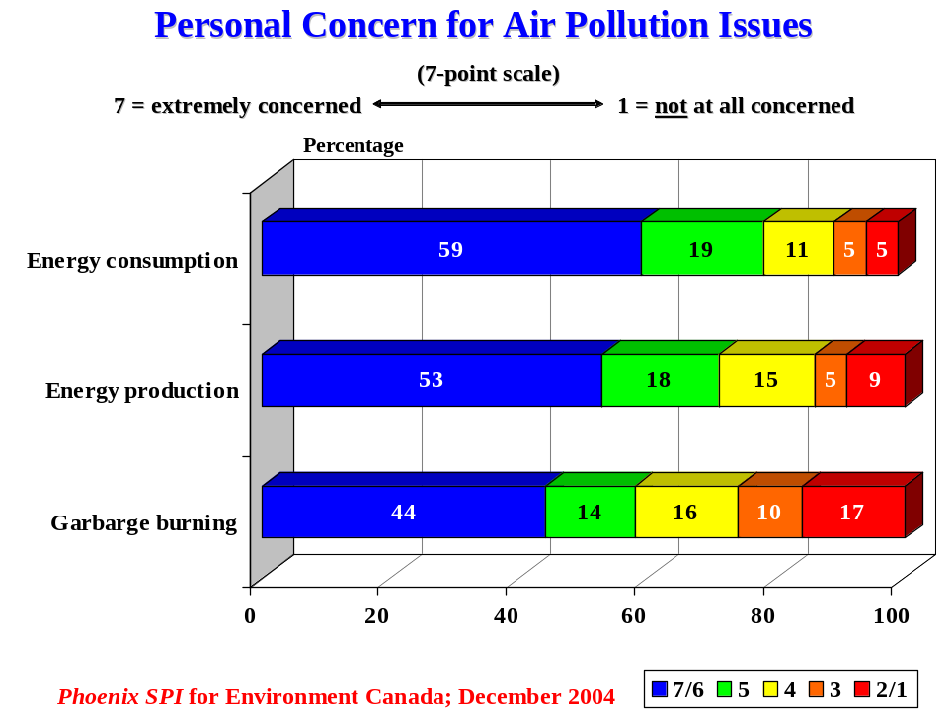

The accompanying table compares the perceived level of knowledge in each area (scores of 5-7) with the level of concern (scores of 5-7).

Air-Related Issues
Issue | Knowledge  % | Concern  %
Energy consumption | 55% | 78%
Energy production | 43% | 71%
Garbage burning | 40% | 58%

Once again, there appears to be a link between levels of knowledge and levels of concern.

Land Use Issues
Residents were asked to rate their level of knowledge and personal concern with the following land use issues:
- Mining activities.
- Logging practices.
- Wildlife habitat loss.
- Invasive exotic species.
- Forest fragmentation.
- Urban sprawl.
- Shoreline development.

Knowledge of individual issues ranged from 31-50%. On only two issues did half of the respondents claim to be at least moderately knowledgeable: logging practices and wildlife habitat loss. For all other issues, residents were more likely to admit lack of knowledge than to claim knowledge. This was especially the case for invasive exotic species, forest fragmentation, and urban sprawl, where a majority admitted having little-to-no knowledge. Moreover, they were more than twice as likely to admit to a complete lack of knowledge on these three issues.

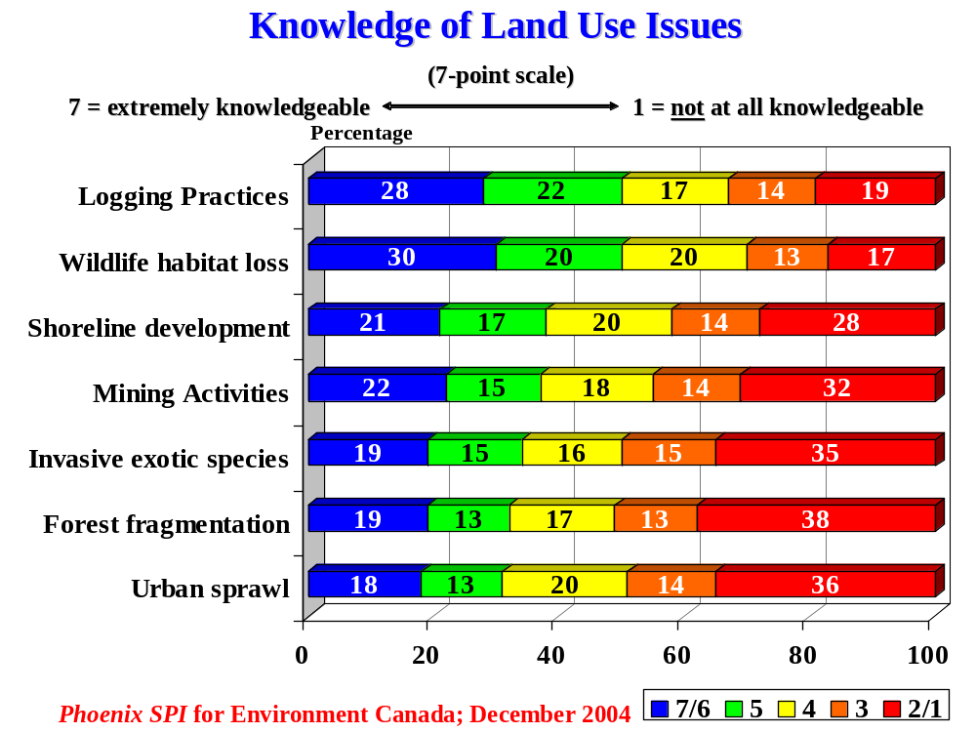

The level of concern with respect to individual issues ranged from 43-72%. Residents were most likely to express concern with wildlife habitat loss (72%), with over half expressing strong concern. Following this were concern about logging practices (64%), invasive exotic species (61%), shoreline development (56%), and forest fragmentation (54%).

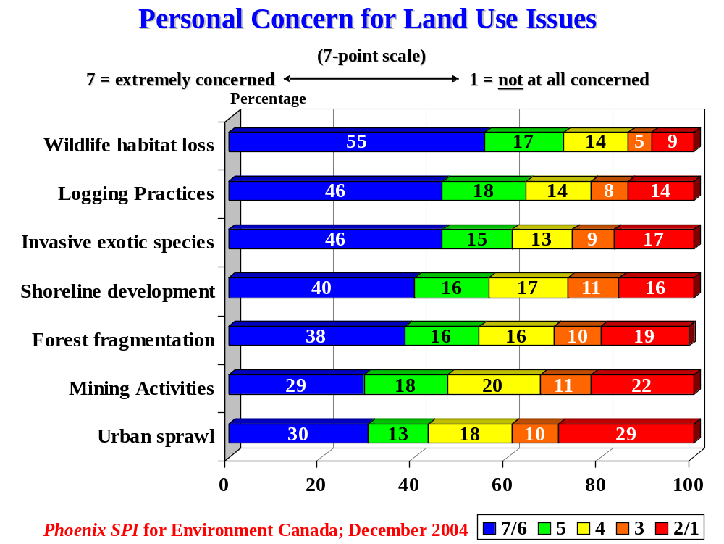
Less than half expressed concern regarding mining activities (47%) and urban sprawl (43%), but residents were still more likely to express at least moderate concern than a lack of concern on these issues.

Lack of concern ranged from 14-39%, and was highest regarding urban sprawl (39%).

The accompanying table compares the perceived level of knowledge in each area (scores of 5-7) with the level of concern (scores of 5-7), and shows the gap between the two.

Land-Related Issues
Issue | Knowledge  % | Concern  %
Wildlife habitat loss | 50% | 72%
Logging practices | 50% | 64%
Shoreline development | 38% | 56%
Mining activities | 37% | 47%
Invasive exotic species | 34% | 61%
Forest fragmentation | 32% | 54%
Urban sprawl | 31% | 43%

While not as strong as with water-related issues, there is nevertheless a relationship between levels of knowledge and concern, where respondents express greater concern on issues that they feel they are more knowledgeable about, and less concern on issues that they know less about.

Health Issues
Finally, surveyed residents were asked to rate their level of knowledge and concern with the following health-related environmental issues:
- Hazardous waste.
- Toxins in food.
- Pesticides.

Exactly half of the residents claimed to be at least moderately knowledgeable about hazardous waste, with just under half claiming moderate knowledge (or more) regarding pesticides (49%) and toxins (45%).

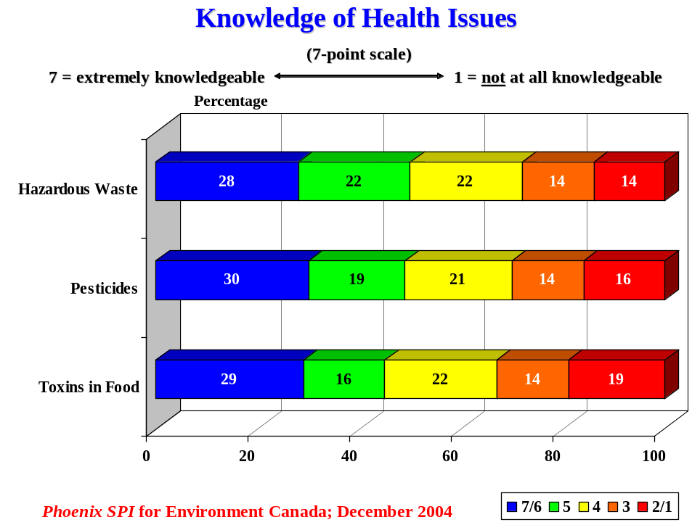

The level of personal concern over these issues tended to be widespread and quite similar (78-81%), with approximately two-thirds expressing strong concern for each one. Those who were not concerned were almost equally divided between indifference and lack of concern.

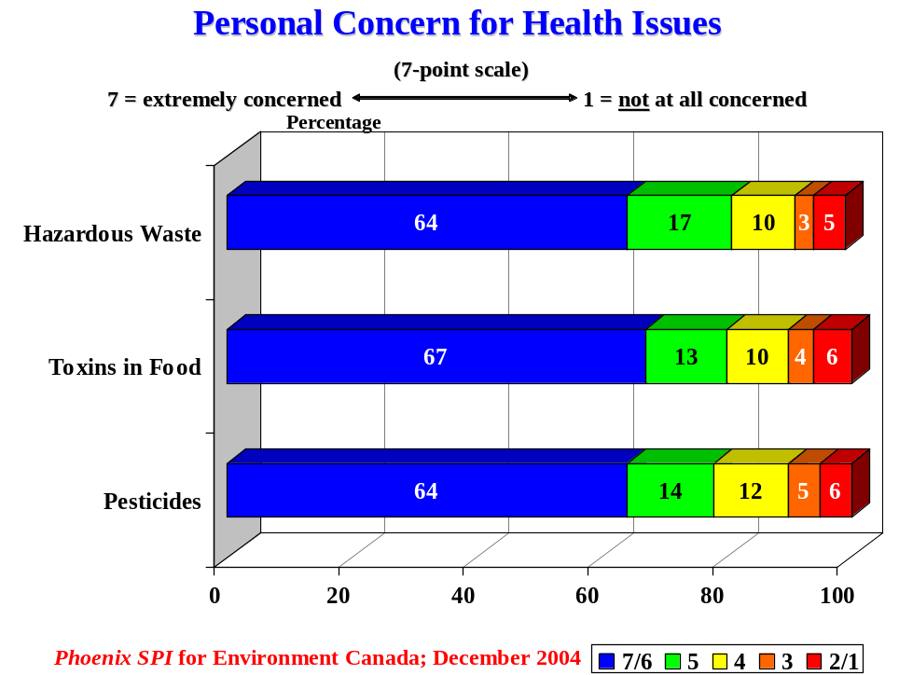

The accompanying table compares the perceived level of knowledge in each area (scores of 5-7) with the level of concern (scores of 5-7).

Health-Related Issues
Issue | Knowledge  % | Concern  %
Hazardous waste | 50% | 81%
Pesticides | 49% | 78%
Toxins | 45% | 80%

On health-related issues, where the levels of concern for the different issues were virtually identical, it is noteworthy that there is no relationship between levels of knowledge and concern as were apparent for all other sets of issues explored in this part of the survey.

Environmental Issues Residents Most Interested in Learning More About
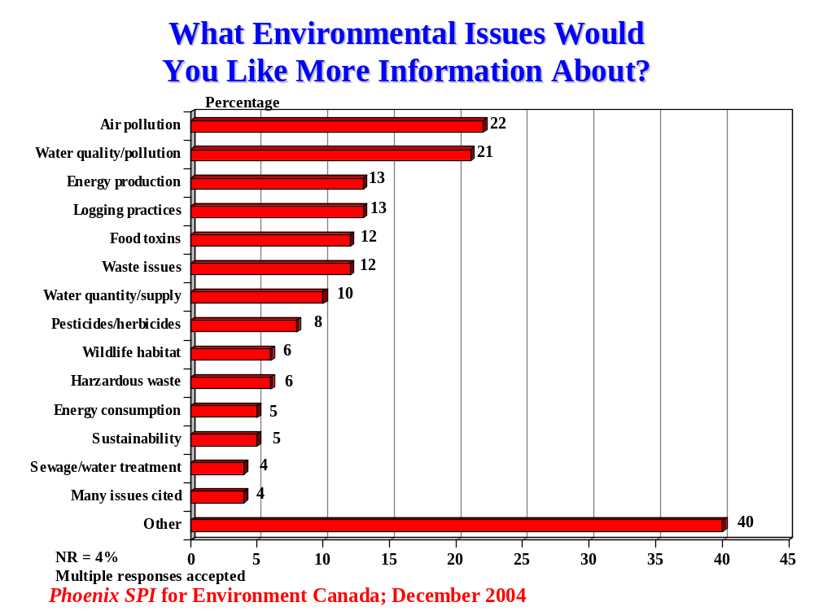Residents were asked in an open-ended manner to identify the environmental issue(s) they would like to know more about. Two issues topped the list and received almost identical attention: air pollution (22%) and water quality/pollution (21%). That said, cumulative interest in water-related issues is increased by interest in learning more about water quantity/supply (10%) and sewage/water treatment (4%). In total therefore, just over one-third of residents want to know more about water-related issues. Substantial and similar numbers would like to know more about a range of issues including energy production and logging practices (13% each), food toxins and waste issues (12% each) (multiple responses accepted).

Following this, in descending order, were interest in pesticides/herbicides (8%), wildlife habitat and hazardous waste (6% each), energy consumption and sustainability (5% each), and sewage treatment (4%). A few residents (4%) cited many issues all together, such as a combination of water, air, health and land issues. Included in the ‘other’ category are issues identified by 3% or fewer residents. These include storm-water run-off, stream bank erosion, pollution from agriculture, pollution from parking lots, roads and vehicles, garbage burning, mining activities, invasive exotic species, forest fragmentation, urban sprawl, and health and land-related issues.

Newspapers, TV – Preferred Vehicles for Learning
Residents would prefer to learn about the environmental issues explored in this survey through newspapers (68%) and television (64%) (multiple responses accepted). Significant numbers would also like to learn about these issues through the radio (40%) and websites (35%).

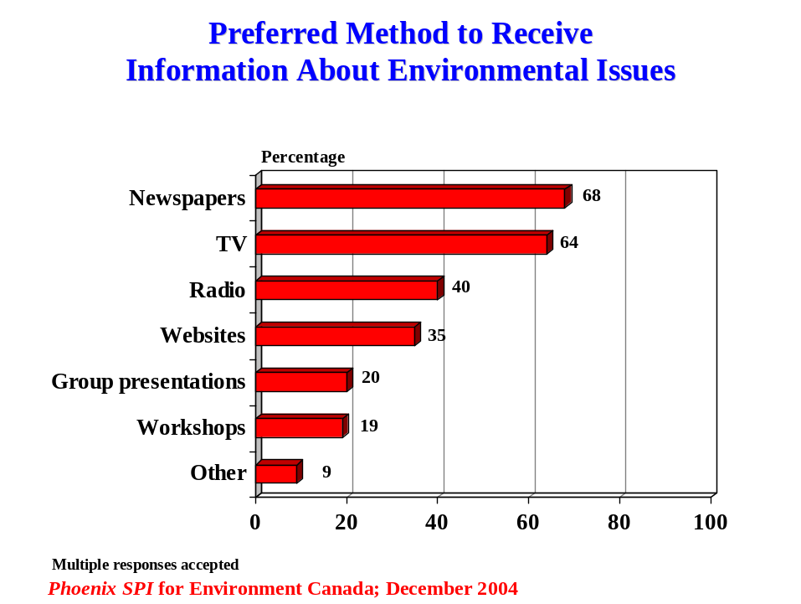

Approximately one-in five indicated a preference for group presentations (20%) and workshops (19%). Included in the ‘other’ category are hand-outs/flyers, mail, town meetings, schools, newsletters, brochures, government brochures/mail-outs, telephone, and big posters in public places.

Participant Characteristics
The following graphs present the characteristics of survey participants according to age, level of education, employment status, household size, household income, and location. Following these graphs, a set of tables compares the characteristics of survey participants with those of the residents of the Lake Superior Basin (i.e. Thunder Bay, Wawa, Marathon and Sault Ste. Marie).
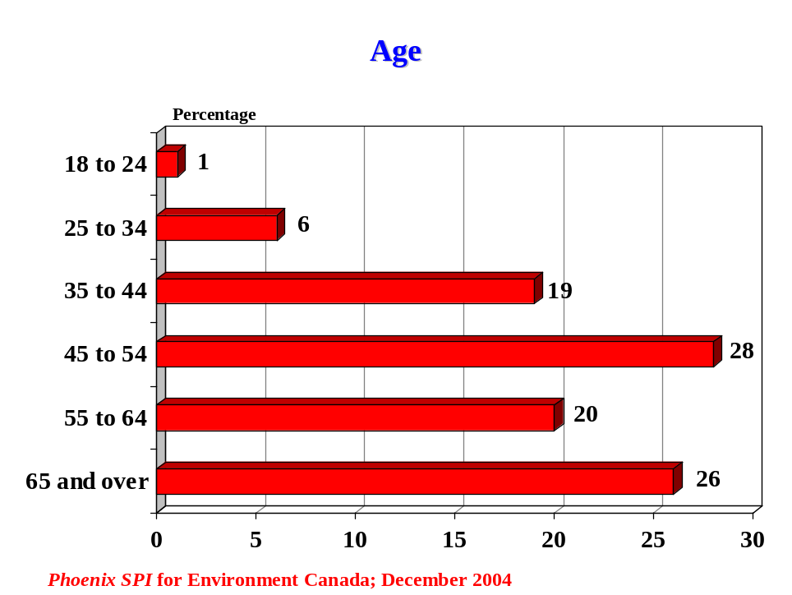

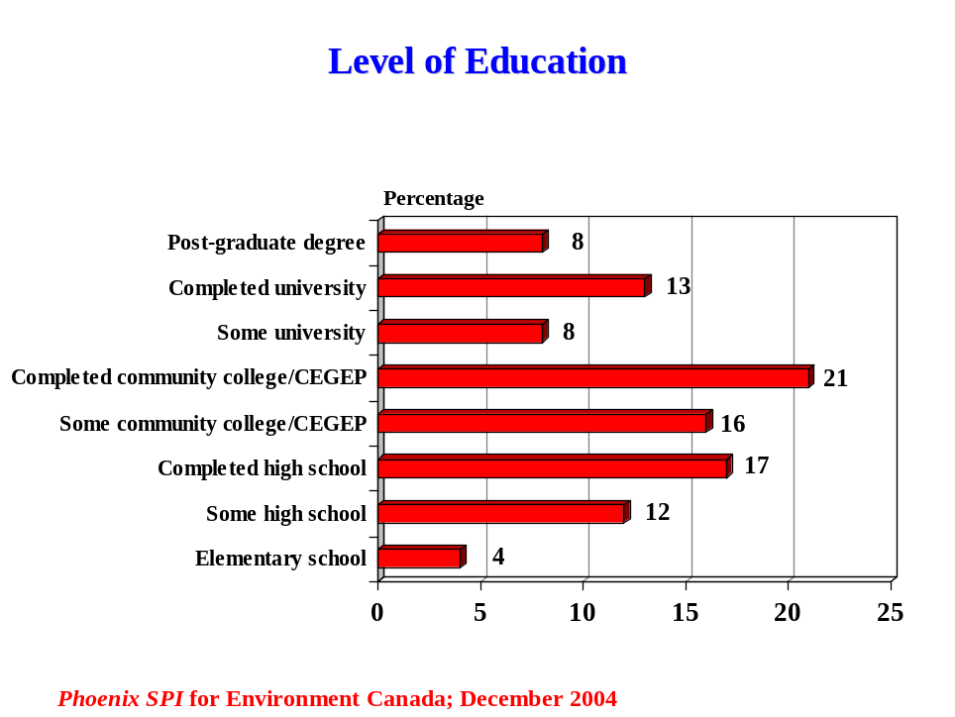

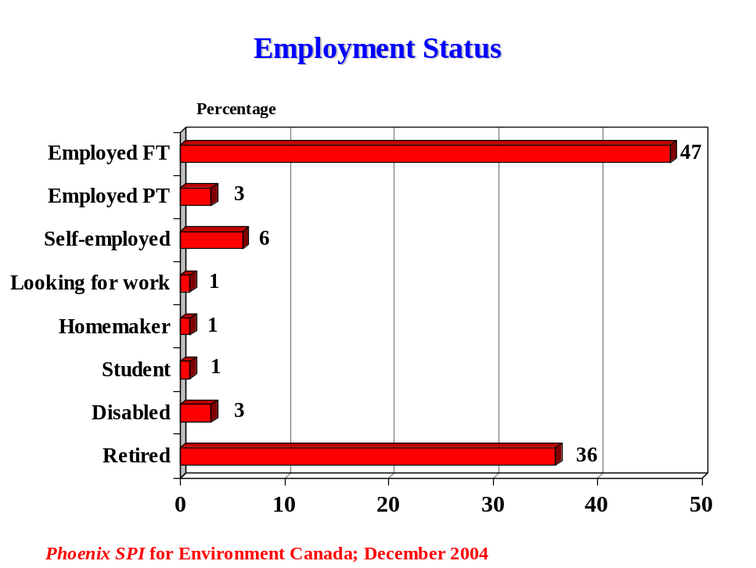

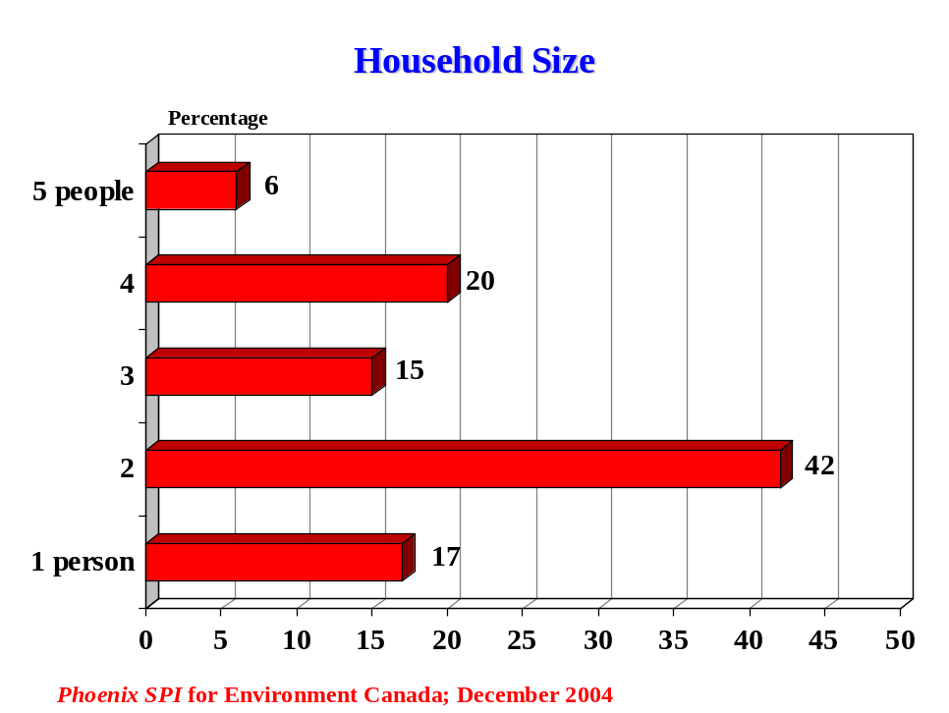

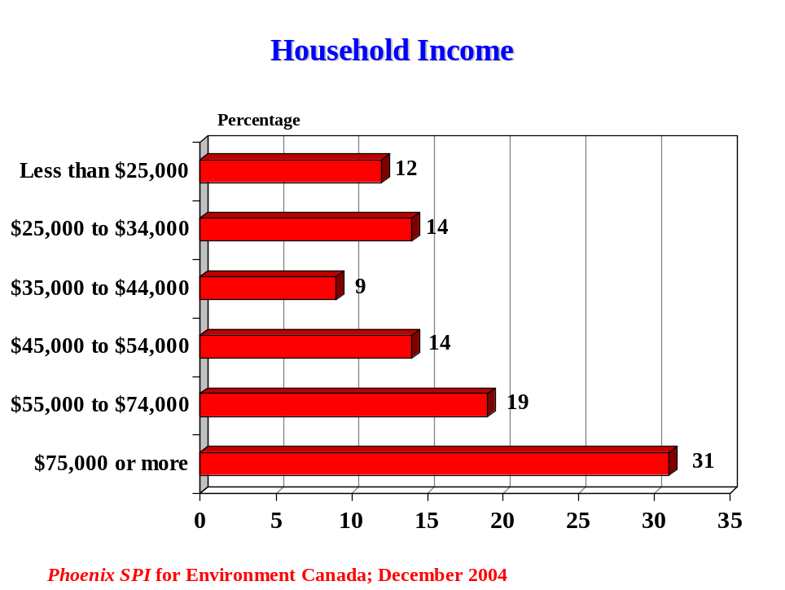

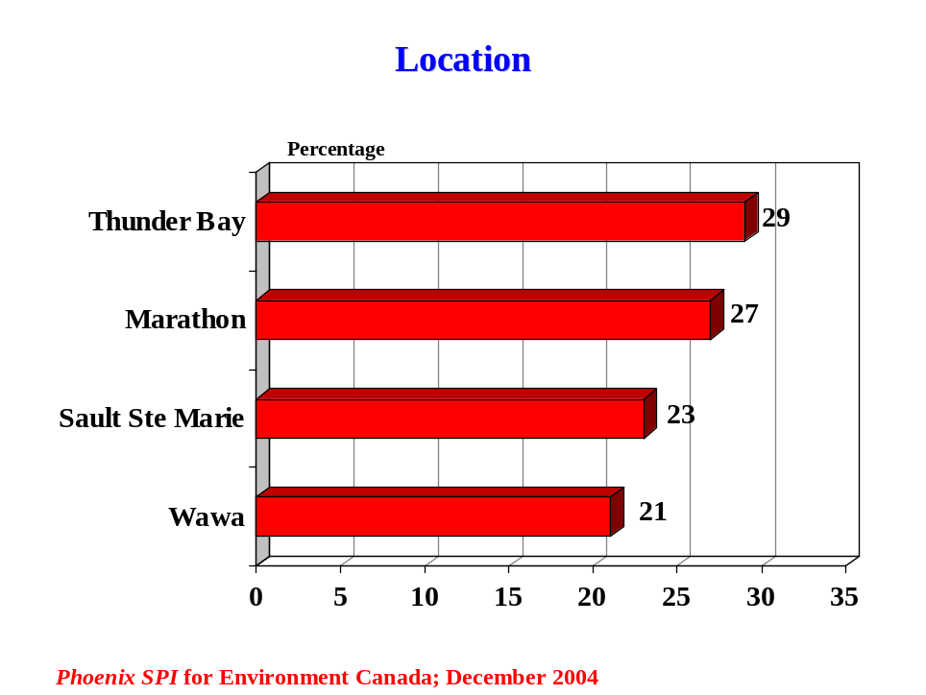

The tables below present the characteristics of survey participants for age and education compared with the characteristics of Lake Superior residents based on available Statistics Canada 2001 census data. Note that these data are not directly comparable because the survey category breakdowns are different from those available through Statistics Canada. Such differences are noted under each table.

Age | Survey | Census Total | Variance
18 to 24 | 1% | 13%* | -12%
25 to 44 | 25% | 28% | -3%
45 to 54 | 28% | 15% | 13%
55 to 64 | 20% | 10% | 10%
65 and over | 26% | 15% | 11%
*Includes residents 15to 24 years.

Education | Survey | Census Total** | Variance
Less than a high school graduation certificate | 16% | 21% | -5%
High school graduation and/or some postsecondary | 41% | 27% | 14%
College/trades certificate or diploma | 21% | 34% | -13%
University certificate, diploma or degree* | 21% | 17% | 4%
*Survey % includes post graduate degrees.
**Census % based on population aged 20-64 years (unlike survey data which includes residents aged 18 years and older).

Demographic Differences
Presented below are variations in responses based on the age and education of respondents, and household size (i.e. the number of household residents).

Note that the caveat presented in the introduction regarding grouping of results applies to the reporting of demographic differences as well. Once again, this can take two forms:
- The first groups similar proportions of respondents identifying different issues (e.g. “similar numbers, X-Y%, identified issues A, B, and C”).
- The second provides the range of respondents answering in a certain way (e.g. “the proportion of respondents claiming knowledge of A [e.g. different water-related issues] ranged from X-Y%).

General Overview
Differences based on education and household size were most pervasive and most subject to distinct patterns. However, even here, most differences tended to be modest rather than significant. In terms of education, differences tended to increase or decrease with the level of education, with the higher-educated being more knowledgeable about many related issues; however, the record was largely mixed regarding environmentally-friendly behaviours. In terms of household size, differences tended to distinguish those living alone from those living with others (i.e. living with at least one other person). Differences based on age were less widespread. However, where they did manifest themselves they tended to distinguish the oldest residents (i.e. those 55 and older) from others. Note that the pool of respondents tended to consist of older respondents (about one-quarter under 45 years of age).

Age
For the purposes of this analysis, residents were divided into three age groups: under 45, 45-54, and 55 and older.

Overview
Overall, differences based on age were not pronounced. Where these differences exist, they tend to distinguish the oldest residents (i.e. those 55 and older) from the others. Perceptions of the most important environmental issues at various levels tended to be similar, the main exception being that the oldest residents attributed more importance to air pollution. Residents, regardless of age, also tended to be very similar in the types of environmental issues they wanted to know more about. In terms of behaviour, differences are more evident (i.e. likelihood of conserving energy and water, garbage disposal habits). However, there was no consistent pattern in terms of whether younger or older residents embraced more environmentally-friendly behaviours.

Findings
In terms of the top issues facing their community, the oldest residents were most likely to attribute importance to health issues (24% vs. 14% of others). Moreover, the likelihood of attributing importance to air pollution increased with age (from 11-24%). Those under 55 were more likely to attribute importance to disposal/landfill sites (29-32% vs. 11% of the oldest residents).

The oldest residents (55 and older) were more likely to identify air pollution as the most important environmental issue affecting them and their household (21% vs. 11-14% of others). Those under 55 were slightly more likely to identify garbage issues (13-15% vs. 9% of those 55 and older). At the community level, perceptions were very similar with two exceptions: once again, air pollution was more likely to be considered important by the oldest residents (22% vs. 9-13% of others), and dump/landfill sites were much more likely to be considered important by those under 55 (24-25% vs. 8%). Perceptions regarding the most important issue affecting the Lake Superior Basin were very similar although the oldest residents were slightly more likely to stress water quality/pollution (31% vs. 24-25% of others). Perceptions of the most important environmental issue at the provincial level were very similar.

The oldest residents were most likely to say they always conserve oil, gas, or electricity (42% vs. 28-32% of others) and always conserve water (29% vs. 13-18% of others). Residents under 55 were more likely to take their garbage to a recycling centre (46-49% vs. 38% of oldest residents), and to the local landfill (37-38% vs. 22%). The likelihood of putting it by the roadside for recycling increased noticeably with age (from 26-46%).

Perceptions regarding the extent of trash burning varied by age. The oldest residents were much more likely to say that none of the households in their community burn garbage (55%). Those 45-54 were most likely to say a few do this (63%). Those 44 and younger were most likely to say many do it (11%).

Older respondents (45 and older) were more likely to say their community has a hazardous waste disposal program (76% vs. 64% of those 44 and younger). Among those who said their community has such a program, the oldest ones were more likely to say they often or always use it (42% vs. 33-36% of others), while the youngest were much more likely to say they never do (22% vs. 10% of others).

Those 45-54 were a little more likely to say their community has implemented watershed management plans (30% vs. 24-25% of others) and that there are land trust conservancies in their area (50% vs. 40-44% of others). Residents under 45 were moderately more likely to say they were not aware of government advisories to limit consumption of fish (47% vs. 39-40% of others). Among those who were aware, the likelihood that it motivated them to eat less fish increased modestly with age (from 20-29%).

When it came to reasons why people continue doing activities that are bad for the environment, residents under 55 were more likely to suggest that it is too expensive to change (29% vs. 17% of those 55 and older), that there are no facilities available (22-25% vs. 16%), and that facilities are inconvenient to use (25-26% vs. 16%).

Overall, levels of knowledge about water, air, land, and health issues did not vary much by age. On most issues, differences between members of various age groups regarding perceived knowledge did not exceed 6%. Moreover, these differences did not tend to follow a pattern. Areas where differences in knowledge were larger included water and land issues. Knowledge of septic systems was highest among the oldest residents (38% vs. 27-31% of others), and knowledge of sewage treatment increased with age (from 30-40%). Knowledge of wildlife habitat loss ranged from 53% of those 55 and older to 46% of those 45-54 years old. Knowledge of invasive exotic species ranged from 37-29% between the same groups.

Differences in concern over these same issues also tended to be small, not exceeding 6% on most issues. The exceptions related mainly to water and land-related issues, and differences still tended to be relatively small. In terms of water-related issues, concern over septic systems ranged from 49% of those under 45 to 37% of those 45-54, while concern over storm water runoff was highest among those 55 and older (56% vs. 46% of others). In terms of land-related issues, those under 55 were more likely to express concern over garbage burning (61% vs. 55%) and mining activities (50% vs. 41%). Those 45-54 were most likely to express concern over urban sprawl (49% vs. 40-42% of others). Residents under 55 also expressed more concern over hazardous waste (84% vs. 77% of those 55 and older).

Residents, regardless of age, tended to be similar in the types of environmental issues they wanted to know more about. In terms of preferences for receiving this information, differences were relatively small when it came to radio, workshops, and group presentations. However, the likelihood of preferring newspaper increased with age (from 62-72%). Residents 45 and older were most likely to prefer television (66% vs. 57% of those under 45). Websites were much more likely to be preferred by those under 55 (46-47% vs. 22% of those 55 and older).

Education
For the purposes of analysis, residents were divided into three education groups: high school or less, those with at least some college education, and those with at least some university education.

Overview
Differences based on education tended to be subject to patterns, with the most pervasive pattern involving differences increasing or decreasing with the level of education. Differences were especially evident in relation to perceived knowledge. Perceptions of the most important environmental issues at various levels tended to be similar, as did perceptions of the type of environmental issue residents want to know more about. Conversely, perceptions as to why people continue with activities that are bad for the environment tended to vary by education. Differences in behaviour are evident regarding garbage disposal habits.

Findings
In terms of the top issues facing their community, there were few noteworthy differences based on level of education. That said, cost issues were most important to those with a high school education or less (25% vs. 14-18% of others).

Perceptions of the most important environmental issue for the household tended to be similar, with the exception of recycling/composting which was most important to college-educated residents (13% vs. 7-8% of others), and garbage issues which were most important to the university-educated (14% vs. 4-5% of others). At the community level, perceptions were similar. Perceptions regarding the most important issue affecting the Lake Superior Basin were similar, the biggest difference being over the perceived importance of water quantity/supply. College-educated residents were most likely to view this as important (22% vs. 17% of high-school educated, 13% of university-educated). Perceptions of the most important issue at the provincial level also tended to be similar with three modest exceptions: air pollution was more important to those with only a high school education (28% vs. 21% of others), while the importance of energy increased with education (from 11-21%), as did the importance of garbage issues (from 8-14%).

Residents, regardless of education, were similarly likely to say they often or always conserve energy. While residents were similarly likely to say they often conserve water, the likelihood of saying they always do this decreased noticeably as education increased (from 29% to 15%). College and university-educated residents were more likely to say they take their garbage to a recycling centre (47% vs. 37% others) and the local landfill (34-35% vs. 23%). The university-educated were most likely to say they put it by the road for recycling (46% vs. 36-37% of others).

Perceptions regarding the extent of trash burning varied by education. While residents were similarly likely to say that many households in their community burn trash, those with a high school education or less were much more likely to say that no one in their community did this (54% vs. 36-40% of others). The college and university-educated were somewhat more likely to say that a few do this (53-58% vs. 41%).

The likelihood of saying that their community has a hazardous waste program increased slightly with education (from 70-76%), while the likelihood of being uncertain decreased with education (from 17% to 8%). Among those who said their community has such a program, the likelihood of using it was similar across all levels of education.

The likelihood of saying their community has implemented a watershed management plan increased with education (from 21-33%). The same pattern was evident regarding the existence of land conservancies: the likelihood of saying there were some in the area increased with education (from 31-5%). Awareness of government advisories to limit consumption of fish was similar across all levels of education, but the reaction among those who were aware tended to vary moderately: the college-educated were most likely to say it had no effect on their consumption of fish (64% vs. 52-57% of others), while those with high school or less were most likely to say they ate less fish (31% vs. 22-26%).

Perceptions as to why people continue with activities that are bad for the environment tended to vary by education. The likelihood of citing inconvenience increased noticeably with education (from 51-74%). The university-educated were also much more likely to say that one person won’t make a difference (44% vs.29% of others) and to cite being too busy to change (37% vs. 27-32% of others). College and university-educated residents were more likely to cite facilities being inconvenient to use (24-25% vs. 15%).

Perceived knowledge of most water, air, land, and health issues increased with education or were highest among the university-educated. On those issues where knowledge increased with education, differences tended to range between 9-16%. The only issue in relation to which those with a high school education or less claimed to be more knowledgeable was garbage burning (45% vs. 36-39% of others).

Levels of concern over these issues tended to be similar (usually not exceeding 6%) and less subject to a pattern, with the exception of land-related issues. On all land-related issues, concern increased with education with differences ranging from 8-16% range.

Differences in the type of environmental issue residents want to know more about tend to be small. That said, the university-educated are most likely to want to know about energy production (17% vs. 10-11% of others). As well, the likelihood of wanting to know more about toxins in food increases with education (from 6-18%).

Differences in preferred ways for receiving this type of information are more evident. Those with high school or less are most likely to prefer television (68% vs. 61-63%). Newspapers are most likely to be preferred by college-educated and residents with high school or less (69-73% vs. 62% of university-educated). Preference for the following increased with education: websites (from 23-45%), workshops (from 15-23%), and group presentations (from 15-25%).

Household Size
For the purposes of analysis, respondents were divided into three household size groups: one resident (i.e. living alone), two residents (i.e. living with one other individual), and three or more residents. In the note that follows, the expression ‘those living with others’ designates persons living with at least one other individual (i.e. this includes the two larger household sizes), and the expression ‘residents of larger households’ designates those in the largest household size.

Overview
Differences based on household size were evident and tended to be subject to two distinct patterns. The main pattern distinguished those living alone from those living with others. However, some things also increased or decreased with household size. Differences were especially evident in relation to perceived knowledge of issues, but were also evident in behaviour (i.e. likelihood of conserving energy and water, and garbage disposal habits). That said, most differences tended to be small.

Findings
In terms of the top issues facing their community, there were few noteworthy differences based on household size. Nevertheless, the importance of dump/landfill sites increased with household size (from 14-27%).

Perceptions of the most important environmental issue affecting households did not vary much by household size. Residents of larger households were slightly more likely to identify garbage issues (15% vs. 8-10% of others). Perceptions varied more at the community level. Residents living alone were most likely to identify water quantity (11% vs. 5% of others). Those living with others were most likely to identify garbage issues (10-11% vs. 5%), while the likelihood of identifying dump/landfill sites increased with household size (from 13-22%). Perceptions of the most important environmental issue affecting the Lake Superior Basin were very similar. When focusing on the most important issue at the provincial level, those living alone were slightly more likely to identify water quality (15% vs. 10% of others). Those living with others were most likely to identify garbage issues (13% vs. 8%) while residents of larger households were more likely to identify energy issues (19% vs. 14% of others).

Those living alone were much more likely to say they always conserve energy (46% vs. 30-34% of others) and water (35% vs. 17-20% of others). The likelihood of taking garbage to a recycling centre increases noticeably with household size (from 30-51%), as does the likelihood of taking it to the local landfill (from 20-36%). Among those who said their community has a hazardous waste program, the likelihood of using it did not vary much by household size (34-40%).

The perception that no households in the community burn garbage is highest among those living alone and decreases noticeably as households increase in size (from 56-35%). Conversely, the likelihood of saying that households do burn garbage increases with household size, whether the perception is that only a few do it (from 41-55%) or that many do it (from 2-10%).

Those living with others were most likely to say their community has implemented a watershed management plan (29% vs. 21% of those living alone). The likelihood of saying that there are land trust conservancies in their area increased noticeably with household size (from 33-51%). When it came to awareness of government advisories to limit consumption of fish, residents of larger households were most likely to say they were not aware of any advisory (46% vs. 37-38% of others). Those living alone were most likely to be uncertain (30% vs. 22-23%). Among those who were aware, the likelihood that it had no effect on consumption increased with household size (from 54-62%).

To explain why people continue with activities that are bad for the environment, residents living with others were most likely to point to inconvenience (63-64% vs. 48%), being too busy (34-35% vs. 25%), and conflicting information (16-18% vs. 11%). In addition, the likelihood of identifying the following increased with household size: being too expensive (from 11-30%), inconvenience of using facilities/services (from 12-26%), and the lack of facilities/services (from 16-24%).

Perceived knowledge of water, air, land, and health-related issues tended to increase with household size or be higher among those living with others. That said, differences tended to be relatively small on most issues, not exceeding 6%. Exceptions related mainly to some water and land-related issues. On water issues, those living with others were more likely to claim knowledge about water quality (52-55% vs. 41%), water quantity (51-56% vs. 41%), and septic systems (32-34% vs. 25%).On land issues, those living with others were more likely to claim knowledge about mining activities (40-43% vs. 27%), and logging practices (50-54% vs. 41%). Those living with others were also more likely to claim knowledge about energy production (44-45% vs. 36%).

Concern over these issues tended to be similar, with differences usually not exceeding 6%. There were a few exceptions. Concern over water quality increased with household size (from 77-85%), as did concern over septic systems (from 36-47%). Concern over storm water runoff decreased as household size increased (from 55-48%).

Differences in the types of environmental issues residents wanted to know more about did not tend to vary by household size. The main exception was air pollution, which was of much more interest to those living with others (25-27% vs. 13%). Those living with others wanted to know more about sewage/water treatment (4-5%). Differences in preferred ways for receiving this information were also relatively small for most methods. Those living with another individual were most likely to prefer television (69% vs. 61% of others), and the likelihood of identifying websites increased noticeably with household size (from 27-45%).

