Survey of Canadians’ Use of Banking Products and Services

Final Report

Prepared for the Financial Consumer Agency of Canada

Supplier Name: Phoenix SPI
Contract Number: 5R000-200258-001-CY
Award Date: 2020-07-15
Contract Value: $229,990.46 (including taxes)
Delivery Date: 2021-09-27

Registration Number: POR 014-20

For more information on this report, please contact the Financial Consumer Agency of Canada at: info@fcac-acfc.gc.ca

Ce rapport est aussi disponible en français.

Survey of Canadians’ Use of Banking Products and Services
Final Report

Prepared for the Financial Consumer Agency of Canada (FCAC)
Supplier name: Phoenix Strategic Perspectives Inc.
September 2021

This public opinion research report presents the results of online surveys conducted by Phoenix SPI on behalf of the Financial Consumer Agency of Canada with Canadians aged 18 and older who have a product or service with a bank. Over a 10-month period, 12,183 surveys were completed between July 31, 2020, and April 19, 2021. A follow-up survey was conducted April 7 to April 16, 2021, with 1,599 respondents who completed the survey during waves 1 through 6.

This publication may be reproduced for non-commercial purposes only. Prior written permission must be obtained from FCAC. For more information on this report, please contact FCAC at:

Financial Consumer Agency of Canada
427 Laurier Avenue West, 6th floor
Ottawa, ON
K1R 1B9

Catalogue Number: FC5-72/2021E-PDF

International Standard Book Number (ISBN): 978-0-660-40477-6

Related publications (POR registration number: POR 038-20):
Catalogue number (Final report, French) FC5-72/2021F-PDF
ISBN: 978-0-660-40478-3

Aussi offert en français sous le titre : L’Enquête sur l’utilisation, par les Canadiens, des produits et services bancaires.

© Her Majesty the Queen in Right of Canada, as represented by the Minister of Finance Canada, 2021.

Table of Contents

Executive Summary 1

Introduction 5
1. Background and Objectives 5
2. Methodology 6
3. Notes to Reader 6

Detailed Findings 8
1. Monthly Tracking 8
2. Follow-Up Survey 50

Appendix 58
1. Technical Specifications 58
2. Monthly Tracking Survey Questionnaire: English 61
3. Monthly Tracking Survey Questionnaire: French 77
4. Follow-Up Survey Questionnaire: English 94
5. Follow-Up Survey Questionnaire: French 100

List of Figures

Figure 1: Awareness of department/agency dedicated to financial education 8
Figure 2: Awareness of GC Department Dedicated to Financial Education of Consumers 9
Figure 3: Familiarity with FCAC 10
Figure 4: Preferred Method of Banking 11
Figure 5: Preferred Payment Method 12
Figure 6: Preferred Payment Method 13
Figure 7: Awareness of Increased Contactless Payment Limits 15
Figure 8: Use of Contactless Payment 16
Figure 9: Impact of Retailers’ Preference for Cashless Payment 17
Figure 10: Payment Method Used as Replacement for Cash 18
Figure 11: Impact of Branch Closures 19
Figure 12: Personal Impact of Branch Closures 20
Figure 13: Fees/Interest Incurred Due to COVID-19 21
Figure 14: Contacting Bank for Refund 22
Figure 15: Changes to Credit Limits since March 2020 23
Figure 16: Changes to Credit Limits since March 2020 [Time Series] 24
Figure 17: COVID-19 Information Received from Bank 25
Figure 18: Perceptions of COVID-19 Information from Bank 26
Figure 19: Perceptions of COVID-19 Response from Bank 27
Figure 20: Problems with Bank Since March 2020 28
Figure 21: Problems Encountered with Bank Since March 2020 29
Figure 22: Contact with Bank Re: Problems 30
Figure 23: Sources of Information re: Hardship Programs 31
Figure 24: Contact with Bank for Financial Help [Time Series] 32
Figure 25: Methods Used to Contact Bank 33
Figure 26: Contact Methods Used by Bank 34
Figure 27: Outcome of Contact with Bank 35
Figure 28: Outcome of Contact with Bank [Time Series] 36
Figure 29: Type of Financial Help Received 37
Figure 30: Type of Financial Help Received [Time Series] 38
Figure 31: Length of Hardship Program 39
Figure 32: Reasons for Not Contacting Bank for Financial Help 40
Figure 33: Reasons for Declining Financial Help 41
Figure 34: Perceptions of Hardship Program 42
Figure 35: Perceptions of Bank Service 43
Figure 36: Contact with Other Banks for Financial Assistance 44
Figure 37: End of Hardship Program [Time Series] 45
Figure 38: Contacted by Bank to Discuss Program Ending [Time Series] 46
Figure 39: Alternative Program Offered after End of Initial Program [Time Series] 47
Figure 40: Relief Measures Offered by Bank Once Initial Program was Complete [Time Series] 48
Figure 41: Keeping Bills and Financial Commitments Current [Time Series] 49
Figure 42: Personal Bank Account 50
Figure 43: Intended Use of Payment Methods Post-Pandemic 51
Figure 44: Use of Multiple Financial Institutions 51
Figure 45: Accessing New Financial Products via Online/Mobile Banking since March 2020 52
Figure 46: Delaying Opening New Financial Products since March 2020 53
Figure 47: Sharing Banking Information for Advice or to Purchase Financial Products/Services 54
Figure 48: Unauthorized Use of Bank/Credit Card Number in the last 2 Years 55
Figure 49: Occurrence of Unauthorized Transactions by Type of Card 56
Figure 50: Contact with FI about Unauthorized Transactions 56
Figure 51: Reasons FIs gave for not reimbursing unauthorized transactions 57

Executive Summary
Phoenix Strategic Perspectives Inc. (Phoenix SPI) was commissioned by the Financial Consumer Agency of Canada (FCAC) to conduct quantitative research on consumers’ experiences with their banks during the COVID-19 crisis.

1. Research purpose and objectives
In March 2020, banks began to implement their business continuity plans in response to the COVID-19 global crisis. To better understand the impact of these measures on Canadian consumers, FCAC commissioned a monthly survey to collect quantitative data on consumers’ experiences with their banks during the COVID-19 crisis. The primary research objective was to understand how banks’ responses to the pandemic affected Canadians.

2. Methodology
This research included both a monthly tracking survey and a follow-up survey for a sub-set of those who completed the monthly survey. The monthly online survey was administered to 12,183 Canadians, aged 18 and older, who had a product or service with a bank at the time of the research. The sample was drawn from Advanis’ proprietary General Population Random Sample (GPRS) developed using probability-based recruitment. Based on a sample of this size, the overall results can be considered accurate within ±0.89%, 19 times out of 20. The fieldwork was conducted July 31, 2020, to April 19, 2021. In all, 1,599 respondents completed the follow-up survey, which was conducted April 7 to 16, 2021. No margin of error can be provided for the follow-up survey because it was a non-probability sample.

3. Key Findings

Half of Canadians are aware the government has department dedicated to protecting financial consumers.
- 55% of surveyed Canadians are aware that the government of Canada has a department or agency dedicated to protecting financial consumers.
- One-quarter (25%) are aware the government has a department or agency dedicated to the financial education of its consumers.

Majority of Canadians used contactless banking before March 2020
- Half (51%) of respondents said they most commonly used their bank’s website before March 2020 to complete day-to-day banking while one-quarter (24%) completed their banking their bank’s mobile app.

Most Canadians prefer debit or credit cards for day-to-day purchases
- 45% of Canadians prefer completing day-to-day purchases with a debit card, and 43% prefer using a credit card.

Just over half are using contactless payment methods more often than they did a year ago
- 56% of surveyed Canadians use contactless payment methods more often now than they did last year, and most others (36%) use these methods with about the same frequency as last year. Half (51%) have also used contactless payment to make day-to-day purchases exceeding $100.

Many are unaffected by retailers who no longer accept cash
- 57% said they have not been affected at all by retailers who no longer accept cash. Most others who have been affected say this has affected them a little (31%).
- When shopping at retailer who no longer accepts cash, 38% most often use a debit card, and 33% a credit card.

Most Canadians did not experience any issues related to branch closures
- Seven in 10 (70%) did not experience any issues related to a branch closure. Those who did experience issues had difficulty contacting their bank, depositing a cheque in an automated teller machine (ATM), or incurred a fee to use another bank’s ATM.

Most incurred no fees or interest related to COVID-19
- Six in 10 (61%) respondents said they incurred no fees or interest on their bank products because of COVID-19. For those who did incur fees, the most common fees were overdraft fees, automated banking machine (ABM) withdrawal fees, and late payment or insufficient fund fees.
- Most Canadians who incurred fees and contacted their bank reported that they did not receive a refund on the fees or interest.

Majority said their bank provided information about COVID-19
- 61% of surveyed Canadians said they received information from their bank about COVID-19. The top COVID-19 communications received from banks included:
  - Steps the banks are taking to provide service.
  - Information about the ways to bank during the pandemic.
  - How to contact the bank if in need of financial help.
- The majority who received communications from their bank regarding COVID-19 agreed that the information was easy to understand and was received in their preferred format.

Half are satisfied with their bank’s response to COVID-19 and are familiar with their options if they needed financial help
- 55% are satisfied with the way their bank responded to the COVID-19 crisis, and 51% knew what options their bank has available if they needed financial help.

Majority have not had a problem with their bank during the pandemic; those who have pointed to poor customer service
- Nine in 10 (89%) have not had a problem with their bank since March 2020. Among those who reported experiencing a problem, nearly three in 10 (28%) pointed to the behaviour of a bank employee or to poor customer service in general.
- Most of those who had a complaint (78%) said they contacted their bank about the issue encountered.

Half who contacted their bank about financial assistance received financial help
- 52% of those who contacted their bank said they received financial help, while one in five (21%) were denied financial help. Half (52%) of those who received financial help received it in the form of deferred mortgage payments.
- The majority who were enrolled in a hardship program were enrolled for less than six months, and eight in 10 (80%) of those enrolled in a hardship program said they are satisfied with their bank’s response.

Few applied for or opened a new financial product via online banking since March 2020
- Approximately one in five (18%) applied for or opened a new financial product or service through online or mobile banking since the beginning of the COVID-19 pandemic in March 2020.
  - 47% who did open a new financial product through online banking did so because it was convenient, and 30% said it was faster than doing so in person.
- Few (16%) delayed applying for new financial products due to the pandemic.
  - 35% of those who did delay attribute the delay to the fact that their income was reduced compared to last year.

Nearly a quarter discovered their bank or credit card number was used without authorization
- Almost one-quarter (23%) discovered that someone used their bank or credit card number to pay for goods without their authorization in the last two years. Eighteen percent (18%) among them said this was on a credit card.
- Three-quarters (77%) of those who discovered unauthorized transactions found these transactions on a debit card. Two-thirds (66%) of those who discovered unauthorized transactions on a credit card said this happened only once.

Vast majority contacted their financial institution about unauthorized transactions
- Nearly nine in 10 (88%) of those who had issues with unauthorized transactions contacted their financial institution about these transactions.

4. Limitations of the research and use of the results
The results for the monthly tracking survey are generalizable to the population of Canadians aged 18 and older who have a product or service with a bank. The results of the follow-up survey are not representative of the population because respondents were drawn from among those who completed the online survey during waves 1 to 6 of the monthly survey. The results of this research will inform the supervisory and financial literacy work of FCAC and its stakeholders.

5. Political Neutrality Certification
I hereby certify, as a Senior Officer of Phoenix Strategic Perspectives, that the deliverables fully comply with the Government of Canada political neutrality requirements outlined in the Communications Policy of the Government of Canada and Procedures for Planning and Contracting Public Opinion Research. Specifically, the deliverables do not contain any reference to electoral voting intentions, political party preferences, standings with the electorate, or ratings of the performance of a political party or its leader.

Signed:

Alethea Woods, President
Phoenix Strategic Perspectives Inc.

6. Contract value
The contract value was $229,990.46 (including HST).

Introduction
Phoenix Strategic Perspectives Inc. (Phoenix SPI) was commissioned by the Financial Consumer Agency of Canada (FCAC) to conduct an online monthly tracking survey on consumers’ experiences with their banks during the COVID-19 crisis, including a follow-up online survey of selected respondents.

1. Background and Objectives
FCAC is a federal government regulatory agency created to protect and inform consumers of financial products and services. As a federal regulatory agency, FCAC is responsible for:
- ensuring the market conduct of federally regulated financial entities complies with federal legislation and regulations;
- promoting the adoption of policies and procedures designed to implement legislation, regulation, voluntary codes of conduct and public commitments by federally regulated financial entities;
- monitoring federally regulated financial entities’ compliance with voluntary codes of conduct and their own public commitments;
- informing consumers about their rights and responsibilities when dealing with financial entities, and promoting awareness of the obligations of payment card network operators to consumers and merchants;
- providing timely and objective information and tools to help consumers understand, and shop for, a variety of financial products and services; and
- monitoring and evaluating trends and emerging issues that may have an impact on consumers of financial products and services.

In March 2020, banks began to implement their business continuity plans in response to the COVID-19 global crisis. For example, to help slow the spread of the virus, banks adjusted branch hours and temporarily closed some branches. Such changes can be expected to affect consumers at a time when many are experiencing the financial effects of the COVID-19 crisis and may require more from their financial institution.

To better understand the impact of these measures on Canadian consumers, FCAC commissioned a monthly survey to collect quantitative data on consumers’ experiences with their banks during the COVID-19 crisis. The primary research objective was to understand how banks’ responses to the pandemic affected Canadians. More specifically, this research was designed to collect information about:
- the impact of branch closures on banking behaviour;
- access to banking services, including difficulties experienced because of the pandemic;
- access to funds, including difficulties experienced because of the pandemic;
- consumers’ awareness of banks’ hardship programs;
- consumers’ use of the financial hardship programs offered by the banks; and
- consumers’ experiences with banks’ financial hardship programs.

The results of this research will inform the supervisory and financial literacy work of FCAC and its stakeholders.

2. Methodology
This research included both a monthly tracking survey and a follow-up survey of a sub-set of those who completed the monthly survey. What follows is a brief description of the methodologies; for more details, please see the Appendix: 1. Technical Specifications.

2.1 Monthly survey
An online survey was administered to 12,183 Canadians, aged 18 and older, who have a product or service with a bank. The sample was drawn from Advanis’ proprietary General Population Random Sample (GPRS), which was developed using probability-based recruitment; specifically, RDD via Interactive Voice Response (IVR) and via live Computer Assisted Telephone Interviewing (CATI). One wave per month of approximately 1,000 surveys was conducted in order to create a time-series to identify trends. Based on a sample of this size, the overall results can be considered accurate within ±0.89%, 19 times out of 20. The margin of error is greater for results pertaining to subgroups of the total sample. Data were weighted to reflect the population in terms of age and gender and were based on Statistics Canada 2016 census data. The fieldwork was conducted July 31, 2020, to April 19, 2021.

2.2 Follow-up survey
An online survey was conducted with a sub-set of respondents from waves 1 to 6 of the monthly tracking survey. A total of 2,988 individuals who completed the monthly survey agreed to be re-contacted for the purpose of a follow-up survey. All 2,988 individuals were invited to complete the follow-up survey. In all, 1,599 respondents from the monthly surveys completed the follow-up survey between April 7 and 16, 2021.

3. Notes to Reader
- The report is organized by data collection: the first chapter includes the results of the monthly tracking survey, and the second chapter includes the results of the follow-up survey.
- All results in the report are expressed as a percentage, unless otherwise noted.
- Throughout the report, percentages may not always add to 100 due to rounding and/or multiple responses being offered by respondents.
- The number of respondents changes throughout the report because questions were asked of sub-samples of survey respondents. Readers should be aware of this and exercise caution when interpreting results based on smaller numbers of respondents.
- Responses are categorized as “don’t know” and “prefer not to answer” when respondents chose not to answer survey questions. These response categories have been excluded from the data analysis, where relevant, and noted in the text as applicable.
- Where base sizes are reported in graphs, they reflect the actual number of respondents who were asked the question.
- Statistically significant subgroup differences are identified in the report. When reporting subgroup variations, only differences that are significant at the 95% confidence level and that pertain to sample sizes of n=30 or greater are discussed in the report. If one or more categories in a subgroup are not mentioned in a discussion of subgroup differences (for example, if two out of three age groups are compared), it can be assumed that significant differences were found only among the categories reported.
- The survey questionnaires are appended to the report.
- The tabulated data are available under separate cover.

Detailed Findings

1. Monthly Tracking
This chapter details the findings of the monthly tracking survey. A total of 12,183 Canadians aged 18 and older, who have a product or service with a bank, participated in the surveys.

Familiarity with FCAC and Mandate

Half aware government has department dedicated to protecting financial consumers
Just over half of Canadians (55%) said they are aware the government of Canada has a department or agency dedicated to protecting its financial consumers. Among the rest, approximately one-third (35%) did not know and 10% said no there is not such a department or agency.

Figure 1: Awareness of department/agency dedicated to financial education
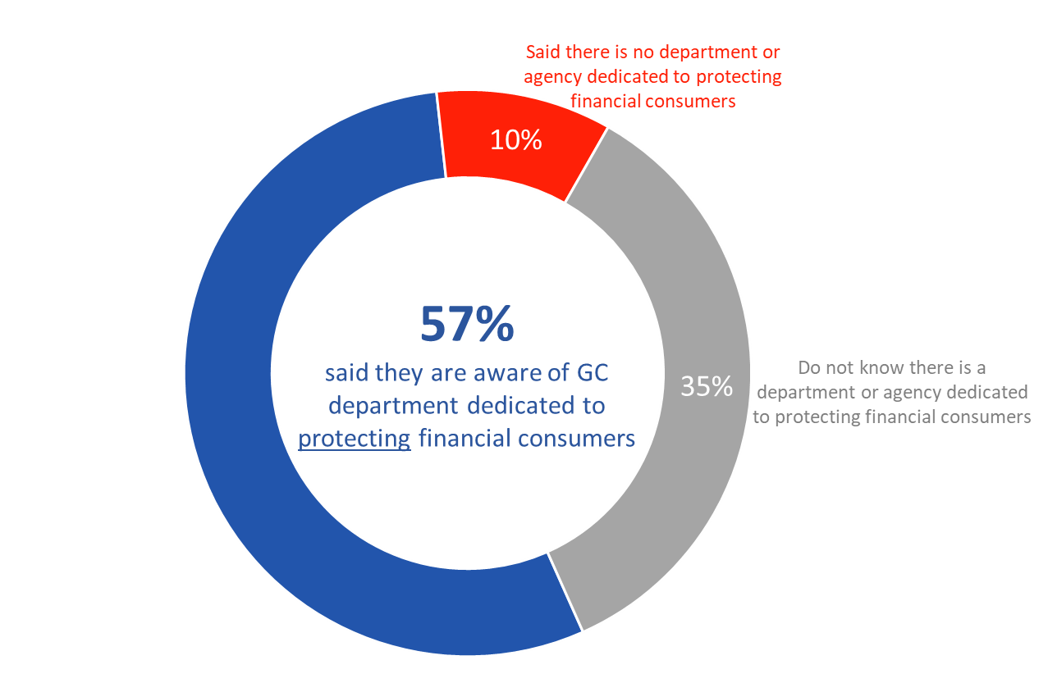

[Wave 1-10]

FCAC1: To the best of your knowledge, does the government of Canada have a department or agency dedicated to protecting financial consumers?

Base: n=12,101; all respondents. Refused to respond excluded.

The likelihood of being aware that the government of Canada has a department or agency dedicated to protecting financial consumers was significantly higher among respondents from Ontario compared to those from the West and Quebec, as well as among recent immigrants compared to those who immigrated to Canada more than five years ago.

One in four aware government has department dedicated to financial education
Fewer Canadians (25%) said they are aware the government of Canada has a department dedicated to the financial education of consumers. Among the rest, 46% did not know and 29% said no there is not such a department or agency.

Figure 2: Awareness of GC Department Dedicated to Financial Education of Consumers
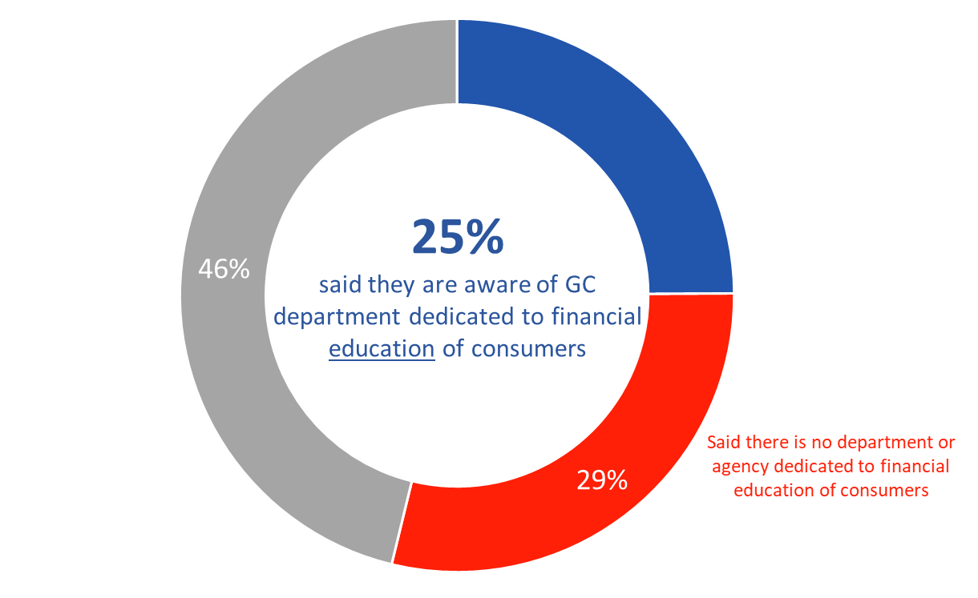

[Wave 1-10]

FCAC2: To the best of your knowledge, does the government of Canada have a department or agency dedicated to the financial education of consumers?

Base: n=12,102; all respondents. Refused to respond excluded.

Awareness that the government of Canada has a department or agency dedicated to the financial education of consumers was highest among recent immigrants and lowest among those born in Canada. Additionally, visible minorities were more likely than others to have said they know that such a government department or agency exists.

Limited familiarity with the Financial Consumer Agency of Canada
Few Canadians (8%) claimed at least some familiarity with the Financial Consumer Agency of Canada (FCAC). Nearly half (48%) said they have never heard of the agency, while four in 10 (41%) claimed to have little or no familiarity with it.

Figure 3: Familiarity with FCAC
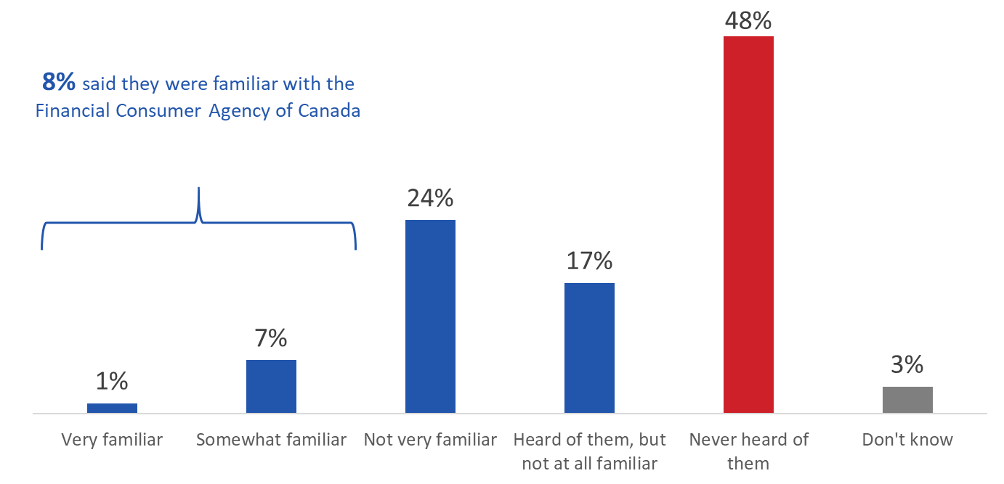

[Wave 1-10]

FCAC3: How familiar would you say you are with the Financial Consumer Agency of Canada?

Base: n=12,143; all respondents Refused to respond excluded.

Visible minorities were more likely than others to have said they are somewhat or very familiar with the FCAC.

Banking Habits and Awareness

Majority of Canadians conducted contactless banking before March 2020
A large majority of Canadians said they engaged in contactless banking methods before March of 2020. Just over half (51%) said they most commonly used their bank’s website, approximately one-quarter (24%) said they used a mobile app, 8% used an ATM, and 4% used the phone to complete their banking needs. Thirteen percent said they most commonly did their banking in person at a branch.

Figure 4: Preferred Method of Banking

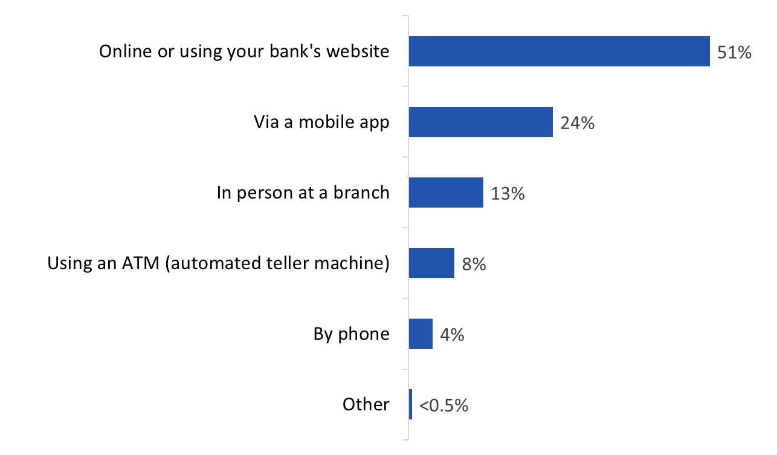

[Wave 1-10]

B1: Before March 2020, what was the most common way you did your banking?

Base: n=12,072; all respondents. Don’t know/no response excluded.

The following sub-group differences are noteworthy:
- The likelihood of banking online or using their banks website increased with age, while the likelihood of banking via a mobile app decreased with age.
- Respondents from Quebec were more likely than those from the West and Ontario to bank online.
- Recent immigrants were less likely than those who immigrated to Canada more than five years ago and those born in Canada to report banking online.
- Visible minorities were less likely than others to bank online.
- The likelihood of banking online increased with education and was highest among those who completed a bachelor’s or post-graduate degree.
- Those from lower income households (earning under $40,000 annually) were least likely to have reported banking online or through their bank’s website.

Most Canadians prefer debit or credit cards for day-to-day purchases
Surveyed Canadians were most likely to say they prefer to use a debit card (45%) or credit card (43%) to complete their day-to-day purchases. By contrast, very few said they prefer using cash (7%), mobile apps (3%) or electronic money transfers (2%).

Figure 5: Preferred Payment Method
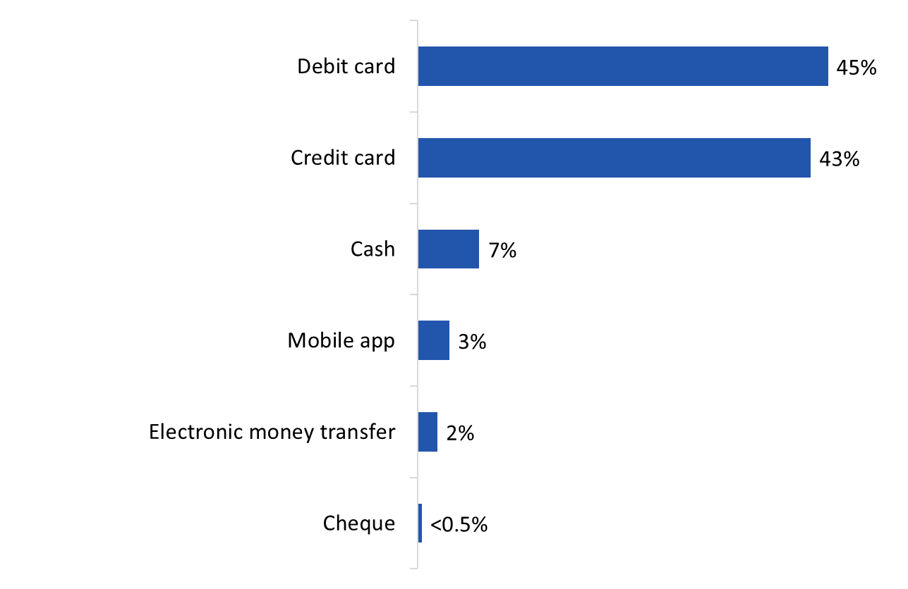

[Wave 1-10]

M1: What is your preferred payment method for day-to-day purchases?

Base: n=11,994; all respondents. Don’t know/no response excluded.

The following sub-group differences are noteworthy:
- The likelihood of using a debit card for day-to-day purchases increased with age, while 18 to 34 year olds were more likely than older Canadians report a preference for credit cards.
- Regionally, debit card use was highest in Atlantic Canada while credit use was lowest in these provinces. In contrast, those who reported a preference for credit cards were more likely to be from the North, Ontario and Quebec.
- Recent immigrants were less likely than those who immigrated to Canada more than five years ago and those born in Canada to prefer to use a debit card for day-to-day purchases. Those born in Canada were less likely than those born abroad to prefer to use a credit card for daily purchases.
- Visible minorities were more likely to report using a debit card for daily purchases and less likely to use a credit card.
- The likelihood of using a debit card for daily purchases decreased with respondents’ highest level of education, while the likelihood of using a credit card increased as education levels decreased. The same pattern was seen when it came to household income: use of debit cards decreased with income while use of credit cards increased as respondents’ household income increased.

More than half use contactless payment methods more often
As the accompanying graph shows, compared to one year ago Canadians use some payment methods more and others less. Contactless payment methods and e-transfers tend to be used more often now compared to a year ago. Over half of surveyed Canadians (56%) indicated that they use contactless methods of payments more often now than last year, with most others (36%) using them about as often. When it comes to e-transfers, the largest proportion (49%) said they use these more often now than a year ago, with most others (43%) using them about as often.

Figure 6: Preferred Payment Method
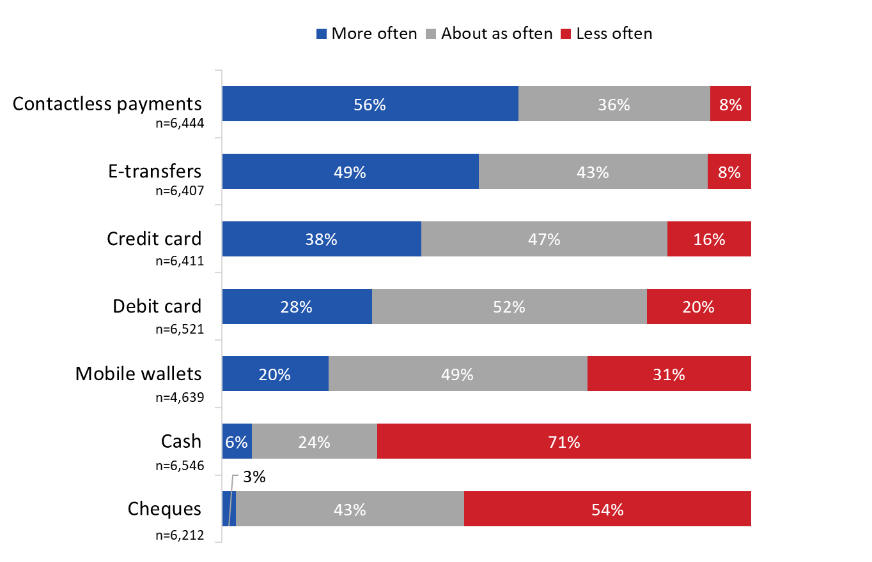

[Wave 5-10]

M4: What is your preferred payment method for day-to-day purchases?

Base: all respondents. Don’t know/no response excluded.

For their part, credit, debit cards, and money wallets are more likely to be used about as often now as they were last year. Just over half (52%) indicated that they use debit cards about as often as last year, with over one-quarter (28%) saying they use them more often, and one-in-five saying they use them less often. Nearly half (49%) said they use mobile wallets about as often as a year ago, with others more likely to say they use them less often (31%) than more often (20%). When it comes to credit cards, the largest proportion (47%) said they use these about as often as a year ago, with others twice as likely to say they use them more often (38%) than less often (16%).

Finally, cash and cheques are more likely to be used less often than a year ago. Close to three-quarters (71%) said they use cash less often than a year ago, with most others (24%) saying they use it about as often. A majority (54%) said they use cheques less often than a year ago, with nearly all others (43%) saying they use them about as often.

The following sub-group differences are noteworthy:
- Immigrants were more likely than those born in Canada to report using contactless payment options, mobile wallets and credit cards more often now than compared to a year ago.
- Those with a bachelor’s or post-graduate degree were more likely than those with less formal education to report using e-transfers, contactless payments, and credit cards more often now than a year ago. Debit card use increased as education levels decreased, while use of mobile wallets did not differ by level of education.
- Use of debit cards decreased as household income increased. In contrast, use of e-transfers, contactless payments and mobile wallets did not differ significantly based on household income.
- Visible minorities were more likely to report using contactless payments, credit cards and mobile wallets more often now than a year ago.
- Older respondents were less likely to say they increased their use of mobile wallets. Those aged 18 to 34 were most likely to say they are using mobile wallets more now as compared to their use of this payment option a year ago.

Canadians divided when it comes to awareness of increased contactless payment limit increases
Nearly half (47%) of Canadian said they were aware that some credit and debit card issuers have increased their contactless payment limits, while exactly half (50%) said they were not aware (the rest (3%) did not know).

Figure 7: Awareness of Increased Contactless Payment Limits
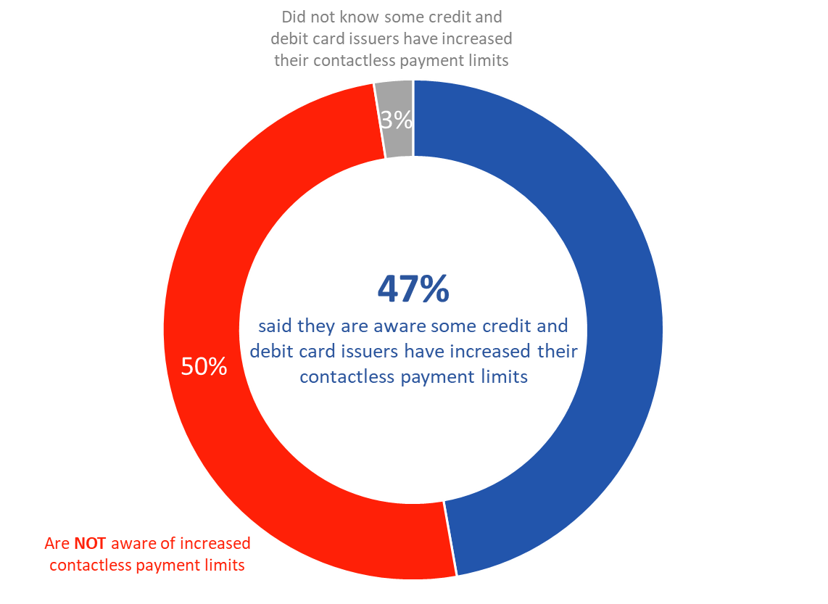

[Wave 1-4]

M2: Recently, some credit and debit card issuers have increased their contactless payment limits. Have you heard about these increases?

Base: n=5,562; all respondents. Refused to respond excluded.

The following were less likely to have heard about the increases: those from Atlantic Canada, respondents with a high school level education or less, those from households reporting annual incomes of under $40,000, and visible minorities.

Half have used contactless payment to make day-to-day purchases over $100
Half of surveyed Canadians (51%) said they have used a contactless payment method to make day-to-day purchases for more than $100, while almost as many (49%) said they have not.

Figure 8: Use of Contactless Payment
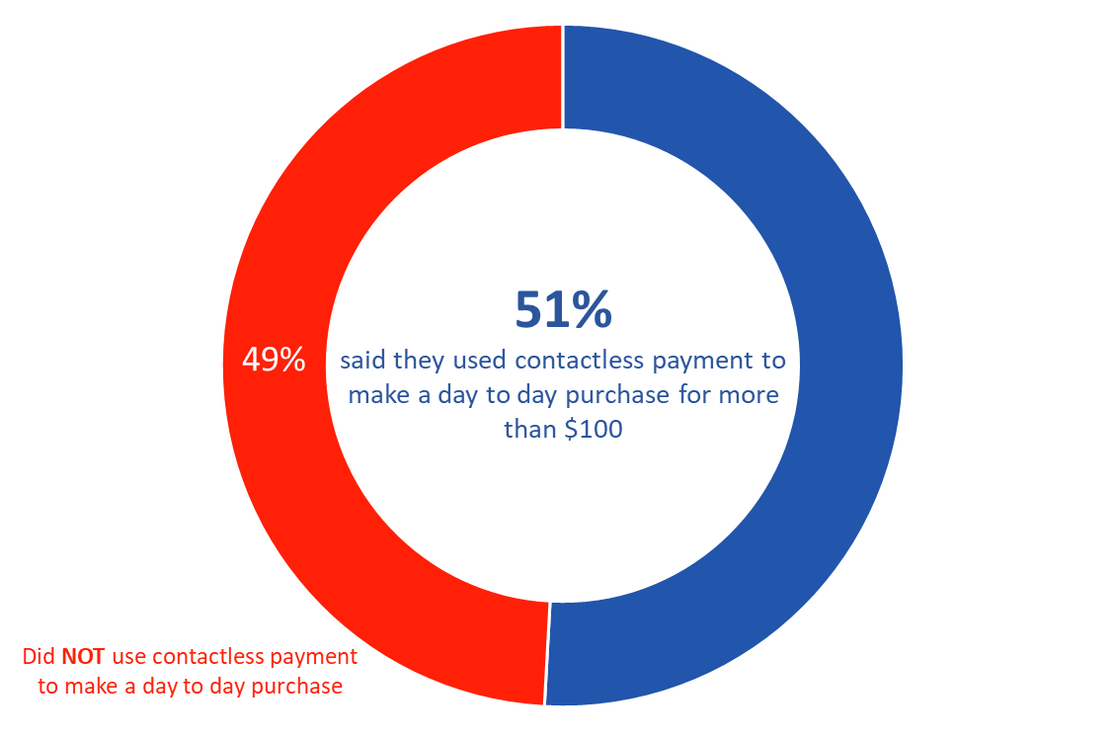

[Wave 1-4]

M3: Have you used contactless payment to make a day-to-day purchase for more than $100?

Base: n=5,329; all respondents. Don’t know/no response excluded.

Canadians aged 35 and older were more likely to have used contactless payment for daily purchases of more than $100, as were those from Quebec, those who completed a bachelor’s or post-graduate degree, and those from higher income households ($80,000+).

Nearly six in 10 unaffected by retailers who no longer accept cash
Fifty-seven percent (57%) of Canadians said have not been affected at all by retailers who have no longer accepted cash since March of 2020. Conversely, just under one-third (31%) said they have been slightly affected by this change, while approximately one in 10 (11%) said they have been heavily impacted by this.

Figure 9: Impact of Retailers’ Preference for Cashless Payment
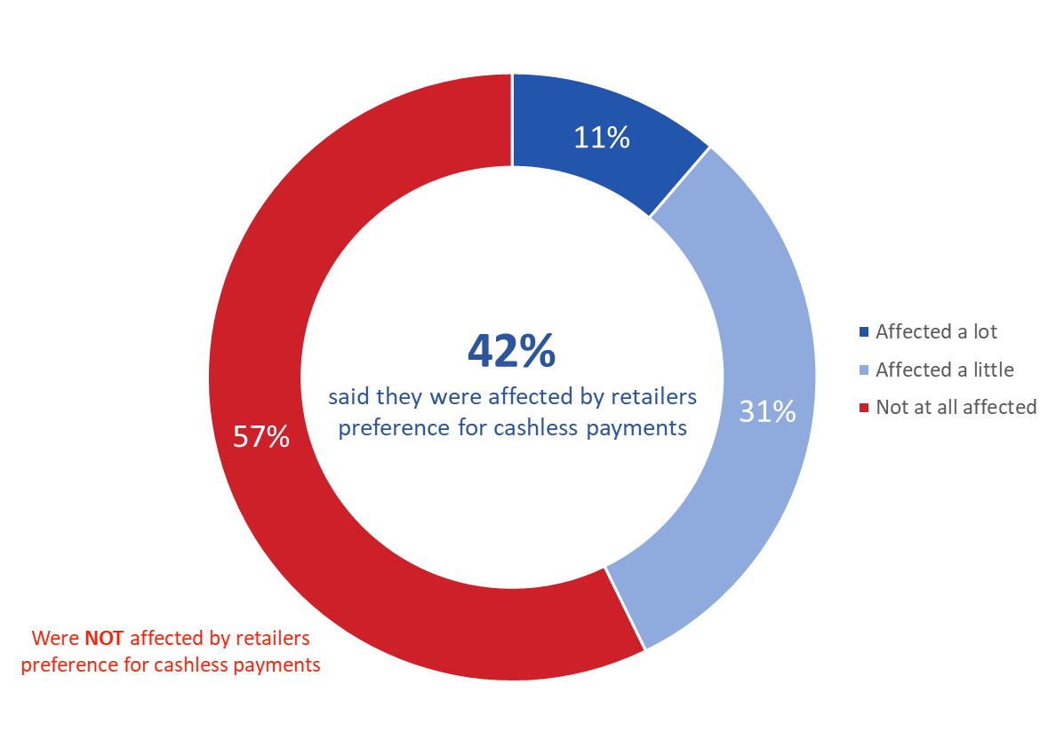

[Wave 5-10]

M5: Since March 2020, many retailers no longer accept cash. How, if at all, has this affected you?

Base: n=6,577; all respondents. Don’t know/no response excluded.

Canadians aged 55+, those from Quebec, and those with a bachelor’s or post-graduate degree were less likely than other to say this affected them a little or a lot.

Many prefer credit or debit cards if a retailer no longer accept cash
Debit and credit cards are the options most likely to be used by surveyed Canadians if a retailer no longer accepts cash. Nearly one in four (38%) said they most often use a debit card in such circumstances, and exactly one-third (33%) said they most often use a credit card. These two options were followed at a distance by a contactless payment method (16%).

Only a few respondents said that they use a mobile wallet or electronic transfer under these circumstances (2% each). A small proportion of respondents (5%) said they would find another retailer who accepted cash, while almost as many (4%) said they have not encountered a retailer who does not accept cash.

Figure 10: Payment Method Used as Replacement for Cash

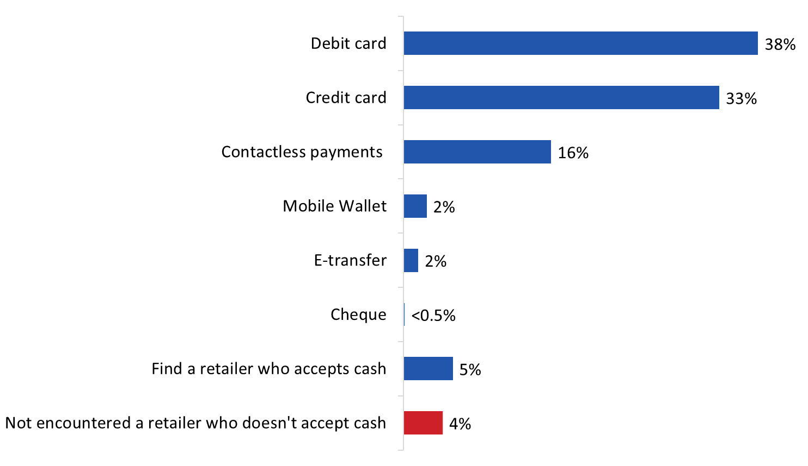

[Wave 5-10]

M6: If a retailer no longer accepts cash, what payment method do you end up using most often? Base: n=6,586; all respondents. Don’t know/no response excluded.

The following sub-group differences are noteworthy:
- Those aged 18 to 34 were more likely to use contactless payments and a mobile wallet if a retailer no longer accepts cash. In contrast, those aged 55+ were more likely use a debit or credit card.
- Those who immigrated to Canada and visible minorities were less likely to report using a debit card and more likely to have used a credit card in place of cash.
- Canadians with a bachelor’s or post-graduate degree were more likely to use of contactless payments in place of cash.

Impact of Bank Branch Closures

Impact of having to change where they do their banking affects Canadians differently
Respondents who said they were affected by the closure of their local bank branch (19%, n=2,294) were affected to different degrees in terms of their ability to conduct their regular banking activities. Just over one-quarter (26%) said the closure of their local bank branch affected their regular banking activity ‘a lot’ because there are few or no other branches nearby. One-third said this affected their regular banking activities ‘a little’ since they had to change where they do their banking.

Approximately one in ten (11%) Canadians said they were affected ‘not much’ because the new location was easy to get to, while 16% said they were ‘not at all’ affected because they do most of their banking online.

One in five (19%) mentioned “other” reasons which affected their ability to conduct their regular banking activities. Reasons commonly mentioned included lack of access to bank due to reduced or changed hours, lack of access to cash and safety deposit boxes, the need to switch banking methods (i.e., in-person to online), and increased use of ATMs.

Figure 11: Impact of Branch Closures

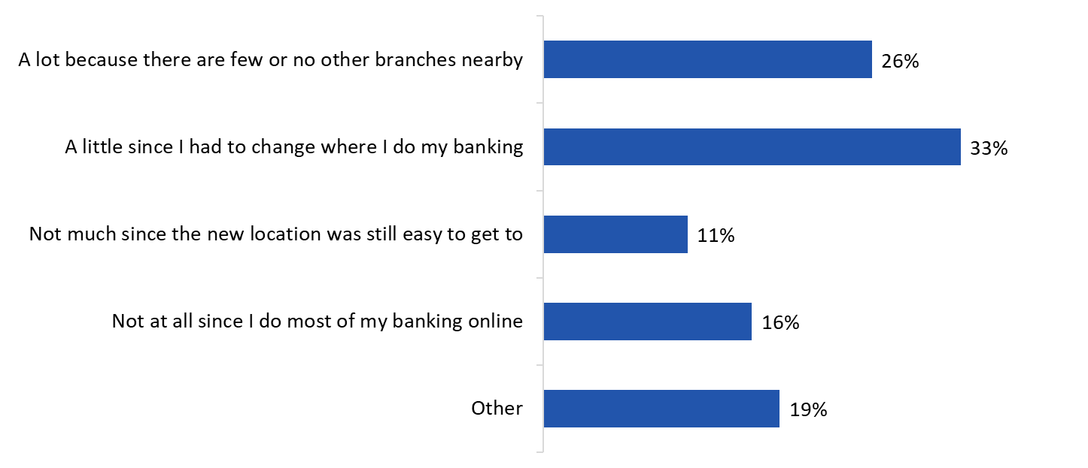

[Wave 1-10]

B2: Since the beginning of March 2020, have you been affected by the closure of your local bank branch? Base: n=11,941; all respondents. Don’t know/no response excluded

B3: How did this branch closure affect your ability to conduct your regular banking activities? Multiple response accepted.

Base: n=2,294; those said they were affected by local bank branch closure. Don’t know/no response excluded.

Immigrants were more likely to have been affected by the closure of their local bank branch as were those with lower levels of formal education, those from households those reporting annual incomes of under $80,000, and visible minorities.

Most Canadians did not experience any issues related to branch closures
Seven in 10 surveyed Canadians (70%) said they did not experience any issues resulting from branch closures. As the accompanying graph shows, among those who did experience issues related to branch closures, the only issues identified with any frequency were difficulty contacting their bank (9%), depositing a cheque in an automatic machine instead of depositing it in a branch (7%), and incurring a fee to use another bank’s ABM (5%). Other issues included being charged fees or interest they did not know could be charged, issues accessing funds, inability to get issues with their bank addressed, inability to lodge a complaint with their bank, inability to open a bank account, holds being placed on cheques, and having to cash a cheque elsewhere than their bank.

Figure 12: Personal Impact of Branch Closures
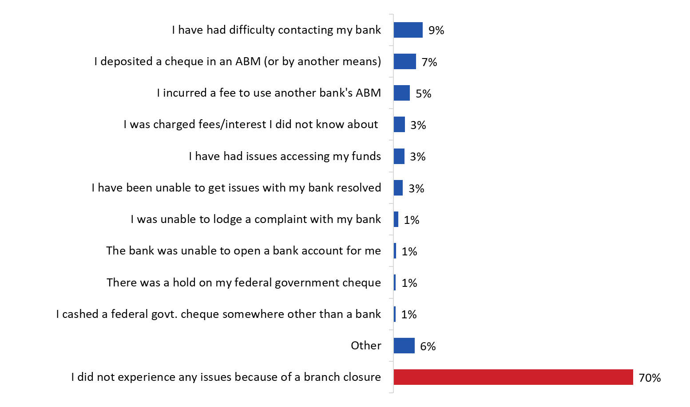

[Wave 1-10]

B4: Have you experienced any of the following as a result of a branch closure? Multiple response accepted.

Base: n=10,834; all respondents. Don’t know/no response excluded.

Respondents from households reporting annual incomes of under $80,000 and visible minorities were less likely to say they did not experience any issues because of a bank closure when compared to those from higher income households and those who are not a visible minority.

Most incurred no fees or interest related to COVID-19
Most respondents (61%) said they incurred no fees or interest on their bank products because of COVID-19. Among those who did incur fees or interest, the most common fees or interest were identified as being overdraft, withdrawals from an automated banking machine, late payment fees, and insufficient funds (multiple responses accepted). The accompanying graph identifies the full list of fees or interests identified.

Figure 13: Fees/Interest Incurred Due to COVID-19
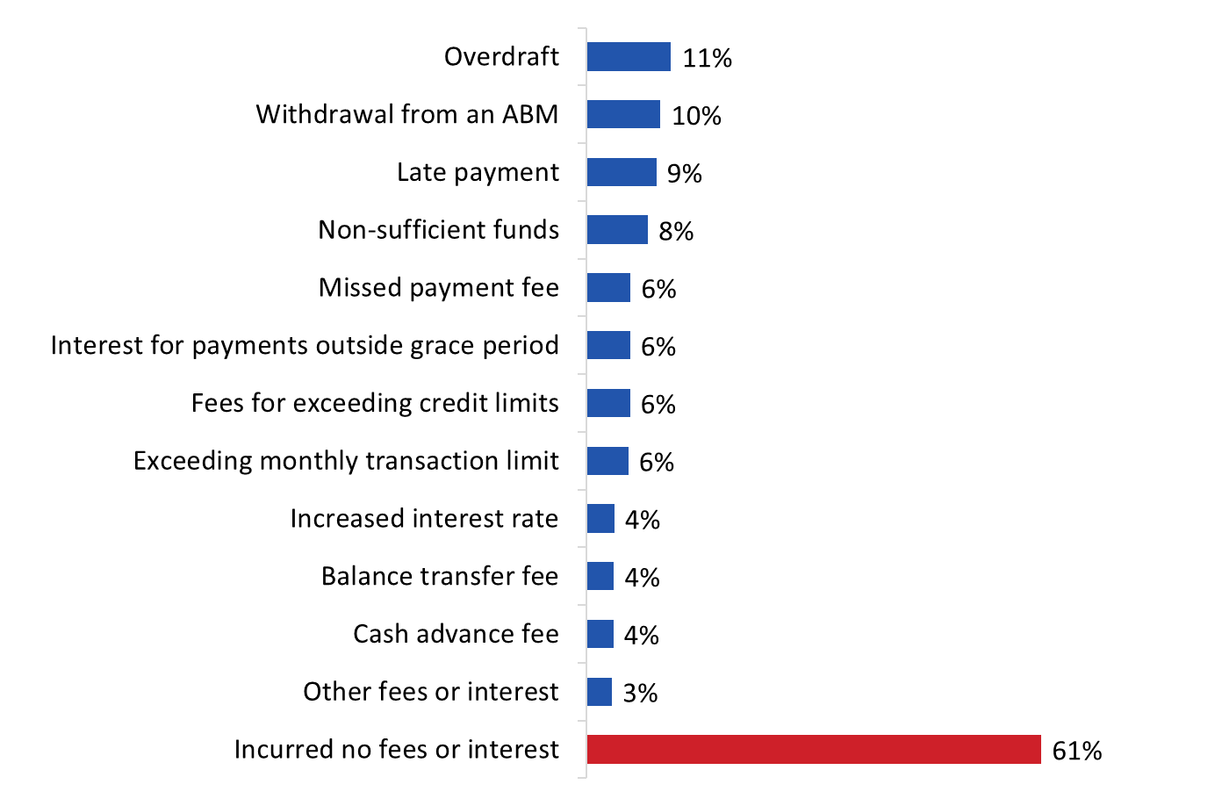
[Wave 1-10]
B5: Because of COVID-19, have you incurred any of the following fees or interest on your bank products? Multiple response accepted.
Base: n=9,662; all respondents. Don’t know/no response excluded.

The following groups were more likely to say they incurred no fees or interest: those aged 55+, those born in Canada, those with a bachelor’s or post-graduate degree, those from households with annual incomes of $80,000, and those who are not visible minorities.

Few where refunded the fees or interest they incurred
Among respondents who said they incurred fees or interest charges due to COVID-19 (n=1,459), just over one in five (22%) said they contacted their bank about it. A large majority of those who contacted their bank (80%) said none of the fees or interest charges were refunded. In comparison, only a small percentage said those fees or interest charges were refunded, either entirely (11%) or in part (9%).

Figure 14: Contacting Bank for Refund

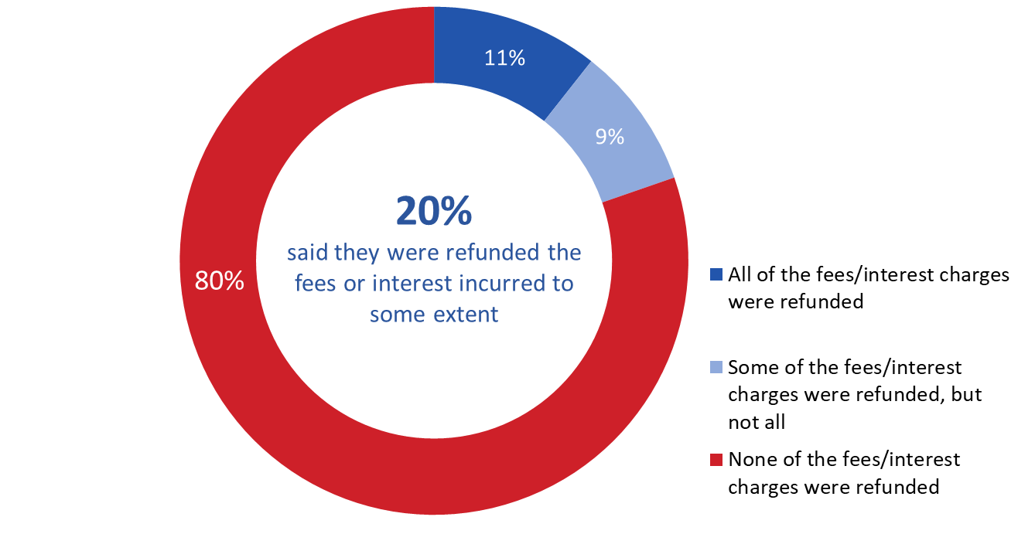

[Wave 1-4]

B6: Did you contact your bank about those fees or interest charges?

Base: n=1,459; those who said they incurred fees. Don’t know/no response excluded.

B7: Were those fees or interest charges refunded?

Base: n=1,214; those who said they incurred fees. Don’t know/no response excluded.

Visible minorities were more likely to report having contacted their bank about the fees or interest charges.

Three-quarters say their credit limits have not changed
Approximately three-quarters (74%) of respondents said their credit limits have not changed since the beginning of March 2020.

As the accompanying graph shows, the nearly one in five (18%) who said their credit limits have changed over that time period identified various ways in which they have changed. These range from all credit limits increasing (5%) to some increasing while others remained the same (8%), to some remaining the same while others decreased (2%), to some increasing while others decreased (1%), to all credit limits decreasing (2%).

Figure 15: Changes to Credit Limits since March 2020

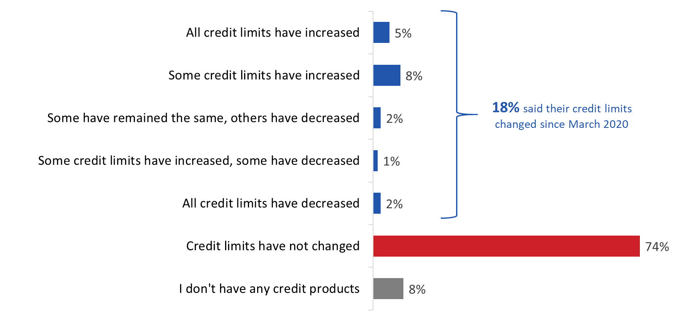

[Wave 1-10]

B8: How, if at all, have your credit limits changed since the beginning of March 2020?

Base: all respondents. Don’t know/no response excluded.

The following were more likely to say all of their credit limits have increased: those aged 18 to 34, recent immigrants, those with high school or less formal education, those from households reporting annual incomes of under $40,000, and visible minorities.
Figure 16 shows how changes in credit limits have evolved over time. Overall, variations between July of 2020 and April of 2021 have been relatively limited, with some or all credit limits tending to increase slightly over this period.

Figure 16: Changes to Credit Limits since March 2020 [Time Series]

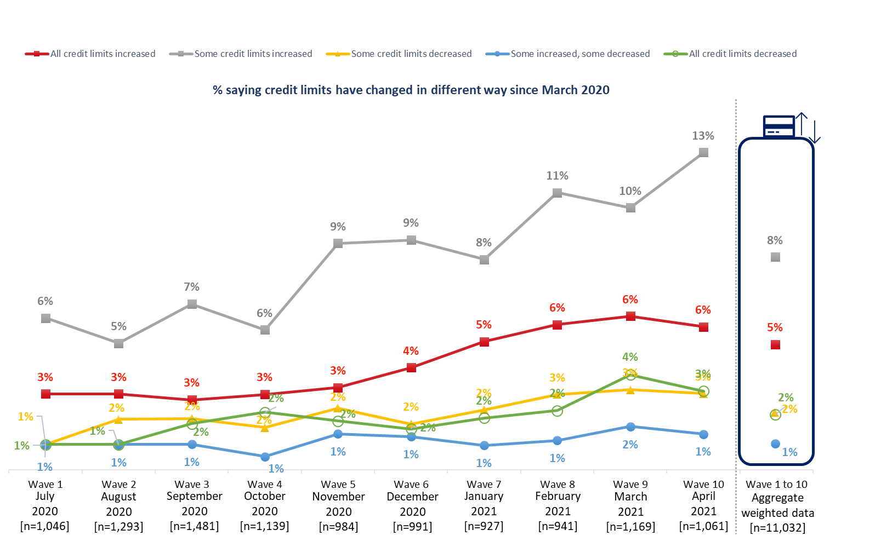

[Wave 1-10]

B8: How, if at all, have your credit limits changed since the beginning of March 2020?

Base: all respondents. Don’t know/no response excluded.

COVID-19 Communication from Bank

Majority said their bank provided information about COVID-19
A majority of surveyed Canadians (61%) said their bank provided them with information about COVID-19. These respondents most often said they received information about steps the bank is taking to provide continued service (59%), followed by information about ways to bank during the pandemic (49%) and how to contact the bank if they need financial help (43%) (multiple responses accepted). Just over one-quarter said they received information about payment deferrals (28%) and about branch closures (27%), while just over one in five (22%) said they received information about how to access government benefits during the pandemic (22%). This was followed by information about budgeting or financial planning (17%), information about signing up for direct deposit and information about waived or lowered fees (13% each), and information about how to lower the interest rate on credit products (8%).

Figure 17: COVID-19 Information Received from Bank

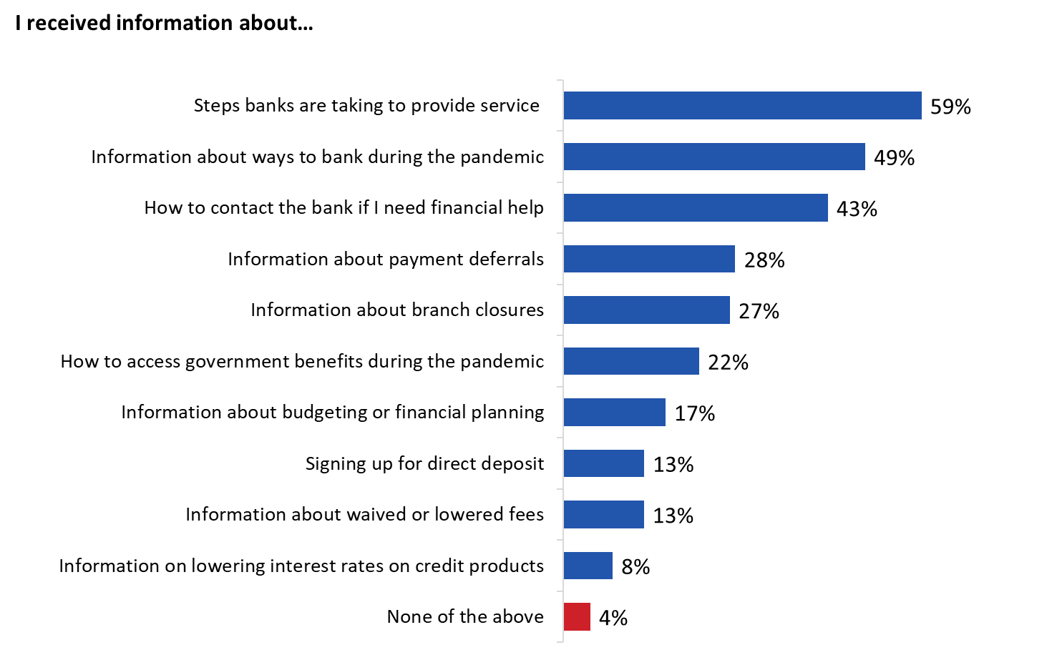

[Wave 1-10]

PB2: What information did your bank provide you? Multiple responses accepted.

Base: n=6,338; those who received information about COVID-19 from their bank. Don’t know/no response excluded.

Recent immigrants, those with a bachelor’s or post-graduate degree, visible minorities and those from household reporting annual incomes of $40,000+ were more likely than other groups to say their bank provided them with information about COVID-19.

Perceptions regarding bank communications related to COVID-19
Surveyed Canadians who said their bank provided them with information about COVID-19 were asked to rate the extent to which they agree or disagree with the following statements:
- The communications from my bank about COVID-19 are easy to understand.
- I am receiving COVID-19 communications from my bank in my preferred format.
- The communications from my bank regarding COVID-19 have been helpful.

A majority of these respondents agreed at least to some extent with each of these statements, but the size of the majority varied. Three-quarters agreed strongly (36%) or somewhat (39%) that the communications from their bank about COVID-19 were easy to understand. Slightly fewer (70%) agreed that they received COVID-19 communications from their bank in their preferred format (33% strongly, 37% somewhat). A smaller majority agreed strongly (21%) or somewhat (35%) that the communications from their bank regarding COVID-19 have been helpful.

Respondents who did not agree with these statements were more likely to be neutral than to disagree with them. Levels of disagreements with these statements ranged from 9-12%.

Figure 18: Perceptions of COVID-19 Information from Bank

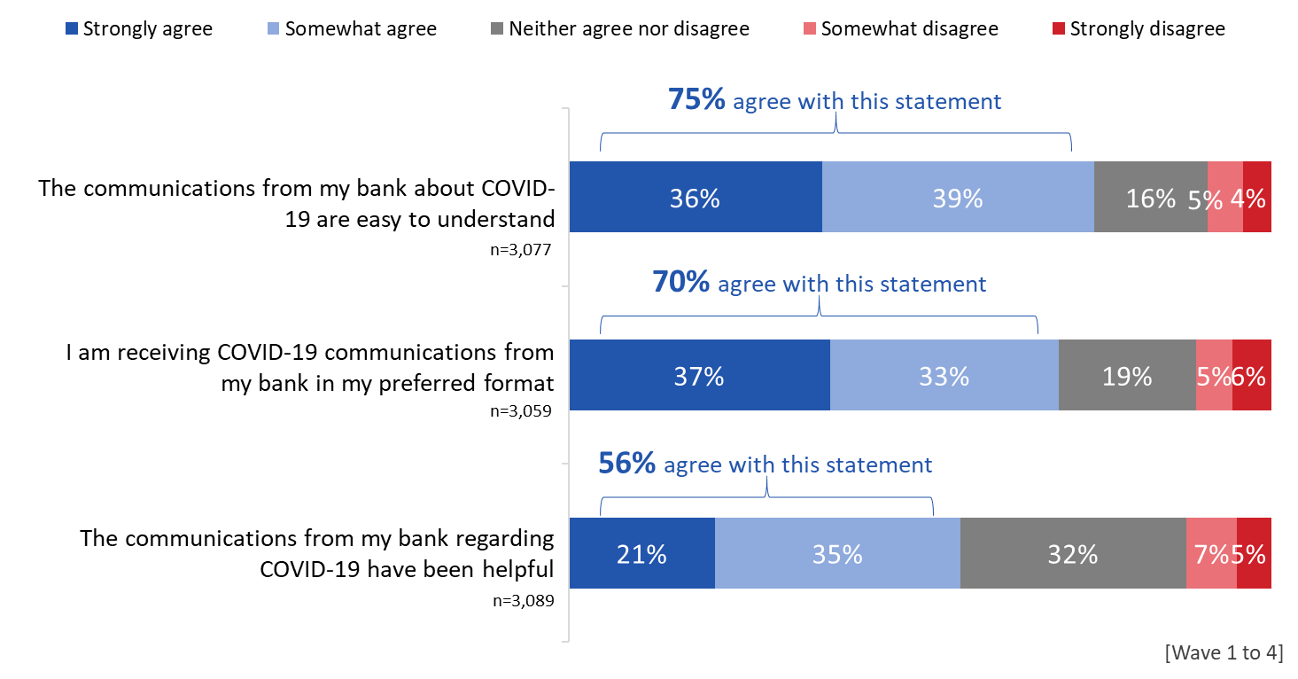

[Wave 1-4]

PB3: How strongly do you agree or disagree with the following statements about your bank?

Base: those who received information about COVID-19 from their bank. Don’t know/no response excluded.

Mixed perceptions regarding bank responses to COVID-19
Surveyed Canadians were asked to rate the extent to which they agreed or disagreed with the following statements:
- I am satisfied with the way my bank is responding to the COVID-19 crisis.
- I know what options my bank has available if I need financial help.
- I would like more information about the bank’s response to the pandemic.

Respondents’ perceptions regarding these issues were mixed. A majority (55%) agreed at least to some extent that they are satisfied with their bank’s response to the COVID-19 crisis (24% strongly agreeing). Those who did not agree with this statement were much more likely to neither agree nor disagree (30%) than to disagree (16%). Approximately half (49%) agreed at least to some extent that they knew what options their bank has available if they need financial help, but nearly one-third (31%) disagreed with this, while one in five (20%) neither agreed nor disagreed. Over one-third (37%) agreed at least to some extent that they would like more information about their bank’s response to the pandemic, while almost as many (36%) neither agreed nor disagreed and just over one-quarter (27%) disagreed to some extent.

Figure 19: Perceptions of COVID-19 Response from Bank

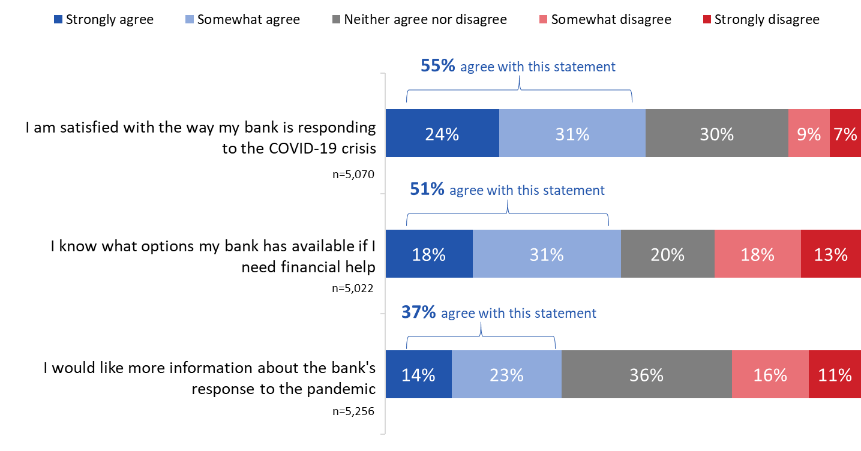

[Wave 1-4]

PB4: How strongly do you agree or disagree with the following statements about your bank?

Base: all respondents. Don’t know/no response excluded.

Vast majority have not had a problem with their bank
Most surveyed Canadians (89%) said they had not had a problem with their bank since the beginning of the pandemic in March of 2020. Just over half of those who said they have had a problem with their bank said their problem was related to the COVID-19 pandemic.

Figure 20: Problems with Bank Since March 2020

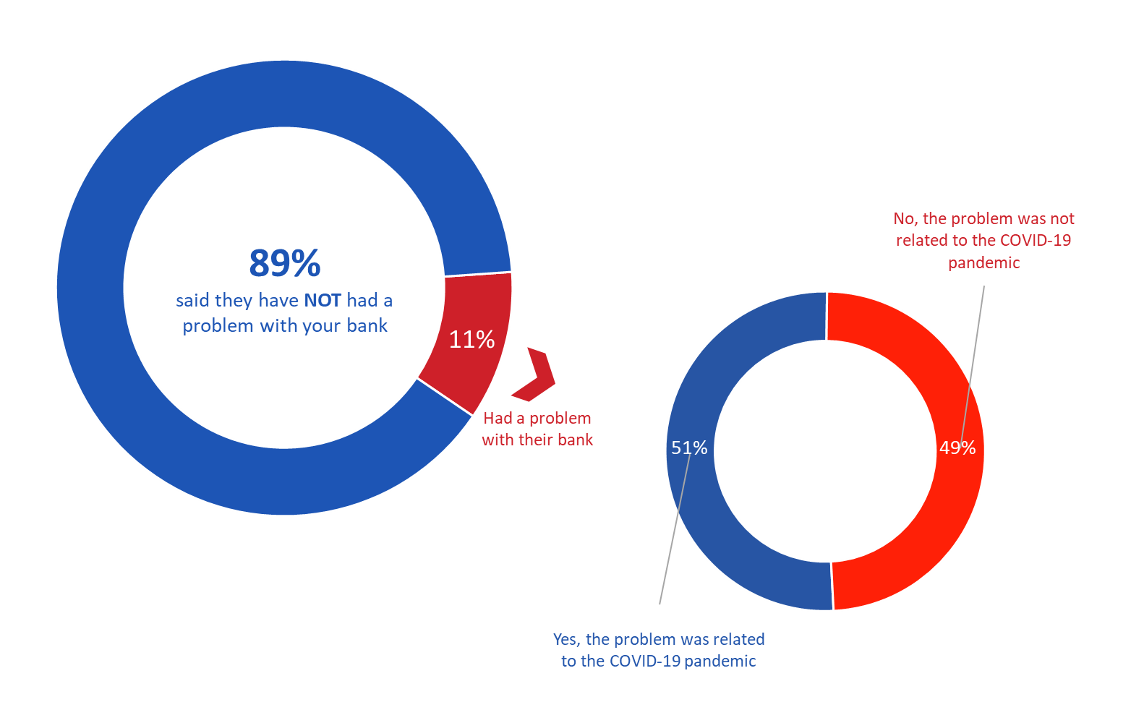

[Wave 5-10]

[LEFT] PB6: Since March 2020, have you had a problem with your bank?

Base: n=6,499; all respondents. Don’t know/no response excluded.

[RIGHT] PB9: Was the problem related to the COVID-19 pandemic?

Base: n=641; those who had banking problem. Don’t know/no response excluded.

Poor customer service is the leading banking problem encountered by Canadians
As the accompanying graph shows, respondents who said they had banking problems (n=731) collectively identified a host of issues they encountered. The most common banking problems related to the behaviour of a bank employee or receipt of poor customer service (28%), followed by an issue that prevented respondents from accessing funds or an unexpected hold placed on a deposited cheque (19%), unexpected banking services or fees and a transaction error (16% each), charges for a banking service not agreed to (11%), and fraud or some other unauthorized access to funds (10%) (multiple responses accepted).

Problems identified less frequently included a problem with the bank’s hardship program, being misled or pressured into signing up for a service or product, interest rates that were unexpected/not what they were told, aggressive activities related to debt collection or service cancellation, increasing or lowering credit limits without consent, and data breaches or misuse of personal information.

Figure 21: Problems Encountered with Bank Since March 2020

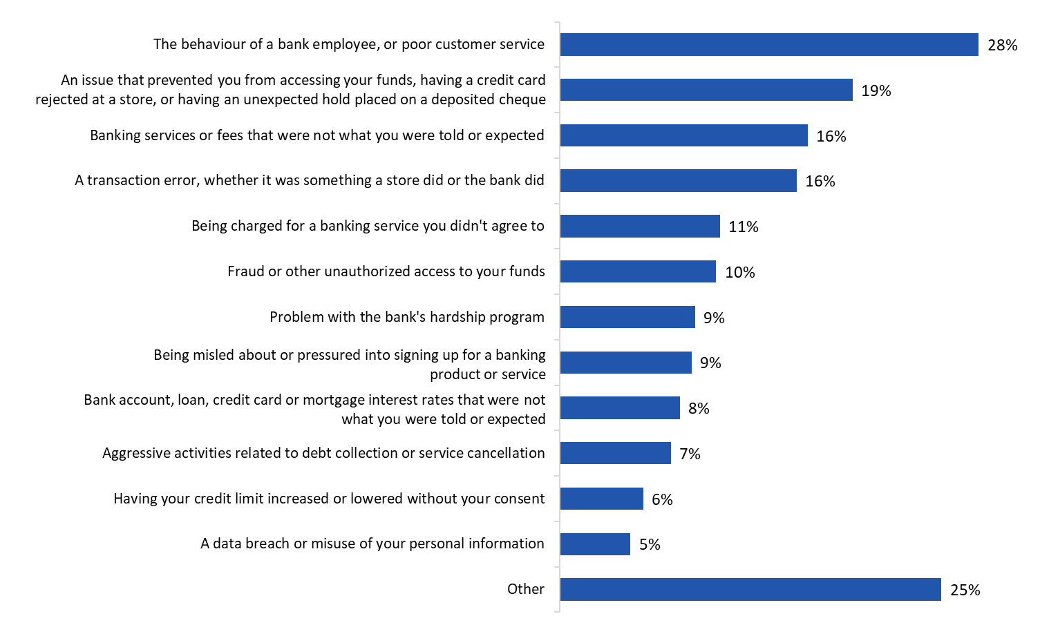

[Wave 5-10]

PB7: What was the problem? Multiple response accepted.

Base: n=731; those who had banking problem. Don’t know/no response excluded.

Most of those who had a banking complaint contacted their bank to resolve it
Over three-quarters (78%) of respondents who had a complaint said they contacted their bank to resolve the issue. More specifically, just over one-third (38%) of those with a complaint said they contacted their bank and their problem was either resolved (27%) or in the process of being resolved (11%), slightly more (40%) said they contacted their bank but their problem was not resolved. Notably, nearly one-quarter (23%) said they did not contact their bank about their complaint.

Figure 22: Contact with Bank Re: Problems

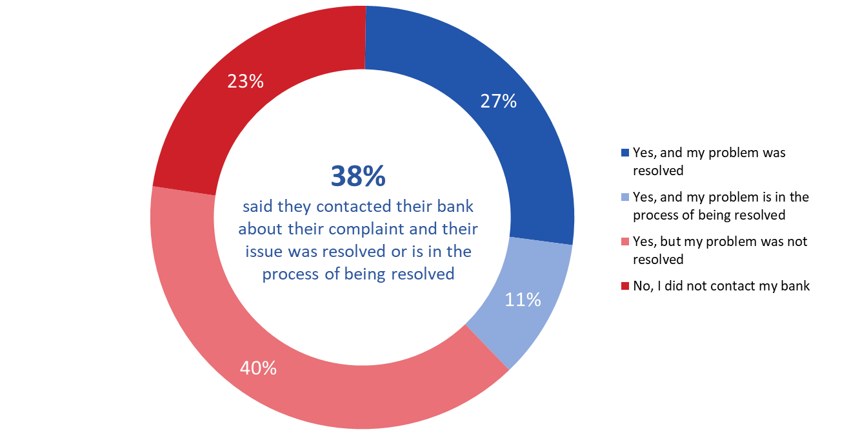

[Wave 5-10]

PB8: Did you contact your bank about your complaint?

Base: n=746; those who had banking problem. Don’t know/no response excluded.

Hardship Programs

Many are aware about the financial help being offered by Canadian banks
Nearly two-thirds of surveyed Canadians (64%) said they have heard about financial help being offered by Canadian banks since the beginning of COVID-19. Recent immigrants, respondents with a high school education or less, and visible minorities were significantly less likely to have heard about financial help offered by Canadian banks. Notably, awareness increased with education and household income. As respondents’ level of education and household income increased, so too did the proportion of respondents reporting they have heard anything about financial help being offered by Canadian banks.

Respondents who heard about the financial help being offered said they most often heard about it on the radio or television (52%), followed by the internet (37%) or directly from their bank (36%) (multiple responses accepted). Over one-quarter (29%) said they learned about these programs through social media (29%). Just under one in five learned about it through print media (18%). Less than one in six learned about it through word of mouth, either a friend or family member (14%) or a professional financial advisor or planner (5%).

Figure 23: Sources of Information re: Hardship Programs

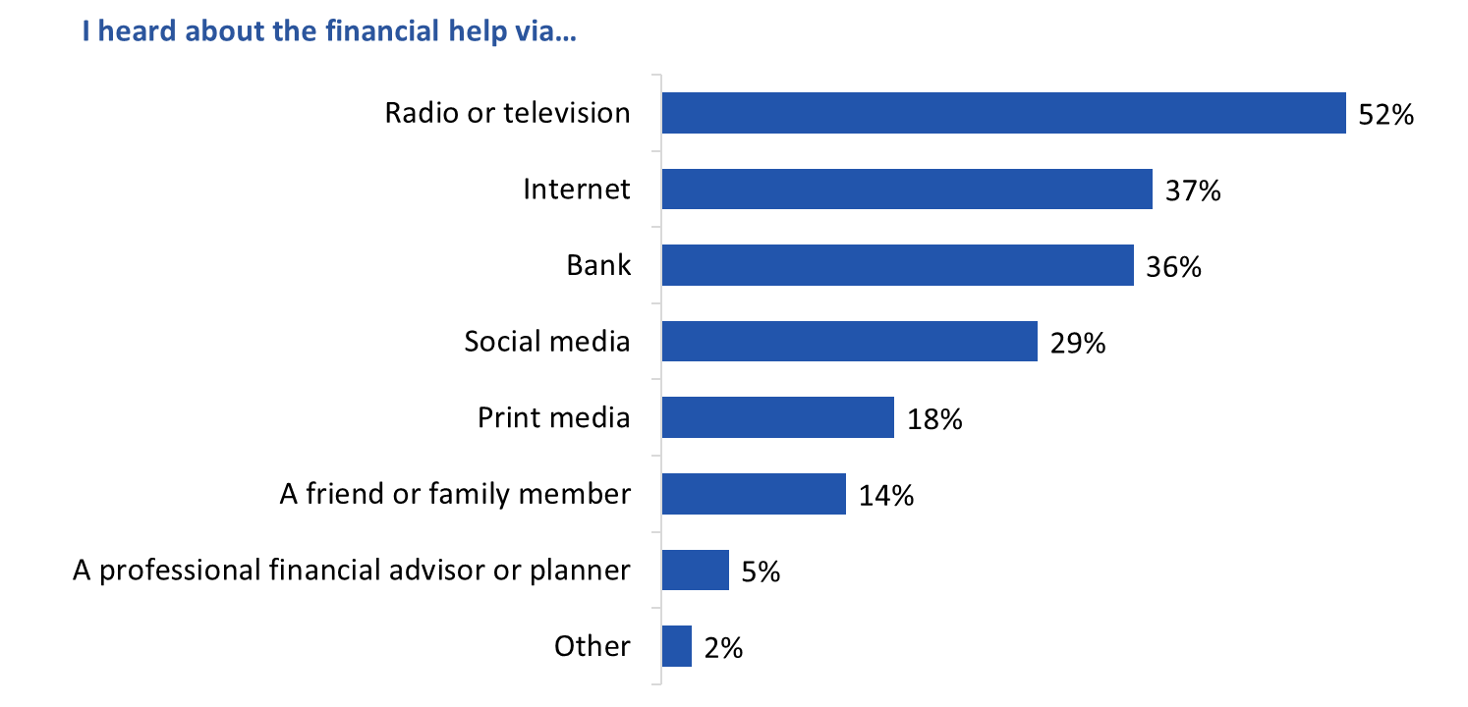

[Wave 1-4]

H2: How did you hear about financial help being offered by Canadian banks? [Multiple responses accepted].

Base: n=3,405; those who heard about financial help being offered by banks. Don’t know/no response excluded.

Notable sub-group differences include the following:
- Younger Canadians were more likely to say they heard about financial help via social media, a friend or family member, or the Internet when compared to older Canadians. Conversely, those who mentioned print media, radio or television were more likely to be aged 55 and older.
- Recent immigrants were less likely than respondents born in Canada to have heard about financial help from the radio or television.
- Visible minorities were less likely than others to have mentioned print media, radio or television, and more likely to have heard about financial help being offered by Canadian banks via the Internet, social media, friends or family, or a bank.

Most have not tried to contact their bank for financial help because of the pandemic
The aggregated tracking data reveals that, on average, 14% of respondents said they contacted their bank for financial help in relation to the COVID-19 pandemic. There was a notable increase in respondents who contacted their bank for help in November of 2020 (19%) – up 7% from October of that year. Since then, the proportion of respondents who said they contacted their bank has remained relatively steady, though it has declined to 15% as of April 2021.

Figure 24: Contact with Bank for Financial Help [Time Series]

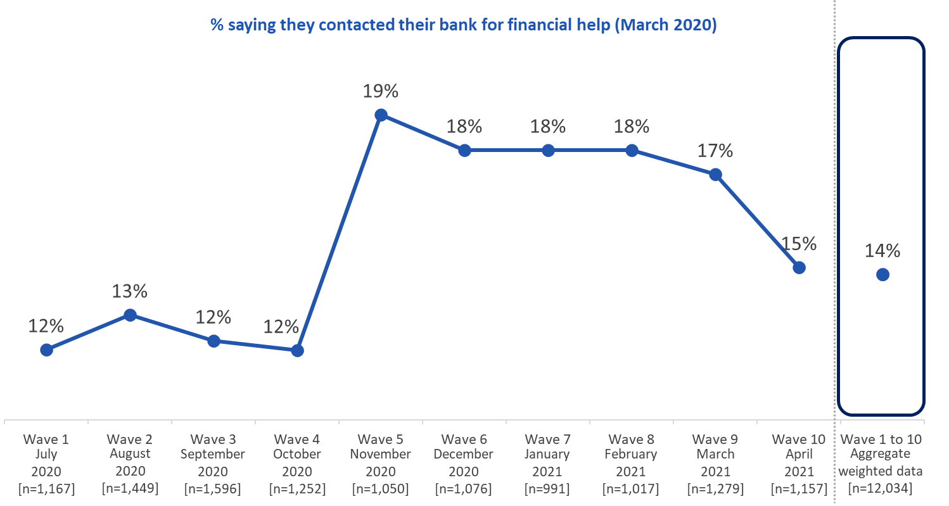

[Wave 1-10]

H3: Since the beginning of March, have you tried to contact your bank for financial help because of the pandemic?

Base: n=all respondents. Don’t know/no response excluded.

The following subgroup were more likely to have tried to contact their bank for financial help: those aged 35 to 54, respondents from the West compared to those from Ontario and Quebec, those with a college or high school level education, those with household incomes of under $40,000 compared to those earning $100,000+ annually, and visible minorities.

Over half who communicated with their bank did so by phone
Among those who tried to contact their bank (n=1,817), most said they did so by phone (59%), followed by online (18%), in-person at a bank branch (12%), or through email (11%). Very few (1%) did so by regular mail.

Figure 25: Methods Used to Contact Bank
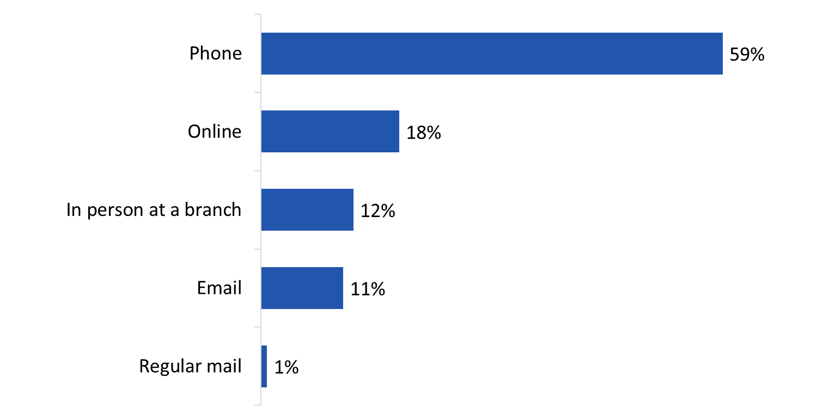

[Wave 1-10]

H5: How did you try to contact your bank?

Base: n=1,817; those who contacted their bank. Don’t know/no response excluded.

Those aged 55 and older were more likely than younger Canadians to have tried to contact their bank by going in to a branch. They were also less likely than those aged 18 to 34 to report having used the telephone and more likely than 18 to 34 year olds to have tried to contact their bank by email. Respondents from lower income households were less likely to have contacted their bank online and more likely to have done so in person at a branch.

Nearly half said their bank contacted them by phone
Among those who received financial help from their bank (n=823), nearly half (48%) said their bank informed them about the terms and services of this program by phone. This was followed by email (25%), online (21%), and in-branch (16%). Relatively few (6%) were contacted by regular mail.

Figure 26: Contact Methods Used by Bank
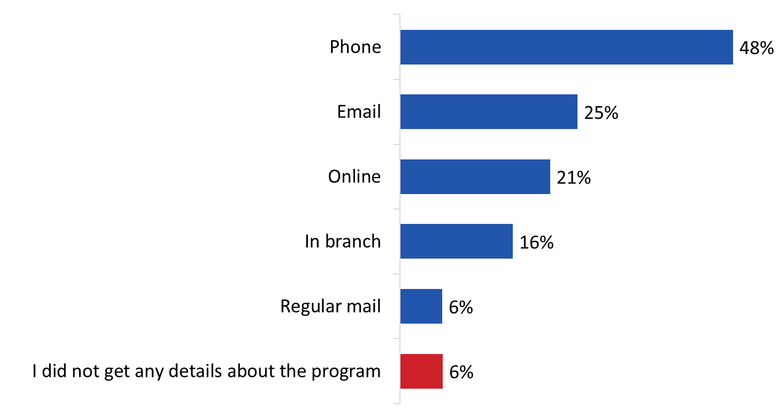

[Wave 1-10]

H9: How did your bank tell you about the terms and conditions of the program? Multiple responses accepted.

Base: n=823; those who received financial help. Don’t know/no response excluded.

Respondents from the west were less likely to have heard about the terms and conditions of the program by phone (as compared to those from Ontario and Quebec), while visible minorities were more likely to have been informed by their bank by phone.

Majority who contacted their bank received financial help
Of those who contacted their bank (n=1,644) just over half (52%) said they received financial help. By contrast, just over one in five (21%) said they were denied financial help. Among those who contacted their bank there were also some who were offered financial help but declined after the program was explained (8%), gave up because wait times were too long (12%), or gave up because they did not know who to contact within the bank (7%).

Figure 27: Outcome of Contact with Bank
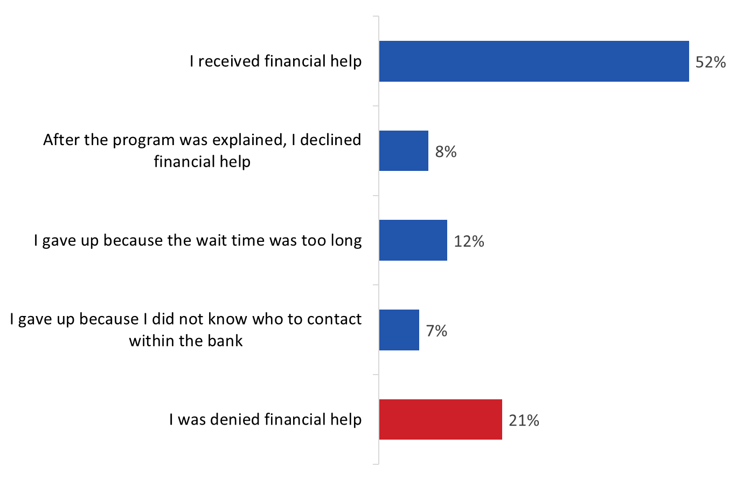

[Wave 1-10]

H6: Which of the following best describes what happened when you tried to contact your bank? Base: n=1,644 those who contacted their bank. Don’t know/no response excluded.

Notable sub-group differences include the following:
- Respondents under 35 were less likely to report having received financial help and more likely to report having been denied financial help.
- Those living in the West were more likely than those from Ontario to indicate they received financial help.
- Recent immigrants and visible minorities were significantly less likely than others to report having received financial help.
- Those reporting household incomes of under $40,000 were least likely to report having received financial help and most likely to say they were denied financial help.

Figure 28 shows how the various outcomes of contact with banks has varied over time. Between July of 2020 and April of 2021, the proportion of surveyed respondents who received financial help has fluctuated, ranging from a high of 60% in September of 2020 to a low of 43% in March 2021. The aggregated tracking data reveals that, on average, 52% of those who contacted their bank received financial help.

Figure 28: Outcome of Contact with Bank [Time Series]

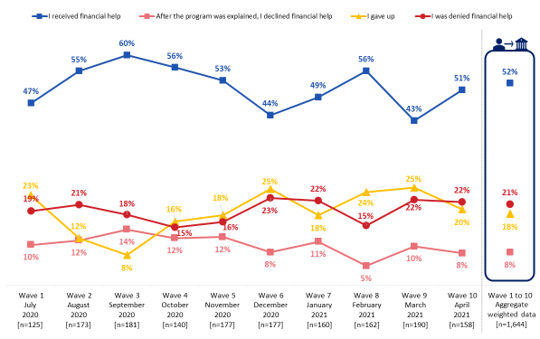

[Wave 1-10]

H6: Which of the following best describes what happened when you tried to contact your bank?

Base: those who contacted their bank. Don’t know/no response excluded.

Those who received financial help most often did so by deferred mortgage payments
Among those who received financial help from their bank (n=810) just over half (52%) obtained deferred mortgage payments. The next most common were deferred payments on a car loan (17%) and outstanding credit card balances (15%), or reduced interest rates on credit card balances (10%) (multiple responses accepted). Small numbers (5% or less) obtained increased credit limits on a personal line of credit or credit card, reduced interest rates on credit products other than a credit card, and increased credit limits on a home equity line of credit. Other forms of financial help received included applying for personal and business loans, setting up the Canada Emergency Response Benefit (CERB) payments, and assistance with investments.

Figure 29: Type of Financial Help Received
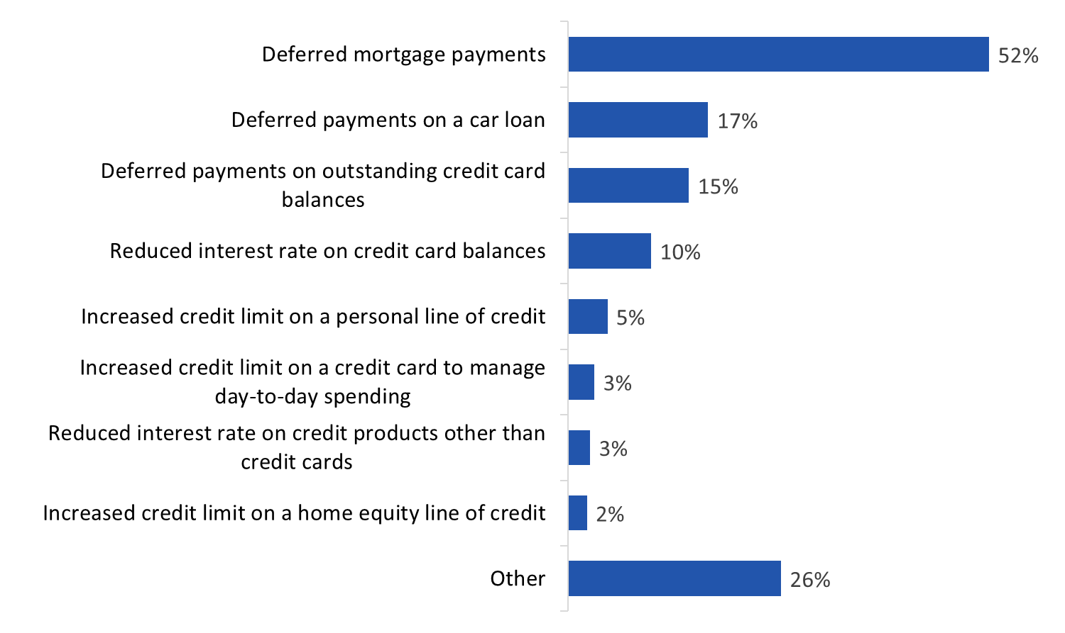

[Wave 1-10]

H8: What sort of financial help did you receive? Multiple response accepted.

Base: n=810; those who received financial help. Don’t know/no response excluded.

As the accompanying tracking graph shows, receipt of deferrals of mortgage payments has declined over time from a high of 69% in July of 2020 to 49% in April of 2021.

Figure 30: Type of Financial Help Received [Time Series]

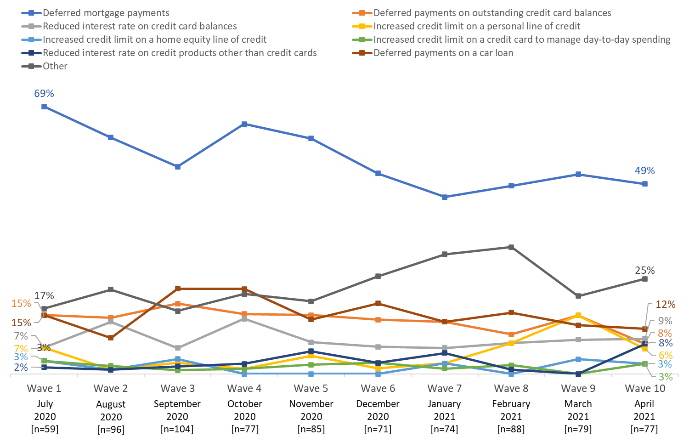

[Wave 1-10]

H8: What sort of financial help did you receive? Multiple response accepted.

Base: n=810; those who received financial help. Don’t know/no response excluded.

Seven in 10 enrolled in a financial help program for less than 6 months
Among those who accepted financial help from their bank through a hardship program (n=770), seven in 10 (70%) were enrolled in the program for less than six months (over one-third for less than three months). The accompanying graph provides a more specific breakdown of the length of time respondents were involved in a financial help program.

Figure 31: Length of Hardship Program
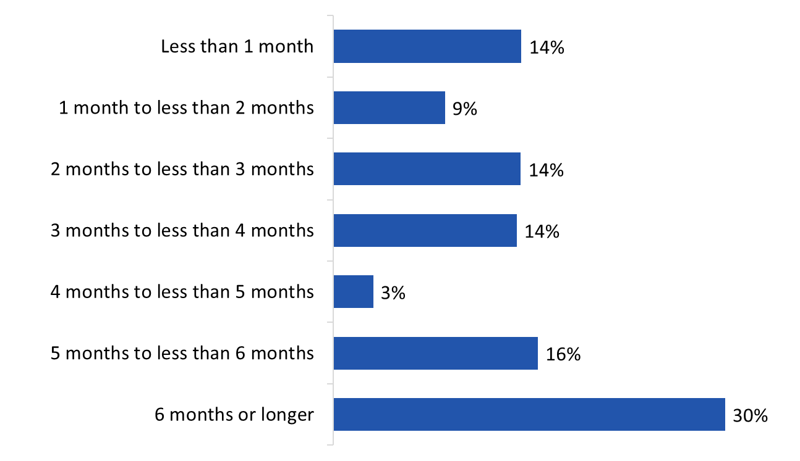

[Wave 1-10]

H10: For how long did you enroll in the program?

Base: n=770; those who received financial help. Don’t know/no response excluded.

Most who did not contact their bank did not experience financial hardship
Among those who did not try to contact their bank (n=9,642), over two-thirds (71%) said that they did not do so because they did not experience any financial hardship. About one in 10 respondents said they lacked confidence that their issue would be resolved in their favour (11%). Smaller numbers (5% or less) pointed to the following reasons: the financial amount involved being insignificant, not knowing how or who to contact, the amount of effort involved, the length of time it would take, and the difficulties involved in contacting their bank.

Figure 32: Reasons for Not Contacting Bank for Financial Help
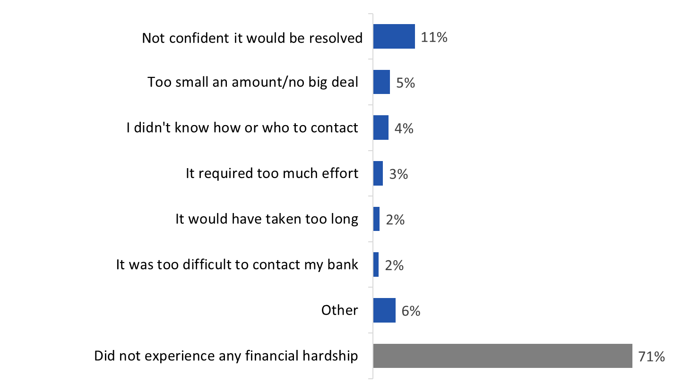

[Wave 1-10]

H4: Why have you not tried to contact your bank? Multiple response accepted.

Base: n= 9,642; those who did not contact their bank for financial help. Don’t know/no response excluded.

The likelihood of saying they did not experience any financial hardship increased with age, and it was higher among respondents from Ontario and Quebec (versus those from the West), those born in Canada, and those who are not a visible minority. The likelihood of not experiencing financial hardship increased with household income.

Refusal of financial help due to concerns about future obligations, or perception that the help would not give much benefit
Those who declined financial help (n=167) most often explained that they did so because they believed the help would not have given them much benefit or because they were concerned about implications of future obligations (28% each). Approximately one in five said they did not like the details of the program (22%) or found other means of financial help (21%). Reasons identified less frequently included the negative effects on their credit rating resulting from such help (13%), the effort required (11%), and the length of time required (4%).

Figure 33: Reasons for Declining Financial Help

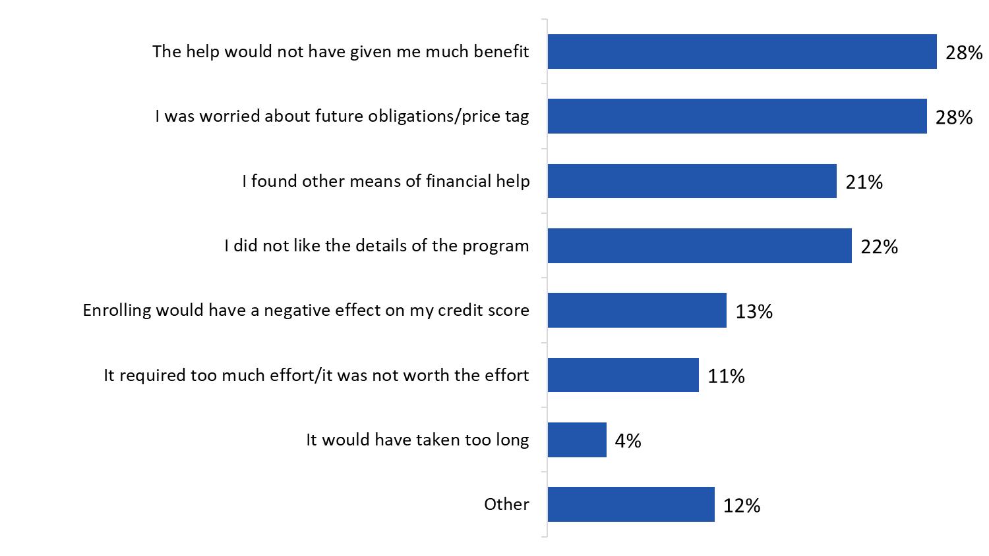

[Wave 1-10]

H7: Why did you decline financial help? Multiple response accepted.

Base: n= 167; those who declined financial help. Don’t know/no response excluded.

Perceptions of banks’ financial assistance programs
Using a five-point scale (strongly agree, somewhat agree, neither agree nor disagree, somewhat disagree, strongly disagree), respondents who received financial assistance from their bank were asked to what extent they agreed with the following statements:
- I am satisfied with the way the bank responded to my request.
- I understand my obligations under the program.
- The bank clearly disclosed the terms and conditions of the program.
- I trust the advice the bank gave me about my options.

Over two-thirds of respondents who received financial assistance from their bank agreed with each of these statements, and in all but one case agreement was more likely to strong than moderate. Over three-quarters expressed satisfaction with the way the bank responded to their request (80%) and agreed that they understand their obligations under the program (79%). Over two-thirds agreed that their bank clearly disclosed the terms and conditions of their program (71%) and that they trust the advice the bank gave them about their options (68%). Levels of disagreement with these statements ranged from 15-20% and were highest regarding banks clearly disclosing the terms and conditions of the program.

Figure 34: Perceptions of Hardship Program

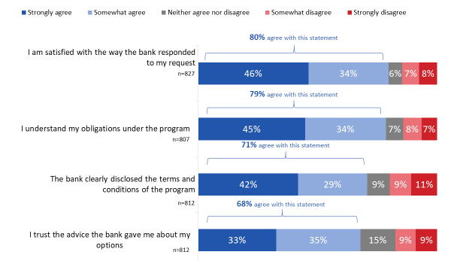

[Wave 1-10]

H13: On a scale of 1 to 5, please indicate how much you agree or disagree with the following statements.

Base: those who received financial help. Don’t know/no response excluded.

Using the same scale, respondents who contacted their bank were asked to what extent they agreed with the following statements:
- The bank dealt with my request in a reasonable amount of time.
- It was easy to contact the bank about the program.
- The bank clearly explained the options available to me.
- The bank kept me informed about the status of my request.

While a majority of respondents who contacted their bank agreed with each of these statements, the size of the majority varied. Approximately three-quarters of Canadians who contacted their bank agreed that the bank dealt with their request in a reasonable amount of time (74%), while two-thirds (66%) agreed that it was easy to contact the bank about the program. Smaller majorities agreed that the bank clearly explained the options available to them (58%), and that the bank kept them informed about the status of their request (56%). Agreement with each of these statements was more likely to be strong than moderate. Levels of disagreement with these statements ranged from 21-32% and were highest regarding banks keeping respondents informed about the status of their requests.

Figure 35: Perceptions of Bank Service

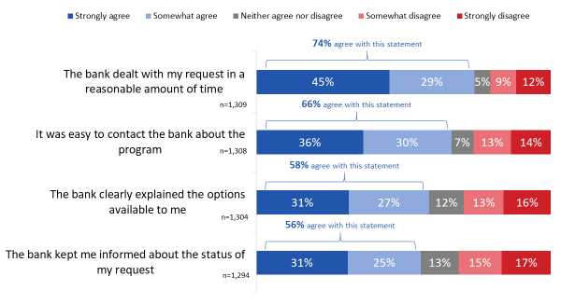

[Wave 1-10]

H14: On a scale of 1 to 5, please indicate how much you agree or disagree with the following statements.

Base: those who contacted their bank. Don’t know/no response excluded.

Most who gave up seeking financial assistance from their bank did not contact another financial institution
Among respondents who gave up trying to contact their bank for financial help because of the pandemic (n=1,719), two-thirds said they did not contact any other type of financial institutions to access help because of the pandemic. Those who did most often contacted other lenders (16%) followed by an insurance company (10%), credit union (5%), or securities firm (2%) (multiple responses accepted).

Figure 36: Contact with Other Banks for Financial Assistance
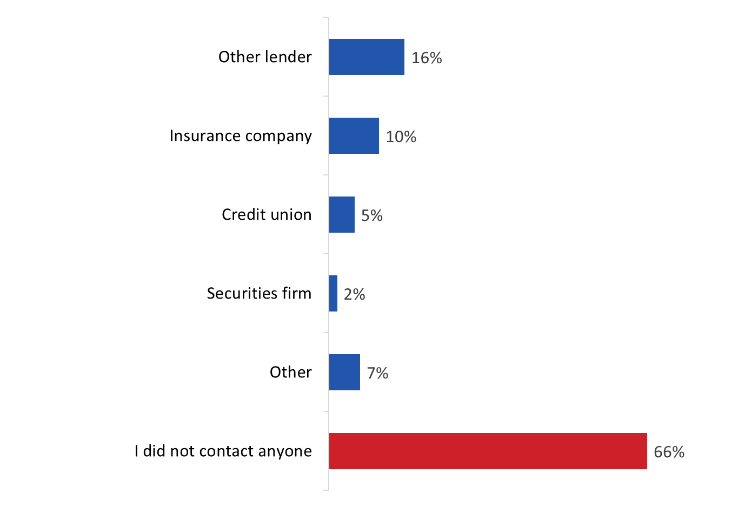

[Wave 1-10]

H15: Did you contact any other types of financial institutions to access financial help because of the pandemic? Multiple response accepted.

Base: n= 1,719; those who gave up trying to contact their bank about hardship programs. Don’t know/no response excluded.

Those from households with annual incomes of under $40,000 and those who completed high or less education were more likely than others to report contacting other lenders to access financial help.

End of Hardship Programs

Majority say their hardship program has ended
The aggregated tracking data reveals that, on average, 68% of respondents who received financial help reported that their hardship program had ended. As the accompanying graph shows, however, the proportion of respondents reporting this has fluctuated over time, ranging from a low of 43% in August 2020 (wave 2) to a high of 80% in February 2021 (wave 8).

Figure 37: End of Hardship Program [Time Series]

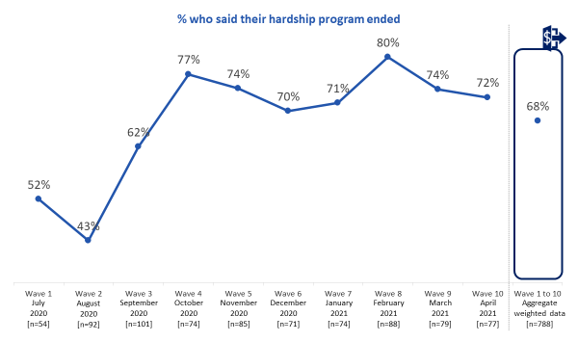

[Wave 1-10]

H11: Has your program ended?

Base: those who received financial help. Don’t know/no response excluded.

One-third were contacted by their bank to discuss the end of the program
The aggregated tracking data also shows that, on average, 31% of Canadians enrolled in a hardship program that has ended reported their bank contacted them before their program ended to discuss the end of the relief measures. That said, as the accompanying graph shows, the proportion of respondents reporting this has fluctuated over time, ranging from a low of 14% in July 2020 (wave 1) to a high of 45% in September 2021 (wave 3). Fluctuations between waves 3 and 9 were relatively limited, only to decline noticeably between waves 9 and 10 (from 38% in March 2021 to 25% in April 2021).

Figure 38: Contacted by Bank to Discuss Program Ending [Time Series]

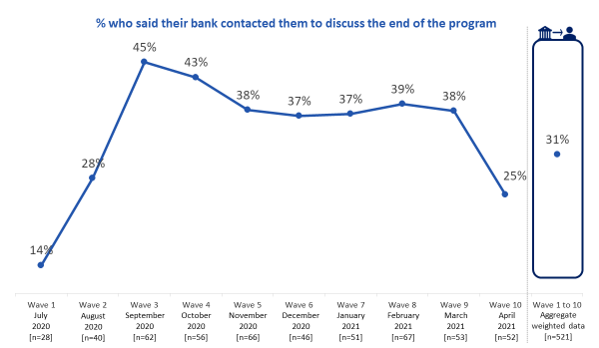

[Wave 1-10]

H12: Before your program ended, did the bank contact you to discuss the end of the program? Base: those enrolled in a hardship program that has ended. Don’t know/no response excluded.

Visible minorities were more likely than others to have had their bank contact them to discuss the end of the program. In contrast, those with household incomes of under $40,000 (compared to those with household incomes of $100,000+), those born in Canada, and those from Quebec (as compared to respondents from Ontario) were less likely to have been contacted by their bank before their program ended.

Nearly half enrolled in program that has ended were offered alternative relief measures
Aggregated tracking data between waves 5-10 reveals that, on average, nearly half (47%) of those who were enrolled in a hardship program that has ended said their bank offered to enroll them in alternative relief measures once their initial program was complete. That said, as the accompanying tracking graph shows, the proportion changed over time, rising from 35% in November 2020 (wave 5) to 64% in January 2021 (wave 7), then fluctuating from January to April 2021.

Figure 39: Alternative Program Offered after End of Initial Program [Time Series]

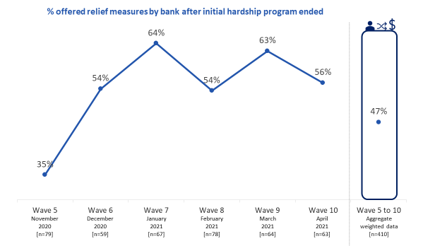

[Wave 5-10]

H18: What relief measures, if any, did the bank offer to enroll you in once your initial program was complete?

Base: those enrolled in a hardship program that has ended. Don’t know/no response excluded.

Among respondents enrolled in a hardship program that has ended (n=410), the majority (60%) indicated that their bank has not offered them continued relief measures. Among those who identified measures that have been offered, the only one identified with any frequency was deferred mortgage payments (14%). Other measures were identified infrequently (4% or less) and are listed in the accompanying graph.

Figure 40: Relief Measures Offered by Bank Once Initial Program was Complete

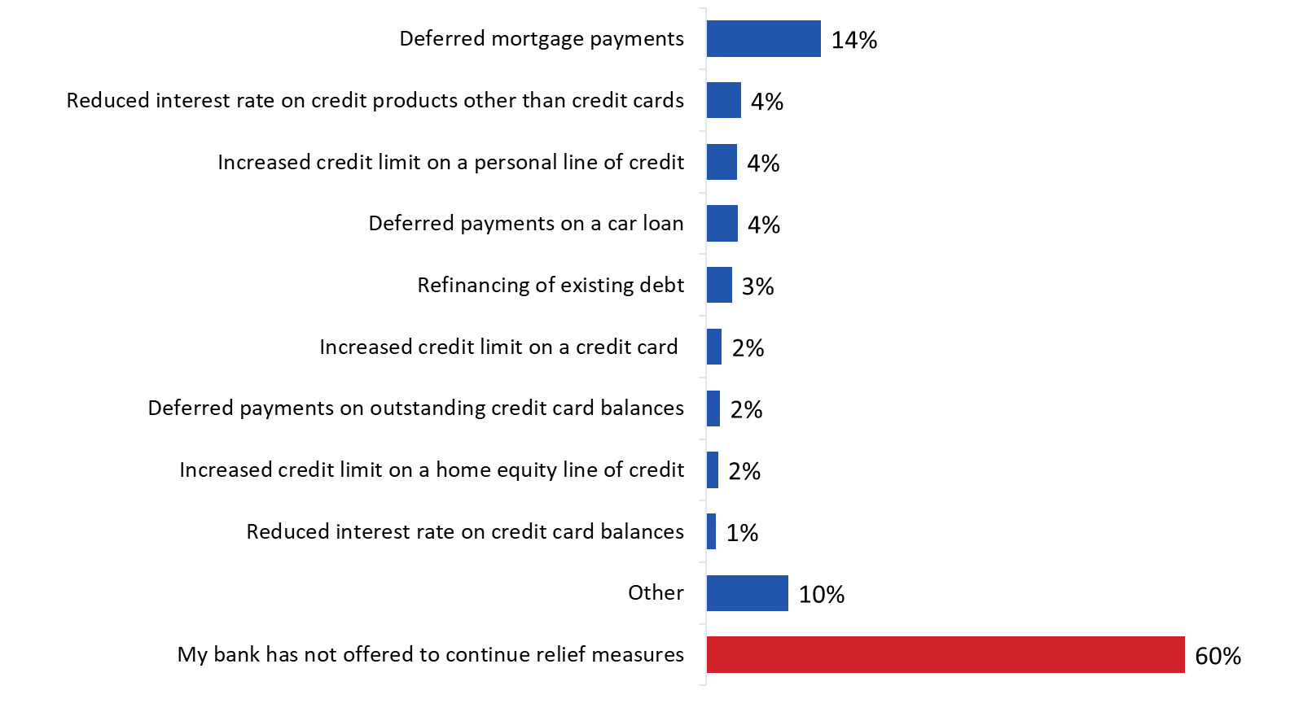

[Wave 5-10]

H18: What relief measures, if any, did the bank offer to enroll you in once your initial program was complete?

Base: n=410; those enrolled in a hardship program that has ended. Don’t know/no response excluded.

Ability to keep up with bills following end of hardship program is varied
In terms of how well respondents whose hardship program has ended are keeping up with bills and other financial commitments, aggregated tracking data reveals the following: on average, the largest proportion (42%) said their ability to keep up with bills and financial commitments is about the same, over one-quarter (28%) said it is easier to keep up with bills, and nearly one-third (31%) said it is harder to keep up with bills.

The accompanying graph reveals how perceptions have changed over time. Note that despite some fluctuation, the proportion of respondents who said it is harder to keep up with bills since their financial program has ended has declined from 41% in November 2020 (wave 5) to 24% by April 2021 (wave 10).

Figure 41: Keeping Bills and Financial Commitments Current [Time Series]

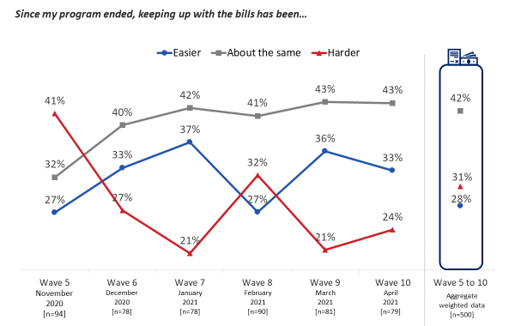

[Wave 5-10]

H19: Since your program has ended, which of the following statements best describes how well you are currently keeping up with your bills and other financial commitments?

Base: those enrolled in a hardship program that has ended. Don’t know/no response excluded

2. Follow-Up Survey
This section details the findings of the follow-up survey. A total of 1,599 respondents who previously participated in a monthly survey participated in the follow-up survey.

Current Banking Habits

Virtually all have a personal chequing or savings account
Nearly all (95%) said they have a personal chequing or savings account with a bank, credit union or trust company.

Figure 42: Personal Bank Account
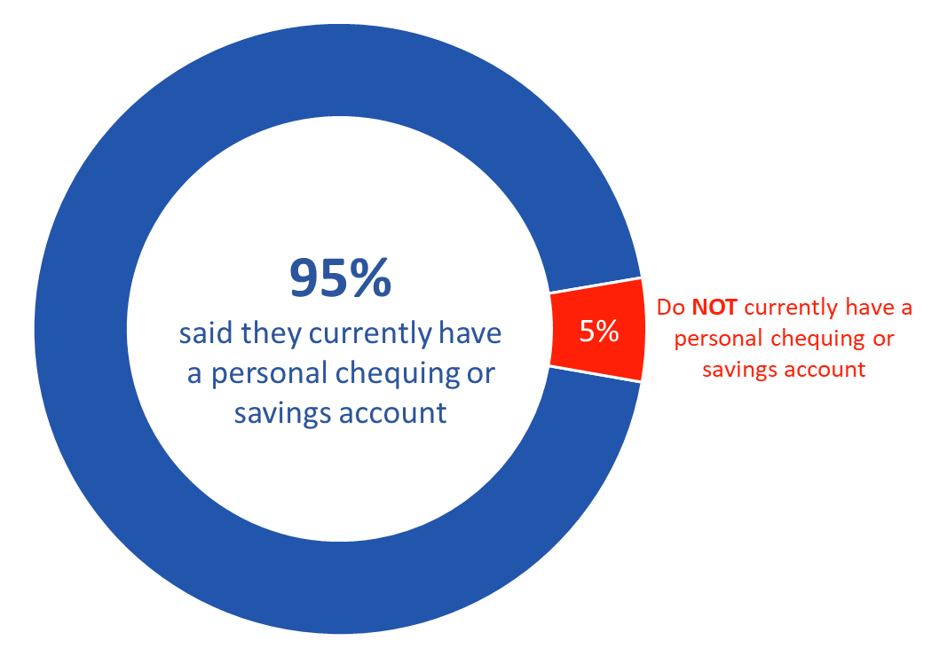

D13: Do you currently have a personal chequing or savings account with a bank, credit union or trust company? Please include any joint account you may have with someone else. Please exclude any investment accounts, such as RESPs, RRSPs and BONDS, and line of credit accounts.

Base: n=1,557; all respondents.

Don’t know/no response excluded.

Vast majority currently use online banking method; one in four expect an increase mobile payments
Looking at current banking and payment methods, the majority indicated they use online banking (85%), e-transfers (80%) and contactless purchase with their credit or debit card (78%). Following at a distance, half said they currently use mobile banking (57%) and ATMs (51%), while fewer (46%) use cash. The full range of responses can be found in Figure 43.

When asked if they expect their use of these banking and payment methods to increase, decrease or stay the same once the pandemic is over, majorities indicated they expect their use of these methods to stay the same. However, one in four (24%) expect their use of mobile payments to increase post-pandemic and two in 10 expect their use contactless purchases (21%), cash (20%) and e-transfers (19%) to increase. In contrast, one in four mentioned they expect their use of pre-paid cards (26%) and cash (25%) to decrease once the pandemic is over, while one in five said the same about in-branch banking (20%) and ATMs (19%).
Figure 43: Intended Use of Payment Methods Post-Pandemic
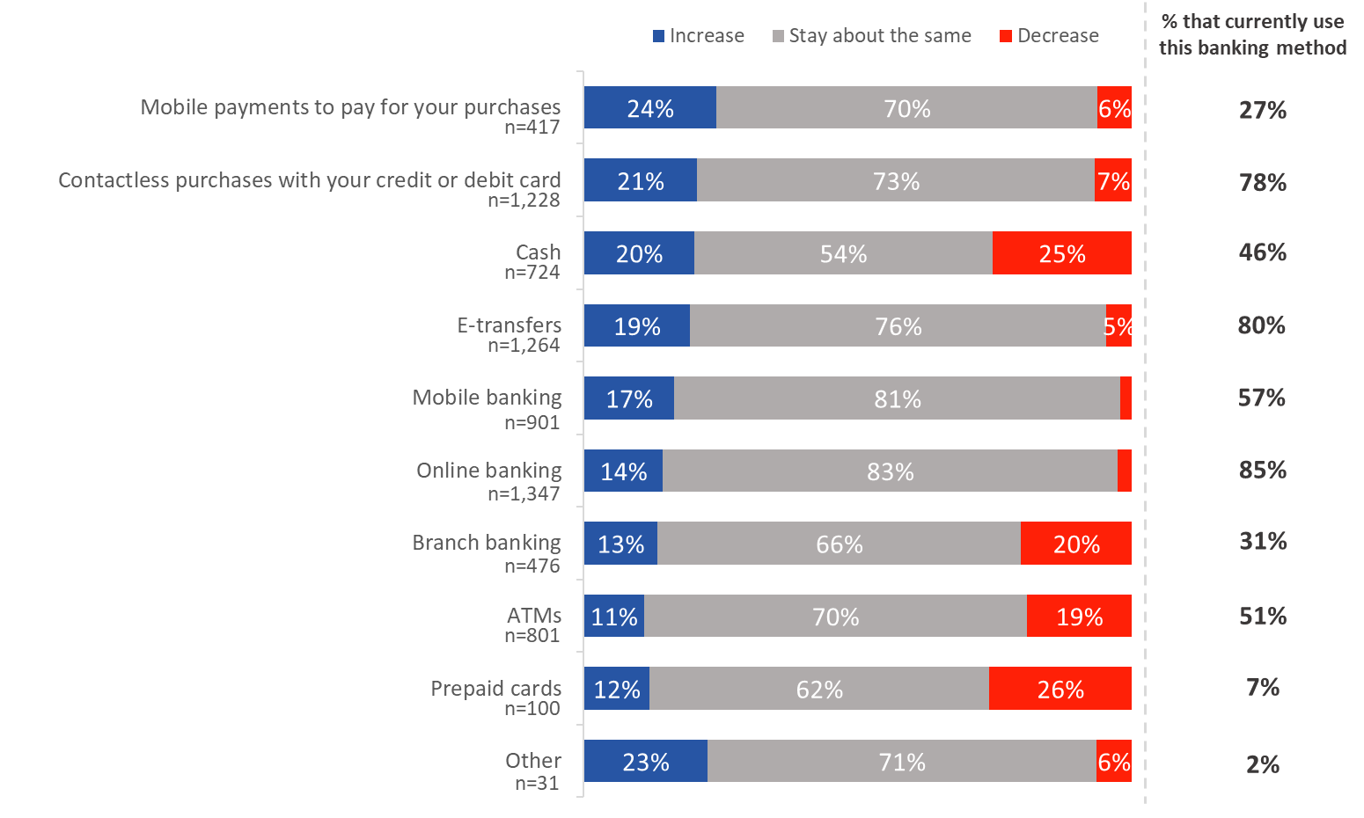

H1: From the list of banking and payment methods below, select the ones you currently use and indicate whether you expect your use to increase, decrease or stay the same once the pandemic is over.

Base: all respondents. Don’t know/no response excluded.

Most Canadians use multiple financial institutions
When asked with how many different financial institutions they have debit, credit or prepaid payment cards with, a little over half (55%) the survey respondents said their cards are split between two (39%) or three or more (26%) financial institutions. A third (35%) have all their debit, credit and prepaid payment cards with the same financial institution.

Figure 44: Use of Multiple Financial Institutions
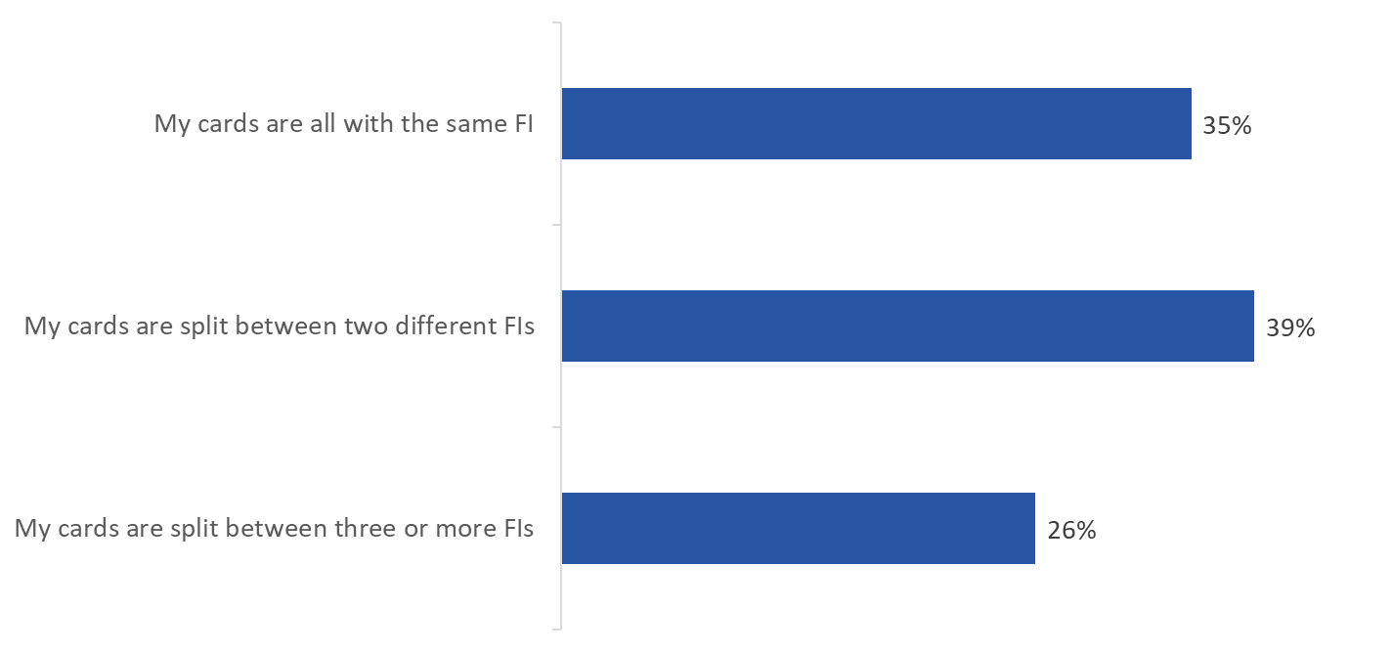

H2: With how many different financial institutions do you have debit cards, credit cards, or prepaid payment cards?

Base: n=1,543; all respondents.

Don’t know/no response excluded.

Few applied for or opened a new financial product or service via online banking since March 2020; convenience cited as top reason for doing so
Nearly two in 10 (18%) said they applied for or opened a new financial product or services through online or mobile banking since March 2020. Of those who said they applied for or opened a new financial product or service through online or mobile banking (n=273), close to half (47%) did so because it was convenient. Following this, three in 10 did so because it was faster to use online or mobile banking than going in-person (30%) and because they wanted to minimize in-person contact (28%). The full range of responses can be found in Figure 45.

Figure 45: Accessing New Financial Products via Online/Mobile Banking since March 2020

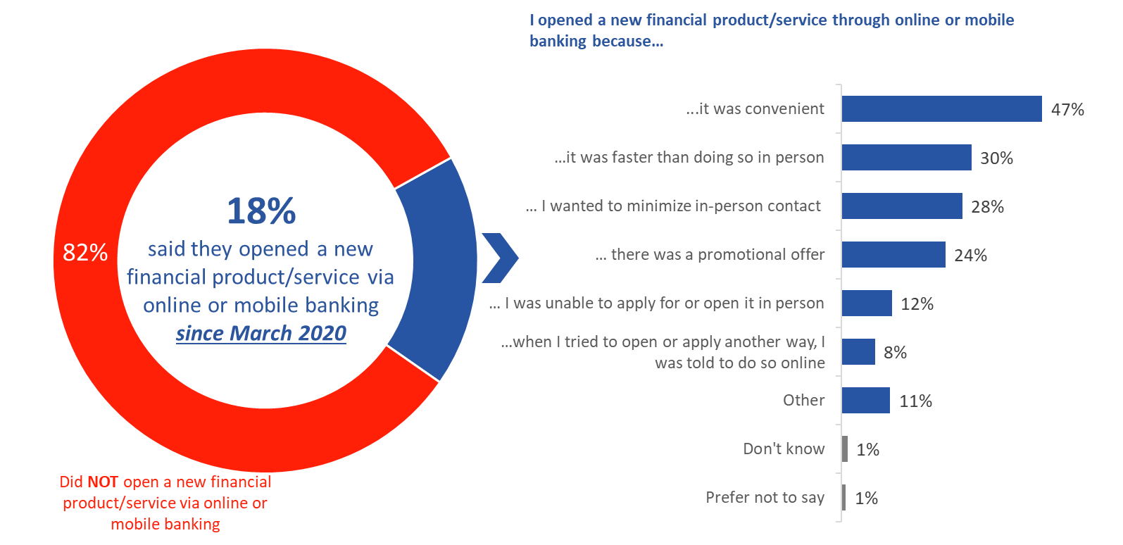

[LEFT] H3: Since March 2020, have you applied for or opened a new financial product or service, such as a chequing account, credit card, or mortgage, through online or mobile banking? Base: n=1,579; all respondents. Don’t know/no response excluded.

[RIGHT] H4: For what reasons did you apply for or open a new financial product or service through online or mobile banking instead of doing so in person? Base: n=273; those who said they opened a new financial product/service via online or mobile banking. Multiple responses accepted.

Few delayed applying for or opening a new financial product or service via online banking since March 2020; reduced income cited as top reason for doing so
Fewer than two in 10 (16%) said they delayed applying for or opening a new financial product or service since March 2020. Of those who said they delayed applying for opening a new financial product or service (n=255), just over one-third (35%) did so because their income was reduced compared to the previous year and one-quarter (24%) did so because they could not visit a branch and meet with a customer service representative due to the branch closures. The full range of responses can be found in Figure 46.

Figure 46: Delaying Opening New Financial Products since March 2020

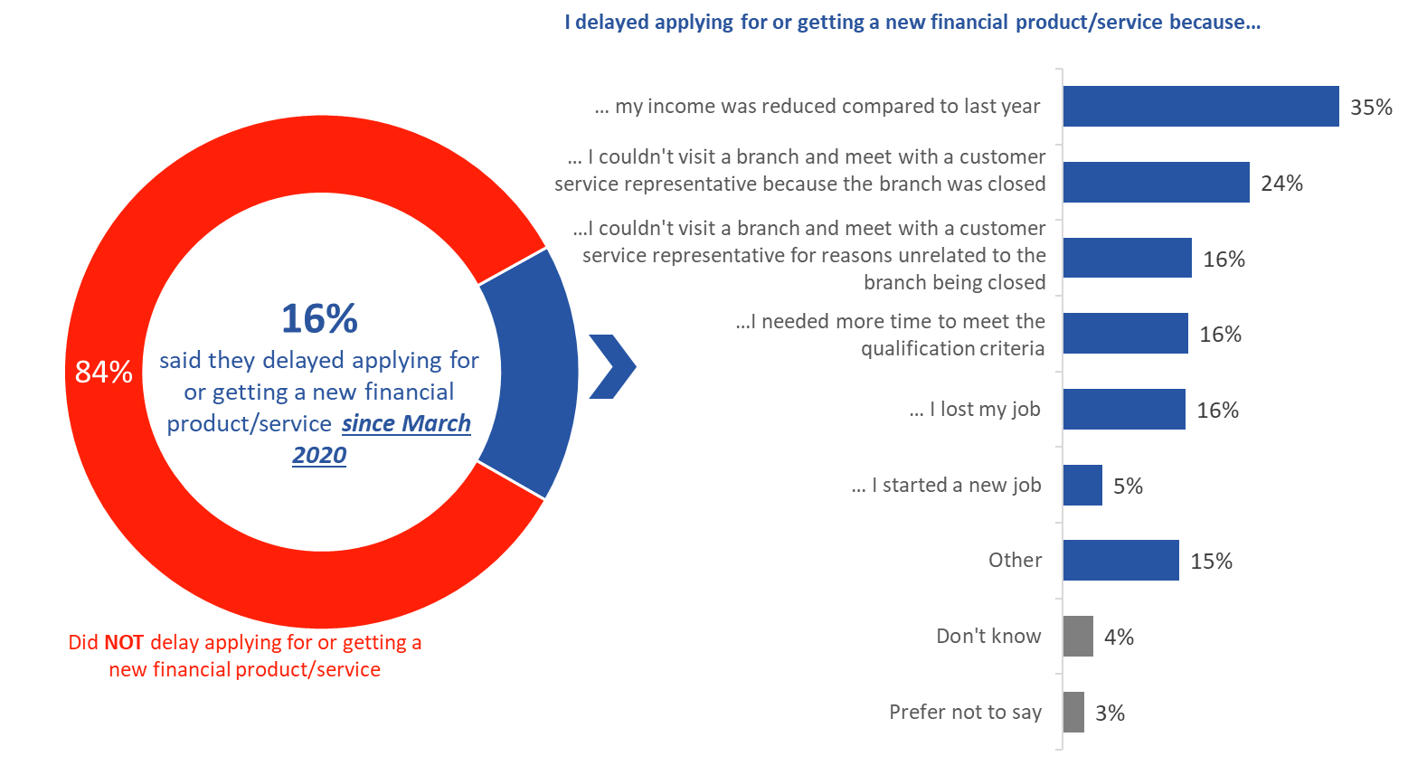

[LEFT] H5: Since March 2020, have you delayed applying for or getting a new financial product or service? Base: n=1,562; all respondents. Don’t know/no response excluded.

[RIGHT] H6: For what reasons did you delay applying for or getting a new financial product or service? Base: n=255; those who said they delayed applying for or getting a new financial product/service. Multiple responses accepted.

Very few shared their online and mobile banking login information to get financial advice or to purchase financial products or services
Five percent of respondents said they shared their online or mobile banking login information in the past with a company to get financial advice or to purchase financial products or services. Of those who shared their online or mobile banking with a company (n=71), just over half (54%) said they currently share this information with a financial institution.

Figure 47: Sharing Banking Information for Advice or to Purchase Financial Products/Services
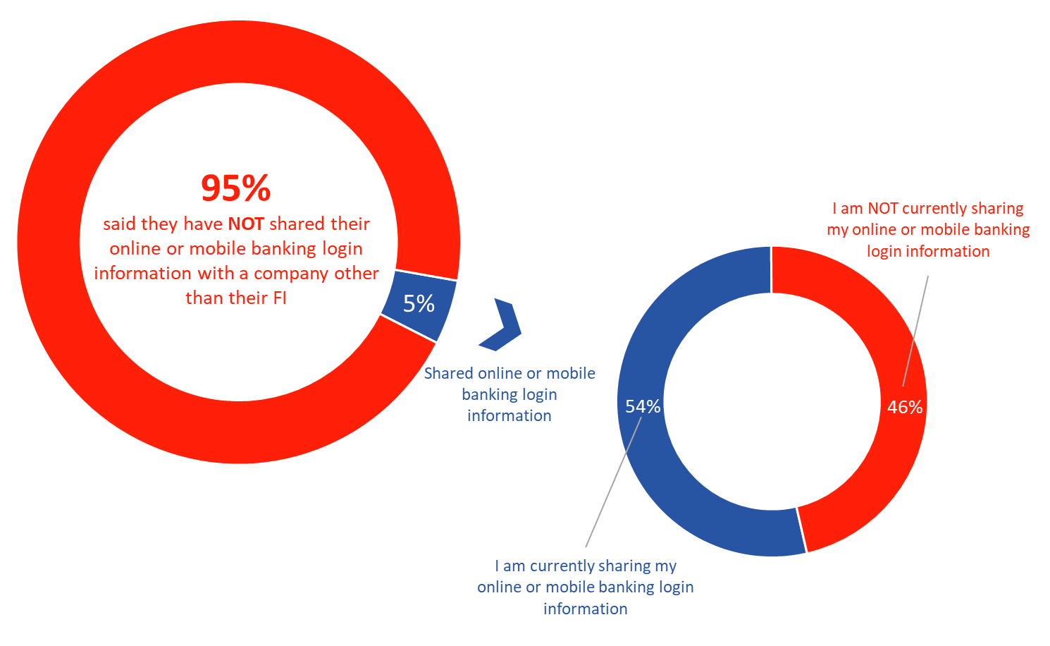

[LEFT] H7: Have you ever shared your online or mobile banking login information, such as your username and password, with a company other than your financial institution to get financial advice or to purchase financial products or services? Base: n=1,573; all respondents.

[RIGHT] H8: Are you currently sharing your online or mobile banking login with a company other than your financial institution to get financial advice or to purchase financial products or services? Base: n=71; those who said they shared online or mobile banking login information with a company other than their FI.

Don’t know/no response excluded.

Unauthorized Transactions

Nearly a quarter discovered their bank or credit card number was used without authorization
Almost a quarter discovered that someone used their bank or credit card number to pay for goods without their authorization in the last two years. Eighteen percent said only their credit card number was used for unauthorized transactions, while comparatively few said only their debit card number (4%) or both their credit and debit card numbers (2%) were used to pay for goods without their authorization. In contrast, more than three-quarters (77%) of respondent said neither their bank nor credit card number was used without their authorization in the last two years.

Since March 2020, a little over one in 10 (13%) said someone used their bank or credit card number to pay for goods without their authorization, with exactly 10% saying only their card numbers was used. In contrast, nearly nine in 10 (87%) said neither their bank nor credit card number was used without their authorization.

Figure 48: Unauthorized Use of Bank/Credit Card Number in the last 2 Years
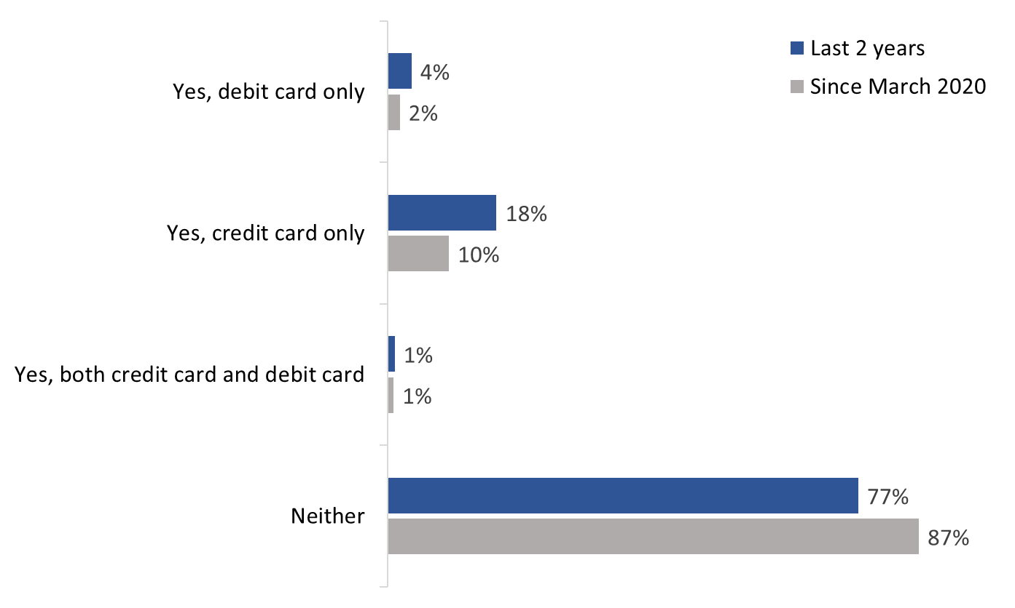

FR1/FR2: In the last 2 years, have you discovered that someone has used your bank or credit card number to pay for goods without your authorization? Base: n=1,531; all respondents.

FR1: Since March 2020, have you discovered that someone has used your bank or credit card number to pay for goods without your authorization? Base: n=1,521; all respondents.

Don’t know/no response excluded.

Unauthorized transactions most commonly occurred once
Those who said their bank (n=26) or credit card (n=120) number was used without their authorization were most likely to have experienced this once only (77% and 66%, respectively).

Figure 49: Occurrence of Unauthorized Transactions by Type of Card
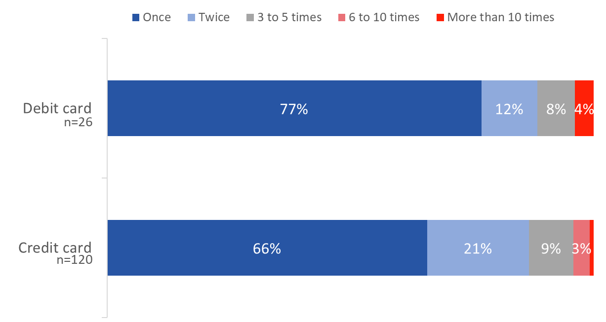

FR3: How many times did this occur? Base: those who reported someone used their bank or credit card number without their authorization.

Don’t know/no response excluded.

Vast majority contacted their FI about unauthorized transactions
Nearly nine in 10 (88%) of those who had issues with unauthorized transactions contacted their financial institution about these transactions. When asked which type of financial institution they contacted, the majority (86%) contacted their bank. Very few contacted a credit union (5%) or trust company (1%).

Figure 50: Contact with FI about Unauthorized Transactions
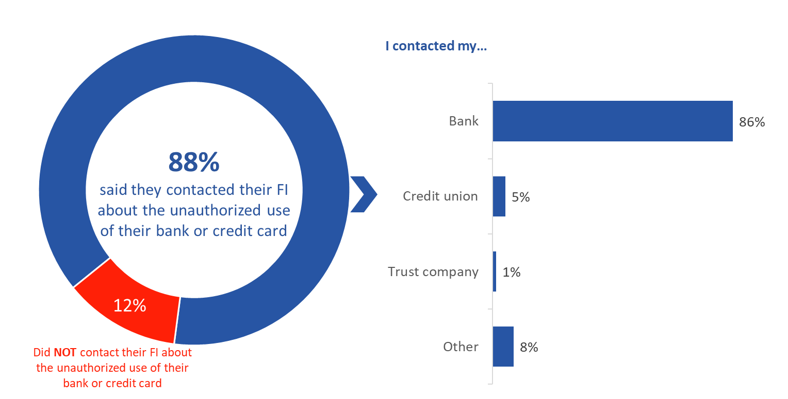

[LEFT] FR5: Did you contact your financial institution about the unauthorized transaction? Base: n=347; those who had issues with unauthorized use bank or credit card. Don’t know/no response excluded.

[RIGHT] FR6: What kind of financial institution did you contact? Base: n=302; those who contacted their FI about unauthorized transactions.

FIs cited varying reasons cited for not reimbursing unauthorized transaction
Of the respondents who were not reimbursed for the unauthorized transaction (n=23), seven respondents mentioned their financial institution did not reimburse them because the incident was viewed as a dispute with the merchant. Other reasons cited by financial institutions for not reimbursing unauthorized transactions included it took too long for the respondent to report the issue, the respondent authorized the transaction, and the respondent’s PIN was used during the transaction.

Due to the small sample size, the following graph depicts the feedback as number of respondents rather than as a percentage.

Figure 51: Reasons FIs gave for not reimbursing unauthorized transactions

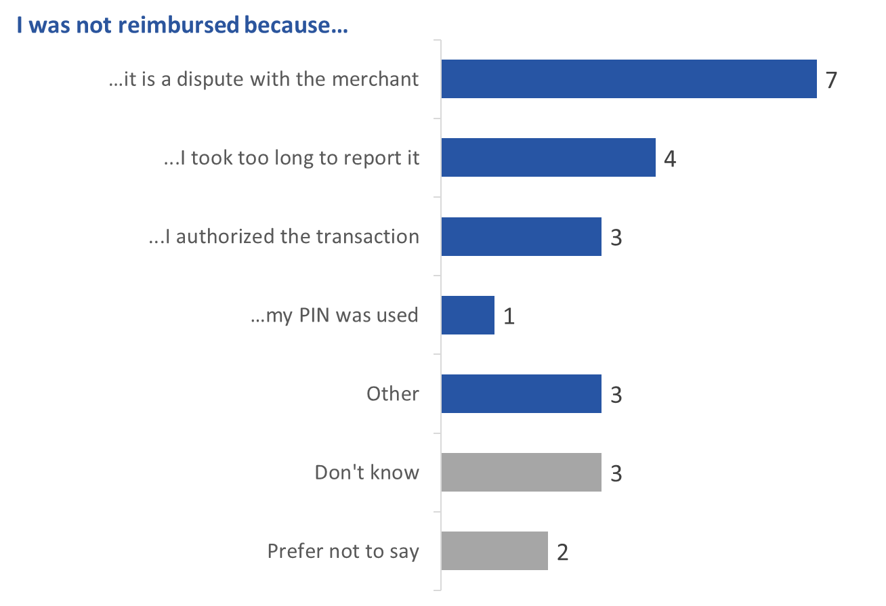

FR8: Which of the following reasons did your financial institution give you for not reimbursing you for the unauthorized transaction? Base: n=23*; those who were not reimbursed for the unauthorized transactions.

*Exercise caution due to the small sample size.

Appendix

1. Technical Specifications

The following specifications applied to the monthly tracking survey:
- A 15-minute online survey was administered to 12,183 Canadians, 18 years of age and older, who have a product or service with a bank or financial institution. Based on a sample of this size, the overall results can be considered accurate within ±0.89%, 19 times out of 20.
- The fieldwork was conducted over a 10-month period, from July 30, 2020, to April 14, 2021.
- The sample source was Advanis’ General Population Random Sample (GPRS). The target was n=1,000 completed surveys each wave, for a total of n=10,000. To ensure sufficient representation of harder to reach populations, quotas were set for each of the following target groups:
  - 18 to 34 year olds
  - Lower income households (under $40k)
  - People with high school education or less
  - Visible minorities
  - Recent immigrants (within the last 5 years)
  - Indigenous persons
  - People who live in rural areas
A minimum of 100 surveys were completed with respondents from each of these target groups each month.
- The table below presents the sample size and field dates for each wave:
 | Field Dates | Sample Size
Wave 1 | July 31 to August 10, 2020 | n=1,179
Wave 2 | August 24 to September 3, 2020 | n=1,462
Wave 3 | September 21 to October 2, 2020 | n=1,614
Wave 4 | October 16 to October 26, 2020 | n=1,265
Wave 5 | November 17 to November 24, 2020 | n=1,058
Wave 6 | December 9 to December 22, 2020 | n=1,098
Wave 7 | January 13 to January 27, 2021 | n=1,004
Wave 8 | February 10 to February 24, 2021 | n=1,026
Wave 9 | March 10 to March 17, 2021 | n=1,301
Wave 10 | April 1 to April 19, 2021 | n=1,176
- Canadians were recruited by telephone to participate in the online survey each month. If an individual could not be reached by telephone, a voicemail was left, and a text message was sent which contained a password-protected URL to access the survey. Those reached by telephone who agreed to participate were also sent a text message containing a password-protected URL to access the survey. The table below presents the recruitment information and response rate for each wave:
 | Recruited via CATI | Voicemail + Invite | Survey Completions | Participation Rate
Wave 1 | 1,502 | 1,881 | 1,179 | 34.8%
Wave 2 | 1,630 | 2,009 | 1,462 | 40.2%
Wave 3 | 2,039 | 1,819 | 1,614 | 41.8%
Wave 4 | 1,278 | 1,394 | 1,265 | 47.3%
Wave 5 | 1,240 | 1,710 | 1,058 | 35.9%
Wave 6 | 1,823 | 2,569 | 1,098 | 25.0%
Wave 7 | 1,633 | 2,211 | 1,004 | 26.1%
Wave 8 | 1,572 | 2,502 | 1,026 | 25.2%
Wave 9 | 394 | 681 | 1,301 | --%
Wave 10 | 1,589 | 2,192 | 1,176 | 31.1%
- The questionnaire was pre-tested in advance of the fieldwork to ensure that it measured what it intended to measure and that respondents understood the questions.
- The same questionnaire was administered for waves 1 to 4. At wave 5, changes were introduced to the questionnaire. This was questionnaire was administered from wave 5 to wave 10.
- The survey data have been weighted by age and gender using population figures from Statistics Canada’s 2016 census data. The weights correct for the oversampling of the selected target populations identified above.

The following specifications applied to the follow-up survey:
- A 5-minute online survey was administered to 1,599 individuals who completed the monthly tracking survey. No margin of error can be applied to this sample because probability sampling was not used.
- Respondents represent a convenience sample. Those who completed the tracking survey during waves 1 to 6 were asked if they would be willing to participate in a follow-up survey. A total of 2,988 Canadians agreed to participate and were invited to complete the follow-up survey.
- Of the 2,988 invited, a total of 1,599 completed the follow-up survey. This represents a participation rate of 54%.
- The fieldwork was conducted April 7 to April 16, 2021.
- The survey data have not been weighted.

Regarding non-response:
- Monthly tracking survey: As is the case for all probability samples, there is the potential for survey non-response to bias the sample collected over the 10-month period as part of this tracking study. Research shows that some groups within the population are less likely to respond to surveys for different reasons. Weighting the sample to Statistics Canada census data can correct for demographic imbalances in the final survey sample. The table below compares the distribution of the survey sample with the weighted proportions. Overall, the unweighted data underrepresents Quebec, and overrepresents the rest of Canada. It should be noted that sampling in proportion to population regionally was more complex because of the quotas in place for selected subgroups of the population.
 | Unweighted | Weighted
British Columbia | 15.5% | 12.6%
Alberta | 14.2% | 12.5%
Saskatchewan and Manitoba | 7.0% | 5.7%
Ontario | 37.3% | 39.1%
Quebec | 16.0% | 22.5%
Atlantic | 8.7% | 6.6%
Territories | 1.2% | 1.0%
- Follow-up survey: As a convenience sample, this survey sample has limitations in that it only includes respondents of the monthly tracking survey who agreed to be re-contacted and who were available and willing to complete the follow-up survey during the fieldwork period.

2. Monthly Tracking Survey Questionnaire: English
Introduction

[BILINGUAL LANDING PAGE: If language preference is known, English first for panelists with an English preference and French first for those with a French preference. If language preference is not known, English first outside of Quebec and French first for Quebec]

Please select the language in which you wish to complete the survey.
- English/Anglais
- French/Français

Veuillez choisir la langue dans laquelle vous désirez répondre au sondage.
- Anglais/English
- Français/French

[NEXT]

Thank you for agreeing to take part in this short survey being conducted on behalf of the Government of Canada by Phoenix SPI. The survey should take no more than 15 minutes to complete and is voluntary and completely confidential.

The information provided will be administered according to the requirements of the Privacy Act. Your responses will not be used to identify you, and none of your opinions will be attributed to you personally in any way. To view Phoenix SPI’s privacy policy, click <here>.

This survey is registered with the Canadian Research Insights Council’s Research Verification Service. The project verification code is: 20200722-PH163. Click <here> to verify the legitimacy of this survey.

Screening Questions [1 minute]
S1 d_age. In what year you were born?
[text field]
Prefer not to say - 98

If S1 = 2002 or 98, ask S2: d_agerange.
If S1 = 2003+, terminate.
Else continue to FCAC1.

S2 d_agerange. [if S1 = 2002 or 98] Would you be willing to indicate in which of the following age categories you belong?
Under 18 - 97
18 to 24 – 1
25 to 29 – 2
30 to 34 – 3
35 to 39 – 4
40 to 44 – 5
45 to 49 – 6
50 to 54 – 7
55 to 59 – 8
60 to 64 – 9
65 to 69 – 10
70 to 74 – 11
75 and older - 12
Prefer not to say - 98

Terminate if S2 = 97

S3 PROV. In which province or territory do you live?
British Columbia - 1
Alberta - 2
Saskatchewan - 3
Manitoba - 4
Ontario - 5
Quebec - 6
New Brunswick - 7
Nova Scotia - 8
Prince Edward Island - 9
Newfoundland and Labrador - 10
Yukon - 11
Northwest Territories - 12
Nunavut - 13
Prefer not to say - 98

S4 d_indigenous Are you of First Nations, Métis or Inuit descent?
Yes - 1
No – 2
Prefer not to say - 98

S5 d_imm. Were you born in Canada?
Yes - 1
No – 2
Prefer not to say - 98

If S5 = 2, continue. Else skip to FCAC1.

S6 d_immstat. In which year did you first immigrate or move to Canada?

[text field] [2015-2020 = RECENT IMMIGRANT]
Prefer not to say - 98
If S6 = 98, terminate.
Else continue to FCAC1.

Questions about FCAC and Mandate (1 minute)

FCAC1 protection. To the best of your knowledge, does the government of Canada have a department or agency dedicated to protecting financial consumers?
Yes – 1
No – 2
Prefer not to say – 98
Don’t know - 99

FCAC2 education. To the best of your knowledge, does the government of Canada have a department or agency dedicated to the financial education of consumers?
Yes – 1
No – 2
Prefer not to say – 98
Don’t know - 99

FCAC3 familiarity. How familiar would you say you are with the Financial Consumer Agency of Canada?
Never heard of them - 1
Heard of them, but not at all familiar - 2
Not very familiar - 3
Somewhat familiar - 4
Very familiar - 5
Prefer not to say - 98
Don’t know - 99

Hardship programs (5 minutes)
The questions in this survey deal with banking, but please be assured that you will not be asked to provide any information about your personal finances.

H1 hardship_information. Since the beginning of the COVID-19 crisis in March 2020, have you heard anything about financial help being offered by Canadian banks?
Yes – 1
No – 2
Prefer not to say – 98
Don’t know - 99
If H1 = 1, continue. Else skip to H3.

H2 information_source. [If H1 = 1] How did you hear about financial help being offered by Canadian banks? Select all that apply
[select all that apply]
[randomize]
Print media (newspapers and magazines) - 1
Radio or television - 2
Internet - 3
Bank - 4
A professional financial advisor or planner - 5
A friend or family member – 6
Social media - 7
Other [text field] – 8 [anchor]
Prefer not to say – 98 [anchor]
Don’t know - 99 [anchor]

H3 help_hardship. Since the beginning of March, have you tried to contact your bank for financial help because of the pandemic?
Yes – 1
No – 2
Prefer not to say - 98
Don’t know - 99

If H3 = 1, skip to H5.
If H3 = 98 or 99, skip to B1
Else continue

H4 reason_no_contact. [If QH3 = 2] Why have you not tried to contact your bank? Select all that apply
[select all that apply]
[randomize]
Too small an amount/no big deal - 1
Not confident it would be resolved in my favour/it would not make a difference - 2
It required too much effort/it was not worth the effort - 3
It would have taken too long - 4
I didn’t know how or who to contact - 5
It was too difficult to contact my bank (e.g. branch
too far away, could not get through to call centre) – 6
Did not experience any financial hardship – 7 [anchor]
I do not have any products or services with a bank – 8 [anchor]
Other – please specify [text field] – 97 [anchor]
Prefer not to say - 98 [anchor]
Don’t know - 99 [anchor]
Skip to H13

We’d now like you to answer a few questions about your experience contacting your bank for financial help.

H5 how_contact. How did you try to contact your bank?
[randomize]
Online (e.g., through the bank’s online banking portal) – 1
In branch – 2
By phone – 3
Email – 4
By regular mail - 5
Prefer not to say - 98 [anchor]
Don’t know - 99 [anchor]

H6 accepted_hardship. What happened when you tried to contact your bank?
I received financial help – 1
After the program was explained, I declined financial help – 2
I gave up because the wait time was too long – 3
I gave up because I did not know who to contact within the bank – 4
I was denied financial help - 5
Prefer not to say - 98
Don’t know - 99

If H6 = 1, skip to H8
If H6 = 2, continue.
If H6 = 3,4, 98 or 99 skip to H15.
If H6 = 5, skip to H14

H7 reason_decline. Why did you decline financial help? Select all that apply
[select all that apply]
[randomize]
I did not like the details of the program - 1
Enrolling would have a negative effect on my credit score - 2
It required too much effort/it was not worth the effort - 3
It would have taken too long – 4
The help would not have given me much benefit – 5
I found other means of financial help – 6
I was worried about future obligations/price tag - 7
Other – please specify [text field] – 97 [anchor]
Prefer not to say - 98 [anchor]
Don’t know - 99 [anchor]

Skip to H14

H8 hardship_program. What sort of financial help did you receive? Select all that apply
[select all that apply]
[Randomize]
Deferred mortgage payments - 1
Deferred payments on outstanding credit card balances – 2
Reduced interest rate on credit card balances - 3
Increased the credit limit on a personal line of credit - 4
Increased the credit limit on a home equity line of credit - 5
Increased the credit limit on a credit card to manage day-to-day spending – 6
Reduced interest rate on credit products other than credit cards – 7
Deferred payments on a car loan - 8
Other [text field] – 7 [anchor]
Prefer not to say - 98 [anchor]
Don’t know - 99 [anchor]

H9 disclosure_how. How did your bank tell you about the terms and conditions of the program? Select all that apply
[select all that apply]
[randomize]
Online (e.g., through the bank’s online banking portal) – 1
In branch – 2
By phone – 3
Email – 4
By regular mail – 5
I did not get any details about the program – 6 [anchor]
Prefer not to say - 98 [anchor]
Don’t know - 99 [anchor]

H10 program_length For how long did you enroll in the program?
Less than 1 month - 1
1 to less than 2 months - 2
2 months to less than 3 months - 3
3 months to less than 4 months - 4
4 months to less than 5 months - 5
5 months to less than 6 months - 6
6 months or longer – 7
Prefer not to say – 98
Don’t know - 99

H11 ended Has your program ended?
Yes – 1
No – 2
Prefer not to say - 98
Don’t know - 99

If H_11 = 1, continue, else H13.

H18 offered_alternative. What relief measures, if any, did the bank offer to enroll you in once your initial program was complete?
[select all that apply]
[Randomize]
Deferred mortgage payments - 1
Deferred payments on outstanding credit card balances – 2
Reduced interest rate on credit card balances - 3
Increased credit limit on a personal line of credit - 4
Increased credit limit on a home equity line of credit - 5
Increased credit limit on a credit card to manage day-to-day spending – 6
Reduced interest rate on credit products other than credit cards – 7
Deferred payments on a car loan – 8
Refinancing of existing debt - 9
My bank has not offered to continue relief measures – 10 [anchor]
Other [text field] – 97 [anchor]
Prefer not to say - 98 [anchor]
Don’t know - 99 [anchor]

H12 bank_exit Before your program ended, did the bank contact you to discuss the end of the program?
Yes – 1
No – 2
Prefer not to say - 98
Don’t know - 99

H19 difficuly_payment Since your program has ended, which of the following statements best describes how well you are currently keeping up with your bills and other financial commitments?
It is much easier than before I enrolled in the program – 1
It is slightly easier than before I enrolled in the program – 2
It is about the same as before I enrolled in the program – 3
It is slightly harder than before I enrolled in the program – 4
It is much harder than before I enrolled in the program - 5
Prefer not to say - 98
Don’t know - 99

H13 likert_hardship. On a scale of 1 to 5, please indicate how much you agree or disagree with the following statements:
[GRID FORMAT]
[ROWS]
[Randomize]
I am satisfied with the way the bank responded to my request
The bank clearly disclosed the terms and conditions of the program
I understand my obligations under the program
I trust the advice the bank gave me about my options

[COLUMNS]
Strongly disagree - 1
Somewhat disagree - 2
Neither agree nor disagree - 3
Somewhat agree - 4
Strongly agree – 5
Prefer not to say - 98
Don’t know – 99

H14 likert general. On a scale of 1 to 5, please indicate how much you agree or disagree with the following statements:
[GRID FORMAT]
[ROWS]
[Randomize]
The bank kept me informed about the status of my request
The bank clearly explained the options available to me
The bank dealt with my request in a reasonable amount of time
It was easy to contact the bank about the program
[COLUMNS]
Strongly disagree - 1
Somewhat disagree - 2
Neither agree nor disagree - 3
Somewhat agree - 4
Strongly agree – 5
Prefer not to say - 98
Don’t know – 99

H15 other_institutions. Did you contact any other types of financial institutions to access financial help because of the pandemic? Select all that apply
[select all that apply]
[randomize]
Credit union - 1
Other lender - 2
Securities firm - 3
Insurance company – 4
I did not contact anyone – 5 [anchor]
Other - Please specify [text field] – 97 [anchor]
Prefer not to say – 98 [anchor]
Don’t know – 99 [anchor]

H16 hardship_other. If there is anything else you would like to share about the financial help, or hardship programs, being offered by Canadian banks, please enter it in the text box below.
[text field]

branch closures and fees (3 minutes)
B1 method of banking Before March 2020, what was the most common way you did your banking?
In person at a branch - 1
By phone - 2
Using an ATM (automated teller machine) - 3
Online or using your bank’s website - 4
Via a mobile app - 5
Other_ Please specify – text field – 97 [anchor]
Prefer not to say – 98 [anchor]
Don’t know – 99 [anchor]

B2 affected_closure Since the beginning of March 2020, have you been affected by the closure of your local bank branch?
Yes - 1
No – 2
Prefer not to say - 98
Don’t know - 99

If B2 = 1, continue. Else B4.

B3 severity_affected How did this branch closure affect your ability to conduct your regular banking activities? Select all that apply
[select all that apply]
[randomize]
Not at all since I do most of my banking online - 1
Not much since the new location was still easy to get to - 2
A little since I had to change where I do my banking - 3
A lot because there are few or no other branches nearby - 4
Other_ Please specify [text field] – 97
Prefer not to say - 98
Don’t know - 99

B4 affected_behaviour. Have you experienced any of the following as a result of a branch closure? Select all that apply.
[select all that apply]
[randomize]
I incurred a fee to use another bank’s automated banking machine (ABM) - 1
I deposited a cheque in an automatic banking machine (ABM) (or by another means) instead of cashing or depositing it in a branch- 2
I cashed a federal government cheque somewhere other than at a bank - 3
The bank was unable to open a bank account for me - 4
I was charged fees or interest that I did not know I could be charged - 5
There was a hold on my federal government cheque - 6
I was unable to lodge a complaint with my bank - 7
I have had difficulty contacting my bank - 8
I have been unable to get issues with my bank resolved – 9
I have had issues accessing my funds – 10
I did not experience any issues because of a branch closure – 11 [anchor]
Other - please specify [text field]– 97 [anchor]
Prefer not to say – 98 [anchor]
Don’t know – 99 [anchor]

B5 incurred_fees. Because of COVID-19, have you incurred any of the following fees or interest on your bank products? Select all that apply
[randomize]
[select all that apply]
Non-sufficient funds (NSF) - 1
Withdrawal from an automated banking machine (ABM) - 2
Overdraft - 3
Exceeding monthly transaction limit - 4
Fees for exceeding credit limits - 5
Increased interest rate - 6
Missed payment fee - 7
Balance transfer fee - 8
Cash advance fee - 9
Interest for making a payment after the grace period - 10
Late payment - 11
Other fees or interest - please specify - 97 [anchor]
Prefer not to say – 98 [anchor]
Don’t know – 99 [anchor]

If B5 ≠ 6, 98 or 99, continue. Else skip to B8

B6 bank_contact_refund Did you contact your bank about those fees or interest charges?
Yes – 1
No – 2
Prefer not to say – 98
Don’t know – 99

B7 refund_fees. Were those fees or interest charges refunded?
All of the fees/interest charges were refunded – 1
Some of the fees/interest charges were refunded, but not all – 2
None of the fees/interest charges were refunded – 3
Prefer not to say – 98
Don’t know – 99

B8 credit_limits. How, if at all, have your credit limits changed since the beginning of March 2020?
All of my credit limits have increased - 1
Some of my credit limits have increased, while others have remained the same - 2
Some of my credit limits have remained the same, while others have decreased - 3
Some credit limits have increased, some have decreased - 4
All of my credit limits have decreased - 5
My credit limits have not changed – 6
I don’t have any credit products - 7
Prefer not to say – 98
Don’t know – 99

Primary bank (2 minutes)
For the next few questions, please think about your primary bank.

PB1 bank_informed. Has your bank provided you with any information about COVID-19?
Yes – 1
No – 2
Prefer not to say – 98
Don’t know – 99
If PB1 = 1, continue, else skip to PB4

PB2 information_provided What information did your bank provide you? Select all that apply
[select all that apply]
[randomize]
Information about payment deferrals – 1
Information about waived or lowered fees – 2
Information about how to lower the interest rate on credit products - 3
Information about branch closures - 4
Information about ways to bank during the pandemic - 5
How to contact the bank if I need financial help – 6
What steps the bank is taking to provide service during the pandemic – 7
Information about budgeting or financial planning – 8
How to access government benefits during the pandemic – 9
Signing up for direct deposit – 10
None of the above – 97 [anchor]
Prefer not to say – 98 [anchor]
Don’t know – 99 [anchor]

PB3 primary_bank. On a scale of 1 to 5, how strongly do you agree or disagree with the following statements about your bank?
[GRID FORMAT]
[ROWS]
[Randomize]
The communications from my bank about COVID-19 are easy to understand
I am receiving COVID-19 communications from my bank in my preferred format
The communications from my bank regarding COVID-19 have been helpful

[COLUMNS]
Strongly disagree - 1
Somewhat disagree - 2
Neither agree nor disagree - 3
Somewhat agree - 4
Strongly agree – 5
Prefer not to say - 98
Don’t know - 99

PB4 bank_response_general. On a scale of 1 to 5, how strongly do you agree or disagree with the following statements about your bank?
[GRID FORMAT]
[ROWS]
[Randomize]
I am satisfied with the way my bank is responding to the COVID-19 crisis
I know what options my bank has available if I need financial help
I would like more information about the bank’s response to the pandemic

[COLUMNS]
Strongly disagree - 1
Somewhat disagree - 2
Neither agree nor disagree - 3
Somewhat agree - 4
Strongly agree – 5
Prefer not to say - 98
Don’t know - 99

PB6 problem_bank Since March 2020, have you had a problem with your bank?
Yes – 1
No – 2
Prefer not to say – 98
Don’t know – 99

PB7 problem_description What was the problem? Select all that apply
[Randomize]
A transaction error, whether it was something a store or bank did. - 1
Banking services or fees that were not what you were told or expected. - 2
Interest rates for a bank account, loan, credit card or mortgage that were not what you were told or expected. - 3
Having your credit limit increased or lowered without your consent. - 4
An issue that prevented you from accessing your funds, i.e.: having a credit card rejected at a store, or having an unexpected hold placed on a deposited cheque - 5
A data breach or misuse of your personal information - 6
The behaviour of a bank employee, or poor customer service. - 7
Being misled or pressured into signing up for a banking product or service. - 8
Being charged for a banking service you didn’t agree to. – 9
Aggressive activities related to debt collection or service cancellation. - 10
Fraud or other unauthorized access to your funds. – 11
Problem with the bank’s hardship program. – 12
Other - 13
Prefer not to say – 98
Don’t know - 99

PB8 problem_resolved Did you contact your bank about your complaint?
Yes, and my problem was resolved – 1
Yes, and my problem is in the process of being resolved – 2
Yes, but my problem was not resolved - 3
No, I did not contact my bank – 4
Prefer not to say – 98
Don’t know – 99

PB9 problem_pandemic Was the problem related to the COVID-19 pandemic?
Yes – 1
No – 2
Prefer not to say – 98
Don’t know – 99

PB5 final. If there is anything else you would like to share about your bank’s response to the COVID-19 crisis, please enter it in the text box below.
[text field]

Miscellaneous (1 min)

M1 pay_method. What is your preferred payment method for day to day purchases?
[randomize]
Debit card – 1
Credit card – 2
Cash – 3
Cheque – 4
Mobile app – 5
Electronic money transfer – 6
Prefer not to say – 98 [anchor]
Don’t know – 99 [anchor]

M2 pay_limits. Recently, some credit and debit card issuers have increased their contactless payment limits (i.e., tapping your card to pay without having to enter your PIN). Have you heard about these increases?
Yes – 1
No – 2
Prefer not to say – 98
Don’t know – 99

M3 used_limit. Have you used contactless payment to make a day to day purchase for more than $100?
Yes – 1
No – 2
Prefer not to say – 98
Don’t know – 99

M4 payment_frequency Compared to last year, are you using the following payment methods less often, about as often, or more often:
Cash – A
E-transfers – B
Contactless payments (e.g., taping your card at a retailor) – C
Mobile wallets
Cheques – D
Debit card – E
Credit card - F

Less often – 1
About as often – 2
More often – 3
Prefer not to say – 98
Don’t know - 99

M5 affected_cash Since March 2020, many retailers no longer accept cash. How, if at all, has this affected you?
Not at all - 1
A little - 2
A lot – 3
Prefer not to say – 98
Don’t know – 99

M6 cash_replacement If a retailer no longer accepts cash, what payment method do you end up using most often?
E-transfer - 1
Contactless payments (e.g., taping your card at a retailor) - 2
Mobile wallet - 3
Cheque - 4
Debit card - 5
Credit card - 6
I find another retailer who accepted cash – 7
I have not encountered a retailer who does not accept cash – 8 [anchor]
Prefer not to say – 98
Don’t know - 99

Demographic (4 min)
These last questions will help us group your answers with others that we will receive in this survey.

D1 gender. What is your gender?
Female - 1
Male - 2
Prefer to specify: - 97 [TEXT]
Prefer not to say - 98

D2 d_edu. What is the highest level of education you have completed?
Grade 8 or less - 1
Some high school - 2
High School diploma or equivalent - 3
Registered Apprenticeship or other trades certificate or diploma - 4
College, CEGEP or other non-university certificate or diploma - 5
University certificate or diploma below Bachelor’s level - 6
Bachelor’s degree - 7
Post graduate degree above bachelor’s level - 8
Prefer not to say – 98

D3 d_work_status. In February 2020, which of the following would have best described your work status?
Working full-time, that is, 35 or more hours per week - 1
Working part-time, that is, less than 35 hours per week - 2
Self-employed - 3
Unemployed, but looking for work - 4
A student attending school full-time - 5
Retired - 6
Not in the workforce (e.g., homemaker, not looking for work) – 7
Seasonal employee laid off for the season - 8
Other - 9
Prefer not to say – 98

D4 d_income. Which of the following categories best describes your total household income last year?
[definition: household income is the total income of all persons in a household combined, before taxes]
Under $20,000 - 1
$20,000 to just under $40,000 - 2
$40,000 to just under $60,000 - 3
$60,000 to just under $80,000 - 4
$80,000 to just under $100,000 - 5
$100,000 to just under $150,000 - 6
$150,000 and above - 7
Prefer not to say – 98

D5 d_income_change. Since the beginning of March 2020, has your total monthly household income…
Fallen by more than one-third) – 1
Fallen by less than one-third - 2
Stayed more or less stable - 3
Increased but by less one-third – 4
Increased by more than one-third) - 5
Prefer not to say - 98 [anchor]
Don’t know - 99

D6 d_tenant Do you currently own or rent your home?
Own, with a mortgage - 1
Own, without a mortgage - 2
Rent - 3
Prefer not to say - 98

D7 d_lang. At home, what language do you speak most often?
English - 1
French - 2
Other – 3
Prefer not to say - 98

D8 d_visminority. What is your ethnic or cultural background?
Caucasian/European - 1
Latino/Hispanic -2
Middle Eastern - 3
African - 4
Caribbean - 5
South Asian - 6
East Asian - 7
Other. Please specify: - 97 [TEXT]
Prefer not to say - 98

D9 d_disability. Do you consider yourself to have a disability?
Yes – 1
No – 2
Prefer not to say – 98
Don’t know - 99

D10 marital_status. What is your current marital status?
Married - 1
Living with partner (common-law) - 2
Separated - 3
Divorced - 4
Widowed - 5
Single (never married) - 6
Prefer not to say – 98

D11 PC. Finally, to help us better understand how results vary locally and by region, would you please provide the first three digits of your postal code?
[text field]
Prefer not to say – 98

This survey was conducted on behalf of the Financial Consumer Agency of Canada (FCAC). Thank you very much for your participation. The results of this survey will help to monitor the financial impact of COVID-19 on Canadians. This survey is registered under the Federal Access to Information Act.

3. Monthly Tracking Survey Questionnaire: French
Introduction

[PAGE D’ACCUEIL BILINGUE : Si l’on connaît la préférence linguistique, on utilise d’abord l’anglais pour les participants qui préfèrent l’anglais et le français en premier pour les personnes qui préfèrent le français. Si l’on ne connaît pas la préférence linguistique, on utilise d’abord l’anglais à l’extérieur du Québec et le français en premier au Québec.]

Please select the language in which you wish to complete the survey.
- English/Anglais
- French/Français

Veuillez choisir la langue dans laquelle vous désirez répondre au sondage.
- Anglais/English
- Français/French

[SUIVANT]

Nous vous remercions d’avoir accepté de répondre à ce court sondage mené par Phoenix SPI pour le compte du gouvernement du Canada. Il ne vous faudra probablement pas plus de 15 minutes pour y répondre. Vous êtes libre d’y participer ou non et vos réponses demeureront entièrement confidentielles.

Les renseignements fournis seront gérés conformément aux exigences de la Loi sur la protection des renseignements personnels. Vos réponses ne serviront pas à vous identifier et vos opinions ne vous seront pas attribuées personnellement. Pour consulter la politique de confidentialité de Phoenix SPI, cliquez <ici>.

Le sondage est enregistré auprès du Service de vérification des recherches du Conseil de recherche et d’intelligence marketing canadien. Le code de vérification du projet est le suivant : 20200722-PH163. Cliquez <ici> pour vérifier la légitimité du sondage.

Questions de recrutement [1 minute]
S1 d_age. En quelle année êtes-vous né(e)?
[champ de texte]
Je préfère ne pas répondre - 98
Si S1 = 2002 ou 98, demandez S2: d_agerange.
Si S1 = 2003 ou plus, mettre fin au sondage.
Autre réponse, continuez à FCAC1.

S2 d_agerange. [si S1 = 2002 ou 98] Pourriez-vous nous indiquer à quelle catégorie d’âge vous appartenez?
Moins de 18 ans - 97
18 à 24 ans – 1
25 à 29 ans – 2
30 à 34 ans – 3
35 à 39 ans – 4
40 à 44 ans – 5
45 à 49 ans – 6
50 à 54 ans – 7
55 à 59 ans – 8
60 à 64 ans – 9
65 à 69 ans – 10
70 à 74 ans – 11
75 ans et plus - 12
Je préfère ne pas répondre - 98

Mettre fin au sondage si S2 = 97

S3 PROV. Dans quelle province ou quel territoire habitez-vous?
Colombie-Britannique - 1
Alberta - 2
Saskatchewan - 3
Manitoba - 4
Ontario - 5
Québec - 6
Nouveau-Brunswick - 7
Nouvelle-Écosse - 8
Île-du-Prince-Édouard - 9
Terre-Neuve-et-Labrador - 10
Yukon - 11
Territoires du Nord-Ouest - 12
Nunavut - 13
Je préfère ne pas répondre - 98

S4 d_indigenous Êtes-vous de descendance métisse, inuite ou des Premières Nations?
Oui - 1
Non – 2
Je préfère ne pas répondre - 98

S5 d_imm. Êtes-vous né(e) au Canada?
Oui - 1
Non – 2
Je préfère ne pas répondre - 98

Si S5 = 2, continuez. Autre réponse, passez à FCAC1.

S6 d_immstat. En quelle année avez-vous immigré ou déménagé pour la première fois au Canada?

[champ de texte] [2015-2020 = IMMIGRANT RÉCENT]
Je préfère ne pas répondre - 98
Si S6 = 98, mettre fin au sondage.
Autre réponse, passez à FCAC1.

Questions au sujet de l’ACFC et de son mandat (1 minute)

FCAC1 protection. À votre connaissance, le gouvernement du Canada a-t-il un ministère ou un organisme voué à la protection des consommateurs financiers?
Oui – 1
Non – 2
Je préfère ne pas répondre – 98
Je ne sais pas - 99

FCAC2 education. À votre connaissance, le gouvernement du Canada a-t-il un ministère ou un organisme voué à l’éducation financière des consommateurs?
Oui – 1
Non – 2
Je préfère ne pas répondre – 98
Je ne sais pas - 99

FCAC3 familiarity. Dans quelle mesure diriez-vous que vous connaissez l’Agence de la consommation en matière financière du Canada?
Je n’en ai jamais entendu parler - 1
J’en ai entendu parler, mais je ne la connais pas - 2
Je ne la connais pas beaucoup - 3
Je la connais un peu - 4
Je la connais bien - 5
Je préfère ne pas répondre - 98
Je ne sais pas - 99

Programmes d’aide (5 minutes)

Les questions du présent sondage ont trait aux opérations bancaires, mais soyez assuré(e) que l’on ne vous demandera pas de fournir des renseignements concernant vos finances personnelles.

H1 hardship_information. Depuis le début de la crise de la COVID-19 en mars 2020, avez-vous entendu quoi que ce soit au sujet de l’aide financière offerte par les banques canadiennes?
Oui – 1
Non – 2
Je préfère ne pas répondre – 98
Je ne sais pas - 99
Si H1 = 1, continuez. Autre réponse, passez à H3.

H2 information_source. [Si H1 = 1] Comment avez-vous entendu parler de l’aide financière offerte par les banques canadiennes? Sélectionnez toutes les réponses qui s’appliquent.
[Sélectionnez toutes les réponses qui s’appliquent]
[Alterner l’ordre des choix de réponse]
Presse écrite (journaux et magazines) - 1
Radio ou télévision - 2
Internet - 3
Banque - 4
Un conseiller ou planificateur financier professionnel - 5
Un ami ou un membre de la famille – 6
Médias sociaux - 7
Autre [champ de texte] – 8 [ancrage]
Je préfère ne pas répondre – 98 [ancrage]
Je ne sais pas - 99 [ancrage]

H3 help_hardship. Depuis le début du mois de mars, avez-vous tenté de communiquer avec votre banque pour obtenir une aide financière en raison de la pandémie?
Oui – 1
Non – 2
Je préfère ne pas répondre - 98
Je ne sais pas - 99

Si H3 = 1, passez à H5.
Si H3 = 98 ou 99, passez à B1.
Autre réponse, continuez.

H4 reason_no_contact. [If QH3 = 2] Pourquoi n’avez-vous pas tenté de communiquer avec votre banque? Sélectionnez toutes les réponses qui s’appliquent.
[Sélectionnez toutes les réponses qui s’appliquent]
[Alterner l’ordre des choix de réponse]
Le montant était trop petit/ce n’était pas grave - 1
Je n’ai pas l’impression que cela aurait été à mon avantage/cela n’aurait pas fait de différence - 2
Cela me demandait trop d’efforts/le jeu n’en valait pas la chandelle - 3
Cela aurait pris trop de temps - 4
Je ne savais pas avec qui communiquer ou comment le faire - 5
Il était trop difficile de communiquer avec ma banque (p. ex., la succursale était trop loin, je n’ai pas réussi à parler à quelqu’un du centre d’appels) – 6
Je n’ai pas éprouvé de difficultés financières – 7 [ancrage]
Je n’ai pas de produits ou de services avec une banque – 8 [ancrage]
Autre – veuillez préciser [champ de texte] – 97 [ancrage]
Je préfère ne pas répondre - 98 [ancrage]
Je ne sais pas - 99 [ancrage]

Passez à H13.

Nous aimerions maintenant vous demander de répondre à quelques questions au sujet de votre expérience lorsque vous avez communiqué avec votre banque pour obtenir une aide financière.

H5 how_contact. Comment avez-vous essayé de communiquer avec votre banque?
[Alterner l’ordre des choix de réponse]
En ligne (p. ex., par l’entremise du portail en ligne de la banque) – 1
En succursale – 2
Par téléphone – 3
Par courriel – 4
Par la poste - 5
Je préfère ne pas répondre - 98 [ancrage]
Je ne sais pas - 99 [ancrage]

H6 accepted_hardship. Laquelle des options suivantes décrit le mieux ce qui s'est passé lorsque vous avez essayé de communiquer avec votre banque?
J’ai reçu une aide financière – 1
Après que l’on m’ait expliqué le programme, j’ai refusé l’aide financière – 2
J’ai renoncé parce que le temps d’attente était trop long – 3
J’ai renoncé parce que je ne savais pas avec qui communiquer au sein de la banque – 4
On a refusé de me fournir une aide financière - 5
Je préfère ne pas répondre - 98
Je ne sais pas - 99
Si H6 = 1, passez à H8.
Si H6 = 2, continuez.
Si H6 = 3,4, 98 ou 99, passez à H15.
Si H6 = 5, passez à H14.

H7 reason_decline. Pourquoi avez-vous refusé l’aide financière? Sélectionnez toutes les réponses qui s’appliquent.
[Sélectionnez toutes les réponses qui s’appliquent]
[Alterner l’ordre des choix de réponse]
Je n’aimais pas les détails du programme - 1
Y participer aurait eu un effet négatif sur ma cote de crédit - 2
Cela demandait trop d’efforts/le jeu n’en valait pas la chandelle - 3
Cela aurait pris trop de temps – 4
L’aide ne m’aurait pas vraiment été utile – 5
J’ai trouvé d’autres moyens d’obtenir de l’aide financière – 6
Je me souciais des obligations futures/du prix à payer - 7
Autre – veuillez préciser [champ de texte] – 97 [ancrage]
Je préfère ne pas répondre - 98 [ancrage]
Je ne sais pas - 99 [ancrage]

Passez à H14.

H8 hardship_program. Quel type d’aide financière avez-vous reçu? Sélectionnez toutes les réponses qui s’appliquent.
[Sélectionnez toutes les réponses qui s’appliquent]
[Alterner l’ordre des choix de réponse]
Le report de remboursements hypothécaires - 1
Le report de paiements sur le solde d’une carte de crédit – 2
Une réduction du taux d’intérêt sur le solde d’une carte de crédit - 3
Une augmentation du plafond d’une marge de crédit personnelle - 4
Une augmentation du plafond d’une marge de crédit hypothécaire - 5
Une augmentation du plafond d’une carte de crédit pour gérer les dépenses courantes – 6
Une réduction du taux d’intérêt sur les produits de crédit autres que les cartes de crédit – 7
Le report des mensualités à verser pour un prêt auto - 8
Autre [champ de texte] – 7 [ancrage]
Je préfère ne pas répondre - 98 [ancrage]
Je ne sais pas - 99 [ancrage]

H9 disclosure_how. Comment votre banque vous a-t-elle fait part des modalités du programme? Sélectionnez toutes les réponses qui s’appliquent.
[Sélectionnez toutes les réponses qui s’appliquent]
[Alterner l’ordre des choix de réponse]
En ligne (p. ex., par l’entremise du portail en ligne de la banque) – 1
En succursale – 2
Par téléphone – 3
Par courriel – 4
Par la poste – 5
Je n’ai pas obtenu de détails au sujet du programme – 6 [ancrage]
Je préfère ne pas répondre - 98 [ancrage]
Je ne sais pas - 99 [ancrage]

H10 program_length Pendant combien de temps avez-vous participé au programme?
Moins de 1 mois - 1
De 1 mois à moins de 2 mois - 2
De 2 mois à moins de 3 mois - 3
De 3 mois à moins de 4 mois - 4
De 4 mois à moins de 5 mois - 5
De 5 mois à moins de 6 mois - 6
6 mois ou plus – 7
Je préfère ne pas répondre – 98
Je ne sais pas - 99

H11 ended Votre programme est-il terminé?
Oui – 1
Non – 2
Je préfère ne pas répondre - 98
Je ne sais pas - 99

Si H_11 = 1, continuez. Autre réponse, passez à H13.

H18 offered_alternative. Quelles mesures d’aide, s’il y a lieu, votre banque vous a-t-elle offertes après la fin du programme initial?
[Sélectionnez toutes les réponses qui s’appliquent]
[Alterner l’ordre des choix de réponse]
Le report de remboursements hypothécaires - 1
Le report de paiements sur le solde d’une carte de crédit – 2
Une réduction du taux d’intérêt sur le solde d’une carte de crédit - 3
Une augmentation du plafond d’une marge de crédit personnelle - 4
Une augmentation du plafond d’une marge de crédit hypothécaire - 5
Une augmentation du plafond d’une carte de crédit pour gérer les dépenses courantes – 6
Une réduction du taux d’intérêt sur les produits de crédit autres que les cartes de crédit – 7
Le report des mensualités à verser pour un prêt auto – 8
Le refinancement de votre dette actuelle – 9
Ma banque ne m’a pas offert de prolonger les mesures d’aide – 10 [ancrage]
Autre [champ de texte] – 97 [ancrage]
Je préfère ne pas répondre - 98 [ancrage]
Je ne sais pas - 99 [ancrage]

H12 bank_exit Avant la fin du programme, la banque a-t-elle communiqué avec vous pour discuter de la fin du programme?
Oui – 1
Non – 2
Je préfère ne pas répondre - 98
Je ne sais pas - 99

H19 difficuly_payment Parmi les énoncés suivants, lequel décrit le mieux votre capacité de payer vos factures et de respecter vos autres obligations financières depuis la fin du programme?
C’est beaucoup plus facile qu’avant ma participation au programme – 1
C’est un peu plus facile qu’avant ma participation au programme – 2
C’est à peu près la même chose qu’avant ma participation au programme – 3
C’est un peu plus difficile qu’avant ma participation au programme – 4
C’est beaucoup plus difficile qu’avant ma participation au programme - 5
Je préfère ne pas répondre - 98
Je ne sais pas - 99

H13 likert_hardship. En utilisant une échelle de 1 à 5, veuillez indiquer dans quelle mesure vous êtes d’accord ou en désaccord avec les énoncés suivants :
[FORMAT DE GRILLE]
[RANGÉES]
[Alterner l’ordre des choix de réponse]
Je suis satisfait(e) de la façon dont la banque a répondu à ma demande.
La banque a clairement divulgué les modalités du programme.
Je comprends mes obligations dans le cadre du programme.
Je me fie aux conseils que m’a fournis ma banque au sujet de mes options.
[COLONNES]
Fortement en désaccord - 1
Plutôt en désaccord - 2
Ni d’accord ni en désaccord - 3
Plutôt d’accord - 4
Fortement d’accord – 5
Je préfère ne pas répondre - 98
Je ne sais pas – 99

H14 likert general. En utilisant une échelle de 1 à 5, veuillez indiquer dans quelle mesure vous êtes d’accord ou en désaccord avec les énoncés suivants :
[FORMAT DE GRILLE]
[RANGÉES]
[Alterner l’ordre des choix de réponse]
La banque m’a tenu informé(e) de l’état de ma demande.
La banque m’a clairement expliqué les options qui m’étaient offertes.
La banque a traité ma demande dans un délai raisonnable.
Il était facile de communiquer avec la banque au sujet du programme.
[COLONNES]
Fortement en désaccord - 1
Plutôt en désaccord - 2
Ni d’accord ni en désaccord - 3
Plutôt d’accord - 4
Fortement d’accord – 5
Je préfère ne pas répondre - 98
Je ne sais pas – 99

H15 other_institutions. Avez-vous communiqué avec d’autres types d’institutions financières pour obtenir une aide financière en raison de la pandémie? Sélectionnez toutes les réponses qui s’appliquent.
[Sélectionnez toutes les réponses qui s’appliquent]
[Alterner l’ordre des choix de réponse]
Coopérative de crédit - 1
Autre prêteur - 2
Firme de courtage - 3
Compagnie d’assurance – 4
Je n’ai communiqué avec personne – 5 [ancrage]
Autre – veuillez préciser [champ de texte] – 97 [ancrage]
Je préfère ne pas répondre – 98 [ancrage]
Je ne sais pas – 99 [ancrage]

H16 hardship_other. S’il y a autre chose que vous aimeriez mentionner au sujet de l’aide financière ou des programmes d’aide offerts par les banques canadiennes, veuillez l’inscrire dans la case de texte ci-dessous.
[champ de texte]

Fermetures de succursales et frais (3 minutes)

B1 method of banking Avant le mois de mars 2020, comment effectuiez-vous le plus souvent vos opérations bancaires?
En personne à une succursale - 1
Par téléphone - 2
En utilisant un guichet automatique - 3
En ligne ou en utilisant le site Web de votre banque - 4
Par l’entremise d’une application mobile - 5
Autre_ veuillez préciser – champ de texte – 97 [ancrage]
Je préfère ne pas répondre – 98 [ancrage]
Je ne sais pas – 99 [ancrage]

B2 affected_closure Depuis le début du mois de mars 2020, avez-vous été affecté(e) par la fermeture d’une succursale locale de votre banque?
Oui - 1
Non – 2
Je préfère ne pas répondre - 98
Je ne sais pas - 99

Si B2 = 1, continuez. Autre réponse, passez à B4.

B3 severity_affected Dans quelle mesure la fermeture de cette succursale a-t-elle affecté votre capacité à effectuer vos opérations bancaires courantes? Sélectionnez toutes les réponses qui s’appliquent.
[Sélectionnez toutes les réponses qui s’appliquent]
[Alterner l’ordre des choix de réponse]
Pas du tout puisque j’effectue la plupart de mes opérations bancaires en ligne - 1
Pas beaucoup puisque la nouvelle succursale était également facile d’accès - 2
Un peu puisque j’ai dû changer d’endroit pour effectuer mes opérations bancaires - 3
Beaucoup parce qu’il n’y a pas ou il y a peu de succursales à proximité - 4
Autre_ veuillez préciser [champ de texte] – 97
Je préfère ne pas répondre - 98
Je ne sais pas - 99

B4 affected_behaviour. Avez-vous fait l’expérience de l’une ou l’autre des situations suivantes en raison de la fermeture d’une succursale? Sélectionnez toutes les réponses qui s’appliquent.
[Sélectionnez toutes les réponses qui s’appliquent]
[Alterner l’ordre des choix de réponse]
J’ai dû payer des frais pour avoir utilisé le guichet automatique d’une autre banque - 1
J’ai déposé un chèque à un guichet automatique (ou en utilisant un autre moyen) plutôt que de l’encaisser ou de le déposer à une succursale - 2
J’ai encaissé un chèque du gouvernement fédéral à un endroit autre qu’une banque - 3
La banque n’a pas été en mesure d’ouvrir un compte pour moi - 4
On m’a facturé des frais ou de l’intérêt auxquels je ne m’attendais pas - 5
Mon chèque du gouvernement fédéral a fait l’objet d’une retenue - 6
Je n’ai pas été capable de déposer une plainte auprès de ma banque - 7
J’ai eu de la difficulté à communiquer avec ma banque - 8
Je n’ai pas été capable de résoudre certains problèmes avec ma banque – 9
J’ai eu des problèmes à recevoir mon argent – 10
La fermeture d’une succursale ne m’a pas occasionné de problème – 11 [ancrage]
Autre – veuillez préciser [champ de texte] – 97 [ancrage]
Je préfère ne pas répondre – 98 [ancrage]
Je ne sais pas – 99 [ancrage]

B5 incurred_fees. En raison de la COVID-19, avez-vous dû payer des frais ou des intérêts sur vos produits bancaires? Sélectionnez toutes les réponses qui s’appliquent.
[Alterner l’ordre des choix de réponse]
[Sélectionnez toutes les réponses qui s’appliquent]
Insuffisance de fonds - 1
Retrait d’un guichet automatique - 2
Découvert - 3
Dépassement de la limite mensuelle du nombre de transactions - 4
Frais associés au dépassement du plafond de crédit - 5
Augmentation du taux d’intérêt - 6
Frais pour paiement non effectué - 7
Frais pour transfert de solde - 8
Frais pour avance de fonds - 9
Intérêts pour avoir effectué un paiement après le délai de grâce - 10
Paiement en retard - 11
Autres frais ou intérêts – veuillez préciser - 97 [ancrage]
Je préfère ne pas répondre – 98 [ancrage]
Je ne sais pas – 99 [ancrage]

Si B5 ≠ 6, 98 ou 99, continuez. Autre réponse, passez à B8.

B6 bank_contact_refund Avez-vous communiqué avec votre banque au sujet de ces frais ou de ces intérêts?
Oui – 1
Non – 2
Je préfère ne pas répondre – 98
Je ne sais pas – 99

B7 refund_fees. Ces frais ou intérêts ont-ils été remboursés?
Tous les frais/intérêts ont été remboursés – 1
Une partie seulement des frais/intérêts a été remboursée – 2
Les frais/intérêts n’ont pas du tout été remboursés – 3
Je préfère ne pas répondre – 98
Je ne sais pas – 99

B8 credit_limits. Dans quelle mesure, s’il y a lieu, vos plafonds de crédit ont-ils changé depuis le début de mars 2020?
Tous mes plafonds de crédit ont augmenté - 1
Certains plafonds de crédit ont augmenté, alors que d’autres sont demeurés les mêmes - 2
Certains plafonds de crédit sont demeurés les mêmes, alors que d’autres ont diminué - 3
Certains plafonds de crédit ont augmenté, alors que d’autres ont diminué - 4
Tous mes plafonds de crédit ont diminué - 5
Mes plafonds de crédit n’ont pas changé – 6
Je n’ai pas de produits de crédit - 7
Je préfère ne pas répondre – 98
Je ne sais pas – 99

Principale banque (2 minutes)
Pour les prochaines questions, veuillez penser à votre banque principale.

PB1 bank_informed. Votre banque vous a-t-elle fourni des renseignements au sujet de la COVID-19?
Oui – 1
Non – 2
Je préfère ne pas répondre – 98
Je ne sais pas – 99

Si PB1 = 1, continuez. Autre réponse, passez à PB4.

PB2 information_provided Quels types de renseignements votre banque vous a-t-elle fournis? Sélectionnez toutes les réponses qui s’appliquent.
[Sélectionnez toutes les réponses qui s’appliquent]
[Alterner l’ordre des choix de réponse]
De l’information concernant le report de paiements – 1
De l’information au sujet des frais non facturés ou réduits – 2
De l’information concernant la façon de réduire le taux d’intérêt sur les produits de crédit - 3
De l’information au sujet de la fermeture de succursales - 4
De l’information sur les façons d’effectuer des opérations bancaires pendant la pandémie - 5
Comment communiquer avec la banque si j’ai besoin d’aide financière – 6
Les mesures prises par la banque pour offrir ses services pendant la pandémie – 7
De l’information concernant le budget ou la planification financière – 8
Comment accéder aux prestations du gouvernement pendant la pandémie – 9
L’inscription au dépôt direct – 10
Aucune des options précédentes – 97 [ancrage]
Je préfère ne pas répondre – 98 [ancrage]
Je ne sais pas – 99 [ancrage]

PB3 primary_bank. En utilisant une échelle de 1 à 5, dans quelle mesure êtes-vous d’accord ou en désaccord avec les énoncés suivants concernant votre banque?
[FORMAT DE GRILLE]
[RANGÉES]
[Alterner l’ordre des choix de réponse]
Les communications de ma banque au sujet de la COVID-19 sont faciles à comprendre.
Je reçois de ma banque des communications sur la COVID-19 dans le format que je préfère.
Les communications de ma banque concernant la COVID-19 ont été utiles.

[COLONNES]
Fortement en désaccord - 1
Plutôt en désaccord - 2
Ni d’accord ni en désaccord - 3
Plutôt d’accord - 4
Fortement d’accord – 5
Je préfère ne pas répondre - 98
Je ne sais pas - 99

PB4 bank_response_general. En utilisant une échelle de 1 à 5, dans quelle mesure êtes-vous d’accord ou en désaccord avec les énoncés suivants concernant votre banque?
[FORMAT DE GRILLE]
[RANGÉES]
[Alterner l’ordre des choix de réponse]
Je suis satisfait(e) de la façon dont ma banque réagit à la crise de la COVID-19.
Je connais les options offertes par ma banque si j’ai besoin d’une aide financière.
J’aimerais obtenir de plus amples renseignements au sujet de la réaction de ma banque à la pandémie.

[COLONNES]
Fortement en désaccord - 1
Plutôt en désaccord - 2
Ni d’accord ni en désaccord - 3
Plutôt d’accord - 4
Fortement d’accord – 5
Je préfère ne pas répondre - 98
Je ne sais pas - 99

PB6 problem_bank Depuis le mois de mars 2020, avez-eu un problème avec votre banque?
Oui – 1
Non – 2
Je préfère ne pas répondre – 98
Je ne sais pas – 99

Si PB6 = 1, continuez. Autre réponse, passez à PB5.

PB7 problem_description Avez-vous déjà rencontré l’un ou l’autre des problèmes? Sélectionnez toutes les réponses qui s’appliquent.
[Alterner l’ordre des choix de réponse]
Une transaction erronée, que la faute soit attribuable à un magasin ou à une banque - 1
Des services bancaires ou des frais qui ne correspondaient pas à ce qu’on vous avait dit ou à vos attentes - 2
Des taux d’intérêt liés à un compte bancaire, un prêt, une carte de crédit ou un prêt hypothécaire, qui ne correspondaient pas à ce qu’on vous avait dit ou à vos attentes - 3
La hausse ou la baisse de votre limite de crédit sans votre consentement - 4
Un problème qui vous a empêché d’accéder à vos fonds, comme le refus d’une carte de crédit dans un magasin ou la retenue inattendue de fonds déposés par chèque - 5
Une atteinte à la sécurité de vos données ou une mauvaise utilisation de vos renseignements personnels - 6
Le comportement d’un employé de la banque ou un mauvais service à la clientèle - 7
Avoir été induit(e) en erreur ou vous être procuré un produit ou un service bancaire en raison des pressions en ce sens exercées sur vous - 8
Le fait de vous voir facturer un service bancaire auquel vous n’aviez pas consenti - 9
Des activités insistantes liées au recouvrement de créances ou à l’annulation d’un service - 10
Une fraude ou un autre accès non autorisé à vos fonds – 11
Un problème quelconque avec un programme d'aide offert par une banque - 12
Autre - 97 [ancrage]
Je préfère ne pas répondre – 98
Je ne sais pas – 99

PB8 problem_resolved Avez-vous communiqué avec la banque pour discuter de votre plainte?
Oui, et mon problème a été réglé – 1
Oui, et mon problème est en voie d’être réglé – 2
Oui, mais mon problème n’a pas été réglé - 3
Non, je n’ai pas communiqué avec ma banque – 4
Je préfère ne pas répondre – 98
Je ne sais pas – 99

PB9 problem_pandemic Le problème était-il lié à la pandémie de la COVID-19?
Oui – 1
Non – 2
Je préfère ne pas répondre – 98
Je ne sais pas – 99

PB5 final. Si vous désirez mentionner autre chose au sujet de la réaction de votre banque à la crise de la COVID-19, veuillez l’indiquer dans la case de texte ci-dessous.
[champ de texte]

Divers (1 min.)

M1 pay_method. Quelle est la méthode de paiement que vous préférez utiliser pour vos achats courants?
[Alterner l’ordre des choix de réponse]
Carte de débit – 1
Carte de crédit – 2
Argent comptant – 3
Chèque – 4
Application mobile – 5
Transfert électronique d’argent – 6
Je préfère ne pas répondre – 98 [ancrage]
Je ne sais pas – 99 [ancrage]

M2 pay_limits. Récemment, certains émetteurs de cartes de crédit et de débit ont augmenté le montant maximal des paiements sans contact (c.-à-d. lorsque vous approchez votre carte à proximité du lecteur sans devoir indiquer votre NIP). Avez-vous entendu parler de ces augmentations?
Oui – 1
Non – 2
Je préfère ne pas répondre – 98
Je ne sais pas – 99

M3 used_limit. Avez-vous utilisé les paiements sans contact pour effectuer des achats courants de plus de 100 $?
Oui – 1
Non – 2
Je préfère ne pas répondre – 98
Je ne sais pas – 99

M4 payment_frequency Comparativement à l’an dernier, utilisez-vous moins souvent, à peu près à la même fréquence ou plus souvent les méthodes de paiement suivantes :
Argent comptant – A
Transferts électroniques d’argent – B
Paiements sans contact (c.-à-d. lorsque vous approchez votre carte à proximité du lecteur chez un détaillant) – C
Portefeuille mobile - D
Chèques – E
Carte de débit – F
Carte de crédit - G

Moins souvent – 1
À peu près à la même fréquence – 2
Plus souvent – 3
Je préfère ne pas répondre – 98
Je ne sais pas - 99

M5 affected_cash Depuis le mois de mars 2020, plusieurs détaillants n’acceptent plus d’argent comptant. Dans quelle mesure, s’il y a lieu, cette décision vous a-t-elle affecté(e)?
Pas du tout - 1
Un peu - 2
Beaucoup – 3
Je préfère ne pas répondre – 98
Je ne sais pas – 99

M6 cash_replacement Lorsqu’un détaillant n’accepte plus d’argent comptant, quelle méthode de paiement utilisez-vous le plus souvent?
Transfert électronique d’argent - 1
Paiements sans contact (c.-à-d. lorsque vous approchez votre carte à proximité du lecteur chez un détaillant) - 2
Portefeuille mobile - 3
Chèque - 4
Carte de débit - 5
Carte de crédit - 6
Je trouve un autre détaillant qui accepte l’argent comptant – 7
Je n’ai pas fait l’expérience d’un détaillant qui n’acceptait pas l’argent comptant – 8 [ancrage]
Je préfère ne pas répondre – 98
Je ne sais pas - 99

Renseignements démographiques (4 min.)

Ces dernières questions nous aideront à regrouper vos réponses avec celles d’autres répondants.

D1 gender. Quel est votre genre?
Femme - 1
Homme - 2
Je préfère préciser : - 97 [TEXTE]
Je préfère ne pas répondre - 98

D2 d_edu. Quel est le plus haut niveau de scolarité que vous avez atteint?
Études primaires ou moins - 1
Études secondaires partielles - 2
Diplôme d’études secondaires ou équivalent - 3
Diplôme d’apprenti ou autre certificat ou diplôme d’une école de métiers - 4
Certificat ou diplôme d’un collège, d’un cégep ou d’un établissement d’enseignement autre qu’une université - 5
Certificat ou diplôme universitaire inférieur à un baccalauréat - 6
Baccalauréat - 7
Diplôme d’études supérieures - 8
Je préfère ne pas répondre – 98

Q3 d_work_status. En février 2020, laquelle des options suivantes décrivait le mieux votre situation d’emploi?
Travailleur(euse) à temps plein, c’est-à-dire 35 heures ou plus par semaine - 1
Travailleur(euse) à temps partiel, c’est-à-dire moins de 35 heures par semaine - 2
Travailleur(euse) autonome - 3
Sans emploi, mais à la recherche d’un emploi - 4
Personne aux études à temps plein - 5
Personne à la retraite - 6
À l’extérieur du marché du travail (p. ex., personne au foyer, pas à la recherche de travail) – 7
Employé(e) saisonnier(ère) mis(e) à pied pour la saison - 8
Autre - 9
Je préfère ne pas répondre – 98

D4 d_income. Laquelle des catégories suivantes décrit le mieux le revenu total de votre ménage l’an dernier?
[définition : le revenu du ménage désigne le revenu total combiné de toutes les personnes de votre foyer, avant impôts]
Moins de 20 000 $ - 1
De 20 000 $ à moins de 40 000 $ - 2
De 40 000 $ à moins de 60 000 $ - 3
De 60 000 $ à moins de 80 000 $ - 4
De 80 000 $ à moins de 100 000 $ - 5
De 100 000 $ à moins de 150 000 $ - 6
150 000 $ et plus - 7
Je préfère ne pas répondre – 98

D5 d_income_change. Depuis le début du mois de mars 2020, le revenu mensuel total de votre ménage a-t-il…
Diminué de plus du tiers – 1
Diminué de moins d’un tiers - 2
Été plus ou moins stable - 3
Augmenté de moins du tiers – 4
Augmenté de plus du tiers - 5
Je préfère ne pas répondre - 98 [ancrage]
Je ne sais pas - 99

D6 d_tenant Êtes-vous actuellement propriétaire ou locataire du logement que vous habitez?
Propriétaire, avec un prêt hypothécaire - 1
Propriétaire, sans prêt hypothécaire - 2
Locataire - 3
Je préfère ne pas répondre - 98

D7 d_lang. À la maison, quelle langue parlez-vous le plus souvent?
Anglais - 1
Français - 2
Autre – 3
Je préfère ne pas répondre - 98

D8 d_visminority. Quelle est votre origine ethnique ou culturelle?
Caucasien(ne)/Européen(ne) - 1
Latino(a)/Hispanique -2
Personne du Moyen-Orient - 3
Africain(e) - 4
Antillais(e) - 5
Sud-Asiatique - 6
Asiatique de l’Est - 7
Autre. Veuillez préciser : - 97 [TEXTE]
Je préfère ne pas répondre - 98

D9 d_disability. Estimez-vous que vous avez un handicap?
Oui – 1
Non – 2
Je préfère ne pas répondre – 98
Je ne sais pas - 99

D10 marital_status. Quel est votre état civil actuel?
Marié(e) - 1
En cohabitation (conjoint(e) de fait) - 2
Séparé(e) - 3
Divorcé(e) - 4
Veuf(ve) - 5
Célibataire (jamais marié(e)) - 6
Je préfère ne pas répondre – 98

D11 PC. Finalement, pour mieux nous aider à comprendre les variations des résultats au niveau local et selon les régions, pourriez-vous nous fournir les trois premiers caractères de votre code postal?
[champ de texte]
Je préfère ne pas répondre – 98

Le présent sondage a été mené pour le compte de l’Agence de la consommation en matière financière du Canada (ACFC). Nous vous remercions beaucoup pour votre participation. Les résultats du sondage contribueront à évaluer les répercussions financières de la COVID-19 sur les Canadiens. Le sondage est enregistré en vertu de la Loi sur l’accès à l’information du gouvernement fédéral.

4. Follow-Up Survey Questionnaire: English
Introduction

[BILINGUAL LANDING PAGE: If language preference is known, English first for panelists with an English preference and French first for those with a French preference. If language preference is not known, English first outside of Quebec and French first for Quebec]

Please select the language in which you wish to complete the survey.
- English/Anglais
- French/Français

Veuillez choisir la langue dans laquelle vous désirez répondre au sondage.
- Anglais/English
- Français/French

[NEXT]

Thank you for agreeing to take part in this short survey being conducted on behalf of the Government of Canada by Phoenix SPI. The survey should take no more than 5 minutes to complete and is voluntary and completely confidential.

The information provided will be administered according to the requirements of the Privacy Act. Your responses will not be used to identify you, and none of your opinions will be attributed to you personally in any way. To view Phoenix SPI’s privacy policy, click <here>.

This survey is registered with the Canadian Research Insights Council’s Research Verification Service. The project verification code is: 20200722-PH163. Click <here> to verify the legitimacy of this survey.

Update demographics [1 minute]
D3 d_work_status_follow. Which of the following best describes your current work status?
Working full-time, that is, 35 or more hours per week - 1
Working part-time, that is, less than 35 hours per week - 2
Self-employed - 3
Unemployed, but looking for work - 4
A student attending school full-time - 5
Retired - 6
Not in the workforce (e.g., homemaker, not looking for work) – 7
Seasonal employee laid off for the season - 8
Other - 9
Prefer not to say – 98

D4 d_income_follow_up. Which of the following categories best describes your total household income last year?
[definition: household income is the total income of all persons in a household combined, before taxes]
Under $20,000 - 1
$20,000 to just under $40,000 - 2
$40,000 to just under $60,000 - 3
$60,000 to just under $80,000 - 4
$80,000 to just under $100,000 - 5
$100,000 to just under $150,000 - 6
$150,000 and above - 7
Prefer not to say – 98

D5 d_income_change_follow_up. Since the beginning of March 2020, has your total monthly household income…
Fallen by more than one-third) – 1
Fallen by less than one-third - 2
Stayed more or less stable - 3
Increased but by less one-third – 4
Increased by more than one-third) - 5
Prefer not to say - 98 [anchor]
Don’t know - 99

D13 bank_account Do you currently have a personal chequing or savings account with a bank, credit union or trust company? Please include any joint account you may have with someone else. Please exclude any investment accounts, such as RESPs, RRSPs and BONDS, and line of credit accounts.
Yes - 1
No - 2
Prefer not to say - 98
Don’t know - 99

Digital banking habits [2 min]

H1 From the list of banking and payment methods below, select the ones you currently use and indicate whether you expect your use to increase, decrease or stay the same once the pandemic is over.

Select all that apply.

[Row options: Randomize]
Contactless purchases with your credit or debit card
Mobile payments (e.g., Apple Pay, Google Pay) to pay for your purchases
Online banking
Mobile banking
ATMs (automated teller machines)
Prepaid cards
Branch banking
E-transfers
Cash
Other [text box] [anchor]

[Column options]
Increase– 1
Stay about the same - 2
Decrease - 3
Prefer not to say – 98 [anchor]
Don’t know – 99 [anchor]

H2 With how many different financial institutions do you have debit cards, credit cards, or prepaid payment cards?

My cards are all with the same financial institution - 1
My cards are split between two different financial institutions – 2
My cards are split between three or more financial institutions - 3
Prefer not to say – 98 [anchor]
Don’t know – 99 [anchor]

H3 Since March 2020, have you applied for or opened a new financial product or service, such as a chequing account, credit card, or mortgage, through online or mobile banking?

Yes - 1
No - 2
Prefer not to say – 98 [anchor]
Don’t know – 99 [anchor]

[if H3=1, continue, else skip H5]

H4 For what reasons did you apply for or open a new financial product or service through online or mobile banking instead of doing so in person? Select all that apply.

[randomize order]
Convenience – 1
Promotional offer – 2
Unable to apply for or open it in person due to pandemic – 3
Wanted to minimize in-person contact due to the pandemic - 4
Tried to open or apply another way, but was told to do so online – 5
It was faster than doing so in person- 5
Other – 6 [anchor]
Prefer not to say – 98 [anchor]
Don’t know – 99 [anchor]

H5 Since March 2020, have you delayed applying for or getting a new financial product or service?

Yes - 1
No - 2
Prefer not to say – 98 [anchor]
Don’t know – 99 [anchor]

[If H5 =1, continue, else skip H7]

H6 For what reasons did you delay applying for or getting a new financial product or service? Select all that apply.

[Randomize order]
I couldn’t visit a branch and meet with a customer service representative because the branch was closed - 1
I lost my job - 2
My income was reduced compared to last year – 3
I started a new job – 4
I couldn’t visit a branch and meet with a customer service representative for reasons unrelated to the branch being closed – 5
I needed more time to meet the qualification criteria - 6
Other – 7 [anchor]
Prefer not to say – 98 [anchor]
Don’t know – 99 [anchor]

H7 Have you ever shared your online or mobile banking login information, such as your username and password, with a company other than your financial institution to get financial advice or to purchase financial products or services? This could include sharing your login information with mobile apps or websites.

Yes - 1
No - 2
Prefer not to say – 98 [anchor]
Don’t know – 99 [anchor]

[if H7=1, continue, else skip FR1]

H8 Are you currently sharing your online or mobile banking login with a company other than your financial institution to get financial advice or to purchase financial products or services?

Yes - 1
No - 2
Prefer not to say – 98 [anchor]
Don’t know – 99 [anchor]

Unauthorized transactions [2 min]

FR1 Since March 2020, have you discovered that someone has used your bank or credit card number to pay for goods without your authorization?

Yes, debit card only - 1
Yes, credit card only - 2
Yes, both credit card and debit card - 3
Neither - 4
Prefer not to say – 98 [anchor]
Don’t know – 99 [anchor]

[If FR1=4, 98 or 99, continue, else skip to FR3]

FR2 In the last 2 years, have you discovered that someone has used your bank or credit card number to pay for goods without your authorization?

Yes, debit card only - 1
Yes, credit card only - 2
Yes, both credit card and debit card - 3
Neither - 4
Prefer not to say – 98 [anchor]
Don’t know – 99 [anchor]

[If FR2= 1-3, continue, else skip to end]

FR3 How many times did this occur?

Credit card [text box]
Debit card [text box]
Prefer not to say – 98 [anchor]
Don’t know – 99 [anchor]

[If FR1/FR2=1-3, else skip to end]

For the next set of questions, think about the most recent time your bank or credit card information was used without your authorization.

[ASK IF F1 OR F2=3] FR4 Did the most recent unauthorized transaction occur on your credit card or debit card?

Credit card - 1
Debit card – 2
Prefer not to say – 98 [anchor]
Don’t know – 99 [anchor]

[ASK IF FR1 OR FR2=1-3] FR5 Did you contact your financial institution about the unauthorized transaction?

Yes – 1
No – 2
Prefer not to say – 98 [anchor]
Don’t know – 99 [anchor]

[If FR5=1, else skip to end]

FR6 What kind of financial institution did you contact?

Bank - 1
Credit union/caisse populaire - 2
Trust company – 3
Other - 4
Prefer not to say – 98 [anchor]
Don’t know – 99 [anchor]

FR7 Were you reimbursed for the unauthorized transaction?

Yes, all of it - 1
Yes, some of it - 2
No, none of it - 3
Prefer not to say – 98 [anchor]
Don’t know – 99 [anchor]

[If FR7=3, continue, else skip to end]

FR8 Which of the following reasons did your financial institution give you for not reimbursing you for the unauthorized transaction?

My PIN was used - 1
I authorized the transaction - 2
It is a dispute with the merchant - 3
I took too long to report it - 4
Other – 5 [specify]
Prefer not to say – 98 [anchor]
Don’t know – 99 [anchor]

Thank you very much for your participation. The results of this survey will help to monitor the financial impact of COVID-19 on Canadians. This survey is registered under the Federal Access to Information Act.

5. Follow-Up Survey Questionnaire: French
Introduction

[PAGE D’ACCUEIL BILINGUE : Si l’on connaît la préférence linguistique, on utilise d’abord l’anglais pour les participants qui préfèrent l’anglais et le français en premier pour les personnes qui préfèrent le français. Si l’on ne connaît pas la préférence linguistique, on utilise d’abord l’anglais à l’extérieur du Québec et le français en premier au Québec.]

Please select the language in which you wish to complete the survey.
- English/Anglais
- French/Français

Veuillez choisir la langue dans laquelle vous désirez répondre au sondage.
- Anglais/English
- Français/French

[SUIVANT]

Nous vous remercions d’avoir accepté de répondre à ce court sondage mené par Phoenix SPI pour le compte du gouvernement du Canada. Il ne vous faudra probablement pas plus de 5 minutes pour y répondre. Vous êtes libre d’y participer ou non et vos réponses demeureront entièrement confidentielles.

Les renseignements fournis seront gérés conformément aux exigences de la Loi sur la protection des renseignements personnels. Vos réponses ne serviront pas à vous identifier et vos opinions ne vous seront pas attribuées personnellement. Pour consulter la politique de confidentialité de Phoenix SPI, cliquez <ici>.

Le sondage est enregistré auprès du Service de vérification des recherches du Conseil de recherche et d’intelligence marketing canadien. Le code de vérification du projet est le suivant : 20200722-PH163. Cliquez <ici> pour vérifier la légitimité du sondage.

Mise à jour des renseignements démographiques [1 minute]
D3 d_work_status_follow. Laquelle des options suivantes décrit le mieux votre situation d’emploi à l’heure actuelle?
Travailleur(euse) à temps plein, c’est-à-dire 35 heures ou plus par semaine - 1
Travailleur(euse) à temps partiel, c’est-à-dire moins de 35 heures par semaine - 2
Travailleur(euse) autonome - 3
Sans emploi, mais à la recherche d’un emploi - 4
Personne aux études à temps plein - 5
Personne à la retraite - 6
À l’extérieur du marché du travail (p. ex., personne au foyer, pas à la recherche de travail) – 7
Employé(e) saisonnier(ère) mis(e) à pied pour la saison - 8
Autre - 9
Je préfère ne pas répondre – 98

D4 d_income_follow_up. Laquelle des catégories suivantes décrit le mieux le revenu total de votre ménage l’an dernier?
[définition : le revenu du ménage désigne le revenu total combiné de toutes les personnes de votre foyer, avant impôts]
Moins de 20 000 $ - 1
De 20 000 $ à moins de 40 000 $ - 2
De 40 000 $ à moins de 60 000 $ - 3
De 60 000 $ à moins de 80 000 $ - 4
De 80 000 $ à moins de 100 000 $ - 5
De 100 000 $ à moins de 150 000 $ - 6
150 000 $ et plus - 7
Je préfère ne pas répondre – 98

D5 d_income_change_follow_up. Depuis le début du mois de mars 2020, le revenu mensuel total de votre ménage a-t-il…
Diminué de plus du tiers – 1
Diminué de moins d’un tiers - 2
Été plus ou moins stable - 3
Augmenté de moins du tiers – 4
Augmenté de plus du tiers - 5
Je préfère ne pas répondre - 98 [ancrage]
Je ne sais pas - 99

D13 bank_account Avez-vous actuellement un compte chèques ou d’épargne personnel auprès d’une banque, d’une coopérative de crédit ou d’une société de fiducie? Veuillez inclure tout compte conjoint que vous pourriez détenir avec une autre personne, et exclure tous les comptes de placement, comme les REEE, les REER et les obligations, ainsi que les comptes de marges de crédit.
Oui - 1
Non - 2
Je préfère ne pas répondre - 98
Je ne sais pas - 99

Habitudes bancaires dans la sphère numérique [2 min]

H1 Parmi les moyens énumérés ci-dessous pour effectuer des opérations bancaires et des paiements, veuillez sélectionner ceux que vous utilisez actuellement et indiquer si vous croyez que vous utiliserez plus souvent, moins souvent ou à la même fréquence ce mode de paiement une fois que la pandémie sera terminée.

Sélectionnez toutes les réponses qui s’appliquent.

[Options des rangées : alterner l’ordre des choix de réponse]
Achats sans contact avec votre carte de crédit ou de débit
Paiements en utilisant une application mobile (p. ex., Apple Pay, Google Pay) pour vos achats
Opérations bancaires en ligne
Opérations bancaires mobiles
Guichets automatiques
Cartes prépayées
Opérations bancaires à une succursale
Transferts électroniques
Argent comptant
Autre [champ de texte] [ancrage]

[Options des colonnes]
Plus souvent – 1
À peu près à la même fréquence - 2
Moins souvent - 3
Je préfère ne pas répondre – 98 [ancrage]
Je ne sais pas – 99 [ancrage]

H2 Auprès de combien d’institutions financières différentes avez-vous des cartes de débit, des cartes de crédit ou des cartes prépayées de paiement?

Mes cartes proviennent toutes de la même institution financière - 1
Mes cartes proviennent de deux institutions financières différentes – 2
Mes cartes proviennent de trois institutions financières ou plus - 3
Je préfère ne pas répondre – 98 [ancrage]
Je ne sais pas – 99 [ancrage]

H3 Depuis mars 2020, avez-vous demandé ou obtenu un nouveau produit ou service financier, comme un compte chèques, une carte de crédit ou un prêt hypothécaire, en utilisant les services bancaires en ligne ou mobiles?

Oui - 1
Non - 2
Je préfère ne pas répondre – 98 [ancrage]
Je ne sais pas – 99 [ancrage]

[Si H3=1, continuer, sinon passer à la question H5]

H4 Pour quelles raisons avez-vous utilisé les services bancaires en ligne ou mobiles pour demander ou obtenir un nouveau produit ou service financier plutôt que de le faire en personne? Sélectionnez toutes les réponses qui s’appliquent.

[Alterner l’ordre des choix de réponse]
Pour des raisons de commodité – 1
Offre promotionnelle – 2
J’étais incapable de demander ou d’obtenir le produit ou le service en personne en raison de la pandémie – 3
Je désirais minimiser les contacts en personne en raison de la pandémie - 4
J’ai essayé d’obtenir ou de demander le produit ou le service d’une autre façon, mais on m’a dit de le faire en ligne – 5
C’était plus rapide que de le faire en personne – 6
Autre – 7 [ancrage]
Je préfère ne pas répondre – 98 [ancrage]
Je ne sais pas – 99 [ancrage]

H5 Depuis mars 2020, avez-vous reporté la demande ou l’obtention d’un nouveau produit ou service financier?

Oui - 1
Non - 2
Je préfère ne pas répondre – 98 [ancrage]
Je ne sais pas – 99 [ancrage]

[Si H5 =1, continuer, sinon passer à la question H7]

H6 Pour quelles raisons avez-vous reporté la demande ou l’obtention d’un nouveau produit ou service financier? Sélectionnez toutes les réponses qui s’appliquent.

[Alterner l’ordre des choix de réponse]
Je ne pouvais me rendre à une succursale et rencontrer un représentant du service à la clientèle parce que la succursale était fermée - 1
J’ai perdu mon emploi - 2
Mon revenu a diminué comparativement à l’an dernier – 3
J’ai commencé un nouvel emploi – 4
Je ne pouvais me rendre à une succursale et rencontrer un représentant du service à la clientèle pour des raisons autres que la fermeture de la succursale – 5
J’avais besoin de plus de temps pour répondre aux critères d’admissibilité - 6
Autre – 7 [ancrage]
Je préfère ne pas répondre – 98 [ancrage]
Je ne sais pas – 99 [ancrage]

H7 Avez-vous déjà communiqué les renseignements permettant d’accéder à vos services bancaires en ligne ou mobiles, par exemple votre nom d’utilisateur et votre mot de passe, à une entreprise autre que votre institution financière afin d’obtenir des conseils financiers ou d’acheter des produits ou services financiers? Cela peut comprendre la divulgation de ces renseignements dans des applications mobiles ou des sites Web.

Oui - 1
Non - 2
Je préfère ne pas répondre – 98 [ancrage]
Je ne sais pas – 99 [ancrage]

[Si H7=1, continuer, sinon passer à la question FR1]

H8 Communiquez-vous actuellement les renseignements permettant d’accéder à vos services bancaires en ligne ou mobiles à une entreprise autre que votre institution financière afin d’obtenir des conseils financiers ou d’acheter des produits ou services financiers?

Oui - 1
Non - 2
Je préfère ne pas répondre – 98 [ancrage]
Je ne sais pas – 99 [ancrage]

Transactions non autorisées [2 min]

FR1 Depuis mars 2020, avez-vous découvert qu’une personne avait utilisé votre numéro de carte bancaire ou de carte de crédit pour acheter des biens sans votre autorisation?

Oui, ma carte de débit seulement - 1
Oui, ma carte de crédit seulement - 2
Oui, ma carte de crédit et ma carte de débit - 3
Ni l’une ni l’autre - 4
Je préfère ne pas répondre – 98 [ancrage]
Je ne sais pas – 99 [ancrage]

[Si FR1=4, 98 ou 99, continuer, sinon passer à la question FR3]

FR2 Au cours des deux dernières années, avez-vous découvert qu’une personne avait utilisé votre numéro de carte de débit ou de carte de crédit pour acheter des biens sans votre autorisation?

Oui, ma carte de débit seulement - 1
Oui, ma carte de crédit seulement - 2
Oui, ma carte de crédit et ma carte de débit - 3
Ni l’une ni l’autre - 4
Je préfère ne pas répondre – 98 [ancrage]
Je ne sais pas – 99 [ancrage]

[Si FR2= 1-3, continuer, sinon se rendre à la fin]

FR3 Combien de fois cela s’est-il produit?

Carte de crédit [champ de texte]
Carte de débit [champ de texte]
Je préfère ne pas répondre – 98 [ancrage]
Je ne sais pas – 99 [ancrage]

[Si FR1/FR2=1-3, sinon se rendre à la fin]

Pour les prochaines questions, pensez au plus récent incident où les renseignements de votre carte bancaire ou de crédit ont été utilisés sans votre autorisation.

[POSER SI FR1 OU FR2=3] FR4 Est-ce que la plus récente transaction non autorisée s’est produite avec votre carte de crédit ou votre carte de débit?

Carte de crédit - 1
Carte de débit – 2
Je préfère ne pas répondre – 98 [ancrage]
Je ne sais pas – 99 [ancrage]

[POSER SI FR1 OU FR2=1-3] FR5 Avez-vous communiqué avec votre institution financière au sujet de la transaction non autorisée?

Oui – 1
Non – 2
Je préfère ne pas répondre – 98 [ancrage]
Je ne sais pas – 99 [ancrage]

[Si FR5=1, sinon se rendre à la fin]

FR6 Avec quel type d’institution financière avez-vous communiqué?

Banque - 1
Coopérative de crédit/caisse populaire - 2
Société de fiducie – 3
Autre - 4
Je préfère ne pas répondre – 98 [ancrage]
Je ne sais pas – 99 [ancrage]

FR7 Vous a-t-on remboursé la transaction non autorisée?

Oui, en entier - 1
Oui, en partie - 2
Non, pas du tout - 3
Je préfère ne pas répondre – 98 [ancrage]
Je ne sais pas – 99 [ancrage]

[Si FR7=3, continuer, sinon se rendre à la fin]

FR8 Parmi les raisons suivantes, laquelle vous a donné votre institution financière pour ne pas vous rembourser la transaction non autorisée?

Mon numéro d’identification personnel (NIP) a été utilisé - 1
J’ai autorisé la transaction - 2
Elle fait l’objet d’une contestation auprès du commerçant - 3
J’ai mis trop de temps avant de la signaler - 4
Autre – 5 [précisez]
Je préfère ne pas répondre – 98 [ancrage]
Je ne sais pas – 99 [ancrage]

Nous vous remercions beaucoup pour votre participation. Les résultats du sondage contribueront à évaluer les répercussions financières de la COVID-19 sur les Canadiens. Le sondage est enregistré en vertu de la Loi sur l’accès à l’information du gouvernement fédéral.

ATM and ABM are used interchangeably throughout the report to match their use in the survey questionnaires.
At wave 9, there was an influx of people recruited from the previous wave, especially those recruited near the end of wave 8, who did not complete the wave 8 survey and who were eligible to complete the wave 9 survey. This resulted in a significant reduction in the amount of recruiting that was required for wave 9.

