Pre-testing and Evaluation of the “Take charge of your financial future” Ad Campaign

Focus Group and ACET Methodological Report

Prepared for the Financial Consumer Agency of Canada (FCAC)
Supplier: EKOS RESEARCH ASSOCIATES INC.
Contract Number: 5R000-200546/001/CY
Contract Value: $99,983.68
Award Date: September 13, 2020
Delivery Date: January 25, 2021

Registration Number: POR 032-20
For more information on this report, please contact info@fcac-acfc.gc.ca

Ce rapport est aussi disponible en français

Pre-testing and Evaluation of the “Take charge of your financial future” Ad Campaign
Focus Group and ACET Methodological Report

Prepared for the Financial Consumer Agency of Canada (FCAC)
Supplier: EKOS RESEARCH ASSOCIATES INC.
Date: January 25, 2021

This public opinion research report presents the results of a series of focus groups and two online surveys conducted by EKOS Research Associates Inc. on behalf of Financial Consumer Agency of Canada (FCAC).

Cette publication est aussi disponible en français sous le titre : Essai préliminaire et évaluation de la campagne publicitaire « Prenez votre avenir financier en main » : Groupe de discussion et rapport méthodologique de l’OECP.

This publication may be reproduced for non-commercial purposes only. Prior written permission must be obtained from the Financial Consumer Agency of Canada. For more information on this report, please contact the Financial Consumer Agency of Canada at info@fcac-acfc.gc.ca

Catalogue Number:
FC5-68/1-2021E-PDF

International Standard Book Number (ISBN):
978-0-660-37586-1

Related publications registration number: POR 32-20

Catalogue Number FC5-68/1-2021F-PDF
ISBN 978-0-660-37588-5

© Her Majesty the Queen in Right of Canada, as represented by the Commissioner of the Financial Consumer Agency of Canada, 2021

Table of Contents

Summary 4
A. Campaign Background 4
B. Methodology 6
C. Key Findings (Focus Groups) 8
D. Note to Readers 9
E. Contract Value 9
F. Political Neutrality Certification 10
Concept Testing – Detailed Findings 11
A. Financial Literacy 11
B. Concept Testing 13
C. Concept Ratings 17
D. Recommendation 18

Appendix A: Detailed Methodology
Appendix B: Recruitment Script
Appendix C: Concept Testing Discussion Guide
Appendix D: Ratings Sheets
Appendix E: Concepts
Appendix F: Pre-Campaign ACET Questionnaire
Appendix G: Post-Campaign ACET Questionnaire

Summary

Campaign Background

Strengthening the financial literacy of Canadians is a key pillar of the Financial Consumer Agency of Canada’s (FCAC) consumer protection mandate. As the financial marketplace grows increasingly complex, it is more crucial than ever that Canadians have the knowledge, skills, and confidence to make informed decisions about the financial products and services that best meet their needs. Financial literacy is important not only for the financial well-being of individuals, but also for the economy. Understanding the basics about money is as essential today as numeracy and basic literacy.

COVID-19 pandemic (as of fall 2020)

The COVID-19 pandemic has caused unprecedented impacts on Canadians and the economy. Health concerns, physical distancing, isolation, and employment layoffs have made it harder for Canadians to pay bills on time, manage their debts and save for unexpected expenses. Add to this a debt-to-income ratio of 177% in 2019 (up from 168% in 2018), making Canadians even more vulnerable.

Since early March, polling results have shown that many Canadians have low confidence in their ability to manage their finances in response to the current economic situation. These Canadians could benefit from financial education to strengthen their confidence and make informed financial decisions during challenging times. In particular, information and resources related to saving money (including saving for emergencies), alternatives to debt, and credit and debt options are needed.

Findings from the external polls identified working-aged Canadians (aged 18 to 54), low-income households, and those with a low educational attainment (high school diploma or less) as being more at-risk of facing negative financial consequences due to the COVID-19 pandemic. Those aged 25 to 54, in particular families with children and lone parents, are more likely to have greater financial constraints, such as supporting a family and balancing multiple debt payments. Whereas those aged 18 to 24 are entering the work force and would benefit from building good financial habits early. Many in these age groups are also learning to manage their day-to-day finances and debt obligations with a reduced income due to changes to their employment earnings.

These vulnerable groups are feeling anxious about their money. Regaining confidence to manage their finances will be very important to help Canadians strengthen their financial well-being. Financial confidence and feeling in control of the future are strongly related to financial well-being.

National advertising campaign

FCAC’s national, multi-media advertising campaign titled “Take charge of your financial future” launched in November 2020 to coincide with the 10th anniversary of Financial Literacy Month (November). The aim of the campaign was to equip Canadians with practical tips and tools to help them make informed financial decisions relevant to their circumstances. The goals of the campaign were to:
- Raise awareness of the importance of making informed financial decisions during challenging times;
- Promote FCAC as an authoritative source for financial literacy resources and tools to help strengthen the financial literacy of Canadians;
- Raise awareness of Financial Literacy Month and the educational resources and events offered by participating organizations across Canada.

The campaign’s research objectives included three components:

- Pre-testing of creative concepts: The goal was to choose the creative concept that resonated the most with the target audiences and performed the best in terms of meeting the campaign objectives.

- Pre-campaign evaluation using the standardized Advertising Campaign Evaluation Tool (ACET) baseline online survey: The goal was to assess pre-campaign awareness of the subject matter, including:
- Aided and unaided awareness of general Government of Canada advertisements or other advertisements related to the campaign topic
- Aided and unaided awareness of the subject matter

- Post-campaign evaluation using the standardized ACET post-campaign online survey: The goal was to measure post-campaign awareness of the subject matter, including:
- Aided and unaided awareness of FCAC’s ads and general Government of Canada ads
- Recall of key campaign messages
- Whether the ads were attention grabbing, relevant, difficult to follow, about an important topic, and provided new information
- Whether any action was taken as a result of seeing or hearing FCAC’s ads
- Awareness of who was responsible for creating the ads

The data from this research was used to select the creative concept and evaluate the effectiveness of the campaign in reaching the campaign goals.

Methodology

Concept Testing

Three concepts were each tested in eight online focus groups, which included participants from five different regions across the country. Participants logged onto a Zoom video meeting to generally discuss their comfort with financial decisions and their sources of information for financial decision-making, then viewed the 30-second and 15-second video scripts of the three concepts. They were asked to react to each concept in terms of overall impressions, clarity of message and appropriateness of the approach in encouraging Canadians to visit FCAC’s online resource. They were also asked to provide a series of ratings for each concept along similar dimensions. The average length of each group was 90 minutes.

Participants were recruited to represent a region, rather than one specific city, which was a cost-effective means of obtaining feedback. One or two groups were held in each region (Atlantic (1), Ontario (2), Quebec (2), Prairies including Alberta, Manitoba and Saskatchewan (2) and BC (1)). Between six and seven participants were recruited to attend each discussion, using the Probit online panel, targeting Canadians 18 or older, keeping in mind a mix of participants in terms of gender, age, socioeconomic status and parents vs. non-parents (recruitment screener is provided in Appendix B). In total, 43 individuals participated in the concept testing discussions, of the 48 recruited (see details in following table). Discussions occurred between September 23 and 30, 2020.

Table 1: Number of Participants per Region –
Concept Testing Discussions
Region | # of Groups | Total # of Recruits | Total # of Participants
Atlantic | 1 | 6 | 6
Ontario | 2 | 13 | 12
Quebec | 2 | 11 | 8
Prairies | 2 | 12 | 12
BC | 1 | 6 | 5

Focus group guides (provided in Appendix C) were developed by EKOS in consultation with FCAC, along with a rating sheet used to rate each concept and an overall rating and ranking of the top concepts to quantify the results and obtain an initial reaction from each participant prior to discussion. Six of the eight groups were conducted in English, while the two groups held with residents of Quebec were conducted in French. Each focus group took roughly 90 minutes to conduct. Participants received an incentive of $100 for their participation. Video recordings, researchers’ notes and observations from the focus groups formed the basis for analysis and reporting of results.

Pre- and Post-Campaign ACET

Two bilingual, national online surveys were conducted: one as a baseline, in advance of the campaign, and one at the end of the campaign to measure change in awareness, and to assess the impact of the campaign. The baseline survey included 2,074 Canadians 18 years of age or older, and was collected between October 16 and 28, 2020. The post campaign sample included 2,137 Canadians, also 18 years of age or older, and was collected between December 10 and 21, 2020. Each survey instrument included the Advertising Campaign Evaluation Tool (ACET) questions used by the Government of Canada in all of its advertising evaluation research, along with additional questions testing impact on perceptions and behaviour targeted through the campaign. Each sample included randomly selected respondents from all provinces and territories.

Each survey sample relied on EKOS’ Probit panel, which is assembled using a random digit dial process for sampling from a blended land-line cell-phone frame, and provides full coverage of Canadians with telephone access. The distribution of the recruitment process is meant to mirror the actual population in Canada (as defined by Statistics Canada). As such, our more than 90,000 member panel can be considered representative of the general public in Canada (meaning that the incidence of a given target population within our panel very closely resembles the public at large) and margins of error can be applied.

Appendix A provides the details of the methodology for these pre- and post-campaign surveys, along with the focus groups.

Key Findings (Focus Groups)

Concept Testing

Overall, there were a few overarching themes expressed by participants when discussing the three concepts:
- Use of humour is viewed as acceptable by most, and seen as useful in garnering attention;
- Pay careful attention to avoid anyone being made to look silly;
- Be aware of constraining or negative stereotypes;
- Be sensitive to the mood of the public; messaging should be constructive and hopeful. Negative messaging is seen as particularly inappropriate at this time;
- Use of animated or live action work equally well for most; and,
- Use of concrete examples of financial information/management/planning tools is helpful in garnering attention and understanding.

Following are specific reactions to each of the three concepts:

Smart Decisions
The Smart Decisions concept was generally met with the most mixed reactions from participants. Those who liked this concept, really liked it, seeing the humour as quirky and commanding of attention. Many, however, found it odd, confusing and distracting. More importantly, while some interpreted the message as FCAC offering assistance in meeting financial goals, others saw the message as one of curbing expectations and lowering aspirations, which was not seen as an appropriate message in the current environment. The description required to set the scene for this concept may have distracted participants from appreciating the approach fully. However, the mixed interpretation of the message makes this concept difficult to work with. Overall ratings provided by participants also placed this concept last among the three concepts.

Know Better
Like the Smart Decisions concept, there were also mixed reviews about the Know Better concept. Again, some enjoyed the straightforward approach and the quirky humour of the mattress. Some also appreciated the historical reference to stuffing money in a mattress, equating it with a broad range of inferior sources of financial advice. Many others, however, did not understand this reference, or did not make this connection. Some also found the image of the mattress distracting, and even “creepy”, making this concept also difficult to implement in a way that would strike a positive chord with most Canadians. While ratings were slightly higher than garnered by Smart Decisions, this concept was also not rated strongly.

Something New to Learn
The Something New to Learn concept was, of the three, the preferred one, seen as likely to be successful with Canadians. It was seen as light-hearted and at the same time relevant to the times. There were a few issues discussed by participants that would argue for some changes in the implementation of this approach. While many liked the humorous reference to trial and error in learning something new, participants warned against making someone look unintelligent or incapable. Avoiding cliché stereotypes was also raised. This concept garnered higher ratings than the other two on tone, clarity of message, commanding attention, relevance, and impact, and also received the highest overall ranking.

Note to Readers

It should be kept in mind when reading this report that findings from the focus groups are qualitative in nature, designed to provide a richer context rather than to measure percentages of the target population. These results are not intended to be used to estimate the numeric proportion or number of individuals in the population who hold a particular opinion as they are not statistically projectable.

Contract Value

The contract value for the POR project is $99,983.68 (including HST).

Supplier Name: EKOS Research Associates
PWGSC Contract Number: 5R000-200546/001/CY
Contract Award Date: September 13, 2020
To obtain more information on this study, please e-mail info@fcac-acfc.gc.ca

Political Neutrality Certification

I hereby certify as Senior Officer of EKOS Research Associates Inc. that the deliverables fully comply with the Government of Canada political neutrality requirements outlined in the Communications Policy of the Government of Canada and Procedures for Planning and Contracting Public Opinion Research.

Specifically, the deliverables do not include information on electoral voting intentions, political party preferences, standings with the electorate, or ratings of the performance of a political party or its leaders.

Signed by:
Susan Galley (Vice President)

Concept Testing – Detailed Findings

Financial Literacy

Most participants describe themselves as moderately or highly knowledgeable and comfortable with finances. Most said they do well with day-to-day household finances and budgeting. Some also described themselves as being well-versed in higher level finances, such as stocks, bonds, and investments, although this was typically the case among participants with a higher level of education. Many also indicated that they have related professional experience in accounting, law, real estate, or other fields. Some participants, however, said they leave financial decisions to their partner or those with financial expertise, such as a financial advisor, accountant or other professional. A few noted how stressful or intimidating they find it to make more complex financial decisions.

A few participants who noted their level of financial literacy as low also said they have fewer financial responsibilities to manage. For example, they rent or live at home with parents, have limited or no financial investments to manage, and carry little or no debt. A number of participants said they share financial decision-making responsibilities with their partner or spouse. This was described as beneficial insofar as their partner has greater financial literacy or that simply pooling knowledge and discussing options is good. A few participants, however, noted this can sometimes complicate matters when partners hold opposing views on a financial issue.

Sources of Financial Information

Participants spoke of a variety of sources they draw on for financial information. Most commonly mentioned was independent online research using search engines, and known, reliable websites, such as mainstream news media or a Government of Canada website. Some participants also reported reaching out to family and friends for advice. Other sources of information included speaking with an employee from their bank or financial institution, other professionals, such as advisors or accountants, attending formal classes, or listening to podcasts. Other, less frequently noted sources included social media, blogs, books, magazines, and budgeting/financial software. Some said they do not typically look for financial information, describing their knowledge as already high.

Impact of the COVID-19 Pandemic

Most participants said they were not affected financially by the COVID-19 pandemic, typically because they worked in essential services, able to work from home or had general job security. A few participants pointed out they had actually saved money since the start of the pandemic because of reduced spending (e.g., daycare, reduced retail spending, and reduced use of a household vehicle).

Some said that they or their partners had been laid off in the early phases of the COVID-19 pandemic. Of those that were laid off, most received the Canada Emergency Response Benefit (CERB) which covered their monthly expenses, and a few have since returned to work. A couple of people said CERB payments actually left them in a better financial situation than before the pandemic.

Those who said they were financially prepared for an emergency, like the COVID-19 pandemic, typically said this was because they keep their household debt levels low to mitigate risks, or because they have emergency savings set aside. A few noted they have dipped into their savings in recent months, and should their employment situation change, adjustments would need to be made.

Conversely, those who said they were not prepared for an emergency typically did not have savings set aside and carry greater debts. A few participants expressed general concerns about a potential second shutdown of the economy and what impacts that could have on their household. A similar number said the pandemic was a wake-up call for their need to carry more savings in an emergency fund or take other measures to increase preparedness.

A few were required to take actions to help mitigate their increasing financial risks during the pandemic, including adjusting their debt repayment schedules, moving to an area with lower rental payments, and in one case, using this as “an opportunity to try new things” like invest in renovating a condo.

Concept Testing

Smart Decisions

The Smart Decisions concept consisted of a 15- and 30-second video ad (scripts only with supporting visuals) showing Jenna, a horse enthusiast. FCAC’s tools and resources helped her be smarter with her money and she found a horse that’s right for her. Her “horse” is a dog dressed to look like a horse and Jenna is happy and proud. The 15-second spot shows Jenna using FCAC’s Budget Planner on her laptop and sitting beside her dog dressed like a horse. She states that owning a pet can cost a lot and the FCAC’s free Budget Planner helps her manage expenses.

The Smart Decisions concept was well received by some focus group participants. These participants appreciated the quirky sense of humour of this concept and its ability to command attention. It was particularly popular among pet lovers and also seemed to be more popular with younger participants. Those who liked it, liked it a lot; expressing greater enthusiasm than typically expressed for the other concepts.

The Smart Decisions concept, however, was not viewed favourably by many participants. Some elements of the concept received negative feedback, notably in the 30-second ad, where participants felt that there was too much detail, that it was distracting and confusing, diverting from the message. This could have been a result of the scripted concept that required detailed description of the setting; perhaps a video format would have alleviated this reaction to a certain extent. Some participants were not aware of the historical context of “See Biscuit” and therefore, the humour of the name on the dog collar was lost or only served to add to their confusion. A few participants said that people who dress up their pets are annoying, and this concept would create a negative reaction as a result. One participant in Quebec perceived the ad as being cruel to animals. Many noted that the 15-second ad does not contain the necessary context to understand why the dog was dressed up as a horse. Some said they liked the 15-second ad, compared to the 30-second ad, because it was more straightforward and was relatable to more people given the reference to the expense of pet ownership. Finally, although a few noted the use of FCAC’s free Budget Planner in the 15-second ad, participants were less likely to pick up on the mention of this tool compared with the other two concepts.

A moderate number of participants across the different groups observed that the message of this concept is or can be interpreted as having to live within your means, and that FCAC’s tools help you figure out how to understand what you can afford. These participants felt that it was a positive message to encourage Canadians to spend their money responsibly. Another interpretation, identified by a few, is that FCAC’s tools and resources can help support large purchase decisions. Conversely, many participants interpreted the message to be that sometimes you have to settle for less. This was seen as a discouraging and insensitive message, particularly in current times when so many people are experiencing difficulties, including mental heath challenges, and that a more uplifting message is needed.

The tone of this concept was perceived as more overtly humorous than the other concepts to some participants, with a pleasantly silly sense of humour. By and large, participants appreciated across all three concepts that a light tone can help make the subject of financial literacy more approachable. Although a few took exception to the use of humour for financial issues, most saw humour as a reasonable approach. Many however, felt that the humour in this particular concept was too silly and served to diminish the credibility of FCAC’s tools and resources. Participants in Quebec were particular unimpressed with the ad. Many felt the tone was too pessimistic and that the ad could be perceived to be saying that one’s dreams are beyond reach.

Know Better

The Know Better concept consisted of a 15- and 30-second video ad (scripts only with supporting visuals) depicting Rick in his bedroom, using FCAC’s online resource. A mattress is presented as his former source of financial information, talking and dispensing advice or money.

Many participants found the Know Better concept to be simple and straightforward, describing it as “cute” or “fun”. Many of the participants who preferred this concept over the other two said they found it to be less confusing or distracting than the scenes featured in the other concepts. Although the lighthearted tone was appreciated in all three concepts, some participants felt the Know Better concept benefitted from a lighter touch of humour and was less weighed down with needless details. Participants in Quebec were of mixed opinions, with some saying the concept was more humourous and compelling than the other two concepts, while others thought it lacked sufficient context.

The idea of saving money in a mattress, although cute for some, was described by others as an old (tired, stale) trope; perhaps to the point of seeming familiar or similar to many other ads. A few participants had either never heard of saving money in a mattress or it did not register with them when they saw the ad described. Some participants felt that the concept overall did not have anything catchy or compelling to be interesting to viewers or memorable.

A few thought the visual of the mattress was unsettling, as though something living or untoward were in one’s mattress. A few were unsure of the tone of the mattress or perceived that the animation of the mattress could feel ominous.

Many participants felt they understood the message of this concept; that you should not get financial information from unreliable sources. A few told stories of knowing people who got bad advice from friends and family. These participants felt that the Government of Canada would be a reliable, unbiased source of information and a good contrast to the unreliable source. Some participants said it was clear that the mattress was an illustration of an unreliable source and using guesswork to make financial decisions.

The recall of FCAC content generated by this concept was better than the other two concepts. Perhaps because of the more “simple” image and descriptions, participants more often mentioned the “tools and resources” or particularly the “free Budget Planner”. The free Budget Planner was mentioned twice in the 15-second ad which could also have influenced the focus and recall of this tool within the group discussions, compared with the other two concepts. A number of participants observed that mention of a free Budget Planner provides a specific example of the “tools and resources” that could be found in FCAC’s online resource. A few participants noted that the use of this type of tangible example could have greater potential to drive traffic to the website than a more general mention of information available on the website. A few also observed that some may be enticed by the word “free”.

Something New to Learn

The Something New to Learn concept also consisted of a 15- and 30-second video ad (scripts only with supporting visuals) but was the only one proposed in an animation style, with different characters and images between the two ads. The 30-second ad featured Greg, talking about learning new things, including how to be better at managing his money, and also knitting. For the first three focus groups, the knitting project resulted in a disjointed sweater for Greg’s wife. Early negative feedback indicated the “failed” knitting project made Greg look bad. The concept was subsequently modified for the remaining five discussions, to show Greg’s family in a single, oversized sweater with head holes for his family of four, including the family cat. The 15-second ad remained unchanged throughout the discussions and depicted Greg’s wife Laura using the Budget Planner on her phone. She also learned new things like how to budget better. Her cat Paul also learned something new; how to play the keyboard.

In general, most participants did not express a preference for an animated style vs. live action, although a few did see this as the preferred option, garnering greater attention. On the other hand, some participants in Quebec did not like that the ad was animated. Most clarified that it would depend on how the animation was executed, and on the style and tone of the animation. In terms of the images and tone presented in the Something New to Learn concept, the animation style was well received; although some felt it could work just as well or perhaps be more comical if it was live action. Given that some financial institutions, such as RBC, use an animation style in their ads, some participants felt that animation is appropriate and perhaps typical of a financial ad.

Most participants reacted positively to the Something New to Learn concept. The relevance and timeliness of the characters having had more time to learn new things resonated with participants and was well received. Although a few people, notably in Quebec, said they have not had time to take up new hobbies as they had to work harder during the COVID-19 pandemic, most could relate to using this time to try new hobbies or organize their home. The reference to learning something new during the pandemic also resonated in a positive tone, rather than alluding to the negative economic and socially isolating elements. Most found the tone to be lighthearted and relatable. The message was perceived by many to suggest that with your finances in order, you have more time for new hobbies. A few participants, however, could not articulate a clear or meaningful message from this concept.

The 30-second ad opened with Greg performing financial tasks, followed by images of the sweater resulting from him learning how to knit. Many participants felt “distracted” by the knitting element and said that they lost the message of the ad in the absurdity of the sweater. As with the Smart Decisions concept, this could be an implementation issue arising from the still visual of the family in the large sweater, with the descriptions needed to play out the scene in the video. The examples of financial tasks performed by Greg were noted by a few to be very basic, notably organizing papers on his desk, doing his unspecific finances, and taxes that are required by everyone whether you are financially literate or not. As with other 30-second examples, this 30-second example of the concept lacks a clear reference to specific FCAC tools and resources, like the Budget Planner, and/or their use on the computer or mobile phone which participants said would help Canadians “see” the products in use.

The first version showing a disjointed sweater, with one arm longer than the other, resulted in a portrayal of Greg as inept, according to some participants in the first groups. Although the revised version met with greater approval, it was also perceived by a few participants as making fun of Greg because he does not realize his sweater is not well received by his family. Some participants reacted negatively when the individual learning from FCAC’s tools and resources also looked silly or was shown as not making good decisions.

Some participants liked the image of a family in the 30-second version of the concept, as financial literacy has an impact on the whole family. Some felt that the 30-second version was about connectedness and plays on the interaction of a family. A few said that they could see themselves in this ad because they were a family of four and could relate to the theme of embarrassing their kids. A few, however, felt it was a negative stereotype to have the man appear as head of the household performing financial tasks, suggesting that both partners could be involved for a more inclusive image.

The 15-second spot was well received by almost all participants. Laura was perceived by many as competent in learning how to budget better. Use of the Budget Planner on her phone was described as referencing a specific product that can be accessed through FCAC. The cat’s keyboard skills, while described by some as absurd humour, was generally viewed as lighthearted, simple, and fun, with limited need for explanation, as cat videos make most people smile, and with the 80’s music, it’s particularly catchy.

Although notably less than the Know Better concept, a few recalled that the 30-second ad mentioned FCAC’s “tools and resources”. However, appreciation for the reference to FCAC’s “Free Budget Planner” in the 15-second ad was stronger. While the word “free” was desirable to a few, it was the “Budget Planner” that referenced a specific tool that can be found on the website or is an app. These participants said they were more likely to go to the website for more information when specific tools were described.

Concept Ratings

In advance of any discussion, participants were asked to rate each concept along five dimensions for top-of-mind reactions. In terms of process, a concept was introduced (i.e., read to participants, with visual materials shown), and then participants were sent to a ratings page for their initial reaction, followed by an in-depth discussion. Once a concept was described, rated and discussed, the next concept was presented, and so on. The order of presentation of the three concepts was also rotated from discussion to discussion.

The results of the ratings provided by focus group participants for each of the three tested concepts show no clear winner, but a consistent lean towards the Learn Something New concept across all dimensions.

Once all three concepts were introduced and discussed, participants were asked to again go to a ratings page to individually provide their overall rating of each concept, as well as a ranking of their preference. Based on these results, none of the three is a clear winner, although the Learn Something New concept is rated strongly by more of the participants. It was also selected more often as the first ranked choice, and few ranked it as their least favourite choice.

Recommendation

The Something New to Learn concept is the recommended concept. It was preferred by more participants; described as light-hearted and at the same time relevant to the times. Suggested changes relate to the implementation of this approach. While many liked the humorous reference to trial and error in learning something new, participants warned against making someone look unintelligent or incapable. Avoiding cliché stereotypes was also raised. Where possible, in the final development of the ad, ensure that no one is seen to be denigrated or criticized, and that gender stereotyping, in particular is avoided.

Appendix A
Pre- and Post-Campaign ACET Methodology

APPENDIX A: Pre- and Post-Campaign ACET Methodology

The Advertising Campaign Evaluation Tool (ACET) consisted of a baseline and post-campaign survey, featuring questions used by the Government of Canada in all of its advertising evaluation research. The campaign included a 15-second and 30-second video, banners, and static images. Mediums used for the campaign were Canadian websites, YouTube, Facebook, Instagram and Snapchat. The duration of the campaign was 49 days from November 2 to December 20, 2020. The ACET focused on recall of the campaign, along with questions testing the impact of the ads on perceptions and behaviour. The average time it took respondents to complete the survey was seven minutes for the baseline, and 10 minutes for the post-campaign survey. The survey was pre-tested with 41 respondents (21 in English, 20 in French). Since no significant changes were made these cases were retained in the final sample.

In each case, respondents to the online survey were 18 years of age and older and were randomly selected. The sample included all provinces and territories, and the survey was administered in English and French, as well as with an accessible link for those using a mobile phone or screen reading technology. The survey sample relied on an EKOS’ Probit panel, which is assembled using a random digit dial process for sampling from a blended land-line cell-phone frame and provides full coverage of Canadians with telephone access. The distribution of the recruitment process is meant to mirror the actual population in Canada (as defined by Statistics Canada). As such, our more than 90,000-member panel can be considered representative of the general public in Canada (meaning that the incidence of a given target population within our panel very closely resembles the public at large) and margins of error can be applied. All households/individuals in the Probit panel are contacted by telephone and the nature of the panel is explained in greater detail (as are EKOS’ privacy policies) and demographic information is collected. At this time, the online/off-line as well as landline/cell phone status is ascertained to determine the method of completing surveys (i.e., online, telephone, or mail). This variable of ‘type of telephone service’ (cell phone only, landline only or both) collected at the time of screening is used to determine cell phone only sample. As with any random digit dialing sample, Probit panel cases are considered to be a probability-based sample.

In the baseline survey, the total number of completed cases in the sample was 2,074 and was collected between October 16 and 28, 2020. This post-campaign survey was collected between December 10 and 21, 2020 including 2,137 cases. The associated margin of error is up to plus or minus 2.2%, at a .95 confidence interval (i.e., 19 times out of 20) in each sample. The regional distribution is as follows:

Province/Region | Baseline | Post-Campaign
British Columbia | 269 | 282
Alberta | 277 | 274
Manitoba & Saskatchewan | 159 | 156
Ontario | 778 | 704
Quebec | 432 | 548
Atlantic | 147 | 168
Total | 2,074 | 2,137

Survey data collection adhered to the Government of Canada standard for public opinion research as well as all applicable industry standards. EKOS informed respondents of their rights under the Privacy Act and the Access to Information Act and ensured that those rights were protected throughout the research process. This included: informing respondents of the purpose of the research; identifying both the sponsoring department and the research supplier; informing respondents that their participation in the study is voluntary, and that the information provided would be administered according to the requirements of the Privacy Act.

Once the survey data was collected, each database was reviewed for data quality. Coding was also completed. Survey results were weighted based on Statistics Canada data according to age, gender, education and region to ensure the sample was representative of the general public aged 18 years and older.

Data tables were created for each survey to isolate results for major subgroups to be used in the analysis (e.g., results for each age segment, gender, and region).

Response Rates and Non-Response Bias
The response rate for the online baseline survey was 19.2%, using a formula developed by the Marketing Research Intelligence Agency in conjunction with the Government of Canada. A total of 12,931 email invitations were sent, of which 84 were returned as undeliverable, for a resulting valid sample of 12,847. A total of 2,074 valid cases were completed and combined with another 392 respondents who were screened out of the survey as ineligible, as the responding numerator in the calculation of the response rate. In the post-campaign, 28,660 invitations were sent, of which 242 were undeliverable for a valid sample of 28,418. In addition to the 2,137, 478 respondents were screened out of the survey. The resulting response rate was 9.2%.

 | Baseline | Post-Campaign
Total Invited | 12,931 | 28,660
Invalid | 0 | 0
Unresolved | 84 | 242
In-scope Responding | 10,381 | 25,803
Responding Units | 2,466 | 2,615
Response Rate (R/(U+IS+R) | 19.2% | 9.2%

A comparison of each unweighted sample with 2016 Census figures from Statistics Canada suggests that there are similar sources of systematic sample bias in the survey, following patterns typically found in most general public surveys. There is a somewhat more educated sample in each survey than found in the population with 37% reporting university degrees in the baseline and 43% in the post-campaign survey, compared with 23% in the population. There is also an under representation of Canadians under age 35 (20% in the baseline and 23% in the post-campaign survey compared with 28% in the population), and among Canadians born outside of Canada in each survey (13% in the baseline and 14% in the post-campaign survey versus 22%). As previously described, each sample was weighted by age, gender, education, and region.

Concept Testing

Three concepts were each tested in eight online focus groups, which included participants from five different regions across the country. Participants logged onto a Zoom video meeting to generally discuss their comfort with financial decisions and their sources of information for financial decision-making, then viewed the 30-second and 15-second video scripts of the three concepts. They were asked to react to each concept in terms of overall impressions, clarity of message and appropriateness of the approach in encouraging Canadians to visit FCAC’s online resource. They were also asked to provide a series of ratings for each concept along similar dimensions. The average length of each group was 90 minutes.

Participants were recruited to represent a region, rather than one specific city, which was a cost-effective means of obtaining feedback. One or two groups were held in each region (Atlantic (1), Ontario (2), Quebec (2), Prairies including Alberta, Manitoba and Saskatchewan (2) and BC (1)). Between six and seven participants were recruited to attend each discussion, using the Probit online panel, targeting Canadians 18 or older, keeping in mind a mix of participants in terms of gender, age, socioeconomic status and parents vs. non-parents (recruitment screener is provided in Appendix B). In total, 43 individuals participated in the concept testing discussions, of the 48 recruited (see details in following table). Discussions occurred between September 23 and 30, 2020.

Table 1: Number of Participants per Region –
Concept Testing Discussions
Region | # of Groups | Total # of Recruits | Total # of Participants
Atlantic | 1 | 6 | 6
Ontario | 2 | 13 | 12
Quebec | 2 | 11 | 8
Prairies | 2 | 12 | 12
BC | 1 | 6 | 5

Focus group guides (provided in Appendix C) were developed by EKOS in consultation with FCAC, along with a rating sheet used to rate each concept and an overall rating and ranking of the top concepts to quantify the results and obtain an initial reaction from each participant prior to discussion. Six of the eight groups were conducted in English, while the two groups held with residents of Quebec were conducted in French. Each focus group took roughly 90 minutes to conduct. Participants received an incentive of $100 for their participation. Video recordings, researchers’ notes and observations from the focus groups formed the basis for analysis and reporting of results.

Appendix B
Recruitment Script

APPENDIX B: Recruitment Script
PREENG
Government of Canada Online Group Discussions for $100 Incentive
Dear ______ ,
We are holding a series of small, online discussions with Canadians to gather feedback about proposed approached to an upcoming public awareness campaign. All participants will receive a $100 incentive for their participation. If you are interested, please click on the following link to choose a time applicable to your region and to get a few more details:

CLICK HERE

If the link does not work for you, please copy the following one into your browser:
Details:
We are holding these small, online discussions for the Financial Consumer Agency of Canada to gather feedback about several proposed approaches to an upcoming awareness campaign on financial literacy. It's important that the Financial Consumer Agency of Canada is able to get this kind of feedback so that they can design the best possible awareness campaign going into their 10th anniversary, kicking off Financial Literacy Month in November.
Participation is easy, and of course, voluntary! You will be asked to log into a video conference website, using a password protected link, to discuss and review several proposed approaches to the campaign. The discussion will last about 90 minutes and will be attended by only 5 or 6 participants. The discussion will be led by an experienced moderator and observed by officials responsible for planning the awareness campaign.
This online discussion will take place in a secure and confidential environment. All personal identities will be protected. You will only log in, and referred to by, your first name. No one else in the discussion will know your identity. Anonymous excerpts or quotes from the discussion may be included in the final aggregate report to illustrate the findings, but they will not be linked to any participant.
Once you register, you will receive a confirmation email right away and a short confirmation call within a few days. We can answer any questions you may have at that time. You will also be sent an email reminder the day before the discussion which will include the video conference link, meeting ID and password to gain access to the discussion.

If you have any questions, contact Sarah McKay at EKOS Research: 1-800-388-2873 or smckay@ekos.com. This research is also registered with the Research Verification Service maintained by the Canadian Research Insights Council and can be verified at https://canadianresearchinsightscouncil.ca/rvs/home/ by entering project code 20200917-EK618.
Thank you in advance for your interest. We hope you are able to join us!

Susan Galley
Project Manager
EKOS Research Associates, Inc.
www.ekos.com
INTRO
Thank you for visiting the registration site for the online focus groups with Canadians for the Financial Consumer Agency of Canada (FCAC). As explained in the email invitation, EKOS Research Associates is leading a series of discussions to get feedback on several proposed approaches to an awareness campaign to be launched in November 2020.
The 90-minute discussions will take place online between September 23 and 30 in the evening. In each session, a small group of 5 or 6 participants will be asked to provide constructive feedback to help the FCAC by reviewing and discussing several proposed approaches to the upcoming campaign. The sessions will be observed by representatives responsible for planning the campaign so that they can hear first-hand what Canadians think. Confidentiality and anonymity will be maintained throughout the research process. Participants will receive a $100 incentive for their participation.
Once you have registered, you will receive an email confirmation right away. We will randomly select 5 or 6 participants for each session, among those who register. If you are selected, you will receive a telephone confirmation within a few days. You will also receive an email reminder with the link to the secure video conference meeting a day or two before the session.
QGENDR
Are you...
Male 1
Female 2
Prefer to self-describe: 77
Prefer not to say 99

QAGEX
May we have your year of birth, please?
Enter year : 77
Prefer not to say 99

QAGEY
Hesitant
Would you be willing to tell us in which of the following age categories you belong?
Under 18 years 1
18 – 24 years 2
25 – 34 years 3
35 – 44 years 4
45 – 54 years 5
55 – 64 years 6
65 – 69 years 7
70+ years 8
Prefer not to say 9
Q2
Are you or is any member of your household or immediate family employed in:
Q2A
Government of Canada
Yes 1
No 2

Q2B
An advertising agency
Yes 1
No 2

Q2C
A market research company
Yes 1
No 2

Q2D
The media (Print, Radio, TV, Internet)
Yes 1
No 2

CALCQ2
If yes, Screen out
THNK2 1
Continue 2

QINCOME
Which of the following categories best describes your total household income? That is, the total income of all persons in your household, before taxes?
Under $20,000 1
$20,000 to just under $40,000 2
$40,000 to just under $60,000 3
$60,000 to just under $80,000 4
$80,000 to just under $100,000 5
$100,000 to just under $120,000 6
$120,000 to just under $150,000 7
$150,000 and above 8
Don't know / No answer 99

QEDUC
What is the highest level of formal education that you have completed to date?
Grade 8 or less 1
Some high school 2
High school diploma or equivalent 3
Registered Apprenticeship or other trades certificate or diploma 4
College, CEGEP or other non-university certificate or diploma 5
University certificate or diploma below bachelors level 6
Bachelor's degree 7
Post graduate degree above bachelor's level 8
Don't know / No answer 99

DM_Q02
What is your current marital status?
Married 1
Living with partner (common-law) 2
Separated 3
Divorced 4
Widowed 5
Single (never married) 6
Don't know 98
Prefer not to say 99

DM_Q02B
Are you financially responsible for any children living in your household or currently living somewhere else? If so, how many?
Yes (please enter number of children) : 1
No 2
Prefer not to say 9

D2
Which of the following categories best describes your current employment status? Are you ... ?
Working full-time (35 or more hours per week) 1
Working part-time (less than 35 hours per week) 2
Self-employed 3
Unemployed, but looking for work 5
Not in the workforce (for example, unemployed, but not looking for work, a full-time homemaker or parent) 6
Retired 7
Other (please specify) 77
No response 99

Q3
Participants in these discussions will be asked to voice their opinions and thoughts in the discussion. How comfortable are you in voicing your opinions in front of others, in <[QC]French[ELSE]English> ? Are you...
Very Comfortable 1
Comfortable 2
Fairly Comfortable 3
Not Very Comfortable 4
Very Uncomfortable 5

Q3B
If you are selected to participate in one of the discussions, you will be asked to log onto a video conference website and if you use separate audio, also dial into a teleconference number, with a Canadian number provided. You will participate through a general discussion, as well as by viewing some materials shown to you online throughout the discussion. Sessions will be recorded for research purposes only, but confidentiality and anonymity will be maintained.
Would you be comfortable clicking on a link that we provide in an email to log onto the website to participate and see these materials?
Yes 1
No 2
No response 9

Q3C
Participants may also be asked to read a few paragraphs of materials during the discussion. Is there any reason why you could not participate, including reading some material on screen?
Yes 1
No 2

Q4
Have you ever attended a focus group or one on one discussion for which you have received a sum of money?
Yes 1
No 2

Q5
Yes, Q4
When did you last attend one of these discussions that was sponsored by the Government of Canada?
Please specify : 77
Months 1
Years 2
Never 999

CALCQ5
Calculation
Within last 6 months, thank and terminate 1
Continue 99

Q5B
Yes, Q4 AND not never, Q5
Have you attended 5 or more of these discussions that were sponsored by the Government of Canada?
Yes 1
No 2

QINFO
Would you be interested in participating in one of these online discussions?
Yes 1
No 2
It depends on the date and time 3

QFOCUS
Replacements are not permitted. If you usually use reading glasses you should make sure to have them with you as there will be some viewing of some images and reading of materials throughout the discussion.
Are you able to participate in the one and a half hour discussion on ...?
NOTE that times are listed as eastern standard time and may not necessarily be in your own time zone.
ON
Wednesday, September 23 at 6:30 p.m. eastern time, in English 1
Atlantic
Thursday, September 24 at 5:30 p.m. eastern time, in English 2
Prairies
Thursday, September 24 at 8:30 p.m. eastern time, in English 3
Prairies
Monday, September 28 at 8:00 p.m. eastern time, in English 4
BC
Monday, September 28 at 10:00 p.m. eastern time, in English 5
ON
Tuesday, September 29 at 6:30 p.m. eastern time, in English 6
QC
Tuesday, September 29 at 6:30 p.m. eastern time, in French 7
QC
Wednesday, September 30 at 6:30 p.m. eastern time, in French 8
Not available at any of these times. 99

QFOCUSB
We are asking that all participants log in 5 minutes prior to the start time of the session. If you are selected, would you be able to log on and dial in 5 minutes prior to the session time? Late arrivals may not be admitted to the discussion, nor would an incentive be received.
Yes 1
No 98

QTELE
Text/phone
If you are selected to participate in one of the discussions, we will be giving you a reminder telephone call and sending an email a day or two prior to your group discussion.
Is <telephone> the best telephone number at which to reach you?
Yes 1
No, please provide alternate phone number: 2

QEMAIL
Email
<[EMAIL is not empty]Is EMAIL the best email address at which to send you an invitation to the discussion, with the secure link and 1-800 number?[ELSE]What is the best email address at which to send you an invitation to the discussion, with the secure link and 1-800 number?>
EMAIL is not empty
Yes 1
<[EMAIL is not empty]No, please provide alternate email :[ELSE]Email address :> 77
(VOLUNTEERED) Prefer not to provide email 99

PFNAME
Please provide your first and last names. Only your first name will be used in the discussion.
FNAME
First name:
1 1

LNAME
Last name:
1 1

PSMAIL
If you participate, your $100 honorarium will be sent by regular mail following the discussion. May we have your mailing address?
Street address format: (apt #) - (Street #) (Street name) eg. 102 - 359 Kent st.
Postal Box Number format: (PO BOX #) (Station info, if applicable) eg. PO BOX 1004 STN MAIN
Rural Route format: (RR #) (Station info, if applicable) eg. RR 6 STN MAIN

DDRESS1
Address Line 1:
1 1

DDRESS2
Address Line 2 (if needed):
1 1
DDRESS3
Address Line 3 (if needed):
1 1

DDRESS4
City:
1 1

DDRESS5
Province:
Please specify 98
BC 1
Alberta 2
Saskatchewan 3
Manitoba 4
Ontario 5
Quebec 6
New Brunswick 7
Nova Scotia 8
PEI 9
Newfoundland 10
Yukon 11
NorthWest Territories 12
Nunavut 13

DDRESS6
Postal Code: (Format: T5A 1A1)
1 1

ECONFIRM
Confirmation of online registration for group discussion
(La version française du message suit)

Dear ______ ,
This is to confirm that you are registered to attend an online discussion taking place on <date, time> . The discussion will be in <language> .
Thank you for expressing your interest. If you are selected to participate in one of the discussions we will call you to confirm by telephone and provide a few more details about the discussion, as well as answer any questions you may have. We will then send you an email reminder the day before the discussions, including the login instructions as well as the password protected link for the discussion. We MUST first have the confirmation telephone call completed or we will not be able to send you these details for you to participate in the discussion.
If you want to contact us about this group, please call Sarah McKay, EKOS Research, at 1-800-388-2873 or email her at smckay@ekos.com. You may also verify this research with the Research Verification Service operated by the Canadian Research Insights Council (CRIC) at https://canadianresearchinsightscouncil.ca/rvs/home/ by entering project code 20200917-EK618.
Sessions will be recorded for research purposes only. EKOS Research Associates Inc. is committed to maintaining the security and privacy of the information we collect from the public, and we protect your personal information through appropriate physical, organizational and technological measures. For more information about our privacy practices, please read our Privacy Policy. For questions regarding access to personal information held by EKOS, the accuracy of this personal information, or complaints related to EKOS' privacy practices, please contact our Privacy Officer at pobox@ekos.com.
Thank you for your registration.

Susan Galley
Project Manager
EKOS Research Associates, Inc.
www.ekos.com

THNK
If you have any questions, please let us know by calling us toll-free at 1-800-388-2873 or by sending an e-mail to smckay@ekos.com. Thank you for your cooperation and time.
<Visit ekos.com>
THNK2
Screened out
<[QFOCUS = 99]If you are able to select one of the other available focus groups, please use the Back button to return to the previous screen and change your selection. Otherwise, thank you for your time.[ELSE]Thank you for your cooperation! Based on the information you have provided, unfortunately you are not eligible to participate in this survey.>

Appendix C
Concept Testing Discussion Guide

Appendix C: Concept Testing Discussion Guide

1. Introduction (5 minutes)
- I represent EKOS Research (reminder to only use first name of moderator and participants). These groups are being conducted for the Financial Consumer Agency of Canada to explore reactions to some possible approaches used to tell Canadians about the value & importance of making informed financial decisions, as well as introducing the FCAC as a good source of information about financial literacy, and also tell people about Financial Literacy Month.
- This research will help the Government Canada plan communications activities designed to increase the awareness of Canadians about each of these things.
- The purpose today is to talk about the types of communications materials that could be used in the awareness campaign, not to concentrate on actual literacy content. Our objective is to focus only on the communications aspect.
- This group is part of a series of focus groups taking place online with Canadians across the country. This session will last about 90 minutes, and we’ll just quickly go over the format and “ground rules”:
- Discussion is being recorded so I can listen to what everyone is saying and not worry too much about taking notes.
- There are observers who have logged in from the Government of Canada and the ad agency developing the campaign so they can hear your opinions first-hand.
- All comments are confidential.
- Please do not take screen shots or make copies of the concepts shared today. They are for discussion purposes only, in draft form as you will see, and they are confidential.
- There are no right or wrong answers here and no need for any expertise. We’re looking for reactions and opinions.
- Please try to speak one at a time and be respectful of one another’s opinions.
- It’s okay to disagree. Please speak up even if you think you’re the only one who feels a certain way. Everyone may have different experiences and different points of view.
- I’m going to raise some points for discussion, watch for time and make sure everyone has a chance to participate. We do not work for the Government of Canada.
- Please make sure that you are in a quiet place, free from distractions. We ask for your full attention for this time.

2. Introductions (5 minutes)
- Let’s start by going around the group. Please introduce yourself and tell us something about yourself (work, children, city you live in, etc).

3. Warm Up (10 minutes)
- If you had to characterize yourself would you say that your own level of financial literacy is high, low or in between? (How confident do you feel making financial decisions?)

- Do you ever look for information or advice from others in order to make financial decisions?
- Where do you go for that information or advice?
[Probe: family/friends, governments, banking institutions, books]

  - Do you feel you were prepared for an emergency or something unexpected like the economic impact of the pandemic?
  - Did you feel you needed more information or guidance about your options?
  - Did you look for or get any information or advice?

4. Concept Testing (60 minutes, 15 / concept, 15 overall)

We are going to look at three different concepts or approaches that the Government of Canada is considering and get everyone’s reaction to them. Your feedback is important and will feed into developing some new communication material to help inform people about the importance of financial literacy, and the kinds of information products offered by the FCAC to help Canadians gain greater knowledge and confidence in their financial decision-making.

Again, remember that there are no right or wrong answers here. Everybody has an equally valid opinion.

Moderator: Show and go through each concept individually. Rotate order each time.

Each of these concepts or approaches is currently at the development stage, so what we will look at is rough mock-up. First, we will look at a rough story line for a 15 second online ad. As you will see, it isn’t acted out, but is shown in a single drawing, with a brief description of the audio portion. So, it’s not really what the video of the ad would look like, but it’s meant to give us an idea of what they are thinking about. For each one there will be a description of a 30 second video, and then a similar 15 second video that we will also review. We will also go to a ratings page for the set so open your chat now and that is where you will find the links after each concept.

Moderator: show first 30 second storyboard then 15 second of sample concept

Before we start our discussion, take a minute to fill in a few ratings on the sheet and write down a few words on your initial reaction on the comments line on the ratings sheet.

- What do you think of it? What is your first impression?

  - What do you like/not like about it?
  - Is the message or main point clear (e.g., the value of financial literacy, what FCAC can offer to support Canadians when it comes to financial decision-making)?
  - Is the tone of the material appropriate? Likes/dislikes and why?
  - What do you think of the images or characterization used? Does it work? Is there anything that you don’t like?
  - Would it have you looking for information or going to the website?

AFTER PRESENTING ALL CONCEPTS:

- Thinking about these three different approaches, which one do you like the best and why?

  - Which approach and tone appeals to you more?
  - Which one more clearly tells the story of the objectives: emphasizing the importance of financial literacy; how the FCAC can help; and promoting Financial Literacy Month?
  - Which approach would you be more apt to pay attention to or is generally more engaging?
  - Which one would be more likely to have you go to the website or generally look for more information?
.
- Is there anything that you would change about the one you prefer the best that we have not already discussed that would make it better or clearer or more impactful as far as you are concerned?

- What about the animation versus live action approach? Would one work better for you?

5. Overall Impression of Campaign (10 minutes)
- What do you think generally about this campaign and its objectives?

  - Does it seem to make sense to you to inform Canadians about the importance of financial literacy?
  - About the FCAC as a reliable source for information to help Canadians make sound financial decisions
  - Does it make sense or make it more impactful that it ties in with Financial Literacy Month?

- What do you think of the feel of the campaign? Is FCAC striking the right chord with Canadians, particularly right now during the COVID-19 pandemic? Is the campaign on the right track / taking the right approach in how it is informing Canadians about financial literacy & information sources?

6. Wrap Up (2 minutes)
- Is there anything that we haven’t talked about or that you would like to add before we go?

THANK YOU

Appendix D
Ratings Sheet

Appendix D: Ratings Sheet

RATINGS

Per concept (Smart Decisions, Know Better, Something New to Learn)

NEITHER WEAK
WEAK NOR STRONG STRONG

Tone & approach 1 2 3 4 5

Clarity of the message – tells a clear story 1 2 3 4 5

Grabs my attention 1 2 3 4 5

Is relevant to me / Would work for me 1 2 3 4 5

Comments:

Overall Impression

NEITHER WEAK
WEAK NOR STRONG STRONG

Smart Decisions 1 2 3 4 5

Know Better 1 2 3 4 5

Something New to Learn 1 2 3 4 5

Comments:

Now, please rank the top three messages in the order of your preference: First, Second and Third.

Appendix E
Concepts

Appendix E: Concepts

Concepts tested in Focus Groups

IDEA ONE

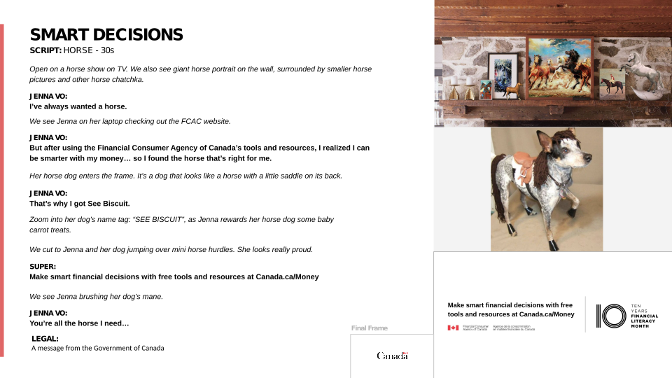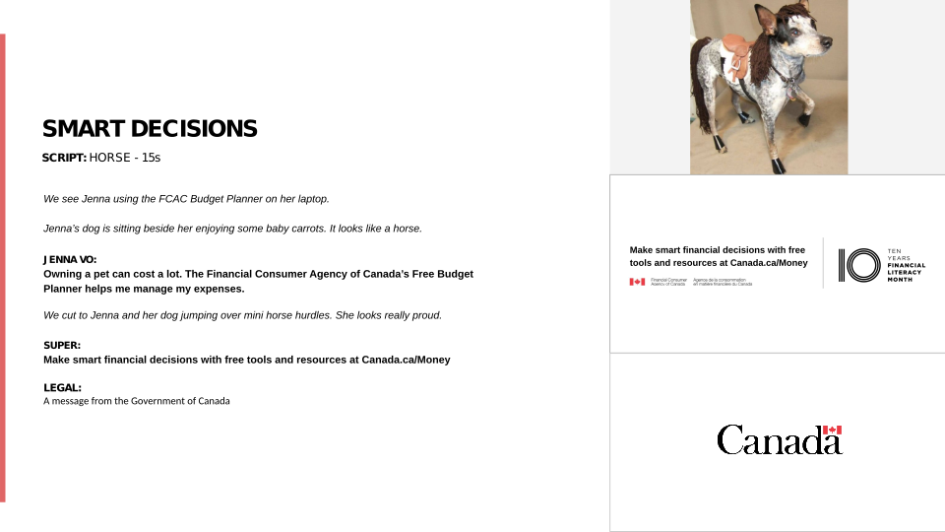
IDEA TWO

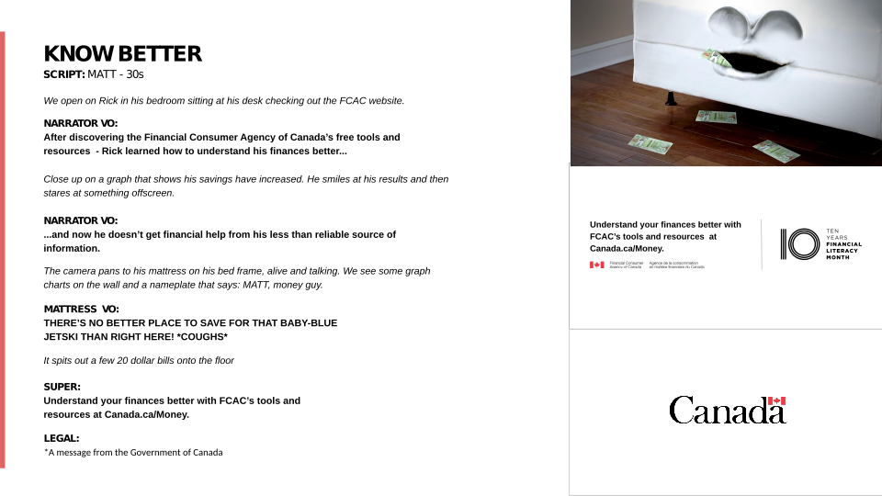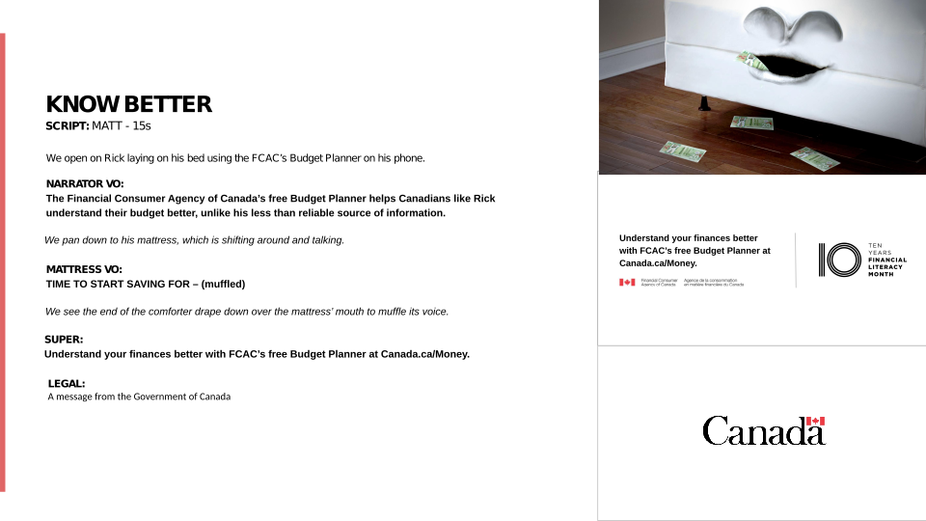

IDEA THREE

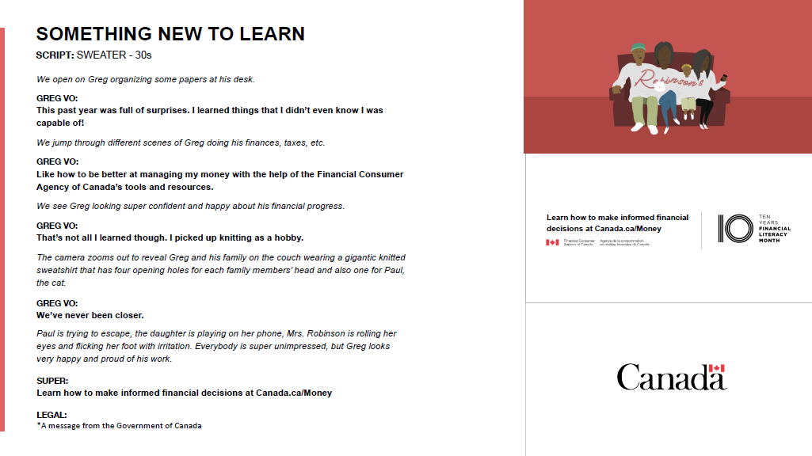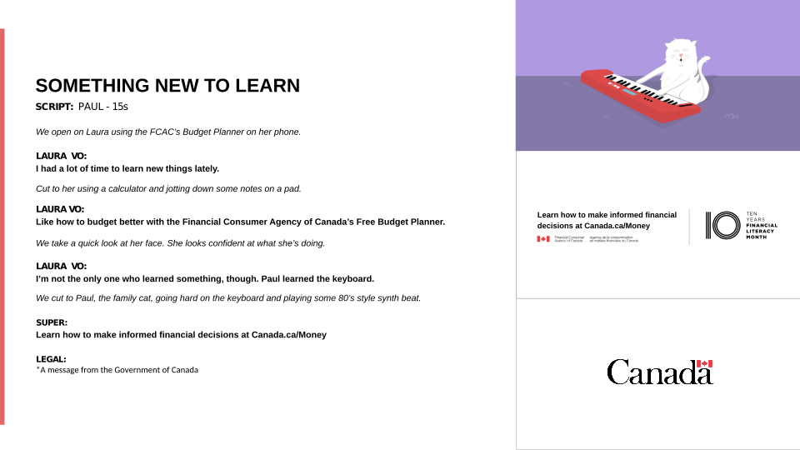

Appendix F
Pre-campaign ACET Questionnaire

Appendix F: Pre-Campaign acet Questionnaire

INTRO
Thank you for taking the time to complete this survey dealing with current issues of interest to Canadians.
Si vous préférez répondre au sondage en français, veuillez cliquer sur « Français » dans le coin supérieur droit.
Your participation is voluntary and your responses will be kept entirely confidential and anonymous. The survey takes about 5 minutes to complete. This survey is being directed by EKOS Research, and is being administered according to the requirements of the Privacy Act and is registered with the Canadian Research Insights Council's (CRIC) Research Verification Service. To view our privacy policy, click here.
If you require any technical assistance, please contact@ekos.com.
Unlike most surveys you may have completed with us, feel free to leave a question blank where preferred, and simply advance to the next question or screen.

D1A [0,7]
Does anyone in your household work for any of the following organizations?
SELECT ALL THAT APPLY
A marketing research firm 1
A magazine or newspaper 2
An advertising agency or graphic design firm 3
A political party 4
A radio or television station 5
A public relations company 6
Federal or provincial government 7
None of the above 98

D1B [0,1]
Are you...
Male gender 1
Female gender 2
Gender diverse 3

QAGE [0,1]
In what year were you born?
Note: answer the full year, i.e. 1977 as "1977"
Year 77

D1C [0,1]
In which of the following age categories do you belong?
Less than 18 years old 1
18 to 24 2
25 to 34 3
35 to 44 4
45 to 54 5
55 to 64 6
65 or older 7

D1E [0,1]
In which province or territory do you live?
Newfoundland and Labrador 1
Prince Edward Island 2
Nova Scotia 3
New Brunswick 4
Quebec 5
Ontario 6
Manitoba 7
Saskatchewan 8
Alberta 9
British Columbia 10
Yukon 11
Northwest Territories 12
Nunavut 13

Q1 [0,1]
Over the past three weeks, have you seen, read or heard any advertising from the Government of Canada?
Yes 1
No 2

Q2 [0,18]
Think about the most recent ad from the Government of Canada that comes to mind. Where have you seen, read or heard this ad?
Select all that apply
Cinema 1
Internet website 2
Magazines 3
Newspaper (daily) 4
Newspaper (weekly or community) 5
Outdoor billboard 6
Pamphlet or brochure in the mail 7
Public transit (bus or subway) 8
Radio 9
Television 10
Twitter 11
YouTube 13
Facebook 12
Instagram 14
LinkedIn 15
Snapchat 16
Spotify 17
Other, specify: 77

Q3 [0,3]
What do you remember about this ad?
77 77

Q4 [0,3]
How did you know that it was an ad from the Government of Canada?
77 77

T1A [0,1]
Over the past three weeks, have you seen, read or heard any Government of Canada advertising about financial tools and resources to help Canadians with their finances?
Yes 1
No 2

T1B [0,18]
Where have you seen, read or heard this advertising about financial tools and resources to help Canadians with their finances?
Select all that apply
Cinema 1
Facebook 12
Internet website 2
Magazines 3
Newspaper (daily) 4
Newspaper (weekly or community) 5
Outdoor billboard 6
Pamphlet or brochure in the mail 7
Public transit (bus or subway) 8
Radio 9
Television 10
Twitter 11
YouTube 13
Instagram 14
LinkedIn 15
Snapchat 16
Spotify 17
Other, specify: 77

T1C [0,3]
What do you remember about this ad?
Specify 77

T1D [0,1]
Have you heard anything about Financial Literacy Month?
Yes, I have heard about it and I am familiar with the details 1
Yes, I have heard about it and I know some of the details 2
Yes, I have heard about it but I don't know any of the details 3
No 4
Not sure 98

T1DB [0,18]
Where have you seen, read or heard about Financial Literacy Month?
Select all that apply
Cinema 1
Internet website 2
Magazines 3
Newspaper (daily) 4
Newspaper (weekly or community) 5
Outdoor billboard 6
Pamphlet or brochure in the mail 7
Public transit (bus or subway) 8
Radio 9
Television 10
Twitter 11
YouTube 13
Facebook 12
Instagram 14
LinkedIn 15
Snapchat 16
Spotify 17
Other, specify: 77

T1E [0,1]
To the best of your knowledge, does the government of Canada have a department or agency that provides free financial tools and resources for Canadians?
Yes, I have heard about it and I am familiar with the agency and/or department 1
Yes, I have heard about it and I know some information about the agency and/or department 2
Yes, I have heard about it but I don't know the agency and/or department 3
No, I haven't heard anything about it 4

T1F [0,1]
To the best of your knowledge, does the government of Canada have a department or agency dedicated to financial education and consumer protection?
Yes, I have heard about it and I am familiar with the agency and/or department 1
Yes, I have heard about it and I know some information about the agency and/or department 2
Yes, I have heard about it but I don't know the agency and/or department 3
No, I haven't heard anything about it 4

T1G [0,1]
Have you heard of the Financial Consumer Agency of Canada or FCAC?
Yes, I have heard about the FCAC and I am familiar with its mandate 1
Yes, I have heard about the FCAC and I know some information about its mandate 2
Yes, I have heard about the FCAC but I don't know its mandate 3
No, I haven't heard about them 4

DEMIN
And in closing, a few questions that will help us to analyze the survey results.
D1 [0,1]
Which of the following categories best describes your current employment status? Are you...?
Working full-time (30 or more hours per week) 1
Working part-time (less than 30 hours per week) 2
Self-employed 3
Unemployed, but looking for work 4
A student attending full-time school 5
Retired 6
Not in the workforce (Full-time homemaker, unemployed but not looking for work) 7
Other employment status (please specify) 77

D2 [0,1]
What is the highest level of formal education that you have completed?
Grade 8 or less 1
Some high school 2
High school diploma or equivalent 3
Registered Apprenticeship or other trades certificate or diploma 4
College, CEGEP or other non-university certificate or diploma 5
University certificate or diploma below bachelor's level 6
Bachelor's degree 7
Post graduate degree above bachelor's level 8

D3 [0,1]
Are there any children under the age of 18 currently living in your household?
Yes 1
No 2
D4 [0,1]
Which of the following categories best describes your total annual household income, including income from all household members, before taxes are deducted?
Under $20,000 1
Between $20,000 and $40,000 2
Between $40,000 and $60,000 3
Between $60,000 and $80,000 4
Between $80,000 and $100,000 5
Between $100,000 and $150,000 6
$150,000 or above 7
Prefer not to say 99

D5 [0,1]
Where were you born?
Born in Canada 1
Born outside Canada (Specify the country): 2

D6 [0,1]
In what year did you first move to Canada?
Record year: 77>

D7 [0,2]
What is the language you first learned at home as a child and still understand?
English 1
French 2
Other (specify): 77>

THNK
That concludes the survey. This survey was conducted on behalf of Financial Consumer Agency of Canada. In the coming months the report will be available from Library and Archives Canada. We thank you very much for taking the time to answer this survey. Your help is greatly appreciated.
THNK2
We regret that your responses have shown that you are ineligible to participate in this survey. Thank you for your time.

Appendix G
Post-Campaign ACET Questionnaire

Appendix G: Post-Campaign Acet Questionnaire

INTRO
Thank you for taking the time to complete this survey dealing with current issues of interest to Canadians.
Si vous préférez répondre au sondage en français, veuillez cliquer sur « Français » dans le coin supérieur droit.
Your participation is voluntary and your responses will be kept entirely confidential and anonymous. The survey takes about 10 minutes to complete. The survey is being conducted by EKOS Research Associates. Your participation is voluntary and your responses will be kept entirely confidential. This survey is being administered according to the requirements of the Privacy Act, the Access to Information Act, and any other relevant legislation. It is registered with the Canadian Research Insights Council's (CRIC) Research Verification Service. To view our privacy policy, click here.
If you require any technical assistance, please contact online@ekos.com.
Unlike most surveys you may have completed with us, feel free to leave a question blank where preferred, and simply advance to the next question or screen.

D1A [0,7]
Does anyone in your household work for any of the following organizations?
SELECT ALL THAT APPLY
A marketing research firm 1
A magazine or newspaper 2
An advertising agency or graphic design firm 3
A political party 4
A radio or television station 5
A public relations company 6
Federal or provincial government 7
None of the above 98

D1B [0,1]
Are you...
Male gender 1
Female gender 2
Gender diverse 3

QAGE [0,1]
In what year were you born?
Note: answer the full year, i.e. 1977 as "1977"
Year 77

D1C [0,1]
In which of the following age categories do you belong?
Less than 18 years old 1
18 to 24 2
25 to 34 3
35 to 44 4
45 to 54 5
55 to 64 6
65 or older 7

D1E [0,1]
In which province or territory do you live?
Newfoundland and Labrador 1
Prince Edward Island 2
Nova Scotia 3
New Brunswick 4
Quebec 5
Ontario 6
Manitoba 7
Saskatchewan 8
Alberta 9
British Columbia 10
Yukon 11
Northwest Territories 12
Nunavut 13

Q1 [0,1]
Over the past three weeks, have you seen, read or heard any advertising from the Government of Canada?
Yes 1
No 2

Q2 [0,18]
Think about the most recent ad from the Government of Canada that comes to mind. Where have you seen, read or heard this ad?
Select all that apply
Cinema 1
Internet website 2
Magazines 3
Newspaper (daily) 4
Newspaper (weekly or community) 5
Outdoor billboard 6
Pamphlet or brochure in the mail 7
Public transit (bus or subway) 8
Radio 9
Television 10
Twitter 11
YouTube 13
Facebook 12
Instagram 14
LinkedIn 15
Snapchat 16
Spotify 17
Other, specify: 77

Q3 [0,3]
What do you remember about this ad?
Specify 77

Q4 [0,3]
How did you know that it was an ad from the Government of Canada?
Specify 77

T1A [0,1]
Over the past three weeks, have you seen, read or heard any Government of Canada advertising about financial tools and resources to help Canadians with their finances?
Yes 1
No 2
T1B [0,18]
Where have you seen, read or heard this advertising about financial tools and resources to help Canadians with their finances?
Select all that apply
Cinema 1
Internet website 2
Magazines 3
Newspaper (daily) 4
Newspaper (weekly or community) 5
Outdoor billboard 6
Pamphlet or brochure in the mail 7
Public transit (bus or subway) 8
Radio 9
Television 10
Twitter 11
YouTube 13
Facebook 12
Instagram 14
LinkedIn 15
Snapchat 16
Spotify 17
Other, specify: 77

T1C [0,3]
What do you remember about this ad?
Specify 77

T1D [0,1]
Have you heard anything lately about Financial Literacy Month?
Yes, I have heard about it and I am familiar with the details 1
Yes, I have heard about it and I know some of the details 2
Yes, I have heard about it but I don't know any of the details 3
No 4
Not sure 98

T1DB [0,18]
Where have you seen, read or heard about Financial Literacy Month?
Select all that apply
Cinema 1
Internet website 2
Magazines 3
Newspaper (daily) 4
Newspaper (weekly or community) 5
Outdoor billboard 6
Pamphlet or brochure in the mail 7
Public transit (bus or subway) 8
Radio 9
Television 10
Twitter 11
YouTube 13
Facebook 12
Instagram 14
LinkedIn 15
Snapchat 16
Spotify 17
Other, specify: 77

T1E [0,1]
To the best of your knowledge, does the government of Canada have a department or agency that provides free financial tools and resources for Canadians?
Yes, I have heard about it and I am familiar with the agency and/or department 1
Yes, I have heard about it and I know some information about the agency and/or department 2
Yes, I have heard about it but I don't know the agency and/or department 3
No, I haven't heard anything about it 4

T1F [0,1]
To the best of your knowledge, does the government of Canada have a department or agency dedicated to financial education and consumer protection?
Yes, I have heard about it and I am familiar with the agency and/or department 1
Yes, I have heard about it and I know some information about the agency and/or department 2
Yes, I have heard about it but I don't know the agency and/or department 3
No, I haven't heard anything about it 4

T1G [0,1]
Have you heard of the Financial Consumer Agency of Canada or FCAC?
Yes, I have heard about the FCAC and I am familiar with its mandate 1
Yes, I have heard about the FCAC and I know some information about its mandate 2
Yes, I have heard about the FCAC but I don't know its mandate 3
No, I haven't heard about them 4

T1H_SCREEN
Here are some ads that have recently been broadcast on various media.
T1HA [0,1]
Over the past two months, have you seen or heard this ad?
Yes 1
No 2

T1H_SCREENA
Click to watch.
<30 second ad>

T1IA [0,20]
Where have you seen or heard this ad?
Select all that apply
Cinema 1
Internet website 2
Magazines 3
Newspaper (daily) 4
Newspaper (weekly or community) 5
Outdoor billboard 6
Pamphlet or brochure in the mail 7
Public transit (bus or subway) 8
Radio 9
Television 10
Twitter 11
YouTube 13
Facebook 12
Instagram 14
LinkedIn 15
Snapchat 18
Spotify 19
Other, specify: 77

T1HB [0,1]
Over the past two months, have you seen or heard this ad?
Yes 1
No 2

T1H_SCREENB
Click to watch.
<15 second ad>

T1IB [0,20]
Where have you seen or heard this ad?
Select all that apply
Cinema 1
Internet website 2
Magazines 3
Newspaper (daily) 4
Newspaper (weekly or community) 5
Outdoor billboard 6
Pamphlet or brochure in the mail 7
Public transit (bus or subway) 8
Radio 9
Television 10
Twitter 11
YouTube 13
Facebook 12
Instagram 14
LinkedIn 15
Snapchat 18
Spotify 19
Other, specify: 77

T1HD [0,1]
Over the past two months, have you seen any of these ads?
Yes 1
No 2

T1H_SCREEND
< Social media static ad>

T1ID [0,20]
Where have you seen these ads?
Select all that apply
Cinema 1
Internet website 2
Magazines 3
Newspaper (daily) 4
Newspaper (weekly or community) 5
Outdoor billboard 6
Pamphlet or brochure in the mail 7
Public transit (bus or subway) 8
Radio 9
Television 10
Twitter 11
YouTube 13
Facebook 12
Instagram 14
LinkedIn 15
Snapchat 18
Spotify 19
Other, specify: 77

T1J [0,3]
What do you think is the main point these ads are trying to get across?
Specify 77

PT1K
Please indicate your level of agreement with the following statements about these ads.
T1KA [0,1]
These ads catch my attention
Strongly Disagree 1 1
2 2
3 3
4 4
Strongly Agree 5 5

T1KB [0,1]
These ads are relevant to me
Strongly Disagree 1 1
2 2
3 3
4 4
Strongly Agree 5 5

T1KC [0,1]
These ads are difficult to follow
Strongly Disagree 1 1
2 2
3 3
4 4
Strongly Agree 5 5

T1KD [0,1]
These ads do not favour one political party over another
Strongly Disagree 1 1
2 2
3 3
4 4
Strongly Agree 5 5

T1KE [0,1]
These ads talk about an important topic
Strongly Disagree 1 1
2 2
3 3
4 4
Strongly Agree 5 5

T1KF [0,1]
These ads provide new information
Strongly Disagree 1 1
2 2
3 3
4 4
Strongly Agree 5 5

T1KG [0,1]
These ads clearly convey that the Government of Canada provides financial tools and resources for Canadians
Strongly Disagree 1 1
2 2
3 3
4 4
Strongly Agree 5 5

DEMIN
And in closing, a few questions that will help us to analyze the survey results.
D1 [0,1]
Which of the following categories best describes your current employment status? Are you...?
Working full-time (30 or more hours per week) 1
Working part-time (less than 30 hours per week) 2
Self-employed 3
Unemployed, but looking for work 4
A student attending full-time school 5
Retired 6
Not in the workforce (Full-time homemaker, unemployed but not looking for work) 7
Other employment status (please specify) 77

D2 [0,1]
What is the highest level of formal education that you have completed?
Grade 8 or less 1
Some high school 2
High school diploma or equivalent 3
Registered Apprenticeship or other trades certificate or diploma 4
College, CEGEP or other non-university certificate or diploma 5
University certificate or diploma below bachelor's level 6
Bachelor's degree 7
Post graduate degree above bachelor's level 8

D3 [0,1]
Are there any children under the age of 18 currently living in your household?
Yes 1
No 2

D4 [0,1]
Which of the following categories best describes your total annual household income, including income from all household members, before taxes are deducted?
Under $20,000 1
Between $20,000 and $40,000 2
Between $40,000 and $60,000 3
Between $60,000 and $80,000 4
Between $80,000 and $100,000 5
Between $100,000 and $150,000 6
$150,000 or above 7
Prefer not to say 99

D7 [0,2]
What is the language you first learned at home as a child and still understand?
English 1
French 2
Other (specify): 77>

D5 [0,1]
Where were you born?
Born in Canada 1
Born outside Canada (Specify the country): 2

D6 [0,1]
In what year did you first move to Canada?
Record year: 77>

THNK
That concludes the survey. This survey was conducted on behalf of Financial Consumer Agency of Canada. In the coming months the report will be available from Library and Archives Canada. We thank you very much for taking the time to answer this survey. Your help is greatly appreciated.
THNK2
We regret that your responses have shown that you are ineligible to participate in this survey. Thank you for your time.

Under 18 years of age or work for an advertising agency, graphic design firm, media, market research, a political party, government or public relations company.

