Pre-testing of the “Make change that counts” ad campaign
Final report
Prepared for the Financial Consumer Agency of Canada (FCAC)
Supplier: Leger Marketing Inc.
Contract Number: 5R000-211423/001/CY
Contract Value: $46,636.86 (including HST)
Award Date: December 21, 2022
Delivery Date: February 15, 2022
Registration Number: POR 074-21
For more information on this report, please contact the Financial Consumer Agency of Canada at: info@fcac-acfc.gc.ca

Ce rapport est aussi disponible en français
Pre-testing of the “Make change that counts” ad campaign
Final Report
Prepared for the Financial Consumer Agency of Canada
Supplier Name: Leger Marketing Inc.
February 2022
This public opinion research report presents the results of a series of focus groups conducted by Leger Marketing Inc. on behalf of the Financial Consumer Agency of Canada. The research study was conducted with 49 Canadians from January 24th to January 26th, 2022.
Cette publication est aussi disponible en français sous le titre : Essai préliminaire de la campagne publicitaire "Faisons des changements qui comptent"
This publication may be reproduced for non-commercial purposes only. Prior written permission must be obtained from the Financial Consumer Agency of Canada. For more information on this report, please contact the Financial Consumer Agency of Canada at: info@fcac-acfc.gc.ca
Financial Consumer Agency of Canada
427 Laurier Avenue West, 6th Floor
Ottawa ON K1R 1B9
Catalogue Number: FC5-76/1-2022E-PDF
International Standard Book Number (ISBN): 978-0-660-42628-0
Related publications (registration number: POR 074-21):
- Catalogue Number: FC5-76/1-2022F-PDF (Final Report, French)
- ISBN: 978-0-660-42630-3
© Her Majesty the Queen in Right of Canada, as represented by the Commissioner of the Financial Consumer Agency of Canada, 2022

Table of contents
Executive Summary 4
Political Neutrality Certificate 7
Project Background and Research Methodology 8
Background 8
Research Purpose and Objectives 8
Research Methodology 9
Context of Qualitative Research 9
Detailed Findings 10
Discussion Warm-Up 10
Concept 1- More Financial Power to You 10
Concept 2- Budgeting Can Make It Possible 12
Concept 3- A Financial Plan Brings Confidence 14
Budget Planner Tool 16
Conclusion & Final Recommendations 16
Appendix A – Concept Advertisements & Description 17
Concept 1- More Financial Power to You 17
Concept 2- Budgeting Can Make It Possible 18
Concept 3- A Financial Plan Brings Confidence 20
Appendix B: Recruitment Screener 21
Appendix D: Moderator’s Guide 27

Executive Summary
Leger Marketing Inc.
Contract Number: 5R000-211423/001/CY
Contract Value: $46,636.86 (including HST)
Award Date: December 21, 2022
Registration Number: POR 074-21

Introduction
Leger was contracted by the Financial Consumer Agency of Canada (FCAC) to conduct the pre-testing of their “Make a change that counts” advertising campaign. A total of six (6) online focus groups were conducted from January 24th to January 26th, 2022, with Canadian residents 18 to 54 years old. Participants were recruited from across Canada to take part in a two (2) hour focus group, held virtually. A total of three (3) groups were conducted in English and three (3) groups were conducted in French. The following document summarizes the findings from this qualitative research study.

Background
The Financial Consumer Agency of Canada is an independent federal government agency mandated to protect Canadian financial consumers. FCAC supervises federally regulated financial entities, ensuring that they comply with consumer protection measures set out in legislation, public commitments, and codes of conduct. It also promotes financial education to strengthen the knowledge, skills and confidence of Canadians and raise awareness of consumer rights and responsibilities.
Strengthening the financial literacy of Canadians is a key pillar of the Financial Consumer Agency of Canada’s (FCAC) consumer protection mandate. Canadians face an increasingly complex and digital financial marketplace. For this reason, it is more important than ever that Canadians have the knowledge, skills, and confidence to make informed decisions about their personal finances. Understanding the basics about money is as essential today as numeracy and basic literacy. Financial literacy is important not only for the financial well-being of individuals, but also for the economy.
The global pandemic has caused economic challenges for many Canadians and magnified disparities in the population. It has also underlined that financial vulnerability can affect anyone—regardless of income, background, or education. Although emergency government support measures helped Canadians manage through the pandemic, it is important that Canadians build financial confidence and, ultimately financial resilience, in the face of continued economic uncertainties (e.g., shifting labour market) to help them rebound financially from the pandemic and achieve good financial outcomes.
FCAC’s recent COVID-19 Financial Well-Being Survey measured the impact of the pandemic on Canadians’ financial well-being on a number of key indicators. Furthermore, research has shown that women face both different and greater financial challenges compared to men and were more greatly impacted by the economic disruptions created by the pandemic itself.
In this context, FCAC is set to launch a national multimedia campaign titled “Make change that counts” that will aim to strengthen the financial literacy of Canadians. The campaign will focus on encouraging Canadians to manage their money (expenses, debt, and savings) so that they can confidently make informed decisions about their personal finances in challenging times and a digital economy.
The campaign goal is to promote FCAC as an authoritative source for financial literacy tools and resources to help Canadians strengthen their financial literacy and build financial confidence. All advertising activities will direct Canadians to FCAC’s Budget Planner tool at Canada.ca/Budget-Planner where they can create a customized budget to manage their expenses, debt, and savings.

Research Purpose and Objectives
FCAC is set to launch a national multimedia campaign titled “Make change that counts” that will aim to strengthen the financial literacy of Canadians. The campaign will focus on encouraging Canadians to manage their money (expenses, debt, and savings) so that they can confidently make informed decisions about their personal finances in challenging times and a digital economy.
Through the completion of online focus groups, a review of three advertising campaign concepts was completed to gather final feedback and conduct a disaster check before they are released in the media. The research findings will help determine which campaign concept is most effective in drawing the attention of the target audience and in communicating the messages that are aligned with the campaign’s objectives. The three campaign concepts included Budgeting Can Make It Possible, More Financial Power to You, and A Financial Plan Brings Confidence.

Methodology
A total of six (6) online focus groups were conducted from January 24th to January 26th, 2022, with Canadian residents 18 to 54 years old. Participants were recruited from across Canada to take part in a two (2) hour focus group, held virtually. A total of three (3) groups were conducted in English and three (3) groups were conducted in French. A total of forty-nine (49) participants took part in the focus groups and all participants were provided with $125 as an honorarium. The recruitment of participants was conducted through random calling of a general population qualitative panel. All participants were recruited per established industry standards and per the recruitment specifications for the Government of Canada. This report presents the findings from these focus groups. Caution must be exercised when interpreting the results from this research, as qualitative research is directional only. Results cannot be attributed to the overall population under study, with any degree of confidence.

Key Findings and Conclusions
The focus group findings indicated that the “Make change that counts” ad campaign concepts do not contain any hidden disasters and the overall reactions to the campaign concepts were positive.
Across the different demographic segments, participants generally had similar reactions and feedback towards the three campaign concepts. Some differences of opinion were present among young adults (18 to 24) and French and English language participants. However, the overall results of the focus groups were consistent across all six (6) groups and demographic segments.
Participants recognized that the advertisements were targeted towards women. Male English language participants indicated the gender portrayed in the ads would not influence their response to the ad and that they would pay attention to the messaging, regardless of the person depicted in the image. French language participants, both male and female, expressed concern that the ads lacked the presence of male figures and believed the concepts should be more inclusive to avoid appearing sexist. It is important to note that this sentiment was only expressed among the French language participants (Groups 4, 5, 6).
Budgeting Can Make It Possible
Of the three campaign concepts shown to participants, Budgeting Can Make It Possible was selected as the concept that would encourage participants to take action. The main message of this concept was thought to urge people to take control of their budget, access the free Budget Planner, and manage their finances to make goals possible. First reactions to the concept were generally positive across all groups. The ads were thought to provide a clear message, highlighting the budgeting tool, and demonstrated what can be achieved through budgeting. Additionally, participants felt the concept portrayed achievable goals which encouraged them to visit the Budget Planner tool.
The images used in this concept were thought to be relatable and many participants could envision themselves doing the various activities such as owning a pet, a vacation, a new place, and post-secondary education. Overall, the images were thought to work well with the concept’s messaging and were relatable. Many participants across all groups resonated with the concept because it portrayed specific, relatable, and achievable goals.
The wording used in the Budgeting Can Make It Possible concept was well received. Participants across all groups understood the use of the word possible and impossible, and thought the tagline, Budgeting can make it possible was positive and encouraging. Several French language participants said they would prefer if the ad did not use the word impossible and instead focused on the word possible to keep the tone of the message positive. Across all groups, participants indicated that the message in the Budgeting Can Make It Possible concept was important and effective. Budgeting Can Make It Possible was also selected as the most preferred tagline across all groups.
More Financial Power to You

The main message of the More Financial Power to You concept was thought to encourage people to take control of their budget, show how easy it can be to manage personal finances, and to have more power and freedom to do the things you want such as hobbies. Overall, the concept was well received and was the second most preferred concept, including the second most preferred tagline, More Power to You.

While the concept was thought to be relatable and showcase a variety of different and interesting goals, young adult participants were more likely to dislike the concept images, indicating they were not unique and resembled stock photos. Some participants felt the concept was missing imagery related to other goals such as vacations, education, and retirement.

The wording used in the More Financial Power to You concept was understood and well received. Participants believed the phrase More power to you meant having financial control and independence and/or having the power to budget your money. Participants in the French language groups linked the tagline to the idea of having the power of purchase, the ability to purchase more. Participants across all groups associated having power and control over your finances as leading to having reduced stress in one’s life. Young adult participants were more likely to indicate they did not like the concept’s tagline, particularly personal power and creative power. Several participants across all groups thought these particular ads missed the mark and did not convey a clear meaning. The family power messaging was understood by most and participants did see the connection with personal finances in the copy. Participants with children had a stronger connection to the family power message and indicated positive reactions to this messaging.

A Financial Plan Brings Confidence
The A Financial Plan Brings Confidence concept was understood by participants but was the least preferred. Feedback from both French and English participants, and both female and male participants tended to be negative. The main message was believed to be that financial planning leads to confidence and less worry about financial security, that financial planning can give you confidence to achieve your dreams, and that financial confidence leads to happiness. Many participants across all groups did not think the concept was as clear or direct in comparison to the other two concepts. Several participants did not make the immediate connection between finances and confidence.
Young adult participants were less likely to connect with the A Financial Plan Brings Confidence concept. Both female and male young adult participants thought the messaging was unclear and that the images were not relatable. In addition, several female participants in the English language groups, including one participant living with a disability, thought the images depicted dangerous actions, particularly the skydiving, motorcycle riding, and the woman doing a flip, and they could not imagine themselves doing these types of activities. While participants across all groups indicated the main message being communicated through the advertisement concept was important, most did not think the message was effective or would encourage them to take action and explore the Budget Planner tool.
While there were a variety of different opinions in relation to whether the term financial plan or budget/budgeting is preferred in the concept’s copy, the term financial plan was generally thought to be an activity that would include budgeting and that financial planning is for long-term planning. In comparison, budgeting was thought to be a more immediate activity. Some participants, particularly in the French language groups, found the term financial plan to be intimidating and said budgeting was a less intimidating term and more relatable and easier to envision. While participants in the English language groups were divided on their preference between the two terms, most agreed that financial plan and budget were interchangeable in the context of the ads and would not change the main message of the concept. Several English language participants also suggested using both terms in the ad to cover all aspects of personal financial management.

Political Neutrality Certificate
I hereby certify as a Representative of Leger Marketing Inc. that the deliverables fully comply with the Government of Canada political neutrality requirements outlined in the Policy on Communications and Federal Identity and the Directive on the Management of Communications.
Specifically, the deliverables do not include information on electoral voting intentions, political party preferences, standings with the electorate or ratings of the performance of a political party or its leaders.
Signed
Llisa Morrow, Associate Vice-President
Leger Marketing Inc.
February 15, 2022

Project Background and Research Methodology

Background
The Financial Consumer Agency of Canada (FCAC) is an independent federal government agency mandated to protect Canadian financial consumers. FCAC supervises federally regulated financial entities, ensuring that they comply with consumer protection measures set out in legislation, public commitments, and codes of conduct. It also promotes financial education to strengthen the knowledge, skills and confidence of Canadians and raise awareness of consumer rights and responsibilities.
Strengthening the financial literacy of Canadians is a key pillar of the Financial Consumer Agency of Canada’s (FCAC) consumer protection mandate. Canadians face an increasingly complex and digital financial marketplace. For this reason, it is more important than ever that Canadians have the knowledge, skills, and confidence to make informed decisions about their personal finances. Understanding the basics about money is as essential today as numeracy and basic literacy. Financial literacy is important not only for the financial well-being of individuals, but also for the economy.
The global pandemic has caused economic challenges for many Canadians and magnified disparities in the population. It has also underlined that financial vulnerability can affect anyone—regardless of income, background, or education. Although emergency government support measures helped Canadians manage through the pandemic, it is important that Canadians build financial confidence and, ultimately financial resilience, in the face of continued economic uncertainties (e.g., shifting labour market) to help them rebound financially from the pandemic and achieve good financial outcomes.
FCAC’s recent COVID-19 Financial Well-Being Survey measured the impact of the pandemic on Canadians’ financial well-being on a number of key indicators. Furthermore, research has shown that women face both different and greater financial challenges compared to men and were more greatly impacted by the economic disruptions created by the pandemic itself.
In this context, FCAC is set to launch a national multimedia campaign titled “Make change that counts” that will aim to strengthen the financial literacy of Canadians. The campaign will focus on encouraging Canadians to manage their money (expenses, debt, and savings) so that they can confidently make informed decisions about their personal finances in challenging times and a digital economy.
The campaign goal is to promote FCAC as an authoritative source for financial literacy tools and resources to help Canadians strengthen their financial literacy and build financial confidence. All advertising activities will direct Canadians to FCAC’s Budget Planner tool at Canada.ca/Budget-Planner where they can create a customized budget to manage their expenses, debt, and savings.

Research Purpose and Objectives
FCAC is set to launch a national multimedia campaign titled “Make change that counts” that will aim to strengthen the financial literacy of Canadians. The campaign will focus on encouraging Canadians to manage their money (expenses, debt, and savings) so that they can confidently make informed decisions about their personal finances in challenging times and a digital economy.
Through the completion of online focus groups, a review of three advertising campaign concepts was completed to gather final feedback and conduct a disaster check before they are released in the media. The research findings will help determine which concept is the most effective in drawing the attention of the target audience and in communicating the message(s) that are aligned with the campaign’s objectives. The three campaign concepts included Budgeting Can Make It Possible, More Financial Power to You, and A Financial Plan Brings Confidence.

Research Methodology
A qualitative (focus group) research approach was used to pre-test the advertising campaign concepts for final feedback and disaster check before being released in the media. The target audience for the research included working-aged Canadians (18 to 54) with participants recruited from the following primary and secondary audience segments:
Primary:
- Women
- Low-income (less than $40,000 annual household income)
- Young adults aged 18 to 24
Secondary:
- Individuals with part-time, precarious, or self-employment, or who are unemployed
- Indigenous Peoples
- Recent immigrants
- Individuals living with a disability
A total of six (6) online focus groups were conducted from January 24th to January 26th, 2022, with Canadian residents 18 to 54 years old. Participants were recruited from across Canada to take part in a two (2) hour focus group, held virtually. A total of three (3) groups were conducted in English and three (3) were conducted in French. A total of forty-nine (49) participants took part in the discussion groups and all participants were provided with $125 as an honorarium. The recruitment of participants was conducted through random calling of a general population qualitative panel. All participants were recruited per established industry standards and per the recruitment specifications for the Government of Canada.
Group Schedule:
- Group 1: Gen Pop (18-54), All Provinces- English (7 participants: 4 females and 3 males)
- Group 2: Gen Pop (18-54), All Provinces- English (8 participants: 4 females and 4 males)
- Group 3: Women (18-54), All Provinces- English (8 participants: 8 females)
- Group 4: Women (18-54), Québec, Atlantic- French (9 participants: 9 females)
- Group 5: Gen Pop (18-54), Québec, Atlantic- French (8 participants: 4 Females and 4 males)
- Group 6: Gen Pop (18-54), Québec, Atlantic- French (9 participants: 5 females and 4 males)

Context of Qualitative Research
Focus groups are an ideal way of conducting qualitative research that allows for a moderator-directed, informal discussion with a variety of different participants with different demographic backgrounds, habits, and attitudes. Qualitative research allows for in-depth questioning and important discussions among the participants to help determine attitudes, behavioural habits and patterns, and perceptions related to the research topic. Using a focus group approach allows for the moderator to adjust questioning in response to participants feedback and reactions within the group. The primary focus is on uncovering participant’s feelings and opinions driven by their current awareness of the subject matter and the world around them. It is important to note that qualitative techniques used in market research are structured to provide insight and direction rather than quantitative data and numeric measurements. Throughout this report, we occasionally use participant counts and percentages to illustrate differences, but these references should be used only as a guide and not thought of as valid quantitative data due to the small sample size and overall qualitative research method used for the study.
An online focus group approach was chosen for the research structure. Using Leger’s virtual focus group platform called FOCUS, participants were able to connect to the discussion group using the virtual meeting platform. An online focus group was best suited for this project due to COVID-19 restrictions. In addition, the online focus group approach allowed participants from across the country to participate, not limiting the focus groups to specific geographical locations.

Detailed Findings

Discussion Warm-Up
A warm-up series of questions is typically used to help participants start thinking about the topics to be discussed during the group. At the beginning of each focus group, participants were asked how much time they typically spend in a month on their household’s finances including activities such as paying bills, looking at a budget, etc. While responses varied among participants, most indicated that they spend some amount of time either weekly or monthly conducting these types of activities. Participants who currently budget or use budgeting tools typically spent a few hours a month on these types of activities. Young adult participants (18-24) were somewhat less likely to indicate they followed a budget or paid close attention to their finances in comparison to older participants (25+).
While most participants indicated they were comfortable in keeping track of their financial situation, a few young adult participants (18-24) indicated they struggled with personal finances and found the budgeting tools they have tried in the past to be challenging or difficult to use.
During the warm-up, participants were also asked if they work with a financial planner or outside professional to help with retirement planning or other financial goals. Some participants indicated that they do work with a financial planner or someone at their financial institution, many others said they did not. Younger adult participants (18-24) were less likely to indicate they work with a financial planner or other financial professional.

Presenting Each Concept
It is important to note that each of the three concepts tested during the focus groups were presented in a different order for each group. Each individual concept was shown to participants and discussed as a group before moving on to the next concept. Concept images and descriptions can be found in Appendix A.

Concept 1- More Financial Power to You

Initial Reactions
After reviewing the images for Concept 1- More Financial Power to You, participants shared what they believed to be the main message and purpose of the concept. Frequent response themes included:
- Encourage people to take control of their budget
- Show how easy it can be to manage your finances
- Actively manage your finances with the help of a budget planner tool
- Provide more power and freedom to do the things you want (hobbies)
- Power to have financial independence
- Educating people on how to budget so they can reach their goals
- Providing a free budget planner for those who need or want help budgeting
While there were no major differences between different participant segments, young adults (18-24) thought the main message aligned with how they viewed financial planning. They indicated that financial planning could lead to stability and that the main purpose of the ad was to encourage people to take control of their budget.
Participants were asked for both their positive and negative reactions to the concept. In terms of positive reactions, most participants stated the images were relatable, showed a variety of different interests and goals, and the overall messaging was clear and consistent.

In terms of negative reactions, some participants, particularly the young adults (18-24) stated the images looked like stock photos and were not unique enough to grab their attention. Some participants in the French language groups, particularly older adults (40+) suggested that the ads should include images related to money, vacations, getting a diploma and/or retirement. A couple of young adults (18-24) mentioned the boxing image was too “aggressive” and looked like an ad for a gym or fitness center.

Across all groups, participants indicated that the message being communicated through the concept was important and effective. A total of twenty-two percent (22%) (11 participants) selected Concept 1- More Financial Power to You as the concept that would encourage them to take action. Of the 11 participants that selected this concept, 8 were female and 3 were male. More Financial Power to You was the second most preferred tagline across all groups.

Male participants were asked if they felt the images and messaging was relevant to them even if all the images were of women. English language male participants agreed that the gender portrayed in the images of the concept did not influence their opinion of the ads and having all women in the ads did not prevent them from being curious about the ad’s message. However, some participants in the French language groups, including female participants, thought the ads could be interpreted as sexist because of the lack of gender diversity and suggested that both men and women be included in the images. This was especially true for the image showing a mother and her daughter: participants felt it could have been a couple shown in the “Donnez-vous le pouvoir de passer du temps en famille” copy. Several women in both the English and French language groups said the images portrayed strong and smart women that were taking control and that this messaging resonated with them.

Feedback on Wording
Participants were asked what they thought of the phrase More power to you and what it meant to them. Almost all participants interpreted More power to you as having financial control and independence and/or having the power to budget your money. Participants in the French language groups linked the tagline to the idea of having the power of purchase, the ability to purchase more. Participants across all groups associated having power and control over your finances to having reduced stress in one’s life.

While there were no significant differences across the segments, a few participants in the all-female English group (group 3) found the more power to you in the ad copy to be “wordy” and suggested removing the “to you” to make the message easier to read. Among these few participants, there was the sense that the current copy seemed grammatically incorrect. One participant in this group who indicated she had a neurological disability also agreed that the wording was a bit challenging to understand. She said, “For someone with cognitive impairments, other than the fact that we’ve been doing an exercise about this financial planning tool, I couldn’t tell you the message, it’s too difficult to read.” When probed further, she said she found “more power to you” confusing because it did not seem like a full sentence.

The wording personal power and creative power did not resonate with all respondents. Several participants in both the French and English groups, male and female, struggled to see the connection to finances when viewing this particular copy. The family power messaging was understood by most and participants did see the connection with personal finances in the copy. Participants with children had a stronger connection to the family power message and indicated positive reactions to this messaging.
Most participants agreed with the statement, More power starts with a financial plan. Many believed this statement meant having the ability to make themselves financially strong. Several participants believed that having a financial plan was responsible and provides flexibility and power. Young adult (18-24) participants tended to be more skeptical of the idea that a financial plan and budget can really make that much difference in one’s life but were generally open to the idea of exploring how budgeting can provide them with more independence and power. For some young adult participants, power meant freedom and having the ability to be more independent.
Participants were asked if they preferred the term financial plan or budget and what would make more sense to them within the context of the concept. While there were a variety of different comments and opinions, the term financial plan was generally thought to be an activity that would include budgeting and that financial planning is for long-term planning. In comparison, the term budgeting was thought to be a more immediate activity. Some participants, particularly in the French language groups, found the term financial plan to be intimidating and said budgeting was a less intimidating term and more relatable and easier to envision. Several English language participants suggested using both terms in the ad to cover all aspects of personal financial management.
While some participants in the English language groups were divided on their preference between the two terms, most agreed that financial plan and budget were interchangeable in the context of the ad and would not change the main message of the concept.
Specific comments about the terms financial plan and budget included:
- Financial planning is way down the road
- Financial planning is needed for longer term goals
- Budgeting is easier to envision and not as intimidating
- Budget is operational and financial plan is for long term
- Either term works for the ad concept

Concept 2- Budgeting Can Make It Possible

Initial Reactions
After reviewing the images for Concept 2- Budgeting Can Make It Possible, participants shared what they believed to be the main message and purpose of the concept. Frequent response themes included:
- Encourage people to take control of their budget
- Budgeting with a free budget planner will allow you to reach your goals
- Actively manage your finances with the help of a budget planner tool
- Managing your finances with more flexibility
- With a budget, you can save for what you really want; it is possible with a budget planner
- I can make what I want possible
First reactions to the concept were generally positive across all groups. The ads were thought to provide a clear message, highlight the budgeting tool, and show what can be achieved through budgeting. Additionally, participants felt the ads portrayed achievable goals which encouraged them to visit the Budget Planner tool.
Participants thought the check mark boxes supported the main messaging of the concept and were aesthetically pleasing. Some French language participants felt the concept was very catchy, particularly commenting on the check mark boxes: “Cela attire mon attention”. It is noteworthy to mention that some participants from the all-female English group (group 3) thought the check boxes distracted from the concept and were “cheesy.” Overall, group 3 had a slightly more critical view of the concept but almost all participants in the group indicated the concept was effective at getting their attention and communicating the main message.
The images used in this concept were thought to be relatable and many participants could envision themselves doing the various activities. The concept itself was not considered as “abstract” in comparison to the other two concepts, contributing to the cohesion between the messaging and the images. Overall, the images were thought to work well with the concepts messaging and were relatable. Many participants across all groups resonated with the concept because it portrayed specific, relatable, and achievable goals.
In terms of negative reactions, a few participants in the all-female English language thought the images were somewhat generic and would not stand out in a social media campaign. A couple of participants in this same group also commented the punctuation used in the concept seemed a bit awkward and questioned if there was a better way to present the message. Finally, several French language participants suggested that they would like to see some images related to retirement and felt this element of financial planning was missing.

Across all groups, participants indicated that the message being communicated through the advertisement concept was important and effective. A total of seventy-one percent (71%) (35 participants) selected Concept 2- Budgeting Can Make It Possible as the concept that would encourage them to take action. Of the 35 participants that selected this concept, 22 were female and 12 were male. Budgeting Can Make It Possible was also selected as the most preferred tagline across all groups.

Feedback on Wording
Participants were asked what they thought of the phrases possible and impossible used in the concept and what these different words suggested to them. Participants across all groups understood the use of these two words in the concept and believed that the word possible represented the notion of possibilities through budgeting and that goals are possible with the right budgeting tools and information. Several French language participants said they would prefer if the ad did not use the word impossible and instead focused on the word possible to keep the tone of the ads message positive. They felt the use of the word impossible gave the ad a negative feel. This sentiment was only present in the French language groups and was not discussed in the English language groups.
When asked about the phrase Budgeting can make it possible, most participants agreed with this statement and thought it meant you can achieve your goals with the right information and financial tools, including a budgeting tool. Budgeting can make it possible was viewed as a positive statement and was perceived as encouraging.
A few participants in the all-female English group (group 3) who were part of the low-income segment thought the messaging of the concept, Budgeting can make it possible, was overly optimistic. While they believed that budgeting is important and aids in financial stability, they also believed that obtaining what you want often requires more than just money. One English female participant in the low-income segment commented, “It really should be, ‘I can help make it possible’ because there is a lot of things you need in place to make things possible. It’s not always about money.” Others in the group also agreed with the sentiment. These participants agreed that there are some things that budgeting can make possible but not all goals can be accomplished simply through financial planning and budgeting.

Similar to the previous concept, participants were asked if they preferred the term budgeting or financial plan and what would make more sense to them within the context of this concept. Participants in the French language groups preferred the word budgeting because it was thought to be more accessible and less intimidating in comparison to financial plan. Participants in the English language groups were divided on their preference but most agreed that the terms were interchangeable.
Specific comments about the terms budgeting and financial plan included:
- Financial planning is in the future and budgeting is current
- The terms are interchangeable/ they have the same impact
- Budgeting can be somewhat limiting, and financial plan covers more

Concept 3- A Financial Plan Brings Confidence

Initial Reactions
After reviewing the images for Concept 3- A Financial Plan Brings Confidence, participants shared what they believed to be the main message and purpose of the concept. Frequent response themes included:
- Financial planning leads to confidence and not having to worry about financial security as much
- Financial planning gives you confidence to achieve your dreams
- Financial confidence leads to happiness
- A budget planner will provide financial confidence
- Without a financial plan, people are less confident in their ability to achieve certain goals
The concept was understood among participants, but it was the least preferred of the three. Feedback from both French and English participants, both female and male tended to be negative. Many participants across all groups did not think the concept was as clear or direct as the other two concepts and did not make the immediate connection between finances and confidence.
Participants agreed that having confidence was viewed as a positive goal. Participants also agreed that having financial confidence will lead to the ability to be more confident in general. Some participants felt the images used in the concept would grab their attention because the activities depicted were interesting and stood out. However, many participants did not connect with the images, some stated they were “boring”, and others did not think they were memorable.
Of important note, young adults (18-24) did not connect with the campaign. Both female and male young adult respondents thought the messaging was unclear and that the images were not relatable. In addition, several female participants in the English language groups, including one participant living with a disability, thought the images of skydiving, motorcycle riding, and the woman doing a flip depicted dangerous activities that they could not picture themselves doing. Several female participants across all groups described the activities in the images as dangerous and not relatable.
Additional feedback about the overall concept included:
- The concept is missing the family element that was included in the other concepts
- This concept did not seem as professional in comparison to the other concepts
- It would be better to include more diversity in the ad images (men, women, families)
- The concept would not get people to click on the link to the budget planner or explore further

Similar to the previous concepts, male participants in both the English and French language groups didn’t think the ads were targeted to women only, but they also thought that having more diversity, including different genders, portrayed in the ads would be ideal.

While participants across all groups indicated the main message being communicated through the concept was important, over half of the participants did not think the message was effective. A total of seven percent (7%) (3 participants) selected Concept 3- A Financial Plan Brings Confidence as the concept that would encourage them to take action. All three participants who selected this concept were female, two from the French language groups and one from the English language group.

Feedback on Wording
Participants were asked what the phrase A financial plan brings confidence means to them. Many participants indicated that having a financial plan can result in stability and less stress and worry about finances in general, resulting in increased financial confidence. Most participants believed this phrase was more abstract in comparison to the first two concepts and while the phrase was understood, it was not well liked.
The phrase You can never have too much confidence was generally seen as having limited connection to finances and did not resonate with many participants. Some specifically thought the idea of having too much confidence was negative. Specific feedback included:
- Sometimes too much confidence can get you into trouble
- Too much confidence sounds like someone being too full of themselves
- Overconfidence is not a positive attribute
- Too much confidence could lead to making bad discissions/ unsafe activities
- Having too much confidence can get you into financial trouble
Participants were asked if they preferred the phrase A financial plan brings confidence or budgeting brings confidence and what would make more sense to them within the context of this concept. Similar to previous concepts, participants in the French language groups preferred the word budgeting because it was thought to be more accessible and less intimidating in comparison to financial plan. Participants in the English language groups were divided on their preference but most agreed that the terms were interchangeable.
Specific comments about the terms A financial plan brings confidence and budgeting brings confidence included:
- Financial planning is for future planning
- Financial planning is needed for longer term goals
- Financial planning is better because it is a broader concept
- Budgeting is easier to envision and not as intimidating
Finally, participants across all groups were asked for their reactions to the specific ad that had You can never have too much confidence in comparison to the ad with A financial plan brings confidence superimposed on the image. While most participants did not have a preference, a few female participants indicated they preferred You can never have too much confidence as the image copy because they would most likely read the image copy first and this phrase would grab their attention. As previously mentioned, most participants indicated they did not have a preference.

Budget Planner Tool
Participants were asked what the ads encouraged them to do and what action they specifically should take. Many participants thought the specific action was to think about their finances, start budgeting, or get a financial plan. After some additional probing, participants identified using the Budget Planner tool as the ads specific message. Interestingly, many participants did not immediately connect using the Budget Planner tool as the ad’s call to action, but instead thought budgeting and financial planning in general was the main message. Concept 2- Budgeting Can Make It Possible was the most likely to have participants identify the correct call to action: use the Budget Planner tool.
A few participants mentioned they would most likely visit the Budget Planner tool because the ad included the word “free”, and this was appealing to them. Others stated that they would expect a Government of Canada tool to be offered without a cost attached. While the word “free” did grab some attention, most participants did not specifically mention it when discussing the messaging of the advertisements.
When asked what they would expect from a budget planner tool, participants indicated they would expect an easy-to-use tool to help keep track of their incoming and outgoing money and provide guidance on how to plan for short-term and long-term budgeting activities.
It is noteworthy to mention that a few English language participants said they had used Mint, the personal finance app. These participants expected the Budget Planner tool would be like Mint or at least have some of the same budgeting features.

Conclusion & Final Recommendations
- Overall, the message of the “Make change that counts” campaign is viewed as important, and the concepts are effective.
- Focus efforts on the Budgeting Can Make It Possible and/or More Financial Power to You concepts.
- Consider having a very direct instruction to get people to visit the Budget Planner (Get the Budget Planner tool to help you take control of your finances).
- Using both financial plan and budgeting may be advantageous.
- Consider removing the “to you” from the ad copy so it reads “More power starts with a financial plan.” Keep the “to you” on the image copy.
- For the French language campaign, including some additional images of men will be well received.
- Having images that are relatable, realistic, and eye catching will be an important element when connecting Canadians to the ad’s messaging.

Appendix A – Concept Advertisements & Description

Concept 1- More Financial Power to You
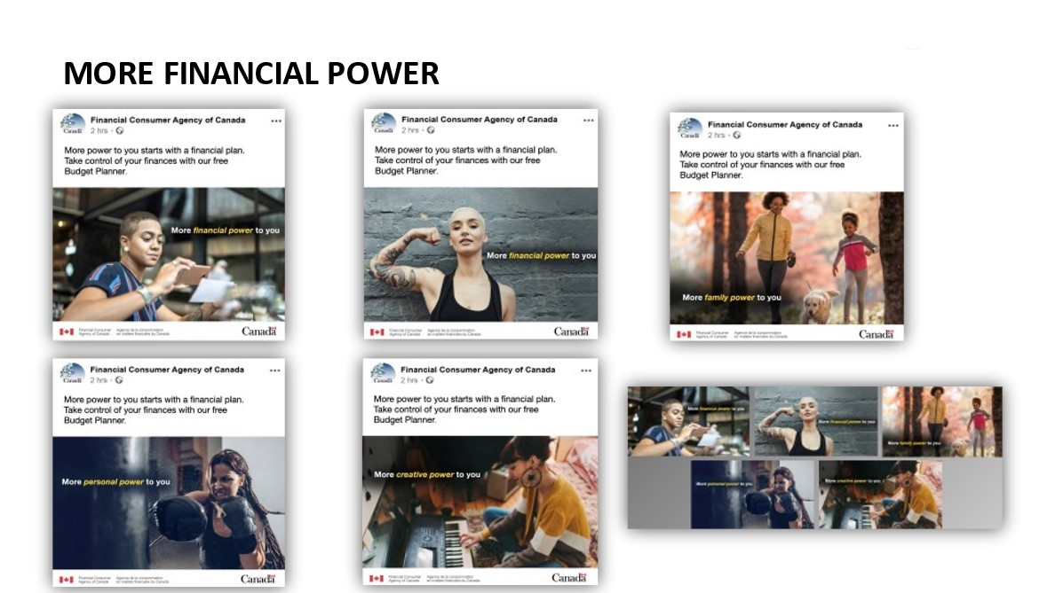
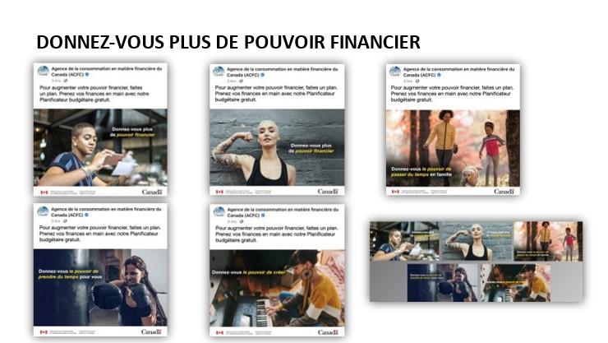
Image descriptions:
- A woman taking a picture of a cheque for depositing using a mobile device with the tagline More financial power to you. The ad copy reads: More power to you starts with a financial plan. Take control of your finances with our free Budget Planner.
- A woman flexing her arm that has several tattoos with the tagline More financial power to you. The ad copy reads: More power to you starts with a financial plan. Take control of your finances with our free Budget Planner.
- A woman walking a dog with a young boy with the tagline More family power to you. The ad copy reads: More power to you starts with a financial plan. Take control of your finances with our free Budget Planner.
- A woman with boxing gloves about to intensely hit a punching bag with the tagline More personal power to you. The ad copy reads: More power to you starts with a financial plan. Take control of your finances with our free Budget Planner.
- A woman sitting cross legged on the floor playing a keyboard with the tagline More creative power to you. The ad copy reads: More power to you starts with a financial plan. Take control of your finances with our free Budget Planner.
- All five images together to allow for easy comparison.

Concept 2- Budgeting Can Make It Possible
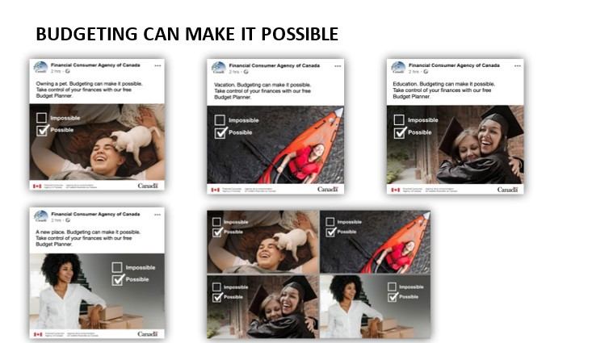
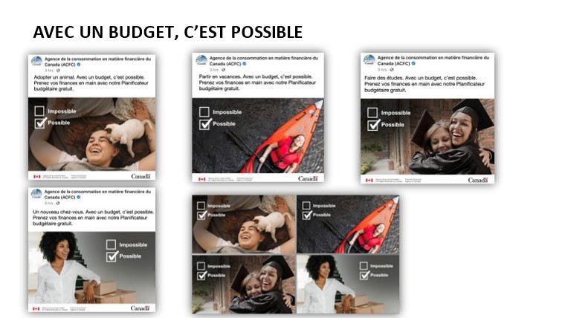
Image descriptions:
- A woman laying down and laughing with a small puppy licking her face. There are two check boxes, one with the word Impossible and one below with the word Possible. Possible has a check mark beside it. The ad copy reads: Owning a pet. Budgeting can make it possible. Take control of your finances with our free Budget Planner.
- A woman in a kayak with her head back and smiling up at the sky. There are two check boxes, one with the word Impossible and one below with the word Possible. Possible has a check mark beside it. The ad copy reads: Vacation. Budgeting can make it possible. Take control of your finances with our Free Budget Planner.
- A woman in a graduation cap and gown embraces another woman and they are both smiling. There are two check boxes, one with the word Impossible and one below with the word Possible. Possible has a check mark beside it. The ad copy reads: Education. Budgeting can make it possible. Take control of your finances with our Free Budget Planner.
- A woman who is smiling is standing beside several moving boxes in an empty room with a staircase. There are two check boxes, one with the word Impossible and one below with the word Possible. Possible has a check mark beside it. The ad copy reads: A new place. Budgeting can make it possible. Take control of your finances with our free Budget Planner.
- All four images together to allow for easy comparison.

Concept 3- A Financial Plan Brings Confidence
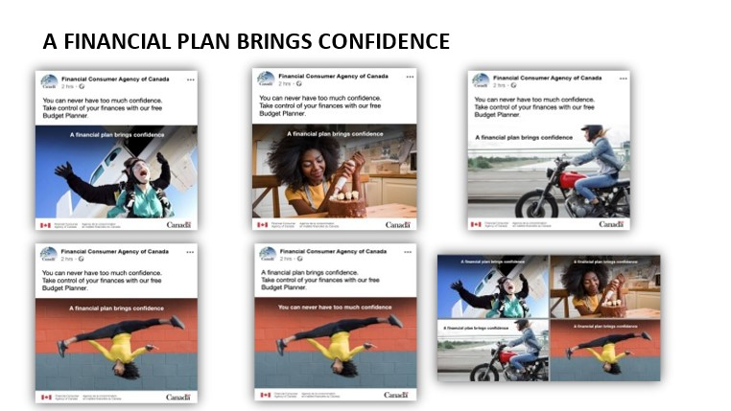

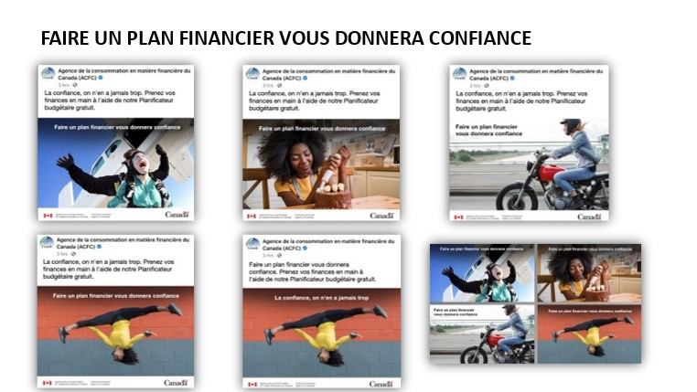
Image descriptions:
- A woman skydiving in tandem. The tagline A financial plan brings confidence is at the top of the image. The ad copy reads: You can never have too much confidence. Take control of your finances with our free Budget Planner.
- A woman sits at a kitchen table and is decorating a cake. The tagline A financial plan brings confidence is at the top of the image. The ad copy reads: You can never have too much confidence. Take control of your finances with our free Budget Planner.
- A woman is riding a motorcycle. The tagline A financial plan brings confidence is at the top of the image. The ad copy reads: You can never have too much confidence. Take control of your finances with our free Budget Planner.
- A woman is doing a flip in the air. She is mid-flip and is upside down in a straddle position with her arms outstretched at her sides. The tagline A financial plan brings confidence is at the top of the image. The ad copy reads: You can never have too much confidence. Take control of your finances with our free Budget Planner.
- A woman is doing a flip in the air. She is mid-flip and is upside down in a straddle position with her arms outstretched at her sides. The tagline You can never have too much confidence is at the top of the image. The ad copy reads: A financial plan brings confidence. Take control of your finances with our free Budget Planner.
- All five images together to allow for easy comparison.

Appendix B: Recruitment Screener

SURVEY SAMPLE/ PANEL INTRO
Hello/Bonjour, may I please speak with _____________? My name is ________ and I am calling on behalf of Leger, a national opinion research firm. Would you prefer that I continue in English or French? Préférez-vous continuer en français ou en anglais?”.

We are calling today to see if you are interested in participating in upcoming online Focus Group research, the focus group will discuss advertising ideas that the Government of Canada is planning to share with Canadians.

READ TO ALL:
Participation is voluntary and all your answers will be kept confidential and will be used for research purposes only. We are simply interested in hearing your opinions – no attempt will be made to sell you anything. The online discussion is led by a research professional with Leger. Only first names are used to identify your comments during the discussion. Transcripts of the session will be produced for research purposes. The transcripts will be used only by the research professional to assist in preparing a report on the research findings and will be destroyed once the report is completed.

READ TO ALL:
“The information collected through the research is subject to the provisions of the Privacy Act, the legislation of the Government of Canada, and to the provisions of relevant provincial privacy legislation.]

All those who participate in the research will receive a $100 virtual Visa eGift card as a token of appreciation for their time. The total time commitment to participate is approximately 90-120 minutes.
For more information about this research by visiting Canadianresearchinsightscouncil.ca search using this project registration # 20220106-LE962

A2. The group discussions we are organizing are going to be held over the Internet. They are going to be "online focus groups". Participants will need to have a computer (you can participate on a tablet or a smartphone as well), a high-speed Internet connection, and a WebCam in order to participate in the group. Would you be able to participate with these requirements?
Yes | 1 | CONTINUE
No | 2 | THANK AND CONCLUDE

Would you be interested in participating in the focus group?
[IF YES, CONTINUE to READ ALL].

- IF YES, CONTINUE
- IF NO, TRY TO SET A CALL BACK OR THANK AND TERMINATE

Before I can invite you to attend there are a few questions I need to ask to see if you qualify. This will take few minutes (e.g. 5 minutes)
May I ask you a few questions? [YES = CONTINUE]
- Are you between the age of 18 and 54?
- Yes CONTINUE
- No TERMINATE
1a. What is your province /Territory of residency?
- Atlantic Canada [Newfoundland and Labrador, Prince Edward Island, Nova Scotia, New Brunswick]
- Quebec
- Ontario
- Manitoba
- Saskatchewan
- Alberta
- British Columbia
[INTERNAL] ENGLISH REGIONS [GROUP 1,2,3]: [AIM FOR 3 Ontario, 1 Atlantic Canada, 1 or 2 MB/SK, 1 or 2 AB, 2 BC]
FRENCH REGIONS [GROUP 4,5,6]: [AIM FOR a minimum of two (2) from Atlantic Canada or Ontario, Rest from Quebec]
- Please tell me if you or any member of your immediate family works in or has retired from:
✔
Media, such a newspaper, TV or radio station
Advertising or Communications
Market or PublicPublic opinion research
Journalism
[IF YES TO ANY OF Q2: THANK AND TERMINATE]
NOTE: FOR TERMINATION SAY – UNFORTUNATELY THAT CATEGORY IS FILLED FOR THIS SESSION. THANK YOU FOR YOUR TIME.
- Gender [By observation only] [AIM FOR 50/50 split for group 1,2, 5, 6]
- Male [GROUP 1,2, 5, 6]
- Female [GROUP 1,2,3,4,5,6]
- Can you please tell me which of the following age categories you fall into? [AIM FOR GOOD MIX]
- Under 18 [TERMINATE]
- 18-24 [MINIMUM 3 IN EACH GROUP]
- 25-40
- 41-54
- 55 plus [THANK & TERMINATE]
- Refuse [THANK & TERMINATE]
4A. What is your marital status? [AIM for a mix]
- Single
- Common-law partner/ Married
- Separated/ Divorced
- Widowed
- Refuse [TERMINATE]
- Can you estimate in which of the following groups your household income falls:
- Less than $40,000 [MINIMUM 3 per group]
- $40,000 to $60,000
- $60,000 to $80,000
- $80,000 to $100,000
- $100,000 to $150,000
- Over $150,000
- Refuse [THANK & TERMINATE]
- What is your current employment situation? Are you… [READ; SELECT ONE] [AIM for a good mix]
- Employed full time
- Employed part-time
- Self-employed
- Not employed
- Retired
- Student
- Unable to work/ Employed but on leave (due to disability/ maternity/ paternity etc)
- Other
- Refuse [THANK & TERMINATE]
- What is the highest degree or level of school you have completed? [Aim for a good mix]
- Less than a high school diploma
- High school degree or equivalent
- Bachelor’s degree
- Master’s degree
- Professional degree
- Doctorate
- Refuse [THANK & TERMINATE
- Were you born in Canada or did you immigrant to Canada? [AIM for a good mix]
- Born in Canada
- Immigrated to Canada more than 5 years ago
- Immigrated to Canada one to five yearsa ago
- Immigrated to Canada less than one year ago
- Refuse [THANK & TERMINATE]
- While we are all Canadians, we belong to different ethnic or cultural groups, to which ethnic group(s) do you belong? [AIM FOR A MIX]
    - Black
    - East/Southeast Asian
    - Indigenous (First Nations, Inuk, Inuit, Métis)
    - Latino
    - Middle Eastern
    - South Asian
    - White
    - Other Specify
    - Don’t know
    - Prefer not to answer
- Are you a person that is currently living with a disability? [AIM FOR A MIX]
    - Yes
    - No
    - Prefer not to answer
[INTERNAL] For each group, need a good mix of:
  - Individuals with part-time, precarious, or self-employment, or who are unemployed
  - Recent immigrants
  - Indigenous Peoples
  - Individuals living with a disability]
- As I mentioned earlier, you are being invited to an online group discussion where you will be asked to type in answers to questions from the moderator as well as possibly questions put forward by other participants in a chat/text-based format. How comfortable are you participating in a discussion forum in this manner? Would you say you are very comfortable, somewhat comfortable, not very comfortable or not at all comfortable?
 | ✔ | Instruction
Very comfortable |  | CONTINUE
Somewhat comfortable |  | CONTINUE
Not very comfortable |  | THANK & TERMINATE
Not at all comfortable |  | THANK & TERMINATE
Don’t know |  | THANK & TERMINATE
- Have you ever attended a consumer group discussion, an interview or survey which was arranged in advance and for which you received a sum of money?
- Yes [CONTINUE TO Q14]
- No [SKIP TO Q16]
- When was the last time you attended a focus group? PLEASE SPECIFY __________________
[STAND BY IF IN THE six months]
- [IF ATTENDED GROUPS IN PAST ASK SIX MONTHS] What was the topic of the research groups you attended in the past six months? _______________________________________________________ [TERMINATE IF FINANCE / BANKING RELATED]
- Sometimes participants are also asked to type out their answers to a questionnaire, read or watch a communication material during the discussion. Is there any reason why you could not participate in any of this?
- Yes PROBE TO UNDERSTAND BUT IF UNABLE TO DO ANY OF ABOVE THANK & TERMINATE]
- No [CONTINUE]
PRIVACY SECTION
Now I have a few questions that relate to privacy, your personal information and the research process. We will need your consent on a few issues that enable us to conduct our research. As I run through these questions, please feel free to ask me any questions you would like clarified.
P1) First, we will provide the session moderator with a list of respondents’ names and profiles (screener responses) so
that they can sign you into the group. This information will not be shared with the Government of Canada. Do we have
your permission to do this? I assure you it will be kept strictly confidential.

Yes | 1 GO TO P2
No | 2 Read information below and P1A
We need to provide the online platform and session moderator with the names and background of the people attending the focus group because only the individuals invited are allowed in the session and the facility and moderator must have this information for verification purposes. Please be assured that this information will be kept strictly confidential. GO TO P1A
P1a) Now that I’ve explained this, do I have your permission to provide your name and profiles to the online platform
and moderator?
Yes | 1 GO TO P2
No | 2 THANK AND CONCLUDE
P2) A recording of the group session will be produced for research purposes. The recording will only be used by the
team of researchers at Léger to assist in preparing a report on the research findings. Do you agree to be recorded for
research purposes only?
Yes | 1 GO TO INVITATION
No | 2 Read information below and P2A
It is necessary for the research process for us to record the session as the researcher needs this material to complete the report. When the report is finalized the recordings are destroyed.
P2a) Now that I’ve explained this, do I have your permission for recording?
Yes | 1 GO TO INVITATION
No | 2 THANK AND CONCLUDE
To ensure that the focus groups run smoothly, we remind you:
- To make sure you are connected to the Internet and logged on 5 to 10 minutes in advance of the group
- To turn off your cellular phones – to avoid disruptions during the group.
- Make sure your WebCam is ON and functional
- To bring reading glasses, if necessary, to be able to go over the material.
- To make sure you will be located in a clear room (luminous)
- That the session will be recorded for analysis purposes only.
We look forward to seeing you

Appendix D: Moderator’s Guide
Introduction & DISCUSSION Guidelines (7 minutes)

- Introduce the moderator and Leger
- The sponsor of this research is the Financial Consumer Agency of Canada, an agency of the Government of Canada. This agency is mandated to protect Canadian financial consumers [MODERATOR Link to background on role of FCAC https://www.canada.ca/en/financial-consumer-agency/corporate/about.html ]
- Participation is voluntary, length of session is 1.5hrs, (explain if there is a break)
- Today we will be reviewing some creative materials about managing personal finances and I will be asking you some specific questions to gather your feedback.
- Only talking with a few groups of people across Canada, thus your observations and opinions are important.
- Conduct of the discussion
  - Not all at once, please use your “hands up” button
  - Please keep your mic on mute unless you are speaking (helps to eliminate background noise)
  - There is no correct or wrong answers. I Want to get individual thoughts and opinions—I’m not looking for a consensus.
  - I will encourage individual group members to participate.
  - Please bring a paper, and pen, have it in-front of you. We will ask you to jot some ideas or answers that you will later share with the group!
- Recording and presence of observers from FCAC. They won’t participate in the discussion.
- Confirm that individual identities, and responses will be kept confidential. Use of first names. The purpose is not to report on individuals, but instead to get a better understanding of the opinions of different members of the Canadian society.
- Explain what to do if anyone needs technical advice.

Now I would like to quickly go around and have everyone introduce themselves, first name is fine. And tell us a little about what keeps you busy these days—if its work; school; family hobbies...

WARM-UP (10 MINUTES)

- How much time do you typically spend in a month on your household’s finances—that is paying bills, looking at your budget, savings? DISCUSS BRIEFLY

How comfortable are you in terms of keeping track of your household’s financial situation? Show of hands quite comfortable; Somewhat comfortable; Not very comfortable. Not comfortable at all.

- Do you work with a financial planner or outside professional to help with retirement planning and other goals for savings?

Who (or who else) do you sometimes speak to for financial advice?
REVIEW OF CONCEPTS (45 MINUTES)
I have some images that I would like to show you to get your reactions.
I am going to share my screen and show you several images. As I am showing them to you, I would like you to answer the questions I ask using the paper in front of you. We will all record our answers and then we will discuss as a group. So, for now, we will save our comments until we open up the discussion. Sound good?
FIRST CONCEPT - #1 (15 minutes per concept)
[SHOW SLIDE # VISUAL OF THE FIRST CONCEPT – CHECK ROTATION ORDER OF CONCEPTS – last page] (Will need to confirm which slide and order)
ALLOW A FEW SECONDS TO REVIEW. ASK POLL QUESTIONS PRIOR TO DISCUSSION
Before we get into a discussion about this concept, I want you to answer a few questions for me.
- Using the chat feature [IF NECESSARY, DESCRIBE WHERE CHAT FEATURE IS] send me/the moderator a short message of what you feel is the main message or purpose of this advertisement.
- What are your initial reactions to the concept? DISCUSS
- What did you like?
- What did you dislike?

- What was the main message? REFER TO CHATS AS NECESSARY
Next are a couple of poll questions….
- POLL QUESTION #1a How important is the message being communicated?
- Very important
- Somewhat important
- Not very important
- Not at all important

- POLL QUESTION #1b How effective is the advertisement in getting your attention and communicating the message?
- Very effective
- Somewhat effective
- Not very effective
- Not at all effective
DISCUSSION – USE POLL RESULTS AND CHAT FEEDBACK TO PROBE DURING THE DISCUSSION
SHARE SCREEN AND SHOW OTHER SLIDES WITH DIFFERENT RENDERINGS OF THE CONCEPT.
I am going through a few additional slides of the concept showing how it could be used in different media. DISCUSS AS YOU GO THROUGH
- As you are seeing the concept in different settings what other comments or reactions are coming to mind? PROBE READ TEXT AND IF NECESSARY, DESCRIBE THE FORMAT FOR THE MEDIUM I.E. FACEBOOK, TWITTER, ETC.
- Several visuals encourage you to do something specific. What is that? [Visit site to access Budget Planner]
- Would you do this?
- What do you expect this site-Budget Planner-to provide?

Moderator instruction: ASK SPECIFIC CONCEPT PROBES BELOW AND THEN REPEAT GENERAL APPROACH ABOVE FOR CONCEPTS 2 AND 3
SPECIFIC CONCEPT PROBES

Concept #1 – More Financial Power to You (10 minutes)
- Do you relate to these visuals? What are your first impressions? Tell me more about this.
[PROBE WITH MEN] The visuals show women, but do you still feel the message is relevant to you? Can you tell me about this?
- What do you think of the phrase ‘More power to you’? What does that mean to you?
What about the phrase ‘More power starts with a financial plan’? Is that true? Do you agree with that statement?
- When we say “More family power to you” or “More creative power to you”, do you see the link with finances? Tell me more about this.
- Would you prefer that we replace “financial plan” with “budget”? Would that make more sense to you? What does “a financial plan” mean to you?
Concept #2 – Budgeting can make it possible (10 minutes)
- Do you relate to these visuals? What are your first impressions? Tell me more about this.
- What do you think of the phrases “possible” and “impossible”? What meaning do these different words suggest to you?
What about the phrase ‘Budgeting can make it possible’? Is that true? Do agree with that statement?
- What if we replaced the word “Budgeting” with “A financial plan”, i.e. A financial plan can make it possible. Would the message make more sense to you? Does financial plan mean something different to you than budgeting?
Concept #3- A financial plan brings confidence (10 minutes)
- Do you relate to these visuals? What are your first impressions? Tell me more about this.
- What do you think of the phrase ‘A financial plan brings confidence’? What does that mean to you?
- What if we replace “A financial plan brings confidence” with “Budgeting brings confidence”? Does “budgeting” make more sense to you?
What about the phrase “You can never have too much confidence”? Does this statement work well with the images and the overall concept? Tell me about this.
- What if we swapped the text on the image to “You can never have too much confidence” and put “A financial plan brings confidence” at the start of the paragraph above the image? Would that be more impactful? Would the ad make more sense to you?
WRAP-UP OVERVIEW DISCUSSION (15 minutes)
- POLL QUESTION Which of the four concepts would most encourage you to take action?
- More financial power to you
- Budgeting can make it possible.
- A financial plan brings confidence.

- POLL QUESTION Was there a concept that you didn’t like? Please use the chat function to tell me why you didn’t like the concept?
- More financial power to you
- Budgeting can make it possible.
- A financial plan brings confidence.
- None- liked all the concepts

- POLL QUESTION Below are several of the slogans tested. Please select the 2 that are most effective in communicating the intended message.
- More financial power to you.
- Budgeting can make it possible.
- A financial plan brings confidence.

DISCUSS RESULTS TO BOTH QUESTIONS
- Those who selected concept 1/2/3 as preferred, what was the reason for this? DISCUSS FOR EACH CONCEPT
What made this concept stand-out from the others?
- What about the slogans or phrases? REVIEW RESULTS] Many of you selected xxxx, Why was that?
FINAL WRAP UP (5 MINUTES)
[FINAL QUESTION FROM OBSERVERS]
Those are all of my questions for today but before I let you go, are there any other final thoughts or comments that you would like to share?
On behalf of the Financial Consumer Agency of Canada and Léger, thank you for your time and great feedback.

CONCEPT ROTATION GRID
GROUP | Order of Discussion
 | First | Second | Third
Grp 1 Mon Jan 24 Gen Pop E 5:30 pm CST | #1 More Financial Power to You | #2 Budgeting can make it possible | #3 A financial plan brings confidence
Grp 2 Mon Jan 24 Gen Pop E 7:30 pm CST | #3 A financial plan brings confidence | #1 More Financial Power to You | #2 Budgeting can make it possible
Grp 3 Mon Jan 25 Women E 5:30 pm CST | #2 Budgeting can make it possible | #3 A financial plan brings confidence | #1 More Financial Power to You
Grp 4 Tues Jan 25 Franco. All regions Women F 8:30 pm EST | #1 More Financial Power to You | #2 Budgeting can make it possible | #3 A financial plan brings confidence
Grp 5 Wed Jan 26 Gen Pop F 5:30 pm EST | #3 A financial plan brings confidence | #1 More Financial Power to You | #2 Budgeting can make it possible
Grp 6 Wed Jan 26 Gen Pop F 7:30 pm EST | #2 Budgeting can make it possible | #3 A financial plan brings confidence | #1 More Financial Power to You

Financial Consumer Agency of Canada’s Monthly Monitor on COVID-19 and the Financial Well-Being of Canadians, July 2021
Financial Consumer Agency of Canada’s Monthly Monitor on COVID-19 and the Financial Well-Being of Canadians, July 2021

