Pre-testing and Evaluation of the “Make Change that Counts: Managing Your Money in a Changing World” Ad Campaign
Focus Group and ACET Methodological Report
Prepared for the Financial Consumer Agency of Canada (FCAC)
Supplier: Leger Marketing Inc.
Contract Number: CW2240026
Contract Value: $126,206.31 (including HST)
Award Date: September 12, 2022
Delivery Date: March 29, 2023
Registration Number: POR 045-22
For more information on this report, please contact the Financial Consumer Agency of Canada at: info@fcac-acfc.gc.ca

Ce rapport est aussi disponible en français
Pre-testing and Evaluation of the “Make Change that Counts: Managing Your Money in a Changing World” Ad Campaign
Focus Group and ACET Methodological Report
Prepared for the Financial Consumer Agency of Canada
Supplier Name: Leger Marketing Inc.
March 2023
This public opinion research report presents the results of a series of focus groups conducted pre-campaign, as well as a methodological report for pre- and post-campaign online surveys conducted by Leger Marketing Inc. on behalf of the Financial Consumer Agency of Canada. The focus group research was conducted with 106 Canadians between October 3rd and October 26th, 2022. The ACET pre-campaign survey was conducted with 2,000 respondents from the Canadian general public aged 18 years and older, between October 19 and October 27, 2022. The ACET post-campaign survey was conducted with 2,005 respondents from the Canadian general population aged 18 years and older, between February 6 and 16, 2023.
Cette publication est aussi disponible en français sous le titre : Essai préliminaire et évaluation de la campagne publicitaire « Faisons des changements qui comptent : Gérer votre argent dans un monde en évolution » Groupe de discussion et rapport méthodologique de l’OECP
This publication may be reproduced for non-commercial purposes only. Prior written permission must be obtained from the Financial Consumer Agency of Canada. For more information on this report, please contact the Financial Consumer Agency of Canada at: info@fcac-acfc.gc.ca
Financial Consumer Agency of Canada
427 Laurier Avenue West, 6th Floor
Ottawa ON K1R 1B9
Catalogue Number: FC5-84/2023E-PDF
International Standard Book Number (ISBN): 978-0-660-48174-6
Related publications (registration number: POR 045-22):
- Catalogue Number: FC5-84/2023F-PDF (Final Report, French)
- ISBN: 978-0-660-48176-0
© His Majesty the King in Right of Canada, as represented by the Commissioner of the Financial Consumer Agency of Canada, 2023
Table of Contents
Executive Summary 4
Political Neutrality Certificate 10
Project Background and Research Methodology 11
Background 11
Research Purpose and Objectives 12
Research Methodology 13
Context of Qualitative Research 14
Detailed Findings (Qualitative Pre-testing) 15
Discussion Warm-Up 15
Concept 1 (Set A Groups)- “Shaping Balance” 15
Concept 2 (Set A Groups)- “Push and Pull” 17
Concept 3 (Set A Groups)- “Voice of Reason” 19
Ad 4 (Set B Groups)- “Financial Balance” 20
Ad 5 (Set B Groups)- “Financial Future” 21
Ad 6 (Set B Groups)- “Abstract” 23
Conclusion & Final Recommendations 24
Appendix A: Qualitative Research 25
A.1 Concepts/Ads & Descriptions 25
A.2 Recruitment Screener 38
A.3 Moderator’s Guide (Set A) 45
A.4 Moderator’s Guide (Set B) 50
Appendix B: Quantitative Research (ACET) 55
B.1 Quantitative Methodology 55
B.1.1 Questionnaire Design 55
B.1.2 Survey Administration 55
B.1.3 Data Cleaning and Tabulation 57
B.2.1 Survey Questionnaires: Pre-Campaign 61
B.2.2 Survey Questionnaires: Post-Campaign 67

Executive Summary

Introduction

Leger was contracted by the Financial Consumer Agency of Canada (FCAC) to conduct concept testing and campaign evaluation using the Advertising Campaign Evaluation Tool (ACET) for the ad campaign “Make Change that Counts: Managing Your Money in a Changing World”. A total of twelve (12) online focus groups were conducted from October 3rd to October 25th, 2022, with Canadian residents 18 to 54 years old. Participants were recruited from across Canada to take part in a two (2) hour focus group, held virtually. A total of eight (8) groups were conducted in English and four (4) groups were conducted in French. In addition, the pre-campaign survey was conducted with 2,000 respondents from the Canadian general population aged 18 years and older, between October 19 and October 27, 2022. The post-campaign survey was conducted with 2,005 respondents from the Canadian general population aged 18 years and older, between February 6 and 16, 2023. The following summarizes the findings from the qualitative research study and the methodological report on findings from the ACET surveys designed to determine the effectiveness of the advertising campaign in shifting attitudes, beliefs, and behaviours by measuring awareness of the subject matter with the target audiences.

Background

The Financial Consumer Agency of Canada (FCAC) is an independent federal government agency mandated to protect Canadian financial consumers. FCAC supervises federally regulated financial entities, ensuring that they comply with consumer protection measures set out in legislation, public commitments, and codes of conduct. It also promotes financial education to strengthen the knowledge, skills and confidence of Canadians and raise awareness of consumer rights and responsibilities.
Strengthening the financial literacy of Canadians is a key pillar of FCACs’ consumer protection mandate. Canadians face an increasingly complex and digital financial marketplace. For this reason, it is more important than ever that Canadians have the knowledge, skills, and confidence to make informed decisions about their personal finances. Understanding the basics about money is as essential today as numeracy and basic literacy. Financial literacy is important not only for the financial well-being of individuals, but also for the economy.
Canadians have faced many economic challenges over the past couple of years - from the unprecedented and uneven economic effects of the pandemic to the recent surge in inflation and rising interest rates. Inflation globally and in Canada continued to rise, largely driven by higher prices for energy and food. As of June 2022, inflation in Canada reached 7.6% year over year (the largest increase in decades) and, at the time, it was expected that interest rates would continue to rise, making it more expensive for Canadians to borrow money. As the cost-of-living increased, Canadians may have needed to adjust their household spending to deal with rising prices and interest rates.
Inflation and rising interest rates left many Canadians worried about their financial futures, particularly those on low or fixed incomes and those with high debt burdens. According to the Bank of Canada’s Financial System Review in June 2022, more households were carrying large mortgage debt and households with high debt burdens are especially vulnerable if their incomes decline. They will also feel the impact of higher interest rates on their budgets more than others will. This is especially true for those who have a variable-rate mortgage or other variable-rate loans, like a home equity line of credit (HELOC), and those with an upcoming mortgage renewal.
A mortgage is the most common and significant type of debt held by Canadians. FCAC’s COVID-19 Financial Well-Being Survey found that most Canadian households (55%) own a home and two-thirds of Canadian homeowners (60%) have a mortgage and about 12% have an outstanding balance on a HELOC. Other common types of debt include balances owing on credit cards (held by 39% of Canadians), vehicle loans or leases (27%), personal lines of credit (30%) and student loans (10%).
Given the potential of further interest rate hikes, it was important that indebted Canadians have access to trustworthy and unbiased financial information and tools to help them make informed decisions that will lead to positive financial outcomes. Strengthening the financial literacy of Canadians would help decrease their risk of vulnerability and increase their resilience in these challenging and changing times. Financial literacy is a key contributor to financial resilience and building the financial resilience of Canadians is the vision of FCAC’s Make Change that Counts: National Financial Literacy Strategy 2021-2026.
On top of personal financial challenges, Canadians faced a daunting financial landscape. The marketplace for financial products, services, and advice is complex, constantly changing and increasingly digital. There is a wide range of product choices, an overwhelming amount of information available through financial websites and financial apps, and more people and companies providing advice on money and finances. As a result, it is more difficult to navigate the financial marketplace, know who to trust, and how to make the best decisions for one’s circumstances. This is especially problematic for people with limited financial knowledge.
National advertising campaign
FCAC’s national multimedia campaign “Make Change that Counts: Managing Your Money in a Changing World” aimed to strengthen the financial literacy of Canadians to help build their financial resilience in a continually shifting economic landscape. With Canada’s annual inflation at its highest point in over 30 years and interest rates rising, the campaign focused on equipping indebted Canadians with practical tips and tools to manage their money and debt in a challenging economy and increasingly complex financial marketplace.
The campaign was in market for two flights: 1) a Search Engine Marketing campaign launched on November 1 and ran until December 15, 2022 (just over 6 weeks), and 2) a multimedia campaign, including display banners, social media ads, and Search Engine Marketing launched January 9 and ran until February 5, 2023 (4 weeks).

Research Purpose and Objectives

The purpose of the qualitative research was to conduct a pre-test and disaster check of the creative concepts/ads to guide decisions related to the selection of the most effective creative concept and assist with the finalization of creative elements for the ads. The purpose of the quantitative research was to conduct the campaign evaluation using the standardized Advertising Campaign Evaluation Tool (ACET). Pre- and post-campaign ACETs are used for all major Government of Canada advertising campaigns to consistently evaluate campaigns and comply with key requirements in the Government of Canada Communications Policy.
The campaign’s research objectives included four components:
- Qualitative pre-testing of creative concepts: The goal was to choose the creative concept that resonated the most with the target audiences and performed the best in terms of meeting the campaign objectives.

- Qualitative disaster check of selected creative concept: The goal was to test changes to the selected creative concept with the target audiences and choose the ads that resonated the most with them and performed the best in terms of meeting the campaign objectives.

- Quantitative pre-campaign evaluation using the standardized ACET baseline online survey: The goal was to assess pre-campaign awareness of the subject matter, including:
- Aided and unaided awareness of general Government of Canada advertisements or other advertisements related to the campaign topic;
- Aided and unaided awareness of the subject matter.

- Quantitative post-campaign evaluation using the standardized ACET post-campaign online survey: The goal was to measure the post-campaign awareness of the subject matter, including:
- Aided and unaided awareness of FCAC’s ads and general Government of Canada ads;
- Recall of key campaign messages;
- Whether the ads were attention grabbing, relevant, difficult to follow, about an important topic, and provided new information;
- Whether any action was taken as a result of seeing or hearing FCAC’s ads;
- Awareness of who was responsible for creating the ads.

Methodology

Pre-testing and disaster check of creative concepts (qualitative research)
A qualitative (focus group) research approach was used to pre-test the creative concepts for final feedback and disaster check before being released in the media. The target audience for the research included working-aged Canadians (18 to 54) with participants recruited from the following targets:
- Homeowners with a mortgage
- Individuals with any type of loan
- Low-income (less than $40,000)
- Youth (18-24)
A total of twelve (12) online focus groups were conducted from October 3rd to October 25th, 2022, with Canadian residents 18 to 54 years old. Participants were recruited from across Canada to take part in a two (2) hour focus group, held virtually. A total of eight (8) groups were conducted in English and four (4) groups were conducted in French. A total of one hundred and six (106) participants took part in the focus groups and all participants were provided with $100 as an honorarium. All participants were recruited per established industry standards and per the recruitment specifications for the Government of Canada. The participants were screened using online panel and then validated and recruited by phone.
It is important to note that the focus groups were conducted in two rounds. The first round tested concepts one (1), two (2), and three (3) (titled Shaping Balance, Push & Pull, and Voice of Reason respectively) and consisted of eight (8) groups, six (6) conducted in English and two (2) conducted in French. A total of sixty-six (66) participants took part in the first round. The second round (disaster check) tested ads four (4), five (5), and six (6) from the selected concept (titled Financial Balance, Financial Future, and Abstract respectively) and consisted of four (4) groups in total, two (2) conducted in English and two (2) conducted in French. A total of forty (40) participants took part in the second round.
This report presents the findings from these focus groups. Caution must be exercised when interpreting the results from this research, as qualitative research is directional only. Results cannot be attributed to the overall population under study, with any degree of confidence.
Pre- and post-campaign ACET (quantitative research)
For the ACET, the target audience was Canadians 18 years of age and older. Data for both the pre- and post-campaign surveys was gathered from Leger’s panel LEO. Leger ensured that the sample reflected the key demographics of Canadians by age, gender, and region.
The pre-campaign ACET baseline survey of Canadians aged 18+ years of age was undertaken online from October 19 to 27, 2022. It required an average of approximately four minutes to administer for both the French and English versions. There was a total of 2,000 useable surveys completed in the pre-campaign evaluation.
The post-campaign ACET survey of Canadians aged 18+ years of age was undertaken online from February 6 to 16, 2023. It required an average of approximately six minutes to administer for both the French and English versions. There was a total of 2,005 useable surveys completed in the post-campaign evaluation.

Interpretation of ACET Research Findings

Given that the pre- and post-campaign ACET was conducted using online survey methodology and the sample drawn from an internet panel is a non-probability sample, the data collected cannot be extrapolated to the Canadian general public adult population. Respondents for this survey were selected from among those who had volunteered or registered to participate in online surveys. The results of such surveys cannot be described as statistically projectable to the target population. The data has been weighted to reflect the demographic composition of the target population.

Key Findings and Conclusions (Qualitative Research)

The pre-testing and disaster check findings indicated that the creative concepts/ads did not contain any hidden disasters and the overall reactions to them were positive.
Among the first three concepts shown (Concepts 1-3), Voice of Reason (Concept 3) was the preferred concept. Among the last three ads (Ads 4-6), Abstract (Ad 6) was the preferred ad. However, these preferences were fairly minor, with all concepts/ads having several positive and negative notes. And across the different demographic segments, some differences of opinion were present among young adults (18 to 24) and French and English-speaking participants.
Overall, Canadians want to see the Government of Canada wordmark, especially on a social media ad, so they can know the information is coming from a trusted source. However, while many look to the government as a trusted source of information, many also fault the government for the rising cost of living. It is important to keep this conundrum in mind when choosing words to express debt responsibility and financial management. Emotions are high when it comes to discussions around finances, even more so in today’s economic climate. Words such as habits, resilience, responsibility are not well received by Canadians.
Keeping the ads short, vibrant, and easy to follow will increase the likelihood that Canadians will take action and click on the link for more information. And, if possible, providing some information on the type of support (tips and tools) that are being offered would be a valuable aspect to include. Financial Literacy Month is not well known so this information does not add to the consumers knowledge of what supports may be available.
Shaping Balance (Concept 1)
The concept Shaping Balance was preferred by and resonated with participants between 25 to 40 but was believed to speak to all Canadians. Younger participants (18-24) were more likely to indicate that this concept was targeted towards older Canadians (40+). Participants who are currently facing financial challenges, such as debt, said they would most likely click the link to get more information. And, while some participants felt the simplicity of the ads worked for the overall messaging, many also felt that not enough information was provided.
When it comes to the wording for the resilience version, the use of the term resilience was not understood by all participants. Many indicated they did not understand what financial resilience meant. In Quebec, the term resilience was not appreciated because it is a word that was overused during the pandemic and has lost its impact, i.e., people don’t want to see it anymore.
The version with the wording balance was preferred when it came to the copy used. Balance resonated with many participants, as they felt this was a practical and obtainable way to manage finances and debt. However, while participants understood the phrase, “You don’t need to be an expert to find your financial balance”, the accompanying imagery was not easily recognized.
Push and Pull (Concept 2)
Among the first set of concepts (Concepts 1-3), the concept Push and Pull was the most effective in getting participants’ attention and communicating the message. It was especially effective for those in the 18-24 age range. Participants who are currently facing financial challenges, such as lower incomes, said they would most likely click the link to get more information. Overall, the bright colors, text bubbles, and use of emojis was thought to be attention grabbing. However, it was noted that this concept might be too long to hold someone's attention, so it would need to be executed as quickly as possible.
Some participants, especially in Quebec, said they did not understand the link between the pictures and the message. For example, participants mentioned that they would never go into debt for some cheese and therefore the images and messaging was not relatable. Additionally, in Quebec, the words Tiraillements et bras de fer were seen as negative and not a good phrase for the message being shared.
The grocery version of the concept was felt by many to be the most relatable, with almost all indicating that they had felt the strain of increasing grocery costs, and many indicating that cutting back on grocery spending was an important way to save money. The movie version was perceived to be a bit confusing, as many weren’t sure if the person in the ad ended up going to the movies or not, while the leaking roof version was too depressing. Some participants mentioned that they expected the ad to end on something more positive.
Voice of Reason (Concept 3)
The concept Voice of Reason had the highest rating among the first three concepts when it came to the message being important. The concept was specifically preferred by and resonated most with those in the 41-54 age range. In addition, many participants in their late 30s also found this concept most relevant to them. However, this concept did not resonate with the younger participants (18-24), particularly those in British Columbia. Demographically, participants with a higher household income ($100k+) and a mortgage were more likely to find this concept appealing. Those in the 41-54 age range who were managing larger debts, such as mortgages and car loans, indicated this concept (out of Concepts 1-3) was their most preferred.
Notably, having the Government of Canada wordmark more prominently visible was seen as necessary by participants. They wanted to be assured that the information was coming from a reliable source (the government) and not a scam ad, a banking ad, or a debt rescue ad. The personification of the credit card in the spending habits version was somewhat lost on participants and the concept felt a little disjointed. The manage your money version was preferred, with the phrasing came across as empowering.
Financial Balance (Ad 4)
The ad Financial Balance resonated with those having large debt (either a mortgage or student loan). Many participants felt that the ad was targeted towards millennials because this age group is looking for “balance” in life and are often carrying a lot of debt with minimal experience. Only a few participants believed that the message was not important, while most believed that the message was very important. Those who thought the message was unimportant indicated they did not think they needed financial literacy to manage their finances.
Quebec participants liked the combination of the messaging and the image because it clearly illustrated the struggle with finding financial balance.
Many participants in the age group 41-54 believed that they didn’t need help managing debt. Participants with higher household incomes ($80,000+) were more likely to indicate this ad resonated with them. Quebec participants generally agreed the ad was targeted towards an older audience, those who were 30+ because they were likely to be managing more financial responsibilities, such as loans and mortgages.
Overall, participants didn’t find anything negative or disturbing about the ad. However, the ad was not perceived as overly effective. Participants highlighted that they would need more details on the help available before clicking the link. Some participants also highlighted that it should be made clear at the outset that the ad is from the Government of Canada to increase its credibility.
Financial Future (Ad 5)
Most participants felt that the ad Financial Future was more relevant for a 25+ age group. Those with large debt were more likely to react positively to this creative. Younger participants (aged 18-24) didn’t relate with the language and thought it was unappealing. Almost all participants felt that it conveyed an important message. This ad was effective and believable and specifically resonated with those who were late millennials and those in the 41-54 age group. Participants understood the messaging and appreciated the clear and simple text and images. In Quebec, Remboursez vos dettes was off-putting and did not resonate with participants. In addition, Prenez votre avenir financier en main was thought to be somewhat judgmental and indicated that there was something that needed fixing.
While younger participants felt shaping the financial future made sense in the ad, paying down debt wasn’t something that would make them click an ad to find out more. When it comes to the wording in the two different versions, participants believed that build would have made more sense if they had just started out and had no debt. Those aged 18-24 liked build more than shape for this reason. In Quebec, Bâtissez votre avenir financier was preferred. Shape was clearly more liked by English language participants. Many reasoned that shape made more sense since they already have debt, and they would need to shape it for a better future.
Abstract (Ad 6)
Overall, the message of the ad Abstract was seen as more supportive and empathizing in comparison to the other two ads in the set (Ads 4-6). Respondents appreciated that this message showed that the government understands that their financial situation is not their fault. While some Quebec participants thought the ad was the best of the three, some thought the message was vague and as a whole, did not make sense.
This message resonated the most with young respondents, especially 18-24 and early 30s. Those in eastern Canada (comparatively lower mortgage/debt as compared to BC) found it most appealing, especially when compared to the other ads. Among British Columbians, youth aged 18-24, who are new to managing their own finances were drawn towards this ad. Quebec participants were fairly divided when it came to the Abstract ad, with the first group expressing dislike for the ad and the second group providing much more positive feedback.
The ad was seen as having wider appeal, and most liked the term abstract. They liked the tone of the message and found it more empathizing than others. Additionally, it was felt to have wider appeal, in that you don’t have to be debt ridden to manage your finances. However, some found the ad a touch vague and felt that there may be a need for more details before expecting a reaction to the call-to-action.

Expenditure

The total project expenditure was $126,206.31 including HST, for qualitative concept testing and the quantitative pre- and post-campaign ACET surveys.

Political Neutrality Certificate
I hereby certify as a representative of Leger Marketing Inc. that the deliverables fully comply with the Government of Canada political neutrality requirements outlined in the Policy on Communications and Federal Identity and the Directive on the Management of Communications.
Specifically, the deliverables do not include information on electoral voting intentions, political party preferences, standings with the electorate or ratings of the performance of a political party or its leaders.
Signed
Llisa Morrow, Associate Vice-President
Leger Marketing Inc.
March 10, 2023

Project Background and Research Methodology

Background

The Financial Consumer Agency of Canada (FCAC) is an independent federal government agency mandated to protect Canadian financial consumers. FCAC supervises federally regulated financial entities, ensuring that they comply with consumer protection measures set out in legislation, public commitments, and codes of conduct. It also promotes financial education to strengthen the knowledge, skills and confidence of Canadians and raise awareness of consumer rights and responsibilities.
Strengthening the financial literacy of Canadians is a key pillar of FCAC’s consumer protection mandate. Canadians face an increasingly complex and digital financial marketplace. For this reason, it is more important than ever that Canadians have the knowledge, skills, and confidence to make informed decisions about their personal finances. Understanding the basics about money is as essential today as numeracy and basic literacy. Financial literacy is important not only for the financial well-being of individuals, but also for the economy.
Canadians have faced many economic challenges over the past couple of years – from the unprecedented and uneven economic effects of the pandemic to the recent surge in inflation and rising interest rates. Inflation globally and in Canada continued to rise, largely driven by higher prices for energy and food. As of July 2022, inflation in Canada reached 7.6% year over year (largest increase in decades) and, at the time, it was expected that interest rates would continue to rise, making it more expensive for Canadians to borrow money. As the cost-of-living increased, Canadians may have needed to adjust their household spending to deal with rising prices and interest rates.
According to Statistics Canada:
- Prices for groceries continue to increase. Canadians paid 9.9% more in July for food compared with July 2021. Canadians reported food as the area in which they were the most affected by rising prices.
- Gasoline prices rise at a slower pace year over year. Consumers paid 35.6% more for gasoline in July compared with July 2021 after a 54.6% increase in June.
- Higher mortgage rates could lead to additional rental demand. Rent increased 4.9% in July compared with the same month in 2021, following a 4.3% increase in June.
Canada’s household debt levels are also the highest in the world. Statistics Canada says Canadians owe $1.83 in consumer debt for every dollar of income they have.
Inflation and rising interest rates left many Canadians worried about their financial futures, particularly those on low or fixed incomes and those with high debt burdens. According to the Bank of Canada’s Financial System Review from June 2022, more households were carrying large mortgage debt and households with high debt burdens are especially vulnerable if their incomes decline. They will also feel the impact of higher interest rates on their budgets more than others will. This is especially true for those who have a variable-rate mortgage or other variable-rate loans, like a home equity line of credit (HELOC), and those with an upcoming mortgage renewal.
A mortgage is the most common and significant type of debt held by Canadians. FCAC’s COVID-19 Financial Well-Being Survey found that most Canadian households (55%) own a home and two-thirds of Canadian homeowners (60%) have a mortgage and about 12% have an outstanding balance on a HELOC. Other common types of debt include balances owing on credit cards (held by 39% of Canadians), vehicle loans or leases (27%), personal lines of credit (30%) and student loans (10%).
Given the potential of further interest rate hikes, it was important that indebted Canadians have access to trustworthy and unbiased financial information and tools to help them make informed decisions that will lead to positive financial outcomes. Strengthening the financial literacy of Canadians would help decrease their risk of financial vulnerability and increase their resilience in these challenging and changing times.
Financial literacy is a key contributor to financial resilience and building the financial resilience of Canadians is the vision of FCAC’s Make Change that Counts: National Financial Literacy Strategy 2021-2026 (National Strategy). The National Strategy identifies 5 key consumer building blocks that have been proven to help Canadians develop the skills, capacity and behaviors that lead to financial resilience. Managing debt is one of the consumer building blocks in the National Strategy and a key behavior that will help indebted Canadians increase their resilience and take control of their overall debt situation.
On top of personal financial challenges, Canadians faced a daunting financial landscape. The marketplace for financial products, services, and advice is complex, constantly changing and increasingly digital. There is a wide range of product choices, an overwhelming amount of information available through financial websites and financial apps, and more people and companies providing advice on money and finances. As a result, it is more difficult to navigate the financial marketplace, know who to trust, and how to make the best decisions for one’s circumstances. This is especially problematic for people with limited financial knowledge.
National advertising campaign
FCAC’s national multimedia campaign “Make Change that Counts: Managing Your Money in a Changing World” aimed to strengthen the financial literacy of Canadians to help build their financial resilience in a continually shifting economic landscape. With Canada’s annual inflation at its highest point in over 30 years and interest rates rising, the campaign focused on equipping indebted Canadians with practical tips and tools to manage their money and debt in a challenging economy and increasingly complex financial marketplace.

Research Purpose and Objectives

The purpose of the qualitative research was to conduct a pre-test and disaster check of the creative concepts/ads to guide decisions related to the selection of the most effective creative concept and assist with the finalization of creative elements for the ads. The purpose of the quantitative research was to conduct the campaign evaluation using the standardized Advertising Campaign Evaluation Tool (ACET). Pre- and post-campaign ACETs are used for all major Government of Canada advertising campaigns to consistently evaluate campaigns and comply with key requirements in the Government of Canada Communications Policy.

The campaign’s research objectives included four components:
- Qualitative pre-testing of creative concepts: The goal was to choose the creative concept that resonated the most with the target audiences and performed the best in terms of meeting the campaign objectives.

- Qualitative disaster check of selected creative concept: The goal was to test changes to the selected creative concept with the target audiences and choose the ads that resonated the most with them and performed the best in terms of meeting the campaign objectives.

- Quantitative pre-campaign evaluation using the standardized ACET baseline online survey: The goal was to assess pre-campaign awareness of the subject matter, including:
- Aided and unaided awareness of general Government of Canada advertisements or other advertisements related to the campaign topic;
- Aided and unaided awareness of the subject matter.

- Quantative post-campaign evaluation using the standardized ACET post-campaign online survey: The goal was to measure the post-campaign awareness of the subject matter, including:
- Aided and unaided awareness of FCAC’s ads and general Government of Canada ads;
- Recall of key campaign messages;
- Whether the ads were attention grabbing, relevant, difficult to follow, about an important topic, and provided new information;
- Whether any action was taken as a result of seeing or hearing FCAC’s ads;
- Awareness of who was responsible for creating the ads.

Research Methodology

A qualitative (focus group) research approach was used to pre-test the campaign concepts for final feedback and disaster check before being released in the media. The target audience for the research included working-aged Canadians (18 to 54) with participants recruited from the following targets:
- Homeowners with a mortgage
- Individuals with any type of loan
- Low-income (less than $40,000)
- Youth (18-24)
There were two sets of groups, with Set A being comprised of eight (8) online focus groups, and Set B being comprised of four (4). Each set of groups were shown different creative concepts.
Set A groups:
A total of eight (8) groups were completed, six (6) conducted in English and two (2) conducted in French. All groups were conducted in the evening and completed between October 3rd and 5th, 2022. A total of sixty-six (66) participants took part in the discussion groups, all of which were conducted online using Leger’s virtual focus group platform. The English language groups were moderated by Llisa Morrow, Associate Vice-President with Leger and the French language groups were moderated by Sebastien Poitras, Vice-President with Leger. The groups lasted approximately one hundred and twenty (120) minutes and all participants were provided with $100 as a thank you for their time. All participants were recruited per established industry standards and per the recruitment specifications for the Government of Canada.
Group Schedule:
- Group 1: Gen Pop (18-54), Ontario - English (9 participants)
- Group 2: Gen Pop (18-54), Ontario - English (9 participants)
- Group 3: Gen Pop (18-54), British Columbia - English (9 participants)
- Group 4: Gen Pop (18-54), British Columbia - English (9 participants)
- Group 5: Gen Pop (18-54), Atlantic - English (7 participants)
- Group 6: Gen Pop (18-54), Atlantic - English (8 participants)
- Group 7: Gen Pop (18-54), Québec - French (8 participants)
- Group 8: Gen Pop (18-54), Québec - French (7 participants)
Set B groups:
A total of four (4) groups were completed, two (2) conducted in English and two (2) conducted in French. All groups were conducted in the evening and completed between October 24th and 25th, 2022. A total of forty (40) participants took part in the discussion groups, all of which were conducted online using Leger’s virtual focus group platform. The English language groups were moderated by Llisa Morrow, Associate Vice-President with Leger and the French language groups were moderated by Sebastien Poitras, Vice-President with Leger. The groups lasted approximately one hundred and twenty (120) minutes and all participants were provided with $100 as a thank you for their time. All participants were recruited per established industry standards and per the recruitment specifications for the Government of Canada.
Group Schedule:
- Group 1: Gen Pop (18-54), Ontario & Atlantic - English (10 participants)
- Group 2: Gen Pop (18-54), British Columbia - English (10 participants)
- Group 3: Gen Pop (18-54), Quebec - French (10 participants)
- Group 4: Gen Pop (18-54), Quebec - French (10 participants)

Context of Qualitative Research

Focus groups are an ideal way of conducting qualitative research that allows for a moderator-directed, informal discussion with a variety of different participants with different demographic backgrounds, habits, and attitudes. Qualitative research allows for in-depth questioning and important discussions among the participants to help determine attitudes, behavioural habits and patterns, and perceptions related to the research topic. Using a focus group approach allows for the moderator to adjust questioning in response to participants feedback and reactions within the group. The primary focus is on uncovering participant’s feelings and opinions driven by their current awareness of the subject matter and the world around them. It is important to note that qualitative techniques used in market research are structured to provide insight and direction rather than quantitative data and numeric measurements. Throughout this report, we occasionally use participant counts and percentages to illustrate differences, but these references should be used only as a guide and not thought of as valid quantitative data due to the small sample size and overall qualitative research method used for the study.
An online focus group approach was chosen for the research structure. Using Leger’s virtual focus group platform called FOCUS, participants were able to connect to the discussion group using the virtual meeting platform. The online focus group approach allowed participants from across the country to participate, not limiting the focus groups to specific geographical locations.

Detailed Findings (Qualitative Pre-testing)

Discussion Warm-Up

A warm-up series of questions is typically used to help participants start thinking about the topics to be discussed during the group. At the beginning of each focus group, participants were asked questions related to their household debt, the impact of inflation on their finances/debt management, and increased cost of living.
When asked how the increasing cost of living is impacting their debt management, the younger age group without mortgages (but with student loans) said they are now making smaller payments on repaying student loans and credit cards as they now have less money for essential needs. Most participants agreed that they were feeling the pressure of rising costs. When participants were asked about how they are managing their household budget with inflation, they provided a range of ways they are making changes to their budget. Many reduced travel/vacations or were doing more local vacations (was common response among British Columbia group to fight inflation). Youth (18-24) also mentioned cutting back on unnecessary purchases, such as restaurant food and entertainment. Several participants are choosing installment options for big purchases. Many are watching what food to buy, how much they purchase, and looking out for sales. Some pointed out that many of their expenses, such as food and gas, are out of their control and are necessities that cannot be eliminated from their budget.

Presenting Each Concept/Ad

It is important to note that each of the concepts/ads tested during the focus groups were presented in a different order for each group. Concepts 1-3 were shown to the groups in Set A, while ads 4-6 of the selected concept were shown to the groups in Set B. Each individual concept/ad was shown to participants and discussed as a group before moving on to the next concept/ad. Concept/ad images and descriptions can be found in Appendix A.

Concept 1 (Set A Groups)- “Shaping Balance”

Initial Reactions

After reviewing the images for Concept 1- Shaping Balance, participants in the Set A groups shared what they believed to be the main message and purpose of the concept. Frequent response themes included:
- To inform the public about their financial stability by giving them resources.
- To encourage financial health.
- To provide a financial support platform for debt management and achieve a good financial balance.
- The government is providing financial literacy education and tools.
- Visit the government website for tips and tools.
- An average person can get a hold of their finances with the help of specific tips and tools.
- Finding balance between managing finances and being able to enjoy life.
This concept was preferred by and resonated with participants between 25 to 40 but was believed to speak to all Canadians. Younger participants (18-24) were more likely to indicate that this concept was targeted towards older Canadians (40+). As stated by one participant, “I just think it mainly would apply to older Canadians, probably those who deal with more financial issues than the younger generation like me” (Ontario Female 18-24).
Participants who are currently facing financial challenges/have debt issues said they would most likely click the link to get more information. And while some felt the simplicity of the ads worked for the overall messaging, many also felt too little information was provided.
Participants were asked for both their positive and negative reactions to the concept. In terms of positive reactions, the concept was thought to be more generic, and as a result, the ads speak to a wider audience. Participants also felt that referencing debt management makes the concept more personal and relatable, and the use of simple messaging and language was seen as appealing. Most Quebec participants indicated they would click the ads to find out more information. And the Canada wordmark was reassuring for some, with one participant mentioning that, “seeing the Canada logo gives me a little bit of relief that it’s something legit and not some kind of scam” (British Columbia Male 25-40).

In terms of negative reactions, some participants felt there was not enough information in the ads to grab your attention. Notably, some Quebec respondents mentioned that the language used in the concepts could be negatively perceived. For example, the ad’s language made it sound “easy” to pay off debts and this did not sit well with participants. Additionally, the blue colour reminded some Quebec participants of the provincial government’s colours.

Feedback on “Financial Balance”
- The graphics were somewhat confusing to participants.
  - The dollar sign in the first frame and the transition to the tightrope was not immediately understood.
- Participants understood the phrase, “You don’t need to be an expert to find your financial balance” but the accompanying imagery was not easily recognized. Participants found it difficult to see a person walking on at tightrope.
- The blue background was said to be eye-catching and the last frame with the large Government of Canada wordmark was seen as a positive.
- The analogy of finances being a “tightrope walk” was seen as a discouraging message. While it was understood that the tightrope was meant to represent balance, some saw it as meaning that balancing finances is extremely difficult and “one slip away” from disaster.
- The word “balance” resonated with many participants. They felt this was a practical and obtainable way to manage finances and debt.
  - “I love the word ‘balance’. It’s more of a symmetry but it could mean a lot of other aspects. For me, the plainness of this ad is actually very captivating, but at the same time, too, there is not enough information” (Ontario Male 41-54).

Feedback on “Financial Resilience”
- The graphics were well received and the physical representation of “paying down debt” was understood.
- The use of the term “resilience” was not understood by all participants. Many indicated they did not understand what “financial resilience” meant.
- The image of the purple blocks was thought to be eye catching and a relevant representation of debt reduction.
  - “The purple boxes being moved/removed conveys management of existing issues or circumstances, whereas the other one [balance] feels more fantastical. Not everyone can walk a tight rope and that doesn’t convey stability or financial freedom” (Atlantic Female 25-40).
- In Quebec, the term resilience was not appreciated because it is a word that was overused during the pandemic and has lost its impact/people don’t want to see it anymore.

Polling Results for “Shaping Balance”

During polling, almost all participants (58 out of 66 – 88%) indicated the message being communicated was important. Over half of the participants (43 out of 66 – 66%) believed the concept was effective in getting their attention and communicating the message. Those who indicated the message was not effective said it was because the concept did not grab their attention, the ads were boring, and/or the term “financial resilience” was not clear. Most participants said the concept was believable (51 out of 66 – 77%).

Concept 2 (Set A Groups)- “Push and Pull”

Initial Reactions

After reviewing the images for Concept 2- Push and Pull, participants in the Set A groups shared what they believed to be the main message and purpose of the concept. Frequent response themes included:
- A site for tips and tools to manage your money and finances.
- To make a well-constructed budget to manage our expenses.
- You have to give up some stuff you enjoy in order to stay on top of your debt.
- You shouldn't have to give up your leisure/fun activities if you want to do them.
- To better understand where to put priorities.
- We can continue to live as we did before, despite the rise in prices, if we are well advised.
The concepts spoke to a variety of participants across all age groups, but those in the 18-24 age range were more likely to think this ad would grab their attention. Several participants in the 25-40 age range felt the grocery depiction was relatable. When it comes to resonating with that age group, one 25-40-year-old participant stated, “The message is kind of relevant to my group of friends. I am 30 years old, so people do have those kinds of conversations. Like, they can’t make it to an event because they have to save for something” (British Columbia Female 25-40).
Other commentary from participants from the younger age groups included:
- “I think [the concept] would probably be for people in the millennials or Gen Z category. Especially since it’s like a social media ad” (Atlantic Female 25-40).
- “I got the sense of budgeting and being aware of your limitations with your finances, and I get the impression that it was for people under 40, especially the use of emojis. I know my parents or grandparents would never be caught dead using an emoji. They probably don’t even know what an emoji is” (Atlantic Male 18-24).
- “I think the message is really about that we shouldn’t have to choose between the things that are essential and the things we do for fun” (Quebec Male 18-24).
Participants who are currently facing financial challenges/have lower incomes said they would most likely click the link to get more information. Overall, the bright colors, text bubbles, and use of emojis was thought to be attention grabbing. It was noted that this concept might be too long to hold someone's attention so it would need to be executed as quickly as possible. Increasing the size or including the Government of Canada wordmark was suggested. Participants wanted to know that this was not a scam or business advertisement.
Participants were asked for both their positive and negative reactions to the concept. In terms of positive reactions, many participants, especially in the 18-24 age range, thought the concept would grab their attention. The concept was thought to be more interactive in comparison to the other two concepts. The colors and the humoristic tone was appreciated, especially in Quebec.
In terms of negative reactions, some participants perceived the concept as having a “scolding” tone instead of one that was supportive and helpful. And many participants believed the ads were geared towards those who were really struggling financially and didn’t necessarily speak to all Canadians. As stated by one participant, “I wouldn’t click on these ones personally because I feel like I’m doing fine at this time, but maybe if I was struggling, then I might check it out” (British Columbia Male 25-40). The push and pull examples used in the ads (specifically the movie/rent and take-out/leaking roof) were not perceived as realistic or relatable. Having more realistic trade-offs was thought to be ideal.
Some participants, especially in Quebec, said they did not understand the link between the pictures and the message. For example, participants mentioned that they would never go into debt for some cheese and therefore the images and messaging were not relatable. Some participants also pointed that the message should end with a positive tone. Additionally, in Quebec, the words Tiraillements et bras de fer were seen as negative and not a good phrase for the message being shared. one participant noted, “the word ‘tiraillement’ is a beautiful word, but I don’t think it works here and connects everyone to the message. Another word would be better” (Quebec Male 41-54).

Feedback on “Push Pull - Groceries”
- Was thought to be the most relatable and therefore the most preferrable of the three ads presented in the concept.
- The push and pull example of the cheese/groceries was perceived as relatable by most since participants could relate to the rising cost of groceries.
- Almost all participants indicated that they had felt the strain of increasing grocery costs, and many indicated that cutting back on grocery spending was an important way to save money.

Feedback on “Push Pull - Movies”
- Several participants were not sure of the outcome of this ad. It was not clear to them if the person ended up going to the movies or not.
  - “The movie one was a bit confusing to me since you couldn’t tell if they end up going to the movie or not” (Atlantic Female 25-40).
- Additionally, many found this ad to be unrelatable or unrealistic since the cost of a movie vs. the cost of rent were not a sensible comparison.
- Similarly to the grocery version of the concept, some found this ad to be “preachy” or “scolding” in terms of how people should spend their money or even choose their friends.
  - “I don’t know if I take kindly to my government basically saying, choose your friends better, which is what it really came across specifically with the movie example. This seems like more of an interpersonal conflict and not a budget issue” (Atlantic Female 25-40).

Feedback on “Tug of War – Leaking Roof”
- Many participants said they found the ad depressing and discouraging, and thought the ad was saying that you could never have a night out or occasionally order in dinner; that you always had to be thinking of the bigger financial responsibilities, like a leaking roof.
- Overall, this version was not as clear as the other two and participants were not sure of the final outcome.
- In Quebec, the words Tiraillements et bras de fer were seen as negative, while the English group participants were divided on if they preferred tug of war or push and pull. Some English language participants did comment that tug of war felt more negative in comparison to push and pull.

Polling Results for “Push and Pull”

During polling, almost all participants (57 out of 66 -86%) indicated the message being communicated was important. Many (46 out of 66 – 70%) believed the concept was effective in grabbing their attention and communicating the message. Those who indicated the message was not effective said it was because the concept didn’t speak to their financial situation and/or the push and pull comparisons were not relevant to them. Most (47 out of 66 – 71%) felt that the concept was believable.

Concept 3 (Set A Groups)- “Voice of Reason”

Initial Reactions

After reviewing the images for Concept 3 – Voice of Reason, participants in the Set A groups shared what they believed to be the main message and purpose of the concept. Frequent response themes included:
- With changing times, Canadians are dealing with more pressure from debt. Visit the site for tools to help manage finances and debt.
- You can change the way you manage debt from help with the website.
- To raise awareness and share tools related to/helping with financial literacy and debt management.
- Get Canadians to take control of their finances and provide them with resources they can use to manage financial challenges.
- Credit cards are not the only way to pay for things. Think before spending and do not be impulsive with your money.
- A PSA regarding the rising costs and to be mindful of upcoming bills.
The concept was preferred by and resonated with those in the 41-54 age range. In addition, many participants in their late 30s also found this concept most relevant to them. “I think it’s pretty clear that the message they’re getting across and letting us know that there are some tools and tips and whatnot that can help you manage your debt” (British Columbia Female 25-40). However, this concept did not resonate with the younger participants (18-24), particularly those in British Columbia.
Participants with a higher household income ($100k+) and a mortgage were more likely to find this concept appealing. Participants in the 41-54 age range who were managing larger debts, such as mortgages and car loans, indicated this concept was their most preferred.
Having the Government of Canada wordmark more prominently visible was seen as necessary by participants. They wanted to be assured that the information was coming from a reliable source (the government) and not a scam ad, a banking ad, or a debt rescue ad. As one participant stated, “I think this is definitely relevant to me. Because it’s coming from the Government of Canada, I would be curious to see what they would be suggesting” (Ontario Male 41-54).
Participants were asked for both their positive and negative reactions to the concept. In terms of positive reactions, many participants, particularly those with higher household incomes ($100k+) related to the graphics and the messaging. The visuals were appreciated by many, especially in Atlantic Canada. Participants said they thought the transparency of the credit card worked well for the ad’s messaging. As noted by one participant, “I like that there is a transparent effect, kind of showing the debts behind that you might not necessarily think about upfront every day. I thought it was a really cool effect” (Atlantic Female 41-54). The look of the ad was thought to be “more professional” and “serious” in comparison to the other two concepts. This was seen as an important element for a debt/financial information ad from the government.
In terms of negative reactions, some believed the ad might be misinterpreted as a debt relief company ad or a scam. Additionally, the personification of the credit card was somewhat lost on the participants. Many were not sure how this element of the concept connected to debt management and finances. Visually, the credit card (the chip) and colors of the ad (blue) reminded participants of a bank ad or an ad for a credit card. Several participants, especially in Quebec, thought the visuals were dense/cluttered. As one participant stated, “I find that it is very dense at the graphic level. I don’t see my situation reflected in this concept. There is too much going on” (Quebec Male 18-24).

Feedback on “Voice of Reason – Spending Habits”
- The personification of the credit card was somewhat lost on the participants. Many were not sure how this element of the concept connected to debt management and finances.

Feedback on “Voice of Reason – Manage your Money”
- The majority of participants preferred the phrase manage your money in comparison to spending habits.
- For many participants, the term managing your money was thought to be empowering and providing a sense of control.
  - “For me personally, I think the second one, how you manage your money, because that, to me, is like a tool that I could use to manage my money versus my spending habits. I have already cut down on my spending habits to the best of my ability so a tool to help me manage my money better is more appealing to me personally” (British Columbia Male 25-40).

Polling Results for “Voice of Reason”

During polling, the majority (61 out of 66 – 92%) indicated the message being communicated was important. Three-fifths (41 out of 66 – 62%) believed the concept was effective in getting their attention and communicating the message. Those who indicated the message was not effective said it was because the concept didn’t speak to their financial situation. Many (57 out of 66 – 86%) felt that the concept was believable.

Ad 4 (Set B Groups)- “Financial Balance”

Initial Reactions

After reviewing the images for Ad 4 – Financial Balance, participants in the Set B groups shared what they believed to be the main message and purpose of the ad. Frequent response themes included:
- Improve financial literacy.
- Help Canadians manage their debt.
- Tools and tips are being promoted to help Canadians manage debt.
Only a few participants believed that the message was not important, while most believed that the message was very important. Those who thought the message was unimportant indicated they did not think they needed financial literacy to manage their finances. Quebec participants liked the combination of the messaging and the image because it clearly illustrated the struggle with finding financial balance.
This ad resonated with those having large debt (either a mortgage or student loan). Many participants felt that the ad was targeted towards millennials. The reason they thought this was because this age group is looking for “balance” in life and are often carrying a lot of debt with minimal experience. As stated by one participant, “I think it's aimed at probably younger people because, especially today, it's hard for people to manage their needs with things that they want to buy to make their life more comfortable. And I think it also applies a lot to people like me, who have large debt, such as student loans” (Ontario Male 18-24).
Many participants in the age group 41-54 believed that they didn’t need help managing debt. Participants with higher household incomes ($80,000+) were more likely to indicate this ad resonated with them. Quebec participants generally agreed the ad was targeted towards an older audience, those who were 30+ because they were likely to be managing more financial responsibilities, such as loans and mortgages.
Participants were asked for both their positive and negative reactions to the ad. In terms of positive reactions, many participants felt that it was a simple, clean presentation; the clear messaging was appreciated. They liked that the ad was pointing towards bringing ‘balance’ and that the information provided is specific about how to manage debt. They found the first image to be engaging. The 25-41 age group felt that they would click the link for more information because it looked like stock/investment commercials, and they like to follow investment opportunities.
In terms of negative reactions, some participants found the ‘debt’ in the initial slide was intimidating and felt that it gave the ad a negative tone. As stated by one participant, “debt maybe more of an intimidating word. So if you include something that is sort of intimidating, it may prevent people from clicking on it, whereas if you use a word like finances, like managing your finances, it's sort of leading you down a rosier path” (British Columbia Male 25-40). They suggested flipping the text on the slides to have the mention of debt as the second message. A couple of participants indicated that they needed more clarity on what the bars signify and suggested labeling them. Some participants in the Eastern Canada group felt that the colour and style of the ad was very reminiscent of other financial institution advertisements, such as TD, Desjardin, giving the impression that it would be to sell some financial product instead of being government backed information - “the colours and the shades and the style of the ad really just remind me of like TD and Desjardin and Manulife, companies like that” (Ontario Female 25-40). Participants in BC did not have this same association. A few Quebec participants also noted the similarity to TD Bank.

Overall Feedback on “Financial Balance”
- This ad resonated with those respondents who had large debt (mostly aged 30+ and those in Ontario and BC).
- Those with a large mortgage found the messaging to be effective and to speak specifically to their demographic. Youth with large student loans who believed they didn’t know how to manage finances also gravitated towards this ad.
- Overall, participants didn’t find anything negative or disturbing about the ad. However, the ad was not perceived as overly effective.
- Participants highlighted that they would need more details on the help available before clicking the link. Some participants also highlighted that it should be made clear at the outset that the ad is sponsored by the Government of Canada to increase its credibility.
  - “I wouldn't necessarily know that it comes from the Government of Canada. So maybe there's an opportunity there to also change the name of the account or maybe the logo; or maybe just put a Canadian flag there to make it more trustworthy” (British Columbia Female 25-40).
- Many suggested adding the Government of Canada wordmark at the beginning of the ad.

Polling Results for “Financial Balance”

During polling, the majority (37 out of 40 – 92%) indicated the message being communicated was important. Three-fifths (25 out of 40 – 62%) believed the ad was effective in getting their attention and communicating the message. Many (32 out of 40 – 80%) felt that the ad was believable.

Ad 5 (Set B Groups)- “Financial Future”

Initial Reactions

After reviewing the images for Ad 5 – Financial Future, participants in the Set B groups shared what they believed to be the main message and purpose of the ad. Frequent response themes included:
- To promote tools to help Canadians reduce household debt.
- To help Canadians through advice in managing finances and planning for the future financially.
Almost all participants felt that it conveyed an important message. This message was effective and believable and specifically resonated with those who were late millennials and those in the 41-54 age group. Participants understood the messaging and appreciated the clear and simple text and images. In Quebec, Remboursez vos dettes was off-putting and did not resonate with participants. In addition, Prenez votre avenir financier en main was thought to be somewhat judgmental and indicated that there was something that needed fixing.
Most participants felt that this creative was more relevant for a 25+ age group. Those with large debt were more likely to react positively to this creative. Younger participants (aged 18-24) didn’t relate with the language and thought it was not appealing. While younger participants felt shaping the financial future made sense in the ad, paying down debt wasn’t something that would make them click on an ad to find out more.
Participants were asked for both their positive and negative reactions to the ad. In terms of positive reactions, participants felt that it resonated with those who are just starting out (with their partner) and thinking about their future. They liked the fact that it was easy to read, wasn’t cluttered, and had good graphics – “It's clean, it's simple, it's easy to see” (British Columbia Female 41-54). They preferred the colour palette to the Financial Balance ad (Ad 4) and liked the fact that the ad was unique in that it was not reminiscent of anything else.
In terms of negative reactions, some participants didn’t find it very eye catching for a social media advertisement. Many young participants (aged 18-24) felt the language was very formal, boring, and parent-like. “The wording is pretty formal. It's not an interesting ad to look at or to read, and it doesn't particularly make me want to look further into it” (Ontario Male 18-24). Additionally, they felt it needs more credibility to ensure click through; many said that the Government of Canada wordmark should be highlighted.

Feedback on “Financial Future– Shape your Financial Future”
- Shape was clearly more liked by English language participants (16/20). Many reasoned that shape made more sense since they already have debt, and they would need to shape it for a better future.
  - “I think shape is more benefiting my situation because if you use the word build, it's like building from the ground up; like you don't have any financial future set, and that's not the case for me. So, I think shape would be better because I've already used tools to manage my money” (British Columbia Male 18-24).

Feedback on “Financial Future– Build your Financial Future”
- Participants believed that build would have made more sense if they had just started out and had no debt. Those aged 18-24 liked ‘build’ more than shape for this reason.
- In Quebec, Bâtissez votre avenir financier was preferred.

Overall Feedback on “Financial Future”
- This ad received similar feedback as Ad 4 (Financial Balance), but participants generally connected more with the messaging and imagery in this ad.
- Respondents knew that the message is important and those with large debt found the message effective for them.
- The tone of the message resonated with younger millennials, along with 41-54 age group, as the message focuses on improving the future.
- There was some discussion throughout about making the advertisements more credible by prominently placing the Government of Canada wordmark at the beginning of the ad.
- In Quebec, mentioning debt in the second frame was seen as an important adjustment to the messaging.

Polling Results for “Financial Balance”

During polling, almost all (38 out of 40 – 95%) indicated the message being communicated was important. Most (35 out of 40 – 87%) believed the ad was effective in getting their attention and communicating the message. Many (27 out of 40 – 67%) felt that the ad was believable.

Ad 6 (Set B Groups)- “Abstract”

Initial Reactions

After reviewing the images for Ad 6 – Abstract, participants in the Set B groups shared what they believed to be the main message and purpose of the ad. Frequent response themes included:
- To let Canadians know that there are resources available to help them understand and manage finances.
Overall, the message of this ad was seen as more supportive and empathizing in comparison to the other two ads. Respondents appreciated that this message showed that the government understands that their financial situation is not their fault. While some Quebec participants thought the ad was the best of the three, some participants thought the message was vague and as a whole, did not make sense.
This message resonated the most with young respondents, especially 18-24 and early 30s. Those in eastern Canada (comparatively lower mortgage/debt as compared to BC) found it most appealing, especially as compared to the other ads. Among British Columbians, youth aged 18-24, who are new to managing their own finances were drawn towards this ad. Quebec participants were fairly divided when it came to the Abstract ad, with the first group expressing dislike for the ad and the second group providing much more positive feedback.
Participants were asked for both their positive and negative reactions to the ad. In terms of positive reactions, most liked the term Abstract. They mentioned that this ad assumes that Canadians are financially literate, but it is the nature of finance that is abstract. As stated by one participant, “So I think the word abstract is probably one of the better verbiage or wordings that has been used so far in all of the terms, because it really does encompass the fact that most Canadians aren't financially literate. It's an abstract concept that you have to really think about. So, I think that's great” (Ontario Male 41-54). As a result, they liked the tone of the message and found it more empathizing than others. Additionally, it was felt to have wider appeal, in that you don’t have to be debt ridden to manage your finances. Visually, they found that the colour was attention-grabbing and the ad in general was more eye-catching than others. The graphics explained the ad well – The load, which was large, became bite sized later with help. Overall, the message about ‘free tips and tools’ is clearer in this ad in comparison to Ad 4 and Ad 5.
In terms of negative reactions, some participants, especially in Quebec, questioned what the ad was for, and what the main purpose was. Some, especially those in Quebec, found it a bit vague. “The message is abstract. If I have specific problems, I don't see how having knowledge of finances in general can help me” (Quebec Female 25-40). It was also felt that there may be a need for more details before expecting a reaction to the call-to-action.

Overall Feedback on “Abstract”
- This ad was most liked among the younger age group, those who might not have a mortgage, may have other debt, and find managing finances difficult in general.
- The tone of the message was well liked.
  - “This is definitely a lot more positive” (British Columbia Female 25-40).
  - Those who found the pay down debt or manage debt as condescending were more appreciative of this empathetic tone.
- The ad was seen as having wider appeal.

Polling Results for “Financial Balance”

During polling, almost all (37 out of 40 – 92%) indicated the message being communicated was important. Most (36 out of 40 – 90%) believed the ad was effective in getting their attention and communicating the message. Many (29 out of 40 – 72%) felt that the ad was believable.

Conclusion & Final Recommendations
Conclusion
- Overall, the message of the Make Change that Counts: Managing Your Money in A Changing World campaign is viewed as important, and the concepts/ads are effective.
- While there was no specific “winner” and each concept/ad resonated with some, but not others, all concepts/ads were free of “red flags” and did not contain anything negative that would prevent the use of the concepts/ads.
Recommendations
- Ensure that the chosen concept(s) account for different age demographics and people in varying financial situations. If only one concept is chosen, it will be important to adjust the messaging in order to speak to different segments of the Canadian population.
- Depict realistic and relatable scenarios of individuals struggling with debt and making everyday decisions. This is especially important in the Push & Pull concept. While deciding on what groceries to purchase and work within a budget was clear to many, the scenarios of choosing between a movie or rent or choosing between fixing a leaking roof vs. take out were not.
- Canadians want to see the Government of Canada wordmark, especially on a social media ad, so they can know the information is coming from a trusted source.
- While many look to the government as a trusted source of information, many also fault the government for the rising cost of living. It is important to keep this conundrum in mind when choosing words to express debt responsibility and financial management.
- Emotions are high when it comes to discussions around finances, even more so in today’s economic climate. Words such as habits, resilience, responsibility are not well received by Canadians.
- If possible, provide some information on the type of support (tips and tools) that are being offered. Financial Literacy Month is not well known so this information does not add to the consumers’ knowledge of what supports may be available.
- Keeping the ads short, vibrant, and easy to follow will increase the likelihood that Canadians will take action and click on the link for more information.

Appendix A: Qualitative Research

A.1 Concepts/Ads & Descriptions

Concept 1- Shaping Balance / Créer l’équilibre

Shaping Balance
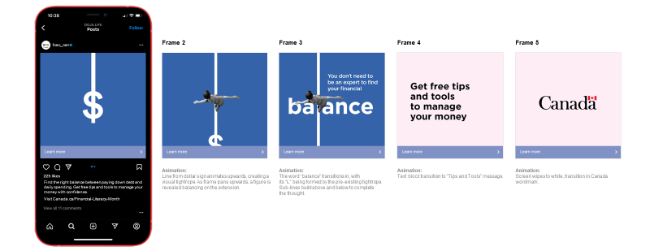
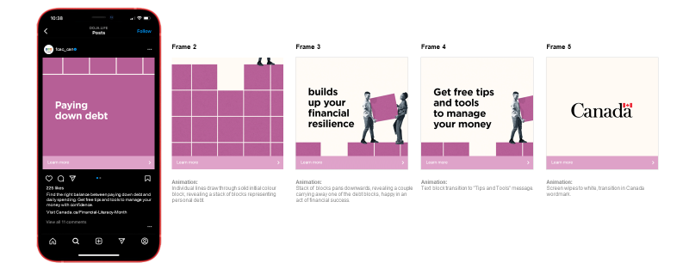

Créer l’équilibre
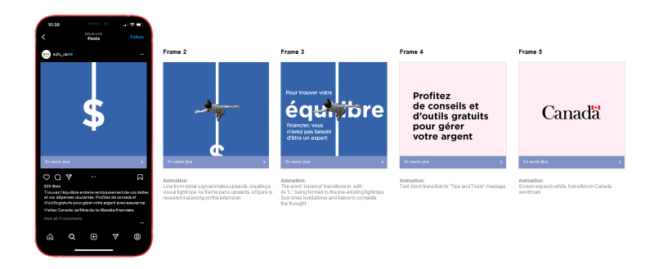
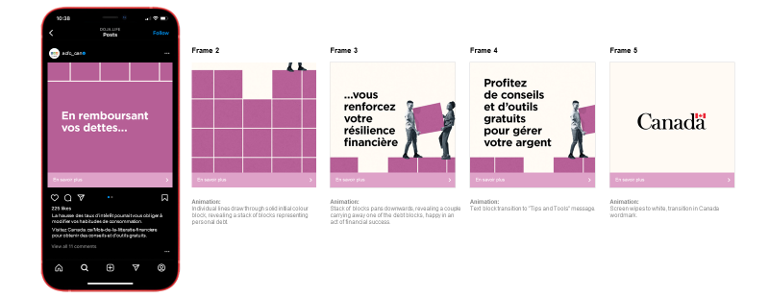
Image descriptions:
Financial Balance
- A white dollar sign symbol is shown with the strike-through extending upwards towards the top of the blue background. The ad copy reads: Find the right balance between paying down debt and daily spending. Get free tips and tools to manage your money with confidence. Visit Canada.ca/Financial-Literacy-Month.
- The solid line extends vertically up the screen, with the top of the dollar sign still slightly visible at the bottom. From a top-down angle, a person balances tenuously on the white line as a tightrope.
- The word “balance” is now visible, with its “L” being formed by the pre-existing tightrope. The tagline You don’t need to be an expert to find your financial balance is at the top right side of the screen.
- The screen is now a soft pink colour, with the tagline Get free tips and tools to manage your money displayed across it.
- The Government of Canada wordmark is displayed in the middle of the screen.

Financial Resilience
- White text that reads Paying down dept is displayed on a purple screen with the white outline of four boxes slightly visible at the top of the screen. The ad copy reads Find the right balance between paying down debt and daily spending. Get free tips and tools to manage your money with confidence. Visit Canada.ca/Financial-Literacy-Month.
- A stack of purple blocks representing personal debt take up the majority of the screen. A pair of feet are visible in the upper right portion of the screen.
- A stack of blocks is at the bottom of the screen, revealing a couple carrying away one of the debt blocks, happy and in an act of financial success. The tagline Builds up your financial resilience is displayed above the gap where the debt block originally was.
- The tagline reads Get free tips and tools to manage your money as the couple is now more out of view of the screen.
- The Government of Canada wordmark is displayed in the middle of the screen.

Concept 2- Push & Pull / Le Tiraillement

Push & Pull
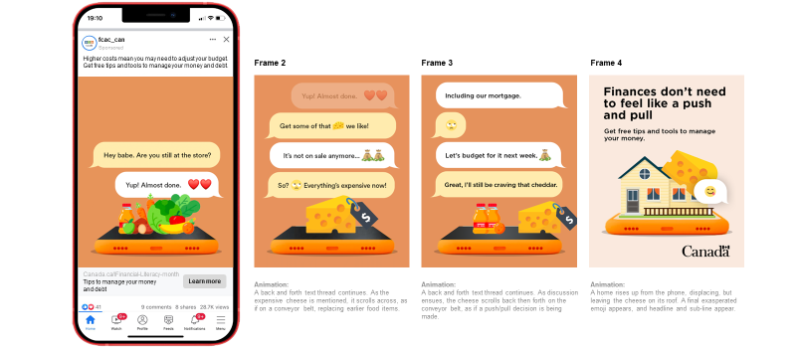
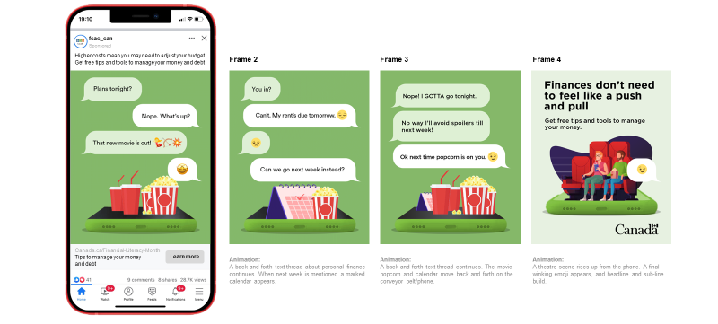
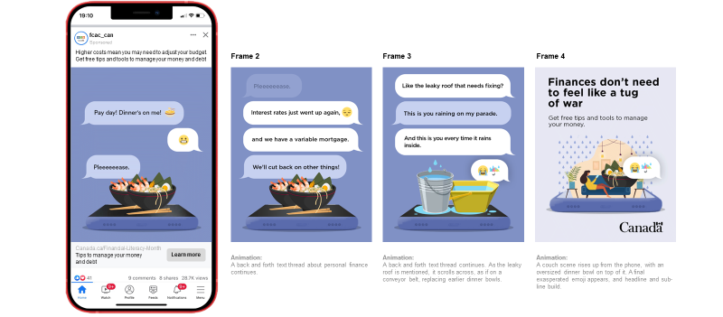

Le tiraillement
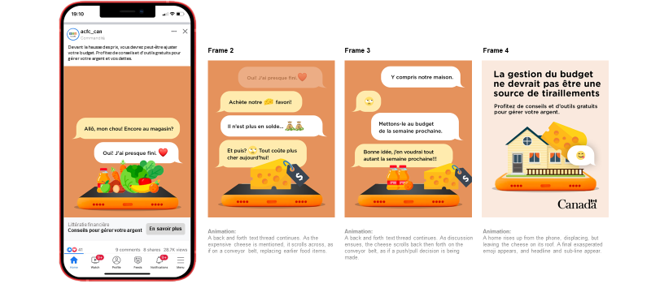
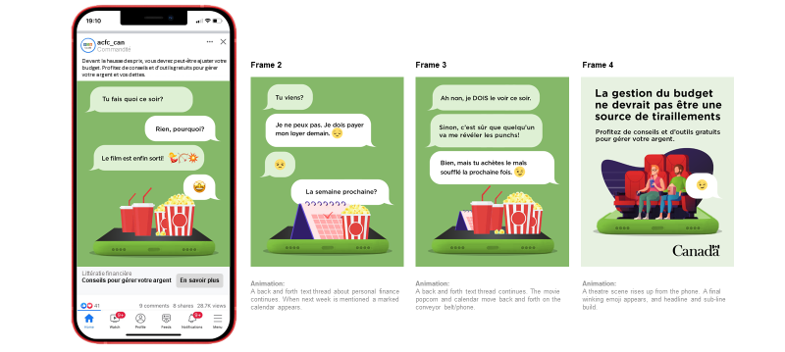
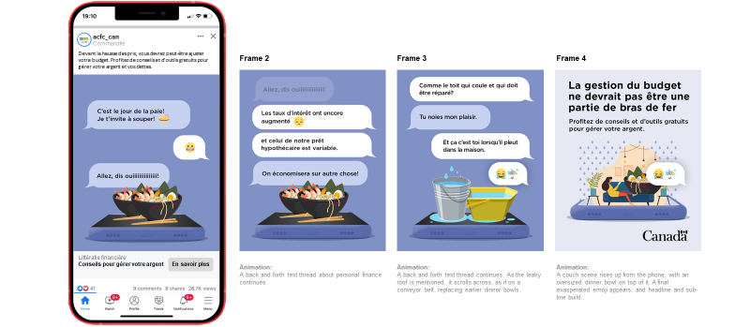

Image descriptions:
Groceries
- An orange screen displays graphics of a collection of grocery items sitting on a smartphone screen. Text messages between two individuals are displayed on the screen. Text one reads Hey babe. Are you still at the store? Text two reads Yup! Almost done (heart emoji). The ad copy reads Higher costs mean you may need to adjust your budget. Get free tips and tools to manage your money and debt.
- The collection of grocery items has now been replaced by a single block of cheese with a price tag displaying a large dollar sign on it. The back-and-forth text thread continues. Text one reads Get some of that (cheese emoji) we like! Text two states It’s not on sale anymore… (two money bag emojis). Text three reads So? (eyeroll emoji) Everything’s expensive now!
- The cheese has now been joined by two bottles of juice next to an orange. The back-and-forth text thread continues. Text one reads Including our mortgage. Text two simply shows an eyeroll emoji. Text three reads Let’s budget for it next week (moneybag emoji). Text four states Great, I’ll still be craving that cheddar.
- A graphic of a house with a block of cheese resting on the roof is shown. The tagline reads Finances don’t need to feel like a push and pull. Get free tips and tools to manage your money. The Government of Canada wordmark is depicted in the bottom right corner.
Movies
- A light green screen displays graphics of two sets of movie popcorn and drinks sitting on a smartphone screen. Text messages between two individuals are displayed on the screen. Text one reads Plans tonight? Text two reads Nope. What’s up? Text three states That new movie is out! (dancing women emoji, bow and arrow emoji, explosion emoji). Text four depicts a starry-eyed emoji. The ad copy reads Higher costs mean you may need to adjust your budget. Get free tips and tools to manage your money and debt.
- The phone now depicts graphics of a calendar with one date check-off on it and one bag of movie popcorn. The back-and-forth text thread continues. Text one reads You in? Text two reads Can’t. My rent’s due tomorrow (downcast emoji). Text three shows a sad emoji. Text four reads Can we go next week instead?
- The calendar and movie popcorn are now joined by two movie theater drinks and another bag of popcorn. The back-and-forth text thread continues. Text one states Nope! GOTTA go tonight. Text two (from the same individual) reads No way I’ll avoid spoilers till next week! Text three states Ok next time popcorn is on you (winky emoji).
- A graphic of a man and woman sitting next to each other in movie theater chairs while the woman holds a fountain drink, and the man holds a bag of movie popcorn is shown. There is a text bubble with a winky emoji next to the man. The tagline reads Finances don’t need to feel like a push and pull. Get free tips and tools to manage your money. The Government of Canada wordmark is depicted in the bottom right corner.
Restaurant (Tug of war)
- A light blue screen displays graphics of two bowls of shrimp ramen sitting on a smartphone screen. Text messages between two individuals are displayed on the screen. Text one reads Pay day! Dinner’s on me! (ramen bowl emoji). Text two depicts a cringe emoji. Text three reads Pleeeeeease. The ad copy reads Higher costs mean you may need to adjust your budget. Get free tips and tools to manage your money and debt.
- The back-and-forth text thread continues. Text one reads Interest rates just went up again, (downcast emoji). Text two (from the same individual) reads and we have a variable mortgage. Text three states We’ll cut back on other things!
- A graphic of two buckets full of water now sit on the smartphone screen. The back-and-forth text thread continues. Text one states Like the roof that needs fixing? Text two reads This is you raining on my parade. Text three reads And this is you every time it rains inside. Text four (from the same individuals shows a crying emoji and a rain umbrella emoji.
- A graphic of a woman reclining on a couch with a smartphone in hand and a large bowl of ramen is depicted. There is a text bubble with a crying emoji and a rain umbrella emoji next to the woman. The tagline reads Finances don’t need to feel like a tug of war. Get free tips and tools to manage your money. The Government of Canada wordmark is depicted in the bottom right corner.

Concept 3- Voice of Reason / La voix de la raison

Voice of Reason
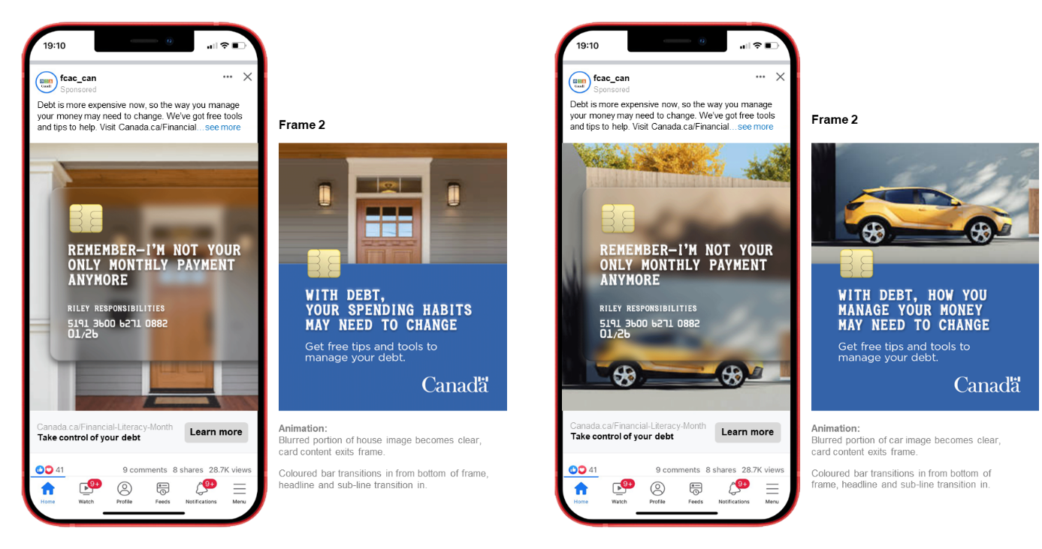

La voix de la raison
Image descriptions:
Spending Habits
- A transparent credit card is superimposed over the wooden front door of a house, which is now blurry in the background. The tagline is on the card and reads Remember – I’m not your only monthly payment anymore. The ad copy states Debt is more expensive now, so the way you manage your money may need to change. We’ve got free tools and tips to help. Visit Canada.ca/financial… (see more).
- The blurred portion of the house is now clear and a blue bar with a credit card chip on the top left takes up the bottom half of the screen. The tagline reads With debt, your spending habits may need to change. Get free tips and tools to manage your debt. The Government of Canada wordmark is depicted in the bottom right corner.
Manage Your Money
- A transparent credit card is superimposed over a parked, yellow SUV, which is now blurry in the background. The tagline is on the card and reads Remember – I’m not your only monthly payment anymore. The ad copy states Debt is more expensive now, so the way you manage your money may need to change. We’ve got free tools and tips to help. Visit Canada.ca/financial… (see more).
- The blurred portion of the SUV is now clear and a blue bar with a credit card chip on the top left takes up the bottom half of the screen. The tagline reads With debt, your spending habits may need to change. Get free tips and tools to manage your debt. The Government of Canada wordmark is depicted in the bottom right corner.

Ad 4- Financial Balance / Équilibre financier

Financial Balance
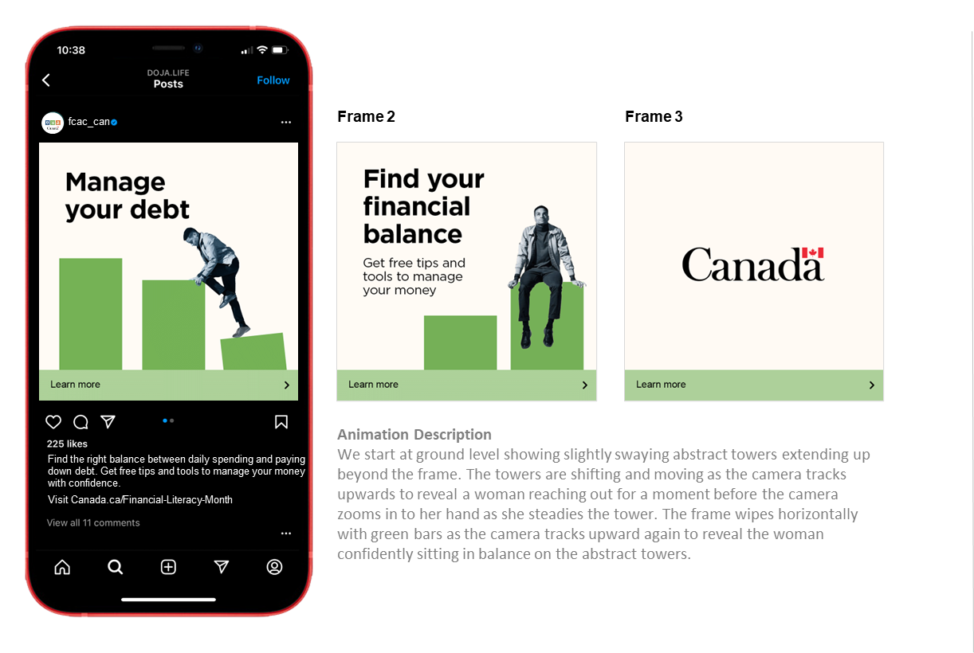
Équilibre financier
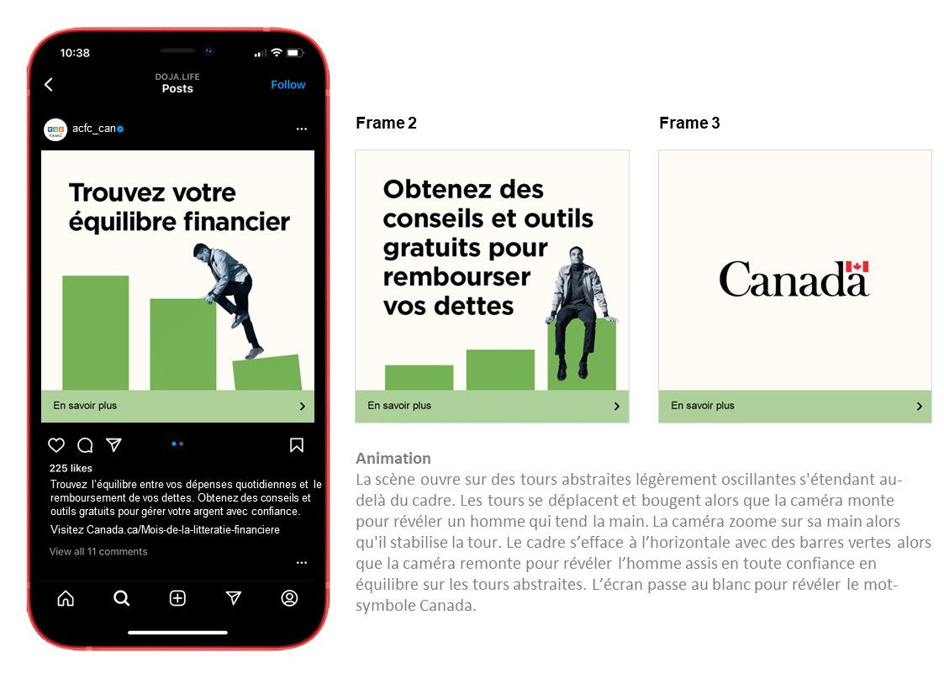

Image descriptions:
Manage Your Debt
- Three light green vertical bars are displayed in a descending pattern, reminiscent of a bar chart. There is a man in black and white climbing on top of the middle bar precariously, using the bottom one as leverage as it sways under his movement. The tagline reads Manage your debt. The ad copy states Find the right balance between daily spending and paying down debt. Get free tips and tools to manage your money with confidence. Visit Canada.ca/Financial-Literacy-Month.
- The man is now seen to be sitting confidently on one of three vertical bars that are now in ascending order. The tagline reads Find your financial balance. Get free tips and tools to manage your money.
- The screen is blank aside from the Government of Canada wordmark in the center.

Ad 5- Financial Future / Avenir financier

Financial Future
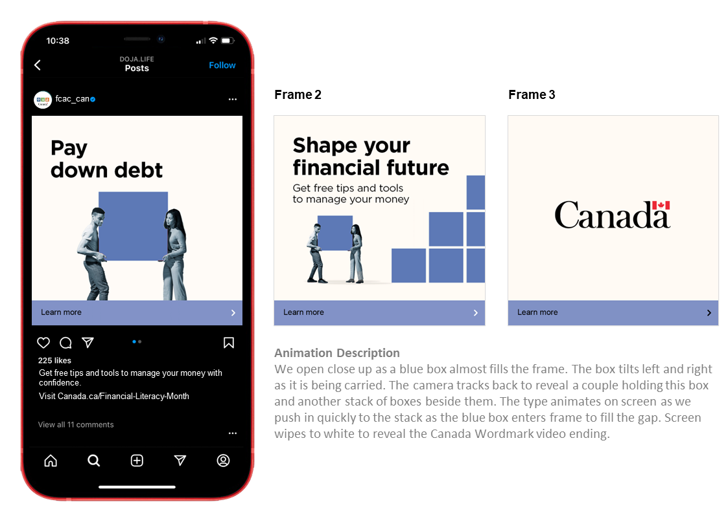
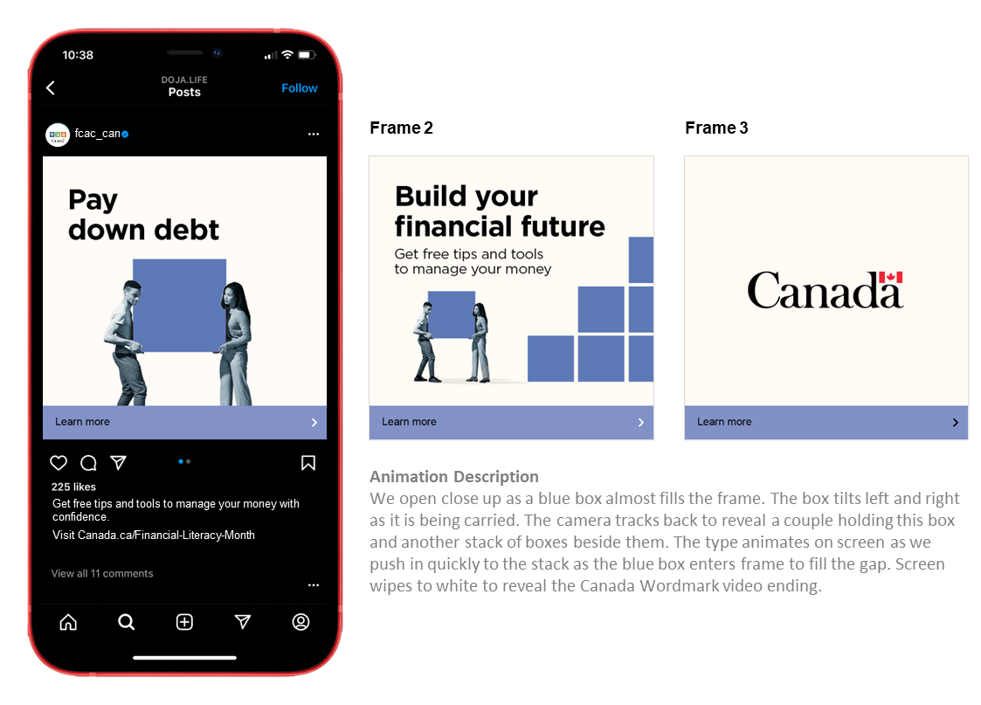

Avenir financier
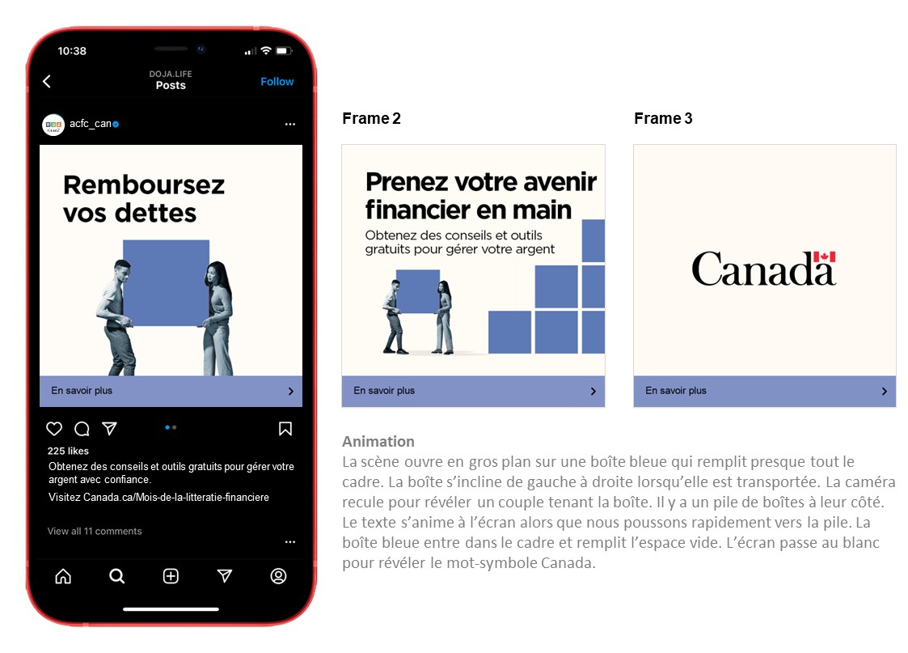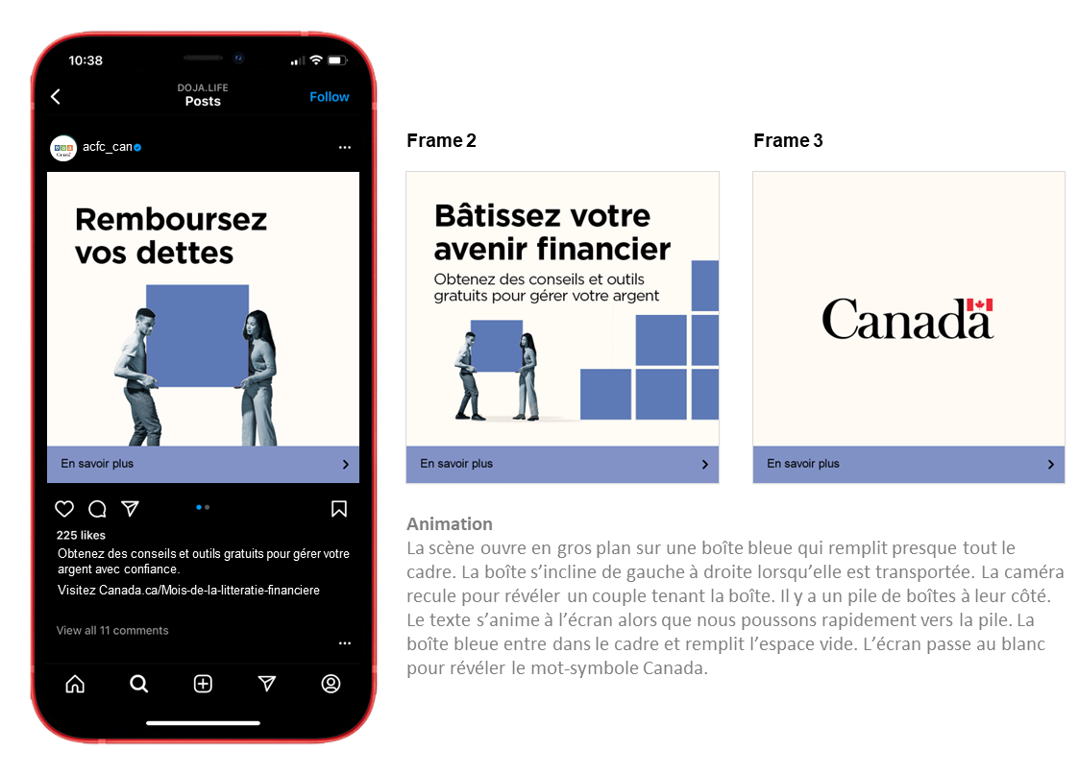

Image descriptions:
Shape
- A man and women in black and white carry an illustrated blue box together, as if holding a moving box. The tagline reads Pay down debt. The ad copy states Get free tips and tools to manage your money with confidence. Visit Canada.ca/Financial-Literacy-Month.
- The couple is still carrying the box and there is now a stack of several boxes to the right of them. The tagline reads Shape your financial future. Get free tips and tools to manage your money.
- The screen is blank aside from the Government of Canada wordmark in the center.
Build
- A man and women in black and white carry an illustrated blue box together, as if holding a moving box. The tagline reads Pay down debt. The ad copy states Get free tips and tools to manage your money with confidence. Visit Canada.ca/Financial-Literacy-Month.
- The couple is still carrying the box and there is now a stack of several boxes to the right of them. The tagline reads Build your financial future. Get free tips and tools to manage your money.
- The screen is blank aside from the Government of Canada wordmark in the center.

Ad 6- Abstract / Abstraite

Abstract
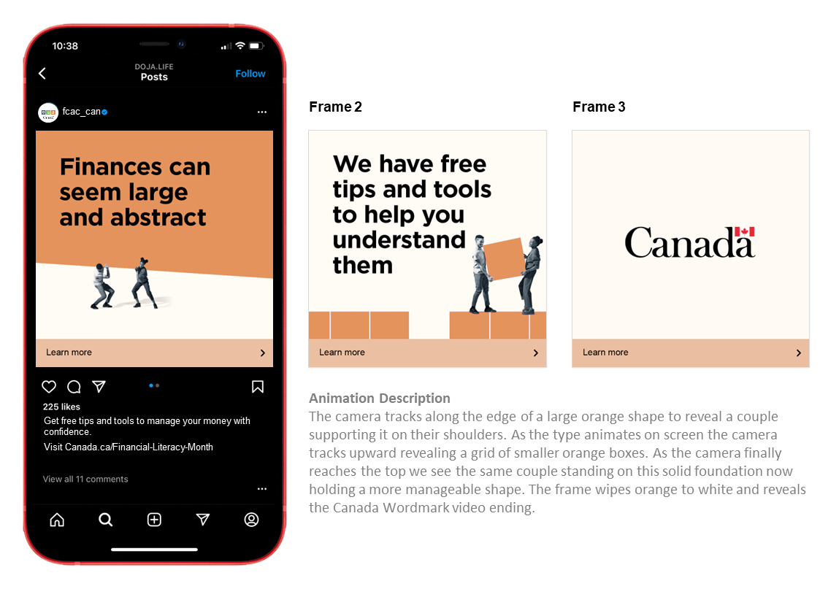

Abstraite
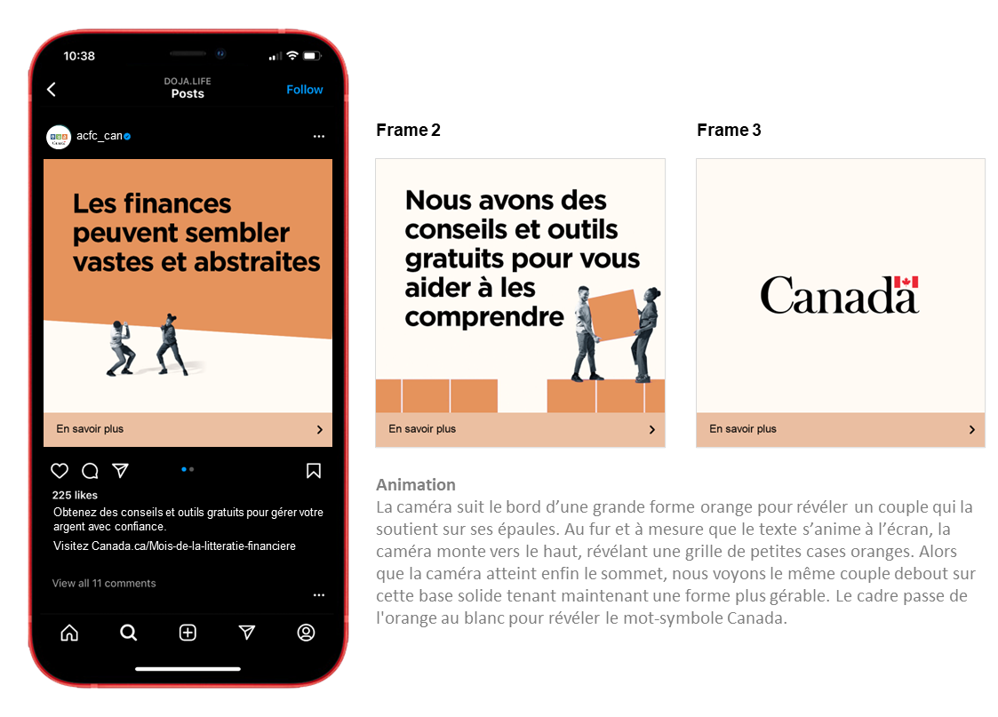
Image descriptions:
Abstract
- A looming, large orange shape takes up the top half of the image in a precarious manner, with a black and white couple supporting it on their shoulders but struggling to do so. The tagline reads Finances can seem large and abstract. The ad copy states Get free tips and tools to manage your money with confidence. Visit Canada.ca/Financial-Literacy-Month.
- We see the same couple standing on a solid foundation of orange boxes, now holding a more manageable sized box. The tagline states We have free tips and tools to help you understand them.
- The screen is blank aside from the Government of Canada wordmark in the center.

A.2 Recruitment Screener
Hello/Bonjour, may I please speak with _____________? My name is ________ and I am calling on behalf of Leger, a national opinion research firm. Would you prefer that I continue in English or French? Préférez-vous continuer en français ou en anglais?”.

We are calling today to see if you are interested in participating in upcoming online Focus Group research, the focus group will discuss advertising ideas that the Government of Canada is planning to share with Canadians.

READ TO ALL:
Participation is voluntary and all your answers will be kept confidential and will be used for research purposes only. We are simply interested in hearing your opinions – no attempt will be made to sell you anything. The online discussion is led by a research professional with Leger. Only first names are used to identify your comments during the discussion. Transcripts of the session will be produced for research purposes. The transcripts will be used only by the research professional to assist in preparing a report on the research findings and will be destroyed once the report is completed.

READ TO ALL:
“The information collected through the research is subject to the provisions of the Privacy Act, the legislation of the Government of Canada, and to the provisions of relevant provincial privacy legislation.]

All those who participate in the research will receive a $100 virtual Visa eGift card as a token of appreciation for their time. The total time commitment to participate is approximately 90-120 minutes.

For more information about this research by visiting Canadianresearchinsightscouncil.ca search using this project registration # 20220912-LE311

A2. The group discussions we are organizing are going to be held over the Internet. They are going to be "online focus groups". Participants will need to have access to a reliable laptop or desktop computer, a high-speed Internet connection, and a WebCam in order to participate in the group. You would need to be in a place that is quiet and free of distractions for the duration of the discussion, with no distractions like other people, children or pets. Would you be able to participate with these requirements?

Yes | 1 | CONTINUE
No | 2 | THANK AND CONCLUDE

Would you be interested in participating in the focus group?
[IF YES, CONTINUE to READ ALL].

- IF YES, CONTINUE
- IF NO, TRY TO SET A CALL BACK OR THANK AND TERMINATE

Before I can invite you to attend there are a few questions I need to ask to see if you qualify. This will take few minutes (e.g. 5 minutes)

May I ask you a few questions? [YES = CONTINUE]

- Are you between the age of 18 and 54?
- Yes CONTINUE
- No TERMINATE

1a. What is your province /Territory of residency? [Do not read]
- Atlantic Canada
[Newfoundland and Labrador, Prince Edward Island, Nova Scotia, New Brunswick] [Group 5,6]
- Quebec [Group 7,8]
- Ontario [Group 1,2]
- Manitoba
- Saskatchewan
- Alberta
- British Columbia [Group 3,4]

[Interviewer NOTE: If the respondent prefers to speak in French, they can be recruited for groups 7 & 8, regardless of location]

- Please tell me if you or any member of your immediate family works in or has retired from:

✔
Media, such a newspaper, TV or radio station
Advertising or Communications
Market or PublicPublic opinion research
Journalism

[IF YES TO ANY OF Q2: THANK AND TERMINATE]

NOTE: FOR TERMINATION SAY – UNFORTUNATELY THAT CATEGORY IS FILLED FOR THIS SESSION. THANK YOU FOR YOUR TIME.
- Gender [By observation only] [AIM FOR 50/50 split for all groups]
- Male
- Female

- Can you please tell me which of the following age categories you fall into? [AIM FOR GOOD MIX]
- Under 18 [TERMINATE]
- 18-24 [MINIMUM 3 IN EACH GROUP]
- 25-40
- 41-54
- 55 plus [THANK & TERMINATE]
- Refuse [THANK & TERMINATE]

4A. What is your marital status? [AIM for a mix]
- Single
- Common-law partner/ Married
- Separated/ Divorced
- Widowed
- Refuse [THANK & TERMINATE]

- Can you estimate in which of the following groups your household income falls [WATCH MINIMUM QUOTAS AND AIM FOR MIX OF INCOME RANGES]:

- Less than $40,000 [MINIMUM 3 per group]
- $40,000 to $60,000
- $60,000 to $80,000
- $80,000 to $100,000
- $100,000 to $150,000
- Over $150,000
- Refuse [THANK & TERMINATE]

- Which of the following represent your current primary residence situation? [AIM for a good mix]

- Own my home [At least 4 per group]
- Rent my home
- Other
- Refuse [THANK & TERMINATE]

- [HOMEOWNERS] What kind of mortgage do you have?

- Fixed rate mortgage
- Variable rate mortgage
- Refuse [THANK & TERMINATE]

- [HOMEOWNERS/RENT/OTHER] Are you looking to purchase a new house in the next 12 to 24 months?

- Yes
- No
- Refuse

- There are also other types of loans available for household needsaside from a mortgage. Has your household currently taken out or paying back any of the following loans? [CHECK ALL THAT APPLY]

- Student loan
- Home equity line of credit
- Credit card
- Car or Automobile loan
- Personal loan or line of credit
- Any other loan (please specify….)
- No debt/loan
- Refuse

- What is your current employment situation? Are you… [READ; SELECT ONE] [AIM for a good mix]

- Employed full time
- Employed part-time
- Self-employed
- Not employed
- Retired
- Student
- Unable to work/ Employed but on leave (due to disability/ maternity/ paternity etc)
- Other
- Refuse [THANK & TERMINATE]

- What is the highest degree or level of school you have completed? [Aim for a good mix]
- Less than a high school diploma
- High school degree or equivalent
- Bachelor’s degree
- Master’s degree
- Professional degree
- Doctorate
- Refuse [THANK & TERMINATE

- Were you born in Canada or did you immigrate to Canada? [AIM for a good mix]
- Born in Canada
- Immigrated to Canada more than 5 years ago
- Immigrated to Canada one to five years a ago
- Immigrated to Canada less than one year ago
- Refuse [THANK & TERMINATE]

- While we are all Canadians, we belong to different ethnic or cultural groups, to which ethnic group(s) do you belong? [AIM FOR A MIX]
    - Black
    - East/Southeast Asian
    - Indigenous (First Nations, Inuk, Inuit, Métis)
    - Latino
    - Middle Eastern
    - South Asian
    - White
    - Other Specify
    - Don’t know
    - Prefer not to answer

- Are you a person that is currently living with a disability? [AIM FOR A MIX]
    - Yes
    - No
    - Prefer not to answer

[INTERNAL NOTE] Each participant should qualify as at least one of the following
- Homeowner [01 at Q6] and aged 25+
- Aged 18-24
- Household income <$40,000
- Taken out any loan [Q9], other than automobile loan

- As I mentioned earlier, you are being invited to an online group discussion where you will be asked to type in answers to questions from the moderator as well as possibly questions put forward by other participants in a chat/text-based format. How comfortable are you participating in a discussion forum in this manner? Would you say you are very comfortable, somewhat comfortable, not very comfortable or not at all comfortable?

 | ✔ | Instruction
Very comfortable |  | CONTINUE
Somewhat comfortable |  | CONTINUE
Not very comfortable |  | THANK & TERMINATE
Not at all comfortable |  | THANK & TERMINATE
Don’t know |  | THANK & TERMINATE

- Have you ever attended a consumer group discussion, an interview or survey which was arranged in advance and for which you received a sum of money?

- Yes [CONTINUE TO Q14]
- No [SKIP TO Q16]

- When was the last time you attended a focus group? PLEASE SPECIFY __________________
[STAND BY IF IN THE six months]

- [IF ATTENDED GROUPS IN PAST ASK SIX MONTHS] What was the topic of the research groups you attended in the past six months?

_______________________________________________________ [TERMINATE IF FINANCE RELATED]

- Sometimes participants are also asked to type out their answers to a questionnaire, read or watch a communication material during the discussion. Is there any reason why you could not participate in any of this?

- Yes PROBE TO UNDERSTAND BUT IF UNABLE TO DO ANY OF ABOVE THANK & TERMINATE]
- No [CONTINUE]

Read to Stand-by Respondents

Thank you for answering my questions. At this time, the group that you qualify for is full. I would like to place you on our stand-by list. This means that if there is an opening in the group, we will call you back and see if you are available to attend the group. Please understand, you are not invited to attend the focus group at this time. If we have a spot open, WE will call you back and ask you to attend.

May I please have a daytime contact number, an evening contact number and an email address, if you have one, so that we can contact you as soon as possible if an opening becomes available. [RECORD CONTACT INFO]

PRIVACY SECTION
Now I have a few questions that relate to privacy, your personal information and the research process. We will need your consent on a few issues that enable us to conduct our research. As I run through these questions, please feel free to ask me any questions you would like clarified.

P1) First, we will provide the session moderator with a list of respondents’ names and profiles (screener responses) so
that they can sign you into the group. This information will not be shared with the Government of Canada. Do we have
your permission to do this? I assure you it will be kept strictly confidential.

Yes | 1 GO TO P2
No | 2 Read information below and P1A

We need to provide the online platform and session moderator with the names and background of the people attending the focus group because only the individuals invited are allowed in the session and the facility and moderator must have this information for verification purposes. Please be assured that this information will be kept strictly confidential. GO TO P1A

P1a) Now that I’ve explained this, do I have your permission to provide your name and profiles to the online platform
and moderator?

Yes | 1 GO TO P2
No | 2 THANK AND CONCLUDE

P2) A recording of the group session will be produced for research purposes. The recording will only be used by the
team of researchers at Léger to assist in preparing a report on the research findings. Do you agree to be recorded for
research purposes only?

Yes | 1 GO TO INVITATION
No | 2 Read information below and P2A

It is necessary for the research process for us to record the session as the researcher needs this material to complete the report. When the report is finalized the recordings are destroyed.

P2a) Now that I’ve explained this, do I have your permission for recording?
Yes | 1 GO TO INVITATION
No | 2 THANK AND CONCLUDE

[INV1] As I mentioned earlier, the online group discussion will take place [INSERT DATE/TIME].
The groups are conducted via a video group discussion. You will be required to log-in a few minutes prior to the start time [5:30pm/7:30pm]. The moderator will ask questions in the video discussion as well as display some material. A video camera associated with your computer is required for the discussion. Would you be willing to participate?
- Yes [CONTINUE]
- No [THANK & TERMINATE]

Great, I would like to invite you to participate in an Online Focus Group. All participants who attend will receive $100 Visa Virtual eGift card as a thank you for their time.

I want to tell you a bit more about how the online focus group will run:
All you would need is access to a computer with High speed Internet and a video camera. The group will have 8 to 10 other participants. You can participate on a tablet or a smartphone as well, however we recommend using a laptop or desktop. The device must be video enabled.
You will be required to log-in about 5 to 10 minutes prior to the beginning of the group [5:30pm/7:30pm]. Participating in the group is very easy and you only need to be able to contribute in the discussion and provide your opinion.

In the next couple of days, a confirmation email will be sent out with all this information. The day before the group takes place you will receive an email with your log in instruction and special password.
If you have never participated in an online focus group that is O.K- you will be provided with all the instructions by the moderator via email and you can ask questions at anytime. Again, it is very user friendly.

You should know that in addition to the moderators, there may be other people from department’s creative/ research team observing the session. You should also know that a transcript of the sessions will be kept to assist in preparing a report on the research findings and will be destroyed once the report is completed.

This is standard for research studies of this nature. Please be assured, however, that any transcripts will be used for research purposes only and that your comments will be treated confidentially.
Participants will receive an $100 Visa Virtual eGift card; the gift cards will be sent out 10-15 business days after the groups are completed. They will be sent to your email address.

Given all that I’ve just outlined, would you be willing to commit to and participate in the online focus group?
- Yes [CONTINUE & RECORD ALL CONTACT INFORMATION ON PAGE 1]
- No [THANK & TERMINATE]

Your attendance is very important to the success of this research, we are depending on you to attend.

Your attendance is extremely important since we only ask a small number of people to participate. If for any reason you are unable to participate, please let me know as soon as possible so we can find someone to fill your spot. Because we are looking for specific types of people, please do not have anyone log on in your place. I can be reached at [XXXXX].

To ensure that the focus groups run smoothly, we remind you:

- To make sure you are connected to the Internet and logged on 5 to 10 minutes in advance of the group
- To turn off your cellular phones – to avoid disruptions during the group.
- Make sure your WebCam is ON and functional
- To bring reading glasses, if necessary, to be able to go over the material.
- To make sure you will be located in a quiet and clear room (luminous)
- That the session will be recorded for analysis purposes only.

A.3 Moderator’s Guide (Set A)
Group Discussion schedule
- Introduction (10 minutes)
- Warm up (10 minutes)
- Review of concepts (45 minutes)
- Specific concept probes (30 minutes)
- Wrap-up overview discussion (15 minutes)
- Wrap-up (5 minutes)

Objective

FCAC is set to launch a national multimedia campaign “Make Change that Counts: Managing Your Money in a Changing World”.

The campaign will aim to strengthen the financial literacy of Canadians and help build their financial resilience in a continually shifting economic landscape. Considering inflation and higher interest rates, the campaign will focus on equipping Canadians with practical tips and tools to manage their money and debt in these challenging and changing times.

The objective of the qualitative work is to capture overall impressions and determine the effectiveness of the advertising among Canadians.

Introduction & DISCUSSION Guidelines (10 minutes)

- Introduce the moderator and Leger
- The sponsor of this research is the Financial Consumer Agency of Canada, an agency of the Government of Canada. This agency is mandated to protect Canadian financial consumers [MODERATOR Link to background on role of FCAC https://www.canada.ca/en/financial-consumer-agency/corporate/about.html ]
- Participation is voluntary, length of session is no more than two hours.
- Today we will be reviewing some creative materials about managing personal finances and I will be asking you some specific questions to gather your feedback.
- Only talking with a few groups of people across Canada, thus your observations and opinions are important.
- Conduct of the discussion
  - Not all at once, please use your “hands up” button
  - Please keep your mic on mute unless you are speaking (helps to eliminate background noise)
  - There is no correct or wrong answers. I want to get individual thoughts and opinions—I’m not looking for a consensus.
  - I will encourage individual group members to participate.
  - Please bring a paper and pen, have it in-front of you. We will ask you to jot some ideas or answers that you will later share with the group!
- Recording and presence of observers from Government of Canada. They won’t participate in the discussion.
- Confirm that individual identities, and responses will be kept confidential. Use of first names. The purpose is not to report on individuals, but instead to get a better understanding of the opinions of different members of the Canadian population.
- Explain what to do if anyone needs technical advice.

Now I would like to quickly go around and have everyone introduce themselves, first name is fine. And tell us a little about what keeps you busy these days—if its work; school; family hobbies...

WARM-UP [Understanding perceptions of current financial wellbeing] (10 MINUTES)

- Most Canadians have debt. It could be a mortgage for some, automobile loan or credit card debt for others. Thinking of your own household finances, can you tell me a bit about what your own household debt looks like?

- Inflation is impacting our finances. Prices and interest rates have increased. How is the increasing cost of living impacting your debt management?

- How are you covering the increasing cost of living? Are there any tips or tricks that you follow for managing your household finances?

REVIEW OF CONCEPTS (45 MINUTES)
I have some images that I would like to show you to get your reactions.

I am going to share my screen and show you several images. The images are of advertisements in a storyboard format. This just means its not in the final format, but in a preliminary planning stage and when they are final, they will be in a video format. I will walk you through each storyboard. We will look at three individual concepts.

As I am showing them to you, I would like you to answer the questions I ask using the paper in front of you. We will all record our answers and then we will discuss as a group. So, for now, we will save our comments until we open up the discussion. Sound good?

FIRST CONCEPT - #1 / 2 /3 (15 minutes per concept)

- Shaping Balance (Two storyboards) (POLL Questions 1a, 1b, 1c)
- Push & Pull (Three storyboards) (POLL Questions 2a, 2b, 2c)
- Voice of Reason (One storyboard) (POLL Questions 3a, 3b, 3c)

[SHOW SLIDE # VISUAL OF THE FIRST CONCEPT – CHECK ROTATION ORDER OF CONCEPTS] (Will need to confirm which slide and order)

WALK THE GROUP THROUGH THE AD CONCEPT BY SHOWING EACH OF THE STORYBOARDS FOR THE CONCEPT AND READ OUT TEXT. ALLOW A FEW SECONDS TO REVIEW.

Before we get into a discussion about this concept, I want you to answer a few questions for me.

- Using the chat feature [IF NECESSARY, DESCRIBE WHERE CHAT FEATURE IS] send me/the moderator a short message of what you feel is the main message or purpose of this advertisement.

- Who do you think this ad is meant to speak to? Do you find it relevant to you? [PROBE: Why/ Why not]

- What are your initial reactions to the concept? DISCUSS
- What did you like?
- What did you dislike?

- What was the main message? REFER TO CHATS AS NECESSARY
Next are a couple of poll questions….

- POLL QUESTION #1a How important is the message being communicated?
- Very important
- Somewhat important
- Not very important
- Not at all important

- POLL QUESTION #1b How effective is the advertisement in getting your attention and communicating the message?
- Very effective
- Somewhat effective
- Not very effective
- Not at all effective

- POLL QUESTION #1C How believable do you find the message of the advertisement?
- Very believable
      - Somewhat believable
      - Somewhat unbelievable
      - Very unbelievable

DISCUSSION – USE POLL RESULTS AS NEEEDED AND CHAT FEEDBACK TO PROBE DURING THE DISCUSSION

- Several visuals encourage you to do something specific. What is that? [Visit site to get tips & tools to manage finances]
- Would you do this?
- What do you expect this site to provide?
- Do you see yourself using the tips and information to manage your finances?

Moderator instruction: ASK SPECIFIC CONCEPT PROBES BELOW AND THEN REPEAT GENERAL APPROACH ABOVE FOR CONCEPTS 2 AND 3

SPECIFIC CONCEPT PROBES

Concept #1 – Shaping Balance (10 minutes)

- What is your impression of the visuals of this creative? What is happening in the ad?

- If you see this ad while scrolling your social media, would the initial visual make you check the whole ad? [WHY/WHY NOT]

- Does the text go well with the ad? Does it make sense altogether? [WHY/WHY NOT]

- [1st execution] What do you think of the phrase ‘builds up your financial resilience’? Does this make sense to you? [WHY/WHY NOT]

- [2nd execution] What do you think of the phrase ‘you don’t need to be an expert to find your financial balance’? Do you agree with that statement? [WHY/ WHY NOT]

Concept #2 – Push & Pull (10 minutes)

- Do you relate to the ads? What are your first impressions? Tell me more about this.

- What do you think of this chat format as a visual? If you saw such a message online, would you read/check the creative? WHY / WHY NOT

- [1st & 2 slide] What do you think of the phrase ‘finances don’t need to feel like a push and pull’?
Is that true? Do you relate with that statement?

- REMOVED

- [3rd slide] What do you think of the phrase ‘finances don’t need to feel like a tug of war’? Is that true? Do you relate with that statement?

- Which of the following terms make the most sense to you? Finances don’t need to feel like a ‘push and pull’, or a ‘tug of war’?

- If you see this visual while scrolling your social media, would you check the ad?

Concept #3 – Voice of Reason (10 minutes)

- Do you relate to these visuals? What are your first impressions? Tell me more about this.

- Do you think the text and the visuals go together?

- Which of the two phrases make the most sense for this concept, “With debt, your spending habits may need to change” OR “With debt, how you manage your money may need to change”?

- What does the term ‘spending habits’ mean to you?

- If you see this visual while scrolling your social media, would you check the ad?

WRAP-UP OVERVIEW DISCUSSION (15 minutes)

- POLL QUESTION Which of the three concepts would most encourage you to take action?
- Shaping Balance
- Push & Pull
- Voice of Reason

- POLL QUESTION Was there a concept that you didn’t like? Please use the chat function to tell me why you didn’t like the concept?
- Shaping Balance
- Push & Pull
- Voice of Reason
- None- liked all the concepts

- POLL QUESTION Of the three concepts, which one would be most attention grabbing if you saw them on social media?
- Shaping Balance
- Push & Pull
- Voice of Reason

- POLL QUESTION Of the three concepts, which one is most relevant to you?
- Shaping Balance
- Push & Pull
- Voice of Reason

DISCUSS RESULTS OF COMPARISON QUESTIONS

- POLL QUESTION Of the three concepts, which is the one you prefer overall?
- Shaping Balance
- Push & Pull
- Voice of Reason

Those who selected concept 1/2/3 as preferred, what was the reason for this? DISCUSS FOR EACH CONCEPT

What made this concept stand-out from the others?

FINAL WRAP UP (5 MINUTES) (IF YOU HAVE TIME)

[CHECK TO SEE IF ANY FINAL QUESTION FROM OBSERVERS]

- Either the link or the description of each concept mentioned Financial Literacy Month, what do you know about Financial Literacy Month?

- Before you saw these creatives, were you aware of Financial Literacy Month?

Those are all of my questions for today but before I let you go, are there any other final thoughts or comments that you would like to share?

On behalf of the Financial Consumer Agency of Canada and Léger, thank you for your time and great feedback.
CONCEPT ROTATION GRID

GROUP | Order of Discussion
 | First | Second | Third
Grp 1 Mon Oct 3 ON (E) 5:30 pm EST | #1 Shaping Balance | #2 Push & Pull | #3 Voice of reason
Grp 2 Mon Oct 3 ON (E) 7:30 pm EST | #2 Push & Pull | #3 Voice of reason | 1 Shaping Balance
Grp 3 TUE OCT 4 BC (E) 5:30 pm PST | #3 Voice of reason | 1 Shaping Balance | #2 Push & Pull
Grp 4 TUE OCT 4 BC (E) 7:30 pm PST | #1 Shaping Balance | #2 Push & Pull | #3 Voice of reason
Grp 5 TUE OCT 4 ATL (E) 5:30 pm AST | #2 Push & Pull | #3 Voice of reason | 1 Shaping Balance
Grp 6 TUE OCT 4 ATL (E) 7:30 pm AST | #3 Voice of reason | 1 Shaping Balance | #2 Push & Pull
Grp 7 WED OCT 5 QC (F) 5:30 pm EST | #1 Shaping Balance | #2 Push & Pull | #3 Voice of reason
Grp 8 WED OCT 4 QC (F) 7:30 pm EST | #2 Push & Pull | #3 Voice of reason | 1 Shaping Balance

A.4 Moderator’s Guide (Set B)
Group Discussion schedule
- Introduction (10 minutes)
- Warm up (10 minutes)
- Review of concepts (45 minutes)
- Specific concept probes (30 minutes)
- Wrap-up overview discussion (15 minutes)
- Wrap-up (5 minutes)

Objective

FCAC is set to launch a national multimedia campaign “Make Change that Counts: Managing Your Money in a Changing World”.

The campaign will aim to strengthen the financial literacy of Canadians and help build their financial resilience in a continually shifting economic landscape. Considering inflation and higher interest rates, the campaign will focus on equipping Canadians with practical tips and tools to manage their money and debt in these challenging and changing times.

The objective of the qualitative work is to capture overall impressions and determine the effectiveness of the advertising among Canadians.

Introduction & DISCUSSION Guidelines (10 minutes)

- Introduce the moderator and Leger
- The sponsor of this research is the Financial Consumer Agency of Canada, an agency of the Government of Canada. This agency is mandated to protect Canadian financial consumers [MODERATOR Link to background on role of FCAC https://www.canada.ca/en/financial-consumer-agency/corporate/about.html ]
- Participation is voluntary, length of session is no more than two hours.
- Today we will be reviewing some creative materials about managing personal finances and I will be asking you some specific questions to gather your feedback.
- Only talking with a few groups of people across Canada, thus your observations and opinions are important.
- Conduct of the discussion
  - Not all at once, please use your “hands up” button
  - Please keep your mic on mute unless you are speaking (helps to eliminate background noise)
  - There is no correct or wrong answers. I want to get individual thoughts and opinions—I’m not looking for a consensus.
  - I will encourage individual group members to participate.
  - Please bring a paper and pen, have it in-front of you. We will ask you to jot some ideas or answers that you will later share with the group!
- Recording and presence of observers from Government of Canada. They won’t participate in the discussion.
- Confirm that individual identities, and responses will be kept confidential. Use of first names. The purpose is not to report on individuals, but instead to get a better understanding of the opinions of different members of the Canadian population.
- Explain what to do if anyone needs technical advice.

Now I would like to quickly go around and have everyone introduce themselves, first name is fine. And tell us a little about what keeps you busy these days—if its work; school; family hobbies...

WARM-UP [Understanding perceptions of current financial wellbeing] (10 MINUTES)

- Most Canadians have debt. It could be a mortgage for some, automobile loan or credit card debt for others. Thinking of your own household finances, can you tell me a bit about what your own household debt looks like?

- Inflation is impacting our finances. Prices and interest rates have increased. How is the increasing cost of living impacting your debt management?

- How are you covering the increasing cost of living? Are there any tips or tricks that you follow for managing your household finances?

REVIEW OF CONCEPTS (45 MINUTES)
I have some images that I would like to show you to get your reactions.

I am going to share my screen and show you several images. The images are of advertisements in a storyboard format. This just means its not in the final format, but in a preliminary planning stage and when they are final, they will be in a video format. I will walk you through each storyboard. We will look at three individual concepts.

As I am showing them to you, I would like you to answer the questions I ask using the paper in front of you. We will all record our answers and then we will discuss as a group. So, for now, we will save our comments until we open up the discussion. Sound good?

FIRST CONCEPT - #1 / 2 /3 (15 minutes per concept)

- Financial Balance (one storyboard) (POLL Questions 1a, 1b, 1c)
- Financial Future (two storyboards- Build & Shape) (POLL Questions 2a, 2b, 2c)
- Abstract (one storyboard) POLL Questions 3a, 3b, 3c)

[SHOW SLIDE # VISUAL OF THE FIRST CONCEPT – CHECK ROTATION ORDER OF CONCEPTS] (Will need to confirm which slide and order)

WALK THE GROUP THROUGH THE AD CONCEPT BY SHOWING EACH OF THE STORYBOARDS FOR THE CONCEPT AND READ OUT TEXT. ALLOW A FEW SECONDS TO REVIEW.

Before we get into a discussion about this concept, I want you to answer a few questions for me.

- Using the chat feature [IF NECESSARY, DESCRIBE WHERE CHAT FEATURE IS] send me/the moderator a short message of what you feel is the main message or purpose of this advertisement.

- Who do you think this ad is meant to speak to? Do you find it relevant to you? [PROBE: Why/ Why not]

- What are your initial reactions to the concept? DISCUSS
- What did you like?
- What did you dislike?

- What was the main message? REFER TO CHATS AS NECESSARY
Next are a couple of poll questions….

- POLL QUESTION #1a How important is the message being communicated?
- Very important
- Somewhat important
- Not very important
- Not at all important

- POLL QUESTION #1b How effective is the advertisement in getting your attention and communicating the message?
- Very effective
- Somewhat effective
- Not very effective
- Not at all effective

- POLL QUESTION #1C How believable do you find the message of the advertisement?
- Very believable
      - Somewhat believable
      - Somewhat unbelievable
      - Very unbelievable

DISCUSSION – USE POLL RESULTS AS NEEEDED AND CHAT FEEDBACK TO PROBE DURING THE DISCUSSION

- Several visuals encourage you to do something specific. What is that? [Visit site to get tips & tools to manage finances]
- Would you do this?
- What do you expect this site to provide?
- Do you see yourself using the tips and information to manage your finances?

Moderator instruction: ASK SPECIFIC CONCEPT PROBES BELOW AND THEN REPEAT GENERAL APPROACH ABOVE FOR CONCEPTS 2 AND 3

SPECIFIC CONCEPT PROBES

Concept #1 – Financial Balance (10 minutes)

- What is your impression of the visuals of this creative? What is happening in the ad?

- If you see this ad while scrolling your social media, would the initial visual make you check the whole ad? [WHY/WHY NOT]

- Does the text go well with the ad? Does it make sense altogether? [WHY/WHY NOT]

- What do you think of the phrase ‘find your financial balance’? Does this make sense to you? [WHY/WHY NOT]

Concept #2 – Financial Future (10 minutes)

- What is your impression of the visuals of this creative? What is happening in the ad?

- If you see this ad while scrolling your social media, would the initial visual make you check the whole ad? [WHY/WHY NOT]

- Does the text go well with the ad? Does it make sense altogether? [WHY/WHY NOT]

- [Execution 1- “Build”] What do you think of the phrase “Build your financial future?’?
Does this make sense to you? [WHY/WHY NOT]

- [Execution 2- “Shape”] What do you think of the phrase ‘Shape your financial future’? Does this make sense to you? [WHY/WHY NOT]

Concept #3 – Abstract (10 minutes)

- What is your impression of the visuals of this creative? What is happening in the ad?

- If you see this ad while scrolling your social media, would the initial visual make you check the whole ad? [WHY/WHY NOT]

- Does the text go well with the ad? Does it make sense altogether? [WHY/WHY NOT]

- What do you think of the phrase ‘Finances can seem large and abstract’? Does this make sense to you? [WHY/WHY NOT]

WRAP-UP OVERVIEW DISCUSSION (15 minutes)

- POLL QUESTION Which of the three concepts would most encourage you to take action?
- Financial Balance
- Financial Future
- Abstract

- POLL QUESTION Of the three concepts, which one are you more likely to click on for more information?
- Financial Balance
- Financial Future
- Abstract
- Non of the above

- POLL QUESTION Was there a concept that you didn’t like? Please use the chat function to tell me why you didn’t like the concept?
- Financial Balance
- Financial Future
- Abstract
- None- liked all the concepts

- POLL QUESTION Of the three concepts, which one would be most attention grabbing if you saw them on social media?
- Financial Balance
- Financial Future
- Abstract

- POLL QUESTION Of the three concepts, which one is most relevant to you?
- Financial Balance
- Financial Future
- Abstract

DISCUSS RESULTS OF COMPARISON QUESTIONS

- POLL QUESTION Of the three concepts, which is the one you prefer overall?
- Financial Balance
- Financial Future
- Abstract

Those who selected concept 1/2/3 as preferred, what was the reason for this? DISCUSS FOR EACH CONCEPT

What made this concept stand-out from the others?

FINAL WRAP UP (5 MINUTES) (IF YOU HAVE TIME)

[CHECK TO SEE IF ANY FINAL QUESTION FROM OBSERVERS]

- Either the link or the description of each concept mentioned Financial Literacy Month, what do you know about Financial Literacy Month?

- Before you saw these creatives, were you aware of Financial Literacy Month?

Those are all of my questions for today but before I let you go, are there any other final thoughts or comments that you would like to share?

On behalf of the Financial Consumer Agency of Canada and Léger, thank you for your time and great feedback.

CONCEPT ROTATION GRID

GROUP | Order of Discussion
 | First | Second | Third
Grp 1 Mon Oct 24 5:30 pm EST (Ontario and Atlantic Participants) | #1 Financial Balance | #2 Financial Future | #3 Abstract
Grp 2 Mon Oct 24 8:30 pm EST (British Columbia Participants) | #2 Financial Future | #3 Abstract | #1 Financial Balance
Grp 3 TUE OCT 25 5:30 pm EST  (French/Quebec Participants) | #3 Abstract | 1 Financial Balance | #2 Financial Future
Grp 4 TUE OCT 25 7:30 pm EST  (French/ Quebec Participants) | #1 Financial Balance | #2 Financial Future | #3 Abstract

Appendix B: Quantitative Research (ACET)

B.1 Quantitative Methodology
This evaluation utilized the Government of Canada’s Advertising Campaign Evaluation Tool (ACET) and was administered to a sample of Canadian adults 18 years old and older. Quantitative research was conducted through online surveys, using Computer Aided Web Interviewing (CAWI) technology. The online-based data collection regimen entailed pre- and post-advertising campaign data collection conducted in two waves. This approach permits a comparison of awareness and opinions over time, as compared to other Government of Canada commissioned advertising campaigns.
As a CRIC Member, Leger adheres to the most stringent guidelines for quantitative research. The survey was conducted in accordance with Government of Canada requirements for quantitative research, including the Standards of the Conduct of Government of Canada Public Opinion Research— Series A – Fieldwork and Data Tabulation for Online Surveys.
Respondents were assured of the voluntary, confidential, and anonymous nature of this research. As with all research conducted by Leger, all information that could allow for the identification of participants was removed from the data, in accordance with the Privacy Act.

B.1.1 Questionnaire Design
The questions utilized in this study were based on the Government of Canada’s standard Advertising Campaign Evaluation Tool questionnaire. No ads were displayed in the pre-campaign wave as the pre-advertising survey was aimed at assessing recall and opinions prior to the new 2022-23 advertising campaign. In the post-campaign wave, the respondents were shown three ads from the campaign and were subsequently asked a series of questions about the advertisements. Leger ensured that respondents were able to complete the survey on various platforms including computers, tablets, or smartphones. English and French pre-test surveys were collected in both pre- and post-waves.
To make sure that online respondents answered the survey properly and seriously, Leger inserted two validation questions. Our experience shows that including such questions reduces the likelihood that respondents do not read the questions. In addition, any respondent that answered the survey in less than 30% of the median completion time was automatically removed from the sample as such speeds are simply not achievable when reading questions properly. The questionnaires were not altered in any other way, including the wording, order, and coding of questions.
The questionnaire is available in Appendix A2.

B.1.2 Survey Administration

B.1.2.1 Sampling Procedure
The survey approach utilized in each wave was designed to be administered to an online adult panel sample of approximately 2,000 Canadian adults aged 18 or older. Leger ensured that the surveys collected closely reflected the Canadian general population in terms of region, gender, and age groups. To ensure robustness of the samples that approximate the true population parameters, quotas were implemented in both pre- and post-wave data collection.
Leger owns and operates an Internet panel of more than 400,000 Canadians from coast to coast. An Internet panel is made up of Web users profiled on different sociodemographic variables. The majority of Leger’s panel members (61%) have been recruited randomly over the phone over the past decade, making it highly similar to the actual Canadian population on many demographic characteristics.

B.1.2.2 Survey Programming and Testing
In both waves, Leger programmed the questionnaire using Decipher software. The survey was both desktop and mobile optimized and thoroughly tested for consistent functionality. To best accomplish this, rather than the usual method of designing for desktop and adapting for mobile, Leger designs the surveys for smartphones and then adapts for larger screens. This “mobile-first” approach provides the best overall usability. The Decipher software we use stands out as the best online survey software for this purpose, as well as in terms of being able to handle even the most complex surveys.
An important part of our internal testing of the survey is to ensure the survey is programmed correctly. To help with this, we run a survey “simulation” which automatically inserts many cases of randomly generated data so we can see how the survey works along every possible path and for every possible response. Effectively, a simulation essentially runs imitation sample through the program to make it easier to review for correct skip logic and programming instructions. Leger also tested the survey manually to explore every path and response as well as to assess the usability and visual appeal of the survey.
Once the team was certain about the functionality of the survey using simulation and testing the programming, the surveys were pre-tested. Pre-test is a soft launch with a small portion of respondents. It allowed the collected data to be reviewed to ensure accuracy and to identify any programming aspects that should be modified. Pre- test were conducted in both official languages for both waves. For pre-campaign baseline survey, the pre-test was conducted on October 19, 2022, and completed 24 interviews in English and 11 interviews in French. For the post-campaign survey, Leger conducted pre-test on February 6, 2023.For this round, 28 English interviews and 9 French interviews were conducted.

B.1.2.3 Data Collection
After the pre-test results were checked and found to have no concerns, the surveys were launched for the data collection phase. The pre-campaign wave was conducted with 2,000 respondents from the Canadian general population aged 18 years and older, between October 19 and October 27, 2022. The post-campaign wave was conducted with 2,005 respondents from the Canadian general population aged 18 years and older, between February 6 and 16, 2023. The survey invitations as well as reminder invitations were sent to panel members during the data collection period. Fieldwork was monitored and reviewed on an ongoing basis to ensure target quotas were being met.
Since a sample drawn from an Internet panel is not probabilistic in nature, the margin of error cannot be calculated for this project. Respondents for the surveys were selected from among those who have volunteered or registered to participate in online surveys. The results of such surveys cannot be described as statistically projectable to the target population. The data have been weighted to reflect the demographic composition of the target population. Because the sample is based on those who initially self-selected for participation, no estimates of sampling error can be calculated.
Based on data from Statistics Canada’s 2021 national census, Leger weighted the results of this survey by age, gender, language, education and presence of children in the household within each region of the country.
Overall Participation rate for each wave was ~16%. The following table provides detailed calculation of the Web survey’s participation rate. The participation rate is calculated using the following formula: Participation rate / response rate = R ÷ (U + IS + R):
Table B.1 Participation Rate Calculation
 | Pre-Campaign Wave | Post-Campaign Wave
Invalid cases | 273 | 430
Invitations mistakenly sent to people who did not qualify for the study | 207 | 269
Incomplete or missing email addresses | 66 | 161
Unresolved (U) | 11,459 | 12,375
Email invitations bounce back | 43 | 12
Email invitations unanswered | 11,416 | 12,363
In-scope non-responding units (IS) | 56 | 150
Non-response from eligible respondents | - | -
Respondent refusals | - | -
Language problem | - | -
Selected respondent not available (illness; leave of absence; vacation; other) | - | -
Early breakoffs | 56 | 150
Responding units (R) | 2,208 | 2,304
Surveys disqualified – quota filled | 0 | 28
Completed surveys disqualified for other reasons | 208 | 271
Completed interviews | 2,000 | 2,005
POTENTIALLY ELIGIBLE (U+IS+R) | 13,723 | 14,829
Participation rate= R/(U + IS + R) | 16.1% | 15.5%
The participation rates were within the range of what is normally recorded for general population web surveys.

B.1.3 Data Cleaning and Tabulation
Once the data collection was completed, the data collected in each wave was processed, cleaned and tabulated.

B.1.3.1 Unweighted and Weighted Sample
A basic comparison of the unweighted and weighted sample sizes was conducted to identify any potential non-response bias that could be introduced by lower response rates among specific demographic subgroups (see tables below).
The following tables provides the geographic distribution of respondents, before and after weighting. The weighting adjusted for some minor discrepancies so that each province has a representative importance in the results.
Table B.2 Unweighted and Weighted Sample Distribution by Province
Province | Pre-campaign  Unweighted | Pre-campaign  Weighted | Post-campaign Unweighted | Post-campaign  Weighted
Atlantic | 156 | 135 | 146 | 135
Quebec | 427 | 462 | 470 | 463
Ontario | 781 | 774 | 778 | 776
Prairies | 138 | 129 | 131 | 129
Alberta | 222 | 223 | 220 | 22
British Columbia | 278 | 276 | 260 | 279
Total | 2000 | 2000 | 2005 | 2005

The following tables present the demographic distribution of respondents, according to gender and age. The adjustments made by weighting are minor, and in no way can we believe that the small differences observed in the effective samples could have introduced a non-response bias for either of these two sample subgroups.

Table B.3 Unweighted and Weighted Sample Distribution by Gender
Gender | Pre-campaign  Unweighted | Pre-campaign  Weighted | Post-campaign Unweighted | Post-campaign  Weighted
Male | 982 | 967 | 972 | 969
Female | 1009 | 1025 | 1024 | 1027
Total | 1991 | 1991 | 1996 | 1996
Note: Gender-diverse people and answer refusals make up the rest of the sample.

Regarding age distribution, the weighting process has corrected some discrepancies. The actual distribution of the sample generally follows the distribution of age groups in the actual population. In this case, it is unlikely that the observed distributions introduce a non-response bias for a particular age group. Weighting allowed the weights to be corrected without further manipulation.

Table B.4 Unweighted and Weighted Sample Distribution by Age Group
Age | Pre-campaign  Unweighted | Pre-campaign  Weighted | Post-campaign Unweighted | Post-campaign  Weighted
Between 18 and 34 | 528 | 533 | 520 | 535
Between 35 and 55 | 710 | 644 | 709 | 645
55 and over | 762 | 823 | 776 | 825
Total | 2000 | 2000 | 2005 | 2005

There is no evidence from the data that having achieved a different age or gender distribution prior to weighting would have significantly changed the results for this study.
The following tables present the weighting factors applied to the database according to the different respondent profiles.
Table B.5 Weight Factors
Labels | Pre-Campaign Wave Weights | Post-Campaign Wave Weights
BC/YK: M 18-24 | 0.981743 | 1.252615
BC/YK: M 25-34 | 1.307889 | 1.685776
BC/YK: M 35-44 | 0.931032 | 1.120032
BC/YK: M 45-54 | 0.768707 | 0.904652
BC/YK: M 55-64 | 1.003954 | 0.925947
BC/YK: M 65+ | 0.886411 | 1.103124
BC/YK: F 25-34 | 1.078668 | 1.081364
BC/YK: F 35-44 | 1.166388 | 0.866151
BC/YK: F 45-54 | 0.958487 | 1.098152
BC/YK: F 18-24 | 0.891959 | 0.971944
BC/YK: F 55-64 | 0.993747 | 1.037741
BC/YK: F 65+ | 1.305892 | 1.182464
AB/NT: M 18-24 | 2.022251 | 1.013653
AB/NT: M 25-34 | 1.006174 | 1.440984
AB/NT: M 35-44 | 1.356335 | 0.988892
AB/NT: M 45-54 | 1.015675 | 0.704918
AB/NT: M 55-64 | 0.85797 | 1.204161
AB/NT: M 65+ | 1.104758 | 0.687426
AB/NT: F 25-34 | 0.946351 | 1.264956
AB/NT: F 35-44 | 0.808591 | 1.12585
AB/NT: F 45-54 | 1.214652 | 1.565599
AB/NT: F 18-24 | 0.647713 | 0.95691
AB/NT: F 55-64 | 1.017958 | 1.080533
AB/NT: F 65+ | 1.023067 | 0.90255
SK/MB/NU: M 18-24 | 0.766866 | 3.843916
SK/MB/NU: M 25-34 | 1.601518 | 1.404831
SK/MB/NU: M 35-44 | 0.729588 | 1.097118
SK/MB/NU: M 45-54 | 0.737766 | 0.565585
SK/MB/NU: M 55-64 | 0.818278 | 0.820323
SK/MB/NU: M 65+ | 1.200597 | 0.945684
SK/MB/NU: F 25-34 | 1.00324 | 0.88003
SK/MB/NU: F 35-44 | 0.85142 | 0.739742
SK/MB/NU: F 45-54 | 0.739807 | 1.236094
SK/MB/NU: F 18-24 | 0.969539 | 0.809969
SK/MB/NU: F 55-64 | 0.727095 | 1.214855
SK/MB/NU: F 65+ | 1.72933 | 1.114491
ON: M 18-24 | 1.416909 | 1.253339
ON: M 25-34 | 1.005142 | 1.127207
ON: M 35-44 | 0.870027 | 0.986589
ON: M 45-54 | 0.829069 | 0.920649
ON: M 55-64 | 0.876445 | 0.969084
ON: M 65+ | 0.973166 | 1.065457
ON: F 25-34 | 1.194886 | 1.068374
ON: F 35-44 | 1.091407 | 1.042034
ON: F 45-54 | 0.981742 | 0.841747
ON: F 18-24 | 0.901335 | 0.763747
ON: F 55-64 | 0.857632 | 0.90444
ON: F 65+ | 1.27551 | 1.245912
QC: M 18-24 | 0.777226 | 0.808027
QC: M 25-34 | 0.719853 | 0.767715
QC: M 35-44 | 1.218712 | 0.923769
QC: M 45-54 | 0.781795 | 0.860213
QC: M 55-64 | 1.255476 | 1.258614
QC: M 65+ | 1.543673 | 1.17747
QC: F 25-34 | 0.992647 | 0.674119
QC: F 35-44 | 1.048194 | 0.811993
QC: F 45-54 | 1.221928 | 1.265816
QC: F 18-24 | 0.893529 | 1.027493
QC: F 55-64 | 1.055011 | 0.940132
QC: F 65+ | 1.602825 | 1.260261
ATL: M 18-24 | 2.160984 | 1.083193
ATL: M 25-34 | 0.931237 | 1.555942
ATL: M 35-44 | 0.930193 | 0.717322
ATL: M 45-54 | 0.740195 | 0.519432
ATL: M 55-64 | 0.903118 | 0.667119
ATL: M 65+ | 1.310882 | 1.138938
ATL: F 25-34 | 0.500608 | 1.204463
ATL: F 35-44 | 0.548639 | 0.850016
ATL: F 45-54 | 0.553193 | 0.587198
ATL: F 18-24 | 0.91673 | 1.002569
ATL: F 55-64 | 0.744122 | 1.118974
ATL: F 65+ | 1.315446 | 1.798275

B.1.3.2 Non-response Bias Analysis
Any survey that is conducted is potentially subject to bias or error. When a survey is conducted with a sample of the population, different types of biases or errors can occur such as: sampling error, measurement errors, non-response bias, processing error. While sampling error cannot be measured given that the contact records utilized in the data collection process were derived from an online panel, which is to say, a non-probability sample source. Having stated that, measures were taken in the implementation of the data collection to ensure sufficient completed surveys were obtained from demographic groups traditionally regarded as central in quantitative survey research, such as gender, age, region/province.
With respect to non-sampling error, several steps were taken to minimize bias. All surveys utilized online interviewing technology to ensure proper survey skip patterns were followed and to minimize errors due to data entry and data capture. The French and English survey instruments from each campaign were pre-tested with a small sample of respondents to ensure the survey material was easily understood by respondents, and that the resultant data were being captured properly. In terms of coverage, the surveys were conducted based on a randomized sampling of panel records for the target audience drawn from an online general population panel.

B.2.1 Survey Questionnaires: Pre-Campaign
ADVERTISING CAMPAIGN EVALUATION TOOL
BASELINE AND POST-CAMPAIGN SURVEY TEMPLATE

Baseline sections should be asked before the ads have run in the media.
All sections should be asked after the ads have run in the media.

INTRODUCTION [ASK IN BASELINE AND POST-CAMPAIGN SURVEYS]

Thank you for taking a few minutes to complete this survey on current issues that matter to Canadians. Si vous préférez répondre à ce sondage en français, veuillez cliquer sur français [SWITCH TO FRENCH VERSION].

Your participation is voluntary and your responses will be kept entirely confidential. The survey takes about [BASELINE: 5 minutes / POST-CAMPAIGN: 7 minutes] to complete.

START SURVEY

Click here if you wish to verify the authenticity of this survey. To view our privacy policy, click here.

If you require any technical assistance, please contact XXX.

- Does anyone in your household work for any of the following organizations?

SELECT ALL THAT APPLY

- a marketing research firm
- a magazine or newspaper
- an advertising agency or graphic design firm
- a political party
- a radio or television station
- a public relations company
- the federal or provincial government
- none of these organizations

IF “NONE OF THESE ORGANIZATIONS” CONTINUE, OTHERWISE THANK AND TERMINATE.

- What is your gender?

- Male
- Female
- Other
- Prefer not to answer

- In what year were you born?

YYYY

ADMISSIBLE RANGE 1900-2004
IF > 2004, THANK AND TERMINATE
ASK D IF QUESTION C IS LEFT BLANK

- In which of the following age categories do you belong?

SELECT ONE ONLY

  - less than 18 years old
  - 18 to 24
  - 25 to 34
  - 35 to 44
  - 45 to 54
  - 55 to 64
  - 65 or older
IF “LESS THAN 18 YEARS OLD” OR “BLANK”, THANK AND TERMINATE

- In which province or territory do you live?

SELECT ONE ONLY

- Alberta
- British Columbia
- Manitoba
- New Brunswick
- Newfoundland and Labrador
- Northwest Territories
- Nova Scotia
- Nunavut
- Ontario
- Prince Edward Island
- Quebec
- Saskatchewan
- Yukon

IF NO PROVINCE OR TERRITORY IS SELECTED, THANK AND TERMINATE

- Which of the following best describes your housing arrangement?

- Own your home with a mortgage
- Own your home without a mortgage
- Rent your home
- Neither own nor rent your home
- Don’t know

CORE QUESTIONS [ASK IN BASELINE AND POST-CAMPAIGN SURVEYS]
ASK ALL RESPONDENTS

Q1:
Over the past three weeks, have you seen, read or heard any advertising from the Government of Canada?

- yes
- no => GO TO T1A

Q3:
Think about the most recent Government of Canada ad that comes to mind. What do you remember about this ad?

CAMPAIGN-SPECIFIC QUESTIONS [ASK IN BASELINE AND POST-CAMPAIGN SURVEYS]
ASK ALL RESPONDENTS

T1A:
Over the past three weeks, have you seen, read or heard any Government of Canada advertising about financial tips and tools to help Canadians manage their money? [STATE TOPIC IN TWO OR THREE WORDS BUT DO NOT DESCRIBE CAMPAIGN THEME]

- Yes
- No => GO TO T1D

T1B:
Where have you seen, read or heard this ad about financial tips and tools to help Canadians manage their money?
[NOTE: SELECT FROM LIST ALL MEDIA USED IN THE CAMPAIGN. YOU MAY ALSO INCLUDE OTHER MEDIA OF YOUR CHOICE. HEADINGS ARE FOR GUIDANCE ONLY AND NOT TO BE USED IN THE FINAL VERSION OF THE QUESTIONNAIRE]

SELECT ALL THAT APPLY

Online / digital
Digital/Streaming TV (e.g. Netflix, Disney+) | Snapchat
Facebook | Digital/Streaming radio (e.g. Spotify, Podcast)
In a mobile app | TikTok
Instagram | Twitch
Internet website | Twitter
LinkedIn | Video game
Online news sites | Web search (e.g. Google, Bing)
Pinterest | YouTube
Mandatory option(s):
Other, specify:

T1C:
What do you remember about this ad?

ASK ALL RESPONDENTS

CAMPAIGN SPECIFIC ATTITUDINAL AND BEHAVIOURAL QUESTIONS MAY BE ADDED HERE

T1D:

T1Da. Have you heard anything about Financial Literacy Month?
  - Yes, I have heard about it and I am familiar with the details
  - Yes, I have heard about it and I know some of the details
  - Yes, I have heard about it but I don’t know any of the details [SKIP TO T1Db]
  - Not sure [SKIP TO T1E]

T1Db. Where have you seen, read or heard about Financial Literacy Month? Select all that apply. [ACCEPT MULTIPLE RESPONSES]
- cinema
- Internet website
- magazines
- newspaper (daily)
- newspaper (weekly or community)
- outdoor billboards
- pamphlet or brochure in the mail
- public transit (bus or subway)
- radio
- television
- Twitter
- YouTube
- Facebook
- Instagram
- LinkedIn
- Snapchat
- Spotify
- Other, specify ___________________

T1E: To the best of your knowledge, does the government of Canada have a department or agency that provides free financial tools and resources for Canadians?

  - Yes, I have heard about it and I am familiar with the agency and/or department
  - Yes, I have heard about it and I know some information about the agency and/or department
  - Yes, I have heard about it but I don’t know the agency and/or department
  - No, I haven’t heard anything about it 2
T1F: To the best of your knowledge, does the government of Canada have a department or agency dedicated to financial education and consumer protection?
  - Yes, I have heard about it and I am familiar with the agency and/or department
  - Yes, I have heard about it and I know some information about the agency and/or department
  - Yes, I have heard about it but I don’t know the agency and/or department
  - No, I haven’t heard anything about it 2

T1G: Have you heard of the Financial Consumer Agency of Canada or FCAC?

  - Yes, I have heard about the FCAC and I am familiar with its mandate
  - Yes, I have heard about the FCAC and I know some information about its mandate
  - Yes, I have heard about the FCAC but I don’t know its mandate
  - No, I haven’t heard about them
T1H: Have you ever used online financial management tools or resources?

- yes
- no

T1I: Have you ever used financial management tools or resources offered by the FCAC? [ONLY ASK IF YES TO T1G]
- yes
- no

T1J: Would you ever use financial management tools or resources offered by the FCAC? [ONLY ASK IF YES TO T1G]
- yes
- no [SKIP TO T1Ja]

T1Ja: If no, why?

AD RECALL QUESTIONS [ASK IN POST-CAMPAIGN SURVEY ONLY]
T1H:
Here are some ads that have recently been broadcast on various media. Click here to watch.

[INSERT VIDEO, PRINT AND RADIO ADS]

[CLICK TO GO TO THE NEXT PAGE]

Over the past three weeks, have you seen, read or heard these ads?

- yes
- no => GO TO T1J

T1I:
Where have you seen, read or heard these ads?
[NOTE: SELECT FROM LIST ALL MEDIA USED IN THE CAMPAIGN. YOU MAY ALSO INCLUDE OTHER MEDIA OF YOUR CHOICE. HEADINGS ARE FOR GUIDANCE ONLY AND NOT TO BE USED IN THE FINAL VERSION OF THE QUESTIONNAIRE]

SELECT ALL THAT APPLY

Online / digital
Digital/Streaming TV (e.g. Netflix, Disney+) | Snapchat
Facebook | Digital/Streaming radio (e.g. Spotify, Podcast)
In a mobile app | TikTok
Instagram | Twitch
Internet website | Twitter
LinkedIn | Video game
Online news sites | Web search (e.g. Google, Bing)
Pinterest | YouTube
Mandatory option(s):
Other, specify:

T1J:
What do you think is the main point these ads are trying to get across?

T1K:
Please indicate your level of agreement with the following statements about these ads?

RANDOMIZE STATEMENTS

 | 1  Strongly Disagree | 2 | 3 | 4 | 5  Strongly Agree
These ads catch my attention | o | o | o | o | o
These ads are relevant to me | o | o | o | o | o
These ads are difficult to follow | o | o | o | o | o
These ads do not favour one political party over another | o | o | o | o | o
These ads talk about an important topic | o | o | o | o | o
These ads provide new information | o | o | o | o | o
These ads clearly convey that the Government of Canada had [INSERT CAMPAIGN TOPIC AREA] | o | o | o | o | o

DEMOGRAPHIC QUESTIONS [ASK IN BASELINE AND POST-CAMPAIGN SURVEYS]
D1:
Which of the following categories best describes your current employment status? Are you…

SELECT ONE ONLY

- working full-time (30 or more hours per week)
- working part-time (less than 30 hours per week)
- self-employed
- unemployed, but looking for work
- a student attending school full-time
- retired
- not in the workforce (Full-time homemaker or unemployed but not looking for work)
- other employment status

D2:
What is the highest level of formal education that you have completed?

SELECT ONE ONLY

- grade 8 or less
- some high school
- high school diploma or equivalent
- registered Apprenticeship or other trades certificate or diploma
- college, CEGEP or other non-university certificate or diploma
- university certificate or diploma below bachelor's level
- bachelor's degree
- postgraduate degree above bachelor's level

D3:
Are there any children under the age of 18 currently living in your household?

- yes
- no

D4:
Which of the following categories best describes your total annual household income, including income from all household members, before taxes are deducted?

SELECT ONE ONLY

- under $20,000
- between $20,000 and $40,000
- between $40,000 and $60,000
- between $60,000 and $80,000
- between $80,000 and $100,000
- between $100,000 and $150,000
- between $150,000 and $200,000
- $200,000 and above
- prefer not to say

D5:
Where were you born?

- born in Canada
- born outside Canada

Ê Specify the country:

ASK IF D5=BORN OUTSIDE CANADA
D6:
In what year did you first move to Canada?

YYYY

ADMISSIBLE RANGE: 1900-2022

D7:
What is the language you first learned at home as a child and still understand?

SELECT UP TO TWO

- English
- French
- Other language, specify ___________________

That concludes the survey. This survey was conducted on behalf of the Financial Consumer Agency of Canada. In the coming months the report will be available from Library and Archives Canada. We thank you very much for taking the time to answer this survey, it is greatly appreciated.

B.2.2 Survey Questionnaires: Post-Campaign
ADVERTISING CAMPAIGN EVALUATION TOOL
BASELINE AND POST-CAMPAIGN SURVEY TEMPLATE

Baseline sections should be asked before the ads have run in the media.
All sections should be asked after the ads have run in the media.

INTRODUCTION [ASK IN BASELINE AND POST-CAMPAIGN SURVEYS]

Thank you for taking a few minutes to complete this survey on current issues that matter to Canadians. Si vous préférez répondre à ce sondage en français, veuillez cliquer sur français [SWITCH TO FRENCH VERSION].

Your participation is voluntary and your responses will be kept entirely confidential. The survey takes about [BASELINE: 7 minutes / POST-CAMPAIGN: 10 minutes] to complete.

START SURVEY

Click here if you wish to verify the authenticity of this survey. To view our privacy policy, click here.

If you require any technical assistance, please contact XXX.

- Does anyone in your household work for any of the following organizations?

SELECT ALL THAT APPLY

- a marketing research firm
- a magazine or newspaper
- an advertising agency or graphic design firm
- a political party
- a radio or television station
- a public relations company
- the federal or provincial government
- none of these organizations

IF “NONE OF THESE ORGANIZATIONS” CONTINUE, OTHERWISE THANK AND TERMINATE.

- What is your gender?

- Male
- Female
- Other
- Prefer not to answer

- In what year were you born?

YYYY

ADMISSIBLE RANGE 1900-2005
IF > 2005, THANK AND TERMINATE
ASK D IF QUESTION C IS LEFT BLANK

- In which of the following age categories do you belong?

SELECT ONE ONLY

  - less than 18 years old
  - 18 to 24
  - 25 to 34
  - 35 to 44
  - 45 to 54
  - 55 to 64
  - 65 or older
IF “LESS THAN 18 YEARS OLD” OR “BLANK”, THANK AND TERMINATE

- In which province or territory do you live?

SELECT ONE ONLY

- Alberta
- British Columbia
- Manitoba
- New Brunswick
- Newfoundland and Labrador
- Northwest Territories
- Nova Scotia
- Nunavut
- Ontario
- Prince Edward Island
- Quebec
- Saskatchewan
- Yukon
- Prefer not to say

IF NO PROVINCE OR TERRITORY IS SELECTED, THANK AND TERMINATE

- Which of the following best describes your housing arrangement?

- Own your home with a mortgage
- Own your home without a mortgage
- Rent your home
- Neither own nor rent your home
- Don’t know

CORE QUESTIONS [ASK IN BASELINE AND POST-CAMPAIGN SURVEYS]
ASK ALL RESPONDENTS
Q1:
Over the past three weeks, have you seen, read or heard any advertising from the Government of Canada?

- yes
- no => GO TO T1A

Q3:
Think about the most recent Government of Canada ad that comes to mind. What do you remember about this ad?

CAMPAIGN-SPECIFIC QUESTIONS [ASK IN BASELINE AND POST-CAMPAIGN SURVEYS]
ASK ALL RESPONDENTS

T1A:
Over the past three weeks, have you seen, read or heard any Government of Canada advertising about financial tips and tools to help Canadians manage their money? [STATE TOPIC IN TWO OR THREE WORDS BUT DO NOT DESCRIBE CAMPAIGN THEME]

- Yes
- No => GO TO T1D

T1B:
Where have you seen, read or heard this ad about financial tips and tools to help Canadians manage their money?
[NOTE: SELECT FROM LIST ALL MEDIA USED IN THE CAMPAIGN. YOU MAY ALSO INCLUDE OTHER MEDIA OF YOUR CHOICE. HEADINGS ARE FOR GUIDANCE ONLY AND NOT TO BE USED IN THE FINAL VERSION OF THE QUESTIONNAIRE]

SELECT ALL THAT APPLY

Online / digital
Digital/Streaming TV (e.g. Netflix, Disney+) | Snapchat
Facebook | Digital/Streaming radio (e.g. Spotify, Podcast)
In a mobile app | TikTok
Instagram | Twitch
Internet website | Twitter
LinkedIn | Video game
Online news sites | Web search (e.g. Google, Bing)
Pinterest | YouTube
Mandatory option(s):
Other, specify:

T1C:
What do you remember about this ad?

ASK ALL RESPONDENTS

CAMPAIGN SPECIFIC ATTITUDINAL AND BEHAVIOURAL QUESTIONS MAY BE ADDED HERE

T1D:

T1Da. Have you heard anything about Financial Literacy Month?
  - Yes, I have heard about it and I am familiar with the details
  - Yes, I have heard about it and I know some of the details
  - Yes, I have heard about it but I don’t know any of the details [SKIP TO T1Db]
  - Not sure [SKIP TO T1E]

T1Db. Where have you seen, read or heard about Financial Literacy Month? Select all that apply. [ACCEPT MULTIPLE RESPONSES]
- Internet website
- conference
- cinema
- magazines
- newspaper (daily)
- newspaper (weekly or community)
- outdoor billboards
- pamphlet or brochure in the mail
- public transit (bus or subway)
- radio
- television
- Twitter
- YouTube
- Facebook
- Instagram
- LinkedIn
- Snapchat
- Spotify
- Other, specify ___________________
T1E: To the best of your knowledge, does the government of Canada have a department or agency that provides free financial tools and resources for Canadians?

  - Yes, I have heard about it and I am familiar with the agency and/or department
  - Yes, I have heard about it and I know some information about the agency and/or department
  - Yes, I have heard about it but I don’t know the agency and/or department
  - No, I haven’t heard anything about it 2
T1F: To the best of your knowledge, does the government of Canada have a department or agency dedicated to financial education and consumer protection?
  - Yes, I have heard about it and I am familiar with the agency and/or department
  - Yes, I have heard about it and I know some information about the agency and/or department
  - Yes, I have heard about it but I don’t know the agency and/or department
  - No, I haven’t heard anything about it 2

T1G: Have you heard of the Financial Consumer Agency of Canada or FCAC?

  - Yes, I have heard about the FCAC and I am familiar with its mandate
  - Yes, I have heard about the FCAC and I know some information about its mandate
  - Yes, I have heard about the FCAC but I don’t know its mandate
  - No, I haven’t heard about them
T1H: Have you ever used any online financial management tools or resources?

- yes
- no

T1I: Have you ever used financial management tools or resources offered by the FCAC? [ONLY ASK IF YES TO T1G]
- yes
- no

T1J: Would you ever use financial management tools or resources offered by the FCAC? [ONLY ASK IF YES TO T1G AND NO TO T1I]
- yes
- no [SKIP TO T1Ja]

T1Ja: If no, why?

AD RECALL QUESTIONS [ASK IN POST-CAMPAIGN SURVEY ONLY]
T1H:
Here are some ads that have recently been broadcast on various media. Click here to watch.

Over the past three weeks, have you seen, read or heard any of these ads?

- yes
- no => GO TO T1J

T1I:
Where have you seen, read or heard these ads?
[NOTE: SELECT FROM LIST ALL MEDIA USED IN THE CAMPAIGN. YOU MAY ALSO INCLUDE OTHER MEDIA OF YOUR CHOICE. HEADINGS ARE FOR GUIDANCE ONLY AND NOT TO BE USED IN THE FINAL VERSION OF THE QUESTIONNAIRE]

SELECT ALL THAT APPLY

Online / digital
Facebook | Snapchat
Instagram | Pinterest
Internet website | YouTube
Online news sites | Web search (e.g. Google, Bing)
Other, specify:

T1J:
What do you think is the main point these ads are trying to get across?

T1K:
Please indicate your level of agreement with the following statements about these ads?

RANDOMIZE STATEMENTS

 | 1  Strongly Disagree | 2 | 3 | 4 | 5  Strongly Agree
These ads catch my attention | o | o | o | o | o
These ads are relevant to me | o | o | o | o | o
These ads are difficult to follow | o | o | o | o | o
These ads do not favour one political party over another | o | o | o | o | o
These ads talk about an important topic | o | o | o | o | o
These ads provide new information | o | o | o | o | o
These ads clearly convey that the Government of Canada has financial tips and tools to help Canadians manage their money | o | o | o | o | o

DEMOGRAPHIC QUESTIONS [ASK IN BASELINE AND POST-CAMPAIGN SURVEYS]
D1:
Which of the following categories best describes your current employment status? Are you…

SELECT ONE ONLY

- working full-time (30 or more hours per week)
- working part-time (less than 30 hours per week)
- self-employed
- unemployed, but looking for work
- a student attending school full-time
- retired
- not in the workforce (Full-time homemaker or unemployed but not looking for work)
- other employment status

D2:
What is the highest level of formal education that you have completed?

SELECT ONE ONLY

- grade 8 or less
- some high school
- high school diploma or equivalent
- registered Apprenticeship or other trades certificate or diploma
- college, CEGEP or other non-university certificate or diploma
- university certificate or diploma below bachelor's level
- bachelor's degree
- postgraduate degree above bachelor's level

D3:
Are there any children under the age of 18 currently living in your household?

- yes
- no

D4:
Which of the following categories best describes your total annual household income, including income from all household members, before taxes are deducted?

SELECT ONE ONLY

- under $20,000
- between $20,000 and $40,000
- between $40,000 and $60,000
- between $60,000 and $80,000
- between $80,000 and $100,000
- between $100,000 and $150,000
- between $150,000 and $200,000
- $200,000 and above
- prefer not to say

D5:
Where were you born?

- born in Canada
- born outside Canada

Ê Specify the country:

ASK IF D5=BORN OUTSIDE CANADA
D6:
In what year did you first move to Canada?

YYYY

ADMISSIBLE RANGE: 1900-2023

D7:
What is the language you first learned at home as a child and still understand?

SELECT UP TO TWO

- English
- French
- Other language, specify ___________________

That concludes the survey. This survey was conducted on behalf of the Financial Consumer Agency of Canada. In the coming months the report will be available from Library and Archives Canada. We thank you very much for taking the time to answer this survey, it is greatly appreciated.

Financial Consumer Agency of Canada’s Monthly Monitor on COVID-19 and the Financial Well-Being of Canadians, 2022
Statistics Canada, Consumer Price Index, July 2022: The Daily — Consumer Price Index, July 2022 (statcan.gc.ca)
CBC News, June 13, 2022: Debt-to-disposable-income ratio eases down from record 185% | CBC News
Bank of Canada, June 2022: Financial System Review—2022 - Bank of Canada
Financial Consumer Agency of Canada’s Monthly Monitor on COVID-19 and the Financial Well-Being of Canadians, 2022

