

Virtual Trade Commissioner
Usability Test and Evaluation of Proposed Enhancements

User Focus Groups

Foreign Affairs and International Trade Canada
POR-378-06

March 21, 2007

EXECUTIVE SUMMARY

Prepared by:


Background and Objectives
The Trade Commissioner Service (TCS) has made preliminary modifications to the Graphical User Interface (GUI) in order to address some usability issues, primarily the issue of the crowding of the home page. Prior to implementing these modifications, the TCS wanted to conduct usability testing on the existing site and an evaluation of the proposed enhancements. To this end, we conducted two focus groups in the National Capital Region on the evening of March 21, 2007. The specific objectives of the focus groups were as follows:

- to evaluate how recent changes will change usability;
- to assess whether the changes will make the site easier or more difficult to navigate;
- to assess how design enhancements could improve user experience.

The target participants for the focus groups were members of the Canadian business community, who are considered exporters or ready to export, and who have registered for the Virtual Trade Commissioner Service.

Interpretive Note: Although qualitative research in general, and focus groups in particular, are highly valuable for providing insight into the needs, attitudes and opinions of an organization’s customers and prospects, the results cannot be deemed to be representative of any wider group of individuals than those who participated.

Impressions of the Current Site
Generally speaking, participants all felt that the site was ‘too content heavy’, too busy, and difficult to situate and orient themselves. By the same token, participants appreciated the fact that there is “lots of information”. No one felt that there was not enough content; rather, they felt that the content was not organized in way which was tailored to their needs, and that much of the content on the home page was superfluous for their needs.

On the following page, we present the home page of the existing site and identify the usability and functionality issues which surfaced as a result of the different tasks performed.

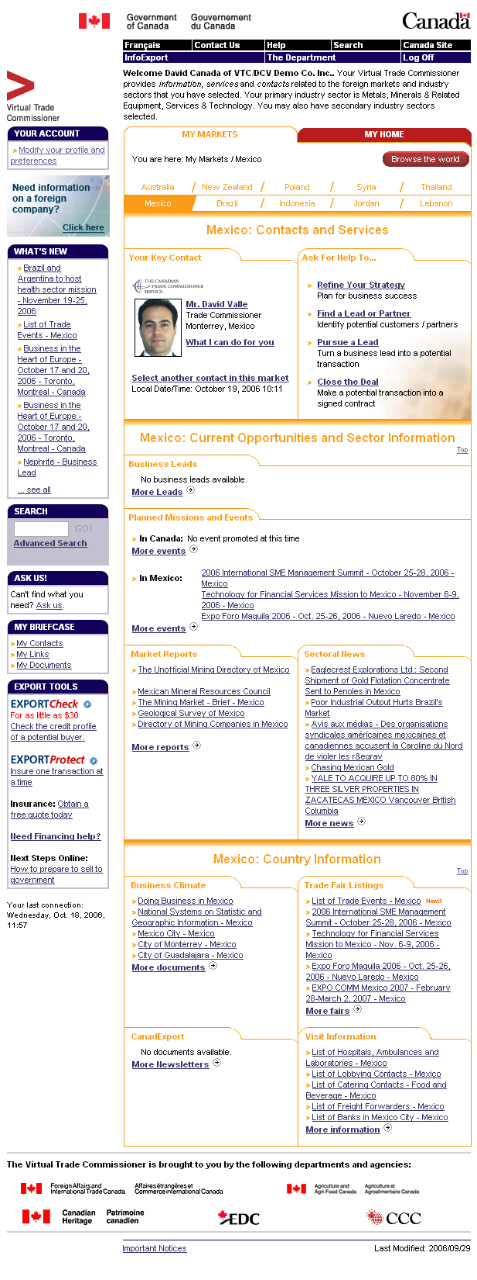
Information by country too limiting.
Participants’ think about their business
based on their sector or sectors’ of
interest. Participants requested layout as presented on “My Home” Tab, but it is not apparent to go there.

Particpants don’t understand “Browse the world” button, they use it to search and get lost.
Participants recognize the sales process, but inexperienced exporters also want services at the ‘downstream’ end, i.e. pursue a lead and close the deal.
Experienced exporters already have their strategy in place and don’t see themselves here.
Photo is a very strong feature of the page, connecting with the users and adding personalization of the site.
More and more users expect the search field to be more prominently displayed in the top centre of the page.
Users have become so accustomed to the bar that they don’t see the buttons being different from site to site, and they areignored in various tasks. It is also visually unappealing.
The “Welcome” text contributes to the page’s appearance as cluttered, heavy, and having too much information.
“No events”. “No leads, and “No documents available” sends a strong negative message that the site is not delivering value.
Valuable content is not seen since participants don’t scroll the page before they click on links higher on the page to find content.
Links to partner site’s home pages are detract from functionality because participants leave the site and cannot get back. They do communicate that there are many partner/sponsors contributing to the site.
Most participants clicked here to complete the task of finding a contact at EDC. “Select another contact” in this market is not intuitive for this task.

Participants found local date and time very useful. Perhaps make it more prominent.

Current VTC Home Page

The Modified Page
The reaction to the modified page was very positive, as illustrated by the comments presented below. Participants generally found the page much cleaner and much more pleasing to the eye. Below we present the modified page with the summary of comments.
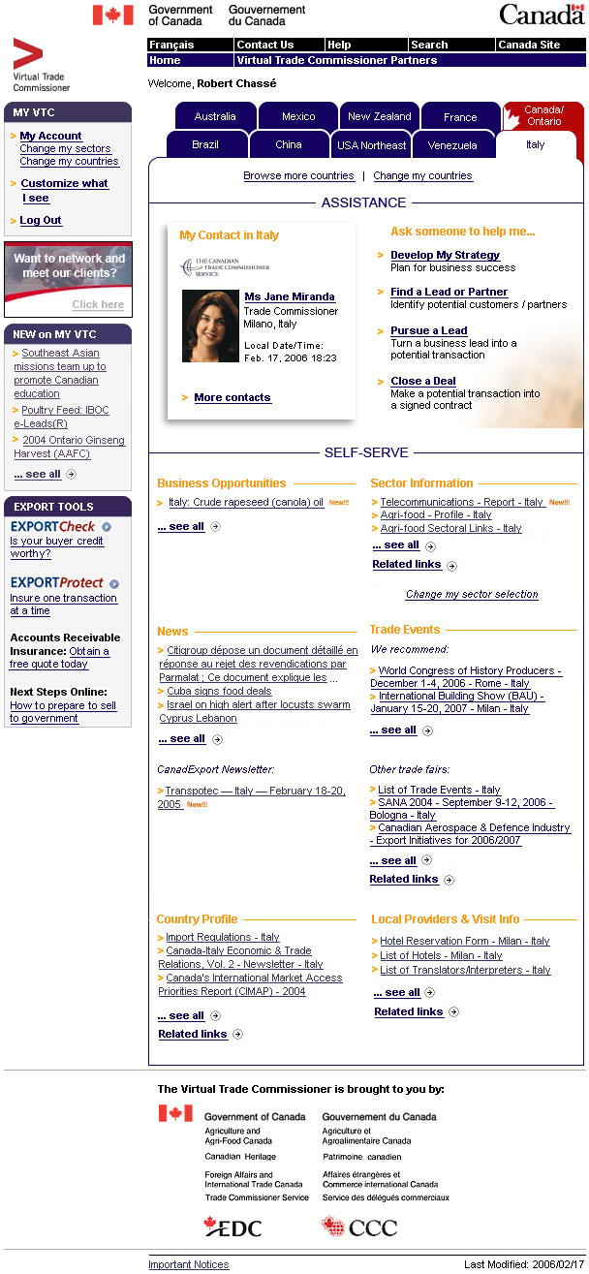
Welcome line much cleaner without text.
White on blue tabs for geographic much clearer and visually appealing
Meaning of Canada/Ontario button not clear or apparent.
“Develop” considered unnecessary. Refine is seen as more appropriate. Participants would still like this to be more tailored to their level of expertise
Participants find the distinction between assistance and self-serve very clear and intuitive. Many suggest it should be inverted since they will self-serve first, then seek assistance.
“My VTC considered clearer and sharper. Change my sectors / countries buttons appreciate.
Browse more countries button clearer and does not divert participants as “browse the world” button did.
New on My VTC preferred.
Participants still don’t like scrolling down and navigation or links below may not be found.
Fewer boxes in left column makes the site much cleaner and less cluttered.
Modified VTC Home Page

Conclusions and Recommendations
These focus groups allowed us to draw the following conclusions with regard to the usability of the VTC website and the potential acceptance of the proposed enhancements:

- The modified page represents a marked improvement in terms of visual appeal, intuitiveness, and usability.
Recommendation:
Proceed with the proposed enhancements and suggested improvements found throughout this report, subject to the remainder of our recommendations below.
- Participants did not understand the meaning of the Canada-Ontario tab and the nomenclature did not encourage them to click on the tab to find out. Most participants wrongly guessed that this tab would lead to “Canadian” content, i.e. information and business opportunities in Canada.
Recommendations:
- Re-name the ‘Canada-Ontario’ tab to ‘All (my) Markets’ while maintaining the red coloring which symbolizes that they are at their “home-base”, since participants repeatedly requested not to have the content parsed by geographic market;

- Consider having the site open to this tab by default, rather than to a geographic market.

- In the more substantive review to follow, evaluate the extent to which the wider body of users prefers a sector rather than geographic/market organization of content, and consider allowing the use of “sector” tabs as well as “market” tabs.
- Although two focus groups do not allow us to make definitive conclusions, they do provide an interesting hypothesis: participants with less international experience want and expect the VTC to provide personalized service delivery from a Trade Commissioner and are increasingly disenchanted that they do not receive responses to their enquiries. Participants with more international experience use the site for self-serve purposes and to keep themselves up-to-date on market information. They seek personalized service through other (direct) channels. Most (internationally experienced) participants also seek to satisfy their needs by themselves first (self-serve) before seeking assistance or personalized service.
- A final, yet crucial, consideration is the visual appeal and power of the photograph of the trade commissioner in the “assistance” section.
Recommendations:
- Move the “Self-Serve” section to the top, and the “Assistance” section underneath. However in doing so, the visual appeal of the top section must be augmented using photographs or other powerful imagery.

- As part of the more substantive review of the VTC to take place, we submit a preliminary recommendation to review and possibly restrict the ability to make direct service requests for all users. Our experience with this and other research and extensive interaction with the TCS indicates that requests from inexperienced users is causing increased frustration on both sides, and is severely jeopardizing the credibility of the VTC both among users (this is a hypothesis not substantiated by quantitative research) and in the Department.

- When participants see “no business leads available” or “no opportunities available”, it reflects extremely poorly on the image of the TCS and the VTC.
Recommendation:
- If the only content to drive the business opportunities section on the page comes from “IBOC” or other “leads”, provide the user with an option to obtain an RSS feed of business opportunities. In this manner, they will not see “no business leads…” available, and will be kept informed of any leads and opportunities of interest. The World Bank and InterAmerican Development Bank provide models in this regard.

The Antima Group has been extremely pleased to have had the opportunity to assist the VTC Team in achieving what we hope was a successful outcome to this exercise, and we stand ready to provide any assistance during the development and execution of your future plans.

T H E A N T I M A G R O U P

Norman Baillie-David
Managing Partner

