POR 387-06
Contract # 08227-075900/001/CY
Contract Award Date: 2007-02-16

Final Report
Consular Affairs Public Outreach Tools Evaluation: airport intercept tracking study

Prepared for
Department of Foreign Affairs and International Trade Canada

March 31, 2007

Prepared by
The Strategic Counsel
21 St. Clair Ave E., Ste. 1100
Toronto, Ontario M4T 1L9
Tel: (416) 975-4465 Fax: (416) 975-1883
Email: info@thestrategiccounsel.com
Website: www.thestrategiccounsel.com

Ce rapport est aussi disponible en français sur demande.

Table of Contents

I. Executive Summary 1
A. Research Objectives and Methodology 2
1. Research Objectives 2
2. Methodology 3
B. Planning International Travels 3
C. Paradoxical Views on the Government of Canada as Source of Information on Travel 4
1. High Degree of Trust 5
2. Lower Usage Levels 5
3. Travel Advisories: Also Useful, but Seldom Used 5
4. Over Time, Travellers do get Information from the Government of Canada 6
D. The Perceived Role of the Government of Canada when Abroad 6
II. Sommaire 8
A. Objectifs et méthodologie 9
1. Objectifs de recherche 9
2. Méthodologie 10
B. Planification des voyages internationaux 10
C. Vues paradoxales sur le gouvernement du Canada comme source d’information sur
les voyages 11
1. Degré élevé de confiance 12
2. Degrés d’utilisation plus faibles 12
3. Avis aux voyageurs : utiles, mais rarement consultés 13
4. Avec le temps, les voyageurs sont exposés à l’information provenant du gouvernement du Canada 13
D. Le rôle perçu du gouvernement du Canada lors de voyages à l’étranger 14
III. Objectives and Methodology 15
A. Research Objectives 16
B. Methodology 17
IV. Travel Planning and Common Sources of Information 19
A. Steps Taken to Plan International Travels 20
1. Unprompted Responses 20
2. Prompted Responses 21
3. Importance of Being Prepared 22
B. Information Sources 23
1. Best Sources of Information 23
2. Credibility of Information Sources 26
3. Awareness of Travel Advisories 27
V. Awareness and Usage of Government of Canada as an Information Source 29
A. Government Travel Advisories 30
B. General information from the Government of Canada 32
VI. Views on Consular Affairs’ Web Site and Bon Voyage, But… Booklet 35
A. Consular Affairs’ Web Site – voyage.gc.ca 36
B. Bon Voyage, But… Booklet 38
VII. Roles and Responsibilities when Abroad 41
A. Individual Steps Taken in Case of Trouble Abroad 42
B. Perceived Role of the Canadian Government 43
VIII. Respondents’ Profile 46
A. Travel Profile 47
B. Demographic Profile 51
IX. Areas for Improvement 55
A. Promoting the Planning Message: Relevance, Simplicity and Convenience 56
B. Merging the Gap between Credibility and Accessibility 56
X. Survey Questionnaire 58
A. English version 59
B. French Version 74

- Executive Summary

Executive Summary
The Strategic Counsel is pleased to present the Department of Foreign Affairs and International Trade Canada with this report on a survey conducted between March 7th and March 20th, 2007 among 850 Canadian travellers in the Montreal, Toronto and Vancouver international airports. This survey of international travellers is the second phase of a two-phased research program. The first phase of research comprised a series of 12 focus groups held among travellers and travel professionals in Toronto (February 26th), Calgary (February 27th), Halifax (February 27th), Vancouver (February 28th) and Montreal (March 1st). Results of the first phase of research are presented under separate cover.

Research Objectives and Methodology

Research Objectives
In keeping with the need to ensure the safety and well-being of Canadian travellers, the Client Services Division of the Department of Foreign Affairs and International Trade Canada’s (DFAIT) Consular Affairs Bureau has produced a series of communication tools designed to inform Canadians on the precautions and/or considerations to be taken into account when traveling abroad. This research built on the findings of a prior study completed in 2006 by DFAIT’s Consular Affairs Bureau.
The current program of research was thus intended to extend DFAIT’s understanding of travellers’ and travel professionals’ information requirements when preparing for travel abroad and specifically to undertake a deeper and more probing evaluation on the effectiveness of DFAIT’s communication tools and how they might be improved.
As such, the main objectives of this research were to:
- Further explore and examine the tools, sources and references that travellers and travel professionals employ in preparation for travel abroad, and to better understand how they use these tools.
- Assess DFAIT’s communication tools with respect to a number of criteria and relative to other commonly referenced travel resources.
- Test whether key messaging (e.g. preparation, insurance, avoidance of dangerous locations, personal responsibility) is being received by target audiences and whether it is encouraging Canadian travelers to modify their behaviour when traveling abroad.
- Appraise travel agents’ views regarding the usefulness of the information provided by DFAIT, as well as the extent to which they disseminate this information to their clients.

Executive Summary

Methodology
This second phase of research was conducted inside the international departure concourse beyond the security screening areas at the Montreal, Toronto and Vancouver airports. A total of 850 interviews lasting approximately 15 minutes were conducted between March 7th, 2007 and March 20th, 2007. The margin of error for the entire survey is of +/- 3.4% 19 times in 20. It is important to note that this margin of error applies to generalizations for the population of Canadian international travellers. The survey is not deemed representative of the entire Canadian population and should not be considered as such. Respondents were selected randomly among travellers in international waiting areas, with care being taken to ensure appropriate representation by gender and age groups.
Interviewing was held on different days and times in each airport, depending on flight schedules and times made available by airport authorities. Appropriate authorization for on-site interviewing was provided by the Airport authorities at each location. The interviewing process took place as follows at each airport:

LOCATION | DATES | TIMES | NO. OF COMPLETIONS
Montreal | March 7th-14th | 7am-11pm | 280
Toronto | March 9th, 12th-13th, 16th, 19th-20th | 6am-11pm | 292
Vancouver | March 7th-9th, 12th-16th | 7am-11pm | 278

Planning International Travels
Travellers have a tendency to overstate the extent of their planning before they embark on a trip to a new international destination. The vast majority report taking a number of key steps when asked about the preparation process on a prompted basis, although their initial, un-prompted, responses demonstrated a certain lack of top-of-mind awareness of the specific key steps to be taken. Getting information about the destination country (51%) tops the un-prompted list, followed by looking for accommodation, attractions and weather (48%), ensuring that their passport is valid (44%), seeking health information (36%), checking entry visa requirements (28%), getting health and/or travel insurance (26%), verifying money/currency requirements (22%) and checking travel advisories (20%) are also important steps for a fair number of travellers.

Executive Summary
When prompted, participants are much more likely to report taking many more crucial steps in their preparation. Respondents verify that their passport is current (99%), ensure that their health insurance coverage is sufficient (84%), leave a copy of their itinerary with someone at home (80%), check visa requirements (80%), get information on currency (72%), ensure proper travel insurance coverage (70%), check vaccination requirements (68%) and get travel report information regarding the destination (59%).
These somewhat clashing results indicate that preparation does take place, but it appears to be somewhat improvised. The improvisational approach to travel may not be all that surprising given the hectic pace of life and the limited time that remains for recreational and leisure pursuits and the preparation for such pursuits. In addition, the availability of voluminous travel information online may actually be serving to reduce the amount of time and thought that goes into pre-trip planning. While travellers can now search through numerous web sites to obtain information about their destinations over the Internet, they may in fact be somewhat overwhelmed by the amount of available information. In this respect the internet may be seen more as a hindrance than a help. Moreover, increased access to the internet, even in seemingly remote parts of the world, and the explosion of cellphone use may offer travellers, who previously might have prepared for trips more diligently, an option to make or finalize their plans “on the fly.” The advancements in and proliferation of telecommunications technology may leave travellers with some sense of comfort, either real or imagined, that any situation that might arise can be dealt with, reducing the importance of rigorous advance planning. At the same time respondents to the survey did acknowledge that it is better to prepare rather than to deal with situations abroad as they arise. This ad-hoc approach to trip planning also surfaced during the focus groups discussions held prior to fielding this survey, when many participants said that they planned their trips, but not necessarily as carefully as they knew they should. This gap between the prompted and un-prompted answers on the topic of trip planning was even more noticeable among Francophone respondents.

Paradoxical Views on the Government of Canada as Source of Information on Travel
Respondents to the 2006 and 2007 travellers’ survey exhibit similar, somewhat paradoxical, views towards the Government of Canada as an information source on international travel when compared to their use of the information gleaned from the government. On the one hand, the Government of Canada is seen as a highly credible source of information on international travel, particularly regarding safety and security issues. On the other hand, it is not commonly used as a source of information. While, on the surface, this finding may seem unusual and somewhat contradictory, it is in keeping with other research that suggests the Government of Canada garners a high degree of credibility as a repository of information on a variety of important topics, but is not commonly the first or even a top-of-mind “go-to” source for such information. This likely stems from an historical tendency to view the process of accessing and extracting information from government as onerous and labyrinthine.

Executive Summary

High Degree of Trust
Canadian travellers are almost unanimous in stating that the Government of Canada is a highly credible information source on safety and security issues related to international travel, with a full 96 per cent of respondents saying they trust the information provided by the government. This level of trust is higher than that for family and friends (92%), travel guides (88%), travel agents (83%) and especially the governments of destination countries (64%).

Lower Usage Levels
Nevertheless, the Government of Canada is not commonly identified as a primary source of information on international travel in general. In fact, only 4 per cent of respondents identified the Government of Canada as a top-of-mind source of information on international destinations in 2007, down from 10 per cent in 2006. For both 2006 and 2007, the internet is the main source of information on new or unknown destinations. In fact, its importance rose by 12 percentage points in 2007, with 73 per cent saying it was one of their favourite sources of information compared to 61 per cent stating the same in 2006. Approximately a third (34%) of respondents mentioned using travel books, while one-in-five (18%) identified family and friends who have been there as a favourite source of information. Family and friends living in the country of destination were seen as a key source of information by 12 per cent of all respondents.
The Government of Canada nonetheless ranks higher as a preferred source of information about issues specifically related to safety and security. While the internet remains the most important source of information on such topics, with one-in-three respondents (34%) choosing it as their favourite source, it does not trump all other sources as it did for the previous question. The Canadian Government now appears as a key source of information for 17 per cent of respondents. Nevertheless, this proportion is 10 percentage points lower than in 2006. Travel books (15%), friends and family who have been there (10%) and friends and family who live there (8%) are also important sources of information for some.

Travel Advisories: Also Useful, but Seldom Used
In the same vein, a majority of respondents in both 2006 (66%) and 2007 (87%) who have seen travel advisories from the Government of Canada state that they are useful. Yet, only 15 per cent of respondents have ever checked travel advisories and only a minority among this small group (20% in 2006 and 29% in 2007) say that the information they read in the advisory made them change their behaviour.

Executive Summary
It is difficult to know on the basis of responses to this survey what is behind the apparent discrepancy between perceptions of the high degree of utility of travel advisories and the low actual usage or reference to these tools. One could speculate that in a post 9/11 environment, travellers have become more cautious about their travel plans and choice of destinations to the point where they generally avoid destinations that might, in their view, warrant consultation of travel advisories from government. By the same token, it may also be the case that travellers presume that they would likely hear of issues in the news media that might affect their travel plans. The news media may, to some extent, be usurping or be used as a proxy for the information role provided by governments in issuing travel advisories. As such, travellers may rely more heavily, perhaps disproportionately so, on the former to keep them informed of significant issues affecting their travel plans. Finally, it may simply be the case that travellers are not fully aware of the type of helpful information which can be found in travel advisories (i.e. contact information, laws and customs, etc.) and that these reports are not exclusively focused on major issues or problems that might be encountered in a particular country.

Over Time, Travellers do get Information from the Government of Canada
Despite the fact that travellers do not often see the Government of Canada as a regular or preferred source of information on international travel, a majority of them (71%) state that they have encountered information provided by the government over the past five years. Not surprisingly, the vast majority of them have seen this information over the internet (92%). Nearly half of respondents (46%) recall having seen the Bon Voyage, But… brochure, while 19 per cent recall visiting the “voyage.gc.ca” web site.

The Perceived Role of the Government of Canada when Abroad
The vast majority of travellers would make use of Government of Canada resources if they encountered trouble when travelling abroad. Three-in-four respondents (74%) say that they would contact the Canadian embassy in the country of destination, with another 36 per cent saying they would contact the Canadian consulate. By contrast, only 18 per cent would contact the local police, 12 per cent would contact local friends or family and 9 per cent would call home.
The most important role of the Canadian Government relative to Canadian travellers who need help in a foreign country is seen to be the provision of a new passport in case of loss (50%). One-third (31%) of respondents also see the government as a source of assistance in case of natural or civil disaster. Help in case of detention by foreign authorities (20%) and providing information about local country (20%) are also seen as important roles.

Executive Summary
A shift in opinion from 2006 to 2007 can also be found with regards to views on limiting Canadian Government assistance to Canadians abroad. For most items listed, the proportion of travellers who do not believe that limits should be imposed increased substantially from 2006 to 2007. At the same time, the proportion of those who believe that the government should not impose limits also increased. These simultaneous shifts in opposite directions were made possible by the vast decrease among those with ambivalent positions compared to 2006. Opinions are therefore much more polarised in 2007 when compared to 2006. The highly publicised Lebanese crisis during the summer of 2006 may explain this large shift in opinions, having made Canadians more aware of some of the issues with respect to assisting Canadian citizens travelling through conflict zones. Canadian travellers have more entrenched views on what the Government of Canada should do or should not do in case of crisis abroad.

- Sommaire

Sommaire
The Strategic Counsel, est heureuse de présenter au Ministère des Affaires étrangères et du Commerce international (MAECI) le présent rapport d’un sondage mené entre le 7 et le 20 mars 2007 auprès de 850 voyageurs canadiens dans les aéroports internationaux de Montréal, Toronto et Vancouver. Ce sondage auprès des voyageurs internationaux est la deuxième phase d’un projet de recherche en deux volets. La première phase de l’étude consistait en une série de 12 groupes de discussion avec des voyageurs et des professionnels du voyage. Ces discussions ont eu lieu à Toronto (le 26 février), Calgary (le 27 février), Halifax (le 27 février), Vancouver (le 28 février) et Montréal (le 1er mars). Les résultats de la première phase de l’étude sont présentés sous pli séparé.

Objectifs et méthodologie

Objectifs de recherche
Dans le cadre de son mandat d’assurer la sécurité et le bien-être des voyageurs canadiens, la Direction des services à la clientèle de la Direction générale des affaires consulaires du Ministère des Affaires étrangères et du Commerce international (MAECI) a produit une série d’outils de communication conçus pour informer les Canadiens des précautions et des aspects à prendre en considération lorsqu’ils voyagent à l’étranger. La présente étude élargit les constatations d’une étude antérieure exécutée en 2006 par la Direction générale des affaires consulaires du MAECI.
Le programme courant de recherche avait donc pour objet de permettre au MAECI de mieux comprendre les besoins d’information des voyageurs et des professionnels du voyage quand ils préparent un voyage à l’étranger et, plus particulièrement, d’entreprendre une évaluation plus approfondie de l’efficacité des outils de communication du MAECI et de la façon dont on pourrait les améliorer.
À ce titre, les principaux objectifs de la recherche étaient les suivants :
- Explorer et examiner de plus près les outils, les sources et les références que les voyageurs et les professionnels du voyage utilisent pour préparer un voyage à l’étranger, et mieux comprendre comment ils utilisent ces outils.
- Évaluer les outils de communication du MAECI en fonction d’un certain nombre de critères et par rapport à d’autres ressources de voyages fréquemment consultées.
- Vérifier si les messages clés (préparation, assurances, endroits dangereux à éviter, responsabilité personnelle et autres) sont reçus par les publics cibles et s’ils encouragent les voyageurs canadiens à modifier leur comportement lorsqu’ils voyagent à l’étranger.
- Évaluer les points de vue des agents de voyage concernant l’utilité de l’information fournie par le MAECI, en plus de déterminer dans quelle mesure ils diffusent cette information à leurs clients.

Sommaire

Méthodologie
Cette deuxième phase de l’étude a été menée dans le hall des départs internationaux, au-delà des contrôles de sécurité, des aéroports de Montréal, Toronto et Vancouver. Un total de 850 entrevues durant environ 15 minutes chacune ont été menées entre le 7 et le 20 mars 2007. La marge d’erreur de l’ensemble du sondage est de +/- 3,4 %, 19 fois sur 20. Il est important de souligner que cette marge d’erreur s’applique aux généralisations pour la population des voyageurs canadiens internationaux. Le sondage ne peut être considéré représentatif de l’ensemble de la population canadienne et ne doit pas être interprété comme tel. Les répondants ont été choisis au hasard parmi les voyageurs circulant dans les zones d’attente internationales, tout en prenant soin de respecter une représentation appropriée par sexe et groupes d’âge.
Dans chaque aéroport, les entrevues se sont étalées sur plusieurs jours et ont eu lieu à différents moments de la journée, selon l’horaire des vols et les périodes approuvées par les autorités aéroportuaires. Les autorités aéroportuaires ont accordé leur autorisation expresse pour la conduite d’entrevues dans chaque aéroport. Le processus d’entrevue s’est déroulé comme suit dans chaque aéroport :

Aéroport | Dates | Times | Nº d’entrevues complétées
Montréal | Du 7 au 14 mars | De 7 h à 23 h | 280
Toronto | Les 9, 12, 13,16, 19 et 20 mars | De 6 h à 23 h | 292
Vancouver | Les 7, 9, 12 et 16 mars | De 7 h à 23 h | 278

Planification des voyages internationaux
Les voyageurs ont tendance à sous-estimer l’étendue de leur planification avant d’entreprendre un voyage vers une nouvelle destination internationale. Lorsqu’on les guide concernant les mesures qu’ils pourraient prendre durant la préparation de leur voyage, une grande majorité des voyageurs affirme prendre un certain nombre de mesures. Toutefois, leurs réponses initiales, non guidées, révèlent un certain manque de connaissance spontanée des principales mesures à prendre. Obtenir des renseignements sur le pays de destination (51 %) arrive en tête de la liste non guidée de mesures à prendre, suivie par Chercher de l’hébergement, des attractions et vérifier la météo (48 %), S’assurer que le passeport est valide (44 %), Rechercher de l’information en matière de santé (36 %), Vérifier les exigences en matière de visas (28 %), Se procurer une assurance maladie / voyage (26 %), Vérifier les devises en cours (22 %) et Vérifier les avis aux voyageurs (20 %) sont aussi des mesures importantes pour un bon nombre de voyageurs.

Sommaire
Une fois guidés, les participants étaient beaucoup plus susceptibles de souligner qu’ils avaient pris plus de mesures importantes dans le cadre de leur préparation. Les répondants vérifient que leur passeport est valide (99 %), s’assurent que leur couverture d’assurance maladie est suffisante (84 %), confient une copie de leur itinéraire à quelqu’un qui demeure au pays (80 %), vérifient les exigences en matière de visa (80 %), se renseignent sur les devises en cours (72 %), vérifient que leur couverture d’assurance voyage est suffisante (70 %), vérifient les exigences en termes de vaccins (68 %) et consultent les avis aux voyageurs concernant leur destination (59 %).
Ces résultats quelque peu contradictoires indiquent que la préparation a lieu, mais semble plutôt improvisée. Cette approche improvisée de la planification de voyage n’est pas entièrement surprenante si on considère le rythme de vie frénétique de la population et le peu de temps disponible pour les activités récréatives, les loisirs et la préparation nécessaire à la poursuite de ces loisirs. De plus, la disponibilité d’une grande quantité d’information en ligne peut contribuer à réduire le temps et l’effort investis dans la planification de voyages. Bien que les voyageurs puissent désormais visiter de nombreux sites Internet afin de recueillir de l’information sur leurs destinations, ils peuvent en fait être submergés par la quantité d’information disponible. Vu sous cet angle, l’Internet peut être perçu comme une nuisance plutôt qu’une source d’assistance. De plus, un accès accru à l’Internet, même dans les endroits les plus reclus de la planète, ainsi que l’explosion de la téléphonie cellulaire offrent une option de dernière minute aux voyageurs qui auraient peut-être planifié leurs voyages plus diligemment sans la présence de ces outils. L’avancement rapide de la technologie des télécommunications peut donner aux voyageurs l’impression, réelle ou imaginaire, qu’ils peuvent toujours régler un problème à la dernière minute, quel qu’il soit, réduisant du même coup l’importance d’une préparation rigoureuse. Malgré tout, une majorité de répondants au sondage ont admis qu’il est préférable de se préparer au préalable plutôt que de régler les problèmes au fur et à mesure. Cette approche impromptue quant à la planification de voyages était aussi évidente pendant les discussions de groupe qui ont eu lieu avant ce sondage dans les aéroports. De nombreux participants avaient alors affirmé planifier leurs voyages, mais pas nécessairement aussi soigneusement qu’ils le devraient. Cet écart entre les réponses guidées et spontanées quant à la préparation de voyages est particulièrement visible chez les répondants francophones.

Vues paradoxales sur le gouvernement du Canada comme source d’information sur les voyages
Les répondants aux versions 2006 et 2007 du sondage auprès des voyageurs affichent des points de vue semblables, et quelque peu paradoxaux, à l’endroit du gouvernement du Canada comme source d’information pour les voyages à l’étranger et leur recours à l’information émanant du gouvernement. D’une part, le gouvernement du Canada est perçu comme une source hautement crédible d’information pour les voyages à l’étranger, surtout en ce qui a trait aux questions de sûreté et de sécurité. D’autre part, on n’y a

Sommaire
pas souvent recours pour s’informer. Bien que cette situation puisse sembler étrange et quelque peu contradictoire, elle correspond aux résultats d’autres recherches suggérant que le Gouvernement du Canada est perçu comme très crédible en tant que banque d’information sur une grande variété de sujets importants, mais n’est pas une source d’information primordiale ou même une source d’information spontanée. Ceci est probablement lié à une perception constante voulant que les procédures nécessaires à l’accès à l’information émanant du gouvernement soient onéreuses et confuses.

Degré élevé de confiance
Les voyageurs canadiens sont presque unanimes à affirmer que le gouvernement du Canada est une source d’information hautement crédible en matière de sûreté et de sécurité pour les voyages internationaux, alors que 96 pour cent des répondants indiquent qu’ils font confiance à l’information fournie par le gouvernement. Ce degré de confiance est plus élevé que celui envers les parents et les amis (92 %), les guides de voyage (88 %), les agents de voyage (83 %) et, surtout, le gouvernement des pays de destination (64 %).

Degrés d’utilisation plus faibles
Malgré tout, dans l’ensemble, le gouvernement du Canada n’est pas souvent cité comme source d’information pour les voyages internationaux. En fait, en 2007, seulement 4 pour cent des répondants ont identifié le gouvernement du Canada comme principale source d’information pour les destinations internationales, soit une baisse par rapport aux 10 pour cent qui avaient fait de même en 2006. Lors des deux sondages, 2006 et 2007, Internet est la principale source d’information pour les nouvelles destinations ou celles qui ne sont pas connues des répondants. En fait, son importance s’est accrue de 12 points de pourcentage en 2007, avec 73 pour cent des répondants affirmant que c’était une de leurs sources d’information préférées, par rapport à 61 pour cent des répondants affirmant la même chose en 2006. Environ un tiers (34 %) des répondants a mentionné consulter des guides de voyage, tandis que seulement un sur cinq (18 %) a indiqué les parents ou les amis qui ont visité cette destination comme source d’information favorite. Les membres de la famille et les amis qui vivent dans le pays de destination étaient perçus comme une source importante d’information par 12 pour cent de tous les répondants.
Malgré tout, le gouvernement du Canada se classe mieux comme source d’information privilégiée pour les questions de sûreté et de sécurité. Alors qu’Internet demeure la plus importante source d’information pour ces questions, avec un répondant sur trois (34 %) le citant comme sa source préférée, il ne supplante pas toutes les autres sources comme pour la question précédente. Le gouvernement canadien apparaît maintenant comme une des meilleures sources d’information pour 17 pour cent des répondants. Malgré tout, cette proportion est 10 points de pourcentage plus faible qu’en 2006. Les guides de voyage (15 %), les amis et les membres de la famille qui ont visité la destination (10 %) et les amis et les membres de la famille qui vivent à cet endroit (8 %) sont aussi des sources d’information importantes pour certains répondants.

Sommaire

Avis aux voyageurs : utiles, mais rarement consultés
Dans un même ordre d’idée, une majorité des répondants au sondage de 2006 (66 %) et à celui de 2007 (87 %) qui ont vu les avis aux voyageurs du gouvernement du Canada affirment qu’ils sont utiles. Pourtant, seulement 15 pour cent de ces répondants les ont déjà consultés, et seulement une minorité au sein de ce petit groupe (20 % en 2006 et 29 % en 2007) mentionne que l’information contenue dans l’avis les a encouragés à modifier leur comportement.
Il est difficile de comprendre la cause de l’apparente divergence entre la perception que les avis aux voyageurs sont très utiles et le faible usage de ces outils en se basant uniquement sur les résultats du sondage. Il est possible de spéculer que dans un contexte post-9/11, les voyageurs sont devenus plus prudents concernant leurs plans de voyage et leurs choix de destinations. Cette plus grande prudence peut les inciter à éviter toutes destinations qui pourraient, selon eux, nécessiter la consultation d’un avis aux voyageurs émis par le gouvernement. Dans un même ordre d’idées, il se peut que les voyageurs se fient sur la couverture médiatique pour les informer de tout incident ou problème pouvant affecter leurs plans de voyage. Les médias d’information peuvent, jusqu’à un certain point, usurper le gouvernement ou servir de remplacement quant à son rôle d’émetteur d’avis aux voyageurs. Donc, les voyageurs peuvent se fier plus fortement, peut-être même de manière disproportionnée, sur les médias pour les garder informés sur les problèmes importants pouvant affecter leurs plans de voyage. Finalement, il est possible que les voyageurs ne soient tout simplement au courant du genre d’information utile qu’ils peuvent trouver dans les avis aux voyageurs (i.e. listes de contacts, lois et coutumes, etc.) et que ces rapports ne sont pas uniquement centrés sur les problèmes ou enjeux majeurs dans un pays donné.

Avec le temps, les voyageurs sont exposés à l’information provenant du gouvernement du Canada
Même si les voyageurs ne perçoivent pas souvent le gouvernement du Canada comme une source d’information privilégiée ou habituelle, la majorité d’entre eux (71 %) affirme avoir vu de l’information émanant du gouvernement au cours des cinq dernières années. Sans surprise, la grande majorité d’entre eux a vu cette information sur Internet (92 %). Près de la moitié des répondants (46 %) se souviennent avoir vu le guide Bon Voyage, mais…, tandis que 19 pour cent se souviennent avoir visité le site Web « voyage.gc.ca ».

Sommaire

Le rôle perçu du gouvernement du Canada lors de voyages à l’étranger
La grande majorité des voyageurs feraient appel aux ressources du gouvernement du Canada s’ils éprouvaient des problèmes au cours de leur séjour à l’étranger. Trois répondants sur quatre (74 %) affirment qu’ils communiqueraient avec l’ambassade canadienne du pays de destination, tandis que 36 pour cent disent qu’ils communiqueraient avec le consulat canadien. En contrepartie, seulement 18 pour cent des répondants communiqueraient avec la police locale, 12 pour cent communiqueraient avec des amis ou des membres de la famille demeurés au pays et 9 pour cent appelleraient à la maison.
Le rôle le plus important du gouvernement canadien par rapport aux voyageurs canadiens ayant besoin d’aide à l’étranger est perçu comme était celui de fournir un nouveau passeport en cas de perte (50 %). Un tiers des répondants (31 %) perçoivent aussi le gouvernement comme une source d’aide en cas de désastre naturel ou de troubles publics. L’aide en cas de détention par des autorités étrangères (20 %) et fournir de l’information au sujet du pays (20 %) sont aussi perçus comme des rôles importants.
On remarque aussi un changement d’opinion par rapport à 2006 quant aux limites qui devraient être imposées à l’aide du gouvernement canadien aux Canadiens à l’étranger. Pour la majeure partie des énoncés, la proportion de voyageurs qui croient que des limites devraient être imposées a augmenté de façon importante par rapport à 2006. En même temps, la proportion de ceux qui croient que le gouvernement ne devrait pas imposer de limites a aussi augmenté. Ces deux revirements d’opinion contradictoires ont été rendus possible par une forte diminution de l’ambivalence des voyageurs au sujet de l’imposition de limites. Ainsi, les opinions sont beaucoup plus polarisées en 2007 qu’en 2006. La crise du Liban au cours de l’été 2006, qui a été fortement médiatisée, explique probablement cet important changement d’opinion, ayant rendu les Canadiens plus au fait des enjeux concernant l’assistance aux citoyens canadiens voyageant dans des zones de conflit. Les voyageurs canadiens possèdent donc des opinions plus tranchées concernant ce que le gouvernement du Canada doit ou ne doit pas faire en cas de crise à l’étranger.

- Objectives and Methodology

Objectives and Methodology

Research Objectives
As the number of Canadians travelling abroad continued to steadily increase over the past decades and increasingly diverse destinations are visited, a better understanding of safety measures on the part of travellers is crucial. In keeping with the need to ensure the safety and well-being of Canadian travellers, the Client Services Division of the Department of Foreign Affairs and International Trade Canada’s (DFAIT) Consular Affairs Bureau has produced a series of communication tools designed to inform Canadians on the precautions and/or considerations to be taken into account when traveling abroad.
Earlier qualitative and quantitative research undertaken in 2006 by DFAIT with travellers and travel agents explored key sources of travel information, awareness of the www.voyage.gc.ca website and top-of-mind consideration given to safety and security issues when travelling abroad. The findings from this benchmark program of qualitative and quantitative research underscored the opportunities for DFAIT to enhance their travel information materials to align them with the way in which travellers search for and use this information. In addition, it is clear that greater promotion of the information available from the Government of Canada could be undertaken, especially given the strong levels of trust and credibility in DFAIT as a source.
The current program of research was thus intended to extend DFAIT’s understanding of travellers’ and travel professionals’ information requirements when preparing for travel abroad and specifically to undertake a deeper and more probing evaluation on the effectiveness of DFAIT’s communication tools and how they might be improved.
As such, the main objectives of this research were to:
- Further explore and examine the tools, sources and references that travellers and travel professionals employ in preparation for travel abroad, and to better understand how they use these tools.
- Assess DFAITs communication tools with respect to a number of criteria and relative to other commonly referenced travel resources, as follows:
  - Assess whether the length of the communications is appropriate;
  - Obtain feedback on the clarity and layout of the communication tools; and,
  - Gather views on the relative merits of various media to deliver information to travelers.
- Test whether key messaging is being received by target audiences. The main messages include:
  - Preparation required before traveling;
  - Purchase of travel insurance;

Objectives and Methodology
  - Avoiding dangerous locations; and,
  - Taking responsibility for individual actions while away.
- Test the extent to which the information received is encouraging Canadian travelers to modify their behaviour when traveling abroad:
  - Assess the extent to which they would listen if a DFAIT advisory recommended not to visit certain areas; and,
  - Seek travelers’ input on what other type/source of information would make them change their behaviour.
- Appraise travel agents’ view regarding the perceived usefulness of the information provided by DFAIT, as well as the extent to which they disseminate this information to their clients.
- Gauge the traveling public’s understanding of a number of key issues they might be faced with when traveling abroad:
  - Usefulness of Canadian embassies in countries they may be visiting; and,
  - Steps to take if they ever ran into trouble when traveling in foreign countries (e.g. needing a doctor while away, losing their passport, etc.)
- Determine the extent to which travelers pay attention to specific materials given to them:
  - Booklet provided inside their new passport; and,
  - Publications released by DFAIT and the Consular Affairs Bureau web site.
Similar to the methodology used in 2006, this research project was divided in two phases. The first phase of the research was comprised of a series of 12 focus groups conducted with the travelling public and travel agents. The second phase of research consisted of an intercept survey of 850 Canadian travellers conducted in three major Canadian airports: Montreal, Toronto and Vancouver. This report pertains to the second of these two phases of research, while the results of the focus groups were presented under separate cover.

Methodology
This second phase of research was conducted inside the international departure concourse beyond the security screening areas at the Montreal, Toronto and Vancouver airports. A total of 850 interviews lasting approximately 15 minutes were conducted between March 7th, 2007 and March 20th, 2007. The margin of error for the entire survey is of +/- 3.4% 19 times in 20. It is important to note that this margin of error applies to generalizations for the population of Canadian international travellers. The survey is not deemed representative of the entire Canadian population and should not be considered as such. Respondents were selected randomly among travellers in international waiting areas. No “hard” quotas were fixed in order to maintain the random nature of the survey, although care was taken to ensure adequate representation by gender, age groups and language.

Objectives and Methodology
Interviewing was held on different days and times in each airport, depending on flight schedules and times made available by airport authorities. The interviewing process took place as follows at each airport:

LOCATION | DATES | TIMES | NO. OF COMPLETIONS
Montreal | March 7th-14th | 7am-11pm | 280
Toronto | March 9th, 12th-13th, 16th, 19th-20th | 6am-11pm | 292
Vancouver | March 7th-9th, 12th-16th | 7am-11pm | 278

- Travel Planning and Common Sources of Information

Travel Planning and Common Sources of Information

Steps Taken to Plan International Travels

Unprompted Responses
When planning a visit to a new international destination, travellers report taking a number of measures. Topping the list is getting information about the country (51%), followed by looking for accommodation, identifying local attractions and obtaining weather forecasts (48%) and ensuring that their passport is valid (44%). Health issues are also important for a plurality of travellers, with 36 per cent saying they check into necessary health steps and another 26 per cent stating that they arrange for health and/or travel insurance. Entry visa requirements (28%), as well as money/currency requirements (22%) and checking travel advisories (20%) are also important steps for a fair number of travellers.
Getting information on a new country is the step taken by travellers that shows the highest proportion of change between 2006 and 2007, having increased by 17 percentage points. Getting a new passport is also seen as more important in 2007, which could be related to the highly publicised changes in United States entry requirements for Canadians. The increases in the number of travellers taking both of these steps could also be related to an increasingly cautious and security-conscious travelling public.
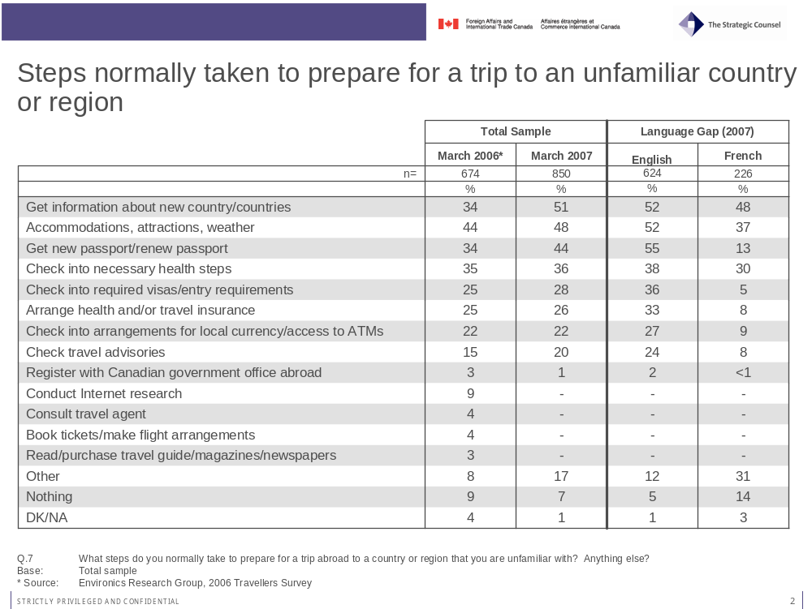

Travel Planning and Common Sources of Information
Language has a substantial effect on the typical steps identified by respondents. As a general rule, French respondents are less likely to take any of the most steps mentioned as compared to English respondents. The gap in answers appears particularly large for verifying/getting a new passport (32 percentage points), checking entry or visa requirements (31%), making insurance arrangements (25%), verifying money requirements (18%) and checking travel advisories (16%).

Prompted Responses
These unprompted answers regarding travel planning are mainly in line with responses to another question in which participants were asked to state whether they typically took a series of steps that were read to them. Not surprisingly, almost all respondents report verifying that their passport is current (99%). Slightly more than eight-in-ten (84%) say they ensure that they have health insurance coverage, while an almost equal number state that they leave a copy of their itinerary with someone at home (80%) and check visa requirements (80%). Getting additional information on currency (72%), ensuring proper travel insurance coverage (70%), checking vaccination requirements (68%) and getting travel report information regarding the destination (59%) are also steps taken by a majority of respondents.
Noticeably, only four per cent of respondents said that they registered with the Canadian Government before traveling to another country.

Travel Planning and Common Sources of Information

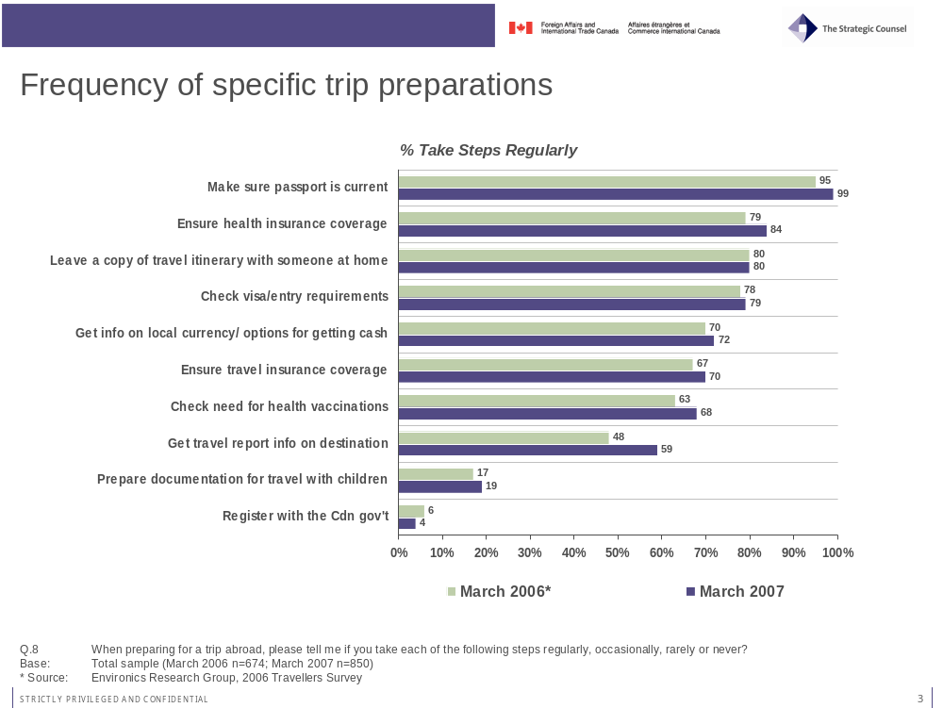
Interestingly, language makes little or no difference in the answers to this question. While unprompted answers were very different, French respondents provided the same answers to the prompted questions and even report a slightly higher propensity to take some of the steps listed. This may indicate that English respondents have a higher top-of-mind awareness or higher concern with legal and safety issues when compared to French respondents. This difference could be explained in part by English respondents’ higher level of exposure to more security-minded American media and culture, especially in the post-9/11 context. Coverage of border issues between Canada and the U.S. and of new passport requirements is also more prominent in the English media and likely affects top-of-mind awareness of legal and safety issues.

Importance of Being Prepared
When asked to choose between the view that planning your trip is important and the idea that travellers can deal with situations as they arise, the majority of respondents believe that being prepared is the best option, with 64 per cent of respondents choosing the latter. While men are still more likely to say they would rather deal with situations when they arise (30%) than women (23%), the gap is slightly smaller than in 2006 (34 per cent and 23 per cent respectively). Respondents aged 18 to 34 years of age (33%), as well as French respondents (33%) are more likely to say that it is better to deal with situations as they arise.

Travel Planning and Common Sources of Information

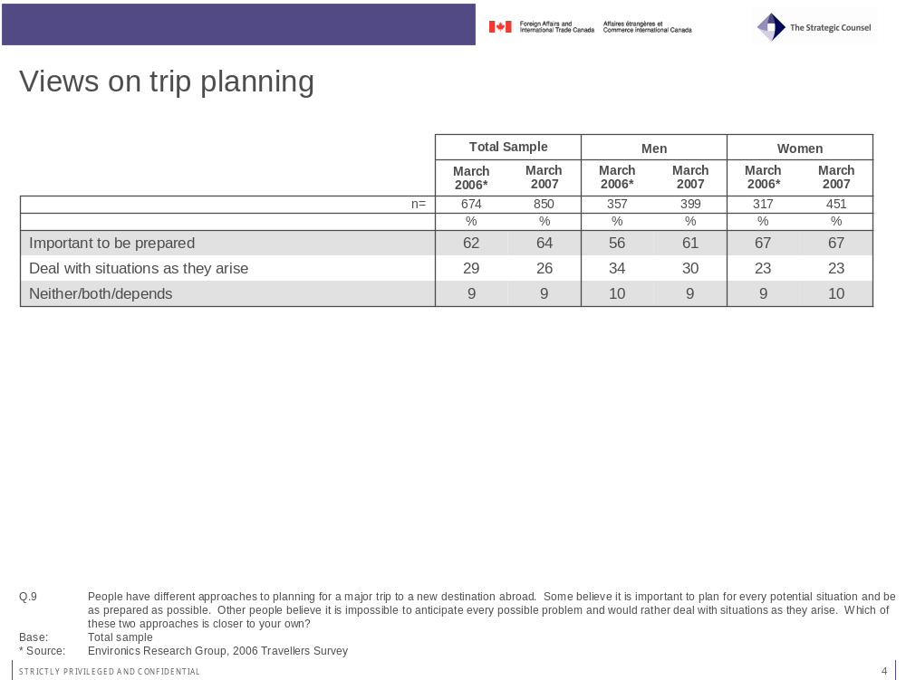

Information Sources

Best Sources of Information
For both 2006 and 2007, the internet emerges as the main source of information on new or unknown destinations. In fact, its importance rose by 12 percentage points in 2007, with 73 per cent saying it was one of their favourite sources of information compared to 61 per cent stating the same in 2006. Among internet sources, Google (29%) is the most commonly cited, followed by the web site of the destination country (19%) and travel/tourism web sites (11%).
Approximately a third (34%) of respondents mentioned using travel books, while one-in-five (18%) identify family and friends who have been there as a favourite source of information. Family and friends who live in the country of destination are seen as a key source by 12 per cent of all respondents. Noticeably, travel agencies have not been mentioned in 2007, while 12 per cent selected them in 2006. Also remarkable is the very low percentage (4%) mentioning the Canadian Government as a key information source in 2007 compared to 2006 (10%).

Travel Planning and Common Sources of Information

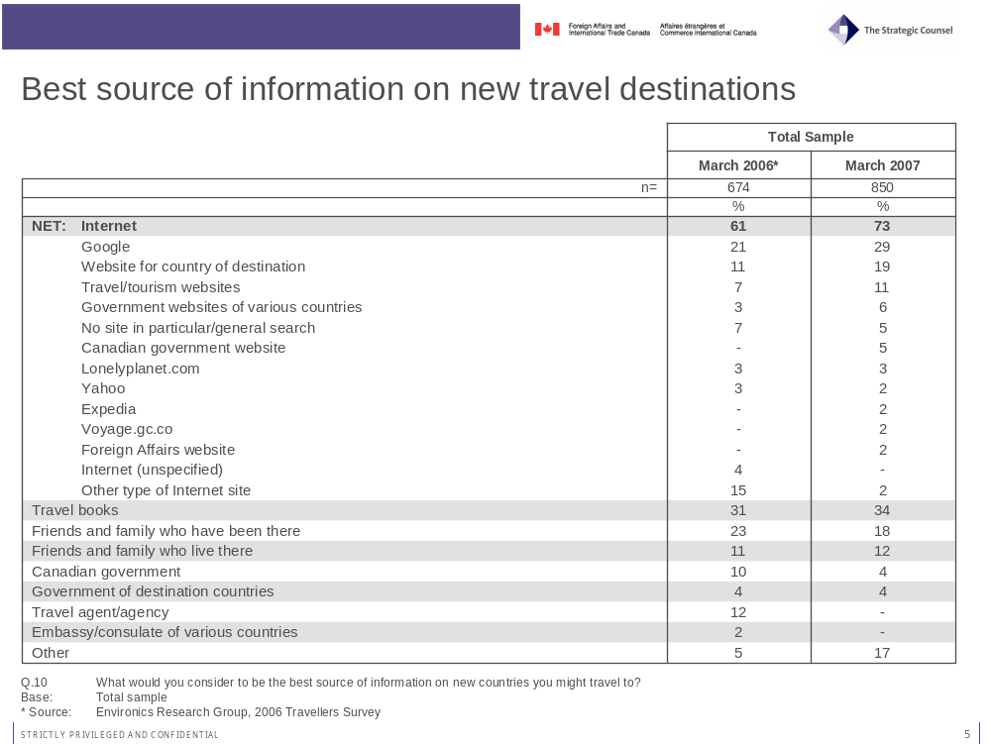
Participants aged 55 and older are slightly less likely than others to see the internet (64%) as the best source of information on a new destination when compared to those aged 18 to 34 (74%) and 35 to 54 years (79%). On the other hand, older respondents aged 55 and above (43%) were also more likely to view travel books as the best source of information compared to those aged 18-34 (31%) and 35 to 54 years (28%). French respondents (23%) are also less likely to see travel books as the best source of information compared to English respondents (38%). Women (40%) are also more likely than men (27%) to prefer travel books as a source of information.
When asked the same question, but this time focusing only on information regarding safety and security issues for international travel, responses are very different. The internet remains the most important source of information, with one-in-three respondents (34%) choosing it as their favourite source, but it does not trump all other sources as it did for the previous question. The Canadian Government now appears as a key source of information, with 17 per cent of respondents identifying it as such. Nevertheless, this proportion is 10 percentage points lower than in 2006. Travel books (15%), friends and family who have been there (10%) and friends and family who live there (8%) are also important sources of information for some.

Travel Planning and Common Sources of Information

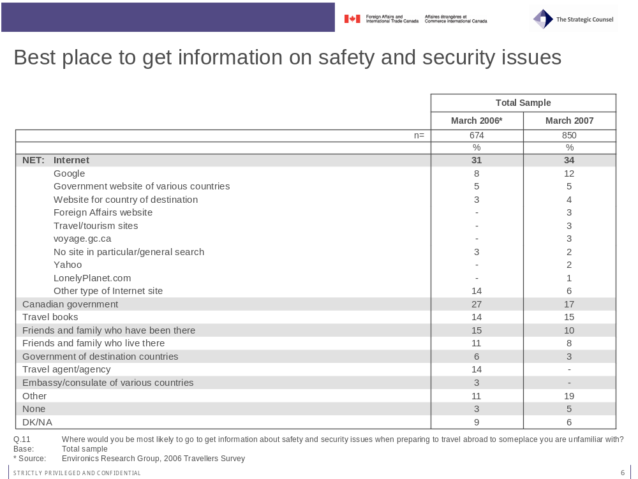
The main reasons offered to explain why the internet and the Government of Canada are the two best sources of information on safety and security vary significantly between the two sources. While being up-to-date is seen as the main reason for both the internet (31%) and the government (32%), there remains a clear distinction between the perceived advantages of both sources. All issues related to convenience and speed rank very high among reasons why the internet is a key source of information, while depth of knowledge (28%) and reliability/accuracy (21%) are key reasons why the Government of Canada is seen as a good source of information.

Travel Planning and Common Sources of Information

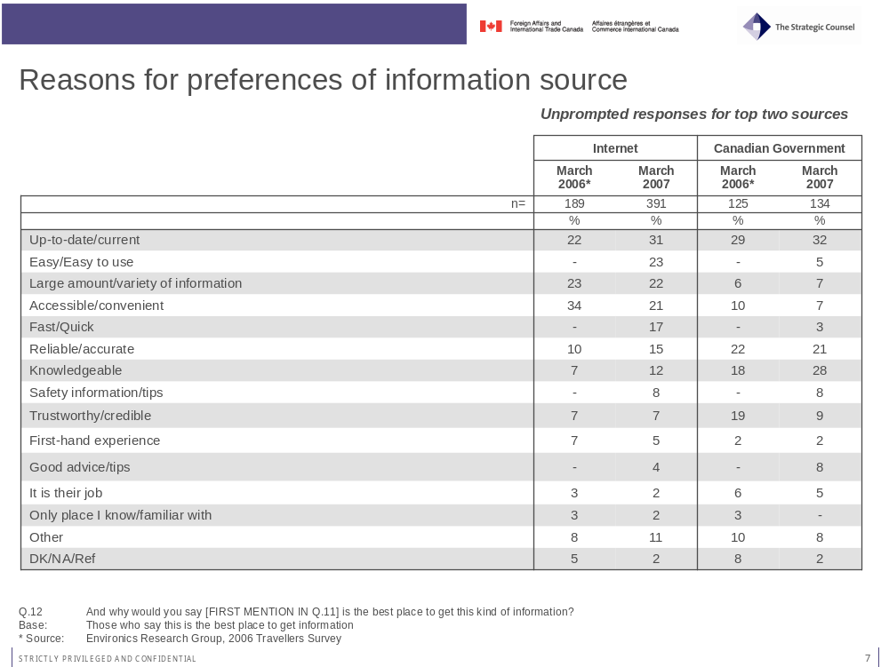

Credibility of Information Sources
In accordance with the views expressed in the previous question regarding the updated, knowledgeable and reliable/accurate nature of the information provided by the Government of Canada, respondents were quasi-unanimous (96%) in saying that the government was a credible source of information on safety and security issues. Other sources, such as friends and family who visited the country (92%), published travel guides (88%) and travel agents (83%) all receive very high credibility scores. Governments of destination country are viewed as credible by a majority (64%) but rank lower then other sources.
Notably, this high level of trust in the Government of Canada as an information source on safety and security issues does not vary by region or demographic breakdowns. Trust in travel agents is on the other hand strongly affected by whether respondents are traveling mainly for business or for personal matters. Business travellers (18%) are much less likely to say that they have a great deal of trust in travel agents when compared to other travellers (41%).

Travel Planning and Common Sources of Information

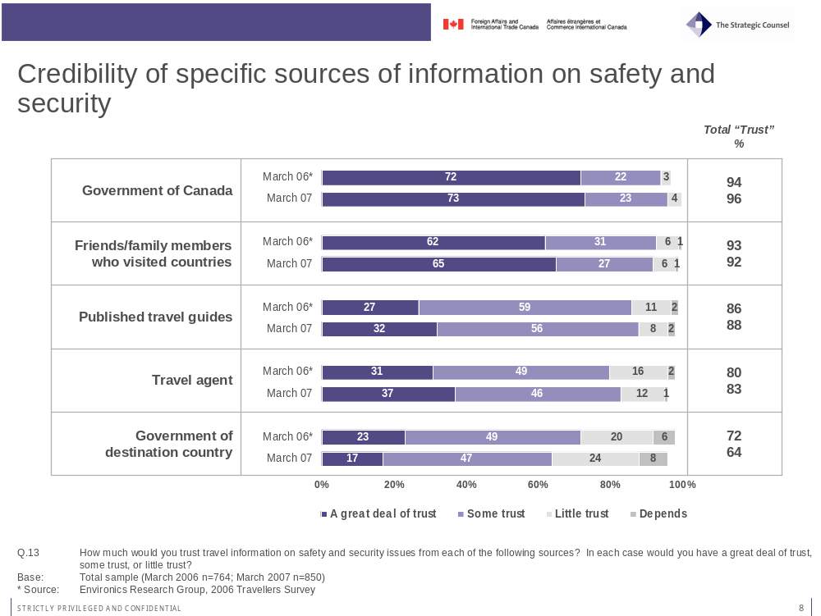

Awareness of Travel Advisories
A clear majority of survey respondents (62%) reported being aware of travel advisories providing up-to-date information on safety and security issues in connection to specific countries. This number is higher than in 2006 (53%), maybe in part because of the highly publicised crisis that arose in Lebanon during the summer and fall of 2006.
Language and frequency of travel have a clear effect on awareness of such advisories. French respondents (43%) are much less likely to be aware of advisories compared to English respondents (68%). Also, those who have travelled six times or more during the past five years (70%) are more likely to know about advisories than those who travelled less than three times (58%) or between 3 and 5 times (56%).
Seven-in-ten (69%) of those who say they are aware of travel advisories believe that they emanate from the Government of Canada. Another 18 per cent say that they have seen them on the internet, without specifying the source, while 7 per cent state having seen them in a travel guide and 6 per cent say that the U.S. government issued the advisories.

Travel Planning and Common Sources of Information

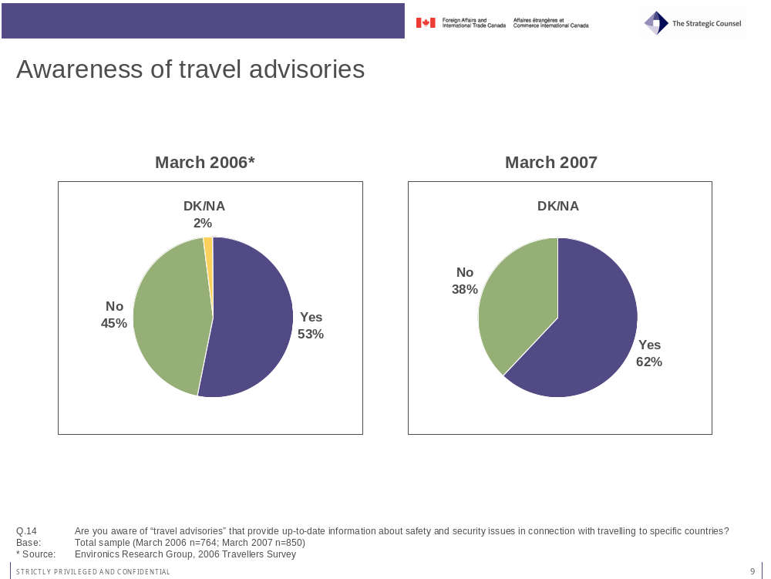
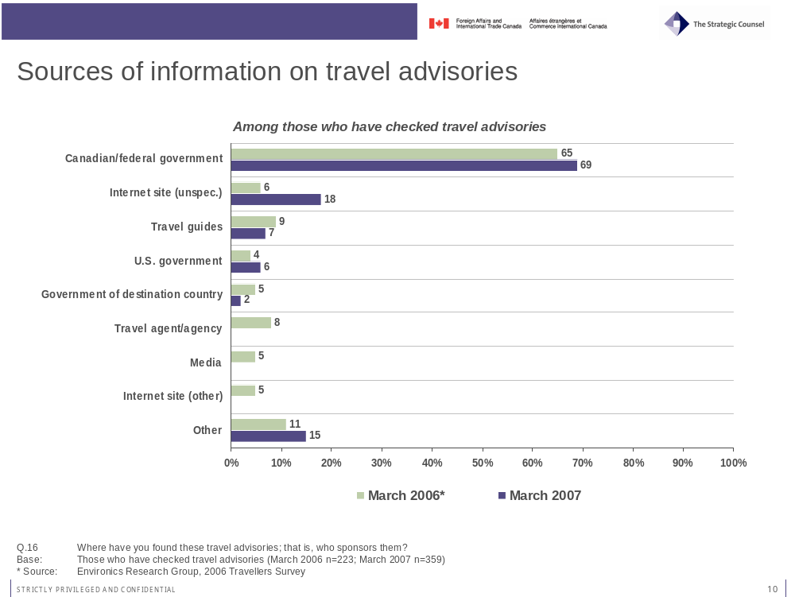

- Awareness and Usage of Government of Canada as an Information Source

Awareness and Usage of Government of Canada as an Information Source

Government Travel Advisories
A third of all respondents (30%) say they are familiar with travel advisories released by the Government of Canada. Of those, half say that they have checked advisories in the past, while the other half is aware but has not checked them in the past. Results from 2006 and 2007 are nearly identical.
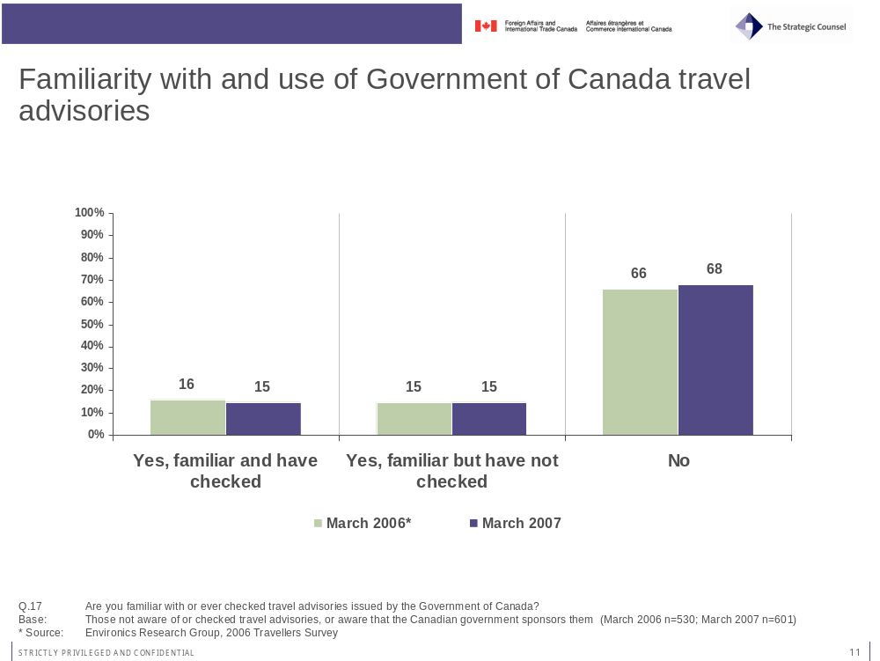
The vast majority (85%) of those aware of travel advisories released by the Government of Canada say that this type of information is useful in planning their trip. This contrasts with only 66 per cent saying the same in 2006. The large year-over-year increase is principally a result of fewer respondents in 2007 (3%) as compared to 2006 (19%) who declined to give an answer to the question.
This result concerning the usefulness of travel advisories stands in contrast compared to the much smaller proportion (29%) of those who say that this information made them change their travel behaviour. While this is significantly higher than in 2006 (20%), this increase is largely offset by the rising proportion of those who said it did not affect their behaviour (68% in 2007 compared to 63% in 2006). The major change in answers to this question is once again the smaller proportion of those who declined to answer in 2007.

Awareness and Usage of Government of Canada as an Information Source

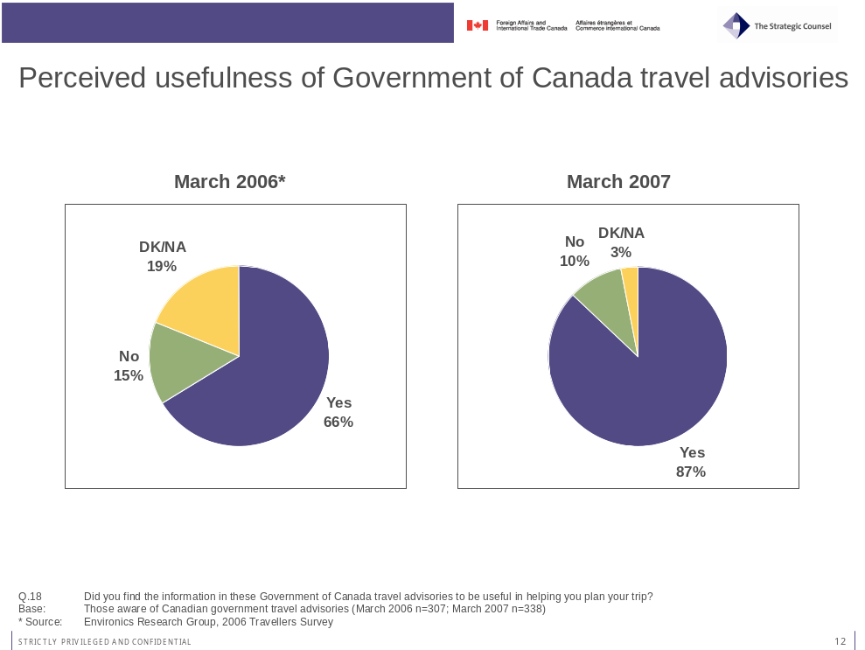
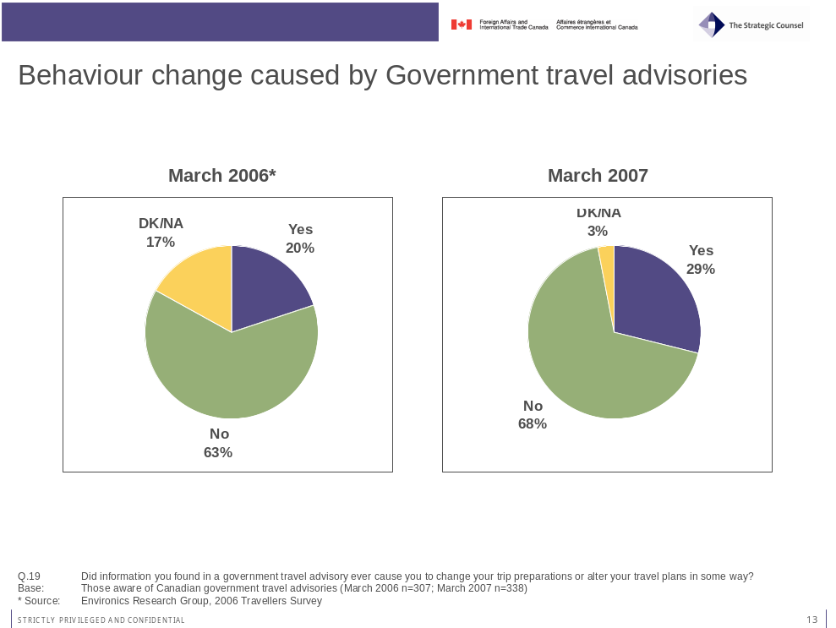

Awareness and Usage of Government of Canada as an Information Source

General information from the Government of Canada
A majority of travellers (59%) say that they know where to find Canadian Government information on international travel. This proportion is slightly higher among those who are born in Canada (61%) compared to those who are born outside of Canada (52%). While frequency of travel was a key factor in explaining awareness levels in 2006, this variable has minimal impact in 2007, with those having made 0 to 2 trips in the past five years (59%) being just as likely as those who have travelled 3 to 5 times (55%) and 6 times or more (63%) to be aware of the information available from the Government of Canada.
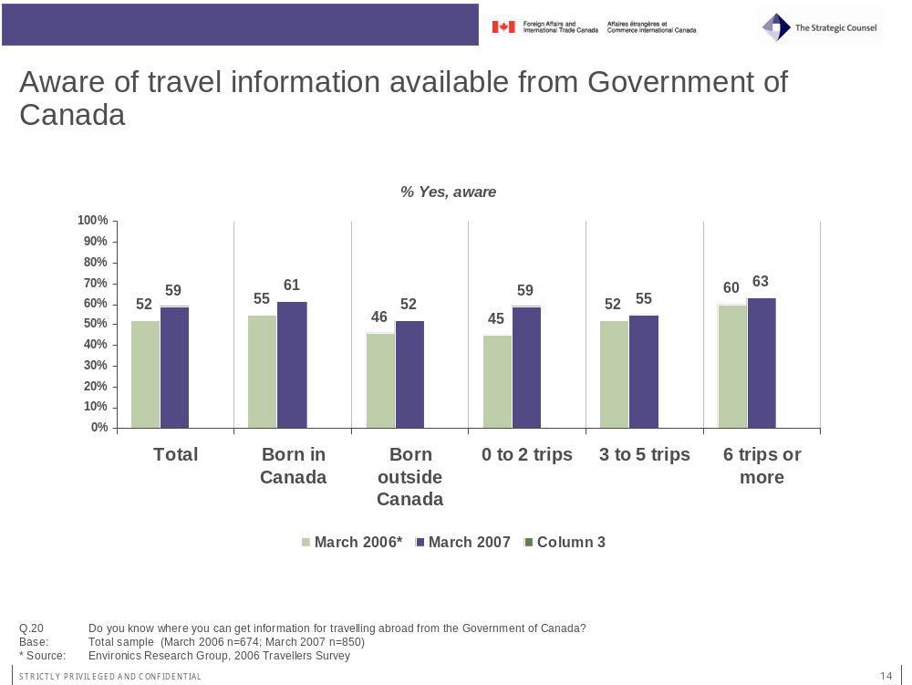

Awareness and Usage of Government of Canada as an Information Source
Of those who report knowing where to find government information, nearly three-quarters (71%) of respondents state that they have obtained information from the Government of Canada over the past five years. This number is once again slightly higher than in 2006, when 64 per cent of respondents said the same.
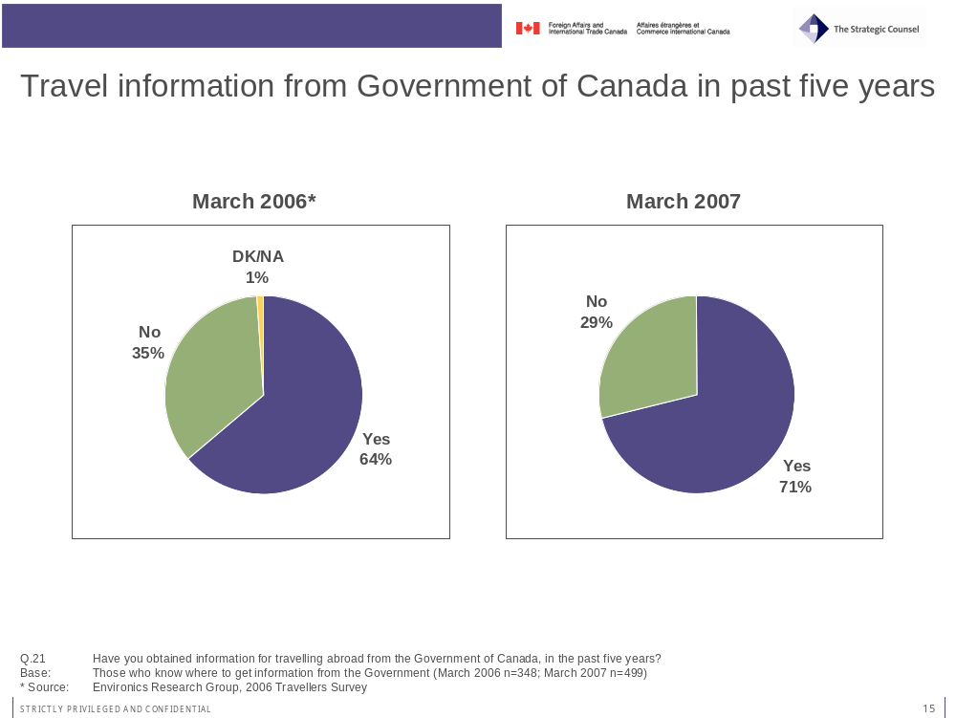
The internet once again far outweighs all other sources for information sought and found from the Government of Canada. More than nine-in-ten (92%) listed the internet as their source of governmental information, with 46 per cent listing the Government of Canada web site as their source, compared to 10 per cent specifically naming the Consular Affairs web site and 5 percent saying www.voyage.gc.ca. Other offline sources listed included passport offices (10%), travel agents (6%) and other types of government offices (8%).
Results to a question asking respondents who have obtained information from the Government of Canada whether they found it easy or difficult to find this information are very positive. Two-thirds (66%) of respondents said that they found it very easy to find the information, compared to 29 per cent who found it somewhat easy and only 4 per cent finding it either somewhat (3%) or very (1%) difficult.

Awareness and Usage of Government of Canada as an Information Source

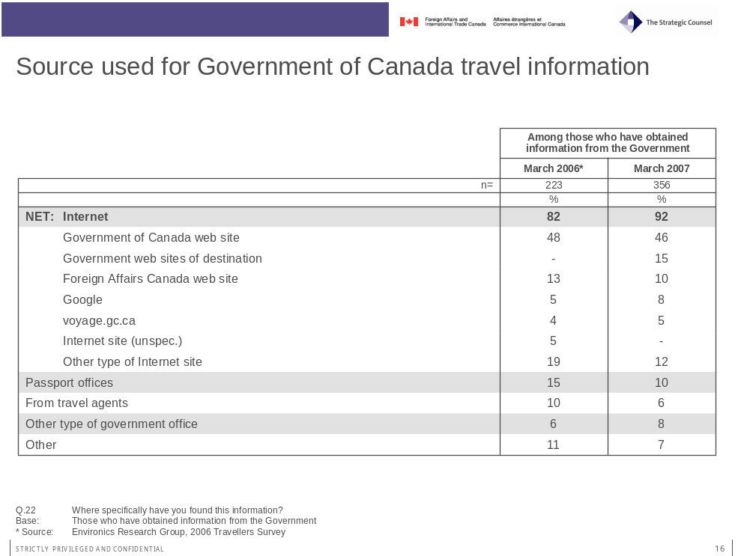
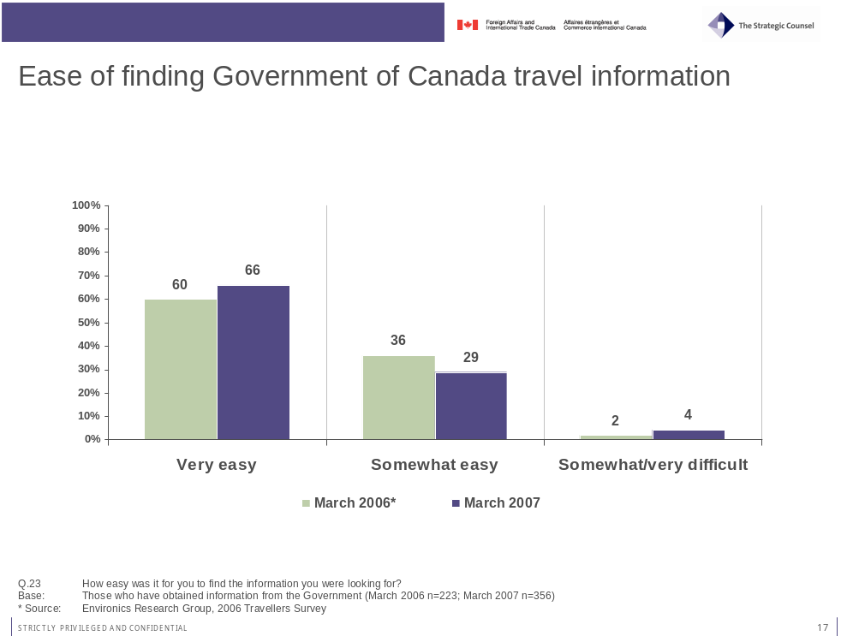

- Views on Consular Affairs’ Web Site and Bon Voyage, But… Booklet

Views on Consular Affairs’ Web Site and Bon Voyage, But… Booklet

Consular Affairs’ Web Site – voyage.gc.ca
Slightly less than one-in-five respondents (19%) report being familiar with the Consular Affairs Bureau web site, in line with 2006 results (17%). Travellers who stated they were travelling both for personal and business matters (32%) are more likely than others to report being familiar with the web site.

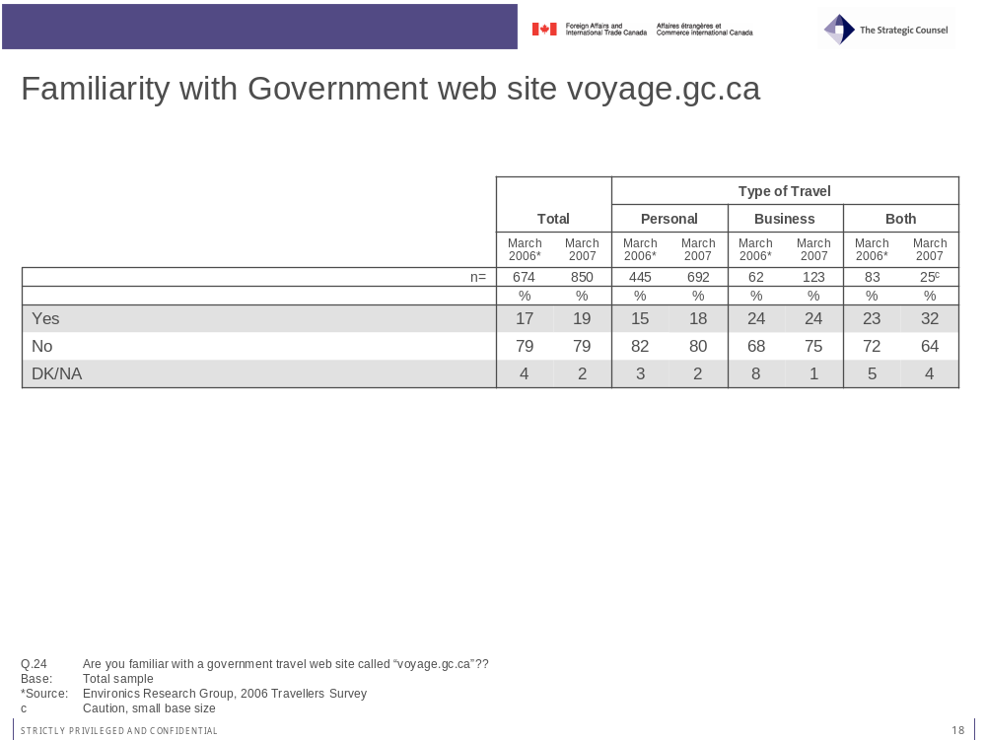
The vast majority (89%) of those who are familiar with the web site say that it is either very (55%) or somewhat useful (35%). Only 1 per cent believes that the web site is not very useful, while another 6 per cent did not provide a ranking because they have not used the site.
Not one particular item stands out as the most useful aspect of the web site. Approximately one-fifth of respondents listed information on security measures (20%), the vast amount of information (19%), the up-to-date information (18%), the accessibility of the site (18%) and the presence of travel advisories (17%) as the site’s most useful aspects.

Views on Consular Affairs’ Web Site and Bon Voyage, But… Booklet

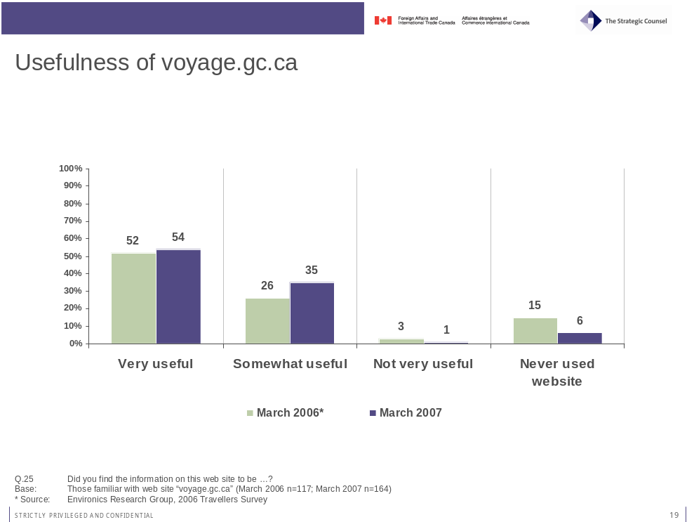
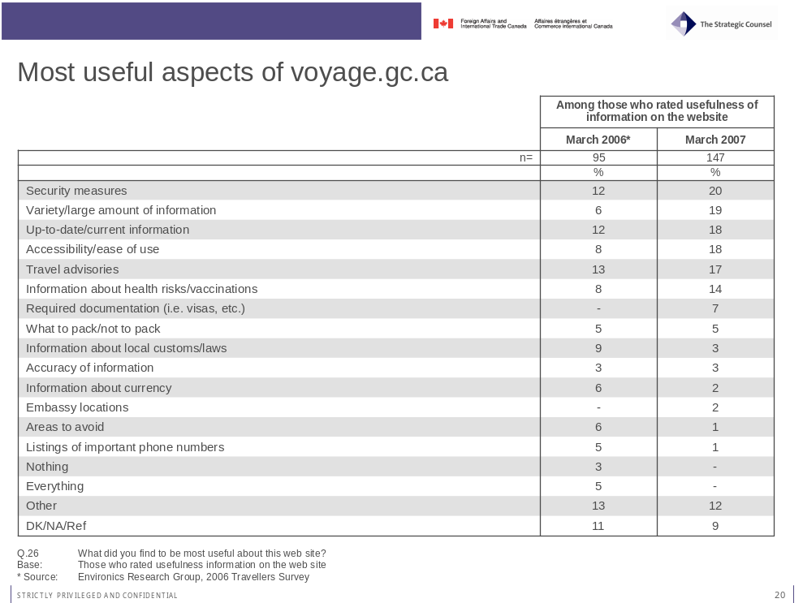

Views on Consular Affairs’ Web Site and Bon Voyage, But… Booklet

Bon Voyage, But… Booklet
More than a third (36%) of travellers interviewed reported being familiar with the brochure Bon Voyage, But…, published by the Consular Affairs Bureau. Adding this percentage to the proportion (10%) of those who did not recall the name at first but recognised the brochure when it was shown to them, nearly half (46%) of all travellers reported being familiar with Bon Voyage, But…
Awareness of the brochure clearly increased with age. About three-in-ten respondents aged 18 to 34 (28%) or 34 to 54 (33%) said they had seen the brochure before, while a full 45 per cent of those aged 55 years and older reported having seen the brochure before. Women (40%) were also more likely to have seen the brochure compared with men (32%), while a greater proportion of respondents born in Canada (40%) have seen the brochure compared with those born outside of Canada (27%). Frequent travellers were also slightly more likely to have seen the brochure.

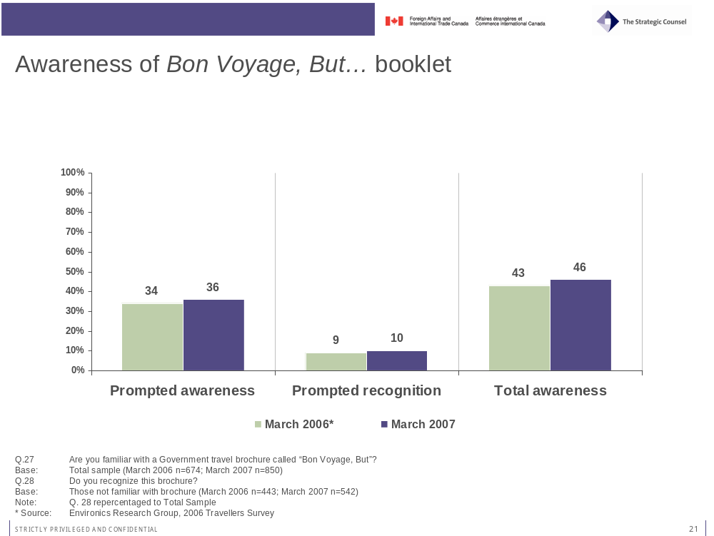

Views on Consular Affairs’ Web Site and Bon Voyage, But… Booklet
Of those who were aware of the brochure, 45 per cent say they found the content very useful, compared to 23 per cent who stated that it is somewhat useful. As was the case for the web site, only 3 per cent of those who responded did not find the information contained in it to be useful. Slightly more than a quarter (28%) of those who were familiar declined to answer because they had not read the brochure before.
Views on usefulness are affected by age, as respondents aged 35 to 54 years of age (46%) and 55 years and older (48%) are more likely to find the information very useful than respondents aged 18 to 34 years (34%).

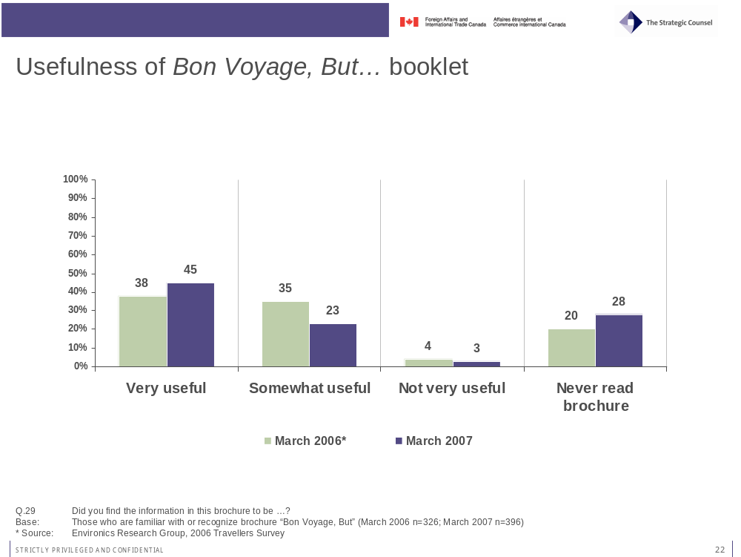

Participants were divided in their assessment regarding the most useful aspects of the brochure, with no single aspects gathering more than 15 per cent of answers. Information about health risks or health tips (15%), duty-free/custom allowances (14%), safety tips (13%), information on vaccinations (11%), locations of Canadian embassies or consulates (10%) and preparation/travel tips (10%) were the most common answers.

Views on Consular Affairs’ Web Site and Bon Voyage, But… Booklet

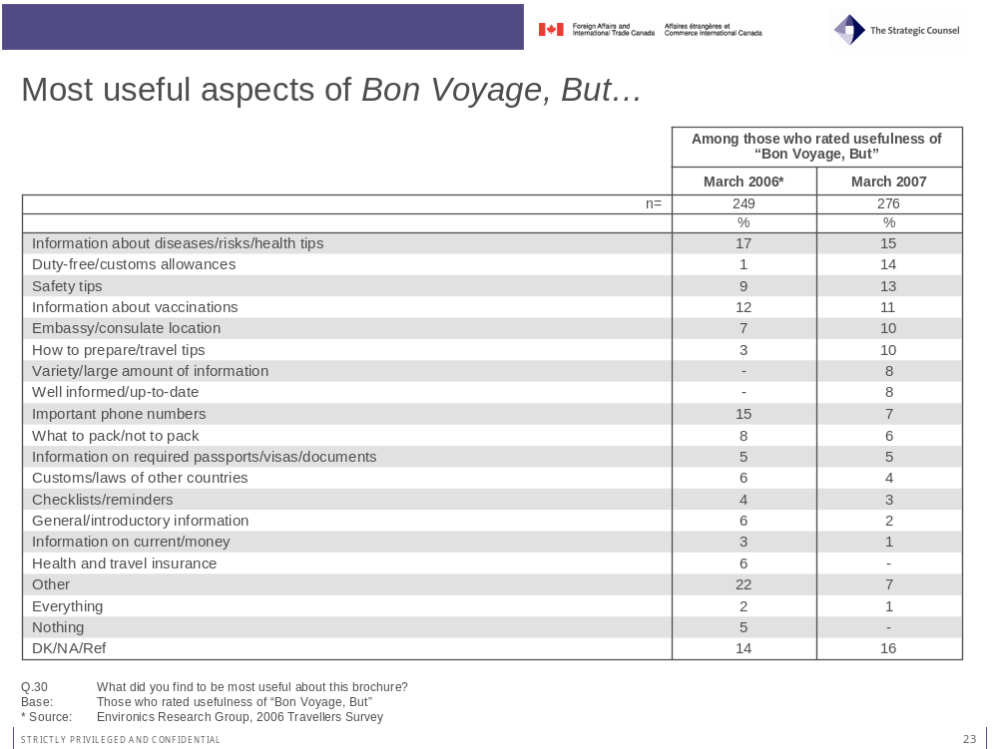

- Roles and Responsibilities when Abroad

Roles and Responsibilities when Abroad

Individual Steps Taken in Case of Trouble Abroad
The vast majority of travellers said they would make use of Government of Canada resources if they encountered trouble when travelling abroad. Three-in-four respondents (74%) said that they would contact the Canadian embassy in the country of destination, with another 36 per cent indicating they would contact the Canadian consulate. By contrast, only 18 per cent would contact the local police, 12 per cent would contact local friends or family and 9 per cent would call home.
Language appears to affect views on typical steps to take in case of emergency when abroad. While Francophone respondents are no less likely to contact the Canadian Government, they are less inclined to say they would contact the local police (9%), friends or family living there (4%) or call home (1%).

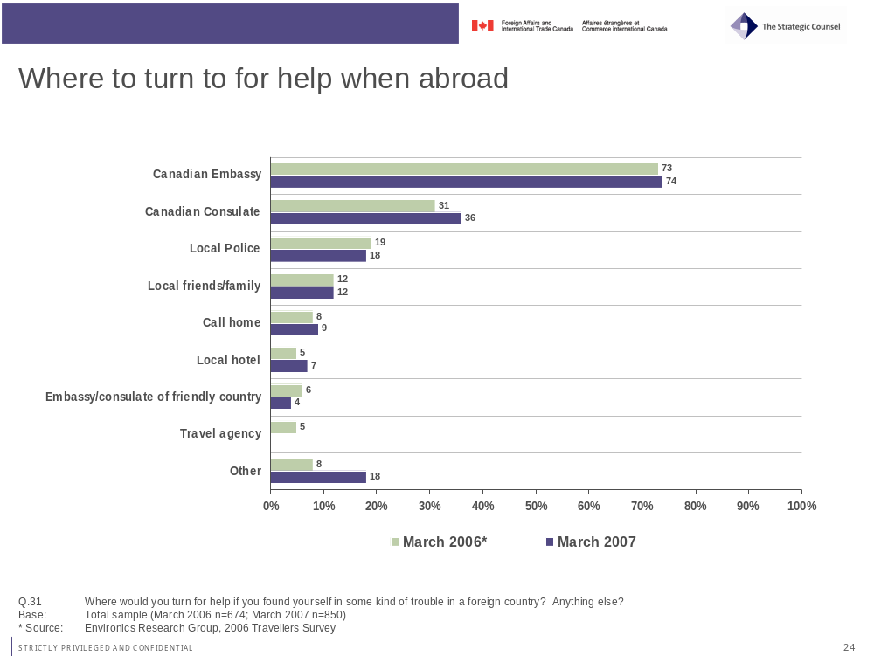

Roles and Responsibilities when Abroad

Perceived Role of the Canadian Government
The most important role of the Canadian Government for Canadian travellers who need help in a foreign country is seen to be the provision of a new passport in case of loss (50%). One-third (31%) of respondents also see the government as a source of assistance in case of natural or civil disaster. Help in case of detention by foreign authorities (20%) and providing information about local country (20%) are also seen as important roles. There was a notable shift in responses from 2006 to 2007 regarding natural or civil disasters as well as arrest by local authorities. Assistance in case of disaster is more important than help in case of arrest by foreign authorities in 2007, while the opposite was true in 2006. Once more, the Lebanese crisis may explain part of this shift in opinion.
There is once again a significant variation by language in answers to this question. Francophone respondents appear to expect much less from the Government of Canada than their Anglophone counterparts. Not only do many fewer French respondents name each possible area of assistance, but they are also much less likely to provide any answer to this question, with nearly half of them (48%) saying they did not know or refused to answer. More of the responses from Francophone respondents were also listed as “other” because they could not be grouped into larger categories.
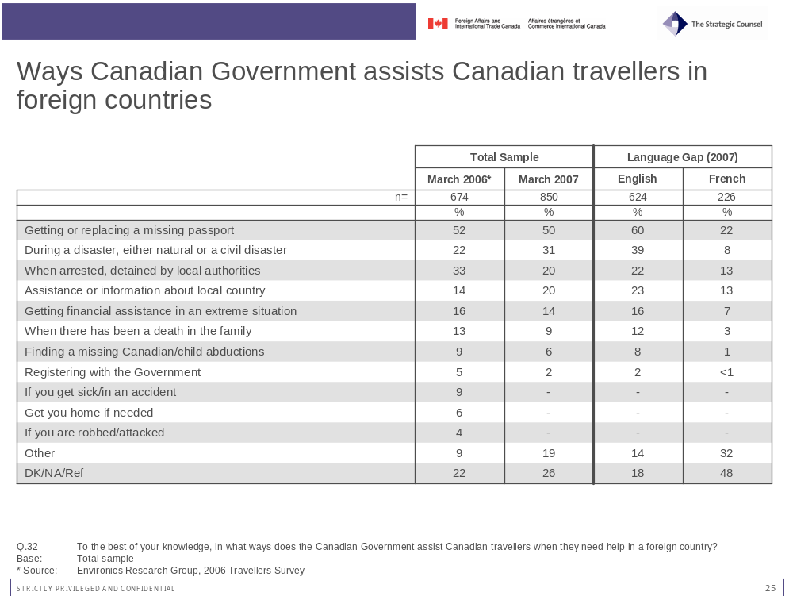

Roles and Responsibilities when Abroad
A shift in opinion from 2006 to 2007 can also be found with regards to views on limiting Canadian Government assistance to Canadians abroad. For most items listed, the proportion of travellers who do not believe that limits should be imposed increased substantially from 2006 to 2007. This increase is surprisingly not fuelled by a large decrease in those who believe that limits should be imposed, but is the result of a large decrease among those who were ambivalent about imposing limits. In fact, the proportions of those who said there should be limits imposed have also increased for all items. Opinions are therefore much more polarised in 2007 when compared to 2006.

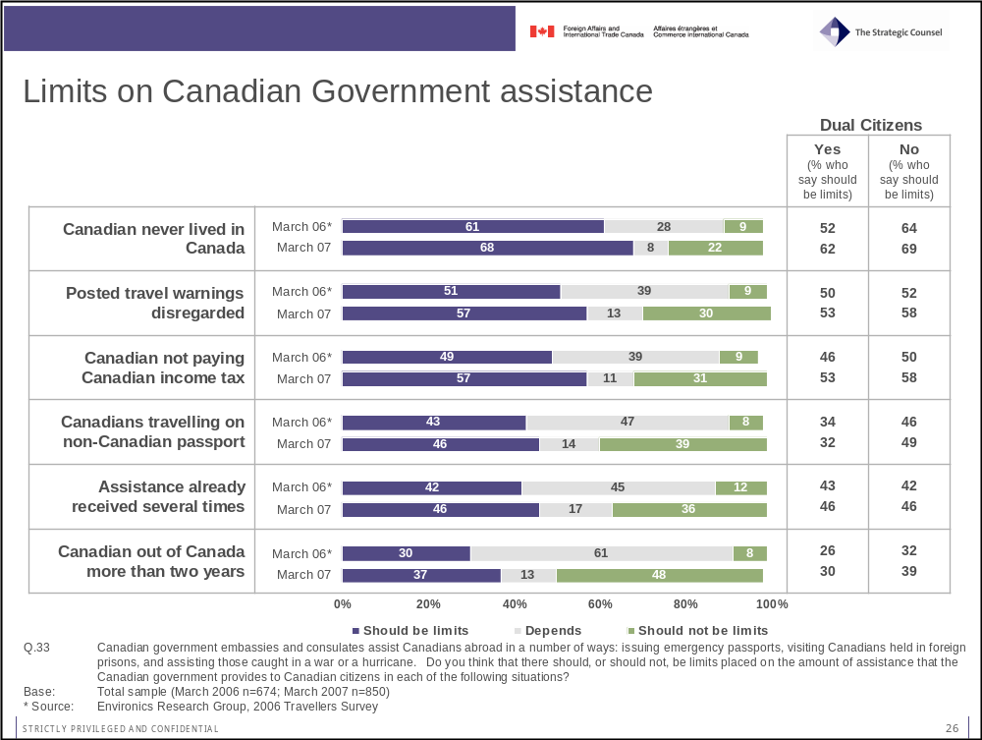
For example, the proportion of those who stated that there should be no limits on assistance provided to Canadians who have been out of Canada for more than two years rose by 40 percentage points between 2006 and 2007 (from 8 per cent to 48 per cent), while the proportion of those who said that limits should be imposed also rose, albeit only by 7 percentage points (from 30 per cent to 37 per cent). The percentage of those who said that “it depends” decreased by no less than 48 per cent (61 per cent to only 13 per cent). Similar trends can be seen for all items.

Roles and Responsibilities when Abroad
Results also show that this increase in the proportion of those who believe that limits on Government of Canada assistance should be imposed is visible among dual citizens and single citizens alike, although the trend is more evident among the latter. Nonetheless, dual citizens remain generally less favourable towards imposing limits.
Interestingly, this polarisation of views on whether to impose limits on the assistance provided by the Canadian Government is not reflected in answers to a similar question on whether the government should be responsible for helping dual citizens when they are traveling to other countries. Answers to this question are very similar for both 2006 and 2007, with a solid majority for both years believing that the government should provide assistance.
Canadian travellers holding dual citizenship (66%) are more likely to think that the Government of Canada does have a responsibility to assist dual citizens when abroad than Canadian travellers holding a single citizenship (54%).
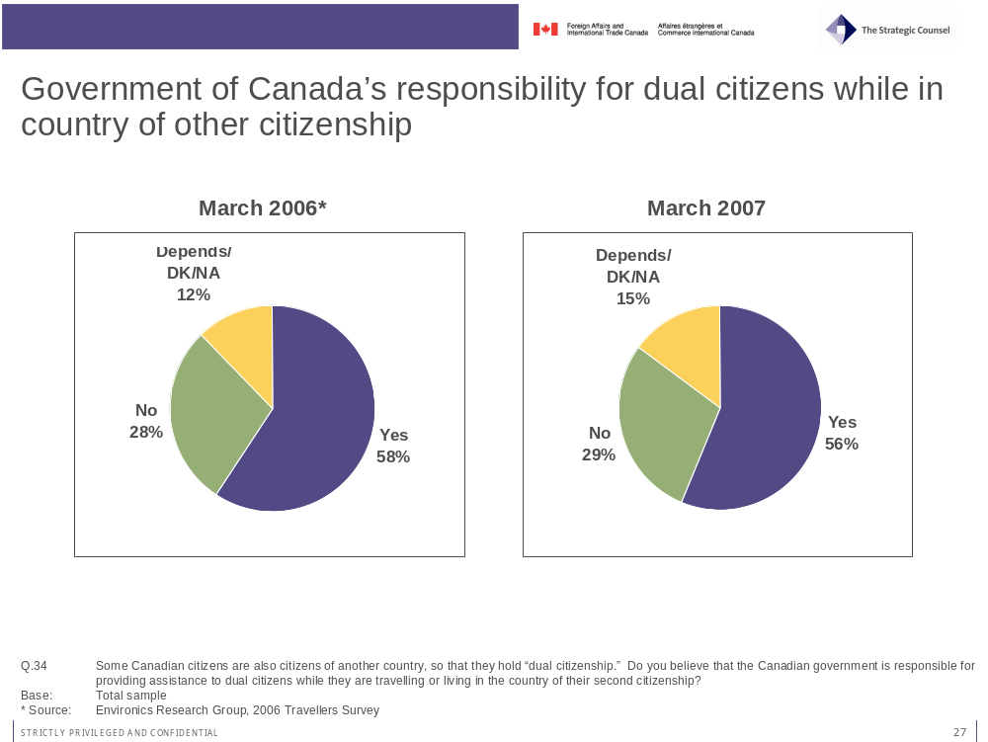

- Respondents’ Profile

Respondents’ Profile

Travel Profile
Survey respondents are mainly visiting three areas for their current trip, namely Western Europe (35%), Mexico/Caribbean/Cuba (26%) and Northern Asia (22%). No other destination was mentioned by more than 6 per cent of travellers. These results are similar to those obtained for the 2006 survey, with the one obvious difference being the proportion of people visiting Mexico/Caribbean/Cuba, which is nearly three times larger in 2007 when compared to 2006.

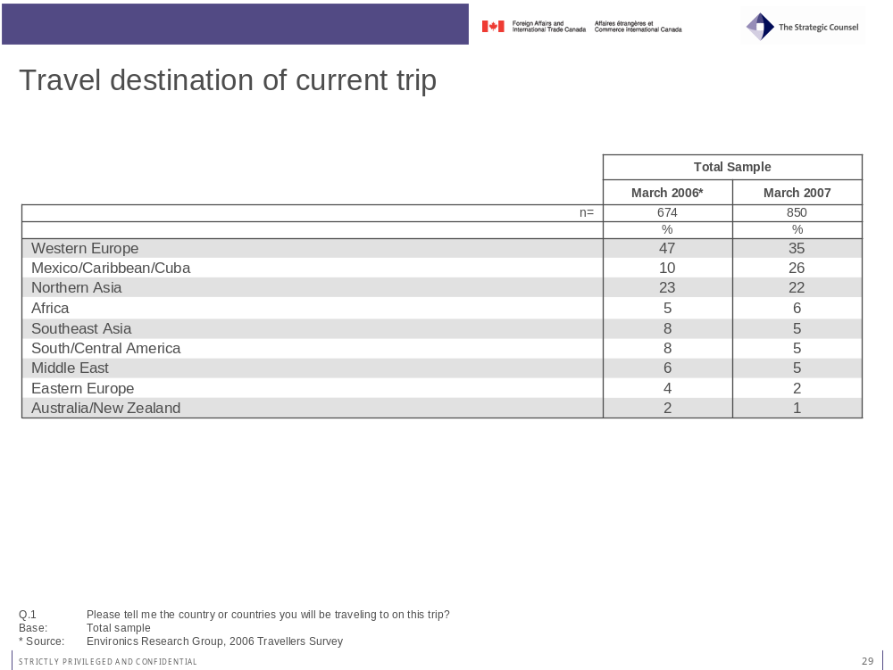

Participants’ travel destinations over the past 5 years are very similar for both years and show that Canadian travellers visit a wide array of countries or continents. The rank order of destinations is exactly the same from 2006 to 2007, but respondents from this year’s survey have seemingly visited more destinations during their trips. The most common destination is the United States (65%), followed by Western Europe (55%), Mexico/Caribbean/Cuba (44%) and South/Central America (33%). Asia is also a common destination, with one-in-four (25%) respondents having visited Northern Asia in the pas 5 years and one-in-five (19%) having visited Southeast Asia.

Respondents’ Profile

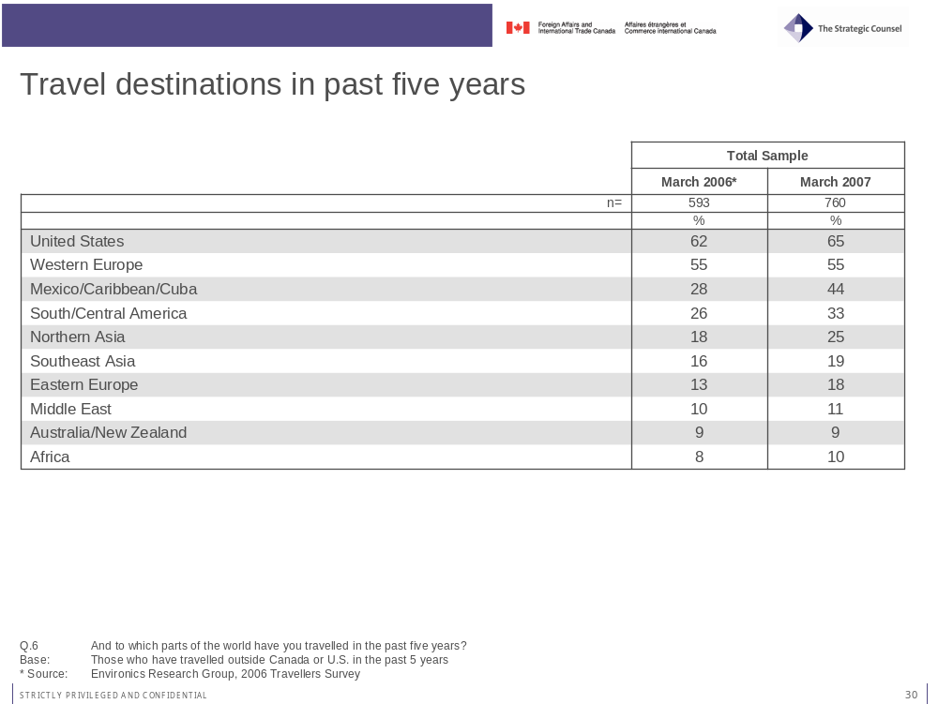

When asked how many time they have travelled outside of Canada and the United States over the past 5 years, respondents once again gave very similar answers to what was found in 2006. Two-thirds (68%) of respondents report having travelled more than 3 times over the past 5 years, closely matching results from 2006 (63%). However, a higher percentage of respondents to this year’s survey have travelled 6 times or more (36%) compared to last year (26%). This result partly explains why more destinations outside of the United States have been visited in 2007.

Respondents’ Profile

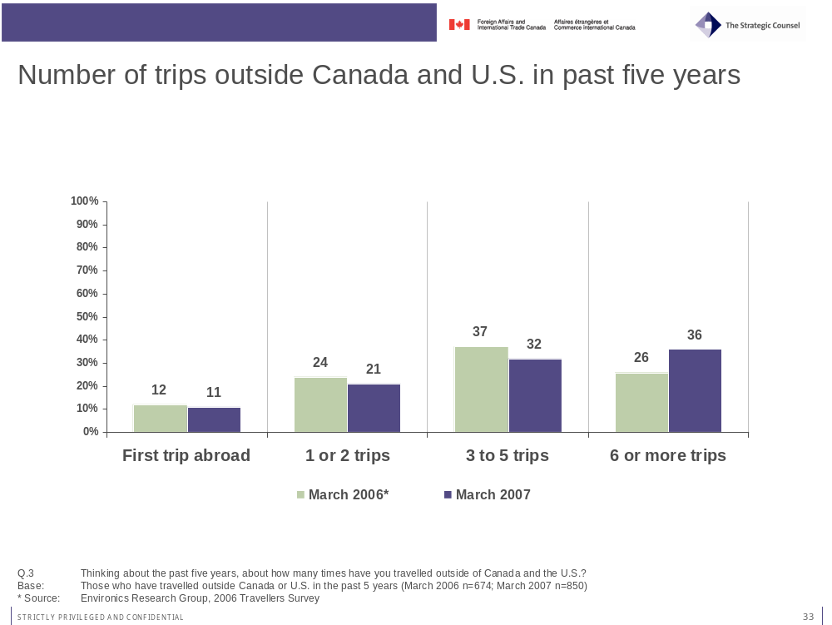

In terms of the typical length of their trips abroad, respondents to the 2007 survey report travelling for slightly shorter periods of time compared to respondent in 2006. Nevertheless, the breakdown of answers is relatively similar, with approximately one-third of respondents travelling 1 to 10 days (37%), 11 to 20 days (34%) and 21 days and above (29%).
The general purpose of travels is almost identical from year to the next. The vast majority (75%) say they travel mainly for personal matters, compared to only 11 per cent saying they travel mostly for business and 13 per cent stating that they travel for both business and pleasure.

Respondents’ Profile

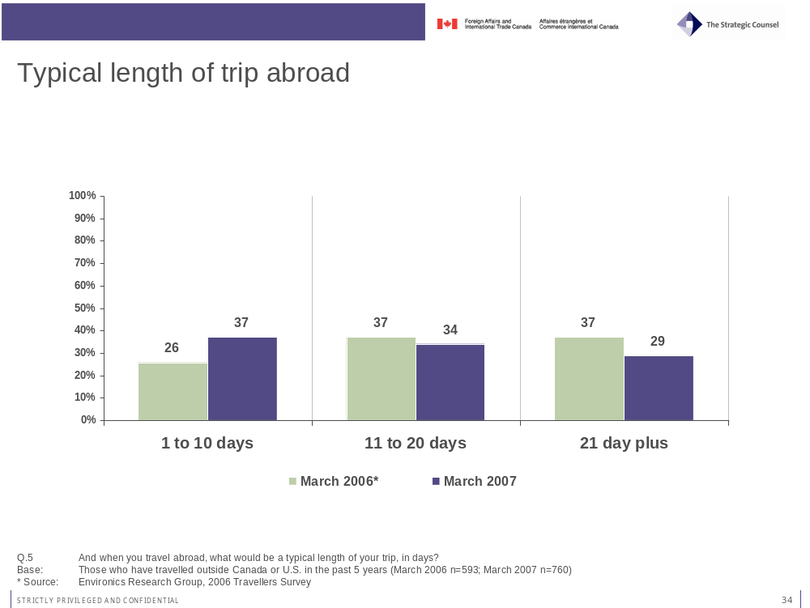
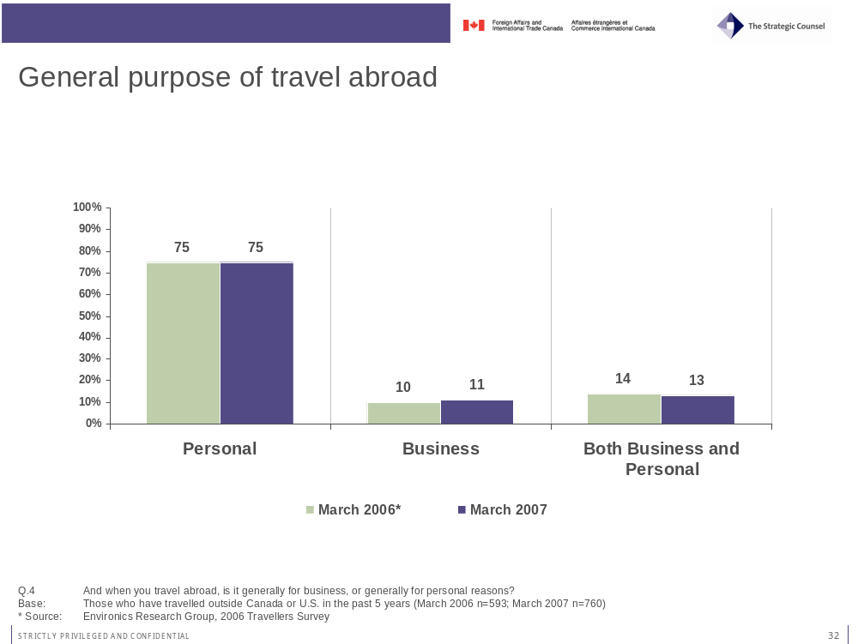

Respondents’ Profile
Results concerning the purpose of the current trip mirror those of the previous question on the typical purpose of travel. Eight-in-ten (81%) respondents say their current trip is for personal matters, while 15 per cent say it is for business and another 4 per cent state that they are travelling for both business and personal reasons.

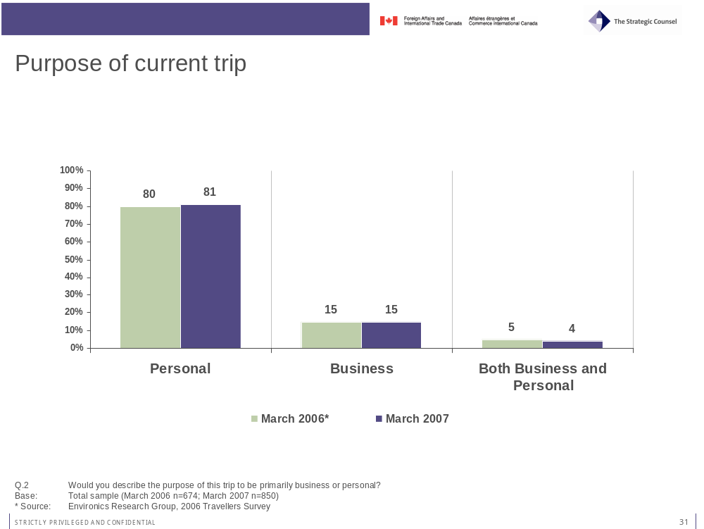

Demographic Profile
The demographic breakdown of respondents closely matches the typical profile of Canadian travellers and the Canadian adult population in general. The language split for 2007 is identical to that of 2006, while the gender balance is more appropriate in 2007, with a slightly larger proportion of women taking part in the survey compared to men.

Respondents’ Profile

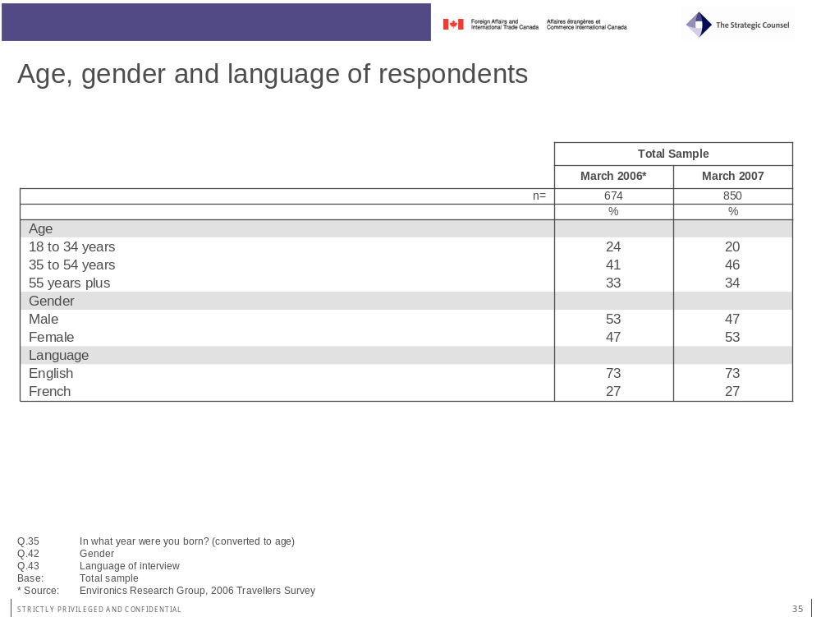
Regional representation is on the other hand skewed in favour of the three provinces where the airports are located, although a fair number of travellers from Alberta were interviewed at the Vancouver airport. The results for 2007 mirror those of 2006.
Nearly all respondents (96%) report being current residents of Canada, while nearly three-quarters (73%) say they were born in Canada. The latter proportion is larger than in 2006, when less then two-thirds (62%) of respondents reported being born in Canada.

Respondents’ Profile

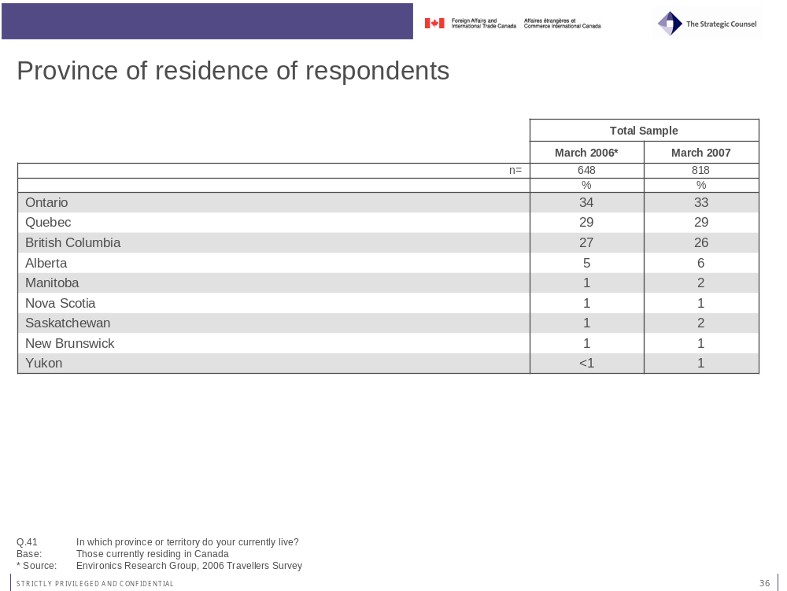
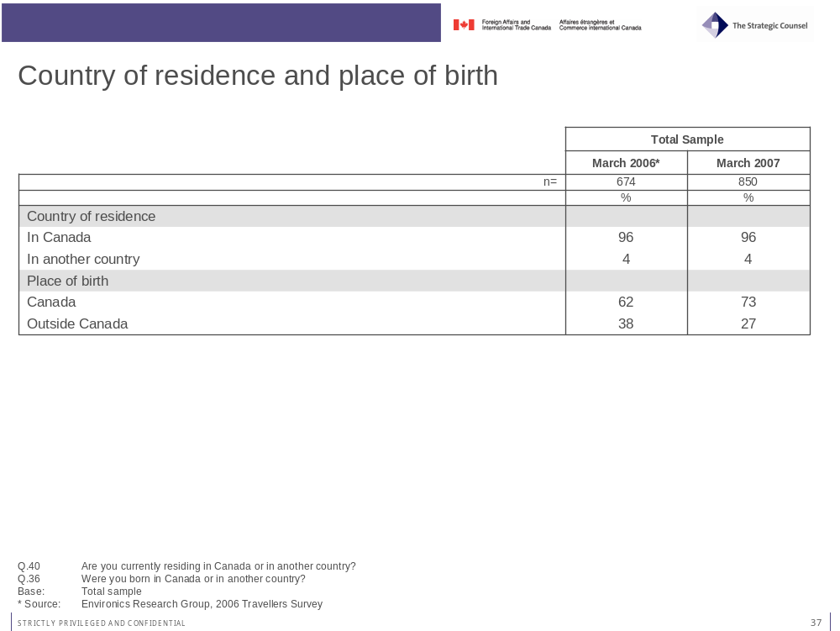

Respondents’ Profile
One-in-five (20%) respondents to this year’s survey report being dual citizens. This is down from 27 per cent in 2006. As was the case in 2006, the majority of them are also citizens of either a Western European (43%) or Northern Asian (18%) country.

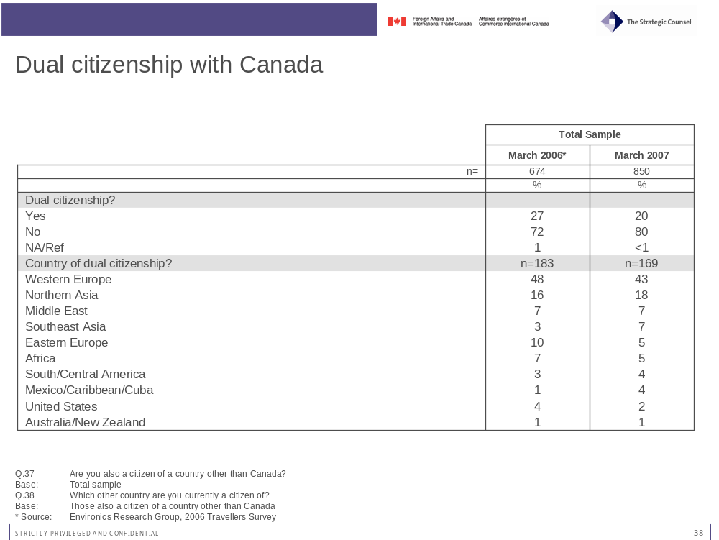

- Areas for Improvement

Areas for Improvement

Promoting the Planning Message: Relevance, Simplicity and Convenience
Results of the survey for both 2006 and 2007 highlight a paradoxical fact. One the one hand, Canadian travellers report taking most of the important steps in planning their international travels on a prompted basis and a large majority (64%) believe it is important to be prepared ahead of time. On the other hand, much smaller proportions cite most of these preparatory steps on an un-prompted basis. The juxtaposition of these seemingly contradictory approaches to planning indicates that while travellers will take many important steps before they go abroad, they do not have a systematic approach to planning. Considering that one of the key messages promoted by the Consular Affairs Bureau is the importance of planning ahead of time, this lack of top-of-mind awareness is an area of concern.
The qualitative phase of research completed before the conduct of this survey demonstrated that tools such as the “Travellers’ Checklist” contained in the Bon Voyage, But… brochure are appreciated by travellers because they allow them to plan their trips properly and without stress. Research experience tells us that many people do not typically take the time to read complex material unless they are highly motivated. However, they will pay attention to relevant, simple reminders that are placed in convenient areas.
Increasing the visibility and availability of practical tools such as the checklist could improve planning habits among travellers. A broader outreach or partnership program should be considered to extend the reach of this key travel planning tool placing it prominently in the Bon Voyage, But… brochure. Obvious partners include travel agencies, associations and clubs, key online travel web sites and retail outlets selling luggage and other travel-related items. This stand alone checklist could contain a link directing travellers to additional information on the elements listed, or a phone number to be called for further details. Other collateral marketing materials referencing the checklist and the Bon Boyage, But … brochure could include items such as luggage tags, stickers, fridge magnets, and business cards. Given that so much scheduling is now undertaken online using scheduling assistant software such as Microsoft Outlook or Lotus Notes, it may be worth considering developing an online interactive checklist that is compatible with these platforms in much the same way that “to-do” lists are integrated into these types of programs.

Merging the Gap between Credibility and Accessibility
Travel information on safety and security issues emanating from the Government of Canada is seen as highly credible by most Canadian travellers, ranking higher than any other source in this respect. However, information from the Government of Canada is not used by many travellers. Issues raised during the qualitative portion of the research program and answers to the survey indicate that Canadian travellers tend to use sources that they consider more accessible or easy to use, mainly on the internet.

Areas for Improvement
This tendency to overlook Government of Canada sources for travel information and the perception that it is not as accessible as other sources extends to all spheres of government. Other research has underscored the difficulties faced by those attempting to access information from the Government of Canada either via online or offline channels. In particular, comments from qualitative research of Government of Canada service delivery and on the functionality of Government of Canada web sites consistently suggest concerns over the unwieldy search engine which is described as imprecise and yields a large volume of information which is difficult to sort and/or prioritize.
Addressing this situation is a difficult task that will require a sustained communication effort aimed at promoting the information available from the government and generating word-of-mouth advertising. Considering the prominence of online information sources for Canadian travellers, it may be advisable to promote the “new and improved” features of the Consular Affairs’ web site using multiple channels such as travel agencies’ web sites, travel information web sites, general advertising campaigns, and other marketing collateral. The objective is to promote awareness, turn awareness into behaviour and consequently create the habit of visiting the site prior to travelling. While most internet users are now very adept at using a multitude of online tools, research consistently shows a certain degree of loyalty to specific sites based on a sense of comfort. The key is to have users bookmark the site so that they return to it frequently.

- Survey Questionnaire

Survey Questionnaire

English version

Foreign Affairs Canada – Consular Services
2007 Public Outreach Tools Evaluation - Traveller Survey

Final Questionnaire

Introduction

Good afternoon/evening. My name is _______________ from The Strategic Counsel, a national research firm. We are currently conducting a survey of Canadian travellers for the Government of Canada, and I’d like to ask you a few questions. This survey is registered with the National Survey Registration System.

IF ASKED: The survey will take about 15 minutes, depending on your answers to some of the questions.

IF ASKED: I can tell you a bit more about the background of this study at the end of the survey

IF ASKED: The registration system has been created by the Canadian survey research industry to allow the public to verify that a survey is legitimate, get information about the survey industry or register a complaint. The registration systems toll-free telephone number is 1-800-554-9996.

A. Are you currently a Canadian citizen?

1 – Yes CONTINUE
2 – No THANK AND TERMINATE

CONFIRM WHETHER RESPONDENT WOULD LIKE TO BE INTERVIEWED IN ENGLISH OR FRENCH

A. Respondent Selection

Before we begin, I’d just like to ask you a few questions to make sure you qualify to be interviewed for this study . . .

1. Please tell me the country or countries you will be travelling to on this trip?
RECORD ALL COUNTRIES – UP TO A MAXIMUM OF 3

1. _________________________________
2. _________________________________
3. _________________________________

2. Would you describe the purpose of this trip to be primarily business or personal?

1 – Business
2 – Personal (includes vacation or visiting friends or family)
VOLUNTEERED/DO NOT READ
3 – Both business and personal
8 – Other (SPECIFY) _____________________________________________
9 – DK/NA/Ref

IF MEETS CRITERIA/QUOTAS, CONTINUE: OTHERWISE THANK AND TERMINATE

B. General Travel Pattern and Preparation

I would now like to ask you about the type of preparations you typically make when planning to travel abroad, that is outside of Canada and the U.S. Please answer the following questions based on your travel experiences over the past five years.

3. Thinking about the past five years, about how many times have you travelled outside of Canada and the U.S.?
RECORD NUMBER OF TRIPS – ACCEPT ESTIMATE

_______ Number of trips
98 – This is first trip abroad SKIP TO Q.7
99 – DK/NA/Ref (DO NOT READ)

4. And when you travel abroad, is it generally for business, or generally for personal reasons?

1 – Business
2 – Personal (includes vacation, visiting friends/family)
VOLUNTEERED/DO NOT READ
3 – Both business and personal equally
8 – Other (SPECIFY) _____________________________________________) 99 – DK/NA/Ref

5. And when you travel abroad, what would be a typical length of your trip, in days?
RECORD NUMBER OF DAYS – ACCEPT ESTIMATE

_____ Number of days
99 – DK/NA/Ref (DO NOT READ)

6. And to which parts of the world have you travelled in the past 5 years?
CODE ALL THAT APPLY

1 – United States
2 – Mexico
2 – Western Europe
3 – Eastern Europe
4 – Northern Asia (China, Japan)
5 – Southeast Asia (India, Philippines, Vietnam, Indonesia)
6 – Middle East (including Egypt, Israel)
7 – Australia/New Zealand
8 – Africa
9 – South/Central America
98 – Other (SPECIFY ____________________________________________)
99 – DK/NA/Ref

7. What steps do you normally take to prepare for a trip abroad to a country or region that you are unfamiliar with?
DO NOT READ – CODE ALL THAT APPLY; PROBE: Anything else?

1 – Accommodations, attractions, weather (non-security/safety information)
2 – Get information about new country/countries
3 – Check travel advisories
4 – Get new passport/renew passport
5 – Check into required visas/entry requirements
6 – Check into necessary health steps (vaccinations)
7 – Arrange health and/or travel insurance
8 – Check into arrangements for local currency/access to ATMs
9 – Register with Canadian government office abroad
98 – Other (SPECIFY) ____________________________________________
VOLUNTEERED/DO NOT READ
97 – Nothing
99 – DK/NA/Ref
8. When preparing for a trip abroad, please tell me if you take each of the following steps regularly, occasionally, rarely or never?
READ IN RANDOM ORDER

VOLUNTEERED/
DO NOT READ
 | Regularly | Occasionally | Rarely | Never | Depends – different every trip | NA to travel or destinations | DK/NA/Ref
a. Get travel report information on your country of destination | 1 | 2 | 3 | 4 | 5 | 6 | 99
b. Obtain or ensure you have health insurance coverage | 1 | 2 | 3 | 4 | 5 | 6 | 99
c. Obtain or ensure you have travel insurance coverage | 1 | 2 | 3 | 4 | 5 | 6 | 99
d. Check to make sure your passport is current for the travel period | 1 | 2 | 3 | 4 | 5 | 6 | 99
e. Check visa or entry requirements for countries to be visited | 1 | 2 | 3 | 4 | 5 | 6 | 99
f. Check into the need for health vaccinations | 1 | 2 | 3 | 4 | 5 | 6 | 99
g. Register with the Canadian Government to let them know where you will be travelling | 1 | 2 | 3 | 4 | 5 | 6 | 99
h. Get information about local currency and options for getting cash | 1 | 2 | 3 | 4 | 5 | 6 | 99
i. Prepare documentation for travelling with children (e.g. consent letter) | 1 | 2 | 3 | 4 | 5 | 6 | 99
j. Leave a copy of your travel itinerary with someone at home | 1 | 2 | 3 | 4 | 5 | 6 | 99

9. People have different approaches to planning for a major trip to a new destination abroad. Some believe it is important to plan for every potential situation and be as prepared as possible. Other people believe it is impossible to anticipate every possible problem and would rather deal with situations as they arise.

Which of these two approaches is closer to your own?

1 – Important to be prepared
2 – Better to deal with situations as they arise
VOLUNTEERED/DO NOT READ
3 – Neither/Both/Depends
99 – DK/NA/Ref

C. Sources of Travel Information

10. What would you consider to be the best source of information on new countries you might travel to?
DO NOT READ – CODE ALL THAT APPLY: PROBE: Anything else?

1 – Internet (PROBE FOR TYPE OF SITE)

2 – Travel books (e.g. Fodors, Lonely Planet)
3 – Friends and family who have been there
4 – Friends and family who live there
5 – Canadian Government
6 – Government of destination countries
98 – Other (SPECIFY) _____________________________________________
97 – None
99 – DK/NA/Ref

11. Where would you be most likely to go to get information about safety and security issues when preparing to travel abroad to someplace you are unfamiliar with?
DO NOT READ – CODE FIRST AND OTHER MENTIONS

1 – Internet (PROBE FOR TYPE OF SITE)

2 – Travel books (e.g. Fodors, Lonely Planet)
3 – Friends and family who have been there
4 – Friends and family who live there
5 – Canadian Government
6 – Government of destination countries
98 – Other (SPECIFY __________________________________________)
97 – None
99 – DK/NA/Ref

12. And why would you say [FIRST MENTION IN Q.11] is the best place to get this kind of information?
RECORD

99 – DK/NA/Ref

13. How much would you trust travel information on safety and security issues from each of the following sources? In each case would you have a great deal of trust, some trust, or little trust?
READ ITEMS IN RANDOM ORDER

 |  |  |  | VOLUNTEERED/ DO NOT READ
 | A great deal of trust | Some trust | Little trust | Depends | DK/NA/Ref
a. The Government of Canada | 1 | 2 | 3 | 97 | 99
b. Published travel guides (books or websites) | 1 | 2 | 3 | 97 | 99
c. The government of the destinations countries | 1 | 2 | 3 | 97 | 99
d. A travel agent | 1 | 2 | 3 | 97 | 99
e. Friends or family members who have visited the countries | 1 | 2 | 3 | 97 | 99

14. Are you aware of “travel advisories” that provide up-to-date information about safety and security issues in connection with travelling to specific countries?

1 – Yes
2 – No SKIP TO Q.17
99 – DK/NA/Ref SKIP TO Q.17

15. (IF YES TO Q.14) Have you checked such travel advisories yourself in preparing for a trip abroad in the past five years?

1 – Yes
2 – No SKIP TO Q.17
99 – DK/NA/Ref SKIP TO Q.17

16. Where have you found these travel advisories; that is, who sponsors them?
DO NOT READ – CODE ALL THAT APPLY

1 – Canadian/Federal government SKIP TO Q.18
2 – U.S. government
3 – Government of destination country
4 – Travel guides
5 – Internet (PROBE FOR SPONSOR OF SITE)_______________________
98 – Other (SPECIFY) ___________________________________________
99 – DK/NA/Ref

17. (ASK IF/DK NO TO Q.14 OR Q.15 OR IF CANADIAN/FEDERAL GOVERNMENT NOT MENTIONED IN Q.16)

Are you familiar with or ever checked travel advisories issued by the Government of Canada?
IF YES, CLARIFY FAMILIAR ONLY, OR FAMILIAR AND USED

1 – Yes – familiar but have not checked
2 – Yes – familiar and have checked
3 – No SKIP TO Q.20
99 – DK/NA/Ref SKIP TO Q.20

18. (IF MENTION CANADIAN GOV’T IN Q.16 OR YES-CHECKED TO Q.17) Did you find the information in these Government of Canada travel advisories to be useful in helping you plan your trip?

1 – Yes
2 – No
99 – DK/NA/Ref

19. Did information you found in a government travel advisory ever cause you to change your trip preparations or alter your travel plans in some way?

1 – Yes
2 – No
99 – DK/NA/Ref

20. Do you know where you can get information for travelling abroad from the Government of Canada?

1 – Yes
2 – No SKIP TO Q.24
99 – DK/NA/Ref SKIP TO Q.24

21. (IF YES TO Q.20) Have you obtained information for travelling abroad from the Government of Canada, in the past five years?

1 – Yes
2 – No SKIP TO Q.24
99 – DK/NA/Ref SKIP TO Q.24

22. (IF YES TO Q.21) Where specifically have you found this information?
DO NOT READ – CODE ALL THAT APPLY

1 – Web/Internet (PROBE FOR SPECIFICS)

2 – Passport offices
3 – Government offices (PROBE FOR SPECIFICS)

4 – Libraries
5 – From travel agents
6 – Post offices
98 – Other (SPECIFY _________________________________________)
99 – DK/NA/Ref

23. How easy was it for you to find the information you were looking for? Was it:

1 – Very easy
2 – Somewhat easy
3 – Somewhat difficult, or
4 – Very difficult
VOLUNTEERED/DO NOT READ
99 – DK/NA/Ref

24. Are you familiar with a government travel website called “Voyage.gc.ca”?

1 – Yes
2 – No SKIP TO Q.27
99 – DK/NA/Ref SKIP TO Q.27

25. (IF YES TO Q.24) Did you find the information on this website to be:

1 – Very useful
2 – Somewhat useful
3 – Not very useful, or
4 – Not at all useful
VOLUNTEERED/DO NOT READ
97 – NEVER USED WEBSITE SKIP TO Q.27
99 – DK/NA/Ref SKIP TO Q.27

26. What did you find to be most useful about this website?
RECORD

97 – Nothing
99 – DK/NA/Ref

27. Are you familiar with a Government travel brochure called “Bon Voyage, But”?

1 – Yes SKIP TO Q.29
2 – No
99 – DK/NA/Ref

28. (IF NO/DK/NA IN Q.27) Do you recognize this brochure?
SHOW COPY OF BROCHURE

1 – Yes
2 – No SKIP TO Q.31
99 – DK/NA/Ref SKIP TO Q.31

29. (IF YES TO Q.27 OR Q.28) Did you find the information in this brochure to be:

01 – Very useful
02 – Somewhat useful
03 – Not very useful, or
04 – Not at all useful
VOLUNTEERED/DO NOT READ
97 – NEVER USED/READ BROCHURE SKIP TO Q.31
99 – DK/NA/Ref SKIP TO Q.31

30. What did you find to be most useful about this brochure?
RECORD

97 – Nothing
99 – DK/NA/Ref

D. Traveller Assistance While Abroad

I would now like to ask you about getting assistance during a trip abroad . . .

31. Where would you turn for help if you found yourself in some kind of trouble in a foreign country?
(IF CLARIFICATION NEEDED: This might involve a situation involving your health, finances, personal safety or a legal issue)
DO NOT READ – CODE ALL THAT APPLY; PROBE: Anything else?

1 – Canadian government (PROBE FOR SPECIFICS)

2 – Canadian Embassy
3 – Canadian Consulate
4 – Local police
5 – Local hotel
6 – Local friends/family
7 – Call home
8 – Embassy/consulate of a friendly country
98 – Other (SPECIFY) __________________________________________
99 – DK/NA/Ref

32. To the best of your knowledge, in what ways does the Canadian Government assist Canadian travellers when they need help in a foreign country?
DO NOT READ – CODE ALL THAT APPLY; PROBE: Anything else?

1 – When arrested, detained by local authorities
2 – Assistance or information about local country or Canada (how extend my visa; what can be brought back to Canada)
3 – Finding a missing Canadian/Child abductions
4 – When there has been a death in the family
5 - During a disaster, either natural (like a hurricane) or a civil disaster (rioting)
6 - Getting financial assistance in an extreme situation
7 – Getting or replacing a missing passport
8 - Registering with the Govt
98 – Other (SPECIFY) ___________________________________________
99 – DK/NA/Ref

33. Canadian government embassies and consulates assist Canadians abroad in a number of ways: issuing emergency passports, visiting Canadians held in foreign prisons, and assisting those caught in a war or a hurricane.

Do you think that there should, or should not, be limits placed on the amount of assistance that the Canadian government provides to Canadian citizens in each of the following situations?
READ IN SEQUENCE

 |  |  | VOLUNTEERED/DO NOT READ
 | Should be limits | Should not be limits | Depends | DK/NA/Ref
a. When Canadians disregard a posted travel warning not to travel to a country considered a high security risk | 1 | 2 | 3 | 99
b. When Canadians have already received Government assistance on a number of prior occasions | 1 | 2 | 3 | 99
c. When Canadians are travelling on a passport other than a Canadian passport | 1 | 2 | 3 | 99
d. When Canadians have not lived in Canada for at least two years | 1 | 2 | 3 | 99
e. When Canadians are not paying Canadian income taxes | 1 | 2 | 3 | 99
f. When Canadians have never actually lived in Canada | 1 | 2 | 3 | 99

34. Some Canadian citizens are also citizens of another country, so that they hold “dual citizenship.” Do you believe that the Canadian government is responsible for providing assistance to dual citizens while they are travelling or living in the country of their second citizenship?

1 – Yes
2 – No
VOLUNTEERED/DO NOT READ
3 – Depends
99 – DK/NA/Ref

E. Respondent Profile

I’d like to finish with a few general questions about yourself to help us analyze the results. Please be assured this information will remain fully confidential . . .

35. In what year were you born?

________ Year
99 – DK/NA/Ref

36. Where you born in Canada, or in another country?

1 – Canada
2 – Another country
99 – DK/NA/Ref

37. Are you also a citizen of a country other than Canada?
CLARIFY IF NECESSARY: That is, are you a dual citizen?

1 – Yes
2 – No SKIP TO Q.39
99 – DK/NA/Ref SKIP TO Q.39

38. (IF YES TO Q.37) Which other country are you currently a citizen of?
RECORD NAME OF COUNTRY

_____________________________
99 – DK/NA/Ref

39. Please tell me what is the highest level of education that you have completed?
CODE ONE ONLY

1 - Some High School
2 - High School Graduate
3 - Some College
4 - Graduated College
5 - Some University
6 - Graduated University
7 - Graduate School
99 – DK/NA/Ref

40. Are you currently residing in Canada or in another country?

1 – In Canada
2 – In another country SKIP TO END
99 – NA/REFUSE SKIP TO END

41. (IF IN CANADA) In which province or territory do you currently live?

1 – Alberta
2 – British Columbia
3 – Manitoba
4 – Newfoundland/Labrador
5 – New Brunswick
6 – Nova Scotia
7 – Ontario
8 – Quebec
9 – Prince Edward Island
10 – Saskatchewan
11 – Northwest Territories
12 – Nunavut
13 – Yukon
99 – DK/NA/Ref

This completes the survey. On behalf of the Consular Services Bureau of Foreign Affairs Canada, thank you for your assistance.

OFFER COPY OF “Bon Voyage, But” Brochure

IFASKED: This survey is being conducted by the Consular Services Bureau to evaluate the effectiveness of the travel information it currently provides to Canadian travellers, and to identify how it might be improved.

RECORD:

42. Gender

01 – Male
02 – Female

43. Language of Interview

01 – English
02 – French

44. Airport

1 – Montreal
2 – Toronto
3 – Vancouver

45. Date of interview

46. Time of interview

47. Interviewer: ID # __________________

French Version

Services consulaires d'Affaires étrangères Canada
Évaluation des outils d’information du public 2007 –
Sondage auprès des voyageurs

Questionnaire final

Introduction

Bonjour/Bonsoir. Mon nom est _______________. Je travaille pour The Strategic Counsel, un cabinet national spécialisé en recherches. Nous effectuons actuellement un sondage auprès des voyageurs canadiens pour le compte du gouvernement du Canada et j'aimerais vous poser quelques questions. Ce sondage est inscrit auprès du Système d’enregistrement des sondages national.

SI ON LE DEMANDE : Répondre au sondage devrait prendre environ 15 minutes de votre temps, selon vos réponses à certaines questions.

SI ON LE DEMANDE : Je peux vous en dire davantage au sujet des antécédents de cette étude à la fin du sondage.

SI ON LE DEMANDE : Ce système d’enregistrement a été conçu par l’industrie canadienne de la recherche par sondages. Par l’entremise de ce système, le public peut s’assurer de la légitimité d’un sondage, obtenir de l’information sur le secteur des études de marché ou déposer une plainte. Le numéro sans frais du Système d'enregistrement des sondages est le 1 800 554-9996.

A. Êtes-vous citoyen canadien?

01 – Oui CONTINUEZ
02 – NON REMERCIEZ LE RÉPONDANT ET TERMINEZ LE SONDAGE

CONFIRMEZ AUPRÈS DU RÉPONDANT S’IL PRÉFÈRE QUE L’ENTREVUE SE DÉROULE EN FRANÇAIS OU EN ANGLAIS

A. Sélection des répondants

Avant de commencer, j’aimerais vous poser quelques questions afin de m’assurer que vous répondiez aux conditions voulues de cette étude.

1. Veuillez m’indiquer quels pays vous visiterez pendant votre voyage?
CONSIGNEZ TOUS LES PAYS – JUSQU’À CONCURRENCE DE TROIS PAYS

1. _________________________________
2. _________________________________
3. _________________________________

2. Diriez-vous que ce voyage est principalement un voyage d’affaires ou un voyage personnel?

1 – Voyage d’affaires
2 – Voyage personnel (y compris des vacances ou une visite chez des amis ou la famille)
DÉCLARE SPONTANÉMENT/NE LISEZ PAS
3 – Autant un voyage d'affaires qu'un voyage personnel
8 – Autre (PRÉCISEZ) _____________________________________________
99 – NRP/REFUS

POURSUIVEZ SI LE RÉPONDANT SATISFAIT AUX CRITÈRES OU À L'ÉCHANTILLONNAGE : SINON REMERCIEZ LE RÉPONDANT ET TERMINEZ LE SONDAGE

B. Structures générales des déplacements et préparation

J'aimerais maintenant vous poser des questions à l'égard du type de préparation que vous faites habituellement lorsque vous planifiez un voyage à l'étranger, c'est-à-dire un voyage à l'extérieur du Canada et des États-Unis. Veuillez répondre aux questions suivantes en vous inspirant de vos expériences de voyage au cours des cinq dernières années.

3. En réfléchissant aux cinq dernières années, combien de fois avez-vous voyagé à l’extérieur du Canada et des États-Unis?
INSCRIVEZ LE NOMBRE DE VOYAGES – ACCEPTEZ LES ESTIMATIONS

_______ Nombre de voyages
98 – Il s’agit de mon premier voyage à l’étranger PASSEZ À LA QUESTION 7
99 – NRP/REFUS (NE LISEZ PAS)

4. Et lorsque vous voyagez à l’étranger, s’agit-il essentiellement de voyages d’affaires ou de voyages personnels?

1 – Voyage d’affaires
2 – Voyage personnel (y compris des vacances ou une visite chez des amis ou la famille)
DÉCLARE SPONTANÉMENT/NE LISEZ PAS
3 – Autant un voyage d'affaires qu'un voyage personnel également
8 – Autre (PRÉCISEZ) _____________________________________________
99 – NRP/REFUS

5. Lorsque vous voyagez à l’étranger, quelle est en moyenne la durée de vos voyages, en nombre de jours?
INSCRIVEZ LE NOMBRE DE JOURS – ACCEPTEZ LES ESTIMATIONS

_______ Nombre de jours
99 – NRP/REFUS (NE LISEZ PAS)

6. Dans quelles régions du monde avez-vous voyagé au cours des cinq dernières années?
ENTREZ TOUTES LES RÉPONSES

1 – États-Unis
2 – Mexique
3 – Europe occidentale
4 – Europe orientale
5 – Asie du Nord (Chine, Japon)
6 – Asie du Sud-Est (Inde, Philippines, Vietnam, Indonésie)
7 – Moyen-Orient (y compris l’Égypte et Israël)
8 – Australie/Nouvelle-Zélande
9 – Afrique
10 – Amérique du Sud/Amérique centrale
98 – Autre (PRÉCISEZ) ____________________________________________
99 – NRP/REFUS

7. Quelles mesures prenez-vous habituellement lorsque vous visitez un pays ou une région à l’étranger que vous ne connaissez pas?
NE LISEZ PAS – ENTREZ TOUTES LES RÉPONSES; DEMANDEZ DES PRÉCISIONS : Y a-t-il autre chose?

1 – Vérifier l’hébergement, les attractions, la météo (renseignements non sécuritaires/renseignements sur la sécurité)
2 – Obtenir des renseignements sur les nouveaux pays
3 – Vérifier les avis aux voyageurs
4 – Obtenir un nouveau passeport/renouveler son passeport
5 – Vérifier pour savoir quels visas sont nécessaires ou quels sont les exigences en matière d’entrée
6 – Vérifier pour connaître les mesures sanitaires requises (vaccinations)
7 – Prendre des dispositions pour obtenir une assurance maladie ou une assurance voyage
8 – Vérifier pour connaître la monnaie nationale et les dispositions d’accès aux guichets automatiques bancaires (GAB)

9 – S’inscrire auprès du bureau du gouvernement canadien à l'étranger
98 – Autre (PRÉCISEZ) ____________________________________________
DÉCLARE SPONTANÉMENT/NE LISEZ PAS
97 – Rien
99 – NRP/REFUS

8. Prenez-vous les mesures suivantes régulièrement, occasionnellement, rarement ou jamais lorsque vous préparez un voyage à l’étranger?
LIRE ET CHANGER L’ORDRE DES RÉPONSES

 |  |  |  |  |  |  |  | DÉCLARE SPONTANÉMENT/ NE LISEZ PAS
 | Régulièrement | Occasionnellement |  | Rarement |  | Jamais |  | Cela dépend – Mesures différentes à chaque voyage | Ne s’applique pas aux voyages ou aux destinations | NRP/Refus
a. Obtenir des conseils aux voyageurs sur le pays de destination | 1 | 2 |  | 3 |  | 4 |  | 5 | 6 | 99
b. Obtenir une assurance maladie ou vous assurer d'une couverture en ce sens | 1 | 2 |  | 3 |  | 4 |  | 5 | 6 | 99
c. Obtenir une assurance voyage ou vous assurer d'une couverture en ce sens | 1 | 2 |  | 3 |  | 4 |  | 5 | 6 | 99
d. Vérifier que votre passeport est valide pour la durée du voyage | 1 | 2 |  | 3 |  | 4 |  | 5 | 6 | 99
e. Vérifier pour savoir quels sont les visas nécessaires ou quelles sont les exigences en matière d’entrée pour les pays que vous visiterez | 1 | 2 |  | 3 |  | 4 |  | 5 | 6 | 99
f. Vérifier s’il faut obtenir certains vaccins pour voyager | 1 | 2 |  | 3 |  | 4 |  | 5 | 6 | 99
g. Vous inscrire auprès du gouvernement canadien pour l’informer des régions ou des pays visités | 1 | 2 |  | 3 |  | 4 |  | 5 | 6 | 99
h. Vous informer sur la monnaie nationale et sur les options pour vous procurer de l'argent | 1 | 2 |  | 3 |  | 4 |  | 5 | 6 | 99
i. Remplir ou obtenir les documents nécessaires pour voyager avec des enfants (p. ex. une lettre de consentement) | 1 | 2 |  | 3 |  | 4 |  | 5 | 6 | 99
j. Confiez une copie de votre itinéraire à quelqu’un au Canada | 1 | 2 |  | 3 |  | 4 |  | 5 | 6 | 99

9. Les gens utilisent des approches différentes lorsqu’ils planifient un voyage important vers une nouvelle destination à l’étranger. Certaines personnes croient qu’il est important de prévoir chaque situation possible et de se préparer en conséquence. D’autres croient qu’il est impossible de prévoir tous les problèmes qui peuvent surgir et préfèrent faire face aux situations dès qu’elles se présentent.

Laquelle de ces deux approches correspond le plus à la vôtre?

1 – Il est important d’être préparé
2 – Il vaut mieux faire face aux situations lorsqu’elles se présentent
DÉCLARE SPONTANÉMENT/NE LISEZ PAS
3 – Aucune/Les deux/Cela dépend de la situation
99 – NSP/NRP

C. Sources de renseignements sur les voyages

10. Quelle est, selon vous, la meilleure source de renseignements sur les nouveaux pays que vous pourrez être appelé à visiter?
NE LISEZ PAS – ENTREZ TOUTES LES RÉPONSES; DEMANDEZ DES PRÉCISIONS : Y a-t-il autre chose?

1 – Internet (DEMANDEZ DES PRÉCISIONS QUANT AU TYPE DE SITE)

2 – Guides de voyage (p. ex. Fodors, Lonely Planet)
3 – Amis ou membres de la famille qui ont visité ces pays
4 – Amis ou membres de la famille qui habitent ces pays
5 – Gouvernement canadien
6 – Gouvernement des pays de destination
98 – Autre (PRÉCISEZ) _____________________________________________
97 – Aucune
99 – NSP/NRP

11. Quelles sources seriez-vous plus susceptibles de visiter pour obtenir des renseignements sur les questions de sécurité et de sûreté lorsque vous préparez un voyage à l’extérieur dans une région ou un pays que vous ne connaissez pas?
NE LISEZ PAS – ENTREZ LA PREMIÈRE RÉPONSE ET LES AUTRES QUI SONT MENTIONNÉES

1 – Internet (DEMANDEZ DES PRÉCISIONS QUANT AU TYPE DE SITE)

2 – Guides de voyage (p. ex. Fodors, Lonely Planet)
3 – Amis ou membres de la famille qui ont visité ces pays
4 – Amis ou membres de la famille qui habitent ces pays
5 – Gouvernement canadien
6 – Gouvernement des pays de destination
98 – Autre (PRÉCISEZ) __________________________________________
97 – Aucune
99 – NSP/NRP

12. Et pourquoi diriez-vous que [SELON LA RÉPONSE MENTIONNÉE À LA QUESTION 11] est le meilleur endroit pour obtenir ce genre de renseignements?
CONSIGNEZ

99 – NSP/NRP

13. Dans quelle mesure avez-vous confiance aux renseignements sur les voyages quant aux questions de sécurité et de sûreté provenant de chacune des sources suivantes? Pour chaque cas énoncé ci-dessous, indiquez si vous auriez entièrement confiance, une certaine confiance ou peu confiance.

 |  |  |  | DÉCLARE SPONTANÉMENT/NE LISEZ PAS
 | Entièrement confiance | Une certaine confiance | Peu confiance | Cela dépend de la source | NSP/NRP
a. Le gouvernement du Canada | 1 | 2 | 3 | 97 | 99
b. Les guides de voyage publiés (livres ou sites Web) | 1 | 2 | 3 | 97 | 99
c. Le gouvernement des pays de destination | 1 | 2 | 3 | 97 | 99
d. Un agent de voyages | 1 | 2 | 3 | 97 | 99
e. Des amis ou des membres de la famille qui ont visité les pays | 1 | 2 | 3 | 97 | 99

14. Êtes-vous au courant des « avis aux voyageurs » qui offrent des renseignements actualisés au sujet des questions de sécurité et de sûreté en ce qui a trait aux voyages dans des pays précis?

1 – Oui
2 – Non PASSEZ À LA QUESTION 17
99 – NSP/NRP PASSEZ À LA QUESTION 17

15. (SI OUI À LA QUESTION 14) Avez-vous consulté au cours des cinq dernières années de tels avis aux voyageurs lorsque vous prépariez votre voyage à l'étranger?

1 – Oui
2 – Non PASSEZ À LA QUESTION 17
99 – NSP/NRP PASSEZ À LA QUESTION 17

16. Où avez-vous trouvé ces avis aux voyageurs, c’est-à-dire qui en est le commanditaire?
NE LISEZ PAS – ENTREZ TOUTES LES RÉPONSES

1 – Le gouvernement canadien/fédéral PASSEZ À LA QUESTION 18
2 – Le gouvernement américain
3 – Le gouvernement du pays de destination
4 – Les guides de voyage

5 – Internet (DEMANDEZ DES PRÉCISIONS QUANT AU COMMANDITAIRE DU SITE)
___________________________________________________
98 – Autre (PRÉCISEZ) ___________________________________________
99 – NSP/NRP

17. (POSEZ LA QUESTION SUIVANTE SI LE RÉPONDANT A RÉPONDU NE SAIT PAS OU NON À LA QUESTION 14 OU À LA QUESTION 15 OU SI LE GOUVERNEMENT CANADIEN/FÉDÉRAL N'EST PAS MENTIONNÉ À LA QUESTION 16)

Connaissez-vous les avis aux voyageurs émis par le gouvernement du Canada ou avez- vous déjà consulté de tels avis?
SI OUI, DEMANDEZ AU RÉPONDANT DE PRÉCISER, À SAVOIR S’IL CONNAÎT LES AVIS OU S'IL CONNAÎT ET A UTILISÉ LES AVIS

1 – Oui – connaît les avis mais ne les a pas consultés
2 – Oui – connaît les avis et les a consultés
3 – Non PASSER À Q.20
99 – NSP/NRP PASSER À Q.20

18. (SI LE RÉPONDANT A MENTIONNÉ LE GOUVERNEMENT CANADIEN À LA QUESTION 16 OU SI OUI A ÉTÉ COCHÉ À LA QUESTION 17) Avez-vous trouvé les renseignements des avis aux voyageurs du gouvernement du Canada utiles dans la planification de votre voyage?

1 – Oui
2 – Non
99 – NSP/NRP

19. Vous est-il arrivé de modifier les préparations de votre voyage ou de changer vos plans de voyage d'une quelconque façon en raison des renseignements que vous avez trouvés dans un avis aux voyageurs?

1 – Oui
2 – Non
99 – NSP/NRP

20. Savez-vous où vous procurer des renseignements provenant du gouvernement du Canada sur les voyages à l’étranger?

1 – Oui
2 – Non PASSEZ À LA QUESTION 24
99 – NSP/NRP PASSEZ À LA QUESTION 24

21. (SI OUI À LA QUESTION 20) Avez-vous obtenu des renseignements sur les voyages à l'étranger auprès du gouvernement du Canada au cours des cinq dernières années?

1 – Oui
2 – Non PASSEZ À LA QUESTION 24
99 – NSP/NRP PASSEZ À LA QUESTION 24

22. (SI OUI À LA QUESTION 21) Où exactement avez-vous trouvé ces renseignements?
NE LISEZ PAS – ENTREZ TOUTES LES RÉPONSES

1 – Web/Internet (DEMANDEZ DES PRÉCISIONS)

2 – Bureaux des passeports
3 – Bureaux du gouvernement (DEMANDEZ DES PRÉCISIONS)

4 – Bibliothèques
5 – Agent de voyages
6 – Bureaux de poste
98 – Autre (PRÉCISEZ _________________________________________)
99 – NSP/NRP

23. Dans quelle mesure était-il facile pour vous de trouver les renseignements que vous recherchiez? Était-ce :

1 – Très facile
2 – Assez facile
3 – Plutôt difficile
4 – Très difficile
DÉCLARE SPONTANÉMENT/NE LISEZ PAS
99 – NSP/NRP

24. Connaissez-vous le site Web sur les voyages du gouvernement intitulé « Voyage.gc.ca »?

1 – Oui
2 – Non PASSEZ À LA QUESTION 27
99 – NSP/NRP PASSEZ À LA QUESTION 27

25. (SI OUI À LA QUESTION 24) Trouvez-vous que les renseignements sur ce site sont :

1 – Très utiles
2 – Plutôt utiles
3 – Pas très utiles
4 – Pas du tout utiles
DÉCLARE SPONTANÉMENT/NE LISEZ PAS
97 – N’A JAMAIS UTILISÉ LE SITE WEB PASSEZ À LA QUESTION 27
99 – NSP/NRP PASSEZ À LA QUESTION 27

26. Qu’avez-vous trouvé le plus utile au sujet de ce site Web?
CONSIGNEZ

97 – Rien
99 – NSP/NRP

27. Connaissez-vous la brochure de voyage « Bon Voyage, mais… » du gouvernement du Canada?

01 – Oui PASSEZ À LA QUESTION 29
02 – Non
99 – NSP/NRP

28. (SI NON OU NE SAIT PAS OU NE S’APPLIQUE PAS À LA QUESTION 27) Reconnaissez- vous cette brochure?
MONTREZ UNE COPIE DE LA BROCHURE AU RÉPONDANT

1 – Oui
2 – Non PASSEZ À LA QUESTION 31
99 – NSP/NRP PASSEZ À LA QUESTION 31

29. (SI OUI À LA QUESTION 27 OU À LA QUESTION 28) Trouvez-vous que les renseignements dans cette brochure sont :

1 – Très utiles
2 – Plutôt utiles
3 – Pas très utiles
4 – Pas du tout utiles
DÉCLARE SPONTANÉMENT/NE LISEZ PAS
97 – N’A JAMAIS UTILISÉ OU LU CETTE BROCHURE
PASSEZ À LA QUESTION 31
99 – NSP/NRP PASSEZ À LA QUESTION 31

30. Qu’avez-vous trouvé le plus utile au sujet de cette brochure?
CONSIGNEZ

97 – Rien
99 – NSP/NRP

D. Aide aux voyageurs à l’étranger

J’aimerais maintenant vous poser quelques questions quant à l’obtention d'aide lors d'un séjour à l'étranger.

31. Où obtiendriez-vous de l'aide si vous vous attiriez des problèmes dans un pays étranger?
(SI LE RÉPONDANT A BESOIN DE PLUS D’EXPLICATIONS : Il pourrait s’agir d’une situation ayant des répercussions sur votre santé, vos finances, votre sécurité personnelle ou une question d'ordre juridique)
NE LISEZ PAS – ENTREZ TOUTES LES RÉPONSES; DEMANDEZ DES PRÉCISIONS : Y a-t-il autre chose?

1 – Gouvernement canadien (DEMANDEZ DES PRÉCISIONS)

2 – Ambassade du Canada
3 – Consulat général du Canada
4 – Police locale
5 – Hôtel local
6 – Amis ou membres de la famille habitant la région
7 – Appel chez-soi
8 – Ambassade ou consulat d'un pays ami
98 – Autre (PRÉCISEZ) __________________________________________
99 – NSP/NRP

32. Selon vous, de quelle façon le gouvernement canadien aide-t-il les voyageurs canadiens lorsqu’ils ont besoin d’aide dans un pays étranger?
NE LISEZ PAS – ENTREZ TOUTES LES RÉPONSES; DEMANDEZ DES PRÉCISIONS : Y a-t-il autre chose?

1 – Lors d’une arrestation ou d’une détention par les autorités locales
2 – En fournissant de l’aide ou des renseignements au sujet d’un pays local ou du Canada (comment prolonger la durée de mon visa; ce qui peut être ramené au Canada)
3 – Dans les recherches pour trouver un Canadien ou un enfant disparu ou enlevé
4 – Lors du décès d’un membre de la famille
5 – Au cours d’une catastrophe naturelle (comme un ouragan) ou un désastre civil
(notamment une émeute)
6 – En fournissant de l’aide financière lors d’une situation extrême
7 – En aidant dans l’obtention ou le remplacement d’un passeport manquant
8 – Lors de l’enregistrement auprès du gouvernement
98 – Autre (PRÉCISEZ) ___________________________________________
99 – NSP/NRP

33. Les ambassades et les consulats du gouvernement canadien aident les Canadiens à l’étranger de plusieurs façons, en délivrant des passeports d'urgence, en visitant les Canadiens qui sont détenus dans des prisons étrangères et en aidant ceux qui sont pris dans une situation de guerre ou dans un ouragan.

Croyez-vous que des limites devraient ou ne devraient pas être imposées sur l’aide apportée par le gouvernement du Canada aux citoyens canadiens dans chacune des situations suivantes?

LISEZ DANS L’ORDRE

 |  |  | DÉCLARE SPONTANÉMENT/NE LISEZ PAS
 | Il devrait y avoir des limites | Il ne devrait y avoir aucune limite | Cela dépend de la situation | NSP/NRP
a. Lorsque les Canadiens ne tiennent pas compte d’un avertissement aux voyageurs affiché qui restreint les voyages dans un pays où les déplacements sont considérés à haut risque | 1 | 2 | 3 | 99
b. Lorsque les Canadiens ont déjà reçu de l’aide du gouvernement à plusieurs occasions antérieures | 1 | 2 | 3 | 99
c. Lorsque les Canadiens utilisent un passeport lors de leurs déplacements qui n’est pas un passeport canadien | 1 | 2 | 3 | 99
d. Lorsque les Canadiens ne résident pas au Canada depuis au moins deux ans | 1 | 2 | 3 | 99
e. Lorsque les Canadiens ne paient pas d'impôts canadiens sur le revenu | 1 | 2 | 3 | 99
f. Lorsque les Canadiens n'ont jamais vraiment résidé au Canada | 1 | 2 | 3 | 99

34. Certains Canadiens sont également citoyens d’un autre pays, ils possèdent alors ce qu'on appelle une « double citoyenneté ». Croyez-vous que le gouvernement canadien est tenu de fournir de l’aide aux citoyens à double citoyenneté pendant qu’ils voyagent ou qu'ils habitent dans leur second pays?

1 – Oui
2 – Non
DÉCLARE SPONTANÉMENT/NE LISEZ PAS
3 – Cela dépend de la situation
99 – NSP/NRP

E. Profil des répondants

J’aimerais enfin vous poser quelques questions sur vous-même afin de nous aider à analyser les résultats. Soyez assuré que ces renseignements demeureront strictement confidentiels.

35. Quelle est l’année de votre naissance?

________ Année
99 – NRP/REFUS

36. Êtes-vous né au Canada ou dans un autre pays?

1 – Canada
2 – Un autre pays
99 – NRP/REFUS

37. Êtes-vous également un citoyen d’un pays autre que le Canada?
APPORTEZ LA PRÉCISION SUIVANTE AU BESOIN : C’est-à-dire, êtes-vous un citoyen à double nationalité?

1 – Oui
2 – Non PASSEZ À LA QUESTION 39
99 – NRP/REFUS PASSEZ À LA QUESTION 39

38. (SI OUI À LA QUESTION 37) Dans quel autre pays jouissez-vous d’une nationalité?
INSCRIVEZ LE NOM DU PAYS

_____________________________
99 – NRP/REFUS

39. Quel est le plus haut niveau d’études que vous avez terminé?
ENTREZ UNE SEULE RÉPONSE

1 – Quelques années d’études secondaires
2 – Diplôme d’études secondaires
3 – Quelques années d’études collégiales
4 – Certificat ou diplôme collégial
5 – Quelques années d’études universitaires
6 – Diplôme universitaire
7 – Diplôme d’études supérieures
99 – NRP/REFUS

40. Habitez-vous actuellement au Canada ou dans un autre pays?

1 – Au Canada
2 – Dans un autre pays PASSEZ À LA DERNIÈRE QUESTION
99 – NRP/REFUS PASSEZ À LA DERNIÈRE QUESTION

41. (SI LE RÉPONDANT RÉSIDE AU CANADA) Dans quelle province ou dans quel territoire habitez-vous actuellement?

1 – Alberta
2 – Colombie-Britannique
3 – Manitoba
4 – Terre-Neuve-et-Labrador
5 – Nouveau-Brunswick
6 – Nouvelle-Écosse
7 – Ontario
8 – Québec
9 – Île-du-Prince-Édouard
10 – Saskatchewan
11 – Territoires du Nord-Ouest
12 – Nunavut
13 – Yukon
99 – NRP/REFUS

Ceci met fin au sondage. Au nom de la Direction générale des affaires consulaires du Ministère des Affaires étrangères et du commerce international du Canada, je tiens à vous remercier de votre collaboration.

OFFREZ UNE COPIE de la brochure « Bon voyage, mais... »

SI ON LE DEMANDE : Ce sondage est effectué par la Direction générale des affaires consulaires en vue d’évaluer l’efficacité des renseignements sur les voyages qu’elle offre actuellement aux voyageurs canadiens et afin de déterminer comment améliorer ces renseignements.

CONSIGNEZ :

42. Sexe

1 – Masculin
2 – Féminin

43. Langue de l’entrevue

1 – Français
2 – Anglais

44. Aéroport

1 – Montréal
2 – Toronto
3 – Vancouver

45. Date de l’entrevue

46. Heure de l’entrevue

47. Intervieweur : Numéro d’identification __________________

