POR-311-07
Contract #08170-070500/001/CY
Contract Award Date: 2007-12-20

Final Report
FOCUS TESTING OF EDUCATION BRAND FOR CANADA

Prepared for
Foreign Affairs and International Trade Canada
Lester B. Pearson Building
125 Sussex Drive
2nd Floor
Ottawa (Ontario) K1A 0G2
Kevin.Chappell@international.gc.ca

March 31, 2008

Prepared by
The Strategic Counsel
21 St. Clair Ave E., Ste. 1100
Toronto, Ontario M4T 1L9
Tel: (416) 975-4465 Fax: (416) 975-1883
Email: info@thestrategiccounsel.com
Website: www.thestrategiccounsel.com

Ce rapport est disponible en français sur demande.

Table of Contents
I. Executive Summary 1
A. Research Objectives and Methodology 2
B. Key Findings 3
1. Perceptions of Canada as a Study Destination 3
2. Concept Evaluation 3
II. Sommaire 6
A. Objectifs de l’étude et méthodologie 7
B. Principales constatations 8
1. Perceptions du Canada comme destination d’études 8
2. Évaluation des concepts 8
III. Background and Methodology 12
A. Research Background and Objectives 13
B. Methodology 14
IV. Perceptions of Canada as a Study Destination 15
A. Canada: An Open, Multicultural Place to Study 16
B. Safety, Degree Recognition and Long-Term Prospects: Key Practical Features of Canada 17
C. Canada Compared to the United States and Europe: Slightly Less Prestigious, But More Attractive Overall 18
D. Perceptual Map: The Characteristics of Education in Canada 20
V. The Four Concepts: No Clear Winner, But Clear Winning Elements 22
A. The Five Components of a Successful Education Brand for Canada 23
B. The “Imagine” Concept: Inviting Canadian Imagery, but Lacking Concreteness 23
1. Logo and Tagline: Recognizable, but Vague and Confusing 23
2. Overall Concept: Emotionally Appeal, but Not Concrete and Credible 24
C. The “Empower” Concept: Catchy and Different, but Unconvincing 26
1. Logo and Tagline: Powerful Tagline in English, But Unconvincing Logo in Both Languages 27
2. Overall Concept: Catchy but Lacking Seriousness 28
D. The “Infinite” Concept: Overly Ambitious 29
1. Logo and Tagline: Unfinished and Over-promising 30
2. Overall Concept: Consistent, but Disliked by Most 30
E. The “Maps” Concept: Broad Emotional and Visual Appeal, but Not Clearly Canadian 31
1. Logo and tagline: Clear Name and Tagline, but Confusing Symbol 32
2. Overall Concept: Credible and Appealing, but not Clearly Canadian 32
F. Brand Name: Clarity is Key 34
VI. Avenues for Improvement 35
A. Logo and Tagline: Combining “Study” and “Canada” 36
B. Emotional Imagery: A Good Thing, if Accompanied by Concrete Information 36
C. Pictures: Showing the Uniqueness of Canada as Well as Clear Student Experiences 37
VII. Appendix: Research Instruments 39
A. Concepts tested 40
1. English versions 40
2. French versions 44
B. Moderator’s Guide 48
1. English version 48
2. French version 55
C. Recruitment Screeners 62
1. Vancouver and Halifax 62
2. Montreal and Quebec City 65
D. Participant Grids 68

- Executive Summary

Executive Summary
The Strategic Counsel is pleased to present International Promotion of Education in Canada (PCET) division of the Department of Foreign Affairs and International Trade Canada (DFAIT) with this report on findings from a series of focus groups testing four visual concepts developed to create an Education Brand for Canada.

Research Objectives and Methodology
Foreign students studying at Canadian educational institutions contribute greatly to the Canadian economy and to improved bilateral relations between Canada and their home countries. Given that Canada currently attracts just five percent of the total number of internationals students studying around the world, there is interest in increasing this percentage share.

Objectives
Key to improving the numbers of foreign students studying in Canada is the development of the Education Brand for Canada, promoting Canada as a prime study destination. With this objective in mind, PCET has developed four concepts of the Brand visual identity. With this research, PCET wished to gauge reaction to the concepts from the target audience. As such, qualitative research was commissioned to:
- Gauge this audience’s reaction to a series of four concepts for the Brand visual identity in terms of their emotional appeal, their clarity and the extent to which they represent the study experience in Canada.
  - The research also helped uncover some of the key factors underlying international student reactions to potential advertising, such as their perception of Canada as a study destination and the factors that drove participating students to come to Canada for their education needs.

Methodology
The Strategic Counsel undertook a total of eight (8) focus groups, two in each of four centers across Canada between January 21st and 24th, 2008: Halifax, Vancouver, Montreal (in French) and Quebec City (in French). Each discussion lasted approximately 2 hours and was comprised of an appropriate mix of international students (10 per group).
In total, 92 students from the following regions of origin were recruited for the discussions:
  - Europe: 32 (15 from France)
  - Asia: 31
  - Africa: 16
  - Latin and Central America: 10
  - North America: 7 (incl. Mexico)
  - Oceania: 2
Important note on methodology and interpretation of findings: The findings from qualitative research cannot be extrapolated to the broader target population with any degree of statistical validity. As such, this research does not present percentages or proportions, but seeks deeper understanding of participant opinions. This research is meant to provide guidance and suggest directions for improvement to the concepts and should not be read as a “representative survey” of international students in Canada.

Key Findings

Perceptions of Canada as a Study Destination
Perceptions of Canada as a study destination largely correspond to some of the more traditional images associated with Canada. Participants thus viewed Canada has an open, multicultural country offering great opportunities for international students. In addition, participants commonly mentioned the great outdoors as a key Canadian attribute.
Canada was consistently compared to the United States as a study destination. Europe was also used as a basis for comparison, albeit to a lesser extent. Comparisons were generally favourable because Canada is perceived to be more open to diversity, to offer better long term prospects for work and immigration, as well as being more affordable and safer than the United States. While participants often viewed large U.S. schools as possessing more prestige than their Canadian counterparts, they thought that Canadian degrees enjoyed strong international recognition. This last point was seen as particularly important because many participants remained unsure of their next steps and needed the assurance that their degree would be recognized wherever they may go.

Concept Evaluation
Overall, no concept emerged as a clear “winner” over the others. Rather, elements from each concept as well as possible combinations were identified as preferred visuals or content. The absence of a winning concept does not mean results of the discussions were unclear. To the contrary, participants helped identify multiple key features for each concept and provided clear paths for improvement. While the “Maps” concept appeared as somewhat more successful than others in the areas of clarity, emotional appeal, visual appeal and call to action, it lacked a crucial element: brand recognition.

“Imagine” Concept: Inviting Canadian Imagery, but Lacking Concreteness
The “Imagine” concept did very well in one of the key features of a successful brand: recognition. This quality was seen to be present in the logo and tagline as well as in the overall concept, including images and headers.
Participants clearly recognised the logo as being Canadian because the bright red maple leaf represents Canada: “I see Canada.” It should be noted, however, that the hand-drawn maple leaf was often criticised for looking “childish”. It also elicited positive emotions due to its colourful and emotionally charged messaging, giving a sense of the possibilities offered in Canada.
Nevertheless, the overall concept fell somewhat short on clarity of message and on credibility. The positive features were somewhat overshadowed by common criticisms pointing to a perceived lack of concreteness and seriousness. It is important to note that this seemingly negative outlook may well have been exacerbated by participants’ initial confusion with the tagline and logo. The combination of the red maple leaf and the simple tagline “Imagine” left many participants confused over the message conveyed because they did not see the link with education (“What are we supposed to imagine?”) in the absence of a name that resonated with them. As such, the name edu-canada was not always recognised as relating to education. Since they were confused over what the initial message was, they were obviously looking for clear explanations in the rest of the images and headlines, something many felt was missing.

The “Empower” Concept: Catchy and Different, but Unconvincing
The “Empower” concept shared some of the positive attributes associated with the “Imagine” concept, strongly resonating with some participants for being youthful and lively, which some thought was very appealing for a campaign aimed at attracting foreign students.
The English tagline “Empower Your Future” was well received by many students in English groups who saw it as creating a sense of empowerment and possibilities for the future. Nevertheless it left many, especially in French groups, ambivalent over its overall appeal to them and to students in general. The logo and tagline did not resonate with most students for being “generic” and “boring”,
Many elements in the overall concept were nevertheless easily recognisable as Canadian because of the bright red colour and the allusion to the great outdoors. Yet, the concept was also criticised for lacking seriousness and for being inconsistent overall. As such, the logo and the font used for the name were seen as bland, while two of the three pictures and the headers’ style were most often seen as being too “out there”. A few participants also raised concerns over possible clashes between the images presented in the ad and the more conservative culture prevalent in their home countries.

The “Infinite” Concept: Overly Ambitious
The “Infinite” concept was the least favoured among all four concepts. The most important problems raised by participants surrounded its very powerful individualistic imagery, which did not match the values of many participants and their views of what the student experience was all about. In addition, it was not clearly linked with Canada, with the Canadian experience and/or with the student experience.
The logo and tagline were not very well received overall, although the “infinite possibilities” tagline did elicit some positive comments among English participants for being inspirational and the logo was praised by a few for looking multicultural. The tagline was mostly deemed to be over-promising (especially among French-speaking participants) and not credible, while the logo was often seen as unfinished and unprofessional.
Despite some positive comments about the internal consistency of the theme developed in the concept and the motivational messaging, the images and headlines presented in this concept were the least preferred overall. The images of beautiful, confident looking young persons standing in front of a non-descript background, accompanied by powerful headlines about individual achievement seemed overbearing for many.

The “Maps” Concept: Broad Emotional and Visual Appeal, but Not Clearly Canadian
The “maps” concept was more successful than other concepts in terms of its credibility and overall appeal. As such, it appeared to have tapped into the all-important multicultural imagery and resonated with the experience of studying in Canada for participants.
The name “Study in Canada” was preferred over “edu-canada” and “educationcanada” for being clear and straight to the point. The logo was also seen as generally attractive, but it was not easily recognizable as Canadian. The tagline “Invest in your future” got mixed reviews, with most finding it credible but at the same time viewing it as too “financial” or “business”, reminding them that school can be expensive.
The overall concept connected with participants’ perceptions of Canada in part because it presented a group of people of different ethnic origins smiling together, underlining the multicultural as well as the social aspect of studying in Canada. The student experience was not viewed as a solitary exercise by participants and consequently, seeing more than one person on one image was very well-received. Another key positive attribute for this brand concept was the use of powerful emotional messaging that offered a sense of opportunities and proposed a great future, while at the same time not setting lofty individual goals, as was the case for the “Infinite” concept. The concept offered a way to achieve goals rather than the goals themselves, which participants seemed to appreciate more.
Despite these important positive aspects, this concept suffered from one important drawback: it lacked brand recognition. From the logo to the headlines, the concept was perceived to be lacking uniquely Canadian branding symbols, except for the Canadian map. However, the presence of the map was questioned by some because it contradicted the idea of absence of boundaries presented in the text and also because many doubted that students outside of Canada would necessarily recognized the map and especially the regional components.

- Sommaire

Sommaire
The Strategic Counsel est heureuse de présenter à Promotion internationale de l’éducation au Canada (PIEC), une division du ministère des Affaires étrangères et du Commerce international (MAECI), ce rapport des résultats d’une série de groupes de discussion mettant à l’essai quatre concepts visuels visant à créer une marque distinctive du Canada pour les études.

Objectifs de l’étude et méthodologie
Les étudiants étrangers fréquentant les établissements d’enseignement canadiens contribuent grandement à l’économie canadienne et à l’amélioration des relations bilatérales entre le Canada et leur pays d’origine. Étant donné qu’à l’heure actuelle le Canada n’attire que cinq pour cent du nombre total d’étudiants étrangers dispersés à travers le monde, cette proportion gagnerait à être augmentée.

Objectifs
La création d’une marque distinctive du Canada pour les études qui permettrait d’en faire la promotion comme destination d’études de choix est cruciale pour augmenter le nombre d’étudiants étrangers. Avec cet objectif à l’esprit, PIEC a mis au point quatre concepts pour l’identité visuelle de la marque. Grâce à cette étude, PIEC désirait jauger la réaction de groupes cibles à ces concepts. Par conséquent, l’étude qualitative a été mandatée pour :
- Évaluer la réaction des groupes cibles à une série de quatre concepts pour l’identité visuelle de la marque en termes d’attrait émotionnel, de clarté et de la mesure dans laquelle ils représentent l’expérience d’étudier au Canada.
  - L’étude a aussi permis de découvrir certains des éléments importants qui déterminent la réaction des étudiants étrangers à d’éventuelles publicités, soit leur perception du Canada comme destination d’études et les facteurs qui les encouragent à venir au Canada pour étudier.

Méthodologie
Entre le 21 et le 24 janvier 2008, The Strategic Counsel a tenu un total de huit (8) groupes de discussion, deux dans chacune de ces quatre villes canadiennes : Halifax, Vancouver, Montréal (en français) et Québec (en français). Chaque discussion durait environ deux heures et regroupait un éventail d’étudiants étrangers (10 par groupe).
Au total, 92 étudiants ont été recrutés pour les discussions; ils étaient originaires de ces régions :
  - Europe : 32 (15 de France)
  - Asie : 31
  - Afrique : 16
  - Amérique latine et centrale : 10
  - Amérique du Nord : 7 (y compris du Mexique)
  - Océanie : 2
Remarque importante concernant la méthodologie et l’interprétation des résultats : Les résultats de l’étude qualitative ne peuvent être extrapolés à une population cible plus vaste avec une certaine validité statistique. Par conséquent, cette étude ne présente pas de pourcentages ou de proportions, mais cherche plutôt à mieux comprendre les opinions des participants. Cette étude vise à orienter et à apporter des suggestions pour améliorer les concepts et ne doit pas être considérée comme une « étude représentative » des étudiants étrangers au Canada.

Principales constatations

Perceptions du Canada comme destination d’études
Les perceptions du Canada comme destination d’études correspondent beaucoup à certaines des images plus traditionnelles associées au Canada. Ainsi, les participants perçoivent le Canada comme un pays ouvert et multiculturel offrant beaucoup d’occasions pour les étudiants étrangers. De plus, les participants ont souvent mentionné les grands espaces comme attribut canadien clé.
Le Canada était toujours comparé aux États-Unis comme destination d’études. L’Europe a aussi servi de point de comparaison, mais dans une moindre mesure. Les comparaisons étaient généralement favorables, car le Canada est perçu comme plus ouvert à la diversité, comme offrant plus de perspectives à long terme pour le travail et l’immigration et comme plus abordable et sécuritaire que les États-Unis. Si les participants considéraient souvent les grandes écoles américaines comme plus prestigieuses que leurs pendants canadiens, ils croyaient toutefois que les diplômes canadiens jouissent d’une forte reconnaissance internationale. Ce dernier point était considéré particulièrement important, car plusieurs participants étaient encore incertains de leurs prochaines démarches et voulaient l’assurance que leur diplôme serait reconnu où qu’ils aillent.

Évaluation des concepts
Dans l’ensemble, aucun concept ne s’est clairement démarqué des autres. En fait, des éléments de chaque concept, ainsi que des combinaisons possibles, ont été identifiés comme éléments visuels ou contenu préférés. L’absence d’un concept qui se démarque ne signifie toutefois pas que les résultats de la discussion étaient imprécis. Au contraire, les participants ont permis d’identifier de multiples caractéristiques clés pour chaque concept, et ont fourni des directives claires pour les améliorer. Bien que le concept « Étudier au Canada » semblait un peu plus populaire que les autres au niveau de la clarté, de l’attrait émotionnel, de l’attrait visuel et de l’encouragement à agir, il lui manque un élément crucial : une image distinctive.

Concept « Imagine » : une imagerie canadienne attrayante, mais qui manque de concrétisme
Le concept « Imagine » s’en est bien tiré au niveau d’une des caractéristiques clés d’une marque distinctive : la reconnaissance. Cette qualité importante s’appliquait au logo et au slogan, ainsi qu’au concept en général, incluant les images et les en-têtes.
Les participants ont clairement reconnu le logo comme étant canadien, en raison de la feuille d’érable rouge vif représentant le Canada: « I see Canada. » Toutefois, il faut souligner que la feuille d’érable dessinée à la main a souvent été qualifiée « d’enfantine ». Ce concept suscitait aussi des émotions positives en raison de son aspect coloré et de son message émotif donnant un aperçu des possibilités offertes au Canada.
Malgré tout, le concept global manquait un peu de clarté au niveau du message et de crédibilité. Les caractéristiques positives ont été quelque peu éclipsées par les critiques courantes au sujet du manque de concrétisme et de sérieux. Il est important de souligner que ce point de vue qui semble négatif peut découler de la confusion initiale des participants quant au slogan et au logo. La combinaison de la feuille d’érable rouge et du mot « Imagine » a laissé plusieurs participants perplexes quant au message véhiculé, car ils ne voyaient pas le lien avec l’éducation (« What are we supposed to imagine? ») en l’absence d’un nom qui aurait eu une consonance familière. Ainsi, le nom edu-canada n’a pas toujours été associé à l’éducation. Comme le message initial leur semblait confus, les participants cherchaient une explication claire dans le reste des images et des en-têtes, ce qui manquait selon plusieurs d’entre eux.

Concept « Dynamise ton avenir » : attrayant et différent, mais pas convaincant
Le concept « Dynamise ton avenir» partage certains des attributs positifs associés au concept « Imagine », faisant fortement écho chez certains participants, car il est jeune et dynamique, ce qui pour certains est très attrayant pour une campagne visant à attirer des étudiants étrangers.
Le slogan anglophone : « Empower Your Future » a été bien accueilli par plusieurs étudiants des groupes anglophones qui avaient l’impression qu’il transmettait un sentiment d’habilitation et de possibilités pour l’avenir. Malgré tout, plusieurs, surtout dans les groupes francophones, étaient ambivalents quant à son attrait général pour eux et pour les étudiants en général. Le logo et le slogan ne sont pas parvenus à capter l’attention de la plupart des étudiants, étant perçus comme « génériques » et « sans attraits ».
Plusieurs éléments du concept global étaient malgré tout facilement identifiables comme canadiens en raison de la couleur rouge vif et de l’allusion aux grands espaces. Malgré tout, le concept a aussi été critiqué pour son manque de sérieux et d’uniformité dans l’ensemble. Ainsi, le logo et la police utilisés pour le nom ont été perçus comme ennuyeux, tandis que deux des trois images et le style des en-têtes ont été souvent perçus comme trop « excentriques ». Quelques participants s’inquiétaient aussi des incompatibilités possibles entre les images présentées dans la publicité et la culture plus conservatrice de leur pays d’origine.

Concept « Des possibilités infinies » : trop ambitieux
Le concept « Des possibilités infinies » a été le moins bien accueilli des quatre concepts. Les problèmes les plus importants soulignés par les participants concernaient sa puissante imagerie individualiste qui ne correspondait pas aux valeurs de plusieurs participants et à leur perception de ce que devrait être l’expérience d’études. De plus, il n’était pas clairement lié au Canada, à l’expérience canadienne ou à l’expérience étudiante.
Dans l’ensemble, le logo et le slogan n’ont pas été très bien reçus, bien que le slogan « Infinite possibilities » ait eu droit à quelques commentaires positifs de la part d’étudiants anglophones qui le trouvaient stimulant et que le logo ait été apprécié par certains pour son aspect multiculturel. Le slogan semblait surtout promettre trop de choses (surtout pour les participants francophones) et ne pas être crédible, tandis que le logo a souvent été qualifié d’inachevé et manquant de professionnalisme.
Malgré quelques commentaires positifs au sujet de l’uniformité du thème développé dans le concept et du message motivant, les images et les en-têtes présentés dans ce concept étaient les moins aimés en général. Les images de jeunes gens attirants et exultant la confiance se tenant devant un arrière-plan générique, accompagnées d’en-têtes très forts centrés sur le succès individuel semblaient trop imposantes pour plusieurs participants.

Concept « Étudier au Canada » : grand attrait émotionnel et visuel, mais pas clairement canadien
Le concept « Étudier au Canada » a eu plus de succès que les autres en termes de crédibilité et d’attrait général. Par conséquent, il semble avoir visé juste au niveau de la très importante imagerie multiculturelle et a trouvé écho chez les participants pour ce qui est de l’expérience d’études au Canada.
Le titre « Étudier au Canada » a aussi été préféré à « edu-canada » et à « educationcanada », car il a le mérite d’être clair et direct. Le logo était également perçu comme attrayant dans l’ensemble, mais il n’était pas facilement identifiable comme canadien. Le slogan « S’investir pour l’avenir » a suscité des commentaires mitigés; la plupart des participants le trouvaient crédible, mais aussi trop « financier » ou « commercial », ce qui leur rappelait qu’étudier peut coûter cher.
Le concept global correspondait à la perception des participants face au Canada, en partie dû à la présentation d’un groupe de personnes de différentes origines ethniques souriant ensemble, soulignant ainsi l’aspect multiculturel et social d’étudier au Canada. L’expérience d’études n’était pas perçue comme un exercice solitaire par les participants et, par conséquent, le fait de voir plus d’une personne sur une image a été très bien accueilli. Un autre point positif pour ce concept est l’utilisation de messages émotionnels puissants qui donnent l’impression d’avoir des possibilités et sous-entendent un avenir prometteur, tout en n’établissant pas de nobles objectifs personnels comme le concept « Des possibilités infinies ». Ce concept propose une façon d’atteindre des objectifs plutôt que des objectifs en soi, ce que les participants ont semblé apprécier.
Malgré ses importants aspects positifs, ce concept souffre d’un grave problème : il lui manque la reconnaissance de la marque. Du logo au slogan, le concept a été perçu comme manquant de symboles typiquement canadiens, sauf pour la carte du Canada. Cependant, la présence de la carte a été remise en question par certains, car elle contredisait l’idée d’absence de frontières présentée dans le texte et parce que plusieurs doutaient que les étudiants à l’extérieur du Canada la reconnaîtraient nécessairement, surtout ses composantes régionales.

- Background and Methodology

Background and Methodology

Research Background and Objectives
Foreign students studying at Canadian educational institutions contribute greatly to the Canadian economy and to improved bilateral relations between Canada and their home countries. Recent statistics show that the financial impacts of international student expenditures, through their tuition fees, living expenses, travel and other related expenditures amounts to approximately $5 billion annually. The demand for international higher education is expected to triple within the next 20 years (from 2.4 million foreign students in 2004 to 7.2 million by 2025). The potential economic and diplomatic impacts of this upswing in numbers are considerable.
Given that Canada currently attracts just five percent of the total number of internationals students studying around the world, there is interest in increasing this percentage share. Key to improving the numbers of foreign students studying in Canada is the development of the Education Brand for Canada, promoting Canada as a prime and desirable study destination. It is the intention to employ the Education Brand for Canada in recruitment fairs, trade shows, conferences of international education professionals, information evens and on web sites.
The team which has been mandated to define the essence of the Brand has developed four concepts of the Brand visual identity. The International Promotion of Education in Canada division of DFAIT (PCET) wished to gauge reaction to the concepts from the target audience. As such, qualitative research was conducted in order to:
  - Examine prevailing attitudes, opinions and perceptions of Canada as a study destination;
  - Evaluate which emotions the three Brand concepts evoke in international students;
  - Evaluate how international students interpret the message and the visual concepts;
  - Determine if the overall messages are compelling and believable;
  - Determine how the brand concepts reflect their own experience as international students and what each concept says to them;
  - Determine if the logos presented are appealing (e.g. do they capture their attention?);
  - Find out how international students rank the three concepts; and
  - Find out which key factors they use in their decision-making process.
The findings from this program of research will assist the Brand working group in identifying which Brand concept should be retained as the official Education Brand for Canada.

Methodology
Qualitative research employing focus groups was best suited for this type of assignment. Given that visual concepts (hard copy) were being presented to students and that the discussion required gauging the emotional reaction and perceived “believability” of each concept, it was important that the research be conducted within a forum that provided for open, semi-structured and informal discussion. It was important for the working group to understand how students responded, in their own words, to each of the visual concepts. This type of feedback was useful in determining which of the concepts is most promising (e.g. strong visual appeal, connection, and impact) and what, if anything, needs to be done to further refine and improve the concept(s) to make them more appealing and more effective.
As such, The Strategic Counsel undertook a total of eight (8) groups, two in each of four centers across Canada: Halifax, Vancouver, Montreal (in French) and Quebec City (in French). Participants were recruited from as many different countries as possible, within the parameters outlined in section C of the Appendix. Two similar groups, comprising up to 12 international students (assuming approximately 10 participants would attend), were conducted in each center.
In total, 92 students from the following regions of origin were recruited for the discussions:
  - Europe: 32 (15 from France)
  - Asia: 31
  - Africa: 16
  - Latin and Central America: 10
  - North America: 7 (incl. Mexico)
  - Oceania: 2

Important note on methodology and interpretation of findings: The findings from qualitative research cannot be extrapolated to the broader target population with any degree of statistical validity. As such, this research does not present percentages or proportions, but seeks deeper understanding of participant opinions. This research is meant to provide guidance and suggest directions for improvement to the concepts and should not be read as a “representative survey” of international students in Canada.

- Perceptions of Canada as a Study Destination

Perceptions of Canada as a Study Destination

Canada: An Open, Multicultural Place to Study

Many Traditional Images of Canada
When asked to share their thoughts on Canada as a study destination, participants identified many of the more traditional images associated with the country as a whole. As such, the study experience in Canada is commonly associated with friendliness, openness, and respect for other cultures. The ideas surfaced in a consistent manner across all focus groups and with students from all origins.
“In my opinion, by going to Canada you have the chance to become someone whether you are an immigrant or not. You really have a chance.”
“In Canada, you can live the Canadian Dream, but you still have your own culture and live that too.”
One can hardly overstate the importance of this vision of Canada. Participants consistently brought up Canadian diversity and tolerance throughout the groups, most often on an unprompted basis. These features were spontaneously mentioned as crucial attributes of the country in attracting international students. This positive attribute of Canada as a study destination resonated even more strongly among non-Caucasian students, who felt that they would likely face discrimination in other countries.
Many participating students also mentioned Canada’s natural or physical attributes when thinking of the country as a study destination. Vast lands, open spaces and mountains are all attractive features of Canada as a study destination because they are not easily found in other potential destinations or in students’ home countries. While these attributes were mainly positive, a few students were ambivalent about winter and cold weather in general. It is perceived as a clearly distinctive feature that can be attractive, but many still complained it was difficult to adapt to the climate:
“Pour les gens en provenance de [pays tropical], la neige et le froid ça fait peur!”
“I didn’t think it would be that cold!”
Participants in Vancouver were more likely to identify the weather as a positive feature of the region as a study destination. It offered outdoor activities for all seasons, yet was not seen as being too cold. The cold was a bigger issue for some in other cities.

North America…but Not American
Participants also found the idea of coming to North America, but without being in the United States, to be an attractive feature of Canada, one that offered a different life experience. The North American lifestyle is seen to be different and attractive for many. Even for Western European students, who grew up in similar cultural and material environments, the idea of coming to North America for their studies is seen as attractive because it remains different, new. Participants from France also said that Quebec was attractive because it allowed them to study and work in a language they were familiar with, while remaining a North American destination: “on est en Amérique, mais on a pas besoin de changer de langue, alors c’est facile.” By the same token, the perceived mix of North American and European culture (especially in Quebec) is inviting for many.
Participants also contrasted these positive North American attributes with some more negative images they typically associated with the United States, such as perceived lack of personal safety, intolerance for other cultures and tougher immigration rules.

Safety, Degree Recognition and Long-Term Prospects: Key Practical Features of Canada
In addition to the powerful perceptions of Canada as an open, multicultural society, a few more practical features of Canada were consistently mentioned as very appealing by participants: safety, degree recognition and long-term prospects.

Safety
Participants in all locations were unanimous in saying that Canada was a safe country to study in. Safety was consistently mentioned as a positive and important attribute on both a prompted and unprompted basis. It compared favourably to any other destination that students could think of. This attribute is important because it means that students can do what they want and go where they want without fear, also contributing to their feeling of “freedom” when studying in Canada.
“On peut aller n’importe où à n’importe quelle heure sans problème.”
“I immediately thought about safety. I always think of Canada as a safe country with lots of opportunities.”

Degree Recognition
Canadian degrees are seen to be recognized around the world, increasing Canada’s attraction for international students. Students are confident that their degree will be recognized for work or graduate studies in their home country or other destinations they may choose. Many participants linked degree recognition to the fact that Canada is seen as a well-established, rich industrialized country with stable institutions. As such, it has the newest technologies and installations to allow for the best education students can get:
“People at home may not necessarily know which university I studied in, but if I tell them I studied in Canada, they will think that this must be good.”
Notably, some students made a clear distinction between prestige and recognition. Canadian degrees are seen to be recognized, but some students also said they may not be the most prestigious. However, prestige was not perceived to be as essential. What really matters is that the degree is recognized once school is over. Prestige is seen as an ideal, but not a necessity.

Long-Term Prospects
In-line with comments about the openness of Canada, many participants mentioned that long-term prospects related to work and potentially immigration played a role in their decision to come to Canada. Having the possibility to work in Canada, both during their studies and after their program is completed is seen as an attractive proposition and as a key difference with other countries, including the US:
“We can work and go to school at the same time. You can’t do that in other countries.”
“It is better than in the US, where it would take you a lifetime to get a Green Card.”
Beyond the work opportunities, many participants identified Canada’s immigration policy as an attractive feature. The combination of an open immigration policy with the perceived friendliness and welcoming nature of Canadian society is winning proposition:
“This is very important: the immigrant-friendly policies they [Canada] have, and the fact that compared to other countries it is much easier to get integrated into society and work.”

Canada Compared to the United States and Europe: Slightly Less Prestigious, But More Attractive Overall
Canada was consistently compared to the US as a study destination during groups, especially in Halifax and Vancouver. Participants in Montreal and Quebec City tended to compare it with Europe as well as the United States. Overall, comparisons were very favourable.

A More Open Society
Compared to the US and Europe (France being a commonly cited example in Montreal and Quebec City), Canada is seen to be particularly open for people of other cultures.
“I wanted to study in North America, but I did not want to go to the US. I am from […] and it is a big concern for me. If you are from [my country] and go to the US, you face a lot of discrimination.”
“Mon autre option si je voulais étudier en français était d’aller en France, mais le Canada me semblait plus tolérant des différences ethniques.”
Interestingly, participants studying in smaller, less multicultural cities like Halifax and Quebec City, still perceived Canada as a more open and multicultural city. They thought the open multicultural aspect of Canada filtered down to smaller centres even if the social fabric was not as diverse as that of Montreal, Toronto or Vancouver. Nevertheless, a few participants in Quebec City stated that they sometimes felt the city could be a little more open to cultural and ethnic differences.

Less Prestigious, yet More Affordable (than the United States)
Canada educational institutions are perceived to be somewhat less prestigious than many American universities. A few participants in Montreal and Quebec City also thought Canadian universities as somewhat less prestigious than European ones, but the most common point of comparison was clearly the United States.
In general, students could not name specific international ranking sites or publications, but relied more on a general perception of a universities’ international reputation. Noticeably, students spontaneously associated rankings with specific universities rather than with countries. Graduate students were more likely to know about specific sources for international university rankings. Others based their views on more general perceptions of prestige and international recognition.
In that sense, Canadian universities are seen as good, but few participants ranked them as being equal or better than their US counterparts: “Most of the top-ranked universities are in the US.”
Despite this idea that Canadian educational institutions do not match the prestige of some American schools, participants consistently noted that Canadian degrees were recognised, which carried a lot of importance for them. Canada as a study destination is also seen to be more affordable than the United States, something that many students mentioned as a crucial advantage. Students coming from countries with lower standards of living and those coming from countries with lower education costs strongly emphasised the importance of affordability:
“Pour quelqu’un en provenance de [mon pays], le prix d’une éducation aux États-Unis est pratiquement impensable.”
“C’est sûr que c’est moins cher en France en général, mais avec l’entente que nous avons [entre le Québec et la France] c’est très abordable.”
Nevertheless, Canada is not always perceived as an inexpensive place to study for students who have to pay the full cost of international tuition fees. As seen in the results of the perceptual mapping exercise presented below, the issue of affordability was perceived very differently depending on the point of comparison (i.e. more affordable than the United States, Australia or the U.K., but more expensive than many European destinations) as well as the students’ country of origin.

Perceptual Map: The Characteristics of Education in Canada
A simple perceptual mapping exercise was used during the discussions in order to induce participants to think carefully of the various aspects of their study experience in Canadian as well as their relative importance for international students.
Students were thus given a series of labels and asked to stick them on a target representing the Canadian study experience. The items which most clearly represented the Canadian study experience were to be placed near the centre of the target, while those that did not correspond to their study experience were to be placed further away from the centre. Once they had placed the different attributes on the target, they were then asked to circle the three most important attributes, irrespective of their position on the target. This allowed for an analysis of the potential gaps for items that were far away from the target but were identified as the most important. Such gaps would indicate that Canada may not be doing well on attributes that were considered essential for students.
Results from the exercise showed that few gaps existed, as the most important attributes were most often situated near the centre of the target.
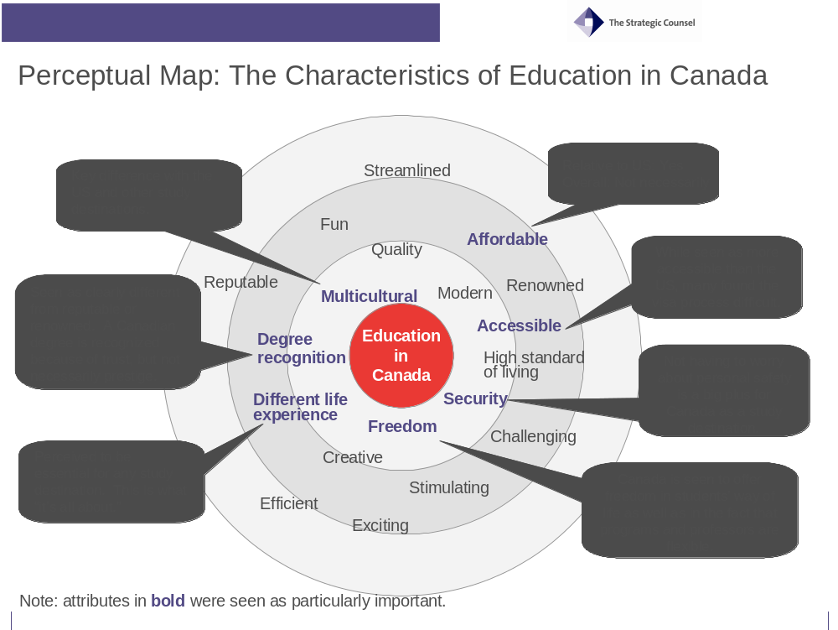
It is important for the reader not assume that because some attributes that are not in bold does not imply they are not important for international students. Students were forced to select the three attributes that were the most important to them. It was obvious during the discussions that items such as quality, creative, challenging, reputable and others were important, but they simply did not stand out as the “most important” ones for participants.
The results of the mapping exercise are also extremely consistent with the unprompted perceptions presented during the group discussions, as discussed in previous sections of the report.

- The Four Concepts: No Clear Winner, But Clear Winning Elements

The Four Concepts: No Clear Winner, But Clear Winning Elements

The Five Components of a Successful Education Brand for Canada
Overall, no concept emerged as a clear “winner” over the others. Rather, elements from each concept as well as possible combinations were identified as preferred visuals or content. The absence of a winning concept does not mean results of the discussions were unclear. To the contrary, participants helped identify multiple key features for each concept and provided clear paths for improvement. In addition, the reader should be reminded that participants were asked to evaluate these concepts with a critical eye, something that students in different settings may not always do. As a result, focus-testing tends to slightly inflate some of the negative views.
Overall, none of the concepts was seen to possess all of the following keys for a successful education brand for Canada, although each ranked well on at least one of them:
- Brand recognition/differentiation
- Clarity of message
- Emotional appeal
- Visual appeal
- Call to action
While the “Maps” concept appeared as somewhat more successful than others in the areas of clarity, emotional appeal, visual appeal and call to action, it lacked a crucial element: brand recognition. This section presents key findings from the focus groups for each of the four concepts, focusing on the key positive and negative attributes so as to provide clear guidelines for improvements.

The “Imagine” Concept: Inviting Canadian Imagery, but Lacking Concreteness
The “Imagine” concept did very well in one of the key features of a successful brand: recognition. Participants clearly recognised the logo as being Canadian because the bright red maple leaf represents Canada: “I see Canada.” It also elicited positive emotions due to its colourful and emotionally charged messaging. Nevertheless, the concept fell somewhat short on clarity of message and on credibility.

Logo and Tagline: Recognizable, but Vague and Confusing
Overall, the hand-drawn maple leaf logo and the tagline “imagine” elicited two distinct views. On the positive side, the logo was clearly recognized as Canadian. On the negative side, the combination of logo and tagline left many participants confused over the message conveyed.

Key Positives
Strong brand recognition: More than any of the four logos tested, the bright red maple leaf logo was readily associated with Canada: “Seeing the maple leaf confirms that I am seeing Canada.” It not only reminded participants of Canada, but it was also seen as uniquely Canadian. Participants also thought that they would have recognized the logo as a Canadian symbol even before they came to Canada.
Liveliness: The hand-drawn logo was also associated with fun and liveliness by some participants: “c’est vivant”. It gave them the impression that it was fresh, young.
Expanding possibilities: The “Imagine” tagline attracted attention for some because it opened up wide-ranging possibilities. Some added that it made them want to know what this meant, possibly inciting them to seek more information.
Name as a URL: The inclusion of a web address as part of the name was well received by most participants. Adding a “.com” or “.ca” is seen as a great way to encourage students to seek information because it worked as some kind of automatic reflex for most young people.

Key Negatives
Confusion over meaning: Despite its attractive nature to some, the tagline “imagine”, combined with the red maple leaf left most participants confused over the meaning of the concept: “Imagine…what?” Very few participants said they could instantly link the logo and tagline to studying in Canada.
  - This difficulty was compounded by the fact that “edu-canada” is not necessarily associated to studying either. The name would work better if accompanied by a more specific tagline.
Childish: The hand-drawn logo was often associated with young children. Many participants used the word “childish” to describe their impression of the logo. Most felt it did not relate well to college or university students: “It’s for pre-school students, for young kids.”
Wrong associations: Some participants also said the logo made them think of a blood bank or a hospital sign because of the shape and color.

Overall Concept: Emotionally Appeal, but Not Concrete and Credible
The “Imagine” concept got some positive feedback for being visually and emotionally attractive, but these positive features were most often overshadowed by common criticisms pointing to a perceived lack of concreteness and seriousness. It is important to note that this seemingly negative outlook may well have been exacerbated by participants’ initial confusion with the tagline and logo. Since they were confused over what the initial message was, they were obviously looking for clear explanations in the rest of the images and headlines, something many felt was missing.

Key positives
Sense of possibilities: The concept elicited a sense of the vast possibilities and choices offered to those who choose to study in Canada. A few participants associated the concept with the ideas of freedom and power to live your dreams. The presence of individuals from different ethnic origins was received positively, a positive feature common to all concepts.
Sense of optimism: It was also associated with optimism and hope by some participants. The idea of finding a cure for HIV/AIDS exemplified the possibility of doing something positive for the world. The same was true for the idea of making the world go green.
Lively and creative: The bright color schemes create a sense of liveliness and creativity. Some participants, especially in Vancouver, reacted very positively to this feature
Emotional connection: Some participants felt an emotional connection with the ideas presented in this concept. They liked the fact that Canada was associated with these positive outcomes and that international students were presented as being part of it all.
“I think those are very heartfelt, you know. You could actually develop an aids vaccine, and you are linking that with Canada.”
“It creates an identity. Everyone has a dream and this kind of, like, draws you in and makes you part of it.”

Key Negatives
“Too much”: While a few participants enjoyed the positive emotions associated with imagination and dreams, a larger proportion felt it was unrealistic, over-promising or not serious. Setting such lofty achievements in a setting seemingly unrelated to studying lacked credibility for many. The goals presented were seen by some as very ambitious and not necessarily representing what all students would want. It created a disconnect for those who “only” wanted to get a good education and lead a quality life afterwards. They did not necessarily feel they needed to achieve momentous individual goals in order to succeed in life.
In this respect, the ad was deemed to represent only a portion of students and did not relate to others such as language students, undergraduate students, or simply those with lower levels of ambition. A few also mentioned that the Blackberry would not be recognized in their country of origin. It is an important discovery from a Canadian perspective and for students in fields related to technology, but many do not feel a strong connection to it.
Needing pragmatism: Many understood what kind of emotions the concept was trying to convey, but they also felt that this was not what they were looking for when seeking a study destination. Their approach, and their parents’ approach, was seen to be more pragmatic.
“I think it asks us to imagine the quality of education and the experience that we are going to be facing, but they should be telling us that! They should be telling us what we should be up for.”
Concrete information: Attracting attention was seen as a good thing, but most participants mentioned that concrete information had to be seen right away. Students want to know exactly what they can expect and how they can do it. They said they were looking for concrete information first and foremost. They saw the appeal of the imagery included in the concept, but thought it needed not be so dominant.
“Don’t tell people they need to dream: make them dream with what you propose.”
Not “student” enough: Despite the emotional appeal for some, most participants did not relate to the concept as students. For example, many thought the images included did not necessarily represent students because they were not seen in a context that they could relate to learning. They would have liked to see clear education landmarks and symbols on the pictures.
“This doesn’t look like and education campaign at all…”
“It looks like a web site for Contiki Tours!”
Confusing symbols: The presence of flowers in the background also attracted criticisms because their symbolism was not recognized by most (except for many participants in Quebec who recognized the “fleur de lys”). This lack of recognition made participants more critical of the choices because they saw these drawings as unrelated decorations. Some suggested replacing them with drawings related to education, like research instruments, diplomas, etc.
“The fleur de lys represents France…and the other one looks like Hawaiian flowers that I associate with surfing, not Canada or education.”
Possible controversies: Some participants also mentioned that certain elements of the concept could potentially create controversy. They pointed out that it may be preferable to avoid associating AIDS with a specific ethnic group. Some clearly thought that the current image imputed responsibility for the fight against AIDS on persons from a particular background. A few others, especially in French groups, mentioned that they thought Canada may not be seen as “green” in light of recent international developments, questioning the credibility of the first image.

The “Empower” Concept: Catchy and Different, but Unconvincing
Not unlike the “Imagine” concept, the “Empower” concept resonated with some participants for being youthful and lively, which some thought was very appealing for a campaign aimed at attracting foreign students. Many elements in the concept were also easily recognisable as Canadian. Yet, the concept was also criticised for lacking seriousness and for being inconsistent overall, with elements being seen as too generic or boring and others as being to “out there”.

Logo and Tagline: Powerful Tagline in English, But Unconvincing Logo in Both Languages
The English tagline “Empower Your Future” was well received by many students in English groups who saw it as creating a sense of empowerment and possibilities for the future. Nevertheless it left many, especially in French groups, ambivalent over its overall appeal to them and to students in general.

Key positives
Serious look: Some participants appreciated what they perceived as serious, formal logo and tagline. This was contrasted with other logos and taglines that were seen to be too informal or too young looking. Nevertheless, this quality was also seen by a larger proportion of participants as a negative attribute, as discussed below.
Clarity: The name “educationcanada” was clear and well-understood: “You know what it’s about.” This was contrasted with edu-canada, which many found to be unclear or “unofficial”.
Recognizable: The stylized red maple leaf was readily associated with Canada by most. While most participants were not enthusiastic about the look of the logo, they said it was clear and easily recognizable as a Canadian symbol.

Key negatives
Lacking emotional appeal: Contrary to the English tagline, which got some positive feedback regarding its emotional traction for some participants, the French version “Dynamise ton avenir” did not resonate with most participants. French participants themselves drew comparisons with the English version to say they much preferred it to the French one.
Boring logo: In the same vein, the logo was commonly referred to as boring, business-like, institutional, “math-like”, statistical or digital-looking. This was seen to clash directly with the objective of the tagline “Empower Your Future” and “Dynamise ton avenir”. While the words were meant to elicit action and youth, the logo seemed to suggest the opposite for many participants: “It looks like it’s crumbling.”
Wrong associations: Some participants thought that the logo seemed more appropriate to specific companies rather than an educational campaign:
“Moi, je vois Shell…”
“It looks like it could be for Air Canada or something.”
Unappealing font: Without necessarily being able to articulate the exact reasons for their dislike, many participants commented on the fact that they did not like the font used in the name “educationcanada”. It once again seemed boring to some.

Overall Concept: Catchy but Lacking Seriousness
The overall concept generated some positive comments for being different and showing the dynamism and variety of the Canadian experience. Nevertheless, it clearly lacked credibility for most and was seen as somewhat inconsistent.

Key positives
Catchy and different: The overall concept of “Empower Your Future” was seen by many as catchy and different. The bright colors used in the pictures as well as the collage style text gave the impression that Canada was a lively: “It shows that it is dynamic.” In that sense, the imagery fit the idea behind the tagline. The images created the impression that the Canadian experience was more than just studying. While this could be positive, it was also raised a as negative feature by many because it was not deemed serious enough.
Uniquely Canadian, or almost: The combination of images was perceived by many as projecting some of the uniqueness of Canada, although some disagreement remained over this issue. The three images were seen to highlight different facets of the Canadian experience. They reflected the artistic side, as well as scientific achievements and the great outdoors’ experience. The third image was especially noticeable in this respect because it included a combination a studying, the great outdoors and the red color symbolizing Canada: “cette image, c’est vraiment le Canada.”
Good headlines: A few participants also liked the message conveyed by the headlines of the second and third images. “Strive for excellence” and “Create your own path” created a sense of empowerment, without necessarily being seen as too dreamy or too ambitious, a common criticism for the “Imagine” and “Infinite Possibilities” concepts. The difference was that striving for excellence and creating your own path did not impose lofty objectives but left some space for individuals to choose what their own objectives could be. Excellence could mean different things to different people.

Key negatives
Lack of connection with the student experience: Many participants said the concept did not connect with them as students because it lacked seriousness. While the overall combination was seen in this manner, the first image of a young man listening to music was most strongly targeted by these criticisms for being too casual and unrelated to education:
“What does listening to music have to do with education?”
“I can’t relate to the boy with the headphones…we don’t do that at my university.”
Ambiguous headline: The headline of the first image, “Speak Out”, was also received with suspicion because its meaning was very ambiguous for some. It was seen by some as a sign that you could not succeed if you did not voice your opinion, which did not correspond to the study experience in all cultures:
“What are we speaking out about? Why speak out?”
“Doesn’t sound good…it looks like he is already in trouble and needs to defend himself!”
Culture clash: In addition to the previous comments regarding the headline “Speak Out”, a few participants mentioned that this concept could create a certain culture shock for students and parents in certain countries who are not used to such strong individual messaging:
“This might be a real culture shock. I think of my parents for example…I don’t think they would want me to come to Canada if they saw this.”
“La majorité du temps ce sont les parents qui décident et s’ils voyaient ça, ils n’enverraient pas leurs enfants.”
Inconsistent imagery: Participants pointed to a disconnect between the font for the name “educationcanada” and the logo on the one hand, and the images and text appearing on the three other images on the other hand. While the logo and font for the brand name were seen as boring and institutional, the style of the pictures and the text attached to them was seen as loud and lively: “I don’t find the logo matches the campaign layout. It looks more formal than the ads.”
Too busy and loud: Some participants disliked the ad for seemingly being too busy, too loud. The “cut and paste” headlines and the mix of colors was unappealing to some because it looked very noisy and seemed unfinished: “Ça fait brouillon.” Others commented on the fact that “It does not look professional”.
Lacking credibility: Although the image of a student using a laptop outdoors was seen as Canadian and different by some, others found it lacked credibility (“What is she doing with her laptop in the field?”) or for being too bright (“This one is way too red for me.”), matching criticisms voiced about the image of the young man listening to music.

The “Infinite” Concept: Overly Ambitious
The “Infinite” concept was the east favoured among all four concepts. The most important problems raised by participants surrounded its very powerful individualistic imagery, which did not match the values of many participants and their views of what the student experience was all about. In addition, it was not clearly linked with Canada, or with the Canadian experience.

Logo and Tagline: Unfinished and Over-promising
The logo and tagline were not very well received overall. Although the infinite possibilities tagline did elicit some positive comments among English participants, it did not fair well with French-speaking students.

Key positives
Sense of possibilities: The tagline “Infinite Possibilities” was fairly well received in English groups for giving the impression that numerous options were available; that one “is not boxed into one thing.” It was deemed by some to allow for diverse interests to develop and gave a sense that different experiences were available when studying in Canada.
Multicultural logo: Many participants directly linked the logo to the idea of multiculturalism on an unprompted basis. With the idea of multiculturalism being an important facet of the Canadian experience for many, this was a clear positive for some:
“It says we are a multicultural country.”
“This says that Canada is welcoming and diverse.”
Interesting artistic design: While the logo was disliked by many for looking unfinished or unappealing, a few saw it as an interesting artistic design: “It will appeal to more artistic persons.”

Key negatives
Unfinished appearance: The logo was seen by many as being rather unfinished or unprofessional. Some even called it messy: “The maple leaf is a bit messy here…”
Hardly recognizable: Others questioned whether the maple leaf would be recognised by students outside of Canada because it looked so different: “C’est pas évident que c’est une feuille d’érable…”
Over-promising: Some, especially in French, saw the tagline as over-promising. The notion of “infinite” was read more literally in French compared to the English variant, making it sound exaggerated for most participants in the French groups: “C’est trop. Une trop grande promesse.” This concern was also expressed by some in the English groups: “It is a bit of an exaggeration.”

Overall Concept: Consistent, but Disliked by Most
Despite some positive comments about its internal consistency and motivational messaging, the images and headlines presented in this concept were the least preferred overall.

Key positives
Internally consistent: The general theme developed with this concept was considered clear and consistent by many participants. Participants saw a strong focus on individual success in all pictures and in the text. This was made obvious to them via the pictures of confident looking individuals and powerful headlines about outstanding achievement. Some participants also noticed the consistency of the color scheme between the logo and the background for each picture: “I see the relationship between the logo and the pictures.”
Motivating for some: A few participants felt that the concept could be motivating for certain types of individuals because it appealed to those seeking a challenge. While very few liked the pictures used, some mentioned that the text associated with them could be motivating: “I don’t like the pictures, but the slogan for each one is good. It makes you think that you could really do something big if you want to.”

Key negatives
Unrelated to the study experience: This concept was perceived by most to be unrelated to their study experience, which was one of the key reasons for the sometimes strong dislike expressed by some participants. As such, the pictures used were seen to be interchangeable with advertising for any other product:
“You could put these pictures in a shampoo ad!”
“I would like to see this if I was about to go on vacation or something.”
Strong focus on individual achievements: The apparently very strong focus on individual achievement did not sit well with many participants. While some focus on individual success was not seen as a bad thing, this concept was perceived by many to centre too strongly on this aspect of the study experience. The idea of the “world as their playground” seemed overbearing and not credible to many. Combined with the picture of a young, confident, man with sunglasses, this line provoked strong negative reactions by some students.
Potentially negative messaging: A few students commented that the idea of “leaving a mark” could have negative connotations. Not only could one leave a mark by doing something bad, but some said that students who were not overly ambitious would feel daunted by this idea.

The “Maps” Concept: Broad Emotional and Visual Appeal, but Not Clearly Canadian
The “maps” concept was more successful than other concepts in terms of its credibility and overall appeal. As such, it appeared to have tapped into the all-important multicultural imagery and resonated with the experience of studying in Canada for participants. However, this concept suffered from one important drawback: it lacked brand recognition.

Logo and tagline: Clear Name and Tagline, but Confusing Symbol
The name and tagline for this concept were the clearest and most credible for most participants. However, the logo was not easily recognizable as Canadian.

Key positives
Clear name: The name “Study in Canada” was liked by most for being very clear, direct. This made the concept look serious, credible.
Bilingual component: Many participants viewed positively the presence of the name in both official languages. While names and taglines for all concepts were bilingual, the fact that this one presented two separate names in English and French was seen as a symbol of Canadian bilingualism, and this in all regions. The other concepts’ names could be read in English or French interchangeably, but not this one.
Modern looking: The font used and the design of the logo created a sense of modernity, sophistication for many. The light colors were pleasing to the eye for many.
Credible tagline: The tagline “Invest in Your Future” was viewed as credible because it represented the student experience for participants: “This is what you do as a student.”

Key negatives
Not recognizable as Canadian: Apart from the name “Study in Canada”, which clearly says it all, there was little in the tagline and logo that could be identified as Canadian. While participants could recognize a maple leaf, they also said that students in other countries would not and that they probably would not have thought of it before they decided to come to Canada to study. The logo was more commonly associated with the four seasons or the Olympic symbol than with the Canadian flag.
Financial connotation: Despite being credible, the tagline “Invest in your Future” elicited some negative feelings. Many mentioned that it sounded too “financial” or “business-like”. A few others said that it only served to remind them that education in Canada was costly: “It says that you will have to pay a lot.”

Overall Concept: Credible and Appealing, but not Clearly Canadian
As was the case for the logo and tagline, the overall concept was deemed to be credible and appealing because it matched the Canadian experience, but it was also perceived to be lacking uniquely Canadian branding symbols.

Key positives
Strong multicultural imagery: In every group, the concept was directly associated with multiculturalism, considered to be a key feature of the Canadian experience. The first picture with the three young students from different ethnic origins was particularly remarkable in that regard. It was mentioned in all groups as a symbol of cultural differences and of Canadians’ acceptance of these differences.
Each picture also portrayed people with different personal styles as well as cultural origin, reinforcing the idea that differences are accepted in Canada:
“You have images that tell you that you can succeed in business, but it is also acceptable for someone to just go somewhere and have fun.”
Representative of the study experience: This concept was also seen by most as being the most realistic concerning the educational experience. It did not promise too much and presented characters that were identifiable as students: “The pictures are average. I could see myself doing these things.”
Sense of possibilities: The concept also elicited a sense of possibilities and long-term achievements when coming to Canada. Contrary to the other three concepts, this one leveraged this sense of accomplishment without looking overly ambitious or centering too strongly on individual success: “I like the emphasis on teamwork, the fact that people can do things together.”
The headlines associated with each image also contributed in creating this message of possibilities, without focusing solely on outstanding individual achievements. The ideas of opening doors and providing the tools needed to achieve what students chose to achieve did not appear as lofty goals that only a handful of students could achieve. The concept also provided insights into what life could be in Canada after school was finished: “It gives me a sense of what I could do in Canada after I finish school.”
Visual appeal: Some participants commented on the attractiveness of having the colour scheme from the logo appearing as a pale background for each image. Some also commented on the fact that the images gave the impression that Canada was a fun place to study in, while remaining focused on the educational experience. The smiling, yet soft, faces on the first two pictures were reassuring in this regard.

Key negatives
Not clearly Canadian: Despite the emotional appeal of the messaging and credibility of the ad, one key problem remains: without the words “Study in Canada”, the ad is not clearly identifiable as Canadian. As mentioned previously, the logo was not immediately recognized as being Canadian. While the Canadian map is a clear national symbol, its success as a branding tool depends on the ability of international students to know about the geography of Canada, something that was put in doubt by many participants.
In that regard, the blown-up provincial maps were believed to be unrecognizable for students not already in Canada. Some participants spontaneously commented that without knowing the map was Canada, they could see the text and images applying to many other countries.
A few participants suggested that the map may be put in a broader geographical context, like North America, to clearly identify Canada compared to other countries. The presence of provincial boundaries was also questioned by some because it contradicted the headline “knowledge without boundaries.”

Brand Name: Clarity is Key
The brand name “Study in Canada” clearly emerged as the favourite in all groups. The most common reason mentioned by participants to explain their preference for one brand name over another was simple: clarity. The name Study in Canada was therefore favored by most because it was deemed direct and unambiguous:
“It just says it straight!”
“You know what this is about. It is about studying in Canada.”
When asked to compare edu-canada with educationcanada, a larger group selected educationcanada for similar reasons. Having the complete word “education” was seen to be clearer than just the prefix “edu”. Nevertheless, a few participants said that “edu” was a little more edgy and more fun, more particularly in Montreal. If they had to choose between “edu-canada” and “educanada”, most said they would prefer the hyphenated version.
The idea of having a brand name that is also a web address was generally well-received by participants. It was seen as a clear call to action because using the Internet is now a common reflex among students. Seeing a “.ca” (preferred to .com) at the end of the name would make them go and look for additional information, or at least it would generate some curiosity.

- Avenues for Improvement

Avenues for Improvement

Logo and Tagline: Combining “Study” and “Canada”
The logo and tagline may gain from saying more clearly that the advertising is about “studying in Canada”, meaning that it may benefit from a clearer portrayal of the experience of studying within the Canadian context rather than portray only a Canadian experience independent of studying or present a more generic educational experience that is not strictly Canadian.
The “Maps” logo clearly exemplifies the potential benefits of portraying the combination of education and Canada. While many found this logo attractive and intriguing, very few thought it was necessarily about Canada and/or about studying. Its message was clear because it was accompanied by the name “Study in Canada”, which could hardly be more direct. Similarly, the “Imagine” logo was seen as being clearly Canadian, but it would gain from being accompanied by a name and tagline that more directly identified education as the topic.
  - Clear Canadian symbols and the red color of the Canadian flag are easily identifiable to Canada and may be used to boost brand recognition.

The Web attraction
In the same way that a clearly recognizable brand can be a powerful call to action, the usage of a web address as part of the name of the program or tagline might motivate potential students to seek further information.
  - The Internet has become the primary source of information for students and is often an information-seeking “reflex” for them. Seeing a web address makes them more likely to take the extra step, a habit that was often mentioned during the group discussions.
  - The insertion of a web address does not necessarily need to be within the name, but it could also be linked to the tagline, a technique that has recently been used very successfully by private companies and public institutions alike.

Emotional Imagery: A Good Thing, if Accompanied by Concrete Information
While the brand concept could use emotional imagery to attract students’ attention, it may need to do so in a subtle manner. Students and parents (many have reminded us that their parents looked for information with them) tend to look for concrete elements first. The emotional aspect is important in terms of attracting their attention, but it is not necessarily the initial driving force behind their information seeking behaviour. As such, direct emotional appeals may be used more effectively if they are presented as a complement to more concrete information and images, rather than presented as the core of the message. As one participant clearly stated: “Don’t tell people they need to dream: make them dream with what you propose.”
The “Imagine” and “Infinite” concepts exemplify the great potential of emotional imagery, but without what participants deemed to be concrete messaging, these concepts seemed to fall somewhat short of the mark for lacking credibility or seriousness.

Student connection
In the same vein, focus group results demonstrate that students expect to see images of students like them doing things related to student-life. Images of individuals in settings not readily linked to education seemed odd to many participants. The success of the “Maps” concept in connecting with participants can be linked directly to this sense of connection with their own experience. The images were not seen to be over-promising or unrealistic, fact that was appreciated by many.

Less about specific individual achievements
Again, the success of the “Maps” concept in creating a sense of opportunities in Canada also suggests that focusing on specific individual achievements may not be the most efficient way to stimulate positive emotional reactions. Participants reacted more positively to being shown what tools or opportunities Canada could provide them with in order to achieve their objectives as opposed to being show pre-set objectives or dreams.
  - Negative reactions to the lofty individual goals or ideals presented in some concepts, especially the “Possibilities” concept, underline the potential benefit of a more nuanced approach.
  - This preference also underpinned some of the negative views regarding the “welcome to your future” headline included in the “Imagine” concept: it made many think their path was forced onto them. Many participants said they would rather create their own paths and set their own objectives.

Pictures: Showing the Uniqueness of Canada as Well as Clear Student Experiences
Different combination of pictures may work better at attracting students’ attention and represent the Canadian experience. Having more than one individual per image demonstrates that student-life is not a solitary experience. The image of the three students smiling in the maps concept was very well received in part because it was deemed to reflect this social experience. In addition, including individuals from more than one ethnic origin in the same picture is directly associated with multiculturalism, a key strength of the Canadian brand.
In the same vein, having only one person per image combined with taglines directed at individuals gave many students the impression that the ad was targeted at “high-achievers” only and was not for all students.
Including backgrounds that represent Canada’s natural surroundings and open spaces is another way to differentiate Canada from other study destinations. This could be done while still putting students at the forefront (e.g. biologist taking samples in the forest or in a lake, showing a student in a classroom with natural surroundings visible from a window, etc.)
  - The backgrounds could potentially be adapted to regional contexts, if possible. Otherwise, they could be chosen as generally representative of the Canadian landscape.
  - Many students also said they would have been attracted to images of large Canadian campuses in their natural surroundings.

Consistency between imagery and text
It would also be important to ensure harmony between all visual and textual facets of the concept. Some students pointed to an apparent disconnect between the somewhat conservative fonts used in the “Empower Your Future” tagline and the vibrant colours and contours of the text attached to the pictures. Conversely, many participants commented positively on the presence of the same colour scheme in part of each image. The shades of colour appearing as a faded background in each of the “Maps” concept were seen as visually appealing by many who noted its consistency with the logo.

Adaptability to national contexts
It may also be a good idea to show different sets of images depending on the country in which the ad is shown. Many participants commented on the importance of cultural sensitivities in reading an advertisement, making it difficult to have images that would appeal to all audiences in all countries. Finding images that are consistent with the idea behind the advertising concept while being adaptable to cultural settings could be a key asset for a successful campaign.

- Appendix: Research Instruments

Research Instruments

Concepts tested

English versions
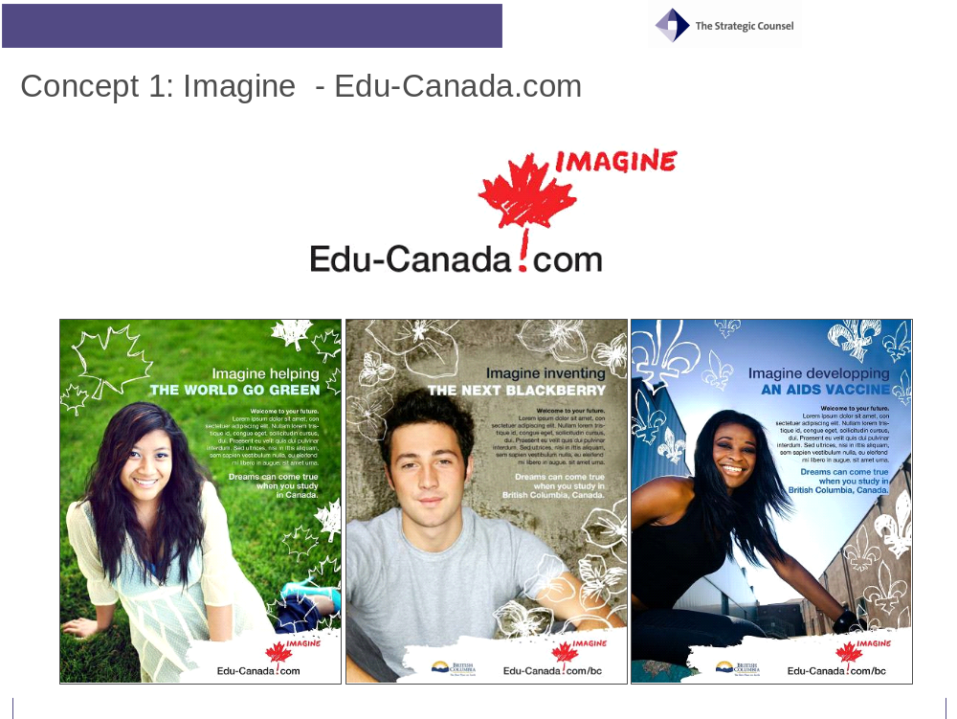

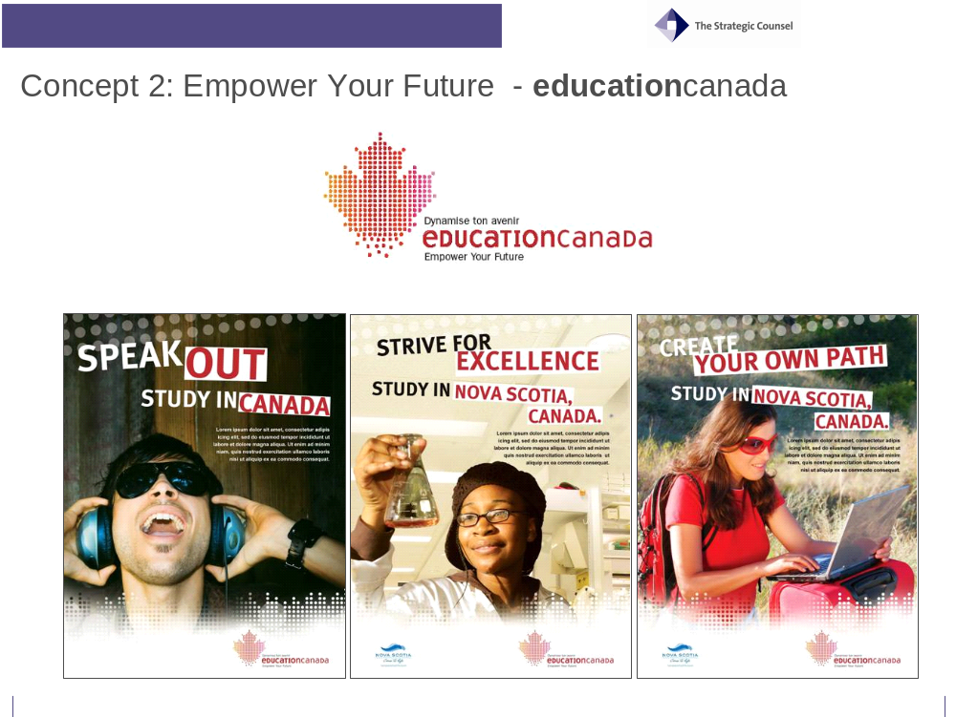

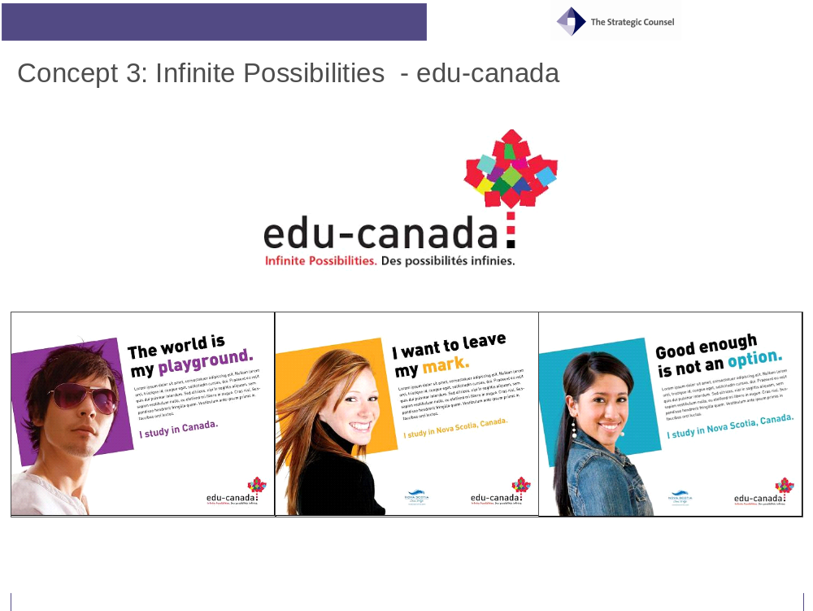



French versions
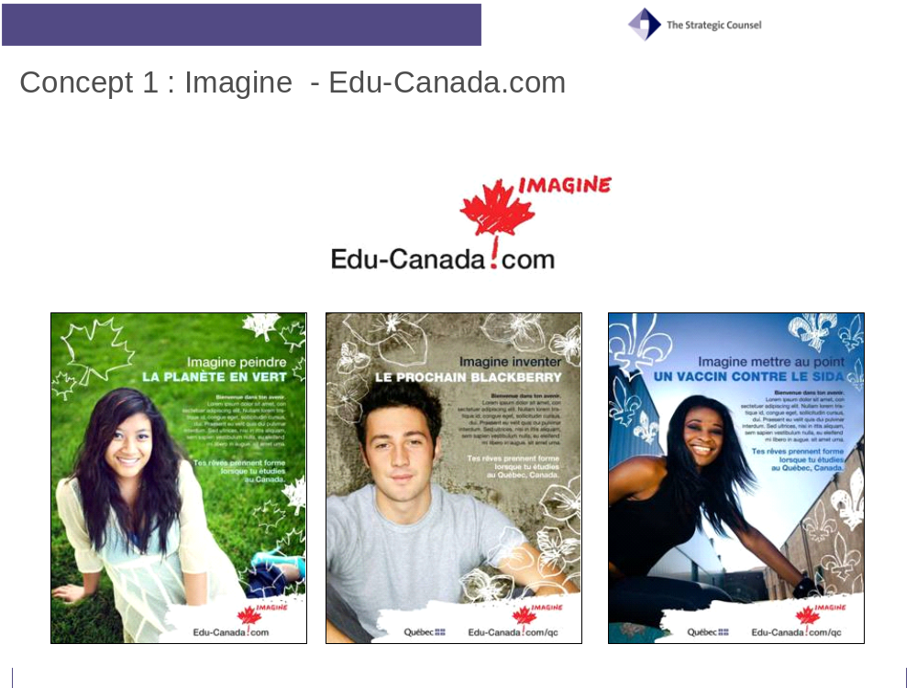
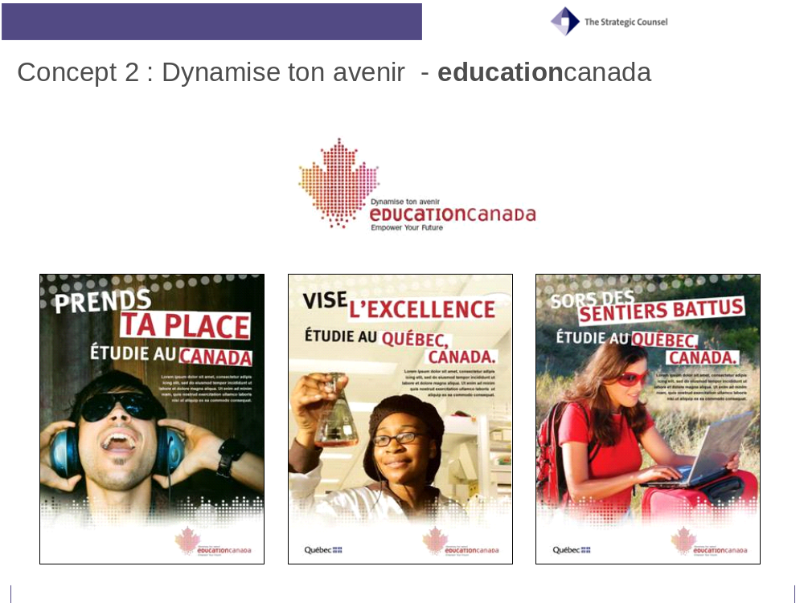
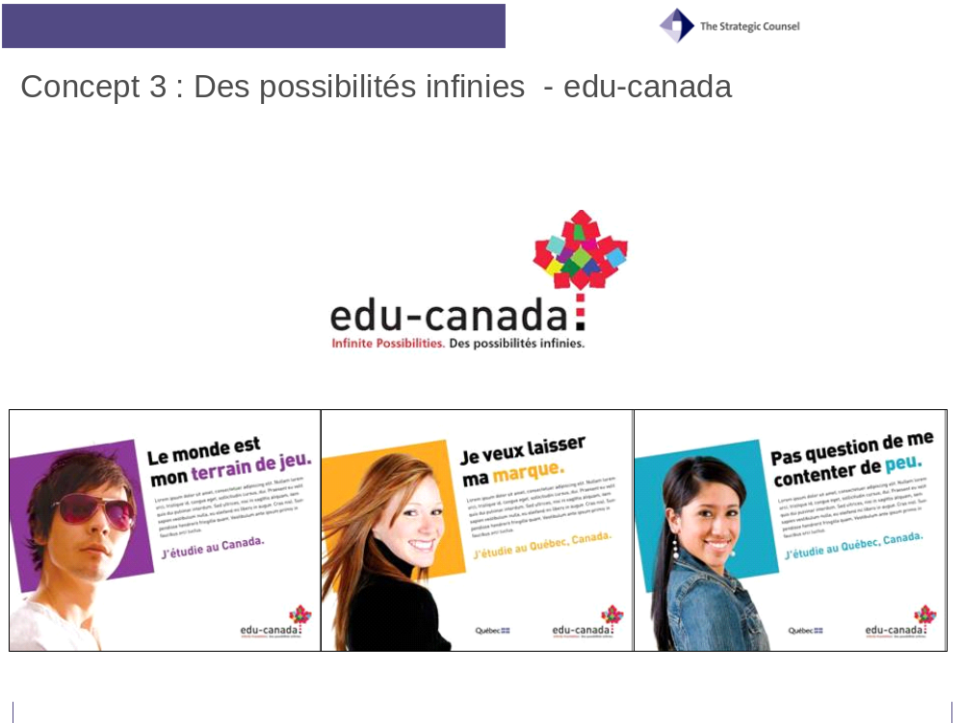
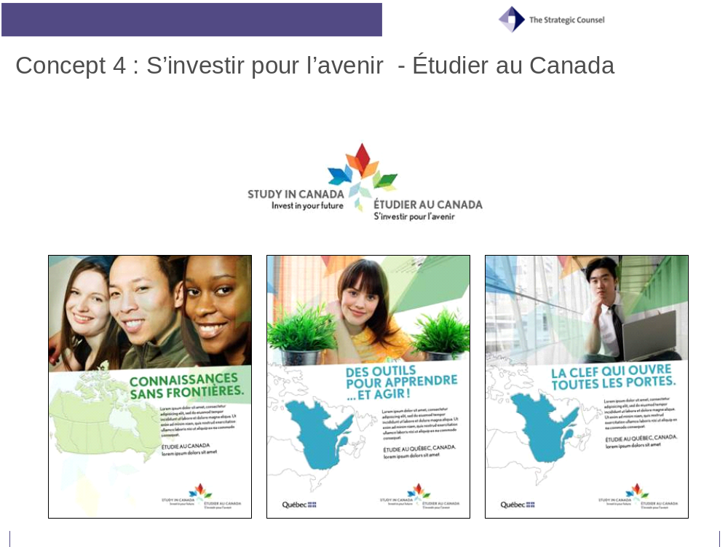

Moderator’s Guide

English version
DFAIT
Moderator’s Guide
Testing of Education Brand Concepts for Canada with Foreign Students
Final – January 16th, 2008

Introduction (5 minutes):

- Introduce moderator and welcome participants to the focus group.
  - As we indicated during the recruiting process, we are conducting focus group discussions on behalf of the Government of Canada. This evening’s discussion will focus on your attitudes and opinions towards Canada as a study destination. We will also be looking at concepts for advertisements on this topic in order to obtain your feedback and comments. I’ll explain more on that in a moment.

- The discussion will last approximately 2 hours. Feel free to excuse yourself during the session if necessary.

- Explanation re:
  - Audio/video-taping – The session is being video/audio-taped for analysis purposes, in case we need to double-check the proceedings against our notes. These video-tapes remain in our possession and will not be released to anyone without written consent from all participants.
  - One-way mirror – There are observers representing the government and the creative agency for the ads who will be watching the discussion from behind the glass. They are there to assist me in analyzing the findings, as I may not remember all that I hear in various groups. However, they will not take part in this discussion.
  - Confidentiality – Please note that anything you say during these groups will be held in the strictest confidence. We do not attribute comments to specific people. Our report summarizes the findings from the groups but does not mention anyone by name. The report can be accessed through the Library of Parliament or Archives Canada or via the web site www.porr-rrop.gc.ca.

- Describe how a discussion group functions:
  - Discussion groups are designed to stimulate an open and honest discussion. My role as a moderator is to guide the discussion and encourage everyone to participate. Another function of the moderator is to ensure that the discussion stays on topic and on time.
  - Your role is to answer questions and voice your opinions. We are looking for minority as well as majority opinion in a focus group, so don't hold back if you have a comment even if you feel your opinion may be different from others in the group. There may or may not be others who share your point of view. Everyone's opinion is important and should be respected.
  - I would also like to stress that there are no right or wrong answers. We are simply looking for your opinions and attitudes. This is not a test of your knowledge. We did not expect you to do anything in preparation for this group.

- (Moderator introduces herself/himself). Please note that the moderator is not an employee of the Government of Canada and may not be able to answer some of your questions about the program we will be discussing. Participants should introduce themselves, using their first names only.
  - Please tell us a little bit about yourself. In particular, I would like to know how what you are studying, or have studied, in Canada and when you started your studies.

Warm-up/Context: Canada as a Study Destination (10 minutes)
- Before we look at the advertising concepts I’d like to get a better sense of what comes to mind when I talk about “Canada” OR “studying in Canada”. When you think about “Canada” OR “studying in Canada” what are the kinds of images or things that come to mind? Don’t hesitate to close your eyes when you try to think of these images.
  - Now, let me ask you about the most important factors in making your decision to study abroad. In other words, what was it that made you decide to study in Canada? And why did you choose (name of province) more specifically? Did you think it would be different than another province?
  - Do you think that the images that come to mind now are different than those you had in mind before you came to Canada? How so?
- Was Canada your first choice for a study destination?
- In your opinion does Canada provide you with any different benefits than you may get from studying in another country? If so, what type of benefits? What does Canada provide you that is different?
- I would now like you to imagine that you are sitting in front of a computer and are seeking information about coming to study in Canada. Tell me what keywords you would use in your web browser (e.g. Google, Yahoo!) in order to search for this information (MODERATOR TO NOTE ON FLIPCHART). Anything else?

Perceptual Mapping: The Education Brand for Canada (20 minutes):
- Now, I’d like to get your thoughts on a vision for what the experience of studying in Canada should look like/be to foreign students. To get this conversation started, I’d like each of you to complete a quick exercise. (HAND OUT STICKERS – PERCEPTUAL MAPPING). I would like you to work in pairs for this exercise. (MODERATOR TO HAND OUT PAGE WITH STICKERS)
- You’ll find a list of words on this page, each of them written on a sticker. Using the target in front of you (MODERATOR TO HAND OUT ONE TARGET PER TEAM OF 2), I’d like you to use this target to tell me whether each description does or does not describe the studying experience in Canada. The more you find a description to be accurate, the closer it will be to the centre of the target. Conversely, the less appropriate you find the descriptor, the farther away it should be put from the centre of the target. We also left a few blank stickers so you can add characteristics that you feel may be missing. GIVE SOME TIME TO COMPLETE.
- Also, I would like you to identify what are, or maybe what should be, the three most and the three least important attributes or characteristics of the educational experience in Canada. To do this, simply put a circle around the three attributes that you think are the most important, and put an X over, or cross-out, the attributes that you find are least important. In other words, what are the three most, and the three least, important attributes to encourage students to come to Canada? (MODERATOR TO POST EACH MAP ON THE WALL AND DISCUSS EACH IN TURN)
  - Can you tell me what makes you situate these elements (READ ON MAP) closer to the centre? And what made you put these farther away from the centre?
  - MODERATOR TO LOOK AT POSSIBLE GAPS OR SIMILARITIES BETWEEN THE PLACEMENT OF ATTRIBUTES ON THE TARGET AND THE IMPORTANCE GIVEN TO THEM BY PARTICIPANTS AND DISCUSS.
  - Are there any other words that we should have added to this list? RECORD
  - What specifically does that word or phrase mean to you? Is there another word that might describe the same notion better/in a more meaningful way?
- MODERATOR TO COLLECT BACK TARGETS

Discussion of Concepts 1 to 4 (80 minutes in total)
This evening we will be looking at three advertising concepts and logos that have been developed for a campaign. Please keep in mind that the concepts and logos are close to, but not in final form, so the idea is to get your reaction and input before they are finalized. THE ORDERING OF PRESENTATION OF CONCEPTS SHOULD BE ROTATED IN EACH GROUP ACCORDING TO THE FOLLOWING CHART:
NOTE TO MODERATORS: TWO GROUPS ARE BEING CONDUCTED IN EACH CITY. CONCEPTS 1 THROUGH 4 ARE TO BE ROTATED ACROSS LOCATIONS ACCORDING TO THE FOLLOWING SCHEDULE
LOCATION | GROUP 1 | GROUP 2
Montreal | Concept 1 – Edu imagine  Concept 2 – Edu empower  Concept 3- Edu possibilities  Concept 4 – Invest in Future | Concept 3- Edu possibilities Concept 2 – Edu empower  Concept 4 - Invest in Future  Concept 1 – Edu imagine
Quebec City | Concept 2 – Edu empower  Concept 1 – Edu imagine  Concept 4 - Invest in Future  Concept 3- Edu possibilities | Concept 4 – Invest in Future  Concept 3 – Edu perspectives  Concept 1- Edu imagine Concept 2 – Edu empower
Halifax | Concept 1 – Edu imagine  Concept 2 – Edu empower  Concept 3- Edu possibilities  Concept 4 - Invest in Future | Concept 3- Edu possibilities Concept 2 – Edu empower  Concept 4 - Invest in Future  Concept 1 – Edu imagine
Vancouver | Concept 2 – Edu empower  Concept 1 – Edu imagine  Concept 4 - Invest in Future  Concept 3- Edu possibilities | Concept 4 - Invest in Future  Concept 1 – Edu imagine  Concept 3- Edu possibilities Concept 2 – Edu empower
Discussion of taglines (20 minutes)
Now I would like to get your reaction to some possible taglines and logos that could be used in various promotional campaigns. A tagline is a catchy and memorable phrase, often accompanied by a logo or image, that is often used in advertising to briefly summarize the essence of the ad or a brand (and the idea, service or product that is being promoted) in a few words. For example, we can think of the famous taglines for Nike (Just do it) or McDonald’s (I’m lovin’ it).
I’d like you to think about the tagline in relation to the international promotion (i.e. to people outside of Canada) of education in Canada. In other words, this tagline would be meant to encourage foreign students to study in Canada.
MODERATOR TO SHOW ONE TAGLINE AND LOGO AT A TIME BASED ON THE SCHEDULE ABOVE.
- Now let’s go through these taglines and logos one by one. FOR EACH, ASK:
  - Overall, what is your reaction to reading this tagline and/or to the logo associated with it?
  - Which aspects did react most positively too?
  - Which did you react negatively to?
  - What emotions or feelings to do you associate with this tagline and/or this logo?
  - What does it say about studying in Canada?
- Now, looking at all these taglines and logos, I would like you to tell me which ONE of these do you think is most powerful in encouraging foreign students to study in Canada? RECORD PREFERENCE.
- What makes you say that?
- And, which combination of tagline and logo do you think is the best at grabbing your attention. What makes you say that?
- And, which logo do you think is the most visually appealing? What makes you say that?
- Are each of these taglines different? If so, how do they differ?
- Do you get different impressions for the logos used?
- Do you think that you could put a logo with a different tagline? That is, can you think of a better combination?
- Now, I would like to focus more specifically on the name of the program (i.e. Edu-Canada, Edu-Canada.com and educationcanada). Which name do you prefer? What do you like about this one? What do you dislike about the others?
  - What are the main differences between them?
  - Would one of them make you more likely to seek out more information about studying in Canada? Which one? Why?
  - How do you feel about the idea of including a “.com” at the end of the name? Does it make you more likely to go and look?
  - Can you think of a way to improve them? What would make them better?
  - Do you prefer edu-canada with the hyphen (-) or without (EduCanada)? What difference does it make?

Overall concepts (60 minutes – 15 minutes each)

MODERATOR TO PRESENT ON BOARDS THE ENTIRE CREATIVE PACKAGE ATTACHED TO THE FIRST /SECOND/THIRD TAGLINE --- THE CREATIVE PACKAGE SHOWN BY THE MODERATOR DEPENDS ON THE CITY/GROUP ROTATION SPECIFIED ABOVE. ONCE PARTICIPANTS RECEIVE THE FIRST PACKAGE, THEY ARE TO HAVE ADEQUATE TIME TO LOOK OVER TAGLINES AND RELATED CREATIVES.
- Overall, what is your reaction to this group of ads? What are your impressions of these ads?
  - Now, how many would say they generally had a positive reaction to/liked the overall concept of these ads? RECORD.
  - And, how many would say they generally had a negative reaction to/ disliked the overall concept of these ads? RECORD.
- What was it that you liked about the ads? Why?
- What was it that you disliked about them? Why?
  - Overall, how would you describe the “mood” of these ads? What words best describe the mood or the tone of the series? A different way of asking this question is … how did these ads make you feel? What emotions come to mind? (e.g. pride, happiness, etc.)
- In general, did you find the ad believable/credible? Why or why not?
- Now, what do you think these ads are trying to tell you? Are the messages from each of the ads consistent? What is the main message that you take away from the package as a whole? RECORD PERCEIVED MESSAGES ON FLIP CHART.
  - How believable is this message?
  - Is this a message that is relevant to you? Why or why not?
  - Is this an important message? Why/why not?
- Do you see yourself in these ads? In other words, can you connect personally with these ads? If yes, what specific aspects or parts of these ads do you connect with most? If no, why not?
  - Who do you think these ads are targeted to? Is it you or someone else? Is there anything in these ads that specifically suggests who the target or intended audience might be?
  - If you don’t see yourself in these ads, is there any way that these ads could be altered so that it is more targeted to you?
- Are these ads telling you to do anything? Do you find these ads motivating? What does it make you think about/or do, if anything? Would you do anything as a result of seeing these ads? Explain. PROBE FOR:
  - Would these ads motivate you to want to get more information about how to study abroad in Canada? How? (PROBE FOR: SOURCES OF INFORMATION, e.g. web site)
- What sort of place do these images suggest Canada to be?
- What do these images say about students in Canada?
- What sort of education or education experience do these images suggest you would have in Canada?
- And, were there any pieces of information, terms or phrases that you found suspect, confusing or unclear? What do you think these mean (in plain language)?
  - Would you change anything about these ads? Do you think anything is out of place, or doesn’t work?
- Is there anything you feel is missing from these ads (e.g. mood, setting, tone, environment, narrative, etc.) which you think would make a noticeable improvement? Why? How so? REVIEW CONCEPT PACKAGE AS NECESSARY.
  - If the idea is to encourage international students to come study in Canada, what more (if anything) needs to be included either in the text or the visuals for this ad?

FOR “IMAGINE” ONLY, ASK :
- If you had to choose between the sentence “welcome to your future” and “dreams can come true”, which one would you pick? Why? Which one fits better with this advertisement concept?

REPEAT FOR ALL 4 CREATIVE PACKAGES
- Thinking about the three concepts that you have seen, MODERATOR TO SHOW ALL CREATIVE PACKAGES, which concept do you think work together as a campaign to encourage foreign students to study in Canada?
- Which concept do you find the most/attractive and appealing? Why?
- Which concept do you find the least/attractive and appealing? Why?
- Which concept is the best way for Canada to promote itself as a study destination?

Wrap-Up (5 minutes)

- Overall, thinking now about the concept for the campaign as, that is to promote and encourage study in Canada, how well do you think the these ads would work to encourage people to think more about coming to study in Canada? Elaborate. What other information do you think should be included in this ad in order to more effectively raise awareness of the educational opportunities available in Canada and encourage people to take advantage of them?
- Do you have any final thoughts or recommendations regarding improvements to anything we have looked at tonight?
THANK PARTICIPANTS

French version
MAECI
Guide du modérateur
Essai de concepts auprès d’étudiants étrangers
Marque distinctive du Canada pour les études
Final – Le 16 janvier 2008

Introduction (5 minutes) :

- Présentez le modérateur et souhaitez la bienvenue aux participants au groupe de discussion.

  - Comme nous l’avons mentionné lors du processus de recrutement, nous organisons des groupes de discussion pour le compte du gouvernement du Canada. La discussion de ce soir portera sur votre attitude et votre opinion à l’endroit du Canada comme destination d’études. Nous allons aussi examiner des concepts publicitaires à ce sujet afin de recueillir vos commentaires. Je vous en parlerai plus en détail dans quelques instants.

- La discussion durera environ deux heures. Au besoin, n’hésitez pas à sortir de la salle.

- Expliquez :
    - Enregistrement audio-vidéo - La séance sera enregistrée à des fins d’analyse si nous devions contrevérifier son compte-rendu avec nos notes. Ces bandes vidéo demeurent en notre possession et ne seront transmises à personne sans le consentement écrit de tous les participants.
    - Miroir sans tain – Des observateurs représentant le gouvernement et les agences qui ont conçu les publicités suivront le déroulement de la discussion de l’autre côté du miroir. Ils sont ici pour m’aider à analyser les résultats, car il est possible que je ne retienne pas tout ce que j’entendrai dans les divers groupes de discussion. Ils ne participeront toutefois pas à la discussion.
    - Confidentialité – Prenez note que tout ce que vous direz au cours de cette discussion demeurera confidentiel. Les auteurs des commentaires ne sont pas identifiés. Notre rapport résume les constatations des groupes, mais ne mentionne aucun nom. Le rapport sera accessible par l’entremise de Bibliothèque et Archives Canada ou du site Web www.porr-rrop.gc.ca.

- Décrivez le fonctionnement d’un groupe de discussion.
    - Les groupes de discussion visent à stimuler une discussion ouverte et honnête. Mon rôle en tant que modérateur est de guider la discussion et d’encourager tout le monde à participer. Un des autres rôles du modérateur est de veiller à ce que la discussion ne s’éloigne pas du sujet.
    - Votre rôle est de répondre aux questions et de nous faire part de votre opinion. Nous tenons à connaître l’opinion de la majorité et de la minorité; ainsi, même si vous croyez que votre opinion diffère de celle des autres membres du groupe, faites-nous en part quand même. Qu’il y ait d’autres participants qui partagent votre point de vue ou non, votre opinion est importante et doit être respectée.
    - Je tiens aussi à préciser qu’il n’y a pas de bonnes ou de mauvaises réponses. Nous voulons simplement connaître votre opinion et comprendre votre attitude. Ce n’est pas un contrôle de vos connaissances, et vous n’aviez aucune préparation à faire pour participer au groupe.

- (Le modérateur ou la modératrice se présente) Prenez note que le modérateur n’est pas à l’emploi du gouvernement du Canada et ne sera peut-être pas en mesure de répondre à certaines de vos questions au sujet du programme dont nous allons parler. Les participants doivent se présenter en ne disant que leur prénom.
  - Parlez-nous un peu de vous. Plus précisément, j’aimerais savoir en quoi vous étudiez, ou avez étudié, au Canada, et quand vous avez commencé vos études.

Contexte : le Canada comme destination d’études (10 minutes)
- Avant d’examiner les concepts publicitaires, j’aimerais mieux comprendre ce qui vous vient à l’esprit lorsque je dis « Canada » OU « étudier au Canada ». Lorsque vous pensez au « Canada » OU à « étudier au Canada », quels genres d’images ou de choses vous viennent à l’esprit? N’hésitez pas à fermer vos yeux lorsque vous essayez de penser à ces images.
  - Permettez-moi maintenant de vous demander les facteurs qui ont été les plus importants pour votre prise de décision d’étudier à l’étranger. En d’autres mots, qu’est-ce qui vous a décidé à venir étudier au Canada? Et pourquoi avez-vous choisi (nom de la province) plus précisément? Croyiez-vous que ce serait différent que dans une autre province?
  - Croyez-vous que les images qui vous viennent à l’esprit maintenant sont différentes de celles que vous aviez à l’esprit avant de venir au Canada? En quoi?
- Est-ce que le Canada était votre premier choix de destination pour étudier?
- Selon vous, est-ce que le Canada vous offre des avantages différents de ceux que vous auriez à étudier dans un autre pays? Si c’est le cas, de quels types d’avantages s’agit-il? Qu’est-ce que le Canada vous offre de différent?
- J’aimerais maintenant que vous vous imaginiez être assis devant un ordinateur à chercher de l’information relative aux études au Canada. Dites-moi quels mots-clés vous utiliseriez dans votre fureteur (p.ex. Google, Yahoo!) pour chercher ces renseignements (LE MODÉRATEUR INSCRIT LES RÉPONSES AU TABLEAU DE PAPIER). Y a-t-il autre chose?

Carte perceptuelle : la marque distinctive du Canada pour les études (20 minutes) :
- J’aimerais maintenant recueillir vos impressions sur une vision de ce à quoi l’expérience d’étudier au Canada devrait ressembler pour les étudiants étrangers. Pour lancer cette conversation, j’aimerais que vous fassiez un bref exercice. (DISTRIBUEZ LES ÉTIQUETTES – CARTE PERCEPTUELLE). J’aimerais que vous travailliez par paires pour cet exercice. (LE MODÉRATEUR DISTRIBUE LA PAGE AVEC LES ÉTIQUETTES)
- Vous trouverez une liste de mots sur cette page; chacun d’entre eux est inscrit sur une étiquette. À l’aide de la cible devant vous (LE MODÉRATEUR DISTRIBUE UNE CIBLE PAR ÉQUIPE DE 2), j’aimerais que vous me disiez si chaque description décrit ou non l’expérience d’étudier au Canada. Plus vous trouvez qu’une description est exacte, plus elle sera près du centre de la cible. À l’inverse, moins vous trouvez la description appropriée, plus vous devriez la placer loin du centre de la cible. Nous avons aussi laissé quelques étiquettes vierges pour que vous puissiez ajouter des caractéristiques qui manquent, selon vous. ALLOUEZ DU TEMPS POUR FAIRE L’EXERCICE.
- J’aimerais aussi que vous identifiiez quelles sont, ou quelles devraient être, les trois caractéristiques ou facteurs les plus importants et les moins importants de l’expérience d’étudier au Canada. Pour ce faire, encerclez simplement les trois attributs que vous jugez les plus importants, et placez un X sur ou barrez les attributs que vous trouvez les moins importants. En d’autres mots, quels sont les trois attributs les plus importants et les trois les moins importants pour encourager les étudiants à venir au Canada? (LE MODÉRATEUR AFFICHE CHAQUE CARTE SUR LE MUR ET DISCUTE DE CHACUNE D’ELLE À TOUR DE RÔLE)
  - Pouvez-vous me dire ce que vous fait placer ces éléments (LISEZ SUR LA CARTE) plus près du centre? Et qu’est-ce qui vous a fait placer ces éléments plus loin du centre?
  - LE MODÉRATEUR RECHERCHE LES ÉCARTS POSSIBLES OU LES SIMILITUDES ENTRE LE PLACEMENT DES ATTRIBUTS SUR LES DIVERSES CIBLES ET L’IMPORTANCE QUI LEUR EST ACCORDÉE PAR LES PARTICIPANTS ET EN DISCUTE
  - Y a-t-il d’autres mots que nous aurions dû ajouter à cette liste? INSCRIVEZ
  - Qu’est-ce que ce mot ou cette phrase signifie précisément pour vous? Y a-t-il un autre mot qui pourrait décrire la même notion mieux ou de façon plus éloquente?
- LE MODÉRATEUR RAMASSE LES ÉTIQUETTES

Discussion à propos des concepts 1 à 4 (80 minutes au total)
Ce soir, nous allons examiner quatre concepts publicitaires et les logos qui ont été conçus pour une campagne. Gardez à l’esprit que les concepts et les logos ne sont pas encore tout à fait finalisés; l’idée est donc de recueillir votre réaction et vos commentaires avant qu’ils le soient. L’ORDRE DE PRÉSENTATION DES CONCEPTS DEVRAIT ÊTRE RENOUVELÉ DANS CHAQUE GROUPE EN FONCTION DE CE TABLEAU :
REMARQUE À L’INTENTION DES MODÉRATEURS : DEUX GROUPES ONT LIEU DANS CHAQUE VILLE. LES CONCEPTS 1 À 4 DOIVENT ÊTRE RENOUVELÉS AUX DIVERS ENDROITS SELON CE TABLEAU
EMPLACEMENT | GROUPE 1 | GROUPE 2
Montréal | Concept 1 – imagine  Concept 2 – dynamise  Concept 3- possibilités  Concept 4 – Investir dans le futur | Concept 3- possibilités Concept 2 – dynamise  Concept 4 - Investir dans le futur  Concept 1 – imagine
Québec | Concept 2 – dynamise  Concept 1 – imagine  Concept 4 - Investir dans le futur  Concept 3- possibilités | Concept 4 – Investir dans le futur  Concept 3 – possibilités  Concept 1- imagine Concept 2 – dynamise
Halifax | Concept 1 – imagine  Concept 2 – dynamise  Concept 3- possibilités  Concept 4 - Investir dans le futur | Concept 3- possibilités Concept 2 – dynamise  Concept 4 - Investir dans le futur  Concept 1 – imagine
Vancouver | Concept 2 – dynamise  Concept 1 – imagine  Concept 4 - Investir dans le futur  Concept 3- possibilités | Concept 4 - Investir dans le futur  Concept 1 – imagine  Concept 3- possibilités Concept 2 – dynamise

Discussion à propos des slogans (20 minutes) :
J’aimerais maintenant connaître votre réaction à certains slogans et logos possibles qui pourraient être utilisés dans diverses compagnes promotionnelles. Un slogan est une phrase accrocheuse et mémorable, souvent accompagnée d’un logo ou d’une image, fréquemment utilisée en publicité pour résumer brièvement l’essence de l’annonce ou de la marque (et l’idée, le service ou le produit dont on fait la promotion) en quelques mots. Par exemple, nous pouvons penser à des slogans célèbres comme celui de McDonald (C’est ça que j’M).
J’aimerais que vous pensiez au slogan en lien avec la promotion internationale (c’est-à-dire qui s’adresse aux gens à l’extérieur du Canada) des études au Canada. En d’autres mots, ce slogan viserait à encourager les étudiants étrangers à venir étudier au Canada.
LE MODÉRATEUR PRÉSENTE UN SLOGAN ET UN LOGO À LA FOIS SELON LE TABLEAU CI-DESSUS.
- Passons maintenant ces slogans et ces logos en revue un par un. POUR CHACUN, DEMANDEZ :
  - Dans l’ensemble, quelle est votre réaction de lire ce slogan ou de voir le logo qui lui est associé?
  - À quels aspects avez-vous réagi le plus positivement?
  - À quels aspects avez-vous réagi le plus négativement?
  - Quelles émotions ou quels sentiments associez-vous à ce slogan ou à ce logo?
  - Qu’est-ce qu’il dit au sujet des études au Canada?
- Et maintenant, en regardant tous ces slogans et logos, j’aimerais que vous me disiez LEQUEL est le plus puissant, selon vous, pour encourager les étudiants étrangers à venir étudier au Canada? INSCRIVEZ LA PRÉFÉRENCE
- Qu’est-ce qui vous fait dire cela?
- Et quelle combinaison de slogan et de logo est la meilleure, selon vous, pour attirer votre attention. Qu’est-ce qui vous fait dire cela?
- Et quel logo est le plus attrayant visuellement, selon vous? Qu’est-ce qui vous fait dire cela?
- Est-ce que chacun de ces slogans est différent? Si c’est le cas, comment diffèrent-ils?
- Avez-vous une impression différente pour les logos utilisés?
- Croyez-vous que vous pourriez associer un logo à un autre slogan? En d’autres mots, pouvez-vous penser à une meilleure combinaison?
- J’aimerais maintenant que nous nous concentrions plus précisément sur le nom du programme (c’est-à-dire EduCanada, EduCanada.com et educationcanada). Quel nom préférez-vous? Qu’est-ce que vous aimez à propos de ce nom? Qu’est-ce que vous n’aimez pas à propos des autres?
  - Quelles sont les principales différences entre ces noms?
  - Est-ce l’un d’entre eux vous rend plus susceptible de chercher de l’information au sujet des études au Canada? Lequel? Pourquoi?
  - Que pensez-vous de l’idée d’inclure un « .com » à la fin du nom? Est-ce qu’elle vous rend plus susceptible de vous informer davantage à son sujet?
  - Pouvez-vous penser à une façon de les améliorer? Qu’est-ce qui les rendrait meilleurs?
  - Préférez-vous edu-canada avec un trait d’union (-) ou sans (EduCanada)? Quelle différence cela fait-il?

Concepts globaux (60 minutes – 15 minutes chacun)
LE MODÉRATEUR PRÉSENTE AU TABLEAU LA TROUSSE CRÉATIVE JOINTE AU PREMIER/DEUXIÈME/TROISIÈME SLOGAN --- LA TROUSSE CRÉATIVE PRÉSENTÉE PAR LE MODÉRATEUR DÉPEND DU RENOUVELLEMENT SELON LA VILLE/GROUPE PRÉCISÉ AUPARAVANT. LORSQUE LES PARTICIPANTS ONT REÇU LA PREMIÈRE TROUSSE, ILS DOIVENT AVOIR LE TEMPS DE REGARDER LES SLOGANS ET LES DOCUMENTS CRÉATIFS CONNEXES.
- Dans l’ensemble, quelle est votre réaction à ce groupe de publicités? Quelle est votre impression de ces publicités?
  - Et combien d’entre vous diraient qu’ils ont une réaction positive dans l’ensemble, qu’ils ont aimé le concept général de ces publicités? INSCRIVEZ.
  - Et combien d’entre vous diraient qu’ils ont une réaction négative dans l’ensemble, qu’ils n’ont pas aimé le concept général de ces publicités? INSCRIVEZ.
- Qu’est-ce que vous avez aimé à propos de ces publicités? Pourquoi?
- Qu’est-ce que vous n’avez pas aimé à propos de ces publicités? Pourquoi?
  - Dans l’ensemble, comment décririez-vous « l’atmosphère » de ces publicités? Quels mots décrivent le mieux l’atmosphère ou le ton de la série? Une autre façon de poser la question serait : « Quelle impression vous donnent ces publicités? Quelles émotions vous viennent à l’esprit? (p.ex. fierté, joie, etc.)
- En général, avez-vous trouvé la publicité crédible? Pourquoi ou pourquoi pas?
- Selon vous, qu’est-ce que ces publicités essaient de vous communiquer? Est-ce que les messages de chacune de ces publicités sont cohérents? Quel est le message principal que vous retenez de la trousse dans son ensemble? INSCRIVEZ LES MESSAGES PERÇUS SUR LA TABLEAU DE PAPIER
  - À quel point ce message est-il crédible?
  - Est-ce un message pertinent pour vous? Pourquoi ou pourquoi pas?
  - Est-ce un message important? Pourquoi ou pourquoi pas?
- Vous reconnaissez-vous dans ces publicités? En d’autres mots, vous identifiez-vous à ces publicités? Si oui, à quels aspects précis ou à quelles parties précises de ces publicités vous identifiez-vous le plus? Si non, pourquoi pas?
  - Qui ciblent ces publicités selon vous? Est-ce vous ou une autre personne? Y a-t-il quelque chose dans ces publicités qui suggèrent précisément qui est ciblé ou quel est l’auditoire visé?
  - Si vous ne vous reconnaissez pas dans ces publicités, y a-t-il une façon dont ces publicités pourraient être modifiées pour qu’elles vous ciblent davantage?
- Est-ce que ces publicités vous disent de faire quelque chose? Trouvez-vous ces publicités motivantes? À quoi vous font-elles penser, ou que vous encouragent-elles à faire, s’il y a lieu? Est-ce que vous feriez quelque chose après avoir vu ces publicités? Expliquez. INTERROGEZ POUR :
  - Est-ce que ces publicités vous motiveraient à vouloir obtenir plus d’information sur la façon de venir étudier au Canada? Comment? (INTERROGEZ POUR : SOURCES D’INFORMATION, p.ex. site Web)
- Quel genre d’endroit ces images suggèrent-elles que le Canada est?
- Qu’est-ce que ces images disent au sujet des étudiants au Canada?
- Quel genre d’études ou d’expérience éducative ces images suggèrent-elles que vous auriez au Canada?
- Et y a-t-il des renseignements, des termes ou des phrases que vous trouvez suspectes, portant à confusion ou imprécis? Que signifient-ils, selon vous (en langage clair)?
  - Changeriez-vous quelque chose à ces publicités? Croyez-vous qu’il y a quelque chose qui n’est pas à sa place ou qui ne fonctionne pas?
- Manque-t-il quelque chose à ces publicités, selon vous (p.ex. atmosphère, décors, ton, environnement, texte, etc.) qui les améliorerait de façon importante? Pourquoi? Comment? PASSEZ LA TROUSSE DE CONCEPTS EN REVUE, AU BESOIN
  - Si l’idée est d’encourager les étudiants étrangers à venir étudier au Canada, s’il y a lieu, qu’est-ce qui devrait être inclus de plus dans le texte ou le visuel de cette publicité?

POUR « IMAGINE » SEULEMENT, DEMANDER :
- Si vous aviez à choisir entre la phrase “bienvenue dans ton avenir » et « tes rêves prennent forme », laquelle choisiriez-vous ? Pourquoi ? Laquelle fonctionne mieux dans le contexte de cette publicité ?

RÉPÉTEZ POUR LES QUATRE TROUSSES CRÉATIVES
- En pensant aux trois concepts que vous avez vus, LE MODÉRATEUR PRÉSENTE TOUTES LES TROUSSES CRÉATIVES, quel concept, selon vous, fonctionne comme un tout pour une campagne visant à encourager les étudiants étrangers à venir étudier au Canada?
- Quel concept trouvez-vous le plus attrayant? Pourquoi?
- Quel concept trouvez-vous le moins attrayant? Pourquoi?
- Quel concept constitue la meilleure façon pour le Canada de se promouvoir comme destination d’études?

Conclusion (5 minutes)

- Dans l’ensemble, en pensant maintenant au concept pour une campagne visant à encourager les étudiants étrangers à venir étudier au Canada, à quel point croyez-vous que ces publicités fonctionneraient bien pour encourager les gens à penser davantage à venir étudier Canada? Élaborez. Quelle autre information devrait, selon vous, être incluse dans cette publicité afin de mieux sensibiliser les étudiants à propos des occasions d’études offertes au Canada et les encourager à en profiter?
- Avez-vous d’autres commentaires ou des recommandations à formuler quant à des améliorations à apporter à ce que nous avons regardé ce soir?

REMERCIEZ LES PARTICIPANTS.

Recruitment Screeners

Vancouver and Halifax
Foreign Affairs and International Trade Canada
Recruiting Script – International Students in Canada 18+
January 9th, 2008
VANCOUVER AND HALIFAX

Good morning/afternoon. My name is ______________ and I am calling from The Strategic Counsel a national public opinion research firm. We would like to invite you to attend a discussion group that is being conducted on behalf of the Government of Canada.

Your participation is completely voluntary and all your answers are confidential. They will be used for research purposes only. We are simply interested in hearing your opinions – no attempt will be made to sell you anything. The format is a “round table” discussion led by a research professional. Any personal information that you share with us will remain confidential. Any reports that are produced from the series of discussion groups we are holding will not contain comments that are attributed to specific individuals. And, upon completion of the project, all reports will be made publicly available through the Library and Archives of Canada and the Library of Parliament.

But before we invite you to attend, we need to ask you a few questions to ensure that we get a good mix/variety of people in each of the groups. We are organizing a series of discussion groups on behalf of Foreign Affairs and International Trade Canada among international students who are studying at or have recently* graduated from a Canadian post-secondary institution (*graduated within the past year). Do you or anyone else in your household meet these criteria?

Yes – CONTINUE
No – THANK AND TERMINATE

- First, are you or is any member of your household or your immediate family employed in: Market Research, Advertising, Marketing, Public Relations, Any Media (print, radio, tv.), or Government, including at the federal, provincial or municipal levels?

IF YES, THANK AND TERMINATE CALL
IF NO, CONTINUE
IF REFUSED, THANK AND TERMINATE CALL

- Are you familiar with the concept of a focus group?

IF YES, CONTINUE
IF NO, EXPLAIN THE FOLLOWING “a focus group consists of eight to ten participants and one moderator. During a 2- hour session, participants are asked to discuss a wide range of issues related to the topic being examined.”

- How comfortable are you in expressing your views in public, reading written materials or looking at images projected onto a screen?

Very Comfortable
Somewhat Comfortable
Somewhat Uncomfortable (THANK & TERMINATE)
Very Uncomfortable (THANK & TERMINATE)

- Have you ever participated in a focus group for which you received a sum of money?

YES NO – Skip to Q.5 and Continue

IF YES – How long ago was that? ______
(TERMINATE IF LESS THAN 12 MTHS)

How many have you been involved with? ________
(TERMINATE IF MORE THAN 3 FOCUS GROUPS)

Were any of these groups being conducted on behalf of the Government of Canada?
(IF YES, THANK AND TERMINATE)

- Which of the following age categories do you fall into?

Under 18 (THANK AND TERMINATE)
18-24
25-34
35-44
44 and older (THANK AND TERMINATE)

- What is your country of origin? DO NOT READ LIST…ACCEPT ALL AND ENSURE:
  - A MINIMUM OF 5 AND A MAXIMUM OF 7 STUDENTS PER GROUP ARE FROM ASIA
  - A MINIMUM OF 2 AND A MAXIMUM OF 3 STUDENTS PER GROUP ARE FROM EUROPE
  - AT LEAST 2 STUDENTS PER GROUP ARE FROM EITHER THE U.S., MEXICO OR LATIN/CENTRAL AMERICA
  - 1 STUDENT PER GROUP IS FROM AFRICA

  - Europe (e.g. Britain, Ireland, Scotland, Wales, France, Germany, Italy, The Netherlands, Portugal, Spain, Norway, Finland, Sweden, Greece Ukraine, Poland, …)
  - Asia (e.g. China, Japan, Korea, Vietnam, Cambodia, Thailand, Malaysia, Philippines, India, Sri Lanka, Pakistan…)
  - Africa (ex. Morocco, Algeria, Tunisia, Libya, Egypt, Somalia, Sudan, Ethiopia, Ghana, South Africa…)
  - U.S., Mexico or Latin/Central America (e.g. America/U.S.A., Mexico, Brazil, Chile…)
  - Other (NO MORE THAN 1)

- What type of post-secondary educational institution are you studying at (or have you graduated from within the past year)? ENSURE THAT:
  - A MINIMUM OF 6 AND A MAXIMUM OF 8 STUDENTS PER GROUP ARE UNIVERSITY STUDENTS (OR HAVE GRADUATED FROM UNIVERSITY <1 YEAR AGO) ENSURE MIX OF GRADUATE AND UNDERGRADUATE STUDENTS
  - BETWEEN 3 AND 4 STUDENTS PER GROUP ARE TECHNICAL/COMMUNITY COLLEGE STUDENTS (OR HAVE GRADUATED FROM COLLEGE<1 YEAR AGO)
  - A MAXIMUM OF 2 STUDENTS PER GROUP ARE STUDYING IN A LANGUAGE PROGRAM OR AT A LANGUAGE SCHOOL

University - undergraduate
University – graduate
Technical/Community College
Language school or program

- Record gender ENSURE GOOD MIX OF GENDER

Male
Female

I would like to invite you to attend this session on (give city particulars, dates and times):
SCHEDULE OF GROUPS
Date | Location | Language | Time of Groups
Jan. 22, 2008 | Halifax | English | 5:00 p.m.
Jan. 22, 2008 | Halifax | English | 7:00 p.m.
Jan. 24, 2008 | Vancouver | English | 5:00 p.m.
Jan. 24, 2008 | Vancouver | English | 7:00 p.m.

This is a firm commitment. If you envision anything preventing you from attending (either home- or work-related), please let me know now and we will keep your name for a future study.

Recruitment Specifications:
- Q.6 and Q.7 – ensure good mix within categories noted
- Q.8 – ensure good mix of gender

$70 incentive for all participants
Recruit 12 maximum per group for 8-10 show

Montreal and Quebec City
Affaires étrangères et Commerce International Canada
Questionnaire de recrutement – Étudiants Étrangers au Canada 18+
Le 9 janvier 2008
MONTRÉAL ET QUÉBEC

Bonjour / bonsoir, je suis ______________ et je vous appelle de la part du Strategic Counsel, une firme nationale de sondage de l’opinion publique. Nous aimerions vous inviter à participer à un groupe de discussion tenu au nom du Gouvernement du Canada.

Votre participation est entièrement volontaire. Toutes vos réponses seront traitées de manière confidentielle, et elles ne seront utilisées qu’aux fins de cette recherche. Nous sommes tout simplement intéressés à connaître vos opinions – en aucune façon n’essaierons-nous de vous vendre quoi que ce soit. Le format de la discussion est celui d’une table ronde menée par un professionnel de la recherche. Tous les renseignements personnels que vous nous communiquerez demeureront strictement confidentiels. Les rapports qui découleront de la série de groupes de discussion que nous organisons ne contiendront pas de commentaires attribués à des personnes précises. Une fois le projet de recherche complété, les rapports seront toutefois mis à la disposition du public via Bibliothèque et Archives Canada ainsi que la Bibliothèque du Parlement.

Mais avant de vous demander de participer, nous avons quelques questions à vous poser afin de nous assurer d’avoir un bon équilibre / une bonne variété de gens dans chaque groupe. Nous organisons des discussions de groupe pour Affaires étrangères et Commerce International Canada avec des étudiants étrangers qui étudient ou qui on récemment obtenus un diplôme* d’un établissement d’éducation postsecondaire au Canada (*ont obtenu un diplôme au cours de la dernière année ). Est-ce que vous ou une autre personne dans votre ménage rencontre ces critères ?

Oui - CONTINUER
Non – REMERCIER ET METTRE FIN À L’APPEL

- Premièrement, est-ce que vous ou un une autre membre de votre ménage ou famille immédiate travaillez pour : une firme d’études de marché, de publicité, de marketing, de relations publiques, quelque média que ce soit (journal, radio ou télévision), ou encore pour le gouvernement, que ce soit fédéral, provincial ou municipal ?

SI OUI, REMERCIER ET METTRE FIN À LA CONVERSATION
SI NON, CONTINUER
SI REFUS DE RÉPONDRE, REMERCIER ET METTRE FIN À LA CONVERSATION

- Connaissez-vous le concept d’un groupe de discussion?

SI OUI, CONTINUER
SI NON, EXPLIQUER : « un groupe de discussion comprend de huit à dix participants et un modérateur. Durant une session de deux heures, les participants sont invités à discuter de divers enjeux reliés au sujet sur lequel porte l’étude ».

- Dans quelle mesure êtes-vous à l’aise à l’idée d’exprimer vos opinions en public, de lire des documents sur papier ou de regarder des images projetées sur un écran ?

Très à l’aise
Plutôt à l’aise
Plutôt mal à l’aise (REMERCIER ET METTRE FIN À LA CONVERSATION)
Très mal à l’aise (REMERCIER ET METTRE FIN À LA CONVERSATION)

- Avez-vous déjà participé à un groupe de discussion pour lequel vous avez reçu une somme d’argent ?

OUI NON – Passer à Q.5 et continuer

SI OUI – Il y a combien de temps de cela ? ______
(METTRE FIN SI CELA FAIT MOINS DE 12 MOIS)

À combien de ces groupes avez-vous pris part au total ? ________
(METTRE FIN SI PLUS DE 3 GROUPES)

Est-ce qu’un ou plusieurs de ces groupes ont été tenus au nom du gouvernement du Canada ?
(SI OUI, REMERCIER ET METTRE FIN À LA CONVERSATION)

- Dans lequel des groupes d’âge suivants vous situez-vous ?
Moins de 18 ans (REMERCIER ET METTRE FIN À LA CONVERSATION)
18- 24 ans
25- 34 ans
35- 44 ans
45 ans et plus (REMERCIER ET METTRE FIN À LA CONVERSATION)

- Quel est votre pays d’origine ? NE PAS LIRE LA LISTE… S’ASSURER QUE :
- UN MINIMUM DE 5 ET UN MAXIMUM DE 7 ÉTUDIANTS DANS CHAQUE GROUPE SONT ORIGINAIRES D’UN PAYS D’EUROPE
- UN MINIMUM DE 2 ET UN MAXIMUM DE 3 ÉTUDIANTS DANS CHAQUE GROUPE SONT ORIGINAIRES D’UN PAYS D’AFRIQUE
- AU MOINS 2 ÉTUDIANTS DANS CHAQUE GROUPE SONT ORIGINAIRES DES ÉTATS-UNIS, DU MEXIQUE OU DE L’AMÉRIQUE LATINE/CENTRALE
- 1 ETUDIANT DANS CHAQUE GROUP EST DE L’ASIE

  - Europe (p.ex. la France, la Belgique…)
  - Afrique (p.ex. le Maroc, l’Algérie, la Tunisie, la Libye, l’Egypte, la Somalie, le Soudan, l’Ethiopie, le Ghana, l’Afrique du Sud …)
  - Les É.-U., le Mexique ou Amérique latine ou centrale (p.ex. Brésil, Chili, Haïti…)
  - L’Asie (p.ex. la Chine, le Japon, la Corée, le Viêt-Nam, le Cambodge, la Thaïlande, la Malaisie, les Philippines, l’Inde, le Sri Lanka, le Pakistan…)
  - Autre (MAXIMUM 1 ÉTUDIANT)

- Dans quel type d’établissement postsecondaire étudiez-vous ? (ou avez-vous reçu votre diplôme durant la dernière année) ? S’ASSURER QUE :
- UN MINIMUM DE 6 ET UN MAXIMUM DE 8 ÉTUDIANTS DANS CHAQUE GROUPE ÉTUDIENT À L’UNIVERSITÉ (OU ONT OBTENU UN DIPLÔME DURANT LA DERNIÈRE ANNÉE) S’ASSURER SI POSSIBLE D’UN BON MÉLANGE DE BACCALAURÉAT ET DE CYCLES SUPÉRIEURS.
- ENTRE 3 ET 4 ÉTUDIANTS DANS CHAQUE GROUPE ÉTUDIENT AU COLLÈGE (OU ONT OBTENU UN DIPLÔME DURANT LA DERNIÈRE ANNÉE)
- UN MAXIMUM DE 2 ÉTUDIANTS DANS CHAQUE GROUPE ÉTUDIENT DANS UN PROGRAMME DE LANGUES OU À UNE ÉCOLE DE LANGUES.

Université - baccalauréat
Université - maîtrise ou doctorat
Études collégiales
Programme de langue/école de langues

- Noter le sexe (S’ASSURER AUTANT QUE POSSIBLE D’UN ÉQUILIBRE 50/50)

Homme
Femme

J’aimerais vous inviter à participer à une session ayant lieu à (dicter le lieu, la date et l’heure du groupe) :

HORAIRE DES GROUPES
DATE | VILLE | LANGUE | HEURE
Lundi le 21 janvier, 2008 | Montréal | Français | 17h00
Lundi le 21 janvier, 2008 | Montréal | Français | 19h00
Mardi le 22 janvier, 2008 | Ville de Québec | Français | 17h00
Mardi le 22 janvier, 2008 | Ville de Québec | Français | 19h00

Ceci est un engagement ferme. Si vous prévoyez quoi que ce soit qui puisse vous empêcher d’être présent/présente (que ce soit relié à la maison ou au travail), veuillez s.v.p. me le mentionner dès maintenant et nous garderons votre nom pour une étude future.

Spécifications de recrutement :
- Q.6 et Q. 7 – s’assurer d’un bon mélange dans les catégories notées
- Q.8 – s’assurer d’un bon mélange de sexe

Compensation : 70$ pour chaque participant
Recruter 12 participants pour en avoir de 8 à 10 présents

Participant Grids



