POR-343-07
Contract # 08170-070582/001/CY

Final Report
DFAIT Trade Commissioner Service
Advertising Campaign ACET Survey
(POR 343-07)

Prepared for
Foreign Affairs and International Trade Canada
Trade Commissioner Service
Lester B. Pearson Building
125 Sussex Drive
Ottawa (Ontario) K1A 0G2
Kevin.Chappell@international.gc.ca

April 15, 2008

Prepared by
The Strategic Counsel
21 St. Clair Ave E., Ste. 1100
Toronto, Ontario M4T 1L9
Tel: (416) 975-4465 Fax: (416) 975-1883
Email: info@thestrategiccounsel.com
Website: www.thestrategiccounsel.com

Ce rapport est aussi disponible en français sur demande.

Table of Contents
I. Introduction 1
A. Background 2
B. Methodology 3
C. Reading This Report 4
II. Executive Summary 5
A. Advertising Recall 6
1. Unaided Recall 6
2. Aided Recall 7
B. Evaluation of the Performance of the Government of Canada 8
C. Awareness of Trade Service Organizations 9
D. Recommendations 10
III. Sommaire 12
A. Rappel des publicités 13
1. Rappel spontané 13
2. Rappel assisté 14
B. Évaluation de la performance du gouvernement du Canada 15
C. Connaissance des organismes offrant des services de commerce 16
D. Recommandations 17
IV. Detailed Findings 19
A. Awareness of Advertising 20
1. Unaided Recall 20
2. Aided Recall of Advertising 24
3. Total Aided Recall of Advertising 35
4. Total Recall – Unaided or Aided 36
B. Evaluation of the Government of Canada 37
1. Overall Performance 37
2. Performance on Offering International Trade Services 38
3. Performance on Providing Information to Public on Government Services 40
4. Performance on Key Dimensions of Service Delivery 41
5. Performance Ratings: Aware versus Not Aware of Advertising 43
C. Awareness of Trade Service Organizations 44
1. Overall Awareness of TCS and Use of TCS Services 46
D. Conclusions 48
Appendix A – Survey Instrument 50
Advertising Campaign Evaluation Tool 51
DFAIT Trade Commissioner Service Advertising Campaign 51
Draft Questionnaire, March 5, 2008 51
Outil d’évaluation de la campagne publicitaire 60
Service des délégués commerciaux du MAECI 60
Ébauche du questionnaire - Le 5 mars 2008 60

- Introduction

Introduction

Background
The Trade Commissioner Service (TCS) offers a wide range of services to Canadian companies who do business abroad or plan to do business abroad. These services range from the provision of practical advice of trade opportunities, to information on market incentives or regulations, identification of contact persons in foreign countries and assistance with venture capital and R&D opportunities abroad. Operating through the offices of Foreign Affairs and International Trade Canada (DFAIT) in Canada and abroad, the TCS can provide crucial assistance to companies and help foster Canada’s business interests abroad.
As a key resource for Canadian businesses currently exporting or considering overseas markets for Canadian goods and services, DFAIT deemed it important to raise the profile of TCS among this target audience. In previous surveys DFAIT found unaided awareness of the TCS to be quite low among target audiences. In a 2007 survey of Canadian executives working in organizations engaged in international business, results showed that just over one-third (34%) were aware of and could identify specific organizations that offer trade services for exporters and international investors. Of these, almost half (48%) identified Export Development Canada, 18 per cent identified Business Development Canada, and a similar percentage (18%) mentioned the Government of Canada, including references to DFAIT, Canadian embassies, Industry Canada, etc. In total, just two respondents of the 162 interviewed in this survey specifically cited DFAIT as an organization that they were aware of which offered trade services for exporters and international investors.
As such, DFAIT launched an initial advertising campaign aimed at Canadian businesses which ran from January to March of 2007. This was subsequently followed by second wave of advertising in the fall of 2007 and a third wave during the winter and early spring of 2008. The primary objective of the TCS campaign is to increase awareness of and pride in the TCS among the Canadian business community and to raise awareness of the TCS among the specific subgroup of the business community conducting business overseas. Secondary objectives included an increase in web visits, calls to the enquiry service, in-person enquiries from new and existing clients and additions to the DFAIT client database, as well as encouraging existing clients to revisit the TCS and requesting contacts for information. With respect to service, an additional secondary objective of the 2008 campaign is an increase in client uptake of programs and services.

Following the winter/spring 2008 wave of advertising, DFAIT conducted an evaluation of the effectiveness of the latest advertising campaign utilizing the Advertising Campaign Evaluation Tool (ACET), a standardized measurement tool employed across government for this purpose. The Government of Canada developed this tool as a means of consistently evaluating major advertising campaigns and to assist departments in complying with a key requirement in the Communications Policy. ACET was specifically developed for use in telephone surveys and was formulated in partnership with an interdepartmental committee and the Government Advertising Committee.
Specific objectives of this research program included:

- Gauging recall of the campaign held in airports and on flights, including: unaided and aided recall, location of the sightings and identification of the sponsor of the ads;
- Obtaining an assessment of the overall level of understanding of the ad messaging, as well as the perceived effectiveness, credibility and success of the ad in raising awareness of the TCS among the target audience;
- Measuring the effectiveness of the campaign as a “call to action” on the part of the target audience, such as encouraging visits to the web site www.infoexport.gc.ca;
- Capturing general views on the advertising (Is it appealing? Does it grab business travelers’ attention?)
- Measuring the impact of the campaign on the level of interest in TCS’s program;
- Gauging awareness of the TCS among business travelers; and
- Gathering views regarding the perception of the TCS and its programs.

Methodology
Following the ACET guidelines for testing the effectiveness of the advertising campaign, a quantitative survey of businesses doing business abroad was conducted using a 12-minute questionnaire structured according to ACET guidelines.
The survey was conducted by telephone among a sample of 400 firms doing business abroad. More specifically, the survey was conducted among the cadre of senior executive members within these firms who travel overseas for business. C-suite members were targeted for inclusion in the survey such as the Chief Executive Officer or President and included the Vice President, Marketing, Vice President, Sales, Vice President, Business Development and senior executives in charge of international trade, or their equivalents. A series of preliminary screening questions were included in the survey to ensure that an appropriate respondent, representing the target audience, responded to the survey.

Reading This Report
Readers of this report should note two very important issues:
- First, the results of this survey should not be deemed representative of the entire population of business travelers or even of travelers from those firms involved in international trade. Because we cannot say within a degree of accuracy what the total population of “international business travelers” or of “international business travelers within exports firms” is, nor can do we have access to a reasonable listing of these target audiences, a margin of error cannot be applied to these results. Rather, the findings from this research should be interpreted as having a somewhat more limited scope in that they are representative of Canadian executive travelers from firms involved in international trade.
- In addition, the sample sizes for some of the questions (and sub-level analysis) are very low in some cases. For this reason, caution should be used when interpreting the results of these questions, although they may provide useful directional guidance.
- Executive Summary
The Strategic Counsel is pleased to present this report to Foreign Affairs and International Trade Canada (DFAIT) and the Canadian Trade Commissioner Service (TCS) on the results of a post-campaign evaluation of advertising aimed at executives working in companies who are engaged in exporting activity or investing in international markets. Respondents to the survey included business executives, principally from the C-suite or senior ranks of firms, who travel outside of Canada for business purposes. A total of 400 business travelers were interviewed by telephone between March 17 and 20, 2008, following the launch of advertising in business magazines, airports and on the Internet to raise the profile of and promote the services of the TCS. This is the first time TCS has formally evaluated its advertising. Thus, these results represent a benchmark against which future campaigns can be compared.

A. Advertising Recall
Overall, recall of the advertisements among business travelers was modest. A number of measures of recall were collected in the course of the survey, including “unaided recall” (e.g. with little explanation of the advertising) as well as “aided recall” (e.g. providing the respondent with some description of the ad and prompting them as to whether they have seen the ad in a magazine, airport or on the Internet) by medium, “total aided recall” and “total recall (aided + unaided).” Together, these measures provide some assessment as to the effectiveness of the campaign in reaching the target audience and are useful in offering the TCS some direction for purposes of media buy and creative development in any future campaigns.

Unaided Recall
Unaided or general awareness of the advertising is modest but reasonable for this type of campaign and for the audience. About one-quarter of business travelers recall seeing advertising on international trade services for exporters and investors. Recall of the advertisements is highest among Quebecers (36%).
It is important to note, however, that those respondents who work in larger organizations ($5 million in annual sales or more), those who are more familiar with organizations that assist exporters (aware of TCS, EDC, BDC) as well as those who are somewhat heavier users of media (read business magazines or daily newspapers) are more likely to recall seeing the ads; about one-third of these “more engaged” business travelers recall seeing the ad. This suggests that the ads are at a minimum being seen by a reasonable portion of that segment of the target audience that is likely more “tuned-in” although there are clearly opportunities to expand the breadth of exposure to the ads across the wider spectrum of the exporting business audience.

Aided Recall
When asked more specifically about advertisements that depict a business person standing in front of an international city backdrop asking you if you were doing business abroad, recall rates were again relatively modest, although again these findings should be considered in the context of the nature and scope of the campaign, particularly the mediums in which the ad appeared, as well as the very targeted audience. Although less than 10% recall seeing these advertisements either via magazine, in an airport, or on the Internet, this number reflects a reasonable result for the target audience given the lower reach of magazines, billboard advertising and the Internet, compared to television and radio, for example, which typically generate higher aided recall rates given multiple and ongoing ad exposure.
By the same token, the “call-to-action” (e.g. to access TCS services) was also fairly modest with very few of those who had seen the ads indicating they did anything as a result. Again, it is important to interpret these results recognizing that this is only the second year in which the campaign was run and typically actions occur after repeated, and typically sustained, exposure.
The following table illustrates the trends in aided recall, message recall and action taken, by medium.
Medium | Aided Recall | Message Recall | Action Taken
Magazine | 8% | - Services | 7%
Airport | 8% | - Promote sales  - Services | 0%
Internet | 4% | - Promote sales  - Increase exporting | 10%

Interestingly, while recall of the Internet advertising was the lowest, across the three mediums, the “take-up” or “call-to-action” generated by this medium was slightly higher compared to the other mediums. Although the base sample on this indicator is quite small, it is worth re-examining the delivery of the “call-to-action” across all three mediums to ascertain opportunities for enhancement and increased impact.
The main message of the magazine advertisements, according to those who saw the ads, is fairly generic (something pertaining to the services and assistance available to exporters or to promoting sales) rather than a specific message about services available through TCS.

Total aided recall, those who saw the advertisements that depict a business person standing in front of an international city backdrop via any of the three mediums is modest at 24 per cent, but represents a reasonable starting point for tracking in future evaluations. Notably, when aided and unaided recall are combined, the figure jumps to just over four-in-ten (43%). Of note, both total aided and total recall are higher in Quebec. This suggests that the Quebec media strategy should be reviewed against that employed in other regions of the country to ascertain what the principal differences are and how any specifics of the Quebec strategy might be adopted in other areas. Of course, it would be important to consider any unique features of the target audience in Quebec versus other parts of the country in conducting this analysis.

Evaluation of the Performance of the Government of Canada
Ratings of the performance of the Government of Canada could be characterized as fair to good. The government is perceived to be doing a moderately good job overall and in providing information to the public about government services. At the same time, there is considerable room for improvement on the rating of government in offering international trade services.
Notably, business travelers who recall seeing the ads that depict a business person standing in front of an international city backdrop are more likely to think the Government of Canada is doing a good job on offering international trade services.
Awareness of the advertising has a positive impact on some measures of government performance, although not all. Most particularly, and perhaps most importantly for TCS, awareness impacts perceptions of the government’s international trade service offering as well as the sense that government is innovative in the ways in which it provides services and information to citizens. Nevertheless, on both these measures, and many others as well, there is considerable room for improvement in assessments of performance by the target audience. As noted earlier, subsequent campaigns will likely reinforce and build on positive perceptions.

Evaluation of Government of Canada | Total  (% good or excellent) | Aware of Advertising  (% good or excellent) | Not Aware of Advertising  (% good or excellent) | GAP*
The Government of Canada delivers its services and information in a respectful way | 73 | 80 | 70 | +10
You can count on the Government of Canada for reliable service and information. | 56 | 54 | 56 | -2
Generally speaking, how do you rate the performance of the Government of Canada? | 45 | 44 | 45 | -1
How would you rate the performance of the Government of Canada in providing information to the public about government services that are available to Canadians? | 43 | 49 | 40 | +9
It is easy to contact the Government of Canada for information and service | 41 | 48 | 39 | +9
Using new and innovative ways to provide information and services to citizens | 35 | 48 | 31 | +17
How would you rate the performance of the Government of Canada on offering international trade services for exporters and investors? | 26 | 41 | 21 | +20
*Calculated by subtracting the figure for those “not aware” of the advertising from those “aware” of the advertising.

Awareness of Trade Service Organizations
Awareness of trade service organizations in Canada is very high among business travelers, particularly for Business Development Bank of Canada (BDC) and Export Development Canada (EDC). Fewer business travelers are aware of the Canadian Trade Commissioner Service (TCS), however.
Awareness of the provincial trade services, while not as high as their federal counterparts, is still relatively high.
Many of those who are aware of TCS are still not using the services. About one-quarter of respondents have used TCS services. Another one-third plan on using TCS services in the future. Fully 39 per cent say they do not plan on using these services in the future. However, larger firms (over $5 million in annual sales) and those whose exporting sales make-up over half of total sales are much more likely to use or plan to use the services provided by TCS. Notably, for those who have used TCS services, ratings of the organization’s performance are strong.

Recommendations
This is the first time that the TCS has undertaken a formal evaluation of its advertising campaign. The results generally suggest there is an opportunity in future campaigns to continue to enhance target audience exposure both to the advertising as well as to TCS, the organization. The key recommendations are as follows:
- Modest recall rates suggest that the media strategy should be closely examined with a view to more explicitly identifying primary, secondary and tertiary target audiences as well as media usage and habits for these audiences. The results suggest that the strategy is achieving somewhat better results among that segment of the audience that represents firms with a higher proportion of annual sales/revenues generated from exports, although results even among this segment could be improved upon. Awareness of TCS itself is higher among this segment as well as among those business travelers with at least 10 years of experience in their industry. This segment is likely to be somewhat more “tuned-in” to the export market and to the players and organizations that could provide assistance. As such, particular messaging may be more appropriate for this segment of the audience, but less effective among other segments of the exporting market;
- Linked to the above point, it may be useful to conduct a limited series of qualitative interviews among various segments of the target audience to more fully assess knowledge of TCS as an organization, its services, comparisons with EDC and BDC (and perceptions of key differentiators, both with respect to information and service) as well as to obtain feedback on advertising (from the perspective of content, creative and the media strategy employed). Given relatively modest results, in-depth interviews could prove extremely insightful in pointing to additional opportunities to enhance exposure to the ads as well as the “call-to-action;”
- As noted earlier, a thorough review of the media strategy should be undertaken. In particular, it is important to consider unique regional aspects of the strategy (e.g. Quebec versus other regions/provinces) to determine what aspects of the media buy in Quebec could be applied and/or adapted in other parts of the country;
- TCS may wish to consider setting specific objectives for the results of future campaigns, specifically with respect to the improvements in recall rates and in action taken. Depending on the nature and reach of future campaigns, target for increases in recall could be set at +5 points (e.g. a 5 point increase from the 2008 results). Similarly, it is reasonable to establish goals or targets of +2 points, or perhaps slightly higher, on action taken with respect to next year’s evaluation. Goals should also be set for all other objectives including the number of enquiries from new/existing clients, visits to the website, etc.; and
- Finally, further refinement of the specific target audience for the advertising should be undertaken. In this regard, it is important for future evaluations, and for the validity/credibility of the results of these evaluations, to ensure that the respondents closely reflect the desired target audience, to the extent that it is possible to accurately define and reach this audience. For example, if the campaign is specifically intended to target those businesses with high dollar volume of sales generated through exports, the respondents to the survey should target this audience exclusively. By contrast, if clients are principally micro-businesses (this segment represents about 50% of the TCS clientele) with annual revenues below $500,000, this group should be targeted more directly in the evaluation. A further discussion of the sample design for future evaluations is warranted.
- Sommaire
The Strategic Counsel est heureuse de présenter, à Affaires étrangères et Commerce international Canada (MAECI) et au Service des délégués commerciaux du Canada (SDC), ce rapport sur les résultats de l’évaluation post-campagne de publicités visant les dirigeants d’entreprises exportatrices ou investissant dans les marchés internationaux. Parmi les répondants à l’étude, on comptait des dirigeants d’entreprises, principalement des hauts dirigeants ou des dirigeants des échelons supérieurs, qui voyagent à l’extérieur du Canada à des fins commerciales. En mars 2008, on a interrogé par téléphone 400 voyageurs d’affaires, suite au lancement d’une campagne publicitaire dans des revues d’affaires, les aéroports et sur Internet visant à promouvoir les services de SDC et à les mettre en valeur. C’est la première fois que SDC évalue officiellement une campagne publicitaire. Par conséquent, ces résultats constituent une référence avec laquelle on pourra comparer les prochaines campagnes.

Rappel des publicités
En général, peu de voyageurs d’affaires se souvenaient des publicités. Durant le sondage, on a utilisé plusieurs mesures de rappel, y compris le « rappel spontané » (c’est-à-dire avec peu d’explication sur la publicité), le « rappel assisté » par média (c’est-à-dire en offrant au répondant une brève description de la publicité et en lui demandant s’il a vu la publicité dans un magazine, un aéroport ou à un site Web), le « rappel entièrement assisté » et le « rappel total » (spontané et non assisté). Regroupées, ces mesures permettent d’évaluer l’efficacité de la campagne à joindre le public cible. De plus, grâce à celles-ci, SDC disposera de quelques lignes directrices en ce qui a trait à l’achat d’espace média et à la conception des prochaines campagnes.

Rappel spontané
Le rappel spontané ou général des publicités est faible, mais raisonnable pour ce type de campagne et l’auditoire visé. Environ un quart des voyageurs d’affaires se souviennent d’avoir vu une publicité sur des services de commerce international à l’intention des exportateurs et des investisseurs. Ce sont les Québécois (36 %) qui se souviennent le plus de ces publicités.
Cependant, il est important de noter que les répondants qui travaillent dans de grandes entreprises (dont les ventes annuelles atteignent au moins 5 millions de dollars), ceux qui connaissent davantage les organisations appuyant les exportateurs (qui connaissent SDC, EDC et la BDC), ainsi que ceux qui sont de plus grands consommateurs de médias (qui lisent des revues commerciales ou les quotidiens) sont plus susceptibles de se souvenir des publicités. Environ un tiers de ces voyageurs d’affaires plus réceptifs se souviennent d’avoir vu les publicités. Ces résultats suggèrent qu’au moins une portion raisonnable de ce segment du public cible plus réceptif a vu ces publicités. Toutefois, il est clair que la portée de ces publicités au sein de ce vaste public que constituent les exportateurs peut être améliorée.

Rappel assisté
Lorsqu’on a posé aux répondants des questions spécifiques sur des publicités présentant un homme d’affaires debout avec comme toile de fond une ville internationale et demandant si vous faisiez des affaires à l’étranger, le taux de rappel était, encore une fois, plutôt faible. Toutefois, il faut évaluer ces résultats dans le contexte de la nature et de la portée de la campagne, tout particulièrement les médias où paraissait la publicité, ainsi que le public étroitement ciblé. Même si moins de 10 p. cent des répondants ont déclaré se souvenir d’avoir vu ces publicités dans une revue, un aéroport ou sur Internet, ce résultat est raisonnable compte tenu du public cible et du mode de diffusion utilisé, soit des revues au lectorat modeste, des panneaux-réclames et Internet, plutôt que des publicités télévisées et radiodiffusées, par exemple, qui affichent, en général, un taux de rappel assisté supérieur en raison d’une exposition multiple et prolongée à la publicité.
Du même coup, parmi les répondants qui ont vu les publicités, peu ont indiqué avoir réagi (p. ex. utiliser les services de SDC). De nouveau, il est important de garder à l’esprit en interprétant ces résultats que ce n’est que la deuxième année que cette campagne a lieu. Habituellement, les gens prennent des mesures lorsqu’ils sont exposés d’une manière répétitive et prolongée à une publicité.
Le tableau suivant illustre les tendances sur le plan du rappel assisté, du rappel du message et des gestes posés selon le média.
Média | Rappel assisté | Rappel du message | Geste posé
Revue | 8 % | - Services | 7 %
Aéroport | 8 % | - Promotion des ventes  - Services | 0 %
Internet | 4 % | - Promotion des ventes  - Hausse de l’exportation | 10 %

Il est intéressant de noter que, même si le rappel des publicités sur Internet affichait le taux le plus faible parmi les trois modes de diffusion, la réaction suscitée par ce média était légèrement supérieure, comparativement aux autres. Même si l’échantillon de base pour cet indicateur est très petit, il est utile de réexaminer la présentation de l’appel à l’action dans les trois médias afin de déterminer les améliorations pouvant être apportées et de hausser l’incidence.
Selon les répondants qui ont vu les publicités, le message principal des publicités diffusées dans les revues était de nature générique (il portait sur l’aide et les services offerts aux exportateurs ou faisait la promotion des ventes), plutôt que de nature spécifique quant aux services offerts par SDC.

Le taux de rappel entièrement assisté, celui où les répondants ont vu une publicité présentant un homme d’affaires debout avec comme toile de fond une ville internationale dans un des trois médias, est modeste, soit 24 p. cent. Cependant, il représente un point de départ raisonnable pour le suivi lors des prochaines évaluations. De façon notable, lorsqu’on regroupe les taux de rappel assisté et spontané, le résultat est légèrement supérieur, soit 4 répondants sur 10 (43 p. cent). Remarquez que les taux de rappel entièrement assisté et de rappel total sont supérieurs au Québec. Cette situation suggère qu’il faudrait comparer la stratégie médiatique utilisée au Québec à celle utilisée dans les autres régions du pays afin de déterminer les principales différences et comment elles pourraient être transposées dans d’autres régions. Il est évident qu’il faudrait tenir compte des caractéristiques uniques du public cible québécois et du public d’autres régions du pays lorsqu’on effectue cette analyse.

Évaluation de la performance du gouvernement du Canada
La performance du gouvernement du Canada a été jugée de moyen à bon. Selon les répondants, le gouvernement accomplit un travail moyennement bon dans l’ensemble et pour ce qui est d’offrir de l’information sur les services gouvernementaux à la population. Du même coup, en ce qui a trait à la prestation de services de commerce international, le gouvernement pourrait s’améliorer grandement.
On peut noter que les voyageurs d’affaires qui se souviennent d’avoir vu les publicités présentant un homme d’affaires debout avec comme toile de fond une ville internationale sont plus portés à penser que le gouvernement du Canada accomplit un bon travail sur le plan de la prestation de services de commerce international.
L’exposition aux publicités a une incidence positive sur certaines mesures du rendement du gouvernement, mais pas toutes. Tout particulièrement, et surtout dans le cas de SDC, l’exposition influe sur la perception qu’ont les gens de la prestation des services de commerce international du gouvernement, ainsi que sur la perception que le gouvernement fait preuve d’innovation sur le plan des méthodes utilisées pour offrir des services et de l’information aux citoyens. Malgré tout, en ce qui a trait à ces deux mesures et à plusieurs autres, il faudrait améliorer grandement l’évaluation de la performance par le groupe cible. Comme on l’a noté précédemment, les campagnes ultérieures pourraient probablement renforcer les perceptions positives et les accroître.

Évaluation du gouvernement du Canada | Total  (% bon ou excellent) | Connaît la publicité (% bon ou excellent) | Ne connaît pas la publicité (% bon ou excellent) | ÉCART*
Le gouvernement du Canada fournit ses services et ses informations de façon respectueuse. | 73 | 80 | 70 | +10
On peut compter sur le gouvernement du Canada pour obtenir des services et de l’information fiables. | 56 | 54 | 56 | -2
De façon générale, comment évaluez-vous la performance du gouvernement du Canada? | 45 | 44 | 45 | -1
Comment évalueriez-vous la performance du gouvernement du Canada pour ce qui est de fournir aux Canadiens de l’information sur les services qui leur sont offerts? | 43 | 49 | 40 | +9
C’est facile de communiquer avec le gouvernement du Canada pour avoir des informations ou des services. | 41 | 48 | 39 | +9
Le gouvernement du Canada utilise des façons novatrices pour fournir des informations et des services aux citoyens. | 35 | 48 | 31 | +17
Comment évalueriez-vous la performance du gouvernement du Canada pour ce qui est d’offrir des services reliés au commerce international pour les exportateurs et les investisseurs? | 26 | 41 | 21 | +20
*Calculé en soustrayant le nombre de répondants qui ne connaissent pas les publicités du nombre qui les connaissent.

Connaissance des organismes offrant des services de commerce
Un nombre élevé de voyageurs d’affaires connaît les organismes canadiens offrant des services de commerce, tout particulièrement la Banque de développement du Canada (BDC) et Exportation et développement Canada (EDC). Toutefois, un nombre inférieur de voyageurs d’affaires connaissent le Service des délégués commerciaux du Canada (SDC).
Un nombre plutôt élevé de répondants connaît les services de commerce provinciaux. Ce nombre, par contre, est moindre que pour les services fédéraux.
Plusieurs répondants qui ont indiqué connaître le SDC n’utilisent pas encore ses services. Environ un quart des répondants ont utilisé les services de SDC; un autre tiers planifie utiliser les services de SDC prochainement. Au total, 39 p. cent des répondants ont déclaré ne pas planifier avoir recours à ces services à l’avenir. Toutefois, les grandes entreprises (dont les ventes annuelles atteignent au moins 5 millions de dollars), et celles dont les exportations représentent plus de la moitié du total des ventes, sont beaucoup plus portées à utiliser ou à planifier utiliser les services de SDC. On peut noter que, selon les répondants qui ont utilisé les services de SDC, la performance de l’organisme est bonne.

Recommandations
C’est la première fois que SDC effectue une évaluation officielle de sa campagne de publicité. De manière générale, selon les résultats, les prochaines campagnes pourraient permettre de continuer d’accroître l’exposition du public cible aux publicités et au SDC. Voici les principales recommandations :
- En raison des taux de rappel modestes, la stratégie médiatique devrait être examinée attentivement en tentant de déterminer, de manière plus explicite, les publics cibles primaires, secondaires et tertiaires, ainsi que l’utilisation des médias et les habitudes liées à ces publics. Selon les résultats, la stratégie atteint des résultats légèrement supérieurs auprès du groupe qui représente les entreprises dont le pourcentage des ventes le plus élevé provient des ventes/revenus annuels tirés d’exportations. Toutefois, on pourrait améliorer les résultats même auprès de ce groupe. Le taux de connaissance du SDC est aussi plus élevé parmi ce groupe cible, ainsi que parmi les voyageurs d’affaires qui comptent au moins 10 années d’expérience dans leur industrie. Ce groupe serait légèrement plus porté à être réceptif au marché de l’exportation, ainsi qu’aux intervenants et aux organismes prêts à offrir de l’aide. Ainsi, les messages particuliers peuvent s’avérer plus appropriés pour ce groupe, ce qui ne serait pas le cas pour les autres types de groupes exportateurs.
- En lien avec le point ci-dessus, il pourrait être utile d’effectuer un nombre restreint d’entrevues qualitatives avec différents segments du groupe cible, afin d’évaluer de façon plus approfondie les connaissances du SDC, en tant qu’organisme et pour ce qui est de ses services, d’effectuer des comparaisons avec EDC et la BDC (et d’évaluer les perceptions des principaux différentiateurs en ce qui a trait à l’information et aux services), et obtenir des commentaires sur la publicité (sur le plan du contenu, de la création et de la stratégie médiatique). En raison des résultats plutôt modestes obtenus, des entrevues approfondies pourraient s’avérer extrêmement utiles pour déterminer les possibilités additionnelles d’accroître l’exposition aux publicités, ainsi que le taux de réaction.
- Comme on l’a noté précédemment, il faudrait effectuer un examen approfondi de la stratégie médiatique. Il est tout particulièrement important de tenir compte des aspects régionaux uniques de la stratégie (p. ex. le Québec par rapport aux autres régions / provinces), afin de déterminer les éléments de la campagne médiatique du Québec qu’on pourrait appliquer ou adapter aux autres régions du pays.
- SDC pourrait songer à établir des objectifs précis en ce qui a trait aux résultats des prochaines campagnes, surtout pour ce qui est d’une hausse des taux de rappel et de mesures prises. Selon la nature et la portée des prochaines campagnes, on pourrait fixer la cible d’augmentation des taux de rappel à +5 points (soit une hausse de 5 points comparativement aux résultats de 2008). Dans le même ordre d’idées, il serait raisonnable de fixer des objectifs ou des cibles de +2 points, ou un objectif légèrement supérieur, pour les mesures prises lors de l’évaluation de l’année prochaine. Il faudrait aussi définir des cibles pour tous les autres objectifs, y compris le nombre de demandes de nouveaux clients et de clients existants, les visites du site Web et autres.
- En dernier lieu, il faudrait définir plus précisément le public cible de la campagne publicitaire. À cet égard, lors des prochaines évaluations, il serait important de s’assurer que les répondants reflètent bien le public cible recherché, dans la mesure où il est possible de définir exactement ce public et le viser. On pourrait ainsi garantir la validité et la crédibilité des résultats de ces évaluations. Par exemple, si la campagne vise précisément les entreprises dont le pourcentage des ventes tirées d’exportations est supérieur, les répondants au sondage devraient représenter exclusivement ce groupe. D’un autre côté, si les clients proviennent principalement de microentreprises (ce public représente environ 50 p. cent de la clientèle de SDC) dont les revenus annuels sont inférieurs à 500 000 $, l’évaluation devrait viser plus directement ce groupe. On recommande donc de discuter plus amplement du plan d’échantillonnage en vue des prochaines évaluations.

- Detailed Findings

Detailed Findings

Awareness of Advertising

Unaided Recall
A key indicator of campaign success is unaided recall. This is measured by the percentage of respondents to the survey who, on a completely unprompted basis, indicate in the affirmative having seen, heard or read something related to international trade services. This is the case for just over one-quarter (28%) of the business travelers surveyed who said they have seen or heard advertisements on international trade services for exporters and investors in recent weeks.
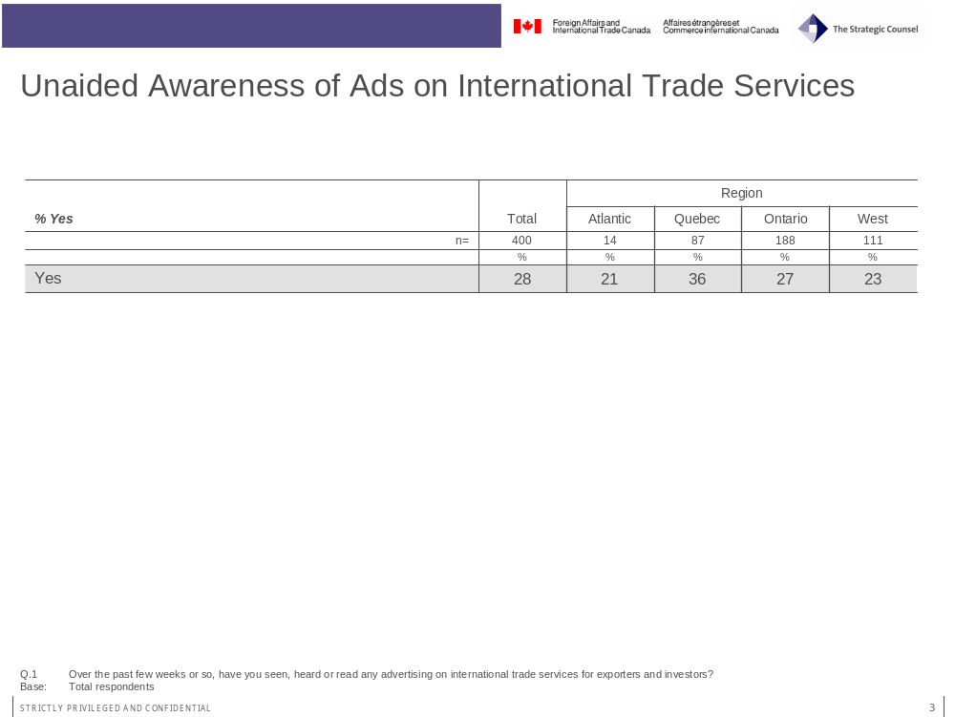
Across the regions, business travelers from Quebec (36%) are more likely to have seen or heard the ads, while those from the West (23%) are least likely.

Business travelers who work in firms with higher annual sales are more likely to have seen or heard any advertising on international trade services for exporters and investors. Specifically, there is a correlation between the level of annual sales of the firm, in dollar terms, and the likelihood of recalling the ad such that the higher the annual revenue figure for the firm, the more likely the traveler is to have seen, heard or read the ad. About one-in-six (17%) of those with annual sales less than one million, 29 percent of those between one and five million and 35 per cent of those working in firms with over five million dollars in sales have seen or heard the ads.
The age of the respondent is also an indicator of whether a business traveler has seen or heard the ads. Those aged 40 or older (32%) are more likely than those aged 18 to 39 (14%) to have seen or heard the ads.
Notably, business travelers who are more knowledgeable of export assistance services as well as those who are somewhat heavier users of news media are also more likely to have seen or heard the ads. For example, those who are aware of TCS are more likely (31%) than those not aware (21%) to recall seeing or hearing the ads. Similarly, those who are aware of EDC (32%) are more likely than those not aware (13%). Those who have read a business magazine (33%) or a daily newspaper (30%) in the past two weeks are more likely than those who have not (16% for both magazine and newspaper) to recall seeing or hearing the ads.

When asked to describe exactly what they recalled from the advertising, again without any prompting, those who had seen, heard or read the ad referred to a variety of descriptions that were relatively generic. The top 5 messages recalled by those respondents who had seen the ad are: a general comment about exporting (13%), Export Development Canada (12%), e-mail (11%), Business Development Canada (7%) and something about the government offering services (6).
Notably, about one-quarter of business travelers (26%) indicated they couldn’t think of anything in particular, either by way of content or visuals, when asked to recall specifics of the ad. This suggests that a challenge exists in enhancing the impact or “memorability” of the advertisement.
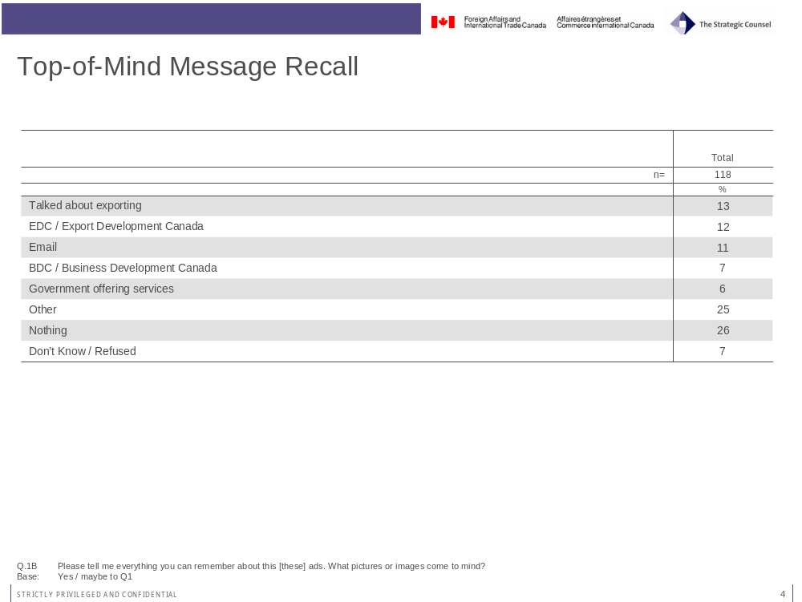

Again on an unaided basis, about one-third (35%) of those who saw the ads say they noticed them on the Internet. One-in-five (21%) say they noticed the ads in a magazine (21%) or in pamphlets in the mail (19%). A further 14 per cent recall seeing the ads in the newspaper and seven per cent (7%) say they recall seeing the ads on television.
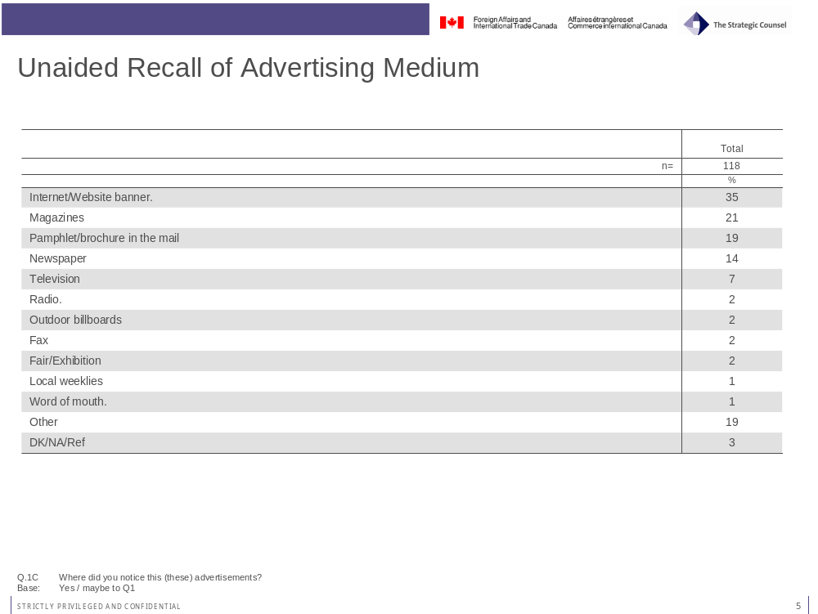
Business travelers who are aware of TCS (44%) are substantially more likely than those who are not aware (12%) to recall seeing the ads on the Internet.

Aided Recall of Advertising

Recall of Print Ad
Less than one-in-ten (8%) business travelers recall seeing an advertisement in a magazine showing a person standing in front of an international city backdrop asking them if they were doing business abroad.
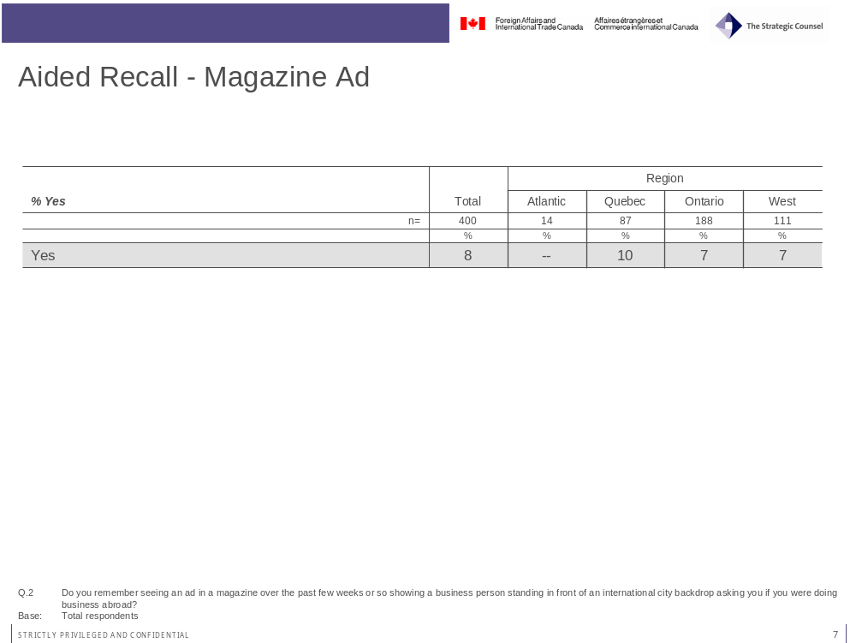
There is little variation in recall rates for magazine advertising across the regions. However, further analysis of the findings indicates that awareness of the magazine advertising is linked to educational levels. Those business travelers with higher levels of educational attainment are more likely to say that they have seen the ads in business magazines. In particular, those with university degrees (11%) are more likely than those without degrees (4%) to see the ads.
In addition, business travelers who are familiar with EDC (9%) are more likely than those who are not (2%) to recall seeing the ads in business magazines.
About half of business travelers (49%) who recall seeing the magazine ad think it was produced by the Government of Canada. Note that this percentage reflects a relatively small number of respondents.
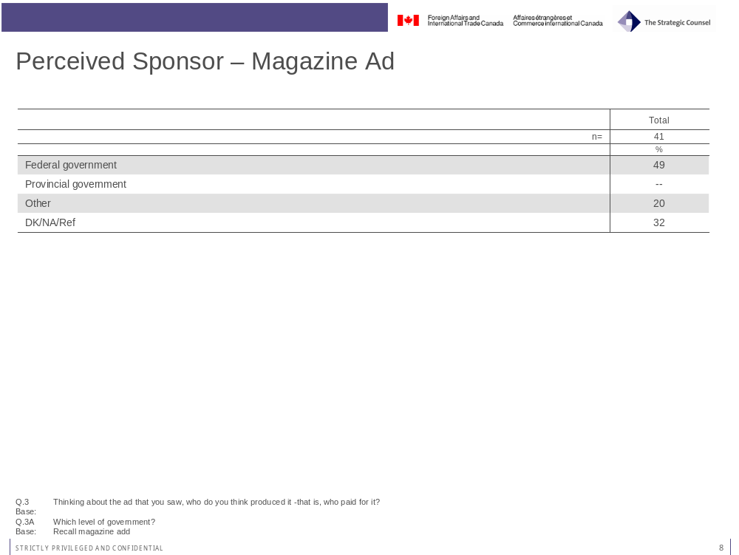

For each medium, respondents who recall having seen the ad are asked what the main message was. Responses are provided on an unprompted basis. The table below illustrates the groupings or categories of responses offered by respondents to the survey who saw the magazine ad.
About one-quarter of those who recall seeing the ad in a magazine believe the main point of the ad pertained to services and assistance available to exporters (22%). About one-in-ten think the main point is either to promote sales and international business (12%) or export development (10%). Over one-third (37%) say they do not think the ad had any main point. Again, these percentages reflect small actual numbers of respondents to the survey.
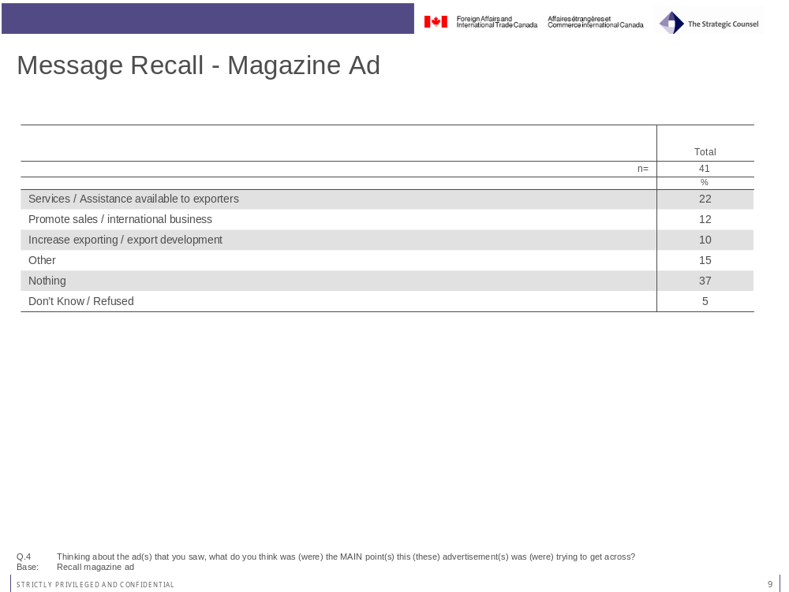

Notably, very few (7%) indicated that they took any specific action as a result of seeing the magazine advertisement.
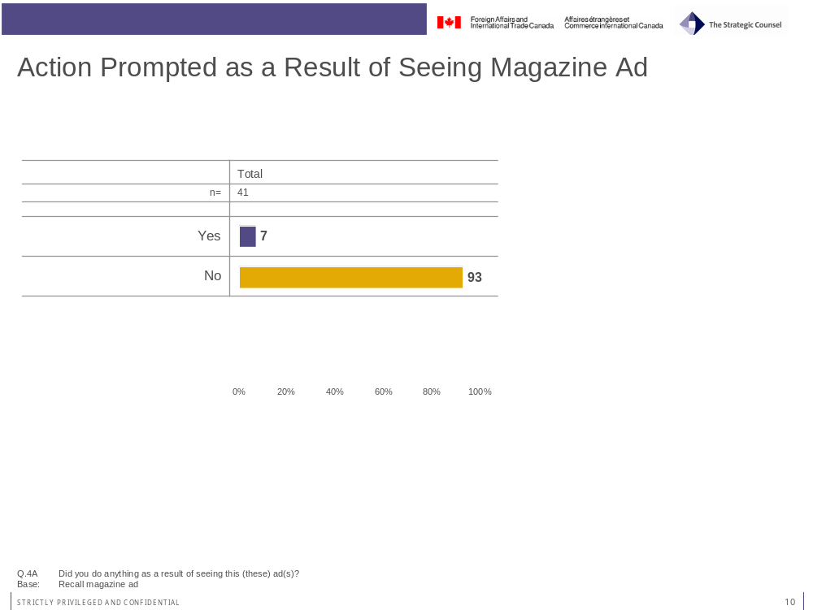

Recall of Airport Ad
Recall levels for the advertising in airports is similar to that for magazines. Less than one-in-ten (8%) recall seeing the ad in an airport showing a business person standing in front of an international city backdrop asking the viewer if they were doing business abroad.
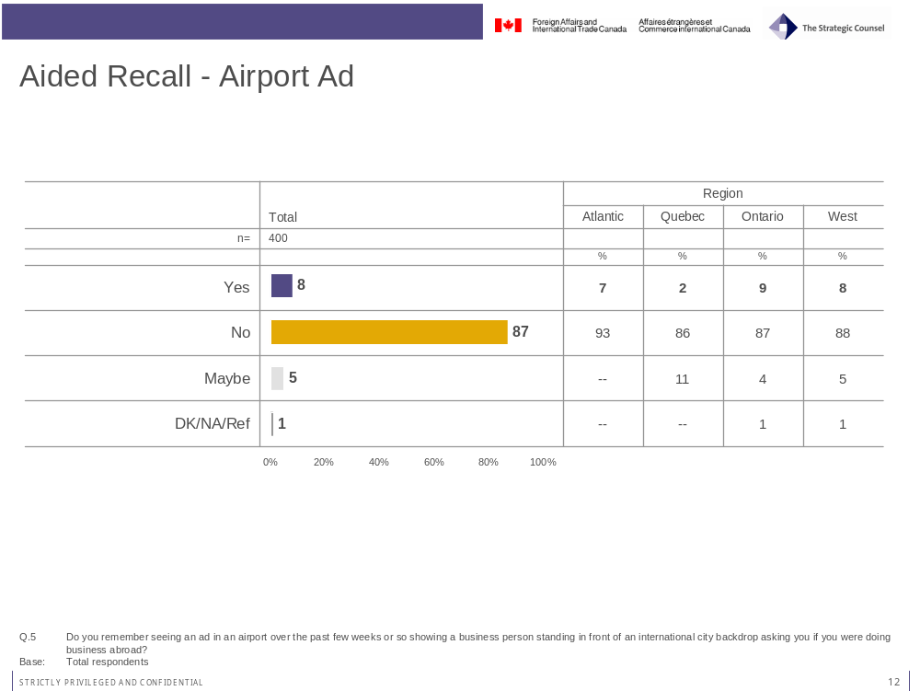
Recall rates for the advertising in airports is lowest in Quebec and highest in Ontario, although relatively modest across the board in all regions and provinces of Canada.
Interestingly, while just eight per cent of business travelers overall said they have seen the airport ads, 11 per cent of those who have traveled for business by airplane recall seeing the ads (vs. 5% of those who have not traveled for business by airplane).
About one-third (35%) of those who recall seeing the airport ad say that the Government of Canada produced and paid for it. Almost half (43%) did not know who produced it, slightly higher than the finding with respect to the magazine ad on this question. Again, however, readers are cautioned that the sample size for those having recalled the advertising in airports is quite small. As such, it is difficult to infer any strong conclusions from these findings.
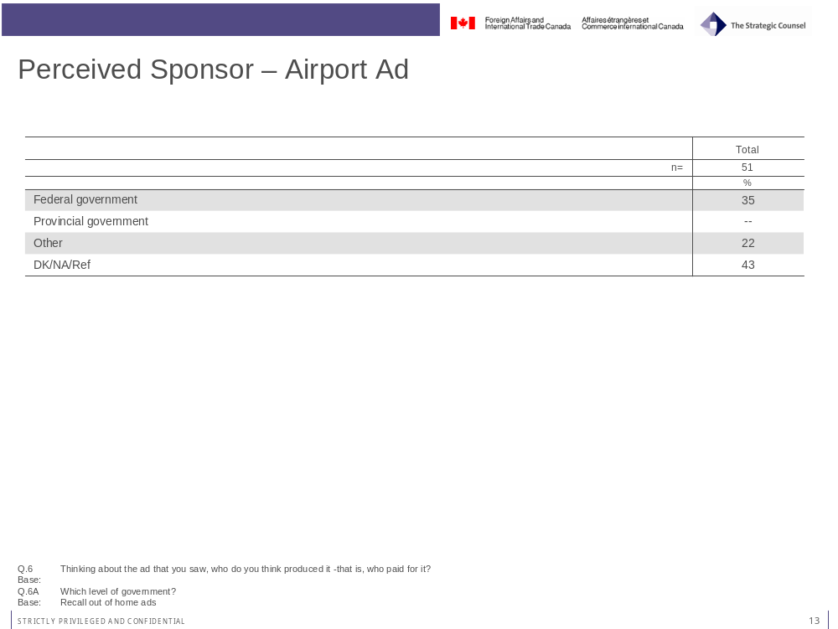

About one-quarter of those who recall seeing the airport ads thinks the main points are to promote sales and international business (27%) or the services and assistance available to exporters (24%). Another quarter (24%) says they recall nothing in particular.
Interestingly, the findings on this question suggest that the airport advertising may leave a somewhat stronger impression in the viewer’s mind regarding services and assistance to exporters as compared to the magazine advertising. Again, due to small sample sizes for those who recalled the magazine or the airport advertising, these findings should be interpreted with some caution. Nevertheless, the results make some sense given the likelihood that business travelers who see the ad in an airport setting may have a particular mindset at the time of viewing the ad which contributes to the ad having a somewhat higher impact or resonance, with respect to the message.
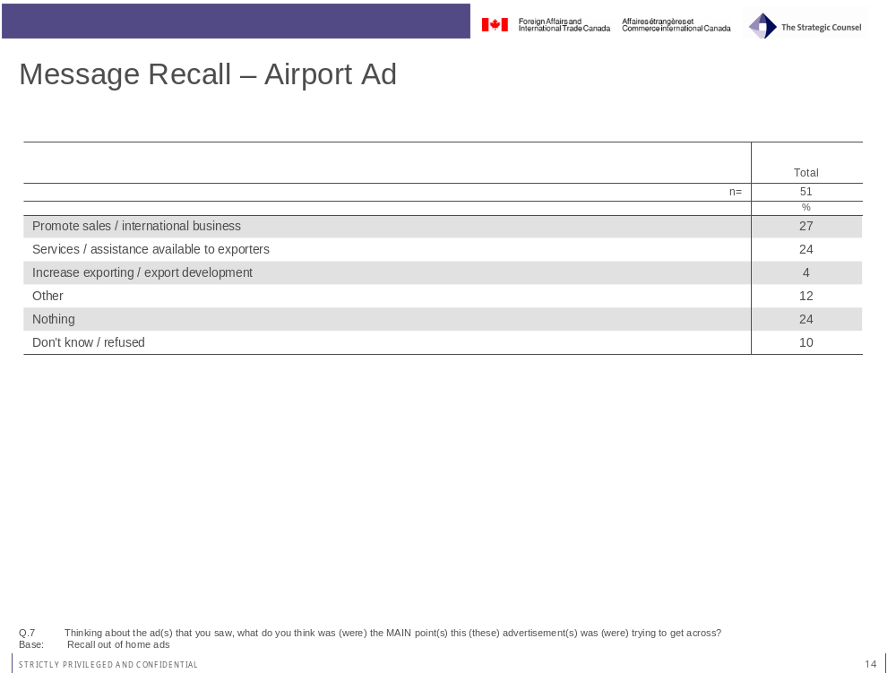
At the same time, none of those who recall seeing the airport ad say they have definitively taken action as a result of seeing the ad, although two per cent (2%) did say offer that they might have done something based on having viewed the ad.

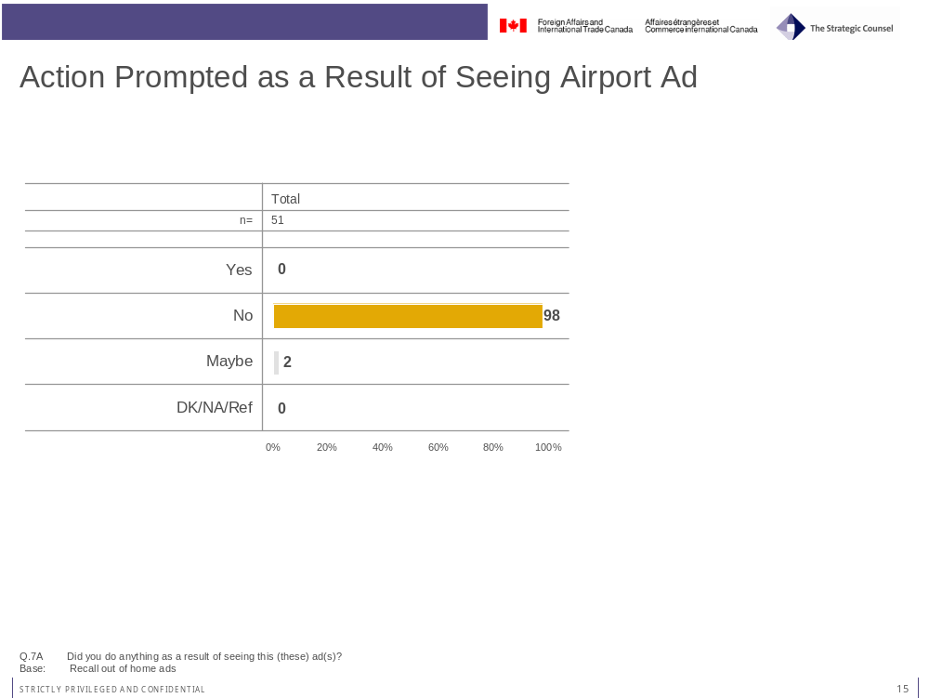

Recall of Internet Ad
Recall rates for the Internet advertising are even lower than they were for the magazine and airport advertising. Very few business travelers (4%) recall seeing an ad on the Internet showing a business person standing in front of an international city backdrop asking them if they were doing business abroad.
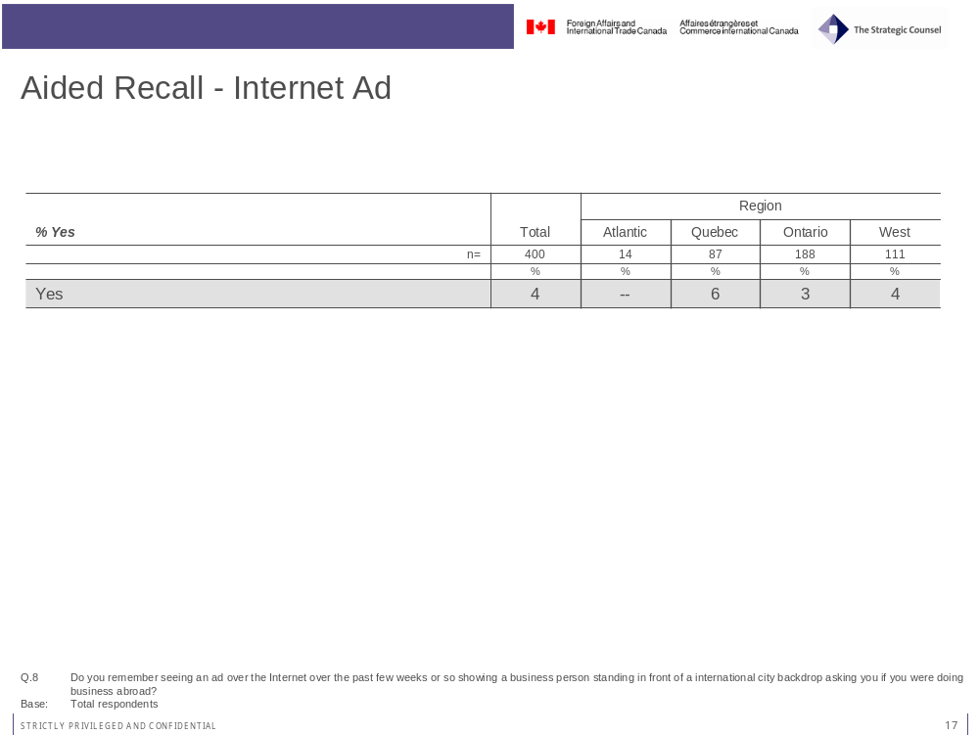
There are no significant variations in recall of the Internet advertising across key attitudinal, demographic or firmagraphic variables (e.g. firm revenues, size of firm, etc.). The one exception is awareness of the Canadian Trade Commissioner Service. Business travelers who are aware of TCS (5%) tend to be more aware of the Internet ads than those who are not (1%).
About half (45%) of those who recall seeing the Internet ads thinks it was produced by the Government of Canada. Almost one-third (30%) say they do not know who produced the ads.
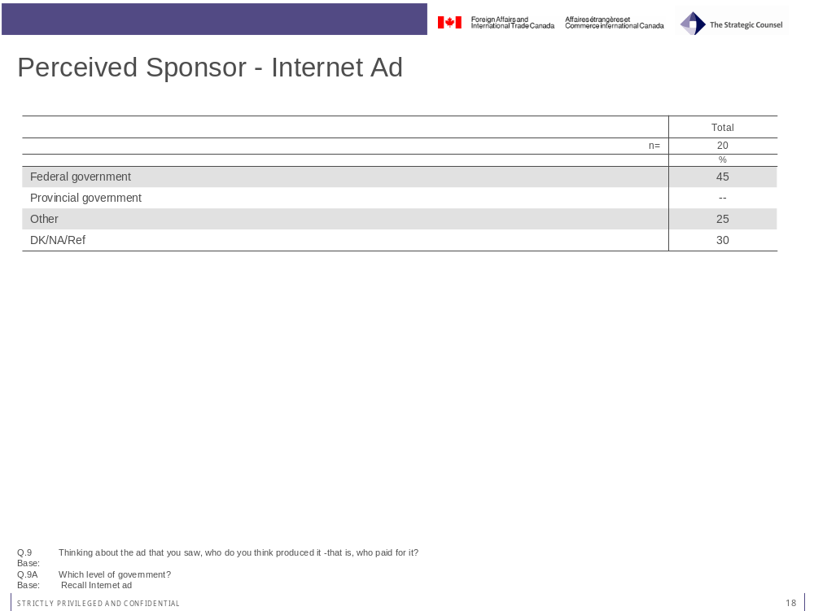
A plurality of business travelers who saw the Internet ad say the main point of the ad was to promote sales and international business.
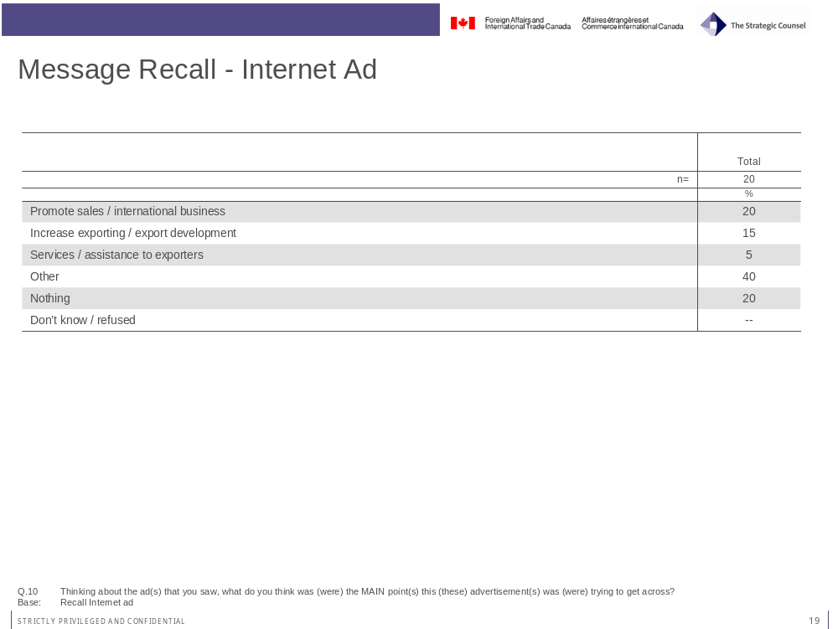

One-in-ten (10%) of those who saw the internet ad say they took action as a result. While this reflects a low overall number of respondents, it is notable that action taken as a result of seeing the Internet ad is higher than for the airport advertising and virtually equivalent to the response from those who saw the magazine advertising. Although it is difficult to say with any degree of confidence that the medium has an effect on the effectiveness of the “call-to-action,” it is quite likely that circumstance at which time the target audience would find themselves viewing either the magazine or the Internet advertising might lend itself to following up more immediately with some type of action (e.g. either going to the TCS web-site or calling the TCS) as a result of seeing the ad.
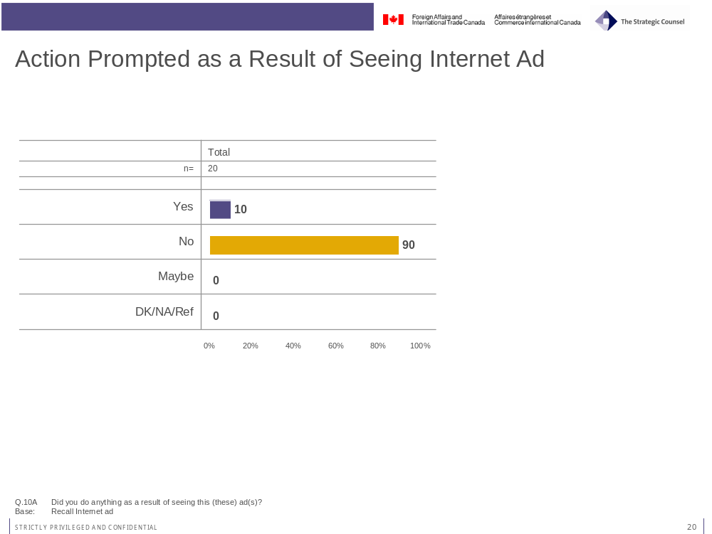

Total Aided Recall of Advertising
Total aided recall is the combined measure of those who recall, on a prompted basis, seeing the ad across any of the mediums in which it appeared. Even with prompting, just under one-quarter (24%) of business travelers say they have seen the advertisements whether in a magazine, an airport, or on the Internet. However it is notable that combined, aided recall is higher in Quebec (33%) compared to Ontario (22%) and the West (22%).
Business travelers whose firms generate over 10 per cent of their annual sales via exporting (31%) are more likely than those whose firms generate 10 per cent or less from exports (16%) to recall on an aided basis the advertising across any of the mediums.
Those that are aware of national organizations that provide export and trade assistance to businesses are also more likely to recall seeing the advertising. The following illustrates the variation in ad recall on this basis:
- Aware of TCS (29%) vs. not aware (16%);
- Aware of BDC (26%) vs. not aware (10%); and
- Aware of EDC (26%) vs. not aware (16%).

Total Recall – Unaided or Aided
Of particular interest is the percentage of respondents who say they recall the ad either on an unaided or aided basis. Typically, this figure is higher than either of the two individual measures of unaided and aided recall as some of who have seen the ad on an aided basis may not, on an unprompted basis, recall the ad.
Almost half (43%) of business travelers recall seeing the advertising, either aided or unaided. Again, this is highest in Quebec where over half (51%) recall the ads. Total recall is lowest in Ontario (41%) and the West (41%).
Awareness of organizations that assist exporting firms as well as media usage are clear positive indicators of total ad recall. The following illustrates this point in more detail:
- Aware of TCS (49%) vs. not aware (32%);
- Aware of EDC (49%) vs. not aware (23%);
- Aware of BDC (45%) vs. not aware (25%);
- Read a business magazine in the past 2 weeks (49%) vs. not (30%)
- Read a daily newspaper in the past 2 weeks (44%) vs. not (34%); and
- Listened to the radio in the past 2 weeks (44%) vs. not (30%).

Evaluation of the Government of Canada
All ACET evaluations contain a component which examines attitudes toward the Government of Canada, specifically with respect to overall perceptions of performance as well as an assessment of some aspects of service delivery. This series of questions also includes an assessment of government performance with respect to international trade services offered to exporters and investors considering overseas markets.

Overall Performance
Respondents were first asked to consider the Government of Canada’s overall performance. This assessment was not necessarily linked to a specific agenda or mandate pertaining to international trade services. On this question, about half (45%) of business travelers rated the Government of Canada’s performance as good to excellent. Notably, however, few offered the top rating of excellent (4%), while the plurality among this group were just slightly positive, a rating of 5 on a 7-point scale (27%). Just over one-third of business travelers (35%) were neutral in their assessment, saying that the Government of Canada is doing neither a good nor a bad job overall.
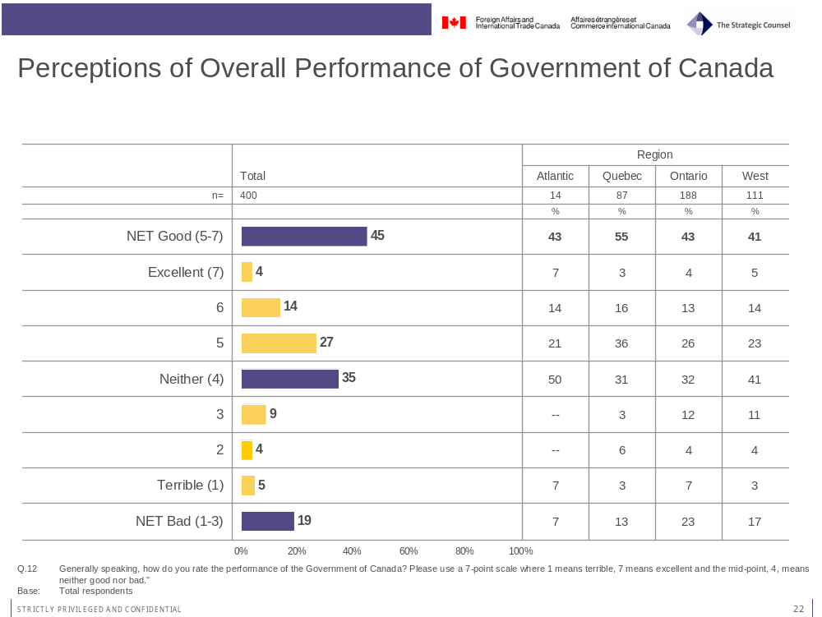

Performance on Offering International Trade Services
On perceptions of the Government of Canada’s performance with respect to international trade services, ratings are considerably lower as compared to perceptions of its overall performance. About one-quarter (26%) of business travelers say they are doing a good job on this front. About the same number rate the government unfavourably on this measure (26% say they are doing a poor job, a rating of 1 to 3 on a 7-point scale). As with the more general assessment of government performance, a similar number offer a neutral rating (35%) with respect to the Government of Canada’s performance on international trade services.
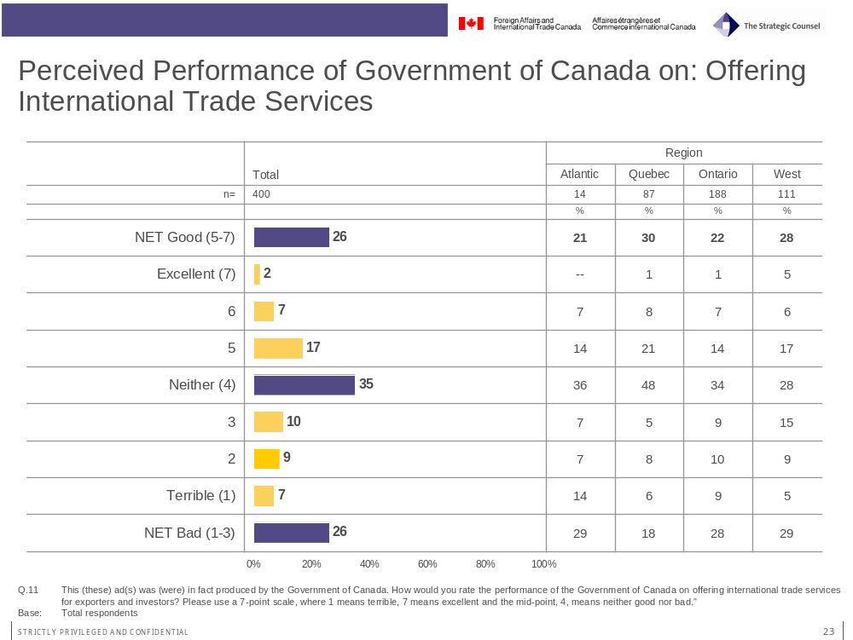
Exporting trends, education and awareness of trade service organizations are all positive indicators of perceived performance of the Government of Canada on offering international trade services.
Business travelers for whom sales from exports contribute to over half of overall firm revenues (55%) are more likely than those whose firms bring in less than half of their sales through exporting (41%) to think the Government of Canada does a good job in offering international trade services.
Those respondents with university degrees (30%) are more likely to provide a good rating to the Government of Canada on this metric than those without degrees (20%).
Travelers who are aware of TCS (30%) or EDC (30%) are more likely than those who are not aware (18%; 10% respectively) to think the Government of Canada does a good job in offering international trade services.
Of particular interest is the finding that business travelers who recall seeing the ads, from any medium, are more likely to think the Government of Canada is doing a good job on offering international trade services. In fact, 41 per cent of this group rate the Government of Canada positively on this measure compared to 21 per cent of those who have not seen the ads.

Performance on Providing Information to Public on Government Services

Ratings for the Government of Canada on providing information to the public about government services are fairly good. Over four-in-ten (43%) say the government of Canada is doing a good to excellent job on this front. At the same time, there is still room for improvement as almost one-third (30%) of business travelers say the Government of Canada is doing a bad job in this regard.
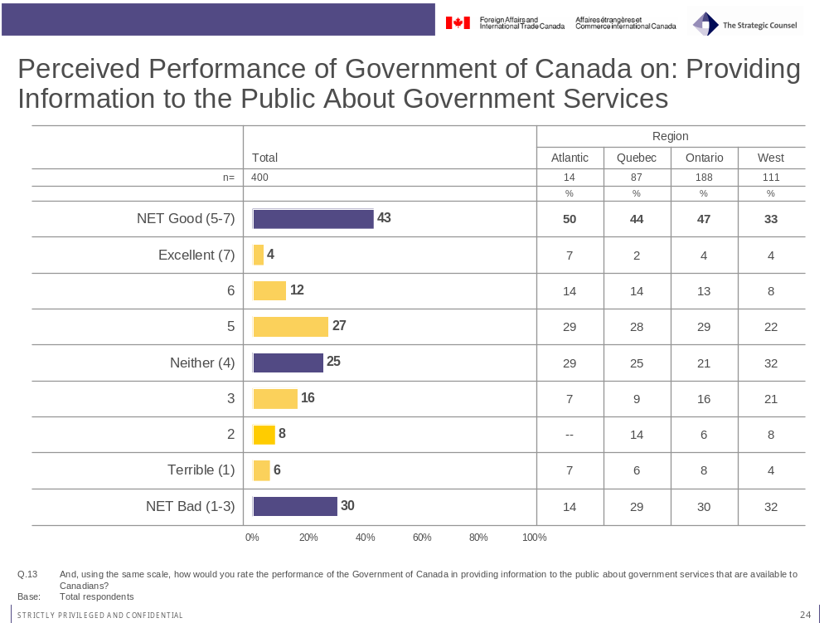
Across the regions, assessments of government performance in providing information to the public about government services is less positive in the West, where almost two-thirds (64%) of business travelers rated the Government of Canada as neutral to negative on this measure.
Notably, almost half (49%) of those who recall seeing the advertisements via one of the three mediums rate the Government of Canada as doing a good job in providing information to the public about Government Services (vs. 40% of those who have not seen the ads).

Performance on Key Dimensions of Service Delivery
The survey examined business travelers’ perceptions of the Government of Canada’s service on a number of key dimensions deemed to be important drivers of overall satisfaction with government service. Again, these questions are a standard unit of ACET evaluations. The findings indicate that the Government of Canada is perceived by business travelers to provide reliable service in a respectful way, but could perhaps improve on being seen as innovative.
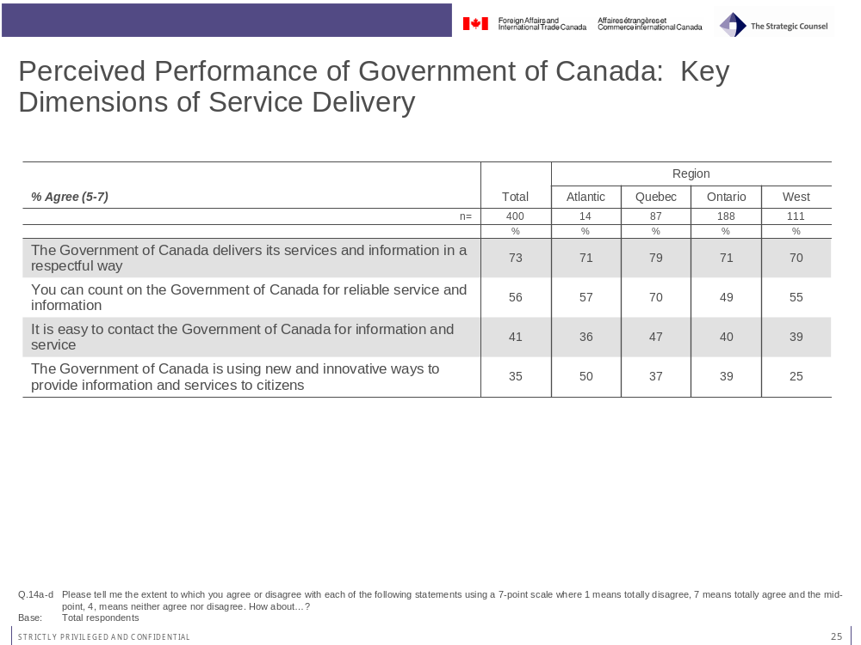
In fact, about three-quarters (73%) of business travelers say the Government of Canada delivers its services an information in a respectful way. This rating is slightly higher in Quebec (79%) than Ontario (71%) and the West (70%).
Over half (56%) of business travelers thinks the Government of Canada can be counted on to provide reliable service and information. Again, this rating is more positive in Quebec where seven-in-ten (70%) agree with the statement compared to the results for those respondents from Ontario (49%) and the West (55%).

Business travelers are less convinced about the ease of contacting the Government of Canada for information and services. In fact, only 41 per cent of them agree with a statement to this effect. Regional trends are similar as for other results on ratings of specific dimensions of service delivery with those in Quebec (47%) offering a more positive assessment on this attribute compared to Ontario (40%) and the West (39%).
Across all the measures of “serviceability” examined in this survey, the lowest rating is with respect to using new and innovative ways to provide information and services to citizens. Just over one-third (35%) of business travelers think the government is doing a good job in this regard. Business travelers in the West are less likely to perceive the government as using new and innovative ways to provide information and services while those in Quebec (79%) offer a slightly higher rating. It is important to note that almost half of those who recall seeing the advertisements (48%) think the Government of Canada is doing a good job here (vs. 31% of those who have not seen the ads).

Performance Ratings: Aware versus Not Aware of Advertising
The chart below summarizes the results on each of the performance ratings for the Government of Canada by those who were aware versus those not aware of the advertising in any of the mediums tested. As noted in the above analysis, the ratings do not vary greatly on overall performance or perceptions of the reliability of service and information from the Government of Canada.
Ratings are, however, somewhat higher for those aware of the advertising on perceptions of the Government of Canada in providing information and services in a respective way, providing information about government services in general as well as in perceptions about the ease of contacting the Government of Canada. Significant improvements in the ratings are found among those who are aware of the advertising, versus those who are not, on perceptions of performance in offering international trade services and on using innovative service delivery methods.
Evaluation of Government of Canada | Total  (% good or excellent) | Aware of Advertising  (% good or excellent) | Not Aware of Advertising  (% good or excellent) | GAP*
The Government of Canada delivers its services and information in a respectful way | 73 | 80 | 70 | +10
You can count on the Government of Canada for reliable service and information. | 56 | 54 | 56 | -2
Generally speaking, how do you rate the performance of the Government of Canada? | 45 | 44 | 45 | -1
How would you rate the performance of the Government of Canada in providing information to the public about government services that are available to Canadians? | 43 | 49 | 40 | +9
It is easy to contact the Government of Canada for information and service | 41 | 48 | 39 | +9
Using new and innovative ways to provide information and services to citizens | 35 | 48 | 31 | +17
How would you rate the performance of the Government of Canada on offering international trade services for exporters and investors? | 26 | 41 | 21 | +20
*Calculated by subtracting the figure for those “not aware” of the advertising from those “aware” of the advertising.

Awareness of Trade Service Organizations
Awareness of trade service organizations is moderate to high, at both the national and provincial level.
With regards to national trade service organizations, the vast majority of business travelers have heard of the Business Development Bank of Canada (88%) and Export Development Canada (78%). The Canadian Trade Commissioner Service (56%) is less well known than the two previously mentioned organizations. Nevertheless, this result represents a significant improvement over findings from the 2007 Corporate Connection Survey in which just one of 162 respondents identified TCS, on an unprompted basis, as an organization that offers trade services for exporters and international investors. While the results from 2007 are not directly comparable to the current findings, given that the 2008 figure is based on a prompted response, the findings are positive for TCS.
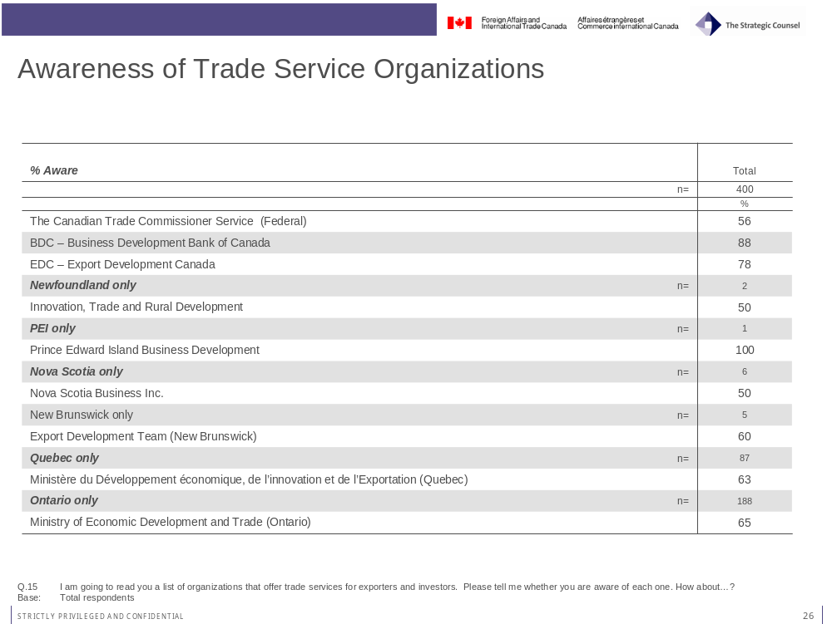
Business experience, age (probably linked to business experience) and awareness of other trade service organizations are positive indicators for awareness of TCS. The following outlines the profile of those business travelers who are more likely to indicate an awareness of TCS:
- Business travelers who are 55 years old or more (65%), versus those aged 18 to 39 (46%);
- Those who work in companies that bring in over 10 per cent of their annual sales through exporting (62%);
- Those whose company’s annual sales are one million or more (60%);
- Business travelers with 10 years or more experience in the industry (59%);
- Those who are aware of EDC (59%); and
- Those who are aware of BDC (57%).
Scanning across the regions, in Québec, about two-thirds (63%) of business travelers have heard of Ministère du Développement économique, de l’innovation et de l’Exportation. In Ontario, about two-thirds (65%) of business travelers have heard of Ministry of Economic Development and Trade (Ontario). In Alberta, an overwhelming 88 per cent have heard of Alberta Economic Development. In British Columbia, over half (56%) of business travelers have heard of Small Business B.C.
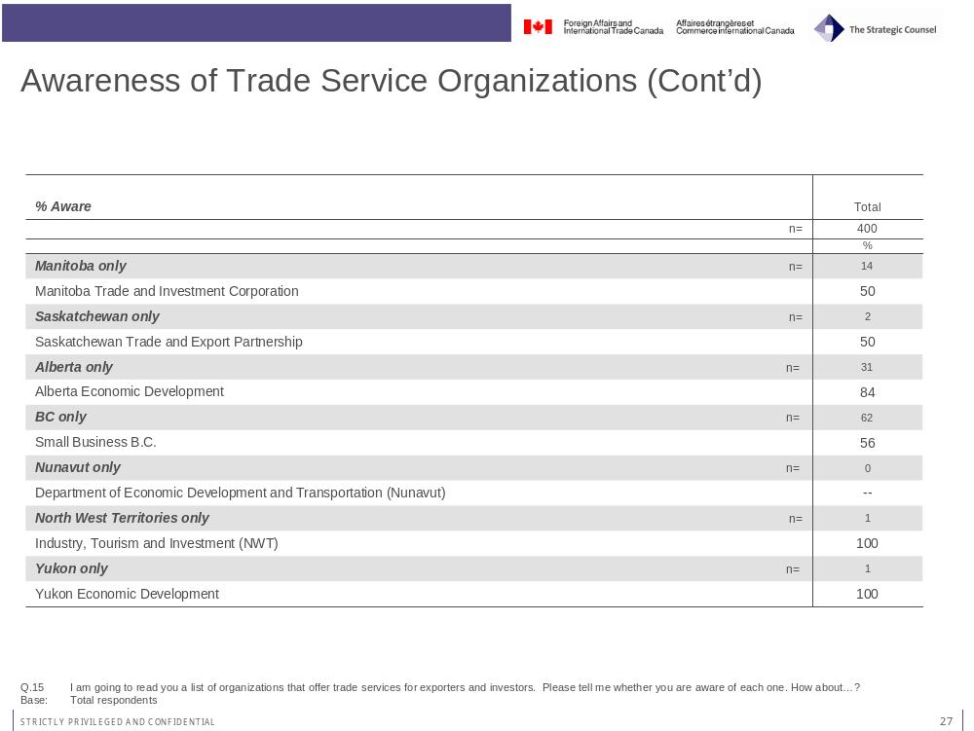

Overall Awareness of TCS and Use of TCS Services
Overall, the results show that awareness of the Canadian Trade Commissioner Service (TCS) is somewhat lower than it is for other national and provincial organizations that offer assistance and support to exporters and investors in overseas markets (e.g. EDC and BDC). When offered a second opportunity to indicate whether respondents had heard of the TCS prior to participating in the survey the total level of awareness rises to 64 per cent (combining those who initially indicated they were aware of the organization on the preliminary round of questions with those who were aware when asked the follow-up question). In total, about two-thirds (64%) of respondents have heard of the TCS.
These respondents were then asked about their use of TCS services. Just over one-quarter (28%) of those who are aware of TCS have used the services it provides in the past 3 years. About four-in-ten respondents (39%) say they have not used TCS services and do not plan to. However, just under one-third of respondents (30%) did say they planned on using TCS services in the future.
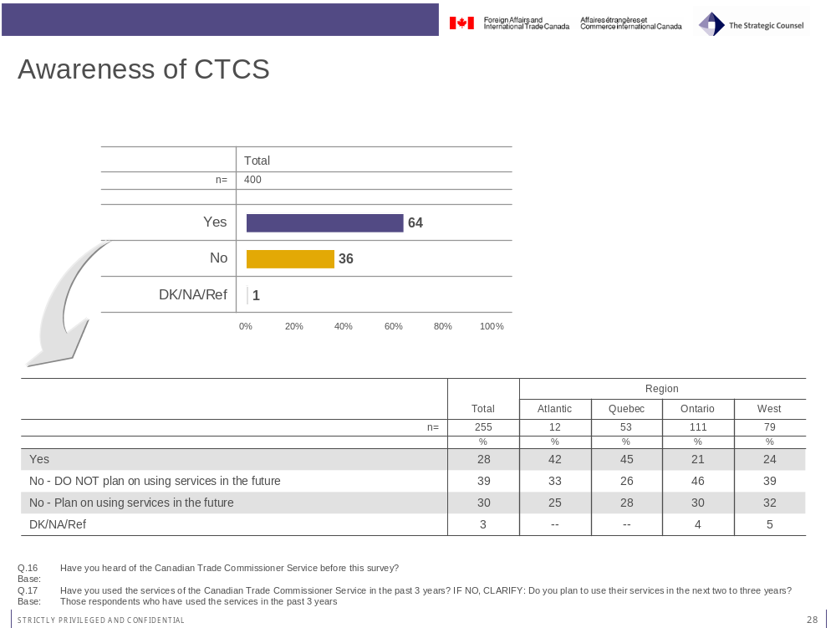

Larger firms, on the basis of sales volume, with a higher percentage of sales generated through exporting are most likely to have used the services provided by TCS. Those whose firms have annual sales above five million (35%) are more likely than those with five million or less (25%) and those whose exporting sales make up over half of total sales (40%) are more likely than those whose exporting sales are less than half of total sales (22%) to have used the services provided by TCS.
The majority of those who do use TCS services rate them as good or excellent (73%). Notably, only 6 per cent per rated the service as poor.

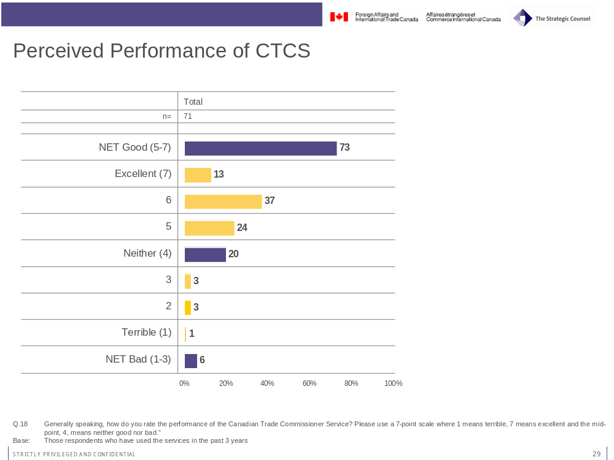

Conclusions
This is the first year in which the Canadian Trade Commissioner Services (TCS) has formally evaluated its advertising campaign aimed at business executives working for companies that export and/or invest in international markets. The campaign included advertising in business magazines, airport billboards and on the Internet.
This evaluation recorded relatively modest levels of awareness of the advertising on both an unaided and aided basis. The table below summarizes the results of the various recall measures by medium and overall:
Medium | Aided Recall | Message Recall | Action Taken
Magazine | 8% | - Services | 7%
Airport | 8%  (11% among those who had been in an airport) | - Promote sales  - Services | 0%
Internet | 4% | - Promote sales  - Increase exporting | 10%
TOTAL AIDED RECALL (across all mediums) | 24%
TOTAL RECALL (Aided +Unaided) | 43%

Among business executives who participated in the survey, 64 per cent indicated some level of awareness of TCS. This level of familiarity is lower than that recorded for EDC and BDC. Further, relatively few of the business travelers surveyed have used the services of TCS (28%) although there is some interest among those who have not to date used their services in doing so in the future (30%). Notably, among those from the target audience who have used TCS services, ratings of the performance of TCS were quite positive (73% assessed the performance of TCS as good/excellent).

Taken together, results for recall of the advertising and for awareness of TCS suggest that there is significant potential for the organization to increase its exposure among the target audience. In particular, that segment of the target audience comprising businesses with sales figures over five million and with a higher percentage of revenues attributed to exports are more likely to have used TCS services. A full profile of this segment of the market should be developed in order to more effectively target this category of businesses. In parallel, it may be useful to examine mid-size exporters as a separate target audience and develop a targeted strategy aimed at this audience.

Appendix A – Survey Instrument

Advertising Campaign Evaluation Tool

DFAIT Trade Commissioner Service Advertising Campaign

Draft Questionnaire, March 5, 2008

Introduction: REVEAL NAME OF CLIENT DEPARTMENT WHICH COMMISSIONED SURVEY AT THE END OF THE SURVEY ONLY.

Good morning/afternoon/evening, my name is _______ calling from The Strategic Counsel on behalf of the Government of Canada. We’re a professional public opinion research company.
Today we are taking to persons who are traveling for business purposes.

I’d like to assure you that we’re not trying to sell you anything. Your participation is voluntary and your answers will remain confidential. This survey is registered with the national survey registration system.

[FOR RESPONDENTS SEEKING MORE INFORMATION: The registration system has been created by the Canadian survey research industry to allow the public to verify that a survey is legitimate, get information about the survey industry or register a complaint. The registration system’s toll-free telephone number is 1-800-554-9996.]

May I speak to someone in your firm who travels regularly for business purposes? [IF YES, REPEAT INTRODUCTION; IF NO, RESCHEDULE OR THANK AND TERMINATE]

Which of the following best describes your business? READ LIST. CHOOSE ONE ONLY.

  - My company is currently doing business abroad (CONTINUE)
  - My company is planning to do business abroad over the next two years (CONTINUE)
  - My company is not planning to do business abroad (THANK AND TERMINATE)
  - (DO NOT READ) Don’t know (THANK AND TERMINATE)

Q1:
Over the past few weeks or so, have you seen, heard or read any advertising on international trade services for exporters and investors?" [DO NOT READ. DO NOT DESCRIBE THEME – STATE IT IN TWO OR THREE WORDS]
Yes.......................................................................... 1 => ASK Q1B AND Q1C
No........................................................................... 2 => GO TO Q2
Maybe...................................................................... 3 => ASK Q1B AND Q1C
DON’T KNOW/REFUSED 99

Q1B: = >Q1 = 1,3
Please tell me everything you can remember about this [these] ads. What pictures or images come to mind? [PROBE] Anything else? [OPEN-ENDED. DO NOT READ. CODE ALL THAT APPLY.]
DON'T KNOW/REFUSED 99

Q1C: = >Q1 = 1,3
Where did you notice this (these) advertisements? [PROBE. OPEN-ENDED. DO NOT READ. CODE ALL THAT APPLY].
Television 1
Radio. 2
Newspaper 3
Magazines 4
Local weeklies 5
Pamphlet/brochure in the mail 6
Outdoor billboards 7
Public transit 8
Internet/Website banner. 9
Word of mouth. 10
Ethnic paper 11
Fair/Exhibition 12
Airport signage 13
Airport Television 14
Other 98 => SPECIFY
DON’T KNOW/REFUSED 99

PRINT RECALL
ROTATE BLOCKS OF QUESTIONS (FOR PRINT RECALL, OUT OF HOME RECALL AND INTERNET RECALL)
ASK ALL.

I would now like to ask you some questions about some specific advertising.

Q2:
Do you remember seeing an ad in a magazine over the past few weeks or so showing a business person standing in front of an international city backdrop asking you if you were doing business abroad?
Yes 1 => ASK Q3 AND Q4
No 2 => GO TO Q5
Maybe 3 => ASK Q3 AND Q4
DON’T KNOW/REFUSED 99

Q3: = >Q2 = 1,3
Thinking about the ad that you saw, who do you think produced it -that is, who paid for it? [PROBE. OPEN-ENDED. DO NOT READ. ACCEPT ONE RESPONSE].
Government of Canada 1
Provincial government 2
Government - General 3 => ASK Q3A
Other 98 => SPECIFY
DON’T KNOW/REFUSED 99

Q3A: = >Q3 = 3
Which level of government? [READ. ACCEPT ONE RESPONSE].
Federal government 1
Provincial government 2
Other [DO NOT READ] 98
DON’T KNOW/REFUSED 99

Q4: = >Q2 = 1,3
Thinking about the ad(s) that you saw, what do you think was (were) the MAIN point(s) this (these) advertisement(s) was (were) trying to get across? [OPEN-ENDED. ACCEPT ONE RESPONSE. ANSWER SHOULD BE AT LEAST FIVE WORDS]
Nothing 88
DON’T KNOW/REFUSED 99

Q4A: = >Q2 = 1,3
Did you do anything as a result of seeing this (these) ad(s)?
Yes 1 => ASK Q4B
No 2 => GO TO Q5
Maybe 3 => ASK Q4B
DON’T KNOW/REFUSED 99

Q4B: = >Q4A = 1,3
What did you do? Anything else? [PROBE. OPEN ENDED. ACCEPT UP TO THREE RESPONSES.]
DON'T KNOW/REFUSED 99

OUT OF HOME RECALL
ASK ALL

Q5:
Do you remember seeing an ad in an airport over the past few weeks or so showing a business person standing in front of an international city backdrop asking you if you were doing business abroad?
Yes 1 => ASK Q6 AND Q7
No 2 => GO TO Q8
Maybe 3 => ASK Q6 AND Q7
DON’T KNOW/REFUSED 99

Q6: = >Q5 = 1,3
Thinking about the ad that you saw, who do you think produced it -that is, who paid for it? [PROBE. OPEN-ENDED. DO NOT READ. ACCEPT ONE RESPONSE].
Government of Canada 1
Provincial government 2
Government – General 3 => ASK Q6A
Other 98 => SPECIFY
DON’T KNOW/REFUSED 99

Q6A: = >Q6 = 3
Which level of government? [READ. ACCEPT ONE RESPONSE].
Federal government 1
Provincial government 2
Other [DO NOT READ] 98
DON’T KNOW/REFUSED 99

Q7: = >Q5 = 1,3
Thinking about the ad(s) that you saw, what do you think was (were) the MAIN point(s) this (these) advertisement(s) was (were) trying to get across? [OPEN-ENDED. ACCEPT ONE RESPONSE. ANSWER SHOULD BE AT LEAST FIVE WORDS]
Nothing 88
DON’T KNOW/REFUSED 99

Q7A: = >Q5 = 1,3
Did you do anything as a result of seeing this (these) ad(s)?
Yes 1 => ASK Q7B
No 2 => GO TO Q8
Maybe 3 => ASK Q7B
DON’T KNOW/REFUSED 99

Q7B: = >Q7A = 1,3
What did you do? Anything else? [PROBE. OPEN ENDED. ACCEPT UP TO THREE RESPONSES.]
DON'T KNOW/REFUSED 99

INTERNET RECALL
ASK ALL

Q8:
Do you remember seeing an ad over the Internet over the past few weeks or so showing a business person standing in front of a international city backdrop asking you if you were doing business abroad?
Yes 1 => ASK Q9 AND Q10
No 2 => GO TO Q11
Maybe 3 => ASK Q9 AND Q10
DON’T KNOW/REFUSED 99

Q9: = >Q8 = 1,3
Thinking about the ad that you saw, who do you think produced it -that is, who paid for it? [PROBE. OPEN-ENDED. DO NOT READ. ACCEPT ONE RESPONSE].
Government of Canada 1
Provincial government 2
Government – General 3 => ASK Q9A
Other 98 => SPECIFY
DON’T KNOW/REFUSED 99

Q9A: = >Q9 = 3
Which level of government? [READ. ACCEPT ONE RESPONSE].
Federal government 1
Provincial government 2
Other [DO NOT READ] 98
DON’T KNOW/REFUSED 99

Q10: = >Q8 = 1,3
Thinking about the ad(s) that you saw, what do you think was (were) the MAIN point(s) this (these) advertisement(s) was (were) trying to get across? [OPEN-ENDED. ACCEPT ONE RESPONSE. ANSWER SHOULD BE AT LEAST FIVE WORDS]
Nothing 88
DON’T KNOW/REFUSED 99

Q10A: = >Q8 = 1,3
Did you do anything as a result of seeing this (these) ad(s)?
Yes 1 => ASK Q10B
No 2 => GO TO Q11
Maybe 3 => ASK Q10B
DON’T KNOW/REFUSED 99

Q10B: = >Q10A = 1,3
What did you do? Anything else? [PROBE. OPEN ENDED. ACCEPT UP TO THREE RESPONSES.]
DON'T KNOW/REFUSED 99

ASK ALL.
Q11:
This (these) ad(s) was (were) in fact produced by the Government of Canada. How would you rate the performance of the Government of Canada on offering international trade services for exporters and investors? Please use a 7-point scale, where 1 means terrible, 7 means excellent and the mid-point, 4, means neither good nor bad."
01 – Terrible 1
02 2
03 3
04 – Neither good nor bad 4
05 5
06 6
07 – Excellent 7
DON'T KNOW/REFUSED 99

Q12:
Generally speaking, how do you rate the performance of the Government of Canada? Please use a 7-point scale where 1 means terrible, 7 means excellent and the mid-point, 4, means neither good nor bad."
01 – Terrible 1
02 2
03 3
04 – Neither good nor bad 4
05 5
06 6
07 – Excellent 7
DON'T KNOW/REFUSED 99

Q13:
And, using the same scale [REPEAT IF NECESSARY], how would you rate the performance of the Government of Canada in providing information to the public about government services that are available to Canadians?
01 – Terrible 1
02 2
03 3
04 – Neither good nor bad 4
05 5
06 6
07 – Excellent 7
DON'T KNOW/REFUSED 99

Q14:
Please tell me the extent to which you agree or disagree with each of the following statements using a 7-point scale where 1 means totally disagree, 7 means totally agree and the mid-point, 4, means neither agree nor disagree. How about...[READ AND ROTATE]

a) It is easy to contact the Government of Canada for information and service.
01 - Totally disagree 1
02 2
03 3
04 – Neither agree nor disagree 4
05 5
06 6
07 – Totally agree 7
DON'T KNOW/REFUSED 99

b) The Government of Canada is using new and innovative ways to provide information and services to citizens.
01 - Totally disagree 1
02 2
03 3
04 – Neither agree nor disagree 4
05 5
06 6
07 – Totally agree 7
DON'T KNOW/REFUSED 99

c) The Government of Canada delivers its services and information in a respectful way.
01 - Totally disagree 1
02. 2
03 3
04 – Neither agree nor disagree 4
05 5
06 6
07 – Totally agree 7
DON'T KNOW/REFUSED. 99

d) You can count on the Government of Canada for reliable service and information.
01 - Totally disagree 1
02 2
03 3
04 – Neither agree nor disagree 4
05. 5
06 6
07 – Totally agree 7
DON'T KNOW/REFUSED 99

Q15:
I am going to read you a list of organizations that offer trade services for exporters and investors. Please tell me whether you are aware of each one. How about… RANDOMIZE ORGANIZATIONS.
ASK ALL.
A. The Canadian Trade Commissioner Service (Federal)
B. BDC – Business Development Bank of Canada
C. EDC – Export Development Canada
NFLD ONLY.
D. Innovation, Trade and Rural Development (Newfoundland)
PEI ONLY.
E. Prince Edward Island Business Development
NOVA SCOTIA ONLY.
F. Nova Scotia Business Inc
NEW BRUNSWICK ONLY.
G. Export Development Team (New Brunswick)
QUEBEC ONLY.
Ministère du Développement économique, de l’innovation et de l’Exportation (Quebec)
ONTARIO ONLY.
I. Ministry of Economic Development and Trade (Ontario)
MANITOBA ONLY.
J. Manitoba Trade and Investment Corporation
SASK ONLY.
K. Saskatchewan Trade and Export Partnership
ALBERTA ONLY.
L. Alberta Economic Development
BC ONLY.
M. Small Business B.C.
NUNAVUT ONLY.
N. Department of Economic Development and Transportation (Nunavut)
NWT ONLY.
O. Industry, Tourism and Investment (NWT)
YUKON ONLY.
P. Yukon Economic Development

Yes. 1
No 2
DON’T KNOW/REFUSED 99

Q16: SKIP IF Q15A = YES
Have you heard of the Canadian Trade Commissioner Service before this survey?
Yes 1 => ASK Q17
No 2 => SKIP TO D1
DON’T KNOW/REFUSED 99 => SKIP TO D1

Q17:
Have you used the services of the Canadian Trade Commissioner Service in the past 3 years? IF NO, CLARIFY: Do you plan to use their services in the next two to three years?
Yes 1 => ASK Q18
No – DO NOT plan on using services in the future 2 => SKIP TO D1
No – Plan on using services in the future 2 => SKIP TO D1
DON’T KNOW/REFUSED 99 => SKIP TO D1

Q18:
Generally speaking, how do you rate the performance of the Canadian Trade Commissioner Service? Please use a 7-point scale where 1 means terrible, 7 means excellent and the mid-point, 4, means neither good nor bad."
01 – Terrible 1
02 2
03 3
04 – Neither good nor bad 4
05 5
06 6
07 – Excellent 7
DON'T KNOW/REFUSED 99

DEMOGRAPHICS:
INTERVIEWER RECORDS GENDER, LANGUAGE OF INTERVIEW, URBAN/RURAL.
Finally, I would like to ask you a few questions about you and your company for statistical purposes. Please be assured that all your answers will remain completely confidential.
D1:
Over the past two weeks, have you...[READ AND RANDOMIZE. CODE ALL THAT APPLY.]

a) Read a daily newspaper?
Yes 1
No 2
Maybe 3
DON’T KNOW/REFUSED 99

b) Watched television?
Yes 1
No 2
Maybe 3
DON’T KNOW/REFUSED 99

c) Listened to the radio?
Yes 1
No 2
Maybe 3
DON’T KNOW/REFUSED 99

d) Read a business magazine?
Yes (Please specify ___________) 1
No 2
Maybe 3
DON’T KNOW/REFUSED 99

e) Used the internet?
Yes 1
No 2
Maybe 3
DON’T KNOW/REFUSED 99

f) Travelled for business by airplane?
Yes 1
No 2
Maybe 3
DON’T KNOW/REFUSED 99

D2:
How long has your company been in business?
Less than three months 1
Three months to less than one year 2
One year to less than three years 3
Three years to less than five years 4
Five years to less than 10 years 5
10 years or more 6
DON’T KNOW/REFUSED 99

D3:
In what industry or sector does your business operate? If you are active in more than one, please identify the main industry/sector. DO NOT READ LIST. CHOOSE ONLY ONE.
Agriculture/Fishing/Hunting/Forestry 1
Oil/Gas/Mining 2
Utilities 3
Construction 4
Manufacturing 5
Wholesale Trade 6
Retail Trade 7
Transportation and Warehousing 8
Information and cultural industries 9
Finance and insurance 10
Real Estate and Rental/Leasing 11
Professional, Scientific and Technical Services 12
Management of Companies and Enterprises 13
Administrative and support, Waste
Management, Remediation Services 14
Art, Entertainment, Recreation 15
Accommodation and Food Services 16
Other 98 => SPECIFY
DON'T KNOW/REFUSED 99

D4:
Which of the following best estimates your company’s annual sales?
Less than $500,000 1
Between $500,000 and $1,000,000 2
Between $1,000,000 and $5,000,000 3
More than $5,000,000 4
DON’T KNOW/REFUSED 99

D5:
Approximately what percentage of your company’s annual sales is generated through exports?
10% or less 1
11-20% 2
21-30% 3
31-40% 4
41-50% 5
51-60% 6
61-70% 7
71-80%. 8
81-90% 9
91-100%. 10
DON'T KNOW/REFUSED 99

D6:
Which export markets are you currently or plan to be engaged in over the next two to three years?
Asia-Pacific 1
Eastern Europe 2
Western Europe 3
United States 4
Latin/Central America/Caribbean 5
Middle East and North Africa 6
Other 98 => SPECIFY
DON'T KNOW/REFUSED 99

D7:
What is the highest level of formal education that you have completed? [READ LIST]
Grade 8 or less 1
Some high school 2
Complete high school. 3
Technical, vocational post-secondary, college 4
Some university 5
Complete university degree. 6
Post graduate degree 7
DON'T KNOW/REFUSED 99

D8:
In what year were you born? [RECORD YEAR - XXXX]
DON'T KNOW/REFUSED 99

Outil d’évaluation de la campagne publicitaire

Service des délégués commerciaux du MAECI

Ébauche du questionnaire - Le 5 mars 2008

Introduction : NE RÉVÉLER LE NOM DU MINISTÈRE CLIENT QUI A MANDATÉ L’ÉTUDE QU’À LA FIN.

Bonjour / Bonsoir, je suis _______ de The Strategic Counsel pour le compte du gouvernement du Canada. Nous sommes une société professionnelle de sondage de l’opinion publique. Aujourd’hui, nous parlons à des gens qui voyagent par affaires.

Je tiens à vous assurer que nous ne vendons rien. Votre participation est volontaire et vos réponses demeureront confidentielles. Ce sondage est inscrit auprès du Système national d’enregistrement des sondages.

(Pour les répondants qui désirent plus d’information : le Système national d’enregistrement des sondages a été créé par l’industrie canadienne de la recherche-sondage afin de permettre au public de confirmer la légitimité d’un sondage, d’obtenir de l’information sur le secteur ou de déposer une plainte. Le numéro sans frais du système est le 1 800 554-9996.)

Puis-je parler à un employé de votre entreprise qui voyage régulièrement par affaires? [SI OUI, RÉPÉTER L’INTRODUCTION; SI NON, FIXER UN RAPPEL OU REMERCIER ET METTRE FIN À L’ENTREVUE]

Lequel de ces énoncés décrit le mieux votre entreprise? LIRE LA LISTE. CHOISIR UNE SEULE RÉPONSE.

  - Mon entreprise fait présentement des affaires à l’étranger (CONTINUER)
  - Mon entreprise prévoit faire des affaires à l’étranger au cours des deux prochaines années (CONTINUER)
  - Mon entreprise ne prévoit pas faire des affaires à l’étranger (REMERCIER ET METTRE FIN À L’ENTREVUE)
  - (NE PAS LIRE) Ne sait pas (REMERCIER ET METTRE FIN À L’ENTREVUE)

Q1:
Au cours des dernières semaines, avez-vous vu, entendu ou lu des annonces sur des services reliés au commerce international à l’intention des exportateurs et des investisseurs? [NE PAS LIRE. NE PAS DÉCRIRE LE THÈME – EXPOSER EN DEUX OU TROIS MOTS]
Oui 1 => POSER Q1B ET Q1C
Non 2 => ALLER À Q2
Peut-être 3 => POSER Q1B ET Q1C
NE SAIT PAS/REFUS 99

Q1B: = >Q1 = 1,3
Dites-moi tout ce dont vous vous souvenez à propos de cette(ces) annonce(s). Quelles sont les images qui vous viennent à l’esprit? [INTERROGER] Est-ce qu’il y en a d’autres? [RÉPONSE OUVERTE. NE PAS LIRE. CODER TOUTES LES RÉPONSES PERTINENTES.]
NE SAIT PAS/REFUS 99

Q1C: = >Q1 = 1,3
Où avez-vous remarqué cette(ces) annonce(s)? [INTERROGER. RÉPONSE OUVERTE. NE PAS LIRE. CODER TOUTES LES RÉPONSES PERTINENTES].
Télévision 1
Radio 2
Journal 3
Magazines 4
Hebdomadaires locaux 5
Dépliant / brochure dans le courrier. 6
Panneaux-réclames 7
Transports en commun 8
Internet / bannière Web 9
Bouche à oreille 10
Journal ethnique 11
Foire / Exhibition. 12
Affiches à l’aéroport 13
Télévision à l’aéroport 14
Autre. 98 => PRÉCISER
NE SAIT PAS/REFUS 99

RAPPEL DE PUBLICITÉ IMPRIMÉE
RENOUVELER LES BLOCS DE QUESTIONS (POUR LE RAPPEL DE LA PUBLICITÉ IMPRIMÉE, CELLE DANS LES AÉROPORTS ET CELLE SUR INTERNET)
DEMANDER À TOUS LES RÉPONDANTS.
Je vais maintenant vous poser quelques questions sur des campagnes en particulier.

Q2:
Vous rappelez-vous avoir vu au cours des dernières semaines une annonce dans une revue présentant un homme d’affaires debout avec comme toile de fond une ville internationale et demandant si vous faisiez des affaires à l’étranger?
Oui 1 => POSER Q3 ET Q4
Non 2 => ALLER À Q5
Peut-être 3 => POSER Q3 ET Q4
NE SAIT PAS/REFUS 99

Q3: = >Q2 = 1,3
Si vous pensez à la publicité que vous avez vue qui, selon vous, en était l’auteur, c’est-à-dire qui l’a financée? [INTERROGER. RÉPONSE OUVERTE. NE PAS LIRE. ACCEPTER UNE RÉPONSE].
Gouvernement du Canada 1
Gouvernement provincial. 2
Gouvernement – en général 3 => POSER Q3A
Autre 98 => PRÉCISER
NE SAIT PAS/REFUS 99

Q3A: = >Q3 = 3
Quel ordre de gouvernement? [LIRE. ACCEPTER UNE RÉPONSE].
Gouvernement du Canada 1
Gouvernement provincial 2
Autre [NE PAS LIRE] 98
NE SAIT PAS/REFUS 99

Q4: = >Q2 = 1,3
Si vous pensez à la (aux) publicité(s) que vous avez vues, quels en étaient les messages principaux? [RÉPONSE OUVERTE. ACCEPTER UNE RÉPONSE. LA RÉPONSE DOIT COMPRENDRE AU MOINS CINQ MOTS]
Aucun 88
NE SAIT PAS/REFUS 99

Q4A: = >Q2 = 1,3
Avez-vous fait quelque chose en réponse à cette (ces) annonce(s)?
Oui 1 => POSER Q4B
Non 2 => ALLER À Q5
Peut-être 3 => POSER Q4B
NE SAIT PAS/REFUS 99

Q4B: = >Q4A = 1,3
Qu’avez-vous fait? Autre chose? [INTERROGER. RÉPONSE OUVERTE. ACCEPTER JUSQU’À TROIS RÉPONSES.]
NE SAIT PAS/REFUS 99

RAPPEL DE PUBLICITÉ DANS LES AÉROPORTS
DEMANDER À TOUS LES RÉPONDANTS.

Q5:
Vous rappelez-vous avoir vu au cours des dernières semaines une annonce dans un aéroport présentant un homme d’affaires debout avec comme toile de fond une ville internationale et demandant si vous faisiez des affaires à l’étranger?
Oui 1 => POSER Q6 ET Q7
Non 2 => ALLER À Q8
Peut-être 3 => POSER Q6 ET Q7
NE SAIT PAS/REFUS 99

Q6: = >Q5 = 1,3
Si vous pensez à la publicité que vous avez vue qui, selon vous, en était l’auteur, c’est-à-dire qui l’a financée? [INTERROGER. RÉPONSE OUVERTE. NE PAS LIRE. ACCEPTER UNE RÉPONSE].
Gouvernement du Canada 1
Gouvernement provincial 2
Gouvernement – en général 3 => POSER Q6A
Autre....................................................................... 98 => PRÉCISER
NE SAIT PAS/REFUS 99

Q6A: = >Q6 = 3
Quel ordre de gouvernement? [LIRE. ACCEPTER UNE RÉPONSE].
Gouvernement du Canada 1
Gouvernement provincial 2
Autre [NE PAS LIRE 98
NE SAIT PAS/REFUS 99

Q7: = >Q5 = 1,3
Si vous pensez à la (aux) publicité(s) que vous avez vues, quels en étaient les messages principaux? [RÉPONSE OUVERTE. ACCEPTER UNE RÉPONSE. LA RÉPONSE DOIT COMPRENDRE AU MOINS CINQ MOTS]
Aucun 88
NE SAIT PAS/REFUS 99

Q7A: = >Q5 = 1,3
Avez-vous fait quelque chose en réponse à cette(ces) annonce(s)?
Oui 1 => POSER Q7B
Non 2 => ALLER À Q8
Peut-être 3 => POSER Q7B
NE SAIT PAS/REFUS 99

Q7B: = >Q7A = 1,3
Qu’avez-vous fait? Autre chose? [INTERROGER. RÉPONSE OUVERTE. ACCEPTER JUSQU’À TROIS RÉPONSES.]
NE SAIT PAS/REFUS 99

RAPPEL DE PUBLICITÉ SUR INTERNET
DEMANDER À TOUS LES RÉPONDANTS.

Q8:
Vous rappelez-vous avoir vu au cours des dernières semaines une annonce sur Internet présentant un homme d’affaires debout avec comme toile de fond une ville internationale et demandant si vous faisiez des affaires à l’étranger?
Oui 1 => POSER Q9 ET Q10
Non 2 => ALLER À Q11
Peut-être 3 => POSER Q9 ET Q10
NE SAIT PAS/REFUS 99

Q9: = >Q8 = 1,3
Si vous pensez à la publicité que vous avez vue qui, selon vous, en était l’auteur, c’est-à-dire qui l’a financée? [INTERROGER. RÉPONSE OUVERTE. NE PAS LIRE. ACCEPTER UNE RÉPONSE].
Gouvernement du Canada 1
Gouvernement provincial 2
Gouvernement – en général 3 => POSER Q9A
Autre....................................................................... 98 => PRÉCISER
NE SAIT PAS/REFUS 99

Q9A: = >Q9 = 3
Quel ordre de gouvernement? [LIRE. ACCEPTER UNE RÉPONSE].
Gouvernement du Canada 1
Gouvernement provincial 2
Autre [NE PAS LIRE 98
NE SAIT PAS/REFUS 99

Q10: = >Q8 = 1,3
Si vous pensez à la (aux) publicité(s) que vous avez vues, quels en étaient les messages principaux? [RÉPONSE OUVERTE. ACCEPTER UNE RÉPONSE. LA RÉPONSE DOIT COMPRENDRE AU MOINS CINQ MOTS]
Aucun 88
NE SAIT PAS/REFUS 99

Q10A: = >Q8 = 1,3
Avez-vous fait quelque chose en réponse à cette(ces) annonce(s)?
Oui 1 => POSER Q10B
Non 2 => ALLER À Q11
Peut-être 3 => POSER Q10B
NE SAIT PAS/REFUS 99

Q10B: = >Q10A = 1,3
Qu’avez-vous fait? Autre chose? [INTERROGER. RÉPONSE OUVERTE. ACCEPTER JUSQU’À TROIS RÉPONSES.]
NE SAIT PAS/REFUS 99

DEMANDER À TOUS LES RÉPONDANTS.
Q11:
Ces annonces étaient en fait produites par le gouvernement du Canada. Comment évalueriez-vous la performance du gouvernement du Canada pour ce qui est d’offrir des services reliés au commerce international pour les exportateurs et les investisseurs? Veuillez utiliser une échelle de sept points, où 1 veut dire « Affreuse », 7 veut dire, « Excellente » et 4, le point milieu, veut dire « Ni bonne, ni mauvaise ».
01 – Affreuse 1
02 2
03 3
04 – Ni bonne, ni mauvaise 4
05 5
06 6
07 – Excellente 7
NE SAIT PAS/REFUS 99

Q12:
De façon générale, comment évaluez-vous la performance du gouvernement du Canada? Veuillez utiliser une échelle de sept points, où 1 veut dire « Affreuse », 7 veut dire, « Excellente » et 4, le point milieu, veut dire « Ni bonne, ni mauvaise ».
01 – Affreuse 1
02 2
03 3
04 – Ni bonne, ni mauvaise 4
05 5
06 6
07 – Excellente 7
NE SAIT PAS/REFUS 99

Q13:
En utilisant la même échelle [RÉPÉTER AU BESOIN], comment évalueriez-vous la performance du gouvernement du Canada pour ce qui est de fournir aux canadiens de l’information sur les services qui leur sont offerts?
01 – Affreuse 1
02 2
03 3
04 – Ni bonne, ni mauvaise 4
05 5
06 6
07 – Excellente 7
NE SAIT PAS/REFUS 99

Q14:
Dans quelle mesure êtes-vous d’accord avec les énoncés suivants, en utilisant une échelle de sept points, où 1 veut dire « Entièrement en désaccord », 7 veut dire « Entièrement d’accord » et 4, le point milieu veut dire, « Ni d’accord, ni en désaccord ». Voici les énoncés. [LIRE ET RENOUVELER]

a) C’est facile de communiquer avec le gouvernement du Canada pour avoir des informations ou des services.
01 – Entièrement en désaccord 1
02 2
03. 3
04 – Ni en accord, ni en désaccord. 4
05 5
06 6
07 – Entièrement d’accord 7
NE SAIT PAS/REFUS 99

b) Le gouvernement du Canada utilise des façons novatrices pour fournir des informations et des services aux citoyens.
01 - Entièrement en désaccord. 1
02. 2
03 3
04 – Ni en accord, ni en désaccord 4
05 5
06 6
07 – Entièrement d’accord 7
NE SAIT PAS/REFUS 99

c) Le gouvernement du Canada fournit ses services et ses informations de façon respectueuse.
01 - Entièrement en désaccord 1
02 2
03 3
04 – Ni en accord, ni en désaccord 4
05 5
06 6
07 – Entièrement d’accord 7
NE SAIT PAS/REFUS 99

d) On peut compter sur le gouvernement du Canada pour obtenir des services et de l’information fiables.
01 - Entièrement en désaccord 1
02 2
03 3
04 – Ni en accord, ni en désaccord 4
05 5
06. 6
07 – Entièrement d’accord 7
NE SAIT PAS/REFUS 99

Q15:
Je vais vous lire une liste d’organismes qui offrent des services aux exportateurs et aux investisseurs. Veuillez me dire si vous connaissez chacun d’entre eux. Qu’en est-il de… RANDOMISER LES ORGANISMES.
DEMANDER À TOUS LES RÉPONDANTS.
A. Service des délégués commerciaux du Canada (Fédéral)
B. BDC – Banque de développement du Canada
C. EDC – Exportation et développement Canada
TERRE-NEUVE SEULEMENT.
D. Innovation, Trade and Rural Development (Terre-Neuve)
IPE SEULEMENT.
E. Prince Edward Island Business Development
NOUVELLE-ÉCOSSE SEULEMENT.
F. Nova Scotia Business Inc
NOUVEAU-BRUNSWICK SEULEMENT.
G. Export Development Team (Nouveau-Brunswick)
QUÉBEC SEULEMENT.
H. Ministère du Développement économique, de l’innovation et de l’Exportation (Québec)
ONTARIO SEULEMENT.
I. Ministère du Développement économique, du Commerce et du Tourisme (Ontario)
MANITOBA SEULEMENT.
J. Société du commerce et de l’investissement du Manitoba
SASK SEULEMENT.
K. Saskatchewan Trade and Export Partnership
ALBERTA SEULEMENT.
L. Alberta Economic Development
C.-B. SEULEMENT.
M. Small Business B.C.
NUNAVUT SEULEMENT.
N. Department of Economic Development and Transportation (Nunavut)
TNO SEULEMENT.
O. Industry, Tourism and Investment (NWT)
YUKON SEULEMENT.
P. Ministère de l’Expansion économique

Oui 1
Non 2
NE SAIT PAS/REFUS 99

Q16: NE PAS DEMANDER SI Q15A = OUI
Aviez-vous déjà entendu parler du Service des délégués commerciaux du Canada avant ce sondage?
Oui 1 => POSER Q17
Non 2 => PASSER À D1
NE SAIT PAS/REFUS 99 => PASSER À D1

Q17:
Avez-vous eu recours aux services du Service des délégués commerciaux du Canada au cours des trois dernières années? SI NON, CLARIFIER : Prévoyez-vous utiliser leurs services dans les deux ou trois prochaines années?
Oui 1 => POSER Q18
Non – NE prévoit PAS utiliser leurs services
à l’avenir 2 => PASSER À D1
Non – prévoit utiliser leurs services à l’avenir 2 => PASSER À D1
NE SAIT PAS/REFUS 99 => PASSER À D1

Q18:
En général, comment évaluez-vous le rendement du Service des délégués commerciaux du Canada? Veuillez utiliser une échelle de sept points, où 1 signifie « Affreux », 7, « Excellent » et le point médian, 4, signifie « Ni bon, ni mauvais ».
01 – Affreux 1
02 2
03 3
04 – Ni bon, ni mauvais 4
05 5
06 6
07 – Excellent 7
NE SAIT PAS/REFUS 99

DONNÉES DÉMOGRAPHIQUES :
L’INTERVIEWEUR INSCRIT LE SEXE, LA LANGUE DE L’ENTREVUE, RÉGION URBAINE OU RURALE
Finalement, j’aimerais vous poser quelques questions à votre sujet et au sujet de votre entreprise pour fins statistiques. Je tiens à vous rappeler que vos réponses demeureront entièrement confidentielles.
D1:
Au cours des deux dernières semaines, avez-vous...[LIRE ET RANDOMISER. CODER TOUTES LES RÉPONSES PERTINENTES.]

a) Lu un quotidien?
Oui 1
Non 2
Peut-être 3
NE SAIT PAS/REFUS 99

b) Regardé la télévision?
Oui 1
Non 2
Peut-être 3
NE SAIT PAS/REFUS 99

c) Écouté la radio?
Oui 1
Non 2
Peut-être 3
NE SAIT PAS/REFUS 99

d) Lu une revue d’affaires?
Oui (Veuillez préciser ___________) 1
Non 2
Peut-être 3
NE SAIT PAS/REFUS 99

e) Utilisé Internet?
Oui 1
Non 2
Peut-être 3
NE SAIT PAS/REFUS 99

f) Voyagé par affaires en avion?
Oui 1
Non 2
Peut-être 3
NE SAIT PAS/REFUS 99

D2:
Depuis combien de temps votre entreprise est-elle en affaires?
Moins de trois mois 1
De trois mois à moins d’un an 2
D’un an à moins de trois ans 3
De trois ans à moins de cinq ans 4
De cinq ans à moins de dix ans 5
Dix ans ou plus 6
NE SAIT PAS/REFUS 99

D3:
Dans quel secteur ou quelle industrie œuvre votre entreprise? Si vous êtes présent dans plus d’une industrie ou d’un secteur, veuillez identifier l’industrie ou le secteur principal. NE PAS LIRE LA LISTE. CHOISIR UNE SEULE RÉPONSE.
Agriculture/Pêches/Chasse/Foresterie 1
Pétrole/Gaz/Mines 2
Services publics 3
Construction 4
Fabrication 5
Commerce de gros 6
Vente au détail 7
Transport et entreposage 8
Information et industries culturelles 9
Finance et assurance 10
Immobilier et location 11
Services professionnels, scientifiques
et techniques 12
Gestion d’entreprises 13
Administration et soutien, gestion des déchets
et services de réhabilitation 14
Art, divertissement, récréation 15
Hébergement et services alimentaires 16
Autre 98 => PRÉCISER
NE SAIT PAS/REFUS 99

D4:
Laquelle de ces catégories représente le mieux les ventes annuelles de votre entreprise?
Moins de 500 000 $ 1
Entre 500 000 $ et 1 000 000 $ 2
Entre 1 000 000 $ et 5 000 000 $ 3
Plus de 5 000 000 $ 4
NE SAIT PAS/REFUS 99

D5:
Approximativement, quel pourcentage des ventes annuelles de votre entreprise est généré par les exportations?
10% ou moins 1
11-20% 2
21-30% 3
31-40% 4
41-50% 5
51-60% 6
61-70% 7
71-80% 8
81-90% 9
91-100% 10
NE SAIT PAS/REFUS 99

D6:
Dans quels marchés d’exportations faites-vous couramment des affaires ou encore planifiez-vous faire des affaires au cours des deux ou trois prochaines années?
Asie / Pacifique 1
Europe de l’Est 2
Europe de l’Ouest 3
Etats-Unis 4
Amérique latine / centrale / Caraïbes 5
Moyen-Orient / Afrique du Nord 6
Autre 98 => PRÉCISER
NE SAIT PAS/REFUS 99

D7:
Quel est le plus haut niveau de scolarité que vous avez atteint? [LIRE LA LISTE]
Huitième année ou moins 1
Études secondaires (commencées) 2
Diplôme d’études secondaires 3
Technique, formation professionnelle, collège 4
Études universitaires (commencées) 5
Diplôme d’études universitaires de 1er cycle 6
Diplôme d’études universitaires de 2e et 3e cycle 7
NE SAIT PAS/REFUS 99

D8:
En quelle année êtes-vous né(e)? [INSCRIRE L’ANNÉE - XXXX]
NE SAIT PAS/REFUS 99

Corporate Connection, Phoenix Strategic Perspectives Inc., Fall 2007 Report to DFAIT.
The Communications Policy of the Government of Canada can be accessed at the following URL: http://publicservice.tbs-sct.gc.ca/pubs_sipubs/comm/siglist_e.asp.

