POR-424-07
Contract # 08170-070592/001/CY
Contract Award Date: 2008-02-28

Final Report
Consular Affairs Public Outreach Tools Evaluation: 2008 airport intercept tracking study

Prepared for
Foreign Affairs and International Trade Canada
Lester B. Pearson Building
125 Sussex Drive
2nd floor
Ottawa (Ontario) K1A 0G2
Kevin.Chappell@international.gc.ca

March 31, 2008

Prepared by
The Strategic Counsel
21 St. Clair Ave E., Ste. 1100
Toronto, Ontario M4T 1L9
Tel: (416) 975-4465 Fax: (416) 975-1883
Email: info@thestrategiccounsel.com
Website: www.thestrategiccounsel.com

Ce rapport est aussi disponible en français, sur demande.

Table of Contents
I. Executive Summary 1
A. Research Objectives and Methodology 2
1. Research Objectives 2
2. Methodology 3
B. Planning International Travels 3
C. A Question of Awareness: Government of Canada is a Credible Source of Information on Travel, but Seldom Used 4
1. Continued High Levels of Trust 5
2. Competing with the Internet as a Key Source of Information 5
3. Travel Advisories: Useful, but Seldom Used 6
4. Over Time, Travellers are Exposed to Information from the Government of Canada 6
D. The Perceived Role of the Government of Canada when Abroad 7
II. Sommaire 8
A. Objectifs et méthodologie 9
1. Objectifs de recherche 9
2. Méthodologie 10
B. Planification des voyages internationaux 10
C. Question de sensibilisation : le gouvernement du Canada est une source crédible d’information pour voyager, mais rarement utilisée 11
1. Niveaux de confiance élevés qui ne se dissipent pas 12
2. Concurrencer Internet comme source clé d’information 12
3. Les avis aux voyageurs : utiles mais rarement utilisés 13
4. Avec le temps, les voyageurs sont exposés à l’information du gouvernement du Canada 14
D. Le rôle perçu du gouvernement du Canada pour un voyageur à l’étranger 14
III. Objectives and Methodology 15
A. Research Objectives 16
B. Methodology 17
IV. Planning a Trip: Steps Taken and Common Sources of Information 19
A. Steps Taken when Planning International Travels 20
1. Unprompted Responses 20
2. Prompted Responses 21
3. Preparation as Risk Avoidance 24
B. Information Sources 25
1. Preferred Sources of Information 25
2. Credibility of Information Sources 28
3. Awareness of Travel Reports and/or Warnings 29
V. Awareness and Usage of Government of Canada as an Information Source 31
A. Government Travel Reports and/or Warnings 32
B. General Information from the Government of Canada 35
VI. Views on Consular Affairs’ Web Site and Bon Voyage, But… Booklet 39
A. Consular Affairs’ Web Site – voyage.gc.ca 40
B. Bon Voyage, But… Booklet 43
VII. Roles and Responsibilities when Abroad 46
A. Individual Steps Taken in Case of Trouble Abroad 47
B. Perceived Role of the Canadian Government 48
VIII. Respondents’ Profile 52
A. Travel profile 53
B. Demographic profile 56
IX. Survey Questionnaire 59
A. English Version 60
B. French Version 76

- Executive Summary

Executive Summary
The Strategic Counsel is pleased to present the Department of Foreign Affairs and International Trade Canada with this report on a survey conducted between March 5th and March 20th, 2008 among 817 Canadian travellers in the Montreal, Toronto and Vancouver international airports. This survey of international travellers is the second phase of a two-phased research program. The first phase of research comprised a series of 18 focus groups held among travellers and travel professionals in Halifax, Quebec City (in French), Montreal (in French), Toronto, Calgary and Vancouver. Results of the first phase of research are presented under separate cover.

Research Objectives and Methodology

Research Objectives
In keeping with the need to ensure the safety and well-being of Canadian travellers, the Client Services Division of the Department of Foreign Affairs and International Trade Canada’s (DFAIT) Consular Affairs Bureau has produced a series of communication tools designed to inform Canadians on the precautions and/or considerations to be taken into account when travelling abroad. Since 2006, yearly evaluations of these tools have been undertaken as a means of obtaining feedback from the target audience regarding awareness, usage and reaction. DFAIT’s Consular Affairs Bureau employs the results from these combined qualitative and quantitative evaluations to provide guidance on improvements to its suite of communications products and tools.
The current program of research was conducted to extend DFAIT’s understanding of travellers’ and travel professionals’ information requirements when preparing for travel abroad. The qualitative and quantitative components of the 2007 study were replicated for the 2008 research program such that tracking data over a three-year period can be provided for the quantitative portion and trends can be reported on for the qualitative portion.
This report presents the findings of the quantitative portion only of the research. Te qualitative results are presented under separate cover.
The research objectives of this quantitative phase of research were as follows:
- Measure changes, if any, in travellers’ attitudes toward international travel safety and the information sources they use when preparing for a trip;
- Test whether key messaging of the Consular Affairs Bureau communications tools is being received by target audiences;
- Test the extent to which the information contained in the tools is encouraging Canadian travellers to modify their behaviour when travelling abroad;
- Gauge the travelling public’s understanding of a number of key issues they might be faced with when travelling abroad; and
- Determine the extent to which travellers pay attention to specific materials given to them.

Methodology
As in previous years, this second phase of research was conducted inside the international departure concourse beyond the security screening areas at the Montreal, Toronto and Vancouver airports. A total of 817 interviews lasting approximately 15 minutes were conducted between March 5th, 2008 and March 20th, 2008.
It is important to note that results of this survey are indicative of the opinions of Canadian international travellers and they should not be deemed representative of the views of the entire Canadian population. Although respondents were selected randomly among travellers in international waiting areas, it is advisable not to assign a set margin of error to an intercept survey. This is because intercept surveys cannot be considered a fully random sampling technique, as not all Canadian international travellers have an equal chance of being selected during the fielding of the survey. Nevertheless, no “hard” quotas were fixed in order to maximize the random nature of the survey, although care was taken to ensure adequate representation by gender, age groups and language.
Interviewing was held on different days and times in each airport, depending on flight schedules and times made available by airport authorities. The interviewing process took place as follows at each airport:

LOCATION | DATES | TIMES | NO. OF COMPLETIONS
Montreal | March 7th-15th | 2pm-10pm | 268
Toronto | March 6th-9th, 14th-16th | 6am-11pm | 275
Vancouver | March 5th-9th, 18th- 20th | 7am-11pm | 274

Planning International Travels
As was the case in previous years, travellers show a lack of top-of mind awareness of the specific key steps to be taken when planning a trip to a new international destination. Looking for accommodation, attractions, and weather (57%) tops the un-prompted list, followed by ensuring their passport is valid (41%), getting information about the destination country (36%), checking the necessary health steps (34%), arranging health and/or travel insurance (27%), checking entry visa requirements (24%), and checking travel advisories (21%).

When prompted, travellers are much more likely to report taking many more steps in their preparation, suggesting that these steps may simply not be top-of-mind for many. Almost all respondents indicated that they verified that their passport is current (97%). The vast majority of respondents also ensured they have health insurance coverage (86%), left a copy of their itinerary with someone at home (81%), ensured proper travel insurance coverage (75%), obtained information on currency (74%), checked visa requirements (72%), and checked vaccination requirements (67%).
It is notable that significantly fewer travellers this year indicated that they obtained information regarding their destination (39% vs. 59% in 2007). One possible explanation for this could be that travellers generally feel more comfortable travelling to the Mexican and Caribbean destinations they favoured this year, given that so much is already known about these areas.
In last year’s report, we ventured that the stark difference in unprompted and prompted responses may be linked to the time-compressed nature of many people’s lives which, combined with increasing access to the Internet almost anywhere in the world, means that travellers may feel more comfortable taking an improvisational or less planned approach to trips. Based on findings from the focus groups, it is also likely that recommendations from friends and family on accommodations and sights may require less upfront legwork by travellers as they are preparing their trip plans. It also appears to be the case, based on focus group commentary, that as international travel becomes more commonplace, even to destinations in more remote or less travelled parts of the world, travellers appear to be more confident in their own ability to react to or handle situations as they arise. As such, they may embark on a trip with the attitude that “nothing can happen” rather than with the attitude that “anything could happen” and this tends to reduce the degree of active thought given to key steps in the trip planning process.

A Question of Awareness: Government of Canada is a Credible Source of Information on Travel, but Seldom Used
Respondents to the 2008 survey, like those from the 2006 and 2007 surveys, exhibit a somewhat paradoxical view towards the Government of Canada as a source of information on international travel when compared to how often they are actually used as a source of this information. The Government of Canada continues to be seen as credible source of information on international travel, especially regarding safety and security issues, though it is seldom used as such a source. Interestingly, the Government of Canada is used less often than in 2006 and fewer travellers consider are now considering it as the best place to get information on safety and security issues.
The predominance of the Internet is displacing other sources, such as the Government of Canada as more travellers consider the web as the best place to obtain travel-related information compared to 2006 or 2007.

Continued High Levels of Trust
Almost all Canadian travellers view the Government of Canada as a highly credible information source on safety and security issues related to international travel. A full 95 per cent of respondents indicated that they trust the information provided by the government, including 71 per cent who said they have a great deal of trust in the Government of Canada on this front.
As was the case in previous research, these levels of trust are slightly higher than that for friends and family (93%), travel guides (90%) and travel agents (87%) and significantly higher than the trust of governments of destination countries (66%).

Competing with the Internet as a Key Source of Information
While the Government of Canada is seen as a highly trustworthy source of information to international travellers, it is not identified as a primary source of such information. These results are even lower in 2008 (5%) than in 2006 (10%), though are on par with 2007 (4%).
Interestingly, in each year these studies have been conducted results have confirmed the high degree of reliance on the Internet as the primary source of information on international destinations. Results for 2008 show the Internet substantially higher as a key source (70%) as compared to the baseline findings in 2006 (61%), although there has been little year-over-year change on this measure since 2007.
As in other years, about one-third of respondents indicated travel books are the best source of information on new travel destinations (30%), while about one-in-five (22%) said they thought friends and family who live in the destination country are the best source of this information.
Very few travellers see the Government of Canada as the best place to get information on safety and security issues (15%), about the same as in 2007 (17%), but lower than in 2006 (27%). Again, the Internet is the most important source of information on safety and security (48%), significantly higher than in 2006 (31%) and 2007 (34%). Travel books (12%) and friends and family who have been to the destination country (11%) are also seen as sources of information on safety and security issues.
It is quite possible, and this is backed up by comments from focus group participants, that those who are using the Internet are in fact finding themselves, unbeknownst to them, on Government of Canada web sites. While many would readily be able to identify a Government of Canada web site through the “Canada” wordmark, it is often the case that in surfing the net, one may not absorb the extent to which one is relying on government web sites for information.

Travel Advisories: Useful, but Seldom Used
Familiarity with Government of Canada travel reports and warnings is low. Almost two-thirds (63%) of travellers indicated that they were not familiar with these reports and warnings. Of those who are aware of the warnings, about half have checked them. This amounts to just 18% of all travellers.
Nevertheless, the reports and/or warnings are seen as having a high level of utility to international travellers. In fact, almost nine-in-ten (87%) travellers who have used the reports and/or warnings indicated that they found the reports/warnings to be useful in helping them plan their trips. While travelers do see the reports as useful, many are not altering their trip preparations or travel plans as a result of the reports; only about three-in-ten (29%) said they did so.
The key issue here, for the Government of Canada, is awareness. Awareness levels for these reports and warnings are low, but about half of those aware of the reports do use them. Additional efforts to enhance travellers’ exposure to these reports would in all likelihood have beneficial effects on their usage. In last year’s report, given similar findings, we speculated that many travellers rely on the media for information with regard to destinations that are under a travel advisory or warning. In addition, it is possible that most travellers or those preparing to travel simply do not view travel reports as a “routine” source of information. There may be a tendency to view the information from DFAIT such as travel reports and warnings or advisories, as the latter terms suggest, as information alerts rather than routine information that one could rely on to familiarize oneself with all aspects of a foreign country, including local laws and customs, climate, currency, entry requirements, health conditions as well as safety and security. It may be important to emphasize that these travel reports and warnings provide a very exhaustive portrait of the current situation in a given country and, in particular, provide important information on regional safety and security concerns which may not be top-of-mind for many travellers.

Over Time, Travellers are Exposed to Information from the Government of Canada
As in previous years, despite the fact that travellers do not see the Government of Canada as a preferred source of information on international travel, about two-thirds (63%) of them indicated that they obtained some information about travelling abroad from the Government of Canada in the past five years, although this has dropped off from 2007 (71%). The vast majority of travellers (91%) have seen this information on the Internet.
About one-half (45%) of Canadian international travellers recall seeing the Bon Voyage, But… brochure, while one-quarter (25%) recall visiting the “voyage.gc.ca” Web site.

The Perceived Role of the Government of Canada when Abroad
The vast majority of travellers would make use of Government of Canada resources if they found themselves in trouble in a foreign country. About two-thirds (67%) said they would contact the Canadian Embassy in the country of their destination, while over one-third (37%) would contact the Canadian Consulate. Travellers are less likely to rely on local resources such as local police (17%) and family and friends (13%). These results are in line with findings from the focus groups in which participants indicated they would immediately contact consular officials in the event of a problem such as loss of a passport or a run-in with police.
The most important role of the Government of Canada in assisting Canadian travellers in need is the provision of a new passport in case of loss (53%). About one-third of travellers (31%) see the Canadian Government as providing assistance during natural or civil disasters. Respondents would also rely on the Government of Canada to provide assistance in case of detention by foreign authorities (29%).
While a shift in opinion from 2006 to 2007 was found with regards to views on limiting Government of Canada assistance to Canadians abroad, that trend has abated somewhat in 2008. Results in 2008 have either levelled off since 2007 or reverted back to 2006 numbers. The drop in these numbers may very well reflect a shift in the frame of reference or the lens through which respondents interpreted this question. The 2007 survey followed the much publicised Lebanese crises which had occurred during the previous summer and undoubtedly influence respondents’ perceptions with respect to any limitations on Government of Canada assistance for persons travelling abroad. A full year later, this crisis is probably no longer as top-of-mind for travellers. As such, it may be the case that the 2077 findings were somewhat of an anomaly, while those for 2006 and 2008 may represent the norm.

- Sommaire

Sommaire
The Strategic Counsel est heureuse de présenter à Affaires étrangères et Commerce international Canada (MAECI) le présent rapport sur l'enquête effectuée entre le 5 et le 20 mars 2008 auprès de 817 voyageurs dans les aéroports internationaux de Montréal, Toronto et Vancouver. L’enquête auprès des voyageurs internationaux est la deuxième et dernière phase d’un programme d’étude en deux parties. La première phase consistait en une série de 18 groupes de discussion formés de voyageurs et de professionnels du voyage qui ont été tenus à Halifax, Québec (en français), Montréal (en français), Toronto, Calgary et Vancouver. Les résultats de la première phase sont présentés sous pli distinct.

Objectifs et méthodologie

Objectifs de recherche
Conformément à la nécessité d’assurer la sécurité et le bien-être des voyageurs canadiens, la Direction des services à la clientèle de la Direction générale des affaires consulaires des Affaires étrangères et Commerce international Canada (MAECI) a produit une série d’outils de communication conçus pour informer les Canadiens des précautions et autres aspects à prendre en considération lorsqu’ils voyagent à l’étranger. Ces outils sont évalués sur une base annuelle depuis 2006 afin d'obtenir la rétroaction des publics cibles concernant la sensibilisation, l'usage et la réaction. La Direction générale des affaires consulaires du MAECI utilise les résultats de ces évaluations qualitatives et quantitatives combinées pour déterminer les améliorations à apporter à sa gamme d’outils et de produits de communication.
Le programme d’étude courant a été mené pour éclairer le MAECI quant aux besoins d'information des voyageurs et des professionnels du voyage pour préparer un voyage à l'étranger. Les éléments qualitatifs et quantitatifs de l’étude 2007 ont été reproduits pour le programme d’étude 2008 afin qu’il soit possible de présenter un suivi des données sur une période de trois ans pour la portion quantitative, et d’établir des tendances pour la portion qualitative.
Nous présentons dans notre rapport les constatations de la portion quantitative de l’étude seulement. Les résultats qualitatifs sont présentés sous pli distinct.
Les objectifs de recherche de cette phase quantitative de l'étude étaient les suivants :
- Mesurer les changements, s’il y a lieu, au niveau de l’attitude des voyageurs à l’égard de la sécurité lors de voyages à l’étranger et des sources d’information qu’ils utilisent lorsqu’ils préparent un voyage;
- Vérifier si les publics cibles captent les messages clés des outils de communication de la Direction générale des affaires consulaires;
- Vérifier dans quelle mesure les renseignements présentés dans les outils encouragent les voyageurs canadiens à modifier leur comportement lorsqu’ils voyagent à l’étranger;
- Mesurer la compréhension des voyageurs d’un certain nombre de problèmes clés qu’ils sont susceptibles de rencontrer lorsqu’ils voyagent à l’étranger;
- Déterminer dans quelle mesure les voyageurs se préoccupent du matériel particulier qui leur est présenté.

Méthodologie
Tout comme les années précédentes, la seconde phase de l'étude s’est déroulée à l'intérieur de la salle des départs internationaux, au-delà de la zone de vérification de la sécurité, des aéroports de Montréal, Toronto et Vancouver. Un total de 817 entrevues d’une durée d’environ 15 minutes chacune ont été réalisées entre le 5 et le 20 mars 2008.
Il est important de noter que les résultats de l’enquête reflètent les opinions de voyageurs internationaux canadiens et qu’on ne doit pas considérer qu’ils représentent le point de vue de l’ensemble de la population canadienne. Même si les répondants ont été choisis d’une manière aléatoire parmi les voyageurs en attente dans les salles de départ des aéroports internationaux, il est préférable de ne pas attribuer de marge d'erreur fixe à une interrogation au passage. La raison est que l’interrogation au passage ne peut pas être considérée comme une technique d’échantillonnage entièrement aléatoire, du fait que tous les voyageurs internationaux canadiens n'ont pas une chance égale d'être choisis au cours de la durée de l'enquête. Nous avons évité néanmoins de fixer des quotas « fermes » afin de maximiser la nature aléatoire de l'enquête, en prenant soin toutefois d'assurer une représentation adéquate par sexe, groupes d'âge et langue.
Les entrevues se sont échelonnées sur plusieurs jours et ont été menées à des heures différentes dans chaque aéroport, selon les horaires de vol et le temps qui nous était alloué par les autorités aéroportuaires. Le processus d'entrevue s'est déroulé comme suit dans chaque aéroport :
ENDROIT | DATES | HEURES | NOMBRE D’ENTREVUES COMPLÉTÉES
Montréal | Du 7 au 15 mars | De 14 h à 22 h | 268
Toronto | Du 6 au 9 mars et du 14 au 16 mars | De 6 h à 23 h | 275
Vancouver | Du 5 au 9 mars et du 18 au 20 mars | De 7 h à 23 h | 274

Planification des voyages internationaux
Comme c’était le cas les années précédentes, les voyageurs ne citent pas spontanément les principales étapes précises de la planification d'un voyage vers une nouvelle destination internationale. Vérifier l’hébergement, les attractions et la météo (57 %) vient en tête de liste des réponses non suggérées, suivie de vérifier la validité du passeport (41 %), obtenir de l’information sur le pays de destination (36 %), vérifier les mesures sanitaires requises (34 %), prendre les dispositions pour obtenir une assurance maladie ou une assurance-voyage (27 %), vérifier les exigences de visa (24 %), et vérifier les avis aux voyageurs (21 %).
Quand on leur suggère des réponses, les voyageurs sont beaucoup plus susceptibles d’indiquer de nombreuses autres étapes de leur préparation, ce qui signifie peut-être qu'ils seraient nombreux à tout simplement ne pas songer à ces étapes en premier lieu. Presque tous les répondants ont indiqué qu’ils ont vérifié si leur passeport est valide (97 %). La grande majorité des répondants se sont aussi assurés d’avoir une assurance maladie ou une couverture en ce sens (86 %), ont laissé une copie de leur itinéraire à quelqu’un au Canada (81 %), se sont assurés d’avoir une assurance-voyage ou une couverture en ce sens (75 %), ont obtenu des renseignements sur la monnaie (74 %), ont vérifié les exigences de visa (72 %) et vérifié les exigences de vaccination (67 %).
Il est intéressant de constater que, cette année, considérablement moins de voyageurs ont indiqué qu’ils avaient obtenu des renseignements sur leur destination (39 % contre 59 % en 2007). Ce pourrait être parce que les voyageurs se sentent en général plus à l’aise d’aller au Mexique et dans les Caraïbes, des endroits très bien connus qui ont été privilégiés cette année.
Dans le rapport de l’an dernier, nous avons émis l’hypothèse que l'écart marqué entre les réponses suggérées et non suggérées est peut-être lié au fait que de nombreux répondants manquent de temps et que, étant donné qu’Internet est de plus en plus accessible presque partout au monde, les voyageurs se sentent peut-être plus à l’aise d'improviser leurs voyages ou de moins les planifier. Selon les constatations émanant des groupes de discussion, il est également probable que les recommandations des amis et de la famille pour ce qui est de l'hébergement et des attractions font en sorte que les voyageurs ont moins de travail à faire pour s’informer en organisant leur voyage. Il semble toutefois à la lumière de ce qui émane des groupes de discussion que dans l’optique où les voyages internationaux deviennent plus fréquents, même vers des destinations plus éloignées ou moins visitées du monde, les voyageurs semblent plus confiants envers leur propre capacité à réagir ou à faire face aux situations qui peuvent se produire. Il peuvent donc partir en pensant que « tout va bien aller » plutôt qu’en pensant que « tout est possible », ce qui peut tendre à réduire le degré de réflexion accordé aux principales étapes du processus de planification d’un voyage.

Question de sensibilisation : le gouvernement du Canada est une source crédible d’information pour voyager, mais rarement utilisée
Les répondants de l’enquête 2008, comme ceux des enquêtes 2006 et 2007, ont un point de vue relativement paradoxal envers le gouvernement du Canada comme source d’information sur les voyages internationaux par rapport à leur fréquence d’utilisation réelle de cette source d’information. On continue de considérer le gouvernement du Canada comme une source crédible d’information sur les voyages internationaux, surtout pour les questions de sécurité, mais on utilise rarement cette source. Fait intéressant, on consulte moins le gouvernement du Canada qu’en 2006, et moins de voyageurs considèrent maintenant le gouvernement comme la meilleure source d’information pour les questions de sécurité.
La prédominance de l’Internet écarte les autres sources, comme le gouvernement du Canada; les voyageurs sont plus nombreux qu’en 2006 ou 2007 à considérer le Web comme le meilleur endroit pour trouver l’information de voyage qu’ils cherchent.

Niveaux de confiance élevés qui ne se dissipent pas
Presque tous les voyageurs canadiens considèrent le gouvernement du Canada comme une source d’information très crédible pour les questions de sécurité en ce qui concerne les voyages internationaux. C'est dans une proportion de 95 % que les répondants ont indiqué qu'ils font confiance à l'information fournie par le gouvernement, y compris 71 % qui ont dit qu'ils font entièrement confiance au gouvernement du Canada à cet égard.
Comme dans le cas des études précédentes, ces niveaux de confiance sont légèrement plus élevés que ceux affichés envers les amis et la famille (93 %), les guides de voyage (90 %) et les agents de voyage (87 %) et considérablement plus élevés que ceux affichés envers les gouvernements des pays de destination (66 %).

Concurrencer Internet comme source clé d’information
Même si les voyageurs internationaux considèrent que le gouvernement du Canada est une source extrêmement fiable d'information pour eux, ils n’en font pas état comme source principale d’information. Ces résultats sont encore moins élevés en 2008 (5 %) qu’en 2006 (10 %), mais ils sont semblables à ceux de 2007 (4 %).
Fait intéressant, au cours de chacune des années où ces études ont été faites, les résultats ont confirmé le degré élevé de confiance manifesté envers Internet comme source principale d’information sur les destinations internationales. Les résultats pour 2008 indiquent qu’Internet est une source clé considérablement plus favorisée (70 %) par rapport aux résultats initiaux de 2006 (61 %), mais cette mesure a peu changé d’une année sur l’autre depuis 2007.
Comme les autres années, environ le tiers des répondants ont indiqué que les guides de voyage sont la meilleure source d'information pour les nouvelles destinations de voyage (30 %), tandis qu’environ un répondant sur cinq (22 %) a dit qu’il pensait que les amis et la famille qui vivent dans le pays de destination sont la meilleure source pour cette information.
Très peu de voyageurs considèrent le gouvernement du Canada comme la meilleure source d’information sur les questions de sécurité (15 %), approximativement la même proportion qu’en 2007 (17 %), mais moins élevée qu’en 2006 (27 %). Encore une fois, Internet est la source d’information la plus importante sur la sécurité (48 %), une proportion considérablement plus élevée qu’en 2006 (31 %) et en 2007 (34 %). Les guides de voyage (12 %) et les amis et la famille qui sont allés dans le pays de destination (11 %) sont également considérés comme des sources d’information sur les questions de sécurité.
Il est tout à fait possible, les commentaires des participants aux groupes de discussion l’attestent, que ceux qui utilisent l’Internet aboutissent à leur insu sur les sites Web du gouvernement du Canada. Si les répondants seraient nombreux à être capables d’identifier facilement un site Web du gouvernement du Canada au moyen du mot-symbole « Canada », il se produit souvent, lorsqu'une personne navigue sur le Web, qu'elle ne se rende pas compte à quel point elle se fie aux sites Web du gouvernement pour s'informer.

Les avis aux voyageurs : utiles mais rarement utilisés
La connaissance des conseils et avertissements aux voyageurs émis par le gouvernement du Canada est faible. Presque les deux tiers (63 %) des voyageurs ont indiqué qu’ils ne connaissaient pas ces conseils et ces avertissements. De ceux qui connaissent les avertissements, environ la moitié les avait consultés. Cela constitue seulement 18 % de tous les voyageurs.
Les voyageurs internationaux considèrent néanmoins que les conseils et avertissements aux voyageurs sont très utiles. En fait, presque neuf voyageurs sur dix (87 %) qui ont consulté les conseils ou les avertissements ont indiqué qu’ils les avaient trouvés utiles pour planifier leurs voyages. Si les voyageurs trouvent que les conseils sont utiles, ils sont peu nombreux à changer leur préparation ou leurs plans de voyage après en avoir pris connaissance. Seulement environ trois voyageurs sur dix (29 %) ont répondu l’avoir fait.
La clé ici pour le gouvernement du Canada est la sensibilisation. Les niveaux de sensibilisation à ces conseils et à ces avertissements sont faibles, mais environ la moitié de ceux qui les connaissent les consultent. Il est très probable que des efforts additionnels pour améliorer l’exposition des voyageurs à ces conseils auraient des effets bénéfiques sur leur utilisation. Dans le rapport de l’an dernier, devant des constatations semblables, nous avions émis l'hypothèse que de nombreux voyageurs se fient sur les médias pour s'informer sur les destinations qui font l'objet d'un avis aux voyageurs ou d'un avertissement. De plus, il est possible que la plupart des voyageurs, ou de ceux qui se préparent à voyager, ne considèrent tout simplement pas les conseils aux voyageurs comme une source d'information « de routine ». Il existe peut-être une tendance à considérer l'information du MAECI, par exemple les conseils, les avertissements et les avis aux voyageurs, comme des alertes au lieu d’information de routine sur laquelle on pourrait se baser pour se familiariser avec tous les aspects d’un pays étranger, y compris les lois et les coutumes locales, le climat, la monnaie, les exigences d’entrée, les conditions de santé et la sécurité. Il est peut-être important de souligner que ces conseils et avertissements aux voyageurs offrent un portrait très exhaustif de la situation courante d’un pays donné et, en particulier, fournissent de l’information importante sur les questions de sécurité régionales qui ne viennent peut-être pas en premier lieu à l’esprit de nombreux voyageurs.

Avec le temps, les voyageurs sont exposés à l’information du gouvernement du Canada
Comme les années précédentes, malgré le fait que les voyageurs ne considèrent pas le gouvernement du Canada comme une source d’information privilégiée sur les voyages internationaux, environ les deux tiers (63 %) d’entre eux ont indiqué qu’ils avaient obtenu de l’information sur les voyages à l’étranger du gouvernement du Canada au cours des cinq dernières années. Il faut toutefois noter une diminution par rapport à la proportion de 71 % en 2007. La grande majorité des voyageurs (91 %) ont vu cette information sur Internet.
Environ la moitié (45 %) des voyageurs internationaux canadiens se souviennent d’avoir vu la brochure Bon Voyage, mais…, tandis que le quart (25 %) se souviennent d’avoir visité le site Web « voyage.gc.ca ».

Le rôle perçu du gouvernement du Canada pour un voyageur à l’étranger
La grande majorité des voyageurs utiliseraient les ressources du gouvernement du Canada s’ils se trouvaient en difficulté dans un pays étranger. Environ les deux tiers (67 %) ont dit qu’ils contacteraient l’ambassade canadienne dans leur pays de destination, tandis que plus des deux tiers (37 %) contacteraient le consulat canadien. Les voyageurs sont moins susceptibles de se fier aux ressources locales comme la police locale (17 %) et la famille et les amis (13 %). Ces résultats s’inscrivent dans la lignée des constatations émanant des groupes de discussion où les participants ont indiqué qu’ils contacteraient immédiatement le consulat en cas de problème comme la perte d’un passeport ou un incident avec la police.
Le rôle le plus important du gouvernement du Canada pour aider les voyageurs canadiens dans le besoin est de fournir un nouveau passeport en cas de perte (53 %). Environ le tiers des voyageurs (31 %) voient le gouvernement canadien fournir de l’aide en cas de catastrophes naturelles ou civiles. Les répondants se fieraient aussi sur le gouvernement du Canada pour les aider s'ils devaient être détenus par les autorités étrangères (29 %).
Si on a constaté une évolution de l’opinion de 2006 à 2007 concernant la possibilité de limiter l’aide du gouvernement du Canada à l’intention des Canadiens à l’étranger, cette tendance a relativement diminué en 2008. Les résultats de 2008 se sont soit stabilisés depuis 2007 ou sont revenus à ceux de 2006. La diminution des pourcentages pourrait très bien refléter une évolution du cadre de référence ou de la lentille que les répondants ont utilisé pour interpréter cette question. L'étude 2007 a été réalisée après la crise très médiatisée au Liban au cours de l’été précédent, et cela a certainement influencé les perceptions des répondants à l’égard des limites qui pourraient être imposées à l’aide fournie par le gouvernement du Canada aux voyageurs canadiens à l’étranger. Un an plus tard, cette crise ne vient probablement plus en premier lieu à l'esprit des voyageurs. Il est par conséquent possible que les constatations de 2007 étaient ce qu’il serait convenu d’appeler une anomalie, tandis que celles de 2006 et 2008 pourraient représenter la norme.
- Objectives and Methodology

Objectives and Methodology

Research Objectives
In keeping with the need to ensure the safety and well-being of Canadian travellers, the Client Services Division of the Department of Foreign Affairs and International Trade Canada’s (DFAIT) Consular Affairs Bureau regularly produces and updates a series of communications tools designed to inform Canadians on the precautions and/or considerations to be taken into account when travelling abroad. In order to maximise the effectiveness of its communications, DFAIT needs to conduct periodical evaluations of these tools and their visibility among travellers and travel professionals.
DFAIT conducted baseline qualitative and quantitative research on this topic in 2006. Subsequent research performed by The Strategic Counsel for DFAIT in 2007 revealed that travellers were mainly interested in a pleasurable experience when travelling abroad, and were less concerned about safety and security issues. Furthermore, when trips do not unfold as planned, travellers were more likely to contact family, friends or travel agents rather than the Canadian consulate; which was perceived as a point of contact only for very serious conditions. The 2007 study also showed that the Government of Canada was viewed as a reliable and credible source of information for travelling abroad, and also a fair level of awareness of the Government of Canada travel advisories was demonstrated. However, awareness of the kinds of services available at Canadian consulates abroad was quite low.
The current program of research was conducted to extend DFAIT’s understanding of travellers’ and travel professionals’ information requirements when preparing for travel abroad by replicating both the qualitative and quantitative components of the 2007 study. The first phase of the research was comprised of a series of 18 focus groups conducted among members of travelling public and with travel agents in six Canadian cities identified as key international travel hubs: Halifax, Quebec City (in French), Montreal (in French), Toronto, Calgary and Vancouver. The second phase of research consisted of an intercept survey of 817 Canadian travellers conducted in three major Canadian airports: Montreal, Toronto and Vancouver.
This report presents the findings of the quantitative portion of the research, with the qualitative results being presented under separate cover.
The research objectives of this quantitative phase of research were as follows:
- Measure changes, if any, in travellers’ attitudes toward international travel safety and the information sources they use when preparing for a trip.
- Test whether key messaging of the Consular Affairs Bureau communications tools is being received by target audiences. The main messages include:
  - Preparation required before travelling;
  - Purchase of travel insurance;
  - Avoiding dangerous locations;
  - Taking responsibility for individual actions while away.
- Test the extent to which the information contained in the tools is encouraging Canadian travellers to modify their behaviour when travelling abroad:
  - Assess the extent to which they would listen if a DFAIT advisory recommended not to visit certain areas (e.g. would they cancel a trip if DFAIT advised them against going);
- Gauge the travelling public’s understanding of a number of key issues they might be faced with when travelling abroad:
  - Usefulness of Canadian embassies in countries they may be visiting (e.g. do they know what Canadian embassies and consulates abroad can do for them);
  - Steps to take if they ever ran into trouble when travelling in foreign countries (e.g. needing a doctor while away, losing their passport, etc.)
- Determine the extent to which travellers pay attention to specific materials given to them:
  - Booklet provided inside their new passport (did they read it; if no, why?, if so, what do they recall from it);
  - Publications released by DFAIT and Web site.

Methodology
This second phase of research was conducted inside the international departure concourse beyond the security screening areas at the Montreal, Toronto and Vancouver airports. A total of 817 interviews lasting approximately 15 minutes were conducted between March 5th, 2008 and March 20th, 2008. It is important to note that results of this survey are indicative of the opinions of Canadian international travellers and they should not be deemed representative of the views of the entire Canadian population. Although respondents were selected randomly among travellers in international waiting areas, it is advisable not to assign a set margin of error to an intercept survey. This is because intercept surveys cannot be considered a fully random sampling technique, as not all Canadian international travellers have an equal chance of being selected during the fielding of the survey. Nevertheless, no “hard” quotas were fixed in order to maximize the random nature of the survey, although care was taken to ensure adequate representation by gender, age groups and language.
Interviewing was held on different days and times in each airport, depending on flight schedules and times made available by airport authorities. The interviewing process took place as follows at each airport:

LOCATION | DATES | TIMES | NO. OF COMPLETIONS
Montreal | March 7th-15th | 2pm-10pm | 268
Toronto | March 6th-9th, 14th-16th | 6am-11pm | 275
Vancouver | March 5th-9th, 18th- 20th | 7am-11pm | 274

- Planning a Trip: Steps Taken and Common Sources of Information

Planning a Trip: Steps Taken and Common Sources of Information

A. Steps Taken when Planning International Travels

Unprompted Responses
When asked about their preparations for a trip to a new international destination, travellers report taking a variety of actions. This year looking for accommodation, identifying local attractions and obtaining weather forecasts topped the list of preparatory activities with 57 per cent reporting having done so. Ensuring that their passport is valid (41%) and checking into and obtaining required entry visas (24%) were also common actions taken. Health issues remain important for many travellers with 34 percent saying they check into necessary health steps and 27 percent stating they arrange for health and/or travel insurance, in line with previous years’ findings. Getting information about the country (36%), checking travel advisories (21%) and making arrangements for local money/currency (16%) round up the list of common actions taken.
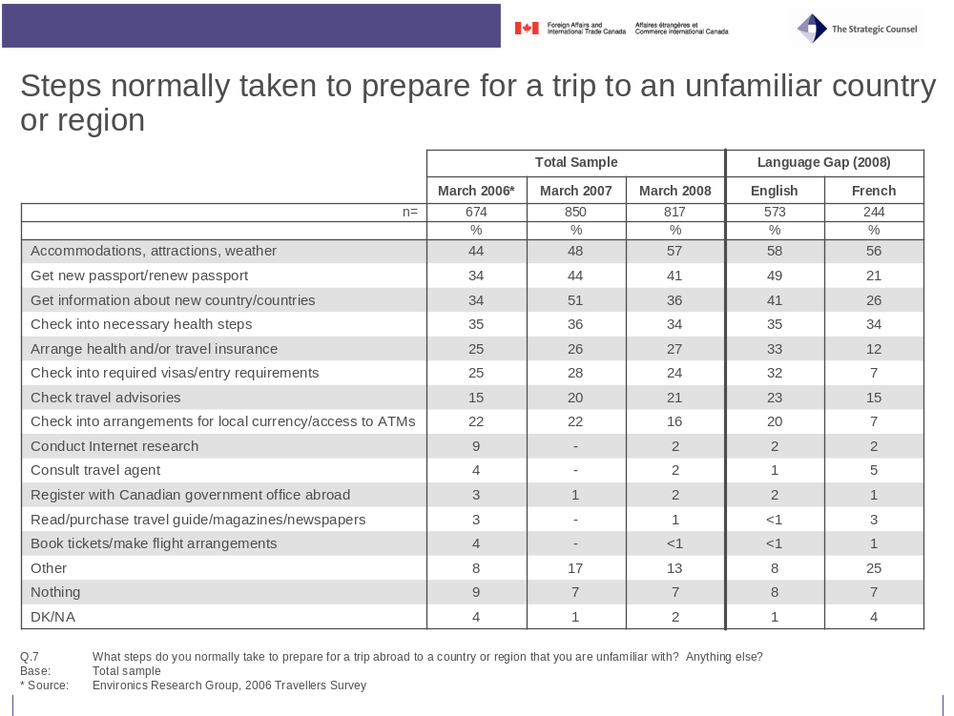
The notable increase in the proportion of travellers investigating the weather and other aspects of their destination (an increase of 9 percentage points over 2007) as well as significantly more people travelling to “sunshine destinations” in Mexico and the Caribbean this year (41% versus 26% in 2007) suggests that the above average snowfall and extreme winter weather experienced across the county this year may have had an impact on many Canadians’ travel choices.
As observed in previous years, French speaking respondents are less likely, as a general rule, to take any of the common steps mentioned above when compared to their English speaking counterparts, except for the step of looking into the weather, accommodations and attractions where a similar proportion reports taking action. Again this year there are particularly large gaps in the unprompted reporting of travel preparation by French speakers in the areas of ensuring they have a valid passport (-28 percentage points), checking entry or visa requirements (-25 percentage points), arranging travel/health insurance (-21 percentage points), getting information on the country (-15 percentage points), and checking into ATM access and other money issues (-13 percentage points).

Prompted Responses
In contrast to the unprompted answers discussed above, prompted answers on steps typically taken suggest that much higher proportions of travellers actually do take specific steps. These steps may simply not be on top of people’s minds, explaining the lower numbers found for the unprompted answers. Not surprisingly, almost all respondents report verifying that their passport is current (97%). Slightly more than eight-in-ten say they ensure that they have health insurance coverage (86%), and a similar proportion state that they leave a copy of their itinerary with someone at home (81%). Ensuring proper travel insurance coverage (75%), getting additional information on currency (74%), checking visa requirements (72%), and checking vaccination requirements (67%) are also steps taken by a majority of respondents.
Significantly fewer travelers this year report getting travel report information regarding their destination (39% versus 59% in 2007). This may be because Canadians feel comfortable traveling to the Mexican and Caribbean destinations they favoured this year, believing they already have sufficient knowledge of the area.
Just one-in-five (19%) prepare documentation for travel with children (caution: not all travellers bring children with them, so this number should be interpreted with care) and only about one-in-twenty (6%) said that they registered with the Canadian Government before traveling to another country.

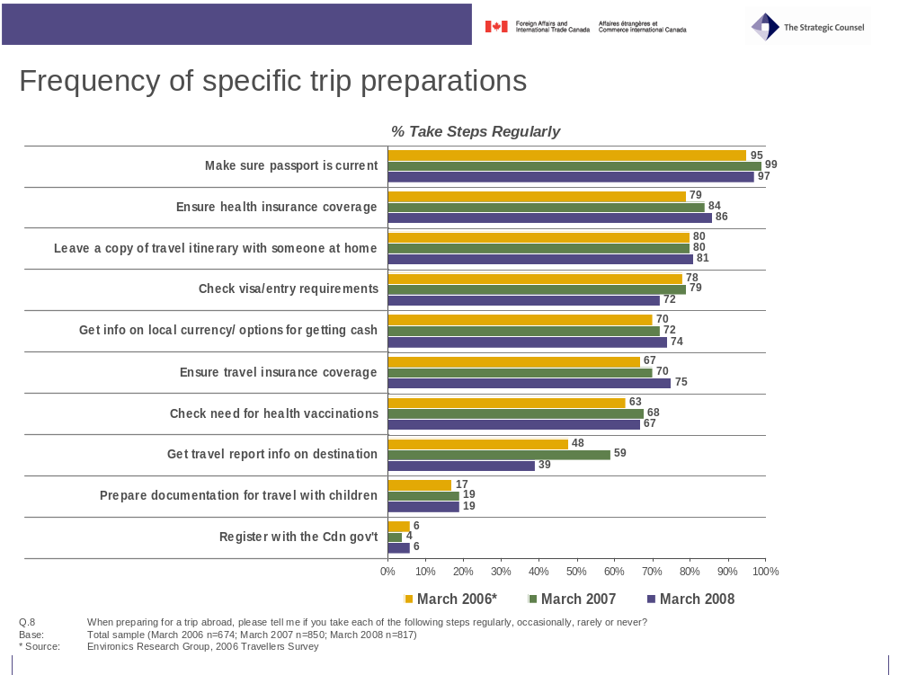
As observed in 2007, language makes little or no difference in the answers to this question. It is interesting that while unprompted answers in many cases were very different, French speaking respondents provided the very similar answers to the prompted questions and even report a slightly higher propensity to take some of the steps listed. The continued greater prominence in the English language media of border issues and new passport requirements between Canada and the U.S., as well as higher levels of exposure to the post-9/11 security-minded American media and culture, may explain, in part, the greater top-of-mind awareness among English speaking travellers of the legal and safety issues to be looked into before travelling to an international destination.

This year’s survey added one question directed at travellers holding more than one passport to gauge their views on whether they prepared their trips differently based on their destination. Results show that a majority of dual citizens (53%) say that they prepare their trips the same way regardless of whether it is their other country of citizenship or not. Only a minority (36%) say they plan their trip more carefully when visiting a country other than their second country of citizenship.
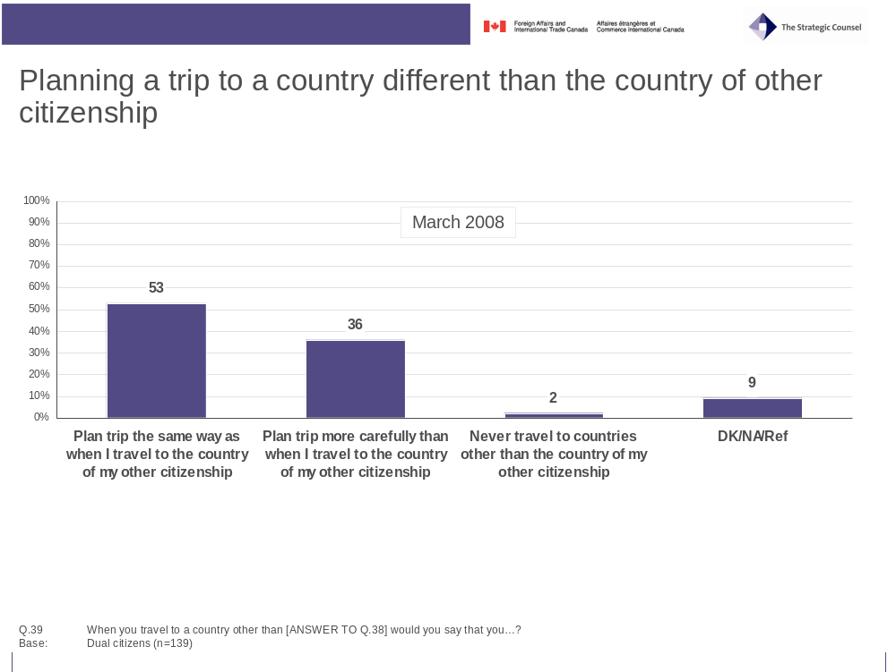

Preparation as Risk Avoidance
A majority of respondents are of the view that being prepared is a better option (67%) over the idea that travellers can deal with situations as they arise (25%). While the proportion of those saying that being prepared is the best option has increased gradually since 2006, the relatively small size of the gap indicates that one should refrain from reading too much into this.
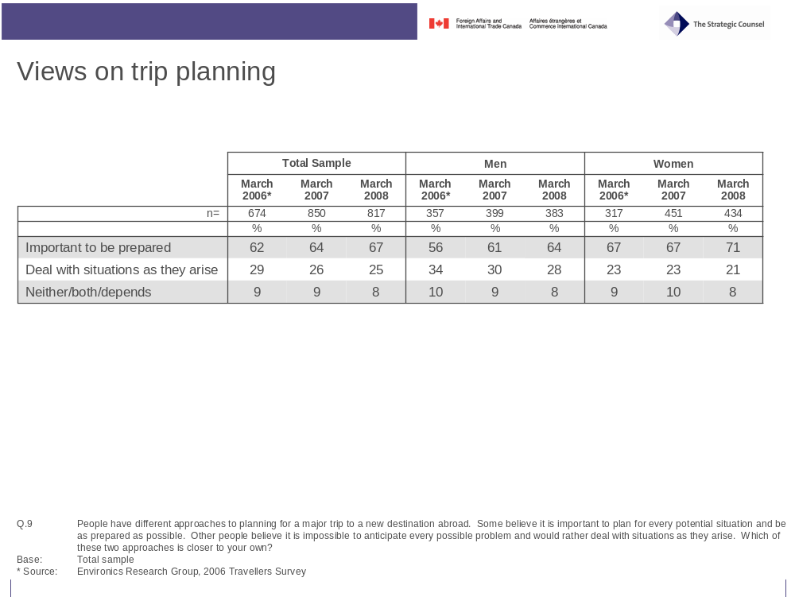

B. Information Sources

Preferred Sources of Information
Not surprisingly, the internet is considered by Canadian travelers to be an important source for information on a new country, with seven-in-ten (70%) giving it as one of their sources. More than half (53%) of those mentioning internet sites or nearly four-in-ten (37%) of all travelers referred to the search engine Google as best Web destination. The second and third most commonly cited internet sources are the Web site of the destination country (14%) and travel/tourism web sites (7%). The Web site for the government of Canada (4%), voyage.gc.ca (2%), and the department of Foreign Affairs (1%) were not common choices, and were rivalled by the Web sites of third-party countries (4%) in popularity. Similar low proportions mentioned the Canadian government (5%) and the government of the destination country (4%) as sources of information without specifying the internet. After the internet, travel books (30%) are the second most favourite source of travel information on a new country, followed by family and friends who have been there (22%) or live there (12%).
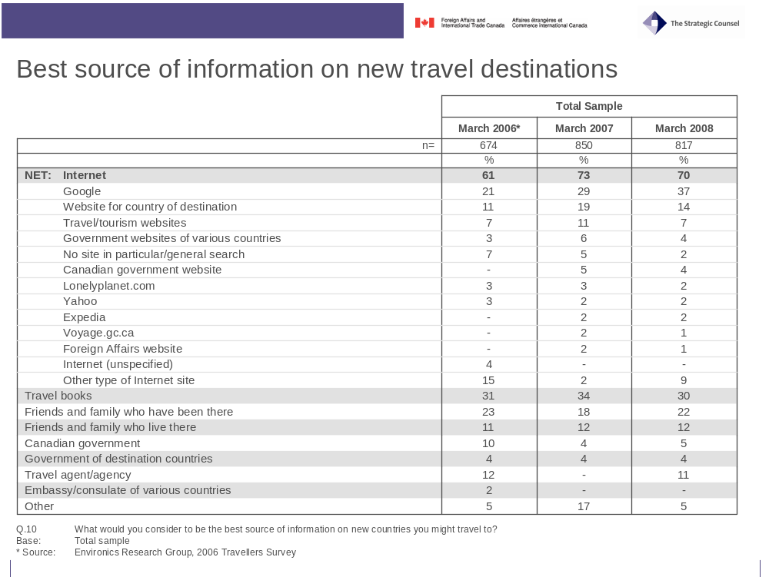
Business travellers (86%), English speakers (73%) and those aged 18-34 (72%) and 35-54 (75%) are the most likely to seek out information about a new destination on the internet. Travel books are a more popular choice among vacationers (32% versus 19% for business travellers) and English speakers (33% versus 25% for French speakers). Those travelling for personal pleasure are also more likely to speak with family and friends who have previously visited (23%) or live in (14%) a new destination country than those traveling for business reasons (15% and 4% respectively). A similar difference is occurs between English and French speakers, with English speakers more likely to speak with family and friends who have previously visited (25%) or lived in (15%) a new destination country than French speakers (15% and 6% respectively). Travel agents were more commonly used by French speakers (15%), those fifty-five years of age and older (15%) and vacationers (12%).
Responses to a similar question, this time focusing only on information regarding safety and security issues for international travel, are very different. The internet remains the most important source of information, with half (48%, up from 34% in 2007) saying it is the most likely place they would go for safety and security information when preparing to travel abroad to someplace unfamiliar. The Government of Canada Web site, mentioned by 13 per cent of respondents, along with the website of the department of Foreign Affairs (3%) and voyage.gc.ca (2%) now rival Google (17%) for the best place to go on the internet. The Canadian Government (cited separately from the internet) now appears as a key source of information and the second most commonly mentioned, with 15 per cent of respondents identifying it. Travel books (12%), friends and family who have been there (11%) or who live there (8%), and travel agencies (9%) are also mentioned as important sources of information.
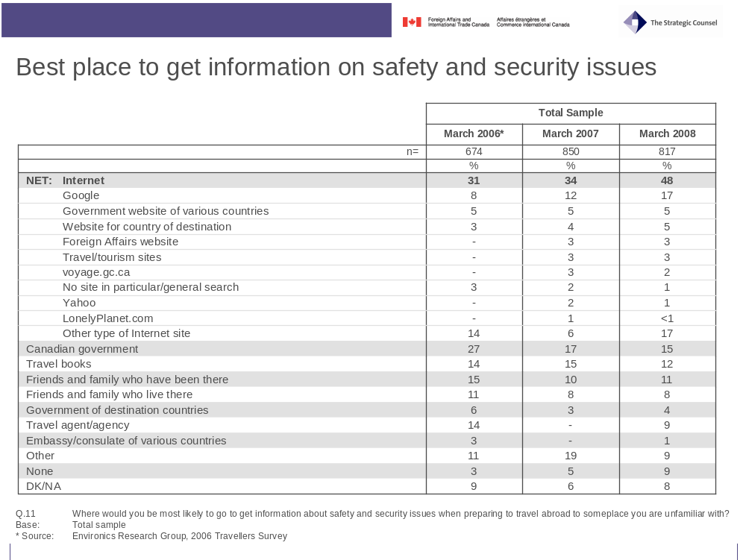
With very few exceptions, French speakers are less likely to mention any of the information sources, whether general or safety and security related, than their English speaking counterparts, suggesting English speakers are more likely to consult multiple sources for information about a new destination country.
Those who identified the internet or the Government of Canada as the best source of information on safety and security did so for very different reasons. While being up-to-date is the principal reason mentioned for both the internet (28%) and the Canadian government (26%), other reasons vary markedly. One the one hand, issues related to convenience and speed rank very high among reasons why the internet is a key source of information. One the other hand, depth of knowledge (23%), credibility/trustworthiness (15%), and reliability/accuracy (13%), are key reasons why the Government of Canada is seen as a good source of information.
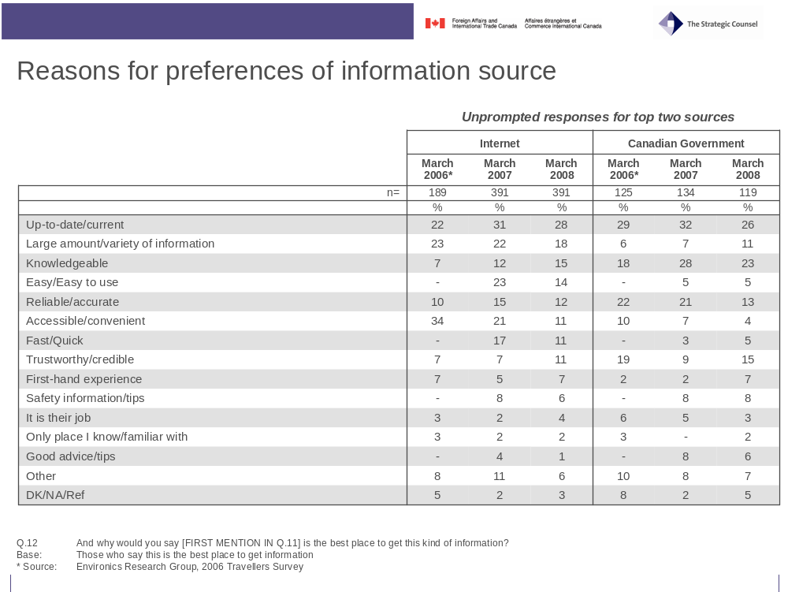

Credibility of Information Sources
In accordance with previous results highlighting that travellers trust travel information emanating from the Government of Canada, respondents were virtually unanimous (95%) in saying that they would trust travel information centred on safety and security issues from the government either a great deal (71%) or somewhat (24%). Friends and family who visited the country (93%) are also trusted a great deal (61%). Other sources, such as published travel guides (90%) and travel agents (87%) are also viewed to be credible, though only somewhat so (29% and 35% saying a great deal of trust respectively). While the government of the destination country is viewed as believable by a majority (66%) only 17 per cent are willing to place a great deal of trust in what it says.
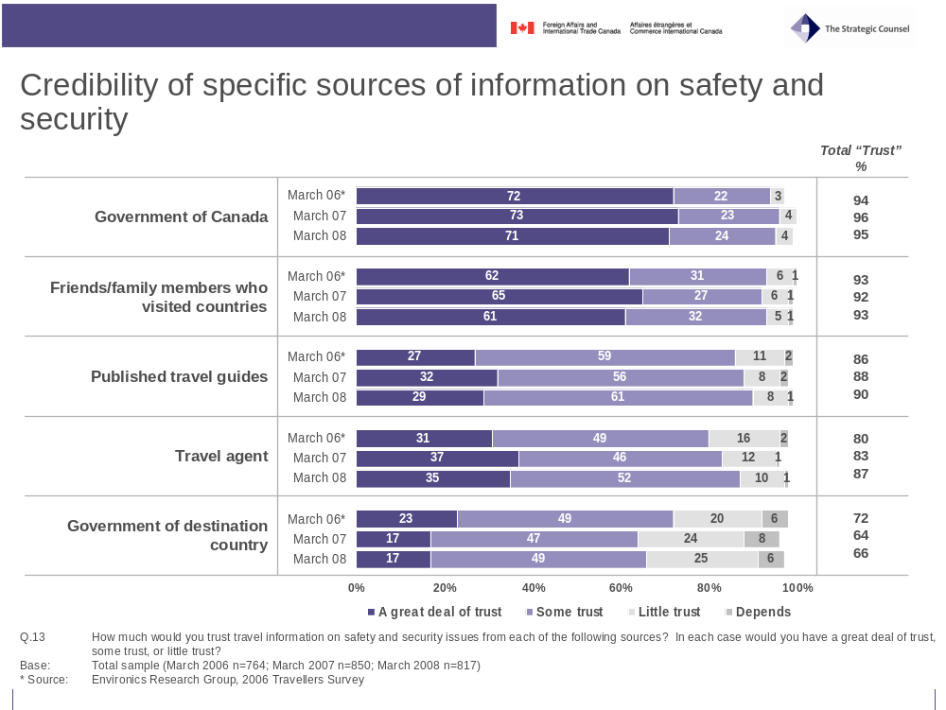
Trust in family and friends who have visited the country in question is highest among those born outside Canada (71% versus 58% for Canadian born), English speakers (63% versus 55% for French speakers) and those traveling for personal pleasure (62% versus 53% for business travelers) indicating at least one reason why these groups were more likely to site these same sources as being the best for travel information. Similarly, French speakers (43%), those fifty-five years of age and older (43%) are more likely to place a great deal of trust in travel agents whom they were also more likely to site as good sources of information.

Awareness of Travel Reports and/or Warnings
Nearly two-thirds (63%) of travellers responding to the survey reported being aware of travel reports and/or warnings. This compares favourably with 2007 (62%) and is up markedly from the levels of awareness in 2006 (53%). Awareness of such advisories increases with age and frequency of travel with those aged fifty-five and over (70%) or who have travelled six times or more in the past five years (74%) being more likely to know about reports and warnings than their younger (18-34 years, 53%; 35-54 years, 66%) or less traveled (0-2 trips, 55%; 3-5 trips, 65%) counterparts. English speakers (67%) are more likely to be aware of travel advisories than French Canadians (54%) and business travellers (76%) indicate greater levels of awareness than vacationers (62%).
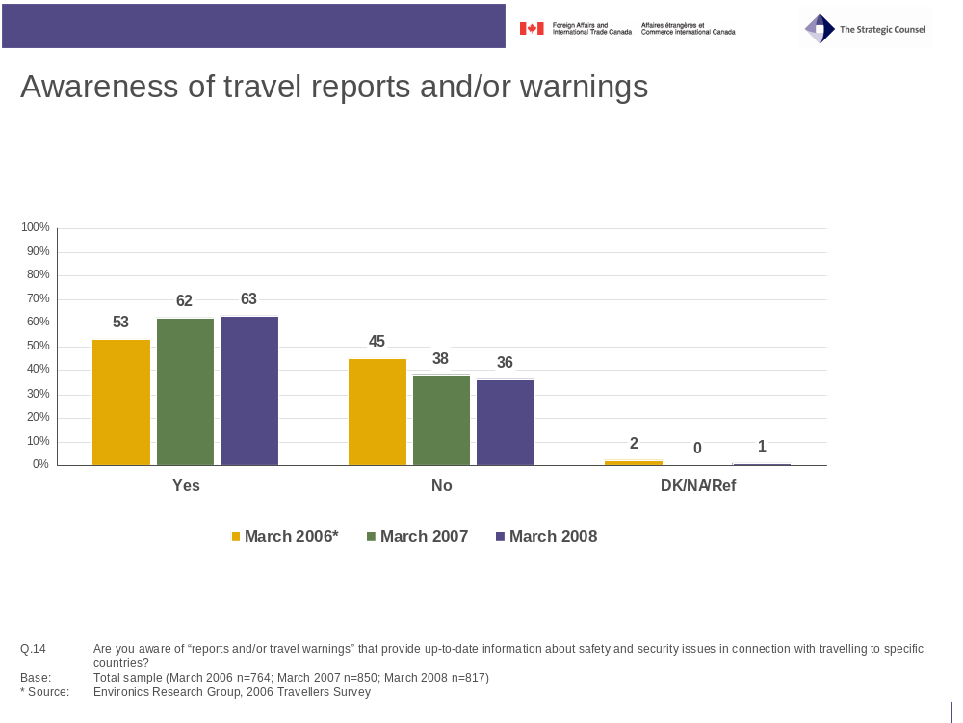
Among those aware of reports and/or travel warnings, two-thirds (65%) say they have checked such reports themselves in preparing for a trip abroad in the past five years.
Among those who have checked a travel report or warning in the past five years, slightly over half (54%) identify the Canadian Government as the sponsor of the report, down markedly from 2007 when seven-in-ten (69%) believed such reports emanated from the Government of Canada. Over a quarter (28%) of respondents this year identified the internet as the source of travel reports and/or travel warnings, up significantly over 2007 (18%) and 2006 (6%). Delving a little deeper into the generic “internet” answer reveals that while 8 per cent reported doing a search through the search engine Google, 7 percent recalled visiting the website of the Government of Canada, and a further 2 per cent visited the website of the department of Foreign Affairs and 1 per cent visited voyage.gc.ca. In total, 64 per cent identified a Canadian government source as the sponsor of the travel advisory they read.
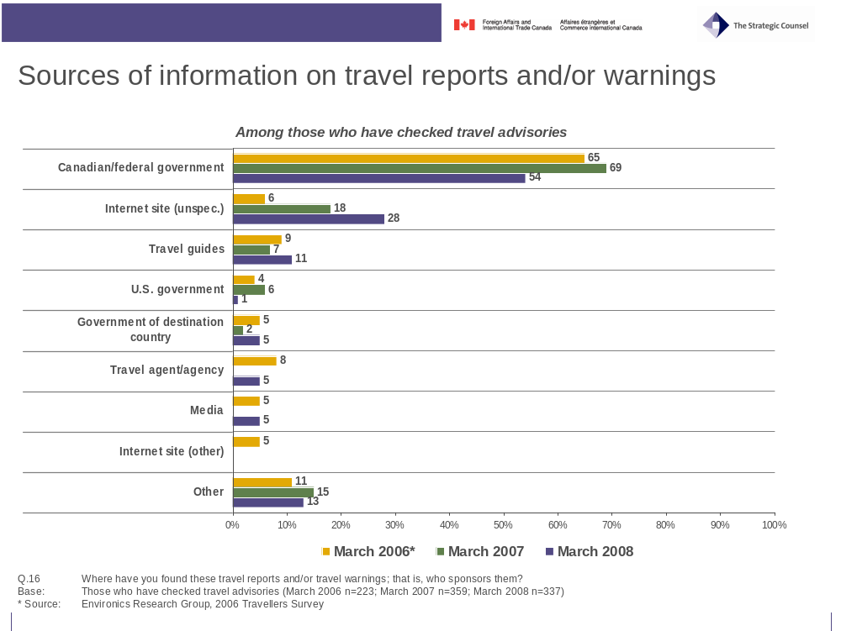
French Canadians (30%) are significantly less likely to identify the Government of Canada as the sponsor of travel reports and/or travel warnings, than are English Canadians (63%). Even after adding in those who, upon further probing, had visited a Canadian government website, the difference is still quite stark with just 46 per cent of French speakers compared to 70 per cent of English speakers identifying a Canadian government source as the sponsor of the travel report and/or warning they read.

- Awareness and Usage of Government of Canada as an Information Source

Awareness and Usage of Government of Canada as an Information Source.

Government Travel Reports and/or Warnings
Slightly more than a third (36%) of respondents who did not identify the Government of Canada on an unprompted basis as sponsoring travel reports and/or warnings, say they are familiar with travel advisories released by the Government of Canada. Of those, half report having checked reports and/or warnings in the past, while the other half did not. These findings are similar to those from 2006 and 2007.
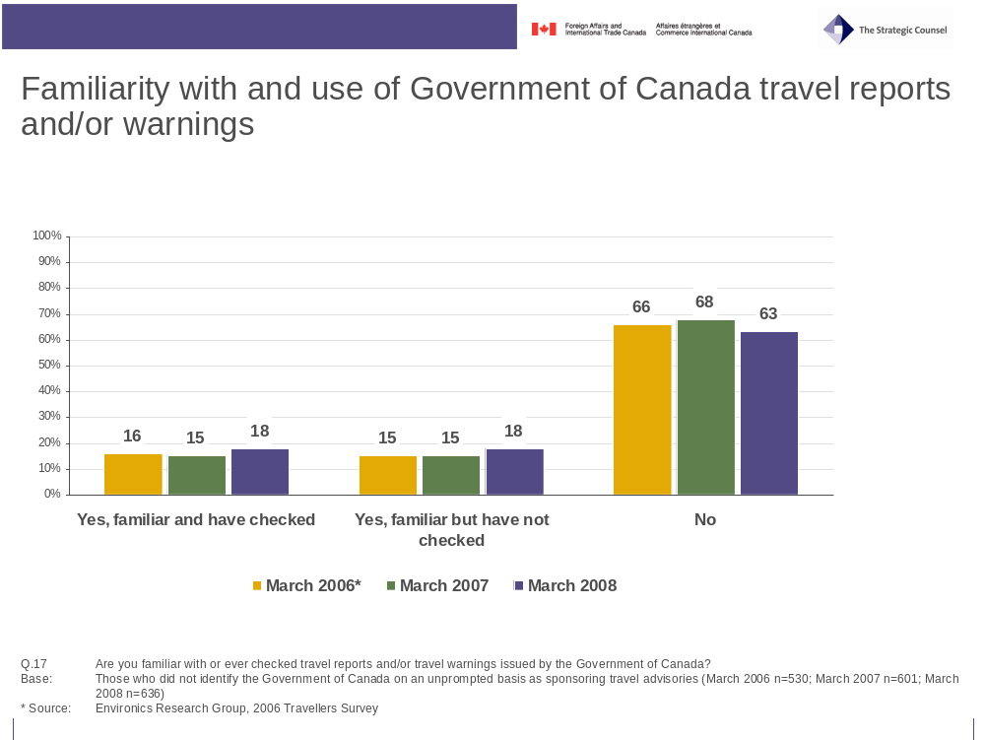

A considerable majority (87%) of those who have read travel reports and/or travel warnings issued by the Government of Canada found the information to be useful in planning their trip, in line with the 2007 results. There is little variation in the finding by region, language, frequency of travel, or other demographic indicators.
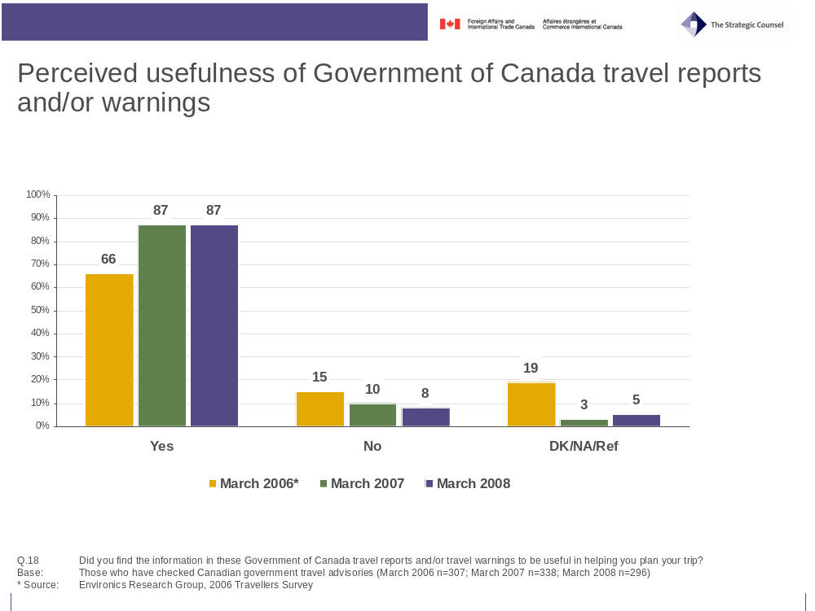

While most view travel reports and/or travel warnings issued by the Government of Canada to be useful, relatively few (27%) actually alter their travel plans in some way as a result of reading the advisory. Here too, demographic factors seem to have little impact.
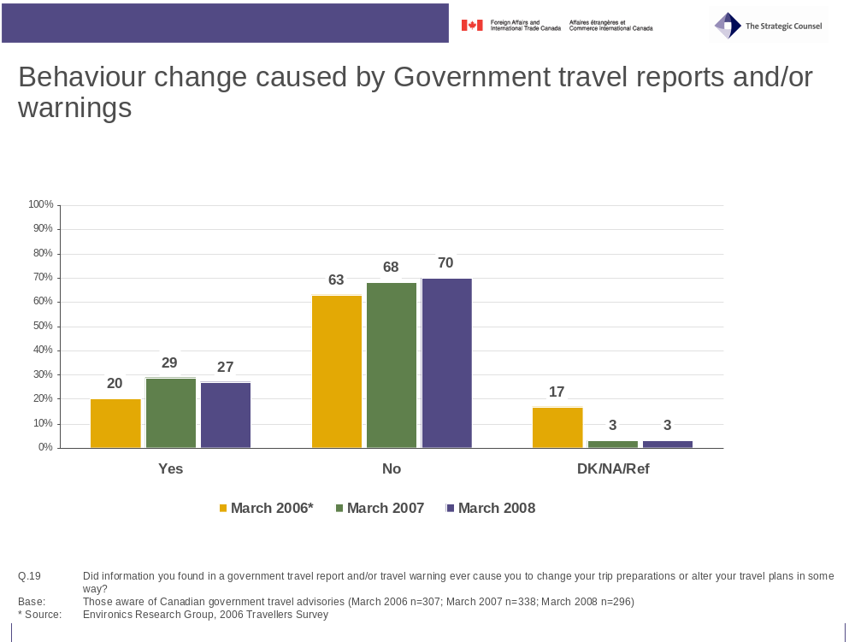

General Information from the Government of Canada
About half (53%) of all respondents say that they know where to find Government of Canada information on international travel. The greater awareness among those born in Canada that was observed in previous years appears to have largely disappeared in 2008. As in 2006, but not 2007, frequency of travel appears to have an impact on the levels of awareness, with frequent travellers (i.e. those making six or more trips in the past five years) being noticeably more aware of where to get travel information from the federal government (63% versus 49% for 0-5 trips). Business travellers (66%) are also more likely to be aware than those traveling for personal reasons (51%).
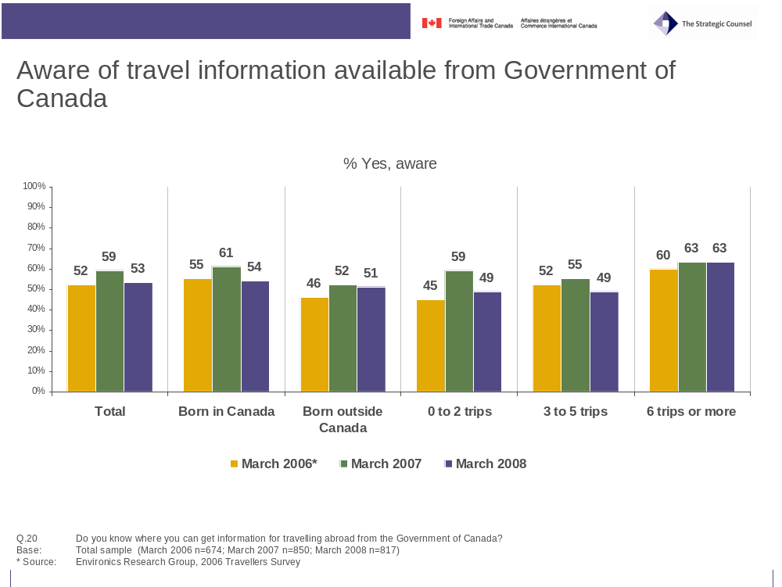

Among those who know where to find government information, six-in-ten (63%) report that they have obtained information for travelling abroad from the Government of Canada over the past five years. This proportion is lower than observed in 2007 (71%) but similar to 2006 when 64 per cent of respondents said the same. Here too, frequency of travel appears to impact the decision to access travel information with 72 per cent of those making six or more trips in the past five years retrieving such information, while only 63 per cent of those who made 3-5 trips and just 53 per cent of those who made 0-2 trips did the same. Business travellers (77%) are also significantly more likely to have obtained government travel information than those traveling for personal reasons (60%).
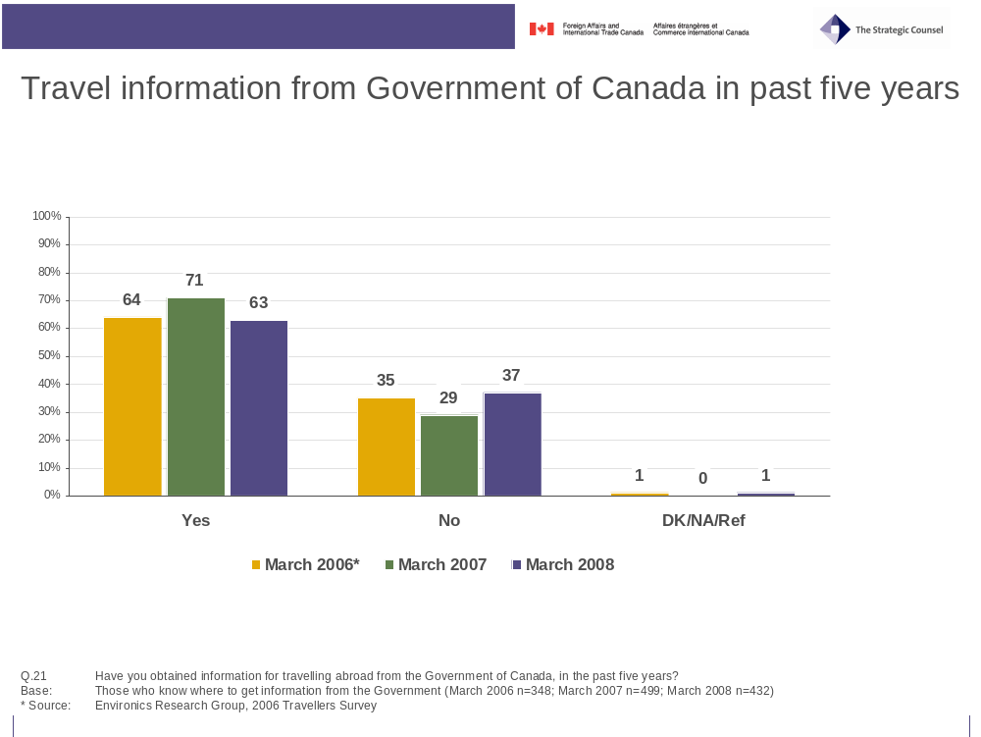

The internet appears once again as the major source for information produced by the Government of Canada. Nine-in-ten (91%) identified the internet as their main source of governmental information, with 42 per cent listing the Government of Canada web site as their source, compared to 11 per cent specifically naming the Foreign Affairs Canada web site and 11 percent saying voyage.gc.ca. Other offline sources listed included passport offices (7%), other types of government offices (8%), and travel agents (4%).
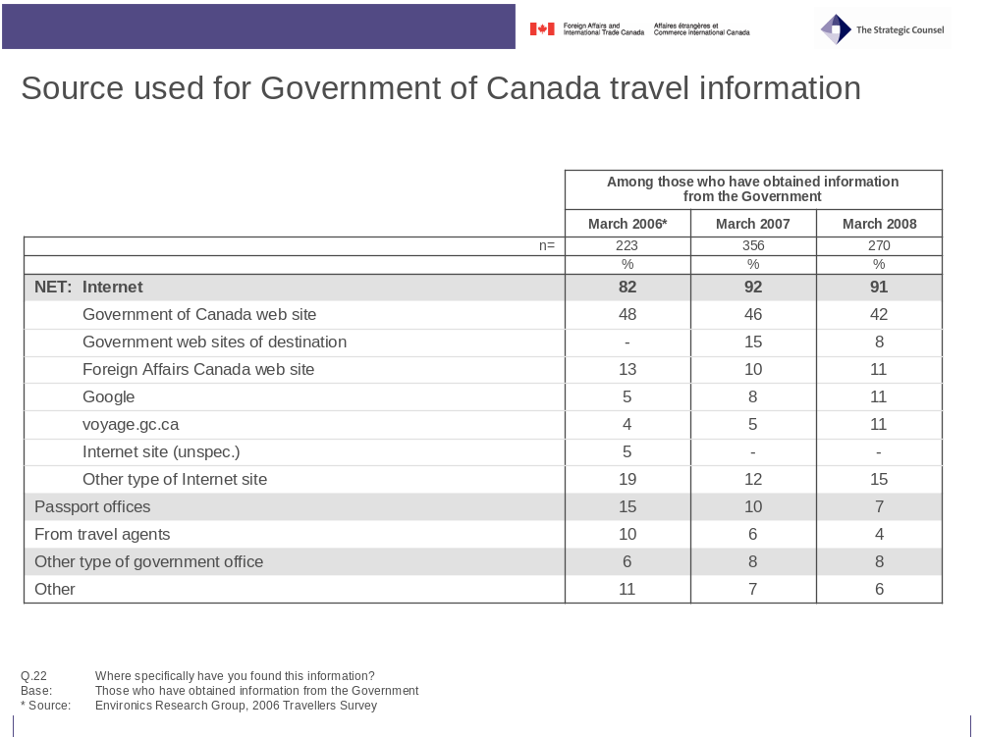

Those who have obtained travel information from the government of Canada give quite positive reviews of the ease with which they were able to find the information. Six-in-ten (60%) say it was very easy to find, and another third (34%) say it was somewhat easy; only 4 per cent say it is somewhat or very difficult. Notably, French speakers (42%) were much less likely to say the information was very easy to access than English speakers (67%) and much more likely to say it was only somewhat easy (50% versus 28% for English speakers).
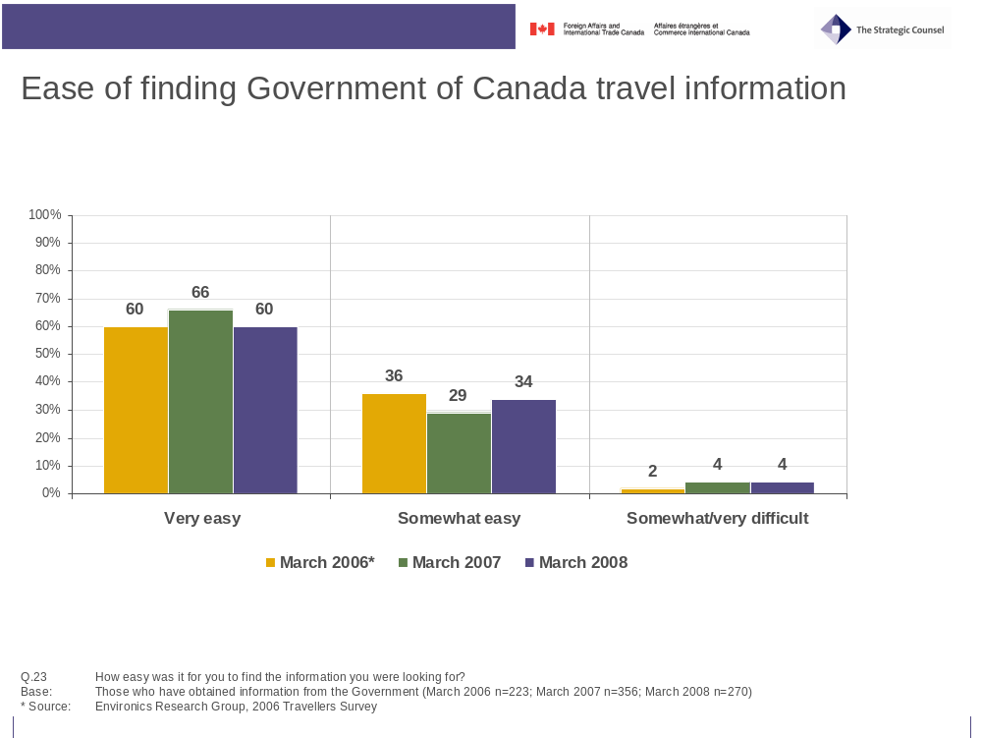
- Views on Consular Affairs’ Web Site and Bon Voyage, But… Booklet

Views on Consular Affairs’ Web Site and Bon Voyage, But… Booklet

Consular Affairs’ Web Site – voyage.gc.ca
One quarter (25%) of travellers report being familiar with a government Web site called “voyage.gc.ca”. This is up from 2006 (17%) and 2007 levels (19%), with awareness being up among both those travelling for business (29% up from 24% in 2007) and personal (24% up from 18% in 2007) reasons. Younger travelers aged 18-34 (32%) are more likely than those between 35 and 54 yeas of age (25%), and much more likely than those fifty-five and older (19%) to be aware of the Consular Affairs’ web site.
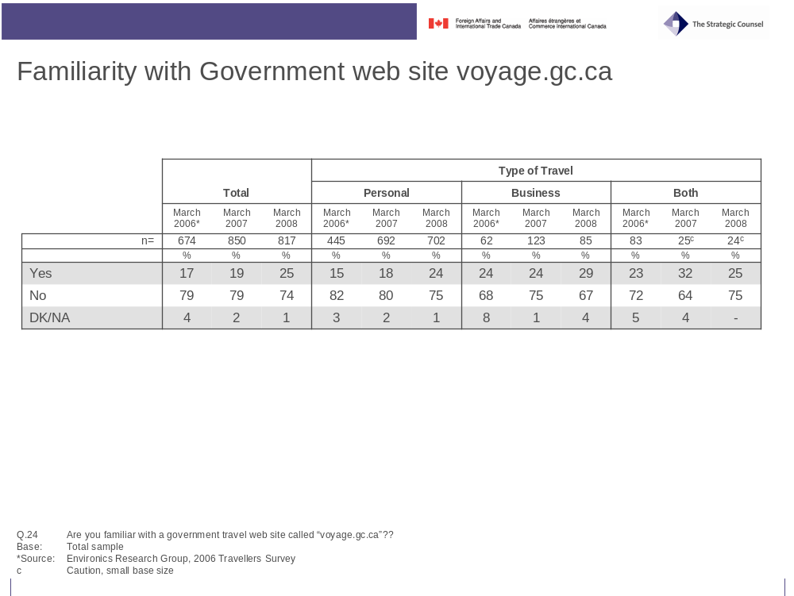

A large majority (79%) of those who are familiar with the web site say that it is either very (46%) or somewhat useful (33%). Only 3 per cent believes that the web site is not very useful, while another 16 per cent did not provide a answer because they have not used the site.
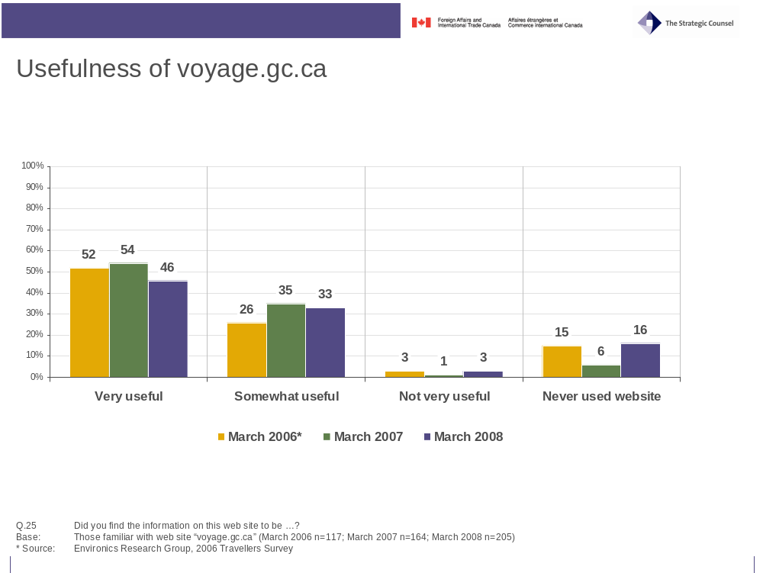

Travellers are divided on what they deem to be the most useful aspect of the web site. One-in-five of those visiting the site singled out the large amount and variety of information available (21%) and a similar proportion mentioned information on health risks and vaccinations (17%). A little more than one-in-ten picked the information being easily accessible (14%) as the most useful aspect of the web site while a similar proportion picked the up-to-date nature of the information (12%). While information on security measures topped the list of the site’s most useful aspects in 2007 (with 20%), this year it is tied in fifth place with travel warnings, both at 11 percent.
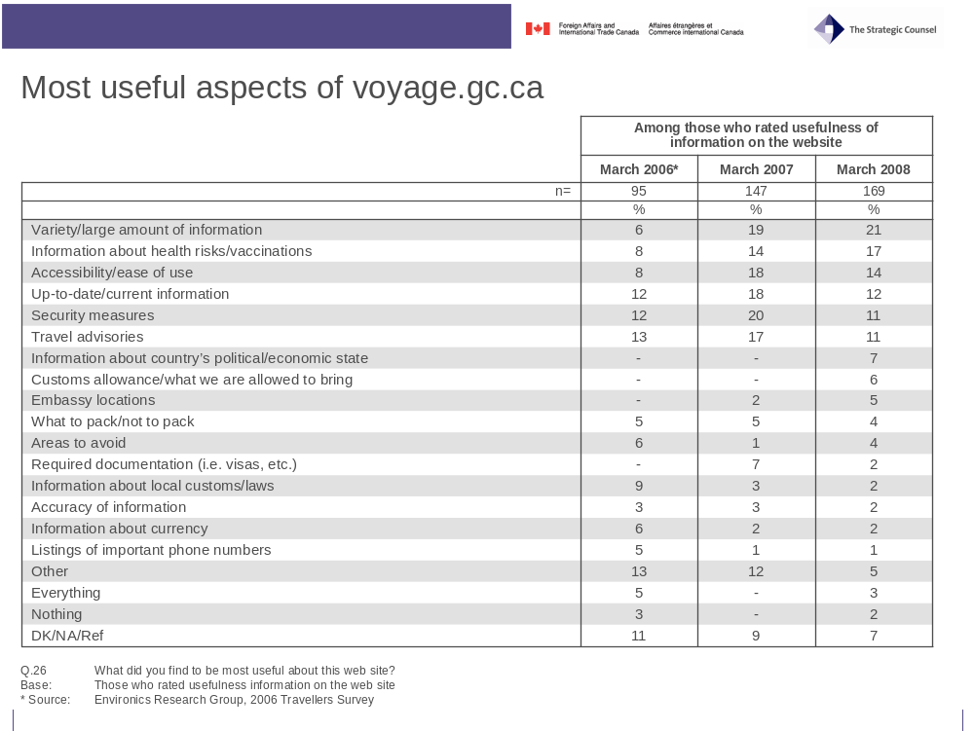

Bon Voyage, But… Booklet
A third (34%) of travellers interviewed said they were familiar with the brochure Bon Voyage, But…. Another one-in-ten (11%) did not recall the name at first but recognised the brochure when it was shown to them. In all, nearly half (45%) of all travellers reported being familiar with Bon Voyage, But…, matching previous years’ results.
Combined awareness and recognition of the brochure increases with age: about four-in-ten respondents aged 18 to 34 (39%) said they had seen the brochure before, while half of those aged 34 to 54 (47%) and those aged 55 years and older (50%) reported having seen the brochure before.
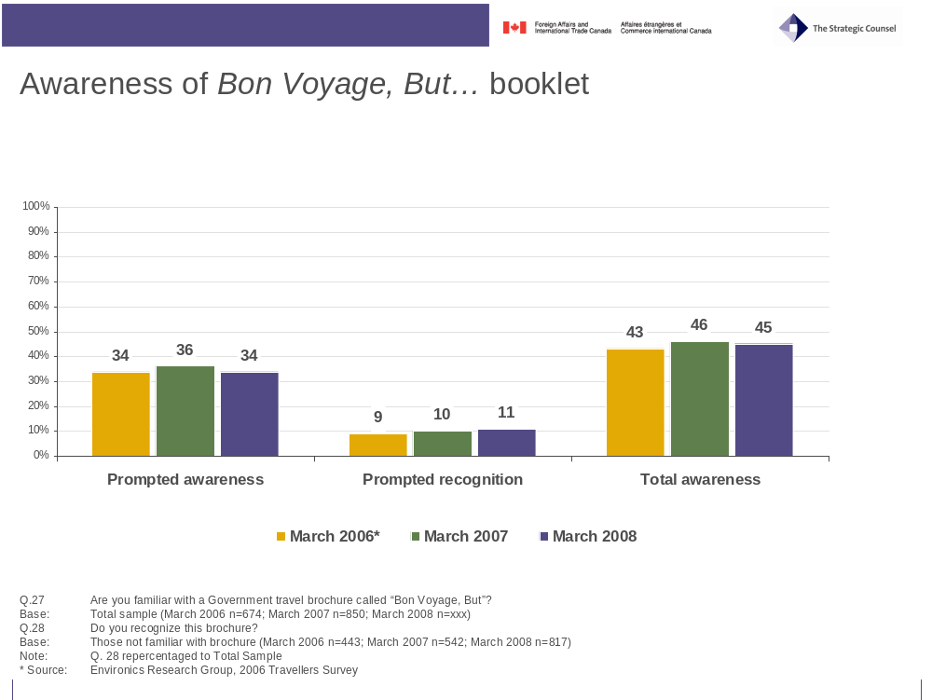

Views on the usefulness of the brochure are comparable, if slightly lower, with views on the usefulness of the web site. A sizable majority (70%) of those who are familiar with the booklet say that it is either very (39%) or somewhat useful (31%). Only 3 per cent believes that the brochure is not very useful, while another 23 per cent did not provide a ranking because they have not read the booklet before.
Business travellers (25%), men (29%), and frequent travellers who have made six or more trips in the past five years (31%) are less likely to say the booklet is very useful than those traveling for personal reasons (40%), women (47%) and those who have made 0-2 trips (42%) and 3-5 trips (42%) in the past five years. Views on usefulness are once again affected by age, as respondents aged 35 to 54 years of age (39%) and 55 years and older (42%) are more likely to find the information very useful than respondents aged 18 to 34 years (33%).
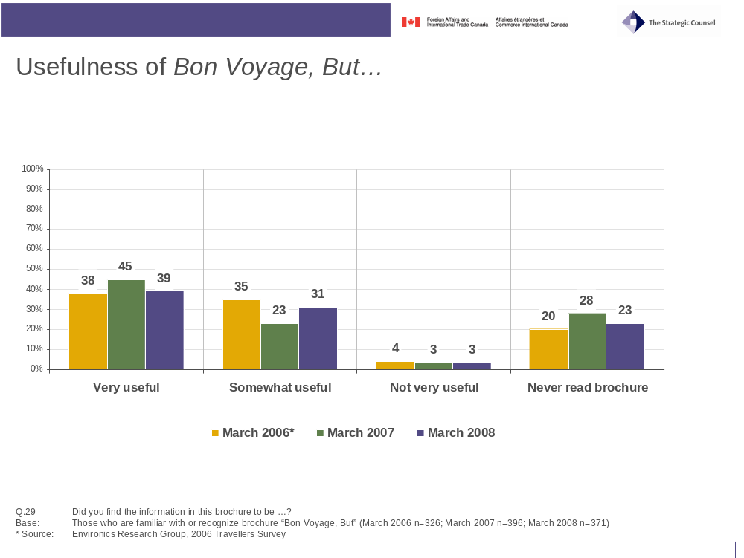

As with the Web site, travellers appear divided regarding what they deem to be the most useful aspects of the brochure, with no single aspects being named by more than 13 per cent of respondents. Information about duty-free/custom allowances (13%), locations of Canadian embassies or consulates (12%), safety tips (11%), preparation/travel tips (11%), and important phone numbers (11%) were the most common answers. Health risks or health tips (9%), and information on vaccinations (8%) continue to decline as the most useful aspects of the booklet.
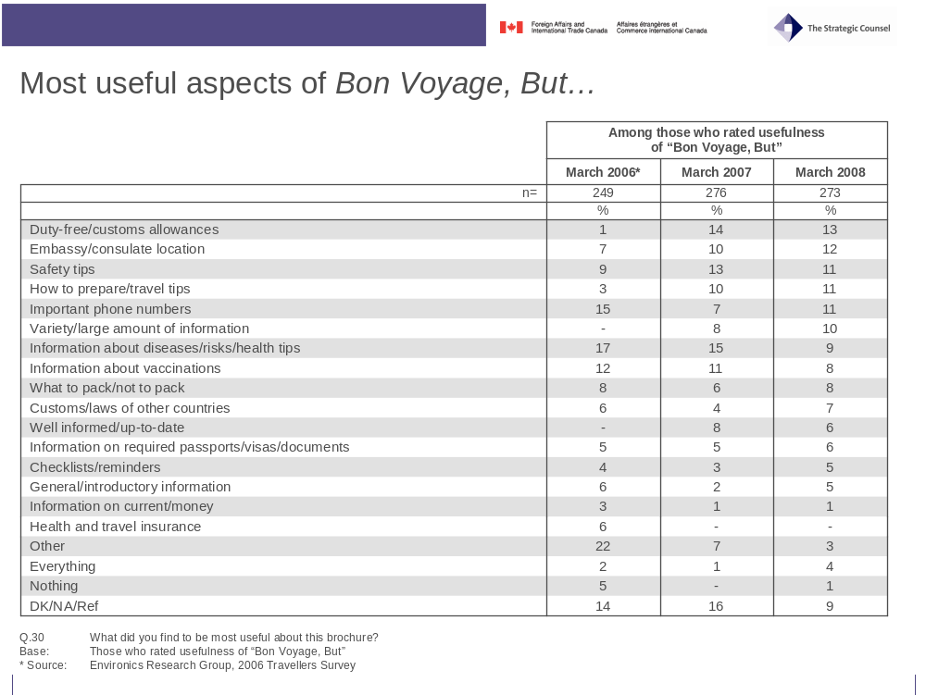

- Roles and Responsibilities when Abroad

Roles and Responsibilities when Abroad

Individual Steps Taken in Case of Trouble Abroad
The vast majority of travellers would use resources provided by the Government of Canada were they to encounter trouble when travelling abroad. Two-thirds (68%) said that they would contact the Canadian embassy in the country of destination, while just over a third (37%) indicated they would contact the nearest Canadian consulate. By contrast, only 17 per cent would contact the local police, 13 per cent would contact local friends or family and 10 per cent would call home.
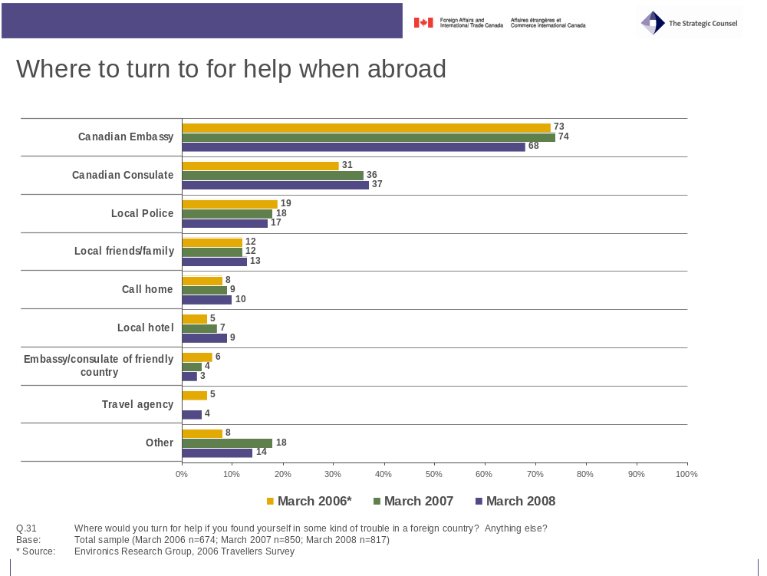
Views on typical steps to take in case of emergency when abroad vary according to the respondent’s language. While Francophone respondents are slightly less likely to contact the Canadian Government, they are significantly less likely to contact the local police compared to Anglophone respondents (11% versus 20%). The same gap is visible with regard to friends or family living there (6% versus 16%) or calling home (<1% versus 13%). French speakers are significantly more likely to contact their tour guide (16% versus 1%), their hotel (14% versus 7%), or even their travel agency (8% versus 2%) should they run into trouble and need help in a foreign country.
Frequency of travel also appears to influence the propensity to contact various sources of possible assistance when abroad. Frequent travellers who have travelled abroad six or more times in the past five years are more likely to contact a Canadian embassy (79%), a Canadian consulate (41%), or to call home (13%) versus those who have taken 2-5 trips (66%, 38%, 11%) and infrequent travellers who have been on two or less trips abroad in the last five years (63%, 33%, 6%). Frequent travellers are less likely to contact local police (17%), their hotel (6%) or their travel guide (1%) than those who have taken 2-5 trips (13%, 9%, 6%) and infrequent travellers (21%, 11%, 8%).

Perceived Role of the Canadian Government
When asked to consider in what ways the Government of Canada can assist Canadian travellers when they need help in a foreign country, getting or replacing a missing passport comes to mind for just over half (53%) of the travelers surveyed. Three-in-ten respondents also see the government as a source of assistance in case of a natural or civil disaster (31%) and a similar proportion would expect help for the Canadian government in case of detention by foreign authorities (29%). Assistance with information about the foreign country such as extending a visa (15%) and obtaining financial assistance in an extreme situation were also seen as important roles.
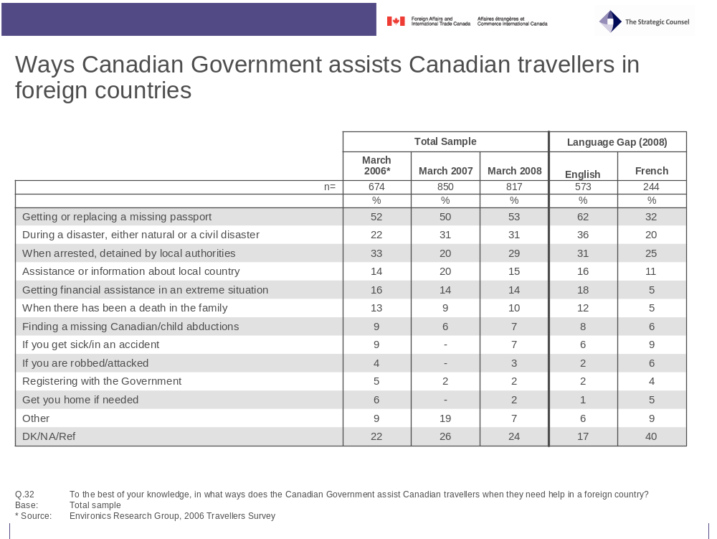
There is once again a significant variation by language in answers to this question. Francophone respondents have lower expectations from the Government of Canada than their Anglophone counterparts. Not only do fewer French speaking respondents name each possible area of assistance, but they are also much less likely to provide any substantial answer to this question. Four-in-ten Francophone respondents (40%) said they do not know or did not giving an answer, similar to the 2007 results (48%).
The polarization of opinion which was observed between 2006 and 2007 as to whether there should be limits on the assistance Canadian government embassies and consulates provide to Canadians abroad in certain situations continues to exist in 2008. More than half of those surveyed were of the opinion that assistance should be limited in the cases where the Canadian citizen has never lived in Canada (66%), has disregarded warnings not to travel to a country considered a high security risk (54%) or is not paying Canadian income taxes (54%). Opinion is more evenly split when the circumstances are that the Canadian citizen is travelling on a passport issued by another country (44% for limits, 43% opposed), has already received similar assistance on several previous occasions (45% for limits, 42% opposed), or has been living outside of Canada for two or more years (40% for limits, 47% opposed).
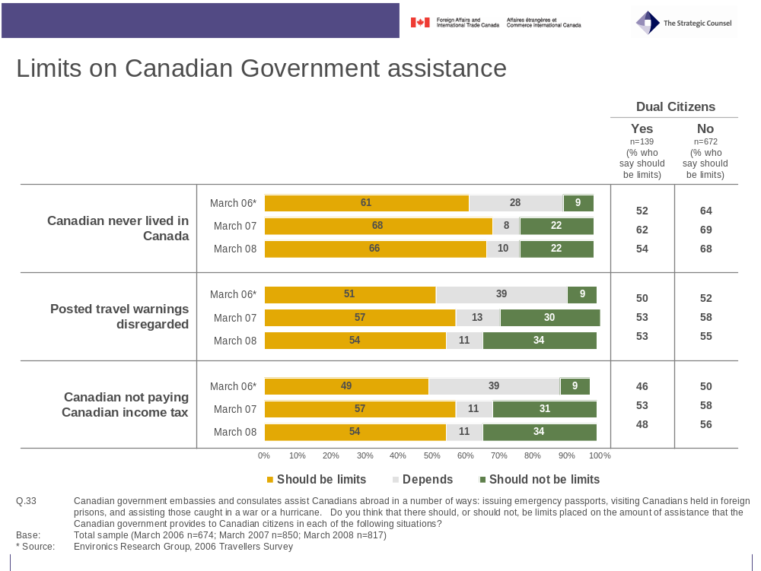

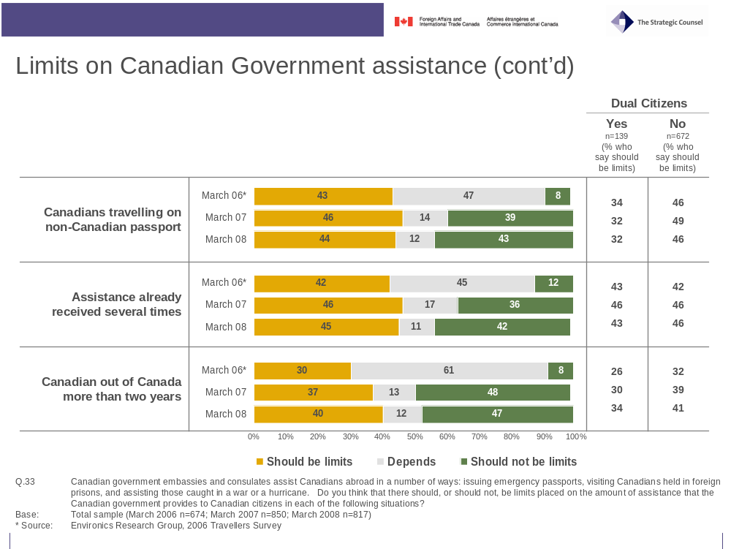
Frequency of travel and gender have little impact on opinion except in the case of Canadians travelling on a non-Canadian passport where 51 per cent of men support limits while only 38 per cent of women do. In general, business travellers, perhaps feeling compelled to travel because business deals and money are at stake, are less supportive of limits on assistance than those travelling for personal reasons who may feel that their travel choices are more discretionary. Support for limits on the assistance provided by the Canadian government increases with age in five of the six situations, the sixth being the case where a Canadian has never lived in Canada when two-thirds of all age groups support limits.
Here too, the language spoken by the respondent appears to highlight differences in opinion. Francophone respondents are much more likely than English speaking respondents to support limits on the assistance provided by the Canadian Government. There are particularly large differences of opinion in the situation where a Canadian citizen has not liven in Canada for two or more years (59% versus 32%) and where a Canadian citizen is not travelling on a Canadian passport (61% versus 37%). Given that Francophone respondents appear to expect much less from the Government of Canada when travelling abroad than their Anglophone counterparts they may also feel it is unacceptable for others to demand more from the Canadian government. The highly publicised Lebanese crisis during the summer of 2006, which had particular resonance in the province of Quebec, may be influencing opinions.
Somewhat in contrast to the support for limits on assistance the Government of Canada provides to Canadians when they are abroad, half of all respondents (52%) believe that the Canadian government is responsible for providing assistance to dual citizens while they are travelling or living in the country of their second citizenship and only one-third (34%) disagree. On this question French respondents (55%) are slightly more supportive than English respondents (51%).
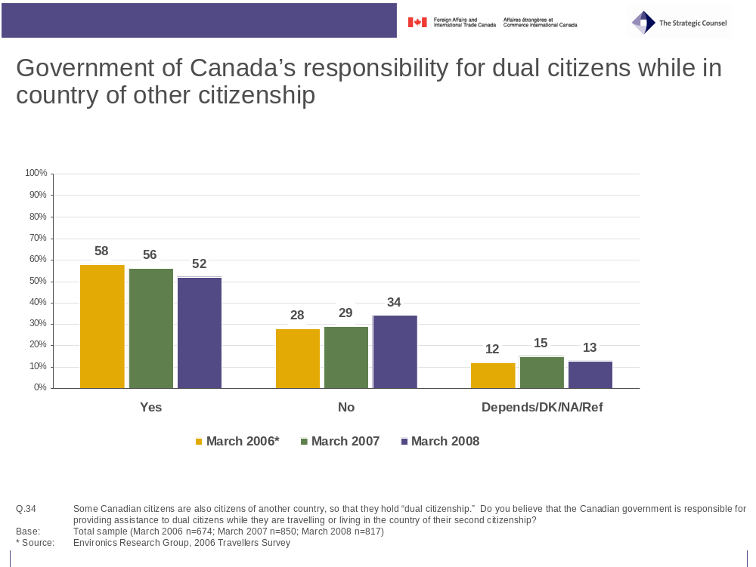

- Respondents’ Profile

Respondents’ Profile

Travel profile
Survey respondents are once again travelling to three main areas for their current trip, namely Mexico/Caribbean/Cuba (41%), Western Europe (24%), and Northern Asia (22%). While South and Southeast Asia was the destination of one-in-ten (10%), no other region was mentioned by more than 3 per cent of travellers. As mentioned previously, the number of respondents travelling to destinations in Mexico, Cuba and the Caribbean in 2008 is up over 2007 (26%) and is four times the proportion in the 2006 survey (10%). There appears to have been a corresponding decrease in travel to Western Europe (35% in 2007; 47% in 2006).
Participants’ travel destinations over the past 5 years are similar to previous years and highlight the wide array of countries and regions of the world visited by Canadian travellers. The one notable change is the significant increase over the three years in the number of respondents who report having travelled to destinations in Mexico, Cuba and the Caribbean. The noticeable decrease in length of travel also corresponds with this higher proportion of travellers going to sunshine destinations.
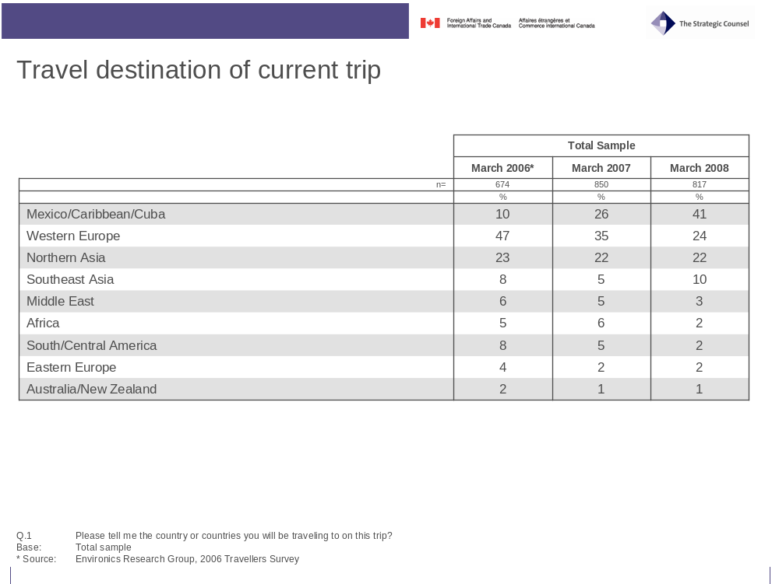
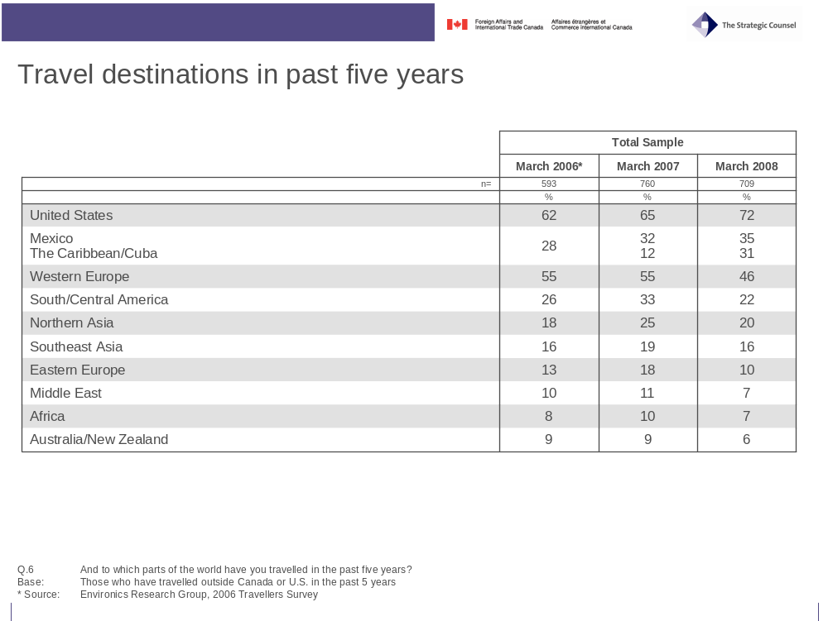
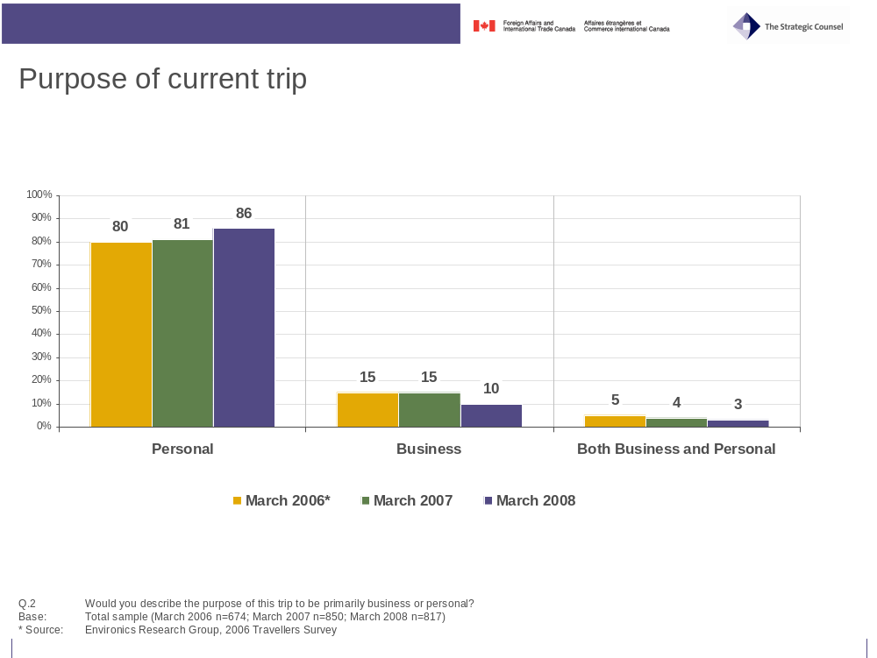
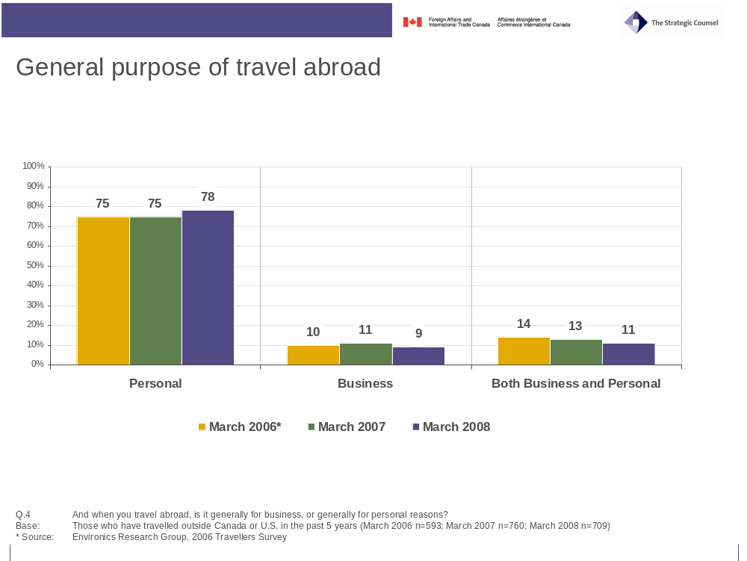
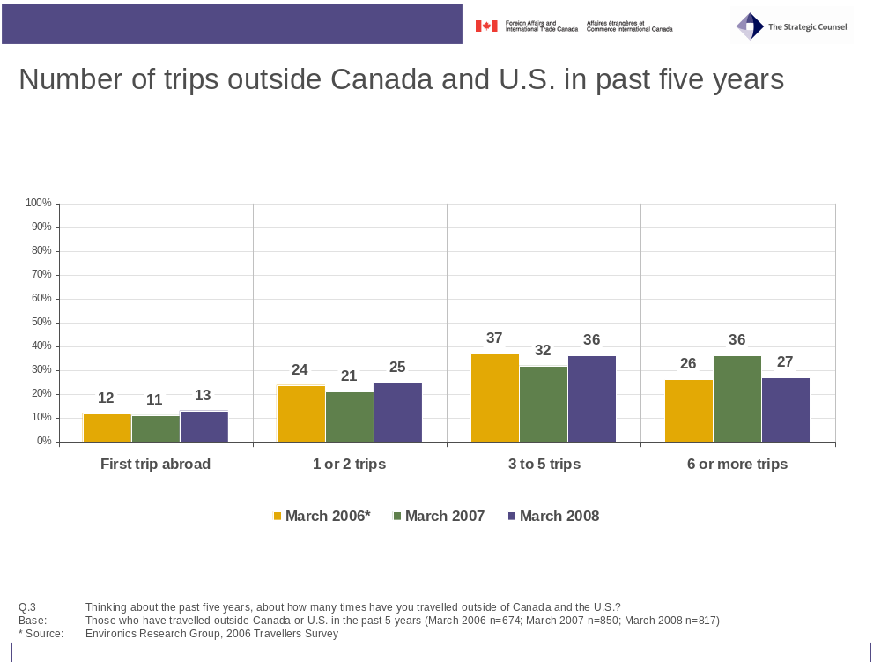
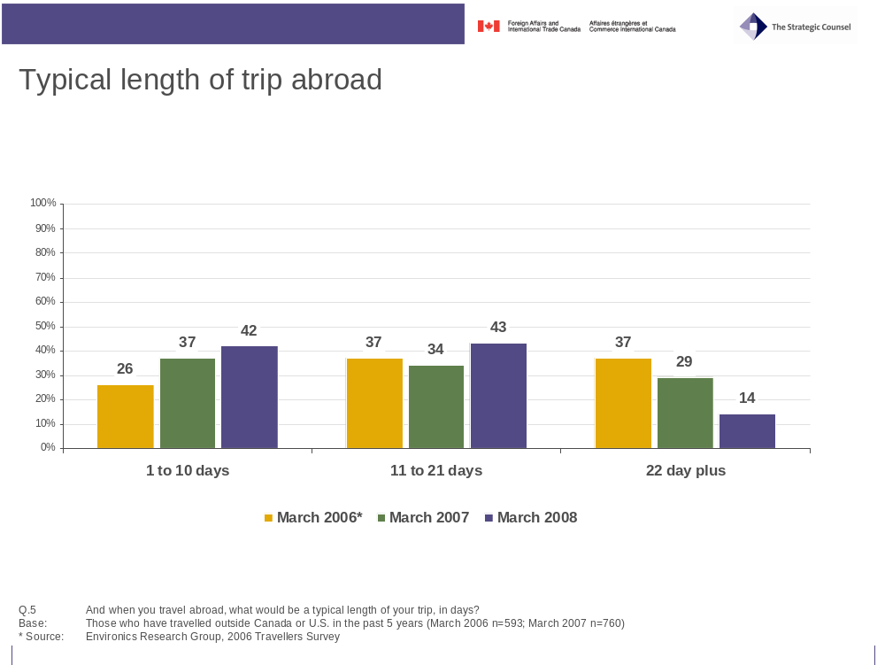

Demographic profile
The following charts indicate the demographic profile of travellers who participated in this research program, including gender, age, language, province of residence, country of birth and dual citizenship.
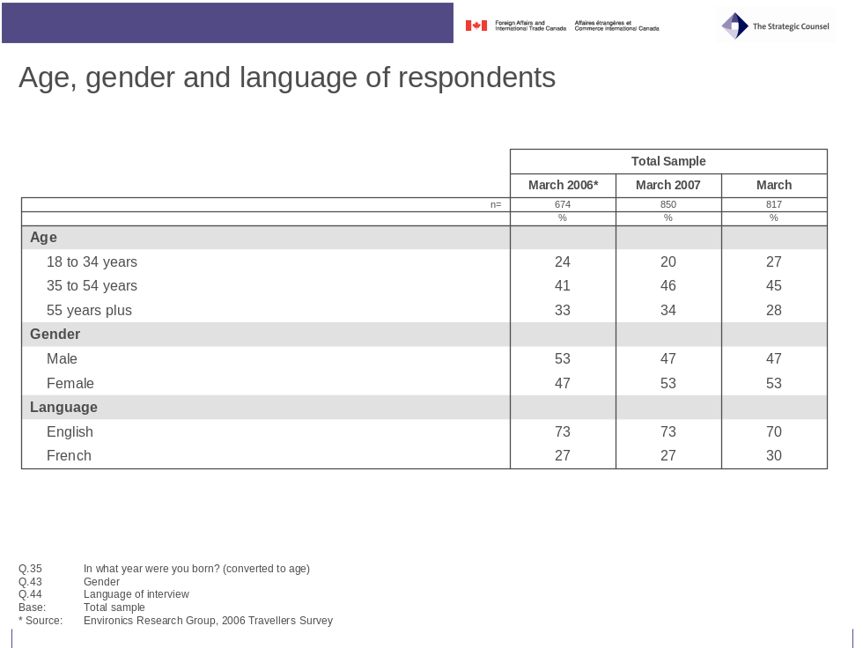
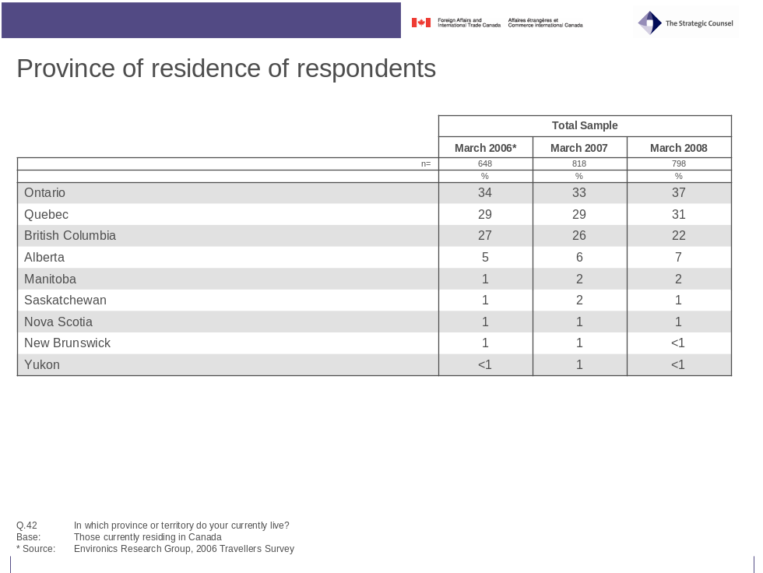
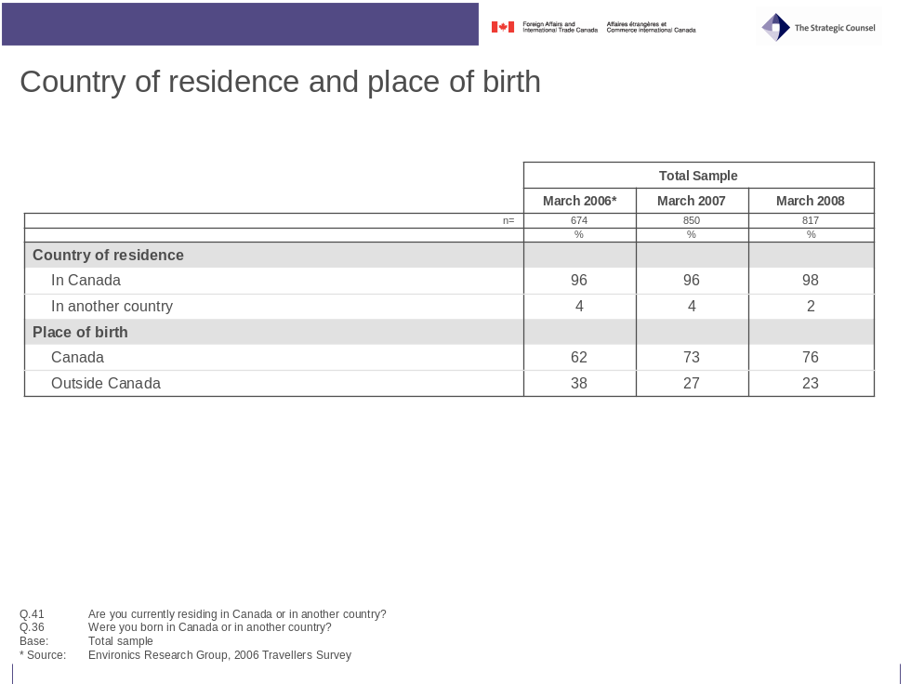
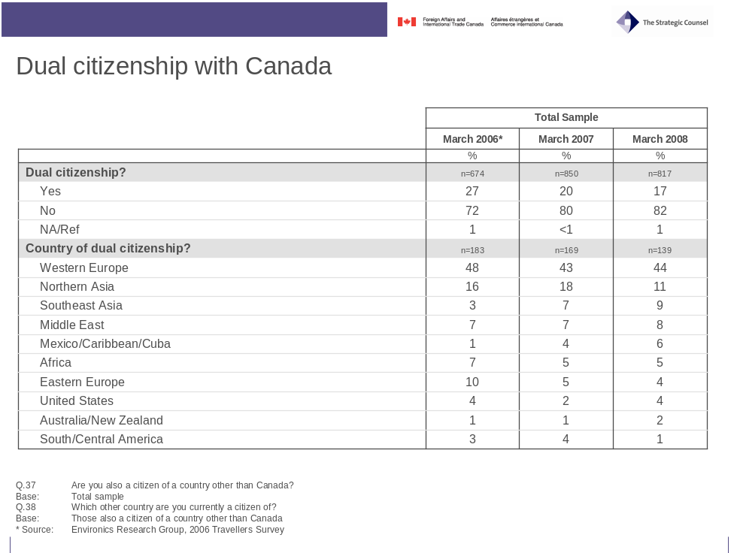

- Survey Questionnaire

Survey Questionnaire

English Version

Foreign Affairs Canada – Consular Services
2008 Public Outreach Tools Evaluation - Traveller Survey

Final Questionnaire

Introduction

Good afternoon/evening. My name is _______________ from The Strategic Counsel, a national research firm. We are currently conducting a survey of Canadian travellers for the Government of Canada, and I’d like to ask you a few questions. This survey is registered with the National Survey Registration System.

IF ASKED: The survey will take about 15 minutes, depending on your answers to some of the questions.

IF ASKED: I can tell you a bit more about the background of this study at the end of the survey

IF ASKED: The registration system has been created by the Canadian survey research industry to allow the public to verify that a survey is legitimate, get information about the survey industry or register a complaint. The registration systems toll-free telephone number is 1-800-554-9996.

A. Are you currently a Canadian citizen?

1 – Yes CONTINUE
2 – No THANK AND TERMINATE

CONFIRM WHETHER RESPONDENT WOULD LIKE TO BE INTERVIEWED IN ENGLISH OR FRENCH

A. Respondent Selection

Before we begin, I’d just like to ask you a few questions to make sure you qualify to be interviewed for this study . . .

1. Please tell me the country or countries you will be travelling on this trip?
RECORD ALL COUNTRIES – UP TO A MAXIMUM OF 3

1. _________________________________
2. _________________________________
3. _________________________________

2. Would you describe the purpose of this trip to be primarily business or personal?

1 – Business
2 – Personal (includes vacation or visiting friends or family)
VOLUNTEERED/DO NOT READ
3 – Both business and personal
8 – Other (SPECIFY) _____________________________________________
9 – DK/NA/Ref

IF MEETS CRITERIA/QUOTAS, CONTINUE: OTHERWISE THANK AND TERMINATE

B. General Travel Pattern and Preparation

I would now like to ask you about the type of preparations you typically make when planning to travel abroad, that is outside of Canada and the U.S. Please answer the following questions based on your travel experiences over the past five years.

3. Thinking about the past five years, about how many times have you travelled outside of Canada and the U.S.?
RECORD NUMBER OF TRIPS – ACCEPT ESTIMATE

_______ Number of trips
98 – This is first trip abroad SKIP TO Q.7
99 – DK/NA/Ref (DO NOT READ)

4. And when you travel abroad, is it generally for business, or generally for personal reasons?

1 – Business
2 – Personal (includes vacation, visiting friends/family)
VOLUNTEERED/DO NOT READ
3 – Both business and personal equally
8 – Other (SPECIFY) _____________________________________________)
99 – DK/NA/Ref

5. And when you travel abroad, what would be a typical length of your trip, in days?
RECORD NUMBER OF DAYS – ACCEPT ESTIMATE

_____ Number of days
99 – DK/NA/Ref (DO NOT READ)

6. And to which parts of the world have you travelled in the past 5 years?
CODE ALL THAT APPLY

1 – United States
2 – Mexico
2 – Western Europe
3 – Eastern Europe
4 – Northern Asia (China, Japan)
5 – Southeast Asia (India, Philippines, Vietnam, Indonesia)
6 – Middle East (including Egypt, Israel)
7 – Australia/New Zealand
8 – Africa
9 – South/Central America
98 – Other (SPECIFY ____________________________________________)
99 – DK/NA/Ref

7. What steps do you normally take to prepare for a trip abroad to a country or region that you are unfamiliar with?
DO NOT READ – CODE ALL THAT APPLY; PROBE: Anything else?

1 – Accommodations, attractions, weather (non-security/safety information)
2 – Get information about new country/countries
3 – Check travel advisories
4 – Get new passport/renew passport
5 – Check into required visas/entry requirements
6 – Check into necessary health steps (vaccinations)
7 – Arrange health and/or travel insurance
8 – Check into arrangements for local currency/access to ATMs
9 – Register with Canadian government office abroad
98 – Other (SPECIFY) ____________________________________________
VOLUNTEERED/DO NOT READ
97 – Nothing
99 – DK/NA/Ref

8. When preparing for a trip abroad, please tell me if you take each of the following steps regularly, occasionally, rarely or never?
READ IN RANDOM ORDER

VOLUNTEERED/
DO NOT READ
 | Regularly | Occasionally | Rarely | Never | Depends – different every trip | NA to travel or destinations | DK/NA/Ref
a. Get travel report on your country of destination | 1 | 2 | 3 | 4 | 5 | 6 | 99
b. Obtain or ensure you have health insurance coverage | 1 | 2 | 3 | 4 | 5 | 6 | 99
c. Obtain or ensure you have travel insurance coverage | 1 | 2 | 3 | 4 | 5 | 6 | 99
d. Check to make sure your passport is current for the travel period | 1 | 2 | 3 | 4 | 5 | 6 | 99
e. Check visa or entry requirements for countries to be visited | 1 | 2 | 3 | 4 | 5 | 6 | 99
f. Check into the need for health vaccinations | 1 | 2 | 3 | 4 | 5 | 6 | 99
g. Register with the Canadian Government to let them know where you will be travelling | 1 | 2 | 3 | 4 | 5 | 6 | 99
h. Get information about local currency and options for getting cash | 1 | 2 | 3 | 4 | 5 | 6 | 99
i. Prepare documentation for travelling with children (e.g. consent letter) | 1 | 2 | 3 | 4 | 5 | 6 | 99
j. Leave a copy of your travel itinerary with someone at home | 1 | 2 | 3 | 4 | 5 | 6 | 99

9. People have different approaches to planning for a major trip to a new destination abroad. Some believe it is important to plan for every potential situation and be as prepared as possible. Other people believe it is impossible to anticipate every possible problem and would rather deal with situations as they arise.

Which of these two approaches is closer to your own?

1 – Important to be prepared
2 – Better to deal with situations as they arise
VOLUNTEERED/DO NOT READ
3 – Neither/Both/Depends
99 – DK/NA/Ref

C. Sources of Travel Information

10. What would you consider to be the best source of information on new countries you might travel to?
DO NOT READ – CODE ALL THAT APPLY: PROBE: Anything else?

1 – Internet (PROBE FOR TYPE OF SITE)

2 – Travel books (e.g. Fodors, Lonely Planet)
3 – Friends and family who have been there
4 – Friends and family who live there
5 – Canadian Government
6 – Government of destination countries
98 – Other (SPECIFY) _____________________________________________
97 – None
99 – DK/NA/Ref

11. Where would you be most likely to go to get information about safety and security issues when preparing to travel abroad to someplace you are unfamiliar with?
DO NOT READ – CODE FIRST AND OTHER MENTIONS

1 – Internet (PROBE FOR TYPE OF SITE)

2 – Travel books (e.g. Fodors, Lonely Planet)
3 – Friends and family who have been there
4 – Friends and family who live there
5 – Canadian Government
6 – Government of destination countries
98 – Other (SPECIFY __________________________________________)
97 – None
99 – DK/NA/Ref

12. And why would you say [FIRST MENTION IN Q.11] is the best place to get this kind of information?
RECORD

99 – DK/NA/Ref

13. How much would you trust travel information on safety and security issues from each of the following sources? In each case would you have a great deal of trust, some trust, or little trust?
READ ITEMS IN RANDOM ORDER

 |  |  |  | VOLUNTEERED/ DO NOT READ
 | A great deal of trust | Some trust | Little trust | Depends | DK/NA/Ref
a. The Government of Canada | 1 | 2 | 3 | 97 | 99
b. Published travel guides (books or websites) | 1 | 2 | 3 | 97 | 99
c. The government of the destinations countries | 1 | 2 | 3 | 97 | 99
d. A travel agent | 1 | 2 | 3 | 97 | 99
e. Friends or family members who have visited the countries | 1 | 2 | 3 | 97 | 99

14. Are you aware of “reports and/or travel warnings” that provide up-to-date information about safety and security issues in connection with travelling to specific countries?

1 – Yes
2 – No SKIP TO Q.17
99 – DK/NA/Ref SKIP TO Q.17
15. (IF YES TO Q.14) Have you checked such travel reports and/or travel warnings yourself in preparing for a trip abroad in the past five years?

1 – Yes
2 – No SKIP TO Q.17
99 – DK/NA/Ref SKIP TO Q.17

16. Where have you found these travel reports and/or travel warnings; that is, who sponsors them?
DO NOT READ – CODE ALL THAT APPLY

1 – Canadian/Federal government SKIP TO Q.18
2 – U.S. government
3 – Government of destination country
4 – Travel guides
5 – Internet (PROBE FOR SPONSOR OF SITE)_______________________
98 – Other (SPECIFY) ___________________________________________
99 – DK/NA/Ref

17. (ASK IF/DK NO TO Q.14 OR Q.15 OR IF CANADIAN/FEDERAL GOVERNMENT NOT MENTIONED IN Q.16)

Are you familiar with or ever checked travel reports and/or travel warnings issued by the Government of Canada?
IF YES, CLARIFY FAMILIAR ONLY, OR FAMILIAR AND USED

1 – Yes – familiar but have not checked
2 – Yes – familiar and have checked
3 – No SKIP TO Q.20
99 – DK/NA/Ref SKIP TO Q.20

18. (IF MENTION CANADIAN GOV’T IN Q.16 OR YES-CHECKED TO Q.17) Did you find the information in these Government of Canada travel reports and/or travel warnings to be useful in helping you plan your trip?

1 – Yes
2 – No
99 – DK/NA/Ref

19. Did information you found in a government travel report and/or travel warning ever cause you to change your trip preparations or alter your travel plans in some way?

1 – Yes
2 – No
99 – DK/NA/Ref

20. Do you know where you can get information for travelling abroad from the Government of Canada?

1 – Yes
2 – No SKIP TO Q.24
99 – DK/NA/Ref SKIP TO Q.24

21. (IF YES TO Q.20) Have you obtained information for travelling abroad from the Government of Canada, in the past five years?

1 – Yes
2 – No SKIP TO Q.24
99 – DK/NA/Ref SKIP TO Q.24

22. (IF YES TO Q.21) Where specifically have you found this information?
DO NOT READ – CODE ALL THAT APPLY

1 – Web/Internet (PROBE FOR SPECIFICS)

2 – Passport offices
3 – Government offices (PROBE FOR SPECIFICS)

4 – Libraries
5 – From travel agents
6 – Post offices
98 – Other (SPECIFY _________________________________________)
99 – DK/NA/Ref
23. How easy was it for you to find the information you were looking for? Was it:

1 – Very easy
2 – Somewhat easy
3 – Somewhat difficult, or
4 – Very difficult
VOLUNTEERED/DO NOT READ
99 – DK/NA/Ref

24. Are you familiar with a government travel website called “Voyage.gc.ca”?

1 – Yes
2 – No SKIP TO Q.27
99 – DK/NA/Ref SKIP TO Q.27

25. (IF YES TO Q.24) Did you find the information on this website to be:

1 – Very useful
2 – Somewhat useful
3 – Not very useful, or
4 – Not at all useful
VOLUNTEERED/DO NOT READ
97 – NEVER USED WEBSITE SKIP TO Q.27
99 – DK/NA/Ref SKIP TO Q.27

26. What did you find to be most useful about this website?
RECORD

97 – Nothing
99 – DK/NA/Ref
27. Are you familiar with a Government travel brochure called “Bon Voyage, But”?

1 – Yes SKIP TO Q.29
2 – No
99 – DK/NA/Ref

28. (IF NO/DK/NA IN Q.27) Do you recognize this brochure?
SHOW COPY OF BROCHURE

1 – Yes
2 – No SKIP TO Q.31
99 – DK/NA/Ref SKIP TO Q.31

29. (IF YES TO Q.27 OR Q.28) Did you find the information in this brochure to be:

01 – Very useful
02 – Somewhat useful
03 – Not very useful, or
04 – Not at all useful
VOLUNTEERED/DO NOT READ
97 – NEVER USED/READ BROCHURE SKIP TO Q.31
99 – DK/NA/Ref SKIP TO Q.31

30. What did you find to be most useful about this brochure?
RECORD

97 – Nothing
99 – DK/NA/Ref

D. Traveller Assistance While Abroad

I would now like to ask you about getting assistance during a trip abroad . . .

31. Where would you turn for help if you found yourself in some kind of trouble in a foreign country?
(IF CLARIFICATION NEEDED: This might involve a situation involving your health, finances, personal safety or a legal issue)
DO NOT READ – CODE ALL THAT APPLY; PROBE: Anything else?

1 – Canadian government (PROBE FOR SPECIFICS)

2 – Canadian Embassy
3 – Canadian Consulate
4 – Local police
5 – Local hotel
6 – Local friends/family
7 – Call home
8 – Embassy/consulate of a friendly country
98 – Other (SPECIFY) __________________________________________
99 – DK/NA/Ref

32. To the best of your knowledge, in what ways does the Canadian Government assist Canadian travellers when they need help in a foreign country?
DO NOT READ – CODE ALL THAT APPLY; PROBE: Anything else?

1 – When arrested, detained by local authorities
2 – Assistance or information about local country or Canada (how extend my visa; what can be brought back to Canada)
3 – Finding a missing Canadian/Child abductions
4 – When there has been a death in the family
5 - During a disaster, either natural (like a hurricane) or a civil disaster (rioting)
6 - Getting financial assistance in an extreme situation
7 – Getting or replacing a missing passport
8 - Registering with the Govt
98 – Other (SPECIFY) ___________________________________________
99 – DK/NA/Ref
33. Canadian government embassies and consulates assist Canadians abroad in a number of ways: issuing emergency passports, visiting Canadians held in foreign prisons, and assisting those caught in a war or a hurricane.

Do you think that there should, or should not, be limits placed on the amount of assistance that the Canadian government provides to Canadian citizens in each of the following situations?
READ IN SEQUENCE
 |  |  | VOLUNTEERED/DO NOT READ
 | Should be limits | Should not be limits | Depends | DK/NA/Ref
a. When Canadians disregard a posted travel warning not to travel to a country considered a high security risk | 1 | 2 | 3 | 99
b. When Canadians have already received Government assistance on a number of prior occasions | 1 | 2 | 3 | 99
c. When Canadians are travelling on a passport other than a Canadian passport | 1 | 2 | 3 | 99
d. When Canadians have not lived in Canada for at least two years | 1 | 2 | 3 | 99
e. When Canadians are not paying Canadian income taxes | 1 | 2 | 3 | 99
f. When Canadians have never actually lived in Canada | 1 | 2 | 3 | 99

34. Some Canadian citizens are also citizens of another country, so that they hold “dual citizenship.” Do you believe that the Canadian government is responsible for providing assistance to dual citizens while they are travelling or living in the country of their second citizenship?

1 – Yes
2 – No
VOLUNTEERED/DO NOT READ
3 – Depends
99 – DK/NA/Ref

E. Respondent Profile

I’d like to finish with a few general questions about yourself to help us analyze the results. Please be assured this information will remain fully confidential . . .

35. In what year were you born?

________ Year
99 – DK/NA/Ref
36. Where you born in Canada, or in another country?

1 – Canada
2 – Another country
99 – DK/NA/Ref

37. Are you also a citizen of a country other than Canada?
CLARIFY IF NECESSARY: That is, are you a dual citizen?

1 – Yes
2 – No SKIP TO Q.40
99 – DK/NA/Ref SKIP TO Q.40

38. (IF YES TO Q.37) Which other country are you currently a citizen of?
RECORD NAME OF COUNTRY

_____________________________
99 – DK/NA/Ref

39. When you travel to a country other than (ANSWER TO Q.38), would you say that you…

1 – Plan your trip the same way as when you travel to (ANSWER TO Q.38)?
2 – Plan your trip more carefully than when you travel to (ANSWER TO Q.38)?
3 – (DO NOT READ) Never travels to countries other than (ANSWER TO Q.38)?
99 – DK/NA/Ref

40. Please tell me what is the highest level of education that you have completed?
CODE ONE ONLY

1 - Some High School
2 - High School Graduate
3 - Some College
4 - Graduated College
5 - Some University
6 - Graduated University
7 - Graduate School
99 – DK/NA/Ref

41. Are you currently residing in Canada or in another country?

1 – In Canada
2 – In another country SKIP TO END
99 – NA/REFUSE SKIP TO END

42. (IF IN CANADA) In which province or territory do you currently live?

1 – Alberta
2 – British Columbia
3 – Manitoba
4 – Newfoundland/Labrador
5 – New Brunswick
6 – Nova Scotia
7 – Ontario
8 – Quebec
9 – Prince Edward Island
10 – Saskatchewan
11 – Northwest Territories
12 – Nunavut
13 – Yukon
99 – DK/NA/Ref

This completes the survey. On behalf of the Consular Services Bureau of Foreign Affairs and International Trade Canada, thank you for your assistance.

OFFER COPY OF “Bon Voyage, But” Brochure and a luggage tag.

IFASKED: This survey is being conducted by the Consular Services Bureau to evaluate the effectiveness of the travel information it currently provides to Canadian travellers, and to identify how it might be improved.

RECORD:

43. Gender

01 – Male
02 – Female

44. Language of Interview

01 – English
02 – French

45. Airport

1 – Montreal
2 – Toronto
3 – Vancouver

46. Date of interview

47. Time of interview

48. Interviewer: ID # __________________

Survey Questionnaire

French Version

Services consulaires d'Affaires étrangères Canada
Évaluation des outils d’information du public 2008 –
Sondage auprès des voyageurs

Questionnaire final

Introduction

Bonjour/Bonsoir. Mon nom est _______________. Je travaille pour The Strategic Counsel, un cabinet national spécialisé en recherches. Nous effectuons actuellement un sondage auprès des voyageurs canadiens pour le compte du gouvernement du Canada et j'aimerais vous poser quelques questions. Ce sondage est inscrit auprès du Système d’enregistrement des sondages national.

SI ON LE DEMANDE : Répondre au sondage devrait prendre environ 15 minutes de votre temps, selon vos réponses à certaines questions.

SI ON LE DEMANDE : Je peux vous en dire davantage au sujet des antécédents de cette étude à la fin du sondage.

SI ON LE DEMANDE : Ce système d’enregistrement a été conçu par l’industrie canadienne de la recherche par sondages. Par l’entremise de ce système, le public peut s’assurer de la légitimité d’un sondage, obtenir de l’information sur le secteur des études de marché ou déposer une plainte. Le numéro sans frais du Système d'enregistrement des sondages est le 1 800 554-9996.

A. Êtes-vous citoyen canadien?

01 – Oui CONTINUEZ
02 – NON REMERCIEZ LE RÉPONDANT ET TERMINEZ LE SONDAGE

CONFIRMEZ AUPRÈS DU RÉPONDANT S’IL PRÉFÈRE QUE L’ENTREVUE SE DÉROULE EN FRANÇAIS OU EN ANGLAIS

A. Sélection des répondants

Avant de commencer, j’aimerais vous poser quelques questions afin de m’assurer que vous répondiez aux conditions voulues de cette étude.

1. Veuillez m’indiquer quels pays vous visiterez pendant votre voyage?
CONSIGNEZ TOUS LES PAYS – JUSQU’À CONCURRENCE DE TROIS PAYS

1. _________________________________
2. _________________________________
3. _________________________________

2. Diriez-vous que ce voyage est principalement un voyage d’affaires ou un voyage personnel?

1 – Voyage d’affaires
2 – Voyage personnel (y compris des vacances ou une visite chez des amis ou la famille)
DÉCLARE SPONTANÉMENT/NE LISEZ PAS
3 – Autant un voyage d'affaires qu'un voyage personnel
4 – Autre (PRÉCISEZ) _____________________________________________
5 – NRP/REFUS

POURSUIVEZ SI LE RÉPONDANT SATISFAIT AUX CRITÈRES OU À L'ÉCHANTILLONNAGE : SINON REMERCIEZ LE RÉPONDANT ET TERMINEZ LE SONDAGE

B. Structures générales des déplacements et préparation

J'aimerais maintenant vous poser des questions à l'égard du type de préparation que vous faites habituellement lorsque vous planifiez un voyage à l'étranger, c'est-à-dire un voyage à l'extérieur du Canada et des États-Unis. Veuillez répondre aux questions suivantes en vous inspirant de vos expériences de voyage au cours des cinq dernières années.

3. En réfléchissant aux cinq dernières années, combien de fois avez-vous voyagé à l’extérieur du Canada et des États-Unis?
INSCRIVEZ LE NOMBRE DE VOYAGES – ACCEPTEZ LES ESTIMATIONS

_______ Nombre de voyages
98 – Il s’agit de mon premier voyage à l’étranger PASSEZ À LA QUESTION 7
99 – NRP/REFUS (NE LISEZ PAS)

4. Et lorsque vous voyagez à l’étranger, s’agit-il essentiellement de voyages d’affaires ou de voyages personnels?

1 – Voyage d’affaires
2 – Voyage personnel (y compris des vacances ou une visite chez des amis ou la famille)
DÉCLARE SPONTANÉMENT/NE LISEZ PAS
3 – Autant un voyage d'affaires qu'un voyage personnel également
4 – Autre (PRÉCISEZ) _____________________________________________
5 – NRP/REFUS

5. Lorsque vous voyagez à l’étranger, quelle est en moyenne la durée de vos voyages, en nombre de jours?
INSCRIVEZ LE NOMBRE DE JOURS – ACCEPTEZ LES ESTIMATIONS

_______ Nombre de jours
99 – NRP/REFUS (NE LISEZ PAS)

6. Dans quelles régions du monde avez-vous voyagé au cours des cinq dernières années?
ENTREZ TOUTES LES RÉPONSES

1 – États-Unis
2 – Mexique
3 – Europe occidentale
4 – Europe orientale
5 – Asie du Nord (Chine, Japon)
6 – Asie du Sud-Est (Inde, Philippines, Vietnam, Indonésie)
7 – Moyen-Orient (y compris l’Égypte et Israël)
8 – Australie/Nouvelle-Zélande
9 – Afrique
10 – Amérique du Sud/Amérique centrale
98 – Autre (PRÉCISEZ) ____________________________________________
99 – NRP/REFUS

7. Quelles mesures prenez-vous habituellement lorsque vous visitez un pays ou une région à l’étranger que vous ne connaissez pas?
NE LISEZ PAS – ENTREZ TOUTES LES RÉPONSES; DEMANDEZ DES PRÉCISIONS : Y a-t-il autre chose?

1 – Vérifier l’hébergement, les attractions, la météo (renseignements non sécuritaires/renseignements sur la sécurité)
2 – Obtenir des renseignements sur les nouveaux pays
3 – Vérifier les avis aux voyageurs
4 – Obtenir un nouveau passeport/renouveler son passeport
5 – Vérifier pour savoir quels visas sont nécessaires ou quels sont les exigences en matière d’entrée
6 – Vérifier pour connaître les mesures sanitaires requises (vaccinations)
7 – Prendre des dispositions pour obtenir une assurance maladie ou une assurance voyage
8 – Vérifier pour connaître la monnaie nationale et les dispositions d’accès aux guichets automatiques bancaires (GAB)
9 – S’inscrire auprès du bureau du gouvernement canadien à l'étranger
98 – Autre (PRÉCISEZ) ____________________________________________
DÉCLARE SPONTANÉMENT/NE LISEZ PAS
97 – Rien
99 – NRP/REFUS

8. Prenez-vous les mesures suivantes régulièrement, occasionnellement, rarement ou jamais lorsque vous préparez un voyage à l’étranger?
LIRE ET CHANGER L’ORDRE DES RÉPONSES

 |  |  |  |  |  |  |  | DÉCLARE SPONTANÉMENT/ NE LISEZ PAS
 | Régulièrement | Occasionnellement |  | Rarement |  | Jamais |  | Cela dépend – Mesures différentes à chaque voyage | Ne s’applique pas aux voyages ou aux destinations | NRP/Refus
a. Obtenir des conseils aux voyageurs sur le pays de destination | 1 | 2 |  | 3 |  | 4 |  | 5 | 6 | 99
b. Obtenir une assurance maladie ou vous assurer d'une couverture en ce sens | 1 | 2 |  | 3 |  | 4 |  | 5 | 6 | 99
c. Obtenir une assurance voyage ou vous assurer d'une couverture en ce sens | 1 | 2 |  | 3 |  | 4 |  | 5 | 6 | 99
d. Vérifier que votre passeport est valide pour la durée du voyage | 1 | 2 |  | 3 |  | 4 |  | 5 | 6 | 99
e. Vérifier pour savoir quels sont les visas nécessaires ou quelles sont les exigences en matière d’entrée pour les pays que vous visiterez | 1 | 2 |  | 3 |  | 4 |  | 5 | 6 | 99
f. Vérifier s’il faut obtenir certains vaccins pour voyager | 1 | 2 |  | 3 |  | 4 |  | 5 | 6 | 99
g. Vous inscrire auprès du gouvernement canadien pour l’informer des régions ou des pays visités | 1 | 2 |  | 3 |  | 4 |  | 5 | 6 | 99
h. Vous informer sur la monnaie nationale et sur les options pour vous procurer de l'argent | 1 | 2 |  | 3 |  | 4 |  | 5 | 6 | 99
i. Remplir ou obtenir les documents nécessaires pour voyager avec des enfants (p. ex. une lettre de consentement) | 1 | 2 |  | 3 |  | 4 |  | 5 | 6 | 99
j. Confiez une copie de votre itinéraire à quelqu’un au Canada | 1 | 2 |  | 3 |  | 4 |  | 5 | 6 | 99

9. Les gens utilisent des approches différentes lorsqu’ils planifient un voyage important vers une nouvelle destination à l’étranger. Certaines personnes croient qu’il est important de prévoir chaque situation possible et de se préparer en conséquence. D’autres croient qu’il est impossible de prévoir tous les problèmes qui peuvent surgir et préfèrent faire face aux situations dès qu’elles se présentent.

Laquelle de ces deux approches correspond le plus à la vôtre?

1 – Il est important d’être préparé
2 – Il vaut mieux faire face aux situations lorsqu’elles se présentent
DÉCLARE SPONTANÉMENT/NE LISEZ PAS
3 – Aucune/Les deux/Cela dépend de la situation
99 – NSP/NRP

C. Sources de renseignements sur les voyages

10. Quelle est, selon vous, la meilleure source de renseignements sur les nouveaux pays que vous pourrez être appelé à visiter?
NE LISEZ PAS – ENTREZ TOUTES LES RÉPONSES; DEMANDEZ DES PRÉCISIONS : Y a-t-il autre chose?

1 – Internet (DEMANDEZ DES PRÉCISIONS QUANT AU TYPE DE SITE)

2 – Guides de voyage (p. ex. Fodors, Lonely Planet)
3 – Amis ou membres de la famille qui ont visité ces pays
4 – Amis ou membres de la famille qui habitent ces pays
5 – Gouvernement canadien
6 – Gouvernement des pays de destination
98 – Autre (PRÉCISEZ) _____________________________________________
97 – Aucune
99 – NSP/NRP

11. Quelles sources seriez-vous plus susceptibles de visiter pour obtenir des renseignements sur les questions de sécurité et de sûreté lorsque vous préparez un voyage à l’extérieur dans une région ou un pays que vous ne connaissez pas?
NE LISEZ PAS – ENTREZ LA PREMIÈRE RÉPONSE ET LES AUTRES QUI SONT MENTIONNÉES

1 – Internet (DEMANDEZ DES PRÉCISIONS QUANT AU TYPE DE SITE)

2 – Guides de voyage (p. ex. Fodors, Lonely Planet)
3 – Amis ou membres de la famille qui ont visité ces pays
4 – Amis ou membres de la famille qui habitent ces pays
5 – Gouvernement canadien
6 – Gouvernement des pays de destination
98 – Autre (PRÉCISEZ) __________________________________________
97 – Aucune
99 – NSP/NRP

12. Et pourquoi diriez-vous que [SELON LA RÉPONSE MENTIONNÉE À LA QUESTION 11] est le meilleur endroit pour obtenir ce genre de renseignements?
CONSIGNEZ

99 – NSP/NRP

13. Dans quelle mesure avez-vous confiance aux renseignements sur les voyages quant aux questions de sécurité et de sûreté provenant de chacune des sources suivantes? Pour chaque cas énoncé ci-dessous, indiquez si vous auriez entièrement confiance, une certaine confiance ou peu confiance.

 |  |  |  | DÉCLARE SPONTANÉMENT/NE LISEZ PAS
 | Entièrement confiance | Une certaine confiance | Peu confiance | Cela dépend de la source | NSP/NRP
a. Le gouvernement du Canada | 1 | 2 | 3 | 97 | 99
b. Les guides de voyage publiés (livres ou sites Web) | 1 | 2 | 3 | 97 | 99
c. Le gouvernement des pays de destination | 1 | 2 | 3 | 97 | 99
d. Un agent de voyages | 1 | 2 | 3 | 97 | 99
e. Des amis ou des membres de la famille qui ont visité les pays | 1 | 2 | 3 | 97 | 99

14. Êtes-vous au courant des « conseils aux voyageurs et / ou avertissements aux voyageurs » qui offrent des renseignements actualisés au sujet des questions de sécurité et de sûreté en ce qui a trait aux voyages dans des pays précis?

1 – Oui
2 – Non PASSEZ À LA QUESTION 17
99 – NSP/NRP PASSEZ À LA QUESTION 17

15. (SI OUI À LA QUESTION 14) Avez-vous consulté au cours des cinq dernières années de tels conseils aux voyageurs ou avertissements aux voyageurs lorsque vous prépariez votre voyage à l'étranger?

1 – Oui
2 – Non PASSEZ À LA QUESTION 17
99 – NSP/NRP PASSEZ À LA QUESTION 17

16. Où avez-vous trouvé ces conseils aux voyageurs ou avertissements aux voyageurs, c’est-à-dire qui en est le commanditaire?
NE LISEZ PAS – ENTREZ TOUTES LES RÉPONSES

1 – Le gouvernement canadien/fédéral PASSEZ À LA QUESTION 18
2 – Le gouvernement américain
3 – Le gouvernement du pays de destination
4 – Les guides de voyage
5 – Internet (DEMANDEZ DES PRÉCISIONS QUANT AU COMMANDITAIRE DU SITE)
___________________________________________________
98 – Autre (PRÉCISEZ) ___________________________________________
99 – NSP/NRP

17. (POSEZ LA QUESTION SUIVANTE SI LE RÉPONDANT A RÉPONDU NE SAIT PAS OU NON À LA QUESTION 14 OU À LA QUESTION 15 OU SI LE GOUVERNEMENT CANADIEN/FÉDÉRAL N'EST PAS MENTIONNÉ À LA QUESTION 16)

Connaissez-vous les conseils aux voyageurs ou avertissements aux voyageurs émis par le gouvernement du Canada ou avez-vous déjà consulté de tels avis?
SI OUI, DEMANDEZ AU RÉPONDANT DE PRÉCISER, À SAVOIR S’IL CONNAÎT LES AVIS OU S'IL CONNAÎT ET A UTILISÉ LES AVIS

1 – Oui – connaît les avis mais ne les a pas consultés
2 – Oui – connaît les avis et les a consultés
3 – Non PASSER À Q.20
99 – NSP/NRP PASSER À Q.20

18. (SI LE RÉPONDANT A MENTIONNÉ LE GOUVERNEMENT CANADIEN À LA QUESTION 16 OU SI OUI A ÉTÉ COCHÉ À LA QUESTION 17) Avez-vous trouvé les renseignements des conseils aux voyageurs ou avertissements aux voyageurs du gouvernement du Canada utiles dans la planification de votre voyage?

1 – Oui
2 – Non
99 – NSP/NRP
19. Vous est-il arrivé de modifier les préparations de votre voyage ou de changer vos plans de voyage d'une quelconque façon en raison des renseignements que vous avez trouvés dans un conseils aux voyageurs ou avertissements aux voyageurs?

1 – Oui
2 – Non
99 – NSP/NRP

20. Savez-vous où vous procurer des renseignements provenant du gouvernement du Canada sur les voyages à l’étranger?

1 – Oui
2 – Non PASSEZ À LA QUESTION 24
99 – NSP/NRP PASSEZ À LA QUESTION 24

21. (SI OUI À LA QUESTION 20) Avez-vous obtenu des renseignements sur les voyages à l'étranger auprès du gouvernement du Canada au cours des cinq dernières années?

1 – Oui
2 – Non PASSEZ À LA QUESTION 24
99 – NSP/NRP PASSEZ À LA QUESTION 24

22. (SI OUI À LA QUESTION 21) Où exactement avez-vous trouvé ces renseignements?
NE LISEZ PAS – ENTREZ TOUTES LES RÉPONSES

1 – Web/Internet (DEMANDEZ DES PRÉCISIONS)

2 – Bureaux des passeports
3 – Bureaux du gouvernement (DEMANDEZ DES PRÉCISIONS)

4 – Bibliothèques
5 – Agent de voyages
6 – Bureaux de poste
98 – Autre (PRÉCISEZ _________________________________________)
99 – NSP/NRP
23. Dans quelle mesure était-il facile pour vous de trouver les renseignements que vous recherchiez? Était-ce :

1 – Très facile
2 – Assez facile
3 – Plutôt difficile
4 – Très difficile
DÉCLARE SPONTANÉMENT/NE LISEZ PAS
99 – NSP/NRP

24. Connaissez-vous le site Web sur les voyages du gouvernement intitulé « Voyage.gc.ca »?

1 – Oui
2 – Non PASSEZ À LA QUESTION 27
99 – NSP/NRP PASSEZ À LA QUESTION 27

25. (SI OUI À LA QUESTION 24) Trouvez-vous que les renseignements sur ce site sont :

1 – Très utiles
2 – Plutôt utiles
3 – Pas très utiles
4 – Pas du tout utiles
DÉCLARE SPONTANÉMENT/NE LISEZ PAS
97 – N’A JAMAIS UTILISÉ LE SITE WEB PASSEZ À LA QUESTION 27
99 – NSP/NRP PASSEZ À LA QUESTION 27

26. Qu’avez-vous trouvé le plus utile au sujet de ce site Web?
CONSIGNEZ

97 – Rien
99 – NSP/NRP
27. Connaissez-vous la brochure de voyage « Bon Voyage, mais… » du gouvernement du Canada?

01 – Oui PASSEZ À LA QUESTION 29
02 – Non
99 – NSP/NRP

28. (SI NON OU NE SAIT PAS OU NE S’APPLIQUE PAS À LA QUESTION 27) Reconnaissez- vous cette brochure?
MONTREZ UNE COPIE DE LA BROCHURE AU RÉPONDANT

1 – Oui
2 – Non PASSEZ À LA QUESTION 31
99 – NSP/NRP PASSEZ À LA QUESTION 31

29. (SI OUI À LA QUESTION 27 OU À LA QUESTION 28) Trouvez-vous que les renseignements dans cette brochure sont :

1 – Très utiles
2 – Plutôt utiles
3 – Pas très utiles
4 – Pas du tout utiles
DÉCLARE SPONTANÉMENT/NE LISEZ PAS
97 – N’A JAMAIS UTILISÉ OU LU CETTE BROCHURE
PASSEZ À LA QUESTION 31
99 – NSP/NRP PASSEZ À LA QUESTION 31

30. Qu’avez-vous trouvé le plus utile au sujet de cette brochure?
CONSIGNEZ

97 – Rien
99 – NSP/NRP

D. Aide aux voyageurs à l’étranger

J’aimerais maintenant vous poser quelques questions quant à l’obtention d'aide lors d'un séjour à l'étranger.

31. Où obtiendriez-vous de l'aide si vous vous attiriez des problèmes dans un pays étranger?
(SI LE RÉPONDANT A BESOIN DE PLUS D’EXPLICATIONS : Il pourrait s’agir d’une situation ayant des répercussions sur votre santé, vos finances, votre sécurité personnelle ou une question d'ordre juridique)
NE LISEZ PAS – ENTREZ TOUTES LES RÉPONSES; DEMANDEZ DES PRÉCISIONS : Y a-t-il autre chose?

1 – Gouvernement canadien (DEMANDEZ DES PRÉCISIONS)

2 – Ambassade du Canada
3 – Consulat du Canada
4 – Police locale
5 – Hôtel local
6 – Amis ou membres de la famille habitant la région
7 – Appel chez-soi
8 – Ambassade ou consulat d'un pays ami
98 – Autre (PRÉCISEZ) __________________________________________
99 – NSP/NRP

32. Selon vous, de quelle façon le gouvernement canadien aide-t-il les voyageurs canadiens lorsqu’ils ont besoin d’aide dans un pays étranger?
NE LISEZ PAS – ENTREZ TOUTES LES RÉPONSES; DEMANDEZ DES PRÉCISIONS : Y a-t-il autre chose?

1 – Lors d’une arrestation ou d’une détention par les autorités locales
2 – En fournissant de l’aide ou des renseignements au sujet d’un pays local ou du Canada (comment prolonger la durée de mon visa; ce qui peut être ramené au Canada)
3 – Dans les recherches pour trouver un Canadien ou un enfant disparu ou enlevé
4 – Lors du décès d’un membre de la famille
5 – Au cours d’une catastrophe naturelle (comme un ouragan) ou un désastre civil
(notamment une émeute)
6 – En fournissant de l’aide financière lors d’une situation extrême
7 – En aidant dans l’obtention ou le remplacement d’un passeport manquant
8 – Lors de l’enregistrement auprès du gouvernement
98 – Autre (PRÉCISEZ) ___________________________________________
99 – NSP/NRP

33. Les ambassades et les consulats du gouvernement canadien aident les Canadiens à l’étranger de plusieurs façons, en délivrant des passeports d'urgence, en visitant les Canadiens qui sont détenus dans des prisons étrangères et en aidant ceux qui sont pris dans une situation de guerre ou dans un ouragan.

Croyez-vous que des limites devraient ou ne devraient pas être imposées sur l’aide apportée par le gouvernement du Canada aux citoyens canadiens dans chacune des situations suivantes?

LISEZ DANS L’ORDRE

 |  |  | DÉCLARE SPONTANÉMENT/NE LISEZ PAS
 | Il devrait y avoir des limites | Il ne devrait y avoir aucune limite | Cela dépend de la situation | NSP/NRP
a. Lorsque les Canadiens ne tiennent pas compte d’un avertissement aux voyageurs affiché qui restreint les voyages dans un pays où les déplacements sont considérés à haut risque | 1 | 2 | 3 | 99
b. Lorsque les Canadiens ont déjà reçu de l’aide du gouvernement à plusieurs occasions antérieures | 1 | 2 | 3 | 99
c. Lorsque les Canadiens utilisent un passeport lors de leurs déplacements qui n’est pas un passeport canadien | 1 | 2 | 3 | 99
d. Lorsque les Canadiens ne résident pas au Canada depuis au moins deux ans | 1 | 2 | 3 | 99
e. Lorsque les Canadiens ne paient pas d'impôts canadiens sur le revenu | 1 | 2 | 3 | 99
f. Lorsque les Canadiens n'ont jamais vraiment résidé au Canada | 1 | 2 | 3 | 99

34. Certains Canadiens sont également citoyens d’un autre pays, ils possèdent alors ce qu'on appelle une « double citoyenneté ». Croyez-vous que le gouvernement canadien est tenu de fournir de l’aide aux citoyens à double citoyenneté pendant qu’ils voyagent ou qu'ils habitent dans leur second pays?

1 – Oui
2 – Non
DÉCLARE SPONTANÉMENT/NE LISEZ PAS
3 – Cela dépend de la situation
99 – NSP/NRP

E. Profil des répondants

J’aimerais enfin vous poser quelques questions sur vous-même afin de nous aider à analyser les résultats. Soyez assuré que ces renseignements demeureront strictement confidentiels.

35. Quelle est l’année de votre naissance?

________ Année
99 – NRP/REFUS

36. Êtes-vous né au Canada ou dans un autre pays?

1 – Canada
2 – Un autre pays
99 – NRP/REFUS

37. Êtes-vous également un citoyen d’un pays autre que le Canada?
APPORTEZ LA PRÉCISION SUIVANTE AU BESOIN : C’est-à-dire, êtes-vous un citoyen à double nationalité?

1 – Oui
2 – Non PASSEZ À LA QUESTION 40
99 – NRP/REFUS PASSEZ À LA QUESTION 40

38. (SI OUI À LA QUESTION 37) Dans quel autre pays jouissez-vous d’une nationalité?
INSCRIVEZ LE NOM DU PAYS

_____________________________
99 – NRP/REFUS
39. Quand vous voyagez dans un pays autre que le / la (RÉPONSE À Q.38), diriez-vous que vous…

1 – Planifiez votre voyage de la même manière que lorsque vous voyagez en / au (RÉPONSE À Q.38)
2 – Planifiez votre voyage plus minutieusement que lorsque vous voyagez en / au (RÉPONSE À Q.38)
3 – (NE PAS LIRE) Ne voyage jamais dans un pays autre que (RÉPONSE À Q.38)
99 – NRP/REFUS

40. Quel est le plus haut niveau d’études que vous avez terminé?
ENTREZ UNE SEULE RÉPONSE

1 – Quelques années d’études secondaires
2 – Diplôme d’études secondaires
3 – Quelques années d’études collégiales
4 – Certificat ou diplôme collégial
5 – Quelques années d’études universitaires
6 – Diplôme universitaire
7 – Diplôme d’études supérieures
99 – NRP/REFUS

41. Habitez-vous actuellement au Canada ou dans un autre pays?

1 – Au Canada
2 – Dans un autre pays PASSEZ À LA DERNIÈRE QUESTION
99 – NRP/REFUS PASSEZ À LA DERNIÈRE QUESTION

42. (SI LE RÉPONDANT RÉSIDE AU CANADA) Dans quelle province ou dans quel territoire habitez-vous actuellement?

1 – Alberta
2 – Colombie-Britannique
3 – Manitoba
4 – Terre-Neuve-et-Labrador
5 – Nouveau-Brunswick
6 – Nouvelle-Écosse
7 – Ontario
8 – Québec
9 – Île-du-Prince-Édouard
10 – Saskatchewan
11 – Territoires du Nord-Ouest
12 – Nunavut
13 – Yukon
99 – NRP/REFUS

Ceci met fin au sondage. Au nom de la Direction générale des affaires consulaires d’Affaires étrangères et Commerce international Canada, je tiens à vous remercier de votre collaboration.

OFFREZ UNE COPIE de la brochure « Bon voyage, mais... », ainsi qu’une étiquette pour les bagages.

SI ON LE DEMANDE : Ce sondage est effectué par la Direction générale des affaires consulaires en vue d’évaluer l’efficacité des renseignements sur les voyages qu’elle offre actuellement aux voyageurs canadiens et afin de déterminer comment améliorer ces renseignements.

CONSIGNEZ :

43. Sexe

1 – Masculin
2 – Féminin

44. Langue de l’entrevue

1 – Français
2 – Anglais

45. Aéroport

1 – Montréal
2 – Toronto
3 – Vancouver

46. Date de l’entrevue

47. Heure de l’entrevue

48. Intervieweur : Numéro d’identification __________________

