
POR-446-07
Date of Contract: February 27, 2008



The Americas Survey 2008
Report – March 2008

Submitted to: Foreign Affairs and International Trade Canada

Prepared by: Ipsos Reid Corporation

DSS File # 08170-070660/001/CY

"Ce rapport est également disponible en français, sur demande".

Submitted to:
Foreign Affairs and International Trade Canada
Lester B. Pearson Building
125 Sussex Drive
2nd floor
Ottawa (Ontario)
K1A 0G2
kevin.chappell@international.gc.ca
Ipsos Reid Public Affairs
One Nicholas Street, Suite 1400
Ottawa ON K1N 7B7
Tel: 613.241.5802
Fax: 613.241.5460
www.ipsos.com

Ipsos Reid Public Affairs
One Nicholas Street, Suite 1400
Ottawa ON K1N 7B7
Tel: 613.241.5802
Fax: 613.241.5460
www.ipsos.ca
Table of Contents
1. Background and Objectives 1
2. Methodology 2
3. Executive Summary 3
Conclusions 4
4. Résumé 5
Conclusions 6
5. Detailed Findings 7
Understanding of “The Americas” 7
Extent to Which Canada’s Interests Are Tied to the Americas 9
Importance of Central America, South America and the Caribbean 11
Reasons Central America, South America and the Caribbean are Important 12
Reasons Central America, South America and the Caribbean Are Not Seen as Important 13
Support for Stronger Ties with Central America, South America and the Caribbean 14
Importance of Policy Objectives in the Americas 15
Existence of Ties to Central America, South America and the Caribbean 17
6. Appendix I – Bilingual Questionnaire 18

- Background and Objectives

Canada's reengagement in the Americas, as announced by the Prime Minister last July, will advance three key and interlinked objectives: increasing economic prosperity; enhancing security and health; and advancing our fundamental values of freedom, democracy, human rights and the rule of law.

The Minister of Foreign Affairs is the lead in developing a whole-of-government approach for Canada’s reengagement with the Americas.

The goal of this study is to help inform and guide the government’s strategy on engagement with the Americas.

Specifically, this research was designed to:
- Determine the baseline level of interest in and understanding of Canada’s reengagement strategy with the Americas; and,
- To evaluate Canadian’s interest in the Americas vis-à-vis the 3 pillars: prosperity, security and the promotion of fundamental values.

- Methodology

Ipsos Reid added questions to its weekly telephone omnibus survey, the Canadian Ipsos-Reid Express (CIRE), on behalf of the Department of Foreign Affairs and International Trade. The fieldwork was conducted March 18-20, 2008. A representative sample of 1,000 Canadians was interviewed. The table below outlines the regional distribution of the sample.

 | Sample Size | Margin of Error
Canada | 1000 | ± 3.1
British Columbia | 120 | ± 8.9
Alberta | 91 | ± 10.3
Sask./Man. | 59 | ± 12.8
ON | 325 | ± 5.4
QC | 184 | ± 7.2
Atlantic Canada | 61 | ± 12.5

The sample is stratified by census division and households are selected from a central telephone sampling program using modified random-digit dialling. The survey data is weighted to ensure the sample's age and gender composition reflects that of the actual adult Canadian population according the Statistics Canada census data.

The following response rate calculation has been conducted using the Marketing Research and Intelligence Association’s empirical method of response rate calculation.

Total Numbers Attempted | 34387
Invalid (NIS, fax/modem, business/non-res.) | 10873
Unresolved (U) (Busy, no answer, answering machine) | 12050
In-scope - non-responding (IS) | 9993
Language problem | 386
Illness, incapable, deaf | 76
Household refusal | 3849
Respondent refusal | 5242
Qualified respondent break-off | 440
In-scope - Responding units (R) | 1471
No one 18+ | 102
Other disqualify | 369
Completed interviews | 1000
Response Rate = R/(U+IS+R) | 6%

- Executive Summary

When asked to define the term ‘The Americas’, most respondents say North America or South America with some mentioning Central America, the United States or even Canada. Those with a higher education or higher income are more likely to mention North America, South America or Central America. Those with little education or lower income are more likely not to be able to offer any answer.

Majorities say Canada’s interests are either very or somewhat linked to what happens in the United States, Mexico, South America, Central America and the Caribbean. Canadians overwhelmingly believe that Canada’s interests are strongly linked to the United States, with four in five (80%) saying so. Mexico comes in a distant second, with one in four (25%) saying Canada’s interests are strongly linked with this country. Just one in ten respondents believes Canada’s interests are strongly linked to South America (10%), Central America (11%) and the Caribbean (9%). While respondents do not see a strong link between Canada and South America, Central America or the Caribbean, three in ten believe that what happens in these regions is very important to Canada.

Respondents are twice as likely to mention the impact of economic activity as a reason why they feel that what happens in Central America, South America and the Caribbean is important compared to the next highest mention. Interestingly, the lack of economic activity is also the main reason respondents think it is not important to know what happens in these regions.

Nearly four in five Canadians support strengthening ties with South America (79%), Central America (78%) or the Caribbean (78%). Respondents with a higher education or higher income are even more supportive in this regard.

Most Canadians agree that each of several objectives are important to Canada’s foreign policy in Central America, South America and the Caribbean. Dealing with drug trafficking, increasing exports and increasing security are seen as most important, followed by promoting Canadian values like democracy, Canada’s aid program and political stability. Objectives focusing on promoting investment in the region and attracting skilled immigrants are seen as less important compared to the others.

Conclusions

A large proportion of Canadians say that what happens in Central America, South America and the Caribbean is important to Canada. However they do not necessarily see as strong a link with these regions as they do with the United States or with Mexico.

Economic activity is volunteered as the top reason for why what happens in Central America, South America and the Caribbean is important to Canada. Concerns with drug trafficking and the security of Canadians do not emerge as reasons to care about Central America, South America and the Caribbean on an unprompted basis, but are among the three most important objectives in the region when prompted with a list of objectives.

The findings suggest that, while the public are not actively engaged or concerned with Central America, South America or the Caribbean, they agree that the objectives of Canada’s foreign policy in Central America, South America and the Caribbean are important. That said, while Canadians do recognize the importance of key region-specific issues, such as drug trafficking and security issues, these are not top-of-mind issues when they are asked to consider why Canada’s relations with the region are important.

- Résumé

Lorsqu’on demande aux répondants de définir le terme « les Amériques », la plupart nomment l’Amérique du Nord ou l’Amérique du Sud, et certains mentionnent l’Amérique centrale, les États-Unis ou même le Canada. Les répondants plus scolarisés ou à revenu plus élevé ont plus tendance à mentionner l’Amérique du Nord, l’Amérique du Sud ou l’Amérique centrale. Les répondants peu scolarisés ou à revenu inférieur ont plus tendance à ne pas être en mesure de répondre.

La majorité des répondants disent que les intérêts du Canada sont très ou plutôt liés à ce qui se passe aux États-Unis, au Mexique, en Amérique du Sud, en Amérique centrale et dans les Caraïbes. Une très grande majorité de Canadiens estiment que les intérêts du Canada sont fortement liés aux États-Unis; quatre répondants sur cinq (80 %) expriment cet avis. Le Mexique arrive loin au deuxième rang : un répondant sur quatre (25 %) juge que les intérêts du Canada sont fortement liés à ce pays. Seulement un répondant sur dix croit que les intérêts du Canada sont fortement liés à l’Amérique du Sud (10 %), à l’Amérique centrale (11 %) et aux Caraïbes (9 %). Même si les répondants ne voient pas de lien fort entre le Canada et l’Amérique du Sud, l’Amérique centrale ou les Caraïbes, trois sur dix jugent que ce qui se passe dans ces régions est très important pour le Canada.

Les répondants ont plus tendance à indiquer l’incidence de l’activité économique comme étant une raison pour laquelle ils estiment que ce qui se passe en Amérique centrale, en Amérique du Sud et dans les Caraïbes est important; ils invoquent cette raison deux fois plus souvent que celle qui vient au deuxième rang. Fait intéressant, le manque d’activité économique est aussi une raison importante pour laquelle les répondants estiment qu’il n’est pas important de savoir ce qui se passe dans ces régions.

Près de quatre Canadiens sur cinq sont pour l’idée d’un resserrement des liens avec l’Amérique du Sud (79 %), l’Amérique centrale (78 %) ou les Caraïbes (78 %). Les répondants plus scolarisés et à revenu plus élevé sont encore plus en faveur de cette idée.

La plupart des Canadiens sont d’accord pour dire que plusieurs objectifs sont importants pour la politique étrangère du Canada en Amérique centrale, en Amérique du Sud et dans les Caraïbes. La lutte contre le trafic de drogue, l’augmentation des exportations et l’amélioration de la sécurité sont perçues comme les objectifs les plus importants, suivis de la promotion des valeurs canadiennes comme la démocratie, de la mise en œuvre d’un programme d’aide canadien et de la stabilité politique. Les objectifs concernant la promotion de l’investissement dans la région et la promotion du Canada auprès d’immigrants qualifiés sont perçus comme étant moins importants que les autres.

Conclusions

Selon une vaste proportion de Canadiens, ce qui se passe en Amérique centrale, en Amérique du Sud et dans les Caraïbes est important pour le Canada. Toutefois, le lien qu’ils voient avec ces pays n’est pas nécessairement aussi fort que celui qu’ils voient avec les États-Unis ou avec le Mexique.

L’activité économique est la première raison qui vient spontanément à l’esprit des répondants lorsqu’on leur demande d’expliquer pourquoi ce qui se passe en Amérique centrale, en Amérique du Sud et dans les Caraïbes est important pour le Canada. Les préoccupations en matière de trafic de drogue et de sécurité des Canadiens ne sont pas spontanément invoquées pour expliquer la nécessité de tenir compte de ce qui se passe en Amérique centrale, en Amérique du Sud et dans les Caraïbes. Mais, lorsqu’on soumet aux répondants une liste d’objectifs, ces préoccupations figurent au nombre des trois objectifs les plus importants dans la région.

Les résultats semblent indiquer que, même si la population n’est pas activement intéressée ou préoccupée par le sort de l’Amérique centrale, de l’Amérique du Sud ou des Caraïbes, elle est d’accord avec les objectifs de la politique étrangère du Canada en Amérique Centrale. Cela dit, bien que les Canadiens reconnaissent l’importance de questions-clés particulières à la région, par exemple le trafic de drogue et les problèmes de sécurité, il ne s’agit pas de raisons qui leur viennent spontanément à l’esprit lorsqu’on leur demande d’expliquer pourquoi les relations du Canada avec la région sont importantes.
- Detailed Findings

Understanding of “The Americas”

In general, when respondents are asked what the term ‘The Americas’ means to them, North America (43%) or South America (41%) are commonly mentioned. Others mention Central America (18%), the United States (16%) or Canada (14%). Fewer than one in ten mention Mexico (7%) or the entire continent (5%), although not specifying which continent. Five percent of respondents think the term means Americans, as in the people.

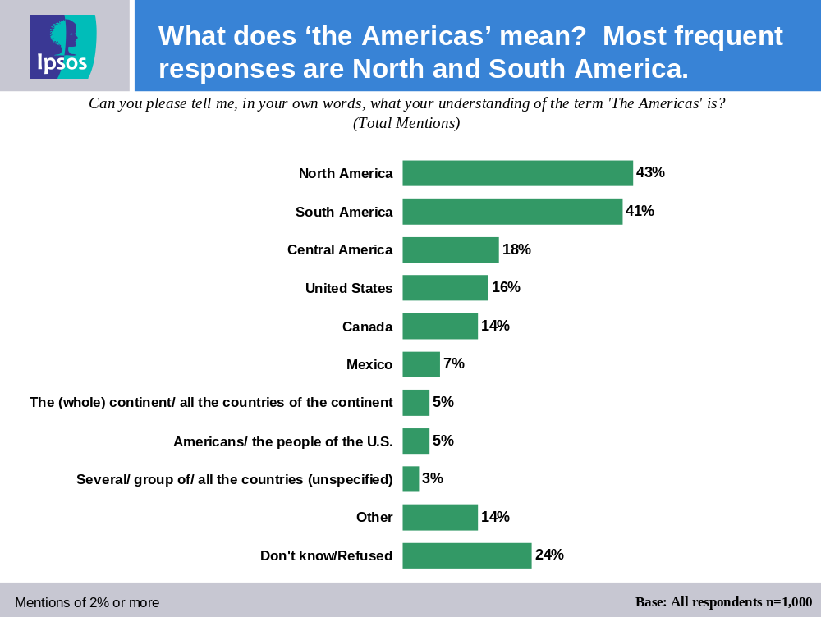

Looking at the demographic subgroups, those more likely to mention North America include:

- Those from Ontario (49%);
- Males (48%);
- Those with a post-secondary education (49%) or a university education (62%); and,
- Those earning more than $60,000 (55%).

Looking at the demographic subgroups, those more likely to mention South America include:

- Males (47%);
- Those with a post-secondary education (46%) or a university education (61%); and,
- Those earning more than $60,000 (54%).

Looking at the demographic subgroups, those more likely to mention Central America include:

- Those with a university education (29%); and,
- Those earning more than $60,000 (27%).

Those 55 years or older are more likely to mention the United States (23%) or Canada (20%).

Looking at the demographic subgroups, those more likely to mention don’t know include:

- Those with less than a high school education (41%);
- Those earning less than $35,000 (34%); and,
- Those from Saskatchewan/Manitoba (40%).

Extent to Which Canada’s Interests Are Tied to the Americas

Canadians were asked the extent to which Canada’s interests are tied to what happens in several countries and regions.

Majorities say Canada’s interests are either very or somewhat linked to what happens in the United States, Mexico, South America, Central America and the Caribbean. In particular, most respondents believe that Canada’s interests are very or somewhat linked to what happens in the United States (95%). Three in four (76%) believe that Canada’s interests are linked to Mexico, while six in ten say that Canada’s interests are linked to South America (62%) and Central America (61%). Just over half say that Canada’s interests are linked to the Caribbean (51%).

The proportion who feel that Canada’s interests are very linked to the tested countries and regions range from 80% for the United States to 25% for Mexico and around one in ten for South America (10%), Central America (11%) and the Caribbean (9%).

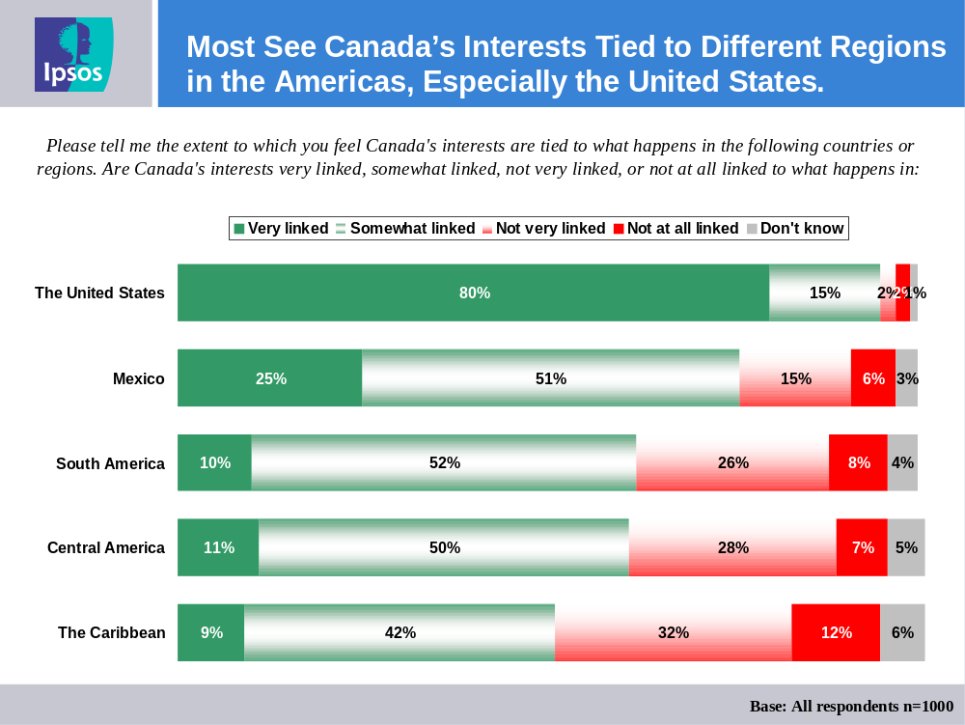

Looking at the demographic subgroups, the following are more likely to think that Canada’s interests are linked to Mexico:

- Those from Ontario (84%);
- Those 55 years or older (81%);
- Those with a university education (87%); and,
- Those earning more than $60,000 (84%).

Looking at the demographic subgroups, the following are more likely to think that Canada’s interests are linked to the Caribbean:

- Those from Saskatchewan/Manitoba (62%);
- Those from the Atlantic provinces (57%); and,
- Those 55 years or older (62%).

Looking at the demographic subgroups, the following are more likely to think that Canada’s interests are linked to the Central America:

- Those from Ontario (69%);
- Those with a university education (70%); and,
- Those involved in the region (68%), and particularly those who have family in the Americas (72%).

Looking at the demographic subgroups, the following are more likely to think that Canada’s interests are linked to the South America:

- Those from Ontario (71%); and,
- Those earning more than $60,000 (68%).

Importance of Central America, South America and the Caribbean

Most respondents believe that what happens in Central America, South America and the Caribbean is important to Canada (82%), including one in three who say very important (29%).

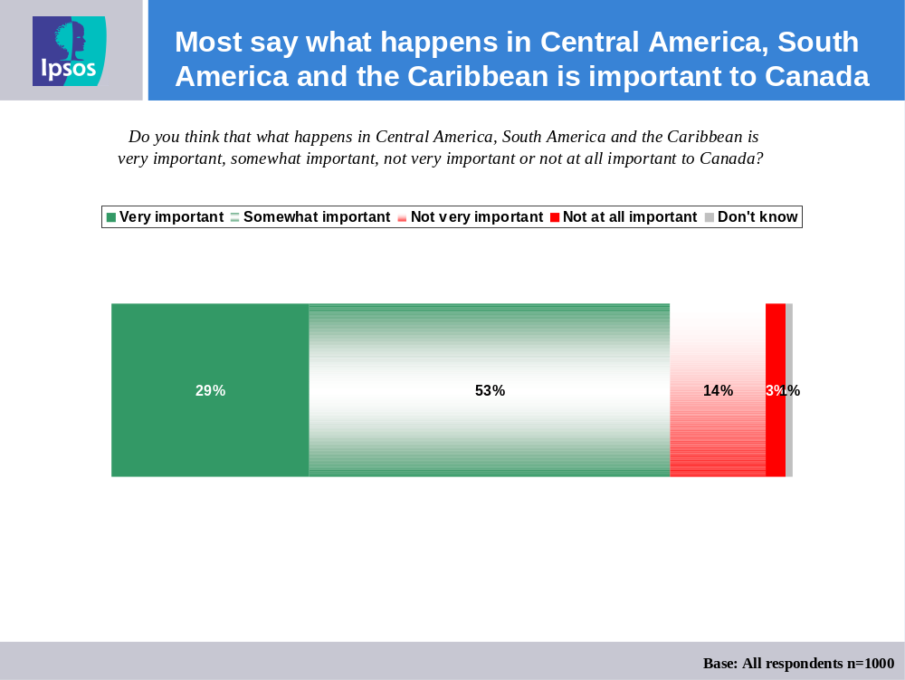

Those involved in the region (38%) are more likely than those not involved in the region (26%) to say what happens in the Americas is very important to Canada.

Looking at the demographic subgroups, the following are more likely to think that what happens in Central America, South America and the Caribbean is not very or not at all important:

- Those from Quebec (27%); and,
- Those with less than a high school education (23%).

Reasons Central America, South America and the Caribbean are Important

Two in five respondents who say what happens in Central America, South America and the Caribbean is important to Canada cite the impact on economic activity (44%), while one in five say it is because what the other regions do will affect Canada (19%).

A few respondents believe the regions are important because of humanitarian (9%), immigration (8%) and tourism issues (8%).

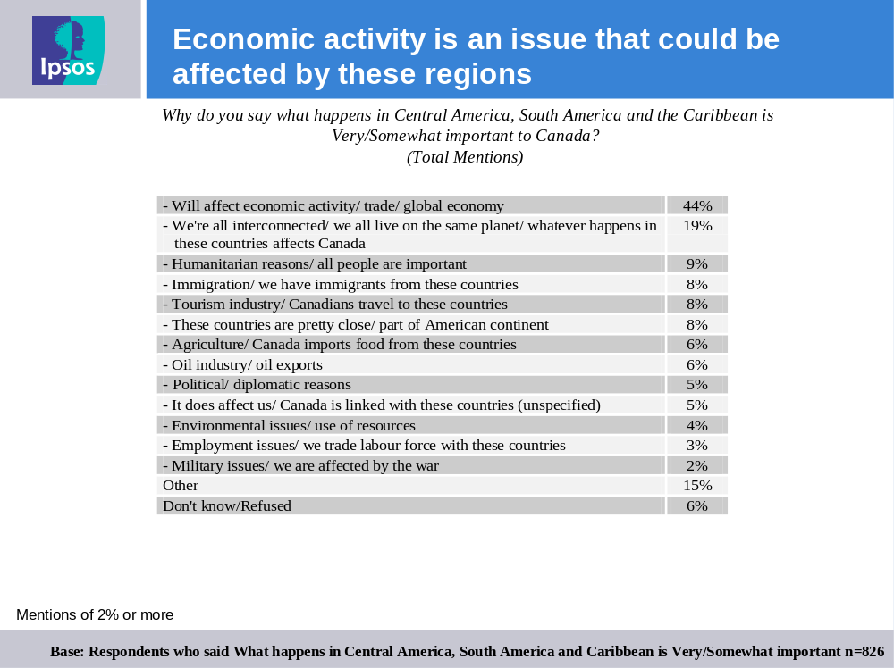

Those from British Columbia are more likely to say that we are all interconnected and from the same planet (33%).

Reasons Central America, South America and the Caribbean Are Not Seen as Important

Among those who do not think what happens in Central America, South America and the Caribbean is important to Canada, one in five (19%) believe it is because there is little economic activity, while 14% say we should take care of Canada first.

Others say it’s not important because we have no links to these regions (12%), no political ties (6%) or what happens there does not affect Canada (4%).

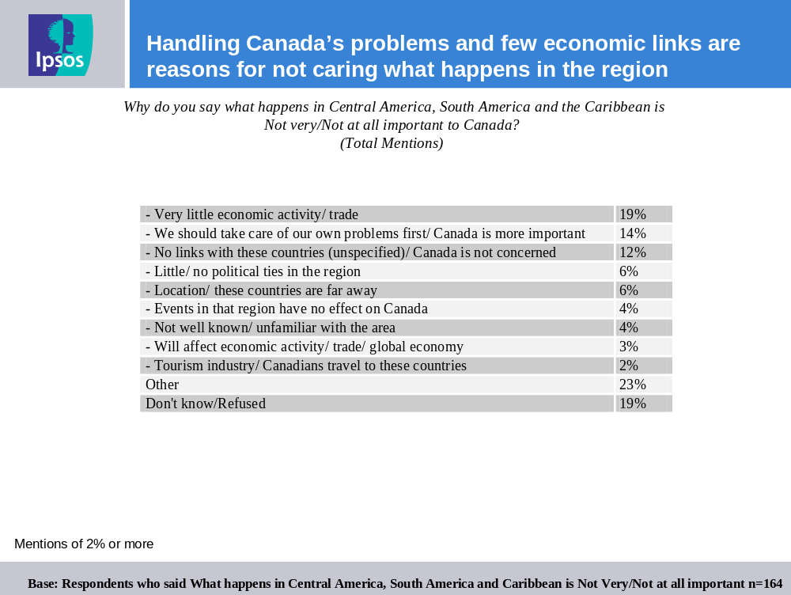

Support for Stronger Ties with Central America, South America and the Caribbean

Nearly four in five Canadians support stronger ties between Canada and South America (79%), Central America (78%) and the Caribbean (78%). Roughly one in four are strong supportive of increased ties in each region.

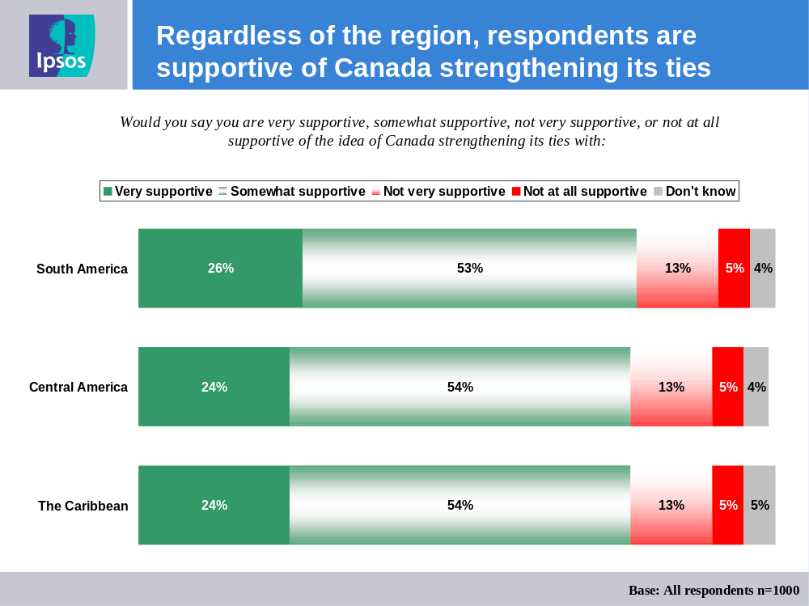

Those with a higher education and those earning more than $60,000 are more supportive of Canada strengthening its ties with these regions.
- Those with a university education: South America (87%, very or somewhat supportive), Central America (87%) and the Caribbean (88%); and,
- Those earning more than $60,000: South America (84%), Central America (86%) and the Caribbean (84%).

Importance of Policy Objectives in the Americas

Most Canadians agree that each of several objectives are important to Canada’s foreign policy in Central America, South America and the Caribbean. Specifically eight in ten believe that helping control crime, such as drug trafficking (80%) is very or somewhat important with almost half saying very important (49%). About three quarters believe that improving security for citizens and travelers (74%) as well as increasing exports and trading opportunities (77%) is important.

Over two thirds believe that promoting values (68%), assisting the development of countries through Canada’s aid program (65%) and promoting stability and democracy (64%) is important. More than half of respondents believe that promoting investment by Canadian companies (58%), as well as, attracting skilled immigrants is important (56%).

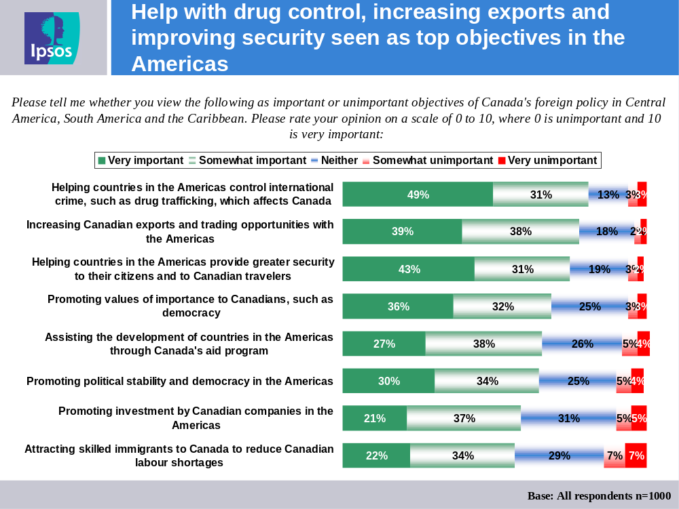

The following demographic subgroups are more likely to believe these objectives are important:

‘Increasing Canadian exports and trading opportunities with the Americas’
- Those earning between $30,000 and $60,000 (83%).

‘Helping countries in the Americas provide greater security to their citizens and to Canadian travelers’
- Those from the Atlantic provinces (87%); and,
- Those with a university education (81%).

‘Promoting values of importance to Canadians, such as democracy’
- Those with a post-secondary education (73%); and,
- Those earning more than $60,000 (73%).

‘Assisting the development of countries in the Americas through Canada’s aid program’
- Those with a university education (72%); and,
- Those earning more than $60,000 (71%).

‘Promoting investment by Canadian companies in the Americas’
- Those from Quebec (65%);
- Those with a university education (65%); and,
- Those earning more than $60,000 (64%).

‘Attracting skilled immigrants to Canada to reduce Canadian labour shortages’
- Those with a post-secondary education (73%); and,
- Those earning more than $60,000 (73%).

Among the tested regional objectives, those involved in the region are much more likely to view helping countries in the Americas provide greater security to their citizens and Canadian travellers (84% vs. 71% among others). This is the top priority for those involved in the region (though just slightly higher than controlling international crime and drug trafficking).

Those involved in the region are also more likely to development assistance to the region through Canada's aid program (75% vs. 61% among others) and promoting investment in the region by Canadian companies (69% vs. 55% among others) as important objectives.
Existence of Ties to Central America, South America and the Caribbean

Over one in ten Canadians have family or close friends who live in Central America, South America and the Caribbean (13%) or who frequently travel (12%) to Central America, South America and the Caribbean. Very few (5%) have business interests in these regions.

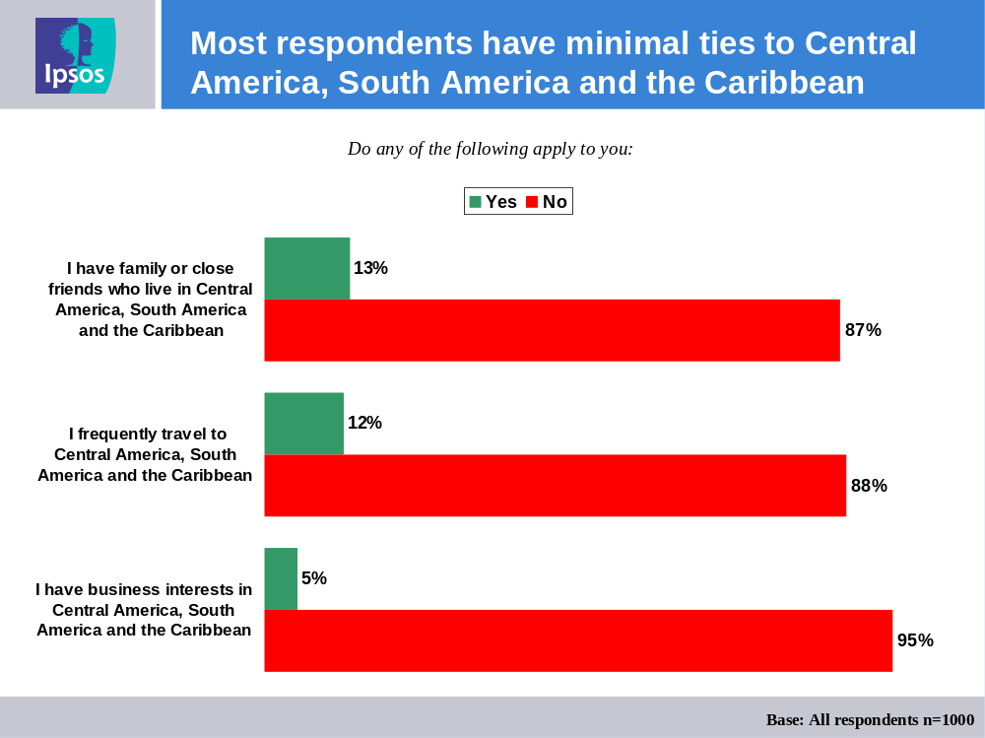

Those between 18 and 34 years (19%) are more likely to say they have family or close friend in these regions.

- Appendix I – Bilingual Questionnaire

1. Can you please tell me, in your own words, what your understanding of the term “The Americas” is? (RECORD ALL MENTIONS. IF UNSURE, ENCOURAGE BEST GUESS) (PROBE: Anything else?)
1. Pouvez-vous me dire dans vos propres mots quelle est pour vous la signification du terme « les Amériques »? (INSCRIRE TOUTES LES RÉPONSES. SI INCERTAIN, DEMANDER DE DONNER LA MEILLEURE APPROXIMATION.) (SONDER : Y a-t-il autre chose?)

[OPEN END]
[OPEN END]

2. Please tell me the extent to which you feel Canada’s interests are tied to what happens in the following countries or regions.
2. Veuillez me dire dans quelle mesure vous estimez que les intérêts du Canada sont liés à ce qui se passe dans chacun des pays ou chacune des régions suivants.
Are Canada’s interests very linked, somewhat linked, not very linked, or not at all linked to what happens in... [INSERT ITEM]
Les intérêts du Canada sont-ils très liés, plutôt liés, pas très liés ou pas du tout liés à ce qui se passe... [INSERT ITEM]
How about… [INSERT ITEM]
En ce qui concerne… [INSÉRER UN ÉLÉMENT]
(READ AS NECESSARY: Are Canada’s interests very linked, somewhat links, not very linked, or not at all linked to what happens in [INSERT ITEM]?)
(LIRE AU BESOIN : Les intérêts du Canada sont-ils très liés, plutôt liés, pas très liés ou pas du tout liés à ce qui se passe... [INSÉRER UN ÉLÉMENT]?)

[ITEM LIST. RANDOMIZE]
[ITEM LIST. RANDOMIZE]
The United States
Aux États-Unis
Mexico
Au Mexique
The Caribbean
Dans les Caraïbes
Central America
En Amérique centrale
South America
En Amérique du Sud

[RESPONSE LIST]
[RESPONSE LIST]
Very linked
Très liés
Somewhat linked
Plutôt liés
Not very linked
Pas très liés
Not at all linked
Pas du tout liés

[Q3 LEAD IN]
[Q3 LEAD IN]
The Americas refers to the United States and Mexico, Central America, South America and the Caribbean. For the purposes of this survey, we will be focusing on Central America, South America and the Caribbean.
Les Amériques comprennent les États-Unis et le Mexique, l’Amérique centrale, l’Amérique du Sud et les Caraïbes. Le présent sondage porte principalement sur l’Amérique centrale, l’Amérique du Sud et les Caraïbes.

3. Do you think that what happens in Central America, South America and the Caribbean is very important, somewhat important, not very important or not at all important to Canada? (READ LIST IF NECESSARY. ENTER SINGLE RESPONSE ONLY. IF UNSURE, ENCOURAGE BEST GUESS)
3. Selon vous, ce qui se passe en Amérique centrale, en Amérique du Sud et dans les Caraïbes est-il très important, plutôt important, pas très important ou pas du tout important pour le Canada? (LIRE LA LISTE AU BESOIN. INSCRIRE UNE SEULE RÉPONSE. SI INCERTAIN, DEMANDER DE DONNER LA MEILLEURE APPROXIMATION.)

Very important
Très important
Somewhat important
Plutôt important
Not very important
Pas très important
Not at all important
Pas du tout important

[IF DK/REF TO Q3 SKIP TO Q5, OTHERWISE CONTINUE]
[IF DK/REF TO Q3 SKIP TO Q5, OTHERWISE CONTINUE]

4. Why do you say what happens in Central America, South America and the Caribbean is [INSERT RESPONSE TO Q3] to Canada? (RECORD ALL MENTIONS. IF UNSURE, ENCOURAGE BEST GUESS) (PROBE: Why else?)
4. Pourquoi dites-vous que ce qui se passe en Amérique centrale, en Amérique du Sud et dans les Caraïbes est [INSÉRER LA RÉPONSE DE LA Q3] pour le Canada? (INSCRIRE TOUTES LES RÉPONSES. SI INCERTAIN, DEMANDER DE DONNER LA MEILLEURE APPROXIMATION.) (SONDER : Y a-t-il une autre raison?)

[OPEN END]
[OPEN END]

5. Would you say you are very supportive, somewhat supportive, not very supportive, or not at all supportive of the idea of Canada strengthening it ties with… [INSERT ITEM]
5. Diriez-vous que vous êtes fortement pour, plutôt pour, plutôt contre ou fortement contre l’idée que le Canada resserre ses liens avec… [INSÉRER UN ÉLÉMENT]
How about… [INSERT ITEM]
En ce qui concerne… [INSÉRER UN ÉLÉMENT]
(READ AS NECESSARY: Would you say you are very supportive, somewhat supportive, not very supportive, or not at all supportive of the idea of Canada strengthening it ties with [INSERT ITEM]?)
(LIRE AU BESOIN : Diriez-vous que vous êtes fortement pour, plutôt pour, plutôt contre ou fortement contre l’idée que le Canada resserre ses liens avec… [INSÉRER UN ÉLÉMENT]?)

[ITEM LIST. RANDOMIZE]
[ITEM LIST. RANDOMIZE]
The Caribbean
Les Caraïbes
Central America
L’Amérique centrale
South America
L’Amérique du Sud

[RESPONSE LIST]
[RESPONSE LIST]
Very supportive
Fortement pour
Somewhat supportive
Plutôt pour
Not very supportive
Plutôt contre
Not at all supportive
Fortement contre

6. Please tell me whether you view the following as important or unimportant objectives of Canada’s foreign policy in Central America, South America and the Caribbean. Please rate your opinion on a scale of 0 to 10, where 0 is unimportant and 10 is very important.
6. Veuillez me dire dans quelle mesure vous considérez que les objectifs suivants sont importants ou non pour la politique étrangère du Canada en Amérique centrale, en Amérique du Sud et dans les Caraïbes, sur une échelle de 0 à 10, où 0 signifie pas du tout important, et 10, très important.
How about… [INSERT ITEM]
En ce qui concerne l’objectif… [INSÉRER UN ÉLÉMENT]
(READ AS NECESSARY: Using a scale of 0 to 10, where 0 is unimportant and 10 is very important, please rate your opinion on whether you view the following as important or unimportant objectives of Canada’s foreign policy in Central America, South America and the Caribbean.)
(LIRE AU BESOIN : Sur une échelle de 0 à 10, où 0 signifie pas du tout important, et 10, très important, veuillez indiquer si vous considérez que les objectifs suivants sont importants ou non pour la politique étrangère du Canada en Amérique centrale, en Amérique du Sud et dans les Caraïbes.)

[ITEM LIST. RANDOMIZE]
[ITEM LIST. RANDOMIZE]
Increasing Canadian exports and trading opportunities with the Americas
L’augmentation des exportations canadiennes et des occasions commerciales avec les Amériques
Promoting investment by Canadian companies in the Americas
La promotion de l’investissement dans les Amériques par des entreprises canadiennes
Promoting political stability and democracy in the Americas
La promotion de la stabilité politique et de la démocratie dans les Amériques
Helping countries in the Americas control international crime, such as drug trafficking, which affects Canada
L’aide aux pays des Amériques pour contrôler la criminalité internationale, comme le trafic de drogue, qui touche le Canada
Helping countries in the Americas provide greater security to their citizens and to Canadian travelers
L’aide aux pays des Amériques pour assurer une plus grande sécurité à leurs citoyens et aux voyageurs canadiens
Assisting the development of countries in the Americas through Canada's aid program
L’assistance au développement des pays des Amériques par l’entremise d’un programme d’aide canadien
Attracting skilled immigrants to Canada to reduce Canadian labour shortages
La promotion du Canada auprès d’immigrants qualifiés pour réduire les pénuries de travailleurs au Canada
Promoting values of importance to Canadians, such as democracy
La promotion des valeurs importantes pour les Canadiens comme la démocratie

[RANGE 0 TO 10]
[RANGE 0 TO 10]

7. Do any of the following apply to you?
7. Est-ce que l’un ou l’autre des énoncés suivants s’applique à vous?
How about… [INSERT ITEM]
En ce qui concerne l’énoncé… [INSÉRER UN ÉLÉMENT]
(READ AS NECESSARY: Does this apply to you?)
(LIRE AU BESOIN : Cet énoncé s’applique-t-il à vous?)

[ITEM LIST. RANDOMIZE]
[ITEM LIST. RANDOMIZE]
I have family or close friends who live in Central America, South America and the Caribbean
J’ai des parents ou des amis proches qui vivent en Amérique centrale, en Amérique du Sud ou dans les Caraïbes
I have business interests in Central America, South America and the Caribbean
J’ai des intérêts commerciaux en Amérique centrale, en Amérique du Sud ou dans les Caraïbes
I frequently travel to Central America, South America and the Caribbean
Je voyage fréquemment en Amérique centrale, en Amérique du Sud ou dans les Caraïbes

[RESPONSE LIST]
[RESPONSE LIST]
Yes
Oui
No
Non

“Those involved in the region” includes respondents who either have family or friends living in the region, have business interests in the region or who say they frequently travel to the region.

