POR Number: 059-09
Contract Number: 08170-090271-001/CY
Award Date: 03/12/2009
Fieldwork Completion Date: 28/01/2010
Project Authority: Kevin Chappell

Corporate Connection: Custom Questions - Trade Survey 2010

Report to
the Department of Foreign Affairs and International Trade (DFAIT)

February 2010

Phoenix SPI is a ‘Gold Seal Certified’ Corporate Member of the MRIA





Table of Contents

Introduction 1
Executive Summary 1
Sommaire 2
Findings 4
Characteristics of Survey Respondents 12

Appendices:
Questionnaire (English and French)
Technical report

Introduction
This report presents the results for questions asked on behalf of the Department of Foreign Affairs and International Trade (DFAIT) that were included in the winter 2010 wave of Corporate Connection. The objective was to explore the views of executives regarding trade-related issues, including perceptions of regions representing the best opportunities for international business for their company, the type of government assistance that would be most useful to them, assessments of the barriers that impact on their ability to take advantage of international trade opportunities, and awareness of organizations that offer trade services for exporters and international investors.

Corporate Connection is a twice-yearly survey of CEOs and senior executives that focuses on current corporate and public affairs issues. For this wave of the study, 403 interviews were completed January 13-28, 2010. Over half of the sample (54%) consisted of CEOs, presidents, and business owners. The results were weighted by size, sector and region to reflect the actual distribution of firms across Canada (according to Statistics Canada data). Based on a sample of this size, the findings can be considered to be accurate to within ± 5%, 19 times out of 20. Interviews were conducted in French and English and averaged seven minutes in length. Participants will receive a summary of the research findings in appreciation of their participation in the survey.

For this research, quotas were applied based on size of business. Small businesses were those with less than 50 employees, medium-sized were 50-99, and large firms were 100 employees and more (with well over half of the large firms having 200 or more employees). As noted, following the fieldwork the data were weighted to ensure that the results are proportionate to the distribution of the business population in Canada. At times in the report, the number of respondents (i.e. not the percentage) who answered certain questions or answered in a certain way is provided. The following method is used to denote this: n = 150, which means the number of respondents, in this instance, is 150. Unweighted numbers are used in these instances.

This study was conducted by Phoenix Strategic Perspectives, a public opinion research firm that specializes in public affairs and special audience research. The questionnaire is appended to this report.

Executive Summary
Almost one-quarter (24%) of surveyed firms are involved in international business, with a further 4% planning to be in the next few years. Current involvement in international business has decreased significantly since 2009, but is generally consistent with what it was in 2007 (24% in 2010 vs. 36% in 2009 and 27% in 2007). Among executives of companies currently involved in international business (n=109), a small majority (52%) perceive the United States to be the best trade opportunity for their firm, followed at a distance by Asia (28%) and Europe (25%). Fewer than one in ten identified other regions, including South America, the Middle East and North Africa, Australia, India, Mexico, and Africa. There has been a general decline in the likelihood of identifying most regions, with the largest year-to-year decline recorded for the U.S. (from 72% in 2009 to 52% in 2010).

Executives of firms involved in international business identified numerous types of support that the Government of Canada could provide to help their business take advantage of international trade and investment opportunities. That said, none of the suggestions was identified with much frequency. Leading the way was increasing financial support for international business (14%), stabilizing the economy/currency exchange (8%), helping to promote products or services (6%), and lowering the value of the Canadian dollar (6%).

When it came to potential barriers to international business, the following were most likely to be identified: access to capital (42%), taxes (41%), complex international rules and regulations (36%), and lack of reliable market intelligence (32%). These were followed by skills shortages (29%), inter-provincial commercial barriers (29%), and foreign ownership restrictions (12%). With a few exceptions, the likelihood of assigning significance to these potential barriers has decreased considerably since 2007 and 2009. The one noteworthy exception is inter-provincial barriers – this wave, 29% consider this a significant barrier compared to 16% in 2009 and 23% in 2007.

In total, 51% of executives of firms involved in international business said they were aware of organizations offering trade services, although relatively few of these were aware of any organizations by name. When these executives (n=70) were asked to identify the organizations of which they were aware, the only one identified frequently was Export Development Canada (73%). All other organizations were identified by no more than a few executives. The main ones included Business Development Canada (n=7), Canadian Manufacturers and Exporters Association (n=6), Saskatchewan Trade and Export Partnership (n=4), Canadian Trade Commissioner Service (n=3), Ministry of Economic Development and Trade [Ontario] (n=3), Ministère du Développement économique, de l’innovation et de l’Exportation [Quebec] (n=3), and the Department of Foreign Affairs and International Trade (n=3). Executives who did not identify the Canadian Trade Commissioner Service (TCS) on an unaided basis (n=138) were asked if they had ever heard of the service. In terms of aided awareness, almost half (47%) claimed to be aware of the TCS.
The survey results will be used by DFAIT to inform decision makers and policy planners and to provide insight on how to improve service delivery. The cost of this research was $18,050 (GST excluded).

Sommaire
C’est dans une proportion avoisinant le quart (24 %) que les entreprises ayant participé au sondage sont engagées dans des activités commerciales à l’échelle internationale. En outre, 4 % des entreprises prévoient le devenir au cours des prochaines années. Si ces résultats sur l’engagement dans le commerce international témoignent d’un important recul depuis 2009, en général, ils reflètent toutefois les résultats observés en 2007 (24 % en 2010 par rapport à 36 % en 2009 et à 27 % en 2007). En ce qui concerne les entreprises actuellement engagées dans des activités commerciales à l’échelle internationale (n = 109), une proportion faiblement majoritaire (52 %) des dirigeants interrogés tiennent les États-Unis pour la région du monde offrant pour leur entreprise les meilleures occasions sur le plan du commerce international. Suivent à bonne distance l’Asie (28 %) puis l’Europe (25 %). Par ailleurs, c’est dans des proportions inférieures à un pour dix que les dirigeants interrogés signalent à ce chapitre d’autres régions, comme l’Amérique du Sud, le Moyen-Orient et l’Afrique du Nord, l’Australie, l’Inde, le Mexique, de même que l’Afrique. En général, nous constatons un recul au chapitre de la mesure dans laquelle les dirigeants sont susceptibles de signaler la plupart des régions. En particulier, la plus importante réduction depuis l’année précédente s’observe pour les É.-U. (ce résultat est passé de 72 % en 2009 à 52 % en 2010).

Les dirigeants des entreprises engagées dans des activités commerciales à l’échelle internationale ont défini divers types de soutien ou d’aide que le gouvernement du Canada pourrait leur offrir afin de les aider à tirer profit des occasions qui s'offrent en matière de commerce international et d'investissements à l'étranger. En revanche, aucun de ces moyens n’a été signalé dans une proportion considérable. En tête de la liste des moyens signalés, figure l’accroissement du soutien financier pour le commerce international (14 %). Suivent la stabilisation de l’économie ou du taux de change (8 %), l’aide pour la promotion des produits ou services (6 %), ainsi que la diminution de la valeur du dollar canadien (6 %).

Au chapitre des éventuels obstacles au commerce international, voici les enjeux que les dirigeants d’entreprise se sont révélés le plus susceptibles de signaler : l’accès au capital (42 %), les impôts (41 %), la complexité des règlements et des lois à l’étranger (36 %) et le manque de renseignements fiables sur le marché visé (32 %). Ont aussi été signalés en moindres proportions la pénurie de main-d’œuvre qualifiée (29 %), les obstacles commerciaux interprovinciaux (29 %), de même que les restrictions en matière de propriété à l'étranger (12 %). À quelques exceptions près, par rapport aux résultats de 2007 et de 2009, nous observons d’importantes diminutions sur le plan de la mesure dans laquelle les dirigeants sont susceptibles d’attribuer de l’importance aux obstacles possibles. À ce chapitre, la seule exception digne de mention a pour objet les obstacles commerciaux interprovinciaux. En effet, dans le cadre de la présente édition de l’enquête, 29 % des dirigeants ont affirmé estimer qu’il s’agit d’un obstacle d’importance, comparativement à 16 % en 2009 et à 23 % en 2007.

Au total, 51 % des dirigeants des entreprises engagées dans des activités commerciales à l’échelle internationale affirment connaître des organisations qui offrent des services d’expansion commerciale, encore qu’ils soient relativement peu nombreux à être en mesure de nommer l’une ou l’autre de ces organisations. À la question de savoir quelles sont les organisations qu’ils connaissent, ces dirigeants (n = 70) n’ont nommé fréquemment qu’une seule d’entre elles : Exportation et développement Canada (73 %). Dans tous les autres cas, les organisations nommées ont été signalées par tout au plus quelques dirigeants. En particulier, au nombre des principales organisations signalées, figurent la Banque de développement du Canada (n = 7), l’association des Manufacturiers et exportateurs du Canada (n = 6), le Saskatchewan Trade and Export Partnership (n = 4), le Service des délégués commerciaux du Canada (n = 3), le ministère du Développement économique et du Commerce [Ontario] (n = 3), le ministère du Développement économique, de l’Innovation et de l’Exportation [Québec] (n = 3) et le ministère des Affaires étrangères et du Commerce international (n = 3). Les dirigeants n’ayant pas spontanément nommé le Service des délégués commerciaux du Canada (SDCC) (n = 138) devaient indiquer s’ils ont déjà entendu parler du service. En ce qui concerne la connaissance évaluée de cette façon, c.-à-d. avec de l’aide, près de la moitié (47 %) des dirigeants interrogés signalent connaître le SDCC.

Les résultats du sondage seront utilisés par AECIC pour informer les décideurs et responsables des politiques et cerner les façons d’améliorer la prestation de service. Le coût de cette recherche était de $18,050 (TPS exclue).

Findings
Approximately One-Quarter Involved in International Business
Nearly one-quarter (24%) of executives reported that their firm is currently involved in international business activities, including exporting. A further 4% said their firm is not involved in such activities at this time, but plan to be within the next few years. The large majority (72%) are not currently involved in international business and have no immediate plans to be.
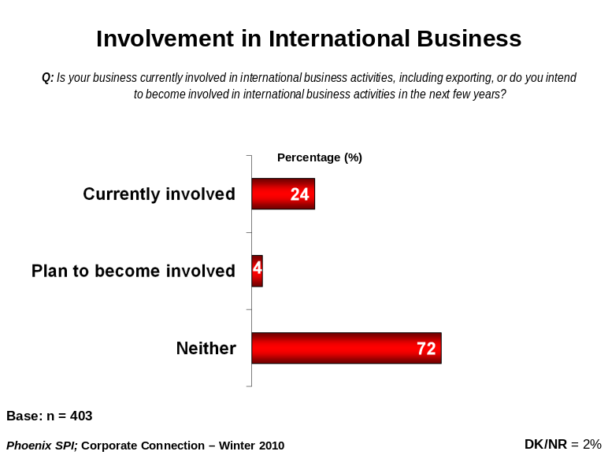

Firm size and region did not have an impact on the likelihood of executives reporting involvement in international trade.

Current involvement in international business has decreased significantly since 2009, but is generally consistent with what it was in 2007 (24% in 2010 vs. 36% in 2009 and 27% in 2007).

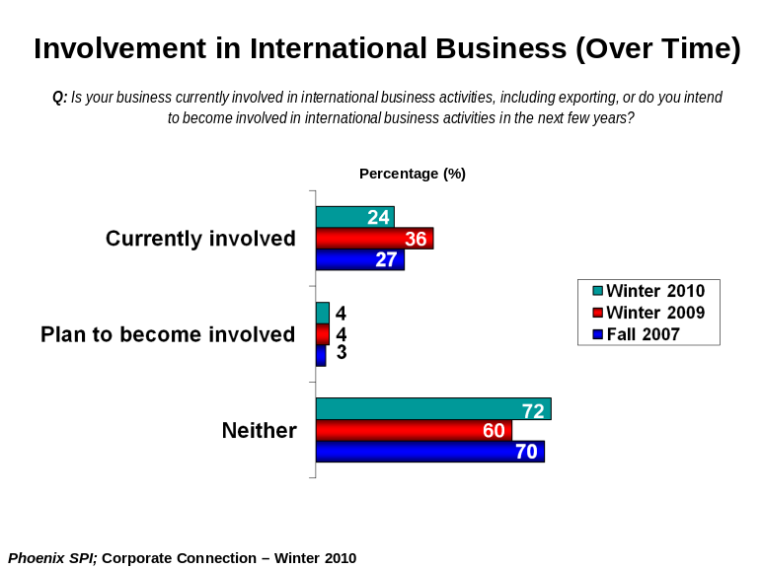

USA – Top International Trade Opportunity
Among executives involved in international business (n=141), a slight majority (52%) perceive the United States to be the best international trade opportunity for their firm. The U.S. was followed at a distance by Asia (28%) and Europe (25%) (respondents were able to provide multiple responses). Fewer than one in ten felt that the best opportunities for trade could be found in other regions, including South America, the Middle East and North Africa, Australia, India, Mexico, and Africa.

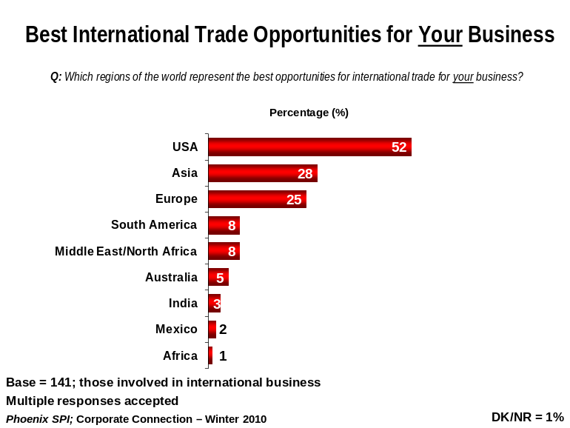

Executives in the West (42%) and Ontario (32%) were more likely than those in Quebec (0%) to point to Asia. Firm size, however, had no affect on business leaders’ perceptions of trade opportunities.

Compared to winter 2009, there has been a general decline in the likelihood of identifying most regions, with the largest year-to-year decline recorded for the U.S. (from 72% in 2009 to 52% in 2010). While Asia was mentioned by fewer executives this year (28% in 2010 vs. 36% in 2009), it continues to rank 2nd behind the U.S. in terms of perceived trade opportunities (it ranked 3rd in 2007).

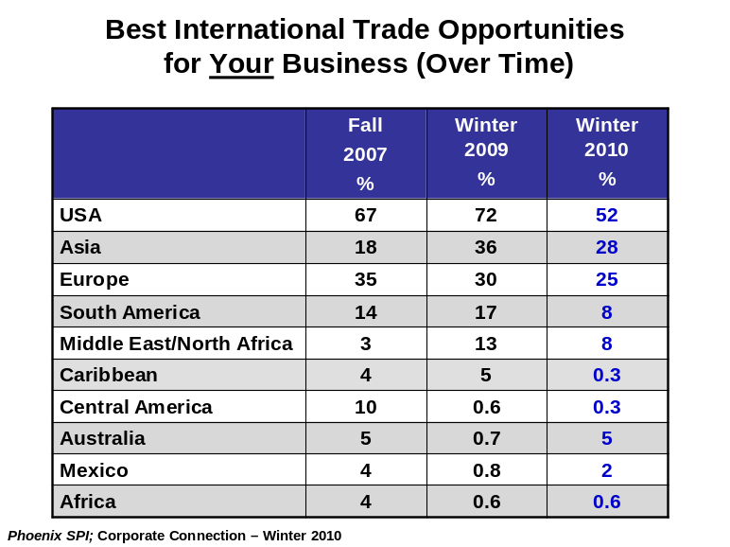

Range of Potential Federal Activities to Support International Business
Executives of firms involved in international business identified numerous types of support or assistance that the Government of Canada could provide to help their business take advantage of international trade and investment opportunities. Despite the variety of suggestions, none was identified with very much frequency. Leading the way was increasing financial support for international business (14%). Following, at a distance, were stabilizing the economy/currency exchange (8%), helping to promote products or services (6%), and lowering the value of the Canadian dollar (6%) (multiple responses accepted).

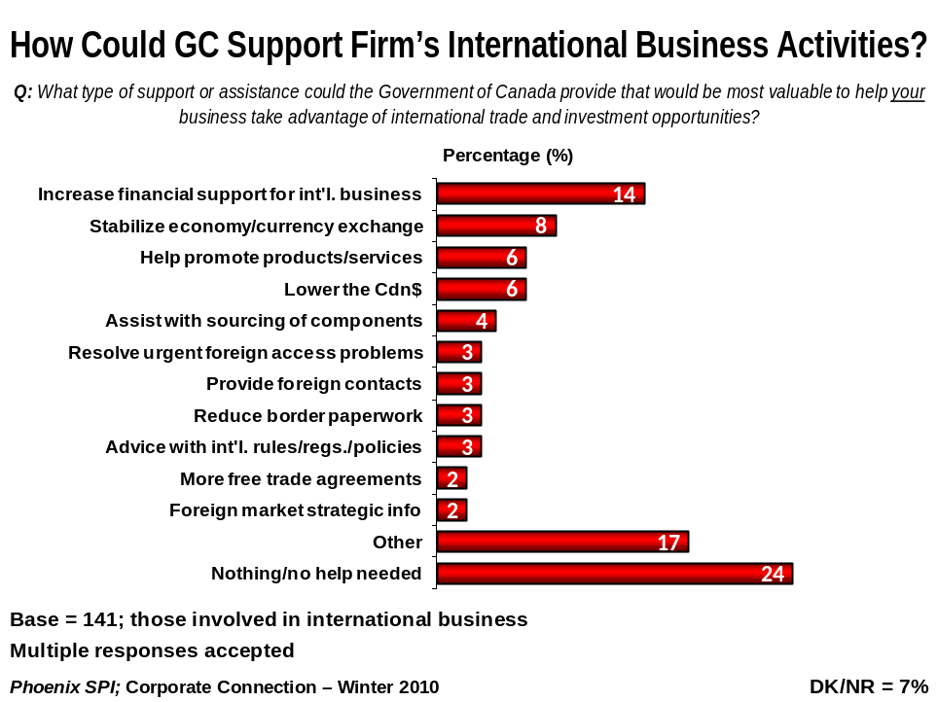

Beyond this, in descending order, were assisting with the sourcing of components, resolving urgent foreign access problems, providing foreign contacts, reducing border paperwork, providing advice on international rules, regulations and policies, securing more free trade agreements, and offering foreign market strategic information.

The types of assistance and/or support grouped in the ‘other’ category include negotiating agreements to increase access to foreign markets, lowering taxes, providing business leads, developing better relations with the U.S. government, promoting trade with the U.S., and encouraging more investment in research and development (R&D). Each of these suggestions was identified by a single respondent only.

Nearly one-third of corporate executives (31%) did not identify any type of potential assistance or support – 24% did not think that help from the government was necessary and 7% offered no response at all.

The table below presents this same data, but this time the data are broken out by executives of firms involved in international business who claimed to be aware of the Canadian Trade Commissioner Service (TCS) (n=80) and those who said they are not aware (n=61). Caution should be exercised when interpreting these results due to the small sample sizes.
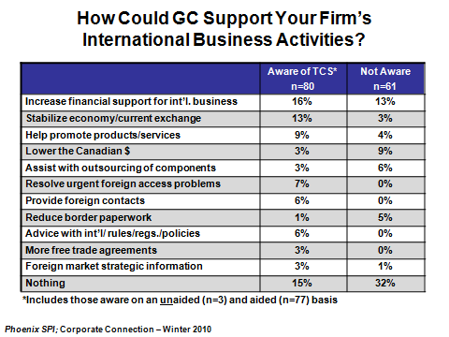

As the table below depicts, there has been a noticeable decrease in most areas over the past year, but also since tracking began in 2007. The only pronounced increase since 2009 has been in the proportion of executives saying that no help is needed from the federal government (24% in 2010 vs. 18% in 2009).
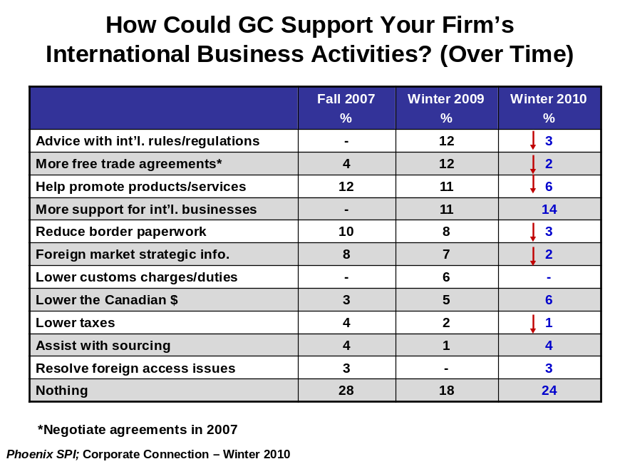

Note: caution should be exercised when interpreting these changes over time due to the relatively small sample sizes.
Perceptions of Potential Barriers/Obstacles to International Trade
Executives of firms involved in international trade were asked to assess the impact of a number of potential obstacles or barriers on their businesses’ ability to take advantage of international trade opportunities, using a 7-point scale (1 = not an obstacle/barrier at all, 7 = a very significant obstacle/barrier). The potential barriers assessed were:
- Skills shortages
- Taxes
- Foreign ownership restrictions
- Inter-provincial commercial barriers
- Complexity of international rules and regulations
- Access to capital
- Lack of reliable market intelligence.

The likelihood of attributing at least some significance to these potential barriers to international trade (scores of 5 or more) varied widely. In fact, business leaders were more likely to ascribe at least some significance than little or none at all to only two of the seven barriers. Approximately four in ten assigned some significance to access to capital (42%) and taxes (41%) (compared to 33% and 38% respectively who felt that these issues were not significant barriers to international trade).

Reference to international rules and regulations and reliable market intelligence elicited mixed views among executives. Looking first at international rules and regulations, 36% assigned it at least some significance, while 40% assigned it little or no significance as a barrier (scores of 3 or less). Similarly, 32% felt that a lack of reliable market intelligence was a significant barrier to international trade, while nearly half (49%) attributed little or no significance to it as a trade barrier.

The majority of executives felt that the remaining potential barriers have little or no significance when it comes to obstacles to international trade: 62% felt this way about skills shortages, 67% about foreign ownership restrictions, and 69% about inter-provincial barriers.
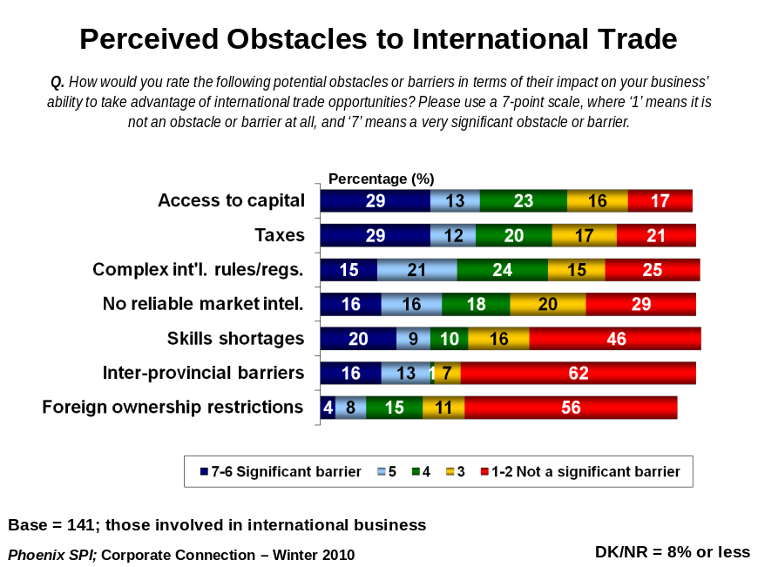

With a few exceptions, the likelihood of assigning significance to these potential barriers has decreased considerably since 2009. In addition, compared to 2007, most of these perceived obstacles are less likely to be viewed as real barriers to international trade. The one noteworthy exception is inter-provincial barriers – this wave, 29% consider this a significant barrier compared to 16% in 2009 and 23% in 2007.
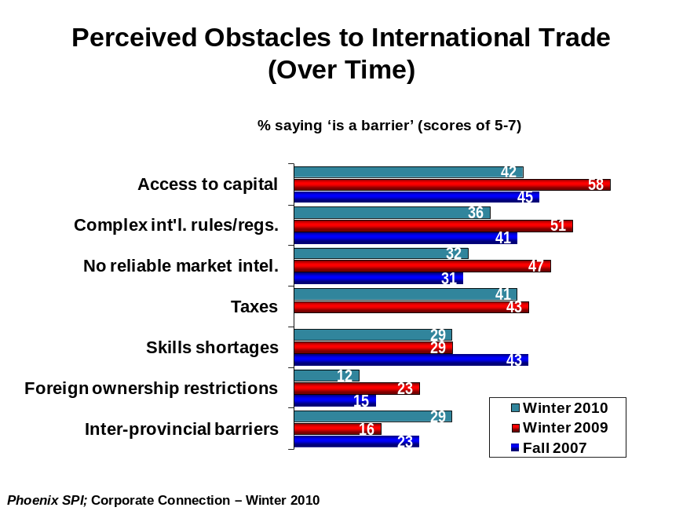

Majority Aware of Organizations Offering Trade Services
Just over half of the executives of companies involved in international business (51%) said they are aware of organizations offering trade services for exporters and international investors: 46% claimed to be aware of specific organizations, while 5% said they are aware that such organizations exist but are not able to identify any by name. Conversely, 49% said they are not aware of any such organizations.
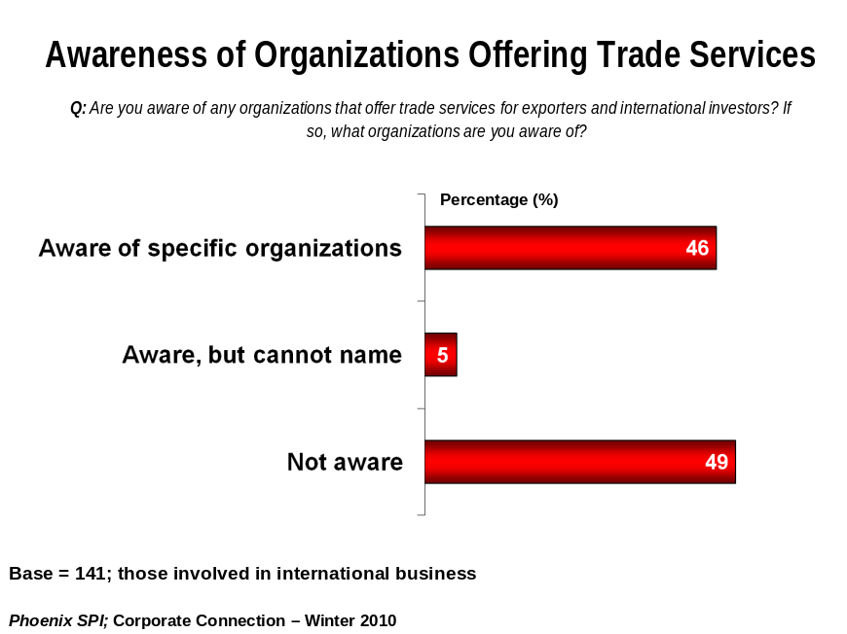

There has been a noticeable decline in overall awareness of organizations offering trade services – from 69% in 2007 and 2009 to 51% in 2010.
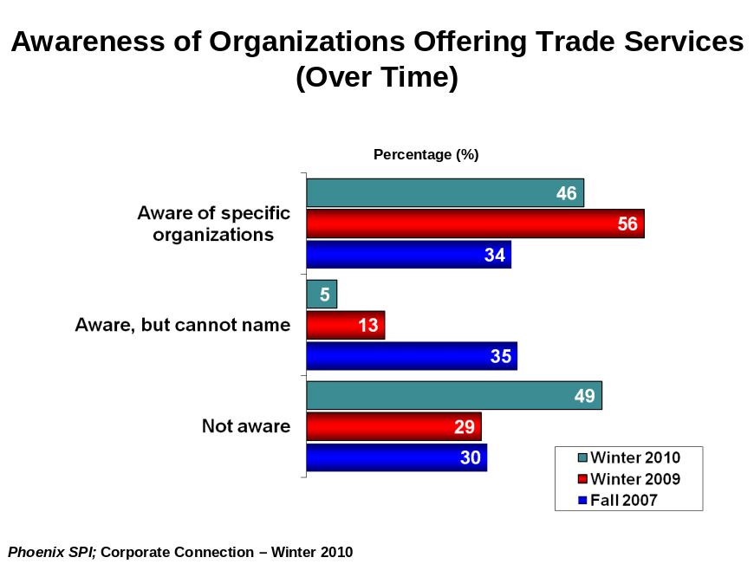

Export Development Canada – Most Recognized Trade Services Organization
Executives aware of specific organizations offering trade services (n=70) were asked to identify these organizations by name. The most frequently identified organization, by far, was Export Development Canada (EDC). Nearly three-quarters of business leaders (73%) pointed to EDC. This is similar to the results of past waves (conducted in 2007 and 2009) insofar as Export Development Canada is the only organization mentioned with any real frequency.

All other organizations were identified by no more than a few executives. They include the following: Business Development Canada (n=7), Canadian Manufacturers and Exporters Association (n=6), Saskatchewan Trade and Export Partnership (n=4), Canadian Trade Commissioner Service (n=3), Ministry of Economic Development and Trade [Ontario] (n=3), Ministère du Développement économique, de l’innovation et de l’Exportation [Quebec] (n=3), the Department of Foreign Affairs and International Trade (n=3), and private sector consultants (n=2).

Each of the following was identified by individual respondents:
- Petroleum Service Association of Canada  - Canadian International Development Agency  - Canadian Commercial Corporation  - Russell A. Farrow Limited  - Ministry of Industry and Trade  - Nova Scotia Business Inc.  - Manitoba Trade and Investment Corporation  - Credit insurers (e.g. Euler, Coface, Atradius) | - Export Ontario  - Canadian Consulates  - Import Export Bank  - Trade Canada  - Quebec Government  - Brokerage firms  - Fonds de solidarité FTQ  - Investissement Québec
Looking at awareness of trade services organizations among all of those involved in international business (n=141) (not just those who said they are aware of specific organizations), 34% of business leaders identified EDC by name. Compared to last year, executives were less likely to identify EDC this wave: 34% in 2010 vs. 43% in 2009. Recognition of EDC as a trade services organization, nevertheless, remains more than twice as high as it was in 2007 (34% in 2010 vs. 16% in 2007).

Almost Half Aware of TCS on Aided Basis
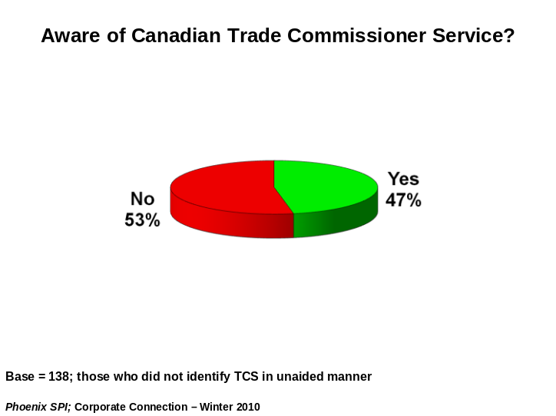
Business leaders working in firms involved in international business who did not identify the Canadian Trade Commissioner Service (TCS) on an unaided basis (n=138) were asked if they had ever heard of the service. In terms of aided awareness, almost half (47%) claimed to be aware of the TCS, while slightly more (53%) said they did not know about the service offered through Foreign Affairs and International Trade Canada.

Characteristics of Survey Respondents
The following graphs present the characteristics of survey participants by position of respondent, business size, sector, and region. Note that unweighted data are used to present the characteristics of survey participants.
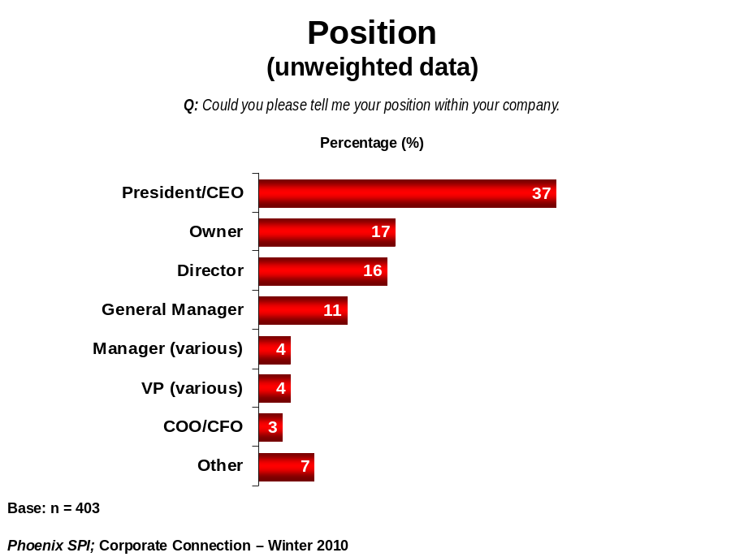

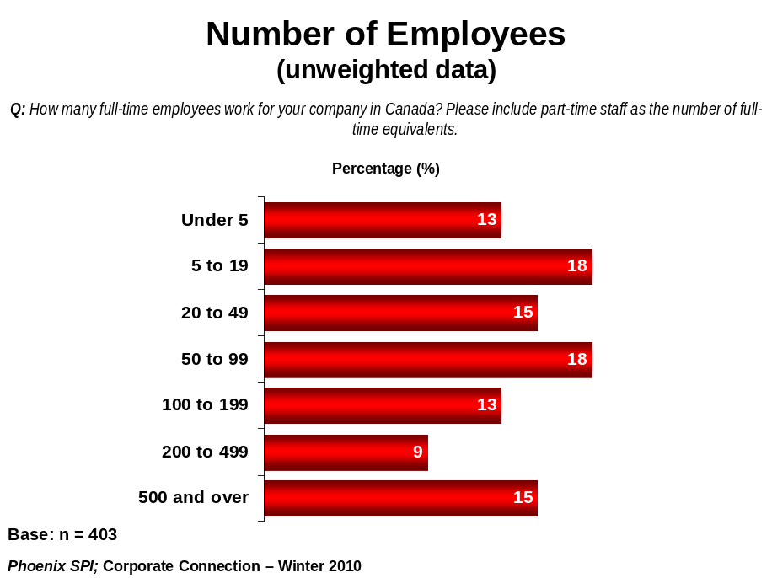

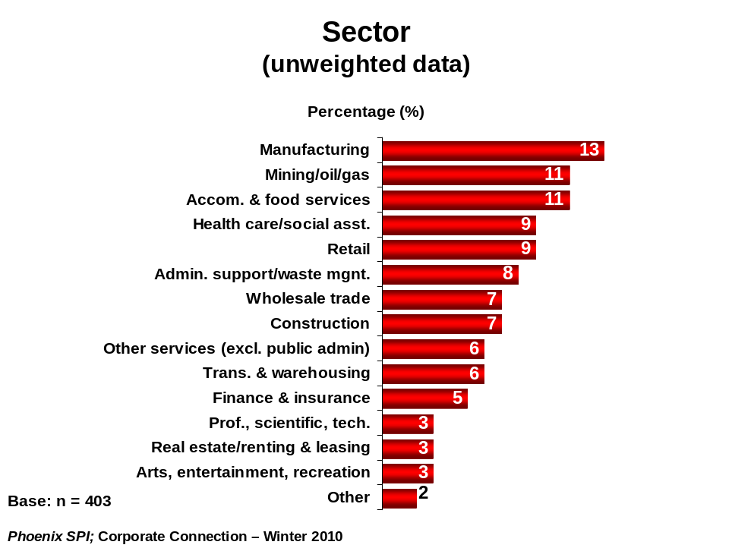

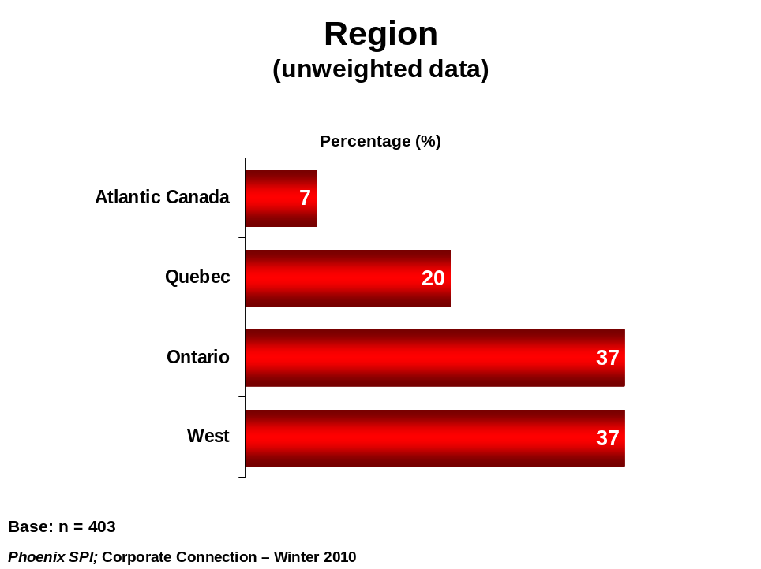

Appendix 1 – Questions Asked

English:

- Is your business currently involved in international business activities, including exporting, or do you intend to become involved in international business activities in the next few years? TF09 [READ LIST; ACCEPT ONE RESPONSE]

Currently involved in international business 1
Plan to become involved in international business 2
Neither 3 THANK AND SEND TO LAST Q

- Which regions of the world represent the best opportunities for international trade for your business? TF09 [DO NOT READ LIST; ACCEPT MULTIPLE RESPONSES]

United States
Mexico
Central America
South America
Caribbean
Europe
Asia
Middle East and North Africa
Africa
Other (specify): ______________________

- What type of support or assistance could the Government of Canada provide that would be most valuable to help your business take advantage of international trade and investment opportunities? TF09 [DO NOT READ LIST; ACCEPT MULTIPLE RESPONSES]

Provide strategic information to help enter foreign markets
Provide business leads
Help companies promote products/services (e.g. intl. trade shows, missions)
Negotiate agreements to increase access to foreign markets
Provide advice to help with international rules, regulations, policies
Resolve urgent foreign access problems (i.e. troubleshooting)
Assist with sourcing of components, technology and capital
Provide foreign contacts to help implement market plan
Nothing/no help needed
Other (specify): ______________________

How would you rate the following potential obstacles or barriers in terms of their impact on your business’ ability to take advantage of international trade opportunities? Please use a 7-point scale, where ‘1’ means it is not an obstacle or barrier at all, and ‘7’ means a very significant obstacle or barrier. TF09 [RANDOMIZE]

- Skills shortages
- Taxes
- Foreign ownership restrictions
- Inter-provincial commercial barriers
- Complexity of international rules and regulations
- Access to capital
- Lack of reliable market intelligence

- Are you aware of any organizations that offer trade services for exporters and international investors? If so, what organization(s) are you aware of? TF09 [DO NOT READ LIST; ACCEPT MULTIPLE RESPONSES]

No, not aware
Yes, aware but cannot name organization
Yes, aware and identified:
Canadian Trade Commissioner Service
Export Development Canada (EDC)
Private sector/consultants
Provincial Trade Organizations (see below)
Alberta Economic Development
Small Business B.C.
Prince Edward Island Business Development
Manitoba Trade and Investment Corporation
Export Development Team (New Brunswick)
Nova Scotia Business Inc
Department of Economic Development and Transportation (Nunavut)
Ministry of Economic Development and Trade (Ontario)
Ministère du Développement économique, de l’innovation et de l’Exportation (Quebec)
Saskatchewan Trade and Export Partnership
Innovation, Trade and Rural Development (Newfoundland)
Industry, Tourism and Investment (NWT)
Yukon Economic Development
Regional/Municipal Trade Organizations (specify): ___________
Not for profits (e.g. Chambers of Commerce) (specify): ________
Other (specify): ______________________

IF RESPONDENT DOES NOT MENTION TCS IN PRECEDING QUESTION, ASK:
- Have you ever heard of the Canadian Trade Commissioners Service?

Yes
No

French:

- Votre entreprise est-elle engagée dans des activités commerciales sur le plan international, comme l'exportation, ou prévoit-elle le faire au cours des prochaines années ? TF09 (LIRE LA LISTE; ACCEPTER UNE SEULE RÉPONSE)

Présentement engagée dans le commerce international
Prévoit s'engager dans le commerce international
Ni l'un, ni l'autre REMERCIER ET PASSER À LA DERNIERE QUESTION

- Quelles régions du monde offrent les meilleures occasions à votre entreprise, sur le plan du commerce international ? TF09 (NE PAS LIRE LA LISTE; RÉPONSES MULTIPLES ACCEPTÉES)

États-Unis
Mexique
Amérique centrale
Amérique du Sud
Caraïbes
Europe
Asie
Moyen-Orient et Afrique du Nord
Afrique
Aucune / n'exporte pas
Autre (préciser) : ______________________

- Pensez à tous les genres de soutien ou d'aide que pourrait offrir le gouvernement du Canada à votre entreprise afin de lui permettre de tirer avantage des occasions s'offrant à elle en matière de commerce international et d'investissements à l'étranger. Lesquels seraient les plus utiles à votre entreprise ? TF09 (NE PAS LIRE LA LISTE; RÉPONSES MULTIPLES ACCEPTÉES)

Offrir des renseignements stratégiques lui permettant de pénétrer les marchés étrangers
Fournir une liste de clients potentiels
Aider les entreprises à promouvoir leurs produits ou services (p. ex., foires commerciales internationales, missions)
Négocier des ententes pour accroître l'accès aux marchés étrangers
Offrir des conseils au sujet des règlements, des lois et des politiques des pays étrangers
Résoudre les problèmes urgents d'accès aux marchés étrangers (résolution de problèmes à mesure qu'ils surviennent)
Aider à trouver les fournisseurs nécessaires en matière de composantes, de technologies et de capital
Donner accès à des personnes-ressources à l'étranger pouvant aider à mettre en oeuvre le plan de mise en marché
Rien / aucun soutien requis
Autre (préciser) : ______________________

Dans quelle mesure les facteurs suivants constituent-ils des obstacles empêchant votre entreprise de tirer avantage des occasions qui s'offrent à elle en matière de commerce international ? Veuillez utiliser une échelle de 1 à 7, où « 1 » signifie qu'ils ne constituent aucun obstacle et « 7 », qu'ils constituent un obstacle très important. TF09 (AU HASARD)

- La pénurie de main-d'oeuvre qualifiée
- Impôts
- Les restrictions en matière de propriété à l'étranger
- Les obstacles commerciaux interprovinciaux
- La complexité des règlements et des lois à l'étranger
- L'accès au capital
- Le manque de renseignements fiables sur le marché visé

- Connaissez-vous des organisations qui offrent des services d'expansion commerciale aux exportateurs et aux investisseurs internationaux ? Si oui, quelles organisations connaissez-vous ? TF07 (NE PAS LIRE LA LISTE; RÉPONSES MULTIPLES ACCEPTÉES)

Non, n'en connaît aucune
Oui, en connaît mais ne peut en nommer aucune
Oui, en connaît et a nommé les organisations suivantes :
Service des délégués commerciaux du Canada
Exportation et développement Canada (EDC)
Secteur privé / experts-conseils
Organisations provinciales se rapportant au commerce (voir ci-dessous)
Alberta Economic Development
Small Business B.C.
Prince Edward Island Business Development
Société du commerce et de l'investissement du Manitoba
Export Development Team (New Brunswick)
Nova Scotia Business Inc.
Ministère du Développement économique et des transports (Nunavut)
Ministère du Développement économique, du Commerce et du Tourisme (Ontario)
Ministère du Développement économique, de l’Innovation et de l’Exportation (Québec)
Saskatchewan Trade and Export Partnership
Innovation, Trade and Rural Development (Terre-Neuve)
Industry, Tourism and Investment (Territoires du Nord-Ouest)
Yukon Economic Development
Organisations régionales/municipales se rapportant au commerce (préciser) : ___________
Organisations sans but lucratif (p. ex., chambres de commerce) (préciser) : ________
Autre (préciser) : ______________________

SI LE RÉPONDANT NE MENTIONNE PAS SDCC A LA QUESTION PRÉCÉDENTE, DEMANDER:
- Avez-vous entendu parler du service des délégués commerciaux du Canada?

Oui
Non

Appendix 2 – Technical Report

Research Design
- The sample size for the survey was 403. Based on a sample of this size, the findings can be considered to be accurate to within ± 5%, 19 times out of 20. This is the total number of businesses that were included in the study; however, it is not the number of exporters, but rather all businesses. The number of firms involved in international business – to which the DFAIT questions were asked – was considerably less (n = 141), as per previous iterations of this survey.
- Quotas were applied based on size of business. Small businesses were those with less than 50 employees, medium-sized were 50-99, and large firms were 100 employees and more (well over half of the large firms had 200 or more employees).
- The results were weighted by size, sector and region to reflect the actual distribution of firms across Canada (according to Statistics Canada data).
- Respondents are CEOs, presidents, business owners, vice presidents and other senior decision-makers. Over half of the sample (54%) consisted of CEOs, presidents, and business owners.
- Interviews were conducted in French and English and averaged seven minutes in length.
- Interviewing was conducted January 13-28, 2010.
- The survey was administered as part of Corporate Connection. Corporate Connection is a syndicated survey conducted with CEOs and senior executives across Canada. The focus is on topical, broad-based corporate issues, including policy and economic matters, with emphasis on their interface with government.
- A pre-test was conducted, with 10 interviews conducted in each official language. Since this is a tracking study, which has gone to field on two previous occasions, no changes were needed to the questionnaire. Accordingly, the completed pre-test interviews were retained and included as part of the main dataset.

The sample consisted of a random sampling of business organizations across Canada that contains a NAICS and employee size breakdown for quota targeting. The sample list for this study is based on multiple sources, such as InfoCan, Telco white pages, Canada Post, etc., and has one of the highest degrees of reliability within the industry. Additionally, the sample frame is vetted for “aliveness” by cross-checking with various databases. It is not a marketing list, but a pure random sample of businesses within Canada.

The random sampling was based on “pure” randomness (i.e. randomly go to the available frame and pick up the requested number records). It was not based on the “interval” method (i.e. randomly selecting a start point and skipping the records by the calculated interval to pick up the records). Records were provided with a C-level name as reported by the business itself.

Finally, this was a standard random business sample, with businesses drawn from different sectors and regions in approximate proportion to their distribution in Canada, with size quotas set (as discussed above). However, a key difference is that we brought forward the sample from previous waves, where previous respondents were invited to participate in subsequent waves of the study. In this way, it is a panel study. We refresh the sample list when the not-in-service/refusals reduce the sample where we do not have enough sample to achieve the target number of completions.

The table below presents call disposition information for this survey, including calculation of the response rate (using the formula suggested by MRIA, the industry association):

Call Disposition Table
Total Numbers Attempted | 4112
Out-of-scope - Invalid | 178
Unresolved (U) | 2034
No answer/Answering machine | 2034
In-scope - Non-responding (IS) | 649
Language barrier | 6
Incapable of completing (ill/deceased) | 4
Callback (Respondent not available) | 639
Total Asked | 1251
Refusal | 846
Termination | 2
In-scope - Responding units (R) | 403
Completed Interview | 403
Refusal Rate | 67.79
Response Rate | 12.27

When the actual number of business leaders identifying a source that offers trade services is indicated, the number provided is unweighted.

