Connecting with Canadians: Qualitative Research on International Assistance – Final Report

Prepared for: | Global Affairs Canada
Prepared by: | Narrative Research  5001-7071 Bayers Road Halifax NS B3L2C2  (T) 902.493.3820 (F) 902.439.3879
POR Registration Number: | 031-19
PSPC Contract Number: | 08873-190110/001/CY
Contract Award Date: | June 27, 2019
Delivery Date: | August 2019
Contracted Cost: | $78,964.40

Ce rapport est aussi disponible en français.
For more information on this report, please email:
Kevin.chappell@international.gc.ca

Connecting with Canadians: Qualitative Research on International Assistance
Final Report

Prepared for Global Affairs Canada
Supplier Name: Narrative Research
August 2019

This public opinion research report presents the results of focus groups conducted by Narrative Research on behalf of Global Affairs Canada. The research study was done using qualitative focus groups. The research entailed a total of ten in-person focus groups conducted in five locations. More specifically, in each of Toronto, Calgary, Vancouver, Halifax, and Quebec City, one group was conducted with men and one group with women. Participants included a mix of ages, household income, and education level. The research was conducted between July 23rd and 29th, 2019.

Cette publication est aussi disponible en français sous le titre : Tisser des liens avec les Canadiens : recherche qualitative sur le développement international

This publication may be reproduced for non-commercial purposes only. Prior written permission must be obtained from Global Affairs Canada. For more information on this report, please contact Global Affairs Canada at: Kevin.chappell@international.gc.ca

Catalogue Number:
FR5-167/2019E-PDF
International Standard Book Number (ISBN):
978-0-660-32432-6

Related publications (registration number: POR-037-18):
Catalogue Number FR5-167/2019F-PDF (Final Report, French)
ISBN 978-0-660-32433-3

© Her Majesty the Queen in Right of Canada, 2019

Table of Contents

Executive Summary 1
Introduction 4
Research Methodology 5
Detailed Analysis 6
International Assistance and International Humanitarian Assistance 6
Reasons for Low Awareness of Canada’s Efforts in International Assistance 13
Opinions of Canada’s Involvement in International Assistance and Humanitarian Assistance 15
Communications Approach 18
Reactions to Selected Images 23
Conclusions 28
Recommendations 32
Appendix A: Recruitment Screener 34
Appendix B: Moderator’s Guide 40

Executive Summary

Narrative Research Inc.
Contract Number: 08873-190110/001/CY
POR Registration Number: 031-19
Contract Award Date: June 27, 2019
Contracted Cost: $78,964.40

Background and Research Methodology

Results from the Pricy Council Office’s 2018 Current Issues Survey showed that Canadian residents have limited awareness of the Government of Canada’s Sustainable Development Goals or Agenda 2030 as well as relating to specific programs and initiatives. To better inform its communication strategy, Global Affairs Canada commissioned qualitative research with Canadian residents to identify best ways to engage them on these topics.

A total of ten (10) focus groups were conducted from July 23rd to 29th, 2019 with Canadian residents 18 years or older. In each of Halifax (NS), Toronto (ON), Calgary (AB), Vancouver (BC), and Quebec City (QC), one group was conducted with women, and one group was conducted with men. Discussions in Quebec City were held in French, while English was used in all other locations. Each session lasted approximately two (2) hours, and participants each received $100 in appreciation of their time. The research included a total of 87 participants across locations. Recruitment of participants was conducted through random telephone calling of the general public and from general population online qualitative panels. All participants were recruited per established industry standards and per the recruitment specifications for the Government of Canada. This report presents the findings from the study. Caution must be exercised when interpreting the results from this study, as qualitative research is directional only. Results cannot be attributed to the overall population under study, with any degree of confidence.

Political Neutrality Certification

I hereby certify as a Representative of Narrative Research that the deliverables fully comply with the Government of Canada political neutrality requirements outlined in the Directive on the Management of Communications. Specifically, the deliverables do not include information on electoral voting intentions, political party preferences, standings with the electorate or ratings of the performance of a political party or its leaders.

Signed
Margaret Chapman, COO & Partner | Narrative Research
Date: August 19, 2019

Key Findings and Conclusions

Findings from the Connecting with Canadians: Qualitative Research on International Assistance study show that there is limited awareness or specific knowledge of Canada’s international assistance and international humanitarian assistance initiatives, despite positive opinions regarding the Country’s involvement at a general level.

The study findings also reveal that the concepts of international assistance and international humanitarian assistance are viewed as referring to different ideas, to varying degrees. International assistance was considered as a broad term to describe the general idea of helping out other countries or foreign governments through the donation of money, supplies, or expertise. By contrast, international humanitarian assistance conveyed the idea of direct support to populations (e.g., food, medication) during times of crisis. Despite these broad perceptions, there remained a fair bit of confusion regarding what these concepts specifically include and how they are applied by the Canadian government.

Reportedly, the news media was the most relied-upon source of information on international news, or involvement of Canada in international assistance, followed by word-of-mouth from individuals directly involved in international aid, and to a lesser extent, social media. With media focusing their international affairs reporting on crisis situations and political events, participants were most likely to view Canada as primarily involved in providing assistance during natural disasters and in disease prevention, treatment, and awareness. Education, safety and security, and addressing famine were also considered current areas of focus for Canada. By contrast, fewer participants were under the impression that Canada was involved in initiatives related to skills and training development, gender equality, solutions that empower the poor, healthcare, and the promotion of democracy. Along with the provision of assistance during natural disasters, participants believed that human rights initiatives, disease prevention and awareness, and addressing famine should be Canada’s priorities internationally.

Given their limited knowledge of what is being done, participants expressed an interest in better understanding Canada’s strategic plan for international assistance at a high level. Specifically, knowing the amounts allocated (in dollars and percentage of government spending), the causes and countries supported, how these were chosen, what actions were taken, and what were the outcomes, are all considered of interest to varying degrees to participants. Informing the public on the broad scope of international assistance may also help alleviate some of the negative feelings that exist and the perception that Canada is helping other countries to the detriment of helping Canadians in need (e.g., fighting poverty; employment; clean water for Indigenous people within Canada). In essence, speaking of the plan will help establish its validity, relevance, importance and usefulness to Canadians.

Apart from information being filtered by news media, other reasons explaining participants’ limited recall of Canada’s international aid initiatives included a greater interest in local or national stories, and a perceived lack of personal relevance in the topic. This points to the need to present stories related to international assistance initiatives in an engaging manner, by focusing on topics of interest or by featuring a personal story, while providing supporting facts to showcase the scale or scope of the initiative. A more developed strategy for unpaid communications content in news media should also be considered.

Participants were most attracted to communications pieces discussed during the sessions that elicited a sense of connection through a topic of interest and a personal story in the form of a testimonial. This approach was felt to be engaging, and informative, when supported by facts and statistics. Nonetheless, results show that because of where and when messages may be heard, as well as how different approaches appealed to different individuals, there is a need to include more than a single type of approach. For example, focusing stories on one individual, within the context of a community or country level, were considered both important elements to include. Similarly, speaking of the situation was felt to highlight the need for assistance, while focusing on the outcomes engendered pride, making both angles important to communicate. At the same time, greater cohesion between communication pieces – either by theme or visual identity – to bring them together may help capture attention and strengthen memorability.

In terms of format, there was a preference for communications that presented real people or situations over those that focused solely on animations or infographics, and participants generally voiced a preference for a video format, as long as it was short (less than a minute). As for images, showing a diversity of scenarios and emotions in images is important to capture the attention of a wide variety of people. Images showing emotion and those that evoked curiosity about what was happening or what the story is worked best.

Results of the focus groups also found that there is limited information available right now regarding Canada’s international assistance. This perception may be in part due to a lack of sufficient proactive communications, providing the information to the public where they are most likely to encounter it, without having to seek it out. To increase the impact of communications about international aid, consideration should be given to more clearly identifying the Canadian government as the financial sponsor of specific initiatives, especially when describing the work of non-governmental organization (NGO) partners. In addition, a more prominent Canada wordmark will lend greater credibility to information presented, and a way to quickly establish its validity.

Introduction

To enhanced its public outreach and social media messaging targeted at the Canadian public, Global Affairs Canada is continually looking to identify the best ways to connect with Canadians and improve its communications on development programs and policies. Most recently, results from the Privy Council Office’s 2018 Current Issues Survey highlighted Canadian residents’ limited awareness and understanding of the Sustainable Development Goals or Agenda 2030 for Sustainable Development, as well as with respect to specific international assistance programs.

With this in mind, Global Affairs Canada commissioned Narrative Research to conduct a series of focus groups with Canadian residents to better understand how to best engage them in information regarding Canada’s international assistance policies and initiatives. Results from the study will be used to direct the development of departmental communications.

More specific research objectives included:

- Explore what types of words, phrases and language are meaningful to Canadians when communicating international assistance and helping lift the poorest and most vulnerable population out of poverty;
- Test the impact of images in the groups; and
- Test key themes and messages.

This report presents the findings of the research. It includes a high-level executive summary, the description of the detailed methodology used, the detailed findings of the focus group discussions, and considerations derived from the analysis of research findings. The working documents are appended to the report, including the recruitment screener and the moderator’s guide.

Research Methodology

Target Audience

The target audience for this study was comprised of adult Canadian residents from the general public, who were at least 18 years of age or older.

Research Approach

A total of ten in-person focus groups were conducted in five locations from July 23rd to 29th, 2019. Specifically, in each of Halifax (NS), Toronto (ON), Calgary (AB), Vancouver (BC), and Quebec City (QC), one group was conducted with women and one group with men. In Quebec City, group discussions were held in French, while English was used in all other locations. Each session lasted approximately two hours. Recruitment of participants was conducted through random telephone calling of the general public and from general population online qualitative panels. All participants were recruited per established industry standards and per the recruitment specifications for the Government of Canada. Ten individuals were recruited per group, totaling 100 recruits across locations, while 87 took part in the focus groups. Those who took part in the research each received a monetary incentive of $100 in appreciation for their time.

Those recruited excluded individuals who currently work or have worked in sensitive occupations (including marketing, market research, public relations, communications, graphic design, creative agency, advertising, media, political parties, federal or provincial government, and international development agency or organization). All participants had lived in their respective community for at least two years. The group composition included a mix of ages, education levels and household incomes. At least eight recruits per group mentioned getting their information or news stories from social media, among other sources.

Context of Qualitative Research

Qualitative discussions are intended as moderator-directed, informal, non-threatening discussions with participants whose characteristics, habits and attitudes are considered relevant to the topic of discussion. The primary benefits of individual or group qualitative discussions are that they allow for in-depth probing with qualifying participants on behavioural habits, usage patterns, perceptions and attitudes related to the subject matter. This type of discussion allows for flexibility in exploring other areas that may be pertinent to the investigation. Qualitative research allows for more complete understanding of the segment in that the thoughts or feelings are expressed in the participants’ “own language” and at their “own levels of passion.” Qualitative techniques are used in marketing research as a means of developing insight and direction, rather than collecting quantitatively precise data or absolute measures. As such, results are directional only and cannot be projected to the overall population under study.

Detailed Analysis

International Assistance and International Humanitarian Assistance

How Terms are Defined

There is some variability in how the concepts of international assistance and international humanitarian assistance are defined.

To begin each discussion, participants were asked how they define the term “international assistance” and “international humanitarian assistance”, in their own words. In a written exercise, participants explained their understanding of each concept prior to discussing as a group. Overall, most participants believed that the two concepts refer to different ideas, either with minor or major differences between them. Only a handful of participants felt that either the two ideas were the same entirely, or that the ideas conveyed were completely different.

During discussions, it became clear that the term “international assistance” was construed as a broader term, and generally referred to countries interacting with countries, or the Canadian government assisting another country’s government. This concept brought to mind a wide variety of inclusions for participants, from monetary donations, military assistance, healthcare, food donations, assistance related to gender rights and equality, education and economic development.

“C’est aussi d’aider ces différents pays-là à se développer dans différents aspects soit économiquement ou au niveau des droits de la personne, la démocratie, l’éducation.” (It is also to help these different countries, overseas, to grow in various aspects: economically or for human rights, democracy, and education.) (Quebec, woman)

“C’est le bureau versus le plancher. Le bureau c’est vraiment plus l’aide internationale tandis que le plancher c’est l’aide humanitaire internationale.” (It’s the office versus the floor. International assistance is the office while international humanitarian assistance is the floor.) (Quebec, woman)

“One nation providing support in some form to another nation in a time of need.” (Toronto male)

“Would be helping a country in building and infrastructure, sewers, safe drinking water, schools, perhaps after a natural disaster or conflict.” (Vancouver male)
“For Canadians it's a must we are a very fortunate country and that fortune has to be shared. It could be more money, man power, compassion, giving someone a new home.” (Calgary woman)

“Providing help and support to other countries i.e. joining the US in war, exchanging ideas, and information.” (Calgary woman)

By contrast, “international humanitarian assistance” denoted a more personal idea of helping people during crises, such as natural disasters or times of war. This concept was understood to include or address more immediate and personal needs, primarily related to the provision of healthcare, water, food and other types of aid deemed essential for survival.

“Similar to above but focused on life and death of people in other countries, how people are treated. Humanity and equality.” (Halifax male)

“Canadian government helping others in developing countries and usually with no strings attached.” (Calgary male)

“I always thought it was more about human rights, not an earthquake.” (Halifax male)

“More specific than the above. More to do with the countries. People assisting with housing, rebuilding communities, after war/environment disaster.” (Vancouver woman)

Despite these perceived differences, the group discussions on the two concepts unveiled a lack of consistency in how each expression is defined, and what differentiates both concepts. That said, the term “humanitarian” conveyed a sense of people helping others.

“Pour humanitaire, vraiment c’est de l’aide qui implique les personnes. Des gens qui vont aider des gens. Des humains qui vont aider, ce n’est pas juste d’envoyer de l’argent. L’aide international il y a tout le volet politique… l’aide humanitaire c’est vraiment quand il arrive une catastrophe et ils ont besoin d’aide.” (For humanitarian aid, it is help that involves people. People helping people. Human beings helping and not just sending over money. International assistance involves the political side… humanitarian assistance is really when there is a catastrophe and they need help.) (Quebec, woman)

A few participants brought up associations with charitable organizations and NGOs such as Unicef, Oxfam, the UN and the Red Cross when thinking of what the term “international humanitarian assistance” included. That being said, this was not a common perception in nearly all locations, with most participants looking at humanitarian assistance as being provided directly by the Canadian government.

“L’aide internationale vient du gouvernement tandis que l’aide humanitaire peut venir d’autres organismes aussi.” (International assistance comes from the government while humanitarian assistance can come from other organizations as well.) (Quebec woman)

“Humanitarian assistance refers to a charitable donation made by the country to another, but goes directly to a certain humanitarian/civilian cause, often in a crisis.” (Vancouver woman)

“Helping people, like Doctors [Without] Borders.” (Vancouver woman)

Opinions varied in terms of where human rights protection fell, with some seeing it as international aid, while others felt it aligned better with the concept of humanitarian assistance.
To direct the remainder of the discussion, participants were presented with a definition for each of the two terms, as follow:

International assistance refers to any financial resource provided by Canadian governments in favour of development. The terms international assistance, international aid and aid are synonymous, and can be used interchangeably. It is a broader term, and actually includes humanitarian assistance.

And international humanitarian assistance is a more specific term, and relates to saving lives, alleviating suffering and maintaining human dignity during and after man-made crises and disasters caused by natural hazards, as well as preventing and strengthening preparedness for these situations.

Upon hearing and seeing these definitions, participants were generally in agreement with what they saw and felt that those definitions reflected what they understood of the concepts. That said, many were surprised to hear that international humanitarian assistance was a component of international assistance.

Awareness of International Assistance and International Humanitarian Assistance

While there is knowledge in the broad areas of focus for Canada’s international assistance and international humanitarian assistance, awareness of specific areas of focus or initiatives is limited.

Discussions continued to explore what types of international assistance and humanitarian assistance participants were aware of Canada being involved in.

Participants indicated fairly low levels of awareness and understanding of specific types of efforts Canada makes, though they felt that the country was likely involved in various types of natural disaster aid, education, healthcare as well as promotion of democracy and human rights. A few mentioned that they believed Canada to be active in promotion of skills or skills development, and others noted safety and security of certain countries, as well as peacekeeping efforts.

Results of an individual exercise showed that overall, participants are keenly aware of Canada’s assistance during national disasters such as hurricanes, earthquakes or flooding, despite very few specific examples being provided. This awareness is consistent across region and gender. Awareness is also strong on the general topic of human rights, with most participants having heard something about Canada’s participation in these kinds of efforts.

Participants across locations also believed that Canada was involved in international assistance related to disease prevention, treatment and awareness, however males in Quebec City and Calgary, and women in Vancouver, did not express the same level of familiarity. Safety and security was also moderately familiar to participants across genders and locations.

Awareness of Canada’s involvement in international assistance related to education was moderate across locations, however nearly all women participants in Quebec City believed that this was an area of focus. Participants also expressed that they had some familiarity with efforts related to famine, although familiarity varied by location for women, with those in Vancouver and Halifax not having heard much about these efforts.

Efforts or assistance related to skills development and training, gender equality, solutions that benefit and empower the poor, and promotion of democracy were familiar topics to a lower range of participants. There was moderately more awareness of Canada providing solutions that benefit and empower the poor among males in Vancouver, and women in Halifax.

Canada’s international assistance efforts related to healthcare such as midwifery were not heard of as commonly by participants, across gender and locations, with the exception of Quebec City women, who expressed more familiarity with this initiative than other groups.

Participants were also asked to rank several international assistance priorities or initiatives in terms of which ones they deemed to matter most. In many cases, ranking of these items varied by region as well as by gender.

Overall, human rights, as well as help during natural disasters such as hurricanes, earthquakes or flooding matter most to participants, with males in Calgary ranking this item of particular importance. Disease prevention and awareness were also ranked as important by participants, as well as famine, however this item was of higher importance to Halifax men than any other group.

Several items were given moderate priority by participants, including safety and security, solutions that benefit and empower the poor, and education. Also moderately ranked were the promotion of democracy, which was considered less important by women, as compared to males; and healthcare such as midwifery. Of particular note, males from Halifax ranked this item particularly low.

Gender equality was ranked moderately by both genders as an area of focus for international aid, with the exception of women in Halifax, who offered it a slightly higher spot than others across locations. Males ranked this as slightly less of a priority than women.

The issue that was deemed to matter least overall to participants in terms of Canada’s international assistance efforts, women in particular, was skills development and training, although this was ranked slightly more moderately by Quebec City men.

While participants felt they had some level of awareness of areas of focus in Canada’s international assistance, very few specific examples were provided of initiatives having recently been undertaken. Although difficult for some participants to recall, some specific examples of aid were mentioned, including:

- Assistance with the Ebola crisis in Africa
- Humanitarian aid (food and water) in Venezuela
- Help in Haiti after a major earthquake
- Promotion of national security for countries in Eastern Europe such as Latvia
- Assisting with Syrian refugees at home and abroad
- AIDS education for both women and men in Rwanda
- Help in Puerto Rico following a major storm
- Water purification in the Dominican Republic
- Help with the administration of fair elections in the Ukraine
- Peacekeeping efforts in the Ukraine and in the past, Yugoslavia
- UN peacekeeping missions
- The promotion of gender equality in Pakistan and Afghanistan

Often, though, participants only recalled the issues being addressed and the recipient country, without being aware of the specific details of the international assistance or humanitarian aid that was provided, nor were they able to explain the results that were achieved. In fact, in a few instances, participants expressed an interest for a form of “post-mortem” report on a situation, providing information on the lasting effect of aid provided. For many of the examples of humanitarian assistance, participants were unsure of Canada’s specific involvement, and felt that there may be cooperation or work alongside NGOs. One of the most recalled initiative was the assistance provided to Haiti during the last major earthquake.

Despite a lack of specific recall, there was a general sense among participants that Canada was involved in humanitarian assistance through the provision of food, shelter and clothing to people in need, the provision of healthcare, assisting countries in establishing a democratic process, and supporting education for women and girls. A number of participants also saw Canada’s efforts in helping the Syrian refugees as a form of humanitarian assistance.

Source of Information Recall

News media, word-of-mouth from those involved and social media are the primary sources of information regarding Canada’s international assistance and international humanitarian assistance.

In terms of where participants had become aware of any of these efforts, there was generally mention of either news (TV, newspapers or online), personal stories or word of mouth (generally from those involved in this type of work such as friends in the military or who work for organizations such as Doctors without Borders) or from social media channels.

“I’m fortunate enough to know people who do that sort of thing. Those personal stories compel me.” (Calgary woman)

“I had a friend who went to Greece to help with refugees. I followed her blog about her experiences” (Vancouver woman)

For the most part though, there is a perception that little information is readily available on the topic, thus explaining limited awareness and knowledge of the Canadian government actions. In fact, many, notably those who found out about international situations through the news media, indicated that the focus is primarily on the crisis situation itself, more so than being on the specific assistance or support provided and how it has solved the issues.

“Je ne trouve pas qu’on en entend parler (aide internationale et aide humanitaire internationale) tant que ça. Un reportage par-ci, par-là mais … il n’y a pas un focus (sur ça).” (I find that we do not hear about international assistance or international humanitarian assistance that much. A news report here and there but… there is no focus on it.) (Quebec woman)

“I feel like the news I’m watching; it doesn’t say what Canada is doing to help, or give actual answers. It’s just saying where this is happening.” (Halifax woman)

For the most part, it was believed that public awareness is largely influenced by news media reports, thus resulting in information on humanitarian assistance in times of crisis being more readily available than information on other aspects of international aid. It was believed by some that the news media focused more on the crisis situation than the specific details of assistance, thus further limiting Canadians’ awareness of the what the Government is doing to provide assistance.

“C’est surtout quand il y a une crise qu’on s’en intéresse parce que là tous les réseaux de télé en parlent (de la situation).” (It’s mostly when there is a crisis that we are interested in it because then all television networks are talking about the situation.) (Quebec woman)

For social media channels, very few participants mentioned having heard of international aid or humanitarian assistance via Twitter (either from news organizations directly or from individuals sharing stories from news organizations) or Facebook (similarly, from individuals sharing news stories). A few individuals mentioned watching YouTube (either watching news channels or aggregators), reading Reddit, or seeing stories on Instagram (again generally from news outlets).
It was believed that although the information may be available through these channels, it is not readily accessible without looking for it, something that most people do not seek out for lack of need or interest.

“Sur les réseaux sociaux aussi, il y a certains journalistes politiques que quand tu les suis sur Twitter tu es plus au courant (de ce qui se passe). Après ça je vais lire (les journaux) La Presse ou Le Devoir.” (On social media, when you subscribe to some journalists on Twitter you are more aware of what is happening. Them I would go read more in-depth stories in La Presse or Le Devoir newspaper.) (Quebec woman)

“J’utilise beaucoup les réseaux sociaux mais j’ai peu d’information (sur l’aide international ou humanitaire). J’ai beaucoup d’information sur ce que fait mon voisin mais peu sur l’aide internationale.” (I use social media a lot but I have little information on international aid or humanitarian assistance. I get a lot of information on what my neighbour does but little information on international assistance.) (Quebec woman)

“I find it hard [on Facebook] because everyone has an opinion and it’s hard to digest. I can’t tell if it’s a commenter or a contributor.” (Toronto male)

Several participants felt that Canada’s involvement in international assistance was waning, having been much greater 20 or 30 years ago. When asked what had contributed to this view, participants felt there were fewer news stories, and fewer mentions of Canada’s involvement in these types of efforts.

“On an international stage, Canada doesn’t seem to have the presence it did 20 years ago. I don’t know if they have pulled back.” (Toronto male)

Of note, some were under the impression that Canada’s international assistance has increased under the Liberal government, while others believed that the lack of publicly available information on initiatives suggests that international assistance has declined.

Despite feeling that many stories related to international assistance topics were eclipsed by sensational news stories related to US politics or local tragedies, participants were able to recall some imagery and detail from these types of stories. In particular, there were mentions of the following:

- Hearing about monetary contribution announcements from politicians;
- Assistance with Syrian refugees at refugee camps in Greece;
- A story related to a child and father who drowned trying to flee their home country;
- Canada having sent divers / being involved in rescuing children from a cave in Thailand;
- Some involvement in assistance in Venezuela (particularly having seen an image of a blockade of aid on a bridge);
- General recall of seeing malnourished children, children receiving vaccinations, children receiving food / water;
- Firefighters in Australia;

In Calgary, some participants noted having seen posts from friends on Facebook critiquing the Prime Minister’s decision to spend money abroad at a time of perceived suffering of individuals in Canada, or a suffering Canadian economy.

“People are bad mouthing Trudeau for spending money abroad when Canada is suffering.” (Calgary male)

“I wonder if [the government] doesn’t want to announce that they are spending on all of this money in other places, when our economy is hurting.” (Calgary woman)

In Vancouver, there was mention of a news story that had been seen where there was conflict between politicians for focusing on gender-based foreign aid. Another participant had read a story in a local newspaper (the Georgia Straight) comparing amounts spent on foreign aid, with Canada not comparing favorably to the higher amounts spent by other countries.

In Halifax, only one participant recalled select stories on social media, namely some related the how Syrian refugees were welcomed to Canada (including recall of the hashtag #WelcomeToCanada) and of Prime Minister Trudeau’s distribution of blankets when welcoming refugees at airports.

Recollection of social media posts on international assistance or humanitarian assistance were also dismal in Quebec City where some indicating they were confident having seen stories on news media channels, though they were not able to specify the details of what they had seen.

Reasons for Low Awareness of Canada’s Efforts in International Assistance

A lack of interest, limited availability of information, lack of focus in the news, and an interest for more local stories primarily explained the limited awareness of Canada’s international assistance efforts.

Participants were informed that the government shares a lot of information about its involvement abroad, but that despite its efforts, research has shown that few Canadians are aware of the many efforts the government is involved in. A discussion ensued regarding the potential reasons explaining this situation. This discussion provided insight to explain the low levels of awareness of Canada’s international aid among focus group participants.

A number of elements were mentioned as potentially explaining limited awareness of Canada’s international assistance efforts:

Lack of interest or personal relevance:
It was believed that some people may simply not be interested in this topic. In some instances, it was felt that the topic of Canada’s international assistance does not stand out, that it is not “glamourous” or “sensational” enough to capture people’s attention, especially considering the overwhelming amount of information people are faced with daily. Some felt that the stories lack a personal relevance or connection to elicit sufficient interest to pay attention to the situation.

“Il y en a qui préfère jouer à l’autruche. Peut-être qu’ils se disent que je ne peux pas faire grand-chose de plus.” (Some people prefer to put their head in the sand. May they think that they can’t do anything more about it.) (Quebec woman)

“It’s not sexy. They’re not interested in hearing we’ve spent 10 million dollars in aid. People want sensational media. The media prefers this too.” (Toronto male)

Difficulty in finding the information:
Participants often mentioned that it is difficult to come across information about Canada’s international assistance efforts without having to proactively look for it. The lack of clear prominence across various channels was identified as a likely reason explaining why people are not aware of what is being done.
“Unless you are watching the legislation channel, Canada needs to find a better way to promote itself. The media is just going after what’s going to be a blitz to get the most viewers in there, so we don’t know everything that Canada is doing out there.” (Toronto woman)

“If you’re not on the 24 hours news cycle it’s very hard to find, because it get buried [in all the other stories].” (Calgary woman)

Lack of focus in the news:
As most participants indicated receiving information on international stories via news media, it was believed that their level of awareness of Canada’s international assistance efforts was dependent on how the story was related by news media. Many believed that the news focused mostly on explaining the crisis and the general response from Canada, without providing details on specific international assistance initiatives. In essence, the information “was lost” in the news, thus eliciting lower levels of awareness or recall. There was also a perception that news media were selective in what information was provided to the public.

“Je trouve ça dommage que les médias ce soit eux qui soient porteurs de toute cette information-là parce qu’ils sont souvent biaisés et qu’ils vont martelés sur certains événements et qu’ils en laissent de côté d’autres fait que nous après ça on est un peu à leur merci de l’information qu’on va recevoir.” (It is too bad that the media is an important conveyor of this information because they are often biased. They will focus on some things and leave others out so we are at the mercy of the information they share.) (Quebec woman)

News focusing more on local and national stories:
At the same time, it was believed that news primarily focused on local or provincial stories, thus enabling less coverage on what is happening internationally. As such, it was believed that only the broad lines of international stories were provided, leaving Canadians with minimal information regarding Canada’s assistance or the resulting impact of its efforts. A number of participants also expressed a greater interest or curiosity for stories that were “close to home”, on things that influenced their day-to-day lives or pertained to their immediate community.

Opinions of Canada’s Involvement in International Assistance and Humanitarian Assistance

Overall Opinions

Opinions of Canada’s involvement in international assistance and international humanitarian assistance are generally positive.

To understand where opinions stand towards Canada’s involvement in international assistance and international humanitarian assistance, participants were asked to indicate their personal viewpoint on a 5-point scale with each end points being an opposing statement. Five areas were assessed in this written individual exercise, using the following statements:

- “It’s money well spent” versus “It’s a waste of money”
- “I feel proud that Canada is helping other countries” versus “I’m embarrassed of the approach Canada takes internationally”
- “I want to know more facts about Canada’s international assistance” versus “I already have enough information about Canada’s international assistance”
- I’m interested in stories about Canada’s international assistance” versus “I’m not interested in stories about Canada’s international assistance”
- “Canada should do more to help people in the world’s poorest countries” versus “Canada should do less to help people in the world’s poorest countries”

When asked about their opinion towards Canada being involved in international assistance, responses were moderately positive overall. In fact, most participants indicated that international assistance was a good use of money. In particular, males in Halifax and women in Quebec felt this was money well spent.

Most participants also leaned towards feeling proud that Canada is helping other countries, with only males from Calgary indicating a slightly more moderate view. Additionally, participants across genders and locations showed a keen interest in learning more about Canada’s international assistance. Women from Vancouver felt this to a greater extent than any other regions, whereas women from Halifax and males from Vancouver were more muted in their interest.

In terms of having an interest in stories about Canada’s international assistance, there was a mixed interest overall. Women in particular lean towards this preference, with the exception again of Halifax, which was slightly less. Males from Vancouver and Quebec City also felt they were not interested quite as much as their peers, however interest was still moderate.

Participants leaned more towards the middle ground when asked whether Canada should do more to help people in the world’s poorest countries, indicating uncertainty about how much assistance should be offered. Both genders indicated uncertainty.

Mixed opinions were offered in a group discussion in terms of describing Canada’s international assistance efforts. That said, across locations, many were left with a general positive sense from knowing that Canada is involved in helping other countries. In general, Canada was seen as stepping forward when basic needs are to be fulfilled and being quick to respond to crises. There was a great level of support for these initiatives, and a recognition that it raises our profile internationally as a “kind” or “giving” country. Further, these were considered as aligning with the Canadian value of generosity.

Despite these general positive feelings, the lack of awareness or knowledge of what is being done and what results were achieved left many uneasy and with questions. There were questions regarding how causes or countries to support are selected, and what political interference there may be in those choices. An example cited a number of times is Canada’s focus on supporting gender-equality abroad, a cause that is known as one that is important for Prime Minister Trudeau.

In Quebec City, a few participants also mentioned the potential for corruption, whereby it was believed that in some instances, Canada is providing financial assistance while leaving the use of these funds to foreign governments.

In general, Canadians indicated that Canada’s international assistance makes them proud, as helping others is a core value of the Canadian culture. Likewise, knowing what initiatives are undertaken is reassuring to some.

“J’ai un sentiment de fierté, je suis totalement en accord à ce que le Canada (comme) pays riche, qu’on aide les autres dans le besoin.” (I feel proud. I totally agree that as a rich country, Canada helps others.) (Quebec woman)

“I feel pride. We do a lot, spend a lot.” (Calgary male)

It should be noted, however, that in most locations, participants questioned the need to providing international assistance when they see a need to provide greater assistance to Canadians in areas such as employment, income assistance and the provision of clean water for Indigenous populations.

“The image we portray internationally is that we aren’t taking care of our own house.” (Toronto male)

Information of Interest

There was an interest to know the broad areas of focus for Canada’s international assistance, including the budget, the choice of causes and the type of assistance provided.

Participants were asked to identify what they would like to know about Canada’s international assistance efforts, as well as identify what they considered “need to know” and “nice to know” information.

Things related to the overall plan or strategy were considered most important to communicate, including how much is spent on international assistance (in dollar amount and percentage of overall government spending), what causes are chosen, how these priority areas are selected, and how international assistance is applied.

“I want to know who is making the decisions, how big is the department, who influences them, who suggests where to put the money, what is the process?” (Halifax woman)

In terms of information that is of interest to people though not deemed essential, a variety of topics were mentioned. That said, many concurred that knowing of the outcome of international aid would provide insight into the success of aid provided. In a sense, this would provide reassurance that Canada’s spending and efforts worked.

“Le résultat de l’aide fourni ça inciterait à s’y intéresser. S’ils ont aidé Haïti, savoir où ils en sont rendus aujourd’hui.” (I would be interested in knowing the results of the aid provided. If they helped Haiti, knowing where things are today.) (Quebec woman)

It was believed that other more detailed information – such as a breakdown of spending, an annual review or summary of initiatives undertaken, and discussions on solutions being considered were also of interest to some, though to a lesser extent.

“I’d like to know what the government’s priorities are. Not what [the public] thinks they should be. Is this the best allocation of money, or is it political?” (Vancouver male)

A variety of topics or causes related to international aid and humanitarian assistance were identified as being of interest to participants. Most frequent mentions related to the fulfilment of basic needs (e.g., addressing famine; helping populations in times of crisis), providing the foundations for healthy population (e.g., education; healthcare), and ensuring the safety and security of people. To a lesser extent, human rights was identified as holding interest to fewer participants.

“Beaucoup pour les choses de bases, se nourrir, la famine, la santé, la sécurité. Parce c’est ce qu’on a de besoin à la base pour être bien et après on peut toujours continuer à améliorer.” (Basic things: food, famine, health, security. Because these are basic things, we need to feel good and then we can continue to improve.) (Quebec woman)

“The most important thing we can do is to be ready to help in times of disaster, whether it’s natural or not. It’s important that we as Canadians take on that role so that other countries may follow suit.” (Toronto male)

Opinions were similar when asked what topics or causes were more representative of Canada or reflected participants’ Canada. The fulfillment of basic needs, providing assistance in times of crisis, gender equality, and the promotion of human rights were all identified as being “most Canadian”. Disease prevention was also mentioned, albeit less commonly.

“Education and healthcare are strong representatives of [Canadians].” (Vancouver woman)

Communications Approach

To inform the discussion on communications styles and approaches, participants were shown four different examples of communication pieces published by Global Affairs Canada within the recent past. The presentation order of materials was randomized across groups so as to avoid any biases. The four approaches included:

- An approach that focuses on showing facts and statistics through animations to identify the problem and showcase Canada’s efforts. The material shown to participants can be found here:
English: https://twitter.com/CanadaDev/status/1068867312521027584
French: https://twitter.com/DevCanada/status/1068867315431817217
- An approach that one tells a story in writing of an individual person, to showcase how Canada’s assistance is making a difference. It focuses on both the issue being addressed as well as showing the result of assistance. The material can be found here:
English: https://www.facebook.com/notes/canadas-international-development-global-affairs-canada/preventing-child-marriage-in-bangladesh/2075344195851626/
French: https://www.facebook.com/notes/marie-claude-bibeau/mettre-fin-au-mariage-forc%C3%A9-des-enfants/1604479169667281/
- An approach that tells an individual story from a personal perspective, showing both some of the issues as well as the result. The material shown (in video format) can be found here:
English: https://www.facebook.com/CanadaDevelopment/videos/vb.185396678179730/880684855598810/?type=2&theater
French: https://www.facebook.com/watch/?v=645207992577952
- An approach that explains Canada’s approach to helping a community from Canada’s perspective, as well as by showing what is being provided (a list). The material can be found here:
English: https://www.facebook.com/CanadaDevelopment/photos/a.192858837433514/2533823963336978/?type=3&theater
French: https://www.facebook.com/DevCanada/photos/a.392383587519958/2424633444294952/?type=3&theater

Overall Preferences

Communications that elicited a sense of connection and provided a story describing the impact of international aid on someone’s life, in a personal manner, were considered most engaging.

There was a general sense that the use of varied communications approaches was important to ensure that the message was effectively communicated. That being said, participants were most compelled by approaches that elicited a connection, as a result of a personal interest in the topic or by being showed how initiatives had a positive impact on someone’s life.

“J’ai retenu plus d’information avec la vidéo de la femme qui parlait. J’imagine que ça ma plus intéressé de voir quelqu’un de vrai, de concret. Les autres (approches) j’ai regardé les images et j’ai retenu l’information mais ça m’a moins touché.” (I remembered most the information in the video with the woman talking. It was most interesting for me to see a real person, something concrete. I looked at the other approaches and would remember the information, but they were less compelling to me.) (Quebec woman)

Participants recognized that the appeal of communication pieces depend on a number of factors, including the topic presented, the appeal of the visuals, the depth of information covered, the channels used to convey the information, and the time of year or day the information is received.

“Avec le nombre de choses que je reçois dans une journée et le nombre de courriel je n’ai pas le temps de regarder (une vidéo).” With the number of things I get in a day and the number of emails I receive, I don’t have time to watch a video.) (Quebec woman)

To further explore communication preferences, specific areas or approaches were discussed in group, following an individual exercise. The following sections provide an overview of participants’ reactions.

Sad vs. Happy

There was no clear preference for stories conveyed using a happy theme, as opposed to stories that were sadder in nature. Across genders and locations, participants expressed feeling moderately about these options. However, participants of both genders in Quebec City showed a slight preference for sad approaches to communication. In general, though, a preference was expressed based on each individual (some preferred happy, some preferred sad) with the choice largely dependant on the topics of communication.

Focus on Facts vs. Focus on a Personal Story

Personal stories were generally felt to be important in order to establish an emotional connection.

“When I hear that x number of thousand people have been displaced, I feel less able to solve that problem or help. But a personal story is less overwhelming.” (Toronto woman)

Overall, participants were more inclined to believe that a communications approach that leans towards a story-based approach, rather than an approach that leads with facts and statistics. Women across locations expressed a preference for stories, with women in Calgary and Quebec particularly leaning towards this option.

Despite an appeal for a personal story, facts, statistics and context were also felt to be important in order to help give a sense of scale. That being said, how the facts are presented is an important consideration to ensure they communicate the extent of the assistance provided (the scope), as well as the outcomes of Canada’s efforts. As such, it was believed that combining a personal story and factual or statistical information was the best approach to inform the public about international assistance.

“Moi ça m’intéresse (les faits) mais je ne comprends pas toujours, 10 millions dans le budget ça représente quoi? C’est-tu beaucoup d’argent? C’est-tu pas beaucoup?” I am interested by facts but I don’t always understand. Is 10 million in the budget a lot of money or not?) (Quebec woman)

“The story is the bait. The facts are the hook.” (Calgary male)

A number of participants felt that the approach depended on what information was being shared and how it was communicated.

Focus on Highlighting the Problem vs. Highlighting the Solution or Outcome

A mixture of highlighting the problem and highlighting a solution was felt to be important. Participants made the point that their answer could depend on the desired outcome of the communication, in that it was felt to be extremely important to highlight a solution or outcome if the point of the communication was to engender pride and demonstrate how money was being spent. By contrast, participants made the point that if the aim was to solicit contributions or ensure buy-in for spending being considered or for an area of focus, then highlighting the problem or need was key.

During a group exercise, the preference for a mix of the two options was reinforced, with most participants expressing moderate views on which option was preferred. However, men in Toronto and women in Calgary and Vancouver leaned towards highlighting the solution or outcome to a greater extent than focusing on the issue.

“On dirait qu’on quête quand on parle de la situation et du problème. Tandis que là on arrive avec un résultat… c’est concret.” (It looks as though we are asking for money when we focus on the situation or the issue. While showing results is more concrete.) (Quebec woman)

“Bad things are happening all over the world, we are flooded with that information. I can’t do anything for the entire population of South Africa, but if you see Oxfam talking about a specific project, I know that when I put my money somewhere it’s going into these particular projects, rather than my money going to this civil war.” (Toronto woman)

“If it’s all solution based, people will say ‘cool! There isn’t a problem.’.” (Calgary woman)

Focus on Narrating a Story vs. a Testimonial

Generally, participants felt that narration was less impactful than a testimonial that was told from the point of view of an individual, which was felt to be more authentic and interesting. This approach was also felt to convey more emotion, as well as provide a clear example of results from Canada’s efforts.

During a participant exercise, participants across locations and genders expressed that their preference was for a testimonial, with Quebec City men being most interested in this option.

“Je lis plus de blogue que je vais lire de nouvelles. On dirait que je vais chercher plus d’information quand je lis quelqu’un parce que je m’associe à cette personne-là.” (I read more blogs than I read news. I get more from reading someone because I relate to that person.) (Quebec woman)

Focus on the Individual Level vs. the Community/Country Level

A mixture of both the individual level (similar to hearing a personal story) and the wider, community-level impact was felt to be important. In some instances, it was believed that learning what happened to one individual or hearing one person’s point of view on the situation exemplify how Canada’s efforts have made a real difference.
A participant exercise also reinforced the desire for communication approaches on the individual level although men in Calgary and women in Halifax were slightly more moderate in their preference.

Some described it as a more tangible example of what was done, and one that elicits a positive emotional response.

“Ça nous touche et on ne l’oublie pas. Ça reste dans notre mémoire.” (It touches us and we don’t forget it. It stays in my memory.) (Quebec woman)

In other instances, knowing that efforts helped a large number of people (a community or country) conveyed the idea of a more beneficial investment, or one with a more wide-spread result.

“I don’t care about one person. I care about a whole population of people.” (Toronto male)

“I bet nobody can remember the person’s name [in the video] but we could all remember the name of the country.” (Vancouver male)

Focus on Animation vs. Real People/Situation

In general, the inclusion of real people/situations in images or videos held greater appeal and was believed to be most effective at engaging the reader/viewer as well as enhancing the message’s credibility and personal relevance.

“If it’s a crisis it should be real people. I don’t feel cartoons are appropriate for that.” (Halifax woman)

A participant exercise showed that a video with real people was the overwhelming choice, however a small handful of participants did express a preference for animations and infographics.

Communication Format

Participants were asked to identify which type of format they preferred to see the information presented, either video or text.

Generally, participants indicated that video provided a more compelling format, though a short length was felt to be important in order to ensure viewership. Indeed, many stated that they would not have watched the entirety of the two example videos shown due to length.

However, for those who preferred terms of communications involving text, participants indicated a slight preference for text with infographics and graphic data, as opposed to text with photos and images.

“What catches me in all of it is the Government of Canada’s symbol. This is not media news, or Facebook. This isn’t speculation, this isn’t somebody’s view, fake news, this is the Government of Canada and its official, and I can believe this. It’s worth taking the extra time to watch it. If [the symbol] comes at the end, I may have already skipped it.” (Toronto woman)

Graphic photos vs pleasing photos

A participant exercise showed mixed feelings about whether communications should be graphic/shocking in nature, or whether they should be pleasing/attractive. Males in Calgary showed a greater preference for graphic and shocking images, where women in Quebec City showed a slight preference for pleasing and attractive images. Overall, however, participants felt moderately about these options.

Reactions to Selected Images

Showing a diversity of scenarios and emotions in images is important at capturing the attention of a wide variety of people.

Participants were presented with a series of fifteen images that were used by Global Affairs Canada in its communications. Most of the images elicited some reactions, suggesting that the diversity of scenarios is important at capturing the attention of a broad audience.

Individual Preferences

When asked to rank the fifteen images in an individual exercise, participants displayed a strong preference for image number 14, which showed a woman emerging from a fire or ruins in her town. Participants in Halifax, Calgary, and Vancouver all gave highest preference to this image. While one showed the dire need for assistance, the other communicated success of international aid.

Image number 14: woman emerging from a fire or ruins in her town.
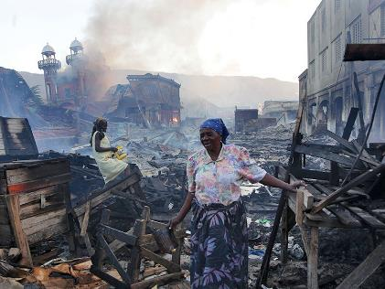

Participants also indicated liking image number 2, which shows a man with his happy, smiling baby. Toronto participants particularly liked this image above all others.

Image number 2: man with his happy, smiling baby.

Participants were also asked to indicate which images they liked the least. Two emerged as being ineffective for participants across locations, image number 15, which shows people walking across a dry terrain with an animal, and also image number 7, which shows a woman with washing machines, although women from Quebec City did express a preference for this image. Both required greater context or explanations to be compelling, thus being less evocative of the story on their own.

Image number 15: people walking across a dry terrain with an animal.
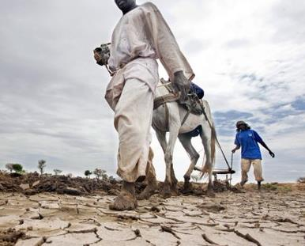

Image number 7: woman with washing machines.
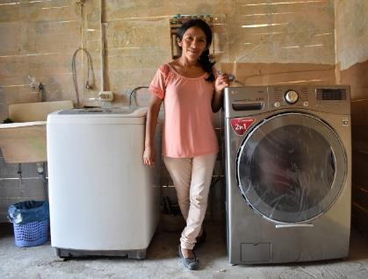

Group Discussion

Following the individual exercise, a group discussion enabled the further analysis of image preferences. This discussion helped uncover general approaches in the choice of images that held appeal. The following provides a summary of general reactions.

Positive Images
A number of participants gravitated towards images that showed happy people and situations, as they conveyed a sense that Canada’s efforts were successful at having a positive impact on people’s lives.

Image number 2: man with his happy, smiling baby.

Image number 9: happy girl with cascading water in hands.
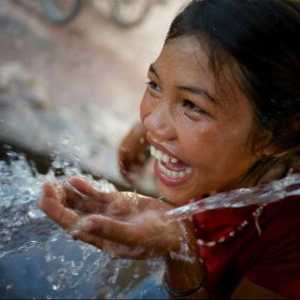

Images Showing the Problem/Hardship or a Need
In some instances, participants felt that showing the situation or the problem illustrated the acute need for assistance and conveyed the message that Canada’s international assistance was needed.

“Dans ce que j’ai choisi, je vois l’urgence…. je vois une catastrophe et je vais aller chercher l’information. J’ai l’impression que s’ils sont heureux le problème est réglé (donc pas besoin de s’y intéresser).” (In those I chose I see the urgency… I see a catastrophe and I will go get the information. I get the impression that if they are happy the problem is solved and I don’t need to look at it.) (Quebec woman)

Image number 15: people walking across a dry terrain with an animal.

Image number 8: child holding a basket on a destroyed city background.
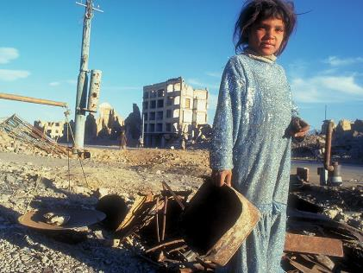

Image number 13: woman holding child.
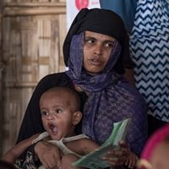

Image number 14: woman emerging from a fire or ruins in her town.

Images Showing Results
The images that showed results – access to clean water, healthcare – were deemed important to convey a sense that aid was successful, and thus that it was well worth for Canada to invest in those causes or situations.

“That woman is making an income, to help her family, to be successful. They’re also getting the help from somewhere else; Canada is educating them.” (Toronto woman)

“There’s a misconception that the receivers of our aid and money use it on a never-ending train. I love to see people doing stuff, this challenges, teaching sustainable processes.” (Vancouver woman)

Image number 9: happy girl with cascading water in hands.

Image number 1: girl holding a water barrel.
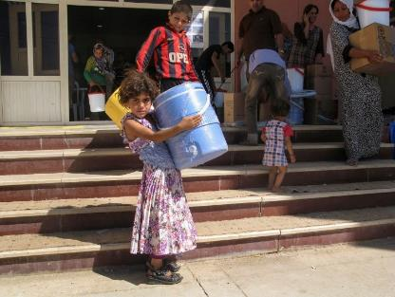

Image number 7: woman with washing machines.

Image number 5: boy being measured by healthcare provider.
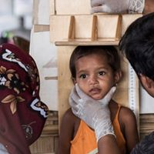

Images Showing Empowerment
Some of the images were considered effective at grabbing attention as they were telling the story of Canada’s efforts at educating or empowering populations. Showing people how to farm or care for their animals were examples of how Canada’s assistance would have a lasting effect on those communities touched by aid.

“It looks like they are succeeding. It looks like they are getting help. Something productive is actually happening. The other ones look like infomercials, where they are asking for donations. At some point when you see that enough you start to tune it out.” (Toronto woman)

“On leur montre comment cultiver. Ce n’est pas juste de leur donner la patate c’est de leur montrer comment on la cultive.” (We are showing them how to grow food. It’s not only giving them the potatoe, it’s showing them how to grow the potatoe.) (Quebec, woman)

Image number 12: two adults on a tractor
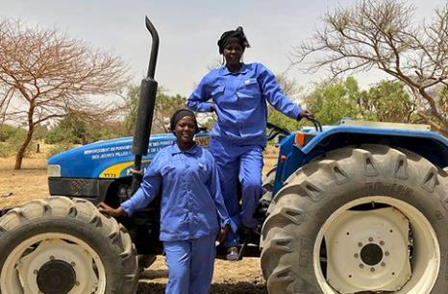

Image number 11: Man showing plant to other two adults.

Image number 6: two workers on a construction site.
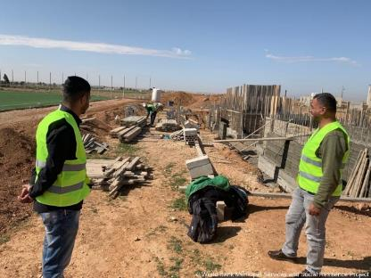

Image number 3: two adults with sheep.
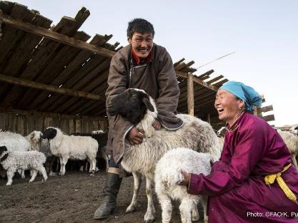

Final Comments (from participants on written tally sheets related to tested concepts)

To conclude the discussion, participants were asked to write down their personal recommendations on what the Government of Canada should do to ensure they get information about its international assistance efforts. The following provides an overview of the suggestions provided:

- Align the communication pieces to the social media platform uses or focus
- Be more present on social media platforms
- Promote their social media channels/presence/sponsored ads
- Keep communications pieces short to sustain attention
- Use a mix of personal stories and factual or descriptive information
- Explore the use of alternate dissemination methods (e.g., pharmacy or doctors’ office wait rooms; community or library billboards; YouTube; bus shelters)
- Include a link in online posts to obtain more information on the situation if desired
- Provide more information about the financials (e.g., how much is spent and where)
- Articles in newspapers (print or online)
- Show personal testimonials by individuals or groups that have been helping or involved in international assistance initiatives
- Mass media advertising
- Focus on personal stories
- Be more transparent regarding the amount of money provided towards international assistance
- Show positive stories/focus on results/describe how it makes a difference;
- Short, concise videos, posts, or articles
- Publish an annual report/summary outlining the causes supported and how it has made a difference
- Continue to use a multi-modal approach
- Greater visibility to the Canadian wordmark when speaking of international assistance
- Advertise or inform more/be more “out there”
- Elicit a sense of pride in some of the communications

Conclusions

The following conclusions are derived from the analysis of focus group discussions:

International Assistance and International Humanitarian Assistance

There is some variability in how the concepts of international assistance and international humanitarian assistance are defined.

The terms were considered as referring to different ideas, despite having some similarities. The term, “international assistance” was considered as broader and entailed the assistance of another country or government more generally, either through the donation of money, supplies or expertise (e.g., military, doctors). By contrast, “international humanitarian assistance” pointed more specifically to helping people in need during a crisis to address more immediate and personal needs. That being said, there remained a fair bit of confusion regarding what was entailed or included in each concept, with participants often sharing varying and at times conflicting viewpoints on these inclusions.

Of note, many participants did not readily think of the Government of Canada working with non-governmental organizations (NGOs) to deliver international assistance. As such, this may cause some message confusion in communications that feature the NGO more prominently than the Government of Canada, as providing the international aid.

While there is knowledge in the broad areas of focus for Canada’s international assistance and international humanitarian assistance, awareness of specific areas of focus or initiatives is limited.

Participants indicated fairly low levels of awareness and understanding of specific international aid initiatives, though they felt that the Country was involved in helping through natural disaster aid and with respect to disease prevention, treatment and awareness. To a lesser extent, Canada was viewed as being involved in international initiatives related to education, safety and security, and addressing famine, while awareness was lowest for assistance related to skills development and training, gender equality, solutions that benefit and empower the poor, healthcare, and the promotion of democracy. Awareness of Canada’s participation was more acute during natural disasters, likely due to greater media coverage of these situations.

In terms of areas considered a priority for Canada, participants most valued human rights initiatives and assistance during natural disasters, and to a lesser extent, disease prevention and awareness and addressing famine. Of moderate importance were safety and security, solutions that benefit and empower the poor, education, democracy, healthcare, and gender equality. Skills development and training was considered less important in comparison.

News media, word-of-mouth from those involved and social media are the primary sources of information regarding Canada’s international assistance and international humanitarian assistance.

There was generally a perception that little information is available regarding Canada’s international assistance and international humanitarian assistance, unless someone specifically seeks it out. Most recalled stories were initially learned of through news media reports and to a lesser extent via word-of-mouth from those involved in the situation (e.g., military personnel, aid workers, volunteers), or social media. It was believed that the news media reports primarily focus on the crisis and Canada’s reactions in response to the situation, thus minimizing the attention afforded to specific initiatives or other forms of international assistance (e.g., skills development or gender equality initiatives). There was also a sense that international aid stories are often eclipsed by news related to US politics or locally-focused stories.

Reasons for Low Awareness of Canada’s Efforts in International Assistance

A lack of interest, limited availability of information, lack of focus in the news, and an interest for more local stories primarily explained the limited awareness of Canada’s international assistance efforts

Participants were informed that a recent survey of Canadian adult residents showed that awareness of the government’s specific efforts in international assistance is low, reflective of the situation in the focus group sessions. A discussion regarding the causes for the low level of awareness explained some of the reasons for the low level of information recall among participants.

More specifically, a lack of interest in this topic and a lack of personal relevance were identified to explain why some people may not pay attention to the information or stories about those initiatives. The lack of a personal connection or relevance to elicit interest in the story was also seen as a major deterrent. In some instances, it was believed that while the information may be available, it may be lost in the sea of information today. In essence, if someone does not look for the information, they may not come across it. Finally, where most participants garner their information from news channels (traditional or online methods), they felt that the media drives the type of information presented, and puts less focus on the initiatives than on the crisis or situation. Finally, participants indicated being more interested in local news, essentially what is likely to affect their day-to-day lives, and thus paying less attention to what is happening internationally.

Opinions of Canada’s Involvement in International Assistance and Humanitarian Assistance

Opinions of Canada’s involvement in international assistance and international humanitarian assistance are generally positive.

Despite limited awareness, there was a great level of support for Canada’s international assistance and international humanitarian assistance. Knowing of the country’s involvement elicited pride and was felt to elevate Canada’s profile internationally. That being said, a lack of understanding of Canada’s efforts led some to question international investments in areas where a need is identified in Canada (i.e., fighting poverty; employment; clean water for Indigenous people).

Canada’s spending on international assistance was generally considered a good use of money. At the same time, Canada helping other countries elicited feelings of pride and Canada’s contribution was generally considered right-levelled.

There was an interest to know the broad areas of focus for Canada’s international assistance, including the budget, the choice of causes and the type of assistance provided.

In general, participants felt that there is some information that is needed regarding Canada’s involvement in international assistance and international humanitarian assistance although they expressed some interest in learning more. When asked to describe what is a “need to know”, participants expressed the greatest interest in knowing about Canada’s strategic approach to international assistance, including the level of financial contribution (both in dollar amounts and percentage of government spending), what causes are chosen and how they are selected, and how international aid is applied. To a lesser extent, knowing the outcomes of initiatives was felt to provide reassurance of the value of Canada’s investment.

Communications Approach

Communications that elicited a sense of connection and provided a story describing the impact of international aid on someone’s life, in a personal manner, were considered most engaging.

Four communication pieces were presented as examples to discuss the various formats and approaches. In general, approaches that elicited a connection – either via the topic or the storyline - held the greatest appeal. Personal stories were generally seen as important to establish an emotional connection, as long as they are supported by facts or statistics to speak of the scope and outcomes of the international assistance provided. This may explain why presenting the information in the form of a testimonial was felt to be more impactful than narrating the story. Despite a preference for a personal story, there was a sense that the use of varied communications approaches was important to ensure that the message is effectively communicated.

In terms of what is being communicated, mixed opinions were offered regarding the value of focusing on the individual level versus presenting the situation at a community or country level. Similarly, highlighting the problem or situation in communications was considered essential to garner support or buy-in for Canada’s involvement, while focusing on the outcomes or the solutions would be most effective to engender pride and demonstrate how money was being spent.
There was a preference for communications that presented real people or situations over those solely with animations or infographics, and participants generally voiced a preference for a video format, as long as it was short.

Reactions to Selected Images

Showing a diversity of scenarios and emotions in images is important at capturing the attention of a wide variety of people.

Of 15 images shown to participants, some were considered most appealing overall, although in general, it was believed that using a variety of approaches was important based on the stories being communicated and the intent. To some, positive images conveyed a sense of success and illustrated how Canada’s assistance has a positive impact on people. To others, showing the hardship of the situation to be addressed created an impactful reminder of the acute need for Canada’s help. Images showing results also held appeal, especially those implying education/skills development, or empowerment.

Recommendations

Overall, the study aimed at assessing how to best communicate Canada’s efforts in international assistance and international humanitarian assistance to Canadian residents. Based on this premise, the following are Narrative Research’s recommendations drawn from the analysis of focus group discussions:

- There is merit in communicating broad aspects of the strategy supporting Canada’s international assistance and international humanitarian assistance, to provide context.

Findings suggest that although Canada is perceived as being involved in international assistance and international humanitarian assistance, there is limited awareness of what is being done. At the same time, questions were raised as to the value of helping other populations when some people in Canada were in need of assistance. Together, this points to the need to better establish the value of Canada’s international assistance by informing the public of key elements of the overall plan or strategy and the benefits or reasons for getting involved.

Simple information should be used to express the scope of assistance provided and ensure it remains memorable. These may include, the number of countries or individuals who received assistance in a year, the amounts allocated to initiatives (in dollar amounts and in percentages of government spending), the causes or countries selected, and how they were chosen.

Consideration should also be given to more clearly communicating the mid- to long-term outcomes of international assistance, either for specific initiatives or more broadly, as a whole. This could be done through follow-up stories that show what impacts were felt over time following a specific initiative or being involved in an area of focus.

- More proactive communications should be considered to ensure information reaches the public, notably on social media.

While information on Canada’s international assistance and international humanitarian assistance appears to be readily available, there is merit in reviewing how the information is presented online to ensure that it reaches a broader audience. Findings revealed that it is more likely that someone will come across the information rather than seek it out, thus highlighting the need to “push-out” the information across channels where Canadians are already present. This is especially important on social media where interest in stories is often dependent on it being shared within personal networks. Further, with news now being ever present on various platforms, breaking through is difficult, but required to stand out.

- Communications should strive to establish a personal and emotional connection while showcasing the scale of any particular initiative.

As mentioned earlier in this report, participants were most compelled by stories that engaged them through a sense of connection. This was achieved either through a personal interest in the topic or by communicating a personal story that established an emotional connection. At the same time, showcasing the scale of the initiative, in addition to the impact it has on one individual, was felt to be important. As such, personal stories should be used as a means to communicate the outcomes of international assistance initiatives. A mixture of facts and personal story is important to establish an emotional connection, while showcasing the scale of any particular initiative. Attention should be paid, however, to address any concerns that individuals portrayed in the stories have full awareness of how their image and story is being used, and that consent was obtained.

- The use of a variety of topics, approaches and formats will ensure broad outreach, especially on social media, while greater cohesion between stories would provide clout.

Although some of the approaches and formats were preferred by participants, there is a recognition that variety is required to ensure that the information reaches a broad audience. Consideration should therefore be given to continue to communicate initiatives or areas of focus using multiple formats and channels, while featuring various approaches. At the same time, greater cohesion between communication pieces should be developed, either from a themed or visual identity perspective. This approach to “branding” or “organizing” communication pieces would likely provide clout and ensure that it stands out, as well as make the information more memorable.

- Consideration should be given to strengthening the communications strategy for unpaid content.

Given the public’s reliance on news media reports for information on what is happening internationally, there is merit in developing or strengthening a communication strategy for unpaid content. Getting features as stories or ensuring that communications are newsworthy should be considered.

- Communications on international initiatives should be more strongly branded with the Government of Canada wordmark.

Findings revealed that some communications related to Canada’s international assistance but focusing on non-governmental organization (NGO) partners’ involvement were not always perceived as exemplifying Canada’s involvement. As such, attention should be paid to ensure that the Government of Canada is mentioned in all stories as being the instigator or as supporting the initiative as part of its international aid strategy. In addition, the Canada wordmark should be prominently featured in all stories to lend credibility and establish the validity of the information. This is most important given the amount of information available to the public and the increased prevalence of “fake news”.

Appendix A: Recruitment Screener

RECRUITMENT SCREENER – FINAL

Name:_______________________________________________________________________

Tel. (H):_______________________ Tel. (W):______________________ Tel. (Cell):_______________________

Email: _______________________________________________________________________________________

Group 1 2 3 4 5 6 7 8 9 10

FOCUS GROUPS:

Toronto, Ontario (English)
Date: | July 23, 2019 | Location: | CRC
Time: | Group 1 - 6:00 PM: Women  Group 2 - 8:00 PM: Men |  | 1867 Younge Street  Suite 200
Calgary, AB (English)
Date: | July 24, 2019 | Location: | Qualitative Coordination
Time: | Group 3 - 6:00 PM: Women  Group 4 - 8:00 PM: Men |  | 707 – 10 Avenue SW  Suite 120
Quebec City, QC (French)
Date: | July 24, 2019 | Location: | Léger Marketing
Time: | Group 5 - 6:00 PM: Women  Group 6 - 8:00 PM: Men |  | 580 Grande-Allee East
Vancouver, BC (English)
Date: | July 25, 2019 | Location: | Vancouver Focus
Time: | Group 7 - 6:00 PM: Women  Group 8 - 8:00 PM: Men |  | 1080 Howe Street  Suite 503
Halifax, NS (English)
Date: | July 29, 2019 | Location: | Narrative Research
Time: | Group 9 - 6:00 PM: Women  Group 10 - 8:00 PM: Men |  | 7071 Bayers Road  Suite 5001

SPECIFICATIONS SUMMARY
- Ten (10) traditional focus groups:  - Two (2) English groups in each of Vancouver, Calgary, Toronto & Halifax  - Two (2) French groups in Quebec City  - In each location, one (1) group with men and one (1) group with women  - All to be Canadian citizens 18+ years old (mix of age based on quotas)  - All have lived in their respective markets for at least 2 years.  - Must not personally or have someone in household work or be retired from sensitive occupations  - Mix of occupation, education and household income | - Min 8 per group gets their info/news from social media  - Max 6 recruits per group who have been to focus groups before.  - Must not have taken part in a focus group in past six months  - Must not have taken part in 5 or more focus groups in past 5 years.  - Able to take part in written/visual exercises in English / French (based on location)  - Recruit 10 per group  - Group length: 2 hours each  - $100 incentive

Hello, my name is ____ and I am with Narrative Research (if needed: formerly known as Corporate Research Associates), a market research firm. We are planning a series of small group discussions on behalf of the Government of Canada and we are looking to include people who are at least 18 years of age or older. Would you be that person, or is there someone else I could speak with? REPEAT INTRO IF NECESSARY

Would you prefer that I continue in English or in French? Préférez-vous continuer en français ou en anglais? [IF FRENCH, CONTINUE IN FRENCH OR ARRANGE CALL BACK WITH FRENCH INTERVIEWER: Nous vous rappellerons pour mener cette entrevue de recherche en français. Merci. Au revoir.]

The purpose the small group discussions is to discuss Canada’s involvement in international assistance. These group discussions will be held on <DATE>, will last two hours and those who attend will receive $100 in appreciation for their time. May I ask you a few quick questions at this time to see if you qualify to participate in this study? This will take about 5 or 6 minutes.

Please note, this information will remain completely confidential and you are free to opt out at any time. We are not trying to sell you anything. The information collected will be used for research purposes only and handled according the Privacy Act of Canada. Your participation in this research is voluntary. Thank you.

IF A REFERENCE IS REQUIRED TO AUTHENTICATE THE STUDY, PROVIDE THE FOLLOWING INFORMATION: <INSERT>

THANK & TERMINATE WHERE REQUIRED IN THE SCREENER: Unfortunately, we will not be able to include you in this study. We already have enough participants who have a similar profile to yours. Thank you for your time today.

QUALIFYING QUESTIONS

- Do you or any member of your household work in or has retired from: READ RESPONSES
Marketing or Market Research 1
Public relations, communications, graphic design, or creative agency 2
Advertising or media (TV, Radio, Newspaper) 3
Political Party 4
Federal or provincial governments 5
International development agency or organization 6

IF YES TO ANY OF THE ABOVE, THANK AND TERMINATE

- Are you a Canadian citizen at least 18 years old who normally resides in the [SPECIFY COMMUNITY] area?
Yes 1 CONTINUE
No 2 THANK AND TERMINATE

- How long have you lived in [SPECIFY COMMUNITY]?
Response: ____________ TERMINATE IF LESS THAN 2 YEARS

- Have you ever attended a focus group discussion or in-depth interview for which you received a sum of money?
Yes 1 CONTINUE – MAX 6 RECRUITS PER GROUP
No 2 GO TO PROFILING QUESTIONS

- When was the last time you attended a focus group or interview? _____________

IF THEY HAVE BEEN TO A GROUP/INTERVIEW IN THE PAST 6 MONTHS - THANK & TERMINATE

- How many focus groups or interviews have you attended in the past five years? ______

IF THEY HAVE BEEN TO 5 OR MORE GROUPS/INTERVIEWS IN PAST 5 YEARS - THANK & TERMINATE

PROFILING QUESTIONS

- Are you a…
Woman; or 1 RECRUIT FOR GROUPS 1, 3, 5, 7, 9
Man 2 RECRUIT FOR GROUPS 2, 4, 6, 8, 10
VOLUNTEERED
Other/refused 3 ASK WITH WHICH GROUP THEY ASSOCIATE

- In which of the following age group do you fall? Please stop me when I reach your age. Are you [READ]?
Less than 18 1 THANK & TERMINATE
18 to 24 2
25 to 34 3
35 to 44 4
45 to 54 5 [2-8] SEE QUOTAS
55 to 64 6
65 to 74 7
75 or older 8
VOLUNTEERED
Refused 9 THANK & TERMINATE

AGE QUOTAS:
Recruit min 3 between 18-34; min 3 between 35-54, max 2 between 55-74 and max 2 who are 75 or older

- What is the highest level of education you have finished?
Less than High School 1
Some High School/Vocational 2
Completed High School 3
Some College / Technical Training 4 AIM FOR MIX IN EACH GROUP
Completed College / Technical Training 5
Some University 6
Completed university 7
VOLUNTEERED
Refused 8

- Are you currently [READ]?
Employed full time 1
Employed part-time 2
Self-employed 3
A homemaker 4
Unemployed 6 [4, 6, 7] RECRUIT MAX 3 PER GROUP
A student 7

- [IF EMPLOYED, ASK] What is your current occupation? ___________
- [IF RETIRED, ASK] What was your last occupation? _______________
TERMINATE IF SIMILAR OCCUPATIONS AS IN Q1 – RECRUIT MIX OF OCCUPATIONS

- Which of the following categories best describes your total household income? That is, the total income of all persons in your household combined, before taxes? READ RESPONSES
Under $20,000 1
$20,000 to just under $ 40,000 2
$40,000 to just under $ 60,000 3
$60,000 to just under $ 80,000 4
$80,000 to just under $100,000 5
$100,000 to just under $150,000 6
$150,000 and above 7
VOLUNTEERED
Don’t know/Refused 8

Ensure good mix:
Recruit 2 below $40K category
Recruit 4 between $40 and $80K
Recruit 4 above $80K category

- Do you generally get your information or news stories from…? SELECT ALL THAT APPLY
Social media (such as Facebook, Instagram, and Twitter) 1 Min 8 per group
Elsewhere online on the Internet 2
Traditional media like TV, radio, magazines, newspaper 3

INVITATION

Based on your responses, it looks like you have the profile we are looking for. I would like to invite you to participate in a focus group discussion we are holding at [TIME] on [DATE]. As you may know, focus groups are used to gather information on a particular subject matter; in this case, some of Canada’s foreign programs and policies. The discussion will consist of about 8 to 10 people and will be very informal. The information provided by participants during the focus groups will remain anonymous and confidential.

- This discussion will last up to 2 hours; it will begin at [TIME] and end at [TIME]. Refreshments will be served and you will receive $100 as a thank you for your time. We ask that you arrive 15 minutes before the session begins. Would you be interested in attending?
Yes 1
No 2 THANK & TERMINATE

- The discussion you will be participating in will be audio and video recorded for use by the research team only to analyze the findings. Please be assured your comments and responses are strictly confidential. Are you comfortable with the discussion being recorded?
Yes 1
No 2 THANK & TERMINATE

- Participants may be asked to read some materials and write out responses individually during the group discussion. Would it be possible for you to take part in these activities in [English/French – based on location] by yourself without assistance?
Yes 1
No 2 THANK & TERMINATE

- The discussion will take place in a room that is equipped with a one-way mirror for observation. This set up will allow Government of Canada employees who are involved in this research, and partner organizations, to observe the discussion without disturbing it. Your participation will be anonymous and only your first name will be given to these people. Would this be acceptable to you?
Yes 1
No 2 THANK & TERMINATE

As part of our quality control measures, we ask everyone who is participating in the focus group to bring along a piece of I.D., picture if possible. You may be asked to show your I.D.

As these are small groups and with even one person missing, the overall success of the group may be affected, I would ask that once you have decided to attend that you make every effort. In the event you are unable to attend, please call_____ (collect) at ________as soon as possible in order that a replacement may be found.

The focus group will be held at [LOCATION] on [DATE] from [TIME] to [TIME]. Please also arrive 15 minutes prior to the starting time. The discussion begins promptly at [TIME]. Anyone arriving after [TIME] will NOT be able to take part in the discussion and will NOT receive the $100 incentive.

Please bring with you reading glasses or anything else that you need to read with or take part in the discussion.

Thank you for your interest in our study. We look forward to meeting you and hearing your thoughts and opinions.

ATTENTION RECRUITERS
- Recruit 10 participants for each group.
- CHECK QUOTAS.
- Ensure participant has a good speaking (overall responses) & written ability - If in doubt, DO NOT INVITE.
- Do not put names on profile sheet unless you have a firm commitment.
- Repeat the date, time and location before hanging up.
- Ask them to arrive 15 minutes prior to the start time.
- Reminded them of the discussion start and end time

CONFIRMING
- Confirm at the beginning of the day prior to the day of the groups.
- Verify qualifying questions
- Confirm in person; do not leave a message.
- Verify time and location (ask if they are familiar).
- Remind participants to glasses if needed.
- Remind them to arrive 15 minutes prior to the start time
- Remind them to bring their IDs

Appendix B: Moderator’s Guide

Moderator’s Guide – Final
Connecting with Canadians: Qualitative Research on International Assistance
Study Objectives (do not share with participants)
- Explore what types of words, phrases and language are meaningful to Canadians when communicating international assistance and helping lift the poorest and most vulnerable population out of poverty;
- Test the impact of images in the groups, and;
- Test key themes and messages.

Materials presentation order grid

 | Toronto | Calgary | Vancouver | Halifax | Quebec City
Woman | A | B | C | D | French versions
Male | D | C | B | A | French versions

Introduction 10 minutes
- Welcome: Introduce self & research firm & role as moderator (keep on time/on topic)
- Sponsor: Groups on behalf of the Government of Canada
- Length: Our discussion should last up to 2 hours without a break
- Topic: Discuss how some government foreign policies or programs are presented or communicated to Canadians
- Your Role: Share your opinions freely and honestly; no prep needed; not testing your knowledge
- Process: All opinions are important; looking to understand minority/majority of opinions; talk one at a time; interested in hearing from everyone
- Logistics: Audio/Video recording for reporting; observers representing the government
- Confidentiality: Your comments are anonymous; no names in reports; answers will not affect dealings with Government of Canada; Once finalized, the report can be accessed through the Library and Archives Canada. Participating in the group is voluntary, and all information you provide will be administered according to the requirements of the Privacy Act.
- Incentives: you will each be receiving $100 as a thank you for your participation at the end of the group discussion.
- Does anyone have any questions or concerns before we start? (If none) Ok, then we will get started with the discussion.
- Participant Introduction: We will start with a round of introductions so we all know who is in the room. Please introduce yourself by telling the group your first name and something else you’d like to share with the group. That could include something you do as a hobby, something about your family or anything else. I’ll start…
International Assistance Issues 30 minutes
Objectives: (not to be shared with participants)
• Explore what types of words, phrases and language are meaningful to Canadians when communicating international assistance initiatives and helping lift the poorest and most vulnerable population out of poverty;
As you may know, Canada has always been actively involved in international and humanitarian assistance. In general, that includes things like development assistance, and international aid. To begin, I’d like you to provide me with a better understanding of what you think international and humanitarian assistance means to you. Today I’m going to be asking you to complete a number of individual exercises so I can capture your personal opinion before we discuss it together.

I’ve put the exercises together on a ‘placemat’. Let’s take a moment to review and complete a few… [moderator to review exercises 1-3] Notes to client: These exercises explore personal knowledge, perceptions and relevance
- Exercise #1: A. Take a moment and jot down (in a few words) how you would define international assistance. B. Secondly, please indicate how you would define international humanitarian assistance. C. Thirdly, tell me if you think the two terms mean the same thing or not, and to what degree.
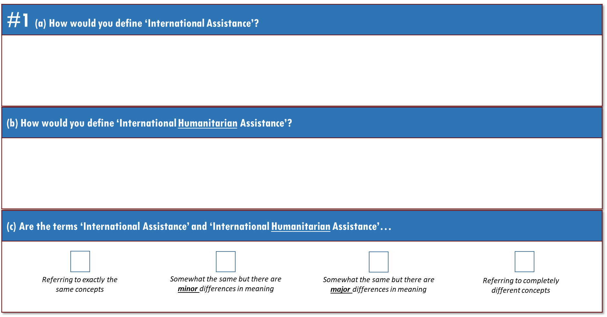

- Exercise #2: I’d like to understand where your opinion stands on Canada being involved in international assistance. For each set of statements, indicate where your opinion lies by marking a checkmark along the boxes.
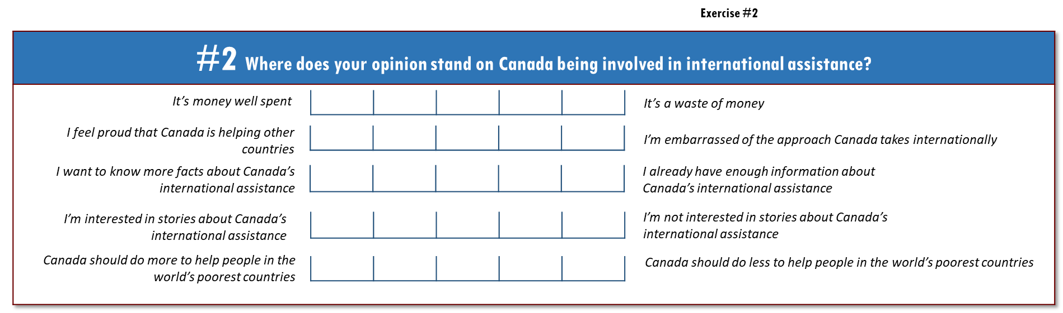

Exercise #3: This lists different types of international assistance. For each item in the first column, check if it’s something you’ve heard about Canada being involved in. You can mark as many or as few as you like. In the third column, please indicate a level of priority in terms of what matters to you most and least. Use numbers from 1 to 11, and use each number only once. Number 1 is what matters to you most, and 11 matters to you least.
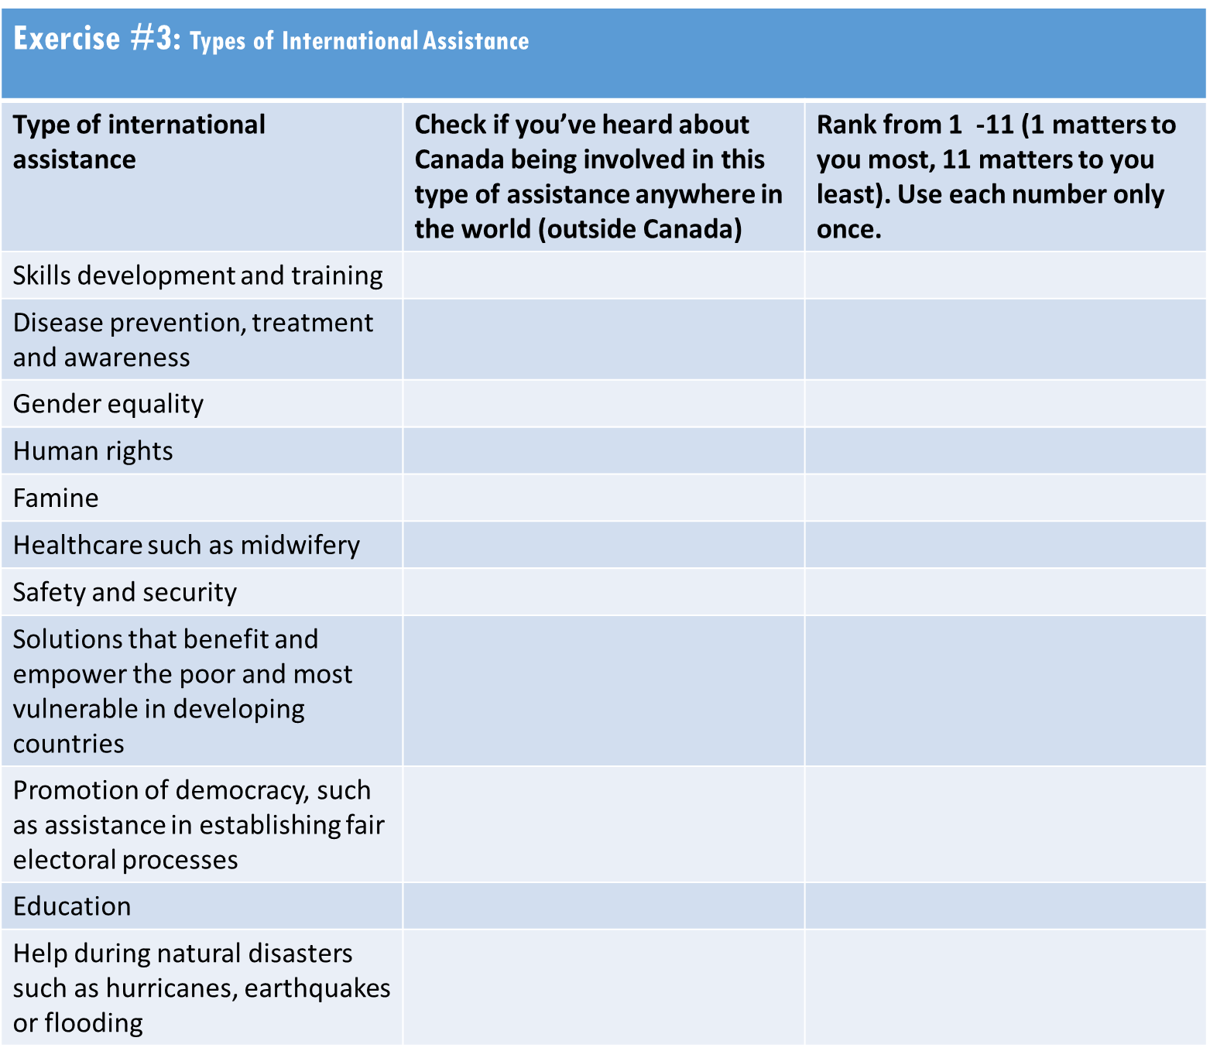

Discussion:
- (Discussion of exercise 1) When I say international assistance – what does that mean to you?
- What does it include?
- What images come to mind?

- When I say international humanitarian assistance – what does that mean to you?
  - What does it include?
  - What images come to mind?
  - Does it bring to mind a different idea than international assistance or is it the same? If so, how?
So that we’re all thinking about the same things, I’m going to give you two definitions (Moderator to show on a flip chart):

International assistance refers to any financial resource provided by Canadian governments in favour of development. The terms international assistance, international aid and aid are synonymous, and can be used interchangeably. It is a broader term, and actually includes humanitarian assistance.

And international humanitarian assistance is a more specific term, and relates to saving lives, alleviating suffering and maintaining human dignity during and after man-made crises and disasters caused by natural hazards, as well as preventing and strengthening preparedness for these situations.

- (Discussion of exercise 3) As far as you know, what type of international assistance is Canada involved in?
- And as far as you know, what type of international humanitarian assistance is Canada involved in?
  - Any specific initiatives you have heard about? What have you seen / heard?
- Where / how have you heard about those things? Any other ways? [probe: television, print, social media, word of mouth]
- [If appropriate] What have you seen on social media? What platforms specifically?
  - [Facebook, Instagram, Twitter, etc.]
- What do you remember seeing?
- What specifically caught your attention? (probe for image / content / tone that was memorable)
- Which areas / causes are you most interested in? Why?
- Based on what you have seen or heard about Canada’s international assistance efforts, what words would you use to describe Canada’s efforts to others?
- How does it make you feel, knowing that Canada is involved in international assistance [Note to client: Want to assess what types of emotions international assistance evokes: e.g. is it pride, anger, sadness, etc., This could help ensure personal relevance through messaging]
  - How do you feel when you hear about / see specific efforts?
- Are some topics / causes more representative of Canada overall, or reflective of your Canada?
  - If so which ones and why?
Images, Key Themes and Messages 45 minutes
Objectives: (not shared with participants)
• Test the impact of different types of images /messaging approaches, and;
• Direct messaging development.
The government shares a lot of information about its involvement abroad. As mentioned, Canada has always been actively involved in international and humanitarian assistance, and contributes a significant amount to a wide range of efforts including helping people overseas during crises, such as earthquakes, famine, other natural disasters and often providing food and medicines to war-torn areas. Recently there has been a focus on women and girls in international assistance.

Despite Canada’s efforts, research has actually shown that few Canadians are aware of the many efforts the government is involved in.
- Why do you think that is the case? Any other reasons?
  - [Probe: lack of interest, lack of awareness, other?]
- Personally, are there some things that you consider more important to be told?
  - What would you consider to be ‘need to know’ versus a ‘nice to know’?
  - How do you want to learn about those things?
    - Which methods would be most impactful?

Ensuring the Canadian public is informed on the government’s initiatives is important, but of course, the information that is communicated needs to be relevant and interesting. So, I’d like your help today to determine how best to inform the public about Canada’s international efforts.
I have three examples to show you, which take different approaches. As we review, please focus less on the topic, issue or cause, and more about the type of approach. I’ll walk you through each. [Moderator to rotate presentation order between groups, showing examples on screen]

- FACT FOCUS, ANIMATICS. This one takes an approach of showing facts and statistics through animations to identify the problem and showcase Canada’s efforts. [Moderator to show AIDS Twitter ad] https://twitter.com/CanadaDev/status/1068867312521027584
- PERSONAL STORY TOLD IN WRITING: This one tells a story of an individual person, to showcase how Canada’s assistance is making a difference. It focuses on both the issue being addressed as well as showing the result of assistance.
- https://www.facebook.com/notes/canadas-international-development-global-affairs-canada/preventing-child-marriage-in-bangladesh/2075344195851626/
- TESTIMONIAL VIDEO: This one tells an individual story from a personal perspective, showing both some of the issues as well as the result.
- https://www.facebook.com/CanadaDevelopment/videos/vb.185396678179730/880684855598810/?type=2&theater
- COMMUNITY LEVEL: This one explains Canada’s approach to helping a community from Canada’s perspective, as well as by showing what is being provided (a list).
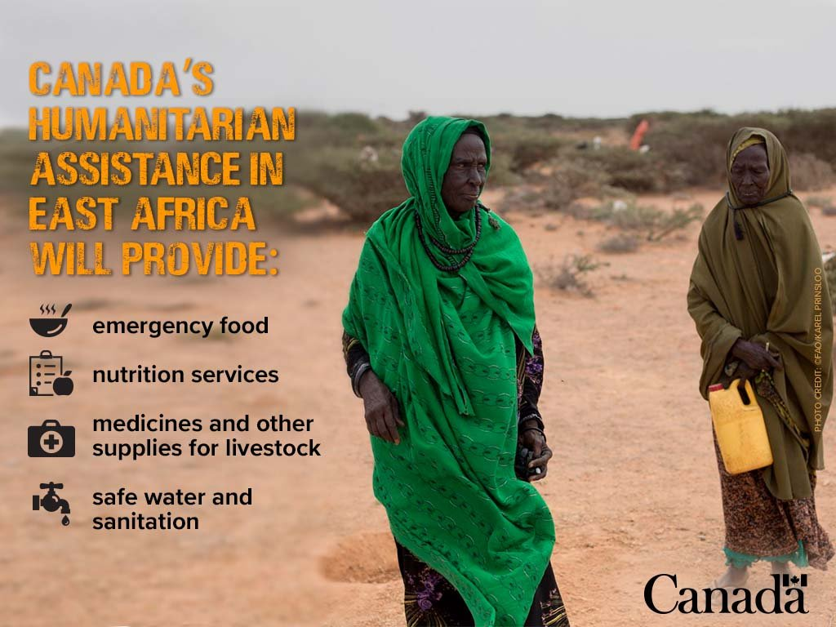

Before we discuss as a group, I’d like you to complete an exercise that tells me your thoughts on what type of approach works best. Again, please think of the type of approach and format rather than the specific subject matter, country, or topic.

- Exercise #4: a) I’ve listed a number of opposing statements relating to the different tones or approaches that information could be shared relating to international assistance. For each pair, please check which statement is closer to how you personally would want to learn about international assistance efforts.
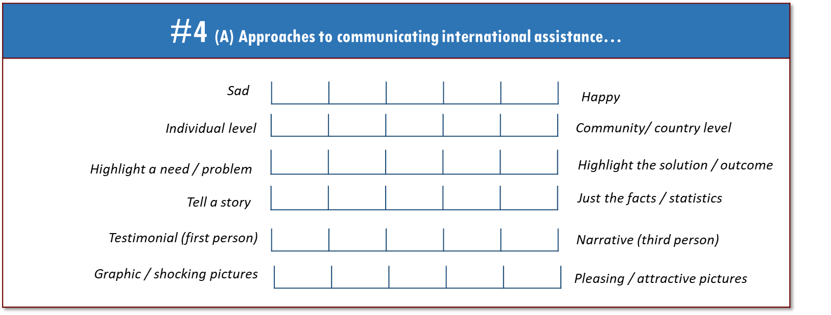

- B) Secondly, I’d like to understand, of the examples we reviewed, which format works best?

Discussion of examples:
- We looked at four different approaches. Let’s first discuss the approach.
  - Which works better – a focus on facts, or a focus on a personal story? Why?
  - Which works better, a story told about someone, or a story told by that person themselves? Why?
  - Which works better, a story that highlights a need or a problem, or a focus on the solution or outcome? Why?
  - Which works better, a focus at the individual level (a personal story) or a community or country level? Why?
- Next let’s think about format.
  - Which type of format (not medium) works better – a video or words / text? Why?
  - Which works better, animations or showing real people and situations? Why?
- Overall, which approach or tone is most effective for you personally? Why?
- Are there any approaches that are ineffective or problematic for you?
  - Why? What makes them so?

I have one more area that I would you like to look at.

Exercise #5: You’ll see a series of images. Circle the ones that engage you or are most compelling– those would be the types of pictures you are most drawn to personally. If some are ineffective for you – please put an X through them.

Discussion:
- What kinds of images have an impact for you?
  - Which ones are most compelling? Why?

To finish up…
As the government looks to share information on its various international assistance efforts, I’d like your recommendations on what it could do to ensure you get information about its efforts. [Exercise #5: Moderator to go to back room to get any other direction]

- What advice do you have? Any other recommendations?

Thanks & Closure
That concludes our discussion. On behalf of the Government of Canada, thank you for your time and input.

