Travel and Border - COVID 19 Post-Advertising Campaign Evaluation Tool (ACET)
Executive Summary

Prepared for Global Affairs Canada
Supplier name: Advanis Inc.
Contract number: EP363-140002/001/CY
Contract value: $24,961.43 (including HST)
Award date: March 10, 2022
Delivery date: May 25, 2022
Registration number: POR 131-21

For more information on this report, please contact Global Affairs Canada at:
POR-ROP@international.gc.ca

Ce rapport est aussi disponible en français.

Table of contents

Table of contents 2
1. Executive Summary 3
1.1 Background 3
1.2 Objective 6
1.3 Methodology 6
1.4 Contract Value 6
1.5 Political Neutrality Requirement 6

1. Executive Summary

1.1 Background

As the COVID-19 pandemic evolves and restrictions change, the Government of Canada must communicate relevant travel information and provide resources to Canadians to make informed decisions around travel.

Feedback from social media comments, general inquiry mailboxes and 1-800 calls to Global Affairs Canada (GAC) and Treasury Board Secretariat (TBS), indicated that Canadians are finding it difficult to find and understand travel information that pertains to their situation during the pandemic. A high volume of inquiries, calls and emails to the GAC general information lines have been questions related to quarantine and isolation. The overall strategy of the ad campaign is to ensure that Canadians have all the up-to-date information and resources they need to make safe travel decisions by driving them to the https://travel.gc.ca/travel-covid site, the hub for all government travel and border information, which was launched on July 10, 2020. A mix of paid and organic media tactics across different digital channels was used to promote the resources Canadians need to make safe travel decisions.

The site reminds Canadians of the global travel advisories and raises awareness of the tools, advice and assistance at the disposal of Canadians to make informed decisions. The site also provides information on how to stay safe should they decide to travel abroad. It informs foreign nationals and Canadian citizens about entry restrictions, what they need to know before they travel or leave Canada, and what they can expect at the border. The latest Public Health Agency of Canada/Health Canada (PHAC/HC) information is also on this site. PHAC/HC is running a $1.5 million advertising campaign to support the ArriveCAN app, a key tool that will support Canada Border Services Agency (CBSA) operations.

Global Affairs Canada has launched an ad campaign to promote safe travel and border information during the pandemic. Travel and border post-campaign feedback will help to inform advertising campaigns in the COVID-19 era. This study collected feedback on the creative digital advertising campaigns and short-term outcomes. The results of this study will help to ensure GAC’s delivery of important messaging to Canadians in future advertising campaigns. Details of each digital advertising campaign are as follows:

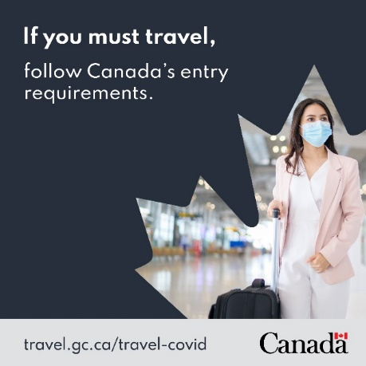
Ad 1

In market:
- October 13, 2021 – March 31, 2022
Platforms:
- Facebook/Instagram/Web search
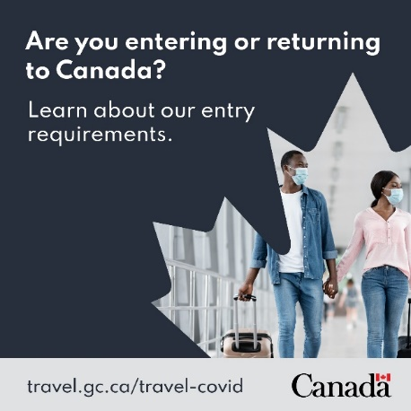
Ad 2

In market:
- October 13, 2021 – March 31, 2022
Platforms:
- Facebook/Instagram/Web search

Ad 3
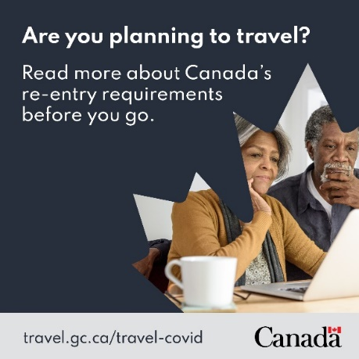
In market:
- October 13, 2021 – December 31, 2021
- March 1, 2022 – March 31, 2022
Platforms:
- Facebook/Instagram/Web search
Ad 4
In market:
- December 23, 2021 – February 28, 2022
Platforms:
- Facebook/Web search

1.2 Objective

The purpose of this quantitative study is to collect feedback from Canadians in order to:
- measure public awareness of the campaign;
- understand public recall of the campaign;
- gauge personal relevance; and
- understand if the public is motivated to learn more about travel restrictions.

1.3 Methodology

This study was completed from April 4 to April 27, 2022, in the form of a post-campaign survey through the use of Advanis’ General Population Representative Sample (GPRS) sample. Advanis sought a probability-based sample of 2,000 Canadian adults aged 18 or older drawn from the general population. Participants were invited via email or SMS to take part in a Web survey. The study was drawn from a random sample and can be extrapolated to the broader population only on a national level.

1.4 Contract Value

The contract value for this study was $24,961.43 (including HST).

1.5 Political Neutrality Requirement

Political neutrality certification
I hereby certify as Senior Officer of Advanis that the deliverables fully comply with the Government of Canada political neutrality requirements outlined in the Policy on Communications and Federal Identity and the Directive on the Management of Communications.
Specifically, the deliverables do not include information on electoral voting intentions, political party preferences, standings with the electorate or ratings of the performance of a political party or its leaders.
Signed:

Nicolas Toutant, Vice-President, Research and Evaluation

