Report
Focus Group Testing:
Review of Performance Indicators
for Reporting 2004
POR-03-62

Prepared for Sally Thornton
Director, Accountability Implementation

January 27, 2004

Prepared by:


Binarius Research Group

300 Earl Grey Drive, Suite 431, Kanata, ON K2T 1C1
Tel.: 836-6666, Fax: 836-3648
www.Binarius.com

Table of Contents

Page No.

Executive Summary . . . . . . . . . i

1.0 Introduction . . . . . . . . . . 1

2.0 Theme Assessment . . . . . . . . 3

3.0 Indicator Assessment . . . . . . . . 6

4.0 Understanding, Readability and Presentation . . . . . 11

5.0 Communication . . . . . . . . . 14

6.0 Conclusion and Recommendations . . . . . . 15

Appendices

- Logistics . . . . . . . . . 18

- Recruiting Screener . . . . . . . 20

- Moderator’s Guide . . . . . . . . 24

- Questionnaire and Homework . . . . . . 30

- Focus Group Handout . . . . . . . 38

- Theme Findings . . . . . . . . 43

- Specified Indicator Findings . . . . . . 45

Executive Summary
Review of Health performance Indicators
January 26, 2004

In September 2000, the First Ministers directed Health Ministers to collaborate on the development of a comprehensive framework using jointly agreed comparable indicators. In February 2003, the First Ministers’ directed Health Ministers to develop further indicators to meet the objectives of timely access, quality, sustainability and health status and wellness.

The Advisory Committee on Governance and Accountability (ACGA) agreed to further public consultations by way of focus group testing and Binarius Research Group was asked to conduct the research. The purpose of the focus groups was to consult around what is important and meaningful to the public in terms of data and the form of presentation of results. The research provided information on:

- What themes and indicators have the most meaning and why

- Guidance for future decision-making re: indicators

- Presentation preferences

- Measuring stick preferences

- and, Communications/marketing/promotion suggestions.

Two sessions of focus groups were held in each of the following cities: Toronto, Halifax, Winnipeg, Quebec City (Fr), and Vancouver. A wide selection of urban population demographics was recruited: various ages, socio-economic & educational background.

Participants were asked to rank health performance indicator themes in order of personal “relevance/meaningful” (These were then standardized to a 100 base for comparison purposes). The following are the results:

- Access to essential services (76)

- Availability of appropriate home care services (57)

- Costs of drugs for Canadians (52)

- Health wellness of the population (36)

- Quality of services (26)

- Sustainability of health system (19)

Twenty-two performance indicators were also tested according to the same scale. The following lists the top 5 and the bottom 5 tested indicators:

Top 5 |  | Bottom 5
1. | Hospitalizations that could have been prevented with adequate basic health care. (90) | The number of calls made to provincial health hotlines. (16)
2. | Indicators of food-borne and water-borne disease (such as E. Coli). (85) | How many years of life are lost, at an early age, due to unintentional injury (19)
3. | The number of doctors, nurses and other providers available (per person). (80) | The proportion of women having pap tests to screen for cervical cancer. (27)
4. | Knowing about the costs of drugs. (72) | Indicators that provide an indication of the future health of the population, e.g., number of babies born with a low birth weight. (30)
5. | How many family doctors are accepting new patients. (62) | How many doctors work closely (i.e. in the same practice setting) with other health providers, such as nurses, physiotherapists, psychologists for example. (34)

The results of both the themes and specific indicator analysis showed that the most meaningful ones are those that have personal significance. Personal significance is primarily defined as various measures of access to health care.

Participants felt that segmenting the performance indicator information on a local level has the best explanatory power and meaning. A number of other segments made sense. This included: age, sex, occupation, employment sector, urban/rural. Further segments would be provided by whatever made most analytical sense (e.g., lung cancer rates among smokers/non-smokers).

While many participants looked to the information initially for personal health care and their own demographic profile, many gradually come to appreciate the value in having health system performance indicators from a more global perspective. In this vein, an overall report card mark of the health system (by province) was suggested.

The tested information whetted the appetites of the participants. Many noted how they would like to have had more information and analysis – essentially answering the “why” question.

Charts and text were provided in the homework and the handout. Participants generally preferred simple, direct charts that provided a straightforward message. A one-line time series chart was oft-mentioned as the best example. Jurisdiction information was preferred by some so as to better hold provinces accountable by comparing other health systems but this was a point that participants gradually warmed up to.

The tested sample reports were considered very readable. The language level should be the same for the official report as it met the needs of the target audience. Minimize the use of technical jargon but ensure that references are provided as footnotes.

Participants had difficulty with concepts and terms such as the use of a 100k base, confidence interval, age standardization and PYLL. Their use should be restricted to the extent possible.

In terms of measuring sticks, participants liked the “per person” measure best. Round numbers for a certain geographical area (e.g., 128 people died in Montreal of …) or per 1,000 (e.g., 5 doctors for every 1,000 patients) are also favoured.

The various Ministries of Health, Health Canada, and Statistics Canada have publishing credibility for a health performance indicator report.

In terms of channeling this information to Canadians, the Internet is a necessary but not solely a sufficient mode. Hard copy should be available. In terms of marketing and promotion, TV is the first choice followed by other secondary choices such as posters and health service providers
1.0
Introduction

1.1 Background

In September 2000, the First Ministers directed Health Ministers to: “Collaborate on the development of a comprehensive framework using jointly agreed comparable indicators such that each government will begin reporting by September 2002.” All 14 jurisdictions released their respective reports on September 30, 2002.

In February 2003, the First Ministers’ directed Health Ministers to: “Develop further indicators to supplement the work undertaken in follow-up to the September 2000 Communiqué. This work is to follow review of experts and stakeholders to ensure these new indicators measure progress on achieving the reforms set out in this Accord and meet objectives of timely access, quality, sustainability and health status and wellness.

A consultation session with experts and stakeholders was held June 26th, 2003. A website was made available until the end of August 2003 for consultations by way of written submissions. The Advisory Committee on Governance and Accountability (ACGA) agreed to further public consultations by way of focus group testing and Binarius Research Group was asked to conduct the research.

1.2 Research Purpose and Objectives

The purpose of the focus groups was to consult around what is important and meaningful to the public in terms of data and the form of presentation of results.

From a list of predefined performance indicators, Canadians will be asked to determine:

- What performance indicators have the most meaning, specifically, determine how specified performance indicators are relevant, understandable, and useful to Canadians.

- What graphic, visual presentation or other aids enables a better understanding of performance indicators.

- What communication, advertising, promotion or marketing approach is most suitable and credible. Determine what can best help Canadians understand the health system and make use of performance indicators.

1.3 Methodology

Target Audiences

The target audience were identified as Canadian adults 18 years and over. The recruiting sought a representative age distribution, sex, and education levels (with the minimum being a high school diploma). The table below outlines the preliminary logistics for the research:

Toronto | Halifax | Winnipeg | Quebec City (Fr) | Vancouver
January 12 | January 12 | January 13 | January 14 | January 15
Larry | Nadia | Larry | Nadia | Larry

Outline of Research Process

Binarius finalized the research plan including developing a logistics sheet that outlined the specific dates, times and locations of the focus groups upon consultation with the project manager from the Advisory Committee on Governance and Accountability.

A recruiting screener was developed to recruit the target groups according to the specifications of the project manager. The screener also ensured that health care professionals, market researchers and those with political affiliations, among other criteria, are not included.

A moderator’s guide was developed to probe the issues according to the aforementioned objectives. Both the recruiting screener and the moderator’s guide were approved by the ACGA Working Group.

Recruited participants were issued a questionnaire prior to the groups. The questionnaire was designed to solicit help in prioritizing indicators, offering, for example, specific indicators, themes, and/or types of measures to help determine what is most relevant and easily understood by the public. This was also approved by the Working Group.

Binarius recruited 10 participants with the expectation that 8-10 would show. Participants were paid an incentive of $75 for participating in the group.

Each focus group session began with an introduction that includes a review of the focus group objectives, expectations, ground rules and role of the moderator. The sessions then proceeded through the objectives, questionnaire and other issues. The client was provided an opportunity at the end of the session to solicit the moderator to ask the group supplementary questions. Each session lasted between 1.5 and two hours.

The focus groups were conducted in professional focus group facilities complete with private viewing facility, two-way mirrors, audio, video and reception services. All recordings will be destroyed upon acceptance of the final report.

2.0
Theme Assessment

2.1 Introduction

Participants were introduced to six health system performance themes that encompassed a wide variety of health performance indicators. They were asked to determine which themes were most relevant, meaningful and understandable on a personal level. Each theme was rated according to the following scale:

1 – the theme was personally relevant and meaningful
2 – the theme was somewhat meaningful
3 – the theme was not meaningful at all

Participants were asked for a show of hands depending on how relevant and meaningful they felt the theme was for them. For example, if a participant felt that a theme was deemed to be essential, relevant or meaningful (that is, a “1”), he/she would raise their hand and the moderator would indicate this as such on the display board next to that theme. The following themes were tested:

- Access to essential services
- The quality of services
- The sustainability of the health system
- The health wellness of the population
- The availability of appropriate home care services
- The costs of drugs for Canadians

A total of 94 Canadians participated in the focus groups. The “1” scores were totaled for each indicator and then standardized out of 100 for comparison and ranking purposes. The tested indicators are shown in Section 2.2 in descending order of interest.

Appendix F provides additional information by showing the tested themes in descending order of interest (those that said “must include/essential”) by focus group location.

2.2 Findings

The following theme indicators are shown in descending order of meaningfulness:

- Access to essential services (76)
- The availability of appropriate home care services. (57)
- The costs of drugs for Canadians. (52)
- The health wellness of the population (36)
- The quality of services (26)
- The sustainability of the health system (19)

2.3 Interpretation

Access to essential services (76)

This theme best captured the primary concern of participants. Many participants want information that reflect concrete, personal issues (e.g., are there enough doctors / equipment in our area to meet my needs). Of less interest are the more global statistics and indicators.

Comments such as the following best embodies participants concern over access:

- “if something happens, you want to know that you’re going to be taken care of, and looked after properly.”

- “Chances are if you’re looking at this, you’ve been diagnosed with something, and if you want to get help, you want to know where you have to go to get that help, and how long are you going to have to wait.”

This finding also reflected concerns over wait times.

- “If I was in the States and needed at CT scan, I could get it down the street, here you can wait a year. If I need a certain type of cancer chemotherapy, I might have to wait several months.”

Home care services (57)

Home care services are a sensitive and very personal issue. Many participants noted how with the aging population, many Canadians either face this situation personally or know people who would or do need home care services. The attitudinal differences often centred on whether one had personal experience with a home care situation.

Participants noted that the home environment is often healthier, pleasant, respectful and humane. However, more than one participant noted how difficult it was to provide this care and that the care-giver was often the first one that died.

Cost of drugs (52)

Attitudes towards this theme often centred on whether one was covered by a drug plan or not. However, participants are aware that costs are increasing drastically and that not all drugs are covered by a provincial or company plan.

There is some mention of the need for more preventative measures required (e.g., in the US, some health plans insist that plan holders have a yearly check-up.). As well, alternative medicines are often not covered.

Health Wellness (36)

The health and wellness theme suffered from the same issue that home care services did, that is, if one could not personalize the theme in some manner, it was not of concern. For many participants, health and wellness was almost an academic exercise that had no impact on their lives. The theme also suffered from the term “health wellness.” It is not well understood, hence the relatively low score given this theme.

Quality of services (26)

The relatively low rating given this theme likely reflects the satisfaction level of participants with the quality of medical care. As one person noted, “If you’re waiting, that’s access. Once I’ve gotten to the doctor I’ve rarely gotten substandard service.”

Participants appreciate that patient safety and satisfaction are important elements but some cannot understand how this measure can be rolled up effectively into an indicator since it is such a personal experience. Quality of service is perceived as a nebulous concept unlike the other top themes that rely more on concrete black and white statistics. As one participant noted, “It’s like when you come out of the movie and they have you check (a card) to see if you liked the movie.”

There is also the element of the seriousness in which the information is perceived. Quality of service is not seen as a theme that best gauges the status of the health system.

Sustainability of Health System (19)

There were very few comments on this theme. This likely reflects the confidence that health care will be provided by government. This theme also invokes comments on the value for money or cost effectiveness of the health system. However, this theme was not top of mind for participants but saw a gradual warming up of the significance as the groups progressed.
3.0

Indicator Assessment

3.1 Introduction

Participants were introduced to 22 specific health system performance indicators. They were asked to determine which indicator was most relevant, meaningful and understandable to them on a personal level. Participants were asked to rate each as to whether it was personally relevant and meaningful or not – with no middle ground.

This section of the focus group had participants asked for a show of hands if they felt that an indicator was deemed to be essential, relevant or meaningful. If it was otherwise, the participant was asked to keep their hands down.

A total of 94 participants were in the focus groups. The scores were totaled for each indicator and then standardized out of 100 for comparison and ranking purposes.

3.2 Findings

Appendix G provides additional information by showing the tested indicators in descending order of interest (those that said “must include/essential”) by focus group location.

What the findings have shown is that there are essentially four tiers of importance.

Tier 1

Hospitalizations that could have been prevented with adequate basic health care (e.g. people with diabetes or asthma can be kept out of a hospital if they receive timely preventive care and treatment). | 90

- Hospitalizations are a concern because it represents the presumed result and fear of participants of inadequate basic health care. In some respects it is the baseline or flagship measure of how well the health system is doing.

Indicators of food-borne and water-borne disease (such as E. Coli) – diseases that result from things we eat or because of problems with our water and/or food supply. | 85

- It touches everyone ion their daily lives, reflecting fears regarding the safety of the food supply (e.g., beef, fish) and e-coli bacteria (e.g., Walkerton) both of which have been very prominent in the media.

The number of doctors, nurses and other providers available (per person) | 80

- The “per person” measuring stick is the key to understanding the statistics and making them relevant. It has to have local relevance with comparison to Canada and other provinces as a complement.

Knowing about the costs of drugs, particularly the financial impact of purchasing drugs on individuals, i.e. the per cent of households that spend in excess of a determined amount on drugs. | 72

- Participants realize that the costs of drugs are increasing and many are not covered by the provincial or company program. Some feel it will help governments in their negotiations with pharmaceutical companies.

How many family doctors are accepting new patients. | 62

- For those that have a doctor, it is of no concern.

Tier 2

How many people use publicly funded home care services, including home support services (e.g. cleaning, cooking and shopping duties) | 61

- Only participants who have a personal experience commented on this indicator. Many noted the overwhelming burden and stress it can be.

The number of diagnostic professionals (e.g. professionals to run and read X-rays, MRIs and CTs) (per person) | 59

- Some participants are more concerned about the wait times for diagnostic professionals because treatment cannot often start before a diagnosis.

The number of individuals in the population with diabetes. | 55

- No comment, little relevance.

Indicators of sexually transmitted diseases. | 52

- No comment, little relevance.

The stress on family and volunteers providing unpaid care, i.e. the per cent of caregivers aged 45+ who reported feeling burdened by caring for a person aged 65+. | 50

- The “sandwich generation” – those that are looking after their parents while still looking after their kids at the same time. Participants noted the severe limitation on their lifestyle.

The number of years an average individual will live in good health, or free of moderate or severe disability. | 49

- No comment.

Tier 3

The age distribution of doctors and nurses (e.g. how many are within a few years of retirement compared to the number of young/new graduates). | 45

- No comment, little relevance

The number of CT exams (Computerized tomography is used to by specialists to view internal organs, and to create bone/brain and vascular imaging in an effort to detect cancers, heart disease and osteoporosis.) | 41

- No comment, little relevance

Knowing about the mental health of the population, i.e. the proportion of individuals who contacted health professionals about their mental/emotional health. | 39

- Participants appeared unconcerned about this indicator believing that, if it was an issue where there was a lack of psychologists or psychiatrists, then it would be more relevant.

The proportion of women having mammography tests to screen for breast cancer. | 37

- Participants assume this is standard procedure for all women.

The number of MRI exams (Magnetic resonance imaging is used by specialists to assess illness, injuries and abnormalities inside the body and to aide in evaluation and treatment of such conditions) | 37

- No comment, little relevance.

How many years of life are lost, at an early age, due to suicide. | 37

- No comment, little relevance.

How many doctors work closely (i.e. in the same practice setting) with other health providers, such as nurses, physiotherapists, psychologists for example. | 34

- No comment, little relevance.

Indicators that provide an indication of the future health of the population, such as the number of babies born with a low birth weight. | 30

- No comment, little relevance.

The proportion of women having pap tests to screen for cervical cancer. | 27

- Participants assume this is standard procedure for all women in much the same manner as men receive prostrate cancer tests.

Tier 4

How many years of life are lost, at an early age, due to unintentional injury (e.g. preventable injuries which include falls, motor vehicle crashes, railway and pedestrian injuries, drowning and suffocation, poisoning and fires. | 19

- This indicator reflects the difficulty of understanding what “potential years of life lost” (PYLL) measuring stick means. It is a concept that participants feel do not represent the quality of the health system.

The number of calls made to provincial health hotlines (these are telephone lines you can call for information about any health-related question). | 16

- The number of calls is reflective of the management of a call centre and not related to real health issues.

3.3 Interpretation

Top 5

The top five tested indicators are as follows:

- Hospitalizations that could have been prevented with adequate basic health care. (90)
- Indicators of food-borne and water-borne disease (such as E. Coli). (85)
- The number of doctors, nurses and other providers available (per person). (80)
- Knowing about the costs of drugs. (72)
- How many family doctors are accepting new patients. (62)

Bottom 5

The bottom five tested indicators are as follows:

- How many doctors work closely (i.e. in the same practice setting) with other health providers, such as nurses, physiotherapists, psychologists for example. (34)
- Indicators that provide an indication of the future health of the population, e.g., number of babies born with a low birth weight. (30)
- The proportion of women having pap tests to screen for cervical cancer. (27)
- How many years of life are lost, at an early age, due to unintentional injury (19)
- The number of calls made to provincial health hotlines (16)

By comparing the top and bottom five indicators, a number of factors are highlighted:

- Personalization – The first factor is the extent to which the top five factors are ones that are a personalized, that is, participants believe that they could personally be impacted by almost everyone of these indicators, hence their interest. Without adequate basic health care, one would have a greater likelihood of requiring hospital care. Without a drug plan, participants have concern about the costs of drugs.

- Risk factor – Even with adequate basic health care, participants have a latent fear that the water we drink and the food we eat may be contaminated. Therefore, there is an interest in seeing more information on indicators of food-borne and water-borne disease.

- Visibility – Media coverage of water contaminants (e.g., Walkerton), mad cow disease, cost of drugs in the US brings the visibility of these issues to the forefront with the accompanying concerns about the health system and how it can respond.

- Interest – Or lack of interest or personal relevance to participants.

4.0

Understanding, Readability and Presentation

4.1 Introduction

The methodological design of this research had participants completing a homework assignment and a handout review in the focus group itself. The various assignments provided examples of what could be included in a report on health performance systems. This included samples of:

- Simple and detailed reporting

- Mortality, incidence, survival and potential years of life lost

- Comparison to other jurisdictions

- Time series

4.2 Findings

In terms of readability and the language level of the tested materials, participants gave it a favourable rating. The wording was appropriate for the target audience. As one participant noted, “it talks to me in layman’s language … we’re not doctors.”

Participants consistently preferred a simple, direct style of presentation with minimal technical information provided. As long as there was confidence in the credibility of the data, most of the technical references was felt to be unnecessary. However, standard sources should be cited.

- “You like the idea of something like this, you would read it, but it has to be readable, short and sweet.”

After reading through much of the material, participants often felt they needed more information than was provided. Essentially, many participants were seeking more answers to the “why” question, that is, what are the implications and personal relevance of the information that is presented. As one participant noted, there is “lots of what but no why.”

While participants saw the value in understanding health performance in their province, many expressed the desire for more detailed local information. They are looking for a segment that is personally relevant to them, e.g., Montreal vs. Shawinigan, Vancouver vs. Surrey, Toronto vs. London comparisons would be very useful.

Other useful subgroups include:

- age

- sex

- occupation

- employment sector

- urban/rural and,

- Whatever made sense for more explanatory power (e.g., cancer – smokers/non-smokers)

The time series chart data was easily understood. It was clear and to the point. As one participant noted, “people just want to know is it going up, or going down.”

Regarding the jurisdiction breakdown, participants either liked the provincial comparisons or simply did not care for the information. It was only after some time for discussion that some in the latter camp began to appreciate the significance of comparing province to province. The opposing views are shown in the quotes below:

- “Is there a reason why this is all provincial versus Canada? I mean, do I really care about lung cancer in Saskatchewan? Like, I’m not going to move to Saskatchewan because they’re going to get less lung cancer.”

- “I’m at a point in my life right now where I’m about to retire, and something like that would be really useful for me, because if I looked at a geographic breakdown that said, ‘access to services is much better in rural BC than it is in urban Winnipeg,’ that could affect where I decide to live.”

- “I think the stats give me an indication of what needs to be done in our province.”

The depiction of the survival rates for lung cancer left a very clear but sobering message to participants (one gets lung cancer and there is an 84% chance of dying in five years). Many felt that this is the type of statistic would have anyone with lung cancer interested in knowing more . This is the type of information that would intrigue participants if considered for other illnesses or disease.

The example of incidence rates for lung cancer was not favoured by most participants. This was primarily because participants could not intuitively understand the significance (or lack of) using a 100,000 population base.

The example of “potential years of life lost to lung cancer” (PYLL) was criticized for the same reason. The use of 100k was seen as meaningless. In addition, it evoked more questions than what it answered. As one participant noted, “just putting 450 years or whatever, I found that pretty useless.” The term PYLL needs more work and explanation in order for participants to understand its significance.

In both cases, participants felt that something more concrete had to be provided in order to better understand the context. This could be achieved in the corresponding text, for example, using a city the size of London, Kamloops as a reference in lieu of or as an example of 100k.

In terms of charts, participants liked the use of colour. They generally preferred the more direct charts (e.g., time series) over the ones that contained more information (e.g., lung cancer mortality comparing sex by province and Canada). While the jurisdictional information had value it seemed a little more complicated to understand what the chart had to say. The multiple bars seemed a little busy.

In terms of the measuring stick used for the performance indicators, participants had clear preference for the information to be put in a context they could understand. This included:

- The use of a per capita or per person measure

- Round numbers (e.g., 128 people died in Montreal of …)

- Per 1,000 (e.g., 5 doctors for every 1,000 patients)

- A percentage

Participants had difficulty with:

- The use of 100k population base

- Confidence interval

- Age standardization

- The concept of PYLL

5.0

Communication

Participants were asked a number of questions surrounding communication, marketing and promotion of report material.

In terms of who should publish the information, it was clear that credibility of the source is important. There were a number of options in this regard including the various Ministries of Health, Statistics Canada or Health Canada.

When asked if a coordinating body e.g., a coordinating body of health councils or something similar would have credibility, many felt it might be the ideal publisher because it represented all of the jurisdictions. As one person said, “you need confidence in the authority that’s giving it, that’s all.”

Outside verification through an independent audit is not required. It may even lead to more questions as to why such a system was necessary (“Why do they need it, are they not credible?”)

In terms of how the information gets published, there was a clear preference for the Internet as the primary channel. However, participants cautioned that it should not be the only source of the information. Hard copy was needed for those who were not Internet savvy.

Other methods included distribution through health service providers (e.g., doctor’s offices, pharmacies, hospitals, etc.) Participants cautioned against mail-outs unless it was personally addressed. Even then, many participants would question the cost.

In terms of how to promote the report, TV commercials were often mentioned as the best way. However, in Toronto, the subway was a popular suggestion. Other suggestions included:

- posters in pharmacies or medical clinics

- Insurance policies

- Newspapers and magazines

- Senior citizens groups and clubs

6.0

Conclusion and Recommendations

- The most appropriate indicators for this target audience are the ones that have personal significance to the reader. Personal significance is primarily defined by measurements of access to health care (e.g., hospitalizations) and health risk (disease related to water-borne and food-borne).

- Generally, participants looked to this document as an advisory piece on their own personal health and well-being. Essentially, they were looking for themselves in the demographic profiles being tested. Gradually, participants saw the value in a report of health performance system measures. This suggests that the report must clarify the objectives of the health reporting system early and often so as not to mislead. At the same time, it must be acknowledged that readers will be looking for themselves in the demographics.

- Consider the following elements as being the acid test for consideration of whether or not to include a performance indicator in the report:

  - The extent to which it addresses a personalized impact.

  - The assessment of whether Canadians feel at risk.

  - Visibility – media coverage of health issues

  - Interest – whether the indicator looks to be an academic exercise versus something of personal relevance.

- Detailed indicators broken down by local level was preferred. Many felt that it had the best explanatory power for the topic or subject being reported. Jurisdiction information was preferred by some so as to better hold provinces accountable by comparing other health systems. But participants often came to this gradually and not spontaneously.

- Participants recommended further segmenting the indicators for greater explanatory power if the analysis makes sense (e.g., lung cancer rates among smokers/non-smokers).

- Participants believed the following breaks had relevance:

  - age
  - sex
  - occupation
  - employment sector
  - urban/rural

- The tested information whetted the appetites of the participants. Many noted how they would like to have had more information and analysis – essentially answering the “why” question.

- Use simple, but not simplistic charts with liberal use of colour. Consider table and pie charts as alternatives.

- Retain the readability and the language level used in the tested documents as a template for the officially published report.

- Minimize the use of technical jargon but ensure that references are provided as footnotes.

- Participants had difficulty with concepts and terms such as the use of 100k population base, confidence interval, age standardization and PYLL. Their use should be restricted to the extent possible.

- In terms of measuring sticks, use a “per person” or “per capita” measure, round numbers for a certain geographical area (e.g., 128 people died in Montreal of …), per 1,000 (e.g., 5 doctors for every 1,000 patients).

- Participants gradually come to appreciate the implications of the cost/value of the health system. A suggestion is made to provide an overall efficiency indicator in the same vein as a an overall report card mark of the health system (by province).

- The various Ministries of Health, Health Canada, Statistics Canada have publishing credibility for a performance indicator report.

- In terms of channelling this information to Canadians, the Internet is a necessary but not solely sufficient mode. Hard copy should be available.

- In terms of marketing and promotion, TV is the first choice followed by other secondary choices such as posters, health service providers, etc.

- Many participants were less concerned about health performance indicators as regards the system as a whole. Instead, many saw this as an opportunity to learn more about how they could better understand or improve upon their own health. It was only upon an evolution in the discussion that many participants warmed up to the importance of health system assessment.

Appendices

Appendix A

Logistics

Binarius Logistics

Health Canada
Performance Indicators Focus Groups

December 22, 2003

Larry Johnson – Moderator

Location: | Toronto | Winnipeg | Vancouver
Date/time | Monday, January 12 | Tuesday, January 13 | Thursday, January 15
Time | 5:30-7:30 + 7:30-9:30 | 5:30-7:30 + 7:30-9:30 | 5:30-7:30 + 7:30-9:30
Location: | In-Sync Inspirations  300-30 Soudan  Toronto, ON  (Off Yonge  Just south of Eglinton) | Prairie Research Associates  500-363 Broadway  Winnipeg, MB  R3C 3N9 | JMP Marketing/  Creative Consumer Contact  1685 Ingleton Ave  Burnaby, BC  V5C 4L8
Contact: | Reception  416-932-0921 | Reception  204-987-2030 | Jan Peskett  (604) 294-2422 x 30

Nadia Papineau-Couture - moderator

Location: | Quebec City | Halifax
Date/time | Wednesday, January 14 | Thursday, January 15
Time | 5:30-7:30 + 7:30-9:30 | 5:30-7:30 + 7:30-9:30
Location: | SOM  2136, Chemin Ste-Foy  Ste-Foy, Quebec  G1V 1R8 | Omnifacts/Bristol Group  Cogswell Tower  800-2000 Barrington  Halifax
Contact: | Julie Gauvin  418-687-8025 | Miranda Burns  902-491-2526

Appendix B

Recruiting Screener

Binarius Research Group
Recruiting Screener – ACGA Performance Indicators
December 9, 2003 – Draft

Target

Canadian adults 18 years and over. Ensure a representative age distribution, sex, and education levels (with the minimum being a high school diploma). The table below outlines the logistics for the research with two groups in each location:

Toronto | Winnipeg | Quebec City (Fr) | Halifax | Vancouver
January 12 | January 13 | January 14 | January 15 | January 15
Larry | Larry | Nadia | Nadia | Larry

Participant Information

Date & Time: | Recruit 10 for 8 to show
Respondent’s name:  Respondent’s phone #: work _______ home ______________ | $75 incentive per person for each group

Script

Hello, my name is . I'm calling from __________, a national marketing research firm. We’re organizing a discussion group to explore current issues facing Canadians. Participation is voluntary and comments made during the discussion will remain confidential.

No attempt will be made to sell you anything – we are simply interested in hearing your opinions. The format is a “round table” discussion led by a research professional. An audio tape of the group session will be produced for research purposes. The tapes will be used only by the researcher to assist in preparing a report.

But before we invite you to attend, we need to ask you a few questions to ensure that we get a good mix/variety of people. May I ask you a few questions?

Yes 1 CONTINUE
No 2 THANK & DISCONTINUE

- Would you be available to attend a discussion group, Date + Time? It will last two hours and you will receive $75 for your time.

Yes 1 CONTINUE
No 2 THANK & TERMINATE

- Are you or any members of your household, employed in or retired from…(READ LIST)

Yes No
  - Market research 1 2
  - Advertising, marketing, public relations 1 2
  - Media (e.g., Newspaper/print/radio/TV) 1 2
  - Health profession 1 2
  - Government (at the political level) 1 2

IF YES TO ANY, THANK & TERMINATE

- Have you ever attended a consumer group discussion, an interview or survey which was arranged in advance and for which you received a sum of money?

Yes 1 CONTINUE
No 2 GO TO Q5

- When the last time you attended a group?

(THANK & TERMINATE IF IN THE PAST 6 MONTHS; IF NOT, CONTINUE)

- We are looking for a specific age group. What age category do you fall in? (READ LIST and RECRUIT A GOOD MIX)

Under 18 1 THANK & TERMINATE
18 to 29 2 CONTINUE, RECRUIT
30 to 45 3 CONTINUE, RECRUIT
46 to 60 4 CONTINUE, RECRUIT
61 + 5 CONTINUE, RECRUIT
Refuse 9 THANK & TERMINATE

- What level of education have you achieved? (READ LIST and RECRUIT A GOOD MIX)

< High school diploma 1 THANK & TERMINATE
High school diploma 2 CONTINUE, RECRUIT
College or some college 3 CONTINUE, RECRUIT
Undergraduate 4 CONTINUE, RECRUIT
Graduate + 5 CONTINUE, RECRUIT
Refuse 9 THANK & TERMINATE

- Would you be comfortable writing out answers to a questionnaire or reading a brochure or magazine?

Yes 1 CONTINUE
No 2 THANK & TERMINATE

(MUST BE ARTICULATE AND RESPONSIVE)

- Gender (DO NOT ASK – BY OBSERVATION ONLY)

Male 1
Female 2

As I mentioned earlier, the group discussion will take place on ______________ for two hours. Would you be available to attend?

Yes 1
No 2 THANK AND DISCONTINUE

In order to better prepare you for the group, we are going to send you some quick reading material and a small questionnaire to fill out. (Ensure that a proper mailing address is recorded on the first page)

We ask that you arrive fifteen minutes early to be sure you find parking and have time to check-in with the hosts. The hosts will be checking respondent’s identification prior to the group. Please be sure to bring some personal identification that includes a photograph. Only ID with photographs will be accepted (i.e. driver’s license). Also, if you require glasses for reading, please bring them with you.

As we are only inviting a small number of people, your participation is very important to us. If for some reason, you are unable to attend, please call so that we may get someone to replace you. You can reach us at our office.

May I please get your name: ON FRONT PAGE

DIRECTIONS

Thank you very much for your help!

Appendix C

Moderator’s Guide

Moderator’s Guide
Focus Group Testing:
Review of Performance Indicators
for Reporting 2004
POR-03-62

Prepared for Sally Thornton
Director, Accountability Implementation

Revised: January 6, 2004

Prepared by:

Binarius Research Group

300 Earl Grey Drive, Suite 431, Kanata, ON K2T 1C1
Tel.: 836-6666, Fax: 836-3648
www.Binarius.com

A. Introduction (10 minutes)

- Welcome participants.

- As I am sure you know, the purpose of this discussion group is to get your thoughts on health care systems performance reporting. I will be asking you questions on:

  - Ease of understanding/comprehension of the information.
  - Readability
  - Presentation – suggestions for improvement
  - Interest in the information, relevance, usefulness
  - Marketing and promotional techniques

3. Inform participants of:

- Two-way mirror
- Session is being audio and video taped
- Focus groups are confidential

4. There are observers (my clients). They appreciate your help; your opinions represent an important contribution.

5. Review basic rules of the discussion (open discussion, can have different opinions, no good or bad answers, importance of personal opinions).

6. Specify that moderator is objective, not involved in the results of the discussion, must ensure that mandate is fulfilled, must respect time restrictions so may have to intervene. Duration: maximum 2 hours.

8. Before we begin, please turn off your cell phones or pagers.

9. “Let’s get started.”

B. Warm up, Homework Review & Handout (15 minutes)

I wanted to thank you for doing the homework. (Collect the homework, collate/summarize the responses after the focus group session). In that package, you looked at the story of lung cancer, and saw four different ways of presenting core information – mortality rates, incidence rates, survival rates and person years of life lost. Today, I would like to focus on some variations for reporting, focussing on mortality rates for lung cancer. Specifically, I would like to get your response to a couple of different approaches.
- The first piece is a more detailed technical report, which provides information on the statistics – sources, limitations etc.
- The second piece shows comparisons to other jurisdictions.
- The third piece shows comparisons over time.

- Which makes more sense to you? If not mentioned, probe:

    - Preference for more detail, e.g., technical notes
    - Preference for comparison to other jurisdictions
    - Preference for comparison over time.

C. Performance Indicators Assessment (65 minutes)

Themes (15 minutes)
There are various ways of approaching reporting on health system performance. One way is by theme – that is to say key issues that are important. I’m going to list a number of these themes, and would like to know which themes are most relevant, meaningful and understandable to you.. Show of hands – (Can these be written up on a board or on a sheet for participants to read as well as to hear?)

- Which performance indicator theme is the most relevant to you meaning? Second most? Third most?
- Access to essential services (wait times, doctors, technology, etc.)
- The quality of services (Patient safety, satisfaction, etc.)
- The sustainability of the health system (number of health professionals, value for money)
- The health wellness of the population (life expectancy, mortality rates, etc.)
- The availability of appropriate home care services
- The costs of drugs for Canadians

2. Of these themes, you identified (list top 3) as those that are the most relevant to you. Why are these more relevant to you than the others?

Indicators (50 minutes)
Introduction: We are now going to shift to specific indicators of performance. I am going to read a number of performance indicators. For each indicator, raise your hand if it is one that is meaningful, relevant and understandable for you.
(For each indicator, note the number of hands raised. Probe)
Group location and number: | Total participants:
Indicators |  | # of hands
Governments are working to increase your access to appropriate care. Sometimes, it is not necessary to see a doctor if a nurse or other provider can meet your needs. How interested are you in: (Do you want to know about?)
- The number of calls made to provincial health hotlines (these are telephone lines you can call for information about any health-related question).
- How many family doctors are accepting new patients. (Probe)
- How many doctors work closely (i.e. in the same practice setting) with other health providers, such as nurses, physiotherapists, psychologists for example.
Another core building block of good health care is early detection and treatment of illnesses. How interested are you in:
- Hospitalizations that could have been prevented with adequate basic health care (e.g. people with diabetes or asthma can be kept out of a hospital if they receive timely preventive care and treatment).
- The proportion of women having pap tests to screen for cervical cancer.
- The proportion of women having mammography tests to screen for breast cancer.
Improving access to services in the home and community will improve the quality of life for many Canadians by allowing them to remain or recover at home. How interested are you in:
- How many people use publicly funded home care services, including home support services (e.g. cleaning, cooking and shopping duties)
- The stress on family and volunteers providing unpaid care, i.e. the per cent of caregivers aged 45+ who reported feeling burdened by caring for a person aged 65+. (probe)
- Knowing about the mental health of the population, i.e. the proportion of individuals who contacted health professionals about their mental/emotional health.
Drugs and pharmaceuticals are increasingly a part of treatment. Canadians should not suffer undue financial hardship for needed drug therapy. How interested are you in:
- Knowing about the costs of drugs, particularly the financial impact of purchasing drugs on individuals, i.e. the per cent of households that spend in excess of a determined about on drugs. (probe)
A number of diagnostic technologies have been developed to help identify problems. How interested are you in:
- The number of MRI exams (Magnetic resonance imaging is used by specialists to assess illness, injuries and abnormalities inside the body and to aide in evaluation and treatment of such conditions)
- The number of CT exams (Computerized tomography is used to by specialists to view internal organs, and to create bone/brain and vascular imaging in an effort to detect cancers, heart disease and osteoporosis.)
The appropriate supply and deployment of health professionals (doctors, nurses, other providers) is key to ensuring that Canadians have access to the health providers they need now and in the future. How interested are you in:
- The age distribution of doctors and nurses (e.g. how many are within a few years of retirement compared to the number of young/new graduates).
- The number of doctors, nurses and other providers available (per person?) (probe)
- The number of diagnostic professionals (e.g. professionals to run and read X-rays, MRIs and CTs?) (per person)
Indicators of health status tell us how healthy we are. How interested are you in knowing about:
- Indicators that provide an indication of the future health of the population, such as the number of babies born with a low birth weight.
- How many years of life are lost, at an early age, due to suicide.
- How many years of life are lost, at an early age, due to unintentional injury (e.g. preventable injuries which include falls, motor vehicle crashes, railway and pedestrian injuries, drowning and suffocation, poisoning and fires.
- The number of individuals in the population with diabetes
- Indicators of food-borne and water-borne disease (such as E. Coli) – diseases that result from things we eat or because of problems with our water and/or food supply.
- Indicators of sexually transmitted diseases.
- The number of years an average individual will live in good health, or free of moderate or severe disability.

D. Communication (15 minutes)

1. Where would you go to find information about health system performance?

- A government department responsible for health/a government document (e.g. regular performance report. website)

- An independent statistical organization (e.g. Statistics Canada, CIHI)

- A report from an arms length or independent organization?

- The media (newspapers, newspaper inserts, magazine)?

- Reports to households?

- What do you think of having a third party expert confirm that the information is accurately presented? (e.g., much like a CA audits business financial statements)

- What is the best way of creating awareness of reporting on the performance of the health system?

- Would the Internet be a good way to disseminate the information? Why, why not?

- What other health information on health system performance would you like to see in a report to the public from your government? (links to E- wrap up).

E. Wrap-up (15 minutes)

If the purpose is to give the facilitator a chance to check with observers, would suggest leaving them for 10 minutes with the following questions:

- Does the type of information discussed during this session help me to better understand the health care system? What would you do with it?
- What are the top 3-5 things that you would like to see in a report on performance in the health care system?

Wrap up: 5 minutes

Invite questions from respondents, terminate, thank respondents and collect material.

Appendix D

Questionnaire and Homework

Binarius Research Group

Dear Focus Group Participant,

Government health departments regularly produce documents to provide the public with information on health and on the results of their performance. You have been selected to participate in a focus group to get your opinion on reporting on health and on health system performance.

To give you an idea of what we will be discussing, we have included a four-page discussion paper showing various indicators of lung cancer in Canada, including mortality rates, incidence rates, survival rates and potential years of life lost. Please read the material and provide comments on what type of information has the most meaning for you in terms of relevance, understanding and usefulness.

We would like you to think about this information in a few different ways. As you go through it, please ask yourself:

- Is this information easy to read and understand?

- Which indicator makes the most sense to me, i.e. provides information that is most relevant, understandable and useful?

- Is the layout and presentation helpful, i.e. is it easy to read, do I like how it is presented, could it be presented in a way that would make me more likely to read and understand it?

We have attached a short questionnaire to help you frame your responses.

Please fill out the accompanying questionnaire and bring the discussion paper and the completed questionnaire to the focus group.

Thank you and see you at the group!
Binarius Research Group

Questionnaire

- Was the discussion paper easy to read?

- Which indicator made the most sense to you? Describe how and why it provided information that was relevant, understandable or useful.

- Which indicator made the least sense to you? Describe how and why this part did not provide information that was relevant, understandable or useful.

- Please comment on the layout and presentation of the information (graphs, writing, etc). Are there better ways to present this information to you? In what way?

- General comments? Anything else to add?

The Story of Lung Cancer

Mortality Rates

Definition: Mortality Rate –
The number of deaths of individuals (per 100,000 population) where the underlying cause of death is lung cancer.

Interpretation: Almost one-third of all cancer deaths in men and almost one quarter in women are due to lung cancer (National Cancer Institute of Canada: Canadian Cancer Statistics, 2000). My Province had one of the highest lung cancer mortality rates nationwide in 1996 at 49.2 deaths per 100,000 people. This is higher than the national average of 43 deaths per 100,000 people. In My Province men and women had very different lung cancer mortality rates; men were twice as likely to die from lung cancer in My Province than women, with rates of 72 cases and 32.5 cases per 100,000 people respectively.
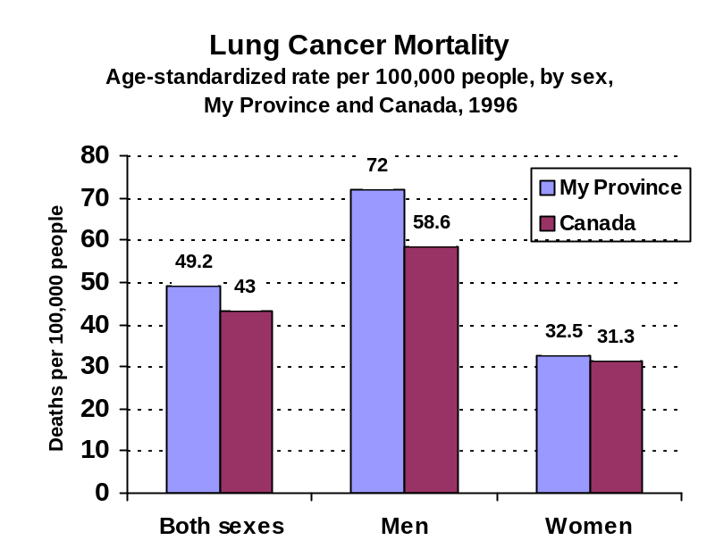

Comment: The increased likelihood of men dying from lung cancer is consistent with the situation in other provinces and territories.

Incidence Rates

Definition: Incidence Rate–
Incidence rates for lung cancer measure the number (per 100,000 population) of newly diagnosed primary cancer cases in a given year.
Interpretation: The incidence of lung cancer in My Province is lower than the national average. There were 52.9 cases per 100,000 people in My Province in 1997, compared to the national average of 57.9 cases per 100,000 people.

In My Province, the incidence of lung cancer in 1997 was substantially higher among men than among women, with 71.6 cases per 100,000 men compared to 38.7 cases per 100,000 women.
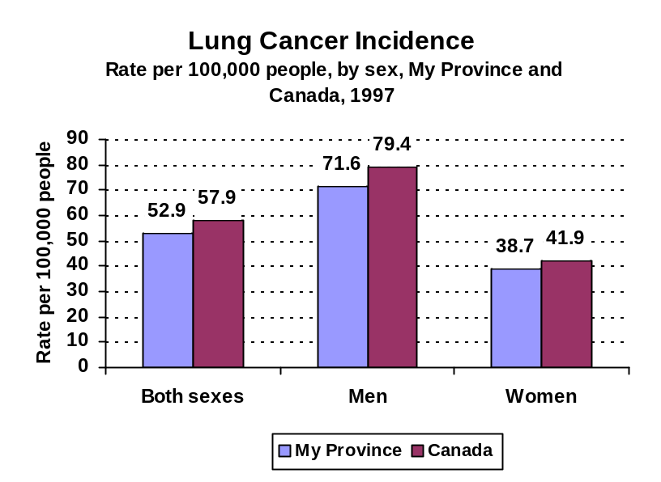
Comment: The substantial increase in the incidence of lung cancer among women is of particular note. The gap between incidence rates for males and females has been decreasing during the past 20 years.

Survival Rates

Definition: Survival Rate –
The ratio of the observed survival in a group of patients under study, five years after diagnosis, and the expected survival in the general population.

Interpretation: In My Province the rate of survival at five years after a diagnosis of lung cancer is not substantially different from the national average. In 1997, 16 per cent of those diagnosed with lung cancer in 1992 had survived five years, compared to 18 per cent nationally.

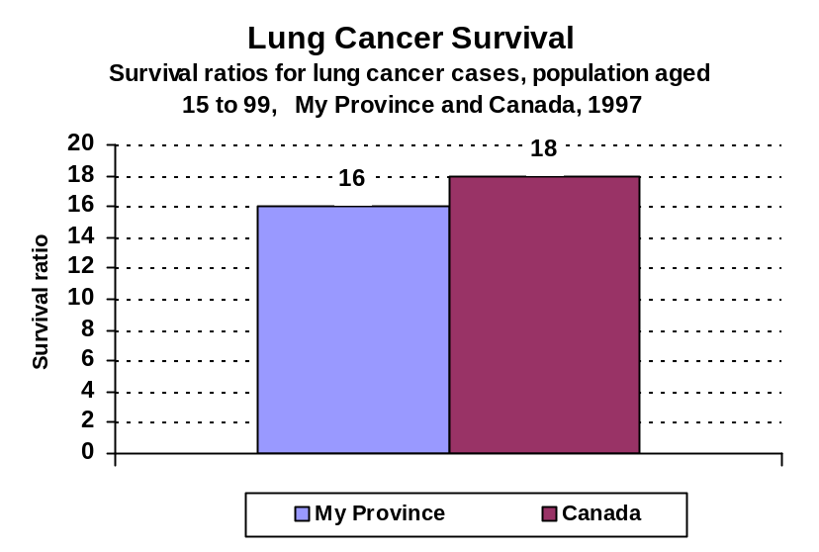

Potential Years of Life Lost to Lung Cancer

Definition: Potential Years of Life Lost (PYLL) –
Potential years of life lost (PYLL) to lung cancer is the number of years “lost” when a person dies prematurely due to this cancer – defined as dying before age 75. A person dying at age 25, for example, has lost 50 potential years of life.

Interpretation: In 1998, 446 potential years were lost per 100,000 people in My Province due to people dying before the age of 75 from lung cancer. This is slightly higher than the national average of 417.9 potential years lost.

Comment: Lung cancer claims the lives of many young people in our population, as it is the third highest cause of PYLL after unintentional injuries and suicides. PYLL to lung cancer have been falling for males in recent years, but have been rising fairly consistently for Canadian females. This trend is reflective of the high number of teenage girls in the population who are smokers.
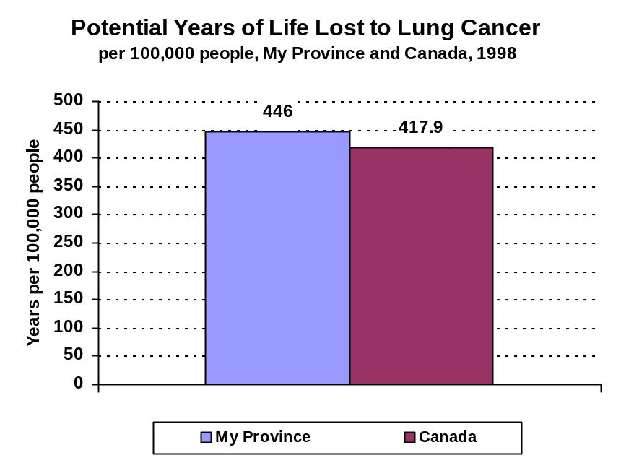

Appendix E

Focus Group Handout

The Story of Lung Cancer

Mortality Rates
Definition: Mortality Rate - The number of deaths of individuals (per100,000 population) where the underlying cause of death is lung cancer.

Interpretation: Almost one-third of all cancer deaths in men and almost one quarter in women are due to lung cancer (National Cancer Institute of Canada: Canadian Cancer Statistics, 2000). My Province had one of the highest lung cancer mortality rates nationwide in 1996 at 49.2 deaths per 100,000 people. This is higher than the national average of 43 deaths per 100,000 people. In My Province men and women had very different lung cancer mortality rates; men were twice as likely to die from lung cancer in My Province than women, with rates of 72 cases and 32.5 cases per 100,000 people respectively.
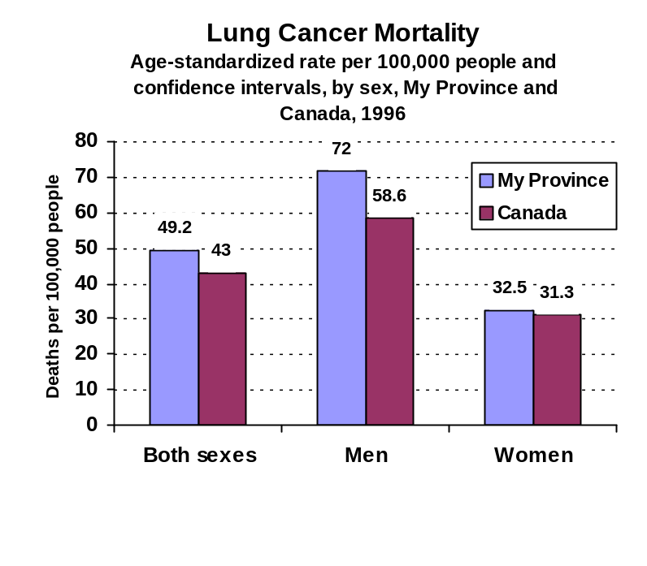
CI =
Prov, 48.8 – 49.7
Can, 41.5 – 44.5
CI =
Prov, 71.2 – 72.8
Can, 56 – 61.3
CI =
Prov, 32 – 33
Can, 29.5 – 33.1

Comments: The increased likelihood of men dying from lung cancer is consistent with the situation in other provinces and territories.

Definition: Age Standardization –
A procedure for adjusting rates (e.g., death rates) designed to minimize the effects of differences in age composition when comparing rates for different populations.
Age-standardized cancer mortality rate trends may indicate long-term success in reducing deaths from lung cancer. Lower mortality rates may indicate success in disease detection and treatment. Lung cancer includes tumours of the trachea, bronchi and lung.
Definition: Confidence Interval -
An estimated range of values that is likely to include an unknown population parameter, the estimated range being calculated from a given set of sample data.

Notes:
- Data sources: Statistics Canada, Vital Statistics, Death Database and Demography Division (population estimates)
- World Health Organization, International Classification of Diseases (ICD-9)
- Rates are age-standardized using the direct method and the direct method, and the 1991 Canadian Census population structure. All rates are per 100,000 population. The use of a standard population results in more meaningful mortality rate comparisons, because it adjusts for variations in age distributions over time and across geographic areas.
- Rates in this table are based on three years of death data (for example, 1995 to 1997) which were summed and divided by three. This product was then divided by the population estimate of the middle year. The reference period associated with these data reflect the mid-point of the three-year period (for example, 1996).
- Confidence intervals for age-standardized rates were produced using the Spiegelman method. Source: Spiegelman M. “Introduction to Demography”, Revised Edition. Cambridge, Massachusetts: Harvard University Press, 1968, page 113, formula 4.29.
- The 95% confidence interval (CI) illustrates the degree of variability associated with the rate. Wide confidence intervals indicate high variability, thus, these rates should be interpreted and prepared with due caution.
- CANSIM table number 01020014.
Comparison To Other Jurisdictions

When comparing My Province to two other provinces, it becomes apparent that Province A has a significantly higher rate of lung cancer mortality among men, but significantly lower rate among women. Province B, however, has a slightly lower rate of lung cancer mortality for both men and women.

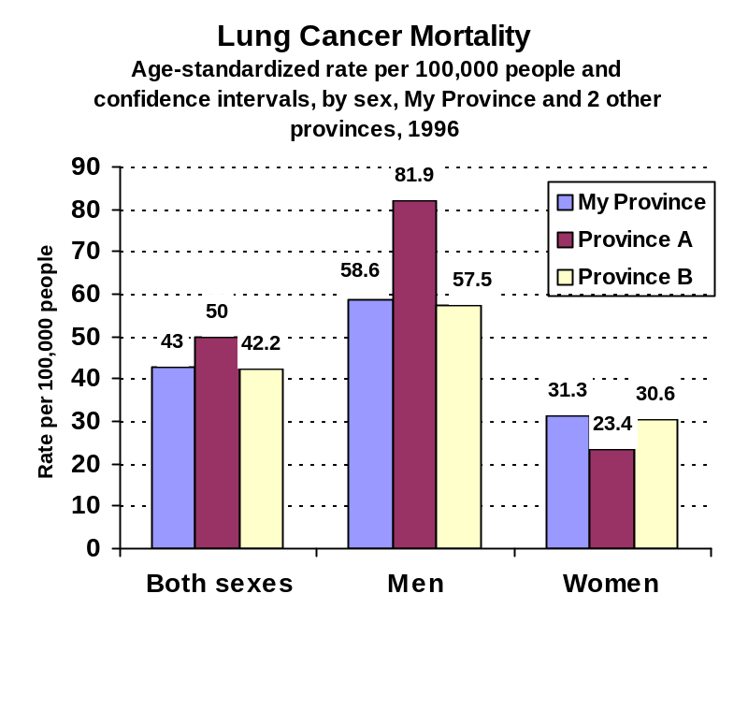
CI =
My, 41.5 – 44.5
A, 46.5 – 53.4
B, 40.1 – 44.4
CI =
My, 56 – 61.3
A, 75.4 – 88.5
B, 53.8 – 61.1
CI =
My, 29.5 – 33.1
A, 20.2 – 26.7
B, 28 – 33.2

Comparisons Over Time

When we examine lung cancer mortality figures over time, we see that in both My Province and in Canada mortality rates have been climbing steadily. In 1979 lung cancer mortality figures in my province were lower than the Canadian average. Around 1995, however, the mortality rates in My Province surpassed those of the Canadian average, and the gap has continued to rise.

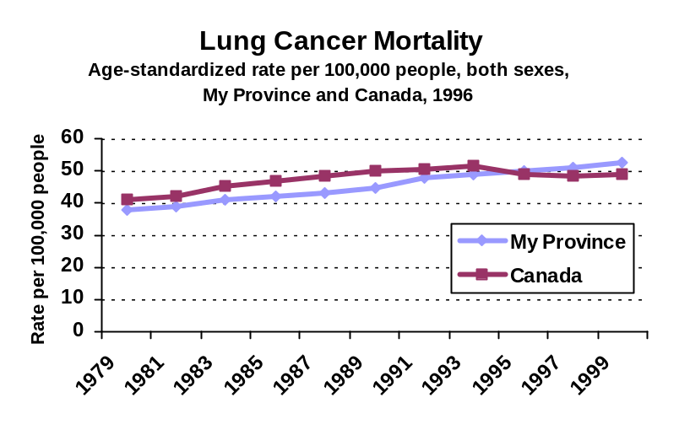

Appendix F

Theme Findings

Tested Indicators in descending order of interest – those that said “must include/essential”

Key:

Tested theme … |  |  |  |  |  |  |  |  |  | Score
Hal 1 | Hal 2 | Que 1 | Que 2 | Tor 1 | Tor 2 | Win 1 | Win 2 | Van 1 | Van 2 | Totals
 |  |  |  |  |  |  |  |  |  | Row total
8 | 8 | 10 | 9 | 10 | 9 | 10 | 10 | 10 | 10 | Total parts.

Second row: Location (e.g., Hal1 – 1st group in Halifax @5:30 PM)
Third row: Those that said “must include/essential”
Fourth row: Participants in the focus group.

Access to essential services (wait times, doctors, technology, etc.) |  |  |  |  |  |  |  |  |  | 76
Hal 1 | Hal 2 | Que 1 | Que 2 | Tor 1 | Tor 2 | Win 1 | Win 2 | Van 1 | Van 2 | Totals
7 | 6 | 5 | 8 | 9 | 9 | 9 | 7 | 5 | 6 | 71
8 | 8 | 10 | 9 | 10 | 9 | 10 | 10 | 10 | 10 | 94

The availability of appropriate home care services. |  |  |  |  |  |  |  |  |  | 57
Hal 1 | Hal 2 | Que 1 | Que 2 | Tor 1 | Tor 2 | Win 1 | Win 2 | Van 1 | Van 2 | Totals
7 | 8 | 9 | 7 | 4 | 6 | 4 | 5 | 3 | 1 | 54
8 | 8 | 10 | 9 | 10 | 9 | 10 | 10 | 10 | 10 | 94

The costs of drugs for Canadians. |  |  |  |  |  |  |  |  |  | 52
Hal 1 | Hal 2 | Que 1 | Que 2 | Tor 1 | Tor 2 | Win 1 | Win 2 | Van 1 | Van 2 | Totals
7 | 2 | 1 | 9 | 4 | 8 | 2 | 4 | 6 | 6 | 49
8 | 8 | 10 | 9 | 10 | 9 | 10 | 10 | 10 | 10 | 94

The health wellness of the population (life expectancy, mortality rates, etc.) |  |  |  |  |  |  |  |  |  | 36
Hal 1 | Hal 2 | Que 1 | Que 2 | Tor 1 | Tor 2 | Win 1 | Win 2 | Van 1 | Van 2 | Totals
2 | 5 | 3 | 1 | 1 | 2 | 3 | 8 | 2 | 7 | 34
8 | 8 | 10 | 9 | 10 | 9 | 10 | 10 | 10 | 10 | 94

The quality of services (patient safety, satisfaction, etc.) |  |  |  |  |  |  |  |  |  | 26
Hal 1 | Hal 2 | Que 1 | Que 2 | Tor 1 | Tor 2 | Win 1 | Win 2 | Van 1 | Van 2 | Totals
3 | 1 | 0 | 6 | 10 | 1 | 0 | 1 | 0 | 2 | 24
8 | 8 | 10 | 9 | 10 | 9 | 10 | 10 | 10 | 10 | 94

The sustainability of the health system (# of health professionals, value for money) |  |  |  |  |  |  |  |  |  | 19
Hal 1 | Hal 2 | Que 1 | Que 2 | Tor 1 | Tor 2 | Win 1 | Win 2 | Van 1 | Van 2 | Totals
3 | 1 | 0 | 2 | 4 | 4 | 0 | 0 | 0 | 4 | 18
8 | 8 | 10 | 9 | 10 | 9 | 10 | 10 | 10 | 10 | 94

Appendix G

Specified Indicator Findings

Tested Indicators in descending order of interest

Key:

Tested Indicator … |  |  |  |  |  |  |  |  |  | Score
Hal 1 | Hal 2 | Que 1 | Que 2 | Tor 1 | Tor 2 | Win 1 | Win 2 | Van 1 | Van 2 | Totals
 |  |  |  |  |  |  |  |  |  | Row total
8 | 8 | 10 | 9 | 10 | 9 | 10 | 10 | 10 | 10 | Total parts.

Second row: Location (e.g., Hal1 – 1st group in Halifax @5:30 PM)
Third row: Those that said “must include/essential”
Fourth row: Participants in the focus group.

Hospitalizations that could have been prevented with adequate basic health care (e.g. people with diabetes or asthma can be kept out of a hospital if they receive timely preventive care and treatment). |  |  |  |  |  |  |  |  |  | 90
Hal 1 | Hal 2 | Que 1 | Que 2 | Tor 1 | Tor 2 | Win 1 | Win 2 | Van 1 | Van 2 | Totals
8 | 8 | 9 | 8 | 9 | 9 | 7 | 10 | 10 | 7 | 85
8 | 8 | 10 | 9 | 10 | 9 | 10 | 10 | 10 | 10 | 94

Indicators of food-borne and water-borne disease (such as E. Coli) – diseases that result from things we eat or because of problems with our water and/or food supply. |  |  |  |  |  |  |  |  |  | 85
Hal 1 | Hal 2 | Que 1 | Que 2 | Tor 1 | Tor 2 | Win 1 | Win 2 | Van 1 | Van 2 | Totals
8 | 8 | 8 | 5 | 8 | 8 | 8 | 9 | 8 | 10 | 80
8 | 8 | 10 | 9 | 10 | 9 | 10 | 10 | 10 | 10 | 94

The number of doctors, nurses and other providers available (per person) |  |  |  |  |  |  |  |  |  | 80
Hal 1 | Hal 2 | Que 1 | Que 2 | Tor 1 | Tor 2 | Win 1 | Win 2 | Van 1 | Van 2 | Totals
6 | 8 | 9 | 7 | 9 | 8 | 9 | 9 | 4 | 6 | 75
8 | 8 | 10 | 9 | 10 | 9 | 10 | 10 | 10 | 10 | 94

Knowing about the costs of drugs, particularly the financial impact of purchasing drugs on individuals, i.e. the per cent of households that spend in excess of a determined amount on drugs. |  |  |  |  |  |  |  |  |  | 72
Hal 1 | Hal 2 | Que 1 | Que 2 | Tor 1 | Tor 2 | Win 1 | Win 2 | Van 1 | Van 2 | Totals
8 | 6 | 10 | 7 | 6 | 9 | 7 | 2 | 10 | 3 | 68
8 | 8 | 10 | 9 | 10 | 9 | 10 | 10 | 10 | 10 | 94

How many family doctors are accepting new patients. |  |  |  |  |  |  |  |  |  | 62
Hal 1 | Hal 2 | Que 1 | Que 2 | Tor 1 | Tor 2 | Win 1 | Win 2 | Van 1 | Van 2 | Totals
8 | 7 | 0 | 5 | 6 | 2 | 10 | 7 | 4 | 9 | 58
8 | 8 | 10 | 9 | 10 | 9 | 10 | 10 | 10 | 10 | 94

How many people use publicly funded home care services, including home support services (e.g. cleaning, cooking and shopping duties) |  |  |  |  |  |  |  |  |  | 61
Hal 1 | Hal 2 | Que 1 | Que 2 | Tor 1 | Tor 2 | Win 1 | Win 2 | Van 1 | Van 2 | Totals
7 | 2 | 7 | 7 | 6 | 8 | 2 | 5 | 4 | 9 | 57
8 | 8 | 10 | 9 | 10 | 9 | 10 | 10 | 10 | 10 | 94

The number of diagnostic professionals (e.g. professionals to run and read X-rays, MRIs and CTs) (per person) |  |  |  |  |  |  |  |  |  | 59
Hal 1 | Hal 2 | Que 1 | Que 2 | Tor 1 | Tor 2 | Win 1 | Win 2 | Van 1 | Van 2 | Totals
8 | 2 | 3 | 4 | 7 | 4 | 9 | 5 | 3 | 10 | 55
8 | 8 | 10 | 9 | 10 | 9 | 10 | 10 | 10 | 10 | 94

The number of individuals in the population with diabetes. |  |  |  |  |  |  |  |  |  | 55
Hal 1 | Hal 2 | Que 1 | Que 2 | Tor 1 | Tor 2 | Win 1 | Win 2 | Van 1 | Van 2 | Totals
7 | 2 | 9 | 6 | 2 | 6 | 9 | 4 | 2 | 5 | 52
8 | 8 | 10 | 9 | 10 | 9 | 10 | 10 | 10 | 10 | 94

Indicators of sexually transmitted diseases. |  |  |  |  |  |  |  |  |  | 52
Hal 1 | Hal 2 | Que 1 | Que 2 | Tor 1 | Tor 2 | Win 1 | Win 2 | Van 1 | Van 2 | Totals
8 | 0 | 7 | 8 | 5 | 8 | 5 | 0 | 0 | 8 | 49
8 | 8 | 10 | 9 | 10 | 9 | 10 | 10 | 10 | 10 | 94

The stress on family and volunteers providing unpaid care, i.e. the per cent of caregivers aged 45+ who reported reeling burdened by caring for a person aged 65+. |  |  |  |  |  |  |  |  |  | 50
Hal 1 | Hal 2 | Que 1 | Que 2 | Tor 1 | Tor 2 | Win 1 | Win 2 | Van 1 | Van 2 | Totals
8 | 4 | 4 | 0 | 6 | 4 | 5 | 7 | 4 | 5 | 47
8 | 8 | 10 | 9 | 10 | 9 | 10 | 10 | 10 | 10 | 94

The number of years an average individual will live in good health, or free of moderate or severe disability. |  |  |  |  |  |  |  |  |  | 49
Hal 1 | Hal 2 | Que 1 | Que 2 | Tor 1 | Tor 2 | Win 1 | Win 2 | Van 1 | Van 2 | Totals
1 | 3 | 4 | 2 | 4 | 5 | 8 | 9 | 6 | 4 | 46
8 | 8 | 10 | 9 | 10 | 9 | 10 | 10 | 10 | 10 | 94

The age distribution of doctors and nurses (e.g. how many are within a few years of retirement compared to the number of young/new graduates). |  |  |  |  |  |  |  |  |  | 45
Hal 1 | Hal 2 | Que 1 | Que 2 | Tor 1 | Tor 2 | Win 1 | Win 2 | Van 1 | Van 2 | Totals
5 | 5 | 8 | 3 | 4 | 2 | 1 | 7 | 1 | 6 | 42
8 | 8 | 10 | 9 | 10 | 9 | 10 | 10 | 10 | 10 | 94

The number of CT exams (Computerized tomography is used to by specialists to view internal organs, and to create bone/brain and vascular imaging in an effort to detect cancers, heart disease and osteoporosis.) |  |  |  |  |  |  |  |  |  | 41
Hal 1 | Hal 2 | Que 1 | Que 2 | Tor 1 | Tor 2 | Win 1 | Win 2 | Van 1 | Van 2 | Totals
7 | 4 | 0 | 4 | 2 | 3 | 7 | 4 | 0 | 8 | 39
8 | 8 | 10 | 9 | 10 | 9 | 10 | 10 | 10 | 10 | 94

Knowing about the mental health of the population, i.e. the proportion of individuals who contacted health professionals about their mental/emotional health. |  |  |  |  |  |  |  |  |  | 39
Hal 1 | Hal 2 | Que 1 | Que 2 | Tor 1 | Tor 2 | Win 1 | Win 2 | Van 1 | Van 2 | Totals
6 | 4 | 4 | 8 | 1 | 1 | 0 | 9 | 0 | 4 | 37
8 | 8 | 10 | 9 | 10 | 9 | 10 | 10 | 10 | 10 | 94

The proportion of women having mammography tests to screen for breast cancer. |  |  |  |  |  |  |  |  |  | 37
Hal 1 | Hal 2 | Que 1 | Que 2 | Tor 1 | Tor 2 | Win 1 | Win 2 | Van 1 | Van 2 | Totals
8 | 1 | 5 | 6 | 1 | 3 | 0 | 8 | 2 | 1 | 35
8 | 8 | 10 | 9 | 10 | 9 | 10 | 10 | 10 | 10 | 94

The number of MRI exams (Magnetic resonance imaging is used by specialists to assess illness, injuries and abnormalities inside the body and to aide in evaluation and treatment of such conditions) |  |  |  |  |  |  |  |  |  | 37
Hal 1 | Hal 2 | Que 1 | Que 2 | Tor 1 | Tor 2 | Win 1 | Win 2 | Van 1 | Van 2 | Totals
7 | 4 | 0 | 1 | 2 | 4 | 7 | 5 | 0 | 5 | 35
8 | 8 | 10 | 9 | 10 | 9 | 10 | 10 | 10 | 10 | 94

How many years of life are lost, at an early age, due to suicide. |  |  |  |  |  |  |  |  |  | 37
Hal 1 | Hal 2 | Que 1 | Que 2 | Tor 1 | Tor 2 | Win 1 | Win 2 | Van 1 | Van 2 | Totals
7 | 0 | 0 | 8 | 2 | 4 | 3 | 8 | 0 | 3 | 35
8 | 8 | 10 | 9 | 10 | 9 | 10 | 10 | 10 | 10 | 94

How many doctors work closely (i.e. in the same practice setting) with other health providers, such as nurses, physiotherapists, psychologists for example. |  |  |  |  |  |  |  |  |  | 34
Hal 1 | Hal 2 | Que 1 | Que 2 | Tor 1 | Tor 2 | Win 1 | Win 2 | Van 1 | Van 2 | Totals
4 | 0 | 3 | 4 | 7 | 2 | 0 | 2 | 1 | 9 | 32
8 | 8 | 10 | 9 | 10 | 9 | 10 | 10 | 10 | 10 | 94

Indicators that provide an indication of the future health of the population, such as the number of babies born with a low birth weight. |  |  |  |  |  |  |  |  |  | 30
Hal 1 | Hal 2 | Que 1 | Que 2 | Tor 1 | Tor 2 | Win 1 | Win 2 | Van 1 | Van 2 | Totals
2 | 2 | 8 | 2 | 4 | 5 | 2 | 3 | 0 | 0 | 28
8 | 8 | 10 | 9 | 10 | 9 | 10 | 10 | 10 | 10 | 94

The proportion of women having pap tests to screen for cervical cancer. |  |  |  |  |  |  |  |  |  | 27
Hal 1 | Hal 2 | Que 1 | Que 2 | Tor 1 | Tor 2 | Win 1 | Win 2 | Van 1 | Van 2 | Totals
7 | 1 | 8 | 2 | 1 | 0 | 0 | 4 | 2 | 0 | 25
8 | 8 | 10 | 9 | 10 | 9 | 10 | 10 | 10 | 10 | 94

How many years of life are lost, at an early age, due to unintentional injury (e.g. preventable injuries which include falls, motor vehicle crashes, railway and pedestrian injuries, drowning and suffocation, poisoning and fires. |  |  |  |  |  |  |  |  |  | 19
Hal 1 | Hal 2 | Que 1 | Que 2 | Tor 1 | Tor 2 | Win 1 | Win 2 | Van 1 | Van 2 | Totals
1 | 0 | 0 | 0 | 2 | 3 | 9 | 1 | 1 | 1 | 18
8 | 8 | 10 | 9 | 10 | 9 | 10 | 10 | 10 | 10 | 94

The number of calls made to provincial health hotlines (these are telephone lines you can call for information about any health-related question). |  |  |  |  |  |  |  |  |  | 16
Hal 1 | Hal 2 | Que 1 | Que 2 | Tor 1 | Tor 2 | Win 1 | Win 2 | Van 1 | Van 2 | Totals
0 | 2 | 0 | 0 | 1 | 7 | 0 | 4 | 1 | 0 | 15
8 | 8 | 10 | 9 | 10 | 9 | 10 | 10 | 10 | 10 | 94

Not all performance indicators were tested, only the ones that required some form of clarification to determine its viability as to whether or not it should be included in a report on health performance indicators.

