

Interdisciplinary Learning and Academia: Attitudes Towards Interdisciplinary Learning Among Canadian Schools of Health Professional Education

A Survey of Senior Academic Administrators in Health Professional Education
Discussion Paper

Submitted by:

Centre for Collaborative Health Professional Education
Faculty of Medicine
Memorial University of Newfoundland

February 2004


Interdisciplinary Learning and Academia: Attitudes Towards Interdisciplinary Learning Among Canadian Schools of Health Professional Education

Introduction

Interdisciplinary teams in health care

Health care systems have become increasingly complex in recent decades. The rapid advancements in health sciences information and the accompanying emergence of health care providers from multiple disciplines (Drinka,1996) has meant that comprehensive health care now requires a range of knowledge that no one practitioner can supply (Fagin, 1992). Health care is not only more specialized, it is more highly technical in nature. Teams of health care professionals, each with distinctive contributions to make, are becoming the standard for patient-centred care.

In contrast, the hospital system has traditionally been highly bureaucratic. Its structures and processes are built on a division of labor along departmental and professional lines, and on hierarchical patterns of communication, decision-making, leadership, and rewards. Within this model, health professions practice in separate hierarchies rather than functional units, with each profession making autonomous clinical decisions and each hierarchy (department/service) within an institution making its own rules (Drinka,1996).

Over the past two decades, concepts of interprofessional cooperation, interdisciplinary collaboration, collaborative practice, collaborative alliances, collaborative efforts among health care professionals, nurse-doctor collaboration, collaborative care, and outcomes of collaborative models have been heralded having positive consequences on provider satisfaction and patient care outcomes (Makaram, 1995). Collaborative, patient-centred care is widely viewed as one of the primary strategies by which hospitals can meet the extraordinary challenges they face in the current environment (Liedtka, 1998). Interprofessional teamwork has been proposed as a means to provide an organized and unified framework for both the delivery of health care and the work of health professionals (Lowe and Herranen, 1981).

Defining Interdisciplinary Teams

The World Health Organization (WHO) defined a health care team as:

“a group who share a common health goal and common objectives, determined by community needs, to the achievement of which each member of the team contributes, in accordance with his or her competence and skill and in coordination with the functions of others” (World Health Organization [WHO], 1988).”

Health Canada defines collaborative practice as follows:

“Collaborative patient-centred practice is designed to promote the active participation of each discipline in patient care. It enhances patient - and family - centred goals and values, provides mechanisms for continuous communication among care givers, optimizes staff participation in clinical decision making (within and across disciplines), and fosters respect for the contributions of all disciplines.”

Tsukuda (1990) classifies teamwork as a special form of interdependence between health care providers which draws on their different skills and viewpoints to serve patients and solve their health problems. This requirement for interdependent collaborative action is based on several assumptions:

- the problem is big and/or complex enough to require more than one skill or knowledge set;
- the amount of relevant knowledge or skills is too great for one person to possess;
- the creation of a group of professionals with more than one skill or knowledge set will enhance the solution of the problem;
- the possessors of the skills or knowledge relevant to solving the problem are considered to be equally important;
- all of the professionals involved are working for a common goal and as a result are willing to sacrifice some professional scrutiny.

Pros and cons of interdisciplinary teams

A number of positive outcomes are associated with enhanced collaborative teamwork:

- Improvements in health care delivery
  - a more comprehensive and better range of service (Tsukuda,1990; Hill, 1998)
  - efficiencies in length of stay, cost per case, and delivery of care (Tsukuda,1990; Liedtka, 1998)
  - more holistic patient care (Hill, 1998)
  - increased patient satisfaction (Liedtka, 1998)
  - more effective and successful patient care and outcomes (Tsuduka, 1990; Makaram, 1995; Liedtka, 1998)

- Improvements for health care providers
  - increased work satisfaction (Makaram, 1995; Liedtka, 1998)
  - increased levels of collegial support (Tsuduka, 1990; Makaram, 1995; Hill, 1998)
  - more shared knowledge and cross-fertilization of ideas ( Tsuduka, 1990; Makaram, 1995; Hill, 1998)
  - more manageable workloads (Hill, 1998)
  - improved understanding of collaborative practice (Makaram, 1995)
  - enhanced mutual trust and respect for colleagues from other health professions (Makaram, 1995)

Interdisciplinary teams present a number of challenges. Conflict within teams is influenced by the values held by team members (Hill, 1998). Differing values, work styles, and even personality traits are sources of conflicting and competing communication patterns among health professionals trained in different models and methods of practice (Clark, 1995; Liedtka, 1998). Interdisciplinary teams often fail when key team members are unwilling to commit to the interdisciplinary process and relinquish perceived independent decision-making (Drinka, 1996). Turf wars, weak leadership, and confusion regarding autonomy and authority can erode the ability of teams to work together and produce results (Leidtka,1998), especially in light of the history of relationships of power between physicians, nurses, and other health professionals (Makaram, 1995). Trust between team members is essential and when it is lacking it has detrimental effects on team effectiveness, commitment to group goals, attachment to the group, and support of group decisions (Liedtka, 1998).

Differing perceptions of teamwork arise because each team member holds a unique blend of values, attitudes, and prior experience based on their professional socialization, personal history, and beliefs. Much of this blend is formed during their professional education (Clark, 1994a; Clark, 1994b; Glen, 1999). The inclusion of collaborative, interprofessional learning experiences in the education of health professionals is therefore a key element in any efforts to support interdisciplinary teamwork in health care settings.

Defining Interprofessional Learning

The World Health Organization (1988) defines interprofessional education as a “process by which a group of students (or workers) from health-related occupations with different educational backgrounds learn together during certain periods of their education.”

Health Canada defines interdisciplinary learning as follows:

“Interdisciplinary learning for collaborative patient-centred practice encompasses undergraduate, graduate and continuing education. It has been described as an educational approach which transcends typical disciplinary boundaries. It involves collaboration among disciplines in the learning process to:

- socialize professionals in working together, in shared problem solving and decision making, towards enhancing the benefit for patients, and other recipients of services;

- develop mutual understanding and respect for the contributions of various disciplines;

- instill the requisite competencies for collaborative practice.

Its impact will be felt across primary health care, home/continuing care, and acute care sectors.”

Characteristics of Interprofessional Learning

Working as a member of a team requires communication, collaboration and negotiation skills which can be learned. There is evidence that shared, interprofessional learning can provide structured opportunities to learn these skills while breaking down stereotypical views of other health professionals, deepening understanding of each profession’s contribution to the team, and developing a sense of the strengths and limitations of each profession (WHO, 1988; Parsell and Bligh, 1999a).

According to Parsell and Bligh (1999a), interprofessional education has several distinguishing characteristics. It promotes interprofessional collaboration, involves interactive learning between professional groups, develops knowledge and understanding of other professions, encourages professionals to learn with, from and about each other, and respects the integrity and contribution of others. These characteristics are key elements in meeting the most commonly-cited goals of interprofessional learning: building interaction between different health professions, developing teamwork skills, and understanding the roles and responsibilities of other health professions, (WHO, 1988; Parsell et al., 1998; Parsell and Bligh, 1999a).

Advantages of Interprofessional Education

A number of advantages have been reported in the literature concerning interprofessional education. The most frequently noted advantages are related to a better understanding of other professions and include increased understanding of the roles and responsibilities of other professions ( Parsell et al., 1998; Parsell & Bligh, 1999a), increased understanding about the contribution that other professions make to patient care (Clark, 1991), and increased respect for and trust of other professions (WHO, 1988; Parsell et al., 1998; Parsell & Bligh, 1999a).

Another advantage of interprofessional education is the facilitation of skill development in areas needed for students to function in the current health care environment (Parsell et al., 1998). Students who have experienced interprofessional learning in their programs develop communication and interpersonal skills that enable them to work collaboratively in teams after graduation and contribute to more efficient and effective health care delivery (WHO, 1988; Parsell & Bligh, 1999a).

Interprofessional education is also associated with attitude changes that increase understanding and trust between professions, and reduce negative stereotypes (Parsell et al., 1998; Parsell & Bligh, 1999). In particular, interprofessional educational initiatives introduced early in the curriculum can ensure that students do not become entrenched in conventional professional roles (WHO, 1988).

Challenges for interprofessional learning

A number of challenges have been identified to the successful implementation of interprofessional learning. Challenges related to learning style preferences (WHO, 1988; Clark, 1991), loss of professional and disciplinary status (WHO, 1988; Bernstein, 1996; Moore, 2000; Gardner et al. 2002), curricular and scheduling challenges (Clark, Spence & Sheehan, 1986), and lack of familiarity and comfort with interprofessional learning settings (WHO, 1988; Clark, Spence & Sheehan, 1986). Parsell & Bligh (1999) classified barriers into the following categories: structural, curriculum/teaching, professional/disciplinary, and attitudinal. The latter is of particular interest for this study.

Attitudinal factors have been identified as major influences on the development and implementation of interprofessional learning (Parsell & Bligh, 1999; Glasby and Lester, 2004). The literature to date has largely focused on attitudes of health care workers, students and (to a lesser degree) faculty towards interprofessional learning (Lowe & Herranen,1981; Glen, 1999; Wilcock & Headrick, 2000; Reeves et al., 2002; Dieleman et al., 2004). However, the attitudes of senior administrators have been identified as a major influence on interdisciplinary efforts in academic settings (Bernstein, 1996; Moore, 2000). Attitudes towards interprofessional education at organizational levels are alluded to in many studies (Clark,1994a; Annandale et al., 2000; Cooper et al., 2001; Gelmon et al., 2000; Barrett, Greenwood & Ross, 2003; Cullen, Fraser & Symonds, 2003; Calleson & Seifer, 2004). However, few studies have specifically and systematically examined the attitudes of senior academic administrators to interprofessional teamwork and learning in the didactic setting. Gardner et al. (2002) surveyed deans from professional schools of medicine, nursing, and pharmacy in a total of 184 academic health centres in the United States about their attitudes towards interprofessional education, barriers to its implementation, and courses that could provide opportunities for its introduction to the curriculum. They concluded that, “it may be possible to overcome potential barriers to interdisciplinary education, because the environment on academic health center campuses from all three disciplines is generally positive.” (Gardner et al., 2002, pp. 189).

Study rationale

A lack of resources and genuine commitment at the highest levels of academic decision-making can contribute to a decline in enthusiasm for interdisciplinary learning and decrease the possibility of a permanent change to the curriculum. There must be overt support for interdisciplinary learning at the most senior levels in academia. Changes to course structures and organization are required if interdisciplinary learning is to occur. All participating departments should be involved in course planning and implementation. Institutional support from senior management is important. If there is an intersectoral component (i.e. participation of external agencies) then education planning will have to involve these sectors as well (WHO, 1988; Parsell & Bligh, 1999a). Understanding the attitudes of senior administrators for health professional education programs is essential for the success of interprofessional learning in support of increased interdisciplinary health care teamwork.

Study aims

The purpose of this paper is to:
- design and construct a questionnaire survey of attitudes towards interdisciplinary learning, perceived barriers and challenges, and academic administrator needs;
- conduct a questionnaire survey of senior health professional education administrators across Canada using this survey;
- identify attitudes towards interdisciplinary learning among Canadian health professional education administrators.

Methods

Sample generation

E-mails in English and French (for Francophone institutions) inviting participation in a web-based survey on attitudes towards interdisciplinary, patient-centred care and interprofessional health education were sent to senior administrators of health professional education programs in Canada. A reminder e-mail invitation was sent to all groups approximately one week after the initial contact. The following groups were represented:

I. Faculties/Colleges of Medicine (N=16)

*Compiled from the Association of Canadian Medical Colleges Website (http://www.acmc.ca) – list of Canadian Faculties of Medicine.

*E-mail message was sent to the Director of the Association of Canadian Medical Colleges and distributed to the Deans on our behalf.

II. Schools of Nursing (N=90)

*E-mail message was sent to Director of Data and Communications, Canadian Association of Schools of Nursing and distributed to the Directors of the Schools of Nursing in Canada on our behalf. Follow-up e-mails sent directly to Schools of Nursing, e-mail list generated from member listing on CASN web site.

III. Schools of Pharmacy (N=9)

*Compiled from the Canadian Pharmacists Association (http://www.pharmacists.ca) - list of Canadian Faculties and Schools of Pharmacy, and each school’s Website.

IV. Schools of Social Work (N=35)

*Compiled from the Canadian Association of Schools of Social Work Website (http://www.cassw-acess.ca) Directory of Accredited Canadian Social Work Programs 2003-2004.

V. Schools of Physical Therapy (N=13)

*Compiled from the Website of the Canadian Physiotherapy Association Website (http://www.physiotherapy.ca) - list of University Physiotherapy Programs in Canada, as well as each school’s website.

VI. Occupational Therapy (N=12)

*Compiled from the Canadian Association of Occupational Therapists Website (http://www.caot.ca) - list of University Occupational Therapy programs in Canada.

Total Sample Population N=175

Survey description

A web-based survey in English and French (Appendices A and B) was developed based on several existing scales measuring attitudes towards interprofessional work teams, interprofessional learning, and barriers within the academic environment. The survey consisted of the following sections:

- Demographic information: type of program, type of program setting, type of students, number of students in program’s first-year class, number of students in institution as a whole

- Attitudes toward interdisciplinary health care teams: 14 item Likert scale
  - adapted from: Heinemann, G.D. et al. (1999; 2002) and Hyer et al. (2000)
  - Factors: 1) Team value 2) Team efficiency.

- Attitudes towards interprofessional learning: 13 item Likert scale
  - adapted from: Gardner et al. (2002).

- Attitudes towards the relevance of interprofessional learning to students’ development as health professionals: 15 item Likert scale
  - adapted from: Parsell, G and Bligh, J.(1999b) and Horsburgh et al. (2001).
  - Factors: 1) Teamwork & Collaboration 2) Professional Identity

- Potential barriers to interdisciplinary learning: 10 item Likert scale
  - adapted from: Gardner et al. (2002).

- Courses that lend themselves to interdisciplinary learning: 12 item Likert scale
  - adapted from: Gardner et al. (2002)

Data analysis

Survey responses were analyzed using SSPS to summarize responses for individual items and each survey section above. Reverse coding was applied to negatively-worded items. Sub-scale (factors) scores were calculated using mean overall sum scores. Mean overall scores were obtained by adding responses for all positively oriented items and by reversing the scale for all negatively phrased statements. In order to determine the existence of significant differences between professions in relation to the various attitudinal sub-scales, analysis of variance (ANOVA) with an alpha level of 0.05 was applied to the composite attitude scores.

Results

Response Rate

Table 1. Response Rate (English & French) by type of institution

Type of Institution | # of Potential Respondents | # of Actual Responses | Response Rate
Schools of Medicine | 16 | 8 | 50%
Schools of Nursing* | 90 | 30 | 33.3%
Schools of Pharmacy | 9 | 6 | 66.7%
Schools of Social Work | 35 | 17 | 48.6%
Schools of Physical Therapy | 13 | 9 | 69.2%
Schools of Occupational Therapy | 12 | 12 | 100%
TOTAL | 175 | 82**
*Includes Nurse Practitioners.
**There were 71 surveys submitted, but several respondents indicated their involvement with more that one program. As a result, there are 84 responses used in this analysis. Two respondents did not indicate the program in which they were involved.
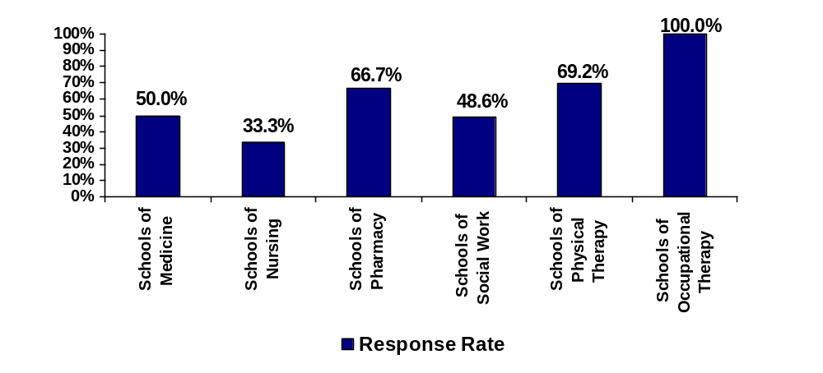***Some of the other programs identified include: “Child and Youth Care Diploma, Community and School Support Certificate, Social Service Certificate”; Dentistry” (n=3); “Gerontology”; “Palliative Care”; “Kinesiology”; “Master of Health Studies”; “Midwifery”; “Paramedic”; “Rehabilitation” (n=2); “Massage Therapy”; “Nutrition Management”; “Speech Language Pathology”; “Genetic Counselling”.

Figure 1: Response rate (%) by type of institution

Table 1 presents the response rate by type of institution. Percentage response rates are shown graphically in Figure 1. Although the highest number of responses was obtained from Schools of Nursing (30) and Social Work (17), these represent the lowest response rates in terms of the percentage of total possible responses for their school type. Schools of Occupational Therapy (100%), Physical Therapy (69.2%), and Pharmacy (66.7%) had the highest percentage responses. Schools of Medicine had a 50% response rate.

Institutional Demographics

Type of setting

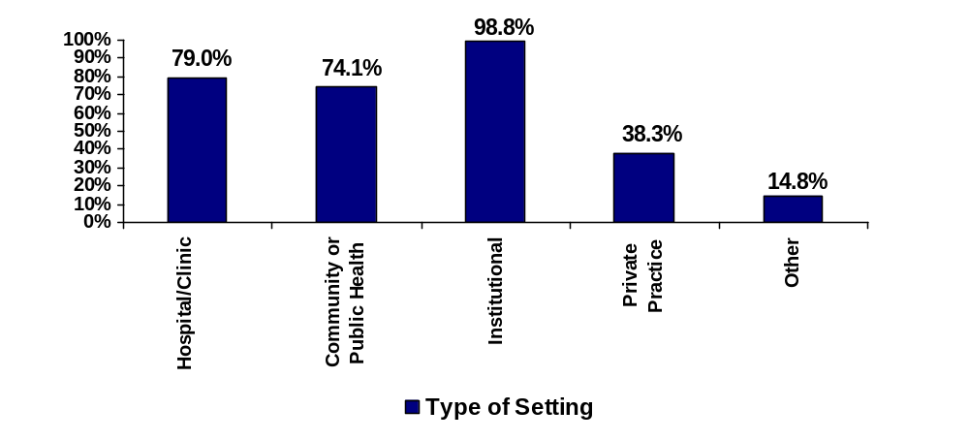Figure 2: Distribution of respondents by type of setting

Figure 2 presents a graphical representation of the type of setting in which respondents’ provide educational and training programs. Ninety-eight percent (98.8%) of respondents indicated providing educational program in an institutional (college, university) setting, while 79.0% reported educational programs were provided in a hospital and/or clinic settings and 74.1% indicated educational programs were provided in a community or public health settings. A Smaller percentage of respondents reported that educational and training were provided in private practice (38.3%) and other settings (14.8%). Other settings identified included: “client’s residence/homes (n=3)”; “field placement settings” (n=2); “government and NGO”; “industry mental health facility”; “throughout region and online nationally”; “web-based-distance delivery”; and “community health centres”. Since respondents were able to indicate multiple settings as appropriate for their school, there is considerable overlap in the responses indicating that although most schools identify themselves in relation to an academic institution they also provide educational and training programs in cooperation with hospital, clinical, and community settings.

Type of students
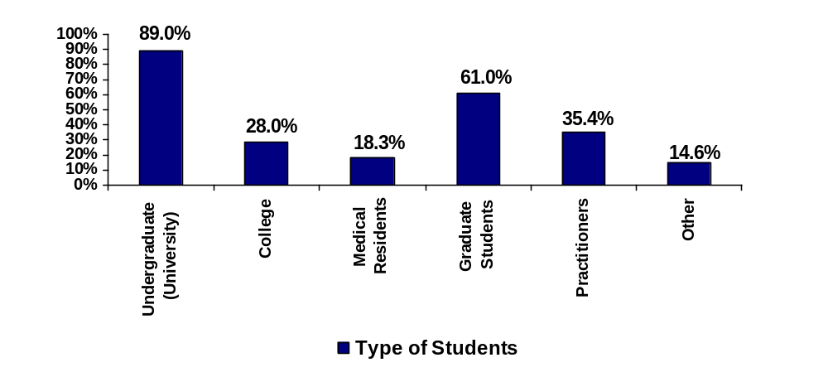
Figure 3. Distribution of types of students in respondent’s programs

Figure 3 presents results related to respondents’ reports of types of students participating in educational and training programs at their institution and in their programming areas. Eighty-nine percent (89%) of respondents indicated that undergraduate students are included in their programs, while 61% included graduate students and 18.3% included medical residents. Twenty-eight percent (28%) included college level students in their programs. Thirty-five percent (35.4%) included practitioners in their programs. The “other” category (14.6%) included responses such as “adult learners”; “professional and research graduate students”(n=3); “hospital pharmacy residents”; “post diploma certificate students”(n=2); “post RN students”; and “undergraduate students in a collaborative degree program”. Since respondents could choose multiple responses as appropriate for their school there is overlap between the categories. The results indicate that the majority of respondents represent academic programs from degree-granting institutions, serving primarily undergraduate students but also including graduate students and residents.

Number of students in respondents’ first-year classes
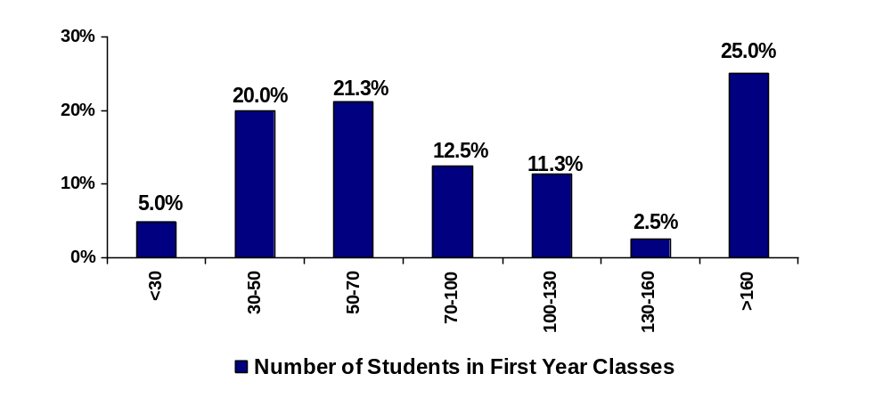
Figure 4. Number of students in first year classes, percentage of respondents by class size category

Figure 4 presents the number of students in first year classes as a percentage of respondents by class size category. Twenty-five percent (25%) of programs had a first year class of greater than 160 students. Only 5% of respondents had first year classes smaller than 30. A large proportion of respondents had first year classes between 30 and 70; 21.3% reported classes from 50-70 and 20% reported classes from 30-50. Class sizes between 70 and 160 were reported by a total of 26.3% of respondents. Other responses included: “We admit into 3rd year BSW approximately 200; into MSW approximately 85; and PhD about 8”. “Distance deliver program – do not track classes of students – student work at own pace”.
Attitudes toward interdisciplinary health care teams

Figures 5 and 6 present the results concerning respondents’ attitudes towards interdisciplinary health care teams. The survey question asked respondents to indicate their level of agreement or disagreement with a total of fourteen attitudinal items related to interdisciplinary health care teams. Reponses were made based on a Likert scale of Strongly Disagree (1) to Strongly Agree (5). Within this section, items were divided into subscales relating to two factors. A total of eleven items relate to Factor I: Team value and are intended to measure attitudes towards the value or teamwork in health care. A total of three items relate to Factor II: Team efficiency and are intended to measure attitudes towards the perceived efficiency and productivity of teamwork.

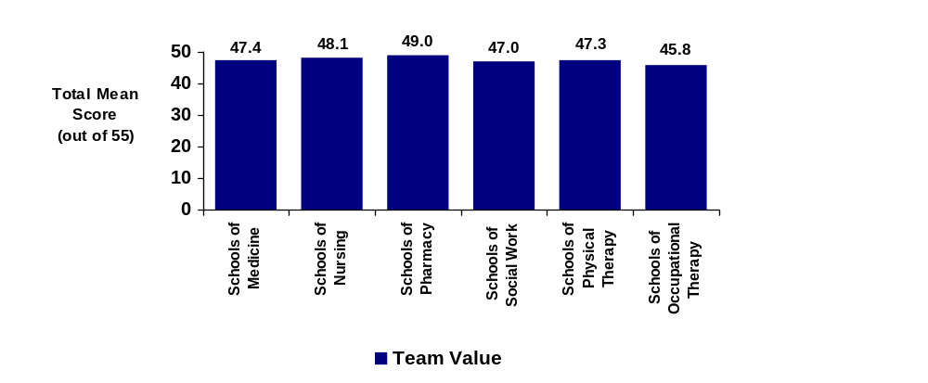Factor I: Team value

Figure 5. Total mean scores by profession for Factor I: Team value.

Figure 5 presents the total mean composite scores for the team value factor items within the attitudes towards interdisciplinary health teams scale. These represent mean score out of a maximum possible score of 55 for all items. All professions displayed mean composite scores between 45.8 and 49.0 out of 55 for this factor, indicating strong positive attitudes towards the value of teamwork in the provision of patient-centred care.

Factor II: Team efficiency
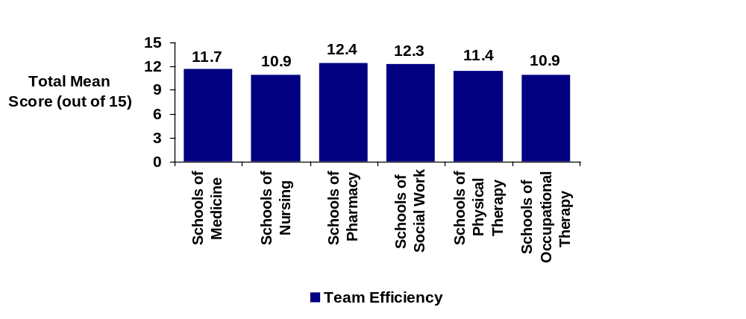
Figure 6. Total mean scores by profession for Factor II: Team efficiency.

Figure 6 presents the total mean composite scores for the team efficiency factor items within the attitudes towards interdisciplinary health teams scale. These represent mean score out of a maximum possible score of 15 for all items. All professions displayed mean composite scores between 10.9 and 12.4 out of 15 for this factor, indicating positive attitudes towards the efficiency of teamwork in the provision of patient-centred care.

An analysis of variance (ANOVA) was conducted to determine if there was a difference among the total mean sum scores for each professional school. No significant difference was found between professions for the team value (p=0.867) and team efficiency (p=0.561) subscales at the < 0.5 level of probability.
Attitudes towards interprofessional learning

Table 2 presents the results concerning respondents’ attitudes towards interdisciplinary learning. Respondents were asked to indicate their level of agreement or disagreement with a total of thirteen attitudinal items related to interdisciplinary learning. Reponses were made based on a Likert scale of Strongly Disagree (1) to Strongly Agree (5). Mean responses were calculated for each item, using reverse coding for negatively-worded items. Mean responses for positively-worded items ranged from 3.5 to 4.6, indicating that respondents generally held positive attitudes towards interprofessional learning. The highest mean scores were attained for items referring to the importance of providing interprofessional learning opportunities (4.6), the need for support from campus administration (4.4), the value of encouraging faculty to participate (4.4), and the desirability of interprofessional learning as a goal for the campus (4.3).

For several items, lower mean scores did not necessarily indicate negative attitudes towards interprofessional learning. These items referred to more practical logistical, course content, and accreditation concerns and were worded in a negative manner, thus eliciting in most cases a response which skewed towards ‘disagreement.’ As an example, the responses to the item “Interdisciplinary didactic courses are logistically difficult” resulted in a mean score of 2.4, with 52.0% or respondents disagreeing. In response to the item “Accreditation requirements do limit interdisciplinary efforts.”, the mean score was 3.0 while the distribution of scores – Disagree (25.7%), Neutral (27.0%), and Agree (24.3%) – suggest a widespread variation in opinion towards the impact of accreditation.

Table 2: Attitudes towards interprofessional learning

Attitudes Toward Interdisciplinary Learning in General | Strongly Disagree |  | Disagree |  | Neutral |  | Agree |  | Strongly Agree |  | N/A |  | TOTAL | Mean Response
Attitudes Toward Interdisciplinary Learning in General | N | % | N | % | N | % | N | % | N | % | N | % | TOTAL | Mean Response
Interdisciplinary learning better utilizes resources. | 0 | 0% | 4 | 5.4% | 12 | 16.2% | 35 | 47.3% | 23 | 31.1% | 0 | 0% | 74* | 4.0
It is important for academic health center campuses to provide interdisciplinary learning opportunities. | 0 | 0% | 0 | 0% | 1 | 1.3% | 31 | 41.3% | 43 | 57.3% | 0 | 0% | 75** | 4.6
Interdisciplinary learning should be a goal of this campus. | 0 | 0% | 0 | 0% | 10 | 13.3% | 29 | 38.7% | 35 | 46.7% | 1 | 1.3% | 75 | 4.3
Students like courses taught by faculty from other academic departments. | 4 | 5.4% | 4 | 5.4% | 22 | 29.7% | 32 | 43.2% | 12 | 16.2% | 0 | 0% | 74 | 3.6
Students like courses that include students from other academic departments | 0 | 0% | 6 | 8.0% | 17 | 22.7% | 43 | 57.3% | 8 | 10.7% | 1 | 1.3% | 75 | 3.7
Faculty should be encouraged to participate in interdisciplinary courses. | 0 | 0% | 0 | 0% | 4 | 5.3% | 41 | 54.7% | 30 | 40.0% | 0 | 0% | 75 | 4.4
Faculty like lecturing to students in other academic departments. | 0 | 0% | 6 | 8.1% | 30 | 40.5% | 30 | 40.5% | 6 | 8.1% | 2 | 2.7% | 74 | 3.5
Faculty like lecturing with faculty from other academic departments. | 0 | 0% | 2 | 2.7% | 28 | 37.8% | 33 | 44.6% | 9 | 12.2% | 2 | 2.7% | 74 | 3.7
***Interdisciplinary efforts in the didactic setting do weaken course content. | 1 | 1.3% | 8 | 10.7% | 11 | 14.7% | 36 | 48.0% | 19 | 25.3% | 0 | 0% | 75 | 3.9
Interdisciplinary efforts require support from campus administration. | 0 | 0% | 5 | 6.7% | 2 | 2.7% | 23 | 30.7% | 44 | 58.7% | 1 | 1.3% | 75 | 4.4
***Interdisciplinary didactic courses are logistically difficult. | 10 | 13.3% | 39 | 52.0% | 11 | 14.7% | 13 | 17.3% | 2 | 2.7% | 0 | 0% | 75 | 2.4
Faculty should be rewarded for participation in interdisciplinary courses. | 1 | 1.4% | 5 | 6.8% | 13 | 17.6% | 31 | 41.9% | 24 | 32.4% | 0 | 0% | 74 | 4.0
***Accreditation requirements do limit interdisciplinary efforts. | 7 | 9.5% | 19 | 25.7% | 20 | 27.0% | 18 | 24.3% | 9 | 12.2% | 1 | 1.4% | 74 | 3.0
SD=1; D=2; N=3; A=4; SA=5
*Ten respondents did not answer these questions.
**Nine respondents did not answer these questions.
***Reversed coding for negative items.

Attitudes towards the relevance of interprofessional learning to students’ development as health professionals

Figures 7 and 8 present the results concerning respondents’ attitudes towards the relevance of interdisciplinary learning to students’ development as health professionals. The survey question asked respondents to indicate their level of agreement or disagreement with a total of fifteen attitudinal items related to interdisciplinary health care teams. Reponses were made based on a Likert scale of Strongly Disagree (1) to Strongly Agree (5). Within this section, items were divided into two subscales. A total of ten items relate to Subscale I: Teamwork and collaboration and reflect a strong belief that interprofessional learning promotes the acquisition of team working skills and positive relationships between professions. A total of five items relate to Subscale II: Professional identity and reflect the relevance of interprofessional learning to the acquisition of students’ professional identities.

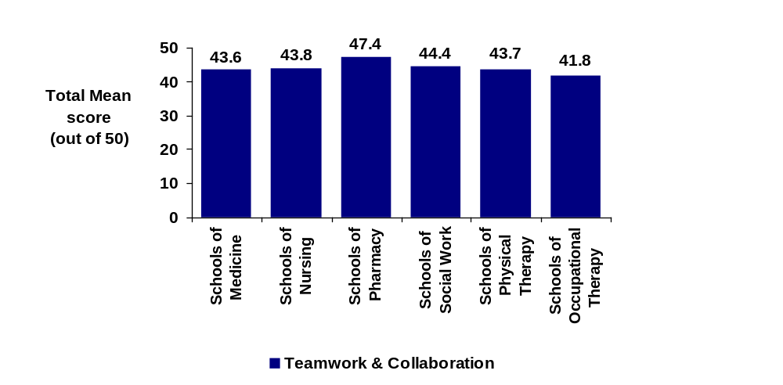Subscale I: Teamwork and collaboration

Figure 7. Total mean scores by profession for Subscale I: Teamwork and collaboration

Figure 7 presents the total mean composite scores for Subscale I: Teamwork and collaboration items, out of a maximum possible score of 50 for all items. All professions displayed mean composite scores between 41.8 and 47.8 out of 50 for this subscale, indicating a belief that interprofessional learning benefits the development of teamwork and collaboration skills by students in all health professions.

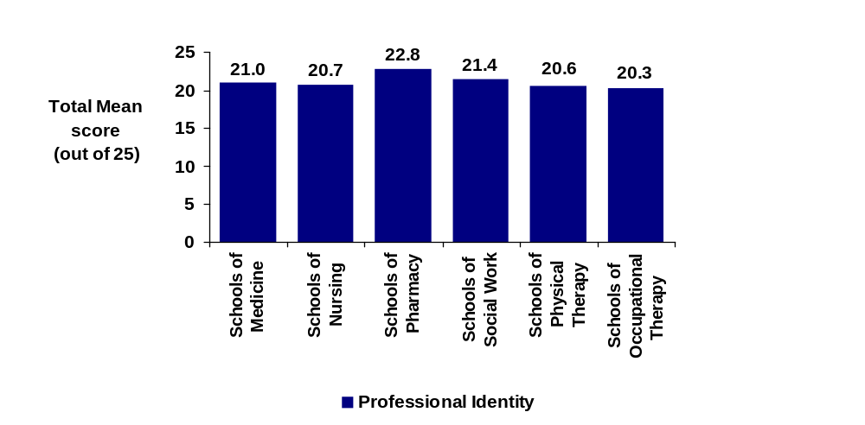
Subscale II: Professional identity

Figure 8. Total mean scores by profession for Subscale II: Professional identity

Figure 8 presents the total mean composite scores for Subscale II: Professional identity items, out of a maximum possible score of 25 for all items. All professions displayed mean composite scores between 20.3 and 22.8 out of 25 for this subscale, indicating a belief that interprofessional learning has a positive influence on the acquisition of professional identity by students in all health professions.

An analysis of variance (ANOVA) was conducted to determine if there was a difference among the total mean sum scores for each professional school. No significant difference was found between professions for the teamwork and collaboration (p=0.550) and professional identity (p=0.896) subscales at the < 0.5 level of probability.
Potential barriers to the implementation of interdisciplinary learning in the didactic setting

Table 3 presents results concerning potential barriers to the implementation of interdisciplinary learning in the didactic setting. Respondents were asked to indicate the extent to which they agreed or disagreed that each of ten potential barriers serve as barriers to interdisciplinary learning in their institution. Reponses were made based on a Likert scale of Strongly Disagree (1) to Strongly Agree (5).

Overall, many barriers were identified as limiting interdisciplinary learning efforts. The top four barriers identified by adding Agree and Strongly Agree responses were: problems with schedule/calendar (84.7%), rigid curriculum (73.0%), lack of financial resources (69.2%), and lack of perceived value (67.3%). Respondents were also asked to identify other barriers that they felt impeded interprofessional education efforts. Some of the ‘other’ barriers included:

- lack of resources or interest
- faculty interest
- lack of understanding
- concern over consequences of blending knowledge and diluting professional roles for the future
- time to coordinate
- accreditation requirements
- inequality of disciplines' status within the health care system
- geographical distance between teaching environment
- not high on agenda of leadership
- limitations from professional bodies
- perceived hierarchy among health disciplines
- domination by one of the other disciplines
- very little collaboration between different health care disciplines.

Table 3. Potential barriers to the implementation of interdisciplinary learning in the didactic setting

Potential barriers to the implementation of interdisciplinary learning in the didactic setting | Strongly Disagree |  | Disagree |  | Neutral |  | Agree |  | Strongly Agree |  | N/A |  | TOTAL | Mean Response
 | N | % | N | % | N | % | N | % | N | % | N | % | TOTAL | Mean Response
Lack of financial resources | 0 | 0% | 17 | 23.3% | 9 | 12.3% | 26 | 35.6% | 20 | 27.4% | 1 | 1.4% | 73* | 3.7
Lack of administrative support | 2 | 2.7% | 22 | 30.1% | 11 | 15.1% | 31 | 42.5% | 7 | 9.6% | 0 | 0% | 73 | 3.3
Lack of perceived value | 3 | 4.1% | 18 | 24.7% | 4 | 5.5% | 26 | 35.6% | 22 | 30.1% | 0 | 0% | 73 | 3.6
Problems with schedule/calendar | 0 | 0% | 4 | 5.5% | 4 | 5.5% | 28 | 38.4% | 35 | 47.9% | 2 | 2.7% | 73 | 4.3
Classroom size | 1 | 1.4% | 13 | 17.8% | 19 | 26.0% | 14 | 19.2% | 25 | 34.2% | 0 | 0% | 73 | 3.6
Faculty attitudes | 4 | 5.5% | 10 | 13.7% | 12 | 16.4% | 33 | 45.2% | 14 | 19.2% | 0 | 0% | 73 | 3.6
Student acceptance | 6 | 8.3% | 33 | 45.8% | 12 | 16.7% | 13 | 18.1% | 8 | 11.1% | 0 | 0% | 72** | 2.8
Rigid curriculum | 2 | 2.7% | 4 | 4.4% | 13 | 17.8% | 39 | 53.4% | 15 | 20.5% | 0 | 0% | 73 | 3.8
Turf battles | 2 | 2.7% | 15 | 20.5% | 6 | 8.2% | 30 | 41.1% | 18 | 24.7% | 2 | 2.7% | 73 | 3.7
Lack of reward for faculty | 2 | 2.7% | 12 | 16.4% | 15 | 20.5% | 29 | 39.7% | 13 | 17.8% | 1 | 1.4% | 73 | 3.5
*Eleven respondents did not answer these questions.
**Twelve respondents did not answer this question.
Courses that lend themselves to interdisciplinary learning in the didactic setting

Table 4 presents percentages and mean scores for responses concerning courses that lend themselves to interdisciplinary learning in the didactic setting. Respondents were asked to indicate the extent to which they agreed or disagreed that each of twelve courses listed would lend itself to interdisciplinary learning. Reponses were made based on a Likert scale of Strongly Disagree (1) to Strongly Agree (5).

The top five courses listed in rank order were identified by adding Agree and Strongly Agree responses. These were: Community health/prevention (97.9%), Medical ethics (95.8%), Communications (89.3%), Critical appraisal (89.1%), and Epidemiology (73.9%). Respondents were also asked to list other courses that they felt could lend themselves to interprofessional learning. Some of the other courses identified included team work, mental health, therapeutics, research methodology, group dynamics, health service organizations, cultural competency, and health care ethics.
Table 4. Courses that lend themselves to interdisciplinary learning in the didactic setting.

Courses that lend themselves to interdisciplinary learning in the didactic setting. | Strongly Disagree |  | Disagree |  | Neutral |  | Agree |  | Strongly Agree |  | N/A |  | TOTAL | Mean Response
 | N | % | N | % | N | % | N | % | N | % | N | % | TOTAL | Mean Response
Medical Ethics | 0 | 0% | 1 | 1.6% | 0 | 0% | 24 | 37.5% | 38 | 59.4% | 1 | 1.6% | 64* | 4.6
Critical Appraisal | 0 | 0% | 6 | 9.8 | 3 | 4.9% | 24 | 39.3% | 28 | 45.9% | 0 | 0% | 61** | 4.2
Biostatistics | 0 | 0% | 7 | 11.3% | 14 | 22.6% | 15 | 24.2% | 25 | 40.3% | 1 | 1.6% | 62*** | 4.0
Epidemiology | 0 | 0% | 5 | 8.1% | 7 | 11.3% | 23 | 37.1% | 26 | 41.9% | 1 | 1.6% | 62 | 4.1
Communications | 0 | 0% | 5 | 7.8% | 3 | 4.7% | 16 | 25.0% | 40 | 62.5% | 0 | 0% | 64 | 4.4
Physical Assessment | 1 | 1.6% | 15 | 24.2% | 12 | 19.4% | 13 | 21.0% | 19 | 30.6% | 2 | 3.2% | 62 | 3.6
Community health/prevention | 0 | 0% | 1 | 1.6% | 0 | 0% | 23 | 35.9% | 40 | 62.5% | 0 | 0% | 64 | 4.6
Pharmacology | 0 | 0% | 16 | 25.4% | 16 | 25.4% | 18 | 28.6% | 11 | 17.5% | 2 | 3.2% | 63**** | 3.4
Anatomy | 1 | 1.6% | 14 | 21.9% | 9 | 14.1% | 22 | 34.4% | 16 | 25.0% | 2 | 3.1% | 64 | 3.6
Physiology | 1 | 1.6% | 10 | 15.6% | 10 | 15.6% | 27 | 42.2% | 14 | 21.9% | 2 | 3.1% | 64 | 3.7
Pathology | 1 | 1.6% | 15 | 24.2% | 10 | 16.1% | 23 | 37.1% | 11 | 17.7% | 2 | 3.2% | 62 | 3.5
Microbiology | 2 | 3.2% | 10 | 15.9% | 10 | 15.9% | 27 | 42.9% | 12 | 19.0% | 2 | 3.2% | 63 | 3.6
*Ten respondents did not answer these questions.
**Thirteen respondents did not answer this question.
***Twelve respondents did not answer these questions.
****Eleven respondents did not answer these questions
Discussion and Conclusions

The response rate to questionnaire-survey studies is always a concern for researchers, and is traditionally lower than in other research methods. A number of strategies were used in this study to increase the survey response rate. Providing a web-based survey made responding more convenient and efficient. However, there is a concern that individuals with low confidence or experience in computer usage may not feel comfortable completing a computer-based survey. An invitational e-mail was used to describe the survey’s purpose and gave a submission deadline. Repeat e-mails were used to remind potential respondents, and French versions of the survey and e-mails were provided for Francophone institutions. Contact with professional groups was made through their individual professional organizations so that there was an added level of support for the survey. The highest response rates were obtained from Schools of Occupational Therapy, Physical Therapy, and Pharmacy. Schools of Medicine, Nursing, and Social Work had response rates of 50% or less.

As expected, respondents represented programs from a range of institutional types, sizes, and settings. The majority of respondents indicated that their programs took place within an institutional setting (e.g. university or college campus), with a large proportion of respondents also indicating that educational settings were based in a hospital or community-based context. The majority of respondents reported educational programs targeting undergraduate students, while a large number also indicated graduate students as a key target audience.

The responses to the survey also suggest a positive level of attitudes towards the notion of interdisciplinary health care teams, the efficiency and productivity of teamwork and the value of teamwork in the provision of patient-centred care. In contrast to the results of Heinemann et al. (1999), no significant differences in attitudes were found between respondents from different health care disciplines. Similarly, respondents held favourable attitudes towards interprofessional learning in general. The most positive attitudes were those associated with the value and impact of interprofessional learning on students and faculty. Statements about more practical issues elicited less positive responses in general.

The responses to survey items related to attitudes towards the relevance of interprofessional learning were also positive. These results suggest that respondents believed that interprofessional learning benefited the development of teamwork and collaboration skills for students in all health professions, and that interprofessional learning has a positive influence on the acquisition of professional identity by students in all health professions. Studies applying these scales to health care students (Parsell & Bligh, 1999; Horsburgh, Lamdin & Williamson, 2001) report similar results. Again, no significant difference was found between disciplines.

A number of potential barriers to the implementation of interdisciplinary learning in the didactic setting were identified by respondents. The barriers which were rated the highest, in keeping with results from Gardner et al. (2002) survey of US schools of health professional education, were problems with schedule/calendar, rigid curriculum, lack of financial resources, and lack of perceived value. Barriers related to the attitudes of faculty and students towards interprofessional learning were not rated as highly.

Respondents also identified a range of courses that they believed could lend themselves to interdisciplinary learning in the didactic setting. The results of this survey also parallel the findings of Gardner et al. (2002). Courses concerned with interpersonal and critical skills related to collaboration were rated highly, while more specific clinical skills courses were rated lower by most respondents. In general, the ranking of courses on the basis of proportion of respondents indicating agreement suggests that courses related to community health and more generic personal skills such as communications, ethics, and critical appraisal could lend themselves to interdisciplinary learning in the didactic setting to a greater extent than others. Less agreement occurred for more specific clinical courses such as pharmacology, physical assessment, and pathology.

As Gardner et al. (2002) concluded, senior administrators in health professional schools in the United States held overall positive attitudes toward interdisciplinary teams and interprofessional learning. However, they also identified both attitudinal and practical barriers that can hamper the implementation of interprofessional learning. They note that “more discussions among administrators of various disciplines may allow for barriers to be overcome” (pp.189). The results of this survey suggest that support for interprofessional learning exists at the administrative level of Canadian health professional schools. The administrators who responded to this survey also indicated that a number of attitudinal and practical barriers to interprofessional learning exist on their campuses.

Several areas of interest and future study are indicated. For example, what is the role of professional socialization in determining attitudes towards interprofessional learning? Since it appears that high-level administrators hold positive attitudes but identify largely logistical barriers, what influence is exerted by the attitudes of clinical faculty, level of support from clinical faculty, and the “hidden curriculum” on the implementation of interprofessional learning? Further study on the cultural values and attitudes of different professional schools is also indicated to determine if the lack of difference noted in this study is reflected on a wider scale.

References

Annandale, S. J., McCann, S., Nattrass, H., de Bere, S. R., Williams, S., & Evans, D. (2000). Achieving health improvements through interprofessional learning in south west England. Journal of Interprofessional Care, 14(2), 161-174.

Barrett, G., Greenwood, R., & Ross, K. (2003). Integrating interprofessional education into 10 health and social care programmes. Journal of Interprofessional Care, 17(3),293-301.

Bernstein, B. (1996). Pedagogy, symbolic control and identity: Theory, research, critique. London: Taylor & Francis.

Calleson, D. C. & Seifer, S. D. (2004). Institutional collaboration and competition in community-based education. Journal of Interprofessional Care, 18(1),63-74.

Clark, P. (1991). Toward a conceptual framework for developing interdisciplinary teams in gerontology: Cognitive and ethical dimensions. Gerontology & Geriatrics Education, 12(1), 79-96.

Clark, P. (1994a). Social, professional and educational values on the interdisciplinary team: Implications for gerontological and geriatric education. Educational Gerontology, 20, 35-51.

Clark, P.G. (1994b). Learning on Interdisciplinary Gerontological Teams: Instructional Concepts and Methods. Educational Gerontology, 20, 349-364.

Clark, P.C. (1995). Quality of Life, Values, and Teamwork in Geriatric Care: Do We Communicate What we Mean? The Gerontologist, 35(3), 402-411.

Clark, P.G., Spence, D.L., Sheehan, J.L. (1991). A service/learning model for interdisciplinary teamwork in health and aging. Gerontol Geriatr Educ, 6 (4),3-16.

Cooper, H., Carlisle, C., Gibbs, T., & Watkins, C. (2001). Developing an evidence base for interdisciplinary learning: a systematic review. Journal of Advanced Nursing, 35(2), 228-237.

Cullen, L., Fraser, D., & Symonds, I. (2003). Strategies for interprofessional education: The Interprofessional Team Objective Structured Clinical Examination for midwifery and medical students. Nurse Education Today, 23, 427-433.

Dieleman, S. L., Farris, K. B., Feeny, D., Johnson, J. A., Tsuyuki, R. T., & Brilliant, S. (2004). Primary health care teams: team members’ perceptions of the collaborative process. Journal of Interprofessional Care, 18(1), 75-78.

Drinka, T.J.K. (1996). Applying Learning from Self-Directed Work Teams in Business to Curriculum Development for Interdisciplinary Geriatric Teams. Educational Gerontology, 22, 433-450.

Fagin, C. ( 1992). Collaboration between nurses and physicians: No longer a choice. Academic Medicine 67(5), 295-303.

Gardner, S.F., Chamberlin, G.D., Heestand, D.E., & Stowe, C.D. (2002). Interdisciplinary didactic instruction at academic health centers in the United States: Attitudes and barriers. Advances in Health Sciences Education 7, 179-190.

Gelmon, S. B., White, A. W., Carlson, L. and Norman, L. (2000). Making organizational change to achieve improvement and interprofessional learning: perspectives from health professions educators. Journal of Interprofessional Care, 14(2), 131-146.

Glasby, J. & Lester, H. (2004). Cases for change in mental health: partnership working in mental health services. Journal of Interprofessional Care, 18(1), 7-16.

Glen, S. (1999). Educating for interprofessional collaboration: teaching about values. Nursing Ethics, 6(3), 202-213.

Heinemann, G.D., Schmitt, M.H., Farrell, M.P., & Brallier, S.A. (1999). Development of an Attitudes Toward Health Care Teams Scale. Evaluation & the Health Professions, 22(1), 123-142.

Heinemann, G.D., Schmitt, M.H., & Farrell, M.P. (2002). Attitudes toward health care teams. In Heinemann, G.D., and Zeiss, A.M. (Eds.). Team performance in health care: Assessment and Development. (pp. 155-159). New York: Kluwer Academic/ Plenum Publishers.

Horsburgh, M., Lamdin, R., & Williamson, E. (2001). Multiprofessional learning: The attitudes of medical, nursing and pharmacy students to shared learning. Medical Education 35, 876-883.

Hyer, K., Fairchild, S., Abraham, I., Mezey, M., & Fulmer, T. (2000). Measuring attitudes related to interdisciplinary training: Revisiting the Heinemann, Schmitt and Farrell ‘attitudes towards health care teams’ scale. Journal of Interprofessional Care, 14(3), 249-258.

Liedtka, J.M. & Whitten, E. (1998). Enhancing care delivery through cross-disciplinary collaboration: A case study. Journal of Healthcare Management, 43(2), 185-205.

Lowe, J. & Herranen, M. (1981). Understanding teamwork: Another look at the concepts. Social Work in Health Care, 7(2), 1-11.

Makaram, S. (1995). Interprofessional cooperation. Medical Education, 29 (Supplement 1), 65-69.

Moore, R. (2000). The (Re)Organisation of knowledge and assessment for a learning society: the constraints on interdisciplinarity. Studies in Continuing Education, 22(2), 183-199.

Parsell, G. & Bligh J. (1999a). Interprofessional learning. Medical Education, 33(9), 632-3.

Parsell, G. & Bligh, J. (1999b). The development of a questionnaire to assess the readiness of health care students for interprofessional learning (RIPLS). Medical Education 33(2), 95-100.

Parsell, G., Spalding, R., & Bligh, J. (1998). Shared goals, shared learning: evaluation of a multiprofessional course for undergraduate students. Medical Education, 32, 304-311.

Reeves, S., Freeth, D., McCrorie, P., & Perry, D. (2002). ‘It teaches you what to expect in future…’: Interprofessional learning on a training ward for medical, nursing, occupational therapy and physiotherapy students. Medical Education, 36, 337-344.

Wilcock, P. M. & Headrick, L. A. (2000). Interprofessional learning for the improvement of health care: why bother? Journal of Interprofessional Care, 14(2), 111-117.

World Health Organization. (1988). Learning together to work together for health. (Technical Report Series 769). Geneva: Author.
Appendix A
Survey form (English)

ATTITUDES TOWARDS INTERDISPLINARY TEAMWORK AND INTERDISCIPLINARY LEARNING

Health Canada has commissioned our team to conduct a survey of health professional education administrators’ attitudes towards collaborative patient-centred practice and interdisciplinary learning.

As an academic administrator of a health professional education program, your opinions on collaborative patient-centred practice and interdisciplinary learning are very important.

The following survey has been designed to gather the information necessary so that Health Canada can begin to make informed decisions about the future of interdisciplinary learning and collaborative, patient-centred practice. It should take no more than 5-10 minutes to complete.

Health Canada defines collaborative practice and interdisciplinary learning as follows:

Collaborative patient-centred practice is designed to promote the active participation of each discipline in patient care. It enhances patient - and family - centred goals and values, provides mechanisms for continuous communication among care givers, optimizes staff participation in clinical decision making (within and across disciplines), and fosters respect for the contributions of all disciplines.

Interdisciplinary learning for collaborative patient-centred practice encompasses undergraduate, graduate and continuing education. It has been described as an educational approach which transcends typical disciplinary boundaries. It involves collaboration among disciplines in the learning process to:

- socialize professionals in working together, in shared problem solving and decision making, towards enhancing the benefit for patients, and other recipients of services;

- develop mutual understanding and respect for the contributions of various disciplines;

- instill the requisite competencies for collaborative practice.

Its impact will be felt across primary health care, home/continuing care, and acute care sectors.

If you have any questions about the survey or difficulties in completing it, please contact:

Diana R. Deacon
Health Professional Education Specialist
Faculty of Medicine
Memorial University of Newfoundland
Phone: (709) 777-7077
e-mail: ddeacon@mun.ca
Fax: (709) 777-6576

DEMOGRAPHIC INFORMATION

1. What types of students are included in your programs? Please check all that apply.
- undergraduate students (university)
- college students
- medical residents
- graduate students
- practitioners
- other (specify) ______________________

2. What type of setting do your programs take place in? Please check all that apply.
- hospital/clinical setting
- community or public health setting
- institutional setting (e.g., university or other post-secondary institution)
- private practice
- other (specify) ______________________

- What type of program are you responsible for?
- Nursing
- Nurse Practitioner
- Medicine
- Pharmacy
- Social Work
- Physiotherapy
- Occupational Therapy
- Other, please specify______________

4. How many students are in your first-year class? _____
5. How many students are enrolled in your institution as a whole? __________

SECTION I: Attitudes toward interdisciplinary health care teams

We are interested in learning about your attitudes toward interdisciplinary health care teams (ie. participation of more than two professions in collaborative patient care).

Please indicate your level of agreement with each of the following statements, by checking the appropriate space following each statement.
Use the scale SD = strongly disagree; D = disagree; N = neutral; A = agree; SA = strongly agree; NA = not applicable

STATEMENT: | SD | D | N | A | SA | NA
Patients/clients receiving interdisciplinary care are more likely than others to be treated as whole persons.
Developing an interdisciplinary patient/client care plan is excessively time consuming.
The give and take among team members helps them make better patient/client care decisions.
The interdisciplinary approach makes the delivery of care more efficient.
Developing a patient/client care plan with other team members avoids errors in delivering care.
Working in an interdisciplinary manner unnecessarily complicates things most of the time.
Working in an interdisciplinary environment keeps most health professionals enthusiastic and interested in their jobs.
The interdisciplinary approach improves the quality of care to patients/clients.
In most instances, the time required for interdisciplinary consultations could be better spent in other ways.
Health professionals working as teams are more responsive than others to the emotional and financial needs of patients/clients.
The interdisciplinary approach permits health professionals to meet the needs of family caregivers as well as patients.
Having to report observations to a team helps team members better understand the work of other health professionals.
Hospital patients who receive interdisciplinary team care are better prepared for discharge than other patients.
Team meetings foster communication among team members from different disciplines.

Scale adapted from: Heinemann, GD, Schmitt, MH, and Farrell, MP. Attitudes toward health care teams. In Heinemann, GD, and Zeiss, AM. (Eds.) Team performance in health care: Assessment and Development. (pp. 155-159). New York: Kluwer Academic/ Plenum Publishers, 2002.

SECTION II : Attitudes towards interdisciplinary learning

We are interested in learning about your attitudes toward interdisciplinary learning (i.e. interdisciplinary learning prior to the clinical setting).

Please indicate your level of agreement with each of the following statements, by checking the appropriate space following each statement.
Use the scale SD = strongly disagree; D = disagree; N = neutral; A = agree; SA = strongly agree; NA = not applicable

STATEMENT: | SD | D | N | A | SA | NA
Interdisciplinary learning better utilizes resources.
It is important for academic health center campuses to provide Interdisciplinary learning opportunities.
Interdisciplinary learning should be a goal of this campus.
Students like courses taught by faculty from other academic departments.
Students like courses that include students from other academic departments.
Faculty should be encouraged to participate in interdisciplinary courses.
Faculty like lecturing to students in other academic departments.
Faculty like lecturing with faculty from other academic departments.
Interdisciplinary efforts in the didactic setting weaken course content.
Interdisciplinary efforts require support from campus administration.
Interdisciplinary didactic courses are logistically difficult.
Faculty should be rewarded for participation in interdisciplinary courses.
Accreditation requirements limit interdisciplinary efforts.
Instrument developed by Dr. S. Gardner, Pharm.D., Ed.D., Department of Pharmacy Practice
University of Arkansas for Medical Sciences

SECTION III: Attitudes towards the relevance of interdisciplinary learning to students’ development as health professionals

We are interested in learning about your attitudes toward the relevance of interdisciplinary learning to students’ development as health professionals.

Please indicate your level of agreement with each of the following statements, by checking the appropriate space following each statement.
Use the scale SD = strongly disagree; D = disagree; N = neutral; A = agree; SA = strongly agree; NA = not applicable

STATEMENT: | SD | D | N | A | SA | NA
Interdisciplinary learning will help students think positively about other health care professionals.
Clinical problem-solving can only be learned effectively when students are taught within their individual department/school.
Interdisciplinary learning before qualification will help health professional students to become better team-workers.
Patients would ultimately benefit if health care students worked together to solve patient problems.
Students in my professional group would benefit from working on small group projects with other health care students.
Communication skills should be learned with integrated classes of health care students.
Interdisciplinary learning will help to clarify the nature of patient problems for students.
It is not necessary for undergraduate health care students to learn together.
Learning with students in other health professional schools helps undergraduates to become more effective members of a health care team.
Interdisciplinary learning among health care students will increase their ability to understand clinical problems.
Interdisciplinary learning will help students to understand their own professional limitations.
For small-group learning to work, students need to trust and respect each other.
Interdisciplinary learning among health professional students will help them to communicate better with patients and other professionals.
Team-working skills are essential for all health care students to learn.
Learning between health care students before qualification would improve working relationships after qualification.

Adapted from: Parsell, G and Bligh, J. The development of a questionnaire to assess the readiness of health care students for interprofessional learning (RIPLS). Medical Education 33(2): 95-100, 1999.

SECTION IV: Potential barriers to interdisciplinary learning

The factors below have been identified as potential barriers to the implementation of inter-
disciplinary learning in the didactic setting. To what extent do you believe that each of the following factors serves as a barrier to interdisciplinary learning on your campus?

Please indicate your level of agreement with each of the following statements, by checking the appropriate space following each statement.
Use the scale SD = strongly disagree; D = disagree; N = neutral; A = agree; SA = strongly agree; NA = not applicable

STATEMENT: This factor is a potential barrier to the implementation of interdisciplinary learning in the didactic setting… | SD | D | N | A | SA | NA
Lack of financial resources
Lack of administrative support
Lack of perceived value
Problems with schedule/calendar
Classroom size
Faculty attitudes
Student acceptance
Rigid curriculum
Turf battles
Lack of reward for faculty

Instrument developed by Dr. S. Gardner, Pharm.D., Ed.D., Department of Pharmacy Practice
University of Arkansas for Medical Sciences

List any other barriers that you feel limit interdisciplinary efforts on your campus.

1.

2.

3.

4.

SECTION V: Courses that lend themselves to interdisciplinary learning

We are now interested in what courses you believe may lend themselves to interdisciplinary
learning in the didactic setting.

Please indicate your level of agreement with each of the following statements, by checking the appropriate space following each statement.
Use the scale SD = strongly disagree; D = disagree; N = neutral; A = agree; SA = strongly agree; NA = not applicable

STATEMENT: This course lends itself to interdisciplinary  learning in the didactic setting… | SD | D | N | A | SA | NA
Medical Ethics
Critical Appraisal
Biostatistics
Epidemiology
Communications
Physical Assessment
Community health/prevention
Pharmacology
Anatomy
Physiology
Pathology
Microbiology

Instrument developed by Dr. S. Gardner, Pharm.D., Ed.D., Department of Pharmacy Practice
University of Arkansas for Medical Sciences

List any other courses that you feel would lend themselves to an interdisciplinary approach.

1.

2.

3.

Are your students in class with students from other health professions? Yes No

If yes, list any courses in your program in which your students are in class with students from other
health professions.

Course | Taught by faculty from
1.
2.
3.
4.
5.
6.
7.

Thank you for taking the time to complete this survey.
Appendix B
Survey (Français)

LES ATTITUDES VIS-À-VIS DU TRAVAIL D’ÉQUIPE INTERDISCIPLINAIRE ET L’APPRENTISSAGE INTERDISCIPLINAIRE.

Santé Canada a donné mission à notre équipe de mener un sondage auprès des gestionnaires de l’éducation des professionnels de la santé pour déterminer leurs attitudes vis-à-vis de la pratique collaborative centrée sur le patient et l’apprentissage interdisciplinaire.

En tant que gestionnaire d’un programme de formation de professionnels de la santé, vos opinions sur la pratique collaborative centrée sur le patient et sur l’apprentissage interdisciplinaire nous sont très importantes.

Le questionnaire suivant a été conçu pour recueillir les renseignements essentiels qui permettront à Santé Canada de prendre des décisions éclairées quant à l’avenir de l’apprentissage interdisciplinaire et à la pratique collaborative centrée sur le patient. Ce sondage ne devrait pas vous prendre plus de dix minutes à compléter.

Santé Canada définit ainsi la pratique collaborative et l’apprentissage interdisciplinaire :

La pratique collaborative centrée sur le patient est conçue pour promouvoir la participation active de chaque discipline aux soins du patient. Elle met en valeur les objectifs et les valeurs centrés sur le patient et sur la famille, fournit les mécanismes permettant une communication continue entre les fournisseurs de soins, optimise la participation du personnel à la prise de décisions cliniques (dans une même discipline et entre disciplines), et favorise le respect des contributions venant de toutes les disciplines.

L’apprentissage interdisciplinaire menant à une pratique collaborative centrée sur le patient intéresse l’éducation aux niveaux du premier, deuxième et troisième cycles ainsi que la formation continue. On en a parlé comme d’une approche éducationnelle qui transcende les frontières disciplinaires typiques. Cette approche demande une collaboration entre les disciplines dans le processus d’apprentissage ayant pour but de :

-assurer que les professionnels travaillent ensemble, participent à la résolution de problèmes et à la prise de décision, en favorisant l’interaction entre eux pour le bien-être du patient, et des autres bénéficiaires de services;

-faire développer une compréhension et un respect réciproques des contributions des différentes disciplines;

-inculquer les compétences nécessaires pour une pratique collaborative.

Sa mise en place touchera tous les secteurs, les soins primaires, les soins à domicile et continus, et les soins de courte durée.

Si vous avez des questions sur ce sondage ou de la difficulté à le compléter, veuillez contacter :

Diana Deacon
Spécialiste en formation de professionnels de la santé
Faculté de médecine
Université Memorial de Terre-Neuve
Téléphone : (709) 777-7077
Courriel : ddeacon@mun.ca
Fax : (709) 777-6576

INFORMATION DÉMOGRAPHIQUE

1. Quelles catégories d’étudiants participent à vos programmes? Veuillez cocher toutes les catégories pertinentes.
étudiants du premier cycle (universitaires)
étudiants de CÉGEP
médecins résidents
étudiants de 2e et 3e cycles
praticiens
autres (précisez S.V.P.)

2. Dans quel cadre vos programmes ont-ils lieu? Veuillez cocher tous les cadres pertinents :
hôpital ou clinique
service de soins communautaires ou publics
établissement scolaire (université, ou autre établissement postscolaire, par exemple)
secteur privé
autre (précisez S.V.P.)

3. De quelle catégorie de programme êtes-vous responsable?
sciences infirmières
infirmier praticien
médecine
pharmacie
travail social
physiothérapie
ergothérapie
autre (précisez S.V.P.)

- Combien y a-t-il d’étudiants dans votre classe de première année?

- Combien en tout y a-t-il d’étudiants inscrits dans votre établissement?
SECTION I : Attitudes envers les équipes de soins interdisciplinaires.

Nous cherchons à nous renseigner sur vos attitudes envers les équipes de soins interdisciplinaires (c.-à-d. celles où plus de deux disciplines participent à des soins de patient collaboratifs).

Nous vous prions d’indiquer dans quelle mesure vous êtes d’accord avec chacun des énoncés suivants, en cochant dans l’espace approprié après chaque énoncé.
Employez le barème suivant : DT = désaccord total ; D = désaccord; SA = sans avis; AC = d’accord ; TAC = totalement d’accord; SO = sans objet

ÉNONCÉ | DT | D | SA | AC | TAC | SO
Il est probable que les patients/clients recevant des soins interdisciplinaires sont traités davantage comme des personnes complètes que les autres patients.
L’élaboration d’un plan de soins interdisciplinaires pour un client/patient prend beaucoup trop de temps.
Les échanges entre les membres de l’équipe les aident à prendre de meilleures décisions vis-à-vis du client/patient.
L’approche interdisciplinaire rend la prestation de soins plus efficace.
L’élaboration d’un plan de soins du client/patient avec d’autres membres de l’équipe permet d’éviter des erreurs dans la prestation des soins.
La plupart du temps, l’approche interdisciplinaire complique inutilement la situation.
Travailler dans un milieu interdisciplinaire maintient l’enthousiasme et l’intérêt des professionnels de la santé vis-à-vis de leur travail.
L’approche interdisciplinaire rehausse la qualité des soins reçus par les clients/patients.
Dans la plupart des cas, le temps consacré aux consultations interdisciplinaires pourrait servir à des fins plus utiles.
Les professionnels de la santé qui travaillent en équipes sont plus sensibles que les autres aux besoins affectifs et financiers des clients/patients
L’approche interdisciplinaire permet aux professionnels de la santé de répondre aux besoins des membres de la famille qui soignent le patient ainsi qu’à ceux du patient lui-même.
Le fait de présenter des rapports à une équipe aide les membres de l’équipe à mieux comprendre le travail d’autres professionnels de la santé.
Les patients hospitalisés recevant les soins interdisciplinaires d’une équipe sont mieux préparés pour sortir de l’hôpital que les autres patients.
Les réunions de l’équipe favorise la communication entre les membres de l’équipe venant d’autres disciplines.

Barème adapté de : Heinemann, GD, Schmitt, MH, et Farrell, MP. Attitudes towards health care teams. Dans Heinemann, GD, et Zeiss, AM. (Éds.) Team Performance in health care : Assessment and Development. (pp. 155-159). New York : Kluwer Academic / Plenum Publishers, 2002.

SECTION II : Attitudes vis-à-vis de l’apprentissage interdisciplinaire

Nous cherchons à nous renseigner sur vos attitudes vis-à-vis de l’apprentissage interdisciplinaire (c.-à-d. l’apprentissage interdisciplinaire qui précède le travail en clinique).

Nous vous prions d’indiquer dans quelle mesure vous êtes d’accord avec chacun des énoncés suivants, en cochant dans l’espace approprié après chaque énoncé.
Employez le barème suivant : DT = désaccord total ; D = désaccord; SA = sans avis; AC = d’accord ; TAC = totalement d’accord; SO = sans objet

ÉNONCÉ | DT | D | SA | AC | TAC | SO
L’apprentissage interdisciplinaire permet une meilleure utilisation des ressources.
Il est important que les campus de tous les centres de soins offrent des occasions d’apprentissage interdisciplinaire.
L’apprentissage interdisciplinaire devrait être un but de ce campus
Les étudiants apprécient les cours assurés par des professeurs venant d’autres départements.
Les étudiants apprécient les cours auxquels assistent des étudiants venant d’autres départements.
Le corps professoral devrait être encouragé à participer à des cours interdisciplinaires.
Le corps professoral apprécie d’enseigner des cours dans d’autres départements.
Le corps professoral apprécie d’enseigner avec des collègues venant d’autres départements.
Les initiatives interdisciplinaires en milieu didactique appauvrissent le contenu pédagogique.
Les initiatives interdisciplinaires demandent l’appui de l’administration du campus.
Les cours didactiques interdisciplinaires présentent des difficultés logistiques.
Le corps professoral devrait être récompensé de sa participation aux cours interdisciplinaires.
Les exigences de l’agrément limitent les initiatives interdisciplinaires.

Outil développé par Dr. S. Gardner, Pharm.D, Ed.D., Department of Pharmacy Practice, University of Arkansas for Medical Sciences.

SECTION III : Attitudes vis-à-vis de la pertinence de l’apprentissage interdisciplinaire dans l’évolution des étudiants en tant que professionnels de la santé.

Nous cherchons à savoir vos attitudes vis-àvis de la pertinence de l’apprentissage interdisciplinaire dans l’évolution des étudiants en tant que professionnels de la santé.

Nous vous prions d’indiquer dans quelle mesure vous êtes d’accord avec chacun des énoncés suivants, en cochant dans l’espace approprié après chaque énoncé.
Employez le barème suivant : DT = désaccord total ; D = désaccord; SA = sans avis; AC = d’accord ; TAC = totalement d’accord; SO = sans objet

ÉNONCÉ |  | DT |  | D |  | SA |  | AC |  | TAC |  | SO
L’apprentissage interdisciplinaire aidera les étudiants à voir de façon positive les autres professionnels de la santé.
La capacité de résoudre des problèmes cliniques s’apprend de façon efficace seulement quand les étudiants sont formés au sein de leur département ou établissement.
L’apprentissage interdisciplinaire avant l’obtention d’un diplôme aidera les étudiants en soins de la santé à devenir de meilleurs membres d’équipes de travail.
Les patients en bénéficieraient à long terme si les étudiants en soins de la santé travaillaient ensemble pour résoudre les problèmes des patients.
Les étudiants dans mon groupe professionnel gagneraient à travailler à des projets en petits groupes avec d’autres étudiants en soins de santé.
Les compétences en communication devraient s’apprendre en classes intégrées auxquelles assistent tous les étudiants en soins de santé.
L’apprentissage interdisciplinaire aidera les étudiants à mieux comprendre la nature des problèmes des patients.
Les étudiants en soins de santé n’ont pas besoin d’une formation partagée.
Apprendre en compagnie d’étudiants venant d’autres établissements de formation professionnelle en soins de santé aide les étudiants du 1er cycle à devenir des membres plus efficaces d’une équipe de soins de la santé
L’apprentissage interdisciplinaire permettra aux étudiants en soins de santé de mieux comprendre les problèmes cliniques.
L’apprentissage interdisciplinaire aidera les étudiants à comprendre leurs limitations professionnelles.
Pour que l’apprentissage en petits groupes marche bien, les étudiants doivent se faire confiance et se respecter.
L’apprentissage interdisciplinaire permettra aux étudiants en soins de santé de mieux communiquer avec les patients et les autres professionnels.
Il est essentiel que les étudiants en soins de santé acquièrent des compétences en travail d’équipe.
Un apprentissage partagé avant l’obtention d’un diplôme favoriserait de meilleurs rapports de travail après l’obtention du diplôme.

Adapté de : Parsell, G and Bligh, J. The development of a questionnaire to assess the readiness of health care students for interprofessional learning (RIPLS). Medical Education 33(2) : 95-100, 1999.

SECTION IV : Barrières éventuelles à l’apprentissage interdisciplinaire.

Les facteurs suivants ont été identifiés comme des barrières éventuelles à la mise en oeuvre de l’apprentissage interdisciplinaire en milieu didactique. Dans quelle mesure pensez-vous que chacun des facteurs suivants sert de barrière à l’apprentissage interdisciplinaire dans votre campus?

Nous vous prions d’indiquer dans quelle mesure vous êtes d’accord avec chacun des énoncés suivants, en cochant dans l’espace approprié après chaque énoncé.
Employez le barème suivant : DT = désaccord total ; D = désaccord; SA = sans avis; AC = d’accord ; TAC = totalement d’accord; SO = sans objet

ÉNONCÉ : Ce facteur est une barrière éventuelle à la mise en oeuvre de l’apprentissage interdisciplinaire en milieu didactique. |  | DT |  | D |  | SA |  | AC |  | TAC |  | SO
Manque de ressources financières
Manque de soutien de la part de l’administration
Manque d’appréciation de la valeur de l’apprentissage interdisciplinaire
Problèmes d’emploi du temps / horaire
Grandeur des salles de classe
Attitude du corps professoral
Acceptation de la part des étudiants
Manque de souplesse du curriculum
Refus de céder le contrôle des programmes actuels
Manque de récompense pour le corps professoral

Questionnaire développé par Dr. S. Gardner, Pharm.D., Ed.D., Department of Pharmacy Practice, University of Arkansas for Medical Sciences.

Veuillez énumérer toutes les autres barrières qui, selon vous, limitent les initiatives interdisciplinaires dans votre campus.

1.

2.

3.

4.

SECTION V : Cours qui se prêtent à l’apprentissage interdisciplinaire

Nous nous intéressons maintenant à savoir quels cours, selon vous, se prêtent à l’apprentissage interdisciplinaire en milieu didactique.

Nous vous prions d’indiquer dans quelle mesure vous êtes d’accord avec chacun des énoncés suivants, en cochant dans l’espace approprié après chaque énoncé.
Employez le barème suivant : DT = désaccord total ; D = désaccord; SA = sans avis; AC = d’accord ; TAC = totalement d’accord; SO = sans objet

ÉNONCÉ : Ce cours se prête à l’apprentissage interdisciplinaire en milieu didactique… |  | DT |  | D |  | SA |  | AC |  | TAC |  | SO
Éthique médicale
Evaluation critique
Biostatistique
Épidémiologie
Communications
Évaluation physique
Santé communautaire / prévention
Pharmacologie
Anatomie
Physiologie
Pathologie
Microbiologie

Questionnaire développé par Dr. S. Gardner, Pharm.D., Ed.D., Department of Pharmacy Practice, University of Arkansas for Medical Sciences.

Veuillez indiquer tout autre cours qui, selon vous, se prêterait à une approche interdisciplinaire.

1.

2.

3.

Vos étudiants sont-ils en classe avec des étudiants d’autres professions de la santé?
Oui Non

Si oui, veuillez indiquer tous les cours dans votre programme où vos étudiants se retrouvent en classe avec des étudiants d’autres professions de la santé.

Cours | Enseigné par un professeur de
1.
2.
3.
4.
5.
6.
7.

Nous vous remercions d’avoir pris le temps de compléter ce questionnaire.

