

**POR Number: 088-16**

**Contract Number: HT372-164514**

**Contract Award Date: 2016-12-22**

**Date of Submission: 2017-04-25**

**FINAL REPORT**

**Qualitative/Quantitative Research on**

**E-cigarette Flavours and Risk Perception**

***Prepared for:* Health Canada**

**For more information, please contact: por-rop@hc-sc.gc.ca**

April 2017

Ce rapport est aussi disponible en français.

Phoenix SPI is a ‘Gold Seal Certified’ Corporate Member of the MRIA



*Table of Contents*

Executive Summary 1

Background and Objectives 1

Methodology 2

Key Findings 4

Notes to Reader 8

Detailed Findings 9

Qualitative Research 10

Quantitative Research 28

Appendix 62

Annex 1: Qualitative Research Instruments 63

Annex 2: Quantitative Research Instrument 78

Annex 3: Final Case Dispositions 92

Annex 4: Statement of Political Neutrality 93

*List of Figures*

Figure 1: Smoking Status (Traditional Cigarettes) 28

Figure 2: Length of Time Smoking 29

Figure 3: Use of E-Cigarettes 30

Figure 4: E-Cigarette User Profile Frequency of Use 31

Figure 5: E-Cigarette User Profile Age of First Use 31

Figure 6: Path of Use 32

Figure 7: Sources of E-Cigarette Awareness 33

Figure 8: E-Cigarette Users in Personal Life 34

Figure 9: Knowledge of Nicotine Content 35

Figure 10: First-Time Users' Reasons for Trying E-Cigarettes 36

Figure 11: Likelihood of Trying E-Cigarettes Again 37

Figure 12: Reasons for Not Using E-Cigarettes Again 37

Figure 13: Frequency of E-Cigarette Use Over Time 38

Figure 14: Location of E-Cigarette Use 39

Figure 15: Length of Time After Waking Before Using an E-Cigarette 40

Figure 16: Strong Cravings to Use an E-Cigarette 40

Figure 17: Parents' Awareness of E-Cigarette Use 41

Figure 18: Parents' Perceptions of E-Cigarettes 42

Figure 19: Quitting E-Cigarettes Tried to Stop Using 43

Figure 20: Quitting E-Cigarettes Likelihood of Ever Quitting 43

Figure 21: Use of E-Cigarettes to Quit Smoking 44

Figure 22: Likelihood of Using E-Cigarettes to Quit Smoking 45

Figure 23: Devices Ownership 46

Figure 24: Devices Use of Refillable Devices 46

Figure 25: Nicotine Use in E-Cigarettes Frequency of Use 47

Figure 26: Nicotine Use in E-Cigarettes Nicotine Concentration 47

Figure 27: E-Cigarette Flavour Preferences Last Flavour Used 48

Figure 28: E-Cigarette Flavour Preferences Last Flavour Used by Age Group 48

Figure 29: E-Cigarette Flavour Preferences Preferred Flavour 49

Figure 30: E-Cigarette Flavour Preferences Preferred Flavour by Age Group 49

Figure 31: Purchasing Habits 50

Figure 32: Reasons for E-Cigarette Use 51

Figure 33: Perceived Disadvantages of E-Cigarettes 52

Figure 34: Perceived Risks of Smoking and Vaping 53

Figure 35: E-Cigarette Status and Perceived Risks 54

Figure 36: Attitudes Towards E-Cigarettes and Nicotine 55

Figure 37: E-Cigarette Status and Attitudes Towards E-Cigarettes and Nicotine 55

Figure 38: E-Cigarette Information Sought 57

Figure 39: Sources of E-Cigarette Information 58

Figure 40: Gender 60

Figure 41: Language 60

Figure 42: Age 60

Figure 43: Education 60

Figure 44: Location 61

# Executive Summary

Health Canada commissioned Phoenix Strategic Perspectives Inc. to conduct qualitative and quantitative research with youth and young adult to explore issues related to e-cigarettes.

## Background and Objectives

Under the current federal framework, vaping products are either regulated under the *Food and Drugs Act* (FDA) or the *Canada* *Consumer Product Safety Act* (CCPSA). Vaping products that contain nicotine or make a therapeutic claim must be authorized under the FDA by Health Canada before being sold. Vaping products without nicotine and without therapeutic claims do not require authorization by Health Canada but are subject to post-market requirements of the CCPSA.

The Government of Canada has launched an ambitious tobacco control agenda for Canada, which includes banning menthol in most tobacco products, implementing plain packaging requirements, introducing a new approach to regulating vaping products, and modernizing Canada’s approach to tobacco control.

With respect to vaping products, the Government of Canada has introduced amendments that would establish the *Tobacco and Vaping Products Act*, a new legislative framework to regulate the manufacture, sale, labelling and promotion of these products in Canada. The proposed legislation aims to protect youth from nicotine addiction and inducements to tobacco use, while allowing adults to legally access vaping products as a likely less harmful alternative to tobacco. The new legislation would apply to a range of devices and substances, such as e-liquids, and cover vaping products with and without nicotine. The proposed legislation includes provisions that would ban the sale and promotion of all vaping products to persons under 18, prohibit the promotion of flavours that appeal to youth, and create regulatory authority to mandate the display of health warning messages on vaping devices and refill packages.

Though scientific knowledge is still emerging, Health Canada recognizes that vaping products could bring public health benefits if they reduce tobacco-related death and disease by helping smokers quit or switch completely to a likely less harmful source of nicotine. However, vaping products could also bring public health harms. There is a growing body of evidence that nicotine exposure during adolescence adversely affects cognitive function and development. Nicotine is also a potent and powerfully addictive substance, particularly for youth. There are concerns that vaping products could potentially lead to nicotine addiction, the use of tobacco products, and the renormalization of smoking behaviours.

There is a wide selection of flavours in e-liquids, some of which may be more appealing to youth. Health Canada is interested in better understanding how youth and young adult e-cigarette users engage with the product and how flavours factor into the appeal of the product for both users and non-users.

The 2014-2015 Canadian Student Tobacco Alcohol and Drugs Survey (CSTADS) asked students in grades 6 to 12 (grade 6 to secondary V in Quebec) about perceived harm associated with e-cigarettes. Almost one in four students (23%) thought there was "no risk" of harm from using an e-cigarette once in a while, compared to 9% who thought there was "great risk". Using an e-cigarette on a regular basis was thought to pose "no risk" of harm by 12% of students and great risk of harm by 25%. Almost one in six students (16%) were unaware how much a person risked harming themselves by using an e-cigarette once in a while or on a regular basis. The perception of risk of harm from smoking cigarettes and using e-cigarettes varied by smoking status. Current and former smokers attribute less risk to the use of cigarettes and e-cigarettes than never smokers.

E-cigarettes have been in the North American market for approximately a decade. With only a few studies available, data are limited on the knowledge, attitudes and beliefs of Canadians as they relate to e-cigarettes. Health Canada is interested in better understanding how Canadians, and in particular youth and young adults, are using e-cigarette products. Further, the study intends to explore the impact of flavours on the appeal to Canadian youth and young adults.

Qualitative and quantitative research was therefore required to better understand Canadians’ perceptions on e-cigarette flavours, and perceptions of harms associated with e-cigarette use with a special focus on youth and young adults.

Specific objectives of the research were:

* To examine Canadian youth and young adults’ knowledge, awareness, attitudes, opinions and behaviours regarding e-cigarettes.
* To gain a broader understanding of Canadian youth and young adults’ perceptions and opinions of e-cigarettes risks (including sources of information on e-cigarettes).
* To explore Canadian youth and young adults’ perceptions regarding e-cigarettes flavours, including the attractiveness of certain flavours.

Findings from this study are intended to provide greater insight and understanding into how Canadians are interacting with e-cigarettes and what the appeal of e-cigarette products is, particularly among Canadian youth and young adults. The results will inform future regulation as well as contribute to future public awareness and education campaigns.

## Methodology

To meet the research objectives, qualitative and quantitative research was conducted with Canadian youth and young adults. Specifically: a series of 12 in-person focus groups in three locations across Canada; and an online survey of 1,509 Canadian residents between the ages of 15 and 24 years. Phoenix ensured that all steps in the research complied with market research industry standards and guidelines, including those of the Marketing Research and Intelligence Association (MRIA).

1. **Qualitative**

Phoenix conducted a series of 12 focus groups with youth and young adults between January 30th and February 2nd, 2017. Four sessions were conducted in each of Toronto, Montreal and Vancouver: two groups with non-users of e-cigarettes and two groups with e-cigarette users. The groups were segment by age: 15-19 year olds in one group, and 20-24 year olds in the other group. Each group included a mix of cigarette smokers and non-smokers. Groups lasted two hours and turnout was excellent, with at least eight participants taking part in each group. Recruitment was undertaken by Research House, under sub-contract to Phoenix, and participants received an honorarium of $125 in appreciation of their time. Parental consent was obtained for all 15 year olds who participated in one of the focus group discussions.

The 12 sessions were distributed as follows:

**Groups’ distribution**

|  |  |  |
| --- | --- | --- |
| **Date and time** | **Location** | **Group Composition** |
| January 30, 5:30 p.m. Eastern | Toronto, Ontario | Youth (users) |
| January 30, 7:30 p.m. Eastern | Toronto, Ontario | Youth (non-users) |
| January 31, 5:30 p.m. Eastern | Toronto, Ontario | Young adult (users) |
| January 31, 7:30 p.m. Eastern | Toronto, Ontario | Young adult (non-users) |
| February 1, 5:30 p.m. Eastern | Montreal, Quebec | Youth (users) |
| February 1, 7:30 p.m. Eastern | Montreal, Quebec | Youth (non-users) |
| February 1, 5:30 p.m. Pacific | Vancouver, British Columbia | Youth (users) |
| February 1, 7:30 p.m. Pacific | Vancouver, British Columbia | Youth (non-users) |
| February 2, 5:30 p.m. Eastern | Montreal, Quebec | Young adult (users) |
| February 2, 7:30 p.m. Eastern | Montreal, Quebec | Young adult (non-users) |
| February 2, 5:30 p.m. Pacific | Vancouver, British Columbia | Young adult (users) |
| February 2, 7:30 p.m. Pacific | Vancouver, British Columbia | Young adult (non-users) |

The groups in Toronto and Vancouver were conducted in English and those in Montreal in French.

The investigators for this study were Alethea Woods and Philippe Azzie. Alethea moderated the groups in Vancouver. Philippe moderated the focus groups in Toronto and Montreal. Both moderators contributed to the final report.

1. **Quantitative**

An online survey was administered to 1,509 Canadian youth (15-19 year olds, n=759) and young adults (20-24 year olds, n=750) between March 1st and 20th, 2017. The survey was designed to take up to 10 minutes to complete. The sample was drawn from Research Now’s panel of online Canadians.[1] Surveys that use samples drawn from online panels cannot be described as statistically projectable to the target population. Panellists were invited to participate in the survey through an email invitation which contained a password-protected URL to access the survey. Parental permission was obtained for youth 15 years of age. Panellists were rewarded for taking part in the survey per the panel’s incentive program, which is structured to reflect the length of survey and the nature of the sample. Survey data has been weighted by region, age and gender to reflect the demographic composition of the target population. Because the sample is based on those who initially self-selected for participation in the panel, no estimates of sampling error can be calculated.

## Key Findings

1. **Qualitative**

*First Encounters with E-cigarettes*

Users and non-users of e-cigarettes first learned of them in similar ways. These typically include friends/acquaintances/colleagues, seeing vapers using them, social media (e.g. ads on Facebook, YouTube videos, Snapchat), ads in stores and vape shop windows, and relatives using them to try to quit smoking. Contexts or situations in which users first tried e-cigarettes varied but the vast majority were offered their first e-cigarette (i.e. they did not purchase it themselves). Routinely identified situations in which they first tried e-cigarettes include at school, at parties, in bars/on patios, at friends’ houses, in parks, and on break at work.

Routinely given reasons for first trying e-cigarettes include curiosity, appealing smell, social bonding (e.g. fun making clouds/doing tricks), and convenience (i.e. the ability to vape indoors). Some were encouraged to try by others, and some said they first tried it because it seemed ‘cool’ (e.g. allowed them to engage in smoking without the bad effects of smoking). Only a few started vaping in order to quit smoking.

Non-users have seen e-cigarettes used in many places, including all those places in which users first tried theirs. In addition, non-users have seen them used on buses, subways, in movie theatres, in class, in school halls, on university campuses, and in cars. Virtually all non-users have smelled e-cigarettes and most found the smell pleasant, mainly because it was sweet, fragrant, or fruity. Most non-users have had the opportunity to try e-cigarettes or been offered one, typically by friends, colleagues, relatives, and acquaintances.

*Patterns of Use*

E-cigarettes are used both indoors and outdoors. Indoor locations include one’s own house, friend’s houses, parties, bars, on subways, and in cars. Outdoor locations include school yards, while walking home, while waiting for the bus, on work breaks, and on restaurant or bar patios. Patterns of use do not tend to vary (indeed there do not tend to be any patterns) because use of e-cigarettes tends to be circumstantial. Most do not purchase their own and usually use them only if and when offered by a friend or only in the company of other vapers (i.e. a group setting). Smokers were more likely to distinguish their vaping behaviour from their smoking behaviour. They are more likely to vape inside and smoke outside, smoke for relaxation/stress relief and vape for fun/amusement.

*Devices, Liquids, Flavours*

Most vapers use cig-a-likes, but many have at least tried an advanced vaping device. Cig-a-likes are typically used because they are what is on offer from friends, they are cheaper, and they are ready to use. Vaping devices are preferred because they allow a more intense pleasure (i.e. better/stronger flavour), produce thicker smoke, allow more puffs, are more hobby-like (e.g. can be customized), and allow you to change or mix flavours.

All users seem to know whether their e-cigarettes contain nicotine or not, but few users of nicotine-filled e-cigarettes know the strength of nicotine they contain. All users have tried more than one flavour but all have their favourite flavours, mostly sweet (e.g. dessert-like) or fruit-like flavours. The main reason why vapers like the flavours they use is that it matches some of their consumption preferences (e.g. they like bubble gum, fruit, candy floss, cake, cappuccino).

*Drivers/Motivating Factors*

Users typically use e-cigarettes for fun/pleasure and/or as a social bonding experience**.** For their part, non-users typically have not vaped because they find nothing appealing or attractive about it. Users and non-users tended to identify the same advantages and disadvantages of vaping. The main advantages included fun, pleasure, taste, social bonding, and convenience (i.e. ability to vape in many places including indoors). The main inconveniences included potential health risks/lack of knowledge of long-term health implications, cost, and social stigma.

*Sources of Information*

Many users and non-users recall having seen advertising for e-cigarettes and they tended to identify the same locations or sources in terms of where they have seen ads and their content. Sources include television, online (e.g. Facebook, Youtube), in store/vape shop windows, in bus shelters, on buses, and in the metro/subway. Users and non-users also tend to agree on the target audience(s) of e-cigarette advertising. These include smokers in general, smokers trying to quit, and especially youth/young people. Users and non-users identified similar sources they would use to find information about e-cigarettes, with many adding that the source would depend on the information they were seeking. Google or the Internet were routinely identified first and most often.

Among both users and non-users, the most frequently identified important information for potential vapers was the possible long-term health effects of vaping and information about the content/ingredients in vaping liquids/flavours. Users and non-users also identified similar sources of information on the health benefits and risks of e-cigarettes. These typically included physicians, pharmacists, government sites (e.g. Health Canada), Universities, and research-based resources.

*Risk Perceptions*

Both users and non-users tended to have difficulty identifying definite health risks or benefits associated with e-cigarettes. The only benefit identified with any frequency was the possibility of weaning oneself off cigarettes. The most frequently identified health risks were associated with lack of knowledge and information about the possible long-term health effects of vaping (e.g. lung problems resulting from inhaling vapour such as ‘popcorn lung’ or water on the lungs, possible allergic reactions, effects on pregnant women, abscesses, etc.)

1. **Quantitative**

*Smoking Status*

Six in 10 respondents said that they do not smoke at the present time. Specifically, 47% are non-smokers and 13% are former smokers. Conversely, 40% are current smokers, of which 18% smoke daily and 22% smoke occasionally.

*Use of E-cigarettes*

Just over half the respondents (53%) said they have never tried an e-cigarette, while the remainder (47%) said they have. Among all respondents, 15% said they use e-cigarettes occasionally and 6% do so daily. The rest are infrequent (14%) or one-time (13%) users. The likelihood of having tried e-cigarettes was higher among young adults (20-24 years old) than among youth (15-19 years old). Nearly two-thirds of users were between 16 and 18 years of age (32%) or 19 and 21 years of age (31%) when they first tried an e-cigarette. Half (51%) of all e-cigarette users indicated that their parents are aware that they use e-cigarettes.

Friends are, by far, the most common source through which respondents first learned about e-cigarettes, with close to two-thirds (62%) saying this is how they initially heard about them. Friends were identified twice as often as the next most frequently cited source which was social media (31%). Young adults were more likely to have heard about e-cigarettes from their co-workers. Conversely, youth were more likely to have first learned about e-cigarettes from YouTube. Friends also topped the list of people in respondents’ lives who use e-cigarettes. Just over half (53%) indicated that they have friends who use e-cigarettes.

Most daily and occasional vapers have not tried quitting (64%), but a significant minority (43%) think they will stop using e-cigarettes at some point. A majority (58%) of smokers who vape daily or occasionally have used e-cigarettes as a quitting aide. Among those who have not, 62% said they would be somewhat or very likely to do this.

### E-cigarette Users’ Knowledge and Habits

Most e-cigarette users (64%) know that e-cigarettes *sometimes* contain nicotine. Compared to youth, young adults were more likely to say that e-cigarettes *always* and *sometimes* contain nicotine. Conversely, youth were more apt to believe that e-cigarettes *never* contain nicotine.

One-time users of e-cigarettes said they tried e-cigarettes because their friends were vaping (43%), because they liked the flavours and smell (40%), and because it was offered to them (39%) (multiple responses accepted). Youth were more likely to say they tried e-cigarettes because their friends were vaping. Conversely, young adults were more likely to say they tried because they liked the flavours and smell. One-time and infrequent users of e-cigarettes were divided over whether they would try an e-cigarette again: 38% said they would, 32% said they would not, and 30% said they did not know. The main reasons cited for not using an e-cigarette again were that it’s not healthy (40%) and that it’s unappealing (37%).

Many daily and occasional vapers use e-cigarettes at home (59%). A substantial minority (43%) said they tend to use them at parties, while approximately one-quarter identified the sidewalk (29%), school (26%), while driving (24%), and work (23%) (multiple responses accepted). Respondents 20 and 24 years old were more likely to say they use e-cigarettes at home and while they are driving. Those between 15 and 19 were more apt to say they use them at parties, at school, or at movie theatres or pool halls. Three-quarters of daily users of e-cigarettes[2] (76%) said, that in a typical day, they vape within one hour of waking up, with almost half (46%) doing so almost immediately after waking (i.e. within 15 minutes of waking). More than half of daily users (57%) said they have strong cravings to use an e-cigarette.

### Consumer Behaviour

More than three-quarters (77%) of daily and occasional users of e-cigarettes said they own their own device. Among those who own a device, more than half (58%) said they always use a device that can be refilled. Regarding nicotine, 54% said they *sometimes* use nicotine in their e-cigarette. Conversely, nearly one-quarter (23%) *always* use nicotine, while approximately one in five (19%) *never* use nicotine. Half of the respondents who use nicotine in their e-cigarette (51%) do not know what concentration of nicotine they use.

The most popular flavour by far among e-cigarette users is fruit. Asked what flavour they used last time they vaped, over one-third (37%) said fruit. Fruit is also the preferred flavour of e-cigarette users. Nearly half of daily and occasional e-cigarette users (47%) acquire their e-cigarettes by purchasing them themselves. Fewer, but a sizeable proportion nonetheless, said they usually borrow their e-cigarettes or get them from someone else. This includes 17% who said they get them from friends, 8% from someone else, and 7% from family members. Fourteen percent said they ask someone to purchase e-cigarettes for them.

### Risk Perceptions and Attitudes

Users of e-cigarettes collectively identified numerous reasons why they vape, but flavour and aroma topped the list with nearly half (45%) identifying this as the reason they use e-cigarettes. Following this, close to one-third explained that they vape because their friends do (31%) or because it’s safer than smoking traditional cigarettes (30%) (multiple responses accepted). The two perceived disadvantages of using e-cigarettes most frequently identified by vapers were the associated health risks and the cost, each identified by 55% of e-cigarette users.

Turning to perceptions of potential harm, smoking cigarettes and using e-cigarettes with nicotine were seen as the riskiest activities. Nine in 10 respondents rated regular use of cigarettes as at least moderately risky, while 82% felt that way about regular use of e-cigarettes containing nicotine. Apart from using nicotine-free e-cigarettes once in a while, non-users of e-cigarettes were more likely than e-cigarette users to perceive every risk as a *great* risk. Occasional use of nicotine-free e-cigarettes was the only activity which a majority (59%) viewed as posing no more than a slight risk.

Attitudes towards e-cigarettes and nicotine tended to be mixed. The only majority view related to addiction and nicotine. Over three-quarters agreed that one can become addicted to e-cigarettes containing nicotine (79%) and that nicotine is a toxic chemical that should be avoided (77%).

### Information Needs and Sources

Information on health effects (42%) is the most common type of information sought by users of e-cigarettes. This was followed by information about content/ingredients, with one-third looking for information on ingredients (33%) and chemicals (32%) in e-cigarette liquids. Just over one-quarter (27%) have looked for safety information, including general product safety and information about explosions and device defects, while almost as many have looked for information comparing e-cigarettes to regular cigarettes (24%), information about choosing nicotine levels (24%), and information about the cost of e-cigarettes (23%) (multiple responses accepted). Online sources in one form or another constitute the main source of information for users of e-cigarettes. The most frequently identified non-Internet source of information was friends and colleagues, identified by just over one-quarter of respondents (28%).

## Notes to Reader

* The report presents the findings from the qualitative research, following by the findings from the quantitative research.
* The expressions ‘users of e-cigarettes’ and ‘vapers’ are used interchangeably throughout the report to refer to focus group participants and survey respondents who use e-cigarettes. The expression ‘vaping’ is used at times to refer to the use of e-cigarettes.
* Qualitative findings:
  + Overall, differences by age (i.e. between youth and young adults), by use of e-cigarettes (users vs. non-users), and by location (i.e. Toronto, Montreal, Vancouver) were limited. Wherever such differences manifested themselves they are noted.
  + This research is qualitative in nature, not quantitative. As such, the results provide an indication of participants’ views about the issues explored, but cannot be generalized to the full population of youth and young adult non-smokers, smokers and e-cigarette users and non-users.
* Quantitative findings:
  + All quantitative results in the report are expressed as percentages, unless otherwise noted. Throughout the report, percentages may not always add to 100% due to rounding and questions which permitted multiple responses.
  + Demographic and other subgroup differences are identified in the report. When reporting subgroup variations, only differences that are significant at the 95% confidence level, indicative of a pattern, and/or pertaining to a subgroup sample size of more than n=30 are discussed in the report.
  + The results are reflective of youth and young adult non-smokers, smokers and e-cigarette users and non-users, but they cannot be considered representative of the target population because random sampling was not used. When non-probability sampling is used, the extent to which the survey sample represents the target population is not known (because probability theory cannot be applied).
  + The full set of tabulated data for the survey are available under separate cover.
* The research instruments for both phases of the research are appended to this report.

The contract value was $149,077.09 (including applicable taxes).

# 

# *Detailed Findings*

## 

## Qualitative Research

This section of the report describes the findings from the qualitative research (the focus groups).

1. **Context**

This section provides background information about users and non-users of e-cigarettes.

**Use of e-cigarettes tends to be recent**

Both youth and young adult users of e-cigarettes tend to be recent vapers. A majority of e-cigarette users in every group said they have been vaping for less than one year and many said they only tried their first e-cigarette within a few months of the research. Only a small number have been vaping for more than one year, and the longest anyone has been vaping is approximately three years.

**Use of e-cigarettes tends to be occasional**

In addition to being recent users of e-cigarettes, most vapers tend to describe themselves as occasional users. For the most part, use of e-cigarettes as reported by vapers ranges from a few times a week to less than once a month. Some occasional users indicated that their use of e-cigarettes may vary because they borrow e-cigarettes from their friends. Consequently, their use depends on the availability of e-cigarettes through their friends. Only a small number are daily users of e-cigarettes, and most of these were in Vancouver. A few users of e-cigarettes in other locations specified that they used to be daily users but are not anymore.

**Some users of e-cigarettes also smoke regular cigarettes**

Every group with users of e-cigarettes included at least a few smokers of regular cigarettes as well, but most of these said they smoke cigarettes occasionally rather than daily. The most frequently given reason for smoking both cigarettes and using e-cigarettes was that smoking is addictive or a bad habit that relieves stress and/or helps them relax whereas vaping is an amusement and/or a fun social activity.

Other reasons for vaping and smoking cigarettes tended to emphasize advantages of vaping over smoking. These included taste (i.e. vaping tastes good), convenience (i.e. e-cigarettes can be used indoors), and the fact that vaping does not make one’s clothes smell bad. Only a few indicated that they use e-cigarettes to wean themselves off cigarettes while a few other daily smokers noted that this was the reason they first started using e-cigarettes but that it has not worked for them.

**Some non-users of e-cigarettes smoke regular cigarettes**

Every group of non-users of e-cigarettes included at least a few participants who are smokers of regular cigarettes. Like their counterparts among e-cigarette users most of these smoke cigarettes occasionally rather than daily. The length of time they have been smoking varies widely, ranging from as recently as one year to as long as ten years, but most have been smoking somewhere between 1-3 years.

Only a few smokers said they have tried to quit smoking. Some who haven’t tried volunteered that they feel no real need to quit smoking because their consumption of cigarettes is only occasional. In other words, while they see smoking as a bad habit they do not see it as an addiction. Since they feel they can quit smoking anytime they do not feel dependent and therefore see no reason to quit.

**Quit smoking technique – Main thing non-users know about e-cigarettes**

All non-users of e-cigarettes had heard of e-cigarettes prior to the research and are familiar with them at least to some extent. Asked what they know about e-cigarettes, non-users collectively identified a variety of things, but the only thing identified routinely in every group was that e-cigarettes can be used as a way to quit smoking, though a few added that they may not be effective in this regard.

Presented below is a list of other things identified by non-users as ‘known’ about e-cigarettes. Most of these things were identified by at least a few participants in all groups of non-users. They have been grouped by category so as to facilitate review. When reviewing the list, it should be kept in mind that while participants were asked what they ‘know’ about e-cigarettes, they were not always certain that their impressions were correct.

Characteristics/features of e-cigarettes

* e-cigarettes contain less nicotine than regular cigarettes
* some types of e-cigarettes contain nicotine and some do not
* users can control/regulate their intake of vapour and/or nicotine
* e-cigarettes have to be refilled
* liquids can be added to e-cigarettes
* e-cigarettes can be used indoors
* there are many different flavours of e-cigarettes
* e-cigarettes come in different sizes and shapes
* e-cigarettes lack the social stigma of cigarettes
* e-cigarettes are trendy
* e-cigarettes are expensive
* e-cigarettes are cheaper than cigarettes over the long-term

Availability

* e-cigarettes are easily accessible
* e-cigarettes can be purchased in stores/shops and ordered online
* the production and use of e-cigarettes is not regulated

Potential risks/dangers

* e-cigarettes can/might explode (i.e. they can be defective)
* e-cigarettes might have negative health effects
* there is lack of information/knowledge about the long-term health effects of e-cigarettes.

1. **First Encounters with e-Cigarettes**

This section reports on the circumstances under which participants first encountered e-cigarettes.

**Users and non-users of e-cigarettes became aware of them in similar ways**

Both users and non-users of e-cigarettes first became aware of them in similar ways. These ways typically included learning about them through friends, acquaintances, colleagues/co-workers, and family members, seeing e-cigarettes used in public (e.g. on the street, in bars/pubs, outside at school), seeing them in convenience stores or seeing ads in convenience stores, and seeing vape shops and ads in vape shop windows.

Many also recall first hearing about e-cigarettes through social media. This included hearing about them through Facebook, YouTube, Snapchat, and Instagram. Some recall hearing about e-cigarettes through a television ad or through TV news and one participant trying to quit smoking heard about them through her physician. Nearly all non-users said they know someone who vapes (e.g. friends, students at school, colleagues, family members).

**Most vapers were offered their first e-cigarette in a group setting**

While the specific circumstances in which users of e-cigarettes first tried one varied, the vast majority of them said they were offered their first e-cigarette (i.e. they did not purchase it themselves). Routinely identified circumstance in which users first tried an e-cigarette include outside at school, at house parties, in a bar/on a nightclub patio, at a friend’s house, in a park, and on a break at work. Some participants specified that they first tried an e-cigarette in their own home or a relative’s home and that they were offered the e-cigarette by a relative or family member. The common element underlining all these circumstances is that users tried their first e-cigarette in a group setting.

Those who purchased their first e-cigarette were far more likely to do so from a convenience store than from a vape shop. A few of those who purchased their first e-cigarette specified that they did not purchase it alone or individually but rather purchased it with others in order to share it.

**Most non-users of e-cigarettes have had the opportunity to try one**

For their part, most non-users said they have had the opportunity to try an e-cigarette or have been offered one. Moreover, the contexts in which they were offered e-cigarettes were the same as those in which most users first tried theirs. In other words, non-users were most often offered an e-cigarette by friends, colleagues, relatives, and acquaintances in the types of circumstances identified above (e.g. at school, at house parties, in a bar/on a nightclub patio, at a friend’s house).

**Curiosity, aroma/smell, social bonding – main motivations for trying e-cigarettes**

Among users of e-cigarettes, routinely given reasons for first trying one included curiosity, the appealing smell/aroma, and the social bonding aspect of vaping (e.g. having fun, making clouds/doing tricks). Reasons identified less frequently but by at least a few participants in all groups with e-cigarette users included convenience (i.e. the ability to vape indoors), encouragement from others, the impression that it is ‘cool’ or ‘trendy’ and the ability to engage in the experience of smoking without the bad effects of smoking. Only a few users said they started vaping in order to quit smoking.

**Lack of appeal/attraction – main reason for not trying e-cigarettes**

For their part, non-users most often explained their lack of interest in vaping by saying that they find little or nothing appealing or attractive about it. Lack of appeal was ascribed to a variety of factors:

* Some described vaping as unappealing because it amounts to ‘pretend smoking’ and that if one wants to smoke one should just smoke cigarettes. Since they do not want to smoke, they see no reason to vape either.
* Some said they see nothing appealing in what was described by one participant as ‘inhaling what they like to eat’, the suggestion being that users of e-cigarettes tend to choose flavours that correspond to foods or tastes they find appealing.
* Some described vaping as unappealing because the experience strikes them as ‘juvenile’ or ‘dorky’, consisting in such activities as making clouds and blowing smoke. This impression was most likely to be articulated by young adult non-users.
* A few described vaping as unappealing because they do not like being exposed to smoke or inhaling vapours.

Other routinely identified reasons for not vaping included health concerns and/or apprehensions due to a lack of information about potential health risks, the fact that they have no friends or acquaintances who vape, and the perception that it is costly and/or a waste of money.

Reasons for not vaping mentioned by small numbers included the impression that it is a bad habit and possible gateway to smoking, apprehensions that e-cigarettes can malfunction (i.e. explode), the impression that e-cigarettes are designed to help people stop smoking and they themselves do not need such help, and the impression, identified by a few smokers, that e-cigarettes will not help them quit smoking.

Despite its lack of appeal to them personally, virtually all non-users have smelled e-cigarettes and most said that they found the smell pleasant, often describing the aroma as ‘sweet’, ‘fragrant’, or ‘fruity’. Those who did not like the smell were more likely to be neutral about the aroma than negative about it. Those who did not like the smell described it either as too sweet, too strong, or unnatural/artificial.

1. **Patterns of Use**

This section reports on patterns or behaviors when it comes to using e-cigarettes. Given the focus on the use of e-cigarettes, feedback in this section was provided mainly by users of cigarettes. However, in some instances relevant feedback from non-users is included.

**E-cigarettes used and seen used in many locations, both indoors and outdoors**

Users of e-cigarettes tend to vape in a variety of locations, both indoors and outdoors. Indoor locations usually include their own house, friend’s houses, and bars/pubs/night clubs. Some also said they have vaped on subways, in cars (i.e. while driving or being driven), and in the halls at school. Outdoor locations routinely include schoolyards and college campuses, parks, on the street in general, while waiting for the bus, outside the office during work breaks, and on restaurant or bar patios.

For their part, non-users have seen e-cigarettes used in many places, including all the places in which users indicated that they tend to vape. In addition to these locations, non-users have seen them used on buses, subways, in movie theatres, and in class. A few have also seen them used in their own houses by relatives trying to quit smoking.

**Use of e-cigarettes does not tend to follow a pattern**

Most users of e-cigarettes indicated that their usage patterns do not tend to change or vary depending on who they are with or where they are. The main reason why is that their use of e-cigarettes tends to be occasional and circumstantial (i.e. they do not vape on a regular basis and usually only do so with friends/acquaintances in social situations). In short, there is relatively little structure to vaping behaviour. Indeed, the only patterned behaviours related to vaping were identified by individual vapers and included the following:

* being more likely to vape on weekends than weekdays
* being more likely to vape in the evening than the morning
* never vaping in the presence of parents

**Use of cigarettes tends to differ from use of e-cigarettes**

Smokers who vape tend to distinguish their use of e-cigarettes from their use of regular cigarettes. This was especially the case among regular smokers and daily vapers. The following differences were identified:

* vaping indoors and smoking outdoors
* smoking for relaxation/stress relief and vaping for fun/amusement
* vaping in order to help quit smoking
* vaping with girlfriend/friends and smoking alone (because girlfriend/friends do not like smoking)
* smoking when drinking alcohol (alcohol complementing cigarettes better than e-cigarettes)
* smoking more often than vaping because the individual in question purchases cigarettes but borrows e-cigarettes which means that cigarettes are more readily available.

1. **Devices, Liquids, Flavours**

This section reports on the purchasing habits of e-cigarette users, including the types of devices and flavours they use. Given the focus, feedback in this section comes almost exclusively from users of e-cigarettes, with some relevant feedback from non-users included at the end.

**Users of e-cigarettes more likely to borrow them than purchase them**

Most users of e-cigarettes said that they do not usually purchase their own. They are much more likely to borrow e-cigarettes and use them only if and when offered by a friend or in the company of other vapers. Those who purchase their own e-cigarettes are most likely to acquire them in a convenience store. Some have purchased them from a vape shop and a few have purchased them online. Those who purchase their e-cigarettes from a vape shop or online were most likely to be frequent or regular users of e-cigarettes.

A few users said they usually have friends purchase them (i.e. they provide the money and the friend purchases the e-cigarettes), while a few others indicated that they typically tend to pool their funds with friends and purchase e-cigarettes to share.

Nearly everyone purchases liquids and devices from the same place for reason of convenience. Some volunteered that since they use disposable e-cigarettes this is not an issue. The few who purchase their devices and liquids from different places explained that they tend to purchase specialty liquids from a particular shop.

**Cig-a-likes much more likely to be used than advanced vaping devices**

Most vapers said they use cig-a-likes, though many have at least tried an advanced vaping device. Routinely given reasons for using cig-a-likes are that they are cheaper, convenient because ready to use, and usually what is on offer from friends. Regarding the latter point, many re-iterated that they tend to borrow rather than purchase e-cigarettes and that as a result of this they tend to use whatever is on offer. Some also explained that they use cig-a-likes because they only vape occasionally so there is no reason to purchase a more sophisticated type of vaping device. Users of cig-a-likes use, or have used, both rechargeable and disposable types, with many again adding that it depends on what is on offer because they tend to borrow e-cigarettes from friends.

Routinely given reasons for using advanced vaping devices included the impression that they provide a more intense pleasure (i.e. better/stronger flavour), produce thicker smoke, and last longer (i.e. allow more puffs). It was also observed that advanced devices allow the whole experience of vaping to acquire a hobby-like character (e.g. devices can be customized, liquids can be changed or mixed). Only a few users said they have customized their own device. This includes building coils, mixing flavours, and purchasing accessories (e.g. a tank guard).

**Both nicotine and nicotine-free e-cigarettes used**

User experience with e-cigarettes varies when it comes to the content of e-cigarettes. Vapers include people who use nicotine filled e-cigarettes, nicotine-free e-cigarettes, or both. Virtually all users said they know whether their e-cigarettes contain nicotine or not. On the other hand, only a small number of users of nicotine-filled e-cigarettes said they know the strength of nicotine they contain.

Users of nicotine-filled e-cigarettes who know the strength nicotine content are people using them (or who have used them) to try to quit smoking. Specific strengths identified by these users include 8 mgs, between 3-9 mgs, between 6-12 mgs and between 8-16 mgs. A few have changed the strength of nicotine content over time, either to help wean themselves off cigarettes or because they found that a higher dose of nicotine made the experience less pleasant (e.g. the higher dose hurt their lungs).

Among users of nicotine-free e-cigarettes most said they began that way (i.e. they have only ever used nicotine-free versions), but some said that they changed from nicotine to nicotine-free versions because of health concerns or because they did not like the taste of e-cigarettes containing nicotine.

**Virtually all e-cigarettes users have tried more than one flavour**

Virtually all users of e-cigarettes said they have tried more than one flavour. Most have tried a limited number, ranging somewhere between 2-5 flavours. On the other hand, many say they have tried a wider variety of flavours, ranging anywhere between 10 flavours and over 50. Although users of e-cigarettes have tried a variety of flavours, their current use tends to be limited. Indeed, most said they currently tend to use only one flavour and those who currently use more than one flavour tend to limit themselves to a few options.

**Taste – Main reason for using one flavour or multiple flavours**

Both those who currently use only one flavour and those who currently use more than one flavour routinely provided the same reason to explain why: they have a favourite flavour or favourite flavours. For the most part, users said they prefer sweet flavours, usually fruit-like flavours but also dessert or candy-like flavours. Favourite flavours identified included the following (presented in alphabetical order):

* black classic (tobacco taste)
* blueberry
* bubblegum
* cappuccino
* cherry
* chocolate
* coffee
* cotton candy
* dessert
* menthol
* mint
* peach
* pina colada
* pudding
* strawberry
* watermelon

Among those who currently use more than one flavour, reasons offered less frequently for doing so included a desire for some variety and a desire to experiment/curiosity. A small number also linked use of more than one flavour to following a pattern regarding their use of flavours (see details below under heading *Few follow a pattern in their use of flavours*). Among those who currently use only one flavour reasons offered less frequently included cost, habit, and limited use of e-cigarettes.

A number of participants indicated that the extent to which they use one or more flavours is at least partly dependent on the fact that they are occasional users of e-cigarettes who tend to borrow them rather than purchase them. Consequently, the number of flavours they currently use depends in part on what is on offer from their friends.

**Change of flavours tends to be limited or conditional upon what is on offer**

Most users of e-cigarettes also said they rarely or very rarely change flavours and the reasons given to explain why tended to be the same ones identified above to explain why they use the flavour(s) they currently use (i.e. preferred flavour/flavours, habit, and limited use of e-cigarettes). Once again, a number of users indicated that the extent to which they change flavours depends in part on the fact that they tend to borrow e-cigarettes rather than purchase them (i.e. it depends in part on what is on offer from their friends).

Relatively few users indicated that they switch flavours often or on a regular basis. Reasons given to explain frequent or regular changes included the following, none of which was offered by more than a couple of individuals: a tendency to switch flavours when they run out of a certain liquid, curiosity about other flavours, and a desire for a change of taste.

**Few follow a pattern in their use of flavours**

Only a few participants said they follow any kind of pattern when it comes to the flavours they use. The pattern in question involved matching vaping behaviour to consumption patterns (i.e. a breakfast-like flavour in the morning like coffee and a dessert-like flavour in the evening like cake).

**Taste and aroma – Most appealing aspects of e-cigarette flavours**

What most appeals to vapers about the flavours they use is the taste and aroma, with many adding that the flavours they like mirror their consumption preferences (e.g. they like fruit, desserts, coffee, etc.). While some indicated that they first tried flavours based on trial and error, what was offered to them, or simply curiosity, what appeals to them principally is taste and aroma.

Related to this emphasis on taste, many said that what appeals to them about the flavour(s) they use is the aftertaste, observing that what they like about the flavour they use is that it makes their mouth feel clean and/or their breath feel fresh. A few observed that the flavour they like is also appealing to others around them who do not vape. A small number of users said that what they find appealing about the flavour they use is that it is popular or commonly used by friends and acquaintances.

**Most think non-descriptive e-cigarette flavours are designed to target youth**

Few users of e-cigarettes said they have tried non-descriptive flavours and none currently use a non-descriptive flavour. Those who have tried such flavours said they did so mainly out of curiosity at the name (though only a couple could recall the name of the flavour they tried[3]) and/or because the flavour in question is what was on offer at the time.

Asked who they think flavours with non-descriptive names such as “island breeze”, “unicorn puke”, or “golden ticket” are marketed to, there was widespread agreement that such names target youth or young people. There was also widespread agreement among non-users that such names are designed to target youth or younger people.

Users and non-users of e-cigarettes identified two main reasons to explain why they think such names target younger people.

* The impression that younger people are more likely to be curious and adventurous and therefore more likely to be attracted to things that sound strange or out of the ordinary.
* The impression that young people are more likely to be impressionable and attracted to what seems fashionable and trendy, especially if it seems to be outside the mainstream. With this in mind, a few non-users suggested that such names would appeal to what was described as ‘edgy teens’ and ‘hipsters’.

Some participants suggested that youth or young people are targeted because a name like ‘unicorn puke’ sounds ‘juvenile’ and most likely would not appeal to mature people or adults, though some suggested that it might appeal to adults who wants to seem ‘young’ or ‘cool’.

Some participants think that non-descriptive flavours do not target a specific age group but are designed to appeal to the ‘curious’ in general. A few participants also suggested that names such as these might be designed to attract non-smokers and women. Regarding non-smokers, the suggestion was that these names make the product sound fun and harmless and therefore might be designed to appeal to people who do not want to start smoking because it is dangerous. Regarding women, it was suggested that a name like “island breeze’, with its emphasis on fragrance, has a feminine undertone to it which might be designed to target women.

1. **Drivers/Motivating Factors**

This section reports on reasons for using e-cigarettes, as well as on perceived advantages and disadvantages of vaping.

**E-cigarettes used mainly for fun/pleasure and social bonding**

Users of e-cigarettes collectively identified various reasons why they vape but two reasons dominated and were often identified together: it is a fun/pleasant experience and a social bonding experience**.** A key factor in making the experience pleasant or fun is the taste and/or aroma of e-cigarettes. While some identified taste as a distinct reason for vaping, many identified it as part of what makes the experience fun or pleasant. The emphasis on the social bonding aspect of vaping underscores what by this point in the discussion had emerged as a recurring theme in all groups: the fact that most users vape in the company of others. The ability to perform tricks was sometimes linked to the social bonding aspect of vaping and sometimes identified separately.

Two additional reasons for vaping were also identified relatively frequently, but were more likely to be emphasized by cigarettes smokers: convenience (i.e. the ability to vape indoors) and the absence of smell on oneself/one’s clothes. A few cigarette smokers also said they use e-cigarettes in order to try to quit smoking or cut down on their smoking. Reasons identified infrequently included curiosity, the impression that it is a harmless pastime, the ability to make a hobby out of it (e.g. customizing one’s device), the impression that it is fashionable/cool, and the impression that it complements drinking alcohol.

**Perceived advantages of using e-cigarettes**

Both users and non-users of e-cigarettes tended to identify the same advantages of vaping. Routinely identified advantages included fun/pleasure, taste and aroma, social bonding, and convenience (i.e. ability to vape in many places including indoors). The following reasons were identified less frequently, but were still identified in most groups:

* it lacks the social stigma of smoking cigarettes
* it is harmless or less dangerous than smoking cigarettes
* it does not leave one’s clothes smelling bad
* it does not cause yellow teeth like smoking
* it can/may help people quit smoking
* it has a soothing/calming effect
* non-vapers are not subjected to health-risks posed by second-hand smoke
* there are many different flavours from which to choose
* they cost less than cigarettes in the long run

Advantages identified by individuals or no more than a few participants included the following:

* e-cigarettes do not produce butts like cigarettes
* e-cigarettes are rechargeable
* e-cigarettes do not cause fires or burns like cigarettes

**Possible health risks/long-term effects – main perceived disadvantages of vaping**

As was the case with perceived advantages, users and non-users of e-cigarettes tended to identify the same disadvantages of vaping. The most frequently identified inconveniences included potential health risks and lack of knowledge of long-term health implications of vaping. Although identification of both was widespread, they were more likely to be identified by non-users of e-cigarettes.

Also identified relatively frequently were the cost of vaping (including refills and repairs), and social stigma. Regarding the latter, the impression was that while vaping is not as stigmatized as smoking there is nonetheless a stigma associated with it, based primarily on the impression that it is a ‘silly’ activity (e.g. standing around blowing smoke and doing tricks). Some also linked the stigma to the impression that vaping is offensive to many non-vapers who do not like being in a smoke-filled environment. Social stigma was also more likely to be identified as a disadvantage by non-users of e-cigarettes.

Perceived disadvantages identified less frequently but in all groups included the following:

* potential malfunctions/explosions
* the impression that it does not help one quit smoking
* the impression that it could be a gateway activity into smoking
* the inconveniences associated with advanced devices (e.g. repairs, recharging the battery, refilling, cleaning)

Perceived disadvantages identified by individuals or no more than a few participants included the environmental impact of vaping (e.g. how are devices, including batteries, disposed of), and the impression that vaping is an unregulated activity (i.e. there do not seem to be laws governing it to date).

**Most vapers do not see themselves stopping and most non-users do not see themselves starting**

None of the vapers consider themselves to be dependent on e-cigarettes, routinely explaining that their use is only occasional, that they vape only for fun, and that it is harmless, especially if the e-cigarette contains no nicotine. Some added that they feel no need to vape or cravings, which would be an indication that they are dependent on e-cigarettes.

Most vapers also pointed to their limited or occasional use of e-cigarettes and the perception that it is a harmless activity to explain why they do not see themselves stopping. On the other hand, a few vapers said they already have stopped or will stop in the future. Reasons included the fact that their friends no longer vape, that they are pregnant, and that vaping has not helped cut down on smoking.

For their part, virtually none of the non-users see themselves as likely to start. Their reasons for not starting mirrored their reasons for not trying in the first place (i.e. lack of appeal, health-related concerns, absence of friends who vape, and perceived waste of time and money). A few said they might try it at some point in the future out of sheer curiosity.

**Most non-users who smoke won’t start vaping as a way to quit smoking**

Most non-users of e-cigarettes who smoke said they do not see themselves as starting to vape as an aid to help them quit smoking. The main reason given was that they are occasional smokers and therefore see no need to wean themselves off cigarettes. One smoker added that there is no proof that vaping helps one quit smoking, which is why he/she does not plan to start. On the other hand, a few regular smokers said they might try vaping at some point in the future as an aid to help them quit smoking.

1. **Sources of Information**

This section reports on issues related to information about e-cigarettes.

**Ads for e-cigarettes noticed in variety of places**

Virtually all users and non-users recall having noticed advertising for e-cigarettes. Routinely identified locations include social media such as Facebook, Youtube, and Instagram, convenience stores, vape shop windows, bus shelters and buses, and in the metro/subway. Some also recall seeing ads on television, hearing an ad on the radio, and seeing ads in newspapers and advertising flyers (publi-sacs).

Asked about the nature of the ads, participants who could remember the content of the ads recall the focus being on the following types of things:

* the range of products/devices available, with pictures of vaping devices.
* the range of fruit-like flavours available, with images of fruits beside their corresponding flavours.
* e-cigarettes as a quit smoking aid.
* e-cigarettes as a safe substitute for cigarettes.
* vaping will not make your teeth yellow.
* the fun/amusing side of vaping (e.g. making clouds and a jingle that says: ‘don’t just vape, va-va vape!’.
* discounts available on vaping products.

**‘Youth’ and ‘smokers’ seen as main target audiences for e-cigarettes**

Users and non-users tend to agree on the main target audience(s) of e-cigarette advertising. A majority of participants in every group think there are two main target audiences: smokers, especially smokers trying to quit, and youth/young people. Smokers, and particularly smokers trying to quit, were identified as a target audience because they are seen as susceptible to being influenced by one or more of the following ideas:

* vaping is a safe substitute to smoking.
* vaping is a way to wean oneself off cigarettes.
* vaping is more socially acceptable than smoking.

Youth and young people (identified by a few as somewhere within the 16-25 age range) were seen as a target audience for the following reasons:

* they tend to be curious, impressionable, and enticed by what is perceived as fun and/or trendy and fashionable.
* they are attracted to technologically advanced gadgetry.
* young people have grown up with the knowledge that smoking is harmful, and the law prohibits people under 20 from purchasing cigarettes. This makes them a potentially huge market for any product claiming to be a safe alternative to smoking.
* Targeting people when they are young is a way to make them customers for life or for a number of years.

Some participants felt that the target audience for e-cigarettes is wider than youth and smokers. These wider audiences were seen to include people who like gadgetry and technology, people who are curious and like to try new things, and adults trying to act young or seem ‘cool’.

**Google/Internet – Main source of information about e-cigarettes**

Users and non-users identified similar sources they would use or go to in order to find information about e-cigarettes, with many adding that the source would depend on the information they were seeking. Google or the Internet (including social media) were routinely identified first and most often as a source of information. Other routinely identified sources included vape shops/vendors, friends and acquaintances who vape, research/evidence-based sources (e.g. PubMed, physicians, universities, government, news sites), and vendors/manufacturers of vaping products.

Routinely given reasons for using various sources included the following:

* *Vendors/manufacturers*: This source would be used for information about the products themselves (e.g. what is available/range of products, cost, how devices work, maintenance and upkeep).
* *Friends/acquaintances who vape and social media*: These are seen as a source of practical information based on first-hand experience with e-cigarettes.
* *Research/evidence-based sources*: These are seen neutral sources for objective information/data on such things as the health effects/implications of vaping, the content/ingredients of liquids, and possible defects/malfunctions associated with e-cigarettes.
* *YouTube*: Seen as a good source for testimonials and tutorials/demos on such things as customizing one’s device.
* *Wikipedia*: Seen as a good first stop for general information.

**Potential health effects and ingredients – most important information about e-cigarettes**

Users and non-users routinely identified the possible long-term health effects of vaping and information about the content/ingredients in vaping liquids/flavours as the most important information for someone to have in order to make an informed decision about whether or not to begin using e-cigarettes. Other types of information were identified much less frequently but came up in most groups. They included the following:

* costs associated with vaping (e.g. cost of devices, liquids, etc.)
* how e-cigarettes work and how to maintain devices
* where and how e-cigarettes are produced
* options available in terms of vaping (e.g. types of devices, nicotine content).
* potential problems/defects with e-cigarettes
* regulations/laws governing the production and distribution of e-cigarettes

**Non-users most often identify potential health effects of vaping and ingredients in liquids/flavours as information they would like**

Asked if there is any information they do not currently have about e-cigarettes but would like to have, non-users routinely identified the possible long-term health effects of vaping and information about the content/ingredients in vaping liquids/flavours. Types of information identified by smaller numbers or by individuals included the following: how to regulate the nicotine content in e-cigarettes, are e-cigarettes addictive, and are there any side-effects associated with vaping.

1. **Risk Perceptions**

This section reports on issues related to possible health benefits and risks associated with e-cigarettes, as well as on sources of information about health benefits and risks.

**Health risks associated with e-cigarettes**

Discussion about health risks associated with e-cigarettes was framed by participants’ self-declared lack of knowledge and information about the possible long-term health effects of vaping and lack of knowledge about the ingredients in vaping liquids. This lack of knowledge provided the context within which participants in every group raised questions or voiced concerns about potential health problems/issues resulting from the use of e-cigarettes. These included the following:

* Lung problems/respiratory problems: Participants most often wondered about potential lung-related health problems resulting from the use of e-cigarettes. These included asthma, bronchitis, water in the lungs, and ‘popcorn lung’.
* Allergic reactions
* Addiction/dependence
* The effect of vaping on pregnant women
* Polyps, abscesses and cankers
* Cancers
* Allergic reactions
* The long-term effect of vapours on the nose/nostrils and eyes
* Health risks posed to others by the smoke/vapours
* Vaping as a gateway activity to smoking.

**Possibility of weaning oneself off cigarettes – main benefit of e-cigarettes**

Users and non-users of e-cigarettes had difficulty identifying specific benefits associated with e-cigarettes. Indeed, the only health benefit identified with any frequency was the possibility of weaning oneself off cigarettes. Beyond this the only benefits associated with e-cigarettes were the possibility of stress relief and the possibility that they are not as bad as cigarettes. A number of participants, primarily non-users of e-cigarettes, said they can think of no health benefits associated with e-cigarettes.

**Difference of opinion on whether or not e-cigarettes are better than cigarettes**

As part of the discussion of the health benefits and risks of e-cigarettes, participants were given a hand out which asked them to rate their level of agreement with the following statement: *I believe e-cigarettes are no better than smoking regular cigarettes.* In addition to rating their level of agreement with the statement participants were asked to explain their opinion.

Participants’ views on the extent to which e-cigarettes are or are not better than cigarettes varied. In almost every group opinion was divided between those agreeing with the statement, those disagreeing, and those neither agreeing nor disagreeing. To the extent that a pattern emerged it was between users and non-users of e-cigarettes, with non-users more likely to agree that e-cigarettes are no better than regular cigarettes, and users more likely to disagree that they are no better than cigarettes.

Those who disagreed with the statement that e-cigarettes are no better than cigarettes provided the following reasons to explain their opinion:

* e-cigarettes are not as bad as cigarettes because …
  + they come in a nicotine-free variety.
  + they contain less nicotine than cigarettes.
  + they contain fewer chemicals than cigarettes.
  + what is being inhaled is water vapour not organic matter.
  + vaporized nicotine is not as dangerous as ignited (i.e. lit) nicotine.
  + there is no danger posed to others by second-hand smoke.
  + e-cigarettes are not carcinogenic.
  + the smoke from cigarettes coats the lungs with tar whereas the vapour from e-cigarettes does not.
* e-cigarettes can help wean people off cigarettes.
* there is no conclusive data showing that e-cigarettes are bad or as bad as cigarettes.
* e-cigarettes taste good and have a pleasant odor.

Those who agreed that e-cigarettes are no better than cigarettes provided the following reasons to explain their opinion:

* inhaling anything other than oxygen into one’s lungs cannot be good.
* e-cigarettes are no better than cigarettes if they contain nicotine.
* we do not know the ingredients in vaping liquids.
* we do not yet know the long-term health effects of vaping.
* the fact that e-cigarettes contain fewer chemicals than cigarettes does not mean they are better.

Finally, those who neither agreed nor disagreed with the statement most often pointed to lack of knowledge or information to explain their position or indicated that it depends on whether or not the e-cigarette contains nicotine or not. Other reasons for taking a more neutral stance included the impression that e-cigarettes are designed to help people quit smoking but they might also act as a gateway to smoking, that inhaling anything but oxygen into one’s lungs could be risky, and that it depends on whether the e-cigarettes contain nicotine or are nicotine-free.

In some instances, participants used the same reason to justify different opinions. For example, some felt that e-cigarettes are no better than cigarettes due to lack of knowledge about their long-term health effects, while some used the same reasoning to take a neutral stance on the issue.

**Participants look mainly to trustworthy sources for information about health-risks and benefits of e-cigarettes**

Users and non-users of e-cigarettes identified similar sources they would go to for information about the health benefits and risks of e-cigarettes. Sources identified most frequently included physicians, pharmacists, government/government websites, Health Canada, universities, and research-based resources such as PubMed, scientific journals, and Google scholar. Sources mentioned less frequently included Reddit, Wikipedia, friends and acquaintances, the World Health Organization (WHO), the Food and Drug Administration (FDA), and vendors of e-cigarettes.

Reasons for using these sources revolved primarily around the issue of trust. Such sources were described using expressions such as ‘credible’, ‘authoritative’, ‘neutral’, ‘objective’, and ‘disinterested’. In the case of vendors, it was suggested that they would be obliged to provide health-related information. In the case of friends and acquaintances it was suggested that they would have first-hand experience about the health impact of using e-cigarettes. In addition, some said they would go to the sources they identified because these sources would be most likely to have up-to-date information about the health effects of e-cigarettes or know where to find such information.

## Quantitative Research

This section of the report describes the findings from the online survey.

1. **Smoking Status**

Six in 10 respondents do not currently smoke

Overall, six in 10 said they do not smoke at the present time. Specifically, 47% are non-smokers and 13% are former smokers. Conversely, 40% of survey respondents are current smokers, of which 18% smoke daily and 22% smoke occasionally. Respondents who are 20 to 24 years old were more likely than those who are 15 to 19 years old to be both current (46% vs 34%) and former smokers (15% vs 11%).

Figure : Smoking Status (Traditional Cigarettes)

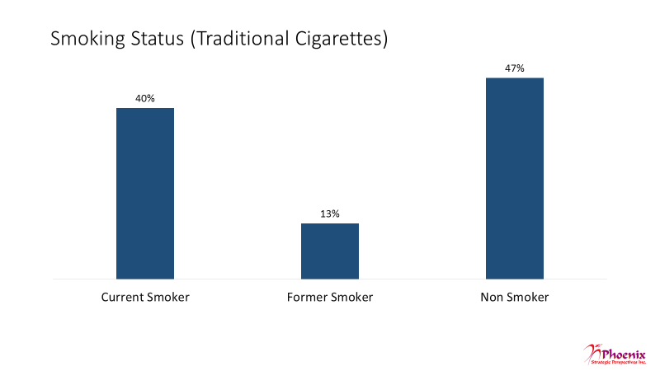

Base: n=1,509; all surveyed respondents

This includes cigarettes that are bought ready-made, as well as cigarettes that people make themselves.

Compared to Ontarians, respondents from Quebec were *less* likely to be current smokers (35% vs 45%), and men were *more* likely than women to be current smokers (43% vs 36%). In addition, the likelihood of currently smoking was higher among e-cigarettes users than non-users (69% vs 14%).

Vast majority of smokers have been smoking for 5 years or less

The vast majority of youth and young adult smokers (n=607) have been smoking cigarettes for five years or less (82%); only 16% said they have been smoking for more than five years. Young adults (age 20 to 24) were more likely to be daily smokers, as well as more likely to have been smoking for more than 5 years. Women were significantly more likely than men to have started smoking cigarettes less than a year ago (27% vs 19%).

Figure 2: Length of Time Smoking

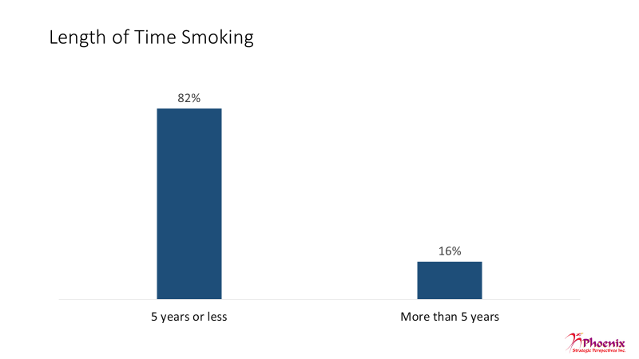

Base: n=607; those who smoke currently

Q5. How long have you been smoking cigarettes?

1. **E-cigarette Use**

Just over half of respondents have not tried e-cigarettes

Just over half the respondents (53%) said they have never tried an e-cigarette, while the remainder (47%) said they have tried e-cigarettes. Respondents were offered the following description of e-cigarettes:

*E-cigarettes are battery-powered vaping devices which are sometimes designed to look and feel like regular cigarettes. These devices are used to heat e-liquid into vapour you can inhale.*

Figure : Use of E-Cigarettes



Base: n = 1,509; all surveyed respondents

Q7. Have you ever tried an electronic cigarette, also known as an e-cigarette?

The likelihood of having tried e-cigarettes was higher among young adults (20-24 years old) than youth (15-19 years old) (51% vs 43%), and among men compared to women (50% vs 44%).

E-cigarette users are occasional users

Respondents were more likely to say they are occasional e-cigarette users. While 53% do not use e-cigarettes, 15% said they do so occasionally and 6% do so daily. In addition, 14% are infrequent users, and 13% said they have used an e-cigarette once. Men were more likely than women to be daily users.

When asked how old they were when they first tried an e-cigarette, e-cigarette users (n=713) were more likely to say they were between 16 and 21 years of age. Nearly two-thirds of users were between 16 and 18 years of age (32%) or 19 and 21 years of age (31%) when they first tried an e-cigarette. An additional 20% said they were between 12 and 15 years old, while 18% were 21 to 24 years old when they first tried an e-cigarette.

Figure : E-Cigarette User Profile Frequency of Use

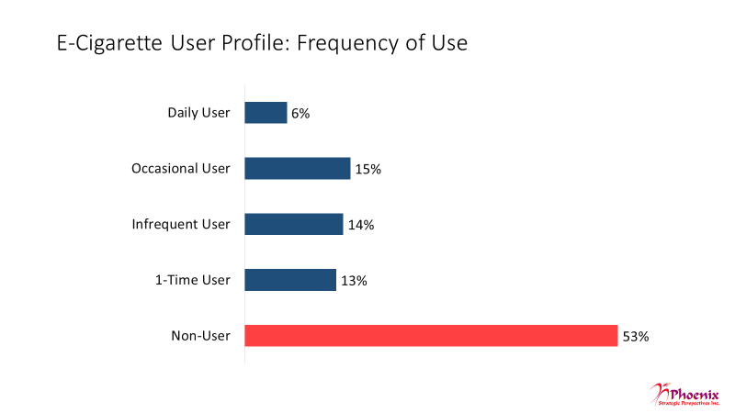Base: n = 1,509; all surveyed respondents

Q12. Which of the following statements best describes your use of e-cigarettes?

Figure : E-Cigarette User Profile Age of First Use

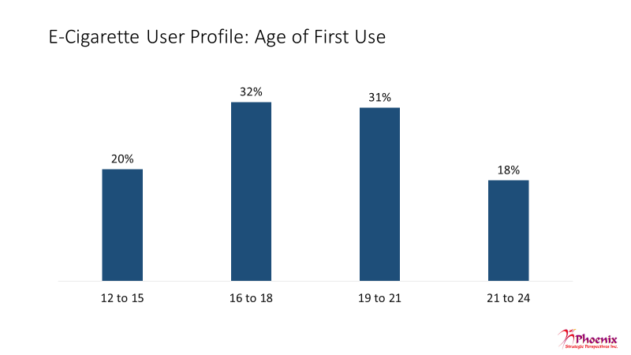

Base: n=713; all e-cigarette users

Q13. How old were you when you first tried an e-cigarette?

E-cigarette users more likely to have tried traditional cigarettes first

The large majority of e-cigarettes users who are current or former smokers said they tried traditional cigarettes before e-cigarettes. Fully 83% said they tried traditional cigarettes first, followed by e-cigarettes.

Figure : Path of Use



Base: n = 613; those who use e-cigarettes, are smokers and are former smokers

Q8. Which did you try first?

Youth were more likely to have used e-cigarettes first (21% vs 13%), while young adults were more likely to have tried regular cigarettes first (86% vs 78%).

Friends most common source of awareness of e-cigarettes

Friends are, by far, the most common source through which respondents first learned about e-cigarettes, with close to two-thirds (62%) saying this is how they initially heard about them. Friends were identified twice as often as the next most frequently cited source which was social media (31%). This was followed by news sources (22%), family members (19%), store signs/advertisement (16%), YouTube (10%), and co-workers (7%) (multiple responses accepted).

Young adults were more likely to have heard about e-cigarettes from their co-workers than youth (10% vs 4%). Conversely, youth were more likely to have first learned about e-cigarettes from YouTube (12% vs 8%). The likelihood of having learned about e-cigarettes from social media was higher among women (35% vs 28%). Men, on the other hand, were more likely to have first learned about e-cigarettes from YouTube (12% vs 8%).

Figure : Sources of E-Cigarette Awareness

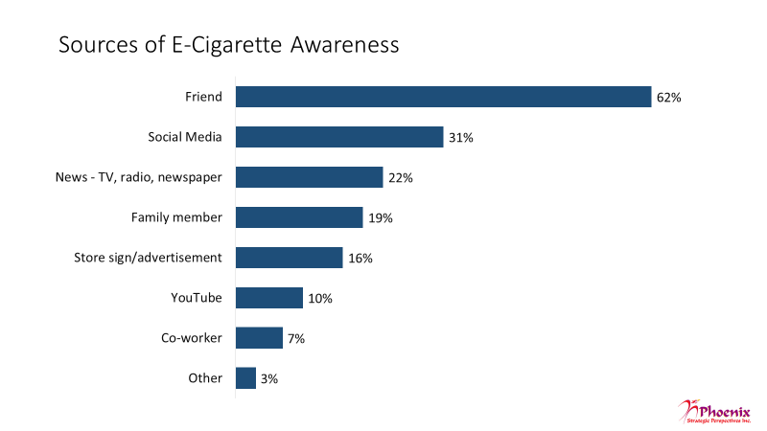

Base: n=1,509; all surveyed respondents

MULTIPLE RESPONSES ACCEPTED

Q10. How did you first learn or hear about e-cigarettes?

Acquaintances of all kinds use e-cigarettes

Friends top the list of people in respondents’ lives who use e-cigarettes. Just over half (53%) indicated that they have friends who use e-cigarettes. Over one-quarter (29%) said classmates use e-cigarettes, while one-in-five (20%) identified family members as users (multiple responses accepted). This was followed by 15% who identified co-workers and 6% who identified parents or guardian as users of e-cigarettes.

Young adults were more likely to say their friends as well as their co-workers are people in their lives that use e-cigarettes. In contrast, youth were more likely to say they have classmates who use e-cigarettes. Turning to gender, men were more likely to have a friend or co-worker who uses an e-cigarette, while women were apt to have a family member who does. Respondents who currently smoke cigarettes were more likely than non-smokers, and in some cases former smokers, to have a friend, classmate, family member or co-worker in their life who uses e-cigarettes.

Compared to non-users, e-cigarettes users were more likely to have different people in their lives who also use e-cigarettes. The differences for each type of person are as follows: friends (75% user vs. 33% non-user), classmates (36% user vs. 22% non-user), family members (27% user vs. 15% non-user), co-worker (20% user vs. 10% non-user), and parent or guardian (7% user vs. 4% non-user).

Figure : E-Cigarette Users in Personal Life

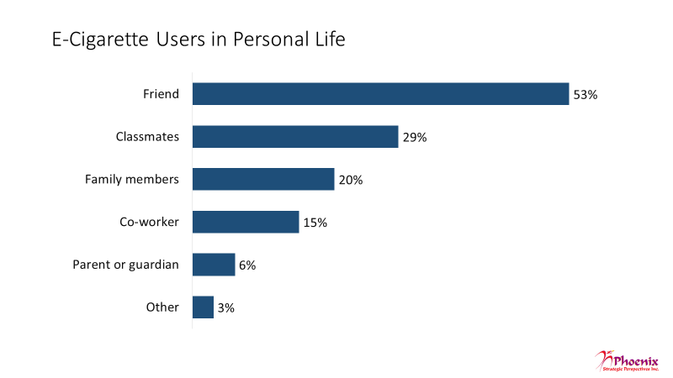

Base: n=1,509; all surveyed respondents

MULTIPLE RESPONSES ACCEPTED

Q11. Do any of the following people in your life use e-cigarettes?

1. **E-cigarette Users’ Knowledge and Habits**

Most vapers are correct regarding nicotine content of e-cigarettes

Users of e-cigarettes were asked which of the following statements about e-cigarettes is true:

* E-cigarettes always contain nicotine
* E-cigarettes sometimes contain nicotine
* E-cigarettes never contain nicotine

In response, a majority chose the correct statement. Nearly two-thirds of e-cigarette users (64%) said that e-cigarettes *sometimes* contain nicotine. Just over one in five responded incorrectly, either by indicating that e-cigarettes *always* contain nicotine (14%) or *never* contain nicotine (8%). A further 14% said they did not know.

Figure : Knowledge of Nicotine Content

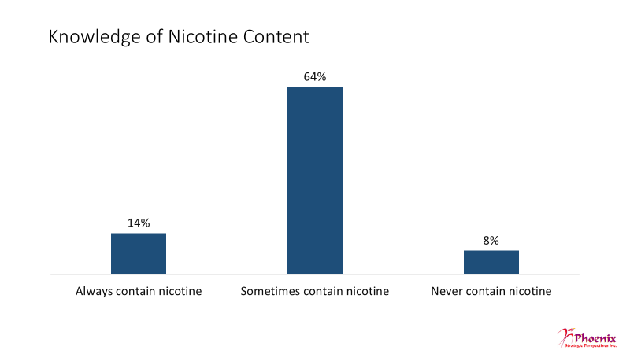

Base: n=713; all e-cigarette users

Q14. Which of the following statements about e-cigarettes is correct?

Compared to youth, young adults were more likely to say that e-cigarettes *always* (17% vs 11%) or *sometimes* contain nicotine (68% vs 60%). Youth were more apt that young adults to believe that e-cigarettes *never* contain nicotine (11% vs 6%). The likelihood of saying that e-cigarettes *always* contain nicotine was higher in Quebec (21%), as well as among current smokers (16%) and daily e-cigarette users (21%).

Friends, flavour, free - Top reasons why one-time users tried e-cigarettes

One-time users of e-cigarettes (n=189) were asked to identify the top two reasons why they tried e-cigarettes. In response, three reasons were identified most frequently: because their friends were vaping (43%), because they liked the flavours and smell (40%), and because it was offered to them (39%) (multiple responses accepted).

This was followed by nearly one-quarter (23%) who said they tried an e-cigarette because it looked fun and exciting. Small numbers said they tried an e-cigarette in order to try to quit smoking (4%), or because they wanting to try it (3%).

Figure : First-Time Users' Reasons for Trying E-Cigarettes

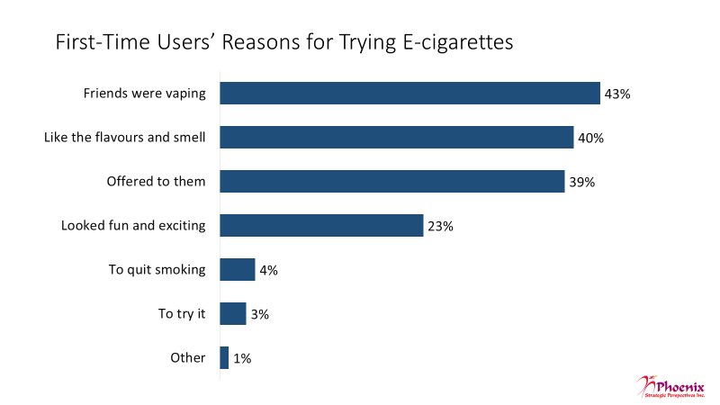

Base: n=189; one-time users

MULTIPLE RESPONSES ACCEPTED

Q15. Why did you try an e-cigarette?

Youth (15 to 19 years old) were more likely to say they tried e-cigarettes because their friends were vaping (55% vs 32%). Conversely, young adults (20 to 24 years old) were more likely to say they tried because they liked the flavours and smell (48% vs 32%).

One-time and infrequent users divided over likelihood of trying e-cigarettes again

One-time and infrequent users of e-cigarettes were divided over whether or not they would try an e-cigarette again: 38% said they would, 32% said they would not, and 30% said they did not know.

Figure : Likelihood of Trying E-Cigarettes Again



Base: n=397; those who are first-time and infrequent smokers

Q16. Do you think you will try an e-cigarette again?

Among those who said they would not try e-cigarettes again or who did not know if they would (n=251), the main reasons cited were that it’s not healthy (40%) and that it’s unappealing (37%) (two responses accepted).

Figure : Reasons for Not Using E-Cigarettes Again

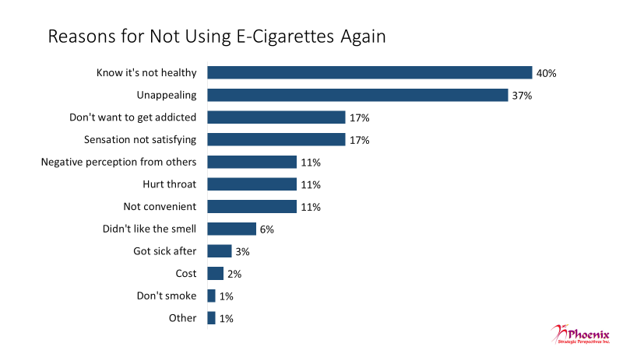

Base: n=251; those who won’t or don’t know if they will try again

TWO RESPONSES ACCEPTED. Q17. Why would you not use an e-cigarette again?

These reasons were followed at a distance by equal proportions who said that they do not want to get addicted and that the sensation was not satisfying (17% each). Approximately one-in-ten (11%) said they would not use e-cigarettes again because of the negative perception of others, because it hurt their throat, and because it is not convenient. Smaller proportions said they wouldn’t use again because they didn’t like the smell (6%), because they got sick after vaping (3%), and because of the cost (2%).

Respondents from Quebec were less likely to say they will try an e-cigarette again (28%). Current smokers were more likely than former and non-smokers to say they will try an e-cigarette again (49% vs. 24% and 25%).

In addition, non-smokers were more likely than current and former smokers to cite e-cigarettes not being healthy as their reason for not using them again (50% vs. 33% and 42%). Non-smokers and former smokers were more likely to say they would not try e-cigarettes again because it was generally unappealing to them (49% and 42% vs. 26% of current smokers). Current smokers were more likely to say they would not try e-cigarettes again because the sensation was not satisfying (25% vs. 9% of former smokers and 12% of non-smokers).

Use among daily and occasional users more likely to have not changed

Daily and occasional users of e-cigarettes (i.e. those using them daily or several times a month) (n=316) were asked if their frequency of use has changed since they first started using e-cigarettes. In response, the largest proportion (40%) said that their frequency of use has not changed. Most of the rest were equally divided between ones who said that it has increased and ones who said it has decreased (28% each). A small proportion (4%) said they did not know.

Figure : Frequency of E-Cigarette Use Over Time

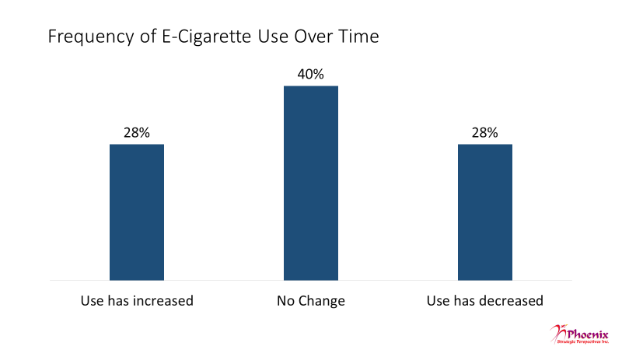

Base: n=316; daily and occasional e-cigarette users

Q18. Since you first started using e-cigarettes, has your frequency of use changed?

Youth were more likely to say their frequency of use has not changed since they started using e-cigarettes (47% vs 35%). Daily e-cigarette users were more likely than occasional users to report that their use has increased (45% vs. 21%).

Many daily and occasional vapers use e-cigarettes at home

A majority of daily and occasional users of e-cigarettes (59%) said they tend to use e-cigarettes at home. A substantial minority (43%) said they tend to use them at parties, while approximately one-quarter identified the sidewalk (29%), school (26%), while driving (24%), and work (23%) (multiple responses accepted). Locations cited less frequently included bars (14%), and movie theatres, pool halls etc. (10%).

Figure : Location of E-Cigarette Use

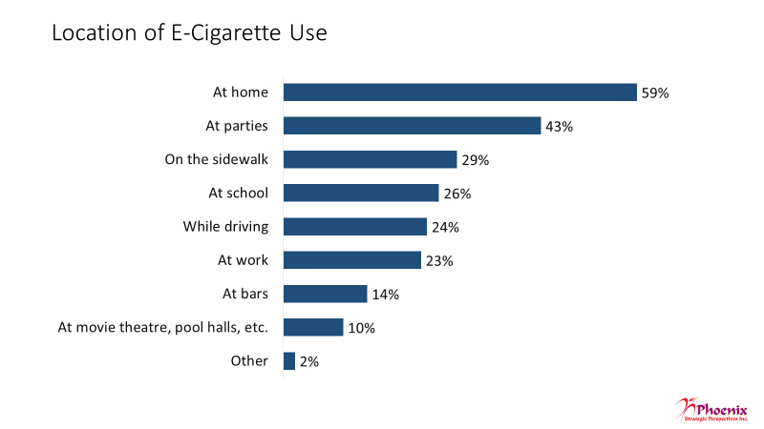

Base: n=316; daily and occasional e-cigarette users

MULTIPLE RESPONSES ACCEPTED

Q19. Where do you tend to use e-cigarettes?

Respondents 20 and 24 years old were more likely to say they use e-cigarettes at home (69% vs 48%) and while they are driving (31% vs 16%). Those between 15 and 19 were more apt to say they use them at parties (51% vs 36%), at school (36% vs 17%), or at movie theatres or pool halls (15% vs 5%). Compared to women, men were more likely to report using e-cigarettes at home (64% vs 53%) and at work (32% vs 12%).

Most daily users[4] vape within an hour of waking

Three-quarters of daily users of e-cigarettes (76%) said, that on a typical day, they vape within one hour of waking up, with almost half (46%) doing so almost immediately after waking (i.e. within 15 minutes of waking). Close to one in five (17%) said they wait at least an hour or more before vaping.

Figure : Length of Time After Waking Before Using an E-Cigarette

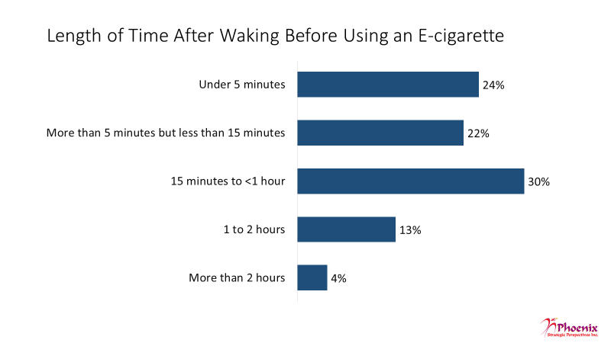

Base: n=87; those who are daily e-cigarette users

Q20. On a typical day, how soon after you wake up do you use your e-cigarette?

More than half of daily users[5] have strong cravings

When daily users were asked whether they have strong cravings to use an e-cigarette, more than half (57%) said they did, while one-third (33%) said they did not. One in ten said they did not know.

Figure : Strong Cravings to Use an E-Cigarette



Base: n=87; those who are daily e-cigarette users

Q21. Do you ever have strong cravings to use an e-cigarette?

1. **Parental Awareness**

Half of users’ parents aware of their use

Half (51%) of all e-cigarette users indicated that their parents are aware that they use e-cigarettes. Conversely, 40% said that their parents do not know about their use of e-cigarettes, while 9% said they did not know.

Figure : Parents' Awareness of E-Cigarette Use



Base: n=713; all e-cigarette users.

Q22. Do your parents or guardian know that you use an e-cigarette?

Daily e-cigarette users (78%), current smokers (58%), and men (55%) were more likely to say that their parents or guardian know about their e-cigarette use.

Parental views on e-cigarettes vary

Respondents whose parents are aware of their use of e-cigarettes (n=356) were asked which of the following statements describes their parents’ or guardian’s views of e-cigarettes:

* They’re worried about the health risks of e-cigarettes.
* They’re worried about the safety risks of e-cigarettes.
* They pressure me to stop using e-cigarettes all the time.
* They don’t really care that I use e-cigarettes.
* They don’t really care that I use e-cigarettes because they think it’s less harmful than smoking traditional cigarettes or other drugs.
* They don’t care at all about what I put in my body.
* They don’t know much about e-cigarettes.
* They don’t know anything about e-cigarettes.

Responses were mixed, with similar proportions attributing the following views to their parents or guardian: they don’t really care that e-cigarettes are being used because they are less harmful than traditional cigarettes or other drugs (26%), they are worried about the health risks of using e-cigarettes (26%), they don’t really care that e-cigarettes are being used (23%), and they are worried about the safety risks of e-cigarettes (23%) (up to three statements accepted).

Figure : Parents' Perceptions of E-Cigarettes



Base: n=356; those respondents’ whose parents are aware

THREE RESPONSES ACCEPTED

Q23. Which of the following describes your parents’ or guardian’s view of e-cigarettes?

Approximately one-in-five (19%) indicated their parents or guardian doesn’t know much about e-cigarettes, while slightly fewer (16%) said they are pressured to stop using e-cigarettes all the time. Smaller, and almost equal, proportions indicated that their parents or guardian don’t care at all about what they put in their bodies (7%) and don’t know anything about e-cigarettes (6%).

Youth were more likely than young adults to say that their parents are worried about the health (35% vs 18%) and safety risks (31% vs 16%) of e-cigarettes and that they pressure them to quit (21 vs 11%), while young adults were more likely to say that their parents do not care (30% vs 19%).

1. **Quitting Behaviour**

Most daily and occasional vapers have not tried quitting but think they will

Asked if they had ever tried to stop using e-cigarettes, nearly two-thirds (64%) of daily and occasional e-cigarette users said they have not, while 32% said they have tried quitting (4% did not know). Asked if they think they will *ever* stop using e-cigarettes, 43% of these same respondents said yes, while nearly one-quarter (23%) said no, and approximately one-third (34%) said they were unsure/did not know.

Figure : Quitting E-Cigarettes Tried to Stop Using



Base: n=316; daily and occasional e-cigarette users. Q24. Have you ever tried to stop using e-cigarettes?

Figure : Quitting E-Cigarettes Likelihood of Ever Quitting

 Base: n=316; daily and occasional e-cigarette users.

Q25. Do you think you will stop using e-cigarettes?

Majority of smokers who vape daily or occasionally have used e-cigarettes as quitting aide; most who haven’t are likely to try

A majority of respondents who are smokers as well as daily or occasional users of e-cigarettes (58%) said they have used e-cigarettes as an aide to quit smoking cigarettes. Conversely, 38% said they have not. The remaining 4% said they did not know or were unsure.

Daily e-cigarette users are more likely than occasional users to have used e-cigarettes for smoking cessation.

Figure : Use of E-Cigarettes to Quit Smoking



Base: n=309; smokers who also use e-cigarettes

Q26. Have you ever used e-cigarettes to help you quit smoking cigarettes?

Among those who have not used an e-cigarette to quit smoking cigarettes (n=132), the majority (62%) said they would be likely to do this. That said, they were much more likely to indicate that they would be *somewhat* likely to do this (48%) than *very* likely to do it (14%). Among the rest, 14% said they were *not very* likely to do this, 5% said they were *not at all* likely to do it. Seven percent said they were not planning on quitting. In all, 12% said they did not know.

Figure : Likelihood of Using E-Cigarettes to Quit Smoking



Base: n=132; those who have not tried e-cigarettes to quit cigarettes

Q27. How likely is it that you would consider using e-cigarettes as an aid to help you quit smoking cigarettes?

1. **Consumer Behaviour**

Majority own a device; devices most likely to be refillable

The majority of daily and occasional users of e-cigarette said they own their own device (fully 77% said they own a device, while 23% said they do not).

Figure : Devices Ownership



Base: n=316; daily and occasional e-cigarette users

Q28. Do you have your own e-cigarette device?

Among those who own a device (n=244), more than half (58%) said they always use a device that can be refilled. A further 35% said they sometimes use one that can be refilled. Only 5% said they never use a refillable device (2% did not know).

Figure : Devices Use of Refillable Devices

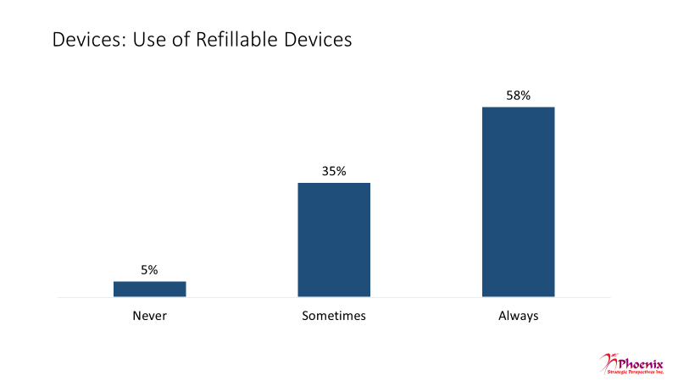

Base: n=244; those who own a device

Q29. Do you use an e-cigarette that can be refilled?

Majority use nicotine sometimes or all the time in e-cigarettes

Among owners of an e-cigarette device, a small majority (54%) said they *sometimes* use nicotine in their e-cigarette. Conversely, nearly one-quarter (23%) said they *always* use nicotine, while approximately one in five (19%) said they *never* use nicotine.

Figure : Nicotine Use in E-Cigarettes Frequency of Use

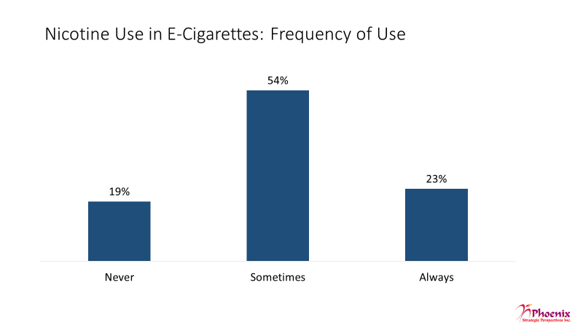

Base: n=244; those who own a device

Q30. How often, if at all, do you use nicotine in your device?

Half of the respondents who use nicotine in their e-cigarette (51%) do not know what concentration of nicotine they use. Of those who do know the concentration,13% said they use 3mg/ml or 0.3%, while 10% said they use more than this and 6% said they use less than this.

Figure : Nicotine Use in E-Cigarettes Nicotine Concentration

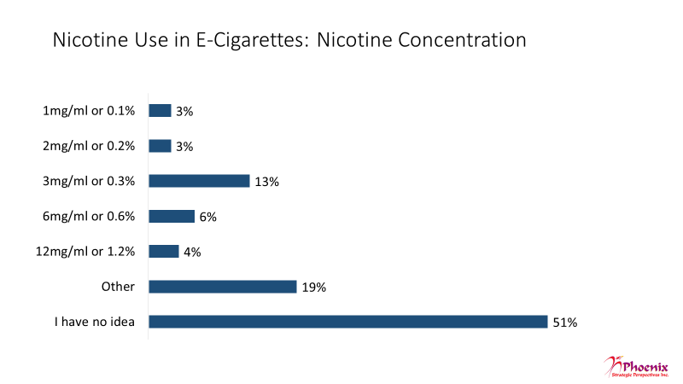

Base: n=188; those who use nicotine

Q31. What concentration of nicotine do you typically use?

Fruit by far the most popular flavour among e-cigarette users

The most popular flavour by far among e-cigarette users is fruit. Asked what flavour they used last time they vaped, over one-third (37%) said fruit. This was followed at a distance by bubble gum (11%), coffee/ cappuccino (7%), tobacco (6%), dessert (6%), candy/ confectionary (5%), candy floss or marijuana (4%), soft drinks/energy drinks (3%), and cookies (2%).

Figure : E-Cigarette Flavour Preferences Last Flavour Used

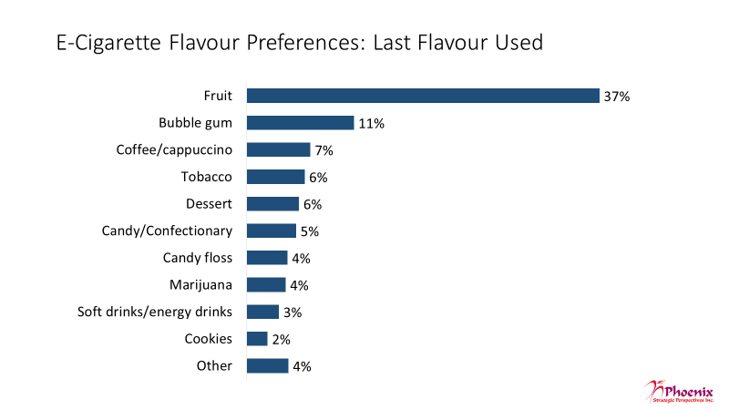

Base: n=713; all e-cigarette users

Q32. What flavour did you use the last time you used an e-cigarette?

The following table presents the results broken out by age segment (differences not statistically significant):

Figure : E-Cigarette Flavour Preferences Last Flavour Used by Age Group

|  |  |  |
| --- | --- | --- |
| **Flavour** | **Youth** | **Young Adults** |
| Fruit | 34% | 40% |
| Bubble gum | 12% | 11% |
| Coffee/cappuccino | 7% | 6% |
| Tobacco | 6% | 6% |
| Dessert | 7% | 4% |
| Candy/confectionary | 6% | 5% |
| Candy floss | 4% | 5% |
| Marijuana | 5% | 4% |
| Soft drinks/energy drinks | 3% | 4% |
| Cookies | 2% | 2% |

Asked specifically what flavour they prefer, nearly one-third (32%) of e-cigarette users said they prefer fruit. This was followed at a distance by bubble gum (9%), coffee/ cappuccino (7%), dessert and marijuana (6% each), candy/confectionary and candy floss (5% each), tobacco and soft drinks/energy drinks (4% each), and cookies (2%).

Included in the ‘other’ category are black cherry/cherry, alcohol, cereal, vanilla, and mint, among a small number of others.

Figure : E-Cigarette Flavour Preferences Preferred Flavour

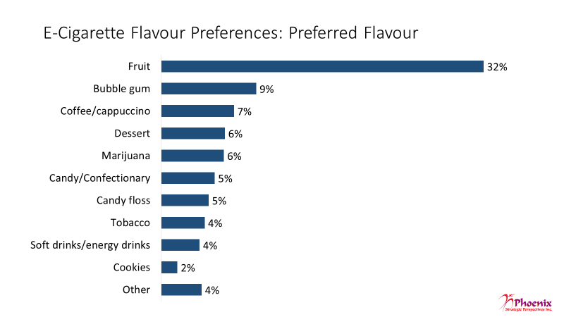

Base: n=713; all e-cigarette users

Q33. What is your preferrede-cigarette flavour?

The following table presents the results broken out by age segment (statistically significant differences are noted using italics):

Figure : E-Cigarette Flavour Preferences Preferred Flavour by Age Group

|  |  |  |
| --- | --- | --- |
| **Flavour** | **Youth** | **Young Adults** |
| Fruit | 30% | 34% |
| Bubble gum | 12% | 7% |
| Coffee/cappuccino | 7% | 8% |
| Dessert | 7% | 5% |
| Marijuana | 6% | 7% |
| Candy/confectionary | 6% | 5% |
| Candy floss | 5% | 4% |
| Tobacco | 5% | 4% |
| Soft drinks/energy drinks | 3% | 5% |
| Cookies | 2% | 2% |

Nearly half of daily and occasional e-cigarette users buy them themselves at stores

Daily and occasional e-cigarette users are most likely to acquire their e-cigarettes by purchasing them themselves. Nearly half (47%) said they usually buy their e-cigarettes at a store, while 20% said they buy them online, 12% from friends, and 8% from someone else (multiple responses accepted). Fewer, but a sizeable proportion nonetheless, said they usually borrow their e-cigarettes or get them from someone else. This includes 17% who said they get them from friends, 8% from someone else, and 7% from family members. Fourteen percent said they ask someone to purchase e-cigarettes for them.

Figure : Purchasing Habits

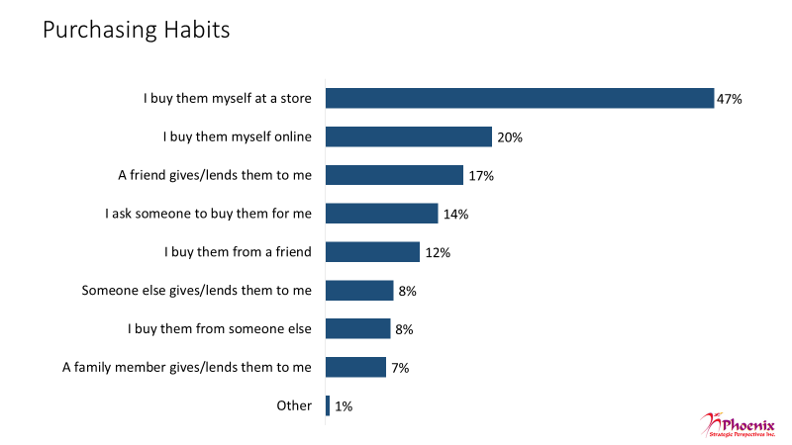

Base: n=316; daily and occasional e-cigarette users

MULTIPLE RESPONSES ACCEPTED

Q34. From where do you usually get your e-cigarettes?

Young adults are more likely than youth to say they buy their own e-cigarettes (57% vs 36%). Youths are more likely than young adults to say they ask someone else to buy them for them (22% vs. 6%) and that they buy them from someone else (11% vs. 5%).

1. **Risk Perceptions and Attitudes**

Flavours and smell - most common reasons for using e-cigarettes

Users of e-cigarettes (n=713) collectively identified a number of reasons why they vape, but flavour and aroma topped the list with nearly half (45%) identifying this as the reason they use e-cigarettes. Close to one-third explained that they vape because their friends do (31%) or because it’s safer than smoking traditional cigarettes (30%). In addition, almost equal numbers said that they like doing tricks with the vapour (22%), that it’s fun and exciting (21%), and that they use to help them quit cigarettes (20%) (multiple responses accepted).

Figure : Reasons for E-Cigarette Use

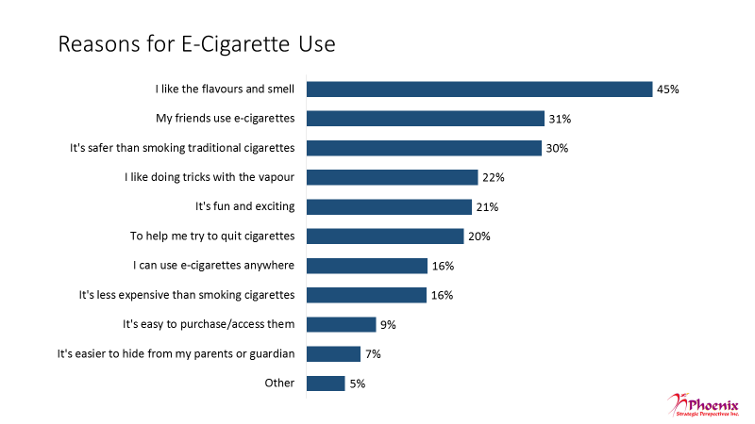

Base: n=713; all e-cigarette users

THREE RESPONSES ACCEPTED

Q35. Why do you use e-cigarettes?

This was followed by equal numbers (16% each) who said they can use e-cigarettes because they can vape anywhere and they are less expensive than cigarettes. Smaller numbers said they use e-cigarettes because it’s easy to purchase them (9%) and because it is easier to hide their use from their parents (7%).

Youth were more likely than young adults to say they use e-cigarettes because their friends do (39% vs 24%). Occasional and infrequent users were more likely than daily users to say they use e-cigarettes because they like the flavours and smell (52% and 50% vs 30%).

Health risks and cost identified as main disadvantages of vaping

Two perceived disadvantages of using e-cigarettes were most frequently identified by vapers: the associated health risks and the cost, each identified by 55% of e-cigarette users. Sizeable proportions also identified the potential of becoming addicted (43%) and the social stigma associated with using e-cigarettes (37%), while one in five (20%) identified having to vape outdoors, and 16% identified the smell (multiple responses accepted).

Women were more likely to mention the following disadvantages: the associated health risks (60%), the cost (60%), and the potential to become addicted (48%). Among e-cigarette users, the likelihood of saying the associated health risks are a disadvantage decreased with use, from one-timer users (66%) to daily users (34%). Current cigarette smokers were more likely to point to having to smoke outside (23%) and the social stigma of using e-cigarettes (39%) as disadvantages, while former smokers were more apt to mention the associated health risks (64%).

Figure : Perceived Disadvantages of E-Cigarettes

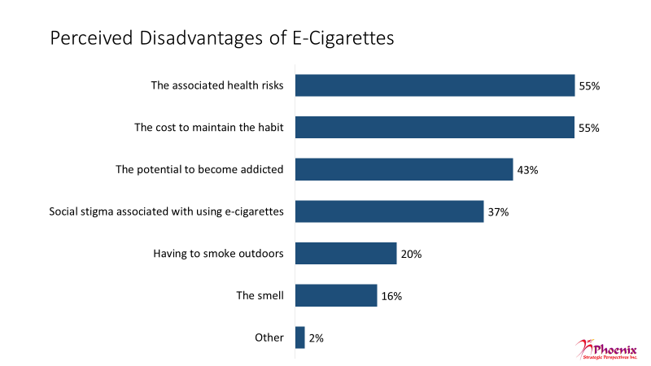

Base: n=713; all e-cigarette users

THREE RESPONSES ACCEPTED

Q36. What would you say are the main disadvantages of using e-cigarettes?

Using cigarettes and e-cigarettes with nicotine seen as most risky activities

All respondents were asked to rate the extent to which they think people risk harming themselves when they do each of the following activities:

* Using an e-cigarette containing nicotine once in a while
* Using a nicotine-free e-cigarette once in a while
* Using an e-cigarette containing nicotine on a regular basis
* Using a nicotine-free e-cigarette on a regular basis
* Using cigarettes once in a while
* Using cigarettes on a regular basis

With one exception, a majority of respondents consider all of these activities at least moderately risky. However, the size of the majority varied considerably, ranging from 90% to 52%. Respondents were most likely to rate regular use of cigarettes and e-cigarettes containing nicotine as risky. Fully 90% rated regular use of cigarettes as at least moderately risky while 82% felt that way about regular use of e-cigarettes containing nicotine. That said, regular use of cigarettes was much more likely to be seen as a ‘great’ risk than regular use of e-cigarettes containing nicotine (76% vs. 46%).

Nearly three-quarters of respondents (74%) consider occasional use of cigarettes as at least somewhat risky while close to two-thirds (63%) felt that way about occasional use of e-cigarettes containing nicotine. Here again, occasional use of cigarettes was more likely to be seen as posing a ‘great’ risk than occasional use of e-cigarettes containing nicotine (28% vs. 19%).

Just over half (52%) rated using nicotine-free e-cigarettes on a regular basis as risky, though they were much more likely to rate this as a moderate risk (36%) than a great risk (16%).

Occasional use of nicotine-free e-cigarettes was the only activity which a majority viewed as posing no more than a slight risk (59%). That said, just over one-third (35%) rated this as at least moderately risky.

Figure : Perceived Risks of Smoking and Vaping

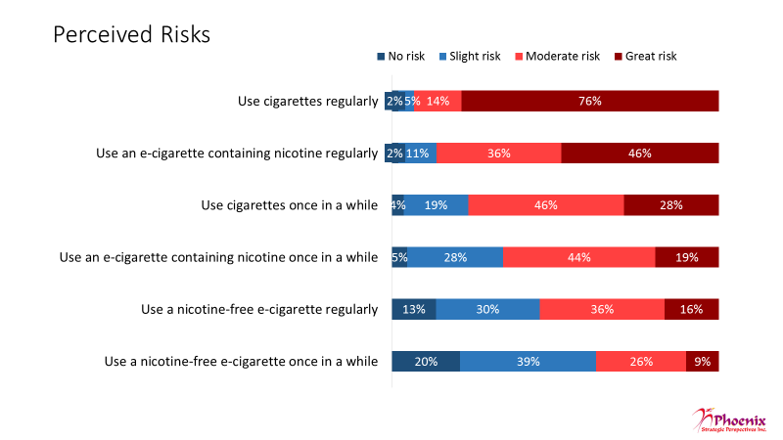

Base: n=1,509; all surveyed respondents

Q37. How much do you think people risk harming themselves when they do each of the following activities?

Figure 35 displays the results by e-cigarette use. Apart from using nicotine-free e-cigarettes once in a while, non-users were more likely than e-cigarette users to perceive every risk as a *great* risk. Among e-cigarette users, occasional users were more likely to view all the risks as moderate as opposed to great.

Figure : E-Cigarette Status and Perceived Risks

|  |  |  |  |  |  |  |  |  |
| --- | --- | --- | --- | --- | --- | --- | --- | --- |
| **E-Cigarette Status** | | | | | | | | |
|  | **User** | | | | **Non-User** | | | |
| **No Risk** | **Slight Risk** | **Moderate Risk** | **Great Risk** | **No Risk** | **Slight Risk** | **Moderate Risk** | **Great Risk** |
| Use cigarettes regularly | **3%** | **7%** | **20%** | 67% | 1% | 3% | 9% | **85%** |
| Use an e-cigarette containing nicotine regularly | **3%** | **15%** | **42%** | 36% | 1% | 7% | 32% | **55%** |
| Use cigarettes once in a while | **6%** | **22%** | 48% | 22% | 2% | 16% | 45% | **34%** |
| Use an e-cigarette containing nicotine once in a while | **6%** | **35%** | 44% | 10% | 3% | 21% | 45% | **26%** |
| Use a nicotine-free e-cigarette regularly | **15%** | **36%** | 34% | 10% | 10% | 24% | 37% | **20%** |
| Use a nicotine-free e-cigarette once in a while | **25%** | 41% | 24% | 7% | 15% | 37% | 28% | 12% |

Overall, men and current smokers attributed moderate or great risk to fewer items than women and former smokers.

Perceptions of e-cigarettes tend to be mixed

Respondents were asked to rate the extent to which they agree or disagree with the following statements:

* I believe e-cigarettes are no better than smoking regular cigarettes
* Nicotine-free e-cigarettes pose little health risks to users
* E-cigarettes don’t have the same chemicals in them as regular cigarettes so they are safer to use
* You can become addicted to e-cigarettes containing nicotine
* Using e-cigarettes will lead to smoking regular cigarettes
* Smoking regular cigarettes is not socially acceptable but using an e-cigarette is not a big deal
* Nicotine is a toxic chemical and should be avoided
* Using an e-cigarette is embarrassing/not cool

Respondents’ views regarding most of these statements were mixed. Only in relation to two statements did a majority pronounce itself one way or another, with over three-quarters agreeing that one can become addicted to e-cigarettes containing nicotine (79%) and that nicotine is a toxic chemical that should be avoided (77%). In neither case, however, did a majority of respondents ‘strongly’ agree with the statement.

In relation to all other statements, opinion tended to be divided between those agreeing, those disagreeing, and those neither agreeing nor disagreeing. That said, respondents were more likely to agree than disagree with the following: that e-cigarettes are no better than regular cigarettes (47% vs. 29%), that e-cigarettes don’t have the same chemical content as cigarettes and are safer to use (38% vs. 29%), that using an e-cigarette is embarrassing/not cool (37% vs. 27%), and that nicotine-free e-cigarettes pose little health risks to users (36% vs. 31%). Conversely, respondents were slightly more likely to disagree than agree that using e-cigarettes will lead to smoking regular cigarettes (32% vs. 30%) and somewhat more likely to disagree than agree that smoking regular cigarettes is not socially acceptable but using an e-cigarette is not a big deal (42% vs. 25%).

The proportion of respondents neither agreeing nor disagreeing with all these statements ranged from 10% regarding whether one can become addicted to e-cigarettes with nicotine to 30% regarding whether using an e-cigarette is embarrassing/not cool.

Figure : Attitudes Towards E-Cigarettes and Nicotine

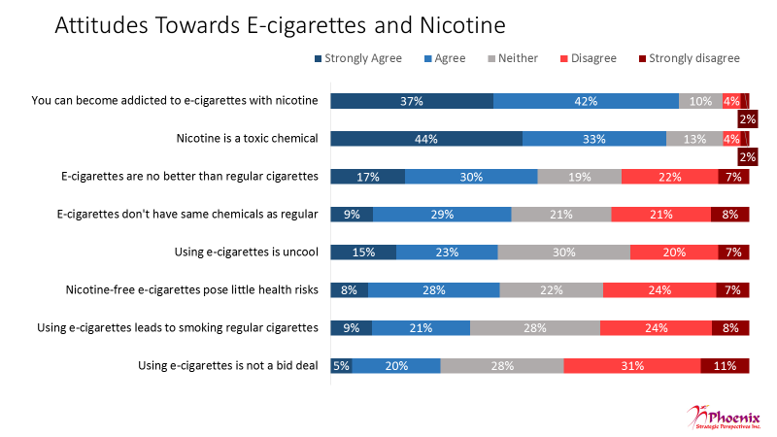

Base: n=1,509; all surveyed respondents

Q38. Please rate the extent to which you agree or disagree with the following statements?

Figure 37 displays the results by e-cigarette use.

Figure : E-Cigarette Status and Attitudes Towards E-Cigarettes and Nicotine

| **E-Cigarette Status** | | | | | | | | |
| --- | --- | --- | --- | --- | --- | --- | --- | --- |
|  | **User** | | | | **Non-User** | | | |
| **Strongly Agree** | **Agree** | **Disagree** | **Strongly Disagree** | **Strongly Agree** | **Agree** | **Disagree** | **Strongly Disagree** |
| You can become addicted to e-cigarettes with nicotine | 30% | 43% | **6%** | 2% | **43%** | 40% | 2% | 1% |
| Nicotine is a toxic chemical | 32% | **37%** | **6%** | 3% | **55%** | 29% | 2% | 2% |
| E-cigarettes are no better than regular cigarettes | 9% | 24% | **26%** | **11%** | **25%** | **34%** | 18% | 3% |
| E-cigarettes don't have same chemicals as regular | **13%** | **34%** | 15% | 5% | 6% | 25% | **26%** | **10%** |
| Using e-cigarettes is uncool | 9% | 21% | **29%** | **8%** | **21%** | 24% | 13% | 5% |
| Nicotine-free e-cigarettes pose little health risks | **10%** | **35%** | 19% | 3% | 7% | 22% | **29%** | **10%** |
| Using e-cigarettes leads to smoking regular cigarettes | 6% | 19% | **30%** | **12%** | **11%** | 23% | 19% | 5% |
| Using e-cigarettes not a big deal | **7%** | **26%** | 25% | 6% | 3% | 15% | **36%** | **14%** |

Women were more likely to agree with the statements than men. Women agreed that you can become addicted to e-cigarettes with nicotine (82% vs 76%), that nicotine is a toxic chemical (80% vs 74%), and that e-cigarettes are no better than regular cigarettes (50% vs 44%). Conversely, men were more a likely to agree that e-cigarettes don’t have the same chemicals as regular cigarettes (42% vs 35%) and that using e-cigarettes is not a big deal (30% vs 21%).

Turning to smoking status, current smokers were more likely than former smokers to agree using nicotine e-cigarettes poses little health risks (48% vs 38%) and e-cigarettes don’t have the same chemicals as regular cigarettes (48% vs 40%).

1. **Information Needs and Sources**

Information on health effects most common type of information sought

Users of e-cigarettes (n=713) were asked what type of information on e-cigarettes, if any, they have looked for. The most commonly mentioned information health effects (42%). This was followed by information about content/ingredients, with one-third looking for information on ingredients (33%) and chemicals (32%) in e-cigarette liquids. Just over one-quarter (27%) have looked for safety information, including general product safety and information about explosions and device defects, while almost as many have looked for information comparing e-cigarettes to regular cigarettes (24%), information about choosing nicotine levels (24%), and information about the cost of e-cigarettes (23%) (multiple responses accepted).

Figure : E-Cigarette Information Sought

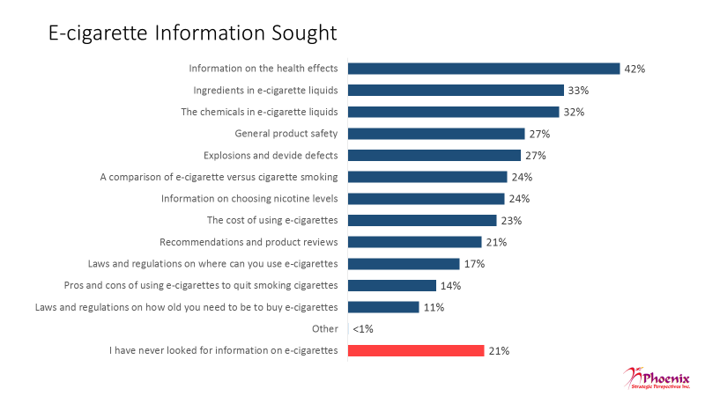

Base: n=713; all e-cigarette users

MULTIPLE RESPONSES ACCEPTED

Q39. What type of information, if any, have you looked for on e-cigarettes?

Following this, in declining order of frequency are information related to recommendations and product reviews (21%), laws and regulations on where one can use e-cigarettes (17%), pros and cons of using e-cigarettes to quit smoking cigarettes (14%), and laws and regulations on how old one needs to be to buy e-cigarettes (11%).

Just over one in five users (21%) say they have *never* looked for information on e-cigarettes.

Men were more likely than women to have sought information on the chemicals in liquids (36% vs 28%), explosions and device defects (31% vs 22%), choosing nicotine levels (28% vs 20%), and product recommendation (24% vs 16%). Among e-cigarette users, the likelihood of *never* looking for information on e-cigarettes was higher among one-time and infrequent users (34% and 22%).

Online resources - Main sources for health risk or benefits information

Online sources in one form or another constitute the main source of information for users of e-cigarettes (n=713) regarding the health risks or benefits of using e-cigarettes. Google leads the way, with over one-third of e-cigarette users (37%) identifying it as a source for such information. Google was followed at a distance by a cluster of online sources identified by similar proportions of respondents. These include Facebook (17%), online forums (16%), online news outlets (15%), and YouTube (14%) (up to three responses accepted). Online sources identified less frequently include Reddit (8%), Instagram (6%), and Pubmed/Google Scholar (4%).

Figure : Sources of E-Cigarette Information



Base: n=713; all e-cigarette users

THREE RESPONSES ACCEPTED

Q40. From which sources do you get information on the risks or benefits to your health of using e-cigarettes?

The most frequently identified non-Internet source of information was friends and colleagues, identified by just over one-quarter of respondents (28%). This was followed at a distance by vape shops (17%). Approximately one-in-ten said they consult research institutes/universities (11%), physicians/medical professionals (11%), and government sources (9%). The only other source identified with any frequency was testimonials (7%). It should be noted that these sources (i.e. health professionals, research institutes, government, testimonials) may also be accessible online, thereby underscoring the importance of online sources when it comes to getting information about e-cigarettes.

In all, 15% of e-cigarette users said they have *never* looked for information on the risks or benefits of using e-cigarettes.

Among e-cigarette users, the likelihood of *never* looking for information on the risks or benefits of e-cigarettes was higher among one-time and infrequent users.

1. **Respondent Profile**

The tables below provide a profile of survey respondents (all data are weighted).

Figure : Gender

|  |  |  |  |
| --- | --- | --- | --- |
| Gender | Age Cohort | | Total |
| **15-19** | **20-24** |
| Male | 51% | 49% | 50% |
| Female | 48% | 50% | 49% |
| Prefer not to say | 1% | 1% | 1% |

Figure : Language

|  |  |  |  |
| --- | --- | --- | --- |
| Language | Age Cohort | | Total |
| **15-19** | **20-24** |
| English | 81% | 84% | 82% |
| French | 19% | 16% | 18% |

Figure : Age

|  |  |  |  |  |
| --- | --- | --- | --- | --- |
| Age | Age Cohort | | | Total |
| **15-19** | | **20-24** |
| 15 | 21% | | -- | 10% |
| 16 | 20% | | -- | 10% |
| 17 | 20% | | -- | 10% |
| 18 | 17% | | -- | 9% |
| 19 | 22% | | -- | 11% |
| 20 | -- | 18% | | 9% |
| 21 | -- | | 20% | 10% |
| 22 | -- | | 20% | 10% |
| 23 | -- | | 21% | 10% |
| 24 | -- | | 21% | 10% |

Figure : Education

|  |  |  |  |
| --- | --- | --- | --- |
| Education Level | Age Cohort | | Total |
| **15-19** | **20-24** |
| Less than high school (no certificate, diploma or degree) | 47% | 3% | 25% |
| High School diploma or equivalent | 36% | 34% | 35% |
| Registered Apprenticeship or other trades certificate or diploma | 2% | 5% | 3% |
| College, CEGEP or non-university certificate or diploma | 6% | 22% | 14% |
| University certificate or diploma below bachelor's level | 3% | 9% | 6% |
| Bachelor's degree | 2% | 21% | 11% |
| Post graduate degree above bachelor's level | 1% | 4% | 2% |
| Prefer not to say | 3% | 2% | 3% |

Figure : Location

|  |  |  |  |
| --- | --- | --- | --- |
| Location | Age Cohort | | Total |
| **15-19** | **20-24** |
| Alberta | 11% | 11% | 11% |
| British Columbia | 11% | 13% | 12% |
| Manitoba | 4% | 4% | 4% |
| New Brunswick | 2% | 3% | 2% |
| Newfoundland and Labrador | 2% | 1% | 1% |
| Nova Scotia | 3% | 2% | 3% |
| Northwest Territories | 0% | 0% | 0% |
| Ontario | 39% | 39% | 39% |
| Prince Edward Island | 1% | 0% | 0% |
| Quebec | 25% | 23% | 24% |
| Saskatchewan | 3% | 2% | 3% |
| Prefer not to say | 0% | 1% | 0% |

# *Appendix*

## Annex 1: Qualitative Research Instruments

### A: Recruitment Screener

**Specifications**

* Recruit 12 participants.
* Participants to be paid $125.
* For each location, two groups will be held with youth (aged 15-19) and young adult (aged 20-24) participants who are e-cigarette users and the other two will be held with youth and young adult participants who are e-cigarette non-users.
* Each group will have a mix of participants who are of cigarette smoking and non-smoking status.

|  |  |  |  |  |  |
| --- | --- | --- | --- | --- | --- |
| **Group 1**  **Toronto**  Youth  (User) | **Group 2**  **Toronto**  Youth  (Non-user) | **Group 3**  **Toronto**  Young adult (User) | **Group 4**  **Toronto**  Young adult (Non-user) | **Group 5**  **Montreal**  Youth  (User) | **Group 6**  **Montreal**  Youth  (Non-user) |
| **Group 7**  **Montreal**  Young adult (User) | **Group 8**  **Montreal**  Young adult (Non-user) | **Group 9**  **Vancouver**  Youth  (User) | **Group 10**  **Vancouver**  Youth  (Non-user) | **Group 11**  **Vancouver**  Young adult (User) | **Group 12**  **Vancouver**  Young adult (Non-user) |

**Questionnaire**

Hello/Bonjour, my name is           . Would you prefer to continue in English or French? / Préférez-vous continuer en anglais ou en français?

**[INTERVIEWER NOTE: FOR ENGLISH GROUPS, IF PARTICIPANT WOULD PREFER TO CONTINUE IN FRENCH, PLEASE RESPOND WITH, "Malheureusement, nous recherchons des gens qui parlent anglais pour participer à ces groupes de discussion. Nous vous remercions de votre intérêt."]**

INTRO: I’m calling from Research House, a Canadian research firm. We’re organizing a series of discussion groups on behalf of the Government of Canada to explore issues of importance to Canadians. The groups will last up to two hours and people who take part will receive a cash gift to thank them for their time. The format is a "round table" discussion led by a research professional with up to ten participants. All opinions will remain anonymous and will be used for research purposes only in accordance with laws designed to protect your privacy. Before we invite you to attend, we need to ask you a few questions to ensure that we get a good mix of people in each of the groups. This will take 5 minutes. May I continue?

Yes **CONTINUE**

No **THANK/DISCONTINUE**

**[INTERVIEWER NOTE: IF ASKED ABOUT PRIVACY LAWS, SAY: “The information collected through the research is subject to the provisions of the *Privacy Act*, legislation of the Government of Canada, and to the provisions of relevant provincial privacy legislation.”]**

Q1. We have been asked to speak to participants from all different ages. May I have your age please? _________. **RECORD**

Under 14 **THANK/DISCONTINUE**

15 years old **GO TO Q3**

16 to 19 years **GO TO Q4**

20 to 24 years **GO TO Q4**

1. years or older **ASK Q2**

Q2. Are you a parent of guardian of a child between the ages of 15 and 20?

Yes, age 15 **GO TO Q2A**

Yes, age 16-20 **GO TO Q2B**

No **THANK/DISCONTINUE**

Q2A. May we have your permission to ask your child some further questions to see if s/he qualifies for the discussion group which will take place on **[INSERT DATE]** at **[TIME]**? The group will last up to 2 hours and your child will receive $125.00 for his/her time. The groups are being conducted on behalf of Health Canada to help them develop regulations and information campaigns about e-cigarettes. Your written consent for your child to participate in the focus group will be required upon arrival. In addition, your child will be asked to sign a waiver to acknowledge that s/he will be video-recorded during the session and that the recordings will be shared with Health Canada for research purposes only.

Yes **CONTINUE; REINTRODUCE TOPIC TO CHILD [INTRO] AND THEN GO TO Q4**

No **THANK/DISCONTINUE**

**[INTERVIEWER NOTE: IF THE CHILD IS NOT HOME, AND THE PARENT CONSENTS, ASK FOR THE CHILD’S NAME AND ARRANGE A TIME TO CALL BACK]**

Q2B. May we have your permission to ask your child some further questions to see if s/he qualifies for the discussion group?

Yes **CONTINUE REINTRODUCE TOPIC TO CHILD [INTRO] AND THEN GO TO Q4**

No **THANK/DISCONTINUE**

**[INTERVIEWER NOTE: IF THE CHILD IS NOT HOME, AND THE PARENT CONSENTS, ASK FOR THE CHILD’S NAME AND ARRANGE A TIME TO CALL BACK]**

Q3. Before we can continue, we need permission from your parent of legal guardian. May we speak to him/her?

Yes **CONTINUE**

No **THANK/DISCONTINUE**

**[INTERVIEWER NOTE: ARRANGE A TIME TO CALL BACK IF THE PARENT/GUARDIAN IS NOT HOME]**

Hello, I’m calling from Research House, a Canadian research firm. We’re organizing a series of discussion groups on behalf of the Government of Canada to explore issues of importance to Canadians. May we have your permission to ask your child some questions to see if s/he qualifies for the discussion group which will take place on **[INSERT DATE]** at **[TIME]**? The group will last up to 2 hours and your child will receive $125.00 for his/her time. The groups are being conducted on behalf of Health Canada to help them develop regulations and information campaigns about e-cigarettes. Your written consent for your child to participate in the focus group will be required upon arrival.

Yes **CONTINUE**

No **THANK/DISCONTINUE**

Q4. Do you, or any member of your household or immediate family, work for…? **READ LIST**

…a marketing research, public relations, or advertising firm?

…the media (radio, television, newspapers, magazines, etc.)?

…the federal or provincial government?

…tobacco or e-cigarettes company

…smoking cessation company

…legal or law firm

Yes **THANK/DISCONTINUE IF YES TO ANY**

No **CONTINUE**

Q6. Record gender by observation. **50/50 SPLIT**

Female

Male

Q7. Have you ever tried an electronic cigarette, also known as an e-cigarette?

Yes **GROUP 1, 3, 5, 7, 9 AND 11**

No **GROUP 2, 4, 6, 8, 10 AND 12**

**[SKIP Q8 IF NO AT Q7]**

Q8. At the present time, which of the following statements best describes your use of an electronic cigarette….? **MIX OF USERS BY FREQUENCY; MAXIMUM OF TWO PARTICIPANTS IN EACH GROUP WHO HAVE USED AN E-CIG ONCE ONLY.**

I use e-cigarettes every day

I use e-cigarettes at least 4 times in the past 30 days

I have used an e-cigarette, but not in the past 30 days

I have tried an e-cigarette once

Q9. At the present time, do you smoke cigarettes every day, occassionally, or not at all? **MIX OF SMOKER AND NON-SMOKER STATUS FOR EACH GROUP**

Every day

Occassionally

Not at all

**[ASK IF NOT AT ALL AT Q9]**

Q10. Have you ever smoked cigarettes? **MIX OF NON-SMOKER STATUS FOR THESE GROUPS**

Yes [FORMER SMOKER]

No [NEVER SMOKER]

Q11. Could you please tell me what is the last level of education that you completed? **READ LIST; GET MIX**

Some High School

Completed High School

Trade School certificate

Some Post secondary

Completed Post secondary

Graduate degree

Q12. Do you consider yourself to be a member of a visible ethno-cultural group?

Yes **CONTINUE**

No **GO TO Q14**

Q13. What is your ethnic background? **RECORD:**

Ethnicity: ______________

**Recruit at least two per group who are of non-European descent or who are other visible minorities (i.e. Chinese or South Asian, but could include aboriginal people or Afro-Canadians as well).**

Q14. Participants in group discussions are asked to voice their opinions and thoughts, how comfortable are you in voicing your opinions in front of others? Are you... **READ OPTIONS**

Very comfortable **MIN 5 PER GROUP**

Fairly comfortable

Not very comfortable **TERMINATE**

Very uncomfortable **TERMINATE**

Q15. Have you ever attended a discussion group or interview on any topic that was arranged in advance and for which you received money for your participation?

Yes **MAXIMUM 5 PER GROUP**

No **GO TO INVITATION**

Q16. When did you last attend one of these discussion groups or interviews?

Within the last 6 months **TERMINATE**

Over 6 months ago

Q17. Thinking about the groups or interviews that you took part in in the past 2 years, what was the main topic of these discussions?

RECORD: _______________

TERMINATE IF RELATED TO TOBACCO

Q18. How many discussion groups or interviews have you attended in the past 5 years?

Fewer than 5

Five or more **TERMINATE**

Q19. Sometimes participants are also asked to write out their answers on a questionnaire. Is there any reason why you could not participate? If you need glasses to read, please remember to bring them. (Add hearing impairment.)

Yes **TERMINATE**

No

**TERMINATE IF RESPONDENT OFFERS ANY REASON SUCH AS SIGHT OR HEARING PROBLEM, A WRITTEN OR VERBAL LANGUAGE PROBLEM, A CONCERN WITH NOT BEING ABLE TO COMMUNICATE EFFECTIVELY.**

**INVITATION TO PARTICIPATE:** I would like to invite you to attend the focus group session where you will exchange your opinions in a moderated discussion with other Canadians from your community. The discussion will be lead by a researcher from the national public opinion research firm, Phoenix SPI. The session will be taped and observed, but your participation will be confidential. The group will take place on **[DAY OF WEEK]**, **[DATE]**, at **[TIME]**. It will last two hours. People who attend will receive $125 to thank them for their time. Would you be willing to attend?

Yes

No **TERMINATE**

Do you have a pen handy so that I can give you the address where the group will be held? It will be held at **[INSERT FACILITY]**. I would like to remind you that the group is at **[TIME]** on **[DATE]**. We ask that you arrive 15 minutes early.

At the facility, you will be asked to produce photo identification, so please remember to bring something with you (for example, a driver's license). If you use glasses to read, please remember to bring them with you. **[INTERVIEWER NOTE: PLEASE ASK PARTICIPANT TO BRING WRITTTEN CONSENT FORM TO FOCUS GROUP**. “Please ensure that you bring a written consent form from your parent or guardian to participate in this group”**]**.

The session will be video recorded for research purposes and representatives of the Government of Canada research team will be observing from an adjoining room. You will be asked to sign a waiver to acknowledge that you will be video recorded during the session. The recordings will be used only by the Phoenix SPI research team and Health Canada clients (for research purposes only) and will not be shared with others. As I mentioned, all information collected in the group discussion will remain anonymous and be used for research purposes only in accordance with laws designed to protect your privacy.

As we are only inviting a small number of people to attend, your participation is very important to us. If for some reason you are unable to attend, please call us so that we can get someone to replace you. You can reach us at **[INSERT NUMBER]** at our office. Please ask **for [INSERT NAME]**.

Someone will call you the day before to remind you about the session.

**[15 YEAR OLDS ONLY: In the next few days we will be sending your parent or legal guardian a letter by email. The letter will have instructions on what you need to do for the discussion group, as well as a consent form that your parent or legal guardian must sign and return to us in advance of the group. Could I please confirm your name, your parent’s name, phone number, and your parent’s email address (or fax #, if applicable)?]**

PARENT/GUARDIAN

|  |  |
| --- | --- |
| First name: |  |
| Last Name: |  |
| Daytime phone number: |  |
| Evening phone number: |  |
| E-mail or fax number: |  |

So that we can call you to remind you about the focus group or contact you should there be any changes, can you please confirm your name and contact information for me?

PARTICIPANT

|  |  |
| --- | --- |
| First name: |  |
| Last Name: |  |
| Daytime phone number: |  |
| Evening phone number: |  |
| E-mail or fax number: |  |

### B: Moderator’s Guide

Introduction (5 minutes)

* Thank participants for attending
* Introduce moderator and Phoenix
* Tonight, we are conducting research on behalf of Health Canada to discuss electronic, or e-cigarettes.
* My job is to facilitate the discussion, keeping us on topic and on time.
* Your job is to offer your opinions about the issues to be covered tonight.
  + Not a knowledge test; no right or wrong answers (interested in opinions)
  + Looking for candour and honesty;
  + Okay to disagree; want people to speak up if hold different view
* Comments treated in confidence; reporting in aggregate form only; recording for report writing purposes only; observers behind one-way glass and watching online/listening by phone (adjust/use as appropriate)
* If you have a cell phone or other electronic device, please turn it off.
* Any questions?
* Roundtable introduction: Please tell us your first name and a hobby you have.

*USERS ONLY* Context: E-Cigarette user Behaviours (10 minutes)

When you were recruited for this study, all of you said you use or have tried e-cigarettes. I’d like to begin with a few general questions about your use patterns or behaviours …

1. How long have you been using e-cigarettes? [MODERATOR: LET PARTICIPANTS KNOW WE ARE NOT DISCUSSING THE USE OF E-CIG DEVICES FOR MARIJUANA SMOKING; NOTE HOW MANY USE E-CIGS AND ALSO VAPE CANNABIS]
2. How many of you use e-cigarettes on a daily basis? [HAND COUNT]
3. For those of you who do, approximately how many times a day do you use your e-cigarette?
4. For those who don’t, how often do you use e-cigarettes?
5. How many of you also smoke regular cigarettes [HAND COUNT]?

**[ASK CIGARETTE SMOKERS]**

1. At the present time, do you smoke cigarettes every day or only occasionally?
2. Why do you use e-cigarettes and smoke cigarettes?

*NON-USERS ONLY* Context (25 minutes)

When you were recruited for this study, some of you said you are a cigarette smoker …

1. For those of you who smoke cigarettes, at the present time, do you smoke cigarettes every day or only occasionally?
2. How long have you been smoking? And, have you ever tried to quit?
3. As I mentioned, tonight we’re going to be discussing e-cigarettes. Before this evening, how many of you had heard of or seen e-cigarettes? [HAND COUNT] [MODERATOR: IF NEEDED, EXPLAIN WHAT E-CIGS ARE: E-cigarettes are battery-powered smoking devices which are sometimes designed to look and feel like regular cigarettes.]
4. For those of you aware of e-cigarettes, what do you know about them? [MODERATOR: IF NEEDED, LET PARTICIPANTS KNOW WE ARE NOT DISCUSSING THE USE OF E-CIG DEVICES FOR MARIJUANA SMOKING]

Probe:

-where can they be purchased?

-do they contain nicotine?

-are there age restrictions on the sale/purchase?

-where can they be used?

- are they dangerous to/for your health?

1. How did you first hear/learn about e-cigarettes?

Probe:

-friends (peer, someone older, co-worker, classmate?)

-ad (where: social media, store sign, etc.?)

-news (medium: TV, online?)

- celebrity, hero, idol?

1. Does anyone know someone who uses e-cigarettes?

Probe:

-friend/co-worker/classmate/family member

1. Where have you seen people using e-cigarettes, or vaping?

Probe:

- while driving, indoors, outside

1. Have you been able to smell the liquid when people are vaping around you? How did it smell—sweet, spicy, tobacco? Were you bothered by the smell?
2. Some of the liquids used by e-cigarette users have names like “island breeze”, “unicorn puke” or “golden ticket”? Who do you think flavours like these are marketed to and why?

*BOTH* First Encounter(s) with e-Cigarettes (15 minutes)

[USERS]

Now I’d like to focus on the first time you encountered or became acquainted with e-cigarettes.

1. How did you first hear/learn about e-cigarettes?

Probe:

-friends (peer, someone older, co-worker, classmate?)

-ad (where: social media, store sign, etc.?)

-news (medium: TV, online?)

- celebrity, idol, hero?

[BOTH]

1. [USERS] What was the context or situation in which you first tried an e-cigarette? [MODERATOR: WATCH FOR DIFFERENCES BETWEEN CIGARETTE SMOKERS AND NON-SMOKERS]

Probe: - setting they were in, who offered it to them

- did they purchase their own or were they given the e-cigarette?

- If given, by whom?; if purchased, where? (e.g. online, vape shop, friends)

[NON-USERS] Have you ever been offered an e-cigarette? If so, by whom and where? [MODERATOR: WATCH FOR DIFFERENCES BETWEEN CIGARETTE SMOKERS AND NON-SMOKERS]

1. [USERS] What prompted or encouraged you to try an e-cigarette? [MODERATOR: WATCH FOR DIFFERENCES BETWEEN CIGARETTE SMOKERS AND NON-SMOKERS]

[NON-USERS] Why did you decide not to try vaping? Lack of appeal? [MODERATOR: WATCH FOR DIFFERENCES BETWEEN CIGARETTE SMOKERS AND NON-SMOKERS]

Probe: - what was appealing / not appealing

*USERS ONLY* Patterns of Use (15 minutes)

These next questions are about your patterns or behaviours when it comes to using e-cigarettes. For those of you who don’t use e-cigarettes regularly, please think about the time or times you’ve used one.

1. E-cigarettes are prohibited in a lot of places. In general, where do you use them?

Probe: - at home, while driving, indoors, outside

1. Does your usage pattern change depending on who you’re with or where you are?

Probe: -friends, family, at school, at a party

**[ASK CIGARETTE SMOKERS]**

For those of you who also smoke cigarettes,

1. How, if at all, does your use of e-cigarettes differ from your use of regular cigarettes?

Probe: - using e-cigarettes to cut down on/wean themselves off cigarettes?

*USERS ONLY* Devices, Vaping Liquids and Flavours (30 minutes)

Changing the focus a bit…..[MODERATOR: PAY ATTENTION TO DIFFERENCES BY CIGARETTE SMOKER STATUS]

1. Where/how do you acquire e-cigarettes? Do you get your liquids and devices from the same place? If not, why not?

Probe: - buying themselves (if so, where)/others buying for them

1. What type of e-cigarettes do you use/have you tried? “Cig-a-likes” containing pre-filled cartridges of vaping liquid or advanced vaping devices that require you to add the liquid? Both? Why do you use this type(s)?
2. For those of you who use/have used “cig-a-likes”, do you use disposable or rechargeable ones?
3. For those of you who use/have used advanced devices, do you customize your device? If so, what parts and why?

Probe: - tank, atomizer, coils?

1. Currently, is the liquid you use nicotine-free, containing nicotine, or both [HAND COUNT; NOTE HOW MANY DO NOT KNOW IF THE LIQUID CONTAINS NICOTINE]?

**[ASK THOSE USING LIQUID CONTAINING NICOTINE]**

1. What strength of nicotine do you use? Why?
2. Has it changed over time? Why?

**[ASK THOSE USING LIQUID CONTAINING NO NICOTINE]**

1. Did you start with liquid containing nicotine?
2. Why did you change to nicotine-free liquid?

**[ALL]**

1. Do any of you mix your own liquids? Why/why not? If so, do you mix flavours, nicotine strengths, or brands (regular or premium)?
2. How many different flavours have you tried?
3. How many flavours do you use currently? [NOTE NUMBER WHO USE MORE THAN ONE] For those who use multiple flavours, why is that? Is it just for variety? For those who don’t change flavours, why don’t you? Habit, preference, convenience (too much trouble/need to clean tank/filter to switch flavours)?
4. How do/did you choose your flavour(s)?

Probe: - name of flavour, smell of flavour?

1. How often do you switch flavours?
2. What appeals to you about this/these flavours?

**[ASK THOSE WHO USE MORE THAN ONE FLAVOUR]**

1. Is there a pattern to your use of flavours?

**[ALL]**

1. Do any of you use non-descriptive flavours like “island breeze”, “unicorn puke” or “golden ticket”? For those who do, what do you like about them? For everyone else, who do you think flavours like these are marketed to and why?

*BOTH* Drivers/Motivating Factors (15 minutes)

These next few questions are about [USERS: your] reasons for using e-cigarettes.

1. [USERS] Why do you use e-cigarettes?

Probe for drivers/motivating factors:

- fun/pleasurable

- relaxing/calming

- social bonding/experience

- quit smoking aid

- other reasons?

**[ROTATE NEXT TWO QUESTIONS]**

1. [USERS] When you think about using e-cigarettes, what would you say are the main advantages...why do you use e-cigarettes, what do you get out of them? USE FLIP CHART

[NON-USERS] When you think about e-cigarettes, what would you say are the main advantages...why do you think people use e-cigarettes, what do they get out of them? USE FLIP CHART

Probe (as needed):

- fun/pleasurable

- relaxing/calming

- keeps alert/increases concentration

- curbs appetite/helps maintain/lose weight

- social bonding/experience

- quit smoking aid

- other advantages?

1. [USERS] And when you think about using e-cigarettes, what would you say are the main disadvantages of them? USE FLIP CHART

[NON-USERS] And when you think about e-cigarettes, what would you say are the main disadvantages of them? USE FLIP CHART

Probe (as needed):

- health risks

- cost

- social stigma

- having to smoke outdoors

- smell

- other disadvantages?

**[USERS ONLY]**

1. How dependent would you say you are you on e-cigarettes? Why do you say that?
2. Do you foresee yourself stopping the use of e-cigarettes? Why/why not?

**[NON-USERS ONLY]**

1. Do you think you would ever start using e-cigarettes? Why/why not? MODERATOR: PAY ATTENTION TO DIFFERENCES BY CIGARETTE SMOKER STATUS]

[IF NOT MENTIONED AT Q41]

1. For those of you who smoke cigarettes, do you think you would use e-cigarettes as an aid to help you quit smoking? Why/ why not?

*BOTH* Sources of Information (15 minutes)

Changing topics,

1. [BOTH] Have you seen any advertising for e-cigarettes? If so, where did you see ads and what were the nature of the ads?
2. [BOTH] Who do you think advertising for e-cigarettes is directed at? Why do you say that?

1. [USERS] Where do you get your information about e-cigarettes?

Probe: - Sources--vape shops, online forums, friends, Internet [SPECIFY]?

- Reasons for using sources

[NON-USERS] If you wanted to get information about e-cigarettes, where would you go and why?

Probe: - Source--friends, Internet [SPECIFY], government [SPECIFY]

- Reasons for using sources

1. [USERS] In your opinion, what information is important for someone to have in order to make an informed decision about whether or not to begin using e-cigarettes? Why?

[NON-USERS] In your opinion, what information would be important for someone to have in order to make an informed decision about whether or not to begin using e-cigarettes? Why?

1. [USERS] Is there any information you do not currently have about e-cigarettes but would like to have?

*BOTH* Risk Perceptions (15 minutes)

**[USERS AND NON-USERS]**

1. What, if any, are the health risks associated with smoking e-cigarettes? NOTE DISTINCTION BETWEEN NICOTINE-FREE AND NICOTINE-CONTAINING E-CIGARETTES. WATCH FOR DIFFERENCE BETWEEN CIGARETTE SMOKERS AND NON-SMOKERS.
2. And what about benefits…are there any health benefits associated with smoking e-cigarettes? If so, what are they?

I’m going to pass around a double-sided document. Please look at only the side facing up for now and answer the questions. When everyone is done, we’ll talk about what you put for each question. HANDOUT ONE DOCUMENT, THEN CONTINUE.

1. Just a quick show of hands…how many put “1” meaning it’s not at all harmful? Why do you say that? And how put….[INSERT SCALE AND CONTINUE TO “5”]?

Now I’d like you to rate your level of agreement or disagreement with the following statement: “I believe e-cigarettes are no better than smoking regular cigarettes.” Please flip over the paper in front of you to respond, and provide at least one reason to support your view.

1. One again, just a quick show of hands…how many put “1” meaning you strongly disagree? And how many put [INSERT SCALE AND CONTINUE TO “5”]?
2. For those of you who agreed with the statement, either moderately or strongly, why do you think this?
3. And what about those who disagreed with the statement, either moderately or strongly, why do you think this?
4. USERS: Where do you get information on the risks or benefits to your health when it comes to e-cigarettes?

NON-USERS: If you wanted information on the risks or benefits to your health when it comes to e-cigarettes, where would you go?

Probe: - Sources

- Reasons for using sources

1. USERS: Do you trust these sources? If so, why? If, not why not?

Probe: Do they trust some sources over others?

NON-USERS: Which of these sources do you view as being must trustworthy when it comes to providing information about health-related risks or benefits? Why?

Conclusion

1. Do you have any final comments or ideas you’d like to offer before we conclude?

Thank you very much for your time and thoughtful feedback. It is very much appreciated.

USERS: 120 minutes

NON-USERS: 90 minutes

### C: Handout

**Statement:**

I believe e-cigarettes are no better than smoking regular cigarettes.

**Rating:**

🔾 Strongly agree

🔾 Moderately agree

🔾 Neither agree nor disagree

🔾 Moderately disagree

🔾 Strongly disagree

**Reason**

## Annex 2: Quantitative Research Instrument

Landing Page

Thank you for agreeing to take part in this short survey on e-cigarettes. We anticipate that the survey will take 10 minutes to complete and it is registered with the national survey registration system.

**[NEXT]**

Intro Page for 16+

Background information

This research is being conducted by Phoenix Strategic Perspectives (Phoenix SPI), a Canadian public opinion research firm on behalf of Health Canada.

The purpose of this online survey is to collect opinions and feedback from youth and young adults that will be used by Health Canada in the development of regulations relating to e-cigarettes and in the design of educational public materials.

**How does the online survey work?**

* You are being asked to offer your opinions about e-cigarettes through an online survey.
* We anticipate that the survey will take 10 minutes to complete.
* Your participation in the survey is completely voluntary.
* Your decision on whether or not to participate will not affect any dealings you may have with the Government of Canada.

**What about your personal information?**

* Your personal information will be collected, used, retained and disclosed by Phoenix SPI in accordance with the applicable provincial privacy legislation or the Personal Information Protection and Electronic Documents Act (PIPEDA).
* Please be assured that all opinions will remain anonymous and will not be attributed to you personally in any way.

**What happens after the online survey?**

The final report written by Phoenix SPI will be available to the public from Library and Archives Canada (<http://www.bac-lac.gc.ca/>).

If you have any questions about the survey, you may contact Phoenix SPI at [research@phoenixspi.ca](mailto:research@phoenixspi.ca).   
  
Your assistance is greatly appreciated, and we look forward to receiving your feedback.

**[CONTINUE]**

Intro Page for 15 year olds

We would like to conduct this survey with your 15 year old teenager. In this survey, we will ask your child questions about e-cigarettes. You may watch your teen while they are taking the survey. Would you like them to continue?

* Yes NEXT SCREEN
* No TERMINATE

Background information

This research is being conducted by Phoenix Strategic Perspectives (Phoenix SPI), a Canadian public opinion research firm on behalf of Health Canada.

The purpose of this online survey is to collect opinions and feedback from youth and young adults that will be used by Health Canada in the development of regulations relating to e-cigarettes and in the design of educational public materials.

**How does the online survey work?**

* Your child is being asked to offer his/her opinions about e-cigarettes.
* We anticipate that the survey will take 10 minutes to complete.
* Your child’s participation in the survey is completely voluntary.
* Your decision on whether or not to allow your child to participate will not affect any dealings you may have with the Government of Canada.

**What about your child’s personal information?**

* Your child’s views, opinions and feedback are his/her personal information.
* Your child’s personal information will be collected, used, retained and disclosed by Phoenix SPI in accordance with the applicable provincial privacy legislation or the Personal Information Protection and Electronic Documents Act (PIPEDA).
* Please be assured that all opinions will remain anonymous and will not be attributed to your child in any way.

**What happens after the online survey?**

The final report written by Phoenix SPI will be available to the public from Library and Archives Canada (<http://www.bac-lac.gc.ca/>).

If you have any questions about the survey, you may contact Phoenix SPI at [research@phoenixspi.ca](mailto:research@phoenixspi.ca).

PARENT SCREEN

Before hitting the continue button, please have your teen available to begin answering the following questions. We welcome you to sit with your teen while they participate in this survey, but we ask that you allow your teen to answer the questions themselves.

**[CONTINUE]**

**PROGRAMMING NOTES:**

**HYPERLINK NATIONAL SURVEY REGISTRATION SYSTEM. TEXT:**

The registration system has been created by the survey research industry to allow the public to verify that a survey is legitimate, get information about the survey industry or register a complaint. The registration system’s toll-free phone number is 1-800-554-9996.

**SECTION TITLES SHOULD NOT APPEAR ON SCREEN FOR RESPONDENTS.**

**DO NOT PRESENT QUESTION NUMBERS ON SCREEN FOR RESPONDENTS.**

**INCLUDE A PROGRESS BAR.**

**ALL QUESTIONS ARE MANDATORY, BUT INCLUDE A DON’T KNOW OPTION**

Screening

1. What is your age?

[TEXT BOX]

TERMINATE IF UNDER 15 OR OVER 24

1. In the previous 30 days, which, if any, of the following have you participated in?

**Select all that apply**

🞏 A Government of Canada survey               TERMINATE

🞏 A survey about smoking cigarettes or e-cigarettes     TERMINATE

🞏 None of the above

1. Do you, or any member of your household or immediate family, work for…

**Select all that apply**

* …a marketing research, public relations, or advertising firm? TERMINATE
* …the media (radio, television, newspapers, magazines, etc.)? TERMINATE
* …the federal or provincial government? TERMINATE
* …a tobacco or e-cigarettes company? TERMINATE
* …a smoking cessation company? TERMINATE
* …a legal or law firm? TERMINATE
* None of the above

TERMINATION MESSAGE:

Thank you very much for your interest in completing this survey. Unfortunately, you are not eligible for this survey.

Smoking Status and Behaviours

1. At the present time, do you smoke cigarettes every day, occasionally or not at all? This includes cigarettes that are bought ready-made, as well as cigarettes that people make themselves.

* Every day SMOKER, CONTINUE
* Occassionally SMOKER, CONTINUE
* Not at all GO TO Q6

1. How long have you been smoking cigarettes?

* Less than 1 year
* 1-3 years
* 4-5 years
* Over 5 years
* Don’t know

1. Have you ever smoked cigarettes?

* Yes FORMER SMOKER
* No NEVER SMOKER

1. Have you ever tried an electronic cigarette, also known as an e-cigarette*?

PROGRAMMING NOTE: “e-cigarette” hyperlink with the following description: E-cigarettes are battery-powered vaping devices which are sometimes designed to look and feel like regular cigarettes. These devices are used to heat e-liquid into vapour you can inhale. Note: we are not interested in information on THC or marijuana vaping.

* Yes E-CIGARETTE USER
* No E-CIGARETTE NON-USER

**[E-CIGARETTE USERS AND SMOKERS OR FORMER SMOKERS]**

1. Which did you try first?

* E-cigarettes
* Traditional cigarettes
* Don’t know

**[E-CIGARETTE NON-USER ONLY]**

1. Before this survey, had you heard of e-cigarettes?

* Yes
* No TERMINATE

**[EVERYONE]**

1. How did you first learn or hear about e-cigarettes?

**Select all that apply**

* Friend
* Family member
* Co-worker
* Social Media – Facebook/Instagram/Twitter
* YouTube
* News – TV, radio, newspapers
* Store sign/advertisement
* Other: Click here to enter text.
* Don’t know

1. Do any of the following people in your life use e-cigarettes?

**Select all that apply**

* Friends
* Classmates
* Co-workers
* Family members
* Parent or guardian
* Other: Click here to enter text.
* Don’t know

**[ALL USERS]**

1. Which of the following statements best describes your use of e-cigarettes?

* I use e-cigarettes every day DAILY USER
* I use e-cigarettes several times a month OCCASIONAL USER

SHOW IF OCCASIONAL USER:

A couple times a week

Weekends only

Other: Click here to enter text.

* I have used e-cigarettes, but not in the past 30 days INFREQUENT USER
* I tried e-cigarettes once 1-TIME USER

1. How old were you when you first tried an e-cigarette?

ENTER AGE _______

* I don’t know

1. Which of the following statements about e-cigarettes is correct?

* E-cigarettes always contain nicotine
* E-cigarettes sometimes contain nicotine
* E-cigarettes never contain nicotine
* I don’t know

**[1-TIME USERS]**

1. Why did you try an e-cigarette?

**Select the top 2 reasons**

[ROTATE]

* Because it looked fun and exciting
* Because my friends were vaping
* Because it was offered to me
* Because I liked the flavours and smell
* Other: Click here to enter text.
* Don’t know

**[1-TIME AND INFREQUENT USERS]**

1. Do you think you will try an e-cigarette again?

* Yes SKIP TO Q22
* No
* Don’t know

1. Why would you **not** use an e-cigarette again?

**Select the top 2 reasons**

[ROTATE]

* I know it’s not healthy
* Using it hurt my throat
* I got sick after using an e-cigarette
* I didn’t like the smell
* I don’t want to get addicted
* Negative perception from others
* The sensation was not satisfying
* Not convenient for me
* It’s generally unappealing to me
* Other: Click here to enter text.
* Don’t know

**==1-TIME AND INFREQUENT USERS GO TO Q22==**

**[REGULAR AND OCCASIONAL USERS]**

1. Since you first started using e-cigarettes, has your frequency of use changed?

* Yes, it’s increased
* Yes, it’s decreased
* No Change
* Don’t know

1. Where do you tend to use e-cigarettes?

**Select all that apply**

* At home
* While driving
* At school
* At work
* At parties
* On the sidewalk
* At bars
* At movie theatres, pool halls, etc.
* Other: Click here to enter text.
* Don’t know

**[DAILY USERS]**

1. On a typical day, how soon after you wake up do you use your e-cigarette (i.e., have your first vape/puff of the day)?

* Under 5 minutes
* More than 5 minutes but less than 15 minutes
* 15 minutes but less than 1 hour
* 1-2 hours
* More than 2 hours
* Don’t know / not sure

1. Do you ever have strong cravings to use an e-cigarette?

* Yes
* No
* Don’t know / not sure

**[ALL USERS]**

1. Do your parents or guardian know that you use e-cigarettes?

* Yes
* No SKIP NEXT QUESTION
* I don’t know SKIP NEXT QUESTION

1. Which of the following describe your parents’ or guardian’s view of e-cigarettes?

**Select up to three statements that apply**

[ROTATE]

* They’re worried about the health risks of e-cigarettes.
* They’re worried about the safety risks of e-cigarettes.
* They pressure me to stop using e-cigarettes all the time.
* They don’t really care that I use e-cigarettes.
* They don’t really care that I use e-cigarettes because they think it’s less harmful than smoking traditional cigarettes or other drugs.
* They don’t care at all about what I put in my body.
* They don’t know much about e-cigarettes.
* They don’t know anything about e-cigarettes.
* Don’t know / not sure

**==1-TIME AND INFREQUENT USERS GO TO Q32==**

**[REGULAR AND OCCASIONAL USERS]**

1. Have you ever tried to stop using e-cigarettes?

* Yes
* No
* Don’t know

1. Do you think you will stop using e-cigarettes?

* Yes
* No
* Don’t know / not sure

**[SMOKERS AND REGULAR / OCCASIONAL USERS]**

1. Have you ever used e-cigarettes to help you quit smoking cigarettes?

* Yes SKIP NEXT QUESTION
* No
* Don’t know / not sure

1. How likely is it that you would consider using e-cigarettes as an aid to help you quit smoking cigarettes?

* Very likely
* Somewhat likely
* Not very likely
* Not at all likely
* I’m not planning to quit
* Don’t know / not sure

Consumer Behaviour

**[REGULAR / OCCASIONAL USERS]**

1. Do you have your own e-cigarette device?

* Yes
* No GO TO Q32

1. Do you use an e-cigarette that can be refilled?

* Never
* Sometimes
* Always
* Don’t know

1. How often, if at all, do you use nicotine in your device?

* Never GO TO Q32
* Sometimes
* Always
* Don’t know GO TO Q32

1. What concentration of nicotine do you typically use?

[OPEN TEXT]

* I have no idea

**[ALL USERS]**

1. What flavour did you use the **last time** you used an e-cigarette?

* Fruit
* Bubble gum
* Candy floss
* Coffee/cappuccino
* Dessert
* Candy/confectionary
* Soft drinks/energy drinks
* Cereal
* Cookies
* Tobacco
* Marijuana
* Alcohol
* Other: Click here to enter text.
* Don’t know

1. What is your **preferred** e-cigarette flavour?

* Fruit
* Bubble gum
* Candy floss
* Coffee/cappuccino
* Dessert
* Candy/confectionary
* Soft drinks/energy drinks
* Cereal
* Cookies
* Tobacco
* Marijuana
* Alcohol
* Other: Click here to enter text.
* Don’t know

**==1-TIME AND INFREQUENT USERS GO TO Q37==**

**[REGULAR / OCCASIONAL USERS]**

1. From where do you usually get your e-cigarettes?

**Select all that apply**

[ROTATE]

* I buy them myself at a store
* I buy them myself online
* I buy them from a friend
* I buy them from someone else
* I ask someone to buy them for me
* A family member gives/lends them to me
* A friend gives/lends them to me
* Someone else gives/lends them to me
* Other: Click here to enter text.
* Don’t know / prefer not to say

Risk Perceptions and Attitudes

**[ALL USERS]**

1. Why do you use e-cigarettes?

**Select the top 3 reasons**

[ROTATE]

* It’s fun and exciting
* My friends use e-cigarettes
* It’s safer than smoking traditional cigarettes
* It’s easy to purchase/access them
* I can use e-cigarettes anywhere
* It’s easier to hide from my parents or guardian
* I like the flavours and smell
* I like doing tricks with the vapour
* It’s less expensive than smoking cigarettes
* To help me try to quit cigarettes
* Other: Click here to enter text.
* Don’t know

1. What would you say are the main disadvantages of using e-cigarettes?

**Select the top 3 reasons**

[ROTATE]

* The associated health risks
* The costs to maintain the habit
* Social stigma associated with using e-cigarettes
* Having to smoke outdoors
* The smell
* The potential to become addicted
* Other: Click here to enter text.
* Don’t know

**[EVERYONE]**

1. How much do you think people risk harming themselves when they do each of the following activities?

[RANDOMIZE ORDER; GRID/TABLE FORMAT]

1. Use an e-cigarette containing nicotine once in a while
2. Use a nicotine-free e-cigarette once in a while
3. Use an e-cigarette containing nicotine on a regular basis
4. Use a nicotine-free e-cigarette on a regular basis
5. Use cigarettes once in a while
6. Use cigarettes on a regular basis

[RESPONSE OPTIONS]

No risk

Slight risk

Moderate risk

Great risk

Don’t know

1. Please rate the extent to which you agree or disagree with the following statements.

[RANDOMIZE ORDER; GRID/TABLE FORMAT]

1. I believe e-cigarettes are no better than smoking regular cigarettes.
2. Nicotine-free e-cigarette pose little health risks to users.
3. E-cigarettes don’t have the same chemicals in them as regular cigarettes so they are safer to use.
4. You can become addicted to e-cigarettes containing nicotine.
5. Using e-cigarettes will lead to smoking regular cigarettes.
6. Smoking regular cigarettes is not socially acceptable but using an e-cigarette is not a big deal.
7. Nicotine is a toxic chemical and should be avoided.
8. Using an e-cigarette is embarrassing/not cool.

[RESPONSE OPTIONS]

Strongly disagree

Disagree

Neither

Agree

Strongly agree

Don’t know

**==NON-USERS GO TO DEMOGRAPHICS==**

Source of Information

You’re almost finished the survey. These last questions are on sources of information about e-cigarettes.

**[ALL USERS]**

1. What type of information, if any, have you looked for on e-cigarettes?

**Select all that apply**

* Information on the health effects
* The chemicals in e-cigarette liquids
* Ingredients in e-cigarette liquids
* Information on choosing nicotine levels
* A comparison of e-cigarette versus cigarette smoking
* Explosions and device defects
* General product safety
* Recommendations and product reviews
* Laws and regulations on where can you use e-cigarettes
* Laws and regulations on how old you need to be to buy e-cigarettes
* The cost of using e-cigarettes
* Pros and cons of using e-cigarettes to quit smoking cigarettes
* Other: Click here to enter text.
* I have never looked for information on e-cigarettes
* Don’t know

1. From which sources do you get information on the risks or benefits to your health of using e-cigarettes?

**Select the top 3 sources**

[ROTATE]

* Vape shops
* Online forums
* Testimonials
* Friends/Colleagues
* Government sources
* Google
* Facebook
* Instagram
* YouTube
* Reddit
* Online news outlets
* Research institutes/universities
* Physicians/medical professionals
* Pubmed/Google Scholar
* Other: Click here to enter text.
* I have never looked for information on the risks or benefits
* Don’t know

Demographics

These last questions will help us group your answers with others that we will receive in this survey.

**[EVERYONE]**

1. In which province or territory are you located?

* [ALPHABETICAL LIST]
* Prefer not to say

1. What is the highest level of formal education that you have completed?

* Less than high school (no certificate, diploma or degree)
* High School diploma or equivalent
* Registered Apprenticeship or other trades certificate or diploma
* College, CEGEP or other non-university certificate or diploma
* University certificate or diploma below bachelor's level
* Bachelor's degree
* Post graduate degree above bachelor's level
* Prefer not to say

1. What is your gender?

* Male
* Female
* Prefer not to say

Completion Page

That concludes the survey. The results will be available at the Library and Archives Canada website in the coming months. Thank you very much for your thoughtful feedback. It is much appreciated**.**

## Annex 3: Final Case Dispositions

**Total email addresses used: 52,620 (estimate)**

* **Invalid cases: 0**
* **Unresolved (U): 0[6]** 
  + email invitations bounce back
  + email invitations unanswered
* **In-scope non-responding units (IS): 128**
  + Early break-offs: 128
* **Responding units (R): 2,631**
  + Completed surveys disqualified – quota filled: 145
  + Completed surveys disqualified – parent refusal: 63
  + Completed surveys disqualified – age: 356
  + Completed surveys disqualified – survey participation in last 30 days: 336
  + Completed surveys disqualified – industry: 188
  + Completed surveys disqualified – not aware of e-cigarettes: 34
  + Completed surveys: 1,509

## Annex 4: Statement of Political Neutrality

I hereby certify as a Senior Officer of Phoenix Strategic Perspectives that the deliverables fully comply with the Government of Canada political neutrality requirements outlined in the *Communications Policy* of the Government of Canada and Procedures for Planning and Contracting Public Opinion Research. Specifically, the deliverables do not contain any reference to electoral voting intentions, political party preferences, standings with the electorate, or ratings of the performance of a political party or its leader.



Alethea Woods

President

Phoenix Strategic Perspectives Inc.

1. For this survey, probability sampling was not feasible given the known incidence rates of the target audience (youth and young adult smokers and e-cigarette users).
2. Exercise caution when interpreting results for daily users due to the relatively small sample size (n=87).
3. These included ‘zen’ and ‘tropica’.
4. Caution should be exercised when interpreting results for daily users due to the relatively small sample size (n=87).
5. Caution should be exercised when interpreting results for daily users due to the relatively small sample size (n=87).
6. This does not apply. Panels do not use a traditional email invitation.