

CESG Insert Distribution
Winter 02/03
Post Distribution Assessment
Final Report
Call Up #: V9178-020037/002/CY

Submitted to:

Human Resources Development Canada
August 2003
Table of Contents
Background 1
Methodology 2
Executive Summary 4
Conclusions 9
Detailed Findings 10
Awareness of Leaflet or Ad 10
Number of Times Exposed to Leaflet or Ad 12
Main Message of Leaflet or Ad 13
Impact of Leaflet or Ad 14
Saving for Children’s Post Secondary Education 16
Options Available for Saving for Post Secondary Education 17
Options Available for Saving for Post Secondary Education (General Public) 18
Knowledge of How to Get Information About Saving for Education (General Public) 20
Knowledge of How to Get Information About Saving for Education (Targeted Survey) 21
Familiarity With RESPs (Targeted Survey) 22
Familiarity With RESPs (General Public) 23
Familiarity With the CESG (Targeted Survey) 24
Familiarity With CESGs (General Public) 25
Understanding of CESG (Targeted Survey) 26
Understanding of CESG (General Public) 27
Impact of Ad or Leaflet on Familiarity With CESG 28
Intention to Save for Children’s Post Secondary Education 29
Reasons for Not Intending to Save for Children’s Post Secondary Education 30
Reasons for Not Saving With RESP 31
Views on Opening RESP Based on Description of CESG 32
Reasons for Opening RESP 33
Number of Times Exposed to CESG Before Opening RESP 34
Source of Information About CESG 35
Appendix I – Topline Questionnaire 36
Appendix II – Topline Questionnaire (General Public) 47
Appendix III – English and French Leaflet 51
Appendix IV - Bilingual Questionnaire 53

Background
As part of its ongoing efforts to promote the Canada Education Savings Grant (CESG), a financial incentive for Canadians to save for children’s post-secondary education through investing in a Registered Education Savings Grant, Human Resources Development Canada (HRDC) distributed approximately 5 million single page leaflets and print ads with basic information about the CESG and about how to get further information over the period of February and March of 2003. The distribution was aimed at those with children aged 12 and under, and those whose household income is between $30,000 and $60,000 per year, whose locations were identified using Statistics Canada Census data.
The largest components of the distribution were a mail drop to homes likely to contain families in the target audience, and inserts and print ads in community newspapers delivered to these residential areas. Leaflets were also inserted into several magazines targeted to families, a mail out to National Child Tax Benefit cheque recipients, and to all people who applied for a Social Insurance Number for their child or themselves in February and March of 2003.
The post-distribution survey had three main purposes:
1. To measure the impact of the distribution, the awareness level of the CESG, and the reasons associated with intentions to or not to subscribe to an RESP/CESG among those with children aged 12 and under, whose household income is between $30,000 and $60,000 per year, and living within the postal codes of the mail drop and community newspapers distribution.
2. To determine the proportion of households within the mail drop/community newspaper postal code areas who fall into the target audience.
3. To determine the recall rate for the recent distribution.

Methodology
Phase I
Ipsos-Reid conducted a survey of 1,306 target respondents using a 12-minute questionnaire. The survey was conducted between May 2 and May 19, 2003. The sample consisted of 716 respondents who have children aged 12 and under, and whose annual household income is between $30,000 and $60,000; and 590 respondents who have children aged 12 and under, whose annual household income is between $30,000 and $60,000, and who recall receiving the leaflet or seeing the print ad in a community newspaper.
The research issues explored in the questionnaire were:
- What is the recall rate for this distribution?
- Among those who recalled receiving the insert/seeing the print ad
How many times do they recall receiving and seeing it?
How did they receive/see it?
- What was the main message received?
- Did they do anything with respect to the CESG after receiving the insert or seeing the print ad? (get more information [call the 1-800 number, consult a financial planner, consult a friend with children, go to the website], decide to subscribe, make arrangements to subscribe to an RESP, subscribe to an RESP)
- Awareness of RESPs and the CESG
- For those who are not already subscribers to RESP/CESG, intention to subscribe
- Reasons for intention to subscribe or not subscribe
Does the CESG make a difference in the intention to subscribe?
- For those who intend to subscribe, what are intended next steps?
- For those who were subscribers when they received the insert/saw the print ad, how many times did they hear about it before they decided they wanted to subscribe? (not including discussions during their investigation of the best vehicle for subscribing)

The sample was drawn from 1.5 million postal codes (provided by HRDC) for households to whom a mail drop was made or a community newspaper was delivered.
Phase II
Ipsos-Reid also conducted a survey of 1,000 general public respondents regarding views on saving for post secondary education, and awareness and understanding of the Registered Education Savings Plan (RESP) and the Canada Education Savings Grant (CESG). The survey was conducted during the same field window as the targeted (Phase I) survey.
Executive Summary
Communication Activity and Evaluation Approach
In an effort to raise awareness of the CESG, and encourage Canadians with a child 12 and under, with a household income of $30,000 to $60,000 to take advantage of the CESG, HRDC carried out a mail drop of leaflets with basic information and messages about the CESG to households likely to contain this target audience. The households were identified by using 2000 Census data to select areas with a high concentration of people in this target audience. Canada Post dropped off a leaflet with information about the CESG to the homes with postal codes associated with these areas. In the few locations where a mail drop was not possible, the information in the leaflet was printed as an ad in community newspapers delivered to the identified postal codes. In all, 1.5 million households received a leaflet or print ad over February and March of 2003.
In addition to this effort, leaflets were also inserted into several magazines targeted to families, into a mail out to National Child Tax Benefit cheque recipients, and to all people who applied for a Social Insurance Number for their child or themselves in February and March of 2003. Five million leaflets were distributed over the course of the mail drop and associated activities, and it is expected that some households would have received the leaflet through more than one avenue.
To evaluate the impact of the communication activity, Ipsos-Reid surveyed a sample of the households who received a mail drop or print ad in a community newspaper. This approach was chosen for three reasons. This is a population whom we know was exposed to the leaflet information, and recall of the leaflet can be understood in that context. Surveying the mail drop audience was more cost-efficient than surveying the general public in an effort to isolate the target audience (children with families under 12, with a household income of $30,000 - $60,000). Finally, surveying the mail drop audience allowed Ipsos-Reid to assess the proportion of households identified using Census data that actually did contain families in the target audience. This was done by measuring the incidence of the target audience among the mail drop audience.
The survey questionnaire was administered to 1,306 mail drop or leaflet recipients who have children aged 12 or under and have a household income of $30,000 to $60,000 per year. Survey quotas were set so that approximately half the survey sample was made up of people who did recall seeing the leaflet or ad. The other half was made up of those who received the mail drop and were in the target audience, but did not recall seeing the ad or leaflet.
In addition, five questions about awareness of the CESG were administered to the general public at the same time as the mail drop audience survey, so that awareness levels could be compared between the two audiences.
Reach of the Mail Drop
When conducting the survey, Ipsos-Reid found that 15.3% of the households that received the mail drop contained families in the target audience. Another 13.2% of the households contained families with children 12 or under, but with a household income outside the target range of $30,000 to $60,000. These are families who may also be encouraged to save for their children’s post-secondary education by exposure to the information about the CESG.
Awareness of the Leaflet or Ad
The survey was conducted in May of 2003. This provided time for those receiving the leaflet or ad to consider the CESG, gather more information, and perhaps make a decision about whether they would invest in an RESP. With respect to the lasting impression created by the communication activity, 5.1% recalled seeing the leaflet or ad. Almost half (49%) of the respondents who recalled seeing the leaflet or ad saw it only once. Forty-four percent saw it more than once.
Impact of the Leaflet or Ad
When those who recalled seeing a leaflet or ad “that talked about saving for children’s post-secondary education,” were asked what its main point was, more than half (57%) identified a main message in the advertising. Thirty percent identified the importance of starting to save now for children’s education, 20% mentioned the more general ideas of saving for the future/how to save for children’s education, and 7% identified the message that the government gives an additional 20 cents for every dollar saved in an RESP. Mentions of the messages were significantly higher among those who recalled seeing the leaflet or ad more than once.
Sixty-three percent of those in the target audience who received the mail drop were already saving for their children’s education. Forty-one percent of these said they were saving with an RESP, and another 10% with an education fund (group fund). Fifty one percent of these respondents were saving outside an RESP with savings accounts (29%), mutual funds (8%), RRSP’s (5%), bonds (4%), and with other unspecified investments (5%). There was almost no difference in this respect between those who recalled seeing the leaflet or ad and those who did not.
One in five respondents (21%) who recalled seeing the ad reported that it motivated them to consider opening an RESP, talk to a financial institution about saving for their children’s education, start saving money, decide to open an RESP, or continue saving. Once again, multiple exposures to the ad appears to have had an impact on the target audience: those who saw the ad or leaflet four times or more were much more likely than those who saw the ad or leaflet only once to say the ad motivated them to take action.
Saving Behaviour
Among respondents not currently saving for education, 48% of those who recalled seeing the leaflet or ad said they plan to begin saving in the next year or so, compared to 39% who do not recall seeing the advertising. Among those who plan to begin saving, 33% said they would open an RESP, and another 3% said they would contribute to a group fund.
Among respondents not intending to save for their children’s education in the next year, 69% said they didn’t have enough money to do so, 10% said their children are still quite young, 5% said their children will not be attending post-secondary education, 3% have other savings that could be used, and another 3% expect their children to pay for their own education.
Among respondents currently saving outside an RESP or not yet saving but planning to do so in the next year or so, 25% were not saving with an RESP because they felt they didn’t have enough money to do so. Others said they had an alternate plan (20%), didn’t know enough about how RESPs work (15%), had not got around to it (11%), or felt it was too early to save (4%). There was little difference between those who saw the leaflet or ad and those who did not, except that those who had seen the leaflet or ad were less likely to say that they did not know enough about how RESPs work.
Awareness of RESPs and CESGs
Among the target audience who received the mail drop, awareness of RESPs was moderate. Just over one third (36%) identified RESPs and 7% identified group funds (unprompted) as an option available for saving money for children’s post-secondary education (the same respondents may have mentioned both responses). There was almost no difference in awareness among those who recalled and did not recall seeing the leaflet or ad, but this was higher than the general public (29% of whom identified RESP’s and 5% identified group funds). This level of awareness among the general public is lower than it was in 2001.
Using a different measure, respondents were asked how familiar they were with RESP’s. When posed this way, awareness of RESPs (rated familiarity as 1 to 10 on a scale from 0 to 10) increased to 82% for those in the target audience who received the mail drop. This is considerably higher than the general public (65%). People claiming they were fairly familiar with RESPs (rated familiarity as 6 to 10 on the scale) comprised more than a third (36%) of the target audience receiving the mail drop, and claimed familiarity was higher (42%) for those who recalled seeing the leaflet or ad. Among the general public, reported familiarity with RESPs (rated 6 to 10) is lower (23%), down from a high of 31% in 2001.
Awareness of and familiarity with the CESG is lower than with RESPs. Among people in the target audience, familiarity with the CESG (rated 1 to 10 out of 0 to 10) was 62%, with 29% reporting that they were fairly familiar with the CESG (rated 6 to 10). Again, those who recalled seeing the leaflet or ad were more likely to report familiarity than those who did not (33% vs 26% rating familiarity as 6 to 10), and again, familiarity with the CESG among the target audience was higher than among the general public, where 19% rated themselves as fairly familiar (6 to 10).
This self-rating of familiarity is somewhat borne out by respondents’ ability to describe the CESG. Among people in the target audience who received the mail drop, 35% could describe the CESG in fairly specific terms (i.e., 20% contribution to an RESP), while 10% described the grant in more general terms. The ability to describe the CESG was slightly higher among those who recalled seeing the leaflet or ad. Further, this awareness level is considerably higher than that of the general public, among whom 15% described the CESG in specific terms, and 5% described it in general terms. This reading of general public awareness of the CESG is lower than in previous years, but it has never been as high as the 35% found among the target audience receiving the mail drop.
Among those who recalled receiving the leaflet or ad, 65% attributed at least some of their familiarity to the advertising, with 26% attributing much of their familiarity to the advertising.
Among those in the target audience who are not saving for post-secondary education with an RESP, 47% said that if they were to open an RESP, they would talk to a bank or financial advisor as their first step. Another 13% said they would simply learn more about it. Similarly, 44% of the general public said they would go to a financial institution or advisor for information about saving for education. Another 20% said they would visit a website or government department.
Attitudes Toward CESG
Respondents not currently saving for children’s post-secondary education with an RESP were read a description of how the CESG works. After hearing the description, 57% of those who recalled seeing the leaflet or ad said they would consider opening an RESP, compared to 52% of those who did not recall seeing the advertising. Among those who said they would not consider opening an RESP, 38% said they did not have enough money, 15% had an alternate plan, 14% had concerns about RESPs, and 8% said they didn’t know enough about how RESPs work.
Those who are saving with an RESP said they decided to do so because it is important to save for their children’s education (58%), and 8% cited the high cost of post-secondary education. Twelve percent said they did so because of the CESG incentive.
Cumulative Impact of Communication Activity Regarding the CESG
Respondents saving with RESPs were likely to have heard about the CESG multiple times before deciding to open an RESP (51%). Only sixteen percent opened an RESP after hearing about the CESG just once, while 30% said they opened an RESP without having heard of the CESG.
A plurality of those with RESPs who had heard of the CESG had become aware through financial institutions or advisors (45%). Others heard about it through family or friends (24%), articles (10%), TV ads (7%), and Government of Canada materials (4%).
Conclusions
While a fairly small proportion of targeted respondents recalled the leaflet or ad, more than half (57%) of those who did recall the leaflet or ad identified a main message in the advertising (e.g., important to start saving now for education, government adds 20% to RESP). Moreover, mentions of the messages were significantly higher among those who recalled seeing the leaflet or ad more than once.
One in five respondents (21%) who recalled seeing the ad reported that it motivated them to action (e.g., consider opening an RESP, talk to a financial institution about saving for children's education, start saving money, open an RESP). Again, those who saw the ad or leaflet multiple times were much more likely than those who saw the ad or leaflet only once to say the ad motivated them to take action.
The findings also reveal that among the target audience, just over one third (36%) identified RESPs (unaided) as an option for saving for children’s education. This is higher than the general public (29% identified RESP's). Moreover, target respondents aware of the advertising are more likely to mention RESPs than those who did not recall the advertising.
Targeted survey respondents are more likely than Canadians as a whole to express familiarity with RESPs (36% vs. 23%, respectively). Again, target respondents aware of the advertising are more familiar with RESPs than those who did not recall the advertising.
Targeted survey respondents are more likely than the Canadian public to express familiarity with CESGs (29% vs. 19%, respectively). Target respondents aware of the advertising are more familiar with the CESG than those not aware of the advertising.
Targeted respondents are also much more likely than the general public to be able to provide (on an unaided basis) detailed explanations of how CESGs work. Again, the ability to describe the CESG was slightly higher among targeted respondents aware of the advertising.
These findings suggest that the ad campaign did have some impact on awareness and understanding of RESPs and the CESG among the target audience.
Detailed Findings

Awareness of Leaflet or Ad
The study findings reveal that among a sample of the population that received the CESG mail drop provided by HRDC, 28.5% were parents of children 12 years of age and under, while 15.3% were parents of children 12 years of age and under, and had household incomes of between $30,000 and $60,000 per year. This finding would suggest that there is a significant portion of the target audience that may not have been reached by the mail drop, though they may have been reached by the magazine and letter inserts.
With respect to the lasting impression left by the leaflet, 6 to 10 weeks after receiving it, 5.1% of the people who received the leaflet through the mail drop or received a community newspaper with the ad recalled seeing the leaflet or ad. However, Ipsos-Reid set quotas for this question to ensure that roughly half of the sample consisted of people who recalled seeing the leaflet or ad (in order to improve the reliability of the findings among those who recalled the advertising). Consequently, a total of 45% of the sample saw the leaflet or ad in a magazine or newspaper (N=590).
Claimed awareness of the advertising was highest among:
- Residents of the Atlantic Provinces and B.C. (and lowest among Alberta and Saskatchewan/Manitoba residents).
- Women.

There were few differences with respect to the number of children in the household 12 years of age or younger, however, respondents with one child 3 years of age or younger were more likely than those with one child 4 years of age or older to recall seeing the advertising.
It is also instructive to note that those with RESPs were more likely to have seen the advertising than those saving for post secondary education without RESPs or those not saving for post secondary education.
Those respondents who said they remembered seeing a leaflet or ad that reported saving for children’s post-secondary education were asked a number of follow-up questions. When asked (on an unaided basis) where they saw the leaflet or ad, the majority of these respondents said a leaflet in their mailbox (58%), followed by newspapers (23%). Television (11%), magazines (9%) and financial institutions (4%) were also mentioned by a number of these respondents.
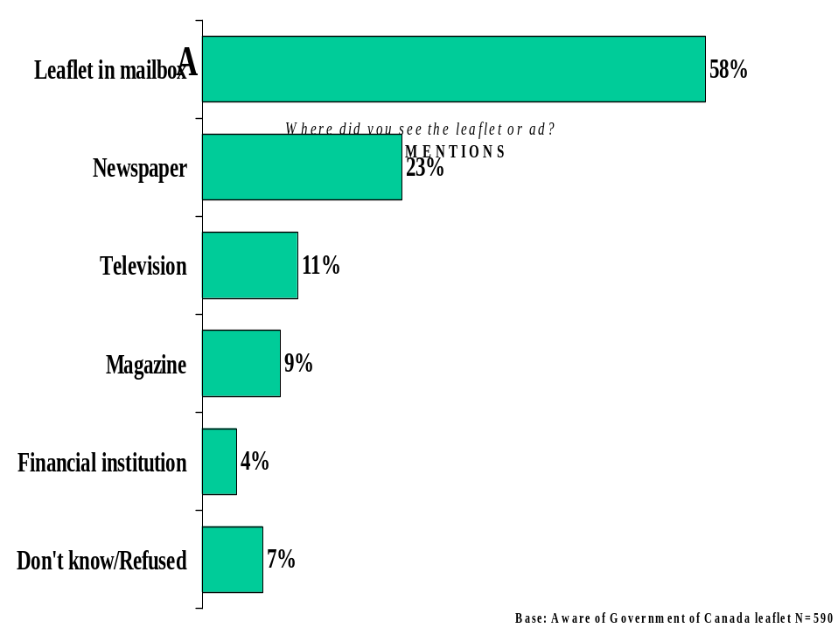

Number of Times Exposed to Leaflet or Ad
Findings also reveal that among those respondents who reported seeing the leaflet or ad, four in ten (44%) saw the ad multiple times (i.e., twice or more). Roughly half (48%) of these respondents saw the leaflet or ad once, and 7% were unsure. As outlined later in this report, recall of the advertising appears to be strongly related to both absorption of the advertising message and motivation to action.
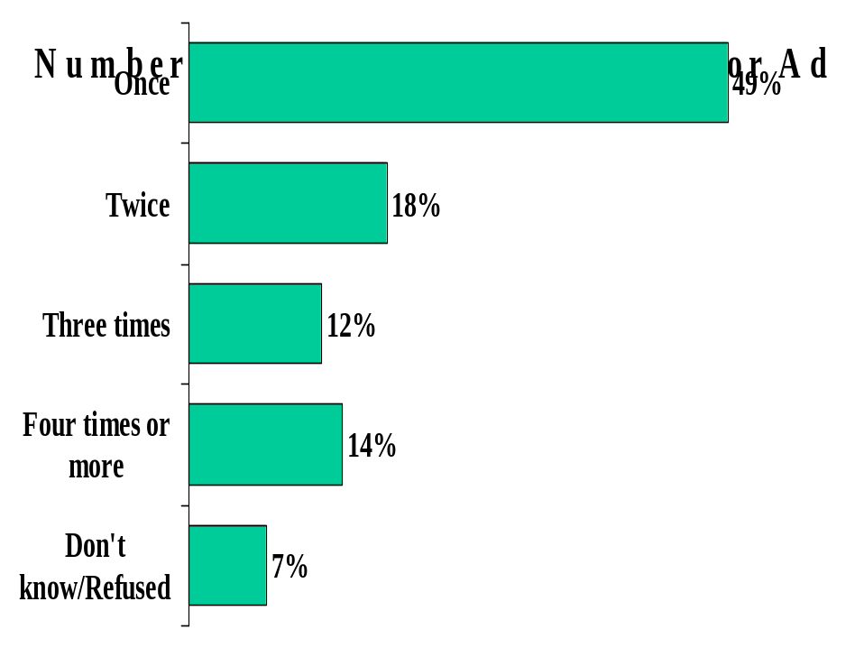

Main Message of Leaflet or Ad
When asked (on an unaided basis) about the main message of the leaflet or ad, respondents who recalled seeing the advertising tended to mention general ideas such as the need to start saving for children’s education (30%) and that people should save for the future (12%). Eight percent mentioned that the ad provided advice about how to save for children’s education, and 7% offered the fairly detailed idea that the government gives an additional 20 cents for every dollar saved in an RESP. All other responses were mentioned by 3% or fewer of these respondents. Thirty percent of respondents who said they saw the ad or leaflet either could not think of any messages conveyed by the ad (16%) or were unsure of the main message (14%).
Interestingly, those who saw the leaflet or ad four times or more were much less likely to say nothing or “don’t know” than those who saw the ad or leaflet only once (11% vs. 39%, respectively) (among those who saw the leaflet or ad twice, 19% said nothing or don’t know; among those who saw the leaflet three times, 14% said nothing or don’t know). Moreover, mentions of the messages outlined above (e.g., need to start saving now for children’s education, government gives additional 20 cents for every dollar saved in RESP) were also significantly higher among those with greater exposure to the advertising. These findings suggest that increased exposure to the ad or leaflet helped improve understanding of the advertising.
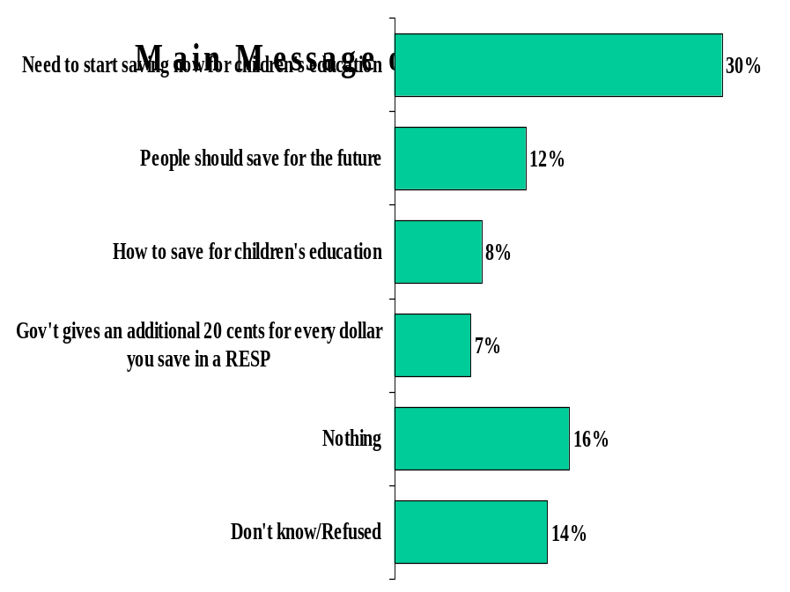

Impact of Leaflet or Ad
Respondents who said they saw the leaflet or ad were also asked if the advertising motivated them to do anything. One in five of these respondents (21%) said the advertising did motivate them to take action, while four in five (78%) said the advertising did not motivate them to do anything. Once again, multiple exposures to the ad appears to have had an impact on the target audience: those who saw the ad or leaflet four times or more were much more likely than those who saw the ad or leaflet only once to say the ad motivated them to take action (16% vs. 31%, respectively) (among those who saw the leaflet or ad twice, 21% said the ad motivated them; among those who saw the ad or leaflet three times, 35% said the ad motivated them to take action). The following sub-groups are particularly likely to say the advertising motivated them to take action:
- Quebec (35%) and Alberta (30%) residents
- Those with high school education (27%).
- Lower income earners ($30,000 - $40,000 a year: 28%).
- Those saving for post secondary education without an RESP (24%)
There were few differences in motivation according to the number of children in the household 12 years of age or younger, however, those with only one child 3 years of age or younger were more likely than those with one child aged 4 to 12 to indicate the ads motivated them to take action (30% vs. 17%, respectively).
In terms of the full target audience (i.e., those with children under 12 and earning $30,000 - $60,000) reached by the mail drop, the proportion of people motivated to take action was 5%.
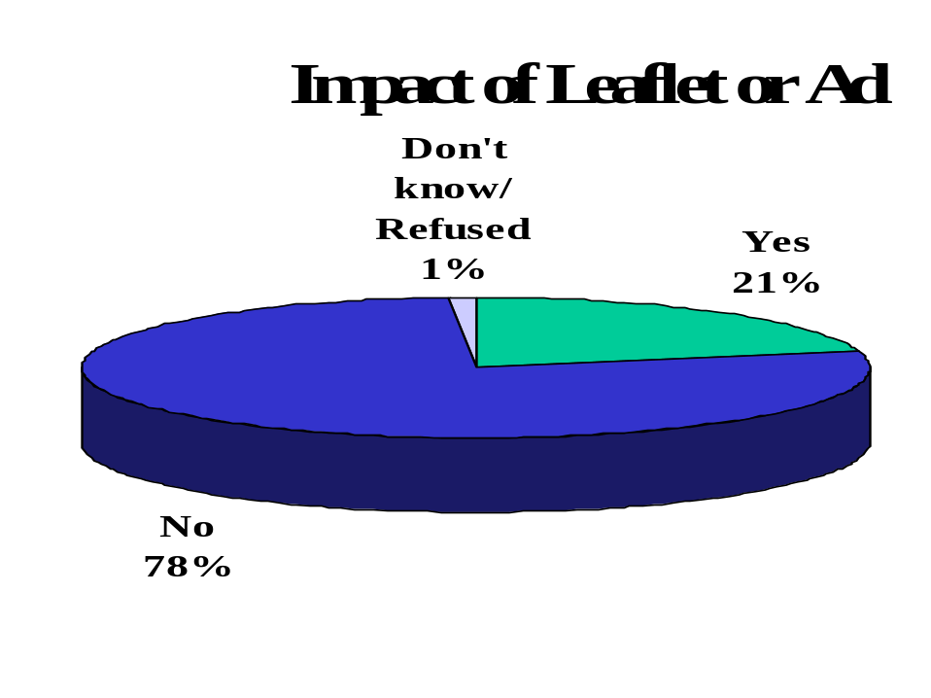
Those respondents who said the advertising did motivate them to take some action were asked, unprompted, what they did. The plurality of these respondents said they considered opening an RESP (27%). Fifteen percent said they talked to a financial advisor about saving for children’s education, 13% said they started saving money, and 10% said they actually opened an RESP account.

Saving for Children’s Post Secondary Education
All respondents were asked if they are currently saving for their children’s education. Two-thirds of respondents (63%) said they were saving for their children’s post secondary education, particularly:
- Residents of Alberta (73%), the Atlantic Provinces (70%) and Ontario (69%) (Quebec residents (48%) are less likely than other Canadians (69%) to say they are currently saving for their children’s education).
- Those with higher levels of academic attainment (peaking at 68% among those with a university education).
- Higher income earners ($50,000 or more: 69%).
- Those who recall the leaflet or ad (66%; compared to 60% among those who did not recall the advertising).
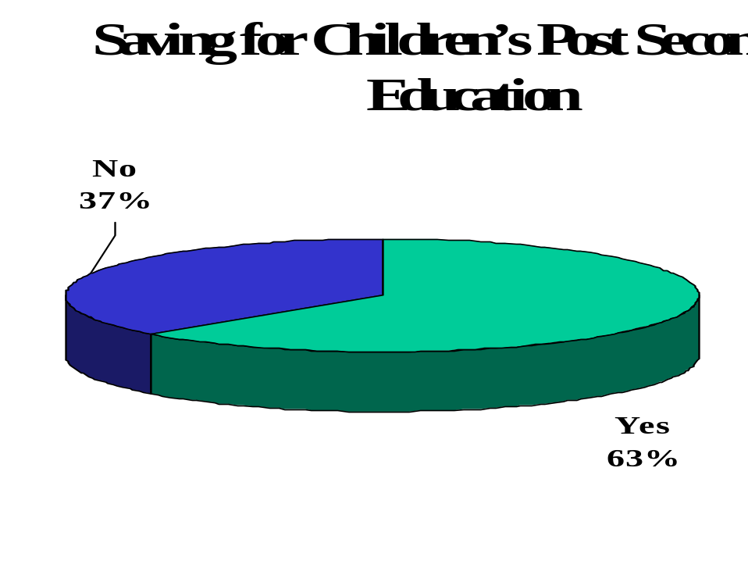
Those respondents who said they were saving for their children’s post secondary education were asked, unprompted, in what way they were saving. RESPs were mentioned most often (41%), followed by a savings account (29%). Education funds (10%), mutual funds (8%), RRSPs (5%) and other investments (5%) were also mentioned by a relatively large proportion of these respondents.
There is little difference in terms of the ways in which respondents are saving for children’s post secondary education between those who recalled the advertising versus those that did not.

Options Available for Saving for Post Secondary Education
All respondents were asked (on an unaided basis) what options they thought were available for saving money for children’s post secondary education. Out of the target audience that received the mail drop, 36% were aware of RESPs. This was followed closely by savings account/other personal savings (31%). Bonds (9%), RRSPs (8%), and mutual funds (8%) were distant second tier responses. One in five respondents indicated that no options are available (12%) or were unsure of the options available (7%).
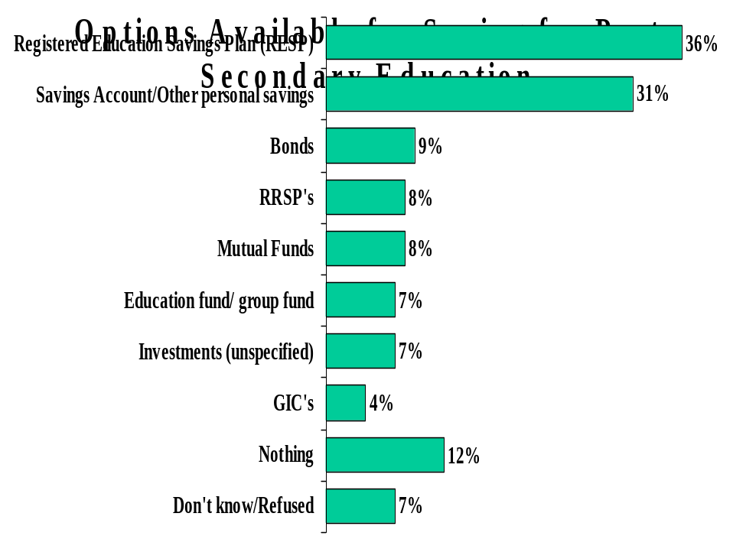
RESPs were mentioned most often by:
- Residents of Alberta (42%) and Saskatchewan/Manitoba (46%) (and least often by Quebec (30%) and Atlantic Province (29%) residents).
- Those with higher levels of academic attainment (peaking at 47% among those with a university education).
- Higher income earners ($50,000 to $60,000: 45%).
- Those with only one child 3 years of age or younger (40%).
- Those who recall the leaflet or ad (38%; compared to 34% among those not exposed to the advertising).

As mentioned earlier, this study also involved a parallel survey of 1,000 general public respondents. A select number of questions asked in the targeted survey (i.e., the HRDC supplied sample) were also asked in the general public survey. Many of these general public findings have been reported in previous ad evaluation studies, and, where available, are tracked over time.

Options Available for Saving for Post Secondary Education (General Public)
General public respondents were also asked, unprompted, what options are available to parents or relatives of children who wanted to save for post-secondary education. Registered Education Savings Plans (29%) and other personal savings in general (28%) were mentioned most often, followed by RRSPs (11%), bonds (10%), and mutual funds (9%). The hierarchy of these findings is similar to earlier soundings of this question, however, mentions of both RESPs and other personal savings have declined since December 2001.
Options for Saving for Post-Secondary Education

If you were a parent or relative of a child, and you were thinking about saving for his or her post-secondary education what are the options available to you for saving money?
 | May ’03 Leaflet | May ‘03 | Dec ‘01 | Mar ‘01 | Oct ‘99 | Apr ‘99
Registered Education Savings Plan (RESP) | 36% | 29% | 37% | 34% | 29% | 38%
Other personal savings | 31% | 20% | 28% | 28% | 29% | 37%
RRPS's | 8% | 11% | 13% | 12% | 13% | 5%
Bonds | 9% | 10% | 11% | 10% | 17% | 9%
Mutual Funds | 8% | 6% | 9% | 9% | 13% | 9%
Investments (unspecified) | 8% | 7% | 7% | 7% | 3% | 3%
Trust funds | 7% | 5% | 5% | 5% | 6% | 4%
GIC's | 4% | 5% | 5% | 4% | 5% | 4%
Don't know | 7% | 14% | 9% | 13% | 12% | 13%

Comparing the targeted survey results to the general public findings reveals that respondents from the targeted survey are more likely than the Canadian public as a whole to, unprompted, mention RESPs as an option for saving for children’s post secondary education (36% vs. 29%, respectively). We cannot definitively say whether this is because the targeted sample received the mail drop, or because RESPs are more salient to the targeted sample. However, findings from the 2001 evaluation of the CESG ad campaign suggest that the mail drop did have an impact on awareness of RESPs. In the 2001 study there was little difference in unaided mention of RESPs as an option for saving for children’s post secondary education between parents of children aged 12 and under with income between $30,000 and $60,000, and other respondents, so the difference exhibited in the current study does not seem to be merely a reflection of RESPs being more salient to the target group.

Knowledge of How to Get Information About Saving for Education (General Public)
General public respondents were also asked, on an unaided basis, what they would do to get more information about saving for education. Financial institutions are seen as the primary source of information about saving for education: 28% said they would seek information from a financial institution (e.g., a bank), and 16% said they would seek information from a financial advisor.
Sixteen percent said they would visit a website (unspecified), and 9% said they would ask a friend or family member. One in five respondents said they would do nothing (13%) or they were unsure how to proceed (9%).
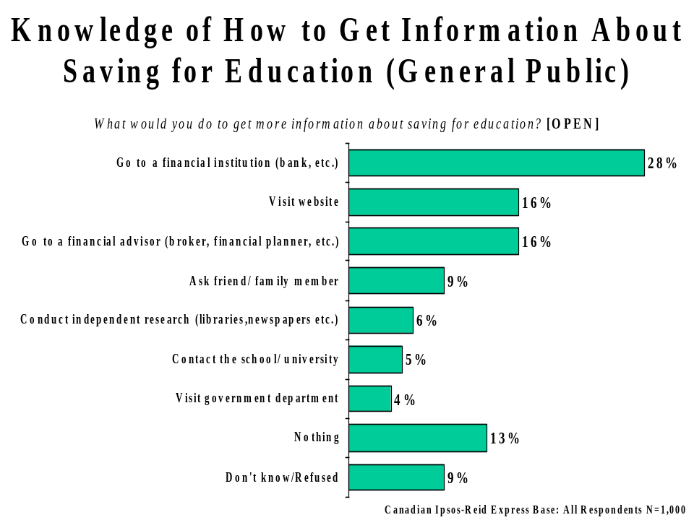

Knowledge of How to Get Information About Saving for Education (Targeted Survey)
Those targeted respondents who were not saving for post secondary education with an RESP were asked a similar (though not identical question) about actions taken to get information about saving for education. When asked what is the first step they would take if they were to open an RESP, 47% said they would talk to a bank or financial advisor, 13% said they would research RESP’s, and 8% said they would start saving.
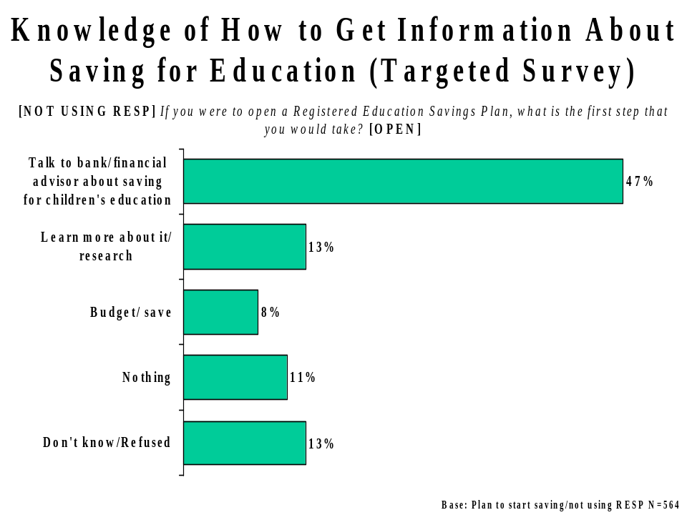

Similar to the general public (among whom 44% said they would go to a financial institution or advisor for information about saving for education), 47% of the mail drop target audience said they would talk to a bank or financial advisor to open an RESP.

Familiarity With RESPs (Targeted Survey)
All respondents in the targeted survey were asked to rate their familiarity with RESPs. Eighty-two percent expressed at least some awareness of RESPs (i.e., 1-10 on a scale from 0 to 10). One in three (36%) claimed to be fairly familiar with RESPs (6-10 on a scale from 0-10). Fifty six percent said they are not familiar with RESPs (0-4 on a scale from 0-10).
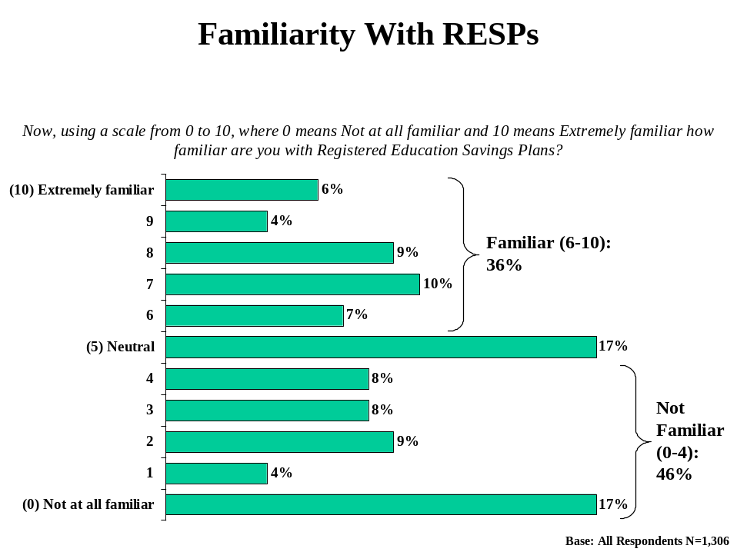

Claimed familiarity (6-10 on a scale from 0 to 10) with RESPs is highest among:
- Residents of B.C. (43%) and Saskatchewan/Manitoba (50%) (and lowest among Quebec residents: 30%).
- Those with higher levels of academic attainment (university: 49%).
- Higher income earners ($50,000 or more: 43%).
- Those aware of the advertising (42%; compared to 33% among those who did not recall the advertising).
- Those saving for post secondary education with an RESP (61%).

Familiarity With RESPs (General Public)
General public respondents were also asked for their familiarity with the Registered Education Savings Plan. Sixty-five percent of general public respondents expressed some awareness of RESPs (1-10 on a scale from 0-10). One in five (23%) Canadians claimed to be familiar (6-10 on a scale from 0-10) with RESPs (down from 31% in December 2001). Six in ten Canadians (61%) are unfamiliar with RESPs (4-10 on a scale from 0-10).
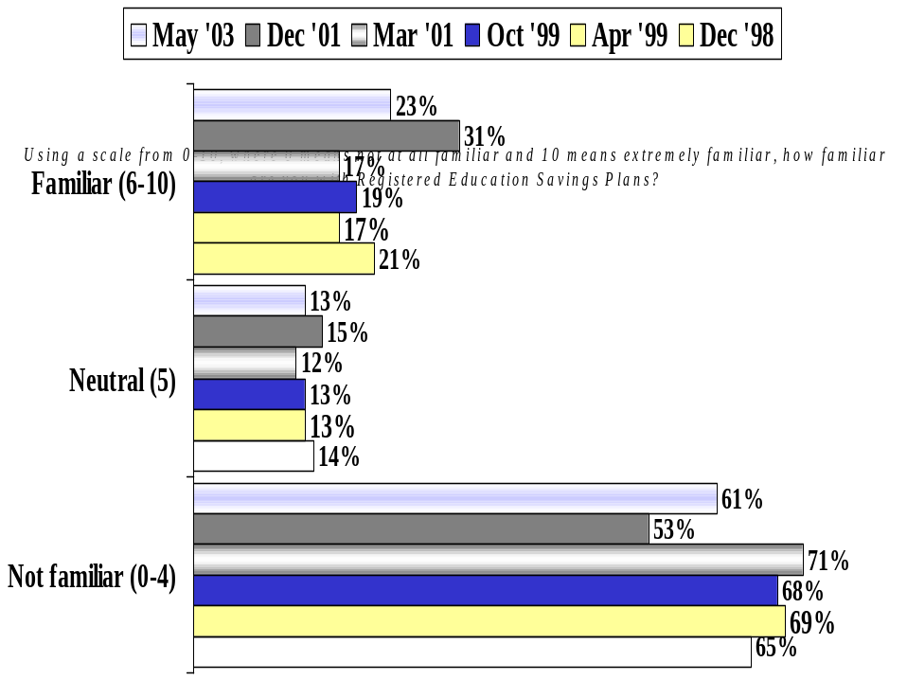
Among the general public, familiarity with RESPs (6-10 on the scale from 0-10) is highest among:
- Residents of Ontario (27%) (and lowest among residents of the Atlantic Provinces – 17%).
- Those higher levels of academic attainment (university: 39%).
- Higher income earners ($60,000 or more: 36%).

Comparing the targeted survey results to the general public findings indicates that respondents from the targeted survey are more likely than the Canadian population as a whole to express familiarity with RESPs (36% vs. 23%, respectively).

Familiarity With the CESG (Targeted Survey)
Targeted respondents were also asked to rate their familiarity with the Canada Education Savings Grant (CESG). Sixty-one percent expressed some awareness of the CESG (i.e., 1-10 on the scale from 0 to 10). However, fewer than one in three (29%) say they are familiar with the CESG (6-10 on a scale from 0-10), while fully two-thirds (64%) are unfamiliar with CESGs (0-4 on a scale from 0-10). Moreover, four in ten respondents (39%) rate themselves as not at all familiar with CESGs (0 on the scale from 0 to 10). These findings suggest that targeted respondents are largely unfamiliar with the CESG.
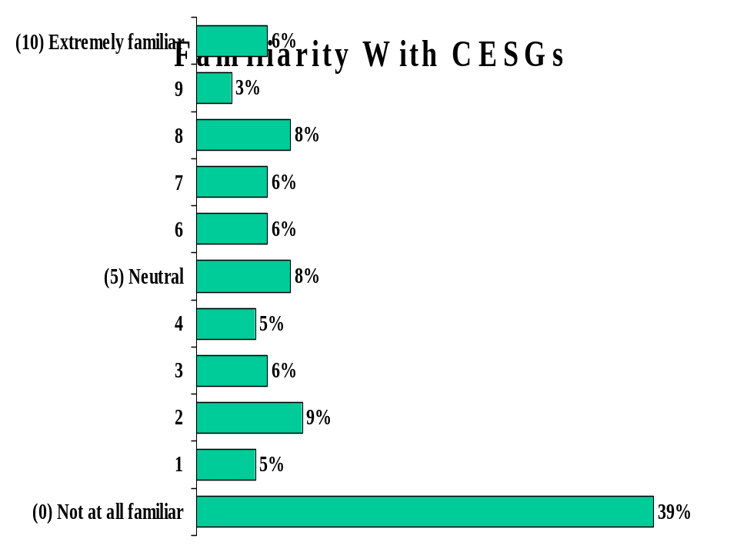
Claimed familiarity with the CESG is highest among:
- B.C. residents (39%).
- As is typical of other results in this research, those with a university education (38%) and those earning $50,000 or more (32%) are more familiar with the CESG than their counterparts.
- Those aware of the advertising (33%; compared to 26% among those not aware).
- Those saving with an RESP (49%).

Familiarity With CESGs (General Public)
The general public findings reveal that familiarity with CESGs has remained stable since December 2001. Fifty-one percent expressed at least some awareness with the CESG (i.e., 1-10 on the scale from 0 to 10). One in five (19%) Canadians currently say they are familiar with CESGs (virtually the same as in December 2001, when 18% said they were familiar with the CESG). Two in three (69%) Canadians are unfamiliar with CESGs (47% are not at all familiar with the CESG).
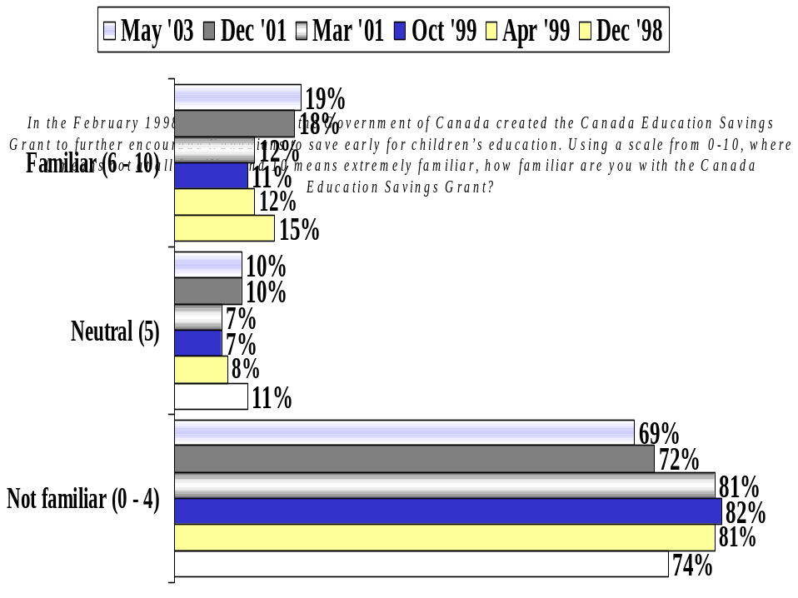
Among the general public, familiarity with the CESG is highest among:
- Residents of Ontario (21%) (and lowest among residents of Saskatchewan/Manitoba - 11%).
- Middle aged respondents (35-54 years of age: 22%).
- University educated respondents (31%).
- Those earning $50,000 a year or more (28%).

Comparing the targeted survey results to the general public findings indicates that respondents from the targeted survey are more likely than the Canadian population as a whole to express familiarity with CESGs (29% vs. 19%, respectively).

Understanding of CESG (Targeted Survey)
Targeted respondents who expressed at least some familiarity with the CESG (1-10 on the scale from 0 to 10) were asked, unprompted, what they could recall about the CESG. One in three (35%) could provide a fairly detailed explanation of the CESG, (i.e., the Government of Canada provides a grant of 20 percent or $400 maximum when someone contributes to an RESP). Ten percent said people pay into an RESP, and the Government of Canada gives additional money to be used when their child undertakes post secondary education. All other responses were mentioned by 7% or fewer of these respondents.
One in three of these respondents indicated nothing in particular (29%) or don’t know (3%). All other responses tended to be more of a general nature (e.g., it’s a good thing) or incorrect (e.g., government matches your contribution).
Those exposed to the ad or leaflet were somewhat more likely to mention the idea people pay into an RESP and the Government of Canada gives additional money to be used when their child undertakes post secondary education (14%; compared to 6% among those who did not recall the advertising).
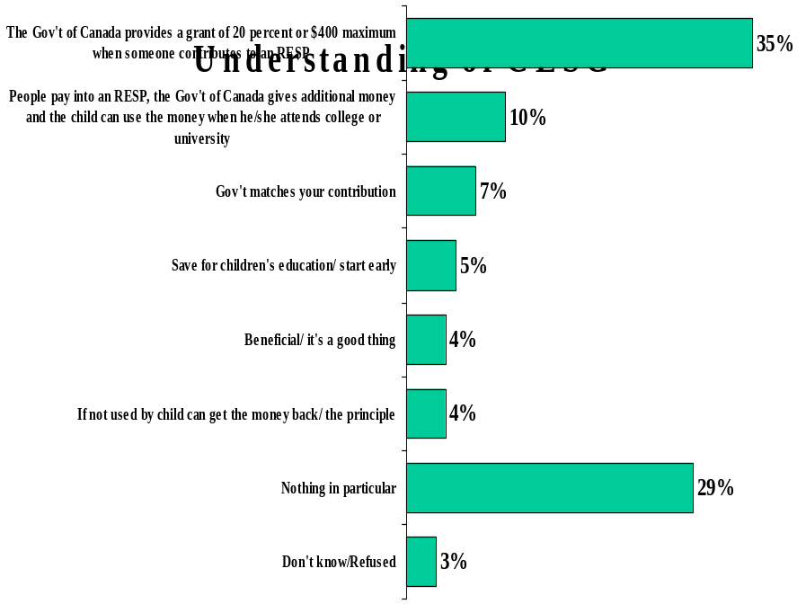

Understanding of CESG (General Public)
General public respondents who had heard of the CESG (1-10 on the scale from 0 to 10) were also asked what they had heard or read about this initiative. Fifteen percent (down from 20% in December 2001) were able to provide a fairly accurate explanation of how CESGs work (i.e., the Government of Canada provides a grant of 20% or $400 maximum when someone contributes to an RESP). Sixteen percent said they have heard about the existence of CESGs in general. One in three (31%) general public respondents said they had heard nothing regarding the CESG.

Understanding of CESG
What have you read or heard about the Canada Education Savings Grant, or CESG?
 | May ’03  Leaflet | May ‘03 | Dec ‘01 | Mar ‘01 | Oct ‘99 | Apr ‘99 | Dec ‘98
Nothing in particular | 29% | 31% | 44% | 49% | 44% | 46% | 40%
The Government of Canada provides a grant of 20 percent or $400 maximum when someone contributes to an RESP | 35% | 15% | 20% | 18% | 23% | 21% | 13%
It’s available/it exists/heard about it | 1% | 16% | 15% | - | - | - | -
Government matches your contribution | 7% | 8% | 5% | 4% | 5% | 1% | 1%
People pay into an RESP, the Government of Canada gives additional money and the child can use the money when he/she attends college or university | 10% | 5% | 3% | 5% | 6% | 5% | 7%
Tax benefit (general) | 3% | 7% | 3% | 2% | 2% | 3% | 8%

Comparing the targeted survey results to the general public findings reveals a greater understanding of CESGs among targeted respondents than among the Canadian population as a whole. Targeted respondents are much more likely than the general public to be able to provide (on an unaided basis) a detailed explanation of how CESGs work (35% vs. 15%, respectively).

Impact of Ad or Leaflet on Familiarity With CESG
Targeted respondents who expressed at least some familiarity with the CESG (1-10 on the scale from 0 to 10) and who recalled seeing the ad or leaflet were asked how much of their familiarity with the CESG was a result of either the information contained in the advertising, or information gathered about the CESG as a result of the advertising. Sixty-eight percent indicated at least some of their familiarity was due to the advertising (1-10 on the scale from 0-10). One in four (26%) say a fair amount of their familiarity was a result of the advertising, however the majority (59%) say little of their familiarity was a result of the advertising (and 32% say none of their familiarity was due to the advertising).
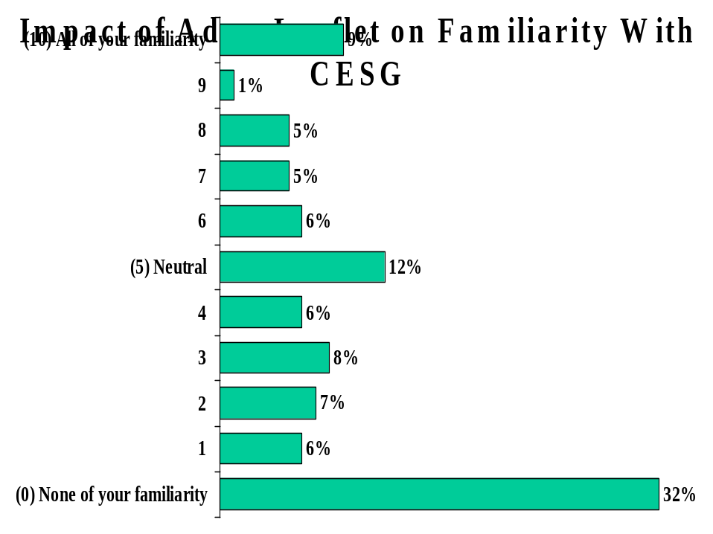
Greater familiarity with the CESG was accorded to the advertising by the following sub-groups:
- Quebec residents (31%), compared to 24% among the rest of Canada.
- Those with a high school education (29%).
- Those saving for post secondary education without an RESP (29%).

Intention to Save for Children’s Post Secondary Education
Targeted respondents who indicated they were not currently saving for children’s post secondary education were asked if they plan to start saving for their children’s post secondary education within the next year or so. Results are split with respect to this question: 57% of these respondents said they will begin saving for their children’s education, while 42% said they will not begin saving within the next year or so. The reasons that people were not saving are presented on the following page.
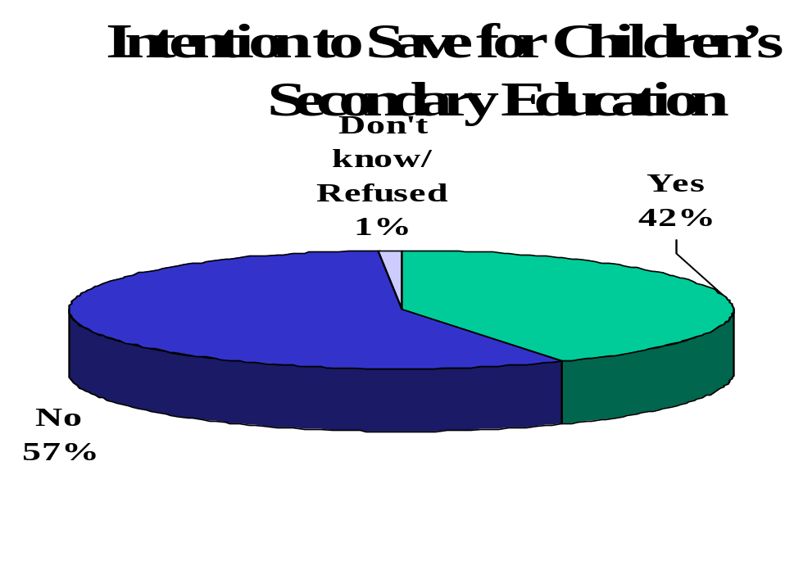
The following sub groups are particularly likely to indicate they plan to start saving for post secondary education within the next year or so:
- Residents of B.C. (53%), Alberta (51%), Saskatchewan/Manitoba (51%) and the Atlantic Provinces (51%) (Quebec residents (33%) are much less likely than other Canadians (49%) to say they plan to start saving for their children’s education in the next year or so).
- Younger respondents (18-34 years of age: 48%).
- Men (46%; compared to 40% among women).
- Those with university education (45%).
- Those earning $50,000 a year or more (45%).
- Those aware of the advertising (48% - compared to 39% among those who did not recall the advertising).
- Those with one child 12 years of age and under (47%), particularly those with one child 3 years of age or younger (67%).

Reasons for Not Intending to Save for Children’s Post Secondary Education
Those respondents who indicated they were not planning to start saving for their children’s post secondary education were asked, on an unaided basis, why they were not planning to save. The vast majority of these respondents (69%) said they do not have enough money to save for post secondary education. The idea that it is too early to save (children are still quite young) was a distant second mention (10%). Five percent said they were not planning to save because their children are not going to pursue post secondary education. There is little difference in the reasons mentioned for not intending to save for post secondary education between those who recalled the advertising and those who did not.
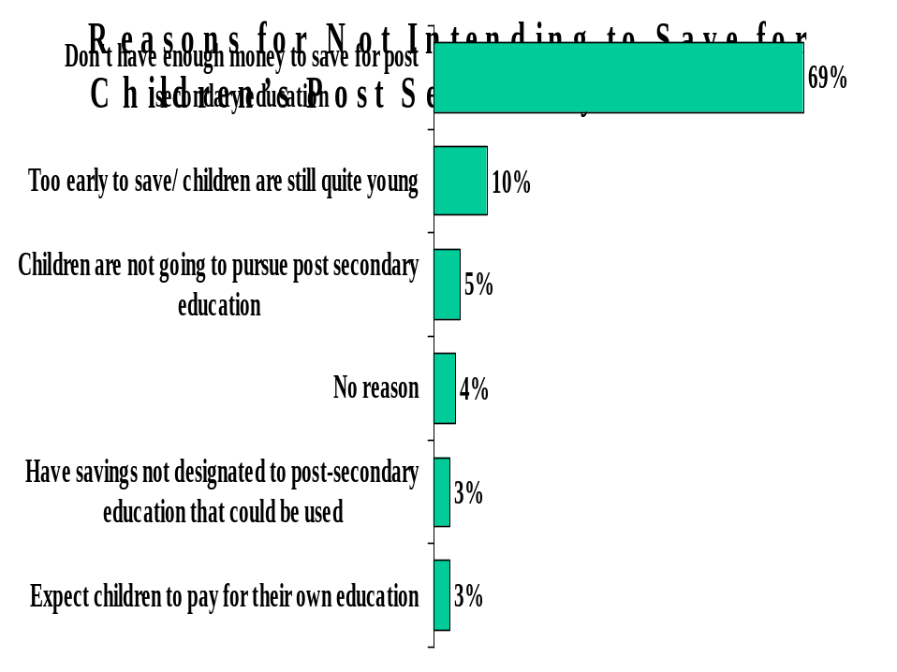

Reasons for Not Saving With RESP
Among respondents currently saving outside an RESP or not yet saving with an RESP but planning to do so within the next year or so, one quarter (25%) were not saving with an RESP due to lack of money, 20% said they were already using an alternative saving mechanism, and 15% said they had a lack of understanding about RESPs. A relatively large proportion of these respondents also mentioned concerns about RESPs (11%), and not having gotten around to looking into RESPs (11%). There is little difference in the reasons mentioned for not saving with an RESP between those who recalled the advertising and those who did not (although those who had seen the leaflet or ad were slightly less likely to say they did not know enough about how RESPs work).
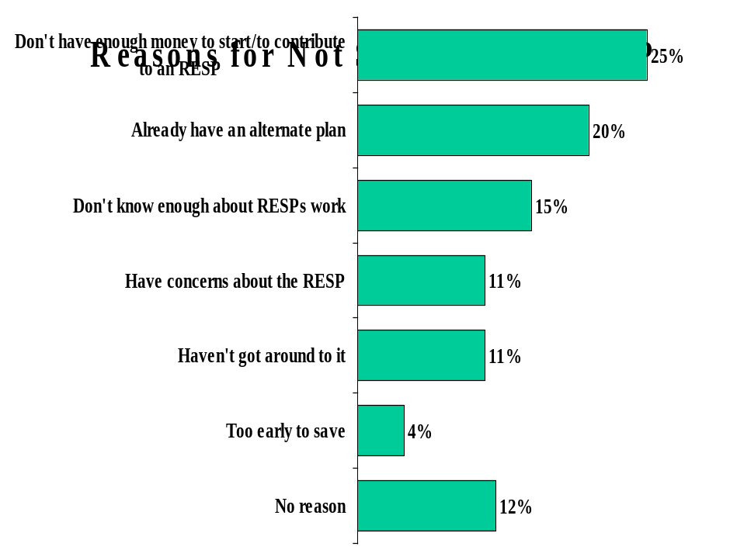

Views on Opening RESP Based on Description of CESG
All respondents who were not currently saving with an RESP (those saving outside an RESP and those not saving at all) were read a description of how the Canada Education Savings Grant (CESG) works and asked if they would now consider opening an RESP. Responses to this question are split: 54% said yes, 42% said no and 4% were unsure.
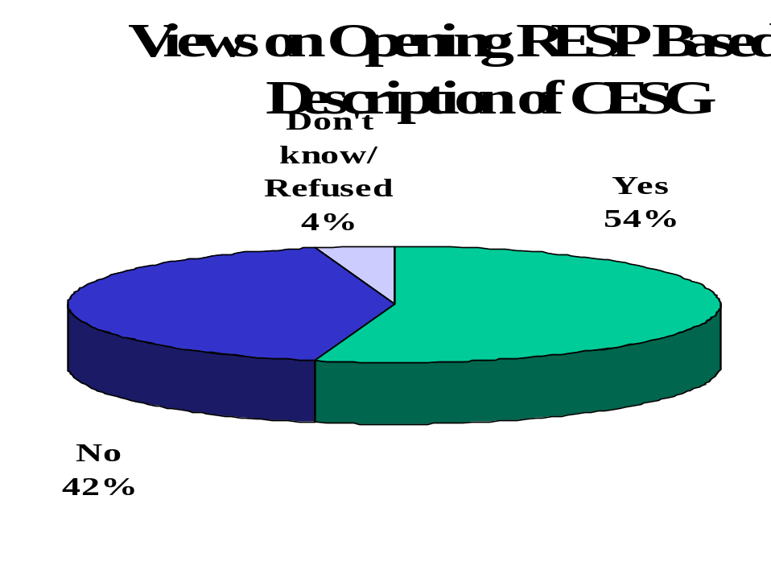
Those who said they would still not consider opening an RESP were asked why they felt this way. The plurality mentioned a lack of money (38%), while 15% said they were saving with an alternative mechanism, and 14% expressed concerns about RESPs.
The following sub-groups are most likely to consider opening an RESP based on the description of the CESG:
- Residents of the Atlantic Provinces (78%) (Quebec residents are least likely to consider opening an RESP - 42%; compared to 60% in the rest of Canada).
- Younger respondents (18-34 years of age: 61%).
- Those aware of the advertising (57%; compared to 52% among those not aware).
- Those saving for post secondary education without an RESP (59%, vs. 50% among those not saving for post secondary education).
- Those with one child 3 years of age or younger (70%).

Reasons for Opening RESP
Among those respondents who are currently using an RESP, the main reason cited for opening an RESP is the importance of saving for children’s education (58%). The CESG is mentioned by 12% of these respondents, while 8% mentioned the high cost of post secondary education.
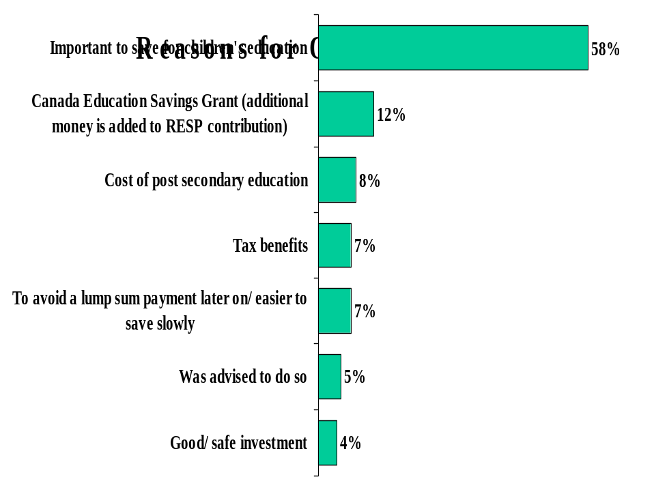

Number of Times Exposed to CESG Before Opening RESP
Respondents using RESPs were also asked how many times they heard about the CESG before they decided to open an RESP. One in three (30%) said they opened an RESP account without ever hearing about the CESG. The majority (55%), however, heard about the CESG multiple times before opening their RESP (including 25% who heard about the CESG five times or more).
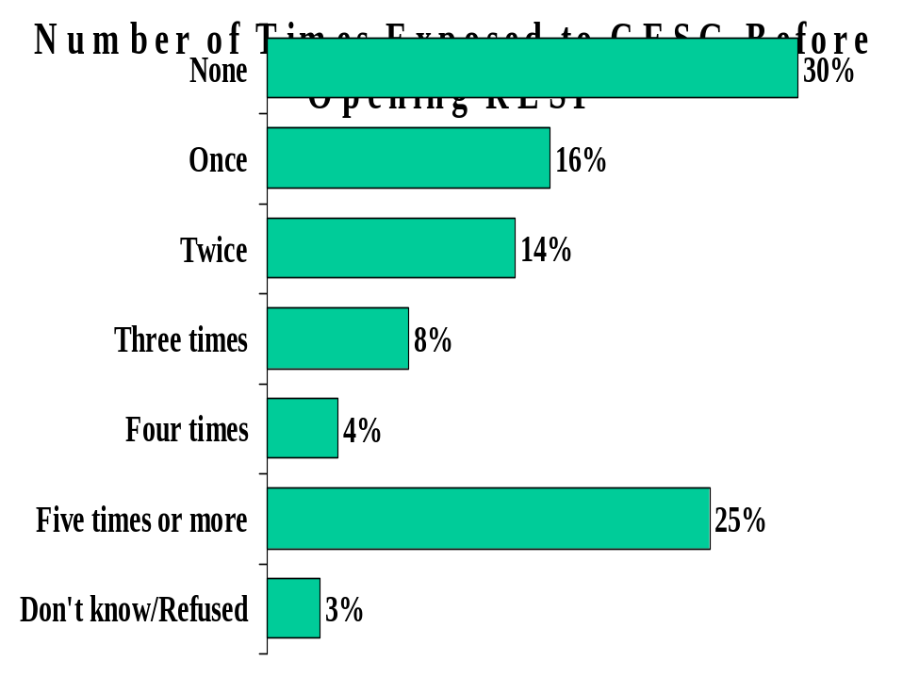

Source of Information About CESG
Those with RESPs were also asked how they heard about the CESG. Financial advisors were mentioned most often (36%), followed by word of mouth (24%). Newspaper/magazine articles (10%), poster/brochures from financial institutions (9%), and TV ads (7%) were also mentioned by a relatively large proportion of these respondents. Relatively few mentioned Government of Canada materials (4%).
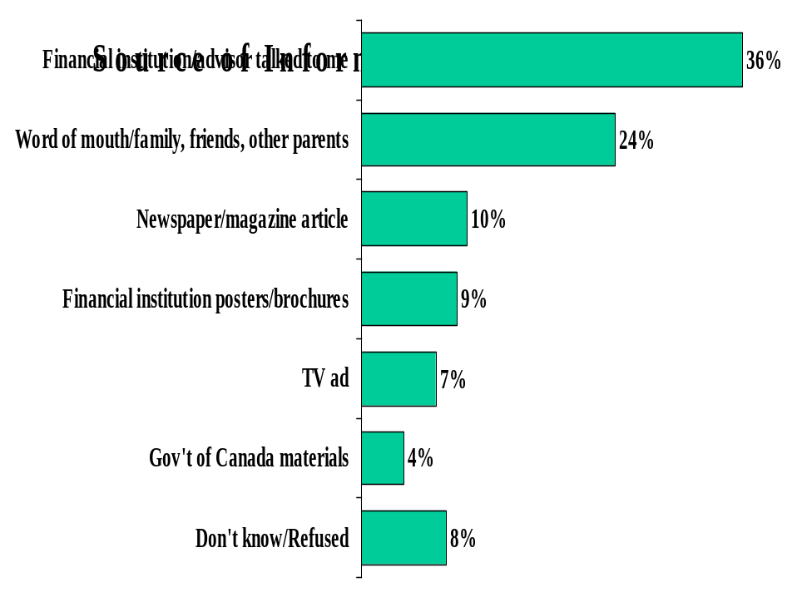

Appendix I – Topline Questionnaire
1a/b. Where did you see the leaflet or ad?
TOTAL MENTIONS | TOTAL
Base: Aware of Government of Canada leaflet
Unweighted Base | 625
Weighted Base | 590
Leaflet in mailbox | 58%
Newspaper | 23%
Television | 11%
Magazine | 9%
Financial institution/ bank | 4%
Post Office | 1%
Other | 12%
None | 64%
Don't know/Refused | 7%
2. How many times did you see the leaflet or ad?
Base: Aware of Government of Canada leaflet | TOTAL
Unweighted Base | 625
Weighted Base | 590
Once | 49%
Twice | 18%
Three times | 12%
Four times or more | 14%
Don't know/Refused | 7%
3. Thinking about the leaflet or ad that you saw, what do you think were the main points they were trying to get across?
Base: Aware of Government of Canada leaflet | TOTAL
Unweighted Base | 625
Weighted Base | 590
Need to start saving now for children's education | 30%
People should save for the future/ your children's future | 12%
How to save for children's education | 8%
Government gives an additional 20 cents for every dollar you save in a Registered Education Savings Plan (RESP) | 7%
Education is important/ a good investment | 3%
Government has made it easier for families to save for post-secondary education | 3%
Information on the Canada Education Savings Grant (CESG) in general | 3%
No amount of money is too small to start saving | 2%
Information on Registered Education Savings Plan (RESP) in general | 2%
Each child receives up to $400 per year | 2%
Information on tax breaks offered | 2%
How expensive education is/ will be in future | 2%
Canada Education Savings Grant (CESG) is part of Youth Employment Strategy | 1%
1-800/ contact number | 0
Other | 9%
Nothing | 16%
Don't know/Refused | 14%
4. Did the leaflet or ad motivate you to do anything?
Base: Aware of Government of Canada leaflet | TOTAL
Unweighted Base | 625
Weighted Base | 590
Yes | 21%
No | 78%
Don't know/Refused | 1%
5. And what was that?
TOTAL MENTIONS | TOTAL
Base: Leaflet or ad motivate respondents
Unweighted Base | 121
Weighted Base | 126
Considered opening an RESP | 27%
Talked to bank/financial advisor about saving for children's education to get information | 15%
Started saving money | 13%
Opened RESP account/decided to open an RESP | 10%
Continue investing/ saving | 4%
Phoned 1-800 number | 3%
Sought more information | 3%
Talked to a group fund provider (Canada Scholarship Trust, Children's Education Foundation, USC Education Savings Plan, International Scholarship Foundation) to get information | 3%
Talked to friends/family about RESP/CESG | 2%
Read the leaflet | 2%
Visited Government of Canada website | 1%
Other | 17%
Nothing | 13%
Don't know/Refused | 2%

6. Are you currently saving for your child or children's post-secondary education?
Base: All Respondents | TOTAL
Unweighted Base | 1306
Weighted Base | 1306
Yes | 63%
No | 37%
7. In what way are you saving?
Base: Currently saving for post-secondary education | TOTAL
Unweighted Base | 819
Weighted Base | 822
Registered Education Savings Plan (RESP) | 41%
Savings Account/Other personal savings | 29%
Education fund/ group fund: (Canada Scholarship Trust, Children's Education Foundation, USC Education Savings Plan, International Scholarship Foundation) | 10%
Mutual Funds | 8%
RRSP's | 5%
Investments (unspecified) | 5%
Bonds | 4%
Trust funds | 3%
Insurance policy | 1%
GIC's | 1%
Term deposits | 1%
Stocks | 1%
Other | 3%
Don't know/Refused | 2%
8. If you were thinking about saving for your child or children's post-secondary education what are the options available to you for saving money?
Base: All Respondents | TOTAL
Unweighted Base | 1306
Weighted Base | 1306
Registered Education Savings Plan (RESP) | 36%
Savings Account/Other personal savings | 31%
Bonds | 9%
RRSP's | 8%
Mutual Funds | 8%
Education fund/ group fund: (Canada Scholarship Trust, Children's Education Foundation, USC Education Savings Plan, International Scholarship Foundation) | 7%
Investments (unspecified) | 7%
GIC's | 4%
Term deposits | 2%
Stocks | 2%
Trust funds | 1%
Insurance policy | 1%
Child tax credit | 1%
Other | 9%
Nothing | 12%
Don't know/Refused | 7%
9. Now, using a scale from 0 to 10, where 0 means Not at all familiar and 10 means Extremely familiar how familiar are you with Registered Education Savings Plans?
Base: All Respondents | TOTAL
Unweighted Base | 1306
Weighted Base | 1306
(10) Extremely familiar | 6%
(9) | 4%
(8) | 9%
(7) | 10%
(6) | 7%
(5) Neutral | 17%
(4) | 8%
(3) | 8%
(2) | 9%
(1) | 4%
(0) Not at all familiar | 17%
TOPBOX LOWBOX SUMMARY
Familiar (Top4Box) | 30%
Neutral (Mid3Box) | 32%
Not familiar (Low4Box) | 38%

10. In 1998, the Government of Canada created the Canada Education Savings Grant (CESG) to further encourage Canadians to save early for children's education. Using a scale from 0 to 10, where 0 means Not at all familiar and 10 means Extremely familiar how familiar are you with the Canada Education Savings Grant?
Base: All Respondents | TOTAL
Unweighted Base | 1306
Weighted Base | 1306
(10) Extremely familiar | 6%
(9) | 3%
(8) | 8%
(7) | 6%
(6) | 6%
(5) Neutral | 8%
(4) | 5%
(3) | 6%
(2) | 9%
(1) | 5%
(0) Not at all familiar | 39%
TOPBOX LOWBOX SUMMARY
Familiar (Top4Box) | 23%
Neutral (Mid3Box) | 18%
Not familiar (Low4Box) | 59%
11. How much of your familiarity with the CESG was a result of either the information contained in the leaflet or ad that you recently saw, or any information you gathered about the CESG as a result of seeing the leaflet or ad? Please use a scale from 0 to 10, where 0 means none of your familiarity with the CESG was a result of the ad or leaflet, and 10 means all of your familiarity with the CESG was due to the ad or leaflet.
Base: Aware of Government of Canada leaflet and familiar with CESG | TOTAL
Unweighted Base | 418
Weighted Base | 397
(10) All of your familiarity | 9%
(9) | 1%
(8) | 5%
(7) | 5%
(6) | 6%
(5) Neutral | 12%
(4) | 6%
(3) | 8%
(2) | 7%
(1) | 6%
(0) None of your familiarity | 32%
Don't know | 1%
TOPBOX LOWBOX SUMMARY
Familiar (Top4Box) | 21%
Neutral (Mid3Box) | 24%
Not familiar (Low4Box) | 55%
12a/b. What can you tell me about the Canada Education Savings Grant, or CESG?
TOTAL MENTIONS | TOTAL
Base: Familiar with the CESG
Unweighted Base | 788
Weighted Base | 791
Nothing in particular | 29%
The Government of Canada provides a grant of 20 percent or $400 maximum when someone contributes to an RESP | 35%
People pay into an RESP, the Government of Canada gives additional money and the child can use the money when he/she attends college or university | 10%
Government matches your contribution | 7%
Save for children's education/ start early | 5%
Beneficial/ it's a good thing | 4%
If not used by child can get the money back/ the principle | 4%
Tax deduction when you contribute to an RESP | 3%
Can use only for education | 3%
Government is working with Canadians to help families save for post-secondary education | 3%
Tax benefit (general) | 3%
General negative mentions | 3%
Similar to an RRSP/ you get a tax credit for the money you put in | 3%
If not used by child can be transferable | 3%
Child needs a SIN card to qualify | 2%
Penalty when child doesn't use it for school | 2%
It's available/ that it exists/ heard about it/ read about it | 1%
Know that someone applied for it | 1%
Other | 9%
Don't know/Refused | 3%
13. Do you plan to start saving for your child or children's post secondary education within the next year or so?
Base: Not currently saving for post-secondary education | TOTAL
Unweighted Base | 487
Weighted Base | 484
Yes | 42%
No | 57%
Don't know/Refused | 1%

14. What method of saving do you plan to use?
Base: Plan to start saving for post-secondary education | TOTAL
Unweighted Base | 191
Weighted Base | 204
Registered Education Savings Plan (RESP) | 33%
Savings Account/Other personal savings | 33%
Education fund/ group fund: (Canada Scholarship Trust, Children's Education Foundation, USC Education Savings Plan, International Scholarship Foundation) | 3%
Trust funds | 3%
Bonds | 3%
Investments (unspecified) | 2%
RRSP's | 1%
GIC's | 1%
Other | 5%
Nothing | 6%
Don't know/Refused | 19%
15a/b. Why do you say that?
TOTAL MENTIONS | TOTAL
Base: Don't plan to start saving for post-secondary education
Unweighted Base | 288
Weighted Base | 274
Don't have enough money to save for post secondary education | 69%
Too early to save/ children are still quite young | 10%
Children are not going to pursue post secondary education | 5%
Have savings not designated to post-secondary education that could be us | 3%
Expect children to pay for their own education | 3%
Expect to use loans/grants/bursaries | 1%
No reason | 4%
Other | 16%
None | 83%
16. Are you currently saving for a child's post secondary education with a Registered Education Savings Plan (RESP)?
Base: Saving/Plan to start saving and not using RESP | TOTAL
Unweighted Base | 699
Weighted Base | 694
Yes | 17%
No | 81%
Don't know/Refused | 2%

17a/b. Why do you say that?
TOTAL MENTIONS | TOTAL
Base: Not using RESP
Unweighted Base | 557
Weighted Base | 564
Don't have enough money to start/contribute to an RESP | 25%
Already have an alternate plan/ program | 20%
Don't know enough about RESPs work | 15%
Have concerns about the RESP/ think I can loose my money/ too many restrictions | 11%
Haven't got around to it/ too busy | 11%
Too early to save/ children are still quite young | 4%
Don't understand/too complicated | 3%
Not enough flexibility in RESP | 2%
Child needs a Social Insurance Number first | 1%
Children not eligible for an RESP | 1%
No reason | 12%
Other | 9%
None | 76%
18. If you were to open a Registered Education Savings Plan, what is the first step that you would take?
Base: Not using RESP | TOTAL
Unweighted Base | 557
Weighted Base | 564
Talk to bank/financial advisor about saving for children's education | 47%
Learn more about it/ research | 13%
Budget/ save | 8%
Talk to family, other parents | 3%
Phone 1-800 number | 3%
Call a group fund (Canada Scholarship Trust, Children's Education Foundation, USC Education Savings Plan, International Scholarship Foundation) | 2%
Visit Government of Canada website | 2%
Get a SIN for my child | 2%
Would not open one | 2%
Other | 5%
Nothing | 11%
Don't know/Refused | 13%

19. The Canada Education Savings Grant (CESG) is designed to encourage Canadians to save early for children's education. The way it works is, when a parent, grandparent, uncle, aunt or any other person contributes money to a child's Registered Education Savings Plan (RESP), the Government of Canada adds a grant of 20 percent, up to a maximum of $400 per year, per child. If you didn't know about the CESG before, would you now consider opening an RESP to save for a child's education?
Base: Not using RESP | TOTAL
Unweighted Base | 864
Weighted Base | 852
Yes | 54%
No | 42%
Don't know/Refused | 4%
20a/b. Why do you say that?
TOTAL MENTIONS | TOTAL
Base: Would not consider opening an RESP
Unweighted Base | 361
Weighted Base | 360
Don't have enough money to start/contribute to an RESP | 38%
Already have an alternative plan/ program | 15%
Have concerns about the RESP/ think I can loose my money/ too many restrictions | 14%
Don't know enough about RESPs work | 8%
Don't like/ distrust government programs | 3%
Children may not go to post secondary education | 3%
Too early/ children are too young | 3%
Need to talk to spouse/ financial advisor/ it's a joint decision | 2%
Maximum contribution is too low | 1%
Not enough flexibility in RESP | 1%
Other | 16%
No reason | 5%
None | 88%

21. Why did you decide to open a Registered Education Savings Plan?
Base: Using RESP | TOTAL
Unweighted Base | 442
Weighted Base | 454
Important to save for children's education | 58%
Canada Education Savings Grant (additional money is added to RESP contribution) | 12%
Cost of post secondary education | 8%
Tax benefits | 7%
To avoid a lump sum payment later on/ easier to save slowly | 7%
Was advised to do so | 5%
Good/ safe investment | 4%
Was opened by someone else | 2%
Approached by sales rep | 2%
Other | 11%
Don't know/Refused | 1%
22. Approximately how many times did you hear about the Canada Education Savings Grant before you decided to open an RESP?
Base: Using RESP | TOTAL
Unweighted Base | 442
Weighted Base | 454
None | 30%
Once | 16%
Twice | 14%
Three times | 8%
Four times | 4%
Five times or more | 25%
Don't know/Refused | 3%

23. How did you hear about the Canada Education Savings Grant that you get with an RESP?
Base: Using RESP | TOTAL
Unweighted Base | 442
Weighted Base | 454
Financial institution/advisor talked to me | 36%
Word of mouth/family, friends, other parents | 24%
Newspaper/magazine article | 10%
Financial institution posters/brochures | 9%
TV ad | 7%
Gov't of Canada materials | 4%
Bank/ financial institution (unsp.) | 3%
Flyer/ leaflet/ brochure (unsp.) | 3%
Phone (someone called to solicit interest) | 3%
TV program | 2%
Government website | 1%
Radio | 1%
Other | 9%
None/ have not heard about it | 3%
Don't know/Refused | 8%

Appendix II – Topline Questionnaire (General Public)
1a/b. If you were a parent or relative of a child, and you were thinking about saving for his or her post-secondary education, what are the options available to you for saving money?
TOTAL MENTIONS | TOTAL
Base: All Respondents
Unweighted Base | 1000
Weighted Base | 1000
Registered Education Savings Plan (RESP) | 29%
Other personal savings | 20%
RRSP's | 11%
Bonds | 10%
Education fund | 8%
Investments (unspecified) | 7%
Mutual Funds | 6%
GIC's | 5%
Trust funds | 5%
Savings account | 4%
Bank-unspecified | 3%
Stocks | 3%
Term deposits | 2%
Life insurance policy | 2%
Scholarships | 2%
Government of Canada (federal) grants | 1%
Borrow money from bank | 1%
Government of Canada (federal) loans | 1%
Other | 4%
Nothing | 7%
Don't know/Refused | 14%

2a/b. What would you do to get more information about saving for education?
TOTAL MENTIONS | TOTAL
Base: All Respondents
Unweighted Base | 1000
Weighted Base | 1000
Go to a financial institution (bank, etc.) | 28%
Visit website | 16%
Go to a financial advisor (broker, financial planner, etc.) | 16%
Ask friend/ family member | 9%
Conduct independent research (libraries,newspapers etc.) | 6%
Contact the school/ university | 5%
Visit government department | 4%
Phone 1-800 number | 2%
Other | 3%
Nothing | 13%
Don't know/Refused | 9%
3. Now, using a scale from 0 to 10, where 0 means Not at all familiar and 10 means Extremely familiar how familiar are you with Registered Education Savings Plans?
Base: All Respondents | TOTAL
Unweighted Base | 1000
Weighted Base | 1000
(10) Extremely familiar | 4%
(9) | 3%
(8) | 6%
(7) | 5%
(6) | 5%
(5) Neutral | 13%
(4) | 6%
(3) | 8%
(2) | 8%
(1) | 6%
(0) Not at all familiar | 33%
Don't know | 2%
TOPBOX & LOWBOX SUMMARY
Familiar (Top5Box) | 24%
Neutral (MidBox) | 13%
Not familiar (Low5Box) | 61%

4. In 1998, the Government of Canada created the Canada Education Savings Grant (CESG) to further encourage Canadians to save early for children's education. Using a scale from 0 to 10, where 0 means Not at all familiar and 10 means Extremely familiar how familiar are you with the Canada Education Savings Grant?
Base: All Respondents | TOTAL
Unweighted Base | 1000
Weighted Base | 1000
(10) Extremely familiar | 5%
(9) | 2%
(8) | 5%
(7) | 5%
(6) | 2%
(5) Neutral | 10%
(4) | 5%
(3) | 6%
(2) | 7%
(1) | 4%
(0) Not at all familiar | 47%
Don't know | 2%
TOPBOX & LOWBOX SUMMARY
Familiar (Top5Box) | 18%
Neutral (MidBox) | 10%
Not familiar (Low5Box) | 70%

5. What have you read or heard about the Canada Education Savings Grant, or CESG?
TOTAL MENTIONS | TOTAL
Base: Familiar with the Canada Education Savings Grant
Unweighted Base | 515
Weighted Base | 511
It's available/ that it exists/ heard about it/ read about it | 16%
The Government of Canada provides a grant of 20 percent or $400 maximum when someone contributes to an RESP | 15%
Government matches your contribution | 8%
Tax benefit (general) | 7%
Save for children's education/ start early | 6%
People pay into an RESP, the Government of Canada gives additional money and the child can use the money when he/she attends college or university | 5%
Tax deduction when you contribute to an RESP | 3%
Government is working with Canadians to help families save for post-secondary education | 2%
If not used by child can get the money back/ the principal | 2%
Similar to an RRSP/ you get a tax credit for the money you put in | 2%
Beneficial/ it's a good thing | 2%
Can use only for education | 2%
General negative mentions | 1%
If not used by child can be transferable | 1%
Know that someone applied for it | 1%
Penalty when child doesn't use it for school | 1%
Other | 6%
Nothing in particular | 31%
Don't know/Refused | 12%

Appendix III – English and French Leaflet

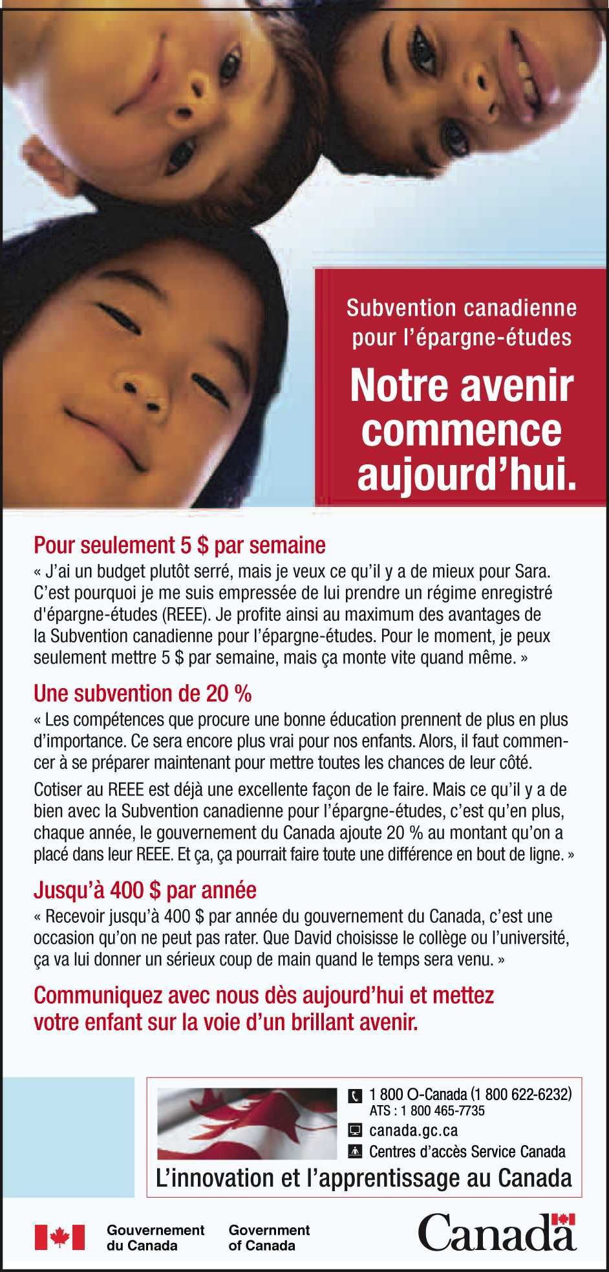
Appendix IV - Bilingual Questionnaire

Hello, this is calling from Ipsos-Reid. We're a professional public opinion research company, conducting a survey on behalf of the federal government department of Human Resources Development Canada about some recent advertising they have done. I’d like to assure you that we’re not trying to sell you anything. I’d also like to assure you that your participation is completely voluntary and your decision as to whether or not to participate will not affect any dealings you may have with the federal government. Only overall statistics will be reported; no individual will be identified. The collection of information through this survey is done under the authority of the Privacy Act.
Bonjour, ici , d'Ipsos-Reid, une firme professionnelle de sondages d'opinion publique. Nous menons présentement une étude pour le compte de Développement des ressources humaines Canada sur une publicité récente de ce ministère. Je tiens à vous assurer que nous n'avons rien à vendre. Je tiens également à vous souligner que votre participation est entièrement volontaire et que votre décision de prendre part ou non à notre étude n'aura aucune incidence sur vos relations avec le gouvernement fédéral. Les statistiques seront publiées une fois regroupées seulement et aucune personne ne sera identifiée. La collecte de renseignements dans le cadre de cette étude est soumise à Loi sur la protection des renseignements personnels.

SCREENERS
QUESTIONS DE RECRUTEMENT
A. Are you a parent of a child 12 years of age and under?
A. Avez-vous un enfant de 12 ans ou moins?
Yes [continue]
Oui [continuer]
No [thank and terminate]
Non [remercier et conclure]

B. Do you have a household income of between $30,000 and $60,000 per year?
B. Est-ce que le revenu de votre foyer se situe entre 30 000 $ et 60 000 $ par année?

Yes [continue]
Oui [continuer]
No [thank and terminate]
Non [remercier et conclure]

C. In the past two months or so, did you receive a Government of Canada leaflet in your mailbox or see a Government of Canada leaflet or ad in a magazine or newspaper that talked about saving for children’s post-secondary education?
C. Au cours des deux derniers mois environ, avez-vous reçu par la poste ou avez-vous vu dans un magazine ou dans un journal un dépliant ou une publicité du gouvernement du Canada portant sur l'épargne en vue des études postsecondaires des enfants?
Yes/maybe [continue – fill quota; n=400]
Oui/peut-être [continuer – remplir le quota; n=400]
No [interviewer ask; is there anyone else in your household who may have seen these ads – if yes, ask to speak to that person; if no continue and fill quota; n=400]
Non [interviewer, demander : y a-t-il quelqu'un d'autre dans votre foyer qui pourrait avoir vu ces publicités – si oui, demander de parler à cette personne; si non, continuer et remplir le quota; n=400]

[IF YES TO SCREENER C, ASK Q1-Q5, OTHERWISE SKIP TO Q6]
[SI OUI À LA QUESTION DE RECRUTEMENT C, POSER LES Q1 À 5. AUTREMENT, PASSER À LA Q6]
- Where did you see the leaflet or ad? [OPEN – DO NOT READ – RECORD FIRST AND OTHER MENTIONS] Anywhere else?
1. Où avez-vous vu le dépliant ou la publicité? [QUESTION OUVERTE – NE PAS LIRE – INSCRIRE LA PREMIÈRE RÉPONSE ET LES AUTRES RÉPONSES] Y a-t-il un autre endroit?
Newspaper
Journal
Leaflet in mailbox
Dépliant dans la boîte aux lettres
Magazine
Magazine
Other (Specify)
Autre (Préciser)

- How many times did you see the leaflet or ad? [OPEN-DO NOT READ-ACCEPT ONE RESPONSE]
2.Combien de fois avez-vous vu le dépliant ou la publicité? [QUESTION OUVERTE-NE PAS LIRE-ACCEPTER UNE SEULE RÉPONSE]
Once
Une fois
Twice
Deux fois
Three times
Trois fois
Four times or more
Quatre fois ou plus

- Thinking about the leaflet or ad that you saw, what do you think were the main points they were trying to get across? [OPEN – DO NOT READ – ACCEPT UP TO THREE RESPONSES] Anything else?
3.Si vous songez au dépliant ou à la publicité que vous avez vus, quels étaient selon vous les principaux messages qu'ils cherchaient à véhiculer? [QUESTION OUVERTE – NE PAS LIRE – ACCEPTER JUSQU'À TROIS RÉPONSES] Y a-t-il autre chose?
[Note to interviewer: If response is “saving for education”, probe further]
[Note à l'interviewer : Si la réponse est « épargner pour les études », sonder davantage]

Need to start saving now for children's education
Il faut commencer à épargner maintenant pour les études des enfants
People should save for the future/ your children's future
Les gens devraient épargner pour l'avenir/l'avenir de leurs enfants
How to save for children’s education
Comment épargner pour les études des enfants
No amount of money is too small to start saving
Aucun montant d'argent n'est trop petit pour commencer à épargner
Education is important/ a good investment
L'éducation est importante/est un bon placement
Government gives an additional 20 cents for every dollar you save in a Registered Education Savings Plan (RESP)
Le gouvernement accorde 20 cents pour chaque dollar que l'on verse dans un régime enregistré d'épargne-études (REEE)
Information on Registered Education Savings Plan (RESP) in general
Des renseignements sur le régime enregistré d'épargne-études (REEE) en général
Canada Education Savings Grant (CESG) is part of Youth Employment Strategy
La Subvention canadienne pour l'épargne-études (SCEE) fait partie de la Stratégie emploi jeunesse
Each child receives up to $400 per year
Chaque enfant reçoit jusqu'à 400 $ par année
Government has made it easier for families to save for post-secondary education
Le gouvernement a fait en sorte qu'il soit plus facile pour les familles d'épargner en vue des études postsecondaires
Information on the Canada Education Savings Grant (CESG) in general
Des renseignements sur la Subvention canadienne pour l'épargne-études (SCEE) en général
Nothing
Rien
Other (Specify)
Autre (Préciser)
Don't know
Ne sait pas

- Did the leaflet or ad motivate you to do anything?
4.Le dépliant ou la publicité vous ont-ils incité à faire quelque chose?
Yes
Oui
No
Non
Don't know
Ne sait pas

[IF YES TO Q4 ASK Q5, OTHERWISE SKIP TO Q6]
[SI OUI À LA Q4, POSER LA Q5. AUTREMENT, PASSER À LA Q6]
- And what was that? [OPEN – DO NOT READ – ACCEPT UP TO THREE RESPONSES] Anything else?
5.Et qu'avez-vous fait? [QUESTION OUVERTE – NE PAS LIRE – ACCEPTER JUSQU'À TROIS RÉPONSES] Y a-t-il autre chose?
Considered opening an RESP
A envisagé d'ouvrir un REEE
Talked to bank/financial advisor about saving for children's education to get information
S'est renseigné auprès de la banque/d'un conseiller financier sur l'épargne pour les études des enfants
Talked to a group fund provider (Canada Scholarship Trust, Children’s Education Foundation, USC Education Savings Plan, International Scholarship Foundation) to get information
A parlé à un promoteur de régime collectif (Plan fiduciaire canadien de bourses d'études, Children’s Education Foundation, Régime d'épargne-études USC, International Scholarship Foundation) pour obtenir des renseignements
Opened RESP account/decided to open an RESP
A ouvert un compte de REEE/décidé d'ouvrir un REEE
Phoned 1-800 number
A appelé au numéro 1 800
Visited Government of Canada website
A visité le site Web du gouvernement du Canada
Talked to friends/family about RESP/CESG
A parlé à des amis/membres de la famille du REEE/de la SCEE
Nothing
Rien
Other (Specify)
Autre (Préciser)
Don't know
Ne sait pas

[ASK ALL RESPONDENTS]
[DEMANDER À TOUS LES RÉPONDANTS]
- Are you currently saving for your child or children’s post-secondary education?
6.À l'heure actuelle, épargnez-vous pour les études postsecondaires de vos enfants?
Yes
Oui
No
Non
[IF YES in Q6 ASK Q7]
[SI OUI à la Q6, POSER la Q7]
- In what way are you saving? [OPEN – DO NOT READ – ACCEPT UP TO THREE RESPONSES] Anything else?
7.De quelle manière épargnez-vous? [QUESTION OUVERTE – NE PAS LIRE – ACCEPTER JUSQU'À TROIS RÉPONSES] Y a-t-il autre chose?
[Note to interviewer: if respondent says anything other than a Registered Education Savings Plan (e.g., a mutual fund), probe to see if it is a mutual fund or other savings vehicle within an RESP or outside an RESP - if it is within an RESP, please code as RESP – i.e., code 1]
[Note à l'interviewer : si le répondant mentionne autre chose qu'un régime enregistré d'épargne-études (p. ex. : un fonds commun de placement), sonder pour savoir s'il s'agit d'un fonds commun de placement ou d'un autre instrument d'épargne dans le cadre d'un REEE ou hors REEE - si c'est dans le cadre d'un REEE, coder REEE, c.-à-d. code 1]

Registered Education Savings Plan (RESP)
Régime enregistré d'épargne-études (REEE)
Savings Account/Other personal savings
Compte d'épargnes/Autres épargnes personnelles
Mutual Funds
Fonds communs de placement
Bonds
Obligations
RRSP's
REER
GIC's
CPG
Trust funds
Fonds en fiducie
Investments (unspecified)
Placements (non précisé)
Education fund/ group fund: (Canada Scholarship Trust, Children’s Education Foundation, USC Education Savings Plan, International Scholarship Foundation)
Fonds d'études/fonds collectif : (Plan fiduciaire canadien de bourses d'études, Children’s Education Foundation, Régime d'épargne-études USC, International Scholarship Foundation)
Term deposits
Dépôts à terme
Stocks
Actions
Nothing
Rien
Other (Specify)
Autre (Préciser)
Don't know
Ne sait pas

[ASK ALL RESPONDENTS]
[DEMANDER À TOUS LES RÉPONDANTS]
- If you were thinking about saving for your child or children’s post-secondary education what are the options available to you for saving money? [OPEN – DO NOT READ – ACCEPT UP TO THREE RESPONSES] Anything else?
8. Si vous songez à épargner en vue des études postsecondaires de vos enfants, quelles sont les options qui s'offrent à vous pour mettre de l'argent de côté? [QUESTION OUVERTE – NE PAS LIRE – ACCEPTER JUSQU'À TROIS RÉPONSES] Y a-t-il autre chose?

Registered Education Savings Plan (RESP)
Régime enregistré d'épargne-études (REEE)
Savings Account/Other personal savings
Compte d'épargnes/Autres épargnes personnelles
Mutual Funds
Fonds communs de placement
Bonds
Obligations
RRSP's
REER
GIC's
CPG
Trust funds
Fonds en fiducie
Investments (unspecified)
Placements (non précisé)
Education fund/ group fund: (Canada Scholarship Trust, Children’s Education Foundation, USC Education Savings Plan, International Scholarship Foundation)
Fonds d'études/fonds collectif : (Plan fiduciaire canadien de bourses d'études, Children’s Education Foundation, Régime d'épargne-études USC, International Scholarship Foundation)
Term deposits
Dépôts à terme
Stocks
Actions
Nothing
Rien
Other (Specify)
Autre (Préciser)
Don't know
Ne sait pas

- Now, using a scale from 0 to 10, where 0 means 'not at all familiar' and 10 means 'extremely familiar' how familiar are you with Registered Education Savings Plans?
9.J’aimerais maintenant savoir dans quelle mesure vous connaissez les Régimes enregistrés d'épargne-études. Veuillez répondre à l'aide d'une échelle de 0 à 10, où 0 signifie que vous ne les « connaissez pas du tout » et 10, que vous les « connaissez très bien ».
0-10
0 à 10

- In 1998, the Government of Canada created the Canada Education Savings Grant (CESG) to further encourage Canadians to save early for children's education. Using a scale from 0 to 10, where 0 means 'not at all familiar' and 10 means 'extremely familiar' how familiar are you with the Canada Education Savings Grant?
10.En 1998, le gouvernement du Canada a créé la Subvention canadienne pour l'épargne-études (SCEE) pour inciter davantage les Canadiens à commencer tôt à épargner pour les études de leurs enfants. Dans quelle mesure connaissez-vous la Subvention canadienne pour l'épargne-études? Veuillez répondre à l'aide d'une échelle de 0 à 10, où 0 signifie que vous ne la « connaissez pas du tout » et 10, que vous la « connaissez très bien ».
0-10
0 à 10

[IF 1 – 10 IN Q.10 AND YES TO SCREENER C, ASK Q.11]
[SI 1 À 10 À LA Q.10 ET OUI À LA QUESTION DE RECRUTEMENT C, POSER LA Q.11]
- How much of your familiarity with the CESG was a result of either the information contained in the leaflet or ad that you recently saw, or any information you gathered about the CESG as a result of seeing the leaflet or ad? Please use a scale from 0 to 10, where 0 means none of your familiarity with the CESG was a result of the ad or leaflet, and 10 means all of your familiarity with the CESG was due to the ad or leaflet.
11.Dans quelle mesure votre connaissance de la SCEE provient-elle de l'information que vous avez vue récemment dans le dépliant ou la publicité à ce sujet, ou encore de renseignements sur la SCEE que vous avez recueillis après avoir vu le dépliant ou la publicité? Veuillez répondre à l'aide d'une échelle de 0 à 10, où 0 signifie que votre connaissance de la SCEE ne provient pas du tout de la publicité ou du dépliant et 10, qu'elle provient uniquement de ces sources.
0-10
0 à 10

[IF 1 – 10 IN Q.10, ASK Q.12, OTHERWISE SKIP TO Q.13]
[SI 1 À 10 À LA Q.10, POSER LA Q.12. AUTREMENT, PASSER À LA Q.13]
- What can you tell me about the Canada Education Savings Grant, or CESG? [OPEN- DO NOT READ-RECORD FIRST AND OTHER MENTIONS] Anything else?
12.Que pouvez-vous me dire sur la Subvention canadienne pour l'épargne-études ou SCEE? [QUESTION OUVERTE – NE PAS LIRE – INSCRIRE LA PREMIÈRE RÉPONSE ET LES AUTRES RÉPONSES] Y a-t-il autre chose?
Nothing in particular
Rien en particulier
The Government of Canada provides a grant of 20 percent or $400 maximum when someone contributes to an RESP
Le gouvernement du Canada offre une subvention de 20 % de la somme placée dans un REEE, jusqu'à concurrence de 400 $
People pay into an RESP, the Government of Canada gives additional money and the child can use the money when he/she attends college or university
Les gens cotisent à un REEE, le gouvernement du Canada donne un montant additionnel et l'enfant peut utiliser l'argent pour ses études collégiales ou universitaires
It's available/ that it exists/ heard about it/ read about it
C'est offert/ce programme existe/en ai entendu parler/ai lu à ce sujet
Tax deduction when you contribute to an RESP
Déduction d'impôt lorsqu'on cotise à un REEE
Tax benefit (general)
Avantage fiscal (en général)
Government matches your contribution
Le gouvernement met le même montant que l'épargnant
General negative mentions
Des commentaires négatifs en général
Government is working with Canadians to help families save for post-secondary education
Le gouvernement collabore avec les Canadiens pour aider les familles à épargner en vue des études postsecondaires
Year 2000 scholarships/ grants
Les bourses/subventions du millénaire
Similar to an RRSP/ you get a tax credit for the money you put in
Semblable à un REER/l'argent versé donne droit à un crédit d'impôt
Save for children's education/ start early
Épargner en vue des études des enfants/commencer tôt
Beneficial/ it's a good thing
Avantageux/c'est une bonne chose
Can use only for education
Peut être utilisé seulement pour les études
If not used by child can get the money back/ the principal
Si l'enfant ne l'utilise pas, possibilité de récupérer l'argent/le capital
Child needs a SIN card to qualify
L'enfant doit avoir un NAS pour être admissible
Borrow money for education/ student loans
Emprunter de l'argent pour les études/prêts étudiant
Penalty when child doesn't use it for school
Pénalité lorsque l'enfant n'utilise pas l'argent pour ses études
If not used by child can be transferable
Transférable si l'enfant ne l'utilise pas
Know that someone applied for it
Connaît quelqu'un qui en a fait la demande
Other (Specify)
Autre (Préciser)
Don't know
Ne sait pas

[ASK ALL RESPONDENTS EXCEPT THOSE WHO SAID YES TO Q6]
[DEMANDER À TOUS, SAUF À CEUX QUI ONT RÉPONDU OUI À LA Q6]
- Do you plan to start saving for your child or children’s post secondary education within the next year or so?
13.Prévoyez-vous commencer à épargner en vue des études postsecondaires de vos enfants au cours de la prochaine année environ?

Yes
Oui
No
Non

[IF YES IN Q.13, ASK Q.14]
[SI OUI À LA Q.13, POSER LA Q.14]
- What method of saving do you plan to use? [OPEN – DO NOT READ – ACCEPT UP TO THREE RESPONSES]
14.À quelle méthode comptez-vous faire appel pour épargner? [QUESTION OUVERTE – NE PAS LIRE – ACCEPTER JUSQU'À TROIS RÉPONSES]
Registered Education Savings Plan (RESP)
Régime enregistré d'épargne-études (REEE)
Savings Account/Other personal savings
Compte d'épargnes/Autres épargnes personnelles
Mutual Funds
Fonds communs de placement
Bonds
Obligations
RRSP's
REER
GIC's
CPG
Trust funds
Fonds en fiducie
Investments (unspecified)
Placements (non précisé)
Education fund/ group fund: (Canada Scholarship Trust, Children’s Education Foundation, USC Education Savings Plan, International Scholarship Foundation)
Fonds d'études/fonds collectif : (Plan fiduciaire canadien de bourses d'études, Children’s Education Foundation, Régime d'épargne-études USC, International Scholarship Foundation)
Term deposits
Dépôts à terme
Stocks
Actions
Nothing
Rien
Other (Specify)
Autre (Préciser)
Don't know
Ne sait pas

[IF NO IN Q13, ASK Q15]
[SI NON À LA Q13, POSER LA Q15]

- Why do you say that? [OPEN- DO NOT READ-RECORD FIRST AND OTHER MENTIONS] Any other reasons?
15.Pourquoi dites-vous cela? [QUESTION OUVERTE – NE PAS LIRE – INSCRIRE LA PREMIÈRE RÉPONSE ET LES AUTRES RÉPONSES] Y a-t-il d'autres raisons?

Children are not going to pursue post secondary education
Les enfants ne feront pas d'études postsecondaires
Expect children to pay for their own education
S'attend à ce que les enfants paient eux-mêmes leurs études
Expect to use loans/grants/bursaries
Compte faire appel à des prêts/subventions/bourses
Don’t have enough money to save for post secondary education
N'a pas assez d'argent pour épargner en vue des études postsecondaires
Other (specify)
Autre (préciser)

[ASK Q16-18 OF ALL RESPONDENTS EXCEPT THOSE WHO SAID IN Q.7 THEY HAVE AN RESP OR THOSE WHO SAID NO IN Q13]
[POSER LES Q16 À 18 À TOUS LES RÉPONDANTS, SAUF À CEUX QUI ONT DIT AVOIR UN REEE À LA Q7 OU À CEUX QUI ONT RÉPONDU NON À LA Q13]

- Are you currently saving for a child’s post secondary education with a Registered Education Savings Plan (RESP)?
16.À l'heure actuelle, épargnez-vous en vue des études postsecondaires d'un enfant dans le cadre d'un régime enregistré d'épargne-études (REEE)?
Yes
Oui
No
Non

[IF NO IN Q.16, ASK Q. 17-18, OTHERWISE SKIP TO Q19]
[SI NON À LA Q.16, POSER LES Q.17 ET 18. AUTREMENT, PASSER À LA Q.19]
- Why do you say that? [OPEN- DO NOT READ-RECORD FIRST AND OTHER MENTIONS] Any other reasons?
17.Pourquoi dites-vous cela? [QUESTION OUVERTE – NE PAS LIRE – INSCRIRE LA PREMIÈRE RÉPONSE ET LES AUTRES RÉPONSES] Y a-t-il d'autres raisons?
Don’t know enough about how RESPs work
N'en sait pas suffisamment sur le fonctionnement des REEE
Don’t have enough money to start/contribute to an RESP
N'a pas assez d'argent pour ouvrir/cotiser à un REEE
Don’t understand/too complicated
Ne comprend pas/trop compliqué
Not enough flexibility in RESP
Le REEE n'offre pas assez de flexibilité
Have concerns about the RESP/ think I can loose my money/ too many restrictions
A des craintes face au REEE/pense qu'il peut perdre son argent/trop de restrictions
Children not eligible for an RESP
Les enfants ne sont pas admissibles au REEE
Other (specify)
Autre (préciser)

- If you were to open a Registered Education Savings Plan, what is the first step that you would take? [OPEN-DO NOT READ-ACCEPT UP TO TWO RESPONSES] Anything else?
18.Si vous décidiez d'ouvrir un régime enregistré d'épargne-études, quelle mesure prendriez-vous en premier lieu? [QUESTION OUVERTE-NE PAS LIRE-ACCEPTER JUSQU'À DEUX RÉPONSES] Y a-t-il autre chose?
Talk to bank/financial advisor about saving for children's education
Se renseignerait auprès d'une banque/d'un conseiller financier sur l'épargne pour les études des enfants
Phone 1-800 number
Appellerait au numéro 1 800
Visit Government of Canada website
Visiterait le site Web du gouvernement du Canada
Talk to family, other parents
En parlerait à des membres de la famille, à d'autres parents
Call a group fund (Canada Scholarship Trust, Children’s Education Foundation, USC Education Savings Plan, International Scholarship Foundation)
Appellerait un promoteur de fonds collectif (Plan fiduciaire canadien de bourses d'études, Children’s Education Foundation, Régime d'épargne-études USC, International Scholarship Foundation)
Get a SIN for my child
Obtiendrait un NAS pour son enfant
Nothing
Rien
Other (Specify)
Autre (Préciser)
Don't know
Ne sait pas

[ASK ALL RESPONDENTS EXCEPT IF RESP IN Q7 OR YES TO Q16]
[DEMANDER À TOUS LES RÉPONDANTS, SAUF SI REEE À LA Q7 OU OUI À LA Q16]
- The Canada Education Savings Grant (CESG) is designed to encourage Canadians to save early for children's education. The way it works is, when a parent, grandparent, uncle, aunt or any other person contributes money to a child's Registered Education Savings Plan (RESP), the Government of Canada adds a grant of 20 percent, up to a maximum of $400 per year, per child. If you didn’t know about the CESG before, would you now consider opening an RESP to save for a child’s education?
19.La Subvention canadienne pour l'épargne-études (SCEE) est conçue pour inciter les Canadiens à commencer tôt à épargner pour les études de leurs enfants. Elle fonctionne de la façon suivante : lorsqu'un père, une mère, un grand-père, une grand-mère, un oncle, une tante ou toute autre personne verse de l'argent dans le régime enregistré d'épargne-études (REEE) d'un enfant, le gouvernement du Canada accorde une subvention de 20 pour cent du montant versé, jusqu'à concurrence de 400 $ par année par enfant. Si vous ne connaissiez pas la SCEE auparavant, envisageriez-vous maintenant d'ouvrir un REEE pour épargner en vue des études d'un enfant?

Yes
Oui
No
Non
DK/NR
NSP/PAS DE RÉPONSE

[IF NO TO Q19, ASK Q20]
[SI NON À LA Q19, POSER LA Q20]

- Why do you say that? [OPEN- DO NOT READ-RECORD FIRST AND OTHER MENTIONS] Any other reasons?
20.Pourquoi dites-vous cela? [QUESTION OUVERTE – NE PAS LIRE – INSCRIRE LA PREMIÈRE RÉPONSE ET LES AUTRES RÉPONSES] Y a-t-il d'autres raisons?

Don’t know enough about how RESPs work
N'en sait pas suffisamment sur le fonctionnement des REEE
Don’t have enough money to start/contribute to an RESP
N'a pas assez d'argent pour ouvrir/cotiser à un REEE
Don’t understand/too complicated
Ne comprend pas/trop compliqué
Not enough flexibility in RESP
Le REEE n'offre pas assez de flexibilité
Have concerns about the RESP/ think I can loose my money/ too many restrictions
A des craintes face au REEE/pense qu'il peut perdre son argent/trop de restrictions
Children not eligible for an RESP
Les enfants ne sont pas admissibles au REEE
Other (specify)
Autre (préciser)

[IF RESP IN Q7 OR YES TO Q16 ASK Q21-23]
[SI REEE À LA Q7 OU OUI À LA Q16, POSER LES Q21 À 23]
- Why did you decide to open a Registered Education Savings Plan? [OPEN-DO NOT READ-ACCEPT UP TO TWO RESPONSES]
21.Pourquoi avez-vous décidé d'ouvrir un régime enregistré d'épargne-études? [QUESTION OUVERTE-NE PAS LIRE-ACCEPTER JUSQU'À DEUX RÉPONSES]
Important to save for children’s education
Il est important d'épargner pour les études des enfants
Tax benefits
Avantages fiscaux
Canada Education Savings Grant (additional money is added to RESP contribution)
Subvention canadienne pour l'épargne-études (un montant est ajouté à la cotisation au REEE)
Other (specify)
Autre (préciser)

- Approximately how many times did you hear about the Canada Education Savings Grant before you decided to open an RESP? [DO NOT READ]
22.Avant de décider d'ouvrir un REEE, environ combien de fois avez-vous entendu parler de la Subvention canadienne pour l'épargne-études ? [NE PAS LIRE]
None
Aucune
Once
Une fois
Twice
Deux fois
Three times
Trois fois
Four times
Quatre fois
Five times or more
Cinq fois ou plus

- How did you hear about the Canada Education Savings Grant that you get with an RESP? [OPEN-DO NOT READ –ACCEPT ALL RESPONSES] Anything else?
23.Comment avez-vous entendu parler de la Subvention canadienne pour l'épargne-études que vous obtenez avec un REEE? [QUESTION OUVERTE-NE PAS LIRE-ACCEPTER TOUTES LES RÉPONSES] Y a-t-il autre chose?
Financial institution/advisor talked to me
Par une institution financière/un conseiller financier
Financial institution posters/brochures
Affiches/brochures d'une institution financière
Word of mouth/family, friends, other parents
Bouche à oreille/famille, amis, autres parents
TV ad
Publicité à la télévision
TV program
Émission de télévision
Newspaper/magazine article
Article de journal/magazine
Government website
Site Web du gouvernement
Phone (someone called to solicit interest)
Téléphone (quelqu'un a appelé pour m'en parler)
Gov’t of Canada materials
Documents du gouvernement du Canada
Other (specify)
Autre (préciser)

DEMOGRAPHIC SECTION
SECTION DES DONNÉES DÉMOGRAPHIQUES
Finally, before I let you go, I just need to ask you a few questions for our statistical calculations.

Pour terminer, il me reste quelques questions à vous poser à des fins statistiques.
- In what year were you born [Record year]
24.En quelle année êtes-vous né? [Inscrire l'année]
- What is the highest level of formal education that you have completed? [READ LIST]
25.Quel est le plus haut niveau de scolarité que vous avez complété? [LIRE LA LISTE]
Grade school or some high school
École primaire ou études secondaires en partie
Complete high school
Diplôme d'études secondaires
Technical, vocational post-secondary
Études postsecondaires techniques, professionnelles
Some university
Études universitaires en partie
Complete university degree
Diplôme d'études universitaires
Post graduate degree
Diplôme d’études universitaires de deuxième ou de troisième cycle

- What is your current employment status? Are you [READ ALL ITEMS – ACCEPT ONE ANSWER ONLY]?
26.Quelle est votre situation d’emploi actuelle? Êtes-vous [LIRE TOUS LES ÉLÉMENTS – ACCEPTER UNE SEULE RÉPONSE]?
Working full-time (35 or more hours per week)
au travail à temps plein (35 heures ou plus par semaine)
Working part-time (less than 35 hours per week)
au travail à temps partiel (moins de 35 heures par semaine)
Self-employed
travailleur autonome
Unemployed, but looking for work
sans emploi – en recherche d'emploi
Attending school full-time/A student
aux études à temps plein/étudiant
Retired
à la retraite
Not in the workforce (Full-time homemaker/Unemployed, not looking for work)
pas sur le marché du travail (au foyer à temps plein/sans emploi et n'en cherche pas)
(IF VOLUNTEERED: Other (do not specify))
(SI SPONTANÉE : Autre (ne pas préciser))

- How many of your children are 12 years of age or younger? [READ LIST]
27.Combien de vos enfants sont âgés de 12 ans ou moins? [LIRE LA LISTE]
One
Un
Two
Deux
Three
Trois
Four or more
Quatre ou plus

[IF ONE CHILD IN Q27, ASK Q28]
[SI UN ENFANT À LA Q27, POSER LA Q28]
- What is the age of your child?
28.Quel est l'âge de votre enfant?
Less than one year of age
Moins d'un an
1-12 years
Entre 1 et 12 ans

(IF 1-12 years in Q28 CONTINUE, OTHERWISE SKIP TO Q29)
(SI ENTRE 1 ET 12 ans à la Q28, CONTINUER. AUTREMENT, PASSER À LA Q29)

28A. RECORD NUMBER OF YEARS
28A. INSCRIRE LE NOMBRE D'ANNÉES

- And finally, which of the following categories best describes your household income? Is it [READ LIST]?
29.Enfin, laquelle des catégories suivantes décrit le mieux le revenu total de votre foyer, c'est-à-dire le revenu total de toutes les personnes de votre foyer combinées, avant impôts [LIRE LA LISTE]?
$30,000 to just under $40,000
De 30 000 $ à un peu moins de 40 000 $
$40,000 to just under $50,000
De 40 000 $ à un peu moins de 50 000 $
$50,000 to $60,000
De 50 000 $ à 60 000 $

Read to all respondents:
Lire à tous les répondants :

To obtain information related to this research you may do so by submitting a written request under the Access to Information Act. Would you like further information on how to do this?
En vertu de la Loi sur l'accès à l'information, vous pouvez obtenir des renseignements sur la présente étude en soumettant une demande écrite. Aimeriez-vous en savoir davantage sur la façon de procéder?

IF YES,
SI OUI,

Instructions for making formal requests are provided in the publication InfoSource. This is located in local HRDC offices, and is available at the website: infosource.gc.ca. When requesting information, please refer to the study name, CESG Insert Distribution Winter 02/03: Quantitative Post-Distribution Assessment.
La publication InfoSource contient les directives pour la présentation d'une demande officielle. On peut trouver cette publication aux bureaux locaux de DRHC et sur son site Web : infosource.gc.ca. Pour présenter une demande de renseignements, veuillez utiliser le nom de l'étude, Distribution de l'encart de la SCEE Hiver 02/03 : Évaluation quantitative suivant la distribution.

INTERVIEWER RECORD REGION, GENDER AND URBAN/RURAL IDENTIFIER
INTERVIEWER, INSCRIRE LA RÉGION, LE SEXE ET L'IDENTIFICATEUR URBAIN/RURAL
THANK RESPONDENT FOR TAKING THE TIME TO COMPLETE THE SURVEY
REMERCIER LE RÉPONDANT D'AVOIR PRIS LE TEMPS DE RÉPONDRE AU SONDAGE.

Please note 34% of the total sample said they were saving for post-secondary education with an RESP, either on an unaided or an aided basis. Twenty-eight percent were saving for post secondary education without RESPs, and 37% of the sample were not saving for their children’s post secondary education.
Please note the remainder of this report examines findings from the targeted survey only.

