Canada Digital Adoption Program: Focus Group Testing of Creative Concepts

Innovation, Science and Economic Development Canada

Final Report

July 2022

Prepared for Innovation, Science and Economic Development Canada
Supplier name: Quorus Consulting Group Inc.
Contract award date: December 20, 2021
Contract number: U1400-222043/001/CY
Contract value: $ $95,853.99
Delivery date: July 2022
POR Number: POR 080-21
For more information, please contact Innovation, Science and Economic Development Canada at: IC.PublicOpinionResearch-Recherchesurlopinionpublique.IC@canada.ca

Ce rapport est aussi disponible en français

This publication is available online at https://www.ic.gc.ca/eic/site/112.nsf/eng/home.

To obtain a copy of this publication, or to receive it in an alternate format (Braille, large print, etc.), please fill out the Publication Request Form at www.ic.gc.ca/Publication-Request or contact:

Web Services Centre
Innovation, Science and Economic Development Canada
C.D. Howe Building
235 Queen Street
Ottawa, ON K1A 0H5
Canada

Telephone (toll-free in Canada): 1-800-328-6189
Telephone (international): 613-954-5031
TTY (for hearing impaired): 1-866-694-8389
Business hours: 8:30 a.m. to 5:00 p.m. (Eastern Time)
Email: ISED@canada.ca

Permission to Reproduce

Except as otherwise specifically noted, the information in this publication may be reproduced, in part or in whole and by any means, without charge or further permission from the Department of Industry, provided that due diligence is exercised in ensuring the accuracy of the information reproduced; that the Department of Industry is identified as the source institution; and that the reproduction is not represented as an official version of the information reproduced or as having been made in affiliation with, or with the endorsement of, the Department of Industry.

For permission to reproduce the information in this publication for commercial purposes, please fill out the Application for Crown Copyright Clearance at www.ic.gc.ca/copyright-request or contact the Web Services Centre mentioned above.

© Her Majesty the Queen in Right of Canada, as represented by the Minister of Industry, (2022).

Cat. No. Iu173-39/2022E -PDF

ISBN 978-0-660-43329-5

Aussi offert en français sous le titre : Programme canadien d'adoption du numérique : Évaluation de concepts créatifs par des groupes de discussion.
Political neutrality statement

I hereby certify as Senior Officer of Quorus Consulting Group Inc. that the deliverables fully comply with the Government of Canada political neutrality requirements outlined in the Policy on Communications and Federal Identity and the Directive on the Management of Communications - Appendix C.
Specifically, the deliverables do not include information on electoral voting intentions, political party preferences, standings with the electorate or ratings of the performance of a political party or its leaders.
Signed:
April 19, 2022
Rick Nadeau, President
Quorus Consulting Group Inc.

Table of contents

Executive summary 5
Background and objectives 5
Methodology 5
Research results 6
Background and research objectives 13
Research findings 14
Digital adoption and e-commerce 14
Concept evaluation 17
TERRITORY A 18
TERRITORY B 21
TERRITORY C 24
Preferred territory 26
HTML banner ad message testing 27
Radio spot 29
Social media message testing 31
Reactions to the campaign overall 34
Reactions to the proposed program 35
Detailed methodology 38
Target audience and sample frame 38
Description of data collection procedures 39
Appendices 43
Recruitment screener – focus groups 44
Moderation guide – focus groups 56

Executive summary

Background and objectives
To encourage small and medium-sized enterprises (SMEs) across the country to adopt digital technologies, the Government of Canada announced in Budget 2021 the Canada Digital Adoption Program (CDAP). In order to raise awareness, promote the program and engage SME’s, ISED developed an advertisement campaign. This research was used to help select and develop creative concepts (both organic and paid messaging) for this campaign by seeking feedback from the campaign’s intended audience.
Additionally, the research sought understand how businesses themselves view the advantages, opportunities and challenges of digital adoption or transformation in their respective sectors.

Methodology
The research methodology consisted of 12 online focus groups and eight one-on-one interviews which were completed between February 15 and February 25, 2022. Participants were small and medium-sized businesses from across Canada. During recruitment, business representatives were grouped into one of two segments based on business size and revenue. Participants were individuals familiar with the decisions their company makes regarding using digital technology to diversify or grow the company. In total, representatives from 71 businesses participated in the focus groups and representatives from 8 businesses attended one-on-one interviews.

Research results

Digital adoption and e-commerce
The COVID-19 pandemic has forced many businesses to adapt in many ways, including the adoption of areas of digital technologies. Staff working from home and the switch from in-person to e-commerce were the main drivers of change, including:
- Investments in new hardware
- More use of videoconferencing solutions
- Server upgrades
- Investment in cyber security solutions
- Investment in remote connectivity tools
- Website upgrades or development, sometimes including e-commerce and online payment integration
- New or expanded digital marketing strategies
- Use of third-party vendors, aggregators or delivery services

Challenges that came with these changes and investments were mainly related to (internal) knowledge and capacity, and cost.

Concept evaluation

HTML banner ad and video concepts
Three “territories” were explored with participants, with “Grow” as the core concept for Stream 1 participants and “Boost” as the core concept for Stream 2 participants:

STREAM 1 TERRITORY CREATIVE SUMMARY
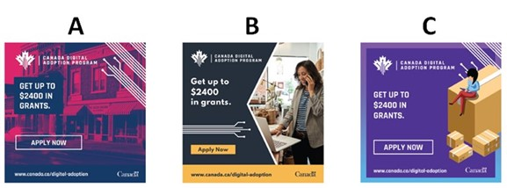

STREAM 2 TERRITORY CREATIVE SUMMARY
The results show that Concept B was by far the most popular among participants in both Streams. The main reactions to the creative approaches include the following:
- Concept A: This concept received the most criticism, especially regarding the choice of colours, which was considered jarring, unappealing and distracting from the main message. Participants in Stream 2 had difficulty deciphering the image in the background while the morphing of the brick-and-mortar store to an online store concept in Stream 1 fell flat for most. A few, especially among younger Quebec entrepreneurs, did appreciate the unique choice of colour, admitting it would be most likely to get their attention. The use of an animated line to draw contours in the Stream 1 concept was also liked by a few.
- Concept B: This was by far the most preferred concept, especially for its “clean” and “professional” layout and for featuring real people and a variety of settings or businesses, giving it the broadest appeal across industry sectors. Some also mentioned that it featured some industries or businesses, such as a farm, that were not traditionally linked to using digital technology, which many felt was a strength. The concept was considered highly relatable, modern, diverse, and having a nice “personal feel.”
- Concept C: Although some did like this concept, it easily ranked between Concept A and B in terms of overall popularity. Participants could not easily relate to the visual elements, with some feeling that the concept looked like an ad for a moving company, a shipping company or Amazon. A few also noted that the person on the box could be the consumer rather than the business owner and that the video would quite narrowly appeal to those in one industry only. There was also less interest in faceless animation compared to seeing real people operating real businesses.

HTML banner ad messages
Stream 2 participants were presented with three different text flows, potentially for an HTML banner ad.

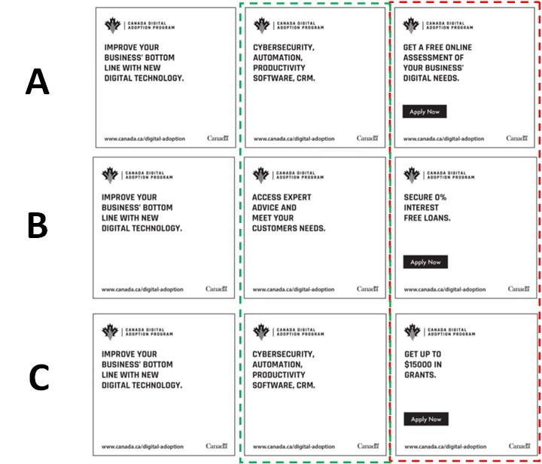

When considering the options in the third column above, the text in row C (getting a grant) was by far the most preferred. For the second column, the text in row B (access to advice) was preferred, although rows A/C also received some votes. Many explained that potentially getting a grant and access to an advisor made for a very compelling combination. However, there were also participants who were a bit skeptical about the offer of advice and who questioned the value that outside advice from the government would bring to their unique business. They therefore leaned towards options A/C in the second column, saying that that information gave them some concrete examples of what they may be able to do with the grant. Cybersecurity resonated best and more broadly than the other items listed.

Radio spots
From a content perspective, there was a sense that the narrator was speaking quickly and that the ad was trying to convey too much information in too short a time. Some also felt that the language was too technical. It was also suggested that the main “hook” is only at the end of the ad, where there is a reference to a grant. As such, participants recommended that the “hook” be at the beginning of the radio ad to more effectively get their attention from the start. It was also suggested that the ad should start with some sort of rhetorical question or interrogation that specifically targets SMEs, and to then continue with the information about the program and the grant.
Two spots were tested with Stream 2 participants, with mixed reviews and preferences. Those who liked Option B, appreciated that it features a free online assessment of how to improve their business’ technology. On the other hand, others felt that this sounded a bit gimmicky or as though it was a trick to draw them into something else, as they often experienced with online ads that ended up being clickbait. Those who liked Option A often felt that it was more explanatory and conveyed more information about the program, as it talked about both the idea of adopting new digital strategies and technology, as well as about the support they would receive from digital advisors – which they felt would be more personal or tailored to their business and therefore more valuable than a mere “free online assessment.”
Social media messages
The final creative element explored with participants was a variety of social media “shareables.” Stream 1 participants were asked to select their two preferred messages among seven options and Stream 2 participants were presented with six different options.
The preferred messages for Steam 1 were:
- Grow Your Business Online Grant
- Give your business a digital edge
- More than 90% of people make their buying decision online
Use of the word “grant” was important to many and this weighed heavily in their preferences. This option clearly told them what the program was about and what was in it for them. Businesses are interested in growing and in getting a digital edge, two notions related to being competitive or to standing out in the marketplace – and something they said would speak to all businesses. Moreover, the top two messages spoke directly to participants through the use of the phrase “your business.” Statistics received mixed reactions in general but the idea that 90% of people make buying decisions online proved most relevant to businesses – it reinforced the importance of being online and it was quite a compelling number. Other options tested were seen as too long, too vague, or showing outdated or irrelevant statistics.
The preferred messages for Stream 2 were:
- Give your business a digital edge
- Improve your businesses’ digital technology today
- Enabling Canadian businesses to expand digitally
As was seen among Stream 1 participants, the idea of a digital edge or business improvements resonated with Stream 2 participants. Again, speaking directly about their business through the use of “your business” clearly showed participants what was in it for them. Other options that did not use that phrase were sometimes said to sound like the government was self-promoting. Shorter, catchier sentences were preferred over options that had more text.

Reactions to the campaign overall
Most participants felt that the campaign and the main message being conveyed was relevant to them as business owners and operators. Most felt that if they were to see the creative “territory” that they preferred online or in social media, they most likely would click through to at least find out more about the program. The main incentive for them is the potential for a grant and to obtain expert advice.
Specific feedback from Stream 1 participants included:
- The amount of the grant was not high enough.
- It would likely be cumbersome to apply.
- It targeted businesses who were not yet online or not yet using e-commerce.
- They were often interested in going beyond setting up a website or a basic e-commerce solution.
- They would like to use the funds for other purposes such as marketing, social media campaigns or search engine optimization.
Specific feedback from Stream 2 participants included:
- The grant amount was interesting and worth the effort of applying.
- It would likely require a lot of effort to apply.
- This program appeared more geared towards savvy digital adopters, while some wanted more help with foundations such as improving their website and digital marketing.
- Digital advice was appreciated by those who felt they were not (yet) very savvy.

Reactions to the proposed program
Awareness of the program was extremely low. Even after hearing the program description, many participants could not easily imagine how the program would work and still had many assumptions or questions, including:
- There were questions about how the grant funds could be used, including whether they could be applied to past expenses or ongoing expenses (rather than one-time purchases).
- There were questions about the application process, eligibility criteria and how challenging it may be to qualify.
- Some assumed that they would meet with an advisor or have an expert conduct a digital audit or evaluation and that, based on this assessment, a plan would be proposed.
- Some hoped that the program would recommend specific software, vendors and platforms.
- Some saw the program as a way to learn about e-commerce and digital technologies.
Nonetheless, there was interest in learning more about the program and how it worked.
At the end of the sessions, participants were asked to think of the future and of where they see their companies’ needs or wants for new or expanded use of digital technologies. Some of the types of digital technologies that businesses are interested in exploring or implementing included:
- developing a mobile app
- improving their website
- more digital marketing
- artificial intelligence
- CRM
- better back-office integration platforms
- virtual reality
- the metaverse
- online scheduling applications
- online collaboration platforms
- online payment systems.

Qualitative research disclaimer
Qualitative research seeks to develop insight and direction rather than quantitatively projectable measures. The purpose is not to generate “statistics” but to hear the full range of opinions on a topic, understand the language participants use, gauge degrees of passion and engagement and to leverage the power of the group to inspire ideas. Participants are encouraged to voice their opinions, irrespective of whether or not that view is shared by others.
Due to the sample size, the special recruitment methods used, and the study objectives themselves, it is clearly understood that the work under discussion is exploratory in nature. The findings are not, nor were they intended to be, projectable to a larger population.
Specifically, it is inappropriate to suggest or to infer that few (or many) real world users would behave in one way simply because few (or many) participants behaved in this way during the sessions. This kind of projection is strictly the prerogative of quantitative research.

Supplier name: Quorus Consulting Group Inc.
PSPC contract number: U1400-222043/001/CY
Contract award date: December 20, 2021
Contract value (including HST): $95,853.99
For more information, please contact Innovation, Science and Economic Development Canada at: IC.PublicOpinionResearch-Recherchesurlopinionpublique.IC@canada.ca

Background and research objectives
The impact of the COVID-19 pandemic on small and medium-sized enterprises (SMEs) has been significant and highlights the need for Canadian businesses to adopt digital technologies in order to meet customers’ needs and stay competitive. For some SMEs, this means adopting e-commerce capabilities to sell online. For others, it’s about implementing advanced digital technologies to improve productivity.
A 2019 study released by BDC found that only four in 10 Canadian SME’s with an online presence sell, receive and take orders online, despite the fact that growing a business online allows for higher revenues, direct communication with customers and easier access to global markets. In 2017, Statistics Canada found that nearly half (46.4%) of Canadian businesses did not have a website, and of those who did, a majority were not set up to receive online payments or collect customer information.
To encourage SME’s across the country to adopt digital technologies, the Government of Canada announced in Budget 2021 the Canada Digital Adoption Program (CDAP). CDAP will offer digital adoption support to SME’s in any industry through two Streams: smaller SMEs that need basic support to create digital storefronts and implement e-commerce; and the more sophisticated SMEs looking to expand digital capabilities and improve productivity through digital transformation.
In an effort to promote the program and engage SME’s, ISED developed an advertisement campaign. The primary research objectives in relation to this campaign are to test the concepts and underlying messages through the engagement of micro, small and medium business owners in online (virtual) focus groups and interviews, to determine, for each identified business audience, the
- reactions towards and insights on proposed advertising concepts;
- reactions towards and insights on organic marketing concepts;
- level of understanding of the overall messaging;
- overall understanding and credibility of the messages presented;
- preference towards the proposed concepts, by target audience; and,
- perceptions of the benefits and identification of any barriers to digital adoption.

The research will be used to help select and develop creative concepts (both organic and paid messaging) for this campaign by seeking feedback from the campaign’s intended audience. This feedback will help determine if the messaging will work to raise awareness of the program, as well as to create sufficient confidence and interest in the CDAP program to propel SMEs in the target audience to respond to the call to action and enroll in the program.
Beyond the concepts and messages tested, there was also a need to understand how businesses themselves view the advantages, opportunities and challenges of digital adoption or transformation in their respective sectors. To that end, the research gathered information on business owners’ outlook on the current business environment, including their current understanding, priorities, needs and challenges with respect to digital adoption and transformation.

Research findings

Digital adoption and e-commerce

Given that the past years had seen necessary changes on many fronts for businesses of all shapes and sizes due to the COVID-19 pandemic, an initial discussion was held to gather insights into how businesses had used digital technologies to a greater extent or differently over the few past years, as well as what challenges they had faced. Following that discussion, a number of advertising concepts were tested.
Many businesses had seen themselves having to adapt due to the pandemic.
Many businesses had to move staff, whether all or some, to working from home rather than in an office. This necessitated changes, including:
  - Investment in hardware such as PCs, laptops, cameras, headsets or smartphones so that staff would have the tools to set up an office remotely;
  - Use of and training for staff in videoconferencing technology to stay in touch with work colleagues but more notably with clients, especially those in the service industries;
  - New, expanded or upgraded server capacity, mostly cloud-based; and,
  - Remote connectivity tools such as secure VPNs to connect to networks but also person-to-person secure messaging for internal uses.
Businesses, especially those in the restaurant industry, in retail and in manufacturing, had to find alternatives to in-person sales and marketing, which necessitated digital strategies and investments such as:
  - Website development, often integrating e-commerce and online payment systems, whether by updating or expanding existing capacities in this area, or adding new ones.
  - Increasing their use of digital marketing, especially through websites and social media.
  - Start using or increasing their use of third-party vendors, aggregators or delivery services such as Amazon, Uber Eats, or local delivery services.
While much of the discussion focused on changes made due to the pandemic, some also mentioned changes that had been made for other reasons that were not necessarily directly related. For example, a number of participants mentioned they have had to invest more in cyber security, whether to prevent hacking, or to respond to (successful or unsuccessful) hacking attempts. There was a sense that this threat had been growing in the past years. For some, this had meant hardware updates, while for others, this has resulted in a need for more specialized IT staff or contractors. As well, some businesses had expanded or “professionalized” their CRM systems to more effectively deal with their existing or growing customer base.
There were a number of challenges and concerns businesses felt while going through their digital transitions, many of which they still feel they face as they ponder their digital future.
One challenge is related to knowledge and capacity. Some said they feel they do not necessarily have sufficient in-house knowledge to make the right decisions regarding a digital strategy overall, but also in terms of where to look for help, including for vendors, software and platforms. Smaller business owners in particular said that they had done a lot themselves, including for example building websites or starting or expanding digital marketing campaigns, that they felt they would have been better off outsourcing, as it took a lot of time and effort to learn and execute – often without yielding an optimal result. This took away time and energy from their “real” business, which had often already been struggling. One of the main reasons a lot was kept in-house was related to costs of outsourcing these services.
In general, costs of digital transformation are also a big concern for many businesses, both for one-time investments such as hardware or developing digital assets, and for ongoing costs, such as for upkeep of new systems, additional IT support or services, costs associated with digital marketing, and subscription fees.
Businesses were also somewhat concerned with being able to meet demand if they were to expand their marketing efforts, suggesting that they would potentially have to expand in different areas, bringing with it more capital costs or staffing needs and expenditures, including in the digital or e-commerce space.
Looking ahead to the near future, some felt that they were now in a place that they were comfortable in terms of their technology. That said, most were always interested in growing and expanding their businesses, fully aware of the associated need to continuously expand their digital capacities and capabilities in all areas to stay competitive.

Concept evaluation
Participants were told that to promote a new program, the Government of Canada would be conducting a national advertising campaign to engage businesses like theirs. The next section of the discussion focused on the evaluation of advertising concepts for this campaign.
Three “territories,” or concept styles, were explored with participants, with “Grow” as the core concept for Stream 1 participants and “Boost” as the core concept for Stream 2 participants. Each territory consisted of:
- The story board for an animated Internet banner ad which would appear at the top of webpages, and,
- The story board for a short video that could appear on webpages or on social media.
Each territory had a different look and feel with the same written copy. They were presented one after the other in a different order from one session to the next. The moderator took care to walk participants through each story board, including reading the copy and the voice-over texts and explaining the general creative idea. Before moving on to the next territory, the territory that had just been presented was given an initial impression rating by all participants.
Stream 2 participants were then asked to provide feedback on three variations of the banner ad messaging.
A radio ad was also tested with Stream 1 participants and two radio ads with Stream 2 participants, followed by social media messages (seven options for Stream 1 and six for Stream 2) that would support the advertising campaign.
In closing, participants were asked to provide feedback on the overall campaign, including the messages and call to action. They were also asked to indicate their preferred territory and a brief discussion was held about likes and dislikes of the creative executions for each.

TERRITORY A

Stream 1:
HTML Banner ad:
Creative note: Circuit visual will feature animation to show electricity moving through.

15-second video ad:
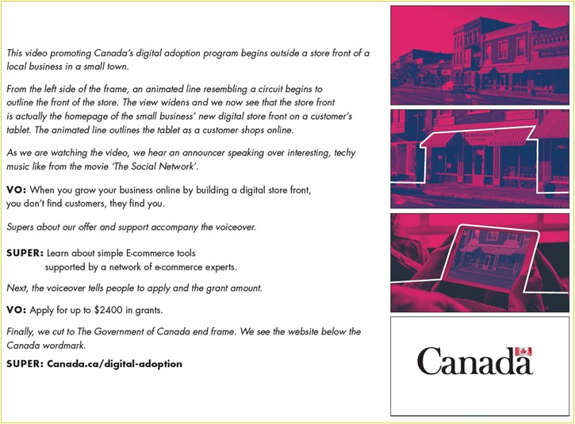

Stream 2:
HTML Banner ad:
Creative note: Circuit visual will feature animation to show electricity moving through.

15-second video ad:
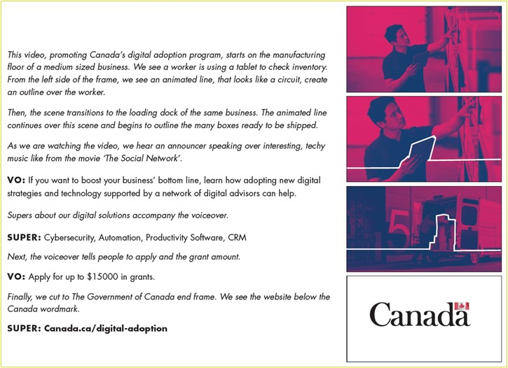
Initial reactions to this overall concept were mixed to negative across all sessions. This concept received the lowest ratings and the most criticism of the three territories tested.
The images of a store in the banner and the morphing of the brick-and-mortar store to an online store concept in the video for Stream 1 fell flat for most. Participants often felt this did not speak to them or did not stand out, even if they had a retail business themselves. Some also said that it reminded them of stores closing and main streets becoming more and more empty, which was not a positive connotation.
The Stream 2 images and storyline of the truck and a warehouse also did not speak to all participants, especially among those who were in industries that do not produce, warehouse or ship goods. It was also mentioned that someone in a warehouse holding an iPad was not the best image to use to showcase digital solutions, as this was not necessarily the most forward-thinking, unique, innovative or cutting-edge example.
The main issue with this territory, however, besides the choice of images and the story lines, was more about the creative execution than anything else. The choice of colours and the contrast in colours and shading received criticism, with many generally saying they were unappealing, jarring and distracting from the main message. It was said to be distracting not only because they were not liked, but also because they made it difficult to decipher the images, focusing attention too much on the visual than on the message. For Stream 2 in particular, the colours and shading in the banner ad made it difficult for many to decipher the image of the person and the boxes in the truck.
Only a few, especially among younger Quebec entrepreneurs, appreciated the unique choice of colour, admitting it would be the most likely to get their attention. The use of an animated line to draw contours in the Stream 1 concept was also liked by a few as it was said to tie the story together nicely.

TERRITORY B

Stream 1:
HTML Banner ad:
Creative note: Animation – start with full image of small business owner in her pottery shop. Blue box and graphics slide in from left. White border bends as it moves in. Copy slides in, with different small business images, fading in and our on the right side. Circuit visual will feature animation to show electricity moving through.

15-second video ad:
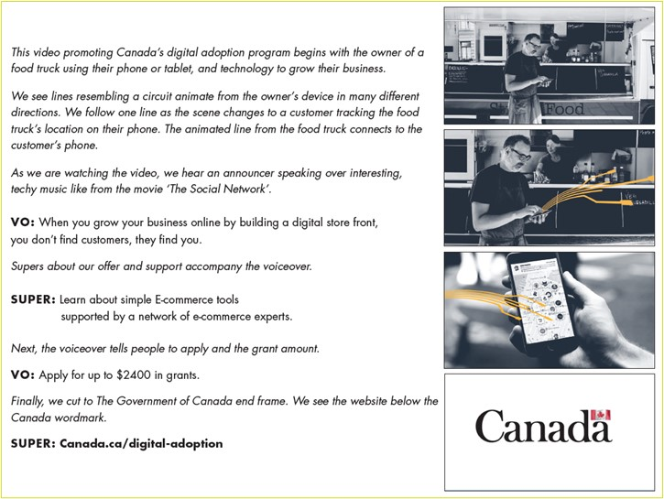
Stream 2:
HTML Banner ad:
Creative note: Animation – Start with a full image of a brewing company owner. Blue box slides in from the left. Copy slides in, with different business owner images fading in and out on the right side. Circuit visual will feature animation to show electricity moving through.

15-second video ad:
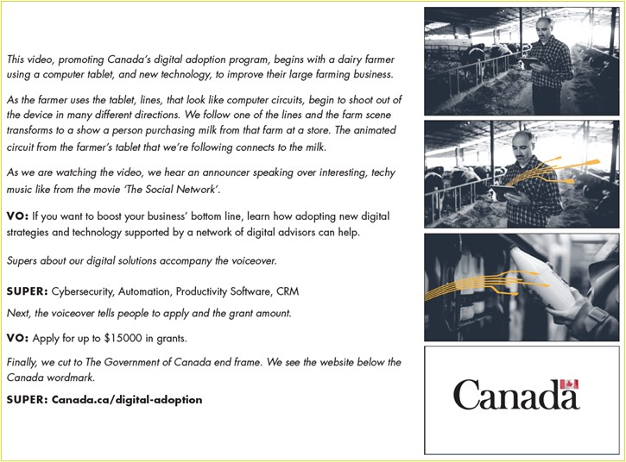
This concept received the highest initial feedback scores overall and among participants from both Streams.
Its main strengths were that it featured real people and a variety of settings or businesses. This made the main message clear and relatable to participants, even if their particular business or sector was not shown. They clearly understood the main message that the program, as advertised, was “for everyone,” and would apply to them as well. They could easily imagine themselves or their business in the place of those depicted, giving this concept a broad appeal.
The creative execution was also appreciated, particularly because the layout was clear, clean and professional and the images fit with the overall message. The use of real people (as opposed to animations) also reinforced a personal connection and relatability. Participants also had positive feedback on the diversity of the people shown, which, again, made it more broadly relatable and appealing. The clean execution gave this a modern and forward-looking feel, which was said to tie in with the overall topic and the message.
The storylines and messages were overall clear to participants and easy to follow. For Stream 2, it was also mentioned that it featured some industries or businesses, such as a farm, that were not traditionally linked to using digital technology, which many felt was a strength. This showed that other types of businesses, including perhaps their own, could think outside the box and take advantage of the program advertised, even if they might not have thought of it before.

TERRITORY C

Stream 1:
HTML Banner ad:
Creative note: Animation – Start with woman sitting on a big box sliding in from the right with her legs swinging. Copy slides in from the left. Copy changes while more boxes pop into the frame. Circuit visual will feature animation to show electricity moving through.

15-second video ad:
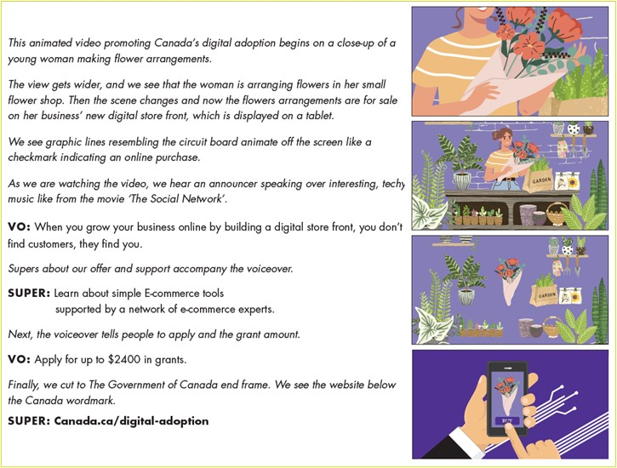

Stream 2:
HTML Banner ad:
Creative note: Animation – Start with a man sitting on a big box sliding in from right. Fingers typing. Copy slides in from the left. Copy changes while more boxes pop into frame. Circuit visual will feature animation to show electricity moving through.

15-second video ad:
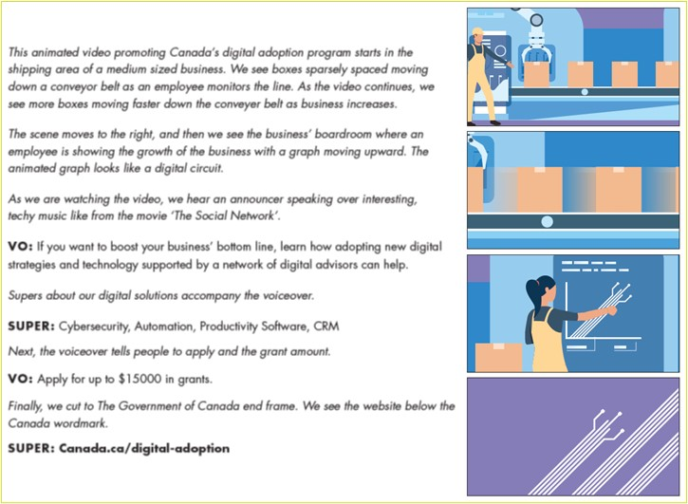
Initial reactions to this concept were not overly positive and it did not have a broad appeal.
Most participants could not easily relate to the visual elements. Two themes emerged in relation to this issue. First, many felt they could not easily relate to the only industry segment being portrayed in the concept. Second, it was also not always clear what was being portrayed altogether, with some feeling that the concept looked like an ad for a moving company, a shipping company or Amazon. The exception to this was the video in Stream 1, which clearly showed the flower business. However, this again did not have the broadest appeal as it focused on one business, or at best, one industry segment only, namely retail.
The growing number of boxes from one frame to the next in the banner ad was also not apparent to everyone, and if it was seen, it was typically not seen as conveying the message of a growing business. A few also noted that the person on the box could be interpreted to represent the consumer rather than the business owner.
There was also less interest in the faceless animation compared to seeing real people operating real businesses. Only a few participants said they preferred the animation idea over the use of real people.
The overall look and feel also fell rather flat, with many commenting that the colours in the banner ads in particular were not attention-grabbing. In Stream 2, the two-toned pants and the dangling legs of the character received negative feedback.
While the video storyline of the digital storefront in Stream 1 was generally clear and understood, the story in Stream 2 left some participants with questions. The idea that boxes moving faster meant a growing business was a bit of a stretch for some, and there was no apparent link between faster-moving boxes and the adoption of digital solutions. The jump from a warehouse with a conveyor belt to the boardroom was jarring to some as well, with no apparent link or continuity in the story.

Preferred territory
The results show that Territory B was by far the most popular among participants in both Streams and that as proposed, it would be highly relatable, visually and conceptually appealing, attention-grabbing and effective at conveying the message to its intended audience.

At a distant second was Territory C, with Territory A receiving the fewest popularity votes and the most criticism.

HTML banner ad message testing

Stream 2 participants were presented with three different text flows, potentially for an HTML banner ad.

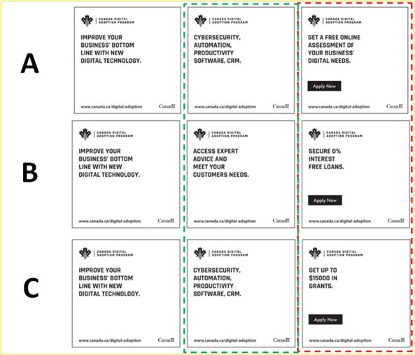
They were asked to first assess the appeal of the text in the last column, which featured three different options:
- Row A: Get a free online assessment of your business’ digital needs
- Row B: Secure 0% interest free loans
- Row C: Get up to $15,000 in grants
Row C, which featured text about a grant valued at $15,000 was by far the most preferred. The idea of “free money” had broad appeal, would be the most attention-grabbing and would be the most likely to compel participants to click to “apply now” or to go to the website for more information. The amount of the grant offered also piqued people’s interest.
A few participants preferred the message in row A about a free online assessment, saying that they would see that as the first step before deciding whether they would apply for either a grant or a loan. On the other hand, others felt that a free online assessment felt like a vague promise, and again, sounded like click-bait. While the idea of interest free loans did appeal to some, it was not seen as the preferred option for a message that was meant to headline the main element of the program in order to draw people in. Some business owners also emphasized that they were not interested in accumulating any debt, even at 0% interest.
For the middle column, two options were tested:
- Rows A and C: Cybersecurity, Automation, Productivity Software, CRM
- Row B: Access expert advice and meet your customers needs.
The option in row B was mostly the preferred option, especially in combination with the message about the grant in the third column. Many explained that potentially getting a grant and access to an advisor made for a very compelling combination. They felt that they would get a better understanding of their needs, that this knowledge would help them access the grant and secure the most funding possible, and that the grant funds would therefore be better spent.
The message in rows A and C also had some appeal, particularly in the Western provinces. Those who preferred this option said that it spoke specifically to the types of investments they could be thinking of making with the grant, while to them, the promise of expert advice in row B once again sounded vague or gimmicky. They often questioned how well an outside advisor or someone from the federal government would be able to understand their business needs, and as such expected that the advice would likely be high level or not overly tailored.
On the other hand, the text in the middle column for rows A and C came across to many as a general list of technologies which did not really convey any particular message. Of the words listed, the term “cybersecurity” was the most interesting and had the broadest appeal. Therefore, the choice of row A/C as the preferred message was often less of a strong vote for this option, rather than a vote against the message in row B.
It was also mentioned that the “www.” at the beginning of the URL was superfluous as it was not necessary for a link and made the ad look somewhat stale or outdated. As well, some felt that the Government of Canada wordmark should be displayed more prominently, for example by superimposing it at the end of the ad. It was however appreciated that the URL and wordmark were shown throughout the banner ad, rather than only at the end.

Radio spot

Radio spots were also tested with participants.

Stream 1 Ad Copy:
Grow your business online by building a digital storefront with simple e-commerce tools, supported by a network of e-commerce experts. Apply for up to $2,400 in grants at canada.ca/digital-adoption. A message from the government of Canada.
- - - - - - - - - - - - - - - - - - - - - - - - - - - - - - - - - - - -
Stream 2 Ad Copy A:
Boost your business’ bottom line by adopting new digital strategies and technology supported by a network of digital advisors. Apply for up to $15,000 in grants at Canada.ca/digital-adoption. A message from the government of Canada.

Stream 2 Ad Copy B:
Boost your business’ bottom line with a free online assessment of how to improve your business’ technology. Apply for up to $15,000 in grants at Canada.ca/digital-adoption. A message from the government of Canada.

Overall, the radio spots received mixed feedback.
From an overall content perspective, irrespective of the Stream and the ad tested, there was a sense that the narrator was speaking quickly and that the ad was trying to convey too much information in too short a time. For some, the language in the first sentence was too technical, adding to confusion about the message of the ad and risking loosing people right from get-go. Participants often said that they would have to hear it more than once to understand the message.
There was also a sense that the ad buried the lead. It was suggested that the main “hook” is only at the end of the ad, where there is a reference to a Government of Canada grant. As such, participants recommended that the “hook” be located at the beginning of the radio ad to more effectively get their attention from the start. It was suggested that the ad could start with some sort of rhetorical question or interrogation that specifically targets SMEs and that would draw people in, and to then continue with the information about the program and the grant.
Some were also concerned with the medium being used, suggesting that radio is not the best way to communicate this type of information. Most explained that they would be most likely to hear this spot while driving and that even if they were to pay attention to the spot, they would not be able to do anything about it at the time and they would be very likely to have forgotten the information by the time they got to work or home.
When it came to the execution, it was suggested that the background music should be balanced properly to be significantly quieter than the voice over in order to ensure that the narrator’s voice was properly heard. As well, some felt the narrator’s voice was quite monotone.
Two spots were tested with Stream 2 participants, with mixed reviews and preferences.
Those who liked Option B appreciated that it features a free online assessment of how to improve their business’ technology. On the other hand, others felt that this sounded a bit gimmicky or as though it was a trick to draw them into something else, as they often experienced with online ads that offered something “free” and then ended up being clickbait. Some suggested to mention that this was a Government of Canada program or service first, which would lend legitimacy to the offer.
Those who liked Option A often felt that it was more explanatory and conveyed more information about the program. They explained that it talked about both the idea of adopting new digital strategies and technology, as well as about the support they would receive from digital advisors – which they felt would be more personal or tailored to their business and therefore more valuable than a mere “free online assessment” as suggested in Option B.

Social media message testing
The final creative element explored with participants was a variety of social media messages that would be launched along with the rest of the campaign. It was explained that the creative execution, including images, colours, logos etc. used were placeholders only and were not part of what was being evaluated. Instead, feedback was only solicited about the messages.
Stream 1 participants were asked to select their two preferred messages among seven options while Stream 2 participants were asked to choose two among six options.
Stream 1:
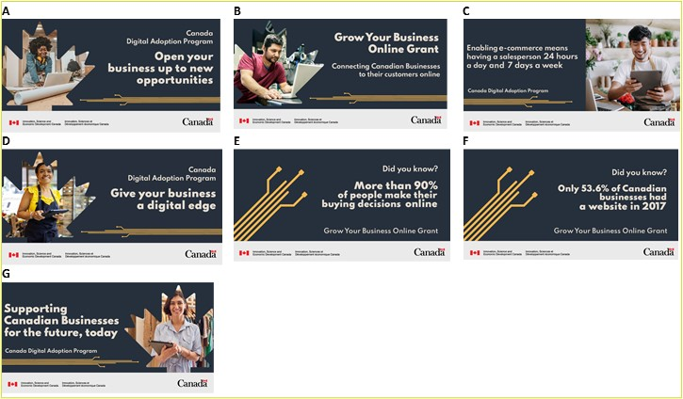
Results for Stream 1 participants show that options B (Grow Your Business Online Grant), D (Give your business a digital edge), and E (More than 90% of people make their buying decisions online) were the most popular, with option B proving the most popular. The four other options were also selected by a few participants but were distant seconds compared to B, D and E.
The high appeal of option B stemmed from the use of the word “grant.” As seen in previous discussions, to many, this was the element of the program that appealed to them the most. It should therefore be the main hook or message, and would be the most likely to catch their attention and potentially lead to them wanting to find out more about the program. As well, the idea of growing their business appealed to nearly all participants, as this was ultimately seen as “every business’ goal.” Therefore, this message promised to help them realize this important goal.
There was some discussion about whether the message was about a “Grow-your-business-online Grant” (or similarly: “Here is a grant to grow your business online”,) or if it was about a “Grow-your-business Online Grant” (or similarly: “Use an online grant to grow your business”). While opinions were mixed, it appeared that both interpretations were appealing. Only a few participants felt that this syntax was confusing.
The strength of option D was in the idea of their business getting a (digital) “edge.” Similar to the word “growth” in option B, the idea of being competitive or of standing out in the marketplace was something they said would speak to all businesses. Also similar to option B, the message spoke to participants because of the use of “your business,” speaking directly to them and about them.
The third-most popular option, option E, was often said to show a statistic that was the most relevant to businesses because it reinforced the importance of having an online presence. It was also the message with the most impactful or interesting statistic because the percentage mentioned (90%) was so high.
On the other hand, the other option with statistics, option F was less appealing. The statistic in option F (Only 53.6% of Canadian businesses had a website in 2017) was considered dated and did not compel them to action, especially if they already have a website.
Both options A (Open your business up to new opportunities) and G (Supporting Canadian Businesses for the future, today) were seen as too general. This made them less attention-grabbing and appealing, often leaving participants with more questions than answers. In this case, the information was not compelling enough to make them want to find those answers or to want to take any other action, including checking out the website. Moreover, the sentence in option G was said to be somewhat awkward to read.
Option C (Enabling e-commerce means having a salesperson 24 hours a day ad 7 days a week) mostly fell flat because it was not necessarily understood or overly relevant to many businesses, leaving many with a sense of “so what.”
While the exercise focused on the messaging rather than the images, participants in the later focus group sessions were asked whether they generally preferred grey-scale imagery used in some renderings of this concept (e.g., the video) or preferred full colour photography as shown. The clear preference was for full colour photography, as it was said to be more “real” and therefore more relatable.
Stream 2:
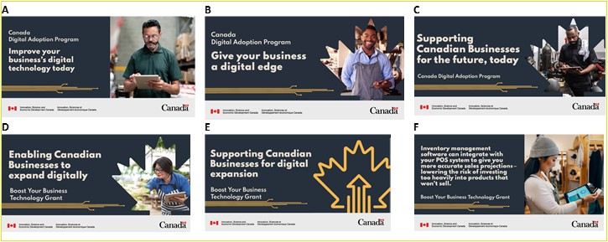
Results for Stream 2 participants show that options B (Give your business a digital edge), A (Improve your business’s digital technology today) and D (Enabling Canadian Businesses to expand digitally) were the strongest concepts.
For option B, participants appreciated that the message was short, direct and catchy. In the same way as in the Stream 1 feedback, they also liked the use of the words “digital edge” to convey something that was desirable for a business. It also appealed because it mentioned “your business,” directly speaking to them about their businesses. As was seen in Stream 1, messages that were about the businesses themselves were more relatable, more “about them,” and seen as having their best interest in mind, rather than it being first and foremost about the program or about the Government of Canada.
Option A also appealed to participants because it again mentioned “your business.” The idea of improving their business also speaks to an important and ongoing goal that businesses universally strive towards and seek help to accomplish, adding to the appeal of this message. Some also said that they liked the word “today” as it made them feel like there was something that they could action immediately.
While option D was often chosen in the top two messages because participants again liked that the message was short and clear, it also had its detractors. In contrast to options A and B which both used the term “your business”, option D, along with C (Supporting Canadian Businesses for the future, today) and E (Enabling Canadian Businesses to expand digitally), was felt by some to be less about specifically saying how the program or the government would help them or their business, and more about the Government of Canada promoting itself and “showing off.” Some were turned off by this line of messaging.
Option F (Inventory management software can integrate with your POS system to go give you more accurate sales projections – lowering the risk of investing too heavily into products that won’t sell) was by far the message with the least appeal, mostly as it was seen by many as too long to read and therefore inappropriate in a social media context. The content of the message was also not easy to quickly understand for quite a few participants, or deemed irrelevant to their business, making it something that had to be read more than once in order to connect to.

Reactions to the campaign overall
After the discussion of the creative elements, a general discussion was held about the overall campaign and its main messages. Most participants felt that the campaign and the main message being conveyed was relevant to them as business owners and operators. Most felt that if they were to see the creative “territory” that they preferred online or in social media, they most likely would click through to at least find out more about the program. The main incentive for them is the potential for a grant, with the promise of expert advice as a nice secondary benefit.
That said, some Stream 1 participants did not feel that the amount of the grant was high enough to warrant them taking the time to look into it further, let alone click on a button that asks them to “apply.” It must be noted, however, that this impression was largely based on an expectation that applying could be a cumbersome task. Some felt that it would likely cost them more in time and effort than the (up to) $2,400 they may receive as a result.
A good number of Stream 1 participants also felt that the campaign seemed to be targeting businesses that were not yet online or not yet using e-commerce, which was not necessarily their situation. They felt they would be more likely to pay attention to the advertising if it encouraged businesses to “grow online,” (in other words expand their online presence,) rather than “go online,” (which to most meant initiating an online presence). As well, the idea of e-commerce often felt targeted towards those in retail, hospitality or other businesses involved in direct sales. Those in the service sector, for instance, were less likely to feel that the program was for them. Similarly, many Stream 1 businesses were interested in more advanced uses of digital technology beyond setting up a website or an e-commerce solution, something which many felt would cost far more than $2,400. There was also some interest in using those funds for marketing purposes such as a social media campaign or search engine optimization.
Stream 2 businesses were also interested in the grant. The grant amount was well received and perceived as worth the effort of applying. That said, not all Stream 2 businesses were necessarily sophisticated digital technology adopters. Some in this category were interested in more foundational uses of digital technologies such as improving their website and exploring digital marketing. These same businesses valued the importance of accessing expert advice since they would not necessarily know where or how to take their next digital steps. On the other hand, there were also some who felt that outside expert advice would not work for their situation or that they did not need it.
In terms of the main message, some felt that the program was a way for the federal government to support businesses during the pandemic. Some felt the government of Canada was encouraging businesses to increase their use of digital technologies to become more productive, profitable and resilient. A few participants also felt that this program, while appreciated, would have helped them out more a year or two ago, when they had to invest in changes to adapt to the pandemic reality.

Reactions to the proposed program
The following description of the program was presented to participants:
STREAM 1: The program shown in the concepts, the Canada Digital Adoption Program or “CDAP,” is designed to help smaller businesses in any industry grow their business online by improving their e-commerce abilities. A 2019 study released by BDC found that only 4 in 10 Canadian SMEs with an online presence sell, receive and take orders online, despite the fact that growing a business online allows for higher revenues, direct communication with customers and easier access to global markets. Through CDAP, eligible businesses will receive micro grants to help with the costs related to adopting digital technologies as well as support and advice from a network of E-commerce collaborators. | STREAM 2: The program shown in the concepts, the Canada Digital Adoption Program or “CDAP,” is designed to help small businesses improve their e-commerce abilities; for larger SMEs, CDAP is designed to provide more comprehensive support to help organizations adopt new technologies or to expand the use of existing digital technologies to improve productivity and boost their competitiveness. Support for these businesses include Digital Advisors who help business develop tailored digital adoption assessments and plans, as well as access to grants and zero interest loans to finance tech implementation.
The program was new to virtually all participants. Prior to participating in the research, only one participant was aware of the new program, who had heard about it when listening to the 2021 federal budget.
Even after reading the description, participants could not easily imagine how the program would work, and questions remained, particularly about the support and advice that came along with the grant.
Some hoped, upon being approved for the grant or qualified for the program, that they would meet with an advisor or have an expert conduct some sort of digital audit or evaluation and that, based on this assessment, a plan would be proposed. This assessment would highlight their strengths and weaknesses and also identify areas for potential improvement or growth given the implementation of certain types of digital technologies. Some hoped that the program would recommend specific software, vendors and platforms. There was also interest in using the program as a way to learn about e-commerce and digital technologies overall – some of the ideas in this area included having the advisor serve as a mentor who could help businesses evolve digitally, having access to a series of webinars and tutorials, and having a series of “digital checkpoints” whereby the advisor would “check in” from time to time to review and assess progress and course correct and advise as needed.
Some questioned how in-depth and specific the advice could possibly be, as they were not sure how well an outside advisor would understand the specificities of their particular industry, let alone those of their business, their needs, current systems and future goals.
Many also questioned how the grant funds could be used. Some would like to use those funds to pay for past expenses, seeing as many had already built their website or had made other investments to get through the pandemic. While some saw themselves using it for capital expenditures, whether to expand or upgrade their digital assets, some also hoped they could be used for such things as ongoing subscription services to digital platforms, social media marketing services, or other IT services.
Another question brought up a few times was that of accountability. Some wondered whether they would have to provide a detailed plan about what they were planning on doing with the money before receiving it, and show receipts or other proof that they had actually used the grant in accordance to their plan or to the program criteria. Some skepticism existed about how feasible it would be for the government to check up on everyone and to evaluate whether the funds were used appropriately or not.
As alluded to when discussing the campaign, there was an underlying suspicion that the application process would not be easy and that they would not be surprised to see a variety of challenging criteria that would need to be met to qualify. This idea often stemmed from past experiences many participants had had applying for other government supports, especially recently as they applied, or had tried to apply, for pandemic supports or programs for their businesses. Many told stories of themselves or other businesses they knew finding it difficult to apply either for financial supports or other programs because the forms and required information were not clear, they could not access the information they needed to apply, or eligibility criteria were vague. As well, there were stories of businesses applying and being rejected, often because of an administrative error rather than because they were not deemed to fall into an eligible category.
Nonetheless, there was interest in learning more about the program and how it worked, and a fair number of participants said that they would remember the website URL from the campaign and visit it.
Besides detailed information about the program itself, eligibility and how to apply, some mentioned that it would be interesting and helpful to include testimonials or short case studies of businesses like theirs who had used the program on the website.
At the end of the sessions, participants were asked to think of the future and of where they see their companies’ needs or wants for new or expanded use of digital technologies. Some of the types of digital technologies that businesses are interested in exploring or implementing included: developing a mobile app; improving their website; more digital marketing; artificial intelligence (notably voice recognition); CRM; better back office integration platforms; virtual reality; the metaverse; online scheduling applications; online collaboration platforms and online payment systems.

Detailed methodology
Overview: The research methodology consisted of 12 online focus groups and eight one-on-one web-assisted depth interviews. The focus groups and interviews were conducted with Canadian small to medium enterprises (SMEs). Businesses were segmented into two categories, with segment 1 focusing on smaller companies interested in growing their business through e-commerce, while segment 2 focused on larger SME’s that are looking to expand e-commerce capabilities. Focus groups and interviews included businesses from across the country.
Quorus was responsible for coordinating all aspects of the research project including working with ISED in designing and translating the recruitment screener and the moderation guides, coordinating all aspects of participant recruitment, managing the online interviewing platform and related logistics, moderating all sessions and interviews and delivering required reports at the end of data collection. The research approach is outlined in greater detail below.

Target audience and sample frame
The research consisted of two broad segments of the business community:
- Segment 1 – Canadian small to medium enterprises (SMEs) interested in E-commerce transformation: This is a group consisting of Canadian SMEs with a focus on small and micro businesses (those with at least one employee and revenues of at least $30K to $500K). The focus will be on sectors such as bricks and mortar retail, travel, tourism, hospitality, restaurants, and recreation-based businesses. Within each organization recruited to this segment, the research will target a business owner, director, or key decision maker who is interested and in part responsible for digital adoption to adopt or expand e-commerce opportunities.
- Segment 2 – Canadian small to medium enterprises (SMEs) interested in advanced digital technologies - the “Boost Your Business Technology” program stream: This is a group consisting of Canadian SMEs with a focus on the medium and larger small organizations (those with 40+ employees and revenues between $500K and $1M), such as small manufacturing and food processing operations who are looking to adopt new technologies. Within each organization recruited to this segment, the research will target a business owner, director, or key decision maker who is interested and in part responsible for furthering their companies’ productivity through modernization and advanced digital adoption.
Within both segments, the research recruitment considered, on a best-effort basis, the following demographic groups:
- large and small urban centres, as well as ex-urban and rural centres
- representation of men and women entrepreneurs
- underrepresented employment equity groups including: women entrepreneurs, Indigenous entrepreneurs, racialized entrepreneurs, disabled entrepreneurs and LGBTQ2+ entrepreneurs
In addition to the general participant profiling criteria noted above, additional screening measures to ensure quality respondents include the following:
- No participant was recruited who worked for any of the following types of companies: a corporate chain or franchise; a registered charity; a multi-level marketing company; a real estate brokerage.
- No participant acquainted with another participant was knowingly recruited for the same study, unless they were recruited into separately scheduled sessions.
- No participant was recruited who had attended a qualitative research session within the past six months.
- No participant was recruited who had attended five or more qualitative research sessions in the past five years.

Description of data collection procedures
Data collection consisted exclusively of online focus groups and individual depth interviews. Each focus group lasted approximately 90 minutes while interviews lasted approximately 45 minutes.
For Segment One, eight participants were recruited to achieve six to eight participants per focus group while for Segment Two, six participants were recruited to achieve five to six participants per focus group. Participants invited to participate in the focus groups and one-on-one interviews were recruited through a combination of random digit dialing by telephone and through the use of a proprietary database. These research candidates were screened using a traditional recruitment screener to ensure they met the target audience definitions for this study.
The recruitment of focus group and depth interview participants followed the screening, recruiting and privacy considerations as set out in the Standards for the Conduct of Government of Canada Public Opinion Research–Qualitative Research. Furthermore, recruitment respected the following requirements:
- All recruitment was conducted in the participant’s official language of choice, English and French, as appropriate.
- Upon request, participants were informed on how they can access the research findings.
- Upon request, participants were provided Quorus’ privacy policy.
- Recruitment confirmed each participant had the ability to speak, understand, read and write in the language in which the session was to be conducted.
- Participants were informed of their rights under the Privacy and Access to Information Acts and ensure that those rights were protected throughout the research process. This included: informing participants of the purpose of the research, identifying both the sponsoring department or agency and research supplier, informing participants that the study will be made available to the public in 6 months after field completion through Library and Archives Canada, and informing participants that their participation in the study is voluntary and the information provided will be administered according to the requirements of the Privacy Act.
At the recruitment stage and at the beginning of each focus group/depth interview, participants were informed that the research was for the Government of Canada/ISED. Participants were informed of the audio/video recording of their session in addition to the presence of ISED observers/ listeners. Quorus ensured that prior consent was obtained at the recruitment stage and before participants began their focus group or interview session.
All online focus groups were conducted in the evening after regular business hours, while all online depth interviews were conducted during regular business hours or during evenings (whatever suited the respondent’s availability and preferences). The research team used the Zoom platform to host and record sessions (through microphones and webcams connected to the moderator and participants’ electronic devices, such as their laptops or tablets) enabling client remote viewing.
Online focus groups
A total of 12 online focus groups were conducted across Canada. In each region, two focus groups were held, one with each target audience. The regional breakdown is as follows:
  - Ontario/Nunavut
  - Atlantic Canada (mix of the four provinces)
  - British Columbia/Yukon
  - Quebec
  - Manitoba/Saskatchewan/Northwest Territories
The details of these groups are outlined in the table below.
Date | Time (EST) | Region | Segment | Language | Number of participants
Tuesday, February 15, 2022 | 5:30 PM | Ontario/Nunavut | Segment 1 | English | 7
 | 7:30 PM | Ontario/Nunavut | Segment 2 | English | 6
Wednesday, February 16, 2022 | 4:30 PM | Atlantic Canada | Segment 1 | English | 7
 | 7:30 PM | Alberta/NWT | Segment 1 | English | 8
Thursday, February 17, 2022 | 4:30 PM | Atlantic Canada | Segment 2 | English | 4
 | 7:30 PM | BC/Yukon | Segment 1 | English | 8
Monday, February 21, 2022 | 5:30 PM | Quebec | Segment 1 | French | 8
 | 7:30 PM | Quebec | Segment 2 | French | 3
Tuesday, February 22, 2022 | 6:00 PM | Manitoba/Saskatchewan/NWT | Segment 1 | English | 5
 | 8:00 PM | Manitoba/Saskatchewan/NWT | Segment 2 | English | 4
Wednesday, February 23, 2022 | 6:30 PM | Alberta/NWT | Segment 2 | English | 5
 | 8:30 PM | BC/Yukon | Segment 2 | English | 6
TOTAL: 71
Online depth interviews
A total of eight one-on-one online depth interviews were conducted with participants from both Segment One and Segment Two, with a goal of recruiting a mix across region and sociodemographic characteristics.
The scheduling and details of the sessions are outlined in the table below:
Date | Time (EST) | Region | Segment | Language
Wednesday, February 16, 2022 | 10:00 AM | Ontario | Segment 2 | English
Wednesday, February 16, 2022 | 1:00 PM | Alberta | Segment 1 | English
Thursday, February 17, 2022 | 9:00 AM | Saskatchewan | Segment 2 | English
Friday, February 18, 2022 | 11:00 AM | British Columbia | Segment 2 | English
Friday, February 18, 2022 | 2:00 PM | Alberta | Segment 1 | English
Friday, February 18, 2022 | 4:00 PM | Quebec | Segment 2 | English
Thursday, February 24, 2022 | 10:30 AM | Quebec | Segment 1 | English
Friday, February 25, 2022 | 10:00 AM | Ontario | Segment 1 | English

Appendices

Recruitment screener – focus groups

SME recruitment screener
Focus group target audiences

Segment 1 – Canadian small to medium enterprises (SMEs) interested in E-commerce transformation: This is a group consisting of Canadian SMEs with a focus on small and micro businesses (those with at least one employee and revenues of at least $30K to $500K). The focus will be on sectors such as bricks and mortar retail, travel, tourism, hospitality, restaurants, and recreation-based businesses that haven’t yet adopted digital technologies to take advantage of e-commerce opportunities. Eligible businesses will receive micro-grants of up to $2,400 to help with costs related to adopting digital technologies. Companies will also be supported by a network of advisors who will help small businesses adopt e-commerce. Within each organization recruited to this segment, the research will target a business owner, director, or key decision maker who is interested and in part responsible for digital adoption to adopt or expand e-commerce opportunities.
  - Incentive: $250
  - Recruit 8 for 6 to 8 to show
Segment 2 – Canadian small to medium enterprises (SMEs) interested in advanced digital technologies - the “Boost Your Business Technology” program stream: This is a group consisting of Canadian SMEs with a focus on the medium and larger small organizations (those with 40+ employees and revenues between $500K and $1M), such as small manufacturing and food processing operations who are looking to adopt new technologies. Support for these businesses will be in the form of grants to offset the cost of retaining Digital Advisors who will develop digital technology plans tailored to the business. The grant will cover 90% of the cost to develop the plan. Within each organization recruited to this segment, the research will target a business owner, director, or key decision maker who is interested and in part responsible for furthering their companies’ productivity through modernization and advanced digital adoption.
  - Incentive: $250
  - Recruit 6 for 5 to 6 to show
For both segments, recruit on a best effort basis the following segments:
- large and small urban centres, as well as ex-urban and rural centres
- representation of men and women entrepreneurs
- underrepresented employment equity groups including: women entrepreneurs, Indigenous entrepreneurs, racialized entrepreneurs, disabled entrepreneurs and LGBTQ2+ entrepreneurs
In the case of overlap between the target audience segments, businesses will be recruited based on their business priority: e-commerce transformation or advanced digital technologies.

All session are 90 minutes.
All times are stated in local area time unless specified otherwise:
Group 1 | Group 2 | Group 3 | Group 4
Ontario/Nunavut | Ontario/Nunavut | Atlantic | Alberta/NWT
February 15  5:30 pm EST  Segment 1 | February 15  7:30 pm EST  Segment 2 | February 16  5:30 pm AST  Segment 1 | February 16  5:30 pm MST  Segment 1
Group 5 | Group 6 | Group 7 | Group 8
Atlantic | BC/Yukon | Quebec - FR | Quebec - FR
February 17  5:30 pm AST  Segment 2 | February 17  4:30 pm PST  Segment 1 | February 21  5:30 pm EST  Segment 1 | February 21  7:30 pm EST  Segment 2
Group 9 | Group 10 | Group 11 | Group 12
Manitoba/ Saskatchewan/NWT | Manitoba/ Saskatchewan/NWT | Alberta/NWT | BC/Yukon
February 22  5:00 pm CST  Segment 1 | February 22  7:00 pm CST  Segment 2 | February 23  4:30 pm MST  Segment 2 | February 23  5:30 pm PST  Segment 2
One-on-one interviews will be leveraged to round out representation from segments including, but not limited to:
- underrepresented employment equity groups including: women entrepreneurs, Indigenous entrepreneurs, racialized entrepreneurs, disabled entrepreneurs and LGBTQ2+ entrepreneurs
- Canadian entrepreneurs "North of 60" including those from Yukon, Northwest Territories, Nunavut, northern Quebec and northern Labrador
- Official language minority participants (OLMC entrepreneurs – e.g., Anglophone entrepreneur in Quebec, or a Francophone entrepreneur outside Quebec and New Brunswick)
Tele-web depth interviews:  - 8 entrepreneurs | Details:  Mix of English and French  Incentive: $250  45-minute sessions

- Introduction

Hello, my name ________________. I'm calling from Quorus Consulting, a Canadian public opinion research company and we are calling on behalf of the Government of Canada.

Would you prefer to continue in English or French? / Préférez-vous continuer en anglais ou en français?

[INTERVIEWER NOTE: FOR ENGLISH GROUPS/INTERVIEWS, IF PARTICIPANT WOULD PREFER TO CONTINUE IN FRENCH, PLEASE RESPOND WITH, "Malheureusement, nous recherchons des gens qui parlent anglais pour participer à cette recherche. Nous vous remercions de votre intérêt." FOR FRENCH GROUPS/INTERVIEWS, IF PARTICIPANT WOULD PREFER TO CONTINUE IN ENGLISH, PLEASE RESPOND WITH, “Unfortunately, we are looking for people who speak French to participate in this research. We thank you for your interest.”]

From time to time, we solicit opinions by sitting down and talking with people. We are preparing to conduct a series of these discussions on behalf of the Government of Canada and I would like to speak to someone in your company who is in part responsible for increasing the company’s revenues and reach through buying and selling online, promoting its offerings via websites or social media OR who is responsible for modernizing its digital systems – from payroll and accounting to improving plant operations via the use of modern digital tools. Is there a person available who fits that description? …this is most likely the business owner, a director, or a key decision maker for the company’s digital strategy.

ONCE APPROPRIATE CONTACT HAS BEEN REACHED – REPEAT INTRO IF NEEDED AND CONTINUE:

We are reaching out to you today to invite you to a research session to share your feedback on the opportunities and challenges your business faces and the kind of role you expect the Government of Canada to play in relation to these.

Other decision makers from small and medium sized companies located in Canada will be taking part in this research. It is a first-name basis only discussion so nobody, including the Government of Canada, will know the companies being represented. For their time, participants will receive a cash compensation.

Participation is voluntary and all opinions will remain anonymous and will be used for research purposes only in accordance with laws designed to protect your privacy, including the Privacy Act and the Access to Information Act. We are simply interested in hearing your opinions, no attempt will be made to sell you anything. The format will be an online “round table” discussion lead by a research professional.
[INTERVIEWER NOTE: IF ASKED ABOUT PRIVACY LAWS, SAY: “The information collected through the research is subject to the provisions of the Privacy Act, legislation of the Government of Canada, and to the provisions of relevant provincial privacy legislation.”]

But before we invite you to attend, we need to ask you a few questions to ensure that we get a good mix/variety of businesses. This should only take about 5 minutes. In case you are uncertain, all my questions pertain to your company’s Canadian operations. May I ask you a few questions?

Yes 1 CONTINUE
No 2 THANK & TERMINATE

- Business and participant profile

- How would you rate your own level of familiarity with the decisions your company takes regarding using digital technology to diversify or grow your company? Would you say you are... READ OPTIONS - RECRUIT A MIX.

[IF NEEDED: This would include decisions related to buying or selling online, improving business operations, and using online technologies such as websites to communicate with customers.]
- Very familiar
- Fairly familiar
- Not very familiar
- Not at all familiar
IF NOT VERY OR NOT AT ALL FAMILIAR, ASK: Since this will be one of the themes discussed, is there someone else in your company who would be more familiar with these types of decisions?
  - IF YES, ASK TO SPEAK WITH THAT PERSON INSTEAD
  - IF NO, CONTINUE

- Is your company a for-profit business, for-profit social enterprise or cooperative?
- Yes
- No [THANK & TERMINATE]

- Is your business registered or incorporated?
- Yes
- No [THANK & TERMINATE]

- Is your company any of the following?
 | Yes | No
- A corporate chain or franchise?
- A registered charity?
- A multi-level marketing company?
- A real estate brokerage?

[IF YES TO ANY OF THE ABOVE, THANK & TERMINATE]

- Approximately how many full-time staff (FTE) does your company currently employ in Canada? (RECORD ACTUAL NUMBER)
_______ Full-time equivalent staff
- 1 to 5 [SMALL BUSINESS AND A MICRO BUSINESS]
- 6 to 99 [SMALL BUSINESS]
- 100 to 499 [MEDIUM BUSINESS]
- More Than 500 [THANK & TERMINATE]
- On average, for each of your company’s past 3 fiscal years, have your company’s revenues been…READ LIST
- Under $30K? [THANK & TERMINATE]
- greater than $30K but under $500K? [Segment 1]
- between $500K and $1 million? [Segment 2]
- Over $1 million? [THANK & TERMINATE]
- Is your business one that can be accessed by customers or one which provides in person services to customers? [RECRUIT A MIX]
- Yes
- No

- Using a scale from 0 to 10, where 10 means it is a significant priority, to what extent would you say the following activities are a priority for your company over the next 3 years?
- To adopt or expand e-commerce opportunities, including creating or improving your business’ online presence, implementing e-commerce, and/or upgrading internal digital processes, from accounting and payroll to marketing?
- furthering the company’s productivity through modernization and advanced digital adoption or transformation—for example, through retooling and updating your current manufacturing processes or plant operations
Not a priority  at all |  |  |  |  |  |  |  |  | Significant priority
0 | 1 | 2 | 3 | 4 | 5 | 6 | 7 | 8 | 9 | 10

- IF Q3A AND Q3B<7, THANK AND TERMINATE
- IF Q3A>Q3B, RECRUIT FOR SEGMENT 1
- IF Q3A<Q3B, RECREUIT FOR SEGMENT 2
- IF Q3A=Q3B, RECRUIT FOR THE HIGHER PRIORITY SEGMENT BASED ON RECRUITMENT NEEDS

- What is your gender?

Note 1: Ensure a good mix in and across all sessions/interviews.
Note 2: DO NOT READ: Gender – Refers to current gender which may be different from sex assigned at birth (male or female) and may be different from what is indicated on legal documents.)
- Male gender
- Female gender
- Gender diverse
- Prefer not to answer
- Are you one of the individuals who founded this company?
- Yes [ENTREPRENEURS]
- No
- IF RESPONDENT IS ONE OF THE FOUNDERS AND A WOMAN, FLAG AS “WOMAN ENTREPRENEUR”

- Please let me know if you fall into any of the following categories:

 | Yes | No
- Are you a person who is blind or has any difficulty seeing even when wearing glasses or contact lenses?
- Are you a person who is physically disabled, for instance you have difficulty walking, using stairs, using your hands or fingers or doing other physical activities?
- Do you have any difficulty learning, remembering or concentrating?
- Do you have any emotional, psychological or mental health conditions?
- Is your business located in a town, village or rural area with a population of less than 30,000 and you are at least a two-hour drive from a city of at least 50,000?
- [FOR RESPONDENTS LIVING IN ONTARIO] Do you consider yourself to be a member of a Francophone minority community? A member of a Francophone minority community refers to Francophones who are outside of Quebec or New Brunswick.
- [FOR RESPONDENTS LIVING IN QUEBEC] Do you consider yourself to be a member of an Anglophone minority community? A member of an Anglophone minority community refers to Anglophones who are living in the province of Quebec.
*Source: 2017 Canadian Survey on Disability

- IF YES AT ANY OF Q12A-D – RECRUIT AS ENTREPRENEUR / BUSINESS OPERATOR / DECISION-MAKER WITH A DISABILITY
- IF YES AT Q12E – RECRUIT AS RURAL AND REMOTE ENTREPRENEUR / BUSINESS OPERATOR / DECISION-MAKER
- IF YES AT Q12F OR Q12G – RECRUIT AS OLMC ENTREPRENEUR / BUSINESS OPERATOR / DECISION-MAKER

- Do you identify as any of the following?
  - An Indigenous person (including, First Nations, Inuit or Métis)
  - A member of a racialized minority group other than an Indigenous person
  - None of the above
- IF YES Q13=1: RECRUIT AS INDIGENOUS ENTREPRENEUR / BUSINESS OPERATOR / DECISION-MAKER
- IF YES Q13=2: RECRUIT AS ETHNIC COMMUNITY ENTREPRENEUR / BUSINESS OPERATOR / DECISION-MAKER

- [ASK ONLY IF Q13=2] What is your ethnic background?
RECORD ETHNICITY: ______________
- In which industry or sector does your company operate? If you are active in more than one sector, please identify the main sector. Do not read list. Accept only one response. Confirm result with respondent as necessary. RECRUIT A MIX.

- Agriculture/Fishing/Hunting/ Forestry
- Oil/Gas/Mining/Alternative Energy
- Utilities
- Construction
- Manufacturing
- Wholesale Trade
- Retail Trade
- Transportation and Warehousing
- Information and Cultural Industries
- Finance and Insurance
- Professional, Scientific and Technical Services / IT / Computers
- Administrative and Support
- Waste Management
- Remediation Services
- Art/Entertainment/Recreation
- Accommodation/Food Services/Tourism
- Other (specify):_________________________

- ALL SECTORS CAN BE REPRESENTED IN BOTH SEGMENTS
- PRIORITIES FOR EACH SEGMENT:
  - SEGMENT 1: Agriculture, fishing, hunting, retail trade, information and cultural industries, administrative and support, art/entertainment/recreation, accommodation/food services/tourism
  - SEGMENT 2: Agriculture, forestry, alternative energy, construction, manufacturing, wholesale trade

- Can you please provide me with your job title? _____________________________________

- Participants in discussion groups or interviews are asked to voice their opinions and thoughts, how comfortable are you in voicing your opinions in front of others? Are you... READ OPTIONS
- Very comfortable MIN 5 PER GROUP
- Fairly comfortable
- Not very comfortable TERMINATE
- Not at all comfortable TERMINATE

- Have you ever attended a discussion group or interview on any topic that was arranged in advance and for which you received money for your participation?
- Yes MAXIMUM 5 PER GROUP
- No GO TO INVITATION
- When did you last attend one of these discussion groups or interviews?
- Within the last 6 months TERMINATE
- Over 6 months ago
- How many discussion groups or interviews have you attended in the past 5 years?
- Fewer than 5
- 5 or more TERMINATE

- Online focus group invitation

I would like to invite you to participate in an online focus group discussion with a senior research consultant from a Canadian public opinion research company, Quorus Consulting. The session for businesses in your region is scheduled take place on [DAY OF WEEK], [DATE], at [TIME]. It will last one and a half hours (90 minutes). People who attend will receive $250 to thank them for their time. We will get this to you either by email transfer or by mailing you a check at the conclusion of the session.

Would you be willing to attend?
- Yes
- No TERMINATE
The session will be audio recorded for research purposes and representatives of the Government of Canada research team may be on the line as remote observers. You will be asked to acknowledge that you will be audio recorded during the session. The recordings will be used only by the Quorus Consulting research team and will not be shared with others. As I mentioned, all information collected in the group discussion will remain anonymous and be used for research purposes only in accordance with laws designed to protect your privacy.

To conduct the session, we will be using a video conferencing application so that you can see material that the moderator will want to show the group. We will need to send you the instructions to connect by email. The use of a computer is necessary since the moderator will want to show material to participants to get their reactions – that will be an important part of the discussion. You can use a tablet if you so choose however you cannot use a smartphone to participate in this discussion since the screen size is too small.

IF ASKED: You will be asked to use a webcam to participate so please be sure that the device you use has a properly functioning microphone and webcam.

Over the coming days we will be sending you an email with the web link to connect to the online session as well as the date and time of the session.

We recommend that you click on the link we will send you a few days prior to your session to make sure you can access the online meeting that has been setup and repeat these steps at least 10 to 15 minutes prior to your session.

As we are only inviting a small number of people, your participation is very important to us. If for some reason you are unable to participate, please call so that we may get someone to replace you – you cannot choose your own replacement if you cannot attend. You can reach us at 1-800-XXX-XXXX at our office. Please ask for [recruiter to provide]. Someone will call you the day before to remind you about the discussion.

So that we can send you the email with the logistics, call you to remind you about the session or contact you should there be any changes, can you please confirm your name and contact information for me?
First name
Last Name
Email
Day time phone number
Night time phone number

Thank you very much for your help!

- Tele-web interview invitation

I would like to invite you to participate in a web-assisted telephone interview with a senior research consultant from a Canadian public opinion research company, Quorus Consulting. We would like to schedule the interview with you between DATE START and DATE END at a time that works best for you. Would you have time on [INSERT DATE AND TIME OPTIONS]? It will last roughly 45 minutes, depending on how much feedback you provide. People who participate will receive $250 to thank them for their time – we will get this to you either by email transfer or by mailing you a check at the conclusion of the interview.

SCHEDULE INTERVIEW THAT FITS RESPONDENT AND INTERVIEWER SCHEDULES

The session will be audio recorded for research purposes and representatives of the Government of Canada research team may be on the line as remote observers. You will be asked to acknowledge that you will be audio recorded during the session. The recordings will be used only by the Quorus Consulting research team and will not be shared with others. As I mentioned, all information collected in the interview will remain anonymous and be used for research purposes only in accordance with laws designed to protect your privacy.

To conduct the session, we will be using a video conferencing application so that you can see material that the moderator will want to show you. We will need to send you the instructions to connect by email. The use of a computer is necessary since the moderator will want to show you material to get your reactions – that will be an important part of the discussion. You can use a tablet if you so choose however you cannot use a smartphone to participate in this discussion since the screen size is too small.

IF ASKED: You will be asked to use a webcam to participate so please be sure that the device you use has a properly functioning microphone and webcam.

Over the coming days we will be sending you an email with the conference call logistics with the specific telephone number you will need to dial, the participant passcode, a web link to connect to the online session as well as the date and time of the call. There will also be contact information in the email in case you need to change the date or time of the interview.

We recommend that you click on the link we will send you a few days prior to your session to make sure you can access the online meeting that has been setup and repeat these steps at least 10 to 15 minutes prior to your session.

As we are only inviting a small number of people, your participation is very important to us. If for some reason you are unable to participate, please call so that we may get someone to replace you – you cannot choose your own replacement if you cannot attend. You can reach us at 1-800-XXX-XXXX at our office. Please ask for [recruiter to provide]. Someone will call you the day before to remind you about the discussion.

So that we can send you the email with the call logistics, call you to remind you about the interview or contact you should there be any changes, can you please confirm your name and contact information for me?
First name
Last Name
Email
Day time phone number
Night time phone number

Thank you very much for your help!

Moderation guide – focus groups
Focus group moderation guide for small and medium business enterprise (SME) owners and directors
Stream 1: owner/operators of small businesses
Stream 2: owners/ directors/ leaders of larger-small and medium businesses
[NOTE: This script has been designed for focus groups. It will be adapted by the moderator for one-on-one interviews as needed.]

- Introduction (12 minutes)
- Introduce moderator and that he works with Quorus Consulting, and they are conducting this research on behalf of the Government of Canada.
- Thanks for attending/value you being here
- Explain general purpose of focus group discussions:
  - Gauge opinions about issues/ideas/products
  - Not a knowledge test; no right or wrong answers (interested in opinions)
  - Today’s session will last approximately 90 minutes.
  - Okay to disagree; want people to speak up if hold different view
  - Do not need to direct all comments to me; can exchange ideas with each other
  - Please note that anything you say during these groups will be held in the strictest confidence. We do not attribute comments to specific people. Our report summarizes the findings from the groups but does not mention anyone by name. Please do not provide any identifiable information about yourself.
  - The session is being audio-video recorded for report writing purposes / verify feedback.
  - If you have a cell phone, please turn it off.
  - To participate in this session, please make sure your webcam and your microphone are on and that you can hear me clearly. If you are not speaking, I would encourage you to mute your line to keep background noise to a minimum…just remember to remove yourself from mute when you want to speak!
  - I will be sharing my screen to show you some things during tonight’s session.
  - We will be making regular use of the chat function. To access that feature, please scroll over the bottom of your screen until the command bar appears. There you will see a function called “chat”. It will open a chat screen on the far right of your screen. I’d like to ask you to use chat throughout our discussion tonight. Let’s do a quick test right now - please open the chat window and send the group a short message (e.g., Hello everyone). If you have an answer to a question and I don’t get to ask you specifically, please type your response in there. We will be reviewing all chat comments at the completion of this project.
  - The final report for this session, and others, can be accessed through the Library of Parliament or Library and Archives Canada once it’s posted.
  - Your responses will in no way affect your dealings with the Government of Canada.
  - Individuals from ISED directly involved in this project are watching this session and this is only so they can hear the comments first-hand.

Please note that I am not an employee of the Government of Canada and may not be able to answer questions about what we will be discussing. If questions do come up over the course of the group, we will try to get answers for you before we wrap up the session. Any questions?

So, let’s go around the table and have everyone introduce themselves…I’ll be curious to know the following:
- What is your role or your position?
- What type of business do you own/operate/manage?
- Roughly how many employees do you have in Canada and how long you’ve been in business?
And, in that role, what would you say is your biggest concern these days? What keeps you up at night?
- Digital adoption and e-commerce (10 minutes)
The impact of the COVID-19 pandemic on small and medium-sized enterprises (SMEs) has been significant. Some Canadian businesses have seen a need to adopt digital technologies in order to meet customers’ needs and stay competitive. For some SMEs, this means adopting e-commerce capabilities to sell online. For others, it’s about implementing advanced digital technologies to improve productivity.

To start, how many of you have had to increase your online presence as a result of the pandemic or had to quickly adopt new digital technologies to continue your operations? IF NEEDED: …such as social media, e-commerce platforms or other applications?
- Can you give me examples of the ways your company has had to adapt?
- Do you feel improving your digital capabilities has or would benefit your business?
STREAM 1: conversation prompts (where needed/not arising organically)
- Do you provide your customers with online access (e.g., website, e-commerce, portal, mobile app)?
- What are your main challenges or concerns with respect to digital transformation?
- How do you rate your digital capacity when compared with your peers?
STREAM 2: conversation prompts (where needed/not arising organically)
- Do you provide your customers with online access (e.g., website, e-commerce, portal, mobile app)?
- What areas of your business do you think would benefit the most from expanded digital adoption? E.g., customer relations management/support; internal operations such as IT/Accounting/Finance/HR/cyber security; external operations, such as supply chain, procurement, customer delivery.
- What are your main challenges or concerns with respect to digital transformation?
- How do you rate your digital maturity level compared with your peers?
- General concept evaluation (55 to 60 minutes total)

Let’s turn our attention to some advertising concepts.
In an effort to promote a new program, the Government of Canada will be conducting a national advertising campaign to engage businesses like yours. I have 3 advertising concepts that I’d like to get your reactions to.
A few things you need to keep in mind – these are all draft concepts, so I’ll be eager to get your honest feedback around these ideas. I’d like you to focus on the general ideas behind the ad, messages that they are trying to get across and the way they are trying to get this through to you.

I‘ll be showing you three different approaches to promoting the new program. Each campaign concept that I’ll be showing you includes:
- The story board for an animated Internet banner ad which would appear at the top of webpages you visit, and,
- The story board for a short video that could appear on webpages you visit or on social media.

Afterwards, I’ll show you how the campaign is supported by radio spots and social media messaging.

So let’s get started. I am going to be sharing some images with you on the screen. We ask that you do not record or take screen shots or otherwise share this content in any way.

FOR INTERNAL USE ONLY:
CONCEPTS/ “TERRITORIES” (EACH IDENTIFIABLE BY A LETTER OF THE ALPHABET) ARE PRESENTED ONE AT A TIME BY THE MODERATOR (CONCEPTS TO BE PRESENTED IN A DIFFERENT ORDER FOR EACH SESSION):
CONCEPT A = Territory 1
CONCEPT B = Territory 2
CONCEPT C = Territory 3
Randomize concepts for each group as follows:
Stream 1 Groups:
Session 1: A, B, C
Session 3: B, C, A
Session 4: C, A, B
Session 6: A, C, B
Session 7: B, A, C
Session 9: C, B, A

Stream 2 Groups:
Session 2: A, B, C
Session 5: B, C, A
Session 8: C, A, B
Session 10: A, C, B
Session 11: B, A, C
Session 12: C, B, A

MODERATOR NOTES FOR CREATIVE PRESENTATION
STREAM 1 FOCUS GROUPS
There are three concepts, labeled “territories” and one thematic: Grow
- Show: Concept A – Territory 1, Grow
  - Elements: Story board of a Banner and .15 Video
  - Get a rating
- Concept B – Territory 2, Grow
  - Elements: Story board of a Banner and .15 Video,
  - Get a rating
- Concept C – Territory 3, Grow
  - Elements: Story board of a Banner and .15 Video,
  - Get a rating
- Play: Radio Spot. (Radio is designed to work with all concepts)
  - Gather feedback
- Show: Supporting ”Grow” social media messages
  - Grid shows mock ups of social media in place
  - Ask groups to look at images + messages but ignore the “look and feel” since they will be consistent with the “winning” territory – Ask to choose favourite text/ “which one is most likely to grab your attention”? (quick poll)

STREAM 2 FOCUS GROUPS
There are three concepts, labeled “territories” and three variations on the thematics and messaging: Boost, Advise and Loan. The focus groups will focus on the thematic “Boost” and will present the variations for Advise and Loan at the end of the session.
- Show: Concept A – Territory 1, Boost
  - Elements: Story board of a Banner and .15 Video
  - Get a rating
- Concept B – Territory 2, Boost
  - Elements: Story board of a Banner and .15 Video,
  - Get a rating
- Concept C – Territory 3, Boost
  - Elements: Story board of a Banner and .15 Video,
  - Get a rating
- Messaging: Introduce the three variants “Boost”, “Advise,” “Loan”
  - Show black and white banner ads on one page, each row representing a variation (labelled as A, B and C)
  - Quick Vote: Which call to action is strongest? (focus on last frame of each banner)
  - Quick Vote: Which internal frame has the right level of information to catch your attention? (focus on middle frame of each banner)

- Play: Radio Spot. (Radio is designed to work with all themes, all concepts, but now that the group has been exposed to the variations in messaging, the variation will make sense to listeners)
  - Variation 1
  - Variation 2
  - Gather feedback/Ask for a vote on preferred radio spot

- Show: Supporting “Boost” social media messages
  - Grid shows mock ups of social media in place
  - Ask groups to look at images + messages but ignore the “look and feel” since they will be consistent with the “winning” territory – Ask to choose favourite text/ “which one is most likely to grab your attention”? (quick poll)

Let’s start with Concept A/B/C [MODERATOR TO SHOW ALL ELEMENTS OF ALL THREE CONCEPTS, GATHER INDIVIDUAL RATINGS AS OUTLINED ON PREVIOUS PAGES, AND THEN PROCEED TO GENERAL DISCUSSION AFTER ALL ELEMENTS HAVE BEEN SHOWN]

[FOR GENERAL DISCUSSION, MODERATOR TO SHOW A SCREEN THAT FEATURES THREE CONCEPTS WITH THEIR ASSOCIATED LETTERS – VISUAL WILL SHOW FRAMES FROM THE BANNER AD AND THE VIDEO FOR EACH CONCEPT AS VISUAL CUES FOR PARTICIPANTS]

- What were your overall reactions to this ad campaign? Help me understand those reactions…
- What were your first impressions: Tell me, what did you like about this ad campaign? Now tell me what you did not like.

MAIN MESSAGE VERBAL PROBES
- What is the main message in this concept, what were they trying to say to you?
- Is the main message…
- Clear? Why/why not?
- New information for you? How so?
- Helpful or relevant for you? Why / why not?
- Persuasive? Why / why not?
- Memorable? Why/why not?
- Credible? Why/why not?
- Was it clear to you that this was a Government of Canada ad?

CREATIVE VERBAL PROBES
- What did you think of the creative idea they are planning to use to get this message across to you? PROBE:
- Describe it to me in your own words.
- How would you describe the tone of it? Positive; negative; upbeat; realistic? Is this appropriate given the message?
- Do you see your business in this creative treatment – do you see yourself as the intended audience?
- Likes/Dislikes
- Attention grabbing/unique – specific visuals, specific message on screen or in the script, etc.? What was your eye drawn to?

CALL TO ACTION PROBES
- What are they trying to get you to do or think? Would you? Why / why not?
- If you were to follow-up, is it clear what the next steps are?
- Do you remember the name of the program? What impression are you left of the program in this concept? Why is that?
- Would you visit the website after seeing this ad? Why / why not?
  - What was the website shown in the ad?
  - Did the concept do enough to persuade you that there is useful information on the site for business owners/operators like yourself? How so?

FINAL VOTE

- Of the three concepts, which one do you prefer and why? I need everyone to submit an answer on this.
Please use the chat function and indicate A, B, or C.
- Is there anything that could be done to improve on the way the information is presented on your preferred ad concept? What specifically would you suggest and why is that?

- Exploring expectations set by advertising / final advice
[10 minutes]

To encourage SMEs across the country to adopt digital technologies, the Government of Canada announced in Budget 2021 the Canada Digital Adoption Program (CDAP). CDAP will offer digital adoption support to SMEs in any industry across Canada.

[MODERATOR TO SHOW ON SCREEN FOR STREAM 1 ONLY] The program shown in the concepts, the Canada Digital Adoption Program or “CDAP,” is designed to help smaller businesses in any industry grow their business online by improving their e-commerce abilities. A 2019 study released by BDC found that only 4 in 10 Canadian SMEs with an online presence sell, receive and take orders online, despite the fact that growing a business online allows for higher revenues, direct communication with customers and easier access to global markets. Through CDAP, eligible businesses will receive micro grants to help with the costs related to adopting digital technologies as well as support and advice from a network of E-commerce collaborators.

[MODERATOR TO SHOW ON SCREEN FOR STREAM 2 ONLY] The program shown in the concepts, the Canada Digital Adoption Program or “CDAP,” is designed to help small businesses improve their e-commerce abilities; for larger SMEs, CDAP is designed to provide more comprehensive support to help organizations adopt new technologies or to expand the use of existing digital technologies to improve productivity and boost their competitiveness. Support for these businesses include Digital Advisors who help business develop tailored digital adoption assessments and plans, as well as access to grants and zero interest loans to finance tech implementation.
Now that I’ve outlined the program, could you tell me

- Were you aware of the CDAP program before today’s group discussion? If yes, how did you come across it?
Now that you’ve seen the advertising concepts…
- What expectations do you have of the program in terms of how it would work?
- What would you expect to find on the website?
- Is this something you would use for your business/to help your business grow or boost its digital capabilities? (why/why not?)
  - What type of digital technology are you most interested in exploring/implementing for your company?
- We started the groups by asking for your challenges. What would you advise the Government of Canada to prioritize to support your business/industry?
  - In the current environment – i.e., now and over the next year?
  - And longer term (i.e. 2 to 5-year horizon)?

- Thank and close (1 minute)

[MODERATOR CHECKS WITH CLIENT POR TEAM REGARDING ANY NEW QUESTIONS / CLARIFICATIONS NEEDED]
In parting, is there anything that you think I should have asked but I didn’t?
Thanks again! The team that invited you to participate in this session will contact you regarding the manner in which you can receive the incentive we promised you.
And have a great evening!

