Canada Digital Adoption Program: Focus Group Testing of Creative Concepts

Innovation, Science and Economic Development Canada

Executive Summary

July 2022

Prepared for Innovation, Science and Economic Development Canada
Supplier name: Quorus Consulting Group Inc.
Contract award date: December 20, 2021
Contract number: U1400-222043/001/CY
Contract value: $ $95,853.99
Delivery date: July 2022
POR Number: POR 080-21
For more information, please contact Innovation, Science and Economic Development Canada at: IC.PublicOpinionResearch-Recherchesurlopinionpublique.IC@canada.ca

Ce rapport est aussi disponible en français

This publication is available online at https://www.ic.gc.ca/eic/site/112.nsf/eng/home.

To obtain a copy of this publication, or to receive it in an alternate format (Braille, large print, etc.), please fill out the Publication Request Form at www.ic.gc.ca/Publication-Request or contact:

Web Services Centre
Innovation, Science and Economic Development Canada
C.D. Howe Building
235 Queen Street
Ottawa, ON K1A 0H5
Canada

Telephone (toll-free in Canada): 1-800-328-6189
Telephone (international): 613-954-5031
TTY (for hearing impaired): 1-866-694-8389
Business hours: 8:30 a.m. to 5:00 p.m. (Eastern Time)
Email: ISED@canada.ca

Permission to Reproduce

Except as otherwise specifically noted, the information in this publication may be reproduced, in part or in whole and by any means, without charge or further permission from the Department of Industry, provided that due diligence is exercised in ensuring the accuracy of the information reproduced; that the Department of Industry is identified as the source institution; and that the reproduction is not represented as an official version of the information reproduced or as having been made in affiliation with, or with the endorsement of, the Department of Industry.

For permission to reproduce the information in this publication for commercial purposes, please fill out the Application for Crown Copyright Clearance at www.ic.gc.ca/copyright-request or contact the Web Services Centre mentioned above.

© Her Majesty the Queen in Right of Canada, as represented by the Minister of Industry, (2022).

Cat. No. Iu173-39/2022E -PDF

ISBN 978-0-660-43329-5

Aussi offert en français sous le titre : Programme canadien d'adoption du numérique : Évaluation de concepts créatifs par des groupes de discussion.
Political neutrality statement

I hereby certify as Senior Officer of Quorus Consulting Group Inc. that the deliverables fully comply with the Government of Canada political neutrality requirements outlined in the Policy on Communications and Federal Identity and the Directive on the Management of Communications - Appendix C.
Specifically, the deliverables do not include information on electoral voting intentions, political party preferences, standings with the electorate or ratings of the performance of a political party or its leaders.
Signed:
April 19, 2022
Rick Nadeau, President
Quorus Consulting Group Inc.

Executive summary

Background and objectives
To encourage small and medium-sized enterprises (SMEs) across the country to adopt digital technologies, the Government of Canada announced in Budget 2021 the Canada Digital Adoption Program (CDAP). In order to raise awareness, promote the program and engage SME’s, ISED developed an advertisement campaign. This research was used to help select and develop creative concepts (both organic and paid messaging) for this campaign by seeking feedback from the campaign’s intended audience.
Additionally, the research sought understand how businesses themselves view the advantages, opportunities and challenges of digital adoption or transformation in their respective sectors.

Methodology
The research methodology consisted of 12 online focus groups and eight one-on-one interviews which were completed between February 15 and February 25, 2022. Participants were small and medium-sized businesses from across Canada. During recruitment, business representatives were grouped into one of two segments based on business size and revenue. Participants were individuals familiar with the decisions their company makes regarding using digital technology to diversify or grow the company. In total, representatives from 71 businesses participated in the focus groups and representatives from 8 businesses attended one-on-one interviews.

Research results

Digital adoption and e-commerce
The COVID-19 pandemic has forced many businesses to adapt in many ways, including the adoption of areas of digital technologies. Staff working from home and the switch from in-person to e-commerce were the main drivers of change, including:
- Investments in new hardware
- More use of videoconferencing solutions
- Server upgrades
- Investment in cyber security solutions
- Investment in remote connectivity tools
- Website upgrades or development, sometimes including e-commerce and online payment integration
- New or expanded digital marketing strategies
- Use of third-party vendors, aggregators or delivery services

Challenges that came with these changes and investments were mainly related to (internal) knowledge and capacity, and cost.

Concept evaluation

HTML banner ad and video concepts
Three “territories” were explored with participants, with “Grow” as the core concept for Stream 1 participants and “Boost” as the core concept for Stream 2 participants:

STREAM 1 TERRITORY CREATIVE SUMMARY
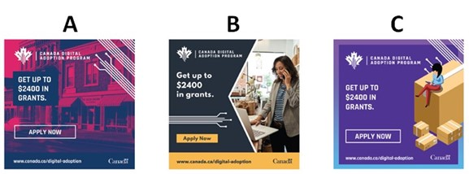

STREAM 2 TERRITORY CREATIVE SUMMARY
The results show that Concept B was by far the most popular among participants in both Streams. The main reactions to the creative approaches include the following:
- Concept A: This concept received the most criticism, especially regarding the choice of colours, which was considered jarring, unappealing and distracting from the main message. Participants in Stream 2 had difficulty deciphering the image in the background while the morphing of the brick-and-mortar store to an online store concept in Stream 1 fell flat for most. A few, especially among younger Quebec entrepreneurs, did appreciate the unique choice of colour, admitting it would be most likely to get their attention. The use of an animated line to draw contours in the Stream 1 concept was also liked by a few.
- Concept B: This was by far the most preferred concept, especially for its “clean” and “professional” layout and for featuring real people and a variety of settings or businesses, giving it the broadest appeal across industry sectors. Some also mentioned that it featured some industries or businesses, such as a farm, that were not traditionally linked to using digital technology, which many felt was a strength. The concept was considered highly relatable, modern, diverse, and having a nice “personal feel.”
- Concept C: Although some did like this concept, it easily ranked between Concept A and B in terms of overall popularity. Participants could not easily relate to the visual elements, with some feeling that the concept looked like an ad for a moving company, a shipping company or Amazon. A few also noted that the person on the box could be the consumer rather than the business owner and that the video would quite narrowly appeal to those in one industry only. There was also less interest in faceless animation compared to seeing real people operating real businesses.

HTML banner ad messages
Stream 2 participants were presented with three different text flows, potentially for an HTML banner ad.

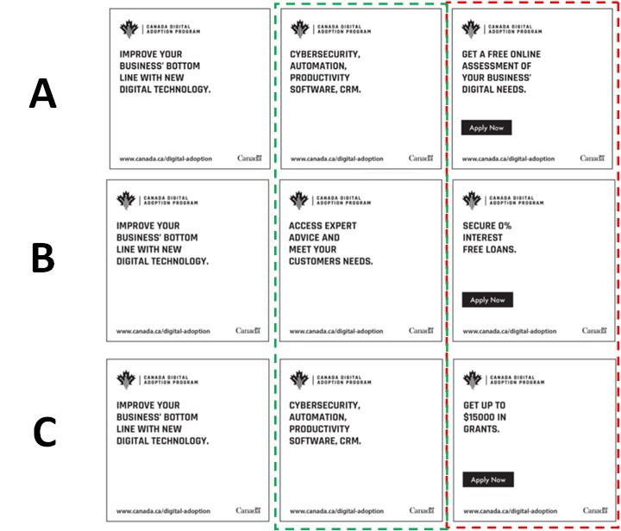

When considering the options in the third column above, the text in row C (getting a grant) was by far the most preferred. For the second column, the text in row B (access to advice) was preferred, although rows A/C also received some votes. Many explained that potentially getting a grant and access to an advisor made for a very compelling combination. However, there were also participants who were a bit skeptical about the offer of advice and who questioned the value that outside advice from the government would bring to their unique business. They therefore leaned towards options A/C in the second column, saying that that information gave them some concrete examples of what they may be able to do with the grant. Cybersecurity resonated best and more broadly than the other items listed.

Radio spots
From a content perspective, there was a sense that the narrator was speaking quickly and that the ad was trying to convey too much information in too short a time. Some also felt that the language was too technical. It was also suggested that the main “hook” is only at the end of the ad, where there is a reference to a grant. As such, participants recommended that the “hook” be at the beginning of the radio ad to more effectively get their attention from the start. It was also suggested that the ad should start with some sort of rhetorical question or interrogation that specifically targets SMEs, and to then continue with the information about the program and the grant.
Two spots were tested with Stream 2 participants, with mixed reviews and preferences. Those who liked Option B, appreciated that it features a free online assessment of how to improve their business’ technology. On the other hand, others felt that this sounded a bit gimmicky or as though it was a trick to draw them into something else, as they often experienced with online ads that ended up being clickbait. Those who liked Option A often felt that it was more explanatory and conveyed more information about the program, as it talked about both the idea of adopting new digital strategies and technology, as well as about the support they would receive from digital advisors – which they felt would be more personal or tailored to their business and therefore more valuable than a mere “free online assessment.”
Social media messages
The final creative element explored with participants was a variety of social media “shareables.” Stream 1 participants were asked to select their two preferred messages among seven options and Stream 2 participants were presented with six different options.
The preferred messages for Steam 1 were:
- Grow Your Business Online Grant
- Give your business a digital edge
- More than 90% of people make their buying decision online
Use of the word “grant” was important to many and this weighed heavily in their preferences. This option clearly told them what the program was about and what was in it for them. Businesses are interested in growing and in getting a digital edge, two notions related to being competitive or to standing out in the marketplace – and something they said would speak to all businesses. Moreover, the top two messages spoke directly to participants through the use of the phrase “your business.” Statistics received mixed reactions in general but the idea that 90% of people make buying decisions online proved most relevant to businesses – it reinforced the importance of being online and it was quite a compelling number. Other options tested were seen as too long, too vague, or showing outdated or irrelevant statistics.
The preferred messages for Stream 2 were:
- Give your business a digital edge
- Improve your businesses’ digital technology today
- Enabling Canadian businesses to expand digitally
As was seen among Stream 1 participants, the idea of a digital edge or business improvements resonated with Stream 2 participants. Again, speaking directly about their business through the use of “your business” clearly showed participants what was in it for them. Other options that did not use that phrase were sometimes said to sound like the government was self-promoting. Shorter, catchier sentences were preferred over options that had more text.

Reactions to the campaign overall
Most participants felt that the campaign and the main message being conveyed was relevant to them as business owners and operators. Most felt that if they were to see the creative “territory” that they preferred online or in social media, they most likely would click through to at least find out more about the program. The main incentive for them is the potential for a grant and to obtain expert advice.
Specific feedback from Stream 1 participants included:
- The amount of the grant was not high enough.
- It would likely be cumbersome to apply.
- It targeted businesses who were not yet online or not yet using e-commerce.
- They were often interested in going beyond setting up a website or a basic e-commerce solution.
- They would like to use the funds for other purposes such as marketing, social media campaigns or search engine optimization.
Specific feedback from Stream 2 participants included:
- The grant amount was interesting and worth the effort of applying.
- It would likely require a lot of effort to apply.
- This program appeared more geared towards savvy digital adopters, while some wanted more help with foundations such as improving their website and digital marketing.
- Digital advice was appreciated by those who felt they were not (yet) very savvy.

Reactions to the proposed program
Awareness of the program was extremely low. Even after hearing the program description, many participants could not easily imagine how the program would work and still had many assumptions or questions, including:
- There were questions about how the grant funds could be used, including whether they could be applied to past expenses or ongoing expenses (rather than one-time purchases).
- There were questions about the application process, eligibility criteria and how challenging it may be to qualify.
- Some assumed that they would meet with an advisor or have an expert conduct a digital audit or evaluation and that, based on this assessment, a plan would be proposed.
- Some hoped that the program would recommend specific software, vendors and platforms.
- Some saw the program as a way to learn about e-commerce and digital technologies.
Nonetheless, there was interest in learning more about the program and how it worked.
At the end of the sessions, participants were asked to think of the future and of where they see their companies’ needs or wants for new or expanded use of digital technologies. Some of the types of digital technologies that businesses are interested in exploring or implementing included:
- developing a mobile app
- improving their website
- more digital marketing
- artificial intelligence
- CRM
- better back-office integration platforms
- virtual reality
- the metaverse
- online scheduling applications
- online collaboration platforms
- online payment systems.

Qualitative research disclaimer
Qualitative research seeks to develop insight and direction rather than quantitatively projectable measures. The purpose is not to generate “statistics” but to hear the full range of opinions on a topic, understand the language participants use, gauge degrees of passion and engagement and to leverage the power of the group to inspire ideas. Participants are encouraged to voice their opinions, irrespective of whether or not that view is shared by others.
Due to the sample size, the special recruitment methods used, and the study objectives themselves, it is clearly understood that the work under discussion is exploratory in nature. The findings are not, nor were they intended to be, projectable to a larger population.
Specifically, it is inappropriate to suggest or to infer that few (or many) real world users would behave in one way simply because few (or many) participants behaved in this way during the sessions. This kind of projection is strictly the prerogative of quantitative research.

Supplier name: Quorus Consulting Group Inc.
PSPC contract number: U1400-222043/001/CY
Contract award date: December 20, 2021
Contract value (including HST): $95,853.99
For more information, please contact Innovation, Science and Economic Development Canada at: IC.PublicOpinionResearch-Recherchesurlopinionpublique.IC@canada.ca

