Fall 2001 Estimate of Firearms in Canada

Report on Findings
Submitted to:
The Public Policy Forum
Final

Submitted by
GPC Research

100 Queen Street

Ottawa, ON

K1P 5Z9

Table of Contents

1 Study Highlights 2
2 Background 4
3 Methodology 6
3.1 Questionnaire Design 6
3.2 Sample 6
3.3 Weighting Structure 8
4 Results: Number of Firearms 9
4.1 Number of Firearms by Type 9
4.1.1 Number of Shotguns 10
4.1.2 Number of Rifles 11
4.1.3 Number of Handguns 12
4.1.4 Other Firearms 13
4.2 Total Number of Firearms in Canada: The Estimate 14
4.3 Number of Firearms by Region 15
5 Results: Number and Profile of Firearm Owners per Household 17
5.1 A Profile of Firearms Owners 18
5.2 Profile of the Top Three Percent of Firearm Owners 20
6 Results: Firearm Usage 21
6.1 Reasons For Owning a Firearm 22
6.2 Intentions Regarding Firearm Ownership 23
7 Results: Attitudes toward the Privacy of Personal Information 25
8 Summary of Findings 28

Appendix A: Marginals
Appendix B: Final Call Dispositions
Appendix C: Distribution of Firearms by Type
Appendix D: Explanation of Weighting Scheme
Appendix E: Margin of Error and the impact of “gun collectors” on the Estimate of the Number of Firearms

Study Highlights

In the Fall of 2001, GPC Research surveyed 3011 for the purpose of estimating the total number of firearms, by type, in Canada. A previous study in the Fall of 2000, also undertaken by GPC Research, involved a survey of 6,145 Canadian households with the objective of estimating firearm ownership in Canada.

At that time, findings indicated that 17% of Canadian households (or 2.0 million Canadian households) own at least one firearm. This study also found that the number of firearm owners per household was 1.23. Therefore the estimate of the Canadian firearm owning population was 2.46 million individuals.

The Fall 2001 study is a complementary piece, following up on the estimate of firearm ownership. With the impending deadline for firearm registration of January 1, 2003, the current estimate provides a benchmark against which to assess compliance with the requirements of The Firearms Act. The previous deadline of January 1, 2001 required that all firearm owners obtain a licence in order to possess or acquire a firearm.

A full reporting on the results and methodology employed can be found in subsequent sections of this report. Key findings from the survey are as follows:

- There are an estimated 7.92 million firearms in Canada. This estimate comprises approximately 4.16 million rifles, 3.22 million shotguns, .49 million handguns and .05 million “other” types of firearms.

  - Some respondents had more firearms than expected in a normal distribution (i.e. greater than 3 standard deviations from the mean score). These firearm owners were no doubt “gun collectors” and impacted the mean score used to calculate the total number of firearms in Canada. Three individuals were removed from the sample to determine the impact.

  - With these three individuals removed, the mean number of firearms drops from 3.22 to 3.04. The associated estimate of total firearms also drops from 7.92 million to 7.46 million.

- The top three percent of firearm owners hold approximately 15% of all firearms or, on average, 15.5 firearms per owner. For the remainder of the firearm-owning population, the mean number of firearms owned is 2.74.

- There are 1.14 firearm owners per household.

- Eight percent of respondents indicated an intention to disable or divest themselves of some/all of their firearms in the next two years. About one-quarter (25%) of those intending to dispose of or disable their firearms intend to destroy, disable or dispose of them to the police.

- Almost two-thirds (61%) now indicate that they use their firearm very infrequently (once a year or less) or never, compared to under half (43%) who said the same in a 1999 survey.

Background

In February of 1995, then Justice Minister, Allan Rock, introduced Bill C-68, The Firearms Act. Senate approval and Royal Assent were granted on December 5, 1995. The main aspects of the new Firearms Act include:

- The Firearms Act and Regulations apply to any person (including visitors to Canada) and any businesses that own, want to obtain, or use firearms.

- The licence deadline to possess or acquire a firearm was January 1, 2001.

- Before a licence is issued, safety checks on applicants are completed. The new system automates this process to speed up decision-making. This is achieved by linking police databases with the new firearm registry system.

- All firearms must be registered by 2003. In order to register a firearm, the applicant must first have a licence (or valid Firearms Acquisition Certificate). New firearms will be registered when they are made, or at the point of purchase.

- Safe storage regulations require that all firearms be stored unloaded and made inoperable, usually through a locking device.

- Mandatory minimum sentences of four years for violent crimes committed with a firearm are in force.

- All handguns with a barrel shorter than 105 millimeters are prohibited; so are all .32 and .25 caliber handguns, all fully automatic machine guns, any firearm with a sawed-off barrel and some military rifle models such as AK 47 and their variants.

- The two key dates are:
- January 1, 2001 for gun owners to obtain a licence
- January 1, 2003 for registration of all firearms.

In the Fall of 2000 GPC Research conducted a survey of 6,145 Canadian households to determine the number of firearm-owning households in Canada and the number of firearm owners. This estimate was required by the Canadian Firearms Centre (CFC) as a means of ensuring that all firearm owners had properly registered on or before the January 1, 2001 deadline.

The survey produced an estimate of 17% of Canadian households having at least one firearm and therefore between 2.32 million and 2.46 million firearm owners in Canada. This represents the most up-to-date count available. The figure of 2.46 million firearm owners is used in calculating the total number of firearms in the results of the Fall 2001 Firearms Estimate Survey.

In order to monitor the registration of firearms in advance of the January 1, 2003 deadline, the CFC requested an additional survey specifically designed to establish a benchmark estimate of the number of firearms in Canada. This study will be used to determine the number of firearms in Canada.

Surveys specifically designed for the purpose of counting or estimating a population usually requires larger sample sizes than might ordinarily be the norm for most other national surveys. This was the case with the Fall 2000 Estimate of Firearm Owners and is equally the case with the Fall 2001 Estimate of Firearms.

The sampling of a greater number of households/individuals increases the level of accuracy of the findings at a broad level, as well as at the level of sub-groups (i.e. regions or demographic segments of the population).

The methodology and the questionnaire employed in the survey were rigorously reviewed and overseen by the Public Policy Forum and their designated statistical expert. Specific attention was paid to ensuring adequate randomization of the sample to remove any possible bias in the selection of respondents for participation in the survey.

The following sections detail the methodological approach and the results of the survey.

Methodology

A national study of firearm-owning Canadians was conducted between September 24th and November 13th 2001. Interviews were conducted in English and French. Non-completes based on a language barrier (i.e. not English or French) were no higher or lower than we find in other national surveys and typically occurred at the outset of the survey.

The complete set of frequencies associated with each question and response category can be found in Appendix A and final call dispositions in Appendix B.

3.1 Questionnaire Design

The questionnaire was approximately seven minutes in length and contained 17 questions, excluding demographic questions such as age, education and household income. The structure of the questionnaire paralleled the previous Fall 2000 questionnaire designed for the purpose of estimating the number of firearm owners.

The survey instrument incorporated some checks within the design to minimize the degree of false reporting. This included an initial question on the types of recreational activities in which the respondent participated, including hunting and sport shooting. Subsequently, respondents were asked to indicate whether they or anyone in their household owned a firearm. Data on the number by type of firearm was collected (i.e. shotguns, rifles, handguns and others).

Additional questions were asked of respondents relating to their firearms usage, including their reasons for owning a firearm, their plans, if any, to increase or decrease their personal stock of firearms.

3.2 Sample
The final sample size of firearm owners was set at a minimum of 3,000 (and actually totaled 3,011). A survey of this magnitude has an accompanying margin of error of +/-2.06% at the national level, with a 95% confidence level.

As with the Fall 2000 survey, the final sample is larger than would typically be employed in a national survey. While a national sample of 1,500 or 2,000 Canadians would suffice for most attitudinal surveys, a larger final sample of firearm owners was deemed desirable in order to achieve a very high degree of statistical accuracy at the national level. Correspondingly, quotas were established for sample sizes at the regional level to ensure that margins of error by province/region/territory were also reasonable.

The sample was randomly drawn using state-of-the-art survey sampler technology with the most up-to-date information on directory-listed numbers in Canada. GPC Research used both directory-listed and non-directory listed sample from every region of the country. This was to ensure the randomness of the sample and, therefore, the accuracy of the results.

The final sample distribution and corresponding margins of error (95% confidence level) are shown in the Table 1 below.

Table 1: Distribution of Sample by Region

Region | Total | Margin of Error
British Columbia | 427 | +/-4.75
Alberta | 427 | +/-4.75
Saskatchewan | 300 | +/-5.67
Manitoba | 300 | +/-5.67
Ontario | 600 | +/-4.00
Quebec | 500 | +/-4.39
Atlantic | 406 | +/-4.87
Yukon/Territories | 51 | +/-13.86
Total | 3011 | +/-2.06
Note: Un-weighted figures

The final sample was not proportionate to the actual distribution of the population in Canada by province and territory. Over-sampling of certain regions and provinces was undertaken to reduce the margin of error associated with the results for these regions and provinces.

Most national surveys usually undertake smaller samples across the Prairie provinces, the North, and the Atlantic region due mainly to the lower population base in these regions as compared to Québec and Ontario. Over sampling occurred in the Fall 2000 Survey of Firearms Owners in some areas in order to ensure the production of very precise estimates of the number of firearms at the regional and provincial levels.

Rural areas were also over sampled, while urban areas were under sampled, similar to sampling procedures in the Fall 2000 Estimate of Firearm Owners. The final sample was drawn to comprise a 60/40 split between urban and rural respondents, while in reality about 78 percent of the Canadian population currently resides in urban areas and 22 percent in rural Canada according to 2000 Statistics Canada data.

A total of 3,011 firearm-owners were contacted for the survey. In the Fall 2000 survey, the estimate was based on a survey of households, while the current survey considers the individual (the firearm owner) as the primary sampling unit.

In each household contacted by GPC Research, an adult member (18 years of age or older) was asked, following an introductory question, whether any member of that household owned any type of functioning firearm. The topic of firearms was introduced earlier in the Fall 2001 survey than in the Fall 2000 survey. The Fall 2000 survey consisted of a series of eight introductory questions, followed by questions to identify the ownership of a firearm within the household and then further questions related to gun ownership and use.

In order to ensure absolute randomness in the selection of a respondent among households with multiple firearm owners, GPC Research employed the “last birthday” selection method. This is a common industry practice to ensure randomization in the selection of a respondent from a household. Interviewers asked to speak with the firearm owner who had celebrated their birthday most recently. Thus randomization was ensured not only at the stage of selecting households for participation in the survey, but also in selecting the firearm-owning participant from within a household for inclusion in the survey.

3.3 Weighting Structure
As the survey sample was not proportionate to the distribution of the Canadian population, weightings were applied so that the results could then be extrapolated to the Canadian population at large. The data was weighted in order to reflect the actual demographic composition of the Canadian firearm-owning population, according to the GPC Research Fall 2000 household Estimate of Firearm Ownership.

The weighting scheme corrected for urban/rural distribution of firearm owners within region resulting in a weighted final sample of 3014. Table 2 below shows original sample, weighting factors and final sample distributions. See Appendix D for an explanation of the weighting scheme.

Table 2: Distribution of Sample by Region after Weighting

Region | Total
British Columbia | 361
Alberta | 274
Saskatchewan | 142
Manitoba | 142
Ontario | 864
Quebec | 852
Atlantic | 348
Yukon/Territories | 31
Total | 3014

Results: Number of Firearms

Estimates of the number of firearms by type are detailed in the following sections. Three measures are reported including the mean (average number), mode (the most frequent response) and the median (the number in the middle of which 50% are above and 50% are below).

Full distributions for each type of firearm are detailed in Appendix C.

4.1 Number of Firearms by Type

A carefully constructed series of questions was posed of respondents in order to precisely estimate the total number of firearms held by firearm owners in Canada. First, respondents were asked simply to indicate the types of firearms they owned without stating the number in each category.

The vast majority of firearm owners have either rifles (74%) or shotguns (71%). One-in-ten (11%) owners indicated they owned a handgun.

Figure 1
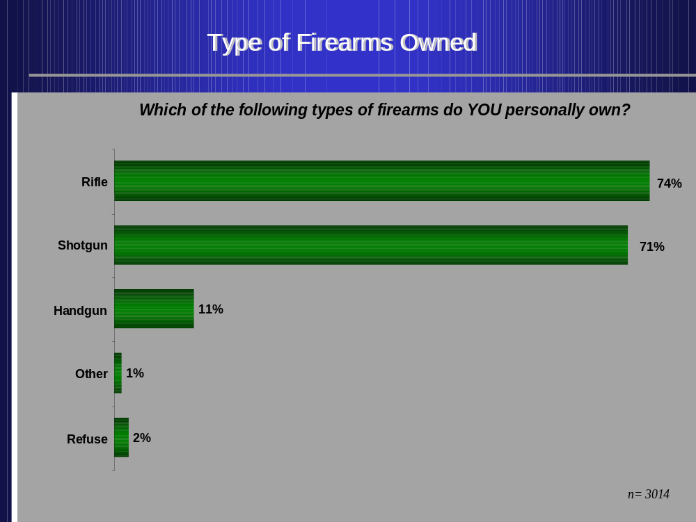

4.1.1 Number of Shotguns

Respondents were then asked to identify the number of each type of firearm owned. In analysing responses to this series of questions, findings are reported on the total number of each type of firearm. In addition to the mean, the mode and the median are also reported in order to mitigate the skewing effect of single owners of any one type of firearm with large holdings or collections. The mode and the median are more valid measures of central tendency and distribution in this case and provide additional useful information.

Nearly two-in-five firearm owners possess only one shotgun (39%) and a further 30 percent own two or more shotguns. One respondent claimed to own 201 shotguns. In total, the findings indicate that all shotgun owners in Canada hold in the order of 3.22 million shotguns. The mean number of shotguns is 1.31, the median is 1.00 and the mode is 1.0.

Figure 2
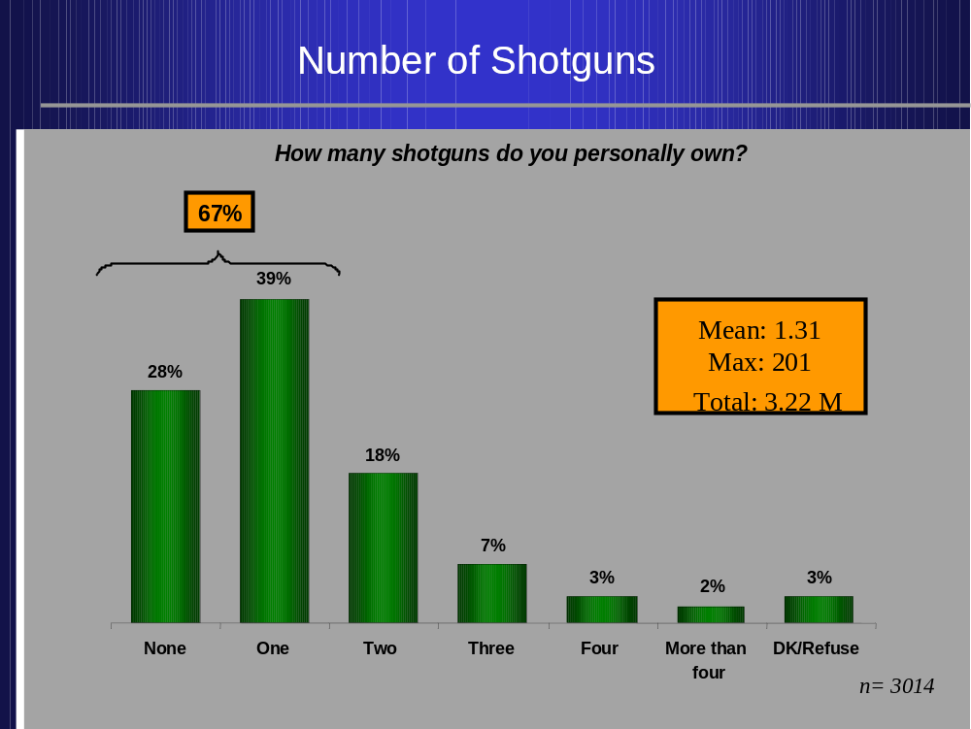

4.1.2 Number of Rifles

Some 35% of firearm owners indicate they hold one rifle only. Slightly more than one-third of all firearm owners (36%) own more than one rifle. The largest collection of rifles belonging to a single individual is 302. In total, the findings indicate that all rifle owners in Canada hold in the order of 4.16 million rifles. The mean number of rifles is 1.69, the median is 1.0 and the mode is 1.0.

Figure 3
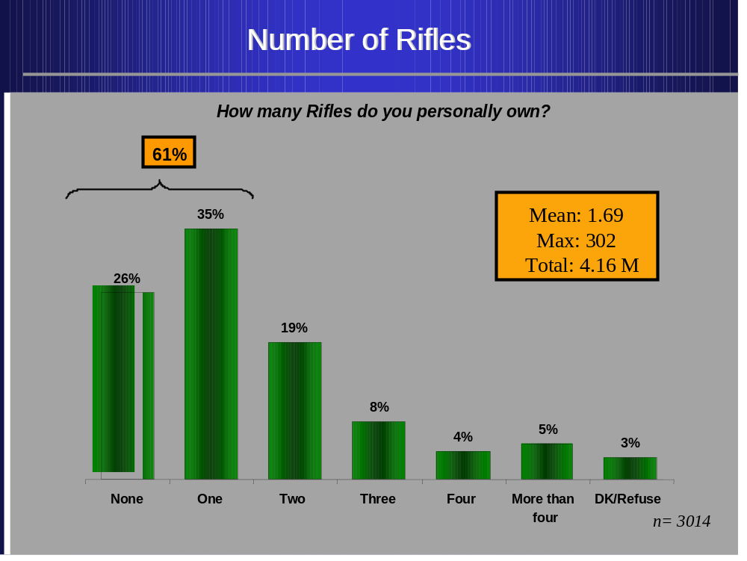

4.1.3 Number of Handguns

About one-in-ten respondents acknowledged owning at least one handgun. One respondent reported ownership of 22 handguns. In total, the findings indicate that all handgun owners in Canada hold in the order of .49 million handguns. The mean number of handguns is 0.2, the median is 0 and the mode is 0.

Figure 4
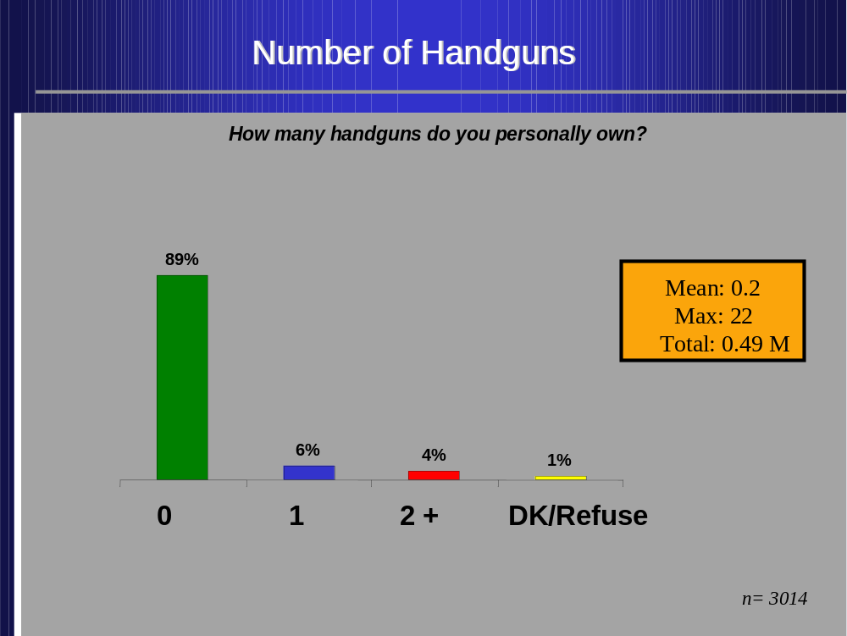

4.1.4 Other Firearms

Only one percent of those surveyed own some other type of firearm. This translates into a total of .05 million “other” types of firearms, with a mean of .02 per owner, a mode of 0 and a median of 0.

Figure 5
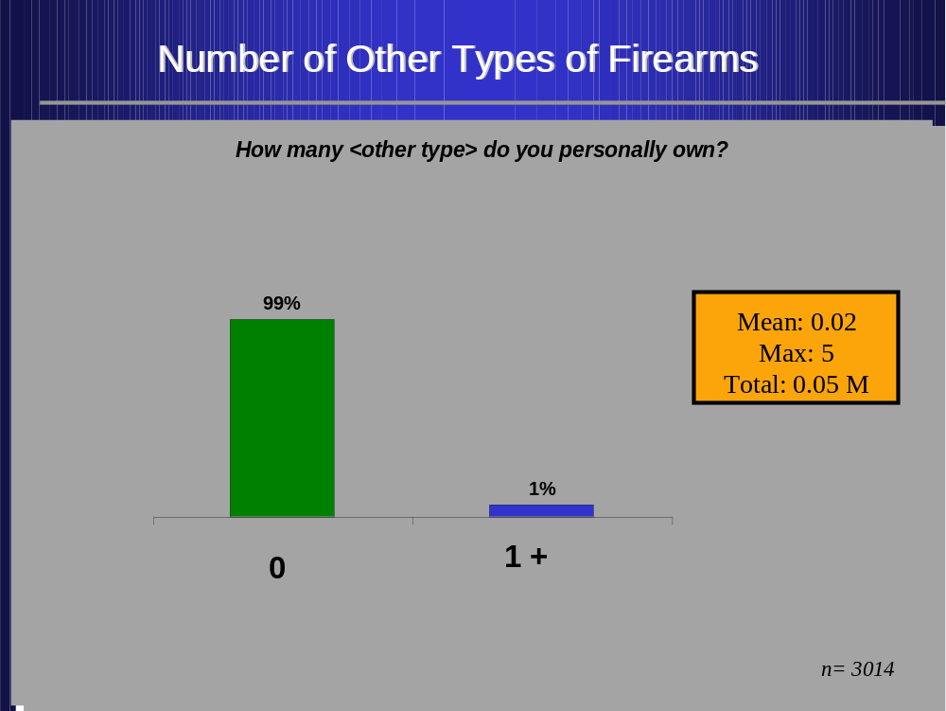

4.2 Total Number of Firearms in Canada: The Estimate

Adding together the total number of rifles, shotguns, handguns and miscellaneous other types of firearms reported, the total estimate of firearms held by firearm owners in Canada in the Fall of 2001 is 7.92 million.

Figure 6
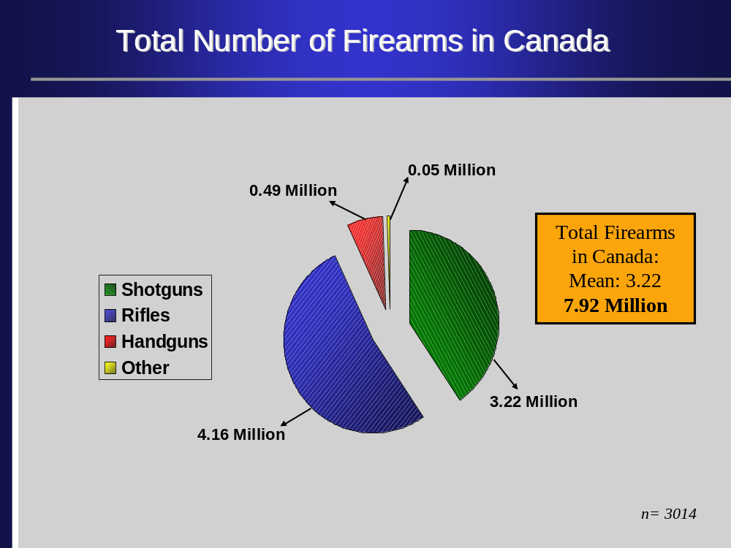

The mean number of firearms owned by any single firearm owner is 3.22, when all types of firearms are combined. This estimate is calculated as the sum of the individual means for each type of firearm. The total and mean are as follows:

Table 3: Total Number and Mean Number of Firearms

 | Number | Mean | Margin of Error for mean
Rifles | 4.16M | 1.69 | +/-0.12
Shotguns | 3.22M | 1.31 | +/-0.24
Handguns | 0.49M | 0.20 | +/-0.03
Others | 0.05M | 0.02 | +/-0.01
Total | 7.92M | 3.22 | +/-0.14

4.3 Number of Firearms by Region

The total number of firearms (combining all types of firearms) held by firearm owners for each region of Canada is shown in the chart below. Nearly one-third (32%) of the firearms in Canada are held by residents of Ontario (2.52 million firearms). The second largest holding is by residents of Quebec (1.89 million), followed by British Columbia (1.10 million).

Figure 7
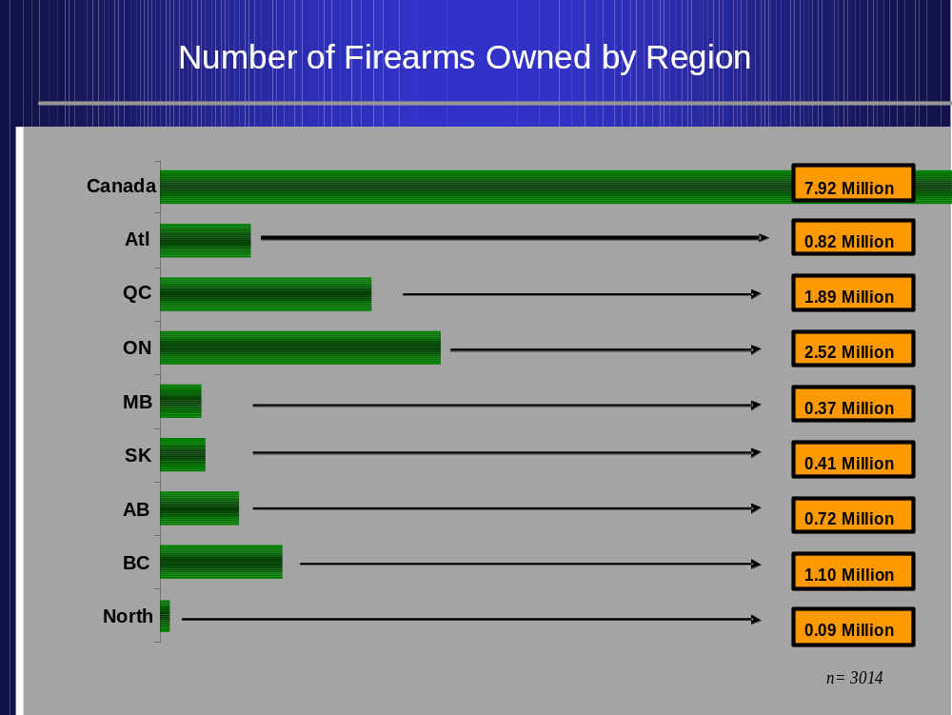

However, the North, the Atlantic Provinces, Manitoba and Saskatchewan have the most firearms per capita. There is nearly a one-to-one ratio of firearms to residents of the North, with two firearms for every five residents of Saskatchewan, and one firearm for every three residents in Atlantic Canada and Manitoba. Table 4 below shows per capita firearms by Region.

Table 4: Number of Firearms by Region and Per Capita Ratio

Region | Number of Residents | Number of Firearms | Firearms Per Capita
British Columbia | 4.02 M | 1.10 M | 1 : 4
Alberta | 2.96 M | 0.72 M | 1 : 4
Saskatchewan | 1.03 M | 0.41 M | 2 : 5
Manitoba | 1.14 M | 0.37 M | 1 : 3
Ontario | 11.51 M | 2.52 M | 1 : 5
Quebec | 7.35 M | 1.89 M | 1 : 4
Atlantic | 2.37 M | 0.82 M | 1 : 3
Yukon/Territories | 0.099 M | 0.09 M | 1 : 1
Total | 30.49 M | 7.92 M | 1: 4

Results: Number and Profile of Firearm Owners per Household

The vast majority (85%) of firearms owners claim they are the only individual owning a firearm in their household. This finding is consistent with the results from the 2000 Estimate of Firearm Owners that found about four-in-five firearm-owning households with one firearm owner. About 12% of firearm owners reside in households of multiple firearm owners.

Figure 8
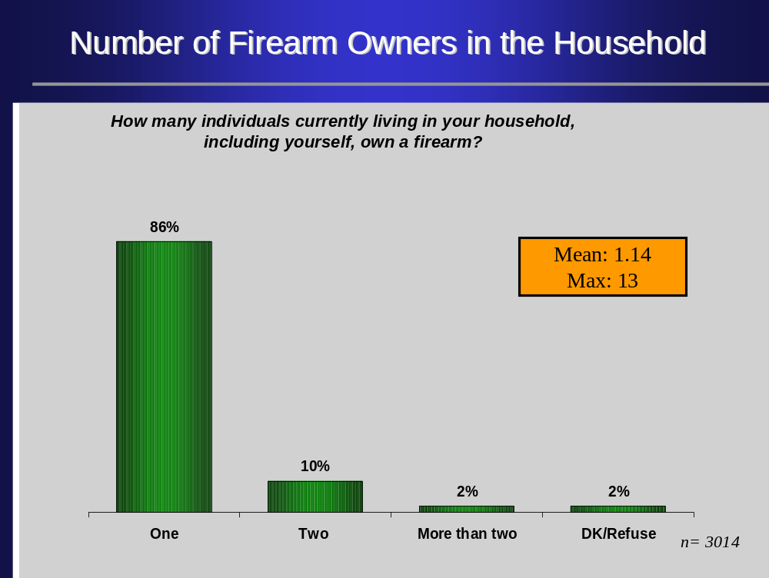

The mean number of firearm owners per household is estimated to be about 1.14 (Margin of error +/- 0.01). This is slightly lower than the 1.23 estimate produced from the Fall 2000 survey. This suggests that some owners may have divested themselves of some of their firearms since the licensing deadline. Findings from the 2000 survey suggested that six percent of respondents had an intention to disable or divest themselves of their firearms.

5.1 A Profile of Firearms Owners

The profile of a typical firearm owner as shown in Table 5 is:
- male
- over 35 years of age
- higher than average household income
- at least a high school education

The Fall 2000 survey showed a decline in the number of firearm owners under the age of 35 by approximately 39 percent since the benchmark 1991 study.

The Fall 2001 GPC Research survey notes a further drop in the number of firearms owners in this age category. Those aged 18 to 34 years of age now represent just 15 percent of the total population of firearm owners compared to almost one-third of the firearm-owning population in 1991.

Table 5: Profile of Firearm Owners versus the General Population

Demographic Variable | 1991  Angus Reid  Survey | 2000  GPC  Survey | 2001  GPC  Survey | Profile of Canadian Population
 | % | % | % | %
Gender
Male | 86 | 87 | 88 | 49
Female | 14 | 13 | 12 | 51
Age
18 to 34 | 31 | 19 | 15 | 33
35 to 54 | 46 | 51 | 49 | 40
55+ | 22 | 29 | 34 | 27
Education
High School or less | 55 | 47 | 51 | 43
College/Some Post-Secondary | 28 | 31 | 28 | 28
Completed University | 15 | 23 | 19 | 30
No response | 2 | 0 | 2 | 1
Household Income
< $ 20,000 | 11 | 8 | 8 | 15
$20,000 to $39,999 | 32 | 23 | 24 | 24
$40,000 to $59,999 | 25 | 26 | 25 | 19
$60,000 + | 20 | 34 | 33 | 27
No Response | 10 | 8 | 10 | 15

5.2 Profile of the Top Three Percent of Firearm Owners

It is useful to consider the full distribution of firearms which owners hold, by each different firearm. Notably, the top three percent of the firearm owners holds slightly more than 15 percent of the total firearms in Canada.

The top tier averages 15.5 firearms per person while the general firearm owning population (the remaining 97%) averages 2.74. This indicates that a small group of firearm owners owns a disproportionate number of the total firearms. As well, this group also owns just over one-third (0.17M of 0.49M) of all handguns.

Figure 9
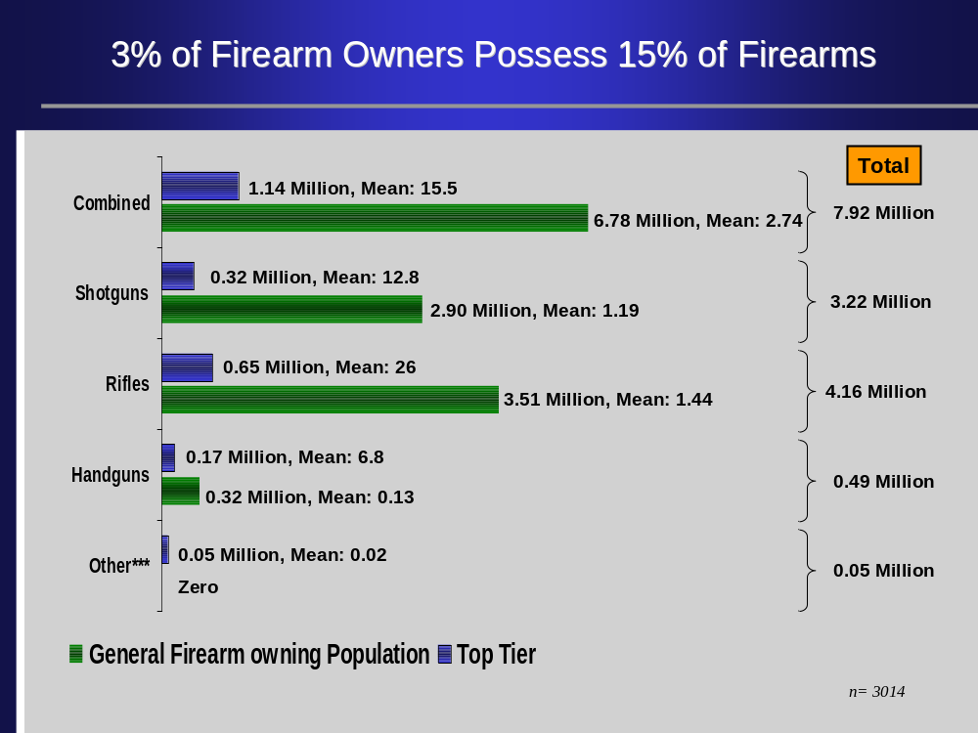

Results: Firearm Usage

The chart below illustrates the continued trend in declining usage of firearms since 1999. At that time 43% of firearm owners indicated they never used their firearms or, at most, once a year. This percentage increased to 56% of owners in Fall 2000 and now stands at 61% in Fall 2001.

Figure 10
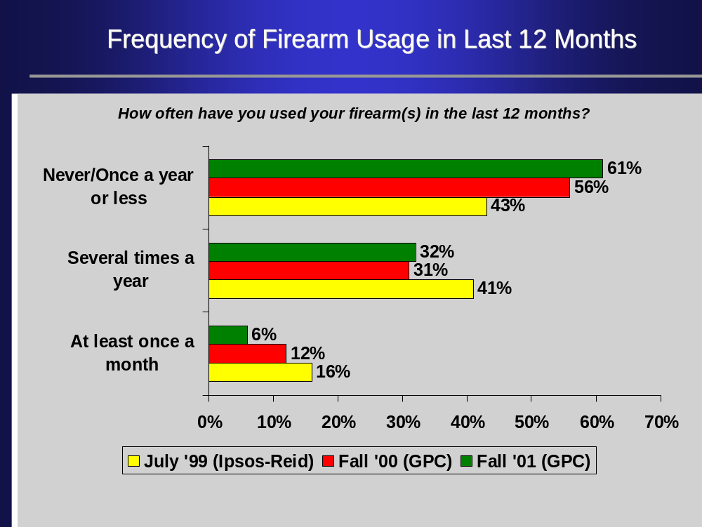

Firearm users can be separated into four distinct groups – heavier users (at least once a month or more), regular users (several times a year), lighter users (once a year or less), and non-users.

Heavier firearm users are more likely to be found:

- residing in Manitoba, Saskatchewan and the Territories;
- among younger firearm owners, aged 18 to 29;
- among rural firearm owners; and
- the top three percent of firearm owners.

Lighter firearm users are primarily found in Quebec. Non-users are more likely to include residents of British Columbia, those in older age categories (50 years of age and older), and those living in urban areas.

6.1 Reasons For Owning a Firearm

Respondents were asked the main reason they own a firearm. Almost three quarters of respondents (73%) cited hunting as the primary reason for owning a firearm. Other reasons given for firearm ownership were target shooting (13%), pest control (8%), collection (6%), and protection from animals(5%).

Figure 11
Purpose of the Firearm(s)
Purpose of the Firearm(s)
What are the main reasons why you own a firearm(s)?
12%
5%
6%
8%
13%
73%
Other
Protection
Collection
Pest
Control
Target
Shooting
Hunting
n= 3014
Most likely to use a firearm for:
•
Hunting
•
Residents of Atlantic, QC & Terr.
•
Firearm owners under 50
•
Target Shooting
•
Residents of ON, MB, SK & AB
•
Urban Canadians
•
Protection from animals
•
Residents of SK, AB, BC & Terr.
•
Rural Canadians
•
Pest Control
•
Residents of MB, SK & AB
•
Rural Canadians

6.2 Intentions Regarding Firearm Ownership

Nearly four in five (78%) firearm-owning respondents indicated that they intend to keep all of their firearms for at least the next two years. Another 10 percent intend to purchase additional firearms. At the same time, eight percent indicated they would get rid of or disable some/all of their firearms.

Of those respondents who indicated they would get rid of some or all of their firearms, nearly half (44%) indicated they would sell them. One-in-five respondents indicated they would give their firearms away, while an additional 18 percent said they would dispose of their firearms to the police department. Other methods of getting rid of their firearms included destroying them (6%), and disabling them (1%).

Figure 12
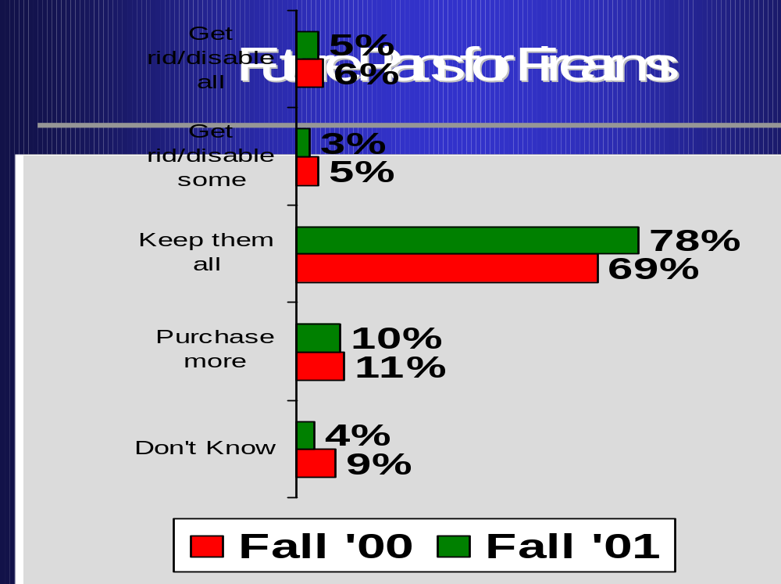
Respondents were asked if they have more firearms, less firearms, or about the same number of firearms as they did five years ago. A majority (77%) of them indicated they had the same number of firearms as they did five years ago. A further 10 percent have increased their holdings/collections and another 9 percent have fewer firearms than they had five years ago.

Figure 13
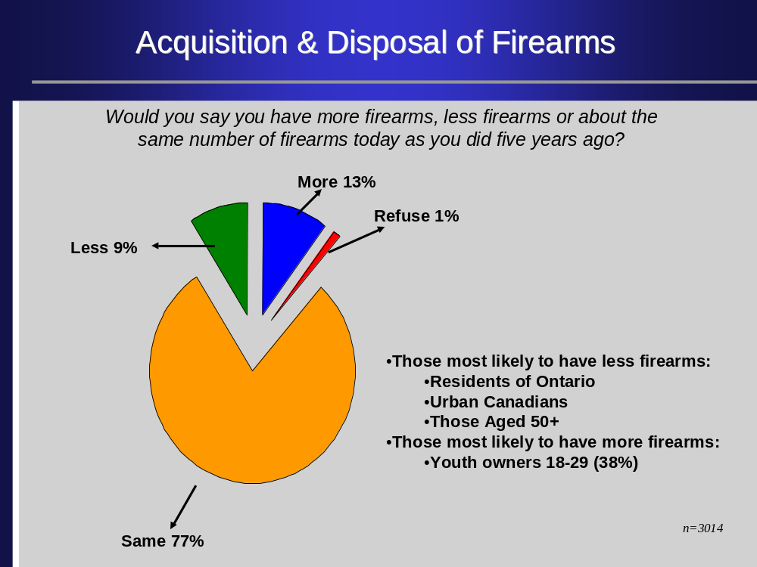

Results: Attitudes toward the Privacy of Personal Information
Firearm owners were asked how concerned they were with the security of personal information such as name, address, date of birth, and telephone number provided during the firearm licencing process.

Respondents were split in their concern with this issue. There were as many respondents more concerned (44%) about privacy issues as there were as were unconcerned (42%). Those who were more concerned about privacy issues tended to be between the ages of 30 and 49 years old, respondents residing in rural regions, respondents from Alberta and British Columbia.

Figure 14
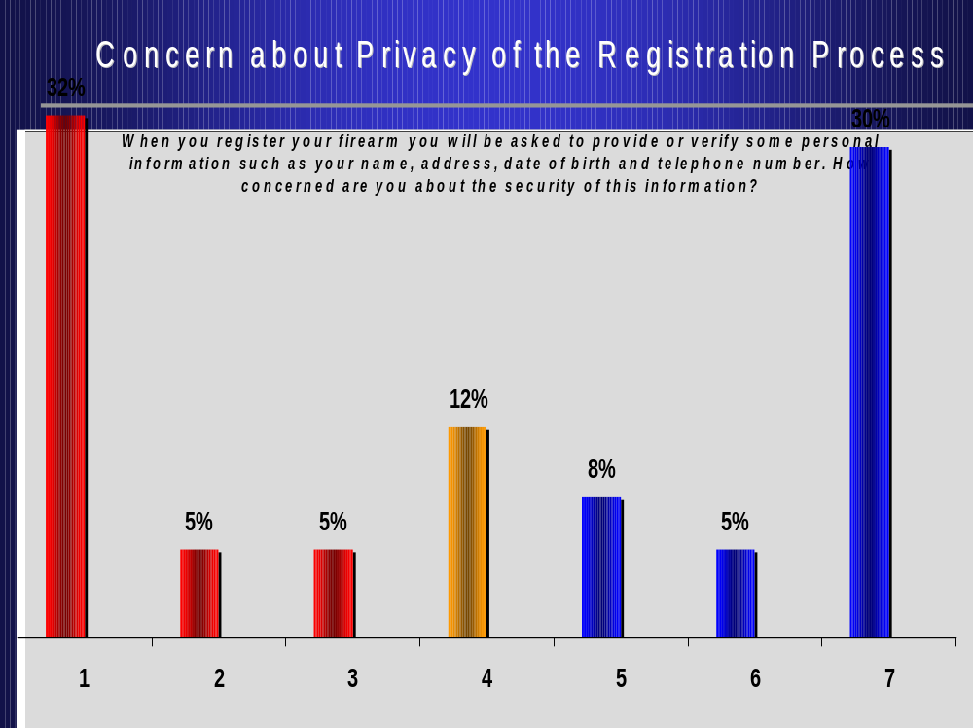
Figure 15
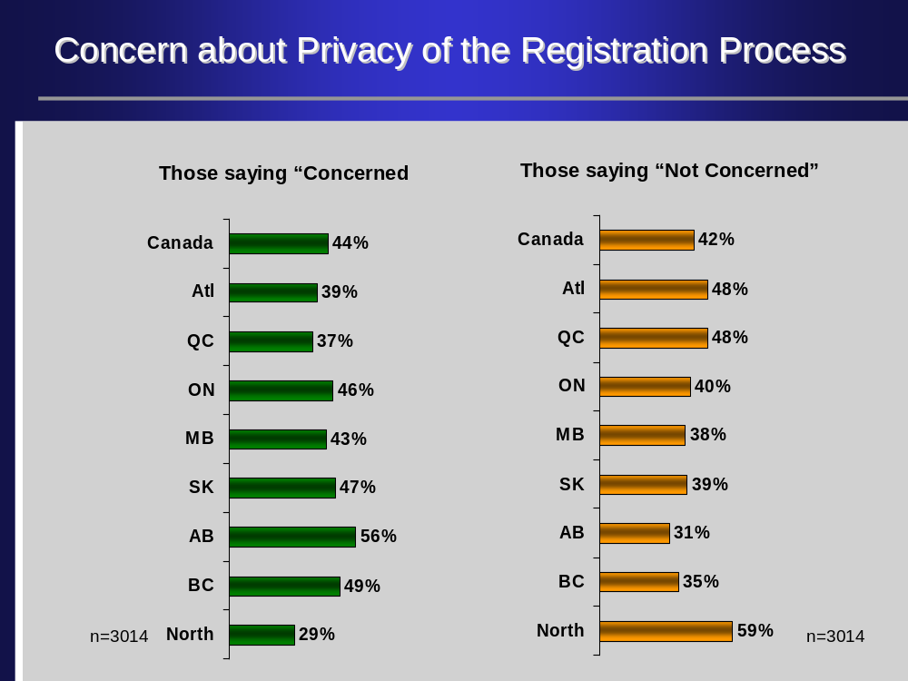

When asked if they would be more or less concerned if they knew the information provided was protected by privacy laws, most of those more concerned lessened their fears. Approximately one-in-ten (11%) still said they would still be more concerned about privacy but clearly the vast majority indicated they would be neither more nor less concerned.

Figure 16
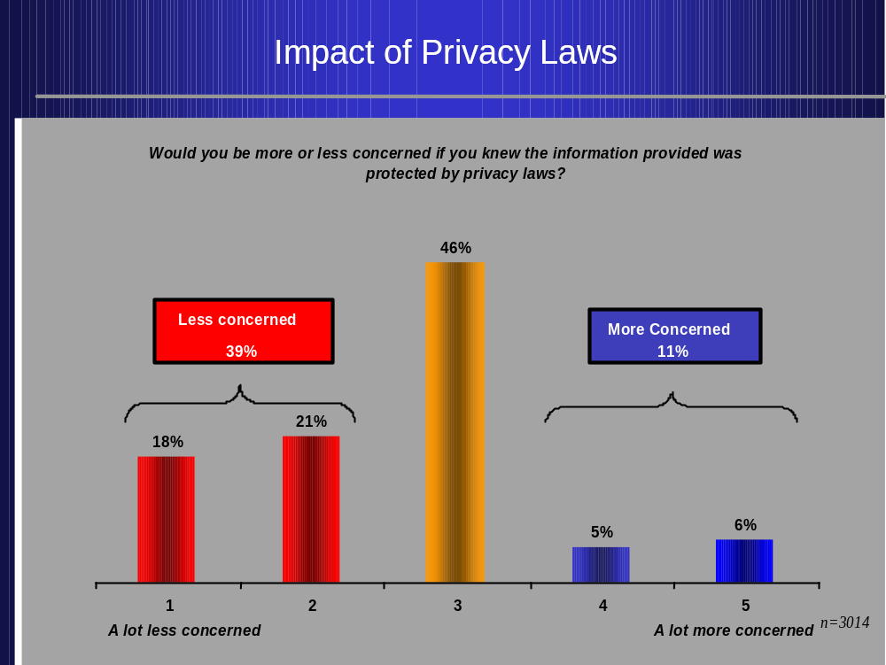

Summary of Findings

The Fall 2001 study of 3,014 (weighted total) firearm owners, aged 18 years of age and older, provides an estimate of the total number of firearms (all types combined) in the order of 7.92 million. There are 4.16 million rifles, 3.22 million shotguns, .49 million handguns, and .05 million “other” types of firearms held by the Canadian firearm-owning population.

The top three percent of firearm owners alone hold 15% of all firearms, or 1.14 million of that total. The mean number of firearms held by the top three percent of firearm owners amounts to 15.5 firearms per owner. As well, this group also owns just over one-third of all handguns. By contrast, the remaining 97% of the firearm-owning population hold an average of 2.74 firearms each, totalling 6.78 million.

The largest proportion of firearms can be found in the provinces of Ontario, Québec and British Columbia. On a per capita basis, however, the North, the Atlantic region, Saskatchewan and Manitoba have the highest ratios of firearms to residents.

Self-reported firearm usage continues to decline, even since the Fall of 2000 when a survey to estimate the number of firearm owners in Canada was undertaken. The percentage of those indicating that they never use their firearms or that they use them less than once a year had increased from 43% in 1999 to 56% in the Fall of 2000 and has increased again to 61% in the Fall of 2001.

The vast majority (78%) of firearm owners intend to keep their firearms. However, eight percent indicate they will get rid of or disable some/all of their firearms over the next two years.

Appendix A: Marginals
INTRO:
Hello my name is ...... And I am calling from GPC Research in Ottawa, a national professional public opinion research company which has been hired by the Department of Justice to speak with a random sample of Canadians about a number of issues in the news. We are not selling anything but I would like to ask you some basic questions about a variety of issues. The survey will take less than 5 minutes to complete and all of your responses will be completely confidential. May I speak to a member of your household who is 18 years of age or older?
3014
Yes - Continue 1 3014 100%

Q2:
Do you or does anyone in your household own a functioning firearm? (If multipule gun owners ask to speak with one who had the birthday last)
Yes - Continue 3014 (Weighted N)
No - Terminate 18642 (Unweighted N)

LANG (DO NOT ASK)
Language of Respondent
English 1
French 2

SEX: (DO NOT ASK) 3014
Gender of Respondent
Male 1 2658 88%
Female 2 356 12%

Q3: 3014
Which of the following types of firearms do YOU personally own?
(ACCEPT ALL RESPONSES)
Shotgun 01 2151 71%
Rifle 02 2237 74%
Handgun 03 330 11%
Other (specify) 88 32 1%
Refused (DO NOT READ) 98 51 2%

Q4A: 3014
PROBE: If 'don't know' probe for best estimate - "We are looking for your best estimate of the number of firearms you own. Can you please give me an exact number, instead of a range?"
How many shotguns do you personally own?
0 853 28%
1 1160 39%
2 547 18%
3 221 7%
4 76 3%
5+ 71 2%
Don't know 999 31 1%
Refused 998 55 2%

Q4B: 3014
PROBE: If 'don't know' probe for best estimate - "We are looking for your best estimate of the number of firearms you own. Can you please give me an exact number, instead of a range?"
How many rifles do you personally own?
0 776 26%
1 1062 35%
2 585 19%
3 235 8%
4 121 4%
5+ 155 5%
Don't know 999 20 1%
Refused 998 60 2%

Q4C: 3014
PROBE: If 'don't know' probe for best estimate - "We are looking for your best estimate of the number of firearms you own. Can you please give me an exact number, instead of a range?"
How many handguns do you personally own?
0 2680 89%
1 180 6%
2 70
3 20
4 19 4%
5+ 25
Don't know 999 6
Refused 998 14 1%

Q4D: 3014
PROBE: If 'don't know' probe for best estimate - "We are looking for your best estimate of the number of firearms you own. Can you please give me an exact number, instead of a range?"
How many <other types of firearms> do you personally own?
0 2980 99%
1+ 34 1%
Don't know 999 0 0%
Refused 998 0 0%

Q5: 3014
How often have you used your firearm(s) in the last 12 months?
Everyday 1 13 0%
Once a week 2 71 2%
Once a month 3 106 4%
Several times a year 4 954 32%
Once a year 5 454 15%
Less than once a year 6 43 1%
Never 7 1359 45%
No response/ Don't know 9 9 0%
Refused 8 6 0%

Q6: 3014
What are the main reasons why you own a firearm? (MARK ALL THAT APPLY)
Hunting 01 2134 73%
Target shooting 02 392 13%
Collection 03 162 6%
Employment-related 04 30 1%
Protection (ie from animals etc) 05 157 5%
Pest control 06 231 8%
Other (specify) 88 354 12%
No response/ Don't know 99 9 0%
Refused 98 14 0%

Q7: 3014
Thinking ahead now to the next 2 years. Do you plan on ...
Getting rid of all your firearms 01 118 4%
Getting rid of some of your firearms 02 67 2%
Disabling all of your firearms 03 27 1%
Disabling some of your firearms 04 24 1%
Keeping all your firearms 05 2340 78%
Purchasing new firearms 06 294 10%
Or something else (specify) 88 43 1%
No response/ Don't know (DO NOT READ) 99 88 3%
Refused (DO NOT READ) 98 14 0%

Q8: 186
You indicated that you will either get rid of some or all your firearms, how do you intend on doing this? Will you ...
Sell them 01 81 44%
Give them away 02 37 20%
Destroy them 03 12 6%
Disable them 04 2 1%
Ask the police to dispose of them 05 33 18%
Or something else (specify) 88 9 5%
Don't know/ No response (DO NOT READ) 99 10 5%
Refused (DO NOT READ) 98 3 2%

Q9: 3014
Would you say you have more firearms, less firearms or about the same number of firearms today as you did five years ago?
More 1 394 13%
Less 2 277 9%
Same 3 2315 77%
Don't know/ No response 9 7 0%
Refused 8 20 1%

Q10: 3014
How many individuals currently living in your household, including yourself, own a gun or firearm?
1 2563 86%
2+ 358 12%
No response/ Don't know 99 46 1%
Refused 98 45 1%

A3: 3014
When you register your firearm you will be asked to provide or verify some personal information such as your name, address, date of birth and telephone number. How concerned are you about the security of this information? Please use a 7-point scale where 1 means you are not at all concerned and 7 means you are very concerned.
1 - Not concerned at all 1 957 32%
2 2 152 5%
3 3 146 5%
4 4 350 12%
5 5 247 8%
6 6 164 5%
7 - Very concerned 7 902 30%
Don't know 9 0 0%
Refused 8 0 0%

A4: 3014
Would you be more or less concerned if you knew the information provided was protected by privacy laws? (PROBE for the level of concern) (Note to Interviewer: privacy laws are both Federal and Provincial)
A lot less concerned 1 548 18%
A bit less concerned 2 635 21%
No change 3 1373 46%
A bit more concerned 4 138 5%
A lot more concerned 5 174 6%
Don't know 9 105 3%
Refused 8 42 1%

S1: 3014
DEMOGRAPHIC SECTION
Now I have a few questions for statistical purposes. May I remind you that all your answers will be kept strictly confidential. Which of he following age categories do you fall into?
18-24 1 96 3%
25-29 2 160 5%
30-34 3 206 7%
35-39 4 318 11%
40-44 5 376 12%
45-49 6 391 13%
50-54 7 397 13%
55 or older 8 1029 34%
Refused 9 40 1%

S2: 3014
What is the highest level of education you have completed?
(PROMPT IF NECESSARY)
Less than high school 1 437 15%
High school 2 1089 36%
Some college 3 240 8%
College graduate 4 465 15%
Some university 5 149 5%
University graduate 6 345 11%
Post graduate degree (MA, PHD) 7 150 5%
Professional degree 8 84 3%
Refused 9 55 2%

S3: 3014
Are you an Aboriginal person (e.g., native Indian from a specific band, Inuit or Metis)?
Yes 1 14 5%
No/ Don't know 2 2832 94%
Refused 9 34 1%

S4: 3014
Which of the following categories best describes your total household income? Would you say that it is ... ?
Less than $20,000 1 228 8%
Between $20,000 and $40,000 2 723 24%
Between $40,000 and $60,000 3 746 25%
Between $60,000 and $80,000 4 463 15%
Over $80,000 5 538 18%
Refused 8 269 9%
Don't know/ No response 9 46 2%

S5: 3014
What is your current marital status (READ LIST?
Single 1 349 12%
Married 2 1999 66%
Common-law 3 298 10%
Divorced 4 152 5%
Separated 5 76 3%
Widow/ Widower 6 86 3%
No response/ Don't know 9 9 3%
Refused 8 46 2%

Appendix B: Final Call Dispositions
FINAL CALL DISPOSITIONS

Appendix B details the fully array of call results recorded in the fall 2001 Firearms Estimate Survey. The refusal rate of 38.9 per cent falls well within the norm for a survey of this length and scope. National surveys of 15 to 20 minutes usually have refusal rates between 50 and 55 percent. The lower refusal rate on this survey can probably be attributed to the short length of the study which respondents were informed of when they were initially contacted. Terminations or refusal part way through were also inline with industry norms for national surveys which typically average around .75 to one percent of the total calls made. Terminations part way through in the Fall 2001 survey were .6 per cent of the total calls made.

Apr 17/02 Final Call Disposition Report - Government Firearms Survey

LAST DIALING DISPOSITION Total Percent

CO Yes 3011 4.0
*** Total Completes 3011 4.0

MR Refusal Part Way Through 410 0.5
BL Refusal due to Birthday Last 38 0.1
*** Total Terminations 448 0.6

RB Household Refusal 187 0.2
SR Soft Refusal 16525 22.0
HR Hard Refusal 2101 2.8
FR Final Refusal 170 0.2
DU Does Not Accept Unidentified Calls 197 0.2
*** Total Refusals 19204 25.4

DA No one 19 years of age or older 315 0.4
CF Complete but Non-Firearm Owner 18642 24.9
*** Total Disqualified 18957 25.3

QF Over Quota 20 0.0
*** Total Over Quota 20 0.0

LE Language Barrier – not English or French 1340 1.8
IL Illness/ Incapable/ Deaf 670 0.9
*** Total Language 2010 2.7

NV Eligible Respondent Not Available 324 0.4
AB Stop 1 0.0
CL Specified Appointment 450 0.6
GC General Appointment 7821 10.4
GF General Callback to Firearm Owning House 126 0.2
SF Respondent to be called back in French 63 0.1
SE Respondent to be called back in English 158 0.2
*** Total Callbacks 8943 11.9

BU Busy 558 0.7
NA No Answer 5072 6.8
AM Answering Machine 4529 6.0
*** Total No Answers 10159 13.5

NI Disconnected – Not in service 8938 11.9
NR Business Number 1244 1.7
FM Fax modem Number 1509 2.0
DN Duplicate Number 65 0.1
WN Wrong Number 167 0.2
PI No incoming calls 46 0.1
*** Total Not In Service 11969 16.0

ME Mechanical Error 265 0.4
*** Total Other 265 0.4

*** Total 74989 100
FINAL CALL DISPOSITIONS

Total Contacts = Callbacks + Refusals + Terminations + DQ’s + Language + Comps
52573 = 8943 + 19204 + 448 + 18957+ 2010 + 3011 - Total
33931 = 8943 + 19204 + 448 + 315 + 2010 + 3011 - Without Non-Firearm Owners

Language as % of total contacts = (language/ total contacts) * 100
3.82 = (2010 / 52573 ) * 100 - Total
5.92 = (2010 / 33931 ) * 100 - Without Non-Firearm Owners

Refusal Rate based on Total Contacts = (Refusals + Terminations) / Tot Contacts * 100
37.4 = ( 19204 + 448 ) / 52573 * 100 - Total
57.9 = ( 19204 + 448 ) / 33931 * 100 - Without Non-Firearm Owners

Refusal Rate based on Contacts in Frames = (Refusals + Terminations) / Contacts in Frame *100
38.9 = (19204 + 448 ) / 50563 * 100 - Total
61.6 = (19204 + 448 ) / 31921 * 100 -
Without Non-Firearm Owners

Incidence = (Comps + Terms + OverQ’s) / (Comps + Terms + DQ’s + OverQ’s) * 100
15.5 = ( 3011 + 448 + 20 ) / (3011 + 448 + 18957+ 20 ) * 100 - Total
91.7 = ( 3011 + 448 + 20 ) / (3011 + 448 + 315 + 20 ) * 100 - Without Non-Firearm Owners

Appendix C: Distribution of Firearms by Type

How many shotguns do you personally own?
906
30.1
1176
39.1
517
17.2
205
6.8
61
2.0
21
.7
15
.5
4
.1
4
.1
2
.1
1
.0
1
.0
4
.1
1
.0
2
.1
1
.0
1
.0
1
.0
2924
97.1
55
1.8
35
1.1
90
2.9
3014
100.0
0
1
2
3
4
5
6
7
8
9
10
11
12
13
15
20
34
201
Total
Valid
998 Refused
999 Don't know
Total
Missing
Total
Frequency
Percent

Mean | 1.31
Mode | 1.00
Median | 1.00

How many rifles do you personally own?
664
22.1
1082
35.9
612
20.3
264
8.8
122
4.1
63
2.1
40
1.3
18
.6
16
.5
8
.3
7
.2
3
.1
8
.3
2
.1
1
.0
1
.0
3
.1
1
.0
2
.1
2
.1
1
.0
2920
97.0
68
2.3
26
.8
94
3.0
3014
100.0
0
1
2
3
4
5
6
7
8
9
10
11
12
13
15
18
20
27
30
35
302
Total
Valid
998 Refused
999 Don't know
Total
Missing
Total
Frequency
Percent

Mean | 1.69
Mode | 1.00
Median | 1.00

How many handguns do you personally own?
2659
88.3
186
6.2
75
2.5
21
.7
22
.7
13
.4
7
.2
1
.0
4
.1
1
.0
1
.0
2989
99.3
15
.5
9
.2
24
.7
3014
100.0
0
1
2
3
4
5
6
7
8
10
22
Total
Valid
998 Refused
999 Don't know
Total
Missing
Total
Frequency
Percent

Mean | 0.2
Mode | 0.00
Median | 0.00

How many <other types of firearms> do
you personally own?
2979
98.9
22
.7
7
.2
1
.0
1
.0
3010
100.0
4
.0
3014
100.0
0
1
2
3
5
Total
Valid
999 Don't know
Missing
Total
Frequency
Percent

Mean | 0.02
Mode | 0.00
Median | 0.00

Appendix D: Explanation of Weighting Scheme

 | A | B | C | D | E |  | F | G
Region | Firearm Owning Pop. | Firearm Owning Households |  | Urban/Rural split within Region weighted to Population |  |  | Target Weights for Analysis
Region | Firearm Owning Pop. | Urban | Rural | Urban |  | Rural | Urban |  | Rural
BC | 12.0% | 13% | 24% | 66% |  | 34% | 7.9% |  | 4.1%
AB | 9.2% | 13% | 33% | 58% |  | 42% | 5.3% |  | 3.8%
SK | 4.7% | 16% | 41% | 58% |  | 42% | 2.7% |  | 2.0%
MB | 4.7% | 14% | 37% | 57% |  | 43% | 2.7% |  | 2.0%
ON | 28.7% | 11% | 30% | 57% |  | 43% | 16.2% |  | 12.5%
QC | 28.3% | 15% | 30% | 64% |  | 36% | 18.1% |  | 10.2%
ATL | 11.6% | 21% | 35% | 68% |  | 32% | 7.9% |  | 3.7%
Y/T | 1.0% | 31% | 50% | 69% |  | 31% | 0.7% |  | 0.3%
Total | 100% | 13% | 30% | 61% |  | 39% | 61% |  | 39%

Unweighted sample = 3011

Weighted sample = 3014

Weighted to represent Urban/Rural split of 78%/22%

Sample Calculation:

British Columbia:

- 12% of firearm owners live in BC – Column A
- 13% of firearm owning households are urban (B) and 24% are rural (C)
- Weight urban and rural percentages by 78%/22% split to get 10% urban (Column B X 0.78) and 5.3% rural (Column C X 0.22).
- Within region split for 10% urban and 5.3% rural equals 66%/34% urban/rural (D and E)
- 66% of firearm owning population in BC is urban or 7.9% of total (A X D) and 34% is rural or 4.1% of total (A X E)

Appendix E: Margin of Error and the impact of “gun collectors” on the Estimate of the Number of Firearms

Margin of Error

The margin of error associated with each type of firearm is listed in the table below. The mean number of firearms owned by each firearm owning individual is 3.22. The 95% confidence interval associated with this number is +/- 0.27.

The estimated number of firearms is 7.92 million. This number is derived from multiplying the mean number of firearms (3.22) by the number of firearm owning households (2.46). The 95% confidence interval around this estimate is 7.26 million to 8.58 million firearms.

Table E1
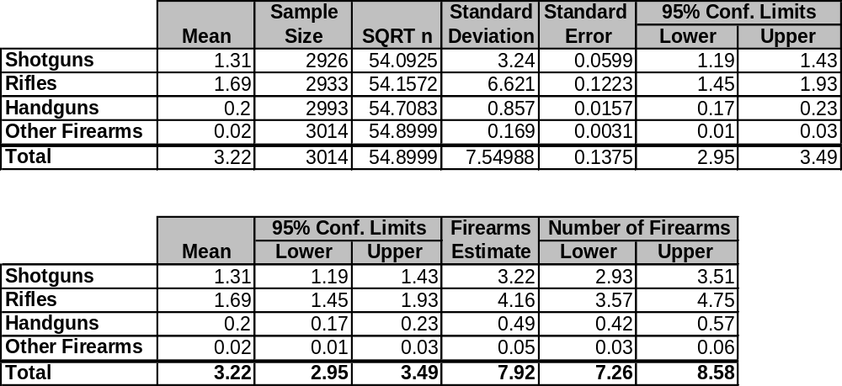

Impact of “Gun Collectors”

Some respondents in the sample of 3014 had more firearms than expected in a normal distribution (These individuals z-score was more than 25 standard deviations from the mean score). These firearm owners were no doubt “gun collectors” and impacted the mean score used to calculate the total number of firearms in Canada. Three individuals, one who owned 201 shotguns, one who owned 302 rifles, and another who owned 22 handguns, were removed from the sample to determine the impact.

When these individuals are removed the mean number of firearms drops from 3.22 to 3.04. The associated estimate of total firearms also drops from 7.92 million to 7.46 million. As well, the 95% confidence interval associated with this new mean of 3.04 is +/- 0.06.

Table E2
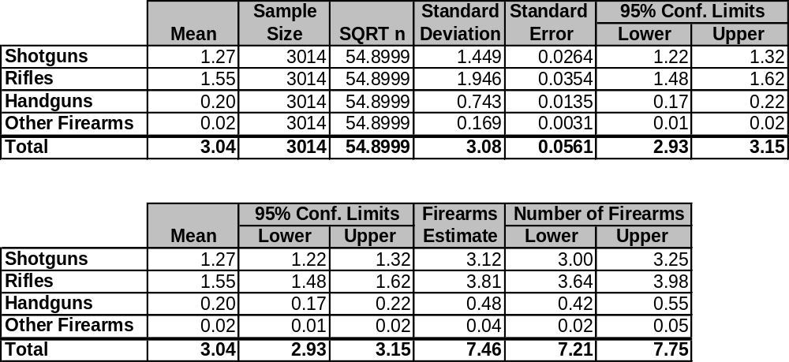

Figures are drawn from 1996 Statistics Canada Census data or from GPC Fall 2000 survey results for the general population, aged 18 years and older. Totals may not equal 100% due to rounding
Fall 2000 Estimate of Firearms Ownership Survey: Figure 2 – page 11

