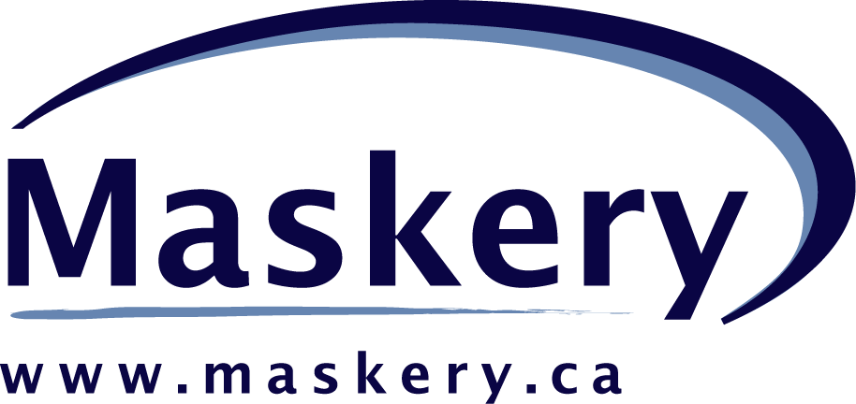

Ease of Use Experts

Ease of Use Experts


Atlas on NRCan Feasibility Study Report – Final
Discover NRCan through Maps and Facts

Melanie Rodney

March 31, 2004

Maskery

39 Robertson Road, Suite 502
Ottawa, Ontario
Canada, K2H 8R2

Telephone: (613) 820-2179
TTY: (613) 820-7274
Fax: (613) 820-3084
Email: info@maskery.ca
Web: www.maskery.ca

Maskery
39 Robertson Road, Suite 502
Ottawa, Ontario
Canada, K2H 8R2

Telephone: (613) 820-2179
TTY: (613) 820-7274
Fax: (613) 820-3084
Email: info@maskery.ca
Web: www.maskery.ca

Table Of Contents
SECTION 1 | Table Of Contents 2
SECTION 2 | Executive Summary 3
2.1 Project Rationale 3
2.2 Methodology 3
2.3 Results Summary and Recommendations 3
SECTION 3 | Project Background 5
3.1 Project Rationale and Background 5
3.2 Research Objectives 5
SECTION 4 | Methodology 7
4.1 Research Participants 7
4.2 Interview Sessions 7
4.3 Stimulus Material 7
4.4 Research Limitations 8
SECTION 5 | Results 9
5.1 Target Audiences 9
5.2 Communications Activities 9
5.3 Cross-sector Activities 10
5.4 Reaction to Concepts 11
5.5 Willingness to participate in Initiative 12
SECTION 6 | Recommendations and Summary 15
6.1 Target Audience 15
6.2 Cross Sector Initiatives 15
6.3 Reactions to Concepts 15
6.4 Creating Synergy to Ensure Success 16
6.5 Summary 17
Appendix A: Interview Script 18
Appendix B: Concepts 21

Executive Summary

Project Rationale
Natural Resources Canada routinely collects, analyzes and makes available a wealth of geo-information. Making this information available to all Canadians is a key part of NRCan’s mandate. Currently this information is accessed through a multitude of connected but unique sites, each with different user interfaces, terminology and presentation capabilities. One of the results of the disparate access and interface styles is that the general public is not fully aware of the resources that NRCan has to offer.

The Atlas of Canada management team is interested in exploring whether the user interface model developed for the Atlas website could be re-used to serve as a simple map-based user interface for the broader spectrum of NRCan information. This map-based user interface would be accessible from the NRCan home page where it would facilitate the exploration of other sector’s information in addition to the regular access mechanisms that are offered in each sector’s website.

The first step in understanding whether or not the Atlas map-based user interface style would work when applied to the sectors within NRCan, was to conduct a business requirements study. This report summarizes the results of that study. Pending decisions based on the outcomes of this report, a detailed project plan scoping development approach, timelines, effort and costs may be created.

Methodology
A semi-structured 1.5 hour interview was conducted with NRCan participants who were considered likely partners for the project. Eleven interview sessions were conducted with a total of 13 participants. Most sessions were one-on-one interviews, with 2 group interviews. The interviewer used an interview script (Appendix A) to guide the discussion and showed two NRCan website concepts during the session to elicit reactions to two different approaches to the website which both incorporated the use of maps to convey information on a sample issue (i.e., Climate Change) for which NRCan currently has extensive data throughout the departmental website.

Results Summary and Recommendations

Target Audience
Most of the sector participants indicated that the audiences for their work were targeted and included provincial government counterparts, policymakers, senior management, international governments and industry associations. So it was surprising how consistent and favourable the response was from all participants in terms of serving the general public. Interview participants repeatedly mentioned the value for their group as well as NRCan in general, in communicating effectively with the general public. There was also consensus that general public users of a departmental website will be issue or topic focused and do not understand or care to understand the sectors within NRCan. They stated that their specialized audiences will know how to get to sector specific information. Some noted that these specialized users would also benefit from the integration of information across sectors on some topics of interest. Although participants saw value in appealing to the general public, because this is not an integral part of their mandate, they may find it difficult to support such an initiative in the face of competition for time and resources with projects within their mandate.

Cross Sector Initiatives
Participants tended to favour cross-sector initiatives if they could be structured to help them achieve their own objectives either directly or indirectly through skill development or knowledge acquisition. There is a general perception that other groups may not be as willing to pursue these types of cross-sectors initiatives. Since this does not appear to be the case, efforts should be made within the sectors to raise awareness of the cooperative attitude that exists and to support the cultural shift to an integrated approach to issues.

Reactions to Concepts
Participants unanimously preferred the issues-based concept to the sector-based concept. All participants echoed the sentiment that the general public is looking for relevant information on topics of interest and they are not interested in understanding the organization of sectors within the department to get that information.

Participants were very supportive of the use of maps on the departmental website and comfortable conveying their sector information through maps. They also felt that maps would be a good communications tool for the general public. In fact, several had ideas for maps they would like to see, but don’t currently have the resources to produce. These suggestions should be explored for further development based on their usefulness to the general public and benefits to the sector.

While a few participants raised some concerns regarding the use of maps, there is also considerable evidence that many people are intrigued by maps and find them a useful tool to learn about a topic. It is recommended that a number of map topics with different presentations of the layers be tested with potential users to understand which methods of presentation best convey the key message of the map.

Creating Synergy to Ensure Success
During the interviews a number of tactics became apparent which would aid in eliciting the support and cooperation of partners.
- demonstrate to partners how the project will provide value to their group or help them meet a specific objective of their group.
- provide direct benefits based on a problem that they have today (e.g., maps to provide information on frequent inquiries)
- explore how to work together with Internet Revitalization Project (IRP) to achieve their goals

Participants identified potential benefits from this initiative, including:
- raising the departmental profile with the general public
- providing issues-based information for the general public that could be re-used for other target audiences including the media, ministers and senior management who often need an overview of the topic
- synergy from pooling resources to deliver an outcome (e.g., access to Atlas of Canada mapping skills and resources)
- emphasize the role of the department in creating a national view of the industry (e.g., forestry, mining)

Some participants view the Atlas of Canada as being in the best position to make this project successful because of their previous involvement working across sectors and their experience delivering information to the general public.

Summary
In summary, there is support for an integrated issues-based approach to the NRCan website with maps as a key component of the site. Participants were very receptive to the idea of having maps on the departmental website and identified a number of benefits including:
- Improved profile for the department with the general public
  - Increased awareness of vast array of sector work relevant to Canadians
- Access to new audiences for their sector work
- Re-use of issues-based information for existing target audiences (e.g., media)
- Access to mapping skills within Atlas of Canada group
- Knowledge acquisition and skill development acquired in cross-sector initiatives

It is clear that there is willingness to work on cross-sector initiatives within the department and recognition that shared outcomes are critical to the success of increasingly complex programs, but there is low awareness that others share this view.

Project Background

Project Rationale and Background
Natural Resources Canada routinely collects, analyzes and makes available a wealth of geo-information. Making this information available to all Canadians is a key part of NRCan’s mandate. Currently this information is accessed through a multitude of connected but unique sites, each with different user interfaces, terminology and presentation capabilities. One of the results of this disparate access and multitude of interface styles is that the general public is not fully aware of the resources that NRCan has to offer.

The Atlas of Canada management team is interested in exploring whether the user interface model developed for the Atlas website could be re-used to serve as a simple map-based user interface for the broader spectrum of NRCan information. This map-based user interface would be accessible from the NRCan home page where it would facilitate the exploration of other sector’s information in addition to the regular access mechanisms that are offered in each sector’s website.

Usability research on the Atlas of Canada website has shown the map-based user interface model facilitates clear communication of the range of information available through the Atlas web site. If the map-based user interface style was made available as an additional navigation mechanism to the four NRCan sectors (Forestry, Energy, Minerals and Metals, and Earth Sciences), NRCan would benefit in a multitude of ways including:
- De-risking the development of an interface targeted at the general public due to the years of development effort and usability research that has already been conducted for the Atlas site
- Re-using validated code in the new user interface
- Re-using style and content creation guidelines developed for Atlas that have been validated with usability testing
- Taking advantage of user familiarity with the Atlas user interface model
- Creating an NRCan ‘brand’ experience whenever maps are used to display, analyze or access information, and
- if the Atlas development team were to create the new access vehicle, de-risking the development process by using a proven team.

The first step in understanding whether or not the Atlas map-based user interface style would work when applied to the sectors within NRCan, was to conduct a business requirements study. This report summarizes the results of that study.

Pending decisions based on the outcomes of this report, a detailed project plan scoping development approach, timelines, effort and costs may be created. The project plan will take into account the learning from the research conducted to gather the business requirements.

Research Objectives
The purpose of this research was to explore the idea of using maps to convey cross-sector information to promote NRCan departmental initiatives and generally raise the awareness of the department with the Canadian public.

The specific objectives included:
- Understand the key target audiences for information from the sectors within NRCan

  - understand overlap in audiences and audiences internal to the department
- Understand existing outreach or communications initiatives within the sectors
  - Media used, role of web
  - Cross-sector collaboration
    - Existing activities, potential for new activities
- Explore reactions to concepts showing integrated approach to NRCan information
  - Preference and rationale for different approaches
  - Explore reaction to maps as method of communicating sector information

  - value to their group, further examples
  - advantages/ disadvantages
- Explore willingness to participate in initiative to develop cohesive cross-sector web structure for NRCan
  - Benefits for their group, NRCan
  - Key challenges for initiative
  - Issues limiting their group participation

Methodology

Research Participants
All interviewees were employees of Natural Resources department (NRCan) of the federal government, representing a cross-section of groups within the department.

Potential interviewees were identified by the Atlas of Canada project prime. Eleven interview sessions were conducted with participants in each of the four sectors – Forestry, Minerals & Mining, Earth Sciences and Energy – as well as other groups within NRCan. Most of these interviews were one-on- one sessions, however 2 group sessions with two participants each were also conducted to accommodate interviewee schedules. A total of thirteen participants were interviewed for this research.

The following is a breakdown of participants by groups within the Natural Resources department:
- Mining & minerals (2)
- Energy
- Canadian Forestry Service (2)
- Earth Sciences (2)
- Corporate Services
- Communications & Policy (4)
- Corporate Policy

The interview participants included:
- Program managers
- Directors
- Policy analyst
- Systems analyst
- Internet and Web content Management
Several of the participants in the study have roles which require them to take a ‘systems’-like approach to their program, rather than the more traditional independent program approach. Because of the nature of their programs, they are dealing with complex issues and relying on others to provide part of the solution. They tend to be pre-disposed to the idea of working in an interdependent fashion with other partners having responsibility for providing key resources or information.

Interview Sessions

To create the participative environment required for this project, the interviewer used a semi-structured interview methodology to cover the key topics of interest. The semi-structured interview methodology is appropriate for this type of research given that it is not possible to anticipate all the answers given by each interviewee. The interviewer uses the script as a guide to ensure that important topics are covered in each interview. However, the semi-structured nature allows the interviewer to probe unexpected answers that may lead to uncovering pertinent information. The interview script used for these sessions is available in Appendix A.

Each interview session lasted approximately 1.5 hours.

Stimulus Material
Two concepts were developed to facilitate the discussion and assist participants in understanding the ideas proposed for the interview session. These concepts illustrated two variations on how the NRCan website could integrate information on topical themes and issues (e.g., forestry, climate change) provided by different groups within NRCan. The first concept focused on issues and themes with sectors as a secondary focus. The second concept reversed the order of priority, showing the sectors prominently displayed on the home page. Both concepts used maps to illustrate key information and to allow users to drill down for more detailed information on the topic by region. The concepts were not meant to suggest a specific design for the NRCan website, but rather, to convey in a tangible way, what might be possible through an integrated approach. The primary purpose of the concepts was to stimulate discussion and provide participants with examples which they could respond to.

The order of presentation of the stimulus material was counterbalanced across interview sessions, with half of the interviewees viewing Concept 1 first and half viewing Concept 2 first. This was done to control bias in preferences based on order of presentation.

These concepts were delivered to the project prime, along with this report, as part of the deliverable for this project. Screen shots of the homepage for each concept are shown in Appendix B.

Research Limitations

Personal interviews are an exploratory technique used to collect qualitative data and provide guidance in business decisions which require support for general directions to be taken (e.g., Is there value in this idea? Do potential users perceive a need or a use for this concept?) Personal interviews, like other exploratory research techniques do not provide a definitive answer on how many users would use the service, how often they would use it, or the specifics of how they would use it. Other research techniques are required to answer these questions.

The results of these interviews are not intended to represent all of the initiatives within NRCan or provide a comprehensive view across sectors. They are intended to provide a starting point for discussion by identifying common ground as well as concerns and issues with potential partners for a specific cross-sector initiative.

- Results

Target Audiences
Interview participants representing the sectors generally had specific audiences for their work. These audiences include:
- Other governments (provincial, municipal)
- NRCan senior management (e.g., minister, DM, ADM, etc.)
- Industry associations (e.g., Mining Association), industry analysts
- Scientific community (e.g., scientists, journals)
- Policy makers
- Academia (e.g., other teachers and students)
- Other NRCan groups
- Other federal government departments (e.g., Stats Can)
- Media

Some participants talked interchangeably of audiences and partners. For example, provincial government departments are audiences for the statistics provided by the MMSD (Mining & Minerals Statistics Division) group, but they are also partners in that they provide data. A similar situation exists for the Forestry sector.

For the sector participants the general public was not always a primary audience for their work – or as one participant mentioned ‘part of their mandate’. Another departmental participant indicated that the general public was a key focus for Atlas on Canada and the Communications & Policy group, but not the sectors. Although many participants did not cite the general public as a primary audience for their work they did recognize that value of appealing to this group to raise the profile of their work and the work being done in NRCan across the sectors.

Participants from support groups (e.g., Communications & Policy, Corporate Services) typically did not have an external audience for their work, but they often work with sectoral groups on projects targeted to the general public or specialized external audiences. They had very strong opinions on the need to communicate more effectively with the general public.

Most participants did not know whether their audiences were also users of information from other groups within NRCan. Some participants thought that there might be overlap for example:
- companies in the mining and minerals sector might also be in the forestry sector
- sustainable development is a topic that relates to each of the sectors

Communications Activities
Some participants were less involved in communications programs than others. As well, some participants represented targeted programs (e.g., Energy Renewal, Climate Change, etc.); while others represented broader mandates (e.g., Mining & Minerals Statistics Division, Forest Information). Participants were only able to speak on behalf of their program. For this reason there were very diverse responses to these questions.

Some participants reported extensive communications materials for their target audiences, while others reported little or no materials. The variability was related two factors:
- Maturity of program
- Scope of program
For programs that were relatively new (1-2 years), there were few communications materials. In some cases they are just developing a website for their target audience compared to mature programs who may have a variety of materials. Also, depending on the mandate of the program, the group may have scientific publications, brochures as well as websites. For example, Mining & Minerals is a mature program with a broad mandate to provide statistics on mining and minerals to encourage investment in Canada. They have a variety of publications, multiple websites, pamphlets, and CD-ROMs for provinces, mining associations and special interest groups.

All sector participants reported having or developing at least one website to communicate with their target audience. Some reported multiple websites for different users and purposes, including:
- Provincial partners
- Industry associations
- Conference proceedings (international audience)

All participants view websites as a central part of their communications strategy. Most of the participants were either directly or indirectly involved in a website for their program, while some of the corporate participants were involved in cross-sector websites.

Cross-sector Activities
Most participants reported current or previous cross-sector initiatives. Some mentioned their work with the Atlas of Canada, providing content for Atlas maps or using Atlas layers as foundation for maps on their sector websites. Others mentioned a variety of cross-sector initiatives, including:
- The impact of fires on climate change (Canadian Forestry Services & Earth Sciences)

Several participants mentioned ideas that they have for getting more information onto websites and were anxious to work with others who could help them realize their goals. Some of these ideas included:
- mining locations combined with transportation & economy
  - to show impact of mining
- likelihood of landslides combined with transportation corridors and economic impact
  - to assist emergency preparedness groups at provincial and municipal levels
- using multidimensional space to convey concepts
  - to display complex information in alternate views for different audiences

A number of participants also mentioned cross-department initiatives and some indicated that they had more interactions with other government departments than other sectors within NRCan. In some cases this is a direct result of their mandate which may require them to work with other government departments. For example, the Canadian Forestry Service and Mining & Minerals work closely with their provincial counterparts because provinces have jurisdiction over these resources. Mining & Minerals also work closely with Statistics Canada to provide data on the mining industry in Canada.

In general, there appears to be less interaction with the Energy sector and other sectors within NRCan; although some participants expressed interest in more interaction with Energy on issues like sustainable development and climate change. (NOTE: The perceived lower level of interaction with Energy may be the result of the participants selected for this interview and may not represent all cross- sector activities)

There was also some concern from the newer sectors (e.g., Forestry, Energy) in the department that their work not be too tightly integrated into the department, because future re-organizations may find them in another governmental department. One participant felt that they would need to be in a position to ‘take their website with them’.

When participants were asked about the benefits of working with other groups in the department, most were able to cite positive experiences that they have had. Some of these are noted above. Although there appear to be pockets of cooperation, there was also a sense of a lack of willingness to work across sectors. As one participant stated:
“It’s far easier to work with international groups than to work within the department.”

Some participants recalled failed attempts to have a greater level of inter-working across the sectors. One reason cited was the lack of senior management support. One participant stated that there has to be a ‘let’s do it together vs. this is the way it’s going to be’ philosophy developed. This was reinforced by various participants who expressed willingness to work across sectors to gain support and expertise from others to help them achieve their goals or knowledge to become more effective in meeting their deliverables.

Reaction to Concepts
Participants were asked for their reactions to two concepts of an integrated NRCan site. All participants chose the issues or theme–based concept (Concept#1) over the sector-based concept(Concept#2). Participants generally agreed that the issues (e.g., Climate change) concept was more appropriate for the general public because this is more consistent with how the public looks for information. Participants provided a number of reasons, including:

- Easy for public to understand
- Recognition that public doesn’t know or care about sectors
- Public wants information on topical, relevant issues
Participants in these interviews repeatedly stressed that the general public doesn’t care where the information is coming from – they just want access to useful information.

While all participants rejected the sector-based approach (Concept#2), some were very strong in their disapproval. They noted an urgent need to get away from a ‘silo’ mentality and acknowledged the need to build a departmental profile. While these participants clearly stated their disapproval of the sector-based approach they also expressed concern that this view was not shared by others, including:
- Other sectors
- Senior management
- Scientists
In some cases, the participant cited an example of a cross-sector initiative that failed because lack of support. Scientists were mentioned by a few participants in the context of their willingness to support efforts to convert their scientific work into simpler terms for the general public.

Some participants felt that information provided on the NRCan site should not be separated by sector at any level. These participants reacted negatively to the links below the Climate change map that were organized by sector. They felt that the links should be organized in a way that is meaningful to the general public.

A number of participants also made general comments about the concepts. Most felt that a map was a value–add to the topic but that key textual information should be provided to give a context to the topic, including:
- Need summary text explaining why topic is important
- NRCan contribution

Some participants indicated that any project going forward would need to define how to provide information in a consistent departmental view, noting that information on the NRcan site is currently provided in a range of ways by the various sectors. A few participants specifically mentioned the Internet Revitalization Project (IRP) as providing a framework for such a departmental view.

Other comments on the concepts included:
- Links should be more descriptive
- Use common language terms
Many participants liked the use of common language terms (e.g., climate change, earthquakes) in the left navigation bar, but reacted negatively to some of the more technical terms (e.g., Geodesy, Geography, etc.). Some participants assumed that the left navigation bar would provide an index of all topics available from NRCan and wondered how this would be accomplished with the vast array of work being done in different sectors.

Use of Maps
Most participants indicated strong support for the use of maps on the NRCan website and think that they would add value to the website. Although the interview discussion was focused on communicating with the general public, some participants also talked about using maps to communicate with their other audiences – like policy makers, media, and Ministers (provincial and federal). In this context, one participant speculated that:
“Within 2-4 years maps will be the best method of providing information for decision making”
His reasoning was that as issues become more complex, maps are the best way to convey multiple layers of data at a glance – providing a ‘full picture’ view and showing relationships between factors.

A few corporate participants cautioned using maps as a primary communication tool for the following reasons:
- Recent client focus groups have shown that some people do not understand how to read maps
  - Interactive maps may be too complex for the general public to understand
- Accessibility of maps
  - Don’t meet CLF guidelines
- Interactive maps are slow to load

Participants also suggested additional topics which could be illustrated on the NRCan site through maps. These included:
- Location of NRCan offices, labs, etc. throughout Canada
- Location of all mines by type
- Program or issue specific maps (e.g., sustainable development, natural hazards, etc.)

All participants liked the idea of providing regional views for the general public and most liked the use of the map to drill down to more local information. Participants repeatedly pointed out that the general public wants information in the context of their own backyard. Some participants view this as critical to the success of the initiative. The level of resolution for regional or local information was not discussed and this would need to be determined in the next phase of the project, should it go forward.

Willingness to participate in Initiative

Participants were asked several questions to gauge their interest in participating as partners in a project to incorporate maps as an integral part of the NRCan website.

Obstacles for Project and Challenges to Participation
Participants were specifically asked for any obstacles to their participation in this project. They cited a number of obstacles including:
- General public (GP) is not primary audience for most participants
  - Will require effort outside their primary mandate
  - Recognition by some participants that their current GP outreach is not effective
    - Scientists talking to scientists
- Lack of commitment to department
  - CFS and Energy have moved often from other departments
- Some cynicism from previous initiatives that have not produced results
- Concern with risk of superficial effort
  - Ensure that data presented is accurate and presented effectively
- Conflicts with current activities
  - Budget and resources are limited
  - Current budgets are being reduced
- Stage of program development for potential partners
  - Some newer programs would not be able to support immediately
    - looking for stepwise process
- Cost of travel for regional participants

Because the general public is not the key audience for most of the sector participants, any activities targeted to the GP audience will require additional efforts on their part and may mean trade-offs for mandated activities. The more that these activities can produce direct or side-benefits which would support the outcomes in their primary programs, the more willing they will be to support the project. For example, a direct benefit could be the development of a map which could be used for their provincial counterparts; while a side-benefit would be getting access to mapping skills and expertise for their program goals.

Participants from the forestry sector were generally very supportive of an integrated departmental website, but also recognized that because they have been moved from other departments in the past there has not been a cultural shift in all parts of the sector to fully embrace an NRCan identity. As one participant stated, they would need to be able to move their website content if they were moved to yet another department.

A few participants also expressed reluctance to become involved in this initiative without some evidence that it would have the funding and support to make it happen. They cited previous projects they had put time and effort into (including the Internet Revitalization Program) which had seemed to wither before completion. Their reluctance to participate stems from their limited resources and wanting to ensure that they are used effectively.

Related to this last point of scarce resources, some participants indicated a general willingness to participate, but qualified that statement by saying that they would need more details on the level of commitment required and evidence that a plan and funding is in place to ensure ongoing support of the project.

A few participants expressed concern that the Atlas of Canada maps are too complex, with so much detail that it’s hard to find what you are looking for. They felt that it would be important to ensure that maps aren’t too complex or too technical in their presentation since most of the general public will be unsophisticated with respect to understanding maps.

Despite the obstacles identified by participants, most participants were enthusiastic about the need to develop an integrated NRCan website and possibilities for their sector or program to participate and benefit from such a project.

Related Programs
During the course of the interviews participants mentioned several past or current programs that they perceived as related to the current proposal. The program which was brought up in conversation most often is the Internet Revitalization Program (IRP). Participants who were familiar with the IRP viewed the current proposal as complementary to the IRP and saw the addition of maps for navigation and information content as a potential value add to the framework developed in the IRP. These participants were particularly strong proponents of the integrated approach to the NRCan site as they were aware of the customer research which indicated that the general public wants access to information at a departmental level rather than at a sector level.

A few participants also mentioned a past project referred to as the Regional Lens project. This came up in the context of providing a regional view of issues. Although Regional Lens was a project to provide access to information for users internal to the department, ideas like providing a map with locations of NRCan offices, labs and projects caused some participants to make the connection to the Regional Lens project.
A few participants also mentioned a new initiative to integrate cross-department information through the clusters and gateways on the Canada site. There was excitement around the idea that an integrated issues-based NRCan website using maps to effectively illustrate key messages could be used as a model to demonstrate what could be accomplished at the cross-department level.

Benefits of Integrated Approach
Although the general public is not the key audience for most of the sector participants, they all recognized the value of communicating effectively with this group – for the department and for their sector. There is recognition that the general public is interested in work being done across the sectors and that much more could be done to encourage further interest. One participant reported that the national fire site is visited twice as often as the Canadian Forestry Service homepage as evidence that people will come to the site if topical information is readily available to them.

Participants cited a number of benefits for the department of an integrated NRCan website, including:
- Promotes department
  - Validation of work done across sectors
  - Marketing tool for dept
- Reduce duplication within department
  - One place to cover an issue
  - Addressing issues in coherent way
- Could satisfy information needs of a number of audiences
  - Academia, media, ministers, ADM, etc.
      - Get complete picture of NRCan efforts

They also identified benefits for their groups and their sector including:
      - Sector Benefit: Deliver new audiences who are unaware of sectors
      - Raise international awareness of Canada’s role in natural resource management
        - e.g., Canada leading in mining expertise
        - e.g., Industry leaders in Sustainable Development
      - Technical interactions with other sectors that they could benefit from
        - e.g., state of the art methods, new approaches, etc.

Some of these benefits would have a direct positive effect on outcomes for their programs while others, such as technical interactions would have an indirect effect.

Recommendations and Summary

Target Audience
It was surprising how consistent and favourable the response was from all participants in terms of serving the general public. Interview participants repeatedly mentioned the value for their group as well as NRCan in general, in communicating effectively with the general public. There was also consensus that general public users of a departmental website will be issue or topic focused and do not understand or care to understand the sectors within NRCan. Participants agreed that the sectors should be transparent to the general public. They stated that their specialized audiences will know how to get to the sector specific information. Some noted that these specialized users would also benefit from the integration of information across sectors on some topics of interest. On the other hand, although participants saw value in appealing to the general public, because this is not an integral part of their mandate, or a clear priority, they may find it difficult to support such an initiative in the face of competition for time and resources with projects within their mandate.

Cross Sector Initiatives
With a few exceptions, there was a consistent response to the challenge of cross-sector initiatives. Participants tended to favour these initiatives if they could be structured to help them achieve their objectives either directly or indirectly through skill development or knowledge acquisition. There is a general perception that other groups may not be as willing to pursue these types of cross-sector initiatives. Since this does not appear to be the case, efforts should be made within the sectors to raise awareness of this cooperative attitude and to support the cultural shift to an integrated approach to issues.

There was also some concern from the newer sectors (e.g., Forestry, Energy) in the department that their work not be too tightly integrated into the department because future re-organizations may find them in another governmental department. One participant felt that they would need to be in a position to ‘take their website with them’. This concern will need to be overcome to ensure cross-sector cooperation.

Reactions to Concepts
Participants unanimously preferred the issues-based concept to the sector-based concept. A number of participants would prefer that the sectors be totally transparent on the departmental website. All participants echoed the sentiment that the general public is looking for relevant information on topics of interest and they are not interested in understanding the organization of sectors within the department to get that information.

Participants were very supportive of the use of maps on the departmental website and comfortable conveying their sector information through maps. In fact, many had ideas for maps they would like to see, but don’t currently have the resources to produce. They also felt that maps would be a good communications tool for the general public. There is sufficient buy-in from participants to support further investigation of what types of maps would be useful and meaningful to the general public.

- Participants suggested a number of ideas for maps at various points in the interview that they thought would be useful for the departmental website. In many cases these ideas came from their experiences with the general public within the context of their sector. Frequently these ideas solved an information need that is currently not met. For example, a map with the locations of mines by type would be useful to miners who are looking for employment in their area and currently call the mining & minerals group to get that information. These suggestions should be explored for further development based on their usefulness to the general public and benefits to the sector (e.g., reducing time spent on calls)

While the fact that some people may not understand maps should be taken into consideration when making a decision to proceed with this project, there is also considerable evidence that many people are intrigued by maps and find them a useful tool to learn about a topic. The first step in developing useful maps is to ensure that that the topic is of interest to the general public. Secondly, the information contained in the map should be presented simply and accompanying text should reinforce the key information provided in the map. This will ensure that users who do not fully understand the map will still have access to the key message and that this information will be fully accessible to users with visual disabilities. It is recommended that a number of map topics with different presentations of the layers be tested with potential users to understand which methods of presentation best convey the key message of the map.

Creating Synergy to Ensure Success
During the interviews a number of tactics became apparent which would aid in eliciting the support and cooperation of partners. One approach is to identify and demonstrate to partners how the project will provide value to their group or help them meet a specific objective of their group. If possible, provide the opportunity for inclusion of projects potential partners are trying to make happen across sectors. For example, one participant mentioned the need for regional level maps of natural hazards with inclusion of transportation routes, key distribution points, and the economic impact based on likelihood of occurrence. While it may not be possible to support development of the idea to its ultimate goal, support that would take it to the next step may be acceptable for that partner.

Another related tactic to engage partners would be to provide direct benefits based on a problem that they have today. For example, developing a map of mining locations across Canada could be used to refer miners to the website for that information and eventually reduce calls from miners looking for a job. As part of the overall strategy for rolling out the project consider choosing a few small activities to demonstrate cross-sector value and use these outcomes to encourage buy-in from additional partners.

During the interview sessions other past or current projects within the department were mentioned by participants as similar to this project. In particular, the Internet Revitalization Project (IRP) was mentioned in several interviews. It may be beneficial to both projects to further explore how they could work together to achieve their goals. This could have the side-benefit of re-assuring partners that there will be ongoing support for this project.

Since this project is targeted to the general public, it is important to keep it simple to ensure broad reach. There was consensus from participants that much of what is produced by their sectors is too complex and too technical for the general public audience. They generally felt that if information on issues-based topics could be made available to the general public at a level which they could comprehend this same information would have value for some of their target audiences including the media, ministers and senior management who often need an overview of the topic. As many participants see value in raising the departmental profile with the general public, this benefit should be emphasized when talking to potential partners and illustrated in early concept development and testing.

Another value to participation in the project is the synergy that comes from pooling resources to deliver an outcome. It would be helpful to highlight the advantages of these pooled resources for partners. For example, partners will gain access to Atlas of Canada mapping skills and resources. At the same time the sectors have valuable content which would get more exposure on the NRCan site.

One of the findings of this research is that some of the sectors (e.g., forestry, mining) have a mandate to provide information at a national level despite the fact that the provinces are responsible for managing that resource. It would be helpful to emphasize the role of the department in creating a national view of the industry. For example, Canada is one of few countries without a national forest inventory. Atlas should consider exploring whether mapping has a role to play in supporting this objective.

It is also important to note that some participants view the Atlas of Canada as being in the best position to make a cross-sector project successful because of their previous involvement working across sectors and their experience delivering information to the general public.

Summary
In summary, there is support for an integrated issues-based approach to the NRCan website with maps as a key component of the site. Participants were generally very receptive to the idea of having ‘Atlas-type’ maps on the departmental website and identified a number of benefits including:
- Improved profile for the department with the general public
  - Increased awareness of vast array of sector work relevant to Canadians
- Access to new audiences for their sector work
- Re-use of issues-based information for existing target audiences (e.g., media)
- Access to mapping skills within Atlas of Canada group
- Knowledge acquisition and skill development acquired in cross-sector initiatives

As discussed above, in order to ensure success of the project a number of issues need to be addressed:
      - Fit with similar initiatives
      - Return on effort for partners
      - Support for potential sector tie-ins
      - Perceived resistance in other sectors

It is clear that there is willingness to work on cross-sector initiatives within the department and recognition that shared outcomes are critical to the success of increasingly complex programs, but there is low awareness that others share this view. More emphasis should be placed on communicating this shared view and on the value of a culture shift to an integrated department view for work being done across various sectors.

Appendix A: Interview Script

Atlas on NRCan Interview Guide

Introduction (30 min.)
My name is ___________ and I’m conducting this interview today on behalf of Atlas of Canada.

Before we start, I would like to give you a little background. This interview is part of a feasibility study funded by the communications council within NRCan. If a decision is made to go forward with a project based on the results of this feasibility study, it is expected that further resources would be provided from the communications council to support the project. I’ll be interviewing people from each of the sectors as well as the communications & policy group.

I would like to ask for your permission to audio tape this session. It helps me because I can’t always capture all of your feedback. The tape will be used only for the purpose of my research report. The results of this session and other sessions will be summarized and you will not be personally identified in any way. Are you ok with that?

I’ll be showing you some concepts today and asking a series of questions and looking for your responses. There are no ‘right or wrong’ answers. I do not work for Natural Resources Canada so I’m not going to be upset by anything that you have to say.

FOR GROUP SESSIONS: It’s important that I hear from all of you even if your opinions differ from other participants. Also, I’d like to remind you not to talk at the same time. I can’t hear what you are saying on the tape if 2 of you are talking together.

The session will last approximately 1.5 hours.

Any questions before we get started?

First, I’d like to talk a little bit about you and your group within NRCan.

Target Audience
- Please tell me a little about yourself and the group that you work in
  - PROBE: on their work, information produced, etc.

- Who are the key target audiences for your group’s work?
  - PROBE: Is your audience primarily internal within NRCan, other federal government departments, industry groups or sectors, other levels of government, the general public, or other?

- What are the main reasons that people are interested in your group’s work?

- Do you know if your clients are interested in NRCan information from other sectors?

- Are other NRCan groups users of your info and vice versa?

Outreach and Cross–sector Projects
- Does your group currently have outreach initiatives in place to communicate to the general public (or your key audience) the role your group plays within the NRCan umbrella?
  - PROBE: Do you have brochures, posters, make presentations and public conferences, etc.
  - Is informing the general public of your role a primary goal of your group? Is it an important issue?

- What is the role of the web in your communication plans?
  - PROBE: How is it used? Is it a primary communication tool or a low priority?

- Do you have a website for your group? Or do you provide program information to another site?
  - Do you actively promote your website?
  - If so: What has worked best to get people to come to your site?

- Would you see any benefits in working with other groups to promote all of the sector sites within NRCan? Why/why not?
  - PROBE: Do you see the NRCan website having a role in promoting your work?

- Have you worked on any projects with other NRCan sectors to communicate value or benefits delivered across groups?
  - If so: Can you provide an example of this? What were the positive/negative outcomes of that project?
  - If not: Can you see any opportunities with other sectors where this might be of value to you? Or are there projects that you’d like to see happen?

Concept walkthrough (60 minutes)
The communications council of NRCan is interested in finding new ways to promote the work done by the sectors within NRCan in a cohesive manner. The aim is to communicate effectively with the Canadian public on the impact of the various NRCan sectors on their everyday lives. To this end we have developed a concept which illustrates a topical issue across the sectors through the use of maps.

I want to emphasize that what I am going to show you is in no way a finished product – but merely an example of what could be possible, to communicate the role of NRCan with the general public. I’m showing you this concept today to get your input on what you think would be required to develop a successful web communication tool of this nature and to get a sense of your goup’s willingness to participate in this venture.

We’ve chosen climate change as an example to illustrate how maps could be used to emphasize the importance of work done within NRCan to Canadian citizens and the contribution of the sectors to this issue. I’m going to walk you through the idea and then I have some questions for you about this. Please feel free to ask any questions you may have to clarify the concept as I go through the slides.

[SCRIPT FOR CONCEPT WALKTHROUGH GOES HERE]

Reaction to Concept
- Which of these concepts would more effectively represent your work?
  - PROBE: Why? Are there any ideas from the other concept that would work well for your group?

- The concepts are illustrating 2 related ideas:
  - The cross-referencing of the sectors within NRCan via themes and the top tabs
  - The use of maps to illustrate information from the sectors
Do either of these ideas have value for you and your group? Why/whynot?
PROBE: Ask for value for each idea separately.

- After seeing the examples that we are showing of sector information illustrated through maps, can you think of similar examples that would be appropriate for your group?
  - PROBE: Please list as many examples as you can think of.
  - Can you think of any cross-sector or cross-group examples where the use of maps would be helpful?

- How comfortable are you conveying your group information through maps?
  - PROBE: What are the advantages and disadvantages that they see?
  - How do you think that your existing audience would react to seeing a map/maps rather than, or in addition to, text on your group’s site?

- Would you be willing to support an initiative to use maps to illustrate sector information? Why/why not?
  - If so: What are the key benefits that you would anticipate for your group? For NRCan?
  - What are the key issues, if any, from such an undertaking that will need to be overcome?
    - Probe for: time and resource constraints, data confidentiality and ownership across groups

- What do you think the challenges will be for your group in participating in this project?

Do you have any further comments or any questions for me?

Thank you for your time today!

Appendix B: Concepts
Concept 1

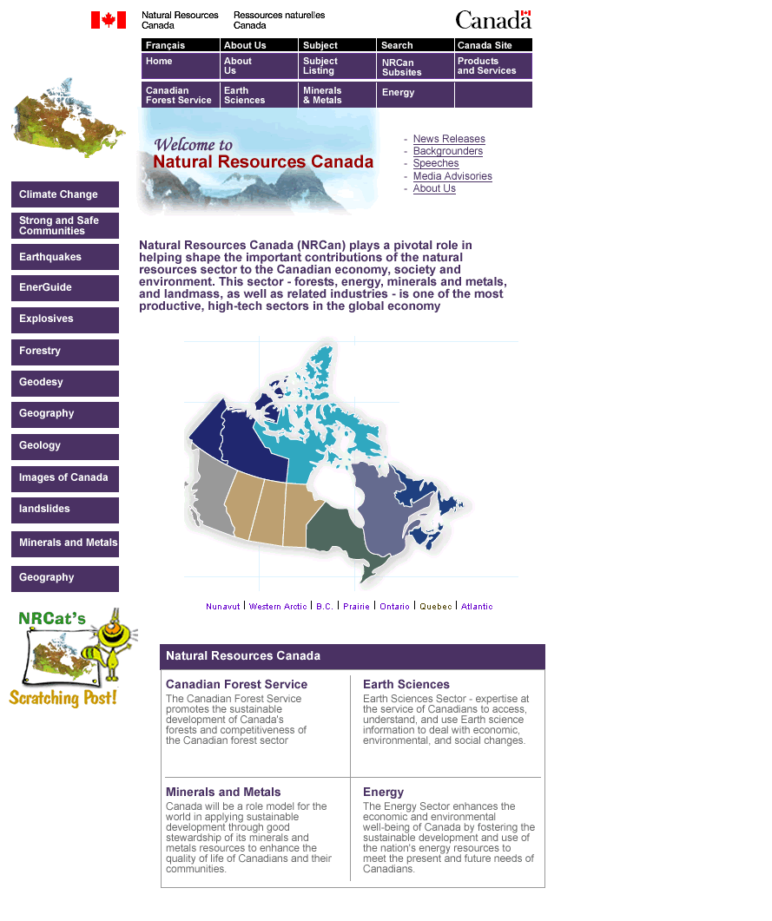

Concept 2

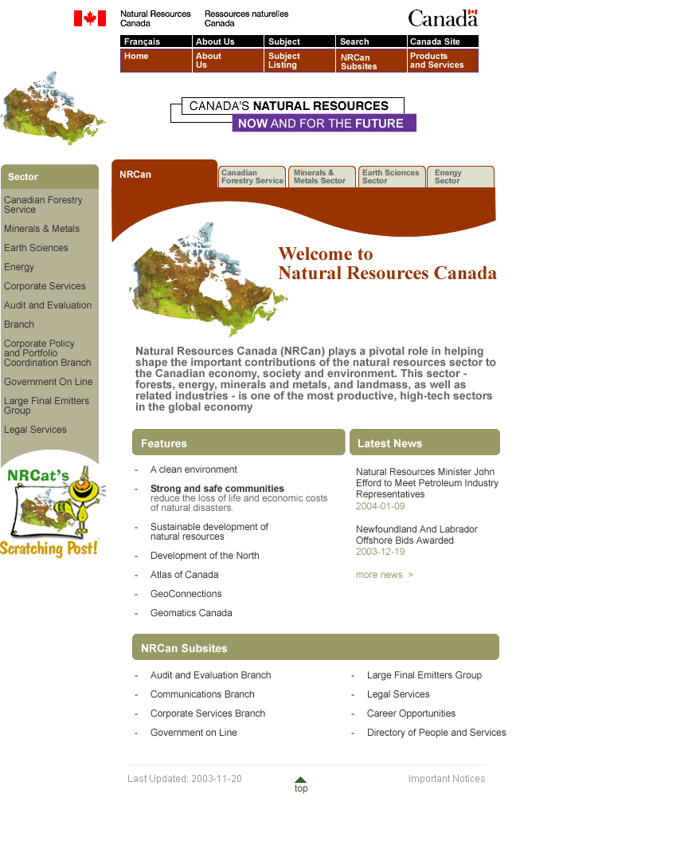

It should be noted that while this statement was made based on comments made by participants in a series of focus groups, other survey research indicates that many Canadians are attracted to maps and find them useful and interesting.

