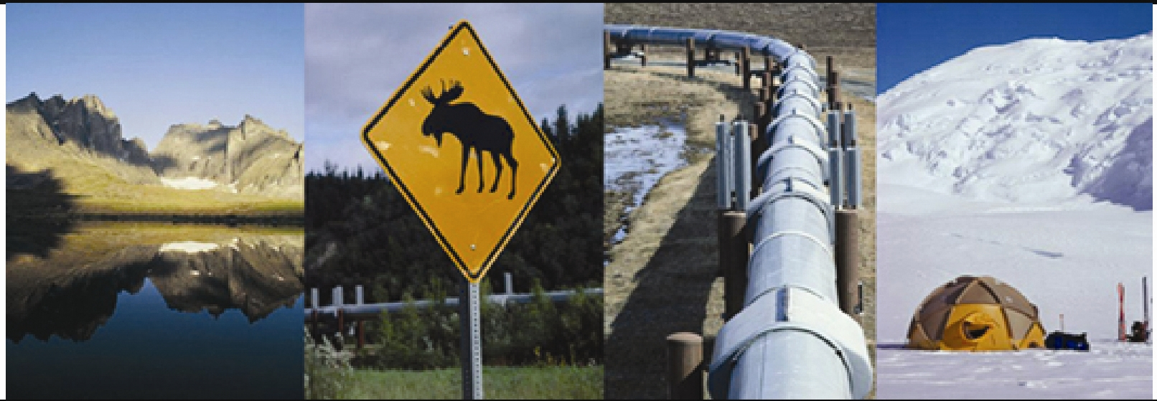



FH Canada Research

Address:
100 Queen Street
Suite 1300
Ottawa, ON K1P 1J9

Telephone:
613-234-8960
The FH Research
Survey of the North
Views of Business Decision Makers

“Outcome of Increased Resource Development”

March, 2006

Fax:
613-236-9867

World Headquarters:
200 N. Broadway
St. Louis, MO 63102

For
Natural Resources Canada
23482-060072/002/CY

Presented by:

Executive Summary

This report, Business in the North: Views of Business Decision-makers, is based on a representative sample of 260 business decision-makers in the Northwest Territories, Yukon and Nunavut conducted by telephone between March 20 and 24, 2006. The following is a summary of the overall report, followed by the findings of a Natural Resources Canada’s omnibus question.

- Northern businesses see infrastructure, economic diversification and energy projects as important priorities for the Government of Canada.

- The cost of living, resource revenue sharing and approval of major energy projects are seen as the top priorities for territorial governments.

- Mining and tourism are priorities for sectoral development, although a number of other sectors are also cited by respondents.

- In the Northwest Territories, there is strong support within the business community for the proposed Mackenzie Gas Project.

- Business decision-makers in the Northwest Territories tend to believe that the Mackenzie Gas Project will increase jobs for Northerners and revenues for Aboriginal communities and territorial government.

- In the Yukon, there is also strong support among the business community for the proposed Alaska Highway Pipeline Project and moderately strong support among the business community for the proposed Alaska-Yukon Rail Link.

- Northern businesspeople tend to have a favourable view of their overall quality of life and economic opportunities in the North. However, the quality of education, crime and the cost of living are the most significant areas of concern.

Résumé

Le présent rapport intitulé « Les affaires dans le Nord : Points de vue des décideurs du monde des affaires » est basé sur un échantillon représentatif composé de 260 décideurs du monde des affaires des Territoires du Nord-Ouest, du Yukon et du Nunavut qui ont participé à une enquête téléphonique entre le 20 et le 24 mars 2006. Voici un résumé du rapport, suivi des résultats d’une question posée expressément pour Ressources naturelles Canada.

- Les gens d’affaires du Nord estiment que l’infrastructure, la diversification économique et les projets énergétiques représentent des priorités importantes pour le gouvernement du Canada.

- Ils estiment aussi que le coût de la vie, le partage des recettes de l’exploitation des ressources et l’autorisation des grands projets énergétiques figurent au premier rang des priorités des gouvernements territoriaux.

- L’exploitation minière et le tourisme sont essentiels au développement sectoriel, bien que d’autres secteurs aient également été mentionnés.

- Dans les Territoires du Nord-Ouest, le milieu des affaires appuie fortement le Projet gazier du Mackenzie qui a été proposé.

- Les décideurs du monde des affaires des Territoires du Nord-Ouest sont d’avis que le Projet gazier du Mackenzie créera des emplois pour les populations du Nord canadien et générera des revenus pour les collectivités autochtones et pour le gouvernement territorial.

- Au Yukon, le milieu des affaires appuie fortement le Projet de gazoduc de la route de l’Alaska qui a été proposé et modérément le projet de liaison ferroviaire Alaska-Yukon.

- Les gens d’affaires du Nord ont tendance à percevoir de façon favorable leur qualité de vie et les possibilités économiques qui sont offertes dans leur région. Cependant, la qualité de l’enseignement, la criminalité et le coût de la vie les préoccupent au plus haut point.

Methodology
Business in the North: Views of Business Decision-makers is based on a survey conducted between March 20 and March 24, 2006 with 260 business decision-makers in the three territories. The results are considered accurate to within +/-6.2%, 19 times out 20. The survey was based on interviews with 110 businesses in the Northwest Territories (margin of error +/-9.5%, 19 times out of 20), 75 businesses in Yukon (margin of error, +/-11.3%, 19 times out of 20), and 75 businesses in Nunavut (margin of error, +/-11.3%, 19 times out of 20). The sample also included the following:

Descriptor | Number of Respondents
Rural | 113
Urban | 147
Total | 260
Size: 1 employee | 50
Size: 2 to 4 employees | 73
Size: 5 to 9 employees | 56
Size: 10 to 24 employees | 34
Size: 25 to 49 employees | 17
Size: 50 employees or more | 30
Total | 260
Education: High School or less | 68
Education: College | 120
Education: University | 72
Total | 260
Aboriginal Person self-identified | 44
Non-Aboriginal Person self-identified | 213
No response | 3
Total | 260
Employed in Aboriginal-owned business | 77
Employed in other type of business | 178
No response | 5
Total | 260

Outcome of Increased Resource Development

Business respondents were very positive about the economic gains to be made from resource development in the north and not concerned about potential harm this development could have to the environment or the lives of Aboriginal people.

Almost 70% of Northern business respondents acknowledged that increased resource development in the North would result in more jobs for northern residents. More than half (57%) said that territorial governments stand to make revenue gains from increased resource development. Almost the same percentage (56%) said that Aboriginal communities would benefit monetarily from increased resource development and with little cost to their way of life, with only 1/3 of respondents (29%) stating increased resource development will harm the way of life of Aboriginal People. Thirty-eight per cent indicated that increased resource development would result in harm to the environment.



