Continuous Qualitative Data Collection of Canadians’ Views –

July 2020

Final Report

Prepared for the Privy Council Office
Supplier name: The Strategic Counsel
Contract number: 35035-182346/001/CY
Contract value: $808,684.50
Award date: June 27, 2019
Delivery date: August 31, 2020

Registration number: POR-005-19
For more information on this report, please email por-rop@pco-bcp.ca

Ce rapport est aussi disponible en français.

Continuous Qualitative Data Collection of Canadians’ Views

Final Report

Prepared for the Privy Council Office
Supplier Name: The Strategic Counsel
July 2020

This public opinion research report presents the results of a series of focus groups conducted by The Strategic Counsel on behalf of the Privy Council Office. The tenth cycle of the study included a total of twelve focus groups with Canadian adults (18 years of age and older) between July 7th and 29th, 2020.

Cette publication est aussi disponible en français sous le titre : Rapport final - Collecte continue de données qualitatives sur les opinions des canadiens – juillet 2020.

This publication may be reproduced for non-commercial purposes only. Prior written permission must be obtained from the Privy Council Office. For more information on this report, please contact the Privy Council Office at: por-rop@pco-bcp.ca or at:
Privy Council Office
Blackburn Building
85 Sparks Street, Room 228
Ottawa, Ontario K1A 0A3

Catalogue Number:
CP22-185/10-2020E-PDF

International Standard Book Number (ISBN):
978-0-660-36002-7

Related publications (registration number: POR-005-19):
CP22-185/10-2020F-PDF (Final Report, French)
978-0-660-36003-4

© Her Majesty the Queen in Right of Canada, 2020

Political Neutrality Certification

I hereby certify as a Senior Officer of The Strategic Counsel that the deliverables fully comply with the Government of Canada political neutrality requirements outlined in the Policy on Communications and Federal Identity and the Directive on the Management of Communications – Appendix C – Mandatory Procedures for Public Opinion Research.
Specifically, the deliverables do not include information on electoral voting intentions, political party preferences, standings with the electorate, or ratings of the performance of a political party or its leaders.

Signed: __________________________________ Date: August 31, 2020
Donna Nixon, Partner
The Strategic Counsel

Table of Contents

Executive Summary 1
Introduction 1
Methodology 2
Key Findings 3
Part I: COVID-19 Related Findings 3
Timeline of July Announcements 3
COVID-19 in the News (All Locations) 4
Government of Canada Response (GMA Black Canadians, Major Centres Ontario Black Canadians, Rural Quebec CERB Recipients, Winnipeg Parents, Toronto, Lower Mainland BC, Mid-size and Small Town Quebec Parents) 4
Status of COVID-19 (Toronto, Lower Mainland BC, Mid-size and Small Town Quebec Parents) 5
Reopening and Behaviour Change (Winnipeg Parents, GTHA and Windsor Young Adults, Toronto, Lower Mainland BC, Mid-size and Small Town Quebec Parents) 5
Parenting Through COVID-19 (Winnipeg Parents, Mid-size and Small Town Quebec Parents) 5
Goals for the Economy (Mid-size and Small Town Quebec Parents) 6
Experiences with the Canada Emergency Response Benefit (CERB) (Windsor CERB Recipients, Rural Quebec CERB Recipients) 6
Travel and Airlines (Winnipeg Parents, Rural Quebec CERB Recipients, GTHA and Windsor Young Adults, Calgary, Montreal, Mid-sized Centres Atlantic Canada, Toronto, Lower Mainland BC, Mid-size and Small Town Quebec Parents) 7
COVID-19 Alert App – Creative Testing (Windsor CERB Recipients, GMA Black Canadians, Major Centres Ontario Black Canadians, Winnipeg Parents, Rural Quebec CERB Recipients, Toronto) 9
COVID-19 Brand Concepts - Ad Testing (Windsor CERB Recipients) 10
COVID-19 Taglines (Lower Mainland BC, Mid-size and Small Town Quebec Parents) 11
Part II: Other Issues 11
Racism (GMA Black Canadians, Major Centres Ontario Black Canadians) 11
Immigration (GTHA and Windsor Young Adults, Calgary, Montreal, Mid-sized Centres Atlantic Canada) 12
Other Federal Government News and Issues (Major Centres Ontario Black Canadians, Winnipeg Parents, GTHA and Windsor Young Adults, Calgary, Montreal, Mid-sized Centres Atlantic Canada, Toronto, Lower Mainland BC, Mid-size and Small Town Quebec Parents) 14
Detailed Findings – Part I: COVID-19 15
Timeline of July Announcements 15
COVID-19 in the News (All Locations) 16
Government of Canada Response (GMA Black Canadians, Major Centres Ontario Black Canadians, Rural Quebec CERB Recipients, Winnipeg Parents, Toronto, Lower Mainland BC, Mid-size and Small Town Quebec Parents) 17
Perceptions of the Government of Canada’s Response to COVID-19 18
Impact of COVID-19 on Black Canadians (GMA Black Canadians, Major Centres Ontario Black Canadians) 19
Status of COVID-19 (Toronto, Lower Mainland BC, Mid-size and Small Town Quebec Parents) 19
Reopening and Behaviour Change (Winnipeg Parents, GTHA and Windsor Young Adults, Toronto, Lower Mainland BC, Mid-size and Small Town Quebec Parents) 20
Reopening and Behaviour 20
Behaviour Change 21
Parenting Through COVID-19 (Winnipeg Parents, Mid-size and Small Town Quebec Parents) 22
Experience Parenting Through the Pandemic 22
Ability to Keep Children Safe and Perceived Challenges during Reopening 23
Goals for the Economy (Mid-size and Small Town Quebec Parents) 24
Experiences with the Canada Emergency Response Benefit (Windsor CERB Recipients, Rural Quebec CERB Recipients) 24
Looking for Work 24
Fairness 25
CERB Extension and Next Steps 25
Travel and Airlines (Winnipeg Parents, Rural Quebec CERB Recipients, GTHA and Windsor Young Adults, Calgary, Montreal, Mid-sized Centres Atlantic Canada, Toronto, Lower Mainland BC, Mid-size and Small Town Quebec Parents) 26
Travel (GTHA and Windsor Young Adults, Calgary, Montreal, Mid-sized Centres Atlantic Canada, Toronto, Lower Mainland BC, Mid-size and Small Town Quebec Parents) 26
Airlines (Winnipeg Parents, Rural Quebec CERB Recipients, Calgary, Montreal, Mid-sized Centres Atlantic Canada) 27
Conditions for Financial Aid (Calgary, Montreal, Mid-sized Centres Atlantic Canada) 29
COVID-19 Alert App – Creative Testing (Windsor CERB Recipients, GMA Black Canadians, Major Centres Ontario Black Canadians, Winnipeg Parents, Rural Quebec CERB Recipients, Toronto) 30
Awareness of COVID-19 Alert App (Windsor CERB Recipients, GMA Black Canadians, Major Centres Ontario Black Canadians, Winnipeg Parents, Rural Quebec CERB Recipients, Toronto) 30
Social Media Messages (Windsor CERB Recipients, GMA Black Canadians, Major Centres Ontario Black Canadians, Winnipeg Parents, Rural Quebec CERB Recipients) 31
How it Works and Onboarding (Windsor CERB Recipients, GMA Black Canadians, Major Centres Ontario Black Canadians, Winnipeg Parents, Rural Quebec, CERB Recipients) 36
COVID-19 Brand Concepts - Ad Testing (Windsor CERB Recipients) 41
COVID-19 Taglines (Lower Mainland BC, Mid-size and Small Town Quebec Parents) 52
Detailed Findings – Part II: Other Issues 53
Racism (GMA Black Canadians, Major Centres Ontario Black Canadians) 53
Immigration (GTHA and Windsor Young Adults, Calgary, Montreal, Mid-sized Centres Atlantic Canada) 56
Immigration and Economy Recovery 57
Keeping Immigrants and Canadians Safe 58
Views on the Temporary Foreign Worker Program 59
Views on International Students 60
Views on Refugees 60
Messages on Immigration 61
Other Federal Government News and Issues (Major Centres Ontario Black Canadians, Winnipeg Parents, GTHA and Windsor Young Adults, Calgary, Montreal, Mid-sized Centres Atlantic Canada, Toronto, Lower Mainland BC, Mid-size and Small Town Quebec Parents) 62
Appendix A – Recruiting Scripts 64
English Recruiting Script 65
French Recruiting Script 73
Appendix B – Discussion Guides 81
English Moderators Guide 82
French Moderators Guide 95
Appendix C – Advertising Concepts 110
COVID Alert App: Social Media Messages 111
COVID Alert App 115
How it Works 115
Onboarding 116
COVID-19 Brand Concepts – Ad Testing 118
Concept A 118
Concept B 120
Concept C 122

Executive Summary

Introduction
The Communications and Consultation Secretariat of the Privy Council Office (PCO) commissioned The Strategic Counsel (TSC) to conduct continuous cycles of focus group research across the country with members of the public on key national issues, events, and policy initiatives related to the Government of Canada.
The broad purpose of this ongoing qualitative research program is three-fold: to explore the dimensions and drivers of public opinion on the most important issues facing the country; to assess perceptions and expectations of the federal government’s actions and priorities, and; to inform the development of Government of Canada communications so that they continue to be aligned with the perspectives and information needs of Canadians, while remaining both clear and easy-to-understand.
The research is intended to be used by the Communications and Consultation Secretariat within PCO in order to fulfill its mandate of supporting the Prime Minister’s Office in coordinating government communications. Specifically, the research will ensure that PCO has an ongoing understanding of Canadians’ opinions on macro-level issues of interest to the government, as well as emerging trends.
This report includes findings from 12 online focus groups which were conducted between July 7th and 29th, 2020 in multiple locations across the country including in the Atlantic region, Quebec, Ontario, the Prairies, Alberta, and British Columbia. Details concerning the locations, recruitment, and composition of the groups are shown in the section below.
The research for this cycle of focus groups focussed primarily on COVID-19, as the pandemic continued in Canada. The discussion explored a wide range of related issues in depth, including what Canadians had heard recently about COVID-19, perceptions of the federal government’s response to date, the economic impacts both broadly and in specific sectors, how Canadians were adapting to the situation as it evolved as well as how different regions across the country were moving through various stages of reopening. In addition, focused discussions were undertaken with key subgroups regarding the impact of the pandemic on parents and youth as well as the experience of those receiving the Canada Emergency Response Benefit (CERB). Over the course of this wave of focus groups several creative concepts and materials related to promoting the COVID-19 Alert App were tested. Other topics were also examined in select groups, including of racism and immigration.
As a note of caution when interpreting the results from this study, findings of qualitative research are directional in nature only and cannot be attributed quantitatively to the overall population under study with any degree of confidence.

Methodology

Overview of Groups
Target audience
- Canadian residents, 18 and older.
- Groups were split primarily by location.
- Some groups focussed on specific subgroups of the population including parents of school-age children, young adults, aged 18 to 24, those receiving the Canada Emergency Response Benefit (CERB) and Black Canadians.

Detailed Approach
- 12 focus groups across various regions in Canada.
- Groups were conducted with the general population in Calgary, the City of Montreal, Atlantic Canada, the City of Toronto, and Lower Mainland BC.
- Groups were conducted with key subgroups including parents in Winnipeg and mid-size and small towns in Quebec, young adults (18-24 years old) in the Greater Toronto Hamilton Area (GTHA) and Windsor, Black Canadians in the Greater Montreal Area (GMA) and major centres in Ontario and those receiving the CERB in Windsor and Rural Quebec.
- Groups in Quebec were conducted in French, while all others were conducted in English
- All groups for this cycle were conducted online.
- A total of 8 participants were recruited for each group, assuming 6 to 8 participants would attend.
- Across all locations, 76 participants in total took part in the discussions. Details on attendance numbers by group can be found below.
- Each participant received a $90 honorarium in respect of their time.

Group Locations and Composition
LOCATION | GROUP | LANGUAGE | DATE | TIME (EST) | GROUP COMPOSITION | NUMBER OF PARTICIPANTS
Windsor | 1 | English | July 7 | 5:30-7:30 pm | Receiving CERB | 7
Greater Montreal Area | 2 | French | July 9 | 6:00-8:00 pm | Black Canadians | 7
Ontario – mix of major centres | 3 | English | July 14 | 6:00-8:00 pm | Black Canadians | 7
Winnipeg | 4 | English | July 15 | 7:00-9:00 pm | Parents (gr.7+) | 6
Rural Quebec | 5 | French | July 16 | 5:30-7:30 pm | Receiving CERB | 5
GTA/Hamilton/ Windsor | 6 | English | July 20 | 6:00-8:00 pm | Young Adults  (18-24) | 7
Calgary | 7 | English | July 21 | 7:00-9:00 pm | Gen Pop | 5
City of Montreal | 8 | French | July 22 | 6:00-8:00 pm | Gen Pop | 8
Atlantic Canada | 9 | English | July 23 | 4:30-6:30 pm | Gen Pop | 4
City of Toronto | 10 | English | July 27 | 6:00-8:00 pm | Gen Pop | 7
Lower Mainland BC | 11 | English | July 28 | 8:30-10:30 pm | Gen Pop | 7
Quebec – mix of mid-size/smaller towns | 12 | French | July 29 | 6:00-8:00 pm | Parents (JK/K-gr.6) | 6
Total number of participants |  |  |  |  |  | 76

Key Findings

Part I: COVID-19 Related Findings

Timeline of July Announcements
In order to place the findings from focus group discussions which were conducted throughout July 2020 into context it is important to note that by the end of June all provinces had reopened, although the stage of reopening varied from one province to another, and that the Canada-U.S. border remained closed to non-essential travel. During the month of July, reopening in each province continued. At the same time, Canada and the U.S, agreed that the border would remain closed for other than essential travel for an additional 30 days, to August 21st. This was the fourth such extension since the start of the pandemic.
Government of Canada economic supports continued, including announcement of a $19B investment in the national Safe Restart Agreement and further refinements to the Canada Emergency Wage Subsidy (CEWS). S&P Global Ratings confirmed Canada’s stable economic outlook and AAA credit rating.

COVID-19 in the News (All Locations)
In July, participants said they were continuing to listen to news about COVID-19 although some reported less interest while others indicated they were actively avoiding news about the virus, feeling that the volume of information on the topic was overwhelming and the news itself somewhat disheartening. Participants reported hearing too much news, conflicting reports and stories, some fearmongering and a sense that no one really knew what to do to effectively vanquish the virus. This confused situation was borne out by further questioning indicating varying levels of understanding as to whether the number of infections was increasing or decreasing, and as to whether or not there might be a second wave.
Some confusion was also apparent in participants’ views about coverage in the news related to the development and availability of a vaccine. Participants were unclear as to whether the news on this front was positive or negative, and some were quite pessimistic about their own chances of being vaccinated.
One area of consensus among participants in many groups was with respect to the situation in the United States. In several groups participants noted the much higher infection rate in the U.S., and that the border would remain closed for at least another month.

Government of Canada Response (GMA Black Canadians, Major Centres Ontario Black Canadians, Rural Quebec CERB Recipients, Winnipeg Parents, Toronto, Lower Mainland BC, Mid-size and Small Town Quebec Parents)
Most participants expressed an overall positive response to the Government of Canada’s actions with respect to the pandemic, even if they mentioned few specifics. They were quite effusive about the speed and breadth of the economic supports that were made available, although a few critical comments were made regarding the impact of the pandemic on long-term care facilities and the low stock or availability of personal protective equipment (PPE) in the early stages of the pandemic. Some also felt that federal government had underestimated the seriousness and severity of the pandemic and, as a result, certain key measures such as border closures and travel restrictions had been implemented too slowly.
The level of information provided by the Government of Canada as well as its transparency were well-appreciated. Some participants remarked on the fact that scientists and healthcare workers were highly respected for their expertise and credibility and were being listened to.

Status of COVID-19 (Toronto, Lower Mainland BC, Mid-size and Small Town Quebec Parents)
When asked about current trends regarding the spread of the virus, a clear majority of participants held the view that the number of daily new COVID-19 cases was staying about the same or increasing. Perceptions that cases were on the rise were linked to reopening in many provinces and the resulting increased activity and social interaction.
Participants’ reactions varied between being worried and annoyed when asked how concerned they were about COVID-19. A large part of the annoyance expressed by participants was less about the behaviour of people around them and more about the ongoing nature of the pandemic situation and associated restrictions when many had hoped that by this time things might begin to return to normal. At the same time, participants felt that while cases of infection may be increasing, the total was below previous peaks and that society was better placed to handle the crisis as compared to the initial days and weeks of the pandemic.
Participants were asked if they thought that a second wave was inevitable or if anything could be done to prevent one from happening. This question prompted discussion of the need for a vaccine, a further push for more preventative distancing measures (especially when the weather changes and activities move back inside), and for more active contact tracing.

Reopening and Behaviour Change (Winnipeg Parents, GTHA and Windsor Young Adults, Toronto, Lower Mainland BC, Mid-size and Small Town Quebec Parents)
All participants reported ongoing and significant reopening initiatives in their areas. The majority were comfortable managing through reopening and many stated that the pace was appropriate given low local rates of infection. This sentiment was not unanimous however, and there were some regional variations with participants in some areas proposing greater caution and/or slowing down the speed of reopening. Nevertheless, most participants fully supported reopening, and variously described it as inevitable, necessary for the economy, and good for public morale and mental health.
When asked if they had changed their behaviours recently or in response to reopening, some had and others had not. When asked why participants had not changed their lives and routines very much as reopening progressed, many explained that this was because they were still trying to avoid infection. Keeping oneself and one’s family healthy was viewed as critical for some so that they could continue to visit or care for immunocompromised relatives. Participants also reported feeling a greater sense of freedom being able to spend more time outdoors. Some also reported a general sense of ease in adapting to the newer rhythm of life during a pandemic or commented that they had been able to find what they needed and wanted locally, without having to travel. Others reported feeling “safer” in their current patterns, and others that they had adjusted to working 100% from home.

Parenting Through COVID-19 (Winnipeg Parents, Mid-size and Small Town Quebec Parents)
Parents in Winnipeg and Quebec exhibited a balanced view of their experience parenting through COVID19, citing both positive and negative aspects. Some felt challenged with the responsibility of having to closely supervise their children and manage their time. This included responding to requests from children to socialize with friends as well as monitoring their online schooling, a task they faced in the earlier months of the pandemic. Many used terms like ‘security’, ‘mental insecurity’, ‘prevention’, ‘restriction’ and ‘management’ to describe being a parent during COVID-19.
However, on the positive side many parents cited great pleasure in being able to spend more quality time with their children and, in many cases, having their relationship grow closer as a result. In this context, parents used terms like ‘patience’, ‘fun’, ‘caring’ and ‘supportive’ to describe parenting during the pandemic.
While many parents said their children were advised of and following preventative measures such as wearing a mask and social distancing, they were still very concerned about keeping their children from contracting COVID-19, especially as the stages of re-opening progressed in each province. Parents were particularly concerned about the prospect of a second wave. Although they questioned what back-to-school would look like in September, as of July most suggested that they would prefer to send their children to school in a positive learning environment where they would benefit from socialization with their peers.

Goals for the Economy (Mid-size and Small Town Quebec Parents)
When thinking more about specific goals for the economy, parents in Quebec reviewed and commented on a series of descriptions for the type of economy Canada could be aiming for:
- Future-proof economy (Une économie à l’épreuve du temps)
- Green economy (Une économie verte)
- Healthy economy (Une économie saine)
- Modern economy (Une économie moderne)
- Resilient economy (Une économie résiliente)
- Strong economy (Une économie forte)
- Economic solidarity (Solidarité economique)
By far, the goal of achieving ‘economic solidarity’ was the priority for this group as it suggested teamwork, community and ensuring support for local, Canadian products.

Experiences with the Canada Emergency Response Benefit (CERB) (Windsor CERB Recipients, Rural Quebec CERB Recipients)
Participants were asked to provide three words to describe their experience receiving the Canada Emergency Response Benefit (CERB) and virtually all of the descriptions were positive. The few negative descriptions put forward were not necessarily pejorative, but more questioning in tone.
Most participants indicated that they had been asked to return to work or were actively looking for work. Some also mentioned that they had already returned to work and would not be reapplying for the CERB. In considering a return to work, some participants were monitoring infection rates in their area and were more comfortable going back to their place of work knowing rates had dropped. Others mentioned their employers did not have sufficient work to recall workers at this time.
Many participants felt the CERB was fair, especially because the speed and simplicity of the program met individual and national interests. Those who thought that it was unfair focused on the varying circumstances of people and households across Canada which they felt had not been reflected in the way in which CERB was administered (e.g., $2,000 monthly to each individual who met the eligibility criteria and applied, regardless of their previous income, family size, etc.). However, these participants also acknowledged the complexities and difficulties of administering such a system.
There was broad support for extension of the CERB (even beyond the additional eight weeks). Participants commented that economic activity had yet to return to pre-pandemic levels and that workers were still being laid off. There was a consensus that continued financial assistance would likely be required until such time as a COVID-19 vaccine had been fully deployed and it was safe for everyone to return to work. Some participants also acknowledged that, in the interim, a transitional program leveraging some version of Employment Insurance (EI) and disability benefits may be required. They also felt that the larger, looming issue was how the various economic measures would be paid for.

Travel and Airlines (Winnipeg Parents, Rural Quebec CERB Recipients, GTHA and Windsor Young Adults, Calgary, Montreal, Mid-sized Centres Atlantic Canada, Toronto, Lower Mainland BC, Mid-size and Small Town Quebec Parents)

Travel (GTHA and Windsor Young Adults, Calgary, Montreal, Mid-sized Centres Atlantic Canada, Toronto, Lower Mainland BC, Mid-size and Small Town Quebec Parents)
In the above-noted locations, participants were asked a series of questions intended to explore issues related to the border, including the status of the Canada-U.S. border and travel into and outside of Canada.
Most participants were aware that the Canada-U.S. border was closed to non-essential travel and that the two countries had reached an agreement to extend the closure for another month. Participants were generally supportive of this decision.
In terms of opening up travel to and from countries (other than the U.S.), most participants were opposed. Many believed that the virus was not yet under control in Canada and felt that opening up the borders to international travellers would be too risky until Canada was in a better position in terms of numbers of cases and the rate of infection. Some commented that Canadians were not yet able to travel between provinces in some regions of the country or that isolation was required for those who did. Others spoke about recent spikes in the number of cases as provinces advanced through the stages of reopening. Those who favoured opening up international travel, a relatively small number overall, suggested that travel should be restricted to those countries that are doing as well as or better than Canada in terms of limiting the spread and flattening the curve for COVID-19 (e.g., New Zealand) and that non-essential or short-term trips should be discouraged or not permitted.
Asked if mandatory testing of those coming into Canada and a compulsory 14-day quarantine would change how they felt, most remained opposed to relaxing current restrictions. Participants were of the view that improvements to the timeliness and accuracy of the tests were needed. Moreover, they preferred international travellers to be tested before they left for their destination. With regards to the 14-day quarantine, participants were not convinced that travellers would abide by these rules and also believed that it could not be adequately enforced.

Airlines (Winnipeg Parents, Rural Quebec CERB Recipients, Calgary, Montreal, Mid-sized Centres Atlantic Canada)
Many participants were aware of the significant financial repercussions of COVID-19 on the airline industry, having heard about cancelled flights, routes being terminated and layoffs of airline and airport staff. And, while many favoured offering financial aid to the industry, viewing air travel as an essential service which employs a significant workforce and serves many of Canada’s smaller communities, they also felt certain conditions should accompany any bail-out (e.g., loans and grants, full reimbursement to customers for cancelled flights, more affordable ticket prices, and continued service to rural/remote communities). A few participants were opposed to any kind of financial assistance for the airline industry from the Government of Canada, maintaining the view that the industry should adjust its business model to the current circumstances and that travel would recover to pre-pandemic levels in the near future.
Participants generally understood and supported the business decision that some airlines have taken to suspend dozens of domestic flight routes, including regional routes as well as service to a number of domestic cities, even knowing this would adversely affect many communities. However, when specifically asked whether the Government of Canada should step in to ensure air service to smaller communities is preserved, many began to reconsider and spoke strongly in favour of keeping these communities connected. Discussions centered on the reliance of smaller and less accessible communities, particularly in the North, on air service to bring in needed goods and to provide access to health care.
As the discussion progressed, participants were increasingly supportive of financial aid to airlines particularly if the airlines agreed to meet one or more of the following potential conditions:
- Cannot sell middle seat in rows as a COVID safety precaution
- Refund everyone who had tickets cancelled due to COVID (right now most only received vouchers)
- Maintain service to smaller communities
- End the practice of charging extra fees for things like checked bags
The possibility of a scenario in which Canadians airlines go bankrupt without federal aid and Canadians are served only by U.S. or international airlines was met with considerable concern. Facing this prospect, many participants opted to ensure that Canadian airlines would receive financial aid. They felt it was vital to sustain the Canadian airline industry for a number of reasons, including maintaining a strong Canadian identity and presence in the sector, as well as jobs and employment, and greater competition.

COVID-19 Alert App – Creative Testing (Windsor CERB Recipients, GMA Black Canadians, Major Centres Ontario Black Canadians, Winnipeg Parents, Rural Quebec CERB Recipients, Toronto)
Relatively few participants had heard anything about the COVID Alert app, and those who were aware of it had only heard that it was under development. Very few could provide further details about the app.
Prior to being given more information about the app, participants were asked to assess some messages from the Government of Canada that could be used to promote it via social media. Images of each of the messages which were tested can be found in the Detailed Findings. Two of the seven tested were identified by participants as particularly compelling in terms of convincing them to download the app (Options A and E), while two others (Options C and G) were also viewed as having some motivational appeal. In general, participants were drawn to messages that:
- Were framed as a request for help, rather than perceived as a directive;
- Spoke to them in a relatable and respectful fashion, and in a friendly rather than more formal tone;
- Included imagery which more clearly reinforced the app itself (e.g., images of cellphones transmitting information/data) and its purpose regarding prevention and protection. Some participants noted that the image of a face mask, in addition to the cell phone, would further underscore the latter point;
- Gave them a sense of control and referenced protecting themselves or loved ones from the virus; and
- Focused on community, promoting a unified approach to reducing the spread of the virus.
By contrast, messages which emphasized protecting people’s privacy were less reassuring as they tended to raise rather than assuage any concerns participants had about the privacy of users’ personal data and information.
Additional information was then provided to participants which explained how the app works and what a user would see when downloading and setting up the app. This was shown to participants in the form of descriptions of what might appear on the app (the images tested are included in the Detailed Findings). Following a review of this information, many participants indicated they would be likely to download the app, primarily because they felt its effectiveness would be limited unless a critical mass of Canadians did the same. Many also felt that doing so would enhance their own personal sense of security knowing that the app would alert them to an incident of exposure.
At the same time, participants had questions about the functioning and mechanics of the app and it was apparent there was some confusion specifically with regard to the generation and sharing of ‘random codes,’ as well as concern by some participants about having to keep Bluetooth enabled. In addition, concerns about privacy, the accuracy of the data collected, and a reliance on individuals to input data if they had a positive test result led some participants to say they would be unlikely to download the app, or to express some uncertainty about doing so pending further clarification. Knowing that the Privacy Commissioner of Canada had said the app met all federal privacy requirements did little to allay participants’ concerns. Some participants were also of the view that they were already doing as much as they felt was necessary to limit their risk of exposure to the virus and they did not believe the app offered them any useful additional protection.
Confusion and misunderstanding about the functioning of the app was a key factor in some participants’ reluctance to download it. Some participants assumed the app operated in real-time, alerting users to an exposure instantaneously rather than to exposures occurring within the last 14 days. These participants questioned the utility of the app if it did not alert them immediately or ‘in the moment’ and were unclear on the importance of the 14-day timeframe (i.e., they did not understand or make the link to the incubation period for the virus). Others queried the information regarding having been exposed for a minimum of 15 minutes, noting that many of their interactions when running errands, for example, were of a much shorter duration.
Additional information provided to participants, showing them what would appear on the screen as they were setting up the app, did answer some of their questions and concerns. Specifically, some found it reassuring as it gave them a better understanding of the app’s capabilities, specifically outlining what it would not do. Regardless, most participants who were initially reluctant to download the app remained unconvinced of its merits and/or said they would need more information and reassurance before reconsidering.

COVID-19 Brand Concepts - Ad Testing (Windsor CERB Recipients)
In the first group held during the month of July, participants were shown a series of three creative concepts, including two variations within each concept that could be used by the Government of Canada to inform Canadians about COVID-19. For evaluation purposes, the concepts were labeled as A1 (the original) and A2 (the alternate version), B1 and B2, and C1 and C2. For each concept, various illustrations of the “look” showed participants how the concept might appear across different media. These included an example of an ad targeting people who may have an interest in travelling and which would be displayed on Facebook, as well as examples of ads which could be used in print or on billboards. When reviewing a concept, participants were shown the original version first, followed by the alternate version. After each concept was fully reviewed and assessed independently, participants were asked to select which one of the three they felt was most compelling. For reference, the creative concepts can be found in the Detailed Findings.
Of the three concepts presented, participants ultimately favoured Concept C, specifically Concept C1. They were drawn to the maple leaf graphic in C1 which was used as a creative element and reinforced the linkage across media for participants. Participants also focused heavily on the colour schemes used within each concept. Their comments suggested that there were marked differences in the types of emotions various colours provoked among participants. More tranquil colours, such as the peach used in Concept C1, were preferred because these tended to evoke a sense of calmness and serenity. The colour palette employed in C1 looked more ‘official’ and was more closely associated with the Government of Canada. By contrast, the vibrant yellow and black colours in Concept B were viewed as more alarmist, and were more strongly associated with safety or emergency messaging, specifically occupational health and safety. The colours employed in Concept A, while liked by some, were generally associated with other large organizations. For example, the Canadian Red Cross was mentioned in relation to Concept A2.
The photography and imagery used in the concepts was also a key topic of discussion. Photo-shopped masks overlaid on photographs of people generally prompted negative reactions, notably that it rendered the ads less professional or authentic. In general, participants also preferred imagery or photographs of multiple people, rather than an individual on his/her own. Additional comments from participants also indicated a general dislike for some of the icons which were included in the concepts, with participants expressing some confusion regarding their purpose, meaning and relevance to the ad or the message. Moreover, including icons in addition to photography was, in some cases, seen as redundant and participants generally tended to gravitate towards photograph-only ads.

COVID-19 Taglines (Lower Mainland BC, Mid-size and Small Town Quebec Parents)
Three taglines were tested among participants in two groups in British Columbia and Quebec. These taglines were developed for possible use in various federal government communications with the intention of helping to motivate Canadians to follow preventive behaviours and keep them safe from COVID-19.:
- Is it really worth it?
- Outsmart future outbreaks
- Unstoppable together
While discussions did not reveal a clear or consistent preference between the two groups, Anglophones generally preferred ‘is it really worth it?’, whereas Francophones favoured ‘unstoppable together.’ ‘Outsmart future outbreaks’ was also well liked by several participants in each group.

Part II: Other Issues

Racism (GMA Black Canadians, Major Centres Ontario Black Canadians)
Two groups were held in July among Black Canadians, one in the Greater Montreal Area and the other among those residing in major centres across Ontario. Participants in both groups were paying close attention to the Black Lives Matters protests occurring in the U.S. and in Canada. Unanimously, participants were of the view that racism is a problem in Canada, but some qualified this by saying that the issue is not as significant or as overt or as it is in the United States. Nevertheless, participants described examples of racism and racist behaviours they have confronted in schools, workplaces, and in their interactions with police. In particular, participants commented on the various forms of micro aggression and stereotyping that occur on a day-to-day basis which they felt revealed more subtle, yet equally destructive, forms of racism toward people of colour.
While many participants believed government has a role to play in addressing the issue, and indeed could do more, few could point to any initiatives or actions taken recently by the Government of Canada, other than those held in conjunction with Black History month which is observed across Canada every February and is an opportunity for Canadians to share and learn about the experiences and achievements of peoples of African ancestry. Most felt opportunities existed for the Government of Canada to tackle racism in a variety of ways: via public education and awareness-raising, addressing the root causes such as poverty, providing greater access to education and housing, ensuring greater representation of Black people in leadership positions, including on Boards of Directors, revisiting the educational curriculum to include a more detailed and accurate history of Black Canadians’ experience, exposing the broader public to Black culture, actively investigating cases of racism, and showcasing stories of success within the Black community.
When asked to consider a set of eight measures with a view to identifying those that could make the biggest difference in reducing racial inequality in Canada, participants were disinclined to narrow down the field, noting that all of the suggested initiatives would have a positive impact. At the same time, several initiatives did surface as being particularly important, including setting up programs that help more Black youth attend university, finding ways to honour Black role models in Canada, and providing more training about racism to people in the justice system. There was also reasonable support for placing more body cameras on police officers, as a means of ensuring greater accountability, and increasing funding for anti-racism campaigns to bring the issue more into the open.
Participants debated the issue of whether government should collect better data on the conditions facing visible minorities. Relatively few participants were worried that this might lead to detrimental effects for racialized groups due to stereotyping, profiling and data being misunderstood or misinterpreted. By contrast, most felt that such data would provide a reality check and a means of determining the extent and nature of the issue of racism in Canada. At the same time, some concerns were raised about expending additional resources and efforts to collect more data rather than using what they believed currently exists, with several participants emphasizing the importance of action over further data gathering exercises.

Immigration (GTHA and Windsor Young Adults, Calgary, Montreal, Mid-sized Centres Atlantic Canada)
Most participants viewed immigration as key to Canada’s economic recovery, pointing out the particular need to address short-term skills gaps in the fields of health care and technology. Although a number of participants expressed concerns about the capacity of the economy to absorb immigrants given current levels of unemployment, and were worried about over-taxing Canada’s social safety net, including Employment Insurance (EI) and the health care system, many felt that immigration was vital to Canada’s continued economic prosperity over the long-term. On balance, participants viewed immigration as having an overall net positive impact. They commented on immigrants’ strong work ethic, their willingness to learn and to adapt, their contribution to innovation and economic growth and to a more diverse culture. The point was made that immigration enriches Canadian communities in many ways, especially over the long-term.
Nevertheless, several participants expressed consternation about the possibility that immigrants, particularly those coming from countries with higher rates of confirmed coronavirus infections, may cause additional outbreaks across Canada, although they were also of the view that this could be addressed by stringent safety protocols upon entry into Canada. Some were also concerned about Canada’s plans to admit about 350,000 in 2021 without a better understanding of how this volume compared to other years or the pace with which immigrants would be permitted into Canada, which some felt should be slowed down and closely monitored.
Participants emphasized the need to keep Canadians, and immigrants, safe and, in general, felt that immigrants should follow the same protocols, standards and guidelines that apply to other Canadians and/or travelers coming into Canada with respect to self-isolation. Some also volunteered that testing should be undertaken both prior to the immigrant’s departure from their country of origin as well as upon arrival in Canada. Others suggested that immigrants should provide assurances that they have adequate funds to cover any health care costs. Questions were raised, in the context of this discussion, about the practicalities and logistics of quarantining new immigrants to Canada, specifically where immigrants would be able to self-isolate and how this would be enforced.
Most participants favoured continuation of the Temporary Foreign Worker Program and commented that these workers filled critical labour shortages in certain sectors, specifically agriculture. Reactions were more mixed, however, on the idea of creating a path for temporary foreign workers to become permanent residents of Canada. While some felt it made sense to offer incentives to foreign workers to forge a longer-term attachment to Canada, others had concerns about possible pressures on Employment Insurance and other financial and social support programs, especially given the seasonal nature of work in which many temporary foreign workers are engaged in Canada.
Focus group participants supported allowing international students to study in Canada this fall, noting the economic benefit both to the universities in which they are enrolled as well as the communities in which these institutions are located. And, they were strongly of the view that Canada should continue to offer assistance to refugees, taking some pride in Canada’s history in this regard and understanding the dire conditions or circumstances faced by many in their home countries. Again, the main reservations expressed by a few participants had to do with the volume of refugees Canada could reasonably accept and the impact of doing so on Canada’s economic recovery.

Messages on Immigration
Participants were shown a series of messages that the Government of Canada could provide related to immigration and were asked to select up to two that they felt were the strongest reasons for bringing immigrants to Canada. While the choices varied somewhat between groups, overall the two statements that resonated most strongly with participants were:
- Canada has a history of immigration, and it is because of immigration that Canada is such a successful country today.
- Immigrants contribute a lot to Canada, for example one-in-four healthcare workers in Canada are immigrants.
The information about the role that immigrants play in health care was new to some, although not all, participants. Moreover, this particular message seemed particularly relevant at this time, given the current public health crisis, the issues faced by long-term care facilities, and perceived shortages of front line health care workers. The historical perspective resonated with others as many could relate to immigrant families, either as part of their own family heritage or as integral to the history of the founding of their communities.

Other Federal Government News and Issues (Major Centres Ontario Black Canadians, Winnipeg Parents, GTHA and Windsor Young Adults, Calgary, Montreal, Mid-sized Centres Atlantic Canada, Toronto, Lower Mainland BC, Mid-size and Small Town Quebec Parents)
Apart from COVID-19, participants were paying some attention to other news involving the Government of Canada, including:
- The ban on many models of assault-style firearms;
- Issues surrounding the Government’s contribution agreement with WE Charity;
- Canada-China relations;
- Racism and the Black Lives Matter protests;
- Pipelines, railway operations and Indigenous issues; and
- Canada-U.S. trade, including issues related to Canadian dairy products and tariffs on exports of Canadian aluminum to the U.S.
Most had not heard much about the Government of Canada’s Economic and Fiscal Snapshot which was released on July 8, 2020.
Overall, the general consensus was that the Government of Canada has been appropriately focused on COVID-19, although some participants indicated that the volume of information from all sources on this topic was, at times, overwhelming and resulted in them paying less attention. While participants were mostly reassured by the downward trend in cases of COVID-19 across the country, they noted that the pandemic had shed a light on a number of concerns with respect to mental health, elder care, long-term care, poverty and the impact on marginalized groups which they believed the Government should evaluate more closely.

MORE INFORMATION
The Strategic Counsel
Contract number: 35035-182346/001/CY
Contract award date: June 27, 2019
Contract value: $808,684.50

Detailed Findings – Part I: COVID-19

Timeline of July Announcements
In order to help put the focus group discussions in context during this continuing COVID-19 pandemic period, below is a quick reminder of the timeline in Canada at the end of June and throughout July.
- At the End of June:
  - All of the provinces had reopened to different extents.
  - Canada’s border controls with the U.S. were still in place.
  - There had been 104,204 cases of COVID-19 in Canada with 8,591 deaths.

- 1-8 July
  - 3 July. The Atlantic Provinces formed a “travel bubble”.
  - 3 July. Nova Scotia raised the limits on gatherings organized by businesses or community organizations to 250 (at 50% capacity).
  - 4 July. Provincial Historic Sites reopened in Newfoundland and Labrador.
  - 6 July. Saskatchewan moved to the second half of its phase 4 reopening.
  - 7 July. Leamington and Kingsville Regions joined the rest of Ontario in stage 2 reopening.
  - Focus group held in Windsor (7 July) with Canadians receiving CERB.
  - 8 July. S&P Global Ratings confirmed Canada’s stable outlook and their AAA rating for the Government of Canada.
- 9-15 July
  - Focus group held in the GMA (9 July) with Black Canadians.
  - 13 July. Manitoba announced that there will be no further phases of reopening – any further restrictions will be based on specific public health risks.
  - 13 July. Masks are made mandatory in Montreal for public transit users.
  - Focus group held in mix of major centres in Ontario (14 July) with Black Canadians.
  - Focus group held in Winnipeg (15 July) with parents of school-age children, Gr. 7+.

- 16-22 July
  - 16 July. The Government of Canada announced that the Canada-U.S. border will remain closed to all non-essential travel until at least 21 August, with more extensions possible.
  - 16 July. The Government of Canada announced a $19 Billion investment through the Safe Restart Agreement to support measures designed to assist with reopening the economy. This was done in agreement with the First Ministers.
  - 16 July. Live entertainment resumed in Saskatchewan.
  - Focus group held in rural Quebec (16 July) with Canadians receiving CERB.
  - 17 July. The Government of Canada announced the launch of a redesign of the Canadian Emergency Wage Subsidy.
  - 17 July. Some of the regions in Ontario moved to stage 3 reopening.
  - 20 July. The Government of Canada introduced legislation to support Canadian workers, businesses and persons with disabilities.
  - Focus group held in GTA/Hamilton/Windsor (20 July) with young adults, ages 18-24.
  - 21 July. Manitoba started Phase Three of reopening.
  - Focus group held in Calgary (21 July).
  - 22 July. First part of Phase Four reopening started in Saskatchewan.
  - Focus group held in Montreal (22 July).

- 23-31 July
  - Focus group held in Atlantic Canada (23 July).
  - 24 July. The rest of Ontario (except Toronto, Peel and Windsor-Essex) entered stage 3 reopening,
  - Focus groups held in Toronto (27 July), in Lower Mainland B.C. (28 July), and in mid-size and small towns in Quebec (29 July) with parents of school-age children, JK/K up to Gr. 6.
  - 31 July. Toronto and Peel entered stage 3 reopening.
  - 31 July. The Government of Canada and the Province of Ontario announced the launch of the COVID-19 Alert app.

COVID-19 in the News (All Locations)
Throughout July participants continued to report that they were listening to the news about COVID-19 although some expressed signs of fatigue and others were actively trying not to listen. Those who had tuned out expressed a sense of exasperation and resignation that there appeared to be little more that could be done to bring the virus under control. Others were overwhelmed by the volume of information, some of which they felt was conflicting, or engaged in fearmongering. A few participants mentioned there were too many “conspiracy” theories being promoted, while others commented on the changeable nature of the situation and corresponding information being reported, to the point that they had difficulty remembering the latest news and updates on the topic.
This latter perspective dovetailed with multiple expressions of confusion about the news: some were of the view that the number of new daily cases was decreasing while others said they were increasing. Participants also held conflicting views about the prospect of a second wave – some had heard that infection rates were rising, while others had heard they were falling and that the nation, or specific regions, should be preparing for a second wave. Confusion about both the current situation and the near-term outlook was compounded by varying points of view on specific demographic groups (e.g., younger people) which appeared in some regions in particular to be contributing to higher levels of infection. Further contributing to some degree of frustration among participants, those in the group held among residents of mid-size and small towns in Quebec, there were reports of conflicting information and inconsistencies from governments and Public Health Units about mask-wearing, as well as a lack of clarity about the upcoming school year.
Participants had also heard differing reports regarding the development and availability of a vaccine. Some had heard positive news, others negative, and several were quite pessimistic about their own chances of being vaccinated. There was also confusion expressed about the nature of the virus itself, as participants in two groups reported that they had heard that there were now multiple versions of COVID-19.
One area where participants’ views tended to align was with respect to the U.S. Participants in several groups mentioned news reports noting much higher rates of infection in the U.S., and that the border would remain closed for at least another month.

Government of Canada Response (GMA Black Canadians, Major Centres Ontario Black Canadians, Rural Quebec CERB Recipients, Winnipeg Parents, Toronto, Lower Mainland BC, Mid-size and Small Town Quebec Parents)

Perceptions of the Government of Canada’s Response to COVID-19
When participants were asked if they had heard anything else about how the Government of Canada has responded, few mentioned anything that had come to their attention recently, although most were generally positive about the Government’s overall handling of the response to the pandemic. This positive view stemmed from participants’ belief that the federal government had moved rapidly to introduce economic supports, primarily the Canada Emergency Response Benefit (CERB) and various supports for business and other groups. Concerns were raised however about the lack of Personal Protective Equipment (PPE) and the impact of the pandemic on long-term care facilities and perceptions that there was insufficient follow-up by public health officials on this issue. At the same time, participants expressed a sense of pride in the way in which various levels of government in Canada have listened to the advice and guidance of scientists, and respected the commitment and efforts of Canada’s healthcare workers.
Deeper discussion revealed a commonly held view among participants that the Government of Canada had done the right thing in making a range of income and economic supports available, although participants in several groups felt that some other actions could have been taken faster. For example, some believed government may have underestimated the extent and severity of the virus, which meant that lockdowns, border closures, travel restrictions and broad public health guidance, in their view, did not happen as quickly as might otherwise have been the case. In this context, some made the point that contact with China, specifically travel to and from China, should have been controlled more tightly in the early days of the pandemic.
The level of information provided by the Government of Canada, including the daily briefings by various officials, was appreciated by many participants. Participants did perceive that the government response in Canada was better and more appropriate compared to the approach taken by many other countries, and the Government of Canada was given credit for its innovative thinking in response to the pandemic as well as adapting quickly as circumstances warranted.
That said, some were critical that the lessons learned from the SARS outbreak in 2003 had not been fully digested and acted on and that, in many respects, Canada was not adequately prepared, resulting in health advice that was both slow to respond and, at times, confusing.
Participants recommended a range of other activities or initiatives the Government of Canada could be undertaking at this time in response to the pandemic. The list below is in no particular order in terms of either of priority or frequency of mention:
- Keep the U.S. border closed until at least the end of the year (this point had multiple mentions and formal support from others)
- Improved supervision of mandatory quarantine (multiple mentions)
- Keep people off the streets if they do not need to be out
- Reduce the number of diners allowed into a restaurant
- More (and perhaps obligatory) testing for the virus
- More focus on and guidance related to the reopening of schools – some felt the Government of Canada should be providing more guidance in this area
- CERB rules could be rewritten to encourage people to return to work
- Mandated social distancing on flights
- Mandatory face masks on public transit and in other public spaces

Impact of COVID-19 on Black Canadians (GMA Black Canadians, Major Centres Ontario Black Canadians)
On balance, the participants in these two groups did not think that Black Canadians were disproportionately affected by COVID-19 infection rates. While several did acknowledge that economics could play a role in differential rates of infection, the theory being that infection rates may occur in areas of higher population density which are typically home to larger concentrations of Black Canadians, there was a strong consensus that the experience in the U.S. in this respect did not translate directly to Canada primarily because of the universality of health care in Canada.
Moreover, participants were somewhat reluctant to take any other point of view in the absence of relevant data upon which to base their comments. Participants commented that they did not know of any race-based health statistics, either in general or specific to the impacts of COVID-19, in Canada.
When asked what the Government of Canada could do to address any disparities or inequities with respect to the experience of Black Canadians and COVID-19 (e.g., risk, impact and treatment), participants offered few suggestions other than to approach provincial governments and request that they conduct an in-depth study specifically evaluating the living conditions of Black Canadians and examining the extent to which they have equal access to health care.

Status of COVID-19 (Toronto, Lower Mainland BC, Mid-size and Small Town Quebec Parents)
Many participants were of the view that the number of new daily COVID-19 cases were staying about the same, though others felt strongly that cases were increasing. This latter view was directly linked to participants’ perceptions of greater activity and increased social interaction, both from what they had seen themselves and news stories that also shared this perspective. They also reported hearing about increasing infection rates on the news and indicated that they were unsurprised as they saw it as an inevitable aspect of reopening. Additionally, they anticipated that, logically, infection rates would likely rise as more Canadians engaged in family get-togethers, holidays and parties.
When asked how concerned they were about the upward trend in cases, participants expressed both worry and annoyance, the latter emotion being less a factor of the behaviour of people around them and more a frustration that the outlook did not seem to suggest any imminent signs of abatement when many were hoping for an imminent return to normal. At the same time, there was an understanding that although cases appeared to be increasing, they were well below previous peak numbers and that society was better positioned to handle them.
Many participants in these three groups believed that there would be a second wave of infection, likely brought on by insufficient social distancing and widespread improper usage of masks. There was a feeling that complacency had set in with the better weather, and they were also looking ahead to the possible impact of school openings.
Participants were asked if they thought that a second wave was inevitable or if anything could be done to prevent it. This prompted discussion of the need for a vaccine, a push for more preventative distancing measures, especially when the weather changes and activities move back inside, and for more active contact tracing.
Discussion drilled down to the issue of what specifically the Government of Canada should do to help prevent a second wave. A specific recommendation was that international borders should remain closed. There were calls for continued lead roles for scientists and for enforcement of mask wearing and social distancing guidelines (albeit there were also comments about the challenge of regulating ‘common sense’). There were also calls for:
- “Intelligent” policy making, including looking at successful practices in countries like The Republic of Korea and Costa Rica
- Ensuring the availability of all necessary supplies
- Maintaining economic supports in readiness for a second wave of lay-offs and unemployment
- Technology investments (like the notification app with additional features, improved and decentralized testing such as home test kits)
- Readying the healthcare system, including long-term care facilities
The discussion of a second wave and the timing around development and deployment of a vaccine led to conversations about participants’ personal willingness to be vaccinated once a vaccine became widely available. Some said that they would, but many were undecided. The indecision expressed by some participants stemmed from confusion about vaccines and their effectiveness. Some were unsure if there were multiple strains of COVID-19, and/or if a vaccine would only be effective if a majority received the vaccination.

Reopening and Behaviour Change (Winnipeg Parents, GTHA and Windsor Young Adults, Toronto, Lower Mainland BC, Mid-size and Small Town Quebec Parents)

Reopening and Behaviour
All participants reported significant reopening in their areas. Most were comfortable with this and many stated that the current rate of reopening was appropriate given the low local rates of infection. The stages of opening felt safe to most and individuals reported feeling able to control their own personal risk circumstances well. Several individuals spoke about additional precautions that they and their families were taking due to the requirements of immune-compromised individuals within their families or the involvement of a household member in the health care profession.
This sentiment was not consistent across all regions and locations in which groups were held. Nevertheless, most supported opening up additional public spaces and activities and variously described this as inevitable, necessary for the economy, good for public morale and mental health.
The elements of reopening that were most often described were:
- children’s sports, and growing family spectatorship
- restaurants, specifically opportunities for indoor dining
- stores
- malls
- increasing vehicle and pedestrian traffic
- playgrounds, parks and trails
- pools and beaches
In conjunction with the support for reopening there were also calls for continued mask wearing, social distancing and other hygiene precautions, as well as for continued closure of Canada’s international borders.

Behaviour Change
When asked if they had changed their behaviour as a result of reopening, many of the participants had not. Those who had typically mentioned that they were socializing more frequently (often with family), while also maintaining social distancing and making use of locations such as parks. By way of example, some participants mentioned holding picnics outdoors in smaller groups where social distancing was relatively easy to maintain. There were also reports of more participants returning to in-person work. Maintenance of mask-wearing, social-distancing and other hygiene measures were discussed by most.
Although participants were asked about recent changes in behaviour, many wanted to talk about the previous changes that they had made in their lives as a result of the pandemic and which they were reluctant to give up. These included:
- Working from home (but adding a smaller amount of time in the office)
- Having moved away from downtown areas and given up on downtown life
- Still restricting errands to essential items and specific times (like early mornings)
- Giving up public transit and purchasing a car
For those who indicated that their behaviours remained much as before, the reason given was that they were still trying to avoid putting themselves in situations which increased the risk of becoming infected. Keeping oneself and one’s family healthy to ensure visits with immuno-compromised relatives was a priority. Participants also reported feeling a sense of freedom while still adhering to public health guidelines and restrictions, especially as it was now possible to get outdoors more frequently. Others commented on the relative ease of finding most of what they needed and wanted locally without having to travel far afield. Some reported feeling more “safe” having adjusted to their current patterns, and several commented on having become more accustomed to working from home which, initially, had been a more difficult transition.

Parenting Through COVID-19 (Winnipeg Parents, Mid-size and Small Town Quebec Parents)
To better understand the unique experience of parents through the pandemic, a specific series of questions were in two groups comprised solely of parents, in Winnipeg and mid-size and small towns in Quebec.

Experience Parenting Through the Pandemic
Overall, parents offered mixed views on their experiences throughout the pandemic. While they cited numerous demands during this period, many also held a positive view of the time they have spent with their children over the past several months.
Many parents spoke about their experience as being busy, demanding and challenging at times. They spoke about the constant need to manage and monitor their children’s lives. Most commonly cited was having to deal with their children’s complaints about not being able to see their friends, although many parents said their children were relying heavily on connecting with friends online. A few parents suggested they also faced challenges with having to oversee and assist their children’s educational program, particularly the transition to online learning which occurred earlier in the pandemic.
On the positive side parents mentioned that being at home had resulted in their families spending more time together. Some parents suggested that the ability to communicate with their children more frequently, and in a deeper way, had in turn strengthened their bond.
To further understand their experiences parents were asked to write three words that described being a parent during COVID-19. Parents’ responses to this exercise reflected the dichotomy of emotions and the nature of the experience of parents during this time. On the one hand, negative descriptions or phrases were put forward, many of which focused around the challenges of managing their children to keep them safe and prevent them from contracting COVID-19. These included words such as:
- Security
- Insecurity (mental)
- Prevention
- Restriction
- Management
- Tutor
- Challenging
- Hectic
- Chaotic
On the other hand, this exercise generated an almost equal number of words that were more positive in nature. In order of frequency, these included:
- Patience
- Fun
- Caring
- Devotion
- Open-minded
- Supportive
- Rewarding
- Love
- Balance
- Reinvent (oneself as a parent)

Ability to Keep Children Safe and Perceived Challenges during Reopening
Efforts to try to keep their children from getting COVID-19 have been taxing for some parents. Many were having their children follow preventative measures such as wearing a mask, social distancing, and waiting some time in between getting together with different sets of friends. In order to off-set their children’s inability to see friends, parents have tried to engage their children in new activities at home. This included, in some cases, major expenditures on pools and other equipment to entertain them.
Overall, children’s behaviour changes tended to model their parents, based on parents’ comments. Parents noted that their children were now going out more, in particular, to spend more times at parks or other recreational venues, participate in sports/other activities, or to visit with other family members such as their grandparents.
When asked about their perceived ability to keep their children safe during re-opening, the overall sentiment was one of worry and anxiety. Although some recalled the death rates among children to be very low (less than 1%), as a parent they still felt very concerned. In particular, a second wave was a grave concern for parents, cited frequently across both groups. Building on this, parents cited concerns about all of the unknowns around how schooling would work in the fall and, although many voiced a number of concerns, they were still hopeful that in-class schooling would open in the fall. Parents were generally of the view that it was important to get children back to school for their children’s mental health and specifically for the opportunity to re-engage in social interactions with their peers, which they felt was highly beneficial during their formative years.

Goals for the Economy (Mid-size and Small Town Quebec Parents)
In mid-sized and small towns in Quebec, participants were asked to consider several options for describing the type of economy that Canada could be aiming for and to select up to two from among them, as follows:
- Future-proof economy (Une économie à l’épreuve du temps)
- Green economy (Une économie verte)
- Healthy economy (Une économie saine)
- Modern economy (Une économie moderne)
- Resilient economy (Une économie résiliente)
- Strong economy (Une économie forte)
- Economic solidarity (Solidarité economique)
There was a general consensus among participants in this group around the goal of achieving ‘economic solidarity’. To many, economic solidarity suggested aspects of teamwork, community and a support for locally grown and produced Canadian products. There was less convergence on any of the other terms. Relatively few selected ‘future-proof’, ‘healthy’, ‘resilient’, or ‘strong,’ as ways to describe the kind of economy that Canada should be aiming for coming out of the pandemic.

Experiences with the Canada Emergency Response Benefit (Windsor CERB Recipients, Rural Quebec CERB Recipients)
Participants were asked to provide three words to describe their experience receiving the CERB. Almost all were positive in nature and tone, including words such as ‘easy,’ ‘lifesaving,’ ‘godsend,’ ‘quick,’ ‘comfort,’ ‘security,' and ‘support.’ The CERB was also referred to as a privilege for citizens residing in a relatively prosperous country like Canada. The few negative words which came forward as part of this exercise were not necessarily pejorative, but more questioning. These included words such as ‘difficult,’ referring specifically to the application process, and ‘tax’ which reflected participants’ concerns about the potential taxes they may owe next tax season and the perceived longer term consequences of higher taxes for all Canadians, put in place to cover the costs of the pandemic.

Looking for Work
Participants were asked if they had been asked to return to work, or if they were looking for new work. Responses varied, most said that they had either been asked to return by their employer or that they were actively seeking employment. Some had in fact already returned to their jobs, and in some cases this involved a shift to working from home. Others were reconsidering requests previously made by their employers to return, as they were now feeling more confident in regards to risk given that infection rates had dropped in their area. These individuals noted that they would not be reapplying for the benefits given their current situation.
Several did mention that they had been unable to return as their employers still did not have sufficient business to warrant re-engaging staff. Others were looking at taking on multiple jobs and expressed hope that any future income support programs would allow for some income to be earned.

Fairness
About half of participants in each of the two groups thought it was fair that everyone who has applied for and receives the CERB, gets the same amount. In defense of this position they mentioned that:
- any payment above this amount would be a disincentive to work
- the amount covers the basics
- it was important to keep the benefit simple so that it could be put in place quickly and money could be pushed out to individuals and into the economy
- it was also supported by those who favoured the concept of Basic Universal Income
Among those participants who felt this approach was unfair, the most commonly expressed view was that some people and households needed or deserved a higher level of benefit. Participants spoke about those with higher incomes who had lost their jobs, but had established lifestyles that would require more to support their needs. Comments were offered that those working for basic wages, for example, and who had subsequently been laid off due to COVID-19 had not lost as much as the business-owner who was forced to scale back or close and faced a major loss in income. At the same time, these participants recognized the challenges of attempting to adjust the program to reflect varying circumstances.

CERB Extension and Next Steps
Participants were told that the Government of Canada had announced an extension of the CERB by eight weeks, meaning the benefit would be available for eligible workers for a total of 24 weeks. When asked about this decision, there was broad support for extending the CERB as many felt that the Canadian economy was nowhere near the point of recovery and workers were still being laid off. There was strong support for continuing to make the CERB available to workers in key sectors, such as hospitality. The one caveat to this was that participants felt there should be a component in place that would encourage people to go back to work – there were worries that if the CERB continues over a longer term that some individuals would be accruing significant tax liabilities and that some sectors would face considerable challenges finding workers.
Most participants in these two groups said that any extensions to the CERB would affect them personally. Several stated that their employers were not taking workers back on a full-time basis yet while others were not yet successful in their job hunting efforts and anticipated it would take more time to find employment. Some others spoke about their own circumstances and the personal choice to remain at home to care for an immunocompromised family member, although there was an opportunity to return to work. For these participants, the view was that it would not be safe for them to resume working until a vaccine had been developed and implemented.
Participants were asked whether the CERB should be extended again for an additional eight weeks. Most favoured another extension until most people can safely return to work. Some were of the view that economic circumstances may reach a point where many have resumed or found work and, as such, the program could morph into a variant of EI or some form of disability benefit for those who are immunocompromised or caring for someone who is. This conversation generated significant concern about how these various initiatives would be paid for and whether or not the cost would be a major burden for future generations. Although not a dominant view, some took the opportunity in the context of this discussion to voice support for implementation of a Basic Universal Income.

Travel and Airlines (Winnipeg Parents, Rural Quebec CERB Recipients, GTHA and Windsor Young Adults, Calgary, Montreal, Mid-sized Centres Atlantic Canada, Toronto, Lower Mainland BC, Mid-size and Small Town Quebec Parents)

Travel (GTHA and Windsor Young Adults, Calgary, Montreal, Mid-sized Centres Atlantic Canada, Toronto, Lower Mainland BC, Mid-size and Small Town Quebec Parents)

Canada-US Border
When participants were asked if they had heard anything about the Canada-U.S. border recently, many were aware that the border remained closed to non-essential travel and that the two federal governments had reached an agreement to extend closure of the border for another month. Participants were generally in agreement with this approach, as they perceived the severity of the pandemic to be much worse in the U.S., which they framed as a result of lax adherence to preventative measures. At the same time, a few participants made comments that suggested there was some confusion around the border closure and specifically whether the rules were different for land versus air crossings. A few believed that the border was strictly closed to all non-essential road traffic, but that some flights between the U.S. and Canada were permitted, which they found concerning.

Opening Travel to/from Other Countries
On balance, most participants were opposed to opening up travel to and from other countries (outside of the U.S.). Many felt that it was too soon and expressed significant concerns around being able to control the virus in Canada if borders were opened. Many believed that Canada was still in a state of flux – whereby cases of infections were still quite variable across the country and unpredictable as re-opening was occurring. Participants from provinces that were in the later stages of re-opening and had recently begun to see rises in cases in their own locations, were especially cautious and reluctant to open up travel into and outside of Canada. Ultimately those opposed, believed Canada should not open travel until a vaccine has been developed and implemented across the country.
A smaller, but still significant, proportion of participants favoured opening up the borders, with the caveat that the borders would only be open to those countries which shared similar or lower COVID-19 rates than Canada. Most commonly, participants suggested New Zealand, as well as Vietnam, Japan and some European countries (e.g., Sweden). Other participants suggested that there should be guidelines as to who could travel internationally and for what reasons. For example, a few participants suggested that short-term trips should not be permitted, while others suggested that it might be important for people to travel internationally to see family members. When probed further about opening up travel to and from those countries with very low COVID-19 case counts, participants remained very hesitant and many saw it as too risky at this time.

Mandatory Testing and Quarantine
In terms of testing, participants believed that current testing capabilities needed to be improved so that people could be tested prior to boarding a flight into Canada rather than when they land, and to allow for expedited results (e.g., within an hour). A few participants also had concerns about the validity of the tests which may result in a false negative result.
With regards to quarantining for 14 days upon arrival into Canada, participants generally did not trust that travelers would follow the rules of self-isolation and were concerned about limited capacity within government to enforce these measures.
Other concerns raised by participants included where travelers might stay if they tested positive and what impacts that would have on the Canadian healthcare system.

Airlines (Winnipeg Parents, Rural Quebec CERB Recipients, Calgary, Montreal, Mid-sized Centres Atlantic Canada)
Participants were questioned about anything they had heard pertaining to how airlines in Canada have responded to the COVID-19 pandemic. Many were aware of the significant financial repercussions of COVID-19 on the airline industry, citing a reduction in or cancellation of flights, suspension or termination of specific routes such as commuter flights, and layoffs or cuts to airline and airport staff. Others had heard about reports of passengers contracting COVID-19 and a decline in overall passenger volumes. The issue of adhering to social distancing in-flight was also raised, with some expressing concerns that this practice was not being respected and that the government had advised airlines to keep the middle seat between passengers empty.
Given the current situation, and the large financial losses reported by airlines due to weak demand, participants were asked whether the Government of Canada should provide financial aid to the industry similar to the support that was given to the auto industry when it was affected by the financial crisis in 2008-09. Many favoured providing financial assistance to the airlines, citing:
- The airlines as an essential service;
- A desire to stave off potential bankruptcies in the industry, save jobs and routes especially into smaller communities across Canada;
- An interest in ensuring Canada continues to be served by Canadian airlines rather than foreign-owned companies; and
- The principle of fairness as well as the fact that the Government has helped other industries in the past and is currently helping many individual Canadians, households and businesses through programs such as the CERB and the Canada Emergency Wage Subsidy (CEWS).
And, although a number of participants supported providing financial aid to the airlines, they felt it should be in the form of loans and/or that some conditions should apply, including insisting that airlines offer passengers full reimbursement on cancelled flights rather than credits, ensuring that flights are priced more affordably, and services to rural or more remote locations are maintained. In particular, some worried that in addition to government revenues being used to provide financial aid, airline customers would also likely have to pay increased ticket prices or additional charges as the airlines look for ways to boost their revenues. These participants felt there should be some relief for customers.
Others equivocated or were not inclined to support financial support for the airlines. For those holding this latter point of view, some indicated that, like other businesses, the airlines must adapt to the present circumstances which may require completely rethinking their business model. These participants also felt that travel was likely to resume at some point in the future and, as such, they predicted the industry would recover albeit with some adjustments to reflect the ‘new normal.’ Some also held the view that the airlines had been highly profitable over the years and thus should be able to sustain themselves during a short-term period of recovery. A number of participants didn’t have a strong point of view one way or the other, but suggested that supporting the airlines should not be a high priority for the Government of Canada, relative to other issues. Others favoured some assistance being offered, but noted that it should be more targeted to regional airlines that provide services to smaller communities outside the main hubs. A few were more supportive of providing assistance to those working in the industry, but not the industry itself. They favoured aid in the form of personal protective equipment (PPE). And, in this vein, others noted that in addition to financial aid, the airlines needed other support to bolster the general public’s confidence in air travel, including additional health and security measures and checks.
Participants generally understood and supported the business decision that some airlines have taken to suspend dozens of domestic flight routes, including regional routes as well as service to a number of domestic cities, knowing this would adversely affect many communities. While some participants were highly critical of this decision, specifically those residing in rural areas and in Atlantic Canada, others believed that it was necessary for the airlines to sustain themselves and viewed it as a rational albeit unfortunate business decision. Others described the situation as complex and empathized with those having to make these kinds of tough decisions. For some participants, this underscored the need voiced earlier to offer more targeted support to particular airlines, specifically directed at the smaller regional services rather than the larger national airlines.
Concerns were raised by participants in rural Quebec about the impact of a decision by Air Canada to terminate service to areas such as the Gaspé, Baie Comeau, Mont Joli and Val d’Or. Many expressed disappointment, especially as businesses located in these areas rely heavily on airlines to transit goods in and out of their communities and would now be faced with few alternatives to move their products. They were also concerned about further isolation of the residents and businesses within these communities.
When specifically asked whether the Government of Canada should step in to ensure air service to smaller communities is preserved, many began to reconsider their earlier views and spoke strongly in favour of keeping these communities connected. Some commented not only on the more concrete economic benefits associated with connecting communities across Canada, but also the less tangible aspects (e.g., broader societal and cultural connections). They also questioned the logic of severing these connections at this time only to end up re-establishing them at a later date when the economy improves.
Discussions centered on the reliance of these smaller, less accessible and particularly Northern communities on air service to bring in needed goods, but also to provide a means for residents to access health care services that may only be available in larger centres. Among participants in Winnipeg, there were also concerns expressed that the cancellation of flights to these communities closely following the termination of Greyhound passenger bus service and freight service in 2018 would serve to further isolate some areas. At the same time, a few participants mentioned that they were less concerned about passenger travel to and from these areas, and felt there were reasonable and more cost effective alternatives to provide service via road and rail.

Conditions for Financial Aid (Calgary, Montreal, Mid-sized Centres Atlantic Canada)
In several groups, participants were questioned about providing financial aid to airlines if they agreed to meet one or more of the following conditions:
- Cannot sell middle seat in rows as a COVID safety precaution
- Refund everyone who had tickets cancelled due to COVID (right now most only received vouchers)
- Maintain service to smaller communities
- End the practice of charging extra fees for things like checked bags
On balance, participants supported putting some conditions in place in exchange for financial assistance. Some went further and insisted that additional conditions should include:
- Monitoring profit levels;
- Additional consumer protections, specifically aimed at preventing sudden increases in ticket prices;
- Enhanced health and safety precautions for the flying public; and
- Job protection – ensuring that airline staff are able to retain their jobs, thereby avoiding additional pressure on EI.
Throughout these discussions a few participants questioned what they viewed as a contradiction in policy aimed at propping up Canadian airlines and encouraging more Canadians to travel domestically while at the same time the Government continues to promote physical distancing and other precautions to stop the spread of COVID-19. While this was not the predominant view, these participants felt that given lower volumes of cross-country travel, the priority should be reinstating or maintaining service to smaller communities. At the same time, some were concerned that any air travel would further contribute to transmission of the virus.
The possibility of a scenario in which Canadians airlines go bankrupt without federal aid and Canadians are then served only by U.S. or international airlines was met with considerable unease. Facing this prospect, many participants opted to ensure that Canadian airlines would receive financial aid. They felt it was vital to sustain the Canadian airline industry for a number of reasons, including maintaining a strong Canadian identity and presence in the sector, a more competitive industry, as well as jobs and employment. There were also worries of a domino effect, with some participants suggesting that service from international airlines alone would threaten the survival of many airports across Canada and the travel industry in Canada as a whole. Some participants took the opportunity at this point in the discussion to reiterate their interest in maintaining service to smaller communities which they felt would be at risk under this scenario. And, while not a widely held view, a few said that the Government of Canada should consider an equity stake in those airlines which are offered financial assistance so that Canadians may benefit from any profitability achieved over the long run.

COVID-19 Alert App – Creative Testing (Windsor CERB Recipients, GMA Black Canadians, Major Centres Ontario Black Canadians, Winnipeg Parents, Rural Quebec CERB Recipients, Toronto)
During the month of July discussions were held among a number of the groups regarding the COVID-19 Alert app. The app was still under development at the time these groups were held. The Government of Canada made the app available for downloading on July 31st, 2020.

Awareness of COVID-19 Alert App (Windsor CERB Recipients, GMA Black Canadians, Major Centres Ontario Black Canadians, Winnipeg Parents, Rural Quebec CERB Recipients, Toronto)
Relatively few participants in each group were aware of the COVID-19 Alert app. Those who were had typically heard that it was under development and/or that the purpose of the app was to allow people to know if they had been in contact with someone who had tested positive for COVID-19. Otherwise, they had little more information about the app and, unprompted, did not express much detailed understanding of how the app functioned with respect to determining exposure to others who have contracted the virus.
Some expressed confusion between the various apps under development, having heard about a number of them on the news or through social media (e.g., Facebook, WhatsApp). Several participants mentioned an app with a similar purpose that they claimed had been automatically downloaded either to their Facebook account or their smart phone. These participants seemed somewhat surprised that the app had been downloaded without their expressed acknowledgement or permission.

Social Media Messages (Windsor CERB Recipients, GMA Black Canadians, Major Centres Ontario Black Canadians, Winnipeg Parents, Rural Quebec CERB Recipients)
In the five groups noted above, participants were asked to review and assess some messages from the Government of Canada related to this app. They were told that these messages would appear on social media sites such as Facebook, Twitter and Instagram. In all, seven social media messages were shown to participants, as illustrated below.
A B
C D

E F

G
The figures above show a series of Facebook ads. The ad sponsor for all ads is Healthy Canadians and the Health Canada and Government of Canada logo are included at the bottom of each ad. Each ad also contains a call to action at the bottom that reads “Help us stop COVID-19. Download the COVID Alert app” and includes a button to “Download” the app. Each concept (A to G) contains a different post headline and different main image.
A: Post headline: We need your help to contain the virus. Download the COVID Alert app so that, together, we can limit the spread of COVID-19. Main image has a green background. Main headline (in image): Help stop the spread. Download the COVID Alert app. Icon (in image): Hand holding a cell phone with COVID Alert app logo on screen.
B: Post headline: We need you to do your part to contain the contain virus. Download the COVID Alert app so that, together, we can limit the spread of COVID-19. Main image has a blue background. Main headline (in image): Do your part. Download the COVID Alert app. Icon (in image): A person with a beard is holding a cell phone that is sending an alert. The COVID Alert app logo is shown in a speech bubble.
C: Post headline: Let’s keep protecting ourselves and others. Download the COVID Alert app so that, together, we can limit the spread of COVID-19. Main image has a yellow background. Main headline (in image): Download the COVID Alert app. Protect your community. Icon (in image): Two different hands each holding a cell phone with COVID Alert app logo on screen. There is a network signal that connects the two phones together.
D: Post headline: Break the chain of infection while protecting your privacy. Download the COVID Alert app so that, together, we can limit the spread of COVID-19. Main image has a pink background. Main headline (in image): We protect your privacy so you can protect others. Icon (in image): A person with long hair is holding a cell phone that is sending an alert. The COVID Alert app logo is shown in a speech bubble.
E: Post headline: Protect yourself and your loved ones by knowing if you’ve been exposed. Download the COVID Alert app so that, together, we can limit the spread of COVID-19. Main image has an orange background. Main headline (in image): Use the COVID Alert app to know if you may have been exposed. Icon (in image): A person with an afro is holding a cell phone that is sending an alert. The COVID Alert app logo is shown in a speech bubble.
F: Post headline: Get tested if someone you’ve been near reports positive for the virus. Download the COVID Alert app so that, together, we can limit the spread of COVID-19. Main image has a purple background. Main headline (in image): Download the COVID Alert app before heading out. Icon (in image): A person with short hair is holding a cell phone with a notification symbol. The COVID Alert app logo is shown in a speech bubble.
G: Post headline: Go further than wearing a mask to protect yourself and others. Download the COVID Alert app so that, together, we can limit the spread of COVID-19. Main image has a seafoam green coloured background. Main headline (in image): Get extra protection. Use both a mask and the COVID Alert app. Icon (in image): A person with short hair, wearing a mask, is holding a cell phone that is sending an alert. The COVID Alert app logo is shown in a speech bubble.
Following a brief review of each, participants were asked to select two or three from the seven that they found to be the most compelling in terms of convincing them to download the app. Across the groups, participants converged around A and E, although there was also reasonable support for C and G. By contrast, relatively few participants identified B, D or F as messages that they would find highly compelling.
In evaluating the extent to which they were captivated by these messages, participants primarily focused on the central message in bold as well as the introductory message consisting of two sentences and which consistently ended with the phrase “Download the COVID Alert app so that, together, we can limit the spread of COVID-19.”
Option A appealed to participants for a number of reasons:
- The introductory message – “We need your help to contain the virus.” This statement was viewed as relatable and truthful. In addition, participants found the tone to be friendly. In particular, the request for assistance from Canadians was thought to be respectful. The key word here was ‘help.’ By contrast, some of the other messages were viewed more as commands or directives, rather than requests.
- The request for help – Participants responded positively to the request for help, seeing tackling the spread of COVID-19 as requiring a team effort. They liked the idea of being part of a team which, for some, countered a sense of helplessness and a perceived lack of control over the current situation which they had developed over the course of the pandemic.
- The prominent image of the cellphone – This image reinforced the idea of downloading an app onto one’s mobile and that the app would contribute to stopping the spread of COVID-19. The image and the message were viewed as quite clear, and mutually reinforcing. However, as some participants suggested, combining the cellphone image with the image of a face mask, as shown in G, would further emphasize the ‘safety’ or ‘protective’ benefit of the app.
The approach taken in Option E reinforced participants’ sense of control as they particularly appreciated that the app would let them know if they had been exposed to the virus, thereby allowing them to better protect themselves and their loved ones. In this respect, they felt they were being spoken to on a very personal level and that the message was highly personally relevant. What struck some participants in particular was the reference to protecting their loved ones. Additionally, the appeal of this message was, at least in part, due to the fact that it did not promote wearing a face mask which some felt had become a less persuasive message given the frequency with which this advice has been promoted in various advertising campaigns aimed at preventing the spread of the virus. In this respect, this message contained new information. For others, this message was seen to be effective at reaching two distinct audiences: those who are aware of and understand the risks, as well as those who may not yet fully appreciate them. Still others reacted positively to the sense of urgency and immediacy embedded in the message as they felt that the app would alert them to possible exposure almost instantaneously. Although not a commonly held view, some participants said that the focus on ‘knowing if you’ve been exposed’ raised some privacy concerns for them specifically with respect to what information government may be collecting on their movements and the extent to which they were being monitored.
The focus on community was what drew some participants to option C. A few participants found that this reinforced the notion of bringing people together, which they responded to positively. The message of unity spoke directly to a number of participants. Others commented on the more prominent image of the cell phone in Option C which they found to be more pertinent to the messaging with respect to the availability of an app and its functionality in terms of transmitting data between cellphones, similar to the response to Option A.
Participants were drawn to G mainly due to the image of the person wearing a face mask. The image amplified the message and underscored the idea of getting ‘double the protection’ by wearing face masks and downloading the COVID Alert app.
Far fewer participants found B, D or F compelling and, in fact, these options were flagged by a number of participants when asked which messages were confusing.
Option B – Very few participants commented either positively or negatively on Option B. Of all the social media messages tested, it was discussed the least among participants. Some participants tended to compare this option with A and found it to be the weaker of the two – they generally preferred the phrase ‘we need your help’ over ‘do your part’ if the intent of the message was to encourage Canadians to work together.
Option D – Participants were the least receptive to Option D. A few participants were quick to point out that the emphasis on protecting people’s privacy had the reverse effect in that it prompted them to question whether in fact there was an issue in this regard. As some noted, in a more subliminal manner, it raised more alarm bells by positioning the issue of privacy as the central or primary message. In so doing it brought the issue to the forefront. Several participants mentioned they had not previously thought much about the privacy issue and, in this respect, this approach tended to be less rather than more reassuring. Some participants also interpreted the reference to privacy in Option D as meaning that the app would require personal or private information from those who downloaded it and/or those who tested positive. This was both confusing and concerning.
Option F – Some participants who found F to be quite compelling were, nevertheless, clearly confused by the messaging. They interpreted the message about downloading the app before heading out to mean that the app would notify them of higher risk areas (e.g., areas where there has been an outbreak of the virus) and redirect or advise them to locations which were considered lower risk or not under an ‘alert.’ Along the same lines, other participants assumed the app would let them know if a particular area was safe so that they could factor that into their plans. They thought of it more as a tool to help them plan their outings. Specifically, some felt the app would only be useful if they were going out and took the time to input specific information to the app on exactly where they intended to go. A few participants carried this line of thinking further and felt the app should provide more specific information about the nature of any contact they had with people who subsequently tested positive (e.g., x number of employees at x store/location tested positive), the intention being that they would then avoid further trips or visits to these locations. Others commented that while this message implored them to download the app, it didn’t provide any explanation as to how it worked or how the app would help protect them.

How it Works and Onboarding (Windsor CERB Recipients, GMA Black Canadians, Major Centres Ontario Black Canadians, Winnipeg Parents, Rural Quebec, CERB Recipients)
Participants were shown mock-ups of descriptions that might appear on the app to explain how it works.
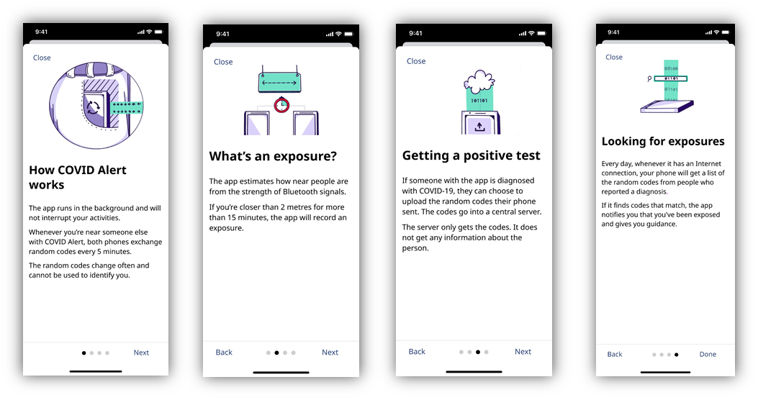
The four figures above show a series of screenshots, in sequential order that Canadians would see on the COVID Alert app. Each frame has a ‘Close’ button on the top right, an image, headline and sub-text in the main frame, and at the bottom, there is a progress bar along with ‘Back’ and ‘Next’ buttons to move through from page to page.
1. This image shows a cell phone in a person’s pocket (in purple) that has a sync icon on the screen. Next to the cell phone is a rectangle block of arrows coming into the phone and away from the cell phone (in green). Headline: How COVID Alert works. Sub-text: The app runs in the background and will not interrupt your activities. Whenever you’re near someone else with COVID Alert, both phones exchange random codes every 5 minutes. The random codes change often and cannot be used to identify you.
2. This image shows two cell phones (in purple) connected by a dotted line above with a timer icon in the middle. Above this is a sign (in green) with a dotted double arrow icon. Headline: What’s an exposure? Sub-text: The app estimates how near people are from the strength of Bluetooth signals. If you’re closer than 2 metres for more than 15 minutes, the app will record an exposure.
3. This image shows a cell phone (in purple) with an export icon on the screen. Above this is a rectangle (in green) that shows the code 101101. Above this is an icon of a white cloud. Headline: Getting a positive test. Sub-text: If someone with the app is diagnosed with COVID-19, they can choose to upload the random codes their phone sent. The codes go into a central server. The server only gets the codes. It does not get any information about the person.
4. This image shows a cell phone (in purple) at the bottom. Above the phone is a vertical rectangle (in green) with codes 00100, 01101, 01101. Over the middle code (01101) is a search bar. Headline: Looking for exposures. Sub-text: Every day, whenever it has an Internet connection, your phone will get a list of the random codes from people who reported a diagnosis. If it finds codes that match, the app notifies you that you’ve been exposed and gives you guidance.
On the basis of the information shown, participants were asked whether they would be inclined to download the app or not. In each group a few participants indicated they would not but, on balance, more said they would. When asked to elaborate, those who responded positively mentioned the following:
- A belief that the app will only be effective if large numbers downloaded and used it;
- Interest in knowing if they have been exposed to COVID-19;
- The app contributed to an increased sense of security and reassurance about their own, and their children’s, health;
- A general sense of curiosity about how the app works; and
- The idea that this app could replace the need to complete forms, as is currently required in some retail outlets (e.g., hair salons), stating that the client would provide any information if they tested positive or were made aware that they had come into contact with someone who had.
For those who were either uncertain or indicated they would not download the app, concerns centered around:
- A belief that they were already doing much of what was necessary to protect themselves from contracting COVID-19, including wearing face masks, social distancing and handwashing. These participants did not see the added value of downloading an app;
- Privacy and how their personal information would be used;
- The accuracy of the data collected, including the possibility for ‘false positive’ tests and thus having some individuals input incorrect data into the app;
- Uncertainty as to whether people who test positive will actually input their information; and
- Confusion around how the app works, specifically:
  - the generation of random codes
  - the requirement for internet connectivity as well as to carry your cell phone on your person at all times. There were also questions and concerns raised about having to keep Bluetooth enabled
  - the reference to exposures defined as being closer than 2 metres proximity and for more than 15 minutes – some participants questioned the stipulation of having to be in the presence of another person for minimum of 15 minutes
While many participants felt the information provided in these screen shots was reasonably clear and answered some of their questions, further comments revealed a number of areas of concern or confusion, even among those who expressed initial interest in downloading the app. Most of these pertained to the functionality and mechanics of the app.
The frequent references to random codes in several of the screens shown to participants were somewhat confusing (e.g., ‘the random codes change often…,’ they can choose to upload the random codes their phone sent,’ ‘the server only gets the codes …,’ and ‘your phone will get a list of the random codes …’). Additionally, the descriptions which referred both to Bluetooth signals and the requirement for an Internet connection were perplexing to some participants. They remained uncertain as to whether the app required an internet connection in order to exchange random codes or not. Some participants were unclear on the mechanics, although they generally understood that this had something to do with maintaining users’ privacy.
There were also questions about who inputs the data if someone tests positive – is it the individual or a medical professional? This raised concerns in some groups about the possibility of breaches of privacy and possible stigmatization of those who have tested positive (based on a misperception that the individual’s identity and their test result would be uploaded to some kind of Government of Canada database). At the same time, others felt that leaving it up to individuals who had tested positive to input their information into the app was not as effective as a more centralized approach. As noted earlier, some were concerned that people with the virus may elect not to use the app, thereby reducing its value as a key component of public health efforts across Canada to reduce the spread of COVID-19.
Others highlighted a number of other issues, including concerns about receiving a high volume of notifications or alerts. This reaction reflected a key misunderstanding about the app and an assumption that it would alert individuals in real-time (i.e., if they came within 2 metres of someone who currently had COVID-19). Several participants also felt the app may give people a false sense of security causing them to relax adherence to other preventive measures. A few thought that the images and icons did not add sufficient clarity or help to further their understanding of the content provided.
Participants who were initially hesitant about downloading the app were asked whether they would change their mind if they knew that the app did not collect any information such as their name, address or anything else that could personally identify them or anyone else who used the app. Knowing this did assuage some concerns. Others remained unmoved or unconvinced. Some, among this latter group, were less concerned about issues related to privacy. Rather, they simply didn’t feel that the app would be that useful to them personally. Others remained unclear on the purpose and still had questions about how the app functioned. In particular, a few participants continued to query the exchange of random codes and whether this was done in real-time, the assumption being that this approach would be most useful. Participants also questioned how long information on those who had tested positive remained on the app, assuming that an individual may be associated with a ‘positive code’ long past the time at which they have recovered from the virus. These types of questions and concerns continued to reflect a lack of understanding of the technical functionality of the app, and this often led to incorrect assumptions.
Participants were further told that the Privacy Commissioner of Canada had said that the app met all federal privacy requirements. Knowing this led some to further question the app’s utility, especially if the information on those who have tested positive is protected. Some felt that the current efforts with respect to contact tracing were likely sufficient, negating the need for or value of an app. Others who initially indicated they were unlikely to download the app continued to focus on aspects such as the issue of exposure for 15 minutes or more, noting that their interactions with most people were typically very brief. This led them to question how effective the app would be given their daily life and routine. Those who had concerns primarily with respect to the credibility of the data that would be input into the app, remained unconvinced by arguments with respect to privacy. Some participants continued to express reservations about having to keep Bluetooth enabled, raising concerns about the battery life of their cell phone and possible hacking.
As the conversation progressed, participants were shown some additional information that could appear when someone who has downloaded the app would like to set it up to begin using it.
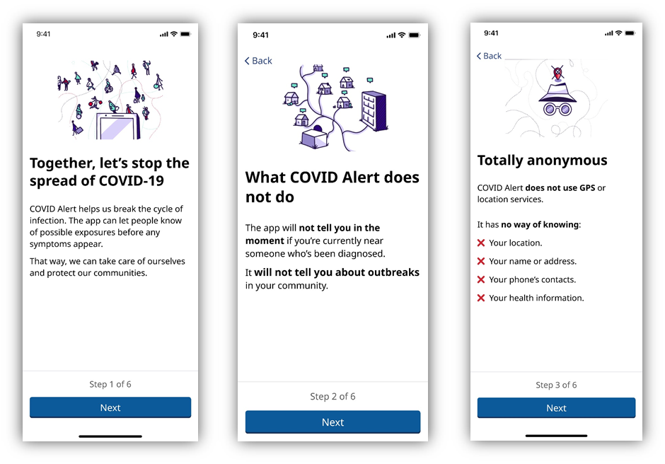
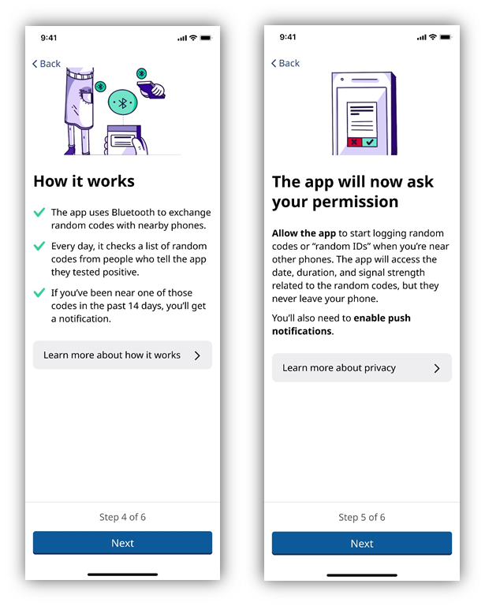
The five figures above show a series of screenshots, in sequential order, that Canadians would first see when they download and open the COVID Alert app. Each frame has an image, headline and sub-text in the main frame. At the bottom, there is a progress statement (e.g. Step 1 of 6), along with a ‘Next’ button to move to the next page.
1. This image shows the top of a cell phone (in purple) with icons of people doing different activities above. Headline: Together, let’s stop the spread of COVID-19. Sub-text: COVID Alert helps us break the cycle of infection. The app can let people know of possible exposures before any symptoms appear. That way, we can take care of ourselves and protect our communities.
2. This image shows icons of a corporate building, an apartment building and several houses all connected. Headline: What COVID Alert does not do. Sub-text: The app will not tell you in the moment if you’re currently near someone who’s been diagnosed. It will not tell you about outbreaks in your community.
3. This image shows a silhouette of a person’s face using icons of a hat and glasses (in purple). Above this, is a location services symbol (in red) with an ‘X” through it. Headline: Totally anonymous. Sub-text: COVID Alert does not use GPS or location services. It has no way of knowing: X Your location. X Your name or address. X Your phone’s contacts. X Your health information.
4. This image shows two people holding cell phones and a person with a cell phone in their pockets (in purple). Above each cell phone is a Bluetooth icon (in green). Headline: How it works. Sub-text: ✓ The app uses Bluetooth to exchange random codes with nearby phones. ✓ Every day, it checks a list of random codes from people who tell the app they tested positive. ✓ If you’ve been near one of those codes in the past 14 days, you will get a notification. At the bottom of the frame there is a button that reads ‘Learn more about how it works’ with a forward arrow.
5. This image shows a cell phone (purple). On screen, is a series of text with an ‘X’ (in red) and a ‘✓” (in green) at the bottom. Headline: The app will now ask your permission. Sub-text: Allow the app to start logging random codes or “random IDs” when you’re near other phones. The app will access the date, duration, and signal strength related to the random codes, but they never leave your phone. You’ll also need to enable push notifications. At the bottom of the frame there is a button that reads ‘Learn more about privacy’ with a forward arrow.
Reactions to the information shown varied. On the positive side, some participants felt the information provided helped to clarify some questions, specifically with respect to what the app does not do. They found it comforting, for example, to have a better understanding of the app’s capabilities. A few participants also felt this information provided some illumination on questions they had about the use of Bluetooth versus GPS tracking technology.
For the most part, however, participants who said they would not download the app continued to maintain this position. Some participants were less convinced of the utility of the app for reasons already stated: it requires a critical mass of people to download it; it relies heavily on people being honest and reporting that they have tested positive, and it doesn’t alert people ‘in the moment’ or in real-time to an exposure. On this last point, it was apparent that some participants did not fully understand the 14-day incubation period for the virus in which an individual could be carrying the virus, but be asymptomatic. Thus they questioned the 14 day timeframe to alert others, at which point they felt it was too late to learn one had possibly come into contact with someone who had tested positive. The name ‘Alert’ also implied to these participants the perception of immediacy that participants had or the possibility of real-time notification in much the same way as an Amber Alert. Others remained worried about privacy issues.
While some participants who were initially skeptical expressed slightly greater interest in downloading the app as a result of the information provided, most continued to have reservations. Additionally, some of those who responded positively to the app at the outset of the discussion, now reversed their earlier position. This response was a factor of several issues but principally a reflection of concerns that the app did not provide real-time information or more precise data on where outbreaks were occurring in the community. Again, participants underscored that the efficacy of the app was heavily predicated on the willingness of people to input credible information.

COVID-19 Brand Concepts - Ad Testing (Windsor CERB Recipients)
In the Windsor location only, participants were asked to evaluate a series of advertising concepts (which had also been tested in two groups at the end of June) in English. There were three concepts in total – labelled A, B and C. Each concept was illustrated with three executions intended for Facebook, print, and billboards. Participants in Windsor were shown the concepts, in the following order, so as to eliminate any potential ordering bias from the ordering in which they were shown in the previous month: Concept C, then A, then B.
Within each concept, an original version (1) and an alternate (2) of each concept was tested. The original was tested first, followed by the alternate. Then both versions of the concept were shown side-by-side (i.e., A1 and A2) to allow for discussion of and comparison between the two.

Concept C
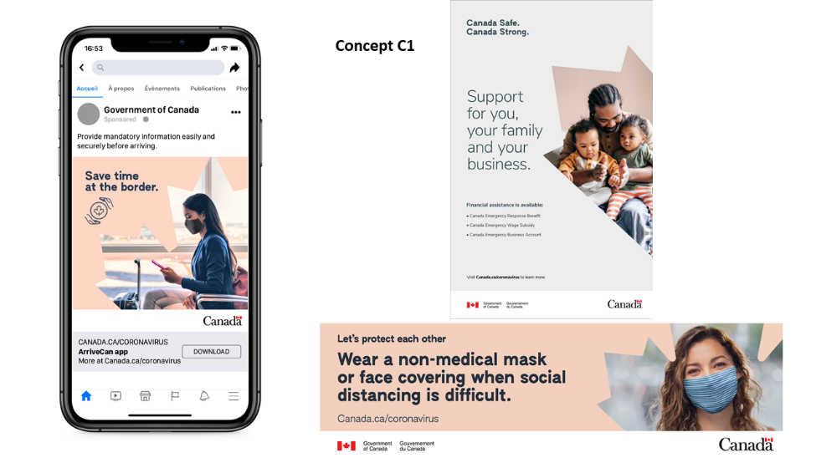
Concept C1: The figure above shows an ad set consisting of three ads over different mediums – Facebook, print and billboard ad. All ads feature a peach and light grey background colour and have a main headline in large black font. The first ad’s (Facebook) main headline (on the left) reads “Save time at the border.” along with a small icon of two hands surrounding a circle with a maple leaf in the middle. The right side of the ad features a photograph of a woman wearing a mask in an airport, which is framed by a maple leaf. At the bottom, there is a button to download the app or find out more information at Canada.ca/coronavirus. The second ad (print) shows (on the right) a large image of a man sitting while holding his two children, which is framed by a partial maple leaf. On the left hand side the main headline reads “Canada Safe. Canada Strong.” and a larger sub headline below reads “Support for you, your family and your business.” Underneath this, is smaller text that reads “Financial assistance is available:” and lists the Canada Emergency Response Benefit, Canada Emergency Wage Subsidy and the Canada Emergency Business Account. At the bottom of the ad the text “Visit Canada.ca/Coronavirus to learn more” and the Government of Canada logo and wordmark are shown. The third ad’s (billboard) main headline reads “Let’s protect each other” and has a sub headline that reads “Wear a non-medical mask or face covering when physical distancing is difficult.” Below this, text with the URL canada.ca/coronavirus is presented. The right hand side of the ad features a photograph of a young man smiling as she is wearing a mask, which is framed by the outline of a maple leaf. At the bottom of the ad, the Government of Canada logo and wordmark are shown.
Initial reactions: Overall participants responded very positively to this set of ads. They commented that the ads appeared to be very well developed and that they were clear and simple to read.
Likes/strengths: Participants cited the two key strengths of the ads to be the stylistic use of the maple leaf ‘cut-out’ throughout each of the concepts and the choice of neutral colours. Participants also liked the image of the woman used in the billboard ad, as she appeared to be wearing a non-medical mask, which some viewed as relatable.
Dislikes/weaknesses: Participants noted very few weaknesses associated with this concept. A few were less favourable of the icon of hands surrounding a maple leaf used in the online ad, while others found the second level of font in the print ad to be too small.
Resonance/impact: For all the reasons mentioned above, including the graphic elements (e.g., maple leaf), colouring, and imagery selected most participants stated that this ad would resonate with them.
Unified look/continuous element: Most felt the ads shared a similar aesthetic and were complementary of one another. They viewed the set to have good continuity throughout, specifically because of the consistent elements mentioned above (use of maple leaf, colours, etc.).
Suggestions: One exception was the print ad, which some participants felt was not as cohesive as the other two. Suggestions were made to improve this version by adding the peach colour or making the maple leaf more defined and more clearly evident.

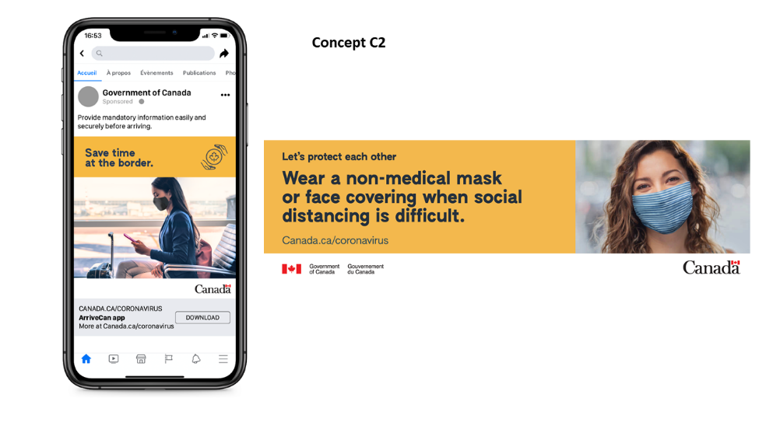
Concept C2: The figure above shows an alternative ad set consisting of two ads over different mediums – Facebook and billboard ad. All ads feature an orange background and have a title headline and/or a main headline in large black font. The first ad’s (Facebook) the main headline reads “Save time at the border.” (on the right) and a black icon of two hands surrounding a circle with a maple leaf in the middle (on the right). Underneath, taking up most of the ad, is a rectangular photograph of a woman wearing a mask in an airport. At the bottom, there is a button to download the app with the text “ArriveCan app” and “More at Canada.ca/coronavirus.” The second ad’s (billboard) title headline reads “Let’s protect each other.” (on the left side) with a main headline below that reads “Wear a non-medical mask or face covering when physical distancing is difficult.” Below this, text with the URL Canada.ca/coronavirus is presented. The right hand side of the ad features a square photograph of a young man smiling as she is wearing a mask. At the bottom of the ad, the Government of Canada logo and wordmark are shown.
Overall reactions: Participants were somewhat neutral to the alternative version of this concept (C2) and it did not garner the same level of favourability as the original.
Notable differences: Most immediately noted the difference in the contrasting colour used between C1 and C2. While the more tranquil and calming peach colour was preferred by many, a few liked the darker yellow/orange colour, feeling that a bright colour would be more effective at grabbing their interest and getting them to pay attention. Apart from the different colours, many noticed that the maple leaf was not present in this alternate version, which they felt made it much less compelling.
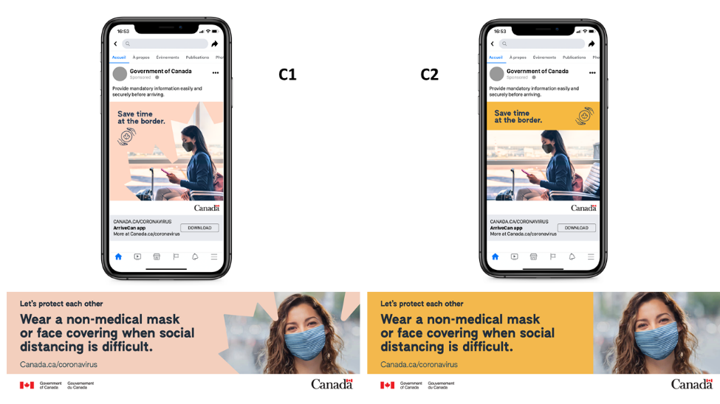
In this figure, the C1 Facebook and billboard ads are shown on the left and C2 Facebook and billboard ads shown on the right.
Preference C1 versus C2: When asked to select which concept they preferred, almost all participants selected C1 over C2. This was mostly driven by strong receptivity to the use of the maple leaf, the colour palette, and the overall design of the original version.

Concept A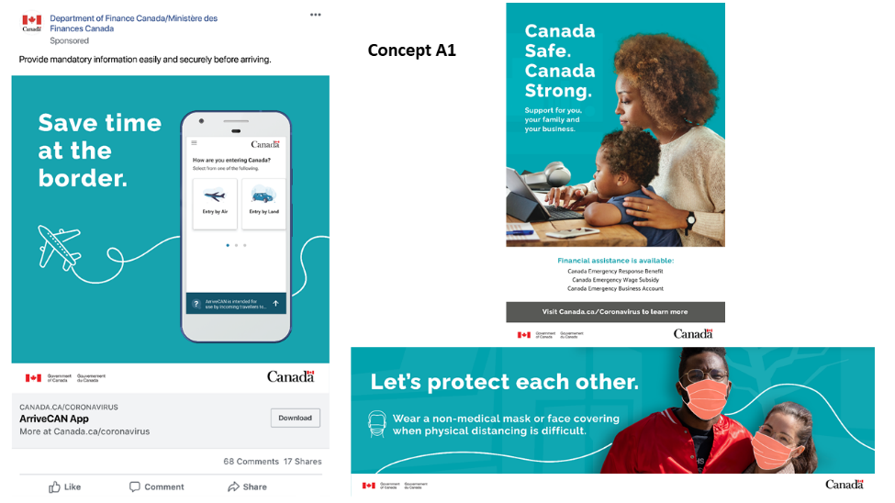
Concept A1: The figure above shows an ad set consisting of three ads over different mediums – Facebook, print and billboard ad. All ads feature a teal blue background and have a main headline in large white font. The first ad’s (Facebook) main headline (on the left) reads “Save time at the border.” along with a small icon of a plane. On the right hand side of this ad a smartphone is shown, featuring a Government of Canada ArriveCan app that reads “How are you entering Canada?” and provides two options on screen – entering by air or by land. At the bottom, there is a button to download the app or find out more information at Canada.ca/coronavirus. The second ad (print) shows a large image of a woman and her son on a computer together. On the left hand side the main headline reads “Canada Safe. Canada Strong.” and a sub-headline that reads “Support for you, your family and your business.” At the bottom of the ad, the ad reads “Financial assistance is available:” and lists the Canada Emergency Response Benefit, Canada Emergency Wage Subsidy and the Canada Emergency Business Account. Below this reads “Visit Canada.ca/Coronavirus to learn more” and the Government of Canada logo and wordmark are shown. The third ad’s (billboard) main headline reads “Let’s protect each other.” and has a sub headline that reads “Wear a non-medical mask or face covering when physical distancing is difficult.” alongside an icon of a public transit train. The right hand side of the ad features an image of a young man and woman with their arms wrapped around each other. Face masks are ‘drawn’ or overlaid on the two individuals faces. In the background there is a faint layer of trees and at the bottom of the ad, the Government of Canada logo and wordmark are shown.
Initial reactions: Response to this set of ads was somewhat neutral. While there were elements of this set of ads that participants liked, there were also many other aspects they disliked.
Likes/strengths: Participants cited a number of strengths, including the bold and prominent headline and the use of imagery – including the use of people standing together (in the billboard ad) and the family (in the print ad).
Dislikes/weaknesses: Participants felt that the use of photo-shopped masks in the billboard concept was a key weakness, as they believed it looked too cartoon-like and it left them with an impression of not taking seriously the realities of those having to wear masks on a daily basis. The use of the curving white line was also disliked by participants as it did not appear to be relevant to the content or add any value to their understanding of the message.
Resonance/impact: As suggested by the comments provided above, on balance, this set of ads did not necessarily resonate with most participants.
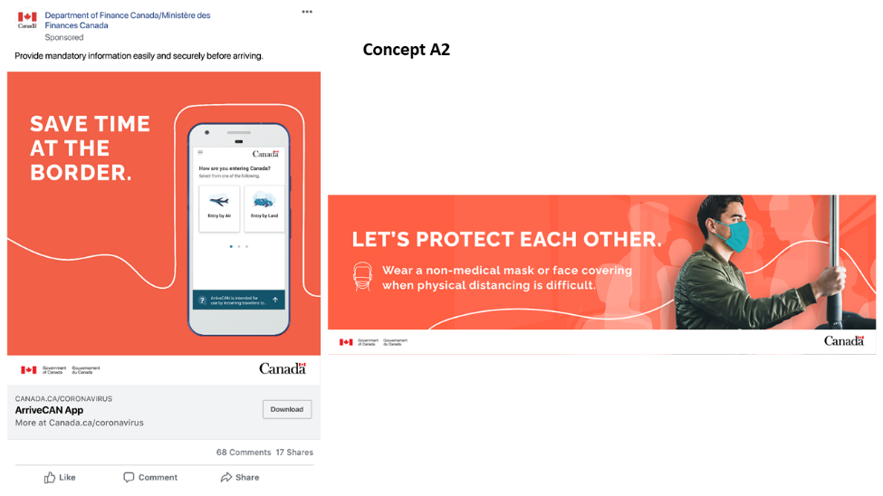
Concept A2: The figure above shows an alternative ad set consisting of two ads over different mediums – Facebook and billboard ad. All ads feature a red-orange background and have a main headline in large white font in capital letters. The first ad’s (Facebook) main headline (on the left) reads “SAVE TIME AT THE BORDER.” along with a small white line in the shape of a border. On the right hand side of this ad a smartphone is shown, featuring a Government of Canada ArriveCan app that reads “How are you entering Canada?” and provides two options on screen – entering by air or by land. At the bottom, there is a button to download the app or find out more information at Canada.ca/coronavirus. The second ad’s (billboard) main headline reads “LET’S PROTECT EACH OTHER..” and has a sub headline that reads “Wear a non-medical mask or face covering when physical distancing is difficult.” alongside an icon of a public transit train. The right hand side of the ad features an image of a young man holding a public transit pole, as if he is riding on a bus or a train. In the background, there are white shadow-like images of other people and at the bottom of the ad, the Government of Canada logo and wordmark are shown.

Overall reactions: When shown the alternative, Concept A2, participants were quite critical in their views. On initial reaction, comments were made that the orange/red background colour reminded participants of an ad for the Canadian Red Cross. Similarly to the original versions, the white lines were not seen as adding any value, and in particular, the use of the line on the Facebook ad suggested more rather than less time at the border and thus did not underpin the message of ‘saving time.’ That said, many were drawn to the imagery in the billboard ad and reacted favourably to the layering of shadows in the background, behind the person standing. Regardless, some did not like the overlay of photo-shopped masks, a comment that was also made in regard to the original version of this concept.
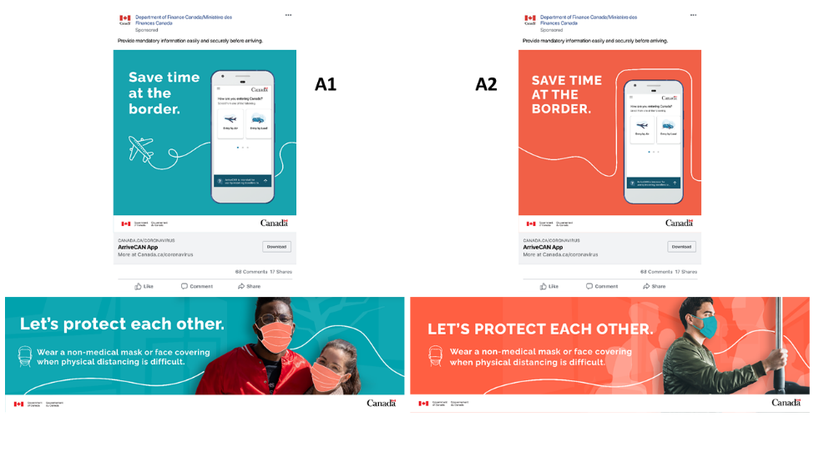
In this figure, the A1 Facebook and billboard ads are shown on the left and A2 Facebook and billboard ads shown on the right.
Preference A1 versus A2: When participants were shown both versions of Concept A, most participants preferred the original version (A1). Preference was driven by key elements in A1 such as the choice of colour (blue was seen as more calming), the font choice (particularly use of lowercase lettering) and the iconography (of the airplane, for example).

Concept B
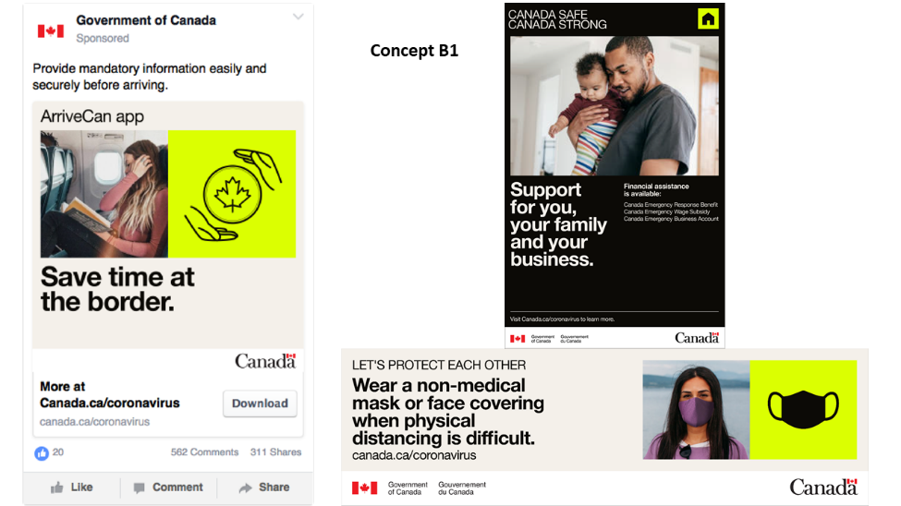
Concept B1: The figure above shows an ad set consisting of three ads over different mediums – Facebook, print and billboard ad. All ads feature an electric yellow, black and cream colour scheme and have a title headline and a main headline in black or white font. The first ad’s (Facebook) title headline reads “ArriveCan app” and the main headline reads “Save time at the border.” In between, there are two square images – one a photograph of a woman on a plane reading a book and tucking her hair behind her ear and another of a black icon of two hands surrounding a circle with a maple leaf in the middle, on a bright yellow background. At the bottom, there is a button to download the app with the text “More at Canada.ca/coronavirus”. The second ad (print) has the title headline at the top of the ad, which reads “CANADA SAFE. CANADA STRONG.” then, it shows a large image of a man holding his son in his arms in a home, in the centre of the page. The bottom half of the ad features the main headline (on the left) which reads “Support for you, your family and your business.” and a sub-headline on the right which reads “Financial assistance is available:” and lists the Canada Emergency Response Benefit, Canada Emergency Wage Subsidy and the Canada Emergency Business Account. At the bottom of the ad, it says “Visit Canada.ca/Coronavirus to learn more” and the Government of Canada logo and wordmark are shown. The third ad’s (billboard) title headline (on the left) reads “LET”S PROTECT EACH OTHER.” and has a sub headline that reads “Wear a non-medical mask or face covering when physical distancing is difficult.” on the left side of the ad. Below this, text with the URL canada.ca/coronavirus is presented. The right hand side of the ad features two square images – one of a young woman wearing a mask and another image of a black icon of a face mask, on a bright yellow background. At the bottom of the ad, the Government of Canada logo and wordmark are shown.
Initial reactions: Participants’ reactions to this set of ads generally skewed more negatively compared to the two other concepts which were shown. Overall, the ads did not resonate well with participants for the reasons outlined below.
Likes/strengths: Unprompted, participants noted very few strengths associated with this concept, although it was clear from comments that the colour scheme did get their attention. When discussed in more detail, however, the reaction was negative.
Dislikes/weaknesses: The colour palette, particularly the bright yellow was strongly disliked by participants. They viewed it as unbecoming and off-putting. In terms of the imagery, participants were confused about the combined use of imagery with icons and suggested that just one or the other be used rather than both. The inclusion of both was seen as redundant and participants felt it contributed to the design appearing somewhat amateur or unprofessional. As well, a few participants commented on the inappropriateness of using an image of a woman covering her face with her arm, as in the Facebook ad, rather than of someone actually wearing a mask in line with guidance from public health officials.
Unified look/continuous element: Overall, participants felt that the ads in this set were generally cohesive. In particular, the use of icons and the consistent colouring seemed to tie the ads together as a set. However, some participants commented that the messaging appeared to be disjointed as they each focused on very different topics – time at the border, support for families/businesses and the use of masks.

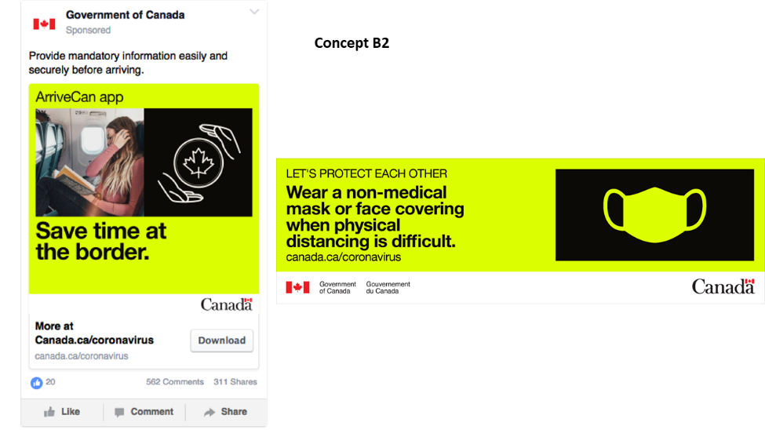

Concept B2: The figure above shows an alternative ad set consisting of two ads over different mediums – Facebook and billboard ad. All ads feature a bright yellow background and have a title headline and a main headline in large black font. The first ad’s (Facebook) title headline (across the top) reads “ArriveCan app.” and the main headline reads “Save time at the border.” In between, there are two square images – one a photograph of a woman on a plane reading a book and tucking her hair behind her ear and another of a white icon of two hands surrounding a circle with a maple leaf in the middle, on a black background. At the bottom, there is a button to download the app with the text “More at Canada.ca/coronavirus.” The second ad’s (billboard) title headline reads “LET’S PROTECT EACH OTHER.” on the left side with a main headline below that reads “Wear a non-medical mask or face covering when physical distancing is difficult.” Below this, text with the URL canada.ca/coronavirus is presented. The right hand side of the ad features an icon of a bright yellow face mask on a black background. At the bottom of the ad, the Government of Canada logo and wordmark are shown.
Overall reactions: Reactions to this alternative concept (B2) were generally less positive than the previous version (B1). The heavier use of the vivid yellow colouring in these ads was noted as the primary difference and was generally less well received, as the colour scheme was a feature that many particularly disliked about this ad concept overall. In this alternative version, participants referred to the colour as being alarming, suggesting a severe emergency or hazardous situation.
Notable differences: Apart from the colouring, participants did not mention any other notable differences compared with Concept B1.

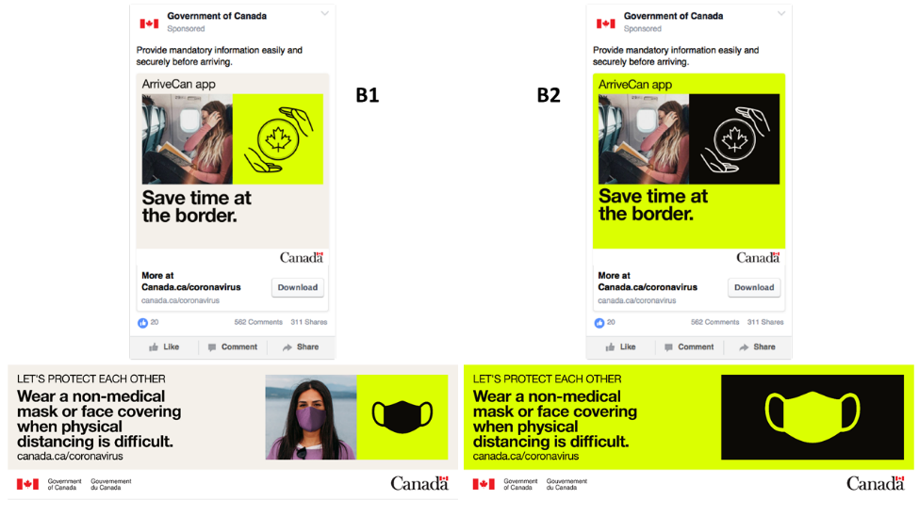
In this figure, the B1 Facebook and billboard ads are shown on the left and B2 Facebook and billboard ads shown on the right.
Preference B1 versus B2: Almost all participants preferred Concept B1. The original version of the concept tended to have less of the bright yellow colouring which participants generally found unattractive or off-putting. Again, participants preferred the use of imagery whereby the individual featured is wearing a mask.

Concept Comparison
In order to conduct a final comparison between concepts, participants were shown the billboard ads only for each of the three concepts, including both the original and alternate versions, as per the image below.
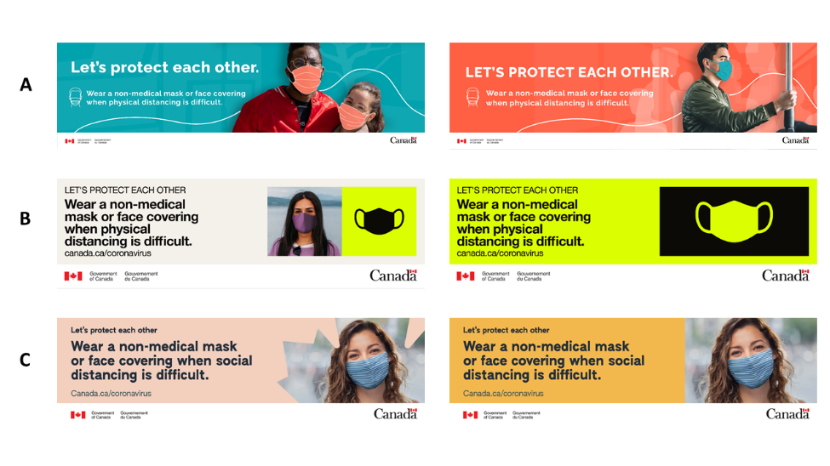
In this figure, the billboard versions of all concepts are shown in the following order (from left to right, top to bottom): A1, A2, B1, B2, C1 and C2.
When asked to select the one they felt to be most compelling, the choice aligned with views expressed earlier when each concept was being reviewed on its individual merits. Almost all participants selected Concept C. This was preferred for several reasons including:
- the colour choice - because it was viewed as more calming and less alarmist;
- the use of the maple leaf– which was viewed as an interesting and recognizable, uniquely Canadian stylistic element;
- the use of photography in this concept was deemed more appropriate, particularly because the woman was wearing a ‘real’ mask and it was apparent that she was happy/smiling; and
- the overall professionalism of the concept- perceived as having a more ‘government’ look compared to the others.

Asked if there was anything that might help to improve Concept C, participants’ only additional suggestion was to include multiple people in the main image. Participants reacted more positively to images showing families (e.g., parent and child) and multiple people as this was more reflective of their social nature as well as their desire to interact with others while still staying safe.

COVID-19 Taglines (Lower Mainland BC, Mid-size and Small Town Quebec Parents)
Participants in the two groups noted above were shown three possible taglines developed by the federal government that could be used to help keep Canadians safe and to motivate people to practice safe behaviours such as wearing masks, practicing physical distancing and avoiding large parties.
The three taglines presented were:
- Is it really worth it?
- Outsmart future outbreaks
- Unstoppable together
Preference on these taglines differed between Anglophone and Francophone participants. Participants in the Lower Mainland group leaned towards the tagline ‘Is it really worth it?’. They believed that phrasing this tagline as a question was engaging and made participants stop, think, internalize and contemplate a response, all which they believed contributed to it being more memorable compared to the others. Meanwhile, about as many participants in the Quebec focus group preferred ‘unstoppable together’ over the other two options. Francophones found the term ‘together’ to be meaningful as it suggested the idea of working cooperatively or a “community spirit”. ‘Outsmart future outbreaks’ was chosen by a couple of participants in each group because they viewed it to be an empowering message.
When asked if they found any of the taglines confusing or giving the wrong message, a few who did not like the first tagline said that without context, it would be difficult to know that the tagline was referring to COVID-19. A couple of participants found the wording of ‘outsmart future outbreaks’ confusing upon initial read. Lastly, a few said their immediate reaction to the word ‘unstoppable’ was that it meant that “COVID is unstoppable’.

Detailed Findings – Part II: Other Issues

Racism (GMA Black Canadians, Major Centres Ontario Black Canadians)
Two groups were held in July among Black Canadians, in the Greater Montreal Area and in major centres across Ontario. All participants in each of these groups appeared to be paying close attention to the Black Lives Matters protests occurring across the U.S. and in Canada.
Unanimously, participants were of the view that racism is a problem in Canada, but some qualified this by saying that the issue is not as significant or as overt or as it is in the United States. A number of participants commented on the politeness of Canadians which they felt can tend to mask underlying racist behaviours and actions that do occur and are experienced by Black Canadians. They also spoke about the relatively small Black population in Canada, by comparison to the U.S., and that this may also be a factor in public perceptions specifically around concerns by some that the Black community poses a ‘threat.’
Nevertheless, several participants did relay stories about racist behaviours and incidents they had experienced, particularly during their youth (e.g., treatment by the police). While underscoring that racism is not as blatant in Canada, others spoke about the more subtle nature in which it occurs, in the form of micro aggression in schools, in the workplace and in many other daily interactions. Participants referenced a myriad of ways in which racism manifests itself, including:
- Treatment by law enforcement officials – Participants referred to racial profiling and their perception that Black people are disproportionately targeted and/or stopped by police officers.
- In the workplace – Some spoke about being held back for promotions, seeing others less qualified advance, or being denied job interviews seemingly only once their ethnicity or colour became clear to the prospective employer. A number of participants expressed particular concern for Black youth and, specifically counselled their own children on how to behave around police to avoid discriminatory treatment and possible harm.
- In school – Participants commented on their experience as one of only a few Black students at school, which contributed to feelings of self-consciousness, while others talked about preconceptions or stereotypes teachers had about Black culture and differing/harsher treatment by school officials, relative to how Caucasian students were dealt with on similar disciplinary issues.
- Financial transactions – Participants noted that racism is evident in the rental market. By way of example, they spoke about landlords who would claim not to have any vacancies upon seeing the tenant was Black, even though participants had been told the opposite in earlier inquiries made over the phone. Others spoke about stereotyping that occurs, for example, assumptions by others that Black people probably can’t afford to purchase expensive vehicles. Participants commented that they feel others are judging their lifestyle according to very outdated and/or completely inaccurate views about people of colour.
- Personal interactions – Examples of interactions that participants perceived to exemplify racist attitudes were shared. These ranged from participants saying they simply felt ‘unnoticed’ or ignored (e.g., by retail clerks) to experiencing more aggressive behaviours such as being closely monitored by store security while shopping.
Many examples of perceived stereotyping were evident throughout these discussions – calls made to police by people worried about crime when they see Black people in their neighbourhood, despite the fact that they are residents of the community, as well as assumptions about the hierarchy of authority within various workplaces (e.g., that the leadership or authority figures are white, while people of colour populate the lower ranks of an organization), and preconceptions about the lifestyle, culture, interests and athletic abilities of Black people. A number of participants commented specifically about their minority status – often being either the only Black person within a group or one of a few – and how this contributed to their personal sense of being ‘different’ and being treated differently from others.
When asked whether the Government of Canada needs to do more to address anti-Black racism most participants felt there was a role for government, and some indicated that they should seize the opportunity while Canadians’ attention is focused on the Black Lives Matter movement. However, the point was also made that addressing racism in Canada is also the responsibility of individuals, families, educators, and organizations, and not exclusively the purview of government. Others commented on the importance of talking more openly about the history and impact of colonialism in Canada, and that the history of Black people was not exclusively Black history, but “everybody’s history.”
While many participants felt the Government of Canada had a role to play, few could point to any specific initiatives or activities the government had undertaken in recent years around this issue, other than events which are held in conjunction with Black History month each year and some efforts within the Canadian military to consult with Black members. A number of suggestions were offered regarding what more the government could do, including:
- Broader public education of Canada’s history and treatment of Black people
- Addressing some of the root causes of systemic inequality and social injustice and improving the quality of life for Black Canadians (e.g., access to education, housing)
- Greater representation in leadership positions
- Actively investigating cases of racism
- Providing opportunities for greater public exposure to Black culture
- Addressing racism at an institutional level, including ensuring greater diversity on Corporate Boards
- Reviewing and updating the educational curriculum to ensure that it includes a full and accurate history of the Black experience in Canada
- Inspiring Black children by showcasing success and opportunities for people within the Black community
Participants were shown a list of eight possible measures, and asked to select up to three that they felt would make the biggest difference in reducing racial inequality in Canada.
- Appointing more visible minority judges
- Collecting better data about hate crimes and the conditions facing visible minorities in Canada
- Finding ways to honour Black role models in Canada
- Increasing funding for anti-racism campaigns
- Placing body cameras on police officers
- Providing more training about racism to people in the justice system
- Repealing mandatory minimum sentences
- Setting up programs that help more Black youth attend university
Participants made it clear that they thought all of these measures should be implemented and they did not identify any as bad ideas. However, compared to the group held in the GMA where participants tended to support all the measures about equally, Ontario participants’ views coalesced around two priorities: setting up programs that help more Black youth attend university and finding ways to honour Black role models in Canada. In both groups, participants saw education as key in several ways – increasing the earning potential of Black Canadians, thereby raising their overall financial security, helping Black Canadians advance into leadership positions (e.g., judgeships, politicians, corporate leaders) where they would have more influence and an opportunity to effect change, and leveling the playing field for future generations of Black Canadians. Participants in Ontario also felt that Black children and youth needed to be able to see themselves represented in a wider variety of roles and occupations, and that doing so would have both inspirational and aspirational affects. They felt that having role models – someone who looks like them – would demonstrate that there are clear pathways to success and show young Black Canadians what is realistic and achievable.
Several participants in both groups focused on providing more training about racism to people in the justice system. Again, participants expressed the view that training on racial bias within the justice system would help to address inequalities in the treatment of minority communities. At the same time, concerns were raised about the necessity of having to train judges and other officials whose job participants felt it is to examine cases on the evidence, setting aside their own personal biases. Some participants pointed to other measures which they perceived would have a greater impact, noting that it is challenging to change deeply embedded racist attitudes at an individual level.
A number of participants supported placing more body cameras on police officers. They saw this as a safety measure for both parties and necessary to ensuring the accountability of law enforcement officials.
Increasing funding for anti-racism campaigns received modest support, overall, but slightly greater interest from the group held in the GMA versus Ontario. In Montreal, participants felt that it was important to raise awareness that racism does exist in Canada, to show what it looks like and the effect it has, in order to counter what some felt is a general tendency of denial among Canadians.
Several participants in each group emphasized the need to collect better data about hate crimes and the conditions facing visible minorities in Canada, underscoring that data reflects the reality and is important to then being able to clearly identify both the extent of the issue in Canada and its various facets. Some participants commented that it is difficult to act without full knowledge as to the extent and nature of the issue. Others, however, felt that via the Census and other data collection methods, policy makers should have sufficient data to act upon. They questioned the need to gather additional data, but also wondered whether the ‘right’ data was currently being collected to provide an accurate picture of racism in Canada and the conditions facing visible minorities. Few held the view that data could be misunderstood or lead to stereotyping. However, some participants did comment that while it is important to compile data about visible minorities, it is more important to act on it.
Relatively few participants identified appointing more visible minority judges or repealing mandatory minimum sentences as measures which would have a significant impact in reducing racial inequality in Canada.

Immigration (GTHA and Windsor Young Adults, Calgary, Montreal, Mid-sized Centres Atlantic Canada)
The topic of immigration was discussed in several groups in order to better understand how participants viewed immigration within the context of economic recovery from the COVID-19 pandemic, in addition to exploring attitudes on particular aspects of Canada’s current immigration policy.

Immigration and Economy Recovery
Most participants made a clear link between economic recovery and immigration. They felt that immigrants were key to growing the economy by addressing skills shortages, particularly in the fields of health care and technology, and by investing in their own and other enterprises, building companies, and creating more employment opportunities for Canadians.
Many participants were highly focused on immigration as a means of addressing skills gaps in Canada, particularly ensuring that more highly skilled immigrants are a priority. Several participants commented on shortages of health professionals which they felt became quite evident throughout the pandemic, noting that immigrants with medical training, including doctors, nurses and other frontline health workers, should be a priority. Others also felt it was critical in the agricultural sector in particular to accommodate the entry of temporary foreign workers into Canada to address seasonal work. At the same time, a few participants expressed concerns about the possibility that these workers may contribute to subsequent outbreaks of COVID-19, although they believed that temporary workers fill an important gap in some sectors where employers are unable to find qualified Canadian workers. And, while some participants also felt that Canadians who are unemployed due to COVID-19 should have the first opportunity at any available jobs, they acknowledged that some may not be interested in temporary or seasonal work and/or may not have the skills in the types of jobs that are likely to be required as the economy recovers.
The point was made by several participants that immigrants to Canada should be contributing to economic growth and should be able to support themselves and their families on entry. Some expressed concerns about the extent to which immigrants may put additional pressure on social services and financial supports, including EI, especially in light of job losses that have occurred as a result of COVID-19. However, most participants felt that the contribution of immigrants was mutually beneficial, both for those immigrating to Canada and for the Canadian economy. Indeed, a number of participants spoke about the importance, for any nation, of having an immigration policy that is balanced, noting that a healthy immigration policy contributes to a healthy economy and economic growth.
The issue of opening up immigration to allow for the entry of more foreign temporary workers was debated as participants specifically considered how immigration fits into short-term versus long-term economic recovery. Some participants felt that temporary workers were particularly vital for the short-term, although many others were of the view that, in the short-term, immigration should focus on those with skills in priority areas such as healthcare and other fields of expertise that are required to rebuild the economy. Over the long-term, some participants were generally of the view that immigration policy, and specifically the level and nature of immigrants to Canada, should seek to be more balanced. By this participants meant that a wider range of factors should be considered, including immigrants’ economic and family circumstances, to ensure that immigration contributes positively to Canada’s economic prosperity as well as overall growth in the labour force and the population. Over the long-term, some participants suggested that immigration could then open up more widely to encompass those facing violence or political persecution in their home countries.
Several participants expressed worries about the possibility that immigrants, particularly those coming from countries with higher rates of confirmed coronavirus infections, may lead to additional outbreaks across Canada, although they were also of the view that this could be addressed by stringent safety protocols for those entering Canada.
On balance, participants viewed immigration as having a net positive impact. They commented on immigrants’ strong work ethic, their willingness to learn and to adapt, their contribution to innovation and economic growth and to a more diverse culture. The point was made the immigration enriches Canadian communities in many ways.
Prior to COVID-19, the Government of Canada had announced plans to admit about 350,000 immigrants in 2021. When asked whether this number seemed too high, too low or about right, participants’ responses were mixed. Many were unsure or responded that it was difficult to say without knowing if this number was higher or lower than in previous years. Additional questions were raised about the timing and flow of immigration, with some expressing concern about massive immigration within a short period of time possibly overwhelming the job market. These participants felt it was important to closely monitor key economic indicators and adjust immigration numbers and the flow accordingly. Others were somewhat uncomfortable venturing any opinion on what an appropriate level of immigration would be because of the uncertainty of the current economic conditions.
When it was clarified that this number (350,000) reflected the pattern of immigration into Canada in previous years most participants, with the exception of those in Montreal, were of the view that this level should be maintained. They described Canada as a country of immigrants and as having a strong history of immigration. Some also felt that, in the context of Canada’s geography and population density, this number did not seem overwhelming as immigrants would be spread across Canada. Again, the only caveat was that immigrants should be tested for exposure to the virus before entering the country and should be required to quarantine for 14 days upon arrival. A few others, who were particularly concerned about the possibility of overtaxing Canada’s health care system, suggested it might be advisable for the Canadian government to extend the timeframe for admission of this number of immigrants beyond the typical 12-month period.
Relative to other locations in which focus groups were held, the balance of participants in Montreal tended to favour reducing the number of immigrants into Canada. Concerns were raised about the timing in light of COVID-19, the existing pressures on the Canadian economy which they felt would lead to greater financial insecurity and homelessness, and a lack of infrastructure to support the influx of immigrants at this time, specifically with respect to services like daycare and schools. Others commented that, while the number in itself may be acceptable, it was too soon in this period of recovery to bring in immigrants.

Keeping Immigrants and Canadians Safe
Participants volunteered a number of suggestions in order to keep immigrants and Canadians safe and ensure that immigration is undertaken in a safe manner. These included:
- Educating immigrants prior to departure from their country of origin on the safety protocols required upon arrival;
- Screening and testing for COVID-19 prior to departure in place of, or in addition to, testing on arrival;
- Instituting a 14-day quarantine period upon arrival regardless of test results, and using military bases to house immigrants for this purpose; and
- Having immigrants pay for COVID-19 screening and testing and/or ensuring they have adequate funds to offset any healthcare costs.
In general, most participants were of the view that immigrants should be aware of and follow the same protocols, standards and guidelines that apply to other Canadians. At the same time, some raised concerns about the logistics of quarantining for immigrants, questioning the practicalities of self-isolation for a two-week period, specifically how they would be able to meet this requirement especially when the pressure on them to obtain immediate employment may be intense. This discussion led to suggestions by some to redeploy hotel rooms, university dormitories, schools, etc. as lodging during the quarantine period. Others suggested that the responsibility for quarantining should rest with the country of origin (e.g., immigrants must quarantine before arriving in Canada). Others, however, questioned how workable this option was as it would be difficult for the Canadian Government to receive full assurance that the conditions for quarantine had been met prior to their arrival.

Views on the Temporary Foreign Worker Program
Most generally knew what a temporary foreign worker was, describing them as migrant workers who typically work in seasonally-based employment, often in the agricultural sector. They noted that these are the types of jobs that are not readily filled by Canadian workers. Some also perceived that these were workers who had been granted temporary employment for a fixed period of time and that their status in Canada was tied directly to the employer or the company which sponsored them.
Most participants held positive views of the Foreign Temporary Worker Program. In their view, the program addressed critical labour shortages in certain industries or sectors. A number of participants also commented that foreign workers fill jobs that are not necessarily viewed as desirable by Canadians, but that these are jobs that are critical to the economy and to Canadian interests, even if they are not highly rewarding financially. From the perspective of the worker, some also felt that they stood to benefit from steady employment in Canada and the opportunity to advance a skill set that may enhance their employability upon return to their home country. At the same time, participants were conscious of a number of possible pitfalls, primarily with respect to foreign workers being taken advantage of by disreputable employers who may not maintain acceptable working conditions or offer minimum wages.
The idea of creating a path for temporary foreign workers to become permanent residents of Canada met with mixed reaction from participants. Some responded positively to this suggestion, believing it made sense to offer incentives to foreign workers to forge a longer-term attachment and commitment to Canada. Others questioned whether permanent residency represented a critical personal goal for foreign workers. Some were concerned about the prospect of foreign workers using the program as a stepping stone to other higher skilled jobs which, in turn, may adversely affect other Canadian job-seekers. While generally supportive of offering opportunities for foreign workers and of rewarding their hard work and efforts, participants also wanted assurances that:
- These workers would be directed into fields and industries where their skills were needed;
- They would not pose a burden to Canadians or their employers during off-seasons, specifically that they would not begin a pattern of working for several months followed by several months on EI; and
- The program should be economically viable in the sense that the economy can support the entry of additional workers to the Canadian job market.

Views on International Students
Most participants were comfortable with international students studying in Canada this fall, provided that they adhered to quarantine protocols when they first arrive. There was a fairly widespread view that international students benefit universities primarily through higher tuition compared to domestic students, but also that they have a positive impact in the communities where these universities are located, both in terms of economic activity and cultural diversity. Some participants underscored their importance to the sustainability of universities, noting that universities would be critically challenged without the revenues from international students. A few other participants commented on the importance of bringing an international perspective to Canadian students.
At the same time, as noted, participants were insistent that international students should follow the standard health a safety protocols around COVID-19 as with other immigrants and travelers entering into Canada.

Views on Refugees
Participants were strongly of the view that Canada should continue to offer assistance to refugees. They focused on Canada’s history of taking in refugees, the opportunities it offers even in the midst of a pandemic to provide shelter to those fleeing conflict or other difficult circumstances, and the sense of obligation they felt to provide relief to those facing a humanitarian crisis.
Again, the point was made that refugees should be brought into Canada safely, including running proper background checks, testing for COVID-19 and quarantining. A few participants did express some reservations, noting that it may be advisable given the current economic crisis resulting from the pandemic to reduce the number of refugees coming into Canada in the short-term. These participants were primarily concerned about the costs associated with supporting refugees and the extent to which they may deter or slow down Canada’s economic recovery. Very few, if any, had any concerns about refugees taking jobs from Canadians.

Messages on Immigration
Participants were shown a series of messages that the Government of Canada could provide related to immigration and asked to select up to two that are the strongest reasons for bringing immigrants to Canada:
- Canada has a history of immigration, and it is because of immigration that Canada is such a successful country today.
- Immigrants can be key to our economic recovery, as they are more likely to start businesses and create jobs.
- Immigrants contribute a lot to Canada, for example one-in-four healthcare workers in Canada are immigrants.
- Immigration will help Canada overcome many of the demographic challenges it faces due to an aging population.
- There are strict health protocols in place, including testing and mandatory two week quarantine for any immigrants who come to Canada.
While the choices varied somewhat between groups, overall the two statements that resonated most strongly with participants were the fact that immigrants contribute a lot to Canada and that one-in-four healthcare workers are immigrants, and that Canada has a history of immigration which is the basis for its success. The information about the role that immigrants play in health care was new to some, although not all, participants. Moreover, this particular message seemed particularly relevant at this time, given the current public health crisis, the issues faced by long-term care facilities, and perceived shortages of front line health care workers. This historical perspective resonated with others as many could relate to immigrant families, either as part of their own family heritage or as foundational to the communities in which they lived. Others spoke about Canada’s multicultural make-up as a unique feature of Canadian society, and they viewed immigration as fundamental.
Some were drawn to the argument that immigration would help Canada to overcome many of the demographic challenges it faces due to an aging population, finding it to be especially relevant at a time when COVID-19 has had a particularly devastating effect on elderly people. At the same time, concerns were raised about ensuring that this issue is addressed by bringing in younger immigrants rather than those who are entering their senior years.
The other messages were less compelling. Although some participants felt that the statement alluding to immigrants being key to Canada’s economic recovery by starting businesses and creating jobs provided a more concrete argument in favour of immigration, others were concerned that the time may not be right. They felt there was a risk that immigrants’ businesses may fail, or at the very least, that it is a difficult time to launch a businesses. Finally, very few were convinced by the statement that there are strict health protocols in place, including testing and mandatory two-week quarantine for immigrants who come to Canada. Most felt this did not present an argument in favour of immigration or explain how immigrants contributed to Canada, but rather was simply a statement of fact or a statement about processes and protocols. Nothing about this statement reflected the larger context or backdrop for immigration in Canada.
Most participants were familiar with all the information provided in these statements, with the exception of a few for whom the fact that one-in-four health care workers in Canada are immigrants was not something they were previously aware of. While some indicated they had a sense that many immigrants worked in the health care sector, they were unaware of the extent to which this was the case. At the same time, several felt this fact further underpinned the case for immigration.
For a few others, the phrase explicitly stating that immigrants contribute a lot to Canada raised some alarm bells. It prompted questions about whether immigration is hurting Canada, and native-born Canadians in particular, by driving down wages and taking away jobs they might otherwise have.

Other Federal Government News and Issues (Major Centres Ontario Black Canadians, Winnipeg Parents, GTHA and Windsor Young Adults, Calgary, Montreal, Mid-sized Centres Atlantic Canada, Toronto, Lower Mainland BC, Mid-size and Small Town Quebec Parents)
Participants were asked whether they had heard about any other Government of Canada news, apart from announcements and discussions related to COVID-19. Several other issues did arise, including the following:
- The ban on assault weapons was mentioned in several groups and generated mixed reaction – more support in groups held in Quebec, less so among participants in Calgary ;
- Ethical issues pertaining to the contractual arrangement between the Government of Canada and WE Charity to manage the student grant program was mentioned in a number of groups, although few participants elaborated other than to express disappointment about how this issue was handled;
- Canada-China relations, specifically the case of the Huawei executive who is fighting extradition to the United States and the detention of Canadian diplomats in China, was also raised in several groups. Again, participants mentioned the issue without much additional commentary;
- Racism and the Black Lives Matter protests were raised by participants, although most did not specifically comment on the Government of Canada’s response to the issue;
- Disputes between the Government of Canada and Indigenous Peoples pertaining to the construction of an oil and gas pipeline and affecting railway operations; and
- The trade agreement between the U.S. and Canada, specifically affecting Canadian dairy products, and the possibility that the U.S. may reinstate tariffs on Canadian aluminum.

Relatively few participants had heard much, if anything, about the Government of Canada’s Economic and Fiscal Snapshot which was released on July 8, 2020. Those who had were short on the details, although some recalled some references to the growing deficit resulting from COVID-19.
Finally, in a select number of groups participants were queried about the extent of the Government’s focus on COVID-19 and, in particular, whether they felt the Government of Canada should be paying more attention to other issues. In general, participants felt the degree of focus on COVID-19 was appropriate and that it was necessary to ensure Canadians were kept informed, up-to-date and properly equipped to combat the virus. While some indicated they were feeling somewhat overwhelmed by the volume of information about COVID-19 and relentless discussion in the media, they were also relieved to see the numbers of cases trending down and commented positively on government communications on the topic. At the same time, several participants did mention that the pandemic had revealed a number of significant concerns with respect to mental health, elder care, long-term care, poverty and marginalized groups which they believed the Government should evaluate more closely.

Appendix A – Recruiting Scripts

English Recruiting Script
Privy Council Office
Recruiting Script – July 2020
English Groups (July 7-28)

Recruitment Specifications Summary

- Groups conducted online
- Each group is expected to last for two hours
- Recruit 8 participants for 6-8 to show
- Incentives will be $90 per person and will be sent to participants via e-transfer following the group

GROUP | DATE | TIME (EST) | TIME (LOCAL) | LOCATION | COMPOSITION | MODERATOR
1 | July 7 | 5:30-7:30 | 5:30-7:30 EST | Windsor | Receiving CERB | D. Nixon
3 | July 14 | 6:00-8:00 | 6:00-8:00 EST | Ontario – Mix of Major Centers | Black Canadians | D. Nixon
4 | July 15 | 7:00-9:00 | 6:00-8:00pm CDT | Winnipeg | Parents of school age children, Gr. 7 and up | T. Woolstencroft
6 | July 20 | 6:00-8:00 | 6:00-8:00 EST | GTA/ Hamilton/ Windsor | Young Adults  Aged 18-24 | T. Woolstencroft
7 | July 21 | 6:00-8:00 | 5:00-7:00pm MDT | Calgary (and surrounding area) | General population | T. Woolstencroft
9 | July 23 | 4:30-6:30 | 5:30-7:30 ADT | Atlantic Canada – Mid-sized centers | General population | D. Nixon
10 | July 27 | 6:00-8:00 | 6:00-8:00 EST | City of Toronto | General population | D. Nixon
11 | July 28 | 8:30-10:30 | 5:30-7:30 pm PDT | Lower Mainland BC | General population | D. Nixon
Specifications for the focus groups are as follows:

Recruiting Script

INTRODUCTION

Hello, my name is [RECRUITER NAME]. I'm calling from The Strategic Counsel, a national public opinion research firm, on behalf of the Government of Canada. / Bonjour, je m’appelle [NOM DU RECRUTEUR]. Je vous téléphone du Strategic Counsel, une entreprise nationale de recherche sur l’opinion publique, pour le compte du gouvernement du Canada.

Would you prefer to continue in English or French? / Préfériez-vous continuer en français ou en anglais? [CONTINUE IN LANGUAGE OF PREFERENCE]

RECORD LANGUAGE
English CONTINUE
French THANK AND END

On behalf of the Government of Canada, we’re organizing a series of online video focus group discussions to explore current issues of interest to Canadians.

The format is a “round table” discussion, led by an experienced moderator. Participants will be given a cash honorarium in appreciation of their time.

Your participation is completely voluntary and all your answers will be kept confidential. We are only interested in hearing your opinions - no attempt will be made to sell or market you anything. The report that is produced from the series of discussion groups we are holding will not contain comments that are attributed to specific individuals.

But before we invite you to attend, we need to ask you a few questions to ensure that we get a good mix/variety of people in each of the groups. May I ask you a few questions?

Yes CONTINUE
No THANK AND END

SCREENING QUESTIONS

- Have you, or has anyone in your household, worked for any of the following types of organizations in the last 5 years?

A market research firm THANK AND END
A marketing, branding or advertising agency THANK AND END
A magazine or newspaper THANK AND END
A federal/provincial/territorial government department or agency THANK AND END
A political party THANK AND END
In public/media relations THANK AND END
In radio/television THANK AND END
No, none of the above CONTINUE
1a. IN ALL LOCATIONS: Are you a retired Government of Canada employee?

Yes THANK AND END
No CONTINUE

- In which city do you reside?

LOCATION | CITIES
Windsor | Windsor  PARTICIPANTS SHOULD RESIDE IN THE ABOVE-NOTED CENTERS PROPER. | CONTINUE – GROUP 1
Ontario – Mix of Major Centers | Cities could include (but are not limited to): Toronto, Ottawa, Mississauga, Brampton, Hamilton  ENSURE A GOOD MIX OF MAJOR CITIES ACROSS THE PROVINCE. | CONTINUE – GROUP 3
Winnipeg | Winnipeg  PARTICIPANTS SHOULD RESIDE IN THE ABOVE-NOTED CENTERS PROPER. | CONTINUE – GROUP 4
GTA/ Hamilton/ Windsor | Mississauga, Vaughn, Newmarket, Richmond Hill, Georgetown, Hamilton, Windsor  Does not include City of Toronto  ENSURE A GOOD MIX OF CITIES ACROSS THE REGION. | CONTINUE – GROUP 6
Calgary (and surrounding area) | Calgary Metropolitan Area  As far North as Airdrie, East as Chestermere, South as Okotoks and West as Bragg Creek | CONTINUE – GROUP 7
Atlantic Canada – Mid-sized centers | Cities could include (but are not limited to):  NS: Cape Breton, Sydney, Truro, New Glasgow, Kentville,  NB: Dieppe, Miramichi, Bathurst  NL&L: Corner Brook, Mount Pearl, Conception Bay South, Gander, Labrador City  PEI: Summerside  ENSURE A GOOD MIX OF MAJOR CITIES ACROSS THE REGION FROM ALL 4 PROVINCES AND KEY CENTERS. | CONTINUE – GROUP 9
City of Toronto | City of Toronto  PARTICIPANTS SHOULD RESIDE IN THE ABOVE-NOTED CENTERS PROPER. | CONTINUE – GROUP 10
Lower Mainland BC | Cities could include (but are not limited to): Abbotsford, Burnaby, Chilliwack, Coquitlam, Delta, Hope, Langley, Maple Ridge, Mission, New Westminster, North Vancouver, Port Coquitlam, Port Moody Richmond, Surrey, Vancouver, Whistler ENSURE A GOOD MIX OF CITIES ACROSS THE REGION. INCLUDE THOSE RESIDING IN LARGER AND SMALLER COMMUNITIES. | CONTINUE – GROUP 11
Other | - | THANK AND END
VOLUNTEERED Prefer not to answer | - | THANK AND END

2a. How long have you lived in [INSERT CITY]?

Less than two years | THANK AND END
Two years or more | CONTINUE
Don’t know/Prefer not to answer | THANK AND END
ENSURE A GOOD MIX BY NUMBER OF YEARS IN CITY. NO MORE THAN 2 PER GROUP UNDER 5 YEARS.

- ASK ONLY IF GROUP 1 Are you currently receiving the Canada Emergency Response Benefit (CERB) from the Government of Canada?

Yes CONTINUE
No THANK AND END
Don’t know/Prefer not to answer THANK AND END

3a. ASK ONLY IF GROUP 1 When did you first apply for the Canada Emergency Response Benefit (CERB)?

April CONTINUE
May CONTINUE
Don’t know/Prefer not to answer CONTINUE

- ASK ONLY IF GROUP 3 Which of the following racial or cultural groups best describes you? (multi-select)

White
South Asian (e.g., East Indian, Pakistani, Sri Lankan)
Chinese
Black CONTINUE - RECRUIT ANY THAT IDENTIFY AS BLACK, EVEN IF THEY ALSO IDENTIFY WITH OTHER CATEGORIES. IF THEY DO NOT IDENTIFY AS BLACK, THANK AND END.
Latin American
Filipino
Arab
Southeast Asian (e.g., Vietnamese, Cambodian, Thai)
Korean or Japanese
Other
VOLUNTEERED Prefer not to answer THANK AND END

- ASK ONLY IF GROUP 4 Do you have any children in Grade 7 to 12?

Yes CONTINUE
No THANK AND END
VOLUNTEERED Prefer not to answer THANK AND TERMINATE

5a. ASK ONLY IF GROUP 4 Could you please tell me which grade these child/these children are in?

Child | Grade
1
2
3
4
5
ENSURE A GOOD MIX BY GRADE AND NUMBER OF CHILDREN IN EACH GROUP.

- Would you be willing to tell me in which of the following age categories you belong?

Under 18 years of age | IF POSSIBLE, ASK FOR SOMEONE OVER 18 AND REINTRODUCE. OTHERWISE THANK AND END.
18-24 | IF GTA/HAMILTON/WINDSOR = GROUP 6  ALL OTHER LOCATIONS, CONTINUE
25-34 | IF GTA/HAMILTON/WINDSOR = THANK AND END  ALL OTHER LOCATIONS, CONTINUE
35-44
45-54
55+
VOLUNTEERED  Prefer not to answer | THANK AND END
ENSURE A GOOD MIX OF AGES WITHIN EACH GROUP. PARENTS IN GROUP 4 WILL SKEW YOUNGER.

- [DO NOT ASK] Gender RECORD BY OBSERVATION.

Male
Female
ENSURE A GOOD MIX BY GENDER IN EACH GROUP.

- Are you familiar with the concept of a focus group?

Yes CONTINUE
No EXPLAIN THE FOLLOWING “a focus group consists of six to eight participants and one moderator. During a two-hour session, participants are asked to discuss a wide range of issues related to the topic being examined.”

- As part of the focus group, you will be asked to actively participate in a conversation. How comfortable are you in expressing your views in public?

Very comfortable CONTINUE
Somewhat comfortable CONTINUE
Somewhat uncomfortable THANK AND END
Very uncomfortable THANK AND END

- As this group is being conducted online, in order to participate you will need to have high-speed Internet and a computer with a working webcam, microphone and speaker. RECRUITER TO CONFIRM THE FOLLOWING. TERMINATE IF NO TO ANY.

Participant has high-speed access to the Internet
Participant has a computer/webcam

- Have you used online meeting software, such as Zoom, Webex, Microsoft Teams, Google Hangouts/Meet, etc., in the last two years?

Yes CONTINUE
No CONTINUE

- How comfortable are you with using these types of online meeting platforms, on your own?

Very comfortable CONTINUE
Somewhat comfortable CONTINUE
Somewhat uncomfortable THANK AND END
Very uncomfortable THANK AND END

- During the discussion, you could be asked to read or view materials on screen and/or participate in poll-type exercises online. You will also be asked to actively participate online using a webcam. Can you think of any reason why you may have difficulty reading the materials or participating by video?
TERMINATE IF RESPONDENT OFFERS ANY REASON SUCH AS SIGHT OR HEARING PROBLEM, A WRITTEN OR VERBAL LANGUAGE PROBLEM, A CONCERN WITH NOT BEING ABLE TO COMMUNICATE EFFECTIVELY, ANY CONCERNS WITH USING A WEBCAM OR IF YOU AS THE INTERVIEWER HAVE A CONCERN ABOUT THE PARTICIPANT’S ABILITY TO PARTICIPATE EFFECTIVELY.

- Have you ever attended a focus group discussion, an interview or survey which was arranged in advance and for which you received a sum of money?

Yes CONTINUE
No SKIP TO Q.18

- How long ago was the last focus group you attended?

Less than 6 months ago THANK AND END
More than 6 months ago CONTINUE

- How many focus group discussions have you attended in the past 5 years?

0-4 groups CONTINUE
5 or more groups THANK AND END

- And on what topics were they?
TERMINATE IF ANY ON SIMILAR/SAME TOPIC

ADDITIONAL RECRUITING CRITERIA

Now we have just a few final questions before we give you the details of the focus group, including the time and date.

- What is the highest level of formal education that you have completed?

Grade 8 or less
Some high school
High school diploma or equivalent
Registered Apprenticeship or other trades certificate or diploma
College, CEGEP or other non-university certificate or diploma
University certificate or diploma below bachelor's level
Bachelor's degree
Post graduate degree above bachelor's level
VOLUNTEERED Prefer not to answer
ENSURE A GOOD MIX.

- Which of the following categories best describes your total household income in 2019? That is, the total income of all persons in your household combined, before taxes?

Under $20,000
$20,000 to just under $40,000
$40,000 to just under $60,000
$60,000 to just under $80,000
$80,000 to just under $100,000
$100,000 to just under $150,000
$150,000 and above
VOLUNTEERED Prefer not to answer
ENSURE A GOOD MIX.

- The focus group discussion will be audio-taped and video-taped for research purposes only. The taping is conducted to assist our researchers in writing their report. Do you consent to being audio-taped and video-taped?
Yes
No THANK AND END

INVITATION

I would like to invite you to this online focus group discussion, which will take place the evening of [INSERT DATE/TIME BASED ON GROUP # IN CHART ON PAGE 1]. The group will be two hours in length and you will receive $90 for your participation following the group via an e-transfer.

Please note that there may be observers from the Government of Canada at the group and that the discussion will be videotaped. By agreeing to participate, you have given your consent to these procedures.

Would you be willing to attend?

Yes CONTINUE
No THANK AND END
May I please have your full name, a telephone number that is best to reach you at as well as your e-mail address if you have one so that I can send you the details for the group?

Name:
Telephone Number:
E-mail Address:

You will receive an e-mail from The Strategic Counsel with the instructions to login to the online group. Should you have any issues logging into the system specifically, you can contact our technical support team at support@thestrategiccounsel.com.

We ask that you are online at least 15 minutes prior to the beginning of the session in order to ensure you are set up and to allow our support team to assist you in case you run into any technical issues.

You may be required to view some material during the course of the discussion. If you require glasses to do so, please be sure to have them handy at the time of the group. Also, you will need pen and paper in order to take some notes throughout the group.

This is a firm commitment. If you anticipate anything preventing you from attending (either home or work-related), please let me know now and we will keep your name for a future study. If for any reason you are unable to attend, please let us know as soon as possible at [1-800-xxx-xxxx] so we can find a replacement.

Thank you very much for your time.

RECRUITED BY: ____________________
DATE RECRUITED: __________________

French Recruiting Script
Bureau du Conseil privé
Questionnaire de recrutement — juillet 2020
Groupes en français (9-29 juillet)

Résumé des consignes de recrutement

- Groupes tenus en ligne.
- Durée prévue de chaque rencontre : deux heures.
- Recrutement de huit participants pour assurer la présence d’au moins six à huit personnes.
- Incitatifs de 90 $ par personne, versés aux participants par transfert électronique après la rencontre.

Caractéristiques des groupes de discussion :

GROUPE | DATE | HEURE  (DE L’EST) | LIEU | COMPOSITION DU GROUPE | MODÉRATEUR
2 | 9 juillet | 18 h-20 h | Région métropolitaine de Montréal – y compris Montréal même | Canadiens noirs | M. Proulx
5 | 16 juillet | 17 h 30-19 h 30 | Communautés rurales du Québec | Bénéficiaires de la PCU | M. Proulx
8 | 22 juillet | 18 h-20 h | Montréal | Population générale | M. Proulx
12 | 29 juillet | 18 h-20 h | Villes de taille moyenne et petites villes du Québec | Parents ayant des enfants d’âge scolaire (prématernelle/maternelle jusqu’à la 6e année) | M. Proulx

Questionnaire de recrutement

INTRODUCTION

Hello, my name is [RECRUITER NAME]. I’m calling from The Strategic Counsel, a national public opinion research firm, on behalf of the Government of Canada / Bonjour, je m’appelle [NOM DU RECRUTEUR]. Je vous téléphone du Strategic Counsel, une entreprise nationale de recherche sur l’opinion publique, pour le compte du gouvernement du Canada.

Would you prefer to continue in English or French? / Préféreriez-vous continuer en français ou en anglais? [CONTINUER DANS LA LANGUE PRÉFÉRÉE]

NOTER LA LANGUE ET CONTINUER
Anglais REMERCIER ET CONCLURE
Français CONTINUER

Nous organisons, pour le compte du gouvernement du Canada, une série de groupes de discussion vidéo en ligne afin d’explorer des questions d’actualité qui intéressent les Canadiens.

La rencontre prendra la forme d’une table ronde animée par un modérateur expérimenté. Les participants recevront un montant d’argent en remerciement de leur temps.

Votre participation est entièrement volontaire et toutes vos réponses seront confidentielles. Nous aimerions simplement connaître vos opinions : personne n’essaiera de vous vendre quoi que ce soit ou de promouvoir des produits. Notre rapport sur cette série de groupes de discussion n’attribuera aucun commentaire à une personne en particulier.

Avant de vous inviter à participer, je dois vous poser quelques questions qui nous permettront de former des groupes suffisamment diversifiés. Puis-je vous poser quelques questions?

Oui CONTINUER
Non REMERCIER ET CONCLURE

QUESTIONS DE SÉLECTION

- Est-ce que vous ou une personne de votre ménage avez travaillé pour l’un des types d’organisations suivants au cours des cinq dernières années?

Une société d’études de marché REMERCIER ET CONCLURE
Une agence de commercialisation, de marque ou de publicité REMERCIER ET CONCLURE
Un magazine ou un journal REMERCIER ET CONCLURE
Un ministère ou un organisme gouvernemental fédéral, provincial ou territorial REMERCIER ET CONCLURE
Un parti politique REMERCIER ET CONCLURE
Dans les relations publiques ou les relations avec les médias REMERCIER ET CONCLURE
Dans le milieu de la radio ou de la télévision REMERCIER ET CONCLURE
Non, aucune de ces réponses CONTINUER

1a. POUR TOUS LES LIEUX : Êtes-vous un ou une employé(e) retraité(e) du gouvernement du Canada?

Oui REMERCIER ET CONCLURE
Non CONTINUER

- Dans quelle ville habitez-vous?

LIEU | VILLES
Région métropolitaine de Montréal – y compris Montréal même | Montréal, Laval, Longueuil, Terrebonne, Brossard, Repentigny, Saint-Jérôme, Blainville, Mirabel, Dollard-des-Ormeaux, etc.  ASSURER UNE BONNE REPRÉSENTATION DES VILLES DANS CHAQUE LIEU. | CONTINUER – GROUPE 2
Communautés rurales du Québec | Moins de 25 000 habitants  Non adjacentes à de grands centres (comme les régions métropolitaines de recensement de Montréal ou de Québec) ASSURER UNE BONNE REPRÉSENTATION DES VILLES DANS CHAQUE LIEU. | CONTINUER – GROUPE 5
Montréal | Montréal  LES PARTICIPANTS DOIVENT RÉSIDER DANS LESDITS CENTRES. | CONTINUER – GROUPE 8
Villes de taille moyenne et petites villes du Québec | Villes de taille moyenne : 100 000 à 300 000 habitants  Petites villes : 25 000 à 100 000 habitants  (comme les régions métropolitaines de recensement de Montréal ou de Québec)  ASSURER UNE BONNE REPRÉSENTATION DES VILLES DANS CHAQUE LIEU. | CONTINUER – GROUPE 12
Autre lieu | - | REMERCIER ET CONCLURE
RÉPONSE SPONTANÉE  Préfère ne pas répondre | - | REMERCIER ET CONCLURE

2a. Depuis combien de temps habitez-vous à [INSÉRER LE NOM DE LA VILLE]?

Moins de deux ans | REMERCIER ET CONCLURE
Deux ans ou plus | CONTINUER
Ne sais pas/Préfère ne pas répondre | REMERCIER ET CONCLURE
ASSURER UNE BONNE REPRÉSENTATION EN FONCTION DU NOMBRE D’ANNÉES DE RÉSIDENCE DANS LA VILLE. PAS PLUS DE DEUX PAR GROUPE DOIVENT Y VIVRE DEPUIS MOINS DE 5 ANS.

- DEMANDER SEULEMENT POUR LE GROUPE 2 Lequel des groupes raciaux ou culturels suivants vous décrit le mieux? (PLUSIEURS RÉPONSES POSSIBLES)
Blanc
Asiatique du sud (p. ex. Indien de l’Inde, Pakistanais, Sri-Lankais)
Chinois
Noir CONTINUER – RECRUTER LES RÉPONDANTS QUI S’IDENTIFIENT COMME NOIRS, MÊME S’ILS S’IDENTIFIENT AUSSI À D’AUTRES CATÉGORIES. S’ILS NE S’IDENTIFIENT PAS COMME NOIRS, REMERCIER ET CONCLURE.
Latino-Américain
Philippin
Arabe
Asiatique du Sud-Est (p. ex., Vietnamien, Cambodgien, Thaïlandais)
Coréen ou Japonais
Autre groupe
RÉPONSE SPONTANÉE Préfère ne pas répondre REMERCIER ET CONCLURE

- DEMANDER SEULEMENT POUR LE GROUPE 5 Recevez-vous actuellement la Prestation canadienne d’urgence (PCU) du gouvernement du Canada?

Oui CONTINUER
Non REMERCIER ET CONCLURE
Ne sais pas/Préfère ne pas répondre REMERCIER ET CONCLURE

4a. DEMANDER SEULEMENT POUR LE GROUPE 5 Quand avez-vous fait votre première demande de Prestation canadienne d’urgence (PCU)?

En avril CONTINUER
En mai CONTINUER
Ne sais pas/Préfère ne pas répondre CONTINUER

- DEMANDER SEULEMENT POUR LE GROUPE 12 Avez-vous des enfants qui vont à l’école, de la prématernelle à la 6e année?

Oui CONTINUER
Non REMERCIER ET CONCLURE
RÉPONSE SPONTANÉE Préfère ne pas répondre REMERCIER ET CONCLURE

5a. DEMANDER SEULEMENT POUR LE GROUPE 12 Pourriez-vous me dire en quelle année est cet enfant / en quelle année sont ces enfants?

Enfant | Année
1
2
3
4
5
ASSURER UNE BONNE REPRÉSENTATION EN FONCTION DU NOMBRE D’ENFANTS ET DU NIVEAU SCOLAIRE.

- Seriez-vous prêt/prête à m’indiquer votre tranche d’âge dans la liste suivante?

Moins de 18 ans | SI POSSIBLE, DEMANDER À PARLER À UNE PERSONNE DE 18 ANS OU PLUS ET REFAIRE L’INTRODUCTION. SINON, REMERCIER ET CONCLURE.
18 à 24 | CONTINUER
25 à 34
35 à 44
45 à 54
55 ans ou plus
RÉPONSE SPONTANÉE  Préfère ne pas répondre | REMERCIER ET CONCLURE
ASSURER UNE BONNE REPRÉSENTATION DES ÂGES DANS CHAQUE GROUPE. LES GROUPES DE PARENTS AURONT TENDANCE À ÊTRE PLUS JEUNES.

- [NE PAS DEMANDER] Sexe NOTER SELON VOTRE OBSERVATION.
Homme
Femme
ASSURER UNE PROPORTION ÉGALE D’HOMMES ET DE FEMMES DANS CHAQUE GROUPE.

- Est-ce que vous connaissez le concept du « groupe de discussion »?

Oui CONTINUER
Non EXPLIQUER QUE : « un groupe de discussion se compose de six à huit participants et d’un modérateur. Au cours d’une période de deux heures, les participants sont invités à discuter d’un éventail de questions reliées au sujet abordé ».

- Dans le cadre du groupe de discussion, on vous demandera de prendre une part active à la conversation. Dans quelle mesure êtes-vous à l’aise pour exprimer vos opinions en public?

Très à l’aise CONTINUER
Assez à l’aise CONTINUER
Assez mal à l’aise REMERCIER ET CONCLURE
Très mal à l’aise REMERCIER ET CONCLURE

- Étant donné que ce groupe se réunira en ligne, vous aurez besoin, pour participer, d’un accès Internet haut débit et d’un ordinateur muni d’une caméra Web, d’un microphone et d’un haut-parleur en bon état de marche. CONFIRMER LES POINTS CI-DESSOUS. METTRE FIN À L’APPEL SI NON À L’UN DES TROIS.

Le participant a accès à Internet haut débit
Le participant a un ordinateur avec caméra Web

- Avez-vous utilisé des logiciels de réunion en ligne tels que Zoom, Webex, Microsoft Teams, Google Hangouts/Meet, etc., au cours des deux dernières années?

Oui CONTINUER
Non CONTINUER

- Dans quelle mesure êtes-vous à l’aise pour utiliser ces types de plateformes de réunion en ligne par vous-même?

Très à l’aise CONTINUER
Assez à l’aise CONTINUER
Assez mal à l’aise REMERCIER ET CONCLURE
Très mal à l’aise REMERCIER ET CONCLURE

- Au cours de la discussion, vous pourriez devoir lire ou visionner du matériel affiché à l’écran, ou faire des exercices en ligne comme ceux qu’on trouve dans les sondages. On vous demandera aussi de participer activement à la discussion en ligne à l’aide d’une caméra Web. Pensez-vous avoir de la difficulté, pour une raison ou une autre, à lire les documents ou à participer à la discussion par vidéo?
CONCLURE L’ENTRETIEN SI LE RÉPONDANT SIGNALE UN PROBLÈME DE VISION OU D’AUDITION, UN PROBLÈME DE LANGUE PARLÉE OU ÉCRITE, S’IL CRAINT DE NE POUVOIR COMMUNIQUER EFFICACEMENT, SI L’UTILISATION D’UNE CAMÉRA WEB LUI POSE PROBLÈME, OU SI VOUS, EN TANT QU’INTERVIEWEUR, AVEZ DES DOUTES QUANT À SA CAPACITÉ DE PARTICIPER EFFICACEMENT AUX DISCUSSIONS.

- Avez-vous déjà participé à un groupe de discussion, à une entrevue ou à un sondage organisé à l’avance en contrepartie d’une somme d’argent?

Oui CONTINUER
Non PASSER À LA Q.18

- À quand remonte le dernier groupe de discussion auquel vous avez participé?

À moins de six mois, REMERCIER ET CONCLURE
À plus de six mois, CONTINUER

- À combien de groupes de discussion avez-vous participé au cours des cinq dernières années?

0 à 4 groupes, CONTINUER
5 groupes ou plus REMERCIER ET CONCLURE

- Et sur quels sujets portaient-ils?
METTRE FIN À L’ENTRETIEN SI LES SUJETS ÉTAIENT LES MÊMES OU SEMBLABLES

CRITÈRES DE RECRUTEMENT SUPPLÉMENTAIRES

Il me reste quelques dernières questions avant de vous donner les détails du groupe de discussion, comme l’heure et la date.

- Quel est le niveau de scolarité le plus élevé que vous avez atteint?

École primaire
Études secondaires partielles
Diplôme d’études secondaires ou l’équivalent
Certificat ou diplôme d’apprenti inscrit ou d’une école de métiers
Certificat ou diplôme d’un collège, cégep ou autre établissement non universitaire
Certificat ou diplôme universitaire inférieur au baccalauréat
Baccalauréat
Diplôme d’études supérieur au baccalauréat
RÉPONSE SPONTANÉE : Préfère ne pas répondre
ASSURER UN BON MÉLANGE.

- Laquelle des catégories suivantes décrit le mieux le revenu annuel total de votre ménage en 2019— c’est-à-dire le revenu cumulatif de l’ensemble des membres de votre ménage avant impôt?

Moins de 20 000 $
20 000 $ à moins de 40 000 $
40 000 $ à moins de 60 000 $
60 000 $ à moins de 80 000 $
80 000 $ à moins de 100 000 $
100 000 $ à moins de 150 000 $
150 000 $ ou plus
RÉPONSE SPONTANÉE : Préfère ne pas répondre
ASSURER UN BON MÉLANGE.

- La discussion sera enregistrée sur bandes audio et vidéo, strictement aux fins de la recherche. Les enregistrements aideront nos chercheurs à rédiger leur rapport. Est-ce que vous consentez à ce qu’on vous enregistre sur bandes audio et vidéo?
Oui
Non REMERCIER ET CONCLURE
INVITATION

J’aimerais vous inviter à ce groupe de discussion en ligne, qui aura lieu le [DONNER LA DATE ET L’HEURE EN FONCTION DU N^{O} DE GROUPE INDIQUÉ DANS LE TABLEAU, PAGE 1]. La discussion durera deux heures et vous recevrez 90 $ pour votre participation. Ce montant vous sera envoyé par transfert électronique après la tenue du groupe de discussion.

Veuillez noter que des observateurs du gouvernement du Canada pourraient être présents au groupe et que la discussion sera enregistrée sur bande vidéo. En acceptant de participer, vous donnez votre consentement à ces modalités.

Est-ce que vous accepteriez de participer?

Oui CONTINUER
Non REMERCIER ET CONCLURE
Puis-je avoir votre nom complet, le numéro de téléphone où vous êtes le plus facile à joindre et votre adresse électronique, si vous en avez une, pour vous envoyer les détails au sujet du groupe?

Nom :
Numéro de téléphone :
Adresse courriel :

Vous recevrez un courrier électronique du Strategic Counsel expliquant comment rejoindre le groupe en ligne. Si la connexion au système vous pose des difficultés, veuillez en aviser notre équipe de soutien technique à : support@thestrategiccounsel.com.

Nous vous prions de vous mettre en ligne au moins 15 minutes avant l’heure prévue, afin d’avoir le temps de vous installer et d’obtenir l’aide de notre équipe de soutien en cas de problèmes techniques.

Vous pourriez devoir lire des documents au cours de la discussion. Si vous utilisez des lunettes, assurez-vous de les avoir à portée de main durant la rencontre. Vous aurez également besoin d’un stylo et de papier pour prendre des notes.

Ce rendez-vous est un engagement ferme. Si vous pensez ne pas pouvoir participer pour des raisons personnelles ou professionnelles, veuillez m’en aviser dès maintenant et nous conserverons votre nom pour une étude ultérieure. Enfin, si jamais vous n’êtes pas en mesure de participer, veuillez nous prévenir le plus rapidement possible au [1-800-xxx-xxxx] pour que nous puissions trouver quelqu’un pour vous remplacer.

Merci de votre temps.

RECRUTEMENT FAIT PAR : ____________________
DATE DU RECRUTEMENT : ____________________

Appendix B – Discussion Guides

English Moderators Guide
MODERATOR’S GUIDE – July 2020
MASTER

INTRODUCTION (10 minutes) All Locations

- Moderator or technician should let participants know that they will need pen and paper in order to take some notes, jot down some thoughts around some material that we will show them later in the discussion.

COVID IN THE NEWS (5-40 minutes) All Locations

- What have you heard about the coronavirus or COVID-19 in the last few days?
  - GTHA and Windsor Young Adults, Calgary, Montreal, Mid-sized Centres Atlantic Canada, Toronto, Lower Mainland BC, Mid-size and Small Town Quebec Parents PROMPT AS NECESSARY: Have you heard anything about the Canada-US border recently?

- GMA Black Canadians, Major Centres Ontario Black Canadians, Rural Quebec CERB Recipients, Winnipeg Parents Do you think that, to date, the government has responded to the COVID-19 pandemic appropriately? Why/not?

- GMA Black Canadians, Major Centres Ontario Black Canadians, Rural Quebec CERB Recipients, Winnipeg Parents What else, if anything, should the Government of Canada be doing at this time in response to the pandemic?

- GMA Black Canadians, Major Centres Ontario Black Canadians Data in the US shows that some members of racial and ethnic minority groups are at increased risk of getting COVID-19 or experiencing severe illness, regardless of age. For example, African Americans have among the highest COVID-19 associated hospitalization rates. Do you think this has been the case in Canada too – i.e. that Black Canadians are disproportionately affected here?
  - (IF YES) What should the government be doing to address this?

- GTHA and Windsor Young Adults, Calgary, Montreal, Mid-sized Centres Atlantic Canada, Toronto, Lower Mainland BC, Mid-size and Small Town Quebec Parents Now thinking about travel to countries other than the US, do you think the Government of Canada should open up travel to and from other countries?
  - IF YES: which ones?
  - IF NO: why not?

- GTHA and Windsor Young Adults, Calgary, Montreal, Mid-sized Centres Atlantic Canada, Toronto What about opening up travel to and from only those countries which have very low COVID-19 case counts, and good screening and safety procedures in place? How do you feel about that?

- GTHA and Windsor Young Adults, Calgary, Montreal, Mid-sized Centres Atlantic Canada, Toronto, Lower Mainland BC, Mid-size and Small Town Quebec Parents If everyone arriving from the countries with very low COVID-19 cases received a mandatory test to check if they had COVID when they landed in Canada and they also had to quarantine for 14 days, does that change how you feel?

- Toronto, Lower Mainland BC, Mid-size and Small Town Quebec Parents Have you heard anything else about how the Government of Canada has responded?
  - Do you think that, to date, the government has responded appropriately? Why/not? [MODERATOR NOTE: TAKE TIME TO ALLOW RESPONDENTS TO CONSIDER ANSWERS]
  - What else, if anything, should they be doing at this time?

- Toronto Have you seen, read or heard anything about the Government of Canada’s recent announcement regarding the launch of a new COVID Alert app?
  - IF AWARE: Based on what you know, how does it work?

CLARIFY
The Government of Canada is launching the COVID Alert app that lets people know if someone they have come in contact with has tested positive for COVID-19, so that they can then go get tested. Several provinces have similar apps.

- Toronto Do you think you’ll download the COVID Alert app? What makes you say that?

STATUS OF COVID (20 minutes) Toronto, Lower Mainland BC, Mid-size and Small Town Quebec Parents

- Do you think the number of COVID cases in Canada are going up, down or staying the same?

FOR THOSE WHO SAY INCREASING:
- Why do you think cases are increasing?
- Does this worry you, or do you think that the number of new cases is still low enough, so it’s not a concern?

- Do you think there will be a second wave of COVID in Canada? What makes you say that?
  - IF YES: Does this worry you? Why/why not?

FOR THOSE WHO SAY SECOND WAVE
- Do you think there is anything we can do to prevent it, or do you see it as inevitable?
- What type of things do you think the Government of Canada should be doing to prevent it?
- Let’s say there is a second wave. What type of things should the Government of Canada be doing to prepare for it so that we’re better able to withstand it?

BEHAVIOUR (20-30 minutes) Winnipeg Parents, GTHA and Windsor Young Adults, Toronto, Lower Mainland BC, Mid-size and Small Town Quebec Parents

- [Province] has been reopening more. What things have opened up in your community?
  - How do you feel about that?

- Have you changed your behaviour in the last few weeks?
  - What have you done? (Probe for going to stores or restaurants (not just grocery), visit people more, run more errands, letting kids visit friends, use public transit, etc.)
  - If yes: why are you doing these things more?
  - If no: why haven’t you changed your behaviour?

- Winnipeg Parents, Mid-size and Small Town Quebec Parents Imagine you were speaking to a friend or relative who does not have any children.
  - What would you tell them about the experience of being a parent during the COVID-19 pandemic?

- Winnipeg Parents, Mid-size and Small Town Quebec Parents What three words best describe being a parent during the COVID-19 pandemic? Please elaborate.

- Winnipeg Parents, Mid-size and Small Town Quebec Parents Has your relationship with your child/children changed since the start of the COVID-19 pandemic?
  - If so, what has changed?

- Winnipeg Parents, GTHA and Windsor Young Adults, Toronto, Mid-size and Small Town Quebec Parents How do you feel about the COVID-19 restrictions that are currently in place?

- Winnipeg Parents, Mid-size and Small Town Quebec Parents As parents with children at home, what has it been like trying to keep from getting sick with COVID-19?

- Winnipeg Parents, Mid-size and Small Town Quebec Parents As COVID-19 restrictions continue to lift in the coming weeks and months, how do you feel about your ability to keep your child/children safe?

- Winnipeg Parents, Mid-size and Small Town Quebec Parents Have your kids changed their behaviour in the last few weeks?
  - What have they done? (Probe for starting to go out more, have friends over, visit friends, etc.)

- GTHA and Windsor Young Adults, Toronto, Lower Mainland BC, Mid-size and Small Town Quebec Parents As COVID-19 restrictions continue to lift in the coming weeks and months, how do you feel about your ability to stay safe?
  - Would you feel safe going to a restaurant or bar? Why/why not?

- GTHA and Windsor Young Adults, Toronto, Lower Mainland BC, Mid-size and Small Town Quebec Parents How worried, if at all, are you about catching COVID-19? What makes you say that?

- GTHA and Windsor Young Adults, Toronto, Lower Mainland BC, Mid-size and Small Town Quebec Parents When it comes to catching COVID-19, do you worry about your own health, and/or about passing it on to a family member?

- GTHA and Windsor Young Adults, Toronto, Lower Mainland BC, Mid-size and Small Town Quebec Parents And has COVID-19 affected your mental health? Are you doing better, worse, or about the same now compared to pre-pandemic?

ECONOMY (10 minutes) Mid-size and Small Town Quebec Parents

- I’d now like to talk about the economy for a bit. I’m going to show you a few different terms to describe the type of economy we could be aiming for. I’d like you to read it individually and then we’ll discuss. SHOW OPTIONS ON SCREEN.

  - Future-proof economy
  - Green economy
  - Healthy economy
  - Modern economy
  - Resilient economy
  - Strong economy
  - Economic solidarity (solidarité economique)

- POLL: I’m going to show you a poll. I’d like you to select which of these represents the type of economy we should be aiming for (participants to select up to 2 choices).
MODERATOR TO SHOW POLL (BEST DESCRIBES ECONOMY AIMING FOR). VIEW VOTES. MODERATOR TO REVIEW SELECTIONS; ASK WHY THEY PICKED THESE ONES.

- And what does “economic solidarity” mean to you in this context?
  - What do you like, if anything, about this term?
  - What do you dislike, if anything about it?

EXPERIENCES WITH CERB (15 minutes) Windsor CERB Recipients, Rural Quebec CERB Recipients

- All of you are currently receiving the Canada Emergency Response Benefit (CERB). What three words best describe your experience of receiving the Canadian Emergency Response Benefit? Please elaborate.

- Since you began receiving the Canadian Emergency Response Benefit, have any of you been asked to return to work? Have any of you been looking for a new job? Why/why not?

- Is it fair that everyone receives the same amount?

The Government of Canada announced a few weeks ago that it is extending the CERB by eight weeks, which means the benefit will be available for eligible workers for up to a total of 24 weeks.

- What do you think of this decision?

- Does this extension impact you personally? How so?

- After the eight-week extension, do you think CERB should be extended again, or do you think it could be phased out at that point, with employment insurance filling in the gaps for those who are still out of work?

COVID ALERT APP - SOCIAL MEDIA MESSAGES (15 minutes) Windsor CERB Recipients, GMA Black Canadians, Major Centres Ontario Black Canadians, Winnipeg Parents, Rural Quebec CERB Recipients

- I’m now going to show you some messages the Government of Canada could provide related to a new app. These messages would appear on social media sites, such as Facebook, Twitter and Instagram. I’d like you to look at these individually and then we’ll discuss. Note that these are just mock-ups; final versions would be higher quality/clearer graphics.

SHOW IMAGES ON SCREEN

- POLL: I’m going to show you a poll. I’d like you to select which of these messages, if any, is the most compelling in terms of convincing you to download the app. (participants to select 2-3 max).
MODERATOR TO SHOW POLL (COMPELLING). VIEW VOTES. MODERATOR TO REVIEW SELECTIONS. MODERATOR TO READ OUT LOUD NUMBER/% WHO VOTED FOR EACH MESSAGE, AND DISCUSS IN ORDER FROM HIGHEST TO LOWEST.

- Do you find any of these messages confusing? IF YES: How so?

COVID ALERT APP (30 minutes) Windsor CERB Recipients, GMA Black Canadians, Major Centres Ontario Black Canadians, Winnipeg Parents, Rural Quebec CERB Recipients
- Prior to this group, had anyone heard of this app? What have you heard? MOVE QUICKLY THROUGH THIS QUESTION

CLARIFY AS NEEDED
The Government of Canada is developing a smartphone app that would notify you if you have been physically close to someone who has been diagnosed with COVID-19.

- I’m now going to show you some descriptions that could appear on the app to explain how it works. Again note that these are just mock-ups.

SHOW THE FOLLOWING IMAGES ON SCREEN: CA-6; CA-7; CA-8; CA-9

- Now that you’ve seen this information, would you download this app and use it once it becomes available in your province? Why or why not?

Now let’s talk about the descriptions I showed you:
- Overall, what do you think of this information?
- Is there anything confusing or unclear?
- Does it answer any questions you may have about how the app will work?

- If you knew the app did not collect any information such as name, address or any other information that could identify you, and had no way to identify anyone, would that change your likelihood of downloading the app? Why/why not?

- If the Privacy Commissioner of Canada said that the app meets all federal privacy requirements, would that change your likelihood of downloading the app? Why/why not?

- What else would you want to know about the app before deciding if you will use it?

Now I’m going to show some descriptions that could appear when someone who has downloaded the app would like to set it up to begin using it.

SHOW IMAGES CA-1, CA-3, CA-2, CA-4, CA-5 ON SCREEN

- Overall, what do you think of this information?
- Is there anything confusing or unclear?
- Does it answer any questions you may have about how the app will work?

- Now that you’ve seen this, do you think you would download it?

COVID BRAND CONCEPTS (45 minutes) Windsor CERB Recipients
We are now going to review a series of images for three creative concepts that may be used by the Government of Canada to inform Canadians about things related to COVID-19. For each concept, we’ll look at examples of how 3 different ads could be crafted using this same “look”. Once we go through each of the examples for one concept, we will discuss what we think about the concept before moving on to the alternate version.

ORDER OF TESTING: C, A, B

CONCEPT C

SHOW C1

Let’s take a look at the first concept. There is one related to travel so this one would be displayed on Facebook to people who may have an interest in travelling – so for example, the ads could be displayed for those who live near airports. The others would be targeted to all Canadians and would be shown in newspapers or other print advertisements, or on billboards.

- Overall, what do you think of the look of these ads?
- Does it resonate with you? Why or why not?
- Would these ads stand out if you saw them on Facebook, in print, etc.?
- What do you like most about them? What do you like least?
- Do these ads all tie together, even though they are each providing different information? Why/why not?
- Do you have any other thoughts about what could make this concept more effective?

ALTERNATE VERSION

Let’s take a look at these same ads but with a different look. The information for each is the same.

SHOW C2

- What are your initial thoughts of this version?
- Do the different colours in the ads related to travel and masks change impact of the advertisement?
- Did you notice any differences aside from the background colour? What did you notice?
  - IF NOTICED ANY OTHER DIFFERENCES, ASK FOR EACH ONE: Which do you prefer? Why do you say that?

Now I’m going to show you smaller images of the 2 versions side by side.

SHOW C COMPARE

- Which version of this concept do you prefer? Why do you prefer this version?

REPEAT FOR CONCEPTS A AND B.

CONCEPT A : A1, A2, A COMPARE
CONCEPT B: B1, B2, B COMPARE

HEAD TO HEAD
Now I’m going to show you a smaller image from each of the 3 concepts, along with the alternate versions of each. SHOW H2H

- POLL: I’m going to show you a poll. I’d like you to select which presentation style or “look” you feel is the most compelling (participants to select 1.).
MODERATOR TO SHOW POLL (OVERALL PREFERENCE). VIEW VOTES. MODERATOR TO REVIEW SELECTIONS AND DISCUSS PARTICIPANTS’ CHOICES. MODERATOR TO READ OUT LOUD NUMBER/% WHO VOTED FOR EACH CONCEPT, AND DISCUSS IN ORDER FROM HIGHEST TO LOWEST.

TAGLINES (10 minutes) Lower Mainland BC, Mid-size and Small Town Quebec Parents

In order to keep everyone safe and to motivate people to practice safe behaviours, such as wearing masks, practice physical distancing, and avoiding large parties, the Government of Canada has developed three taglines. I would like you to please review them and we can discuss them after.

- Is it really worth it?
- Outsmart future outbreaks
- Unstoppable together

Before we go into detail, I will ask you to identify which one you like the most (POLL).

- Gauge why they chose their preference.

- Is there any that are confusing or might give the wrong message?

AIRLINES (15 minutes) Winnipeg Parents, Rural Quebec CERB Recipients, Calgary, Montreal, Mid-sized Centres Atlantic Canada

- Has anyone heard anything about how airlines in Canada have responded to the COVID-19 pandemic? What have you heard?

- Airlines have reported large financial losses due to weak demand. In 2009, the Government of Canada provided financial aid to the auto industry when it was hit hard by the global financial crisis. Do you think that the Government of Canada should do something similar for the airline industry? Why/why not?

- Because of weak demand for both business and leisure travel, airlines are suspending dozens of domestic flight routes. For example, Air Canada is ending service to 8 domestic cities and is cancelling 30 regional routes. How do you feel about this?

- Rural Quebec CERB Recipients The flight routes being cut include a number in Quebec – for example Air Canada is ending service to Gaspé, Baie Comeau, Mont Joli and Val d’Or. Does this impact any of you personally? How do you feel about this?

- Some have said that ending these flight routes limits accessibility to smaller and more remote communities. Do you think the Government of Canada should step in and ensure air service to these communities is preserved? Why/why not?

- Calgary, Montreal, Mid-sized Centres Atlantic Canada Now, thinking back to financial aid from the Government of Canada, what if, as a condition for receiving this, airlines agreed to one or more of the following:

  - Cannot sell middle seat in rows as a COVID safety precaution
  - Refund everyone who had tickets cancelled due to COVID (right now most only received vouchers)
  - Maintain service to smaller communities
  - End the practice of charging extra fees for things like checked bags

- Calgary, Montreal, Mid-sized Centres Atlantic Canada Does this change how you feel about the Government of Canada providing financial aid?

- Calgary, Montreal, Mid-sized Centres Atlantic Canada Let’s say the Government of Canada decides not to provide financial aid to Canadian airlines, and they all go bankrupt as a result. So in this scenario, only US or international airlines would fly in Canada. What do you think about this? Does it concern you, or not? Why/why not?

RACISM (45 minutes) GMA Black Canadians, Major Centres Ontario Black Canadians
- Have you heard anything about the Black Lives Matter protests in the US and Canada?

- Is racism a problem in Canada? IF YES: How big of a problem is it?

  - How would you characterize racism against the Black community in Canada? PROMPT AS NECESSARY: How bad is it?

  - Where does it manifest itself most? (e.g., the way people are treated day-to-day, in law enforcement or the justice system, in workplaces, in education system, etc.)

  - As well as more obvious forms of racism, there can be instances where it’s more subtle, such as making assumptions about individuals because of their race, stereotyping them, or subconsciously treating certain individuals differently because of their race. Have you noticed instances of this in Canada towards the Black community?

    - What specifically?

- Do you think that the Government of Canada needs to do more to address anti-Black racism in Canada? Why/why not?

  - What has the Government of Canada done in recent years around this issue?

  - What more specifically do they need to do?

- Some of the possible measures people have suggested that could make things better for visible minorities in Canada include (SHOW OPTIONS ON SCREEN):

  - Appointing more visible minority judges
  - Collecting better data about hate crimes and the conditions facing visible minorities in Canada
  - Find ways to honour Black role models in Canada
  - Increasing funding for anti-racism campaigns
  - Placing body cameras on police officers
  - Providing more training about racism to people in the justice system
  - Repealing mandatory minimum sentences
  - Set up programs that help more Black youth attend university

- POLL: I’m going to show you a poll. I’d like you to select up to 3 things on this list that you think would make the biggest difference in reducing racial inequality in Canada. If you don’t think any of these will make a difference, you can vote “none of the above”.

- Moderator to discuss the initiatives selected the most. WHY were they selected?

- Was there anything on this list you think is a BAD idea and should NOT be done?

- I want to ask about collecting better data on the conditions facing visible minorities. Some people say the government needs better data about the economic conditions facing visible minority groups so that they can ensure the proper programs reach them. Others feel government should not be collecting data about race because the data can be misunderstood, leading to detrimental impacts for racial groups (e.g. stereotyping). How do you feel about this?

IMMIGRATION (40 minutes) GTHA and Windsor Young Adults, Calgary, Montreal, Mid-sized Centres Atlantic Canada

Now I’d like you to think about immigration to Canada.

- When you think about Canada’s economic recovery from the COVID-19 pandemic, how do you see immigration fitting in to this, if at all?
  - Do you see a difference in terms of how immigration fits into short-term vs. long-term economic recovery?
  - Do you think immigrants are generally a positive for the economy, or a drain on the economy?

- Prior to COVID-19, the Government of Canada had announced plans to admit roughly 350,000 immigrants in 2021. Do you feel that would be too many, too few, or about the right number of immigrants coming to Canada? What makes you say that?

- Now, thinking about keeping Canadians safe, what does Canada need to do to ensure that when immigrants come to Canada, this is done in a safe manner?
  - And what does Canada need to do to keep immigrants themselves safe when they come to Canada?

- Does anyone know what a temporary foreign worker is? How would you explain it?

CLARIFY AS NECESSARY:
Employers can hire workers from other countries to fill temporary labour and skill shortages. These workers leave Canada when their work permit expires

- How do you feel about the Temporary Foreign Worker Program?

- What do you think about creating a path where temporary foreign workers could become permanent residents in Canada? Do you think this is a good or bad idea? What makes you say that?

- How do you feel about international students studying in Canada this fall? If universities are open, are you comfortable with this, so long as they quarantine when they first arrive?

- How do you feel about Canada allowing refugees this fall? If they follow proper testing and quarantine procedures, are you comfortable with this?

- I’m now going to show you some messages the Government of Canada could provide related to immigration I’d like you to look at these individually and then we’ll discuss.

SHOW ON SCREEN
  - Canada has a history of immigration, and it is because of immigration that Canada is such a successful country today.
  - Immigrants can be key to our economic recovery, as they are more likely to start businesses and create jobs.
  - Immigrants contribute a lot to Canada, for example one-in-four healthcare workers in Canada are immigrants.
  - Immigration will help Canada overcome many of the demographic challenges it faces due to an aging population.
  - There are strict health protocols in place, including testing and mandatory two week quarantine for any immigrants who come to Canada.

- POLL: I’m going to show you a poll. I’d like you to select which of these messages, if any, is the strongest reason to bring immigrants to Canada. (participants to select 1-2 max).
MODERATOR TO SHOW POLL (STRONGEST). VIEW VOTES. MODERATOR TO REVIEW SELECTIONS. MODERATOR TO READ OUT LOUD NUMBER/% WHO VOTED FOR EACH MESSAGE, AND DISCUSS IN ORDER FROM HIGHEST TO LOWEST.

- Is any of this new information? Which one(s)?

- Do any of these messages change how you feel about immigration? How so?

OTHER NEWS (5-10 minutes) Major Centres Ontario Black Canadians, Winnipeg Parents, Rural Quebec CERB Recipients, GTHA and Windsor Young Adults, Calgary, Montreal, Mid-sized Centres Atlantic Canada, Toronto, Lower Mainland BC, Mid-size and Small Town Quebec Parents

- We’ve talked a lot about COVID-19 today. Before we go have you heard any other Government of Canada news over the past few months? What have you heard?
  - FOR EACH NEWS ITEM MENTIONED: Have others of you heard about this? How do you feel about it?

PROMPT AS NECESSARY Major Centres Ontario Black Canadians, Winnipeg Parents, Rural Quebec CERB Recipients
- Has anyone heard anything about the Government of Canada releasing the Economic and Fiscal Snapshot?
  - IF YES: What have you heard? How do you feel about it?

- Winnipeg Parents, Rural Quebec CERB Recipients, GTHA and Windsor Young Adults, Calgary, Montreal, Mid-sized Centres Atlantic Canada, Toronto, Lower Mainland BC Most of the recent Government of Canada announcements have been about COVID-19 and people affected by the disease and economic fallout from it. What do you think about all of this focus on COVID-19 - do you think it’s appropriate or do you think the Government of Canada has focussed too much on it? What other issues, if any, do you feel the government should be paying more attention to?

CONCLUSION (5 minutes)

French Moderators Guide
GUIDE DU MODÉRATEUR – Juillet 2020
Document maître

INTRODUCTION (10 minutes) Tous les lieux

- Le modérateur ou la personne responsable du soutien technique doit faire savoir aux participantes et aux participants qu’un stylo et du papier seront nécessaires afin de prendre des notes et d’écrire quelques réflexions au sujet des pièces de communication que nous leur montrerons plus tard au cours de la discussion.

LA COVID DANS L’ACTUALITÉ (5-40 minutes) Tous les lieux

- Qu’avez-vous entendu dire au sujet du coronavirus ou de la COVID-19 au cours des quelques derniers jours?
  - Jeunes adultes de la RGTH et de Windsor, Calgary, Montréal, villes de taille moyenne du Canada atlantique, Toronto, basses-terres continentales de la C.-B., parents de petites villes et de villes de taille moyenne du Québec AU BESOIN, DEMANDER : Avez-vous entendu quoi que ce soit concernant la frontière entre le Canada et les États-Unis récemment?

- Canadiens noirs de la GRM, Canadiens noirs de grandes villes de l’Ontario, bénéficiaires de la PCU du Québec rural, parents de Winnipeg Pensez-vous que, jusqu’à présent, le gouvernement a réagi de manière appropriée à la pandémie de COVID-19? Pourquoi ou pourquoi pas?

- Canadiens noirs de la GRM, Canadiens noirs de grandes villes de l’Ontario, bénéficiaires de la PCU du Québec rural, parents de Winnipeg Et qu’est-ce que le gouvernement du Canada devrait faire d’autre, le cas échéant, en réponse à la pandémie?

- Canadiens noirs de la GRM, Canadiens noirs de grandes villes de l’Ontario Aux États-Unis, les données montrent que certains membres issus de minorités raciales et ethniques courent un risque accru de contracter la COVID-19 ou de se retrouver gravement malades, quel que soit leur âge. Par exemple, les Afro-Américains ont l’un des taux d’hospitalisation associés à la COVID-19 les plus élevés. Pensez-vous que cela a également été le cas au Canada, c’est-à-dire que les Canadiens noirs sont touchés de manière disproportionnée ici?
  - (SI OUI) Que devrait faire le gouvernement pour remédier à cette situation?

- Jeunes adultes de la RGTH et de Windsor, Calgary, Montréal, villes de taille moyenne du Canada atlantique, Toronto, basses-terres continentales de la C.-B., parents de petites villes et de villes de taille moyenne du Québec En ce qui concerne les voyages vers des pays autres que les États-Unis, pensez-vous que le gouvernement canadien devrait permettre les voyages à destination et en provenance d’autres pays?
  - SI OUI : lesquels?
  - SI NON : pourquoi pas?

- Jeunes adultes de la RGTH et de Windsor, Calgary, Montréal, villes de taille moyenne du Canada atlantique, Toronto Que diriez-vous de ne permettre que les voyages à destination et en provenance des pays où le nombre de cas de COVID-19 est très faible et là où de bonnes procédures de dépistage et de sécurité sont en place? Qu’en pensez-vous?

- Jeunes adultes de la RGTH et de Windsor, Calgary, Montréal, villes de taille moyenne du Canada atlantique, Toronto, basses-terres continentales de la C.-B., parents de petites villes et de villes de taille moyenne du Québec Si toutes personnes provenant de pays où le taux de COVID-19 est très faible subissaient un test de dépistage obligatoire pour déterminer si elles ont la COVID à leur arrivée au Canada et qu’elles devaient également se mettre en quarantaine pendant 14 jours, est-ce que ça vous ferait changer d’avis?

- Toronto, basses-terres continentales de la C.-B., parents de petites villes et de villes de taille moyenne du Québec Avez-vous entendu quoi que ce soit d’autre quant à la réponse du gouvernement du Canada?
  - Pensez-vous que, jusqu’à présent, le gouvernement a réagi de manière appropriée? Pourquoi ou pourquoi pas? [NOTE À L’ATTENTION DU MODÉRATEUR : PRENDRE LE TEMPS DE PERMETTRE AUX RÉPONDANTES OU RÉPONDANTS DE RÉFLÉCHIR À LEURS RÉPONSES]
  - Que devraient-ils faire d’autre, s’il y a lieu, à ce moment-ci?

- Toronto Avez-vous vu, lu ou entendu quoi que ce soit concernant l’annonce récente, par le gouvernement du Canada, du lancement de la nouvelle application Alerte COVID?
  - S’ILS EN ONT ENTENDU PARLER : D’après ce que vous savez, comment fonctionne-t-elle?

ÉCLAIRCISSEMENT
Le gouvernement du Canada s’apprête à lancer l’application Alerte COVID, qui avertit les utilisateurs lorsqu’une personne avec laquelle ils ont été en contact est déclarée positive à la COVID-19, afin qu’ils puissent aller passer un test de dépistage. Plusieurs provinces ont des applications semblables.

- Toronto Pensez-vous télécharger l’application Alerte COVID? Qu’est-ce qui vous fait dire cela?

L’ÉTAT DE LA COVID (20 minutes) Toronto, basses-terres continentales de la C.-B., parents de petites villes et de villes de taille moyenne du Québec

- Croyez-vous que le nombre de cas de COVID au Canada augmente, diminue ou demeure le même?

POUR CEUX ET CELLES QUI DISENT QU’IL AUGMENTE :
- Pourquoi pensez-vous que le nombre de cas augmente?
- Est-ce que cela vous inquiète ou vous pensez que le nombre de nouveaux cas est encore suffisamment bas, donc ce n’est pas un souci?

- Croyez-vous qu’il y aura une deuxième vague de COVID au Canada? Qu’est-ce qui vous fait dire cela?
  - SI OUI : Est-ce que cela vous inquiète? Pourquoi ou pourquoi pas?

POUR CEUX ET CELLES QUI DISENT QU’IL Y AURA UNE DEUXIÈME VAGUE :
- Croyez-vous qu’il y a quelque chose que nous pouvons faire pour la prévenir, ou voyez-vous cela comme inévitable?
- Quel genre de choses pensez-vous que le gouvernement du Canada devrait faire pour la prévenir?
- Disons qu’il y a une deuxième vague. Quel genre de choses est-ce que le gouvernement du Canada devrait faire pour s’y préparer afin que nous soyons plus aptes à y résister?

COMPORTEMENT (20-30 minutes) Parents de Winnipeg, jeunes adultes de la RGTH et de Windsor, Toronto, basses-terres continentales de la C.-B., parents de petites villes et de villes de taille moyenne du Québec

- [Province] poursuit sa réouverture. Quelles choses sont en train de rouvrir dans votre collectivité?
  - Que ressentez-vous par rapport à cela?

- Avez-vous modifié votre comportement au cours de ces dernières semaines?
  - Qu’avez-vous fait? (Sonder : aller dans les magasins ou au restaurant (pas seulement à l’épicerie), rendre visite aux gens, faire plus de courses, utiliser les transports en commun, etc.)
  - Si oui : pourquoi faites-vous davantage ces choses?
  - Si non : pourquoi n’avez-vous pas changé votre comportement?

- Parents de Winnipeg, parents de petites villes et de villes de taille moyenne du Québec Imaginez que vous parlez à un ami ou à un membre de votre famille qui n’a pas d’enfant.
  - Que leur diriez-vous de l’expérience d’être parent pendant la pandémie de COVID-19?

- Parents de Winnipeg, parents de petites villes et de villes de taille moyenne du Québec Quels sont les trois mots qui décrivent le mieux ce que c’est que d’être parent pendant la pandémie de COVID-19? Veuillez préciser.

- Parents de Winnipeg, parents de petites villes et de villes de taille moyenne du Québec Est-ce que votre relation avec votre ou vos enfant(s) a changé depuis le début de la pandémie de COVID-19?
  - Si c’est le cas, qu’est-ce qui a changé?

- Parents de Winnipeg, jeunes adultes de la RGTH et de Windsor, Toronto, parents de petites villes et de villes de taille moyenne du Québec Que pensez-vous des restrictions relatives à la COVID-19 qui sont actuellement en vigueur?

- Parents de Winnipeg, parents de petites villes et de villes de taille moyenne du Québec En tant que parents avec des enfants à la maison, comment est-ce que c’est d’essayer d’éviter de tomber malade avec la COVID-19?

- Parents de Winnipeg, parents de petites villes et de villes de taille moyenne du Québec Sachant que la levée des restrictions relatives à la COVID-19 va se poursuivre dans les semaines et les mois à venir, que pensez-vous de votre capacité à assurer la sécurité de votre enfant ou de vos enfants?

- Parents de Winnipeg, parents de petites villes et de villes de taille moyenne du Québec Est-ce que vos enfants ont changé de comportement au cours des dernières semaines?
  - Qu’est-ce qu’ils ou elles ont fait? (Sonder quant à ces éléments : ont commencé à sortir plus souvent ; ont invité des amis à la maison ; rendent visite à des amis, etc.)

- Jeunes adultes de la RGTH et de Windsor, Toronto, basses-terres continentales de la C.-B., parents de petites villes et de villes de taille moyenne du Québec Alors que les restrictions relatives à la COVID-19 continuent d’être levées dans les semaines et les mois à venir, comment vous sentez-vous par rapport à votre capacité de rester en sécurité?
  - Est-ce que vous vous sentiriez en sécurité d’aller dans un restaurant ou dans un bar? Pourquoi ou pourquoi pas?

- Jeunes adultes de la RGTH et de Windsor, Toronto, basses-terres continentales de la C.-B., parents de petites villes et de villes de taille moyenne du Québec Dans quelle mesure êtes-vous inquiet ou inquiète, si même vous l’êtes, d’attraper la COVID-19? Qu’est-ce qui vous fait dire cela?

- Jeunes adultes de la RGTH et de Windsor, Toronto, basses-terres continentales de la C.-B., parents de petites villes et de villes de taille moyenne du Québec Lorsqu’il s’agit d’attraper la COVID-19, est-ce que vous vous inquiétez par rapport à votre propre santé, par rapport à la transmettre à d’autres personnes, ou par rapport à ces deux possibilités?

- Jeunes adultes de la RGTH et de Windsor, Toronto, basses-terres continentales de la C.-B., parents de petites villes et de villes de taille moyenne du Québec Et la COVID-19, a-t-elle affecté votre santé mentale? Est-ce que vous allez mieux, moins bien, ou à peu près aussi bien qu’avant la pandémie?

ÉCONOMIE (10 minutes) Parents de petites villes et de villes de taille moyenne du Québec

- J’aimerais maintenant parler un peu de l’économie.

- Je vais maintenant vous montrer quelques termes différents pour décrire le type d’économie vers lequel nous pourrions nous orienter. J’aimerais qu’individuellement, vous les lisiez, puis nous en discuterons. AFFICHER LES OPTIONS À L’ÉCRAN.

  - Une économie à l’épreuve du temps
  - Une économie verte
  - Une économie saine
  - Une économie moderne
  - Une économie résiliente
  - Une économie forte
  - Solidarité économique

- SONDAGE : Je vais procéder à un sondage. J’aimerais que vous choisissiez celui qui représente le type d’économie vers lequel nous devrions nous orienter. (Veuillez choisir jusqu’à deux termes.)
LE MODÉRATEUR AFFICHERA LE SONDAGE N° 2 (DÉCRIT LE MIEUX LE TYPE D’ÉCONOMIE VERS LEQUEL NOUS DEVRIONS NOUS ORIENTER). LE MODÉRATEUR PASSERA EN REVUE LES TERMES QUI FURENT SÉLECTIONNÉS ; DEMANDER POURQUOI ILS ONT FAIT CES CHOIX.

- Et que signifie « solidarité économique » pour vous dans ce contexte?
  - Qu’est-ce qui vous plaît, le cas échéant, quant à ce terme?
  - Qu’est-ce qui vous déplaît, le cas échéant, quant à ce terme?

EXPÉRIENCES AVEC LA PCU (15 minutes) Bénéficiaires de la PCU de Windsor, bénéficiaires de la PCU du Québec rural

- Vous recevez toutes et tous actuellement la prestation canadienne d’urgence (PCU). Quels sont les trois mots qui décrivent le mieux votre expérience en tant que bénéficiaires de la Prestation canadienne d’urgence? Veuillez préciser.

- Depuis que vous avez commencé à recevoir la Prestation canadienne d’urgence, est-ce ce qu’il y en a parmi vous à qui l’on a demandé de reprendre le travail? Est-ce qu’il y en a parmi vous qui avez cherché un nouvel emploi? Pourquoi ou pourquoi pas?

- Est-il juste que tout le monde reçoive le même montant?

Le gouvernement du Canada a annoncé il y a quelques semaines qu’il prolongeait de huit semaines la PCU, ce qui signifie que les travailleuses et les travailleurs admissibles pourront bénéficier de cette prestation pendant un maximum de 24 semaines au total.

- Que pensez-vous de cette décision?

- Est-ce que cette prolongation a un impact sur vous personnellement? De quelle façon?

- Après la prolongation de huit semaines, pensez-vous que la PCU devrait être prolongée de nouveau, ou pensez-vous qu’elle pourrait être éliminée progressivement à ce moment-là, avec l’assurance-emploi qui comblerait les besoins des personnes qui sont toujours sans emploi?

APPLI ALERTE COVID – MESSAGES SUR MÉDIAS SOCIAUX (15 minutes) bénéficiaires de la PCU de Windsor, Canadiens noirs de la GRM, Canadiens noirs de grandes villes de l’Ontario, parents de Winnipeg, bénéficiaires de la PCU du Québec rural

- Je vais maintenant vous montrer quelques messages que le gouvernement du Canada pourrait fournir en rapport avec une nouvelle application. Ces messages apparaîtraient sur des sites de médias sociaux, tels que Facebook, Twitter et Instagram. J’aimerais qu’individuellement, vous les examiniez et puis nous en discuterons. Notez qu’il ne s’agit que de maquettes ; les versions finales seraient de meilleure qualité, avec un graphisme plus net et précis.

AFFICHER LES IMAGES À L’ÉCRAN

- SONDAGE : Je vais procéder à un sondage. J’aimerais que vous sélectionniez le ou les message(s) que vous trouvez le ou les plus persuasif(s) quant à vous convaincre de télécharger l’application. (Les participant(e)s doivent sélectionner au maximum 2 ou 3 messages.)
LE MODÉRATEUR SOUMETTRA LE SONDAGE N° 1 (PERSUASIF). FIN DU SONDAGE - DIFFUSION DU SONDAGE. AFFICHER LES RÉSULTATS. LE MODÉRATEUR PASSERA EN REVUE LES CHOIX. LE MODÉRATEUR LIRA À HAUTE VOIX LE NOMBRE OU LE POURCENTAGE DE PERSONNES AYANT SÉLECTIONNÉ CHACUN DES MESSAGES, S’ENSUIVRA UNE DISCUSSION DE CEUX-CI EN ORDRE DÉCROISSANT.

- Avez-vous trouvé que certains de ces messages prêtaient à confusion? SI OUI : Comment?

APPLI ALERTE COVID (30 minutes) bénéficiaires de la PCU de Windsor, Canadiens noirs de la GRM, Canadiens noirs de grandes villes de l’Ontario, parents de Winnipeg, bénéficiaires de la PCU du Québec rural
- Avant participer à ce groupe, est-ce que quelqu’un avait déjà entendu parler de cette application? Qu’aviez-vous entendu? TRAITER DE CETTE QUESTION RAPIDEMENT

ÉCLAIRCISSEMENT AU BESOIN
Le gouvernement du Canada est en train de développer une application pour téléphone intelligent qui vous préviendra si vous avez été physiquement proche d’une personne ayant reçu un diagnostic de COVID-19.

- Je vais maintenant vous montrer quelques descriptions qui pourraient apparaître sur l’application pour en expliquer le fonctionnement. Notez encore une fois qu’il ne s’agit que de maquettes.

AFFICHER LES IMAGES SUIVANTES À L’ÉCRAN : CA-6 ; CA-7 ; CA-8 ; CA-9

- Maintenant que vous avez vu ces informations, est-ce que vous téléchargeriez cette application et l’utiliseriez-vous dès qu’elle sera offerte dans votre province? Pourquoi ou pourquoi pas?

Maintenant, discutons des descriptions que je vous ai montrées :
- Dans l’ensemble, que pensez-vous de ces informations?
- Y a-t-il quelque chose qui prête à confusion ou qui n’est pas clair?
- Est-ce que ça répond à toute question que vous auriez pu avoir sur le fonctionnement de l’application?

- Si vous saviez que l’application ne collecte aucune information telle que le nom, l’adresse ou toute autre information permettant de vous identifier, et que vous n’avez aucun moyen d’identifier qui que ce soit, cela changerait-il la probabilité que vous téléchargiez l’application? Pourquoi ou pourquoi pas?

- Si le commissaire à la protection de la vie privée du Canada affirmait que l’application répond à toutes les exigences fédérales en matière de protection de la vie privée, est-ce que cela changerait la probabilité que vous téléchargiez l’application? Pourquoi ou pourquoi pas?

- Que voudriez-vous savoir de plus à propos de l’application avant de décider si vous allez l’utiliser?

Je vais maintenant vous montrer quelques descriptions qui pourraient apparaître lorsque quelqu’un qui a téléchargé l’application voudrait la configurer pour pouvoir commencer à l’utiliser.

AFFICHER À L’ÉCRAN LES IMAGES CA-1, CA-3, CA-2, CA-4, CA-5

- Dans l’ensemble, que pensez-vous de ces informations?
- Y a-t-il quelque chose qui prête à confusion ou qui n’est pas clair?
- Est-ce que ça répond à toute question que vous auriez pu avoir sur le fonctionnement de l’application?

- Maintenant que vous avez vu ceci, pensez-vous que vous la téléchargeriez?

CONCEPTS DE MARQUE POUR LA COVID-19 (45 minutes) Bénéficiaires de la PCU de Windsor
Nous allons maintenant examiner une série d’images pour trois concepts créatifs, qui pourraient être utilisés par le gouvernement du Canada, en vue d’informer les Canadiens sur des choses liées à la COVID-19. Pour chacun des concepts, nous verrons comment trois publicités différentes pourraient être conçues en utilisant ce même « style ». Une fois que nous aurons passé en revue chacun des exemples pour un concept, nous discuterons de ce que nous pensons du concept avant de passer à l’autre version.

ORDRE À SUIVRE POUR L’ÉVALUATION : C, A, B

CONCEPT C

AFFICHER C1

Regardons le premier concept. Il y en a un qui porte sur les voyages, celui-ci serait donc affiché sur Facebook pour les personnes qui pourraient avoir un intérêt à voyager — alors, par exemple, les annonces pourraient être affichées pour ceux qui habitent près des aéroports. Les autres seraient destinés à toute la population canadienne et se trouveraient donc dans les journaux ou d’autres publicités imprimées, ou sur des panneaux publicitaires.

- Dans l’ensemble, que pensez-vous du style de ces publicités?
- Est-ce que ça vous interpelle? Pourquoi ou pourquoi pas?
- Est-ce que ces publicités se démarqueraient si vous les voyiez sur Facebook, en version imprimée, etc.?
- Qu’est-ce qui vous plaît le plus de ces publicités? Qu’est-ce qui vous plaît le moins?
- Est-ce que ces publicités tiennent toutes ensemble, même si elles fournissent chacune des informations différentes? Pourquoi ou pourquoi pas?
- Avez-vous d’autres idées sur ce qui pourrait rendre ce concept plus efficace?

AUTRE VERSION

Examinons ces mêmes publicités, mais avec une allure visuelle différente. Les informations contenues dans chacune sont les mêmes.

AFFICHER C2

- Quelles sont vos premières impressions quant à cette version?
- Est-ce que le fait d’utiliser des couleurs différentes dans les publicités qui portent sur les voyages et les masques a un effet sur l’impact de la publicité?
- Avez-vous remarqué des différences outre la couleur utilisée en arrière-plan? Qu’avez-vous remarqué?
  - SI L’ON A NOTÉ D’AUTRES DIFFÉRENCES, DEMANDEZ POUR CHACUNE D’ENTRE ELLES : Laquelle préférez-vous? Pourquoi dites-vous cela?

Je vais maintenant vous montrer des images plus petites des deux versions, côte à côte.

AFFICHER COMPARAISON C

- Quelle version de ce concept préférez-vous? Pourquoi préférez-vous cette version?

REFAIRE POUR LES CONCEPTS A ET B.

CONCEPT A : COMPARAISON A1, A2, A
CONCEPT B: COMPARAISON B1, B2, B

COMPARAISON DES TROIS CONCEPTS
Je vais maintenant vous montrer une image plus petite de chacun des trois concepts, ainsi que leurs variantes respectives. AFFICHER H2H

- SONDAGE : Je vais procéder à un sondage. J’aimerais que vous choisissiez le style de présentation ou « d’allure visuelle » qui est, selon vous, le plus percutant (les participant(e)s doivent en choisir une).
- LE MODÉRATEUR SOUMETTRA LE SONDAGE (PRÉFÉRENCE GLOBALE). LE MODÉRATEUR PASSERA EN REVUE LES CHOIX ET DISCUTERA DE CEUX-CI AVEC LES PARTICIPANT(E)S. LE MODÉRATEUR DIRA À VOIX HAUTE LE NOMBRE OU LE POURCENTAGE DE PARTICIPANTS AYANT VOTÉ POUR CHAQUE CONCEPT, ET ABORDERA LES CONCEPTS EN SUIVANT L’ORDRE DE PRÉFÉRENCE.

SIGNATURES (10 minutes) Basses-terres continentales de la C.-B., parents de petites villes et de villes de taille moyenne du Québec

Afin d’assurer la sécurité de tout un chacun et de motiver les gens à adopter des comportements sécuritaires, tels que le port du masque, pratiquer la distanciation physique et éviter les grandes fêtes, le gouvernement du Canada a conçu trois signatures ou accroches. J’aimerais que vous les passiez en revue et nous pourrons en discuter par la suite.

- Est-ce que ça en vaut la peine?
- Déjouons les futures éclosions
- Ensemble, rien ne nous arrête

Avant de rentrer dans les détails, je vous demanderai d’indiquer laquelle vous plaît le plus (SONDAGE).

- Obtenir une appréciation à savoir pourquoi leur préférence s’est arrêtée à ce choix.

- Y en a-t-il qui prêtent à confusion ou qui pourraient envoyer un mauvais message?

LES COMPAGNIES AÉRIENNES (15 minutes) Parents de Winnipeg, bénéficiaires de la PCU du Québec rural, Calgary, Montréal, villes de taille moyenne du Canada atlantique

- Est-ce que quelqu’un a entendu quoi que ce soit quant à la façon dont les compagnies aériennes au Canada ont réagi à la pandémie de COVID-19? Qu’avez-vous entendu?

- Les compagnies aériennes ont rapporté d’importantes pertes financières en raison de la faiblesse de la demande. En 2009, le gouvernement du Canada a apporté une aide financière à l’industrie automobile lorsqu’elle a été durement touchée par la crise financière mondiale. Pensez-vous que le gouvernement du Canada devrait faire quelque chose de similaire pour I'industrie du transport aérien? Pourquoi ou pourquoi pas?

- En raison de la faiblesse de la demande pour les voyages d’affaires et de loisirs, les compagnies aériennes suspendent des douzaines de lignes intérieures. Par exemple, Air Canada met fin à 8 escales vers des villes canadiennes et suspend 30 dessertes régionales. Que pensez-vous de cette décision?

- Bénéficiaires de la PCU du Québec rural Les liaisons aériennes qui ont été éliminées comprennent un certain nombre au Québec — par exemple, Air Canada met fin à ses escales sur Gaspé, Baie-Comeau, Mont-Joli et Val-d’Or. Cela a-t-il des répercussions sur l’un ou l’une d’entre vous personnellement? Qu’en pensez-vous?

- Certaines personnes ont déclaré que la fermeture de ces liaisons aériennes limite l’accessibilité aux plus petites communautés et à celles qui sont plus éloignées. Pensez-vous que le gouvernement du Canada devrait intervenir et veiller à ce que le service aérien vers ces communautés soit préservé? Pourquoi ou pourquoi pas?

- Calgary, Montréal, villes de taille moyenne du Canada atlantique Maintenant, pour revenir à l’aide financière du gouvernement du Canada, supposons que, comme condition pour la recevoir, les compagnies aériennes acceptent un ou plus des éléments suivants :

  - Ne pas vendre le siège du milieu dans les rangées par mesure de sécurité spécifique à la COVID
  - Rembourser toute personne dont les billets ont été annulés en raison de la COVID (à l’heure actuelle, la plupart n’ont reçu que des bons)
  - Maintenir le service aux plus petites communautés
  - Mettre fin à la pratique des surcharges pour des choses telles que les bagages enregistrés

- Calgary, Montréal, villes de taille moyenne du Canada atlantique Est-ce que cela change ce que vous pensez à propos de l’aide financière du gouvernement du Canada?

- Calgary, Montréal, villes de taille moyenne du Canada atlantique Disons que le gouvernement du Canada décide de ne pas accorder d’aide financière aux compagnies aériennes canadiennes, avec comme résultat que toutes font faillite. Dans ce scénario, seules les compagnies aériennes américaines ou internationales opéreraient au Canada. Que pensez-vous de cela? Est-ce que ça vous préoccupe ou pas? Pourquoi ou pourquoi pas?

LE RACISME (45 minutes) Canadiens noirs de la GRM, Canadiens noirs de grandes villes de l’Ontario
- Avez-vous entendu parler des manifestations « Black Lives Matter » aux États-Unis et au Canada?

- Est-ce que le racisme est un problème au Canada? SI OUI : Quelle est l’ampleur du problème?

  - Comment caractériseriez-vous le racisme envers la communauté noire au Canada? AU BESOIN, DEMANDER : Quelle est son ampleur?

  - Où est-ce que cela se manifeste-t-il le plus? (par exemple, la façon dont les gens sont traités au quotidien, au niveau des forces de l’ordre ou du système judiciaire, sur les lieux de travail, dans le système éducatif, etc.)

  - En plus des formes de racisme plus évidentes, il peut y avoir des situations où c’est plus subtil, par exemple en faisant des suppositions au sujet des individus en raison de leur race, en les stéréotypant ou en traitant inconsciemment certains individus différemment en raison de leur race. Avez-vous remarqué des cas de ce genre au Canada à l’égard de la communauté noire?

    - Quoi en particulier?

- Croyez-vous que le gouvernement du Canada doit en faire davantage pour lutter contre le racisme anti-noir au Canada? Pourquoi ou pourquoi pas?

  - Qu’a fait le gouvernement du Canada ces dernières années en ce qui concerne cet enjeu?

  - Que doivent-ils plus concrètement faire?

- Voici quelques-unes des mesures possibles que les gens ont suggérées et qui pourraient améliorer les choses pour les minorités visibles au Canada (AFFICHER LES OPTIONS À L’ÉCRAN) :

o Nommer davantage de juges issus de minorités visibles
o Recueillir de meilleures données relatives aux crimes haineux et aux conditions de vie des minorités visibles au Canada
o Trouver des moyens de rendre honneur aux modèles noirs au Canada
o Augmenter le financement des campagnes de lutte contre le racisme
o Le port de caméras corporelles par les policiers
o Offrir plus de formation sur le racisme aux personnes dans le système judiciaire
o Abroger les peines minimales obligatoires
o Mettre en place des programmes qui aident davantage les jeunes Noirs à poursuivre des études universitaires

- SONDAGE : Je vais procéder à un sondage. J’aimerais que vous choisissiez jusqu’à trois éléments de cette liste qui, selon vous, feraient la plus grande différence quant à réduire l’inégalité raciale au Canada. Si vous ne pensez pas que l’une d’entre elles fera une différence, vous pouvez choisir « aucune de ces réponses ».

Le modérateur discutera des initiatives choisies par le plus grand nombre de personnes. POURQUOI ont-elles été retenues?

- Y a-t-il quelque chose sur cette liste que vous pensez être une MAUVAISE idée et qui ne devrait PAS être mise en œuvre?

- Je voudrais vous parler d’une meilleure collecte de données sur les conditions auxquelles sont confrontées les minorités visibles. Certaines personnes disent que le gouvernement a besoin de meilleures données sur les conditions économiques auxquelles les minorités visibles font face afin de s’assurer que les bons programmes leur sont offerts. D’autres estiment que le gouvernement ne devrait pas recueillir de données relatives à la race, car elles peuvent être mal interprétées et avoir des effets néfastes sur les minorités raciales (par exemple, les stéréotypes). Que pensez-vous de tout cela?

IMMIGRATION (40 minutes) Jeunes adultes de la RGTH et de Windsor, Calgary, Montréal, villes de taille moyenne du Canada atlantique

Maintenant, j’aimerais que vous réfléchissiez à l’immigration au Canada.

- Lorsque vous pensez à la reprise économique du Canada à la suite de la pandémie de COVID-19, comment voyez-vous le lien entre l’immigration et cette reprise, le cas échéant?
  - Voyez-vous une différence dans la manière dont l’immigration s’inscrit dans la reprise économique à court terme par rapport au long terme?
  - Pensez-vous que les immigrants sont généralement un facteur positif pour l’économie, ou un fardeau pour l’économie?

- Avant la COVID-19, le gouvernement du Canada avait annoncé son intention d’admettre environ 350 000 immigrants en 2021. Pensez-vous que ce serait trop, trop peu, ou qu’il s’agit du bon nombre d’immigrants arrivant au Canada? Qu’est-ce qui vous fait dire cela?

- Maintenant, en ce qui concerne la sécurité de la population canadienne, que doit faire le Canada pour s’assurer que lorsque des immigrants arrivent au pays, cela se fait de manière sûre?
  - Et que doit faire le Canada pour assurer la sécurité des personnes mêmes qui immigrent au Canada lorsqu’elles y viennent?

- Est-ce que quelqu’un sait ce qu’est un travailleur étranger temporaire? Comment l’expliqueriez-vous?

ÉCLAIRCISSEMENT AU BESOIN :
Les employeurs peuvent embaucher des travailleurs d’autres pays pour combler des pénuries temporaires de main-d’œuvre et de compétences. Ces travailleurs quittent le Canada à l’expiration de leur permis de travail.

- Que pensez-vous du Programme des travailleurs étrangers temporaires?

- Que pensez-vous de la création d’une voie permettant aux travailleurs étrangers temporaires de devenir des résidents permanents du Canada? Pensez-vous que c’est une bonne ou une mauvaise idée? Qu’est-ce qui vous fait dire cela?

- Que pensez-vous des étudiants étrangers qui viendront étudier au Canada cet automne? Si les universités sont ouvertes, êtes-vous à l’aise avec ça, pour autant que ces personnes soient mises en quarantaine dès leur arrivée?

- Que pensez-vous si le Canada acceptait des réfugiés cet automne? Si ces personnes suivent les mesures appropriées relatives aux tests de dépistage et de quarantaine, êtes-vous à l’aise avec ça?

- Je vais maintenant vous montrer quelques messages que le gouvernement du Canada pourrait communiquer en matière d’immigration. J’aimerais qu’individuellement, vous les regardiez et puis nous en discuterons.

AFFICHER LES OPTIONS À L’ÉCRAN
  - Le Canada a une histoire d’immigration, et c’est grâce à l’immigration que le Canada est aujourd’hui un pays si prospère.
  - Les immigrants peuvent être la clé de notre reprise économique, car ils sont plus susceptibles de démarrer des entreprises et de créer des emplois.
  - Les immigrants contribuent beaucoup au Canada, par exemple une personne sur quatre travaillant dans le secteur de la santé au Canada est issue de l’immigration.
  - L’immigration aidera le Canada à surmonter plusieurs des défis démographiques auxquels il est confronté en raison du vieillissement de la population.
  - Des protocoles sanitaires stricts sont en place, notamment des tests de dépistage et une mise en quarantaine obligatoire de deux semaines pour toute personne qui immigre au Canada.

SONDAGE : Je vais procéder à un sondage. J’aimerais que vous choisissiez le ou les messages qui, le cas échéant, représente(nt) la ou les plus forte(s) raison(s) pour faire venir des immigrants au Canada. (Les participant(e)s doivent sélectionner au maximum 1 à 2 messages.) LE MODÉRATEUR SOUMETTRA LE SONDAGE (PLUS FORTE). FIN DU SONDAGE — DIFFUSION DU SONDAGE. AFFICHER LES RÉSULTATS. LE MODÉRATEUR PASSERA EN REVUE LES CHOIX. LE MODÉRATEUR LIRA À HAUTE VOIX LE NOMBRE OU LE POURCENTAGE DE PERSONNES AYANT SÉLECTIONNÉ CHACUN DES MESSAGES, S’ENSUIVRA UNE DISCUSSION DE CEUX-CI EN ORDRE DÉCROISSANT.

- Y a-t-il de nouvelles informations parmi celles-ci? Laquelle ou lesquelles?

- Parmi ces messages, y en a-t-il qui vous font changer d’avis à l’égard de l’immigration? En quoi?

AUTRES ACTUALITÉS (5-10 minutes) Canadiens noirs de grandes villes de l’Ontario, parents de Winnipeg, bénéficiaires de la PCU du Québec rural, jeunes adultes de la RGTH et de Windsor, Calgary, Montréal, villes de taille moyenne du Canada atlantique, Toronto, basses-terres continentales de la C.-B., parents de petites villes et de villes de taille moyenne du Québec

- Nous avons beaucoup parlé de la COVID-19 aujourd’hui. Avant de se quitter, avez-vous entendu d’autres actualités concernant le gouvernement du Canada au cours des derniers mois?
  - POUR CHAQUE ÉLÉMENT D’ACTUALITÉ MENTIONNÉ : Y a-t-il d’autres personnes parmi vous qui ont entendu cela? Qu’en pensez-vous?

DEMANDER SI NÉCESSAIRE Canadiens noirs de grandes villes de l’Ontario, parents de Winnipeg, bénéficiaires de la PCU du Québec rural
- Est-ce que quelqu’un a entendu parler du Portrait économique et fiscal que le gouvernement du Canada a dévoilé?
  - SI OUI : Qu’avez-vous entendu? Qu’en pensez-vous?

- Parents de Winnipeg, bénéficiaires de la PCU du Québec rural, jeunes adultes de la RGTH et de Windsor, Calgary, Montréal, villes de taille moyenne du Canada atlantique, Toronto, basses-terres continentales de la C.-B. La plupart des annonces récentes du gouvernement du Canada portaient sur la COVID-19, les personnes touchées par la maladie et les répercussions économiques de celle-ci. Que pensez-vous de toute cette attention consacrée à la COVID-19 — pensez-vous qu’elle soit appropriée ou pensez-vous que le gouvernement du Canada s’est trop concentré sur cette question? À quels autres enjeux, le cas échéant, pensez-vous que le gouvernement devrait accorder plus d’attention?

CONCLUSION (5 minutes)

Appendix C – Advertising Concepts

COVID Alert App: Social Media Messages
A B
C D
E F
G

The figures above show a series of Facebook ads. The ad sponsor for all ads is Healthy Canadians and the Health Canada and Government of Canada logo are included at the bottom of each ad. Each ad also contains a call to action at the bottom that reads “Help us stop COVID-19. Download the COVID Alert app” and includes a button to “Download” the app. Each concept (A to G) contains a different post headline and different main image.
A: Post headline: We need your help to contain the virus. Download the COVID Alert app so that, together, we can limit the spread of COVID-19. Main image has a green background. Main headline (in image): Help stop the spread. Download the COVID Alert app. Icon (in image): Hand holding a cell phone with COVID Alert app logo on screen.
B: Post headline: We need you to do your part to contain the contain virus. Download the COVID Alert app so that, together, we can limit the spread of COVID-19. Main image has a blue background. Main headline (in image): Do your part. Download the COVID Alert app. Icon (in image): A person with a beard is holding a cell phone that is sending an alert. The COVID Alert app logo is shown in a speech bubble.
C: Post headline: Let’s keep protecting ourselves and others. Download the COVID Alert app so that, together, we can limit the spread of COVID-19. Main image has a yellow background. Main headline (in image): Download the COVID Alert app. Protect your community. Icon (in image): Two different hands each holding a cell phone with COVID Alert app logo on screen. There is a network signal that connects the two phones together.
D: Post headline: Break the chain of infection while protecting your privacy. Download the COVID Alert app so that, together, we can limit the spread of COVID-19. Main image has a pink background. Main headline (in image): We protect your privacy so you can protect others. Icon (in image): A person with long hair is holding a cell phone that is sending an alert. The COVID Alert app logo is shown in a speech bubble.
E: Post headline: Protect yourself and your loved ones by knowing if you’ve been exposed. Download the COVID Alert app so that, together, we can limit the spread of COVID-19. Main image has an orange background. Main headline (in image): Use the COVID Alert app to know if you may have been exposed. Icon (in image): A person with an afro is holding a cell phone that is sending an alert. The COVID Alert app logo is shown in a speech bubble.
F: Post headline: Get tested if someone you’ve been near reports positive for the virus. Download the COVID Alert app so that, together, we can limit the spread of COVID-19. Main image has a purple background. Main headline (in image): Download the COVID Alert app before heading out. Icon (in image): A person with short hair is holding a cell phone with a notification symbol. The COVID Alert app logo is shown in a speech bubble.
G: Post headline: Go further than wearing a mask to protect yourself and others. Download the COVID Alert app so that, together, we can limit the spread of COVID-19. Main image has a seafoam green coloured background. Main headline (in image): Get extra protection. Use both a mask and the COVID Alert app. Icon (in image): A person with short hair, wearing a mask, is holding a cell phone that is sending an alert. The COVID Alert app logo is shown in a speech bubble.

COVID Alert App

How it Works
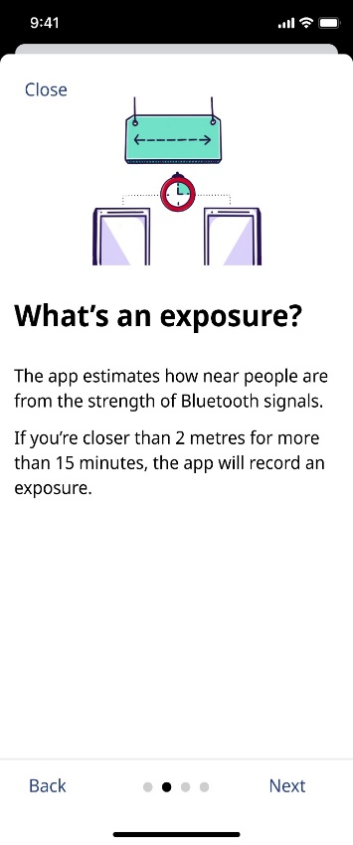

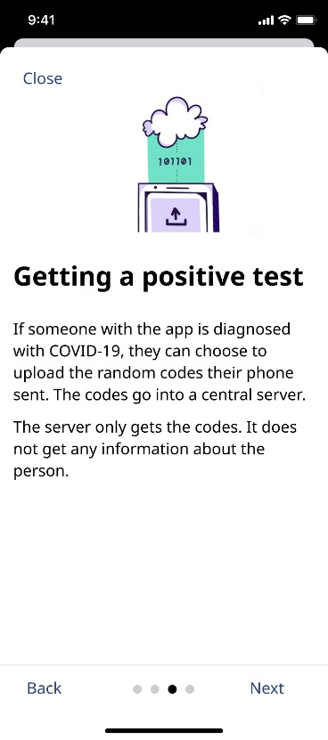
The four figures above show a series of screenshots, in sequential order that Canadians would see on the COVID Alert app. Each frame has a ‘Close’ button on the top right, an image, headline and sub-text in the main frame, and at the bottom, there is a progress bar along with ‘Back’ and ‘Next’ buttons to move through from page to page.
1. This image shows a cell phone in a person’s pocket (in purple) that has a sync icon on the screen. Next to the cell phone is a rectangle block of arrows coming into the phone and away from the cell phone (in green). Headline: How COVID Alert works. Sub-text: The app runs in the background and will not interrupt your activities. Whenever you’re near someone else with COVID Alert, both phones exchange random codes every 5 minutes. The random codes change often and cannot be used to identify you.
2. This image shows two cell phones (in purple) connected by a dotted line above with a timer icon in the middle. Above this is a sign (in green) with a dotted double arrow icon. Headline: What’s an exposure? Sub-text: The app estimates how near people are from the strength of Bluetooth signals. If you’re closer than 2 metres for more than 15 minutes, the app will record an exposure.
3. This image shows a cell phone (in purple) with an export icon on the screen. Above this is a rectangle (in green) that shows the code 101101. Above this is an icon of a white cloud. Headline: Getting a positive test. Sub-text: If someone with the app is diagnosed with COVID-19, they can choose to upload the random codes their phone sent. The codes go into a central server. The server only gets the codes. It does not get any information about the person.
4. This image shows a cell phone (in purple) at the bottom. Above the phone is a vertical rectangle (in green) with codes 00100, 01101, 01101. Over the middle code (01101) is a search bar. Headline: Looking for exposures. Sub-text: Every day, whenever it has an Internet connection, your phone will get a list of the random codes from people who reported a diagnosis. If it finds codes that match, the app notifies you that you’ve been exposed and gives you guidance.

Onboarding
The five figures above show a series of screenshots, in sequential order, that Canadians would first see when they download and open the COVID Alert app. Each frame has an image, headline and sub-text in the main frame. At the bottom, there is a progress statement (e.g. Step 1 of 6), along with a ‘Next’ button to move to the next page.
1. This image shows the top of a cell phone (in purple) with icons of people doing different activities above. Headline: Together, let’s stop the spread of COVID-19. Sub-text: COVID Alert helps us break the cycle of infection. The app can let people know of possible exposures before any symptoms appear. That way, we can take care of ourselves and protect our communities.
2. This image shows icons of a corporate building, an apartment building and several houses all connected. Headline: What COVID Alert does not do. Sub-text: The app will not tell you in the moment if you’re currently near someone who’s been diagnosed. It will not tell you about outbreaks in your community.
3. This image shows a silhouette of a person’s face using icons of a hat and glasses (in purple). Above this, is a location services symbol (in red) with an ‘X” through it. Headline: Totally anonymous. Sub-text: COVID Alert does not use GPS or location services. It has no way of knowing: X Your location. X Your name or address. X Your phone’s contacts. X Your health information.
4. This image shows two people holding cell phones and a person with a cell phone in their pockets (in purple). Above each cell phone is a Bluetooth icon (in green). Headline: How it works. Sub-text: ✓ The app uses Bluetooth to exchange random codes with nearby phones. ✓ Every day, it checks a list of random codes from people who tell the app they tested positive. ✓ If you’ve been near one of those codes in the past 14 days, you will get a notification. At the bottom of the frame there is a button that reads ‘Learn more about how it works’ with a forward arrow.
5. This image shows a cell phone (purple). On screen, is a series of text with an ‘X’ (in red) and a ‘✓” (in green) at the bottom. Headline: The app will now ask your permission. Sub-text: Allow the app to start logging random codes or “random IDs” when you’re near other phones. The app will access the date, duration, and signal strength related to the random codes, but they never leave your phone. You’ll also need to enable push notifications. At the bottom of the frame there is a button that reads ‘Learn more about privacy’ with a forward arrow.

COVID-19 Brand Concepts – Ad Testing

Concept A

A1
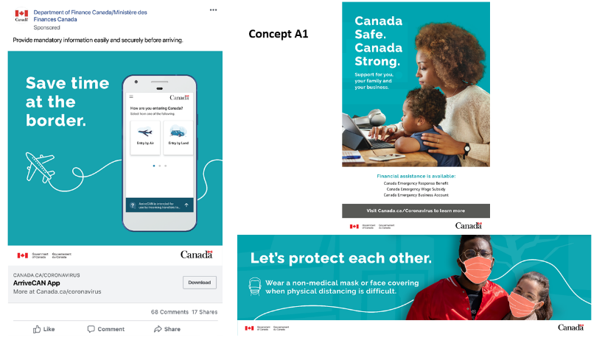
Concept A1: The figure above shows an ad set consisting of three ads over different mediums – Facebook, print and billboard ad. All ads feature a teal blue background and have a main headline in large white font. The first ad’s (Facebook) main headline (on the left) reads “Save time at the border.” along with a small icon of a plane. On the right hand side of this ad a smartphone is shown, featuring a Government of Canada ArriveCan app that reads “How are you entering Canada?” and provides two options on screen – entering by air or by land. At the bottom, there is a button to download the app or find out more information at Canada.ca/coronavirus. The second ad (print) shows a large image of a woman and her son on a computer together. On the left hand side the main headline reads “Canada Safe. Canada Strong.” and a sub-headline that reads “Support for you, your family and your business.” At the bottom of the ad, the ad reads “Financial assistance is available:” and lists the Canada Emergency Response Benefit, Canada Emergency Wage Subsidy and the Canada Emergency Business Account. Below this reads “Visit Canada.ca/Coronavirus to learn more” and the Government of Canada logo and wordmark are shown. The third ad’s (billboard) main headline reads “Let’s protect each other.” and has a sub headline that reads “Wear a non-medical mask or face covering when physical distancing is difficult.” alongside an icon of a public transit train. The right hand side of the ad features an image of a young man and woman with their arms wrapped around each other. Face masks are ‘drawn’ or overlaid on the two individuals faces. In the background there is a faint layer of trees and at the bottom of the ad, the Government of Canada logo and wordmark are shown.

A2
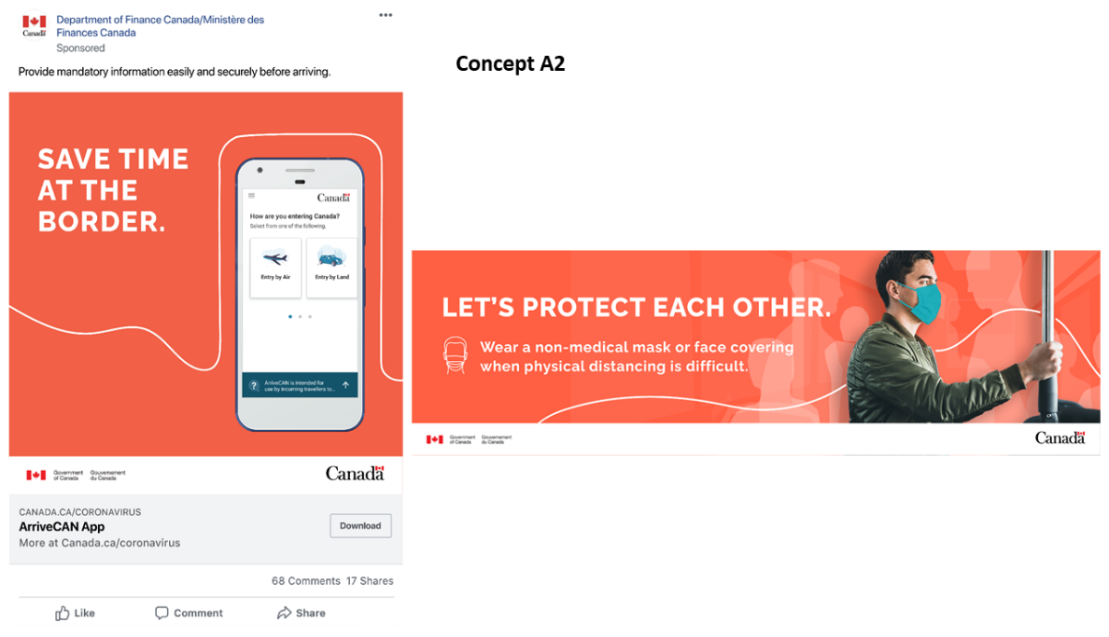
Concept A2: The figure above shows an alternative ad set consisting of two ads over different mediums – Facebook and billboard ad. All ads feature a red-orange background and have a main headline in large white font in capital letters. The first ad’s (Facebook) main headline (on the left) reads “SAVE TIME AT THE BORDER.” along with a small white line in the shape of a border. On the right hand side of this ad a smartphone is shown, featuring a Government of Canada ArriveCan app that reads “How are you entering Canada?” and provides two options on screen – entering by air or by land. At the bottom, there is a button to download the app or find out more information at Canada.ca/coronavirus. The second ad’s (billboard) main headline reads “LET’S PROTECT EACH OTHER..” and has a sub headline that reads “Wear a non-medical mask or face covering when physical distancing is difficult.” alongside an icon of a public transit train. The right hand side of the ad features an image of a young man holding a public transit pole, as if he is riding on a bus or a train. In the background, there are white shadow-like images of other people and at the bottom of the ad, the Government of Canada logo and wordmark are shown.

Concept B

B1
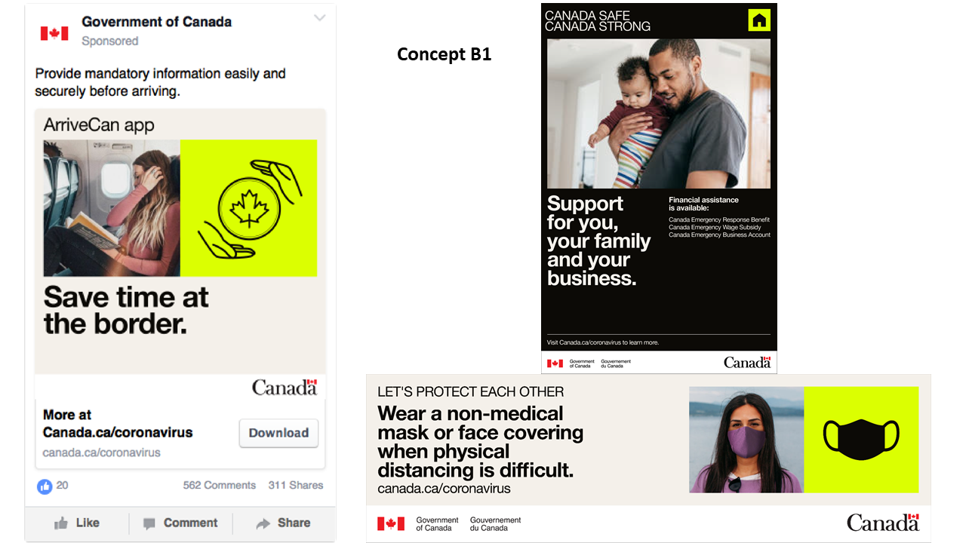
Concept B1: The figure above shows an ad set consisting of three ads over different mediums – Facebook, print and billboard ad. All ads feature an electric yellow, black and cream colour scheme and have a title headline and a main headline in black or white font. The first ad’s (Facebook) title headline reads “ArriveCan app” and the main headline reads “Save time at the border.” In between, there are two square images – one a photograph of a woman on a plane reading a book and tucking her hair behind her ear and another of a black icon of two hands surrounding a circle with a maple leaf in the middle, on a bright yellow background. At the bottom, there is a button to download the app with the text “More at Canada.ca/coronavirus”. The second ad (print) has the title headline at the top of the ad, which reads “CANADA SAFE. CANADA STRONG.” then, it shows a large image of a man holding his son in his arms in a home, in the centre of the page. The bottom half of the ad features the main headline (on the left) which reads “Support for you, your family and your business.” and a sub-headline on the right which reads “Financial assistance is available:” and lists the Canada Emergency Response Benefit, Canada Emergency Wage Subsidy and the Canada Emergency Business Account. At the bottom of the ad, it says “Visit Canada.ca/Coronavirus to learn more” and the Government of Canada logo and wordmark are shown. The third ad’s (billboard) title headline (on the left) reads “LET”S PROTECT EACH OTHER.” and has a sub headline that reads “Wear a non-medical mask or face covering when physical distancing is difficult.” on the left side of the ad. Below this, text with the URL canada.ca/coronavirus is presented. The right hand side of the ad features two square images – one of a young woman wearing a mask and another image of a black icon of a face mask, on a bright yellow background. At the bottom of the ad, the Government of Canada logo and wordmark are shown.

B2
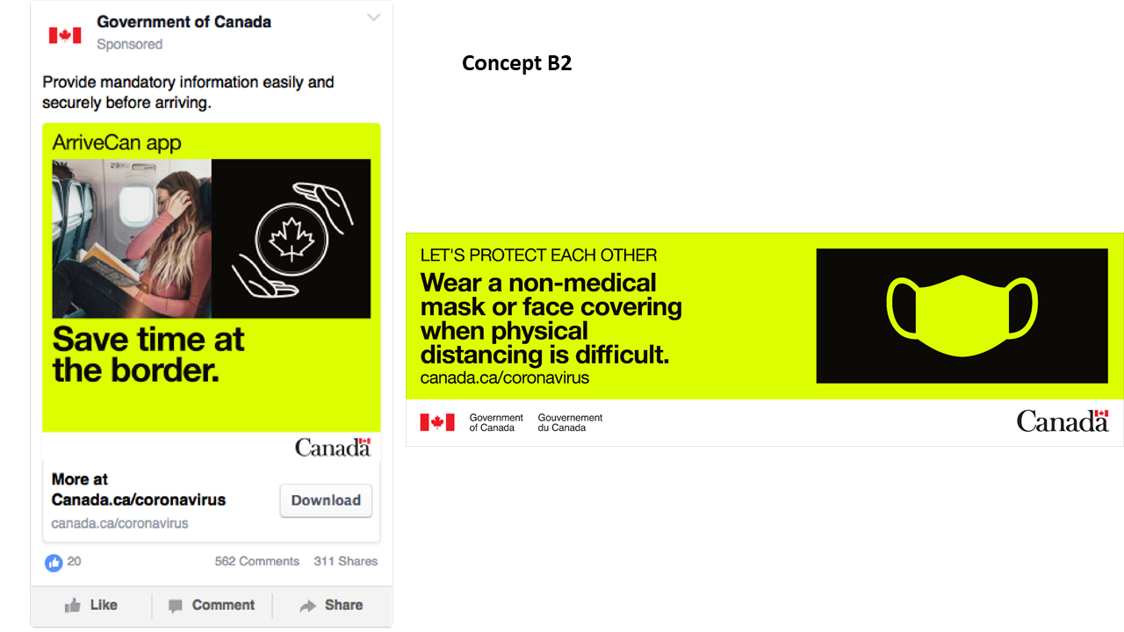
Concept B2: The figure above shows an alternative ad set consisting of two ads over different mediums – Facebook and billboard ad. All ads feature a bright yellow background and have a title headline and a main headline in large black font. The first ad’s (Facebook) title headline (across the top) reads “ArriveCan app.” and the main headline reads “Save time at the border.” In between, there are two square images – one a photograph of a woman on a plane reading a book and tucking her hair behind her ear and another of a white icon of two hands surrounding a circle with a maple leaf in the middle, on a black background. At the bottom, there is a button to download the app with the text “More at Canada.ca/coronavirus.” The second ad’s (billboard) title headline reads “LET’S PROTECT EACH OTHER.” on the left side with a main headline below that reads “Wear a non-medical mask or face covering when physical distancing is difficult.” Below this, text with the URL canada.ca/coronavirus is presented. The right hand side of the ad features an icon of a bright yellow face mask on a black background. At the bottom of the ad, the Government of Canada logo and wordmark are shown.

Concept C

C1
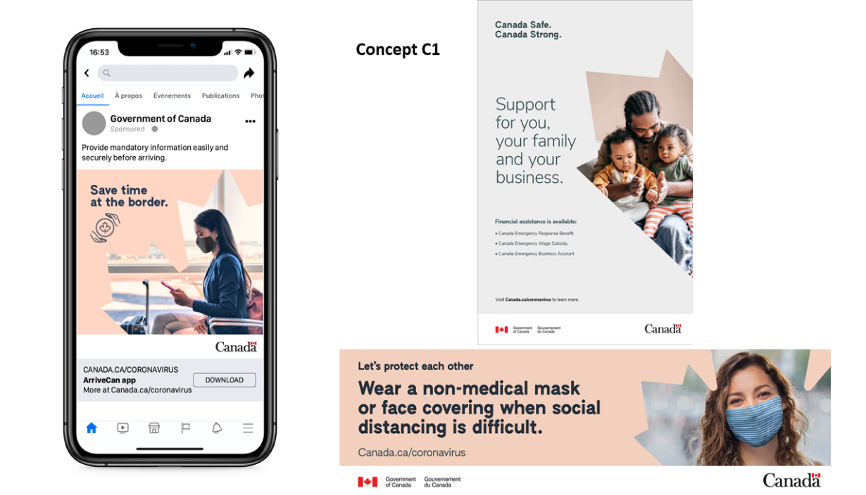
Concept C1: The figure above shows an ad set consisting of three ads over different mediums – Facebook, print and billboard ad. All ads feature a peach and light grey background colour and have a main headline in large black font. The first ad’s (Facebook) main headline (on the left) reads “Save time at the border.” along with a small icon of two hands surrounding a circle with a maple leaf in the middle. The right side of the ad features a photograph of a woman wearing a mask in an airport, which is framed by a maple leaf. At the bottom, there is a button to download the app or find out more information at Canada.ca/coronavirus. The second ad (print) shows (on the right) a large image of a man sitting while holding his two children, which is framed by a partial maple leaf. On the left hand side the main headline reads “Canada Safe. Canada Strong.” and a larger sub headline below reads “Support for you, your family and your business.” Underneath this, is smaller text that reads “Financial assistance is available:” and lists the Canada Emergency Response Benefit, Canada Emergency Wage Subsidy and the Canada Emergency Business Account. At the bottom of the ad the text “Visit Canada.ca/Coronavirus to learn more” and the Government of Canada logo and wordmark are shown. The third ad’s (billboard) main headline reads “Let’s protect each other” and has a sub headline that reads “Wear a non-medical mask or face covering when physical distancing is difficult.” Below this, text with the URL canada.ca/coronavirus is presented. The right hand side of the ad features a photograph of a young man smiling as she is wearing a mask, which is framed by the outline of a maple leaf. At the bottom of the ad, the Government of Canada logo and wordmark are shown.

C2
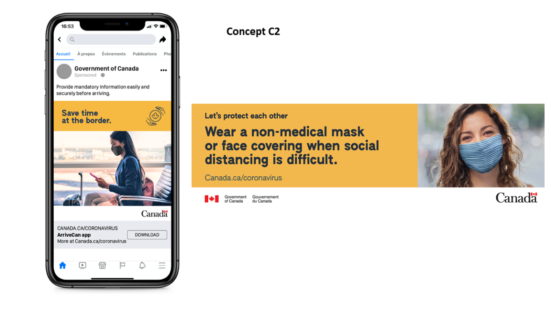
Concept C2: The figure above shows an alternative ad set consisting of two ads over different mediums – Facebook and billboard ad. All ads feature an orange background and have a title headline and/or a main headline in large black font. The first ad’s (Facebook) the main headline reads “Save time at the border.” (on the right) and a black icon of two hands surrounding a circle with a maple leaf in the middle (on the right). Underneath, taking up most of the ad, is a rectangular photograph of a woman wearing a mask in an airport. At the bottom, there is a button to download the app with the text “ArriveCan app” and “More at Canada.ca/coronavirus.” The second ad’s (billboard) title headline reads “Let’s protect each other.” (on the left side) with a main headline below that reads “Wear a non-medical mask or face covering when physical distancing is difficult.” Below this, text with the URL Canada.ca/coronavirus is presented. The right hand side of the ad features a square photograph of a young man smiling as she is wearing a mask. At the bottom of the ad, the Government of Canada logo and wordmark are shown.

