COVID-19 Snapshot Monitoring (COSMO) Study in Canada Phase 2

Summary

Prepared for the Privy Council Office (PCO)
Supplier: EKOS RESEARCH ASSOCIATES INC.
Contract Number: 35035-211315/001/CY
Contract Value: $249,509.48 (tax included)
Award Date: December 7, 2021
Delivery Date: June 26, 2023

Registration Number: POR-057-21
For more information on this report, please contact Public Opinion Research: POR-ROP@pco-bcp.gc.ca

Ce rapport est aussi disponible en français

COVID-19 Snapshot Monitoring (COSMO) Study in Canada Phase 2
Summary

Prepared for the Privy Council Office (PCO)
Supplier: EKOS RESEARCH ASSOCIATES INC.
Date: June 26, 2023

This public opinion research report presents the methodology for the conduct of eight online surveys conducted by EKOS Research Associates Inc. on behalf of the Privy Council Office (PCO).

Cette publication est aussi disponible en français sous le titre : Surveillance instantanée COVID-19 (SICO Canada): Phase 2.

This publication may be reproduced for non-commercial purposes only. Prior written permission must be obtained from PCO.

Catalogue Number: 978-0-660-49315-2

International Standard Book Number (ISBN): CP22-201/2023E-PDF

Catalogue Number (French Report): 978-0-660-49316-9

ISBN: CP22-201/2023F-PDF

© His Majesty the King in Right of Canada, 2023

Summary

Background and Methodology

The Privy Council Office (PCO) is the hub of non-partisan, public service support to the Prime Minister and Cabinet and its decision-making structures. Led by the Clerk of the Privy Council, PCO helps the Government implement its vision and respond effectively and quickly to issues facing the government and the country.

Between March 2020 and September 2021, PCO led the implementation of the COVID-19 Snapshot Monitoring (COSMO) Study Phase 1, which longitudinally captured respondents’ perceptions, knowledge, and behaviours in response to the pandemic. The COSMO Study Phase 1 was founded on a comprehensive survey developed by the World Health Organization (WHO), released to assist countries in quickly establishing a data collection mechanism to track the evolving response context related to COVID-19 at the citizen-level. It enabled PCO to contribute evidence-based, behaviourally-informed insights and recommendations to public communication materials, policy and programmatic considerations, and whole-of-government decision-making related to the Government of Canada’s broader response effort.

This report outlines the methodology used in the COSMO Study’s second Phase, which continued to monitor the evolving pandemic response context with a refreshed sample of Canadians (including a flexible oversample of diverse sub-segments of the population), and a restructured survey body exploring new thematic areas related to re-integration and recovery. More specifically, as the country gradually re-opened, this study monitored Canadians’ beliefs and behaviours on the road to re-integrating to workplaces, social circles, and the day-to-day activities they engaged in before the pandemic, and further explored the factors posing threats to collective recovery emerging from Phase 1 evidence (e.g., vaccine hesitancy, exposure to and spread of mis/disinformation).

Through a partnership with HC and PHAC, the implementation of the COSMO Study Phase 2 allowed PCO to monitor progress and explore challenges related to pandemic recovery, identify specific segments of Canadians with greater need for support, and then tailor efforts to those specific contexts with a deeper understanding of these priority populations.

The target audience for this study was adults living in Canada 18 years of age and older, aiming for appropriate representation of gender, age, education, and regional split (Canadian citizens as well as permanent residents).

The study consisted of eight survey waves of 2,000 respondents each. The sample included general population respondents in all survey waves, as well as an oversample of selected underrepresented populations in one of the waves (sixth wave only).

Expenditure

The contract amount for this project was $249,509.48 (including HST).

Political Neutrality Certification

I hereby certify as Senior Officer of EKOS Research Associates Inc. that the deliverables fully comply with the Government of Canada political neutrality requirements outlined in the Communications Policy of the Government of Canada and Procedures for Planning and Contracting Public Opinion Research.

Specifically, the deliverables do not include information on electoral voting intentions, political party preferences, standings with the electorate or ratings of the performance of a political party or its leaders.
Signed by: 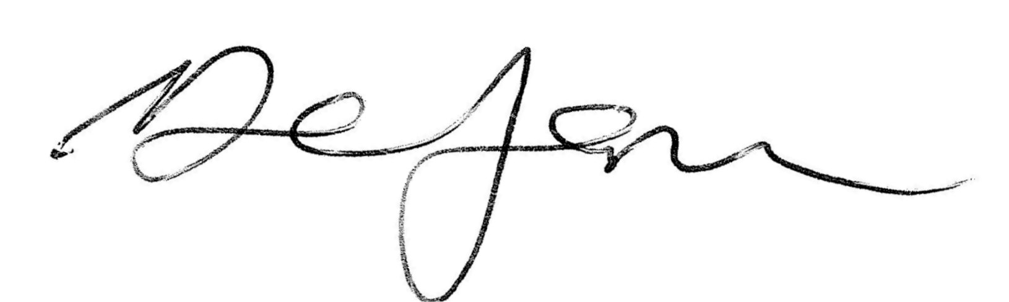
Derek Jansen (Vice President)

