

Public Views on Information Sharing

Submitted to:
Public Safety and Emergency Preparedness Canada
April 2005

Table of Contents
Background 1
Methodology 3
Key Findings and Conclusions 4
Conclusions 9
Detailed Findings 11
Most Important Issue Facing Communities 11
Perceived Change in Crime 12
Confidence in Canada’s Efforts to Ensure Public Safety 13
Satisfaction with Government Performance in Ensuring Public Safety 14
Confidence in the Components of Public Safety 16
Awareness of Information Sharing Efforts 18
Perceived Importance of Information Sharing 20
Perceived Performance in Information Sharing 22
Attitudes Regarding Information Sharing 23
Reasons to Support Information Sharing 23
Reasons Not to Support Information Sharing 26
Views on Types of Information That Should Be Shared 28
Confidence in the Security of Personal Information 31
Appendix I – Topline Questionnaire 33

Background
As part of the Government of Canada’s commitment to improve public safety and security information sharing and interoperability between public safety agencies, Public Safety and Emergency Preparedness Canada (PSEPC) - in collaboration with other federal partners, developed the Integrated Justice Information (IJI) Action Plan. This Plan included the initial implementation phase of the federal component of the Canada Public Safety Information Network (CPSIN). The goal of CPSIN was to deliver a new electronic information-sharing capacity – that would form the basis for a modern, national information network linking the various sources of information to criminal justice and law enforcement practitioners.
PSEPC’s Public Safety Interoperability Directorate (then Integrate Justice Information Secretariat) led a multi-departmental working group which developed six core performance indicators to measure progress of information sharing activities and their impacts on public safety. These core indicators measure: public confidence and awareness of information sharing efforts; the number of agencies represented in information sharing agreements; public safety practitioner confidence with information sharing; federal funds committed to information sharing initiatives; development and use of standards and common tools; and the number of users with electronic access to public safety information.
One of the sources of data identified for these indicators was a survey gauging public opinion. The purpose of this survey is to measure public opinion on information sharing among public safety agencies and the perceived impact of this information sharing on public safety.
Whenever possible, the results from this study are compared to those from an earlier public opinion survey conducted by Ipsos-Reid in 2002, enabling an assessment of shifts in public opinion over time. In addition, this study examines the results from a number of similar questions asked as part of a survey conducted among public safety practitioners in February 2003.
Methodology
The present research involved a random national telephone survey of 1,800 Canadians conducted between February 28 and March 8, 2005. A sample of this size provides a reasonable margin of error for the overall findings (±2.3 percentage points, 19 times out of 20), and is large enough to analyze the findings across demographic characteristics (e. g. , age, income, geographic region, educational attainment). Please note that the margin of error associated with demographic subgroups is higher than that of the overall findings. The distribution of the sample by region is outlined below.
Atlantic Provinces | 138
Quebec | 445
Ontario | 682
Saskatchewan/Manitoba | 122
Alberta | 175
B. C | 238
TOTAL | 1,800

Questions in this research were cross-tabulated against relevant demographic and attitudinal sub-groups (e. g., region, gender, age, educational attainment, etc. ) in order to add context to the results obtained.
Tracking
Several questions throughout this research are tracked against the results from earlier studies of a similar nature conducted on behalf of PSEPC. In particular, Ipsos-Reid conducted a study among 1,800 members of the general public in March 2002, and also conducted research among criminal justice and law enforcement practitioners in February 2003.
Key Findings and Conclusions
Top of Mind Issues
As in 2002, respondents were first asked what they felt were the most important problems or concerns in their community. Health care remains the top priority (24% down from 30% in 2002), while crime and violence has grown as a top-of-mind concern (to 18% from 12% in 2002).
Education and schools have significantly declined as major issues (to 12% from 18% in 2002), while concerns about jobs and unemployment have also slightly declined (to 11% from 14%). All other issues are mentioned by less than 10% of respondents. Consistent with 2002 findings, public safety and security are mentioned by only 5% of Canadians as a top-of-mind issue.
It is interesting to note that, consistent with the 2002 survey results, respondents make a distinction between “public safety and security” and “crime and violence” as separate problems or concerns. In order to obtain comparable results across studies, “public safety and security” was subsequently defined to survey participants to include police, prosecutors, the courts, border security, corrections and parole services, in all jurisdictions.
Perceived Change in Crime
Half of Canadians (50%) believe that crime has remained the same over the last five years. Two in five Canadians (41%) feel that crime has increased in their neighbourhood in the past five years, and only 6% think crime has decreased (3% are unsure).
Confidence in Canada’s Efforts to Ensure Public Safety
More than three quarters of respondents (77%) say they are either very (17%) or somewhat confident (60%) in Canada’s efforts to ensure public safety. Just one in five (22%) say they are not very (16%) or not at all confident (6%).
Satisfaction with Government Performance in Ensuring Public Safety
Among the federal, provincial and municipal levels of government, Canadians express the highest degree of satisfaction in the performance of municipal governments in ensuring public safety (76% saying very or somewhat satisfied). About two in three (65%) say they are satisfied with the performance of provincial governments, while three in five (61%) say they are satisfied with federal performance (9% very satisfied; 52% somewhat satisfied).
Confidence in the Components of Public Safety
Respondents were also asked how much confidence they have in various components of public safety and security in Canada. The “law” (policing aspects) receive the highest confidence levels: fully 87% of Canadians are very or somewhat confident in the RCMP, 82% are very or somewhat confident in their local police, and 79% express confidence in their provincial police.
The “order” aspects of public safety and security are given more mixed results: nearly three in four (73%) express confidence in the Supreme Court, while seven in ten (69%) are very or somewhat confident in the ability of prosecutors. However, a significantly smaller proportion of Canadians (57%) express similar confidence in the courts in general.
Canadians assign the lowest levels of confidence to the corrections component of public safety and security: about half (49%) express confidence in the prison system, and only one in three Canadians (34%) express confidence in the parole system.
The confidence of Canadians’ in the tested components of public safety and security has changed very little since 2002. The most noteworthy change in public confidence is the decline with respect to both the Supreme Court (to 73% from 78%) and the courts generally (to 57% from 62%).
Awareness of Information Sharing Efforts
Canadians are no more aware of Government of Canada efforts to improve the sharing of information between public safety agencies and jurisdictions than in 2002. Fewer than four in ten (38%) say they are very (6%) or somewhat (32%) aware of these efforts (unchanged since 2002). Public safety practitioners interviewed in 2003 indicated a significantly higher level of awareness of information sharing efforts, at 68%.
Those respondents who said they are aware of information sharing efforts by the Government of Canada were then asked, on an unaided basis, to identify initiatives they have heard about. One in four (25%) of these respondents could not provide an answer to this question, and 15% mentioned the general idea that nothing or not enough is being done in this area. These findings are consistent with the 2002 survey results and suggest that awareness of specific Government of Canada efforts to enhance information sharing is limited.
Among the specific responses, increased information sharing between departments (8%) and law enforcement agencies (7%) are mentioned most often, followed closely by information sharing between the federal and provincial governments (6%). Others referenced freedom of information and privacy legislation (6%) and the national sex offender registry (5%).
Perceived Importance of Information Sharing
Nearly all Canadians (97%) indicate that information sharing among public safety agencies is important to improving public safety – including 83% who believe these efforts are very important. This result is unchanged from 2002, when 96% indicated that information sharing is important. In addition, 98% of public safety practitioners interviewed in 2003 also viewed information sharing as either important or very important.
When asked on an unaided basis why information sharing is important, the most popular responses centre on the notion that all agencies should be cooperating (31%); that information sharing helps everyone do their job better (17%); that there would be increased awareness of public safety issues (16%); and that public safety would be improved (15%). In addition, respondents say simply that it is important to share public safety information (13%) and that people in the community have a right to know and should be made aware of public safety issues (10%). All other responses were mentioned by fewer than 10% of respondents.
Interestingly, these results indicate that certain respondents (10%) feel that information sharing should extend to people in the community and thus be a component of public awareness.
The 2005 survey findings show that 36% of respondents feel that all agencies should cooperate and have access to the same information, while only 27% expressed a similar view in 2002.
Perceived Performance in Sharing Information
The majority of Canadians (57%) believe that governments in Canada are doing a very good (4%) or somewhat good (53%) job sharing information among public safety and security agencies. These results are largely consistent with 2002 findings, where 60% of respondents indicated that the Government of Canada was doing a good job.
Reasons to Support Information Sharing
Fully 94% of Canadians agree that information sharing between public safety agencies will improve the efficiency of the criminal justice system and thus increase public safety in Canada. Roughly the same proportion of Canadians (93%) agree that more and better information on previous criminal convictions would be a powerful tool to help police and the courts reduce crime in Canada.
Other attitudinal measures suggest that Canadians feel that safety and security concerns override the protection of some individual rights. Nearly two-thirds of Canadians (63%) think the police and prosecutors should be given more powers to ensure public safety, even if it might be seen as an infringement of some individual rights. A similar proportion (61%) believes that terrorism threats outweigh the protection of individual rights, such as the right to privacy.
Since 2002, there has been little change in the levels of agreement among the general public for reasons to support improved information sharing. Canadians are, however, somewhat less likely to agree that terrorism threats outweigh the protection of certain individual rights and privacy (61% compared to 66% in 2002).
In addition, the tested reasons for sharing information received consistent support by both the general public and public safety practitioners interviewed in 2003. However, a significantly greater number of practitioners indicated that the threat of terrorism outweighs individual rights (79%) and that the police and prosecutors should be given more powers to fight crime, even if seen as an infringement on individual rights (76%).
Reasons Not to Support Information Sharing
Two in three Canadians (65%) agree with the idea that more police and more support for the courts would be a better way to improve public safety than sharing information between public safety agencies.
Respondents are increasingly likely to express concern that information sharing may infringe on Canadians’ rights to privacy (60% compared to 55% in 2002). Interestingly, public safety practitioners interviewed in 2003 were much less likely to share this concern (37%).
Views on Types of Information That Should Be Shared
The general public continues to strongly endorse sharing several different types of information, as they did in 2002. In addition, it is worth observing that public safety practitioners interviewed in 2003 also broadly endorsed the sharing of several different kinds of information, but to an even higher degree than the general public.
Over nine in ten believe that the criminal records of individuals who have been convicted (94%), whether someone is unlawfully present in Canada (92%), and information about criminal charges originating in other countries against individuals (91%) should be shared between public safety agencies.
Similarly, more than eight in ten believe that files of on-going criminal investigations (86%), and firearms ownership (82%) should be subject to information sharing.
While seven in ten believe that driver’s license information should be shared between public safety agencies, this level has declined since 2002 (to 70% from 75% in 2002). Similarly, support for sharing motor vehicle ownership information has declined (to 63%, down from 68% in 2002). Two-thirds of Canadians (66%) continue to believe that basic information about international travellers, such as names, gender and age, should be shared among public safety agencies.
Canadians are less enthusiastic about the sharing of information regarding travel destinations of individuals, and the race, national or ethnic origin of international travellers: less than half (48% and 46%, respectively) support the sharing of this type of information. These findings are consistent with 2002 survey results.
Canadians least often agree that criminal charges against individuals who were not convicted (42%) and information about financial transactions (38%) should be shared.
Confidence in the Security of Personal Information
A majority of Canadians (55%) are confident that personal information shared among public safety agencies is properly safeguarded – however, only 7% are very confident. Just over two in five (44%) lack confidence that personal information is properly safeguarded, including 11% who say they are not at all confident.
Those not confident that personal information is properly handled among public safety agencies were asked to explain why they feel this way. Most often, these respondents say they lack confidence because personal information is always leaked to the public or media (16%) or because of a general mistrust that the agencies in question will keep personal information private (15%). The idea that information frequently ends up in the wrong hands (14%), that too many people can access the information (14%), that the procedures to protect personal information are inadequate (14%) and that computer systems are insecure and vulnerable to being hacked (14%) are all mentioned prominently.

Conclusions
As in 2002, the findings reveal strong public support for information sharing between public safety agencies. These results are consistent across regional and demographic subgroups.
Despite a considerable length of time since the events of 9/11, there are few signs that the public is greatly concerned by the impact of information sharing on individual rights. Solid majorities widely agree that most of several proposed types of information should be shared among public safety agencies. However, there is a growing reluctance to have some types of information shared, particularly driver’s license information and motor vehicle ownership information - although a majority continue to endorse having this information shared among public safety agencies.
The results of the survey suggest that the public is willing to accept some encroachment on individual rights in the interests of improved public safety and security. A majority of Canadians believe that police and prosecutors should have more power to ensure public safety even if this infringes on individual rights, and that confronting terrorist threats outweigh the protection of individual rights.
That said a growing majority do express concern that information sharing among public safety agencies could compromise individual rights. In addition, while a majority express confidence that personal information shared among public safety agencies will be properly safeguarded, a significant 43% do not share this same confidence.
Furthermore, there may be some resistance to information sharing from a resource point of view – the findings indicate that more police and more support for the courts continue to be seen as a better way to improve public safety than information sharing. This suggests that governments should better communicate to the public the link between information sharing and resources – i.e., improved and more effective information sharing will free up police and court resources, thereby improving public safety.

Detailed Findings

Most Important Issue Facing Communities
As in 2002, respondents were first asked, on an unaided basis, what they felt are the most important problems or concerns in their community. Health care remains the top priority (24% down from 30% in 2002), while crime and violence has grown as a top-of-mind concern (to 18% from 12% in 2002).
Education and schools have significantly declined as major issues (to 12% from 18% in 2002), while concerns about jobs and unemployment have also slightly declined (to 11% from 14%). All other issues are mentioned by less than 10% of respondents. It is instructive to note that public safety and security is mentioned by only 5% of Canadians as a top-of-mind issue (consistent with 2002 findings).
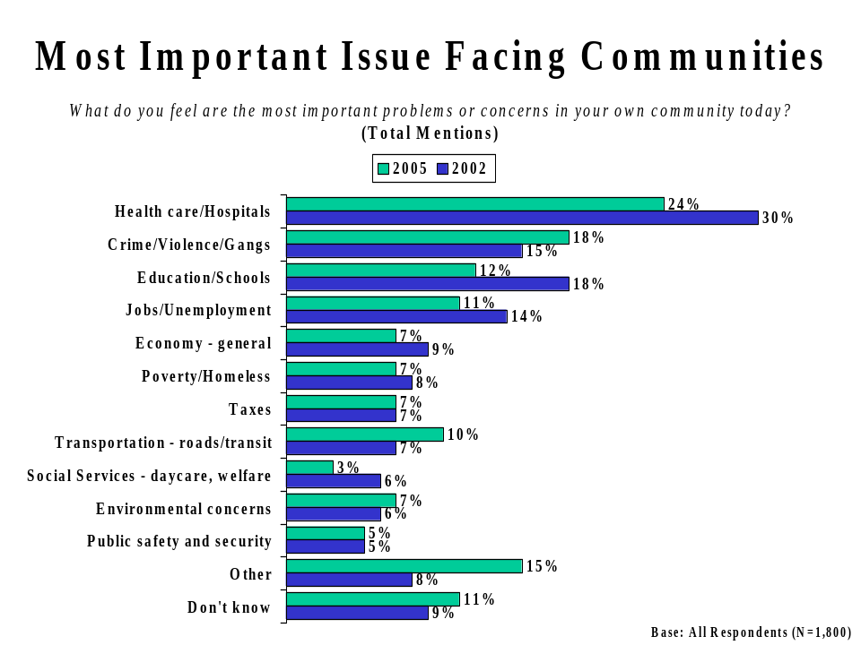

Perceived Change in Crime
Respondents were asked if they thought that crime in their community had increased, decreased, or remained about the same over the previous five years. Half of Canadians (50%) believe that crime has remained the same over this time period. Two in five Canadians (41%) feel that crime has increased in their neighbourhood in the past five years, and only 6% think crime has decreased (3% are unsure).
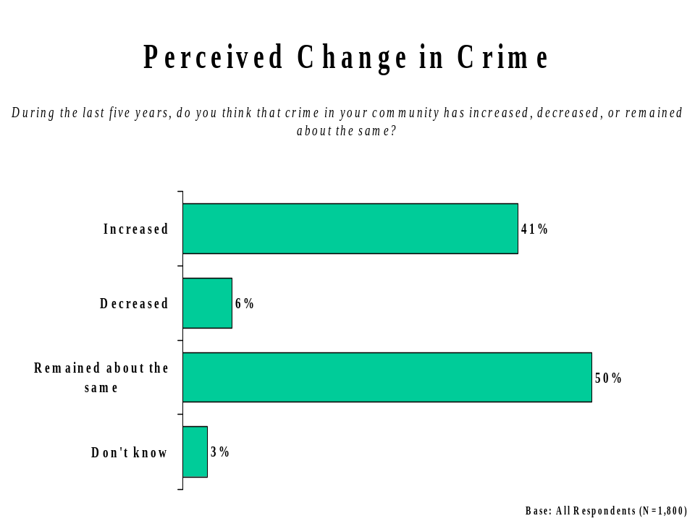
Those more likely to believe that crime in their community has increased in the past five years include:
- Residents of British Columbia (51%) and Alberta (53%);
- Older respondents (55 years and older: 46%);
- Those with a high school education (48%);
- Those not confident in Canada’s public safety efforts (54%); and,
- Those not at all satisfied with federal efforts to ensure public safety (55%).

Confidence in Canada’s Efforts to Ensure Public Safety
Over three in four respondents (77%) say they are either very (17%) or somewhat confident (60%) in Canada’s efforts to ensure public safety. Just one in five (22%) say they are not very (16%) or not at all confident (6%).
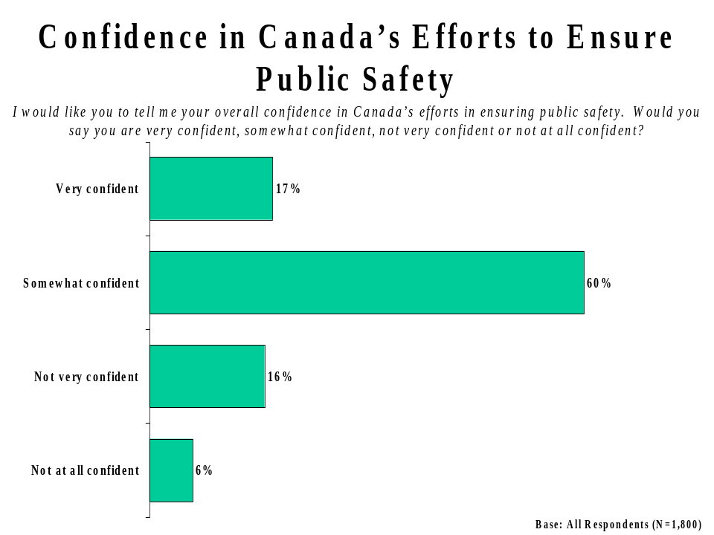
Those more likely to express confidence in Canada’s efforts to ensure public safety include:
- Residents of Ontario (82%) and Atlantic Canada (86%);
- Younger respondents (aged 18-34: 83%);
- Those with higher levels of educational attainment (university: 84%);
- Those with a higher annual income ($60,000 or more: 81%);
- Those who believe that the level of crime has remained the same over the past five years (83% -- notably higher than those who believe crime has decreased, 76%); and,
- Those satisfied with federal efforts to ensure public safety (89%).

Satisfaction with Government Performance in Ensuring Public Safety
Among the federal, provincial and municipal levels of government, Canadians express the highest degree of satisfaction in the performance of municipal governments in ensuring public safety (76% saying very or somewhat satisfied). About two in three (65%) say they are satisfied with the performance of provincial governments, while three in five (61%) say they are satisfied with federal performance (9% very satisfied; 52% somewhat satisfied).
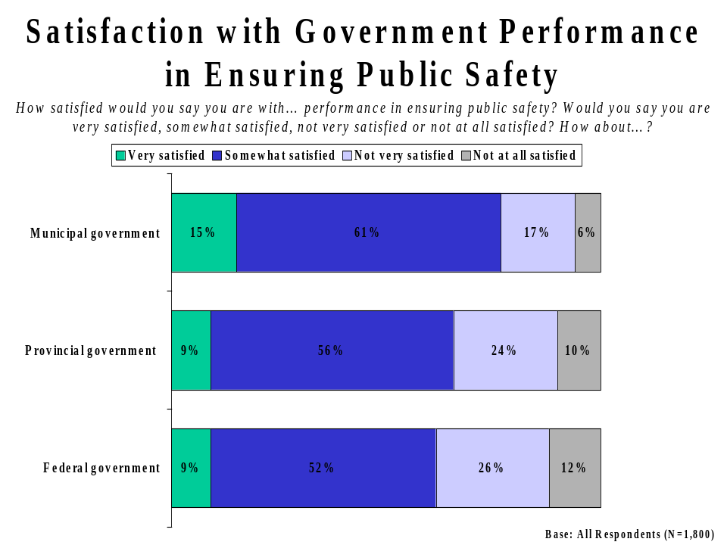
Those more likely to express satisfaction with federal government performance in ensuring public safety include:
- Residents of the Atlantic Provinces (71%);
- Younger respondents (18-34 years of age: 70%);
- Women (65% compared to 57% among men);
- Urban respondents (63% compared to 55% among rural respondents); and,
- University educated respondents (66%).

Among other subgroups, it is worth noting that Alberta residents express the highest levels of satisfaction in the efforts of their provincial (77%) and municipal governments (81%) in ensuring public safety. Also, those who say that crime in their community has decreased most often express satisfaction in their municipal government (82%).

Confidence in the Components of Public Safety
Respondents were also asked how much confidence they have in various components of public safety in Canada. The “law” (policing) aspects of the public safety community are assigned the highest confidence levels: fully 87% of Canadians are very or somewhat confident in the RCMP, 82% are very or somewhat confident in their local police, and 79% express confidence in their provincial police.
The “order” aspects of public safety and security are given more mixed results: nearly three in four (73%) express confidence in the Supreme Court, while seven in ten (69%) are very or somewhat confident in the ability of prosecutors. However, a significantly smaller proportion of Canadians (57%) express similar confidence in the courts in general.
Canadians assign the lowest levels of confidence to the corrections component of public safety and security: about half (49%) express confidence in the prison system, and only one in three Canadians (34%) express confidence in the parole system.
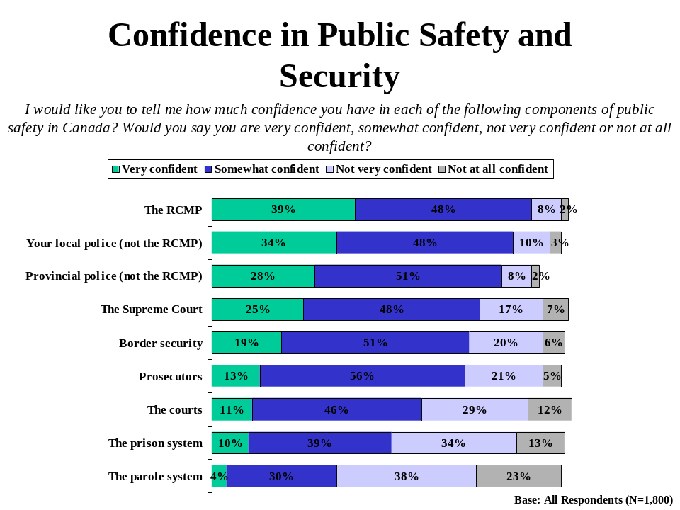
In general, confidence in the tested components of Canada’s public safety and security community tends to be higher among:
- Residents of Saskatchewan, Manitoba, Ontario and the Atlantic Provinces;
- Younger respondents (aged 18-34);
- Those confident in Canada’s public safety efforts; and,
- Those satisfied with the federal government.
Relatively little has changed since 2002 in Canadians’ confidence in the tested components of public safety. It is worth noting however that confidence has declined somewhat with respect to both the Supreme Court (to 73% from 78%) and the courts generally (to 57% from 62%).
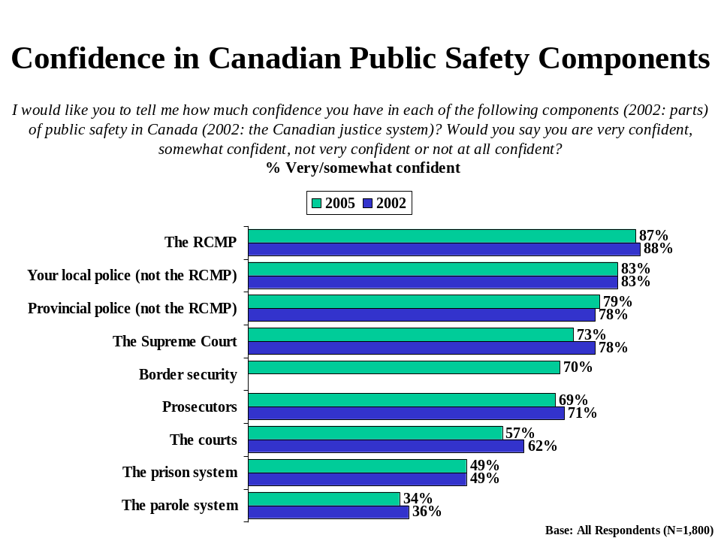

Awareness of Information Sharing Efforts
Canadians are no more aware of federal government efforts to improve the sharing of information between public safety agencies and jurisdictions than in 2002. Just fewer than four in ten (38%) said they were very (6%) or somewhat (32%) aware of these efforts (unchanged since 2002). Public safety practitioners interviewed in 2003 professed a significantly higher level of awareness with information sharing efforts, at 68%.
Three in five (62%) say they were not very (43%) or not at all (19%) aware of these information-sharing initiatives (also largely unchanged since 2002).
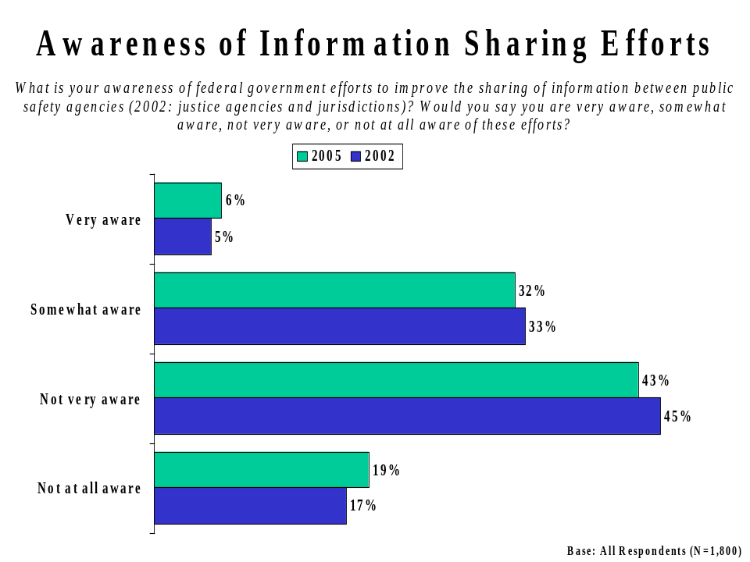
Claimed awareness of federal government efforts to improve information sharing is highest among:
- Those who believe that crime has decreased in their community over the past five years (52%);
- Residents of Ontario (41%), Atlantic Canada (42%), Saskatchewan and Manitoba (43%); and,
- Those with at least some university education (41%).
Those respondents who say they are aware of federal government information sharing efforts were asked, on an unaided basis, what initiatives they had heard about. One in four (25%) of these respondents could not provide an answer to this question, and 15% of these respondents mention the general idea that nothing or not enough is being done in this area. These findings, consistent with the 2002 survey, suggest that awareness of specific federal government efforts to share information is somewhat vague.
Among the specific responses, increased sharing between departments (8%) and law enforcement agencies (7%) is mentioned most often, followed closely by information sharing between the federal and provincial governments (6%). Others referenced freedom of information and privacy legislation (6%) and the national sex offender registry (5%).
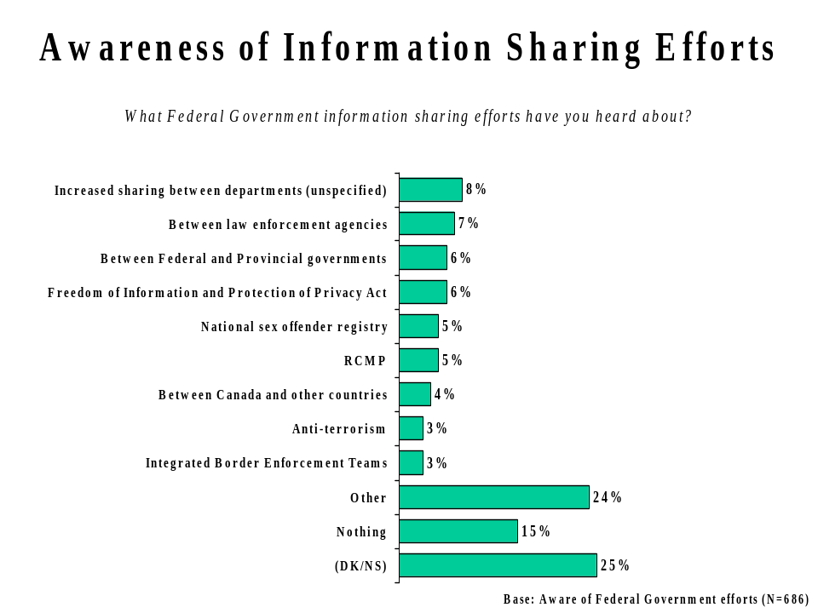

Perceived Importance of Information Sharing
Respondents were told that the Government of Canada is trying to improve information sharing between public safety agencies, such as the police, prosecutors, the courts, border security, corrections and parole, as well as between jurisdictions, such as federal, provincial and municipal governments, and then asked how important they think this information sharing is for improving public safety in Canada.
The vast majority of Canadians (97%) indicate that this is an important initiative to improve public safety - including 83% who think this is a very important initiative. This result is unchanged from 2002, when 96% said they view information sharing as important. In addition, public safety practitioners interviewed in 2003 also overwhelmingly viewed information sharing as critical (98% important, including 90% very important).
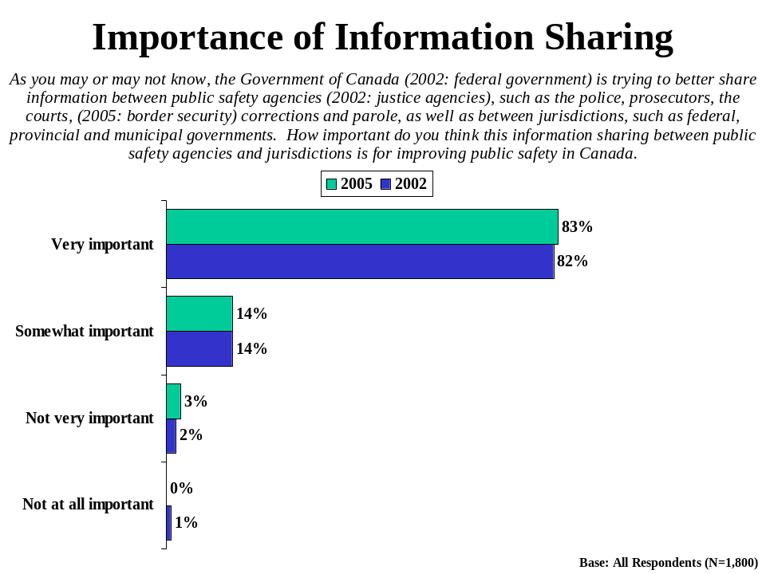
There are few significant demographic distinctions in the view of information sharing as an important way to improve public safety in Canada.
Respondents were asked on an unaided basis why they feel information sharing is important. The most common responses revolve around the ideas all that agencies should be cooperating (31%), that information sharing helps everyone do their job better (17%), that there would be increased awareness of public safety issues (16%) and that public safety would be improved (15%). In addition, respondents say simply that it is important to share this public safety information (13%) and that there is a right to know, that people in the community should be made aware of public safety issues (10%). All other responses were mentioned by less than 10% of respondents.
It is interesting to note that certain respondents feel that information sharing should extend to people in the community, and thus be an aspect of public awareness.

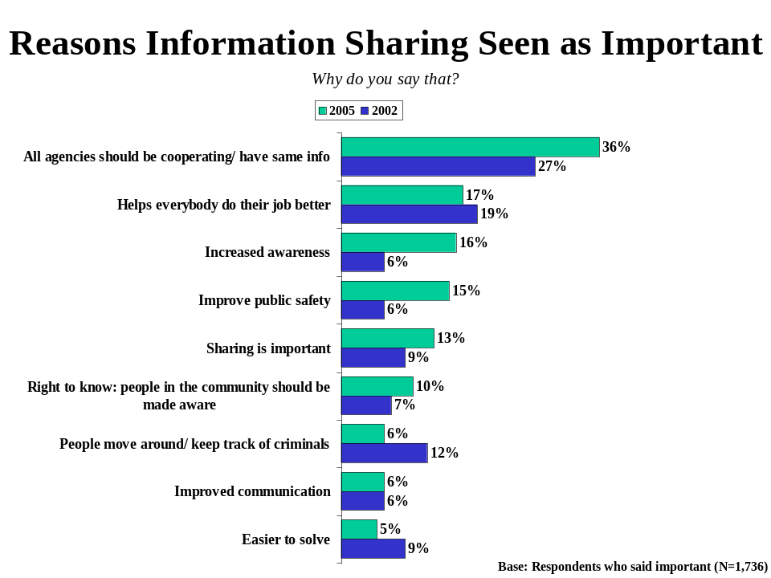
Tracking data shows that a larger proportion of respondents in 2005 identify the need for all agencies to cooperate and have access to the same information (36% compared to 27%). In addition, significantly greater numbers mention increased awareness of public safety threats (16% compared to 6%) and improving public safety (15% compared to 6%) as reasons for the importance of sharing information.

Perceived Performance in Information Sharing
Respondents were also asked to rate the current performance of governments in terms of sharing information between public safety agencies. The majority of Canadians (57%) believe that governments are doing a very good (4%) or somewhat good job (53%) of sharing information among public safety agencies. These results are largely consistent with 2002 findings, when 60% said the federal government was doing a good job.
One in three Canadians (32%) think governments are doing a bad job in this area (up slightly from 29% in 2002), while 12% are unsure.
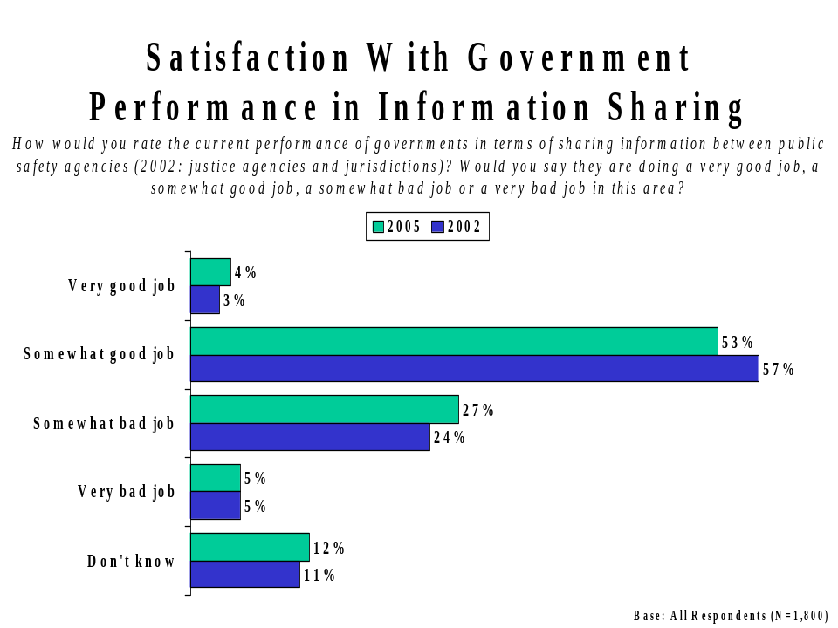
Satisfaction with government performance in terms of sharing information is highest among:
- Residents of Atlantic Canada (63%);
- Canadians between 18-34 years of age (67%);
- Those with either less than a high school education (64%) or a high school education (62%);
- Those earning less than $30,000 (63%);
- Those satisfied with government performance in ensuring public safety (67%).

Attitudes Regarding Information Sharing
Respondents were also asked a number of attitudinal questions regarding their support and their concerns with the sharing of information between public safety agencies.
Reasons to Support Information Sharing
Fully 94% of Canadians strongly (57%) or somewhat (37%) agree with the idea that information sharing between public safety agencies will improve the efficiency of the justice system and thus increase public safety in Canada. There is little variation among demographic subgroups in this perception.
Roughly the same proportion of Canadians (92%) strongly (61%) or somewhat (31%) agree that more and better information on previous criminal convictions would be a powerful tool to help police and the courts reduce crime in Canada. Lower income respondents particularly tend to agree with this statement.
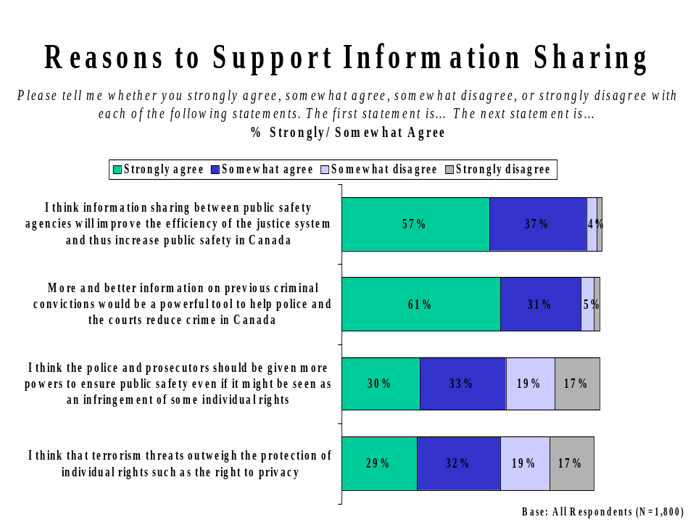
Other attitudinal measures suggest that Canadians feel that safety and security concerns override the protection of some individual rights. Nearly two-thirds of Canadians (63%) think the police and prosecutors should be given more powers to ensure public safety, even if it might be seen as an infringement of some individual rights. The same proportion (61%) thinks that terrorism threats outweigh the protection of individual rights, such as the right to privacy. Rural, low income respondents and respondents with lower levels of education are more likely to believe that concerns over safety, security and terrorism outweigh individual rights.
On a tracking basis, there has been little change in the levels of agreement among the general public for reasons to support information sharing. Canadians are, however, somewhat less likely to agree that terrorism threats outweigh the protection of individual rights and privacy than they were in 2002 (61% compared to 66%). This may reflect a lower degree of concern with terrorism as the events of 9/11 recede farther in the past.
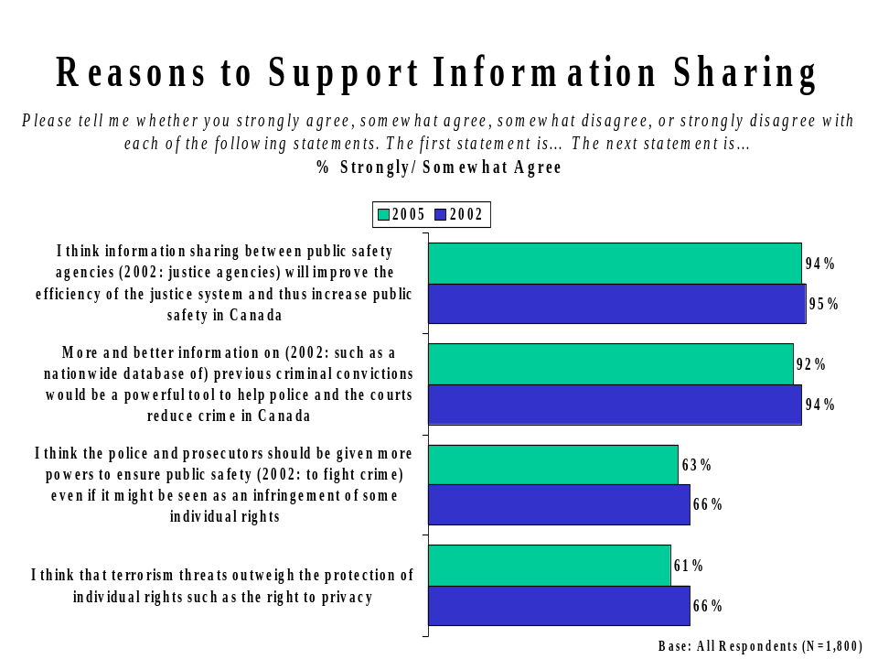
These results are consistent with those obtained from public safety practitioners interviewed in 2003 in the rational they provided for supporting information sharing. It is also worth noting that practitioners were significantly more likely to believe that the threat of terrorism outweighs individual rights (79%) and that the police and prosecutors should be given more powers to fight crime, even if seen as an infringement on individual rights (76%). This may reflect a higher level of knowledge and awareness amongst public safety practitioners of how this information is collected, protected, used and shared in support of public safety and security.
Reasons Not to Support Information Sharing
Two in three Canadians (65%) agree with the idea that more police and more support for the courts would be a better way to improve public safety than sharing information between public safety agencies. Agreement with this idea is highest among Canadians with less than a high school education, those earning less than $30,000 and older respondents (55 years and older).
Three in five Canadians (60%) express concern that information sharing may infringe on Canadians’ right to privacy. Demographically, those who express this concern tend to be between 18 and 34 years of age, have less than a high school education, and live in lower income households. Regionally, residents of Ontario, Saskatchewan and Manitoba are least likely to express concern that information sharing may lead to an infringement of Canadians’ right to privacy.
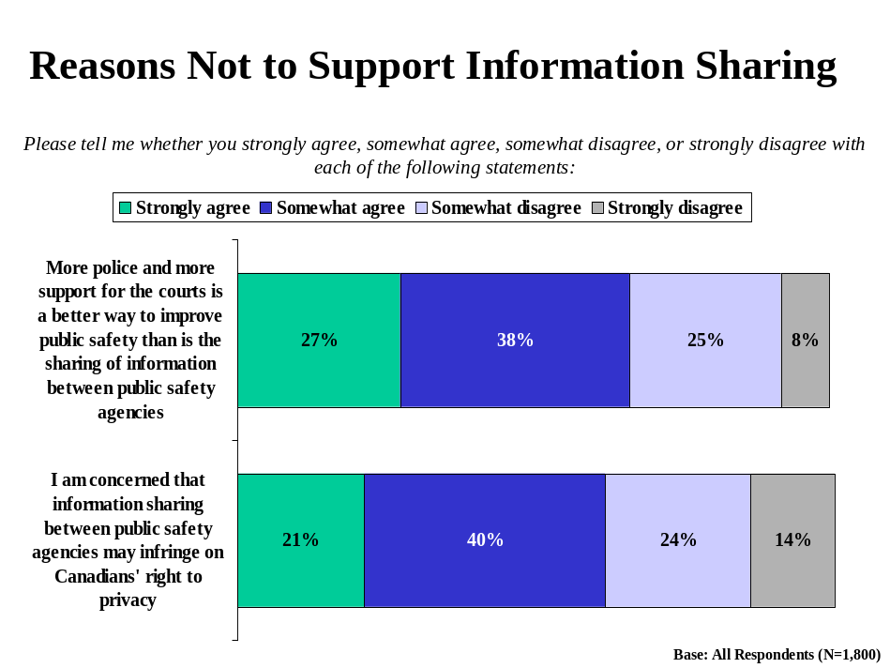
On a tracking basis, the results show little change since 2002 in the levels of those who feel that more police and more support for the courts would be a better way to ensure public safety than information sharing. Respondents are increasingly likely to express concern that information sharing may infringe on Canadians’ rights to privacy (60% compared to 55% in 2002); however, it is worth noting that public safety practitioners interviewed in 2003 were much less likely to share this concern (37%).
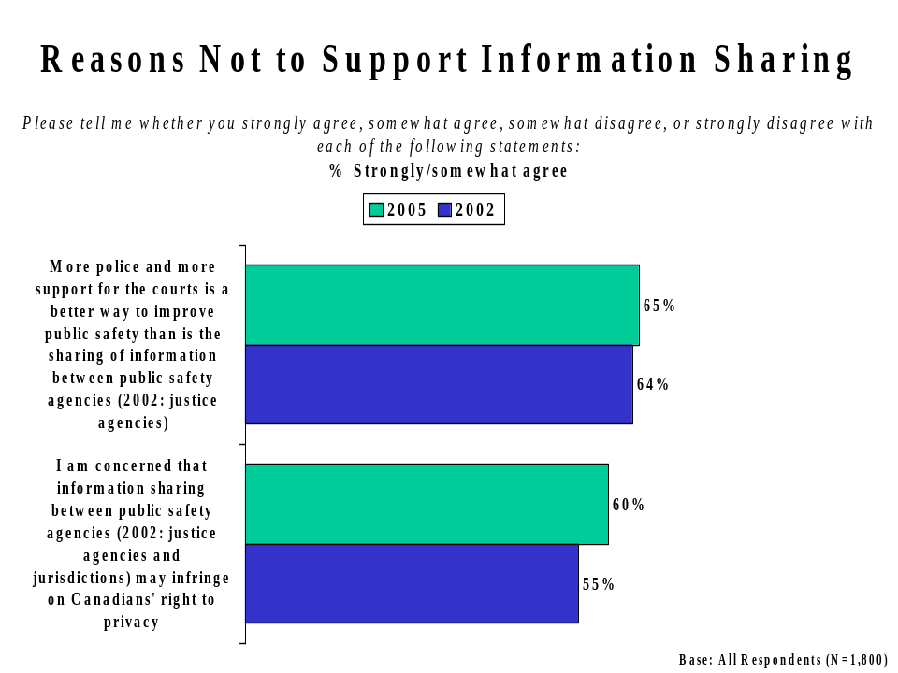

Views on Types of Information That Should Be Shared
Respondents were presented with a range of information types and asked which kinds of information they thought should be shared between public safety agencies. The findings reveal that the general public continues to strongly endorse the sharing of virtually all the types of information tested, as they did in 2002. In addition, it is worth observing that public safety practitioners interviewed in 2003 also broadly endorsed sharing the kinds of information tested, but to an even higher degree than the general public.
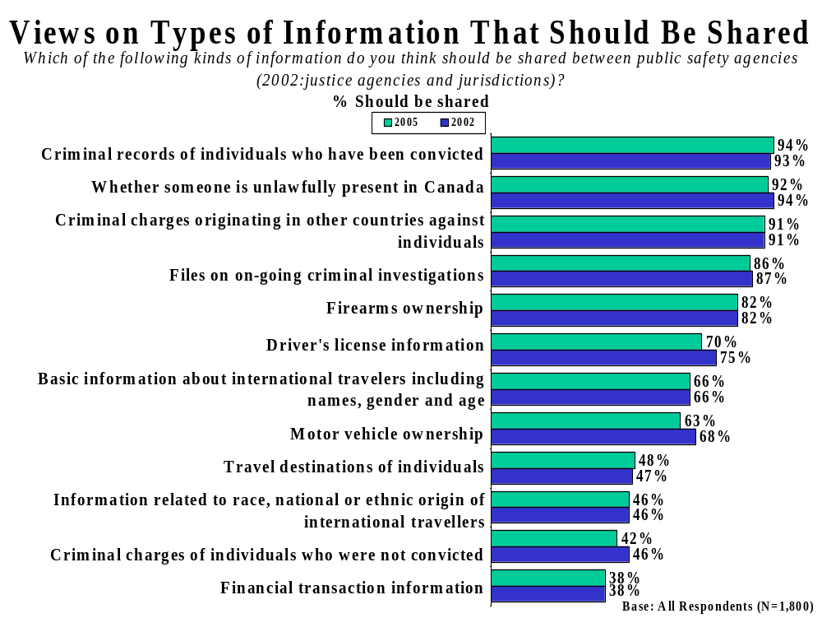
Over nine in ten believe that the criminal records of individuals who have been convicted (94%), whether someone is unlawfully present in Canada (92%), and information about criminal charges originating in other countries against individuals (91%) should be shared between public safety agencies. In this respect, little has changed since 2002.
Similarly, more than eight in ten Canadians believe that files of on-going criminal investigations (86%), and firearms ownership (82%) should be subject to information sharing - again, with almost no change since 2002.
While seven in ten respondents believe that driver’s license information should be shared between public safety agencies, this level has declined since 2002 (to 70% from 75% in 2002). Similarly, support for sharing motor vehicle ownership information has declined (to 63%, down from 68% in 2002). Two in three Canadians (66%) continue to believe that basic information about international travellers, such as names, gender and age, should be shared among public safety agencies.
Canadians are less supportive of the sharing of information regarding travel destinations of individuals, supported by only 48% of respondents. Similarly, only 46% support the sharing of information regarding the race, national or ethnic origin of international travellers. These findings are consistent with those from 2002.
Canadians least often agree that criminal charges against individuals who were not convicted (42%) and information about financial transactions (38%) should be shared.
Generally speaking, women, Canadians 55 years of age and older, and those who feel information sharing is important are more supportive of sharing the types of information tested. Regionally, there are few differences in support for sharing the types of information tested, with the exception of firearms ownership; residents of Alberta, Saskatchewan and Manitoba and the Atlantic Provinces show significantly lower support for sharing this type of information than others.
Respondents were also asked, on an unaided basis, if there were any types of information other than those tested which they thought should or should not be shared between public safety agencies.
The majority of respondents could not think of any other types of information that should (61%) or should not be shared (60%). Among those who were able to identify other types of information that should be shared, sexual offenders and pedophiles (5%) are mentioned; other responses were offered by 2% of respondents or less.
Among those who were able to identify other types of information that should not be shared, personal information (7%) and medical records (4%) were mentioned most often.
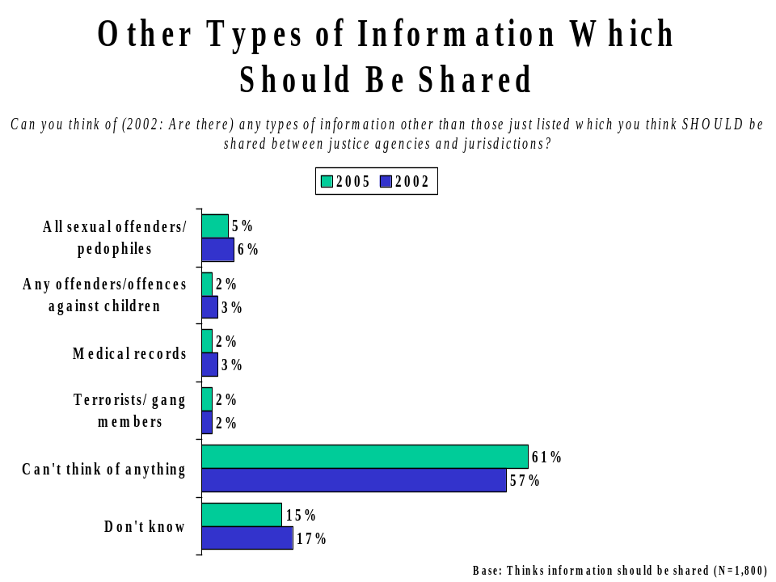
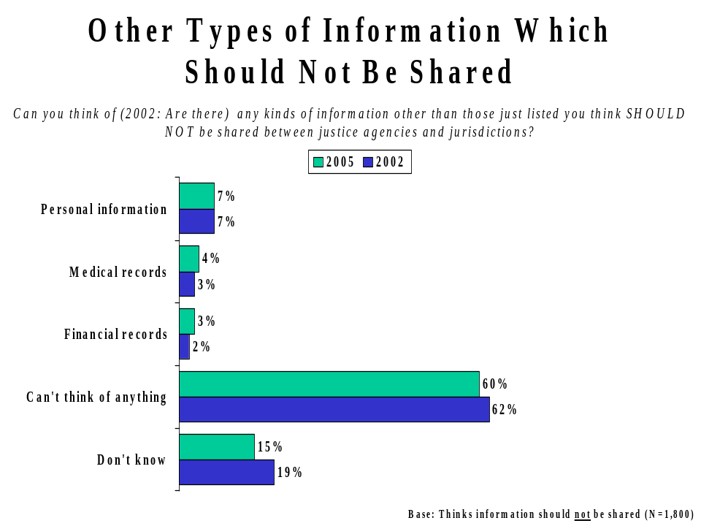

Confidence in the Security of Personal Information
A majority of Canadians (55%) are confident that personal information shared among public safety agencies is properly safeguarded – however, only 7% are very confident. Just over two in five (44%) lack confidence that personal information would be properly safeguarded, including 11% who say they are not at all confident.
Residents of Saskatchewan and Manitoba (66%), and British Columbia (61%), as well as younger respondents (18-34 years of age: 60%) tend to be more confident in the security of personal information than others.
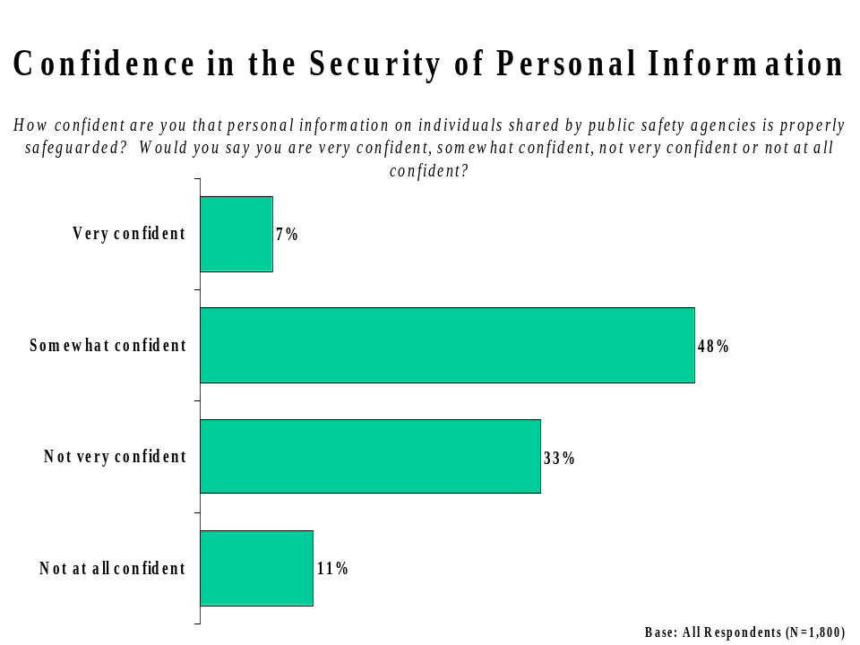
Those not confident that personal information is properly handled among public safety agencies were asked to explain why they feel this way. Most often, these respondents say they lack confidence because personal information is always leaked to the public or media (16%) or because of a general mistrust that the agencies in question will keep personal information private (15%). The idea that information frequently ends up in the wrong hands (14%), that too many people can access the information (14%), that the procedures to protect personal information are inadequate (14%) and that computer systems are insecure and vulnerable to being hacked (14%) are all mentioned prominently. Other responses are mentioned by fewer than 10% of respondents.
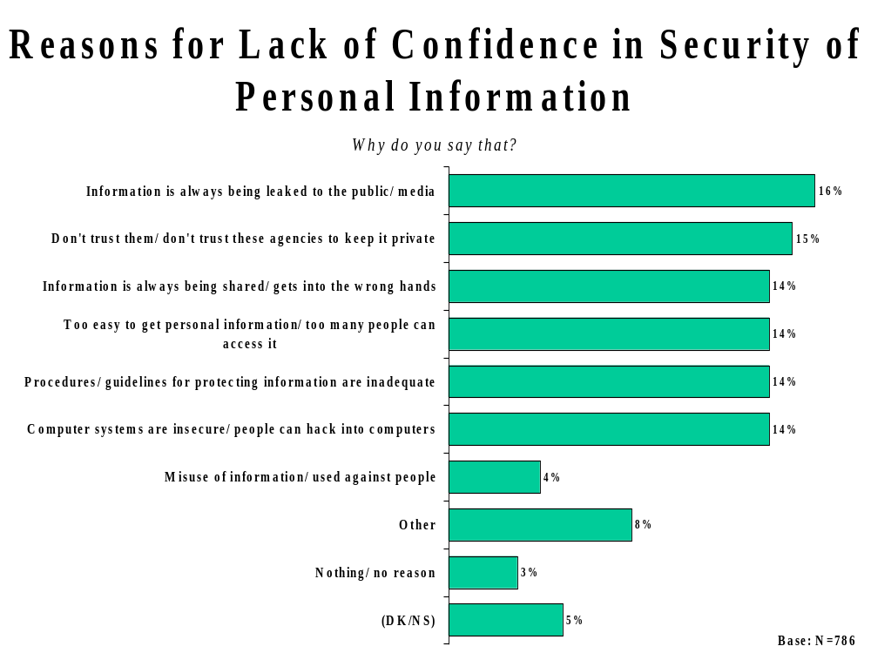

Appendix I – Topline Questionnaire
q1. What do you feel are the most important problems or concerns in your own community today? What other important issues are facing your community?
 | Total
Base: All respondents | 1800
Weighted | 1800
Health care/Hospitals | 24%
Crime/Violence/Gangs | 18%
Education/Schools | 12%
Jobs/Unemployment | 11%
Transportation - roads/transit | 10%
Taxes | 7%
Environmental concerns | 7%
Economy - general | 7%
Poverty/Homeless | 7%
Public safety and security | 5%
Alcohol/ drugs | 5%
Children/ Youth issues | 4%
Social Services - daycare, welfare | 3%
Other | 15%
(DK/NS) | 11%
q2. During the last five years, do you think that crime in your community has increased, decreased, or remained about the same?
 | Total
Base: All respondents | 1800
Weighted | 1800
Increased | 41%
Decreased | 6%
Remained about the same | 50%
(DK/NS) | 3%

q3. I would like you to tell me your overall confidence in Canada's efforts in ensuring public safety. Would you say you are very confident, somewhat confident, not very confident or not at all confident?
 | Total
Base: All respondents | 1800
Weighted | 1800
(4) Very confident | 17%
(3) Somewhat confident | 60%
(2) Not very confident | 16%
(1) Not at all confident | 6%
Summary
Top2Box | 77%
Low2Box | 23%
q4. Now I would like you to tell me how much confidence you have in each of the following components of public safety in Canada? Would you say you are very confident, somewhat confident, not very confident or not at all confident
 | Total | Total
Base: All respondents | 1800 | 1800
Weighted | 1800 | 1800
 | Very Confident | Not very Confident
The RCMP | 87% | 10%
Your local police (not the RCMP) | 83% | 14%
Provincial police (not the RCMP) | 79% | 11%
Border Security | 70% | 25%
Prosecutors | 69% | 27%
The courts/Supreme Court | 65% | 33%
The prison system | 49% | 47%
The parole system | 34% | 61%

q5. How satisfied would you say you are with the following, and their performance in ensuring public safety?
 | Total | Total
Base: All respondents | 1800 | 1800
Weighted | 1800 | 1800
 | Very satisfied | Not very satisfied
Federal government | 61% | 38%
Provincial government | 65% | 34%
Municipal government | 76% | 23%

q6. What is your awareness of federal government efforts to improve the sharing of information between public safety agencies? Would you say you are very aware, somewhat aware, not very aware, or not at all aware of these efforts?
 | Total
Base: All respondents | 1800
Weighted | 1800
(4) Very aware | 6%
(3) Somewhat aware | 32%
(2) Not very aware | 43%
(1) Not at all aware | 19%
(DK/NS) | 1%
Summary
Top2Box | 37%
Low2Box | 62%
q7. What federal government information sharing efforts have you heard about?
 | Total
Base: Very/somewhat aware of efforts | 675
Weighted | 674
Increased sharing between unspecified departments | 8%
Between law enforcement agencies | 7%
Between Federal and Provincial governments | 6%
Freedom of Information and Protection of Privacy Act | 6%
National sex offender registry | 5%
RCMP | 5%
Between Canada and other countries | 4%
Anti-terrorism | 3%
Integrated Border Enforcement Teams | 3%
Other | 24%
Nothing | 15%
(DK/NS) | 25%

q8. How would you rate the current performance of governments in terms of sharing information between public safety agencies? Would you say they are doing a very good job, a somewhat good job, a somewhat bad job or a very bad job in this area?
 | Total
Base: All respondents | 1800
Weighted | 1800
(4) Very good job | 4%
(3) Somewhat good job | 53%
(2) Somewhat bad job | 27%
(1) Very bad job | 5%
(DK/NS) | 12%
Summary
Top2Box | 57%
Low2Box | 32%
q9. As you may or may not know, the Government of Canada is trying to improve information sharing between public safety agencies, such as the police, prosecutors, the courts, border security, corrections and parole, as well as between jurisdictions, such as federal, provincial and municipal governments. How important do you think this information sharing between public safety agencies is for improving public safety in Canada. Would you say it is very important, somewhat important, not very important, or not at all important?
 | Total
Base: All respondents | 1800
Weighted | 1800
(4) Very important | 83%
(3) Somewhat important | 14%
(2) Not very important | 3%
(1) Not at all important | 0
(DK/NS) | 0
Summary
Top2Box | 96%
Low2Box | 3%
q10a. Why do you say that?
 | Total
Base: Information sharing is very/somewhat important | 1737
Weighted | 1736
All agencies should be cooperating/ working together | 31%
Help everybody do their job better/ efficient/ easier | 17%
Increased awareness/ all agencies should be kept informed | 16%
Improve public safety | 15%
Sharing is important | 13%
Right to know: people in the community should be made aware | 10%
People move around/ keep track of criminals | 6%
Improved communication | 6%
Easier to solve/ prevent crime | 5%
All agencies should have access to the same information | 5%
Identify people at risk | 3%
People slipping through the cracks/ loopholes | 3%
Other | 8%
(DK/NS) | 4%
q10b. Why do you say that?
 | Total
Base: Information sharing is not very/not at all important | 56
Weighted | 57
Invasion of privacy/ rights | 18%
Help everybody do their job better/ efficient/ easier | 8%
All agencies should be cooperating/ working together | 5%
Right to know: people in the community should be made aware | 4%
Improve public safety | 3%
Sharing is important | 3%
All agencies should have access to the same information | 2%
Increased awareness/ all agencies should be kept informed | 2%
Improved communication | 1%
Be aware of who is entering/ leaving the country | 1%
Other | 43%
No reason | 4%
(DK/NS) | 15%

q11. Which of the following kinds of information do you think should be shared between public safety agencies? (Yes Summary)
 | Total
Base: All respondents | 1800
Weighted | 1800
Criminal records of individuals who have been convicted | 94%
Files on on-going criminal investigations | 86%
Criminal charges of individuals who were not convicted | 42%
Whether someone is unlawfully present in Canada (an illegal immigrant) | 92%
Driver's license information | 70%
Criminal charges originating in other countries against individuals | 91%
Travel destinations of individuals | 48%
Firearms ownership | 82%
Motor vehicle ownership | 63%
Financial transaction information | 38%
Basic information about international travellers, including their names, gender and age | 66%
Information related to race, national or ethnic origin of international travellers | 46%
q11_1. Which of the following kinds of information do you think should be shared between public safety agencies?

 | Total
Criminal records of individuals who have been convicted
Base: All respondents | 1800
Weighted | 1800
Yes | 94%
No | 5%
(DK/NS) | 1%

q11_2. Which of the following kinds of information do you think should be shared between public safety agencies?

 | Total
Files on on-going criminal investigations
Base: All respondents | 1800
Weighted | 1800
Yes | 86%
No | 12%
(DK/NS) | 2%
q11_3. Which of the following kinds of information do you think should be shared between public safety agencies?

 | Total
Criminal charges of individuals who were not convicted
Base: All respondents | 1800
Weighted | 1800
Yes | 42%
No | 56%
(DK/NS) | 2%
q11_4. Which of the following kinds of information do you think should be shared between public safety agencies?

 | Total
Whether someone is unlawfully present in Canada (an illegal immigrant)
Base: All respondents | 1800
Weighted | 1800
Yes | 92%
No | 7%
(DK/NS) | 1%

q11_5. Which of the following kinds of information do you think should be shared between public safety agencies?

 | Total
Driver's license information
Base: All respondents | 1800
Weighted | 1800
Yes | 70%
No | 29%
(DK/NS) | 1%
q11_6. Which of the following kinds of information do you think should be shared between public safety agencies?

 | Total
Criminal charges originating in other countries against individuals
Base: All respondents | 1800
Weighted | 1800
Yes | 91%
No | 8%
(DK/NS) | 2%
q11_7. Which of the following kinds of information do you think should be shared between public safety agencies?

 | Total
Travel destinations of individuals
Base: All respondents | 1800
Weighted | 1800
Yes | 48%
No | 49%
(DK/NS) | 3%

q11_8. Which of the following kinds of information do you think should be shared between public safety agencies?

 | Total
Firearms ownership
Base: All respondents | 1800
Weighted | 1800
Yes | 82%
No | 17%
(DK/NS) | 1%
q11_9. Which of the following kinds of information do you think should be shared between public safety agencies?

 | Total
Motor vehicle ownership
Base: All respondents | 1800
Weighted | 1800
Yes | 63%
No | 35%
(DK/NS) | 2%
q11_10. Which of the following kinds of information do you think should be shared between public safety agencies?

 | Total
Financial transaction information
Base: All respondents | 1800
Weighted | 1800
Yes | 38%
No | 59%
(DK/NS) | 3%

q11_11. Which of the following kinds of information do you think should be shared between public safety agencies?

 | Total
Basic information about international travellers, including their names, gender and age
Base: All respondents | 1800
Weighted | 1800
Yes | 66%
No | 32%
(DK/NS) | 2%
q11_12. Which of the following kinds of information do you think should be shared between public safety agencies?

 | Total
Information related to race, national or ethnic origin of international travellers
Base: All respondents | 1800
Weighted | 1800
Yes | 46%
No | 53%
(DK/NS) | 2%
q12. Can you think of any types of information other than those just listed which should be shared between public safety agencies?
 | Total
Base: All respondents | 1800
Weighted | 1800
All sexual offenders/ pedophiles | 5%
Terrorists/ Gang members | 2%
Medical records/ files | 2%
Any offenders/ offences against children/ youth | 2%
Other | 9%
None | 61%
(DK/NS) | 15%

q13. Can you think of any types of information other than those just listed you think should not be shared between public safety agencies?
 | Total
Base: All respondents | 1800
Weighted | 1800
Personal information | 7%
Medical records/ files | 4%
Financial records | 3%
Other | 12%
None | 60%
(DK/NS) | 15%
q14. Please tell me whether you strongly agree, somewhat agree, somewhat disagree, or strongly disagree with each of the following statements.
 | Total | Total
Base: All respondents | 1800 | 1800
Weighted | 1800 | 1800
 | Strongly agree | Somewhat disagree
I think information sharing between public safety agencies will improve the efficiency of the justice system and thus increase public safety in Canada | 94% | 5%
More and better information on previous criminal convictions would be a powerful tool to help police and the courts reduce crime in Canada | 93% | 7%
More police and more support for the courts is a better way to improve public safety than is the sharing of information between public safety agencies | 65% | 32%
I think the police and prosecutors should be given more powers to ensure public safety even if it might be seen as an infringement of some individual rights | 63% | 36%
I think that terrorism threats outweigh the protection of individual rights such as the right to privacy | 61% | 37%
I am concerned that information sharing between public safety agencies may infringe on Canadians' rights to privacy | 60% | 39%

q15. How confident are you that personal information on individuals shared by public safety agencies is properly safeguarded? Would you say you are very confident, somewhat confident, not very confident or not at all confident?
 | Total
Base: All respondents | 1800
Weighted | 1800
(4) Very confident | 7%
(3) Somewhat confident | 48%
(2) Not very confident | 33%
(1) Not at all confident | 11%
(DK/NS) | 1%
Summary
Top2Box | 55%
Low2Box | 44%
q16. Why do you say that?
 | Total
Base: Not very/not at all confident information is properly safeguarded | 793
Weighted | 786
Information is always being leaked to the public/ media | 16%
Don't trust them/ don't trust these agencies to keep it private | 15%
Information is always being shared/ gets into the wrong hands | 14%
Too easy to get personal information/ too many people can access it | 14%
Procedures/ guidelines for protecting information are inadequate | 14%
Computer systems are insecure/ people can hack into computers | 14%
Misuse of information/ used against people | 4%
Information can be accessed through the Internet | 3%
Just what I hear/ reports in the media | 3%
Government has too much information on people | 3%
Other | 8%
Nothing/ no reason | 3%
(DK/NS) | 5%

Information Sharing in the Criminal Justice System – Practitioners’ Survey (Ipsos-Reid, February 2003) This study included public safety practitioners from police agencies, corrections, parole, prosecutors, Citizenship and Immigration Canada and the former Canada Customs and Revenue Agency.
For definition and background, see methodology.
For definition and background, see methodology.
For definition and background, see methodology.
For definition and background, see methodology.
For definition and background, see methodology.
“Freedom of Information and Protection of Privacy Act” was accepted as a verbatim response. In actuality, the correct legislation is the Access to Information Act.

