
PWGSC Contract: #EP771-170143
POR Registration: POR-012-16
Contract Award Date: 15/06/2016

Survey of Potential Public Uses for
100 Wellington Street, Ottawa
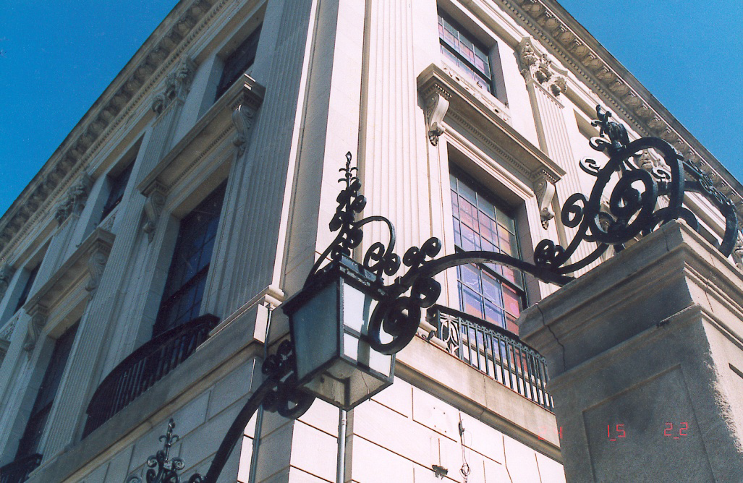

FINAL Report

Prepared for:
Public Services and Procurement Canada

Prepared by:
EKOS RESEARCH ASSOCIATES INC.

November 21, 2016

Ce rapport est aussi disponible en français

To obtain more information on this report please e-mail
TPSGC.Questions-Questions.PWGSC@tpsgc-pwgsc.gc.ca

EKOS RESEARCH ASSOCIATES
Ottawa Office
359 Kent Street, Suite 300
Ottawa, Ontario
K2P 0R6
Tel: (613) 235 7215
Fax: (613) 235 8498
E-mail: pobox@ekos.com

www.ekos.com
Table of Contents

Summary v
1. Introduction 1
1.1 Study Background and Objectives 1
1.2 Methodology 2
1.3 Sample Characteristics 5
2. The Importance of the Parliamentary Precinct 10
3. Six Proposed Uses 11
4. Overall Ranking of Proposed Uses 26

APPENDIX A: Survey Instrument (English)
APPENDIX B: Sample Characteristics
APPENDIX C: Reviewed Comments
APPENDIX D: Details of Top 3 Ranking and Single Score Calculation

This certification is to be submitted with the final report submitted to the Project Authority.

I hereby certify as Senior Office of EKOS RESEARCH ASSOCIATES INC. that the deliverables fully comply with the Government of Canada political neutrality requirements outlined in the Communications Policy of the Government of Canada and Procedures for Planning and Contracting Public Opinion Research. Specifically, the deliverables do not include information on electoral voting intentions, political party preferences, standings with the electorate or ratings of the performance of a political party or its leader.

Signed: 
Susan Galley, Senior Vice President
EKOS Research Associates Inc.

Summary

The remarkable heritage building at 100 Wellington Street in Ottawa has a long and celebrated history. Built in the 1930s and located directly opposite Parliament Hill, 100 Wellington was the Embassy of the United States of America. In 1997 the Government of Canada acquired the property from the U.S. Government and the building was vacated in 1998.

The Government is committed to finding a public use for this important building and creating a space that is meaningful for Canadians and visitors alike. Over the summer of 2016, public consultations on the future of 100 Wellington were undertaken, including a stakeholder workshop, a media tour, a series of open houses, and a public information forum where a three-week, on-line bilingual public opinion survey was launched. Input from the public consultations will provide important information as the Government of Canada assesses options and makes a decision on the future use of 100 Wellington.

The public opinion study included two surveys using the same questionnaire: (1) an open survey that allowed all interested Canadians and international visitors to participate, and (2) a random, nationally representative survey to understand the broader Canadian landscape and provide a point of comparison for the open survey results. Between August 18 and September 9, 2016 a total of 7,137 individuals completed the survey: 5,557 through the open survey (including 4,983 Canadians and 574 international respondents) and 1,580 through the representative survey.

Findings

At the beginning of the survey, respondents were asked to consider the importance of:
- The Parliament Buildings as a symbol of national identity,
- Preserving and rehabilitating the Parliament Buildings for future generations, and
- Making the Parliamentary Precinct a model for environmental sustainability.

Results highlight the strong value that Canadians and those visiting the Parliamentary Precinct place on these matters. The vast majority (90 per cent or more) in the open survey (both Canadians and international respondents) rated each as important. Results are similar in the representative survey with 80 per cent or more indicating that these matters are important.

Respondents were then presented with a list of six possible public uses for a revitalized 100 Wellington and asked to rate their “like” or “dislike” for each one. Respondents were provided an opportunity to comment on each of the uses and to provide suggestions of their own for the future use of 100 Wellington. In the open survey, Gallery is seen as the most appealing, with 57 per cent liking the idea. Canada House also has appeal (46 per cent), while the other options have limited appeal. From the reviewed Gallery comments, two in three supporting a Gallery commented on a “portrait” gallery specifically, mentioning longstanding promises for a National Portrait Gallery, and a need to finally move on this idea.

In the representative survey and among international respondents, Canada House clearly has the widest appeal, with six in ten or more indicating they like this idea. Museum and/or Indigenous Cultural Centre are second or third options. By comparison, a Gallery has less support, with only 38 per cent of the representative survey and 43 per cent of the international respondents expressing support for this idea.

Many who like these options comment about the appeal and value of a Canada House, Museum or Indigenous Cultural Centre. On the other hand, many in the open survey raise concerns about the limited available space for a museum at 100 Wellington, and the number of museums already in the region. Concerns about an Indigenous Cultural Centre at 100 Wellington point to the inappropriateness of the location and style of architecture for this purpose, saying that other more suitable options exist for such a use.

Support for a Gallery in the open survey is heavily concentrated among Canadians 55 years of age or older. Eight in ten of those 65 or older like the idea of a Gallery, but only a third of those under 25 and half of those 25 to 54 say the same. The reverse is true for support for Canada House, a Museum and Indigenous Cultural Centre which have considerably strong support among those under 55, particularly those under 35.

Ranking of Uses
Respondents were asked to rank their top three preferences from the list of potential uses. The results were considered in two ways: (1) first choice results, and (2) top three choices weighted and combined into a single score.

The first choice results show that Gallery is the top choice for respondents in the open survey, whereas Canada House is the top choice in the representative survey. Canada House and Indigenous Cultural Centre are virtually tied as the first choice among international respondents.

The top three choices combined score was created for each use based on the percentages of respondents selecting it as their top three choices. Relatively more weight was given to a first choice selection, less weight to a second choice selection, and least weight to a third choice selection. The results show that:
- In the representative survey, Canada House receives the top average score, with Museum in second place followed closely by an Indigenous Cultural Centre.
- In the open survey, Gallery is the top choice, followed by Canada House as a second choice. Museum and Indigenous Cultural Centre are tied as a third place choice. Support splits along generational lines. Support for Canada House, a Museum and an Indigenous Cultural Centre each have much greater support among those under 55, while support for a Gallery is heavily concentrated among those 55 or older, and in particular those 65 or older.
- For international respondents, Canada House and Indigenous Cultural Centre rank equally with the top score, followed by a Museum and Interpretive Centre for Parliament in second and third respectively.

Overall, results show that Canada House clearly has the widest appeal across all segments with the exception of Canadians 55 years or older who responded to the open survey. It is the first choice among:
- Canadians in the representative survey,
- Canadians under 55 in the open survey, and
- International respondents.

Gallery is the preferred use among the 55 or older segment in the open survey. It is the least preferred option, however, among those in the representative survey and international respondents, and is not a clear preference among those under 55 in the open survey.

Therefore, Canada House is seen as a strong first or second choice across all segments responding to the survey. While a Gallery enjoys significant support, it is singularly concentrated among those 55 or older responding to the open survey.

The total expenditure for the public opinion research project is $42,835.48 (including HST).

Supplier Name: EKOS Research Associates
PWGSC Contract #EP771-1770143
Contract Award Date: June 15, 2016
To obtain more information on this study, please e-mail
TPSGC.Questions-Questions.PWGSC@tpsgc-pwgsc.gc.ca

Introduction

Study Background and Objectives

The Government of Canada is looking to renew and repurpose 100 Wellington Street in Ottawa—a building that is important for its history, architecture, location and potential. The Government is committed to finding a public use with a national focus for this heritage building and is seeking input from Canadians on a range of potential uses.

History of 100 Wellington

100 Wellington was constructed in 1931-32 by the United States government as the first in a series of purpose-built embassies around the world. As the first foreign mission in Ottawa it became a benchmark in Canada’s gradual assumption of sovereignty over foreign affairs and its strategic location opposite Parliament Hill was a strong statement about the growing importance of the U.S.-Canada relationship. This building is one of the finest examples of Beaux-Arts buildings in the country and it was designated a Classified Federal Heritage Building in 1985. In 1997, the Government of Canada acquired 100 Wellington when the U.S. embassy moved to its current location on Sussex Drive. The building has remained vacant since 1998.

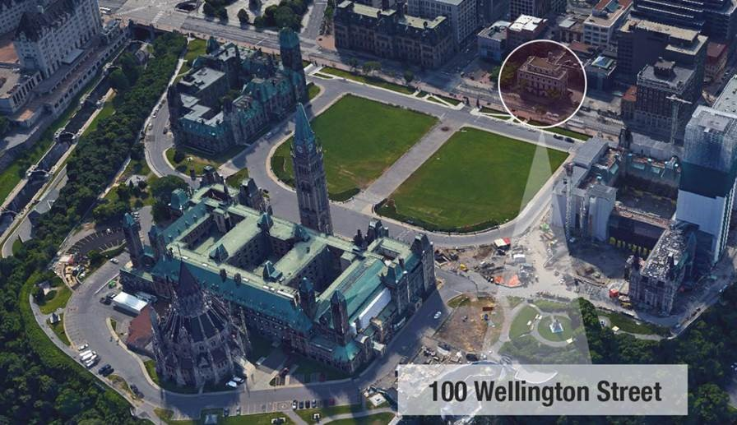

Public Consultation

The Government of Canada is now committed to finding a public use for this important building and creating a space that is meaningful for Canadians and international visitors alike. But before making any decisions, the Government wanted to hear from Canadians to obtain their views and input on the future use of this important building. The results of the public consultation will provide important information as the Government of Canada assesses options and comes to a decision on the future use of this building.

Public consultation on the future of 100 Wellington was undertaken during the summer of 2016 and included five elements:
- A workshop with representatives of community and government stakeholders (July 14);
- A media tour of 100 Wellington (August 8);
- A series of open houses for the public at 100 Wellington (August 18 to September 9);
- A public information forum, which was broadcast live on Facebook and included presentations on historical and planning considerations for the reuse of 100 Wellington (August 18); and
- A three-week, on-line bilingual public opinion survey (August 18 to September 9).

The 10-minute public opinion survey was launched at the information forum on August 18 and was actively promoted to Canadians throughout the survey period by Public Service and Procurement Canada (PSPC) through their website, via print and broadcast media, social media (Facebook, Twitter, Instagram and LinkedIn), as well as direct correspondence with interest groups in the National Capital Region and across the country. During the three-week survey period, PSPC staff and student volunteers encouraged tourists and visitors waiting in line for tickets to Parliament Hill to complete the survey on computer tablets.

Methodology

The methodology for this study included two online surveys using the same questionnaire:
- An open survey, allowing all interested Canadians and international visitors to participate; and
- A nationally representative survey of Canadians.

Survey questions were grouped into five areas:
- Three general questions about the importance of the Parliamentary Precinct,
- Opinions and input on six potential uses for 100 Wellington – Canada House, Capital Information Centre, Gallery, Indigenous Cultural Centre, Interpretive Centre for Parliament, and Museum,
- Opportunity for respondents to submit their own idea for the future public use of 100 Wellington,
- Ranking the top three preferred uses, and
- A series of demographic questions.

The full survey is included in Appendix A.

Following a test of the questionnaire, a total of 7,137 individuals completed the online survey between August 18 and September 9, 2016: 5,557 through the open survey (including 4,983 Canadians and 574 international respondents) and 1,580 through the representative survey.

Open Survey

Respondents to the online open survey are 5,557 individuals (16 years of age and older) who were aware of the survey and motivated to participate in the future of 100 Wellington. Because they self-selected and are not random (i.e., a non-probabilistic sample), the survey is not considered to be representative of the Canadian population overall and no margin of error can be applied to the results. Quality control steps were taken in a review of the results – including a review of IP addresses, examination of combinations of demographic patterns and speeding through questionnaires – to ensure, to the extent possible, that there was not inappropriate use of multiple entries associated with individual respondents in the open survey. The online open survey includes 574 international respondents, capturing the perspective of international visitors to the region, providing valuable input for the future of 100 Wellington.

Representative Survey

As a comparison to the open survey, a nationally representative online survey was also conducted of 1,580 randomly selected Canadians 16 years of age and older. The representative survey was launched late in August, with a participation rate of 21.6 per cent, which is typical for this type of survey. The sample source used was the EKOS Probit panel, a pool of pre-screened respondents. These panel members are recruited through random selection of households rather than opt-in recruitment. This same process is used for to generate random samples for custom telephone surveys, and is considered to offer good coverage of the Canadian population. The sample is therefore considered to be probabilistic and margin or error can be applied. This survey sample size yields a level of precision of up to +/-2.4 per cent, 19 times out of 20, for the sample overall and +/- 7 to 11 per cent for most sub-groups isolated in the analysis (e.g., age, region). This sample provides a useful snapshot of the views of the “average Canadian” by which to compare the views of those most interested in 100 Wellington who responded in the open survey.

Survey Analysis

Survey results were examined overall for each of the three survey segments – representative, open (Canadian) and open (international respondents) – followed by an examination of differences in results within key sub-groups of interest (e.g., region, age) within the two larger survey samples. Results first examine percentages of those who agree (or disagree) with three questions related to the Parliamentary Precinct more broadly. This is followed by a review of percentages of respondents rating their “like” or “dislike” for six uses for 100 Wellington presented in the survey. Relative ranking of these same six uses, based on the percentage selecting each as their first choice are subsequently analyzed. Finally, a score was generated for each proposed use based on percentages of respondents selecting it as their top three choice. The score assigned relatively more weight to a first choice selection, less weight to a second choice selection, and least weight to a third choice selection. This type of indexing is applied as an acceptable practice for bringing together multiple data points to ease comparison across different survey samples or sub-groups within a survey.

The results of the representative survey are presented for all Canadians, combining those living inside as well as outside the National Capital Region (NCR). In order to combine the results in this way, the contribution from NCR residents is adjusted to reflect the normal concentration of the NCR in the population of Canada. Where there are substantive differences in results between those living inside and outside the NCR they are highlighted in the text.

Results from the open survey are also presented for the total 4,983 Canadians who participated. Results for those residing inside and outside of the NCR (which are roughly half and half) were simply combined as there is no way to accurately weight the open responses (i.e., population unknown).

Results are presented separately for international respondents who completed the open survey. These respondents were randomly selected on-site (along Wellington Street) by the PSPC volunteers and students.

Comments provided

Respondents were given an opportunity to provide comments on each of the six potential uses for 100 Wellington. Over 7,100 comments were submitted on the six potential uses, and an additional 1,612 comments received suggesting other ideas for the use of 100 Wellington. Given the number of comments submitted, a random sample of 10 per cent of respondents in the open survey and 25 per cent in the smaller representative sample were selected for review of any comments provided. Based on analysis, the comments were categorized into four to six broad themes of responses associated with each proposed use.

Comments for each use are discussed in Section 3 of this report. Further details of the reviewed comments can be found in Appendix C. All comments have been made available to the client for a deeper review of input.

Sample Characteristics

Sample characteristics were reviewed and compared for Canadians responding to the open survey, international respondents who completed the open survey, and Canadians in the representative survey. Region, age, gender, and education were examined across all three. Responses to the open survey were also reviewed in terms of how respondents received or became aware of the survey, whether they have a special interest in 100 Wellington, and the number of years since visiting the NCR (if they live outside the area).

Details of the sample characteristics are presented in Appendix B. The following findings provide a snapshot of the survey respondents.
- As previously described, almost half of the respondents in the open survey reside in the NCR. In the representative survey the proportion is one-third, however, these cases have been weighted down to reflect a more normal proportion (six per cent) based on the Canadian population.

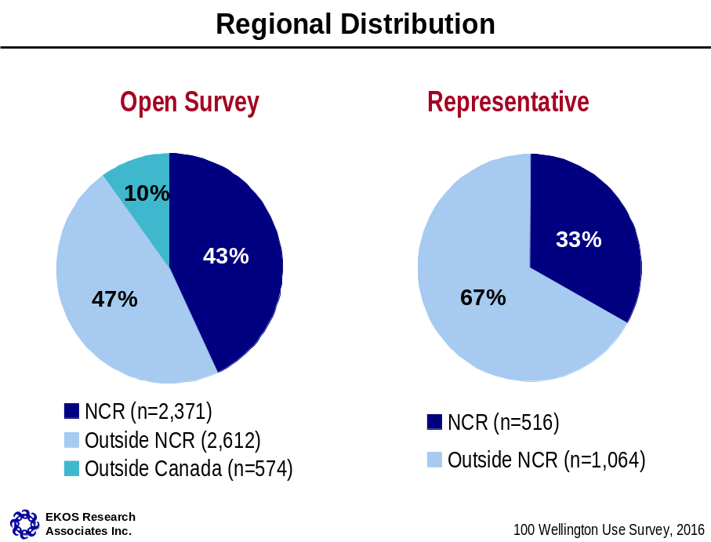

- Half of the representative survey and slightly over half (54 per cent) of the open survey respondents are women, which is generally representative of the Canadian population.

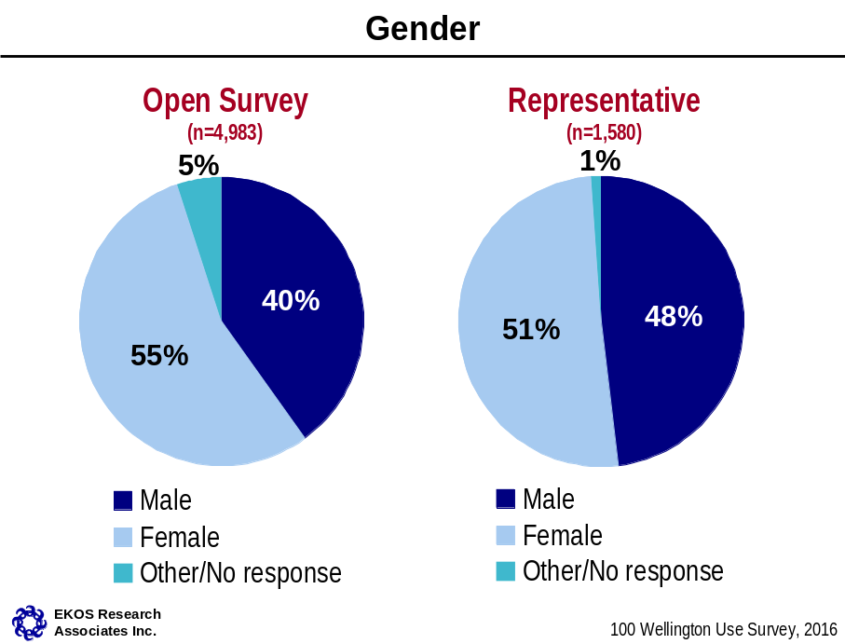

- Respondents in the open survey are over represented in Ontario, and under represented in Quebec, and to a lesser extent in Alberta, and the Prairies, compared with the population distribution. The representative sample is a closer reflection of the general population.
- Of international respondents the largest proportions are from Europe (40 per cent) and North America (34 per cent), leaving one in five coming from other regions of the world.

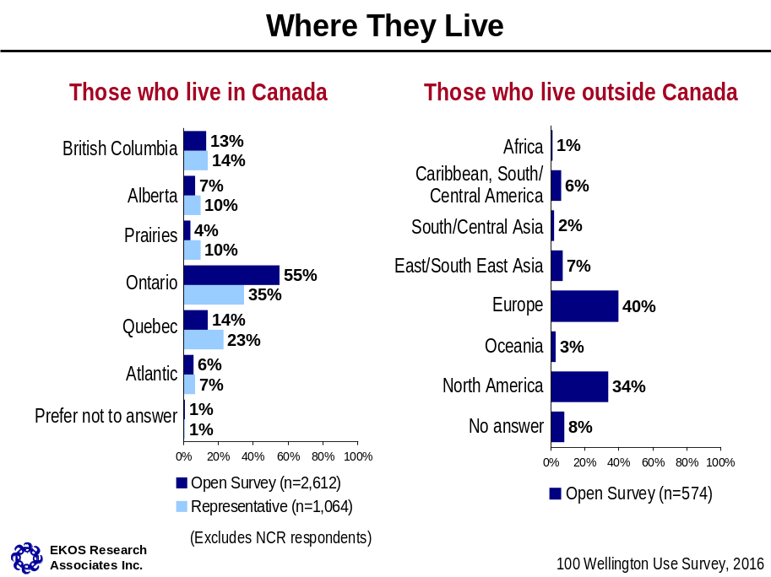

- Both the open and representative surveys over represent those with post-secondary education compared with the population. In the open survey, 78 per cent or higher have a university level education compared with 23 per cent in the general population highlighting that engagement on this issue is largely among those with higher levels of education. The representative survey also had a higher level of university educated respondents (50 per cent) but not to the same extent as the open survey.

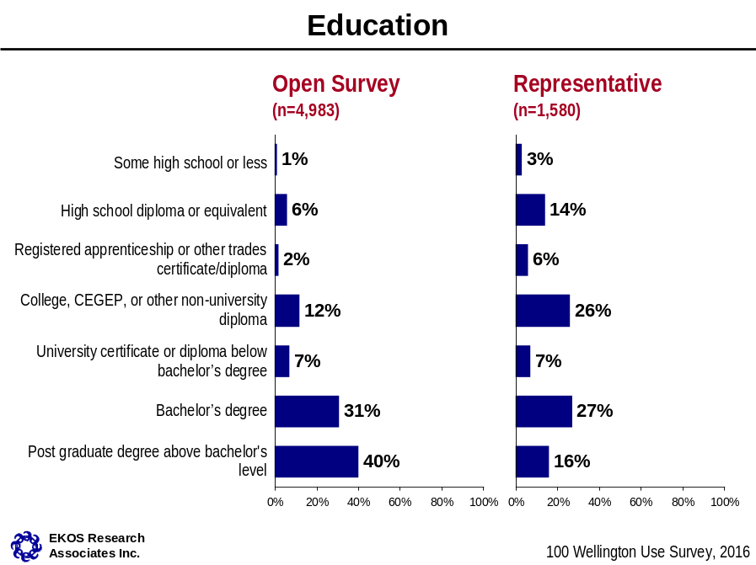

- The open survey and representative survey both include between 16 per cent to 20 per cent of respondents in each age cohort from 25 years of age and over, with eight to ten per cent under the age of 25. Both are a good reflection of the population.

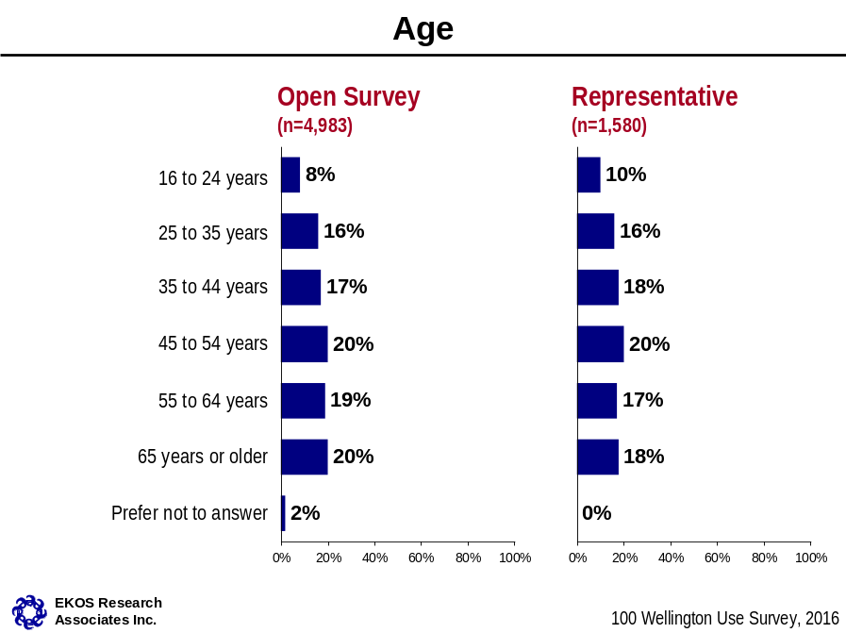

The Importance of the Parliamentary Precinct

At the start of the survey, to help contextualize questions related specifically to 100 Wellington, respondents were told:
“For the past decade, the Parliamentary Precinct Branch has been implementing a coordinated, long-term plan to rehabilitate the Parliament Buildings and other buildings within the Parliamentary Precinct”.

On a scale of one to five, with 1 being “not very important” and 5 being “very important”, respondents were asked to consider the importance of the symbolism of the Parliament Buildings and their rehabilitation, and whether the government should make the Precinct a model for environmental sustainability. The following table illustrates the percentage of responses that ranked these matters as important (i.e. selected 4 or 5):

Table 2.1: The Importance of the Parliamentary Precinct
 | Open Survey  (n=4,983) | Representative Survey  (n=1,580) | International Respondents  (n=574)
 | Important (4-5)
How important are the Parliament Buildings as a symbol of national identity? | 95% | 83% | 94%
How important is it to preserve and rehabilitate the heritage buildings and grounds of the Parliamentary Precinct for future generations of Canadians? | 96% | 84% | 95%
How important is it to that the Government of Canada takes a leadership role in making the Precinct a model for environmental sustainability? | 89% | 80% | 89%

Overall, results highlight the strong value that Canadians and international respondents place on the Parliamentary Precinct. The vast majority of individuals (i.e., 90 per cent or more) responding to the open survey rated each of the three as important.

Results are also strong in the representative survey, where 80 per cent or more indicated the importance of these matters. Within the representative survey, residents of the National Capital Region consistently placed comparatively greater importance on each of the three than other Canadians (e.g., 94 per cent, 93 per cent, 84 per cent, respectively).

Six Proposed Uses

Respondents were presented with the following list of six potential public uses for a revitalized 100 Wellington:

CANADA HOUSE – a venue to bring all of Canada to the nation's capital, giving a taste of the country's diversity and achievements and showcasing the best of the provinces and territories from coast to coast to coast.
CAPITAL INFORMATION CENTRE – a centre to provide information and orientation services for visitors through the grouping of complementary services from federal, municipal and tourism organizations
GALLERY – a space to house a collection of artwork of national significance
INDIGENOUS CULTURAL CENTRE – a use to be determined in partnership with Indigenous Peoples to showcase culture, achievements and the prominent role of Indigenous people in the history and future of Canada
INTERPRETIVE CENTRE FOR PARLIAMENT – a space to engage visitors with Parliament, how it works and its history
MUSEUM – a venue to exhibit national artefacts of historical and cultural interest

These uses were presented in a randomized order and respondents were asked to rate the extent of their like or dislike for each one on a five-point scale from (1) strong dislike to (5) strong like. Respondents were also given the opportunity to comment on each proposed use and asked if they had any specific suggestions.

Respondents were also able to provide their own idea for a possible use for 100 Wellington with the question:
YOUR IDEA – Do you have another idea for 100 Wellington? What public use can you suggest that would transform 100 Wellington into an important Canadian destination in the nation's capital?”

Canada House

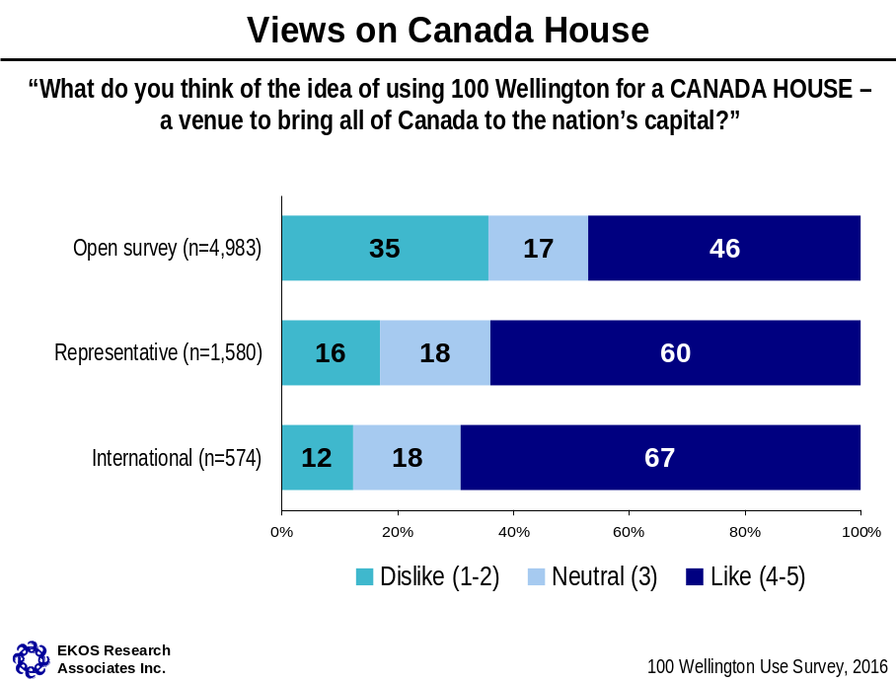

Canada House is clearly the strongest use from the perspective of the representative survey and international respondents, with 60 and 67 per cent saying they like the idea. In contrast, Canada House is liked by only 46 per cent in the open survey, and an even smaller proportion of the residents of the NCR (42 per cent like the idea, but 39 per cent dislike it).
- Canada House has the greatest appeal among younger Canadians. It has wide appeal in each age cohort from 16 to 55 years of age (e.g., 58 per cent of those under 25 like the idea; 54 per cent of those 45 to 54 say the same). But, this is only true for 42 per cent of those 55 to 64, and 25 per cent of those 65 or older in the open survey.
- Regionally, support in the open survey is strongest in the Prairies and in Atlantic Canada (62 per cent among those responding from each region).

Comments

Across the survey samples, 1,068 comments were received about the Canada House use, including 774 in the open survey and 245 in the representative survey. A sample of 209 comments were reviewed in the open survey and just over 120 in the representative survey.

Reviewed comments focused largely on possible themes, including historical achievements in areas such as technology, arts and culture, sports, etc, with many describing a mix of themes. Some (about one in seven) suggest mixed use of the space including a Canada House and other possibilities such as a Gallery or focus on Indigenous themes. Suggested considerations when planning such a space included making it free to the public, consideration for a family-friendly environment, and including a place to rest, eat and purchase refreshments. Themed days were also suggested by a few.

About one in six comments explaining why a Canada House is not the best use of this space, including those who feel that the scope is too broad for the size of the space, and comments pointing to an overlap with existing museums.

A proportion of respondents in the open survey who like the idea of a portrait gallery took the opportunity when commenting on other uses to put forward a portrait gallery as the best use of the space. This represents a small proportion of comments made with regard to most of the proposed uses (less than 10 per cent), including Canada House.

- “Focus on the history and achievements of the people of each province and territory. Each province and territory would have their own room and request inhabitants of the provinces and territories to send in ideas of events, artefacts etc that could be included in room.”
- “Make it fun and interactive. The name suggests a connection to the Olympics. It could be a place to celebrate Canadian achievements!”
- “Add roaming markets, a Christmas market with quality Canadian artisans art. Include a small café for gathering spaces for locals and tourists to sit and enjoy the view. Make it lively and upbeat. Show that Canadians are fun. Showcase emergent artists.”
- “I don't think that it would serve as an attraction. I think that many of these purposes are served by the Museum of Canadian History across the river from this location.”

Capital Information Centre

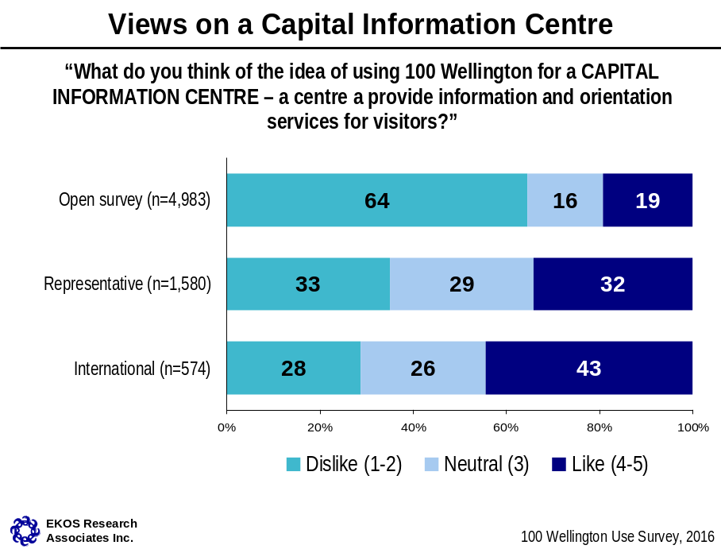

Support is weak for a Capital Information Centre, particularly in the open survey where only 19 per cent like the idea. The response is somewhat more positive in the representative survey where one in three like the idea, but this is still the least positive response to a proposed use. Only international respondents expressed reasonably strong support at 43 per cent. This may be explained, at least in part, by the context in which international respondents were most often approached for the survey: tourists waiting in line for entry to a site.

Comments

Across the survey samples, 671 comments were received about a Capital Information Centre, including 481 in the open survey and 149 in the representative survey. A sample of 167 comments were reviewed in the open survey and 67 in the representative survey.

Those commenting about an information centre largely explained that this function is already addressed elsewhere and that the building is not sufficiently large for this use. Some also talked about the idea of combining this function under a Canada House.

- “Accessible; welcoming; nursing station; a small play area for toddlers; a water bottle filling station in addition to what is already in the current welcome centre. But I would like this in addition to a Parliament interactive exhibit.”
- “Combine Information Centre with Ottawa-Canada museum. It should be open to 9 pm every day in the summer months. With a family orientated activities especially in the evening when everything else is closed.”
- “(…. ) already have such a place....are places still needed in this day of technology for visitor information. There can be pop up sites to do this. No need to waste a good location on something like a visitor info centre. Let’s make better use of such a key site.”

Gallery

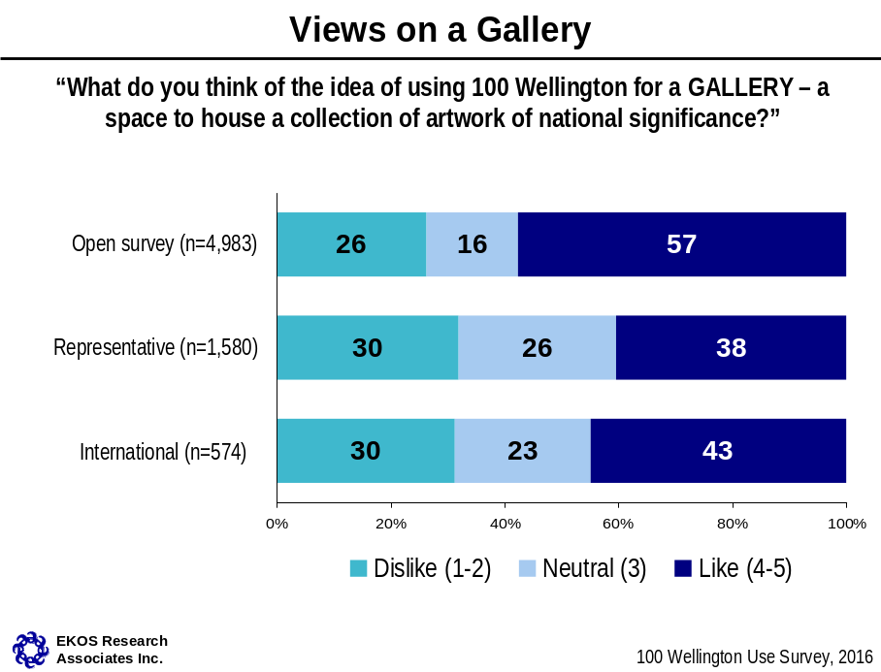

Results show that support for a Gallery is strong in the open survey with 57 per cent indicating they like the use (rating it a 4 or a 5).

In contrast, a Gallery is liked by only about four in ten international respondents, and support in the representative survey is even weaker. One in four in the open survey and 30 per cent among each of representative and international respondents said they dislike the idea of a Gallery, and in the representative sample, almost as many said they dislike the option as said they like it.
- A Gallery is not a young peoples’ choice. Support for a Gallery in the open survey is heavily concentrated among Canadians 55 years of age or older. Eight in ten of those 65 or older like the idea of a Gallery, but only a third of those under 25 and half of those 25 to 54 say the same in the open survey.
- A Gallery is also a less obvious choice to open survey respondents who have never been to the NCR, who are the least apt to like this idea at 46 per cent.
- A Gallery has higher than average support among open survey respondents with a declared special interest in the space (64 per cent of those who declared a special interest like the idea of a Gallery).
- Regionally, residents of British Columbia are the most likely to support a Gallery among open survey respondents (63 per cent of those responding from British Columbia like the idea of a Gallery).
- In the representative survey support is higher in the NCR (44 per cent vs. 38 per cent among other Canadians).

Comments

Across all survey samples, 2,255 comments were received about the Gallery use, including 1,953 in the open survey and 254 in the representative survey. A sample of 420 comments on the Gallery use were reviewed in the open survey and just over 150 in the representative survey. In each case, roughly equal numbers of comments were reviewed among residents living inside and outside the NCR.

Over half of the reviewed comments in the open survey support the idea of a portrait gallery specifically. Some refer to a long standing government “promise” of a portrait gallery, and need to finally move on this idea. A further one in six specify types of portraits for consideration (e.g., Canadian icons/historical themes) or modelling such a Gallery after premiere examples in other countries.

A third to half of the reviewed comments in the representative survey suggested particular themes or mediums (unrelated to a portrait gallery specifically), such as Indigenous art, sculptures, artefacts, paintings, local art, and pieces from the National Archives.

Many also provided reasons why a Gallery is not a use they support at 100 Wellington, typically citing an overlap with the National Gallery of Canada (‘just down the street”).

- “Make it a National Portrait Gallery as previously promised”.
- “Should be a National Portrait Gallery. Most other developed nations have a venue where the nation's peoples, past and present, are showcased. (…) Now is the time and this building would be perfect for such a purpose”.
- “A National Portrait Gallery, and to upgrade it to the 21st century and make it unique, add exhibitions in illustration, comics/graphic novels (Canada excels at these), and design.”
- “Show the many specifically Canadian paintings now held in storage at National Archives.”
- “(….) an excellent place to showcase Canadian art. A section of the Gallery of American art with a Canadian connection would also be a nice addition since it was the US Embassy.”
- “Ottawa already has a number of beautiful galleries and venues to showcase known artists; this might not be the best use of this space.

Indigenous Cultural Centre

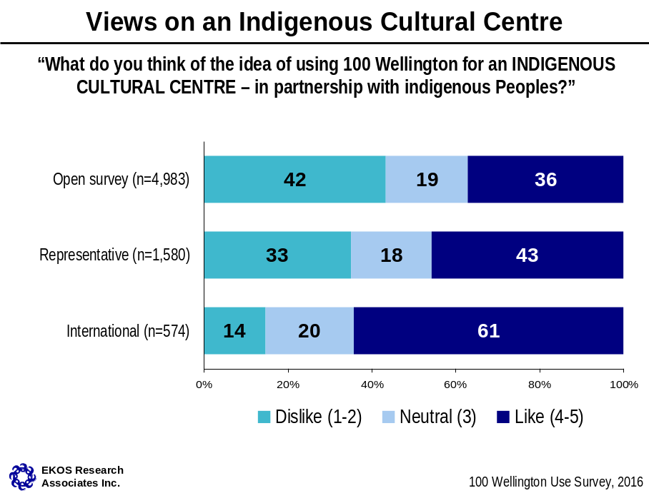

An Indigenous Cultural Centre is a favoured choice with international respondents, with 61 per cent indicating they like the use. In the representative survey, 43 percent like the use and 33 per cent dislike it, while in the open survey it is the reverse with more people disliking the use (42 per cent) than liking it (32 per cent).
- Open survey respondents living in the NCR are least keen on the use, with only 32 per cent supporting the use and 47 per cent saying they dislike it.
- As with Canada House and a Museum, an Indigenous Cultural Centre has wider appeal to younger Canadians in the open survey. For example, 55 per cent of 18 to 24 year olds and 50 per cent of 25 to 34 year olds in the open survey like the idea. Only one in three or fewer of those 55 or older in the open survey like the idea.
- Those in the open survey who have never been to the NCR are also more apt to like the idea of an Indigenous Cultural Centre than those who have been to the NCR in the past (47 per cent versus 40 per cent among other visitors).
- Respondents that indicated a special interest in tourism also stand out in their approval for this use (58 per cent), although caution should be used as this is only represented by 33 individuals in the survey.

Comments

Across the surveys, 1,139 comments were received about the Indigenous Cultural Centre use, including 861 in the open survey and 231 in the representative survey. A sample of 250 comments were reviewed in the open survey and 146 in the representative survey.

Comments typically provide specific themes or suggested focus, including representation of all Indigenous groups, and equal focus on positive and negative aspects of the historical relationship. More than half of reviewed comments in the representative survey and at least a third in the open survey fell into this category.

Many comments in the open survey, and one in four in the representative survey, explain why respondents do not feel positive about this choice. Most explained that they do not see 100 Wellington as an appropriate choice (e.g., architecture and style of building), or that other more suitable locations (e.g., Victoria Island) are available. A few suggested that 100 Wellington should be more inclusive of all Canadians, rather than representing the history and culture of a specific segment of the population.

A few said that the Canadian History Museum already provides a number of high quality Indigenous exhibits. Smaller numbers of respondents described a mix of use of the space, as an Indigenous centre along with other themes, or espouse the importance and value of an Indigenous centre.

- “A location where all Canadians can grow and learn the wonders of the Indigenous people of the country and explore the need to be a country that supports one another and embraces all that we once had and can have again.”
- “Make it participatory - be able to take workshops, have Pow Wows, artists collaborate together on-site on specific artists driven projects NO passive experiences...I need to know our First Nations in a more active way”
- “The Museum of History has good material on Indigenous history and culture as does the National Gallery. This building just does not seem appropriate for a new Indigenous initiative.”
- “I believe the use should be overarching, not specific to any culture.”
- “An important idea, but not in this location. Something more connected to nature would be more appropriate. Perhaps Victoria Island.”
- “Indigenous component could be incorporated in a museum/ cultural centre highlight achievements by Canadians beyond Europe. Most museums/galleries in Canada /US appears to be very Euro-Centric and do not represent the mosaic or melting pot of Canada or US.”

Interpretative Centre for Parliament

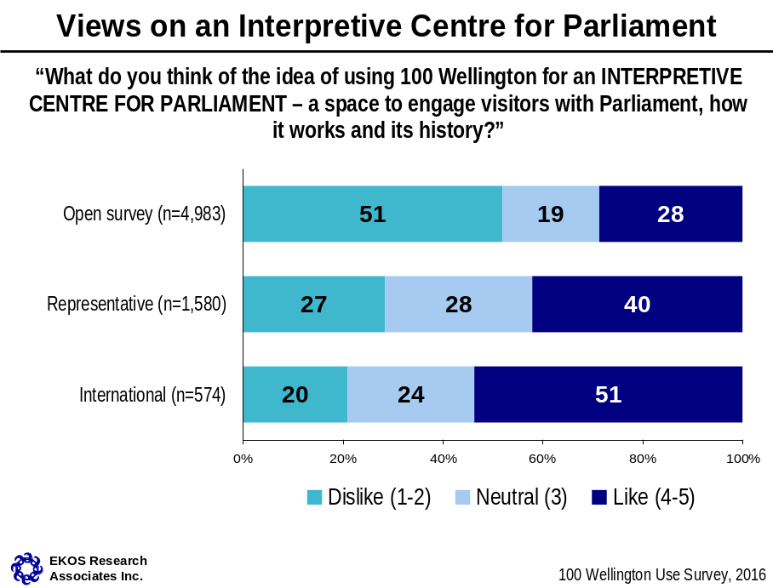

Support for this use for 100 Wellington is not as strong as other uses, such as Canada House, Gallery, Museum or Indigenous Cultural Centre. International respondents are the most supportive of an Interpretive Centre for Parliament, given that half like the idea. Support is also moderately strong in the representative survey, with 40 per cent saying they like this option. Respondents to the open survey, however, are generally not supportive of an Interpretive Centre for Parliament (only 28 per cent like the idea and half dislike it).
- This use has wider appeal with younger Canadians in the open survey, but very limited appeal among those over 45 years of age. The same is true in the representative survey, although the difference is less pronounced.

Comments

Across the survey samples, 782 comments were received about the Interpretive Centre for Parliament, including 565 in the open survey and 176 in the representative survey. A sample of 184 comments were reviewed in the open survey and 102 in the representative survey.

More than half of reviewed comments from the representative survey and one in three in the open survey provide ideas about content, including suggestions for mock debates and tours, as well as content geared specifically to youth. Others talked about a tribute to past leaders. Just under half in the open survey and about one in five in the representative survey provided reasons why 100 Wellington should not be used for this purpose. The most typical comments argue that a separate location is not required for this purpose and is better suited within the Parliament Buildings themselves. A smaller segment also suggested a Parliamentary interpretative space as part of a mixed use including a Canada House or Museum.

- “Canadians should have a place to reflect upon our fundamental freedoms, democratic rights and political achievements; a museum for our founding documents and for artefacts of social and political campaigns. I can think of no more ideal place for this than across the street from Parliament Hill.”
- “I would make an awareness centre on the Canadian democratic system. A central part would explain how our democracy works, and certain parts would be made available to groups and individuals who wish to submit ideas and views on current issues.” (translated)
- “Develop programs that will engage kids, adults, Canadians and visitors to Canada, explaining our system of government, including milestones of achievement and also not shying away from the darker and destructive decisions that have been taken there.”
- “It's hard to beat an actual tour of Parliament for interpretation. Since a visitor reception area is already planned, any interpretive aspects should be coordinated there.”
- “The parliament buildings are already very accessible, with great, comprehensive tours, and so nearby. This seems redundant.”

Museum

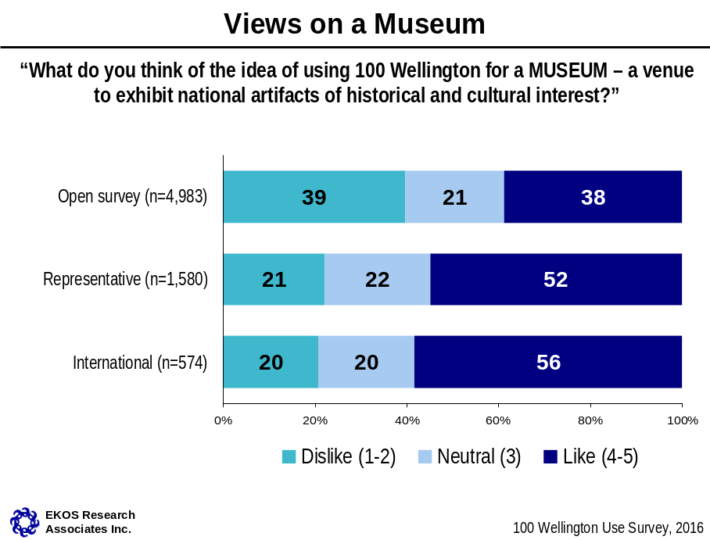

About half of respondents in the representative survey and half of the international respondents indicated they like the idea of a Museum. Less appeal was expressed in the open survey (38 per cent), where an equal proportion says they dislike the option (39 per cent).
- A higher proportion of open survey residents outside the NCR like the idea compared with those inside the NCR (42 per cent vs. 34 per cent, respectively).
- A Museum has wider appeal to younger Canadians in both the open and representative surveys. For example, 55 per cent of 18 to 24 year olds and 49 per cent of 25 to 34 year olds in the open survey like the idea. Only one in three or less of those 55 to 64 in the open survey support the idea.
- Those in the open survey who have never been to the NCR are also more apt to like the idea of a Museum than those who have been to the NCR in the past (52 per cent vs. 43 per cent of other visitors).
- Regionally open survey respondents living in Quebec are most apt to say they like the idea (48 per cent among those responding from Quebec compared with other regions).

Comments

Across the survey samples, 1,229 comments were received about the Museum use, including just over 900 in the open survey and 270 in the representative survey. A sample of 225 comments were reviewed in the open survey and 166 in the representative survey.

Half or more of the comments in the representative survey suggest specific themes including Canada-America relations and various aspects of Canadian history (e.g., Confederation, political, Aboriginal, military, cultural, immigration, architecture).

About one in four in the representative survey and one in three in the open survey suggest reasons for not having the space used for a Museum, typically citing the number of existing museums in the NCR, and/or that museums typically occupy much larger spaces than afforded at 100 Wellington. In the open survey, a much higher proportion of the comments suggested a portrait gallery as the best use of the space (one in four).

- “A museum could house artefacts and tell stories about not only key political figures, but key rulings in Canadian history. Like Heritage Minutes in a tangible form.”
- “I think we should put our most treasured historical documents on display for the world to see, show them how we became a country.”
- “I think what is missing from the current landscape is a museum highlighting Canadian culture - looking back on 150 years, who are the Canadians who stand out in their field as actors, musicians, writers, athletes, scientists, explorers, chefs, other (Terry Fox).”
- “We already have MUSEUM OF CANADIAN HISTORY - let the already existing museum be the destination for Canadians and tourists to see and learn about our great country.”
- “(We) have a museum in Gatineau....too small a building for a museum.”

Your Idea

Your Idea
________________________________________________________________
“Do you have ANOTHER IDEA for 100 Wellington? What public use can you suggest that would transform 100 Wellington into an important Canadian destination in the nation's capital?”

In addition to rating the six uses provided in the survey, 1,612 respondents provided their own idea of how 100 Wellington could be used. A variety of ideas – often along a particular theme – were suggested, including a centre for peacekeeping, architecture, wellness, cultural diversity, Canadian geography, history of immigration, Canadian achievements, innovation and contributions of women. Some also suggested the space be used for performing arts. There were also general suggestions around offering food, tourism shops and a family-friendly space. Thirty-seven per cent of reviewed comments in the open survey indicated support for a portrait gallery.

The following highlight a few of the more unique ideas put forward. A more exhaustive listing of ideas is included in Appendix C.
- “Canada Support Building: a building that is dedicated to bringing handicapped groups (autistic, immobilized, etc) to the capital.”
- “A sustainability education centre to encourage environmental consciousness in the centre of our country's capital.”
- “Start-up incubator, providing subsidized workspace to ventures from across the country, showcasing real Canadian innovation and encouraging economic growth.”
- “Cultural diversity centre. Focus on Canada being a melting pot and the benefits that brings and adds to our own identity as Canadians.”
- “In light of Canada's great performance in Rio, it would be more than fitting to create a Canadian Sports and Cultural Achievement Commemorative Center to highlight the successes of our athletes, musicians, and artists.”
- “A National Poetry Centre.”

- ”Incorporate small scale live performances of re-enactments of important Canadian events”
- “Theatre for national themed information films”
- ”Incubator for public policy ideas, innovations”
- “Needs to be a vibrant space with changing resources featuring aspects of Canadian culture”
- ”Arts and music centre. Place where artists and musicians both local and across Canada can show case their work”

Summary of Appeal

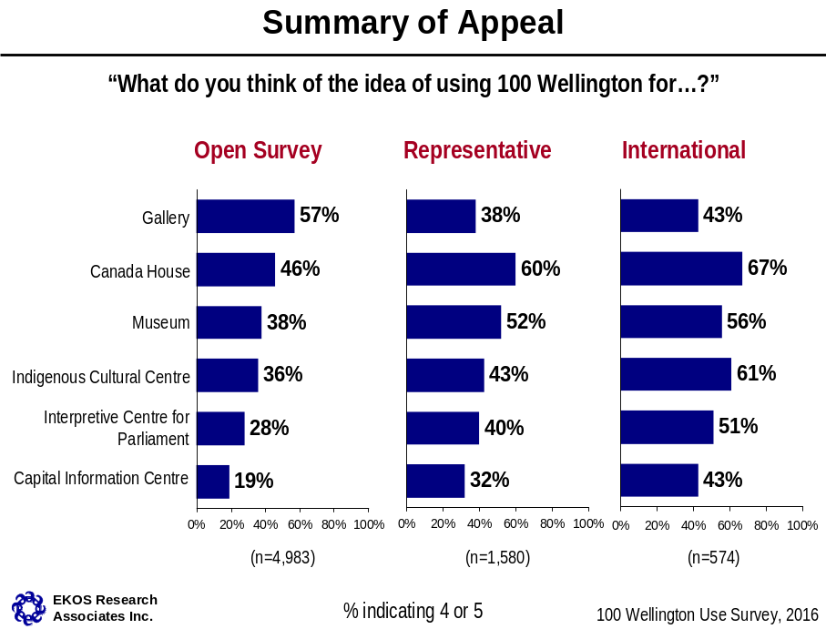

This is a summary of the previous sections, bringing together the percentage of appeal for each use across all three survey segments. Overall, results show that a Gallery has the highest percentage appeal in the open survey, while Canada House has the highest appeal rating in both the representative survey and with international respondents.

Overall Ranking of Proposed Uses

Once respondents provided input on each individual proposed use, they were asked to rank their top three preferences. Looking only at the first choice there is a fundamentally different pattern in the open survey, compared with the representative survey and with international respondents.

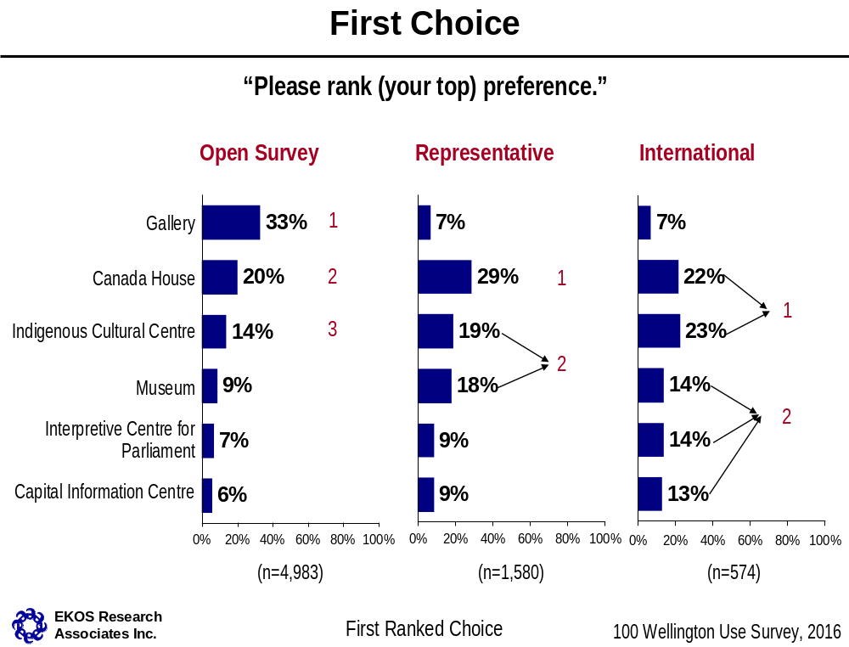

In the open survey, there is a clear preference for a Gallery, voted as the primary choice by 33 per cent. Canada House is the second most popular use, voted as a primary option by 20 per cent. An Indigenous Cultural Centre is the third most popular use, voted as a top choice by 14 per cent of respondents. The remaining one in three selected one of the other three choices.
- Gallery has particular support among residents of the NCR (36 per cent selecting it as their first choice). It is also very popular among residents of British Columbia (38 per cent selected it as a first choice). Residents of the Atlantic and Prairies provinces on the other hand were most likely to select Canada House as their first choice those (31 to 32 per cent).

- Gallery is also a choice more often favoured among those 55 years or older (39 to 61 per cent). An Indigenous Cultural Centre is the favoured response among those under 24 years old (24 per cent), and Canada House was most widely selected among those 25 to 54 years old (23 to 26 per cent).

In the representative survey Canada House is the clear first choice, according to 29 per cent who ranked it their number one option. This is followed by an Indigenous Cultural Centre and Museum, which are tied as the second most popular option. In contrast to the results of the open survey, Gallery is among the least favoured options in the representative survey.
- Gallery has somewhat greater support among residents of the NCR (14 per cent selecting it as their first choice) versus only six per cent outside the NCR.
- A Museum and Canada House are the most often selected choices among those under 35 (21 to 27 per cent).

Among international respondents an Indigenous Cultural Centre and Canada House are tied as the most preferred option, with 23 and 22 per cent selecting them as their first choice. A Museum and an Interpretive Centre for Parliament are tied in a second tier of options. As with the representative survey, Gallery is the least favoured option.

Combining Top Three Choices Into A Single Score
___________________________________________________________________

 | REPRESENTATIVE SURVEY |  | OPEN  SURVEY
 | CANADIANS  (n=1,580) |  | CANADIANS  (n=4,983) |  | INTERNATIONAL  RESPONDENTS  (n=574)
 | Score | Ranking | Score | Ranking | Score | Ranking
Canada House | 139 | 1 | 115 | 2 | 124 | 1
Capital Information Centre | 67 | 5 | 43 | 5 | 83 | 4
Gallery | 67 | 5 | 140 | 1 | 54 | 5
Indigenous Cultural Centre | 95 | 3 | 88 | 3 | 122 | 1
Interpretive Centre for Parliament | 73 | 4 | 61 | 4 | 88 | 3
Museum | 106 | 2 | 90 | 3 | 97 | 2

Accounting for first, second and third choices in one score gives a more complete picture of the rankings and helps to further focus the results. This type of index creation is an accepted methodology, often applied to summarize a number of data points. Scores are presented for each of the three main survey segments – representative survey, open survey (Canadians) and open survey (international) – with a relative ranking based on this score. Details of the methodology and calculation of the scores are presented in Appendix D.
- In the representative survey, Canada House receives the top average score by a considerable margin. Museum is the second most preferred choice, followed by an Indigenous Cultural Centre. The other three choices are much less likely to have been selected as a top three choice as demonstrated by the lower average preference score in each case.
- Scores are generally similar across age segments, although support for a Museum is higher among those under 35.
- In the open survey, results show that Gallery receives the top score, followed by Canada House. Museum and Indigenous Cultural Centre are both equally preferred as a third place choice, as shown by the very close average preference scores for these uses. An Interpretive Centre for Parliament is a third choice with a lesser score and Capital Information Centre shows the lowest score.
- Scores among those under 55 put Canada House as the top choice by a considerable margin. Scores are similar for Gallery, Museum and Indigenous Cultural Centre.
- Scores for those 55 or older are considerably higher for Gallery, followed by Canada House as a second choice. This difference is particularly strong for those 65 or older, who are three times more likely to rank Gallery as their first choice compared with those under 55. It is this strong preference for Gallery among those 55 or older (particularly those 65 and over) that put Gallery into the top choice in the open survey.
- For international respondents Canada House and an Indigenous Cultural Centre are both supported as the first choice to a relatively equal degree given the average scores, followed by a Museum as a second choice, and a fairly close third place ranking of Interpretive Centre for Parliament. Capital Information Centre is a fourth choice, with a score that is also relatively close to an Interpretive Centre for Parliament. Gallery is a clear fifth place choice based on its average score.
- Scores are generally similar across age segments, although support for an Indigenous Cultural Centre is higher among those under 35. A interpretive Centre for Parliament is the top choice among those 55 years of age or older.

Conclusion:

Overall, results show that Canada House clearly has the widest appeal across all survey segments with the exception of Canadians 55 or older in the open survey. It is the first choice among:
- Canadians in the representative survey,
- Canadians under 55 in the open survey, and
- International respondents.

Canada House is the second choice among those 55 or older in the open survey.

Gallery is the preferred use among the 55 or older segment in the open survey. It is the least preferred option, however, among those in the representative survey and international respondents, and is not a clear preference among those under 55 in the open survey.

Therefore, Canada House is seen as a strong first or second choice across all segments responding to the survey. While a Gallery enjoys significant support, it is singularly concentrated among those 55 or older responding to the open survey.

Appendix A
Survey Instrument (English)

HAVE YOUR SAY ON THE FUTURE OF 100 WELLINGTON!
REACHING OUT TO CANADIANS
The former U.S. Embassy, at 100 Wellington Street in Ottawa, has been vacant since 1998. Located across from Parliament Hill in the heart of the nation's capital, this building is an architectural gem, in a unique location, with a special history. We are planning the future of this important heritage building and want Canadians' views on how best to transform this building into an important Canadian institution. This is a fresh start for 100 Wellington!
The Government of Canada invites all Canadians to take part in a research survey on the possible uses for 100 Wellington. Ekos Research Associates has been hired to administer the survey. Si vous préférez répondre au sondage en français, veuillez cliquer sur <FRANÇAIS>. The survey takes about 5 minutes to complete and answers will remain anonymous and confidential. The survey is registered with the Marketing Research and Intelligence Association. <Click here> if you wish to verify its authenticity. To view our privacy policy, click here.

ABOUT 100 WELLINGTON
Built in the 1930s, 100 Wellington was the first in a series of purpose-built embassies constructed around the world by the U.S. government. Its strategic location opposite Centre Block symbolized the important relationship between the U.S. and Canada, and the classical architecture suited its prominent location on the Confederation Boulevard ceremonial route.
Looking to the future, 100 Wellington is a keystone building in the Parliamentary Precinct. It is important architecturally, culturally and symbolically. Determining the future public use of this building is a critical step in developing long-term plans for the lands on the south side of Wellington Street and the broader Parliamentary Precinct.
Please click "Next" to proceed.
QAGEY
Please indicate in which of the following age categories you belong.
Under 16 1
16 to 24 2
25 to 34 3
35 to 44 4
45 to 54 5
55 to 64 6
65 or older 7
Prefer not to answer 9

QAGEX2
Check age if born in 1999, or no response, QAGEY
If... AQAGEX = 1999 or QAGEY = 9
Are you at least 16 years of age?
Yes 1
No 2 ->THNK2

PQ1
For the past decade, the Parliamentary Precinct Branch has been implementing a coordinated, long-term plan to rehabilitate the Parliament Buildings and other buildings within the Parliamentary Precinct. The strategic focus of this work is to:
Preserve and restore the iconic heritage buildings,
Provide additional and appropriate accommodations for a 21st century parliament, and
Create a secure and welcoming environment for visitors, staff and parliamentarians.

Q1
How important are the Parliament Buildings as a symbol of national identity?
Q2
How important is it to preserve and rehabilitate the heritage buildings and grounds of the Parliamentary Precinct for future generations of Canadians?
Q3
How important is it that the Government of Canada take a leadership role in making the Precinct a model for environmental sustainability?
1 = Not very important; 5 = Very important
1 1
2 2
3 3
4 4
5 5
Not sure /don't care 9

PQ4
Please provide your opinions on the following six possible uses for 100 Wellington.

Q4AACOLL
What do you think of the idea of using 100 Wellington for a GALLERY – a space to house a collection of artwork of national significance?
1 = Dislike; 5 = Like
1 1
2 2
3 3
4 4
5 5
Not sure/ don't care 9

Q4ABCOLL
If you support a GALLERY at 100 Wellington, do you have any specific suggestions?

Q4BACOLL
What do you think of the idea of using 100 Wellington for a MUSEUM – a venue to exhibit national artifacts of historical and cultural interest?
1 1
2 2
3 3
4 4
5 5
Not sure/ don't care 9

Q4BBCOLL
If you support a MUSEUM at 100 Wellington, do you have any specific suggestions?

Q4CACOLL
What do you think of the idea of using 100 Wellington for an INDIGENOUS CULTURAL CENTRE – a use to be determined in partnership with Indigenous Peoples to showcase culture, achievements and the prominent role of Indigenous people in the history and future of Canada?
1 1
2 2
3 3
4 4
5 5
Not sure/ don't care 9

Q4CBCOLL
If you support an INDIGENOUS CULTURAL CENTRE at 100 Wellington, do you have any specific suggestions?

Q4DACOLL
What do you think of the idea of using 100 Wellington for a CANADA HOUSE – a venue to bring all of Canada to the nation's capital, giving a taste of the country's diversity and achievements and showcasing the best of the provinces and territories from coast to coast to coast?
1 1
2 2
3 3
4 4
5 5
Not sure/ don't care 9

Q4DBCOLL
If you support a CANADA HOUSE at 100 Wellington, do you have any specific suggestions?

Q4EACOLL
What do you think of the idea of using 100 Wellington for a CAPITAL INFORMATION CENTRE – a centre to provide information and orientation services for visitors through the grouping of complementary services from federal, municipal and tourism organizations?
1 1
2 2
3 3
4 4
5 5
Not sure/ don't care 9

Q4EBCOLL
If you support a CAPITAL INFORMATION CENTRE at 100 Wellington, do you have any specific suggestions?

Q4FACOLL
What do you think of the idea of using 100 Wellington for an INTERPRETIVE CENTRE FOR PARLIAMENT – a space to engage visitors with Parliament, how it works and its history?
1 1
2 2
3 3
4 4
5 5
Not sure/ don't care 9

Q4FBCOLL
If you support an INTERPRETIVE CENTRE FOR PARLIAMENT at 100 Wellington, do you have any specific suggestions?

Q4GB
Do you have ANOTHER IDEA for 100 Wellington? What public use can you suggest that would transform 100 Wellington into an important Canadian destination in the nation's capital?
Other suggestion : 77
No suggestions 99

PQ5
Option "YOUR IDEA" only displayed if open response provided to Q4GB
Now that you have thought about each of the six uses for 100 Wellington (and possibly your own idea), please rank the top three in your own order of preference.
(Please select only 1 per column)

Q5A
1st
GALLERY 1
MUSEUM 2
INDIGENOUS CULTURAL CENTRE 3
CANADA HOUSE 4
CAPITAL INFORMATION CENTRE 5
PARLIAMENTARY INTERPRETATIVE CENTRE 6
Q4GB is not empty
YOUR IDEA 7
NONE OF THESE 99 B

Q5B
2nd
GALLERY 1
MUSEUM 2
INDIGENOUS CULTURAL CENTRE 3
CANADA HOUSE 4
CAPITAL INFORMATION CENTRE 5
PARLIAMENTARY INTERPRETATIVE CENTRE 6
Q4GB is not empty
YOUR IDEA 7
NONE OF THESE 99 B

Q5C
3rd
GALLERY 1
MUSEUM 2
INDIGENOUS CULTURAL CENTRE 3
CANADA HOUSE 4
CAPITAL INFORMATION CENTRE 5
PARLIAMENTARY INTERPRETATIVE CENTRE 6
Q4GB is not empty
YOUR IDEA 7
NONE OF THESE 99 B

PDEMO
The following questions will only be used to help us understand the survey results. All of your answers are completely confidential.

QCITIZ
Open link only
Are you a citizen or permanent resident of Canada?
Yes 1
No 2
Prefer not to answer 9

QPOSTCELL
Citizens and permanent residents, QCITIZ
If... QCITIZ = 1 or SAMPL is not empty
What are the first three digits of your postal code?
Please specify : 1
Prefer not to answer 9

QPROV
Hesitant, QPOSTCELL
If... QCITIZ = 1 and QPOSTCELL = 9
In which province/territory do you live?
Please specify 98 N
Alberta 1
British Columbia 2
Manitoba 3
New Brunswick 4
Newfoundland & Labrador 5
Northwest Territories 6
Nova Scotia 7
Nunavut 8
Ontario 9
Prince Edward Island 10
Quebec 11
Saskatchewan 12
Yukon 13
Prefer not to answer 99

QNCR
NCR FSA or Ontario/Quebec
Are you a resident of the National Capital Region?
Yes 1
No 2
Prefer not to answer 9

QVISITA [1,2]
Citizens and permanent residents, QCITIZ and not NCR resident
Have you ever visited Canada's Capital?
Select all that apply
Yes, here now 1
Yes, in the past 2
No 3 X
Prefer not to answer 9 X

QVISITB
Past visitor to NCR
If... QCITIZ = 1 and (QNCR = 2,9 or QNCR is empty) and QVISITA = 2
How long ago did you visit the capital?
Less than 1 year 8
(years) 1 >
Don't know / No response 9

QCITIZB
Non-Citizens/permanent residents, QCITIZ
If... QCITIZ = 2
In which of the following geographic areas do you live?
Africa 1
Caribbean, South/Central America 2
South/Central Asia 3
West Asia 4
East/South East Asia 5
Europe 6
Oceania 7
North America 8
Prefer not to answer 99

QHOW
Web surveys only
If... SAMPL is empty and ISRC not = 2
How did you receive the link to complete this survey?
Public Engagement Session (August 18th) 1
Twitter 2
Facebook 3
Government website 4
Other (please specify) : 77
Don't know / No response 9

QSPECINT
Open link only
If... SAMPL is empty
Do you represent a professional or special interest group related to a public use for 100 Wellington?
Yes 1
No 2
Prefer not to answer 9

QSPECINTB
Professional or special interest group
If... SAMPL is empty and QSPECINT = 1
In which sector is your special interest?
Tourism 1
Architecture, urban planning/design, heritage 2
Neighbourhood community group 3
Other (please specify) : 77
Prefer not to answer 99

QLANG
What language do you speak most often at home?
English 1
French 2
Other 77
Prefer not to answer 99

QEDUC
What is the highest level of formal education that you have completed?
Grade 8 or less 1
Some high school 2
High School diploma or equivalent 3
Registered Apprenticeship or other trades certificate or diploma 4
College, CEGEP or other non-university certificate or diploma 5
University certificate or diploma below bachelor's level 6
Bachelor's degree 7
Post graduate degree above bachelor's level 8
Prefer not to answer 9

QAGEX
In what year were you born?
Year : 1 >
Prefer not to answer 9

QGENDR
What is your gender?
Male 1
Female 2
Other 3
Prefer not to answer 9

THNK
Thank you for your input on the future use of 100 Wellington, an important public space in the nation's capital!

Appendix B
Sample Characteristics

Sample characteristics of key survey segments
 | Representative |  | Open Link
 | NCR | Canadians | NCR | Canadians | Outside Canada
n= | -- | 1064 | -- | 2612 | --
Language
n= | 516 | 1064 | 2371 | 2612 | 574
English | 73% | 77% | 80% | 83% | 52%
French | 25% | 21% | 17% | 11% | 13%
Other | 2% | 2% | 2% | 5% | 32%
Prefer not to answer | 0% | 0% | 1% | 1% | 3%
Have you ever visited Canada's Capital?
n= | -- | 1046 | -- | 2439 | --
Yes, here now | -- | 3% | -- | 31% | --
Yes, in the past | -- | 74% | -- | 70% | --
No | -- | 23% | -- | 7% | --
Prefer not to answer | -- | 0% | -- | 1% | --
How long ago did you visit the capital?
n= | -- | 1064 | -- | 2612 | --
Within last year (incl. now) | -- | 20% | -- | 50% | --
1-2 years | -- | 8% | -- | 9% | --
3-4 years | -- | 9% | -- | 6% | --
5-9 years | -- | 10% | -- | 7% | --
10 years or more | -- | 25% | -- | 10% | --
Never | -- | 23% | -- | 7% | --
Not applicable – Live close to NCR | -- | 2% | -- | 7% | --
Don't know / No response | -- | 3% | -- | 4% | --
How did you receive the link to complete this survey?
n= | -- | -- | 2371 | 2612 | 574
Public Engagement Session (August 18th) | -- | -- | 5% | 5% | 12%
Twitter | -- | -- | 4% | 1% | 0%
Facebook | -- | -- | 16% | 15% | 1%
Government website | -- | -- | 23% | 11% | 2%
Other | -- | -- | 44% | 36% | 17%
Tablet, on site | -- | -- | 5% | 27% | 62%
Don't know / No response | -- | -- | 4% | 4% | 6%
Do you represent a professional or special interest group related to a public use for 100 Wellington?
n= | -- | -- | 2371 | 2612 | 574
Yes | -- | -- | 4% | 4% | 3%
No | -- | -- | 94% | 93% | 91%
Prefer not to answer | -- | -- | 3% | 3% | 5%
In which sector is your special interest?
n= | -- | -- | 87 | 103 | 20
Architecture, urban planning/design, heritage | -- | -- | 39% | 22% | 30%
Tourism | -- | -- | 9% | 24% | 55%
Government, public administration, various | -- | -- | 7% | 1% | 5%
Historical, museums, conservation, art museums | -- | -- | 6% | 9% | 0%
Neighbourhood community group | -- | -- | 5% | 5% | 10%
Arts/cultural organizations or professional associations | -- | -- | 5% | 6% | 0%
Artists, fine arts, visual arts | -- | -- | 3% | 15% | 0%
Education, information, academic, professors | -- | -- | 3% | 10% | 0%
Other | -- | -- | 10% | 3% | 0%
Prefer not to answer | -- | -- | 13% | 6% | 0%

Appendix C
Reviewed Comments

Comments from a sample of 10 per cent of respondents in the open survey and 25 per cent of the representative survey were categorized into recurring themes. Following are proportions in each:

Categories of reviewed comments about proposed uses
 | Representative Survey |  | Open Survey
 | NCR | Canadians | NCR | Canadians
Suggestions for support of a GALLERY
n= | 82 | 72 | 227 | 193
Specific themes/ideas | 36% | 58% | 12% | 16%
Portrait gallery (general agreement) | 31% | 8% | 52% | 49%
Portrait gallery (specific themes) | 7% | 1% | 15% | 15%
Mixed use | 1% | 3% | 11% | 7%
Rationale for non-support | 25% | 30% | 11% | 13%
Suggestions for support of a MUSEUM
n= | 84 | 82 | 119 | 106
Specific themes/ideas | 50% | 68% | 34% | 44%
Reference to portrait gallery | 10% | 4% | 29% | 25%
Rationale for non-support | 40% | 28% | 38% | 30%
Suggestions for support of an INDIGENOUS CULTURAL CENTRE
n= | 70 | 76 | 142 | 108
Specific themes/ideas | 36% | 51% | 35% | 37%
Considerations | 3% | 1% | 3% | 6%
Reasons for support | 14% | 7% | 10% | 9%
Reference to portrait gallery | 1% | 0% | 2% | 6%
Mixed use | 16% | 15% | 6% | 9%
Rationale for non-support | 33% | 26% | 46% | 38%
Suggestions for support of a CANADA HOUSE
n= | 62 | 62 | 107 | 102
Specific themes/ideas | 61% | 75% | 46% | 51%
Considerations | 11% | 9% | 10% | 16%
Reference to portrait gallery | 0% | 0% | 6% | 7%
Mixed use | 12% | 9% | 21% | 16%
Rationale for non-support | 23% | 10% | 22% | 15%
Suggestions for support of a CAPITAL INFORMATION CENTRE
n= | 41 | 26 | 113 | 54
Considerations | 12% | 15% | 11% | 13%
Reference to portrait gallery | 0% | 0% | 3% | 6%
Mixed use | 10% | 35% | 16% | 9%
Rationale for non-support | 78% | 50% | 71% | 72%
Suggestions for support of an INTERPRETIVE CENTRE FOR PARLIAMENT
n= | 52 | 50 | 95 | 89
Specific themes/ideas | 33% | 62% | 24% | 31%
Considerations | 11% | 12% | 5% | 15%
Reference to portrait gallery | 2% | 0% | 4% | 4%
Mixed use | 25% | 10% | 11% | 18%
Rationale for non-support | 37% | 20% | 57% | 34%
Suggestions for support of ANOTHER IDEA
n= | 5 | 22 | 116 | 111
Specific themes/idea | NA | 51% | 41% | 45%
Considerations | NA | 27% | 14% | 13%
Reference to portrait gallery | NA | 0% | 38% | 35%
Museum | NA | 14% | 9% | 10%
Indigenous cultural centre | NA | 4% | 3% | 2%
Canada house | NA | 5% | 3% | 1%
Interpretive centre for parliament | NA | 13% | 3% | 2%
Private enterprise use | NA | 0% | 1% | 4%
Mixed use | NA | 28% | 14% | 5%

Following are descriptions of the type of comments provided under each category of response assigned in the coding of a sample of respondents.

Details on content of comments reviewed
 | Comments
Suggestions/Comments for a GALLERY
Specific themes/ideas | Popular suggestions for specific themes and mediums include sculptures, artefacts, paintings, Aboriginal art, local art or art from across the country, a blend of historical and modern pieces, and pieces from the national archives.
Portrait gallery (general agreement) | Comments reveal general support for a portrait gallery. Several mention previous government promises of a portrait gallery, and suggest they still believe it is a good idea.
Portrait gallery (specific themes) | This group has specific ideas for a portrait gallery. Some would like to see it modeled after successful galleries in Britain and D.C, others highlight the importance of reflecting both Canada’s history and the current cultural diversity of the country.
Mixed use | Comments support inclusion of a variety of themes and artistic mediums. They would like to see diverse content including a mix of paintings, sculptures, photographs, and cartoons
Rationale for non-support | Those against using the building as a gallery argue it is a redundant use of space with the National Gallery nearby.
Suggestions/Comments for a MUSEUM
Specific themes/ideas | Comments suggest Canadians are interested in a museum focused on a variety of topics. Several suggest that focusing on the history of Canadian-American relations would be a good way to honour the history of the building. Other popular topics include confederation, Aboriginal history, political history, military history, cultural history, immigration, and the history of Canadian architecture.
Reference to portrait gallery | Some suggest that a portrait gallery could be used more like a museum by including portraits associated with confederation and/or having information available about the historical importance of the portrait. Other comments suggest preference of a portrait gallery over a museum
Rationale for non-support | This group overwhelmingly espouse the view that there are enough museums in Ottawa already. A few also criticize that the building is too small for this project, and that the lack of parking would make visiting difficult.
Suggestions/Comments for an INDIGENOUS CULTURAL CENTRE
Specific themes/ideas | Many emphasize making Indigenous Canadians equal partners in the project, showing the variety of Indigenous cultures from all across Canada, and showing the less favourable parts of Canadian history in addition to celebrating the culture. A focus on truth and reconciliation was also mentioned by several
Considerations | Comments highlight the importance of consulting members of the Indigenous population in planning and employment, as well as making a space where all Canadians welcome to participate. Some also believe the space should have free entry to Canadians feel.
Reasons for support | These participants offer general support, citing that it is a good learning opportunity, a great way to embrace Indigenous populations, and a prominent location to house an important project.
Reference to portrait gallery | Comments suggest preference for a portrait gallery that includes Indigenous displays.
Mixed use | These participants mention wanting to see Indigenous culture incorporated into a space that celebrates all Canadians, such as a museum or Canada House.
Rationale for non-support | Comments reveal that many support the idea of an Indigenous cultural centre, but believe this is not the appropriate location to create one, with some citing Lebreton Flats or Victoria Island as more suitable options. Other reasons for disagreement include wanting a space more inclusive of all Canadians.
Suggestions/Comments for a CANADA HOUSE
Specific themes/ideas | Popular ideas for specific themes include Canadian achievements, technology, scientific discoveries, cuisine, music, sports, art, and cultural contributions. Some participants would like to see a mix of these themes.
Considerations | This group offers suggestions like having free entry for all Canadians, a comfortable location for children and adults, a large coffee shop to relax in, and themed days for special occasions.
Reference to portrait gallery | Comments advocate for a national portrait gallery, which several argue is a more appropriate use of the space, and has the ability to display Canada’s heritage and diversity as effectively as a Canada House.
Mixed use | Comments support mixing two or more ideas together to create a multifunctional space. Specific themes/functions suggested for inclusion are a gallery, a celebration of cultural history, representation of Indigenous culture, and a museum. One person mentions that tackling a broad spectrum of ideas means installations could change and encourage visitors to come back for more.
Rationale for non-support | Some feel the scope of the project is too broad for the size of the building, others believe the suggested topics are already covered in museums throughout Ottawa, a few fear the topic would not attract enough visitors, some citing similarity to the Canada and the World museum that already closed.
Suggestions/Comments for a CAPITAL INFORMATION CENTRE
Considerations | Ideas for additional functions include storage for luggage, having businesses that stand to make financial gains pay for the majority of the function, include a shuttle from nearby museums, tour guides, restaurants, washrooms, and make it a comfortable place for tired tourists to relax.
Reference to portrait gallery | Comments express preference for a portrait gallery.
Mixed use | Comments show preference for an information centre becoming a small part of a richer purpose like a Canada house, portrait gallery, or an exhibit.
Rationale for non-support | Comments show hesitance due to similar functions being performed in other buildings in the city, the building being too large to hold such a narrow function, and there not being enough cultural significance for a historic building.
Suggestions/Comments for an INTERPRETIVE CENTRE FOR PARLIAMENT
Specific themes/ideas | Suggestions for specific content includes mock debates, youth geared information, the history of this (and surrounding) building(s), tribute to past leaders, supplement (not overlap) parliament tours, and historical context
Considerations | Considerations for features include cost being tied in with parliament tour fees, having specific children’s programming, a cafeteria or restaurant, and most popularly, interactive displays.
Reference to portrait gallery | Comments express preference for a portrait gallery.
Mixed use | Comments suggest this should be an included part of Canada House, portrait gallery, or a museum of Canadian cultural significance
Rational for non-support | Respondents argue that this could be accomplished through tours of parliament directly. Several also suggest that if additional space is needed for an interpretive centre, it should be located on parliament grounds.
Suggestions/Comments for ANOTHER IDEA
Specific themes/ideas | Comments vary widely for suggested themes. Specific suggestions include sustainability, peacekeeping, Canadian history, architecture, wellness centre, cultural diversity centre, history of immigration, Canadian geography, Canadian achievement, Canadian history library, concert hall, women’s contributions, Canadian innovation and business, and Canadian contributions to the world.
Considerations | Considerations for building features include restaurants, shops/tourism, a digital guestbook, café with Indigenous foods, and family friendly space.
Reference to portrait gallery | Respondents contend that a portrait gallery is the best use of this historic space
Museum | Respondents suggest a variety of themes for a museum including environmental, science, history of Prime Ministers, hall of fame, kids’ museum, cultural, export, and minority contributions
Indigenous cultural centre | Respondents express preference for an Indigenous cultural centre with information about residential schools
Canada House | Comments indicate that creating a Canada House is the best way to show the strengths of the entire nation.
Interpretive centre for Parliament | Comments stress the educational benefits, especially for youth, of having an interpretive centre for parliament
Private enterprise use | Comments suggest selling the building for private use, suggesting it could become a hotel, shopping, or a restaurant. Some express fear that the space will be too costly with government involvement. In fact, one person suggests giving the profits back to tax payers.
Mixed use | Respondents express interest in combining two or more ideas into a multi-functional building, or to have the purpose change on a rotational basis.

Some comments provided by respondents, with specific ideas presented in “your idea” are:
- “Canada Support Building: a building that is dedicated to bringing handicapped groups (autistic, immobilized, etc) to the capital.”
- “A sustainability education center to encourage environmental consciousness in the center of our country's capital.”
- “Retain its use as an embassy, allowing a space for sovereign First Nations to be represented to their occupying government.”
- “Something indoors for the kids and seniors - an aquarium, a see and touch museum... take inspiration from other major cities.”
- “Open forum for all visitors, the world's biggest suggestion box; public access and birthplace of the new parliament; referendums.”
- “Cultural diversity centre. Focus on Canada being a melting pot and the benefits that brings and adds to our own identity as Canadians. Represent every race, creed, sexuality to display how inclusive of a society we are. Stay away from representing religion though.”
- “A true destination, housing the Constitution, a monument to all past PMs, (paintings, busts, etc) something equivalent to the mall in DC.”
- “Interaction with the public, potentially something that families, elementary/secondary students could be engaged in. Something that brings the government into a youthful sphere, making it real and tangible. Let's get young people interested by teaching them that government is a place where real change can be enacted and enforced on a grand scale.”
- “The Future of Canada. Showcase innovative ideas across various categories for industry, architecture, solar power, environmental, Canada's Space Agency (Canada Arm), homes, cars, etc., etc. The Canadian version of Epcot's Future World. That is an exhibit I would actually pay money to see.”
- “A center for performing arts and private gathering rental space and/or investures of Cabinet Ministers, Order of Canada recipients etc. “
- “A venue for dancing (Grand balls) and chamber music, as well as for visual arts and crafts.”
- “Interactive and creative space for Canadians as well as newcomers/visitors to engage with the country and each other. Collaborative spaces to house interactive installations on how they see Canada, what they want Canada to be, and what their primary concerns are. Creative spaces for arts. All spaces for federal use should incorporate elements from the other suggestions as well (i.e., highlight Indigenous culture, important Canadian works, and information about government). Promote value of an open and transparent Canada.”
- “General Community Centre with free events such as yoga, dance classes, cafes etc”
- “Performance space for classical and Canadian music, and performance art”
- “Canadian Hall of Fame”
- “Start-up incubator, provide subsidized workspace to ventures from across the country, showcase real Canadian innovation and encourage economic growth”
- “In light of Canada's great performance in Rio, it would be more than fitting to create a Canadian Sports and Cultural Achievement Commemorative Center to highlight the successes of our athletes, musicians, and artists.”
- “Working with youth groups, such as Cadets Canada, this venue could hold parliamentary summer camps for youth, allowing them to experience Canadian history and citizenship first hand.”
- “Multimedia presentation both displays and IMAX type movies about the Country's diversity and what we are proud of in each province. Kind of like a permanent Expo pavilion”
- “A National Poetry Centre”

Appendix D
Details of Top 3 Ranking and Single Score Calculation

First, Second and Third Choices

Following are the percentages of each of the three respondent groups selecting each use as their first, second or third choices. The total of first, second and third choice is provided at the end of each row.

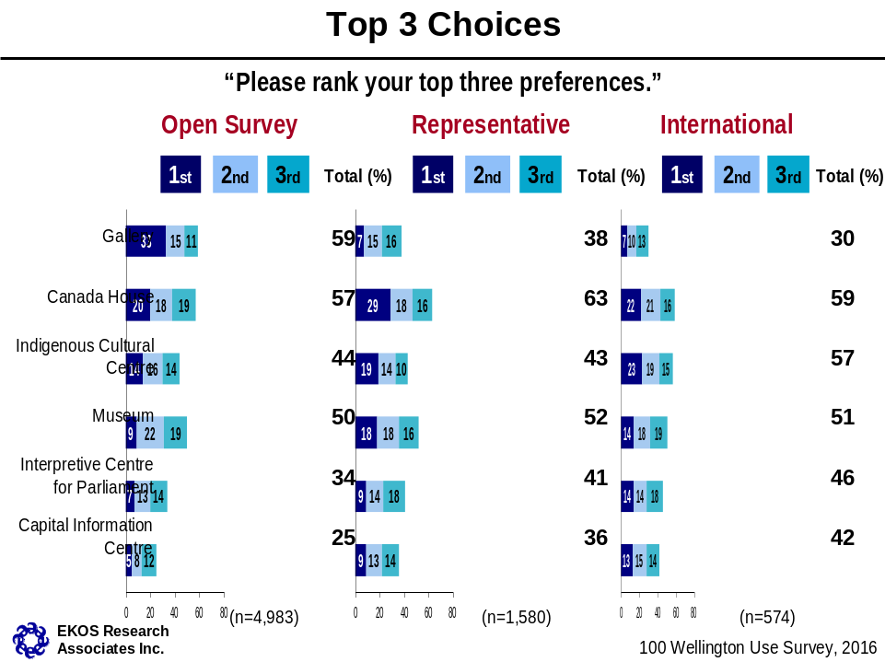

These results provide a more complete picture of which uses are selected as a top three choice most often within each respondent group. The chart also provides some clarity of whether the use is more often selected as a first choice, versus a second or third choice.

These same first, second and third choice percentages selecting each use (as shown in the previous chart) can be used to create an overall score. In order to take first versus second versus third choice into consideration, first choice percentages may be tripled; second choice percentages may be doubled, and third place choices may be used as they are (i.e., multiplied by 1). These values may be added together for an overall, single score. In the table below these percentages have been multiplied as described and overall scores presented for each of the three main segments described throughout the report. A relative ranking has also been assigned based on this score.

 | Representative Survey |  |  |  |  | Open Survey
 | Canadians (n=1,580) |  |  |  |  | Canadians (n=4,983) |  |  |  | International Respondents (n=574)
 | Choice | % | Multipl* | Score | Rank | % | Multipl* | Score | Rank | % | Multipl* | Score | Rank
Canada House | First | 29 | 87 |  |  | 20 | 60 |  |  | 22 | 66
Canada House | Second | 18 | 36 | 139 | 1 | 18 | 36 | 115 | 2 | 21 | 42 | 124 | 1
Canada House | Third | 16 | 16 |  |  | 19 | 19 |  |  | 16 | 16
Capital Information Centre | First | 9 | 27 |  |  | 5 | 15 |  |  | 13 | 39
Capital Information Centre | Second | 13 | 26 | 67 | 5 | 8 | 16 | 43 | 5 | 15 | 30 | 83 | 3
Capital Information Centre | Third | 14 | 14 |  |  | 12 | 12 |  |  | 14 | 14
Gallery | First | 7 | 21 |  |  | 33 | 99 |  |  | 7 | 21
Gallery | Second | 15 | 30 | 67 | 5 | 15 | 30 | 140 | 1 | 10 | 20 | 54 | 5
Gallery | Third | 16 | 16 |  |  | 11 | 11 |  |  | 13 | 13
Indigenous Cultural Centre | First | 19 | 57 |  |  | 14 | 42 |  |  | 23 | 69
Indigenous Cultural Centre | Second | 14 | 28 | 95 | 3 | 16 | 32 | 88 | 3 | 19 | 38 | 122 | 1
Indigenous Cultural Centre | Third | 10 | 10 |  |  | 14 | 14 |  |  | 15 | 15
Interpretation Centre for Parliament | First | 9 | 27 |  |  | 7 | 21 |  |  | 14 | 42
Interpretation Centre for Parliament | Second | 14 | 28 | 73 | 4 | 13 | 26 | 61 | 4 | 14 | 28 | 88 | 4
Interpretation Centre for Parliament | Third | 18 | 18 |  |  | 14 | 14 |  |  | 18 | 18
Museum | First | 18 | 54 |  |  | 9 | 27 |  |  | 14 | 42
Museum | Second | 18 | 36 | 106 | 2 | 22 | 44 | 90 | 3 | 18 | 36 | 97 | 2
Museum | Third | 16 | 16 |  |  | 19 | 19 |  |  | 19 | 19
First choice
Last choice

*First place percentages are multiplied by 3. Second place percentages are multiplied by two and third place percentages are multiplied by 1. These multiplied percentages are then added together to create a single “score”. Rankings are assigned based on the relative score.

Respondents under 55 years of age
 | REPRESENTATIVE SURVEY |  | OPEN SURVEY
 | Canadians  (n=1,019) |  | Canadians  (n=2,882) |  | International Respondents  (n=418)
 | Score | Ranking | Score | Ranking | Score | Ranking
Canada House | 136 | 1 | 130 | 1 | 134 | 1
Capital Information Centre | 66 | 5 | 48 | 6 | 77 | 4
Gallery | 63 | 5 | 106 | 2 | 57 | 5
Indigenous Cultural Centre | 96 | 3 | 100 | 3 | 127 | 2
Interpretive Centre for Parliament | 79 | 4 | 69 | 5 | 79 | 4
Museum | 105 | 2 | 95 | 4 | 100 | 3

Respondents 55 years of age or older
 | REPRESENTATIVE SURVEY |  | OPEN SURVEY
 | Canadians  (n=554) |  | Canadians  (n=1,683) |  | International Respondents  (n=123)
 | Score | Ranking | Score | Ranking | Score | Ranking
Canada House | 147 | 1 | 96 | 2 | 98 | 3
Capital Information Centre | 63 | 5 | 34 | 6 | 99 | 3
Gallery | 69 | 4 | 186 | 1 | 44 | 5
Indigenous Cultural Centre | 89 | 3 | 73 | 4 | 109 | 2
Interpretive Centre for Parliament | 64 | 4 | 53 | 5 | 124 | 1
Museum | 101 | 2 | 79 | 3 | 91 | 4

A total of 7,650 panel members were sampled and sent an invitation to participate. Of these, 345 emails bounced back as “return to sender”, leaving 7,305 valid cases in the sample. Of these 1,580 completed the survey for a participation rate of 21.6%.
10% of the sample was randomly selected from the open survey responses of 5,557 as a sufficiently large sub-sample (n=550) to have confidence that the main themes of the comments were accurately and comprehensively identified. Because of the smaller size of the sample in the representative survey, a larger proportion of respondents were selected to ensure the reliability of the review.

