
PWGSC Contract: #EP771-170143
POR Registration: POR-012-16
Contract Award Date: 15/06/2016

Survey of Potential Public Uses for
100 Wellington Street, Ottawa
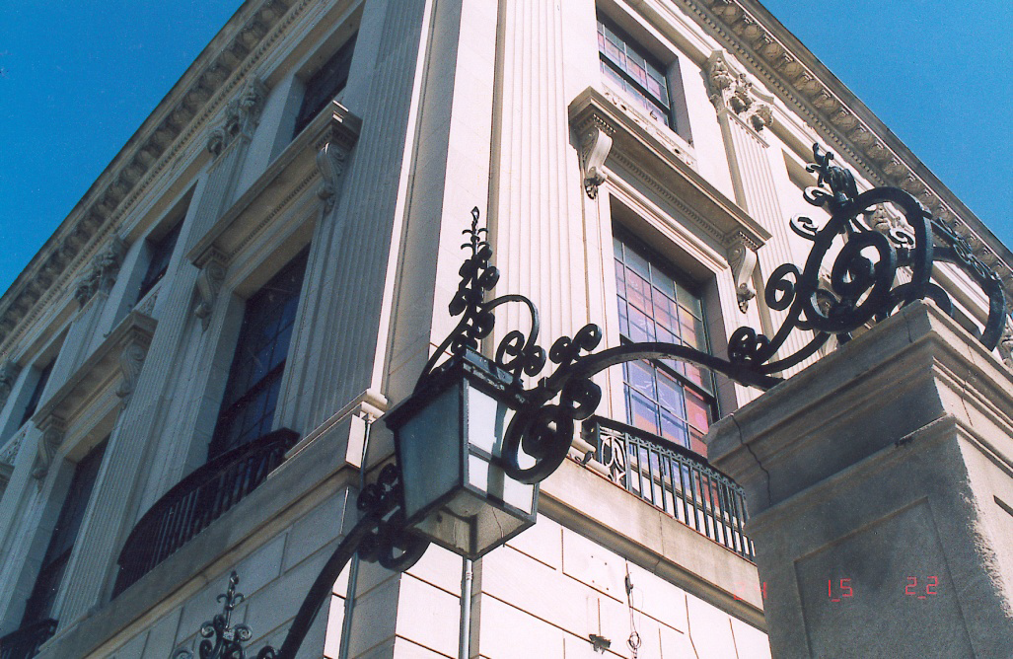

executive summary

Prepared for:
Public Services and Procurement Canada

Prepared by:
EKOS RESEARCH ASSOCIATES INC.

November 21, 2016

Ce rapport est aussi disponible en français

To obtain more information on this report please e-mail
TPSGC.Questions-Questions.PWGSC@tpsgc-pwgsc.gc.ca

EKOS RESEARCH ASSOCIATES
Ottawa Office
359 Kent Street, Suite 300
Ottawa, Ontario
K2P 0R6
Tel: (613) 235 7215
Fax: (613) 235 8498
E-mail: pobox@ekos.com

www.ekos.com

This certification is to be submitted with the final report submitted to the Project Authority.

I hereby certify as Senior Office of EKOS RESEARCH ASSOCIATES INC. that the deliverables fully comply with the Government of Canada political neutrality requirements outlined in the Communications Policy of the Government of Canada and Procedures for Planning and Contracting Public Opinion Research. Specifically, the deliverables do not include information on electoral voting intentions, political party preferences, standings with the electorate or ratings of the performance of a political party or its leader.

Signed: 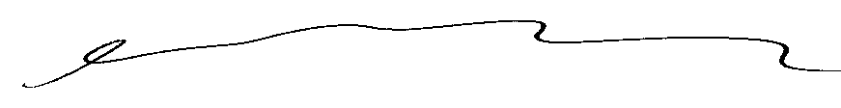
Susan Galley, Senior Vice President
EKOS Research Associates Inc.

Summary

The remarkable heritage building at 100 Wellington Street in Ottawa has a long and celebrated history. Built in the 1930s and located directly opposite Parliament Hill, 100 Wellington was the Embassy of the United States of America. In 1997 the Government of Canada acquired the property from the U.S. Government and the building was vacated in 1998.

The Government is committed to finding a public use for this important building and creating a space that is meaningful for Canadians and visitors alike. Over the summer of 2016, public consultations on the future of 100 Wellington were undertaken, including a stakeholder workshop, a media tour, a series of open houses, and a public information forum where a three-week, on-line bilingual public opinion survey was launched. Input from the public consultations will provide important information as the Government of Canada assesses options and makes a decision on the future use of 100 Wellington.

The public opinion study included two surveys using the same questionnaire: (1) an open survey that allowed all interested Canadians and international visitors to participate, and (2) a random, nationally representative survey to understand the broader Canadian landscape and provide a point of comparison for the open survey results. Between August 18 and September 9, 2016 a total of 7,137 individuals completed the survey: 5,557 through the open survey (including 4,983 Canadians and 574 international respondents) and 1,580 through the representative survey.

Findings

At the beginning of the survey, respondents were asked to consider the importance of:
- The Parliament Buildings as a symbol of national identity,
- Preserving and rehabilitating the Parliament Buildings for future generations, and
- Making the Parliamentary Precinct a model for environmental sustainability.

Results highlight the strong value that Canadians and those visiting the Parliamentary Precinct place on these matters. The vast majority (90 per cent or more) in the open survey (both Canadians and international respondents) rated each as important. Results are similar in the representative survey with 80 per cent or more indicating that these matters are important.

Respondents were then presented with a list of six possible public uses for a revitalized 100 Wellington and asked to rate their “like” or “dislike” for each one. Respondents were provided an opportunity to comment on each of the uses and to provide suggestions of their own for the future use of 100 Wellington. In the open survey, Gallery is seen as the most appealing, with 57 per cent liking the idea. Canada House also has appeal (46 per cent), while the other options have limited appeal. From the reviewed Gallery comments, two in three supporting a Gallery commented on a “portrait” gallery specifically, mentioning longstanding promises for a National Portrait Gallery, and a need to finally move on this idea.

In the representative survey and among international respondents, Canada House clearly has the widest appeal, with six in ten or more indicating they like this idea. Museum and/or Indigenous Cultural Centre are second or third options. By comparison, a Gallery has less support, with only 38 per cent of the representative survey and 43 per cent of the international respondents expressing support for this idea.

Many who like these options comment about the appeal and value of a Canada House, Museum or Indigenous Cultural Centre. On the other hand, many in the open survey raise concerns about the limited available space for a museum at 100 Wellington, and the number of museums already in the region. Concerns about an Indigenous Cultural Centre at 100 Wellington point to the inappropriateness of the location and style of architecture for this purpose, saying that other more suitable options exist for such a use.

Support for a Gallery in the open survey is heavily concentrated among Canadians 55 years of age or older. Eight in ten of those 65 or older like the idea of a Gallery, but only a third of those under 25 and half of those 25 to 54 say the same. The reverse is true for support for Canada House, a Museum and Indigenous Cultural Centre which have considerably strong support among those under 55, particularly those under 35.

Ranking of Uses
Respondents were asked to rank their top three preferences from the list of potential uses. The results were considered in two ways: (1) first choice results, and (2) top three choices weighted and combined into a single score.

The first choice results show that Gallery is the top choice for respondents in the open survey, whereas Canada House is the top choice in the representative survey. Canada House and Indigenous Cultural Centre are virtually tied as the first choice among international respondents.

The top three choices combined score was created for each use based on the percentages of respondents selecting it as their top three choices. Relatively more weight was given to a first choice selection, less weight to a second choice selection, and least weight to a third choice selection. The results show that:
- In the representative survey, Canada House receives the top average score, with Museum in second place followed closely by an Indigenous Cultural Centre.
- In the open survey, Gallery is the top choice, followed by Canada House as a second choice. Museum and Indigenous Cultural Centre are tied as a third place choice. Support splits along generational lines. Support for Canada House, a Museum and an Indigenous Cultural Centre each have much greater support among those under 55, while support for a Gallery is heavily concentrated among those 55 or older, and in particular those 65 or older.
- For international respondents, Canada House and Indigenous Cultural Centre rank equally with the top score, followed by a Museum and Interpretive Centre for Parliament in second and third respectively.

Overall, results show that Canada House clearly has the widest appeal across all segments with the exception of Canadians 55 years or older who responded to the open survey. It is the first choice among:
- Canadians in the representative survey,
- Canadians under 55 in the open survey, and
- International respondents.

Gallery is the preferred use among the 55 or older segment in the open survey. It is the least preferred option, however, among those in the representative survey and international respondents, and is not a clear preference among those under 55 in the open survey.

Therefore, Canada House is seen as a strong first or second choice across all segments responding to the survey. While a Gallery enjoys significant support, it is singularly concentrated among those 55 or older responding to the open survey.

The total expenditure for the public opinion research project is $42,835.48 (including HST).

Supplier Name: EKOS Research Associates
PWGSC Contract #EP771-1770143
Contract Award Date: June 15, 2016
To obtain more information on this study, please e-mail
TPSGC.Questions-Questions.PWGSC@tpsgc-pwgsc.gc.ca

