Whales Initiative: Canadians’ Awareness and Understanding of Southern Resident Killer Whales

Final report
Prepared for Transport Canada
Supplier: Phoenix SPI
Contract Number: CW2344990
Contract Value: $99,238.86 (including HST)
Award Date: 2024-01-10
Delivery Date: 2024-03-18

Registration Number: POR 113-23

For more information on this report, please contact Transport Canada at TC.Publicopinion-Opinionpublique.TC@tc.gc.ca.
Ce rapport est aussi disponible en français.

Whales Initiative: Canadians’ Awareness and Understanding of Southern Resident Killer Whales
Final Report

This public opinion research report presents the results of an online survey conducted by Phoenix SPI on behalf of Transport Canada. The research study was conducted with 1,059 residents of coastal communities located on the south coast of British Columbia and selected areas of Vancouver Island who met the eligibility criteria for recreational watercraft use. The fieldwork was conducted between January 26 and February 29, 2024.

Cette publication est aussi disponible en français sous le titre Recherche sur l'opinion publique : L’initiative de protection des baleines: connaissances et compréhension de la population canadienne concernant les épaulards résidents du Sud

Transport Canada grants permission to copy and/or reproduce the contents of this publication for personal and public non-commercial use. Users must reproduce the materials accurately, identify Transport Canada as the source and not present theirs as an official version, or as having been produced with the help or the endorsement of Transport Canada.

To request permission to reproduce materials from this publication for commercial purposes, please complete the following web form: www.tc.gc.ca/eng/crown-copyright-request-614.html

Or contact TCcopyright-droitdauteurTC@tc.gc.ca

Catalogue Number:
T22-251/1-2024E-PDF
International Standard Book Number (ISBN):
978-0-660-70896-6
Related publications (registration number: POR 113-23):
- Catalogue Number: T22-251/1-2024F-PDF
- ISBN: 978-0-660-70897-3

© His Majesty the King in Right of Canada, as represented by the Minister of Transport, 2024

Table of Contents

Executive Summary 1

Introduction 4
1. Background and Objectives 4
2. Methodology 4
3. Notes to reader 5

Detailed Findings 6
1. Recreational Watercraft Use 6
2. Awareness and Knowledge of Protective Measures 11
3. Communications 15
4. Ad Campaign Recall 17
5. Profile of Respondents 20

Conclusions and Implications for Marketing and Advertising 26

Appendix 27
Technical Specifications 27
Survey Questionnaire 30

List of Figures
Figure 1: Recreational watercraft use 6
Figure 2: Type of recreational watercraft experience 7
Figure 3: Types of watercraft used in the last few years 8
Figure 4: Frequency of recreational watercraft use 9
Figure 5: Type of recreational watercraft use 10
Figure 6: Knowledge of measures to protect SRKWs in BC coastal waters 11
Figure 7: Awareness of specific protective and voluntary measures 13
Figure 8: Awareness of specific protective and voluntary measures over time 14
Figure 9: Term most commonly used for referral 15
Figure 10: Daily habits 16
Figure 11: Aided recall of ad campaign 17
Figure 12: Source of ad recall 18
Figure 13: Recall of ad campaign content, messages 19
Figure 14: Level of education 20
Figure 15: Household income 21
Figure 16: Language spoken most often at home 22
Figure 17: First Nations, Métis, and Inuk status 23
Figure 18: Location 24
Figure 19: Age and gender 25

Executive Summary
Transport Canada commissioned Phoenix Strategic Perspectives Inc. (Phoenix SPI) to conduct public opinion research with residents of south coastal British Columbia (BC) and selected areas of Vancouver Island who use or plan to use recreational watercrafts.

Research Purpose and Objectives
The main purpose of the research was to conduct a second follow-up survey to the baseline which was conducted in 2021 on the awareness of Southern Resident killer whale (SRKW) mandatory and voluntary protective measures in the southern coastal waters of BC. Specific objectives of this year’s survey included measuring public awareness of Transport Canada and Fisheries and Oceans Canada’s efforts to protect the SRKW; measuring public awareness of the advertising campaign, as reducing threats to their survival is one of the goals of the Whales Initiative; and exploring differences over time in awareness levels.

Methodology
An 11-minute random digit dialling (RDD) telephone survey was administered to 1,059 adults aged 18 and older who reside in coastal communities on the south coast of BC and selected areas of Vancouver Island and who met the eligibility criteria for boating. For the purposes of this research, to be classified as a boater, adults must have done the following at least once in the previous 12 months or plan to do so in the coming 12 months:
1) own, operate, rent, or be a passenger on a recreational vessel, motorized or sail; and/or
2) paddle board, kayak, or canoe on the ocean during this timeframe.
The fieldwork was conducted between January 26 and February 29, 2024. Based on a sample of this size, the overall results can be considered accurate within ±3.1%, 19 times out of 20. The margin of error is greater for results pertaining to subgroups of the full sample. Data were weighted to reflect the population in terms of age, gender, and area (with the geographic parameters of the study). For a more complete description of the methodology, refer to Appendix: Technical Specifications.

Key Findings

Awareness that there are measures in place to protect Southern Resident killer whales in BC coastal waters continues to increase, and nine in 10 respondents said they were aware of at least one of the specific voluntary and mandatory measures.
Awareness of measures to protect Southern Resident killer whales in BC coastal waters has been steadily increasing since 2021, with 64% being aware of these measures in 2024 compared to 56% when the baseline survey was conducted in 2021. While awareness of the specific mandatory and voluntary protective measures varied considerably, nine in 10 (91%) coastal BC residents who went out on the ocean in the last 12 months (or who plan to in the coming year) are aware of at least one of the protective measures.

Awareness was highest for the following mandatory and voluntary measures: watercraft must keep 400 metres from killer whales and not be positioned in the path of killer whales (72% aware, including 45% who were definitely aware) and boats should reduce speed when within 1,000 metres of a killer whale (70% aware, including 48% who were definitely aware). Respondents were least likely to be aware of the interim sanctuary zones in key portions of Southern Resident killer whale foraging areas: 23% were aware of the interim sanctuary zone off the northern part of Pender Island and 21% were aware of the interim sanctuary zone off parts of Saturna Island.

Half of surveyed BC coastal residents recalled at least one of the three Transport Canada advertisements about protecting the killer whales in BC coastal waters.
Recall of Transport Canada’s advertisements about protecting the killer whales in BC coastal waters was moderate, with half (51%) of those surveyed recalling at least one of the three digital ads that made up the campaign. Recall was highest for “protecting killer whales by staying away from them when boating”, with 44% saying they had seen or heard this ad. Notably, the protective measure most respondents were aware of was keeping 400 metres from killer whales.

Following the ad about avoiding the SRKW, approximately one-third (30%) recalled seeing or hearing an ad about protecting killer whales in BC coastal waters by “ensuring you do not boat in restricted areas”, while one-quarter (24%) recalled an ad about “ensuring you do not fish for salmon within closures”.

Of those who recalled seeing or hearing an advertisement about protecting killer whales in BC coastal waters, 20% said the main message of the ad was “Slow down and stay away if you see a whale”, 19% said it was “Help keep killer whales safe”, and 17% recalled the instruction to “Stay 400 meters away from killer whales”. The single largest proportion of respondents could not recall anything specific about the advertisements (32%), while an additional 10% mentioned that they were generally aware of, and knowledgeable about, the protective measures (without pointing to anything specific about the ads).

Turning to communications, ‘Orca’ continues to be the preferred term of reference for killer whales. YouTube and AM/FM radio, followed by Facebook, are the media many said they use every day.
Close to six in 10 (58%) said they use the term ‘Orca’ most often to refer to killer whales (compared to 53% in 2021). In contrast, 36% said they mainly use the term ‘killer whale’. When asked to identify from a list of activities what they typically do on a daily basis, many said they use YouTube (57%; up from 47% in 2022), listen to AM/FM radio (53%; unchanged compared to 2022), or use Facebook (49%; unchanged compared to 2022) every day. Daily use of Instagram (42%; up from 38% in 2022) and Spotify (40%; up from 30% in 2022) was also relatively widespread among survey respondents.

Boating habits of coastal BC residents are similar to previous years: power boats and kayaks are the common watercrafts used by respondents and the frequency of boating in a typical year varies considerably.
Forty-three percent (43%) of survey respondents have been out on the ocean in a power boat in the last few years and approximately one-third (32%) have been out on the ocean in a kayak (inflatable or hard shell). Power boats and kayaks also topped the list of the types of recreational watercrafts typically used by coastal BC residents in the baseline survey (2021) and the follow-up survey (2022).

Nearly two-thirds (63%) typically go out in a watercraft fewer than 10 times a year. This includes 31% who go out once (15%) or twice (16%) in a typical year. At the other end of the spectrum, approximately one-quarter (23%) are out on the ocean for recreational purposes 10 or more times in a typical year. In the baseline survey, one-third (34%) reported going out on the ocean in a watercraft once or twice in a typical year and one-quarter (24%) said they tended to do so 10 or more times.

Limitations and Use of the Research
Probability sampling was used. The results, therefore, are generalizable to the target population. The only limitation is smaller sample sizes when it comes to analyzing the results for sub-groups of the population. The survey results will be used by Transport Canada to help inform communications planning, outreach, and education activities, as well as to improve boaters’ confidence, awareness, and compliance with the voluntary and mandatory protective measures for the SRKW and associated boating safety regulations.

Contract Value
The contract value was $99,238.86 (HST included).

Political Neutrality Certification
I hereby certify as a Senior Officer of Phoenix Strategic Perspectives that the deliverables fully comply with the Government of Canada political neutrality requirements outlined in the Communications Policy of the Government of Canada and Procedures for Planning and Contracting Public Opinion Research. Specifically, the deliverables do not contain any reference to electoral voting intentions, political party preferences, standings with the electorate, or ratings of the performance of a political party or its leader.

Alethea Woods
President
Phoenix Strategic Perspectives Inc.

Introduction
Phoenix Strategic Perspectives Inc. (Phoenix SPI) was commissioned by Transport Canada to conduct a survey on boaters’ awareness and understanding of Southern Resident killer whales (SRKW).

Background and Objectives
Building on the Oceans Protection Plan, the Government of Canada introduced a five-year $167.4 million Whales Initiative in Budget 2018 to help protect and support the recovery of the SRKW. Budget 2023 set aside an additional $151.9 million for three more years of efforts under the renewal of the Whales Initiative. For the fifth consecutive year, Transport Canada has put in place an Interim Order to help reduce disturbances in key foraging areas to the SRKW, and Fisheries and Oceans Canada has put fisheries management measures in place.

In line with those measures, the SRKW advertising campaign was launched as a call to action for Canadians to help protect Canada’s endangered whales, specifically the SRKW. Key areas of focus of the campaign included:
- Content of regulations that make it the law to stay a minimum distance away from marine mammals and around the location and restrictions of interim sanctuary zones.
- Messages around slowing down in areas where whales can be found, and when whales are seen.

Given the mandate of the Whales Initiative, Transport Canada conducted a public opinion research study in July 2021 to provide a baseline measure of the public’s awareness of the Whales Initiative measures and of boating safety in the southern coastal waters of BC. Following the baseline survey, a second public opinion research study was conducted in the first quarter of 2022 to measure awareness of Transport Canada’s efforts to protect the SRKW, recall of the advertising campaign, and use of depth finder technology.

The objectives of this second follow-up study were:
- to measure the public’s awareness of Transport Canada and Fisheries and Oceans Canada’s efforts to protect the SRKW;
- to measure awareness of the advertising campaign because reducing threats to the survival of the SRKW is one of the goals of the Whales Initiative; and
- to explore differences over time in awareness levels.

The findings from the research will be used by Transport Canada to inform communications planning and activities, outreach, and education activities. The overall goal is to help improve Canadian recreational boaters’ awareness and understanding of, and compliance with, the protective measures for SRKW and associated boating safety regulations.

Methodology
An 11-minute random digit dialling (RDD) telephone survey was completed with 1,059 adults aged 18 and older who reside in coastal communities located on the south coast of BC and selected areas of Vancouver Island and who met the eligibility criteria for boating. Specifically, this included the coastal communities between Campbell River and Ucluelet on Vancouver Island, and residents of the Sunshine Coast, the Lower Mainland, and Howe Sound. To be classified as a boater, adults must have done the following at least once in the previous 12 months or plan to do so in the coming 12 months:
- own, operate, rent, or be a passenger on a recreational vessel, motorized or sail; and/or
- paddle board, kayak, or canoe on the ocean during this timeframe.

This survey also included an oversample of Indigenous peoples. Based on a sample of this size, the overall results can be considered accurate to within ±3%, 19 times out of 20. The margin of error is greater for results pertaining to subgroups of the total sample.

The data was weighted to reflect the population in terms of age, gender, and region. The fieldwork was conducted from January 26 through February 29, 2024. For a more complete description of the methodology, refer to the Appendix: Technical Specifications.

Notes to Reader
- All results are expressed as percentages, unless otherwise noted. Throughout the report, percentages may not always add up to 100 due to rounding and/or multiple responses being offered by respondents.
- At times, the number of respondents changes in the report because questions were asked of sub-samples of the survey population. Accordingly, readers should be aware of this and exercise caution when interpreting results based on smaller numbers of respondents.
- Where base sizes are reported in graphs, they reflect the actual number of respondents who were asked the question.
- When reporting subgroup variations:
  - The only differences discussed in the report are those that are significant at the 95% confidence level, that exceed the margin of sampling error for the overall sample, and that pertain to a subgroup sample size of at least n=30. The only exception regarding the sample size criterion for subgroup variations is significant differences that are part of a pattern or trend. These may be reported even when a subgroup sample size falls below the reporting threshold of n=30.
  - If one or more categories in a subgroup are not mentioned in a discussion of differences (for example, if two out of three age groups are compared), it can be assumed that significant differences were found only among the categories reported.
- Tracking data is included in the analysis. As noted, the baseline survey was conducted in 2021 and the first follow-up survey was conducted in 2022.
- The survey questionnaire is appended: Survey Questionnaire.

Detailed Findings

Recreational Watercraft Use

Nearly three-quarters have used a recreational watercraft in the last year.
Nearly three-quarters of respondents (73%) have gone out on the ocean in or on a recreational watercraft in the last year. The remainder (27%) plan to use a recreational watercraft in the coming year.
Figure 1: Recreational watercraft use
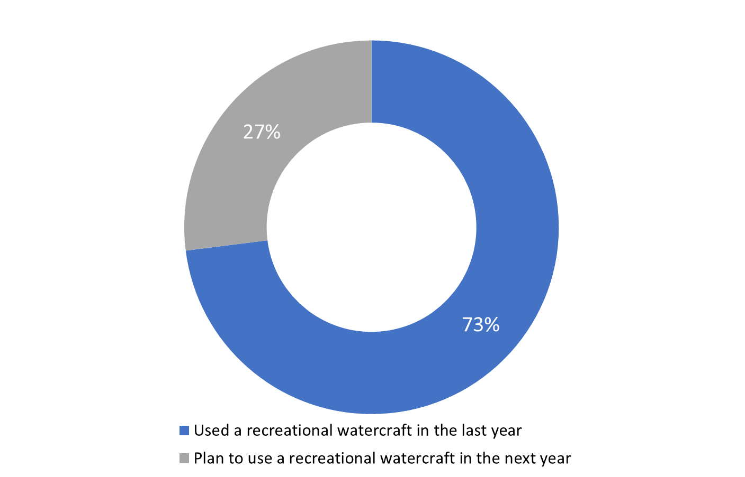
Base: n=1,059; all respondents
SCR. 1A. In the last year, did you go out on the ocean in or on a recreational watercraft?
SCR. 1B. In the next year, do you plan to go out on the ocean in or on a recreational watercraft?

The following groups of people were more likely to have gone out on the ocean in or on a recreational watercraft in the last year: boat owners (83% compared to those who rent boats or who go out as passengers); 18 to 34 year olds (77% compared to those aged 55+), and those from households with an annual income of $100,000 or more (78% compared to those from households earning less than $60,000 per year).

Largest proportion go out on the ocean as passengers.
Boaters and future boaters are more likely to be passengers than owners or renters of a recreational watercraft. Specifically, among respondents who were out on the ocean this past year (n=777), six in 10 (60%) said they went out as a passenger, just over one-third (35%) as a boat owner, and approximately two in 10 (18%) as boat renter. In contrast, almost two-thirds (64%) of those who plan to go out on the ocean in the next year (n=282) intend to go as a passenger, just over one-quarter (27%) as a boat renter, and nearly two in 10 (18%) as a boat owner.
Figure 2: Type of recreational watercraft experience
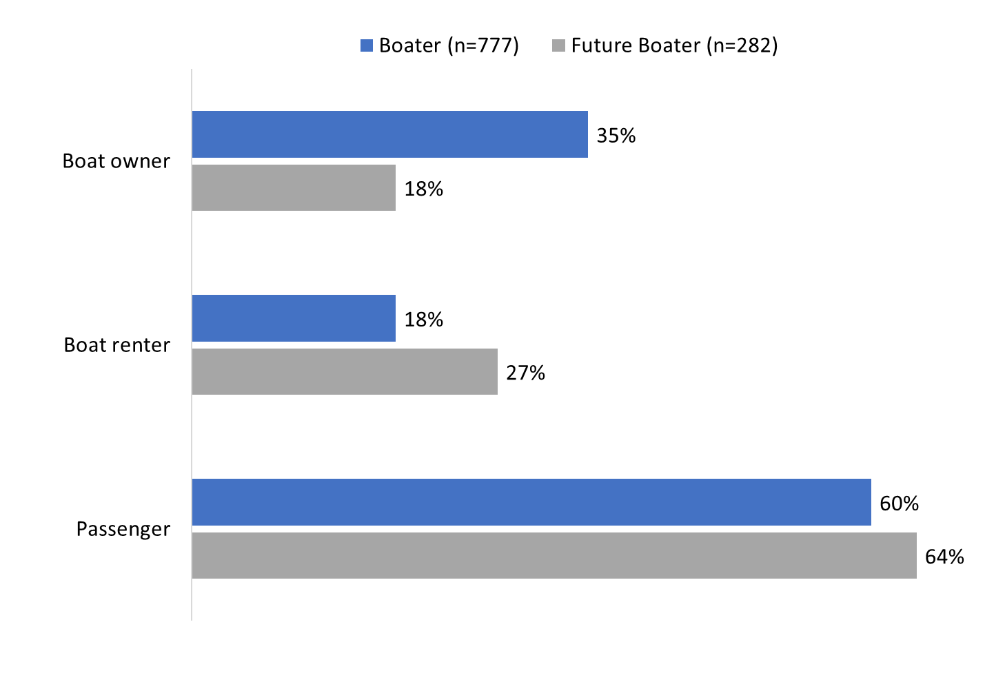
Base: all respondents.
SCR2A/B. When you were out on the ocean this year/go out on the ocean in the next year, will you go out/did you go out as a watercraft owner, renter, or passenger? [multiple responses accepted]

More boat owners are from the Sunshine Coast (54%) and Central (54%) or South Vancouver Island (46%) than from Metro Vancouver (30%), aged 55+ (40% versus 27% who are 18 to 34), and typically use a kayak (48%) rather than a power boat (33%).

Power boats and kayaks are the common watercrafts used by respondents.
Forty-three percent (43%) of survey respondents have been out on the ocean in a power boat in the last few years and approximately one-third (32%) have been out on the ocean in a kayak (inflatable or hard shell). Power boats and kayaks also topped the list of the types of recreational watercrafts typically used by coastal BC residents in the baseline survey (2021) and the follow-up survey (2022).

Following power boats and kayaks, smaller proportions said they have used an inflatable or hard shell paddleboard (16%), a sail boat (11%), a canoe (10%), or a personal watercraft (8%), such as a Jet Ski or Sea-Doo. The full range of watercrafts identified can be found in Figure 3.

Figure 3: Types of watercraft used in the last few years

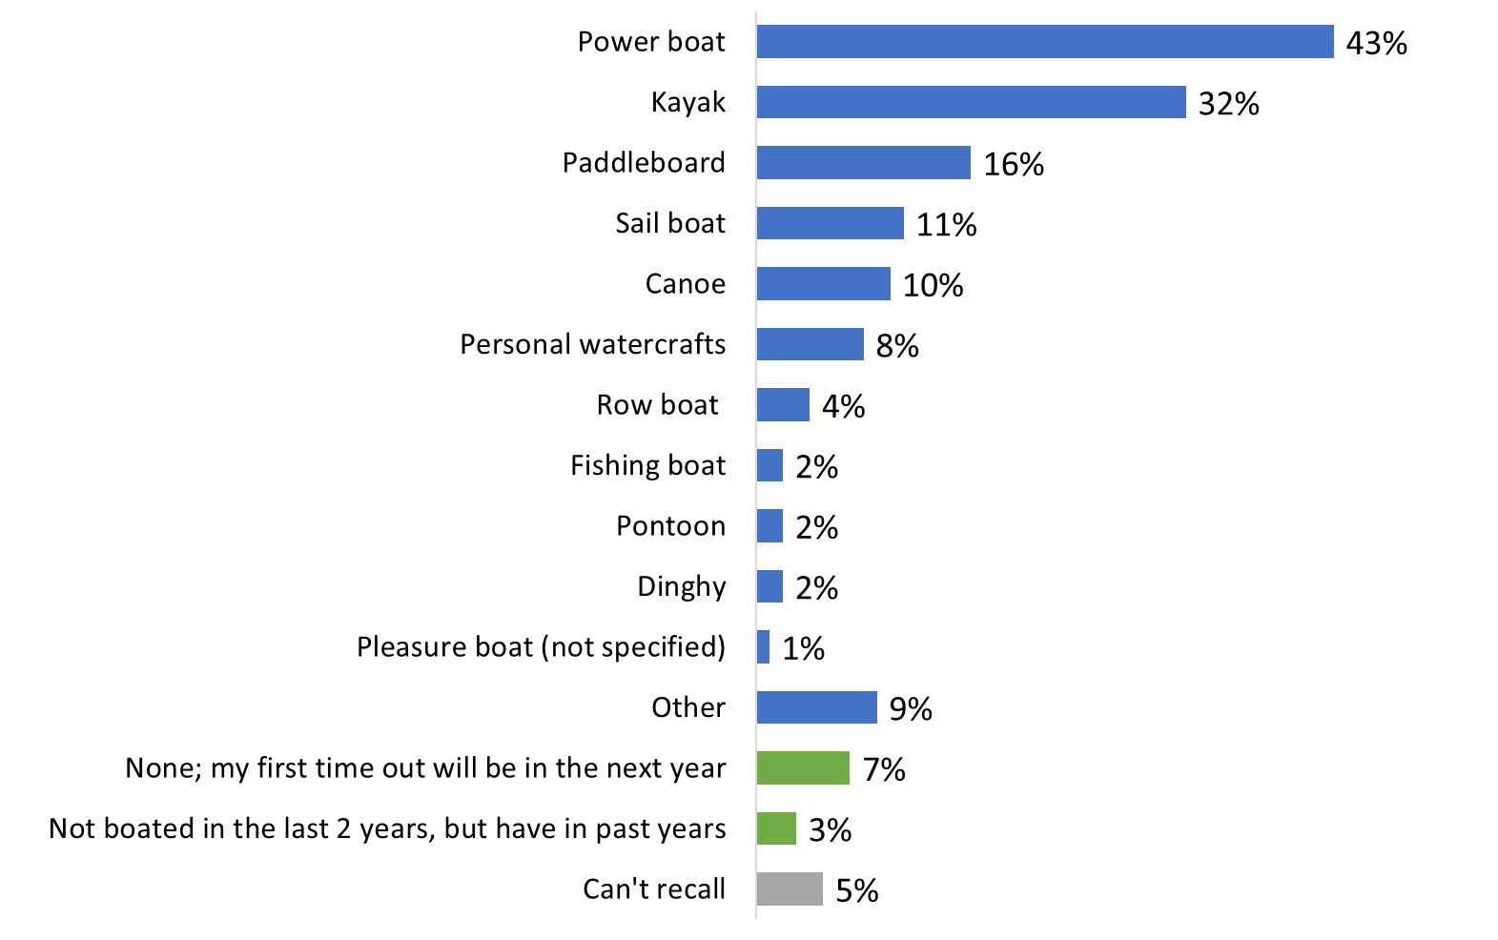
Base: n=1,059; all respondents.
Q3. What type of watercraft have you used on the ocean in the last few years? [Multiple responses accepted]

Respondents who went out on the ocean in a power boat in the last few years were more likely to live on the Sunshine Coast (53%) than Central Vancouver Island (39%) and to report an annual household income of $100,000 or more (48% compared to 35% of those earning less than $60,000 per year). Kayakers, on the other hand, were most likely to be 18 to 34 years of age (42%) and more likely to live on South Vancouver Island (37%) than Central Vancouver Island (27%) or the Sunshine Coast (26%).

The frequency of boating in a typical year varies considerably.
Three in 10 coastal BC residents surveyed (31%) go out on the ocean in, or on, a watercraft for recreational purposes once (15%) or twice (16%) in a typical year. A similar proportion (32%) go out three to four (16%) or five to nine (16%) times. Taken together, nearly two-thirds (63%) typically go out in a watercraft fewer than 10 times a year. At the other end of the spectrum, approximately one-quarter (23%) are out on the ocean for recreational purposes 10 or more times in a typical year. The median number of times respondents reported going out on the ocean in, or on, a watercraft was four.

One in 10 (10%) are first-time watercraft users. These respondents volunteered that they do not typically go out on the ocean or that their plans to go out in the next year will be their first time on the ocean in a watercraft for recreational purposes.

The frequency of going out on the ocean is similar to the baseline survey (2021) and the follow-up survey (2022). In the baseline survey, one-third (34%) reported going out on the ocean in a watercraft for recreational purposes once or twice in a typical year (compared to 31% in 2024 and 28% in 2022) and one-quarter (24%) said they go out 10 or more times (compared to 23% in 2024 and 17% in 2022).

Figure 4: Frequency of recreational watercraft use
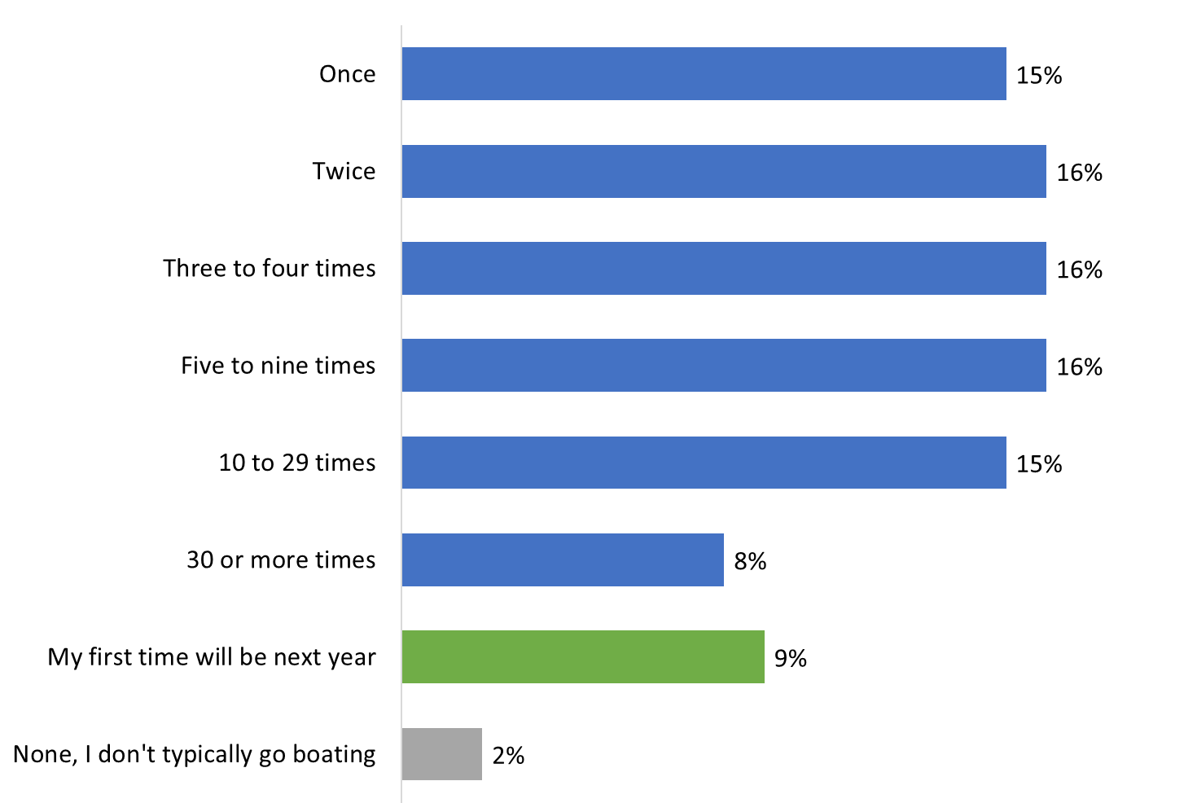
Base: n=1,059; all respondents. [DK/NR: 4%].
Q4. On average, how many times a year do you typically go out on the ocean in a watercraft for recreational purposes?

Boat owners (46%) were more likely than those who rent watercrafts (9%) or those who are typically passengers (12%) to report going out on the ocean 10 or more times in a typical year.

Going out on the ocean in a watercraft is a seasonal activity for most surveyed coastal BC residents.
More than eight in 10 (86%) coastal BC residents surveyed go out on the ocean in a watercraft for recreational purposes as a seasonal activity. Comparatively few (11%) said they do this year-round and 2% volunteered that it depends. These results are consistent with those from the baseline (2021) and follow-up (2022) surveys. In 2021, 85% said it was a seasonal activity (compared to 84% in 2022), for 13% it was year-round (unchanged in 2022), and 1% said it depended (also unchanged in 2022).

Figure 5: Type of recreational watercraft use

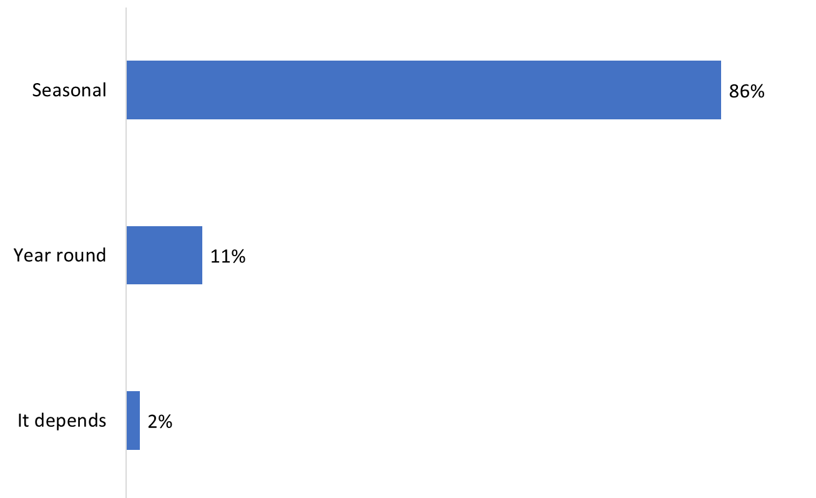
Base: n=897; respondents who typically go out on the ocean in a watercraft for recreational purposes.
Q5. Do you tend to go out on ocean in a watercraft all year long or is this a seasonal activity? [DK/NR: 1%].

Those who typically go out on the ocean in or on a watercraft for recreational purposes year-round are more likely to be boat owners (19%) and to have recalled at least one of Transport Canada’s advertisements on protecting Southern Resident killer whales (14%). Year-round boaters are least likely to reside in Metro Vancouver (7%).

Awareness and Knowledge of Protective Measures

Relatively widespread awareness of measures to protect Southern Resident killer whales.
Awareness of measures to protect Southern Resident killer whales in BC coastal waters continues to increase, from 56% in 2021, to 60% in 2022, to 64% in 2024. Among the rest, 15% were unaware of protective measures and 21% were uncertain.

Figure 6: Knowledge of measures to protect SRKWs in BC coastal waters

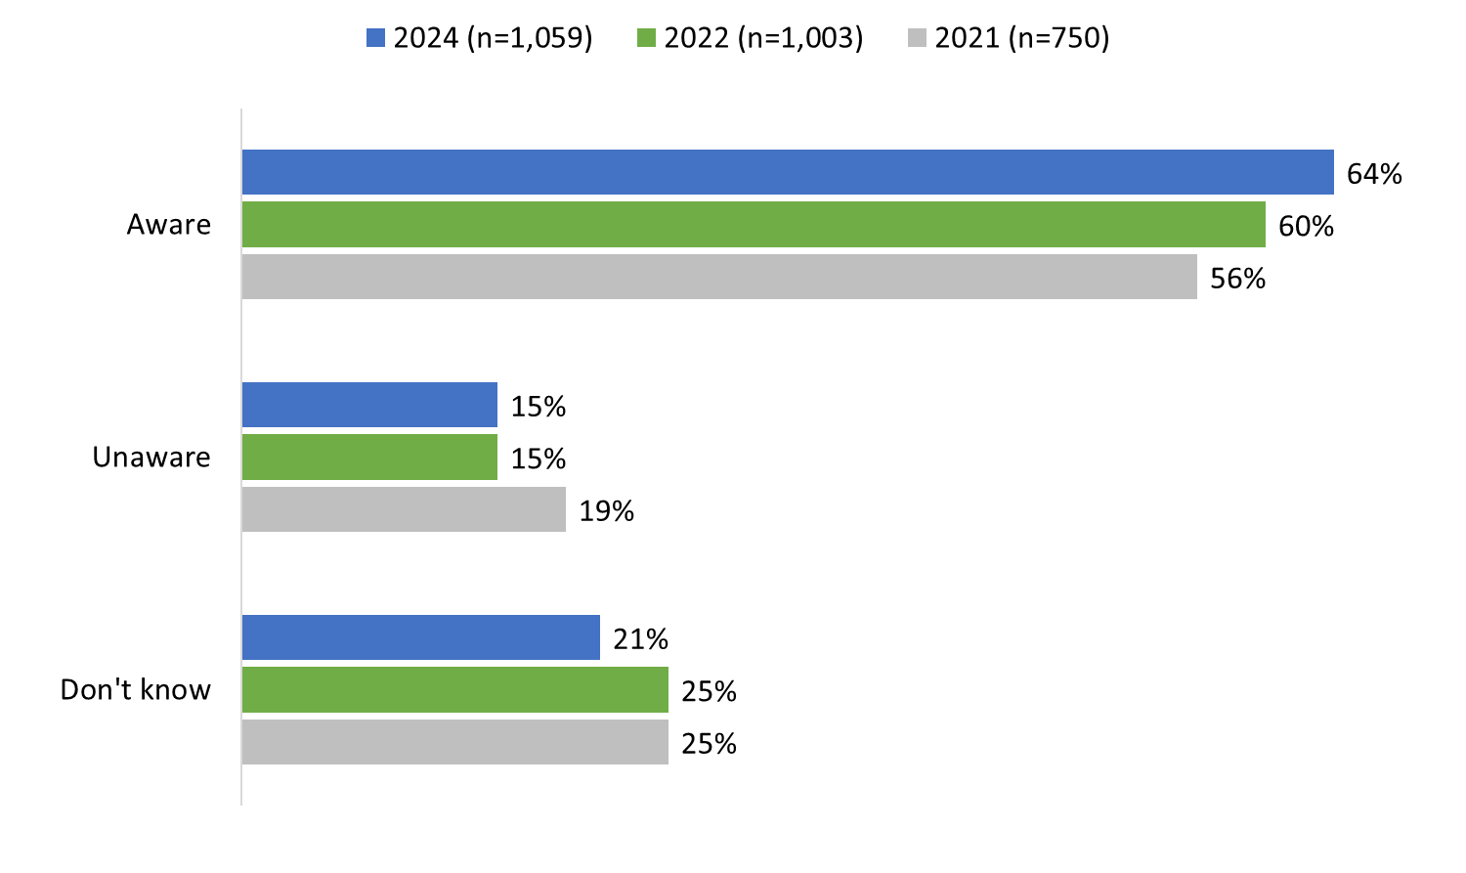
Base: n=1,059; all respondents
Q1. To the best of your knowledge, are there any protective measures in place to protect Southern Resident killer whales in BC coastal waters?

Awareness that there are measures in place to protect Southern Resident killer whales was higher among Indigenous respondents (78%), those who live on South Vancouver Island (76%), and those who recalled one of Transport Canada’s advertisements on protecting Southern Resident killer whales. In addition, awareness increased with age, from 45% of those under 35 to 76% of those aged 55 and older, and with annual household income, 48% of those earning less than $60,000 a year to 70% of those earning $100,000 or more annually.

Awareness of specific mandatory and voluntary protective measures varies.
After being asked about protective measures in general, respondents were informed that there are mandatory and voluntary measures in place to protect Southern Resident killer whales in BC coastal waters. These measures were then read to respondents who were asked to indicate whether they are ‘definitely’ or ‘somewhat’ aware of each one. The measures included:
- There is an interim sanctuary zone that prevents watercraft from operating off the northern part of Pender Island.
- There is an interim sanctuary zone that prevents watercraft from operating off parts of Saturna Island.
- There are two Speed Restricted Zones that require watercraft to operate at no more than 10 knots speed over ground at Swiftsure Bank.*
- There are salmon fishing closures that prohibit recreational or commercial salmon fishing in key Southern Resident killer whale foraging areas near the mouth of the Fraser River, in the southern Gulf Islands, Juan de Fuca Strait and around Swiftsure Bank.*
- Watercraft must keep 400 metres from killer whales and not be positioned in the path of killer whales in all southern BC coastal waters between Campbell River and just north of Ucluelet.**
- Outside of coastal waters between Campbell River and just north of Ucluelet, watercraft must keep 200 metres from killer whales as per the Marine Mammal Regulations.*
- When out on the water, you should not follow whale-watching boats because some have an exemption and do not need to keep 400 metres away from all killer whales.
- Boats should reduce speed when within 1,000 metres of a killer whale.
- Fishing should not take place within 1,000 metres of a killer whale.

The vast majority (91%) of respondents were definitely or somewhat aware of at least one of the protective measures. Awareness was highest for the following measures: watercraft must keep 400 metres from killer whales and not be positioned in the path of killer whales (72% aware, including 45% who were definitely aware) and boats should reduce speed when within 1,000 metres of a killer whale (70% aware, including 48% who were definitely aware).

Following this, the majority of coastal BC residents surveyed were aware that there are salmon fishing closures that prohibit recreational or commercial salmon fishing in key Southern Resident killer whale foraging areas (60%) and that outside of coastal waters between Campbell River and just north of Ucluelet, watercraft must keep 200 metres from killer whales as per the Marine Mammal Regulations (60%). Awareness of each measure was evenly divided between those who were ‘definitely’ and ‘somewhat’ aware. Approximately half (49%) were aware that fishing should not take place within 1,000 metres of a killer whale.

Awareness was lower for the remaining protective measures. One-third (34%) were aware that they should not follow whale-watching boats because some have an exemption and do not need to keep 400 metres away from all killer whales. Close to three in 10 (28%) were aware of the two Speed Restricted Zones that require watercraft to operate at no more than 10 knots speed over ground at Swiftsure Bank (28%). Fewer were aware of the interim sanctuary zones: 23% were aware of the interim sanctuary zone that prevents watercraft from operating off the northern part of Pender Island and 21% were aware of the interim sanctuary zone that prevents watercraft from operating off parts of Saturna Island.

Figure 7: Awareness of specific protective and voluntary measures

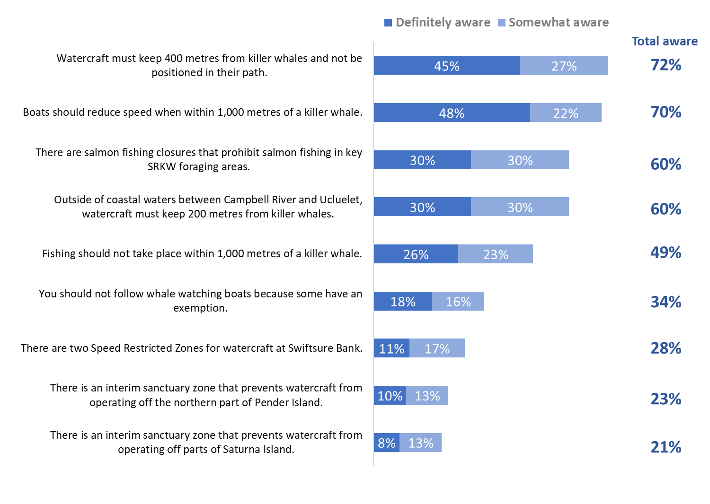
Base: n=1,059; all respondents. [DK: 1%-2%]
Q2. Are you aware that…?

Awareness of all these measures was higher among respondents who recalled at least one of Transport Canada’s advertisements about protecting the SRKW. In addition, awareness of most of the measures was generally lower among those from Metro Vancouver compared to those living on Vancouver Island or the Sunshine Coast.

Boat owners were more likely to be aware of salmon fishing closures, as well as the mandatory requirements to keep 400 metres from killer whales and, when outside of coast waters between Campbell River and Ucluelet, to keep 200 metres from killer whales.

Indigenous respondents were more likely to be aware that there are salmon fishing closures that prohibit salmon fishing in key Southern Resident killer whale foraging areas, that outside of coastal waters between Campbell River and Ucluelet, watercraft must keep 200 metres from killer whales, and that fishing should not take place within 1,000 metres of a killer whale.

Figure 8 compares awareness of the protective measures over time. With one exception, there has been no significant change in reported awareness of the mandatory and voluntary measures in place to protect Southern Resident killer whales. The exception was the mandatory requirement that watercraft keep 400 metres from killer whales and not be positioned in the path of killer whales in all southern BC coastal waters between Campbell River and just north of Ucluelet. This year, 72% of respondents said they were definitely or somewhat aware of the protective measure (up from 59% in 2022 and 63% in 2021). Given the change in wording, the increase in awareness should be considered with caution since it is not possible to determine what impact, if any, the wording change had on awareness.

Figure 8: Awareness of specific protective and voluntary measures over time

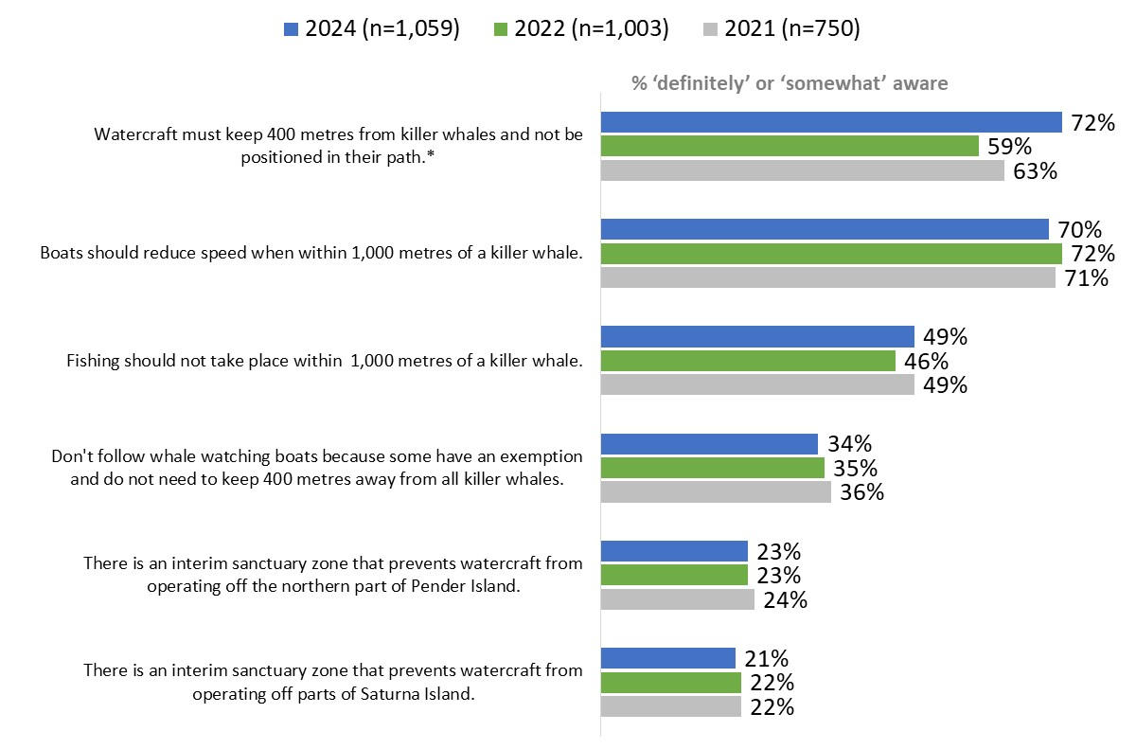

Q2. Are you aware that…?
*This year, “and not be positioned in the path of killer whales” was added to the measure.

Communications

‘Orca’ continues to be the preferred term of reference for killer whales.
When asked what term they use most often to refer to killer whales, close to six in 10 (58%; up from 53% in 2022) said they use the term ‘Orca’. In contrast, 36% said they mainly use the term ‘killer whale’. Three percent volunteered that they use both terms interchangeably, while 1% use a different term all together.

Figure 9: Term most commonly used for referral
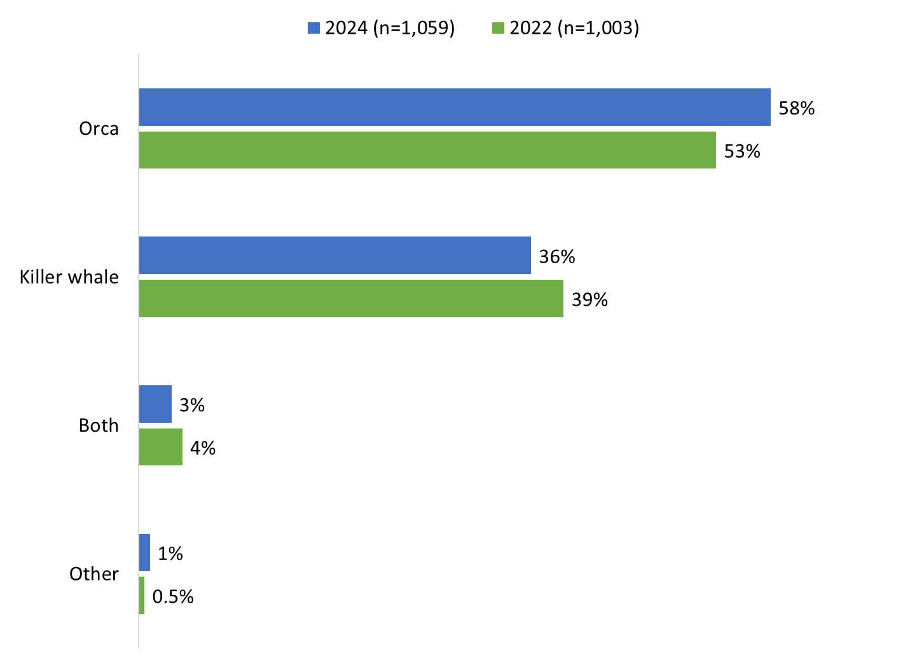
Base: n=1,059; all respondents. [DK/NR: 2%].
Q3A. Killer whales are also referred to as ‘Orcas’. Which term do you most commonly use?

Those with a high school education or less (47%) were more likely to use the term ‘killer whale’ while those with a college (59%) or university (61%) were more apt to use the term ‘Orca’.

YouTube and AM/FM radio, followed by Facebook, are the media many used every day.
When asked to identify from a list of activities what they typically do on a daily basis, many said they use YouTube (57%; up from 47% in 2022), listen to AM/FM radio (53%; unchanged compared to 2022), or use Facebook (49%; unchanged compared to 2022) every day. Daily use of Instagram (42%; up from 38% in 2022) and Spotify (40%; up from 30% in 2022) was also relatively widespread among survey respondents.

Other media are used daily by smaller proportions: 16% use TikTok (vs. 13% in 2022), 15% use X (unchanged compared to 2022), and 12% use Snapchat (unchanged compared to 2022). In addition, 13% listen to Sirius XM and 7% to Stingray radio on a daily basis.

Two in 10 (20%; up from 14% in 2022) said they typically use public transit every day.

Four percent volunteered that they do none of these activities on a daily basis.

Figure 10: Daily habits
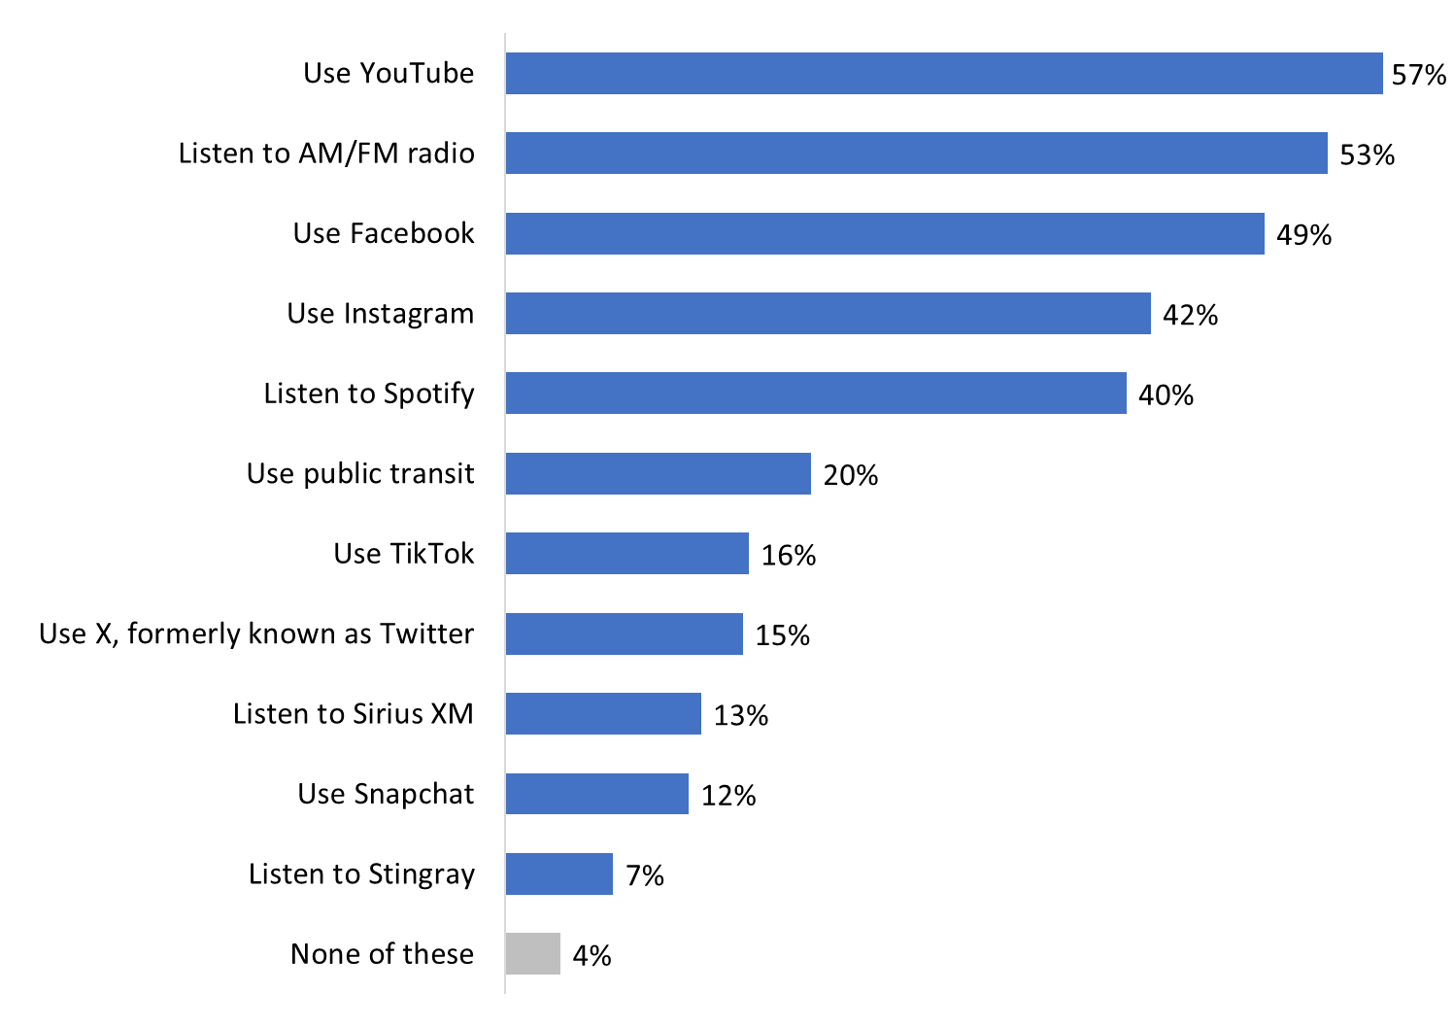

Base: n=1,059; all respondents. [NR: 1%].
Q6. Which of the following do you typically do on a daily basis? [multiple responses accepted]

Those who reported listening to AM/FM radio on a daily basis were more likely to be aware of the protective measures (60%) and to recall at least one of Transport Canada’s advertisements (59%).

Ad Campaign Recall

Moderate recall of the ad campaign.
Recall of Transport Canada’s advertisements about protecting the killer whales in BC coastal waters was moderate, with half (51%) of those surveyed recalling at least one of the three digital ads that made up the campaign. Recall was highest for “protecting killer whales by staying away from them when boating”, with 44% saying they had seen or heard this ad. Approximately one-third (30%) of respondents recalled the ad “protecting killer whales by ensuring you do not boat in restricted areas”, while one-quarter (24%) recalled the ad “protecting killer whales by ensuring you do not fish for salmon within closures”.

Figure 11: Aided recall of ad campaign

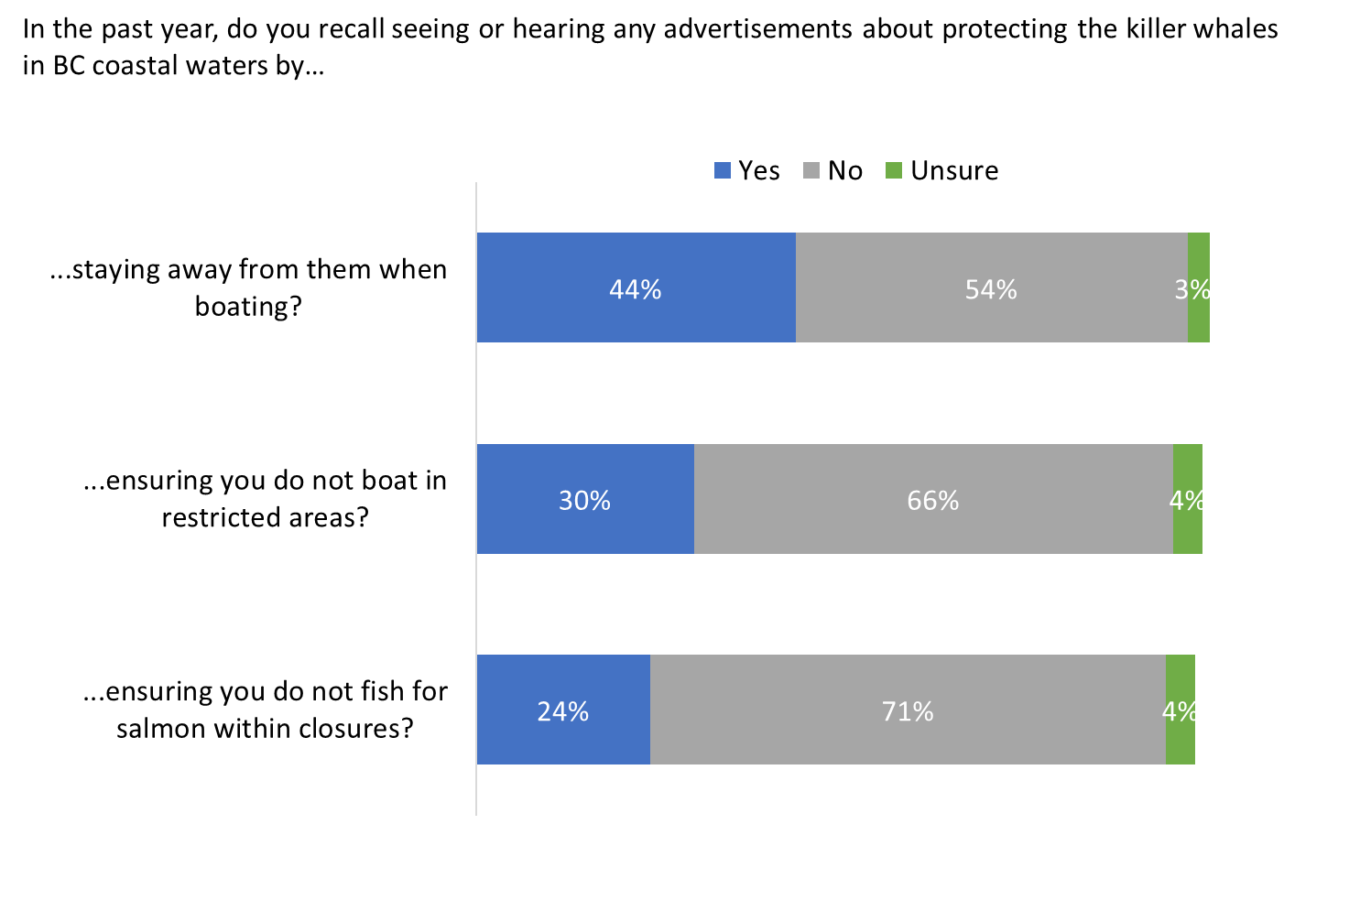
Base: n=1,059; all respondents.
Q7. In the past year, do you recall seeing or hearing any advertisements about protecting the killer whales in BC coastal waters by…

The protective measure most respondents were aware of was keeping 400 metres from killer whales. This was also the subject of the ad that those surveyed were most likely to say they recall seeing or hearing – “protecting killer whales by staying away from them when boating”.

The likelihood of recalling at least one of these advertisements was higher among those aware of the protective measures (58%), those aged 55+ (64%), and Indigenous respondents (63%). In contrast, recall was lowest among residents of Metro Vancouver (47%).

The ad campaign ran July 13 to September 10, 2023, and then again from October 6 to November 26, 2023. It featured web banner ads and YouTube ads with various messages designed to raise awareness of the measures in place to protect SRKW in BC coastal waters among residents, and among boaters, in particular.

Radio and TV were the two sources of ad recall mentioned with the greatest frequency.
Of those who recalled seeing or hearing at least one of the three advertisements about protecting killer whales in BC coastal waters (n=617), 29% said they heard these advertisements on radio and 24% saw them on television. Following these traditional media, 14% pointed to YouTube and 12% to Facebook as their source of ad recall. All other sources of recall were mentioned by less than 10 percent of respondents and can be found in Figure 12. Seven percent of respondents did not recall where they saw or heard the advertisement.

The advertising campaign was digital only, which means it was not played on radio or television, nor did it appear in newspapers, other print publications or other print formats, such as billboards or posters, etc. Radio and television, however, topped the list of sources of ad recall ahead of digital sources, including social media platforms and the Internet. This is not uncommon when measuring recall of ads and happened in 2022 as well when television was the most frequently mentioned source (at 32%). Respondents often defer to the medium they use most often and assume this is where they saw or heard the ad.

Figure 12: Source of ad recall
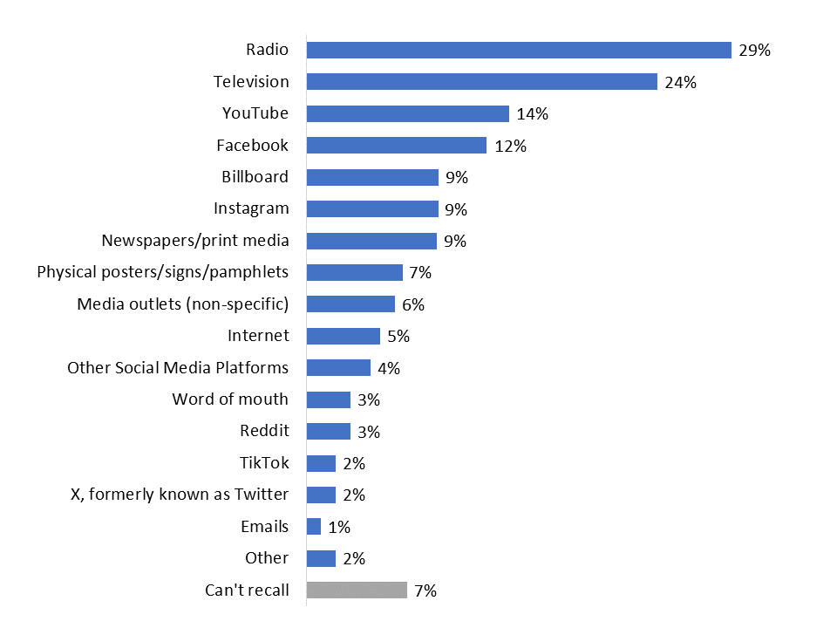
Base: n=617; respondents who recall advertisements about protecting the killer whales in BC coastal waters.
Q8. Where do you recall seeing or hearing these advertisements? [multiple responses accepted]

Some recalled specific content from the advertisements.
Respondents who recalled seeing or hearing an advertisement about protecting killer whales (n=617) were asked what they recalled about the ads. Approximately two in 10 recalled the specific messages “Slow down and stay away if you see a whale” (20%), “Help keep killer whales safe” (19%), and “Stay 400 metres away from killer whales” (17%). Nineteen percent said they recalled a picture of a Southern Resident killer whale. Following this, others recalled the general messages about salmon fishing closures (10%), “no-go” zones or interim sanctuary (8%) and keeping a distance other than 400 metres from killer whales (5%). Very few (3% or less) recalled anything else about the ads.

The single largest proportion could not recall anything about the advertisements (32%) or mentioned that they were generally aware of, and knowledgeable about, the protective measures (10%).

Figure 13: Recall of ad campaign content, messages
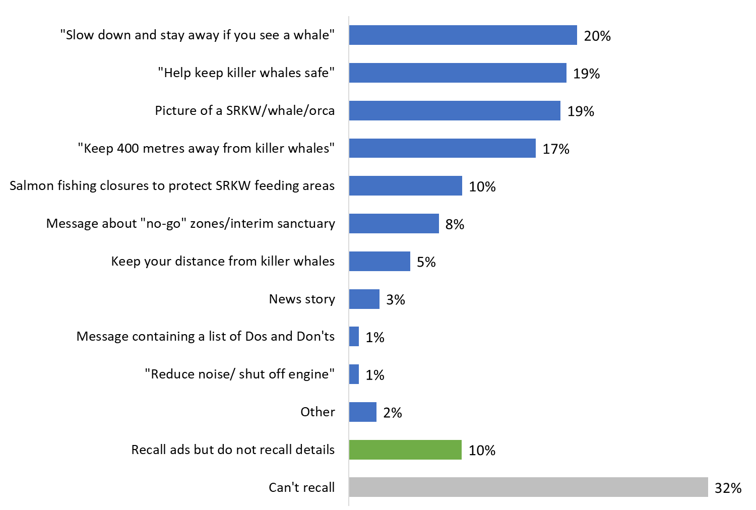

Base: n=617; respondents who recall advertisements about protecting the killer whales in BC coastal waters.
Q9. What, if anything, do you recall about these advertisements? [multiple responses accepted]

Profile of Respondents

Just over half have completed at least a bachelor’s or post-graduate degree.
Just over half the survey respondents reported holding a bachelor’s (29%) or a post-graduate (23%) degree. In addition, approximately one-third have finished an apprenticeship or trades certificate (6%), a college or non-university certificate or diploma (18%), or a university certificate or diploma below a bachelor’s level (7%). Fewer than one in five (17%) have a high school diploma or less education.

Figure 14: Level of education

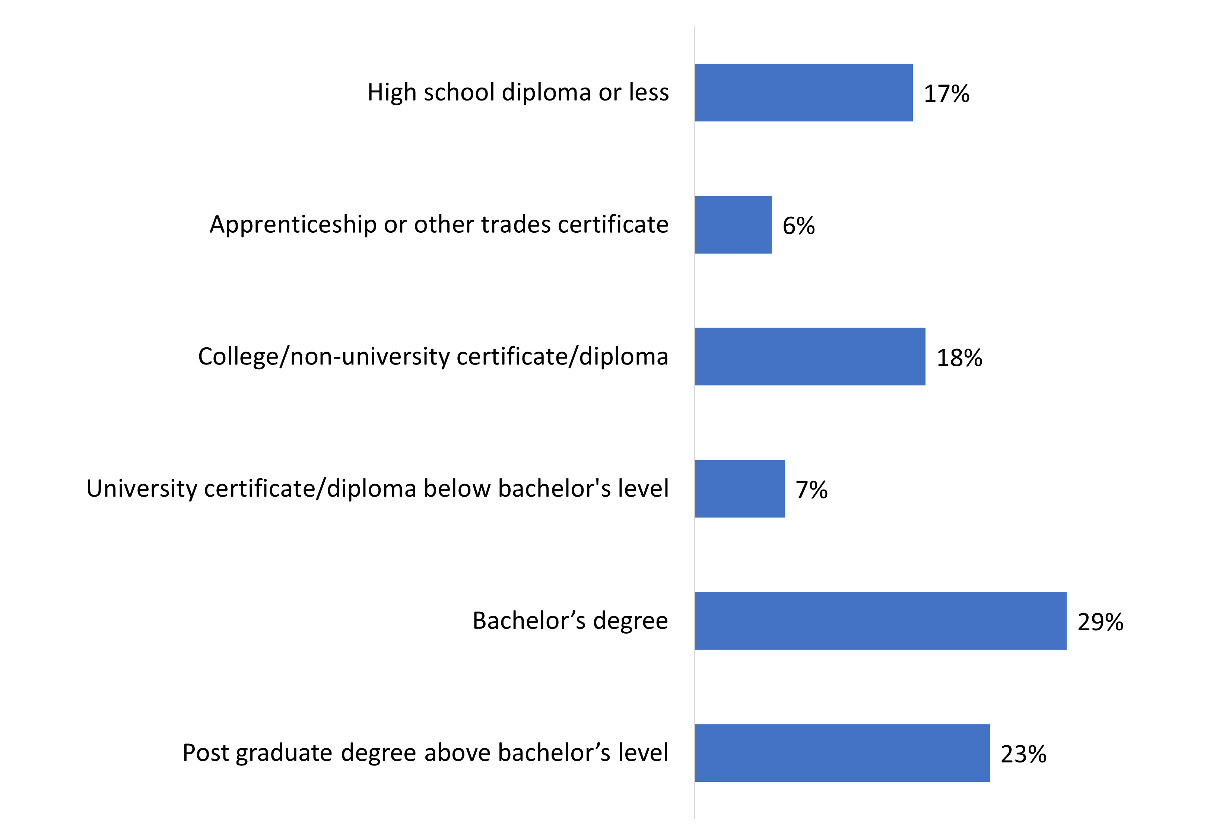
Base: n=1,059; all respondents. [NR: 1%].
Q10. What is the highest level of formal education that you have completed?

More than four in 10 have a household income greater than $100,000.
Forty-five percent (45%) of respondents reported a household income of $100,000 or more last year.

Figure 15: Household income

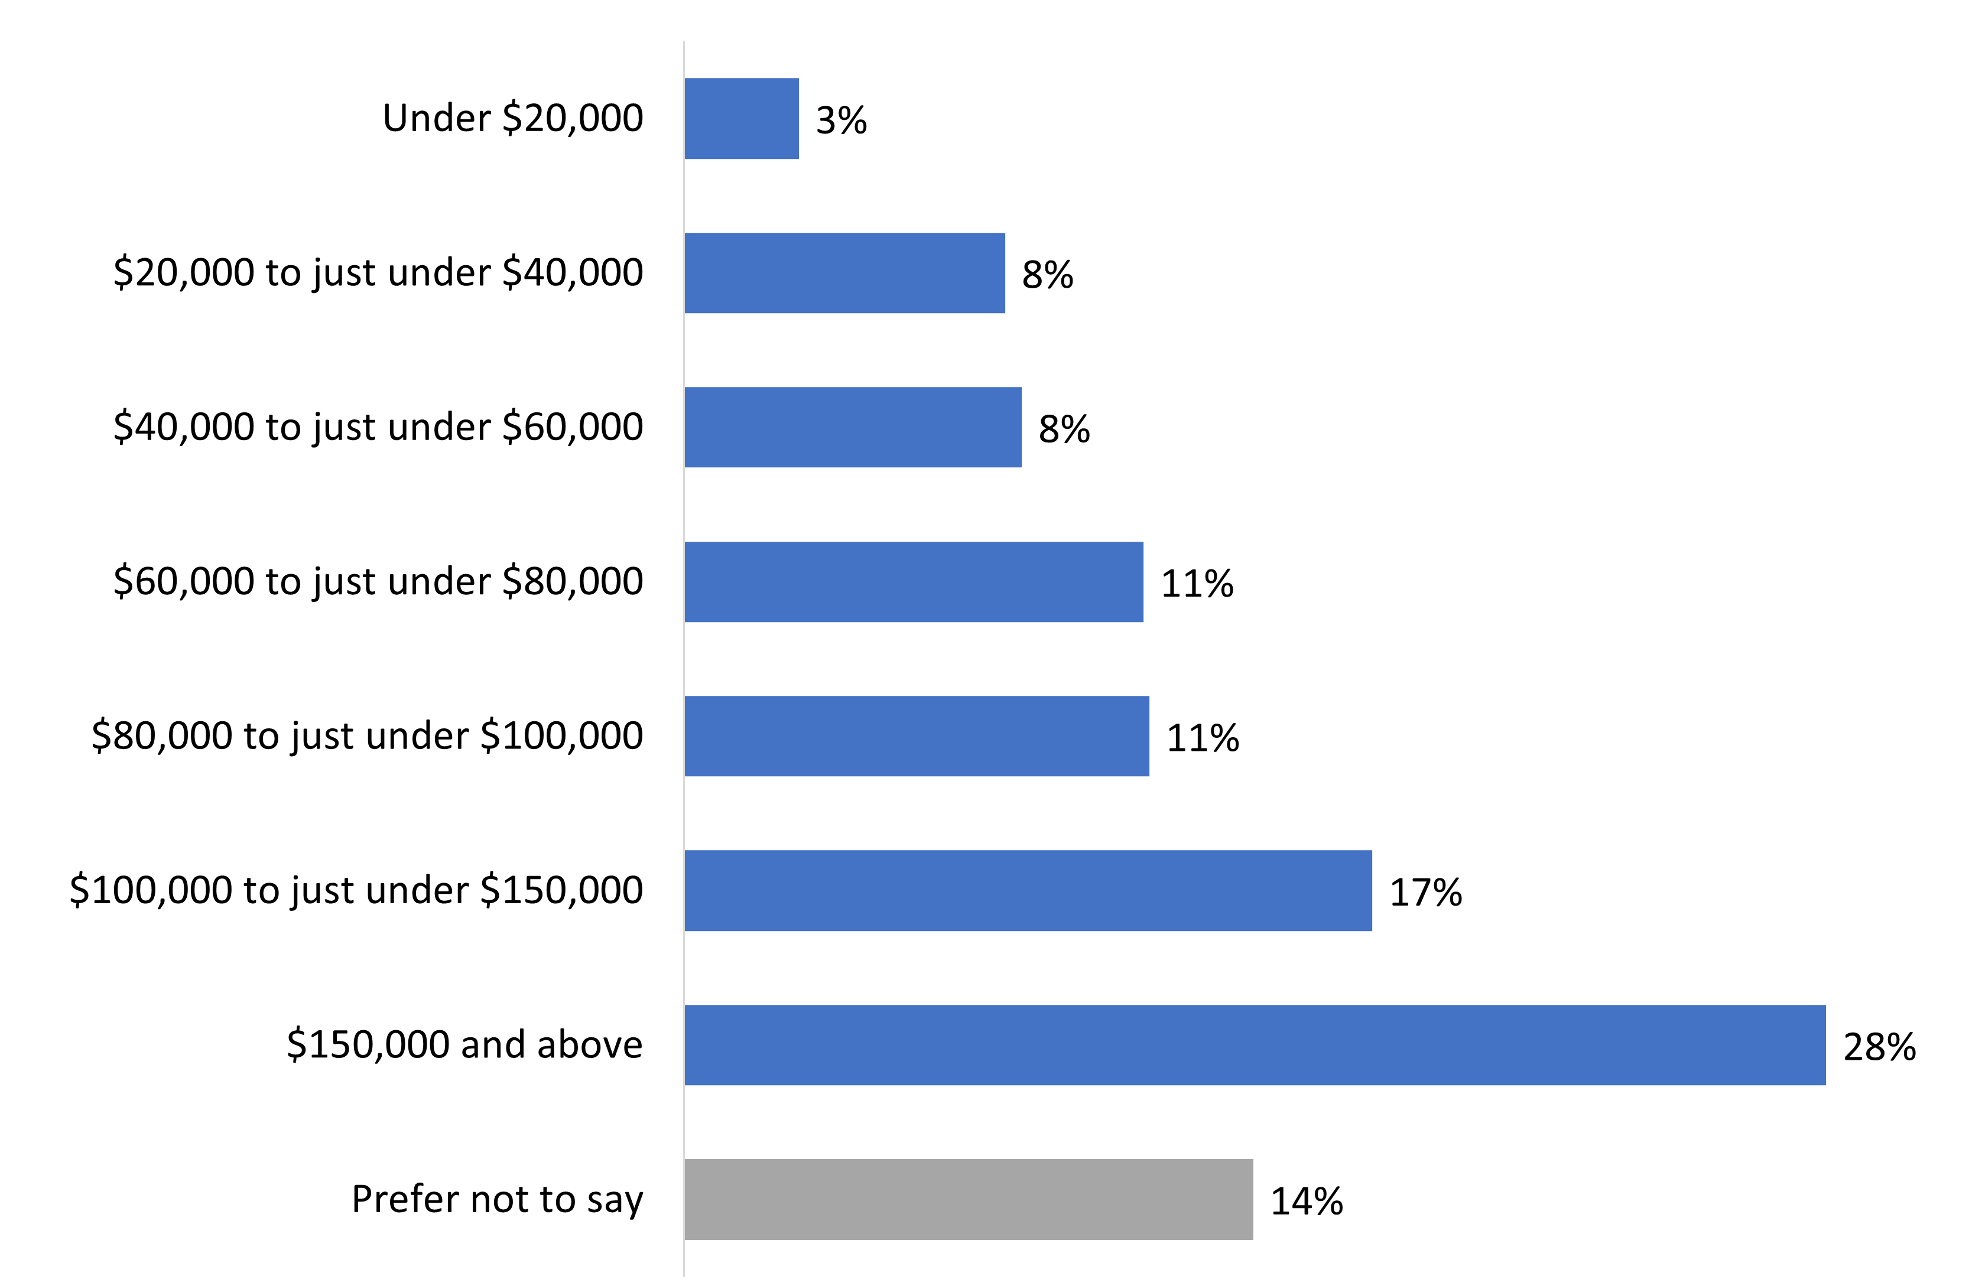

Base: n=1,059; all respondents.
Q11. Which of the following best describes your total household income last year, before taxes, from all sources for all household members?

Vast majority speak English most often at home.
The vast majority of respondents (90%) primarily speak English at home. Moreover, 10% of respondents speak a non-official language most often at home, while 3% speak French (i.e., are a member of an Official Language Minority Community).

Figure 16: Language spoken most often at home
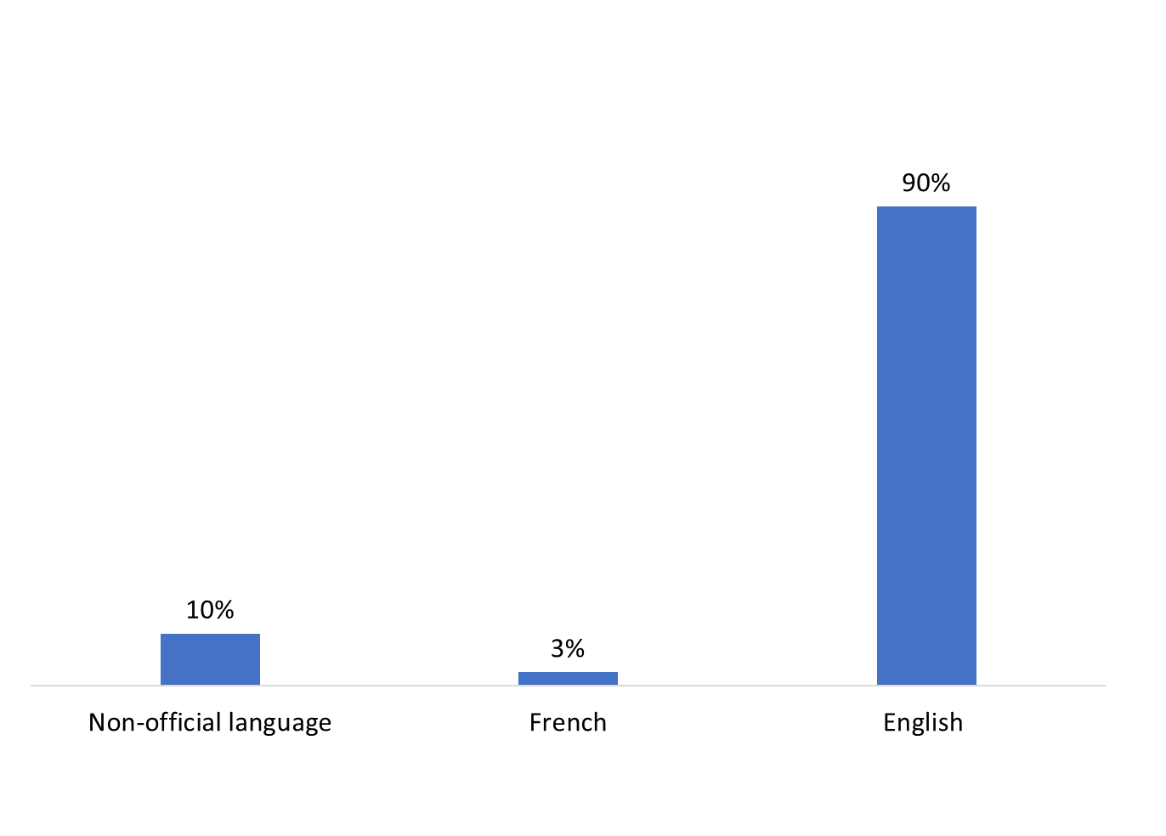
Base: n=1,059; all respondents.
Q12. What language do you speak most often at home? [multiple responses accepted]

A small proportion of respondents identify as Indigenous.
One in 10 (9%) respondents identified themselves as First Nations, Métis or Inuk.

Figure 17: First Nations, Métis, and Inuk status
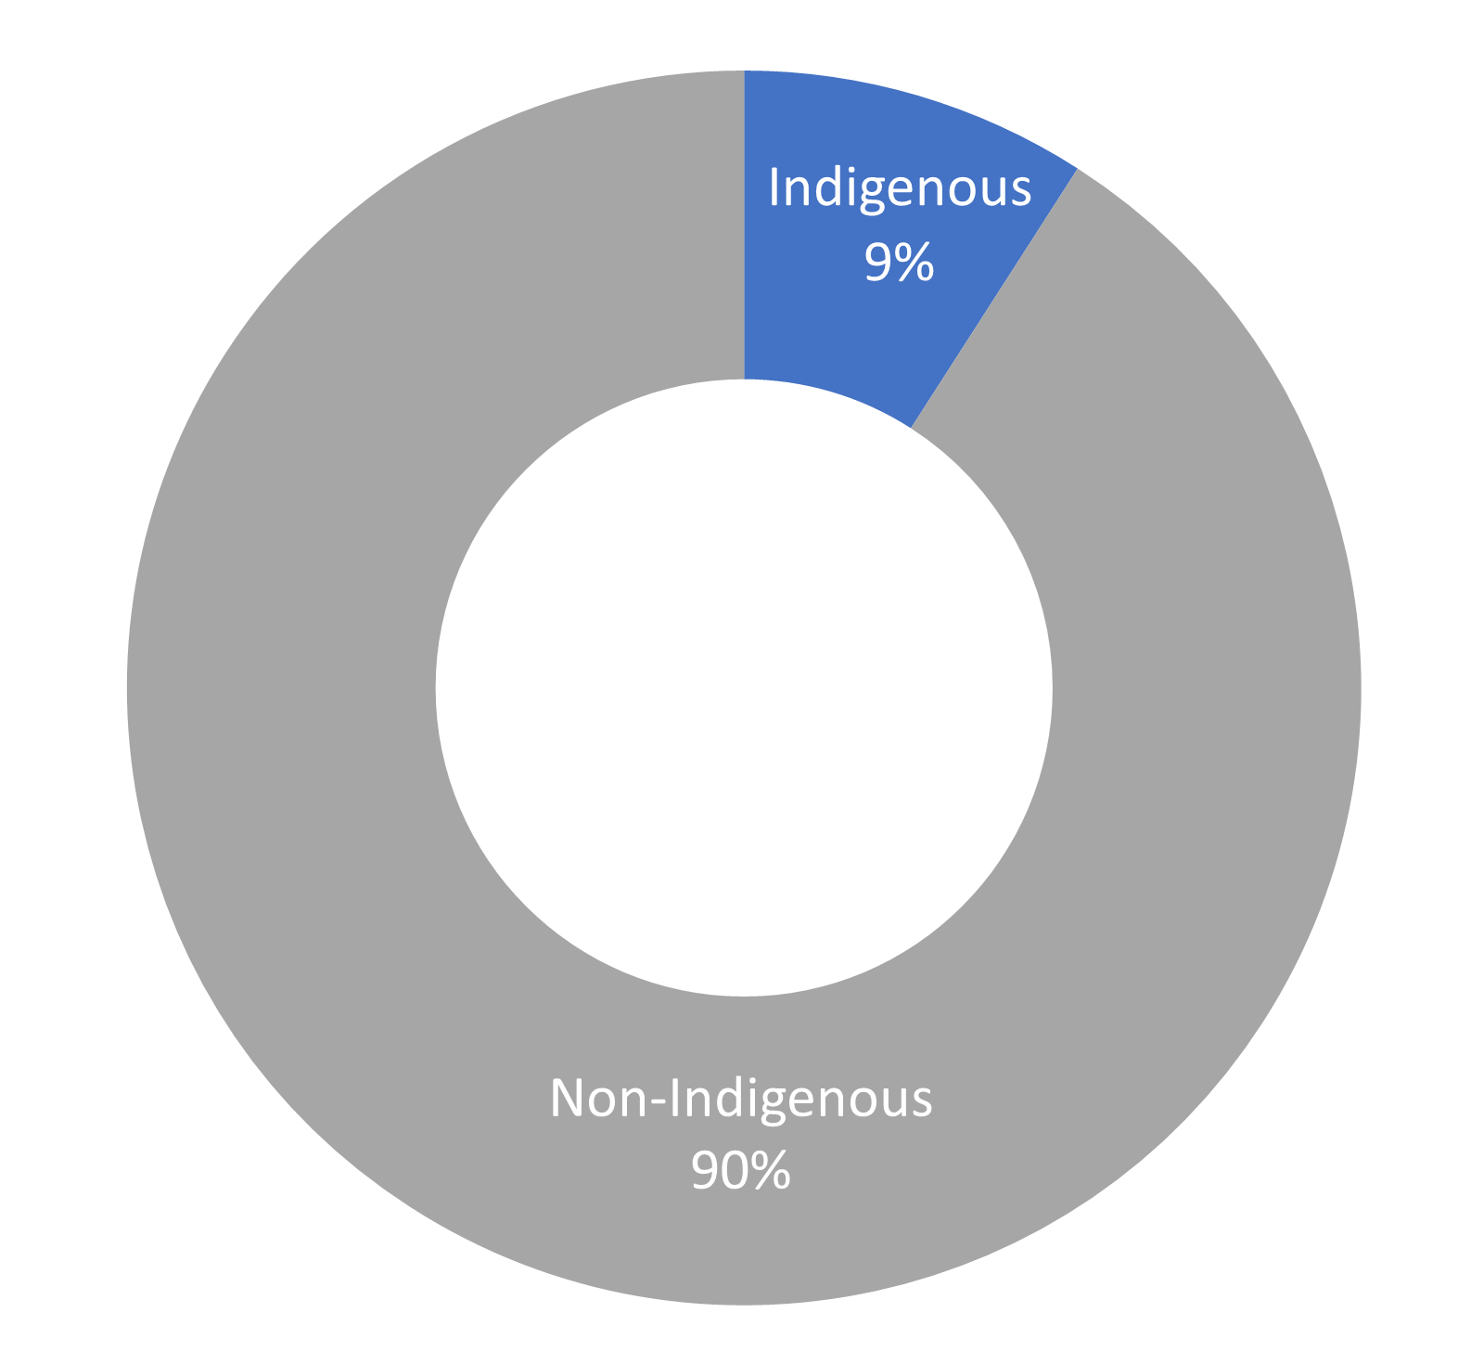

Base: n=1,059; all respondents. [NR: 1%].
SCR.6 Are you First Nations, Métis or Inuk (Inuit)?

Three-quarters of respondents live in Metro Vancouver.
Three-quarters (75%) of respondents live in Metro Vancouver. Following this, 13% live on South Vancouver Island, and 9% on Central Vancouver Island. Fewer (3%) live on the Sunshine Coast.

Figure 18: Location

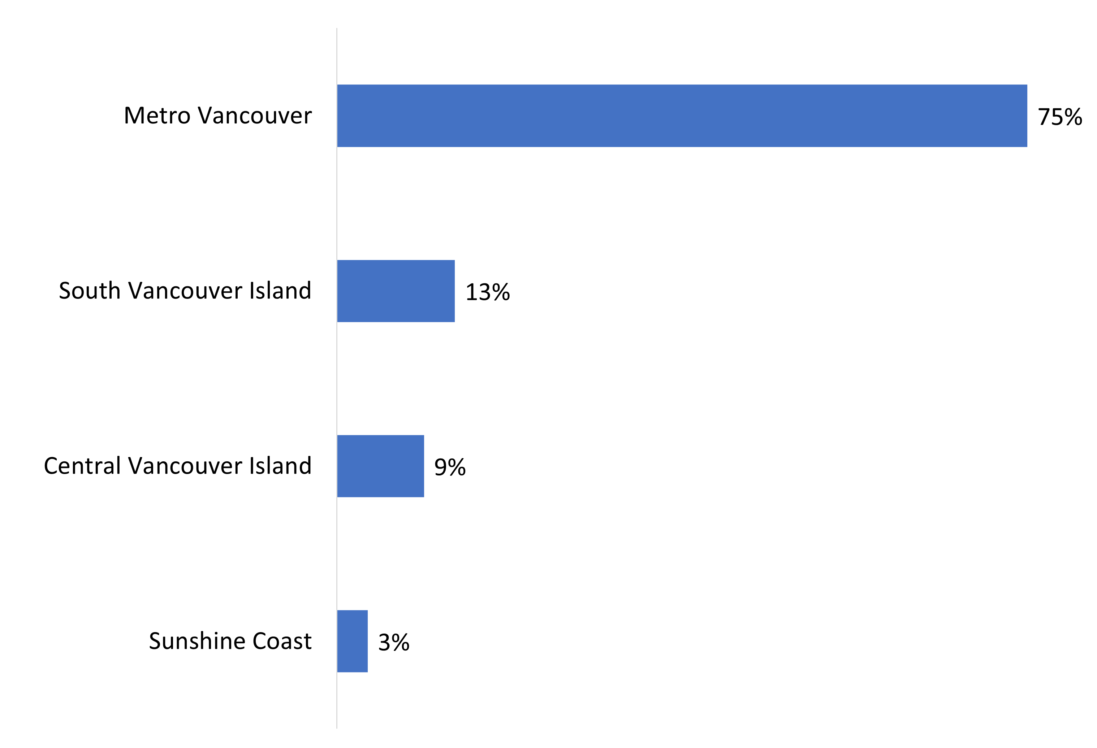
Base: n=1,059; all respondents
SCR. 3A May I have the first three digits of your postal code?
SCR. 3B We need to speak with people who live on Vancouver Island, the Gulf Islands, the Sunshine Coast, or the Greater Vancouver area or who use watercrafts in those areas. In which city or area of coastal British Columbia do you live or use watercrafts?

Age and gender
Respondents varied in terms of their age, with the largest demographic group being those aged 55 and above. Gender was almost evenly divided between women (50%) and men (48%). Two percent identify as another gender.

Figure 19: Age and gender
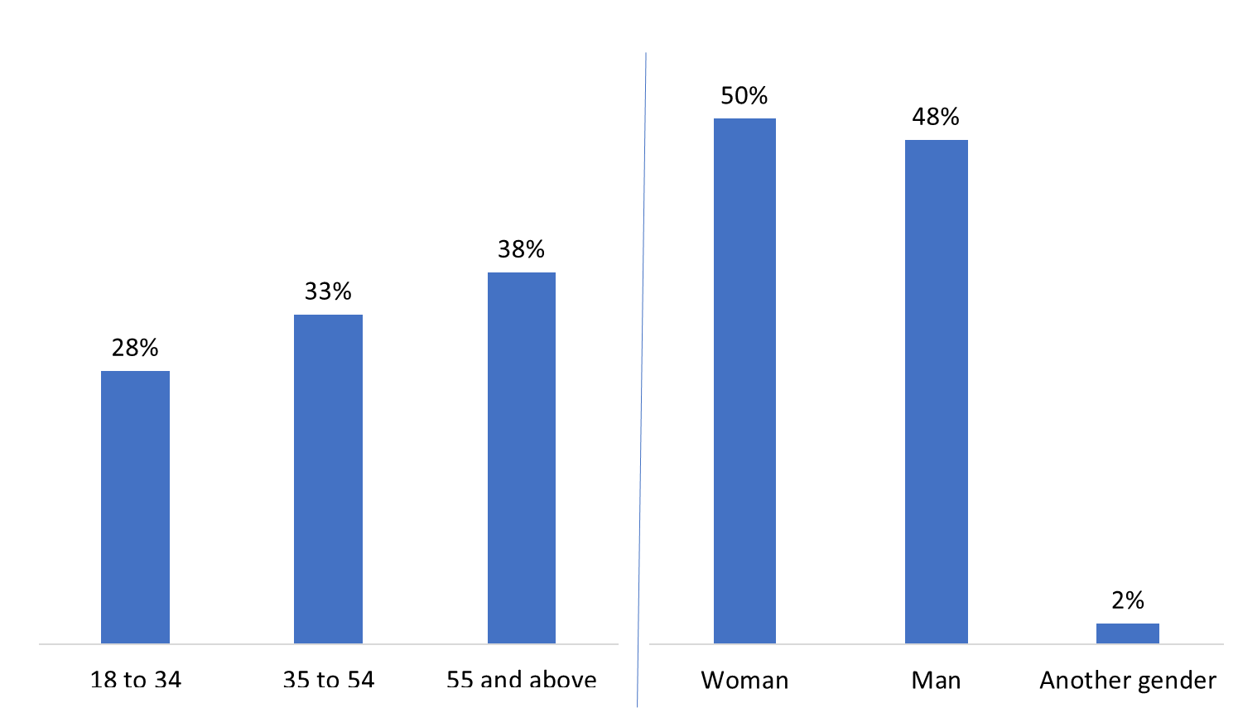

Base: n=1,059; all respondents
SCR. 4A In what year were you born?
SCR. 4B Would you be willing to tell me in which of the following age categories you belong?
SCR. 5 What is your gender?

Conclusions and Implications for Marketing and Advertising
This research yielded some noteworthy observations about residents’ awareness of measures designed to protect Southern Resident killer whales, as well as recall of the advertisement campaign.
- Awareness of the existence of protective measures for Southern Resident killer whales in BC coastal waters has increased steadily since the 2021 baseline survey and, this year, was higher among those who recalled one of Transport Canada’s advertisements on protecting Southern Resident killer whales. In addition, awareness of the specific mandatory and voluntary measures was also higher among those who recalled at least one of Transport Canada’s advertisements. This suggests that the Department’s annual advertising campaigns are having at least some impact on the awareness levels of residents of BC coastal areas.
  - The Department should consider continuing its seasonal outreach efforts until awareness levels begin to plateau.
- With one exception, awareness of the specific mandatory and voluntary measures has not changed significantly since the baseline survey. The exception was the mandatory requirement that watercraft keep 400 metres from killer whales and not be positioned in the path of killer whales. This year, a greater proportion of respondents said they were aware of the protective measure, which is supported by the fact that those who recalled specific messages about protecting the SRKW were more likely to recall an ad about staying away from killer whales when boating.
  - Designing the ad campaigns to raise awareness of the specific measures, in particular the interim sanctuary zones, rather than the existence of protective measures in general, may help to increase understanding of the specific actions boaters should take to do their part to support the recovery of the SRKW.
- Awareness of mandatory and voluntary measures was higher among Indigenous persons, South Vancouver Island residents, and those aged 55 and older. Consistent with the 2021 baseline survey and the 2022 follow-up survey, awareness of these measures generally was lower among Metro Vancouver residents.
- Continued advertising and marketing could be increased in this area by targeting radio and social media platforms as well as public transportation.
- Targeting Transport Canada's advertisements to other demographics – e.g., residents of metro Vancouver and younger boaters – could improve awareness of these measures among these groups, as well as the broader population.

Appendix

Technical Specifications
The following specifications applied to this survey:
- An 11-minute random digit dialling (RDD) telephone survey was administered to 1,059 adults aged 18 and older who reside in coastal communities located on the south coast of British Columbia and selected areas of Vancouver Island and who meet the eligibility criteria for recreational watercraft use on the ocean. The incidence was 41%.
  - This included an oversample of n=50 Indigenous respondents.
- An overlapping dual-frame (landline and cell phone) sample was used to minimize coverage error.
- Based on a sample of this size, the overall results can be considered accurate within ±3%, 19 times out of 20.
- The questionnaire was pre-tested in advance of the fieldwork to ensure that it measured what it intended to measure and that respondents understood the questions. There were no changes to the questionnaire.
- The fieldwork was conducted from January 26 to February 29, 2024.
- The following table presents information about the final call dispositions for this survey and the calculation of the response rate:
 | Total | Landline | Cell
Total Numbers Attempted | 132,239 | 66,480 | 65,759
Out-of-scope - Invalid | 46,675 | 20,745 | 25,930
Unresolved (U) | 63,475 | 31,369 | 32,106
No answer/Answering machine | 63,475 | 31,369 | 32,106
In-scope - Non-responding (IS) | 17,850 | 11,375 | 6,475
Language barrier | 754 | 461 | 293
Incapable of completing (ill/deceased) | 439 | 378 | 61
Callback (Respondent not available) | 1,804 | 1,002 | 802
Refusal | 14,516 | 9,356 | 5,160
Termination | 337 | 178 | 159
In-scope - Responding units (R) | 4,239 | 2,991 | 1,248
Completed Interview | 1,059 | 561 | 498
Quota Filled | 688 | 680 | 8
Not Qualified – Under 18 years | 37 | 0 | 37
Not Qualified – Did not/will not go out on the ocean | 2,414 | 1,739 | 675
Not Qualified – Does not use watercrafts | 41 | 11 | 30
- The overall response rate was 5% (7% for the landline sample and 3% for the cell phone sample). The response rate formula is calculated as follows: [R=R/(U+IS+R)]. This means that the response rate is calculated as the number of responding units [R] divided by the number of unresolved [U] numbers plus in-scope [IS] non-responding households and individuals plus responding units [R].
- The survey data have been weighted by region (within the target geographic area), age and gender using population figures from Statistics Canada’s census data.
- A non-response analysis was conducted to assess the potential for non-response bias. Survey non-response can bias results when there are systematic differences between survey respondents and non-respondents. To undertake the analysis, characteristics of survey respondents—region, gender, and age—were compared with those of the target population. Below, these comparisons are discussed and any differences between the survey sample and the population are evaluated in terms of the potential for non-response bias.
- The following table compares the survey sample on a regional basis to the population parameters by age. All survey data are unweighted. The survey sample over-represented those aged 55+ from South Vancouver Island and the Sunshine Coast. This is typical for RDD surveys of the general public. The result was those aged 18 to 54 from Metro Vancouver were under-represented in the survey sample. The weights that were applied to the survey sample corrected for this difference.
Region and age | Population % | Sample % | Difference
Central Vancouver Island - 18-34 | 2% | 2% | 0%
Central Vancouver Island - 35-54 | 3% | 3% | 0%
Central Vancouver Island - 55+ | 5% | 8% | 3%
Metro Vancouver - 18-34 | 22% | 8% | -16%
Metro Vancouver - 35-54 | 26% | 13% | -13%³
Metro Vancouver - 55+ | 26% | 28% | 2%
South Vancouver Island - 18-34 | 3% | 2% | -1%
South Vancouver Island - 35-54 | 4% | 6% | 2%
South Vancouver Island - 55+ | 5% | 16% | 11%³
Sunshine Coast - 18-34 | <1% | 1% | 0%
Sunshine Coast - 35-54 | 1% | 3% | 2%
Sunshine Coast - 55+ | 1% | 10% | 9%³
- The following table compares the survey sample on a regional basis to the population parameters by gender. All survey data are unweighted. The survey sample under-represented male and female residents of Metro Vancouver and over-represented those from South Vancouver Island and the Sunshine Coast. The weights that were applied to the survey sample corrected for this difference.
Region and gender | Population % | Sample % | Difference
Central Vancouver Island – women | 5% | 6% | 1%
Central Vancouver Island – men | 5% | 7% | 2%
Metro Vancouver – women | 38% | 22% | -16%³
Metro Vancouver – men | 36% | 26% | -10%³
South Vancouver Island – women | 6% | 12% | 6%³
South Vancouver Island – men | 6% | 11% | 5%³
Sunshine Coast – women | 2% | 7% | 5%³
Sunshine Coast – men | 2% | 7% | 5%³
- As mentioned, weights were applied to adjust for the region-age discrepancy between the survey sample and the population. Weighting serves to reduce bias should it be present, but not to eliminate it completely.

Survey Questionnaire
INTRODUCTION

Hello/Bonjour, my name is [Interviewer's name] and I am calling from Phoenix SPI, a Canadian research firm, on behalf of the Government of Canada. We are conducting a survey on current issues of interest to Canadians. Would you prefer that I continue in English or French? Préférez-vous continuer en français ou en anglais? [IF NEEDED: Je vous remercie. Quelqu'un vous rappellera bientôt pour mener le sondage en français.]
The survey takes about 10 minutes and is voluntary. Your responses will be kept confidential and anonymous, and the information provided will be administered according to the requirements of the Privacy Act, the Access to Information Act, and any other pertinent legislation.

This survey is registered with the Canadian Research Insights Council’s survey validation system. Should you have any questions about the survey, I can give you a contact person within the Government of Canada / Transport Canada. May I continue?

IF REQUESTED, THE CONTACT AT TRANSPORT CANADA IS:
tc.publicopinion-opinionpublique.tc@tc.gc.ca

IF REQUESTED, THE CRIC REGISTRATION NUMBER IS: 20240118-PH660

[ACCESSIBILITY NOTE: If an alternate method of taking part in the survey is needed offer mail or email the respondent.]

[LANDLINE SAMPLE]

- May I please speak with the person in your household who is 18 years of age or older and who has had the most recent birthday? Would that be you?

01. Yes GO TO SCR. 1
02. No ASK TO SPEAK TO THAT PERSON; REPEAT INTRO AS NEEDED

[CELL SAMPLE]

- Are you 18 years of age or older?

01. Yes CONTINUE
02. No THANK/DISCONTINUE

TERMINATE MESSAGE-1: “Thank you for your willingness to take part in this survey, but you need to be at least 18 years of age to participate.”

- Are you in a place where you can safely talk on the phone and answer my questions?

01. Yes CONTINUE
02. No ARRANGE CALLBACK

INTERVIEWER NOTE: If you think that respondents’ setting may endanger them (e.g., driving a vehicle), hinder their participation (e.g., background distractions), or hamper their ability to respond openly (e.g., lack of privacy), suggest rescheduling the interview.

- Does your household subscribe to a home phone service, also known as a landline?

01. Yes CONTINUE
02. No CONTINUE; CODE AS CELLPHONE ONLY [WATCH QUOTAS]
03. Don’t know CONTINUE
99. Prefer not to answer CONTINUE

SCREENING QUESTIONS

SCR. 1a In the last year, did you go out on the ocean in or on a recreational watercraft? Recreational watercraft include powerboats, sailboats, and jet skis, as well as canoes, kayaks, rowboats or paddleboards that are privately owned or rented. This does not include watercraft used for commercial purposes, such as tour boats, ferries, or cruise ships.

NOTE TO INTERVIEWER: This does not include activities on lakes or rivers (respondents must have gone out on the ocean in the last year or plan to in the next year: see SCR.1b).

01. Yes GO TO SCR. 2a
02. No CONTINUE
99. Don’t know/Refused THANK/TERMINATE

TERMINATE MESSAGE-2: “Thank you for your willingness to take part in this survey, but you do not meet the eligibility requirements of this study.”

SCR. 1b [ASK IF SCR.1a=2 OR 99] In the next year, do you plan to go out on the ocean in or on a recreational watercraft?

01. Yes CONTINUE
02. No THANK/TERMINATE
99. Don’t know/Refused THANK/TERMINATE

TERMINATE MESSAGE-2: “Thank you for your willingness to take part in this survey, but you do not meet the eligibility requirements of this study.”

SCR. 2a [IF SCR1a=01] When you were out on the ocean this last year, were you out as a watercraft owner, renter, or passenger? [ACCEPT MULTIPLE RESPONSES.]

01. Boat owner
02. Boat renter
03. Passenger
99. Don’t know/Refused

SCR. 2b [IF SCR1b=01] When you go out on the ocean in the next year, will you go out as a watercraft owner, renter, or passenger? [ACCEPT MULTIPLE RESPONSES.]

01. Boat owner
02. Boat renter
03. Passenger
99. Don’t know/Refused

SCR. 3a May I have the first three digits of your postal code?
FSA: ____________ VALIDATE AGAINST LIST; GO TO SCR.4a
99. Don’t know/Refused CONTINUE

SCR. 3b [ASK IF SCR.3a=99] We need to speak with people who live on Vancouver Island, the Gulf Islands, the Sunshine Coast, or the Greater Vancouver area or who use watercrafts in those areas. In which city or area of coastal British Columbia do you live or use watercrafts?

01. TEXT – OPEN-END CONTINUE
02. Do not live or use watercrafts in coastal BC THANK/TERMINATE
99. Don’t know/Refused THANK/TERMINATE

TERMINATE MESSAGE-2: “Thank you for your willingness to take part in this survey, but you do not meet the eligibility requirements of this study.”

INTERVIEWERS: IF UNCERTAIN, CHECK LIST.
Anvil Island | [SUNSHINE COAST]
Bowen Island | [SUNSHINE COAST]
Burnaby | [METRO VANCOUVER]
Campbell River | [VANCOUVER ISLAND]
Central Saanich | [VANCOUVER ISLAND]
Chemainus | [VANCOUVER ISLAND]
Cloverdale | [METRO VANCOUVER]
Comox | [VANCOUVER ISLAND]
Coquitlam | [METRO VANCOUVER]
Courtney | [VANCOUVER ISLAND]
Crofton | [VANCOUVER ISLAND]
Delta | [METRO VANCOUVER]
Discovery Islands | [UNSPECIFIED]
Duncan | [VANCOUVER ISLAND]
Gabriola Island | [GULF ISLANDS]
Galiano Island | [GULF ISLANDS]
Gambier Island | [SUNSHINE COAST]
Gibsons | [SUNSHINE COAST]
Gulf Islands | [UNSPECIFIED]
Jordan River | [VANCOUVER ISLAND]
Ladner | [METRO VANCOUVER]
Ladysmith | [VANCOUVER ISLAND]
Langdale | [SUNSHINE COAST]
Langley | [METRO VANCOUVER]
Lions Bay | [SUNSHINE COAST]
Maple Ridge | [METRO VANCOUVER]
Mayne Island | [GULF ISLANDS]
Mill Bay | [VANCOUVER ISLAND]
Nanaimo | [VANCOUVER ISLAND]
Nanoose Bay | [VANCOUVER ISLAND]
New Westminster | [METRO VANCOUVER]
North Vancouver | [METRO VANCOUVER]
Parksville | [VANCOUVER ISLAND]
Pender Island | [GULF ISLANDS]
Pitt Meadows | [METRO VANCOUVER]
Port Alberni | [VANCOUVER ISLAND]
Port Coquitlam | [METRO VANCOUVER]
Port Moody | [METRO VANCOUVER]
Port Renfrew | [VANCOUVER ISLAND]
Porteau Cove  Powell River | [SUNSHINE COAST]  [SUNSHINE COAST]
Qualicum Beach | [VANCOUVER ISLAND]
Richmond | [METRO VANCOUVER]
Salt Spring Island | [GULF ISLANDS]
Saanich | [VANCOUVER ISLAND]
Saturna Island | [GULF ISLANDS]
Sechelt | [SUNSHINE COAST]
Sidney | [VANCOUVER ISLAND]
Sooke | [VANCOUVER ISLAND]
Southern Gulf Islands | [UNSPECIFIED]
Squamish | [SUNSHINE COAST]
Sunshine Coast | [UNSPECIFIED]
Surrey | [METRO VANCOUVER]
Ucluelet | [VANCOUVER ISLAND]
Vancouver | [METRO VANCOUVER]
Vancouver Island | [UNSPECIFIED]
Victoria | [VANCOUVER ISLAND]
West Vancouver | [METRO VANCOUVER]
Whistler/Sea-to-Sky | [SUNSHINE COAST]
White Rock | [METRO VANCOUVER]

SCR.4a In what year were you born?

Record year: ____________
99. [DO NOT READ] Don’t know/Refused

SCR.4b [ASK IF SCR.4a=99] Would you be willing to tell me in which of the following age categories you belong?

[READ LIST; STOP WHEN RESPONDENT SELECTS AN ANSWER]

01. 18 to 24
02. 25 to 34
03. 35 to 44
04. 45 to 54
05. 55 to 64
06. 65 or older
99. [DO NOT READ] Refused

SCR. 5 What is your gender?

[READ LIST; STOP WHEN RESPONDENT SELECTS AN ANSWER]

01. Female
02. Male
03. Other
99. [DO NOT READ] Refused

SCR. 6 Are you First Nations, Métis or Inuk (Inuit)?

[DO NOT READ]

01. No
02. Yes
99. Prefer not to say

MAIN SURVEY

- To the best of your knowledge, are there any protective measures in place to protect Southern Resident killer whales in BC coastal waters?

01. Yes
02. No
99. I don’t know

- [IF Q1=02,99: There are mandatory protective measures currently in place to protect killer whales, as well as some voluntary measures. / IF Q1=01: As you know, there are mandatory measures in place to protect killer whales, as well as some voluntary measures.] I will read several of them and I’d like you to tell me if you’re aware of it or not. The first one is: [ROTATE ITEMS; A-C ROTATE AS A BLOCK; E-G ROTATE AS A BLOCK; H-I ROTATE AS A BLOCK]

NOTE TO INTERVIEWER: IF RESPONDENTS ARE UNCLEAR ABOUT WHAT IS MEANT BY “WATERCRAFT”, PLEASE REMIND THEM THAT WATERCRAFT INCLUDES POWER BOATS, SAIL BOATS, JET SKIS, CANOES, KAYAKS, ROW BOATS OR PADDLEBOARDS.

- There is an interim sanctuary zone that prevents watercraft from operating off the northern part of Pender Island.
- There is an interim sanctuary zone that prevents watercraft from operating off parts of Saturna Island.
- There are two Speed Restricted Zones that require watercraft to operate at no more than 10 knots speed over ground at Swiftsure Bank.
- There are salmon fishing closures that prohibit recreational or commercial salmon fishing in key Southern Resident killer whale foraging areas near the mouth of the Fraser River, in the southern Gulf Islands, Juan de Fuca Strait and around Swiftsure Bank.
- Watercraft must keep 400 metres from killer whales and not be positioned in the path of killer whales in all southern BC coastal waters between Campbell River and just north of Ucluelet.
- Outside of coastal waters between Campbell River and just north of Ucluelet, watercraft must keep 200 metres from killer whales as per the Marine Mammal Regulations.
- When out on the water, you should not follow whale watching boats because some have an exemption and do not need to keep 400 metres away from all killer whales.
- Boats should reduce speed when within 1,000 metres of a killer whale.
- Fishing should not take place within 1,000 metres of a killer whale.

[READ]

01. Definitely aware
02. Somewhat aware
03. Not aware
99. [DO NOT READ] I don’t know

3a. Killer whales are also referred to as ‘Orcas’. Which term do you most commonly use?

[READ LIST]

01. Killer whale
02. Orca, or
03. Some other term: specify
99. [DO NOT READ] Don’t know/Refused
- What type of recreational watercraft have you used on the ocean in the last two years? [IF NEEDED, REMIND RESPONDENTS OF THE FOLLOWING: Recreational watercraft does not include watercraft used for commercial purposes, such as tour boats, ferries, or cruise ships.]

[ACCEPT ALL THAT APPLY; DO NOT READ LIST]

01. Power boat, motorboat or speedboat
02. Sailboat
03. Personal watercrafts (e.g., WaveRunners/Sea-Doos/Jet Skis)
04. Canoe
05. Kayak (includes inflatable crafts)
06. Rowboat
07. Paddleboard (includes inflatable crafts)
08. Dinghy
09. Houseboat
10. Pontoon
11. Other: specify
12. None; my first time out will be next year. SKIP TO Q6
13. Have not boated in the last two years, but have in years past
99. I don’t know/I can’t recall

- [IF Q3≠12] On average, how many days per year do you typically go out on the ocean in a recreational watercraft?

01. Record days:
02. None; my first time out will be in the next year SKIP TO Q6
99. [DO NOT READ] Don’t know/Refused SKIP TO Q6

- [IF Q4=01] Do you tend to go out on the ocean in a recreational watercraft all year long or is this a seasonal activity?

01. All year
02. Seasonal
03. [VOLUNTEERED] It depends
99. Don’t know/Refused

- Which of the following do you typically do on a daily basis?

[RANDOMIZE; READ LIST; ACCEPT ALL THAT APPLY]
01. Listen to AM/FM radio
02. Listen to Spotify
03. Listen to Sirius XM
04. Listen to Stingray
05. Use Facebook
06. Use Instagram
07. Use public transit
08. Use X, formerly known as Twitter
09. Use YouTube
10. Use Snapchat
11. Use TikTok
12. [VOLUNTEERED] None of these
99. [DO NOT READ] Prefer not to answer

- In the past year, do you recall seeing or hearing any advertisements about protecting the killer whales in BC coastal waters:

[RANDOMIZE; READ ITEMS]
a. by staying away from them when boating?
b. by ensuring you do not boat in restricted areas?
c. by ensuring you do not fish for salmon within closures?

[READ OPTIONS]
01. Yes
02. No
99. [DO NOT READ] I don’t know/unsure

IF Q7=02 OR 99 TO ALL, SKIP TO Q10.

- [IF Q7A OR Q7B OR Q7C=01] Where do you recall seeing or hearing these advertisements?

[DO NOT READ; ACCEPT ALL THAT APPLY]

01. Radio
02. Social media - ASK TO SPECIFY:
- Reddit
- YouTube
- TikTok
- Facebook
- X, formerly known as Twitter
- Instagram
- Other: Please specify: [TEXT]
03. Billboard
88. Other: specify
99. I don’t know/I can’t recall

- What, if anything, do you recall about these advertisements?

[DO NOT READ; ACCEPT ALL THAT APPLY]

01. A picture of a whale/orca/Southern Resident killer whale
02. The message to slow down and stay away if you see a whale
03. That there are “no-go” zones / interim sanctuary
04. That there are salmon fishing closures to protect Southern Resident killer whale feeding areas
05. People should stay 400 metres away from killer whales
06. Help keep killer whales safe
88. Other: specify
99. I don’t know/I can’t recall

DEMOGRAPHICS

We have a couple final questions for statistical classification purposes. Be assured that your responses will be held in strict confidence.

- What is the highest level of formal education that you have completed?

[READ LIST; STOP WHEN RESPONDENT SELECTS AN ANSWER]

01. Less than a High School diploma or equivalent
02. High School diploma or equivalent
03. Registered Apprenticeship or other trades certificate or diploma
04. College, CEGEP or other non-university certificate or diploma
05. University certificate or diploma below bachelor's level
06. Bachelor’s degree
07. Post graduate degree above bachelor’s level
99. [DO NOT READ] Prefer not to answer

- Which of the following best describes your total household income last year, before taxes, from all sources for all household members?

[READ LIST; STOP WHEN RESPONDENT SELECTS AN ANSWER]

01. Under $20,000
02. $20,000 to just under $40,000
03. $40,000 to just under $60,000
04. $60,000 to just under $80,000
05. $80,000 to just under $100,000
06. $100,000 to just under $150,000
07. $150,000 and above
99. [DO NOT READ] Prefer not to answer

Finally,

- What language do you speak most often at home? [ACCEPT ALL THAT APPLY]

[DO NOT READ]

01. English
02. French
03. Other [DO NOT SPECIFY]
99. Prefer not to answer

CONCLUSION

That concludes the survey. Thank you very much for your thoughtful feedback. This survey was conducted on behalf of Transport Canada.

As with the current survey, survey respondents were coastal BC residents who went out on the ocean in, or on, a recreational watercraft in the 12 months preceding the survey or who planned to do so in the following year.
Three of the measures assessed this year were new; an asterisk (*) is used to identify these measures. In addition, the language for another measure is substantially different than the language used in the two previous iterations of this survey. Two asterisks (**) are used to identify these measures.
The difference between the population and unweighted sample proportion exceeded the survey margin of error.

