POR Number: 030-17
Contract Number: 51019-174015-001-CY
Contract Award Date: 2017-09-27
Date of Submission: 2018-03-28

FINAL REPORT

Attitudes Towards Remembrance and Veterans’ Week
2017 Survey of Canadians

Prepared for: Veterans Affairs Canada

For more information, please contact:
information@vac-acc.gc.ca

March 2018

Ce rapport est aussi disponible en français.

Phoenix SPI is a Gold Seal Certified Corporate Member of the MRIA

Table of Contents

Executive Summary 1
1. Background and Objectives 1
2. Methodology 2
3. Key Findings 3
4. Notes to Readers 5

Detailed Findings 6
1. Awareness and Importance of Veterans’ Week 6
2. Participation in Veterans’ Week and Related Activities 12
3. Prioritizing Veterans’ Week Activities 18
4. Attitudes Towards Veterans and Canada’s Military 20
5. Recognizing Canadian Veterans and Those Who Died in Service 23

Appendix 27
Annex 1: Statement of Political Neutrality 28
Annex 2: Methodological Notes 29
Annex 3: Tabulated Data 31
Annex 4: Questionnaire 32

Table of Figures

Figure 1: Awareness of Veterans’ Week 6
Figure 2: Importance of Veterans’ Week 7
Figure 3: Reasons Why Veterans’ Week Is Important [By Theme] 8
Figure 4: Reasons Why Veterans’ Week Is Important [Over Time] 8
Figure 5: Reasons Why Veterans’ Week Is Important [All Responses] 9
Figure 6: Top 3 Reasons Why Veterans' Week Is Important 9
Figure 7: Reasons Why Veterans' Week Is Unimportant 10
Figure 8: Reasons Why Canadians View Veterans' Week Neutrally 11
Figure 9: Participation in Veterans’ Week 12
Figure 10: Reasons for Participating in Veterans’ Week [By Theme] 13
Figure 11: Reasons for Participating in Veterans’ Week [All Responses] 13
Figure 12: Reasons for Not Participating in Veterans’ Week [By Theme] 14
Figure 13: Reasons for Not Participating in Veterans’ Week [All Responses] 14
Figure 14: Participation in Activities to Commemorate Veterans 15
Figure 15: Participation in Veterans’ Week Activities [Over Time] 16
Figure 16: Participation in Activities Outside of Veterans’ Week [Over Time] 16
Figure 17: Importance of Remembrance Initiatives 18
Figure 18: Importance of Remembrance Initiatives [Over Time] 19
Figure 19: Attitudes Towards Veterans and Commemoration 20
Figure 20: Attitudes Towards Canada’s Military Role 21
Figure 21: Attitudes Towards Veterans and Military [Over Time] 22
Figure 22: Attitudes Towards Actions to Recognize Veterans and Those Who Died in Service 23
Figure 23: Attitudes Towards Actions to Recognize Veterans and Those Who Died in Service [Over Time] 24
Figure 24: Attitudes Towards Provision of Funeral and Burial Assistance 25
Figure 25: Awareness and Importance of World War Commemorations 26
Figure 26: Awareness and Importance of World War Commemorations [Over Time] 26

Executive Summary
Phoenix Strategic Perspectives Inc. (Phoenix SPI) was commissioned by Veterans Affairs Canada (VAC) to conduct a telephone survey of Canadians on issues related to Veterans’ Week and the Department’s remembrance programming.

1. Background and Objectives
A core responsibility of VAC is post-Confederation military commemoration. VAC ensures that Veterans and those who died in service are honoured and that Canadians remember and appreciate Veterans and those who died in service. The Canada Remembers Program and the Funeral and Burial Program support the departmental results for commemoration and promote the following:
- Veterans and those who died in service are publicly acknowledged through ceremonies and events, honours and awards, and the presentation and perpetual care of memorials, cemeteries and grave markers;
- Canadians are aware of, and value, the contributions of those who served through a suite of resources that tell the story of our military history and through the provision of funding for community-led commemorative initiatives;
- the memory of the achievements and sacrifices of Canadian Veterans and those who died in service is preserved; and
- the estates of eligible Veterans have access to financial assistance provided for a dignified funeral and burial.

The Attitudes Towards Remembrance and Veterans’ Week survey is a means through which VAC can measure Canadians’ level of participation in remembrance activities, their attitudes toward those who served in Canada’s military and their level of support for VAC's work related to remembrance. The purpose of the quantitative research is to evaluate the effectiveness of the Department’s overall remembrance programming. More specifically, the research was designed to:
- Understand Canadians' attitudes towards and acceptance of commemorating Veterans and their sacrifices and achievements;
- Monitor behavioural changes resulting from Canadians receiving information relating to remembrance;
- Assess Canadians’ awareness of and pride in Canadian military contributions and the sacrifices of Canadian Veterans;
- Identify Canadians’ knowledge of Canada’s military contributions;
- Provide VAC with concrete data to assist in performance measurement; and
- Assess Canadians’ level of participation (active and passive) in remembrance.

The research results help guide the Department in its planning and programming for the future. The information obtained allows VAC to continue determining the impact and effectiveness of its remembrance activities, adapt activities to be relevant to Canadians, improve the methods used to inform Canadians about remembrance initiatives, and improve future initiatives.

2. Methodology
A random digit dialling (RDD) telephone survey was administered to 1,000 Canadian residents, 18 years of age or older, between November 12 and 22, 2017. An overlapping dual-frame (landline and cell phone) sample was used to minimize coverage error. Interviewing was conducted by Elemental Data Collection Inc. (EDCI) using Computer Aided Telephone Interviewing (CATI) technology. A pre-test was conducted in advance of the fieldwork. In all, 20 interviews were conducted during the pre-test, 10 in each language. The survey averaged 11 minutes to complete.

Probability sampling was used: a total of 396 interviews were completed with cell phone only (CPO) households from the cell phone sample and 604 interviews with households from the landline sample. The sample frame was geographically disproportionate to improve the accuracy of regional results. Based on a sample of this size, the overall results can be considered to be accurate within ±3.3%, 19 times out of 20 (adjusted to reflect the geographically disproportionate sampling). The margin of error is greater for results pertaining to subgroups of the total sample. The results of the survey can be considered representative of the population of Canadians aged 18 and older.

The survey data has been weighted by region, age and gender to ensure results that are representative of the Canadian population. Population figures from Statistics Canada’s 2011 census data were used to construct the weights.

The table in Annex 2 presents information about the final call dispositions for this survey, as well as the associated response rates (using the Marketing Research and Intelligence Association [MRIA] formula). The overall response rate was 6% (8% for the landline sample and 5% for the cell phone sample).

The potential for non-response bias was assessed by comparing the characteristics of respondents through unweighted and weighted data. As is typically the case for general population telephone surveys, older Canadians (those aged 65 and older) were overrepresented in the final survey sample and younger Canadians (those under 30 years of age) were underrepresented. This was corrected with weighting.

3. Key Findings
Awareness and Importance of Veterans’ Week
Canadians’ awareness of Veterans’ Week and the importance attributed to it remains unchanged from 2016.
This year, a little over half (55%) of Canadians said they heard of Veterans’ Week. Although awareness is unchanged from 2016, it remains lower than the recent high of 66% recorded in 2011. Similarly, the overall importance that Canadians attribute to Veterans’ Week did not change from 2016. Almost nine in 10 Canadians (88%; unchanged from 2016) think it is important that Veterans’ Week be held each year, with 68% saying that it is very important. Since tracking began, 2016 and 2017 mark the highest level of importance attributed to Veterans’ Week by Canadians.

When Canadians were asked why they support Veterans’ Week, nearly two-thirds (65%) said it is important to honour and show respect to Canadian Veterans and those who died in service. Following this, approximately half (52%) said it is important to focus on our history or remembrance. Few (9%) said that Veterans’ Week is important because of a personal connection, such as having a family member who is a Veteran or in the military. Over time, these same themes have been Canadians’ top reasons for attributing importance to Veterans’ Week, although there has been a slight decline in the proportion of Canadians attributing importance to Veterans’ Week because they feel it is important to honour Veterans.

Participation in Veterans’ Week and Related Activities
Participation in Veterans’ Week has increased steadily since 2011 and it reached a record high this year. Wearing a poppy continues to be the most popular way to commemorate Veterans.
Nine in 10 surveyed Canadians (91%) said they or members of their immediate family participated in Veterans’ Week. Since 2011, there has been a steady increase in participation levels, from 73% in 2011 to this year’s high of 91%. In keeping with patterns from previous years, practical constraints, such as not having time or having to work, were the most common barriers to participating in Veterans’ Week.

Of the Canadians who participated in Veterans’ Week activities, nearly half (48%) said they participated to honour or show respect to Veterans. Following this, four in 10 said it was due to a personal connection, which includes knowing a Veteran, being a Veteran, or knowing someone who participates in the events. Participating in Veterans’ Week due to a personal connection has seen a substantial increase from 2016 (from 32% to 40% in 2017). Since 2011, the need to honour and show respect to Veterans and a personal connection have remained the top reasons for participating in Veterans’ Week.

Wearing a poppy, cited by 79% of respondents, continues to be the most common form of participation in Veterans’ Week (down from 83% in 2016). Additionally, 71% said they observed a moment of silence. Following this, 45% watched a Remembrance Day ceremony on TV (unchanged since 2016), 39% participated in remembrance ceremonies in their communities (also unchanged since 2016), and 25% took part in a remembrance-related activity on social media (down from 29% in 2016). In addition, nearly four in 10 (37%; virtually unchanged from 38% in 2016) Canadians reported that they or members of their immediate family remembered Canadian Veterans and those who died in service in some way outside of Remembrance Day or Veterans’ Week.

Prioritizing Veterans’ Week Activities
Canadians feel the Government of Canada should prioritize all remembrance initiatives.
Canadians were asked to indicate what priority they feel the Government of Canada should place on various initiatives that recognize the achievements and sacrifices of Canadians during wartime and in peacetime operations. Consistent with previous years, events recognizing Veterans and military milestones topped the list (87%; unchanged since 2016). This was followed closely by providing educational materials for schools (86%; also unchanged) and leading remembrance ceremonies at the National War Memorial (85% compared to 87% in 2016).

In addition, 76% consider broadcasting or posting ads on television and the Internet that encourage remembrance to be important (down from 80% in 2016). Similar proportions viewed as important posting remembrance-related content on social media (71% compared to 73% in 2016) and providing funds for communities to undertake remembrance initiatives (70%; unchanged since last year). In addition, as was the case in 2016, nearly two-thirds (65%) of Canadians attributed importance to the production of promotional materials, such as posters and pins.

Attitudes Towards Veterans and Canada’s Military
Canadians’ attitudes towards Veterans remain strongly positive.
More than nine in 10 Canadians think that Canada’s Veterans and those who died in service should be recognized for their service (96%; unchanged since last year) and that Veterans have made major contributions to our country (92% compared to 89% in 2016). Following this, approximately three-quarters of respondents agreed that VAC’s remembrance program effectively honours Veterans and those who died in service and preserves the memory of their achievements and sacrifices (74% compared to 76% in 2016).

Additionally, the majority of surveyed Canadians agreed that they make an effort to demonstrate their appreciation to Veterans (73%; unchanged since 2016) and that participation in commemorative activities increases awareness of, and appreciation for, the contributions of Veterans and those who died in service (86%).

When it comes to Canada’s military role, Canadians’ pride and knowledge remain unchanged. Roughly four in five (82%) agreed that they are proud of the role that Canada’s military has played in peacekeeping missions and conflicts, while 72% agreed that they are knowledgeable about the role that Canada’s military has played in the international domain.

Recognizing Canadian Veterans and Those Who Died in Service
Canadians continue to consider recognizing Veterans and those who died in service as well as commemorating the anniversaries of the World Wars to be important.
As in 2016, this year, 93% of Canadians agreed that it is important that Veterans Affairs Canada recognize and honour Canadian Veterans and those who died in service through the presentation and care of memorials, cemeteries and grave markers, and 90% agreed that it is important that VAC recognize and honour deceased Canadian Veterans by providing funeral and burial assistance. In addition, 63% agreed that they are satisfied with VAC’s performance in recognizing and honouring Veterans and those who died in service through the presentation and care of memorials, cemeteries and grave markers, and 58% felt this way about how VAC recognizes and honours deceased Canadian Veterans through the provision of funeral and burial assistance.

When asked if they were aware of the anniversaries of the First and Second World Wars, nearly half (49%) said they are aware of the 100th anniversary of the First World War, while 44% said this about the 75th anniversary of the Second World War. A clear majority (88%) said they find commemorating the World Wars important, with two-thirds saying it is very important. Compared to 2016, awareness of the World War anniversaries is higher, but not higher than the awareness levels recorded in 2014.

4. Notes to Readers
- All results are expressed as percentages unless otherwise noted.
- Percentages may not always add to 100 due to rounding.
- The number of respondents changes in the report because questions were asked of sub-samples of survey respondents. Readers should be aware of this and exercise caution when interpreting results based on smaller numbers of respondents.
- Demographic differences are identified in the report. Only differences that are significant at the 95% confidence level and pertain to a sub-group sample size of more than n=30 are discussed in the report.
- In graphs, “DK” stands for “Don’t know” and “NR” for “No response.”
- Tracking data are presented where available.
- The tabulated data is available under separate cover.

Contract Amount: $45,613.66 (HST included)

Detailed Findings

Awareness and Importance of Veterans’ Week
This section explores Canadians’ awareness of Veterans’ Week, as well as their views on the importance of Veterans’ Week and reasons why they hold these views.

Canadians Remain Aware of Veterans’ Week
Over half of Canadians (55%) said they had heard of Veterans’ Week. Awareness of Veterans’ Week is unchanged since 2016. However, over time, awareness of Veterans’ Week has fluctuated, from a low of 54% in 2008 to a high of 66% in 2006 and 2011.

Figure 1: Awareness of Veterans’ Week
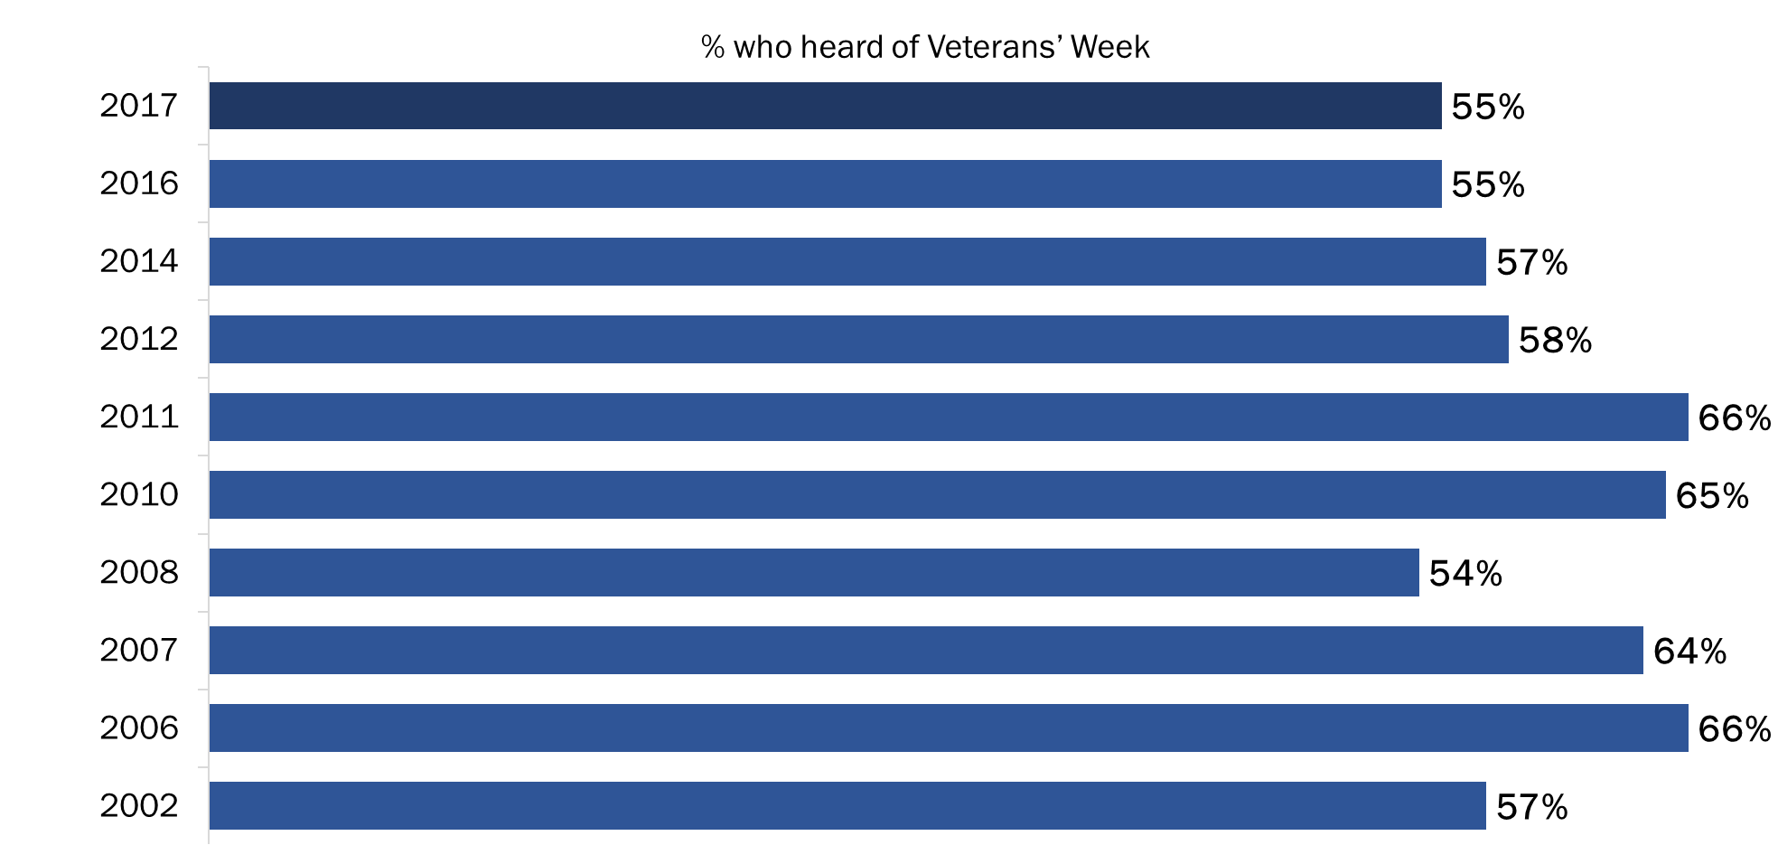
Q1: Have you ever heard of Veterans’ Week? Base: All respondents; 2017 n=1,000

Awareness of Veterans’ Week is higher among residents of Quebec (62%), Atlantic Canada (60%), and the Prairies (60%). In addition, Canadians aged 65 and older have the highest awareness (62%), whereas Canadians aged 30 to 44 have the lowest awareness (45%).

Majority of Canadians Feel Veterans’ Week to be Important
Eighty-eight percent of Canadians believe it is important that Veterans’ Week be held each year, with over two-thirds (68%) saying it is very important. Conversely, very few (2%) Canadians feel that Veterans’ Week is not important.

Respondents were read the following sentence about Veterans’ Week prior to being asked to rate the importance of it:

Veterans’ Week takes place in November each year and ends with Remembrance Day. During this week, commemorative ceremonies and events take place across the country to recognize the achievements of our Veterans and those who died in service. People also take part through things like social media, wearing a poppy, and having discussions with Veterans or military personnel.

The level of importance that Canadians place on Veterans’ Week is unchanged since 2016.

Figure 2: Importance of Veterans’ Week
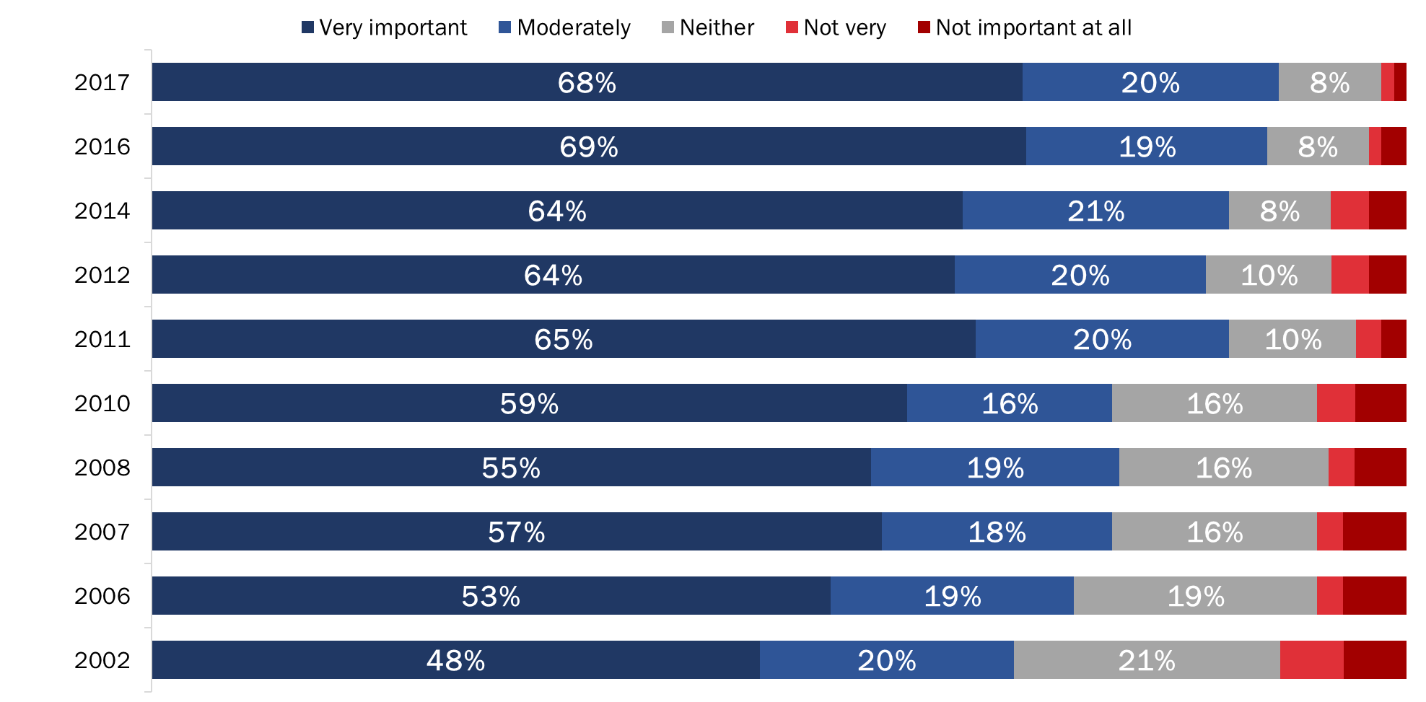
Q2: How important is it that Veterans' Week be held each year? Base: All respondents; 2017 n=1,000. DK/NR: 1%

Atlantic Canadians (96%) were most, and Quebec residents (83%) least, likely to attribute importance to Veterans’ Week. The likelihood of thinking it is very important to hold Veterans’ Week each year increased with age, from 51% of Canadians under 30 to 76% of those aged 65 and older. The likelihood of holding this opinion was higher among women than men (71% and 65% respectively).

Veterans’ Week Important to Honour and Respect Our Veterans
Canadians who said that Veterans’ Week is moderately or very important were asked to give their reasons. Nearly two-thirds (65%) of the explanations focused on the theme of honouring Veterans, or a sense that Veterans have earned respect. Following this, half of those who characterized Veterans’ Week as important (52%) did so due to its focus on our history or remembrance. Few (9%) said that Veterans’ Week is important because of a personal connection, such as having a family member who is a Veteran or in the military.

Figure 3: Reasons Why Veterans’ Week Is Important [By Theme]
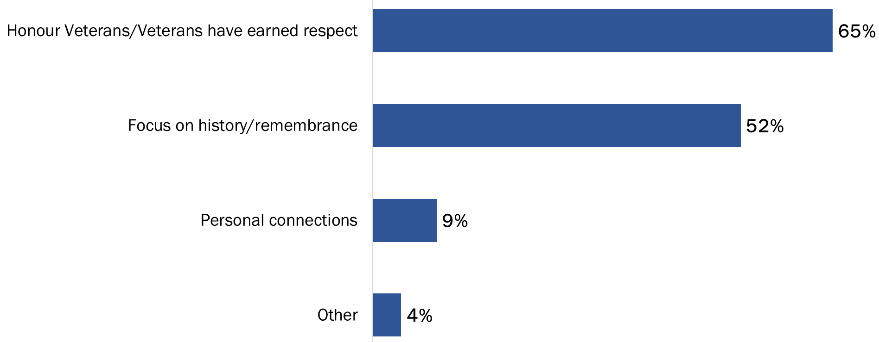
Q2B: And why do you say it is important that Veterans' Week be held each year? Base: Those who said it is important; 2017 n=884. (Up to 2 responses accepted)

Compared to 2016, the proportion of Canadians attributing importance to Veterans’ Week because it is important to honour Veterans has declined four percentage points, from 69% to 65%.

Figure 4: Reasons Why Veterans’ Week Is Important [Over Time]
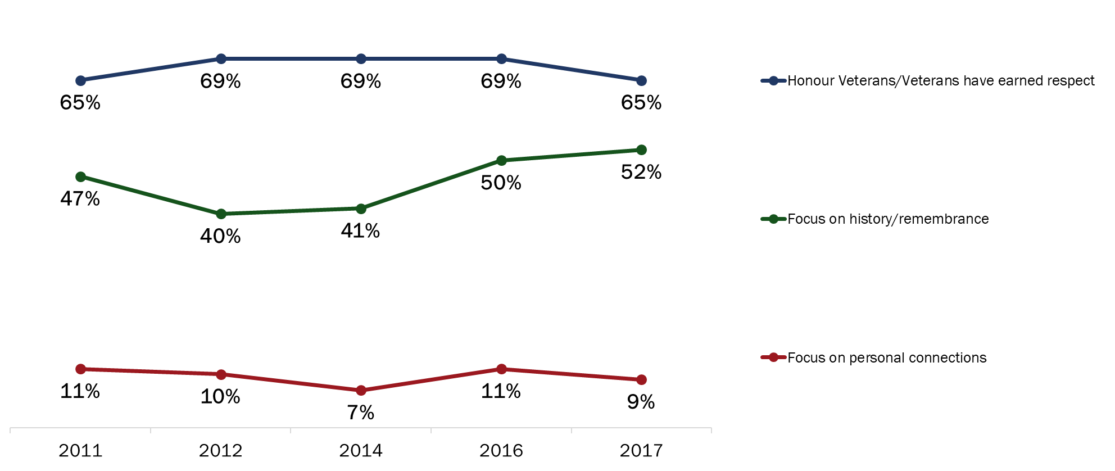
Q2B: And why do you say it is important that Veterans' Week be held each year? Base: Those who said it is important; 2017 n=884. (Up to 2 responses accepted)

When looking at specific reasons why Canadians attribute importance to Veterans’ Week, the following three stand out in terms of frequency:
- To honour/respect Veterans/those who died in service (34%);
- So people will remember their sacrifices (31%); and
- To recognize their contribution to our freedom/security/peace (21%).

The table below presents the full range of responses, grouped by the themes presented in Figure 4:

Figure 5: Reasons Why Veterans’ Week Is Important [All Responses]
Honour Veterans / Veterans Have Earned Respect
To honour / to respect the Veterans / those who died in service | 34%
To recognize their contribution to our freedom / security / peace | 21%
Veterans fought for our country / they served our country | 13%
To recognize their service / accomplishments | 10%
Canada wouldn't be the country it is today / I wouldn't be here if it weren't for Veterans | 3%
We owe them / they deserve recognition | 2%
Focus on History / Remembrance
So people will remember their sacrifices | 31%
Good idea / good to remember | 6%
Part of our heritage / our history | 4%
So children can understand / learn the importance of it | 4%
Many soldiers died in past wars | 2%
Should not / cannot forget | 1%
So we don't repeat past mistakes | 1%
There are fewer Veterans / their story should be told | <1%
Focus on Personal Connections
Family member is a Veteran / I am a Veteran | 9%
Other
To show support for our troops (past and / or present) | 2%
Believe in it / it's important to do it | 1%
Forces us to examine war | 1%
Note: Respondents could provide up to two reasons for thinking that Veterans’ Week is important. Therefore, the percentages in the table above for the full range of responses assigned to each theme (e.g., Focus on History / Remembrance) do not necessarily sum to the total percentage for that theme.

There has been one noteworthy change since last year. The proportion of Canadians attributing importance to Veterans’ Week “so people will remember their sacrifices” increased significantly to 31% (from 20% in 2016). The results for these top responses (over time) are included in Figure 6 below:

Figure 6: Top 3 Reasons Why Veterans' Week Is Important
Top Reasons for Importance of Veterans’ Week Over Time
 | 2017 | 2016 | 2014 | 2012 | 2011 | 2010 | 2008 | 2007 | 2006
To honour / to respect the Veterans | 34% | 34% | 28% | 27% | 23% | 18% | 30% | 33% | 39%
Will remember their sacrifices | 31% | 20% | 25% | 25% | 27% | 14% | 17% | 33% | 39%
To recognize their contribution | 21% | 19% | 24% | 24% | 22% | 13% | 14% | 37% | 33%

Cost-Benefit Focus is Top Reason for Viewing Veterans’ Week as Unimportant
Twenty-one of 1,000 respondents said they view Veterans’ Week as not very important or not important at all. The most common explanation among these respondents for finding Veterans’ Week to be unimportant was that they felt a week to reflect about Veterans to be time-consuming, as there is already a day dedicated to remembrance.

Figure 7 below provides a breakdown of specific reasons why respondents find Veterans’ Week unimportant:

Figure 7: Reasons Why Veterans' Week Is Unimportant
Cost-Benefit Focus
We already have Remembrance Day / a week is too long | 5
Too expensive / waste of money | 3
There are other issues / concerns that are more important | 1
Pacifism
We shouldn't celebrate war / we should focus on peace | 1
Lack of Personal Resonance
Don't care / not important to me personally | 3
Don't have family members who are Veterans / don't know anyone in the military | 1
Lack of Information / Awareness
Never heard of it / don't know about it | 4
Don't know what activities there are for Veterans' Week | 1
Inappropriate Focus on the Past
Happened in the past / we should focus on the present | 1
Re-opens old wounds / sad memories | 1
Note: Respondents could provide up to two reasons for thinking that Veterans’ Week is unimportant. Therefore, the numbers in the table do not sum to 21 (the number of respondents asked this question). The numbers in the table reflect the number of times respondents offered this reason.

Neutrality Towards Veterans’ Week Due to Lack of Personal Resonance
Eighty-five respondents indicated that Veterans’ Week was neither important nor unimportant to them. The most common reason they felt neutral towards Veterans’ Week was due to a lack of personal resonance.

Figure 8 presents a breakdown of the specific reasons Canadians gave for thinking Veterans’ Week is neither important nor unimportant, grouped by theme.

Figure 8: Reasons Why Canadians View Veterans' Week Neutrally
Lack of Personal Resonance
Don't care / not important to me personally | 21
Don't have family members who are Veterans / don't know anyone in the military | 9
Cost-Benefit Focus
We already have Remembrance Day / a week is too long | 19
There are other issues / concerns that are more important | 5
Pacifism
We shouldn't celebrate war / we should focus on peace | 8
Inappropriate Focus on the Past
Most Veterans have died / very few Veterans left | 3
Happened in the past / we should focus on the present | 2
Lack of Information / Awareness
Never heard of it / don't know about it | 13
Don’t know what activities there are for Veterans’ Week | 6
Other
It is important / necessary that we have it | 14
Should be a more private ceremony / held less often (so it's not overdone) | 1
Note: Respondents could provide up to two reasons for thinking that Veterans’ Week is neither important nor unimportant. Therefore, the numbers in the table do not sum to 85 (the number of respondents asked this question). The numbers in the table reflect the number of times respondents offered this reason.

Participation in Veterans’ Week and Related Activities
This section explores topics related to Canadians’ participation in Veterans’ Week, including the level of participation, reasons for participation and non-participation, and the activities respondents participated in during Veterans’ Week.

Participation in Veterans’ Week Continues to Increase
Nine in 10 Canadians (91%) said they or members of their immediate families participated in Veterans’ Week. Since 2011, the level of participation among Canadians has seen a steady increase, from 73% in 2011 to a high of 91% this year.

Figure 9: Participation in Veterans’ Week
Q3: Did you or members of your immediate family participate in Veterans' Week this year? Base: All respondents; 2017 n=1,000.

Residents of Quebec were the least likely to say they participated in Veterans’ Week (75% versus at least 94% of Canadians in other regions of the country). In addition, participation in Veterans’ Week generally increased with age, from 88% of those under 30 to 96% of those aged 65 and older.

Honouring Veterans is Main Reason Canadians Participate in Veterans’ Week
Consistent with 2016, nearly half (48%) of those who did participate in Veterans’ Week said they participated to show respect or to honour Canadian Veterans. Additionally, 40% of Canadians said they participated because of personal connections. This represents a significant increase since 2016 (up eight percentage points). Focusing on history and remembrance was cited by 16% of Canadians who participated as their reason for taking part in Veterans’ Week. Finally, 10% said they participated in Veterans’ Week because they believe in it or because they view it as important.

Figure 10: Reasons for Participating in Veterans’ Week [By Theme]
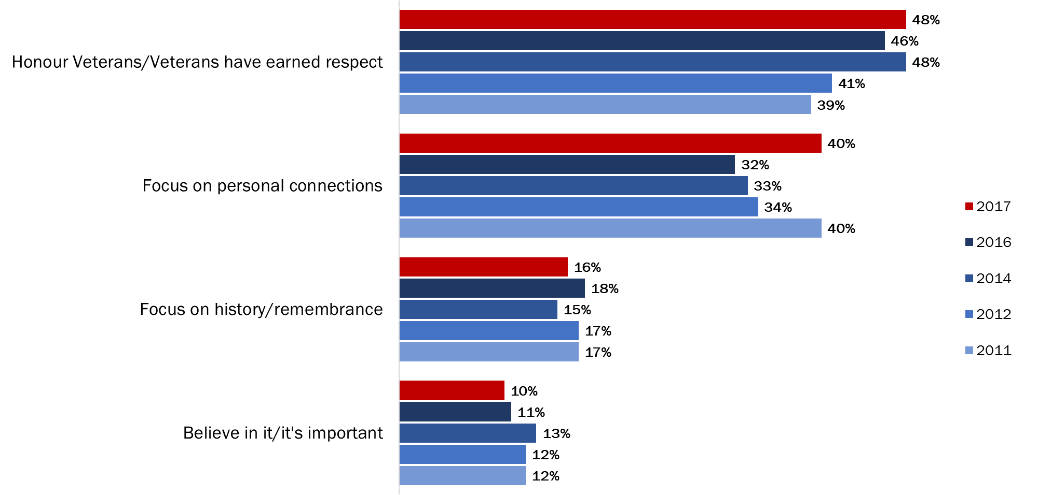
Q3B. And why did you or members of your immediate family participate in Veterans' Week? Base: Those who participated in Veterans’ Week; 2017 n=478. (Up to 2 responses accepted)

The specific reasons Canadians gave for why they participated in Veterans’ Week are presented in Figure 11:

Figure 11: Reasons for Participating in Veterans’ Week [All Responses]
Honour Veterans / Veterans Earned Respect
To honour / to respect the Veterans / those who died in service | 37%
To recognize their contribution to our freedom / security / peace | 7%
To recognize their service / accomplishments | 5%
Veterans fought for our country / they served our country | 4%
Canada wouldn’t be the country it is if it weren’t for Veterans | 1%
Focus on Personal Connections
Family member is a Veteran / I am a Veteran | 28%
Know / am related to someone / I am currently in the military | 7%
I / someone I know participates in events | 7%
Focus on History / Remembrance
So people will remember their sacrifices | 9%
So children can understand / learn the importance of it | 5%
Good idea / good to remember | 3%
Other
Believe in it / it's important to do it | 10%
Tradition / habit / we do it every year | 4%
To show support for our troops (past and/or present) | 3%
Show some (national) pride | <1%
Note: Respondents could provide up to two reasons why they participated in Veterans’ Week. Therefore, the percentages in the table above for the full range of responses assigned to each theme (e.g., Honour Veterans / Veterans Earned Respect) do not necessarily sum to the total percentage for that theme.

Practical Constraints are the Most Common Reason for Not Participating
Exactly half of those who did not participate in Veterans’ Week (n=506) attributed their lack of participation to practical reasons (i.e., too busy, work or health-related reasons). This marks a small increase since last year, when 46% pointed to this as the reason they did not participate. In addition, 26% said they did not participate because of lack of knowledge or awareness. Similar proportions did not participate due to lack of opportunity (10%) or lack of personal resonance (9%).

Figure 12: Reasons for Not Participating in Veterans’ Week [By Theme]
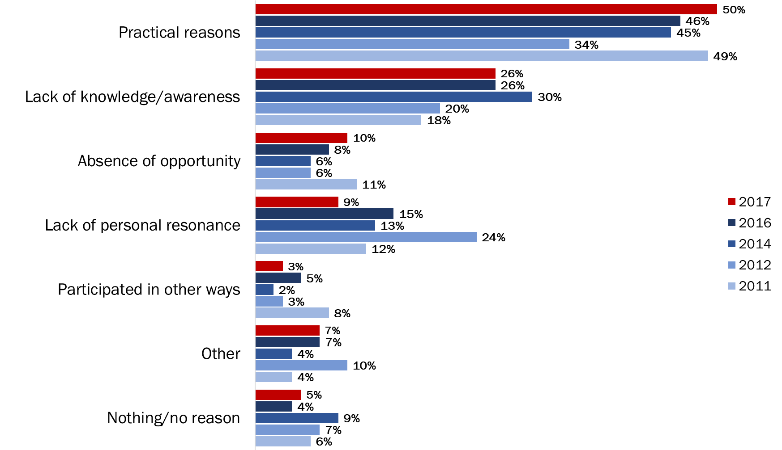
Q3C. And why didn't you or members of your immediate family participate in Veterans' Week? Base: Those who did not participate; 2017 n=506. (Up to 2 responses accepted)

The likelihood of citing practical reasons increased with age, from 40% of Canadians under 30 to 57% of those aged 65 and older.

Figure 13 illustrates the specific reasons Canadians gave for not participating in Veterans’ Week:

Figure 13: Reasons for Not Participating in Veterans’ Week [All Responses]
Practical Reasons
Too busy / no time to attend | 36%
Had to work / not available to participate | 11%
Can't participate due to health reasons / elderly | 8%
Lack of Knowledge / Awareness
Never heard of it / don't know about it | 24%
Don't know what activities there are for Veterans' Week | 2%
No Opportunity
There are no activities for Veterans' Week in the area | 5%
No occasion / opportunity / chance to participate | 5%
Lack of Personal Resonance
Don't have family members who are Veterans / don't know anyone in the military | 4%
Don't care / not important to me personally | 4%
I'm an immigrant | 2%
Participated in Other Ways
Remember by wearing a poppy | 2%
Participate in Remembrance Day events / observe Remembrance Day | 1%
Other
Don't have family nearby | 2%
We shouldn't celebrate war / we should focus on peace | 2%
Nothing/no reason | 5%
Note: Respondents could provide up to two reasons why they did not participate in Veterans’ Week. Therefore, the percentages in the table above for the full range of responses assigned to each theme (e.g., Practical Reasons) do not necessarily sum to the total percentage for that theme.

Majority Participate by Wearing a Poppy, Observing a Moment of Silence
Wearing a poppy is the most popular way to commemorate Veterans. Nearly four in five (79%) Canadians said they wore a poppy in 2017. Additionally, 71% said they observed a moment of silence. Following this, 45% watched Remembrance Day ceremonies on TV, with a further 39% saying they participated in a remembrance ceremony in their community. Exactly one in four Canadians participated in remembrance-related activities on social media, such as Facebook, YouTube, Twitter or Instagram.

Figure 14: Participation in Activities to Commemorate Veterans
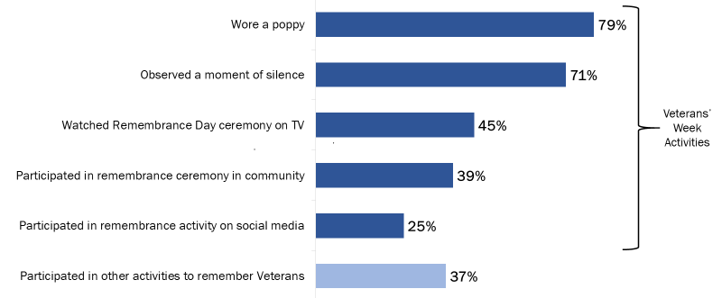
Q4: Did you or members of your immediate family do any of the following during Veterans' Week this year? Base: All respondents; 2017 n=1,000. DK/NR: 1% - 2%. (Multiple responses accepted)
Q4B: Outside of Remembrance Day or Veterans´ Week, in the past year, are there any other ways that you or members of your immediate family have remembered Canadian Veterans and those who died in service? Base: All respondents; 2017 n=1,000. DK/NR: 3%

Residents of Quebec were less likely to have worn a poppy, participated in a remembrance ceremony in their community, or participated in a remembrance-related activity on social media. The likelihood of wearing a poppy and watching a ceremony on television increased with age, while the likelihood of participating in an activity on social media increased as age decreased.

Wearing a poppy to commemorate Veterans has decreased four percentage points since it peaked at 83% in 2016. Additionally, participation through social media has decreased slightly year over year, from 29% in 2016 to 25% in 2017.

Figure 15: Participation in Veterans’ Week Activities [Over Time]
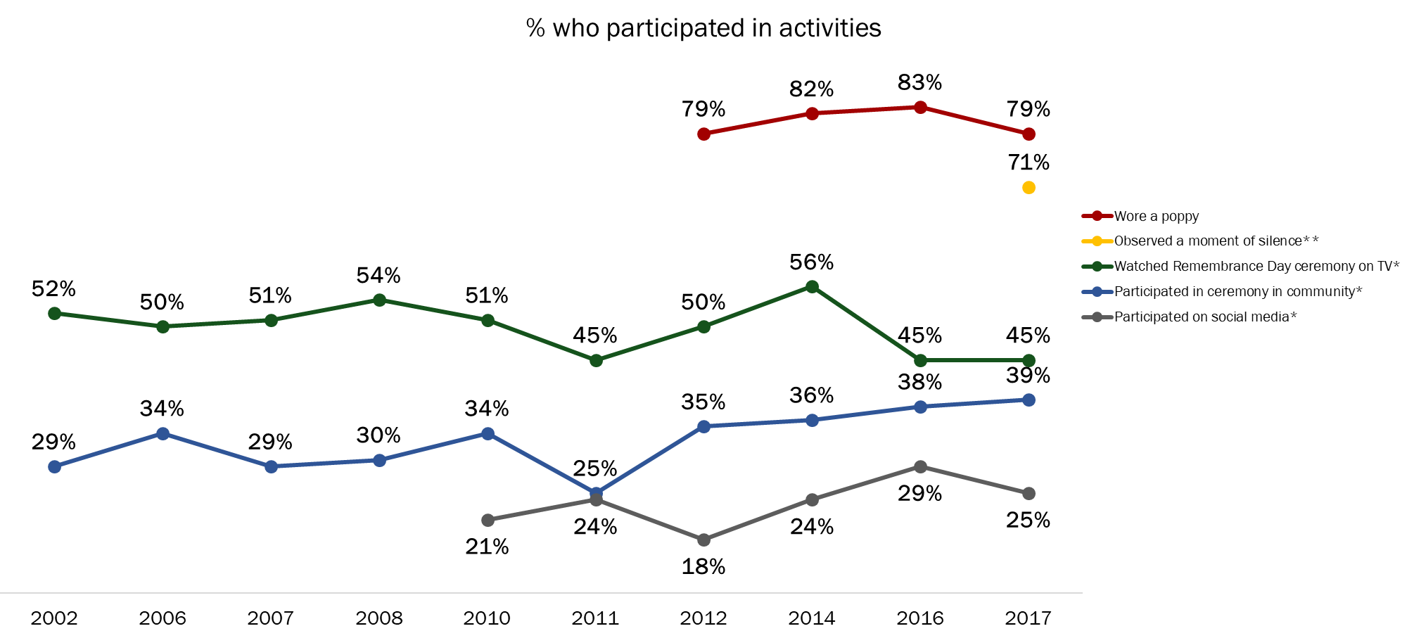
Q4: Did you or members of your immediate family do any of the following during Veterans' Week this year? Base: All respondents; 2017 n=1,000. DK/NR: 1% - 2%. (Multiple responses accepted)
*Wording changed in 2012
**Measure added in 2017

Minority of Canadians Participate Outside of Veterans’ Week
Most Canadians do not remember Canadian Veterans and those who died in service outside of Veterans’ Week. That said, just over one-third (37%) said they do remember Canadian Veterans and those who died in service outside of Veterans’ Week. This result continues the decline recorded last year.

Figure 16: Participation in Activities Outside of Veterans’ Week [Over Time]
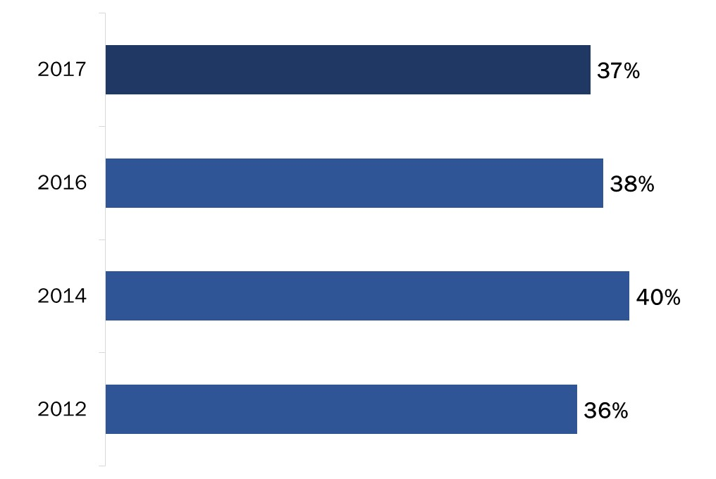
Q4B: Outside of Remembrance Day or Veterans’ Week, in the past year, are there any other ways that you or members of your immediate family have remembered Canadian Veterans and those who died in service? Base: All respondents; 2017 n=1,000. DK/NR: 3%

Residents of Quebec were least likely to have remembered Canadian Veterans and those who died in service outside of Veterans’ Week (22% versus 36% to 47% of Canadians in other regions of the country). Additionally, the likelihood of remembering Canadian Veterans and those who died in service outside of Veterans’ Week increased with age, from 25% of Canadians under 30 to 46% of Canadians aged 65 and older.

Prioritizing Veterans’ Week Activities
This section discusses Canadians’ perceptions about the importance of various Veterans’ Week initiatives.

Most Canadians Attribute At Least Some Importance to All Remembrance Initiatives
When asked to indicate what priority they feel the Government of Canada should place on various initiatives that recognize the achievements and sacrifices of Canadians during wartime and in peacetime operations, most Canadians supported all remembrance initiatives by attributing at least some importance to them.

Most Canadians attributed at least some importance to supporting and leading events recognizing those who served our country and important military milestones (87%), to creating and distributing educational materials for schools (86%), and to supporting and leading remembrance ceremonies at the National War Memorial (85%). In fact, six in 10 or more said these initiatives are very important. Additionally, over three-quarters (76%) place at least some importance on broadcasting or posting ads encouraging remembrance on TV and the Internet.

Following this, 71% of Canadians think the Government of Canada should place priority on posting remembrance-related content on social media and 70% think the Government of Canada should provide funds for communities to undertake remembrance initiatives. Finally, approximately two-thirds of Canadians (65%) attributed importance to providing promotional materials, such as posters and pins.

Figure 17: Importance of Remembrance Initiatives
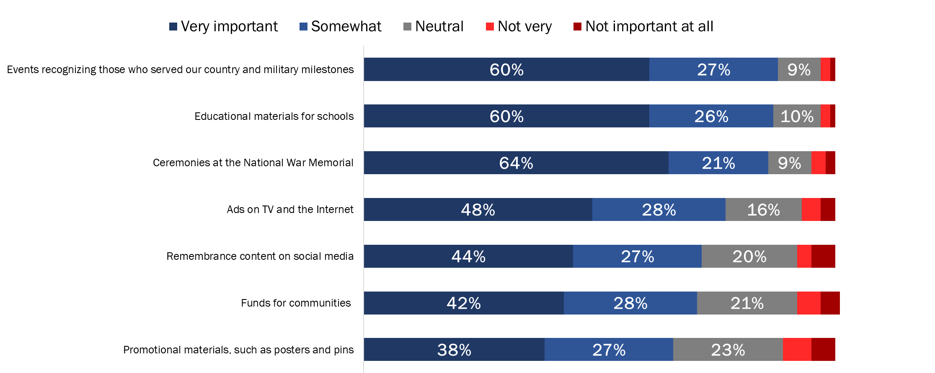
Q5: Now, thinking about ways of recognizing the achievements and sacrifices of Canadians during wartime and in peacetime operations, what priority should the Government of Canada place on each of the following remembrance initiatives? Base: All respondents; 2017 n=1,000. DK/NR: 1%

The likelihood of attributing importance to these remembrance initiatives was generally higher among residents of Atlantic Canada and lower among respondents from Quebec.

The importance that Canadians attribute to these initiatives has changed very little since 2016.

Figure 18: Importance of Remembrance Initiatives [Over Time]
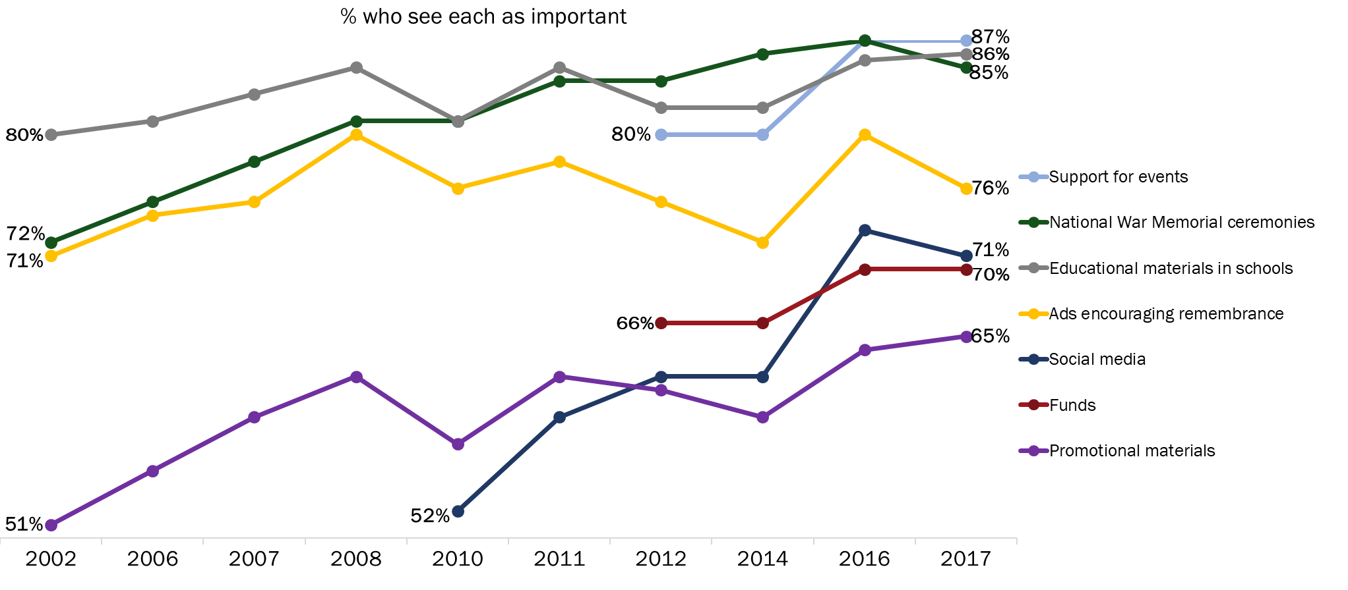
Q5: Now, thinking about ways of recognizing the achievements and sacrifices of Canadians during wartime and in peacetime operations, what priority should the Government of Canada place on each of the following remembrance initiatives? Base: All respondents; 2017 n=1,000. DK/NR: 1%

Attitudes Towards Veterans and Canada’s Military
This section provides an analysis of Canadians’ perceptions of Veterans’ contributions and sacrifices, the effectiveness of VAC’s remembrance program and honouring Veterans and those who died in service.

Canadians Display Positive Attitudes Towards Veterans
Canadians were asked to identify their level of agreement with statements related to Canadian Veterans. The statements were as follows:
    - Canada’s Veterans and those who died in service have made major contributions to our country.
    - Canada’s Veterans and those who died in service should be recognized for their service to Canada.
    - I make an effort to demonstrate my appreciation to those who served our country.
    - Veterans Affairs Canada's remembrance program effectively honours Veterans and those who died in service, and preserves the memory of their achievements and sacrifices.
    - Participation in commemorative activities increases awareness of, and appreciation for, the contributions of Veterans and those who died in service.

There was widespread agreement among Canadians that Canada’s Veterans and those who died in service should be recognized for their service to Canada (96%) and have made major contributions to our country (92%). Moreover, the vast majority of Canadians (85% and 78%, respectively) completely agreed with these statements. Additionally, 86% agreed that participating in commemorative activities increases awareness, with 61% agreeing completely.

Figure 19: Attitudes Towards Veterans and Commemoration
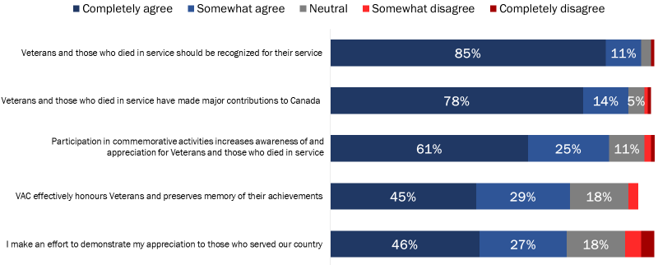
Q6: Please tell me how much you agree or disagree with each of the following statements, using a scale of 1 to 5, where 1 means completely disagree and 5 means completely agree. Base: All respondents; 2017 n=1,000. DK/NR: <1% -3%

Following this, nearly three-quarters think that VAC’s remembrance program effectively honours Veterans and those who died in service and preserves the memory of their achievements and sacrifices and agree that they make an effort to demonstrate their appreciation to those who served our country (74% and 73% respectively).

The likelihood of agreeing with these statements was generally higher among older Canadians and lower among residents of Quebec compared to Canadians in other regions of the country.

Canadians Have a Positive Attitude Towards Canada’s Military Role
Canadians were further asked to rate their level of agreement with statements relating to Canada’s military role. The statements were as follows:
    - I am knowledgeable about the role that Canada’s military has played in peacekeeping missions and conflicts like the World Wars, the Korean War, and the war in Afghanistan.
    - I am proud of the role that Canada’s military has played in peacekeeping missions and conflicts like the World Wars, the Korean War, and the war in Afghanistan.

Similar to previous years, Canadians were more likely to agree that they are proud of Canada’s military role than to think of themselves as knowledgeable about it. Over four in five (82%) Canadians agreed they are proud of the role that Canada’s military has played in peacekeeping missions and conflicts, while 72% agreed that they are knowledgeable about the role that Canada’s military has played.

Figure 20: Attitudes Towards Canada’s Military Role
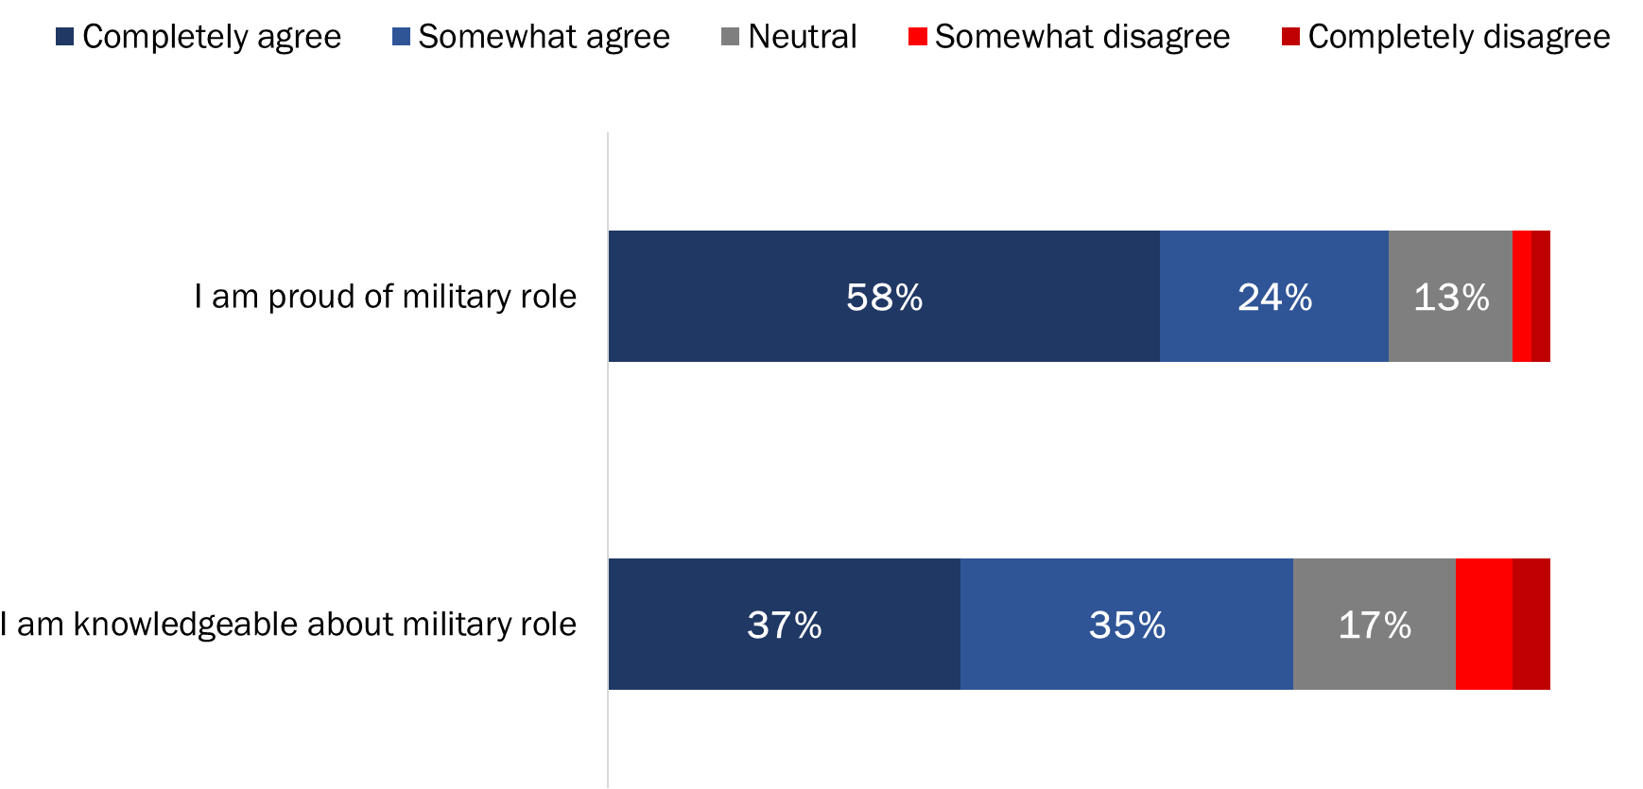
Q6: Please tell me how much you agree or disagree with each of the following statements, using a scale of 1 to 5, where 1 means completely disagree and 5 means completely agree. Base: All respondents; 2017 n=1,000. DK/NR: 1%

The likelihood of agreeing that they are knowledgeable and proud of our country’s military role increased with age.

Compared to 2016, there has been very little change in Canadians’ attitudes towards Veterans and those who died in service, and Canada’s military role (perceptions have changed by no more than three percentage points since last year).

Figure 21: Attitudes Towards Veterans and Military [Over Time]
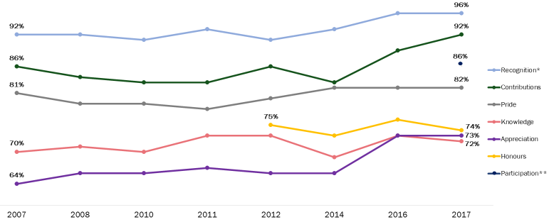
Q6: Please tell me how much you agree or disagree with each of the following statements, using a scale of 1 to 5, where 1 means completely disagree and 5 means completely agree. Base: All respondents; 2017 n=1,000. DK/NR: <1% -3%
*In 2012 the survey language changed when asking about recognition
**Measure added in 2017

Recognizing Canadian Veterans and Those Who Died in Service
This section examines Canadians’ perceptions of the importance of, and levels of satisfaction with, VAC’s measures to recognize Veterans and those who died in service.

Widespread Agreement on Importance of Recognition; Most Are Satisfied with VAC’s Recognition of Veterans and Those Who Died in Service
More than nine in 10 (93%) Canadians agreed that it is important for Veterans Affairs Canada to recognize and honour Canadian Veterans and those who died in service through the presentation and care of memorials, cemeteries and grave markers. Furthermore, nearly two-thirds (63%) of Canadians were satisfied with how Veterans Affairs Canada recognizes and honours Canadian Veterans and those who died in service through the presentation and care of these memorials, cemeteries and grave markers. Respondents who were not satisfied with VAC’s performance were more likely to be neutral (25%) than to express dissatisfaction (7%).

Figure 22: Attitudes Towards Actions to Recognize Veterans and Those Who Died in Service
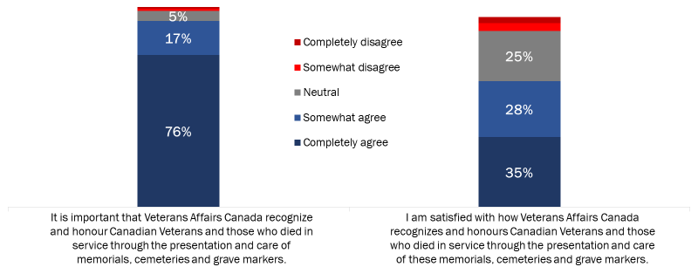
Q7A/B: Veterans Affairs Canada has a mandate to present and care for certain memorials, departmental cemeteries, and grave markers as well as provide funeral and burial assistance for deceased Canadian Veterans. Please tell me how much you agree or disagree with each of the following statements… Base: All respondents; 2017 n=1,000. DK/NR: <1% - 6%

The likelihood of completely agreeing that it is important for Veterans Affairs Canada to recognize and honour Canadian Veterans and those who died in service by presenting and caring for memorials, cemeteries and grave markers increased with age, and was highest among Atlantic Canadians (93% versus 65% of Quebec residents and 71% to 83% of Canadians in other regions). Additionally, Canadians with a high school education or less were more likely to completely agree than university graduates (81% versus 70%). Finally, the likelihood of completely agreeing that they are satisfied with how VAC recognizes and honours Canadian Veterans and those who died in service increased as respondents’ level of education decreased, from 27% of university graduates to 49% of Canadians with a high school education or less.

Attitudes Towards VAC’s Recognition of Veterans Remain Stable Over Time
Agreement that it is important that VAC recognize and honour Canadian Veterans and those who died in service has been increasing since 2012, while satisfaction with VAC’s performance in this area remains stable over time, fluctuating by no more than four percentage points since 2011.

Figure 23: Attitudes Towards Actions to Recognize Veterans and Those Who Died in Service [Over Time]
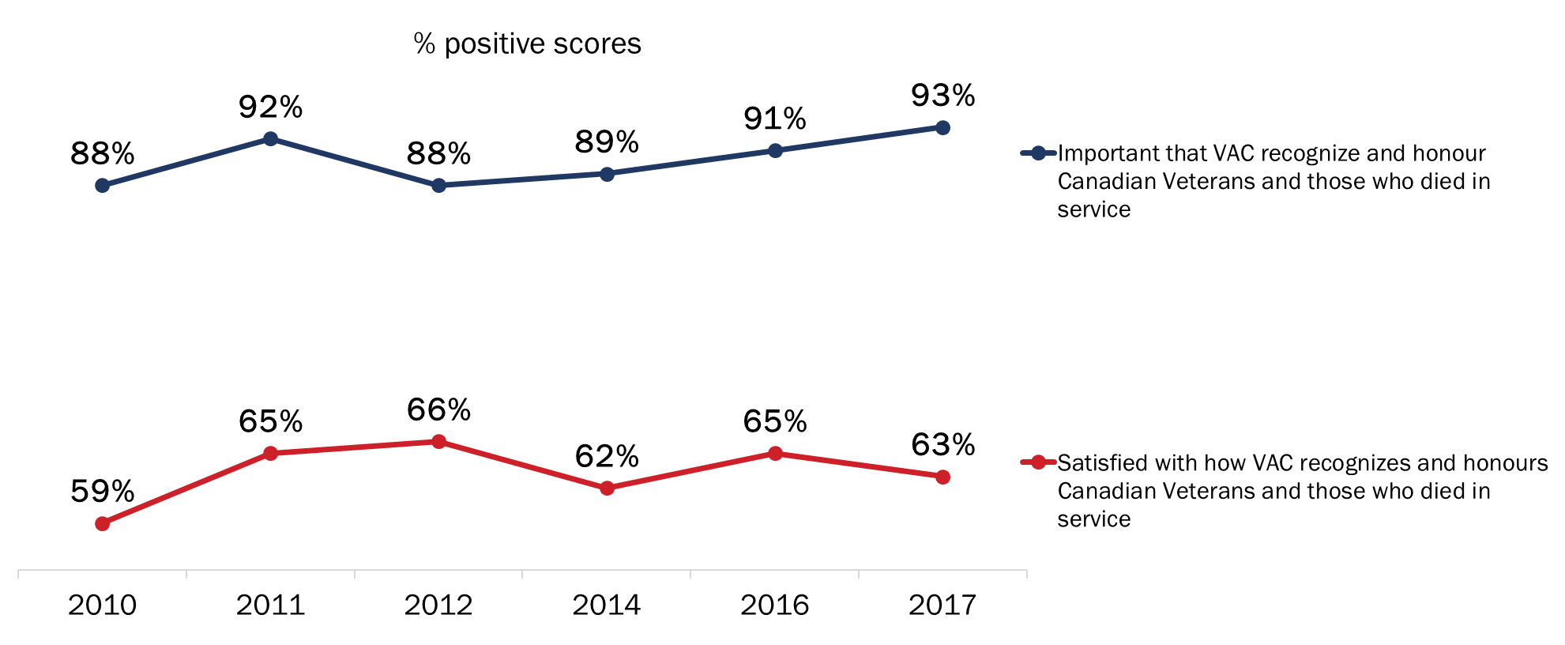
Q7A/B: Veterans Affairs Canada has a mandate to present and care for certain memorials, departmental cemeteries, and grave markers as well as provide funeral and burial assistance for deceased Canadian Veterans. Please tell me how much you agree or disagree with each of the following statements… Base: All respondents; 2017 n=1,000. DK/NR: <1% - 6%

Widespread Agreement on Importance of Providing Funeral Assistance; Majority Satisfied with VAC’s Provision of Funeral Assistance
Ninety percent of Canadians agreed that it is important that Veterans Affairs Canada recognize and honour deceased Canadian Veterans by providing funeral and burial assistance. Nearly three-quarters (74%) completely agreed that it is important for VAC to do so. In addition, 58% of Canadians agreed they are satisfied with how Veterans Affairs Canada recognizes and honours deceased Veterans through the provision of funeral and burial assistance.

Figure 24: Attitudes Towards Provision of Funeral and Burial Assistance
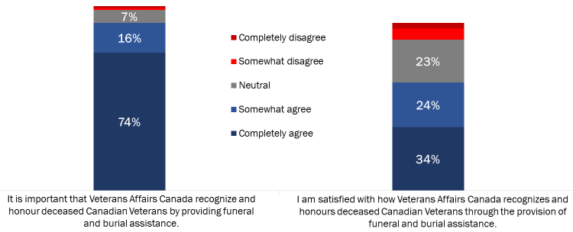Q7C/D: Veterans Affairs Canada has a mandate to present and care for certain memorials, departmental cemeteries, and grave markers as well as provide funeral and burial assistance for deceased Canadian Veterans. Please tell me how much you agree or disagree with each of the following statements… Base: All respondents; 2017 n=1,000. DK/NR: 1% - 11%

Residents of Quebec (65%) were less likely to completely agree that it is important that Veterans Affairs Canada recognize and honour deceased Canadian Veterans by providing funeral and burial assistance. In contrast, respondents from Atlantic Canada (81%) and Ontario (80%) were more likely to feel this way. Canadians under the age of 30 (67%) were the most likely to completely agree that they are satisfied with how Veterans Affairs Canada recognizes and honours deceased Veterans. In addition, the likelihood of completely agreeing increased as respondents’ education level decreased, from 25% of university graduates to 45% of Canadians with high school education or less.

Many Aware of World War Anniversaries; Majority Believe It Is Important to Commemorate World Wars
Canadians were asked if they are aware of upcoming anniversaries for the First and Second World Wars, as well as how important they think it is that these anniversaries be commemorated. Almost half (49%) are at least vaguely aware of the 100th anniversary of the First World War, with 34% saying they are clearly aware. Similarly, 44% of Canadians say they are aware of the 75th anniversary of the Second World War, with 27% saying they are clearly aware.

With respect to how Canadians feel about the importance of commemorating these military anniversaries, 88% said it is at least moderately important, with two-thirds saying it is very important.

Figure 25: Awareness and Importance of World War Commemorations
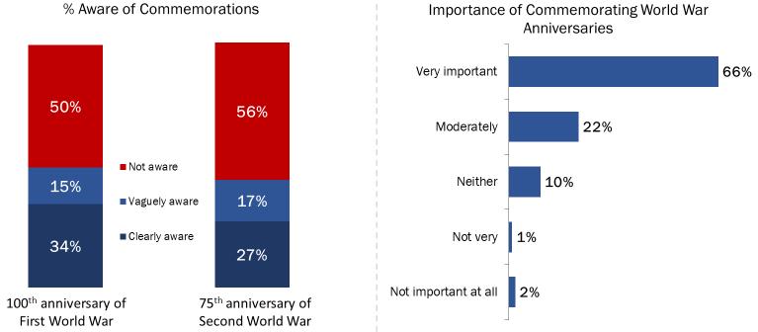
Q8: During the period 2014 to 2020, Canada is marking significant anniversaries of the two World Wars. Are you aware that Canada is commemorating… Base: All respondents; 2017 n=1,000. DK/NR: <1%
Q9: In your view, how important is it for Canada and Canadians to mark these two military anniversaries? Base: All respondents; 2017 n=1,000. DK/NR: <1%

Clear awareness of both anniversaries was lowest among residents of Quebec. Additionally, the likelihood of saying they are clearly aware that Canada is marking significant anniversaries of the two World Wars generally increased with age and was higher among men.

The likelihood of saying it is very important to mark these anniversaries was lowest among Quebec residents (82%), and it increased with age (from 53% of Canadians under 30 to 73% of those aged 65 and older).

Compared to 2016, awareness of the First and Second World War anniversaries has increased among Canadians, although the proportion of Canadians attributing importance to commemorating these anniversaries remains unchanged at 88%.

Figure 26: Awareness and Importance of World War Commemorations [Over Time]
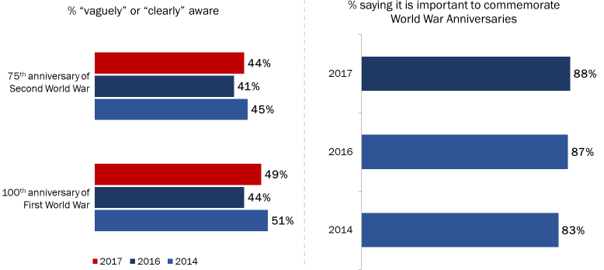
Q8: During the period 2014 to 2020, Canada is marking significant anniversaries of the two World Wars. Are you aware that Canada is commemorating… Base: All respondents; 2017 n=1,000. DK/NR: <1%
Q9: In your view, how important is it for Canada and Canadians to mark these two military anniversaries? Base: All respondents; 2017 n=1,000. DK/NR: <1%

Appendix

Annex 1: Statement of Political Neutrality

I hereby certify as a Senior Officer of Phoenix Strategic Perspectives that the deliverables fully comply with the Government of Canada political neutrality requirements outlined in the Communications Policy of the Government of Canada and Procedures for Planning and Contracting Public Opinion Research. Specifically, the deliverables do not contain any reference to electoral voting intentions, political party preferences, standings with the electorate, or ratings of the performance of a political party or its leader.

Alethea Woods
President
Phoenix Strategic Perspectives Inc.

Annex 2: Methodological Notes

The following specifications applied to this survey:

- An 11-minute random digit dialling (RDD) telephone survey was administered to 1,000 Canadian residents, 18 years of age or older, between November 12 and 22, 2017.
- Probability sampling was used: a total of 396 interviews were completed with cell phone only (CPO) households from the cell phone sample and 604 interviews with households from the landline sample.
- The sample frame was geographically disproportionate to improve the accuracy of regional results. The distribution of completed surveys was as follows:

Strata | Completed Interviews
Atlantic | 100
Quebec | 300
Ontario | 350
Prairies (and Nunavut and the Northwest Territories) | 150
British Columbia (and the Yukon Territory) | 100
Total | 1,000

- Based on a sample of this size, the overall results can be considered to be accurate within ±3.3%, 19 times out of 20 (adjusted to reflect the geographically disproportionate sampling).
- The potential for non-response bias was assessed by comparing the characteristics of respondents through unweighted and weighted data. As is typically the case for general population telephone surveys, older Canadians (those aged 65 and older) were overrepresented in the final survey sample and younger Canadians (those under 30 years of age) were underrepresented. This was corrected with weighting.
- The survey data have been weighted by region, age and gender using population figures from Statistics Canada’s 2011 census data.
- The overall response rate was 6% (8% for the landline sample and 5% for the cell phone sample).
- The table below presents information about the final call dispositions for this survey, as well as the associated response rates (using the Marketing Research and Intelligence Association [MRIA] formula).

 | Total | Landline | Cell
Total Numbers Attempted | 40,471 | 11,169 | 29,302
Out-of-scope - Invalid | 24,014 | 4,006 | 20,008
Unresolved (U) | 7,322 | 2,507 | 4,815
No answer/Answering machine | 7,322 | 2,507 | 4,815
In-scope - Non-responding (IS) | 9,135 | 4,656 | 4,479
Language barrier | 266 | 152 | 114
Incapable of completing (ill/deceased) | 88 | 64 | 24
Callback (Respondent not available) | 1244 | 450 | 794
Refusal | 7,433 | 3,950 | 3,483
Termination | 104 | 40 | 64
In-scope - Responding units (R) | 1,100 | 649 | 451
Quota Full | 25 | 20 | 5
Completed Interview | 1,000 | 604 | 396
NQ - Work | 49 | 25 | 24
NQ - Age | 26 | 0 | 26
Response Rate | 6.27% | 8.31% | 4.63%

Annex 3: Tabulated Data

A full set of tabulated data has been provided under separate cover.

Annex 4: Questionnaire
Hello, my name is . I’m calling on behalf of Phoenix, a public opinion research firm. We’re conducting a survey for the Government of Canada to explore issues of interest to Canadians. This survey should take no more than ten minutes to complete, and is registered with the national survey registration system. Participation is voluntary and completely confidential, and your answers will remain anonymous.

CELL SAMPLE SKIP A, GO TO CS1.
- I’d like to speak to someone in your household who is 18 years of age or older. Is that you?

Yes | CONTINUE
No | ASK TO SPEAK TO ELIGIBLE PERSON. REPEAT INTRO
Refused (Volunteered) | THANK/DISCONTINUE

CELL SAMPLE ONLY:
CS1. Have I reached you on your cell phone?

Yes | CONTINUE
No | GO TO B

CS2. Are you 18 years of age or older?

Yes | CONTINUE
No | THANK/DISCONTINUE

CS3. Are you in a place where you can safely talk on the phone and answer my questions?

Yes | GO TO B
No | CONTINUE

CS4. When would it be more convenient for me to call back?

Schedule call-back if possible (time/day): _______________

ASK EVERYONE:
- Do you, or does anyone in your family or household, work in any of the following areas? [READ LIST]

Advertising or Market Research | THANK/DISCONTINUE
The media (i.e. TV, radio, newspapers) | THANK/DISCONTINUE
An elected official | THANK/DISCONTINUE
* THOSE WHO ARE NOT ELIGIBLE: Thank you for your willingness to take part in this survey, but you do not meet the eligibility requirements of this study.

- In what year were you born?

Record year: ____________

INTERVIEWER AND PROGRAMMING NOTES:

IF RESPONDENT QUESTIONS THE VALIDITY OF THE RESEARCH, INVITE RESPONDENT TO CALL THE NATIONAL SURVEY REGISTRATION SYSTEM (SEE NOTE BELOW).

IF RESPONDENT ASKS ABOUT NATIONAL SURVEY REGISTRATION SYSTEM, SAY:

The registration system has been created by the survey research industry to allow the public to verify that a survey is legitimate, get information about the survey industry or register a complaint. The registration system’s toll-free phone number is 1-888-602-6742 ext. 8728. (www.mria-arim.ca)

IF ASKED ABOUT THE NATIONAL DO NOT CALL LIST, SAY:

Calls made for the purpose of market research, polls or surveys are not considered telemarketing calls. Organizations making these types of calls are not required to register with the National Do Not Call List. The National Do Not Call List toll-free telephone number is 1-866-580-3625

REVEAL THE NAME OF THE CLIENT DEPARTMENT THAT COMMISSIONED THE SURVEY AT THE END OF THE SURVEY ONLY, IF ASKED - VETERANS AFFAIRS CANADA [VAC].

UNLESS OTHERWISE SPECIFIED, ALL QUESTIONS IN THE SURVEY WILL ALLOW FOR ‘DON’T KNOW/NO RESPONSE’ OPTION.

TRACKING QUESTIONS ARE IDENTIFIED AS FOLLOWS: T16 = 2016 IS MOST RECENT TRACKING.

IF ASKED WHERE AND HOW THE RESPONDENT CAN ACCESS THE RESULTS, INFORM HIM OR HER THAT THE REPORT WILL BE DEPOSITED WITH LIBRARY AND ARCHIVES CANADA (LAC) WITHIN SIX MONTHS AFTER THE DATA COLLECTION HAS BEEN COMPLETED. LAC’S WEBSITE IS www.lac-bac.gc.ca.

VAC IS CONDUCTING TWO DIFFERENT SURVEYS DURING NOVEMBER. THE OTHER SURVEY GAUGES RECALL OF A RECENT GOVERNMENT OF CANADA REMEMBRANCE ADVERTISING CAMPAIGN. IF, AT SOME POINT DURING THE INTERVIEW, A RESPONDENT INDICATES THAT S/HE HAS ALREADY COMPLETED A SURVEY ON REMEMBRANCE, ASSURE HIM/HER THAT THERE ARE TWO SURVEYS UNDERWAY RIGHT NOW, BOTH OF WHICH ARE RELATED TO REMEMBRANCE. APOLOGIZE FOR THE INCONVENIENCE, THANK THEM FOR THEIR WILLINGNESS TO RESPOND, AND CONFIRM THAT THEY WILL CONTINUE WITH THIS INTERVIEW.

ASK EVERYONE:
- Have you ever heard of Veterans' Week? T16

Yes
No

READ THIS DESCRIPTION TO EVERYONE:
Veterans’ Week takes place in November each year and ends with Remembrance Day. During this week, commemorative ceremonies and events take place across the country to recognize the achievements of our Veterans and those who died in service. People also take part through things like social media, wearing a poppy, and having discussions with Veterans or military personnel.

- On a scale of 1 to 5, where 1 means not important at all, 5 means very important, with 3 being neither unimportant nor important, in your opinion, how important is it that Veterans' Week be held each year? T16

Not important at all
Not very important
Neither important nor unimportant
Moderately important
Very important

ASK IF ‘VERY/MODERATELY IMPORTANT’:
2b. And why do you say it is important that Veterans’ Week be held each year? [DO NOT READ LIST; ACCEPT UP TO TWO RESPONSES; DO NOT PROBE BEYOND FIRST RESPONSE] T16

To honour/ to respect the Veterans/ those who died in service
So people will remember their sacrifices
To recognize their contribution to our freedom/ security/ peace
Veterans fought for our country/ they served our country
To recognize their service/ accomplishments
Family member is a Veteran/ I am a Veteran
Canada wouldn't be the country it is today/ I wouldn't be here if it weren't for Veterans
So children can understand/ learn the importance of it
Good idea/ good to remember
We owe them/ they deserve recognition
Part of our heritage/ our history
Many soldiers died in past wars
So we don't repeat past mistakes
Should not/ cannot forget
There are fewer Veterans/ their story should be told
Believe in it/ it's important to do it
To show support for our troops (past and/ or present)
Forces us to examine war
Other. Specify: __________________________
Nothing/ no reason

ASK IF ‘NOT VERY/NOT AT ALL IMPORTANT’:
2c. And why do you say it is unimportant that Veterans’ Week be held each year? [DO NOT READ LIST; ACCEPT UP TO TWO RESPONSES; DO NOT PROBE BEYOND FIRST RESPONSE] T16

Never heard of it/ don't know about it
Don't care/ not important to me personally
We already have Remembrance Day/ a week is too long
It is important/ necessary that we have it
Happened in the past/ we should focus on the present
We shouldn't celebrate war/ we should focus on peace
Don't have family members who are Veterans/ don't know anyone in the military
Too expensive/ waste of money
Re-opens old wounds/ sad memories
There are other issues/ concerns that are more important
Most Veterans have died/ very few Veterans left
Don't know what activities there are for Veterans' Week
Other. Specify: __________________________
Nothing/ no reason

ASK IF “NEITHER IMPORTANT/UNIMPORTANT”:
2d. And why do you say it is neither important nor unimportant that Veterans’ Week be held each year? [DO NOT READ LIST; ACCEPT UP TO TWO RESPONSES; DO NOT PROBE BEYOND FIRST RESPONSE] T16

Never heard of it/ don't know about it
Don't care/ not important to me personally
It is important/ necessary that we have it
We already have Remembrance Day/ a week is too long
Don't have family members who are Veterans/ don't know anyone in the military
We shouldn't celebrate war/ we should focus on peace
Happened in the past/ we should focus on the present
Don't know what activities there are for Veterans' Week
There are other issues/ concerns that are more important
Most Veterans have died/ very few Veterans left
Should be a more private ceremony/ held less often (so it's not overdone)
Other. Specify: __________________________
Nothing/ no reason

ASK EVERYONE:
- Did you or members of your immediate family participate in Veterans' Week this year? T16

Yes
No
Don’t know

ASK IF “YES”:
3b. And why did you or members of your immediate family participate in Veterans' Week? [DO NOT READ LIST; ACCEPT UP TO TWO RESPONSES; DO NOT PROBE BEYOND FIRST RESPONSE] T16

Family member is a Veteran/ I am a Veteran
To honour/ to respect the Veterans/ those who died in service
Know/ am related to someone/ I am currently in the military
So people will remember their sacrifices
Believe in it/ it's important to do it
So children can understand/ learn the importance of it
To recognize their contribution to our freedom/ security/ peace
I/ someone I know participate(s) in events
To recognize their service/ accomplishments
Veterans fought for our country/ they served our country
Canada wouldn't be the country it is today/ I wouldn't be here if it weren't for Veterans
To show support for our troops (past and/ or present)
Good idea/ good to remember
Show some (national) pride
Other. Specify: __________________________
Nothing/ no reason

ASK IF “NO”:
3c. And why didn't you or members of your immediate family participate in Veterans' Week? [DO NOT READ LIST; ACCEPT UP TO TWO RESPONSES; DO NOT PROBE BEYOND FIRST RESPONSE] T16

Never heard of it/ don't know about it
Too busy/ no time to attend
Don't have family members who are Veterans/ don't know anyone in the military
Had to work/ not available to participate
Don't care/ not important to me personally
There are no activities for Veterans' Week in the area
No occasion/ opportunity/ chance to participate
Don't know what activities there are for Veterans' Week
Participate in Remembrance Day events/ observe Remembrance Day
Can't participate due to health reasons/ elderly
Don't have family nearby
I'm an immigrant
We shouldn't celebrate war/ we should focus on peace
Remember by wearing a poppy
Other. Specify: __________________________
Nothing/ no reason

ASK EVERYONE:
4. Did you or members of your immediate family do any of the following during Veterans' Week this year? [READ LIST; ACCEPT YES/NO FOR EACH ITEM] T16 MODIFIED

a. Wear a poppy.
b. Participate in a remembrance ceremony in your community. *
c. Watch a Remembrance Day 2017 ceremony on TV. *
d. Participate in any remembrance-related activity on social media, such as Facebook, YouTube, Twitter or Instagram. *
e. Observe a moment of silence. *

* RECODE “NO” TO “YES” AT Q3 IF RESPONDENT SAID “NO” BUT DID ONE OF THESE ACTIVITIES.

4b. Outside of Remembrance Day or Veterans’ Week, in the past year, are there any other ways that you or members of your immediate family have remembered Canadian Veterans and those who died in service? T16

Yes
No

ASK EVERYONE:
5. Now, thinking about ways of recognizing the achievements and sacrifices of Canadians during wartime and in peacetime operations, what priority should the Government of Canada place on each of the following remembrance initiatives? Please respond using a scale of 1 to 5, where 1 means not important at all, 5 means very important, with 3 meaning neither unimportant nor important. [READ LIST; OBTAIN RATING FOR EACH ITEM] T16

- Creating and distributing educational materials for schools
- Supporting and leading events that recognize those who served our country and important military milestones
- Supporting and leading remembrance ceremonies at the National War Memorial
- Broadcasting or posting ads encouraging remembrance on TV and the Internet
- Providing funds for communities to undertake remembrance initiatives
- Providing promotional materials, such as posters and pins
- Posting remembrance-related content on social media (Facebook, YouTube, Twitter, blogs, etc.)

6. Please tell me how much you agree or disagree with each of the following statements, using a scale of 1 to 5, where 1 means completely disagree and 5 means completely agree. [READ LIST; OBTAIN RATING FOR EACH ITEM] T16 MODIFIED

    - I am knowledgeable about the role that Canada’s military has played in peacekeeping missions and conflicts like the World Wars, the Korean War, and the war in Afghanistan.
    - I am proud of the role that Canada’s military has played in peacekeeping missions and conflicts like the World Wars, the Korean War, and the war in Afghanistan.
    - Canada’s Veterans and those who died in service have made major contributions to our country.
    - Canada’s Veterans and those who died in service should be recognized for their service to Canada.
    - I make an effort to demonstrate my appreciation to those who served our country.
    - Veterans Affairs Canada's remembrance program effectively honours Veterans and those who died in service, and preserves the memory of their achievements and sacrifices.
    - Participation in commemorative activities increases awareness of, and appreciation for, the contributions of Veterans and those who died in service.

ASK EVERYONE:
7. Veterans Affairs Canada has a mandate to present and care for certain memorials, departmental cemeteries, and grave markers as well as provide funeral and burial assistance for deceased Canadian Veterans. Please tell me how much you agree or disagree with each of the following statements, using a scale of 1 to 5, where 1 means completely disagree and 5 means completely agree. T16 MODIFIED

- It is important that Veterans Affairs Canada recognize and honour Canadian Veterans and those who died in service through the presentation and care of memorials, cemeteries and grave markers. MODIFIED
- I am satisfied with how Veterans Affairs Canada recognizes and honours Canadian Veterans and those who died in service through the presentation and care of memorials, cemeteries and grave markers. MODIFIED
- It is important that Veterans Affairs Canada recognize and honour deceased Canadian Veterans by providing funeral and burial assistance.
- I am satisfied with how Veterans Affairs Canada recognizes and honours deceased Canadian Veterans through the provision of funeral and burial assistance.

8. During the period 2014 to 2020, Canada is marking significant anniversaries of the two World Wars. Are you aware that Canada is commemorating …T16

- …100th anniversary of the First World War?
- …75th anniversary of the Second World War?

RECORD:
Yes, clearly
Yes, vaguely
No

9. In your view, how important is it for Canada and Canadians to mark these two military anniversaries? Please respond using a scale of 1 to 5, where 1 means not important at all, 5 means very important, with 3 meaning neither unimportant nor important. T16

Not important at all
Not very important
Neither important nor unimportant
Moderately important
Very important

The last few questions are for classification purposes only.

10. What language do you speak most often at home? [READ LIST; ACCEPT ALL THAT APPLY]

English
French
Other

11. What is the highest level of formal education that you have completed? [READ LIST]

Grade 8 or less*
Some high school**
High school diploma or equivalent
Registered Apprenticeship or other trades certificate or diploma
College, CEGEP or other non-university certificate or diploma
University certificate or diploma below bachelor's level
Bachelor's degree
Post graduate degree above bachelor's level
[DO NOT READ] Prefer not to answer

*IN QUEBEC, PLEASE REPLACE WITH: “Secondary II or less”
**IN QUEBEC, PLEASE REPLACE WITH: “Some secondary school”

12. Which of the following categories best describes your current employment status? Are you…? [READ LIST; ACCEPT ONE ANSWER ONLY]

Working full-time, that is, 35 or more hours per week
Working part-time, that is, less than 35 hours per week
Self-employed
Unemployed, but looking for work
A student attending school full-time
Retired
Not in the workforce (full-time homemaker, unemployed and not looking for work)
Other
[DO NOT READ] Refused

13. What is your total household income for 2016? That is, the total income of all persons in your household combined, before taxes. Please stop me when I get to the correct amount. Is it…? [READ LIST]

Under $20,000
$20,000 to just under $40,000
$40,000 to just under $60,000
$60,000 to just under $80,000
$80,000 to just under $100,000
$100,000 to just under $150,000
$150,000 and above
[DO NOT READ] Refused

ASK CELL SAMPLE:
C1. In addition to your cellular telephone, does your household currently have a traditional telephone or landline? [ACCEPT ONE RESPONSE]

Yes
No

ASK LANDLINE SAMPLE:
C2. In addition to your residential landline telephone, do you or someone else in your household also use one or more cell phone numbers? [ACCEPT ONE RESPONSE]

Yes
No

That concludes the survey. Thank you very much for your thoughtful feedback.
It is much appreciated.

RECORD BY OBSERVATION: PROVINCE/REGION, GENDER, LANGUAGE OF INTERVIEW

Population data from 2016 census were not available when the data were tabulated.
This is a new measure added to the questionnaire in 2017.
This is a new measure added to the questionnaire in 2017.
The purpose of this description was to ensure that all respondents had a basis on which to rate the importance of Veterans’ Week.
These responses are more specific to the themes that respondents offered. The responses were then combined to create the graph above.
Refers to the number of respondents who gave a specific response (not the percentage).
Refers to the number of respondents who gave a specific response (not the percentage).
This is a new measure added to the questionnaire in 2017.
Population data from 2016 census were not available when the data were tabulated.
The MRIA response rate formula is as follows: [R=R/(U+IS+R)]. This means that the response rate is calculated as the number of responding units [R] divided by the number of unresolved [U] numbers plus in-scope [IS] non-responding households and individuals plus responding units [R].

