***Exploring perceptions, behaviours and experiences in relation to My VAC Account***

**Final Report**

**Prepared for Veterans Affairs Canada**

Supplier Name: Phoenix SPI

Contract Number: 51019-184026-001-CY

Contract Value: $99,973.36 (including HST)

Award Date: 2018-12-27

Delivery Date: 2019-06-13

Registration Number: POR 095-18

For more information on this report, please contact Veterans Affairs Canada at: vac.information.acc@canada.ca

**Ce rapport est aussi disponible en français.**

***Exploring perceptions, behaviours and experiences in relation to My VAC Account***

Final Report

Prepared for Veterans Affairs Canada

Supplier name: Phoenix Strategic Perspectives Inc.

June 2019

This public opinion research report presents the results of four online surveys, two online focus groups, and a set of 10 in-depth interviews conducted by Phoenix SPI on behalf of Veterans Affairs Canada. The target audience was My VAC Account users and departmental employees. The research took place between February and March, 2019.

This publication may be reproduced for non-commercial purposes only. Prior written permission must be obtained from Veterans Affairs Canada. For more information on this report, please contact Veterans Affairs Canada at: vac.information.acc@canada.ca.

**Catalogue number:**

V49-9/2019E-PDF

**International Standard Book Number (ISBN):**

978-0-660-31195-1

**Related publications (registration number: POR 095-18):**

Catalogue number V49-9/2019F-PDF (Final report, French)

ISBN 978-0-660-31196-8

© Her Majesty the Queen in Right of Canada, as represented by the Minister of Veterans Affairs, 2019

Aussi offert en français sous le titre *E*xplorer les perceptions, le fonctionnement et les expériences de Mon dossier ACC.

*Table of Contents*

Executive Summary 1

Background and Objectives 1

Methodology 1

Summary of Findings 2

Notes to Readers 5

I. Research with My VAC Account Users 8

1st My VAC Account User Survey 8

2nd My VAC Account User Survey 21

3rd My VAC Account User Survey 35

Online Focus Groups with My VAC Account Users 45

II. Research with Departmental Employees 54

Online Survey 54

In-depth Interviews 68

Appendix 83

1: Methodological Notes 83

2: Research Instruments – (My VAC Account Users) 85

3: Research Instruments – (VAC Employees) 107

# Executive Summary

Phoenix Strategic Perspectives Inc. (Phoenix SPI) was commissioned by Veterans Affairs Canada (VAC) to conduct public opinion research in relation to My VAC Account. My VAC Account is a secure, authenticated web application that allows users[1] to access VAC services from anywhere, and at any time.

## Research Purpose and Objectives

Through My VAC Account, Veterans are able to conduct the majority of their business with the department online. They can use the Benefits Navigator to learn more about VAC benefits and services relevant to them, apply online for VAC benefits and services, upload documents to support applications, track the status of applications, receive online correspondence (forms and letters), view a summary of their VAC benefits, sign up for direct deposit or change banking information, update contact information, and connect with VAC through secure messaging. My VAC Account is continually enhanced as the department moves towards having a complete suite of services available online.

As the number of services that are moving to online platforms increases, and the number of Veterans and their families[2] who use My VAC Account continues to increase, it is critical to collect feedback from those who use the channel. For this reason, VAC commissioned public opinion research to be conducted with Veterans as well as with VAC employees. The objectives of the research were to collect feedback from Veterans with respect to their experiences using My VAC Account and to capture perspectives from frontline and other VAC employees. Together, this feedback is intended to help guide future enhancements of My VAC Account, ensuring it meets the needs of Veterans and it can be leveraged by the department to make work processes more efficient for employees.

## Methodology

Qualitative and quantitative research was conducted with the target populations: My VAC Account users and VAC employees. This included:three online surveys; two virtual focus groups with My VAC account users; one online survey; and 10 in-depth, one-on-one telephone interviews with departmental employees. What follows is an overview of the different elements of the research. Additional methodological information is available in the appendix.

The quantitative research consisted of four online surveys: three were conducted with users of My VAC Account and one with departmental employees. Specifically:

* The online surveys of My VAC Account users were intercept surveys, with survey respondents recruited through My VAC Account and the department’s website.[3] In total, 795 individuals responded to the first survey, which was administered between February 28 and March 5, 2019. The second survey was conducted between March 20 and March 26, 2019 and 510 individuals responded. In total, 554 individuals responded to the third online intercept survey, which was administered between March 27 and April 2, 2019. These survey samples are non-probability samples[4]; for this reason, margins of error cannot be provided for the results of the three surveys.
* The online survey of VAC employees was a census; frontline (field operations, case managers and Veterans service agents) and Centralized Operations Division (COD) employees were invited to participate. The invitation to participate was sent by the department and the survey was available for completion from March 6 to March 19, 2019. In total, 161 departmental employees responded to the survey. Since this was an attempted census, there is no margin of sampling error to be estimated or reported.

The qualitative research consisted of two virtual focus groups with My VAC account users and 10 in-depth, one-on-one telephone interviews with departmental employees. Specifically:

* Two online focus groups were conducted with My VAC Account users recruited through the second online intercept survey. One group was conducted in French and the other in English. Both groups took place on March 27, 2019, and each group lasted 90 minutes. A total of 17 My VAC Account users participated (nine participants in the English group and eight in the French group). All research participants received a $100 honorarium to thank them for their time.
* Ten in-depth, one-on-one telephone interviews were conducted with departmental employees recruited through the online survey. Interviews were conducted in the individuals’ official language of choice during business hours. All interviews were completed between March 15 and 25,2019 and averaged approximately 35 minutes.

## Summary of Findings

**I. My VAC Account Users**

**Use of My VAC Account**

***Most use My VAC Account at least monthly and many do so on a weekly basis.***

The two features My VAC Account users were most likely to use are tracking the status of applications (91%) and My VAC Account Inbox (87%). In addition, most have applied for benefits and services (82%) and viewed a summary of benefits (82%).

**My VAC Account Registration**

*Most found registration easy and agree that the steps required to register for My VAC Account justify the security it provides. Just over half used GCKey to do so—primarily because they were not comfortable with the alternative, Secure Key.*

Fifty-seven percent of My VAC Account users surveyed said they registered for the online service using GCKey. When asked why they used GCKey 64% said they were more comfortable with GCKey than the alternative, their online banking login. Most My VAC Account users found the process of registering to be somewhat (37%) or very (38%) easy and 70% agreed that the steps required to register justify the security it provides. A small number of My VAC Account users (15%) found it difficult to register. Those who found the registration process difficult were most likely to say that it took too long or there were too many steps (51%) or that they did not know what GCKey is (46%).

**Secure Messaging**

*Most have used secure messaging to contact VAC, few have experienced difficulties when doing so, and the majority of users are satisfied with their experience using secure messaging.*

Most My VAC Account users who have used secure messaging waited five or fewer days to receive a response. Among those who contacted VAC through secure messaging, 32% said they were able to connect with their case manager through this channel. Of those who have a case manger, the vast majority (91%) would like to contact their case manager directly through secure messaging.

Two-thirds (66%) of those who have contacted VAC through secure message also had to follow up with VAC on these conversations. Just over three-quarters (76%) of those who followed up did so via secure messaging, while 58% followed up by calling VAC. The vast majority (89%) of those who used secure messaging to contact VAC did not have any difficulties. Fifty-six percent of those who used secure messaging over the 12 months preceding the research are satisfied with their experience.

**Online Chat**

*There is moderate interest in an online chat feature among My VAC Account users. Most of those interested in this type of feature would want to use it to connect with a case manager.*

More than half the My VAC Account users surveyed expressed interest in an online chat feature, and approximately one-quarter indicated that they *might* be interested or *may* use this type of feature. Respondents were asked who at VAC they would like to speak to through an online chat. Almost three-quarters (74%) would like to speak with a case manager, 45% with the VAC National Contact Centre, and 42% with the Bureau of Pensions Advocates.

**Track Your Applications**

*Most survey respondents had used ‘track your applications’ and found it at least somewhat helpful. The main weakness of the feature is that is does not provide sufficient details.*

The majority (88%) of My VAC Account users surveyed have used the ‘track your applications’ feature. Of those who have not, just over half (56%) said they have had no need to use the feature. In addition, 24% attributed their lack of use to lack of awareness of the feature, suggesting a need to better promote the feature. Half (50%) of those who used the feature found it helpful in finding out the status of their application, and an additional 40% found it *somewhat* helpful. In terms of weaknesses, 52% said it does not provide sufficient detail about what step their application is at. Focus group participants elaborated on this issue, emphasizing that the current tracking function is not useful or helpful because it does not provide detailed, customized, or personalized information about their applications.

**Benefits Navigator**

*Many survey respondents had used the Benefits Navigator tool and most found it at least somewhat helpful.*

Two-thirds (66%) of the My VAC Account users surveyed said they used the Benefits Navigator tool. The most commonly cited reason for not using the tool was that they did not know about it. Just over half (54%) said this was the reason they had not used Benefits Navigator, suggesting a need to better promote the tool. Among those who used the Benefits Navigator tool, nine in 10 found it helpful on some level, including 38% who said it was very helpful.

**Guided Web Forms**

*Three in 10 survey respondents have used a guided web form in My VAC Account to complete an application. Many still prefer online application forms to guide web forms.*

Three in 10 My VAC Account users said they had used a guided web form in My VAC account to complete an application. Perceived benefits of doing so included: ease of completion (55%), the ability to save one’s progress (53%), and time efficiency (it saves time using a web form) (51%). When asked which method they prefer to use to complete applications, 48% said they prefer online application forms while 30% expressed a preference for a guided web form.

**Related Communications Issues**

*My VAC Account is the preferred channel for receiving updates from the department and most would like to hear from the VAC at least once a month. The top topics of interest are changes to benefits and new benefit rates. In addition, most have signed up for email notifications.*

Eight in 10 (81%) My VAC Account users would prefer to learn through My VAC Account about updates from the department to benefits. When asked how frequently they would prefer to receive news from VAC, most said at least once a month: 45% would like to receive news once a month, and 36% about once a week. When asked which topics they would like to hear about, most selected changes to benefits and new benefit rates. Eighty-six percent of My VAC Account users who responded to the survey are signed up for email notification alerts, and virtually everyone who receives them finds them somewhat (32%) or very (65%) useful.

**II. Departmental Employees**

**Awareness and Use of My VAC Account**

*There is widespread familiarity with My VAC Account and many use it on a daily basis.*

The majority of employees who completed the survey said they are somewhat (46%) or very (38%) familiar with My VAC Account. Employees are most familiar with secure messaging (86%), followed by the features allowing Veterans to upload documents (70%) and to update their contact or direct deposit information (68%). Almost half (47%) refer to My VAC Account at least once a day while interacting with Veterans. In addition, two in 10 (21%) refer to it several times a week and nearly one in 10 (8%) do so about once a week. In total, therefore, 76% generally refer to My VAC Account at least weekly.

**Secure Messaging**

*Most have used secure messaging and have had a positive experience with the communication feature.*

In the 12 months preceding the research, 71% of employees who refer to My VAC Account have used secure messaging to communicate with Veterans. Nine in 10 reported having a good (42%) or very good (48%) experience. Employees who use secure messaging use it daily (34%) or several times a week (16%) and most (84%) have not experienced any difficulties using the feature to communication with Veterans in the last year. Nearly half use secure messaging to respond to messages initiated by My VAC Account users (49%) and to both respond and initiate communication with My VAC Account users (46%). Very few (4%) use secure messaging only to initiate communication.

Motivators to Use My VAC Account

***Understanding how to use My VAC Account is the top motivator to promote use.***

Those familiar with My VAC Account were asked what would encourage them to promote use of My VAC Account with Veterans. Nearly half (46%) said that having a better understanding of how to use My VAC Account would encourage them to promote the online service channel. Approximately one-third (32%) would consider promoting My VAC Account if they had a better understanding of the advantage of the online service channel and one-quarter suggested having My VAC Account ambassadors or champions on their team as a resource.

## ****Notes to Readers****

* The report is divided into two sections. The first section presents the results of the research conducted with My VAC Account users, and the second section presents the results of the research conducted with departmental employees.
* Regarding the qualitative results:
  + The results provide an indication of participants’ views about the issues explored, but they cannot be generalized to the full population of My VAC Account clients or departmental employees.
* Regarding the quantitative results:
  + All results in the report are expressed as percentages, unless otherwise noted. Throughout the report, percentages may not always add to 100% due to rounding.
  + In graphs, “DK” stands for “Don’t know” and “NR” for “No response.”
  + The number of respondents changes throughout the report because questions were asked of sub-samples of survey respondents. Readers should be aware of this and exercise caution when interpreting results based on smaller numbers of respondents.
  + The results are reflective of My VAC Account users, but they cannot be considered representative of the target population because random sampling was not used. When non-probability sampling is used, the extent to which the survey sample represents the target population is not known (because probability theory cannot be applied). Given the nature of the sampling, it is possible that the survey sample over-represents more frequent users of My VAC Account.
* The tabulated data is available under separate cover and the research instruments can be found in the appendix.

The contract value was $99,973.36 (including HST).

### Political Neutrality Certification

I hereby certify as a Senior Officer of Phoenix Strategic Perspectives that the deliverables fully comply with the Government of Canada political neutrality requirements outlined in the *Communications Policy* of the Government of Canada and Procedures for Planning and Contracting Public Opinion Research. Specifically, the deliverables do not contain any reference to electoral voting intentions, political party preferences, standings with the electorate, or ratings of the performance of a political party or its leader.

Signed:

A close up of a logo

Description generated with high confidence

Alethea Woods, President

Phoenix Strategic Perspectives Inc.

# I. Research with My VAC Account Users

## 1st My VAC Account User Survey

**This section presents the results of the first online intercept survey. In total, 795 individuals responded to the survey between February 28 and March 5, 2019. Of this, virtually everyone was a registered user of My VAC Account and had used the online service channel in the 12 months preceding the research (n=765). In all, 11 respondents were not registered users of My VAC Account and 19 registered users had not used the online service channel in the 12 months preceding the research.**

### I. My VAC Account Use

Almost half use My VAC Account at least several times a week

Among those who used My VAC Account in the last 12 months, nearly half (48%) use My VAC Account at least several times a week, including 17% who use it at least once a day. Following this, one-quarter (23%) use My VAC Account about once a week and 19% use it about once a month. Nine percent reported using My VAC Account, on average, less than once a month.

Figure 1: Frequency of Using My VAC



Q3. On average, how often would you say you use My VAC Account? [DK/NR: 1%] / Base: n=765; those who used My VAC in the last 12 months.

VAC staff member most common source of awareness

When asked how they first learned about My VAC Account, the most frequently cited source was a VAC staff member, mentioned by 36% of respondents. Following this, 16% said they first learned of the online service channel by browsing the VAC website, 16% through information sent by VAC, and 15% via word of mouth. Other sources of awareness were mentioned by small numbers of respondents (4% or fewer).

Figure 2: Source of Awareness of My VAC Account



Q4. How did you first learn about My VAC Account? / Base: n=765; those who used My VAC in the last 12 months.

Tracking the status of applications and Inbox are top features accessed

Tracking the status of applications was the most commonly accessed feature in My VAC Account, with 91% of respondents saying they have used this feature. This was followed closely by My VAC Account Inbox (87%).

Figure 3: Features Accessed in My VAC Account



Q5. Which of the following features have you accessed in My VAC Account? (multiple responses accepted)

Base: n=765; those who used My VAC in the last 12 months

In addition, most My VAC Account users surveyed accessed applying for benefits and services (82%) and viewing a summary of benefits (82%), as well as secure messaging (78%). Nearly three-quarters (73%) have accessed uploading documents and two-thirds (66%) have updated personal information. My VAC Account users were less likely to have signed up for email notifications (57%) or direct deposit/changing banking information (56%).

### II. Registering for My VAC Account

Just over half used GCkey to register for My VAC Account

Fifty-seven percent of My VAC Account users surveyed said they registered for the online service using GCKey. Four in 10 (41%) registered using SecureKey. The rest (2%) could not recall which method they used to register for My VAC Account.

Figure 4: Method Used to Register for My VAC Account



Q6. When you registered for My VAC Account, which of the following did you use? / Base: n=765; those who used My VAC in the last 12 months.

Nearly two-thirds used GCkey to register because of comfort

When asked why they used GCKey to register for My VAC Account, almost two-thirds (64%) said they were more comfortable with GCKey than the alternative, their online banking login. One in five (21%) did not want to use their banking information to access My VAC Account, and 9% said that their bank was not an option in SecureKey.

Figure 5: Reason for Using GCKey to Register



Q7. Why did you use GCKey to register? / Base: n=435; those who used My VAC in the last 12 months and used GCKey to register

Three-quarters found registration easy

Most My VAC Account users found the process of registering to be somewhat (37%) or very (38%) easy. Conversely, a little over one in 10 found the process difficult, with 13% saying it was somewhat difficult and 2% very difficult. Additionally, 10% could not recall the registration process.

Figure 6: Perceptions of My VAC Account Registration Process



Q8. How easy or difficult was the process to register for My VAC Account? / Base: n=765; those who used My VAC in the last 12 months.

Taking too long is the top reason why registration was seen as difficult

Those who found the registration process somewhat or very difficult were asked why they felt this way. Half (51%) said it took too long or there were too many steps, while 46% said not knowing what a GCKey is made it difficult to register. Trouble linking their VAC file to their My VAC Account was mentioned by 26% of respondents as the reason they found registration difficult. Included in the “other” category are a variety of technical and health-related issues.

Figure 7: Reasons Registration was Difficult



Q9. You said it was hard to register for My VAC Account. Why was this difficult? (multiple responses accepted)

Base: n=112; those who found it difficult to register for My VAC Account

Majority agrees that registration steps justify security

Seven in 10 My VAC Account users somewhat (30%) or strongly (40%) agreed that the steps required to register for My VAC Account justifies the security it provides. Those who did not agree with this view were more likely to be neutral (20%) than to express any level of disagreement (11%).

Figure 8: Perceptions of My VAC Account Security Measures



Q10. To what extent do you agree or disagree with the following statement: “The steps required to register for My VAC Account justifies the security it provides.”? Base: n=765; those who have used My VAC in last 12 months.

### III. Secure Messaging

Eight in 10 have contacted VAC through secure messaging

Eight in 10 (81%) My VAC Account users have tried contacting VAC through secure messaging. Conversely, nearly one in five (19%) said they have not tried to contact VAC using secure messaging.

Figure 9: Use of Secure Messaging



Q11. In the past 12 months, have you tried contacting VAC through secure messaging? / Base: n=765; those who used My VAC in the last 12 months.

Majority found response wait time reasonable

Those who have contacted VAC through secure messaging were asked how long they had to wait to receive a response. Most waited five or fewer days: 46% waited three to five business days to receive a response, 25% one to two business days, and 3% less than one business day. In contrast, one in five (21%) said they waited six or more business days for a response.

When asked if they found this wait time reasonable, the majority (58%) said it was while one-third (33%) said it was not reasonable. The rest (9%) did not provide a response when asked if this was a reasonable amount of time to wait.

Figure 10: Experience Using Secure Messaging



Q12. How long did you have to wait to receive a response? Base: n=616; those who contacted VAC.

Q13. Was this a reasonable amount of time to wait? Base: n=616; those who contacted VAC.

Most would prefer one to two day response time

Of those who did not find the response time reasonable, 54% said a reasonable amount of time to wait for a secure message reply would be one to two business days. Two in 10 would be fine to wait three to five business days and 17% would prefer to wait less than one business day to receive a response to a secure message.

Figure 11: Preferred Response Time



Q14. What would be a reasonable amount of time to wait for a secure message reply?

Base: n=407; those who contacted VAC but don’t think the wait time for a response is reasonable.

### IV. Overall Assessments of My VAC Account

Positive overall perceptions of My VAC Account

Respondents were asked to what extent they agree or disagree with a variety of statements about My VAC Account. These included:

* My VAC Account had the information I needed.
* It was easy to find what I was looking for in My VAC Account.
* My VAC Account is visually appealing.
* I think My VAC Account uses practices that ensure system security.
* I like the updates that I have seen in My VAC Account.
* The information in My VAC Account is easy to understand.
* I can do the business I need to with VAC through My VAC Account.
* I would recommend My VAC Account to others.

Overall, the My VAC Account users surveyed hold positive perceptions of the department’s online service channel. Strong majorities would recommend My VAC Account to others (82%) and think My VAC Account uses practices that ensure system security (82%).

When it comes to the information available through My VAC Account, 77% agreed that it is easy to understand and 74% agreed that My VAC Account has relevant information (i.e., the information they need). Additionally, slightly more than seven in 10 (72%) agreed that it is easy to find what they need on My VAC Account, while 71% agreed that they can do the business they need to with the department through My VAC Account.

Nearly two-thirds (65%) said they liked the updates they have seen in My VAC Account and 63% find My VAC Account visually appealing.

Figure 12: Perceptions of My VAC Account



Q15. To what extent do you agree or disagree with the following statements? / Base: those who used My VAC in the last 12 months. [Does not apply removed]

Three-quarters are satisfied with My VAC Account

Three-quarters of My VAC Account users said they are satisfied with their experience with My VAC Account, including 41% who are very satisfied. Conversely, a small proportion of users said they are somewhat (12%) or very (4%) dissatisfied with their experience.

Figure 13: Satisfaction with My VAC Account



Q16. Overall, how satisfied are you with your experience with My VAC Account? / Base: n=765; those who used My VAC in the last 12 months.

Lack of communication top reason for dissatisfaction with My VAC Account

Exactly half (50%) of those dissatisfied with their experience using My VAC Account pointed to minimal communication or updates from VAC as the reason for their dissatisfaction. Following this, 46% mentioned lack of support or assistance, and 44% insufficient details available to find forms or specific information. Other reasons for dissatisfaction included trouble finding the information they needed (31%), features that are difficult to use (21%), and technical difficulties (17%).

Figure 14: Reasons for Dissatisfaction with My VAC Account



Q17. Why are you not satisfied with your experience with My VAC Account? (multiple responses accepted) Base: n=123; those who were dissatisfied with My VAC Account

Included in the “other” category are a number of very specific reasons, such as the perception that doctors cannot interact with the system efficiently, a general lack of trust in the information and VAC employees, and timeliness of service.

### V. Communications

Most prefer My VAC Account to provide updates

Eight in 10 (81%) My VAC Account users said they would prefer to learn through My VAC Account about updates from the department to benefits. Ten percent would prefer that such information be communicated via mail and 3% by telephone. An additional 6% said through some other channel, such as email.

Figure 15: Preferred Method of Hearing about Benefits Updates



Q18. How would you prefer to find out about updates from the department to benefits? / Base: n=765; those who used My VAC in the last 12 months.

Top topics of interest include changes to benefits and new programs/services

When asked which topics they would like to hear about in the News section of My VAC Account, 90% selected changes to benefits and 87% selected new programs and services. Following this, 81% would like to hear about updates to My VAC Account or new features. Fewer, but still a majority of 51%, would like to hear about mental health information and services. My VAC Account users were less likely to select commemoration events or related news (33%).

Figure 16: Topics of Interest for the News Section



Q19. What topics would you like to hear about in this News section? (multiple responses accepted) / Base: n=765; those who have used My VAC in last 12 months

Most would like to hear from VAC at least once a month

When asked how frequently they would prefer to receive news from VAC, most My VAC Account users said at least once a month. Specifically, 45% would like to receive news once a month, and 36% about once a week. Six percent would like to receive news from VAC twice a year or less often.

Approximately one in 10 (12%) would like only to receive news from the department when it is necessary.

Figure 17: Preferred Frequency of Receiving News from VAC



Q20. How often would you like to receive news from Veterans Affairs Canada? / Base: n=765; those who used My VAC in the last 12 months.

Slight majority interested in online chat feature

Fifty-four percent of My VAC Account users expressed interest in an online chat feature that could be used to connect with VAC staff. In addition, 29% reported that they *might* be interested in this type of feature. Approximately one in 10 (12%) expressed no interest in an online chat feature.

Figure 18: Interest in an Online Chat Feature



Q21. If an online chat feature was available within My VAC Account, would you use it to connect with VAC staff? Base: n=765; those who used My VAC in the last 12 months

### VI. Profile of Survey Respondents (Wave 1)

|  |  |
| --- | --- |
|  | **Percentage** |
| Client | |
| Second World War or Korean War Veteran | 1% |
| Retired or still-serving member of Canadian Armed Forces | 88% |
| Retired or still-serving member of the RCMP | 9% |
| Family member who received benefits from VAC | 1% |
| Prefer not to say | 2% |
| Age | |
| 18-29 | 2% |
| 30-39 | 12% |
| 40-49 | 20% |
| 50-59 | 37% |
| 60 and over | 28% |
| Prefer not to say | 1% |
| Region | |
| West | 26% |
| Ontario | 25% |
| Quebec | 20% |
| Atlantic Canada | 27% |
| Prefer not to say | 2% |

## 2nd My VAC Account User Survey

**This section presents the results of the second online intercept survey conducted with My VAC Account users. In total, 510 individuals responded to the survey between March 20 and March 26, 2019. My VAC Account users who completed the first online intercept survey were ineligible to complete this survey.**

### I. My VAC Account Use

Consistent with first survey, half use My VAC Account at least several times a week

When asked how often, on average, they use My VAC Account, 51% said they do so at least several times a week. Specifically, 16% tend to use My VAC Account daily and 35% several times a week. One-quarter (26%) said they use My VAC Account once a week typically and 15% do so, on average, about once a month. Eight percent reported using My VAC Account less than once a month.

Figure 19: Frequency of Using My VAC Account



Q2 - On average, how often would you say you use My VAC Account? / Base: n=510 registered users

Two-thirds prefer to contact VAC through secure message

Two-thirds (66%) of My VAC Account users prefer to contact VAC through secure messaging. The rest expressed a preference for non-digital service channels: 30% selected telephone and 1% mail. Other mentions included email, in person, or through a combination of methods.

Figure 20: Preferred Method of Contacting VAC



Q3 - What is your preferred method for contacting VAC? / Base: n=510 registered users

### II. Secure Messaging

Vast majority has contacted VAC through secure messaging

Approximately eight in 10 (82%) My VAC Account users have tried contacting VAC through a secure message from their My VAC Account Inbox. Conversely, 17% said they have not tried to do so in the 12 months preceding the research.

Figure 21: Use of Secure Messaging



Q4 - In the past 12 months, have you tried contacting VAC through a secure message from your My VAC Account Inbox? / Base: n=510 registered users [DK =1%]

Just over half connected with VAC at least six times

Those who have contacted VAC through secure messaging were asked how many times they have connected directly with VAC staff through secure messaging. Just over half (53%) said they had connected at least six times in the 12 months preceding the survey.

Figure 22: Frequency of Connecting with VAC Staff

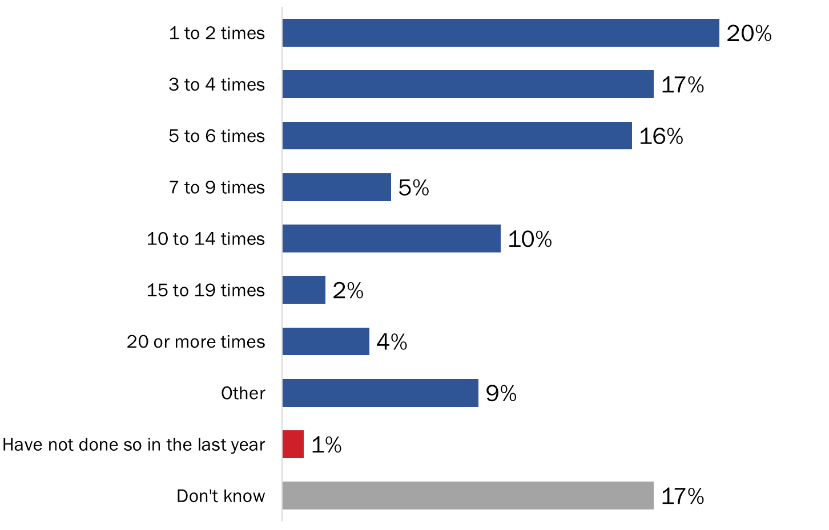

Q5 - In the past 12 months, approximately how many times have you connected directly with VAC staff through secure messaging? Base: n=416; those who have contacted VAC through Secure Message [Multiple Responses Accepted]

Nearly half waited 3 to 5 business days for response

Those who have contacted VAC through secure messaging were asked how long they had to wait to receive a response. Consistent with the results of the first survey, most waited five or fewer days: 48% waited three to five business days to receive a response, 30% one to two business days, and 2% waited less than one business day. In contrast, one in five (21%) said they waited more than five business days for a response.

Figure 23: Response Time



Q6 - On average, how long did you have to wait to receive a response? / Base: n=416; those who have contacted VAC through Secure Message

Most are satisfied with response time

Almost two-thirds (64%) of those who used secure messaging to contact VAC said they were satisfied with the wait time. Conversely, 36% were not satisfied with the response time.

Figure 24: Satisfaction with Response Time



Q7 - Were you satisfied with this response time? / Base: n=416; those who have contacted VAC through Secure Message

Nearly one-third connected with case manager using secure messaging

Among those who contacted VAC through secure messaging, approximately one-third (32%) said they were able to connect with their case manager through this channel. One-quarter (25%) did not connect with their case manager, and 36% said they do not have a case manager.

Figure 25: Connected with Case Manager using Secure Messaging



Q8 - Did you connect with your case manager when using secure messaging? / Base: n=416; those who have contacted VAC through Secure Message

Nine in 10 interested in contacting case manager directly

Among those who have a case manger, the vast majority (91%) would like to contact their case manager directly through secure messaging.

Figure 26: Interest in Connecting with a Case Manager via Secure Messaging



Q9 - Would you like to be able to contact your case manager directly through secure messaging? / Base: n=267; those who have a case manager

Many had to follow up with VAC

Two-thirds (66%) of those who have contacted VAC through secure message also had to follow up with VAC on these conversations. Approximately three in 10 (29%) said they did not have to follow up.

Figure 27: Followed Up with VAC on Secure Messaging Conversations



Q11 - Have you had to follow up on conversations you've had with VAC through secure messaging? / Base: n=416; those who have contacted VAC through Secure Message

Most followed up with VAC via secure messaging

Just over three-quarters (76%) of those who have followed up on conversations they have had with VAC through secure messaging did so via secure messaging. Fifty-eight percent followed up by calling VAC. Other methods mentioned included calling a case manager directly and visiting a local office.

Figure 28: Method Used to Follow Up with VAC



Q12 - How did you follow up with VAC? / Base: n=274; those who followed up with VAC (multiple responses accepted).

Vast majority did not have difficulties using secure messaging

The vast majority (89%) of those who used secure messaging to contact VAC did not have any difficulties.

Figure 29: Difficulties Using Secure Messaging



Q13 - Did you have any difficulties using secure messaging? Base: n=416; those who have contacted VAC through Secure Message [DK =2%]

Those who encountered difficulties (n=38) were most likely to say it took too long to receive a response or their issue was not resolved.

Figure 30: Difficulties Encountered Using Secure Messaging



Q14 - What difficulties did you experience? / Base: n=38; those who had difficulties (multiple responses accepted).

Included in the “other” category are a small number of very specific responses generally focused on technical and communications-related issues.

A little over half are satisfied with their experience using secure messaging

A little over half (56%) of those who contacted VAC through secure messaging over the 12 months preceding the research are satisfied with their experience. Conversely, nearly one-quarter said they are somewhat (15%) or very (8%) dissatisfied with their experience using secure messaging to connect directly to VAC staff. The rest (21%) were neither satisfied nor dissatisfied.

Figure 31: Satisfaction with Secure Messaging



Q15 - Thinking about the past 12 months, how satisfied have you been with your experience using secure messaging to connect directly to VAC staff? / Base: n=416; those who have contacted VAC through Secure Message

### III. Other Communication Channels in My VAC Account

Nearly nine in 10 are familiar with ‘News and Notifications’ section

Nearly nine in 10 (87%) My VAC Account users surveyed are familiar with the ‘News and Notifications’ section on the homepage in My VAC Account.

Figure 32: Familiarity with 'News and Notifications'



Q18 - Are you familiar with the ‘News and Notifications’ section that appears at the bottom of your homepage in My VAC Account? / Base: n=510 registered users

Most say ‘News and Notifications’ are effective in keeping them updated

Most My VAC Account users familiar with ‘News and Notifications’ rated the feature as somewhat (55%) or very (33%) effective when it comes to keeping them up to date on news of relevance. In contrast, only 7% indicated that ‘News and Notifications’ are not at all effective.

Figure 33: Effectiveness of 'News and Notifications' in Keeping Veterans Up-to-date



Q19 - How effective are the ‘News and Notifications’ when it comes to keeping you up to date on news of relevance to you? / Base: n=445; those familiar with ‘News and Notifications’ [DK =5%]

Changes to benefits and new benefit rates top topics of interest

When asked which topics they would like to hear about on ‘News and Notifications’, the vast majority of those familiar with the feature selected changes to benefits (88%) and new benefit rates (86%). Seventy-eight percent selected new My VAC Account features and just over half (53%) mentioned news about mental health. Two in 10 (22%) said they would like to hear about commemoration.

Figure 34: Topics of Interest for 'News and Notifications'



Q20 - What areas or topics would you like to hear about through 'News and Notifications’? / Base: n=445; those familiar with ‘News and Notifications’ [DK =5%] (multiple responses accepted).

Most would use online chat feature

Two-thirds (66%) of respondents would use an online chat feature if it was available within My VAC Account. In addition, 23% said they *may* use such a feature. Nine percent expressed no interest in an online chat feature (2% were uncertain).

Figure 35: Likelihood of Using an Online Chat Feature



Q22 - If an online chat feature was available within My VAC Account, would you use it to connect with VAC staff? / Base: n=510 registered users

Three-quarters would like to chat with a case manager

Respondents were asked who at VAC they would like to speak to through an online chat within My VAC Account. Almost three-quarters (74%) would like to speak to a case manager. Smaller, and similar, proportions would like to speak with the VAC National Contact Centre (45%) or the Bureau of Pensions Advocates (42%).

Figure 36: VAC Employees Veterans would like to Chat with via Online Chat



Q23 - Who at VAC would you like to speak to through an online chat? / Base: n=510 registered users (multiple responses accepted).

Included in the “other” category are adjudicators, ombudsmen, and individuals trained to deal with Education and Training Benefits, among others.

Majorities view all proposed features as valuable

When asked which features they would like to see included in an online chat available within My VAC Account, majorities selected all the different features. Only 8% said they would not want to see any of these features.

Figure 37: Preferred Features of an Online Chat



Q24 - An online chat can have a number of different features available to users. Which, if any, of the following would you like to see included in an online chat available within My VAC Account? Base: n=510; registered users (multiple responses accepted).

More than eight in 10 signed up for email notifications; few unaware of service

Eighty-six percent of My VAC Account users who responded to the survey said they are signed up for email notification alerts. Ten percent are not signed up for the service, including 6% who are not aware of the service.

Figure 38: Use of Email Notification Alerts



Q25 - Are you signed up to receive email notification alerts? / Base: n=510; registered users

Most found signing up for email notification easy

Among those signed up for email notifications, seven in 10 found it somewhat (19%) or very (51%) easy to sign up. Those who did not find it easy were more likely to be neutral (13%) than to describe the process as difficult (3%). The rest (14%) could not recall their experience.

Figure 39: Ease of Signing Up for Email Notifications



Q26 - How easy or difficult was it to sign up for VAC’s email notification service? / Base: n=439; those who are signed up to receive email notifications

Virtually everyone finds email notifications useful

Ninety-seven percent of those signed up for email notifications find them somewhat (32%) or very (65%) useful.

Figure 40: Usefulness of the Email Notification Service



Q27 - Do you find the email notification service useful? / Base: n=439; those who are signed up to receive email notifications [Can’t recall =1%]

Nearly two-thirds favour a live chat feature

Respondents were asked what VAC can do to better communicate with them through My VAC Account. Nearly two-thirds (64%) said they would like VAC to include a live chat feature and half (50%) selected the inclusion of a dashboard feature. “Doing nothing” was selected by 9% of respondents and 11% did not know.

Figure 41: Suggestions to Help VAC Communicate Better



Q28 - What, if any, can VAC do to better communicate with you through My VAC Account? / Base: n=510; registered users (multiple responses accepted).

Method of accessing My VAC Account varies

The method by which respondents access My VAC Account varies: 24% use a mobile device, 36% a laptop or desktop computer, 40% use both.

Figure 42: Method of Accessing My VAC Account



Q29 - How do you typically access My VAC Account? Base: n=510; registered users

### IV. Profile of Survey Respondents (Wave 3)

|  |  |
| --- | --- |
|  | **Percentage** |
| Client | |
| A Veteran | 76% |
| Still-serving member of Canadian Armed Forces | 16% |
| Retired or still-serving member of the RCMP | 7% |
| A family member | 1% |
| Prefer not to say | -- |
| Age Group | |
| 18-29 | 4% |
| 30-39 | 16% |
| 40-49 | 24% |
| 50-59 | 37% |
| 60 and over | 18% |
| Prefer not to say | -- |
| Region | |
| West | 26% |
| Ontario | 28% |
| Quebec | 13% |
| Atlantic Canada | 31% |
| Prefer not to say | 2% |

## 3rd My VAC Account User Survey

**This section presents the results of the third online intercept survey conducted with My VAC Account users. In total, 554 individuals responded to the survey between March 27 and April 2, 2019. All but three respondents were registered users of My VAC Account.**

### I. Benefits Navigator

Two-thirds use My VAC at least once a week

Two-thirds of survey respondents indicated they use My VAC Account at least once a week. Specifically, 28% said they use it about once a week, one-quarter use it several times a week, and 12% at least once a day. An additional one-quarter (25%) use My VAC Account about once a month, while 10% do so less than once a month.

Figure 43: Frequency of Using My VAC Account



Q2 - On average, how often would you say you use My VAC Account? Base: n=551; registered users

Two-thirds used Benefits Navigator tool

Two-thirds (66%) of My VAC Account users said they have used the Benefits Navigator tool. In contrast 22% have not used it, while 13% did not know whether or not they had used the tool.

Figure 44: Use of the Benefits Navigator Tool



Q3 - Have you used the Benefits Navigator tool (located under “What can I apply for?”)? Base: n=551; registered users

Lack of awareness is the main reason for not using Benefits Navigator

Among those who have not used the Benefits Navigator tool, the most commonly cited reason was that they did not know about it. Just over half (54%) said this was the reason they had not used Benefits Navigator. Slightly more than one-quarter (27%) attributed their lack of use to lack of need. Additionally, 14% said it looked too complicated. Included in the “other” category are technical issues and lack of trust, among other reasons.

Figure 45: Reasons for Not Using Benefits Navigator



Q5 - Is there any reason why you haven’t used the Benefits Navigator tool? Base: n=147; those who have not used Benefits Navigator (Multiple responses accepted)

Nine in 10 found Benefits Navigator helpful

Among those who have used the Benefits Navigator tool, nine in 10 found it helpful on some level, including 38% who said it was very helpful. Conversely, 7% said it was not helpful at all (and 3% said they could not recall their experience).

Figure 46: Helpfulness of Benefits Navigator



Q6 - How helpful was the Benefits Navigator tool in terms of finding benefits or services of relevance to you?

Base: n=365; those who have used Benefits Navigator

### II. Track Your Applications

Majority uses ‘Track your Applications’ feature

The majority (88%) of My VAC Account users have used the ‘track your applications’ feature in My VAC Account. In contrast, 12% said they have not viewed the status of their application through this feature.

Figure 47: Use of the 'Track your applications' Feature



Q7 - Have you used the ‘Track your applications’ feature in My VAC Account to view the status of your application? Base: n=551; registered users

Having no need is the top reason for not using ‘Track your Applications’ feature

Of those who have not used ‘track your applications’, just over half (56%) said they have had no need. In addition, 24% attributed their lack of use to lack of awareness of the feature and 3% to the perception that it looked too complicated. Five percent said they did not know, and 12% cited other reasons, typically of a very specific nature, but generally related to lack of need.

Figure 48: Reasons for Not Using 'Track Your Applications' Feature



Q8 - Is there any reason why you haven’t used the ‘Track your applications’ feature? Base: n=66; those who have not used ‘Track your applications’ feature (Multiple responses accepted)

Most found the ‘Track your Applications’ feature at least somewhat helpful

Half (50%) of those who used the ‘track your applications’ feature found it helpful in finding out the status of their application. An additional 40% said it was somewhat helpful. In total, therefore, 90% of those who used the feature found it at least somewhat helpful. Ten percent said it was not helpful.

Figure 49: Helpfulness of 'Track Your Applications' Feature



Q9 - Did the ‘Track your applications’ feature help you find out the status of your application? Base: n=485; those who did use the ‘Track your applications’ feature [DK = <1%]

Half said ‘Track your Applications’ does not provide sufficient details

A little over half (52%) of those who have used the ‘track your applications’ feature said it does not provide sufficient detail about what step their application is at. In contrast, 44% said it was effective in this regard.

Figure 50: Effectiveness of 'Track Your Applications' Feature



Q10 - Does the ‘Track your applications’ feature provide sufficient detail about what step your application is at? Base: n=485; those who did use the ‘Track your applications’ feature

Majority has visited the new Wait Time Tool

The majority (57%) of those who have used the ‘track your applications’ feature said they have visited the new Wait Time Tool to find out the average processing times. Conversely, 40% said they have not.

Figure 51: Visited Wait Time Tool



Q12 - Have you visited the new Wait Time Tool to find out the average processing times? This tool is on VAC’s website and can be accessed through a link on the ‘Track your application’ page. Base: n=485; those who did use the ‘Track your applications’ feature

Almost half found the Wait Time Tool not helpful

Almost half (48%) of those who visited the Wait Time Tool said the information provided was not helpful in terms of estimating when they could expect a decision. In contrast, just over half found the information helpful (22%) or somewhat helpful (30%).

Figure 52: Helpfulness of Wait Time Tool



Q13 - Was the information provided in the Wait Time tool helpful to you in terms of estimating when you can expect a decision? Base: n=278; those who visited Wait Time Tool [DK = 1%]

### III. Guided Web Forms

Three in 10 have used a guided web form

Three in 10 (31%) My VAC Account users said they had used a guided web form in My VAC account to complete an application. The majority (58%) have not used a guided web form in My VAC Account (10% did not know).

Figure 53: Use of Guided Web Form

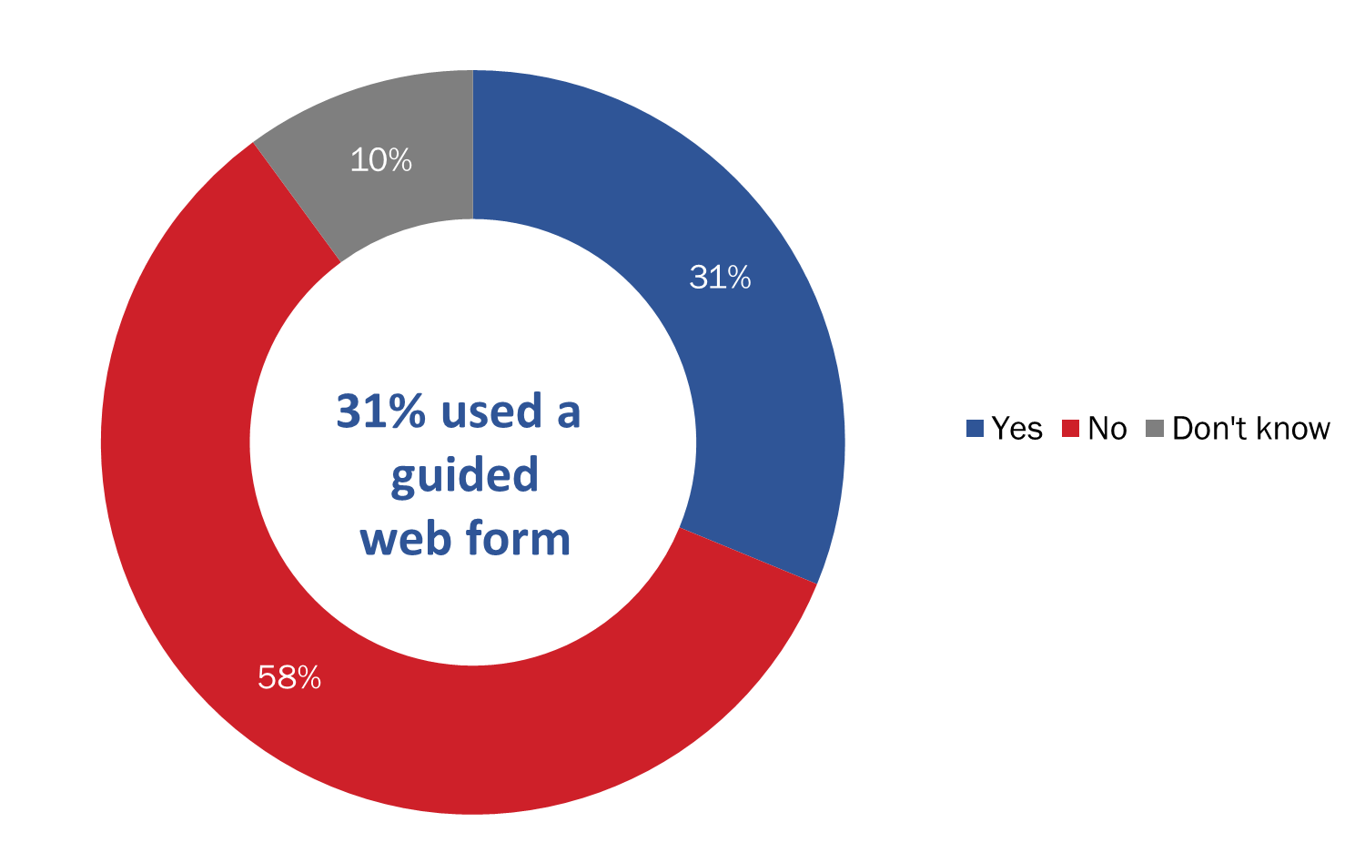

Q14 - Have you ever used a guided web form in My VAC Account to complete an application? A guided web form is different from a traditional application form as you are asked questions with tips provided along the way. Base: n=551; registered users

Many point to benefits of using guided web form

Respondents who reported using a guided web form were asked what the benefits were of doing so. Just over half said guided web forms are easier to complete (55%), allow users to save their progress and complete a form at a later date (53%), and save time (51%). In addition, 42% said the forms minimize the potential for errors. Fewer than one in 10 (9%) said there are no benefits of using a guided web form.

Figure 54: Benefits of a Guided Web Form



Q15 - In your view, what are the benefits, if any, of using a guided web form? Base: n=172; those who used a guided web form (Multiple responses accepted)

Few drawbacks associated with guided web forms

Few drawbacks were associated with guided web forms. The single largest proportion reported no drawbacks at all.

Figure 55: Main Drawback of a Guided Web Form



Q16 - In your view, what’s the main drawback, if any, of using a guided web form? Base: n=172; those who used a guided web form (Multiple responses accepted)

Half prefer online application form

When those who have used a guided web form were asked which method they prefer to use to complete applications, nearly half (48%) said they prefer online application forms while fewer (30%) expressed a preference for a guided web form.

Figure 56: Preferred Method for Application Completion



Q17 - Which do you prefer to use to complete applications? Base: n=172; those who used guided web form

### IV. New Directions

Live chat feature top suggestion to improve communication

Registered users were asked what VAC could do to better communicate with them through My VAC Account. Just over half (53%) said they would like a live chat feature, while 42% said they would like a personalized dashboard feature.

Figure 57: Suggestions to Improve Communication via My VAC Account



Q18 - What, if anything, can VAC do to better communicate with you through My VAC Account? Base: n=551; registered users (Multiple responses accepted)

Included in the “other” category are better communication overall, more accurate processing/wait-times, better response times, more access to case managers, better trained/informed employees, and more/clearer information.

Half access My VAC through laptop or desktop

Just over half (54%) of registered users said they typically access their My VAC Account through a laptop or desktop computer. Only 15% said they access it through a mobile device, while 31% said they access it through both types of devices.

Figure 58: Access to My VAC Account



Q19 - How do you typically access My VAC Account? Base: n=551; registered users

Microsoft Windows is the most widely used OS

Registered users were asked which operating system they use to access My VAC Account. Almost six in 10 (57%) said they use Microsoft Windows. As the graph below depicts, other operating systems were identified by small proportions of respondents (16% or fewer).

Figure 59: Operating Systems Used to Access My VAC



Q20 - Which operating system do you typically use to access My VAC Account? Base: n=551; registered users

My VAC Account seen to provide more value to CAF Members

Registered users of My VAC Account were asked how much value the online service provides for Canadian Armed Forces (CAF) or RCMP members who are transitioning out of service. My VAC Account was viewed as having more value for soon-to-release CAF members than soon-to-release RCMP members. It is noteworthy, however, that 60% of respondents reported not knowing whether My VAC Account provides any value for RCMP members who are transitioning out of service.

Figure 60: Value My VAC Account Provides for CAF and RCMP Members Releasing Soon



Q21 - Finally, considering everything you know about My VAC Account, how much value does the online service provide for Canadian Armed Forces (CAF) or RCMP members who are transitioning out of service (releasing soon)? Base: n=551; registered users

### V. Profile of Survey Respondents (Wave 3)

|  |  |
| --- | --- |
|  | **Percentage** |
| Client | |
| A Veteran | 79% |
| Still-serving member of Canadian Armed Forces | 12% |
| Retired or still-serving member of the RCMP | 7% |
| A family member | 1% |
| Prefer not to say | -- |
| Age | |
| 18-29 | 1% |
| 30-39 | 6% |
| 40-49 | 21% |
| 50-59 | 37% |
| 60 and over | 35% |
| Prefer not to say | -- |
| Region | |
| West | 24% |
| Ontario | 27% |
| Quebec | 19% |
| Atlantic Canada | 27% |
| Prefer not to say | 2% |

## Online Focus Groups with My VAC Account Users

**This section of the report provides feedback from registered users of My VAC Account elicited through two online focus groups. Participants were recruited through the second online intercept survey. Both groups were conducted on March 27, 2019. Each group lasted 90 minutes, with one conducted in English and one in French.**

### I. Use and Impressions of My VAC Account

Overall impressions of My VAC Account

Registered users’ overall impressions of My VAC Account included a mix of positive and critical comments, with some using the opportunity to suggest certain improvements to the service.

Positive impressions were both general and specific. Positive reactions of a general nature focused on the service’s user friendliness, the perception that it is very useful/helpful, and the perception that it eases/facilitates communications and interactions with VAC. Positive reactions of a more specific nature focused on the ability to access the service at one’s convenience (i.e. 24/7), the ability to upload documents and forms, the fact that it provides access to lots of information, the ability to view one’s correspondence, and the ability to communicate through secure messaging. On the positive side it was also suggested that the service is improving over time, with more functions having been added to it over time.

Critical impressions of the service focused on specific aspects or issues. Participants most often suggested that updates on “track your applications” are not helpful because they do not provide details regarding timelines and/or what is happening at various stages of the applications process (e.g. what exactly does it mean when an application proceeds from one stage to another). Other critical comments included the impression that it is not always clear what one is eligible for in terms of programs/benefits, the impression that some forms are difficult to complete, the perception that information is sometimes incorrect or lacking (e.g. being told that a claim has been suspended without explaining why), and the impression that it sometimes takes too long to receive a response to a query (i.e. 2 days or more). Suggested improvements included having a more user-friendly interface (i.e. the ability to customize one’s dashboard), the ability to upload more than one document or form at a time, and the inclusion of a chat function.

Uses of My VAC Account

Participants tend to use My VAC Account for various purposes, but three tend to dominate: using the benefits navigator to try to determine what they might be entitled to, tracking applications for benefits, and using secure messaging to communicate with case managers. Other frequently identified uses include the following: uploading forms and documents, downloading documents, direct deposit, and viewing correspondence. In addition, a few thought they could do (or had done) the following through My VAC Account: contacting the ombudsman service or re-assessment unit and looking for pension-related information or VAC-related news.

Main perceived benefits of My VAC Account

Participants identified a number of benefits of using My VAC Account, including the following:

* The secure messaging service, which facilitates communication (e.g. no waiting on hold on the phone).
* The ability to upload forms/applications, which speeds up application/submission processes (i.e. through the quick transmission of documents).
* 24/7 access to the service which means one can access it at one’s convenience.
* The benefits navigator, which helps them determine what they might be eligible for.
* News/updates, which keeps them up-to-date on changes (e.g. changes regarding pensions, programs, benefits, policies).
* Electronic correspondence, which eliminates reliance on regular mail.
* The service provides an electronic record/trail of interactions/correspondence, which makes it easy to keep track of one’s transactions/interactions.
* The service eliminates the need for paper storage.
* The benefits page updates as payments change.

Main perceived drawbacks of My VAC Account

Among the main perceived drawbacks of My VAC Account identified by registered users, the one most frequently identified was lack of details regarding benefits applications. Other perceived drawbacks identified relatively frequently included the occasionally slow response time through secure messaging, the inability to communicate directly with case managers through secure messaging, and the unavailability of certain forms in relation to the Veterans Independence Program. Additional drawbacks included the perception that it takes too many ‘clicks’ to access one’s account, lack of details regarding access to/connecting with service providers, and daily emails saying ‘check news’ (criticized as excessive because there’s no need to check news every time there’s a new addition unless it is important and sometimes receive multiple email notifications for the same activity).

### II. Tracking Applications

Awareness and use of application tracking function

All participants were aware that My VAC Account allows them to track the status of their applications for benefits and they have all used it. Indeed, as noted above, this is one of the most widely used functions of the service. Moreover, use of it tends to be frequent. Asked how often they tend to check the status of their applications, most participants said they do so at least once a week (e.g. daily, every few days, many times a week, weekly). Others said they do so every few weeks or at least once a month.

Helpfulness of application tracking feature

Participants had already commented on the application tracking feature when providing their overall impressions of My VAC Account. As a result, when asked specifically what they think of the application tracking feature they re-iterated what they had said earlier. While occasionally prefacing their comments by saying that a application tracking feature is useful in principle, they re-emphasized that the current application tracking feature is not useful or helpful because it does not provide detailed, customized, or personalized information about their applications. Specifically, they routinely noted that the feature only informs them about the stage their application has reached (e.g. stage 1, 2, 3). It tells them nothing meaningful about what is going on at a specific stage such as what goes on at this step of the process, how long it might take/possible delays, or if any additional information is required. In short, such updates are not considered helpful because they are too generic.

Stages of application at which updates are expected

Asked specifically at what step or stage of an application process they would expect a status update, the following were routinely identified:

* When a subsequent step has been reached but with details about what goes on at this step.
* If there is a slowdown or backlog at a certain stage and why.
* Receipt stage: Confirmation that information has been received and that the information received is complete (i.e. is more information required).
* Review stage: Notification that received application is now being reviewed and what this will involve.
* Approval/decision stage: Notification that an application is being sent for approval, has been approved, or that approval has been denied (and if so why).

Participants identified two circumstances under which review of a status update would lead them to contact VAC to follow up:

* Each time the application has reached a new stage, because as noted above current updates are too vague and general to be useful. In other words, each time a new step has been reached some participants feel the need to contact VAC in order to get actual details about what is going on.
* If they are informed that further information or documentation is required.

Participants not only feel the need to contact VAC as a result of an update on their application, but also if they have not received an update after an extended period of time or when the 16 week period, which they are told is the average time to process applications, is passed. If the 16 weeks period has passed without hearing from VAC, some participants will begin contacting the department so see what the hold-up is. Ways of contacting VAC include phone, secure messaging, or both. Some said the method of communication would depend on the issue (i.e. if the issue sounds complicated, they would use the phone because complicated issues can be more easily discussed and understood by phone).

Suggestions for improving the tracking of applications

Suggestions for improving the tracking of applications and status updates included the following:

* More customized/personalized information regarding specific applications (i.e. more than just ‘your application is at stage 3’). When informed that an application has reached another stage, participants want to know what has been done and what remains to be done.
* Estimated but realistic timelines for processing specific applications, including any actual or anticipated delays and reasons for them.
* Specific information about whether an application is being actively reviewed and/or where it is in the queue of applications (e.g. ‘we are currently processing applications from April 2018’).
* Timely information/updates about missing information, backlogs, delays in processing.
* An online chat function to allow applicants to communicate directly with case managers about their applications.
* The ability to add/provide additional medical information to support an application that has been submitted.
* A dedicated help line to call in order to get specific information/updates about one’s application and the ability to directly contact an individual working on a claim at a specific stage.

### III. Electronic Notifications

All participants said they are signed-up for and receive electronic notifications when the status of an online application changes. Asked what they think of these notifications, participants once again re-iterated points they had made earlier regarding the tracking of applications function. Specifically, they re-emphasized that current updates are not very useful because they provide generic information on the status of one’s application (i.e. the stage it has reached), with no indication of what is actually happening at the stage in question.

The type of information they would like in such notifications is information tailored or customized to their particular application and related specifically to issues identified in the bulleted points identified above under the heading ‘Suggestions for improving the status of applications’. A few participants added that they would like their notifications to provide some indication of what is in the update (i.e. not just being told ‘you have a notification’. Participants would like to receive such notifications by text (SMS) in addition to email (which is how they are sent now).

Participants collectively identified a variety of other organizations from which they receive electronic notifications. These include the following:

* Banks/financial institutions
* Service providers (e.g. telephone, hydro, insurance companies, credit card companies)
* Airlines/air miles
* The Canada Revenue Agency
* Service Canada
* Pharmacies
* Their children’s school
* Sports organizations
* Entertainment providers.

Specific features provided by such organizations that participants like and think could be incorporated into My VAC Account include a chat function, personalized/customized as opposed to generic/cookie-cutter information, reminders, and links that take one directly to the information (minimizing the number of steps to access the information).

### IV. Going Paperless

Need for mailed version of correspondence

Most participants indicated that if they could view all their correspondence from VAC through My VAC Account they would not want or need a paper copy sent in the mail. Reasons given included the impression that there is no need for it, the ability to print a paper copy if they so desire, the speed of communication, environmental considerations, and ease of storage (i.e. no need for paper files). Some, however, said they would still like to receive a copy sent by mail. Reasons included a desire for back-up/security, possible technical problems with My VAC Account, the ability to compare the mailed and electronic versions to ensure that they are identical (i.e. contain the same information), and a general apprehension when it comes to dealing with government (i.e. the desire for a paper trail in case of any problems/discrepancies). A few participants specified that they would only require an additional mail copy of correspondence related to a final decision on an application.

Perceived benefits and concerns about going paperless

The main perceived benefits or advantages of opting out of paper mail and going paperless were identified as speed of transactions/communication, helping the environment, and easier storage (i.e. no need to file papers). When it came to concerns, many participants said they had none, while others identified potential technical problems and the possibility of not receiving or missing something important. Ways in which concerns could be addressed included ensuring that electronic correspondence from VAC can be downloaded and saved, and periodic phone contact from VAC to make sure important information was received electronically.

### V. Possible Enhancements of My VAC Account

Suggestions for improving My VAC Account

Participants were asked in an open-ended manner what enhancements or changes to My VAC Account would be particularly useful to them and why. A number of potential enhancements were identified. These are listed below, with those identified frequently preceded by an asterisk (*).

* *More detailed information on the status of applications in order to understand what is going on. This could include a checklist that identifies the various steps that have been completed to date in the progress of a claim.
* *A live chat option to allow registered users to communicate directly with case managers.
* *A customized/personalized dashboard on the homepage of one’s My VAC Account. This would allow users to organize their access to resources and information in a way that suits them (e.g. services they use most, what is most relevant to them, most recent correspondence).
* A video conferencing option to facilitate communication/provide another option for contact.
* Automatic confirmation of receipt of documents and forms in order to avoid having to follow up to confirm receipt.
* Quicker access to one’s account/fewer clicks (it was observed that it currently takes 5 clicks to access one’s account).
* A VAC organizational chart to help guide users in terms of who can assist them with an issue (e.g. who to contact if a claim is denied).
* Links to useful relevant information (e.g. lawyers, information about specific benefits).
* A library of information and resources for Veterans.
* The ability to upload more than one document/form at a time in order speed up transactions.
* The ability to update applications in progress in real time (e.g. the ability for a physician to submit additional medical documentation to an existing claim).
* Provide a written/text record of chat conversations..
* Provide drop-down menus with lists of service providers one can just click on
* Provide a summary of interactions/transactions (e.g. ‘here’s what’s going on in your file’).
* Provide a digest/record of past claims and decisions related to them.
* Include short videos with actual users of the service to assist other users by talking them through certain issues (e.g. completing forms) or providing answers to FAQs in language that is plain and simple (i.e. no jargon).
* Make My VAC Account a one-stop service as much as possible (i.e. be able to do as much as possible on and through the service. Examples included the following:
  + Ability to link Blue Cross treatment benefits to My VAC Account, to see for example how many approved therapy sessions are left as well as how to get more approved.
  + Ability to see all ELB calculations in one place.
  + Ability to interact directly with service providers through My VAC Account.
* Hire more Veterans as NCCN analysts because they will have direct experience with the kind of issues Veterans contact them about.

Reaction to possible enhancements to My VAC Account

Participants were then asked to react to a set of new features or enhancements to My VAC Account in terms of how useful each one would be to them personally. These included the following:

* More guided web forms
* Automatic benefits suggestions
* Live online chat ability
* Instant messaging
* Adding access for powers of attorney and other representatives
* Adding case manager agreement to My VAC Account
* Ability to add files and links within secure messages

There was widespread agreement that each of these potential enhancements would be useful to participants. Reasons why are provided below.

* *More guided web forms*: This was described as useful because it would facilitate completion of forms, which in turn would reduce the likelihood that participants would have to contact someone for assistance completing forms or in order to get answers to questions about completing forms.
* *Automatic benefits suggestions*: This was described as useful because it would increase participants’ awareness of benefits they might qualify for and reduce the likelihood of their applying for benefits for which they do not qualify. One caveat qualifying support for such an enhancement was that the suggestions be realistic/plausible. In other words, Veterans should only receive suggestions about benefits they are likely to qualify for, otherwise it will only result in disappointment and frustration should they apply for a benefit and not receive it.
* *Live online chat ability*: This enhancement generated widespread positive reaction. As noted earlier, this is an enhancement of My VAC Account that a number of participants suggested even before being asked about it explicitly. This was considered useful because it would provide another vehicle for communication and hopefully allow participants to communicate directly with case managers. There was a caveat sometimes attached to support for this enhancement, specifically that the value of a chat function would depend on who participants were able to chat with (e.g. is it someone familiar with their situation or is it just another way to communicate with NCCN analysts who are not familiar with their situation).
* *Instant messaging*: There was some initial confusion about how this would differ from a live on chat function, with most participants assuming that it would be very similar. The reference to ‘instant’ messaging was the factor that elicited positive responses because it suggests that this enhancement would result in quicker and more efficient communication with VAC or VAC officials.
* *Adding access for powers of attorney and other representatives*: While not an enhancement that most participants consider important at the moment, there was widespread agreement that it is a positive enhancement which they might use down the road if and when they assign someone as their representative or POA.
* *Adding case manager agreement to My VAC Account*: While this enhancement generated a positive reaction, in some cases the positive reaction was in relation to anything that would facilitate contact with their case manager in general. That said, the idea of being able to enter into an agreement with a case manager ‘electronically’ or ‘online’ was seen as a positive enhancement for reasons of speed and convenience.
* *Ability to add files and links within secure messages*: This possible enhancement generated widespread positive reaction. Reasons for its perceived usefulness included speeding up/facilitating the transmission of documents and reducing the need for paper.

Following this, participants were asked if there are any features of other online services that they use that they would like to see incorporated in My VAC Account. In response, the following suggestions were made.

* Financial institutions provide links to their ‘new products’ as well as to personnel who can assist them with specific problems/issues. Similar links in My VAC Account would be useful.
* Financial institutions also provide the ability, through their websites, to schedule meetings in-person or by video. This would be useful for My VAC Account.
* University websites include a function that allows users to simply drag documents into a ‘submit box’. This was seen as a useful enhancement of My VAC Account.
* Blue Cross provides its clients with the ability to access a history of their files/interactions, something that would be very useful on My VAC Account.

Business to be conducted via My VAC Account

Most participants said that they would be inclined to accomplish all their dealings with VAC online through My VAC Account if they could because it is fast and convenient way of dealing with the department. That said, some added that no one should be forced to interact with VAC in this way (i.e. there should always be a choice), and a few others added that they would be inclined to do so if an online chat function were incorporated into the service. A few participants said that there are some things they would prefer to do with a live person (i.e. by phone) because some issues are easier to explain or discuss by phone, and/or sometimes they just like to talk to someone.

Asked specifically if there was anything they would prefer not to do through My VAC Account, most said no (i.e. there is nothing they would not do through My VAC Account). A few reiterated that on occasion they like or need human contact, but the only specific activity or transaction in regard to which anyone said they would like to interact with a ‘live’ person was opening/registering for their My VAC Account in the first place.

Specific benefits of interacting with or speaking with a VAC representative that cannot be got through My VAC Account included compassion/the ‘human’ touch/psychological support, specific information to a specific question in real time, orientation/guidance, and proactive feedback/suggestions. Asked what if anything could be done to address this through My VAC Account, some participants suggested that including a live chat function would be useful in addressing this.

Perceived value of My VAC Account to those transitioning out of CAF

By way of conclusion, participants were asked how much value My VAC Account provides to those who are transitioning out of the service. In response, some said they could not say based on their own experience because My VAC Account did not exist when they transitioned out of the armed forces. Others suggested that the service was limited in this regard. One reason given to explain why was that the release process can be confusing and in-person/personal assistance is more helpful in terms of navigating the process. Along similar lines, it was suggested that the transition interview is probably more helpful in this regard because it takes place in-person. Finally, without taking a position on the value of My VAC Account in the transition process, one participant suggested that persons releasing from the forces are in a kind of inter-jurisdictional nether land; in his/her words: ‘*The CAF won’t touch you because you are releasing and VAC won’t touch you until you are officially released*’.

# II. Research with Departmental Employees

## Online Survey

**This section presents the results of the online survey conducted with departmental employees (specifically those who work in the Field Operation or Central Operating Division). In total, 164 individuals responded to the survey between March 6 and March 19, 2019. Employees were invited to participate in the survey through internal communications.**

### I. Awareness and Use of My VAC Account

Widespread familiarity with My VAC Account

The majority of employees who completed the survey said they are somewhat (46%) or very (38%) familiar with the department’s online service channel, My VAC Account. Relatively few (16%) said they are not very or not at all familiar.

Figure 86: Familiarity with My VAC Account

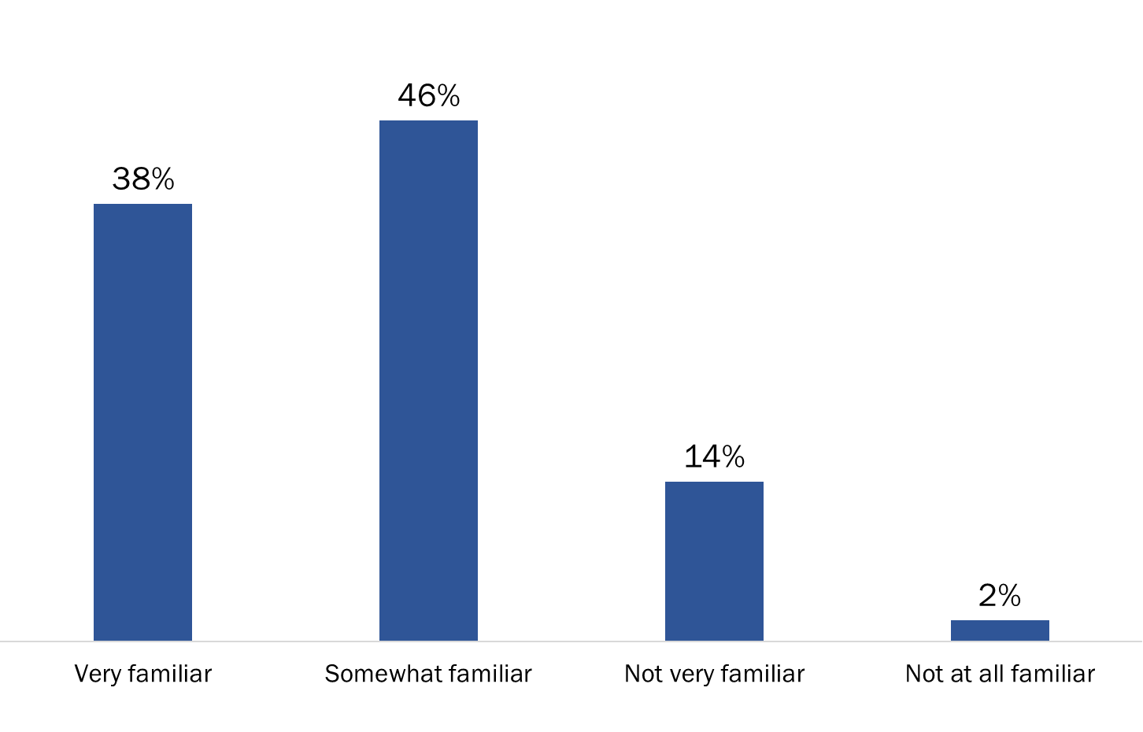

Q1 - How familiar are you with the department’s online service channel, My VAC Account? Base: n=164

Those aware of My VAC Account tend to have moderate knowledge of the channel

Those aware of My VAC Account were more likely to characterize their knowledge of the features available through the department’s online service channel as moderate (54%) not strong or very knowledgeable (25%).

Figure 87: Knowledge of My VAC Account

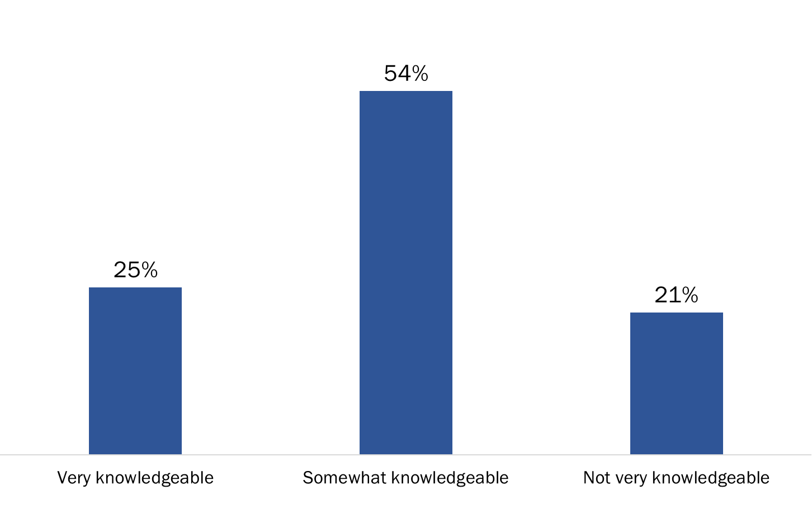

Q2 - How knowledgeable would you say you are about the features available in My VAC Account? Base: n=161; those familiar with My VAC Account

Employees most likely to be familiar with secure messaging

Most employees familiar with My VAC Account said they are most familiar with secure messaging (86%). Following this, more than two-thirds are most familiar with the features allowing Veterans to upload documents (70%) and to update their contact or direct deposit information (68%). In addition, more than half are familiar with guided web forms (63%) and electronic correspondence (58%). Smaller proportions claimed to be most familiar with the Current Benefits and Payment display (35%), Benefits Navigator (24%), and page alerts or broadcast messages for Veterans (15%).

Figure 88: Features of My VAC Account Employees are Familiar with

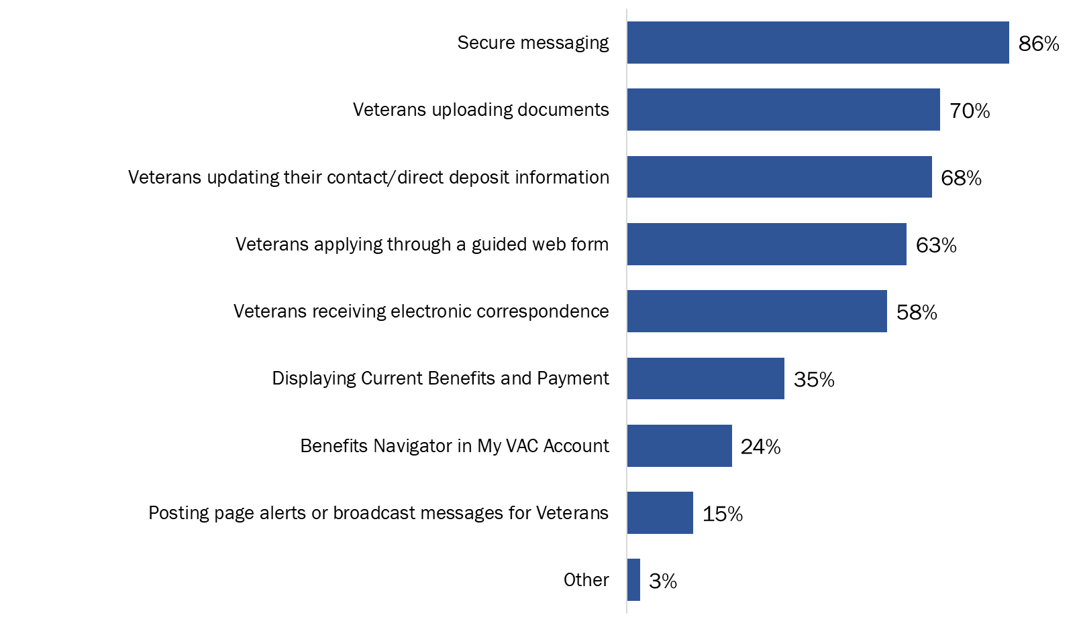

Q3 - Which features are you most familiar with in My VAC Account? (multiple responses accepted) Base: n=161; those familiar with My VAC Account

Half visit My VAC Account Section at least a few times month

Half (51%) of employees familiar with My VAC Account visit the My VAC Account section on VAC@Work at least a few times a month, including one-third (33%) who do so at least once a week. Three in 10 said they visit this section a few times a year (16%) or once only (14%), while approximately two in 10 have never visited this on VAC@Work.

Figure 89: Frequency of Visiting My VAC Account Section on VAC@Work

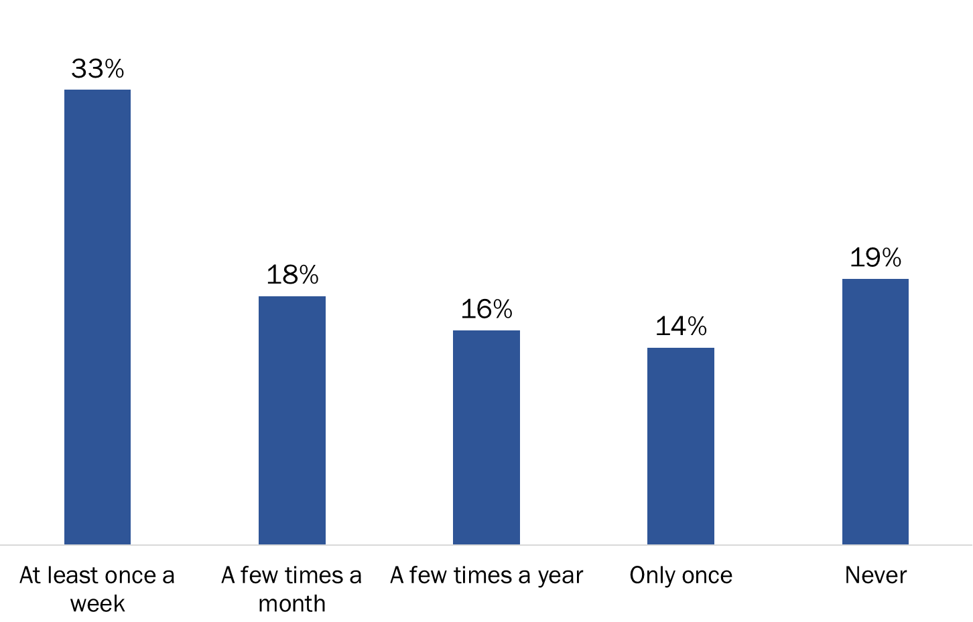

Q4_A - How often do you do the following? - Visit the My VAC Account section on VAC@Work. Base: n=161; those familiar with My VAC Account

Among those who have never visited the My VAC Account section of VAC@Work (n=31), lack of awareness was the reason most frequently offered to explain why they had not done so. In total, 58% said they did not know it existed. Approximately one-quarter each mentioned not having time due to their workload (26%) or that they do not need My VAC Account for their work (23%).

Half have never used or used only once the My VAC Account Training Account

Half of employees familiar with My VAC Account have used the My VAC Account training account only once (25%) or never (27%). In contrast, one-third said they use this training a few times a month (18%) or weekly (14%).

Figure 90: Frequency of Using My VAC Account Training

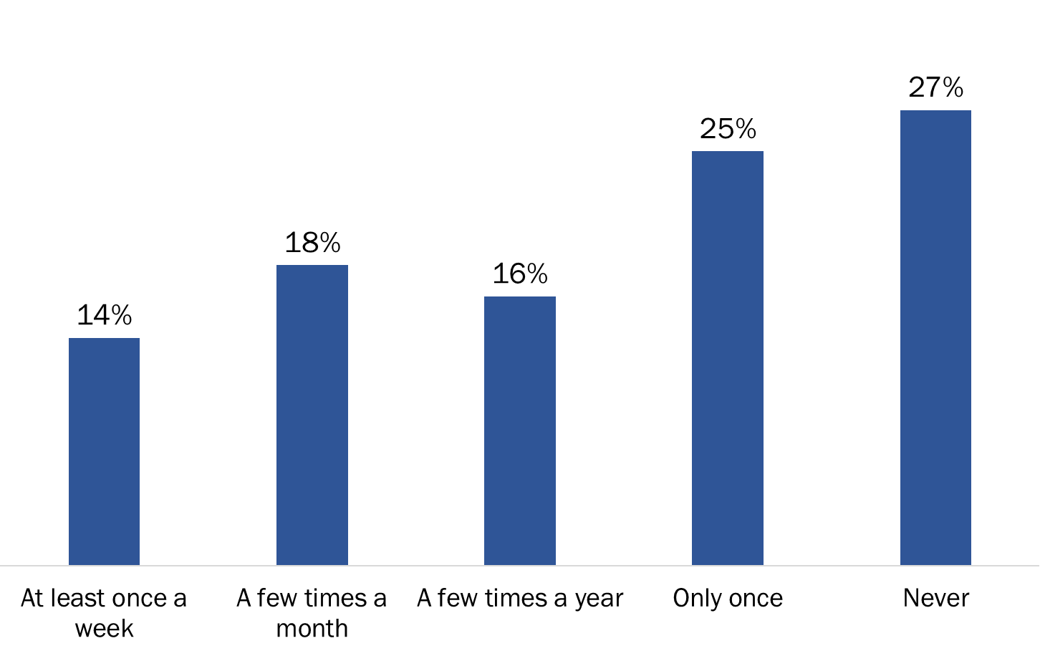

Q4_B - How often do you do the following? - Use the My VAC Account training account. Base: n=161; those familiar with My VAC Account

Among those who have never used the My VAC Account training account (n=44), lack of awareness was the reason most frequently offered to explain why they had not done so. In total, 43% said they did not know it existed. This was followed by lack of needed, which was mentioned by 32%. Fewer than two in 10 (18%) mentioned not having time due to their workload, while 5% said they do not find the training account helpful.

Seven in 10 have had My VAC Account Training

Seven in 10 employees familiar with My VAC Account have taken a training session, either via WebEx or in person. Of the rest, almost one-quarter (23%) said they were not aware of this training, 4% do not have enough time for training and 3% are not interested in the My VAC Account training.

Figure 91: Use of WebEx or In-person My VAC Account Training

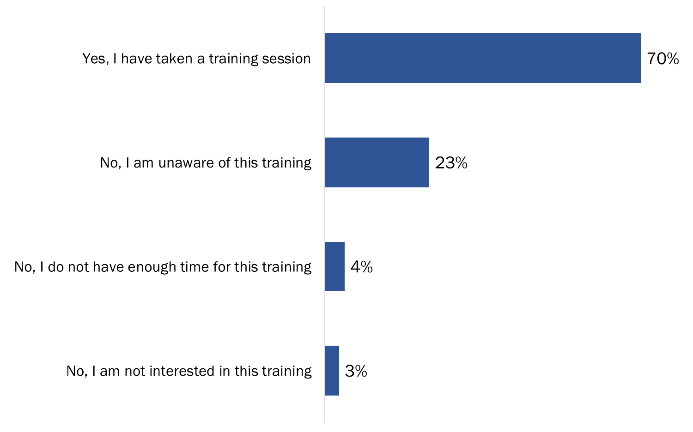

Q7 - Have you received My VAC Account training via WebEx or in person? Base: n=161; those familiar with My VAC Account

Majority said VAC does a good job keeping them informed about My VAC Account updates

A small majority of employees familiar with My VAC Account said the department is doing a good (35%) or very good (20%) job keeping them informed about ongoing updates to My VAC Account. Few (11%) rated the department’s performance as poor or very poor. The rest were neutral (28%) or did not know (6%) how the department has been performing in this area.

Figure 92: Rating of VAC’s Performance Keeping Employees Informed about Updates to My VAC Account

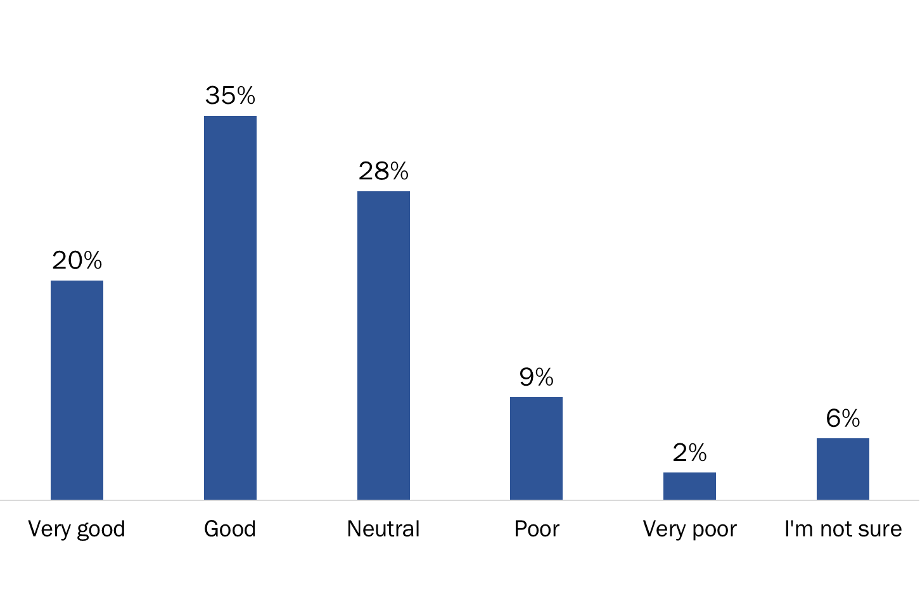

Q8 - How would you rate the department's performance in terms of keeping you informed about ongoing updates to My VAC Account? Base: n=161; those familiar with My VAC Account

Those who felt the department is doing a poor or very poor job keeping them informed (n=19) suggested a few ways the department could better inform them about My VAC Account. Half or more pointed to emails, face-to-face updates, and improved information on VAC@Work.

Eight in 10 said My VAC Account has a positive impact on their work

The vast majority (80%) of employees familiar with My VAC Account reported that the online service channel has had a positive impact on their work. Very few (7%) said that My VAC Account has had a negative impact on their work, while the rest (14%) indicated that the online service channel has had no impact.

Figure 93: Perceived Impact of My VAC Account on Work

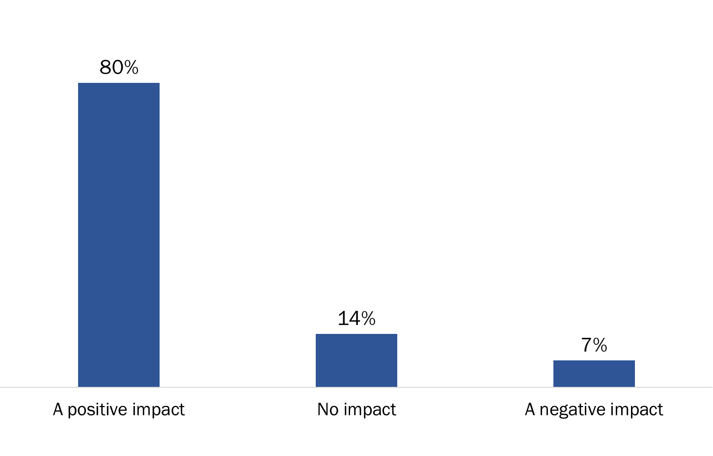

Q10 - Does My VAC Account have an impact on your work in any way? Base: n=161; those familiar with My VAC Account [Does not apply removed from % calculation n=7]

### II. Experience with My VAC Account

Almost half refer to My VAC Account on a daily basis

Almost half (47%) of employees familiar with My VAC Account refer to it at least once a day while interacting with Veterans. In addition, two in 10 (21%) refer to it several times a week and nearly one in 10 (8%) do so about once a week. In total, therefore, 76% generally refer to My VAC Account at least weekly.

Figure 94: Frequency of Referring to My VAC Account when Interacting with Veterans

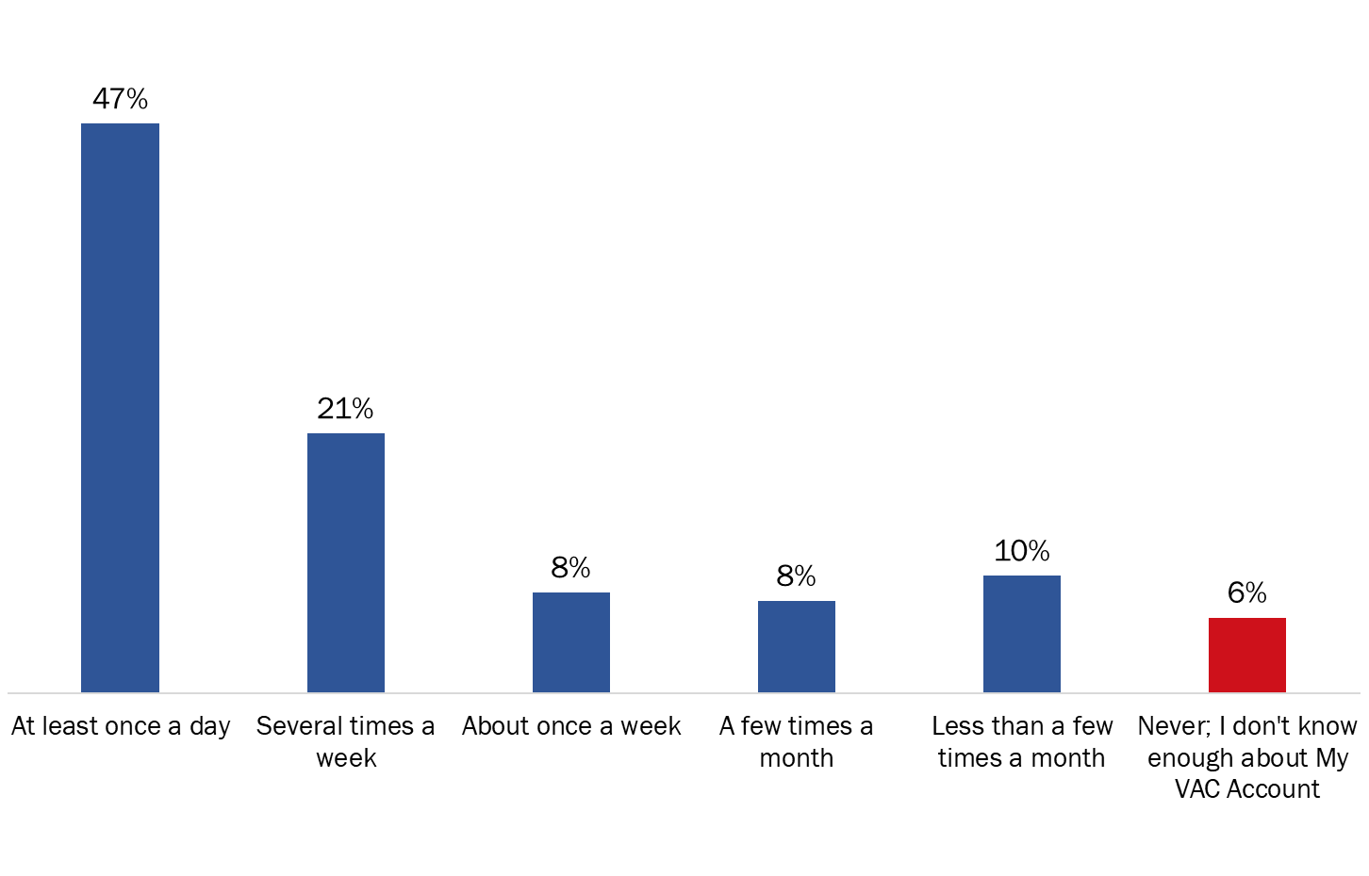

Q11 - How often do you refer to My VAC Account while interacting with Veterans? Base: n=161; those familiar with My VAC Account [Does not apply removed from % calculation n=16]

Four in 10 receive questions from Veterans about My VAC Account on a daily basis

Four in 10 (41%) employees familiar with My VAC Account said they receive questions from Veterans about the department’s online service channel at least once a day.

Figure 95: Frequency of Receiving Questions about My VAC Account from Veterans

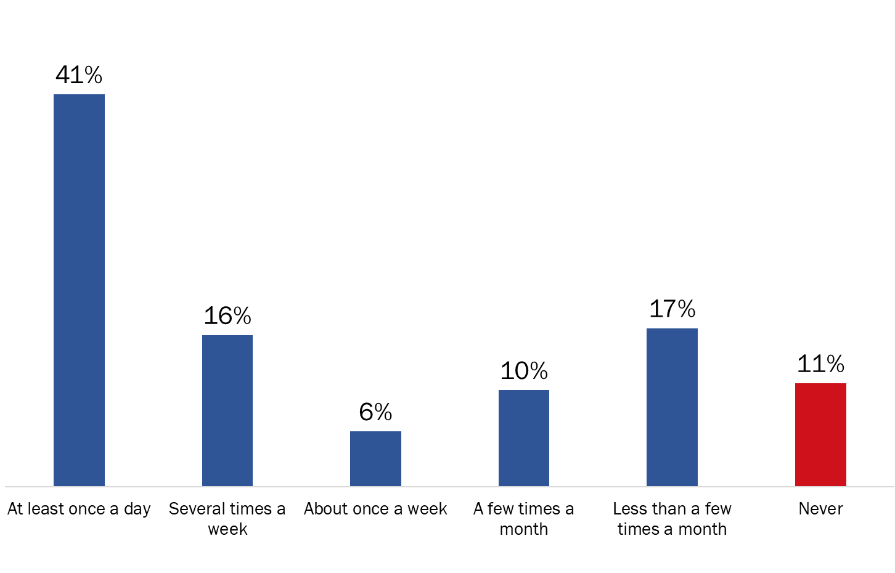

Q12 - How often do you receive questions or comments about My VAC Account from Veterans? Base: n=161; those familiar with My VAC Account [Does not apply removed from % calculation n=22]

In contrast, one in 10 (11%) said they never receive such inquiries. Among the rest, 16% receive questions several times a week, 6% about once a week, 10% a few times a month, and 17% less than a few times a month.

Seven in 10 have used secure messaging to communicate with Veterans

In the 12 months preceding the research, 71% of employees who refer to My VAC Account while interacting with Veterans have used secure messaging to communicate with Veterans.

Figure 96: Use of Secure Messaging to Communicate with Veterans

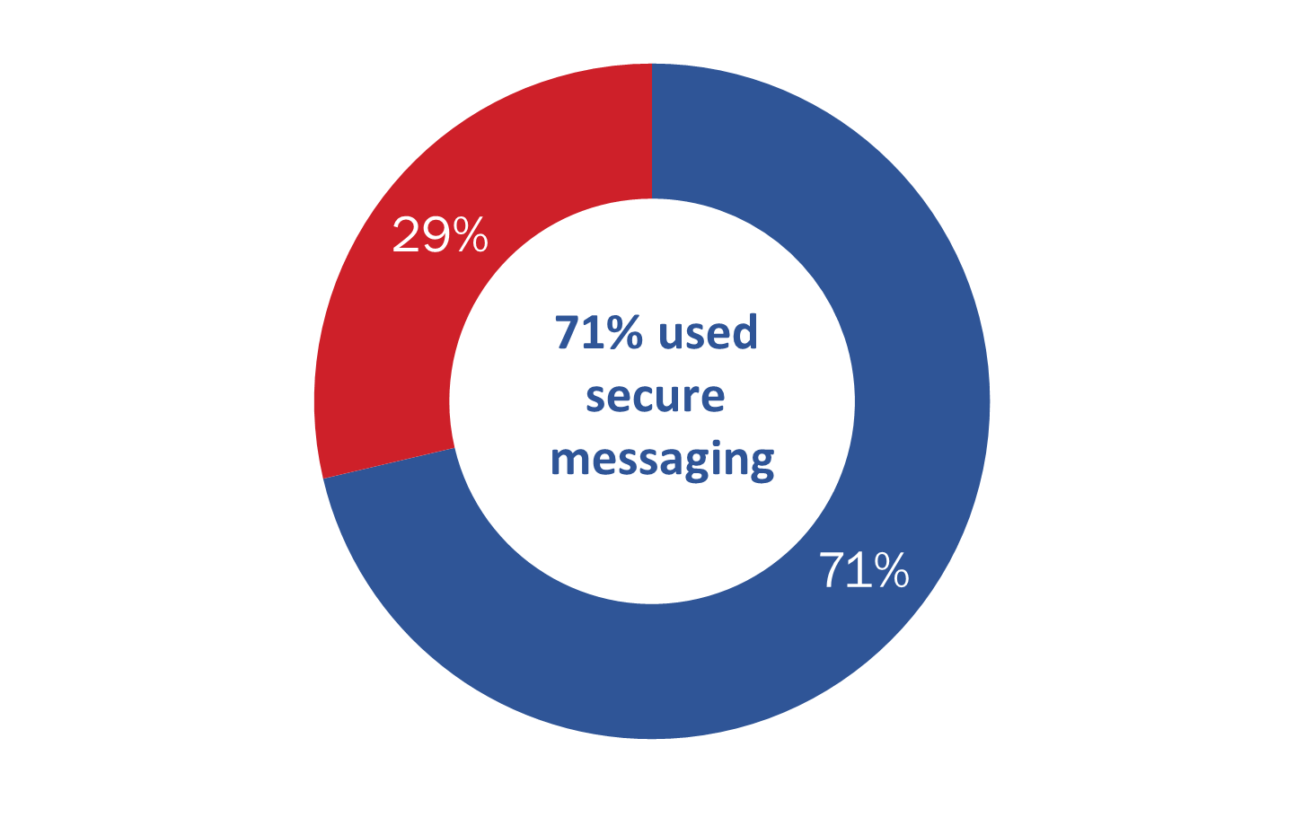

Q13 - In the past 12 months, have you used My VAC Account’s secure messaging to communicate with Veterans? Base: n=136; those who refer to My VAC while interacting with Veterans

**Virtually everyone has had a positive experience with secure messaging**

Nine in 10 employees who have used secure messaging reported having a good (42%) or very good (48%) experience communicating with Veterans via secure messaging. The rest (9%) were neutral.

Figure 97: Experience using Secure Messaging

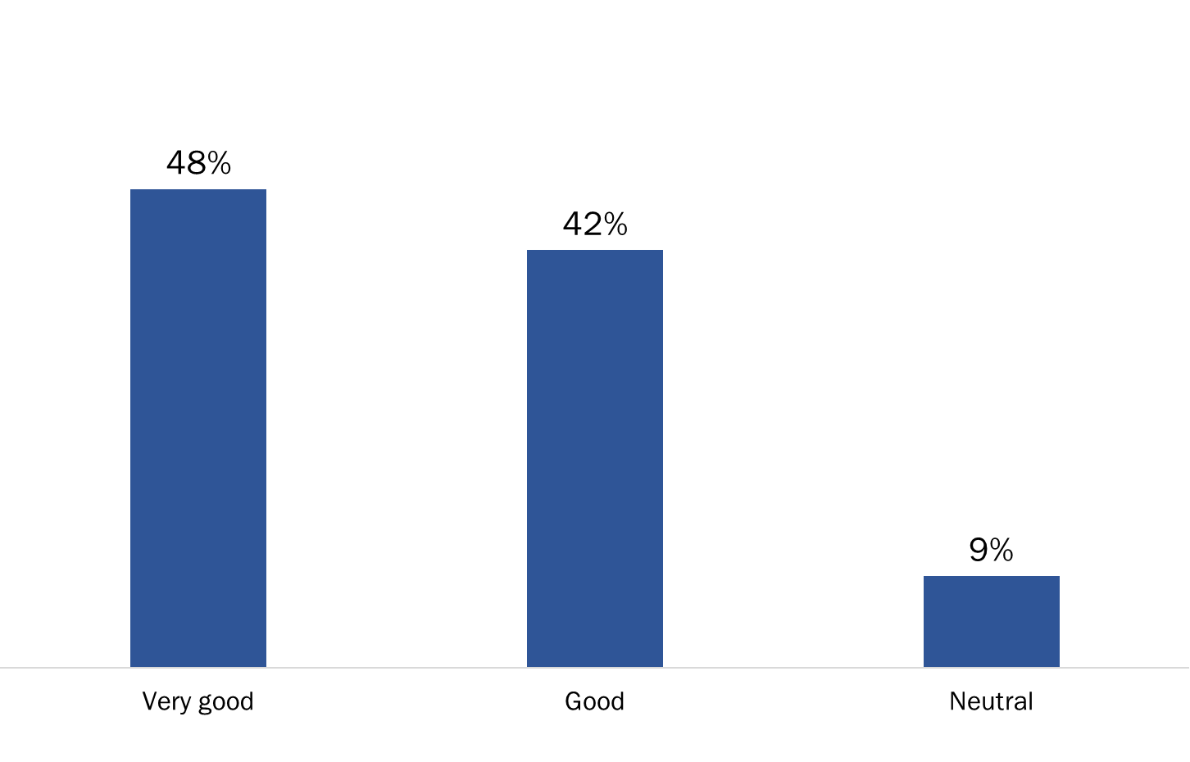

Q14 - Overall, how was your experience with communicating via secure messaging? Base: n=97; those who have used secure messaging

Almost half of those who have not used secure messaging (n=39) said they need proper training. The rest have not needed to use secure messaging in their role, prefer to use other communication methods, or only learned about secure messaging through the survey.

Half use secure messaging at least a few times a week

Half of employees who use secure messaging use it daily (34%) or several times a week (16%) to communicate with Veterans. In addition, 13% use it about once a week. Conversely, just over one-third said they use secure messaging a few times a month (22%) or less often (14%).

Figure 98: Frequency of Using Secure Messaging

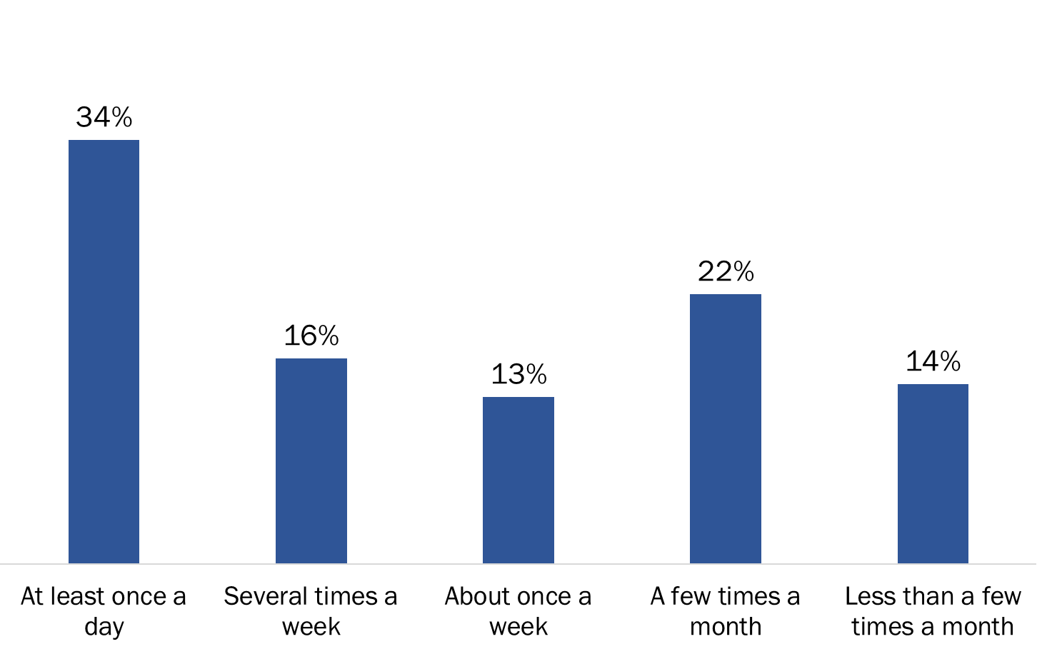

Q16 - How often do you use secure messaging to communicate with Veterans? Base: n=97; those who have used secure messaging

Majority chooses contact method based on nature of communication

Six in 10 (60%) employees who use secure messaging said the contact method they select to communicate with a Veteran who has secure messaging enabled depends on the nature of the communication. Of the rest, 25% would initiate contact via secure messaging and 15% via telephone.

Figure 99: Method Used to Initiate Communication with a Veteran

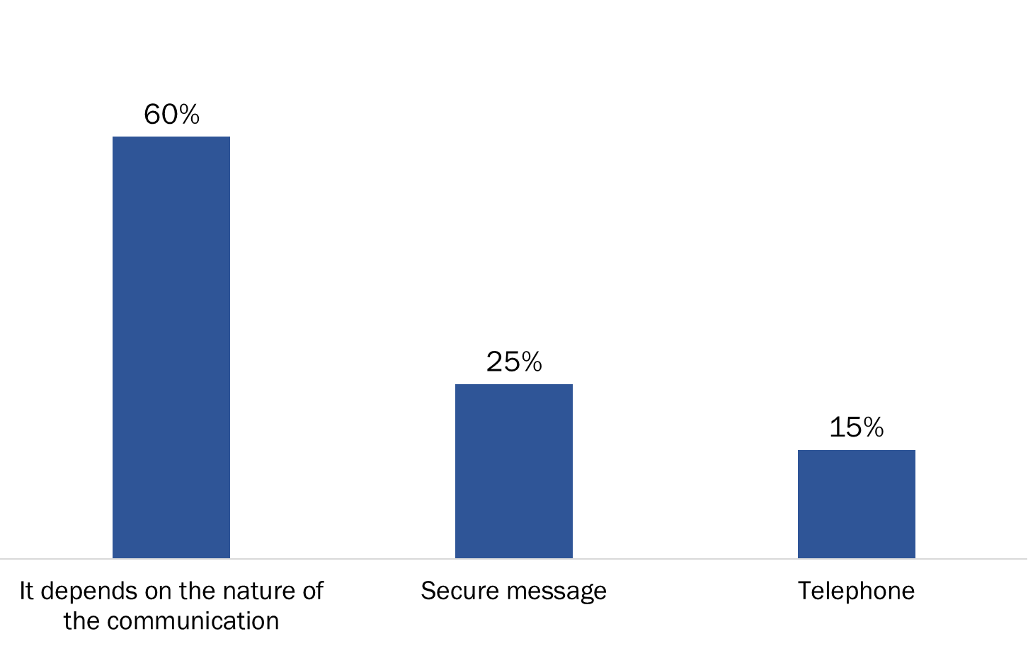

Q17 - If you need to initiate communication with a Veteran who has secure messaging enabled, which contact method would you choose? Base: n=97; those who have used secure messaging

Secure messaging used to respond and initiate communication

Nearly half of those who have used secure messaging use it to respond to messages initiated by My VAC Account users (49%) and to both respond and initiate communication with My VAC Account users (46%). Very few (4%) use secure messaging only to initiate communication.

Figure 100: Use of secure messaging

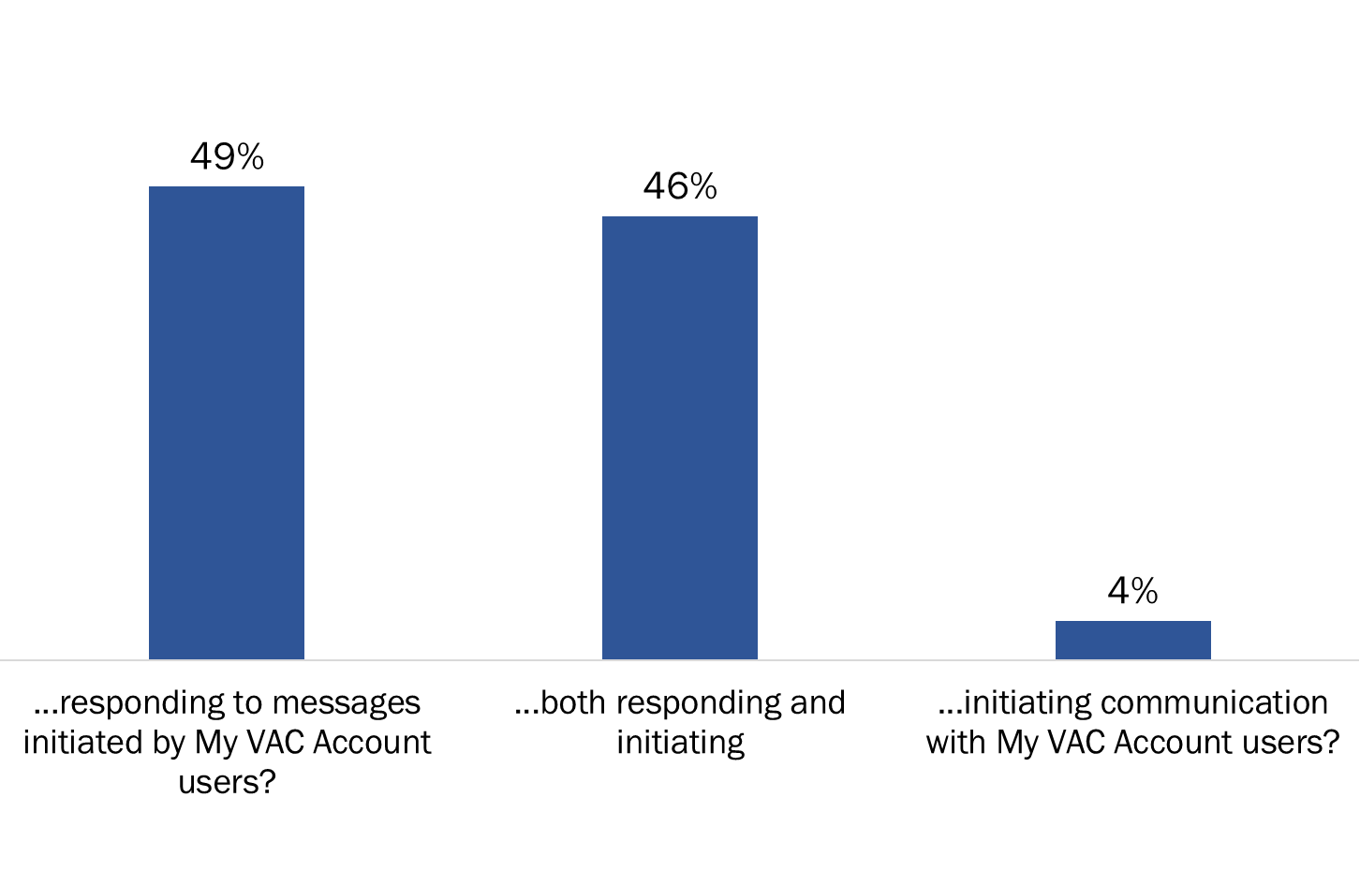

Q18 - When using secure messaging, are you...? Base: n=97; those who have used secure messaging

Most have not had any difficulties using secure messaging

More than eight in 10 (84%) VAC employees who have used secure messaging have not experienced any difficulties using the feature to communication with Veterans in the last year.

Figure 101: Issues with secure messaging

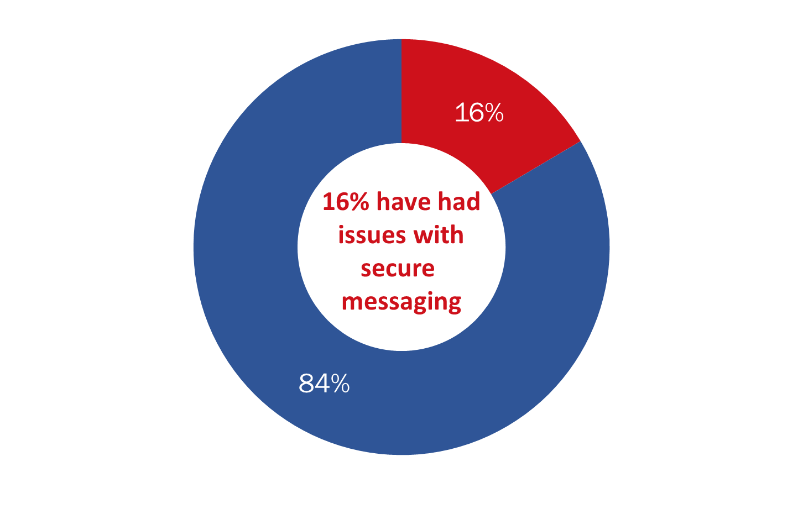

Q19 - In the past 12 months, have you had any difficulties using secure messaging to communicate with Veterans? Base: n=97; those who have used secure messaging

Just over half aware of the new Pension for Life benefits digital-first approach

Fifty-seven percent of VAC employees familiar with My VAC Account said they are aware that the new Pension for Life benefits are being implemented with a digital-first approach, which means that the application process is being designed for My VAC Account. Of these respondents, 29% reported being informed about the digital-first approach and 28% said they know nothing about the approach. A significant minority (43%) are not aware of the new benefits.

Figure 102: Awareness of New Pension for Life Benefits Digital-First Approach

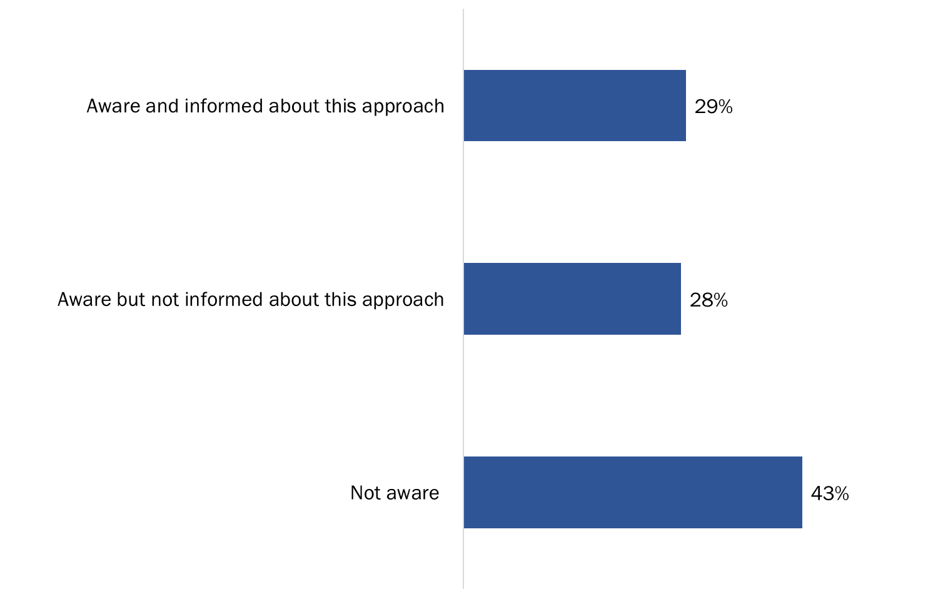

Q21 - Did you know that the new Pension for Life benefits are being implemented with a digital-first approach, which means that the application process is being designed for My VAC Account? Base: n=161; those familiar with My VAC Account

Almost two-thirds are at least fairly comfortable promoting digital-first approach

Almost two-thirds of employees aware of My VAC Account are comfortable (55%) or pretty comfortable (10%) promoting a digital-first approach with Veterans. Those who are not fully comfortable indicated that they might not have the equipment or tools needed to help Veterans (e.g., no computer in their office to access My VAC account). Three in 10 are not comfortable promoting this approach and feel they would need more training in order to do so.

Figure 103: Comfort Promoting Digital-First Approach

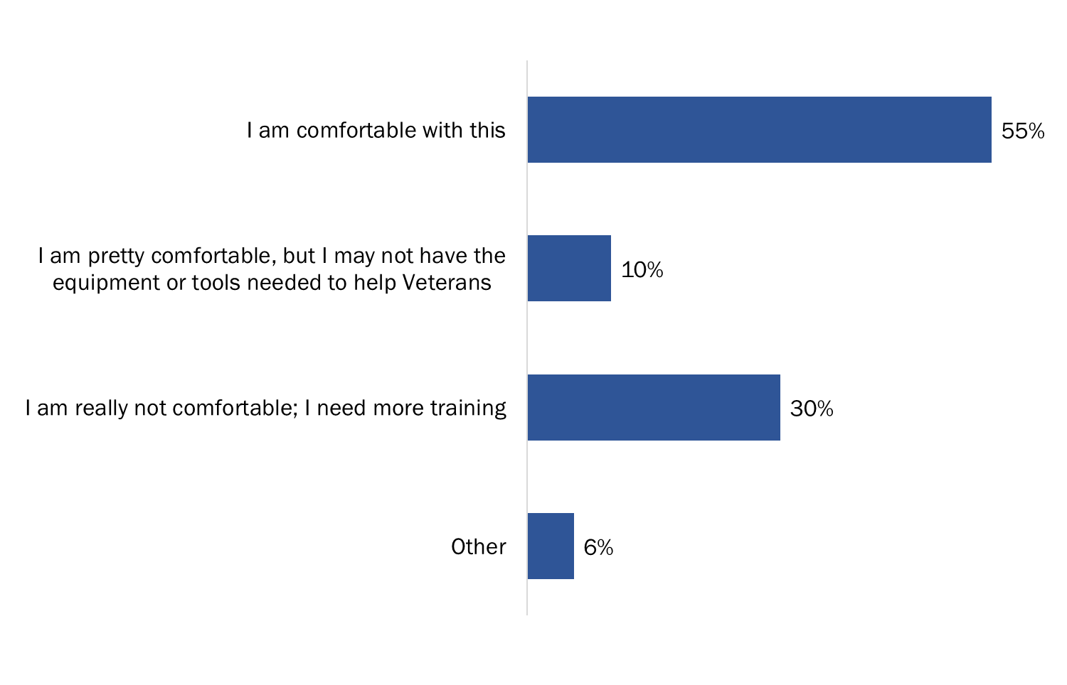

Q22 - Are you comfortable promoting a digital-first approach with Veterans? Please keep in mind that digital does not mean without help and that traditional service channels will still be available. Base: n=161; those familiar with My VAC Account

Understanding how to use My VAC Account is the top motivator to promote use

Those familiar with My VAC Account were asked what would encourage them to promote use of My VAC Account with Veterans. Nearly half (46%) said that having a better understanding of how to use My VAC Account would encourage them to promote the online service channel. Approximately one-third (32%) would consider promoting My VAC Account if they had a better understanding of the advantage of the online service channel and one-quarter suggested having My VAC Account ambassadors or champions on their team as a resource. Thirty-seven percent said they already promote use of My VAC Account.

Figure 104: Motivators to Promote use of My VAC Account

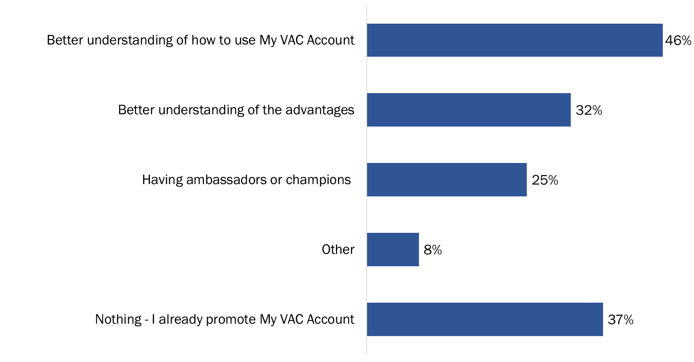

Q23 - What would encourage you to promote use of My VAC Account with Veterans? (multiple responses accepted) Base: n=161; those familiar with My VAC Account

Most view My VAC Account as valuable to them as a departmental employees

Almost nine in 10 employees familiar with My VAC Account rated the online service channel as moderately (40%) or very (48%) valuable when it comes to carrying out their responsibilities as a departmental employee.

Figure 105: Perceptions of the Value of My VAC Account for Employees

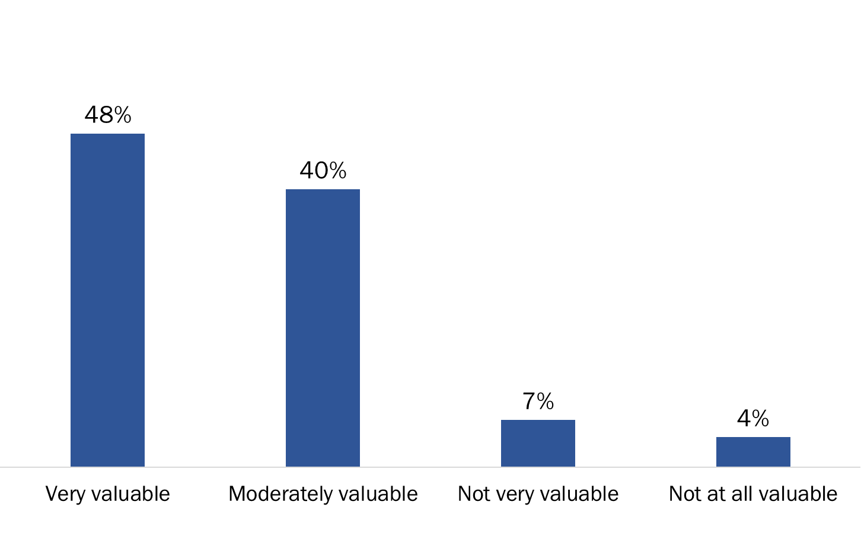

Q24 - How would you rate the overall value of My VAC Account for you when it comes to carrying out your responsibilities as a departmental employee? Base: n=161; those familiar with My VAC Account

Virtually everyone views My VAC Account as valuable for Veterans

Virtually all employees familiar with My VAC Account rated the online service channel as moderately (29%) or very (66%) valuable for Veterans.

Figure 106: Perceptions of the Value of My VAC Account for Employees

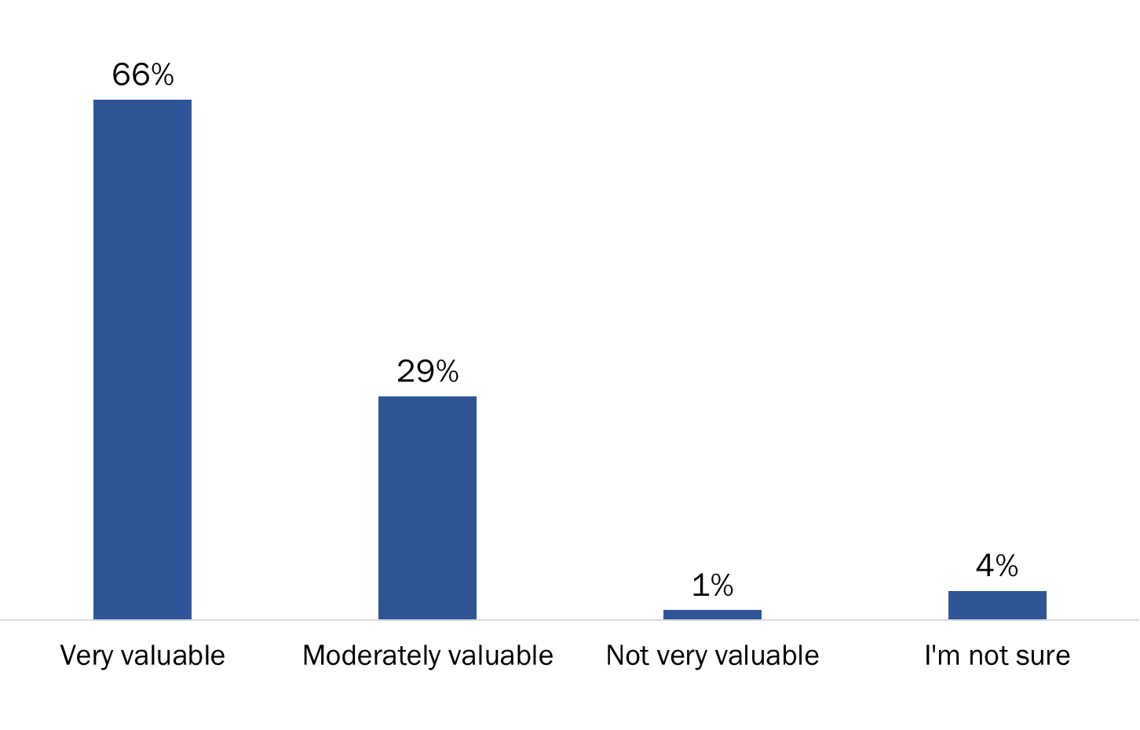

Q25 - And, how would you rate the overall value of My VAC Account for Veterans? Base: n=161; those familiar with My VAC Account

Most potential new features or enhancements viewed as somewhat or very useful

At least seven in 10 employees familiar with My VAC Account rated each of the potential new features or enhancements as somewhat or very useful. Virtually everyone said that the following would be at least somewhat useful: the ability to add files and links within secure messages (98%), the addition of access for powers of attorney or other representatives (96%), improvements to status tracking (95%), more applications available as guided web forms (95%) and automatic benefits suggestions for Veterans (91%). Employees were less likely to view as useful the ability to video conference with Veterans (71%).

Figure 107: Usefulness of New Features

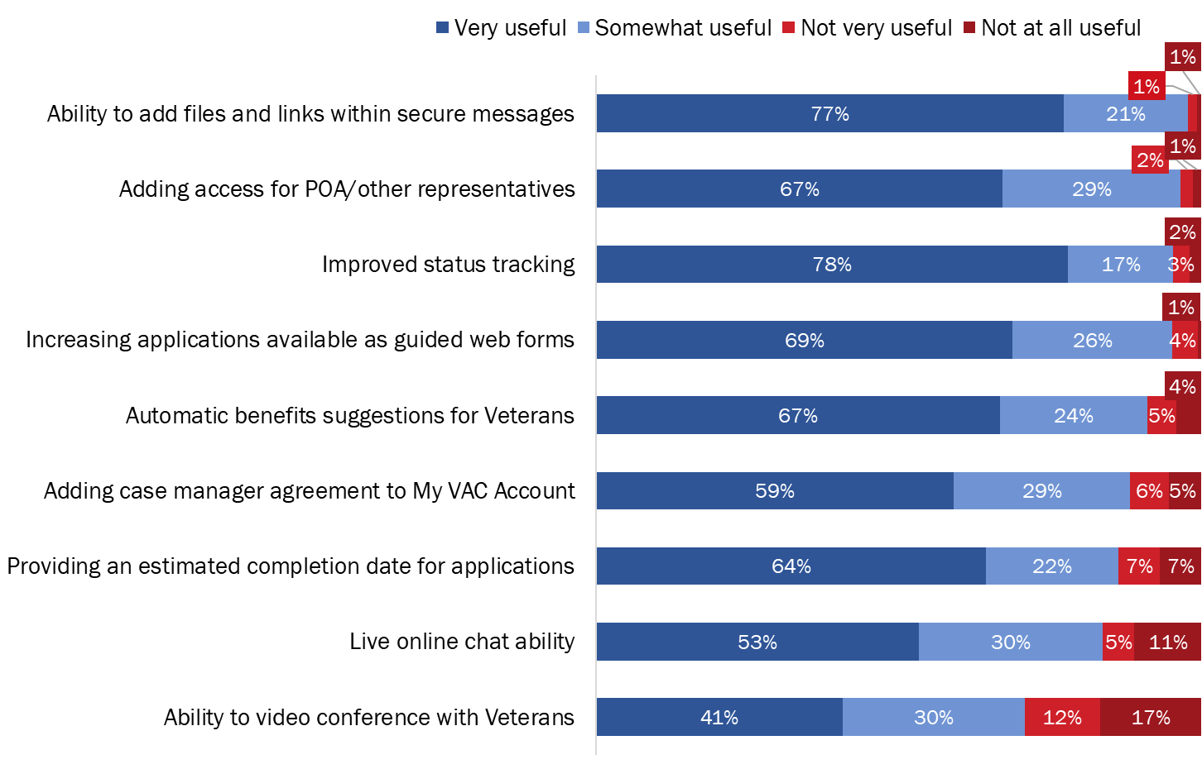

Q26 - The department is considering adding new features or enhancements to My VAC Account. How useful would each of the following be to you in terms of your work? Base: n=161; those familiar with My VAC Account [Don’t Know Removed from % calculation n=12-51]

### III. Profile of Surveyed Employees

|  |  |
| --- | --- |
|  | **Percentage** |
| Position | |
| Field Operations: Case manager | 8% |
| Field Operations: VSA | 4% |
| Field Operations: Team Leader or Manager | 4% |
| NCCN analyst: Part of secure message team | 9% |
| NCCN analyst | 29% |
| Centralized Operations Division: Program employees | 35% |
| Centralized Operations Division: Team Leader or Manager | 4% |
| Other | 9% |
| Tenure with VAC | |
| Less than one year | 21% |
| 1 to 2 years | 10% |
| 2 to 5 years | 22% |
| More than 5 years | 48% |
| Region | |
| Headquarters (Charlottetown, PE) | 28% |
| Western Canada | 32% |
| Ontario | 32% |
| Quebec | 5% |
| Atlantic Canada | 4% |

## In-depth Interviews

**This section of the report focuses on feedback from VAC employees elicited through a set of 10 in-depth telephone interviews. These interviews explored specific topics addressed in the online survey more in depth. Participants were recruited through the online survey, at the end of which respondents were asked if they would like to participate in a follow up telephone interview.**

### I. Context

**Nature and frequency of interaction with Veterans varies by position and responsibilities**

Most participants described themselves as having frequent direct interactions with Veterans. That being said, the extent to which participants interact or deal directly with Veterans tended to vary by position and responsibilities as detailed below.

*National Contact Centre Network (NCCN) analysts*

NCCN analysts were most likely to say they have direct and frequent interactions with Veterans, sometimes describing themselves as being the first point of contact for Veterans seeking information or assistance. Interactions typically include answering phone calls from Veterans and/or dealing with them through the secure messaging system, but it can also include occasional in-person dealings if a Veteran visits a VAC office. NCCN analysts said they deal with Veterans on a daily basis, adding that such interactions account for the bulk of their work responsibilities (estimating that 85% or more of their time is spent dealing directly with Veterans). This routinely includes answering questions, assisting Veterans in setting up My VAC Account or helping them find or do something on their account, transmitting messages to case managers through the secure messaging system, proving information related to benefits/eligibility, and connecting Veterans to other units if they are unable to assist them or answer their questions. The rest of their time is devoted to dealing with Veterans’ representatives who have power of attorney (POAs), Veterans’ family members, service providers (e.g. Blue Cross), and their own team leaders/supervisors. NCCN analysts who participated in this phase of the study have been in their current positions for one and half to two years.

*Case managers*

Case managers also said they have frequent direct interactions with Veterans, either daily or every few days. This includes providing support to Veterans in their transition to civilian life, reaching out/checking in periodically to see how they are doing, providing assistance related to engaging resources/supports (e.g. coordinating with service providers/health care professionals), and responding to messages/queries directed to them thorough the secure messaging system. Case managers estimated that anywhere from 75-85% of their time is spent dealing directly with Veterans, with the rest of their time devoted to administrative duties. One case manager has been in his/her current positions for two years while the other has been in the position for a few months.

*Centralized Operations Program employees and Field Operations Team Leader and VSA*

Among the other participants only the field operations VSA is involved in frequent direct interactions with Veterans, describing himself/herself as a primary point of contact for Veterans and their families and estimating that 70-80% of his/her time is spent interacting with Veterans (most of the rest of the time being devoted to dealing with service providers). Interactions with Veterans included assisting with applications for benefits/long-term care applications, conducting transition interviews, helping set up My VAC accounts, and helping coordinate personal care/ independence programs for Veterans. This participant has occupied this position for approximately two and half years.

The field operations team leader described his/her main responsibility as supervision and quality screening of interactions with Veterans by phone and email. As a result, direct interaction with Veterans was limited to situations where a backlog in communications necessitates him/her to assist in dealing with Veterans through secure messaging, or situations in which a Veteran asks to speak to a manager. The participant from central operations described his/her main responsibility as processing applications for benefits, which does not involve direct interactions with Veterans.

**Challenges experienced in interactions with Veterans**

All participants who interact directly with Veterans identified challenges they encounter in the course of such interactions, but with one exception the challenges encountered tended to vary depending on the nature of interactions. The exception (i.e. the common challenge) is the inability to provide Veterans with details regarding the status of their benefits applications, particularly reasons for delays in processing them, explanations about what is happening at a specific stage of the process, and an estimated completion date for assessment of their application. This was a challenge identified mainly by NCCN analysts, but also by the field operations team leader and the field operations VSA. They all indicated that Veterans they deal with routinely express frustration at not being able to learn anything more about the progress of their application than the stage it is at (i.e. stage 1, 2, 3).

Other challenges experienced by participants related to the specific nature of their interactions with Veterans.

* + *National Contact Centre Network (NCCN) analysts and field operations team leader*: A number of challenges were identified by NCCN analysts, some of which were also identified by the field operations team leader. These included the following:
    - Veterans encountering technical problems accessing their My VAC Account, particularly being locked out because their account has gone ‘dormant’. This requires sending the Veteran in question enrollment codes to allow them to reactivate their account.
    - Veterans making changes to their direct deposit specifications (e.g. changing the bank or the account) and not informing field operations employees of the change. This causes confusion among Veterans when they do not see a deposit in the designated account and requires employees to initiate a payment intervention to redirect the deposit to the new account.
    - Veterans expressing frustration as a result of uncertainty about how to proceed or where to find what they need (e.g. who to contact regarding the authorization of medical treatment, difficulty finding or completing specific forms, receiving emails that an attached form should be taken to their physician when no form is attached).
    - Veterans expressing frustrations about the length of time it takes to process their benefits applications.
    - Veterans being told that information on an application is missing but not being told what specifically is missing.
    - Veterans asking for forms to be sent to them through My VAC account which cannot be sent.
    - Providing answers to Veterans’ queries within 24-48 hours.
    - Taking cold calls from Veterans/knowing nothing about their situation or condition but having to respond to their queries.
    - Occasionally not being aware of changes Veterans seem to know about and as a result not being able to answer their questions or not having up-to-date information.
    - Being the first line of contact often exposes NCCN analysts to venting on the part of Veterans.
    - Being unable to connect Veterans directly to their case managers via secure messaging (i.e. having to redirect their communications to their case manager).
    - Restricted access to My VAC Account: It was observed that more and more Veterans, especially older ones, are appointing a POA or representative to contact or deal with the department on their behalf. However, representatives and POAs have more restricted access because they are not authorized to use My VAC Account. It sometimes happens that an NCCN analyst learns that a POA or representative is communicating with them through secure messaging and the analyst is obliged to inform the representative that they are not authorized to do so and therefore unable to continue dealing with them through this channel.
  + *Case managers*: Challenges identified by case managers included the following:
    - Trying to reach Veterans: Case managers observed that sometimes it is difficult to reach Veterans who for one reason or another are unresponsive (e.g. will not answer the phone or respond to an email).
    - Difficulties interacting with Veterans by phone: It was observed that dealing with Veterans by phone can sometimes be a challenge if the Veteran suffers from a cognitive or memory problems (e.g. they have difficulty processing information and remembering things).
    - Challenges coordinating things between Veterans with service providers.
  + *Field Operations VSA*: The following challenges were identified specifically by the field operations VSA.
    - Having to think on one’s feet: It was observed that one challenge dealing with Veterans is that one has no definite or set client group. One is dealing with different Veterans on a regular basis with little or no familiarity with their situation. This requires that one ‘think on one’s feet’ in terms of what is possible for or available to a Veteran in terms of benefits and/or programs.
    - Client expectations: It was observed that clients sometimes may have unreasonable or unfounded expectations about what they are entitled to.
    - Not being updated on changes: As was the case with NCCN analysts, it was observed that on occasion updates in terms of policies and programs are not communicated quickly enough and/or Veterans may be asking or talking about a change that the VSA is not aware of or the details of which have not been fully communicated.
    - Feeling unsupported by the department: It was observed that on occasion VSAs are left to their own devices in terms of dealing with problems, which results in their feeling unsupported by the department. One example relates to Veterans who miss the 60-day deadline to challenge a reduction to their benefits. When seeking assistance or support in dealing with Veterans in such situations, VSAs have been told to solve the problem themselves, without any guidance or direction.

### II. Experience with My VAC Account

Widespread familiarity with aspects of My VAC Account

All participants who said they interact directly with Veterans at least to some extent claimed to be at least somewhat comfortable with My VAC Account or various aspects of it, and some described themselves as very comfortable with it. Among those who described themselves as very comfortable with it and acquainted with most if not all of its features were a couple of participants who are themselves Veterans and have their own accounts. A few NCCN analysts also described themselves as very familiar with it, in part because of the training module they have which mirrors My VAC Account.

Specific features of My VAC Account participants were most likely to describe themselves as comfortable or familiar with included the following: secure messaging, benefits navigator, ‘What can I apply for’, finding and uploading forms, and News and Notifications. NCCN analysts and the field operations team leader also described themselves as familiar with the following sections/features of My VAC Account: the profile section, communications preferences, correspondence status, and client access history. Most NCCN analysts also described themselves as familiar with the re-registration process (i.e. how to reactivate an account that has gone dormant or become inactive).

**My VAC Account factors into work-related responsibilities in various ways**

Nearly all participants indicated that My VAC Account factors into their work-related responsibilities in one way or another. That said, the more frequently participants interact directly with Veterans, the more numerous the ways in which the service relates to their work responsibilities.

Promoting the service in general was the most commonly identified way in which the service relates to participants’ responsibilities. This includes encouraging Veterans who do not have an account to set one up, and encouraging those who have an account to take advantage of its various features. One case manager specified that he/she promotes it specifically as a way to communicate with Veterans through secure messaging. A couple of participants specified that before promoting the service they ask Veterans if they are computer savvy. If not, they may be reluctant to promote My VAC Account. Additional ways in which My VAC Account factors into work-related responsibilities included the following:

* + Using the secure messaging service, identified by NCCN analysts and case managers.
  + Answering questions about the service, identified by NCCN analysts and the field operations VSA.
  + Helping/guiding Veterans in their use of the service. Examples included registering for the service/creating an account, finding and uploading forms, saving documents, guiding Veterans through the applications process, changing settings, setting up communications preferences, and setting up direct deposit. Helping Veterans in such ways was identified primarily by NCCN analysts and case managers but also by the field operations VSA.
  + Issuing enrollment codes, identified exclusively by NCCN analysts.

Ways in which the service factors into the work responsibilities of the field operations team leader included seeing clients’ access history and their correspondence status.

**My VAC Account described as helpful in carrying out work-related responsibilities**

Nearly all participants described My VAC Account as helpful to them in carrying out their work-related responsibilities. This was especially the case among NCCN analysts and case managers who tend to interact directly with Veterans on a frequent or regular basis.

NCCN analysts emphasized two ways in which My VAC Account makes it easier for them to carry out their work-related responsibilities. First, familiarity with the service makes it much easier for them to answer Veterans’ questions or assist them since many queries concern the service or issues related to it (e.g. where to find X, how to do Y). In dealing with such queries analysts can make use of their familiarity with the service or use the training module to assist Veterans. Secondly, My VAC Account facilitates communication exchanges between analysts and Veterans in the following ways:

* + The secure messaging service provides another channel of communication, so Veterans do not have to rely on the phone and the possibility of having to wait on hold for service.
  + Communication through secure messaging is often less hectic or frantic than communication by phone, and as result exchanges are less likely to become heated. The phone seems to lend itself more to occasional venting, especially if the client is frustrated or upset which sometimes makes it more difficult to assist them.
  + Many Veterans seem more comfortable/at ease communicating through secure messaging than by phone because they do not have to rely on their memory for any follow-up communications/exchanges (i.e. they can refer to the email exchange).
  + Because clients have a record/trail of interactions/exchanges available to them through My VAC Account, the exchange of information tend to be more effective. Specifically, analysts can get more details and information from clients and as a result are more likely to be able to help clients by meeting their needs or answering their questions.

Case managers also identified concrete ways in which My VAC Account assists them in carrying out their work responsibilities. First, it provides them with another channel for reaching out to Veterans. Specifically, if a client is not answering the phone they can check in through secure messaging. Second, as was the case with NCCN analysts, case mangers suggested that My VAC Account makes it easier to assist Veterans because it provides a trail or record of transactions and interactions that Veterans can access. They do not have to rely on their memory when interacting with their case manager (something that can be frustrating if the Veteran is dealing with a cognitive issue). Finally, both case managers noted that they are Veterans themselves with their own My VAC accounts. This means that they can access their accounts in order to help clients by walking them through a transaction or operation they may need or want help with.

My VAC Account was described as either less relevant or not relevant to the remaining participants in carrying out their work-related responsibilities. Reasons included interacting mainly with older Veterans (i.e. 70 or older) who are less technologically adept and therefore do not use My VAC Account or are much less likely to, and not dealing directly with Veterans in one’s work-related responsibilities.

**Relatively few work-related problems or issues related to My VAC Account**

Participants identified relatively few issues, problems, or challenges related to My VAC Account that make it difficult for them to carry out their work-related responsibilities. Moreover, such issues were usually described as irritations rather than difficulties and participants sometimes added that they were outweighed by the benefits. NCCN analysts were most likely to identify such issues which included the following:

* + Technical problems: This included having to send enrollment codes when accounts go dormant, difficulty uploading forms, and difficulty accessing an account through Safari or a banking partner. It was observed that technical problems sometimes have to do with the type of device or browser used by the client.
  + Confusion caused by transmission of incorrect information: Clients are often confused by receipt of a message that tells them to bring the ‘attached’ form to their physician, when no form has been attached.
  + No confirmation of receipt of forms: Clients often call or contact the department to confirm that a form sent electronically has been received because they receive no email confirmation of receipt at their end.
  + Timelines regarding the processing of applications: Clients are informed that the processing of benefit application takes an average of 16 weeks which is rarely if ever the case. As a result, many clients call or contact the department to find out about the reason for delays but cannot be given any specifics beyond the stage the application is at.
  + POAs currently have no authorized access to My VAC Account which means that the only way they can contact the department is by phone. If they do use My VAC Account and it is evident that they are not the registered user, they must be told that they are not authorized to do so.
  + Difficulties guiding Veterans through the registering process: This challenge tends to involve Veterans who are older and/or who are not technically savvy.
  + Helping clients set up direct deposit: Here the specific issue is that the training module used by NCCN analysts only allows them to proceed part of the way in terms of seeing exactly what the client sees on screen when setting up direct deposit. After a certain point, the analyst can no longer see what the client sees which can create a challenge in terms of helping them (i.e. the client has to describe what they see on screen).

Beyond these, the only other difficulties associated with My VAC Account were the lack of technical savvy on the part of some Veterans, which causes them frustration, and the fact that clients will sometimes apply for benefits they do not qualify for, which obliges one to contact them and let them know.

**Feedback from Veterans related to My VAC Account is both positive and critical**

Most participants have received feedback from Veterans regarding My VAC Account and the feedback has been both positive and critical. Positive feedback has focussed on the following:

* + The service is available 24/7.
  + The functionality has increased over time (i.e. you can do more and more through My VAC Account).
  + The service is easy to use overall.
  + The service provides detailed information and covers many areas (e.g. news and notifications, benefits navigator).
  + The guided forms are very helpful.
  + The service provides a record/trail of transactions/interactions/communications.
  + The secure messaging service facilitates communication by providing an additional contact channel.

Critical feedback participants have heard from Veterans tends to focus on one issue: inability to get details about what is happening at different stages of the application for benefits process. Other issues Veterans have commented on critically include periodic technical problems or login issues, accounts going dormant and the need to reactivate one’s account when this happens, inability to upload/attach medical forms because they are too large, and receiving notification that a form is attached when this is not the case. Other comments of a critical nature were described as having to do more with clients’ lack of technical/computer skills.

What participants tend to do with the feedback they receive depends on the nature of the feedback and the type of issue. Positive feedback is not passed on, while critical feedback is most likely to be passed on by NCCN analysts if it is something actionable. For example, technical problems are reported or passed on to technical or online support services, while other problems or issues are typically brought to the attention of a supervisor or team leader. On occasion, a team leader or supervisor will pass on queries about possible enhancements to the national coordination team (e.g. ‘is this an enhancement that can be made’?). One of the case managers noted that if there is critical feedback related to a specific problem or issue that they can help with (e.g. finding a form), they will access their own account to help the client.

**Most have received training related to My VAC Account which they describe as useful**

Most participants said they have received training related to My VAC Account. This includes all NCCN analysts as well as the field operations team leader and VSA. In most instances this included a mix of in-person (i.e. one on one) and online (i.e. WebEx) training. The training received was described as dealing with the following themes/issues:

* + General familiarity with My VAC Account (e.g. where to find/locate tools and resources).
  + ‘How-to’ training related to specific features (e.g. secure messaging, setting up direct deposit, setting up communications preferences).
  + Training designed to bring one up to date regarding enhancements, updates, or improvements (e.g. secure messaging, guided forms).

The case managers involved in this phase of the research have received no training but both re-iterated that they have their own accounts with which they are familiar. As a result, neither one felt that they need any training since they are acquainted with the service as users/clients.

Participants who received training related to My VAC Account were unanimous that it was helpful, not to say very helpful. The main reason it was described as useful was that it familiarized them with the service, which in turn helps them assist Veterans who contact the department with questions or seek assistance regarding the service. NCCN analysts who received training on secure messaging described this as useful because it provides them with the ability to assist Veterans through another communications channel. A few participants also described the training as useful because it makes it easier for them to promote the service to Veterans. Specifically, familiarity with the service and the benefits it offers gives them more confidence to recommend it to Veterans.

Few suggestions were made in terms of improving the training received. One suggestion was to ensure that additional training regarding updates/enhancements be offered in a timely fashion in order to ensure that front-line workers are familiar with the changes before clients in order to be able to assist them with any issues or questions that such changes might bring about. Another suggestion was to ensure as much actual hands-on training using the service. This would allow front-line workers to better assist clients inquiring about specific procedures (e.g. setting up direct deposit). Finally, it was suggested that front line employees be trained on how to deal with specific ‘quirks’ or ‘glitches’ such as what happens if a birthdate is entered incorrectly, or what happens if someone enters an incorrect password followed immediately by entering the correct one.

**Subject to enhancements, participants consider themselves sufficiently familiar with My VAC Account**

Participants with at least some degree of familiarity with My VAC Account consider themselves sufficiently familiar or up-to-date with the service to effectively carry out their responsibilities, provided of course that they are up-to-date on changes or enhancements to the service. In the case of NCCN analysts, this impression was based on their familiarity with the service, acquired not only through training and use of the training module, but through daily on-the-job familiarity with the service acquired through interactions with clients. Case managers and the field operations VSA consider themselves sufficiently acquainted with it because they have their own accounts which they use regularly. Finally, the field operations team leader considers himself/herself sufficiently familiar with the service because of the limited ways in which his/her job responsibilities require familiarity with it.

While there was general acknowledgement that it is always potentially helpful to know more than less about something, no one felt that greater familiarity with My VAC Account would help them better carry out their professional responsibilities, unless of course changes/enhancements are made to the service. That being said, a couple of NCCN analysts said that it would helpful if the training module they use could be enhanced so as to allow them to ‘shadow’ to a greater extent what Veterans themselves are doing. Specifically, it was noted that when they assist Veterans in setting up direct deposit through My VAC Account, the training module only allows them to proceed part of the way in terms of seeing exactly what the client sees on their screen. At a certain point, the point when the client must enter actual account data, the analyst can no longer see what the client sees, making it more difficult to assist them. It was suggested that, if possible, analysts be able to enter ‘dummy data’ (i.e. create a fake account) in order to be able to continue to shadow the client and better assist them in setting up direct deposit.

### III. Impressions of My VAC Account

**Perceived impact of My VAC Account on work ranges from positive to neutral**

The perceived overall impact of My VAC Account on participants’ work ranged from positive to neutral, with assessments tending to vary by position. NCCN analysts and case managers tended to describe the overall impact as positive while those in other positions rated it as neutral (i.e. neither positive nor negative).

NCCN analysts and case managers explained that the overall impact is positive because it facilitates communication and interaction with Veterans. Case managers and NCNN analysts using secure messaging focused specifically on the latter service which provides clients with an additional communications channel (i.e. in addition to the phone). Specifically,

* + Case managers emphasized that the secure messaging service allows them to reach out to Veterans who for one reason or another are unresponsive by phone, and that it facilitates interactions with Veterans who suffer from cognitive or memory problems (i.e. who have difficulty processing information and remembering things).
  + NCNN analysts using secure messaging observed that interaction by secure messaging tends to be less stressful (e.g. clients have not been waiting on hold trying to get though by phone) which makes it easier for them to assist clients. In addition, like case managers, it was observed that secure messaging facilitates interactions with Veterans who suffer from cognitive or memory problems by providing them with a trail/record of communications.

It was also specifically emphasized by a couple of these participants that secure messaging allows communication with Veterans who are deaf or suffer from hearing loss.

In addition to the positive impact of secure messaging, NCCN analysts also observed that My VAC Account makes it easier for them to help clients or answer their questions. For example, they can confirm that a file has been submitted/received and can even review it to ensure that it has been completed correctly. In addition, the training module they use allows them to shadow clients on My VAC Account to a certain extent, thereby making it easier to assist them.

The only way in which My VAC Account was described as ‘not helping’ NCCN analysts to do their job is the inability to provide client with specifics when they enquire about the status of their applications for benefits.

Other participants described the impact of My VAC Account on their work as limited or neither positive nor negative because of their limited interactions with Veterans.

**My VAC Account described as valuable by most**

Feedback regarding the overall value of My VAC Account closely mirrored feedback regarding its impact on participants’ work. Indeed, when explaining their assessment of the overall value of the service to them in carrying out their work responsibilities, participants tended to re-iterate what they had said when explaining the service’s impact on their work. Once again, NCCN analysts and case managers rated the service as valuable to them (and did so for the same reasons identified above). For their part, the other participants emphasized that My VAC Account is particularly useful for those interacting directly and regularly with Veterans, which is not the case for them.

**Most consider themselves promoters of My VAC Account**

Most participants described themselves as promoters of My VAC Account among Veterans. Those who said they promote it identified similar reasons to explain why, including the following:

* + The service is available 24/7.
  + It provides access to numerous services and types of information.
  + The service empowers Veterans.
  + Secure messaging provides an alternative channel for communications (i.e. no waiting on hold on the phone).
  + The service provides a record/trail of transactions/interactions/communications.

A couple of participants who described themselves as promoters specified that before promoting the service they ask Veterans if they are computer savvy. If not, they may be reluctant to promote My VAC Account. Indeed, the only apprehensions about promoting the service concern the extent to which Veterans are computer savvy, sometimes associated with the age of Veterans. This sometimes results in reluctance about promoting it among older Veterans. In this regard, it was suggested that older Veterans might use their account infrequently which could result in the account becoming dormant and having to be reactivated. This in turn could cause frustration among the Veterans in question.

Among the few who do not promote it one explained that he/she only deals with Veterans through secure messaging which means that they already have an account. The others said they do not interact directly with Veterans, so they have no opportunity to promote the service. As a result (i.e. given their current positions) these participants could not think of anything that would encourage them to become promoters of My VAC Account.

### IV. Future Enhancements of My VAC Account

**Near unanimity on importance of updates to My VAC Account**

Virtually all participants felt it is important for them to be informed about ongoing updates to My VAC Account. NCCN analysts were most likely to emphasize that this is very important, but its importance was also emphasized by case managers and the field operations team leader and VSA. Three reasons were given to explain why.

* + Front-line employees need to know/be aware of any changes in order to be able to answer questions Veterans may have about them or assist them in some capacity related to an update.
  + It looks bad if clients learn about an update before employees do.
  + It is important to know about enhancements in order to be able to promote them.

**Department seen as doing god job in updating employees on changes to My VAC Account**

Overall, participants think the department does a good job in terms of keeping them informed about ongoing updates to My VAC Account. In explaining why, they pointed to receiving timely information regarding changes, with some NCCN analysts noting that they usually have enough advance or lead-up time should any updates require additional training or orientation. While positive overall, some NCCN analysts said that occasionally they would have liked to learn about a change more quickly. As an example, one NCCN analyst said she/he only learned about pensions for life through the online survey they completed as part of this study.

NCCN analysts were also the only ones to suggest what the department could do to better inform them about changes or updates to My VAC Account. This included sending emails directly to them or informing their team leaders/supervisors as quickly as possible about any changes, and definitely in advance of informing clients about such changes. This would help prepare them to assist clients contacting them about such changes.

**Suggestion for possible enhancements to My VAC Account**

Participants were asked in an open-ended manner if they could think of any enhancements or changes to My VAC Account that would be useful to them in terms of their work. NCCN analysts were most likely to offer suggestions, including the following:

* + Providing POAs and family members of Veterans access to My VAC Account: While this suggestion was most often made by NCCN analysts, it was also supported by a field operations team leader. Those who made this suggestion explained that more and more Veterans (especially older ones) are designating POAs to handle their affairs with the department and that front-line o already deal with these individuals by phone. Providing them access to My VAC Account would facilitate interactions with individuals who act on behalf of Veterans and who sometimes express frustration about not being able to use the service, particularly the secure messaging system. Moreover, some POAs and family members are already using My VAC Account. As noted earlier, it sometimes happens that an NCCN analyst learns that a POA or family member is communicating with them through secure messaging and the analyst has to inform the representative that they are not authorized to do so and therefore unable to deal with them through this channel.
  + Providing automatic confirmation to clients that a document has been received: This would make it unnecessary for clients to contact front-line workers for such confirmation, giving employees more time to deal with other issues.
  + Revising the timelines regarding the processing of benefits applications: The information according to which it takes on average 16 weeks to process applications for benefits was described as inaccurate and unrealistic. As a result, it gives clients false expectations about when they should be receiving confirmation and when this period expires they contact front-line employees to find out what is going on. In response, employees can give them no specific information about what might be holding up their application. This results in frustration on the part of clients.
  + Include ability for NCCN analysts to send clients forms and documents they are seeking by email. At present, only links can be sent to clients, and these usually have to be copied and pasted into browsers in order to give access to the forms in question. It would be much easier if the forms and documents themselves could be sent directly.
  + Enhance the training module used by NCCN analysts to allow them to ‘shadow’ Veterans to a greater degree when trying to assist them with something on My VAC Account. Currently analysts can only shadow clients part of the way in terms of seeing what the client sees on screen (e.g. when trying to set up direct deposit). After a certain point they can no longer see what the client sees which can create a challenge in terms of helping them (i.e. the client has to describe what they see).
  + Allow analysts to have direct access to client accounts with the latter’s permission in order to help them out with certain tasks.
  + Remove the notification clients currently receive by email informing them that the ‘attached’ form should be taken to their physician. Since there is no ‘attached’ form it creates confusion and obliges clients to contact field employees for clarification.

Two suggested improvements were offered by case managers. One was to allow case managers to communicate directly with their clients though secure messaging. Currently, messages from clients to case managers are re-directed to them by field employees (i.e. NCCN analyst). The second suggestion was to allow case managers to assist those clients who have difficulty filling out forms by allowing the case manager to do it for them and send the client the form.

Beyond these, the only other suggestions made were to add the ‘Transition task list’ to the My VAC Account resource section because it is useful resource, and to try to tailor the types of forms available to Veterans based on their profiles so that they do not apply for things to which they are not likely to be entitled. This would reduce the likelihood of having to contact Veterans to inform them they do not qualify for a benefit they applied for, something that inevitably causes disappointment.

**Reaction to possible enhancements to My VAC Account**

Participants were then asked to react to a set of new features or enhancements to My VAC Account in terms of how useful each one would be to them in terms of their job. These included the following:

* Increasing applications available as guided web forms and expanding the ‘tell us once approach’.
* Improved status tracking with more details for Veterans.
* Automatic benefits suggestions for Veterans.
* Live online chat ability.
* Adding access for powers of attorney (POA) and other Veterans’ representatives.
* Providing Veterans with an estimated completion date for their applications in the status tracking feature.
* Adding case manager agreement to My VAC Account.
* Ability to video conference with Veterans (e.g. case manager with Veteran).
* Ability to add files and links within secure messages.

With one exception (video conferencing), there was widespread agreement that each of these potential enhancements would be useful to clients. However, in terms of their own job, NCCN analysts and case managers were most likely to describe them as useful to themselves. Feedback related to each of these potential enhancements is provided below.

* + *Increasing applications available as guided web forms and expanding the ‘tell us once approach’*. This enhancement was described as useful or very useful particularly by NCCN analysts for the following reasons:
    - * It would facilitate the promotion of My VAC Account by expanding very useful features.
      * Clients would no longer have to query which forms are guided and which are not.
      * Client would feel empowered by the fact that forms are easier to complete which would result in fewer queries about how to complete forms and less time explaining how to do this.
  + *Improved status tracking with more details for Veteran*: NCCN analysts said this would be very useful to them since this is one of the most common reasons clients contact them and the issue about which they are least able to provide a satisfactory answer to clients. This would facilitate interaction between front-line employees and clients by eliminating a cause of frustration for both (i.e. client’s inability to get a satisfactory answer and analyst’s inability to provide one). In addition, if there were fewer calls about this more time could be devoted to other issues.
  + *Automatic benefits suggestions for Veterans*: This was also described as useful by NCCN analysts. It was observed that clients often contact employees to ask what they are eligible for and often find the process of finding this out overwhelming. It was also noted that many clients do not know about the benefits navigator. Such a feature would empower clients by raising awareness about what they might qualify for and assist analysts in terms of screening clients about what they qualify for. In addition, this would assist analysts because they would no longer have to worry about whether or not they have forgotten to mention something a client may qualify for.
  + *Live online chat ability*: NCCN analysts and case managers described this as useful or very useful to themselves in terms of their jobs because it facilitates interaction between clients and themselves by providing another communications channel/option (i.e. in addition to phone and email). It was also suggested that this feature would make it easier to discuss or resolve issues in a timely manner because of the real time back and forth character of the interaction. That said, a few NCCN analysts and the field operations VSA added a caveat regarding the usefulness of this feature. Specifically, it was observed that there could be a resource allocation problem if analysts were now expected to communicate with clients by phone, email, and online chat. In short, it would be a useful tool if resources were properly allocated. One analyst did not think this would provide much added value, explaining that the phone is a better way to deal with the kind of issues that would be dealt with through online chat.
  + *Adding access for powers of attorney (POA) and other Veterans’ representatives*: As noted above, this suggestion had already been volunteered earlier by NCCN analysts and supported by a field operations team leader. In this context however a caveat was added to the effect that it would be crucial to be able to validate the status of the POA to ensure that the person in question is in fact authorized to use the service.
  + *Providing Veterans with an estimated completion date for their applications in the status tracking feature*: In principle, such an enhancement was described as useful to clients by most participants, with NCCN analysts saying it would be particularly useful to them in their jobs. That said, some participants added that this enhancement would only be useful if the estimated completion dates were realistic. Otherwise, this would only lead to frustration among clients if and when the estimated dates were not adhered to.
  + *Adding case manager agreement to My VAC Account*: Case managers described this as useful to themselves because it is sometimes difficult or inconvenient to get clients to show up in person to sign these agreements. It would therefore cut down on response time. It was also suggested that this enhancement be part and parcel of another enhancement allowing case managers to communicate directly with clients through secure messaging.
  + *Ability to video conference with Veterans*: This was seen as useful by and for case managers who tend to have closer interactions with clients. It was suggested for example that this could be an efficient way to bring together case managers, clients, and service providers for three-way conversations. On the other hand, the NCCN analysts as well as the field operations team leader and VSA were unanimous that this would not be helpful for NCCN analysts. The following reasons were given to explain why:
    - * Front-line workers are the initial point of contact for clients and it is better that their interactions be as anonymous as possible. Video conferencing introduces an element of intimacy and personal contact that is inappropriate for the types of interactions front line employees have with clients.
      * Front line employees work in a semi-public environment (i.e. in cubicles) so the setting is not private which should be the case for interaction by video-conferencing.
      * Lack of comfort: Seeing client faces could make analysts uncomfortable because identifiable. Moreover, video conferencing could allow clients to interpret facial expressions in a way that could lead to problems.
      * Employees would be overloaded/overwhelmed if they had to deal with clients by phone, email, online chat, and video conferencing.
  + *Ability to add files and links within secure messages*: This was described as useful or very useful by NCCN analysts because clients are often asking them if they can send forms (right now they can only send links) so it would meet a client expectation or desire. Also, it would speed up timelines because clients would no longer have to search for the forms and the completed forms could be reviewed immediately to make sure they were completed correctly.

# Appendix

## 1: Methodological Notes

Qualitative and quantitative research was conducted with the target populations: My VAC Account users and VAC employees. This includedthree online surveys and two virtual focus groups with My VAC account users; and one online survey and 10 in-depth, one-on-one telephone interviews with departmental employees.

The following specifications applied to the online surveys:

* Each survey was designed to take 7 minutes to complete.
* The surveys were available in both official languages.
* Surveys were pre-tested in advance of the fieldwork. This involved a soft launch of each survey, with a short series of follow-up questions to assess the flow and structure of each questionnaire. The responses to the follow-up questions, as well as the survey data, were reviewed by Phoenix SPI. Overall, each questionnaire worked well, and only one minor change was made to the first questionnaire administered to My VAC Account users.
* In terms of sampling:
  + The online surveys of My VAC Account users were intercept surveys; therefore, no sampling was undertaken. Survey respondents were recruited through My VAC Account.
  + The survey of Department employees was an attempted census; therefore no sampling was undertaken.
* The field period for each survey was as follows:
  + 1st Survey of My VAC Account users: February 28 to March 5, 2019;
  + 2nd Survey of My VAC Account users: March 20 to March 26, 2019;
  + 3rd Survey of My VAC Account users: March 27 to April 2, 2019; and
  + Survey of Departmental employees: March 6 to March 19, 2019.
* The final sample sizes for each survey were:
  + 1st Survey of My VAC Account users: 795 respondents;
  + 2nd Survey of My VAC Account users: 510 respondents;
  + 3rd Survey of My VAC Account users: 554 respondents; and
  + Survey of Departmental employees: 164 respondents.
* No response rates can be provided for these online surveys due to the methodologies. The surveys of My VAC Account users were intercept surveys; therefore, it is not known how many My VAC Account users noticed the survey invitation and declined to participate. While the survey of Department employees was an attempted census, the invitation to participate was not sent directly to employees. It was distributed by managers, at their discretion, to their various teams. For this reason, it is not known how many Departmental employees received the invitation to complete the survey.

Finally, given the methodologies, there is the potential for non-resposne bias. The surveys of My VAC Account users reflect the preferences and experiences of users who visited My VAC Account during the data collection periods. In other words, clients who logged in to My VAC Account more frequently (e.g., to check the status of applications) are more likely to have responded to the surveys than those who access their account less frequently. In the case of the Departmental employee survey, the results reflect feedback only from employees invited to participate in the survey.

The following specifications applied to the online focus groups:

* Two online focus groups were conducted with My VAC Account users recruited through the second online intercept survey.
* One group was conducted in French and the other in English.
* Both groups took place on March 27, 2019, and each group lasted 90 minutes.
* A total of 17 My VAC Account users participated (nine participants in the English group and eight in the French group).
* All research participants received a $100 honorarium to thank them for their time.
* The investigator for this study was Philippe Azzie.
* This research was qualitative in nature, not quantitative. As such, the results provide an indication of participants’ views about the issues explored, but they cannot be generalized to the full population of My VAC Account users.

The following specifications applied to the in-depth interviews:

* Ten in-depth, one-on-one telephone interviews were conducted with departmental employees recruited through the online survey.
* There was a mix of participants by position and region as follows:

|  |  |
| --- | --- |
| **Position/title** | **Number of interviews** |
| Centralized Operations Division: Program employees | 1 |
| Field Operations: Case manager | 2 |
| Field Operations: Team Leader or Manager | 1 |
| Field Operations: VSA | 1 |
| NCCN analyst | 2 |
| NCCN analyst: Part of secure message team | 3 |
| **Total** | **10** |
| **Region** | **Number of interviews** |
| West | 3 |
| Ontario | 2 |
| Quebec | 2 |
| Atlantic | 3 |
| **Total** | **10** |

* Interviews were conducted in the individuals’ official language of choice during business hours.
* All interviews were completed between March 15 and 25,2019 and averaged approximately 35 minutes.
* The investigator for this study was Philippe Azzie.
* This research was qualitative in nature, not quantitative. As such, the results provide an indication of participants’ views about the issues explored, but they cannot be generalized to the full population of departmental employees.

All steps of the project complied with *The Standards for the Conduct of Government of Canada Public Opinion Research*.

## 2: Research Instruments – (My VAC Account Users)

### 1. Online Survey (Wave 1)

Thank you for taking part in this short survey about My VAC Account. Your participation will help Veterans Affairs Canada (VAC) improve the online service to better serve Veterans.

We expect that the survey will take 5 minutes to complete.

This research is being conducted by Phoenix Strategic Perspectives, an independent Canadian research firm. If you have any questions about the survey, you may contact Phoenix Strategic Perspectives at research@phoenixspi.ca.

Please be assured that VAC will not receive your name or contact information. Should you take part in the survey, all opinions will remain anonymous and will not be attributed to you personally in any way. Your participation in the research is completely voluntary and your decision on whether or not to participate will not affect any dealings you may have with the Government of Canada.

Your assistance is greatly appreciated, and we look forward to receiving your feedback.

Please click ‘Next’ to start the survey.

**My VAC Account Use**

[ONLY SHOW Q1 TO RESPONDENTS WHO ARE ACCESSING THE SURVEY FROM OUTSIDE OF MVA]

1. Are you a registered user of My VAC Account?

* Yes CONTINUE
* No GO TO NON-USER MODULE

[EVERYONE]

1. In the past 12 months, have you used My VAC Account?

* Yes CONTINUE
* No GO TO INFREQUENT-USER MODULE

1. On average, how often would you say you use My VAC Account?

* At least once a day
* Several times a week
* About once a week
* About once a month
* Less than once a month

1. How did you first learn about My VAC Account?

* Word of mouth (e.g., from a friend or colleague)
* VAC staff member
* Browsing the VAC website
* Social Media
* Veterans’ organization or event
* Information sent to you by VAC
* Another government department/office
* Other. Please specify: [TEXT BOX]

1. Which of the following features have you accessed in My VAC Account?

Select all that apply

* Applying online for VAC benefits and services.
* Uploading documents to support your applications.
* Tracking the status of your applications.
* Viewing a summary of your benefits.
* Signing up for direct deposit or changing your banking information.
* Communicating with VAC staff through secure messaging.
* Receiving correspondence from VAC in My VAC Account Inbox
* Updating your personal information.
* Adding your email address to receive email notifications from My VAC Account.
* Other – Please specify [TEXT BOX]

**Registration**

These next questions are about the registration process for My VAC Account.

1. When you registered for My VAC Account, which of the following did you use?

* GCKey
* SecureKey (banking login information)

[ASK IF RESPONDENT CHOSE GCKEY]

1. Why did you use GCKey to register?

* I didn’t want to use my banking information.
* I was more comfortable with GCKey.
* My bank wasn’t an option in SecureKey.
* Other – Please specify [TEXT BOX]

1. How easy or difficult was the process to register for My VAC Account?

* Very difficult
* Somewhat difficult
* Somewhat easy
* Very easy
* I can’t recall

[ASK IF REGISTRATION WAS DIFFICULT.]

1. You said it was hard to register for My VAC Account. Why was this difficult?

Select all that apply.

* It took too long/too many steps.
* I didn’t know what a GCKey was.
* I experienced trouble linking my VAC file to my account.
* Other - Please specify: [TEXT BOX]
* I can’t recall

1. To what extent do you agree or disagree with the following statement: “The steps required to register for My VAC Account justifies the security it provides.”
   * Strongly disagree
   * Somewhat disagree
   * Neutral
   * Somewhat agree
   * Strongly agree

# Secure Messaging

1. In the past 12 months, have you tried contacting VAC through secure messaging?

* Yes
* No

[SKIP NEXT 2 QUESTIONS IF NO AT Q11]

1. How long did you have to wait to receive a response?

* Less than one business day
* 1-2 business days
* 3-5 business days
* More than 5 business days

1. Was this a reasonable amount of time to wait?

* Yes
* No

[SKIP IF NO AT Q13]

1. What would be a reasonable amount of time to wait for a secure message reply?

* Less than one business day
* 1-2 business days
* 3-5 business days
* More than 5 business days
* Other. Please specify [TEXT BOX]

# Overall Assessments of My VAC Account

Thinking about all the times you have used My VAC Account over the past year:

15. To what extent do you agree or disagree with the following statements?

1. My VAC Account had the information I needed.
2. It was easy to find what I was looking for in My VAC Account.
3. My VAC Account is visually appealing.
4. I think My VAC Account uses practices that ensure system security.
5. I like the updates that I have seen in My VAC Account in the past year.
6. The information in My VAC Account is easy to understand.
7. I can do the business I need to with VAC through My VAC Account.
8. I would recommend My VAC Account to others.

GRID LAYOUT; RESPONSE OPTIONS:

Strongly disagree

Somewhat disagree

Neutral

Somewhat agree

Strongly agree

Does not apply

1. Overall, how satisfied are you with your experience with My VAC Account?

* Very dissatisfied
* Somewhat dissatisfied
* Neutral
* Somewhat satisfied
* Very satisfied

[ASK THOSE WHO ARE DISSATISFIED]

1. Why are you not satisfied with your experience with My VAC Account?

Select all that apply

* Features are difficult to use
* Minimal communication/updates from VAC
* Not enough details provided to find forms/specific information
* Lack of support/assistance
* Technical difficulties (e.g. it is unavailable often)
* Trouble finding information I need. Please specify: [TEXT BOX]
* Other. Please specify: [TEXT BOX]

# Communications

1. How would you prefer to find out about updates from the Department to benefits?

* Through *My VAC Account*
* Mail
* Telephone
* Other – Please specify: [TEXT BOX]

1. On the main page of My VAC Account, there is a News section at the bottom to share information with you from Veterans Affairs Canada. What topics would you like to hear about in this News section?

Select all the apply

* Commemoration events and related news
* New program and services
* Changes to benefits
* Updates to My VAC Account and new features
* Mental health information and services
* Other – Please specify: [TEXT BOX]

1. How often would you like to receive news from Veterans Affairs Canada?

* Once a week
* Once a month
* Twice a year
* Once a year
* Only when absolutely necessary

1. If an online chat feature was available within My VAC Account, would you use it to connect with VAC staff?

* Yes
* Maybe
* No
* I don’t know

# Suggestions

1. Do you have any suggestions to help Veterans Affairs Canada improve My VAC Account? This could be changes to My VAC Account itself, or suggestions for new features or information to be added to the online service.

[TEXT BOX]

*Please do not include any names or other identifiable personal information.

* No suggestions
* Not sure

**[GO TO DEMOGRAPHICS]**

**Non-User Module**

1. What, if anything, have you seen, read or heard about My VAC Account?

[TEXT BOX]

* I have not heard anything
* I can’t recall
* Prefer not to say

*[Description of MVA]*

My VAC Account is a secure online channel for Veterans to connect with Veterans Affairs Canada (VAC) anytime, anywhere. My VAC Account is available to any Veteran, Canadian Armed Forces or RCMP member. It is also available to family members who receive benefits from VAC.

Specifically, My VAC Account allows you to…

* complete and submit certain applications online
* request a reimbursement for health-related travel
* track the status of your disability benefits application(s)
* view a summary of your Veterans Independence Program (VIP) benefits
* upload applications and supporting documents electronically
* request to start direct deposit payments
* send a secure message
* update your direct deposit and contact information

1. What is the main reason you do not use My VAC Account?

Select all the apply

* Didn’t know about My VAC Account until this survey
* Lack of interest
* Lack of need
* Online is too impersonal/prefer to connect using traditional methods
* Unclear about advantages of using My VAC Account
* Security concerns
* Privacy concerns
* Other. Please specify: [TEXT BOX]

1. What, if anything, would encourage you to use My VAC Account in the future?

Select all the apply

* Understanding the advantages of using My VAC Account
* Confidence that my personal information will be safe
* Online technical support available
* Having access to a computer and internet
* Nothing – I intend to use the service in the future
* Nothing – I have no intention of using the service
* Other. Please specify: [TEXT BOX]

**[GO TO DEMOGRAPHICS]**

**Infrequent-User Module**

1. How long has it been since you last used My VAC Account?

* More than a year, but less than two years
* About two to three years
* I can’t recall
* Prefer not to say

1. Why did you register to use My VAC Account?

* To apply online for VAC benefits and services.
* To view a summary of your benefits.
* To sign up for direct deposit or change your banking information.
* To update your personal information.
* My case manager said I should.
* I can’t recall
* Prefer not to say
* Other. Please specify: [TEXT BOX]

1. What is the main reason you do not use My VAC Account?

Select all the apply

* Nothing that I need to do in My VAC Account
* Prefer using traditional methods (phone and mail)
* It’s not easier to do things
* It’s hard to figure out and find things
* Security and privacy concerns
* Overall, do not like My VAC Account
* Other. Please specify: [TEXT BOX]

1. What, if anything, would encourage you to use My VAC Account?

Select all the apply

* Better information provided
* More features
* Easier to use
* Online technical support or support line
* Nothing – I intend to use My VAC Account in the future.
* Nothing – I have no intention of using My VAC Account.
* Other. Please specify: [TEXT BOX]

**[GO TO DEMOGRAPHICS]**

**Demographics**

This last set of questions is about you. This information will be used only to aggregate and analyze the survey results. Please be assured that VAC will not receive your name or contact information.

1. Are you?

* a war Veteran (Second World War or Korean War)
* a retired or still-serving member of the Canadian Armed Forces
* a retired or still-serving member of the RCMP
* a family member who receives benefits from VAC
* Prefer not to say

1. Your age group:

* 18-29
* 30-39
* 40-49
* 50-59
* 60 and over
* Prefer not to say

1. In which province or territory do you live?

[ALPHABETICAL LIST]

* Prefer not to say

**Closing Page**

Thank you for taking the time to complete this survey. Your input is greatly appreciated and will help to ensure VAC’s online services meet your needs. Once again, please be assured that VAC will not receive your name or contact information.

VAC welcomes additional comments via **information@vac-acc.gc.ca**.

### 2. Online Survey (Wave 2)

Thank you for taking part in this short survey about My VAC Account. Your participation will help Veterans Affairs Canada (VAC) improve the online service to better serve Veterans.

We expect that the survey will take 5 minutes to complete.

This research is being conducted by Phoenix Strategic Perspectives, an independent Canadian research firm. If you have any questions about the survey, you may contact Phoenix Strategic Perspectives at research@phoenixspi.ca.

Please be assured that VAC will not receive your name or contact information. Should you take part in the survey, all opinions will remain anonymous and will not be attributed to you personally in any way. Your participation in the research is completely voluntary and your decision on whether or not to participate will not affect any dealings you may have with the Government of Canada.

Your assistance is greatly appreciated, and we look forward to receiving your feedback.

Please click ‘Next’ to start the survey.

1. In the past month, have you completed an online survey from VAC about My VAC Account?

* Yes TERMINATE
* No
* Don’t know

1. On average, how often would you say you use My VAC Account?

* At least once a day
* Several times a week
* About once a week
* About once a month
* Less than once a month

1. What is your preferred method for contacting VAC?
   * Secure message in My VAC Account
   * Phone
   * Mail
   * Other, please specify: [TEXT BOX]
2. In the past 12 months, have you tried contacting VAC through a secure message from your My VAC Account Inbox?

* Yes
* No GO TO Q18
* Don’t know GO TO Q18

These next questions are about your experience using secure messaging.

1. In the past 12 months, approximately how many times have you connected directly with VAC staff through secure messaging?

[TEXT BOX]

* Don’t know

1. On average, how long did you have to wait to receive a response?

* Less than one business day
* 1-2 business days
* 3-5 business days
* More than 5 business days

1. Were you satisfied with this response time?

* Yes
* No

1. Did you connect with your case manager when using secure messaging?

* Yes
* No
* I don’t have a case manager SKIP Q9
* Can’t recall

1. Would you like to be able to contact your case manager **directly** through secure messaging?

* Yes
* No
* Don’t know

1. Are there other specific staff who you would like to contact directly?

* Yes, please specify: [TEXT BOX]
* Don’t know

1. Have you had to follow up on conversations you’ve had with VAC through secure messaging?

* Yes
* No SKIP Q12
* Don’t know SKIP Q12

1. How did you follow up with VAC?

**Select all that apply**

* Through secure messaging again
* Calling VAC
* Other, please specify: [TEXT BOX]
* Can’t recall

1. Did you have any difficulties using secure messaging?

* Yes
* No SKIP Q14
* Can’t recall SKIP Q14

1. What difficulties did you experience?

**Select all that apply**

* It took too long for a response
* I wanted a secure message reply but got a call back instead
* My issue wasn’t resolved/question wasn’t answered
* Other (Please Specify [TEXT BOX])
* Can’t recall

1. Thinking about the past 12 months, how satisfied have you been with your experience using secure messaging to connect directly to VAC staff?

* Very dissatisfied
* Somewhat dissatisfied
* Neutral SKIP Q16
* Somewhat satisfied SKIP Q16
* Very satisfied SKIP Q16

1. Why are you dissatisfied with your experience using secure messaging?

[OPEN TEXT]

* Prefer not to say

1. What suggestions, if any, do you have to help improve secure messaging?

[OPEN TEXT]

* No suggestions

**Other Communication Channels in My VAC Account**

1. Are you familiar with the ‘News and Notifications’ section that appears at the bottom of your homepage in My VAC Account?

* Yes
* No SKIP TO Q22
* I don’t know SKIP TO Q22

1. How effective are the ‘News and Notifications’ when it comes to keeping you up to date on news of relevance to you?

* Not at all effective
* Somewhat effective
* Very effective
* I don’t know

1. What areas or topics would you like to hear about through ‘News and Notifications’?

**Select all that apply**

* Commemoration
* New benefit rates
* New My VAC Account features
* Changes to benefits
* Mental health
* Other, please specify: [TEXT BOX]
* I don’t know

1. What suggestions, if any, do you have to help improve ‘News and Notifications’?

[OPEN TEXT]

* No suggestions

1. If an online chat feature was available within My VAC Account, would you use it to connect with VAC staff? Online chat would allow you to communicate with to VAC in real time.

* Yes
* Maybe
* No
* I don’t know

1. Who at VAC would you like to speak to through an online chat?

**Select all that apply**

* + A case manager
  + VAC National Contact Centre
  + Bureau of Pensions Advocates
  + Other, please specify: [TEXT BOX]
  + I don’t know

1. An online chat can have a number of different features available to users. Which, if any, of the following would you like to see included in an online chat available within My VAC Account?

**Select all that apply**

* + The option to fill out a form in advance of the chat to better identify the areas you wish to address in advance of the chat starting
  + The option to have a record of the chat conversation sent to you via email
  + The ability to upload documents
  + The ability to be transferred within VAC
  + Other, please specify: [TEXT BOX]
  + None of above

As a My VAC Account user, you can opt to receive email notifications to alert you when there is new information available in your account. You can set notifications to alert you when the status of your application(s) changes, when you receive a message in your inbox, when you make changes to your account, among other things.

1. Are you signed up to receive email notification alerts?
   * Yes
   * No, but I am aware of the service SKIP TO Q28
   * No, and I am not aware of the service SKIP TO Q28
   * Don’t know SKIP TO Q28
2. How easy or difficult was it to sign up for VAC’s email notification service?
   * Very difficult
   * Somewhat difficult
   * Neutral
   * Somewhat easy
   * Very easy
   * Can’t recall
3. Do you find the email notification service useful?
   * Not at all useful
   * Somewhat useful
   * Very useful
   * Can’t recall

**Related Issues**

1. What, if any, can VAC do to better communicate with you through My VAC Account?

**Select all that apply**

* Nothing
* Include a dashboard feature (showing your most recent activity personalized for you)
* Include a live chat feature
* Other, please specify: [TEXT BOX]
* I don’t know

1. How do you typically access My VAC Account?

* Through a mobile device
* Through a laptop or desktop computer
* I use both

1. Which operating system do you typically use to access My VAC Account?

* Microsoft Windows
* Mac OS
* Linux
* Apple iOS
* Google Android
* Other, please specify:
* I don’t know

**Demographics**

This last set of questions is about you. This information will be used only to aggregate and analyze the survey results. Please be assured that VAC will not receive your name or contact information.

1. Are you?

* a Veteran
* a still-serving member of Canadian Armed Forces
* a retired or still-serving member of the RCMP
* a family member
* Prefer not to say

1. Your age group:

* 18-29
* 30-39
* 40-49
* 50-59
* 60 and over
* Prefer not to say

1. In which province or territory do you live?

[ALPHABETICAL LIST]

* Prefer not to say

Finally,

1. Would you be willing to participate in an online focus group to explore these same topics in greater depth? The online focus group will take place one evening during the week of March 25. Participants will receive an honorarium to thank them for their time. If you are willing to participate, you may be contacted by a researcher from the independent research firm, Phoenix Strategic Perspectives, to confirm your participation. Would you be willing to participate?

* Yes
* No [SKIP TO CLOSING PAGE]

1. May we have your contact information?

Name: [TEXT BOX]

Telephone number: [TEXT BOX]

Email: [TEXT BOX]

**Closing Page**

Thank you for taking the time to complete this survey. Your input is greatly appreciated and will help to ensure VAC’s online services meet your needs. Once again, please be assured that VAC will not receive your name or contact information.

VAC welcomes additional comments via **information@vac-acc.gc.ca**.

### 3. Online Survey (Wave 3)

Thank you for taking part in this short survey about My VAC Account. Your participation will help Veterans Affairs Canada (VAC) improve the online service to better serve Veterans.

We expect that the survey will take 5 minutes to complete.

This research is being conducted by Phoenix Strategic Perspectives, an independent Canadian research firm. If you have any questions about the survey, you may contact Phoenix Strategic Perspectives at research@phoenixspi.ca.

Please be assured that VAC will not receive your name or contact information. Should you take part in the survey, all opinions will remain anonymous and will not be attributed to you personally in any way. Your participation in the research is completely voluntary and your decision on whether or not to participate will not affect any dealings you may have with the Government of Canada.

Your assistance is greatly appreciated, and we look forward to receiving your feedback.

Please click ‘Next’ to start the survey.

[ONLY SHOW Q1 TO RESPONDENTS WHO ARE ACCESSING THE SURVEY FROM OUTSIDE OF MVA]

1. Are you a registered user of My VAC Account?

* Yes CONTINUE
* No GO TO Q4

1. On average, how often would you say you use My VAC Account?

* At least once a day
* Several times a week
* About once a week
* About once a month
* Less than once a month

**Benefits Navigator**

1. Have you used the Benefits Navigator tool (located under “What can I apply for?”)? By answering a series of short questions, the Benefits Navigator provides a list of benefits and services that may be relevant to you.

* Yes GO TO Q6
* No ASK Q5, THEN GO TO Q7
* I can’t recall ASK Q5, THEN GO TO Q7

1. Have you used the Benefits Navigator tool to help you identify the VAC programs and services you may be eligible for? You can access it from the “Resources” section of VAC’s website. Here’s a screenshot of the tool your reference.

* Yes GO TO Q6
* No ASK Q5, THEN GO TO Q14

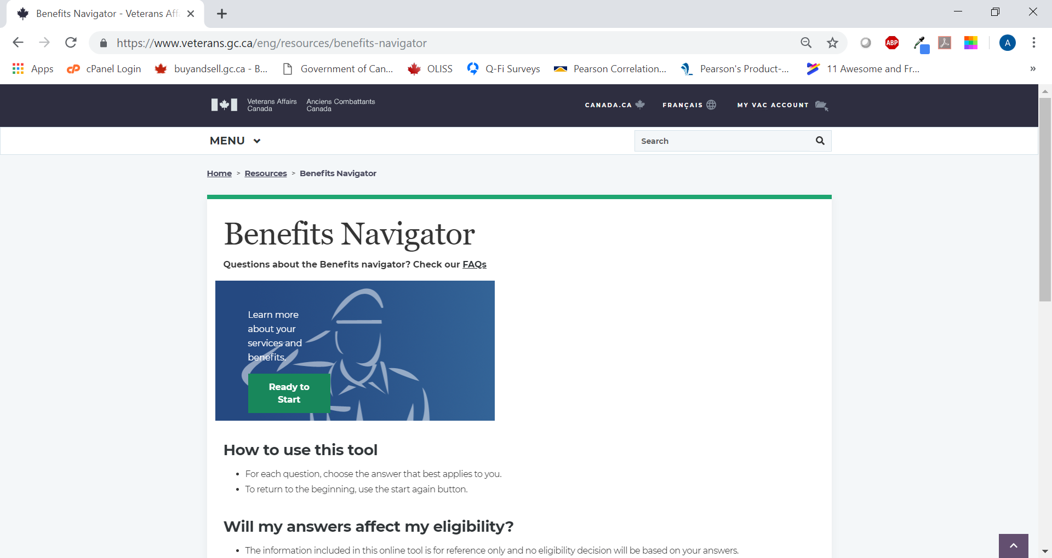

1. Is there any reason why you haven’t used the Benefits Navigator tool?

**Select all that apply**

* I did not know about it
* I have had no need to use it
* It looked complicated
* Other, please specify:
* I don’t know

[NON-USERS OF BENEFITS NAVIGATOR TOOL + NON-MVA HOLDERS ASK Q14-17, THEN GO TO NON-MVA MODULE]

[NON-USERS OF BENEFITS NAVIGATOR TOOL + MVA HOLDERS GO TO Q7]

These next questions are about your experience using the Benefits Navigator tool.

1. How helpful was the Benefits Navigator tool in terms of finding benefits or services of relevance to you?

* Not at all helpful
* Slightly helpful
* Moderately helpful
* Very helpful
* I can’t recall

**Track Your Applications**

1. Have you used the ‘Track your applications’ feature in My VAC Account to view the status of your application?

* Yes GO TO Q9
* No ASK Q8 + THEN GO Q14

1. Is there any reason why you haven’t used the ‘Track your applications’ feature?

**Select all that apply**

* I did not know about it
* I have had no need to use it
* It looked complicated
* Other, please specify:
* I don’t know

1. Did the ‘Track your applications’ feature help you find out the status of your application?

* No
* In part/somewhat
* Yes
* I don’t know

1. Does the ‘Track your applications’ feature provide sufficient detail about what step your application is at?

* Yes SKIP Q11
* No
* I don’t know

1. What additional information would you like the ‘Track your applications’ feature to provide about your application?

[OPEN TEXT]

* I don’t know

1. Have you visited the new Wait Time Tool to find out the average processing times? This tool is on VAC’s website and can be accessed through a link on the ‘Track your application’ page.

* Yes
* No SKIP Q13
* I don’t know SKIP Q13

1. Was the information provided in the Wait Time tool helpful to you in terms of estimating when you can expect a decision?

* No
* In part/somewhat
* Yes
* Don’t know

**Guided Web Forms**

1. Have you ever used a guided web form to complete an application? A guided web form is different from a traditional application form as you are asked questions with tips provided along the way.

* Yes CONTINUE
* No GO TO NEW DIRECTIONS
* I can’t recall GO TO NEW DIRECTIONS

1. In your view, what are the benefits, if any, of using a guided web form?

**Select all that apply**

* Nothing
* It saves time
* It minimizes errors
* It’s easier to complete
* Ability to save progress and complete later
* Other, please specify:
* I don’t know

1. In your view, what’s the main drawback, if any, of using a guided web form?

**Select all that apply**

* Nothing
* I can’t include an electronic signature
* It has to be completed online
* Security concerns
* Other, please specify:
* I don’t know

1. Which do you prefer to use to complete applications?

* Guided web form
* Online application form
* Paper form
* No preference

**[NON_MVA ACCOUNT HOLDERS GO TO NON-USER MODULE]**

**New Directions**

1. What, if anything, can VAC do to better communicate with you through My VAC Account?

**Select all that apply**

* Nothing
* Include a dashboard feature (showing your most recent activity personalized for you)
* Include more guided web forms
* Include a live chat feature
* Other, please specify:
* I don’t know

1. How do you typically access My VAC Account?

* Through a mobile device
* Through a laptop or desktop computer
* I use both

1. Which operating system do you typically use to access My VAC Account?

* Microsoft Windows
* Mac OS
* Linux
* Apple iOS
* Google Android
* Other, please specify:
* I don’t know

1. Finally, considering everything you know about My VAC Account, how much value does the online service provide for Canadian Armed Forces (CAF) or RCMP members who are transitioning out of service (releasing soon)?

GRID

ROWS

a) Soon-to-release CAF members

b) Soon-to-release RCMP members

COLUMNS

* No value at all
* A little value
* Some value
* A lot of value
* I don’t know

**[GO TO DEMOGRAPHICS]**

**Non-User Module**

1. What, if anything, have you seen, read or heard about My VAC Account?

[TEXT BOX]

* I have not heard anything
* I can’t recall
* Prefer not to say

*[Description of MVA]*

My VAC Account is a secure online channel for Veterans to connect with Veterans Affairs Canada (VAC) anytime, anywhere. My VAC Account is available to any Veteran, Canadian Armed Forces or RCMP member. It is also available to family members who receive benefits from VAC.

Specifically, My VAC Account allows you to…

* complete and submit certain applications online
* request a reimbursement for health-related travel
* track the status of your disability benefits application(s)
* view a summary of your Veterans Independence Program (VIP) benefits
* upload applications and supporting documents electronically
* request to start direct deposit payments
* send a secure message
* update your direct deposit and contact information

1. What is the main reason you do not use My VAC Account?

**Select all the apply**

* Didn’t know about My VAC Account until this survey
* Lack of interest
* Lack of need
* Online is too impersonal/prefer to connect using traditional methods
* Unclear about advantages of using My VAC Account
* Security concerns
* Privacy concerns
* Other. Please specify: [TEXT BOX]

1. What, if anything, would encourage you to use My VAC Account in the future?

**Select all the apply**

* Understanding the advantages of using My VAC Account
* Confidence that my personal information will be safe
* Online technical support available
* Having access to a computer and internet
* Nothing – I intend to use the service in the future
* Nothing – I have no intention of using the service
* Other. Please specify: [TEXT BOX]

**[GO TO DEMOGRAPHICS]**

**Demographics**

These last few questions tell us more about you. This information will be used only to aggregate and analyze the survey results. Please be assured that VAC will not receive your name or contact information.

1. Are you?

* a Veteran
* a still-serving member of Canadian Armed Forces
* a retired or still-serving member of the RCMP
* a family member
* Prefer not to say

1. Your age group?

* 18-29
* 30-39
* 40-49
* 50-59
* 60 and over
* Prefer not to say

1. In which province or territory do you live?

[ALPHABETICAL LIST]

* Prefer not to say

**Closing Page**

Thank you for taking the time to complete this survey. Your input is greatly appreciated and will help to ensure VAC’s online services meet your needs. Once again, please be assured that VAC will not receive your name or contact information.

VAC welcomes additional comments via **information@vac-acc.gc.ca**.

### 4. Online Focus Group Guide

**Introduction (5 minutes)**

* Hi everyone and welcome to the group. My name is [MODERATOR].
* I work for a research company called Phoenix SPI, and I'll be moderating our chat tonight.
* Thank you very much for your presence this evening.
* Tonight, we’re conducting research on behalf of Veterans Affairs Canada.
* The discussion will last approximately 1.5 hours. During it, I’ll sometimes refer to the department by its acronym, VAC.
* We will be seeking your opinion on the services available through My VAC Account.
* The feedback you provide will help Veterans Affairs Canada enhance their secure online services.
* There are no right or wrong answers, so please do not hesitate to express yourselves. This includes reacting to what other participants say.
* Everything you say will be treated in confidence. Our report summarizes the findings from the groups but does not mention anyone by name. That said, I encourage you NOT to provide any identifiable information about yourself during the online discussion.
* Here’s how it will work:
  + As well as posting a response, please feel free to post comments in reaction to other participants’ comments.
  + I will post the questions one at a time and wait for everyone to post a response.
  + From time to time I may also send a question to one participant if there is something that I don’t understand or if I would like some more details about a comment. In that case, only you will see that question.
* There are a few observers for tonight's session from Veterans Affairs Canada who are involved in the research. They will follow our discussion but will not participate in it.
* Any questions?
* Can we start with everyone introducing themselves by saying hello?
* Okay, let's start the discussion.

**Use and impressions of My VAC Account (15 minutes)**

What you all have in common is that you are registered users of My VAC Account.

1. I’d like to start with a general question…that is, what’s your overall impression of My VAC Account?
   * Why do you say that?
   * Are you generally able to complete what you want to complete?
   * Do you tend to encounter any problems?
   * For those of you who have encountered problems, what type of issues have you run into?
2. What do you tend to use My VAC Account for?
   * Which services do you use?
   * For those who use more than one service, which one do you use the most and why?

ROTATE NEXT TWO QUESTIONS:

1. What are the main benefits of using My VAC Account?
   * Anything else?
2. What are the main drawbacks of using My VAC Account?
   * Anything else?

**Tracking applications (20 minutes)**

1. Did you know that you can track the status of your online applications in My VAC Account?
2. Has anyone used the track applications feature in My VAC Account to view the status of an online application?

For those who have used the feature,

1. What do you think of it?
   * Is it helpful? If it’s not helpful, why is that?
   * Is it easy to navigate? If not, why not?
   * Does it provide the right amount and type of information? If not, what’s missing?
   * What additional information would you like included with the status updates?
2. How often do you tend to check the status of your application?

For everyone,

1. At what step or stage of an application process would you expect a status update from VAC?

1. After viewing a status update online, under what circumstances, if any, would you feel the need to contact VAC for follow up?
   * Why is that?
2. For those who would contact VAC for follow-up, how would you do this?
   * Through My VAC Account?
   * By phone?
3. Do you have any (other) suggestions to help VAC make this feature as useful as possible for you?

**Electronic notifications (20 minutes)**

Still focusing on the track applications feature,

1. Are any of you signed up for and receiving email notifications when the status of an online application changes?

For those who are,

1. What do you think of these notifications?
   * Are they helpful? If they’re not helpful, why is that?
   * Do they provide the right amount and type of information? If not, what’s missing?
   * What additional information would you like included with the status updates?

For everyone,

1. What information do you want or expect to receive in these electronic notifications?

* File has moved from received to in progress?
* File is complete?
* File is delayed beyond normal processing timeframes?

1. How would you like to receive these electronic notifications?

* Email?
* Text/SMS?
* No preference?

1. Can you think of any other organization, public or private, from which you receive electronic notifications?
   * Does this service include any specific features you like?
   * If so, tell us about the feature(s)?
   * Is this something that could be incorporated in My VAC Account?
2. Do you have any (other) suggestions to help VAC make electronic notifications as useful as possible for you?

**Going paperless (10 minutes)**

1. If you could view all your correspondence from VAC through My VAC Account, would you still want or need a paper copy to be sent in the mail?
   * Why do you say that?

ROTATE NEXT TWO QUESTIONS:

1. What are the main advantages or benefits of opting out of paper mail from VAC and going paperless?
   * Why do you say that?
2. What concerns, if any, would you have with opting out of paper mail from VAC and going paperless?
   * Why do you say that?
   * What could be done to address these concerns?

**Possible enhancements of My VAC Account (20 minutes)**

Looing ahead..

1. What enhancements or changes to My VAC Account would be particularly useful to you?
   * Why is that?
   * Anything else?
2. I’m now going to ask you about possible enhancements to My VAC Account. For each one I’d like to know how useful it would be to you personally. The first one is….[INSERT ITEMS]

* More guided web forms
* Automatic benefits suggestions
* Live online chat ability
* Instant messaging
* Adding access for powers of attorney and other representatives
* Adding case manager agreement to My VAC Account
* Ability to add files and links within secure messages
  + Would this be useful?
  + Why is that?

1. Are there any features of other online services that you use that you would like to see incorporated in My VAC Account?
   * What are they?
   * Who provides the service?
   * What do you like about this feature?
2. If all your dealings with Veterans Affairs Canada could be accomplished online through My VAC Account, would you choose to do so?
   * Why do you say that?
3. What, if anything, would you prefer not to do through My VAC Account?
   * Why do you say that?

1. Do you feel that you get anything from speaking with a VAC representative by phone that you cannot get through My VAC Account? If so what?
   * Why do you say that?
   * What if anything could be done to address this through My VAC Account?

**Conclusion**

1. Do you have any last comments or suggestions about anything we have discussed tonight?

**Well. That is it then. We are finished. Thank you for taking part. You can all log out now. Have a great evening!**

## 3: Research Instruments – (VAC Employees)

### 1. Online Survey

Introduction Page

Thank you for agreeing to take part in this short survey. Your feedback will be used to help improve My VAC Account – so it is better for Veterans and staff.

We anticipate that the survey will take 5 minutes to complete.

This research is being conducted by an independent Canadian research firm on behalf of Veterans Affairs Canada (VAC). If you have any questions about the survey, you may contact Phoenix Strategic Perspectives at research@phoenixspi.ca.

Please be assured that VAC will not receive your name or contact information. Should you take part in the survey, all opinions will remain anonymous and will not be attributed to you personally in any way. Your participation in the research is completely voluntary and your decision on whether or not to participate will not affect any dealings you may have with the Government of Canada.

Your assistance is greatly appreciated, and we look forward to receiving your feedback.

Please click ‘**Next**’ to start the survey.

Awareness and Knowledge of My VAC Account

1. How familiar are you with the Department’s online service channel, My VAC Account?

* Very familiar
* Somewhat familiar
* Not very familiar
* Not at all familiar*

*[SKIP TO UNFAMILIAR W/MY VAC ACCOUNT MODULE]

1. How knowledgeable would you say you are about the features available in My VAC Account?

* Very knowledgeable
* Somewhat knowledgeable
* Not very knowledgeable
* Not at all knowledgeable

1. Which features are you most familiar with in My VAC Account?

**Select all that apply**

* + Secure messaging
  + Veterans receiving electronic correspondence in their Inbox
  + Veterans uploading documents
  + Veterans applying through a guided web form or submittable PDF
  + Veterans updating their contact or direct deposit information
  + Benefits Navigator in My VAC Account
  + Displaying Current Benefits and Payment
  + Posting page alerts or broadcast messages for Veterans
  + Other – Specify [TEXT]

1. How often do you do the following?

[GRID FORMAT]

[ROWS]

1. Visit the My VAC Account section on VAC@Work
2. Use the My VAC Account training account

[COLUMNS]

* At least once a week
* A few times a month
* A few times a year
* Only once
* Never

[IF NEVER FOR 4a]

1. Why have you not visited the My VAC Account section on VAC@Work?

**Select all that apply**

* + I don’t need to for my work
  + I don’t find it helpful
  + I don’t have time due to workload
  + I didn’t know it existed
  + Other – Specify [TEXT]

[IF NEVER FOR 4b]

1. Why have you not used the My VAC Account training account?

**Select all that apply**

* + I don’t need to for my work
  + I don’t find it helpful
  + I don’t have time due to workload
  + I didn’t know it existed
  + Other – Specify [TEXT]

[EVERYONE]

6. Have you received My Account training via WebEx or in person?

* No, I am unaware of this training
* No, I am not interested in this training
* No, I do not have enough time for this training
* Yes, I have taken a training session

1. How would you rate the Department’s performance in terms of keeping you informed about ongoing updates to My VAC Account?

* Very good
* Good
* Neutral
* Poor
* Very poor
* I’m not sure

[IF A POOR/VERY POOR JOB]

1. What could the Department do to better inform you about My VAC Account?

**Select all that apply**

* Face-to-face updates
* Improved information on VAC@Work
* Additional Webex trainings
* Emails
* Nothing; I know where to find the information if I need it
* Other – Specify [TEXT]

1. Does My VAC Account have an impact on your work in any way?
   1. Yes, a positive one
   2. Yes, a negative one
   3. No impact
   4. Not applicable

Experience with My VAC Account

1. How often do you refer to My VAC Account while interacting with Veterans? This includes helping someone register for My VAC Account, letting someone know what can be done in My VAC Account, etc.

* At least once a day
* Several times a week
* About once a week
* A few times a month
* Less than a few times a month
* Never; I don’t know enough about My VAC Account [ASK Q11 AND THEN GO TO Q20]

1. How often do you receive questions or comments about My VAC Account from Veterans?
   1. At least once a day
   2. Several times a week
   3. About once a week
   4. A few times a month
   5. Less than a few times a month
   6. Never
2. In the past 12 months, have you used My VAC Account’s secure messaging to communicate with Veterans?

* Yes
* No [ASK Q14, THEN GO TO Q20]

1. Overall, how was your experience with communicating via secure messaging?

* Very good
* Good
* Neutral
* Poor
* Very poor

[ASK Q14 OF NON-USERS OF SECURE MESSAGING ONLY]

1. Why haven’t you used My VAC Account’s secure messaging?

**Select all that apply**

* I didn’t know about secure messaging until this survey
* I haven’t needed to yet; Veterans I have dealt with do not have secure messaging enabled
* I need proper training first to use secure messaging
* I prefer to use other communication methods
* Traditional communication methods are preferred by my team, including management
* Not related to my role
* Other. Please specify: [TEXT BOX]

[ASK Q15-19 OF THOSE WHO HAVE USED SECURE MESSAGING]

1. How often do you use secure messaging to communicate with Veterans?

* At least once a day
* Several times a week
* About once a week
* A few times a month
* Less than a few times a month

1. If you need to initiate communication with a Veteran who has secure messaging enabled, which contact method would you choose?
   1. Telephone
   2. Secure message
   3. Mail
   4. It depends on the nature of the communication
2. When using secure messaging, are you…

* …responding to messages initiated by My VAC Account users?
* …initiating communication with My VAC Account users?
* …both responding and initiating

1. In the past 12 months, have you had any difficulties using secure messaging to communicate with Veterans?

* Yes [ASK Q19]
* No [SKIP TO Q20]

1. Can you explain the difficulties you encountered using secure messaging to communicate with Veterans?

[TEXT BOX]

1. Did you know that the new Pension for Life benefits are being implemented with a digital-first approach, which means that the application process is being designed for My VAC Account?
   1. I was aware of this and informed about this approach
   2. I was aware of this, but don’t know anything about the approach
   3. I was not aware of this
2. Are you comfortable promoting a digital-first approach with Veterans? Please keep in mind that digital does not mean without help and that traditional service channels will still be available.
   1. I am comfortable with this
   2. I am pretty comfortable, but I may not have the equipment or tools needed to help Veterans (e.g., no computer in my office to access MVA)
   3. I am really not comfortable; I need more training
   4. Other. Please specify: [TEXT BOX]
3. What would encourage you to promote use of My VAC Account with Veterans?

**Select all that apply**

* Better understanding the advantages of using My VAC Account
* Better understanding of how to use My VAC Account
* Having My VAC Account ambassadors or champions on my team as a resource
* Nothing – I already promote My VAC Account when I can
* Other. Please specify: [TEXT BOX]

1. How would you rate the overall value of My VAC Account for you when it comes to carrying out your responsibilities as a Departmental employee?

* Very valuable
* Moderately valuable
* Not very valuable
* Not at all valuable

1. And, how would you rate the overall value of My VAC Account for Veterans?

* Very valuable
* Moderately valuable
* Not very valuable
* Not at all valuable
* I’m not sure

Future enhancements of My VAC Account

1. The Department is considering adding new features or enhancements to My VAC Account. How useful would each of the following be to you in terms of your work?

[GRID]

[ROWS; ROTATE ITEMS]

1. Increasing applications available as guided web forms and expanding the ‘tell us once approach’
2. Improved status tracking with more details for Veteran
3. Automatic benefits suggestions for Veterans
4. Live online chat ability
5. Adding access for powers of attorney (POA) and other Veterans’ representatives
6. Providing Veterans with an estimated completion date for their applications in the status tracking feature
7. Adding case manager agreement to My VAC Account
8. Ability to video conference with Veterans (e.g. case manager with Veteran)
9. Ability to add files and links within secure messages

[COLUMNS]

Very useful

Somewhat useful

Not very useful

Not at all useful

1. Do you have any suggestions to help the Department improve My VAC Account?

[TEXT BOX]

* No suggestions
* Not sure

**[GO TO DEMOGRAPHICS]**

Unfamiliar with My VAC Account

[Description of MVA]

My VAC Account is an online service that allows Veterans to connect with VAC anytime, anywhere. My VAC Account is available to any Veteran or still-serving Canadian Armed Forces or RCMP member, and provides a simple and secure way to engage with VAC. Family members who receive benefits from VAC can also register for their own account.

My VAC Account allows users to…

* complete and submit applications online
* track the status of their applications
* view a summary of their benefits
* upload applications and supporting documents electronically
* receive their correspondence (letters and documents) online
* receive news from VAC
* connect with VAC through secure messaging
* update their direct deposit and contact information

1. What’s the main reason you are not familiar with My VAC Account?

**Select all that apply**

* Haven’t had any exposure
* Lack of interest
* Lack of need
* Previously used it and do not like it
* Unclear about advantages of using My VAC Account
* Other. Please specify: [TEXT BOX]

1. What, if anything, would encourage you to promote My VAC Account to Veterans?

**Select all that apply**

* Understanding the advantages of using My VAC Account
* Training on how to use My VAC Account
* More internal communications about My VAC Account
* Better promotion of My VAC Account among Veterans
* Nothing – I intend to use My VAC Account
* Nothing – I do not plan to use the service
* Other. Please specify: [TEXT BOX]

Demographics

This last set of questions is about you. This information will be used only to aggregate and analyze the survey results. Please be assured that VAC will not receive your name or contact information.

1. How long have you worked for Veterans Affairs Canada?

* Less than one year
* 1 to 2 years
* 2 to 5 years
* More than 5 years

1. Which of the following best describes your position at VAC?

* Field Operations: Case manager
* Field Operations: VSA
* Field Operations: Team Leader or Manager
* NCCN analyst: Part of secure message team
* NCCN analyst
* Centralized Operations Division: Program staff
* Centralized Operations Division: Team Leader or Manager
* Other – Please specify [TEXT BOX]

1. Are you located in?

* Headquarters (Charlottetown, PE)
* Western Canada
* Ontario
* Quebec
* Atlantic Canada

Follow-up Research

Finally,

1. Would you be willing to participate in a follow-up discussion on these same topics to explore a few areas in greater depth? If you are willing, you may be contacted in the next few weeks for a follow-up phone interview by a senior researcher from the independent research firm, Phoenix Strategic Perspectives. Would you be willing to participate?

* Yes
* No [SKIP TO CLOSING PAGE]

1. May we have your contact information?

Name: [TEXT BOX]

Telephone number: [TEXT BOX]

Email: [TEXT BOX]

Closing Page

Thank you for taking the time to complete this survey. Your input is greatly appreciated and will help to ensure VAC’s online services meet not only Veterans’ needs, but yours as well as employees. Once again, please be assured that VAC will not receive your name or contact information.

### 2. Interview Guide

**Introduction**

1. Introduce yourself, thank the individual for agreeing to participate, and re-iterate expected length of interview.
2. Remind him/her that responses are confidential: *Your responses during the interview will be kept confidential and the feedback you provide will be used for research purposes only and will not be attributed to you personally in the report resulting from this study. Your participation in the research is completely voluntary and your decision on whether or not to participate will not affect any dealings you may have with the Government of Canada.*

**Context**

I’d like to begin by asking you a few questions about your work at Veterans Affairs Canada.

1. To begin, could you please briefly describe your main duties and responsibilities?

Probe: - length of time in current position

1. [ADJUST WORDING BASED ON RESPONSE TO QUESTION 1]: To what extent do your work responsibilities involve dealing or interacting directly with Veterans?

Probe: - nature and frequency of interactions with Veterans

- relative importance of such responsibilities vs. other work responsibilities (e.g. % of workday/week devoted to such responsibilities)

1. What challenges, if any, do you encounter in the course of your interactions with Veterans? NOTE SPECIFIC REFERENCES TO MVA

**Awareness and Knowledge of My VAC Account**

1. [ADJUST WORDING IF PARTICIPANT HAS REFERRED TO MVA]: How comfortable would you say you are you with My VAC Account? Which features of My VAC Account are you most familiar with?

Probe: - very, somewhat, not very, not at all

- familiarity with certain features but not others

IF NOT AT ALL FAMILIAR WITH ANY FEATURES OF SERVICE, SKIP TO FINAL SECTION.

**Experience with My VAC Account**

1. Could you please describe how your work-related responsibilities relate to or involve My VAC Account? How does it factor-in to your responsibilities?

Probe: - use/assist others in using it/promote it/receive and answer Qs. about it

1. Does My VAC Account help you in carrying out your work-related responsibilities? Please explain.
2. Are there any issues, problems, or challenges related to My VAC Account that make it difficult for you to carry out any of your work-related responsibilities? If so, what?
3. What kind of feedback, if any, have you received or heard from Veterans concerning My VAC Account?

Probe: - positive and negative/critical feedback

1. [IF YES to Q8 about RECEIVING FEEDBACK]: What do you do with this feedback you receive?
2. Have you received any training related to My VAC Account? If so, what kind of training did you receive? If not, why not?

Probe: - via WebEx, in-person, both

IF NO:

1. Would you like to receive training specifically on My VAC Account? Why/why not?

Probe - valuable for you and your colleagues

- delivery format, any barriers?

IF YES:

1. Was the training you received helpful? Why/why not?

Probe: - what could be done to improve the training

1. Do you consider yourself sufficiently familiar or up-to-date with My VAC Account to effectively carry out your work-related responsibilities? Please explain.

Probe: - what would they like to know more about/be more familiar with

1. Would greater familiarity with VAC My Account enhance your ability to carry out your professional responsibilities? If so, please explain why and how?

**Impressions of My VAC Account**

1. How would you describe the overall impact of My VAC Account on your work? Why do you say that?

Probe: - positive, neutral, negative, no impact

1. How would you rate the overall value of My VAC Account to you when it comes to carrying out your responsibilities as a departmental employee? Why do you say that?
2. Do you promote the use of My VAC Account among Veterans? If so why? If not, why not?

Probe: - features they may be more/less comfortable promoting

- apprehensions about promoting MVA

- impediments to promoting MVA

IF NOT:

1. What if anything would encourage you to promote/further promote use of VAC among Veterans?

**Future Enhancements of My VAC Account**

1. How important is it for you to be informed about ongoing updates to My VAC Account? Please explain.
2. How would you rate the Department’s performance in terms of keeping you informed about ongoing updates to My VAC Account? Please explain.
3. What could the Department do to better inform you about changes or updates to My VAC Account?
4. Can you think of any enhancements or changes to VAC My Account that would be useful to you in terms of your work? If so, what and why?
5. VAC is considering various new features or enhancements to My VAC Account. I’m going to list them and for each one please tell me how useful it would be to you in terms of your job and why [EXCLUDE ANY ALREADY IDENTIFIED IN PREVIOUS QUESTION]:

* Increasing applications available as guided web forms and expanding the ‘tell us once approach’
* Improved status tracking with more details for Veteran
* Automatic benefits suggestions for Veterans
* Live online chat ability
* Adding access for powers of attorney (POA) and other Veterans’ representatives
* Providing Veterans with an estimated completion date for their applications in the status tracking feature
* Adding case manager agreement to My VAC Account
* Ability to video conference with Veterans (e.g. case manager with Veteran)
* Ability to add files and links within secure messages

**Unfamiliar with My VAC Account**

[Description of MVA to be used if and as needed]

My VAC Account is an online service that allows Veterans to connect with VAC anytime, anywhere. My VAC Account is available to any Veteran or still-serving Canadian Armed Forces or RCMP member, and provides a simple and secure way to engage with VAC. Family members who receive benefits from VAC can also register for their own account. My VAC Account allows users to…

* complete and submit applications online
* track the status of their applications
* view a summary of their benefits
* upload applications and supporting documents electronically
* receive their correspondence (letters and documents) online
* receive news from VAC
* connect with VAC through secure messaging
* update their direct deposit and contact information

1. What is the main reason you are not familiar with My VAC Account?
2. Do you think it would be useful for you to be more familiar with My VAC Account or certain of its features? If so why? If not, why not?

IF YES:

1. What do you think it would be useful for you to know more about?
2. How important is it for you to be informed about ongoing updates to My VAC Account? Please explain.
3. How would you rate the Department’s performance in terms of keeping you informed about ongoing updates to My VAC Account? Please explain.
4. What could the Department do to better inform you about changes or updates to My VAC Account?
5. Can you think of any enhancements or changes to VAC My Account that would be useful to you in terms of your work? If so, what and why?

**Conclusion**

1. Do you have any (other) suggestions to help the Department improve My VAC Account?

Thank you very much for taking the time to speak with me today. Your feedback will be very helpful.

1. My VAC Account users include **war service Veterans; Canadian Armed Forces members and Veterans; still-serving and retired RCMP members; and family members who are receiving benefits directly from VAC.** 
2. 81,000 as of October 2018
3. Recruitment notices were included on the department’s website as a way to reach non-users of My VAC Account. In the end, very few non-users of My VAC Account (n=14 respondents) elected to participate in any of the online surveys.
4. For this survey, probability sampling was not feasible because access to a list of My VAC Account users was not available.