Exploring perceptions, behaviours, and experiences in relation to My VAC Account

Final Report

Prepared for Veterans Affairs Canada

Supplier Name: Phoenix SPI
Contract Number: 51019-207002 001 CY
Contract Value: $54,867.72
Award Date: 2021-01-19
Delivery Date: 2021-05-12
Registration Number: POR 107-20

For more information on this report, please contact Veterans Affairs Canada at: commsresearch-commsrecherce@veterans.gc.ca

Ce rapport est aussi disponible en français.
Exploring perceptions, behaviours, and experiences in relation to My VAC Account
Final Report
Prepared for Veterans Affairs Canada
Supplier name: Phoenix Strategic Perspectives Inc.
May 2021

This public opinion research report presents the results of a non-probability online survey of 650 My VAC Account users conducted between March 4 and March 13, 2021, and two virtual focus groups, also conducted with My VAC Account users. The focus groups were held March 24 (English) and March 25, 2021 (French).

This publication may be reproduced for non-commercial purposes only. Prior written permission must be obtained from Veterans Affairs Canada. For more information on this report, please contact Veterans Affairs Canada at:

vac.information.acc@canada.ca

Catalogue number:
V49-9/2021E-PDF

International Standard Book Number (ISBN):
978-0-660-38575-4

Related publications (registration number: POR 107-20):
Catalogue number (Final report, French) V49-9/2021F-PDF
ISBN: 978-0-660-38576-1

© Her Majesty the Queen in Right of Canada, as represented by the Minister of Veterans Affairs, 2021

Aussi offert en français sous le titre : Explorer les perceptions, les expériences et les comportements liés à Mon dossier ACC

Table of Contents

Executive Summary 1

Introduction 5
Background and Objectives 5
Methodology 5
Notes to Readers 6

Profile of Research Participants 7
Survey Respondents 7
Focus Group Participants 8

Detailed Findings 9
Perceptions of the Registration Process 9
General Use of My VAC Account 13
Use of Selected My VAC Account Features/Tools 17
Use and Impressions of Secure Messaging 26
Communications Preferences 33
Overall Assessments of My VAC Account 37
Future Directions 45

Appendix 47
Methodological Information 47
Quantitative Research Instruments 49
Qualitative Research Instruments 65

Table of Figures

Figure 1: Demographic profile of survey respondents 7
Figure 2: Type of My VAC Account User 7
Figure 3: Characteristics of focus group participants 8
Figure 4: Registration process used 9
Figure 5: Reason(s) for using GCKey 10
Figure 6: Ease of registration process 11
Figure 7: Agreement with steps required for registration 12
Figure 8: Source of Awareness 13
Figure 9: Frequency of Use 14
Figure 10: Use of Features 15
Figure 11: Helpfulness of information found on Member Task List 17
Figure 12: Helpfulness of the Wait Time Tool 18
Figure 13: Approximate time expected on application 19
Figure 14: Usefulness of Track your Application Tool 20
Figure 15: Details available through Track Your Applications Tool 21
Figure 16: Reason(s) Track Your Applications was missing details 22
Figure 17: Reason(s) for not using the Track Applications Tool 23
Figure 18: Preferred method for contacting VAC 26
Figure 19: Use of Secure Messaging in past 12 months 27
Figure 20: Frequency of Connecting with VAC Staff via Secure Messaging 28
Figure 21: Waiting time for Secure Messaging reply 29
Figure 22: Connecting with case manager via Secure Messaging 30
Figure 23: Satisfaction with secure messaging system 31
Figure 24: Need for follow up with VAC staff 32
Figure 25: Preferred method to receive VAC updates 33
Figure 26: News and Notifications Section 34
Figure 27: Preferred frequency of VAC news 35
Figure 28: Experience accessing information on My VAC Account 37
Figure 29: Reason(s) for not finding all the information needed 38
Figure 30: Perceptions of the information in My VAC Account 39
Figure 31: Perceptions of different aspects of My VAC Account 40
Figure 32: Reasons for disagreeing with the statements about My VAC Account 41
Figure 33: Overall satisfaction with My VAC Account 42
Figure 34: Reason for dissatisfaction with My VAC Account 44

Executive Summary
Phoenix Strategic Perspectives Inc. (Phoenix SPI) was commissioned to conduct quantitative and qualitative research with clients of Veterans Affairs Canada (VAC) who use the Department’s secure online service, My VAC Account.

1. Research purpose and objectives
To support My VAC Account, the Department commissioned public opinion research to explore account holders’ perceptions, behaviours, and experiences using My VAC Account. Specific areas of investigation included functionality of the service channel, user preferences for communicating with the Department, and satisfaction with the digital channel. In addition, the research was designed to collect information in support of improvements to My VAC Account—specifically, information to help the Department measure reaction to changes implemented since the last public opinion research was conducted in 2019. This research was first conducted in 2017; this year’s research represents the third iteration of the study.

2. Methodology
A non-probability online survey was conducted with My VAC account users. Respondents were recruited through advertisements placed in My VAC Account and on the Department’s social media channels. The survey averaged 17 minutes to complete. In total, 650 surveys were completed between March 4 and March 13, 2021. In addition, two virtual focus groups were conducted with My VAC Account users following the online survey: one group in English (March 24, 2021) and one group in French (March 25, 2021). All focus group participants received a $100 honorarium to thank them for their time.

3. Key findings

Just over half used GCKey to register for my VAC Account. They did so primarily because they were not comfortable with the alternative, Sign-in Partner. The majority who used GCKey found registration easy and most agreed that the steps required to register for My VAC Account justify the security it provides.
Fifty-four percent of My VAC Account users surveyed said they registered for the online service using GCKey (43% used Sign-in Partner). Of those who used GCKey, 68% said they were more comfortable with GCKey than the alternative, using their online banking login (27%). Most My VAC Account holders who used GCKey to register found the process of registering to be ‘somewhat’ (34%) or ‘very’ (41%) easy and the majority (81%) agreed that the steps required to register justify the security it provides.

Half use My VAC Account weekly and most account holders have used the online channel to track applications, apply for benefits and services, receive correspondence, communicate with the Department, or view a summary of benefits.
When asked how frequently they use My VAC Account, approximately half said they do so weekly: 26% do so several times a week and 23% about once a week. Few (10%) use their account daily. At the other end of the spectrum, roughly 4 in 10 use their account less than once a month (15%) or about once a month (24%). A majority of respondents have used My VAC Account to track applications (90%), apply for benefits and services online (89%), receive correspondence from VAC (85%), to communicate with VAC through secure messaging (83%), to view a summary of their benefits (82%), or to upload documents in support of their application (79%). Two-thirds (67%) reported using the Wait Time Tool and relatively few (9%) said they had used the Member Transition Task List.

Like survey respondents, focus group participants’ use of My VAC Account varied, but is also relatively frequent. Participants could not identify any type of transaction or interaction for which they would not use My VAC Account. For focus group participants, the most important services available through My VAC Account include news and updates, secure messaging, tracking applications, and uploading documents, applications as well as forms. All of these services allow for faster, more effective, and efficient interactions with VAC.

90% of survey respondents used the Track your Applications Tool. Most found the tool at least somewhat helpful, although just one-quarter said the feature provides them with enough detail. Indeed, the main weakness of the tool is that it does not provide sufficient detail.
Among survey respondents who used Track your Applications, most (84%) found the tool at least somewhat helpful: 39% said it helped them find out the status of their application and 45% said it did so ‘in part’ or ‘somewhat’. Underscoring these moderately positive assessments, many (69%) said the tool is lacking in detail about the status of their application. Focus group participants emphasized that the tracking feature does not provide detailed, customized, or personalized information about the status of their applications. Survey respondents indicated there is a lack of information at the various steps in the application process (30%), timelines are inaccurate and there are delays (29%), and the information provided is vague or general in nature (25%). Many of the My VAC Account holders (60%) would like more accurate and personalized wait times to be provided together with the ability to see the position of their file in the application processing queue.

8 in 10 used secure messaging, with most My VAC Account users saying they waited up to five business days for a secure message reply. Few experienced difficulties and the majority of users were satisfied with their experience using secure messaging. More than half needed to re-contact VAC to have a follow-up conversation and most (again) used secure messaging.
Among respondents who have used secure messaging in the past 12 months, 38% waited one to two business days and 47% three to five business days for a reply. Actual wait times generally are in line with respondents’ expectations. Forty-three percent expected to wait one to two business days for a reply (compared to 38% who did), while the same proportion expected to wait three to five business days (compared to 47% who did). In addition, two-thirds (66%) were satisfied or ‘very’ satisfied with their experience using secure messaging and very few (7%) experienced any difficulties. A small majority (55%), however, needed to re-contact VAC to have a follow-up conversation; seven in 10 (71%) of those who needed to re-contact VAC did so via secure messaging.

Most are satisfied with their experience using My VAC Account. Perceptions of the information available in My VAC Account were mixed, with room for improvement.
Approximately two-thirds of surveyed My VAC Account users said they find ‘most’ of what they need (38%) or ‘everything’ they need (29%) when visiting My VAC Account. In addition, just over one-quarter (28%) generally find ‘some’ of what they need. Very few (4%) find none of what they need when visiting My VAC Account. Perceptions of the information available in My VAC Account were mixed: 61% agreed that the information is easy to understand, 55% that is helps them understand the next step, 51% that is includes helpful external resources, and 41% that it includes right amount of detail.

All focus group participants were of the opinion that VAC does not keep them well informed or as informed as they could be about programs and services through My VAC Account. In explaining why, many said that they have to do most of the research themselves to find out about programs and services. Related to this, it was also observed that, while the information is available through My VAC Account, one has to find it, which can be difficult, and when one does, it can be difficult to understand.

The majority (71%) of surveyed My VAC Account holders were satisfied with their experience using My VAC Account, including 31% who were ‘very’ satisfied. Relatively few (13%) expressed dissatisfaction with their experience using My VAC Account. Overall satisfaction is underscored by the fact that 83% of survey respondents agreed that My VAC Account uses practices that ensure system security and 79% would recommend My VAC Account to others. Among focus group participants, impressions of My VAC Account also tended to be fairly positive, with many pointing to speed and efficiency, the service’s interface, and 24/7 accessibility as benefits of the service channel.

4. Limitations of the research
Surveys that use convenience samples, like this one, cannot be described as statistically projectable to the target population and no estimates of sampling error can be calculated because the sample is based on those who self-selected for participation. The results from the virtual focus groups are also not statistically projectable, but they offer detailed opinions about the issues explored through this research that complement the broader survey findings.

5. Use of the results
This feedback from the quantitative and qualitative research components will help guide the future of My VAC Account, allowing the Department to prioritize enhancements moving forward and measure progress over time.

6. Political Neutrality Certification
I hereby certify, as a Senior Officer of Phoenix Strategic Perspectives, that the deliverables fully comply with the Government of Canada political neutrality requirements outlined in the Communications Policy of the Government of Canada and Procedures for Planning and Contracting Public Opinion Research. Specifically, the deliverables do not contain any reference to electoral voting intentions, political party preferences, standings with the electorate, or ratings of the performance of a political party or its leader.

Signed:

Alethea Woods, President
Phoenix Strategic Perspectives Inc.

7. Contract value
The contract value was $54,867.72 (including HST).

Introduction
Phoenix Strategic Perspectives (Phoenix SPI) was commissioned by Veterans Affairs Canada (VAC) to conduct quantitative and qualitative public opinion research (POR) with users of My VAC Account.

Background and Objectives
My VAC Account is a secure, authenticated web application that allows users to access VAC services from anywhere, and at any time. Through My VAC Account, Veterans can use the Benefits Navigator to learn more about VAC benefits and services relevant to them, apply online for VAC benefits and services, upload documents to support applications, track the status of applications, receive online correspondence (forms and letters), view a summary of their VAC benefits, sign up for direct deposit or change banking information, update contact information, and connect with VAC through secure messaging. My VAC Account is enhanced on an ongoing basis as the Department moves towards having a complete suite of services available online.

As the Department enhances its online service channel, the number of registered users of My VAC Account also continues to grow. Since the Department last conducted POR with My VAC Account users in 2019, the number of registered users has increased 28%, from 91,239 users to approximately 117,000. As more services move to this online platform, and an increasing number of Veterans and their families use My VAC Account, it is critical that the Department collects feedback regarding My Account holders’ experiences with the digital channel. This feedback will help guide the future of My VAC Account and prioritize enhancements moving forward, so that we can improve service delivery and design.

To support My VAC Account, the Department conducts POR every two years to explore account holders’ perceptions, behaviours, and experiences using My VAC Account. The baseline POR was conducted in 2017 and the first follow-up took place in 2019. This year represents the third iteration of this POR. Specific areas of investigation in 2021 included: use of My VAC Account and selected tools and features (Member Transition Task List, Wait Time Tool, and Track your Applications); experiences registering for My VAC Account; preferences for contacting the Department and use of secure messaging; general communications preferences; and overall level of satisfaction.

In addition, the research was designed to: 1) collect information in support of improvements to My VAC Account—specifically, information to help the Department measure reaction to changes implemented since the last POR was conducted in 2019; and 2) to measure changes in account holders’ perceptions, behaviours, and experiences over time, starting with the baseline in 2017.

This feedback will help guide the future of My VAC Account, allowing the Department to prioritize enhancements moving forward and measure progress over time.

Methodology
To meet the research objectives, both quantitative and qualitative research was conducted with clients of My VAC Account. Specifically:
- A non-probability survey was conducted online with My VAC account users. Respondents were recruited through advertisements placed in My VAC Account and on the Department’s social media channels. The survey averaged 17 minutes to complete. In total, 650 surveys were completed between March 4 and March 13, 2021.

- Two virtual focus groups were conducted following the online survey: one group in English (March 24, 2021) and one group in French (March 25, 2021). Participants were recruited through My VAC Account as well as VAC’s social media channels and included retired or still-serving members of the Canadian Armed Forces and RCMP as well as War Veterans. All research participants received a $100 honorarium to thank them for their time.

Notes to Readers
- The report is organized by theme, with the results of the online survey and virtual focus groups integrated in each section (as relevant). To help the reader clearly delineate quantitative from qualitative findings, the results of the survey are presented first, followed by the focus group findings.
- Regarding the survey results:
  - All results are expressed as percentages, unless otherwise noted. Throughout the report, percentages may not always add to 100 due to rounding and/or multiple responses being offered by respondents.
  - At times, the number of respondents changes in the report because questions were asked of sub-samples of the survey population. Accordingly, readers should be aware of this and exercise caution when interpreting results based on smaller numbers of respondents.
  - Demographic and other subgroup differences are identified in the report. When reporting subgroup variations, only differences that are significant at the 95% confidence level and that pertain to a subgroup sample size of more than n=20 are discussed in the report. If one or more categories in a subgroup are not mentioned in a discussion of subgroup differences (for example, if two out of three age groups are compared), it can be assumed that significant differences were found only among the categories reported.
  - Where relevant, reference is made to findings from the baseline survey conducted in 2017 and the first follow-up survey conducted in 2019.
- Regarding the focus groups results:
  - This research was qualitative in nature, not quantitative. As such, the results provide an indication of participants’ views about the issues explored, but cannot be generalized to the full population of My VAC Account users.
- The research instruments can be found in the Appendix along with more detailed information about the technical specifications of research.

Profile of Research Participants

Survey Respondents
The characteristics of My VAC Account Users who completed the online survey are presented in Figures 1 and 2.

Figure 1: Demographic profile of survey respondents
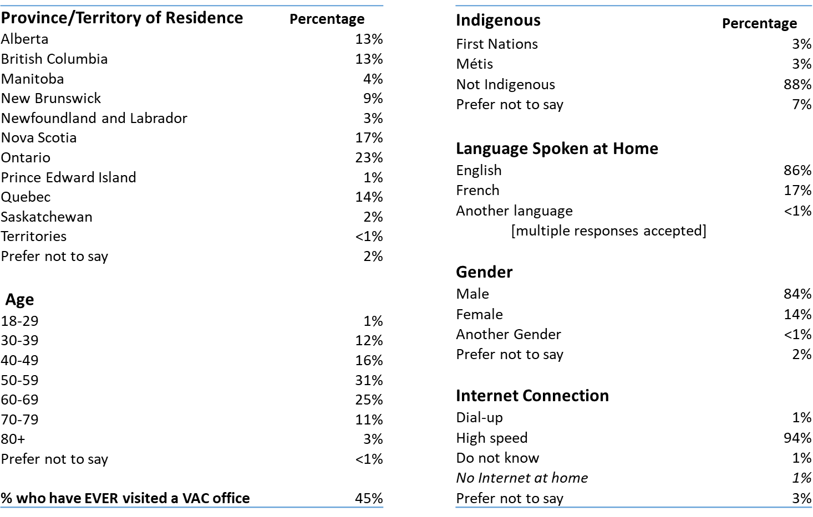

Base: n=650; all respondents

Figure 2: Type of My VAC Account User
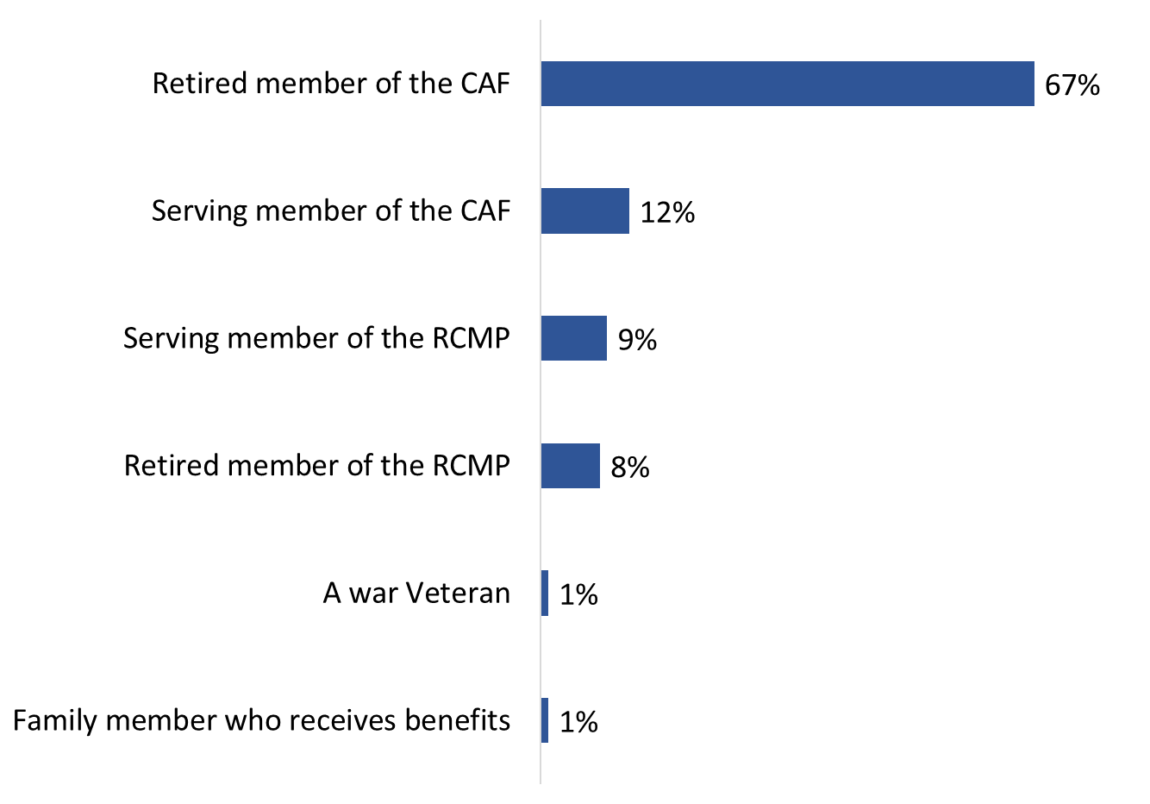

Base: n=650; all respondents; no response: 2%
Q46. Are you…?

Focus Group Participants
The characteristics of My VAC Account users who participated in the two focus groups are as follows:

Figure 3: Characteristics of focus group participants

Type of My VAC Account user | Number of Participants
War Veteran | 4 participants
Retired or still-serving member of the CAF | 6 participants
Retired or still-serving member of the RCMP | 2 participants
Frequency of using My VAC Account in the past year | Number of Participants
Four to 10 times | 2 participants
More than 10 times | 10 participants
Age | Number of Participants
30 to 39 | 3 participants
40 to 49 | 5 participants
50 to 59 | 2 participants
60 to 69 | 1 participant
70 to 79 | 1 participant
Gender | Number of Participants
Male | 10 participants
Female | 2 participants
Region | Number of Participants
Atlantic Canada | 1 participant
Quebec | 4 participants
Ontario | 4 participants
West | 3 participants

Detailed Findings

Perceptions of the Registration Process
This section discusses survey respondents’ experience registering for My VAC Account, including how they did so and whether they found the registration process easy or difficult.

The registration process was only assessed by those who completed the survey; therefore, this section does not refer to findings from the focus groups.

Slightly more than half used GCKey to register for My VAC Account
Slightly more than half of those surveyed (54%) said they registered for My VAC Account using a GCKey, while 43% used Sign-in Partner (2% could not recall how they registered for My VAC Account). Use of Sign-in Partner (referred to as SecureKey in previous surveys) to register for My VAC Account has increased since the baseline survey was conducted in 2017 (36% compared to 43% in 2021).

Figure 4: Registration process used
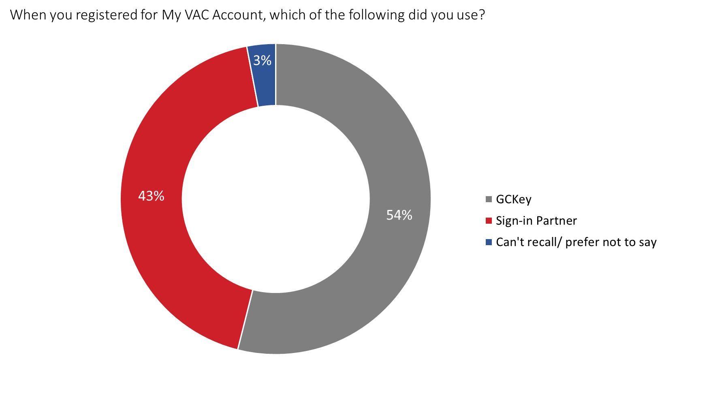
Base: n=650; all respondents
Q8. When you registered for My VAC Account, which of the following did you use?

Respondents aged 40 to 59 (55%), as well as those aged 60 and older (58%), were more likely to have registered for My VAC Account using GCKey. In contrast, more than half of those 18 to 39 years of age (58%) said used Sign-in Partner.

Most who used GCKey felt more comfortable doing so to register for My VAC Account
Among those who used GCKey to register for My VAC Account (n=351), just over two-thirds (68%) did so because they were more comfortable using GCKey. This is consistent with findings from the 2017 baseline and the 2019 follow-up surveys.

Significantly fewer reported using GCKey for other reasons: 27% because they did not want to use their banking information and 10% because their bank was not an option in Sign-in Partner. Fourteen percent could not recall why they used GCKey to register for My VAC Account.

Figure 5: Reason(s) for using GCKey

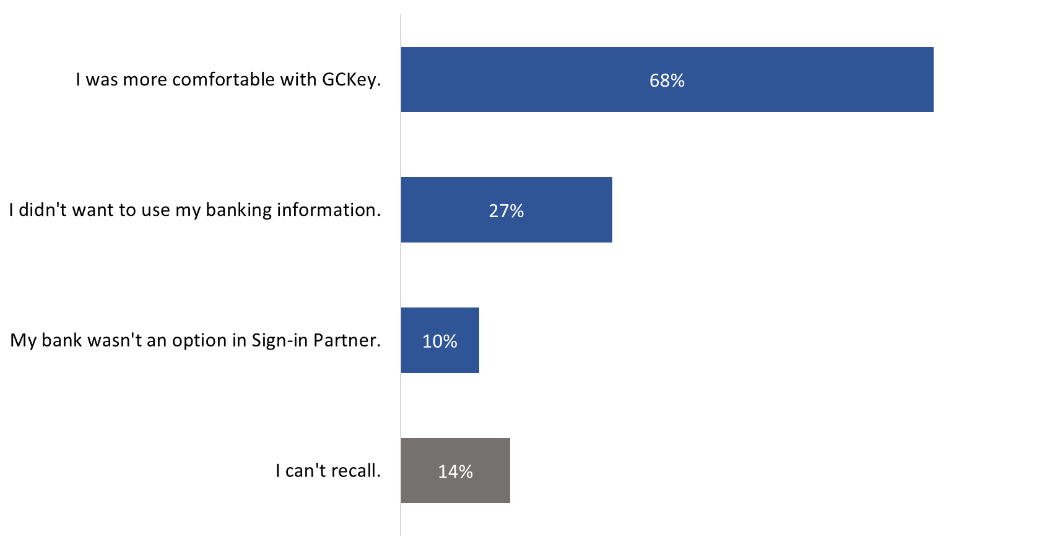Base: n=351; respondents who registered for My VAC Account using GCKey; no response: 1%
Q9. Why did you use GCKey to register? [Multiple responses accepted]

There are no subgroup differences to report. The reasons offered for using GCKey were similar regardless of the demographic profile of respondents or the frequency with which they use My VAC Account.

Most who used GCKey to register found the registration process easy
Three-quarters of respondents who used GCKey to register for my VAC Account (n=351) found the process at least somewhat easy. Specifically, 41% said it was ‘very’ easy and 34% said it was ‘somewhat’ easy. In contrast, 13% said the process to register for My VAC Account was ‘somewhat’ or ‘very’ difficult.

Figure 6: Ease of registration process
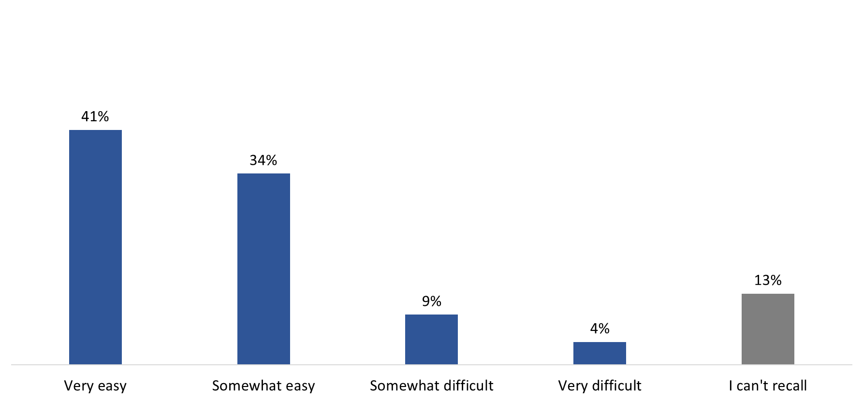

Base: n=351; respondents who registered for My VAC Account using GCKey
Q10. How easy or difficult was the process to register for My VAC Account?
There are no subgroup differences to report. The likelihood of finding the process ‘somewhat’ or ‘very’ easy did not differ by demographic profile nor the frequency with which respondents use My VAC Account.

More than half did not know what a GCKey was or said there were too many steps
Among respondents who used GCKey to register for My VAC Account and found the process difficult (n=44), more than half said this was because they did not know what GCKey was (26 respondents) or because there were too many steps to register (23 respondents). Following this, 19 respondents said it took too long to register using GCKey, while 12 respondents experienced trouble linking their VAC file to their account. Several respondents found registration difficult for some other reason, including, for example, lacking computer literacy, lack of familiarity with the terminology, and difficulties with the username and password.

8 in 10 agree the steps required to register are justified
Eighty-one percent of those surveyed agreed that the steps required to register for My VAC Account justifies the security it provides, including 40% who ‘strongly’ agreed. Relatively few (7%) disagreed with the statement. Views of My VAC Account holders are more positive now than in previous years—in 2017, 76% of respondents agreed or ‘strongly’ agreed and, in 2019, 70% did so.

Figure 7: Agreement with steps required for registration

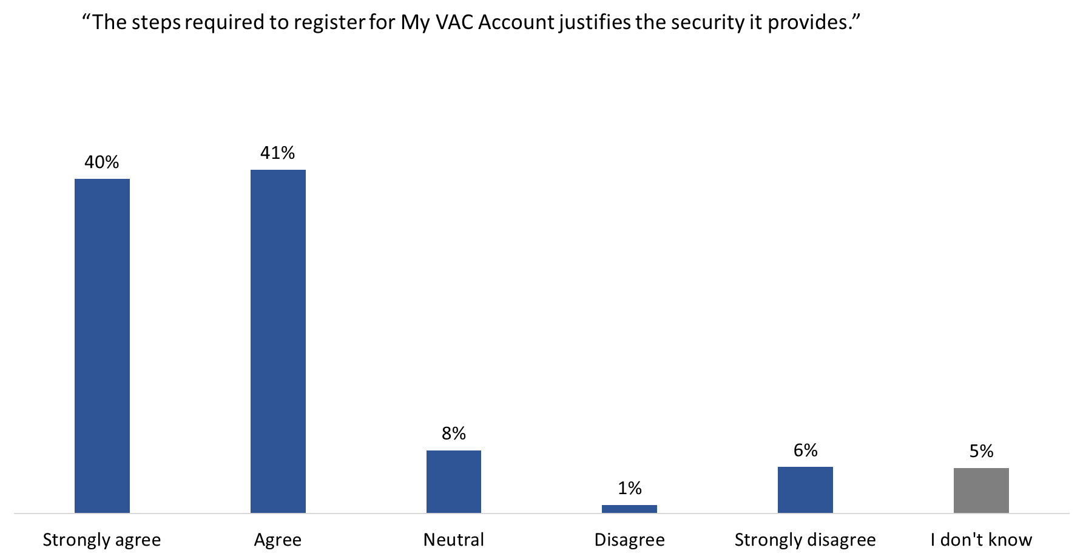

Base: n=650; all respondents
Q12. To what extent do you agree or disagree with the following statement: “The steps required to register for My VAC Account justifies the security it provides.”

Those aged 60 and older (49%) were more likely to ‘strongly’ agree that the steps required to register for My VAC Account justifies the security it provides, as compared to 35% of those 40 to 59 years of age and 31% of those 18 to 39.

General Use of My VAC Account
This section of the report focuses on clients’ general use of My VAC Account, including how they first learned of the online service, the frequency with which they use their account, and the features they have accessed in My VAC Account. These areas were explored with survey respondents and focus group participants. Findings from the focus groups are offset from the survey findings by shaded boxes.

VAC staff and the CAF – top sources of awareness of My VAC Account
Nearly half of survey respondents first heard about My VAC Account from either a VAC staff member (25%) or from the Canadian Armed Forces (CAF) (21%). Following this, smaller and similar proportions mentioned word of mouth, such as from a friend or colleague (14%), information sent to them by VAC staff (12%), or browsing the VAC website (12%). Four percent said they first learned about My VAC Account from a Veterans’ organization or event and 3% mentioned another government department or office.

Figure 8: Source of Awareness
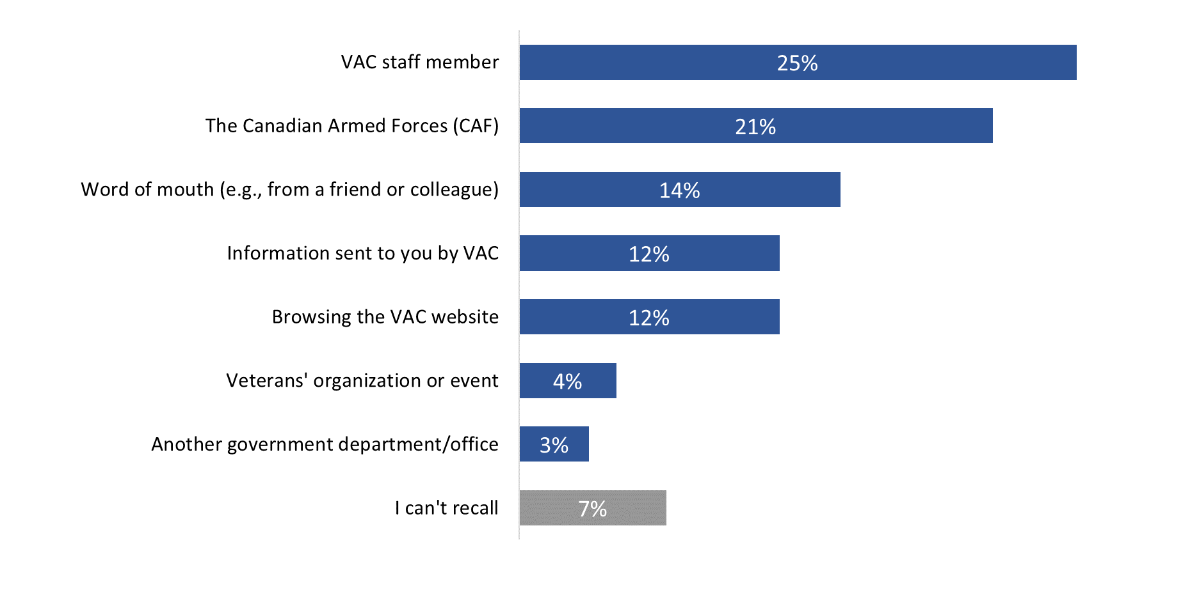
Base: n=650; all respondents
Q5. How did you first learn about My VAC Account?

Clients aged 60 and older were more likely than clients 18 to 59 years of age to have first heard about My VAC Account while browsing the VAC website (17%) or through information sent to them by VAC (18%). In contrast, those aged 18 to 39 were more apt to have said they first learned about My VAC Account through the Canadian Armed Forces (CAF) (36%), as compared to 22% of those aged 40 to 59, and 15% of those aged 60 and older who said the same. Additionally, Francophones (20%) were more likely than Anglophones (10%) to have said they learned about My VAC Account while browsing the Department’s website.

Approximately half use My VAC Account weekly
By design, all survey respondents had used My VAC in the past 12 months, including 96% who had done so in the past six months.

When asked how frequently they use My VAC Account, approximately half said they do so weekly, either several times a week (26%) or about once a week (23%). Few (10%) use their account daily. At the other end of the spectrum, roughly 4 in 10 use their account less than once a month (15%) or about once a month (24%).

Figure 9: Frequency of Use
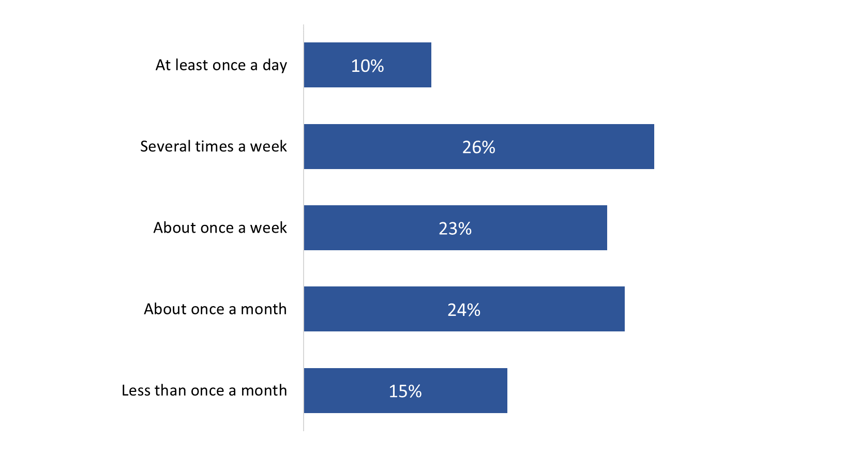
Base: n=650; all respondents
Q4. On average, how often would you say you use My VAC Account?

Respondents aged 60 and older reported using My VAC account less frequently than those between the ages of 40 and 59 years: 21% of clients aged 60+ said they use My VAC Account less than once a month as compared to 11% of those aged 40 to 59.

Focus Group Findings
Like survey respondents, focus group participants’ use of My VAC Account varies, but it is relatively frequent. Most clients who participated in a focus group said they use My VAC Account at least a few times a week. Several participants said they use My VAC Account daily while a few said they use it monthly. When asked if there was anything they would not use My VAC Account for, participants said ‘no’. They could not identify any type of transaction or interaction for which they would not use My VAC Account.

Half or more have used most My VAC Account features
Survey respondents were asked which features they have accessed in My VAC Account. Half or more have used most of the features, with the vast majority having applied online for VAC benefits and services (89%) and received correspondence from VAC in their account inbox (85%). In addition, approximately 8 in 10 each have communicated with VAC staff through secure messaging (83%), viewed a summary of their benefits (82%), and uploaded documents to support their application (79%). Seven in 10 (70%) have used My VAC Account to update their personal information, while smaller proportions signed up for direct deposit (63%) and added their email address to receive email notifications (59%).

The full list of features accessed in My VAC Account can be found in Figure 10.

Figure 10: Use of Features
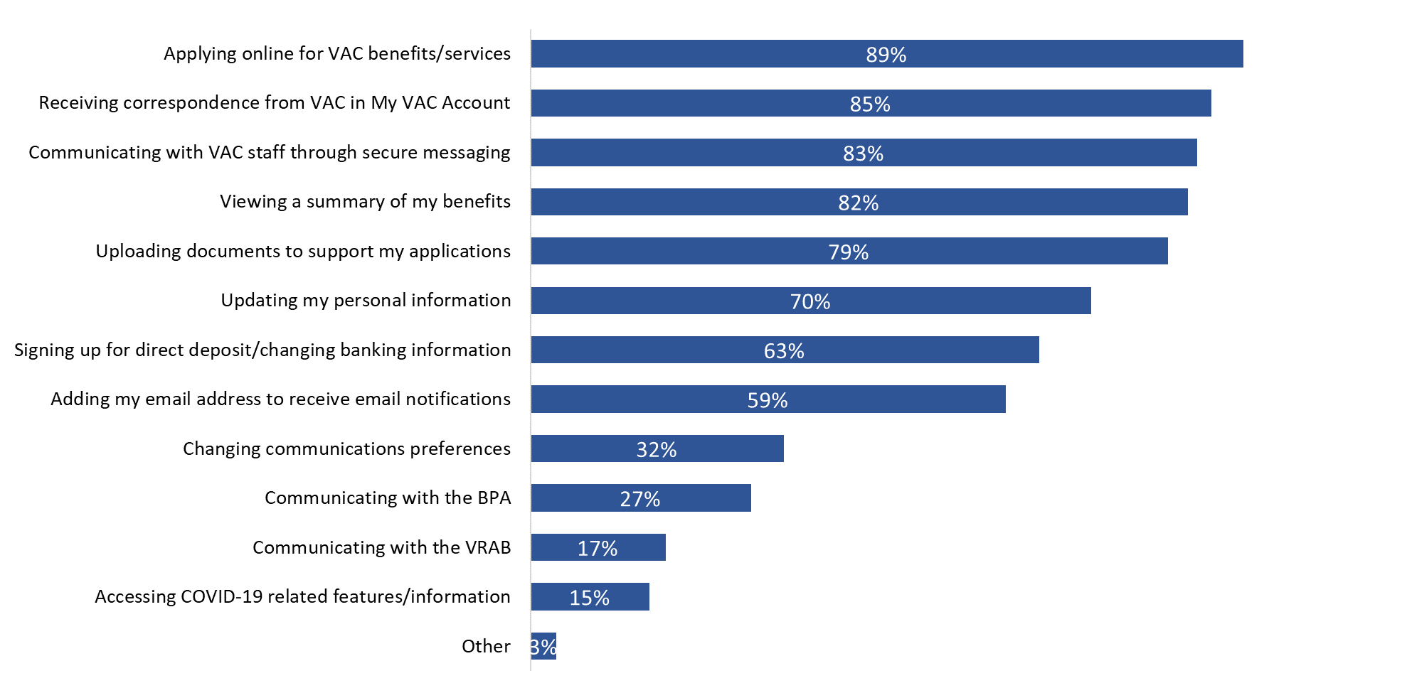
Base: n=650; all respondents. [Multiple responses accepted].
Q6. Which of the following features have you accessed in My VAC Account?

Compared to those who use My VAC Account less than once a month, those who do so once a month or more were more likely to report having applied for benefits online, received correspondence from VAC, and uploaded documents to support their application via My VAC Account.

In addition, those who use My VAC Account more than once a week were significantly more likely to have reported using the following features:
- Viewing a summary of their benefits through My VAC Account (89%).
- Communicating with VAC staff through secure messaging (86%).
- Updating their personal information (76%).
- Signing up for direct deposit or changing their banking information (69%).
- Adding their email address to receive email notifications from My VAC Account (69%).
- Communicating with the Bureau of Pensions Advocates (35%).

Retired CAF members were significantly more likely to report using My VAC Account to view a summary of their benefits (87%) and to communicate with VAC through secure messaging (85%). Conversely, still serving RCMP members were more likely to have applied online for VAC benefits and services (97%) or uploaded documents to support their application (92%) through My VAC Account, while retired RCMP members were more likely to have used their account to view a summary of their benefits (88%).

Focus Group Findings
Like survey respondents, focus group participants also reported using a variety of My VAC Account services, including the following (* = services used most often):
- learning about benefits/services*;
- applying for benefits/using web forms*;
- Track your Applications Tool*;
- secure messaging*;
- direct deposit;
- Member Transition Task List (though it lacks personal tailoring);
- Newsletter;
- checking pay dates and amounts;
- updating information; and
- basic research/useful links.

For focus group participants, the most important services available through My VAC Account include news and updates, secure messaging, tracking applications, and uploading documents, applications as well as forms. According to participants, all of these services allow for faster, more effective, and efficient interactions with VAC.

Asked why they use My VAC Account to access these services, participants explained that they do so because it is faster and more efficient, available 24/7, and provides trail or record of their interactions with the Department. One participant reported using My VAC Account more now because of the COVID-19 pandemic, while another said that, even if a VAC office was open for service, it is not located a reasonable distance from home.

Use of Selected My VAC Account Features/Tools
This section of the report focuses on My VAC Account users’ use and perceptions of the following features or tools: Member Transition Task List, the Wait Time Tool, and the Track your Applications Tool.

The Member Transition Task List and the Wait Time Tool were only assessed by those who completed the survey; therefore, these sub-sections do not refer to findings from the focus groups.

1. Member Transition Task List

Few have used the Member Transition Task List; those who have, found it helpful
Few (8%) surveyed My VAC Account holders have used the Member Transition Task List. Eighty-six percent of those who reported having used the service (n=56) found it helpful, including 59% who said it was ‘very’ helpful. Very few (5%) said the task list was not at all helpful.

Figure 11: Helpfulness of information found on Member Task List
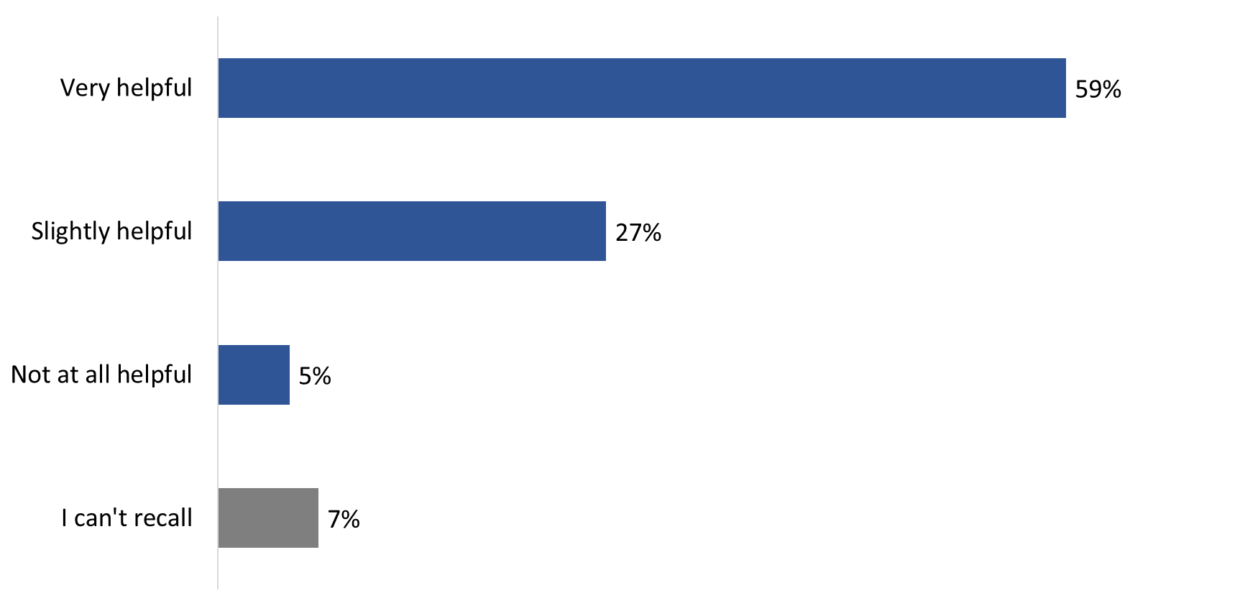
Base: n=56; respondents who have used the Member Transition Task List
Q30. How helpful was the information you found on the Member Transition Task List?

There are no significant subgroup differences to report due to the small sample size.

2. Wait Time Tool

Two-thirds have used the Wait Time Tool; half found processing times at least slightly helpful
Two-thirds (67%) of survey respondents have used the Wait Time Tool. Among those who have used the tool (n=434), half said the average processing times were at least slightly helpful: 6% found them ‘very’ helpful, 21% ‘moderately’ helpful, and 24% ‘slightly’ helpful. Conversely, a significant minority (46%) said the average processing times found in the Wait Time Tool were not at all helpful.

Figure 12: Helpfulness of the Wait Time Tool
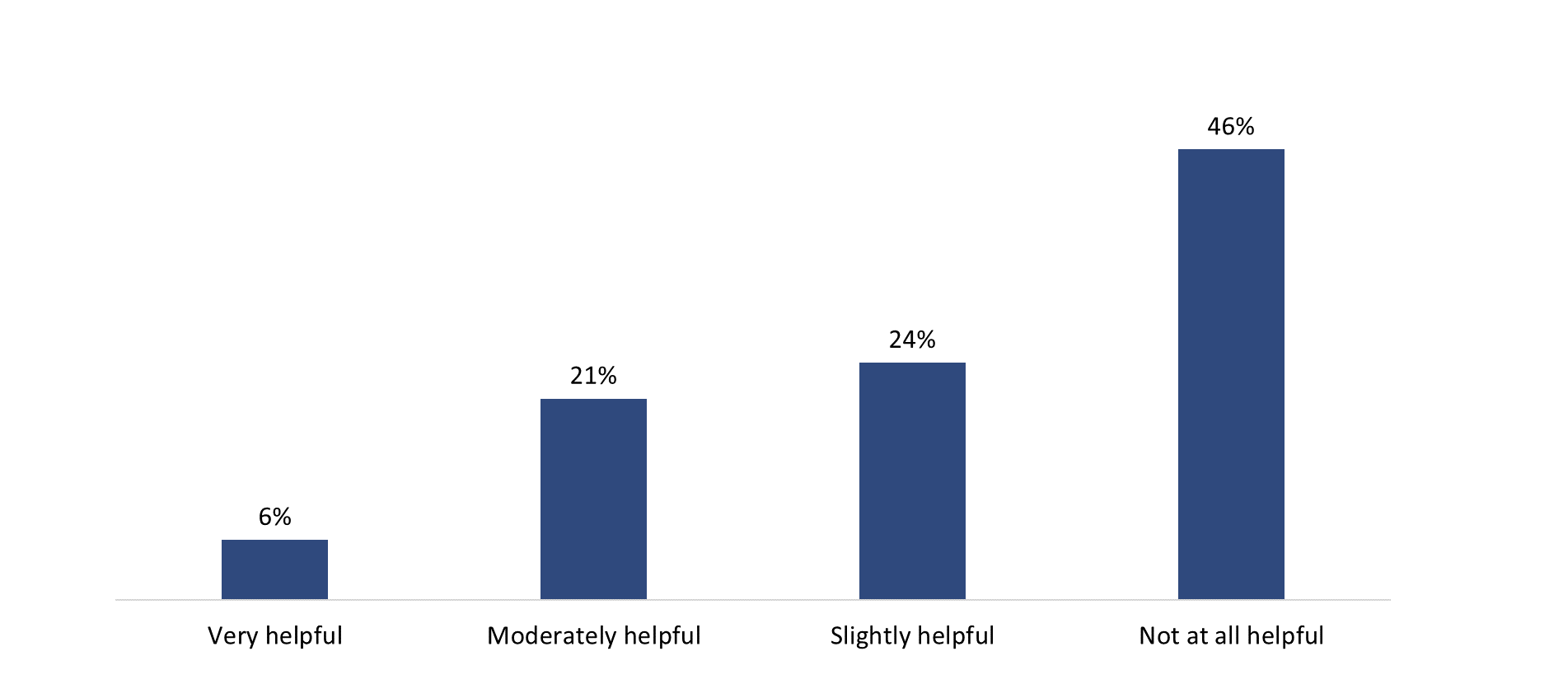

Base: n=434; respondents who used the Wait Time Tool
Q36. How helpful were the average processing times found in the Wait Time Tool?

There are no subgroup differences to report. Views of the helpfulness of the average processing times were similar regardless of the demographic profile of respondents or the frequency with which they use My VAC Account.

Divided views on experience using the Wait Time Tool
While 46% of survey respondents who have used the Wait Time Tool noted that the feature told them approximately when to expect a decision on their application, a similar proportion (48%) said this was not the case.

Figure 13: Approximate time expected on application
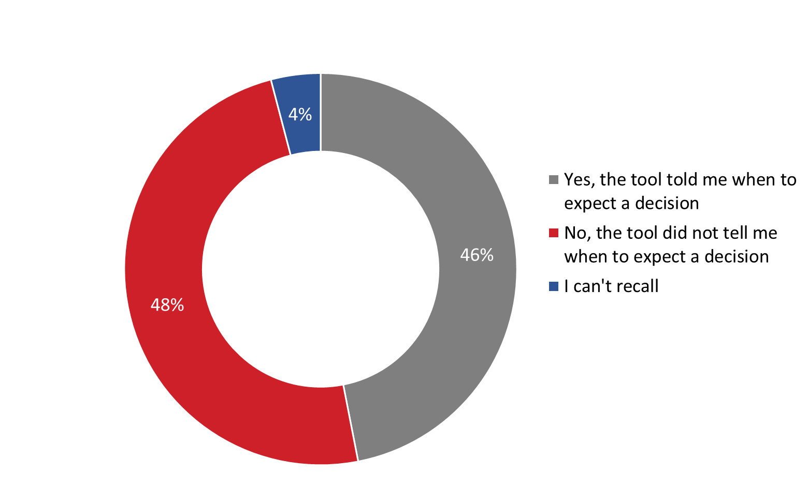

Base: n=434; respondents who used the Wait Time Tool
Q37. Did the Wait Time Tool tell you approximately when to expect a decision on your application?

Respondents from Quebec (65%) were significantly more likely than those from Atlantic Canada (42%) and the West (41%) to say the Wait Time Tool did not tell them when to expect a decision on their application.

3. Track your Applications Tool

Most have used Track your Applications; those who have found it at least somewhat helpful
The vast majority (90%) of survey respondents said they used the Track your Applications Tool. This was also the tool used by the greatest proportion of My VAC Account holders in 2017 (85%) and in 2019 (91%).

Those who used Track your Applications (n=582) were asked if the tool helped them find out the status of their application. In response, the majority said the tool was at least somewhat helpful: 39% said Track your Applications helped them find out the status of their application and 45% said it did so ‘in part’ or ‘somewhat’. Conversely, 15% of those who used the tool said it did not help them find out the status of their application.

Figure 14: Usefulness of Track your Application Tool
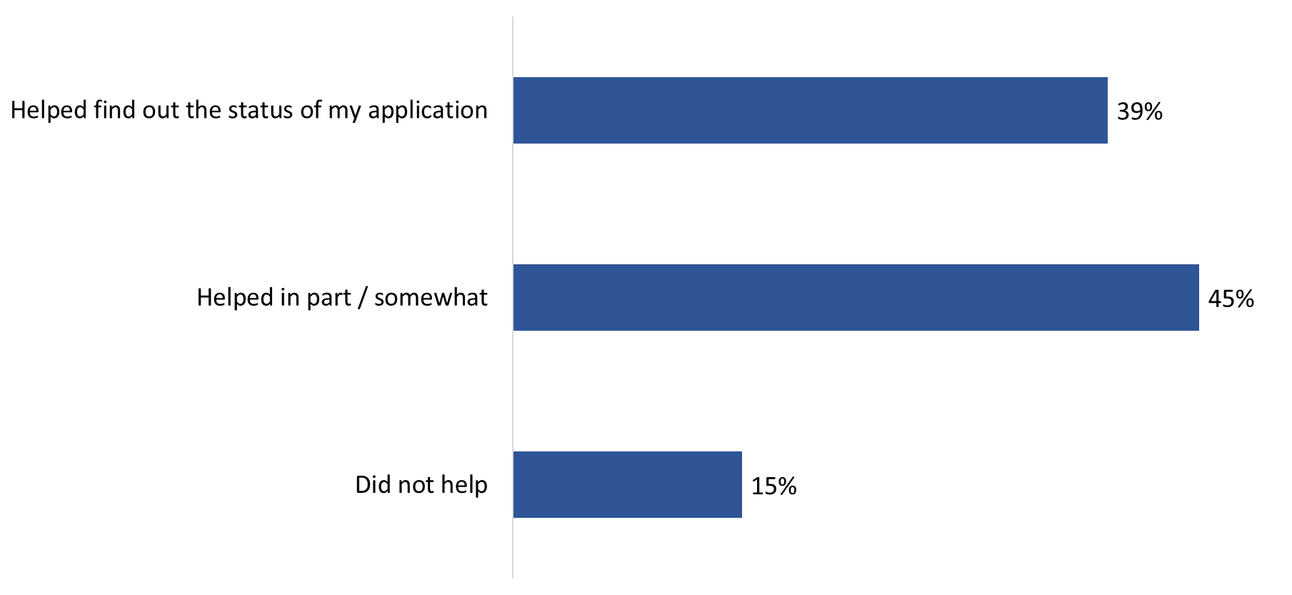
Base: n=582; respondents who used Track your Applications Tool
Q32. Did ‘Track your applications’ help you find out the status of your application?

Those aged 60 and older (48%) were more likely than 18 to 39 year olds (26%) to have said Track your Applications helped them find out the status of their application.

Focus Group Findings
Virtually everyone who participated in a focus group had occasion to need to contact VAC to check on the status of an application. All but one of the focus group participants reported having used Track your Applications in My VAC Account to view the status of an online application. The service was described as easy to navigate in general, though one participant specified that it is easy to use on a computer, but not on a mobile phone. Issues with Track your Applications have to do mainly with delays and lack of details (e.g., when was my file last looked at?), not navigation or ease of use. In other words, the tool functions fine technically, but users are not learning anything substantive or meaningful regarding the status of their applications.

Many said Track your Applications is lacking detail
Those who had used Track your Applications (n=582) were asked if the tool provides enough detail about the status of their application and how quickly their application is being processed. Many (69%) said the tool is lacking in detail; conversely, approximately one-quarter (26%) felt the tool provides sufficient detail.

Figure 15: Details available through Track Your Applications Tool

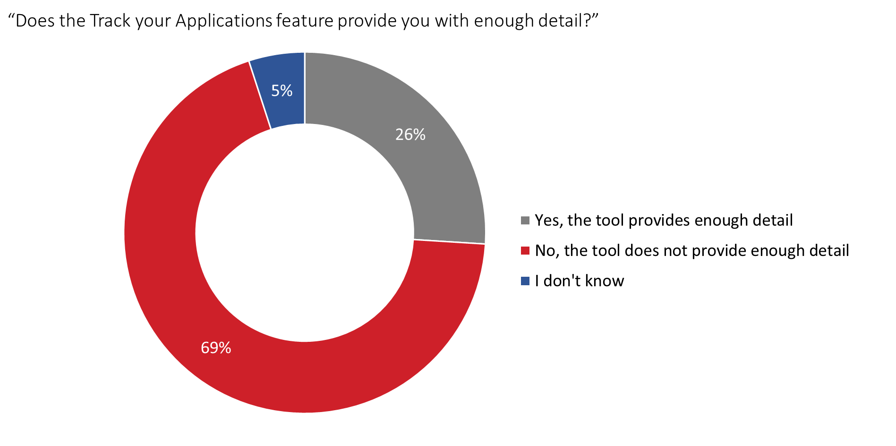
Base: n=582; respondents who used Track your Applications Tool
Q33. Does the ‘Track your applications’ feature provide you with enough detail about the status of your application and how quickly your application is being processed?

Those 18 to 39 years of age (80%) were more likely than those aged 60 and older (61%) to have said the feature does not provide them with enough detail about the status of their application and the processing time.

Lack of information, inaccurate information – main reasons the tool is viewed as missing details
Survey respondents who said Track your Applications does not provide enough detail about the status of their application and how quickly it is being processed (n=367) were asked to explain why they felt this way. Similar, and often overlapping, reasons were provided, including: a lack of information at the various steps in the application process (30%), inaccurate timelines and delays (29%), and the provision of vague or general information (25%). Nine percent mentioned that the feature does not provide an estimated date of approval, and 17% pointed to other very specific reasons which did not lend themselves to coding.

Figure 16: Reason(s) Track Your Applications was missing details

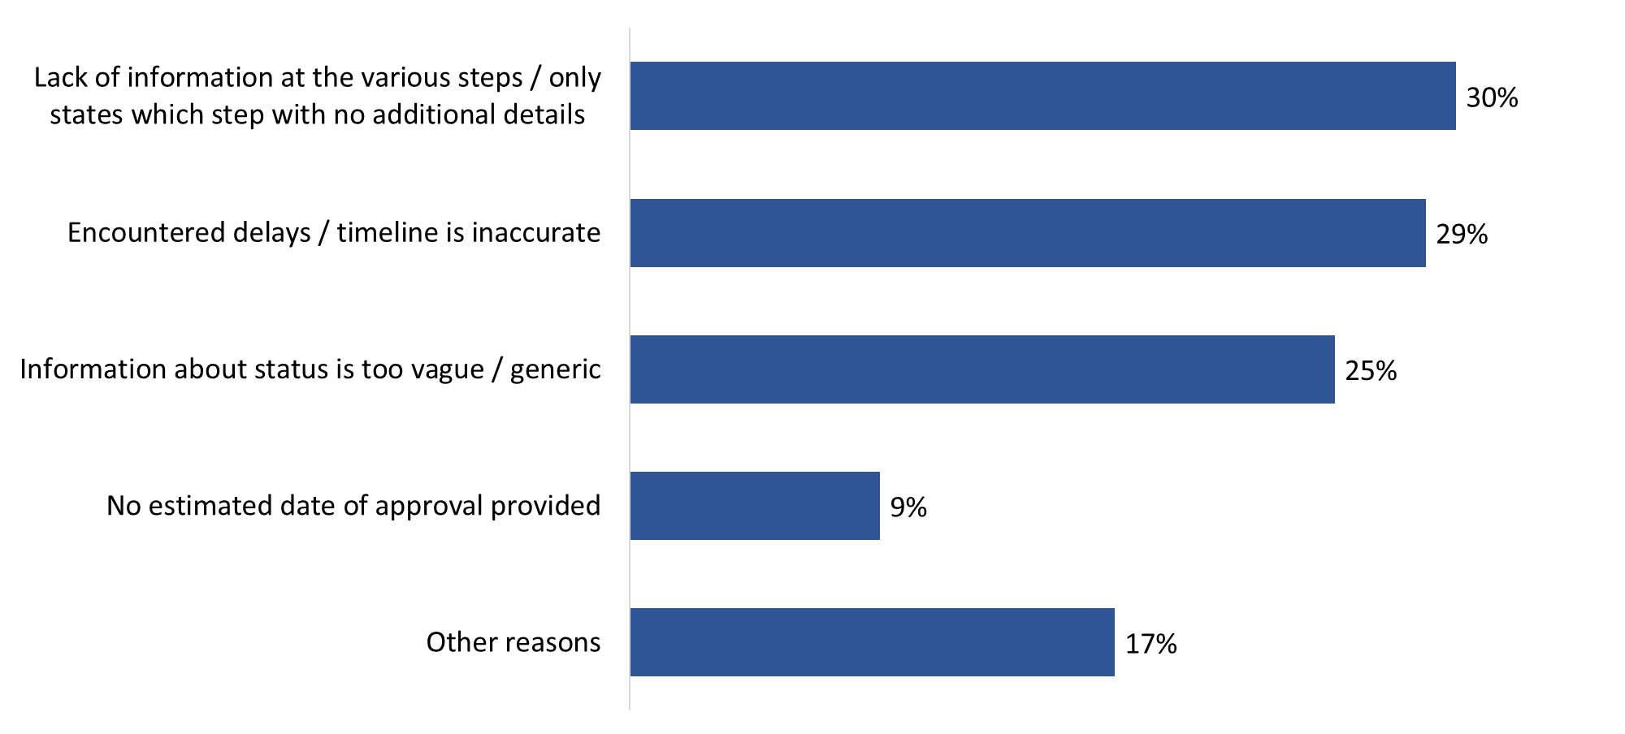

Base: n=367; those who said the tool does not provide enough detail
Q34. Why did you say that the ‘Track your applications’ feature did not provide you with enough detail about the status of your application and how quickly it is being processed?[multiple responses accepted]

There are no significant subgroup differences to report due to small sample sizes.

These respondents were also asked what other information about the status of their application they would like to have included in Track your Applications. In response, many (60%) said more accurate and personalized wait times combined with the ability to see the position of their file in the processing queue. Other requests included better communication of reasons for delays in application processing (i.e., personalized explanations), a clearer description of what each step in the process entails, the ability to view which agent is reviewing a file and how to contact that decision-maker, and information on what document(s), if any, are missing in order to expedite the processing of a file.

Many of those who have not used Track your Applications said they had no need to
Survey respondents who have not used Track your Applications (n=68) were asked why they have not. The majority (59%) attributed their lack of use to ‘no need’. Following at a distance, 12% said they did not know about Track your Applications and 9% pointed to their perception that the tool seemed too complicated to use.

Figure 17: Reason(s) for not using the Track Applications Tool
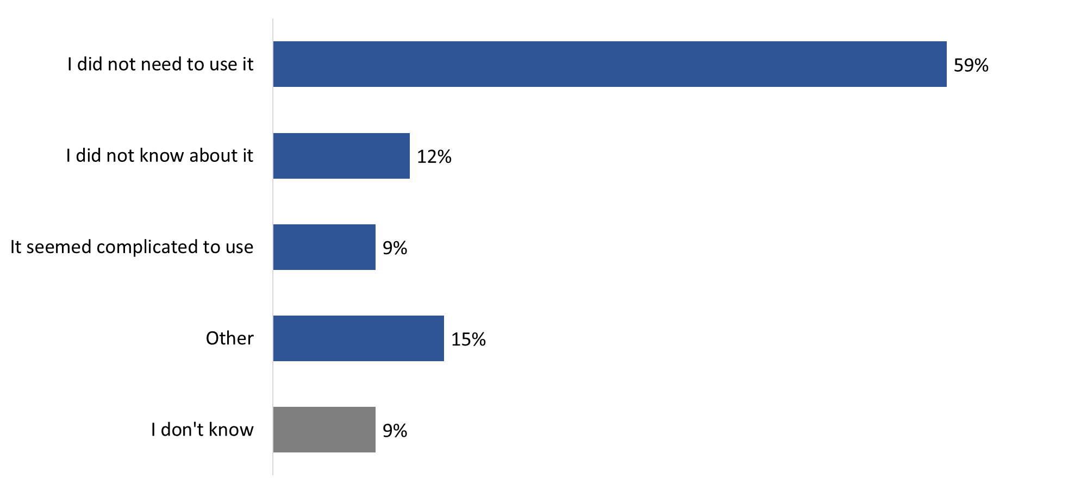
Base: n=68; respondents who have not used Track Applications Tool [Multiple responses accepted].
Q31. Earlier you indicated that you haven’t used the ‘Track your applications’ feature in My VAC Account to view the status of your application. Why is that?

There are no significant subgroup differences to report due to small sample sizes.

Focus Group Findings
All focus group participants said they consider it important to be able to track their applications. When asked why it is important, participants explained that they need the benefits and the ability to track the progress of their applications offers a sense of hope and recognition. Tracking, however, could be improved to be more useful. Currently, the information it provides is generic and not personalized (e.g., application is at stage 1,2,3,4). Related to this, it was observed that, because tracking information is general in nature, one might as well wait for the email indicating that the status of an application has changed since seeking out this information does not provide any meaningful details.

That being said, the general preference among focus group participants is to check the status of applications using the online tracking feature because of its 24/7 availability and because such tracking features are common now (i.e., everything is automated in general anyway). Preferences for other options, such as telephone, had to do with the fact that the online tracking function does not provide the kind of detail needed by applicants (e.g., ‘when was my file last examined’, ‘who examined it’, ‘where am I in the queue of applications being examined’). In other words, alternative modes of contact, such as telephone, are used to try to get specific information/details about the status of an application.

Focus Group Findings (cont’d.)
One participant observed that secure messaging is better than email when tracking applications because the service provides a feeling that those who use the channel are in contact with someone qualified to comment on their application as opposed to a call center employee, or at the very least someone who can access other sections of VAC to get answers to one’s questions. Phone contact was described as good in situations where one’s circumstances have suddenly changed, and if there is a big discrepancy between official and real wait times, e.g. I was told it would take 52 weeks and it has now been 72 weeks. On the negative side, it was noted that using the phone to track an application limits the availability of that resource to other Veterans calling VAC for other reasons.

Acknowledging receipt of documents (i.e. going from step 2 to step 3) is the most important stage for most participants because it means that everything is in place and nothing is missing in terms of information needed to adjudicate an application. In the words of one participant, this is an important stage because at this point the process is now out of your hands, i.e. you are just waiting/there is nothing more you can do.

Nearly everyone had contacted VAC for a follow-up when it comes to tracking applications. Reasons included delays (i.e., being stuck at a certain stage for a while), eligibility issues/application being withdrawn, changes to eligibility, programs and benefits, and documents being faxed to a wrong number. Follow-up was mainly by phone and/or secure messaging. Things identified as helping minimize the need to follow up included the following:
- Providing more detail about the status of an application, e.g., ‘we are now treating applications submitted between dates X and Y’, ‘we’ve received all your documents and we’re now …’, ‘your file was last examined/reviewed on …’.
- Explaining changes in wait times (e.g. here is why the wait times have changed by 20 weeks).
- More transparency about what is going on in general so that applicants do not feel the need to call/contact VAC for clarifications/explanations.

All focus group participants said they are receiving email notifications when the status of an online application changes. These were described as helpful but general, with some indicating that they would like more personalized details or at least a snippet about what has changed, especially since they typically have a number of applications in play, and it would be good to know which one has changed in terms of status. There was a widespread desire for a chat function that would allow applicants to learn about their applications’ status in real time. One participant would like a video conferencing function to do the same.

Use and Impressions of Secure Messaging
This section of the report discusses survey respondents’ experience contacting VAC through a secure message in My VAC Account.

Secure messaging was only explored in the survey; therefore, this section does not refer to findings from the focus groups.

More than half prefer to contact VAC through secure messaging

A small majority (59%) said they prefer contacting VAC through a secure message in my VAC Account. Following this, one-quarter (25%) prefer to use the phone, while 1 in 10 (10%) expressed a preference for email. Three percent said that visiting a VAC office is their preferred method for contacting VAC.

Figure 18: Preferred method for contacting VAC
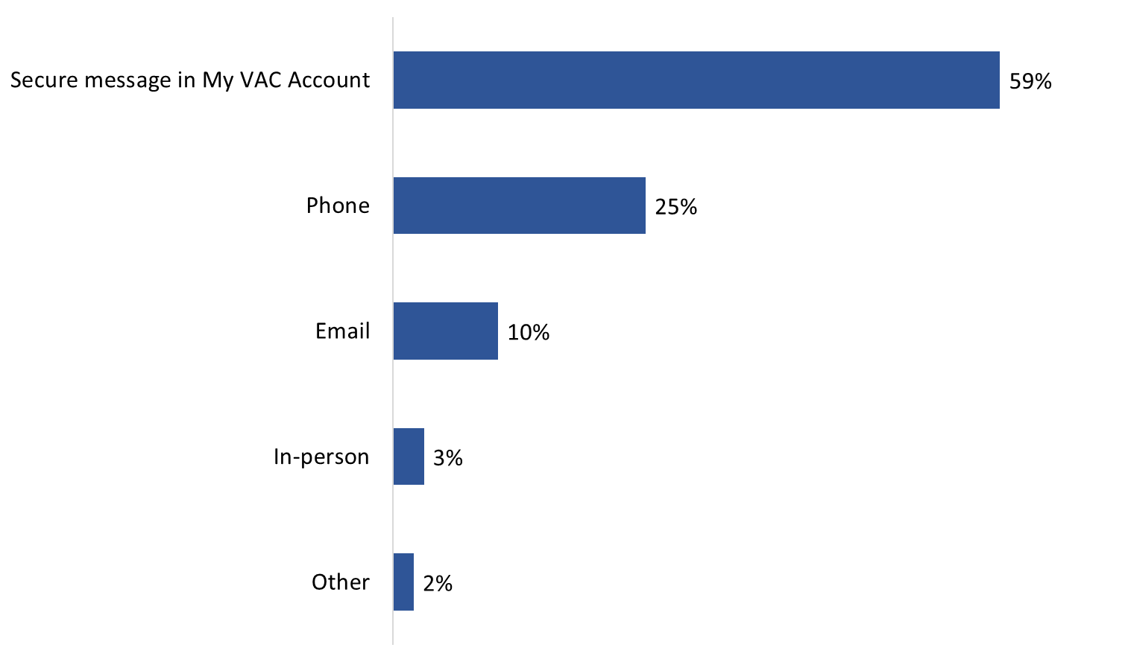
Base: n=650; all respondents; no response: 1%
Q13. What is your preferred method for contacting VAC?

Clients 18 to 39 years of age were more likely to say they prefer to contact VAC by phone (34%) as compared to My VAC Account users aged 60 and older (20%).

8 in 10 have used secure messaging in the past 12 months
In the past 12 months, 80% of those surveyed have tried contacting VAC through secure messaging (79% tried doing so in the past six months). Conversely, 15% had not tried to reach VAC via secure messaging in the past 12 months (and 4% could not recall). Use of secure messaging has increased significantly since the 2017 baseline survey, when 61% reported trying to connect through secure messaging, but it is unchanged since 2019 (when 81% tried secure messaging to contact VAC).

Figure 19: Use of Secure Messaging in past 12 months

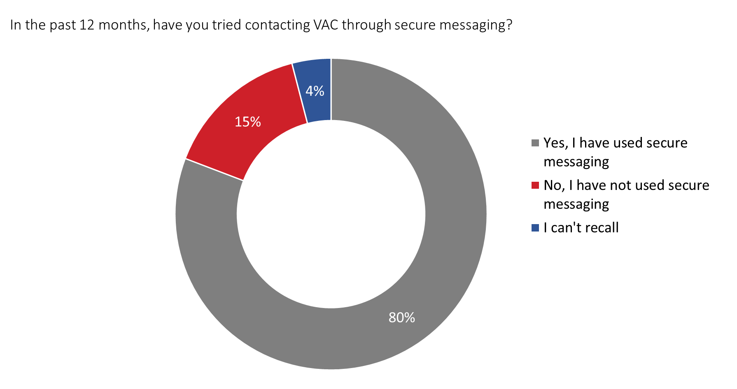
Base: n=650; all respondents
Q14. In the past 12 months, have you tried contacting VAC through secure messaging?

Those who used My VAC Account once a month or more were significantly more likely to report having used secure messaging in the past 12 months, as compared to those who use their account less than once a month (58%):
- 87% of respondents who use My VAC Account more than once a week.
- 86% of respondents who use My VAC Account approximately once a week.
- 82% of respondents who use My VAC Account approximately once a month.

Frequency of connecting with VAC staff via secure messaging varies significantly
Those who tried connecting with VAC staff through secure messaging in the past six (n=515) or 12 (n=522) months were asked to indicate how many times they connected directly with VAC staff during this timeframe. The frequency of connecting varies significantly, as indicated in Figure 20, but the vast majority said they successfully connected at least once (10% of those who tried in the past six months and 6% of those who tried in the past 12 months did not connect via secure messaging).

Figure 20: Frequency of Connecting with VAC Staff via Secure Messaging

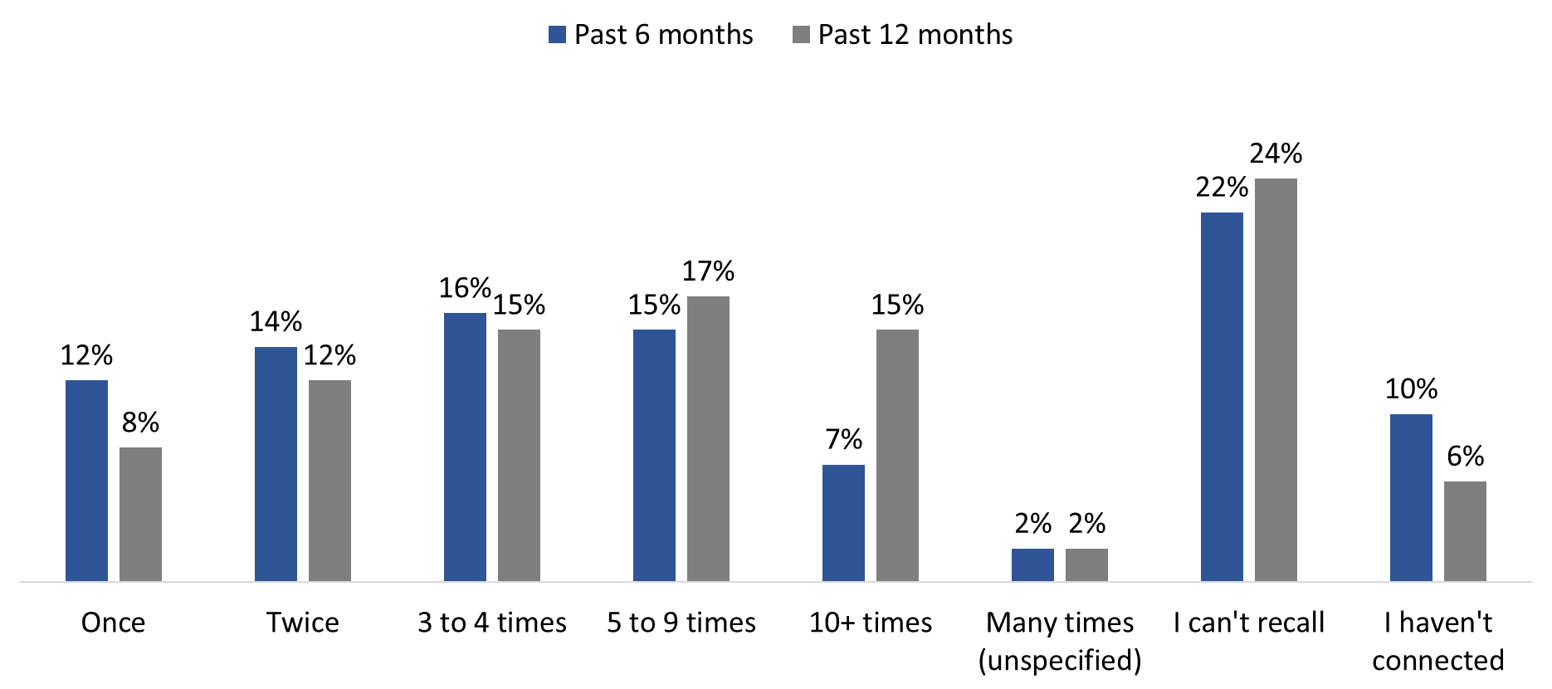

Base: those who tried contacting VAC through secure messaging in the last year (n=522) or last 6 months (n=515); no response: 2%
Q15. Approximately how many times have you connected directly with VAC staff through secure messaging? - In the past 12 months, In the past 6 months

There are no subgroup differences to report.

Most waited between 1 to 5 business days for a secure message reply
The majority of respondents expected to wait one to two (43%) or three to five (43%) business days to receive a reply through secure messaging. Expectations generally aligned with My VAC Account users’ experience. In actuality, 38% waited an average of one to two business days while 47% waited an average of three to five business days to receive a reply through secure messaging. Few reported waiting less than one business day (3%) or more than five business days (9%) to receive a response to a secure message.

Figure 21: Waiting time for Secure Messaging reply

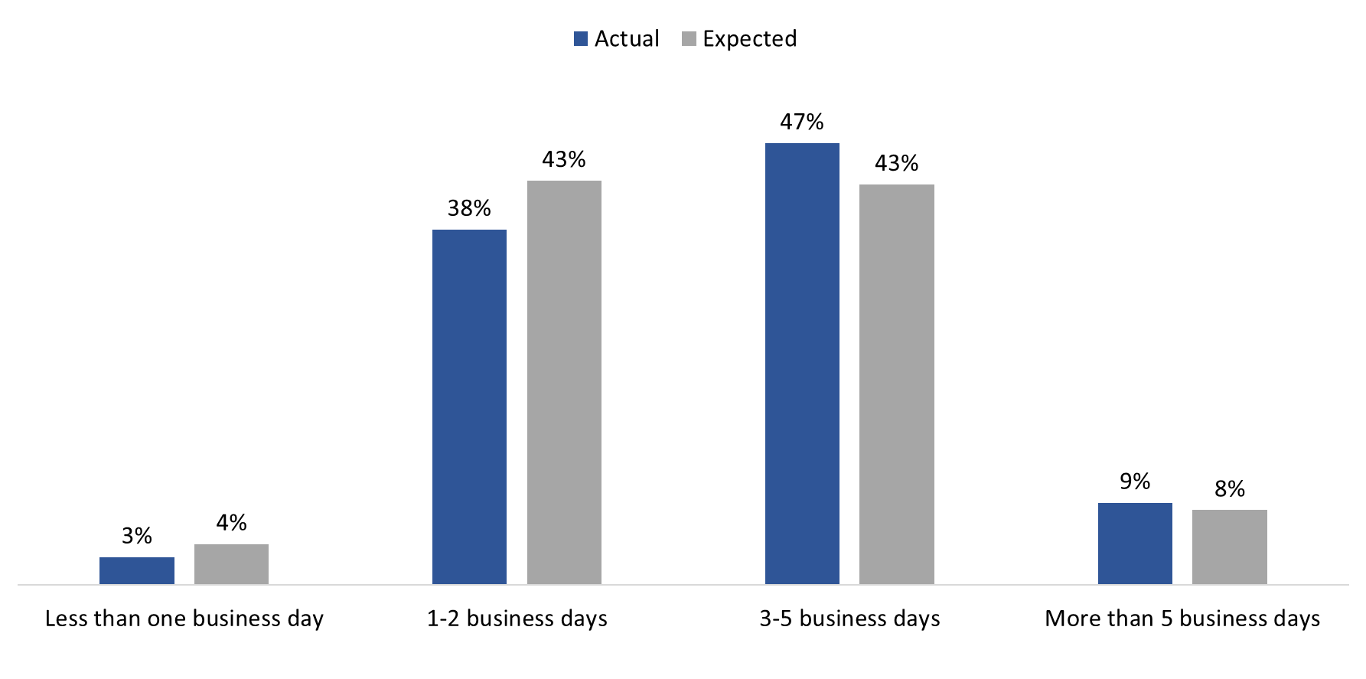
Base: n=501; those who connected directly with VAC staff through secure messaging in the last year.
Q16. On average, how long did you wait to receive a response? (no response: 3%)
Q17. How long did you expect to wait for a secure message reply? (no response: 1%)

Compared to 2017, more My VAC Account users reported waiting three to five business days for a response (47% versus 32% in 2017). Wait times are unchanged since 2019, when 46% waited three to five business days to receive a response.

Female respondents were more likely than male respondents to have waited one to two business days (53% versus 36%) and less likely to have waited three to five business days (33% versus 50%). In addition, retired RCMP members were more likely than retired CAF members to report having waited one to two business days for a response (57% versus 34%). When it came to wait time expectations, those aged 60 and older (53%) were most likely to have expected to wait three to five business days to receive a secure message reply.

One-third have used secure messaging to connect with their case manager
Among those who have used secure messaging in the past 12 months (n=501), one-third (33%) said they connected with their case manager, while approximately one-quarter (26%) had not done so. Notably, 37% of these My VAC Account users indicated they do not have a case manager (4% could not recall if they connected with their case manager).

Figure 22: Connecting with case manager via Secure Messaging

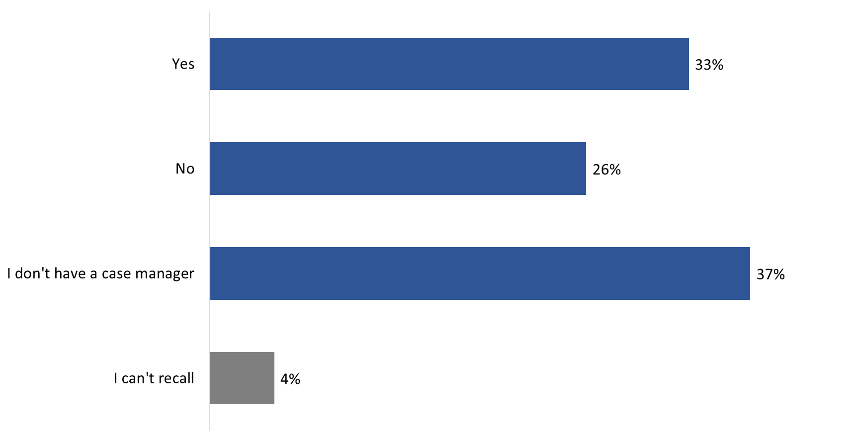

Base: n=501; those who connected directly with VAC staff through secure messaging in the last year
Q18. Did you connect with your case manager when using secure messaging?

Those aged 60 and older (44%) were more likely to report not having a case manager as compared to those who are between the ages of 40 and 59 (31%). Still serving CAF members were also more likely to report not having a case manager (58%) compared to fewer than one-third of retired CAF members (30%) who said the same.
1 in 5 would like to connect with other VAC staff using secure messaging
When asked if there were other VAC staff they would like to contact through secure messaging, 18% of those who used secure messaging in the last 12 months answered in the affirmative. They identified application adjudicators or decision-makers (28 respondents), case managers (15 respondents), or someone specific, either a named individual or VAC program, (11 respondents). The majority (78%) of these respondents did not know who else from VAC they would like to contact through secure messaging.

Majority are satisfied with their experience using secure messaging
Respondents were asked to rate their level of satisfaction using secure messaging to connect with VAC staff in the past six and 12 months. Two-thirds (66%) said they are satisfied or ‘very’ satisfied with their experience using secure messaging over the past six and 12 months. Satisfaction levels are the same, regardless of the timeframe. Those not satisfied were more likely to express some level of dissatisfaction than to be neutral (neither satisfied nor dissatisfied).

Figure 23: Satisfaction with secure messaging system

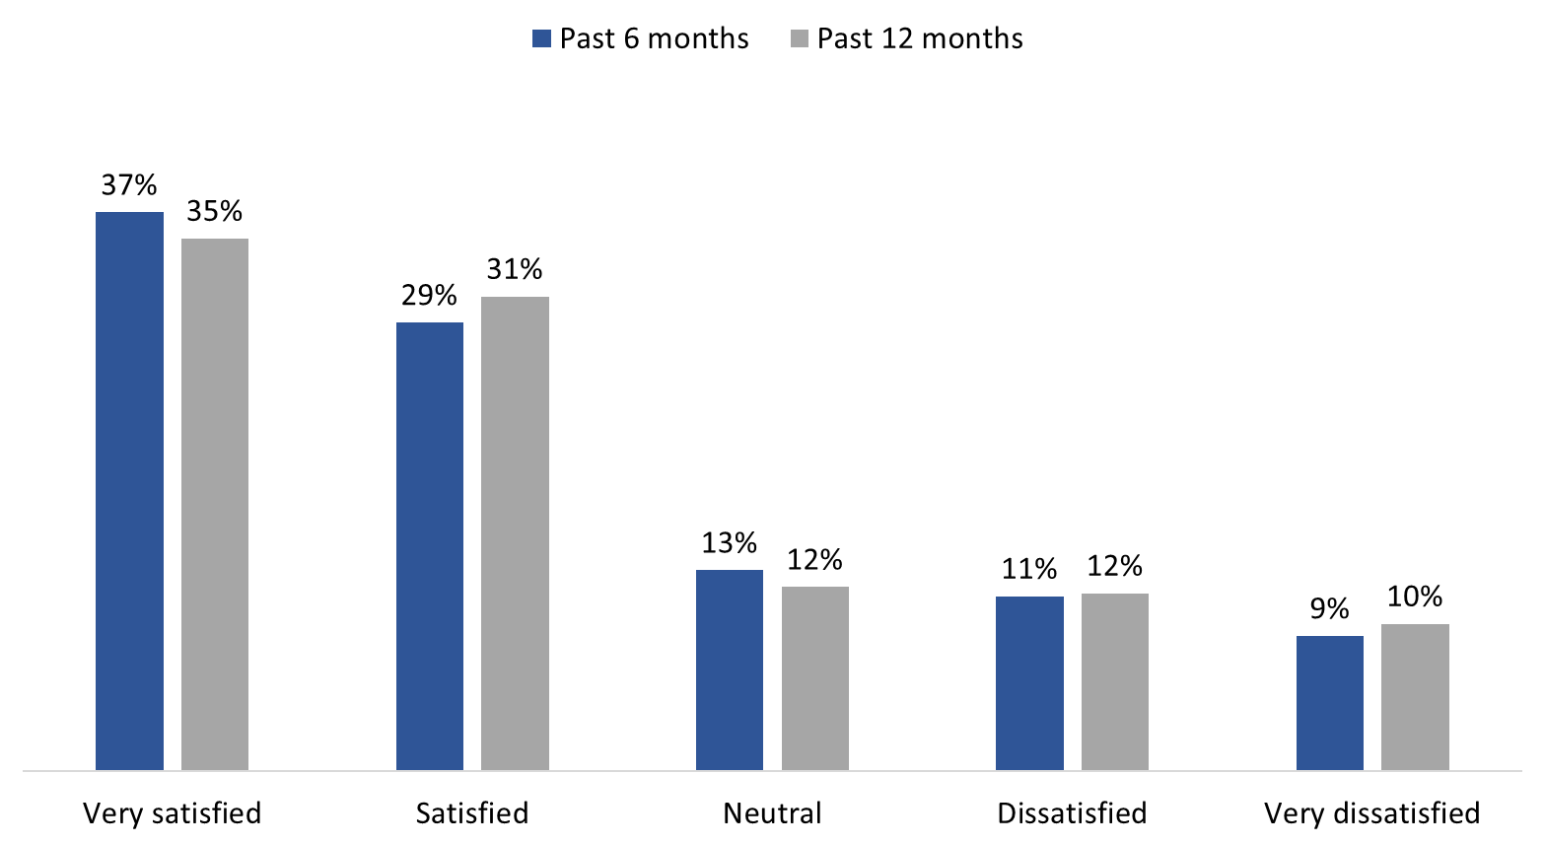

Base: Respondents who have used secure messaging in the past 6 or 12 months; no response: 1%
Q20A. How satisfied, or dissatisfied, have you been with your experience using secure messaging to connect directly to VAC staff in the past 6 months? (n=457)
Q20B. How satisfied, or dissatisfied, have you been with your experience using secure messaging to connect directly to VAC staff in the past 12 months? (n=462)

There are no subgroup differences to report. Satisfaction did not differ by demographic profile nor the frequency with which respondents use My VAC Account.

9 in 10 did not have any difficulties using secure messaging
The vast majority (90%) of those who used secure messaging in the past 12 months did not face any difficulties with the service. Survey respondents who did face difficulties (n=35) pointed to several issues: not knowing where to send the message (i.e., VAC, BPA, VRAB) (15 respondents), not receiving a timely response (i.e., it took too long) (14 respondents), and not having their issue(s) resolved (14 respondents) or their question(s) answered (12 respondents).

5 in 10 needed to re-contact VAC to have a follow-up conversation
Just over half (55%) of survey respondents who used secure messaging to communicate with a VAC staff member, or their case manager, said they needed to re-contact VAC to have a follow-up conversation. Conversely, approximately one-third (36%) did not require a follow-up conversation (8% could not recall whether they needed to re-contact VAC).

Figure 24: Need for follow up with VAC staff
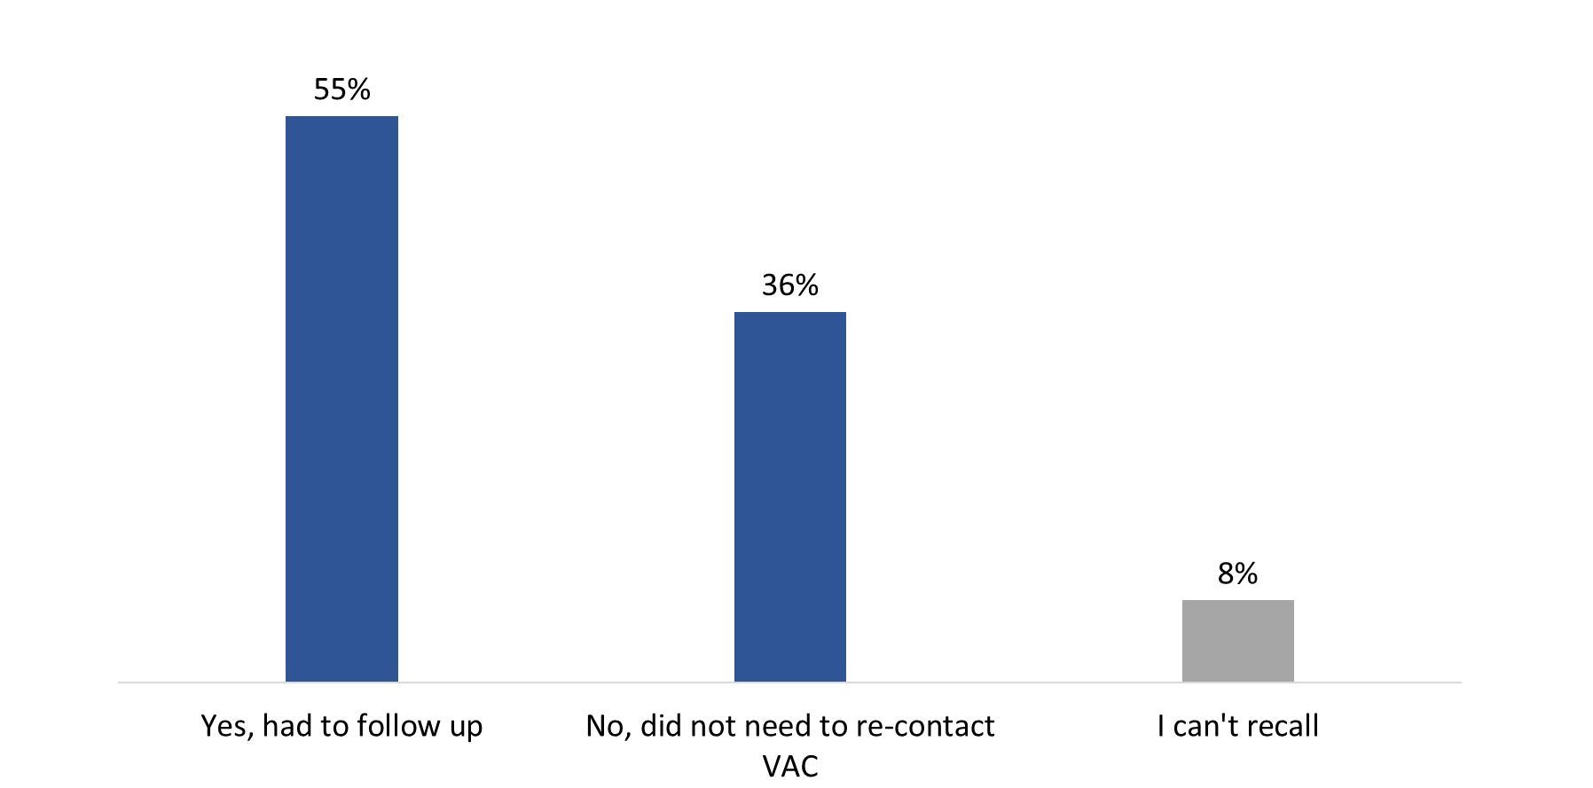
Base: n=501; respondents who have used secure messaging in the past 12 months
Q23. After communicating through secure messaging with a VAC staff member, or your case manager, have you needed to re-contact VAC to have a follow-up conversation?

There are no noteworthy subgroup differences.

Among respondents who needed to re-contact VAC to follow up after using secure messaging to connect with staff (n=278), a majority did so through secure messaging again (71%). Slightly more than half followed up with VAC by phone (56%). Fewer said they followed up in some other way (5%).

Variety of suggestions offered to improve secure messaging
Survey respondents who had tried contacting VAC through secure messaging in the last year (n=522) were asked if they had any suggestions to offer to improve the service. In response, one-quarter of these respondents provided substantive feedback. Specifically, they suggested that VAC provide accurate and clear responses (33 respondents), improve the functionality of the channel, such as allowing for old messages to be deleted or attachments to be uploaded (17 respondents), provide a ‘live’ chat option or faster turnaround times (16 respondents), process applications faster (14 respondents), and offer the ability to contact a case manager or a specific VAC staff member through secure messaging (14 respondents).

Communications Preferences
This section of the report discusses My VAC Account users’ communications preferences. Issues were explored with survey respondents and focus group participants. Findings from the focus groups are offset from the survey findings by shaded boxes.

Majority prefer to receive updated through My VAC Account

The majority (61%) of My VAC Account users surveyed would prefer to receive updates about VAC programs, services, and benefits through My VAC Account. Following this, roughly one-third (32%) indicated that email is their preferred method. Two percent prefer mail, and 10 respondents or fewer expressed a preference for telephone or in-person service channels.

Figure 25: Preferred method to receive VAC updates
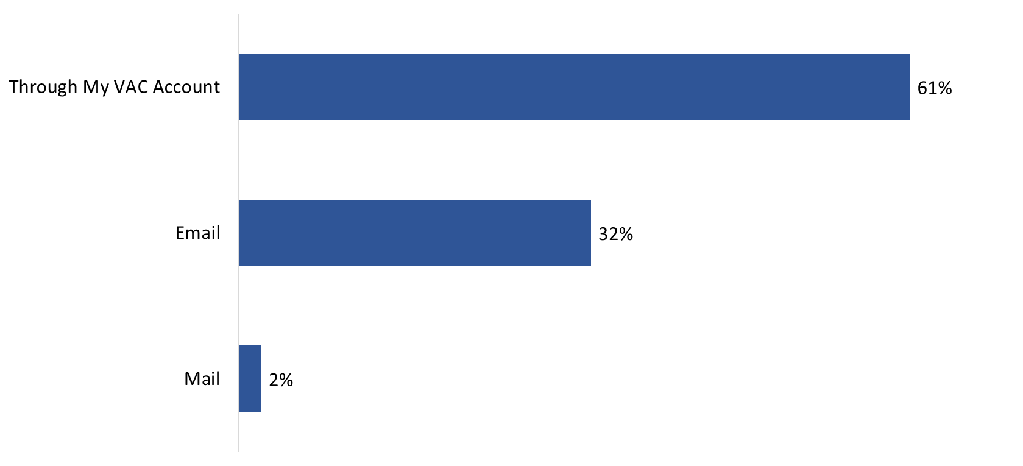
Base: n=650; all respondents
Q26. How would you prefer to receive updates about VAC programs, services, and benefits?

Communications preferences did not differ by demographics nor frequency of using My VAC Account.

Many would like to read about changes to benefits, updates to My VAC Account, and new programs and services
Many survey respondents would like to read about the following in the News and Notifications Section at the bottom of the main page of My VAC Account: changes to benefits (82%), updates to My VAC Account and new features (78%), and new program and services (77%). In addition, nearly half (47%) are interested in reading about mental health information and services, while 3 in 10 (30%) reported interest in reading about commemorative events and related news. Eight percent did not know what other topics to include in this section.

Figure 26: News and Notifications Section
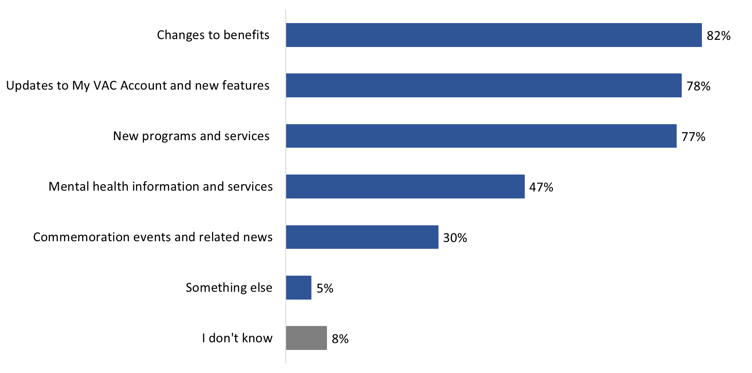
Base: n=650; all respondents; no response: 1%
Q27. There is a News and Notifications Section at the bottom of the main page of My VAC Account. VAC uses this section to share information with you. What topics would you like to read about here?

Those in Quebec (40%) and Ontario (36%) were more likely than respondents in western Canada (21%) to be interested in reading about commemorative events and related news. In addition, 81% of respondents in Atlantic Canada would like to read about new programs and services compared to 69% of their counterparts in western Canada. Interest in mental health information and services was higher among respondents from Ontario (55%) and Atlantic Canada (54%) as compared to those from western Canada (38%).

My VAC Account users aged 40 and over were more likely to be interested in reading about the following topics: commemorative events and related news, new programs and services, changes to benefits, and updates to My VAC Account and new features. Additionally, female respondents were less likely than male respondents to be interested in reading about changes to their benefits (73% versus 84%) or about updates to My VAC Account (64% versus 80%).

Variety of suggestions offered to improve ‘News and Notifications’
All survey respondents were asked if they had any suggestions to help improve ‘News and Notifications’. In response, few (7%) provided substantive feedback. This included, among other suggestions, the following: sending email notifications of new content when it is posted (11 respondents), including more diverse and tailored content (9 respondents) or better content in general (5 respondents), providing information on wait times (9 respondents), keeping the content up-to-date (4 respondents), and ensuring the content and layout is simple and clear (4 respondents).

Two-thirds would like to receive updates at least once a month
Two-thirds of the My VAC Account users surveyed would like to receive news from Veterans Affairs Canada at least once a month—16% would like to receive news weekly and the majority (51%) once a month. The rest would like to receive news from the Department less frequently—10% said twice a year, 1% once a year, and 17% only when necessary.

Figure 27: Preferred frequency of VAC news
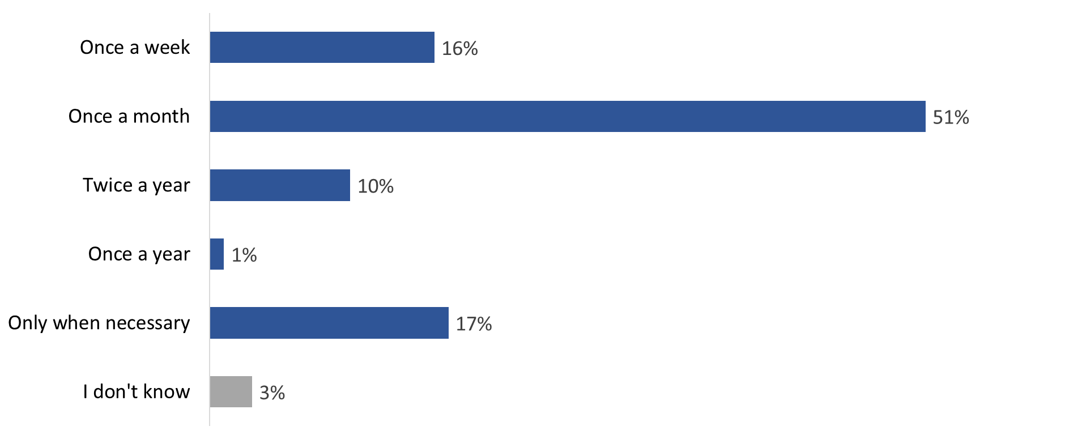
Base: n=650; all respondents
Q29. How often would you like to receive news from Veterans Affairs Canada?
*1% do not want to receive news from VAC

There are no subgroup differences to report.

Focus Group Findings

Focus group participants were asked about their preferences for electronic notifications, their use of the telephone channel to contact VAC, and their interest in ‘going paperless’.

All My VAC Account users who participated in a focus group recalled receiving electronic notifications and said they are helpful in general. Regarding tracking, participants would like to receive these electronic notifications whenever something changes in their application and they expect the notification to be issued in real-time (i.e., as soon as the change is registered in the VAC system). Specific information they would like to receive includes knowing whether any documentation is missing and knowing where they are in the processing line (e.g., X weeks left before a decision is made, or We are now treating applications from February 2019).

Most reported no preference for how to receive such notifications, while a few expressed a preference for email for the following reasons: no texting capacity (i.e., does not use a cell phone), already receives many text messages so VAC text messages would just add to the volume, and typically uses a computer to access My VAC account and does not want to juggle a phone and computer when it comes to email notifications. No one expressed any concerns regarding privacy or security of notifications, though one participant specified the notifications should continue to contain little information, precisely for security reasons.

Focus Group Findings (cont’d.)
Focus group participants were asked about other organizations from which they receive electronic notifications. The following were mentioned: financial institutions, the Canada Revenue Agency (CRA), MLS (the multiple listing service), Netflix, and insurance companies. With two exceptions, no one could identify any features of these services that they felt should be incorporated into My VAC Account. One was the capacity to tailor notifications (i.e., what I want and what I do not want to be notified about) and the other was to include a link in the notification to the My VAC Account login page (but not beyond that page). It was also suggested that the services provided by insurers should be coordinated with VAC, e.g., connect insurers’ services with those of My VAC Account to facilitate or coordinate interactions and/or processes that involve insurance companies.

All focus group participants reported having contacted VAC by phone. Phone contact provides human contact, Q&A opportunities, support/proactivity, and the possibility of being channelled to right person/area in order to resolve an issue. The benefits/advantages of phone contact could be incorporated into My VAC account through a chat function, as well as by allowing direct email contact with case managers. It was also suggested that the secure messaging service could call or contact Veterans if the service is unclear about a message or query sent to them.

Circumstances in which participants would prefer to call VAC rather than send a secure message through My VAC Account included having to schedule injury assessments with VAC doctors (because this involves a lot of back and forth which is easier by phone), and situations where resources or responses are needed immediately (e.g. answers to specific questions, changes in circumstances, a time sensitive issue). In the context of this discussion, one participant noted that secure messaging is preferable to phone contact because it provides a record of communication that phone contact does not.

All focus group participants expressed interest in viewing correspondence from VAC online because it is fast and efficient and localizes correspondence in one place. This applied to all types of correspondence, although the only type of VAC correspondence identified specifically was medical questionnaires.

According to participants, if they could view correspondence from VAC through My VAC Account, they would not want or need a paper copy to be sent in the mail because that constitutes unnecessary duplication. A few noted that if they want a paper copy of their correspondence, they can print one. The only reason why correspondence should be sent by mail would be a situation in which someone does not respond to/acknowledge online correspondence.

The main perceived advantages or benefits of opting out of paper mail from VAC and going paperless included having everything together in one place, the positive ecological impact, and having less paper to file. No one expressed any concern about opting out of paper mail from VAC and going paperless.

Overall Assessments of My VAC Account
This section of the report discusses with survey respondents and focus group participants overall assessments of My VAC Account. communications preferences. Findings from the focus groups are offset from the survey findings by shaded boxes.

Two-thirds generally find most or all of what they need when visiting My VAC Account
Approximately two-thirds of surveyed My VAC Account users said they find ‘most’ of what they need (38%) or ‘everything’ they need (29%) when visiting My VAC Account. In addition, just over one-quarter (28%) generally find ‘some’ of what they need. Very few (4%) find none of what they need when visiting My VAC Account.

Figure 28: Experience accessing information on My VAC Account
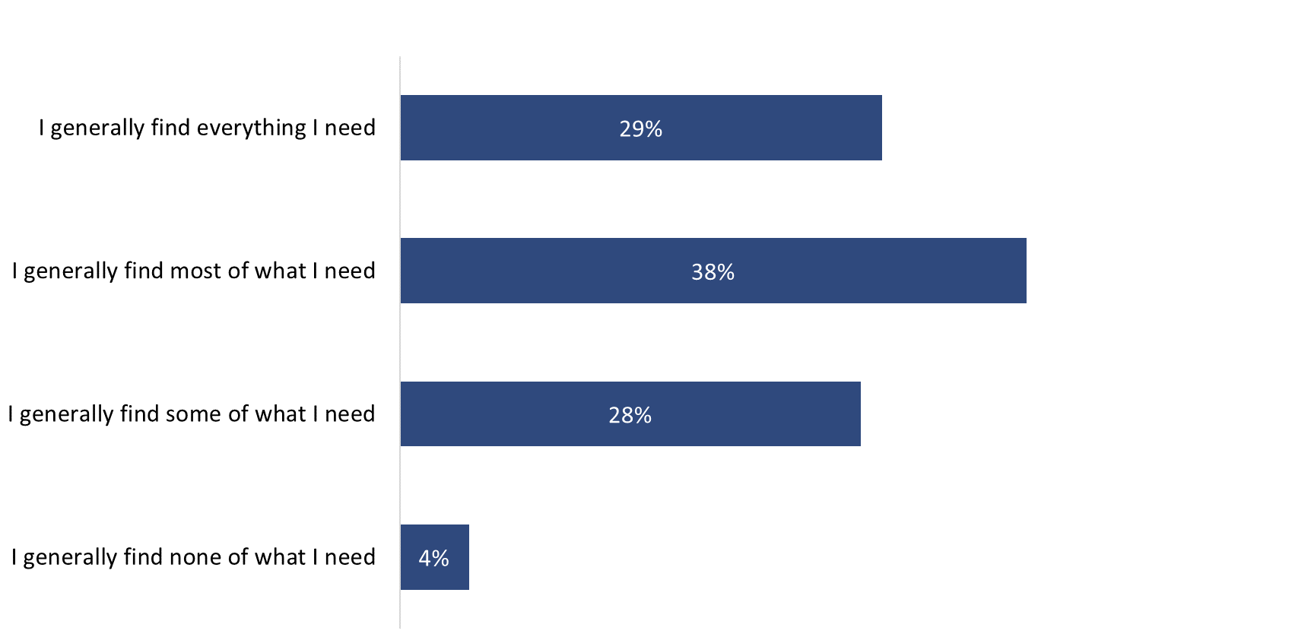
Base: n=650; all respondents; I cannot recall and I prefer not to say: 1%
Q38. Which of the following best describes your experience accessing information when you visit My VAC Account?

Respondents from Quebec (39%) were more likely to say they find everything they need, particularly when compared to those in western Canada (22%). In addition, respondents who use My VAC Account more than once a week were more likely to find most of what they need (47%), as compared to those who use their account less frequently (33% each of those who use their account once a week or once a month).

Majority said the information in My VAC Account does not have enough detail
My VAC Account users who generally do not find all the information they need when visiting My VAC Account (n=455) were most likely to attribute this to lack of details. Specifically, two-thirds (67%) noted that the information available in My VAC Account does not have enough detail. This is followed, at a distance, by the clarity of the information: approximately 1 in 5 (22%) said the information in My VAC Account is difficult to understand. Others pointed to usability issues saying that My VAC Account is hard to navigate (15%) or complicated to access (6%). Four percent each volunteered that forms can be hard to find and/or use and that the wait times posted are not accurate nor up-to-date.

Figure 29: Reason(s) for not finding all the information needed

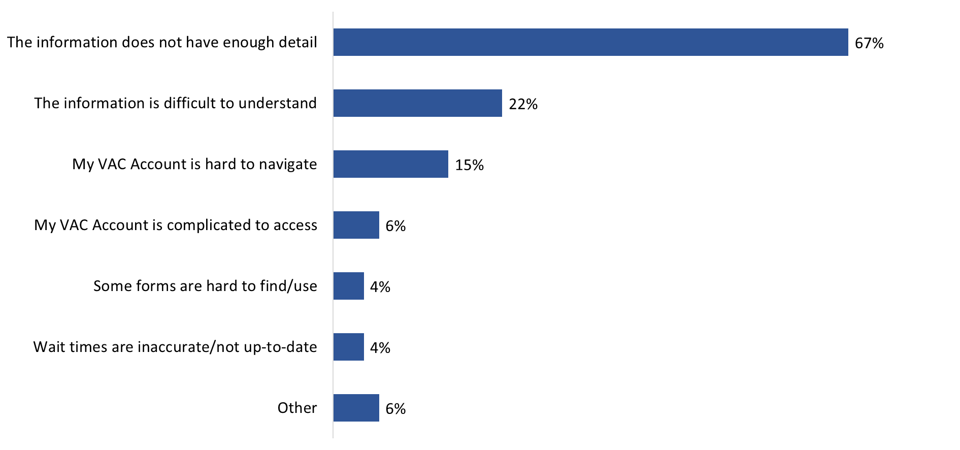
Base: n=455; respondents who said they did not find all the information needed; I don’t know: 6%; no response: 3%
Q39. Why do you generally not find all the information you need when you visit My VAC Account? [Multiple responses accepted]

There are no subgroup differences to report.

Mixed assessments of the information in My VAC Account
Two-thirds (67%) of My VAC Account users agreed that the information in My VAC Account is easy to find while 6 in 10 (61%) agreed that the information is easy to understand (down from 77% in 2019). Smaller majorities said that the information in My VAC account helps them understand the next steps (55%) and includes helpful external resources (51%).

Respondents were least likely to agree that the information in My VAC Account has the right amount of detail—41% agreed and 40% disagreed that this is the case. Recall that the top reason why My VAC Account users felt they do not generally find all the information they need was the perception that the information available does not have enough detail.

Figure 30: Perceptions of the information in My VAC Account

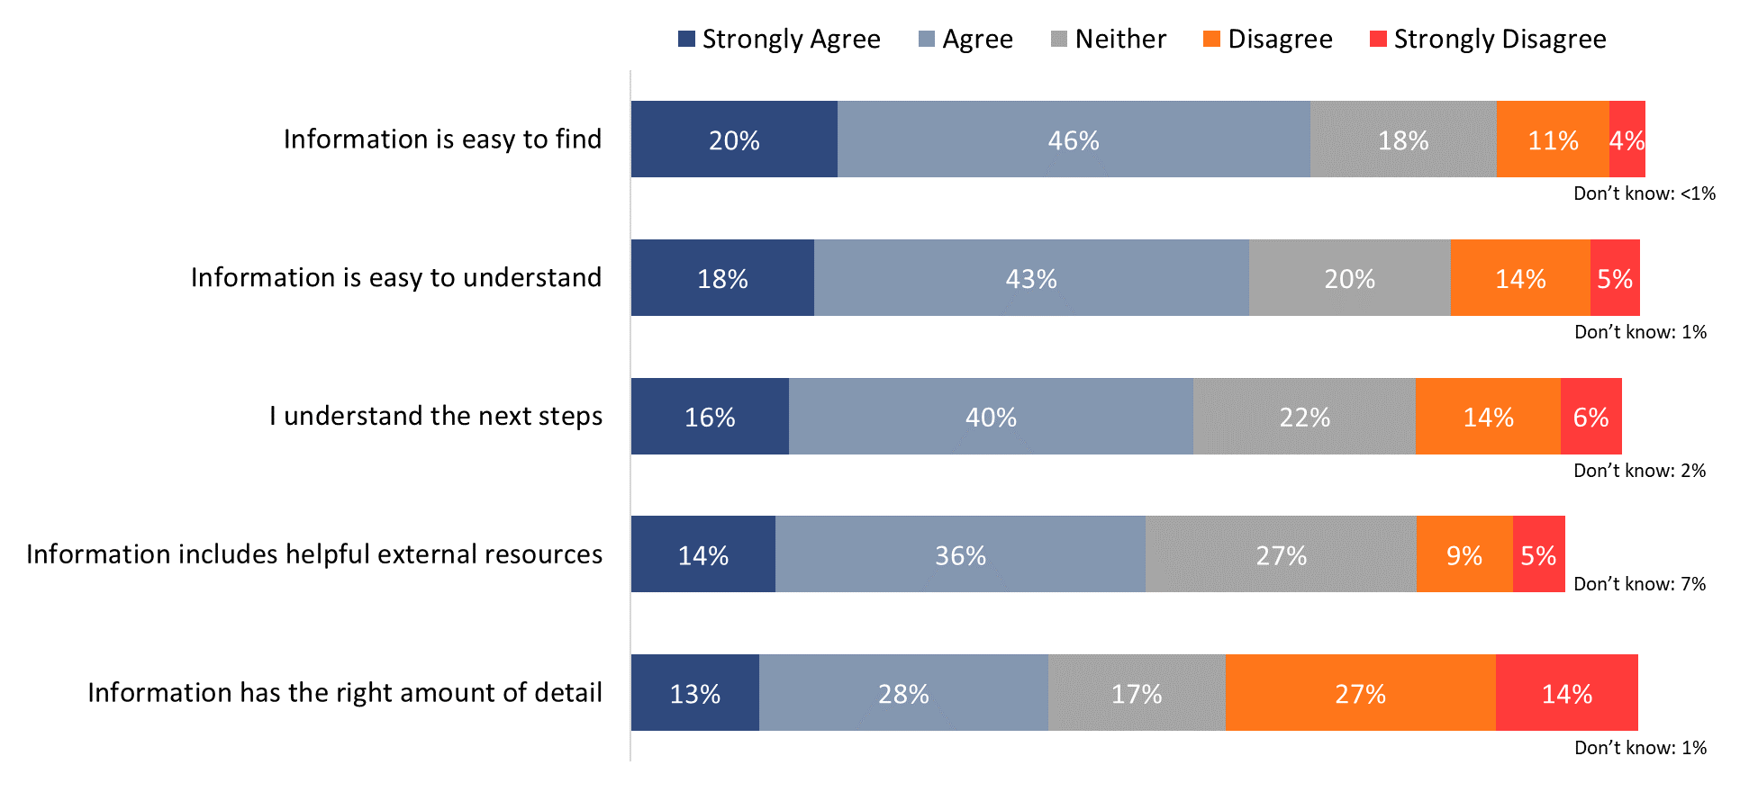
Base: n=650; all respondents; does not apply: 2% or less.
Q41. To what extent do you agree or disagree with the following statements about the information in My VAC Account?

Still serving RCMP members were more likely to agree that the information in My VAC Account is easy to find – two-thirds of whom agreed (66%). This is particularly true when compared to still serving (38%) and retired (45%) CAF members.

Focus Group Findings
All focus group participants were of the opinion that VAC does not keep them well informed or as informed as they could be about programs and services through My VAC Account. In explaining why, many said that they have to do most of the research/work themselves to find out about programs and services. Related to this, it was also observed that, while the information is available through My VAC Account, they have to find it themselves and when they do it can be difficult to understand. There was a widespread feeling that the Department should be more proactive in this regard through My VAC Account, with a few participants noting that word of mouth/networking between Veterans is sometimes a better source of information about programs and benefits than My VAC Account. When asked what role My VAC Account plays when it comes to communicating with VAC or receiving services from VAC, all focus group participants said it was ‘very’ important.
Widespread agreement that My VAC Account uses practice that ensure system security
Respondents were asked to rate the extent to which they agreed or disagreed with a number of statements about aspects of My VAC Account. The My VAC Account users surveyed were most likely to agree that My VAC Account uses practices that ensure system security—fully 83% agreed with this statement (no one disagreed). Almost as many (79%) said they would recommend My VAC Account to others, with few (7%) disagreeing. Perceptions of the online service channel in these areas are virtually unchanged since 2019, when 82% each would recommend My VAC Account and believed the channel used practices that ensure system security.

Following this, approximately two-thirds (68%) agreed that they can do the business they need with VAC through My VAC Account (compared to 71% in 2019). Those who did not agree were more likely to be ambivalent (19%) than to express any level of disagreement (12%) in this regard.

My VAC Account users were less likely to have agreed that My VAC Account is visually appealing (58%; compared to 63% in 2019) and to have liked the updates implemented in the past year (58%; compared to 65% in 2019). Those who did not provide a favourable assessment of My VAC Account were far more likely to be indifferent (31% and 28%, respectively) than to express disagreement (9% each).

Figure 31: Perceptions of different aspects of My VAC Account
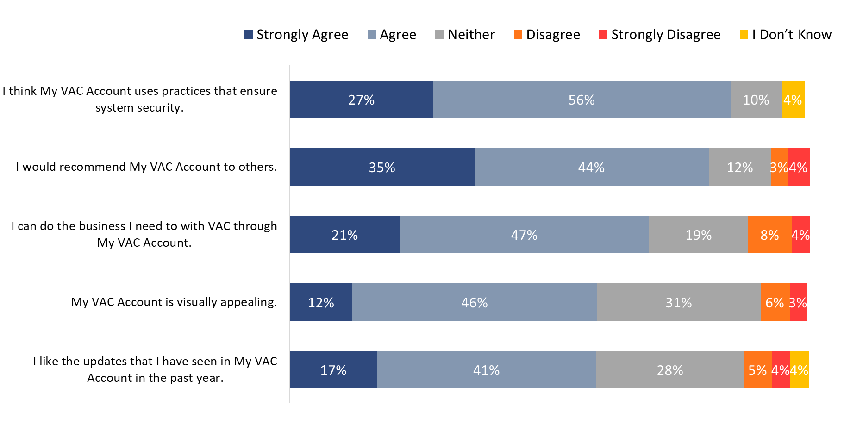
Base: n=650; all respondents
Q42. To what extent do you agree or disagree with the following statements?

Respondents in Quebec were significantly more likely to ‘strongly’ agree that My VAC Account uses practices that ensure system security (38%), as compared to those in western Canada (22%). Moreover, Quebec residents were also more likely to ‘strongly’ agree that they can do the business they need with the Department through My VAC Account (38% versus 18% of Ontarians and 14% of those from western Canada). Additionally, respondents who use My VAC Account several times a week (52%), as well as those who use their account less than once a month (54%), were more likely than those who use their account once a week (36%) to agree they can do the business they need through My VAC Account.

Those who disagreed with any of these statements were asked to explain why they provided this assessment of My VAC Account. A variety of explanations were offered by these respondents. A summary of the themes that emerged from the responses can be found in Figure 29.

Figure 32: Reasons for disagreeing with the statements about My VAC Account

Statement | Feedback
I think My VAC Account uses practices that ensure system security. | No one disagreed with this statement.
I would recommend My VAC Account to others. (n=40) | Those who disagreed tended to point to their perception that My VAC Account is not easy to use (e.g., it is hard to navigate) or not particularly useful because the information provided is not helpful (e.g., it provides generic information about the processing of applications).
I can do the business I need to with VAC through My VAC Account. (n=65) | Reasons for disagreeing with this statement ranged from the perception that the site provides inaccurate wait times for the processing of applications, to having to call VAC to resolve the issue or get the information they tried to find on My VAC Account, to this site providing generic information or information that lacks the necessary details.
My VAC Account is visually appealing. (n=38) | Those who disagreed that My VAC Account is visually appealing attributed this to myriad reasons including, but not limited to, the following: it looks “old” and/or “dated”, it looks like a “typical government website”, “it is boring”, it is “too busy”, it is not intuitively designed nor mobile friendly, and it feels “drab” and “dull”.
I like the updates that I have seen in My VAC Account in the past year. (n=41) | My VAC Account users who disagreed with this statement tended to point to the following: their perception that there have not been any updates to My VAC Account and their opinion that the updates have not improved/addressed the issues they have with My VAC Account, such as wait times and the lack of detailed information provided when tracking applications.
Q42. Why did you disagree with the statement: [INSERT ITEM]?

Seven in 10 were satisfied with their experience using My VAC Account
Seven in 10 (71%) surveyed My VAC Account holders were satisfied with their experience using My VAC Account, including 31% who were ‘very’ satisfied. Relatively few (13%) expressed dissatisfaction with their experience using My VAC Account. The rest (15%) were indifferent (i.e., neither satisfied nor dissatisfied). Satisfaction levels are virtually unchanged since the baseline survey was conducted in 2017, although fewer My VAC Account holders are ‘very’ satisfied this year (31%) compared to 2019 (41%).

Figure 33: Overall satisfaction with My VAC Account

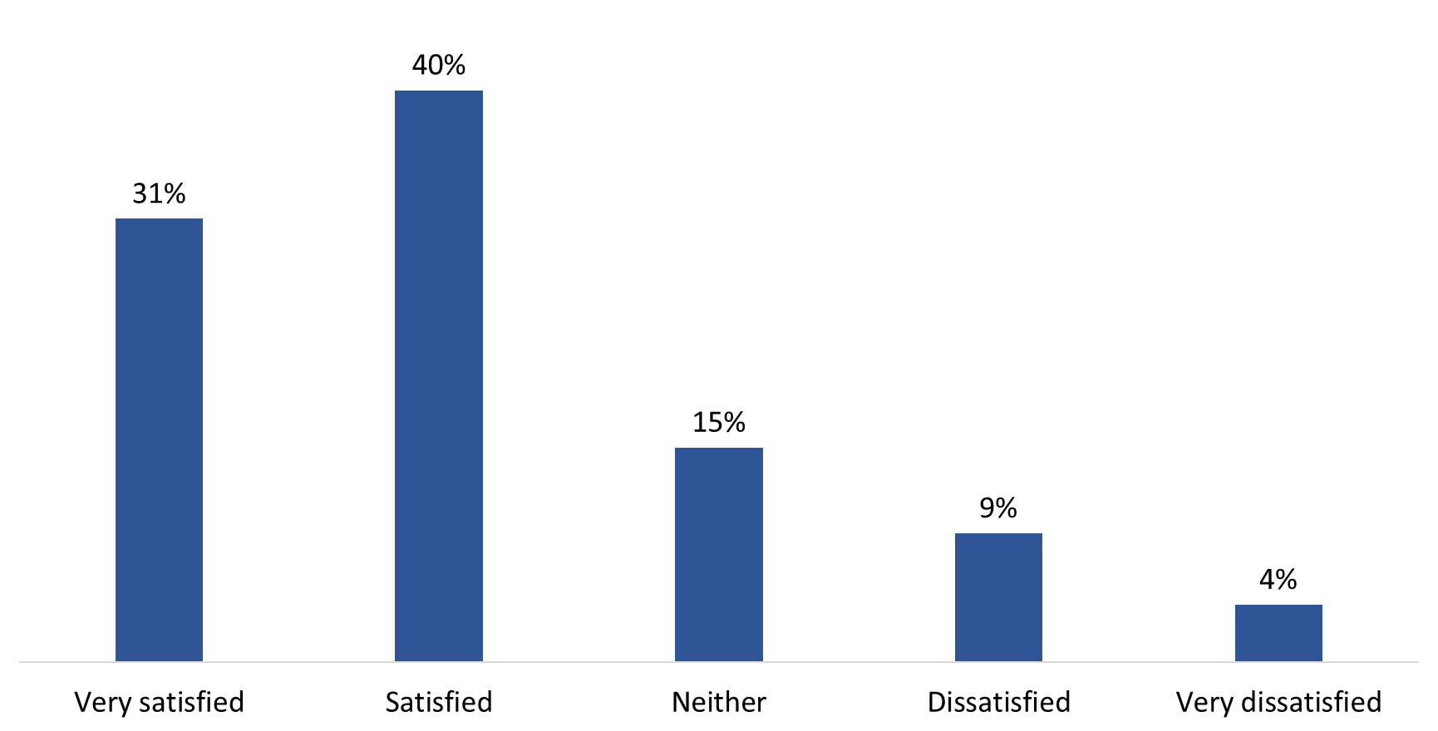

Base: n=650; all respondents
Q43. Overall, how satisfied or dissatisfied are you with your experience using My VAC Account?

Satisfaction with My VAC Account did not differ by demographics nor by frequency of using My VAC Account.

Focus Group Findings
Among focus group participants, initial reactions tended to focus on the time it takes for decision on benefit application and the vague/generic updates on the status of one’s application. However, when the focus shifted to My VAC Account itself, overall impression tended to be positive. When asked about the main benefits of using my VAC Account, participants identified the following:
- the main interface, which was perceived as ‘good’;
- speed and efficiency, particularly the ability to make multiple benefit claims;
- 24/7 accessibility;
- the breadth of information;
- ease of use/user-friendliness, including access to links for additional information (though it was noted that it is easier to use My VAC Account on a computer than on a phone);
- the good snapshot/overview of the status of current benefits;
- access to information on receipt of benefits, i.e., dates and types of benefits;
- the Benefits Navigator tool outlined what can be applied for based on level of service;
- secure messaging which allows for all correspondence in one place in one space, i.e., no need to sift through personal email;
- email notifications;
- ability to track/file all correspondence/exchanges; and
- ability to begin filling out a form then returning to it later.

Main perceived drawbacks of using My VAC Account included the following:
- length of time/number of steps it takes to login to My VAC Account;
- vagueness of information about application(s) status/generic messaging;
- arbitrary/nonsensical changes in status of applications/inaccurate information (e.g., one week it might say it will take 83 weeks to process an application and a week later it will say 48 weeks to do so);
- lack of proactive feedback on applications/need to follow up to obtain meaningful updates;
- the need to do a lot of ‘leg work’ oneself/learn for oneself (e.g., there is no information on who to contact if there is a specific problem);
- online forms not providing enough space for completion, resulting in the need to append Word documents or include additional information in an email with the completed forms;
- inability to communicate with someone familiar with one’s case/file in real-time;
- difficulty finding the right/appropriate online form;
- lack of clarity regarding which forms to use; and
- impression that communication through secure messaging will not be answered/uncertainty about who, if anyone, is reading these messages.

Those dissatisfied with their experience using My VAC Account were most likely to say the service does not provide sufficiently detailed information nor support/assistance
Respondents who said they were dissatisfied with their experience using My VAC Account (n=85) were asked why. More than half of those dissatisfied with their experience using My VAC Account said this is because there are not enough details provided to find specific forms or information (59%) and there is a lack of support and assistance (59%).

Following this, approximately half (49%) were dissatisfied because they feel they receive minimal communications or updates from the Department. Other reasons offered to explain their dissatisfaction included difficulties using the features (31%), technical difficulties (27%), and trouble finding information (26%).

Figure 34: Reason for dissatisfaction with My VAC Account

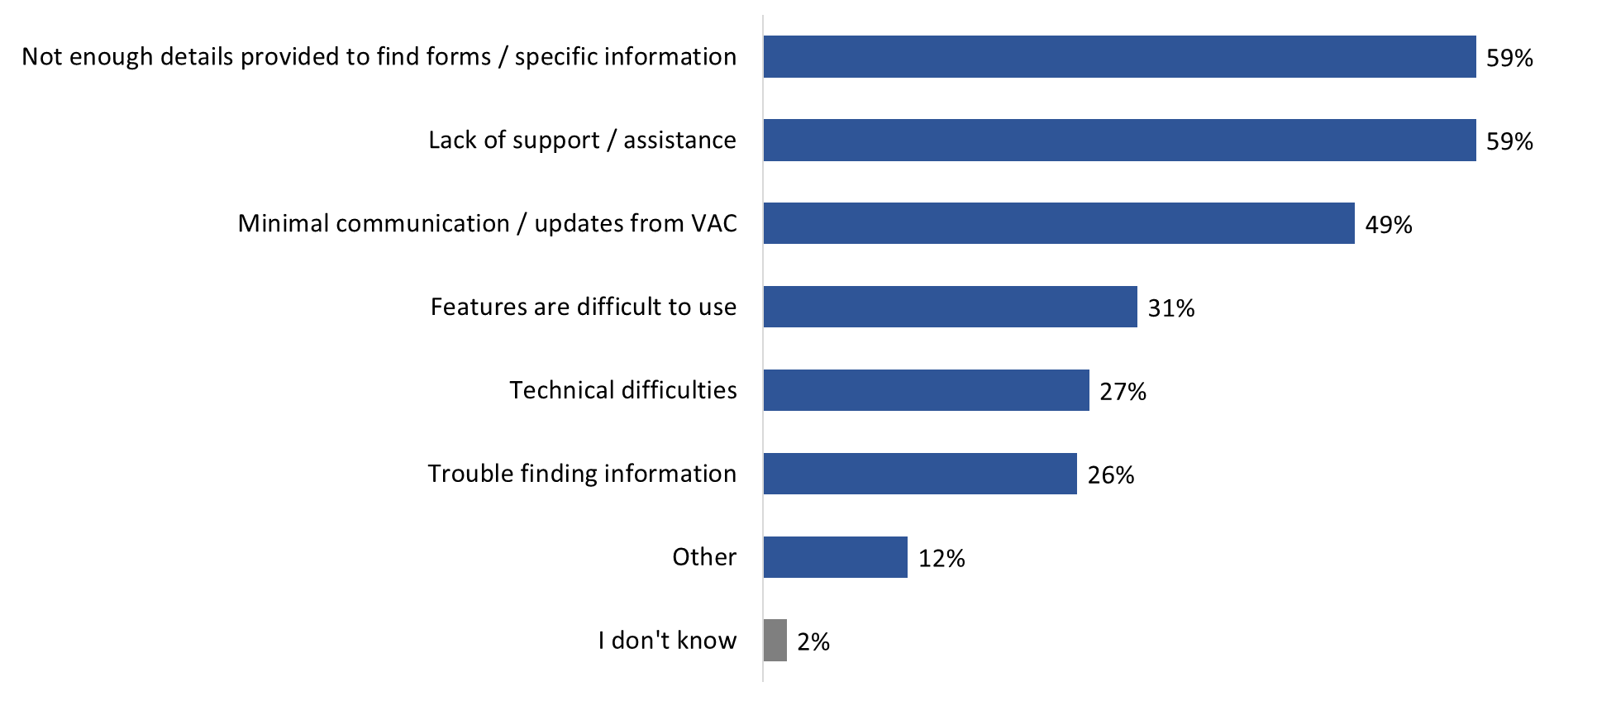

Base: n=85; respondents who said they are dissatisfied with their experience using My VAC Account; no response: 5%
Q45. Why are you dissatisfied with your My VAC Account experience? [Multiple responses accepted].

There are no subgroup differences to report.

Focus Group Findings
Few focus group participants identified any problems using My VAC account in the past year. Problems encountered included the following:
- system time-outs (it was observed that the site seems to be ‘down’ a lot);
- lack of space in online forms;
- lack of knowledge about who is answering their queries/questions;
- getting lost/disoriented and having to start over when logging in because the concierge key window does not always load properly; and
- sometimes dealing with VAC staff unfamiliar with one’s case/file.

Future Directions
Focus group participants were asked about potential enhancements to My VAC Account.

Future directions were only explored in the focus groups; therefore, this section does not refer to findings from the online survey.

Widespread interest in most suggested enhancements to My VAC Account
Asked in an open-ended fashion what enhancements or changes to My VAC Account would be particularly useful, focus group participants identified (or re-iterated) the following:
- a chat function;
- knowing where one’s applications are in the queue;
- integrating the services of insurers with those of VAC;
- not having to input the same profile information each time in each application when the information is the same (e.g., spouse’s name, children’s names, address, date of birth, etc.);
- a little more information/detail in electronic notifications (e.g., what is it about, which application does it concern); and
- in secure messages, there should be an option to choose ‘my case manager’ in the drop down menu.

After being asked to share their feedback on potential enhancements, participants were then presented with a list of possible enhancements and asked to rate the usefulness of each one to them personally. The enhancements were:
- Ability to book appointments with VAC using My VAC Account.
- More guided web forms (i.e., special windows that walk you through the form, question-by-question, instead of traditional PDF forms).
- Automatic benefits suggestions, where possible.
- Adding an indicator to which status has changed in status tracking.
- Adding access for powers of attorney and other representatives.
- Adding case manager agreement to My VAC Account.
- Ability to add files and links within secure messages.
- Personalized wait times for benefit applications.

When it came to these enhancements, all but one was identified as at least moderately useful, with the following considered ‘very’ useful by nearly everyone:
- automatic benefits suggestions;
- adding an indicator to status that has changed (especially important if one has many applications in play);
- ability to add files/links within secure messaging (it being noted that this is now such a basic component of messaging that it is expected as a function); and
- personalized wait times (because it allows one to know exactly where one is in the process instead of being in the dark).
The booking appointments, having more web guided forms, and adding a case manager agreement were also considered useful. In the case of appointments, it was noted that, if one has a number of applications in the queue, this will allow one to discuss them. In the case of more web guided forms, it was noted that these allow applicants to get into the ‘mindset’ of decision-makers and give them a sense of what decision-makers need. This can result in less guess work when it comes to applications, and a better sense of whether one qualifies or not/should apply or not for a specific benefit. When it came to case manager agreements, it was noted that these can help clarify one’s goals and what one is on track for and that they can be updated and modified as needed.

The only feature more likely to be considered of little or no usefulness was adding access for powers of attorney and other representatives.

All would choose to do everything through My VAC Account
All focus group participants said they would choose to do all their dealings with Veterans Affairs Canada online through My VAC Account, with a few adding that other options should still be retained as a back-up or for Veterans who choose not to do everything online. Some specified that they would choose to do this as long as the service was efficient, faster, and easy to use. No one identified anything they would prefer not to do through My VAC Account. A few participants added that they would still like to retain the opportunity to contact VAC by phone as a back-up service channel.

Other things participants said they would like to be able to do through My VAC Account include the following: access all their files (including updates on them and assessments of them), find out about opportunities for Veterans within a geographic region, such as job opportunities, be able to apply for or make appointments with pain clinics (‘cliniques de douleur’), and use a chat function to speak directly with their case manager and decision-makers regarding their applications.

Comparison of Survey Results: 2017 to 2021
As mentioned, the Department conducts this POR every two years in order to track changes in My VAC Account holders’ perceptions, behaviours, and experiences. The tables below present these differences for key performance indicators.

Method used to register for My VAC Account
 | 2017* | 2019 | 2021
% using GCKey | 62% | 57% | 54%
% using Sign-in Partner | 36% | 41% | 43%

Reason for using GCKey to register
 | 2017 | 2019 | 2021
% saying they were more comfortable using GCKey | 53% | 64% | 68%

Perceptions of the registration process
 | 2017* | 2019* | 2021
% saying it was easy | 77% | 75% | 75%
*Not directly comparable; asked of all who registered in 2017 and 2019. In 2021, asked of those who used GCKey.

Agreement: “The steps required to register for My VAC Account justifies the security it provides.”
 | 2017 | 2019 | 2021
% agreeing | 76% | 70% | 81%

Source of awareness of My VAC Account
% identifying each: | 2017 | 2019 | 2021
VAC staff member | 28% | 36% | 25%
Word of mouth | 13% | 15% | 14%
Browsing the VAC website | 14% | 16% | 12%

Use of My VAC Account features
% reporting doing each of the following: | 2017 | 2019 | 2021
Tracking the status of applications | 85%* | 91% | 90%
Applying online for VAC benefits and services | 64% | 82% | 89%
Using secure messaging | 61% | 81% | 83%
Updating personal information | 76% | 66% | 70%
Uploading documents | 63% | 73% | 79%
Signing up for direct deposit/changing bank information | 46% | 56% | 63%
Adding their email address to receive email notifications | 63% | 57% | 59%
Viewing a summary of their benefits | 80% | 82% | 82%

Average wait time for a response to a secure message
 | 2017 | 2019 | 2021
% waited 3-5 business days | 32% | 46% | 47%

Perceptions of My VAC Account
% agreeing with each statement: | 2017 | 2019 | 2021
My VAC Account uses practices to ensure system security | 82% | 82% | 83%
I would recommend My VAC Account to others | -- | 82% | 79%
I can do the business I need through My VAC Account | -- | 71% | 68%
My VAC Account is visually appealing | 62% | 63% | 58%
I like the updates implemented in the past year | 57%* | 65% | 58%
The information in My VAC Account is easy to find | 69%** | 72%*** | 67%
The information is easy to understand | 78%** | 77% | 61%

*Not directly comparable; the timeframe for evaluating was the last two years in 2017.

** Not directly comparable; the statements in 2017 were: It was easy to find what I was looking for in My VAC Account and The information in My VAC Account is understandable.

*** Not directly comparable; in 2019, the statement was: It was easy to find what I was looking for in My VAC Account.

Overall satisfaction with My VAC Account
 | 2017 | 2019 | 2021
% satisfied | 71% | 75% | 71%

Appendix

Methodological Information

1. Online Survey
A non-probability survey was conducted online with 650 My VAC account users between March 4 and March 13, 2021. The following specifications applied to the online survey:
- The survey averaged 17 minutes to complete and was available in both official languages.
- The survey was pre-tested in advance of the fieldwork. This involved a soft launch of the survey, with a short series of follow-up questions to assess the flow and structure of the questionnaire. The responses to the follow-up questions, as well as the survey data, were reviewed by Phoenix SPI. There was no changes to the questionnaire as a result of the pre-test.
- This was an intercept survey; survey respondents were recruited through My VAC Account and VAC’s social media channels. As such, there is no margin of sampling error to report for the survey sample.
- The survey data were not weighted.
- No response rate can be provided due to the intercept methodology. It is not known how many My VAC Account users noticed the survey invitation in their account or on VAC’s social media and declined to participate. What is known is the number of clients who started the survey, but who did not complete it for one reason or another. In total, 1,231 clients started the survey, and 650 completed it, which represents a completion rate of 53%.
- Survey samples generally are affected by survey non-response. This can bias the survey sample when the characteristics of respondents differ in significant ways from those of non-respondents. In this case, there is the potential for non-response bias. The survey sample reflects the preferences, and experiences of users who visited My VAC Account or used VAC’s social media channels during the data collection period. In other words, clients who logged in to My VAC Account more frequently (e.g., to check the status of applications) or engaged with VAC more regularly via social media are more likely to have responded to the survey.

2. Virtual Focus Groups
The following specifications applied to the online focus groups:
- Two online focus groups were conducted with My VAC Account users.
- Participants were recruited through advertisements in My VAC Account and on VAC’s social media.
- The English group took place on March 24, 2021, and the French group on March 25, 2021.
- Each group lasted two hours.
- A total of 12 My VAC Account users participated (eight participants in the English group and four in the French group).
- All research participants received a $100 honorarium to thank them for their time.
- The investigator for this study was Philippe Azzie.
- This research was qualitative in nature, not quantitative. As such, the results provide an indication of participants’ views about the issues explored, but they cannot be generalized to the full population of My VAC Account users.

All steps of the project complied with The Standards for the Conduct of Government of Canada Public Opinion Research.

Quantitative Research Instruments

Survey Questionnaire
Page 1: Landing Page
Please select the language in which you wish to complete the survey.

- English
- French

[NEXT]

Page 2: Survey Intro Page
Background information
Thank you for agreeing to take part in this short survey about My VAC Account. The purpose of this online survey is to collect feedback on My VAC Account. Your participation will help Veterans Affairs Canada (VAC) improve the online service to better serve Veterans. It will take no more than 15 minutes to complete.
How does the online survey work?
- Your participation in the survey is completely voluntary and confidential.
- Your decision on whether or not to participate will not affect any dealings you may have with the Government of Canada, now or in future.

What about your personal information?
- Please be assured that all opinions will remain anonymous and will not be attributed to you personally in any way. VAC will not receive your name or contact information.
- The personal information you will provide to VAC is governed in accordance with the Privacy Act and is being collected in accordance with the Treasury Board Directive on Privacy Practices. For more information, click here.
- Your personal information will be collected by Phoenix Strategic Perspectives, Inc. (Phoenix SPI) in accordance with the applicable provincial privacy legislation or the Personal Information Protection and Electronic Documents Act (PIPEDA).

What happens after the online survey?
The final report will be available to the public through Library and Archives Canada (www.bac-lac.gc.ca/).

Questions?
The survey is registered with the Canadian Research Insights Council’s Research Verification Service. To verify the legitimacy of the project, you may contact Ryan Winters (ryan.winters@canada.ca) at Veterans Affairs Canada or click here to access the Research Verification Service and enter project code: 20210212-PH917.
If you have any questions about the survey, you may contact Phoenix SPI at research@phoenixspi.ca.
Your help is greatly appreciated, and we look forward to receiving your feedback.
[NEXT]

Page 3: Reminders
On each screen, after selecting your answer, click on the "Next" button at the bottom of the screen to move forward in the survey. If you leave the survey before completing it, you can return to the survey URL later, and you will be returned to the page where you left off. Your answers up to that point in the survey will be saved.

PROGRAMMING NOTES:
ALL SURVEY QUESTIONS TO BE PRESENTED 1 QUESTION PER PAGE UNLESS OTHERWISE INDICATED.
SECTION TITLES SHOULD NOT APPEAR ON SCREEN FOR RESPONDENTS.
DO NOT PRESENT QUESTION NUMBERS.
INCLUDE A PROGRESS BAR.
ALL QUESTIONS ARE MANDATORY.

Survey questions
A. Use of My VAC Account
- Are you a registered user of My VAC Account?

01 Yes CONTINUE
02 No TERMINATE
03 I don’t know TERMINATE
04 Prefer not to say TERMINATE

- Have you used My VAC Account in the past 12 months?

01 Yes CONTINUE
02 No TERMINATE
03 I can’t recall CONTINUE
04 I prefer not to say CONTINUE

- Have you used My VAC Account in the past 6 months (i.e., between September 2020 and February 2021)?

01 Yes CONTINUE
02 No CONTINUE
03 I can’t recall TERMINATE
04 I prefer not to say TERMINATE

- On average, how often would you say you use My VAC Account?

01 At least once a day
02 Several times a week
03 About once a week
04 About once a month
05 Less than once a month
06 I don’t know
07 I prefer not to say

- How did you first learn about My VAC Account?

01 Word of mouth (e.g., from a friend or colleague)
02 VAC staff member
03 Browsing the VAC website
04 Social Media
05 Veterans’ organization or event
06 Information sent to you by VAC
07 The Canadian Armed Forces (CAF)
08 Another government department/office
09 Other. Please specify: [TEXT BOX]
10 I can’t recall
11 I prefer not to say

- Which of the following features have you accessed in My VAC Account?

Select all that apply

01 Applying online for VAC benefits and services.
02 Uploading documents to support your applications.
03 Viewing a summary of your benefits.
04 Signing up for direct deposit or changing your banking information.
05 Communicating with VAC staff through secure messaging.
06 Communicating with the Bureau of Pensions Advocates (BPA).
07 Communicating with the Veterans Review and Appeal Board (VRAB).
08 Receiving correspondence from VAC in My VAC Account Inbox.
09 Updating your personal information.
10 Adding your email address to receive email notifications from My VAC Account.
11 Changing communications preferences (e.g., Go Paperless).
12 Assessing COVID-19 related features/information about VAC’s programs and services (e.g., relief measures, virtual document submissions).
13 Other – Please specify [TEXT BOX]

- Have you used any of the following in My VAC Account?

Select all that apply

01 Member Transition Task List to help guide the transition from military life to life after service.
02 Track your Applications to view the status of your application.
03 Wait Time Tool to find out the average processing times.*
04 Guided Web Form to complete a VAC application.
05 None of these tools

*MOUSEOVER: Accessed through a link on the ‘Track your application’ page.

B. Registration
These next questions are about the registration process for My VAC Account.

My VAC Account allows its users to register online through a GCKey, or through a sign-in partner. A GCKey is a Government of Canada assigned credential that can be used to securely access Government of Canada services online. The sign-in partner service instead allows users to register for My VAC Account using your existing online banking username and password.

- When you registered for My VAC Account, which of the following did you use?

01 GCKey*
02 Sign-in Partner
03 I can’t recall
04 I prefer not to say

*MOUSEOVER: A user ID that can be used to securely access Government of Canada's online services.

[ASK IF RESPONDENT CHOSE GCKEY]

- [IF Q8=01] Why did you use GCKey to register?

Select all that apply

01 I didn’t want to use my banking information.
02 I was more comfortable with GCKey.
03 My bank wasn’t an option in Sign-in Partner.
04 Other – Please specify [TEXT BOX]
05 I can’t recall
06 I prefer not to say

- [IF Q8=01] How easy or difficult was the process to register for My VAC Account?

01 Very difficult
02 Somewhat difficult
03 Somewhat easy
04 Very easy
05 I can’t recall
06 I prefer not to say

- [IF Q10=01, 02] You said it was difficult to register for My VAC Account. Why was this difficult?

Select all that apply

01 It took too long.
02 There were too many steps.
03 I didn’t know what a GCKey was.
04 I experienced trouble linking my VAC file to my account.
05 Other - Please specify: [TEXT BOX]
06 I can’t recall
07 I prefer not to say

- To what extent do you agree or disagree with the following statement: “The steps required to register for My VAC Account justifies the security it provides.”

01 Strongly disagree
02 Disagree
03 Neutral
04 Agree
05 Strongly agree
06 I don’t know
07 I prefer not to say

C. Contact with VAC / Secure Messaging
- What is your preferred method for contacting VAC?

01 Secure message in My VAC Account
02 Phone
03 Mail
04 Email
05 In-person
06 Social media
07 Other, please specify: [TEXT BOX]
08 I don’t know
09 I prefer not to say

- In the past 12 months, have you tried contacting VAC through secure messaging?

01 Yes
02 No SKIP TO NEXT SECTION
03 I can’t recall SKIP TO NEXT SECTION
04 I prefer not to say SKIP TO NEXT SECTION

- [IF Q14=01] [SHOW ONLY IF Q3=02: In the past 12 months, approximately] [IF Q3=01: Approximately] how many times have you connected directly with VAC staff through secure messaging? IF Q3=02, DO NOT USE THE GRID LAYOUT. PRESENT ONLY THE RESPONSE OPTIONS.

GRID FORMAT QUESTION

ROWS
15A: In the past 6 months (i.e., between September 2020 and February 2021)
15B: In the past 12 months (i.e., between March 2020 and February 2021)

COLUMNS
01 NUMBER OF TIMES
02 I haven’t connected
03 I can’t recall
04 I prefer not to say

[IF Q15=02, SKIP TO Q20]

- [IF Q15=01, 03, OR 04] On average, how long did you wait to receive a response?

01 Less than one business day
02 1-2 business days
03 3-5 business days
04 More than 5 business days
05 I can’t recall
06 I prefer not to say

- [IF Q15=01, 03, OR 04] How long did you expect to wait for a secure message reply?

01 Less than one business day
02 1-2 business days
03 3-5 business days
04 More than 5 business days
05 Other. Please specify [TEXT BOX]
06 I can’t recall
07 I prefer not to say

18. [IF Q15=01, 03, OR 04] Did you connect with your case manager when using secure messaging?

- Yes
- No
- I don’t have a case manager
- I can’t recall
- I prefer not to say

- [IF Q15=01, 03, OR 04] Are there other Veterans Affairs Canada staff who you would like to contact through secure messaging?

01 Yes, please specify: [TEXT BOX]
02 I don’t know
03 I prefer not to say

- [SHOW ONLY IF Q3=02 AND Q15=01, 03, OR 04] How satisfied, or dissatisfied, have you been with your experience using secure messaging to connect directly to VAC staff in the past 12 months? [SHOW ONLY IF Q3=01 AND Q15=01, 03, OR 04 AND USE A GRID] How satisfied, or dissatisfied, have you been with your experience using secure messaging to connect directly to VAC staff?

01 Very dissatisfied
02 Dissatisfied
03 Neutral
04 Satisfied
05 Very satisfied
06 I don’t know
07 I prefer not to say

GRID FORMAT QUESTION

ROWS
20A: …In the past 6 months (i.e., between September 2020 and February 2021)
20B: …In the past 12 months (i.e., between March 2020 and February 2021)

COLUMNS
01 Very dissatisfied
02 Dissatisfied
03 Neutral
04 Satisfied
05 Very satisfied
06 I don’t know
07 I prefer not to say

- [IF Q14=01] Did you have any difficulties using secure messaging?

01 Yes
02 No
03 I can’t recall
04 I prefer not to say

- [IF Q21=01] What difficulties did you experience?

Select all that apply

- It took too long for a response.
- I wanted a secure message reply but got a call back instead.
- My issue wasn't resolved.
- My question wasn't answered.
- I didn’t know where to send it (i.e., VAC, Bureau of Pension Advocates (BPA), Veterans Review and Appeal Board (VRAB))
- Other (Please Specify [TEXT BOX])
- I can't recall
- I prefer not to say
[IF Q15=02, SKIP TO Q25]

- [IF Q15=01, 03, OR 04] After communicating through secure messaging with a VAC staff member, or your case manager, have you needed to re-contact VAC to have a follow up conversation??

01 Yes
02 No SKIP TO Q24
03 I can’t recall SKIP TO Q24
04 I prefer not to say SKIP TO Q24

- [IF Q23=01] How did you re-contact VAC?

Select all that apply

01 Through secure messaging again
02 Calling VAC
03 Other, please specify: [TEXT BOX]
04 I can’t recall
05 I prefer not to say

- [IF Q14=01] Do you have suggestions to help improve secure messaging?

01 [OPEN TEXT]
02 No suggestions

D. Communications
- How would you prefer to receive updates about VAC programs, services, and benefits?

01 Through My VAC Account
02 Email
03 Mail
04 Telephone
05 In-person
06 Other – Please specify: [TEXT BOX]
07 I don’t know
08 I prefer not to say

- There is a News and Notifications Section at the bottom of the main page of My VAC Account. VAC uses this section to share information with you. What topics would you like to read about here?

Select all the apply

01 Commemoration events and related news
02 New program and services
03 Changes to benefits
04 Updates to My VAC Account and new features
05 Mental health information and services
06 Other – Please specify: [TEXT BOX]
07 I don’t know
08 I prefer not to say

- Do you have any suggestions to help improve ‘News and Notifications’?

01 [OPEN TEXT]
02 No suggestions

- How often would you like to receive news from Veterans Affairs Canada?

01 Once a week
02 Once a month
03 Twice a year
04 Once a year
05 Only when absolutely necessary
06 I do not want to receive news from Veterans Affairs Canada
07 I don’t know
08 I prefer not to say

E. Member Transition Task List
[IF Q7=01; EVERYONE ELSE SKIP TO SECTION F]

You indicated that you have use the Member Transition Task List. The following questions pertain to the Member Transition Task List. The transition task list provides releasing members with a self-guided tool to help them track their progress through their transition from military life to life after service.

- How helpful was the information you found on the Member Transition Task List?

01 Not at all helpful
02 Slightly helpful
03 Very helpful
04 I can’t recall
05 I prefer not to say

F. Track Your Applications
[IF Q7=02; EVERYONE ELSE SKIP TO Q31]

- Earlier you indicated that you haven’t used the ‘Track your applications’ feature in My VAC Account to view the status of your application. Why is that?

Select all that apply

01 I did not know about it.
02 I did not need to use it.
03 It seemed complicated to use.
04 Other, please specify: [TEXT BOX]
05 I don’t know
06 I prefer not to say

[IF Q7≠02; EVERYONE ELSE SKIP TO SECTION G]

Earlier you indicated that you used the ‘Track your applications’ feature in My VAC Account.

- Did ‘Track your applications’ help you find out the status of your application?

01 No
02 In part/somewhat
03 Yes
04 I can't recall
05 I prefer not to say
- Does the ‘Track your applications’ feature provide you with enough detail about the status of your application and how quickly your application is being processed?

01 Yes
02 No
03 I don’t know
04 I prefer not to say

- [IF Q33=02] Why did you say that the ‘Track your applications’ feature did not provide you with enough detail about the status of your application and how quickly it is being processed?

01 [OPEN TEXT]
02 I don’t know

- [IF Q33=02, 03, 04] What other information about the status of your application would you like the ‘Track your applications’ feature to provide?

01 [OPEN TEXT]
02 I don’t know

G. Wait Time Tool
[IF Q7=03; EVERYONE ELSE SKIP TO SECTION H]

Earlier you indicated that you used the Wait Time Tool accessible through a link on the ‘Track your application’ page.

- How helpful were the average processing times found in the Wait Time Tool?

01 Not at all helpful
02 Slightly helpful
03 Moderately helpful
04 Very helpful
05 I can’t recall
06 I prefer not to say

- Did the Wait Time Tool tell you approximately when to expect a decision on your application?

01 Yes
02 No
03 I can’t recall
04 I prefer not to say

H. Overall Assessments of My VAC Account
When answering these next questions, please think about all the times you have used My VAC Account over the past year.

- Which of the following best describes your experience accessing information when you visit My VAC Account?

01 I generally find everything I need
02 I generally find most of what I need
03 I generally find some of what I need
04 I generally find none of what I need
05 I can’t recall
06 I prefer not to say

[IF Q38=01, 05, 06, SKIP TO Q40]

- [[IF Q38=02, 03, 04] Why do you generally not find all the information you need when you visit My VAC Account?

Select all that apply

01 My VAC Account is hard to navigate.
02 The information in My VAC Account does not have enough detail.
03 The information in My VAC Account is difficult to understand.
04 My VAC Account is complicated to access.
05 Other, please specify: [TEXT BOX]
06 I don’t know
07 I prefer not to say

- To what extent do you agree or disagree with the following statements about the information in My VAC Account?

a) Information in My VAC Account is easy to find.
b) Information in My VAC Account has the right amount of detail.
c) Information in My VAC includes helpful external resources.
d) I understand the next steps.
e) The information in My VAC Account is easy to understand.

GRID LAYOUT; RESPONSE OPTIONS:
01 Strongly disagree
02 Disagree
03 Neither agree or disagree
04 Agree
05 Strongly agree
06 I don’t know
07 Does not apply

- To what extent do you agree or disagree with the following statements?

a) My VAC Account is visually appealing.
b) I think My VAC Account uses practices that ensure system security.
c) I like the updates that I have seen in My VAC Account in the past year.
d) I can do the business I need to with VAC through My VAC Account.
e) I would recommend My VAC Account to others.

GRID LAYOUT; RESPONSE OPTIONS:
01 Strongly disagree
02 Disagree
03 Neither agree or disagree
04 Agree
05 Strongly agree
06 I don’t know
07 Does not apply

- [IF Q41a, b, c, d, e = 01, 02] Why did you disagree with the statement: [INSERT ITEM FROM Q37]?

01 [OPEN TEXT]
02 No suggestions

- Overall, how satisfied or dissatisfied are you with your experience using My VAC Account?

01 Very dissatisfied
02 Dissatisfied
03 Neither satisfied or dissatisfied
04 Satisfied
05 Very satisfied
06 I don’t know
07 I prefer not to say

- [IF Q43=01, 02] Why are you dissatisfied with your My VAC Account experience?

Select all that apply

01 Features are difficult to use
02 Minimal communication/updates from VAC
03 Not enough details provided to find forms/specific information
04 Lack of support/assistance
05 Technical difficulties (e.g. it is unavailable often)
06 Trouble finding information I need. Please specify: [TEXT BOX]
07 Other. Please specify: [TEXT BOX]
08 I don’t know
09 I prefer not to say

- What additional suggestions can you share to help Veterans Affairs Canada improve My VAC Account? This could be changes to My VAC Account itself, or suggestions for new features or information to be added to the online service.

[TEXT BOX]
*Please do not include any names or other identifiable personal information.

- No suggestions
- Not sure

I. Demographics
This last set of questions is to learn more about you and your needs. This information will be used only to analyze the survey results. Please be assured that your answers will remain confidential and anonymous. VAC will not receive your name or contact information.

- Are you?

01 a war Veteran (Second World War or Korean War)
02 a serving member of the Canadian Armed Forces
03 a retired member of the Canadian Armed Forces
04 a serving member of the RCMP
05 a retired member of the RCMP
06 a family member who receives benefits from VAC
07 I prefer not to say

- How do you identify your gender? This may be different from the information noted on your birth certificate or other official documents.

01 Male
02 Female
03 Another Gender
04 I prefer not to say

48. What language do you speak most often at home?

Select all that apply

01 English
02 French
03 Other
04 I prefer not to say

- In which of the following age categories you belong?

01 18-29
02 30-39
03 40-49
04 50-59
05 60-69
06 70-79
07 80+
08 I prefer not to say

- Are you of First Nations, Métis or Inuit descent?

01 First Nations
02 Métis
03 Inuit
04 No
05 I prefer not to say

- In which province or territory do you live?

[ALPHABETICAL LIST]
14 I prefer not to say

- To help us better understand how results vary by region of the country, will you please provide your postal code? Your postal code will not be used to identify you or link your survey responses to you.
01 Record: [TEXT]
02 I don’t know
03 I prefer not to say

- [IF Q52=02, 03] Would you be willing to provide the first three digits of your postal code?

01 Record: [TEXT]
02 No

- What type of internet connection do you have at home?

01 Dial-up
02 High speed*
03 I don’t have an internet connection in my home
04 I don’t know
05 I prefer not to say

*MOUSEOVER: This could be through a DSL enabled phone line, a cable TV modem, satellite dish, or fibre optic cables.

- Finally, have you ever visited a VAC area office with a question?

01 Yes
02 No
03 I don’t know
04 I prefer not to say

- [IFQ55=02] Why have you never visited a VAC area office?

Select all that apply

01 I have never needed to visit a VAC office
02 I prefer to deal with VAC online
03 There is not a VAC office in my area
04 Other, please specify: [TEXT BOX]
05 I don’t know
06 I prefer not to say

Closing Page
That concludes the survey. Thank you very much for your feedback. The results will be available at the Library and Archives Canada website in the coming months. [RE-DIRECT: https://www.veterans.gc.ca/eng]

Qualitative Research Instruments

Online Recruitment Screener

Landing Page

Thank you for your interest in this research study. This short online questionnaire will take no more than 2 minutes to complete. The purpose of the online questionnaire is to confirm the eligibility of individuals interested in participating in this research study.

Background information
- This research study is being conducted by Phoenix Strategic Perspectives (Phoenix SPI), a Canadian public opinion research firm, on behalf of Veterans Affairs Canada.
- The research will help guide the future of My VAC Account and prioritize enhancements moving forward, so that we can improve service delivery and design.

About the research study
The research which will take place [ENGLISH: Wednesday, March 24, 2021 at 6p.m. to 8p.m. ET / FRENCH : Jeudi 25 mars 2021 de 18 h à 20 h ET].
- The format is an online discussion with up to 8 participants led by a research professional from Phoenix SPI.
- The discussions will last up to 2 hours.
- To participate, you will need to have access to an internet-enabled device with a web camera.
- People who qualify for the research and take part will receive a cash gift to thank them for their time.

How does the online questionnaire work?
- Your decision to complete the questionnaire is completely voluntary and confidential.
- Your decision on whether or not to participate in the research will not affect any dealings you may have with the Government of Canada, now or in future.

What about your personal information?
- Your personal information will be collected by Phoenix SPI in accordance with the applicable provincial privacy legislation or the Personal Information Protection and Electronic Documents Act (PIPEDA).
- Please be assured that VAC will not receive your name or contact information. Should you take part in the survey, all opinions will remain anonymous and will not be attributed to you personally in any way.
- Phoenix SPI supports and strictly adheres to the Standards for the Conduct of Government of Canada Public Opinion Research, industry standards and guidelines for Internet and other types of research. To view Phoenix SPI’s privacy policy, please click here.

Need to contact us?

PROGRAMMING NOTE: “Contact us” will open a new window that will contain the following:
For more information about this research, contact Phoenix SPI by email at research@phoenixspi.ca or by telephone at 1-844-960-1700.

Phoenix SPI
1678 Bank Street, Ste. 2
Ottawa, ON K1V 7Y6
www.phoenixspi.ca

Start

      - Eligibility
- Do you, or does any member of your household or immediate family, work in any of the following fields?

Marketing research, public relations firm, or advertising agency
Advertising or the media (radio, television, newspapers, magazines, etc.)
A federal or provincial government department or agency
An organization involved in working with or advocating for Canadian veterans or members of Canadian Armed Forces or RCMP

Yes THANK/TERMINATE
No

- Are you….. [RECRUIT MIX]

…a war veteran
…a retired or still-serving member of the Canadian Armed Forces, or
…a retired or still-serving member of the RCMP?
…a family member of a retired Canadian war veteran, Canadian Armed Forces member or RCMP member?
None of the above THANK/TERMINATE

- Can you please confirm that you are a registered user of the My VAC Account online service?

Yes
No THANK/TERMINATE
I don’t know THANK/TERMINATE

- In the past year, how many times have you signed into My VAC Account? [RECRUIT MIX]

One to three times [LIGHT USERS]
Four to 10 times [MODERATE USERS]
More than 10 times [HEAVY USERS]
I can’t recall THANK/TERMINATE

- In which of the following age categories do you belong? [RECRUIT MIX]

Under 18 THANK/TERMINATE
18 to 29
30 to 39
40 to 49
50 to 59
60 to 69
70 to 79
80+
I prefer not to say THANK/TERMINATE

- How do you identify your gender? This may be different from the information noted on your birth certificate or other official documents.

Male
Female
Another Gender
I prefer not to say

- What language do you speak most often at home? [Select all that apply]
English
French
Other
I prefer not to say

      - Industry Screening and Consent
- Have you ever attended a discussion group or taken part in an interview on any topic that was arranged in advance and for which you received money for your participation?

Yes CONTINUE
No GO TO Q10
I can’t recall THANK/TERMINATE

- When did you last attend one of these discussion groups or interviews?

Within the last 6 months THANK/TERMINATE
6 months to under 2 years CONTINUE
2 or more years GO TO Q10
I can’t recall THANK/TERMINATE

- How many discussion groups have you attended in the past 5 years?

Fewer than 5 CONTINUE
5 or more THANK/TERMINATE
I can’t recall THANK/TERMINATE

- The discussion group will be recorded. The recordings will be used only by the research professional to assist in preparing a report on the findings and they will be destroyed once the report is final. Do you agree to be recorded for research purposes only?

Yes CONTINUE
No THANK/TERMINATE
I prefer not to say THANK/TERMINATE

- Are you comfortable expressing your views in a group setting, including reading and commenting on written materials in [ENGLISH/FRANÇAIS]?

Very comfortable
Somewhat comfortable
Not very comfortable THANK/TERMINATE
Not at all comfortable THANK/TERMINATE
I prefer not to say THANK/TERMINATE

- Are you comfortable using a computer to access and interact with online content and participate through typing or use of a webcam?

Very comfortable
Somewhat comfortable
Not very comfortable THANK/TERMINATE
Not at all comfortable THANK/ TERMINATE
I prefer not to say THANK/TERMINATE

- Representatives from Veterans Affairs Canada may observe the discussion. VAC observers will only hear first names of discussion group participants. Are you comfortable with staff from VAC observing the discussion?

Yes CONTINUE
No THANK/TERMINATE
I prefer not to say THANK/TERMINATE

C. Invitation to Participate
You qualify to participate in one of our virtual discussion groups. The discussion will be led by a researcher from the public opinion research firm, Phoenix Strategic Perspectives. The group will take place on [ENGLISH: Wednesday, March 24, 2021 at 6p.m. to 8p.m. ET / FRENCH : Jeudi 25 mars 2021 de 18 h à 20 h ET], and will last up to 2 hours. You will receive an honorarium of $100 for your time.

- Are you willing to participate?

Yes CONTINUE
No THANK/TERMINATE

- May we have your first and last name and email address? Information regarding how to participate in the focus group will be sent to you by email in the coming days.

First name:
Last name:
Email address:

- As we are only inviting a small number of people to attend, please call us at 1-844-960-1700, ext. 222 or email us at research@phoenixspi.ca if for some reason you are unable to attend.

Thank you very much for your time and willingness to participate in this research.

TERMINATION MESSAGE: Thank you for your interest in participating, unfortunately you do not qualify for this study.

Moderator’s Guide

Introduction (10 minutes) 6:00 PM
- Introduce moderator/firm and welcome participants to the focus group.
TECHNICAL CHECK; CONFIRM SOUND AND VIDEO QUALITY.
  - Thank you for attending/value your being here.
  - Tonight, we’re conducting research on behalf of Veterans Affairs Canada.
  - We’ll be asking for opinion on the services available through My VAC Account.
  - What you all have in common is that you are registered users of My VAC Account.
  - The discussion will last approximately two hours.
- Describe focus group.
  - This is a “virtual round table” discussion.
  - My job is to facilitate the discussion, keeping us on topic and on time.
  - Your job is to offer your opinions. There are no right or wrong answers.
  - I’d like to hear from everyone, so we have a range of opinions.
  - I’ll try to call on you, but feel free to wave if you want to contribute.
- Explanations.
  - Comments treated in confidence.
    - Anything you say during these groups will be held in confidence.
    - Our report summarizes the findings but does not mention anyone by name.
    - We encourage you to not provide any identifiable information about yourself.
  - Your responses will in no way affect any dealings you have with the Government of Canada.
  - The session is being video recorded. The recordings remain in our possession and will not be released to anyone, even to the Government of Canada, without your written consent.
    - Recording is for report writing purposes/verify feedback.
  - There are people from Veterans Affairs Canada involved in this project who will be observing tonight’s online session.
    - Purpose: oversee the research process and see your reactions first-hand.
- Any questions?
- Roundtable introduction: Let’s start with everyone introducing themselves?

Use and Impressions of My VAC Account (15 minutes) 6:10 PM

- I’d like to start with a general question…that is, what’s your overall impression of My VAC Account? KEEP DISCUSSION HIGH LEVEL; THE FOCUS MOVES TO SERVICES & FEATURES AT THE NEXT QUESTION.

  - What are the main benefits of using My VAC Account? Why is that?
  - What are the main drawbacks of using My VAC Account? Why is that?

- How do you tend to use My VAC Account? What do you need My VAC Account for? WAIT FOR TOP-OF-MIND RESPONSES AND THEN PROMPT AS NECESSARY WITH:

  - Which services & features have you used? Which do you use the most and why?
  - What do you like about having access to these services? Is it useful? If so, why?
  - Are you able to access any of these services elsewhere? MODERATOR: THIS COULD INCLUDE CALLING VAC, VISITING A VAC OFFICE (CURRENTLY CLOSED DUE TO COVID-19, ETC. If so, why do you access them through use My VAC Account?
  - How often do you tend to access My VAC Account?
  - What, if anything, would you not use My VAC Account for and why?

MODERATOR: NOTE ANY UNEXPECTED USES AND PROBE OR NOTE FOR LATER.
  - Could you tell us more about this?
  - Does anyone else use My VAC Account for these features?

- What is the most important service or feature of My VAC Account for you? Why is that?

- In the last year or so, have you encountered any problems using My VAC Account?
  - If so, what was the nature of the issue?
  - What service or feature were you using when this occurred?
  - What did you do to try to resolve the issue?
  - Were you able to resolve the issue to your satisfaction? If not, why not?

Track your applications (30 minutes) 6:25 PM

Now we’re going to discuss the Track your applications feature that can be found in My VAC Account.

- First, though, how many of you have had occasion to need to contact VAC to check on the status of an application? [HAND COUNT]

MODERATOR: IF PARTICIPANTS WANT TO FOCUS ON WAIT TIMES (E.G., THE LENGTH OF TIME VAC TAKES TO ADJUDICATE BENEFIT APPLICATIONS), ACKNOWLEDGE THAT WAIT TIMES ARE AN ISSUE AND REFOCUS THE DISCUSSION ON THE STATUS TRACKING TOOL ITSELF.

- Has anyone used the Track your applications feature in My VAC Account to view the status of an online application? [HAND COUNT]

For those who have NOT used the feature,
- Did you know that you can track the status of an application in My VAC Account?

For those who have used the feature,
  - Do you find it easy to navigate? If not, why not?
  - Did the features meet your needs? What worked? What didn’t work as well?
  - How important is it for you to track applications online? Why do you say that?
  - How, if at all, does knowing the status of your application help you? Any other ways?
    - If it’s not helpful, why is that?

For everyone,

- How do / would [ADJUST BASED ON RESPONSES TO Q5] you prefer to check the status of applications? Why is that? PROMPT AS NECESSARY WITH:
  - Call VAC?
  - Send VAC a secure message?
  - Use Track your applications?
  - Send VAC an email?
  - Visit a VAC office in-person? MODERATOR: VAC OFFICES ARE CURRENTLY CLOSED DUE TO COVID-19 BUT THE FOCUS OF THIS QUESTION IS PREFERENCES.

- Are there circumstances when one method is better or more appropriate than another? Why is that? PROBE FOR EXAMPLES.

- Is there a specific point in the process when you typically need or want to know the status of your application? Why is it important to know at this time?

- Has anyone ever needed to contact VAC for a follow-up? [HAND COUNT] Why did you need to? What made you feel it was necessary? PROBES:
- Information provided wasn’t specific enough?
- Feel file is taking too long to process?
- Don’t know next steps?

- For those who have contacted VAC for follow-up, how did you do this? And for those who haven’t, how would you prefer to contact VAC for a follow-up? PROMPT AS NECESSARY WITH:
- Secure message in My VAC Account
- Phone
- Mail
- Email

- What could be done to address this … to minimize the likelihood that you will feel the need to for follow-up?

13. Are any of you signed up for and receiving email notifications when the status of an online application changes? [HAND COUNT]
- For those who are, What do you think of these notifications?
- Are they helpful? If not, why is that?
- Do they provide the right amount and type of information? If not, what’s missing?
What additional information would you like included with the status updates?

14. Do you have any (other) suggestions to help VAC make it easier for you to track applications? MODERATOR: IF PARTICIPANTS WANT TO FOCUS ON REDUCING WAIT TIMES, ACKNOWLEDGE THAT THEY ARE AN ISSUE AND REFOCUS THE DISCUSSION ON OTHER SUGGESTIONS. PROBES:
- Is anything missing?
- Is there anything VAC could add?
- Does it provide the right type/amount of information?

Electronic notifications (10 minutes) 6:55 PM

Now I’d like to discuss electronic notifications. Currently VAC offers an electronic notification service that alerts you by email when your application status changes, when you have new mail or a secure message in My VAC Account, or when changes have been made to your profile information in My VAC Account.
- How many of you recall receiving these electronic notifications? Are they helpful? If not, why not?

- For those of you who have used the Track your applications feature in My VAC Account….What information do you want or expect to receive in these electronic notifications? How soon after a change has occurred on your file would you expect to be notified?
PROBES:
- Your file has moved from received to in progress?
- Your file is complete?
- Your file is delayed beyond normal processing timeframes?

For everyone,

- How would you like to receive electronic notifications? PROBES:
- Email? And, why?
- Text/SMS? And, why?
- No preferences?
- IF VOLUNTEERED “Do not like electronic notifications”: Why is that?

- Do you have any concerns about receiving electronic notifications? PROBES:
- Security or privacy concerns
- Concerns/worry notices will be confused with email scams

- Can you think of any other organization, public or private, from whom you receive electronic notifications? [PROBE FOR CONCRETE EXAMPLES] Are they meeting your expectations in this regard? Why/why not? Is this something that could be incorporated in My VAC Account?

Use of Phone to contact VAC (10 minutes) 7:05 PM

Changing topics a bit, I’d now like to focus on phone communication.

- To start, how many of you have contacted VAC by phone? [HAND COUNT] SKIP IF THIS INFORMATION HAS COME UP ALREADY IN THE DISCUSSION.

- Do you feel that you get anything from speaking with a VAC representative by phone that you cannot get through My VAC Account? Why do you say that? [PROBE FOR SPECIFICS]. What, if anything, could be done to address this?

PROMPT AS NECESSARY:
  - Preference for human connection
  - Expect better information
  - More understanding/empathetic responses
  - Helps support unique needs
  - Feel your information is more secure when talking directly on the phone
  - Easier (for some)
  - Faster (for some)

- Are there circumstances in which you would prefer to call VAC instead of sending a secure message through My VAC Account? Tell me about these situations. Why is it that you would prefer to use the phone rather than My VAC Account? PROBES:
- Safety/security? Why is that? Are there situations in which sending a secure message through My VAC Account would be safer, more secure?
- Ease of access? Why is that?

Going paperless (10 minutes) 7:15 PM

As you probably know, many organizations now offer you the option to securely access most of your correspondence online.

- How many of you would be interested in viewing correspondence from VAC online? Why do you say that? [HAND COUNT]

- Are there any specific types of correspondence from VAC that you would be willing to or interested in having available to view and deal with online?

- If you could view your correspondence from VAC through My VAC Account, would you still want or need a paper copy to be sent in the mail? Why do you say that?
PROBE:
- Importance of receiving paper letters / NOT receiving paper letters

ROTATE NEXT TWO QUESTIONS:
- What are the main advantages or benefits of opting out of paper mail from VAC and going paperless? Why do you say that?

- What concerns, if any, would you have with opting out of paper mail from VAC and going paperless? Why do you say that? And, what could be done to address these concerns?

Possible enhancements of My VAC Account (20 minutes) 7:25 PM

Looing ahead..

- What enhancements or changes to My VAC Account would be particularly useful to you? Why is that? Anything else?

- I’m now going to ask you about possible enhancements to My VAC Account. [POINT TO POLL AND EXPLAIN HOW TO USE AS NEEDED]. On the screen, you’ll find a list of possible enhancements. Does everyone see this? I want you to indicate how useful each would be to you using the scale provided, which is: very useful, moderately useful, a little useful, and I would not use it.

POLL:
How useful, if at all, would the following enhancements be to you personally:

- Ability to book appointments with VAC using My VAC Account
- More guided web forms (i.e., special windows that walk you through the form, question-by-question, instead of traditional PDF forms)
- Automatic benefits suggestions, where possible
- Adding an indicator to which status has changed in status tracking
- Adding access for powers of attorney and other representatives
- Adding case manager agreement to My VAC Account
- Ability to add files and links within secure messages
- Personalized wait times for benefit applications

SCALE: 1=I would not use it, 2=A little useful, 3=Moderately useful, 4=Very useful

Now let’s talk about this as a group. [CHECK POLL RESULTS AND ADJUST DISCUSSION BASED ON RESULTS].

How about….[INSERT ITEMS] Why is this useful? Why wouldn’t you use this?

- Are there any features of other online services that you use that you would like to see incorporated in My VAC Account?
- What are they?
- Who provides the service?
- What do you like about this feature?

- If all your dealings with Veterans Affairs Canada could be accomplished online through My VAC Account, would you choose to do so? Why or why not?

- What, if anything, would you prefer not to do through My VAC Account? Why is that?

Conclusion 7:45 PM

[TIME PERMITTING] We’re nearing the end of the discussion. I have a few final questions for you:

- How well does VAC keep you informed about programs and services through My VAC Account?

- Are there things you’d like to be able to do through My VAC Account but cannot? If so, what?

- What role does My VAC Account play when it comes to communicating with VAC or receiving services from VAC? PROMPT AS NEEDED: Is it very important, not very important, etc.? Why is that?

Those are all the questions I have. Is there anything you would like to add? Do you have any last comments or suggestions about anything we have discussed tonight?

On behalf of Veterans Affairs Canada, I would like to thank you for your time and participation today.

You can all log out now. Have a great evening!

Annex: Protocol for potential situation where Veteran becomes upset/distraught during the interview

- Listen for verbal cues that might indicate frustration, irritation, anxiety, or sadness - affect, tone, language.

- Tell them clearly that what you hear/sense, and see if this is correct with the Veteran’s perspective. (i.e. I sense that you are getting confused/upset/frustrated)

- Note that these are sensitive questions, and ask if they would like to postpone the rest of the interview until a later time. If so, try to book for a time within the next 2 days.

- If they have established that they are upset, or have other questions about their file/situation, you can ask them if they would like you to get in touch with their case manager to follow-up with them.

- Offer the Project Authority’s contact info – Ryan Winters 1 782 377 0079 (cell) ryan.winters@veterans.gc.ca

- Provide the VAC Assistance Service phone number, and note that it is available 24/7. It is available by calling: 1-800-268-7708; the TDD/TTY number is: 1-800-567-5803.

This service is one of the first and most immediately accessible lines of help for mental health or personal difficulties that a Veteran, former RCMP member, family member, or caregiver is experiencing. It provides up to 20 hours of psychological support for any given issue they may be facing. The external webpage for the VAC Assistance Service is: http://www.veterans.gc.ca/eng/contact/vac-assistance-service

- Let them know you plan to follow-up with them regardless to see how they are doing
Mandatory reporting:
- In situations where there is reasonable or probable grounds to suspect abuse, or potential self-harm or harm to others, the business process Mandatory Reporting of Suspected Abuse, Potential Self-harm or Harm to Others, will be followed.

Results are presented for the survey unless otherwise indicated.
As of October 3, 2020.
Q11. You said it was difficult to register for My VAC Account. Why was this difficult? [Multiple responses accepted] Base: n=44; respondents who registered using GCKey and said the registration process was difficult.
A VAC staff member has been the top source of awareness since the baseline survey was conducted in 2017.
Q35. What other information about the status of your application would you like the ‘Track your applications’ feature to provide?
Q19. Are there other Veterans Affairs Canada staff who you would like to contact through secure messaging? Base: n=501; those who used secure messaging in the past 12 months.
Q21. Did you have any difficulties using secure messaging? Base: n=501; those who used secure messaging in the past 12 months.
Q22. What difficulties did you experience? [multiple responses accepted]
Q24. How did you re-contact VAC? [Multiple responses accepted]. Base: n=278; those who needed to re-contact VAC
Q25. Do you have suggestions to help improve secure messaging? Base: n=522; those who tried to use secure messaging
Respondents were asked to select the topics of interest to them from a list.
Q28. Do you have any suggestions to help improve ‘News and Notifications’?
Once this information is in the system it should be able to be incorporated into a form/application automatically.

