Determining My VAC Account barriers of entry for veterans

Final Report

Prepared for Veterans Affairs Canada

Supplier Name: Phoenix SPI
Contract Number: 51019-199002/001/CY
Contract Value: $48,988.34
Award Date: 2020-07-14
Delivery Date: October 1, 2020
Registration Number: POR 112-19

For more information on this report, please contact Veterans Affairs Canada at: vac.information.acc@canada.ca

Ce rapport est aussi disponible en français.
Determining My VAC Account barriers of entry for veterans
Final Report
Prepared for Veterans Affairs Canada
Supplier name: Phoenix Strategic Perspectives Inc.
October 2020

This public opinion research report presents the results of a telephone survey of 750 clients of Veterans Affairs Canada conducted by Phoenix SPI on behalf of the Department.

This publication may be reproduced for non-commercial purposes only. Prior written permission must be obtained from Veterans Affairs Canada. For more information on this report, please contact Veterans Affairs Canada at:

vac.information.acc@canada.ca

Catalogue number:
V49-14/2020E-PDF

International Standard Book Number (ISBN):
978-0-660-36221-2

Related publications (registration number: POR 112-19):
Catalogue number (Final report, French) V49-14/2020F-PDF
978-0-660-36222-9

© Her Majesty the Queen in Right of Canada, as represented by the Minister of Veterans Affairs, 2020

Aussi offert en français sous le titre :
Déterminer les obstacles qui entravent l'accès des vétérans à Mon dossier ACC.

Table of Contents

Executive Summary 1

Introduction 6
Background and Objectives 6
Methodology 6
Notes to Readers 7

Detailed Findings 8
Profile of Respondents 8
Unaided Knowledge of Methods to Access or Apply for VAC Benefits 13
Awareness and Knowledge of My VAC Account 15
Use of My VAC Account 18
Registration 21
Barriers and Facilitators to Using My VAC Account 24
Future Use of My VAC Account 30

Appendix 34
Methodological Information 34
Survey Questionnaire 36

Table of Figures

Figure 1: My VAC Account Status 8
Figure 2: Type of VAC Client 9
Figure 3: Language of Survey Completion 9
Figure 4: Age Distribution 10
Figure 5: Gender Breakdown 10
Figure 6: Location 11
Figure 7: Type of internet connection 12
Figure 8: Unaided Knowledge of Methods to Access/Apply for Benefits 13
Figure 9: Awareness of My VAC Account 15
Figure 10: Source of Awareness of My VAC Account 16
Figure 11: Knowledge of My VAC Account Services 17
Figure 12: Time Since Last Use of My VAC Account 18
Figure 13: Reason for Not Registering / Using My VAC Account 19
Figure 14: Interest in Learning More about My VAC Account 20
Figure 15: Reason for Registering for My VAC Account 21
Figure 16: Ease of Registering for My VAC Account 22
Figure 17: Difficulties Experienced when Registering for My VAC Account 23
Figure 18: Importance of Various Reasons for Not using My VAC Account 25
Figure 19: Factors that would Encourage Use of My VAC Account 27
Figure 20: Importance of Various Benefits of Using My VAC Account 28
Figure 21: Likelihood of Registering for / Using My VAC Account 30
Figure 22: Reason for being Unlikely to Register for / Use My VAC Account 31
Figure 23: Likelihood of Submitting Next Benefit Application through My VAC Account 32
Figure 24: Likelihood of Using Secure Messaging to Contact VAC 33

Executive Summary
Phoenix Strategic Perspectives Inc. (Phoenix SPI) was commissioned by Veterans Affairs Canada (VAC) to conduct a 12-minute telephone survey of 750 clients. This included: 1) clients who are registered for My VAC Account but who have not logged in over the 24-month period preceding the research; and 2) clients who have not registered for My VAC Account. The fieldwork was conducted from August 21 through to September 6, 2020. Based on a sample of this size (n=750), the overall survey results can be considered accurate to within ±3.6%, 19 times out of 20.

The main objective of this research was to understand the barriers faced by members who are inactive and non-registered users of My VAC Account. The Department intends to use the results from this research to improve service delivery and design, and reduce the barriers of entry for new users of My VAC Account. What follows below is a summary of the findings. The full results can be found in the section titled, Detailed Findings.

Profile of Respondents
Sixty-three percent of respondents are non-users of My VAC Account, while 37% are inactive users—that is, they are registered account holders who have not logged in to their account in the 24 months preceding the research. Non-users are most likely to be aged 60 and older (71%), female (71%), and family members who receive benefits (87%). In addition, non-users are least likely to reside in Ontario (54%) and more likely to live in one of Canada’s western provinces (64%), Atlantic Canada (66%), or the province of Quebec (70%). Not surprisingly, non-users are more likely to not have an internet connection at home (90%). In contrast, inactive users of My VAC Account are least likely to be aged 60 and older (29%) or a family member (13%), and they are more likely to reside in Ontario (46%), to be male (39%), and to have an internet connection at home (40%).

Unaided Knowledge of Methods to Access or Apply for VAC Benefits
To test clients’ knowledge of the methods available to access or apply for VAC’s benefits, all respondents were asked, in an open-ended manner, to identify which methods can be used to access or apply for VAC’s benefits. Exactly one in five (20%) said clients can access or apply for benefits through My VAC Account. In contrast, approximately four in 10 each mentioned that benefits can be accessed or applied for by telephone (42%) or online (42%) through some means. Following this, 20% reported that clients can apply for benefits by mail, and 12% mentioned benefits can be accessed or applied for in person at an office. Few said that clients can apply or access benefits in person somewhere other than a VAC office (4%) or by email (2%).

Awareness and Knowledge of My VAC Account
Approximately one-third (34%) of clients surveyed who have not registered for My VAC Account (n=473) said they are aware of the online service channel; nearly two-thirds (64%) have not heard of My VAC Account. When non-users aware of My VAC Account were asked what they know about the online service channel, over half (58%) said they know nothing about it. The types of things respondents reported knowing about My VAC Account included that it provides access to VAC benefits and services (12%), that it provides a method to apply for benefits online (11%), that it provides access to account information or one’s My VAC Account profile (9%), and that it provides an alternative to using telephone or mail to contact VAC.

Use of My VAC Account
Almost half (47%) of non-users aware of My VAC Account and inactive My VAC Account holders do not use the online service channel because they have no need to do so. Fewer attributed their lack of use to other factors, such as lack of interest (6%), the perception that online interactions are too impersonal and a preference for traditional service channels (5%), the view that registering for My VAC Account is complicated or difficult (4%), and difficulties experienced logging in to their account (4%).

Registration
The majority (55%) of inactive users registered for My VAC Account in order to apply online for VAC benefits and services. Slightly more than two-thirds (68%) said it was at least somewhat easy to register for My VAC Account, with 29% saying registration was very easy. Among inactive users who found the process of registering difficult, four in 10 (41%) explained that the process was complicated and not user-friendly.

Barriers and Facilitators to Using My VAC Account
For one-third (32%) of all respondents, security of personal information is a potential barrier that is a personally important factor in terms of reasons why they might not use My VAC Account to connect with Veterans Affairs Canada. Following security, 27% pointed to lack of interest, 23% to lack of comfort with online services, and 23% to lack of understanding of the benefits of My VAC Account as important factors in terms of reasons why they might not use the online service. Fewer than two in 10 respondents considered internet access (19%) or having a computer (18%) as important factors.

When asked to attribute importance to a list of potential benefits of using My VAC Account, respondents were most likely to identify email notifications. Six in 10 (62%) considered email notifications of application status changes to be an important potential benefit of My VAC Account, including 50% who said it is a very important factor. This is closely followed by the ability to check the status of an application anytime and the ability to update profile and direct deposit information: 59% said these are important benefits. At least five in 10 rated uploading documents rather than sending them by mail (55%), receiving documents online rather than waiting for them to arrive by mail (53%), and having a record of a conversation with VAC (52%) as personally important potential benefits of My VAC Account.

Future Use of My VAC Account
Slightly more than half (56%) of survey respondents are likely to register for My VAC Account or start using the online service channel again, including nearly one-quarter (23%) who are very likely to do so. Among respondents unlikely to register for, or start using their My VAC Account again, approximately four in 10 (39%) said it is because they have no need.

Conclusions
The research findings do not point to any one barrier that is limiting use of the online service channel; instead, the research indicates that clients’ use of My VAC Account is largely need-based. Lack of need, in fact, is the main reason reported by inactive and non-users for not using, or registering for, My VAC Account, and it was the only reason offered with any frequency by those unlikely to register for, or start using again, the service in the future. Indeed, majorities of inactive and non-users indicated that none of the potential barriers explored in the survey were important factors in terms of reasons why they might not use My VAC Account. And, when asked what would encourage them to use My Account, need topped the list.

In addition to lack of need, there is a general lack of awareness of My VAC Account and the features it offers. For instance, when asked what methods can be used to access or apply for VAC’s benefits, few respondents noted that this can be done through My VAC Account. Moreover, many who do not use My VAC said they had never heard of the online service prior to this study. Not surprisingly, then, when asked what would motivate them to use My Account, increased awareness and understanding of the benefits followed closely behind need on the list of motivators.

Looking ahead, the results from the survey offer some direction for the Department when it comes to targeted communications about My VAC Account to motivate or encourage clients to register for, or start using, the online service. Specifically, the Department will want to consider ways to increase overall awareness of My VAC Account, including the benefits of using the online service to interact with VAC. This could include highlighting specific features of My VAC Account that non-users and inactive users attributed the most importance to, including email notifications, the ability to check one’s application status anytime, and the ability to update profile and direct deposit information. While non-users and inactive users do not appear to see My VAC Account as offering any service or features they need as part of their ongoing relationship with the Department, many expressed a desire to learn more about the service channel and what it offers account holders. Increased promotion of My VAC Account and selected features, therefore, could help to encourage use of the online service channel.

The contract value was $48,988.34 (including HST).

Political Neutrality Certification
I hereby certify as a Senior Officer of Phoenix Strategic Perspectives that the deliverables fully comply with the Government of Canada political neutrality requirements outlined in the Communications Policy of the Government of Canada and Procedures for Planning and Contracting Public Opinion Research. Specifically, the deliverables do not contain any reference to electoral voting intentions, political party preferences, standings with the electorate, or ratings of the performance of a political party or its leader.

Signed:

Alethea Woods, President
Phoenix Strategic Perspectives Inc.

Introduction

Background and Objectives
My VAC Account is a secure, authenticated web application that allows users to access VAC services from anywhere, and at any time. My VAC Account users include: Veterans, Canadian Armed Forces members (CAF), still serving and retired RCMP members, and family members who are receiving benefits directly from VAC. Through My VAC Account, clients can use the Benefits Navigator to learn more about VAC benefits and services relevant to them, apply online for VAC benefits and services, upload documents to support applications, track the status of applications, receive online correspondence from VAC, view a summary of their VAC benefits, sign up for direct deposit or change banking information, update contact information, and connect with VAC through secure messaging. My VAC Account is continually enhanced as the department moves towards having a complete suite of services available online.

As more services move to this online platform, VAC wanted to collect feedback from Veterans and others served by the Department who are not using My VAC Account. This includes those who are not registered for My VAC Account, and those who are registered, but have not logged in to use My VAC Account in the last two years. Veterans Affairs Canada needs to understand why these clients do not use My VAC Account to access services, including the barriers faced when trying to register for an account.

The objectives of this research were as follows: understand the barriers faced by members who are inactive and non-registered users of My VAC Account; gather information in support of improvements implemented to My VAC Account in 2019; gather information that can be used to evaluate VAC’s performance indicators; and gain insight on functionality, preferences, and satisfaction with VAC’s online services. The Department intends to use the results from this research to improve service delivery and design, and reduce the barriers of entry for new users of My VAC Account.

Methodology
A 12-minute telephone survey was conducted from August 21 through to September 6, 2020 with a sample of 750 VAC clients. The target audience was: 1) clients who are registered for My VAC Account but who have not logged in over the 24-month period preceding the research; and 2) clients who have not registered for My VAC Account. Fieldwork was carried out by Elemental Data Collection Inc. (EDCI), under subcontract to Phoenix SPI. The sample frame for this survey was randomly drawn from the Department’s Client Service Delivery Network (CSDN). Based on a sample of this size (n=750), the overall survey results will be considered accurate to within ±3.6%, 19 times out of 20 (95% confidence interval). Additional methodological information is available in the Appendix.

Notes to Readers
- For editorial purposes, the terms “VAC clients” and “respondents” are used interchangeably to denote survey participants.
- All results in the report are expressed as percentages, unless otherwise noted. Percentages may not always add to 100% due to rounding or multiple response questions.
- In graphs, “DK” stands for “Don’t know” and “NR” for “No response.”
- The number of respondents changes throughout the report because selected questions were asked of sub-samples of survey respondents. Readers should be aware of this and exercise caution when interpreting results based on smaller numbers of respondents
- Subgroup differences are identified in the report.
  - When reporting subgroup variations, only differences that are significant at the 95% confidence level and that pertain to a subgroup sample size of more than n=30 are discussed in the report.
  - If one or more categories in a subgroup are not mentioned in a discussion of subgroup differences (for example, if one out of three age segments are compared), it can be assumed that significant differences were found only among the categories reported.
- The tabulated data is available under separate cover and the research instruments can be found in the Appendix.

Detailed Findings

Profile of Respondents

Survey sample contains more non-users than inactive users
Sixty-three percent of respondents are non-users of My VAC Account, while 37% are inactive users—that is, they are registered account holders who have not logged in to their account in the 24 months preceding the research.

Figure 1: My VAC Account Status
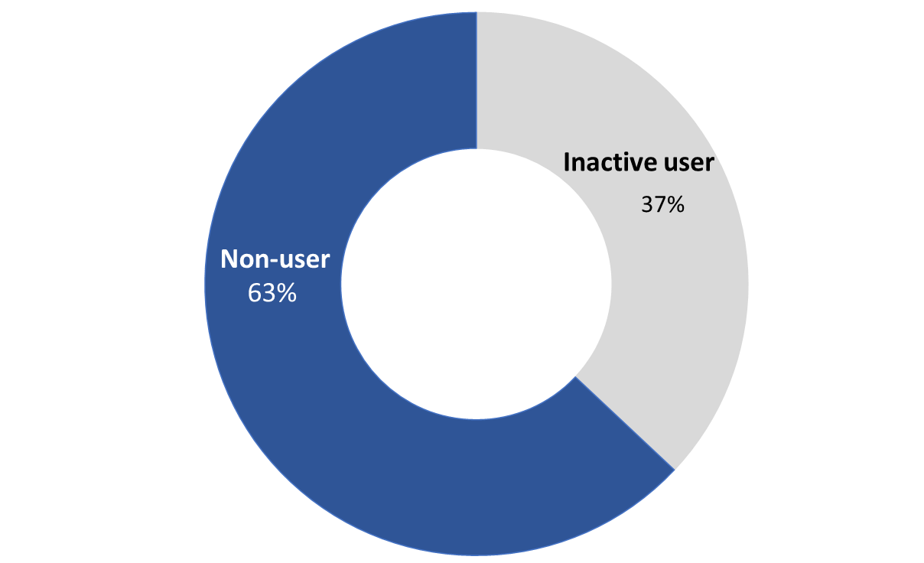
Base: All respondents (n=750).

Non-users are most likely to be aged 60 and older (71%), female (71%), and family members who receive benefits (87%). In addition, non-users are least likely to reside in Ontario (54%) and more likely to live in one of Canada’s western provinces (64%), Atlantic Canada (66%), or the province of Quebec (70%). Not surprisingly, non-users are more likely to not have an internet connection at home (90%).

In contrast, inactive users of My VAC Account are least likely to be aged 60 and older (29%) or a family member (13%), and they are more likely to reside in Ontario (46%), to be male (39%), and to have an internet connection at home (40%).

More than three-quarters of respondents are either a Veteran or a CAF member
Thirty-nine percent (39%) of respondents are Veterans, while 38% are retired or still-serving members of the Canadian Armed Forces (CAF). Following this, 14% of respondents are family members who receive benefits from VAC, while 8% are members of the RCMP.

Figure 2: Type of VAC Client
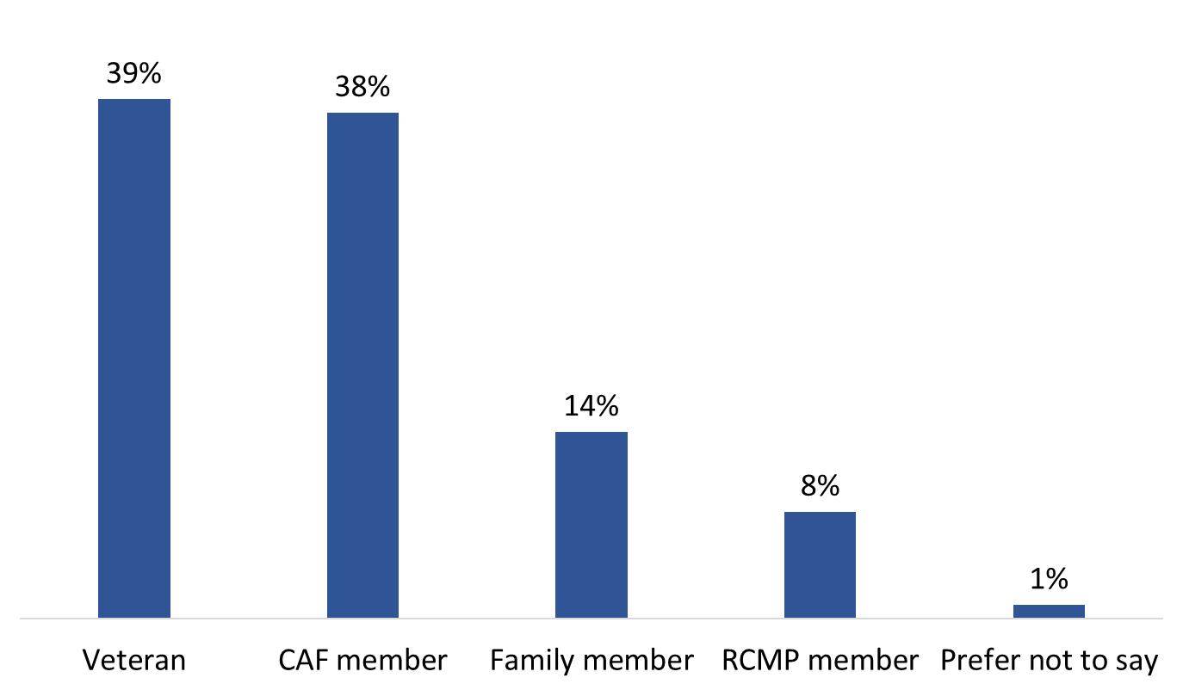

SCR1. Which of the following best describes you? Base: All respondents (n=750).

Nearly three-quarters of the surveys were completed in English
Seventy-two percent (72%) of surveys were completed in English, and 28% were completed in French.

Figure 3: Language of Survey Completion

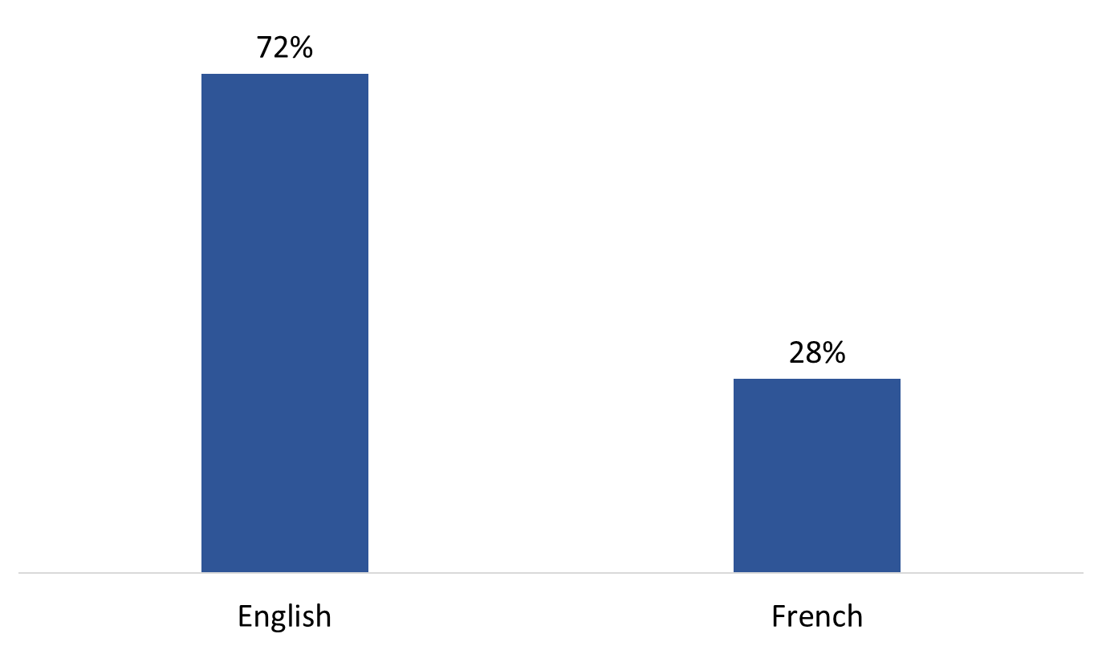
Base: All respondents (n=750).

One in six are aged 60 or over
Eleven percent (11%) of respondents are aged 18 to 39, 27% are 40 to 59, and 61% are aged 60 or over.

Figure 4: Age Distribution

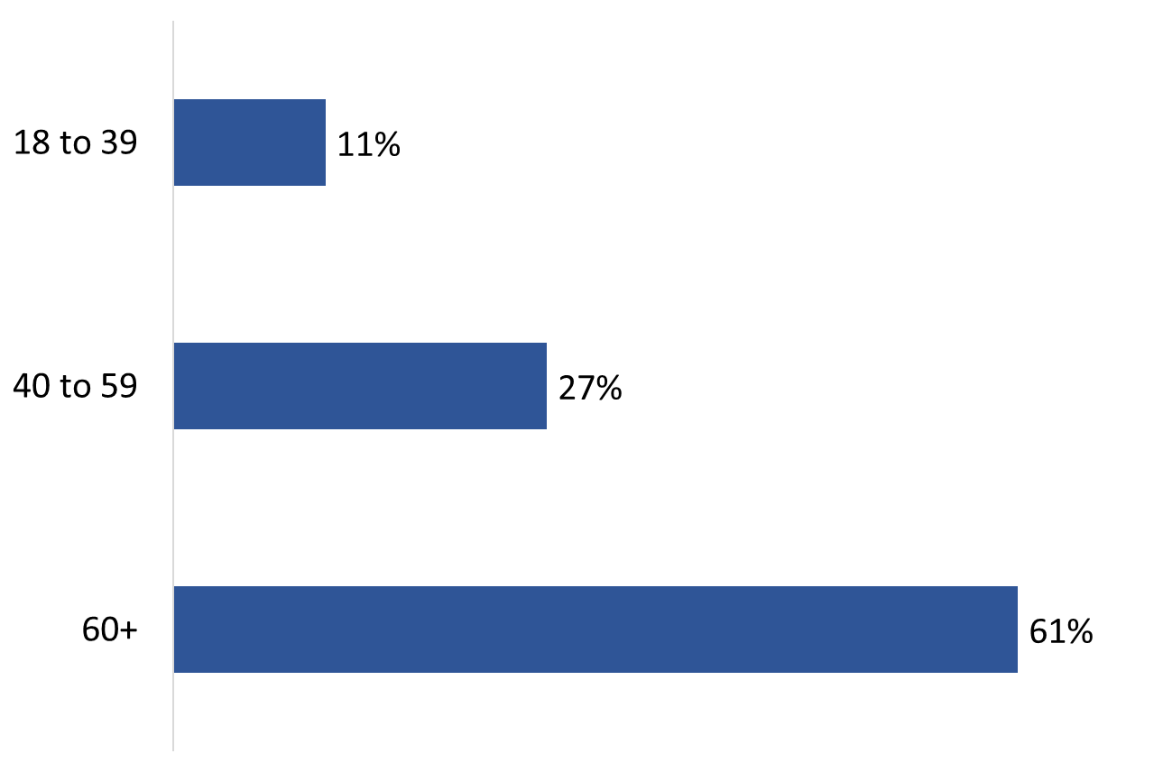
Base: All respondents (n=750).

Three quarters of clients are male
Slightly more than three-quarters (77%) of respondents are male, while 23% are female.

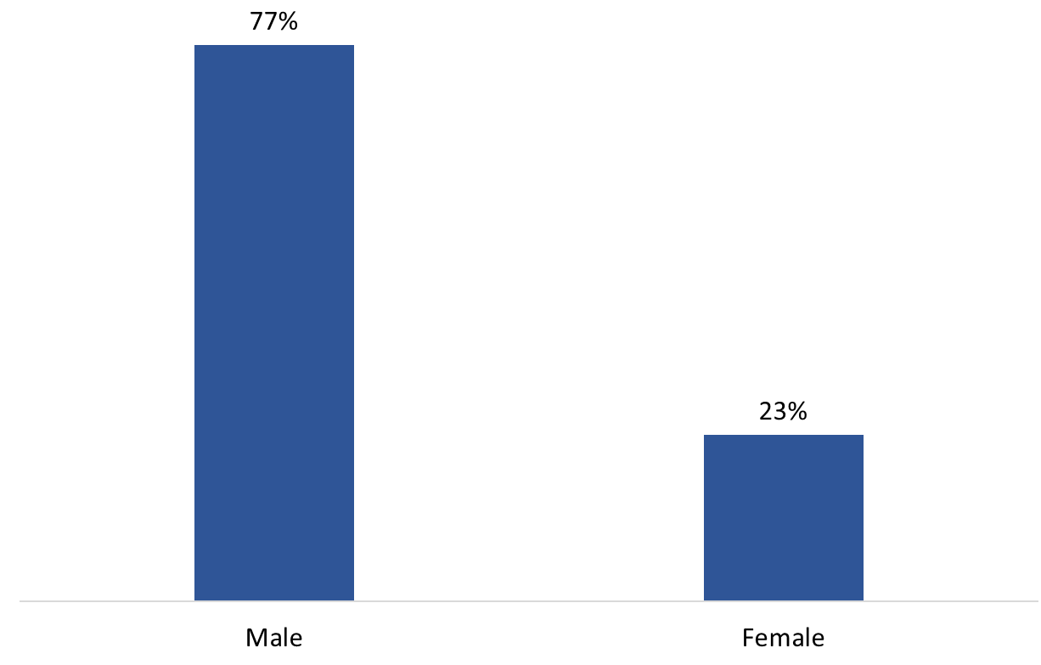
Figure 5: Gender Breakdown

Q28. Gender. Base: All respondents (n=750).

More than half of respondents are located in Ontario or Quebec
Twenty-nine percent (29%) of VAC clients surveyed are located in Ontario, while a similar proportion (28%) are located in Quebec. This is followed by the west at 23%, which includes British Columbia (12%), Alberta (6%), Saskatchewan (3%), Manitoba (2%), and the territories, and then Atlantic Canada at 18%, which includes Newfoundland and Labrador (2%), Prince Edward Island (2%), Nova Scotia (9%), and New Brunswick (5%).

Figure 6: Location
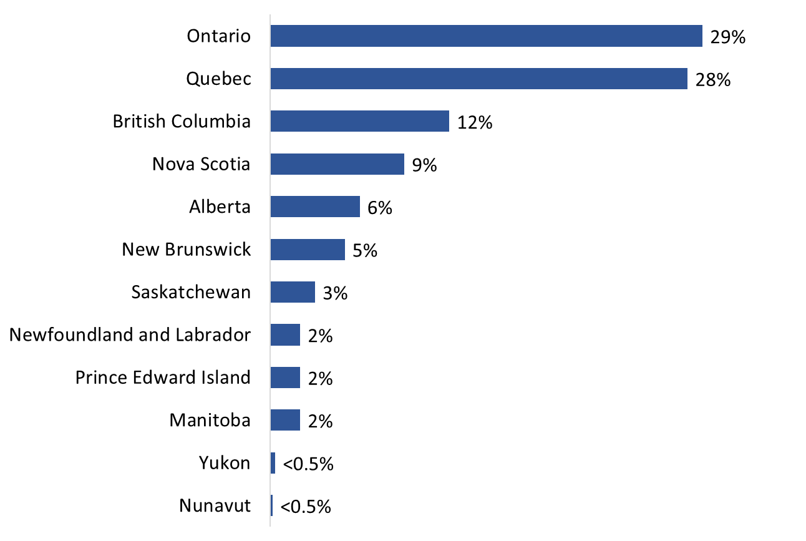

Q23. In which province or territory do you live? Base: All respondents (n=750). [Refused: 2%].

A majority of clients with internet access at home have high speed
Eighty-nine percent (89%) of respondents noted having an internet connection at home. Among these respondents, the vast majority (91%) have high speed internet; 3% reported having a dial-up internet connection.

Figure 7: Type of internet connection

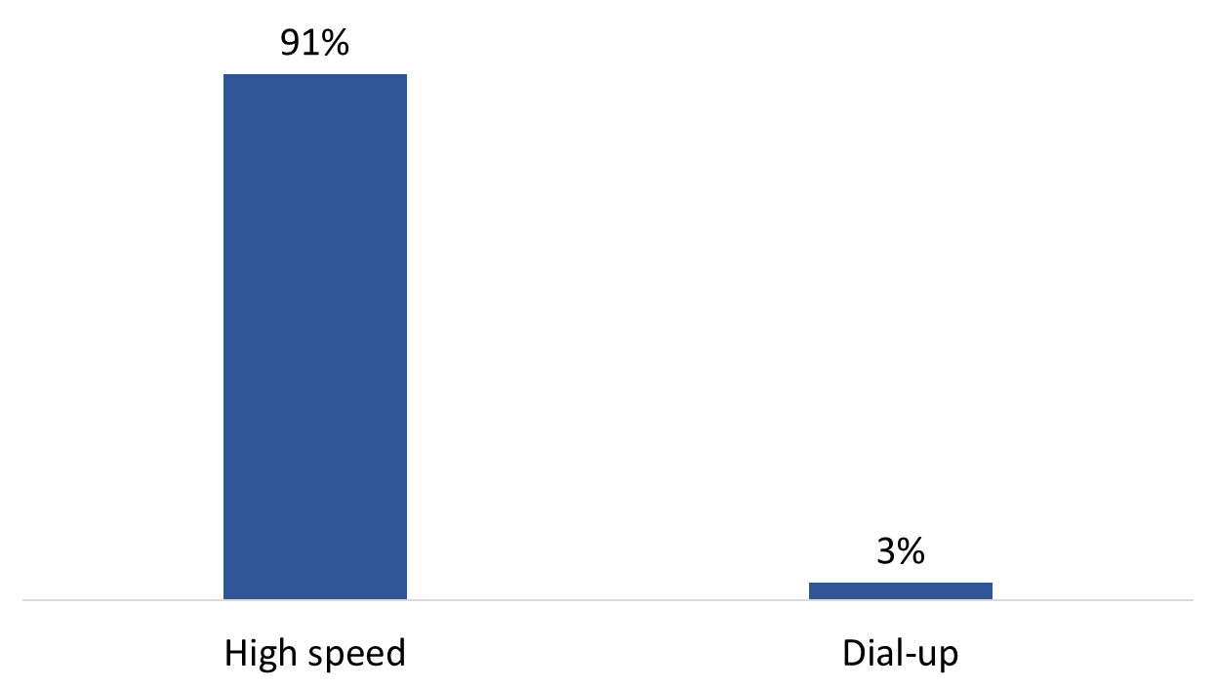

Q27. What type of internet connection do you have at home? Base: Respondents who have internet access at home (n=667). [DK/NR: 6%].

The following groups were more likely to report having a high-speed internet connection at home:
- Inactive My VAC Account users (97%) compared to non-users (87%);
- those in Ontario (95%), the west (94%), and Atlantic Canada (93%) versus Quebec (83%);
- clients who are 40 to 59 (97%) compared to those aged 60 and over (88%); and
- CAF members (94%) as opposed to family members receiving VAC benefits (83%).

Unaided Knowledge of Methods to Access or Apply for VAC Benefits
To test clients’ knowledge of the methods available to access or apply for VAC’s benefits, all respondents were asked, in an open-ended manner, to identify which methods can be used to access or apply for VAC’s benefits. The results are presented below.

One in five aware of My VAC Account as a method of access/apply for benefits
Exactly one in five (20%) said clients can access or apply for benefits through My VAC Account. In contrast, approximately four in 10 each mentioned that benefits can be accessed or applied for by telephone (42%) or online (42%) through some means. Following this, 20% reported that clients can apply for benefits by mail, and 12% mentioned benefits can be accessed or applied for in person at an office. Few said that clients can apply or access benefits in person somewhere other than a VAC office (4%) or by email (2%).

Figure 8: Unaided Knowledge of Methods to Access/Apply for Benefits
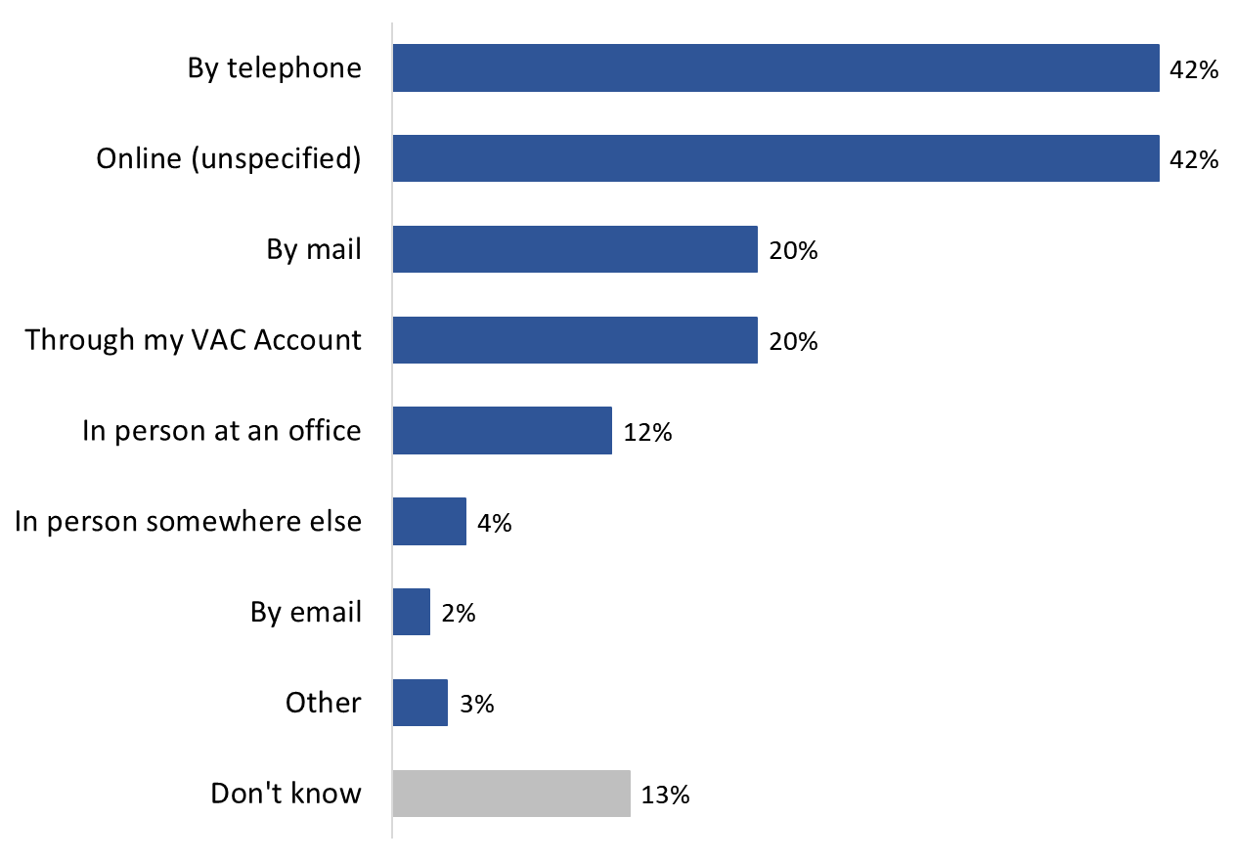
Q1A. To the best of your knowledge, what methods can you use to access or apply for VAC’s benefits? [Multiple responses accepted]. Base: All respondents (n=750).

Inactive My VAC Account users (56%) were significantly more likely than non-users (33%) to report that VAC clients can access or apply for benefits online. In contrast, non-users (17%) were more likely than inactive users (6%) to say they did not know what methods can be used to access or apply for benefits.

Age-related differences were also noteworthy. Those aged 60 and over (45%) were more likely than 18 to 39 year olds (33%) to mention telephone as a method to access or apply for benefits. They were also the most likely to mention mail (24% versus 12% of clients aged 18 to 59). Conversely, clients aged 60 and older were least likely to say that benefits can be accessed or applied for in person at an office (9% versus 17% of younger clients) or online (32% versus 53% of 18 to 39 year olds and 60% of 40 to 59 year olds.

Awareness and Knowledge of My VAC Account
This section reports on respondents’ awareness and knowledge of My VAC Account. These questions were asked of all non-users, non-users aware of My VAC Account, and inactive users of My VAC Account.

One-third of clients who do not use My VAC Account had heard of the online service channel
Approximately one-third (34%) of clients surveyed who have not registered for My VAC Account (n=473) said they are aware of the online service channel; nearly two-thirds (64%) have not heard of My VAC Account.

Figure 9: Awareness of My VAC Account

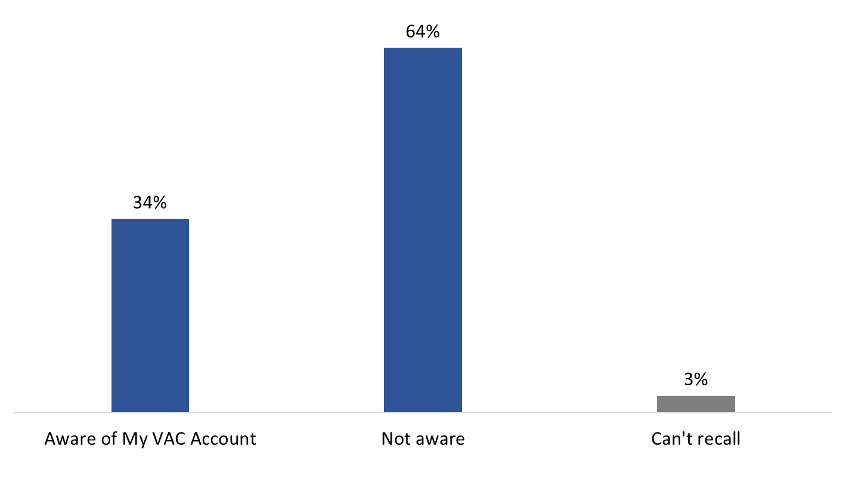
Q1. Before we contacted you for this survey, had you heard of My VAC Account? Base: Non-users only (n=473).

The likelihood of having heard of My VAC Account was higher among VAC clients with an internet connection at home (37% versus 17%), and male clients compared to female clients (36% versus 26%). Family members receiving VAC benefits (77%) were the most likely to say they are not aware of My VAC Account (versus 53% of RCMP members, 60% of CAF members and 63% of Veterans).

Source of awareness of My VAC Account is varied
Inactive users of My VAC Account and non-users aware of the online service channel (n=436) were asked how they first heard about My VAC Account. The source identified with the greatest frequency was word of mouth, such as from a friend or colleague (27%). Following this, smaller proportions first heard of My VAC Account through a VAC staff member (15%) or through information sent to them by VAC (11%). Other sources of awareness were mentioned by fewer than one in 10 respondents, and are depicted in figure 10.

Figure 10: Source of Awareness of My VAC Account

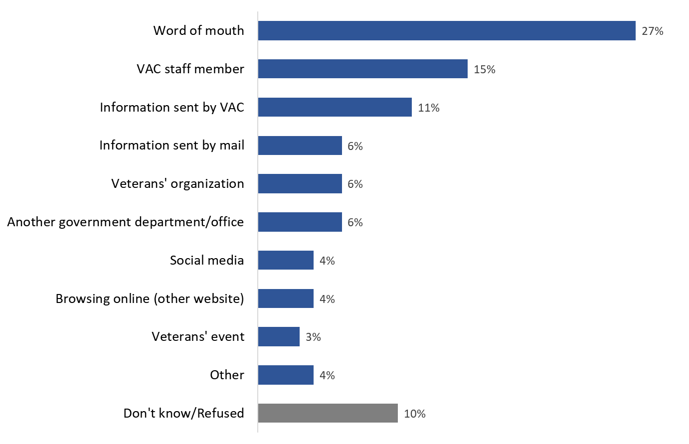
Q6. How did you first hear about My VAC Account? Base: Respondents who were aware of My VAC account (n=436).

Regardless of demographics, respondents were similarly likely to have first heard of My VAC Account via word of mouth. The likelihood of having been informed about My VAC Account by a VAC staff member was higher among respondents 18 to 59 years of age (20%) compared to those aged 60 and older (11%).

Non-users aware of My VAC Account have limited knowledge of what the online service offers
When non-users aware of My VAC Account (n=159) were asked what they know about the online service channel, over half (58%) said they know nothing about it. The types of things respondents reported knowing about My VAC Account included that it provides access to VAC benefits and services (12%), that it provides a method to apply for benefits online (11%), that it provides access to account information or one’s My VAC Account profile (9%), and that it provides an alternative to using telephone or mail to contact VAC.

A variety of other things were mentioned by smaller proportions, and are detailed in the Figure 11.

Figure 11: Knowledge of My VAC Account Services

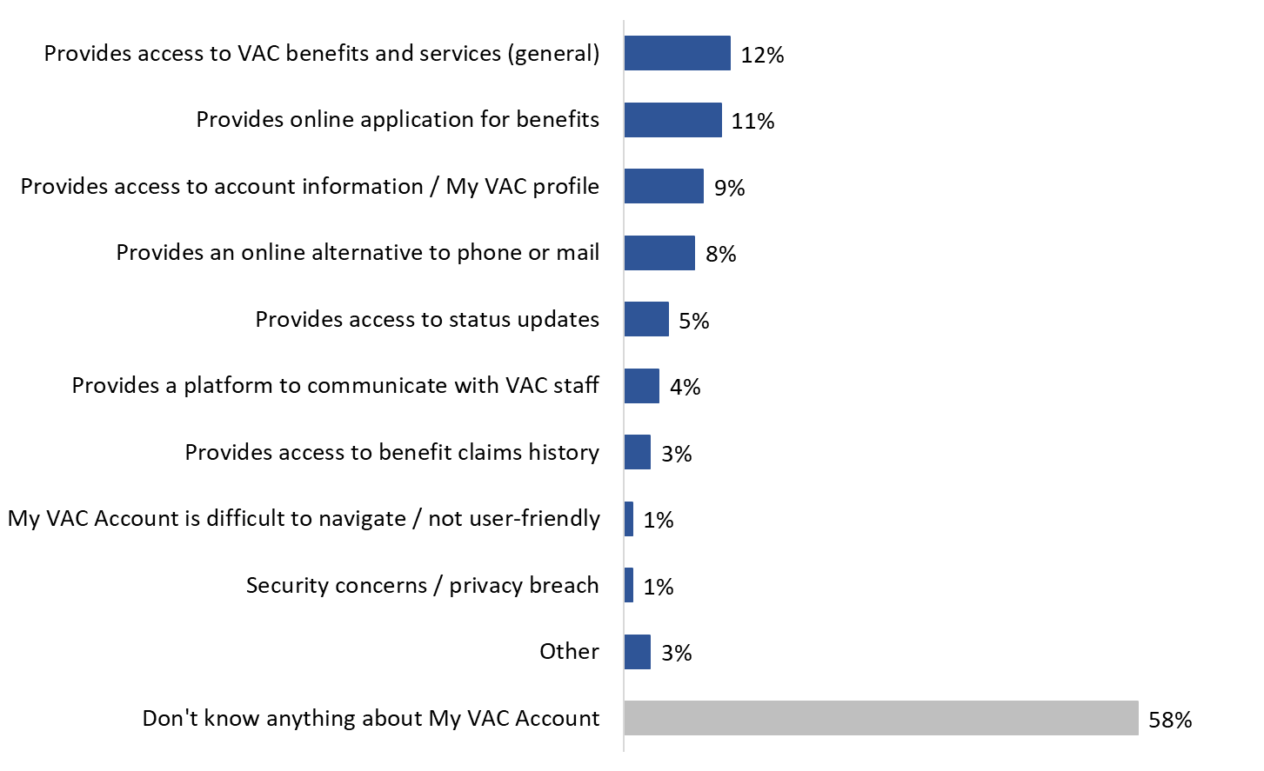

Q7. What, if anything, do you know about My VAC Account? Base: Non-users aware of My VAC Account (n=159).

Use of My VAC Account
This section of the report provides information about use of My VAC Account. These questions were asked of inactive users and non-users aware of My VAC Account.

One-third have used My VAC Account in the past 2 years
Slightly more than one-third (35%) of inactive users said they have used My VAC Account in the past two years. Among the rest, 25% last used My VAC Account between two and three years ago, 17% between three and four years ago, and 15% more than four years ago. Two percent thought they had never used My VAC Account despite having registered to use the online service channel.

Figure 12: Time Since Last Use of My VAC Account
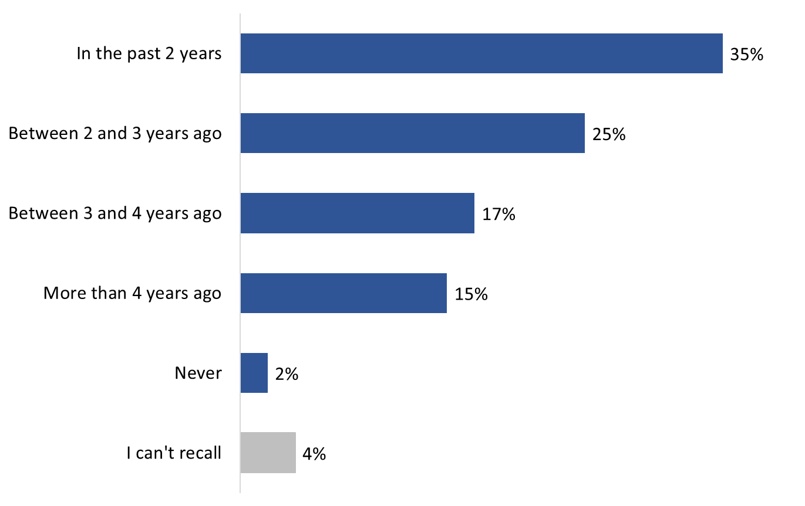
Q2. Approximately how long has it been since you last used My VAC Account? Base: Inactive users only (n=277). [NR: 1%].

The likelihood of having logged into My VAC Account in the past two years was higher among clients aged 40 to 59 (45%) compared to those aged 60 and over (27%).

Many do not use My VAC Account because of a lack of need
Almost half (47%) of non-users aware of My VAC Account and inactive My VAC Account holders (n=436) said they do not use the online service channel because they have no need to do so. Fewer attributed their lack of use to other factors, such as lack of interest (6%), the perception that online interactions are too impersonal and a preference for traditional service channels (5%), the view that registering for My VAC Account is complicated or difficult (4%), and difficulties experienced logging in to their account (4%). Other reasons for not registering for My VAC Account or using the online service channel were mentioned by small numbers of survey respondents and depicted in Figure 13.

Eleven percent (11%) said there is no specific reason why they do not use My VAC Account.

Figure 13: Reason for Not Registering / Using My VAC Account
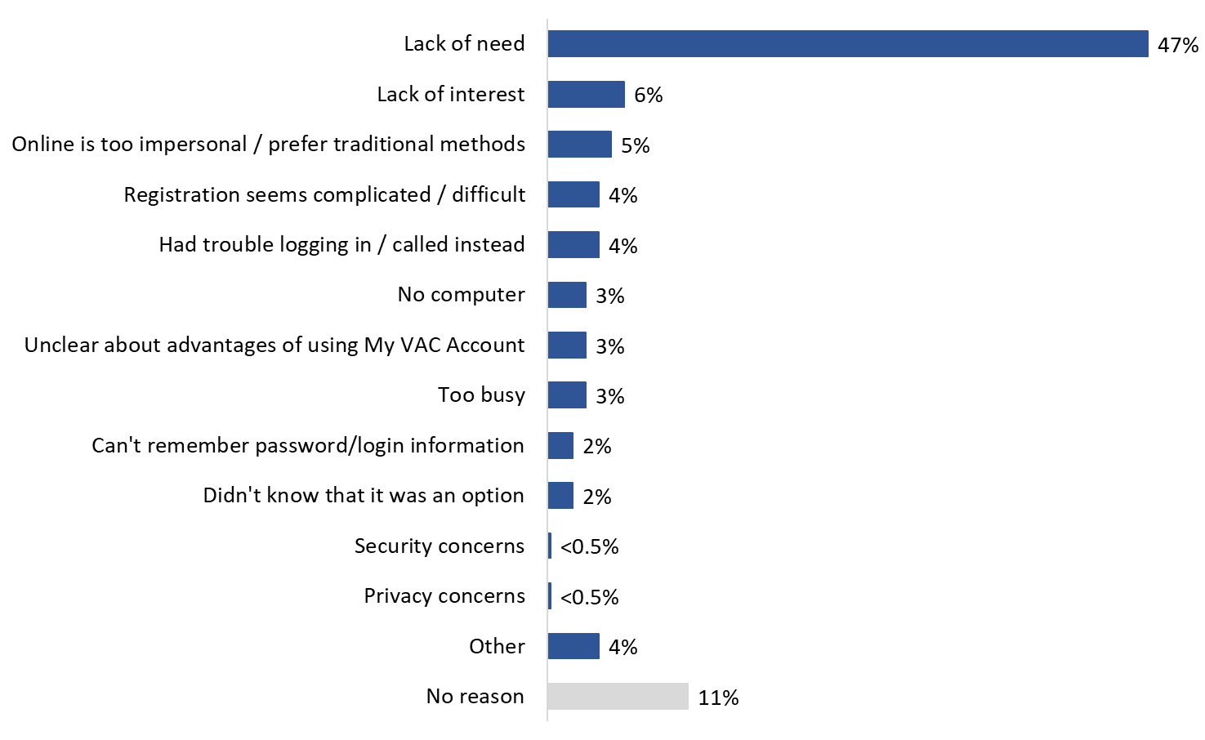

Q8. What is the main reason you [haven’t registered to use My VAC Account/have not used My VAC Account recently]? Base: Inactive users or non-users aware of My VAC Account (n=436) [UP TO TWO RESPONSES ACCEPTED]. [DK/NR: 5%].

The likelihood of reporting lack of need as the main reason for not registering for or not using My VAC Account was higher among the following groups:
- inactive users (55%) compared to non-users (35%);
- 18 to 39 year olds (64%) compared to those aged 60 and over (43%);
- men (50%) compared to women (38%); and
- those with an internet connection at home (49%) compared those without one (25%).

More than half of non-users are interested in learning more about My VAC Account
More than half (55%) of non-users are somewhat (31%) or very (24%) interested in learning more about My VAC Account. In contrast, 16% are not very interested and slightly more than one-quarter (27%) are not at all interested in learning more about My VAC Account.

Figure 14: Interest in Learning More about My VAC Account
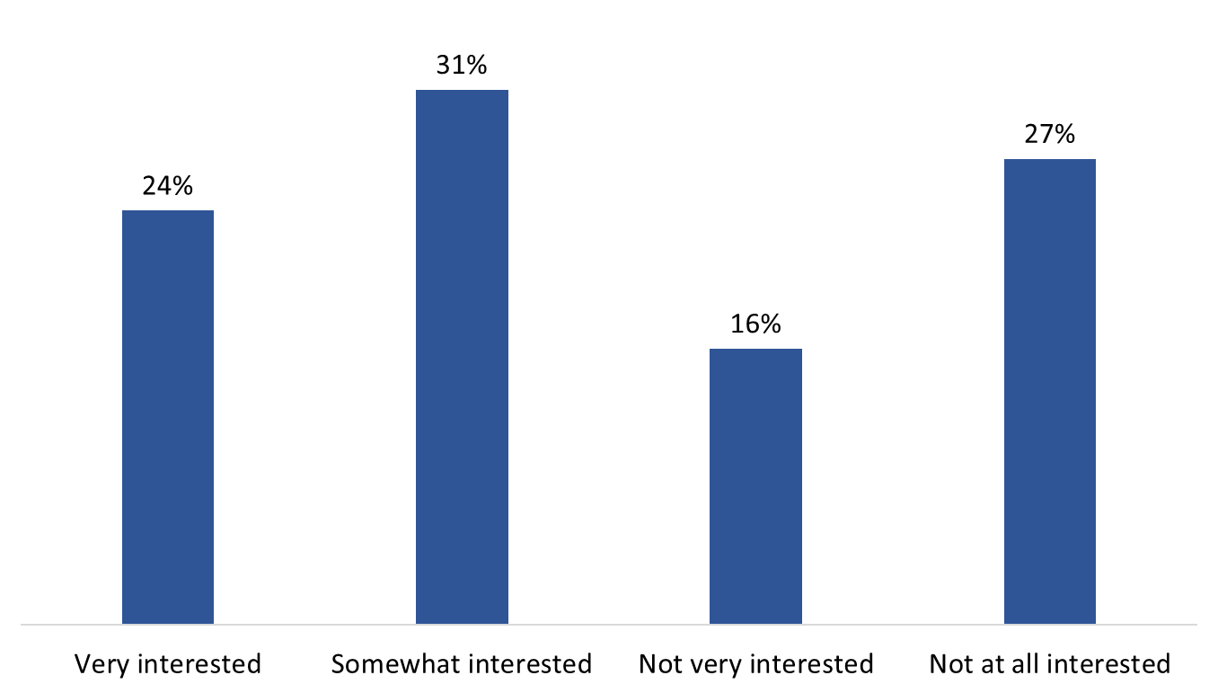

Q9. How interested are you in learning more about this online service channel? Base: Non-users only (n=473). [DK/NR: 3%].

The following were more likely to report an interest in learning more about My VAC Account:
- respondents aged 30 to 59 (71%) compared to those aged 60 and over (49%);
- men (59%) as opposed to women (42%);
- those with an internet connection at home (59%) versus those without one (29%); and
- CAF members (62%) and Veterans (56%) compared to family members receiving benefits from VAC (38%).

Registration
This section provides feedback from inactive users of My VAC Account about their experience registering for the online service.

More than half registered for My VAC Account in order to apply for VAC benefits online
Slightly more than half (55%) of inactive users surveyed said they registered for My VAC Account in order to apply online for VAC benefits and services. All other reasons were mentioned by fewer than one in 10 respondents and are presented in Figure 15.

Figure 15: Reason for Registering for My VAC Account

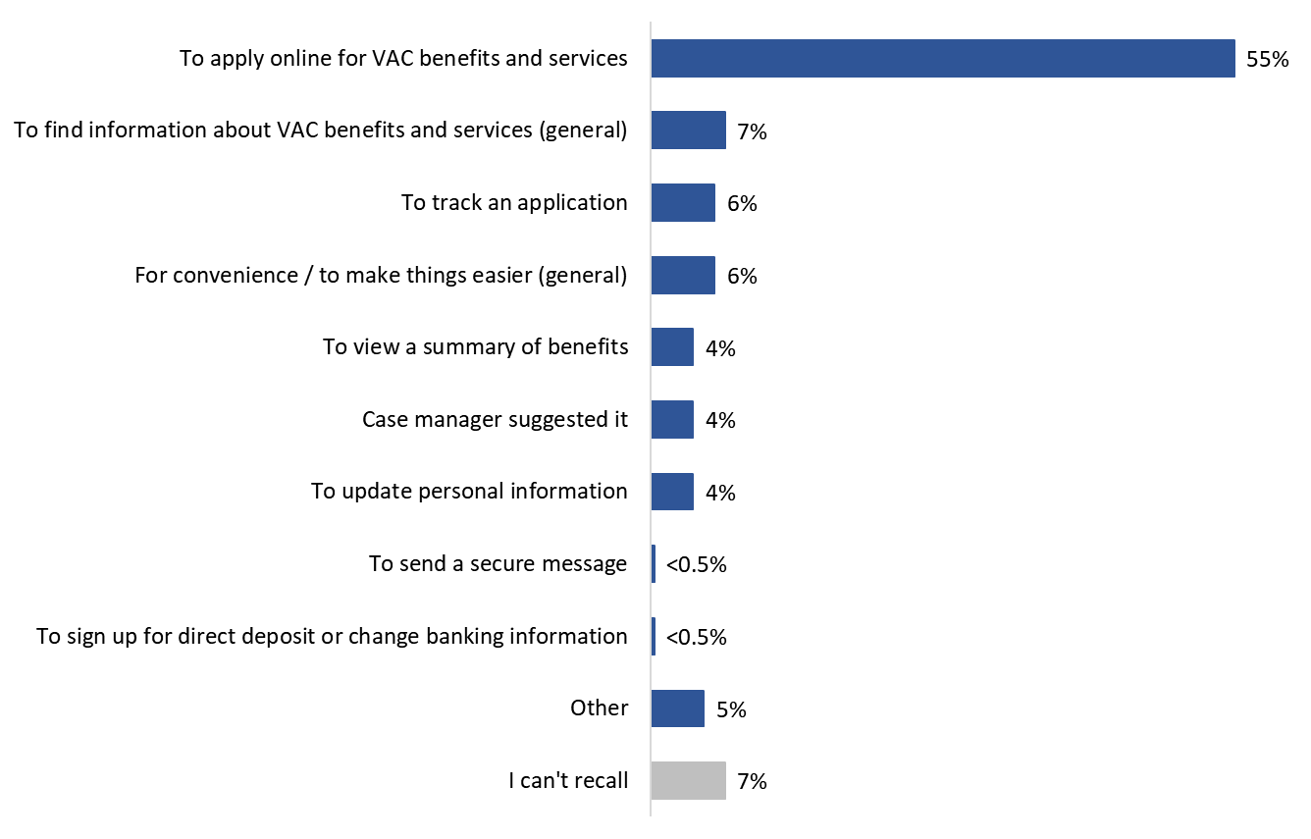
Q3. What was the reason you registered for My VAC Account? Base: Inactive users only (n=277). [NR: 2%].

Two-thirds (66%) of 18 to 39 year olds said they first registered for My VAC Account to apply for VAC benefits and services online compared to approximately half (53%) of inactive users aged 40 and older. Additionally, more than half (58%) of male respondents reported registering for My VAC Account in order to apply for benefits and services online as compared to 40% of women who did the same.

Two-thirds found it easy to register for My VAC Account
Slightly more than two-thirds (68%) of the inactive users surveyed said it was at least somewhat easy to register for My VAC Account, with 29% saying registration was very easy. One in five felt the registration process was somewhat (13%) or very (8%) difficult.

Figure 16: Ease of Registering for My VAC Account

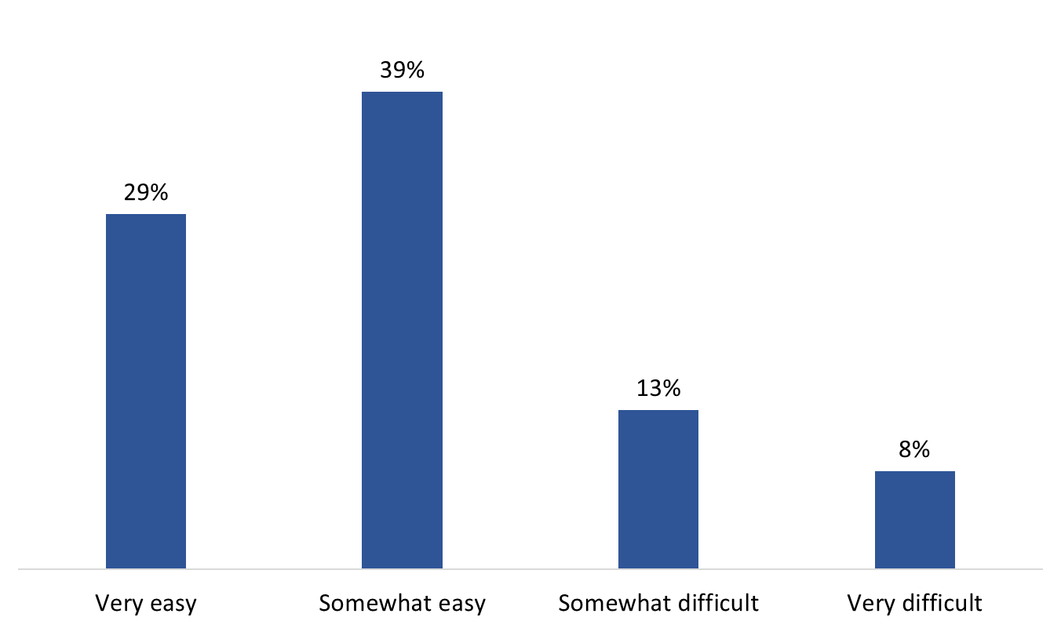

Q4. Did you find registering for My VAC Account very easy, somewhat easy, somewhat difficult or very difficult? Base: Inactive users only (n=277). [DK/NR: 10%].

Regional differences were noteworthy: inactive My VAC Account users from Atlantic Canada were least likely to have found the registration process easy. Specifically, inactive users from Quebec (79%) and western Canada (74%) were more likely to report that the registration process was somewhat or very easy compared to those in Atlantic Canada (56%).

Many report the registration process was complicated and not user-friendly
Among inactive users who found the process of registering for My VAC Account difficult (n=58), four in 10 (41%) explained that the process was complicated and not user-friendly. Seventeen percent (17%) said it took too long or involved too many steps, 16% reported experiencing problems linking My VAC Account to their account, and 12% experienced issues involving passwords. Five percent (5%) found the process difficult because they did not know what a GCKey was.

Figure 17: Difficulties Experienced when Registering for My VAC Account

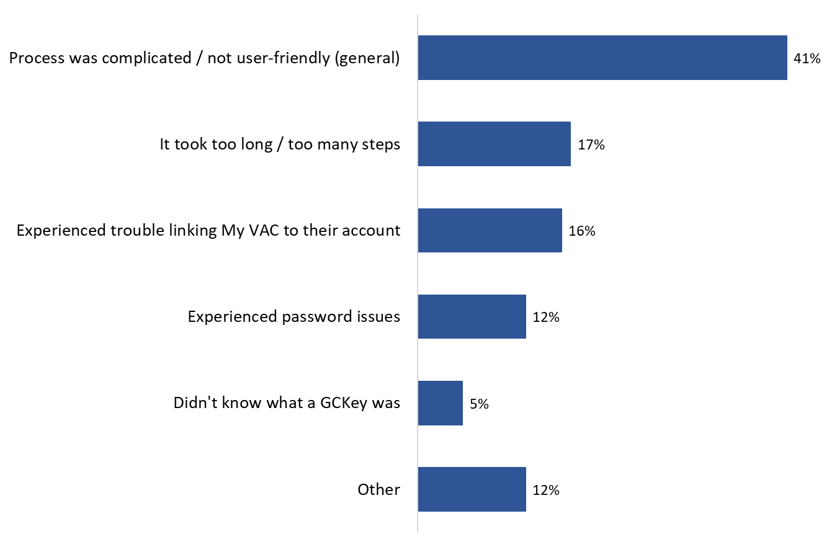
Q5. What did you find difficult about registering for My VAC Account? Base: Inactive users who found the registration process difficult (n=58) [UP TO TWO RESPONSES ACCEPTED]. [DK/NR: 10%].

Barriers and Facilitators to Using My VAC Account
This section presents feedback on potential barriers and facilitators to use of My VAC Account. These questions were asked of all respondents and, at this point in the interview, respondents had been read this description of My VAC Account:

My VAC Account is a secure online channel for Veterans to connect with Veterans Affairs Canada. Specifically, My VAC Account allows you to do things like…
- apply for benefits and services online
- track the status of your application(s)
- upload supporting documents
- communicate with VAC through secure messaging
- update your direct deposit and contact information

For one-third, security of personal information is a barrier to using My VAC Account
Respondents were asked to rate the importance to them personally of various reasons why people might not want to use My VAC Account to connect with Veterans Affairs Canada (using 5-point scale: 1 = not a factor at all, 5 = very important factor). Potential reasons included:
- Concerns about the security of personal information when using the internet.
- Not comfortable using online services like My VAC Account.
- Do not have a computer or access to one.
- Do not have internet access or access is unreliable.
- No interest in using online services like My VAC Account.
- Don’t understand the benefits or advantages of using My VAC Account.

Half or more of survey respondents did not view any of these potential barriers as important factors in terms of reasons why they might not use My VAC Account to connect with Veterans Affairs Canada. Specifically, more than seven in 10 did not attribute importance to lack of technology: not having a computer or access to one (75%) and not having internet access or reliable access to the internet (72%). Fewer than two in 10 respondents considered these important factors to them personally: 19% attributed importance to internet access and 18% to having a computer.

For approximately six in 10 (63%) lack of comfort using online services like My VAC Account is not a barrier. However, for nearly one in four (23%) it is an important factor in terms of reasons why they might not use My VAC Account to connect with Veterans Affairs Canada. Similarly, 23% said that their lack of understanding of the benefits or advantages of using My VAC Account is an important factor that might prevent usage (51% said this is not a factor).

While majorities indicated that lack of interest in using online services like My VAC Account and concerns about the security of personal information would not be reasons preventing them from using My VAC Account, 27% and 32%, respectively, attributed importance to each. Nearly one-quarter (23%) of respondents considered security concerns to be a very important factor in terms of reasons why they might not use My VAC Account and exactly one in five (20%) felt this way about interest in such a service.

Figure 18: Importance of Various Reasons for Not using My VAC Account

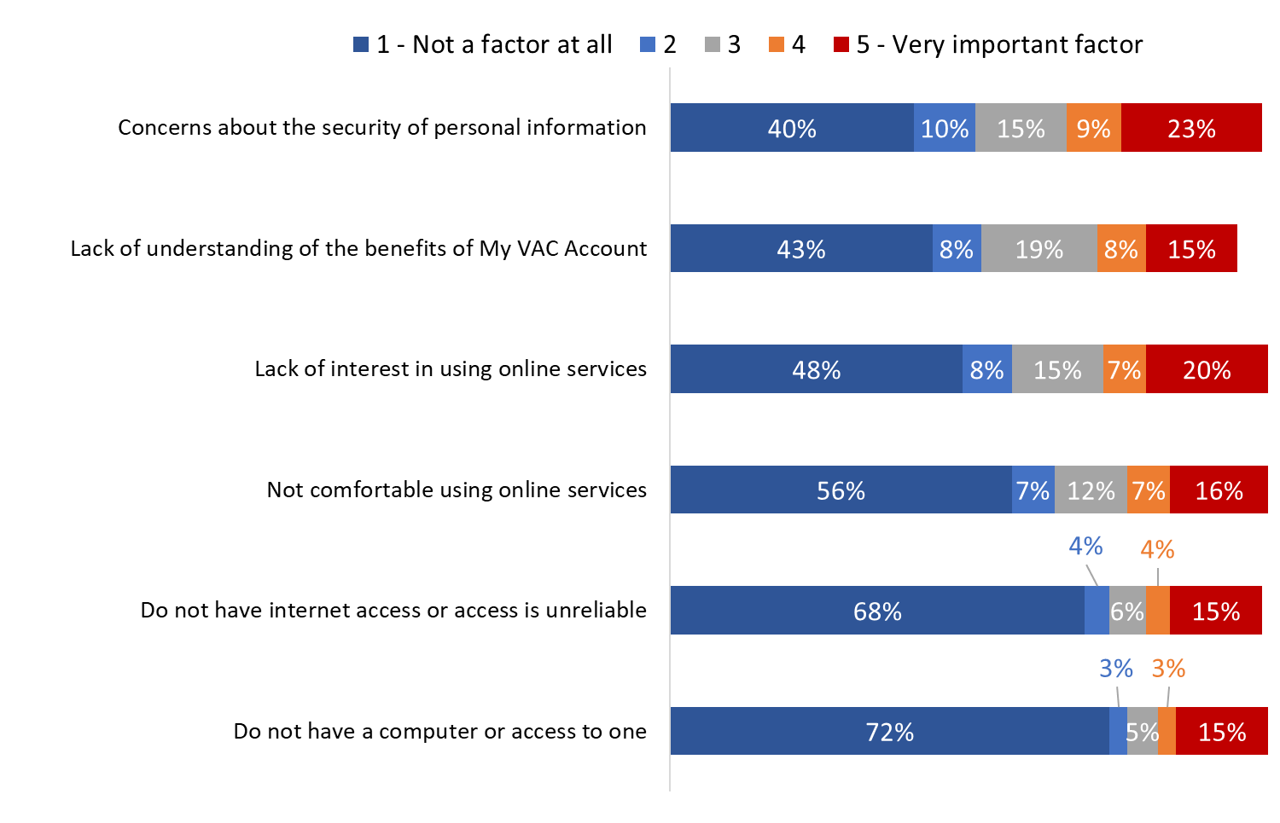
Q12. There are various reasons why some people might not want to use My VAC Account to connect with Veterans Affairs Canada. I’m going to read you some of these. For each one, please tell me how relevant it is to you personally, using a 5-point scale, where ‘1’ means not a factor at all and ‘5’ means a very important factor. How about…? Base: All respondents (n=750). [DK/NR: range from 3% to 6%].

Notable differences between inactive and non-users include the following:
- While nearly half (47%) of inactive users stated that concerns about the security of personal information using the internet is not a factor at all, fewer non-users said the same (37%).
- Two-thirds (66%) of inactive users considered lack of comfort using online services to be not a factor at all in their use of My VAC Account. In contrast, half of non-users (50%) felt the same.
- Seventy-nine percent (79%) of inactive users reported that lack of access to a computer is not a factor at all in their use of My VAC Account compared to 68% of non-users who said the same. Non-users, instead, were more likely than inactive users to have reported that lack of access to a computer is a very important factor for them when it comes to reasons preventing them from using My VAC Account (17% versus 11%).
- Three-quarters (75%) of inactive users said that lack of a reliable internet access is not a factor at all in their use of My VAC Account, while fewer (65%) non-users indicated this is the case. Additionally, RCMP members were significantly more likely to report this is not a factor at all (84%) as compared to CAF members (71%), Veterans (66%), and family members receiving VAC benefits (60%).
- Inactive users (58%) were significantly more likely to report that a lack of interest in using online services is not a factor at all as compared to non-users (42%). Conversely, non-users (24%) were more likely than inactive users (12%) to rate this as a very important factor. The same pattern was evident when it came to not understanding the benefits or advantages: inactive users were more likely to say this is not a factor at all (50% versus 40% of non-users) and non-users were more likely to have said this is a very important factor (18% versus 12% of non-users).

Additionally, clients aged 60 and older were more likely than younger clients to rate the following as very important factors: concerns about security (29%), lack of a computer (20%), and lack of internet access (19%).

Motivation to use My VAC Account is need and awareness based
Respondents were asked to consider in an open-ended manner what would encourage or motivate them to use more of or to start using My VAC Account. While a variety of things were identified, none was mentioned with much frequency. Topping the list were having a need to use My VAC Account benefits (15%), having increased awareness of My VAC Account (13%), and understanding the benefits of using My VAC Account (13%).

Additionally, many ideas related to features of My VAC Account: make it easier to register for the service (7%), make it easier to navigate, more user-friendly (5%), make available online technical support (3%), and provide a 1-800 telephone line for technical support (1%). Following this were issues of accessibility, including computer (2%) and internet (2%) access.

Two percent said that having confidence that their personal information will be safe when using My VAC Account would encourage or motivate them to start using My VAC Account or use My VAC Account again. This contrasts with the third of respondents (32%) who rated concerns about the security of personal information when using the internet as an important factor when it comes to reasons for not using My VAC Account. It suggests, moreover, that security and privacy may not be top of mind concerns for My VAC Account users, but that when presented with this as a potential barrier, it becomes more salient.

Approximately one-third offered not meaningful suggestions: 13% said nothing is needed to encourage them because they intend to use the service in the future and 22% said nothing can be done to motivate them because they have no intention of using the service.

Figure 19: Factors that would Encourage Use of My VAC Account
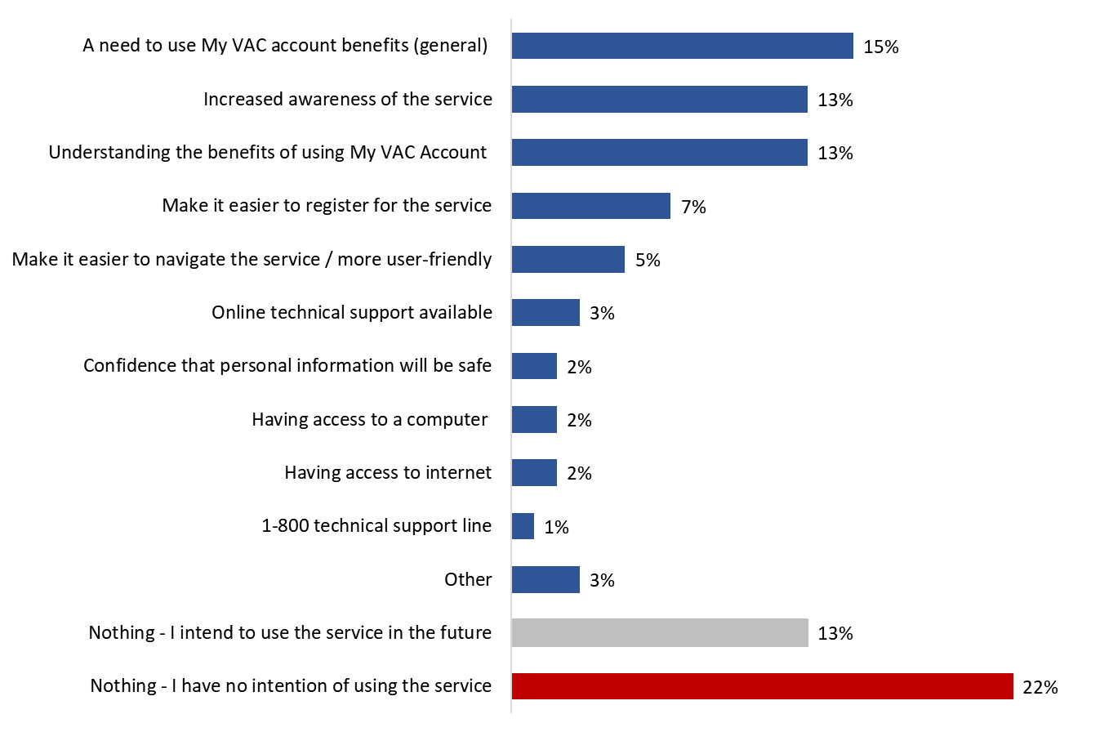

Q13. What, if anything, would encourage or motivate you to [start using My VAC Account/use My VAC Account again]? Base: All respondents (n=750) [UP TO TWO RESPONSES ACCEPTED]. [DK/NR: 6%].

Inactive My VAC Account users (25%) were more likely than non-users (9%) to report that need (i.e., having a reason to use the online service channel) would motivate them to start using My VAC Account. Inactive users also were more likely to have said they intend to use the service in the future (17% versus 11% of non-users). In contrast, 28% of non-users have no intention of using the service in the future as compared to 12% of inactive users. Non-users also were more likely to say that increased awareness of the service might motivate them to start using My VAC Account (15% versus 10% of inactive users).

Many consider email notifications of application status changes to be a potential benefit of using My VAC Account
Respondents were asked to rate the importance or relevance to them personally of a number of potential benefits to using My VAC Account (using a 5-point scale: 1 = not a factor at all, 5 = very important factor). Benefits included:
- Applying is easier with a guided web form in My VAC Account for certain applications
- Uploading documents rather than sending by mail
- Having a record of your conversation with VAC
- Receiving documents online rather than waiting for mail
- Being able to check the status of your application anytime
- Receiving an email notification when your application changes status
- Being able to update profile and direct deposit information
- Receiving VAC news updates

A majority of respondents attributed importance to most of these potential benefits. Six in 10 (62%) considered email notifications of application status changes to be an important potential benefit of My VAC Account, including 50% who said it is a very important factor. This is closely followed by the ability to check the status of an application anytime and the ability to update profile and direct deposit information: 59% said these are important benefits, including 48% and 45%, respectively, who said they are very important factors.

At least five in 10 rated uploading documents rather than sending them by mail (55%), receiving documents online rather than waiting for them to arrive by mail (53%), and having a record of a conversation with VAC (52%) as potential benefits of My VAC Account that are personally important to them.

Almost half (49%) considered important the potential benefit of using guided web forms for certain applications, while 44% characterized receiving VAC news updates as a benefit that would be important to them personally.

Figure 20: Importance of Various Benefits of Using My VAC Account

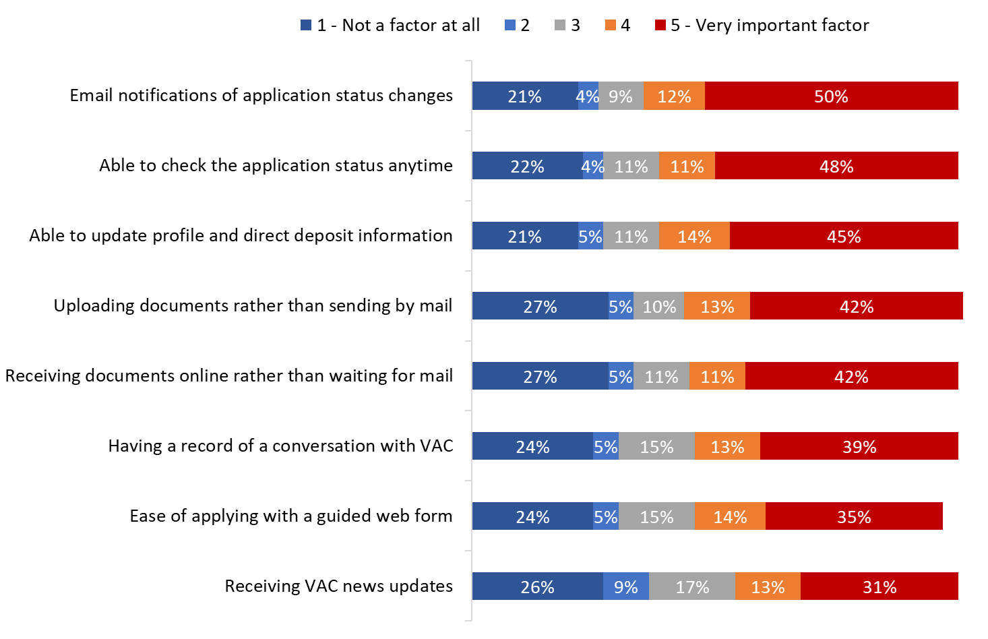

Q14. There are potential benefits to using My VAC Account. I’m going to read some of these to you. For each one, please tell me how relevant it is to you personally, using a 5-point scale, where ‘1’ means not a factor at all and ‘5’ means a very important factor. How about…? Base: All respondents (n=750). [DK/NR: ranged from 4% to 7%].

Inactive users (compared to non-users), clients between the ages of 18 and 59 (compared to clients aged 60 and older), Veterans and CAF members (compared to family members) and clients with internet access at home (compared to those without) were more likely to attribute importance to the potential benefits of using My VAC Account.

Future Use of My VAC Account
This section presents findings related to future use of My VAC Account. With one exception, these questions were asked of all respondents.

One-quarter are very likely to register for My VAC Account or start using My VAC Account again
Slightly more than half (56%) of survey respondents are likely to register for My VAC Account or start using the online service channel again, including nearly one-quarter (23%) who are very likely to do so. In contrast, one-third are unlikely (16%) or very unlikely (17%) to register for My VAC Account or start using My VAC Account again. The rest (7%) are neutral, neither likely no unlikely to register for, or start using again, My VAC Account.

Figure 21: Likelihood of Registering for / Using My VAC Account

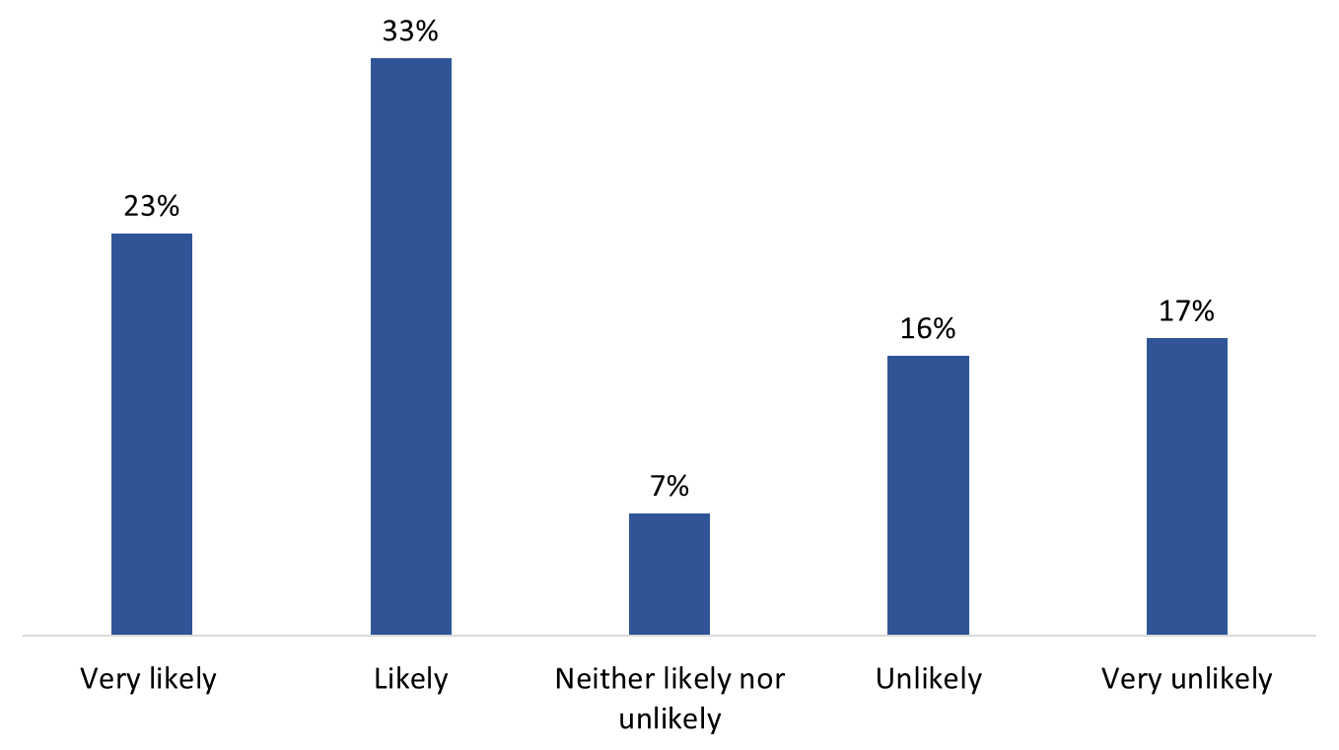
Q10. How likely or unlikely would you be to [register for My VAC Account/start using My VAC Account again]? Base: All respondents (n=750). [DK/NR: 3%].

Two-thirds (66%) of inactive account holders said they are likely or very likely to start using My VAC Account again. In contrast, half (51%) of non-users indicated that it is likely or very likely that they will register to use My VAC Account.

In addition, the following were more likely to report that they are likely or very likely to register for My VAC Account or start using their account again:
- those aged 30 to 59 (69%) compared to clients aged 60 and over (50%);
- those located in Quebec (64%) compared to those in Atlantic Canada (46%);
- men (61%) compared to women (42%); and
- CAF members (65%) compared to Veterans (57%) and family members (30%).

Many say they have no need to register for, or use My VAC Account
Among respondents who say they are unlikely or very unlikely to register for, or start using their My VAC Account again (n=250), approximately four in 10 (39%) said it is because they have no need.

Following this, respondents mentioned technology-related reasons, including not being tech-savvy and preferring not to use a computer (12%), not having a computer (9%) or access to the internet (5%), encountering technical problems (6%), and security concerns (4%).

Other reasons offered to explain why respondents are unlikely or very unlikely to register for, or start using, My VAC Account included the perception that it is faster and more efficient to call VAC than to use My VAC Account (6%), that they do not know the benefits of using My VAC Account (5%), and that they prefer to contact VAC in person (4%).

Nearly one in five (19%) provided no reason for not registering for, or using more, My VAC Account other than simply not wanting to do so.
Figure 22: Reason for being Unlikely to Register for / Use My VAC Account

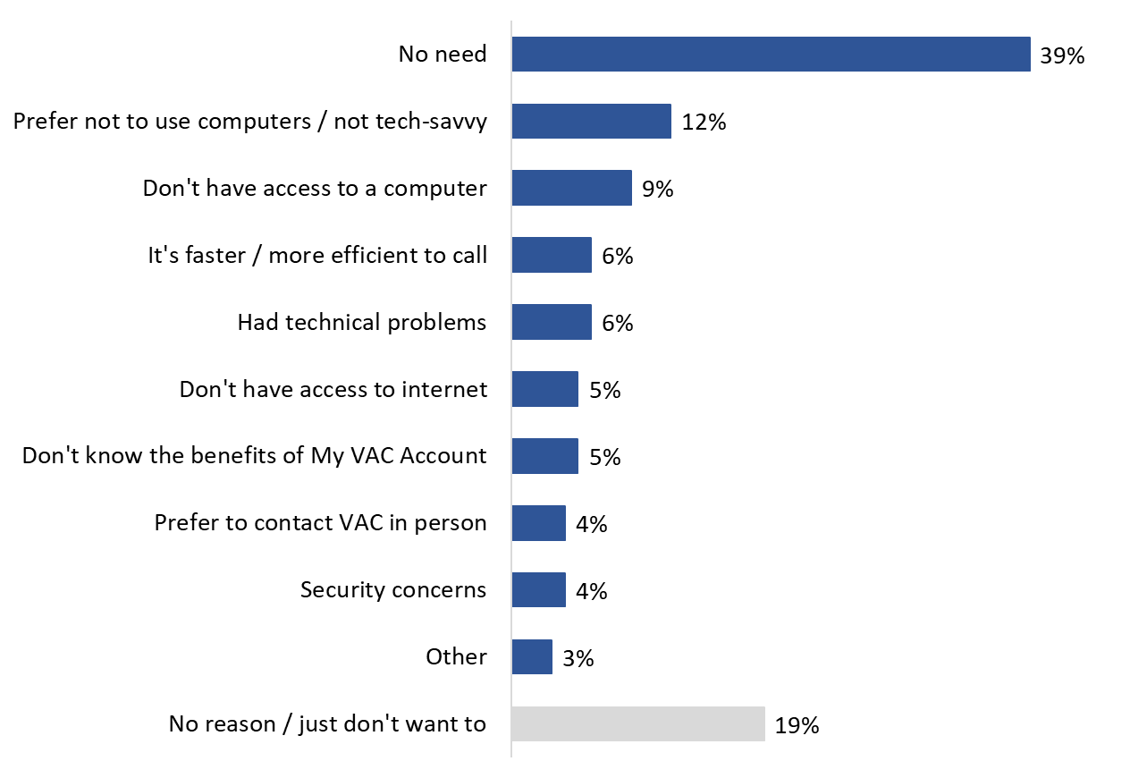
Q11. Why are you not likely to [register for My VAC Account/start using My VAC Account again]? Base: Respondents who said they are unlikely to start using My VAC Account (n=250) [UP TO TWO RESPONSES ACCEPTED]. [DK/NR: 2%].

Half are likely to use My VAC Account to submit their next benefit application
Approximately half of survey respondents are likely (22%) or very likely (31%) to submit their next benefit application through My VAC Account. In contrast, 15% are unlikely to submit their next benefit application through My VAC Account, and 24% are very unlikely to do so. The rest (6%) were indifferent, saying they are neither likely nor unlikely to submit their next benefit application through My VAC Account.

Figure 23: Likelihood of Submitting Next Benefit Application through My VAC Account
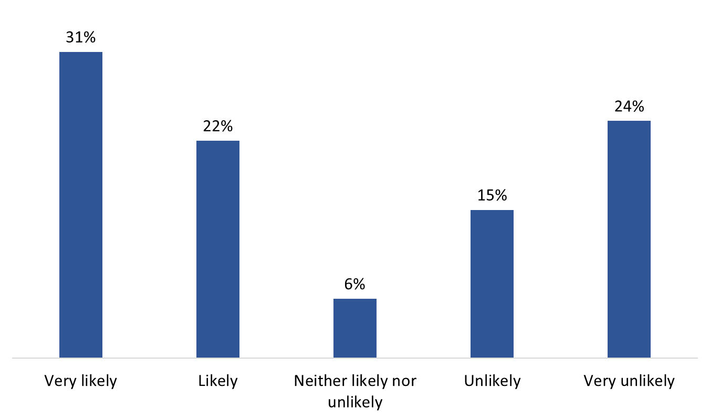
Q16. How likely or unlikely would you be to submit your next benefit application through My VAC Account? Base: All respondents (n=750). [DK/NR: 2%].

Seven in 10 (70%) inactive account holders said they are likely or very likely to submit their next benefit application through My VAC Account. In contrast, approximately four in 10 (43%) non-users surveyed indicated that it is likely or very likely that they will use My VAC Account to submit their next benefit application.

In addition, the following groups were more likely to report being likely or very likely to submit their next benefit application through My VAC Account:
- 18 to 39 (69%) and 40 to 59 (68%) year olds as opposed to those aged 60 and over (44%);
- men (56%) compared to women (42%);
- those with an internet connection at home (57%) compared to those without (19%);
- CAF members (63%) as opposed to Veterans (50%) and family members receiving VAC benefits (25%).

Just over half are likely to use secure messaging to communicate with VAC
Just over half of survey respondents are likely (29%) or very likely (26%) to use secure messaging to communicate with VAC. In contrast, 16% are unlikely to communicate with VAC through secure messaging, and 20% are very unlikely to do so. The rest (7%) were indifferent, saying they are neither likely nor unlikely to use secure messaging.

Figure 24: Likelihood of Using Secure Messaging to Contact VAC
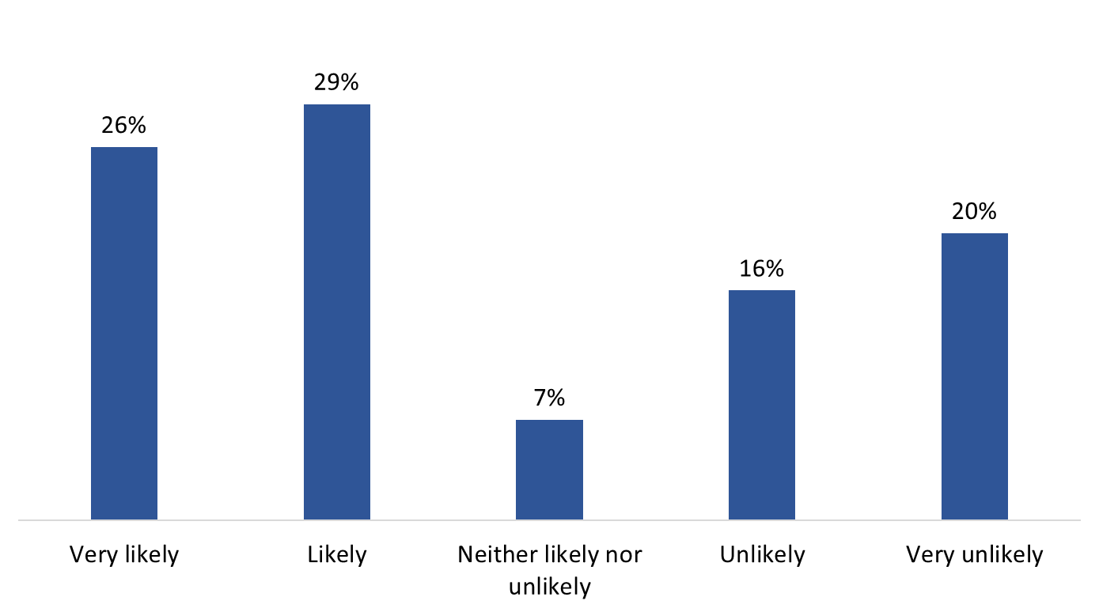
Q18. How likely or unlikely would you be to use secure messaging to communicate with VAC? Base: All respondents (n=750). [DK/NR: 1%].

Just over two-thirds (68%) of inactive account holders said they are likely or very likely to use secure messaging to communicate with VAC. In contrast, fewer than half (47%) the non-users surveyed indicated that it is likely or very likely that they will use secure messaging.

In addition, the following groups were more likely to report being likely or very likely to use secure messaging to communicate with VAC:
- 40 to 59 year olds (65%) compared to those aged 60 and over (50%);
- men (58%) compared to women (42%);
- those with an internet connection at home (59%) versus those without one (18%); and
- RCMP (71%) compared to Veterans (55%) and family members (31%).

Appendix

Methodological Information
The following specifications applied to this survey:

- A 12-minute telephone survey was administered to 750 clients of VAC. This include clients who are registered for My VAC Account but who have not logged in over the 24-month period preceding the research, and clients who have not registered to use My VAC Account.
- The sample frame for this survey was randomly drawn from the Department’s Client Service Delivery Network (CSDN). Two CSDN queries were run to generate two pools of eligible individuals. The resulting extracts included only the first name and telephone number of potential respondents. The extracts were segmented as follows:
  - Current clients who had not registered to use My VAC Account; and
  - My VAC Account users who had not logged in for the past 24 months.
- Probability sampling was used; as such, the results can be extrapolated to the full population of VAC clients who are lapsed or infrequent users of My VAC Account and non-users of My VAC Account.
- Interviewing was conducted by Elemental Data Collection Inc. (EDCI) using Computer Aided Telephone Interviewing (CATI) technology.
- Following survey best practices, the questionnaire was pre-tested in advance of the fieldwork to ensure that it measured what it was intended to measure.
  - Respondents had the choice of participating in the official language of their choice.
  - There were 10 completions in each official language.
  - Overall, the questionnaire worked well. There were no significant problems in terms of design or respondents’ comprehension of the questions.
- All survey participants were informed that their participation is voluntary, and that information collected is protected under the authority of the Privacy Act.
- Calling was conducted at different times of the day and the week to maximize the opportunity to establish contact.
- A minimum of eight call-backs were attempted to reach potential respondents before a sample record was retired.
- The sample of 750 VAC clients can be considered accurate to within ±3.6%, 19 times out of 20.
- The fieldwork took place between August 21 and September 6, 2020.
- The response rate was 7.3%. The table below presents information about the final call dispositions for this survey.
Total Numbers Attempted | 11,533
Out-of-scope - Invalid | 219
Unresolved (U) | 6,729
No answer/Answering machine | 6,729
In-scope - Non-responding (IS) | 3,760
Language barrier | 45
Incapable of completing (ill/deceased) | 210
Callback (respondent not available) | 425
Refusal | 2,864
Termination | 217
In-scope - Responding units (R) | 825
Completed Interview | 750
Indicated that they did use My VAC Account in past 2 years* | 75
*criterion removed mid-data collection
- In terms of the analysis:
  - The survey data were not weighted because there was no reliable information available about the characteristics of the population against which to weight the survey results.
  - Non-response bias is the bias that results when survey respondents differ in meaningful ways from non-respondents. The sample frame contained no information that could be used to assess the potential for bias from survey non-response. That said, by design, the survey sample contains more non-users than inactive users and therefore can be expected to overrepresent the views of non-users.

Survey Questionnaire

A. INTRODUCTION

Hello/Bonjour, may I please speak to [INSERT CLIENT’S NAME].

- IF PERSON IS AVAILABLE, CONTINUE.
- IF NOT AVAILABLE, ARRANGE CALL-BACK.

IF NECESSARY, EXPLAIN PURPOSE OF PHONE CALL. SAY: “I’m calling on behalf of Veterans Affairs Canada to ask some questions about services provided by the Department”.

Would you prefer to continue in English or French? / Préférez-vous continuer en français ou en anglais?

INTERVIEWER NOTE: IF THE RESPONDENT PREFERS TO RESPOND IN FRENCH, THE INTERVIEWER MUST BE ABLE TO EITHER PROCEED WITH THE INTERVIEW IN FRENCH OR READ THE FOLLOWING STATEMENT: “JE VOUS REMERCIE. QUELQU'UN VOUS RAPPELLERA BIENTÔT POUR MENER LE SONDAGE EN FRANÇAIS.”

My name is [INTERVIEWER'S NAME]. I’m calling from Phoenix SPI, a Canadian public opinion research company. We’re conducting a survey on behalf of Veterans Affairs Canada about how you prefer to interact with the Department.

This survey should take no more than ten minutes to complete. Participation is voluntary and completely confidential. Your answers will remain anonymous. None of your opinions will be attributed to you personally in any way. Would you like to continue?

- Yes CONTINUE
- No, not now ARRANGE CALL-BACK
- Refused THANK/DISCONTINUE

IF ASKED HOW WE GOT THE PERSON’S NAME, SAY: “Your name was selected from a random sample of Canadians who have been in contact with Veterans Affairs Canada, or VAC, in the last few years. VAC provided us (Phoenix SPI) your name and contact information for the purposes of this survey only. Your information is protected under the Government of Canada’s Privacy Act and will remain confidential.

INTERVIEWER NOTES:

- If a respondent questions the legitimacy of the survey, invite him/her to:
  - Use the Canadian Research Insights Council’s Research Verification Service to validate the research. The registration number for this survey is: 20200312-PH514 and the URL is https://www.canadianresearchinsightscouncil.ca/rvs/home/; AND/OR
  - Contact Veterans Affairs Canada at 1-866-522-2122 or directly to the project authority, Laura Sinclair-Bevan 1-902-394-7363
- If a respondent expresses concerns about the privacy of their information, reiterate that participation in the survey is voluntary and completely confidential, and that all answers will remain anonymous and say: “If you indicate that you no longer wish to participate, any survey responses already provided will be deleted. Should you complete the survey, any information you provide will be administered according to the requirements of the Privacy Act, the Access to Information Act, and any other pertinent legislation. Veterans Affairs Canada will never receive any personally identifying information.”
- If asked about the National Do Not Call List, say: “Calls made for the purpose of market research, polls or surveys are not considered telemarketing calls. Organizations making these types of calls are not required to register with the national do not call list. The national Do Not Call List toll-free telephone number is 1-866-580-3625.
- If asked where and how the respondent can access the results, inform him or her that the report will be deposited with Library and Archives Canada within six months after the data collection has been completed and can be accessed via: www.lac-bac.gc.ca.

B. SCREENING QUESTIONS

SCR. 1 Which of the following best describes you…?

[READ LIST]

- a Veteran
- a retired or still-serving member of Canadian Armed Forces
- a retired or still-serving member of the RCMP
- a family member who receives benefits from VAC
99. [DO NOT READ] Prefer not to say

1A. To the best of your knowledge, what methods can you use to access or apply for VAC’s benefits? [ACCEPT ALL RESPONSES]

[DO NOT READ]

- By mail
- In person at an office
- Online (unspecified)
- By telephone
- Through My VAC Account
- Other. Please specify: [TEXT BOX]
99. Don’t know/Refused

SCR. 2 Are you a registered user of My VAC Account? INTERVIEWER NOTE: IF ASKED WHAT MY VAC ACCOUNT IS, SAY: My VAC Account is a secure online channel for Veterans, still-serving CAF and RCMP members, and family members who receive benefits from VAC to connect with Veterans Affairs Canada.

[READ LIST]

- Yes CONTINUE
- No NON-USER; SKIP TO Q1
- [DO NOT READ] Can’t recall NON-USER; SKIP TO Q1

SCR. 3 In the past 2 years, have you signed into My VAC Account?

[READ LIST]

- Yes INACTIVE ACCOUNT HOLDER; SKIP TO Q3
- No INACTIVE ACCOUNT HOLDER; SKIP TO Q2
- [DO NOT READ] Can’t recall INACTIVE ACCOUNT HOLDER; SKIP TO Q2

C. SURVEY QUESTIONS

- [NON-USERS ONLY] Before we contacted you for this survey, had you heard of My VAC Account?

[READ LIST]

- Yes SKIP TO Q6
- No SKIP TO DESCRIPTION
- [DO NOT READ] Can’t recall SKIP TO DESCRIPTION

- [INACTIVE ACCOUNT HOLDERS ONLY] Approximately how long has it been since you last used My VAC Account?

[READ LIST]

- Between 2 and 3 years ago
- Between 3 and 4 years ago
- More than 4 years ago
- [DO NOT READ] I can’t recall
- [DO NOT READ] Never
- [DO NOT READ] Don’t know/Refused

- [INACTIVE ACCOUNT HOLDERS ONLY] What was the reason you registered for My VAC Account?

[DO NOT READ]

- To apply online for VAC benefits and services.
- To track my application.
- To send a secure message
- To view a summary of my benefits.
- To sign up for direct deposit or change my banking information.
- To update my personal information.
- My case manager suggested I should.
- Other. Please specify: [TEXT BOX]
- I can’t recall
99. Don’t know/Refused

- [INACTIVE ACCOUNT HOLDERS ONLY] Did you find registering for My VAC Account very easy, somewhat easy, somewhat difficult or very difficult?

[DO NOT READ]

- Very easy
- Somewhat easy
- Somewhat difficult
- Very difficult
99. Don’t know/Refused

- [INACTIVE ACCOUNT HOLDERS IF Q4=03, 04] What did you find difficult about registering for My VAC Account? [ACCEPT UP TO 2 RESPONSES]

[DO NOT READ]

- It took too long/too many steps
- I didn’t know what a GCKey was
- I experienced trouble linking my VAC file to my account
- Other - Please specify.
99. Don’t know/Refused

- [EVERYONE EXCEPT Q1=02, 03] How did you first hear about My VAC Account?

[DO NOT READ]
- Word of mouth (e.g., from a friend or colleague)
- VAC staff member
- Browsing the VAC website
- Veterans’ event
- Social Media
- Veterans’ organization
- Information sent to you by Veterans Affairs Canada
- Another government department/office
- Some other way. Please specify: [TEXT BOX]
99. Don’t know/Refused

- [NON-USERS IF Q1=01] What, if anything, do you know about My VAC Account?

Record: ____________
- [DO NOT READ] Nothing
- [DO NOT READ] Don’t know/Refused

- [EVERYONE EXCEPT NON-USERS IF Q1=02 OR 03] What is the main reason you [NON-USERS: haven’t registered to use My VAC Account] / [INACTIVE ACCOUNT HOLDERS: have not used My VAC Account recently]? [ACCEPT UP TO 2 RESPONSES]

[DO NOT READ]

- Lack of interest
- Lack of need
- Online is too impersonal/prefer to connect using traditional methods
- Unclear about advantages of using My VAC Account
- Security concerns
- Privacy concerns
- Registration seems complicated/difficult
- Can’t remember password/login information
- Had trouble logging in/called instead
- No reason
12. No computer
- Other. Please specify.
99. Don’t know/Refused

DESCRIPTION OF My VAC Account

[INACTIVE ACCOUNT HOLDERS ADD: As you may know…] / [NON-USERS] My VAC Account is a secure online channel for Veterans to connect with Veterans Affairs Canada. Specifically, My VAC Account allows you to do things like…

- apply for benefits and services online
- track the status of your application(s)
- upload supporting documents
- communicate with VAC through secure messaging
- update your direct deposit and contact information

- [NON-USERS] Given this information about what you can do with My VAC Account, how interested are you in learning more about this online service channel? Are you…?

[READ LIST]

- Very interested
- Somewhat interested
- Not very interested
- Not at all interested
99. [DO NOT READ] Don’t know/Refused

- [EVERYONE] How likely or unlikely would you be [NON-USERS: to register for My VAC Account] / [INACTIVE ACCOUNT HOLDERS: to start using My VAC Account again]?

[READ LIST]

- Very likely
- Likely
- Neither likely nor unlikely
- Unlikely
- Very unlikely
99. [DO NOT READ] Don’t know/Refused

- [ASK IF Q10=04-05] Why are you not likely [NON-USERS: to register for My VAC Account] / [INACTIVE ACCOUNT HOLDERS: to start using My VAC Account again]? [ACCEPT UP TO 2 RESPONSES]

[DO NOT READ]

- No need
- No reason/just don’t want to
- It’s faster/more efficient to call
- Had technical problems
- Don’t have access to a computer
- Don’t have access to the internet
- Other. Please specify.
99. Don’t know/Refused

- [EVERYONE] There are various reasons why some people might not want to use My VAC Account to connect with Veterans Affairs Canada. I’m going to read you some of these. For each one, please tell me how relevant it is to you personally, using a 5-point scale, where ‘1’ means not a factor at all and ‘5’ means a very important factor. How about…?

[READ/ROTATE]

- Concerns about the security of personal information when using the internet.
- Not comfortable using online services like My VAC Account.
- Do not have a computer or access to one.
- Do not have internet access or access is unreliable.
- No interest in using online services like My VAC Account.
- Don’t understand the benefits or advantages of using My VAC Account.

- [EVERYONE] What, if anything, would encourage or motivate you to [NON-USERS: start using My VAC Account] / [INACTIVE ACCOUNT HOLDERS: use My VAC Account again]? [ACCEPT UP TO 2 RESPONSES]

[DO NOT READ]

- Increased awareness of the service
- Understanding the benefits/advantages of using My VAC Account
- Make it easier to register for the service
- Confidence that my personal information will be safe
- Online technical support available
- 1-800 technical support line
- Having access to a computer
- Having access to internet
- Nothing – I intend to use the service in the future
10. Nothing – I have no intention of using the service
11. Other. Please specify.
99. Don’t know/Refused

- [EVERYONE] There are potential benefits to using My VAC Account. I’m going to read some of these to you. For each one, please tell me how relevant it is to you personally, using a 5-point scale, where ‘1’ means not a factor at all and ‘5’ means a very important factor. How about…?

[READ/ROTATE]

- Applying is easier with a guided web form in My VAC Account for certain applications
- Uploading documents rather than sending by mail
- Having a record of your conversation with VAC
- Receiving documents online rather than waiting for mail
- Being able to check the status of your application anytime
- Receiving an email notification when your application changes status
- Being able to update profile and direct deposit information
- Receiving VAC news updates

Now I’d like to ask you a few questions about any recent interactions you may have had with VAC.

- In the last year or so, have you submitted a paper application by mail or in person at a VAC area office?

[READ LIST]

- Yes
- No
99. [DO NOT READ] Don’t know/Refused

Earlier I mentioned that you can use My VAC Account to submit applications for benefits and supporting documents.

- How likely or unlikely would you be to submit your next benefit application through My VAC Account?

[READ LIST]

01. Very likely
02. Likely
03. Neither likely nor unlikely
04. Unlikely
05. Very unlikely
99. [DO NOT READ] Don’t know/Refused

- In the last two years or so, prior to the COVID-19 office closures, have you called VAC’s client centre or visited an area office with a question?

[READ LIST]

- Yes
- No
99. [DO NOT READ] Don’t know/Refused

Earlier I mentioned that you can use My VAC Account to communicate with VAC through secure messaging.

- How likely or unlikely would you be to use secure messaging to communicate with VAC?

[READ LIST]

01. Very likely
02. Likely
03. Neither likely nor unlikely
04. Unlikely
05. Very unlikely
99. [DO NOT READ] Don’t know/Refused

We have just a few last questions for you.

- How would you prefer to receive news about benefits from Veterans Affairs Canada?

[DO NOT READ]

- Through My VAC Account
- Mail
- Telephone
- Other – Please specify.

- All things considered, are you very comfortable, somewhat comfortable, not very comfortable or not at all comfortable using web applications?

[DO NOT READ]

- Very comfortable
- Somewhat comfortable
- Not very comfortable
- Not at all comfortable
99. Don’t know/Refused

D. DEMOGRAPHICS

These final questions are for statistical classification purposes. Be assured that your responses will be held in strict confidence.

- In what year were you born?

Record year: ____________
99. [DO NOT READ] Refused

- [ASK IF Q21=99] Would you be willing to tell me in which of the following age categories you belong?

[READ LIST]

- 18 to 29
- 30 to 39
- 40 to 49
- 50 to 59
- 60 to 69
- 70 or older
99. [DO NOT READ] Refused

- In which province or territory do you live?

[DO NOT READ]

- Newfoundland and Labrador
- Prince Edward Island
- Nova Scotia
- New Brunswick
- Quebec
- Ontario
- Manitoba
- Saskatchewan
- Alberta
10. British Columbia
- Yukon
- Northwest Territories
- Nunavut
99. Refused

- To help us better understand how results vary by region, will you please provide your postal code? Your postal code will not be used to identify you or link your survey responses to you.
Record: [TEXT]

98. [DO NOT READ] Don’t know [ASK Q25]
99. [DO NOT READ] Prefer not to answer [ASK Q25]

- [ASK IF Q24=98 OR 99] Would you be willing to provide the first three digits of your postal code?

Record: [TEXT]
No

- Do you have internet access at home?

[READ LIST]

01. Yes
02. No
99. [DO NOT READ] Don’t know/Refused

- [ASK IF Q26=01] What type of internet connection do you have at home?

[READ LIST]

- Dial-up
- High speed*
99. [DO NOT READ] Don’t know/Refused

*IF ASKED, SAY: This could be through a DSL enabled phone line, a cable TV modem, satellite dish, or fibre optic cables.

- RECORD GENDER [BY OBSERVATION]

- Male
- Female

CONCLUSION

That concludes the survey. Your input is greatly appreciated and will help to ensure VAC’s online services meet your needs.

‘Clients’ is used to refer to those served by VAC, including Veterans, Canadian Armed Forces (CAF) members, still serving and retired RCMP members, and family members who are receiving benefits directly from VAC.
My VAC Account is a secure, authenticated web application that allows users to access VAC services from anywhere, and at any time. My VAC Account users include war service Veterans; CAF members and Veterans; still-serving and retired RCMP members; and family members who are receiving benefits directly from VAC.
Includes respondents from the territories.
‘Clients’ is used to refer to those served by VAC, including Veterans, CAF members, still serving and retired RCMP members, and family members who are receiving benefits directly from VAC.
Includes respondents from the territories.
In addition, more inactive users than non-users mentioned My VAC Account, but the number of respondents is too small to report this result.
There are no subgroup differences to report due to low base numbers.
Per the sample design, inactive users of My VAC Account were defined as registered users who have not logged in over the 24-month period preceding the research. All individuals in the sample frame of inactive users met this criterion. The difference in actual and reported use of My VAC Account most likely can be attributed to respondent recall, which can be imperfect.
There are no other subgroup differences than can be reported due to low base numbers.
There are no subgroup differences to report due to low base numbers.
There are no subgroup differences to report due to low base numbers.
Before being asked this question, respondents were reminded that My VAC Account can be used to submit applications for benefits and supporting documents.
Before being asked this question, respondents were reminded that My VAC Account can be used to communicate with VAC through secure messaging.
The response rate formula is as follows: [R=R/(U+IS+R)]. This means that the response rate is calculated as the number of responding units [R] divided by the number of unresolved [U] numbers plus in-scope [IS] non-responding households and individuals plus responding units [R].

