January 2023 POR 033-19

2022 Veterans Affairs Canada National Client Survey
Final Report

Research supplier: Forum Research Inc.
Contract number: 51019-184027/001/CY
Contract value: $188,190.00
Contract award date: 2022-02-16
Delivery date: 2023-01-20
The client department or agency sponsoring the research: Veterans Affairs Canada
For more information on this report, please contact Veterans Affairs Canada at: commsresearch-commsrecherche@veterans.gc.ca

Ce rapport est aussi disponible en français.

2022 Veterans Affairs Canada National Client Survey
Final Report
Prepared for Veterans Affairs Canada
Supplier name: Forum Research Inc.
January 2023
This public opinion research report presents the results of a CATI (computer-assisted telephone interviewing) and CATI recruit to CAWI (computer-assisted web interviewing) survey conducted by Forum Research Inc. on behalf of Veterans Affairs Canada. The research study was conducted with 3,427 VAC clients between May 24th–August 17th, 2022.
Cette publication est aussi disponible en français sous le titre : Sondage national de 2022 auprès des clients d'Anciens Combattants Canada.
This publication may be reproduced for non-commercial purposes only. Prior written permission must be obtained from Veterans Affairs Canada. For more information on this report, please contact Veterans Affairs Canada at: commsresearch-commsrecherche@veterans.gc.ca
Catalogue Number:
V32-343/2022E-PDF
International Standard Book Number (ISBN):
978-0-660-46225-7
Related publications (POR 033-19):
Catalogue Number V32-343/2022F-PDF (Final Report, French)
ISBN 978-0-660-46226-4
© His Majesty the King in Right of Canada, as represented by the Minister of Veterans Affairs, 2023. Contact at: commsresearch-commsrecherche@veterans.gc.ca

Table of Contents
Table of Contents 3
Executive Summary 5
Research purpose and objectives 5
Summary of key findings 5
Methodology 5
Contract value of the POR project 6
Detailed Findings 7
Introduction 7
Methodology 7
Analysis and approach 8
Research considerations 8
Demographics 9
Communicating with Veterans Affairs Canada 14
Satisfaction with Service Experience 22
Services and Programs 32
Case Management Services 32
Veterans Independence Program (VIP) 40
Treatment Benefits Program 43
Disability Benefits Program 47
Rehabilitation Services and Vocational Assistance 49
Pension for Life 56
Office of the Veterans Ombudsman 58
Commemorative Initiatives 60
Funeral and Burial Program 63
Satisfaction with Life 64
Appendices 78
Sample size and sampling procedures 78
Dates of research fieldwork 78
Discussion of the potential for non-response bias 78
Weighting procedures and margin of error 80
Response rate (unweighted) – CATI 82
Response rate (unweighted) – CAWI 83
Research instrument 84
Political neutrality certification 104

Executive Summary

Research purpose and objectives
The purpose of this research project is to measure Veterans Affairs Canada (VAC) clients’ levels of satisfaction with Service Delivery and to measure VAC client health and well-being. The survey provides valuable results on program effectiveness, Veteran well-being, satisfaction with Service Delivery and various service elements, and preferred service channels.
The research results of the 2022 VAC National Client Survey allow VAC to strengthen its performance measurement and ensure that its work is informed by evidence and feedback from Veterans and all of those served by VAC.
The objectives of the VAC National Client Survey are to:
- Assess satisfaction with Service Delivery;
- Determine preferred service channels;
- Measure client health and well-being; and
- Support improvements to Service Delivery.

Summary of key findings
In general, respondents are satisfied with VAC programs, services, and benefits. Among the six key strata of VAC clients—Veterans 85+, Veterans 65–84, Veterans under 65 (case-managed), Veterans under 65 (not case-managed), RCMP, and Survivors—a consistent pattern is observed. Survivors and Veterans 85+ tend to be the most satisfied of the six strata. Veterans under 65, particularly case-managed clients, report being the least satisfied. This striking pattern holds throughout much of the survey and shows up as a recurring sideways “U”-shaped pattern in the stacked bar charts visualizing elements of client satisfaction.
A consistent trend regarding clients who are members of marginalized groups is also observed. Throughout the survey, Indigenous and visible minority respondents are generally less satisfied and less well-off compared to their counterparts. Whether it be service experience, programs, or health and well-being, Indigenous and visible minority respondents tend to rate their VAC experience less positively across the board.
Gender differences are also revealed in the data. Compared to males, females are more likely to give positive responses about their satisfaction with VAC programs, experience with VAC staff, and their relationship with others. This might be connected to the high satisfaction among Survivors, a stratum which is predominantly females.
A positive relationship between age and satisfaction is often seen, with older respondents generally feeling more positively than younger respondents across a range of different areas. This is consistent with the paradox of aging, in which older respondents report higher levels of life satisfaction despite declining health and income.
Although the majority of respondents are satisfied with life in general, their satisfaction in some areas has dropped from 2020, including their well-being, financial situation, activities, and relationship with others.

Methodology
Forum Research administered a quantitative study, which was conducted using computer-assisted telephone interviewing (CATI) and computer-assisted web interviewing (CAWI). Respondents were reached using contact information from a sample file provided by VAC which included six strata of interest: Veterans 85+, Veterans 65–84, Veterans under 65 (split between case-managed and not case-managed), RCMP, and Survivors who were either in receipt of benefits or who had applied for a benefit in the previous 12 months. This included Veterans who applied for benefits in the previous 12 months but who had been declined or who were still awaiting a decision.
A total of 3,427 VAC clients 18 years of age and older were interviewed: 2,007 were interviewed via CATI whereas 1,420 were interviewed via CAWI. The average response rate for CATI respondents was 26%, while the average response rate for CAWI respondents was 56%. The average duration of the questionnaire administered in CATI was 33 minutes whereas that in CAWI was 20 minutes.
The margin of error (at the 95% confidence interval) for the full sample is +/− 1.7%. For the six aforementioned strata, the margins of error are +/− 4.6% for Veterans 85+, +/− 3.9% for Veterans 65–84, +/− 3.9% for case-managed Veterans under 65, +/− 2.4% for Veterans under 65 who are not case-managed, +/− 4.1% for RCMP, +/− 5.2% for Survivors.
Fieldwork was conducted between May 24th–August 17th, 2022.
As shown in the appendix, it does not appear that non-response bias significantly impacted the results, and this data can be generalized to populations with the same characteristics as the sample file of VAC clients.

Contract value of the POR project
$188,190.00
Detailed Findings

Introduction
A core responsibility of Veterans Affairs Canada is to support the care and well-being of Veterans and their families through a range of benefits, services, research, partnerships, and advocacy. This research will strengthen performance measurement and ensure that VAC’s work is informed by evidence and feedback from the Veterans and all of those served by VAC. Further, as overall well-being has been established as the ultimate desired outcome for Veterans and their families, the results of the survey will contribute to the ongoing and systematic assessment, monitoring and improvement of programs and services that impact Veteran well-being. Gender Based Analysis Plus (GBA+) considerations have also been included in the research design to ensure an intersectional approach.
This research supports the priorities of both the Government of Canada and Veterans Affairs Canada through the:
- VAC Well-being Framework (2017)
- VAC Departmental Results Framework (2022)
- Government of Canada Policy on Results (2016)
This research project seeks to gain a deeper understanding of the Veteran client population and their needs.
The 2022 VAC National Client Survey findings will be used to a) increase VAC’s understanding of clients’ experiences with these programs and services, b) inform the development of survey items for future VAC National Client Surveys, and c) inform future research to support the development, management and improvement of programs and services provided to Veterans and their families.
The purpose of this research project is to measure VAC clients’ levels of satisfaction with Service Delivery and to measure VAC client health and well-being.
The objectives of the VAC National Client Survey are to:
- Assess satisfaction with Service Delivery;
- Determine preferred service channels;
- Measure client health and well-being; and
- Support improvements to Service Delivery.

Methodology
Forum Research conducted a quantitative study of 3,427 VAC clients, consisting of Veterans, RCMP, and Survivors. Fieldwork was conducted between May 24th–August 17th, 2022.
The survey was conducted using computer-assisted telephone interviewing (CATI) and computer-assisted web interviewing (CAWI). Respondents were first contacted by telephone and given the option to voluntarily complete the survey using the method of their choosing. 2,007 were interviewed via CATI whereas 1,420 were interviewed via CAWI. Respondents were reached using contact information from a sample file provided by VAC.
The sample file of 36,569 clients was randomly generated using a stratified-sampling technique from the total VAC database of 124,949 clients. After eliminating non-eligible participants and removing cases where no phone number was available, the final sample file used for dialing consisted of 35,215 clients.
Telephone contact was the initial and primary data collection method used. New to 2022 data collection procedures, respondents were provided with the option of an online survey if they required an alternate format, whether due to accessibility reasons, such as hearing impairment, or simply as a personal preference.
The average response rate for CATI respondents was 26%, while the average response rate for CAWI respondents was 56%. The average duration of the questionnaire administered in CATI was 33 minutes whereas that in CAWI was 20 minutes.

Analysis and approach
This report includes an analysis of overall results and the six strata identified. Data have been weighted by age, sex, and strata based on population parameters from a file provided by VAC. This is to mitigate the effects of any imbalances between the survey sample and the population in VAC database, thus reducing the sample bias.
This report analyzes survey results in three ways for each question. First, the report will visualize and state the overall frequencies for the question. Then, it will break out the responses visually by a key demographic, either by age or the six main strata. The six strata which are frequently referred to throughout the report are Veterans 85+, Veterans 65–84, Veterans under 65 (case-managed), Veterans under 65 (not case-managed), RCMP, and Survivors. Here, “Veterans” refers to Canadian Armed Forces (CAF) and War Service Veterans. Lastly, it will add additional commentary on notable trends in the data compared to 2020 and across demographic groups. For example, if there is a significant difference, and the difference is greater or equal to 9%, between male and female responses to a question, the report will note that in the text. Where there are no significant differences—e.g., suppose that satisfaction with wait times is relatively consistent across age groups—then the report will generally not note that sort of non-finding.
To preserve the anonymity of respondents, any findings from a sample size of less than ten are reported with the reference n<10 rather than specifying the exact sample size.

Research considerations
Top 2 (TOP2) and Bottom 2 (BTM2) reference the collective TOP2 positive and BTM2 negative responses, where applicable. For example, a TOP2 grouping referred to as “satisfied” may be the combined result of “very satisfied” and “satisfied,” where a grouping of “not satisfied” (BTM2) may be the combined result of “dissatisfied” and “very dissatisfied.”
Due to rounding, numbers presented throughout this document may not add up to the totals provided. For example, in some cases, the sum of all question values may add up to 101% instead of 100%. Similar logic applies to TOP2 and BTM2 groupings.
Visualizations generally exclude “don’t know” or “prefer not to say” responses to exclude respondents who have indicated either of these choices as a response, i.e., only those choosing to indicate an opinion or comment on the question at hand have been included in the indicated results. Specific notes are provided at the bottom of each page to clarify the group of respondents being visualized on the slide where appropriate.

Demographics
This section summarizes the demographic makeup of the respondents. All data have been weighted by age, sex, and strata using proportions from the larger population file.

Majority of respondents speak English
- Three in four (75%) respondents are English speakers and one-fourth (25%) are French speakers.
Figure 1: Spoken Language Distribution (%)
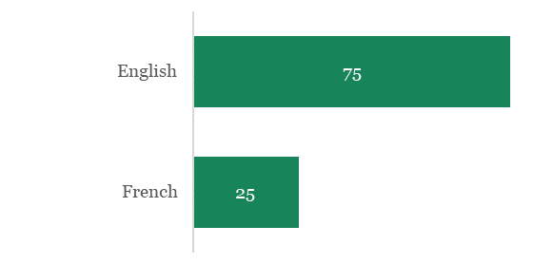
Language Spoken
Sample size: 3427
Framework: All respondents
Respondents are predominantly male
- Seven in ten (69%) respondents are male.
- Five of the six strata are predominantly male: Survivors are the exception.
- Less than 1% of respondents whose administrative data indicates sex as female have reported their gender as male, and less than 1% of those whose data indicates sex as male have responded that their gender is female.
Figure 2: Gender (%)
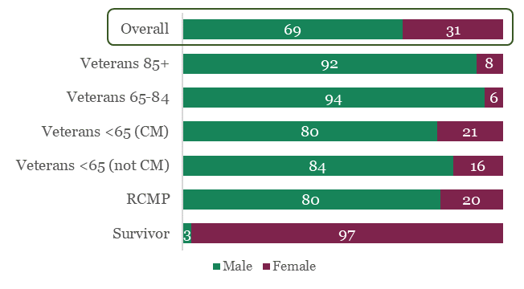
Question: What is your gender?
Sample size: 3387
Framework: All respondents, excluding “don’t know” and refused

Even distribution across age groups
- Veterans under 65 and RCMP consist mostly of respondents aged 18-59, whereas Veterans 65+ and Survivors consist mostly of those aged over 70.
Figure 3: Age (%)
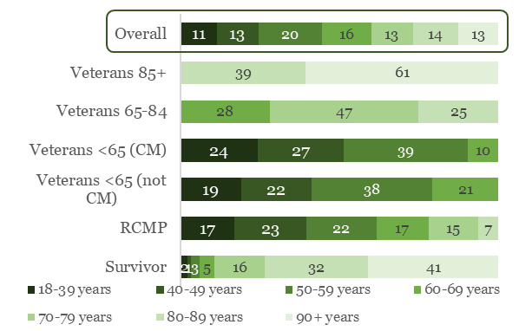
Question: Age
Sample size: 3387Framework: All respondents, excluding “don’t know” and refused

Visible minorities make up small fraction of respondents
- Approximately one in ten (12%) respondents consider themselves visible minorities.
- Those identifying as visible minorities are distributed fairly evenly among the strata.
Figure 4: Visible Minority (%)
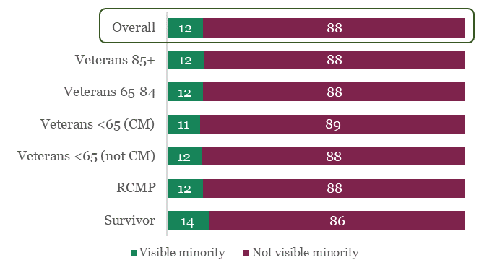
Question: Would you consider yourself to be a member of a visible minority?
Sample size: 3262
Framework: All respondents, excluding “don’t know” and refused

Few Indigenous respondents
- One in 19 respondents report being Indigenous.
Figure 5: Indigenous Background (%)
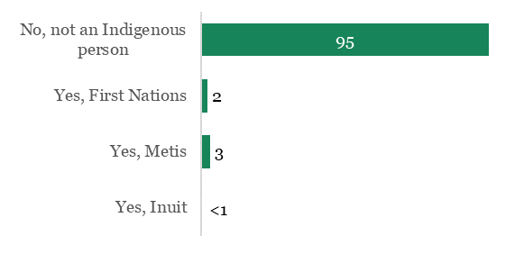
Question: Are you an Indigenous person, that is: First Nations, Métis, or Inuit?
Sample size: 3329
Framework: All respondents, excluding “don’t know” and refused

Indigenous respondents evenly distributed
There are no notable trends concerning how Indigenous respondents are distributed among the strata.
Figure 6: Indigenous Background (%)
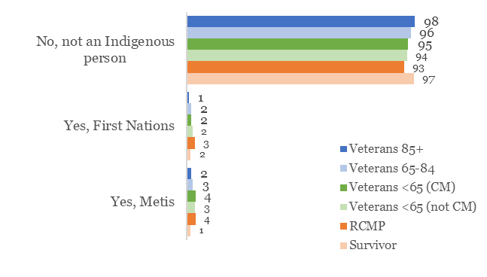
Question: Are you an Indigenous person, that is: First Nations, Métis, or Inuit?
Sample size: 3329
Framework: All respondents, excluding “don’t know” and refused

Half of all respondents have a high school education or less
- About half (45%) of respondents have a high school diploma or less.
- A quarter (23%) have some form of university education.
Figure 7: Education (%)
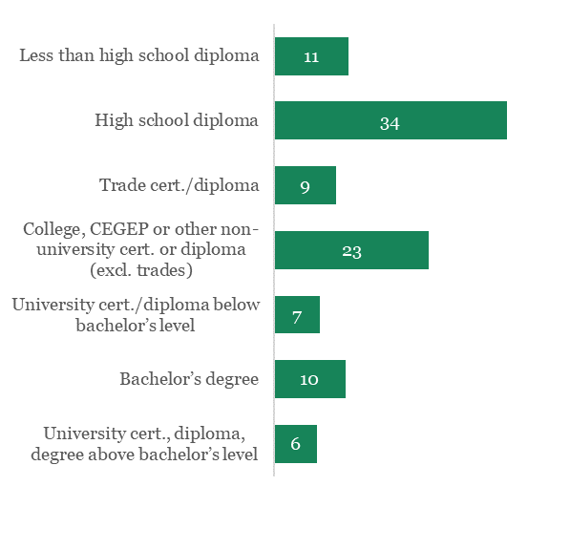
Question: What is the highest level of education you have completed?
Sample size: 3341
Framework: All respondents, excluding “don’t know” and refused

Great variation in education between strata
- Veterans 85+, Veterans 65–84, and Survivors are more likely than other strata to have less than a high school diploma.
- RCMP had the highest rate of bachelor’s degree at 20%.
Figure 8: Education (%)
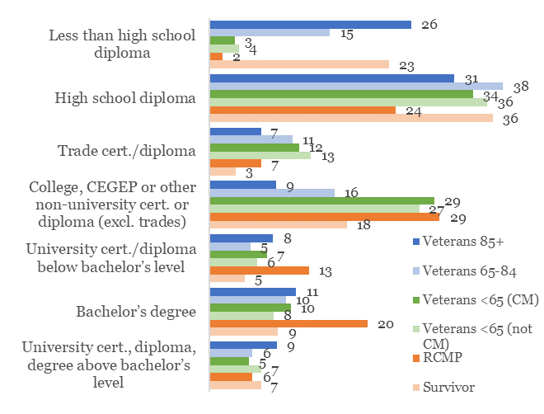
Question: What is the highest level of education you have completed?
Sample size: 3341
Framework: All respondents, excluding “don’t know” and refused

Survivors tend to live alone
- More than three-quarters (77%) of Survivors live alone.
- Other groups are more likely to live with others, most commonly with one other person.
Figure 9: Number of People Living in Household (%)
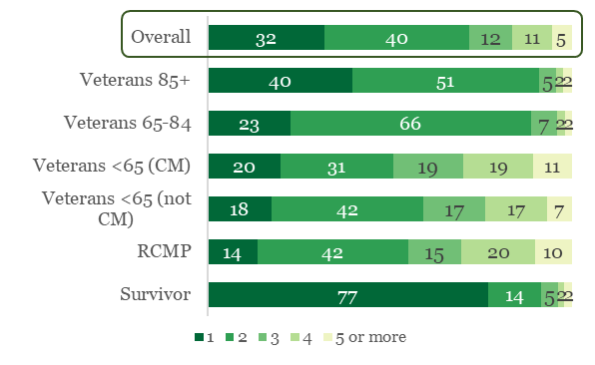
Question: Including yourself, how many people usually live in your household?
Sample size: 3427
Framework: All respondents
Some strata are predominantly lower income
- Survivors stand out as predominantly lower income compared to other strata. Five in nine (56%) make $40,000 or less after tax.
- Veterans 65 and up also have comparatively lower incomes.
Figure 10: Income (%)
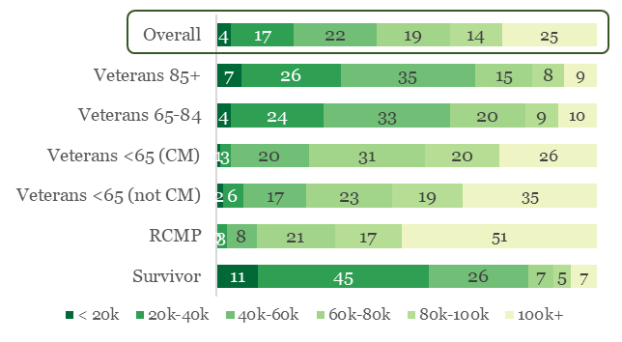
Question: Reminding you that all your answers will remain confidential, could you please tell me what is your best estimate of your total household income received by all household members, from all sources after taxes during the year ending December 31st, 2021?
Sample size: 2543
Framework: All respondents, excluding “don’t know” and refused

Communicating with Veterans Affairs Canada
The most commonly used and preferred method of contact is by phone. The usage and preference for My VAC Account has increased since 2020 (usage for My VAC Account is 65% vs 45% in 2022 and 2020 respectively, whereas preference for My VAC Account is 24% and 13% in 2022 and 2020 respectively). Those who use My VAC Account find it useful. Those who do not use it tend to cite lack of awareness and need, or issues with accessing the internet or a computer. VAC generally receives positive feedback for its communications efforts.
Most have contacted VAC; variations across strata
- Two-thirds (67%) say they contacted VAC in the past 12 months.
- While almost all (98%) of case-managed Veterans under 65 have had contact with VAC in the past 12 months, only two in five (38%) of Survivors say they have contacted VAC.
- Three-quarters (73%) of male respondents have contacted VAC, compared to just over half (53%) of female respondents.
- Respondents under 60 (81%) are more likely to have contacted VAC than respondents 60 and older (55%)
Figure 11: Contact with VAC in the Past 12 Months (%)
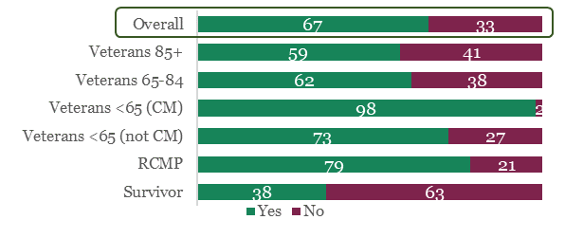
Question: Did you have any contact with VAC during the past 12 months?
Sample size: 3334
Framework: All respondents, excluding “don’t know” and refused

Most have received a letter
- Seven in ten (71%) of case-managed respondents say they received a letter from VAC in the past 12 months.
- Case-managed Veterans under 65 (88%) and RCMP (81%) are the most likely to say they have received a letter.
- Respondents under 70 (76%) are more likely to have received a letter than respondents 80 and older (59%).
Figure 12: Received a Letter from VAC in the Past 12 Months (%)
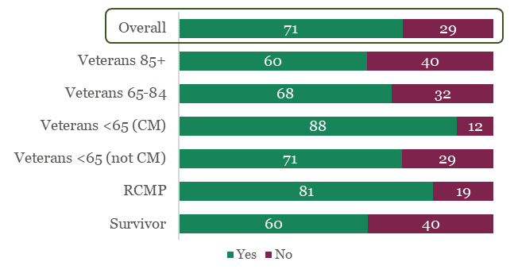
Question: Did you receive a letter from VAC during the past 12 months? Yes or no.
Sample size: 3198
Framework: All respondents, excluding “don’t know” and refused

Phone is the most popular way of contacting VAC
- Four in five (79%) respondents say they have contacted VAC by phone.
- Two-thirds (66%) of respondents have contacted VAC through My VAC Account, which has increased from 2020 (52%)
- In person options are the least popular.
Figure 13: Ways of Contacting VAC (%)
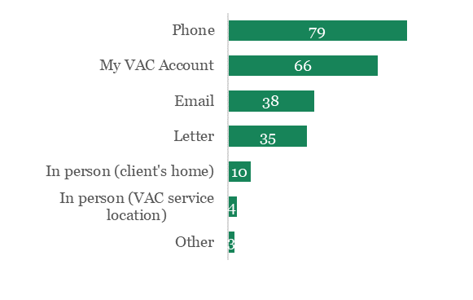
Question: In the previous 12 months, which of the following ways have you used to contact VAC?
Sample size: 2232
Framework: Respondents who say they have contacted VAC in the past 12 months, excluding “don’t know” and refused
Slight variations in methods of contact between strata
- Younger Veterans (under 65) and RCMP are more likely to have contacted VAC through My VAC Account.
  - The same trend exists for email communication.
- Survivors are the least likely to contact VAC online (i.e., through email or My VAC Account).
Figure 14: Ways of Contacting VAC (%)
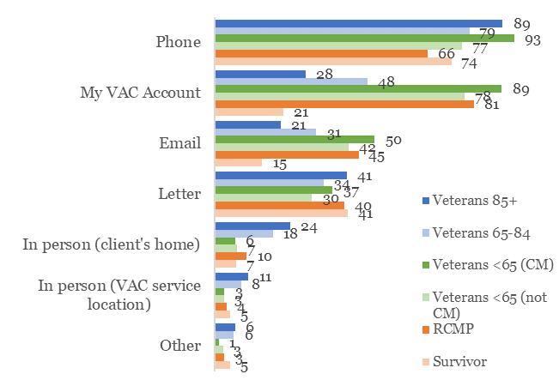
Question: In the previous 12 months, which of the following ways have you used to contact VAC?
Sample size: 2232
Framework: Respondents who say they have contacted VAC in the past 12 months, excluding “don’t know” and refused

Phone most preferred by far
- Phone (46%) is the most preferred method of communication for contacting VAC.
- Preference for My VAC Account has increased in 2022 (24% in 2022; 13% in 2020) and surpassed letters to become the second most preferred method.
- Email (11%) and letters (10%) are preferred relatively equally.
- In-person options are the least preferred.
Figure 15: Preferred Methods for Contacting VAC (%)
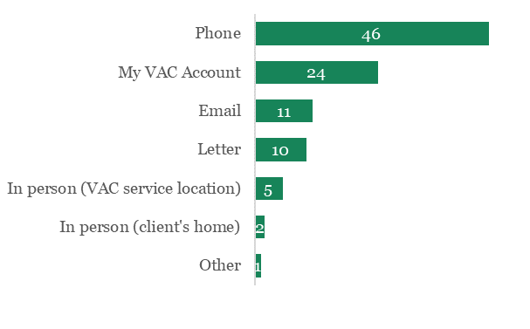
Question: In general, what is your preferred method of contact with VAC? [multiple responses allowed]
Sample size: 3350
Framework: All respondents, excluding “don’t know” and refused

Different strata prefer different methods 0f contact
- The increased preference for My VAC Account is mainly led by younger Veterans (under 65) and RCMP.
- Survivors most prefer phone (53%) and letters (28%) and least prefer contacting VAC online.
Figure 16: Preferred Methods for Contacting VAC (%)
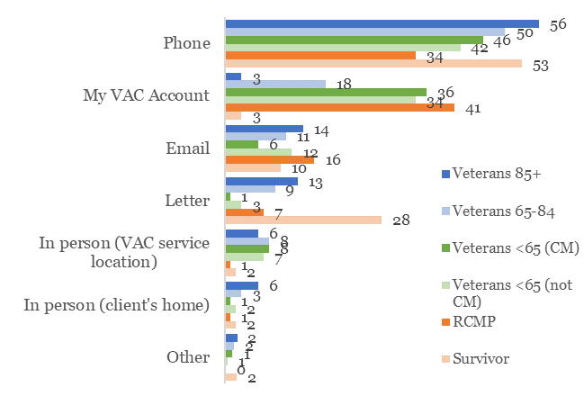
Question: In general, what is your preferred method of contact with VAC? [multiple responses allowed]
Sample size: 3350
Framework: All respondents, excluding “don’t know” and refused

Majority agree that communication has been easy
- Seven in ten (TOP2: 71%) respondents agree that communication with VAC has been easy.
- Survivors are the most likely to agree (TOP2: 81%).
- Respondents 70 and older are more likely to agree (TOP2: 78%) than respondents under 60 (TOP2: 66%).
- Indigenous clients (TOP2: 62%) are less likely to agree than non-Indigenous clients (TOP2: 72%).
- English speakers (TOP2: 69%) are less likely to agree than French speakers (TOP2: 78%).
Figure 17: “Communication with VAC Has Been Easy” (%)
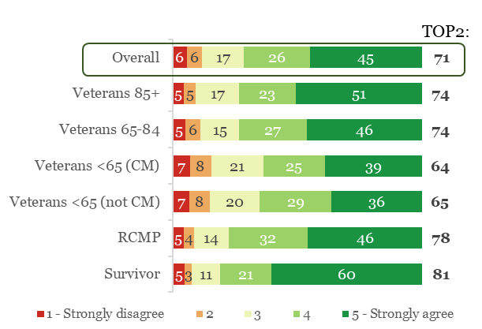
Question: [Explanation of 5-point scale as a measure of agreement with the statement.] … “Communication with VAC has been easy.”
Sample size: 3252
Framework: All respondents, excluding “don’t know” and refused

Most agree communication is provided in a timely manner
- Seven in ten (TOP2: 68%) agree that communication was provided in a timely manner.
- While Survivors (TOP2: 84%) are the most likely to agree, the non case-managed Veterans under 65 (TOP2: 59%) are the least likely to agree.
- Respondents 60 and older are more likely to agree (TOP2: 76%) than those under 50 (TOP2: 56%).
- Females (TOP2: 76%) are more likely to agree than males (TOP2: 65%).
- Indigenous clients (TOP2: 59%) are less likely to agree than non-Indigenous clients (TOP2: 69%).
Figure 18: Communication “Provided in a Timely Manner” (%)
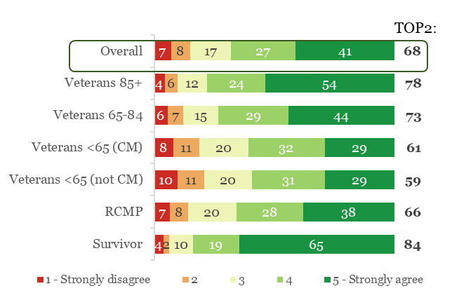
Question: [Explanation of 5-point scale as a measure of agreement with the statement.] … “Communication with VAC was provided in a timely manner.”
Sample size: 3252
Framework: All respondents, excluding “don’t know” and refused

Two-thirds say it was easy to submit the necessary info to apply
- Two-thirds (TOP2: 63%) agree that it was easy to submit the needed information.
- Indigenous clients (TOP2: 51%) are less likely to agree than non-Indigenous clients (TOP2: 64%).
Figure 19: “Easy to Submit” Info Needed for Application (%)
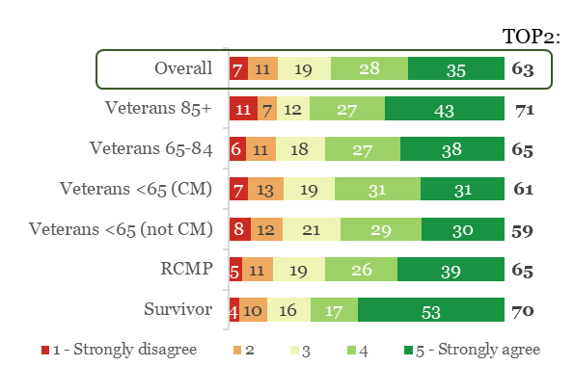

Question: [Explanation of 5-point scale as a measure of agreement with the statement.] … “It was easy to submit the required information to VAC needed for my application.”
Sample size: 1475
Framework: Respondents who say they applied for a service or benefit within the past 12 months, excluding “don’t know” and refused
Large variances in My VAC Account usage
- More respondents have used My VAC Account in 2022 than in 2020 (65% vs 45%).
- There is great variance among the strata: almost all (97%) case-managed Veterans under 65 have used it, versus just three in 20 (15%) Survivors.
- Younger respondents are much more likely than older ones to use My VAC Account.
- French-speakers (73%) are more likely than English-speakers (62%) to use it.
- Male respondents (75%) are much more likely than female respondents (41%) to use it.
Figure 20: Usage of My VAC Account (%)
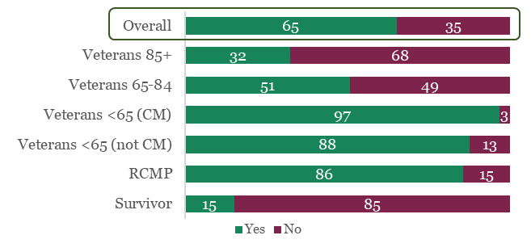
Question: My VAC Account allows you to do business online securely with Veterans Affairs Canada. Have you used My VAC Account?
Sample size: 3306
Framework: All respondents, excluding “don’t know” and refused

Lack of knowledge and need are the top reasons for not using My VAC Account
- Of those who do not use My VAC Account, a quarter (24%) say they do not know about it.
- One in five (21%) say they do not have the need for it.
- Other technological barriers, like lack of access to a computer or internet (19%), or feeling that technology is too complex (18%), are also top reasons for not using My VAC.
Figure 21: Reasons for Not Using My VAC Account (%)
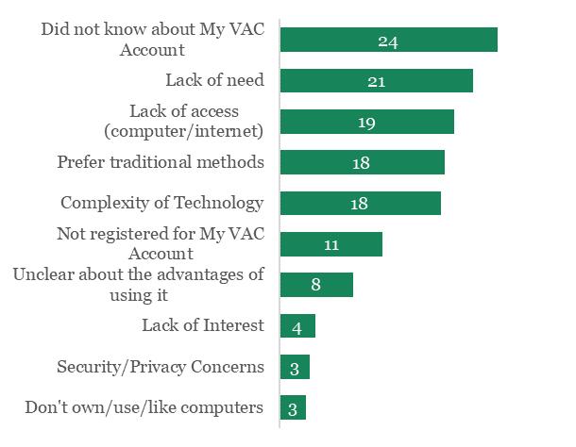
Question: Why don’t you use My VAC Account? [multiple responses allowed]
Sample size: 1090
Framework: Respondents who say they have not used My VAC Account, excluding “don’t know” and refused
Note: Not shown if <3%

Barriers and awareness a theme for lower-usage groups
- Survivors and Veterans aged 85+ are more likely than other strata to say they cannot access the needed technology.
- English-speakers (27%) are twice as likely to be unaware of My VAC Account than French-speakers (12%).
Figure 22: Reasons for Not Using My VAC Account: Top 5 (%)
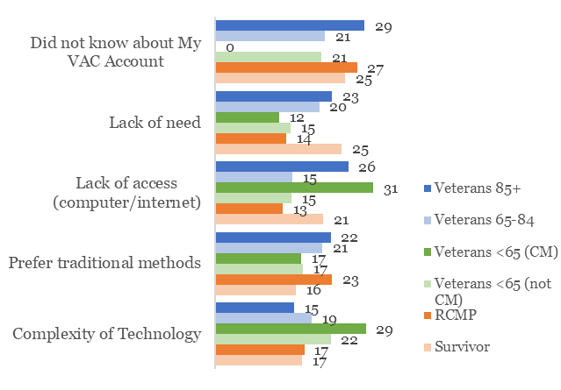
Question: Why don’t you use My VAC Account? [multiple responses allowed]
Sample size: 1090
Framework: Respondents who say they have not used My VAC Account, excluding “don’t know” and refused

Note the small sample size for “Veterans <65 (CM)” (n = 21), interpret with caution.
Most think My VAC Account helps find out about benefits and services
- Of those who use My VAC Account, four in five (80%) respondents say My VAC Account is a good way to find out about benefits and services.
Figure 23: My VAC Account is a Good Way to Find Out About: “Benefits and Services” (%)
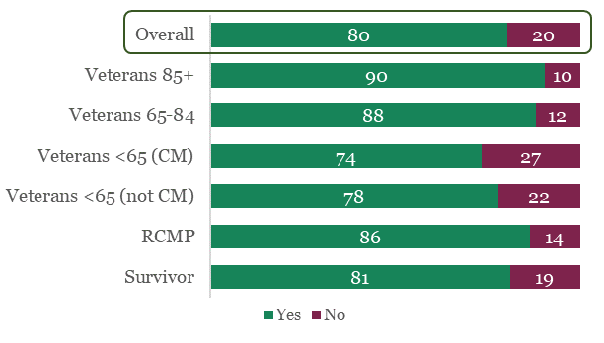
Question: When you used My VAC Account, was it a good way to find out about... “VAC benefits and services”
Sample size: 1960
Framework: Respondents who say they have used My VAC Account, excluding “don’t know” and refused

Majority say My VAC Account is good for checking on application status
- Four in five (83%) My VAC Account users say it is a good way to find out about the status of their applications.
Figure 24: My VAC Account is a Good Way to Find Out About: “Status of My Applications” (%)
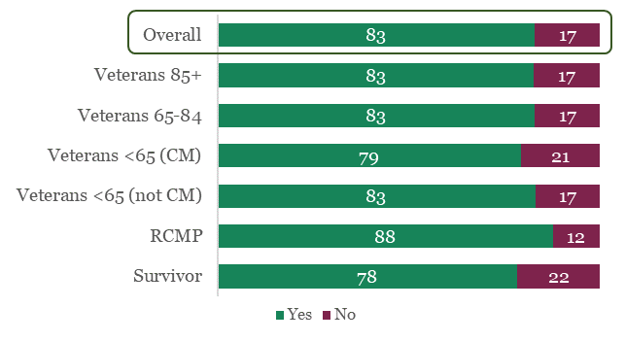
Question: When you used My VAC Account, was it a good way to find out about... “The status of my applications”
Sample size: 1972
Framework: Respondents who say they have used My VAC Account, excluding “don’t know” and refused

Three-quarters of users say My VAC Account is good for learning VAC news
- Three-quarters (76%) of respondents who use my VAC Account say it is a good way to find out about VAC news.
Figure 25: My VAC Account is a Good Way to Find Out About: “VAC News” (%)
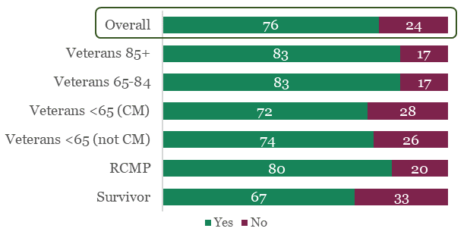
Question: When you used My VAC Account, was it a good way to find out about... “VAC news”
Sample size: 1724
Framework: Respondents who say they have used My VAC Account, excluding “don’t know” and refused

Vast majority say My VAC Account is a good way to message securely with VAC
- Nine in ten (89%) say My VAC Account is a good way to communicate securely with VAC.
Figure 26: My VAC Account is a Good Way to Find Out About: “Comms. Through Secure Messaging with VAC” (%)
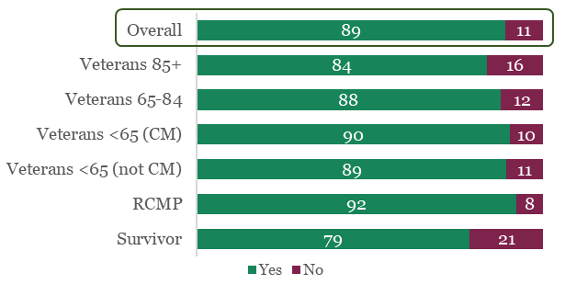
Question: When you used My VAC Account, was it a good way to find out about... “Communications through secure messaging with VAC”
Sample size: 1951
Framework: Respondents who say they have used My VAC Account, excluding “don’t know” and refused

Satisfaction with Service Experience
Satisfaction with the service experience is high. VAC staff receive high marks for being competent, knowledgeable, respectful, and responsive. Half of the respondents applied for a service recently and have diverse opinions on the ease of the application process and finding information.
Most satisfied with quality of programs and services
- Three in four (TOP2: 76%) respondents are satisfied or very satisfied with the quality of programs and services.
- Veterans aged 85+ (TOP2: 89%) are the most satisfied of the six strata.
- Respondents under 50 (TOP2: 68%) are less satisfied than those 60 and older (TOP2: 81%).
- Visible minority (TOP2: 69%) respondents are less satisfied than non-minority respondents (TOP2: 78%).
- Indigenous respondents (TOP2: 65%) are less satisfied than non-Indigenous respondents (TOP2: 78%).
Figure 27: Satisfaction with Quality of Programs and Services (%)
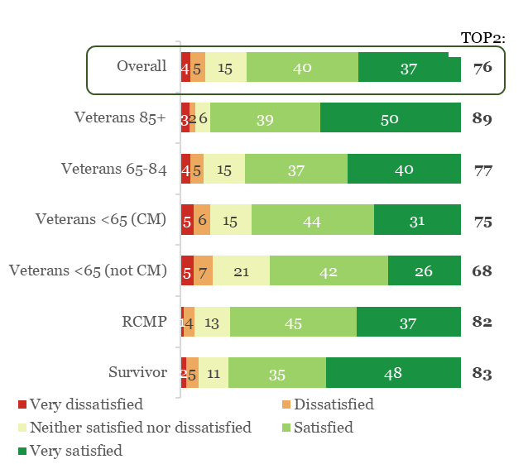
Question: How satisfied are you with the quality of VAC’s programs and services offered?
Sample size: 3194
Framework: All respondents, excluding “don’t know” and refused

Majority satisfied with the quality of service delivery
- Four in five (TOP2: 78%) respondents say they are satisfied with the quality of service delivery.
- While Veterans under 65 who are not case-managed (TOP2: 68%) are the least satisfied of the six strata, Survivors (TOP2: 91%) and Veterans aged 85+ (TOP2: 89%) are the most satisfied.
- Male respondents (TOP2: 75%) are less satisfied than female respondents (TOP2: 84%).
- Indigenous respondents (TOP2: 68%) tend to be less satisfied than non-Indigenous respondents (TOP2: 79%).
- Respondents under 60 (TOP2: 71%) are less satisfied than respondents 60 and older (TOP2: 84%).
Figure 28: Satisfaction with Quality of Service Delivery (%)
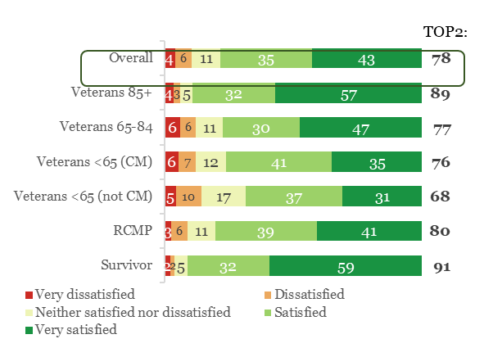
Question: Now we’d like to ask how satisfied you were with the quality of service you received over the past 12 months. You may say, very dissatisfied, dissatisfied, neither satisfied nor dissatisfied, satisfied, or very satisfied. How satisfied are you with the quality of service delivery?
Sample size: 3227
Framework: All respondents, excluding “don’t know” and refused
Nearly half agree service has improved in the past 12 months
- Four in nine (TOP2: 46%) agree that VAC service has improved in the past 12 months.
- Veterans aged 65 and under are less likely to agree whereas Veterans aged 85+ and Survivors are more likely to agree.
- Respondents under 60 (TOP2: 33%) are less likely to agree than respondents 60 and older (TOP2: 57%).
- Female respondents (TOP2: 56%) are more likely to agree than male respondents (TOP2: 42%).
- Indigenous respondents (TOP2: 33%) are less likely to agree than non-Indigenous respondents (TOP2: 47%).
Figure 29: “VAC Service Has Improved” Over Past 12 Months (%)
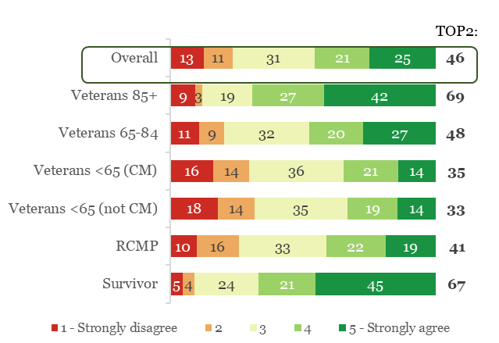
Question: [Explanation of 5-point scale as a measure of agreement with the statement.] … “Over the past 12 months, VAC service has improved.”
Sample size: 2295
Framework: All respondents, excluding “don’t know” and refused

Most agree most recent letter was “easy to understand”
- Eight in ten (TOP2: 80%) respondents who contacted VAC by letter agree that VAC’s most recent letter was “easy to understand.”
- Survivors (TOP2: 93%) are the most likely to agree, compared to other strata.
- Respondents under 60 (TOP2: 76%) are less likely to agree than respondents 70 and older (TOP2: 88%).
Figure 30: Most Recent Letter Was “Easy to Understand” (%)
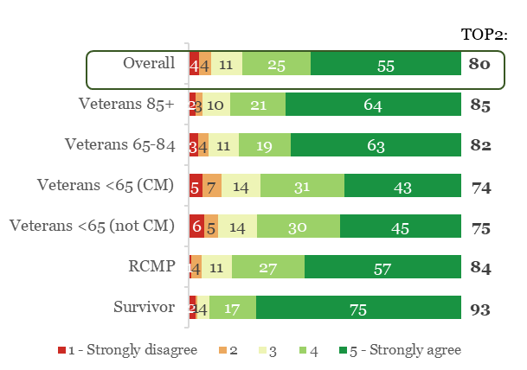
Question: [Explanation of 5-point scale as a measure of agreement with the statement.] … “The most recent letter I received from VAC was easy to understand.”
Sample size: 2201
Framework: Respondents who say have received letter from VAC in past 12 months, excluding “don’t know”

Staff get high marks for service
- Four in five (TOP2: 79%) agree that VAC staff provided satisfactory service.
- Survivors (TOP2: 91%) are most likely of the strata to agree.
- Female respondents (TOP2: 85%) are more likely to agree than male respondents (TOP2: 76%).
- Indigenous respondents (TOP2: 68%) tend to be less likely to agree than non-Indigenous respondents (TOP2: 80%).
- Respondents under 60 (TOP2: 72%) are less likely to agree than respondents 70 and older (TOP2: 86%).
Figure 31: “Overall, VAC Staff Provided Satisfactory Service” (%)
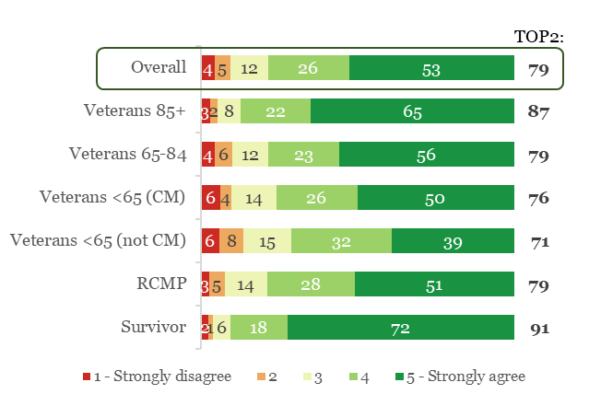
Question: [Explanation of 5-point scale as a measure of agreement with the statement.] … “Overall, VAC staff provided a satisfactory service.”
Sample size: 3206
Framework: All respondents, excluding “don’t know” and refused

VAC staff perceived as knowledgeable
- Four in five (TOP2: 78%) respondents say VAC staff were knowledgeable about programs and services.
- Respondents under 60 (TOP2: 71%) are less likely to agree than respondents 60 and older (TOP2: 83%).
Figure 32: “VAC Staff Were Knowledgeable” About Programs and Services (%)
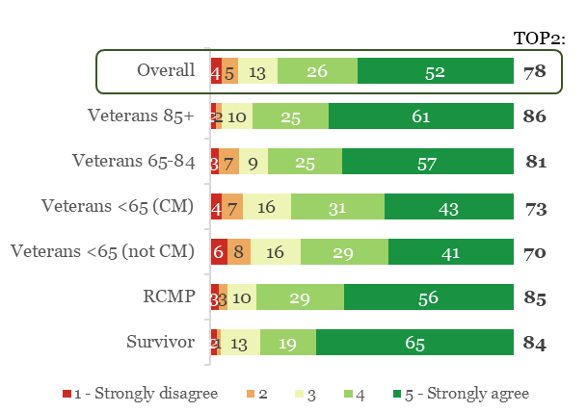
Question: [Explanation of 5-point scale as a measure of agreement with the statement.] … “VAC staff were knowledgeable about the programs and services I inquired about.”
Sample size: 2969
Framework: All respondents, excluding “don’t know” and refused

Most feel staff are competent
- Four in five (TOP2: 79%) respondents agree that VAC staff were competent when responding to their inquiry.
- Respondents under 60 (TOP2: 74%) are less likely to agree than respondents 70 and older (TOP2: 85%).
Figure 33: “VAC Staff Were Competent In Responding To My Inquiry” (%)
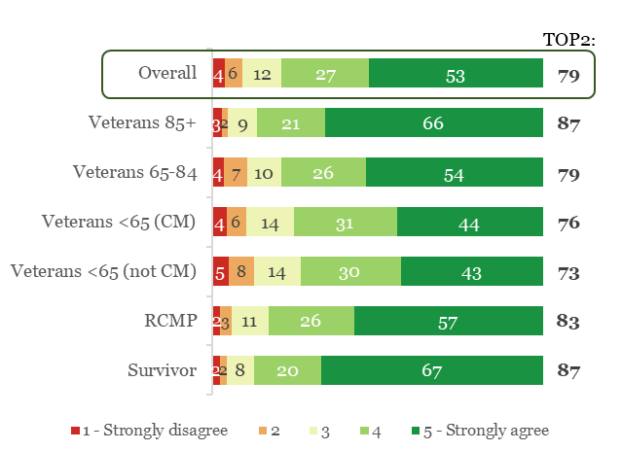
Question: [Explanation of 5-point scale as a measure of agreement with the statement.] … “VAC staff were competent in responding to my inquiry.”
Sample size: 3046
Framework: All respondents, excluding “don’t know” and refused

Many clients say VAC staff treated them exceptionally
- Three-quarters (TOP2: 77%) say VAC staff treated them exceptionally.
- Veterans under 65 who are not case-managed are the least likely to agree (TOP2: 68%).
- Indigenous respondents (TOP2: 68%) tend to be less likely to agree than non-Indigenous respondents (TOP2: 77%).
- Respondents under 60 (TOP2: 71%) are less likely to agree than respondents 70 and older (TOP2: 83%).
Figure 34: “Treatment by VAC Staff Was Exceptional” (%)
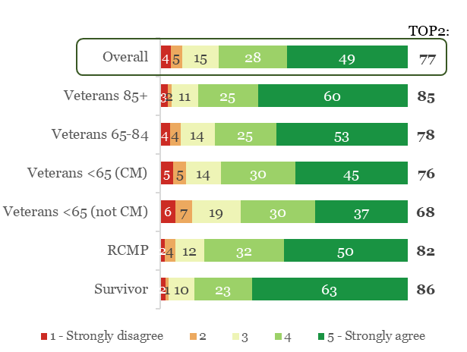
Question: [Explanation of 5-point scale as a measure of agreement with the statement.] … “Treatment by VAC staff was exceptional.”
Sample size: 3085
Framework: All respondents, excluding “don’t know” and refused

Most agree that they were respected by VAC staff
- Four in five (BTM2: 79%) agree that they were respected by VAC staff.
- Only one in seven (TOP2: 15%) respondents say they feel like VAC staff did not respect them.
- RCMP (BTM2: 89%) are the most likely to agree that they feel respected.
- Respondents under 70 (BTM2: 82%) are more likely to agree that they feel respected than respondents 80 and older (BTM2: 72%).
Figure 35: “I Did Not Feel Respected by Staff at VAC” (%)
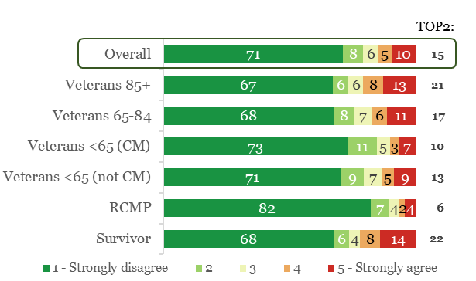
Question: [Explanation of 5-point scale as a measure of agreement with the statement.] … “I did not feel respected by staff at VAC.”
Sample size: 3101
Framework: All respondents, excluding “don’t know” and refused

Most agree that staff were responsive to their needs
- Three-quarters (BTM2: 76%) agree that VAC staff were responsive to their needs.
- Only one in seven (TOP2: 14%) say that VAC staff were not responsive to their needs.
- Again, RCMP (BTM2: 86%) are the most likely to feel positively about staff responsiveness.
- Veterans aged 85+ (TOP2: 23%) are the most likely to agree.
Figure 36: “VAC Staff Were Not Responsive to My Needs” (%)
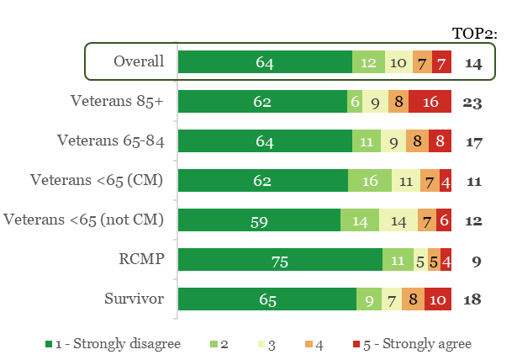
Question: [Explanation of 5-point scale as a measure of agreement with the statement.] … “VAC staff were not responsive to my needs.”
Sample size: 3106
Framework: All respondents, excluding “don’t know” and refused

Most think length of wait at VAC location is reasonable
- Two-thirds (BTM2: 65%) of respondents say that they did not have to wait too long to speak to someone at a VAC location.
- Veterans aged 85+ (TOP2: 28%) are the most likely to say they had to wait too long.
- Visible minority (TOP2: 28%) respondents are more likely to say they had to wait too long than non-minority respondents (TOP2: 17%).
Figure 37: “I Had to Wait Too Long to Speak to Someone at a VAC Location” (%)
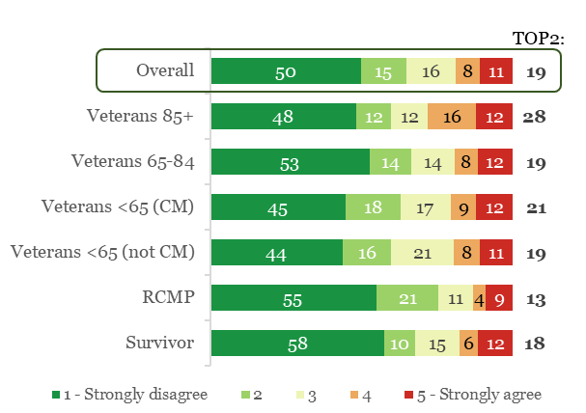
Question: [Explanation of 5-point scale as a measure of agreement with the statement.] … “I had to wait too long to speak to someone at a VAC location.”
Sample size: 2708
Framework: All respondents, excluding “don’t know” and refused

Vast majority agree that they were communicated with in their official language of choice
- 19 in 20 (TOP2: 95%) respondents agree that they were communicated with in the official language of their choice.
- No notable differences for language, gender, visible minority, or Indigenous background.
Figure 38: “VAC Staff Communicated with Me in My Official Language of Choice” (%)
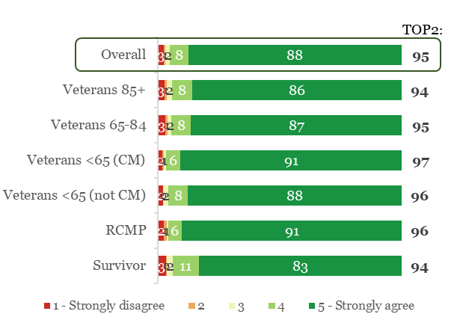

Question: [Explanation of 5-point scale as a measure of agreement with the statement.] … “VAC staff communicated with me in my official language of choice.”
Sample size: 3238
Framework: All respondents, excluding “don’t know” and refused

Variation in timeliness of obtaining services and benefits
- Two-thirds (TOP2: 65%) of respondents say they obtained a service or benefit in a timely manner.
- Veterans under 65 are the least likely to agree, whereas Survivors (TOP2: 87%) and Veterans aged 85+ (TOP2: 86%) are the most likely to agree.
- Male respondents (TOP2: 60%) are less likely to agree than female respondents (TOP2: 75%).
- Younger respondents are less likely to agree than older respondents.
- Indigenous respondents (TOP2: 49%) are less likely to agree than non-Indigenous respondents (TOP2: 66%).
Figure 39: “I Obtained a Service or Benefit in a Timely Manner” (%)
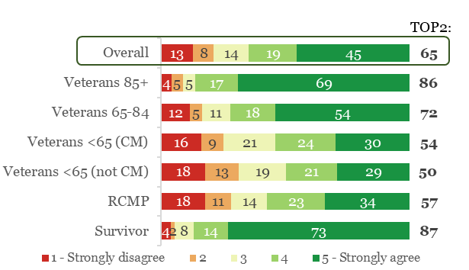
Question: [Explanation of 5-point scale as a measure of agreement with the statement.] … “I obtained a service or benefit in a timely manner.”
Sample size: 3218
Framework: All respondents, excluding “don’t know” and refused

Most understand services and benefits offered
- Overall, five in eight (TOP2: 63%) respondents agree that they understand the services and benefits offered by VAC.
- Veterans aged 85+ (TOP2: 79%) and Survivors (TOP2: 77%) are the most likely to agree.
- Respondents under 70 (TOP2: 55%) are less likely to agree than those 70 and older (TOP2: 76%).
- Indigenous respondents (TOP2: 51%) are less likely to agree than non-Indigenous respondents (TOP2: 64%).
- Male respondents (TOP2: 61%) are less likely to agree than Female respondents (TOP2: 70%).

Figure 40: “I Understand the Services and Benefits Offered by VAC” (%)
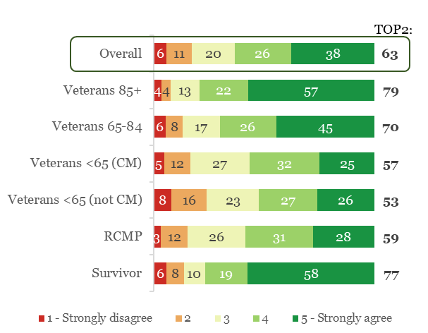
Question: [Explanation of 5-point scale as a measure of agreement with the statement.] … “I understand the services and benefits offered by Veterans Affairs Canada.”
Sample size: 3294
Framework: All respondents, excluding “don’t know” and refused

About half have applied for a service or benefit recently
- About half (45%) of the respondents say they have applied for a service or benefit in the past 12 months.
- Case-managed Veterans under 65 (78%) are the most likely strata to say they applied recently, while Survivors (18%) are the least likely to say they applied.
- Female respondents (31%) are less likely than male respondents (52%) to say they applied in the past 12 months.
- French-speakers (TOP2: 54%) are more likely to say they have applied than the English-speakers (TOP2: 42%).
- Respondents under 70 (TOP2: 55%) are more likely to have applied than respondents 70 and older (TOP2: 31%).
Figure 41: Applying for Services and Benefits (%)
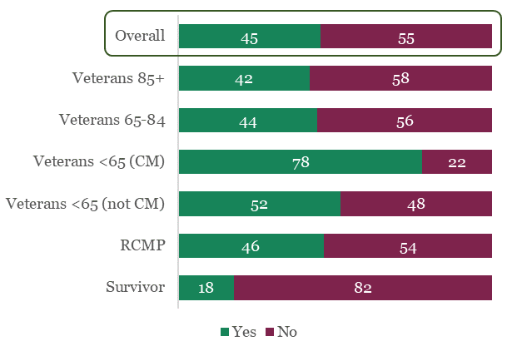
Question: Did you apply for a service or benefit within the past 12 months? Yes or no.
Sample size: 3327
Framework: All respondents, excluding “don’t know” and refused

Veterans aged 85+ and Survivors are more likely to find application process easy
- Four in seven (TOP2: 56%) respondents who applied for a service or benefit in the last 12 months agreed that the application process was easy.
- Veterans aged 85+ (TOP2: 73%) and Survivors (TOP2: 69%) are most likely to agree.
- Respondents 70 and older (TOP2: 66%) are more likely to agree than those aged 40-59 (TOP2: 50%).
Figure 42: “The Application Process Was Easy” (%)
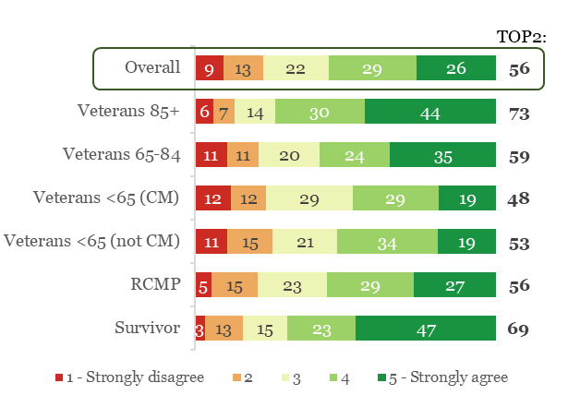
Question: [Explanation of 5-point scale as a measure of agreement with the statement.] … “Overall, the application process was easy.”
Sample size: 1475
Framework: Respondents who say they applied for a service or benefit within the past 12 months, excluding “don’t know” and refused

Veterans aged 85+ and Survivors agree that information required to apply for a service or benefit is easy to find
- Less than half (TOP2: 46%) of respondents who applied for a service or benefit in the past 12 months agree that the information needed to apply was “easy to find.”
- Once again, Veterans aged 85+ (TOP2: 65%) and Survivors (TOP2: 61%) are the two strata most likely to agree.
- Respondents 70 and older (TOP2: 61%) are more likely to agree than those under 70 (TOP2: 40%).
Figure 43: Information for Applying Was “Easy to Find” (%)
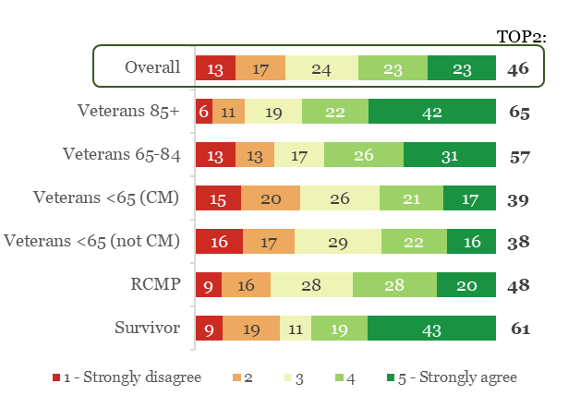
Question: [Explanation of 5-point scale as a measure of agreement with the statement.] … “Overall, the information I needed to apply for a service or benefit that I am eligible for was easy to find.”
Sample size: 1463
Framework: Respondents who say they applied for a service or benefit within the past 12 months, excluding “don’t know” and refused

Status update frequency and clearer explanations are common areas for improvement
- Frequency of status updates (35%) and clearer explanations regarding decisions (32%) are the most common areas of the application process that could be improved.
- On the other hand, one in five (21%) respondents who applied said nothing could be improved.
Figure 44: Potential Improvements to the Application Process (%)
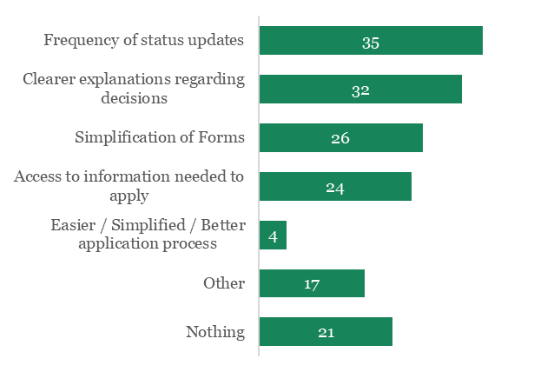
Question: What part of the application process could be improved?
Sample size: 1390
Framework: Respondents who say they applied for a service or benefit within the past 12 months, excluding “don’t know” and refused

Services and Programs

Case Management Services
Four in five are satisfied with case management services and two-thirds say it improves their quality of life. Most are generally satisfied with the working relationship they have with their case manager, however less than half say their family and supporters had the opportunity to be involved in developing their case plan. Older respondents tend to be more satisfied with case management.
Most case-managed respondents have a case manager
- Of the respondents who are on file as case-managed, four in five (82%) say they currently have a case manager.
- One in five (18%) respondents say they do not have a case manager or are unsure. This finding could be because respondents are not familiar with the name of the service or as a result of an administrative data discrepancy.
- This question serves as a screener for the next section of the survey. Those who responded “yes” to this question are asked further questions about case management and other relevant services and programs.

Figure 45: Do You Have a Case Manager? (%)
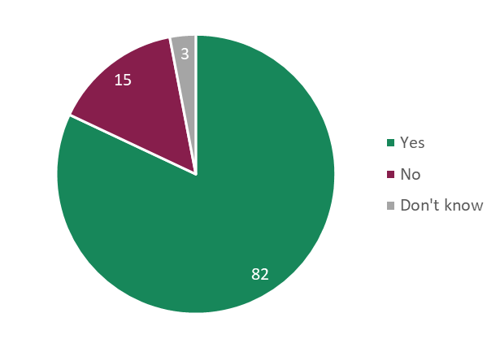
Question: A case manager helps Veterans and former RCMP members set goals and find the services they need to overcome a challenge in their life. Do you currently have a case manager who works with you to obtain services?
Sample size: 393
Framework: Respondents who are case-managed, excluding refused

High satisfaction with case management
- Four in five (TOP2: 78%) respondents who say they have a case manager agree that they are satisfied with case management services.
Figure 46: “Overall, I Have Been Satisfied with Case Management Services” (%)
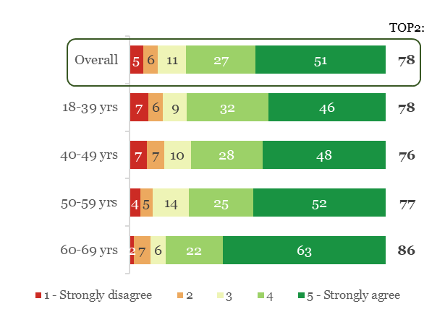
Question: [Reminder of 5-point scale as a measure of agreement with the statement.] … “Overall, I have been satisfied with case management services.”
Sample size: 317
Framework: Respondents who say they have a case manager, excluding “don’t know” and refused

Case management seen as beneficial
- Of those who say they have a case manager, four in five (TOP2: 81%) agree that case management services were beneficial to them.
- Respondents 60 and older (TOP2: 95%) are more likely to agree.
Figure 47: “Case Management Services Were Beneficial to Me” (%)
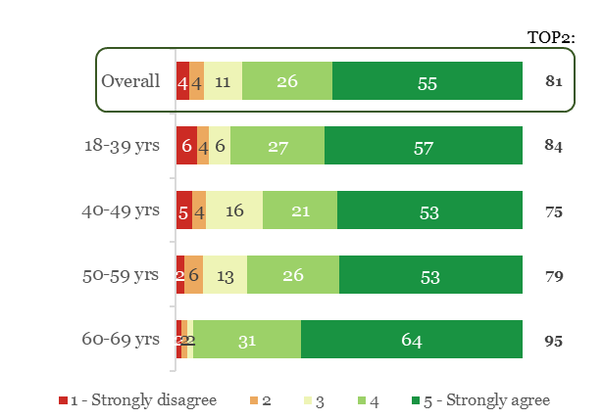
Question: [Reminder of 5-point scale as a measure of agreement with the statement.] … “Case management services were beneficial to me.”
Sample size: 311
Framework: Respondents who say they have a case manager, excluding “don’t know” and refused

Two-thirds say lives improved due to case management
- Two-thirds (TOP2: 68%) of respondents who say they have a case manager agree that case management has improved their lives.
- Again, respondents 60 and older (TOP2: 84%) are more likely to agree.
Figure 48: “As a Result of Case Management Services, My Life Has Improved” (%)
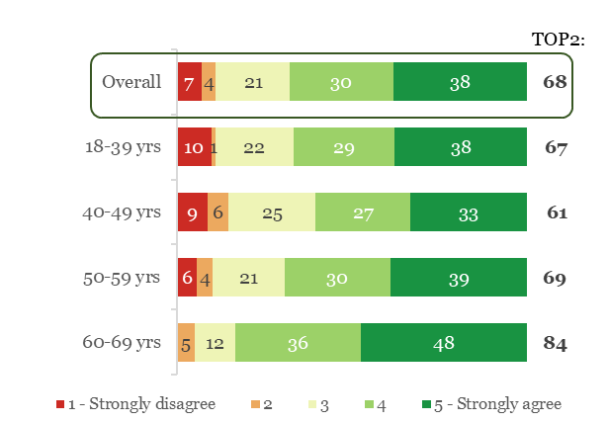
Question: [Reminder of 5-point scale as a measure of agreement with the statement.] … “As a result of case management services, my life has improved.”
Sample size: 309
Framework: Respondents who say they have a case manager, excluding “don’t know” and refused
Most agree a case manager was assigned reasonably quickly
- Of those who say they have case managers, three-quarters (TOP2: 76%) agree that they were assigned their case manager in a reasonable amount of time.
Figure 49: “I Was Assigned Case Manager in Reasonable Amount of Time” (%)
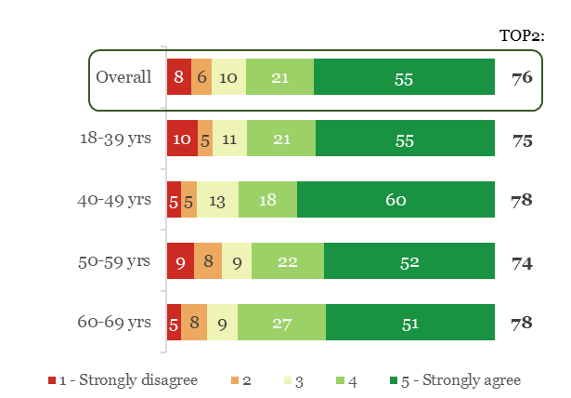
Question: [Reminder of 5-point scale as a measure of agreement with the statement.] … “I was assigned a case manager in a reasonable amount of time.”
Sample size: 321
Framework: Respondents who say they have a case manager, excluding “don’t know” and refused

Most have a good relationship with their case manager
- Four in five (BTM2: 81%) respondents agree that they are happy with the working relationship they have with their current case manager.
- Respondents under 50 (TOP2: 15%) are more likely to be unhappy than those aged 60-69 (TOP2: 5%).
Figure 50: “Not Happy” with Working Relationship with Current Case Manager (%)
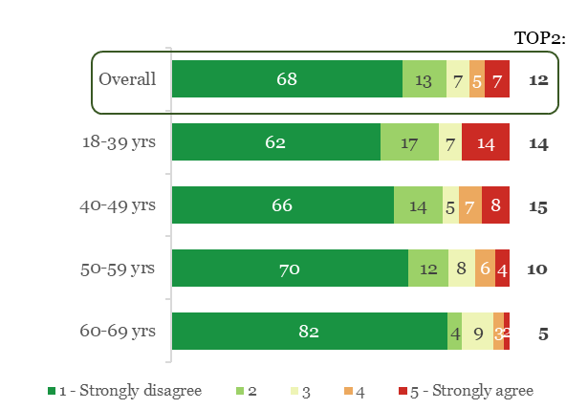
Question: [Reminder of 5-point scale as a measure of agreement with the statement.] … “I am not happy with the working relationship I have with my current case manager.”
Sample size: 319
Framework: Respondents who say they have a case manager, excluding “don’t know” and refused

Majority feel case plan goals reflect their needs
- Three-quarters (BTM2: 74%) of respondents agree that the goals in their case plan reflect their needs.
- Visible minority respondents (TOP2: 22%) are more likely to respond that the goals do not reflect their needs than non-minorities (TOP2: 9%).
Figure 51: “The Goals in My Case Plan Do Not Reflect My Needs” (%)
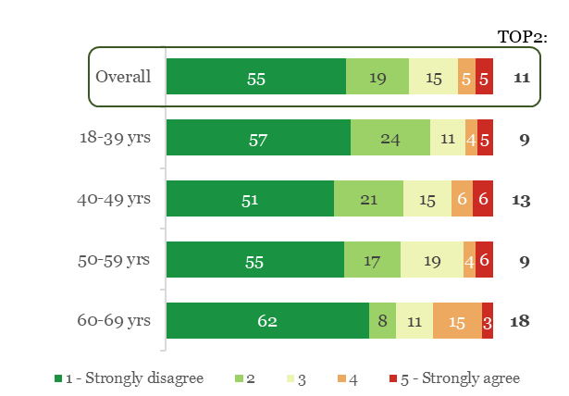
Question: [Reminder of 5-point scale as a measure of agreement with the statement.] … “The goals in my case plan do not reflect my needs.”
Sample size: 301
Framework: Respondents who say they have a case manager, excluding “don’t know” and refused

Most agree they were involved in developing case plan goals
- Seven in ten (TOP2: 69%) agree that they were involved in developing goals for their case plan.
- Indigenous (TOP2: 60%) respondents are less likely to agree than non-indigenous (TOP2: 70%) respondents.
Figure 52: “I Was Involved in Developing My Goals for My Case Plan” (%)
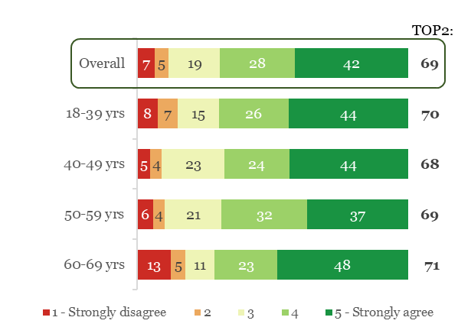
Question: [Reminder of 5-point scale as a measure of agreement with the statement.] … “I was involved in developing my goals for my case plan.”
Sample size: 297
Framework: Respondents who say they have a case manager, excluding “don’t know” and refused

Less than half had the opportunity to involve family and supporters
- Less than half (TOP2: 44%) agree that they had the opportunity to involve family and other supporters in case plan development.
- This is lower than that in 2020 (TOP2: 54%).
- French speakers (TOP2: 34%) are less likely to agree than English speakers (TOP2: 49%).
Figure 53: “I Had the Opportunity to Involve Family and Other Supporters in the Development of My Case Plan” (%)
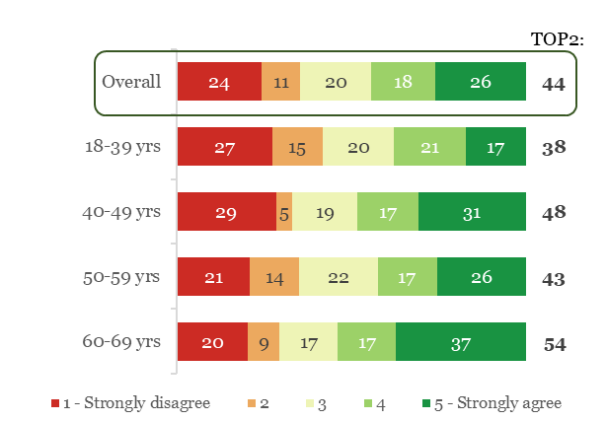
Question: [Reminder of 5-point scale as a measure of agreement with the statement.] … “I had the opportunity to involve family and other supporters in the development of my case plan.”
Sample size: 286
Framework: Respondents who say they have a case manager, excluding “don’t know” and refused

Majority have regular contact with case manager
- Overall, three in five (TOP2: 63%) agree that they had regular contact with their case manager to discuss progress on their goals.
Figure 54: “I Had Regular Contact with My Case Manager to Discuss If I Was Reaching My Goals” (%)
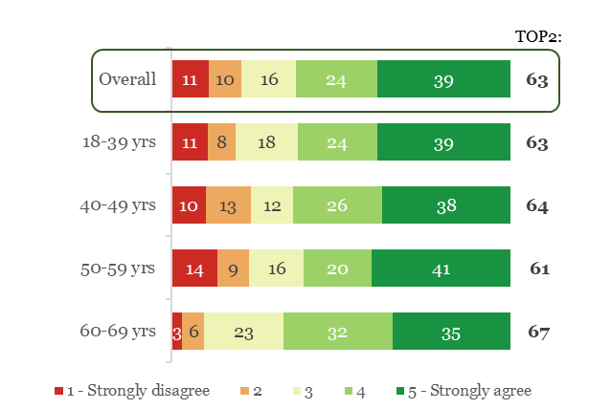
Question: [Reminder of 5-point scale as a measure of agreement with the statement.] … “I had regular contact with my case manager to discuss if I was reaching my goals.”
Sample size: 313
Framework: Respondents who say they have a case manager, excluding “don’t know” and refused

Majority pleased with progress towards achieving goals
- Three in five (TOP2: 57%) agree that they are pleased with their progress towards achieving their goals.
- Respondents aged 60-69 (TOP2: 74%) are more likely to agree.
Figure 55: “I Have Been Pleased with My Progress Towards Achieving My Goals” (%)
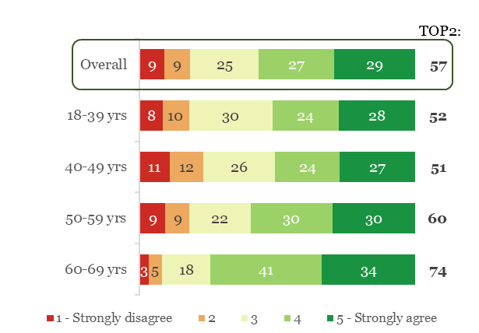
Question: [Reminder of 5-point scale as a measure of agreement with the statement.] … “I have been pleased with my progress towards achieving my goals.”
Sample size: 305
Framework: Respondents who say they have a case manager, excluding “don’t know” and refused

Case managers help inform about programs and services
- Three-quarters (TOP2: 73%) say their case manager better informed them on how to access VAC’s programs and services.
- Older respondents are generally more likely than younger respondents to agree, as shown in the figure below.
Figure 56: Working with My Case Manager “Better Informed” Me on How to Access VAC Programs and Services (%)
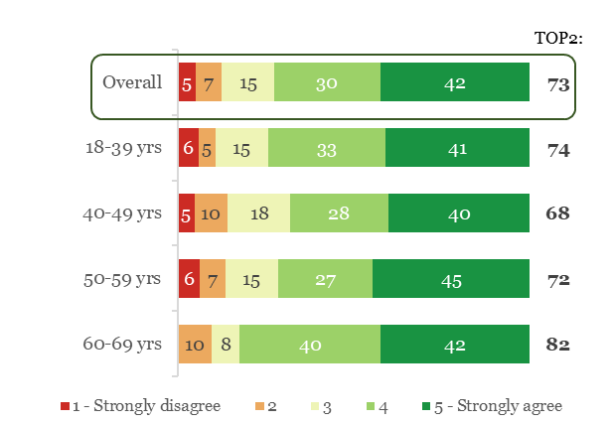
Question: [Reminder of 5-point scale as a measure of agreement with the statement.] … “In working with my case manager, I became better informed on how to access VAC´s programs and services that I needed.”
Sample size: 318
Framework: Respondents who say they have a case manager, excluding “don’t know” and refused

Case managers pointing to community supports
- Seven in ten (TOP2: 68%) agree that case managers informed them of helpful supports and services in their community.
- Once again, older respondents are more likely to agree.
Figure 57: My Case Manager Informed Me of Services and Supports in My Community That Could Help Me” (%)
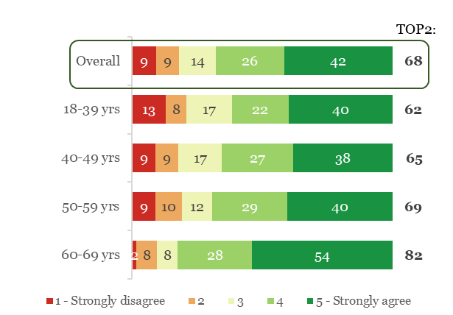
Question: [Reminder of 5-point scale as a measure of agreement with the statement.] … “My case manager informed me of services and supports in my community that could help me.”
Sample size: 316
Framework: Respondents who say they have a case manager, excluding “don’t know” and refused

Most say case managers are responding to calls promptly
- Three-quarters (TOP2: 77%) agree that case managers are responding to their calls in a reasonable amount of time.
- Respondents aged 60+ (TOP2: 88%) are more likely to agree than those under 50 (TOP2: 74%).
Figure 58: “My Case Manager Responded to My Calls in a Reasonable Amount of Time” (%)
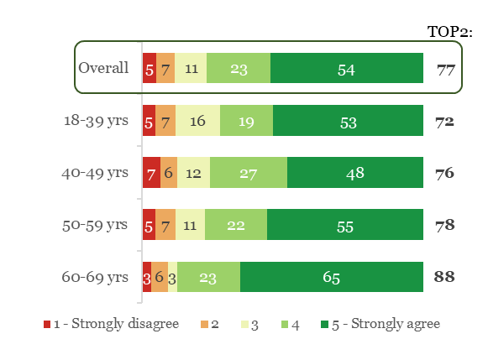
Question: [Reminder of 5-point scale as a measure of agreement with the statement.] … “My case manager responded to my calls in a reasonable amount of time.”
Sample size: 316
Framework: Respondents who say they have a case manager, excluding “don’t know” and refused

Most feel case plan goals are relevant
- Three-quarters (TOP2: 74%) of respondents agree that their case plan goals were relevant.
- Respondents aged 60+ (TOP2: 87%) are more likely to agree.
Figure 59: “My Case Plan Goals Were Relevant” (%)
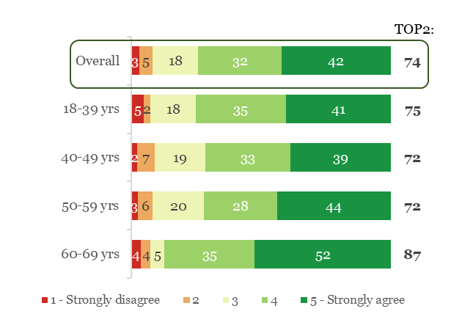
Question: [Reminder of 5-point scale as a measure of agreement with the statement.] … “My case plan goals were relevant.”
Sample size: 298
Framework: Respondents who say they have a case manager, excluding “don’t know” and refused

Veterans Independence Program (VIP)
VIP receives very positive feedback from program recipients. The vast majority are satisfied with the program. Overwhelmingly, respondents say that VIP meets their needs, helps them stay in their communities, and has been a benefit to them.
High overall satisfaction with VIP
- Nine in ten (TOP2: 89%) respondents who receive benefits from VIP agree that they are satisfied with the program overall.
- Two-thirds (67%) of respondents strongly agree, most evident with Survivors (79%).
- Respondents under 40 are less likely to agree than other age groups.
Figure 60: “Overall, I Have Been Satisfied with VIP” (%)
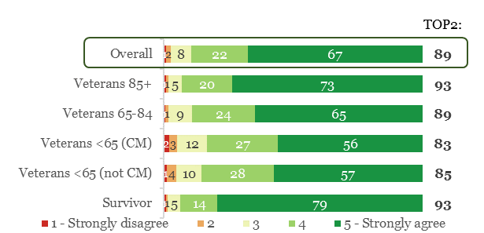
Question: The Veterans Independence Program offers funding for housekeeping, grounds maintenance, and other home care support services that assist clients to remain independent at home … “Overall, I have been satisfied with the Veterans Independence Program.”
Sample size: 1704
Framework: Respondents who are in receipt of benefits from the Veterans Independence Program, excluding “don’t know” and refused

VIP relied on to help respondents remain in their homes and communities
- Nine in ten (TOP2: 91%) respondents who are in receipt of VIP benefits agree that they rely on VIP to help them remain in their home and community.
- Respondents under 40 (TOP2: 74%) are less likely to agree than those 50 or older (TOP2: 92%).
Figure 61: “I Rely on VIP Services to Help Me Remain in My Home and Community” (%)
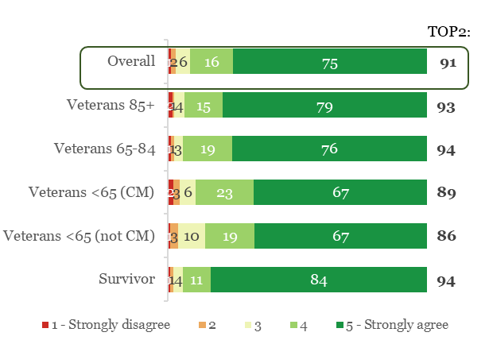
Question: The Veterans Independence Program offers funding for housekeeping, grounds maintenance, and other home care support services that assist clients to remain independent at home … “I rely on VIP services to help me remain in my home and community.”
Sample size: 1657
Framework: Respondents who are in receipt of benefits from the Veterans Independence Program, excluding “don’t know” and refused

Most able to find providers to help with VIP services
- Five in six (TOP2: 84%) of those in receipt of benefits agree that they are able to find service providers to help them with needed VIP services.
- Respondents under 40 (TOP2: 67%) are less likely to agree than those 50 or older (TOP2: 85%).
Figure 62: “I Have Been Able to Find Service Providers to Help Me with the VIP Services I Need” (%)
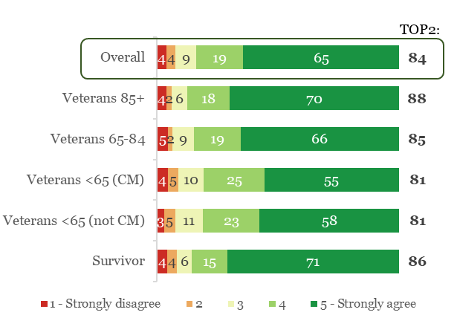
Question: The Veterans Independence Program offers funding for housekeeping, grounds maintenance, and other home care support services that assist clients to remain independent at home … “I have been able to find service providers to help me with the VIP services I need.”
Sample size: 1644
Framework: Respondents who are in receipt of benefits from the Veterans Independence Program, excluding “don’t know” and refused

Majority agree that VIP meets their needs
- Four in five (TOP2: 78%) of those in receipt of benefits from VIP agree that VIP meets their needs.
- Respondents under 40 (TOP2: 47%) are less likely to agree than other age groups (TOP2: 79%).
Figure 63: “VIP Meets My Needs” (%)
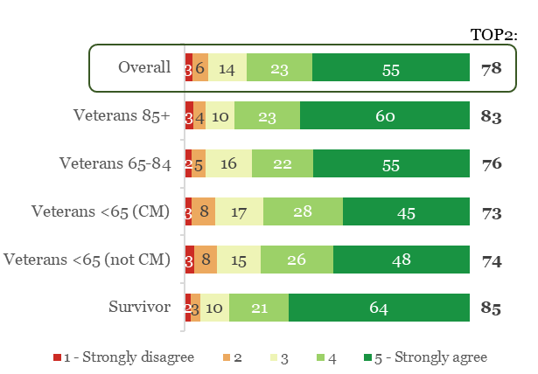
Question: The Veterans Independence Program offers funding for housekeeping, grounds maintenance, and other home care support services that assist clients to remain independent at home … “The VIP program meets my needs.”
Sample size: 1672
Framework: Respondents who are in receipt of benefits from the Veterans Independence Program, excluding “don’t know” and refused

Overwhelming number say VIP has been a benefit to them
- 19 in 20 (TOP2: 94%) respondents in receipt of benefits from VIP say that it has been a benefit to them.
- Three quarters (77%) strongly agree.
Figure 64: “VIP Has Been a Benefit to Me” (%)
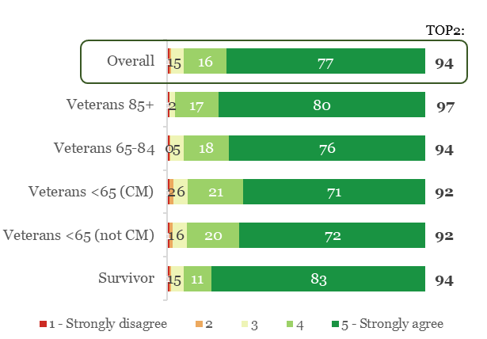
Question: The Veterans Independence Program offers funding for housekeeping, grounds maintenance, and other home care support services that assist clients to remain independent at home … “The VIP program has been a benefit to me”
Sample size: 1697
Framework: Respondents who are in receipt of benefits from the Veterans Independence Program, excluding “don’t know” and refused

Treatment Benefits Program
Three-quarters of respondents are satisfied with the Treatment Benefits Program. Most respondents say the program meets their needs and that the reimbursement time is reasonable. Around five in six are able to access their benefits. The biggest barrier to accessing benefits is lack of approval from VAC.
Program enjoys high satisfaction
- Overall, three-quarters (TOP2: 75%) of respondents who used treatment benefits over the past 24 months agree that they are satisfied.
- Veterans aged 85+ (TOP2: 91%) are more likely to agree.
- Indigenous respondents (TOP2: 59%) are less likely to agree than non-Indigenous respondents (TOP2: 77%).
- Respondents under 60 (TOP2: 67%), are less likely to agree than respondents 60 and older (TOP2: 82%).

Figure 65: “Overall, I Have Been Satisfied with the Treatment Benefits Program” (%)
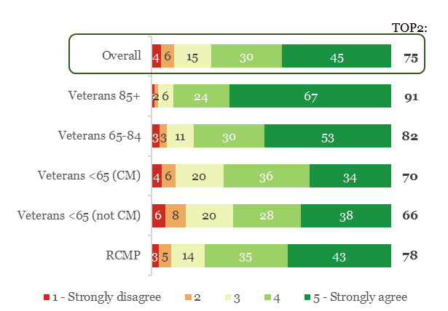
Question: Overall, I have been satisfied with the Treatment Benefits program.
Sample size: 1702
Framework: Respondents who have used treatment benefits over the past 24 months, excluding “don’t know” and refused

Most agree reimbursement time was reasonable
- Seven in ten (TOP2: 72%) of those who used treatment benefits in the past 24 months agree that the time it took to get reimbursed was reasonable.
- Veterans aged 85+ (TOP2: 85%) are more likely to agree.
- Indigenous respondents (TOP2: 61%) are less likely to agree than non-Indigenous respondents (TOP2: 73%).
- Respondents under 60 (TOP2: 64%), are less likely to agree than respondents 70 and older (TOP2: 81%).
Figure 66: Reimbursement Time for Treatment Benefits and Services Was “Reasonable” (%)
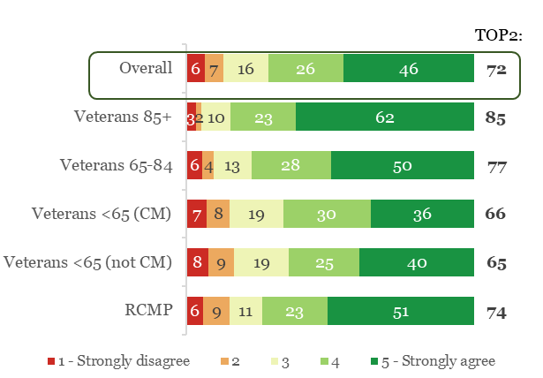
Question: Back to our 5-point response scale... “The time it took to get reimbursed for treatment benefits and services was reasonable.”
Sample size: 1526
Framework: Respondents who have used treatment benefits over the past 24 months, excluding “don’t know” and refused

Most say Treatment Benefits Program meets their needs
- Seven in ten (TOP2: 71%) agree that the program meets their needs.
- Once again, Veterans aged 85+ are more likely to agree.
- Indigenous respondents (TOP2: 54%) are less likely to agree than non-Indigenous respondents (TOP2: 73%).
- Respondents under 60 (TOP2: 63%) are less likely to agree than respondents 60 and older (TOP2: 77%).
- Visible minorities (63%) are less likely to agree than non-minorities (72%).
Figure 67: “The Treatment Benefits Program Meets My Needs” (%)
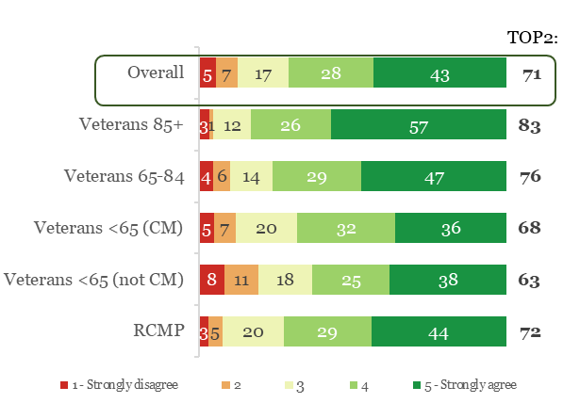
Question: Back to our 5-point response scale... “The Treatment Benefits Program meets my needs.”
Sample size: 1660
Framework: Respondents who have used treatment benefits over the past 24 months, excluding “don’t know” and refused

Vast majority able to access needed treatment benefits
- Five in six (TOP2: 84%) respondents who used treatment benefits in the past 24 months say they were able to access their needed benefits.
- Indigenous respondents (TOP2: 74%) are less likely to say they were able to access the benefits they needed than non-Indigenous respondents (TOP2: 85%).
- Visible minorities respondents (77%) are less likely to agree then non-minorities (86%).
Figure 68: Able to Access Their Needed Treatment Benefits (%)
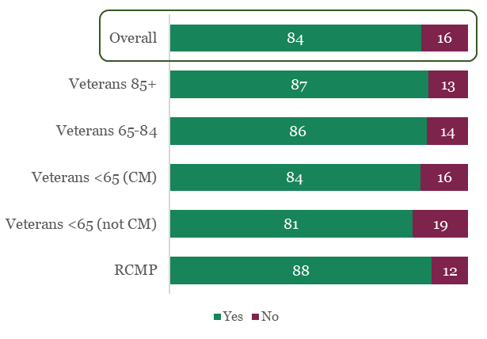
Question: Were you able to access the treatment benefits you needed?
Sample size: 1616
Framework: Respondents who have used treatment benefits over the past 24 months, excluding “don’t know” and refused

Lack of VAC approval for benefits/services top reason for lack of access
- Of those who say they have not accessed their needed treatment benefits, about half (45%) say the benefit or service was not approved by VAC.
- One in five (22%) say the wait time to access the benefits was too long.
Figure 69: Reasons for Not Accessing Needed Benefits (%)
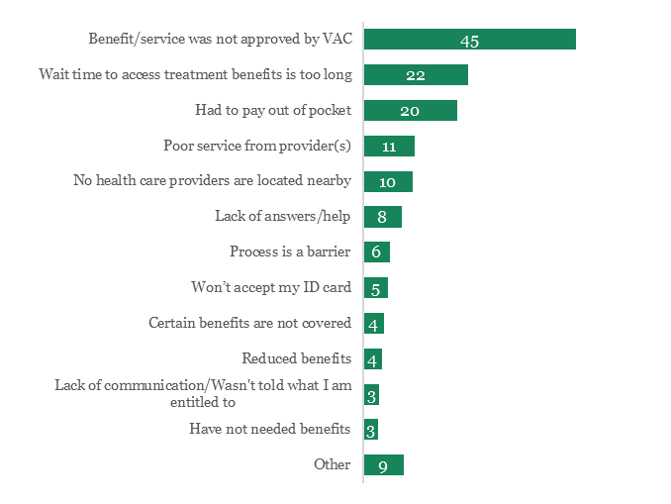
Question: Why haven’t you accessed the benefits you needed? [multiple responses allowed]
Sample size: 248
Framework: Respondents who say they were not able access the treatment benefits they needed, excluding “don’t know” and refused
Note: Not shown if <3%.

Some variation by strata
- Veterans under 65 (not case-managed) are the most likely to cite lack of approval (52%) and wait times (35%) compared to other strata.

Figure 70: Reasons for Not Accessing Needed Benefits: Top 8 (%)
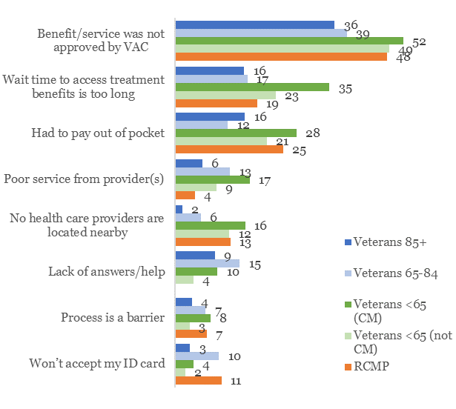
Question: Why haven’t you accessed the benefits you needed? [multiple responses allowed]
Sample size: 241
Framework: Respondents who say they were not able access the treatment benefits they needed, excluding “don’t know” and refused

Disability Benefits Program
Most program recipients are satisfied with the Disability Benefits Program. Most agree that the program recognizes their service-related disability and compensates them for it.
High satisfaction with program; varies among strata
- Two-thirds (TOP2: 66%) of respondents agree that they are satisfied with the Disability Benefits Program overall.
- Veterans under 65 are least satisfied among the six strata, particularly those non-case managed (TOP2: 53%).
- Indigenous respondents (TOP2: 50%) are less satisfied than non-Indigenous respondents (TOP2: 67%).
- Visible minorities (TOP2: 58%) are less satisfied than non-minorities (TOP2: 67%).
- Respondents under 70 (TOP2: 58%) are less likely to agree than those 70+ (TOP2: 82%).
Figure 71: “Overall, I Have Been Satisfied with the Disability Benefits Program” (%)
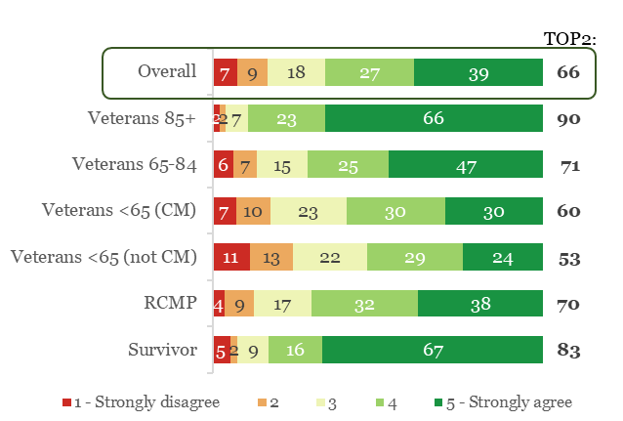

Question: Back to our 5-point response scale where 1 = strongly disagree and 5 = strongly agree … “Overall, I have been satisfied with the Disability Benefits program.”
Sample size: 2942
Framework: Respondents whose Disability Program account status is “in-pay” or “entitlement only,” excluding “don’t know” and refused

Most agree benefits recognize their disability
- Seven in ten (TOP2: 69%) respondents agree that their disability benefits recognize their service-related disability.
- Veterans under 65, not case managed (TOP2: 58%) are the least likely of the six strata to agree, whereas Veterans aged 85+ (TOP2: 86%) and Survivors (TOP2: 80%) are most likely to agree.
- Indigenous respondents (TOP2: 54%) are less likely than non-Indigenous respondents (TOP2: 70%) to agree.
- Visible minorities (TOP2: 60%) are less satisfied than non-minorities (TOP2: 71%).
- Respondents under 70 (TOP2: 64%) are less likely to agree than those 70+ (TOP2: 81%).
Figure 72: My Disability Benefits “Recognize My Service-Related Disability” (%)
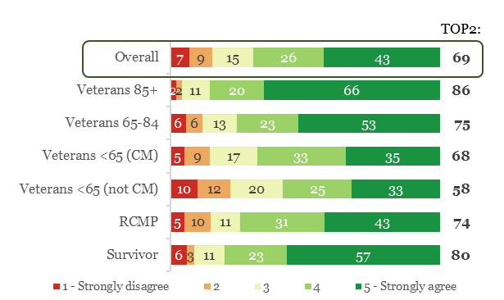
Question: Back to our 5-point response scale where 1 = strongly disagree and 5 = strongly agree … “The disability benefits I receive from VAC recognize my service-related disability.”
Sample size: 2821
Framework: Respondents whose Disability Program account status is “in-pay” or “entitlement only,” excluding “don’t know” and refused

Majority agree benefits compensate them for the effects of their disability
- Three in five (TOP2: 61%) respondents agree that their disability benefits compensate them for the effects of their service-related disability.
- Indigenous respondents (TOP2: 47%) are less likely to agree than non-Indigenous respondents (TOP2: 62%).
- In general, younger respondents are less likely than older respondents to agree. Those aged 18-49 are less likely to agree than those aged 50 and older, although 50-69 are less likely to agree than those aged 70 and older.
Figure 73: My Disability Benefits “Compensate Me for the Effects of My Service-Related Disability” (%)
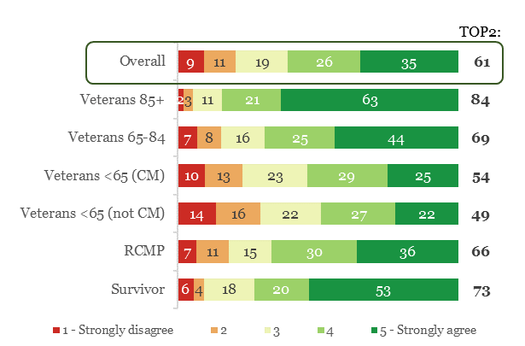
Question: Back to our 5-point response scale where 1 = strongly disagree and 5 = strongly agree … “The disability benefits I receive from VAC compensate me for the effects of my service-related disability.”
Sample size: 2827
Framework: Respondents whose Disability Program account status is “in-pay” or “entitlement only,” excluding “don’t know” and refused

Rehabilitation Services and Vocational Assistance
Seven in ten are satisfied with the rehabilitation services and vocational assistance. A majority say it helped improve their quality of life and benefited themselves and their supporters. Fewer respondents say that the program helped them return to work/their main activity, or that it improved barriers in their life.
Medical and psychosocial rehabilitation most common
- When asked which rehabilitation program streams they had participated in, seven in ten (71%) said medical rehabilitation, two-thirds (68%) said psychosocial rehabilitation, and two in five (42%) said vocational rehabilitation.
- One in ten (9%) said they do not think they are not part of the program or are unsure. This finding may reflect that they are not familiar with the name of the service or could be an administrative data entry error.
Figure 74: Participation in Rehabilitation Program Streams (%)
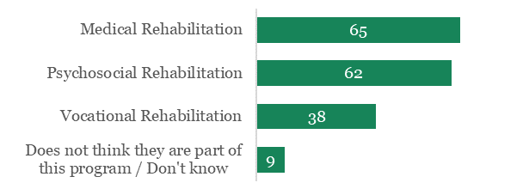
Question: What stream(s) of VAC rehabilitation program have you participated in? [multiple responses allowed]
Sample size: 349
Framework: Respondents whose sample files indicate they are “eligible” or have “completed” rehabilitation, or respondents whose files indicate they are “active” or “in progress” with respect to vocational rehabilitation, excluding refused

Older respondents more likely to participate in Medical Rehabilitation, whereas younger respondents are more likely to participate in Vocational Rehabilitation
- Respondents aged 50+ are more likely to participate in medical rehabilitation than younger respondents under 40.
- Those aged 40 and older are less likely to participate in vocational rehabilitation, potentially because more are retired at that age.
Figure 75: Participation in Rehabilitation Program Streams (%)
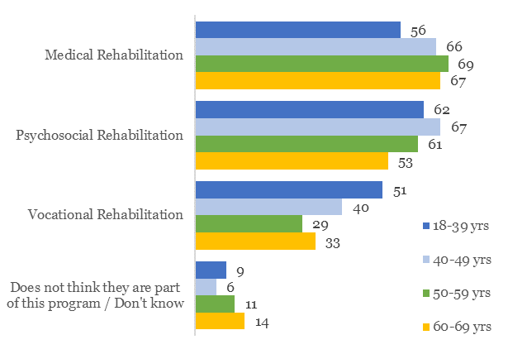
Question: What stream(s) of VAC rehabilitation program have you participated in? [multiple responses allowed]
Sample size: 349
Framework: Respondents whose sample files indicate they are “eligible” or have “completed” rehabilitation, or respondents whose files indicate they are “active” or “in progress” with respect to vocational rehabilitation, excluding refused

Most are satisfied with Rehabilitation Services and Vocational Assistance Program
- Seven in ten (TOP2: 68%) respondents agree that they are satisfied with VAC’s Rehabilitation Services and Vocational Assistance Program.
- Respondents 60 and older (TOP2: 80%) are more likely to be satisfied than those aged 40-59.
Figure 76: “Overall, I Have Been Satisfied” with Rehabilitation Services and Vocational Assistance Program (%)
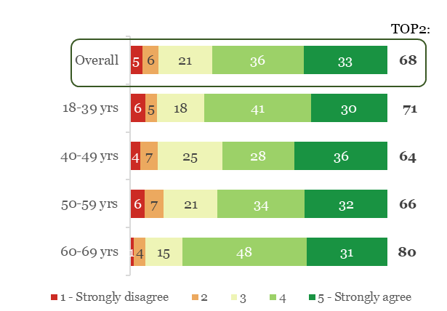
Question: Back to our 5-point response scale where 1 = strongly disagree and 5 = strongly agree … “Overall, I have been satisfied with VAC’s Rehabilitation Services and Vocational Assistance Program.”
Sample size: 310
Framework: Respondents whose sample files indicate they are “eligible” or have “completed” rehabilitation, or respondents whose files indicate they are “active” or “in progress” with respect to vocational rehabilitation, excluding “don’t know” and refused

Most agree program improved quality of life
- Two-thirds (TOP2: 64%) of respondents agree that participation in VAC’s Rehabilitation Program has helped improve their quality of life.
- Respondents 60 and older (TOP2: 80%) and under 40 (TOP2: 73%) are more likely to agree than the middle age groups.
Figure 77: Participation in Rehabilitation Program “Helped Me Improve My Quality of Life” (%)
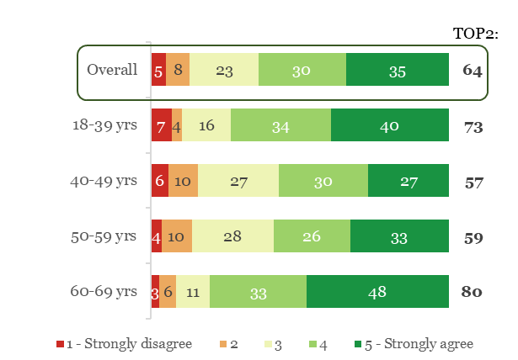
Question: Back to our 5-point response scale where 1 = strongly disagree and 5 = strongly agree … “My participation in VAC's Rehabilitation Program has helped me improve my quality of life.”
Sample size: 312
Framework: Respondents whose sample files indicate they are “eligible” or have “completed” rehabilitation, or respondents whose files indicate they are “active” or “in progress” with respect to vocational rehabilitation, excluding “don’t know” and refused

Fewer agree that the program helped them return to work
- Only a quarter (TOP2: 24%) of respondents agree that the program helped them enter the workforce or return to their main activity.
- Those aged 40-59 are less likely to agree than older respondents.
- Indigenous respondents (TOP2: 10%) are far less likely than non-Indigenous respondents (TOP2: 25%) to agree.
Figure 78: Participation in Rehabilitation Program “Helped Me Enter the Workforce” or “Return to Main Activity” (%)
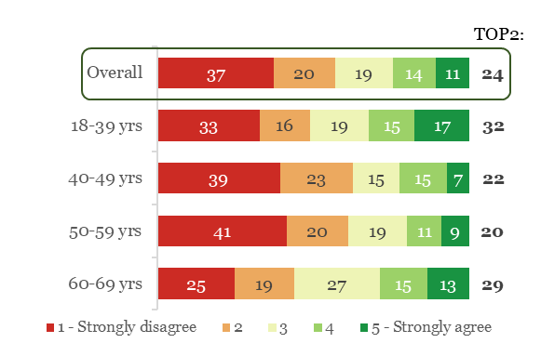
Question: Back to our 5-point response scale where 1 = strongly disagree and 5 = strongly agree … “My participation in the Rehabilitation program has helped me enter the workforce or return to my main activity.”
Sample size: 266
Framework: Respondents whose sample files indicate they are “eligible” or have “completed” rehabilitation, or respondents whose files indicate they are “active” or “in progress” with respect to vocational rehabilitation, excluding “don’t know” and refused
Majority agree rehabilitation has benefited their supporters
- Three in five (TOP2: 58%) agree that participating in rehabilitation has been beneficial to their family or others who support them.
Figure 79: “Participation in Rehabilitation Has Been Beneficial to My Family” or Other Supporters (%)
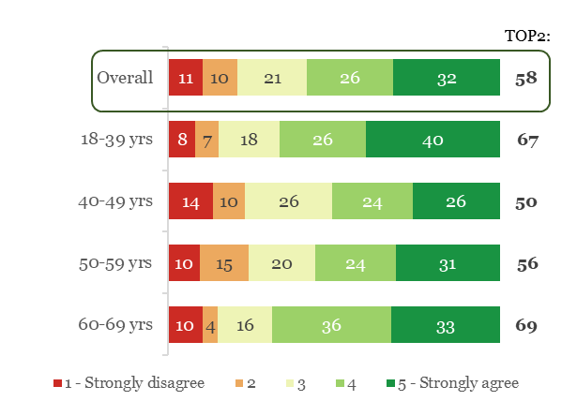
Question: Back to our 5-point response scale where 1 = strongly disagree and 5 = strongly agree … “My participation in rehabilitation has been beneficial to my family or other people who support me.”
Sample size: 301
Framework: Respondents whose sample files indicate they are “eligible” or have “completed” rehabilitation, or respondents whose files indicate they are “active” or “in progress” with respect to vocational rehabilitation, excluding “don’t know” and refused

Most agree that rehabilitation was personally beneficial
- Two-thirds (TOP2: 67%) agree that participating in rehabilitation was beneficial to them.
- Once again, those aged 60 and older (TOP2: 80%) are more likely to agree than those between the ages of 40 and 59 (TOP2: 63%).
Figure 80: “My Participation in Rehabilitation Was Beneficial to Me” (%)
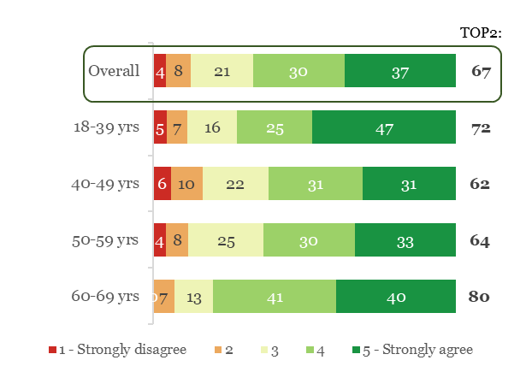
Question: Back to our 5-point response scale where 1 = strongly disagree and 5 = strongly agree … “My participation in rehabilitation was beneficial to me.”
Sample size: 312
Framework: Respondents whose sample files indicate they are “eligible” or have “completed” rehabilitation, or respondents whose files indicate they are “active” or “in progress” with respect to vocational rehabilitation, excluding “don’t know” and refused

Level of participation generally perceived as reasonable
- Four in five (TOP2: 78%) respondents agree that the level of participation expected of them in the rehabilitation program was reasonable.
- Respondents aged 60–69 are more likely to agree than those aged 40-49.
Figure 81: “Level of Participation Expected of Me in the Rehabilitation Program Was Reasonable” (%)
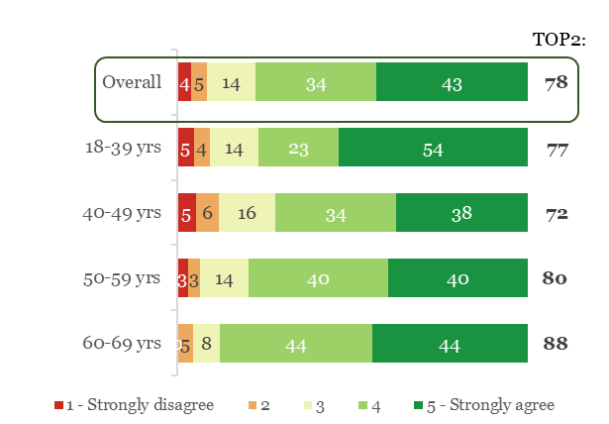
Question: Back to our 5-point response scale where 1 = strongly disagree and 5 = strongly agree … “The level of participation in the Rehabilitation program that was expected of me was reasonable.”
Sample size: 307
Framework: Respondents whose sample files indicate they are “eligible” or have “completed” rehabilitation, or respondents whose files indicate they are “active” or “in progress” with respect to vocational rehabilitation, excluding “don’t know” and refused
Vast majority agree that they tried hard to follow their rehabilitation plan
- Nine in ten (TOP2: 90%) respondents say they tried hard to follow their rehabilitation plan.
Figure 82: “I Tried Hard To Follow My Rehabilitation Plan” (%)
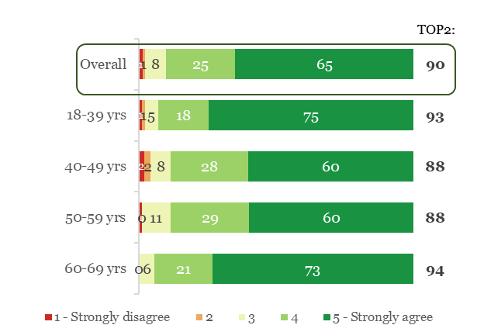
Question: Back to our 5-point response scale where 1 = strongly disagree and 5 = strongly agree … “I tried hard to follow my rehabilitation plan.”
Sample size: 279
Framework: Respondents whose sample files indicate they are “eligible” or have “completed” rehabilitation, or respondents whose files indicate they are “active” or “in progress” with respect to vocational rehabilitation, excluding “don’t know” and refused

Respondents split on whether participation decreased barriers
- Only three in ten (TOP2: 29%) agree that their barriers decreased after participating the program.
- A similar number (BTM2: 33%) disagreed.
- Those aged 60 and older (TOP2: 46%) and under 40 (TOP2: 37%) are more likely to agree than the middle age categories.
Figure 83: “Since Participating in VAC’s Rehabilitation Program, My Barriers Have Decreased” (%)
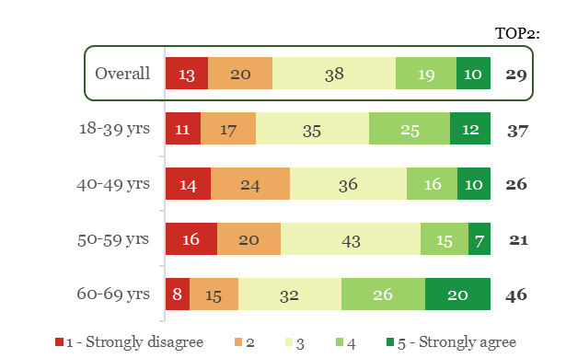
Question: Back to our 5-point response scale where 1 = strongly disagree and 5 = strongly agree … “Since participating in VAC’s Rehabilitation Program, my barriers have decreased.”
Sample size: 295
Framework: Respondents whose sample files indicate they are “eligible” or have “completed” rehabilitation, or respondents whose files indicate they are “active” or “in progress” with respect to vocational rehabilitation, excluding “don’t know” and refused
Home and community top areas where barriers worsened
- Of those who disagreed that their barriers improved, the most commonly cited areas where barriers worsened were at home (56%) and in the community (48%).
- Three in eight (36%) say their barriers worsened at work.
- One in eight (13%) say their barrier(s) have not worsened, presumably because they have stayed the same.
Figure 84: Where Barriers Worsened (%)
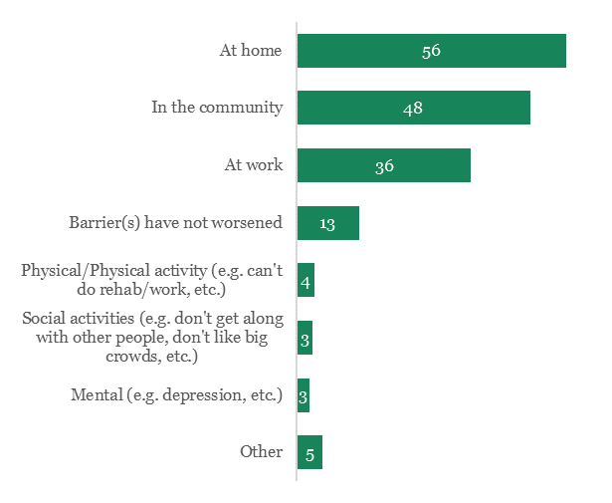
Question: Where has one of your barriers worsened? [multiple responses allowed]
Sample size: 89
Framework: Respondents who say Disagree or Strongly Disagree with the statement “Since participating in VAC’s Rehabilitation Program, my barriers have decreased” , excluding “don’t know” and refused
Variations among age groups
- While those under 59 are more likely to say their barriers worsen at work, those aged 60 and older are more likely to say their barriers have not worsened.
Figure 85: Where Barriers Worsened (%)
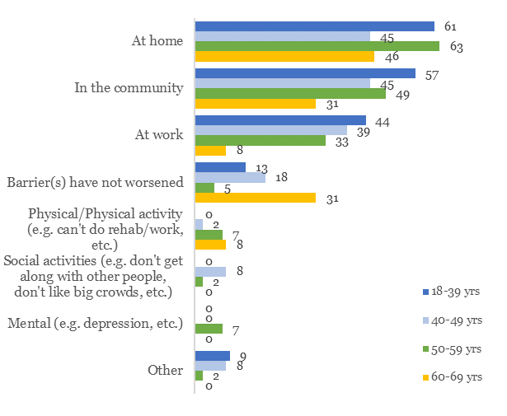
Question: Where has one of your barriers worsened? [multiple responses allowed]
Sample size: 89
Framework: Respondents who rated their agreement with the statement “Since participating in VAC’s Rehabilitation Program, my barriers have decreased” as a 2 or lower, excluding “don’t know” and refused
Improvements in barriers tended to be at home
- Of those who agree that their barriers have decreased as a result of participation, six in seven (85%) say they experienced this improvement at home.
- Four in nine (46%) say they experienced the improvement in the community.
- A quarter (26%) say they saw an improvement at work.
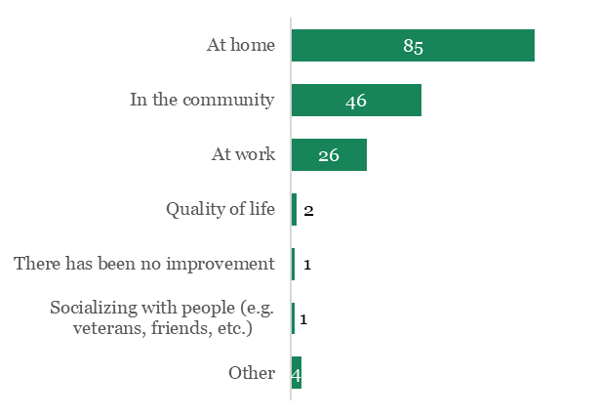
Figure 86: Where Barriers Improved (%)

Question: Where is the improvement in one of your barriers noticeable? [multiple responses allowed]
Sample size: 83
Framework: Respondents who Agree or Strongly Agree with the statement “Since participating in VAC’s Rehabilitation Program, my barriers have decreased”, excluding “don’t know” and refused
Barrier improvements evenly distributed among age groups
There are no great variations among age groups regarding where barriers improved.
Figure 87: Where Barriers Improved (%)
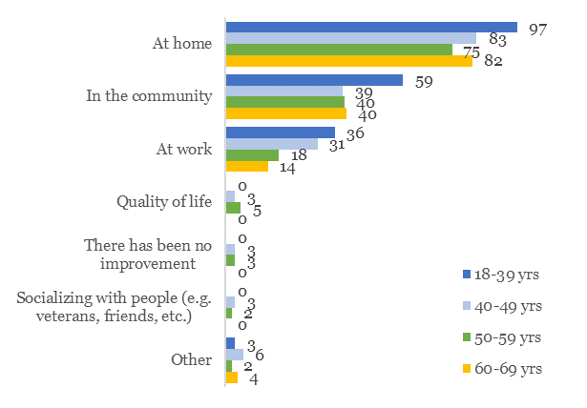
Question: Where is the improvement in one of your barriers noticeable? [multiple responses allowed]
Sample size: 83
Framework: Respondents who Agree or Strongly Agree with the statement “Since participating in VAC’s Rehabilitation Program, my barriers have decreased”, excluding “don’t know” and refused

Pension for Life
Fewer respondents in this wave of research received information from VAC about Pension for Life compared to 2020 findings. For most, it did not change their personal benefits. For those whose benefits changed, most understood the changes.
Half of respondents received information
- One-third (38%) of respondents received information from VAC about their personal benefits as a result of Pension for Life. This is lower than that in 2020 (48%), mainly because fewer Veterans under 65 say that they have received information.
- Respondents under 70 (46%) are more likely than respondents 70 and older (25%) to have received information about Pension for Life.
- Male respondents (44%) are more likely than female respondents (25%) to have received this information.
Figure 88: “Did You Receive Information from VAC About Your Personal Benefits as a Result of Pension for Life?” (%)
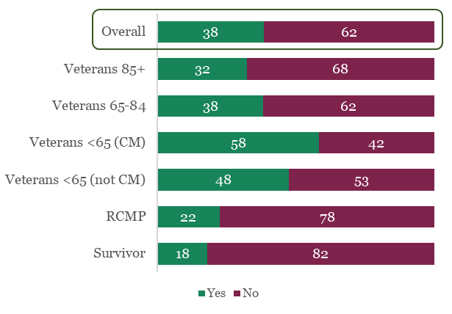
Question: On April 1, 2019, the Government of Canada launched Pension for Life. Pension for Life is a combination of benefits that provide recognition, income support and stability to members and Veterans who experience an illness or injury related to service. Did you receive information from VAC about your personal benefits as a result of Pension for Life?
Sample size: 2566
Framework: All respondents, excluding “don’t know” and refused
Most saw no change in benefits
- Only a quarter (23%) of respondents saw a change in their benefits as a result of Pension for Life.
- Male respondents (25%) are more likely to have seen a change than female respondents (16%).
- Respondents aged 40-69 (29%) are more likely to have seen a change than respondents 70 and older (16%).
Figure 89: “Have Your Benefits Changed as a Result of Pension for Life?” (%)
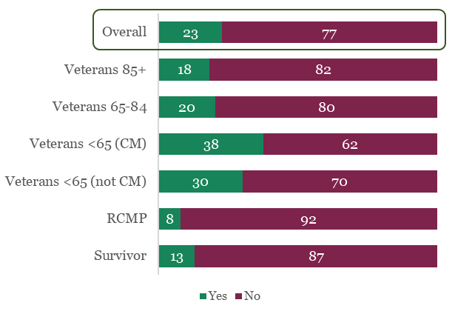
Question: Have your benefits changed as a result of Pension for Life?
Sample size: 2282
Framework: All respondents, excluding “don’t know” and refused

Most understood benefits changes
- Of those who say they experienced changes to their personal benefits, two-thirds (TOP2: 67%) say they understood the changes.
- Understanding is the lowest among Veterans under 65, not case managed (TOP2: 59%).
- French speakers (TOP2: 75%) are more likely to understand the changes than English speakers (TOP2: 63%).
Figure 90: “I Understood the Changes to My Personal Benefits as a Result of Pension for Life” (%)
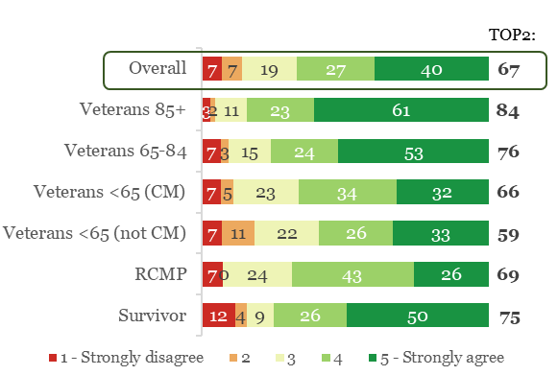
Question: Back to our 5-point response scale where 1 = strongly disagree and 5 = strongly agree … “I understood the changes to my personal benefits as a result of Pension for Life.”
Sample size: 493
Framework: Respondents who say that their benefits have changed as a result of Pension for Life, excluding “don’t know” and refused

Office of the Veterans Ombudsman
Half of respondents are aware of the Office of the Veterans Ombudsman. Of those who are aware, around half are familiar with the Office’s services. Many heard about the Office from VAC or through word of mouth.
Just over half have awareness of the Office
- Half of respondents (52%) are aware of the Office of the Veterans Ombudsman.
- Survivors (34%) are the least likely to be aware of the Office.
- Visible minorities (45%) are less likely to be aware than non-minorities (54%).
- Female respondents (41%) are less likely to be aware than male respondents (57%).
Figure 91: “Were You Aware of the Office of the Veterans Ombudsman?” (%)
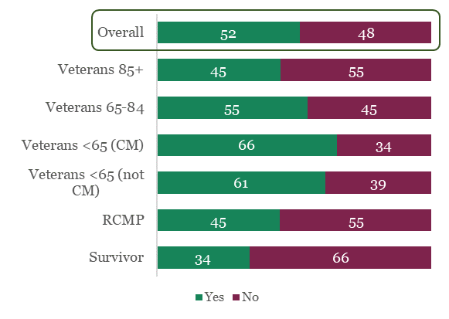
Question: The Office of the Veterans Ombudsman is an independent organization that works to ensure that VAC clients receive the services and benefits that they require in a fair, timely, and efficient manner. Prior to today, were you aware of the Office of the Veterans Ombudsman?
Sample size: 3293
Framework: All respondents, excluding “don’t know” and refused
VAC and word of mouth are the most popular sources of awareness
- Of those who are aware of the Office, many either heard of it from VAC (25%) or through word of mouth (23%).
- Other common sources of awareness are Veterans service organizations (11%), and newspapers and magazines (10%).
- Social media (4%) and TV (4%) are the least popular places to have heard about the Office.
Figure 92: “Where Did You First Hear About the Office?” (%)
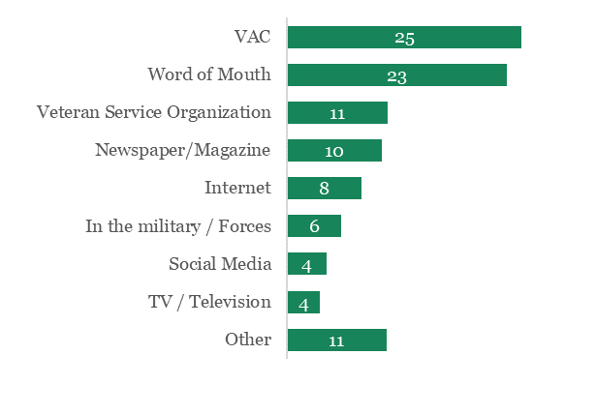
Question: Where did you first hear about the Office of the Veterans Ombudsman?
Sample size: 1626
Framework: Respondents who say they are aware if the Office of the Veterans Ombudsman, excluding “don’t know” and refused

Some variations by strata
- Veterans aged 65 and older and Survivors are the most likely of the six strata to have heard about the Office through Newspaper/Magazine.
- RCMP are most likely to have heard about the Office through VAC.
Figure 93: “Where Did You First Hear About the Office?” (Top 5) (%)
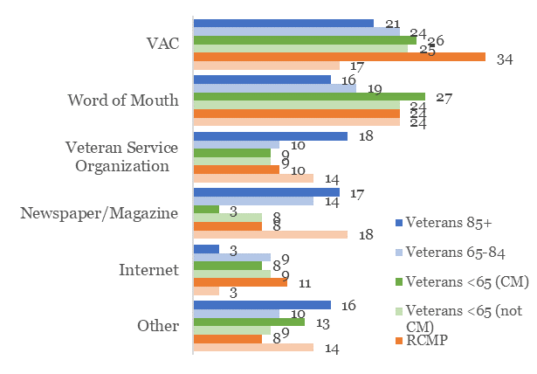
Question: Where did you first hear about the Office of the Veterans Ombudsman?
Sample size: 1626
Framework: Respondents who say they are aware if the Office of the Veterans Ombudsman, excluding “don’t know,” “other,” and refused

Survivors are least familiar with the Office’s services
- Half (TOP2: 47%) of respondents who are aware of the Office say they are familiar with the Office’s services.
- Survivors (TOP2: 39%) are the stratum least familiar with the services of the Office.
- Female respondents (TOP2: 40%) are less familiar with the services of the Office than male respondents (TOP2: 50%).
Figure 94: Familiarity with the Services of the Office (%)
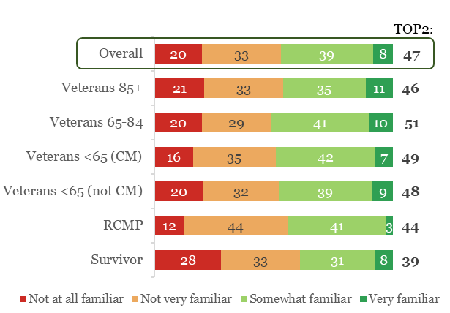
Question: How familiar are you with the services of the Office of the Veterans Ombudsman?
Sample size: 1703
Framework: Respondents who say they are aware if the Office of the Veterans Ombudsman, excluding “don’t know” and refused

Commemorative Initiatives
Most are satisfied with VAC’s commemorative initiatives and the way they honour those who served. To ensure more Canadians are aware of VAC’s commemorative initiatives, respondents suggest reaching out via social media and to community groups and schools.
Most are satisfied with commemorative initiatives overall
- Seven in ten (TOP2: 69%) agree that they are satisfied with VAC’s commemorative initiatives.
- Veterans aged 85+ (TOP2: 81%) and Survivors (TOP2: 79%) are the most satisfied.
- Respondents under 70 (TOP2: 62%), are less satisfied than respondents 70 and older (TOP2: 78%).
- Indigenous respondents (TOP2: 51%) are less satisfied than non-Indigenous respondents (TOP2: 70%).
- Female respondents (TOP2: 77%) are more satisfied than male respondents (TOP2: 65%).
- Visible minorities (61%) are less satisfied than non- minorities (70%).
- French-speakers (TOP2: 76%) are more satisfied than English-speakers (TOP2: 66%).
Figure 95: “Overall, I Have Been Satisfied with VAC’s Commemorative Initiatives” (%)
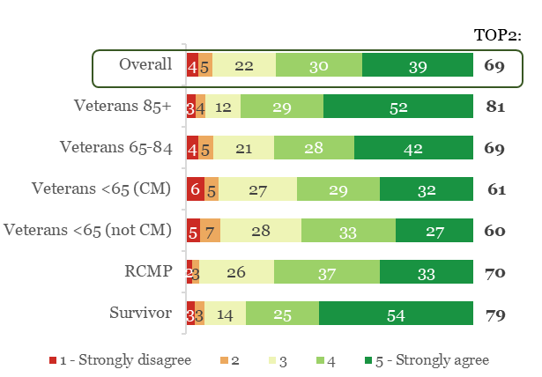
Question: Back to our 5-point response scale where 1 = strongly disagree and 5 = strongly agree. … “Overall, I have been satisfied with VAC´s commemorative initiatives.”
Sample size: 2470
Framework: All respondents, excluding “don’t know” and refused

Majority satisfied with how initiatives honour those who served
- Seven in ten (TOP2: 70%) respondents agree that they are satisfied with the way VAC’s commemorative initiatives honour those who served.
- Respondents 70 and older (TOP2: 78%), are more satisfied than respondents under 70 (TOP2: 64%).
- French-speakers (TOP2: 78%) are more satisfied than English-speakers (TOP2: 67%).
- Male respondents (TOP2: 67%) are less satisfied than female respondents (TOP2: 76%).
- Indigenous respondents (TOP2: 49%) are less satisfied than non-Indigenous respondents (TOP2: 71%).
Figure 96: “I Am Satisfied with the Way VAC’s Commemorative Initiatives Honour Those Who Served” (%)
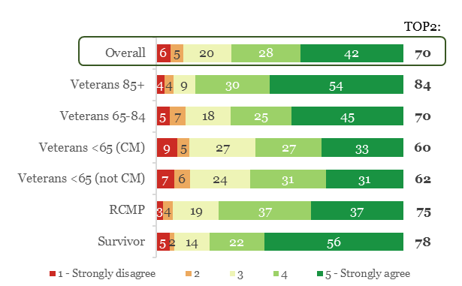
Question: Moving on to VAC's commemorative initiatives, which include ceremonies, learning resources, funding for community projects, cemetery and Veterans grave maintenance. Back to our 5-point response scale where 1 = strongly disagree and 5 = strongly agree. … “I am satisfied with the way VAC’s commemorative initiatives honour those who served our country and preserve the memory of their achievements and sacrifices.”
Sample size: 2560
Framework: All respondents, excluding “don’t know” and refused
Three main suggestions for raising awareness
The three most popular suggestions for raising awareness for commemorative initiatives are social media (64%), local organizations and community groups (48%), and through schools (38%).
Figure 97: Ways of Raising Awareness for Initiatives: Top 10 (%)
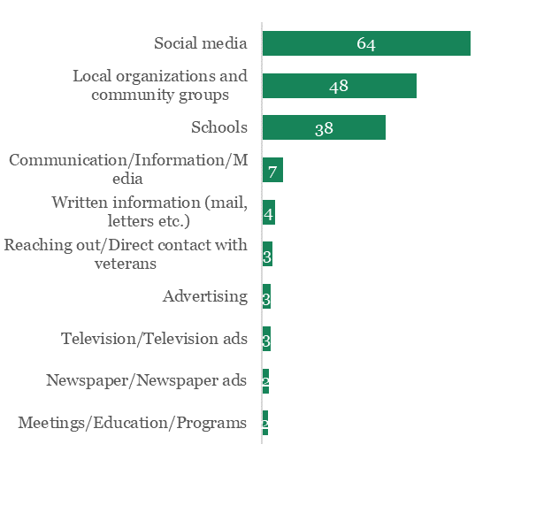
Question: What could VAC do to ensure more Canadians are aware of VAC’s commemorative initiatives?
Sample size: 2691
Framework: All respondents, excluding “don’t know” and refused

No great variation between strata
Social media is most commonly suggested by RCMP (76%) and least commonly suggested by Veterans 85+ and Survivors (each 54%).
Figure 98: Ways of Raising Awareness for Initiatives: Top 5 (%)
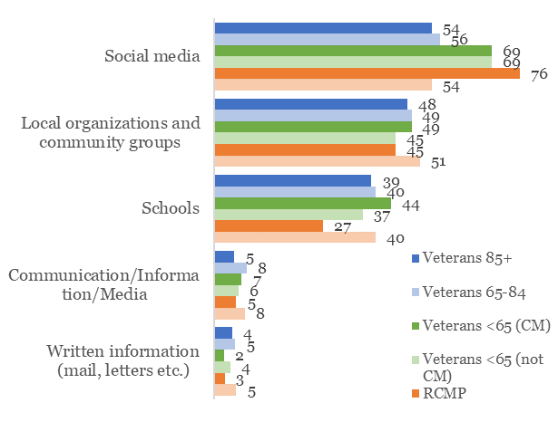
Question: What could VAC do to ensure more Canadians are aware of VAC’s commemorative initiatives?
Sample size: 2691
Framework: All respondents, excluding “don’t know” and refused

Funeral and Burial Program
Two-thirds of respondents are satisfied with the Funeral and Burial Program, and another two-thirds are satisfied with the access to financial assistance for Veterans’ estates.
Most satisfied with program overall
- Two-thirds (TOP2: 68%) of respondents are satisfied with the Funeral and Burial Program overall.
- Veterans aged 85+ (TOP2: 79%) and Survivors (TOP2: 78%) are consistently more satisfied than other strata.
- Indigenous respondents (TOP2: 51%) are less satisfied than non-Indigenous respondents (TOP2: 69%).
- Female respondents (TOP2: 74%) are more satisfied than male respondents (TOP2: 65%).
Figure 99: “Overall, I Have Been Satisfied with the Program” (%)
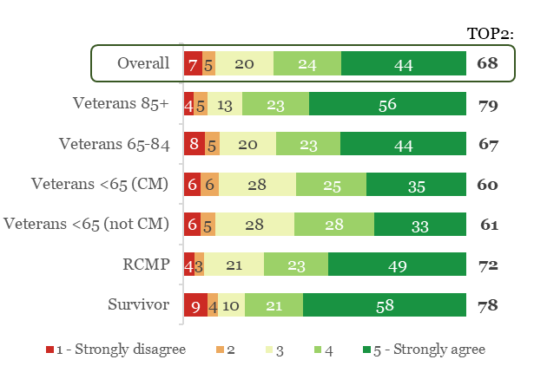
Question: VAC’s Funeral and Burial Program provides financial assistance for funeral, burial, and grave marking services for Veterans whose deaths are attributable to their military service and for Veterans who have insufficient funds. … “Overall, I have been satisfied with the program that provides funding for funerals and burials to eligible Veterans.”
Sample size: 1845
Framework: All respondents, excluding “don’t know” and refused
Two-thirds satisfied with financial assistance for estates
- Two-thirds (TOP2: 68%) of respondents are satisfied that the estates of Veterans have access to financial assistance through VAC’s Funeral and Burial Program.
- Veterans aged 85+ (TOP2: 79%) and Survivors (TOP2: 77%) are consistently more satisfied than other strata.
- Indigenous respondents (TOP2: 51%) are less satisfied than non-Indigenous (TOP2: 69%).
Figure 100: I Am Satisfied that Veterans’ Estates “Have Access to Financial Assistance” Through the Program (%)
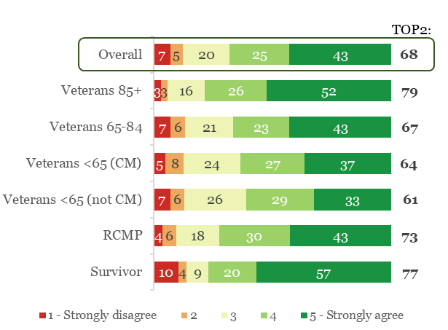
Question: VAC’s Funeral and Burial Program provides financial assistance for funeral, burial, and grave marking services for Veterans whose deaths are attributable to their military service and for Veterans who have insufficient funds. … “I am satisfied that the estates of Veterans have access to financial assistance through VAC’s Funeral and Burial Program.”
Sample size: 2000
Framework: All respondents, excluding “don’t know” and refused

Satisfaction with Life
Three-quarters of respondents are satisfied with life in general. However, satisfaction across most of the areas dropped from 2020. Consistently, case-managed Veterans under 65 are the least satisfied, while Survivors and Veterans 85+ are the most satisfied. Indigenous and visible minority respondents are generally less satisfied. There are few notable gender differences.
Most common main activity in past 12 months is retirement
- When asked what their main activity has been in the past 12 months, two in five (38%) say retirement.
- Working/running a business was cited by one in five (18%).
- Male respondents (22%) are more likely to be working or running a business than female respondents (9%).
Figure 101: Main Activity in the Past 12 Months (%)
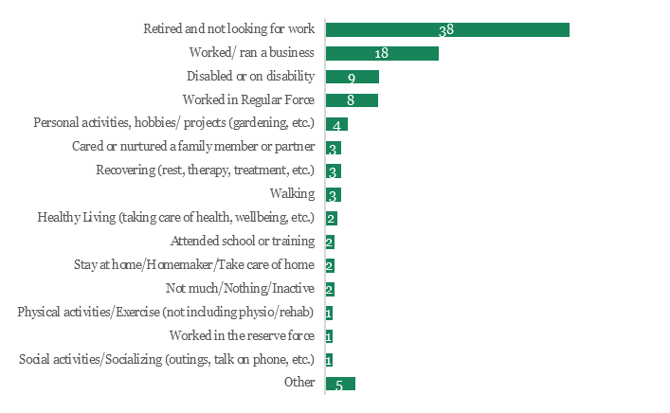
Question: What has been your main activity in the past 12 months?
Sample size: 3310
Framework: All respondents, excluding “don’t know” and refused
Some variation for main activity between strata
- Unsurprisingly, strata comprising respondents under 65 are much less likely to be retired and more likely to be working or running a business.
- Conversely, strata with older respondents are more likely to be retired and less likely to be working.
Figure 102: Main Activity in the Past 12 Months: Top 5 (%)
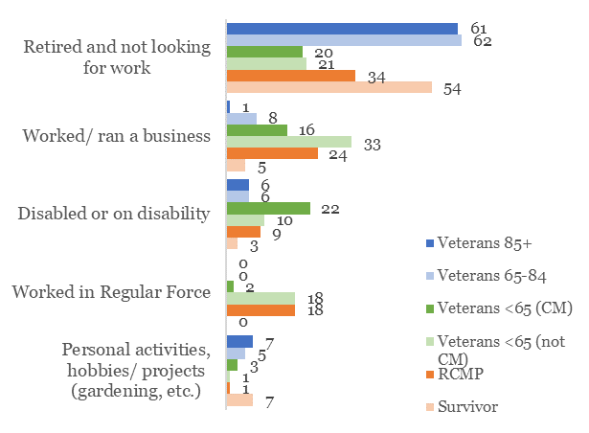
Question: What has been your main activity in the past 12 months?
Sample size: 3310
Framework: All respondents, excluding “don’t know” and refused

Most are satisfied with main job or activity; variations by strata
- Two-thirds (TOP2: 63%) of respondents are satisfied with their main job or activity, which is lower than that in 2020 (TOP2: 73%).
- Case-managed Veterans under 65 are the least satisfied (TOP2: 44%) of the six strata.
- Respondents 60 and older (TOP2: 69%) are more satisfied than those under 60 (TOP2: 55%).
- Indigenous respondents (TOP2: 51%) are less satisfied than non-Indigenous respondents (TOP2: 64%).
Figure 103: Satisfaction with “Main Job or Activity” (%)
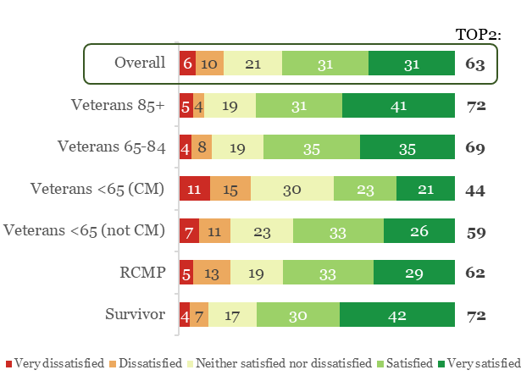
Question: This next set of questions surveys your satisfaction with different aspects of your well-being. Use the response scale: Very dissatisfied, dissatisfied, neither satisfied nor dissatisfied, satisfied, very satisfied. How satisfied are you with your … “main job or activity?”
Sample size: 3068
Framework: All respondents, excluding “don’t know” and refused
Most are satisfied with life in general; variations by strata
- Two-thirds (TOP2: 66%) of respondents say they are satisfied with life in general, which is lower than that in 2020 (TOP2: 76%).
- Case-managed Veterans under 65 are the least satisfied strata: only two in five (TOP2: 42%) are satisfied.
- Indigenous respondents (TOP2: 51%) and visible minorities (TOP2: 59%) are less satisfied than non-Indigenous (TOP2: 67%) and non-minorities (TOP2: 68%).
Figure 104: Satisfaction with “Life in General” (%)
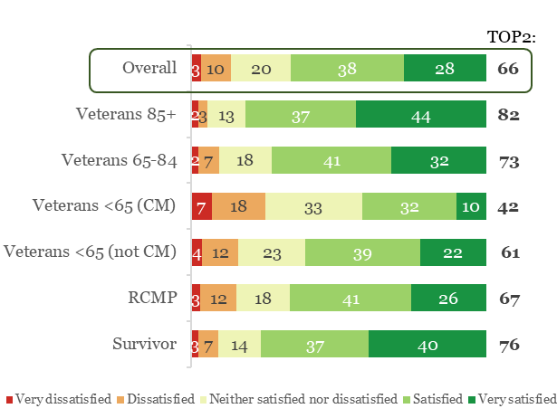
Question: How satisfied are you with your … “life in general?”
Sample size: 3349
Framework: All respondents, excluding “don’t know” and refused
More than half satisfied with overall well-being; variations by strata
- Five in nine (TOP2: 56%) respondents are satisfied with their overall well-being, which is again lower than that in 2020 (TOP2: 69%).
- Once again, case-managed Veterans under 65 are the least satisfied (TOP2: 33%).
- Younger respondents are less satisfied than older respondents.
- Indigenous (TOP2: 39%) respondents are less satisfied than non-Indigenous (TOP2: 57%) respondents.
Figure 105: Satisfaction with Their “Overall Well-Being” (%)
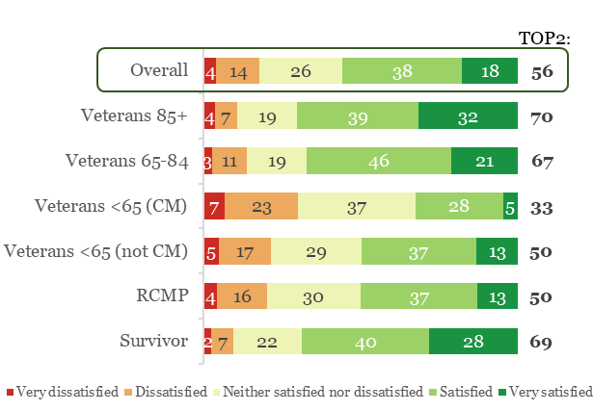
Question: How satisfied are you with your … “overall well-being?”
Sample size: 3346
Framework: All respondents, excluding “don’t know” and refused

Half are satisfied with leisure activities
- Half (TOP2: 52%) of respondents are satisfied with their leisure activities, which is lower than that in 2020 (TOP2: 65%).
- Case-managed Veterans under 65 (TOP2: 32%) are much less satisfied than other strata.
- Respondents under 60 (TOP2: 42%), tend to be less satisfied than respondents 60 and older (TOP2: 60%).
- Indigenous respondents (TOP2: 40%) less satisfied than non-Indigenous respondents (TOP2: 53%).
Figure 106: Satisfaction with “Leisure Activities” (%)
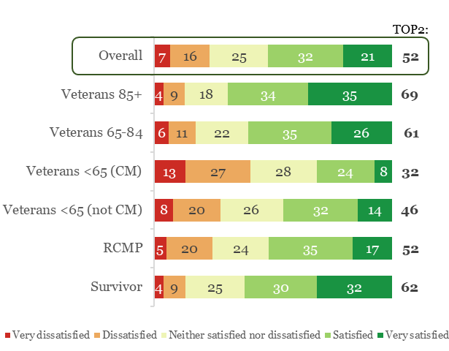
Question: How satisfied are you with your … “leisure activities?”
Sample size: 3281
Framework: All respondents, excluding “don’t know” and refused
Most are satisfied with their finances
- Six in ten (TOP2: 61%) respondents are satisfied with their financial situation, this has decreased from 2020 (TOP2: 72%).
- Respondents under 60 (TOP2: 52%), are generally less satisfied than respondents 60 and older (TOP2: 68%).
- Case-managed Veterans under 65 (TOP2: 57%) are less satisfied than other strata.
- Indigenous respondents (TOP2: 39%) and visible minorities (TOP2: 47%) are less satisfied than non-Indigenous (TOP2: 62%) and non-minorities (TOP2: 64%).
- English speakers (TOP2: 59%) are less satisfied than French speakers (TOP2: 68%).
Figure 107: Satisfaction with Their “Financial Situation” (%)
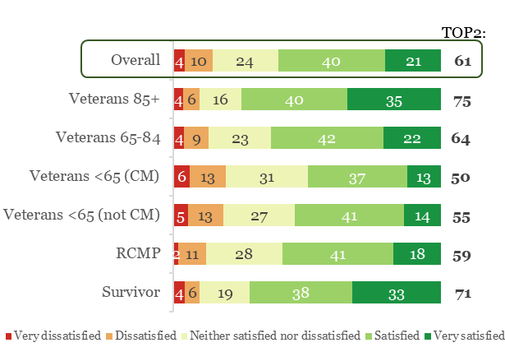
Question: How satisfied are you with your … “financial situation?”
Sample size: 3341
Framework: All respondents, excluding “don’t know” and refused
Majority satisfied with their family relationships
- Three-quarters (TOP2: 76%) of respondents are satisfied with their relationships with their family members, which is a drop from 2020 (TOP2: 85%)
- Case-managed Veterans under 65 (TOP2: 52%) are the least satisfied of the six strata.
- Respondents under 60 (TOP2: 64%), tend to be less satisfied than respondents 60 and older (TOP2: 86%).
- Male respondents (TOP2: 73%) are less likely to be satisfied than female respondents (TOP2: 82%).
- Indigenous (TOP2: 63%) respondents are less satisfied than non-Indigenous (TOP2: 77%) respondents.
Figure 108: Satisfaction with Their “Relationships with Other Family Members” (%)
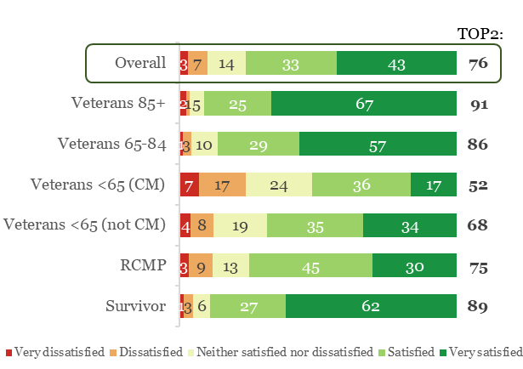
Question: How satisfied are you with your … “relationships with other family members?”
Sample size: 3323
Framework: All respondents, excluding “don’t know” and refused
Most say they are satisfied with their friendships
- Seven in ten (TOP2: 71%) say they are satisfied with their relationships with their friends, which has declined from 2020 (TOP2: 81%).
- Case-managed Veterans under 65 (TOP2: 44%) continue to be the least satisfied of the six strata.
- Respondents aged 80–89 (TOP2: 91%) are the most satisfied age group, while those below 50 (TOP2: 53%) are the least satisfied.
- Male respondents (TOP2: 68%) are less likely to be satisfied than female respondents (TOP2: 78%).
- Indigenous (TOP2: 54%) respondents are less satisfied than non-Indigenous (TOP2: 72%) respondents.
Figure 109: Satisfaction with Their “Relationships with Friends” (%)
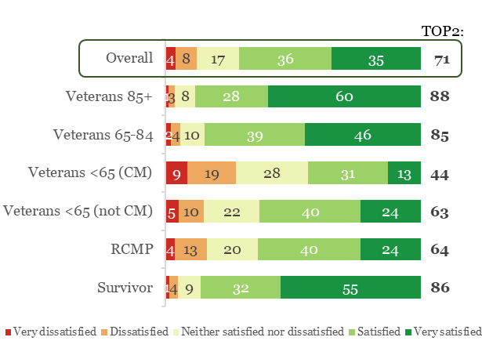
Question: How satisfied are you with your … “relationships with friends?”
Sample size: 3321
Framework: All respondents, excluding “don’t know” and refused
Vast majority are satisfied with housing
- Four in five (TOP2: 81%) respondents say they are satisfied with their housing, which has declined from 2020 (TOP2: 90%).
- Case-managed Veterans under 65 (TOP2: 68%) are the least satisfied stratum.
- Respondents 60 and older (TOP2: 88%) are more satisfied than those below 60 (TOP2: 73%).
- Visible minority (TOP2: 74%) respondents are less satisfied than non-minority (TOP2: 83%) respondents.
Figure 110: Satisfaction with “Housing” (%)
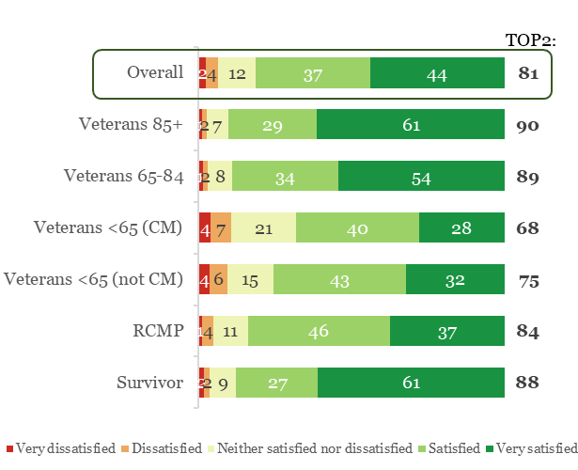
Question: How satisfied are you with your … “housing?”
Sample size: 3360
Framework: All respondents, excluding “don’t know” and refused
Vast majority are satisfied with their neighbourhood
- Four in five (TOP2: 82%) respondents are satisfied with their neighbourhood.
- Case-managed Veterans under 65 (TOP2: 69%) are the least satisfied of the strata.
- Respondents 60 and older (TOP2: 89%) rate their satisfaction more positively than those under 60 (TOP2: 75%).
- Indigenous (TOP2: 71%) respondents tend to be less satisfied than their non-Indigenous (TOP2: 83%) respondents.
Figure 111: Satisfaction with Their “Neighbourhood” (%)
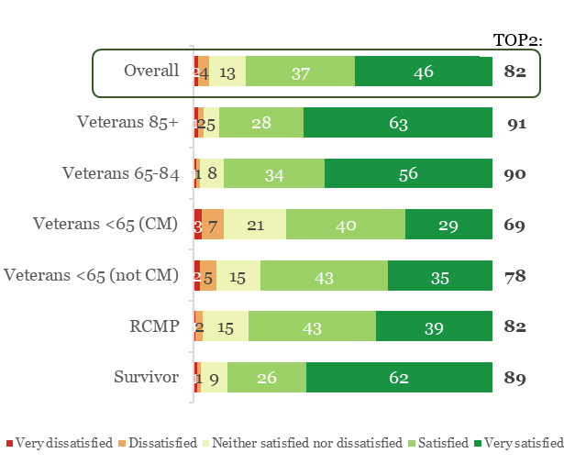
Question: How satisfied are you with your … “neighbourhood?”
Sample size: 3360
Framework: All respondents, excluding “don’t know” and refused
Respondents split when asked to rate their health
- Only one in five of respondents said their health was very good or excellent (TOP2: 21%).
- About half of the respondents rated their health as poor or fair (BTM2: 43%).
- Case-managed Veterans under 65 (BTM2: 58%) are the most likely to rate their health as poor or fair.
- Respondents aged 50-59 (BTM2:50%) tend to rate their health poor or fair.

Figure 112: In General, My Health Is… (%)
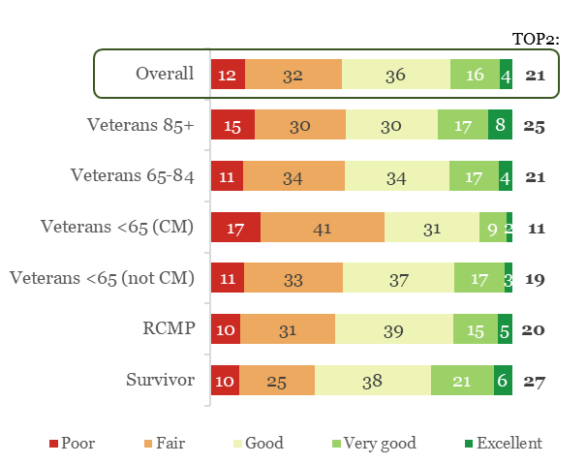
Question: In general, would you say your health is…
Sample size: 3385
Framework: All respondents, excluding “don’t know” and refused

Case-managed Veterans rate their mental health least positively
- Only three in ten (TOP2: 31%) respondents rated their mental health as very good or excellent, which is lower than 2020 (TOP2: 43%).
- Case-managed Veterans under 65 rate their mental health most negatively (BTM2: 71%).
- Respondents 70 and older (TOP2: 48%) rate their mental health more positively than those under 70 (TOP2: 21%).
- Male respondents (TOP2: 28%) are less likely to rate their mental health positively than female respondents (TOP2: 39%).
- Indigenous respondents (TOP2: 14%) rate their mental health less positively than non-Indigenous respondents (TOP2: 33%).
Figure 113: In General, My Mental Health Is… (%)
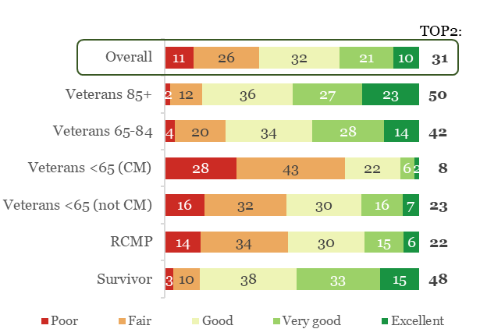
Question: In general, would you say your mental health is…
Sample size: 3389
Framework: All respondents, excluding “don’t know” and refused
Most agree that they have a purpose in life; variations by strata
- Five in eight (TOP2: 64%) respondents agree that they have a purpose in life.
- Case-managed Veterans under 65 (TOP2: 44%) are much less likely to agree compared to other strata, and three in ten (BTM: 29%) actually disagree.
- Indigenous respondents (TOP2: 54%) are less likely to agree than non-Indigenous respondents (TOP2: 65%)
Figure 114: “I Have a Purpose in Life” (%)
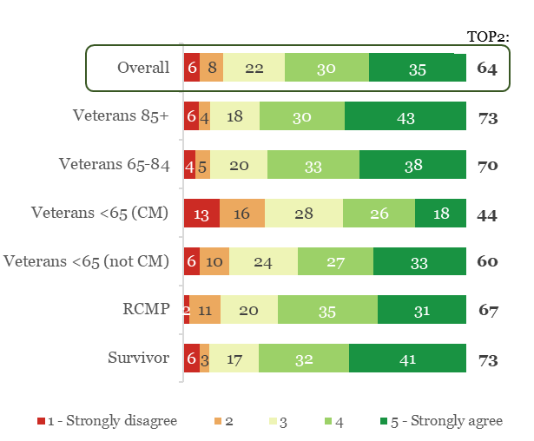
Question: The following questions focus on well-being related to employment or other meaningful activities in your life. Please use our original 5-point rating scale where 1 = strongly disagree and 5 = strongly agree. … “I have a purpose in life.”
Sample size: 3268
Framework: All respondents, excluding “don’t know” and refused

Less than half agree they are physically active
- Only two in five (TOP2: 41%) of respondents would describe themselves as physically active.
- Three in ten (TOP2: 28%) case-managed Veterans under 65 agree.
- Respondents under 40 (TOP2: 56%) tend to be more active than other age groups.
Figure 115: I Am “Physically Active” (%)
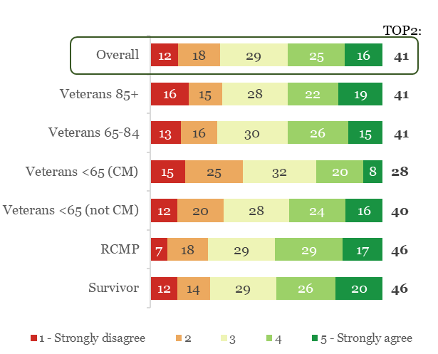
Question: [Explanation of 5-point scale as a measure of agreement with the statement.] … “I would describe myself as physically active.”
Sample size: 3384
Framework: All respondents, excluding “don’t know” and refused

Case-managed Veterans under 65 less likely to socialize
- Seven in ten (TOP2: 69%) respondents agree that they interact with other people at least once a day.
- Once again, case-managed Veterans under 65 are the exception, with only half (TOP2: 52%) agreeing.
Figure 116: “I Interact with Other People at Least Once a Day” (%)
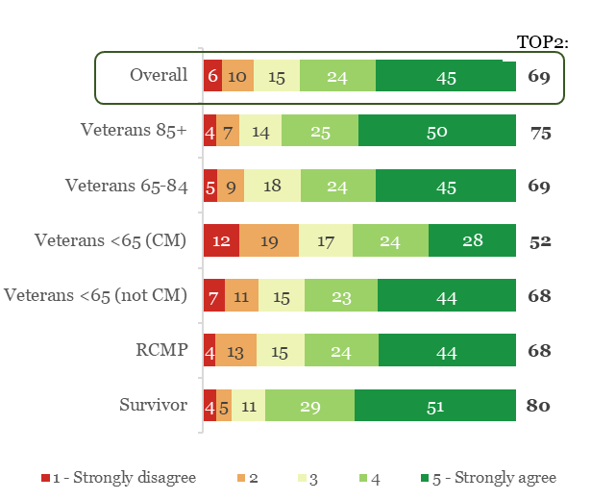
Question: [Explanation of 5-point scale as a measure of agreement with the statement.] … “I interact with other people at least once a day.”
Sample size: 3382
Framework: All respondents, excluding “don’t know” and refused
Less than half say their faith gives a feeling of security
- Less than half (TOP2: 47%) of respondents agree that their faith gives them a feeling of security. This is a drop from 2020 (TOP2: 60%).
- Veterans 85+ (TOP2: 66%) and Survivors (TOP2: 76%) are the most likely to agree.
- Veterans under 65 whether case-managed (TOP2: 27%) or not case-managed (TOP2: 29%) are the least likely to agree.
- Male respondents (TOP2: 39%) are less likely to agree than female respondents (TOP2: 64%).
- Indigenous respondents (TOP2: 34%) are less likely to agree than non-indigenous respondents (TOP2: 47%).
- English speakers (TOP2: 49%) are more likely to agree than the French speakers (TOP2: 40%).
Figure 117: “My Faith Gives Me a Feeling of Security” (%)
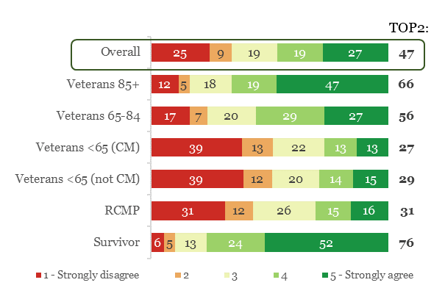
Question: [Explanation of 5-point scale as a measure of agreement with the statement.] … “My faith gives me a feeling of security.”
Sample size: 2956
Framework: All respondents, excluding “don’t know” and refused

Many do not belong to a community group
- Only two in five (38%) say they belong to a community group, which is lower than that in 2020 (47%).
- The number who disagree is highest for case-managed Veterans under 65 (BTM2: 64%).
- Respondents under 70 (TOP2: 29%), tend to be less likely to agree than respondents 70 and older (TOP2: 52%).
- English speakers (TOP2: 42%) are more likely to agree than French speakers (TOP2: 28%).
Figure 118: “I Belong to At Least One Community Group” (%)
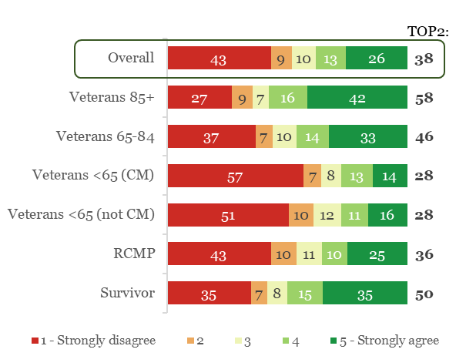
Question: [Explanation of 5-point scale as a measure of agreement with the statement.] … “I belong to at least one community group.”
Sample size: 3270
Framework: All respondents, excluding “don’t know” and refused

Most are happy with their living arrangement
- Four in five (TOP2: 83%) respondents agree that they are happy living with the people they live with or living on their own.
- Indigenous respondents (TOP2: 68%) are less likely to agree than non-Indigenous respondents (TOP2: 84%).
Figure 119: “I Am Happy Living with the Person or People that I Live with or Happy Living on My Own” (%)
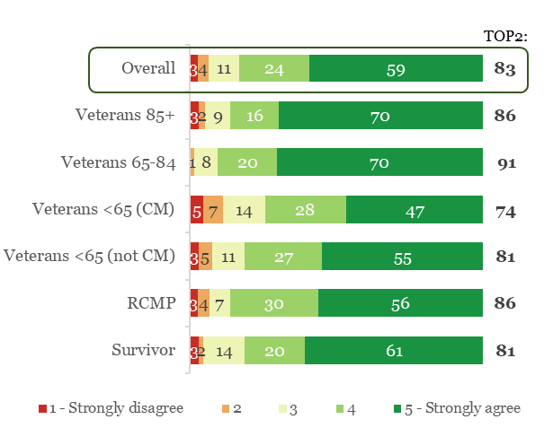
Question: [Explanation of 5-point scale as a measure of agreement with the statement.] … “I am happy living with the person or people that I live with or happy living on my own.”
Sample size: 3345
Framework: All respondents, excluding “don’t know” and refused
Many case-managed Veterans under 65 often feel down, depressed, or hopeless
- A quarter (TOP2: 25%) of respondents agree that they often feel down, depressed, or hopeless.
- Case-managed Veterans under 65 (TOP2: 37%) are the most likely to agree that they often feel down, depressed, or hopeless.
- Those aged 40-49 (TOP2: 36%) are more likely to agree than other age groups.
Figure 120: “I Often Feel Down, Depressed, or Hopeless” (%)
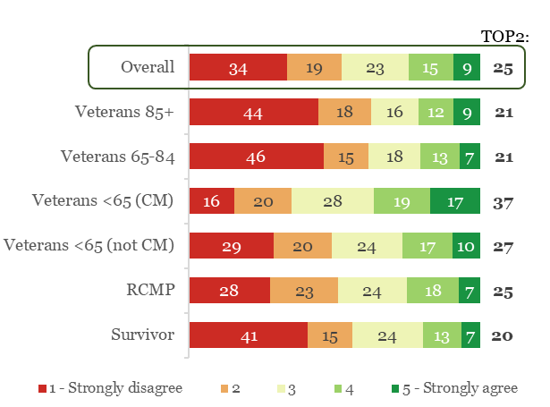
Question: [Explanation of 5-point scale as a measure of agreement with the statement.] … “I often feel down, depressed, or hopeless.”
Sample size: 3314
Framework: All respondents, excluding “don’t know” and refused

Few need help preparing meals
- A quarter (TOP2: 25%) of respondents agree that they need help preparing meals.
- A majority (BTM2: 60%) disagree with the statement.
- Older respondents, especially those 80 and older (TOP2: 39%) are more likely to need help.
- Visible minorities (TOP2: 32%) are more likely to need help than non-minorities (TOP2: 23%).
Figure 121: “I Need Help Preparing Meals” (%)
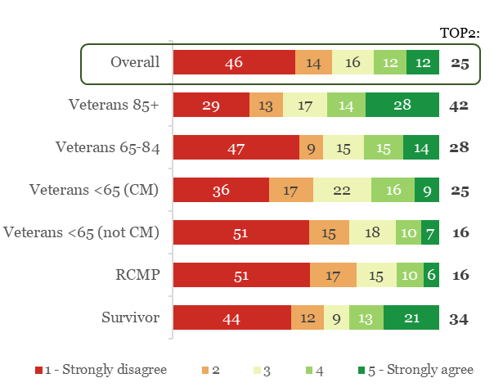
Question: [Explanation of 5-point scale as a measure of agreement with the statement.] … “I need help preparing meals.
Sample size: 3319
Framework: All respondents, excluding “don’t know” and refused
Many have savings set aside for unexpected expenses
- Three in five (TOP2: 59%) respondents agree that they have savings set aside for an unplanned expense.
- Case-managed Veterans under 65 (TOP2: 51%) are the least prepared for unplanned expenses of the six strata.
- Visible minorities (TOP2: 49%) are less likely to agree than non-minorities (TOP2: 61%).
- Indigenous respondents (TOP2: 42%) are less likely to agree than non-Indigenous respondents (TOP2: 61%).
Figure 122: “I Have Savings Set Aside for an Unplanned Expense” (%)
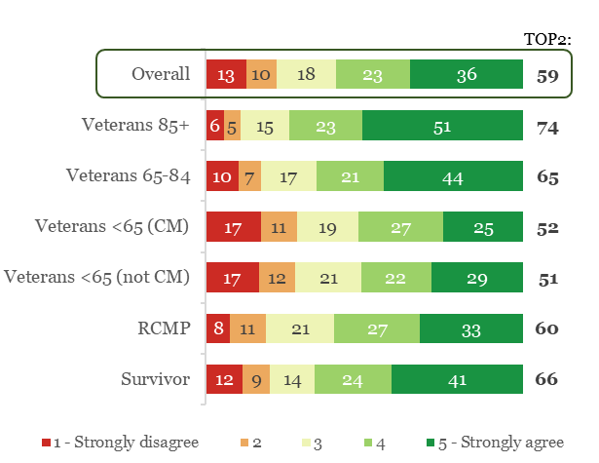
Question: [Explanation of 5-point scale as a measure of agreement with the statement.] … “I have savings set aside for an unplanned expense.”
Sample size: 3281
Framework: All respondents, excluding “don’t know” and refused

Majority would not move to a better home even if they could
- Three in five (BTM2: 58%) respondents do not agree that they would move to a better home, even if they could.
- Case-managed Veterans under 65 are the most likely to agree that they would move if they could (TOP2:43%)
- Respondents under 40 (TOP2: 50%), tend to be more likely to agree that they would move than other age groups.
- Indigenous (TOP2: 42%) respondents are more likely to agree than non-Indigenous respondents (TOP2: 30%)
- Visible minorities (TOP2: 44%) are more likely to agree than non-minorities (TOP2: 29%).
Figure 123: “I Would Move to a Better Home If I Could” (%)
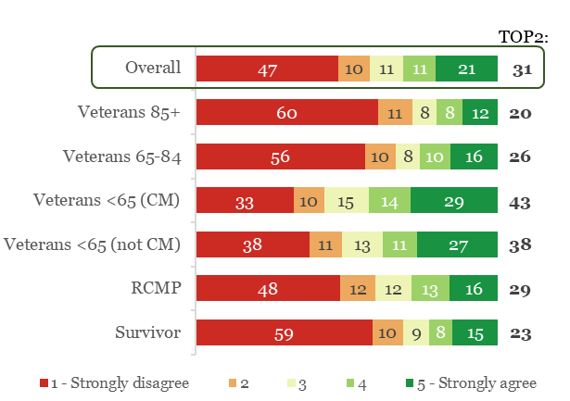
Question: [Explanation of 5-point scale as a measure of agreement with the statement.] … “I would move to a better home if I could.”
Sample size: 3280
Framework: All respondents, excluding “don’t know” and refused

Vast majority feel they live in a safe neighbourhood
- Nine in ten (TOP2: 88%) agree that they live in a safe neighbourhood.
- Indigenous respondents (TOP2: 79%) are less likely to agree than non-Indigenous respondents (TOP2: 89%).
Figure 124: “I Live in a Safe Neighbourhood” (%)
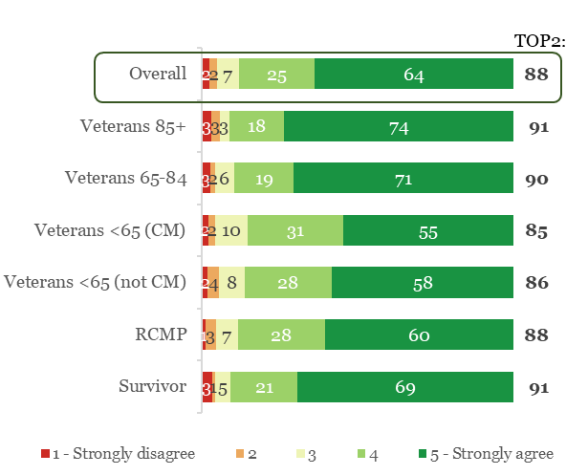
Question: [Explanation of 5-point scale as a measure of agreement with the statement.] … “I live in a safe neigbourhood.”
Sample size: 3371
Framework: All respondents, excluding “don’t know” and refused

Great variance in post-service transition
- Three in five (TOP2: 59%) respondents agree that they have transitioned well into life after service, which is lower than that in 2020 (TOP2: 68%).
- Agreement is lowest among case-managed Veterans under 65 (BTM2: 46%).
- Younger respondents tend to be less likely to agree than older respondents.
- Visible minorities (TOP2: 49%) are less likely to agree than non-minorities (TOP2: 61%).
- Indigenous respondents (TOP2: 41%) are less likely to agree than non-Indigenous respondents (TOP2: 61%).
Figure 125: “I Have Transitioned Well from Military Service to Life After Service” (%)
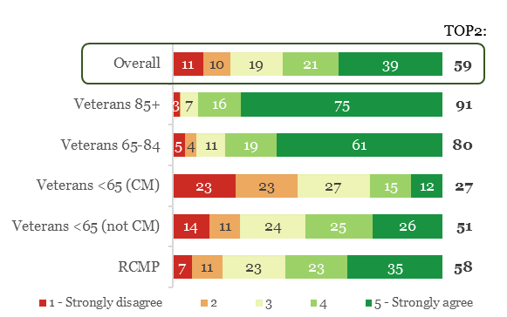
Question: [Explanation of 5-point scale as a measure of agreement with the statement.] … “I have transitioned well from military service to life after service.”
Sample size: 2303
Framework: Respondents who are Veterans, excluding “don’t know” and refused
Vast majority have a family doctor
- Four in five (81%) respondents say they have a family doctor.
- Veterans under 65 are the least likely to say they have a family doctor (70%).
Figure 126: Do You Have a Family Doctor? (%)
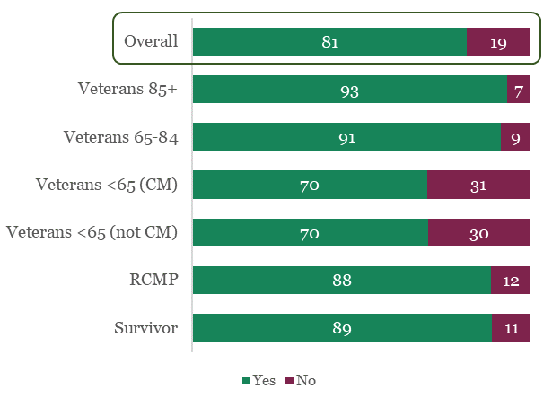
Question: Regarding your health care… Do you have a family doctor?
Sample size: 3384
Framework: All respondents, excluding “don’t know” and refused

Most do not have a nurse practitioner
- Only one in six (17%) respondents have a nurse practitioner.
- RCMP (8%) are the least likely stratum to have a nurse practitioner.
Figure 127: Do You Have a Nurse Practitioner? (%)
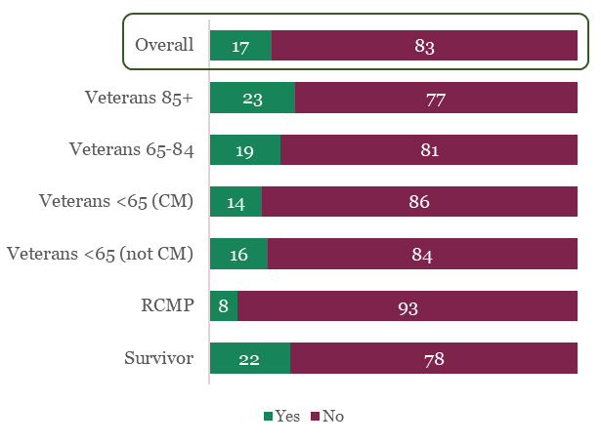
Question: Do you have a nurse practitioner?
Sample size: 3308
Framework: All respondents, excluding “don’t know” and refused

Appendices

Sample size and sampling procedures
Forum Research conducted a quantitative study of 3,427 VAC clients 18 years of age and older. The sample used a file supplied by VAC which included six strata of interest: Veterans 85+, Veterans 65–84, Veterans under 65 (split between case-managed and not case-managed), RCMP, and Survivors. All of whom were either in receipt of benefits or who had applied for a benefit in the previous 12 months. This included Veterans who applied for benefits in the previous 12 months but who had been declined or who were still awaiting a decision.
Strata | Completed
Veterans 85+ | 437
Veterans 65–84 | 608
Veterans < 65 (CM) | 617
Veterans < 65 (not CM) | 870
RCMP | 355
Survivors | 540
Total | 3,427

Survey collection method was CATI (computer-assisted telephone interviewing) and CAWI (computer-assisted web interviewing) using sample file provided by VAC. A total of 37 pretest interviews were conducted starting on May 24th, 2022, until May 29th, 2022 (21 in English and 16 in French). The total average duration of the questionnaire was 27 minutes, with CAWI averaging 20 minutes and CATI averaging 33 minutes.
To ensure valid data throughout the research process, all interviewers were specifically trained on the questionnaire and were instructed to read the questions exactly as they appeared. A minimum of 10% of all interviews were monitored for quality assurance purposes.

Dates of research fieldwork
Fieldwork, inclusive of pretest interviews, was conducted from May 24th, 2022, until August 17th,2022.

Discussion of the potential for non-response bias
To examine and identify any potential non-response bias, we examined the results of our study compared with the population parameters for sex and age.
As outlined below, the set of respondents (both weighted and unweighted) correspond very closely to the population file on the two variables examined, i.e., sex and age). Therefore, it is safe to assume that non-response bias does not significantly impact the resulting dataset.
Characteristics | Unweighted sample size (n) | Unweighted sample proportion (%) |  | Weighted sample proportion (%) |  | Sample file proportion (%)
Sex
Male | 2501 | 73.0 | 69.0 |  | 68.7
Female | 903 | 26.3 | 30.0 |  | 30.3
Other (Unknown) | 23 | 0.7 | 1.0 |  | 1.1

Characteristics | Unweighted sample size (n) | Unweighted sample proportion (%) | Weighted sample proportion (%) | Sample file proportion (%)
Age
18-24 | 12 | 0.4 | 0.3 | 0.3
25-29 | 28 | 0.8 | 1.4 | 1.0
30-34 | 87 | 2.5 | 3.8 | 2.9
35-39 | 140 | 4.1 | 5.8 | 4.4
40-44 | 223 | 6.5 | 6.4 | 5.0
45-49 | 228 | 6.7 | 6.7 | 5.0
50-54 | 299 | 8.7 | 8.9 | 6.4
55-59 | 411 | 12.0 | 11.2 | 7.9
60-64 | 372 | 10.9 | 9.3 | 6.5
65-69 | 282 | 8.2 | 6.3 | 6.4
70-74 | 244 | 7.1 | 6.2 | 6.8
75-79 | 228 | 6.7 | 6.7 | 7.1
80-84 | 244 | 7.1 | 7.3 | 7.8
85-89 | 381 | 11.1 | 7.1 | 13.0
90-94 | 150 | 4.4 | 6.8 | 9.9
95-99 | 98 | 2.9 | 5.8 | 9.1
100+ | 0 | 0.0 | 0.0 | 0.6

Weighting procedures and margin of error
For overall results including all six strata (e.g., “70% of all respondents agree” or “50% of all male respondents agree”), the data are weighted by age, sex, and strata based on population parameters provided by VAC. The population parameters are as follows:
Age | Proportion (%)
18-19 | 0.0
20-24 | 0.3
25-29 | 1.4
30-34 | 3.8
35-39 | 5.8
40-44 | 6.4
45-49 | 6.7
50-54 | 8.9
55-59 | 11.2
60-64 | 9.3
65-69 | 6.3
70-74 | 6.2
75-79 | 6.7
80-84 | 7.3
85-89 | 7.1
90-94 | 6.8
95-99 | 5.4
100+ | 0.4

Sex | Proportion (%)
Male | 69.0
Female | 30.0
Other (Unknown) | 1.0

Strata | Proportion (%)
Veteran 85+ | 7.0
Veteran 65-84 | 16.7
Veteran <65 CM | 11.1
Veteran <65 Not CM | 33.4
RCMP | 11.4
Survivor | 20.4

For results broken out by strata (e.g., “20% of Veterans 85+ agree”), the data are weighted using the age and sex proportions within each stratum. The proportions, drawn from the population file, are as follows:
Age | Veterans 85+ | Veterans  65–84 |  | Veterans <65 (CM) |  | Veterans <65 (not CM) |  |  | RCMP |  | Survivors
18-19 |  |  |  |  | 0.0 |  | 0.0 | 0.0 |  | 0.1
20-24 |  |  |  |  | 0.6 |  | 0.5 | 0.0 |  | 0.4
25-29 |  |  |  |  | 3.2 |  | 2.7 | 0.8 |  | 0.2
30-34 |  |  |  |  | 10.0 |  | 6.7 | 3.3 |  | 0.4
35-39 |  |  |  |  | 14.8 |  | 9.5 | 7.9 |  | 0.4
40-44 |  |  |  |  | 14.5 |  | 10.2 | 10.8 |  | 0.6
45-49 |  |  |  |  | 13.1 |  | 11.3 | 11.7 |  | 0.7
50-54 |  |  |  |  | 16.5 |  | 16.6 | 11.7 |  | 0.9
55-59 |  |  |  |  | 17.5 |  | 22.8 | 11.4 |  | 1.6
60-64 |  |  |  |  | 9.8 |  | 19.7 | 10.3 |  | 2.3
65-69 |  |  | 26.7 |  |  |  |  | 10.6 |  | 3.0
70-74 |  |  | 23.5 |  |  |  |  | 9.9 |  | 5.5
75-79 |  |  | 25.1 |  |  |  |  | 5.6 |  | 9.4
80-84 |  |  | 24.7 |  |  |  |  | 3.4 |  | 13.4
85-89 | 47.0 |  |  |  |  |  |  | 1.7 |  | 17.9
90-94 | 21.6 |  |  |  |  |  |  | 0.5 |  | 25.6
95-99 | 29.4 |  |  |  |  |  |  | 0.0 |  | 16.5
100+ | 2.0 |  |  |  |  |  |  | 0.0 |  | 1.0

Sex | Veterans 85+ | Veterans  65–84 | Veterans <65 (CM) | Veterans <65 (not CM) | RCMP | Survivors
Male | 91.1 | 94.2 | 79.9 | 84.4 | 81.4 | 2.6
Female | 8.3 | 5.1 | 20.1 | 15.4 | 18.6 | 93.8
Other (Unknown) | 0.6 | 0.7 | 0.1 | 0.2 | 0.0 | 3.6

The margin of error (at the 95% confidence interval) for the full set of respondents is +/− 1.7%. For the six aforementioned strata, the margins of error are +/− 4.6% for Veterans 85+, +/− 3.9% for Veterans 65–84, +/− 3.9% for case-managed Veterans under 65, +/− 2.4% for Veterans under 65 who are not case-managed, +/− 4.1% for RCMP, +/− 5.2% for Survivors.

Response rate (unweighted) – CATI
The average response rate for CATI respondents was 26%.

Disposition | Veteran 85+ | Veteran 65-84 | Veteran <65 CM | Veteran <65 Not CM | RCMP | Survivor | TOTAL
(A) Total Numbers Attempted | 6362 | 6019 | 3977 | 5518 | 3165 | 7345 | 32386
(B) Invalid | 735 | 417 | 425 | 654 | 234 | 1193 | 3658
B1) Not in service | 608 | 335 | 289 | 454 | 159 | 935 | 2780
B2) Business/ Non residential | 121 | 75 | 122 | 188 | 70 | 248 | 824
B5) Duplicate | 6 | 7 | 14 | 12 | 5 | 10 | 54
(C) Unresolved | 791 | 1117 | 505 | 1093 | 657 | 933 | 5096
C1) No answer | 765 | 1091 | 483 | 1071 | 648 | 909 | 4967
C2) Busy | 15 | 24 | 21 | 20 | 8 | 18 | 106
C3) Line out of order | 11 | 2 | 1 | 2 | 1 | 6 | 23
(D) In scope - non-responding | 3073 | 3643 | 1970 | 2618 | 1797 | 3042 | 16143
D1) Incapable, illness, language problem | 467 | 80 | 5 | 10 | 12 | 453 | 1027
D2) Selected respondent not available | 1446 | 2366 | 1234 | 1762 | 1186 | 1212 | 9206
D3) Household refusal | 35 | 37 | 105 | 51 | 19 | 81 | 328
D4) Respondent refusal | 575 | 903 | 283 | 416 | 389 | 384 | 2950
D5) Refusal on cell phone | 11 | 6 | 1 | 9 | 1 | 25 | 53
D6) Qualified respondent break-off | 539 | 251 | 342 | 370 | 190 | 887 | 2579
(E) In scope - responding unit | 1763 | 842 | 1077 | 1153 | 477 | 2177 | 7489
E1) Language disqualify | 577 | 76 | 11 | 21 | 23 | 505 | 1213
E2) Ineligible | 895 | 411 | 710 | 664 | 321 | 1268 | 4269
E3) Completed interviews | 291 | 355 | 356 | 468 | 133 | 404 | 2007
Estimated response rate (E/(C+D+E)) | 31% | 15% | 30% | 24% | 16% | 35% | 26%

Response rate (unweighted) – CAWI
The average response rate for CATI respondents was 56%.

Disposition | Veteran 85+ | Veteran 65-84 | Veteran <65 CM | Veteran <65 Not CM | RCMP | Survivor | TOTAL
(A) Total Numbers Attempted | 238 | 383 | 575 | 720 | 369 | 251 | 2536
(C) Unresolved | 74 | 108 | 276 | 286 | 133 | 91 | 968
C1) No answer | 74 | 108 | 276 | 286 | 133 | 91 | 968
(D) In scope - non-responding | 18 | 21 | 34 | 32 | 14 | 24 | 143
D6) Qualified respondent break-off | 18 | 21 | 34 | 32 | 14 | 24 | 143
(E) In scope - responding unit | 146 | 254 | 265 | 402 | 222 | 136 | 1420
E3) Completed interviews | 146 | 253 | 261 | 402 | 222 | 136 | 1420
Estimated response rate (E/(C+D+E)) | 61% | 66% | 46% | 56% | 60% | 54% | 56%

Research instrument

recruitment screener

NOTE: Conversations will begin in the preferred spoken language as indicated by the sample file [SPOKEN].
INTRO1. Hello, bonjour my name is ___________, and I am calling from Forum Research on behalf of Veterans Affairs Canada.
S1. Can I please speak with [NAME]?
1 = Available -> proceed
2 = Unavailable
IF UNAVAILBLE:
-Confirm correct contact info
-Attempt to schedule a callback
-Ask if they would like to continue the survey online and retrieve email address “If now is not a good time I can take your email address and send you an online version of the survey to complete when you have time.”
*Email:
Would you prefer to continue in English or en Français?
1 – English
2 – French
S2. How are you today?
(Pause to wait for answer)
INTRO2. On behalf of Veterans Affairs Canada, we are calling clients to participate the 2022 Veterans Affairs Canada National Client Survey. Veterans Affairs Canada is always trying to improve its service offerings and your feedback would be extremely helpful. If you agree to participate, your feedback would be completely voluntary, totally anonymous, confidential and your participation will have no affect on the benefits or services you receive.
To verify the legitimacy of this survey or for more information on the survey objectives and use of results, please call Veterans Affairs Canada's National Contact Centre Network toll-free line at 1-866-522-2122, or the project authority Jacqueline Smith, A/Senior Operations Manager, Business Intelligence Unit
613-217-4231
jacqueline.smith@veterans.gc.ca
The survey should take about 25 minutes and can be conducted in whichever official language you prefer.
Please note this call may be recorded for quality and training purposes.
S3. Have I reached you today on a landline or Cellphone? [interviewer note- this is for screening people who are on a cellphone and driving]
1 = LL
2 = Cell

S4. [IF S3=2] Are you able to safely speak with me right now?
1=Yes
2=No -> Schedule a call back or ask if they would like to continue the survey online and retrieve email address “If now is not a good time I can take your email address and send you an online version of the survey to complete when you have time.”
*Email:

S4. May I begin the survey now?
1 – Yes [Continue]
2 – No, not at this time [Attempt to Schedule callback]
3 – No, refusal [Code as hard or soft refusal]

S5. Great! You may complete the survey over the phone with me or online. How would you like to continue the survey?
1 – Telephone [Continue]
2 – Online
What is your email address?* Email:

*If pressed on why e-mails are needed, “We need your e-mail address so we can send you the survey link.” [Interviewer note: Repeat back e-mail address to confirm correct details]

[If respondent asks how we obtained their number: “VAC provided Forum Research with a list of clients for the purposes of this survey only. Your participation is voluntary and will not affect your benefits or services in any way.”]
[If respondent asks if results will be published: “Aggregate Results will be posted to the Library and Archives Canada website within six months.”]

Opening Questions
Script: Throughout the remainder of the interview, I will refer to Veterans Affairs Canada as ‘VAC’. Please note this call may be recorded for quality and training purposes.
OP_Q01 | Did you have any contact with VAC during the past 12 months? YES or No.  Prompts:  1: Yes  2: No  3: DNK  4: DNA |  |  |  |  |  |  |  |  |  |  |  | Yes/No
OP_Q02 | [IF OP_Q01=1] In the previous 12 months, which of the following ways have you used to contact VAC?  1: In person at VAC service location  2: Over the phone  3: By letter  4: By email  5: Through My VAC Account  6. In person at your home  7. Other, please specify [Text box] |  |  |  |  |  |  |  |  |  |  |  | Yes/No for each channel
OP_Q04 | In general, what is your preferred method of contact with VAC?  1: In person at VAC service location  2: Over the phone  3: By letter  4: By email  5: Through My VAC Account  6: In person at your home  7: Other please specify [Text box]  8: DNK  9: DNA |  |  |  |  |  |  |  |  |  |  |  | Open response, coded from list
OP_Q05 | Did you apply for a service or benefit within the past 12 months? Yes or no.  Prompts:  1: Yes  2: No  3: DNK  4: DNA |  |  |  |  |  |  |  |  |  |  |  | Yes/No
OP_Q06 | [IF OP_Q05 = 1] What part of the application process could be improved? [MULTISELECT]  <select response from list>  1: Simplification of Forms  2: Access to information needed to apply  3: Frequency of status updates  4: Clearer explanations regarding decisions  5: Other  6: Nothing could be improved  7: DNK (Do not read – DNR)  8: DNA (DNR)
OP_Q07 | Did you receive a letter from VAC during the past 12 months? Yes or no.  1: Yes  2: No  3: DNK  4: DNA |  |  |  |  |  |  |  |  |  |  |  | Yes/No
Time 0:50 for opening questions
Methods of Contact Used & Satisfaction with Communication
Script: In each question below, I will pose a statement. Using a rating scale where 1 = strongly disagree and 5 = strongly agree, please indicate the extent you agree or disagree with the statement by giving us a number between 1 and 5 (Interviewer note: please feel free to remind respondent of the scale at any time, 1=strongly disagree and 5=strongly agree)

<Interviewer note: acknowledge the respondent understands the scale/provide more clarity if needed>

If you do not know what the question is asking, you can say “don’t know”
Let’s get started.
 |  |  |  | SD  1 |  | 2 |  | 3 |  |  | 4 |  |  | SA  5 |  | DNK |  | DNA
CO_Q01 |  | Communication with VAC has been easy.
CO_Q02 |  | Communication with VAC was provided in a timely manner.
CO_Q03 |  | [IF OP_Q05=1] It was easy to submit the required information to VAC needed for my application.
Script: My VAC Account allows you to do business online securely with Veterans Affairs Canada.
CO_Q05 |  | Have you used My VAC Account?  1:Yes  2: No  3: DNK (DNR)  4: DNA (DNR) |  |  |  |  |  |  |  | Yes/No
CO_Q06 |  | [IF CO_Q05 = 1] When you used My VAC Account, was it a good way to find out about…  [Randomize answer option 1 thru 4]  [Scale=yes/no]  1. VAC benefits and services  2. The status of my applications  3. VAC news  4. Communications through secure messaging with VAC |  |  |  |  |  |  |  | Yes/No/DNK (DNR)/DNA (DNR)
CO_Q07 |  | [IF CO_Q05 = 2] Why don’t you use My VAC Account?  Prompt:  1: I’m not registered for My VAC Account  2: Did not know about My VAC Account until now  3: Lack of Interest  4: Lack of need  5: Unclear about the advantages of using My VAC account  6: Lack of access (computer/internet)  7: Complexity of Technology  8: Security/Privacy Concerns  9: Prefer traditional methods (e.g., phone or mail)  10: I lost my password  11: I lost my ID  12: Other [Text box]  13: DNK  14: DNA |  |  |  |  |  |  |  | <open response> (multi-response question)
Time 1:24 Methods of Contact/Communication
Satisfaction with VAC Service Experience
VAC Service Experience
Script: For each question below use the same rating scale as we discussed before where 1 = strongly disagree and 5 = strongly agree, to indicate the extent you agree or disagree with each statement.
 |  |  |  |  | SD  1 |  | 2 |  | 3 |  |  | 4 |  |  | SA  5 |  | DNK |  | DNA
XP_Q12 |  |  | Over the past 12 months, VAC service has improved.
XP_Q02 |  |  | [IF OP_Q05=1] Overall, the application process was easy.
XP_Q01 |  |  | [IF OP_Q05=1] Overall, the information I needed to apply for a service or benefit that I am eligible for was easy to find.
XP_Q03 |  |  | [IF OP_Q07 = 1] The most recent letter I received from VAC was easy to understand.
XP_Q04 |  |  | Overall, VAC staff provided a satisfactory service.
XP_Q05 |  |  | VAC staff were knowledgeable about the programs and services I inquired about.
XP_Q06 |  |  | VAC staff were competent in responding to my inquiry.
XP_Q07 |  |  | Treatment by VAC staff was exceptional.
XP_Q08 |  |  | I did not feel respected by staff at VAC.
XP_Q09 |  |  | VAC staff were not responsive to my needs.
XP_Q10 |  |  | I had to wait too long to speak to someone at a VAC location.
XP_Q11 |  |  | VAC staff communicated with me in my official language of choice.
XP_Q13 |  |  | I obtained a service or benefit in a timely manner.
XP_Q15 |  |  | I understand the services and benefits offered by Veterans Affairs Canada.
Script: Now we’d like to ask how satisfied you were with the quality of service you received over the past 12 months. You may say, very dissatisfied, dissatisfied, neither satisfied nor dissatisfied, satisfied, or very satisfied.
Interviewer note: quality of service delivery means, overall quality of any services received in the last 12 months.
 |  |  |  |  | VD |  | D |  | N |  |  | S |  |  | VS |  | DNK |  | DNA
XP_Q14PIP |  |  | How satisfied are you with the quality of service delivery?
XP_Q16 |  |  | How satisfied are you with the quality of VAC’s programs and services offered?
Time 2:40 – includes explaining the scale

Satisfaction with Services and Programs
Case Management
Script: A case manager helps Veterans and former RCMP members set goals and find the services they need to overcome a challenge in their life.
Context: These items will be linked to clients’ data file and only clients who have had a case plan for 90 days or more will respond to these items.

IF [CM] = ‘Y’ ask question SP_Q02 thru SP_Q16

From: sample:
CM | Case Managed | Y or Blank

SP_Q02 | Do you currently have a case manager who works with you to obtain services?  1. Yes  2: No  3: DNK (DNR)  4: DNA (DNR)
[IF SP_Q02 = 1] Ask questions SP_Q03 thru SP_Q16
Script: For the next few statements, we’re going to once again ask you to use the scale where 1=strongly disagree and 5=strongly agree. How much do you agree or disagree with the following?
 |  | SD  1 | 2 | 3 | 4 | SA  5 | DNK | DNA
SP_Q03 | I was assigned a case manager in a reasonable amount of time.
SP_Q04 | I am not happy with the working relationship I have with my current case manager.
SP_Q05 | The goals in my case plan do not reflect my needs.
SP_Q06 | I was involved in developing my goals for my case plan.
SP_Q07 | I had the opportunity to involve family and other supporters in the development of my case plan.
SP_Q08 | I had regular contact with my case manager to discuss if I was reaching my goals.
SP_Q09 | I have been pleased with my progress towards achieving my goals.
SP_Q10 | In working with my case manager, I became better informed on how to access VAC’s programs and services that I needed.
SP_Q11 | My case manager informed me of services and supports in my community that could help me.
SP_Q12 | My case manager responded to my calls in a reasonable amount of time.
SP_Q13 | My case plan goals were relevant.
SP_Q14 | Case Management services were beneficial to me.
SP_Q16 | As a result of Case Management Services, my life has improved.
SP_Q17 | Overall, I have been satisfied with Case Management Services.
Time 1:52 Case Management

Veterans Independence Program (VIP)
Script: The Veterans Independence Program or VIP offers funding for housekeeping, grounds maintenance, and other home care support services that assist eligible recipients to remain independent at home. This set of questions asks about this program.

Context: Only clients who have been VIP recipients for 90 days or more will answer the questions below.

IF [VIP STATUS] = ‘In Receipt of Benefits’ ask questions VI_Q02 thru VI_Q07

From sample:

VIP Status | VIP Account Status | In Receipt of Benefits, Expired, Terminated

 |  | SD  1 | 2 | 3 | 4 | SA  5 | DNK | DNA
VI_Q02 | I rely on VIP services to help me remain in my home and community.
VI_Q03 | I have been able to find service providers to help me with the VIP services I need.
VI_Q04 | The VIP program meets my needs.
VI_Q05 | The VIP program has been a benefit to me.
VI_Q07 | Overall, I have been satisfied with the Veterans Independence Program.
Time 0:47 VIP

Treatment Benefits Program
Script: Health care benefits and services for eligible recipients are paid for by VAC’s Treatment Benefits Program.

<<Interviewer Notes: If you qualify for the Treatment Benefits program, you will receive a VAC healthcare card.
This healthcare card provides coverage for such things as home health or hospital services, nursing services, appointments with specialists (such as physiotherapists, audiologists, and mental health providers), medical equipment, prosthetics, and prescriptions.
The extent of your coverage will depend on a number of factors, including how you qualified, your health needs and your individual circumstances.>>
Context: Only clients who are eligible for treatment benefits will respond to the questions below.

IF [TRTMNT] = ‘Y’ ask questions TR_Q02 thru TR_Q06

From sample:
TRTMNT | Use of Treatment Benefits over past 12 mths | Y or NA

Script: Back to our 5-point response scale
 |  |  | SD  1 | 2 |  | 3 |  |  | 4 |  |  | SA  5 |  | DNK |  | DNA
TR_Q02 | The time it took to get reimbursed for treatment benefits and services was reasonable.
TR_Q03 | The Treatment Benefits Program meets my needs.
TR_Q04 | Were you able to access the treatment benefits you needed?  1. Yes  2: No  3: DNK (DNR)  4: DNA (DNR)
TR_Q05 | [IF TR_Q04 = 2] Why haven’t you accessed the benefits you needed?  Prompts:  - Wait time to access treatment benefits is too long  - No health care providers are located near me  - Had to pay out of pocket  - Won’t accept my ID card  - Poor service from provider(s)  - Benefit and/or service was not approved by VAC  - Other [Text box] |  |  |  |  |  |  | <more than one response>
Script: Back to our 5-point response scale
 |  |  | SD  1 | 2 |  | 3 |  |  | 4 |  |  | SA  5 |  | DNK |  | DNA
TR_Q06 | Overall, I have been satisfied with the Treatment Benefits program
Time 1:29 Treatment Benefits Program
Disability Benefits Program
Script: The Disability Benefits program compensates for economic and non-economic effects of service-related disability, critical injuries, and death.

<<Interviewer Notes:
A disability benefit is a tax-free, financial payment to support your well-being. The amount you receive depends on the degree to which your condition is related to your service (entitlement) and the severity of your condition, including its impact on your quality of life (assessment).>>
Context: The following items will be posed to clients who are receiving disability benefits.

IF [DP Status] = ‘In-Pay’ or ‘Entitlement Only’ then ask questions DB_Q02 thru DB_Q04

From sample:
DP Status | Disability Program Account Status | In-Pay, Suspended,  Terminated,  Entitlement Only

Script: Back to our 5-point response scale where 1=strongly disagree and 5=strongly agree

 |  |  |  |  | SD  1 |  | 2 |  |  | 3 | 4 |  | SA  5 |  | DNK |  | DNA
DB_Q02PIP |  | The disability benefits I receive from VAC recognize my service-related disability.
DB_Q03PIP |  | The disability benefits I receive from VAC compensate me for the effects of my service related disability.
DB_Q04 |  | Overall, I have been satisfied with the Disability Benefits program.
Time 0:34 Disability Benefits Program

Rehabilitation Services and Vocational Assistance
Script: The VAC Rehabilitation Services and Vocational Assistance program provides services such as medical and psycho-social rehabilitation to aid in Veteran’s re-establishment in life after service.

<<Interviewer Note: Rehabilitation services can improve your health and help you adjust to life at home, in your community or at work. Depending on your circumstances and needs, it may include treatment and therapies to overcome or cope with a service-related illness or injury.>>

Context: The following items will be posed to clients receiving rehabilitation services for 90 days or longer.

IF [Rehab] = ‘Y’ OR
IF [Voc Rehab] = ‘Active’ OR ‘In Pay’
Ask questions RE_Q02 thru RE_Q12

From Sample:
Rehab | Rehabilitation Indicator | Y or NA
Voc Rehab | Vocational Rehabilitation | Referred  Active  In Active  In Progress

RE_Q02 | What stream(s) of VAC rehabilitation program have you participated in?  Prompts:  - Medical Rehabilitation  - Psychosocial Rehabilitation  - Vocational Rehabilitation | <open response, may have more than one response>  DK or NA skip to next section
Script: Back to our 5-point response scale where 1=strongly disagree and 5=strongly agree:
 |  | SD  1 | 2 | 3 | 4 | SA  5 | DNK | DNA
RE_Q03 | My participation in VAC’s Rehabilitation Program has helped me improve my quality of life.
RE_Q04 | My participation in the Rehabilitation program has …  helped me enter the workforce or return to my main activity.
RE_Q05 | My participation in rehabilitation has been beneficial to my family or other people who support me.
RE_Q06 | My participation in rehabilitation was beneficial to me.
RE_Q07 | The level of participation in the Rehabilitation program that was expected of me was reasonable.
RE_Q08 | I tried hard to follow my rehabilitation plan.
Script: Barriers refer to the presence of a temporary or permanent physical or mental health problem that limits or prevents a client’s performance of roles in the workplace, home, or community.
 |  | SD  1 | 2 | 3 | 4 | SA  5 | DNK | DNA
RE_Q09 | Since participating in VAC’s Rehabilitation Program, my barriers have decreased. [Interviewer note: if respondent needs a reminding of the scale “Please use a number from 1 through 5, where 1 is strongly disagree and 5 is strongly agree]
RE_Q10 | [IF RE_Q09 =1 or 2] Where has one of your barriers worsened?  1: At home  2: At work  3: In the community  4: My barrier(s) have not worsened  5: Other [Text box]  6: DNK (DNR)  7: DNA (DNR) | <selected response, select more than one response>
RE_Q11 | [IF RE_Q09 =4 or 5] Where is the improvement in one of your barriers noticeable?  1: At home  2: At work  3: In the community  4: There has been no improvement  5: Other [Text box]  6: DNK (DNR)  7: DNA (DNR) | <selected response, select more than one response>
 |  | SD  1 | 2 | 3 | 4 | SA  5 | DNK | DNA
RE_Q12 | Overall, I have been satisfied with VAC’s Rehabilitation Services and Vocational Assistance Program.
Time 2:26 Rehabilitation

Pension for Life
Script: On April 1, 2019, the Government of Canada launched Pension for Life. Pension for Life is a combination of benefits that provide recognition, income support and stability to members and Veterans who experience an illness or injury related to service.
PE_Q01 | Did you receive information from VAC about your personal benefits as a result of Pension for Life?  1: Yes  2: No  3: DNK  4: DNA
PE_Q02 | Have your benefits changed as a result of Pension for Life?  1: Yes  2: No  3: DNK (DNR)  4: DNA (DNR)
[IF PE_Q02 = 1]
Back to our 5-point response scale where 1=strongly disagree and 5=strongly agree
 |  | SD  1 | 2 | 3 | 4 | SA  5 | D  N  K | D  N  A
PE_Q03 | I have understood the changes to my personal benefits as a result of Pension for Life.
Time 1:00 Pension for Life

Office of the Veterans Ombudsman
Script: The Office of the Veterans Ombudsman is an independent organization that works to ensure that VAC clients receive the services and benefits that they require in a fair, timely, and efficient manner.
VO_Q01 | Prior to today, were you aware of the Office of the Veterans Ombudsman?  1: Yes  2: No  3: DNK (DNR)  4: DNA(DNR)
VO_Q02 | [IF VO_Q01=1]  Where did you first hear about the Office of the Veterans Ombudsman?  Prompts: (Do not read if no prompt needed)  a. Internet  b. Social Media  c. Veteran Service Organization  d. VAC  e. Word of Mouth  f. Newspaper/Magazine  g. Other
VO_Q03 | [IF VO_Q01=1]  How familiar are you with the services of the office of the Veterans Ombudsman?  1: Not at all familiar  2: Not very familiar  3: Somewhat familiar  4: Very familiar  5: DNK (DNR)  6: DNA (DNR)

VAC Commemoration
Script: Moving on to VAC’s commemorative initiatives, which include: ceremonies, learning resources, funding for community projects, cemetery and Veterans’ grave maintenance.
Script: Back to our 5-point response scale where 1=strongly disagree and 5=strongly agree
 |  | SD  1 | 2 | 3 | 4 | SA  5 | DNK | DNA
CI_Q02 | I am satisfied with the way VAC’s commemorative initiatives honour those who served our country and preserve the memory of their achievements and sacrifices.
CI_Q03 | What could VAC do to ensure more Canadians are aware of VAC’s commemorative initiatives?  Prompts:  1: Promotion through social media  2: Promotion through local organizations and community groups  3: Promotion through schools  4: Other [Text box]  5: DNK  6: DNA
CI_Q04 | Overall, I have been satisfied with VAC’s commemorative initiatives.
Time 0:41 VAC Commemoration

VAC’s Funeral and Burial Program
Script: VAC’s Funeral and Burial Program provides financial assistance for funeral, burial and grave marking services for Veterans whose deaths are attributable to their military service and for Veterans who have insufficient funds.
 |  | SD  1 | 2 | 3 | 4 | SA  5 | DNK | DNA
FB_Q02 | I am satisfied that the estates of Veterans have access to financial assistance through VAC’s Funeral and Burial Program.
FB_Q03 | Overall, I have been satisfied with the program that provides funding for funerals and burials to eligible Veterans.
Time 0:39 VAC’s Funeral and Burial Program

Satisfaction with Life (Well-Being)
Context: The well-being framework was developed Thompson et al. (2016) who identified 7 domains of well-being for Veterans. These domains are represented in this section.
Script: This next set of questions surveys your satisfaction with different aspects of your well-being.
Use the response scale: Very dissatisfied, dissatisfied, neither satisfied nor dissatisfied, satisfied, very satisfied.
WB_Q12 | What has been your main activity in the past 12 months? (Do not read)  1: Worked at a job or ran a business  2 a. Worked in Regular Force  2: Worked in the reserve force  3: Was retired and not looking for work  4: Attended school or training  5: Looked for work  6: Cared or nurtured a family member or partner  7: Was disabled or on disability  8: Other [Text box]  9: DNK  10: DNA | <open response>
How satisfied are you with your … |  | VD | D | N | S | VS | DNK | DNA
WB_Q02 | … main job or activity?
WB_Q01 | … life in general?
WB_Q03 | … leisure activities? | VD | D | N | S | VS | DNK | DNA
WB_Q04 | … financial situation?
WB_Q05 | … overall wellbeing?
WB_Q06 | … relationships with other family members?  (DO NOT READ IF NOT NEEDED FOR CONTEXT. Interviewer note: family members include spouse, relatives etc.)
WB_Q07 | … relationships with friends?
WB_Q08 | … housing?
WB_Q09 | … neighbourhood?
WB_Q10 | In general, would you say your health is:  Scale: Excellent, Very Good, Good, Fair, Poor, DNK, DNA | EX | VG | G | F | P | DNK | DNA
WB_Q11 | In general, would you say your mental health is:  Scale: Excellent, Very Good, Good, Fair, Poor, DNK, DNA
Time 1:17 sec Well-being 2017 items

Script: The following questions focus on well-being related to employment or other meaningful activities in your life. Please use our original 5 point rating scale where 1=strongly disagree and 5=strongly agree
 |  | SD  1 | 2 |  | 3 |  | 4 |  | SA  5 |  | DNK |  | DNA
WB_Q13 | I have a purpose in life.
WB_Q15 | I would describe myself as physically active.
WB_Q17 | I interact with other people at least once a day.
WB_Q18 | My faith gives me a feeling of security.
WB_Q19 | I belong to at least one community group.
WB_Q20 | I am happy living with the person or people that I live with or happy living on my own.
WB_Q22 | I often feel down, depressed, or hopeless.
WB_Q24 | I need help preparing meals.
WB_Q26 | I have savings set aside for an unplanned expense.
WB_Q28 | I would move to a better home if I could.
WB_Q29 | I live in a safe neighbourhood.
Context: The item below is for Veterans.

[IF Client Type = Veteran or VIOR]
From Sample:
Client Type | Veteran, VIOR, Survivor

WB_Q32 | I have transitioned well from military service to life after service.
WB_Q33 | Do you have a family doctor?  1. Yes  2: No  3: DNK  4: DNA
WB_Q34 | Do you have a nurse practitioner?  1. Yes  2: No  3: DNK  4: DNA
Time 2:25 Wellbeing Part 2
CAWI: Show protocol below for all at the end of this section
CATI: Show protocol IF
[WBQ01-WBQ09=VD, D] OR
[WBQ10-11= Fair or Poor] OR
WBQ13-32=1 or 2 except for negative worded questions WB 22,24,27,28 when =4 or 5]
“We are nearing the end of the survey, and we wanted to share with you a service called: The VAC Assistance line, which is available at the following phone number 24/7. It is available by calling 1-800-268-7708 or TTD/TTY number is 1-800-567-5803. The VAC assistance line provides help for mental health or personal difficulties that a Veteran, RCMP or family member/caregiver is experiencing. It provides you up to 20hrs of psychological support for any given issue that you may be facing.”
Interviewer note: If the person asks for a contact at VAC and is not showing signs of immediate danger: provide the project authorities number:
“Would you like to contact the project authority (PA), Jacqueline Smith, A/Senior Operations Manager, Business Intelligence Unit 613-217-4231 or jacqueline.smith@veterans.gc.ca
to discuss any help that VAC may be able to provide?”

Script: We are almost done. These final questions are used to describe our clients’ demographic characteristics and are for statistical purposes only.

Demographic Questions
DE_Q01 | Context: Since biological sex is known from the clients file, we only ask for gender identification. The categories for gender have been drawn from Statistics Canada’s GBA+ framework.  Interviewer note: Gender identity is an internal and deeply felt sense of being a man, women, both, or neither. This may be the same as a person’s sex at birth or it may be different. There are 3 classifications for gender: male, female, and gender-diverse.  What is your gender?  1: Male  2: Female  3: Another Gender  4: DNK (DNR)  5: DNA (DNR) | <selected response>
DE_Q02 | Would you consider yourself to be a member of a visible minority?  1: Yes  2: No  3: DNK (DNR)  4:DNA (DNR) | <selected response>
DE_Q03 | Are you an Indigenous person, that is: First Nations, Métis, or Inuit?  1: No, not an Indigenous person  2: Yes, First Nations (e.g., North American Indian)  3: Yes, Metis  4: Yes, Inuit  5: DNK (DNR)  6: DNA (DNR) | <open response>
DE_Q04 | What is the highest level of education that you have completed?  Prompts (DNR unless required and person does not provide answer):  1. Less than high school diploma or equivalent  2: High school diploma or a high school equivalency certificate  3: Trade certificate or diploma  4: College, CEGEP or other non-university certificate or diploma (other than trades certificates or diplomas)  5: University certificate or diploma below the bachelor’s level  6: Bachelor’s degree (e.g., BA, BSC, LLB)  7: University certificate, diploma, degree above the bachelor’s level  8:DNK (DNR)  9:DNA (DNR) | <open response>
DE_Q05 | Including yourself, how many people usually live in your household? | <open response>
Interviewer note: A person’s household income is another indicator of their wellbeing. When income is compared to the average Canadian income, it gives us an idea of how well our clients and their families are doing.

Reminding you that all your answers will remain confidential, could you please tell me what is your best estimate of your total household income received by all household members, from all sources After taxes during the year ending December 31st 2021?

*(If necessary only, read: Income can come from various sources such as from work, investments, pensions or government. Examples include employment insurance, social assistance, the child tax benefit and other income such as child support, alimony and rental income)
DE_Q06 | Interviewer Note: If respondent is unsure or hesitant, ask the questions below. Otherwise just complete the following three questions based on the response they provided you:  Is it less than $50,000 or at least $50,000  1. Less than $50k  2: $50k or more  3: DNK (DNR)  4: DNA (DNR)
DE_Q07 | [If DE_Q06 = 1]  Is it?  1: $10k or less  2: 10k- 20K  3: 20K-30K  4: 30k-40k  5:40k-50K  6:DNK  7:DNA
DE_Q08 | [If DE_Q06 = 2]  Is it?  1: 50K-60k  2: 60k-70k  3: 70k-80k  4: 90k-100k  5: 100k or more  6:DNK  7:DNA
Time 1:25 Demographic Items

Closing Questions
Script: To help VAC improve programs and services, we would like to align your survey information with other information VAC has in your file. This information is protected by the Privacy Act, is confidential and will be stored on VAC’s secure servers. This information will not affect your benefits or services and will be used for research purposes only.

Interviewer note – read if needed: Once again, the information you provided will remain confidential. You will not be identified in the results provided to VAC and your responses will not affect any benefits or services you receive. The information will not be recorded in your client notes or file.

CL_Q01 | For further analysis within VAC , do we have your permission to share your confidential survey data?  Interviewer note – read if needed: If you say no to this further analysis, VAC will not receive access to this data directly, and instead your anonymous data will only be included in the aggregate totals of Forum's report. "  <open response>  Prompts:  1: Yes  2: No  3: DNK  4: DNA
CL_Q02 | Are you interested in participating in similar projects conducted by  VAC in the future? For example, focus groups or interviews.  <open response>  Prompts:  1: Yes  2: No  3: DNK  4: DNA
 | Time 0:48 Closing Questions

Closing Script: Thank you so much for completing our survey. Your information will help VAC better assist Veterans and their families. Thank you again, and thank you for your service to Canada. Have a great day. Good-bye.

If needed: To verify the legitimacy of this survey or for more information on the survey objectives and use of results, please call Veterans Affairs Canada's National Contact Centre Network toll-free line at 1-866-522-2122.
The project authority is Jacqueline Smith, A/Senior Operations Manager, Business Intelligence Unit at 613-217-4231 or email: jacqueline.smith@veterans.gc.ca

Political neutrality certification
This certification is to be submitted with the final report submitted to the Project Authority.

I hereby certify as Senior Officer of Forum Research Inc. that the deliverables fully comply with the Government of Canada political neutrality requirements outlined in the Policy on Communications and Federal Identity and Directive on the Management of Communications – Appendix C: Mandatory Procedures for Public Opinion Research. Specifically, the deliverables do not include information on electoral voting intentions, political party preferences, standings with the electorate or ratings of the performance of a political party or its leaders.

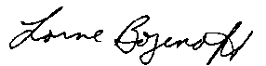
Signature:

Dr. Lorne Bozinoff
President & CEO
Forum Research Inc.

Date:
December 6, 2022

Recall that the six strata are Veterans 85+, Veterans 65–84, Veterans under 65 (case-managed), Veterans under 65 (not case-managed), RCMP, and Survivors. “Veterans” refers to CAF and War Service Veterans.
Those responses of individuals who indicated that they are a person of another gender are not shown due to a small sample size (< 1%).
At present, client profile administrative data captures only sex and not gender. These survey results may indicate that the gender identity of respondents is incongruent with administrative data or potentially that the data itself is not accurate.
Note the small sample size for “Yes, Inuit” (< 1%), which may result in difficulty seeing the corresponding bar.
“Yes, Inuit” not shown due to small sample size (< 1%).
Those aged 18-49 are more likely than those aged 50 and older to use My VAC Account, although those aged 50-59 are more likely to use it than those aged 60 and older, those aged 60-69 are more likely to use it than those aged 70 and older, and those aged 70-79 are more likely to use it than those 80 and older.
Those aged 18-49 are less likely than those aged 50 and older to agree, although those aged 50-59 are less likely to agree than those aged 60 and older, those aged 60-69 are less likely to agree than those aged 70 and older, and those aged 70-79 are less likely to agree than those 80 and older.
Strata breakout unavailable due to small sample sizes for all strata other than Veterans <65 (case-managed).
Strata breakout unavailable due to small sample sizes for all strata other than Veterans <65 (case-managed). Age categories over 69 excluded due to small sample sizes within the current framework.
Strata breakout unavailable due to small sample sizes for all strata other than Veterans <65 (case-managed). Age categories over 69 excluded due to small sample sizes within the current framework.
Strata breakout unavailable due to small sample sizes for all strata other than Veterans <65 (case-managed). Age categories over 69 excluded due to small sample sizes within the current framework.
Strata breakout unavailable due to small sample sizes for all strata other than Veterans <65 (case-managed). Age categories over 69 excluded due to small sample sizes within the current framework.
Strata breakout unavailable due to small sample sizes for all strata other than Veterans <65 (case-managed). Age categories over 69 excluded due to small sample sizes within the current framework.
Strata breakout unavailable due to small sample sizes for all strata other than Veterans <65 (case-managed). Age categories over 69 excluded due to small sample sizes within the current framework.
Strata breakout unavailable due to small sample sizes for all strata other than Veterans <65 (case-managed). Age categories over 69 excluded due to small sample sizes within the current framework.
Strata breakout unavailable due to small sample sizes for all strata other than Veterans <65 (case-managed). Age categories over 69 excluded due to small sample sizes within the current framework.
Strata breakout unavailable due to small sample sizes for all strata other than Veterans <65 (case-managed). Age categories over 69 excluded due to small sample sizes within the current framework.
Strata breakout unavailable due to small sample sizes for all strata other than Veterans <65 (case-managed). Age categories over 69 excluded due to small sample sizes within the current framework
Strata breakout unavailable due to small sample sizes for all strata other than Veterans <65 (case-managed). Age categories over 69 excluded due to small sample sizes within the current framework.
Strata breakout unavailable due to small sample sizes for all strata other than Veterans <65 (case-managed). Age categories over 69 excluded due to small sample sizes within the current framework.
Strata breakout unavailable due to small sample sizes for all strata other than Veterans <65 (case-managed). Age categories over 69 excluded due to small sample sizes within the current framework
Strata breakout unavailable due to small sample sizes for all strata other than Veterans <65 (case-managed). Age categories over 69 excluded due to small sample sizes within the current framework.
Veterans Independence Program (VIP) is only available to Veterans and Survivors.
Treatment Benefits Program is only available to Veterans and RCMP.
Strata breakout unavailable due to small sample sizes/no respondents for all strata other than Veterans <65 (case-managed). Age categories over 69, which has no respondents, are excluded.
Strata breakout unavailable due to small sample sizes/no respondents for all strata other than Veterans <65 (case-managed). Age categories over 69, which has no respondents, are excluded.
Strata breakout unavailable due to small sample sizes/no respondents for all strata other than Veterans <65 (case-managed). Age categories over 69, which has no respondents, are excluded.
Strata breakout unavailable due to small sample sizes/no respondents for all strata other than Veterans <65 (case-managed). Age categories over 69, which has no respondents, are excluded.
Strata breakout unavailable due to small sample sizes/no respondents for all strata other than Veterans <65 (case-managed). Age categories over 69, which has no respondents, are excluded.
Strata breakout unavailable due to small sample sizes/no respondents for all strata other than Veterans <65 (case-managed). Age categories over 69, which has no respondents, are excluded.
Strata breakout unavailable due to small sample sizes/no respondents for all strata other than Veterans <65 (case-managed). Age categories over 69, which has no respondents, are excluded.
Strata breakout unavailable due to small sample sizes/no respondents for all strata other than Veterans <65 (case-managed). Age categories over 69, which has no respondents, are excluded.
Strata breakout unavailable due to small sample sizes/no respondents for all strata other than Veterans <65 (case-managed). Age categories over 69, which has no respondents, are excluded.
Strata breakout unavailable due to small sample sizes/no respondents for all strata other than Veterans <65 (case-managed). Age categories over 69, which has no respondents, are excluded.
Strata breakout unavailable due to small sample sizes/no respondents for all strata other than Veterans <65 (case-managed). Age categories over 69, which has no respondents, are excluded.
“Did You Receive Information from VAC About Your Personal Benefits as a Result of Pension for Life?” All respondents answered this self-reported question that measured their recall of receiving information from VAC about Pension for Life (PFL).
“Have your benefits changed as a result of Pension for Life?” All respondents answered this self-reported question that measured their perceptions of their benefits changing as a result of Pension for Life (PFL).
Results for Veterans 85+ (n = 67), RCMP (n = 43), and Survivor (n = 33) should be interpreted with caution due to smaller sample sizes.
Those aged 60 and older are more likely to agree than those under 60, although those aged 70 and older are also more likely to agree than those aged 60-69.
Those aged 18-49 are less likely than those aged 50 and older to agree, although those aged 50-59 are less likely to agree than those aged 60 and older, those aged 60-69 are less likely to agree than those aged 70 and older, and those aged 70-79 are less likely to agree than those 80 and older.

