Attitudes Towards Remembrance and Veterans’ Week 2022:
Survey of Canadians

Final Report

Prepared for Veterans Affairs Canada

Supplier Name: Phoenix SPI
Contract Number: CW2246361
Contract Value: $59,015.15 (including HST)
Award Date: 2022-10-26
Delivery Date: 2023-03-08
Registration Number: POR 074-22

For more information on this report, please contact Veterans Affairs Canada at: commsresearch-commsrecherche@veterans.gc.ca

Ce rapport est aussi disponible en français.

Attitudes Towards Remembrance and Veterans’ Week 2022: Survey of Canadians

Prepared for Veterans Affairs Canada
Supplier name: Phoenix Strategic Perspectives Inc.

This public opinion research report presents the results of a telephone survey of 1,002 Canadians conducted by Phoenix SPI on behalf of Veterans Affairs Canada.

This publication may be reproduced for non-commercial purposes only. Prior written permission must be obtained from Veterans Affairs Canada. For more information on this report, please contact Veterans Affairs Canada at:

commsresearch-commsrecherche@veterans.gc.ca

Catalogue number:
V32-401/2023E-PDF

International Standard Book Number (ISBN):
978-0-660-47428-1

Related publications (POR registration number: POR 074-22):
Catalogue number (Final report, French): V32-401/2023F-PDF
ISBN: 978-0-660-47429-8

© His Majesty the King in Right of Canada, as represented by the Minister of Veterans Affairs, 2023

Aussi offert en français sous le titre Sondage sur les attitudes des Canadiens à l’égard de la commémoration et de la Semaine des vétérans 2022
Table of Contents

Executive Summary 1

Introduction 4
Background and Objectives 4
Methodology 4
Notes to Reader 5

Detailed Findings 6
Awareness and Importance of Veterans’ Week 6
Participation in Veterans’ Week and Related Activities 12
Prioritizing Veterans’ Week Activities 18
Attitudes Towards Veterans and Canada’s Military 21
Recognizing Canadian Veterans and Those Who Died in Service 24
Recognizing Canadian Military Milestones 28

Appendix 30
1. Technical Specifications 30
2. Questionnaire 32

Table of Figures

Figure 1: Awareness of Veterans' Week 6
Figure 2: Awareness of Remembrance Day 7
Figure 3: Importance of Veterans' Week 8
Figure 4: Reasons Why Veterans’ Week Is Important 9
Figure 5: Reasons Why Veterans’ Week Is Important [All Responses] 9
Figure 6: Reasons Why Veterans’ Week Is Important [Over Time] 10
Figure 7: Reasons Why Canadians View Veterans' Week Neutrally 11
Figure 8: Participation in Veterans’ Week 12
Figure 9: Reasons for Participating in Veterans’ Week [By Theme] 13
Figure 10: Reasons for Participating in Veterans’ Week [All Responses] 13
Figure 11: Reasons for Not Participating in Veterans’ Week [By Theme] 14
Figure 12: Reasons for Not Participating in Veterans’ Week [All Responses] 15
Figure 13: Participation in Activities to Commemorate Veterans 16
Figure 14: Participation in Veterans’ Week Activities [Over Time] 17
Figure 15: Importance of Remembrance Initiatives 18
Figure 16: Importance of Remembrance Initiatives [Over Time] 20
Figure 17: Attitudes Towards Veterans, Commemoration and Canada’s Military 22
Figure 18: Attitudes Towards Veterans and Commemoration [Over Time] 23
Figure 19: Attitudes Towards Actions to Recognize Veterans and Those Who Died in Service 24
Figure 20: Presentation and Care of Memorials, Cemeteries and Grave Markers [Over Time] 25
Figure 21: Importance of Providing Funeral and Burial Assistance 26
Figure 22: Importance of Providing Funeral and Burial Assistance [Over Time] 27
Figure 23: Importance of Marking Military Milestones 28
Figure 24: Attitudes Towards Recent Conflicts 29

Executive Summary
Phoenix Strategic Perspectives Inc. (Phoenix SPI) was commissioned by Veterans Affairs Canada (VAC) to conduct a telephone survey of Canadians regarding Veterans’ Week and VAC’s remembrance programming.

1. Research Purpose and Objectives
The purpose of the Attitudes Towards Remembrance and Veterans’ Week survey is to evaluate the effectiveness of the Department’s remembrance programming. The objectives of this research were to measure Canadians’ level of participation in remembrance activities, their attitudes toward those who served in Canada’s military, and their level of support for VAC's work related to remembrance. The research results allow VAC to continue to determine the impact and effectiveness of its remembrance activities, adapt activities to be relevant to Canadians, improve the methods used to inform Canadians about remembrance initiatives, and help to guide the planning of future remembrance-related programming.

2. Key Findings
Canadians’ awareness of Veterans’ Week and the importance attributed remain unchanged from 2020.
Awareness of Veterans’ Week has not changed since the last iteration of this survey in 2020, when 57% of Canadians said they had heard of Veterans’ Week. Consistent with previous years, close to nine in 10 Canadians (87%) think it is important that Veterans’ Week be held each year, with two-thirds (67%) saying that it is very important. Among those who said it is important that Veterans’ Week be held each year, the top reason offered, mentioned by 74%, was to honour and show respect for Canadian Veterans and those who died in service. Following this, approximately one-third of Canadians (36%) of those who think it is important that Veterans’ Week be held each year provided reasons pertaining to history or remembrance. Relatively few (9%) said that Veterans’ Week is important because of a personal connection, such as having a family member who is a Veteran or in the military. These same themes have been Canadians’ top reasons for attributing importance to Veterans’ Week for over a decade.
Participation in Veterans’ Week has almost returned to pre-pandemic levels.
More than eight in 10 Canadians (86%) said they or members of their immediate family participated in Veterans’ Week this year. This represents an increase of 14 percentage points since 2020, when remembrance activities were affected by the COVID-19 global pandemic, and the start of a return to pre-pandemic participation levels. Between 2016 and 2019, highs of 88% to 92% of Canadians reported participation in Veterans’ Week. Among Canadians who did participate in Veterans’ Week this year, nearly half (47%) said they participated to honour and respect Canadian Veterans and those who died in service and approximately one-third (36%) said they participated for personal connections. This is consistent with previous years. In addition, 23% participated to focus on history and remembrance, an increase of 11% from 2020, and 8% participated because they believe in it/feel it is important.
Wearing a poppy continues to be the most prevalent way to commemorate Veterans and those who died in service.
Like previous years, wearing a poppy, mentioned by 76% of surveyed Canadians, remains the most popular way to recognize Veterans and participate in Veterans’ Week activities. This is closely followed by observing a moment of silence at 72%. In addition, 43% watched a Remembrance Day 2022 ceremony on TV, while smaller proportions participated on social media (31%; up from 22% in 2020) or attended a remembrance ceremony in their community (30%; up from 15% in 2020, a year in which participation was likely affect by the COVID-19 global pandemic).
Many Canadians continue to attribute at least some importance to all remembrance initiatives.
Nine in 10 Canadians (90%) attributed importance to providing educational materials for schools, with 72% saying this is very important. Eight in 10 Canadians (82%) attributed importance to supporting and leading commemorative events in Canada, with just over half (58%) saying this is very important. Support for this initiative drops significantly when events are to be held outside of Canada, with only 50% attributing importance. Following this, similar proportions attributed importance to providing funding for commemorative projects (74%), posting remembrance content on social media (72%), and creating remembrance related ads (71%). Two-thirds of Canadians (65%) attributed importance to providing promotional materials, such as posters and pins, while the creation of virtual or online ceremonies for Veterans’ Week was considered important by 62% of Canadians. Support for these remembrance initiatives remains stable among Canadians, with changes of three percent or less recorded between 2020 and 2022.
Canadians’ attitudes towards Veterans and Canada’s military role remain strongly positive.
The results suggest that Canadians hold positive attitudes towards Veterans and the role played by Canada’s military. More than nine in 10 Canadians agreed that Veterans and those who died in service should be recognized for their service to Canada (96%) and have made major contributions to our country (93%). Following this, more than eight in 10 Canadians agreed that participating in commemorative activities increases awareness of, and appreciation for, the contributions of Veterans and those who died in service (87%) and are proud of the role Canada’s military played in the First and Second World Wars and the Korean War (86%). Pride in Canada’s military role declines somewhat when the focus is activities since the Korean War (79% indicated that they are proud of Canada’s military role post-Korea). In addition, eight in 10 surveyed Canadians (82%) feel they demonstrate their appreciation of those who served our country and approximately three-quarters (76%) agreed that VAC effectively honours Veterans and preserves the memory of their achievements. Over time, Canadians’ attitudes towards commemoration, Veterans and those who died in service have remained strong.
There is widespread agreement among Canadians on the importance of recognizing Veterans and those who died in service.
Consistent with previous years, a strong majority of Canadians agreed that it is important for VAC to recognize and honour Canadian Veterans and those who died in service by presenting and looking after care of memorials, cemeteries, and grave markers (92%) and by providing funeral and burial assistance (92%). Smaller majorities agreed that they are satisfied with how VAC recognizes and honours Canadian Veterans and those who died in service by presenting and looking after care of memorials, cemeteries, and grave markers (67%) and by providing funeral and burial assistance (61%).

Most Canadians believe it is important for Canada to mark key military anniversaries and to recognize the contributions of Veterans and those who served Canada in more recent operations.
In total, 94% of surveyed Canadians attributed importance to marking anniversaries related to military conflicts, such as the 80th anniversary of the Second World War’s Dieppe Raid, and 86% attributed importance to marking anniversaries related to military efforts in Canada, such as the 25th anniversary of the Red River floods in Manitoba. Additionally, more than nine in 10 Canadians (95%) said it is important to recognize the contributions of Veterans and military personnel who served Canada in more recent operations, such as Canada’s Mission in Afghanistan, humanitarian efforts and peace support operations around the world.

Subgroup differences were evident across most issues explored in the survey.
Subgroup variations were most consistent when looking at region, personal connections to Veterans, and immigration status. Respondents from Quebec were less likely to believe it is very important that Veterans’ Week be held each year, less likely to have participated in Veterans’ Week activities, and less likely to have attributed importance to most remembrance initiatives and to marking key anniversaries related to military conflicts. Compared to other Canadians, Veterans, members of the Canadian Armed Forces (CAF) and those who know a Veteran were more likely to be aware of, and to have participated in, Veterans’ Week, and to have view as important remembrance and commemoration. Finally, those who immigrated to Canada were less likely to be aware of Veterans’ Week and to have engaged in remembrance-related activities. However, after living in Canada for six or more years, awareness and engagement levels of those who immigrated to Canada became more similar to those born in Canada.

3. Methodology
A 14-minute random digit dialling (RDD) telephone survey was administered to 1,002 Canadian residents, 16 years of age or older, between November 14 and 24, 2022. The results of the survey can be considered representative of the population of Canadians aged 16 and older. Based on a sample of this size, the overall results can be considered accurate within ±3.3%, 19 times out of 20 (adjusted to reflect the geographically disproportionate sampling). The margins of error are greater for results pertaining to subgroups of the total sample and split samples.

4. Statement of Political Neutrality
I hereby certify as a Senior Officer of Phoenix Strategic Perspectives that the deliverables fully comply with the Government of Canada political neutrality requirements outlined in the Communications Policy of the Government of Canada and Procedures for Planning and Contracting Public Opinion Research. Specifically, the deliverables do not contain any reference to electoral voting intentions, political party preferences, standings with the electorate, or ratings of the performance of a political party or its leader.

Alethea Woods
President
Phoenix Strategic Perspectives Inc.

5. Contract Value
The contract value was $59,015.15 (including HST).

INTRODUCTION
Veterans Affairs Canada (VAC) commissioned Phoenix Strategic Perspectives Inc. (Phoenix SPI) to conduct a telephone survey of Canadians regarding Veterans’ Week and VAC’s remembrance programming.

Background and Objectives
One of VAC’s core responsibilities is post-Confederation military commemoration. VAC ensures (1) that Veterans and those who died in service are honoured and (2) that Canadians remember and appreciate Veterans and those who died in service. The Canada Remembers Program and the Funeral and Burial Program support these departmental results for commemoration and promote the following:
- Veterans and those who died in service are publicly acknowledged through ceremonies and events, honours and awards, and the presentation and perpetual care of memorials, cemeteries, and grave markers;
- Canadians are aware of, and value, the contributions of those who served through a suite of resources that tell the story of our military history and through the provision of funding for community-led commemorative initiatives;
- the memory of the achievements and sacrifices of Canadian Veterans and those who died in service is preserved; and
- the estates of eligible Veterans have access to financial assistance toward a dignified funeral and burial.

The Attitudes Towards Remembrance and Veterans’ Week survey measures Canadians’ level of participation in remembrance activities, their attitudes toward those who served in Canada’s military, and their level of support for VAC's work related to remembrance. The purpose of this research is to evaluate the effectiveness of the Department’s overall remembrance programming.

The research results allow VAC to continue to determine the impact and effectiveness of its remembrance activities, adapt activities to be relevant to Canadians, improve the methods used to inform Canadians about remembrance initiatives, and help to guide the planning of future remembrance-related programming.

Methodology
A random digit dialling (RDD) telephone survey was administered to 1,002 Canadian residents, 16 years of age or older, between November 14 and 24, 2022. The survey averaged 14 minutes to complete. An overlapping dual-frame (landline and cell phone) sample was used to minimize coverage error. The sample frame was geographically disproportionate to improve the accuracy of regional results. The results of the survey can be considered representative of the population of Canadians aged 16 and older. Based on a sample of this size, the overall results can be considered accurate within ±3.3%, 19 times out of 20 (adjusted to reflect the geographically disproportionate sampling). The margins of error are greater for results pertaining to subgroups of the total sample and split samples. For a more complete description of the methodology, refer to the Appendix: 1. Technical Specifications.

Notes to Reader
- All results are expressed as percentages unless otherwise noted.
- Percentages may not always add to 100 due to rounding.
- In graphs:
  - “DK” stands for “Don’t know” and “NR” for “No response.”
  - Tracking data are presented where available. This survey was not conducted in 2009, 2013, 2015, or 2021.
- The number of respondents changes throughout the report because some questions were asked of sub-samples of survey respondents. Readers should be aware of this and exercise caution when interpreting results based on smaller numbers of respondents because the margins of error are higher. The higher the margins of error, the less reliable the survey results.
- Demographic differences are identified in the report. Only differences that are significant at the 95% confidence level and pertain to a subgroup sample size of more than n=30 are discussed in the report.
  - When regional differences are discussed in the report, note that the territories are grouped as follows: respondents from the Yukon Territory are grouped with British Columbia and respondents from the Northwest Territories and Nunavut are grouped with the Prairies.
- The tabulated data is available under separate cover.

Detailed Findings

Awareness and Importance of Veterans’ Week
This section explores Canadians’ awareness of Veterans’ Week, as well as their views on the importance of Veterans’ Week and the reasons why they hold these views.

Awareness of Veterans’ Week is the same as 2020
Just over half (57%) of Canadians said they have heard of Veterans’ Week. Over the last decade, awareness levels have remained consistent, varying by no more than three percentage points year over year.

Figure 1: Awareness of Veterans' Week
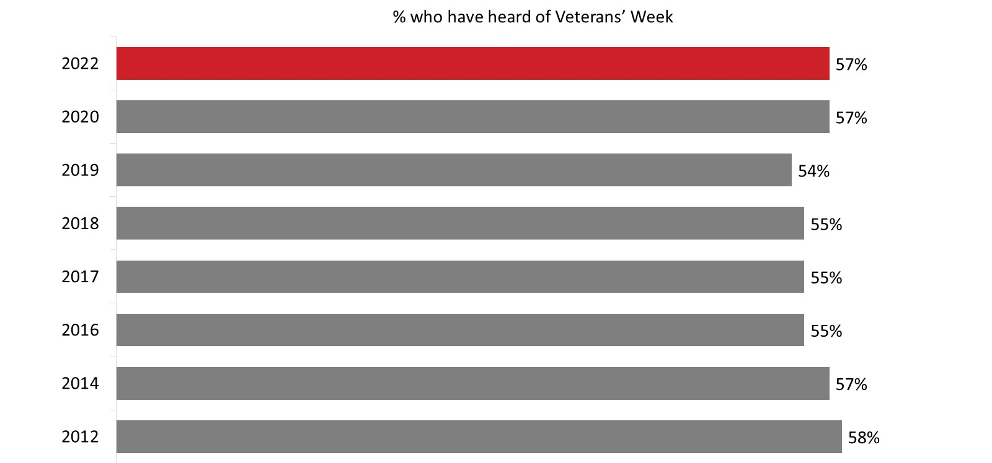

Q1A: Have you ever heard of Veterans’ Week? DK/NR: 2%. Base: All respondents; 2022 n=1,002.

Awareness of Veterans’ Week is higher among the following subgroups:
- Those in Quebec (63%) and Ontario (59%) compared to British Columbia (44%).
- Canadians aged 45 and older (66% of those aged 65+ and 62% of those 45 to 64 years of age) compared to Canadians under 25 (39%) and 25 to 44 years of age (52%).
- Canadians born in Canada (61%) as opposed to those born outside of Canada (46%).
- Veterans, Canadian Armed Forces (CAF) members and those who know a Veteran (64%) versus those who are not a Veteran, not a CAF member or do not personally know any Veterans (50%).

Almost all Canadians are aware of Remembrance Day
Ninety-seven percent of surveyed Canadians said they have heard of Remembrance Day.

Figure 2: Awareness of Remembrance Day

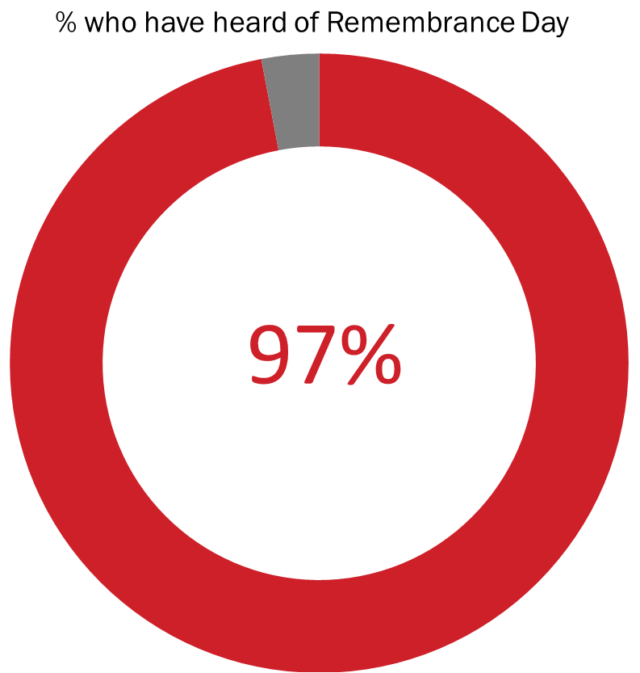

Q1B: Have you ever heard of Remembrance Day? Base: All respondents; 2022 n=1,002.

Respondents from Quebec were least likely to have heard of Remembrance Day: 92% compared to 98% of those from Atlantic Canada, 97% from Ontario, 98% from the Prairies and 99% from British Columbia. In addition, those reporting an annual household income of $100,000 or more (100%), followed by those with an annual income of $60,000 to just under $100,000 (98%), were more likely than those reporting annual incomes of less than $60,000 (94%) to have heard of Remembrance Day. Awareness was also higher among those born in Canada (99% versus 91% of immigrants) as well as among Veterans, CAF members and those who know a Veteran (99% versus 94% of others).

Most Canadians think that it is important that Veterans' Week be held each year
Most surveyed Canadians (87%) believe it is important to that Veterans’ Week be held each year, with two-thirds saying it is very important. Over the last decade, the proportion of Canadians who feel that Veterans’ Week is important has remained relatively stable, with virtually no change outside of the margin of error.

Prior to being asked to rate the importance of Veterans’ Week on a scale of 1 to 5, respondents were first read the following description:

Veterans’ Week takes place November 5th to 11th each year, in the lead up to Remembrance Day. During this week, commemorative ceremonies and events take place across the country to recognize Canada’s military personnel, Veterans, and those who died in service.

Figure 3: Importance of Veterans' Week
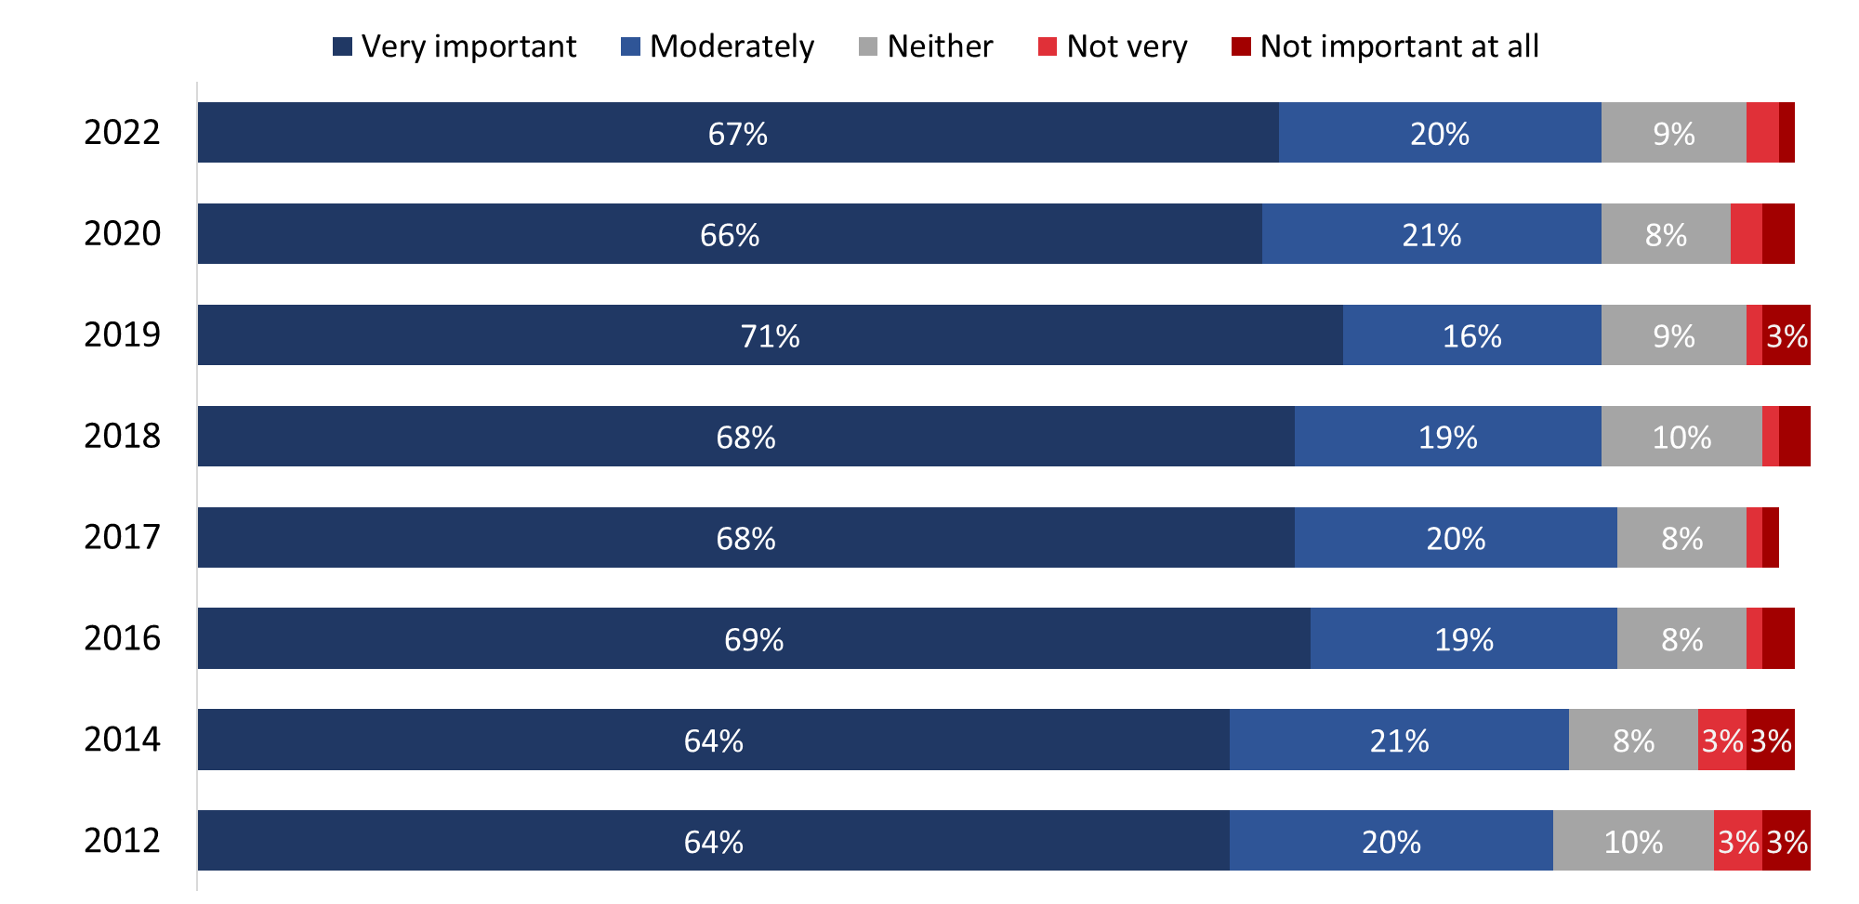

Values of 2% or less are not labelled in the graph.
Q2: How important is it that Veterans' Week be held each year?
Base: All respondents; 2022 n=1,002. DK/NR: 1%.

The following are more likely to believe it is very important that Veterans’ Week be held each year:
- Canadians living in Atlantic Canada (74%), Ontario (73%), and the Prairies (76%) compared to Quebec (52%).
- Older Canadians (72% of 45- to 64-year-olds and 69% of those aged 65+ compared to 61% of 25- to 44-year-olds).
- Veterans, CAF members and those who know a Veteran (79%) compared to those who are not a Veteran, not a CAF member or who do not personally know any Veterans (55%).

Veterans’ Week is important to honour and respect Canadian Veterans
Canadians who said it is important that Veterans’ Week be held each year (n=866) were asked to give their reasons why. Approximately three-quarters (74%) responded that they believe Veterans’ Week is important as a way to honour Veterans and that Veterans have earned respect. Following this, approximately one-third of Canadians (36%) provided reasons pertaining to Canada’s history or remembrance of those who served and sacrificed. One in 10 (9%) said Veterans’ Week is important because of a personal connection, such as having a friend or family member who is a Veteran or in the military. Seven percent of respondents pointed to other reasons to explain why they attribute importance to Veterans’ Week being held each year.

Figure 4: Reasons Why Veterans’ Week Is Important

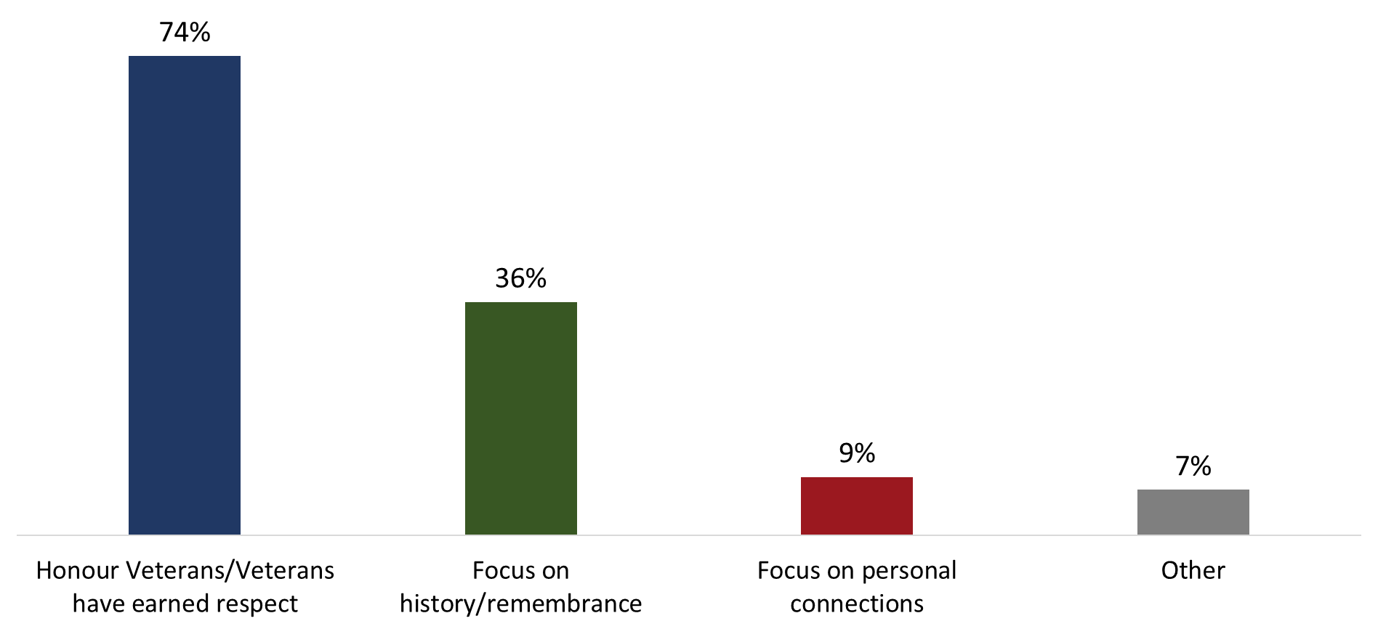

Q2B: And why do you say it is important that Veterans' Week be held each year? Base: Those who said it is important; 2022 n=866. (Up to 2 responses accepted)

University graduates (41% versus 30% of those with a high school education or less) and women (41% versus 31% of men) are more likely to believe it is important that Veterans’ Week be held each year as a way to focus on history and remembrance.

Figure 5 presents the full range of responses, grouped by the themes presented in Figure 4. The following four responses were given most frequently:
- To honour and respect Veterans and those who died in service (38%);
- So people will remember their sacrifices (22%);
- To recognize their contribution to our freedom, security and peace (21%); and
- Because Veterans fought for, and served, our country (16%).

Respondents could provide up to two reasons for thinking that Veterans’ Week is important; therefore, the percentages for the full range of responses assigned to each theme (e.g., Focus on History / Remembrance) do not necessarily sum to the total percentage for that theme.

Figure 5: Reasons Why Veterans’ Week Is Important [All Responses]

Honour Veterans / Veterans Have Earned Respect 74%
To honour and respect Veterans and those who died in service | 38%
To recognize their contribution to our freedom, security, and/or peace | 21%
Veterans fought for, and served, our country | 16%
To recognize their service and accomplishments | 11%
Canada would not be the country it is today / I would not be here if it were not for Veterans | 5%
We owe them / they deserve recognition | 3%

Focus on History / Remembrance 36%
So people will remember their sacrifices | 22%
Part of our heritage / our history | 4%
So children can understand / learn the importance of it | 4%
Good idea / good to remember | 3%
Should not / cannot forget | 3%
So we do not repeat past mistakes | 2%
Many soldiers died in past wars | 2%
There are fewer Veterans / their stories should be told | --*
Focus on Personal Connections 9%
Family member is a Veteran / I am a Veteran | 9%
Other Reasons 7%
To show support for our troops (past and / or present) | 3%
Believe in it / it is important to do it | 2%
Forces us to examine war | --*
Other explanations | --*
*Cell counts are too small to include in the table.
**1% of respondents offered no reason.

Over time, the reasons Canadians attribute importance to Veterans’ Week being held each year have been very consistent since 2018.

Figure 6: Reasons Why Veterans’ Week Is Important [Over Time]

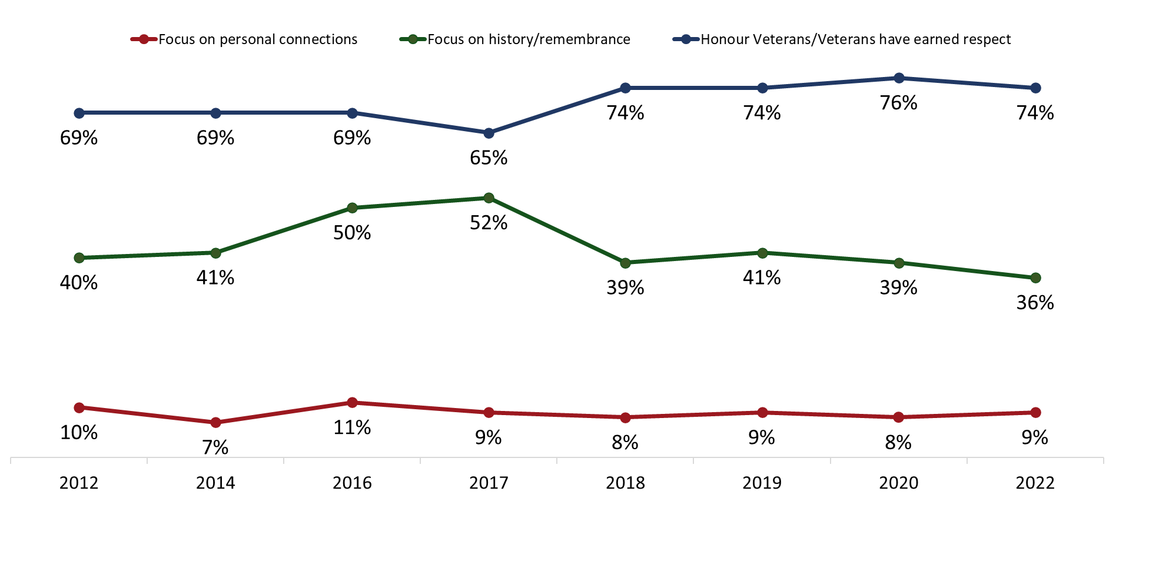
Q2B: And why do you say it is important that Veterans' Week be held each year? Base: Those who said it is important; 2022 n=866. (Up to 2 responses accepted)

Cost-benefit focus is the top reason for viewing Veterans’ Week as not important
Among the small number of surveyed Canadians (n=32 respondents) who said that Veterans’ Week is not very important or not important at all, the most common explanation focused on cost-benefit, and included the view that a week is too long, that there are other issues of concern, and that it is expensive. This was followed by lack of personal resonance (i.e., it is not personally important, or one does not have any family or friends who are Veterans or in the military) and lack of information and awareness.

Lack of personal resonance is the primary reason Canadians think that Veterans' Week is neither important nor unimportant
Respondents who indicated that Veterans’ Week is neither important nor unimportant to them (n=95) were asked to explain why they feel that way. The most common reason was lack of personal resonance. Figure 7 presents the full range of reasons Canadians gave for thinking Veterans’ Week is neither important nor unimportant.

Figure 7: Reasons Why Canadians View Veterans' Week Neutrally

Lack of Personal Resonance 30%
Do not care / not important to me personally | 25%
Do not have family members who are Veterans / Do not know anyone in the military | --*
Cost-Benefit Focus 26%
We already have Remembrance Day / a week is too long | 19%
There are other issues / concerns that are more important | --*
Lack of Information / Awareness 16%
Never heard of it / Do not know about it | 14%
Do not know what activities there are for Veterans’ Week | --*
Pacifism 11%
We should not celebrate war / we should focus on peace | 11%
Wrong Focus on the Past --*
Happened in the past / we should focus on the present | --*
Most Veterans have died / very few Veterans left | --*
Other --*
Should be a more private ceremony / held less often (so it is not overdone) | --*
*Cell counts are too small to include in the table.

Fourteen percent of respondents offered no reason to explain why Veterans’ Week is neither important nor unimportant to them.

Participation in Veterans’ Week and Related Activities
This section explores topics related to Canadians’ participation in Veterans’ Week, including the level of participation, reasons for participation and non-participation, and the specific activities respondents participated in.

Almost nine in 10 Canadians participated in Veterans’ Week activities
Eighty-eight percent of Canadians said they or members of their immediate family participated in Veterans’ Week this year. This represents an increase of 14 percentage points since 2020, when remembrance activities were affected by the COVID-19 global pandemic, and likely the start of a return to pre-pandemic participation levels. Between 2016 and 2019, participation in Veterans’ Week ranged from 88% to 92%.

Figure 8: Participation in Veterans’ Week
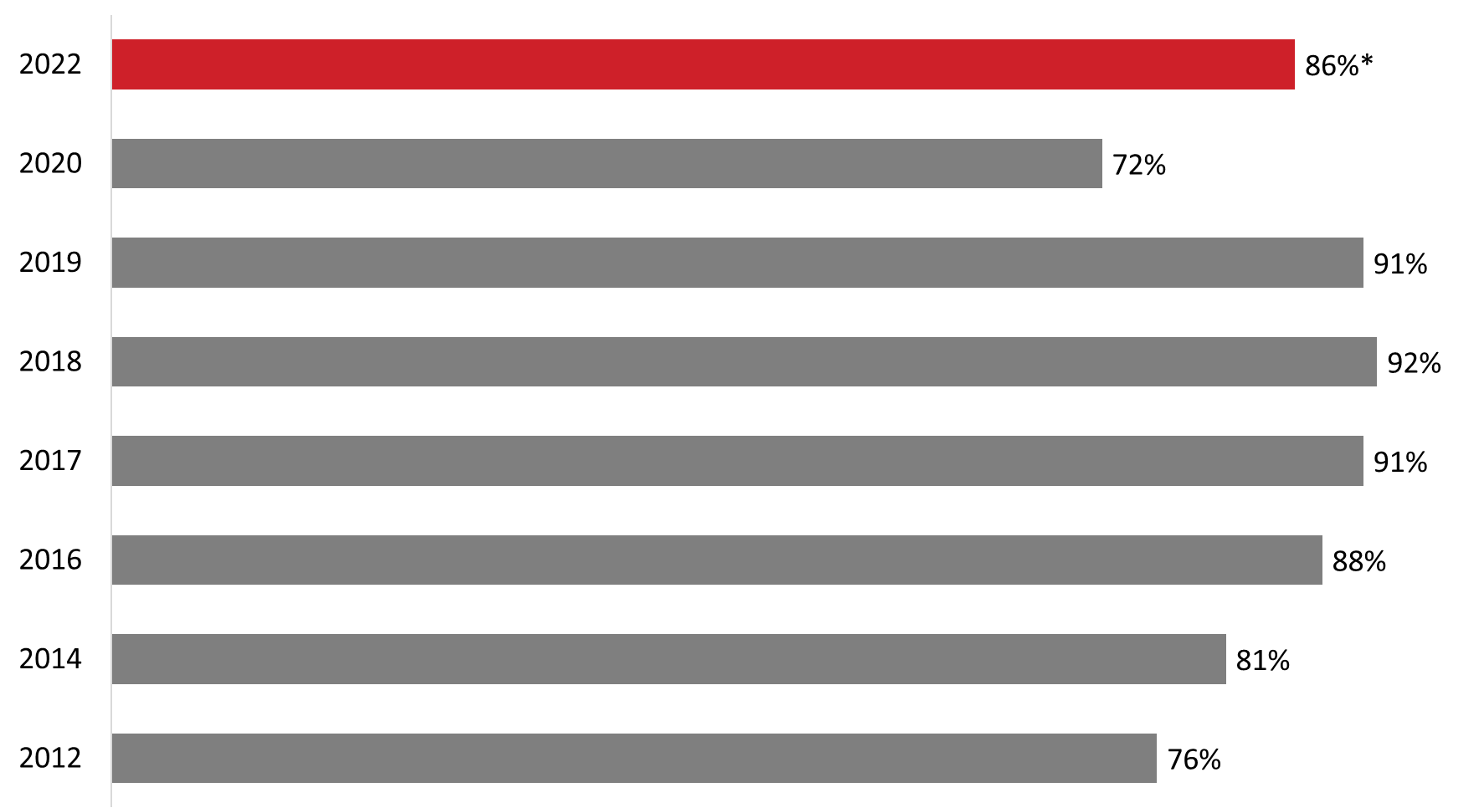

Q3 Revised. This year, did you or members of your immediate family participate in any Veterans' Week activities which includes Remembrance Day? *Question wording changed in 2022
Base: All respondents; 2022 n=1,002

Participation was lowest in Quebec where 69% of respondents participated in Veterans’ Week activities. Elsewhere in the country, participation ranged from 94% in Ontario and British Columbia, to 95% in the Prairies and 96% in Atlantic Canada. Income and personal connections also affected participation. Canadians with a household income of $60,000 or more (92%) were more likely to participate than those from households reporting annual incomes of $40,000 to just under $60,000 (82%). Participation was also higher among Veterans, CAF members and those who know a Veteran personally (95%) compared to other Canadians (81%).

In addition, those born in Canada (90%) were more likely to participate in Veterans’ Week than those who immigrated to Canada (83%). Furthermore, participation was higher among those who immigrated to Canada six or more years ago (90%) compared to those who immigrated to Canada in the last five years (66%).

Honouring Veterans is the main reason Canadians say they participated in Veterans’ Week
Canadians who reported having participated in Veterans’ Week in 2022 (n=452) were asked why they did so. Just under half (47%) of Canadians who participated in Veterans’ Week say they did so to honour and respect Veterans. This value has remained consistent since 2014, varying by no more than two percentage points from year to year.

Following this, approximately one-third (36%) participated because of a personal connection. In addition, nearly one-quarter (23%) participated to focus on history and remembrance, which represents a significant increase since 2020 when 12% of respondents attributed their participation to these reasons. Eight percent participated because they believe it is important (down from a high of 15% in 2019 and 11% in 2020).

Figure 9: Reasons for Participating in Veterans’ Week [By Theme]
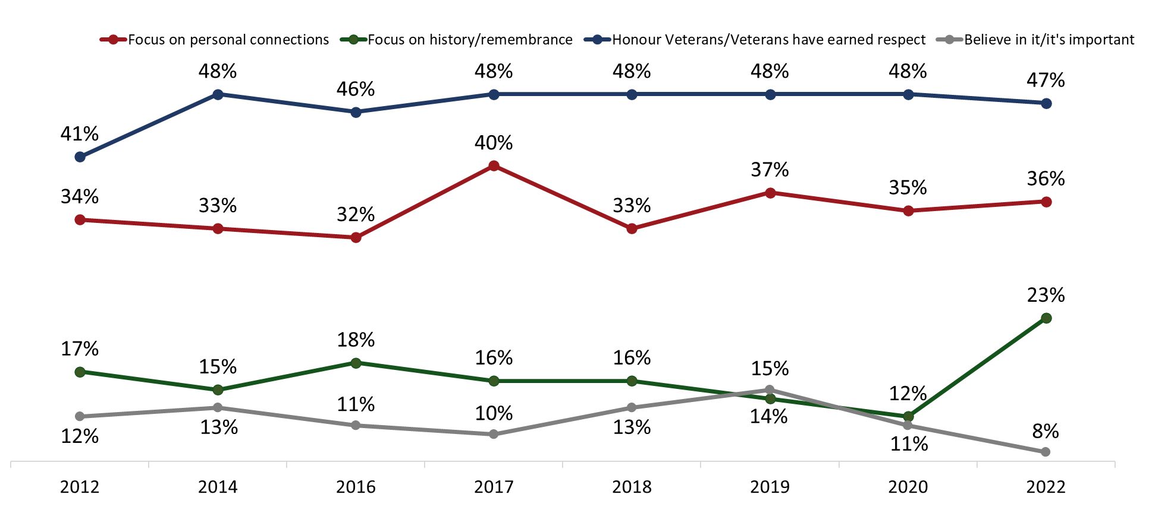
Q3B. And why did you or members of your immediate family participate in Veterans' Week which includes Remembrance Day? *Question wording changed in 2022
Base: Those who initially acknowledged participating in Veterans’ Week when asked; 2022 n=452. (Up to 2 responses accepted)

The specific reasons Canadians gave for participating in Veterans’ Week are presented below in Figure 10. Respondents were permitted to provide up to two reasons; therefore, the percentages for the full range of responses assigned to each theme (e.g., Honour Veterans / Veterans Earned Respect) may not necessarily sum to the total percentage for that theme presented in Figure 9 above.

Figure 10: Reasons for Participating in Veterans’ Week [All Responses]

Honour Veterans / Veterans Earned Respect 47%
To honour and respect the Veterans and those who died in service | 36%
To recognize their contribution to our freedom, security, and/or peace | 7%
To recognize their service and accomplishments | 6%
Veterans fought for, and served, our country | 3%
Canada would not be the country it is if it were not for Veterans | --*
Focus on Personal Connections 36%
Family member is a Veteran / I am a Veteran | 26%
I / someone I know participates in events | 7%
Know / am related to someone who is currently in the military / I am currently in the military | 5%
Focus on History / Remembrance 23%
So children can understand / learn the importance of it | 11%
So people will remember their sacrifices | 10%
Good idea / good to remember | 4%
Other Reasons 16%
Believe in it / it is important to do it | 8%
Tradition / habit / we do it every year | 4%
To show support for our troops (past and/or present) | 3%
Show some (national) pride | --*
*Cell counts are too small to include in the table.

Practical reasons were the primary barrier for most Canadians who did not participate in Veterans’ Week in 2022
Among Canadians who did not participate in Veterans’ Week this year (n=544), half (51%) were unable to participate because of practical reasons. This represents a significant increase since 2020, when 15% of respondents pointed to practice reasons. In 2020, at 49%, the top reason for not participating in Veterans’ Week was the COVID-19 global pandemic. This year, just 4% of surveyed Canadians said they did not participate due to COVID-19 restrictions in their area or to lack of comfort attending a ceremony in person.

Figure 11: Reasons for Not Participating in Veterans’ Week [By Theme]

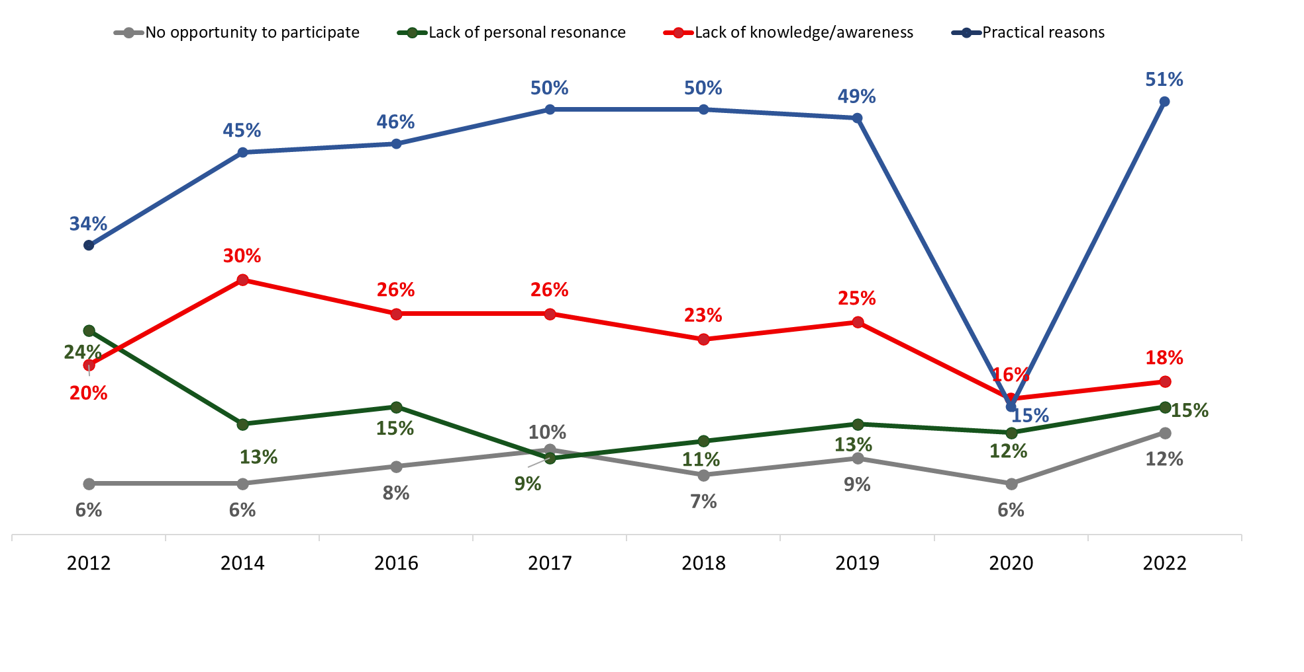 Q3C. And why didn't you or members of your immediate family participate in Veterans' Week which includes Remembrance Day? *Question wording changed in 2022
Base: Those who did not participate; 2022 n=544. (Up to 2 responses accepted)

Following practical reasons, 18% of Canadians did not participate in Veterans’ Week activities due to lack of knowledge or awareness and 15% did not participate because of lack of personal resonance. Twelve percent attributed their lack of participation to the perception that there were no opportunities in their area to participate in Veterans’ Week (up from 6% in 2020, a year in which COVID-19 restrictions limited opportunities to participate).

Figure 12 illustrates the full range of reasons Canadians gave for not participating in Veterans’ Week. Respondents could provide up to two reasons.

Figure 12: Reasons for Not Participating in Veterans’ Week [All Responses]

Practical Reasons 51%
Too busy / no time to attend | 28%
Had to work / not available to participate | 15%
Cannot participate due to health reasons / age | 11%
Lack of Knowledge / Awareness 18%
Never heard of it / do not know about it | 12%
Do not know what activities there are for Veterans' Week | 6%
Lack of Personal Resonance 15%
Do not care / not important to me personally | 7%
I am an immigrant | 6%
Do not have family members who are Veterans / do not know anyone in the military | 3%
No Opportunity 12%
No occasion / opportunity / chance to participate | 7%
There are no activities for Veterans' Week in the area | 5%
COVID-19 Pandemic 4%
COVID-19 restrictions in my area/uncomfortable participating in person due to COVID-19 | 4%
Other Reasons 8%
Don’t have family nearby | 4%
Remembered by wearing a poppy | --*
Already have Remembrance Day | --*
We shouldn't celebrate war/ we should focus on peace | --*
Other explanations | --*
*Cell counts are too small to include in the table.

Four percent of respondents offered no reason to explain why they did not participate in Veterans’ Week.

Wearing a poppy and observing a moment of silence are the most common ways Canadians participated in Veterans’ Week
All surveyed Canadians were asked about their participation in various Veterans’ Week activities. The most common activity was to wear a poppy (76%) closely followed by observing a moment of silence (72%). In addition, four in 10 Canadians (43%) watched a Remembrance Day 2022 ceremony on television, while three in 10 participated on social media (31%), watched a virtual service (30%), or participated in a remembrance ceremony in their community (30%).

Figure 13: Participation in Activities to Commemorate Veterans
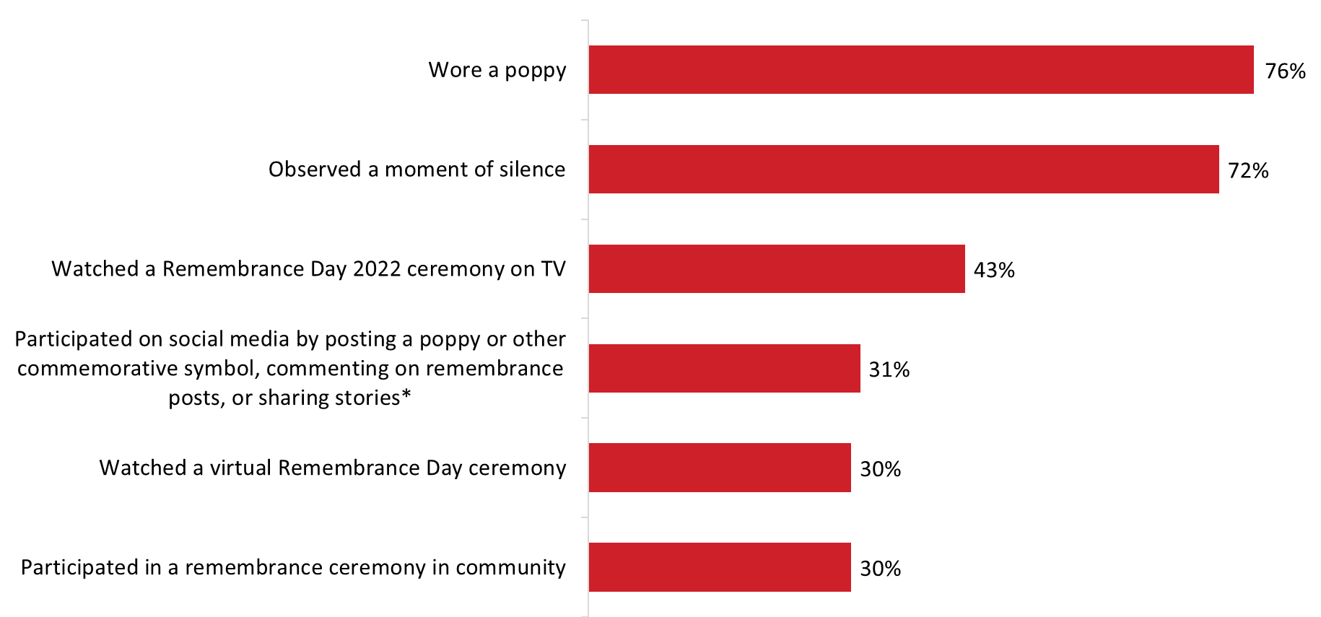

Q4A-F: Did you or members of your immediate family do any of the following during Veterans' Week this year? *Wording changed this year. Base: 2022 n=1,002. DK/NR: <1% - 1%. (Multiple responses accepted)

Residents of Quebec were less likely than those living elsewhere in the country to have participated in many of the activities. Specifically:
- While 47% of respondents from Quebec said they wore a poppy, significantly greater proportions did so in other regions: 85% in Atlantic Canada, 85% in Ontario, 86% in the Prairies and 85% in British Columbia.
- Participation on social media was higher in Atlantic Canada (39%), followed by Ontario (37%) and the Prairies (35%) than it was in British Columbia (23%) and Quebec (20%).
- Those in Quebec were also less likely to participate in a ceremony in their community (9% versus 28% to 44% of Canadians living elsewhere in the country), watch a virtual ceremony (20% versus 28% to 36% of those living in other regions) or a ceremony on TV (37% compared to 52% of those in Atlantic Canada and 45% of those in Ontario), and observe a moment of silence (42% versus 76% to 85% of Canadians living elsewhere in the country).

Differences based on age followed a consistent pattern. Those aged 65+ were less likely than younger Canadians to participate on social media (19% versus 35% of 25- to 44-year-olds and 37% of 45- to 64-year-olds), attend a ceremony in their community (26% versus 33% of 45- to 64-year-olds), and watch a ceremony on TV (67% compared to 21% of those under 25, 30% of 25- to 44-year-olds and 44% of 45- to 64-year-olds). Conversely, those aged 65+ (37%) were more likely than those under 45 (25%) to report having participated in a virtual ceremony.

The likelihood of doing the following was higher among Canadians with annual household incomes of $60,000 or more: wearing a poppy (80% of those with incomes of $60,000 to just under $100,000 and 84% of those with incomes of $100,000 or more compared to 67% of Canadians with incomes of $40,000 to just under $60,000), attending a ceremony in their community (37% of those with incomes of $100,000 and 31% of those with incomes of $60,000 to just under $100,000 compared to 20% of Canadians with incomes of under $40,000), and observing a moment of silence (77% of those with incomes of $60,000 or more compared to 60% of those with incomes of $40,000 to just under $60,000).

Except for participating on social media, those born in Canada were more likely than those who immigrated to Canada to have taken part in all these Veterans’ Week activities. Participation in all activities was higher among Veterans, CAF members and those who know a Veteran personally compared to other Canadians.

Participation in remembrance activities rebounding from Pandemic lows
Participation in Veterans’ Week activities remains largely unchanged since 2017, with two exceptions: attendance of in-person ceremonies and participation on social media. Following a decline in attendance of in-person ceremonies in 2020 (likely due to the COVID-19 pandemic), this year marks an increase, from 15% to 30%, with participation rates now approaching pre-pandemic levels, which ranged from 35% to 39% over the last decade. There has also been a notable increase in the proportion of Canadians who said they participated on social media—from 22% in 2019 and 2020, to 31% this year. It should be noted, however, that the questionnaire wording was changed this year, which may explain, at least in part, some of the change over time.

Figure 14: Participation in Veterans’ Week Activities [Over Time]

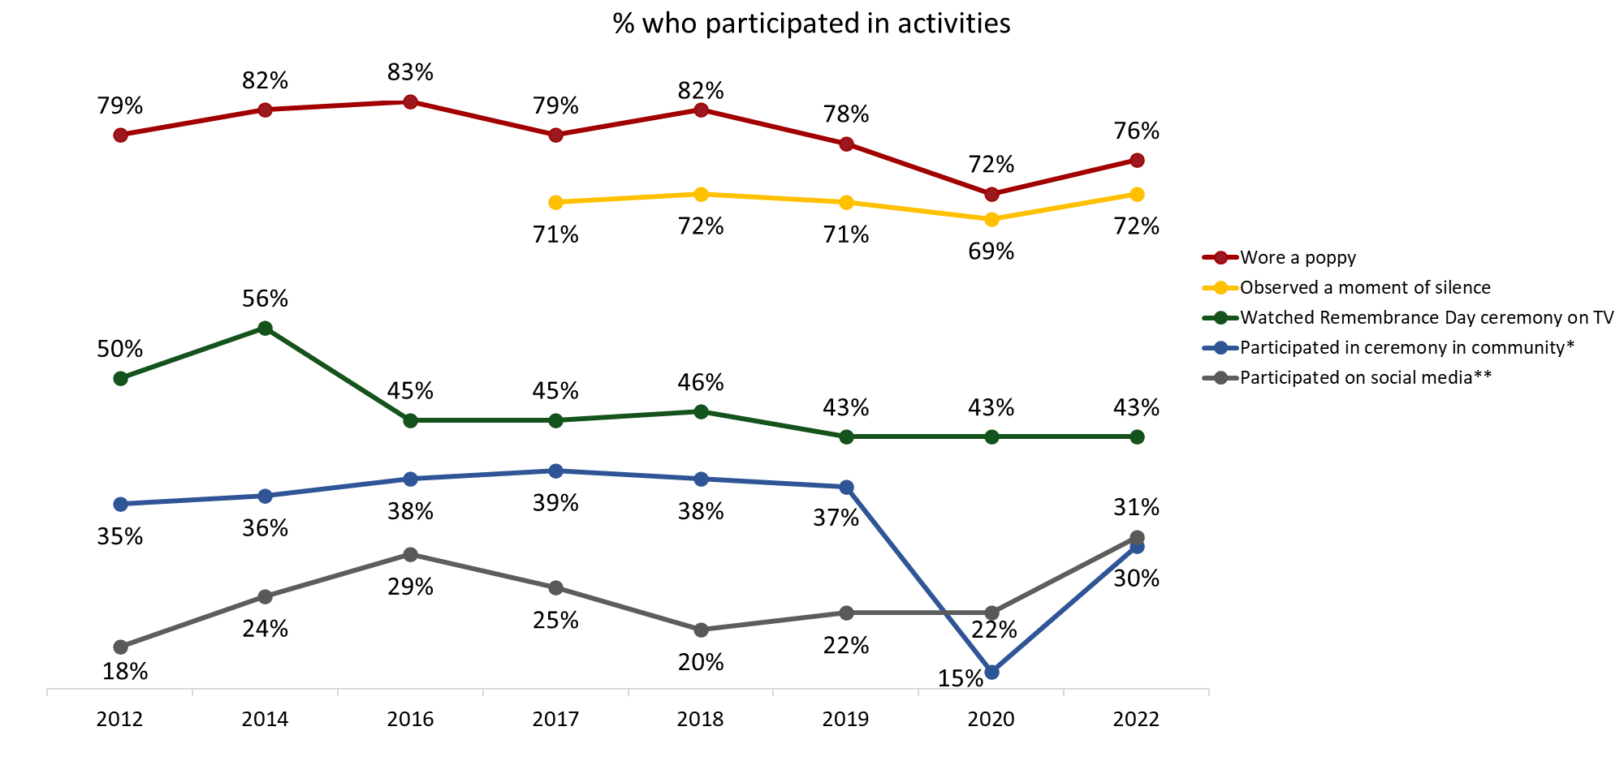

Q4A-F: Did you or members of your immediate family do any of the following during Veterans' Week this year?
Base: All respondents; 2022 n=1,002. DK/NR: <1% - 1%. (Multiple responses accepted)
*Wording change in 2020.
**Wording change in 2020 and 2022.

Prioritizing Veterans’ Week Activities
This section discusses Canadians’ perceptions about the importance of various Veterans’ Week initiatives.

Many Canadians attribute at least some importance to all remembrance initiatives
Respondents were asked to rate the level of priority the Government of Canada should place on the following remembrance initiatives:
    - Providing educational materials for schools.
    - Posting remembrance-related content on social media.
    - Providing funding for commemorative projects.
    - Creating remembrance-related ads.
    - Creating virtual or online remembrance ceremonies.
    - Providing promotional materials, such as posters and pins.
    - Supporting and leading commemorative events in Canada [split sample].
    - Supporting and leading commemorative events outside of Canada [split sample].

Majorities of Canadians support all the initiatives, rating them as somewhat or very important.

Figure 15: Importance of Remembrance Initiatives

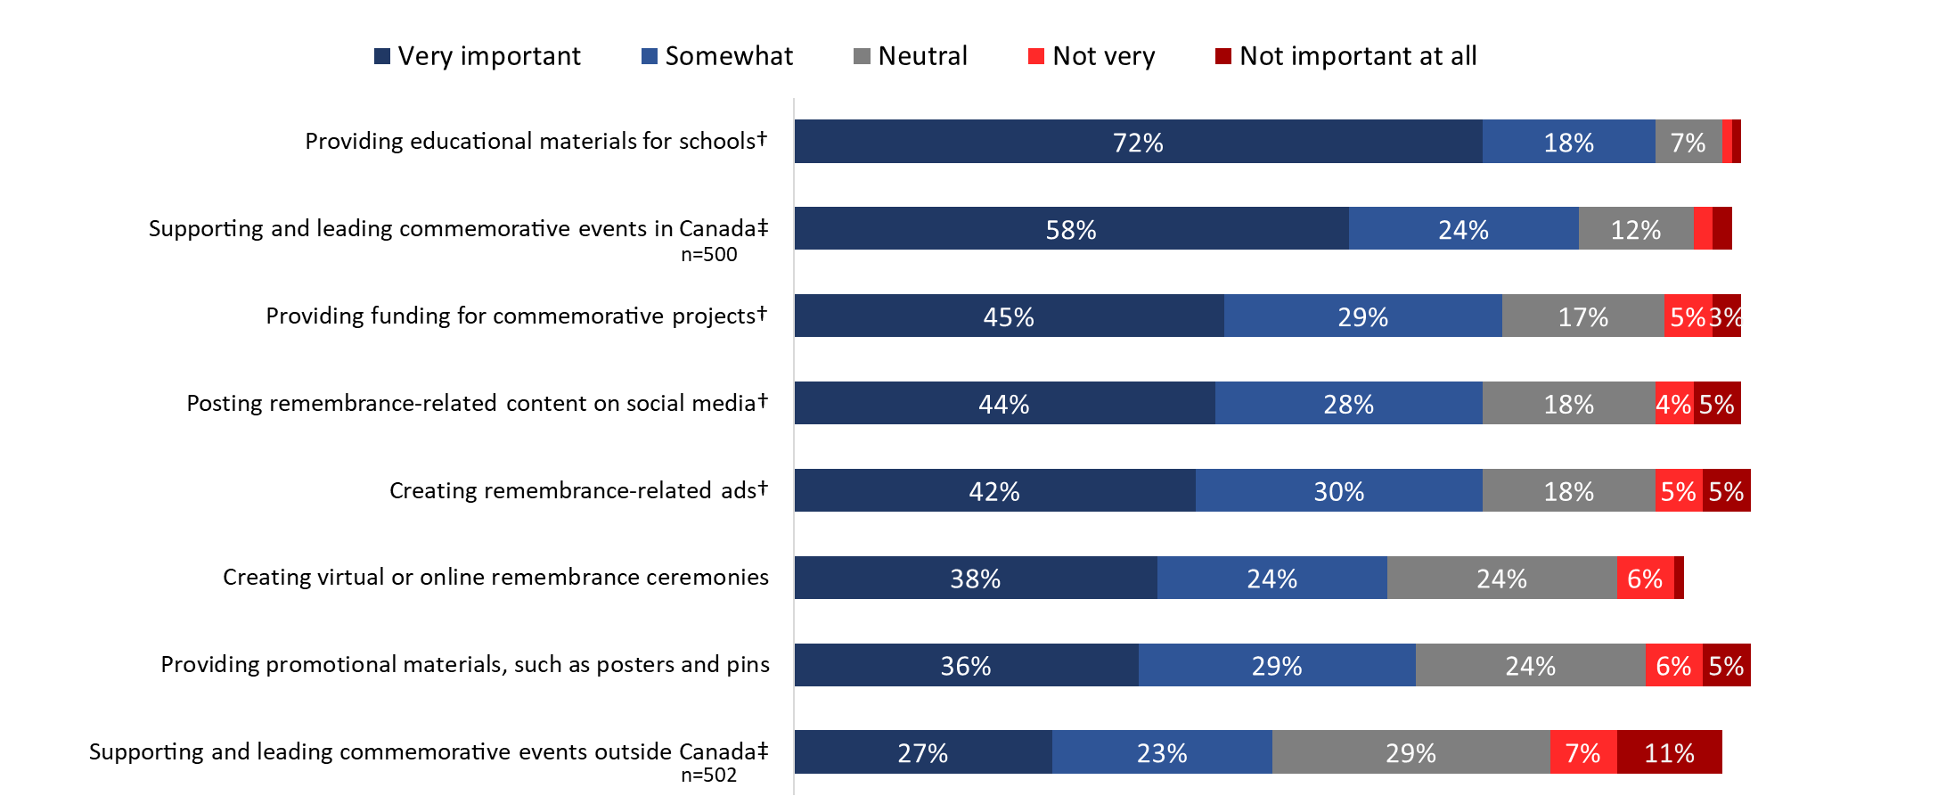

*Values of 2% or less are not labelled in the graph.
Q5A-H: Now, thinking about ways of recognizing the achievements and sacrifices of Canadians during wartime and in peacetime operations, what priority should the Government of Canada place on each of the following remembrance initiatives?
†Wording changed in 2018.
‡Wording changed 2019.
Base: All respondents; 2022 n=1,002. Exception: Q5B/C are split samples. DK/NR: <1%-3%.

Nine in 10 Canadians (90%) attributed importance to providing educational materials for schools, with 72% saying this is very important. Eight in 10 Canadians (82%) attributed importance to supporting and leading commemorative events in Canada, with just over half (58%) saying this is very important. Support for this initiative drops significantly when events are to be held outside of Canada (only 50% attributed importance to this).

Following this, similar proportions attributed importance to providing funding for commemorative projects (74%), posting remembrance content on social media (72%), and creating remembrance related ads (71%). Two-thirds of Canadians (65%) attributed importance to providing promotional materials, such as posters and pins, while the creation of virtual or online ceremonies for Veterans’ Week was considered important by 62% of Canadians.

In terms of subgroup variations, the following are noteworthy:
- Residents of Quebec were less likely than Canadians in other regions of the country to view as important almost all the remembrance initiatives. The exception was posting remembrance-related content on social media. There were no regional differences evident.
- Women were more likely than men to view as important creating virtual ceremonies (68% versus 60% of men) and posting remembrance-related content on social media (76% versus 67% of men).
- Compared to other Canadians, Veterans, CAF members and those who know a Veteran personally were more likely to say the Government of Canada should place importance on supporting and leading commemorative events in Canada (86% versus 77%) and outside Canada (57% versus 43%), creating remembrance-related ads (75% versus 68%), and providing funding for commemorative projects (79% versus 68%).
- Those who immigrated to Canada were more likely than those born in Canada to attribute importance to providing education materials for schools (95% versus 89%), posting remembrance-related content on social media (82% versus 68%), and creating virtual remembrance ceremonies (71% versus 61%).

Canadians’ views on remembrance initiatives have changed little over the last decade
Support for these remembrance initiatives remains stable among Canadians, with virtually no changes since 2020. The exception is supporting or leading commemorative events outside of Canada—support has increased seven percentage points, from 43% in 2020 to 50% in 2022. Looking back over the last decade, except for creating remembrance ads, support for all these initiatives is higher than it was in 2012.

Figure 16: Importance of Remembrance Initiatives [Over Time]

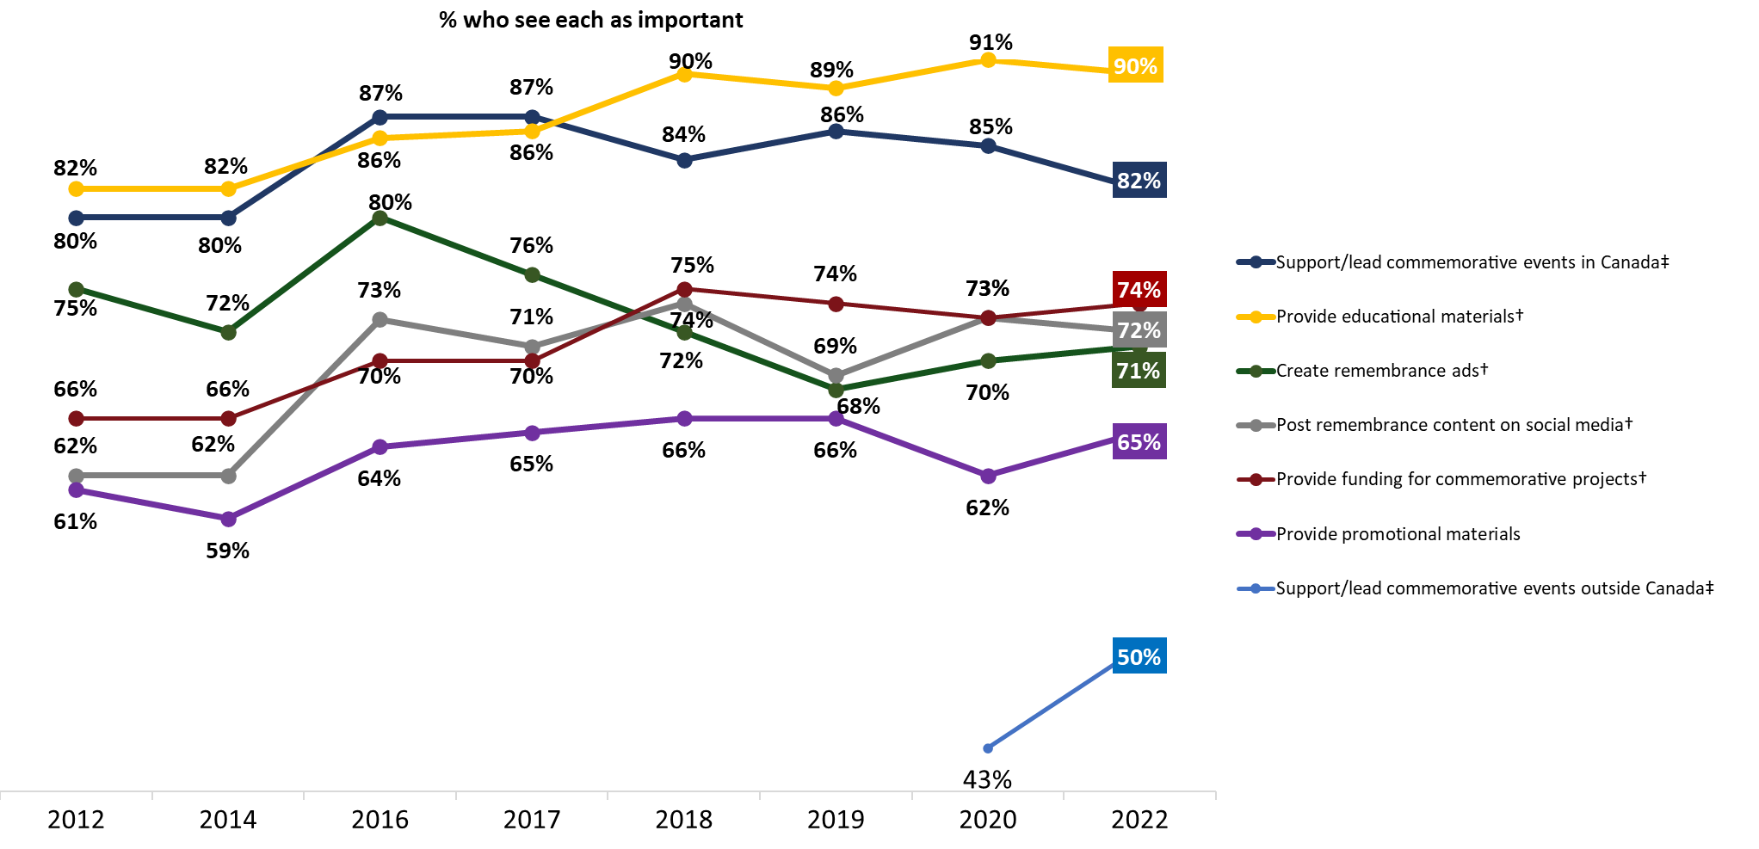

Q5A-H: Now, thinking about ways of recognizing the achievements and sacrifices of Canadians during wartime and in peacetime operations, what priority should the Government of Canada place on each of the following remembrance initiatives? Base: SPLIT SAMPLE; 2022 n=1,002. DK/NR: <1%-2%.

Attitudes Towards Veterans and Canada’s Military
This section explores attitudes towards Canadian Veterans and those who died in service, as well as towards Canada’s military and the role that it plays.

Canadians display positive attitudes towards Veterans and Canada’s military
Canadians were asked to rate their level of agreement with the following statements:

    - I am proud of the role Canada’s military played in the First and Second World Wars and the Korean War.
    - Canada’s Veterans and those who died in service have made major contributions to our country.
    - Canada’s Veterans and those who died in service should be recognized for their service to Canada.
    - I try to show my appreciation to those who served our country.
    - Veterans Affairs Canada's remembrance program effectively honours Veterans and those who died in service and preserves the memory of their achievements and sacrifices.
    - Taking part in commemorative activities increases awareness of, and appreciation for, the contributions of Veterans and those who died in service.
    - I am proud of the role Canada’s military has played since the Korean War. This includes Canada’s mission in Afghanistan, peace support operations, humanitarian aid missions and disaster relief efforts in Canada and around the world.

The results suggest that Canadians hold positive attitudes towards Veterans, commemoration, and Canada’s military. More than nine in 10 Canadians agreed that Veterans and those who died in service should be recognized for their service to Canada (96%) and have made major contributions to our country (93%).

Following this, more than eight in 10 Canadians agreed that participating in commemorative activities increases awareness of, and appreciation for, the contributions of Veterans and those who died in service (87%) and are proud of the role Canada’s military played in the First and Second World Wars and the Korean War (86%). Pride in Canada’s military role declines somewhat when the focus is activities since the Korean War (79% indicated that they are proud of Canada’s military role post-Korea).

In addition, eight in 10 surveyed Canadians (82%) feel that they try to demonstrate their appreciation to those who served our country and approximately three-quarters (76%) agreed that Veterans Affairs Canada effectively honours Veterans and preserves the memory of their achievements.

Figure 17: Attitudes Towards Veterans, Commemoration and Canada’s Military

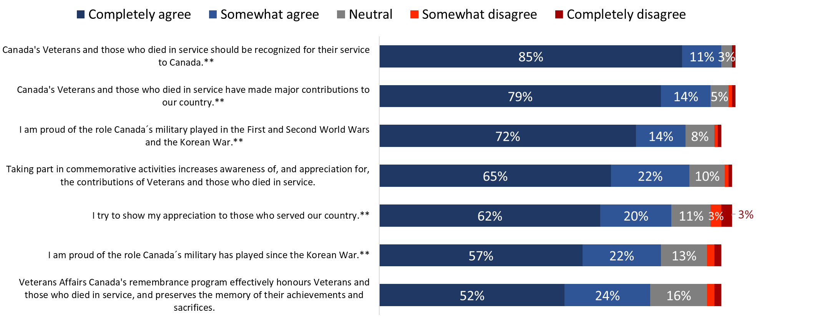
Values of 2% or less are not labelled in the graph.
Q6A-G: Please tell me how much you agree or disagree with each of the following statements, using a scale of 1 to 5, where 1 means completely disagree and 5 means completely agree.
Base: All respondents; 2022 n=1,002. DK/NR: 1%-4%
**Wording changed 2022.

In terms of subgroup variations, the following are noteworthy:
- The likelihood of agreeing with almost all of these statements was lower among Quebec residents. The exception was pride in the role Canada’s military has played since the Korean War: 84% of those in Quebec agreed that this is important compared to 71% of those in British Columbia.
- Canadians aged 45 and older were more likely than those 44 years of age and under to be proud of the role Canada’s military played in the First and Second World Wars and the Korean War (92% of 45- to 64-year-olds and 93% of those aged 65+ versus 79% of those aged 44 and younger) and since the Korean War (86% of 45- to 64-year-olds and 88% of those aged 65+ versus 71% of those 44 years of age and younger).
- Compared to other Canadians, Veterans, CAF members and those who know a Veteran personally were more likely to agree with all but one of these statements. The exception was, “VAC’s remembrance program effectively honours Veterans and those who died in service and preserves the memory of their achievements and sacrifices.”
There were differences based on education, household income, and gender, but these differences were not consistent and not indicative of a pattern.

Attitudes towards commemoration and Veterans/those who died in service are stable over time
Over time, Canadians’ attitudes towards commemoration, Veterans and those who died in service have remained strong. Since 2020, there has been virtually no change, with one exception—there has been a 10-percentage point increase in the proportion of Canadians who say they try to show their appreciation to those who served the country (from 72% to 82% in 2022).

Figure 18: Attitudes Towards Veterans and Commemoration [Over Time]

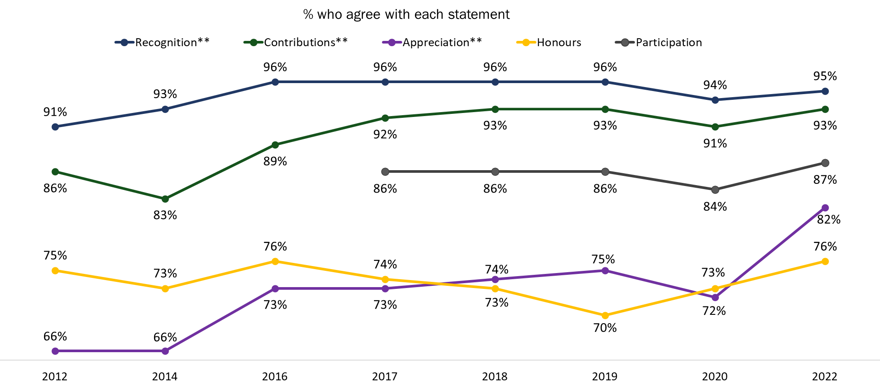

Q6: Please tell me how much you agree or disagree with each of the following statements, using a scale of 1 to 5, where 1 means completely disagree and 5 means completely agree.
Base: All respondents; 2022 n=1,002. DK/NR: 1%-4%
**Wording changed 2022.

Recognizing Canadian Veterans and Those Who Died in Service
This section examines Canadians’ perceptions of the importance of, and levels of satisfaction with, VAC’s measures to recognize Veterans and those who died in service.

Widespread agreement on importance of recognition and many are satisfied with VAC’s performance in this area
Nine in 10 Canadians (92%) considered it important that VAC recognize and honour Canadian Veterans and those who died in service by presenting and looking after memorials, cemeteries, and grave markers. Those who did not (6%) were neutral, neither agreeing nor disagreeing that it is important for VAC to present and look after these sites.

Two-thirds (67%) of surveyed Canadians agreed that they are satisfied with how VAC recognizes and honours Canadian Veterans and those who died in service by presenting and looking after memorials, cemeteries, and grave markers. Those who did not express satisfaction with VAC’s performance were more likely to be neutral (20%) or to not know how to assess VAC in this area (9%) than to report any level of disagreement.

Figure 19: Attitudes Towards Actions to Recognize Veterans and Those Who Died in Service

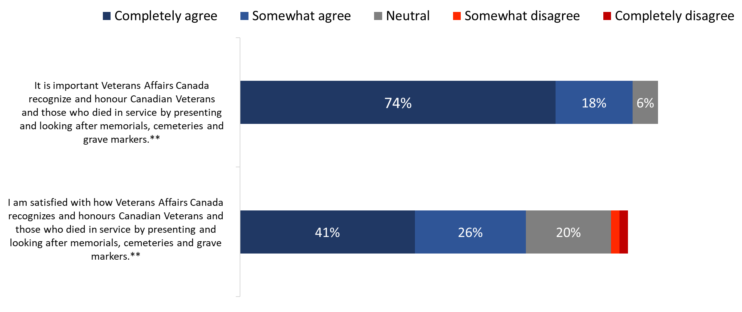
Values of 2% or less are not labelled in the graph.
Q7a/b: Veterans Affairs Canada has a mandate to present and care for certain memorials, cemeteries, and grave markers, and provide funeral and burial assistance for deceased Canadian Veterans. Please tell me how much you agree or disagree with each of the following statements… Base: All respondents; 2022 n=1,002. DK/NR: 1%-9%
**Wording changed in 2022.

Veterans, CAF members, and those who know a Veteran personally (94%) were more likely than other Canadians (89%) to attribute importance to recognizing and honouring Canadian Veterans and those who died in service through the presentation and care of memorials, cemeteries, and grave markers. Regionally, those living in Quebec (86%) were less likely than those living in other regions of the country to agree that it is important to recognize and honour Veterans and those who died in service this way. There were no subgroup differences when Canadians were asked their satisfaction with VAC’s performance.

Attitudes towards VAC’s recognition of Canadian Veterans remains relatively stable over time
Over the past decade, Canadians’ attitudes towards recognition have remained largely stable. Views on the importance of recognizing and honouring Canadian Veterans and those who died in service by presenting and looking after memorials, cemeteries and grave markers are virtually unchanged since 2016, and are more positive now than a decade ago. Views on the performance of VAC in this area have been gradually improving since 2019 when 61% of Canadians agreed they were satisfied to 64% in 2020 and 67% in 2022.

Figure 20: Presentation and Care of Memorials, Cemeteries and Grave Markers [Over Time]

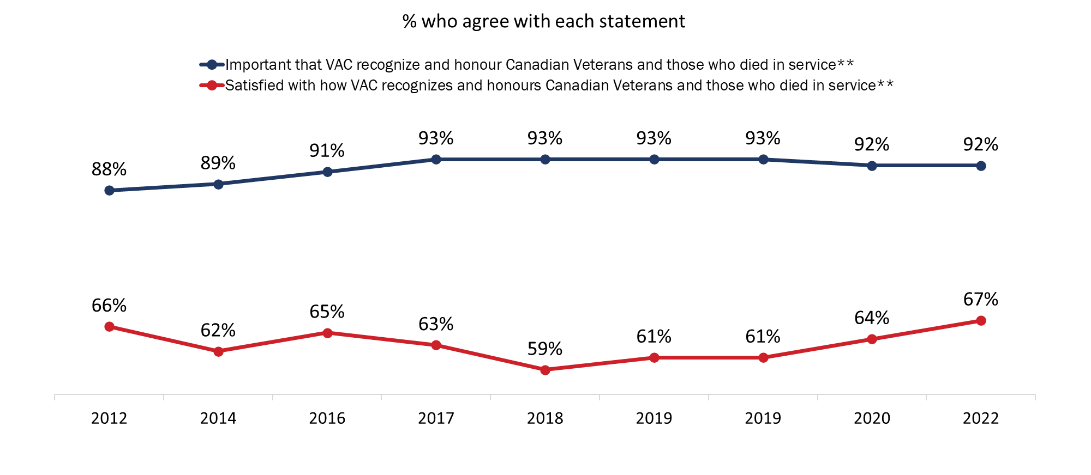

Q7a/b: Veterans Affairs Canada has a mandate to present and care for certain memorials, departmental cemeteries, and grave markers as well as to provide funeral and burial assistance for deceased Canadian Veterans. Please tell me how much you agree or disagree with each of the following statements… Base: All respondents; 2022 n=1,002. DK/NR: 1%-9%
**Wording changed in 2022.

Most Canadians agree on importance of VAC providing funeral and burial assistance and many are satisfied with VAC’s performance in this area
There is strong and widespread agreement among Canadians that it is important VAC recognize and honour deceased Canadian Veterans by providing funeral and burial assistance. Specifically, 92% of surveyed Canadians agreed that this is important, including 77% that completely agreed.

Turning to assessments of VAC’s performance, six in 10 (61%) Canadians agreed they are satisfied with how VAC recognizes and honours deceased Veterans through the provision of funeral and burial assistance. Respondents who were not satisfied with VAC’s performance were more likely to be neutral (21%) than to express dissatisfaction (4%). Thirteen percent of respondents were not able to rate VAC’s performance providing funeral and burial assistance.

Figure 21: Importance of Providing Funeral and Burial Assistance
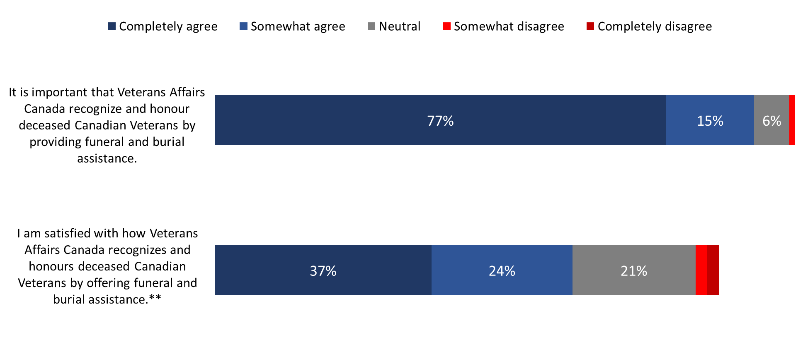
Values of 2% or less are not labelled in the graph.
Q7c/d: Veterans Affairs Canada has a mandate to present and care for certain memorials, departmental cemeteries, and grave markers as well as to provide funeral and burial assistance for deceased Canadian Veterans. Please tell me how much you agree or disagree with each of the following statements… Base: All respondents; 2022 n=1,002. DK/NR: 1% - 13%
**Wording changed in 2022.

The following were more likely to agree that they are satisfied with VAC’s provision of funeral and burial assistance: those in British Columbia (69%) and Atlantic Canada (69%) compared to those in Quebec (54%); those under 25 (77%) compared to 59% of 25- to 44-year-olds and 57% of 45- to 64- year-olds; and those who with a high school education or less (75%) compared to college (58%) and university (55%) graduates. There were no subgroup differences when Canadians were asked about the importance of this activity.

Attitudes towards VAC’s provision of funeral and burial assistance are positive and stable over time
Agreement that it is important that VAC recognize and honour deceased Canadian Veterans by providing funeral and burial assistance has been consistent over time, from 91% in 2016 to 92% in 2022. Satisfaction with how VAC recognizes and honours deceased Canadian Veterans by providing funeral and burial assistance has increased five percentage points, from 56% in 2020 to 61% in 2022.

Figure 22: Importance of Providing Funeral and Burial Assistance [Over Time]

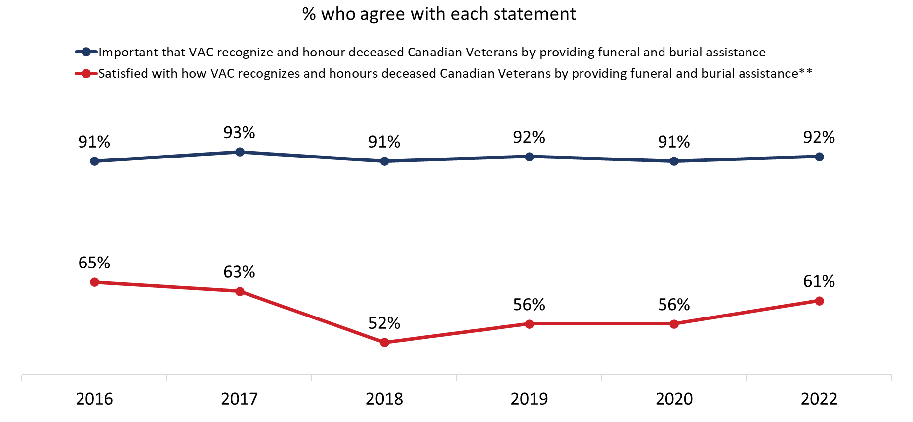

Q7c/d: Veterans Affairs Canada has a mandate to present and care for certain memorials, departmental cemeteries, and grave markers as well as to provide funeral and burial assistance for deceased Canadian Veterans. Please tell me how much you agree or disagree with each of the following statements… Base: All respondents; 2022 n=1,002. DK/NR: 1% - 13%
**Wording changed in 2022.

Recognizing Canadian Military Milestones
This section examines Canadians’ views on recognizing Canadian military milestones.

Most Canadians believe it is important for Canada to mark key military anniversaries
The vast majority of Canadians think it is important to mark key military anniversaries in Canada: 94% attribute importance to marking anniversaries related to military conflicts and 86% attribute importance to marking anniversaries related to military efforts in Canada. When it comes to the level of importance, nearly two-thirds (64%) said marking anniversaries related to military conflicts is very important, while fewer (46%) felt this way about anniversaries related to military efforts in Canada.

Before responding to this question, respondents were informed that the following anniversaries took place in 2022: the 80th anniversary of the Second World War’s Dieppe Raid and the 105th anniversary of the First World War’s Battle of Vimy Ridge; and the 25th anniversary of the Red River floods in Manitoba.

Figure 23: Importance of Marking Military Milestones

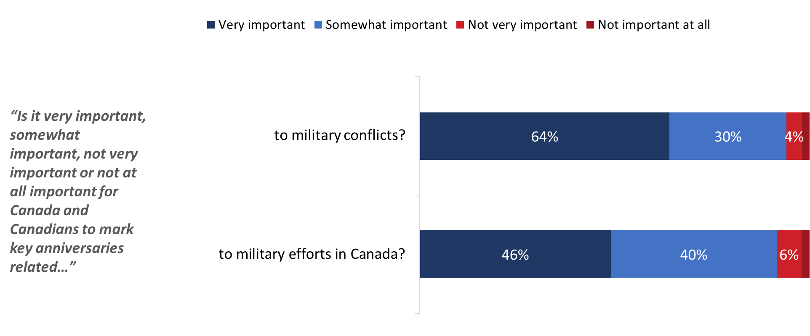

*Values of 2% or less are not labelled in the graph.
Q8a: In 2022, Canada marked the 80th anniversary of the Second World War’s Dieppe Raid and the 105th anniversary of the First World War’s Battle of Vimy Ridge. Is it very important, somewhat important, not very important or not at all important for Canada and Canadians to mark key anniversaries related to military conflicts? Base: SPLIT SAMPLE; 2022 n=501. DK/NR: <1%
Q8b: In 2022, Canada marked the 25th anniversary of the Red River floods in Manitoba. Is it very important, somewhat important, not very important or not at all important for Canada and Canadians to mark key anniversaries related to military efforts in Canada?
Base: SPLIT SAMPLE; 2022 n=501. DK/NR: 5%

Those in Quebec (86%) were less likely than those living in Atlantic Canada (98%) and Ontario (98%) or the Prairies (97%) to say it is important to mark key anniversaries related to military conflicts. On the other hand, Veterans, CAF members, and those who know a Veteran personally (97%) were more likely than other Canadians (91%) to think it is important to mark these types of military anniversaries. There were no subgroup differences when Canadians were asked about marking anniversaries related to military efforts in Canada.

Strong and widepsread support for recognizing the contributions of Veterans and those who served Canada in more recent operations
More than nine in 10 Canadians (95%) said it is important to recognize the contributions of Veterans and military personnel who served Canada in more recent operations, such as Canada’s Mission in Afghanistan, humanitarian efforts and peace support operations around the world.

Figure 24: Attitudes Towards Recent Conflicts

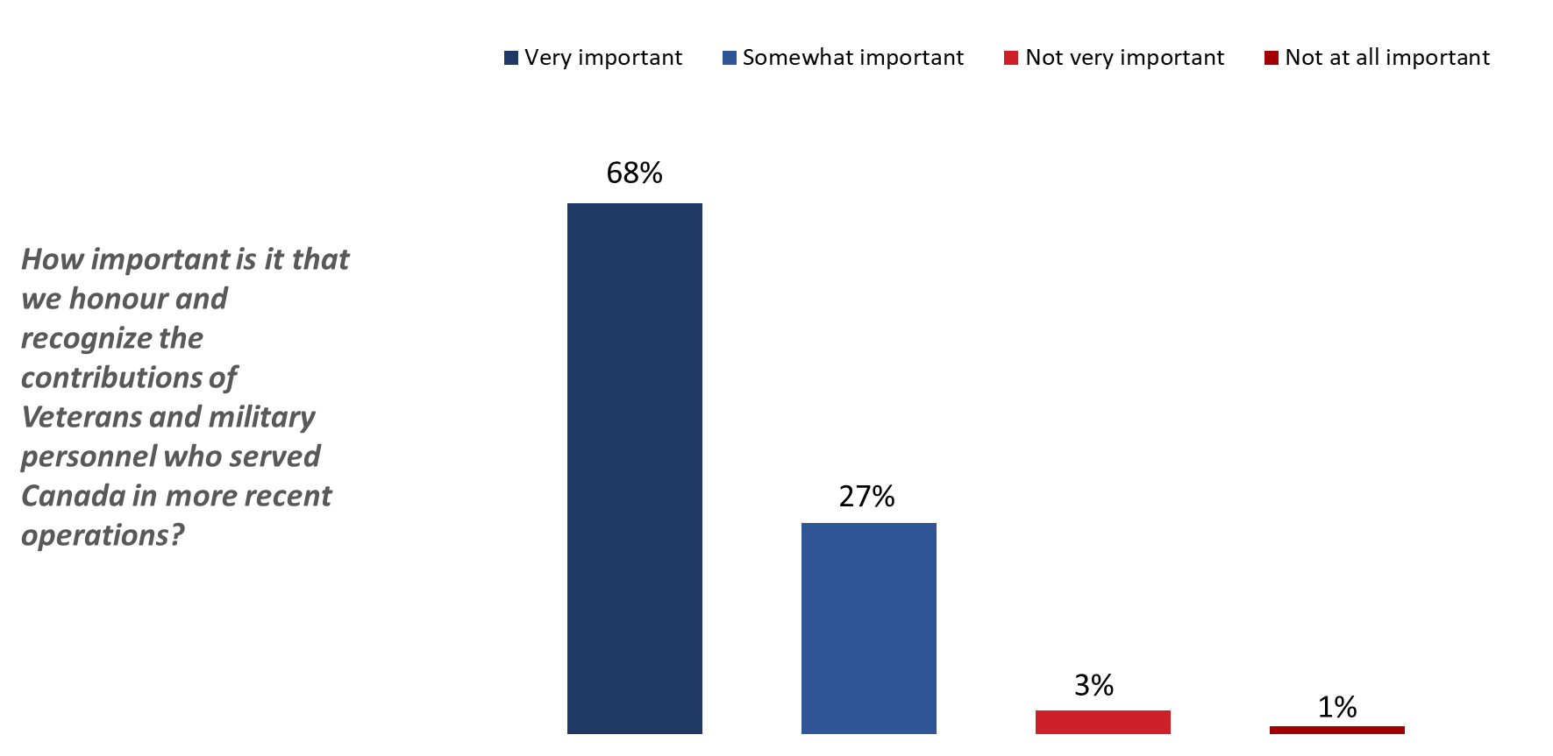
Q9: How important is it that we honour and recognize the contributions of Veterans and military personnel who served Canada in more recent operations such as Canada’s Mission in Afghanistan, humanitarian efforts and peace support operations around the world?
Base: All respondents; 2022 n=1,002. DK/NR: 1%

The following groups of Canadians were more likely to view this as very important: those in Atlantic Canada (69%), Ontario (74%) and the Prairies (74%) compared to Quebec (56%); Canadians aged 65+ (73%) compared to those under 25 (69%); those with a high school education or less (76%); and Veterans, CAF members and those who know a Veteran (76%).

Appendix

1. Technical Specifications
The following specifications applied to this survey:

- A 14-minute random digit dialling (RDD) telephone survey was administered to 1,002 Canadian residents, 16 years of age or older, between November 15 and 24, 2022.
- Elemental Data Collection Inc. (EDCI) carried out data collection, under subcontract to Phoenix SPI.
- The questionnaire was pre-tested in advance of the fieldwork to ensure that it measured what it intended to measure and that respondents understood the questions.
- An overlapping dual-frame (landline and cell phone) sample was used to minimize coverage error. The same random selection process was used for both the landline and cell phone sample, thereby ensuring the integrity of the probability sample. Fifty percent of the interviews were completed using the landline sample and 50 percent using the cell phone sample.
- The sample frame was geographically disproportionate to improve the accuracy of regional results. The unweighted distribution of completed surveys was as follows:
Strata | Completed Interviews
Atlantic | 100
Quebec | 302
Ontario | 350
Prairies (and Nunavut and the Northwest Territories) | 150
British Columbia (and the Yukon Territory) | 100
Total | 1,002
- Based on a sample of this size, the overall results can be considered accurate within ±3.3%, 19 times out of 20 (adjusted to reflect the geographically disproportionate sampling).
- The following table presents information about the final call dispositions for this survey and calculation of the response rate:
 | Total | Landline | Cell
Total Numbers Attempted | 67,807 | 21,794 | 46,013
Out-of-scope - Invalid | 34,934 | 8,956 | 25,978
Unresolved (U) | 19,509 | 6,508 | 13,001
No answer/Answering machine | 19,509 | 6,508 | 13,001
In-scope - Non-responding (IS) | 12,296 | 5,808 | 6,488
Language barrier | 223 | 108 | 115
Incapable of completing (ill/deceased) | 115 | 84 | 31
Callback (Respondent not available) | 986 | 301 | 685
Refusal | 10,782 | 5,229 | 5,553
Termination | 190 | 86 | 104
In-scope - Responding units (R) | 1,068 | 522 | 546
Completed Interview | 1,002 | 500 | 502
Not Qualified – Employment exclusions | 50 | 22 | 28
Not Qualified – Age | 16 | 0 | 16
- The overall response rate was 3% (4% for the landline sample and 3% for the cell phone sample). The response rate formula is calculated as follows: [R=R/(U+IS+R)]. This means that the response rate is calculated as the number of responding units [R] divided by the number of unresolved [U] numbers plus in-scope [IS] non-responding households and individuals plus responding units [R].
- The survey data have been weighted by region, age and gender using population figures from Statistics Canada’s 2021 census data. The weights correct for the disproportionate regional sampling. Any respondents who refused to provide their age were given a neutral weight so as not to skew the weighting proportions. The table below shows the unweighted and weighted proportions for the variables used to create the weights:

 | Unweighted | Weighted
Base | n=1,002 | n=1,002
Region
Atlantic Canada | 100 | 65
Quebec | 302 | 235
Ontario | 350 | 390
Prairies* | 150 | 175
British Columbia** | 100 | 136
Age
Under 25 | 46 | 114
25 to 44 | 207 | 295
45 to 64 | 305 | 296
65 or older | 358 | 210
Gender
Male | 470 | 480
Female | 522 | 511
Another gender | - | -
*Includes Nunavut and the Northwest Territories.
**Includes the Yukon Territory.
- A non-response analysis was conducted to assess the potential for non-response bias. Survey non-response can bias results when there are systematic differences between survey respondents and non-respondents. As displayed in the table above, the survey sample differs from the population in terms of age (as is often the case with telephone surveys of the general population). Canadians under 45 were under-represented in the survey sample and those aged 65 and older were over-represented in the survey sample. Weights were applied to adjust for the discrepancy between the survey sample and the population. To estimate the amount of bias introduced into the survey results, the unweighted and weighted results by age were compared for Q2: How important is it that Veterans' Week be held each year? The analysis indicates that the age bias, overall, is unlikely to had an impact on the survey estimates.

2. Questionnaire

Hello/Bonjour, my name is . I’m calling on behalf of Phoenix, a public opinion research firm. We’re doing a survey for the Government of Canada to explore issues of interest to Canadians. Would you prefer to continue in English or French? / Préférez-vous continuer en français ou en anglais?

This survey should take about ten minutes to complete. Your participation is voluntary and completely confidential. Your answers will remain anonymous. If you say you no longer wish to take part, we will delete your earlier survey responses. Should you complete the survey, we will manage any information you provide as per the Privacy Act, the Access to Information Act, and any other related legislation.

[ACCESSIBILITY NOTE: If an alternative method of taking part in the survey is needed offer this to respondents.]

Cell sample skip A, go to CS1.
- I’d like to speak to someone in your household who is 16 years of age or older. Is that you?

Yes |  | CONTINUE
No |  | ASK TO SPEAK TO ELIGIBLE PERSON.  REPEAT INTRO
Refused (Volunteered) |  | THANK/DISCONTINUE

Cell sample only:
CS1. Have I reached you on your cell phone?

Yes | CONTINUE
No | GO TO B

CS2. Are you 16 years of age or older?

Yes | CONTINUE
No | THANK/DISCONTINUE

CS3. Are you in a place where you can safely talk on the phone and answer my questions?

Yes | GO TO B
No | CONTINUE

CS4. When would be a good time for me to call back?

Schedule call-back if possible (time/day): _______________

Ask everyone:
- Do you, or does anyone in your family or household, work in any of the following areas? [READ LIST]

Advertising or market research | THANK/DISCONTINUE
The media (i.e., TV, radio, newspapers) | THANK/DISCONTINUE
As an elected official | THANK/DISCONTINUE
THOSE BELONGING TO THE ABOVE CATEGORIES ARE NOT ELIGIBLE TO PARTICIPATE IN THE SURVEY. TELL THEM: Thank you for your willingness to take part in this survey. Unfortunately, you do not meet the eligibility requirements of this study.

- In what year were you born?

Record year: ____________

Interviewer and programming notes:

- If respondent questions the legitimacy of the survey, invite respondent to use the Canadian Research Insights Council’s Research Verification Service at:

https://www.canadianresearchinsightscouncil.ca/rvs/home/?Lang=en.

The number for this project is: 20221103-ph855.

- If asked or if the respondent expresses concern about the privacy of their information, reiterate that participation in the survey is voluntary and completely confidential, and that all answers will remain anonymous. Also, reiterate that if the respondent indicates they no longer wish to participate, any survey responses already provided will be deleted. Any information that is retained will be administered according to the requirements of the Privacy Act, the Access to Information Act, and any other pertinent legislation.

- If asked about the National Do Not Call List, say:

Calls made for the purpose of market research, polls or surveys are not considered telemarketing calls. Organizations making these types of calls are not required to register with the National Do Not Call List. The National Do Not Call List toll-free telephone number is 1-866-580-3625.

- Reveal the name of the client department that commissioned the survey at the end of the survey only, if asked - Veterans Affairs Canada [VAC].

- Unless otherwise specified, all questions in the survey will allow for ‘don’t know/no response’ option.

- Tracking questions are identified as follows: T20 = 2020 is most recent tracking.

- If asked where and how the respondent can access the results, inform him or her that the report will be deposited with Library and Archives Canada (LAC) within six months after the data collection has been completed. LAC’s website is www.lac-bac.gc.ca.

- Veterans Affairs Canada is conducting two different surveys during November. The other survey gauges recall of a recent Government of Canada remembrance advertising campaign. If, at some point during the interview, a respondent indicates that s/he has already completed a survey on remembrance, assure him/her that there are two surveys underway right now, both of which are related to remembrance. Apologize for the inconvenience, thank them for their willingness to respond, and confirm that they will continue with this interview.

- The survey can be provided in electronic format for anyone who requires an alternate format to take part.
ASK EVERYONE:
- Have you ever heard of…[READ ITEMS]?

- Veterans' Week T20
- Remembrance Day

Yes
No
[DO NOT READ] Don't know/Refused

READ THIS DESCRIPTION TO EVERYONE:
Veterans’ Week takes place November 5th to 11th each year, in the lead up to Remembrance Day. During this week, commemorative ceremonies and events take place across the country to recognize Canada’s military personnel, Veterans and those who died in service. MODIFIED 2022

2a. On a scale of 1 to 5—where 1 means not important at all and 5 means very important, with 3 being neither unimportant nor important—in your opinion, how important is it that Veterans' Week be held each year? T20

Not important at all
Not very important
Neither important nor unimportant
Moderately important
Very important

ASK IF “VERY/MODERATELY IMPORTANT”:
2b. And why do you say it is important that Veterans’ Week be held each year? [DO NOT READ LIST; ACCEPT UP TO TWO RESPONSES; DO NOT PROBE BEYOND FIRST RESPONSE] T20

To honour/ to respect the Veterans/ those who died in service
So people will remember their sacrifices
To recognize their contribution to our freedom/ security/ peace
Veterans fought for our country/ they served our country
To recognize their service/ accomplishments
Family member is a Veteran/ I am a Veteran
Canada wouldn't be the country it is today/ I wouldn't be here if it weren't for Veterans
So children can understand/ learn the importance of it
Good idea/ good to remember
We owe them/ they deserve recognition
Part of our heritage/ our history
Many soldiers died in past wars
So we don't repeat past mistakes
Should not/ cannot forget
There are fewer Veterans/ their story should be told
Believe in it/ it's important to do it
To show support for our troops (past and/ or present)
Forces us to examine war
Other. Specify: __________________________
Nothing/ no reason

ASK IF “NOT VERY/NOT AT ALL IMPORTANT”:
2c. And why do you say it is not important that Veterans’ Week be held each year? [DO NOT READ LIST; ACCEPT UP TO TWO RESPONSES; DO NOT PROBE BEYOND FIRST RESPONSE] T20

Never heard of it/ don't know about it
Don't care/ not important to me personally
We already have Remembrance Day/ a week is too long
Happened in the past/ we should focus on the present
We shouldn't celebrate war/ we should focus on peace
Don't have family members who are Veterans/ don't know anyone in the military
Too expensive/ waste of money
Re-opens old wounds/ sad memories
There are other issues/ concerns that are more important
Most Veterans have died/ very few Veterans left
Don't know what activities there are for Veterans' Week
COVID-19/the pandemic (general mentions)
Other. Specify: __________________________
Nothing/ no reason

ASK IF “NEITHER IMPORTANT NOR UNIMPORTANT”:
2d. And why do you say it is neither important nor unimportant that Veterans’ Week be held each year? [DO NOT READ LIST; ACCEPT UP TO TWO RESPONSES; DO NOT PROBE BEYOND FIRST RESPONSE] T20

Never heard of it/ don't know about it
Don't care/ not important to me personally
We already have Remembrance Day/ a week is too long
Don't have family members who are Veterans/ don't know anyone in the military
We shouldn't celebrate war/ we should focus on peace
Happened in the past/ we should focus on the present
Don't know what activities there are for Veterans' Week
There are other issues/ concerns that are more important
Most Veterans have died/ very few Veterans left
Should be a more private ceremony/ held less often (so it's not overdone)
COVID-19/the pandemic (general mentions)
Other. Specify: __________________________
Nothing/ no reason

ASK EVERYONE:
3a. This year, did you or members of your immediate family participate in Veterans' Week which includes Remembrance Day? T20; MODIFIED 2022

Yes
No
Don’t know

ASK IF “YES”:
3b. And why did you or members of your immediate family participate in Veterans' Week which includes Remembrance Day? [DO NOT READ LIST; ACCEPT UP TO TWO RESPONSES; DO NOT PROBE BEYOND FIRST RESPONSE] T20; MODIFIED 2022

Family member is a Veteran/ I am a Veteran
To honour/ to respect the Veterans/ those who died in service
Know/ am related to someone/ I am currently in the military
So people will remember their sacrifices
Believe in it/ it's important to do it
So children can understand/ learn the importance of it
To recognize their contribution to our freedom/ security/ peace
I/ someone I know participate(s) in events
To recognize their service/ accomplishments
Veterans fought for our country/ they served our country
Canada wouldn't be the country it is today/ I wouldn't be here if it weren't for Veterans
To show support for our troops (past and/ or present)
Good idea/ good to remember
Show some (national) pride
Other. Specify: __________________________
Nothing/ no reason

ASK IF “NO”:
3c. And why didn't you or members of your immediate family participate in Veterans' Week which includes Remembrance Day? [DO NOT READ LIST; ACCEPT UP TO TWO RESPONSES; DO NOT PROBE BEYOND FIRST RESPONSE] T20; MODIFIED 2022

Never heard of it/ don't know about it
Too busy/ no time to attend
Don't have family members who are Veterans/ don't know anyone in the military
Had to work/ not available to participate
Don't care/ not important to me personally
There are no activities for Veterans' Week in the area
No occasion/ opportunity/ chance to participate
Don't know what activities there are for Veterans' Week
Participate in Remembrance Day events/observe Remembrance Day only
We already have Remembrance Day, a week is too long
Can't participate due to health reasons/ elderly
Don't have family nearby
I'm an immigrant
We shouldn't celebrate war/ we should focus on peace
Remember by wearing a poppy
COVID-19 restrictions in my area/uncomfortable participating in person due to COVID-19
Other. Specify: __________________________
Nothing/ no reason

ASK EVERYONE:
4. Did you or members of your immediate family do any of the following during Veterans' Week this year? [READ LIST; ACCEPT YES/NO FOR EACH ITEM] T20-B=NEW

- Wear a poppy.*
- Participate on social media by posting a poppy or other commemorative symbol, commenting on remembrance posts, or sharing stories.*
- Participate in a Remembrance Day 2022 ceremony in your community.*
- Watch a virtual or online Remembrance Day 2022 ceremony.*
- Watch a Remembrance Day 2022 ceremony on TV.*
- Observe a moment of silence.*

* RECODE “NO” TO “YES” AT Q3 IF RESPONDENT DID ONE OF THE Q4 ACTIVITIES.

5. Now, thinking about ways of recognizing the achievements and sacrifices of Canadians during wartime and in peacetime operation, what priority should the Government of Canada place on each of the following remembrance initiatives? Please respond using a scale of 1 to 5, where 1 means not important at all and 5 means very important, with 3 meaning neither unimportant nor important. [READ LIST; OBTAIN RATING FOR EACH ITEM] T20

- Providing educational materials for schools
- Supporting and leading commemorative events [SPLIT SAMPLE: 50% in Canada / 50% outside of Canada]
- Creating remembrance-related ads
- Providing funding for commemorative projects
- Providing promotional materials, such as posters and pins
- Posting remembrance-related content on social media
- Creating virtual or online remembrance ceremonies

6. Please tell me how much you agree or disagree with each of the following statements, using a scale of 1 to 5, where 1 means completely disagree and 5 means completely agree, with 3 meaning neither agree nor disagree. [READ LIST; OBTAIN RATING FOR EACH ITEM] T20 – A, B MODIFIED IN 2022.

    - I am proud of the role Canada’s military played in the First and Second World Wars and the Korean War.
    - Canada’s Veterans and those who died in service have made major contributions to our country.
    - Canada’s Veterans and those who died in service should be recognized for their service to Canada.
    - I try to show my appreciation to those who served our country.
    - Veterans Affairs Canada's remembrance program effectively honours Veterans and those who died in service, and preserves the memory of their achievements and sacrifices.
    - Taking part in commemorative activities increases awareness of, and appreciation for, the contributions of Veterans and those who died in service.
    - I am proud of the role Canada’s military has played since the Korean War. This includes Canada’s mission in Afghanistan, peace support operations, humanitarian aid missions and disaster relief efforts in Canada and around the world. *ALWAYS ASK AFTER B.

7. Veterans Affairs Canada has a mandate to present and care for certain memorials, cemeteries and grave markers, and provide funeral and burial assistance for deceased Canadian Veterans. Please tell me how much you agree or disagree with each of the following statements, using a scale of 1 to 5, where 1 means completely disagree and 5 means completely agree. T20

- It is important Veterans Affairs Canada recognize and honour Canadian Veterans and those who died in service by presenting and looking after memorials, cemeteries, and grave markers.
- I am satisfied with how Veterans Affairs Canada recognizes and honours Canadian Veterans and those who died in service by presenting and looking after memorials, cemeteries and grave markers.
- It is important Veterans Affairs Canada recognize and honour deceased Canadian Veterans by providing funeral and burial assistance.
- I am satisfied with how Veterans Affairs Canada recognizes and honours deceased Canadian Veterans by offering funeral and burial assistance.

[SPLIT SAMPLE Q8: 50% of respondents are asked Q8A and 50% are asked Q8B.]

8A. In 2022, Canada marked the 80th anniversary of the Second World War’s Dieppe Raid and the 105th anniversary of the First World War’s Battle of Vimy Ridge. Is it very important, somewhat important, not very important or not at all important for Canada and Canadians to mark key anniversaries related to military conflicts?

Not at all important
Not very important
Somewhat important
Very important

8B. In 2022, Canada marked the 25th anniversary of the Red River floods in Manitoba. Is it very important, somewhat important, not very important or not at all important for Canada and Canadians to mark key anniversaries related to military efforts in Canada?

Not at all important
Not very important
Somewhat important
Very important

ASK EVERYONE:
9. How important is it that we honour and recognize the contributions of Veterans and military personnel who served Canada in more recent operations such as Canada’s Mission in Afghanistan, humanitarian efforts and peace support operations around the world? Is it very important, somewhat important, not very important or not at all important?

Not at all important
Not very important
Somewhat important
Very important
The last few questions are for classification purposes only.

10. What language do you speak most often at home? [READ LIST; ACCEPT ALL THAT APPLY]

English
French
Other
[DO NOT READ] Prefer not to answer

11. Were you born in Canada?

Yes
No [CODE AS FIRST GENERATION]
[DO NOT READ] Prefer not to answer

11B. [IF Q11=NO] In what year did you first come to Canada to live?

Record year: [4- digit number] [IF <5 YEARS AGO CODE AS NEWCOMER]
[DO NOT READ] Don't know/ Prefer not to answer

12. How do you identify your gender? [READ LIST]

Woman,
Man, or
Non-binary
[DO NOT READ] Prefer not to answer

13. Do you identify as any of the following? [READ LIST; ACCEPT ALL THAT APPLY]

An Indigenous person
A visible minority
A member of the 2SLGBTQ+ community
[DO NOT READ] None of these
[DO NOT READ] Prefer not to answer

14. What is the highest level of formal education that you have completed? [READ LIST]

Grade 8 or less*
Some high school**
High school diploma or equivalent
Registered Apprenticeship or other trades certificate or diploma
College, CEGEP or other non-university certificate or diploma
University certificate or diploma below bachelor's level
Bachelor's degree
Post graduate degree above bachelor's level
[DO NOT READ] Prefer not to answer

*IN QUEBEC, PLEASE REPLACE WITH: “Secondary II or less”
**IN QUEBEC, PLEASE REPLACE WITH: “Some secondary school”

15. What was your total household income for 2021? That is, the total income of all persons in your household combined, before taxes. Please stop me when I get to the correct amount. Is it…? [READ LIST]

Under $20,000
$20,000 to just under $40,000
$40,000 to just under $60,000
$60,000 to just under $80,000
$80,000 to just under $100,000
$100,000 to just under $150,000
$150,000 and above
[DO NOT READ] Prefer not to answer

16. Are you…? [READ LIST; ACCEPT ONE ANSWER ONLY]

a member of the Canadian Armed Forces
a Veteran of the Canadian Armed Forces
a friend or family member of a Veteran
a friend or family member of a currently serving member of the Canadian Armed Forces
[DO NOT READ] None of these
[DO NOT READ] Prefer not to answer

That concludes the survey. Thank you very much for your thoughtful feedback.
It is much appreciated.

RECORD BY OBSERVATION:
PROVINCE/REGION
LANGUAGE OF INTERVIEW

Coverage error occurs when not all segments of the target population are included in the sample frame. If only landlines were included in the sample frame for this survey, Canadians who only have a cellphone would not have an opportunity to participate in the survey. The survey results, therefore, would only reflect the views of Canadians who have a landline in their household.
The findings suggest that the longer one has resided in Canada the more likely they are to have heard of Veterans’ Week: 53% of immigrants who entered Canada six or more years ago had heard of Veterans’ Week compared to 31% of immigrants who entered Canada within the last five years.
The findings suggest that the longer one has resided in Canada the more likely they are to have heard of Remembrance Day: 95% of immigrants who entered Canada six or more years ago compared to 80% of immigrants who entered Canada within the last five years.
This description was modified this year.
These are specific reasons offered by respondents, which were then combined to create the broader themes depicted in Figure 4.
Given the very small sample size, a table of the full range of responses is not provided. These responses can be found in the banner tables that accompany this report.
Respondents were not asked this question if they did not initially acknowledge participating in Veterans’ Week at Question 3: This year, did you or members of your immediate family participate in Veterans' Week activities, which includes Remembrance Day?
In 2020, respondents were asked whether they participated in any remembrance-related activity on social media. This year they were asked whether they participate on social media by posting a poppy or other commemorative symbol, commenting on remembrance posts, or sharing stories.

